**DESIGN AND IMPLEMENTATION OF A WEB BASED PRESENTATION SYSTEM THAT WOULD ENLIGHTEN USERS ON HOW TO MAKE CREAM, SOAP, PERFUME, BAKE AND CHEMICALS (INSECTICIDE)**

**ABSTRACT**

There is a mentality among the fresh graduates in Nigeria where they always fantasize about getting white collar jobs and having an office work. Over the years, the Nigeria graduates are faced with unemployment, a lot of frustrations from not getting the proposed white collar job. This research outlines the design and implementation of a web based system that will enlighten young people on how to make creams, soaps, perfume, and bake with chemicals (insecticide). For the government to re-positioning the economic, there is a need to build and drive entrepreneurial studies for job creation, wealth creation and global competitiveness of Nigeria youths and graduates. The purpose of the research is to equip Nigerian graduates and create a channel to enable easy venturing into skill acquisition and add to their knowledge and skills gotten from school. They are a lot of Challenges like inadequate funding, lack of training personnel and availability of equipment for training, but with the web system, all the listed challenges has been fixed.

**CHAPTER ONE**

**INTRODUCTION**

**1.1 BACKGROUND OF THE STUDY**

According to (NBS, 2004 and Ojo) about 80% of graduates in Nigeria find it difficult to get employment every year consistently. This is mainly due to the curricula of our tertiary institutions and other schools with emphasis on trainings for white collar jobs. In Nigeria, it is estimated to have about 170 million people (NBS, 2004 and Ojo, Abayomi & Odozi, 2014). This large population is blessed with abundant natural and human resources plus a favorable topographical area in the world. The current financial worldwide crisis has affected negatively on businesses globally and the Nigerian economy. This challenges has posed serious challenges and dangers to government and extraordinary number of citizens. Nigeria like other developing countries is confronted with various issues with regards to youth and graduate unemployment, significant level of poverty, insurgency, diseases, conflict, over reliance on imported products, slow economic development and growth, lack of human capacity and required skills to move the economy forward. Joblessness has become a significant issue to the lives of younger generations and fresh school graduates causing disappointment, discouragement, frustration and dependency on imported products to survive. The level of unemployment among this young population in Nigeria has contributed to the high rate of internet fraud, crime, insecurity and violence in the society during elections (Ajufo, 2003 & Simkovic 2012). The National Population Commission (2013), estimates that about sixty four (64) million of the Nigeria youths are unemployed or jobless while one million six hundred thousand (1.6million) are underemployed bringing the significant number of youths population without jobs to eighty (80) million.

When the high unemployment figures, when deducted from the total number of Nigeria’s population then you would concur that repositioning our entrepreneurship studies with a system to enlighten users on how to gain basic skills is required in our schools, this would help bridge the gap and give our growing unemployed youth job ambitions.

Another cause of unemployment in Nigeria is the lack of our educational system in Nigeria to address capacity development and teach our youth how to be solving problem. In developed countries, for instance, their educational technique introduces the youth to the trail of inquiry-discovery application to perceive problems (including societal problems) as challenges and opportunities that can be turned into goods and services to be rendered for money or commercial value (Adejimola & Olufumilayo, 2009). One of the ways to deal with unemployment in Nigeria is educating and using the advancement in technology for entrepreneurship and innovation. This should help in developing the capacity of students in entrepreneurship and innovation, engaging them in activities with small and large enterprises through such interventions as business incubators. Training our young generation into entrepreneurs is key to help fight unemployment, stop our reliance on imported goods, and grow our industrial and economic development in Nigeria.

* 1. **STATEMENT OF THE PROBLEM**

For the government to re-positioning the economic, there is a need to build and drive entrepreneurial studies for job creation, wealth creation and global competitiveness of Nigeria youths and graduates. The purpose of the research is to equip Nigerian graduates and create a channel to enable easy venturing into skill acquisition and add to their knowledge and skills gotten from school. They are a lot of Challenges like inadequate funding, lack of training personnel and availability of equipment for training, but with the web system, all the listed challenges has been fixed.

* 1. **AIM AND PURPOSE OF THE STUDY**

The primary aim of the study is to design and implement a web based presentation system that would enlighten users on how to make creams, soap, perfume, bake and chemicals (insecticide) in fighting against unemployment and engage our youths meaningfully, with the following objectives:

1. Provide a web based system for entrepreneurship and innovation to fight against unemployment.
2. Create a channel to enable easy venturing into skill acquisition and add to their knowledge and skills gotten from school.
3. Create jobs for the growing unemployed youths.
4. Help in the fight against students’ poor academic performance.
5. Design a secured system that is easily accessible for enlightenment, solving the challenges of inadequate funding, lack of training personnel and availability of equipment for training.
   1. **SCOPE OF THE STUDY**

The scope of the research is focused on designing a system to assist user in learning how to make cream, soap, perfume, bake and chemicals (insecticide), and the system will solve the challenges of youths seeking white collar jobs’ instead of gaining skills.

* 1. **LIMITATION OF THE STUDY**

The web based system can only be accessed with internet connection, users with poor or no internet connection cannot use the platform.

* 1. **DEFINTION OF TERMS**

**Skill Acquisition**: is a type of learning in which repetition results in enduring changes in an individual's capability to perform a specific task.

**Unemployment:** when persons above a specified age are not in paid employment or self-employment and are currently available for work during the reference period.

**Entrepreneurship:** Entrepreneurship is the process of designing, launching and running a new business, which is often initially a small business.

**Population:** is the number of people in a city or town, region, country or world.

**Skills:** A skill is the ability to carry out a task with determined results often within a given amount of time, energy, or both.

**Internet:** is the global system of interconnected computer networks that uses the Internet protocol suite (TCP/IP) to link devices worldwide.

**CHAPTER TWO**

**LITERATURE REVIEW**

**2.0 Introduction**

This chapter reviews literature related to the research. It involves a review of existing books, articles, journals and papers which are related to the research and also entails the interrogation of comments, critiques and issues revised by researchers/scholars on Design And Implementation Of A Web Based Presentation System That Would Enlighten Users On How To Make Cream, Soap, Perfume, Bake And Chemicals (Insecticide). It also provides information that are central to effective understanding of the issues which necessitate the undertaking of this research, putting into cognizance the views and postulations of people across various fields of studies. Thus, it deals with a balance of arguments for or against quoted comments and eventual position of the researcher.

**2.1 The Concept of Web-based Applications**

A web-based application differs from a more traditional [client-server application](https://www.sciencedirect.com/topics/computer-science/client-server-application" \o "Learn more about Client Server Application from ScienceDirect's AI-generated Topic Pages), primarily in the presentation and application logic pieces:

* The presentation component still runs on the user workstation, but a browser, for example, Mozilla Firefox, Microsoft Internet Explorer, or Google Chrome, instead of a specialized program provided by the vendor is used as the presentation tool.
* The application logic executes on the web server instead of on the user’s workstation.
* The storage component typically doesn’t change much. It continues to run on a server dedicated to providing the database functionality.Supporting a web-based application can be much more challenging than supporting a client-server application. The primary reasons for this is that the combined environment is more complicated that a traditional environment: More pieces of software are involved; for example, plug-ins, HTML, and Java script run behind the scenes to allow the application to function. Unless you’re extremely familiar with the application you won’t be aware of all the pieces involved.
* Many of these pieces are outside your control. For example, you have little control over what browser or version of browser each user has on their desktop. You can tell users over and over that application *XYZ* is only certified for Internet Explorer 9, but I guarantee you that you’ll have complaints from users that the application isn’t working on their computers. After you investigate it you’ll determine that they’re using Internet Explorer 10 or Opera or another unsupported server.
* Network throughput is vital. If the network is disrupted or slowed down significantly, then the application will get very sluggish, very quickly. I will advise you that the chances of the problem being the network are fairly slim. It’s very easy to blame unknown performance issues on the network, but most of the time, it turns out to be something else. Be sure you have some proof before blaming the network. Chapter 24—“UNIX Tools” provides information on tools that you can use to determine if a problem is or isn’t being caused by network issues.
* Users employ a wide variety of computers, operating systems, and Internet browsers. All of these combinations, along with the various options for configurations of settings of the O/S and browser, make it difficult to pin down exactly what the cause of a problem is.
* Firewall and port issues can be frustrating because something that worked yesterday might be failing today. Maintaining all of the rules in a firewall isn’t easy and periodically that team will make a mistake and your application might be impacted. Chapter 15 provides information on tools that can be used to identify what firewall ports are open.

Overall is it harder or easier to support a web-based application than a client-server application? It’s difficult to answer that question broadly. A lot of it depends on the applications themselves. Some are difficult to support, while others are significantly easier to work with.

Some things are easier under a web-based application and some things are more difficult. Bringing up a new user is easier because you don’t have to load software onto his or her PC. Typically, you just have to add their account to the application and give them the URL to go to within their web browser.

On the other hand, troubleshooting access or performance problems can be more difficult due to the larger number of components and [interconnections](https://www.sciencedirect.com/topics/computer-science/interconnection" \o "Learn more about Interconnection from ScienceDirect's AI-generated Topic Pages). Here are just a few possible causes that you’ll have to investigate. Some of these causes apply to both client-server and web-based applications:

* Is the user entering the correct URL into the web browser?
* Is he or she using a supported browser?
* Does the user have an account in the application?
* Is the user correctly entering their ID and password?
* Is the user’s application account enabled?
* Is the user’s network account in Active Directory enabled?
* Is the firewall port between the user and the web server open?
* Is the DNS name being resolved correctly?
* Is the web server having resource issues, i.e., disk space, memory, database connections?
* Are the application’s services running on the web server?
* Is the load balancer on the web server running correctly?
* Is the firewall port open between the web server and the [database server](https://www.sciencedirect.com/topics/computer-science/database-server" \o "Learn more about Database Server from ScienceDirect's AI-generated Topic Pages)?
* Is the database server up?
* Has the application’s account on the database server expired?
* Is the database software running on the database server?
* Has the database server run out of resources, e.g., disk space or memory?

**2.2 Role of Web Applications in Skill Acquisition**

According to Ghosh (2013), In order to understand the criticality of web application development issues in the supply of new web applications, we studied entrepreneurial activity in web application market. As mentioned above, we investigated the influence of development dependencies on – a) entrepreneurial strategies; and b) the market structure that affects future entrepreneurial strategies.

Alanin (2003) conducted a total of eighteen interviews in fall 2005. Twelve interviewees were involved in the startup of their firms and were currently active in the web applications market. The other six interviewees were senior managers of firms at different levels of mobile value chain – network operators, application distributors, operation support system providers for network operators (billing, content management system and the like). These six managers were interviewed to capture their expectations of the market structure changes that affect web application developers.

The interviews were open-ended in nature and ranged from 60 to 90 minutes in length. The open-ended interviews were transcribed and categorized to extract technological, entrant-specific and structural constraints on entrepreneurial efforts. The categorization was validated by cross transcript comparison.

Further, emerging themes were weighted on the background of the interviewee (professional, market experience) and on the number of interviewees raising a particular issue.

The preliminary findings are organized in two sections. The first section highlights the strategic challenges entrepreneurs faced that stemmed from development dependencies. The second section attempts to describe the evolving market structure of web application development and its implications for entrepreneurship.

**3.1 Entrepreneurial Strategies and Development Dependencies**

The nascent nature of web applications market provides ample opportunities for entrepreneurial activity. To exploit these opportunities web application developers must generate successful market entry strategies, and among them a niche market strategy is considered the first step towards financial gain.

Almost all the entrants pointed to the unique space, market position, and requirement they had carved out for engaging in business. In addition to delineating the market niche in general, entrepreneurial strategies must also address niche-specific issues of production and distribution. For web applications our interviews suggest that niche-specific production and distribution are shaped by development dependencies.

Development dependencies are technological in nature and depend on the choice of technologies at multiple levels. First, the development language and platform chosen was driven by the developer’s background and experience in similar technologies.

Developers with Java experience chose J2ME as the development technology, whereas developers with C++ background chose to use visual studio development environment for designing their application, which was a requirement for the BREW development platform. Second and more importantly, choice of technology is not limited to development languages, IDEs, and platforms, but also includes selections of various device, operating system, and network operator development standards or Application Programming Interfaces (API’s). These choices had to closely map with the targeted market and distribution opportunities. At the device level, for instance, a developer used ‘Palm Treo’- specific APIs for developing a J2ME-based application to get access to the device-specific special keys. The choice of this device was based on the demand that was projected for the application – that is to say that Palm Treo owners were expected to be more receptive and willing to buy the customized application. At the network level, the choice of technology, took the form of adopting special requirements of mobile operators.

Nextel (now Sprint-Nextel), for instance, provided a limited set of GPS capable handsets. In building a GPS application the developer limits the application to GPS- capable-Nextel Handsets as GPS API implementation differ across mobile operators. This development dependency is not just evident in the GPS applications, as one developer pointed out – “mostly if you make a program in J2ME it should run on every java enabled phone…but it doesn’t…operators have specific, what they call ‘API extensions’ that work on their own phones…these extensions include location APIs, multimedia APIs and many more”. In other words, the technology a developer chooses is a complex mix of different APIs at multiple levels that are dictated by application niche requirements, which in turn influences their distribution strategy.

Another issue that emerged from development dependencies was the certification process. Due to problems with interoperability of applications across a variety of devices, networks and operating systems, upstream firms in the mobile value chain impose certification requirements for applications. Otherwise they are unwilling to offer the application to their customers. The upstream firms defend the certification process as necessary due to – a) the security of the mobile network and devices; and b) to ensure proper functionality of the application that depended on APIs used from platforms and different devices and networks.

The certification process includes the cost of testing the web application, digitally certifying the authenticity of the application for download, and even digitally signing the application to be able to access certain restricted network APIs (for instance, access to GPS-derived location information). Since applications must be tested for performance and functionality on a variety of platforms, devices, and networks, the certification costs are considered high compared to the revenue a typical application generates. Hence, the developers consider certification an important investment as well as a potential market entry barrier.

Furthermore, due to development dependencies the entrepreneur has to be aware of the consumer market for the applications. This is a difficult endeavor, particularly at the device level. Although, devices with improved performance, usability and features are becoming available in the market, the devices in the mass consumer market are typically on average a year old compared to the latest available mobile devices. This is due to the subsidized provisioning of mobile devices by network operators to contractually lock-in the end-user. This trend is more discomforting for the application developer in the prepaid user market. Though the prepaid market is increasing in the US, the phones that are subsidized by the mobile operators are even older and cheaper, further diminishing the potential returns that improved device features might present to application developers.

# 2.9 STRUCTURE OF WEB APPLICATIONS

Applications are usually broken into logical chunks called "tiers", where every tier is assigned a role. Traditional applications consist only of 1 tier, which resides on the client machine, but web applications lend themselves to an n-tiered approach by nature. Though many variations are possible, the most common structure is the three-tiered application. In its most common form, the three tiers are called presentation, application and storage, in this order. A web browser is the first tier (presentation), an engine using some dynamic Web content technology (such as ASP, ASP.NET, CGI, ColdFusion, JSP/Java, Node.js, PHP, Perl, Python, Ruby on Rails or Struts2) is the middle tier (application logic), and a database is the third tier (storage). The web browser sends requests to the middle tier, which services them by making queries and updates against the database and generates a user interface (Petersen, 2015).

For more complex applications, a 3-tier solution may fall short, and it may be beneficial to use an n-tiered approach, where the greatest benefit is breaking the business logic, which resides on the application tier, into a more fine-grained model. Another benefit may be adding an integration tier that separates the data tier from the rest of tiers by providing an easy-to-use interface to access the data. For example, the client data would be accessed by calling a "list_clients()" function instead of making an SQL query directly against the client table on the database. This allows the underlying database to be replaced without making any change to the other tiers (Petersen, 2015).

There are some who view a web application as two-tier architecture. This can be a "smart" client that performs all the work and queries a "dumb" server, or a "dumb" client that relies on a "smart" server. The client would handle the presentation tier, the server would have the database (storage tier), and the business logic (application tier) would be on one of them or on both. While this increases the scalability of the applications and separates the display and the database, it still doesn't allow for true specialization of layers, so most applications will outgrow this model.

In 2005, the term Ajax was coined, and applications like Gmail started to make their client sides more and more interactive. A web page script is able to contact the server for storing/retrieving data without downloading an entire web page.

In 2011, HTML5 was finalized, which provides graphic and multimedia capabilities without the need of client side plug-ins. HTML5 also enriched the semantic content of documents. The APIs and document object model (DOM) are no longer afterthoughts, but are fundamental parts of the HTML5 specification. WebGL API paved the way for advanced 3D graphics based on HTML5 canvas and JavaScript language. These have significant importance in creating truly platform and browser independent rich web applications.

# 2.10 WRITING WEB APPLICATIONS

Writing of web applications is often simplified by open source software such as Django, Drupal, Ruby on Rails or Symfony called web application frameworks. These frameworks facilitate rapid application development by allowing a development team to focus on the parts of their application which are unique to their goals without having to resolve common development issues such as user management ("Web application framework", 2010). While many of these frameworks are open source, this is by no means a requirement.

The use of web application frameworks can often reduce the number of errors in a program, both by making the code simpler, and by allowing one team to concentrate on the framework while another focuses on a specified use case. In applications which are exposed to constant hacking attempts on the Internet, security-related problems can be caused by errors in the program. Frameworks can also promote the use of best practices such as GET after POST.

In addition, there is potential for the development of applications on Internet operating systems, although currently there are not many viable platforms that fit this model.

Examples of browser applications are simple office software (word processors, online spreadsheets, and presentation tools), but can also include more advanced applications such as project management, computer-aided design, video editing and point-of-sale.

# 2.11 FLASH ANIMATIONS

A Flash animation or Flash cartoon is an animated film which is created by Adobe Flash or similar animation software and often distributed in the SWF file format. The term Flash animation not only refers to the file format but to a certain kind of movement and visual style. With dozens of Flash animated television series, countless more Flash animated television commercials, and award-winning online shorts in circulation, Flash animation is currently enjoying a renaissance.

In the late 1990s, when for most Internet users, bandwidth was still at 56 Kbit/s, many Flash animation artists employed limited animation or cutout animation when creating projects intended for web distribution. This allowed artists to release shorts and interactive experiences well under 1 MB, which could stream both audio and high-end animation.

Flash is able to integrate bitmaps and other raster-based art, as well as video, though most Flash films are created using only vector-based drawings which often result in a somewhat clean graphic appearance. Some hallmarks of poorly produced Flash animation are jerky natural movements (seen in walk-cycles and gestures), auto-tweened character movements, lip-sync without interpolation, and abrupt changes from front to profile view.

Flash animations are typically distributed by way of the World Wide Web, in which case they are often referred to as Internet cartoons, online cartoons, or webtoons. Web Flash animations may be interactive and are often created in a series. A Flash animation is distinguished from a Webcomic, which is a comic strip distributed via the Web, rather than an animated cartoon. Flash animation is now taught in schools throughout the UK and can be taken as a GCSE and A-level.

**REFERENCES**

Alanen, J. and Autio, E. Mobile business services: a strategic perspective. in Menneceke, B.E. and Strader, T.J. eds. Mobile Commerce: Technology, Theory and Applications, Idea Group Publishing, Hershey, PA, 2003, 162-184.

Brouwer, M. Entrepreneurship and uncertainty: Innovation and competition among the many. Small Business Economics, 15 (2). 149-160.

Formaini, R.L. The engine of capitalist process: Entrepreneurs in economic theory Economic & Financial Review, 2001, 2-11.

Ghosh, A.K. and Swaminatha, T.M. Software security and privacy risks in mobile e-commerce. Association for Computing Machinery. Communications of the ACM, 44 (2). 51-57.

Antipolis, Sophia (September 1997). [Digital Video Broadcasting (DVB); Implementation of Binary Phase Shift Keying (BPSK) modulation in DVB satellite transmission systems](http://www.etsi.org/deliver/etsi_tr/101100_101199/101198/01.01.01_60/tr_101198v010101p.pdf) (PDF) (Report). [European Telecommunications Standards Institute](https://en.wikipedia.org/wiki/European_Telecommunications_Standards_Institute" \o "European Telecommunications Standards Institute). pp. 1–7. TR 101 198. Retrieved 20 July 2014.

Bruce R. Elbert (2008). "9 Earth Stations and Network Technology". Introduction To Satellite Communications. Artech House. [ISBN](https://en.wikipedia.org/wiki/International_Standard_Book_Number" \o "International Standard Book Number) [9781596932111](https://en.wikipedia.org/wiki/Special:BookSources/9781596932111" \o "Special:BookSources/9781596932111).

Browne, Ray (2001). [The Guide to United States Popular Culture](https://books.google.com/books?id=U3rJxPYT32MC&pg=PA706&lpg=PA706&dq=neiman+marcus+satellite+dish+1977&source=bl&ots=oq7ha9CzGR&sig=XvUPHAnEEqAcMHs-8LjuwMF2hEU&hl=en&sa=X&ei=UkyzU-PxFLHNsQTr4oLIBg&ved=0CDwQ6AEwAg" \l "v=onepage&q=neiman%20marcus%20satellite%20dish%201979&f=false). [Madison, Wisconsin](https://en.wikipedia.org/wiki/Madison,_Wisconsin" \o "Madison, Wisconsin): Popular Press. p. 706. [ISBN](https://en.wikipedia.org/wiki/International_Standard_Book_Number" \o "International Standard Book Number) [9780879728212](https://en.wikipedia.org/wiki/Special:BookSources/9780879728212" \o "Special:BookSources/9780879728212). Retrieved 1 July 2014.

Dodd, Annabel Z. (2002). [The Essential Guide to Telecommunications](https://books.google.com/books?id=H4POZ66FaS0C&pg=PA308&dq=set-top+box+converts&hl=en&sa=X&ei=kuXXU-7uIoO_sQSC6YD4Cg&ved=0CDcQ6AEwAA" \l "v=onepage&q=set-top%20box%20converts&f=false) (5th ed.). [Upper Saddle River, New Jersey](https://en.wikipedia.org/wiki/Upper_Saddle_River,_New_Jersey" \o "Upper Saddle River, New Jersey): [Prentice Hall](https://en.wikipedia.org/wiki/Prentice_Hall" \o "Prentice Hall). p. 307-10. [ISBN](https://en.wikipedia.org/wiki/International_Standard_Book_Number" \o "International Standard Book Number) [0130649074](https://en.wikipedia.org/wiki/Special:BookSources/0130649074" \o "Special:BookSources/0130649074). Retrieved 29 July 2014.

Fox, Barry (1995). ["Leaky dishes drown out terrestrial TV"](https://books.google.com/books?id=lz4eAQAAMAAJ&q=LNB+can+only+handle+a+single+receiver+problem&dq=LNB+can+only+handle+a+single+receiver+problem&hl=en&sa=X&ei=pjTZU5-RJfjKsQTi6oHgDA&ved=0CDwQ6AEwBA). [New Scientist](https://en.wikipedia.org/wiki/New_Scientist" \o "New Scientist). [Reed Business Information](https://en.wikipedia.org/wiki/Reed_Business_Information" \o "Reed Business Information). 145: 19–22. Retrieved 28 July 2014.

Giarrusso, Michael (28 July 1996). ["Tiny Satellite Dishes Sprout in Rural Areas"](http://articles.latimes.com/1996-07-28/news/mn-28792_1_small-dishes). [Los Angeles Times](https://en.wikipedia.org/wiki/Los_Angeles_Times" \o "Los Angeles Times). [Los Angeles](https://en.wikipedia.org/wiki/Los_Angeles" \o "Los Angeles): Los Angeles Times. Retrieved 1 July 2014.

Fox, Barry (1995). ["Leaky dishes drown out terrestrial TV"](https://books.google.com/books?id=lz4eAQAAMAAJ&q=LNB+can+only+handle+a+single+receiver+problem&dq=LNB+can+only+handle+a+single+receiver+problem&hl=en&sa=X&ei=pjTZU5-RJfjKsQTi6oHgDA&ved=0CDwQ6AEwBA). [New Scientist](https://en.wikipedia.org/wiki/New_Scientist" \o "New Scientist). [Reed Business Information](https://en.wikipedia.org/wiki/Reed_Business_Information" \o "Reed Business Information). 145: 19–22. Retrieved 28 July 2014.

Keating, Stephen (1999). ["Stealing Free TV, Part 2"](http://extras.denverpost.com/business/cutt1101.htm). [The Denver Post](https://en.wikipedia.org/wiki/The_Denver_Post" \o "The Denver Post). [Denver, CO](https://en.wikipedia.org/wiki/Denver,_CO" \o "Denver, CO): The Denver Post. Retrieved 3 July 2014.

Minoli, Daniel (3 February 2009). [Satellite Systems Engineering in an IPv6 Environment](https://books.google.com/books?id=4yJi1UQDPp8C&dq=feedhorn+satellite+system&source=gbs_navlinks_s). [Boca Raton, Florida](https://en.wikipedia.org/wiki/Boca_Raton,_Florida" \o "Boca Raton, Florida): [CRC Press](https://en.wikipedia.org/wiki/CRC_Press" \o "CRC Press). [ISBN](https://en.wikipedia.org/wiki/International_Standard_Book_Number" \o "International Standard Book Number) [978-1420078688](https://en.wikipedia.org/wiki/Special:BookSources/978-1420078688" \o "Special:BookSources/978-1420078688). Retrieved 29 July 2014.

["Microwave Journal International"](https://books.google.com/books?ei=sOLXU9rDHeTgsATVz4KgCg&id=X0pKAQAAIAAJ&dq=lnb+70+ohm+satellite+75+ohm&focus=searchwithinvolume&q=lnb+70+ohm+satellite+75+ohm). [Microwave Journal International](https://en.wikipedia.org/w/index.php?title=Microwave_Journal_International&action=edit&redlink=1" \o "Microwave Journal International (page does not exist)). [Horizon House](https://en.wikipedia.org/wiki/Horizon_House" \o "Horizon House). 43 (10–12): 26–28. 2000. Retrieved 28 July 2014.

Pattan, Bruno (31 March 1993). [Satellite Systems:Principles and Technologies](https://books.google.com/books?id=0GJWEro9ea4C&dq=sun+outage+satellite&source=gbs_navlinks_s). Berlin: Springer Science & Business Media. [ISBN](https://en.wikipedia.org/wiki/International_Standard_Book_Number" \o "International Standard Book Number) [9780442013578](https://en.wikipedia.org/wiki/Special:BookSources/9780442013578" \o "Special:BookSources/9780442013578). Retrieved 29 July 2014.

Tirró, S. (30 June 1993). [Satellite Communication Systems Design](https://books.google.com/books?id=AdwFdgykaMUC&pg=PA279&dq=sun+outage+satellite&hl=en&sa=X&ei=yNrXU6HVILfMsQTLvoDYCw&ved=0CCcQ6AEwAA" \l "v=onepage&q=sun%20outage%20satellite&f=false). [Berlin](https://en.wikipedia.org/wiki/Berlin" \o "Berlin): Springer Science & Business Media. p. 279-80. [ISBN](https://en.wikipedia.org/wiki/International_Standard_Book_Number" \o "International Standard Book Number) [978-0306441479](https://en.wikipedia.org/wiki/Special:BookSources/978-0306441479" \o "Special:BookSources/978-0306441479). Retrieved 29 July 2014.

**CHAPTER THREE**

**SYSTEM DESIGN**

* 1. **INTRODUCTION**

This chapter describes in detail the system design methodology. It focuses on the system structure and interactions. The proposed system is a web based presentation system. It is created to be a desktop application or deployed on the web which is aimed at enlightening the users on how to make cream. This chapter begins by examining the Systems Requirement Specification (SRS) document which is majorly focused on only the functional requirements to be provided by the system. It proceeds to the system design which consists of the logic design. The logic design consists of various user interfaces and the chapter also explains the system design using UML diagrams.

* 1. **SYSTEM REQUIREMENT SPECIFICATION**

The system requirement specification is a structured document that collects information which encompasses the requirements of a system. This section would focus mainly on the functional requirements of the proposed system and these include:

1. The system will just work as a youtube or video streaming web application.
2. The database to be used for the system is Local server MYSQL database.
3. The Admin creates a cream topic, post videos for users to watch like and comment
4. Put about 3 videos on cream making in the application. video conferencing
5. The system should allow users to register into the account.
6. The system should allow users to input data.
   1. **SYSTEM DESIGN**

This section explains the design methodology, data and modules for the proposed system. The system design incorporates both UML diagrams and user interface designs.

* + 1. **LOGICAL DESIGN**

The logical design of the system is concerned with the underlying logic of the proposed system which would be abstracted from the various interfaces of the system. The interfaces discussed would be the input design, output design and menu design.

**INPUT DESIGN**

This section includes the various input design interfaces in the system. The input design interfaces to be considered would be the login form interface, create account form, Edit Profile form, and new presentation form.

**Login Form (Input)**

|  |
| --- |
| Login Form |
| Username  Password  Login |

**Figure 3.2: Login Form Interface**

The Login form Interface allows the user to enter their login details in order to have an access to the presentation.

**Create Account Form**

Name

Email

Username

Password

Retype

Password

Register

This section shows the registration details and how users get registered.

**User Profile (Input)**

Name

Email

Username

Change

Password

Save

This section shows the user profile details and how they can be changed.

**New Presentation (Input)**

Title

Upload Video

Post Video

* + 1. **OUTPUT DESIGN**

This section describes the various output of the system to the user. The format of output for the system is majorly text. The output that would be discussed would be the

Video presentation Page

|  |  |  |
| --- | --- | --- |
| Video Name | Video Name | Video name |
|  |  |  |

This section views the video presentation listed in grid and the video content with the user’s likes and comments.

Presentation List (Output window)

|  |  |  |  |  |  |
| --- | --- | --- | --- | --- | --- |
| S/N | Presentation Title | Likes | Comments | Date Created | Action |
|  |  |  |  |  |  |

This section shows the list of presentation and their date of made.

* + 1. **MENU DESIGN**

The menu design describes the various paths or menus available to the user of the system. The menu design below shows the major options provided for a user:

Home

Edit Profile

Presentation

Logout

Form Views for each Menu and their tabs

**Figure 3.5: Web based presentation Menu Design**

* + 1. **USE CASE DIAGRAM**

The use case diagram is a UML diagram that shows the users of a system and the various interactions that exists between the user and the system.

**Figure 3.6: The Use Case Diagram**

The above use case shows the interaction between the user and the application.

* + 1. **ACTIVITY DIAGRAM**

Activity diagrams are representative of step wise activities and actions in a system. They describe the operational step-by-step work flow of components in a system.

Start

Web Start

Enter user name and password

Login Details

Invalid User

No

Yes

Main Menu

Home

Edit Profile

Presentation

Logout

Exit

Stop

Are you sure you want to exit?

Yes

No

Message box

**Figure 3.7: The Activity Diagram**

* 1. **STRUCTURE OF DATABASE DESIGN**

The proposed system makes use of a relational database to store and maintain records. This database will consist of three (3) relational tables discussed below:

**TABLE**

**comments**

|  |  |
| --- | --- |
| **FIELD** | **DATA TYPE** |
| id | Varchar (200) |
| name | Varchar (200) |
| comments | Varchar (200) |
| postid | Varchar (200) |
| username | Varchar (200) |

**post**

|  |  |
| --- | --- |
| **FIELD** | **DATA TYPE** |
| id | Varchar (200) |
| title | Varchar (200) |
| url | Varchar (200) |
| Date_created | Varchar (200) |

**Post_like**

|  |  |
| --- | --- |
| **FIELD** | **DATA TYPE** |
| id | Varchar (200) |
| username | Varchar (200) |
| postid | Varchar (200) |

**User_login**

|  |  |
| --- | --- |
| **FIELD** | **DATA TYPE** |
| Id | Varchar (200) |
| name | Varchar (200) |
| email | Varchar (200) |
| username | Varchar (200) |
| password | Varchar (200) |
| role | Varchar (200) |
| Date_created | Varchar (200) |

**CHAPTER FOUR**

**METHODOLOGY AND ANALYSIS OF THE SYSTEM**

**4.1 SYSTEM FLOWCHART**

**SYSTEM FLOWCHART**

Web based presentation system

Processor

Disk

Storage

Output (Report)

Result to Screen

Input From the

Keyboard

Control Unit

* 1. **SYSTEM TESTING STRATEGIES**

This section is concerned with testing and debugging of the programs and general processes involved in achieving the objectives of the system requirement. System testing is conducted on a complete integrated system to evaluate the system’s compliance with its specified requirements. System testing falls within the scope of black box testing and as such should require no knowledge of the inner design of the code or logic. During system testing, the focus is on the software design, behavior and even the believed expectations of the customer. So we can also refer to the system testing phase as investigatory testing phase of the software development life cycle. The system testing strategies used in this system include the unit test and integration test.

* + 1. **UNIT TEST**

The primary goal of unit testing is to take the smallest piece of testable software in the application, isolate it from the remainder of the code and determine whether it behaves exactly as it is expected to behave. Each unit is tested separately before integrating them into modules to test the interfaces between modules. Unit testing has proven its value in that a large percentage of defects are identified during its use.

The most common approach to unit testing requires drivers and stubs to be written. The driver simulates a calling unit and the stub simulates a called unit. The investment of developer time in this activity sometimes results in demoting unit testing to a lower level of priority and that is almost always a mistake. Even though the drivers and stubs cost time money, unit testing provides some undeniable advantages. It allows for automation of the testing process, reduces difficulties in discovering errors contained in complex pieces of the application. During the unit testing of the application, errors uncovered by the researcher were rectified and the result was satisfactory.

* + 1. **INTEGRATION TESTING**

Integration testing is a logical extension of unit testing. In its simplest form, the units that have already been tested are combined into a component and the interface between them is tested. A component, in this sense, refers to an integrated aggregate of more than one unit. In a realistic scenario, many units are combined into components, which are in turn aggregated into even larger parts of the program. The idea is to test combination of pieces and eventually expand the process to test your modules with those of other groups. Integration testing can be done in a variety of ways which include top-down approach, bottom-up approach and the umbrella approach.

In the integration testing of the software, satisfactory results were obtained from the test using the bottom-up approach.

* 1. **TARGET COMPUTER SYSTEM REQUIREMENTS**

This section considers the requirements that must be met by the target system to enable the developed software application function as required. The target computer system requirement will be discussed in the area of software and hardware requirements.

|  |  |
| --- | --- |
| **Component** | **Requirement** |
| Operating system | Windows 2000, XP, Vista |
| Memory | 128MB or higher |
| Database | MY SQL |
| Web server | LOCALHOST |
| PROGRAMMING LANGUAGE | PHP |

**Table 4.1: software requirement for target computer system**

|  |  |
| --- | --- |
| **Component** | **Requirement** |
| RAM | 256MB of RAM |
| Hard disk | 10GB of hard disk space |
| Processor | 333Hz or higher |

**Table 4.2: hardware requirements for target computer system**

* 1. **SOFTWARE MAINTENANCE ISSUES**

This section focuses on software maintenance issues. Software maintenance is the modification of a software product after delivery to correct faults, improve performance or other product attributes or to adapt the product to a new or changing environment. It also serves as an opportunity to improve the performance of the software to suit the needs of the users if it becomes necessary for the user requirements to be improved upon or changed.

Maintenance would be seen in three areas in this research; corrective maintenance, preventive maintenance and adaptive maintenance.

* + 1. **CORRECTIVE MAINTENANCE**

Corrective maintenance is a maintenance task performed to identify, isolate and rectify a fault so that the failed system can be restored to an operational condition within the tolerances or limits established for in-service operations. Necessary corrections in the form of removal, modification or addition of program modules should be permitted by the software to allow for optimal use of the application.

* + 1. **PREVENTIVE MAINTENANCE**

This is a schedule of planned maintenance actions aimed at the prevention of breakdowns and failures. The primary goal of preventive maintenance is to prevent the failure of software before it actually occurs. It is designed to preserve and enhance software reliability by replacing error-prone components before they actually fail. Recent technological advances in tools for inspection and diagnosis have enabled more accurate and effective software maintenance. Measures like regular diagnosis, database backups, creating system mirrors preserve the integrity of information stored in the application. If these are strictly followed, limited instances of such occurrences would be noticed in the use of the software application.

* + 1. **ADAPTIVE MAINTENANCE**

This involves enhancing the system by adding features, capabilities and functions in response to new technology, upgrades, new requirements or new problems. Since the environment in which the application would be running is dynamic, it should be made to suit whatever requirements that may change in the long run.

**CHAPTER FIVE**

**5.0 Introduction**

This chapter focuses on summary, conclusion and recommendations.

Here, the entire summary of the research from the problem stage to the implementation stage, the relevant conclusion and recommendations are discussed.

**5.1 Constraints of the Study**

The problems encountered during the course of carrying out this research project include:

1. **Time**: Time for the research project was too short coupled with researcher’s academic time table.

2. **Fund**:There was limited fund to take care of the research properly in terms of transportation and other expenses especially when visiting attraction sites.

3. **Research Materials:** Lack of access to research materials on the topic in the school library and even public libraries were also major constraint in the cause of this project.

4. **Web based presentation system:** Access to existing recycle bin system pose a great challenge as industries and other business around were a bit discrete with their manual recycle system.

**5.2 Summary**

Implementation of a web based presentation system that would enlighten users on how to make cream has been created.

The existing method of attending seminars, conferences for offline presentation has been eliminated by the system. The new system would be very easy to use because of its accuracy and reliability. Information about the users and the video presentation for a particular period of time can be promptly assessed easily.

**5.3 CONCLUSION**

Learning is the act of acquiring knowledge or skill through presentation. In order to survive in this ever evolving universe, one is expected to acquire various survival skills and thus improve himself to become a better individual. There is the need for everyone to be educated. It has been realized that learning can be more fun and of greater value outside the traditional four walls of a presentation room. With software such as the web based presentation system, users can now acquire knowledge in the comfort of their rooms, places of residence and other locations of convenience. Major problems encountered by users involve inaccessibility to video conferencing and the tutors. Our main objective is to provide an easier platform for users-tutor relationship and easy dissemination of information by the creation of presentation system software. The Agile software methodology was employed in the development process. This is because it provides visible results for quick iteration and advancement of the system. We discovered that creating a presentation system can be quite challenging because it requires time to transform our ideas into reality with effective use of proper tools for the software development. It is indeed an excellent method of impacting knowledge and should be implemented in any conference center.

**5.4 Recommendations**

Having designed, tested and implemented the new system, the following must be put in place to fully achieve the objective of which the software is designed.

1. **Maintenance:** The system needs to be maintained. This implies that any fault detected should be reported to the programmer for correction at any point in time.
2. **Research:** More research should be conducted on the topic to assess it effectively.

**APPENDICES**

**APPENDIX A – WEB BASED PRESENTATION APPLICATION**

* + - 1. **LOGIN**

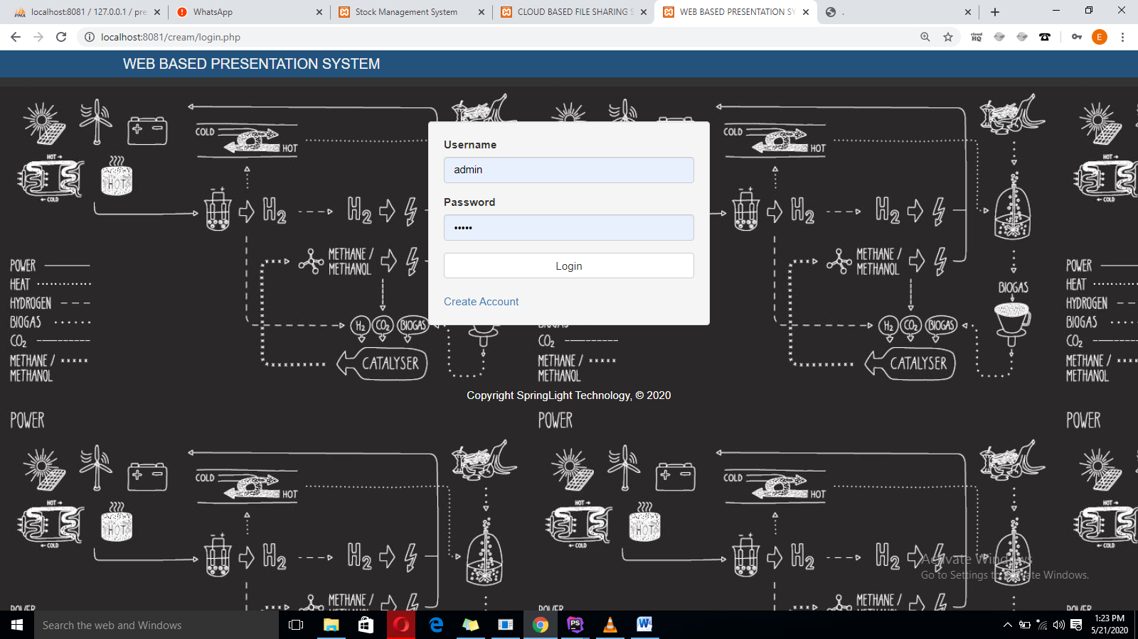

* + - 1. **CREATE ACCOUNT**

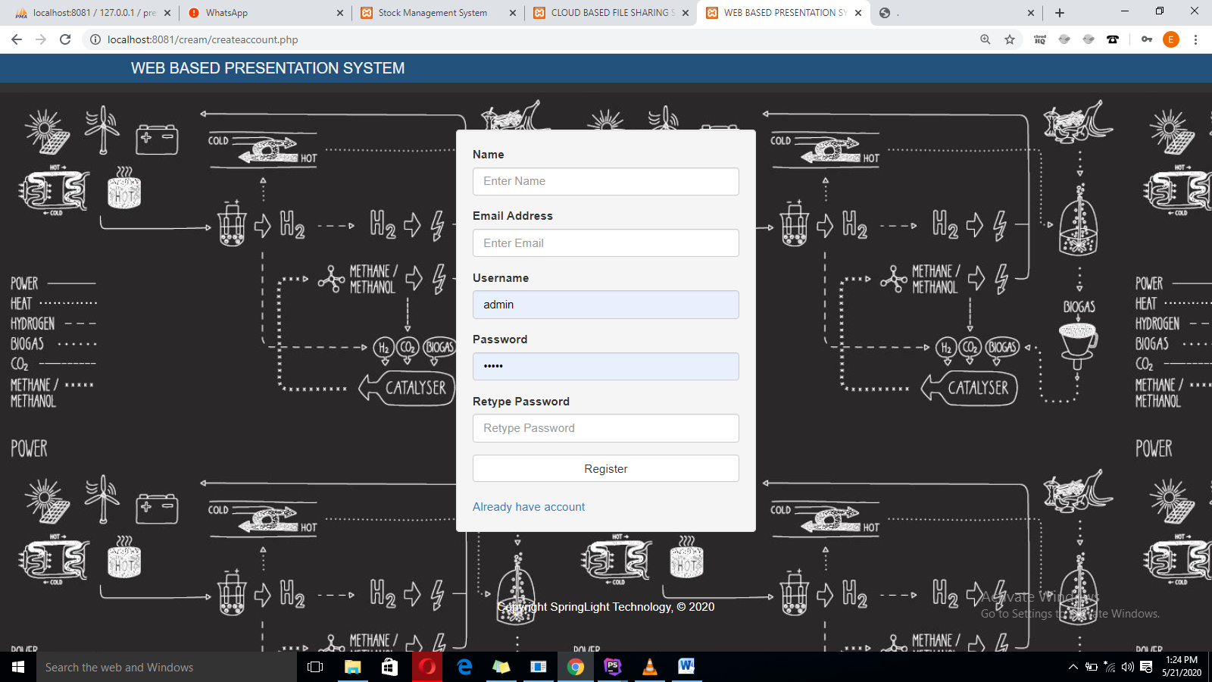

* + - 1. **DASHBOARD**

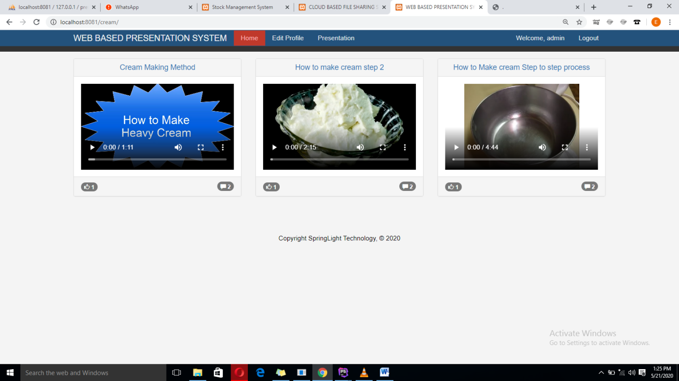

* + - 1. **PRESENTATION**

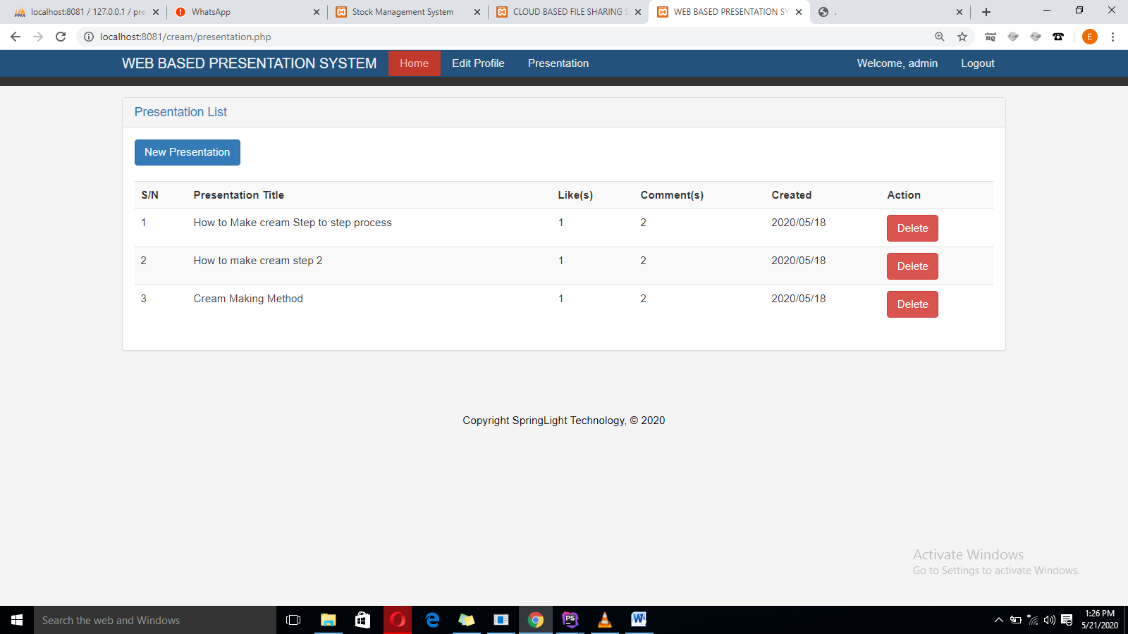

* + - 1. **PROFILE**

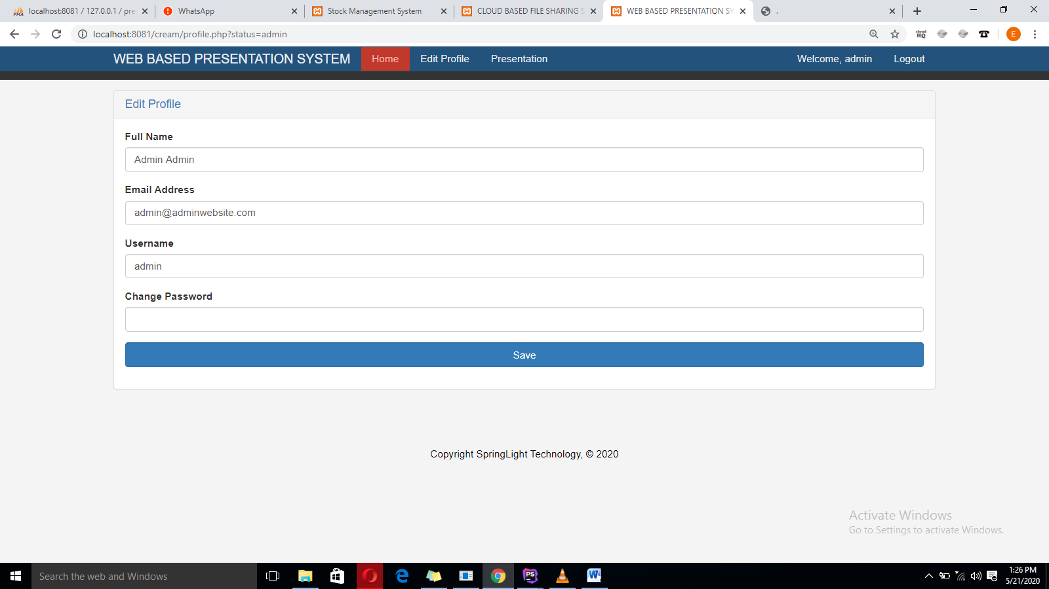

* + - 1. **COMMENTS**



**APPENDIX B – SOURCE CODE:**

1. **createaccount.php**

**<?php require_once ("landing_header.php") ?>**

**<section id="main">**

**<div class="container">**

**<div class="row">**

**<div class="col-md-4 col-md-offset-4">**

**<?php**

**try{**

**if($_SERVER['REQUEST_METHOD']=="POST"){**

**if(isset($_POST['btnRegister'])) {**

**create_account($_POST['txtName'],$_POST['txtEmailAddress'],$_POST['txtUsername'],$_POST['txtPassword'],$_POST['txtRetypePassword']);**

**}**

**if($flagp==true){**

**echo " <div class=\"alert alert-warning alert-dismissible\">**

**<a href=\"#\" class=\"close\" data-dismiss=\"alert\" aria-label=\"close\">&times;</a>**

**Password not Match!!!**

**</div>";}**

**if($userdetails==true){**

**echo " <div class=\"alert alert-warning alert-dismissible\">**

**<a href=\"#\" class=\"close\" data-dismiss=\"alert\" aria-label=\"close\">&times;</a>**

**User Already Exist!!!**

**</div>";}**

**}**

**}catch(Exception $e) {}**

**?>**

**<form id="login" action="createaccount.php" method="post" enctype="multipart/form-data" class="well">**

**<div class="form-group">**

**<label>Name</label>**

**<input type="text" class="form-control" name="txtName" placeholder="Enter Name">**

**</div>**

**<div class="form-group">**

**<label>Email Address</label>**

**<input type="text" class="form-control" name="txtEmailAddress" placeholder="Enter Email">**

**</div>**

**<div class="form-group">**

**<label>Username</label>**

**<input type="text" class="form-control" name="txtUsername" placeholder="Enter Username">**

**</div>**

**<div class="form-group">**

**<label>Password</label>**

**<input type="password" class="form-control" name="txtPassword" placeholder="Enter Password">**

**</div>**

**<div class="form-group">**

**<label>Retype Password</label>**

**<input type="password" class="form-control" name="txtRetypePassword" placeholder="Retype Password">**

**</div>**

**<button type="submit" name="btnRegister" class="btn btn-default btn-block">Register</button>**

**<br>**

**<a href="login.php" class="text-center">Already have account</a>**

**</form>**

**</div>**

**</div>**

**</div>**

**</section>**

**<?php require_once ("landing_footer.php") ?>**

1. **full-video.php**

<?php require_once ("header.php") ?>

<section id="main">

<div class="container">

<div class="row">

<div class="col-md-12">

<!-- Website Overview -->

<?php

try{

if (isset($_GET['postview'])) {

$postview=$_GET['postview'];

$sql = "SELECT * FROM post WHERE id=$postview";

$result = $conn->query($sql);

if ($result->num_rows > 0) {

// output data of each row

while ($row = $result->fetch_assoc()) {

$postID=$row["id"];

?>

<div class="panel panel-default">

<div class="panel-heading">

<a href="#"><h3 class="panel-title"><?php echo $row["title"]; ?></h3></a>

</div>

<div class="panel-body">

<div class="center-block embed-responsive embed-responsive-16by9">

<video class="embed-responsive-item" controls>

<source src="video/<?php echo $row["url"]; ?>" type="video/mp4">

</video>

</div>

<br>

<a class="badge bg-info pull-right"><i class="glyphicon glyphicon-comment"></i> <?php

try{

$DetailUser = $_COOKIE["userdetails"]; $percentNew="";

$sqlNewi = "SELECT count(id) AS value_sum FROM comments WHERE username='$DetailUser' and postid='$postID'";

$resultNewi = $conn->query($sqlNewi);

if ($resultNewi->num_rows > 0) {

// output data of each row

while($rowNewi = $resultNewi->fetch_assoc()) {

$percentNew=$rowNewi["value_sum"] ;

}

} else {

$percentNew="0";

}

echo number_format((float)$percentNew, 0, '', ',') ;

}catch(Exception $e) {}

?></a>

<a href="full-video.php?flike=<?php echo $row["id"]; ?>&fuid=<?php echo $_COOKIE["userdetails"]; ?>" class="badge bg-primary"><i class="glyphicon glyphicon-thumbs-up"></i>

<?php

try{

$DetailUser = $_COOKIE["userdetails"]; $percentNew="";

$sqlNew = "SELECT count(id) AS value_sum FROM post_like WHERE username='$DetailUser' and postid='$postID'";

$resultNew = $conn->query($sqlNew);

if ($resultNew->num_rows > 0) {

// output data of each row

while($rowNew = $resultNew->fetch_assoc()) {

$percentNew=$rowNew["value_sum"] ;

}

} else {

$percentNew="0";

}

echo number_format((float)$percentNew, 0, '', ',') ;

}catch(Exception $e) {}

?>

</a>

<br><br>

<div class="input-group">

<input type="text" placeholder="Type in your comments here..." class="form-control" id="txtSearch" />

<div class="input-group-btn">

<button class="btn btn-default" id="btnSearch" onclick="comments('<?php echo $row["id"]; ?>','txtSearch','<?php echo $_COOKIE["userdetails"]; ?>');">Comment</button>

</div>

</div>

<?php

$DetailUser = $_COOKIE["userdetails"];

$sqlc = "SELECT * FROM comments WHERE username='$DetailUser' and postid='$postID'";

$resultc = $conn->query($sqlc);

if ($resultc->num_rows > 0) {

// output data of each row

while ($rowc = $resultc->fetch_assoc()) {

?>

<hr>

<div class="media">

<div class="media-body">

<h5 class="mt-0 mb-1"><?php echo $rowc["name"]; ?></h5>

<?php echo $rowc["comments"]; ?>

</div>

</div>

<?php

}}

?>

</div>

</div>

<?php

}}

}

}catch(Exception $e) {}

?>

<!----Data--->

</div>

</div>

<script>

function comments(postid,comments,username) {

window.location="full-video.php?videopostid="+postid+"&videocomments="+document.getElementById(comments).value+"&videousername="+username;

}

</script>

<h4 class="text-center text-primary">RECENT PRESENTATION</h4>

<div class="row">

<?php

try{

$sql = "SELECT * FROM post ORDER BY rand()";

$result = $conn->query($sql);

if ($result->num_rows > 0) {

// output data of each row

while ($row = $result->fetch_assoc()) {

$postID=$row["id"];

?>

<div class="col-md-4">

<!-- Website Overview -->

<div class="panel panel-default">

<div class="panel-heading">

<a href="full-video.php?postview=<?php echo $row["id"]; ?>"><h3 class="panel-title text-center"><?php echo $row["title"]; ?></h3></a>

</div>

<div class="panel-body">

<div class="center-block embed-responsive embed-responsive-16by9">

<video class="embed-responsive-item" controls>

<source src="video/<?php echo $row["url"]; ?>" type="video/mp4">

</video>

</div>

</div>

<div class="panel-footer">

<a class="badge bg-info pull-right"><i class="glyphicon glyphicon-comment"></i> <?php

try{

$DetailUser = $_COOKIE["userdetails"]; $percentNew="";

$sqlNew = "SELECT count(id) AS value_sum FROM comments WHERE username='$DetailUser' and postid='$postID'";

$resultNew = $conn->query($sqlNew);

if ($resultNew->num_rows > 0) {

// output data of each row

while($rowNew = $resultNew->fetch_assoc()) {

$percentNew=$rowNew["value_sum"] ;

}

} else {

$percentNew="0";

}

echo number_format((float)$percentNew, 0, '', ',') ;

}catch(Exception $e) {}

?></a>

<a href="full-video.php?flike=<?php echo $row["id"]; ?>&fuid=<?php echo $_COOKIE["userdetails"]; ?>" class="badge bg-primary"><i class="glyphicon glyphicon-thumbs-up"></i>

<?php

try{

$DetailUser = $_COOKIE["userdetails"]; $percentNew="";

$sqlNew = "SELECT count(id) AS value_sum FROM post_like WHERE username='$DetailUser' and postid='$postID'";

$resultNew = $conn->query($sqlNew);

if ($resultNew->num_rows > 0) {

// output data of each row

while($rowNew = $resultNew->fetch_assoc()) {

$percentNew=$rowNew["value_sum"] ;

}

} else {

$percentNew="0";

}

echo number_format((float)$percentNew, 0, '', ',') ;

}catch(Exception $e) {}

?>

</a>

</div>

</div>

</div>

<?php

}

}

}catch(Exception $e) {}

?>

</div>

</div>

</div>

</section>

<?php require_once ("footer.php") ?>

1. **Index.php**

<?php require_once ("header.php") ?>

<section id="main">

<div class="container">

<div class="row">

<?php

try{

$sql = "SELECT * FROM post ORDER BY id DESC";

$result = $conn->query($sql);

if ($result->num_rows > 0) {

// output data of each row

while ($row = $result->fetch_assoc()) {

$postID=$row["id"];

?>

<div class="col-md-4">

<!-- Website Overview -->

<div class="panel panel-default">

<div class="panel-heading">

<a href="full-video.php?postview=<?php echo $row["id"]; ?>"><h3 class="panel-title text-center"><?php echo $row["title"]; ?></h3></a>

</div>

<div class="panel-body">

<div class="center-block embed-responsive embed-responsive-16by9">

<video class="embed-responsive-item" controls>

<source src="video/<?php echo $row["url"]; ?>" type="video/mp4">

</video>

</div>

</div>

<div class="panel-footer">

<a class="badge bg-info pull-right"><i class="glyphicon glyphicon-comment"></i> <?php

try{

$DetailUser = $_COOKIE["userdetails"]; $percentNew="";

$sqlNew = "SELECT count(id) AS value_sum FROM comments WHERE username='$DetailUser' and postid='$postID'";

$resultNew = $conn->query($sqlNew);

if ($resultNew->num_rows > 0) {

// output data of each row

while($rowNew = $resultNew->fetch_assoc()) {

$percentNew=$rowNew["value_sum"] ;

}

} else {

$percentNew="0";

}

echo number_format((float)$percentNew, 0, '', ',') ;

}catch(Exception $e) {}

?></a>

<a href="index.php?like=<?php echo $row["id"]; ?>&uid=<?php echo $_COOKIE["userdetails"]; ?>" class="badge bg-primary"><i class="glyphicon glyphicon-thumbs-up"></i>

<?php

try{

$DetailUser = $_COOKIE["userdetails"]; $percentNew="";

$sqlNew = "SELECT count(id) AS value_sum FROM post_like WHERE username='$DetailUser' and postid='$postID'";

$resultNew = $conn->query($sqlNew);

if ($resultNew->num_rows > 0) {

// output data of each row

while($rowNew = $resultNew->fetch_assoc()) {

$percentNew=$rowNew["value_sum"] ;

}

} else {

$percentNew="0";

}

echo number_format((float)$percentNew, 0, '', ',') ;

}catch(Exception $e) {}

?>

</a>

</div>

</div>

</div>

<?php

}

}

}catch(Exception $e) {}

?>

</div>

</div>

</div>

</section>

<?php require_once ("footer.php") ?>

1. **presentation.php**

<?php require_once ("header.php") ?>

<section id="main">

<div class="container">

<div class="row">

<div class="col-md-12">

<!-- Website Overview -->

<div class="panel panel-default">

<div class="panel-heading">

<a href="#"><h3 class="panel-title">Presentation List</h3></a>

</div>

<div class="panel-body">

<a href="new-presentation.php" class="btn btn-primary">New Presentation</a><br><br>

<table class="table table-striped table-hover">

<tr>

<th>S/N</th>

<th>Presentation Title</th>

<th>Like(s)</th>

<th>Comment(s)</th>

<th>Created</th>

<th>Action</th>

</tr>

<?php

try{

$sql = "SELECT * FROM post";

$result = $conn->query($sql);

$count=1;

if ($result->num_rows > 0) {

// output data of each row

while ($row = $result->fetch_assoc()) {

?>

<tr>

<td><?php echo $count++; ?></td>

<td><?php echo $row["title"]; ?></td>

<td>

<?php

try{

$DetailUser = $_COOKIE["userdetails"]; $percentNew="";$postID=$row["id"];

$sqlNew = "SELECT count(id) AS value_sum FROM post_like WHERE username='$DetailUser' and postid='$postID'";

$resultNew = $conn->query($sqlNew);

if ($resultNew->num_rows > 0) {

// output data of each row

while($rowNew = $resultNew->fetch_assoc()) {

$percentNew=$rowNew["value_sum"] ;

}

} else {

$percentNew="0";

}

echo number_format((float)$percentNew, 0, '', ',') ;

}catch(Exception $e) {}

?>

</td>

<td>

<?php

try{

$DetailUser = $_COOKIE["userdetails"]; $percentNew="";$postID=$row["id"];

$sqlNew = "SELECT count(id) AS value_sum FROM comments WHERE username='$DetailUser' and postid='$postID'";

$resultNew = $conn->query($sqlNew);

if ($resultNew->num_rows > 0) {

// output data of each row

while($rowNew = $resultNew->fetch_assoc()) {

$percentNew=$rowNew["value_sum"] ;

}

} else {

$percentNew="0";

}

echo number_format((float)$percentNew, 0, '', ',') ;

}catch(Exception $e) {}

?>

</td>

<td><?php echo $row["date_created"]; ?></td>

<td>

<a href="presentation.php?deletefilel=<?php echo $row["id"]; ?>" class="btn btn-danger">Delete</a>

</td>

</tr>

<?php

}

}

}catch(Exception $e) {}

?>

</table>

</div>

</div>

</div>

</div>

</div>

</div>

</section><?php require_once ("footer.php") ?>