**DESIGN AND IMPLEMENTATION OF A SOFTWARE RESULT PROCESSING AND TRANSCRIPT GENERATION**

**ABSTRACT**

Result processing can be seen as a continuous process of converting data (scores, grade points, credit units etc.) into a definite and meaningful information (statement of result, transcripts etc). These results are used to check the performance of each student in various courses. These results when processed manually leads to many problems such as error during computation, insecurity of results, untidy results after changes must have been affected and work load on the exam officer(s) etc. However, designing and implementing, as well as the computerization of result processing and transcript generation system will reduce these problems to the barest minimum. Providing password can do this, which grants access to only authorized user(s). Corrections or changes are affected without making the work untidy. Also stress on exam officer(s) is or are reduced. The design and implementation will be developed using the structured system analysis and design methodology (SSADM). The new system was designed using Visual Basic and MS Access. This language was chosen because of its easy syntax and features for developing web applications.

**Keywords:** Result Computation, Software Application, Transcript generation

**CHAPTER ONE**

**INTRODUCTION**

Over the year, several efforts have made to ease the burden of result processing and transcript generation on the desk officers who are in charge of the department from Yusuf Maitama Sule University, Kano at both the Exams, Records and Statistics. David M. Kroenke, David J. Auer (2008), A database is a collection of information that is organized so that it can easily be accessed, managed, in addition, updated. Data processing is defined as the entire process of converging or manipulating data into definite and meaningful data information. The information obtained at the end of the process is the result. Therefore, result processing can be perceived as a continuous process of converting data (which can be scores, grade points, credit units etc.) into definite and meaningful information, which can be either, be statement of result or transcripts. The final report of data processing activity by the administrative unit is the product of basic documents and information (statement of result or transcript) from basic data that can be (which can be scores, grade points, credit units etc.) for managements’ use. In Yusuf Maitama Sule University, Kano the result produced informs the management about the performance of students in their various courses. These results obtain is used to check the students’ level of understanding in the entire subject taught. In the course of research, an intensive investigation carried out on how all the departments in the University performs its result computation, processing and transcript. From the findings, it appears that current method adopted needs improvement. Introduction of computer into the system will do much required magic in result processing. Structured system analysis and design methodology will be applied in other to arrive to the development of the new system thereby introducing the use of Visual Basic dot net for the software development.

**PROBLEM OF THE STATEMENT**

It is an established fact that after every assessment, examination or research work, either report or result are obtain. Many departments in the university keep and manipulate data manually. For those that uses computer application like spreadsheets, word processor to collate and process data relating to their department. A reliable and secure information is vital in today’s education with respect to result processing. This has become a vital issue as students spend so much time trying to know their GPA. The existing system of processing result encounters a problem that has led to time wasting and inaccuracy of results; Furthermore, cases of missing result have been recorded thereby making examination result processing more difficult and time consuming.

This poses many difficulties in getting some required output. This research was intended to develop an automated result and transcripts processing system that will be use in collating and processing information and produce all the necessary report, result and transcripts.

**OBJECTIVE OF THE STUDY**

1. The primary objective is to provide an automated result and transcript processing system, which will take care of result processing and transcript generation.
2. To highlight the role of Information Communication Technology in service delivery for the Institution
3. To provide a platform for effective process of report and transcript generation.

**RESEARCH QUESTIONS**

1. What input data are required for student results to be processed?
2. What output are required after processing the input data?
3. What designed or format required student to see his/her result?
4. What designed or the University senate approves format for the transcript generation?
5. What scale or grading system the University use?

**SIGNIFICATION OF THE STUDY**

As it is mention in the problem definitions, Yusuf Maitama Sule University, Kano store and process their records manually and sometimes uses application like spreadsheet, word processors etc. to keep these data. As such, there are many difficulties in keeping and processing of these records. Sometimes a data might get missing or have inconsistent data. This work will achieve increase in deficiency, easy detection and correction of error, reduce pressure of work on examination officers and makes computation less labor intensive.

**SCOPE OF THE STUDY**

This project work covers the registration of courses and computation of student’s examination score in order to process their results and generate their transcripts centrally.

**LIMITATION OF STUDY**

This project work is not a result processing software for Yusuf Maitama Sule University, Kano. It is about designing and testing an automated result processing and transcript generation system. The limitation of this project is:

1. Its only displays a semester result either GPA or CGPA
2. It is only design to treat academic performance of student
3. Students Application for suspension of Semester or Session should be in cooperated

**CHAPTER TWO**

**LITERATURE REVIEW/ RELATED WORK**

Although all the procedures and techniques used in the processing of result and transcript generation where possible without a computer. Designing of result processing and transcript generation software will be the most important application package that will be use in the processing of each student’s performance in each course of study from the departments in the University. This software is being design to adapt to various changes that may occur due to dynamic nature of the system. When practiced will enhance proper efficiency. Pecham and Joseph (1995) holds the view that various operations in the institution such as processing or computation of student’s results will be faster, more accurate and less prone to error using a computer system. The students’ transcript management system allows the department/exam and record to collect and analyze more accurately and comprehensively information about students’ academic records. It provides accurate, consistent, timely, reliable and complete students’ academic records. In addition, it provides the means for effective decision- making in the department and forwarding of students’ transcripts to requesting institutions for further studies. As noted in L. Vecchioli, 1999, organizing and managing students’ records into a cohesive and efficient system seems to be difficult. However, one of the largest investments in many organizations is the creation, maintenance, and retrieval of information. It has been estimated that in an organization such as tertiary educational community, information is highly essential for correct students’ records and examination data. It was observe in O. P. Ogu (2008, September). that Nigerian University education system needs reformation for it to meet the societal needs. Nigerian universities must seek to remove the constraints that prevent them from responding to the needs of rapidly changing society. Meanwhile, one of the top challenges for institutions and students of higher learning in Nigeria today is the issuance and collection of transcripts. Students sometimes apply for transcripts from their respective institutions and it takes several months before such transcripts could be issue to appropriate institutions, A. Adekiigbe, and B. M. G. Amosa 2009. F. O. Ukem, and E. O. Onoyom-Ita 2011, 8 F. O. Ukem, and F. A. Ofoegbu 2012. There are have been evidence that intellectual capital and technology rule the world and that natural resources such as gold, diamond, oil, etc. are no longer the primary determinant of wealth. In light of this, almost all businesses and organizations, especially in the developed countries are fully that they must adapt to the changing technology or remain with the older version. It is in this note that all tertiary institutions in Nigeria must adoption IT in managing students’ transcripts. Though many tertiary institutions today are trying to change from the traditional and manual methods of carrying out some tasks to the electronic based system, however much have not been achieved except few universities which have Portals where some critical tasks of admission and course registration on the Internet [10]. This has brought about some improvements in those areas covered, while students’ transcripts processing is being neglect. In M. E. Ekpenyong (2008). Microsoft Excel spreadsheet program is use to build an intelligent knowledge-based system (IKBS), making use of various programming facilities provided by that application (Excel). The central issue here is that the programming is hard code into the cells, and cell referencing is use to monitor and track students’ performance. The system has been reported to be working fine. However, it appears to be rather restrictive, and calls for substantial expertise in programming. Similarly, in R. E. Okonigene, G. I. Ighalo, and E. Ogbeifun 2008, an integrated development environment is use to create the Graphic User Interface. MYSQL Server, a relational database management system (RDMS), then is use to create the database tables. However, this application, though tested and found to be working as expected, but cannot generate accurate transcript. An application for processing students’ results was present in A. A. Eludire 2011 and A. U. Osagie 2014. Though the system was tested and found to be working but could not generate students’ transcripts. In F. I. Sadiq, I. B. A. Momodu, and O. S. Aladejuelo 2008 a framework for mobile college portal was developed. However, the framework could only handle students’ registration, result computation and result checking without a module for transcript generation. In this paper, the framework presented concentrates on implementation of transcript generation system. It is indication that giving the right or correct data and information to a computer will produce the correct result.

Martin Holmes (2004) manual processing of results ends up with correction of errors and when is given out to students, they look dauntingly messed up.

Sometimes the delay in declaration of results cause heavy losses to the students, as generally they cannot join further studies or appear in competitive exams because of the non-availability of examination result in time Mohini.B, and Amar. J. S, (2011). Some of the limitations of the existing system, though not comprehensive, are as follows:

Repetition of Work: There is repetition of work in the existing system because the same data is recording in different branches of the examination. This leads to data duplications as well as huge money is spent by the institution to purchase papers in existing system, managing of students’ record is very tedious. Retrieval of students’ records through manual registers, maintaining of records and data reconciliation etc. are very time consuming. Tempering of student Records: In manual examination system, there are chances of tempering with students’ records. Sometimes fake results are prepared and there is no online verification of the results. This leads to unfair practices and it mars the credibility of an institution.

**CHAPTER THREE**

**METHODOLOGY**

It is also an in-depth and comprehensive analysis carried out upon an existing system in order to arrive at a vital and relevant fact, which will assist in the designing of a new system. The aim is to analyze how the current system in operation so as to surface with relevant data. The focus for collection of data is on the Exams, Records of institute.

The investigation was carried out in two parts:

1. Data capturing.
2. Analysis of captured data.

These, will assist in verifying the application and the implication of both the old and new system to management which its objective emerged.

Identifying the area that needs improvement, alongside the cost and constraint of the system.

**FEASIBILITY OF THE STUDY**

The information obtained from the above-mentioned departments clearly justifies the need for the development of new system (designing and implementation of result processing and transcript generation software).

**METHODS OF DATA COLLECTION**

This information was obtained using three method of data collection, they are:

1. Interviewing of various departmental desk officers.
2. Study of procedural manuals.
3. Evaluation of form.

**PROBLEM OF EXISTING SYSTEM**

After the study of the existing system was carried, it was observed that the major problem which these departments in the School of Engineering Technology are facing was the delay of result processing and transcript generation and this delay hinders a lot of things such as:

1. NSYC posting.
2. Students transferring from one school to another

Those who would want to get started a job before going for youth service.

**SYSTEM DESIGN**

Here, the new system is been introduced so as to ensure maximum security of result, fast processing and reduce computational errors to the barest minimum. This new system will provide easy storage and retrieval of result and transcript since the existing manual system is deficient is this aspect. The new system is expected to achieve the following objective

* TO ELIMINATE ERRORS – The errors encountered during manual computation are eliminated.
* FLEXIBILITY – The new system will be flexible enough to accept modification of the old system and also modifications related to the new system.
* ADEQUATE RESPONSE TIME – The new system should be able respond immediately once the necessary data is entered.
* EASY USAGE – The new system is designed to allow the user to easily interact with it. Hence, it provides a Graphic User Interface (GUI), which makes the software user friendly.
* COST EFFECTIVE – The new system should be able to meet the requirements of the user without causing unnecessary financial headache or without being more stressful than the old one.

**MAIN MENU**

When access is gained to the software, the main menu screen is displayed from where the user can select from the available submenus. The main menu for the software is displayed below.

**FILE**

In this submenu, it allows the user to add new departments and also exit the program.

**UPDATE**

It provides for updates of students’ result, students course registration and course deletion.

**IMPLEMENTATION**

When we talk about system implementation, we talk of the changing over from the present or old system to the current or new system. It also has to do how the user feels about this new system. This is where the designed software is being put to practice as well as into comparison with the present or old system.

**PROGRAM FLOWCHART**

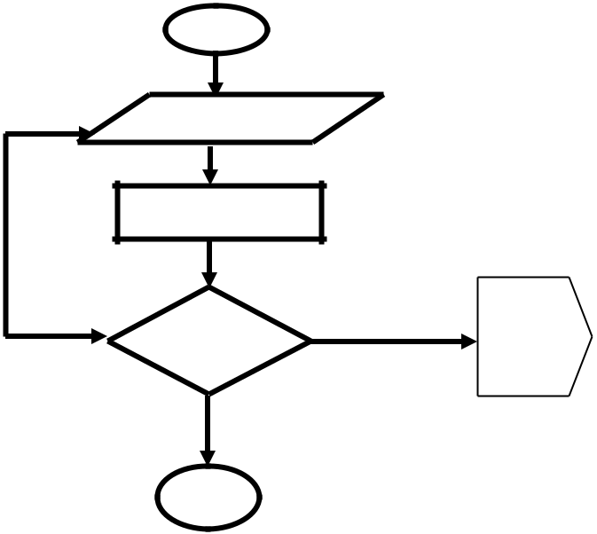

No

St

Welcome

Login

Is Ye

St

A

**STUDENT LOGIN FLOWCHART**

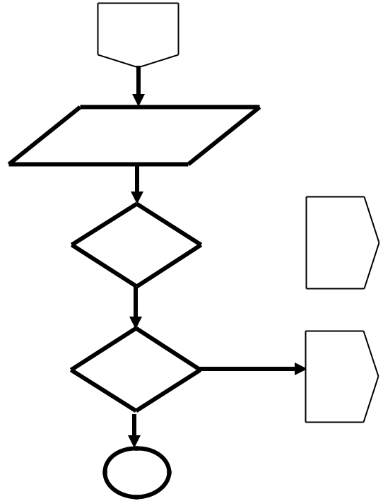

A

MAIN

Is

Me

 B

C

S

**STUDENT MAIN MENU FLOWCHART**



B

View Students Profile

Exit

**View Student Profile Flowchart**

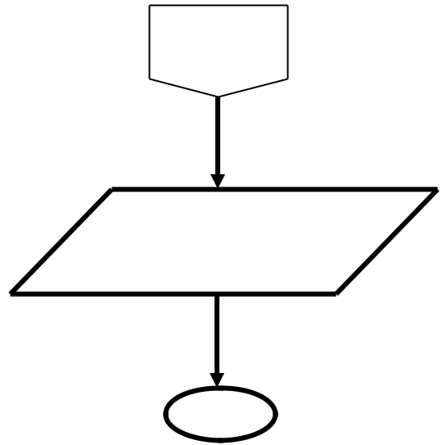

C

View Students

Registration

Exit

**View Student Record Flowchart**

ADMIN LOGIN FLOWCHART

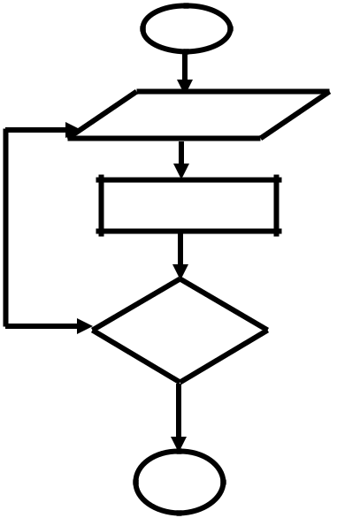

N

S

Welcome

Login



Ye

Is  D

S

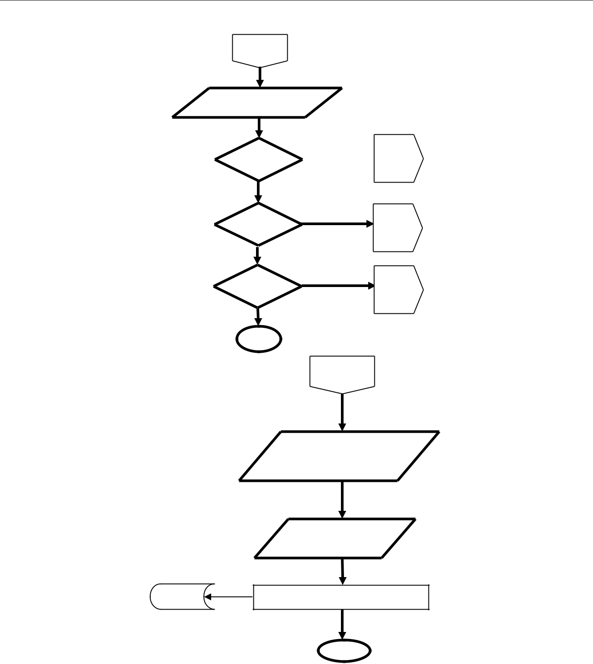

D

MAIN

Is

Is

Is

S

 E

F

G

E

**Dat**

View Student

Enter/

Update Db

**CHAPTER FOUR**

**ANALYSIS**

**REPORT**

In this submenu, the students result and the transcript are generated.

**DATABASE SPECIFICATION**

A computer file holds either instruction or data that is required for providing information either at regular or irregular intervals. The files involved in the design of this system are properly formatted and organized in random access made so as to give immediate access to the desired records. The database of the proposed system is designed using Mysql.

**DATA FLOW DIAGRAM OF THE PRESENT SYSTEM**

From the diagram, it can be that data which are the students’ grade in various courses are processed and the results (statement of result) and the transcript generated are stored in a file as paper document. During this processing which is done manually, error are being made and corrected. Hence, the resulting output document becomes messed up.

**INFORMATION FLOW**

The major information produced is the students’ statement of result and transcript, which is done by the polytechnic and each student, is given a copy of his/her own result. Below is a diagram of how the information flows.

**DESIGNED INPUT/OUTPUT FORMAT FOR THE NEW SYSTEM**

In the design of the proposed system, there is need for one to have a detailed description of how the design was carried out. That is, knowing what kind of input will generate to output.

**INPUT FORMAT**

These are the input documents worked on. The main input documents in this project are the course registration form, student’s information form, updated result form, from which the course credit units, course codes, student’s registration number etc will be supplied. The keyboard will be used as the main input device.

**OUTPUT FORMAT**

In view of the system, the printer and the monitor will be used as the main output devices. The output documents will be the statement of results on the inputs made.

**MATHEMATICAL SPECIFICATION**

GPA= sum of quality points / total credit for all courses registered in the semester.

CGPA= GPA first semester + GPA second semester / Total credit unit for first semester + Total credit unit for second semester.

FCGPA= Total point for the whole academic year / Total credit point for the whole academic year.

**PROGRAM CODING**

This project work is coded with VB and MS Access. The automated system will automatically process the students’ results and as well generate their transcripts.

**SYSTEM TESTING**

The accuracy of the system will be tested using the varying data with deliberate errors.

The new system achieves its objectives when it shows error free message.

In the implementation of the software, there are four basic procedures to follow which are:

1. DIRECT CHANGEOVER.

1. PHACE/ SEGMENTED CHANGEOVER.
2. PARALLEL CHANGEOVER.
3. RCOMNDED CHANGEOVER.

**DIRECT CHANGEOVER:**

This is the immediate changeover which is bee carried out by an institution in order to move or change from their old system to a new system.

**PHASE/SEGMENTED CHANGEOVER:**

Some establishments prefer staring their changeover from one department, unit or branch to another depending on the area where it is immediately needed.

**PARALLEL CHANGEOVER:**

Here, the current data is continually processed by the old while some selected data from the old system is reprocessed by the new system. This is done to compare the two systems and certify that the new system is totally correct and complete.

**RECOMMENDED CHANGEOVER:**

This is where the changeover recommended provides a degree of safety if there are problems with the new system. Also, whenever the computer fails to function as it should, the old system can be used. This is because both the old and the new system run simultaneously over a period of time.

Out of these four (4) basic procedures, only one is being adopted because that is the one that has to do with an institutions motive towards changing from their present or old system to the current or new system. This basic procedure which has been adopted is “DIRECT CHANGEOVER”.

**APPLICATION DETAILS**

When input the necessary or required data needed for the processing of students results, the application software that is being developed automatically computes or processed the results of these students. After the computation or processing of the students result, their statement of result will be obtained and the transcript will also be generated. If the application is being opened, the username and password will be required in order to access the software. This is so because there is need to ensure that the students’ results are secured. The main menu gives access to other sub-menu such as students’ registration number, updated result, transcript generation, etc. At any point in the program; you can go back to the sub-menu. You can end the program by clicking on close in the file menu.

**MAINTAINANCE DETAILS:**

The recommended maintenance operation for this software is enhancement (i.e. software upgrade).

Qualified personnel or the developer of the software if available should do this.

**RECOMMENDATION**

With this software design and implemented to solve the problems of result processing and transcript generation, it is hereby recommended to some other departments who are suffering the fate these departments suffered. This software is subject to change and very much essential for other institutions to embrace it and implement it into their own system.

**CONCLUSION**

So far, the introduction of computer into the institution has been found ubiquitous and of a wonderful benefit. There will be very much improvement in the result processing and transcript generation of these departments after the software must have been installed and implemented.

**REFERENCE**

1. Adigwe P.K and Okoye P.V C. (1998) Data Processing and Technique, (Vol 1) New York: Hafarier Publishing Co.
2. Anderson .H.I (1979) Computer Analysis and Utilization, Cambridge: Cambridge University Press.
3. Dowsing et al (1996) System Automation, London: Brown and Pane Publishing.
4. Martin.H. (200) Computer Application in the Society, Oxford: University Press.
5. Pecham .D. and Joseph. SR. (1995) Computer and Information System, London: Black Well Scientific Publishing Co.
6. Mohini. B, and Amar. J. S, (2011). Automated Integrated University Examination System Himachal Pradesh University Journal.
7. Abel U. O and Abu M. (2013) Data Analysis and Result Computation (DARC) Algorithm for Tertiary Institutions. Journal of Computer Engineering (IOSR-JCE) e-ISSN: 2278-0661, p-ISSN: 2278-8727Volume 14, Issue 3 PP 63-69. Internet :<www.jatit.org>. Accessed on 11/8/2013 www.iosrjournals.org
8. Atabong, T. A. , Okpala, M. C., Abondem, A. L. and Essombe1, C. E.(2010). Eliminating Examination Malpractice in Africa with Automated Test Taking, Marking and Result Printing. Tropical Journal of Biomedical and Allied Sciences Research 4(1)2010
9. Eludire,A.A.(2011).TheDesignand Implementation of Student Academic Record ManagementSystem.Research Journal of Applied Sciences, Engineering and Technology
10. Mohini .B, and Amar. J. S, (2011). Automated Integrated University Examination System Himachal Pradesh University Journal.
11. Moses E. Ekpenyong.(2008). “A Real-Time IKBS for students results computation” International

Journal of physical Sciences (Ultra scientist of physical sciences) Volume 20, Number3(M), September-December,2008. Available:http/www.mySQL.com,(July 22,2012)

1. MySQL:Internet:<http://www.mySQL.com, Accessed on 22/7/2012 Okonigene, R.E., Ighalo, G.I., Ogbeifun, E.(2008). Developed Personal Record Software . The Pacific Journal of Scienceand Technology .9(2):407-412.
2. Ukem , E. O. and Onoyom-Ita, E. O, (2011). A Software Application For The Processing of Students Results; Global Journal ofPure and Applied SciencesVolume 17 No. 4
3. Ukem, E. O. and Ofoegbu, F. A (2012). A Software Application for University Students Results Processing.Journal of Theoretical and Applied Information Technology. Vol. 35 No.1 Internet :<www.jatit.org>. Accessed on 2/07/2012
4. C. Cadar, L. Teytelman, and E. Trusova, (2013, September). Secured and Convenient Computerized Transcript System. [Online]. Available: http://citeseerx.ist.psu.edu [February 22, 2017]
5. S. O. Abidde, (2007, January). Requesting Transcripts from Nigerian Universities. [Online]. Available: https://www.nigeriansinamerica.com/requesting-transcripts-from-nigerian-universities/ [January 24, 2017].
6. B. C. E. Mbam, and G. N. Odachi, “Web-Based Virtual Transcript Processing and Transfer for

Nigerian Universities.” Journal of Electronics and Communication Engineering (IOSR-JECE), Vol 9, Issue 4, pp. 15-20, July-August 2014

1. L. Vecchioli, “A Process for Evaluating Student Records Management Software.” Practical

Assessment, Research & Evaluation, Vol 6 No. 14, December 1999.

1. O. P. Ogu (2008, September). ‘Challenges Facing Nigerian Universities. Nigeria World (Baltimore).’

[Online]. Available: http://nigeriaworld.com/articles/2008/sep/300.html [January 21, 2017].

1. A. Adekiigbe, and B. M. G. Amosa, “Development of Agent-Based Online Transcript Generator for Nigerian Tertiary Institutions.” Journal of Computer Science and its Application, Vol. 16 No. 1, 2009.