DESIGN AND IMPLEMENTATION OF A REAL ESTATE MANAGEMENT SYSTEM

TABLE OF CONTENTS
Title page
Certification
Dedication
Acknowledgement
Table of Contents
Abstract
CHAPTER ONE:
1.1 Introduction………………………………………………………………... 1
1.2 Statement of the Problem…………………………………………………... 1
1.3 Aims and Objectives……………………………………………………….. 2
1.4 Significance of the Study………………………………………………….. 3
  - Scope and Limitation………………………………………………………. 3
1.6 Research Methodology……………………………………………………. 3
1.7 Definition of Terms………………………………………………………… 4
CHAPTER TWO:
2.1 Introduction………………………………………………………………... 5
2.2 Real Estate…………………………………………………………………. 5-6
2.3 Property Manager…………………………………………………………... 6
    - Functions of a Property Manager…………………………………………... 7-8
2.4 Impact of Computers on Property Management…………………………… 8-9

2.5 Property Management Software…………………………………… 9-10
CHAPTER THREE:
3.1 Introduction………………………………………………………………… 11
3.2 Analysis of the Existing System…………………………………………… 11
3.3 Problems and Weakness of the Existing System………………….. 11-12
3.4 Analysis of the New System……………………………………….. 12-13
3.5 Design of the New System…………………………………………………. 13
3.5.1 Usecase Diagram…………………………………………………... 13-14
    - Database Design…………………………………………………… 14-17
3.6 System Architecture………………………………………………………... 18
3.6.1 Dataflow Diagram…………………………………………………………..19
CHAPTER FOUR:
4.1 Sources Codes……………………………………………………… 20
4.2 Sample Outputs……………………………………………………. 20-21
4.3 How to Run the Program…………………………………………... 21-22
4.3.2 System Implementation……………………………………………. 22-29
4.4 Choice of Programming Language………………………………………… 30
4.5 User Guide…………………………………………………………............. 30
CHAPTER FIVE:
5.1 Introduction………………………………………………………………… 31
5.2 Summary…………………………………………………………………….31
5.3 Recommendations………………………………………………... 31-32
5.4 Conclusion…………………………………………………………………. 32
5.5 Problem Encountered……………………………………………………… 33
REFERENCE
APPENDIX

ABSTRACT
This research project is aimed at the development of an Estate Agent and Property Management System for real estate professionals. It will save time and enable estate managers sell more by empowering them to easily keep track of leads, manage listings, and market to new prospects. The basic objective of developing this project is to maintain client details line contact details, required property details, client type like residential and commercial client. Information for registration of property for sale includes property address, property description, price, facilities available. The Proposed System will have powerful logical access management in place, where each user must be identified by login id and strict password policy is applied to secure the system.

CHAPTER ONE
GENERAL INTRODUCTION
  - Introduction
Real estate can be described as Property consisting of land and the buildings on it, along with its natural resources such as crops, minerals or water, immovable property of this nature, buildings or housing in general.
Estate management is the operation, control, and oversight of commercial, industrial or residential real estate, usually on behalf of an owner. Management indicates a need for the property to be cared for, monitored and accountability given for its usable life and condition. This is much similar to the role of management in any business. This involves the processes, systems and manpower required to manage the life cycle of all acquired property as defined above including acquisition, control, accountability, responsibility, maintenance, utilization, and disposition.
One important role of a Property Manager is that of liaison between the Owner of record and the actual tenant/lessee, providing a buffer for those owners who desire to distance themselves from their tenant constituency
Other roles of the Property Manager include gathering data on tenant payment habits as well as maintaining and keeping records about tenant contacts, lease terms, property features, security deposits and payment history.

1.2 Statement of the Problem
Property Managers encounter a number of problems when performing their role of estate management. These are discussed in brief detail below.
- Records Loss: Information and records stored in files and documents could be physically damaged or lost due to theft and this could cripple the activities of the Property Manager.
- Unauthorized Records Access: As the records and information about the estates managed by the Manager are mostly stored in physical materials, it is very possible for competitors or unscrupulous individuals to gain access to these files by hiring a close associate of the Manager or via some other means. Once the files or documents containing the information are found, access to the records cannot be prevented.
- Record Maintenance: When the properties to be managed get very large, manually maintaining the records in the documents becomes a cumbersome task for the manager.

1.3 Aims and Objectives
This research project is aimed at implementing a Web based Real Estate Management System to automate the management of the records and information on the properties managed by the Property Manager.
The solution of the project will be implemented using a three tier distributed architecture with a database server for information storage, a middleware application and a client side application. The client side will be designed using HTML (Hyper Text Mark-Up Language) and will be viewed with a web browser. The records and information about the tenants and properties will be stored using the MySQL online database server while the middleware application will be implemented using the PHP server side scripting language.
With the successful implementation of this project, Property Managers will be able to more effectively manage the properties and estates entrusted to them.

1.4 Significance of the Study
With the successful implementation of the Web based Real Estate Management System, record loss would be eliminated as the information about the tenant contacts, lease terms, property features, security deposits and payment history would all be digitally stored on an online database which would have backup facilities. Security authorization mechanisms will be implemented and enforced the system so that only authorized users will be allowed to gain access to the information stored in the database. Also, large records will be able to be managed more efficiently and search queries will be effectively and easily performed by the system.

  - Scope and Limitation
The scope of this project work covers the design and implementation of a Web based Real Estate Management System that will aid Project Managers to effectively manage records about the properties and estates entrusted to them by their owners.
This project research will be limited to the management of records and information by the Property Manager and will not cover the use of the Web based system as a means of communication between the Manager and the tenants or the property owners.

1.6 Research Methodology
Source for the Data necessary for this project work will be collected through research from journals, materials from the library and the World Wide Web.

1.7 Definition of Terms
HTML: HyperText Markup Language (HTML) is the main markup language for web pages. HTML elements are the basic building-blocks of webpages.HTML is written in the form of HTML elements consisting of tags enclosed in angle brackets (like <html>), within the web page content.
PHP: PHP is a general-purpose server-side scripting language originally designed for Web development to produce dynamic Web pages.
MySQL: MySQL is the world's most used relational database management system (RDBMS) that runs as a server providing multi-user access to a number of databases. It is named after developer Michael Widenius' daughter, MySQL. The SQL phrase stands for Structured Query Language.

CHAPTER TWO
LITERATURE REVIEW

2.1 Introduction
Estate management is the operation, control of (usually on behalf of an owner), and oversight of commercial, industrial or residential real estate as used in its most broad terms. Management indicates a need to be cared for, monitored and accountability given for its usable life and condition. This is much akin to the role of management in any business (Chavis, 2009).
Property management is also the management of personal property, equipment, tooling and physical capital assets that are acquired and used to build, repair and maintain end item deliverables. Property management involves the processes, systems and manpower required to manage the life cycle of all acquired property as defined above including acquisition, control, accountability, responsibility, maintenance, utilization, and disposition (Rhodes, 2008).
This paper will seek to cover the reviews on the topic of Property Management as well as what contributions information technology has made towards the development and implementation of the practice.

  - Real Estate
Real estate is "Property consisting of land and the buildings on it, along with its natural resources such as crops, minerals, or water; immovable property of this nature; an interest vested in this; (also) an item of real property; (more generally) buildings or housing in general. Also: the business of real estate; the profession of buying, selling, or renting land, buildings, or housing (Oxford English Dictionary).
It is a legal term in jurisdictions, such as the United Kingdom, Canada, Australia, United States of America, Dubai, Trinidad and Tobago, Barbados, and The Bahamas (Dictionary.com ). Real estate law is the body of regulations and legal codes which pertain to such matters under a particular jurisdiction and concerns such things as commercial and residential property ownership, development, and transactions. Real estate is often considered synonymous with real property (sometimes called realty), in contrast with personal property (sometimes called 'chattels' or 'personality' under 'chattel law' or 'personal property law'). The terms 'real estate' and 'real property' are used primarily in common law, while civil law jurisdictions refer instead to immovable property.

  - Property Manager
A property manager or estate manager is a person or firm charged with operating a real estate property for a fee, when the owner is unable to personally attend to such details, or is not interested in doing so (Hipp, 2008). The property may be individual title owned or it may be owned under sectional title, share block, company owned and may be registered for residential, commercial office and retail or industrial use.
Property management is the operation, control, and oversight of real estate as used in its most broad terms. Management indicates a need to be cared for, monitored and accountability given for its useful life and condition. This is much akin to the role of management in any business.
Property management is also the management of personal property, equipment, tooling and physical capital assets that are acquired and used to build, repair and maintain end item deliverables. Property management involves the processes, systems and manpower required to manage the life cycle of all acquired property as defined above including acquisition, control, accountability, responsibility, maintenance, utilization and disposition.

2.3.1 Functions of a Property Manager
Typical duties expected of a property manager include finding/evicting and generally dealing with tenants, home repair, home improvement, cleaning, garden maintenance, landscaping, and snow removal, to be coordinated with the owner's wishes. Such arrangements may require the property manager to collect rents, and pay necessary expenses and taxes, making periodic reports to the owner, or the owner may simply delegate specific tasks and deal with others directly (Chavis, 2009).
Property managers ensure that the properties under their care operate smoothly, maintain their appearance, and either preserve or increase in value. They inspect all facilities; hire, supervise and assign duties to maintenance staff; and contract for services such as trash removal or landscaping. They also show properties to prospective tenants or buyers explain occupancy terms and collect monthly rents; and pay taxes and other maintenance fees. On the administrative side, they ensure that all procedures comply with relevant laws, such as the Federal Fair Housing Amendment. They also keep property records and prepare budgets and financial reports for owners.
The following include the functions of a property manager:
- Carry out the owner’s instructions, control costs and maximize revenue to maintain a stabilized cash flow as a return on capital invested (commonly referred to as the capitalization rate or the cap. rate)
- Exercise control over the building to safeguard the capital invested, provide a duty of care through proper maintenance of the building
- Be professional and well informed on Fair Housing laws and property management practices and procedures
- Enhance the value of the property by making improvements that will increase its market value, retain and enhance pride of ownership.
- Ensure the "quiet enjoyment" of the premises—an assurance that the premises will be able to be used and enjoyed for the intended purposes without interference from the landlord and/or other tenants (save for emergencies)
- Provide comfort—-a living environment that is properly heated, cooled and ventilated with as many amenities as possible compatible with the rental level
- Provide security and safety—the ability to live and/or work in a building in which there are no inherent defects or conditions that might be hazardous to health or to property
- Provide status—-accommodation and facilities that meet socio-economic and cultural standards for the tenants and their guests.

  - Impact of Computers on Property Management

As with many occupations, computers and technology have become vital parts of working life (Blurtit.com)
. With estate management, computers bring a variety of benefits including:
Ample amounts of memory: Depending on what area of estate management hey are working in, some managers will require a mass amount of memory to store important details about numerous properties under their management. In the modern day, computers are packed with unbelievable amounts of memory and extra memory is considerably cheaper than it used to be. The amount of information that be contained in a computer would simply be unmanageable on paper.
Advanced communication: Thanks to computers and the Internet, our ability to communicate has been greatly improved. Estate managers now have a variety of ways to communicate with clients and co-workers through email, social networking and even video conferencing. This makes their job much easier; allowing them to communicate with people associated with their properties regardless of location.
Advanced functioning: Computers are very powerful things and offer so many pieces of software to an estate manager. Using their computer, estate managers could calculate costs; write letters, create presentations and diagrams all from their computer. Spreadsheet software allows them to log and calculate the finances on the estates that they are managing. Presentational software helps them to create efficient and engaging presentations for when they may be looking to negotiate with new clients.
Computers: With the various ways estate management can be implemented there are definitely different uses for computers in the management situation. For example, a computer can help to monitor the expenses of the estate, to make purchases, or to keep track of the will. Computers can also help in determining value of an estate by exploring real estate sites or other sites such as antique sites for value of goods. Computers can also check records such as who owned the estate prior to the most recent owner, the family tree and more. Computers are definitely a useful tool for organization and managing anything including estates. Multiple estates can be managed with a computer in a lawyer's office to help keep everything organized for the various clients one might have. Computers also file documents electronically which can be easier than paper.

Property Management Software
Property management software is packages that track the performance of rental properties such as expenses and income.
They help to generate tax reports, indicate tenant payment habits as well as store information about tenant contacts, lease terms, security deposits, and payment history. Depending on software separate accounting, reports, vendor payments, email exchange with tenants, notes, property features, exporting reports to various file formats is possible (Antoniak, 2007).
Below is a list of software to assist in property management.

Real Estate management System: This Web-based system was designed for managing Rented Flats and useful for many company working for Real Estate
It includes features such as tracking income from rent flat payment, alert for Due date rental, collect Expenses Data and revenue and give the final profit, analysis for Income and Expenses and forecast for the following year.

UnitConnect: UnitConnect is an online solution for Commercial & Residential Property Management. It is an excellent tool to help residential and commercial property owners gain more control when managing bills, vendor management, budgeting, expense tracking, etc.

Total Management: Total Management is a comprehensive, cloud-based property management solution. Total Management includes complete accounting with a duplicate invoice catcher, a tenant portal to pay bills online, employee work order texting, a CAM/Tax Reconciliation system and more. It also features a live chat support system, so users can speak to a Total Management representative from inside the software without engaging in a time-consuming phone call.

CHAPTER THREE
SYSTEM ANALYSIS AND DESIGN

3.1 Introduction
The analysis of the proposed system for the Estate Management System will be the main focus of attention in this particular chapter. The System Analysis of the existing system to be improved upon and the proposed solutions to the short comings of the current mode of estate management will be thoroughly discussed.

3.2 Analysis of the Existing System
The process of managing the affairs of the properties is done manually. The list of the properties to be managed is recorded in a list by the estate agents who are responsible for linking the landlords or property owners to the perspective land dwellers or tenants as the case may be.
When a perspective tenant contacts an estate agent for the possibility of finding a property, the estate agent checks the list for any available property that suits the criteria of the client and then contacts its owner to broker a deal with the perspective tenant.
If the price offered by the property owner is found suitable by the client, the deal is closed and the property is leased to the tenant for the period of time agreed upon.

3.3 Problems and Weakness of the Existing System
The short comings of the currently utilized system of estate management are outlined below:
- Information and records stored in files and documents could be physically damaged or lost due to theft and this could cripple the activities of the Property Manager.
- As the records and information about the estates managed by the Manager are mostly stored in physical materials, it is very possible for competitors or unscrupulous individuals to gain access to these files by hiring a close associate of the Manager or via some other means.
- When the properties to be managed get very large, manually maintaining the records in the documents becomes a cumbersome task for the manager.

  - Analysis of the New System
The System will be developed for use by four users of the system:
The Client (the tenants looking for house)
The Owners (Land/House owners)
The Estate Agents
The website Administrator
The Admin:
The administrator of the site will be able to register and include estate agents to the system.
The Estate agent:
The estate agent will perform the following:
- Can Register a Property.
- Read Clients messages
- Login with user name and password created by admin.
The Client:
The Client can perform the following:
- The client can register themselves by entering their data on the registration form after which they can use their usernames and password to login.
- They can book an appointment with the user agent to discuss further on any house that they are interested in buying.
The Owners:
The owners will be able to send message to the estate agents

3.5 Design of the New System
The Estate Management System will be implemented using three major components which are a database server for information storage, a middleware application and a client side application. The client side will be designed using HTML (Hyper Text Mark-Up Language) and will be viewed with a web browser. The records and information about the events will be stored using the MySQL online database server while the middleware application will be implemented using the PHP server side scripting language
In the preceding sections, the design of the new System will be the main focus.

3.5.1 Usecase Diagram
In software and systems engineering, a use case is a list of steps, typically defining interactions between a role (known in UML as an "actor") and a system, to achieve a goal. The actor can be a human or an external system.
Below is the use case diagram of the Estate Management System. 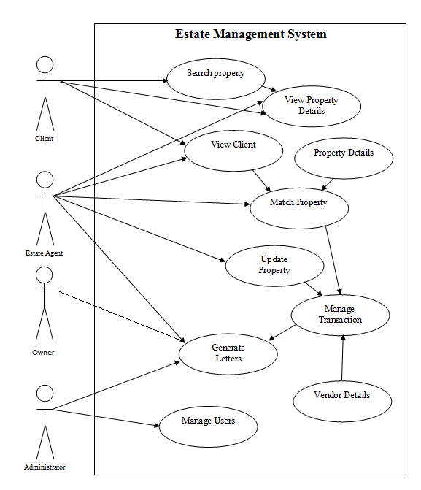
Figure 3.1: Usecase Diagram

3.5.1 Database Design

The database designs that will be used to design the Estate Management System are shown below:

Customer Table Database Structure
FIELD NAME | DATA TYPE | FIELD SIZE
CustomerId | int | 20
CustomerName | vachar | 20
Address | vachar | 100
City | vachar | 20
Mobile | Bigint | 20
Email | vachar | 65
Gender | vachar | 20
BirthDate | date
UserName | vachar | 20
Password | vachar | 20

Owner Table Database Structure
FIELD NAME | DATA TYPE | FIELD SIZE
UserId | int | 20
UserName | vachar | 20
Password | vachar | 20

Property Table Database Structure
FIELD NAME | DATA TYPE | FIELD SIZE
PropertyId | int | 11
CategoryId | int | 11
StateName | vachar | 20
CityName | vachar | 20
AreaName | vachar | 50
PropertyName | vachar | 50
PropertyImage | vachar | 200
PropertyDesc | vachar | 200
TotalArea | float
PropertyAge | vachar | 10
TotalRoom | int | 11
Furnished | vachar | 5
Parking | vachar | 5
DistRail | int | 11
PropertyCost | float
Status | vachar | 20
CustomerId | int | 11

Category Table Database Structure
FIELD NAME | DATA TYPE | FIELD SIZE
CategoryId | int | 11
CategoryName | vachar | 20
Category_Desc | vachar | 100

Property Area Table
FIELD NAME | DATA TYPE | FIELD SIZE
AreaId | int | 11
AreaName | vachar | 20
CityName | vachar | 20

City Table Database Structure
FIELD NAME | DATA TYPE | FIELD SIZE
CityId | int | 11
StateName | vachar | 20
CityName | vachar | 20

News Table Database Structure
FIELD NAME | DATA TYPE | FIELD SIZE
NewsId | int | 11
News | vachar | 200
NewsDate | date

Property State Database Structure
FIELD NAME | DATA TYPE | FIELD SIZE
CategoryId | int | 11
CategoryName | vachar | 20
Category_Desc | vachar | 100

Feedback Database Structure
FIELD NAME | DATA TYPE | FIELD SIZE
FeedbackId | int | 11
CustomerName | vachar | 20
EmailId | vachar | 20
MobileNumber | vachar | 10
Message | vachar | 200

3.6 System Architecture
The System Architecture shows the overall view of the components of the system to be developed. The System Architecture diagram for the Estate Management System is shown below:
Data
Data Warehouse
Data Access
MySQL Server
Properties
Client
Vendor
Match property with client
Search and Retrieval
of Information
Transactional Facade
Retrieval Facade
System
Web Browser
Apache Web
Server
PHP
Application Server
Database Engine
Search and Query data
Figure 3.2: System Architecture

3.6.1 Dataflow Diagram
A data flow diagram (DFD) is a graphical representation of the "flow" of data through an information system, modeling its process aspects.
The Dataflow diagram for the Estate Management System is shown below:

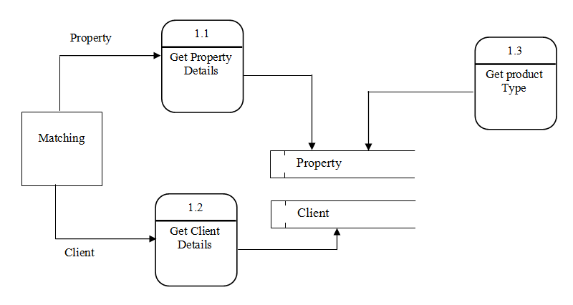
Figure 3.3: Dataflow Diagram

CHAPTER FOUR
PROGRAM IMPLEMENTATION
  - Source Codes
The source code to the Estate Management System, which was written using HTML for the front-end user interface, PHP server-side scripting language for the middleware application and MySQL for the design of the database, is provided at the appendix of this research project.

  - Sample Outputs
Shown below are the sample outputs of the newly proposed Estate Management System.

View Properties Page: This is a sample output of the properties listed on the system’s database.

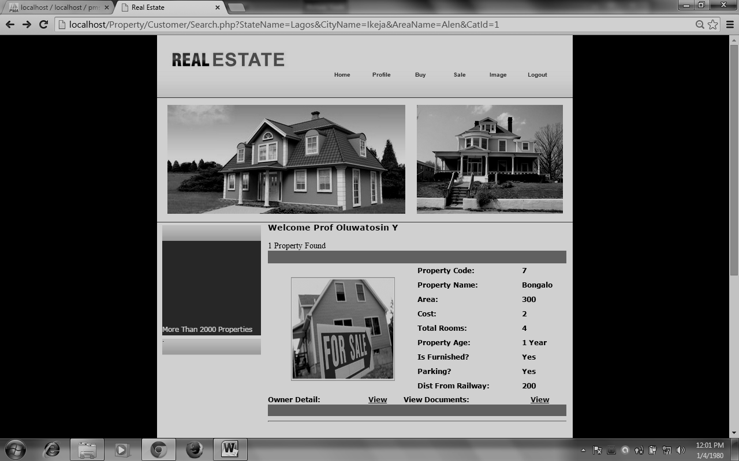
Figure 4.1

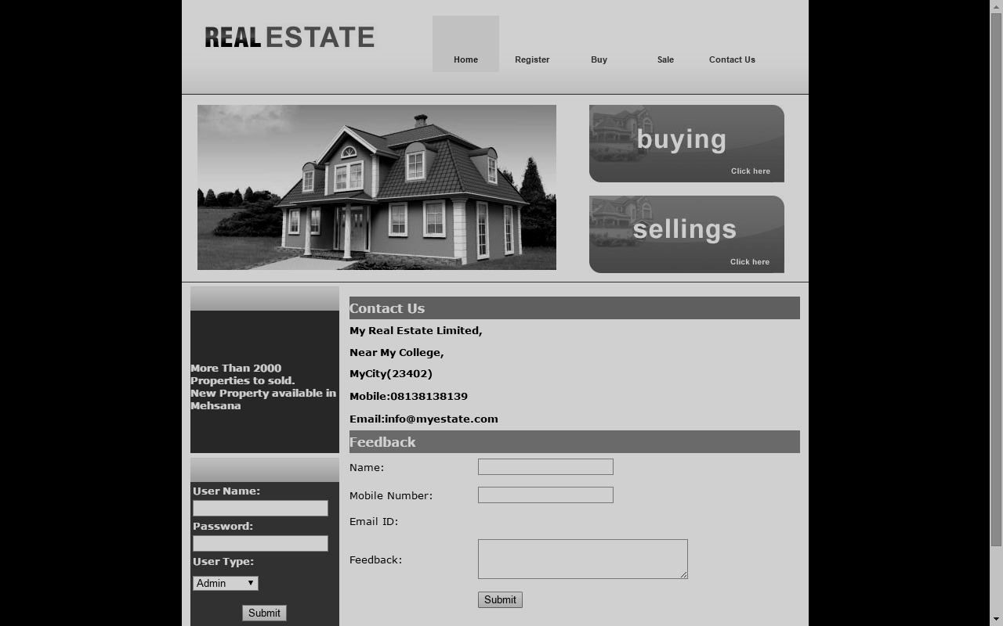
Contact Page: This is a sample output of a contact address from the Contact Page of the Estate Agent/Administrator.

Figure 4.2

4.3 How to Run the Program
In order to effectively run the application, the following hardware and software requirements are required:
- Hardware Requirement:
For proper installation of the system, the following minimum hardware requirements are:
1. Color Monitor
2. 512MB Random Access Memory (RAM Size)
3. 1 Gigabyte Hard Disk Drive
4. Keyboard
5. Mouse
- Software Requirement
The software requirements for the installation of the system are listed below:
- Web Browser Software Application
- Apache WebServer
- MySQL Database Server
    - System Implementation
The following section explains the functionality of the various modules of the Estate Management System.

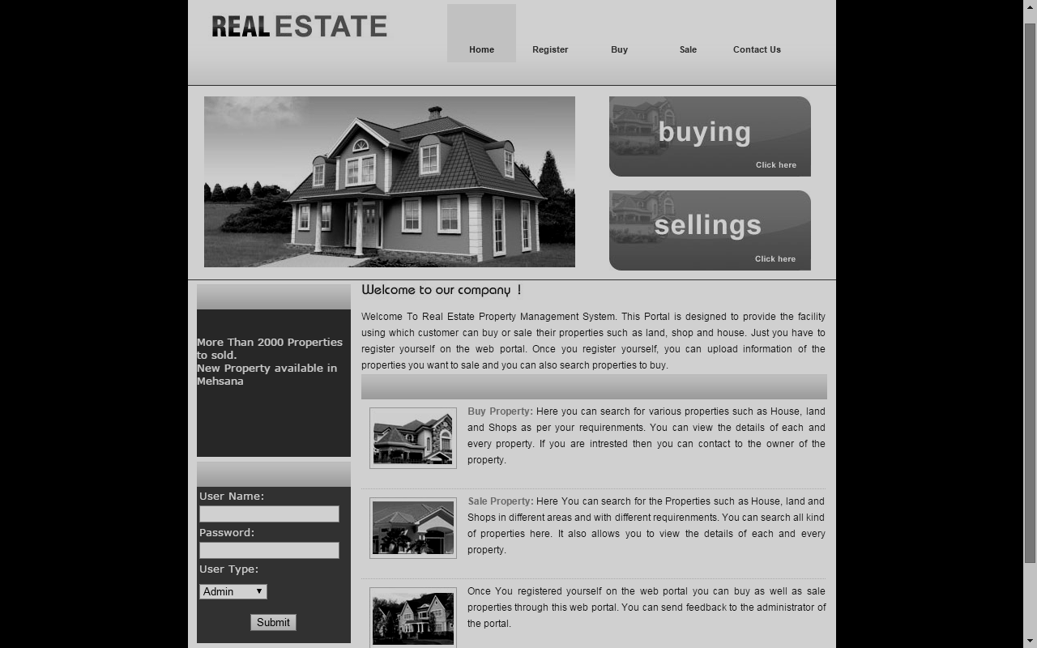
System Login Form
Figure 4.3
This form lets the users of the system submit login details to gain access into the system.
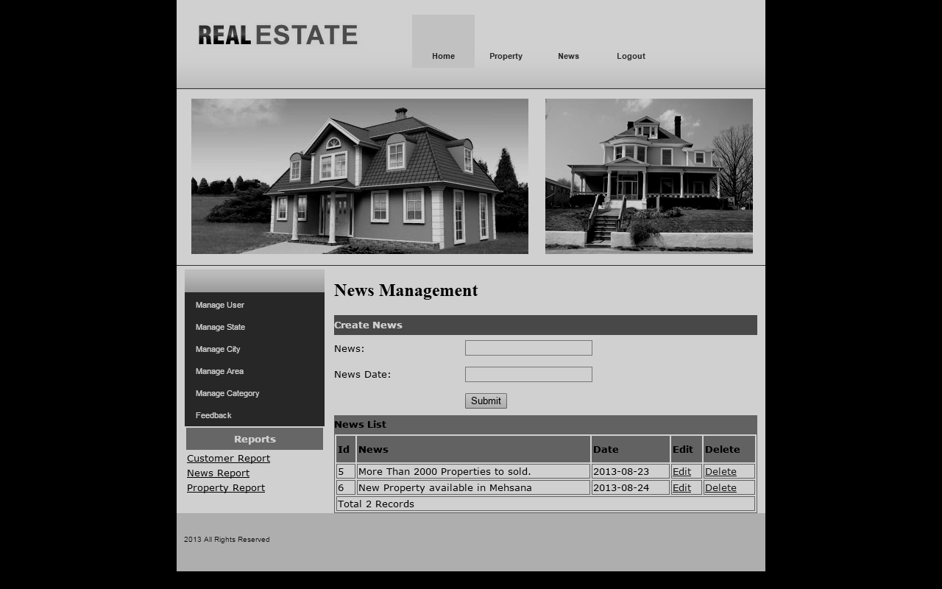
Administrator News Management Page

Figure 4.4
This is the news management page for the web site administrator user. Here the site administrator has the access to post news on a property to be sold. E.g. New
Property available in Lagos, More than 2000 Properties to sold.

Add Agent Form
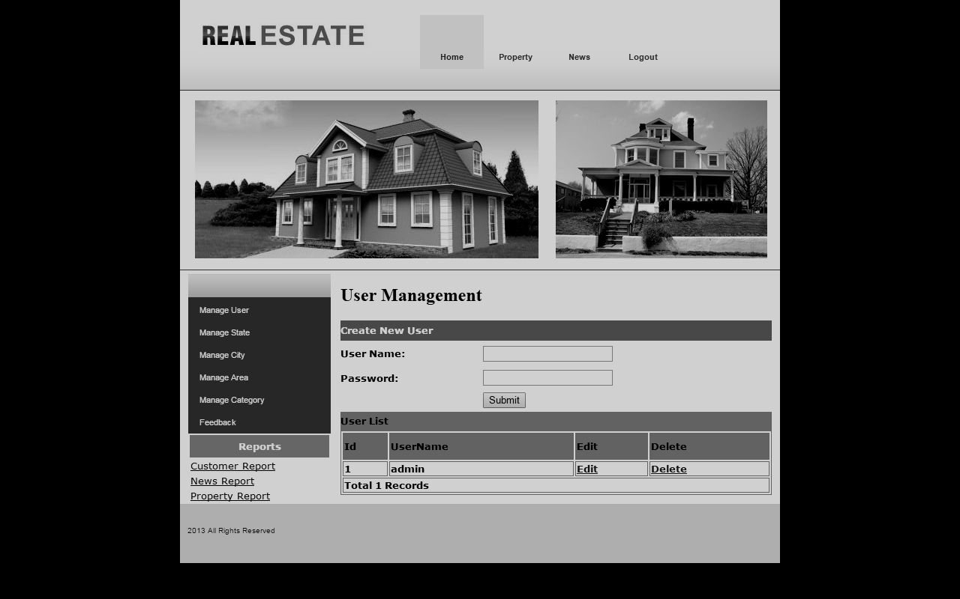
Figure 4.5
This form is used by site administrator to add an estate agent to the system’s database.

Register Property Form
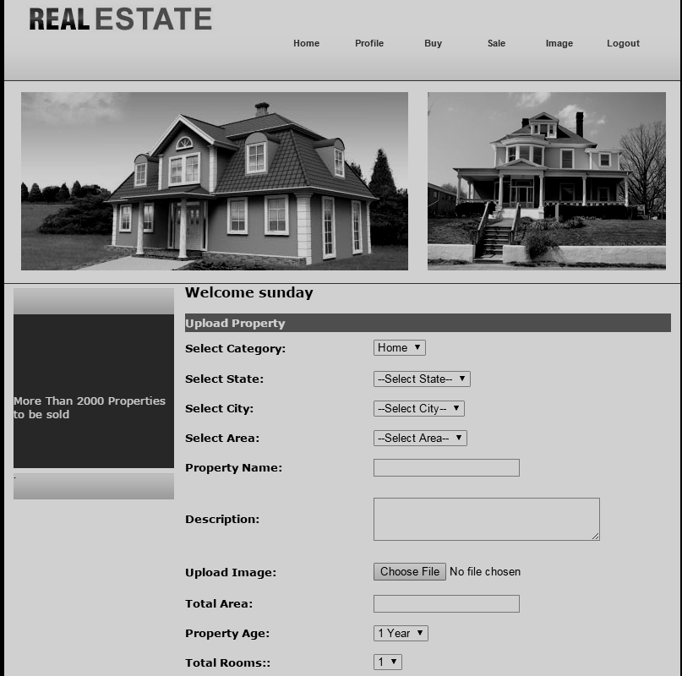
Figure 4.7
This form is used by the estate agent/user to register a property to the system’s database.

Client Request Page
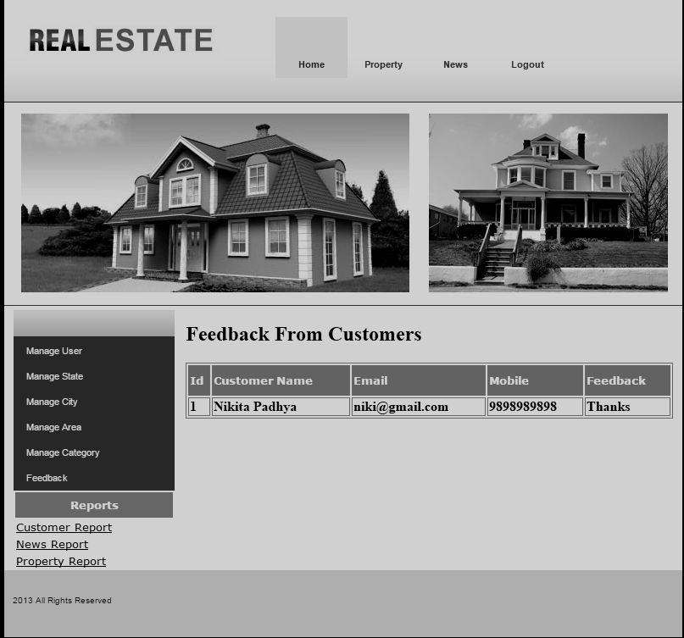
Figure 4.8
This page is used by the estate agent user to view client requests made.

Client Registration Form
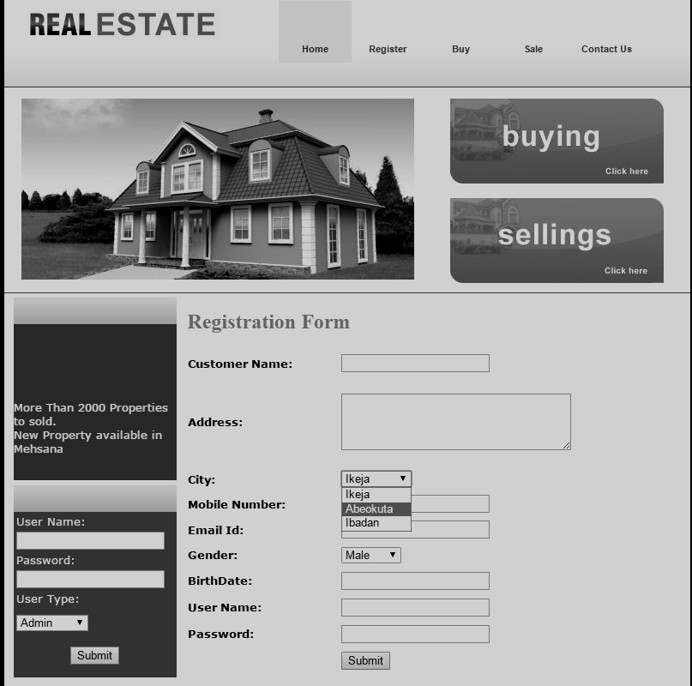
Figure 4.10
Clients will register their information into the system’s database through the use of this form.

Client Page
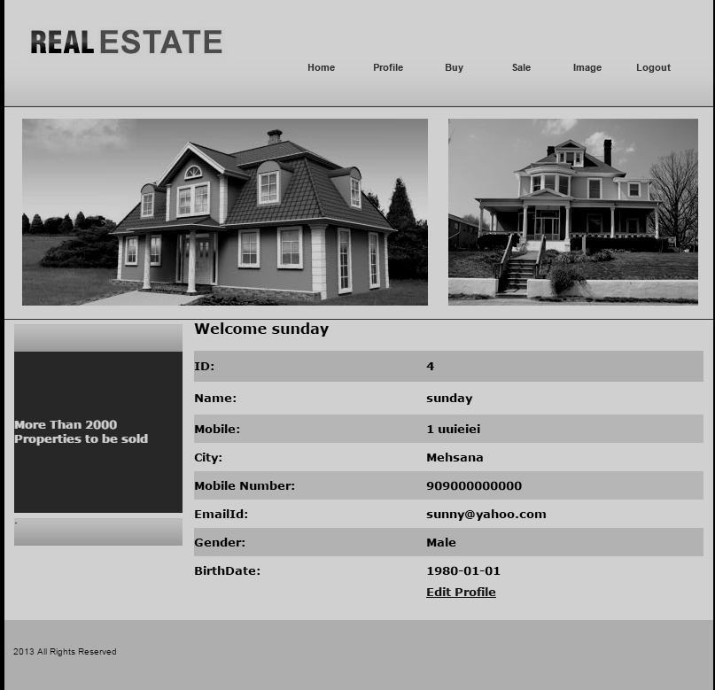
Figure 4.11
This is the interface presented to the client after gaining access to the system.

Search Property Form (Client)
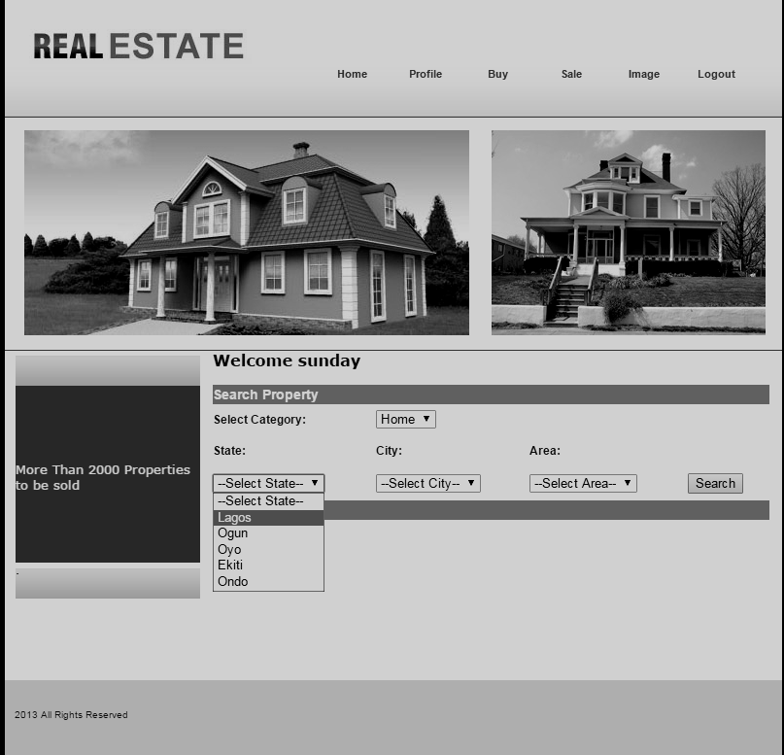
Figure 4.12
This form is used by the client to search for available property in a particular state/city/area.

4.4 Choice of Programming Language
Created by Rasmus Lerdorf in 1994 and publicly released June 8, 1995, PHP, which is short for PHP: Hypertext Preprocessor, is a server-side interpreted scripting language designed for creating dynamic web pages and web pages that effectively work with databases.

The programming language that will be utilized will be PHP. Several reasons ride the choice of using PHP for this system, one of which is its extensive portability and use over several web host servers on the internet. Also PHP possesses several inbuilt functions which allow it to integrate well with the widely used and accepted database storage management system for the web-MySQL. Due to its wide use, several documentations are available online which will guarantee that materials about any aspect of its use will be easily found.

4.5 User Guide
The following are the step involve in settling up the Real estate management system:
- Install the wamp Server.
2 Copy the Property folder to your www directory
Locating Root Folder.....Click on Computer....Click on Local disk c...navigate to wamp.....Click on www…..paste the folder......
3 Import the database file through phpMyAdmin in wamp server
4 Launch your browser
5 Type localhost or 127.0.0.1 in the address bar.
6 Click on Property under “your project”.

CHAPTER FIVE

SUMMARY, RECOMMENDATIONS AND CONCLUSION

  - Introduction
The complete overview of this research project will be given in the subsequent summary. Further areas of improvement for the research work will be discussed in the recommendation section of this chapter while appropriate conclusions of the entire research work will be drawn as well.

  - Summary
Real estate can be described as Property consisting of land and the buildings on it, along with its natural resources such as crops, minerals or water, immovable property of this nature, buildings or housing in general.
So far in developing countries like Nigeria, the main activities of the estate agents have been carried out manually.
This research project is aimed at implementing a Web based Real Estate Management System to automate the management of the records and information on the properties managed by the Property Manager.
The solution of the project will be implemented using a three tier distributed architecture with a database server for information storage, a middleware application and a client side application

5.3 Recommendations
This Project is recommended for use by Estate and Properties Management institutions in the country which are still managing the affairs of their business through the use of brick and mortar paper based filing systems.
In the development of this Estate Management System, I will recommend that if there is going to be any modification, the new writer should endeavor to improve on the limitations such as inclusion of electronic payment method to further increase the system architecture and to satisfy users need more for writing of the source code, PHP programming should be used and MySQL for the database. There are some limitations during the development of this real estate management system that will require improvement as stated in previous chapter. Writer should put them in mind and face it as a challenge and not a problem.

5.4 Conclusion
With the successful implementation of the Web based Real Estate Management System, record loss would be eliminated as the information about the tenant contacts, lease terms, property features, security deposits and payment history would all be digitally stored on an online database which would have backup facilities. Security authorization mechanisms will be implemented and enforced the system so that only authorized users will be allowed to gain access to the information stored in the database. Also, large records will be able to be managed more efficiently and search queries will be effectively and easily performed by the system.
With the successful implementation of this research project, consumers of products in the country will be able to participate in the reduction of fake drugs circulated around the country. Several lives will be spared the torments of suffering from fake or substandard consumable products and the NAFDAC body will be assisted in their fight against the menace as the new system will enable consumers from all parts of the country submit information about products that were found wanting, from which the source of the defaulting products can be traced by staff of the Agency.

5.4 Problem Encountered
A lot of challenges surfaced during the development of this incredible application though it tried stopping this project but the doggedness and consistency of the writer was in match with the challenge
The following are some of the problems or challenges encountered.
- Expensive internet facility.
- Understanding the MySQL Database Syntax.
- Inadequacy of power supply and many more.
- Time factor on research to get a way of packaging the application successively.

REFERENCE
Chavis, Bryan. "Buy It, Rent It, Profit!: Make Money as a Landlord in ANY Real Estate Market". 304 pages. [Paperback] Fireside, April 2009. ISBN 978-1-4165-8984-6
Rhodes, Trevor. American Landlord: Everything U Need to Know... about Property Management. 384 pages. McGraw-Hill, January, 2008. ISBN 0-07-154517-4.
"Real estate": Oxford English Dictionary online: Retrieved September 18, 2011
"Title 16. Conservation; Chapter 1. National Parks, Military Parks, Monuments, and Seashores; Minute Man National Historical Park]". US Legal.
Aghdami, Farhad; Mullen, Williams. Tax Conference (Marshall-Wythe School of Law). William and Mary Tax Conference 54 (2008): HA,H2-H154.

The Role of Property Managers by Aurelio Locsin, Demand Media.

John S. Kirkwood, (2002) "LATEST DEVELOPMENTS IN PROPERTY MANAGEMENT COMPUTER SYSTEMS", Property Management, Vol. 6 Iss: 4, pp.293 – 298

Buyer's Guide: Investment Analysis Software September 2007 by Michael Antoniak

APPENDIX
Homepage (index.php)
<!DOCTYPE html PUBLIC "-//W3C//DTD XHTML 1.0 Transitional//EN" "http://www.w3.org/TR/xhtml1/DTD/xhtml1-transitional.dtd">
<html xmlns="http://www.w3.org/1999/xhtml">
<head>
<title>Real Estate</title>
<meta http-equiv="Content-Type" content="text/html; charset=iso-8859-1" />
<link href="css/style1.css" rel="stylesheet" type="text/css" />
<style type="text/css">
<!--
.style1 {
color: #1CBCFA;
font-weight: bold;
}
.style2 {
color: #FD821B;
font-weight: bold;
}
-->
</style>
</head>
<body>
<div class="main">
<?php
include "Headermenu.php"
?>

<div class="content">
<div class="innercontent">
<?php
include "left.php"
?>
<div class="rightpannel">
<div class="welcome">
<div style="width:200px; height:30px; padding-bottom:5px"><img src="images/welcome.jpg" width="202" height="24" /></div>
<div style="width:573px; height:auto;font-family:Arial, Helvetica, sans-serif; font-size:12px; color:#3f3f3f; line-height:20px; text-align:justify">Welcome To Real Estate Property Management System. This Portal is designed to provide the facility using which customer can buy or sale their properties such as land, shop and house. Just you have to register yourself on the web portal. Once you register yourself, you can upload information of the properties you want to sale and you can also search properties to buy. </div>
</div>
<div class="featured1">
<div class="featuredinner">
<div class="fealeft"><img src="images/house3.jpg" width="108" height="76" /></div>
<div class="fearight">
<div align="justify"><span style="width:573px; height:auto;font-family:Arial, Helvetica, sans-serif; font-size:12px; color:#3f3f3f; line-height:20px; text-align:left">Once You registered yourself on the web portal you can buy as well as sale properties through this web portal. You can send feedback to the administrator of the portal. </span></div>
<?php
include "footer.php"
?>
</div>
</div>
</body>
</html>

Registration Page (register.php)
<?php require_once('Connections/PMS.php'); ?>
<?php
if (!function_exists("GetSQLValueString")) {
function GetSQLValueString($theValue, $theType, $theDefinedValue = "", $theNotDefinedValue = "")
{
$theValue = get_magic_quotes_gpc() ? stripslashes($theValue) : $theValue;
$theValue = function_exists("mysql_real_escape_string") ? mysql_real_escape_string($theValue) : mysql_escape_string($theValue);
switch ($theType) {
case "text":
$theValue = ($theValue != "") ? "'" . $theValue . "'" : "NULL";
break;
case "long":
case "int":
$theValue = ($theValue != "") ? intval($theValue) : "NULL";
break;
case "double":
$theValue = ($theValue != "") ? "'" . doubleval($theValue) . "'" : "NULL";
break;
case "date":
$theValue = ($theValue != "") ? "'" . $theValue . "'" : "NULL";
break;
case "defined":
$theValue = ($theValue != "") ? $theDefinedValue : $theNotDefinedValue;
break;
}
return $theValue;
}
}
mysql_select_db($database_PMS, $PMS);
$query_Recordset1 = "SELECT * FROM city_master";
$Recordset1 = mysql_query($query_Recordset1, $PMS) or die(mysql_error());
$row_Recordset1 = mysql_fetch_assoc($Recordset1);
$totalRows_Recordset1 = mysql_num_rows($Recordset1);
?><!DOCTYPE html PUBLIC "-//W3C//DTD XHTML 1.0 Transitional//EN" "http://www.w3.org/TR/xhtml1/DTD/xhtml1-transitional.dtd">
<html xmlns="http://www.w3.org/1999/xhtml">
<head>
<title>Real Estate</title>

<meta http-equiv="Content-Type" content="text/html; charset=iso-8859-1" />
<link href="css/style1.css" rel="stylesheet" type="text/css" />
<style type="text/css">
<!--
.style3 {color: #F07B1E}
.style6 {font-family: Verdana, Arial, Helvetica, sans-serif}
.style10 {font-family: Verdana, Arial, Helvetica, sans-serif; font-size: small; font-weight: bold; }
-->
</style>
<style type="text/css">
.ds_box {
background-color: #FFF;
border: 1px solid #000;
position: absolute;
z-index: 32767;
}
.ds_tbl {
background-color: #FFF;
}
.ds_head {
background-color: #333;
color: #FFF;
font-family: Arial, Helvetica, sans-serif;
font-size: 13px;
font-weight: bold;
text-align: center;
letter-spacing: 2px;
}
.ds_subhead {
background-color: #CCC;
color: #000;
font-size: 12px;
font-weight: bold;
text-align: center;
font-family: Arial, Helvetica, sans-serif;
width: 32px;
}
.ds_cell {
background-color: #EEE;
color: #000;
font-size: 13px;
text-align: center;
font-family: Arial, Helvetica, sans-serif;
padding: 5px;
cursor: pointer;
}
.ds_cell:hover {
background-color: #F3F3F3;
} /* This hover code won't work for IE */
</style>
<script src="SpryAssets/SpryValidationTextarea.js" type="text/javascript"></script>
<link href="SpryAssets/SpryValidationTextarea.css" rel="stylesheet" type="text/css" />
</head>
<body>

<table class="ds_box" cellpadding="0" cellspacing="0" id="ds_conclass" style="display: none;">
<tr><td id="ds_calclass">
</td></tr>
</table>
<script type="text/javascript">
// <!-- <![CDATA[
// Project: Dynamic Date Selector (DtTvB) - 2006-03-16
// Script featured on JavaScript Kit- http://www.javascriptkit.com
// Code begin...
// Set the initial date.
var ds_i_date = new Date();
ds_c_month = ds_i_date.getMonth() + 1;
ds_c_year = ds_i_date.getFullYear();
// Get Element By Id
function ds_getel(id) {
return document.getElementById(id);
}
// Get the left and the top of the element.
function ds_getleft(el) {
var tmp = el.offsetLeft;
el = el.offsetParent
while(el) {
tmp += el.offsetLeft;
el = el.offsetParent;
}
return tmp;
}
function ds_gettop(el) {
var tmp = el.offsetTop;
el = el.offsetParent
while(el) {
tmp += el.offsetTop;
el = el.offsetParent;
}
return tmp;
}
// Output Element
var ds_oe = ds_getel('ds_calclass');
// Container
var ds_ce = ds_getel('ds_conclass');
// Output Buffering
var ds_ob = '';
function ds_ob_clean() {
ds_ob = '';
}
function ds_ob_flush() {
ds_oe.innerHTML = ds_ob;
ds_ob_clean();
}
function ds_echo(t) {
ds_ob += t;
}
var ds_element; // Text Element...
var ds_monthnames = [
'January', 'February', 'March', 'April', 'May', 'June',
'July', 'August', 'September', 'October', 'November', 'December'
]; // You can translate it for your language.
var ds_daynames = [
'Sun', 'Mon', 'Tue', 'Wed', 'Thu', 'Fri', 'Sat'
]; // You can translate it for your language.
// Calendar template
function ds_template_main_above(t) {
return '<table cellpadding="3" cellspacing="1" class="ds_tbl">'
+ '<tr>'
+ '<td class="ds_head" style="cursor: pointer" onclick="ds_py();">&lt;&lt;</td>'
+ '<td class="ds_head" style="cursor: pointer" onclick="ds_pm();">&lt;</td>'
+ '<td class="ds_head" style="cursor: pointer" onclick="ds_hi();" colspan="3">[Close]</td>'
+ '<td class="ds_head" style="cursor: pointer" onclick="ds_nm();">&gt;</td>'
+ '<td class="ds_head" style="cursor: pointer" onclick="ds_ny();">&gt;&gt;</td>'
+ '</tr>'
+ '<tr>'
+ '<td colspan="7" class="ds_head">' + t + '</td>'
+ '</tr>'
+ '<tr>';
}
function ds_template_day_row(t) {
return '<td class="ds_subhead">' + t + '</td>';
// Define width in CSS, XHTML 1.0 Strict doesn't have width property for it.
}
function ds_template_new_week() {
return '</tr><tr>';
}
function ds_template_blank_cell(colspan) {
return '<td colspan="' + colspan + '"></td>'
}
function ds_template_day(d, m, y) {
return '<td class="ds_cell" onclick="ds_onclick(' + d + ',' + m + ',' + y + ')">' + d + '</td>';
// Define width the day row.
}
function ds_template_main_below() {
return '</tr>'
+ '</table>';
}
// This one draws calendar...
function ds_draw_calendar(m, y) {
// First clean the output buffer.
ds_ob_clean();
// Here we go, do the header
ds_echo (ds_template_main_above(ds_monthnames[m - 1] + ' ' + y));
for (i = 0; i < 7; i ++) {
ds_echo (ds_template_day_row(ds_daynames[i]));
}
// Make a date object.
var ds_dc_date = new Date();
ds_dc_date.setMonth(m - 1);
ds_dc_date.setFullYear(y);
ds_dc_date.setDate(1);
if (m == 1 || m == 3 || m == 5 || m == 7 || m == 8 || m == 10 || m == 12) {
days = 31;
} else if (m == 4 || m == 6 || m == 9 || m == 11) {
days = 30;
} else {
days = (y % 4 == 0) ? 29 : 28;
}
var first_day = ds_dc_date.getDay();
var first_loop = 1;
// Start the first week
ds_echo (ds_template_new_week());
// If sunday is not the first day of the month, make a blank cell...
if (first_day != 0) {
ds_echo (ds_template_blank_cell(first_day));
}
var j = first_day;
for (i = 0; i < days; i ++) {
// Today is sunday, make a new week.
// If this sunday is the first day of the month,
// we've made a new row for you already.
if (j == 0 && !first_loop) {
// New week!!
ds_echo (ds_template_new_week());
}
// Make a row of that day!
ds_echo (ds_template_day(i + 1, m, y));
// This is not first loop anymore...
first_loop = 0;
// What is the next day?
j ++;
j %= 7;
}
// Do the footer
ds_echo (ds_template_main_below());
// And let's display..
ds_ob_flush();
// Scroll it into view.
ds_ce.scrollIntoView();
}
// A function to show the calendar.
// When user click on the date, it will set the content of t.
function ds_sh(t) {
// Set the element to set...
ds_element = t;
// Make a new date, and set the current month and year.
var ds_sh_date = new Date();
ds_c_month = ds_sh_date.getMonth() + 1;
ds_c_year = ds_sh_date.getFullYear();
// Draw the calendar
ds_draw_calendar(ds_c_month, ds_c_year);
// To change the position properly, we must show it first.
ds_ce.style.display = '';
// Move the calendar container!
the_left = ds_getleft(t);
the_top = ds_gettop(t) + t.offsetHeight;
ds_ce.style.left = the_left + 'px';
ds_ce.style.top = the_top + 'px';
// Scroll it into view.
ds_ce.scrollIntoView();
}
// Hide the calendar.
function ds_hi() {
ds_ce.style.display = 'none';
}
// Moves to the next month...
function ds_nm() {
// Increase the current month.
ds_c_month ++;
// We have passed December, let's go to the next year.
// Increase the current year, and set the current month to January.
if (ds_c_month > 12) {
ds_c_month = 1;
ds_c_year++;
}
// Redraw the calendar.
ds_draw_calendar(ds_c_month, ds_c_year);
}
// Moves to the previous month...
function ds_pm() {
ds_c_month = ds_c_month - 1; // Can't use dash-dash here, it will make the page invalid.
// We have passed January, let's go back to the previous year.
// Decrease the current year, and set the current month to December.
if (ds_c_month < 1) {
ds_c_month = 12;
ds_c_year = ds_c_year - 1; // Can't use dash-dash here, it will make the page invalid.
}
// Redraw the calendar.
ds_draw_calendar(ds_c_month, ds_c_year);
}
// Moves to the next year...
function ds_ny() {
// Increase the current year.
ds_c_year++;
// Redraw the calendar.
ds_draw_calendar(ds_c_month, ds_c_year);
}
// Moves to the previous year...
function ds_py() {
// Decrease the current year.
ds_c_year = ds_c_year - 1; // Can't use dash-dash here, it will make the page invalid.
// Redraw the calendar.
ds_draw_calendar(ds_c_month, ds_c_year);
}
// Format the date to output.
function ds_format_date(d, m, y) {
// 2 digits month.
m2 = '00' + m;
m2 = m2.substr(m2.length - 2);
// 2 digits day.
d2 = '00' + d;
d2 = d2.substr(d2.length - 2);
// YYYY-MM-DD
return y + '-' + m2 + '-' + d2;
}
// When the user clicks the day.
function ds_onclick(d, m, y) {
// Hide the calendar.
ds_hi();
// Set the value of it, if we can.
if (typeof(ds_element.value) != 'undefined') {
ds_element.value = ds_format_date(d, m, y);
// Maybe we want to set the HTML in it.
} else if (typeof(ds_element.innerHTML) != 'undefined') {
ds_element.innerHTML = ds_format_date(d, m, y);
// I don't know how should we display it, just alert it to user.
} else {
alert (ds_format_date(d, m, y));
}
}
// And here is the end.
// ]]> -->
</script>
</head>
<body>
<SCRIPT language="JavaScript1.2" src="gen_validation.js"></SCRIPT>
<SCRIPT language="JavaScript1.2">
var arrFormValidation=
[
[//Name
["minlen=1",
"Please Enter Name "
]
],
[//Address
["minlen=1",
"Please Enter Address "
]
],
[//City
],
[//Mobile
["num",
"Please Enter valid Mobile "
],
["minlen=10",
"Please Enter valid Mobile "
]
],
[//Email
["minlen=1",
"Please Enter Email "
],
["email",
"Please Enter valid email "
]
],
[//Gender
],
[//Birthdate
["minlen=1",
"Please Select BirthDate "
]
],
[//UserName
["minlen=1",
"Please Enter UserName "
]
],
[//Password
["minlen=1",
"Please Enter Password "
]
]
];
</SCRIPT>
<div class="main">
<?php
include "Headermenu.php"
?>
<div class="content">
<div class="innercontent">
<?php
include "left.php"
?>
<div class="rightpannel">
<div>
<h2 class="style3">Registration Form</h2>
<form id="form2" name="form2" method="post" action="InsertCustomer.php" onSubmit="return validateForm(this,arrFormValidation);">
<?php
do {
?>
<option value="<?php echo $row_Recordset1['CityName']?>"><?php echo $row_Recordset1['CityName']?></option>
<?php
} while ($row_Recordset1 = mysql_fetch_assoc($Recordset1));
$rows = mysql_num_rows($Recordset1);
if($rows > 0) {
mysql_data_seek($Recordset1, 0);
$row_Recordset1 = mysql_fetch_assoc($Recordset1);
}
?>
</select>
</label></td>
</tr>
<tr>
<td><span class="style10">Mobile Number:</span></td>
<td><span id="sprytextfield4">
<label>
<input type="text" name="txtMobile" id="txtMobile" />
</label>
<span class="textfieldRequiredMsg">A value is required.</span></span></td>
</tr>
<tr>
<td><span class="style10">Email Id:</span></td>
<td><span id="sprytextfield5">
<label>
<input type="text" name="txtEmail" id="txtEmail" />
</label>
<span class="textfieldRequiredMsg">A value is required.</span></span></td>
</tr>
<tr>
<td><span class="style10">Gender:</span></td>
<td><label>
<select name="cmbGender" id="cmbGender">
<option>Male</option>
<option>Female</option>
</select>
</label></td>
</tr>
<tr>
<td><span class="style10">BirthDate:</span></td>
<td><span id="sprytextfield6">
<label>
<input type="text" onclick="ds_sh(this);" name="txtBirthDate" id="txtBirthDate" />
</label>
<span class="textfieldRequiredMsg">A value is required.</span></span></td>
</tr>
<tr>
<td><span class="style10">User Name:</span></td>
<td><span id="sprytextfield7">
<label>
<input type="text" name="txtUserName2" id="txtUserName2" />
</label>
<span class="textfieldRequiredMsg">A value is required.</span></span></td>
</tr>
<tr>
<td><span class="style10">Password:</span></td>
<td><span id="sprytextfield8">
<label>
<input type="password" name="txtPassword2" id="txtPassword2" />
</label>
<span class="textfieldRequiredMsg">A value is required.</span></span></td>
</tr>
<script type="text/javascript">
<!--
var sprytextfield3 = new Spry.Widget.ValidationTextField("sprytextfield3");
var sprytextfield4 = new Spry.Widget.ValidationTextField("sprytextfield4");
var sprytextfield5 = new Spry.Widget.ValidationTextField("sprytextfield5");
var sprytextfield6 = new Spry.Widget.ValidationTextField("sprytextfield6");
var sprytextfield7 = new Spry.Widget.ValidationTextField("sprytextfield7");
var sprytextfield8 = new Spry.Widget.ValidationTextField("sprytextfield8");
var sprytextarea1 = new Spry.Widget.ValidationTextarea("sprytextarea1");
//-->
</script>
</body>
</html>
<?php
mysql_free_result($Recordset1);
?>

Purchase Page (buy.php)
<?php require_once('Connections/PMS.php'); ?>
<?php
if (!function_exists("GetSQLValueString")) {
function GetSQLValueString($theValue, $theType, $theDefinedValue = "", $theNotDefinedValue = "")
{
$theValue = get_magic_quotes_gpc() ? stripslashes($theValue) : $theValue;

$theValue = function_exists("mysql_real_escape_string") ? mysql_real_escape_string($theValue) : mysql_escape_string($theValue);

switch ($theType) {
case "text":
$theValue = ($theValue != "") ? "'" . $theValue . "'" : "NULL";
break;
case "long":
case "int":
$theValue = ($theValue != "") ? intval($theValue) : "NULL";
break;
case "double":
$theValue = ($theValue != "") ? "'" . doubleval($theValue) . "'" : "NULL";
break;
case "date":
$theValue = ($theValue != "") ? "'" . $theValue . "'" : "NULL";
break;
case "defined":
$theValue = ($theValue != "") ? $theDefinedValue : $theNotDefinedValue;
break;
}
return $theValue;
}
}
mysql_select_db($database_PMS, $PMS);
$query_Recordset1 = "SELECT * FROM category_master";
$Recordset1 = mysql_query($query_Recordset1, $PMS) or die(mysql_error());
$row_Recordset1 = mysql_fetch_assoc($Recordset1);
$totalRows_Recordset1 = mysql_num_rows($Recordset1);
?><!DOCTYPE html PUBLIC "-//W3C//DTD XHTML 1.0 Transitional//EN" "http://www.w3.org/TR/xhtml1/DTD/xhtml1-transitional.dtd">
<html xmlns="http://www.w3.org/1999/xhtml">
<head>
<title>Real Estate</title>
<meta http-equiv="Content-Type" content="text/html; charset=iso-8859-1" />
<link href="css/style1.css" rel="stylesheet" type="text/css" />
<style type="text/css">
<!--
.style4 {
font-size: 14px;
font-weight: bold;
color: #FFFFFF;
font-family: Verdana, Arial, Helvetica, sans-serif;
}
-->
</style>
<script type="text/javascript" src="jquery.min.js"></script>
<script type="text/javascript">
$(document).ready(function()
{
$(".country").change(function()
{
var dataString = 'StateName='+ $(this).val();
$.ajax
({
type: "POST",
url: "ajax_state.php",
data: dataString,
cache: false,
success: function(html)
{
$(".state").html(html);
}
});
});
$('.state').live("change",function(){
var dataString = 'CityName='+ $(this).val();
$.ajax
({
type: "POST",
url: "ajax_city.php",
data: dataString,
cache: false,
success: function(html)
{
$(".city").html(html);
}
});
});
});
</script>

