DESIGN AND IMPLEMENTATION OF A FITNESS APP

BY

**ABUBAKAR,** Muhammad BU/19A/IT/3625

DEPARTMENT OF COMPUTER SCIENCE BAZE UNIVERSITY

ABUJA

May, 2021

DESIGN AND IMPLEMENTATION OF A FITNESS APP

Thesis Submitted in Partial Fulfilment of the Requirement For the Degree of

B.Sc.

In

Computer Science [Computer Science] By

**ABUBAKAR**, Muhammad

To

The Department of Computer Science Baez University, Abuja

May, 2021

## DECLARATION

This is to certify that this Thesis entitled **Design and Implementation of a Fitness App**, which is submitted by **Muhammad Abubakar** in partial fulfilment of the requirement for the award of degree for B.Sc. in Information Technology to the Department of Computer Science, Baze University Abuja, Nigeria, comprises of only my original work and due acknowledgement has been made in the text to all other materials used.

Date: 29 May 2021 Name of Student: Muhammad Abubakar

**APPROVED BY** …………………

**HOD**

Dept. of Computer Science

## CERTIFICATION

This is to certify that this Thesis entitled **Design and Implementation of a Fitness App**, which is submitted by **Muhammad Abubakar** in partial fulfilment of the requirement for the award of degree for B.Sc. in Information Technology to the Department of Computer Science, Baze University Abuja, Nigeria is a record of the candidate’s own work carried out by the candidate under my/our supervision. The matter embodied in this thesis is original and has not been submitted for the award of any other degree.

Date: Supervisor: Dr. Fatima. S. Maikore

Date: Supervisor: Mrs Esther. Moses

## APPROVAL

This is to certify that the research work, Design and implementation of a fitness app preparation by Muhammad Abubakar with BU/19A/IT/3625 has been approved by the Department of Computer Science, Faculty of Computing and Applied Science, Baze University, Abuja, Nigeria.

By

Dr. Fatima. S. Maikore Date/Sign

1st Supervisor

Mrs Esther. Moses Date/Sign

2nd Supervisor

Dr. C. V Uppin Date/Sign

Head of Department

Prof M. B. Hammawa Date/Sign

Dean, Faculty of Computing and Applied Science

Prof. Ahmad. B. Garko Date/Sign

External Examiner

## DEDICATION

I thank Allah (SWT) for the guidance, protection and the help he has given to me to be able to finish this project. I dedicate this project to my parents, Mr. and Mrs. Abubakar Bappa for their continuous financial support, moral support and for all their sacrifices and to all my siblings who have seen a source of strength. I will also dedicate this to my lecturer’s Dr. Fatima, Mrs. Esther, Dr Amit, and Mr. Kvac for their immeasurable assistance.

## ABSTRACT

This Fitness App is designed to help people improve their fitness using an app. This app has some basic functionality including gathering user details, example; name. weight, etc. This application consists of features like the walk counter which counts the number of steps a user takes. This dissertation also consists of the activity diagrams, application architecture, used cases and User Interface. The technologies used in the execution of this project are android studio as the IDE and Firebase for the database.

## TABLE OF CONTENTS

ABSTRACT vii

LIST OF TABLES x

LIST OF FIGURES xi

LIST OF ABBREVIATION xii

CHAPTER 1: INTRODUCTION 1

* 1. Overview 1
  2. Background and Motivation 1
  3. Statement of the Problem 2
  4. Aim and Objectives 2
  5. Significance of the Project 2
  6. Project Risks Assessment 3
  7. Scope/Project Organization 3

CHAPTER 2: LITERATURE REVIEW 4

* 1. Introduction 4
  2. Historical Overview 4
  3. Related works 7
     1. Google Fit 7
     2. MyFitnessPal 8
  4. Summary 8

CHAPTER 3: REQUIREMENTS, ANALYSIS AND DESIGN 9

* 1. Overview 9
  2. Research Methodology 9
     1. Desk Research 9
  3. Design Methodology 10
     1. Agile Methodology 10

11

* + 1. Increment Model 11
  1. Tools and Techniques 13
  2. Ethical consideration 14
  3. Requirement Analysis 14
  4. Requirement Specification 15
     1. Functional Requirement Specification 15
     2. Non-Functional Requirement 17
  5. System Design 17
     1. Application Architecture 18
     2. Use Case 19
     3. Activity Diagrams 20
     4. User Interface Design 21
  6. Summary 24

CHAPTER 4: IMPLEMENTATION AND TESTING 25

* 1. Overview 25
  2. Main Features 26
  3. Implementation Problems 29
  4. Overcoming Implementation Problems 30
  5. Testing 30
     1. Tests Plans (for Unit Testing, Integration Testing, and System Testing) 31
     2. Test Suite (for Unit Testing, Integration Testing, and System Testing) 32
     3. Test Traceability Matrix (for Unit Testing, Integration Testing, and System Testing) 38
     4. Test Report Summary (for Unit Testing, Integration Testing, and System Testing) 39
     5. Error Reports and Corrections 40
  6. Use Guide 40
  7. Summary 40

CHAPTER 5: DISCUSSION, CONCLUSION, AND RECOMMENDATIONS 41

* 1. Overview 41
  2. Objective Assessment 41
  3. Limitations and Challenges 41
  4. Future Enhancements 42
  5. Recommendations 42
  6. Summary 42

References 43

APPENDICES 45

Appendix A – Project Document 45

Appendix B – Sources codes 46

Appendix C – User Guide / Manual 52

Appendix D – Test Cases 53

## LIST OF TABLES

TABLE 1 PROJECT RISK ASSESSMENT 3

Table 2 Functional Requirement Specifications 15

Table 3 NON-Functional Requirement Specifications 17

TABLE 4 TEST PLANS EXEXCUTED 31

TABLE 5 TEST SUITE FOR TEST PLAN 1 32

TABLE 6 TEST SUITE FOR TEST PLAN 2 33

TABLE 7 TEST SUITE FOR TEST PLAN 3 34

TABLE 8 TEST SUITE FOR TEST PLAN 4 35

TABLE 9 TEST SUITE FOR TEST PLAN 5 36

TABLE 10 SUMMARY OF TEST SUITES PERFOMRED 37

TABLE 10 REPRESENTATION OF THE TEST TRACEBILITY MATRIX ACCORDING TO TEST(S) PERFORMED 38

## LIST OF FIGURES

FIGURE 1 Health and fitness app downloads worldwide 6

FIGURE 2 AGIle methodology 11

FIGURE 3 INCREMENTAL METHODOLOGY 12

FIGURE 4 APPLICATION ARCHITECTURE 18

FIGURE 5 USE CASE DIAGRAM 19

FIGURE 6 ACTIVITY DIAGRAM 20

FIGURE 7 SIGN UP 21

FIGURE 8 SIGN IN 21

FIGURE 9 VERFYING SIGN IN 22

FIGURE 10 BMI CALCULATOR 22

FIGURE 11 NAVIGATION DRAWER 23

FIGURE 12 STEP COUNTER/PEDOMETER 23

FIGURE 13&14 ACCELEROMETER 23

FIGURE 15 VERFYING USER 26

FIGURE 16 NAVIGATION DRAWER 27

FIGURE 17 BMI CALCULATOR 27

FIGURE 18 STEP DETECTOR 28

FIGURE 19 ACCELERATOR DATA 29

## LIST OF ABBREVIATION

HOD: Head of Department

API: Application Programming Interface

IT: Information Technology

OS: Operating System

IBM: International Business Machines

BMI: Body mass index

# CHAPTER 1: INTRODUCTION

### Overview

Since the rise and promotion of cell phones, numerous versatile applications that track and record information about their users have been made. The exemplary illustration of this is the pedometer which uses the cell phone's built-in accelerometer to track the number of steps the user requires every day. Applications in this class, that track, and record wellbeing or actions of their users are normally called Health/Wellness or Fitness Apps. These fitness Apps are intended to help the user in seeking after a solid way of life by urging them to perform positive exercises and improve their way of life. Variables that are commonly focused by such applications incorporate exercise, rest. Understanding the idea of this relationship is vital when planning a Fitness App. Applications like this can possibly propel its

Clients into keeping a pattern of positive way of life choices and additionally breaking a pattern of negative way of life choices. Diet, exercise and rest can impact a few physiological pathways related with depression and a bidirectional relationship probably exists among depression and these ways of life, in this manner making a possibly expanding pattern of impact.

### Background and Motivation

Mobile phones are becoming increasingly significant tools; they are no longer confined to serving as a means of communication but are also capable of providing a wide range of modern technologies and services. Over the years, mobile technologies have grown in popularity; there have been various new studies and breakthroughs in this field. According to statista.com, In the United States, 68.7 million smartphone owners used at least one health or fitness app at least once each month in 2019. In the United States, 86.3 million people will use health or fitness applications in 2022, according to estimates. (US. fitness app users 2022

| Statista, 2021) The sector is growing in popularity, and consumers want to understand more about their own health and fitness levels without having to rely on a doctor or trainer to assess their progress. A combination of the expansion of the wearable tech industry and the expansion of the wellness movement has resulted in the proliferation of health and fitness apps. As a result, customers are increasingly turning to smartphone apps to assist them in maintaining their health and fitness.

The health and fitness market's needs as a challenge and the widespread use of smart phones to meet people's demands as an opportunity motivate us to create a mobile application solution.

* + - Today, a growing number of people are transitioning from computer-based programs to mobile apps to save time and effort in completing many of their everyday tasks. Only a 33% increase has been witnessed in the whole mobile app sector.
    - The challenges of squandering data written on paper have necessitated the development of a new method to assist and save people's data

### Statement of the Problem

There has been a rising level of interest in physical fitness and health among most people in the current period, and there are people who have a strong desire for it, but it may force them to time or place conditions on the sometimes unpredictability of a specific day for the exercise. Based on that initiative, a mobile application for fitness exercise was developed, allowing users to exercise in any location and at any time, removing the need for them to be disciplined in a given location or at a given time of day, and assisting them in calculating calories burned through sport exercise and being healthily.

### Aim and Objectives

The main aim of this project is to develop an app to help improve the health of the user and achieve physical fitness by helping and motiving them to doing exercise and keeping track.

The objectives of this project are:

* + - To motive the interest of health and physical fitness.
    - To create a connection between physical fitness and health in one application.
    - To develop an android application that allows users to use it at anytime and anywhere.

### Significance of the Project

This project is significant for the following reason:

1. With this application, users wouldn’t have to worry about having to find location or a specific time to exercise.
2. The apps help user stay in fit.

### Project Risks Assessment

**Table 1: Project Risk Assessment**

|  |  |
| --- | --- |
| RISK | SOLUTION |
| Inability to carry out research due to loss of hardware/software resources | Be aware of and observe school IT security procedures  Secure Android mobile phone when not in use. |
| Loss of work due to equipment failure/loss | Weekly data backups to hard drive |
| Software availability (Unavailability of API’s) | Alternate API’s will be checked for. Identify  software requirement in good time for possible contentious software |
| Late delivery of hardware component | Hardware requirement will be identified to  order them in good time |
| Inadequate supervision | Report to a higher authority |
| Health related Issues | Report to the project management team |

### Scope/Project Organization

This project is organized into five chapters. Chapter 1 introduces the project overview, the background. the aim & objective, the significance, the risk assessment and a general outline of the project. Chapter 2 contains the literature review and historical overview of the project. Chapter 3 consists of the methodology used. requirements, analysis and the design of the project. Chapter 4 reviews the implementation, testing and evaluation of the application. Chapter 5 concludes the project,” examining the limitations and suggesting possible improvement to the application”.

# CHAPTER 2: LITERATURE REVIEW

### Introduction

This chapter is based on the literature review of the techniques and technology used in this section. Section 2.2 is based on the historical overview of fitness Applications, starting with the history of the application development. Section 2.3 is a summary of the chapter; the section summarizes the historical overview in addition to the related work.

### Historical Overview

The history of fitness applications first came from the development of the application itself. A mobile application or a mobile app can be defined as a computer program or software application which is designed to run on a mobile device-which include the IOS and Android OS and other various devices (Mobile app - Wikipedia, 2021). In 2009, American Science Writer David Pogue expressed that smartphones could be nicknamed “app phones” to differentiate them from prior less-sophisticated smartphones (A Place to Put Your Apps (Published 2009), 2021). The term”app” another way to say “software application” has since gotten mainstream, in 20 it was recorded as the “Word of the Year” by the American Dialect Society. (“App” voted 2010 word of the year by the American Dialect Society (UPDATED), 2021)

In 1993, The IBM started selling Simon, which is the first-ever known mobile phone to be called a smart phone. It was called a smartphone because it had a touchscreen instead of buttons, it also came with features like the contact book, calendar, word clock and calculator. A couple of years later, in the year 2002, Blackberry Limited (formerly known as Research in Motion Limited) launched the next smartphone which was considered a major accomplishment in the field of the mobile app developed. This was what brought about the integration of the concept known as wireless email. (Blogs, 2021)

In July 2008, Apple launched its “App store”, a year after the first one iPhone was released. The App store launched with 500 app. There were 10 million applications downloaded in the first weekend with 25% of the app being free. Later that year, the Android Market was launched with 50 apps available. Research in Motion was not a long way behind, reporting BlackBerry App World at its designers' gathering in October 2008 and accepting submission

from developers in mid-2009. Nokia's Ovi Store opened in 2009, beginning its fleeting run as the No. 2 worldwide application store behind Apple's pioneer. The Windows Phone Marketplace launched in late October 2010 and by July of 2011 it had nearly 30,000 apps. (Rowinski, 2021)

Fitness app such as Lose it! And “Fit Phone” was one of the first fitness applications to be available for mobile devices. Lose it! Was founded in 2008 but became available to the iPhone device in 2010 and available to android devices in 2011 while “Fit phone” was launched in 2010; however, in the meantime the app is no longer in the app store.

Fitness Apps Have Changed Over Time. These are some the ways it has changed:

* Initially, the companies sought to make money by selling training equipment that suited their app. As a result, fitness bracelets, headbands, and smart watches became popular. The plan was only moderately successful. Mobile commerce was in its infancy at the time.
* The emphasis then shifted to in-app ads. The problem was that most fitness apps were unexpectedly overwhelmed with commercials, and users couldn't use them without clicking on a banner or watching an advertisement video.
* The free app's features were then reduced. Additional features that were previously available for free have now become premium features with fees.
* The concept of a paid edition spawned the subscription model. This ensures that the user pays a monthly fee to be able to access all the features as a "true member" at any time.
* This is how the group concept arose and is now at the heart of most popular fitness apps. For many people, the ability to upload a profile photo, network and compare oneself to other participants, invite friends, and share one's sporting achievements on social networks is a huge draw.
* The increasing personalization of the app and sport reminds users of the app and sport on a regular basis. Push alerts with prompts like "Did you practice today?" or "Get back on the scales!" are meant to keep the app from being inactive on users' phones. (How Fitness Apps Have Developed, 2021)

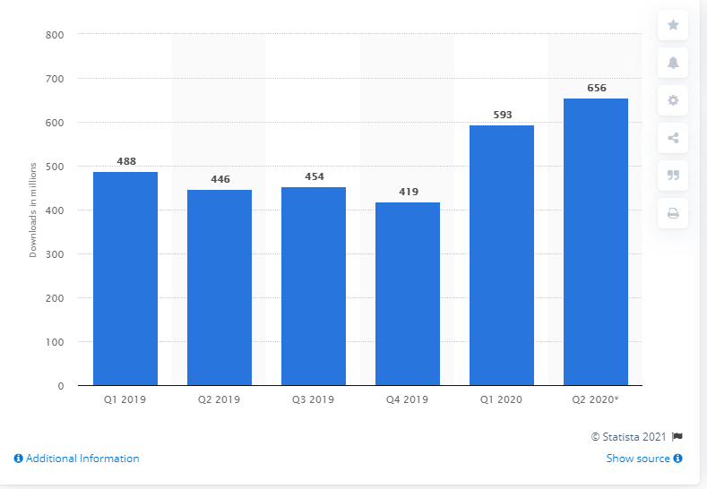

Figure 1 Health and fitness app downloads worldwide from 1st quarter 2019 to 2nd quarter 2020 in millions (Global health and fitness app downloads 2020 | Statista, 2021)

During the first quarter of 2019, the number of available health and fitness apps in the google Play store amounted to 37,143 apps. In March 2019, the most downloaded health and fitness app in the Google play store worldwide encompassed everything from a “Drink Water Reminder” to “Lose Belly Fat in 30 Days” and “Samsung Health”, the companion app for Samsung smart devices. Many health and fitness apps are either linked to specific activity trackers, such as Fit bit devices or Apple and Samsung smart watches, or provide users with tracking and workouts regardless of other digital devices. During a March 2018 survey, 42 percent of U.S. adults stated that they used some sort of digital technology to measure fitness and health improvement goals. (Global health and fitness app downloads 2020 | Statista, 2021)

### Related works

The work presented in this section of the thesis relates to the task of developing a fitness application,

Google Fit and MyFitnessPal are examples of fitness apps that are currently being used.

### Google Fit

Google Fit is a health-tracking platform which was developed by Google that uses sensors in a user’s activity tracker or mobile phone to record the user’s activities such as walking, cycling etc. It can also be used to monitor your fitness goals and weight-loss progress over the course of a day, week, or month. On June 25, 2014, Google Fit was revealed at the Google I/O conference. On August 7, 2014, Google Fit launched a software development kit. On October 28, 2014, Fit became available to the public. In August 2018, Google announced a redesign of its Android Fit app, which includes activity targets based on the American Heart Association and World Health Organization's activity guidelines. The changes are intended to improve Fit's ability to offer measurements for behaviors other than walking and to enable users to participate in activities that increase their heart rate without needing a trip to the gym. (Google Fit - Wikipedia, 2021)

So, how does Google fit track distance into its algorithm? When you walk, drive, or ride during the day, Google Fit will automatically track your movements and count the number of Heart Points you earn using the accelerometer and GPS on your phone or watch. If you choose a specific type of exercise, such as gardening, Pilates, rowing, or spinning, Google Fit will monitor how many Heart Points and Move Minutes you accumulated during your session. Other fitness apps, such as Strava, Runkeeper, Endomondo, and MyFitnessPal, integrate with Google Fit to give you credit for every Move Minute and Heart Point you earn. You'll get advice on how to adjust your goals as your behavior changes over time. Your log will reflect your assignments, milestones, and goal progress for all your applications. (Apps, 2021)

The Google Fit app is a free download from the Google Play store and Apple app store. It's also available on Google's website and comes preloaded on Android Wear watches.

### MyFitnessPal

MyFitnessPal is a diet and activity tracking software and website for smartphones. Gamification is used in the app to keep users engaged. Users can either scan the barcodes of various food items or search the app's enormous pre-existing database manually to track nutrients. Under Armour bought MyFitnessPal in February of 2015. MyFitnessPal launched a premium subscription option for its apps on May 4, 2015.Under Armour stated in October 2020 that MyFitnessPal would be sold to Francisco Partners for $345 million and that Endomondo would be shut down. (MyFitnessPal - Wikipedia, 2021). MyFitnessPal helps you track your meals and exercise in food and exercise diaries as you eat and exercise throughout the day. MyFitnessPal will compute how many calories you've consumed through food and expended through exercise, and how many calories you have left to consume for the day. If you stick to your calorie limits, you should be able to lose (or gain) the weight you want. (How does MyFitnessPal work? 2021)

### Summary

This chapter provides a review of the current literature on recommended systems. The first section of this chapter is the introduction. while the second section of the chapter talks about the history mobile phones, mobile apps, Mobile stores and fitness apps. It also shows how fitness apps have evolved from the first time they will develop to now. The third section talks about related works relating to the topics

# CHAPTER 3: REQUIREMENTS, ANALYSIS AND DESIGN

### Overview

In this chapter the requirement analysis and designed was discussed, the system functionalities, the methodologies and the data gathering techniques used in the design of the system. System analysis is carried out with the aim of determining the objective of a system or its components. It is a problem-solving strategy that strengthens the structure and ensures that all the system’s components work together to achieve their goals. System design is the method of specifying the components or modules of a new system or replacing an existing system to meet specifications. Before you begin preparing, you must first fully understand the old system and decide how machines can be used most effectively to function efficiently. System analysis identifies what the system should do and System design concentrates about how to achieve the system's goal. (System Analysis and Design - Overview - Tutorialspoint, 2021)

### Research Methodology

The path by which researchers must perform their research is known as research methodology. It demonstrates how these researchers construct their problem and purpose, as well as how they present their findings based on the data collected during the study period (Sileyew, 2021). For this project the research methodology that was used is the Desk Research

### Desk Research

Secondary research, often known as desk research, is a type of research that makes use of previously collected data. To improve the overall effectiveness of research, existing data is summarized and compiled. The term "desk research" refers to research information that has been published in research reports and other related materials. Public libraries, websites, and data from previously completed surveys, among other sources, can make these materials available. Some government and non-government organizations also retain data that can be retrieved and used for research purposes. Desk research is far more cost-effective than primary research because it uses data that already exists, as opposed to primary research, which requires organizations or enterprises to collect data themselves or hire a third party to

do it on their behalf. (Secondary Research- Definition, Methods and Examples. | QuestionPro, 2021)

### Design Methodology

Software design methodology lays forth a logical and methodical approach to the design process, as well as a set of decision-making principles. The design approach lays out a series of steps and frequently employs a set of notations or diagrams. The design methodology is especially important for large complex projects that involve programming-in-the-large (where many designers are involved); A methodology establishes a set of common communication channels for translating design to codes, as well as a set of shared goals. For an objective to be effective, it must match between the overall character of the problem and the elements of the solution approach. (Software Design Methodology, 2021)

The agile and incremental methodologies was implemented for this application Because it allows for the release of different parts of the project, and because this methodology is based heavily on iteration, it makes it easier for the programmer to make changes to the application at any point of time.

### Agile Methodology

Agile Software developments refer to software development methodologies based on the concept of iterative development, in which requirements and solutions emerge from collaboration among self-organizing cross-functional teams. (What is AGILE? - What is SCRUM? - Agile FAQ's | Cprime, 2021). It can also be defined as a practice that encourages continuous development and testing during the project's software development lifecycle Unlike the Waterfall model, the agile model allows for parallel development and testing. (Agile Methodology: What is Agile Software Development Model & Process in Testing? 2021)

. Agile Methods generally advocate a disciplined project management process that promotes regular inspection and adaptation, a leadership philosophy that encourages collaboration, self- organization, and transparency, a collection of technical best practices aimed at delivering high-quality software quickly, and a corporate strategy that aligns growth with customer needs and company priorities.

The following are some of the advantages of using an agile methodology:

* + - * Customer satisfaction is described as the production and distribution of useful software at a rapid pace.
      * The product is developed quickly and distributed regularly (weeks rather than months.)
      * Customer, Developer, and Product Owner meet daily to focus on the customer's needs rather than processes and resources.
      * Adapting to changing situations on a regular basis.
      * And last-minute specification modifications are welcomed.

Some of the disadvantages of using the agile approach are as follows:

* + - * There isn't enough focus on the requisite architecture and documentation.
      * It is important for a project expert to make critical decisions during the meeting.
      * If the project manager is unclear about the criteria and the result he or she needs, the project may easily go off track.

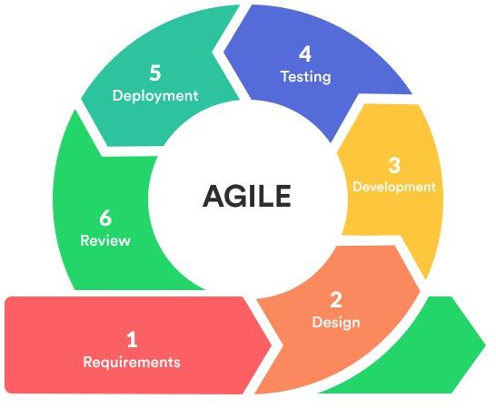

Figure 2: Agile Methodology (Insights to Agile Methodologies for Software Development | Hacker Noon, 2021)

### Increment Model

The incremental model is a software development framework in which requirements are broken down into several stand-alone modules during the software development cycle. Analysis, design, implementation, testing/verification, and maintenance are all stages in incremental progress. Every iteration goes through the phases of specifications, design, coding, and testing. And once all the system's designed functionality has been introduced,

each subsequent release adds functionality to the previous release. (Incremental Model of Software Development Life Cycle – Custom Web & Mobile Development Company – New Line Technologies, 2021)

The following are some of the advantages of using Incremental methodology:

* + - * During the software life cycle, the software can be created easily.
      * Changing criteria and reach is more flexible and less costly.
      * Each building will elicit a response from a customer.
      * Errors are easy to spot, and adjustments can be made at any time during the development process.
      * In comparison to other models, this one is less expensive.

Some of the disadvantages of using the Incremental approach are as follows:

* + - * It requires a good planning designing
      * Each iteration process is separate from the others and does not overlap.
      * Correcting an issue in one unit necessitates correction in all units and takes a long time. (Incremental Model in SDLC: Use, Advantage & Disadvantage, 2021)

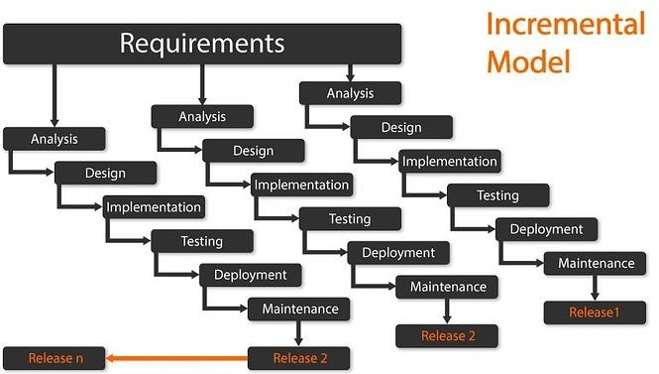

Figure 3 Increment model (Incremental Model of Software Development Life Cycle – Custom Web & Mobile Development Company – New Line Technologies, 2021)

### Tools and Techniques

The development tool used for this project is Android Studio. Android studio is the official integrated development environment (IDE) for Android application development. It’s built on IntelliJ IDEA, a Java integrated development environment for software development that includes code editing and developer tools. Android Studio uses a Gradle-based build framework, emulator, code templates, and GitHub integration to enable application creation on the Android operating system. Every Android Studio project has one or more source code and resource file modalities. Android app modules, Library modules, and Google App Engine modules are among these modalities. The app was first revealed in May 2013 at Google I/O, with the first stable build arriving in December 2014. Android Studio is a software application that runs on Mac, Windows, and Linux computers. It took over as the main IDE for Android application development from Eclipse Android Development Tools (ADT). Google offers direct downloads of Android Studio and the Software Development Kit.

Firebase is a Google-owned software development platform that was launched by Firebase Inc. in 2011 and purchased by Google in 2014. It began as a real-time database and has since grown to include 18 services (4 of which are currently in beta) and dedicated APIs. The entire platform is a Backend-as-a-Service solution for both mobile and web-based software, with facilities for app development, testing, and management. (Firebase, 2021)

* Firebase database & firebase authentication: The firebase database is a NoSQL database that stores data in JSON and can be queried by users. Firebase authentication is a google authentication feature tailored for apps that uses firebase. It allows you to use pre-built or create custom UI for user-authentication, and login users via custom credentials, emails, or social media.

An accelerometer reports the device's acceleration along the three sensor axes. The physical acceleration (change in velocity) as well as gravity are both included in the measured acceleration. Sensors event t. acceleration reports the measurement in the x, y, and z variables. All measurements are in SI units (m/s2) and represent the device's acceleration minus gravity along the three sensor axes. (Sensor types | Android Open Source Project, 2021)

* When the device lies flat on a table, the acceleration value along z is +9.81 aloo, which corresponds to the acceleration of the device (0 m/s^2) minus the force of gravity (-9.81 m/s^2).
* When the device lies flat on a table and is pushed toward the sky, the acceleration value is greater than +9.81, which corresponds to the acceleration of the device (+A m/s^2) minus the force of gravity (-9.81 m/s^2)

### Ethical consideration

In terms of how a project impacts other ethically, there are some problems that must be considered in any project. The following are some of the issues:

* Validity
* Risk of harm
* Confidentiality
* Permission

### Requirement Analysis

The process of identifying the expectations of users for an application that is to be built or upgraded is known as requirements analysis. It includes all the tasks that are carried out to determine the demands of various stakeholders. As a result, the term "requirements analysis" refers to the process of analyzing, documenting, validating, and managing software or system requirements (Requirements Analysis - Understand Its Process & Techniques | ReQtest, 2021)

The software requirements analysis process involves the following steps/phases:

* Eliciting requirements
* Analyzing requirements
* Requirement’s modeling
* Review and retrospective

### Requirement Specification

The functional and non-functional requirements of the system are outlined below.

### Functional Requirement Specification

The table below contains the functional requirements of the system:

**Table 2 Functional Requirement Specifications**

|  |  |  |
| --- | --- | --- |
| Req No. | Description | Type |
| R-101 | The application should be  used on an android smartphone | Configuration |
| R-102 | The application would need internet to function | Configuration |
| R-103 | The operating system should be android 7.0 and above | Configuration |
| R-104 | Firebase Realtime Database | Configuration |
| R-105 | The application should include a user interface | Functional |
| R-106 | The application should work on all Android smartphone | Functional |
| R-107 | The application shall allow users to sign in | Functional |

|  |  |  |
| --- | --- | --- |
| R-108 | The application will take input from the user | Functional |
| R-109 | The application shall count the user’s number of steps | Functional |
| R-110 | The application shall calculate the user’s BMI | Functional |
| R-111 | The application shall require users to register to use its functionalities | Functional |
| R-112 | The application shall allow users logout | Functional |

### Non-Functional Requirement

The table below contains the functional requirements of the system:

**Table 3: Non- Functional Requirement Specifications**

|  |  |  |
| --- | --- | --- |
| Req No | Description | Type |
| NR-101 | The application should keep running when launched except it is closed  by the user | Performance |
| NR-102 | The application should be available to the user at any  time | Availability |
| NR-103 | The application should be user friendly | Usability |
| NR-104 | The application shall  secure any confidential data | Security |

### System Design

This section of the chapter contains:

* Application Architecture
* Use Case
* Data Design
* Activity Diagram

### Application Architecture



Launch Screen

Database Acessor

Step Counter/

pedomerter

Total

distance

View

Sensor

name

Version

Calories

burned

Version

Average

speed

Home Screen

Registration

Calculate BMI

Log Out

BMI Calculator

Weight tracker

Aceelerometer

Login

Figure 4 Application Architecture

### Use Case

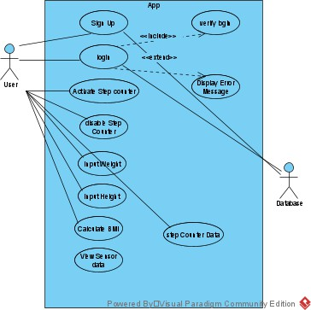

FIGURE 5 USE CASE

### Activity Diagrams

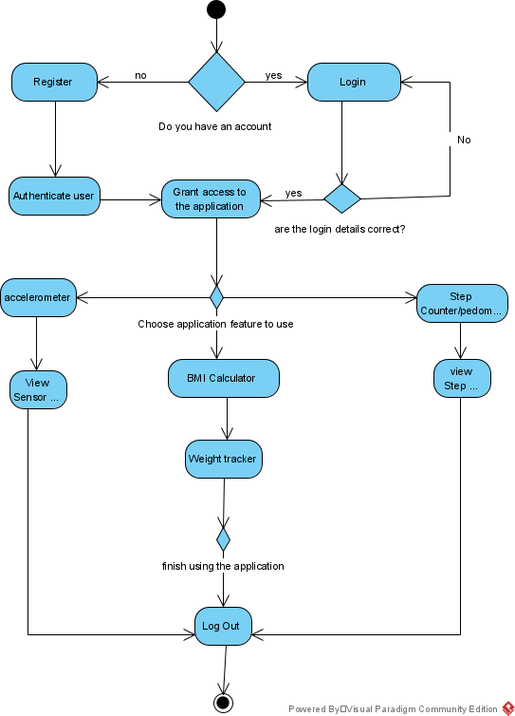

FIGURE 6 ACTIVITY DIAGRAM

### User Interface Design

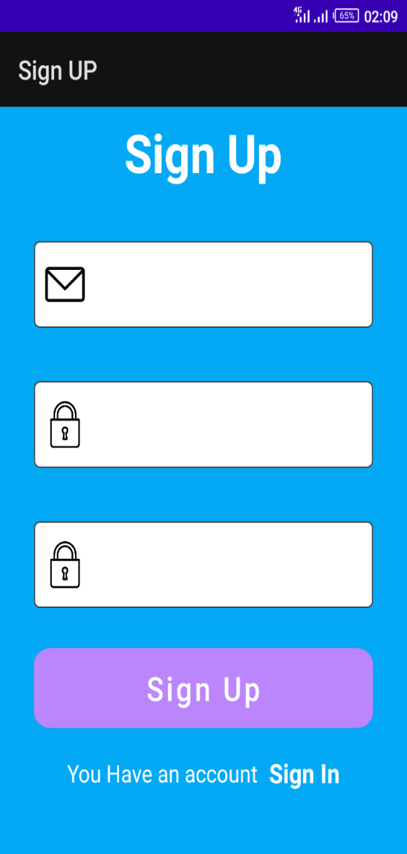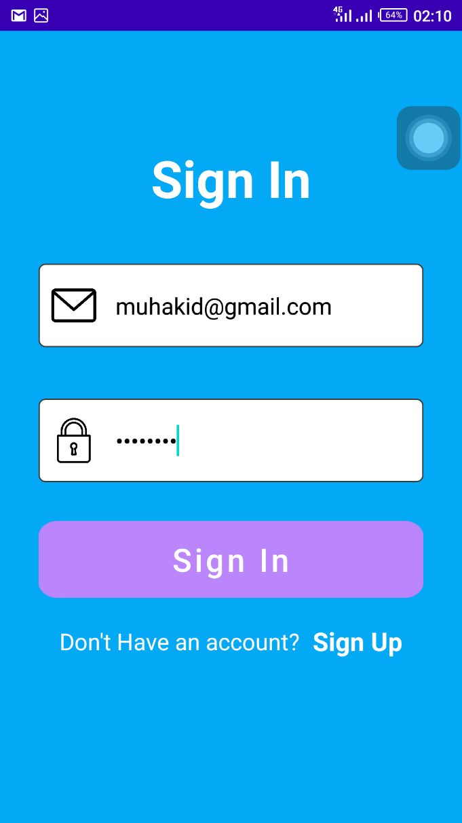

FIGURE 7 SIGN UP FIGURE 8 SIGN IN

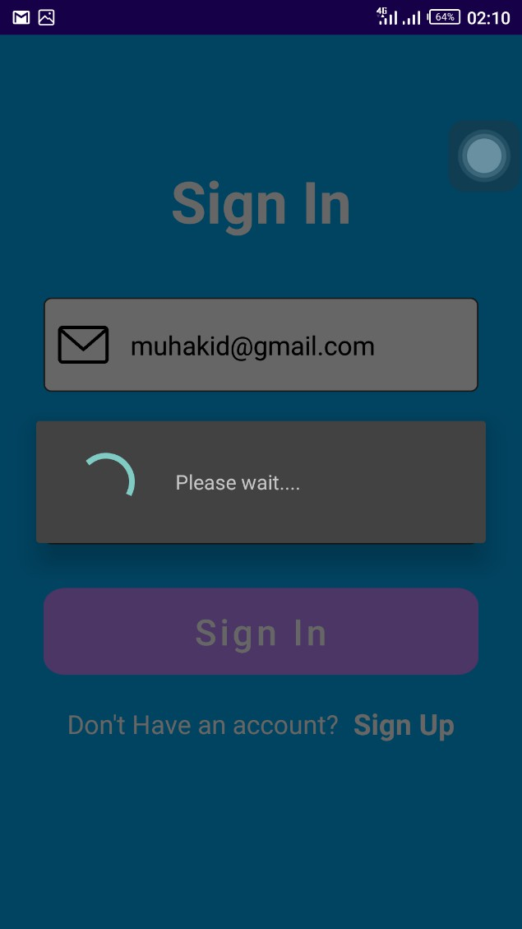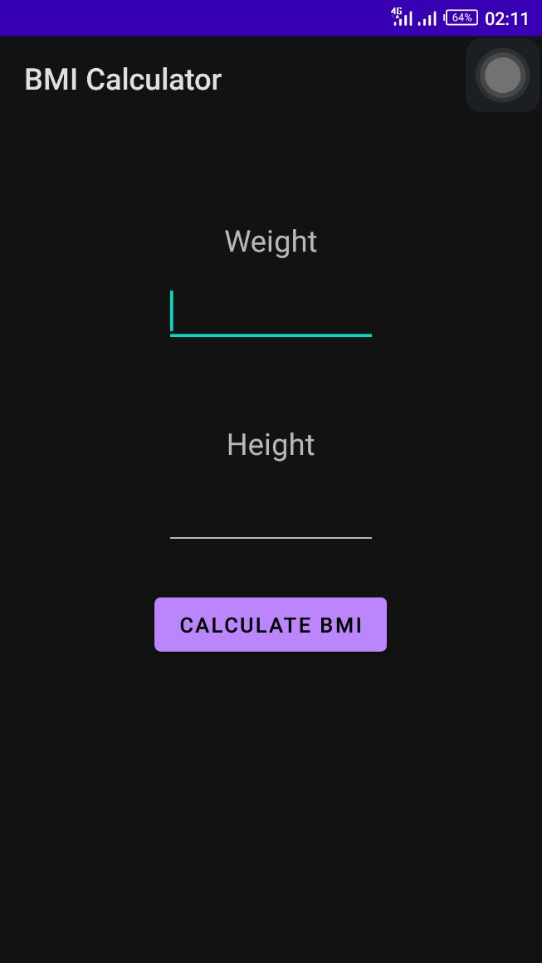

FIGURE 9 VERFYING SIGN IN FIGURE 10 BMI CALCULATOR

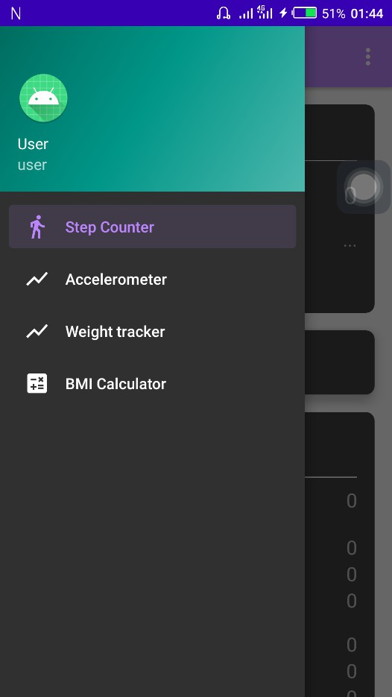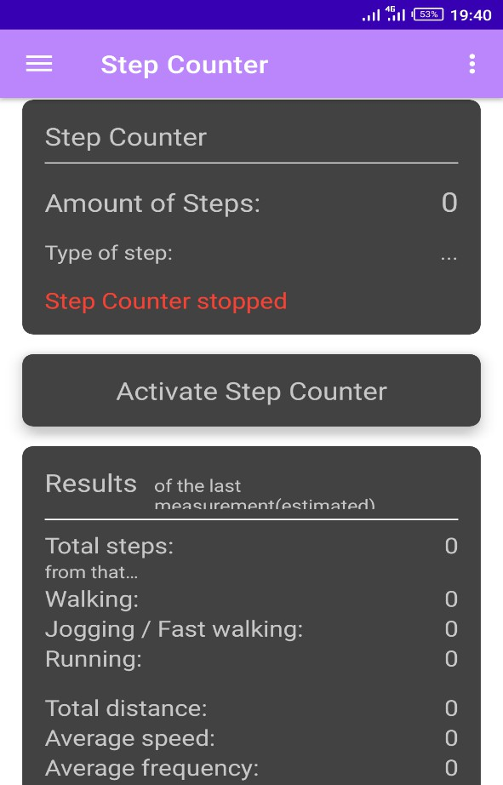

FIGURE 11 NAVIGATION DRAWER FIGURE 12STEP COUNTER/PEDOMETER

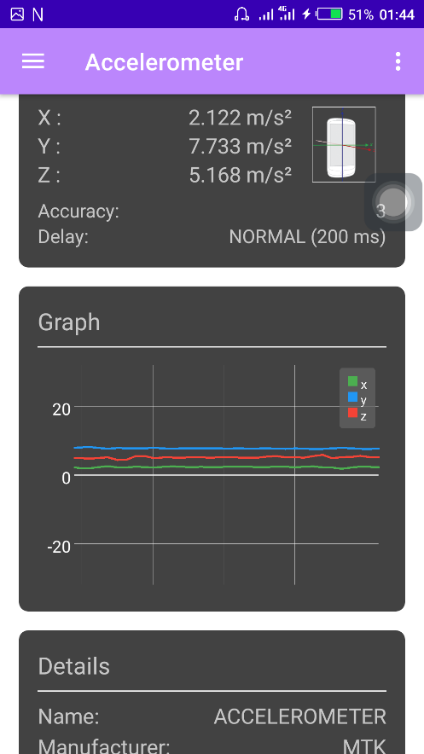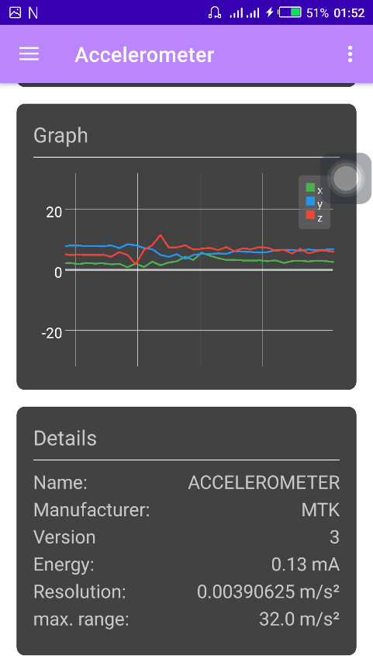

FIGURE 13 & FIGURE 14 ACCELEROMETER

### Summary

This chapter discussed a variety of design methodologies used in the software development. It also looked at the ways for acquiring data and requirements to improve the development of applications. The functional and non-functional requirements of the software applications were also listed with the appropriate UML diagrams Example: The Use case diagram. Application architecture etc. It also contains the ethical considerations to be considered in the development of the application.

# CHAPTER 4: IMPLEMENTATION AND TESTING

### Overview

This chapter focuses on the coding and testing phase of the project and was documented accordingly in the following subsections.

The application was implemented using java on Android 4.1. The application was developed on two system a HP pavilion and a Lenovo ThinkPad (At the course of developing this application the HP pavilion encountered some problem). The specifications for these systems are:

* Intel® Celeron (R) CPU 1007U
* 8.00Gb RAM
* 64-bit Operating System. x64-based processor
* 500GB hard drive

The default devises the application was tasted on are emulator of API level 24 and above and an Infinix note 4

### Main Features

This application was created through coding. Some of the codes will be shown below through pictures and an explanation of the main features of the application.

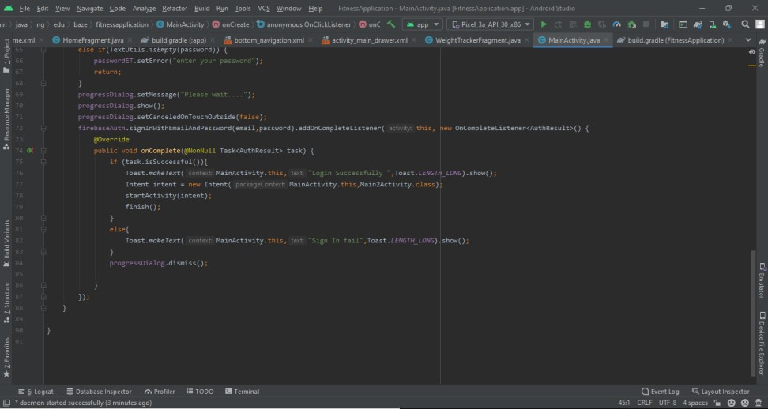

Figure 15 Verifying Users

The figure above shows the code that goes through the firebase database to validate the user. Firebase checks if the password and the email the user enter exist, if the required information exists the user is granted access to the systems

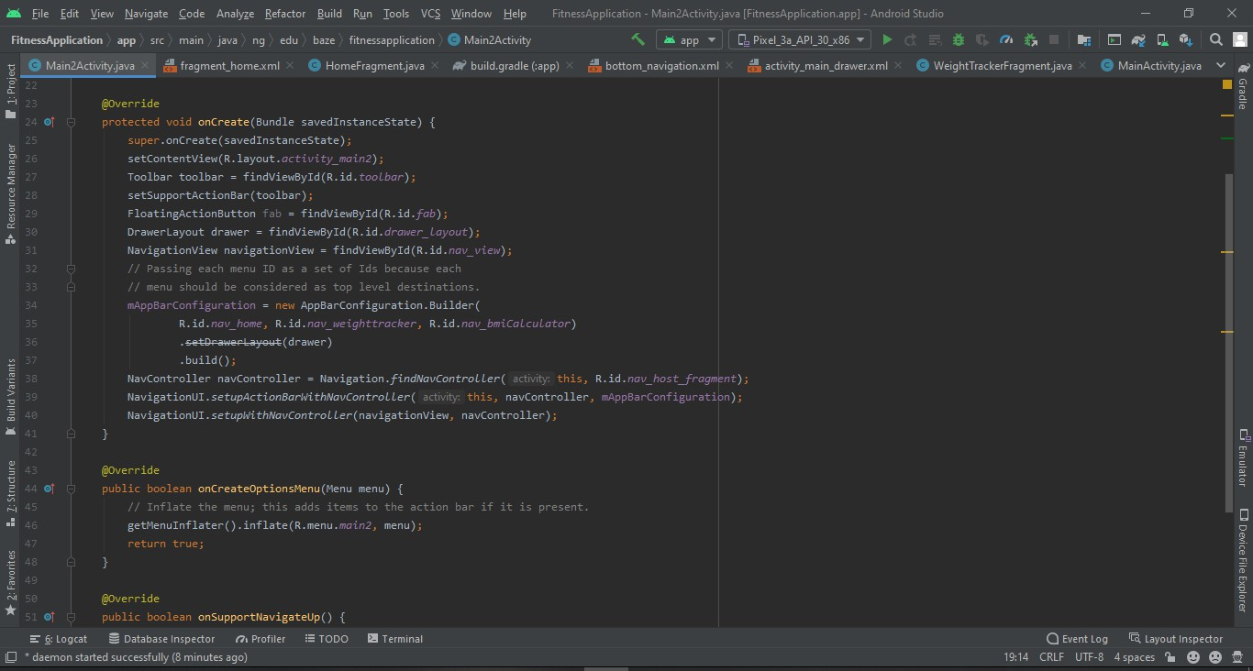

Figure 16 Navigation drawer

The figure above shows the code that allows user to navigate easily through the app using the navigation drawer. This allows the user to move easily from different pages of the application.

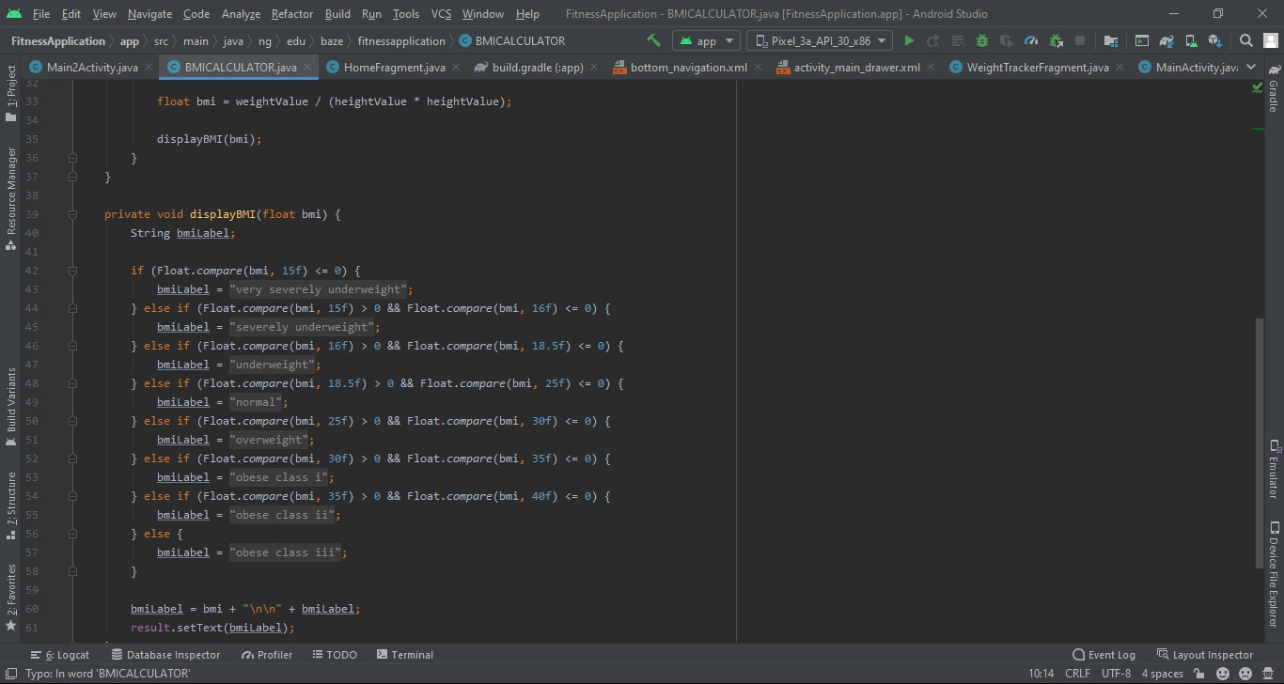

Figure 17 BMI Calculator

The figure above shows the code that allows user to calculate Their BMI by entering their weights and height

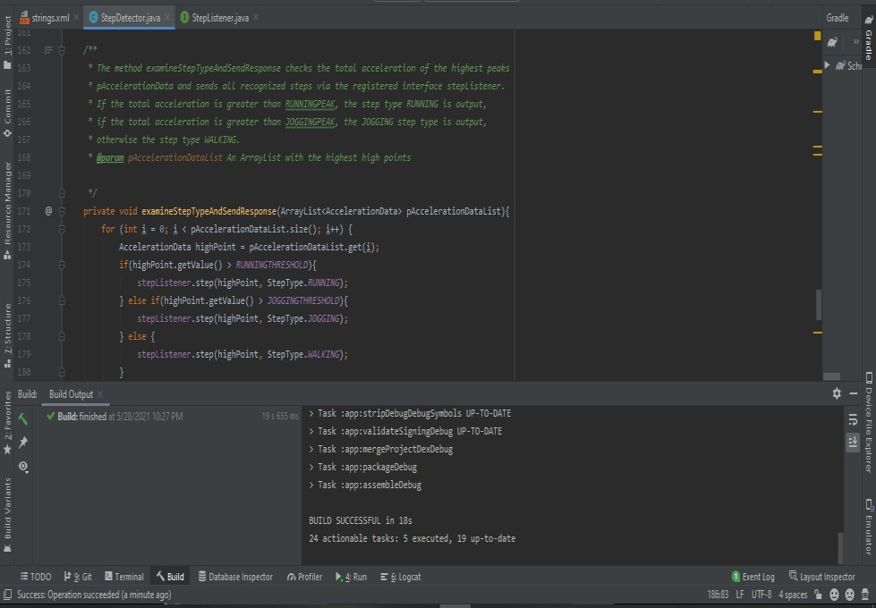

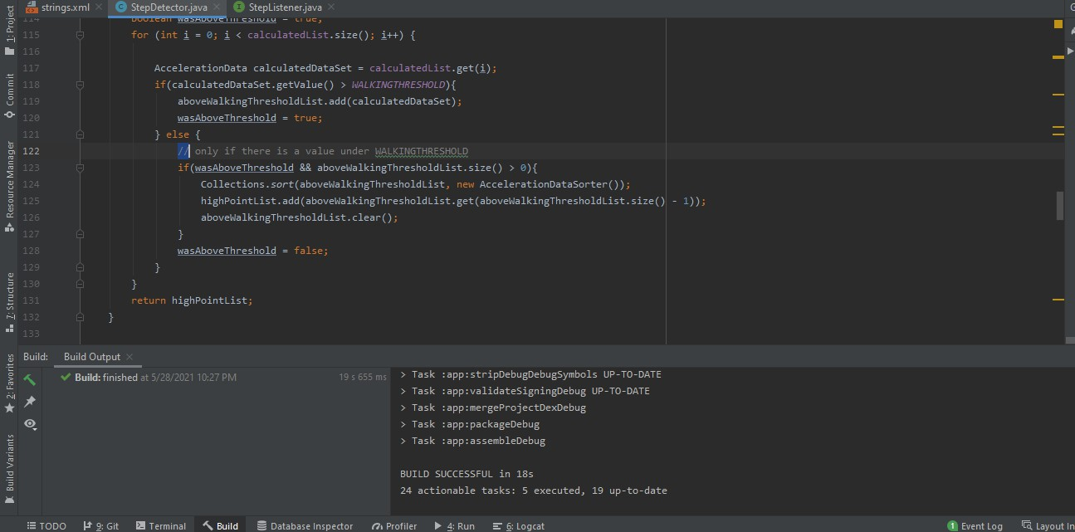

Figure 18 Step Detector

The figures above show the code that allows the step counter manager to count user steps

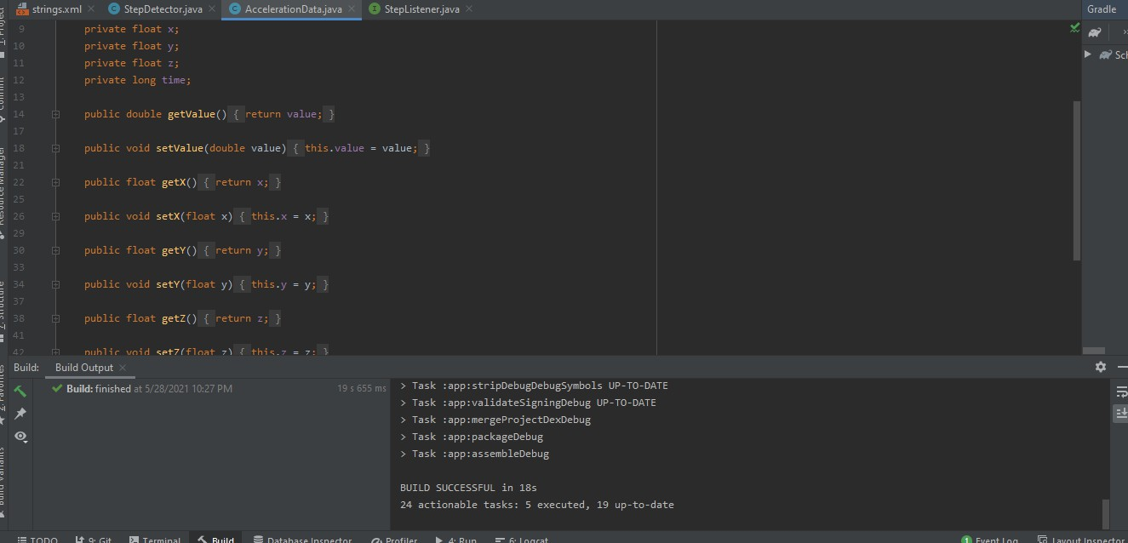

Figure 19 Accelerator data

The figure above shows the code that shows the accelerator data of the sensor

### Implementation Problems

Some of the problems I encountered and solved during the development and implementation of this application are as follows:

* Finding the right sensor for the step counter to work with. This took me about two months to resolve.
* Android emulator kept crashing. I had to start using mobile devices to test my application.
* Find the right way to successfully connect my application to firebase database and to retrieve user data
* Trying to understand the new updates and code formats of android studio.

### Overcoming Implementation Problems

The problems I encountered were solved successfully by researching online, asking my Supervisors and some of my teachers. Some of the steps I also took are as follows:

* Reading through similar codes on platforms like GitHub, Stack Overflow etc. and checking if their codes that had similar problems I was facing and how they resolved it.
* Using my mobile device to test the application instead of emulator
* Going on YouTube and seeing how some of the issues were resolved or alternative to follow
* Trying different sensors till I found the best one to use.

### Testing

Every Application before being deployed must be tested and this application went through different types of testing such as the unit testing, integration testing, system testing and acceptance testing. (Software Testing Help, 2021)

* Unit testing: Unit testing is the process of testing a single software component or module. It is usually done by programmers rather than testers because it necessitates a thorough understanding of the internal program design and code. It could also necessitate the creation of test driver modules or test harnesses.
* Integration testing: Integration testing is the process of testing all integrated modules to ensure that the combined functionality after integration is correct. Code modules, individual applications, client and server applications on a network, and so on are examples of modules. Client/server and distributed systems benefit greatly from this type of testing.
* System testing: the entire system is tested as per the requirements. It is a Black-box type testing that is based on overall requirement specifications and covers all the combined parts of a system.
* Acceptance testing: The client conducts an Acceptance Test to determine whether the system's end-to-end flow meets business requirements and meets the needs of the end-user. Only when all the features and functionalities of the software work as expected does the client accept it. It is the final stage of testing before the software is put into production. It is also known as the User Acceptance testing (UAT). I performed this test on my family members and some of my friends and I received

some positive feedbacks although some suggested I reduce the font size and background color in the sign in page.

### Tests Plans (for Unit Testing, Integration Testing, and System Testing)

A test plan can be defined as a detailed document that explains the test strategy, objectives, schedule, estimation, deliverables, and resources needed to test a software product The Test Plan assists us in determining the amount of effort required to validate the quality of the application being tested.

**Table 4 Test Plans Executed**

|  |  |  |  |  |
| --- | --- | --- | --- | --- |
| S/N | Tested  features | Test Description | Test  Description | Related  Requirement |
| 1 | Sign in Function | Tests if the user can  successfully sign in to the app | 14/01/2021 | R-107 |
| 2 | Step Sensor function | Tests if the application can use sensors to count the user’s steps | 27/04/2021 | R-109 |
| 3 | BMI  Calculator | Tests if the application can calculate the user’s BMI | 21-03-2021 | R-110 |
| 4 | Log out Function | Test if the user can log out successfully from the application | 14/01/2021 | R112 |

* + 1. **Test Suite (for Unit Testing, Integration Testing, and System Testing)** validation suite is another name for this. It is a container with a series of tests that aids testers in the implementation and testing of an application to demonstrate that it has a certain set of characteristics

**Table 5 Test Suite for Test Plan 1**

|  |  |
| --- | --- |
| **Test Suite ID** | **01** |
| Test case | The test case Tests if the user can successfully Sign in  to the app |
| Related requirement | R-107 |
| Prerequisites | * An android device, such as mobile phone or   tablet   * + A good internet connection * An API level of 21 and above |
| Procedures | * Install application on the device   + Enter registered account     - Sign In |
| Expected result | The application should sign in the user and take him/her to the home page if the details entered matches any detail in the database. If the details is not  there, it will not grant the user access |
| Actual result | The result was expected |
| Status | Test case pass |

**Table 6 Test Suite for Test Plan 2**

|  |  |
| --- | --- |
| **Test Suite ID** | **02** |
| Test case | The test case Tests if the app can successfully  calculate the users BMI |
| Related requirement | R-110 |
| Prerequisites | * An android device, such as mobile phone or   tablet   * + A good internet connection * An API level of 21 and above |
| Procedures | * Install application on the device   + Enter registered account     - Sign In * Navigate to BMI Calculator   + Input details   + Click enter |
| Expected result | The application should calculate the user’s BMI with  the details he/she gave |
| Actual result | The result was expected |
| Status | Test case pass |

**Table 7 Test Suite for Test Plan 3**

|  |  |
| --- | --- |
| **Test Suite ID** | **03** |
| Test case | The test case Tests if the app can count the number of  steps the user takes |
| Related requirement | R-109 |
| Prerequisites | * An android device, such as mobile phone or   tablet   * + A good internet connection * An API level of 21 and above |
| Procedures | * Install application on the device   + Enter registered account     - Sign In * Click on activate step counter (pedometer) |
| Expected result | The application should calculate the number of the  steps the user takes |
| Actual result | The result was not expected |
| Status | Test case not successful |

**Table 8 Test Suite for Test Plan 4**

|  |  |
| --- | --- |
| **Test Suite ID** | **04** |
| Test case | The test case Tests if the app can count the number of  steps the user takes |
| Related requirement | R-109 |
| Prerequisites | * An android device, such as mobile phone or   tablet   * + A good internet connection * An API level of 21 and above |
| Procedures | * Install application on the device   + Enter registered account     - Sign In * Click on activate step counter (pedometer) |
| Expected result | The application should calculate the number of the  steps the user takes |
| Actual result | The result was expected |
| Status | Test case successful |

**Table 9 Test Suite for Test Plan 5**

|  |  |
| --- | --- |
| **Test Suite ID** | **05** |
| Test case | Test if the user can log out successfully from the  application |
| Related requirement | R-112 |
| Prerequisites | * An android device, such as mobile phone or   tablet   * + A good internet connection * An API level of 21 and above |
| Procedures | * Install application on the device   + Enter registered account     - Sign In * Click on log out |
| Expected result | The application should log out the user from the app |
| Actual result | The result was expected |
| Status | Test case successful |

Table 5 – 9shows all the test suites of the testable requirements identified and their various prerequisites, status and procedures. The application was tested at the master level which consists of all other test plan levels (unit testing, integration testing, system testing, and acceptance test plan)

**Measurement metrics:** the measure of extent to which each tested case satisfies specified requirements would be given in form of pass or fail. “Pass” means the test case satisfies the given requirement while “Fail” means the test case does not meet the specified requirements.

**Pass/Fail Criteria:** these are the conditions that determines whether each test item passes or fails the equivalent tests.

**Table 9 Summary of Test Suites performed**

|  |  |  |  |
| --- | --- | --- | --- |
| Requirement No | Feature | Description | Type |
| R-107 | Sign in Function | Tests if the user  can successfully sign in to the app | Functional |
| R-109 | Step Sensor function | Tests if the application can use sensors to count the user’s  steps | Functional |
| R-110 | BMI Calculator | Tests if the application can calculate the  user’s BMI | Functional |
| R112 | Log out Function | Test if the user can log out successfully from  the application | Functional |

### Test Traceability Matrix (for Unit Testing, Integration Testing, and System Testing)

This is a document that connects test cases to user requirements. The goal is to ensure that all requirements are completed through test cases, ensuring that no functionality is overlooked during software testing

**Table 10 Representation of the test traceability Matrix according to test(s) performed**

|  |  |  |  |  |  |
| --- | --- | --- | --- | --- | --- |
| Requirement No. | Requirement description | Priority | Test Case  Number | Test date | Test result |
| R-107 | The test case Tests if the application verifies the user on signing in and grant the user access to the  application. | Phases 1 | 01 | 14/01/2021 | pass |
| R-109 | The test case Tests if the application can count the number of steps the user takes by connection to  the sensor. | Phase 1 | 04 | 27/04/2021 | fail |
| R-110 | The test case Tests if the app can  successfully | Phase 2 | 2 | 28/03/2021 | pass |

|  |  |  |  |  |  |
| --- | --- | --- | --- | --- | --- |
|  | calculate the  users BMI |  |  |  |  |
| R-109 | The test case Tests if the application can count the number of steps the user takes by connection to  the sensor. | Phase 1 | 04 | 27/04/2021 | pass |
| R-112 | The test case Tests if the application can log out the user from the application  successfully. | Phase 1 | 05 | 12/01/2021 | pass |

The table above shows the test traceability matrix of all the test cases executed with their corresponding dates and their status.

### Test Report Summary (for Unit Testing, Integration Testing, and System Testing)

These are the results of the tests that were executed:

* + - * Number of tests performed: 5
      * Number of tests passed: 3
      * Number of tests failed: 1
      * Percentage of tests failed:25%
      * Percentage of tests passed:75%

### Error Reports and Corrections

Error report

* + - * Internal code errors due to some mistakes in the code.

Corrections

* To correct this error, I had to Read through the code line- by-line find out the error And I also used the log cat to find error by reading the error page.
* I had to change the sensor type to a different sensor to find a sensor that will work.

### Use Guide

Refer to the appendix for the user guide

### Summary

This chapter described the software tools used in the system's development, the system's implementation technique, the software's testing before it was released for user consumption, and the software's documentation. It also discussed how and why all these processes were carried out.

# CHAPTER 5: DISCUSSION, CONCLUSION, AND RECOMMENDATIONS

### Overview

This is the final chapter of this thesis in it, an objective assessment of the project was discussed in section 5.2. And the limitations and challenges faced during the development of the project were discussed in section 5.3. In section 5.4 The plans for future enhancement for the project was discussed and finally recommendations will be made in final section based on the findings of this project.

### Objective Assessment

Certain objectives were identified at the start of this application's development, and this project was designed to achieve them. It is safe to infer that all the objectives have been met.

This project has also been designed in such a way that any future adjustments or updates may be readily made without impacting the system's functionality. This project is solely for Android devices and may be used on any version, allowing it to be utilized by anyone with various degrees of Android devices.

### Limitations and Challenges

Problems and challenges encountered during the development process of the application due to unavoidable circumstances are listed below:

* + - Finding the right sensor to use for the step counter to count the user steps, as that is the most important feature of the application
    - Implementing the codes to work with the fragment my IDE created

### Future Enhancements

There is still room for future enhancements on the application and some these enhancements that will done are listed below:

* + - Implementation on other platforms like the apple IOS
    - Adding more fitness and health feature to the application
    - Changing the design of the app over time to fit modern design trends

### Recommendations

A few recommendations have been identified based on the gaps and discoveries observed throughout this process and may be found below:

* + - Further research on how to improve the security of the application.
    - The sensors will be improved for better accuracy in counting the user’s steps

### Summary

This chapter was completed successfully, and all the specified criteria were met. It has several benefits like counting the user’s step and using that data to tell the user the number of calories they burnt, the total distance they covered etc. From the start of the application to the point where the users use the step counter is easy to navigate.

### References

American Dialect Society. 2021. “App” voted 2010 word of the year by the American Dialect Society (UPDATED). [online] Available at:

<https:/[/www.americandi](http://www.americandialect.org/app-voted-2010-word-of-the-year-by-the-american-)a[lect.org/app-voted-2010-word-of-the-year-by-the-american-](http://www.americandialect.org/app-voted-2010-word-of-the-year-by-the-american-) dialect-society-updated.> [Accessed 8 February 2021].

Android Open Source Project. 2021. Sensor types | Android Open Source Project. [online] Available at: <https://source.android.com/devices/sensors/sensor-types> [Accessed 11 May 2021].

Blogs, V., 2021. Evolution of Mobile Apps - History of Mobile Application Development. [online] Web Solutions Blog. Available at: <https://acodez.in/evolution- mobile-apps/.> [Accessed 8 February 2021].

Cprime. 2021. What is AGILE? - What is SCRUM? - Agile FAQ's | Cprime. [online] Available at: <https:/[/www.cprime.com/resourc](http://www.cprime.com/resources/what-is-agile-what-is-scrum/)e[s/what-is-agile-what-is-scrum/.>](http://www.cprime.com/resources/what-is-agile-what-is-scrum/) [Accessed 22 April 2021].

En.wikipedia.org. 2021. Google Fit - Wikipedia. [online] Available at:

<https://en.wikipedia.org/wiki/Google_Fit> [Accessed 11 May 2021].

En.wikipedia.org. 2021. Mobile app - Wikipedia. [online] Available at:

<https://en.wikipedia.org/wiki/Mobile_app> [Accessed 8 February 2021].

En.wikipedia.org. 2021. MyFitnessPal - Wikipedia. [online] Available at:

<https://en.wikipedia.org/wiki/MyFitnessPal> [Accessed 11 May 2021].

Firebase. 2021. Firebase. [online] Available at: <https://firebase.google.com/> [Accessed 10 May 2021].

Guru99.com. 2021. Agile Methodology: What is Agile Software Development Model & Process in Testing? [online] Available at: <https:/[/www.guru99](http://www.guru99.com/agile-scrum-).[com/agile-scrum-](http://www.guru99.com/agile-scrum-) extreme-testing.html> [Accessed 22 April 2021].

Guru99.com. 2021. Incremental Model in SDLC: Use, Advantage & Disadvantage. [online] Available at: <https:/[/www.guru99](http://www.guru99.com/what-is-incremental-model-in-sdlc-).[com/what-is-incremental-model-in-sdlc-](http://www.guru99.com/what-is-incremental-model-in-sdlc-) advantages-disadvantages.html> [Accessed 2 May 2021].

Hackernoon.com. 2021. Insights to Agile Methodologies for Software Development | Hacker Noon. [online] Available at: <https://hackernoon.com/a-case-study-type-insight- into-agile-methodologies-for-software-development-cd5932c6> [Accessed 2 May 2021].

Ispo.com. 2021. *How Fitness Apps Have Developed*. [online] Available at:

<https:/[/www.ispo.](http://www.ispo.com/en/markets/how-fitness-apps-have-developed)c[om/en/markets/how-fitness-apps-have-developed](http://www.ispo.com/en/markets/how-fitness-apps-have-developed)> [Accessed 11 May 2021].

MyFitnessPal Help. 2021. How does MyFitnessPal work? [online] Available at:

<https://support.myfitnesspal.com/hc/en-us/articles/360032626011-How-does- MyFitnessPal-work> [Accessed 11 May 2021].

Newline.tech. 2021. Incremental Model of Software Development Life Cycle – Custom Web & Mobile Development Company – New Line Technologies. [online] Available at:

<https://newline.tech/incremental-model-of-software-development-life-cycle/.> [Accessed 2 May 2021].

Nytimes.com. 2021. A Place to Put Your Apps (Published 2009). [online] Available at:

<https:/[/www.n](http://www.nytimes.com/2009/11/05/technology/personaltech/05pogue.html?pagewant)y[times.com/2009/11/05/technology/personaltech/05pogue.html?pagewant](http://www.nytimes.com/2009/11/05/technology/personaltech/05pogue.html?pagewant) ed=all.> [Accessed 8 February 2021].

Republic World. 2021. Apps. [online] Available at:

<https:/[/www.republi](http://www.republicworld.com/technology-news/apps/how-does-google-fit-work-here-)c[world.com/technology-news/apps/how-does-google-fit-work-here-](http://www.republicworld.com/technology-news/apps/how-does-google-fit-work-here-) are-the-different-google-fit-features.html.> [Accessed 11 May 2021].

ReQtest. 2021. Requirements Analysis - Understand Its Process & Techniques | ReQtest. [online] Available at: <https://reqtest.com/requirements-blog/requirements-analysis/.> [Accessed 11 May 2021].

Rowinski, D.,2021. [online]Available at:

<https://readwrite.com/2012/02/07/infographic_history_of_mobile_app_stores-2/> [Accessed 8 February 2021].

QuestionPro. 2021. Secondary Research- Definition, Methods and Examples. | QuestionPro. [online] Available at: <https:/[/www.questionpro.com/blog/seconda](http://www.questionpro.com/blog/secondary-)r[y-](http://www.questionpro.com/blog/secondary-) research/> [Accessed 13 May 2021].

Sileyew, K., 2021. [online] Available at:

<https:/[/www.int](http://www.intechopen.com/books/cyberspace/research-design-and-methodology)e[chopen.com/books/cyberspace/research-design-and-methodology](http://www.intechopen.com/books/cyberspace/research-design-and-methodology)> [Accessed 13 May 2021].

Softwaretestinghelp.com. 2021. Software Testing Help. [online] Available at:

<https:/[/www.softwaretestinghelp.com/t](http://www.softwaretestinghelp.com/types-of-software-testing/)y[pes-of-software-testing/](http://www.softwaretestinghelp.com/types-of-software-testing/)> [Accessed 12 May 2021].

Statista. 2021. Global health and fitness app downloads 2020 | Statista. [online] Available at: <https:/[/www.statista.com/statisti](http://www.statista.com/statistics/1127248/health-fitness-)c[s/1127248/health-fitness-](http://www.statista.com/statistics/1127248/health-fitness-) appsdownloadsworldwide> [Accessed 20 April 2021].

Statista. 2021. US. fitness app users 2022 | Statista. [online] Available at:

<https:/[/www.statista.com/statisti](http://www.statista.com/statistics/1154994/number-us-fitness-health-app-)c[s/1154994/number-us-fitness-health-app-](http://www.statista.com/statistics/1154994/number-us-fitness-health-app-) users/#:~:text=In%202019%2C%20there%20were%2068.7,apps%20in%20the%20Unite d%20States.> [Accessed 13 May 2021].

Tutorialspoint.com. 2021. System Analysis and Design - Overview - Tutorialspoint. [online] Available at:

<https:/[/www.tutorialspoint.com/s](http://www.tutorialspoint.com/system_analysis_and_design/system_analysis_and_desi)y[stem_analysis_and_design/system_analysis_and_desi](http://www.tutorialspoint.com/system_analysis_and_design/system_analysis_and_desi) gn_overview.htm#:~:text=System%20analysis%20is%20conducted%20for,what%20the

%20system%20should%20do.> [Accessed 22 April 2021].

Userpages.umbc.edu. 2021. Software Design Methodology. [online] Available at:

<https://userpages.umbc.edu/~khoo/survey1.html#:~:text=Software%20design%20metho dology%20provides%20a,set%20of%20notations%20or%20diagrams.> [Accessed 13

May 2021].

## APPENDICES

### Appendix A – Project Document

Name: Muhammad Abubakar ID: BU/19A/IT/3625

## PROJECT TOPIC: DESIGN AND IMPLEMENTATION OF A FITNESS APP

Introduction: This is a fitness app which is aimed at improving the fitness of the user. This app will help motivate the user to stay active every day by using the step counter feature on the app and its daily goal. This app will also have an option for the user to be able to record some of the user’s information for example weight, the user can use the app to record his/her weight daily, weekly or monthly, which can also be used to track weight loss/gain.

### Project Goals & Objectives:

* To help improve the fitness of the user.
* To help motivate the user to stay active.
* To set daily goals for the user to achieve.
* To help the user keep records.

### Appendix B – Sources codes







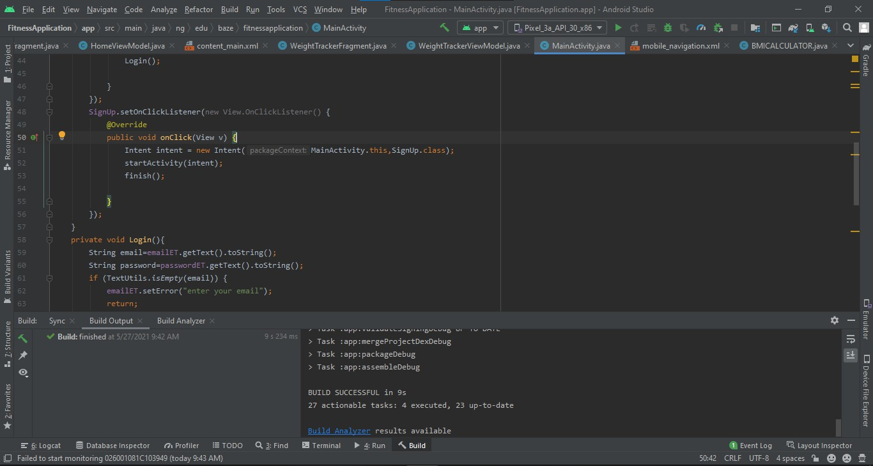



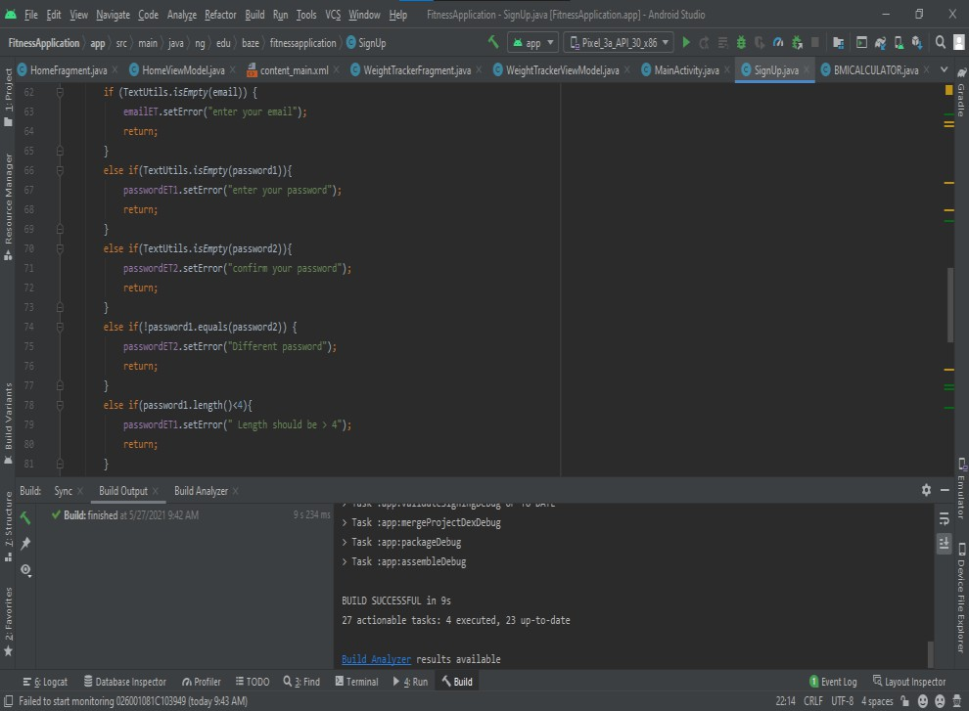



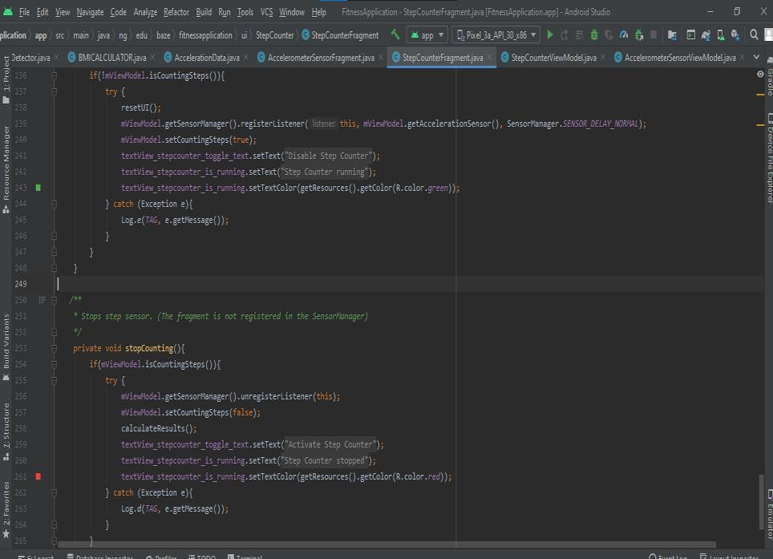

49

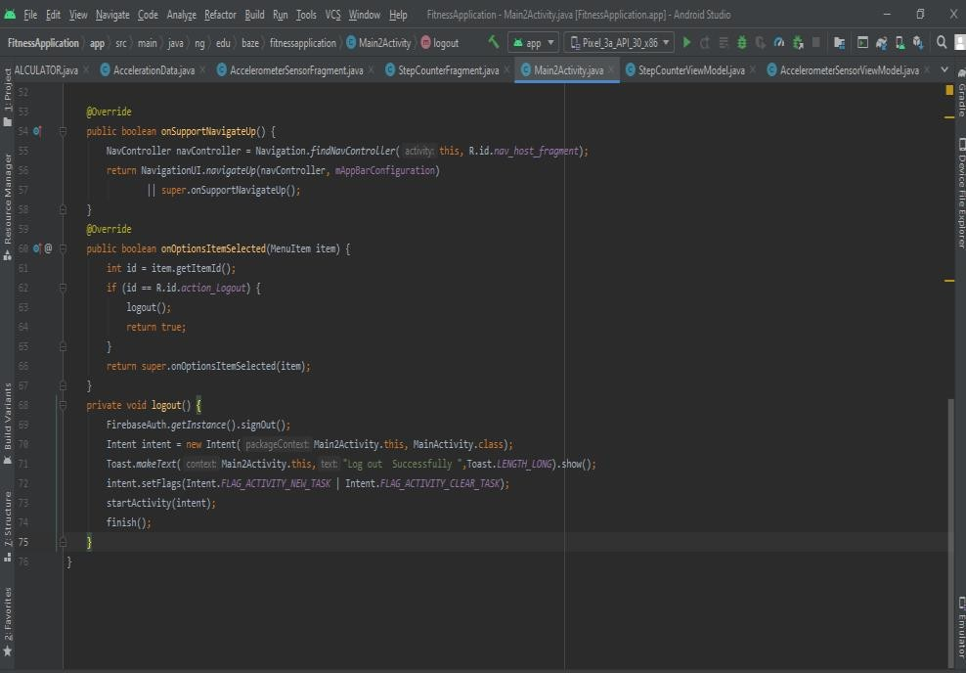

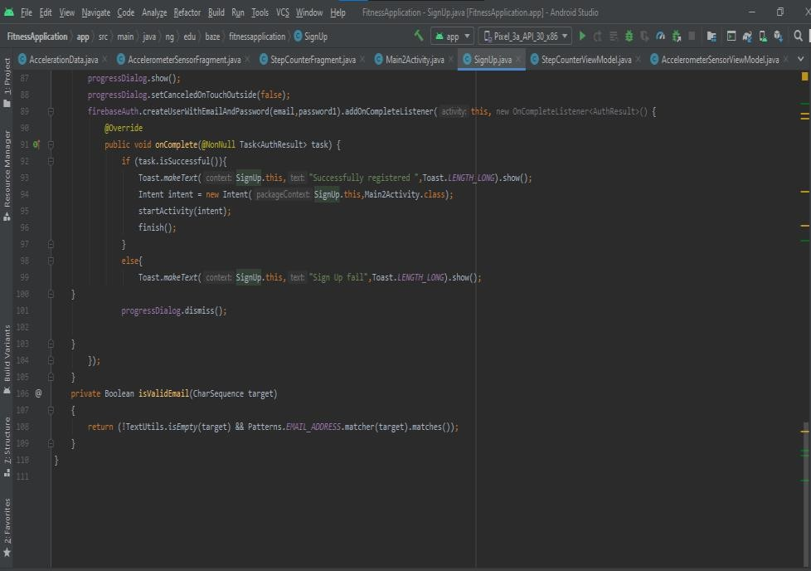

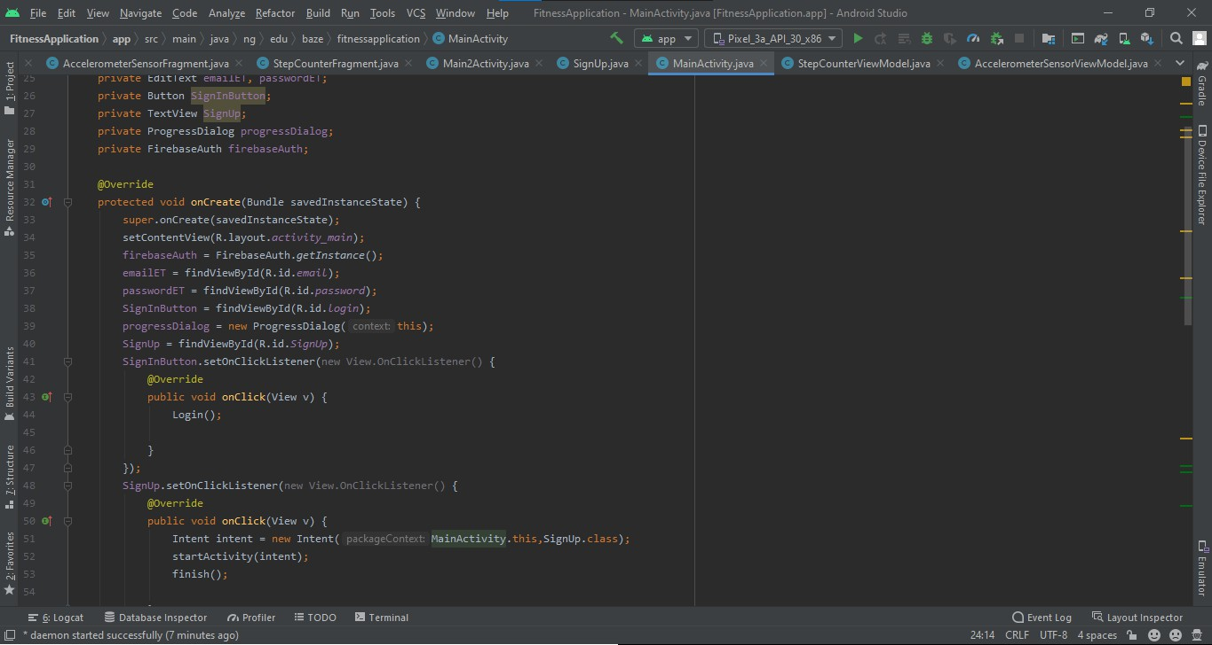

### Appendix C – User Guide / Manual

* Download and Install the application
* Make sure there is internet connectivity
* Open the application
* Register on the application if user does not have an account
* Log into the application if the user has an account
* Navigate through the application using the navigation drawer
* Click activate step counter/pedometer to start the step counter
* View the total steps, distance, burned calories etc. By scrolling Down in the step counter page.
* Click on accelerometer to see the live graph and type of sensor being used.
* Click on the navigation drawer to see the other features
* Click on BMI calculator to calculate Body Mass Index
* Enter your weight and height to calculate the Body Mass Index

### Appendix D – Test Cases

**Test case for signing in**

|  |  |
| --- | --- |
| **Test Suite ID** | **01** |
| Test case | The test case Tests if the user can successfully Sign in  to the app |
| Related requirement | R-107 |
| Prerequisites | * An android device, such as mobile phone or   tablet   * + A good internet connection * An API level of 21 and above |
| Procedures | * Install application on the device   + Enter registered account     - Sign In |
| Expected result | The application should sign in the user and take him/her to the home page if the detail entered matches any detail in the database. If the details is not  there, it will not grant the user access |
| Actual result | The result was expected |
| Status | Test case pass |

**Test case for logging out**

|  |  |
| --- | --- |
| **Test Suite ID** | **05** |
| Test case | Test if the user can log out successfully from the  application |
| Related requirement | R-112 |
| Prerequisites | * An android device, such as mobile phone or   tablet   * + A good internet connection * An API level of 21 and above |
| Procedures | * Install application on the device   + Enter registered account     - Sign In * Click on log out |
| Expected result | The application should log out the user from the app |
| Actual result | The result was expected |
| Status | Test case successful |

**Test case for calculating BMI**

|  |  |
| --- | --- |
| **Test Suite ID** | **02** |
| Test case | The test case Tests if the app can successfully  calculate the users BMI |
| Related requirement | R-110 |
| Prerequisites | * An android device, such as mobile phone or   tablet   * + A good internet connection * An API level of 21 and above |
| Procedures | * Install application on the device   + Enter registered account     - Sign In * Navigate to BMI Calculator   + Input details   + Click enter |
| Expected result | The application should calculate the user’s BMI with  the details he/she gave |
| Actual result | The result was expected |
| Status | Test case pass |

**Test case for calculating number of steps**

|  |  |
| --- | --- |
| **Test Suite ID** | **04** |
| Test case | The test case Tests if the app can count the number of  steps the user takes |
| Related requirement | R-109 |
| Prerequisites | * An android device, such as mobile phone or   tablet   * + A good internet connection * An API level of 21 and above |
| Procedures | * Install application on the device   + Enter registered account     - Sign In * Click on activate step counter (pedometer) |
| Expected result | The application should calculate the number of the  steps the user takes |
| Actual result | The result was expected |
| Status | Test case successful |