## DISPATCH RIDER SYSTEM

BY

**SAHEED,** MUHAMMAD ABDULHAMEED BU/19C/IT/4109

DEPARTMENT OF COMPUTER SCIENCE

BAZE UNIVERSITY

ABUJA

SEPTEMBER, 2022

**DESIGN AND IMPLEMENTATION OF A DISPATCH RIDER SYSTEM**

Thesis Submitted in Partial Fulfilment of the Requirement for the Degree of

B.Sc.

In Computer Science

By

**SAHEED MUHAMMAD ABDULHAMEED**

To

The Department of Computer Science Baze University, Abuja

SEPTEMBER, 2022

## DECLARATION

This is to certify that this Thesis entitled **Design and Implementation of Dispatch Rider System**, which is submitted by **Abdulhameed Muhammad Saheed** in partial fulfilment of the requirement for the award of degree for B.Sc. in Information Technology to the Department of Computer Science, Baze University Abuja, Nigeria, comprises of only my original work and due acknowledgement has been made in the text to all other materials used.

Date: Name of Student:Abdulhameed Muhammad Saheed

**APPROVED BY** …………………

#### HOD

Dept. of Computer Science

## CERTIFICATION

This is to certify that this Thesis entitled **Design and Implementation Of A Dispatch Rider System**, which is submitted by **Abdulhameed Muhammad Saheed** in partial fulfilment of the requirement for the award of degree for B.Sc. in Information Technology to the Department of Computer Science, Baze University Abuja, Nigeria is a record of the candidate’s own work carried out by the candidate under my/our supervision. The matter embodied in this thesis is original and has not been submitted for the award of any other degree.

Date: Supervisor: Ms. Khadijah Saad Mohammed

## APPROVAL

This is to certify that the research work, Dispatch Rider System and the subsequent preparation by **Abdulhameed Muhammad Saheed** with **BU/19C/IT/4109** has been approved by the Department of Computer Science, Faculty of Computing and Applied Science, Baze University, Abuja, Nigeria.

By

Ms. Khadijah Saad Mohammed Date/Sign

Supervisor

Dr. Amit Mishra Date/Sign

Head, Department of Computer Science

Prof. Peter Ogedebe Date/Sign

Dean, Faculty of Computing and Applied Science

Prof. CHOJI Davou Nyap Date/Sign

External Examiner

**DEDICATION**

I thank Allah (SWT) for the guidance, protection and help he has given to me to be able to finish this project. I also dedicate the projects to my parents and my guidance for their continuous financial support, moral support and for all their sacrifices and to all my siblings who have seen a source of strength and motivation. I will also dedicate this to my lecturers Ms. Khadija Saad Mohammed, Mrs Esther and Dr Amit for their Immeasurable assistance.

## ABSTRACT

This project (Design and Implementation of a Dispatch Rider System) is a logistics/delivery app that allows users to connect to drivers or riders to deliver their goods either by ordering or booking for a rider. The application will possess features such as login, registration, and the ordering of a driver/rider and payment features.the technologies that was used in this project are React native and javascript for the frontend and node, mongoDB, and cloudinary.

Everybody is starting a small business/enterprise that will somehow benefit people in his/her society. That’s including situations when goods are being sold to customers, the process of getting the goods is a complicated and stressful process whereby this system is trying to make all those problems go away by bringing easy means of getting goods delivered to their various customers.

## TABLE OF CONTENTS

**ABSTRACT V**

LIST OF TABLES VIII

LIST OF FIGURES IX

LIST OF ABBREVIATIONS X

CHAPTER 1: INTRODUCTION 1

* 1. Overview 1
  2. Background and Motivation 1
  3. Statement of the Problem 2
  4. Aim and Objectives 3
  5. Significance of the Project 4
  6. Project Risks Assessment 5
  7. Scope/Project Organization 5

CHAPTER 2: LITERATURE REVIEW 6

* 1. Introduction 6
  2. Historical Overview 7
  3. Related Work 7
  4. Summary 9

CHAPTER 3: REQUIREMENTS, ANALYSIS, AND DESIGN 10

* 1. Overview 10
  2. Proposed Model 12
  3. Methodology 12
     1. Method 1 (e.g Interview) 12
     2. Method 2 (e.g Observation) 12
  4. Tools and Techniques 12
  5. Ethical Consideration 13
  6. Requirement Analysis 13
  7. Requirements Specifications 14
     1. Functional Requirement Specifications 14
     2. Non-Functional Requirement Specifications 14
  8. System Design 15
     1. Application Architecture 16
     2. Use Case 17
     3. Data Design 18
     4. Activity Diagrams 19
     5. Entity-Relationship Diagram (ERD) 20
     6. User Interface Design 21
  9. Summary 25

CHAPTER 4: IMPLEMENTATION AND TESTING 26

* 1. Overview 26
  2. Main Features 26
  3. Implementation Problems 26
  4. Overcoming Implementation Problems 26
  5. Testing 27
     1. Tests Plans (for Unit Testing, Integration Testing, and System Testing) 27
     2. Test Suite (for Unit Testing, Integration Testing, and System Testing) 28
     3. Test Traceability Matrix (for Unit Testing, Integration Testing, and System Testing) 33
     4. Test Report Summary (for Unit Testing, Integration Testing, and System Testing) 34
     5. Error Reports and Corrections
  6. Use Guide 34
  7. Summary 34

CHAPTER 5: DISCUSSION, CONCLUSION, AND RECOMMENDATIONS 35

* 1. Overview 35
  2. Objective Assessment 35
  3. Limitations and Challenges 35
  4. Future Enhancements 36
  5. Recommendations 36
  6. Summary 37

REFERENCES 38

APPENDICES 40

## LIST OF TABLES

|  |  |  |
| --- | --- | --- |
| Table 1  Table 2 | Program Risk and Assessment  Functional Requirement Specifications | 14 |
| Table 3 | Non-Functional Requirement Specifications | 14 |
| Table 4 | Test Plans |  |
| Table 5 | Test Suites Performed |  |
| Table 6 |  |  |

## LIST OF FIGURES

Figure 1 Waterfall Phases

Figure 2 Use Case diagram 17

|  |  |  |
| --- | --- | --- |
| Figure 3 | Activity Diagram | 18 |
| Figure 4 | Entity Relationship Diagram | 19 |
| Figure 5 | User Interface Design |  |

#### LIST OF ABBREVIATIONS

CPU Central Processing Unit

ERD Entity Relationship Diagram

IT Information Technology

DRS Dispatch Rider System

H. O. D Head of Departments

* 1. **Overview**

# CHAPTER 1: INTRODUCTION

Dispatch Riders in Nigeria have found a way of becoming a part of everyone’s activities, may it be moving(delivering) goods from one place to another. The world has developed gradually into a state where there is a considerable amount of technological development where everything that’s done manually or physically is now technologically or computerized.

### Background and Motivation

The Nigerian business and market environments have since the last two decades been dominated by almost all the above mentioned transportation facilities. With the advent of web 3.0, developers, programmers, software engineers, UI/UX designers in the tech industry have made some of these businesses and services easily and readily available through application systems for smartphones and websites. This researcher, however, noted that the dispatch motor-bike logistics aspect of the business is one of the most used logistics transportation facilities in the country, yet to be developed and integrated as a system or application.

The dispatch or logistics business is one of the many folds of courier service that has over the years, scaled online shopping, and delivery of small goods like envelopes, small packages, and shipments that are to be picked up. The venture is traced to the armed forces, deployed as a military messenger mounted on horse or motorcycle to deliver urgent orders and messages between headquarters and military units.

In Nigeria, this business is remarkable for having helped Small and Medium Enterprises succeed in the country, making possible faster and less costly delivery of goods to the customers’ doorsteps. However, with the vacuum created by the lack of a central system where users can easily access the dispatch motor-bike riders close to their location, the customers have often faced difficulties of delay, waste of time and risks of delivery of goods between buyers and sellers. Therefore, there is a need for a Dispatch Rider System to enhance the ease of doing business by automating and centralising the dispatch motor-bike logistics business in Nigeria.

The Dispatch Rider System (D.R.S) is a system that is developed to collate the details of all dispatch motor-bike riders in a database, make the service readily available for sellers to deliver to buyers, and improve riders’ performances in ensuring a smooth and safe delivery of goods and products. The necessity of this system is seen where the risk of losing products, as well as delays in service delivery are reduced to the barest minimum through a centralised navigation system on a single dashboard. This system is developed as both web-based and mobile applications in order to explore all the resources presented by both programming environments. This means greater accessibility, data protection and integration.

### Statement of the Problem

Nigeria has witnessed a remarkable upgrade in the transportation system due to the advances of internet platforms, smartphones and tablet applications, and the rise of social media platforms. These developments have eased the facilitation of travels and generated new means of both social and network capital. One of these notable developments is in the booking features readily available and notable with airlines, buses, and trains made possible by application systems such as UBER, WAKANOW, BOLT, GIG and amongst others.

The current system has some significant issues that have compounded to the inconvenience and dissatisfaction of customers, the issues encompass time consumption because the individual has to make a call to the company and wait for a while to get a response, that’s if the bikes are available or not, it is energy- consuming because one has to send in their details to their WhatsApp or SMS, and also the riders might be a novice when it comes to a particular destination or location, which means you have to keep describing the destination to help them navigate the address, which will cost the client airtime and also energy.

Albeit, this is not the case for dispatch motor-bike rider activities for intra-logistic delivery services in the country. The impact of motorcyclists in logistics and delivery services in urban areas of the country cannot be overemphasised. The business has positively impacted the socio-economy of the country in no small measure, with different companies registering by the day to sustain the venture.

Unlike the taxi hailing applications and others mentioned above, customers have for the umpteenth times encountered problems associated with ordering these dispatch riders and getting them at the immediate time and pace they needed them. The highlighted problems include time wastage, risk

of loss of goods, unstable price regulation, and monopoly related problems. Even owners of the motorbikes used for this business often face the risk of losing the motorbikes to criminal riders.

Having seen the issues faced by users of dispatch riders, it has become necessary to develop an application system that will connect all the riders in the country to their customers, and incorporate solutions to all these pre-existing problems. This will make transactions of goods a lot easier for start-ups, SMEs and individuals.

### Aim and Objectives

The D.R.S. application system is developed to automate the dispatch motorbike rider business activities for riders and customers in Nigeria where the service is most sought after. The system seeks to contribute to the ease of logistic business already obtainable with other means of transacting goods and services, and also make an easier and smoother communication process between transporters and customers. Through the design and documentation of this project, up till its implementation, the application shall provide an efficient and accurate system by maintaining good functionality and user experience.

The main aim of this project is mainly to allow users to deliver their goods through dispatch riders to their customers. The project is designed to achieve objectives such as logging in, registering, booking a rider/driver and selecting payment choice and the following objectives;

* + - Provide a swift user experience
    - Connect user to dispatch riders and drivers
    - Ease intra-logistic transportation activities.
    - Provide a robust dispatch rider database and ease access to rider information

### Significance of the Project

Taking into cognisance the problems highlighted in section 1.1 and 1.2 of this chapter, it has become imperative to develop a system that can reduce the risk of transacting goods through dispatch motor-bikes, increase rider performance, increase security for goods, and create a healthy and conducive ecosystem for business owners, riders and their potential customers.

The implementation of this project is not just for the good interest of Uber logistics but also other dispatch or delivery companies. This research gives more understanding and comprehension to individuals by providing academic expectations and challenges, aspirations of a more secure environment, and free space for wide-ranging thinking skills.

This system, like the bolt taxi hailing system, will integrate satellite navigation and other features that will save time and cost, helps track the location of goods, make provision for rating of riders and customers, and become a centralised system for all companies running the dispatch riding business in Nigeria.

The system would have card and cash options depending on the customer’s choice, this will help in minimizing time wasted in situations where the rider doesn’t have change. Another obstacle, which will be eliminated, is the lack of organization among the riders where they are arguing with the manager on who goes for this dispatch or not. In a situation where we have the website, app necessary bookings and requests would be done to avoid all of that. Lastly, the introduction of the ability to plan for trips by making advanced bookings or requests.

### Project Risks Assessment

**RISKS**

|  |  |
| --- | --- |
| Inability to carry out research due to loss of hardware/software resources | Be aware of and observe school IT security procedures  Secure Android mobile phone when not in use. |
| Loss of work due to equipment failure /loss | Weekly data backup to H drive |
| Software availability (Unavailability of API’s) | Alternative API’s will be checked for. Software requirements will be identified in good time for possible contentious softwares |
| Late delivery of hardware  component | Hardware requirements will be identified in good  time to be able to order them in good time |
|  |  |

### Scope/Project Organization

The remaining parts of this project report describe the literature review in Chapter 2, requirements in Chapter 3, design in Chapter 4, implementation and method in Chapter 5, and testing in Chapter 6. Other areas covered in the remaining the last chapters include conclusions, limitations, and suggested improvements for the system.

# CHAPTER 2: LITERATURE REVIEW

### Introduction

This part is based on the literature review of the technology and techniques used in this thesis. Section 2.2 is the part on historical overview of the system.

### Historical Overview

Thus, the demand for myriads of transportation facilities has increased remarkably, hence giving a new height to the business of logistics such as trucking, rental services, shipping, air cargo business, chauffeur services, ambulance services, and dispatch motorbikes riders. Society has gradually evolved into a spot where there is development where everything which is manually and physically done is now virtual or computerized.

Logistic is known to be a military term, because back-then the first applications were in military areas. However, the world’s main importance was first understood during World War II and then it was viewed and applied to logistics as a scientific subject. After World War II, many enterprise businesses recognized the importance of logistics and began to take advantage of logistics services beginning in 1960 and continuing to the present.(onur Akarca, 2019).

Dispatch or logistics applications are used to render different kinds of services to users of any device that is compatible with the application. It will allow a user to request for a rider by simply putting details that will always be stored in the application database, after storing a rider nearby will be assigned to the user request. The advent of globalization has enabled the world to assume the shape of a single market. This development has also largely changed the trends of business transactions in the last three decades, such that the world knows no national boundaries. (Fatima amma, M. A, 2020).

Logistics is defined as the efficient planning and implementation of all kinds of products, services, and information flow in the supply chain from the starting point to the endpoint to meet customers’ needs, including transport, and storage.

In a developed world, everybody has become a potential buyer, and all the company has become a potential supplier, while medium-sized companies have gotten the chance to find a customer or supplier in every state. The aim of buying is to supply raw materials with the fastest and cheapest costs, and the end goal is to find the shortest and least expensive effective way to sell products all over the world.

With all of these developments, The supply-chain keeps becoming a very important supply-chain departments within companies that were created, while logistics organisations started to provide full service solutions from scheme to stock management. (onur Akarca, 2019).

With The Increase In globalization In The 1990s, Companies started to import and export more goods, and Transportation became an Important Factor For Businesses In terms Of cost and happening at the right time. (onur Akarca, 2019).

Businesses gave transportation a very big role to maintain their existence in a competitive environment. However, the distances and the value of time management have been two competitive factors, and businesses must act by joining different transportation systems. Which will lead the control of the transportation systems to become a very important factor. Companies that considered transportation as an advantage to help maintain the speed of their day-to-day activities and avoid losing shares in various markets. (onur Akarca, 2019).

* 1. **Related Work**
     1. **concept of transportation**

Transportation, according to Brown (1992), is the movement of people and products from one location to another. Two types of transportation on roadways can be distinguished: the movement of people and the movement of products. A separation of the two services is made possible in many nations by licensing requirements and safety restrictions.

The method of road transportation of goods is dependent on the distance travelled, the weight and volume of each cargo, as well as the type of commodities being transported, in addition to the level of infrastructure development in the local area. A motor-bike, van or pickup can be used to transport very light, modest shipments over short distances. A truck is better suitable for large goods, even if it is less than a full truckload (less than truckload). People are transported (the passengers) on roadways either in private autos or in mass transit by bus or coach.

The gear(equipment) and logistics involved in moving people and things are referred to as the transportation system. It encompasses all modes of transportation, including space travel as well as motor-bikes, buses, boats, and aeroplanes. Transportation systems are used in the logistics and planning of troop movements as well as in the operation of the neighbourhood school bus services.

Transport refers to the movement of people or goods between two locations using a variety of vehicles, including cars, trains, aeroplane, and even animals like donkeys, camels, etc. Based on the surface they travel, it can be divided into three different sorts. The various modalities include land, air, and water (shipping) (road, pipeline and rail). Transportation was available before the advent of contemporary, conventional forms of transportation (Jean-Paul and Rodrigue, 2009). These conventional methods of transportation include walking and jogging as well as human- powered transportation. Although some of these techniques are still used today for short distance travel, contemporary technologies have vastly enhanced human potential. For the sake of rest and exercise, human-powered transportation is still widely used. Even though humans may get around without any infrastructure, modern transportation is still essential. Investments in transportation can be quite significant and revolutionary, either driving or facilitating structural change (Claudia, Uwe, ishen, and Harris, 2017). The use of roads can increase transportation, especially when combining human power with vehicles like bikes and cars. Over time, our society has gone through a period of expanding its transportation infrastructure (Sergio and Francesc, 2018). Road transportation tends to connect individuals more, and transportation networks should be regulated to prioritize higher value trips (Litman, 2021).

#### Types of Transportation System

The following are known categories of transportation systems.

* + - 1. **Aviation Transport**: The ability to move people and products quickly—within a few minutes or hours—from one city or country to another was made possible by the invention of the airplane in 1903. Joseph-Michel (1972). Orville and Wisdom Wright, two brothers, created the best aircraft of A11, according to aviation history. With the addition of a gasoline engine and propeller, they constructed and repaired numerous gliders utilizing various wing designers. When Orville flew the aircraft on its first successful flight in 1903, the ancient dream of humans one day soaring like birds was realized over Killy Hawk, North Carolina. And among all modes of transportation, aviation is the quickest since it uses the air and can cover enormous distances, like travelling from one country to another, in a matter of hours. (Marion, 2000).
      2. **Marine Transport**: Rolla.N. Harger (1993) defined maritime transport as a mode of transportation that uses a river or the sea to move people or products from one town to another or one country to another. In addition to using ships and canoes, this mode of transportation also uses the sea's surface, whereas submarines operate inside the water. Additionally, early water transportation system pioneers employed long rafts for anything

that was practical. because traveling on water was more convenient than on land. A big float boat could transport two or three families, their animals, and everything else they possessed down a river.

* + - 1. **Rail Transport:** George Stephenson asserts (1830). Rail transit is more advantageous to use; this is especially true of the European or Japanese rail transportation systems. When planning a vacation domestically or overseas, trains can be a great mode of transportation in many parts of the world.
      2. **Transit Road Transport:** John Loudon MCAdam claims (1996-2000). In addition to being a method of transportation that uses the road to move people and/or commodities from one location or town to another, transit road transport is also a method of transportation. This mode of transportation uses vehicles such as motor-bike riders, cars, buses, or trucks.

### 2.5 Summary

An overview of Logistics, its predecessor, its associated drawbacks, the advantages of online delivery services, and the crucial element of its design have all been covered in this chapter. Compared to other designs, the logistics app using Java and the Android Operating System is more widely used, according to the research studied in this chapter. There are a ton of delivery applications already available, each with their own special features but with flaws nonetheless. In terms of accessibility and additional features, creating the software as a mobile application will be the best course of action for the time being.

# CHAPTER 3: REQUIREMENTS, ANALYSIS, AND DESIGN

### Overview

In this chapter, the analysis of both the existing and the proposed system is being discussed including the method of designing the program for this project. This chapter is about the various development methodologies that were made use of in the system and software development, the

selected choice of the methodology used for this development, requirement gathering techniques will be talked through too.

### Proposed Model

The system architecture model refers to a structure that is used to shape, plan and monitor any system’s creation procedure, and we will also discuss one of the most popular life cycle(s) and methodology for software development in this section

#### Waterfall Methodology

The Waterfall Model was the first Process Model to be introduced. It is also referred to as a **linear- sequential life cycle model**. It is very simple to understand and use. In a waterfall model, each phase must be completed before the next phase can begin and there is no overlapping in the phases.The Waterfall model is the earliest SDLC approach that was used for software development.

The waterfall Model illustrates the software development process in a linear sequential flow. This means that any phase in the development process begins only if the previous phase is complete. Whereby in the waterfall model, the phases do not overlap.

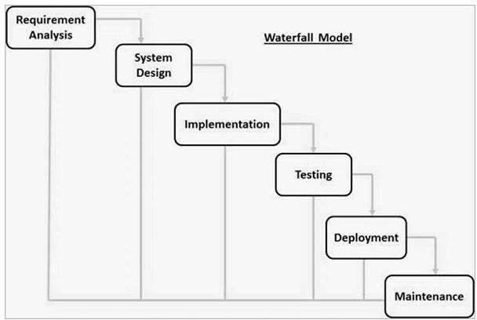

The sequential phases in Waterfall model are

* + - * **Requirement Gathering and analysis** − All possible requirements of the system to be developed are captured in this phase and documented in a requirement specification document.
      * **System Design** − The requirement specifications from first phase are studied in this phase and the system design is prepared. This system design helps in specifying hardware and system requirements and helps in defining the overall system architecture.
      * **Implementation** − With inputs from the system design, the system is first developed in small programs called units, which are integrated in the next phase. Each unit is developed and tested for its functionality, which is referred to as Unit Testing.
      * **Integration and Testing** − All the units developed in the implementation phase are integrated into a system after testing of each unit. Post integration the entire system is tested for any faults and failures.
      * **Deployment of system** − Once the functional and non-functional testing is done; the product is deployed in the customer environment or released into the market.
      * **Maintenance** − There are some issues which come up in the client environment. To fix those issues, patches are released. Also to enhance the product some better versions are released. Maintenance is done to deliver these changes in the customer environment.

### Methodology

The methodology that’s chosen is the preferred/favourable technique for the system development because it will give the user access to feel the moments with the machine to decide whether it is possible or not. The selected method would also decrease both the risk factor and project length.

### Method 1 (e.g Interview)

Interview : This is one of the most used approaches in gathering information, this involves question and answer from two parties and questions involving the relating topic and also important to software we are trying to develop.

The reason for the interview was to;

* To understand the trouble the client facing, interview was the easiest way to converse with the

client to have a better understanding

* To get or see the client perspective
* Collect detailed and important information

### Tools and Techniques

This part is describing the tools and the techniques that can possibly be implied when designing or building the proposed system.

The dispatch rider system is developed and implemented as a mobile application. Mobile applications are applications that run on mobile devices combined with server- side programming which provide functionalities such as interacting with users, connecting to back-end databases, and generating results to the app. There are many state-of-the-art mobile application development technologies used nowadays in building mobile applications. These technologies are majorly categorised into two: Frontend and Backend Technologies.

#### Frontend Technologies

Frontend web technologies refer to the technologies used in building web interfaces, specifically the parts of the website that the user will interact with. everything you see, from images and headings to sliders and buttons is made using VS Code, Android studio, HTML, CSS and JavaScript, these are the main components to any mobile app. The following below are the frontend technologies used in this project:

1. **React Native**
2. **Javascript**
3. **Redux**

**Backend Technologies**

Backend Development refers to the parts of an application that a user doesn’t see or directly interact with. The backend handles application and business logic, algorithms, database interaction and the processing of user requests. The following below are the backend technologies that are used in this project:

1. **Node**
2. **MongoDB**
3. **Cloudinary**

### Ethical Consideration

Since system developers participate in social processes for customers, clients, consumers, users, and partners during the system development or implementation phase, there are ethical issues and elements that can be directly linked to this activity. Representatives from the organisation and project management are present. Strict self-precautions were built to protect the developer from breaking any ethical standards or procedures because the social process being carried out has numerous opportunities for abuse, which is regarded as a breach of ethical norms and procedures. Ethics guidelines, including refraining from plagiarism and making misleading representations, were followed and enforced throughout this project.

### Requirement Analysis

This is very important to the developments of any project, because the basis must be tested, quantifiable, and identified within market conditions as well as it is described in the system architecture.

### Requirements Specifications

A software requirements specification (SRS) describes the nature of a project, software or application. In simple words, requirements specification is a manual of a project which states what the system should do.

#### Functional Requirement Specifications

A list of functional requirements of the system that’s been combined together is in the below table.

**Functional Requirement Specifications table 1**

|  |  |  |
| --- | --- | --- |
| **Req. No.** | **Description** | **Type** |
| R-101 | User will be able to place an order (selecting the origin for the pickup and destination). | Functional |
| R-102 | The user will be able to cancel order | Functional |
| R-103 | The user will be able to see rider details | Functional |

|  |  |  |
| --- | --- | --- |
| R-104 | The user will be able to see total time and estimated cost of order | Functional |
| R-107 | The user will be able to make payment online or  pay on delivery | Functional |

#### Non-Functional Requirement Specifications

The list of non-functional requirements of the system that’s been combined together is in the below table.

**Non-Functional Requirement Specifications table 1**

|  |  |  |
| --- | --- | --- |
| **Req. No.** | **Description** | **Type** |
| R-101 | When launched, the application shall stay running unless there is an intentional shutdown of the application or the platform. | Performan  ce |
| R-102 | The application should be able to handle large volume of users if increasing | Scalability |
| R-103 | The amount of storage needed for the system | Capacity |
| R-104 | The application shall have a GPRS feature that tracks the movement of the rider | Enhancem ent and Performan ce |
| R-105 | The availability and downtime of the application | Availabilit  y |
| R-106 | The system will provide a robust dispatch rider database and ease access to rider information | Enhancem ent |

### System Design

The design of the dispatch rider system is based on the client-server model. That means, the system is made up of two parts namely: the client side and the server side. The client side simply means the end user interacting or using the application through a software program. The client communicates with the server using HTTP (HyperText Transfer Protocol) request. The server side is simply the computer on which the application lives. It responds to clients with appropriate responses (e.g. images, text, web pages, audio etc.) based on the request received.

### Application Architecture

This part includes the application architecture, which outlines the foundation for the application to be constructed in relation to the various needs mentioned to ensure scalability, dependability, and management.

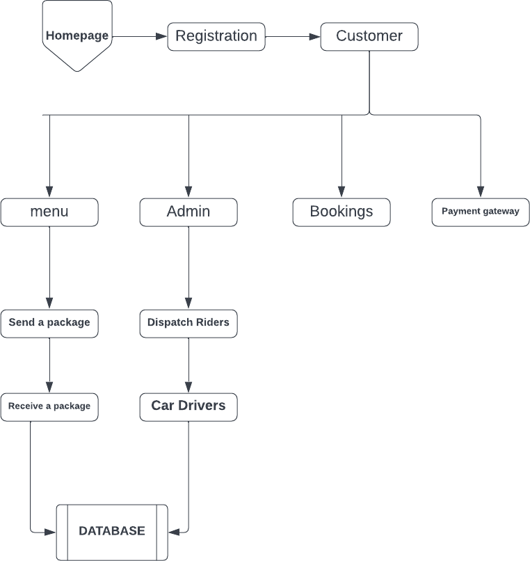

### Use Case

There are four types of actors that the system supports, each having specific capabilities. We will analyse each actor together with the associated use cases. The client actor is the user that has the booking application installed on his mobile phone. He uses the application to order for a rider by sending his location to the server that consists of the Cloud. This is the main functionality of the system, which we will be presenting later on in a more detailed fashion. We note that this use case is composed of two elements: getting the GPS position of the user, which is used by the system to identify the address of the user, and it also offers the possibility of fix tuning this location to specify it more precisely, as this location will be sent to the operator or the driver. The User use cases are presented in the table below.

#### Table 3.3: Client Use Case Specifications

|  |  |
| --- | --- |
| **CATEGORY** | **USE CASE** |

|  |  |
| --- | --- |
| Book vehicle | access map view of nearby vehicles |
| Book vehicle | Specify exact location for pickup |
| Book vehicle | Get time and cost estimates |
| Book vehicle | See vehicle details |
| Book vehicle | See driver details |
| Pay for the ride | In app payment |

Client is going to see the rider number. Also the user must specify the approximate location of pickup (Origin) and the destination, by selecting it from a map. This creates a more visual context for the user and creates a sense of consistency that’s going to be addressed by the rider. As we earlier specified, when an order is set, the address from the map is selected to specify the location of the pickup which will display on the map. It is possible for the user to cancel an order. The user use cases are illustrated in the figure 3.3 below.

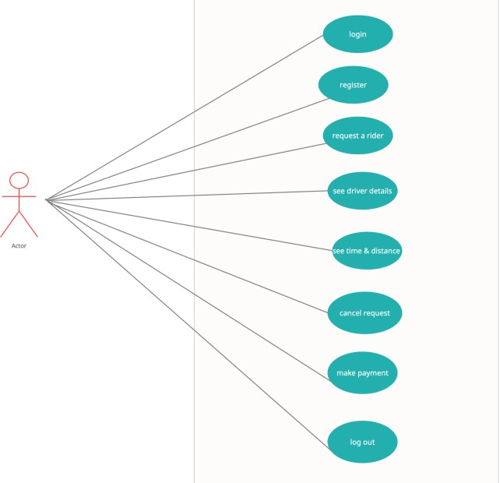

**DISPATCH RIDER USE CASE DIAGRAM**

### Data Design

The proposed system is a complex solution which can be decomposed into multiple components. From a high level architectural point of view, the core of the product is represented by the Cloud Engine, which is stored on a MongoDB server.

### Activity Diagrams

An activity diagram is a model that shows the process of a task or action from a use case.

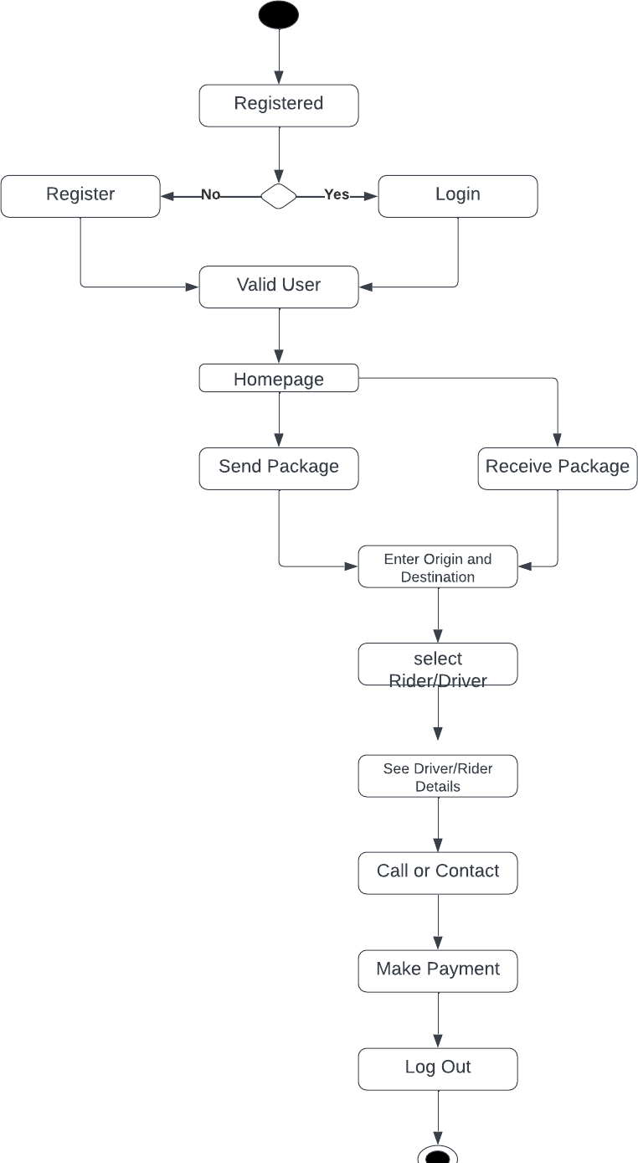

### Entity-Relationship Diagram (ERD)

The below ERD is for the system that will be used for the development, it has 4 entities which are named Admin, Customer, Order, Driver/Rider, vehicle

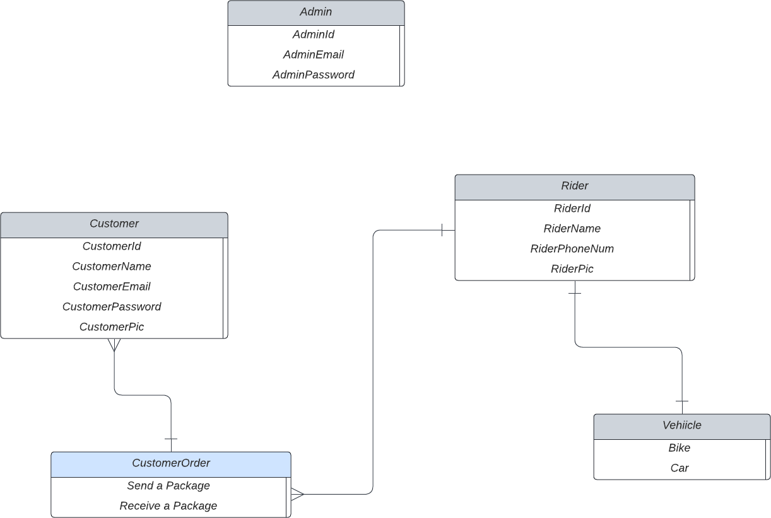

**Entity Relationship Diagram**

### User Interface Design

The User interface (UI) design is the process of making interfaces in software or computerized devices with a focus on looks or style. Designers aim to create designs users will find easy to use and pleasurable.

#### System interface View

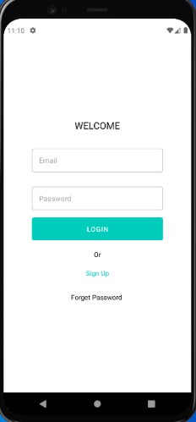

**Figure 4.1: Login Screen**

This is the first page of the application where user can login (already register) or sign up (new to the app)

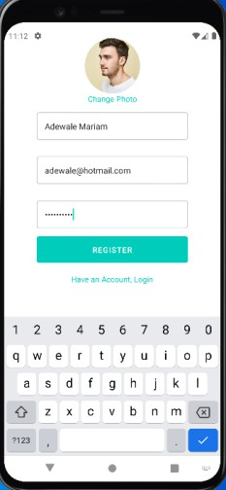

#### Figure 4.2: Sign up Screen

This is a sign up screen in which new user can register and login with the credentials supplied during the sign up session.

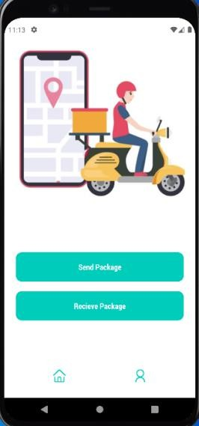

#### Figure 4.3: Action Screen

Action screen is where you can select the action you wish to perform on the app either sending a

package or to receive a package.

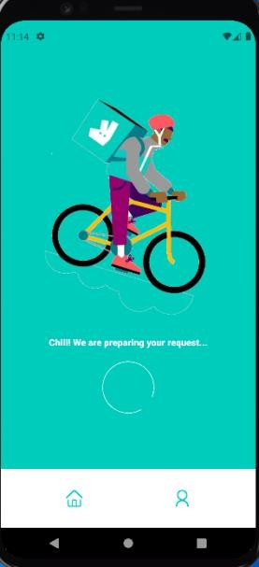

#### Figure 4.4: Preparing Action Screen

This is just a simple animation screen before navigation to the home screen.

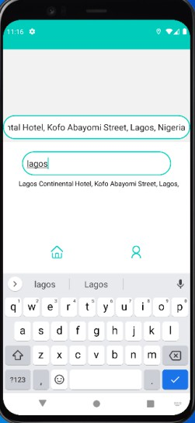

#### Figure 4.5: Home Screen

The figure above shows how the system looks at its home page where the user is going to select the origin of the destination (in which it was required).

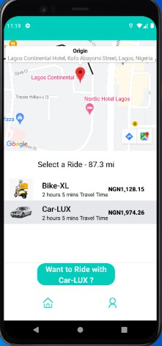

**Figure 4.6: Map and Ride Screen**

On this screen, the distance between the origin and the destination is shown on the map, displaying the time covered between origin and destination and the distance in miles and displaying the cost. Also you can select if you want to select a dispatch rider with a bike or car.

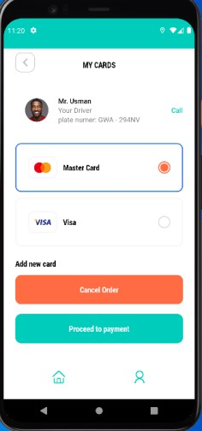

#### Figure 4.7: Payment Option Screen

The figure above shows the available payment option i.e. MasterCard, Visa card or Cash payment and the user can cancel the order too if need be.

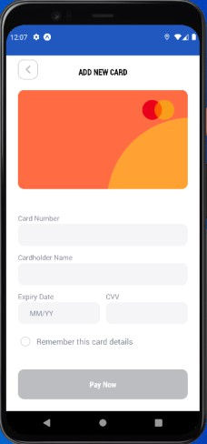

#### Figure 4.8: Card Payment Screen

The figure above imitates the payment mode if the user decided to pay with either MasterCard or Visa Card.

### Summary

The design methods that were involved in building this software were explored in this part, to know which of it is the most compatible with the implementation. The functional and non- functional requirements of the application were described accordingly together with the UML diagrams.

# CHAPTER 4: IMPLEMENTATION AND TESTING

### Overview

This chapter discusses the program used in the implemented and maintained. In this aspect, the choice of programming language, the designing of the program, and Program testing are discussed. Also in the implementation of the program. Implementing a program means following the details set in the system specification. When a system is implemented, it is tested so that it meets the aim set out in the initial specification. On the other hand, documentation serves as a reference manual to any person who wishes to enhance the research further.

### Main Features

The program for the new system was coded using a programming language that is scalable, flexible and more suitable for desktop applications. It involves the selection of a particular programming language that will best achieve the setup objectives. After carrying out the analysis in this research work, this researcher chooses React Native programming language to achieve the design objectives.

### Implementation Problems

When the implementation of this application was carried, there were problems along the journey

that were encountered but were resolved . Below are some of the problems;

* During the development of the application, there were challenges both in the installation of some required software’s
* I had issues with the API’S
* I wanted to host the database on the server but couldn’t

### Overcoming Implementation Problems

The problems that was faced during the application buildup was dealt with successfully with the assistance of my supervisor and a professional from where I did my SIWES(internship)

* I got the distance between the origin and destination by using googleplacesautoComplete
* So I was advised to use Heroku(an online web server hosting site) which I hosted the database on heroku

### Testing

A system implementation requires the testing of the newly developed mobile Application system. This involves not only testing and debugging of all computer programs. But the testing of all other data processing procedures, including the production of test copies of reports and other outputs, which should be reviewed by the users of the proposed system for possible errors.

**Unit test**: This is the first test that’s carried out as a single unit of a system or application. The test

is to see if the methods and objects of the system are functioning as expected to perform. **Integration Test**: This is the test after the Unit test. These parts include joining units together to form a group then testing them together in group. The integration test is going to be based on big groups.

**System Test**: This is carried out after the integration testing. If the two tests that’s stated above have been carried out, that’s when the system test can be done. Therefore, the system test is the testing of the entire system altogether.

### Tests Plans (for Unit Testing, Integration Testing, and System Testing)

The fundamental point of this test plan is to guarantee that the application gives a smooth and bug free use.

The target audience will be the entire public utilising the application for the purpose of ordering a rider/driver. Once the application is working as required, it would be published for users.

The testing would be carried out using the Visual Studio Code. Because of high and critical business requirements, the testing forms have been tweaked to take into consideration quicker and increasingly effective usage.

|  |  |  |
| --- | --- | --- |
| **Related requirement** | **Features to be tested** | **Test description** |
| R - 101 | User register function | User will be able to register |
| R - 102 | User login function | User will be able to login |
| R - 103 | User booking function | Users will be able to place an order (selecting the origin for the pickup and destination). |
| R - 104 | User cancel function | The user will be able to  cancel order |
| R - 105 | Rider function | The user will be able to see rider detail |
| R - 106 | User delivery function | The user will be able to see total time and estimated cost of order |
| R - 107 | User Payment function | The user will be able to make payment online or pay on delivery |

**Figure xx Test Plan Tree**

### Test Suite (for Unit Testing, Integration Testing, and System Testing)

The first test case was carried out on the first functional requirement, to ensure the application successfully registers a Customer. Table 4.1 shows the details of the test case.

##### Table 4.1: User registration test case

|  |  |
| --- | --- |
| Test Suite ID | Dispatch Rider System 1.0 Master Test  Plan (MTP) 1.0 |
| Test Case ID | #1 |

|  |  |
| --- | --- |
| Test Case Summary | Does the system enable a User register |
| Related Requirements | DR_001 |
| Prerequisites | Must deploy and run the application |
| Test Procedure | 1. Press the Sign up button for new user 2. Fill out the form on the page 3. Insert Your Profile Picture 4. Click on Register button |
| Test Data | Dispatch Rider System Application |
| Expected Result | The application will direct you to action page, When Successfully Registered |
| Actual Result | The application will direct you action  page, When Successfully Registered |
| Status | Success |
| Remarks (if any) | Responsive and user friendly |
| Test Environment | Pixel XL Android Emulator |

The second test was carried out on the second functional requirement, to ensure the application

successfully logs a User/Admin into the application. Table 4.2 shows the details of the test case.

##### Table 4.2: Login test case

|  |  |
| --- | --- |
| Test Suite ID | Dispatch Rider System 1.0 Master Test Plan (MTP) 1.0 |
| Test Case ID | #2 |
| Test Case Summary | Does the system request for a User/Admin to login before proceeding |

|  |  |
| --- | --- |
| Related Requirements | DR_002 |
| Prerequisites | Must deploy and run the application |
| Test Procedure | 1. Click the button sign in 2. Fill out the form on the page 3. Click on Login button |
| Test Data | Dispatch Rider System Application |
| Expected Result | The application will take you to the Action page, and it will display “Logged in successfully” |
| Actual Result | The application will take you to the Action page, and it will display “Logged in successfully” |
| Status | Success |
| Remarks (if any) | Responsive and user friendly |
| Test Environment | Pixel XL Android Emulator |

The third test case was carried out on the fourth, fifth and sixth functional requirement for the User side, to ensure that the application allows the Users to see the action page Where the user is going to select either to send package or receive package. Although the requirements are listed separately to select origin and destination.

Table 4.3 shows the details of the test case.

##### Table 4.3: Action Page test case

|  |  |
| --- | --- |
| Test Suite ID | Dispatch Rider System 1.0 Master Test  Plan (MTP) 1.0 |

|  |  |
| --- | --- |
| Test Case ID | #3 |
| Test Case Summary | Does the system allow a Customer to  select origin and destination |
| Related Requirements | DR_004, DR_005, DR_006 |
| Prerequisites | Must deploy and run the application |
| Test Procedure | 1. Click on either send or receive package 2. It will take you to home page where you will select origin and destination 3. Automatically takes you map screen where total distance between origin and destination is going to be displayed and also total cost 4. Click on the ride option 5. Select type of ride either bike or car. |
| Test Data | Dispatch Rider System Application |
| Expected Result | The application will show the distance between the origin and destination, total cost and ride type |
| Actual Result | The application will show the distance between the origin and destination, total cost and ride type |
| Status | Success |
| Remarks (if any) | Responsive and easy to use |
| Test Environment | Pixel XL Android Emulator |

The fourth test case was carried out on the third functional requirement for the side, to ensure that the application allows a user to make payment either by cash(payment on delivery) or online payment. Table 4.4 shows the details of the test case.

***Table 4.4: Deleting item from the menu test case***

|  |  |
| --- | --- |
| Test Suite ID | Dispatch Rider System 1.0 Master Test Plan (MTP) 1.0 |
| Test Case ID | #4 |
| Test Case Summary | Does the system allows payment |
| Related Requirements | FR_003 |
| Prerequisites | Must deploy and run the application |
| Test Procedure | 1. Select the ride option then it will navigate to payment option Page 2. It display Driver Information 3. Choose Online payment or by Cash (Payment on delivery) |
| Test Data | Dispatch Rider System Application |
| Expected Result | A success screen will be displayed with a Done button in which on clicking the done button will take user back to Action Page |

|  |  |
| --- | --- |
| Actual Result | A success screen will be displayed with a Done button. |
| Status | Success |
| Remarks (if any) | Responsive and easy to use |
| Test Environment | Pixel XL Android Emulator |

### Test Traceability Matrix (for Unit Testing, Integration Testing, and

**System Testing)**

Traceability matrix helps to ensure that all the test cases can be effectively traced back to their individual requirements. The traceability matrix for the test cases is shown in table 4.5 below.

***Table 4.5: Traceability Matrix***

|  |  |  |  |  |
| --- | --- | --- | --- | --- |
| **Req. No** | **Description** | **Prior ity** | **Tes t Cas e** | **Test Resul t** |
| DR_0  01 | The system shall enable  a user register | HIG  H | 1 | PASS |
| DR_0 02 | The system shall request for a user to login before proceeding | HIG H | 2 | PASS |
| DR_0 04 DR_0 05 | The system shall be able to allow a User to select origin and destination. | HIG H | 3 | PASS |

|  |  |  |  |  |
| --- | --- | --- | --- | --- |
| DR_0 06 |  |  |  |  |
| DR_0 03 | The system shall be able to allow User to make payment | HIG H | 4 | PASS |

### Test Report Summary (for Unit Testing, Integration Testing, and

**System Testing)**

The summary of the test carried out as shown above is as follows:

* + - * Number of tests carried out = 4
      * Number of successful tests = 4
      * Number of test failed = none

### Use Guide

The user guide will be referred to in the appendix sections

# CHAPTER 5: DISCUSSION, CONCLUSION, AND RECOMMENDATIONS

### Overview

Dispatch services are now very widespread in Nigeria, whether they are for bikes or cars. However, the main divide is that there is no app or system for it; instead, the majority of people handle it manually by having an Instagram account, a phone number, and an email address where customers can contact them. The gap mentioned above can be filled and remedied with the help of this program. This chapter will thoroughly examine and evaluate the methods used to create this application, as well as its shortcomings and obstacles, any improvements that will be made in the future, and suggestions for this thesis's readers.

### Objective Assessment

When the development of the application was going on, some standard aim and objectives have been pointed out at the beginning of this project. This project was carried out to fulfil those aims/objectives but due to certain circumstances not all aim/objectives were successfully met but most of them have been fully met.

### Limitations and Challenges

Due to various unanticipated and unpredictable causes and situations, limitations, restrictions, and problems were encountered when this project was being developed. These restrictions and difficulties are listed below:

* + - Writing the scripts that will run the query and installing the management server are both

necessary steps in trying to connect the application and database.

* + - Due to the short time constraint and the language employed, adding a GPS feature was not feasible.

### Future Enhancements

Every project has potential for growth and advancement, some of which have been identified and described below;

* + - User should be able to select whether light mode or dark mode
    - The system will have a GPS feature that follows the rider's movements.
    - The database will have a backup
    - Packages to be delivered can be described
    - Riders will be able to contact users

### Recommendations

Several recommendations have been made as a result of the gaps and divisions that were discovered throughout this process, and they are listed below;

1. The researcher has advised that a thorough feasibility study be conducted. Before starting the project, you should know why you are using that certain IDE, what database would be best for the project, and know the precise reason why you are using the database as well as any potential problems.
2. Project Backup is crucial, and version control is a crucial element in the creation of applications. If your laptop crashes unexpectedly or you have severe difficulties, you can easily recover and continue despite the setback.
3. The researcher advises making sure the hardware is capable of handling a demanding project; having a malfunctioning RAM or processor could be very risky and frustrating during the development of an application because it makes the entire system and process slow and, in some cases, results in the system crashing.
4. The researcher suggests putting better time management to use in order to make the most

of every opportunity because time won’t wait for anyone

### Summary

The dispatch rider system was build successfully and some of the requirements has been met and it will reduce stress such as waste of time and energy or data consumption for a user.the management is there’ll be less fraud because there’s going to be backup of all request that’s ever made and any detail that’s been entered into the system database is saved. It is within the blink of an eye that a rider is assigned to the user request.

It is very important that at the end of every work done, a conclusion must follow to help one understand the clear objective, while such work is being carried out. Towards the development and understanding of this project work, it could be concluded that computerising dispatch riders to a system will go a long way and with successful future enhancements, lots of goals will be achieved. More also, this project is open for further development and more exploration into the area not thus studied as the need arises and new innovations enumerate to meet the changing society.

# REFERENCES

* Medium. (2018). Software Development Life Cycle (SDLC) – A Quick Overview.[online] Available at: [https://medium.com/@emstelltech/software-developement-life-cyclesdlc-a-quick-](https://medium.com/%40emstelltech/software-developement-life-cyclesdlc-a-quick-) overview-dc4b7702d450 [Accessed 15 may 2022.].
* Waterfall Methodology, [Online]. Available at:

https://[www.tutorialspoint.com/sdlc/sdlc_waterfall_model.htm](http://www.tutorialspoint.com/sdlc/sdlc_waterfall_model.htm) (Accessed on 20 may 2022).

* Fatima amma, M. A.(2020 December). THE DESIGN AND IMPLEMENTATION OF A

DISPATCH/LOGISTICS (DELIVERY). A dispatch/logistics system. Retrieved may 2022

* Neville Arjani: Examining the Trade-Off between Settlement Delay and Intraday Liquidity in Canada's LVTS: A Simulation Approach (Working Paper 2006–20, Bank of Canada) [Simulation](http://googleweblight.com/i?u=http%3A//pss.bof.fi/Pages/Publications.aspx&hl=en-NG&tg=4014&pt=499) [publications](http://googleweblight.com/i?u=http%3A//pss.bof.fi/Pages/Publications.aspx&hl=en-NG&tg=4014&pt=499)
* Agile Methodology | What is Agile Methodology - Javatpoint. (2022). Retrieved 20 June 2022,

from https://[www.javatpoint.com/agile-methodology](http://www.javatpoint.com/agile-methodology)

* Santos, J., Santos, J., Santos, J., Santos, J., Santos, J., & Santos, J. et al. (2022). Jose Maria Delos Santos, Author at Project-Management.com. Retrieved 20 June 2022, from https://project- management.com/author/josemariadelossantos/
* Software Requirements Specification: How to Write an Effective SRS | DICEUS. (2022). Retrieved 20 June 2022, from https://diceus.com/custom-software-requirements-specification/
* Santos, J. (2022). RACI Matrix | Understanding Responsibility Assignment Matrix. Retrieved 21 June 2022, from https://project-management.com/understanding-responsibility-assignment- matrix-raci-matrix/
* Pankki, S. (2022). Publications. Retrieved 21 September 2022, from https://[www.suomenpankki.fi/en/financial-stability/bof-pss-simulator/publications/](http://www.suomenpankki.fi/en/financial-stability/bof-pss-simulator/publications/)
* 12, g. (2022). TRANSPORT MANAGEMENT SYSTEM FOR FACULTY OF SCIENCE.

Retrieved 16 July 2022, from https://[www.academia.edu/38568851/TRANSPORT_MANAGEMENT_SYSTEM_FOR_FAC](http://www.academia.edu/38568851/TRANSPORT_MANAGEMENT_SYSTEM_FOR_FAC) ULTY_OF_SCIENCE?email_work_card=view-paper (2022). Retrieved June September 2022, from https://[www.amazon.com/Creating-Computer-Simulation-Systems-](http://www.amazon.com/Creating-Computer-Simulation-Systems-) Introduction/dp/0130225118

## APPENDICES

**Appendix A - Project Document**

**Student Name :ABDULHAMEED MUHAMMAD SAHEED**

**Matric No :BU/19C/IT/4109**

**Project Topic :DISPATCH RIDER SYSTEM**

**Introduction:** This application describes a delivery system that’s meant for users that require dispatch riders to carry out delivery. The application contain of different features that helps the current situation of dispatch riders I.e login, register, book a driver/rider, view details or contact, make payments, logout. The final result of the application is to help users send or receive package with riders/drivers from one place to another.

#### Basic Features

* Validation of users input/data
* The user can view information and contact the driver/rider

#### Project Goals & Objectives

The main aim of this project is mainly to allow users to deliver their goods through dispatch riders to their customers. The project is designed to achieve objectives such as logging in, registering, booking a rider/driver and selecting payment choice and the following objectives;

* Provide a swift user experience
* Ease intra-logistic transportation activities.
* Provide a robust dispatch rider database and ease access to rider information
* Increase productivity among dispatch riders

**Appendix B - Questionnaire**

1. What do you think about a dispatch rider system(A system where dispatch riders can be ordered online)?

#### Answer :The idea sounds good and would help us have access to dispatch riders on the go

1. How do people order for riders if they want to send a package?

#### Answer : They contact me the owner whereby its gotten from different social medias from p2p and request for riders which I’ll send riders to initial location with phone number.

1. How often do you waste airtime connecting riders to users?

#### Answer : I actually use lots of airtime connecting from customers to my riders.

1. How does a rider make delivery to location is unfamiliar with?

#### Answer : They ask for addresses and sometime use the map for easy location

1. Do you think a system will help the society a lot?

#### Answer : yes actually I think the system will help the society a lot.

1. What features should the system have?

#### Answer : I think the system should allow us to receive orders from customers and able

1. What risk and problem are you facing?

#### Answer :the riders are not responsible and sometimes tamper with customers packages

1. Which of these problems do you want to solve particularly?

#### Answer : There should be responsible riders and not reckless drivers and one order at a Time

**Appendix C – Source Codes**

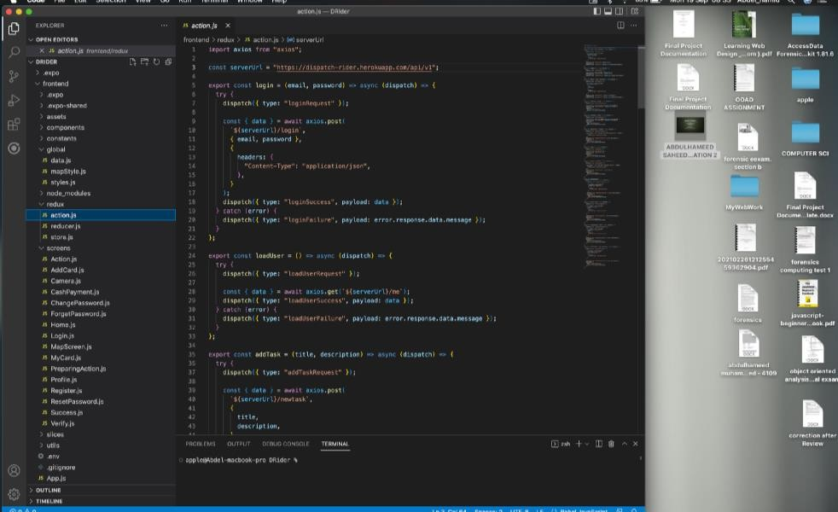

Caption

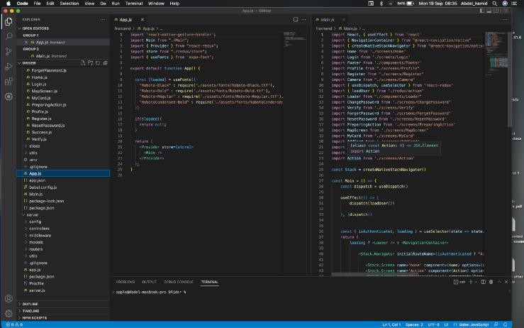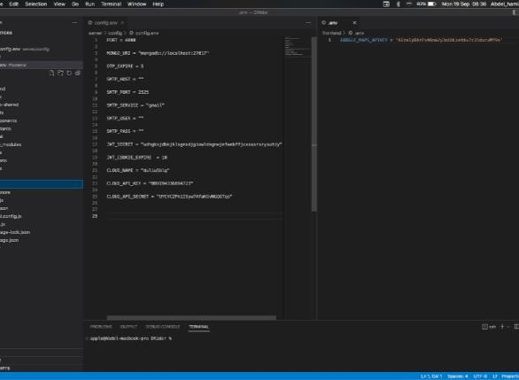

Caption Caption

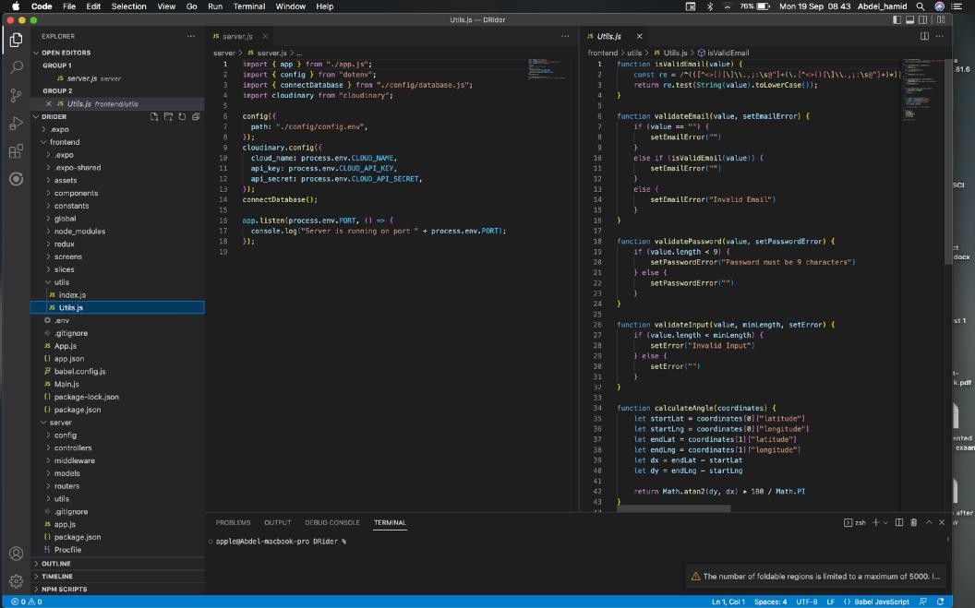

Caption

### Appendix D – Test Cases

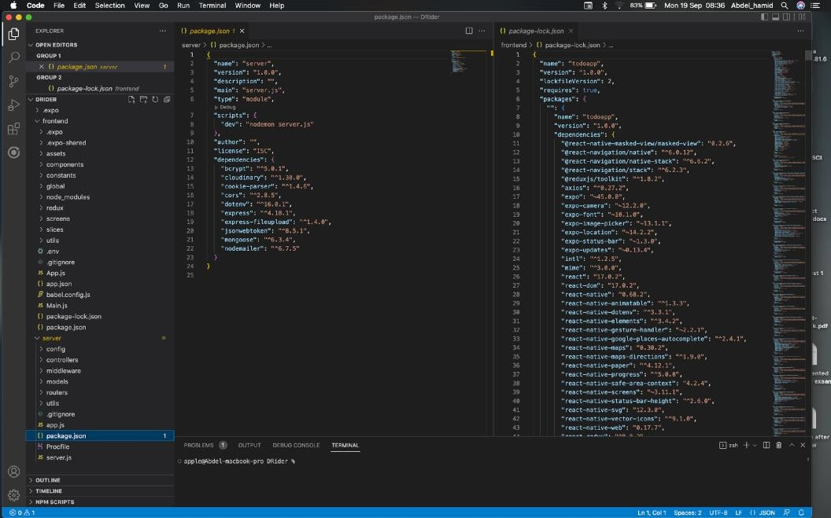

Caption

Test cases are referred and well explained in the chapter 4

**Appendix E – User Guide/Manual**

* **Open the application.**
* **Make sure there’s a good internet connection**
* **Once the app opens, the home page will pop up with the login or Register, and also forget password**
* **If you’re not registered, you’ll have to register make sure you add a photo**
* **After registration, another page will open which will show the functions of the app;**

**whether you’re sending a package or receiving a package**

* **If you click any of them, you’ll be asked from which location to destination then a driver will be assigned to the user’s request**
* **Amount estimated and distance estimated will be displayed for the request**
* **Payment can also be made through the app or payment on cash is allowed also**
* **Then after all this is successful you can logout.**