# DESIGN AND IMPLEMENTATION OF A CONTRACT MANAGEMENT SYSTEM

# ABSTRACT

# As business become increasingly dependent on Information Technology for their operations, project managers find themselves under pressure to remain innovative and go forward to deliver quality contracts on time and within budget constraints. However they try, some organizations still find it difficult to plan and track project components, stakeholders and resources. Additionally, project managers, team members and customers do not communicate frequently to share their expert opinions. Contracts tend to extend beyond scheduled deadlines, not necessarily due to lack of resources or incompetence of projects members, but often because of inability to elicit requirements completely and inadequacy of proper communication.

# To this end, with the advent of Information Technology, there has been an increase in the demand for software that make jobs easier for people, as a result, to keep up with rising demand, project managers need a way to effectively manage their contracts. Using the iterative methodology, a web-based contract management system was developed, that fully monitors contract progress, allocates tasks, creates milestones and provides an avenue for stakeholders to track project progress during its development phase in the construction industry. The developed system which was designed using PHP Hypertext Preprocessor programming language for front-end and MySQL for data storage solves the problem of unity and lack of communication. With this system, once added to a new project, all participating members may send messages to one another and keep tabs on the progress of the project so as to implement the stakeholder’s requirements efficiently.

**CHAPTER ONE**

**INTRODUCTION**

**1.1 BACKGROUND OF THE STUDY**

In November 1999, at Counter Entropy Strategies’ Summit on Software in Chicago, USA, 60 top executives from major engineering and software companies agreed that “the Internet will change how engineering software is used by facilitating collaborative efforts involving large numbers of people” (Dossick & Sakagami, 2008, p189). These industry leaders also predicted that “project Web sites will proliferate rapidly and that e-commerce will come to dominate all aspects of sales and marketing in architecture, engineering, and the construction industry” (as cited by Dossick & Sakagami, 2008, p189). Ten years on and have these industry forecasts been realized?

Multiple studies have demonstrated the benefits of using information and communication technology (ICT). However, the Architectural Engineering and Construction (AEC) Industry remains slow in adopting ICT, especially when comparing it to advanced manufacturing industries. A frequently cited reason is that the industry, by its very nature, is highly fragmented and complex. I believe that by understanding the barriers to implementing ICT in the AEC industry, methods can be then identified to overcome those barriers and limitations.

* + 1. **Information and Communication Technology (ICT)**

Information and communication technology (ICT) is becoming a significant instrument for businesses and countries in ensuring their growth and competitive advantages are optimized. In the 2008-2009 Global Information Technology Report (GITR), the World Economic Forum Executive Chairman, Klaus Schwab (2009) wrote; “Information and communication technology (ICT) is increasingly moving to the core of national competitiveness strategies around the world, thanks [to its revolutionary power as](http://www.pdfcomplete.com/cms/hppl/tabid/108/Default.aspx?r=q8b3uige22) a critical enabler of growth, development, and [modernization”.](http://www.pdfcomplete.com/cms/hppl/tabid/108/Default.aspx?r=q8b3uige22) The term ICT encompasses Information Technology (IT) plus areas such as telephony, broadcast media and all types of audio and video processing and transmission. It is used to describe a range of technologies for gathering, storing, retrieving, processing, analyzing and transmitting information.

Most developed and many developing countries are embracing the ICT movement as they observe the many benefits it brings, such as; empowering citizens with exceptional access to information and knowledge; offering significant outcomes in terms of providing education and access to markets; and successful means of doing business. New Zealand is no exception and the GITR (2008-2009, P 19) states that New Zealand possesses excellent infrastructure for ICT delivery and an “ICT-friendly political and regulatory environment.The majority of industries appear to be embracing the ICT movement – is the AEC (Architectural Engineering and Construction) industry?

**1.1.2 ICT and Contract Management in Architectural Engineering & Construction (AEC) Industry**

The AEC industry is fragmented due to its multi-disciplinary/multi-organizational nature and the many stakeholders and phases involved in a construction project environment. According to Nitithamong & Skibniewski (2006), this has led to well documented problems with information and communication processing and low productivity in construction projects. Matheu (2005) concurs and states that it has also “contributed to the proliferation of adversarial relationships between the parties to a project”.

The use of Information and Communication Technology (ICT) in the AEC industry is creating new opportunities for collaboration, coordination and information exchange among organizations that form a construction project team (Matheu, 2005, p38). ICT is becoming more evident in the AEC industry and is especially being used to combat the fragmentation issues referred to above. Its [benefits consist of more effic](http://www.pdfcomplete.com/cms/hppl/tabid/108/Default.aspx?r=q8b3uige22)ient financial control and communications, an increase in the quality of documents and the speed of the work, and simpler and faster access to data and reduced errors in documentation (Matheu, 2005, p1).

The Internet is at the center of the ICT applications which best facilitates a collaborative working environment in a construction project. It was predicted by Walker and Betts (1997) that the Internet will be the key to change in global construction business in the near future and will impact professions, collaboration, and the construction business structure (as cited in Nitithamong & Skibniewski 2006). Matheu (2005) stated that its use as a communication means can help information transfer occur more quickly and effectively, providing “a unique opportunity for the development of distributed systems that can cross organization boundaries and provide a unique opportunity for teamwork and workflow automation”. The web also has the ability to overcome incompatibilities of data formats; meaning that project participants using different software applications may eventually be able to share the same information over the Web in real time without any data transformations (as cited in Nitithamong & Skibniewski, 2006).

The use of ICT allows for real time access of information and improves coordination and collaboration between the project participants. Ahuja, Yang, & Shankar (2009) state that when utilized, its benefits include, “an increase in the quality of documents and speed of work; better financial control and communications, and simpler and faster access to common data as well as a decrease in documentation errors as use of incorrect data can comprise the scheduled completion of a project and lead to wastage of resources”.

**1.1.3 Web-based Contract Management Systems**

In recent times the concept of how ICT can manage construction projects has been widely acknowledged by practitioners (Matheu, 2005, p1). This concept is now commonly referred to as a computerized Contract Management System [(CMS). A CMS is an ele](http://www.pdfcomplete.com/cms/hppl/tabid/108/Default.aspx?r=q8b3uige22)ctronic project management tool conducted through [the ‘Extranet’, which is a pri](http://www.pdfcomplete.com/cms/hppl/tabid/108/Default.aspx?r=q8b3uige22)vate network that uses Internet protocols to transmit information. They are designed to store and manage project information. Basically, these systems provide a centralized, commonly accessible means of transmitting and storing project information. Project information is stored in a server and a standard web browser is used as an access point to exchange this information, eliminating geographic and boundary hardware platform differences (Matheu, 2005, p1).

The basic rationale behind CMSs is that communication and information control in modern design and construction projects are chaotic. Frequently, this leads to lapses in communication, poor understanding, and ultimately, to annoyance, conflict, and cost and programming over-runs (O’Brien, 2000). These systems offer a level of access to project information that exceeds traditional means of communication such as telephone, fax, traditional post, and email, and storage mechanisms such as project binders for hardcopies. CMSs provide project participants with the same information in a reliable and easily retrievable method, in theory, improving communication and leading to improved projects (O’Brien, 2000).

Many authors believe that CMSs improve overall coordination, collaboration, and communication on construction projects in a variety of ways which will be discussed in subsequent chapters (Cox, 2007). Cox (2007) comments that, “No other technology provides interaction, communication, collaboration, archival data, a project-information continuum, participant reliability, and accountability”. Cox (2007) also suggests that CMS technology is, “placed to make the largest impact on construction project delivery since the introduction of the person computer”, which is a bold statement.

**1.2 STATEMENT OF THE PROBLEM**

[Despite](http://www.pdfcomplete.com/cms/hppl/tabid/108/Default.aspx?r=q8b3uige22) proven advances in the technology itself and the considerable and recognized benefits Computerized Contract Management Systems (CMSs) present, adoption and implementation of this technology still remains slow within the Architectural Engineering Construction (AEC) and contract industries in general.

For consuming necessary time, keeping all troubles less, and to organize all  
documents into one place and most importantly, to keep track of contracts that are in production for customers or for keeping an eye on errors or mistakes that occur during the work process, then a good Contract Management System is needed. To consider everyday use and needs, the aim was to make an inside system for the company. The system is for helping workers (namely programmers, project managers, developers) to deal with some specific project and its errors occurred. Project management system is needed, for helping to organize and keep an eye on contracts and there processes. The system is web-based; there are possibilities to add documents and specifications for specific project. Documentation can consist of different graphs, database diagrams and graphical diagrams, which are needed for project development. The most important part is that, the system has an issue tracking system, a system where can be added comments, bugs and other related questions for specific project.

At the moment, the company has no documentation management system; Specification requirements, application documents and other kind of documents related to one specific project lay around in different places. Most of these documents get spoilt after long time of mishandling. This yields problems as the company cannot keep accurate track of income and expenditures as to maximize profit.

It is better, less time consuming and comfortable to get all the documents in one place. Cloud storage can also be used for database backup. Besides this, the system has all documents related to a specific contract, it also has the code, right paths, folders and links for easy website navigation.

### **1.3 OBJECTIVES OF THE STUY**

The main objective of this study is design and develop a computerized contract management system for a construction industry. To achieve the stated objective, the following specific objectives were laid out:

* Design a decentralized system where contractors and managers can share and store contract information
* Design a secured database for data and information storage devoid of unauthorized access and hack.
* Develop a nice and easy to use interface that will to a great extent reduce the stress involved in writing on a paper.
* Develop a module in the system for easy search of contracts, sorting either by date, paid, completed or pending.

### **1.4 SIGNIFICANCE OF STUDY**

Although the current uptake on CMSs is lower than the anticipated trend, the systems hold great promise and are expected to replace traditional project management methods (as cited in Nitithamong & Skibniewski, 2007). CMSs are focused on efficient information management, of which is a major element is collaborative communication. According to Quashie (2009), a well-structured communication system is a key factor in the success of building project management.

[In achieving the aim of this rese](http://www.pdfcomplete.com/cms/hppl/tabid/108/Default.aspx?r=q8b3uige22)arch, the information and data gathered will assist in [increasing the general awareness](http://www.pdfcomplete.com/cms/hppl/tabid/108/Default.aspx?r=q8b3uige22) of CMSs and their associated benefits in the AEC industry; inform CMS vendors of general limitations with the software; and inform the AEC industry how and why to implement CMS on New Zealand construction projects. This study will be of interest/significance to the AEC industry and their clients.

Government, industry and clients are all seeking to bring about a change in the construction industry, change that will increase value to clients by improving quality, competitiveness and profitability. Traditionally, the emphasis has been on project managers to manage the interface between the project and the client’s organization. There is now a shift towards the requirement of managing the flow of information through the whole life cycle of the project with greater emphasis on those activities which actually add value.

Project managers would particularly benefit from this research as “communication consumes about 75-90% of a project manager’s time and information” and CMSs are predominately centered around improving the communication flow and control on construction projects. Matheu (2005) reiterate this point by stating that, “the management of construction projects is about managing the project communication and information flow. And managing project information about managing the documentation generated in a particular contract”.

This study will also highlight how CMSs have significant potential to add value to the internal performance of an organization and to the whole life cycle of a project, as well as the client. That is, the potential benefits of successful implementation. Understanding which factors are critical for system success is fundamental for improved CMS implementation.

[By verifying the benefits of usin](http://www.pdfcomplete.com/cms/hppl/tabid/108/Default.aspx?r=q8b3uige22)g such systems, setting out the barriers to CMS [implementation and identifying](http://www.pdfcomplete.com/cms/hppl/tabid/108/Default.aspx?r=q8b3uige22) methods of overcoming those barriers, this study will also:

* Assist the vendors of Web-based project management software with feedback from their users,
* Encourage organizations to prepare for and implement ICT, and
* Provide options for overcoming the barriers to implementing CMSs for the AEC industry and their clients.

**1.5 SCOPE OF THE STUDY**

This study revolves around creating a computerized system that will enable contracts management company carry out their projects smoothly. It is a web-based system which is going to run on a browser.

The system has a landing page which welcomes the user with a brief information about the website. It contains links to other pages of the website through which users can communicate with the company managers, seal a contract and monitor the flow of work through the website.

For the purpose of this project, the system is going to be hosted on a localhost and not an online server. This is for developmental purposes. For actual implementation and to make the system available from any part of the world, its database has to be hosted on.

**1.6 Research Question**

The research questions for this study are:

1. Why implementing a computerized contract management system for the company, is it really important?
2. What are the key barriers influencing the implementation/adoption of computerized contract management systems in the Nigeria construction industry?”
3. What are the recommendations to overcoming these barriers?”

**1.7 DEFINITION OF TERMS**

* **Contract Management System**

Contract Management Systems or CMSs have other guises such as ‘Online Collaboration and Project Management (OCPM) Technology’ and ‘Project Management Systems – Application Service Providers’ (PM-ASPs). For the purposes of this research and the sake of generality, the use of Contract Management Systems (CMSs) shall encompass the previously stated commonly used terms, even if such terms are not definitively accurate.

* **Application Service Providers (ASPs)**

“ASPs are third party entities that manage and distribute software-based services and solutions to customers across a wide area network from a central data center. In essence, ASPs are a way for companies to outsource some or almost all the aspects of their information technology needs” (Matheu, 2005).

* **Construction Project Management**

“**Construction Project Management** is the planning, control, and coordination of a project from conception to completion (including commissioning) on behalf of a client. It is concerned with the identification of the client’s objectives in terms of utility, function, quality, time, cost, and the establishment of relationships between resources. The integration, monitoring and control of the contributions to the project and their output, and the evaluation and selection of alternatives in pursuit of the client’s satisfaction with the project outcome and fundamental aspects of Project Management” (as cited in Matheu, 2005).

**CHAPTER TWO**

**Literature Review**

**2.1 CONTRACT MANAGEMENT**

Modern contract management first came into existence in the early 1950s on large defense projects. After World War II, the increasing complexity of projects and a diminishing wartime labour force demanded new organizational structures. The Program Evaluation and Review Technique (PERT) charts and Critical Path Method (CPM) were pioneered allowing managers greater control over heavily engineered and highly complex projects Matheu, 2005).

These techniques spread, initially to larger companies, as business leaders sought new management strategies. However, after viewing the success of these operations, smaller organizations gradually took to adopting the strategies and now a very high majority of construction firm worldwide implement some form of project management (Alshawi & Ingirige, 2003). These days, projects are generally far more complicated involving large capital investments, combining several disciplines, project members who are widely dispersed, tighter schedules, and rigorous quality standards. These factors together with the rapid developments in Information and Communication Technology (ICT) have offered project management practitioners the opportunity to take advantage of newly developed management tools and the latest technology, such as Contract Management Systems (CMSs) (Alshawi & Ingirige, 2003).

According to Ahuja (et al., 2009) contract management requires a system that, “provides shared project information, analysis of tools to analyze the information, [a collaborative infrastructure](http://www.pdfcomplete.com/cms/hppl/tabid/108/Default.aspx?r=q8b3uige22) to handle the flow of information, a multi-device access to the pertaining information and a system that ensures the persistence of the underlying information among the participants”.

**2.2 BENEFITS OF ICT**

ICT tools and systems have the ability to provide these services (Ahuja et al., 2009).

* + 1. **Communication:**According to the Royal Institute of British Architects (as cited in Matheu, 2005), “The overall role of project management….is to harmonize the functions of planning, communicating, monitoring and control in order to meet the project’s overall objectives as defined by the scope, time, cost, quality and client satisfaction”. Communication deals with the producing, issuing and transmitting reports/documents, and chairing meetings with key project participants in order to ensure the proposed timing, method and strategy is made available and understood. Matheu (2005) writes that, in essence, collaboration of various participants in a project is measured by how effectively the communication channels were managed”. Therefore, as conveyed by Matheu (2005), “The responsibilities of the Project Management are to plan, coordinate and control the overall project”. Such duties can be achieved through a good communication and information management tool, such as a Contract Management System (CMS). There is a growing body of literature delineating the advantages/benefits of using CMSs on construction projects.

**Advantages**

Although exploring the various advantages of implementing CMSs is not within the direct scope of this research, the author believes it is important to briefly [outline the benefits of using](http://www.pdfcomplete.com/cms/hppl/tabid/108/Default.aspx?r=q8b3uige22) such systems in order for the reader to understand [why potential users *would* im](http://www.pdfcomplete.com/cms/hppl/tabid/108/Default.aspx?r=q8b3uige22)plement a CMS. It is important to understand the benefits in order to appreciate the purpose of this research - which is to discover what the key barriers are influencing the implementation of CMSs in the New Zealand construction industry. When the benefits are known and the advantages of such systems are explained, the question then remains, “why is the Architecture, Engineering and Construction (AEC) industry not implementing these systems on *all* large construction projects?

**Quasi-tangible Benefits**

1. **Improved communication:**

Matheu (2005) suggests that CMSs improve project communication, align business processes increasing transparency as barriers to communication are removed. Collaborative systems reduce the amount of re-work by storing not just information but the knowledge that derived it. A study conducted by Nitithamyong & Skibniewski (2007) concurs with Matheu’s statement, finding that, “enhancing coordination among team members” is 3rd in the rankings of the benefits of CMS. Alshawi & Ingirige (2003) add that by using a CMS, the speed of communication is substantially increased, resulting in shorter lead-times for tasks. Alshawi & Ingirige (2003) also comment that such systems result in accuracy of communication which transpires into fewer errors and rework costs.

1. **Improved data/information/document availability:**

This benefit derives from the fact that the technology allows the users to “reach and search the project information globally” and thus able to work from anywhere worldwide (Becerik and Pollalis, 2006). Becerik and Pollalis’ (2006) research states that, “The technology ensures and forces data population and provides a structured and easy way to store it”. Assistance in searching for files and documents is ranked 4th in Nitithamyong & Skibniewski’s (2007) study of CMSs success factors, which corroborates the above findings. Cox (2007) also corroborates with the above commenting that, “by having a central portal of the most up-to-date project information for all participants provides the opportunity to access whatever is needed to perform individual project responsibilities”. Cox (2007) also comments that project participants can access archived historical data through these systems which allows the users to understand project issues as they arise and are resolved.

1. **Enabled complete audit trial**

These systems ensure all project information and communication threads have been tracked and stored in a structured and credible way (Becerik and Pollalis, 2006). Cox (2007) views this as a major benefit of using CMSs, because project participants can easily see which team member/s may be causing any bottlenecks by holding up a decision or essential piece of information. This results in improved accountability of project team members and reduces the likelihood of delays (Cox, 2007).

1. **Improved information management**

[CMSs “provide an](http://www.pdfcomplete.com/cms/hppl/tabid/108/Default.aspx?r=q8b3uige22) extensive file management system with granted [access or restrictions](http://www.pdfcomplete.com/cms/hppl/tabid/108/Default.aspx?r=q8b3uige22) to particular project areas and folders” which allows for greater ease of searching for specific documents (Becerik and Pollalis, 2006). Nitithamyong & Skibniewski’s (2007) study concurs, and found, “facilitating document transfer and handling” ranked second out of the most proficient benefits from using a CMS. Becerik and Pollalis (2006) suggest CMSs give members of the project team certainty of information resulting in minimised duplication of effort and wastage on projects. Not only does the user have access to the correct version of documentation, but they also have the ability to track the previous versions and monitor who else accessed or modified the information.

1. **Faster reporting and feedback**

Becerik and Pollalis (2006) suggest project teams can manage complex programs with less administration staff and can communicate with greater effectiveness when using a CMS. In contrast to this, O’Brien (2000) argues that it should be recognized that these systems are “not necessarily labor-saving devices for all individuals on a project team”.

Ilich, Becerik, and Aultman (2006) suggest that CMSs increase the speed of communication on a project which is corroborated by Alshawi & Ingirige (2003) who comment that such systems improve efficiency through “speedy and accurate information between head office and sites”. The study by Matheu (2005) also suggests CMSs create a reduction of the response time for RFIs (Requests for Information), COs (change Orders) and specifications clarification. Nitithamyong & Skibniewski’s (2007) study ranks “enabling immediate report and feedback” 5th from all CMS benefits.

1. [**Enabled valid and ac**](http://www.pdfcomplete.com/cms/hppl/tabid/108/Default.aspx?r=q8b3uige22)**curate decision making**

With faster, more complete information flows comes faster decision making. The web-based software also increases awareness meaning “project managers can easily realize any changes that would affect a project or a contractor” (Becerik and Pollalis, 2006). Alshawi & Ingirige (2003) also acknowledge “Better management and decision-making” as a benefit of CMS implementation.

1. **Improved process automation and standardization**

Documents are generated in a structured way providing the users with a clear and familiar format to interpret. A participant of Becerik and Pollalis’ (2006) research commented that it is very easy to issue or answer an RFI or write meeting minutes once the software is up and running and all the contacts are in the system.

**Intangible Benefits**

These benefits cannot be quantified monetarily rather are represented by qualitative benefits. According to the research of Becerik and Pollalis (2006), “Business benefits rather than cost savings have been more important for the participating investors in most cases”. Their research continues, explaining that most important to organizations when deciding whether to implement these systems are goals such as, “performing the right tasks correctly, staying consistent with the organization’s mission, vision, and values, and supporting its goals and objectives”.

Becerik and Pollalis (2006) acknowledge some performance benefits as: “supply chain integration, process reengineering, gained market access, improved customer relationships, gained competitive advantage, [performance measuri](http://www.pdfcomplete.com/cms/hppl/tabid/108/Default.aspx?r=q8b3uige22)ng, knowledge management, and increased [negotiation power”.](http://www.pdfcomplete.com/cms/hppl/tabid/108/Default.aspx?r=q8b3uige22)

To summarize, it is obvious that many benefits are derived from utilizing CMSs and most are reflected in multiple literature. The implementation of ICT’s/CMSs in the AEC industry is a way to “reduce costs; maintain or create a competitive advantage; save time; and improve productivity, safety, and the accessibility and exchange of information. There is no lack of potential solutions; however, the measurement of benefits and barriers to implementation is not straight forward” (Rankin & Luther, 2006). Prima facie, when observing these significant advantages, one may question why these systems are not utilized on every construction project in New Zealand. There is a growing body of research suggesting the construction industry has been slow to adopt and take advantage of the ICT tools available.

* 1. **LIMITATIONS AND BARRIERS TO THE ADOPTION AND IMPLEMENTATION OF ICT CONTRACT INDUSTRY**

Earlier studies of this topic indicate that cost and technological issues were the major barriers to ICT implementation in the construction industry. However, recent studies have shown a shift away from these barriers with a move towards management problems within construction organizations as the major barrier (as cited in Peansupap & Walker, 2005). The International Council for Research and Innovation in Building Research (CIB) W78 conference papers identifies the management of IT/ICT as a major theme, especially its adoption and implementation (as cited in Peansupap & Walker, 2005). Ahuja, Yang & Shankar (2010) acknowledge this in their research also, stating that studies in this area, until recently, have had a predominately technical focus rather than a managerial focus.

Hewage (et al, 2008) suggests that, “Construction companies lag behind other industries in the creation of long-term strategic plans for the implementation of information technology”. According to Peansupap & Walker (2005) ICT adoption should be planed and strategically thought through and implemented otherwise an organization may obtain little benefit from an ICT investment. For example, it may [result in slow ICT adoption by c](http://www.pdfcomplete.com/cms/hppl/tabid/108/Default.aspx?r=q8b3uige22)onstruction companies because they are unsure of how to commence the implementation process which may result in loss of competitive advantage (Peansupap & Walker, 2005). Unplanned ICT adoption may cause ongoing issues such as user confusion, technical problems, lack of clarity surrounding the software and what the ICT benefits are. This may lead to a negative perception of ICT use among potential users resulting in a resistance to its adoption (Peansupap & Walker, 2005).

Other limitations identified are as follows:

### **Lack of Understanding**

### Many construction practitioners have insufficient experience in understanding organizational and social issues of strategic ICT adoption which is recognized as an important implementation barrier (Peansupap & Walker, 2005). There is also a lack of understanding by the users in terms of the benefits derived from using CMSs. Hewage (et al, 2008) suggests, “The number one barrier to implementation of technology is that construction managers are not aware of proof that the addition of technology has benefits and what possible problems might be experienced”.

### **2. Security & Access**

Because much of the information flowing through these systems is commercially sensitive the Application Service Provider (ASP) must be trusted, reputable and secure (Matheu, 2005). O’Brien (2000) argues there is concern over who has access to the project Web site and asks the question; “What is the boundary to the site?” He comments that it is virtually impossible to give everyone working on a project a password, and also warns that often the greater the security, the greater [the complexity of the system](http://www.pdfcomplete.com/cms/hppl/tabid/108/Default.aspx?r=q8b3uige22) and this deters occasional users from applying the [tool. Alshawi & Ingirige (20](http://www.pdfcomplete.com/cms/hppl/tabid/108/Default.aspx?r=q8b3uige22)03) comment that security is a major issue and that it, “ imposes a lot of financial constraints on project teams as the costs need to be incorporated into project feasibility studies”.

**3. Infrastructure and difficult Internet access.**

Matheu (2005) suggests that most companies do not have the necessary infrastructure to support these systems and most construction sites do not have access to the internet. Not surprisingly, a study by Nitithamyong & Skibniewski (2007) indicates the more project members have access to the internet on site and the faster and more reliable that is, the more beneficial the CMS is to the project. The systems are subject to crashes of both the software and the Internet itself and because the systems are web-based, there is a constant need to upgrade the firewall protection (Alshawi & Ingirige, 2003).

### **4. Need for training**

There is an allowance required for time and money in order to get the users trained and competent using the system. However, projects that provide more training to team members gain higher CMS performance in all perspectives (Nitithamyong & Skibniewski, 2007).

### **5. Cost and time over-runs**

Unclear ICT implementation strategy and processes can result in excessive technological investment costs, delay the implementation, and cause business uncertainty (Peansupap & Walker, 2005). That said, Nitithamyong & Skibniewski’s (2007) study suggests that when more resources in terms of money, time, and personnel are provided, CMSs performance tends to be higher. According to Alshawi & Ingirige’s (2003) research, an issue when implementing CMS is the cost of having to treat the web server as a full-scale IT project, involving the appropriate funding and appropriate staffing.

[**6.**](http://www.pdfcomplete.com/cms/hppl/tabid/108/Default.aspx?r=q8b3uige22) **User resistance**

[Lack of top management sup](http://www.pdfcomplete.com/cms/hppl/tabid/108/Default.aspx?r=q8b3uige22)port or organizational commitment to ICT implementation can result in user resistance. O’Brien’s (2000) study found that ‘pragmatists’, who make up the bulk of the population, need to see some form of benefits when using Web-based systems before they adopted it, whereas ‘innovators’ experiment and commit to their Web use and only accept those with perceived potential benefits. ‘Sceptics’ are at the other end of the scale and resist any change on principal. This indicates that the type of user can influence their adoption decision (as cited in Peansupap & Walker, 2005). According to Dossick & Sakagami’s (2008) there is a resistance from small contractors because of lowcost effectiveness or merit.

According to Hewage’s (et al, 2008) study, managers indicate they have experienced resistance from ‘older’ workers whenever a modern technology has been introduced. Many of the decision makers around the implementation of CMSs are older and more experienced, and these are the same type of workers who have shown resistance to the technology.

### **7. Task-technology fit**

A poor fit between the technology and the organizations requirements is known as ‘task-technology fit’. ‘Task-technology fit’ refers to the technology fitting and being conducive with the user’s requirements to perform various tasks (as cited in Peansupap & Walker, 2005). Obviously if the two are not compatible, then the investment has been somewhat worthless.

### **8. Declining work performance**

Researchers present many benefits of using ICT, such as reducing time and cost of information transfer and improved communication. However, Peansupap and Walker (2005) suggest that “these benefits will only be realized if technology is fully used and integrated into an organization”. [IT benefits that are perceived](http://www.pdfcomplete.com/cms/hppl/tabid/108/Default.aspx?r=q8b3uige22) as low is often a result of poor organizational [change management by the m](http://www.pdfcomplete.com/cms/hppl/tabid/108/Default.aspx?r=q8b3uige22)angers of the company. However, it is argued that the introduction of new IT into an organization can cause a decline in work performance due to training having to take place and staff adapting to the new system. Uncertainty during the time ICT is implemented can also cause a performance reduction (Peansupap & Walker, 2005).

**2.4 RECOMMENDATIONS**

### **1) Initiation**

Research conducted by Dossick & Sakagami’s (2008) suggests “owner-initiated propagation”, where the owner encourages team members to implement the CMS, is more successful than “contractor-initiated propagation”, where the general contractor leads the CMS implementation.

**2) Evaluation**

Peansupap and Walker (2005) state that it is essential to evaluate feedback from users of the system and to rectify any issues they encounter. This recommendation is echoed by Ahuja (et al, 2010) who suggests ICT implementation should be supported by users’ feedback.

**3) Level of Support**

There are multiple studies that suggest support is required internally from within the user organization and also externally from the Application Service Provider (ASP) in order to gain successful implementation of a CMS. [Dossick & Sakagami (20](http://www.pdfcomplete.com/cms/hppl/tabid/108/Default.aspx?r=q8b3uige22)08) state that, “For successful implementation, there needs to be support from upper management and the leaders of the primary user organizations. Research by Nitithamyong & Skibniewski (2007) also suggests, “The level of support from top management has significant positive correlations with all CMS performance perspectives (i.e. strategic, cost, and quality)”. Therefore, a strong level of commitment from top level personnel to a CMS is required if it is to be successful.

An essential element to adopting ICT is to provide organizational [technical] support for users and create a long-term relationship between supplier and user, otherwise the implementation of ICT is likely to fail (as cited in Peansupap & Walker, 2005). Nitithamyong & Skibniewski’s (2007) study goes further, stating that, in order for the system to provide the best results for the users and ultimately the project, Application Service Providers (ASPs) should have:

* Easily accessible contact facilities,
* The resources to respond quickly to any queries,
* Staff with good attitudes towards their customers,
* Staff with the ability to understand technical issues related to the system and to provide solutions to such issues,
* A good understanding of the construction sector to ensure the success of system implementation.

### **4) System Controller**

O’Brien (2000) recommends designating a few project team members as champions of the CMS who have responsibility of not only ensuring it’s operational and performing in the correct manner, but also encouraging team members to use it during and prior to implementation. Nitithamyong & Skibniewski (2007) concur with this statement, adding that a CMS should [not be solely mandated b](http://www.pdfcomplete.com/cms/hppl/tabid/108/Default.aspx?r=q8b3uige22)y an owner otherwise the system will tend to lack a [champion and possibility](http://www.pdfcomplete.com/cms/hppl/tabid/108/Default.aspx?r=q8b3uige22) result in failure. Somewhat in contrast to Nitithamyong & Skibniewski (2007) is Dossick & Sakagami (2008) who suggests the ideal person to lead the implementation of the system is the owner who then requests the use of CMS in the project contract.

### **5) Define Use**

### **a) What**

By defining *what* uses the system should be implemented for, users gain clarity and it also defines their job tasks in relation to those uses. By defining specific uses, it creates a purpose for the system and gains credibility with the team members. Uses and boundaries of the system should be defined early in the project and it should not be seen as a fluid tool but rather a solid ally in achieving operational goals (O’Brien, 2000).

**b) Who**

According to Nitithamyong & Skibniewski (2007), it is recommended that all associated team members should have access to a CMS and access should not be restricted to personnel that are at high authority or management levels. However, they do mention that a very large number of users can be chaotic and difficult to control. The study also states that, “In order to prevent implementation problems, it is important to decide early in the project on an adequate number of project team members who can obtain access to the system”.

c) How

* Etiquette

[Establishing etiqu](http://www.pdfcomplete.com/cms/hppl/tabid/108/Default.aspx?r=q8b3uige22)ette for the utilization of CMSs is an important [aspect to successf](http://www.pdfcomplete.com/cms/hppl/tabid/108/Default.aspx?r=q8b3uige22)ul implementation according to O’Brien (2000). He states that there must be a place for formal and informal communication and it should be decided when which is used. He defines formal communication as the equivalent of letters and normal written correspondence and informal communication as the typical content and style of an email and verbal communication. O’Brien (2000) also recognizes the need for determining who communicates with whom. Dossick & Sakagami (2008) reiterate this point by stating, “The important thing is that users be able to distinguish how to use new processes and conventional processes, such as fax or telephones, and select the best tool for the communication that needs to take place”.

* Information Flow

O’Brien (2000) suggests mapping the information flow on the project when designating uses of the Web site assists in its implementation, so it’s clear who has access to what areas and may highlight any boundary issues.

### **6) Enforce Use**

O’Brien (2000) recommends enforcing the use of the systems because they are most effective when they contain all the information related to a specific issue. Even when a small piece of information is missing, the system can be far less useful. In concurrence with this, Dossick & Sakagami (2008) recommend enforcing the use of such systems by way of contract specifications. Ahuja (et al, 2010) agree, stating that, “Implementation will include introducing contract clauses defining ICT adoption as scope of work of the projects and managing building projects utilizing the new system”.

[**7) Inception**](http://www.pdfcomplete.com/cms/hppl/tabid/108/Default.aspx?r=q8b3uige22)

[O’Brien (2000) suggests](http://www.pdfcomplete.com/cms/hppl/tabid/108/Default.aspx?r=q8b3uige22) using a CMS from the beginning of a project and not to force it into projects already in motion as they have too much momentum and investment in other communication strategies to successfully assume a CMS (Nitithamyong & Skibniewski’s (2007) findings reiterate this, as their results show that “both the time and performance of CMSs are substantially reduced when the systems are introduced during the construction phase”.

**8) Populate the Site**

By populating or “seeding” the software tool with useful information and examples of how to use it, will create a good first impression to first-time users and “is one of the most powerful ways to promote Web site use on the project” (O’Brien, 2000).

### **9) Internet Access & Connection**

Nitithamyong & Skibniewski (2007) recommend that a cable modem connection is the most reliable means of Internet access and thus, advocates it to be selected if available. They highly recommend providing Internet access to all project team members in order for the system to succeed, especially in terms of time performance. The study states that, “Just one team member not being able to access the Internet to input his/her information can affect the system not working as intended and its time performance can significantly decrease”.

### **10) Training**

It is strongly recommended by Nitithamyong & Skibniewski (2007) to continue providing training opportunities for team members so they can [enhance their skills in or](http://www.pdfcomplete.com/cms/hppl/tabid/108/Default.aspx?r=q8b3uige22)der to meet the changing needs of business processes. [Similar sediments are ech](http://www.pdfcomplete.com/cms/hppl/tabid/108/Default.aspx?r=q8b3uige22)oed by Dossick & Sakagami (2008) whose study found that it is not only important to train team members on how to use the system, but also to communicate the benefits of the system. According to this research, this facet appears to be one of the most important barriers to implementing CMSs.

Peansupap & Walker (2005) suggest that a strategic ICT adoption strategy or plan ought to be employed by construction organisations in order not to come unstuck by issues such as user confusion, technical problems, lack of clarity surrounding the software, and unaware of what the benefits are. Ahuja (et al, 2010) argues that training, education and examples of successful implementation are required to modify perceptions and to persuade industry practitioners to increase ICT adoption. If this occurred, and people perceived high benefits and low barriers to the use of ICT, it would increase effective adoption of ICT for project management teams (Ahuja, et al, 2010).

**11) Functionality / Ease of Use**

Nitithamyong & Skibniewski’s (2007) research suggests that a system that is easier to use yields higher performance in terms of communication, cost and strategic. Nitithamyong & Skibniewski (2007) state that, “When a CMS is proven to be easy to use and reliable, team members will be more willing to use it as a central communication channel to coordinate and exchange information with others”. Dossick & Sakagami (2008) continue this theme in their research, suggesting people are like water: they find the path of least resistance. That comment implies that engineers and managers have little time on the job to learn new systems and processes, and will default to the easiest and fastest way to work the work done. Therefore, they say, the best way to implement ICT and CMSs is to ensure they are easiest and fastest way to get [things done (Dossick & S](http://www.pdfcomplete.com/cms/hppl/tabid/108/Default.aspx?r=q8b3uige22)akagami, 2008). Cox (2007) suggests that through [these systems, tasks can,](http://www.pdfcomplete.com/cms/hppl/tabid/108/Default.aspx?r=q8b3uige22) in fact, be accomplished better, faster, and cheaper.

Nitithamyong & Skibniewski’s (2007) study also states that, having good quality screen-based and printed outputs can help reduce misinterpretation of data which could potentially result in miscommunication and disputes. Research by Dossick & Sakagami (2008) agrees suggesting that, “From a user interface and customer service perspective, the software and hardware tools have to be easy to implement”.

**CHAPTER THREE**

**SYSTEM ANALYSIS**

**3.0 INTRODUCTION**

The primary goal for the thesis was to make a complete project for daily use in one small company, which should confirm all requirements. The demands and requirements for the system come from the system structure used in our company.

The project specifications of the system are described in Figure 3.1.

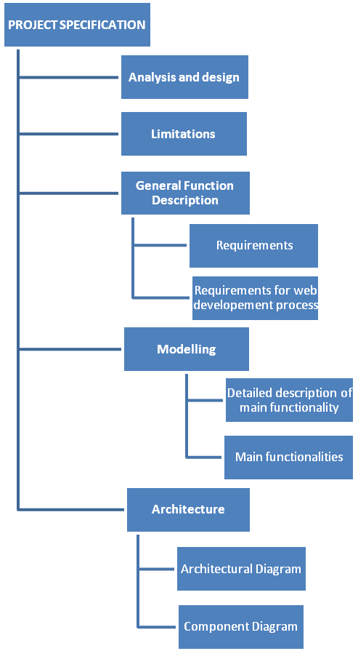

Figure 3.1 Structure of the project specification chapter

Analysis is the process whereby we break down a complex entity into its simpler, components parts. The section describing the aim and the method of the system illustrates the process which led to the final method and aim of the study through the study. Analyze of the design and the general function description is also described. The chapter ends with a description of architecture of the thesis.

**3.1 ANALYSIS AND DESIGN**

The primary goal for the thesis was to make a complete contract management system for daily use in one small company, which should confirm all requirements. The Contract Management System is written in PHP programming language, and has some HTML inside. The demands and requirements for the system come from the system structure used in our company, namely everything connected with web application development in a company has been done in PHP, and it includes all projects and systems: CRM for our clients etc. So, the idea and the structure of the system came from the company. Company prefers PHP, because it is widely-used and best suitable for dynamic and interactive Web development, it is easy and can be easily modified or added to rest of the system. So generally, PHP is available free of charge, deployed mostly on web servers, used on many operating systems and platforms. As the PHP is free it corresponds to our requirements for making free and open source project system.

But why PHP in our Contract Management System? The answer here is quite simple. Namely, starting to create a Contract Management System, have been beforehand token a brief look of application that already has been developed. As company is using PHP, it was their idea to use PHP support on this project either. Finally, the most suitable and obvious application was found, but it is already made, implemented and the application is widely used all over the world. The readymade application was chosen for implementation, then starting to create whole application from zero. Modifying and deploying the application was quite challenging, because to improve an already made application and to suite it to company’s requirements, needs by developer more concentration and understanding of the whole structure of a system. The project is called TRAC. TRAC is already developed and fully working open source application, which corresponds to our needs; TRAC is made for software development projects, which has got integrated wiki and issue tracking system inside TRAC. /TRAC, 12/ TRAC uses a minimalistic approach to web-based software project management. The main reason why TRAC was chosen was that it provides an interface to Subversion (SVN), what is in other words, version control system. To be exact: version control system is used to maintain current and historical versions of files such as source code, web pages, and documentation. Subversion is also well-known and open source – that responds to our needs, as using open source. But in company there is also used Version control system, that is most commonly stand-alone application, but it is also embedded in various types of software. Version control or in other words revision control is the management of changes to documents, programs and other information stored as computer files. It is commonly used in system development, where many people who work on the same project are changing the same file. The main idea to use revision control system in application is to maintain documentation and configuration files as well as source code.

Version control is used in systems that are designed, developed and deployed, commonly for multiple versions of the same system to be deployed in different sites, and for the system developers to be working simultaneously on updates. Bugs and issues with system are often only present in certain versions. Therefore, for the purposes of locating and fixing bugs, it is vitally important to be able to retrieve and run different versions of the system to determine in which version the problem occurs. It may also be necessary to develop two versions of the system concurrently. Developers could simply retain multiple copies of the different versions of the program, and number them appropriately. This simple approach has been used on many large application projects. While this method can work, it is inefficient as many near-identical copies of the program have to be maintained. This requires a lot of self-discipline on the part of developers, and often leads to mistakes. Consequently, systems to automate some or all of the revision control process have been developed.

Moreover, in system development and other environments, including in legal and business practice, it is increasingly common for a single document or snippet of code to be edited by a team, the members of which may be geographically dispersed and/or may pursue different and even contrary interests. Sophisticated revision control that tracks and accounts for ownership of changes to documents and code may be extremely helpful or even necessary in such situations. Another use for revision control is to track changes to configuration files, such as those typically stored in /etc or /usr/local/etc on UNIX systems. This gives system administrators another way to easily track changes to configuration files and a way to roll back to earlier versions should the need arise. On Figure 1-3, you are able to see how the “commit” command acts in server and client side.

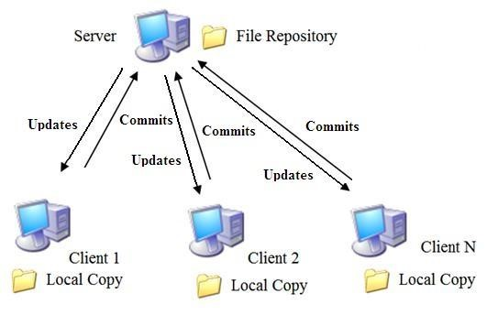

Figure3.3 Commit action through user application

When files are retrieved from the server to the client, it is called an “update”, and when new versions of the files are sent to the server from the client, it is called a “commit”. But why Subversion not CVS, which seem to be identical? Subversion has been done with an effort to write an open source version control system which operated much like CVS but which fixes the bugs and supplies the features missing in CVS. Subversions file system is three dimensional, the third dimension is revision and each revision in a Subversion file system has its own root, which is used to access contents at that revision. Subversion repository is quite compact, while it is storing files as links to the most recent change. The Subversion file system uses transactions to keep changes atomic. A transaction is begun from a specified revision of the file system, not necessarily the latest. The transaction has its own root, on which changes are made. It is then either committed and becomes the latest revision, or is aborted. The transaction is actually a long-lived file system object; a client does not need to commit or abort a transaction itself, rather it can also begin a transaction, exit, and then can re-open the transaction and continue using it. Multiple clients can access the same transaction and work together on an atomic change.

Systems are designed to improve collaboration between the teams working on a project, reducing potential risks and helping to ensure that the project is obtained on time. As a repository they adapt for all the documents, graphs and communications relating to some specific project and are used by all co-workers in a project to access, modify, print out, and edit matter according to authorizations set up by the project creator. Programmers often confuse the terms analysis and design. Determining where analysis ends and design begins is sometimes quite difficult. As analysis proceeds, design consideration keeps popping up, making it easy to get sidetracked into following up in depth on such issues. Dealing with design issues at a superficial level at this stage helps minimize the technical risks, but you must temper any time you schedule at risk. Like so many things in system development, a fine balance is essential. Based on the requirements and the detailed analysis of a new system, the new system must be designed. It is a most crucial phase in the development of a system.

Normally, the design proceeds in two stages:

* preliminary or general design
* structure or detailed design

In the preliminary or general design, the features of the new system are specified. The objective of the detailed design phases is to create a design that will correctly and completely implement the requirements. For the preliminary phase, the main goal is to map out how the Contract Management System will perform the functions specified in the requirements, within the defined interfaces, and the environment. At this phase, the designer needs to maintain a systems perspective and look at the system operations in concert with the rest of the operations. The objective of design assurance is to verify that the design does implement all the requirements, and that it implements nothing but the requirements. The main design activities for the preliminary design phase are:

1. Create the high-level design description.
2. Any derived requirements that result from the process are fed back to the requirements engineering process
3. Any omissions or errors are resolved
4. Include reliability, maintenance, and test features that are necessary to meet performance and quality requirements, and to ensure that testing can be performed to verify the requirements.
5. Identify constraints on other system elements that are a result of this high-level design

Analysis emphasizes an investigation of the problem and requirements, rather than a solution. For example, if a new online project management system is desired, how will it be used? What are its functions? Analysis is more a board term, best qualified, as in requirements analysis an investigation of the requirements. Design emphasizes a conceptual solution (in software and hardware) that full-fills the requirements, rather than its implementation. For example, a description of a database schema and software objects. Design ideas often exclude low-level details – obvious to the intended consumers. Ultimately, designs can be implemented, and the implementation (such as code) expresses the true and complete realized design. With analysis, the term is best qualified, as in database design. Useful analysis and design have been summarized in the phrase “do the right thing (analysis), and do the thing right (design).”

**3.2** **Limitations OF THE CURRENT SYSTEM**

There occurs some limitations and problems in Subversion, namely SVN allows only directory access control and has less detail file access control. Problem occurs in Subversion and in projects where directories are not structured to address the functional separation among various objects. For example, directories like lib, src, and bin do not address security and access control in most cases. For a second case, is the implementation of the file and directory rename operation. Subversion currently has the way to implement the renaming of files and directories as a “copy” to the new name followed by a “delete” of the old name. This means that only names are changed and all data related to the edit history remains the same and SVN will still use the old name.

**3.3 General Function Description**

For us the more helping way to analyze the big picture and its relations between system elements are through diagrams, which basically helps to discover or explore the relations, while allowing us to ignore or hide uninteresting details. To conclude, we can say that it is the most essential value of the UML and can be said that also the simplest value of the UML or any diagramming language.

**3.3.1 Requirements**

To determine the requirements for the development of a project management system for company as an inner system, that aids the project officers in the daily task and responsibility of effectively and professionally managing each of the projects as well as the program. It was the task of to run a series of requirements analysis sessions. There has been found that the analyses show that, it is more time consuming and gives a better outcome for the client or the end-user, while we use a project management system in our daily working life. Each of these outcomes will be supported by evidence collected by the individual projects that showed exactly the same result, for collecting and gathering information for everyday working life. Was identified the following main project management system requirements:

* User management integration to the system
* Security integration on application
* To track projects and its issues / bugs related to specific project
* Upload and delete files in a project
* Create new users who belong to specific group (Admin, SVN)
* Generate project and defined admin rights to it Create a shared database for information

It was agreed that the project management system would be developed as a system to match the requirements of the program that would integrate seamlessly with the security infrastructure of the existing portal website CMS. This will enable authorized users to log in to the system and see a summary of relevant project management system information. From logged in users who have access will be able to seamlessly access to project management system. A system requirements specification is a complete description of the behavior of the system to be developed. It includes a set of use cases that describe all of the interactions that the users will have with the system. In addition to use cases, the system requirements specification contains functional requirements, which define the internal workings of the system: that is, the calculations, technical details, data manipulation and processing, and other specific functionality that shows how the use cases are to be satisfied. It also contains non-functional requirements, which impose constraints on the design or implementation (such as performance requirements, quality standards or design constraints). The objective for collaboration has been the same: getting thing done better, faster and cheaper by bringing together a variety of resources and apply their collective knowledge and abilities in a project. Because valid collaboration with teams improves productivity, speeds up result-making and optimizes of making a right decision, it also helps to intercept precious intellectual fortune and time.

**3.3.2 Requirements for a Web Development Process**

From experience in developing Web applications, have derived a list of requirements for Web development process. The most important requirements are to provide end-user involvement, prototyping, change management, immediate response, risk minimization, no administrative overhead and transparency and guidance. Knowing the end users’ requirements is essential for the development of successful Web applications. Defining the main goals for the development of a Web application, then customer is not the actual end-user and, therefore, he or she is not able to define all the requirements that are important to end-user. Prototyping is used to leverage the involvement of end-users in Web application development. Prototyping produces a preliminary version of the required system that can be reviewed by end-users. After review, the prototype is added to and altered to produce another version closer to the one that is wanted. Figure 2-2 gives a diagram of prototyping process.

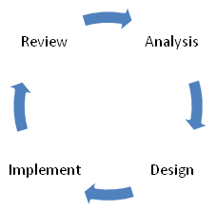

Figure 3.2 Prototyping process

Project development prototyping is essential, because finding the way to solution is much faster and more effective way to speed up the process of the project and find the best option for best results. Prototyping in our case influences the project development process.

**3.3.3 Modelling**

Modelling is like building a representation of things in the „real world‟ and allowing ideas to be investigated. In fact, model is more likely a way of expressing a particular view of a system. Mainly modelling is used to:

* understand the problems involved in building some system
* an aid to communication between those involved in the project
* a component of the methods used in development activities such as the analysis of the requirements

The way modelling is used in this project is called Unified Modelling Language (UML) that is a standard language for specifying, visualizing, constructing, and documenting the artefacts of systems, as well as for business modelling and other non-software systems. The UML represents a collection of best practices that have proven successful in the modelling of large and complex systems. It is an important part of developing system and their development process. The UML uses mostly graphical notations to express the design of projects, it helps project teams communicate, explore potential designs, and validate the architectural design of the system.

The primary goals in the design of the UML were:

1. Provide users with a ready-to-use, expressive visual modelling language so they can develop and exchange meaningful models.
2. Provide extensibility and specialization mechanisms to extend the core concepts.
3. Be independent of particular programming languages and development processes.

Provide a formal basis for understanding the modelling language

**3.3.4 Main functionalities**

Use Cases are text stories, widely used to discover and record requirements. Use cases need to be more detailed or structured and emphasize the user goals and perspective. A use case diagram in the Unified Modelling Language (UML) is a type of behavioral diagram defined by and created from a use case analysis. Its purpose is to present a graphical overview of the functionality provided by a system in terms of actors, their goals, and any dependencies between those use cases. The main purpose of a use case diagram is to show what system functions are performed for which actor. Roles of the actors in the system can be depicted. On the Figure 2-3 is shown a functionality of project management system, where user and administrator have different functionalities to run. While user is modifying or upload / download or delete files in a system while user is logged in, then for our administrators has more rights to control in the system. Namely administrator has the right to add, modify or delete users in a system or add new projects and definitely available to modify projects as the user or add new projects to the system. The Figure below illustrates exactly what kind of possibilities or options are for user and administrator of the system.

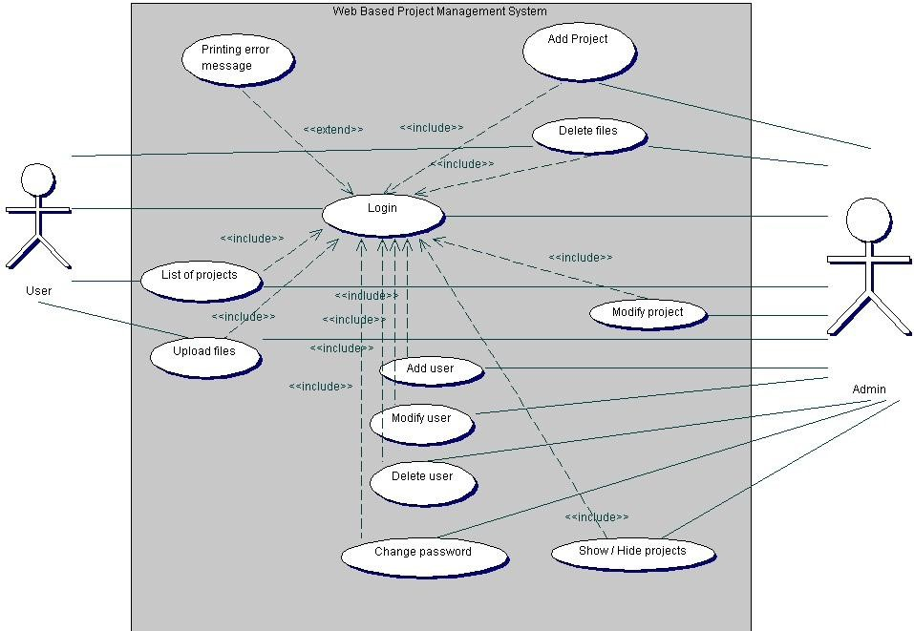

Figure 3.3 Functionality of project management system

**3.3.5 Detailed description of main functionality**

The term interaction diagram is a generalization of more specialized UML diagram type:

* **Sequence diagram**

Sequence diagrams illustrate interactions in a kind of fence format, in which each new object is added to the right. A sequence diagram in Unified Modeling Language (UML) is a kind of interaction diagram that shows how processes operate with one another and in what order. Earlier I stated that sequence diagrams are effectively a form of visual coding, or perhaps another way to think of it is that sequence diagrams can be used for very detailed design.

The flow of messages, events and actions between the objects or components of a system have been easily used to represent or modelled by UML sequence diagrams. On the vertical direction is showed the time that you can find on Figure 2-4 and on 2-5. The reciprocal effect of sequence is the header elements, which are indicated horizontally at the top of the diagrams on the Figures 2-4 and 2-5. Sequence diagrams are mainly used for finding the logic of the system. Document, model the design and displaying the architecture of the system, by describing the actions that need to be performed for completing a task. UML provides a dynamic view of the behavior of the system that can be extremely complicated to read from diagrams or work description, that’s why sequence diagrams are called as powerful designing tools.

To conclude, sequence diagrams are useful in system architecture, as really good engineering tools to design appropriate system, they have been used also in describing object-oriented systems. In other systems we use the tool for showing the system architecture with flow diagrams and protocol stack design with analysis.

On Figure 3.4 Sequence diagram represents a file upload structure in a system used by administrator. First user goes to main page where user gets a login window to authenticate him. If log-in info is an accurate user will be led to admin page, where user is able to see a list of projects, a links which will lead a user to user’s management page, which makes a new project and which show / or hide a project. While user chooses a project, the system will lead user to TRAC page, on the page there is a link “File Upload” inside system is reading and configuring TRAC conf file. Meanwhile the system is also accessing to DB. While user wants to upload a file, system is browsing and reading SVN repo, checkouts if there already similar file exists, if not system commits changes, inserts file to TRAC and returns back message that the file is successfully added to system.

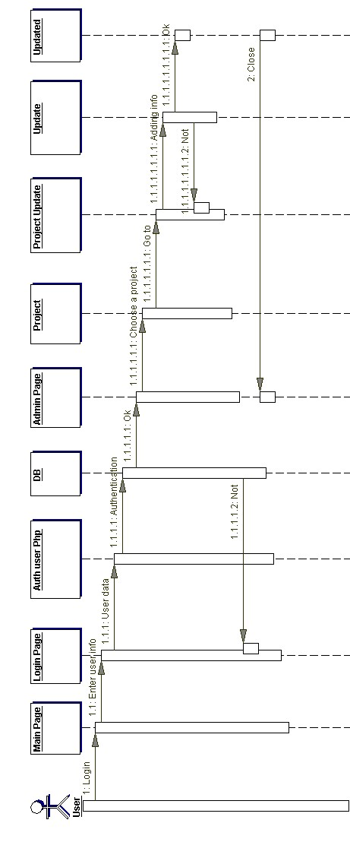

Figure 3.4 Sequence Diagram of File Upload

On Figure 2-5 is shown a sequence diagram of adding users in administrator view through users‟ management. Firstly, user goes to main page and will get a log in window, after adding a username and password, the system checks if the information is correct. If it is correct the user will be led to main page, where user is able to see a list of projects, links to user’s management page, add project page and show/hide project. User moves to user’s management and under there is a add user field, where actually TRAC will get as a root user to work under SUDO that adds contact information to a file. System sends back a replay to user, if the process was successful. The main thing on a Figure to put an attention is that the system is divided as one part belongs to www-data and another one to root.

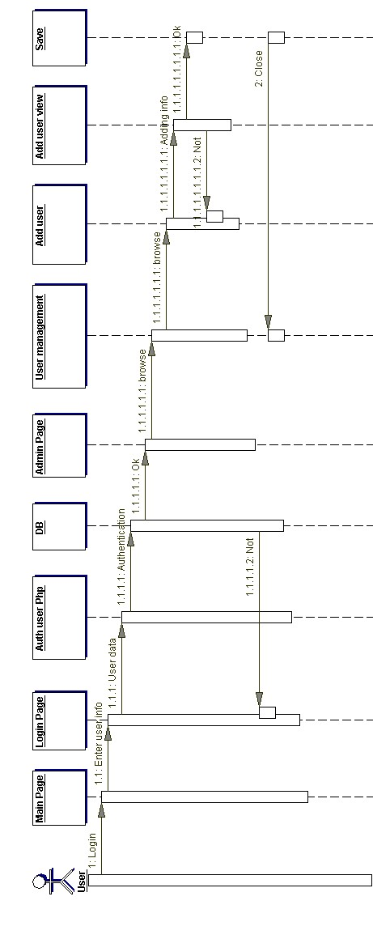

Figure 3.5 Sequence Diagram of adding user

On Figure 3.6 we are able to see more specific view of the system how it reads data from database or from file.

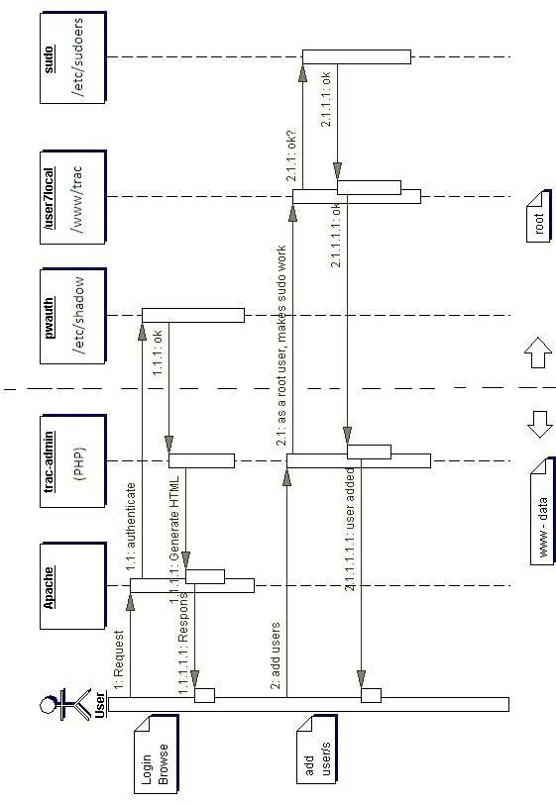

Figure 3.6 Sequence Diagram of adding user (Detailed description)

**3.3.6 Architecture**

System architecture is the conceptual design that defines the structure and/or behavior of a system. An architecture description is a formal description of a system, organized in a way that supports reasoning about the structural properties of the system. It defines the system components or building blocks and provides a plan from which products can be procured, and systems developed, that will work together to implement the overall system. /System Architecture, 11/ Defining the architecture as the set of relationships between the components of a system, that jointly ensures emergent properties of the system as a whole. The architecture of a system is the set of relationships between its components that cause the system to have desired properties, such as desired functionality, behaviour, semantics and quality of service. Architecture is the central problem in web applications because these applications should enable distributed coordination between people and the architecture of these coordination mechanisms evolves by itself as well as is designed by people. As shown on Figure 2-6, we are able to see the architectural diagram of our system that corresponds to our needs.

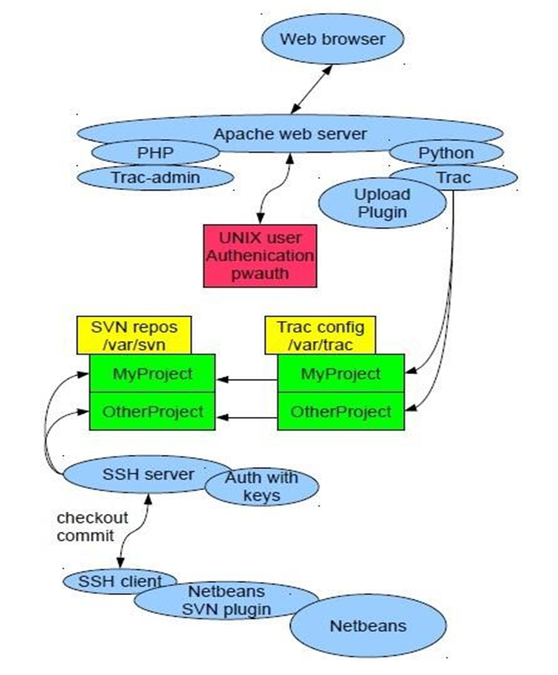

Figure 3.6. Architectural Diagram

While starting to read the chart from top, we start firstly with web browser, that is mainly used as a web application for retrieving and presenting information resources on the web that can be used all over the world. Some browsers can be also used to save information resources to file systems. For next step we connect web browser to Apache web server, what generally is recognized as the world's most popular Web server (HTTP server). Originally designed for UNIX servers, the Apache Web server has been ported to Windows. The Apache Web server provides a full range of Web server features, including CGI, SSL, and virtual domains. Apache is reliable, free, and relatively easy to configure – which corresponds to our requirements. The goal of this project is to provide a secure, efficient and extensible server that provides HTTP services in sync with the current HTTP standards. In our project we use Apache to serve dynamic Web pages, where the content is available in a secure way. To Apache server have added a UNIX authentication pwauth program, that lets authnz-external module, from which can be called out pwauth program, where TRAC can authenticate itself contrary to UNIX users. Pwauth is an authenticator designed to be used with mod_authnz_external and the Apache HTTP Daemon to support reasonably secure web authentication out of the system password database on most versions of UNIX. Particularly - secure authentication against PAM.

Below there is a Figure, that shows component structure of the system, on the Figure 3.7.

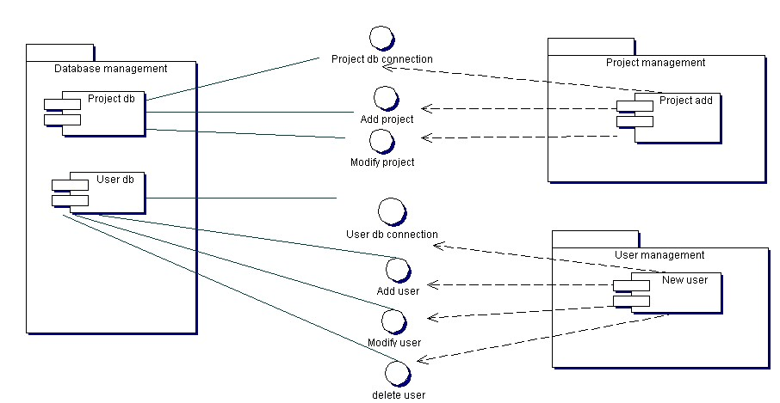

Figure 3.7. Component Diagram

**CHAPTER FOUR**

**SYSTEM IMPLEMENTATION**

Project management system is based on these tools:

* TRAC - It was designed to be simple, modular, secure, and reliable. It is easy to understand, and easy to integrate with other programs.
* Apache - is web server software, that playing a key role in the initial growth of the World Wide Web.
* MySQL - is a relational database management system. The program runs as a server providing multi-user access to a number of databases.
* XAMP Server- A web server for local hosting

TRAC is mainly used for retrieving and presenting information resources on the web that is accessible to all users all over the world. TRAC is connected with Apache web server that provides a full range of Web server features. Apache is reliable, free, and relatively easy to configure and used for dynamic Web pages, where the content is available in a secure way. To Apache server will be connected UNIX authentication pwauth program, where TRAC can authenticate itself contrary to UNIX users. To support reasonably secure web authentication out of the system password database on most versions of UNIX. Subversion uses the Apache Web server as one of the two servers it supports for allowing remote access to the repository. TRAC ini will be configured with SVN repo that creates special projects under /var/svn. For commits, that has been done from user application and in this case, from NetBeans. System is using SSH server to update commits to web server. It provides secure encrypted communications between two no trusted hosts over an insecure network. For accessing to servers by clients, that are properly configured, it is needed a secure shell public key authentication. NetBeans user application, for changing, adding and committing data to web browser, is using SVN plug-in. NetBeans works with the SVN command line client and provides useful tools to manage the SVN operation on the source code.

Basically, SVN is a server/client system.

**4.2 Functional requirements**

To improve productivity of developing web applications for customers and to make easier our every day’s working life, the company has set up requirements for making an internal system that is called Contract Management System. To consume necessary time and for keeping all troubles less than good project management system helps company out. The project management system will help to arrange documentation management inside company, by keeping documents in one place. Also, the most important it helps to keep track on new projects that are implemented and for those that are under implementation for customers and also to keep eye on errors or mistakes that occur during our work process for some projects. The idea come from everyday use and working life, the aim was to make an inside system for the company. The system is for helping workers (namely programmers, project managers, developers) to deal with some specific project and its errors occurred.

The system is web-based; there is a possibility to add documents/specifications for the specific project. Documentation can consist of graphs, database diagrams and sequence diagrams. The most important part is that, the system has the issue tracking system, system where can be added comments, bugs and other related questions for specific project. Besides that, the system has all documents related to that specific project, but it also has the code, right paths, folders and links. Issue tracking inside system, helps programmers to keep their eye on the process, find and search for bugs related to some specific issue or project. Additionally, the system has a functionality to add new members, new projects and ability to delete or lock / unlock users, who later on don´t have access to the system any more.

The system will utilize:

* MySQL database
* PHP
* Version control system (Subversion)
* XAMPP or WAMP server

System utilize MySQL database to store information. PYTHON programming language is used as a dynamic programming language, which is widely used in application domains. PHP is widely-used general –purpose scripting language. For next, our system utilizes Version control system, the basic functionality of any /Version control system is to keep track of the changing states of files over time and merge contributions of multiple developers. They support this, for the most part, by storing a history of changes made over time by different people. In this way, it is possible to roll back those changes and see what the files looked like before they were applied. Additionally, a version control system will provide facilities for merging the changes, using one or more methods ranging from file locking to automatic integration of conflicted changes. (William Nagel, 2005:4)

**4.3 SYSTEM CONFIGURATION**

TRAC and TRAC - admin has two different user interfaces for different users with different rights, who log in to the system. Under TRAC, user can see list of projects and under TRAC-admin user, who has admin rights is able to see all projects that belongs to this user and whole list of projects. Projects that are made for web interface are saved from Apache Web server, and then configured by TRAC conf, folder on /var /TRAC. The TRAC.ini configuration file is writable by the web server, as TRAC currently relies on the possibility to trigger a complete environment reload to flush it caches. TRAC ini will be configured with SVN repo that creates special projects under/var/svn – repository on local machine. For commits, that has been done from user application and in our case, from NetBeans. SSH server has been used to update commits to web server, for later on reading on Web Browser. SSH is a program for logging into a remote machine and for executing commands on a remote machine. It provides secure encrypted communications between two entrusted hosts over an insecure network. SSH connects and logs into the specified hostname (with optional user name). The user must prove his/her identity to the remote machine using one of several methods depending on the protocol version used. For accessing to server by clients, there is need for a secure shell public key authentication. The remote host can authenticate itself using either traditional public-key authentication or certificate authentication. At the beginning of the connection the server sends its public host key to the client for validation. If certificate authentication is used the public key is included in the certificate the server sends to the client. The connection between Client and Server on SSH is shown on Figure 3-21, below.

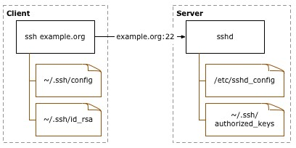

Figure 4-21 SSH public key authentication (Source: http://sial.org/howto/openssh/publickey[-](http://sial.org/howto/openssh/publickey-auth/)auth/)

**4.3.1 Definition of the Figure:**

* **Client**: the system one types directly on, such as a laptop or desktop system.
* **Server**: anything connected to from the client. This includes other servers accessed through the first server connected to. /Open SSH public key authentication, 8/

**4.4 TESTING**

The goal of testing was to demonstrate that the program under control contains bugs. Testing must not be confused with debugging, which is the process of detecting and reducing the number of existing errors. Testing can never prove that a code is error-, but rather verify that errors exist. Therefore, need to consider the fact that the error might come from the test itself, while the tested code might be correct. Have to know what the results of the test will show before it has actually been performed. The one who is responsible for doing the testing has to be able to define what the outcome should be, if not, this will lead to bugs in either the program or the test or in both the program and the test. The good thing about system testing is that it can be carried out without any prior knowledge about the program design and can thus be performed by „outsiders”. To maintain the quality of a system, it is definitely needed to conFigure a system testing. Detecting and fixing the errors in a system is known as one of the main objectives behind testing of a system in a development cycle. Here is described a set of test cases; some of them have been shown below:

1. For checking the conjunction in the system that is developed, couples of users are connected to the Application simultaneously through the Internet browser. Different parts of system, like TRAC, project management and user management have been monitored simultaneously on these client machines. To conclude, the testing showed that system components could be monitored conjunctionally from multiple clients through Internet browser.
2. It has also been noticed that data regarding system modifications are easily available with for all users. This affirms that the data recording feature of the developed system is working correctly.
3. The SVN SSH connection has been tested from user application to commit code or make changes on code and later on to be seen on web browser. Commits and changes are nicely illustrated with differences made on the code on the web browser. These changes are seen for all users.
4. Creating a new project and its administration, description and group. To add new project from admin panel to system, then we had to see, if the projects have made their own SVN repository. Where later on all updated files and commits have been added.
5. Definitely, user management has been tested, while adding users, with different rights – belong to different groups.

To be more specific, testing system started with an admin adding new user with Different rights, belonging to different groups, on Figure 3-24.

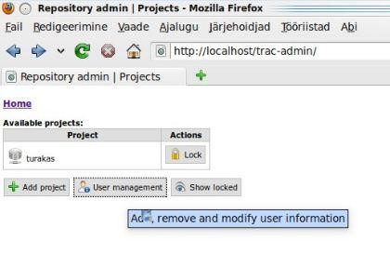

Figure 4-24: User management

Admin has to fill up all fields, as shown on Figure 3.25: user management view. All the fields are needed to fill, because it helps to get an accurate data for every user. Admin fills up username that is users name used for log-in to system and password which should consist of letters and numbers. Password is protected, which avoids unexpected people to hack in to system and read others passwords.

It would be nice to also fill up fields like: user’s full name, Location, Phone and E-mail. Choosing a group is a required field which admin must choose.

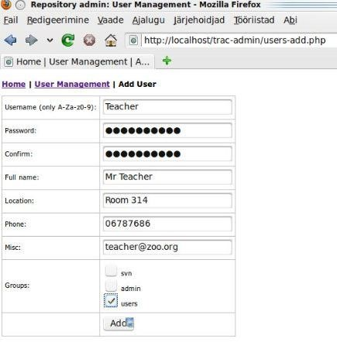

Figure 4-25 Add user management

Next step, admin logs out from the system and for testing purpose with new user account trying to log in to the system, which has been made previously, user will see a login authentication as shown on Figure 3-26, below.

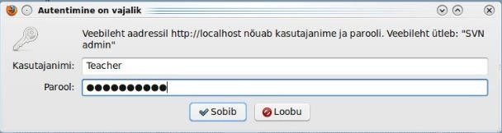

Figure 4-26 Authentications in login

After login, user is able to see a user’s view, as shown on Figure 3-27. Second concern was at the beginning related with view. Namely we have two different types of users, ones are just users and to second group belongs administrators. The difference here is the accessibility to everything. Views are different, by user and its rights. Namely users are able to see only list of projects and they are not able to add any project or user to system. It is important for security reasons.

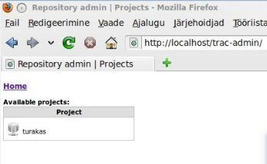

Figure 4-27 Users view

To conclude, all users worked correctly with no mistakes or errors occurred. While have been logged-in to system with different users. But it was not enough, had to check if users have right access and rights, depending on users group that admin has added to user.

Administrators see, different view, as said before, namely: admin has rights to add projects, users and locked/unlocked projects view, as shown on Figure 3-28.

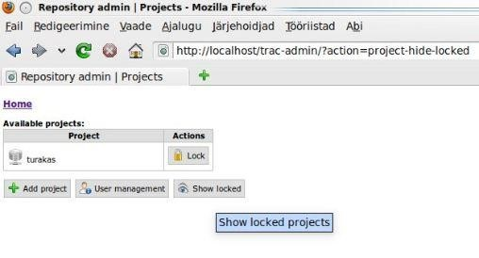

Figure 3-28 Administrator view

“Show locked” is the functionality that helps user easily handle projects in system. Namely users would not like to see all projects in one list, because it is annoying to search from long list some project. But while admin will click “Show locked”, then administrator can easily see all locked projects on the list through simple click. In a mysql database, there can be seen the difference, when project is locked and when project is unlocked as shown on Figures 3-29 and 3-30.

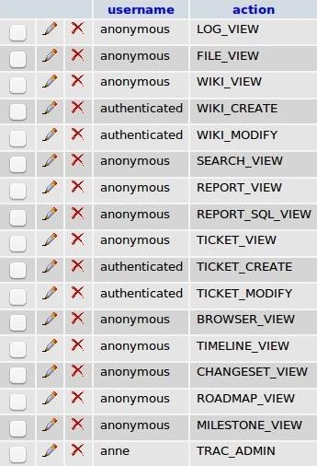

Figure 4-29 shows unlocked projects

On the Figure Locked projects, can be seen that users are not able to create or modify any project information either upload or delete files on the project. While project is locked, it means that we are just able to read the info on the Project.

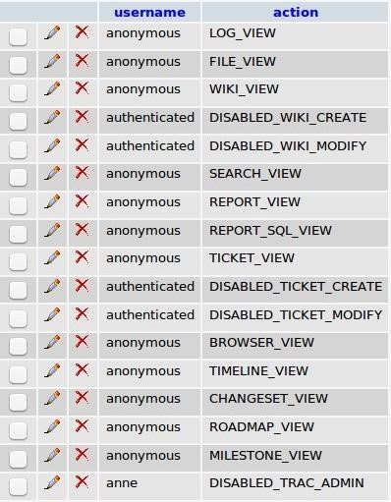

Figure 4-30 Shows projects that are locked

To conclude, all testing related with hiding projects that have been locked, and later on trying to access to those projects and change information, what was added all the information was working correctly. No errors occurred during procedure. The interface of the project management system is also flexible. In order to reach a large number of users, the interface of the system is web based, running inside a standard web browser. This allows the users to work from own computer whenever it is needed, and it does not imply special software to be installed. Whatever the user updates, the system keeps track of projects and their revisions, tests, sessions and results. This is done via apache server that is connected through SSH to SVN. Flexibility is again built in the users and project management.

**CHAPTER FIVE**

**5.1 CONCLUSION**

The result of the project is described from the perspective of the aim and scope set in the beginning of the thesis. The ideas for the future Contract Management System are also described here. The aim of the project was to make a complete, fully working web-based contract management system for the company. Requirements from the company has been gathered and taken into account. In Contract Management System there has been used an already implemented TRAC system to improve company’s everyday use and to increase performance, productivity and efficiency.

As a good project management system, it has a possibility to upload, download and delete files and uniformly gives change for developers to be in constant contact with the customer requirements and expectations for the project. User management tool in Contract Management System is a good appliance for keeping eye on the project and for giving rights to different users by system administrator in company. This all makes a complete and good communication system inside company, all data and material will be accessible from one place, to facilitate the solution of a project and contact communication with a client. Finally, the whole system has been tested to ensure that everything functions correctly before the system processes actual data and produces information that people will rely on.

The features that were implemented are listed below.

General principles of system, implemented:

1. Users management
   * Adding new users
   * Adding reliable data to user
   * Ability to add different rights to users (admin)
   * Ability to change password
   * Ability to delete users
   * Ability to lock users (user don‟t have possibility to log-in to system)
   * Ability to modify data and further on to change rights
2. File upload
   * Users are able to delete files
   * Upload files through Trac interface
   * Download files
3. Project management
   * Adding new projects to system
   * Adding projects logo to Trac system
   * Define a admin for a specific project
   * Adding needed data to project
   * Updating files to project
   * Deleting updated files in project
4. Project based views (Every project has its own Trac project)
5. Security login added to system (authentication of a user)

To conclude, Contract Management System is an improved TRAC system and completed as one fully functioning system that corresponds to the companies needs and helps to produce a good quality web application projects for the clients. The result of the project responded to the customer’s expectations. The company was satisfied with the features implemented and their reliability and robustness. Through the thesis and development process I gained quite good experience, of an overall structure of different systems and the basic concept of the system as whole. It was quite challenging to improve already made system as TRAC, while adding their new features and to put TRAC to work with new functions. New ideas of what more to improve or how to improve the system and what kind of new features to add, come up through the development of thesis. For example, there has been an idea, to make search functionality to project, which will help users to search projects by date or by creator of a project. During the process of implementation, wonderful ideas have been got and hopefully in a near future, there is a possibility and time allocated to improve the system.

**REFERENCES**

[Ahuja, V., Yang, J. & Shanker, R. (201](http://www.pdfcomplete.com/cms/hppl/tabid/108/Default.aspx?r=q8b3uige22)0). IT-enhanced communication protocols for building project management. *Engineering, Construction and Architectural Management*, 17(2), 159-179. Doi 10.1108/09699981011024678

Ahuja V., Yang, J. & Shanker, R. (2009). Study of ICT adoption for building project management in the Indian construction industry. *Automation in Construction*, 18, 415-423. Doi

10.1016/j.autcon.2008.10.009

Alshawi, M. & Ingirige, B. (2003). Web-based project management: an emerging paradigm in construction. Automation in Construction, 12, 349-364. Doi 10.1016/s09265805(03)00003-7

Becerik, B. & Pollalis, S. (2006). *Computer aided collaboration in managing construction*. Harvard University Graduate School of Design. Design and Technology Report Series 2006-2.

Chassiakos, A. P., & Sakellaropoulos, S. P. (2008). A web-based system for managing construction information. *Advances in Engineering Software*, 39, 865-876. Doi

10.1016/j.advengsoft.2008.05.006

Cheung, S. O., Suen, H. C., & Cheung, K. W. (2004). PPMS: a web-based construction Project

Performance Monitoring System. *Automation in Construction*, 13, 361-376. Doi

10.1016/j.autcon.2003.12.001

Cox, R. (2007). Using project-specific websites to manage construction project delivery. Retrieved from <http://www.buildings.com> /ArticleDetails/tabid/ 3321/ArticleID /3652/Default.aspx

Dossick, C. S. & Sakagami, M. (2008). Implementing Contract Management Systems in the United States and Japan. *Journal of Construction Engineering and Management*, 134(3), 189-196. Doi 10.1061/(ASCE)0733-9364(2008)134:3(189)

Dutta, S. (2009). *The Global Information Technology Report 2008-2009*. Mobility in a Networked World. World Economic Forum and INSEAD

Encyclo (2010). Online Encyclopedia. Retrieved from <http://www.encyclo.co.uk/define/Qualitative%20thematic%20analysis>

Fellows, R. & Liu, A. (2008). *Research Methods for Construction*. Third Edition. Wiley- Blackwell. John Wiley & Sons Ltd, The Atrium, Southern Gate, West Sussex, United Kingdom.

### Hauduc, L. (2010). Who Doesn’t Manage Projects? Microsoft Project 2010 Expands Appeal. Microsoft News Center. Retrieved from

[http://www.microsoft.com/presspass/features/2010/apr10/04](http://www.microsoft.com/presspass/features/2010/apr10/04-01microsoftproject2010.mspx)-

[01microsoftproject2010.mspx](http://www.microsoft.com/presspass/features/2010/apr10/04-01microsoftproject2010.mspx)

Hewage, K., Ruwanpura, J. & Jergeas, G. (2008). IT usage in Alberta’s building construction [projects: Current status and cha](http://www.pdfcomplete.com/cms/hppl/tabid/108/Default.aspx?r=q8b3uige22)llenges. *Automation in Construction*, 17, 940-947. Doi

[10.1016/j.autcon.2008.03.002](http://www.pdfcomplete.com/cms/hppl/tabid/108/Default.aspx?r=q8b3uige22)

Ilich, M., Becerik, B., & Aultman, B. (2006). Online collaboration: why aren’t we using our tools?Means, methods and trends. Architectural Engoneering Institute and the Construction Institute of ASCE. Retrieved from [http://ilab.usc.edu/Papers/Papers/Means%20Method%20Trends_2006.pdf](http://i-lab.usc.edu/Papers/Papers/Means%20Method%20Trends_2006.pdf)

Lee, S., Pena-Mora, F., & Park, M. (2006). Web-enabled system dynamics model for error and change management on concurrent design and construction projects. *Journal of Computing in Civil Engineering*,20(4). Doi 10.1061/(ASCE)0887-3801(2006)20:4(290)

Matheu, N. F. (2005*). Life cycle document management system for construction*.

University Politecnica de Catalunya. B-34312-2005/84-689-2537-3. Retrieved from [http://www.tdx.cat/TDX-0518105-155912.](http://www.tdx.cat/TDX-0518105-155912)

Nitithamyong, P. & Skibniewski, M. (2007). Key success/failure factors and their impacts on system performance of Contract Management Systems in construction. *ITcon*, 12, 39-59. Retrieved from http://www.itcon.org/cgibin/works/Show?2007_3

Nitithamyong, P. & Skibniewski, M. (2006). Success/Failure factors and performance measures of web-based construction project management systems: Professionals’ Viewpoint. *Journal of Construction Engineering and Management*. ASCE, 80-87. Doi: 10.1061/(ASCE)0733-9364(2006)132:1(80).

Nitithamyong, P. & Skibniewski, M. (2004). Web-based construction project management systems: how to make them successful? *Automation in Construction*, 13, 491-506. Doi 10.1016/j.autcon.2004.02.003

Nuntasunti, S. & Bernold, L. (2006). Experimental assessment of wireless construction technologies. *Journal of Construction Engineering and Management*, 132(9),

1009-1018. Doi 10.1061/(ASCE)0733-9364(2006)132:9(1009)

O’Brien, W. (2000). Implmentation issues in project web sites: A practitioner’s viewpoint. Journal of Management in Engineering, 16(3), 34-39. Retrieved from

[http://content.ebscohost.com/pdf14_16/pdf/2000/JUM/01May00/3142905.pdf?T=P&P=](http://content.ebscohost.com/pdf14_16/pdf/2000/JUM/01May00/3142905.pdf?T=P&P=AN&K=3142905&EbscoContent=dGJyMMvl7ESep684zdnyOLCmr0ieprJSrqu4Sq6WxWXS&ContentCustomer=dGJyMPPk54zj2bmF39%2FsU%2Fipt02u&D=bth)

[AN&K=3142905&EbscoContent=dGJyMMvl7ESep684zdnyOLCmr0ieprJSrqu4Sq6Wx](http://content.ebscohost.com/pdf14_16/pdf/2000/JUM/01May00/3142905.pdf?T=P&P=AN&K=3142905&EbscoContent=dGJyMMvl7ESep684zdnyOLCmr0ieprJSrqu4Sq6WxWXS&ContentCustomer=dGJyMPPk54zj2bmF39%2FsU%2Fipt02u&D=bth)

[WXS&ContentCustomer=dGJyMPPk54zj2bmF39%2FsU%2Fipt02u&D=bth](http://content.ebscohost.com/pdf14_16/pdf/2000/JUM/01May00/3142905.pdf?T=P&P=AN&K=3142905&EbscoContent=dGJyMMvl7ESep684zdnyOLCmr0ieprJSrqu4Sq6WxWXS&ContentCustomer=dGJyMPPk54zj2bmF39%2FsU%2Fipt02u&D=bth)

Opdenakker, R. (2006). Advantages and Disadvantages of Four Interview Techniques in Qualitative Research. Forum: Qualitative Social Research. Vol 7, No. 4 (2006). Retrieved from <http://www.qualitative-research.net/index.php/fqs/article/viewArticle/175/391>

Peansupap, V. & Walker, D. (2005). Exploratory factors influencing information and communication technology diffusion and adoption within Australian construction organisations: a micro analysis. *Construction Innovation*, 5: 135-157, doi 10.1191/1471417505ci095oa

[Quashie, S. (2009). Systems of commu](http://www.pdfcomplete.com/cms/hppl/tabid/108/Default.aspx?r=q8b3uige22)nication and management in the construction industry. [*Proceedings of the European C*](http://www.pdfcomplete.com/cms/hppl/tabid/108/Default.aspx?r=q8b3uige22)*onference on Management, Leadership & Governance,* p212-221. Retrieved from http://content.ebscohost.com/pdf23_24/pdf/2009/B3LP/01Jan09/48918415.pdf?T=P&P= AN&K=48918415&EbscoContent=dGJyMNLe80Sep7I4zdnyOLCmr0ieprFSrqa4SbeW xWXS&ContentCustomer=dGJyMPPk54zj2bmF39%2FsU%2Fipt02u&D=bth

Rankin, J. & Luther, R. (2006). The innovation process: adoption of information and communication technology for the construction industry. *Canadian Journal of Civil Engineering*, 33, 1538-1546. Doi: 10.1139/L05-128

Stewart, R. & Mohamed, S. (2004). Evaluating web-based project information management in construction: capturing the long-term value creation process. *Automation in Construction* 13, 469-479. Doi: 10.1016/j.autcon.2004.01.003

Walker, D. & Betts, M. (1997). *Information Technology Foresight: The future application of the world wide web in construction.* Proc.. CIB w78: IT for Construction Process

Reengin

Walonick, D. (2005). Elements of a research proposal and report. StatPac. Retrieved from [http://www.statpac.com/research-papers/research-proposal.htm#chapter-3](http://www.statpac.com/research-papers/research-proposal.htm)