**DESIGN AND IMPLEMENTATION OF A COMPUTERIZED PERSONNEL MANAGEMENT SYSTEM**

**ABSTRACT**

Company personnel are the backbone of any company therefore their management plays a major role in deciding the success of an organization. A flexible and easy to use personnel management software solution for small and medium sized companies provides modules for personnel management thereby organization and companies are able to manage the crucial organization asset – people. The goal of this project is to design and develop a personnel management system to fill existing gaps in the manual management of employees. The developed system makes it easy for the managers to keep track of all records. It allows for the editing of employees, adding new employees, transferring, promoting, and termination of employees.

The combination of these modules into one application assures the perfect platform for re-engineering and aligning Human Resource processes along with the organizational goals. This system brings about an easy way of maintaining the details of employees working in any organization. It is simple to understand and can be used by anyone who is not even familiar with simple employees’ system. Using the powerful Object-Oriented nature of PHP programming language, the system is user friendly and just asks the user to follow step by step operations by giving easy to follow options. It is fast and can automate many operations for a company with a reliable database management system, MySQL.

**CHAPTER ONE**

**INTRODUCTION**

**1.1 Background of the Study**

The public and private organizations generate staff records. Staff records play an imperative role in providing the information needed by organizations to manage and pay their staff members, plan their workforce requirements and monitor staff performance. Ultimately, any organization’s development and sustainability will depend on sound and effective human resource management, and the approaches it chooses to follow will be derived in part from an analysis of the information contained in staff records. The goal of staff records management is to ensure that a complete and comprehensive employment history of each employee is readily available for as long as it is needed, and that the information contained in staff records supports the management, deployment, payment and development of staff. Other key objectives of staff records management are to support transparency and organizational accountability and to enable accurate audits by creating and protecting human resource records as reliable evidence (Griffin and Hoyle, 2009).

According to Cain et al (2007) organizations need to keep staff information for long periods. For example, retention periods of 70 years or longer for staff files are common in many countries. Thus, staff databases need to store data about individuals for decades – far longer periods that is typical for most database applications. The development of personnel management dates back to the period of World War I around the year 1915 and more recently to the human relations movement of 1935 – 1950.

In one of the studies of Elton mayor, he discovered that psychological factors as well as social factors influence individuals at work rather than physical factors. Specific reasons for the development of personnel management include: -

1. As a result of increasing influence of trade unions, traditionally personnel administration took on the role of pacifying the trade unions, so that management could be free run the companies without interference from employees.
2. The formulation of minimum wages low costs and individual legislations increased the need for a team of personnel specialties.
3. As the union became more sophisticated and powerful the need for highly skilled individual relations should increase.
4. The increasing size of business, government and other institutions brought new dimension into the profession of personnel management.

Traditionally, it was practiced in homes where the father is the head of the family. It was he who planned what the family should do, the type of farming, size and where to sell the harvested products. His wives and children helped in the process, no external recruitment was involved, so the more wives and children a man had, the more likely it was that the family be well-of. The recent practices of personnel management in Nigeria is tied up with history and development of the public services, private companies and civil services.

**1.2 Statement of the Problem**

With large number of works opportunities, the human workforce is increasing, thus, there is a need of a system which can handle the data of such a large number of personnel. Manual handling of personnel information poses a number of challenges. This is evident in procedures such as leave management where an employee is required to fill in a form which may take several weeks or months to be approved. The use of paper work in handling some of these processes could lead to human error, papers may end up in the wrong hands and not forgetting the fact that this is time consuming. A number of current systems lack employee self-service meaning employees are not able to access and manage their personal information directly without having to go through their HR departments or their managers.

Another challenge is that multi-national companies will have all the personnel information stored at the headquarters of the company making it difficult to access the personnel information from remote places when needed at short notice. The project is aimed at setting up an personnel information system about the status of the employee, the educational background and the work experience in order to help monitor the performance and achievements of the employee through a password protected system.

**1.3 Aim and Objectives of the Study**

The aim of this project is to design and implement a personnel management system for Nigeria Petroleum Corporation Lagos. To achieve the stated objective, the following specific objectives were laid out:

* Design of a web-based personnel management system to fulfill requirements such as project management; leave management, report generation to assist in performance appraisal and employee trainings.
* Develop a well secure database management system for the storage of personnel data
* The system should yield timely and quality information to managers for decision making

**1.4 Significance of the Study**

This work could be useful for personnel managers or officers in an organization as well as those involved in research work on personnel management. This research work would let us know that the success of an organization largely depends on the assessment and appraisal of individuals and company employee’s potential, performance and how well the organization can strive to equip all its workers.

Also, this research work will be of immense assistance to the organizational environment because personnel will be able to find the best solution to the various personnel problems as the computerized personnel management information system software will play a very big role in removing the stress in record keeping.

There are many other advantages, and some of them are listed below.

* It saves a lot of time in processing personnel information.
* Database access is fast, reliable and secure in term of authorized access using data encryption and decryption.
* Transactions are secured (login page).
* It helps in reducing the costs of labour, fixtures and stationery (Paper, files, pens, marker and so on.

**1.5 Scope of the Study**

The scope of this project will be limited to the following:

* **Employee profiles**: Employees will have access to their personal profiles and will be able to edit their details.
* **Electronic leave application:** Complete elimination of paperwork in leave management by enabling an employee apply for leave as well as check their leave status through the system. This will also enable the HR manager to accept/reject leave application through the system
* **Project Management:** Assign tasks and projects to employees, assign a project team and keep track of the progress.
* **Report generation**: The HR manager will be able to generate timely reports in order to monitor employees and this can be used for performance appraisals. The reports will have all the information of an employee from educational background, trainings attended, projects done as well as technical skills.
* **Recruitment Process**: The admin will add an employee and a default password and employee id will be generated and sent to the new employees’ email. The HR manager will then have the ability to add an employee’s information to the database.

**1.7 Limitations of the Study**

The major drawback experienced during this project research is during the actual software development. PHP source code required for the algorithm was not easy to obtain, hence the developed system does not include advanced features except those in the scope. Due to time constraint, finance and confidentiality of information, program developed covers all aspect of employment, assessment and retirement. Whatever is left out is as a result of the stated limitations.

**1.8 Definition of Terms**

* **Personnel:** It is a department in an organization that deals with employee’s records, hiring or retirement.
* **Management:** It is the co-ordination of all the resources of an organization through the process of planning, organization, directing and controlling.
* **System:** A method or set of procedures even personnel working together as a whole to achieve a goal.
* **Information:** A meaning full material derived from computer data by organizing it and interpreting it in a specified way.
* **Information System:** A set of interrelated components that collect (or retrieve), process, store and distribute information to support decision making and control in an organization.

CHAPTER TWO

REVIEW OF RELATED LITERATURE

2.1 CORE CONCEPT OF PERSONNEL MANAGEMENT SYSTEM

There are abundant definitions of personnel management, personnel management is the planning, organizing, directing and controlling of the procurement, development, compensation, integration, maintenance and separation of human resources to the end that individual organization and societal objectives are accomplished. Armstrong (2000), defines personnel management thus;

1. Personnel management is concerned with obtaining, developing and motivating the human resources required by the organization to achieve its objectives.
2. Developing and organization structure and climate and involving management style which will promote cooperation and commitment throughout the organization.
3. Lastly ensuring that the organization meets its social and legal responsibilities towards its employees with regard to the conditions of employment.

In a book by Jamie and John (2007), Defined Personnel management as part of management concerned with people at work, their positions and their relations within a particular organization. According to Unamka and Ewurum (2005), stated that personnel management is the recruitment, selection, development and motivation of human beings who work for a firm or corporation.

The governments of most industrialized nations in the world are investing heavily in research programs to address the issues of conventional paper records, but yet there is no comprehensive technical solution. However, a fundamental strategy is emerging that involves refreshing the storage media, migrating the data onto a new hardware and software; and all necessary steps to validate their integrity, authenticity and addressing issues that has to do with the context of the data which preserve the meaning of the data. The objective is to retain the ability to display, retrieve, manipulate and use digital information in the face of constantly changing technology. These strategies require the development of highly specialized techniques which are also often relative expensive. The management of these electronic records is a relatively new issue for developing countries, but the governments are already beginning to address these challenges.

**2.2 INFORMATION SYSTEM**

With cognizance to Buckingham (2008), An Information System can be defined technically as a set of interrelated components that collect (or retrieve), process, store and distribute information to support decision making and control in an organization. Basically, an Information System handles the flow and maintenance of Information that supports a business or some other operation. It contains information about significant people, places and things within the organization or in the environment surrounding it. Information is derived from meaningful interpretation of data.

A system which assembles, stores, processes, and delivers information relevant to an organization (or to a society), in such a way that the information is accessible and useful to those who wish to use it, including managers, staff, clients and citizens. An information system is a human activity (social) system, which may or may not involve the use of computer systems. Also, in addition to supporting decision-making, information systems help workers and managers to analyze complex problems, to develop new products and to integrate the various modules and departments. Moreover the 'transmission losses inter-departmental communication are reduced considerably leading to better coordination and improved transparency (information sharing) within the organization as a whole.

**2.2.1 Functions of Information System**

According to Laudon and Laudon (2001), Three activities provide the information that organizations need. These activities are Input, Processing and Output. 'Input' consists of acquisition of the 'raw data', which is transformed into more meaningful packets of 'Information' by means of 'Processing'. The processed information now flows to the users or activities also called as 'Output'. The shortcomings are analyzed and the information is sent back to the appropriate members of the organization to help them evaluate and refine the input. This is termed as 'feedback'.

Examples of 'Information Inputs' would be Transactions, events which would undergo 'processing' in the form of sorting, listing, merging and updating resulting in 'outputs' such as detailed reports, lists and summaries. Another example would be in the manufacturing environment with '*information inputs*' such as design specs material requirements and the SOPs (standard operating procedures). These would be '*processed*' by the information system by modeling and simulation techniques and would result in standard production models along with the overall cost of the production process which is calculated by the information system from the knowledge base containing material costs, hourly labor costs and other indirect costs; hence, almost totally eliminating a distinct costing function inthe scheme of things.

\

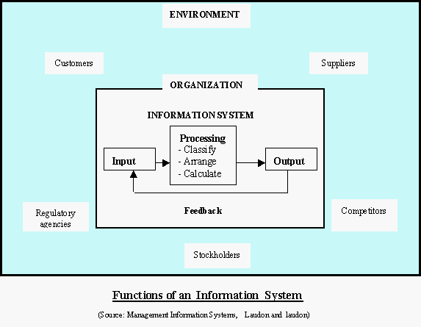

**FIG 2.1:** Functions of an Information System

However, an information system cannot just be broadly described as an Input-Process-output mechanism in vacuum. It is required to provide major organizational solutions to challenges and problems posed in the business environment. Hence a manager needs to be not just computer-literate but also have a good idea of the organizational structure and functions as a whole. This concept is illustrated in FIG 2.1.

Also, at the heart of the issue, Information systems should not be confused with information technology. They exist independent of each other and irrespective of whether they are implemented well. Information systems use computers (or Information Technology) as tools for the storing and rapid processing of information leading to analysis, decision-making and better coordination and control. Hence information technology forms the basis of modern information systems.

**2.2.2 Types of Information Systems**

According to Laudon (2003), the purpose of computer-based information systems is to provide managers and various categories of employees with the appropriate kind of information to help them make decisions. The six major types of information systems corresponding to each organizational level (the four levels shown in figure above) are:

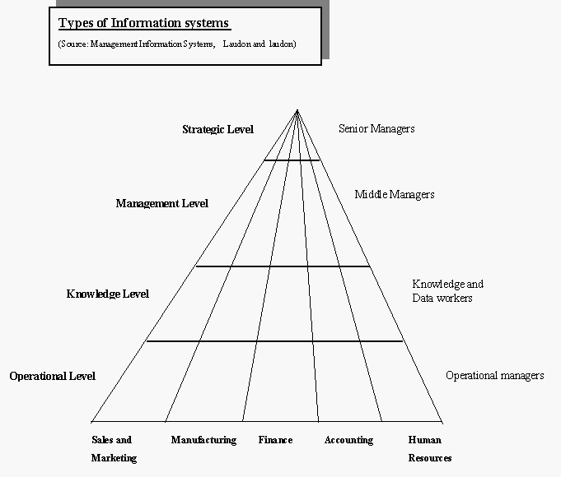

**FIG 2.2:** Types of Information System

**1.** Transaction Processing Systems (TPS): serve the operational level of an organization. It is a computer-based information system that keeps track of the transactions needed to conduct business. It records day-to-day transactions such as customer orders, bills, inventory levels, and production output. It also helps to generate databases that act as the foundation for the other information systems.

**2**. Knowledge work systems (KWS) is also known as Expert systems (ES). Expert system is a set of interactive computer programs that help users solve problems that would otherwise require the assistance of a human expert. It is also known as knowledge-based system (KBS).

**3**. Office automation systems (OAS) to serve the knowledge level of an organization. It is a computer-based information system intended for workers or employees of all levels which combines various technologies to reduce the manual labour required in operating in an efficient office environment.

**4.** Decision-support system (DSS) is a computer-based information system that provides a flexible tool for data analysis. It helps in predicting changes that may influence the data in the future. It simply analyzes data. It helps to analyze a wide range of problems, such as the effect of events and trends outside an organization. Like the MIS, the DSS draws on the detailed data of the transaction processing system.

**5.** Management information systems (MIS) serve the management level of the organization. It is a computer-based information system that produces standardized reports in a summarized structured form.

**6.** Executive support systems (ESS) serve the strategic level of an organization. It is an easy-to-use system that presents information in a very highly summarized form. It helps in developing strategic plans and decision making. It is also known as executive information system.

**2.3 REVIEW OF POSSIBLE DEVELOPMENT TOOLS**

The following are various development tools and software that could be used for the system.

**2.3.1 Back-end Technology**

* **JavaServer Pages**

JavaServer Pages (JSP) is a technology that helps [software developers](http://en.wikipedia.org/wiki/Software_developer) create [dynamically generated web pages](http://en.wikipedia.org/wiki/Dynamic_web_page) based on [HTML](http://en.wikipedia.org/wiki/HTML)[,XML,](http://en.wikipedia.org/wiki/XML) or other document types. Released in 1999 by [Sun Microsystems,](http://en.wikipedia.org/wiki/Sun_Microsystems) JSP is similar to [PHP,](http://en.wikipedia.org/wiki/PHP) but it uses the [Java programming language.](http://en.wikipedia.org/wiki/Java_(programming_language)) To deploy and run JavaServer Pages, a compatible web server with a [servlet](http://en.wikipedia.org/wiki/Servlet) container, such as [Apache Tomcat](http://en.wikipedia.org/wiki/Apache_Tomcat)or[Jetty,](http://en.wikipedia.org/wiki/Jetty_(web_server)) is required.

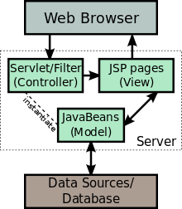

*Figure 2.4 The JSP Model 2 architecture*

* **ASP.NET**

ASP.NET (Active Server Pages.NET) is a proprietary scripting language or application framework developed by Microsoft used to create enterprise wide web applications which can be accessible globally. ASP.NET:

* Drastically reduces the amount of code required to build large applications.
* The HTML produced by the ASP.NET page is sent back to the browser. The application source code you write is not sent and is not easily stolen
* ASP.NET makes for easy deployment. There is no need to register components because the configuration information is built-in
* ASP.NET validates information (validation controls) entered by the user without writing a single line of code.

ASP.NET makes development of any web based application or system easier and faster as it allows developers to drag and drop components and specify their functions while code is automatically generated, as a result of this ease complex applications can be developed in a short period of time even by programmers who are not too familiar with the language. Despite ASP.NET being robust it has also proven to be more expensive to implement and the fact that it’s not platform independent limits the number of places in which it can be used.

* **PYTHON**

Python is a widely used [general-purpose,](http://en.wikipedia.org/wiki/General-purpose_programming_language) [high-level programming language.](http://en.wikipedia.org/wiki/High-level_programming_language) Its design philosophy emphasizes code [readability,](http://en.wikipedia.org/wiki/Readability) and its syntax allows programmers to express concepts in fewer [lines of code](http://en.wikipedia.org/wiki/Lines_of_code) than would be possible in languages such as [C.](http://en.wikipedia.org/wiki/C_(programming_language)) The language provides constructs intended to enable clear programs on both a small and large scale.

Python supports multiple [programming paradigms,](http://en.wikipedia.org/wiki/Programming_paradigm) including [object-oriented,](http://en.wikipedia.org/wiki/Object-oriented_programming) [imperative](http://en.wikipedia.org/wiki/Imperative_programming) and [functional programming](http://en.wikipedia.org/wiki/Functional_programming) or [procedural](http://en.wikipedia.org/wiki/Procedural_programming) styles. It features a [dynamic type](http://en.wikipedia.org/wiki/Dynamic_type) system and automatic [memory management](http://en.wikipedia.org/wiki/Memory_management) and has a large and comprehensive [standard library.](http://en.wikipedia.org/wiki/Standard_library) Like other [dynamic languages,](http://en.wikipedia.org/wiki/Dynamic_language) Python is often used as a [scripting language,](http://en.wikipedia.org/wiki/Scripting_language) but is also used in a wide range of non-scripting contexts. Using third-party tools, such as [Py2exe](http://en.wikipedia.org/wiki/Py2exe)or Pyinstaller, Python code can be packaged into standalone executable programs. Python interpreters are available for many operating systems.

* **PHP**

PHP (Hypertext Preprocessor) is an open source server-side scripting language, it is platform independent, meaning it can work on all major operating systems. PHP supports many types of databases including MySQL and is supported by a large community of users and developers. PHP is an excellent choice for developing web-based systems because it’s an open source technology and has a large community of users and developers, this makes PHP a language that is easy to learn and understand, and furthermore coding solutions and bugs are resolved quickly. The fact that PHP is platform independent gives the developer the freedom to develop an application without worrying about the operating system on a user’s machine. PHP has the ability to integrate with most web technologies thus it can be used as middleware.

**2.3.2Database Management System**

* **MySQL**

MySQL is an open source database that is platform independent and can easily interface with a number of scripting languages, it works best with PHP though. The number of advantages of using MySQL which include, the ability to handle stored procedures, triggers, SQL and User Defined functions. It also offers a high-speed data load utility and support for various drivers (ODBC, JDBC, .NET, PHP).

Deploying a MySQL database has proved to be cheap and easy as it doesn’t require special hardware or software requirements, it can work well on any web server but most professionals recommend the apache web server. MySQL is an excellent database to use when developing web-based applications because its platform independent and can easily interface with a number of scripting languages.

* **MS SQL (Microsoft SQL Server)**

Microsoft SQL Server is Microsoft’s relational web hosting database used to store website information like user information, it’s mostly used on windows servers and it is not free. It has advanced features such as buffer management, logging and transaction, concurrency and locking, replication services, integration services, stored procedures and triggers. MS SQL databases work well with ASP.NET and also integrate well with other Microsoft products. MS SQL has been used to support large enterprise applications worldwide, its most common use is to store data for Customer Relationship Management(CRM) systems in large organization that need to keep track of their customers data for example mobile phone service providers, this database though is not platform independent and is also expensive to implement. A lot of web-based help desk systems around the world created using ASP.NET or C# are all supported by MS SQL database.

* **Oracle Database**

Oracle database is a powerful relational database management system that has a number of features. In today’s market, oracle database management systems are one of the most popular and full featured databases. Oracle databases are widely used as backend database systems for most enterprise applications because they are robust and secure. Oracle is a power-hungry database that requires a lot of system resources to function properly. One of its major advantages is that it is platform independent. An Oracle database will work well with any web-based system as long as there are enough resources required for it to run on.

* 1. REVIEW OF SIMILAR SYSTEMS

**2.4.1 OrangeHRM**

[OrangeHRM](http://www.orangehrm.com/)is a powerhouse human resources tool that any small or midsize business can benefit from using. With OrangeHRM, you have options: You can download and install the system on your own hardware, or you can purchase a hosted solution. To get prices for the hosted solution, you have to contact them from their[Request a Quote](http://www.orangehrmlive.com/signup-OrangeHRM-Live.php)page. OrangeHRM's features include: fully modular, addons (e.g., benefits, employee self-service, training, budget, job and salary history, etc.) for purchase, all standard HR functions (employees, leave, benefits, performance, etc.), and more.

The installation is fairly straight-forward. With a self-extracting Windows installer or full-source installations for Windows, Mac, and Linux, you can get OrangeHRM up and running on nearly every platform. If you don't have the hardware or the skills to set up Orange onsite, you can request a quote for[a hosted instance of OrangeHRM.](http://www.orangehrmlive.com/) You can also purchase support plans and customizations.

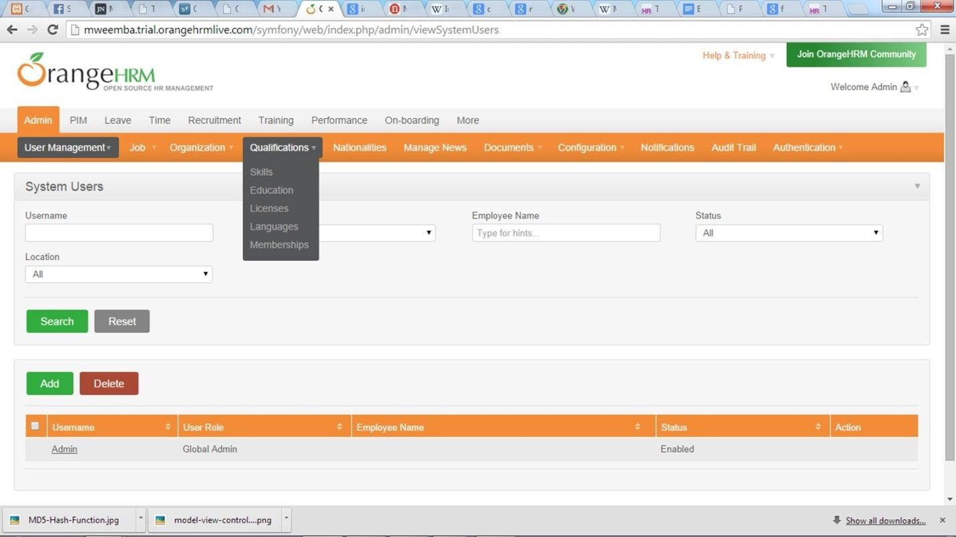

*Figure 2.5 Snapshot of OrangeHRM interface*

**2.4.2 SimpleHRM**

[SimpleHRM](http://www.simplehrm.com/opensource.html)offers an open source version of its professional platform. This version offers time management, and it can be installed on either a WAMP (Windows Apache MySQL PHP) or LAMP (Linux Apache MySQL PHP) server. Once installed, SimpleHRM offers every feature you need to solidify your HRM department: employee information, leave management, travel management, expense management, benefit management, and task reporting. SimpleHRM allows you to assign a CV to an employee and define eligibility for rehire. Each major module offers plenty of granular control, and the user interface is well laid out.

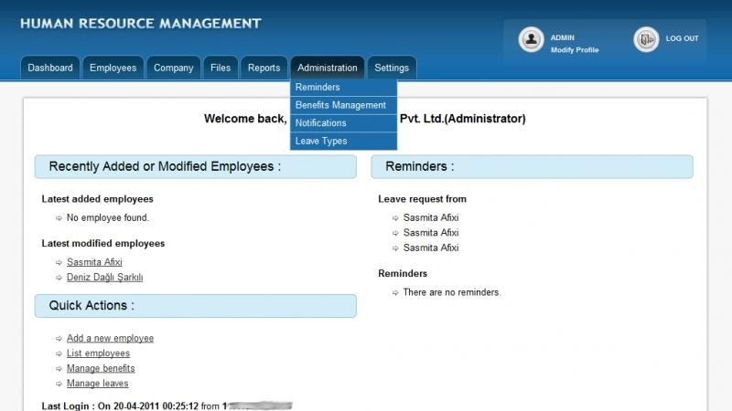

*Figure 2.6 Snapshot of SimpleHRM interface*

**2.4.3 Waypoint HR**

[WaypointHR](http://waypointhr.com/) is the HR software for any small or midsize company looking for a platform that nearly any user, of any experience level, can use. WaypointHR can manage employee data, which include:

* Personal details
* Holiday/sickness/absence history
* Employment/contract/job/salary details
* Discipline and grievance records
* Performance appraisals
* Exit interviews and termination
* A five-step add employee wizard
* Export reports to PDF
* Multi-site facility layering

WaypointHR also offers an active online support forum, a [dedicated support website](http://support.waypointhr.com/)(which includes developer support), as well as an on-demand solution (for those that do not want to bother with the installation of WaypointHR on a local machine). To get a quote for the on demand solution, visit[this page,](http://waypointhr.com/contact.php) fill out the questionnaire, and wait to hear from WaypointHR.

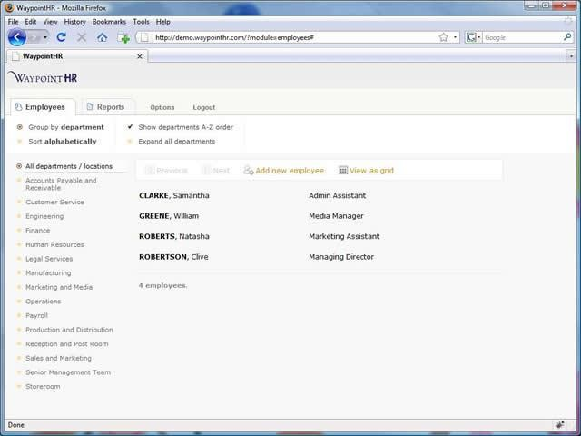

*Figure 2.7 Snapshot of WaypointHR interface*

**2.4.4 Sage HR Africa**

[SageHRAfrica](http://www.sagehrafrica.com/?page_id=179)offers world-class HR and payroll software and services to the African continent. We have an[Africanfootprint](http://www.sagehrafrica.com/?page_id=4)of 35 countries that includes an extensive network of Strategic and Business Partners that can assist you with installation, training and any[on-sitesupport](http://www.sagehrafrica.com/?page_id=6)that your business requires. We are committed to providing robust, innovative and easy-to-use [human](http://www.sagehrafrica.com/?page_id=5) [resource](http://www.sagehrafrica.com/?page_id=5) [and](http://www.sagehrafrica.com/?page_id=5) [software](http://www.sagehrafrica.com/?page_id=5) applications that will make your business life so much easier. We ensure statutory compliance with local authorities and with our software your business is always in line with country-specific payroll and HR rules and regulations. Our HR and Payroll software is ideal for any size and type of business. Whether you are just starting out, or if you have an existing business that is growing, Sage HR Africa’s software solutions aim to support the growth of your business and to develop an ongoing partnership with you, our potential customer, for the long-term. Sage HR Africa Leave application Workflow

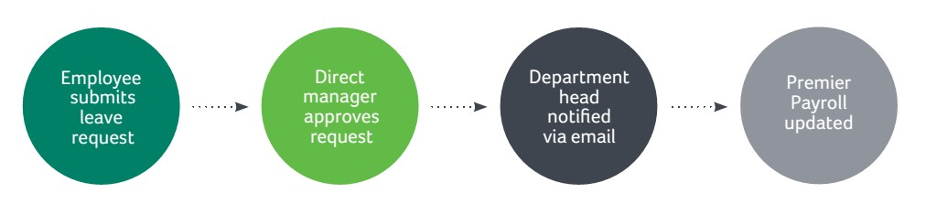

*Figure 1 Leave application Workflow*

2.5 OTHER REVIEWS ON PERSONNEL MANAGEMENT

Innumerable research studies have been undertaken to understand the technological implications on HRM in general. The Present review deals with some of the noteworthy empirical studies found through scholarly Internet Search engines like scholargoogle.com and several online databases like INFODATA, docstoc.com, wikipedia and others) related to the impact of E-technology on Human Resource Management.

Ruel et al, (2002) say that, the term e- HRM was first used in the late 1990’s when e-commerce was sweeping the business world. E-HRM is internal application of e-business techniques to add value to the management through more effective and efficient information flow and is a way of doing HRM

Stefan Strohmeier (2007) has quoted in his review study that rapid development of the Internet during the last decade has also boosted the implementation and application of electronic Human Resource Management. According to him Surveys of HR consultants suggest that both the number of organizations adopting e-HRM and the depth of applications within the organizations are continually increasing. In addition, an escalating number of practitioner reports provide anecdotal evidence that e-HRM is becoming increasingly common and may lead to remarkable changes.

Paul D. Hamerman et al, (2008) in their empirical studies said that technology solutions can help tech Savvy human resource professionals to strategically manage through the crisis and prepare as the climate shifts to the upside. Trends that we will follow in 2009 include managing and developing talent, embracing HRM analytics, Web 2.0 adoption, and HR technology strategy.

A. Sanayei & A.Mirzaei (2008) say that E-HRM applications have a significant positive effect on the effectiveness of HRM activities. This means that deploying E-HRM tools impacts on the effectiveness of HRM activities indirectly. For implementing E-HRM tool, first we must identify the goals and strategies of E-HRM and then provide the infrastructure in organization such as information technology and telecommunication systems. It is essential to consider the limitations of implementing E-HRM such as hardware, software, employees’ skill and financial capabilities.

**2.6 SUMMARY**

The literature review in this chapter has looked at a brief overview of existing HR and employee management systems and what procedures have to be followed when executing these HR tasks. Various front and back end technologies were also reviewed highlighting the advantages and disadvantages of their use, lastly the chapter looked at the importance of security over the Internet and suggested ways in which a web application can be made secure. The next chapter will take a look at the system analysis of the developed system.

CHAPTER THREE

**METHODOLOGY AND ANALYSIS OF THE SYSTEM**

**3.1 INTRODUCTION**

This chapter gives a detailed outline of the software development methodology used in this project following up the various existing software development methodology discussed in chapter two. The strength and weaknesses of the chosen methodology have been outlined. Further, the functional and non-functional requirements of the system are explained in detail and the use cases which are a list of steps, typically defining interactions between a role and a system, to achieve a goal. Class diagrams have been given to show detailed data modeling of the system which will be translated into code.

**3.2 ANALYSIS OF THE EXISTING SYSTEM**

The existing system is operated manually. Personnel information is stored using paper and pen. Manual handling of personnel information poses a number of challenges which include:

1. The speed of processing data manually is low and prone to errors.
2. So many files, papers, drawers, filing cabinets are used. These occupy space and makes data transfer cumbersome.
3. There are no adequate security measures employed in any manual system of data processing and storage. As a result of this, some confidential files and documents could consciously or unconsciously be exposed and these files are not properly checked and restricted.
4. Slow and inefficient database system which lacks cohesion.
5. The lack of a central database that is directly accessible by staff and management in its decision-making procedures.

**3.3** **ANALYSIS of THE NEW SYSTEM**

The new system project a computerized method of managing personnel in an organization. For a big company like Nigerian Petroleum Lagos brance, this system will help to solve all the problems inherent in the existing system. The justification for the new system includes:

* Timely staff record registration.
* Timely processing of employee information.
* Error-free processing of data.
* It is inexpensive to administrators.
* Transactions are secured (Authentication).
* It is cost effective.

**3.4 PROJECT METHODOLOGY**

To design and implement a computerized personnel management system is the purpose of this thesis. As shown in Figure 3.1, there are six stages run through our research design. We use Boehm’s spiral methodology to implement the development process. This model is suitable for our project since it allows flexibility and does not require us to define the entire system from the beginning, because we do not have previous iterations to get a part of the development process, this model relies on prototyping and client interactions. Our current system has been developed through cycles of this model (Boehm & Hansen, 2000). This method was favored for the following reasons:

* It allows for development of high-risk or major functions first
* Each release delivers an operational product
* Customer can respond to each build
* Uses “divide and conquer” breakdown of tasks
* Lowers initial delivery cost
* Initial product delivery is faster
* Customers get important functionality early
* Risk of changing requirements is reduced

**3.5 SYSTEM DESIGN**

**3.5.1 Architecture of the system**

Here we set about to actually design the system. Although we considered many possible architectures. Three-tier Client Server Architecture and the Repository-Based Architecture was used for the development of the system. The three-tier model is a type of client server architecture. This model consists of two types of machines, service consumers (clients) and service providers (servers).

What is most important about this architecture is that clients and servers may or may not be running on dedicated machines. Thus it is possible for a machine to act as both a client and a server depending on the situation. In the case of PRO, the clients will be the individual microcomputers all around the company and the central server will be the service provider. Information exchange between the machines is done through messages requesting data, or invoking procedures on the remote machine. In this case it will usually involve one of the clients requesting information from the server. The three tiers of the system will separate the user (client) from the complex inner workings of the software.

The first tier is an application layer that the user interacts with. Under the application layer is a processing layer that processes the user’s queries. Under that is the database layer which receives the processed queries and returns the appropriate data to the processing layer. The processing layer passes the data back to the application layer which formats it for the user to see. The layers will exist on different machines; the processing and database layers will exist on the server, while the application layer will exist on each client machine

**3.6 UML DIAGRAM**

**3.6.1 Use case analysis**

A use case defines a goal-oriented set of interactions between external users and the system under consideration or development. Thus, a Use Case Scenario is a description that illustrates, step by step, how a user is intending to use a system, essentially capturing the system behavior from the user's point of view.

In order to create relevant use cases for the system, the following actors for the system have been identified:

* Employee (could be lecturers, accountants, technicians)
* Head of Department (HOD)
* Human Resource (HR)

Admin

Actors, Use Cases and their Description

|  |  |  |
| --- | --- | --- |
| Actor | Use case | Description |
| Employee | Edit Profile | Employee will be able to edit personal details such as emergency contacts as well as technical skills acquired. |
| Employee | Apply Leave | Employee will be able to submit leave request along with supporting documents. |
| Employee | View Tasks | The employee will be able to view tasks assigned by the  HOD. |
| Employee | Check Leave days | Employee will be able to check leave days. |
| HOD | Assign tasks | HOD will assign tasks to employees in his department. |
| Admin | Add new employee | Add mean will be able to create new employees. |
| Admin | Edit user role | Admin will be able to edit user roles. |
| HR | Accept leave application | HR will accept leave |
|  |  | applications from employees. |
| HR | Reject leave application | HR will reject leave applications from employees. |
| Admin | View user activity log | Admin will be able to view activity log of all users in the system |
| HOD | Create projects | The HOD is able to create a project, come up with a project teams as well as assign tasks to the project members breaking it down into a WBS. |
| HOD | Create trainings | HOD will create trainings and delegate employees that will attend the trainings. |
| HR | Generate reports | HR will be able to generate reports containing employee information. |
|  |  |  |

*Table 3.1 Actors, Use Cases and their Description*

Use case diagrams:

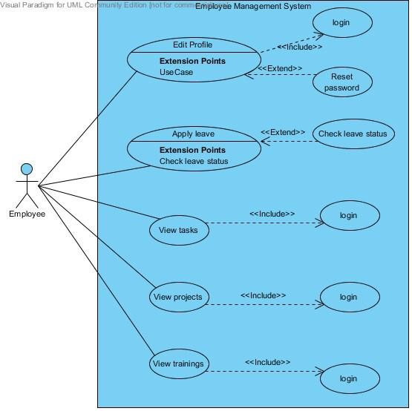

*Figure 3.4 Employee use case*

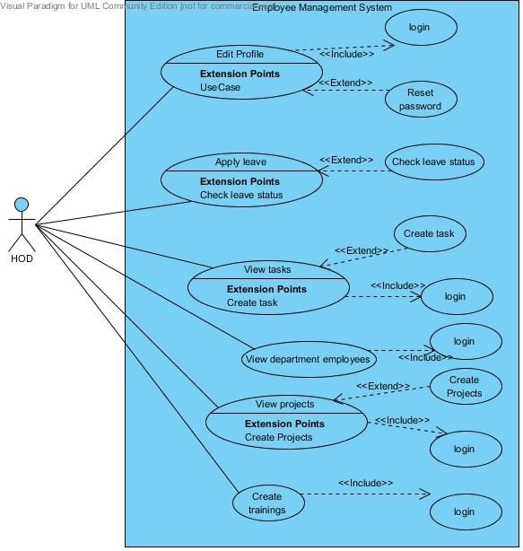

*Figure 3.5 HOD use case*

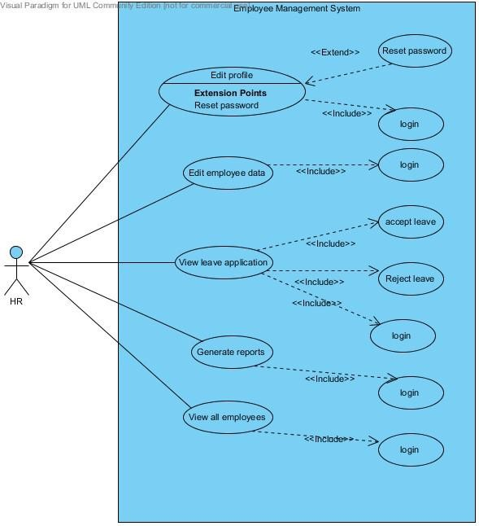

*Figure 3.6 Human Resource use case*

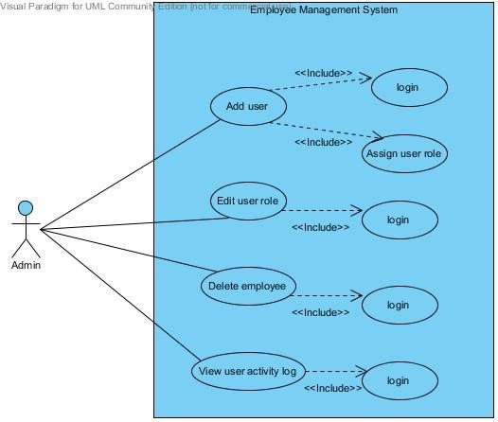

*Figure 3.7 Admin use case*

**3.6.2 Class diagram**

In the class diagram below, the Employee and Admin classes inherit from the User class. The employee class is also parent class to Human Resource class, Head of Department class and Ordinary employee class. An ordinary employee may include lecturers, accountants and all other employees that do not interact with the system with many privileges. These employees carry out the same operations.

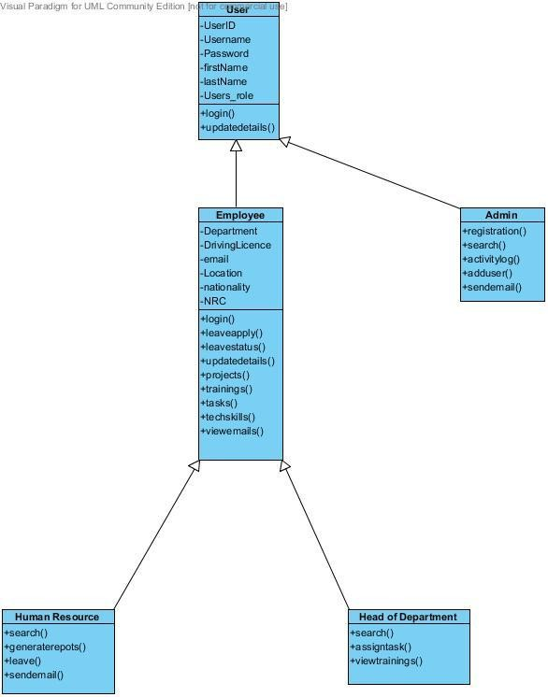

*Figure 3.8 Employee Management System Class diagram*

**3.6.3 Data flow Diagram**

A data-flow diagram is a way of representing a flow of data through a process or a system (usually an information system). The DFD also provides information about the outputs and inputs of each entity and the process itself. A data-flow diagram has no control flow, there are no decision rules and no loops

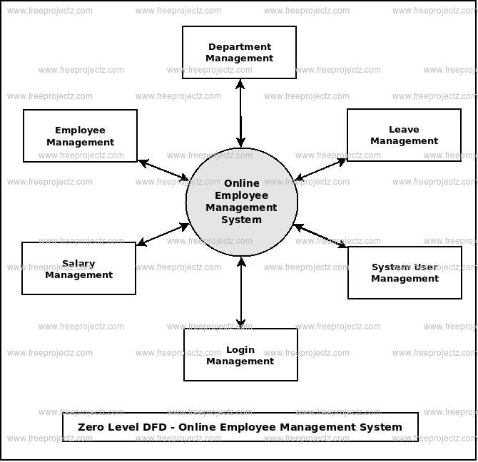

Data flow diagram

3.7 SUMMARY

The core and emphasis of this chapter was the analysis of the current system. The various development tools used in the project were also discussed in this chapter. The next chapter will focus on the design characteristics and aspects of the system to be developed.

CHAPTER FOUR

SYSTEM IMPLEMENTATION

**4.1 INTRODUCTION**

This section shows the actual running of the system. Here the development tools are analyzed and the system requirements are made known. Proper tests are also made to ascertain if the developed system conformed with the intended objectives.

**4.2 DEVELOPMENT TOOLS**

This part of the chapter is an account of the technologies that could be used in the development of the system.

**4.2.1 Front End Technologies**

Front end-is a term used to characterize program interfaces and services relative to the initial user of these interface and services. It usually refers to the client side of an application. A front-end application is one that users interact with directly. Turban et al (2008, p45) defines front end as the portion of an e-seller’s portal, electronic catalogs, a shopping cart, a search engine and a payment gateway.

* **HTML**

HyperText Markup Language (HTML) is a computer language devised to allow website creation. These websites can then be viewed by anyone else connected to the Internet. It is relatively easy to learn, with the basics being accessible to most people in one sitting; and quite powerful in what it allows you to create.

Having the basic knowledge of HTML will could help make or develop m-commerce websites and will also prove to be handy especially for editing and modifying web pages. Furthermore, it has some low cost benefits because of its many free online tutorials and advice support which is vital for m-commerce development.

* **JavaScript**

JavaScript is a scripting language that is browser based and was developed by Netscape to enable web masters/authors to add interactivity and enhances behavior of web pages [11]. Some of the dynamic behavior that can be generated by JavaScript is validating form, performing specific actions e.g. after a mouse click, adding timestamps etc. JavaScript is an open language and anyone can use it. It also shares m any of the features and structures of the Java programming language, though it is not really related to Java. It was developed independently.

* **CSS**

CSS is a style sheet language used to describe presentation and layout of HTML tags. CSS is used to enable separation of document content from document presentation. This refers to the separation of document presentation aspects such as colors, layouts and fonts from the actual document content. CSS helps us achieve layout design and control much easier.

**4.2.2 Back End Technologies**

* **PHP**

PHP, abbreviated to Hypertext Preprocessor is a server side web programming language that can be embedded into HTML. PHP is free software i.e. it is open source code. It is used for creating dynamic web pages that interact with the user and can include functionalities such as getting user input, manipulation of the input and storage of this data in a suitable DBMS. PHP is also easy to integrate with web pages.

* **MySQL**

MySQL stands for My Structured Query Language. It is the world’s most popular open source relational DBMS. MySQL is available for free under the GNU General Public License for open source benefits/reasons related to development. Initially MySQL was free and some versions of it are still free though if you desire to use MySQL for commercial purposes you will need to purchase a license. It is non-proprietary, easily extensible and platform independent. Its downside is that it lacks a graphical user interface; therefore you need to know how the database works to make the most efficient use of it.

4.3 SYSTEM REQUIREMENTS

## The requirements needed to implement this system are as follows:

## Hardware Requirements

## The software designed needed the following hardware for an effective operation of the newly designed system.

## A system running on Pentium 2 or higher processor

## The random-access memory (ram) should be at least 512mb.

## Enhanced keyboard.

## At least 20 GB hard disk.

## V.G.A or a colored monitor.

**4.3.2 Software Requirements**

The software requirements include: -

1. A window 98 or higher version for faster processing.
2. Wamp or Xampp

4.4 SYSTEM INTERFACE

The output design was based on the inputs. The report generated gives a meaningful report to the management. The system designed generates reports using the search operation which can be; (Search via staff ID, by department or by Rank). These outputs can be generated as softcopy or printed in hard copy. Figures below show the screenshots of the developed system

**4.4.1 Login**

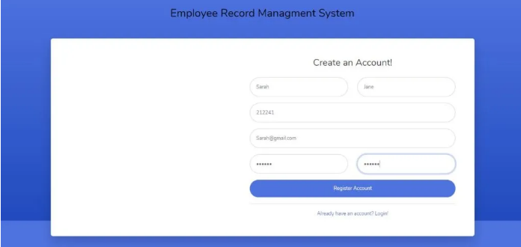

**4.4.2 Personnel**

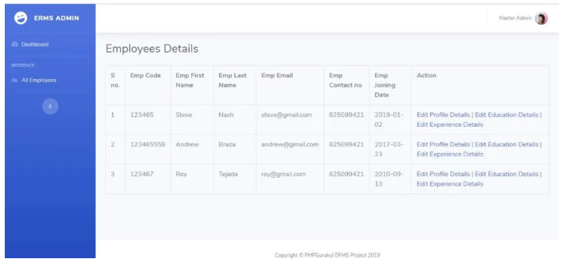

**FIG 4.1** Staff Employment Form “New System”

**4.4.3. Assessment Form**

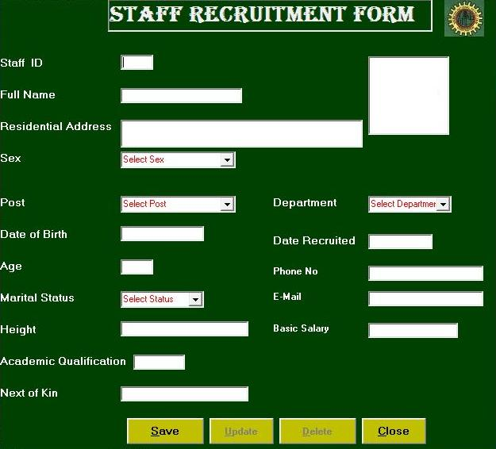

**FIG 4.2** Assessment Form “New System”

**4.5 FILE DESIGN**

Files held in this project are made up of different data types. These types are integer, character, double, date, etc. some of the files used are designed and linked with database. Also in the project design, Microsoft access database was used. Below is the database specification for the files used.

### 4.5.1 Structure for File “Staff”

|  |  |  |
| --- | --- | --- |
| FIELD NAME | **DATA TYPE** | **SIZE** |
| ID | TEXT | 20 |
| NAME | TEXT | 40 |
| ADDRESS | TEXT | 100 |
| DATE OF BIRTH | DATE\TIME | 8 |
| SEX | TEXT | 10 |
| AGE | LONG | 4 |
| STATUS | TEXT | 20 |
| HEIGHT | TEXT | 10 |
| DATE RECRUITED | DATE\TIME | 8 |
| QUALIFICATION | TEXT | 50 |
| DEPARTMENT | TEXT | 50 |
| RANK | TEXT | 30 |
| NEXT OF KIN | TEXT | 50 |
| REMARK | TEXT | 50 |
| CONDITION | TEXT | 50 |
| REASON | TEXT | 150 |
| BASIC SALARY | DOUBLE | 8 |

### TABLE 4.1 Structure for file “staff”

### 4.5.2 Structure for File “Assessment”

|  |  |  |
| --- | --- | --- |
| FIELD NAME | **DATA TYPE** | **SIZE** |
| Id | Text | 20 |
| Name | Text | 40 |
| Date | Date \ Time | 8 |
| Report | Text | Variable |

**TABLE 4.2:** Structure for file “Assessment”

CHAPTER FIVE

SUMMARY, CONCLUSION AND RECOMMENDATIONS.

5.1 SUMMARY

In this project work, I present how personnel roles and functions are administered in an organization. However, I also identified various difficulties confronting an organization in realizing its target, aims or objectives as well as making suggestions and recommendations to the management in order to improve it system generally.

Once again, I have examined the concept of personnel management and I feel that it would be of useful purpose to the readers, students of management, managers of companies as well as administrative practitioners. Hence, personnel management information software was development to assist managers keep track of employee’s record.

5.2 CONCLUSION

The role of personnel management has become an integral part of an establishment set up in Nigerian society. The results of this study coupled with the relative observation in similar organizations in this country have shown an indication that personnel management, as oxygen is to human lungs, is a function that cannot be under-estimated and over rolled in any organization where efficiency of operation is a matter of consideration. The workforce or manpower resource of an organization is the most valuable asset and as such, this aspect of managerial role requires urgent and special attention.

By implementing the computerized staff management system will help the organizations to plan their human resources both quantitatively and qualitatively. Being an information system of human resources, it can store voluminous data about the staffs; and assists not only in identifying the occupied and unoccupied position, but also whether the person is fit for the job or not. Other conclusions that can be drawn from the implementation of the staff information system include a healthier human resources decisions, enhanced supervision and control of man power. Also, the system being an automated one aids in reducing various costs such as labour and recruitment cost; and exert outstanding strategic activities such as training and development, succession planning, tracking of applicant recruitment and selection, manpower planning, staff information, attendance tracking, salary planning, absenteeism analysis and work scheduling. At this juncture, it can be accomplished that staff information system is an excellent tool for human resources management as it facilitates in generating primary reports, and important information could be stored and updated automatically.

5.3 RECOMMENDATIONS.

The Staff Management System (SMS) is recommended for use in Nigeria National Petroleum Corporation as they can be assured of reliability and security of staff information. Also, the developed system can be packaged and improved upon to become a generic one that can be deployed for commercial use. To achieve this there will be need to carry out activities such as data test, user acceptance testing, system review and deployment. Albeit, there are some areas that needs further improvement for future researchers. Some of these areas are; since there are always changes and growth in requirements and these would automatically affect every software project, so there is need to timely updates them, updating of assets and liabilities, certifications, organizational and staffing pattern. The documentation processes in this study are also good source of information for further database system development and data analysis for academic work.

Other recommendations to be taken into consideration include:

Firstly, if people consider the various problems of personnel management the wastages of organization human and material resources should be kept to a practical minimum level. This is because we cannot do without personnel management in any organization. Hence the need for the implementation of this personnel management information software developed in this project work.

Secondly, it is clear that there are many people who have inborn capabilities for management. This is a natural trait, which could be better off if the government can improve the appropriate training and techniques for proper utilization of these traits to accomplish the original objectives.

Thirdly, the personnel department should be competent to advice on the best and most modern techniques, technologies and practices to provide a professional support and monitoring services in the area of this study.

Lastly, Workers should be given their rights and there should be the establishment of mutual co-operation between the employer and the employees with view of eradicating conflicts problems of fatigue, lay-off and improving the industrial harmony within the organization.

Furthermore, the individual needs which become paramount for his joining the organization, should always be given priority attention. This will not only motivate him and increase his productivity but will also give him brighter chances of better career prospects in the enterprise and at the same time, self-actualize himself.

REFERENCES

Agwu,A.A (2009). *Functions and objectives of Personnel Management*. 2nd ed., Akwa: Optimum Publisher

Anyanwu, G. (2003). *Review of Personnel Management*, Management System in Nigeria. Vol 4, Pg78

Barnes, J.G and Cumby, C. (2000). *The Cost of Quality in Service- Oriented Companies*, Making Better Customers’ Decision Through Improved Cost Information. Vol 6, San Diego Conference.

Bachelor, J. (2005). *Management Information System*, Daily Improvement

On Personnel Management. Vol 6, Pg44

Burkingham, H. (2008). *Information system analysis*. California: Olive Publishers

Cole, W. (2001). *Personnel Management Theory and Practice*. San Diego California: City Press

Edward, T. (2005). *Preview of Personnel Management System*, New York City: Geffen Publishing Company

Flippo, A. (2000). *Personnel Management*. London: Hallmark Press

George Wills (2003). *Management Information System*. London: Webster Publisher

Gronroos, C. (2000). *Service management And Marketing*, “Managing The Moments Of Truth In Service Competition”. Massachusetts/Toronto: Lexington Books.

Jamie, K. and John, G. (2007). *Personnel Management And Structure*. New York City: New York Press

Laudon. J.P and Laudon K.C. (1991). *Functions Of Information System*. London: Webster Publisher.

Lucy, t. (2001). *Management Information Systems*. 1st ed., London: Dp Publishers,

Microsoft Encarta (2008*)****.*** *Personnel Management*. New York City: Microsoft Corporation

Mihir, B. andPhillip, R. (2005). *Introduction To Modern Management Information System*. California USA: California Printing *Press*

Unamka and Ewurum (2005). *Personnel Management Functions*. Lagos State: Ekon Press

Vossen, G. (2009). *Data Models, Database Languages and Database Management Systems*. New York city: Adison-Wesley Publishing Company.