DESIGN AND IMPLEMENTATION OF A COMPUTERIZED HUMAN RESOURCES MANAGEMENT SYSTEM: A CASE STUDY OF EMENITE PLC ENUGU

ABSTRACT

The present and forthcoming prosperity of an organisation is predominantly contingent upon the endeavours and administration of its human resources component. The achievement of enhanced productivity, encompassing factors such as profitability, organisational efficiency, and effectiveness, is contingent upon the adept management of human resources. The management of human resources holds a pivotal role in the overall welfare of an organisation, particularly in the realm of fostering constructive transformations that lead to enhanced operational efficacy.

Due to the aforementioned circumstances, it becomes imperative to enhance certain facets of the human resources department's operations that necessitate amelioration or potentially substitute areas that may warrant replacement. This course of action has been set in motion.

This project centres around the computerization of the human resources department, with the objective of mitigating time constraints associated with job functions within the organisation. Additionally, it seeks to address the issue of insufficient record-keeping in the system, which has resulted in systemic problems and inadequate production of products that fail to meet customer satisfaction. A computational model shall be devised to address the problematic domains necessitating computerization, while simultaneously proposing enhancement strategies for areas necessitating evaluation.

This initiative will significantly contribute to the enhancement of human resources management, enabling it to effectively address the multifaceted challenges arising from the rapid advancements in information technology. Moreover, its impact will extend far beyond geographical boundaries, benefiting organisations worldwide.
TABLE OF CONTENT

CHAPTER ONE
INTRODUCTION |  | 1
1.1 | Statement of the problem | 4
1.2 | Objectives of the study | 4
1.3 | Scope of the study | 5
1.4 | Limitation of the study | 5
1.5 | Significance of the study | 6
1.6 | Assumption of the study | 6
1.7 | Definition of terms. | 7

4

CHAPTER TWO
LITERATURE REVIEW | 10
INTRODUCTION | 10

CHAPTER THREE
3.1 | Description and analysis of the existing system | 17
3.2 | Fact finding method | 19
3.3 | Organization structure | 20
3.4 | Input / output and processing analysis | 21
3.5 | Information flowchart | 23
3.6 | Problem of existing system | 25
3.7 | Justification of the new system | 25

CHAPTER FOUR
4.0 | Design of the new system. | 27
4.1 | Input / output specification and design | 28
4.2 | System flowchart | 32
4.3 | Procedure chart | 33

5

4.4 | System requirement | 34
CHAPTER FIVE
5.0 | Implementation | 37
5.1 | Program design | 39
5.2 | Pseudo Code | 45
CHAPTER SIX
6.0 | Documentation | 47
CHAPTER SEVEN
7.0 | Recommendation and conclusion | 49
7.1 | Conclusion | 50
 | REFERENCES | 52

CHAPTER ONE

INTRODUCTION

6

Human resources management at least in a primitive form has existed since the drawn of group of effort. Certain human resources functions even though information nature was performed wherever people come together for a common purpose.

The contemporary area of human resources management begins in the

late (1920�s) it was characterized by an increase concern for human element in management. During the course of this century, however, the process of managing people has become more formalized and specialized and also a growing body of knowledge has been accumulated by practitioners and scholars.

The human resources management (HRM) is a relatively modern label for the ranges of themes and practices involved in managing people.

In organization �people� (Workers) are critical factors in its well-being. Since every organization is made up of people, hiring and maintaining good and qualified people critical to the effectiveness or success of organization. For the fact that every organization is human oriented, a factor without which the organization is reduced to nothing, the process of acquiring human services, developing skills, motivating them and ensuring

7

their loyalty in the organization are vital instrument for achieving organization objectives be it public or private sector.

Human resources is simply defined as the supply of required staff of people with various qualitative skills which when applied, organizational or institutional objectives will be achieved. The globalization process today dictates a need for continuous improvement in productivity and quantity necessary for an effective use of new technologies on organization that would like to survive these challenges of the present and future time anticipate its system reviews and change.

Today things are changing very fast the world has become so much unpredictable and uncertain especially in areas of rapid and radical technological development which focus more on computerization.

This goal could only be achieved by organization engaging in proper utilization of its human resource elements. Manages the implementation and delivery of human resources services and operations agency-wide; implements human resources policies and operating procedures in a consistent manner throughout the agency. Employ technology to improve the efficiency and effectiveness of operations, including electronic

8

recruitment and staffing systems. This lad to this research and project work

�Design and implementation system� using the Emenite Limited (EL) Enugu as a case study of stream line the conduct of company operation with the global demand of present the technological development. Emenite limited has been a member of the Belgium group Etex started operation in

1963 under the name �Turners & Sbetos cement company Nigeria Limited and later change to turners building products (Emene) Limited. Due to dividing fortunes of the company, in March 24, 1998, turners and Newall Ltd diverted its interest in the company and transferred 51% of its shareholding to Eteroutreme societe Anonyme of Belgium (now Etex group S.A) and balance went to Eastern Zones that change the name to Emenite Limited.

In the course of the work Emenite Limited (EL) the computer is used to compute the flow of data, production, quality control, and data processing. This production appointment will properly kept and access information, retrieval of information, storage easy and simply to generate helps to make more reports available to the management and better handling of production,

9

appropriate quality control, personnel data and information flow in other departments.

1.1 STATEMENT OF PROBLEM

The non-satisfaction of customers demand when needed (inadequate production); the time wastage in delivery of goods; the improvement on adequate payment of workers.

1.2 OBJECTIVES OF THE STUDY

The effectiveness of an organization firm or system is determined by its ability to allow certain goals maintain itself internally and adopt to it environment. The main of this project is to improve in production and data flow during delivery within Emenite organization using a more feasible alternative that will eliminate some of the problems in the existing system. The set objectives of the project can be summarized as follows:

- Improvement in production

- To avoid unnecessary delay in time delivery.

10

- To improve on adequate payment of workers.

1.3 SCOPE OF STUDY

The project will cover only the area of Human Resource Management of Emenite Limited, Enugu. After the analysis of the procedure in the present system some areas need improvement while some demand conversion that will be best handled by a computer method. The areas of the automation are area of production, appropriate time delivery of goods and

1.4 LIMITATION OF STUDY

Things that will be the constraints in carrying out the work

- Non-availability of fund/finance: Limited production made the researcher to base his work in Emenite Limited Enugu as the case study.

- Time: The time to travel outside the school premise made the researcher to face some task. Also the time frame stipulated for completion and sub-mission of work also posed a constraint.

11

- Privacy of data: To issue data to me was very tough because of revealing their secret also posed a constraint.

1.5 SIGNIFICANT OF THE STUDY

The improvement of the organization firm or system goal

- Towards zero inventory in production

- Towards bags of one (of) in term of production to satisfied their customer when demand is needed.

- Improve in production.

- Improve on adequate payment of workers.

1.6 ASSUMPTION OF THE STUDY

The assumption that all information being given to me is true and will aid the organization or management to achieve efficiency and effectiveness in operation and production of the organization.

12

THE RECOMMENDATION

The outcome of the project will led to efficiency and effectiveness of the management in terms of production and appropriate delivery on time in the organization.

1.7 DEFINITION OF TERMS

INPUT � is used to feed data to the computer for processing. OUTPUT � are hardware that produce the result of the data processed
by the computer.

HTML � Hypertext make up language.

CONTROL SYSTEM � This unit contains the maintenance of the

computer.

Management:- has to do with organization operation and control of

responsible elements that is required to improve the performance of an

organization.

Information:- is data that have been collected and manipulated into a

meaningful form.

13

Billing Address:- this is where the layer of a particular goods enters the address where the goods is to be delivered.

CITY:- This is the column where the customer enter the state and area he/she currently staying.

STATE/PROVNCE:- This is the column where the customer enters the state and area he/she currently resides.

POSTAL CODE:- This is the column where the customer enter the code of the area he/she currently resides.

COUNTRY:- This is the column where the customer enter the country name where he/she reside.

FIRST NAME:- This is the column where the customer enter his/her

name.

LAST NAME:- This is where the customer enters his/her surname.

COMPANY:- This is where the customer enter his/her company

name if any.

PHONE NUMBER:- This is the column where the customer enters the number they can used to contact him/her.

14

FAX NUMBER: This is the column where the customer enters a number where they can be able to send document him/her.

NOTE:- This is the column where the customer will describe how he/she wants the goods to look like.

15

CHAPTER TWO

LITERATURE REVIEW

INTRODUCTION

Organizational management and control are handled by the human

resources management including �human resources theory� which can be found in the literature in 1981 with its introduction on the courses at Harvard business school.

Human resources management owes a deal to order models of people management but its orientation is constraints with other modern management techniques. The functions of the human resources management including production, hiring, training and record keeping and maintenance. This chapter centers in the review of literary work that had been published or

unpublished or written on the subject �Human Resources�

REVIEW OF PREVIOUS WORK

�Human� is concerned with people since every organization is made up of people hiring and maintaining good and qualified people is critical to the effectiveness or success of organization.

16

Joan Sindair in his book � the Administration management and human relation (1993) stressed that all the activities of any enterprises are initiated and determined by the person who make up an institution.

Resources are seen as �Supplies of stock of something useful� while in management the focus is people. Since every organization is human oriented a factor without which the organization is reduced to nothing the process of acquiring human services, developing skills, motivating them and ensuring the process or their loyalty in the organization are vital instrument for achieving organization objectives be it public or private. Human Resources Management provides also public sector managers and human resources professionals with a sources of practical expertise, best practices and innovative solutions for improving the management of human resources.

Wayru F. Casio (1985) stated that organizations are managed and staffed by people , without people, organization cannot exist. Indeed, the challenges, the opportunities and also the frustration of creating and managing organization frequently stem from people related problem. That arises within them. It is worthy to know or note that all these are emphasizing on management, production and operation of human element

17

hence the life and death of organization rely on it. Management control of human resources functions are supported by reports and analysis showing the various resulting from difference between planned and actual performance for such items as in production and delivery of goods.

The strategic planning for personnel and technical is involved with evaluating alternatives strategies for recruiting, training and production that

will ensure the organization of the necessary personnel�s and technical to achieve its objectives.

COMPUTER IN HUMAN RESOURCES MANAGEMENT

So far, the meaning and concept of human resources is what we have been discussing, here let us have a look at other concept that is aligned with human resources. They are

- Computerization.

- Management

- Information

- System.

18

Computerization is the process of converting a manual method of activity to a mechanical or electronic process in such a ay that the real data processing is no longer done manually.

Management on this scope has to do with organization operation and control of responsible elements that is required to improve the performance of an organization. Its levels of activity are mainly on decision making based on generated reports or information.

System was defined by WOLE ADEWUNWU in his book titled

�Management information system and Data processing� as the integration of people, procedure, software or hardware to accomplish a particular task. Information is data that have been collected and manipulated into a meaningful form. The totality of the whole being the application of technology and management techniques to production, communication and use information in business and general administration of human resources. This simply means that if is a formal integration of components that perform data processing operation to
a. Meet legal and transactional data requirement.

19

b. Produce information to management for support, planning, control and decision making.

c. Provide variety of report as required to external activities of the system.

The gains accusable from implementing a computerized human resources management information system cannot be over emphasized. They are summarized as follows.

- It will help to minimize data redundancy through structural techniques.

- It will help to improving of production in the organization.

- It provides enormous flexibility in all types of on-line inquires and delivery of goods.

COMPUTER APPLICATION IN GENERAL

A computer is defined as an electronic device which can accept input, solve arithmetic or logical problems based on specific set of rules or instructions stored and can retrieve the processed data in a meaningful form and data tremendous speed

20

Accurate and appropriate information storage is a prime commodity in the growth of an organization. Computer and computerization in information technology have come to stay due to its tremendous advantages such as
- Speed of operation

- Accurate of result

- Ability to handled complex problems

- Its capability of mass storage of information.

The ability of computers to handle these things (task above) depends on the hardware and software that compose a computer system. Hardware are physical parts or components of a computer and they are three different purpose namely

- Input

- Output

- Control unit.

The input units are used to feed data to the computer for processing.

Some of the input devices are the keyboard, mouse etc.

21

The output devices are hardware that produces the result of the data processed by the computer. They are monitor, the printer, invoice output etc.

The central or control system unit contains the main brain of the computer system. Some will say that it is the brain box of the computer system. It is here that the logical and arithmetic and data captured by the computer is processed by a device called the Microprocessor.

The functions of the computer performing these operations cannot be achieved without the presence of a set of instruction codes called programs. These programs when integrated together for a specific purpose are called software.

Software are suit of instruction codes that tell the computer what to do and how to perform operation. Software can be classified as system software and application software. System software are software that control the internal behaviour of the computer system and can be used to develop other programs or software. Some are used to maintain efficiency of computer system.

22

Application software are developed for a specific purpose of use in an area of human endeavor. They are used for productivity, entertainment, business or for education purpose.

All these integrated together and the user as well form that is called the computer system that performs as an entity for the computer to achieve it objectives

23

CHAPTER THREE

3.1 DESCRIPTION AND ANALYSIS OF THE EXISTING SYSTEM.

This section talks about existing system of (Emenite Limited) procure their goods manually and automated.

The process of the existing system helps the organization through the two (2) machines that is use. By manually and automated operated the goods of materials are being available by the customers to demand for it when needed. The existing system is used in two production lines through the aid of data processing analysis to know the output and input requirement whether or proceeds in the quality control of the organization before the materials is being published.

Generally, the data processing of input and output aid in production of goods and the process still reach the goals of consumers and appropriate delivery of goods is being made through the data processing methods by recording of their production per profile.

24

3.2 FACT FINDINGS

The information being gathered for the human resources management information system is through the following.

- Questionnaire / interview method

- Reference to related document.

a. INTERVIEW METHOD

The materials are being given to me through the question. I was allowed to ask question face to face with personnel manager that was able to give me some answer to my question that enable to write based on my project topic being issue to me.
b. REFREENCE TO RELEVANT DOCUMENT

I was allowed to request for the relevant materials that of the past transaction of the organization or system face to face with the data processing manager. Which reference to relevant materials was photocopied and issue to me.

25

3.3 ORGANIZATION STRUCTURE.

The current organizational structure of EMENETE provide for the post of managing director, assisted by four executive directors in charge of finance, technical director, commercial and personnel manager. Their responsibilities are fashioned.
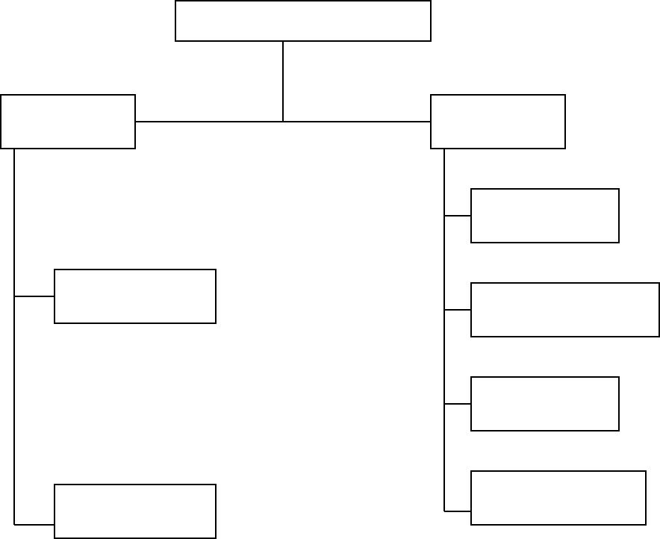

MANAGING DIRECTORS

TECHNICAL PERSONNEL
DIRECTOR MANAGER

HUMAN
RESOURCES

PRODUCTION
ADMINISTRATION

SECURITY

ENGINEERING | OCCUPATIONAL
ENGINEERING | HEALTH

26

3.4 INPUT / OUPUT AND PROCESSING ANALYSIS.

INPUT ANALYSIS

Input simply means the process used to feed data to the computer for processing. Such devices aid in recording that being inputted into the system that field and columns. The following fields as follows include:

- Customer name

- Item description

- Quantity supplied

- Data of order

- Unit price

- Manufacturing date

- Value

- Total amount.

INPUT FORM

Product description, quantity, unit price, value, total amount.

27

DATES


DELIVERY MANUFACTURING

--------------------- --------------------------

PROCESS ANALYSIS

Processing is done by multiplying the unit price with the quantity of every product bought and storing the result in the field for value. Also the various values are summed up and the result stored in the field of TOTAL AMOUNT.

OUTPUT ANALYSIS

This involves actual presentation of the (input) result of the data processed by the computer. This simply specifies the format of input made. This is written openly on a paper and the duplicate is produced to present loss of data or information. It takes the below format.

28

OUTPUT FORMAT

EMENITE LIMITED

CUSTOMERS NAME

--------------------------------------------------------------------------------------


ITEM DESCRIPTION QUANTITY | UNIT PRICE | VALUE
---------------------------------------- | ---------------------- | -------------
------------------------------------- | --------------------- | -----------
-------------------------------------- | --------------------- | ------------

_{CUSTOMER}--------------------------_{�SSIGN} | ------------------------------
_{CUSTOMER}--------------------------_{�SSIGN} | MANAGER�S SIGN

3.5 INFORMAT FLOW.

The production manager will see the goods is being in order and quality control manager will access the goods whether it reach to the required of the organization, then is being suppliers sales to supplies or sales it out. Then data production and records then and all

29

information is being made to account department will then send it to the managing director the photocopy one will be issue to him for the purpose of flow of data. After everything the sales manger will sign the receipt signified that the received the goods being purchased and it receipt to accountant will give the photocopy to the managing director.
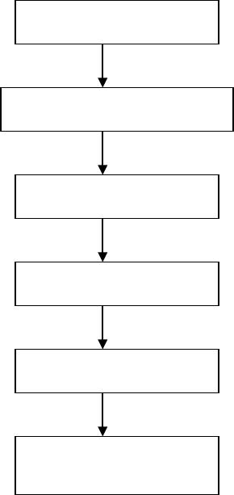

PRODUCTION

QUALITY CONTROL

SALES

DATA PROCESSING

ACCOUNTS

MANAGING

DIRCTOR

30

3.6 PROBLEM OF THE EXISTING SYSTEM.

Emenite Limited are face with a lot of problems in internally etc. these problems are stated below.

- Shortage in supply

- Shortage in production.

- Delay in delivery of goods purchased

- Time accusing and tedious operation due to the fact the operate manually in one of the machine.

- Loss due to breakages.

3.7 JUSTIFIACTION OF THE NEW SYSTEM.

Having looked at the various problem encountered by Emenite Limited which stated above, I believed that the intended new system should be able to carry out the following activities of the human resources management system of Emenite Limited such as.
- Provide adequate production for the customers

- Provide timely delivery.

- Make operations faster and simpler in replace of manual.

31

- Take appropriate care

- Produce little or no paper work

32

CHAPTER FOUR

DESIGN OF THE NEW SYSTEM

This section discusses how the old system can be improved upon the manually and automated machines (Sm and Sm3) of Emenite Limited.

For the fact that the manual and automated machines can�t reduced the barriers or problem involve on increase objectives of the company. Like the following are

- To improve increase in production

- To improve in time delivery of goods

- To improve adequate payment of the workers

This on-line will lead to attraction of foreign customers. Every one will know that Emenite has being on-line system. This will lead in the increase of customers and production process will increase, the time delivery of goods will be effective and their will be adequate payment of workers that will be reached. This someone may require goods at any moment whether in the night or day. Their will be every possible means whether through air, ship and vehicles to make sure the customers requirement is reached.

33

The namely design system consist of the following.

- Home page to history

- History to section

- Section to other form

- Other form to other confirmation.

4.1 INPUT / OUTPUT SPECIFICATION AND DESIGN

Example of design input specification and design is as below. This is presented in a form format which the customer is expected to fill and this form is called order form.
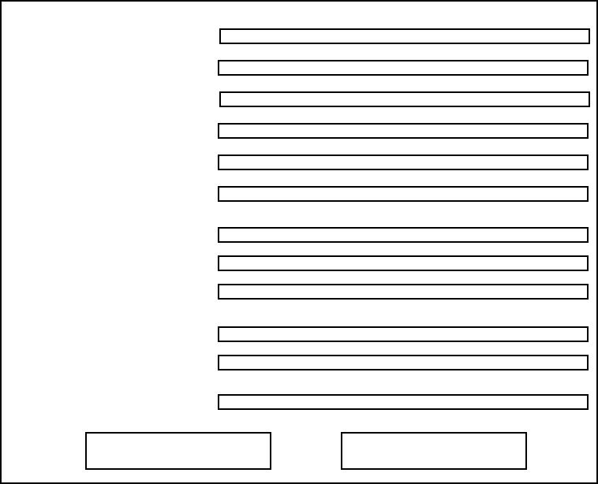
ON � LINE ODER FORM

ORDER BY CUSTOMER

BILLING ADDRESS

CITY

STATE/PROVINCE

POSTAL CODE

COUNTRY

FIRST NAME

LAST NAME

COMPANY

PHONE NUMBER

FAX NUMBER

NOTE

SUBMIT FORM | RESET FORM | 34

This is the form the customer have to fill before specifying the goods ad the quantity of the goods she / he wants and also the price will be computed depending on the goods bought.

OUTPUT SPECIFICATION AND DESIGN 1

This is the place you will see after filling the order form which serves as the input form. This come out as output showing, you to see if the information you enter is correct and if it is correct, it lead you to the section where you will see all the sections of goods available for sales.

Example below is the output specification form.
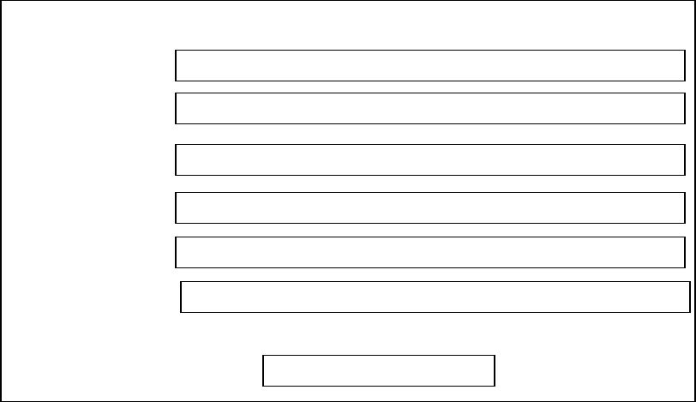

OUTPUT INFORMATION

ORDER ID

SHIP NAME

SHIP ADDRESS

SHIP CITY

SHIP COUNTRY

PHONE NUMBER

MOVE TO SECTION

35

When you have seen that all information are correct, just click on move to section, it will now take you to where the goods are available for sales.

Examples below is to see how section which the goods available will look like

OUTPUT DESIGN 2


GOOD AVALIABLE IN EMENITRE LIMITED

CLICK TH MENU BELOW TP SEE AVAILABLE PRODUCT

ROOFING PRODUCTS

CEILING PRODUCTS

36

ROOFING PRODUCTS

A
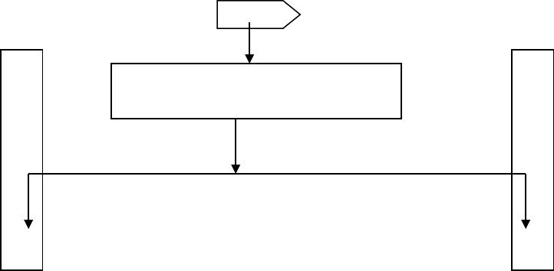

GOODS AVAILABLE IN EMENIT LIMITED

CEILING PRODUCTS

37

4.2 SYSTEM FLOWCHART
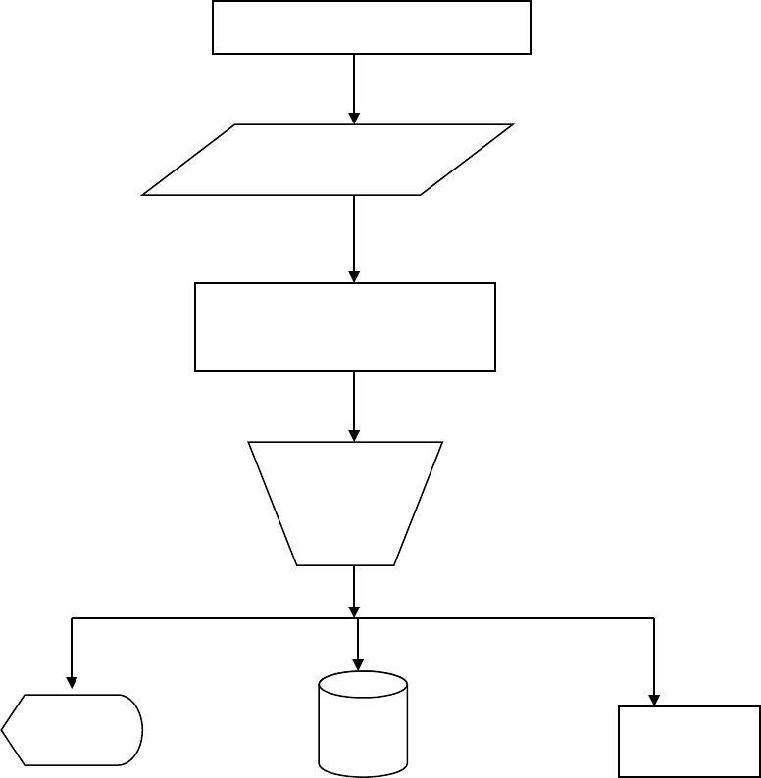

BOOT THE SYSTEM

ENTER CUSTOMER

REQUEST

SUPPLY CUSTOMERS

REQUEST

VALIDATE

CUSTOMERS
CLAIM

V.D.U DISK PAPER

REPORT

38

4.3 PROCEDURE CHART
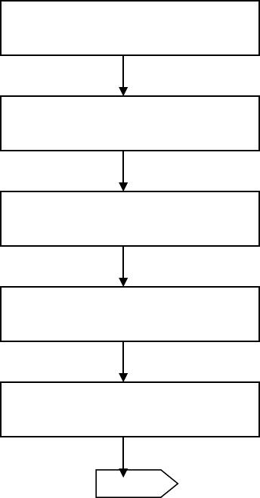

BOOT THE SYSTEM

LOAD THE INTERNET

EXPLORER / NETSCAPE

BROWSE THE WBS ITE

HOME PAGE (ON � LINE

GOODS PROCUREMENT)

LITTLE HISTORY ON

ONLINE PROCUREMENT

A

39

4.4 SYSTEM REQUIREMENT.

These are the hardware and software requirements as well as the environment in which this new system can be operated.

These are necessities for proper and effective implementation of the new system.

HARDWARE REQUIREMENT

These include all those physical components which are necessary to implement the new system. They include the following

- Pentium Processor.

- An uninterrupted power supply (UPS)

- About 1.2GB Hard disk

- A modern card (internal and external modems

- 3.5 floppy diskette

- A 14 color monitor

- A window enhanced keyboard

- Mouse and mouse pad

- A laser jet printer

40

SOFTWARE REQUIREMENT

These are the sets of program that are required to run the system effectively. They include the following

- Window 98 to the latest version

- An application browser such as internet Explorer or Netscape Navigator.

- An install HTML program to run it.

- An internet service provider (ISP) or a server to facilitate logging into system.

- Anti virus programs to prevent downloading of virus infected programs.

THE SYSTEM ENVIRONMENT

The following rules must be observed concerning the environment at which the system is installed for effective implementation.

They include the following.

- The computer room should be fully air conditioned.

41

- The room should be rugged or carpeted to avoid dust.

- It must be electrified to avoid unnecessary accident.

- The system must be installed in a non vibrating area.

- The area must be dust free

- The gadgets must be put in place in case of any fire out break.

- The room should be well secured, probably under lock and key after use.

42

CHAPTER FIVE

IMPLEMENTATION

Implementation simply means putting the newly design system into use. The new system is different from the old system because the new system is computerized as well as being on-line too. It is developed using the Internet language known as HYPER TEXT MAKER UP LANGUGE (HTML).

The newly designed system is developed to create room for easier and quicker accessibility of different variables of Emenite Limited product there by minimizing cost, risk and saving of time to different customers that peruse their product catalogues to make purchased.

Therefore, for this new system to be implemented so as to become effectively operational, the following requirements must be met.

- There must be a Web Browser in the computer system eg Internet explorer or Netscape that will be able to run the program. This browser is an application optimized for accessing of information on the net.

43

- The Internet programming Languages (HTML) must be installed. HTML HYPER TEXT MSKE UP LANGUAGE is the language that internet understand, various Web sites are designed using the languages.

- Emenite Limited must be connected to the Internet through the Internet Service Provider (ISP)

The ISP are the people that link one up if one wishes to be connected to the internet. They log people unto the internet, when people have been changed and paid

- The staff who are handle this system must be well trained either by organizing training courses workshop/seminars or by providing tutorials or handbooks for them to go through so that they can be able to effectively operate the system.

PROCEDURE FOR USING THE NEW SYSTEM

These are steps through which operating the new system have follows.

- Boot the system.

- Load web browser eg Internet Explorer or Netscape Navigator.

44

- Click on file menu and select open

- Type in the address A:\EMENITE LIMITED.

- Click on the OK button

- Double click on Home page

- Surf the site to find out more about the different section available in EMENITE LIMITED and the different products under each section as well as how the form can be filled

5.1 PROGRAM DESIGN

The new design on how goods can be procured from EMENITE LIMITED is designed with the internet Natural language HTML (Hyper Text Make up Language) is used to achieved optimum quality and output generation. Also some powerful graphical picture are embedded to enhance its illustration and paved way for better understanding.

Furthermore the program is designed to run on any graphical web browser especially on Microsoft internet Explorer or Netscape.

45

Finally the program is designed in modules which are limited

together with hyperlinks. These modules consist of the Home PAGE

ETC.
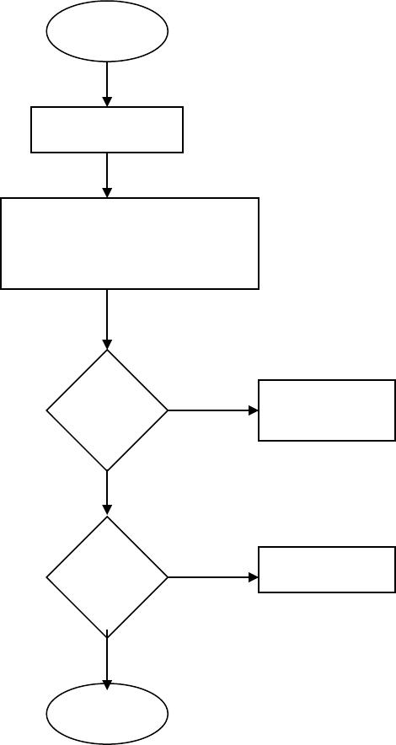
START

HOME PAGE

OPTIONS

1 = MEMBER LOGIN
2 = HISTORY PACK

IS | YES | MEMBERS
OPTION | YES | MEMBERS
OPTION |  | LOGIN
= 1 |  | LOGIN
NO
IS | YES | HISTORY
OPTION | YES | HISTORY
= 2
NO
EXIT

46

FLOW CHART
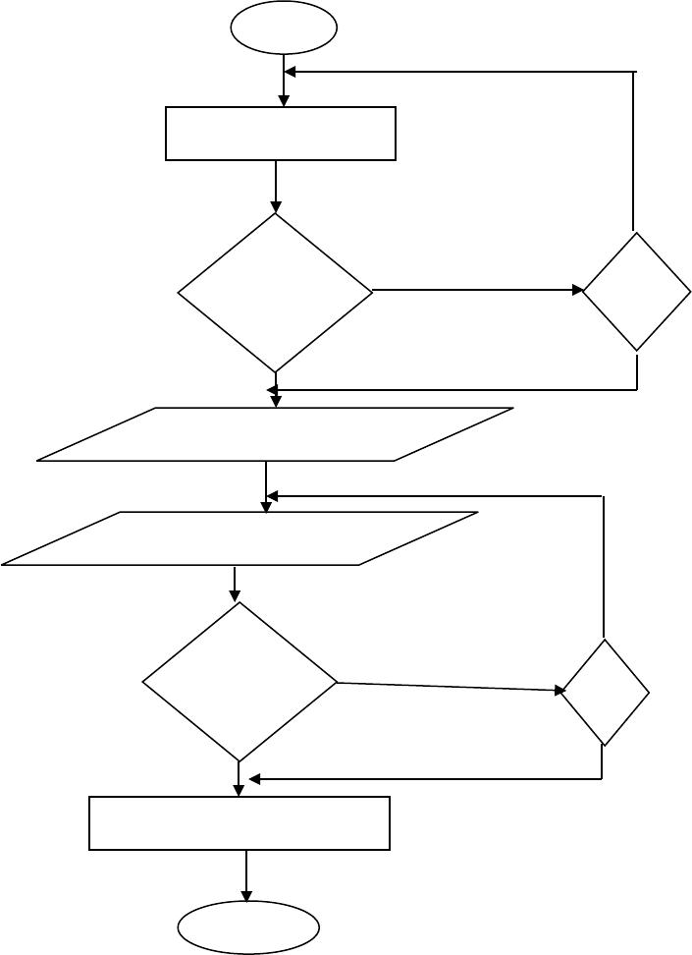

1

MEMBER LOGIN

IS | NO | TRY
PASSWORD | NO | TRY
PASSWORD |  | AGAIN
= TRUE |  | AGAIN
 |  | YES
DISPLAY MEMBERS AREA

INPUT EMPLAY I.D

IF | NO
DATA S | NO
DATA S | TRY
= TRUE | TRY
= TRUE | = 1
 | YES

CHECK FOR UPDATION

EXIT

47

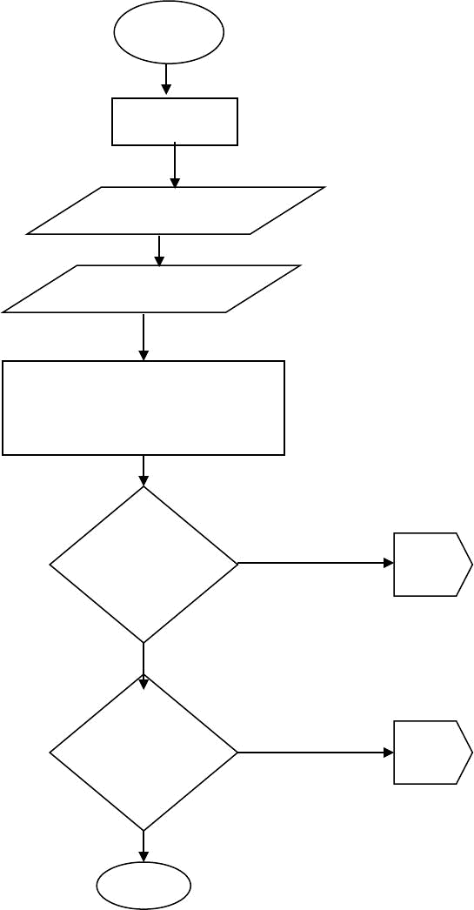
2

HISTORY

DISPLAY HISTORY

DISPLAY SECTORS

OPTION

A = CEILING PRODUCT

B = ROOFING PRODUCTS

IS
SECTION =

CEILING
PRODUCT

IS
SECTION =

ROOFING
PRODUCT

EXI

T

A

B

48

FLOW CHART FPR CEILING PRODUCT
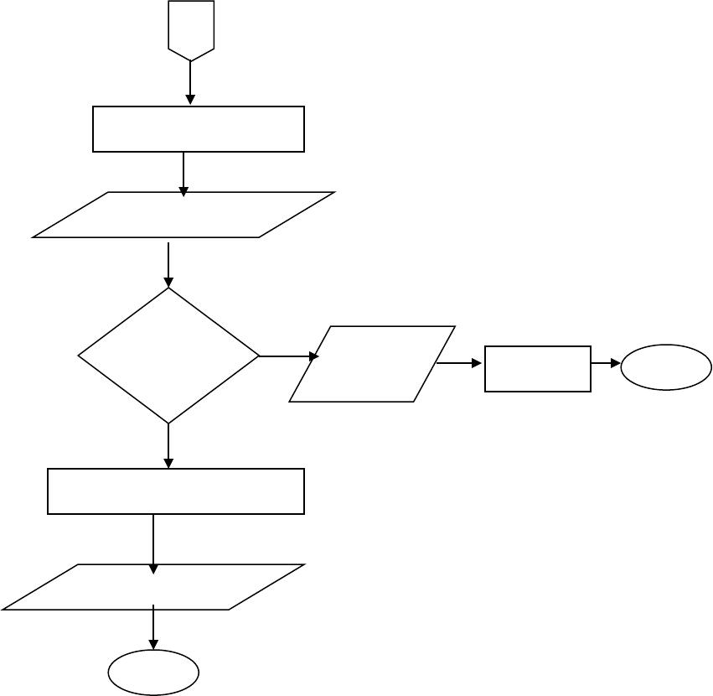

A

CEILING PRODUCT

DISPLAY THE

PRODUCT

IS
OPTION

=

FILE FORM

RETURN TO SECTION

DISPLAY

SECTION

EXI

T

DISPLAY
ONLINE | ACCEPT | EXI
FORM |  | T

49

FLOW CHART FOR ROOFING PRODUCT
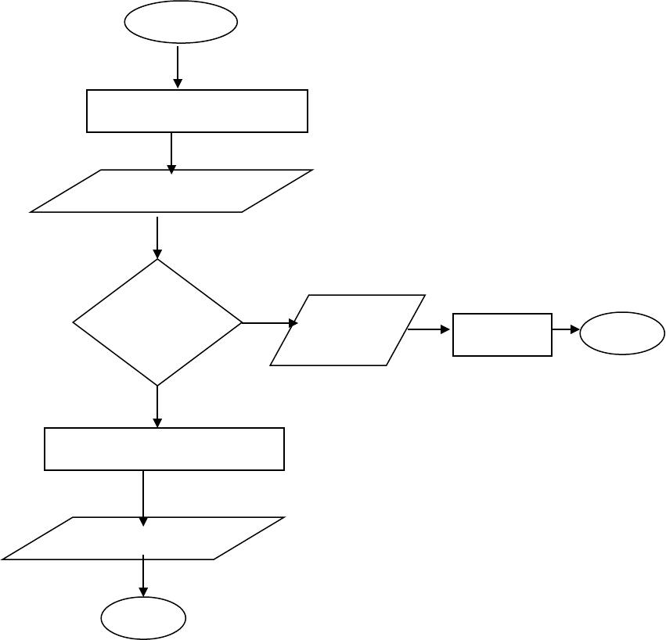

START

RT

ROOFING PRODUCT

DISPLAY THE
PRODUCT

IS

OPTION
=

FILE FORM

RETURN TO SECTION

DISPLAY

SECTION

EXI
T

DISPLAY
ONLINE | ACCEPT | EXI
FORM |  | T

50

5.2 PROGRAM PSEUDO CODE

- Boot the system

- Load the system

- Key in address

- Display home pages

- Display section available.

Select section from the main menu by clicking If section = ceiling product

Display ceiling product

If option from ceiling = fill form

Display on � line order form.

Else

Return to sections available

End if

Else

If section = roofing product

Display roofing product

If option from roofing = fill form

51

Display on � line order form

Else

Return to section

End if

Else

If option = accept form

Display order confirmation

End if

End if.

52

CHAPTER SIX

DOCUMENTATION

Documentation deals with the environment used in running the program and the step taken to operate the new system

The new design system which was developed with the internet natural language (HTML) is designed in diskette which serves as back-ups.

The modules are linked together with hyperlinks and they are interactive in nature. They include the following.

HOME PAGE: This is the first page that opens when webs site is browsed. It contains the interaction of the designer and little history and also provide links to the history page in proper.

HISTORY PAGE: This is the second page you will meet after going through home page of this project, from this section, it let you know what procurement of goods on-line as all about and this section will also provide two links of which one will take you back to the home page and other to section where goods in Emenite Limited is available for sale.

53

SECTION AVAILABLE: This is the page which comprise of the various section that can be found in EMENITE LIMITED. They include the following.

- Roofing product: This consists of varieties of roofing procedures and Durutile Concrete Tile.

- Ceiling product: This consist of varieties of ceiling product.

- Online order form: This page display the form which one has to fill if he or she wishes to buy any of the products online.

- Order acceptance page: This page indicate whether the order has been granted or not. This is confirmed when the customer summits his/her form after purchase.

The steps that were used to document this design are as follows.

STEPS

- Boot the system, after the booting process

- click on start button

- select MICROSOFT INTERNET EXPLORER and click this then load the browser

54

CHAPTER SEVEN

RECOMMENDATION AND CONCLUSION

This newly designed software which is developed through careful documentation will help Emenite Limited Emene to achieve in their increase in production and appropriate time delivery which will help them to generate output and will also help them to gain customers not only within the country but also outside the country.

To achieve these goals, I recommend that Emenite Limited Emene should bee

- Connect to Internet through ISP (Internet Service Provider)

- They should devote enough resources to training their staff / operators so that competent well trained and experience staff / operators would handle the new system.

- They should be often reviewed and updated so as to meet the customers� new requirements.

- The new goods or product should always be placed on the web site to attract customers� attentions.

55

- The new system can be modified to enhance its operations and to achieve better quality.

- They should carryout further researcher on this work on how to improve the qualities of their products.

- I recommend also that Emenite Limited should invest more on information technology so as to keep online to know the latest in the world products always.

7.1 CONCLUSION

On-line procurement of goods has totally changed the way buying and selling over the internet takes place.

Procuring goods over the Net has made purchasing of goods faster, cheaper, increase in production, more efficient and reliable.

In this process, customers can make purchases from Emenite Limited site at any time of the day convenient for them be it Midday, Midnight, or anytime of at all.

To this extent online goods procurement will increase the production continue to grow and expand in popularity. In this new future, on-line

56

procurement of goods will improved the world trade and will produce output

at greater rate.

57

REFERENCES

1. P. U AKANWA (1997) Fundamentals of Human Resources

management in Nigeria.

- THOMAS A. FOOSTER, EDITOR IN CHIEF �a bigger footprint for online purchasing (1990)
3. WAYNE F. CASIO (1993) | Management Resources 2nd edition
4. JOAN SINCLAR (1993) | The Advantages | of Management
 | Human Relation.
5. LAIRY YOUND | Introduction to | computer and
 | information processing
6. MANNING R. (1998) | �Electronic Commerce on the Internet
 | Online.
7. SHAWING G. (2000) | �Foundation of E � Commerce
 | Computer science at Work.
8. INTERNETS | �Google.com, Mama.com Ask.com�

TERMS AND CONDITIONS
Using our service is LEGAL and IS NOT prohibited by any university/college policies
You are allowed to use the original model papers you will receive in the following ways:
1. As a source for additional understanding of the subject
2. As a source for ideas for your own research (if properly referenced)
3. For PROPER paraphrasing (see your university definition of plagiarism and acceptable paraphrase)
4. Direct citing (if referenced properly)
Thank you so much for your respect to the authors copyright.
For more project materials
Log on to www.grossarchive.com
Or call
+2348130686500
+2348093423853

