**DESIGN AND IMPLEMENTATION OF A COMPUTERIZED FOOD MENU**

**ABSTRACT**

The main objective of this study is to develop an ICT assisted menu, whereby someone could be able to choose a meal, get the list of ingredients to cook the meal and follow a step by step help in order to cook the meal. In the other hand, it will also consist of a food time table, where certain meal will be designated for a certain time. Analysis involved a detailed study of the current system, leading to specifications of a new system. The existing system of Menu Directorate System is highly manual; the chef or cook thinks about a specific meal he or she wants to cook, determines the ingredients he or she wants to use, he or she then collects the ingredients before starting the cooking process. There is no definite database in this system; the only thing the chef or cook may do is to write down the ingredients in a book for reference purpose and forming a timetable. The development ICT assisted menu directorate system involved many phases. The approach used is a top-down one concentrating on *what* first, then *how* and moving to successive levels of details. The first phase started with a detailed study of the problems and prospects of cooking a meal. In the course of this study, many problems were discovered to have hindered the effectiveness of the existing manual system. These problems, information needs, and activities were documented and later used as the basis for system design, which immediately followed the first phase. The design phase was concerned primarily with the specification of the system elements in a manner that best met the voter’s registration need. During this phase, strict adherence was made on proven software engineering principles and practices. To implement this design, a computer program was then written and tested. It is hoped that effective implementation of this software product would eliminate many problems discovered during systems investigation.

**CHAPTER ONE**

**INTRODUCTION**

**1.1 Background of the study**

Information and Communication Technology (ICT) is a term used to describe technologies in manipulating and communicating information. As telecommunication systems have evolved, they have increasingly used computing technology in switching nodes and then in non-switching nodes supporting services. With mobile telecommunications, the amount of information processing required to manage mobility and services has increased enormously and this has resulted in a tremendous increase in computer communications within the telecommunications environment.

The parallel emergence of computer communications in science and business, the enormous increase in the capabilities and numbers of personal computers and the extraordinary changes brought about by the Internet have driven a merging of computing technology and telecommunications as the two areas have moved from analog to digital and then to packet technologies, and as the Internet has emerged to become the dominant data communications system in use today, whether as the “public Internet” or “managed Internet.”

What started as a circuit-switched voice network has evolved to a packet switched data network. Initially, data was handled by making it look like voice (modems.) Now voice is handled by making it look like data (Voice over IP or VoIP.) While voice remains the dominant revenue generator, the shift to VoIP brings major challenges to telecommunications operators as they manage the enormous shifts taking place in the nature and volume of traffic they carry on their networks.

ICT capabilities vary widely. In developed countries, they are widespread and sophisticated, while in developing countries, they may be less available and offer less capacity. Developing countries are catching up quickly by leapfrogging older generations of technology as well as creating solutions that suit the needs of their user communities. In some cases, the lack of a legacy infrastructure makes rapid modernization easier.

**1.2 Statement of the Problem**

Cooking a delicious food is a tedious and complex task, the combinations of ingredients of several tastes, weight, and forms is usually a herculean task for various Chefs. One of the major problems of this study is to tackle the problems of selecting a choice of what to cook, also the problem of arranging a complete set of ingredients for cooking a specific meal without forgetting any one of the ingredients, and also to teach how to cook a specific meal in a step by step manner within a specific time and with little or no stress.

**1.3 Objectives of the Study**

The main objective of this study is to develop an ICT assisted menu directorate system, whereby someone could be able to choose a meal, get the list of ingredients to cook the meal and follow a step by step help in order to cook the meal. In the other hand, it will also consist of a food time table, where certain meal will be designated for a certain time.

**1.4 Scope of the Study**

This research work is designed to enable chefs and even a lay man to cook a described meal, with the aid of a step by step directory and also gives the ingredients needed in cooking the specified or chosen meal, within a specific time.

**1.5 Limitations of the Study**

During the design of this project work, much finance was required and owing to the financial meltdown globally, the research was limited by finance and hence concentrated on the available materials within the locality. Another limitation was time, the time given for the project work was limited and there are other works for me on campus thus limiting the scope of the study to the available time.

**1.6 Significance of the Study**

In view of the rapid development of computer technology in virtually all fields of operation and its use in relation to information management, it has become important to look into the development of a menu directory for cooking various meals:

(a) List various meals, both European and African dishes.

(b) Safeguard data and information in the system.

(c) Avoid the omission of cooking ingredients.

(d) Keep accurate record of every meal.

(e) Allocate a specific time to a certain meal

(f) Provide a food time table.

**1.7 Project Report Organization**

This project was covered under five stages:

CHAPTER 1; Deals with the introduction. The background of the project is discussed. The objectives of the project, its significance, scope, and constraints are pointed out.

CHAPTER 2; This chapter is a Review of the evolution of ICT and food applications.

CHAPTER 3; Discusses system Investigation and Analysis. It deals with detailed investigation and analysis of the existing system and problem identification.

CHAPTER 4; Treats the system design and implementation

CHAPTER 5; The summary and conclusion of the project are finally treated in this chapter.

**1.8 Definition of Terms**

**ICT:** Information and communication technology

**Information System:** It is a collection of procedures, people, instructions and equipment to produce information in a useful form

**Technology:** It is study of techniques or process of mobilizing resources (such as information) for accomplishing objectives that benefit man and his environment

**Computer Network:** is a system that connects two or more computers together using a communication link.

**Databases:** A systematically arranged collection of computer data, structured so that it can be automatically retrieved or manipulated. It is also called databank.

**CHAPTER TWO**

**LITERTURE REVIEW**

**2.1 Evolution of ICT**

Information and communications technology (ICT) is often used as an extended synonym for information technology (IT), but is a more specific term that stresses the role of unified communications and the integration of telecommunications (telephone lines and wireless signals), computers as well as necessary enterprise software, middleware, storage, and audio-visual systems, which enable users to access, store, transmit, and manipulate information.

The phrase ICT had been used by academic researchers since the 1980s, but it became popular after it was used in a report to the UK government by Dennis Stevenson in 1997 and in the revised National Curriculum for England, Wales and Northern Ireland in 2000. As of September 2013, the term "ICT" in the UK National Curriculum has been replaced by the broader term "computing".

The term ICT is now also used to refer to the convergence of audio-visual and telephone networks with computer networks through a single cabling or link system. There are large economic incentives (huge cost savings due to elimination of the telephone network) to merge the audio-visual, building management and telephone network with the computer network system using a single unified system of cabling, signal distribution and management.

The term Infocommunications is sometimes used interchangeably with ICT. In fact Infocommunications is the expansion of telecommunications with information processing and content handling functions on a common digital technology base. For a comparison of these and other terms, see.

**2.2 Global Costs of IT**

The total money spent on IT worldwide has been most recently estimated as US $3.5 trillion, and is currently growing at 5% p.a. – doubling every 15 years. IT costs, as a percentage of corporate revenue, have grown 50% since 2002, putting a strain on IT budgets. Today, when looking at companies’ IT budgets, 75% are recurrent costs, used to “keep the lights on” in the IT department, and 25% are cost of new initiatives for technology development.

The average IT budget has the following breakdown: 31% – personnel costs (internal) 29% – software costs (external/purchasing category) 26% – hardware costs (external/purchasing category) 14% – costs of external service providers (external/services).

**2.3 EVOLUTION OF COOKING**

Cooking or cookery is the art of preparing food for consumption with the use of heat. Cooking techniques and ingredients vary widely across the world, reflecting unique environmental, economic, and cultural traditions and trends. The way that cooking takes place also depends on the skill and type of training an individual cook has. Cooking can also occur through chemical reactions without the presence of heat, most notably with Ceviche, a traditional South American dish where fish is cooked with the acids in lemon or lime juice. Sushi also uses a similar chemical reaction between fish and the acidic content of rice glazed with vinegar.

**2.4 HISTORY OF COOKING**

There is no clear archeological evidence when food was first cooked. Most anthropologists believe that cooking fires began only about 250,000 years ago, when hearths started appearing. Bradt, Steve (2002) Phylogenetic analysis by Chris Organ, Charles Nunn, Zarin Machanda, and Richard Wrangham suggests that cooking may have been invented as far back as 1.8 million to 2.3 million years ago.

Wrangham proposed cooking was instrumental in human evolution, as it reduced the time required for foraging and led to an increase in brain size. He estimates the percentage decrease in gut size of early humans directly correlates to the increase in brain size. Most other anthropologists, however, oppose rangham, stating that archeological evidence suggests that cooking fires began in earnest only about 250,000 years ago, when ancient hearths, earth ovens, burnt animal bones, and flint appear across Europe and the Middle East. Two million years ago, the only sign of fire is burnt earth with human remains, which most other anthropologists consider to be mere coincidence rather than evidence of intentional fire. The mainstream view among anthropologists is that the increases in human brain size occurred well before the advent of cooking, due to a shift away from the consumption of nuts and berries to the consumption of meat.

Food has become a part of material culture, and cuisine is much more than a substance. In the seventeenth and eighteenth centuries, food was a classic marker in Europe. However, in the nineteenth century, cuisine became a defining symbol of national identity. The discovery of the New World represented a major turning point in the history of food because of the movement of foods from and to Europe, such as potatoes, tomatoes, corn, yams, and beans. Food in America consisted of traditions that were adapted from England, but up until the end of this century, the presence of new ingredients along with the contact between diverse ethnic groups influenced experimentation. Industrialization was also a turning point that changed how food affected the nation.

During the period of industrialization, food began to be mass-produced, mass marketed, and standardized. Factories processed, preserved, canned, and packaged a wide variety of foods, and processed cereals quickly became a defining feature of the American breakfast. In the twenties, freezing methods as well as the earliest cafeterias and fast food establishments emerged. This point in time is when processed and nationally distributed foods became a huge part of the nation's diet.

Along with changes in food, there have also been several changes in nutritional guidelines as well. Since 1916, there have been several different nutrition guidelines issued by the United States government, eventually leading up to the food pyramid. In 1916, "Food For Young Children" along with its sequel for adults, "How to Select Foods" was the first USDA guide to give specific dietary guidelines. Updated in the 1920s to these guides gave shopping suggestions for different-sized families along with a Depression Era revision which included four cost levels. In 1943, the USDA created the "Basic Seven" chart to make sure that people got the recommended nutrients. It included the first-ever Recommended Daily Allowances from the National Academy of Sciences. In 1956, the "Essentials of an Adequate Diet" brought recommendations which cut seven down to four groups that school children would learn about for decades. In 1979, a guide called "Food" was published, which addressed the link between too much of certain foods and chronic diseases. This publication also added "fats, oils, and sweets" to the four basic food groups and cautioned moderation. In 1992, the food pyramid was debuted. The USDA introduced this, which represented proportions of foods in a balanced diet. In 2005, the pyramid got a makeover and was renamed MyPyramid. Lastly, in 2011, "MyPlate" came about.

**2.5 INGREDIENTS**

Most ingredients in cooking are derived from living organisms. Vegetables, fruits, grains and nuts as well as herbs and spices come from plants, while meat, eggs, and dairy products come from animals. Mushrooms and the yeast used in baking are kinds of fungi. Cooks also use water and minerals such as salt. Cooks can also use wine or spirits.

Naturally occurring ingredients contain various amounts of molecules called proteins, carbohydrates and fats. They also contain water and minerals. Cooking involves a manipulation of the chemical properties of these molecules.

**2.5 Carbohydrate**

Carbohydrates include the common sugar, sucrose (table sugar), a disaccharide, and such simple sugars as glucose (from the digestion of table sugar) and fructose (from fruit), and starches from sources such as cereal flour, rice, arrowroot, and potato. The interaction of heat and carbohydrate is complex.

Long-chain sugars such as starch tend to break down into simpler sugars when cooked, while simple sugars can form syrups. If sugars are heated so that all water of crystallisation is driven off, then caramelization starts, with the sugar undergoing thermal decomposition with the formation of carbon, and other breakdown products producing caramel. Similarly, the heating of sugars and proteins elicits the Maillard reaction, a basic flavor-enhancing technique.

An emulsion of starch with fat or water can, when gently heated, provide thickening to the dish being cooked. In European cooking, a mixture of butter and flour called a roux is used to thicken liquids to make stews or sauces. In Asian cooking, a similar effect is obtained from a mixture of rice or corn starch and water. These techniques rely on the properties of starches to create simpler mucilaginous saccharides during cooking, which causes the familiar thickening of sauces. This thickening will break down, however, under additional heat.

**2.6**  **FATS**

Types of fat include [vegetable oils](http://en.wikipedia.org/wiki/Vegetable_oil" \o "Vegetable oil), animal products such as butter and [lard](http://en.wikipedia.org/wiki/Lard" \o "Lard), as well as fats from grains, including [corn](http://en.wikipedia.org/wiki/Corn" \o "Corn) and [flax](http://en.wikipedia.org/wiki/Flax" \o "Flax) oils. Fats can reach temperatures higher than the boiling point of water, and are often used to conduct high heat to other ingredients, such as in frying or sautéing.

**2.7 PROTEIN**

Edible animal material, including [muscle](http://en.wikipedia.org/wiki/Muscle" \o "Muscle), [offal](http://en.wikipedia.org/wiki/Offal" \o "Offal), milk, [eggs](http://en.wikipedia.org/wiki/Egg_%28food%29" \o "Egg (food)) and [egg whites](http://en.wikipedia.org/wiki/Egg_white" \o "Egg white), contains substantial amounts of protein. Almost all vegetable matter (in particular [legumes](http://en.wikipedia.org/wiki/Legume" \o "Legume) and [seeds](http://en.wikipedia.org/wiki/Seed" \o "Seed)) also includes proteins, although generally in smaller amounts. Mushrooms have high protein content. Any of these may be sources of [essential amino acids](http://en.wikipedia.org/wiki/Essential_amino_acid" \o "Essential amino acid). When [proteins](http://en.wikipedia.org/wiki/Protein" \o "Protein) are heated they become denatured (unfolded) and change texture. In many cases, this causes the structure of the material to become softer or more [friable](http://en.wikipedia.org/wiki/Friable" \o "Friable) – meat becomes *cooked* and is more friable and less flexible. In some cases, proteins can form more rigid structures, such as the coagulation of [albumen](http://en.wikipedia.org/wiki/Albumen" \o "Albumen) in egg whites. The formation of a relatively rigid but flexible matrix from egg white provides an important component in baking cakes, and also underpins many desserts based on [meringue](http://en.wikipedia.org/wiki/Meringue" \o "Meringue)

**2.7 VITAMINS AND MINERALS**

Vitamins are materials required for normal [metabolism](http://en.wikipedia.org/wiki/Metabolism" \o "Metabolism) but which the body cannot manufacture itself and which must therefore come from external sources. Vitamins come from several sources including fresh fruit and vegetables ([Vitamin C](http://en.wikipedia.org/wiki/Vitamin_C" \o "Vitamin C)), carrots, [liver](http://en.wikipedia.org/wiki/Liver_%28food%29" \o "Liver (food)) ([Vitamin A](http://en.wikipedia.org/wiki/Vitamin_A" \o "Vitamin A)), cereal bran, bread, liver e ( B vitamins), fish liver oil ([Vitamin D](http://en.wikipedia.org/wiki/Vitamin_D" \o "Vitamin D)) and fresh green vegetables ([Vitamin K](http://en.wikipedia.org/wiki/Vitamin_K" \o "Vitamin K)). Many minerals are also essential in small quantities including iron, [calcium](http://en.wikipedia.org/wiki/Calcium" \o "Calcium), [magnesium](http://en.wikipedia.org/wiki/Magnesium" \o "Magnesium) and [sulphur](http://en.wikipedia.org/wiki/Sulphur" \o "Sulphur); and in very small quantities copper, [zinc](http://en.wikipedia.org/wiki/Zinc" \o "Zinc) and [selenium](http://en.wikipedia.org/wiki/Selenium" \o "Selenium). The micronutrients, minerals, and vitamins[[12]](http://en.wikipedia.org/wiki/Cooking" \l "cite_note-12) in fruit and vegetables may be destroyed or eluted by cooking. Vitamin C is especially prone to oxidation during cooking and may be completely destroyed by protracted cooking.

**2.8 WATER**

Cooking often involves water, frequently present in other liquids, which is both added in order to immerse the substances being cooked (typically water, [stock](http://en.wikipedia.org/wiki/Stock_%28food%29" \o "Stock (food)) or wine), and released from the foods themselves. Liquids are so important to cooking that the name of the cooking method used is often based on how the liquid is combined with the food, as in [steaming](http://en.wikipedia.org/wiki/Steaming" \o "Steaming), [simmering](http://en.wikipedia.org/wiki/Simmer" \o "Simmer), [boiling](http://en.wikipedia.org/wiki/Boiling" \o "Boiling), [braising](http://en.wikipedia.org/wiki/Braising" \o "Braising), and [blanching](http://en.wikipedia.org/wiki/Blanching_%28cooking%29" \o "Blanching (cooking)). Heating liquid in an open container results in rapidly increased [evaporation](http://en.wikipedia.org/wiki/Evaporation" \o "Evaporation), which [concentrates](http://en.wikipedia.org/wiki/Concentrate" \o "Concentrate) the remaining [flavor](http://en.wikipedia.org/wiki/Flavor" \o "Flavor) and ingredients – this is a critical component of both [stewing](http://en.wikipedia.org/wiki/Stewing" \o "Stewing) and sauce making.

2.9 Methods of cooking

There are very many methods of cooking, most of which have been known since antiquity. These include baking, roasting, frying, grilling, barbecuing, smoking, boiling, steaming and braising. A more recent innovation is microwaving. Various methods use differing levels of heat and moisture and vary in cooking time. The method chosen greatly affects the end result because some foods are more appropriate to some methods than others. Some major hot cooking techniques include:

Roasting

[Roasting](http://en.wikipedia.org/wiki/Roasting" \o "Roasting) – [Barbecuing](http://en.wikipedia.org/wiki/Barbecuing" \o "Barbecuing) – [Grilling](http://en.wikipedia.org/wiki/Grilling" \o "Grilling)/[Broiling](http://en.wikipedia.org/wiki/Broiling" \o "Broiling) – [Rotisserie](http://en.wikipedia.org/wiki/Rotisserie" \o "Rotisserie) – [Searing](http://en.wikipedia.org/wiki/Searing" \o "Searing)

Baking

[Baking](http://en.wikipedia.org/wiki/Baking" \o "Baking) – [Baking Blind](http://en.wikipedia.org/wiki/Blind_Baking" \o "Blind Baking)- Flashbaking

Boiling

[Boiling](http://en.wikipedia.org/wiki/Boiling_in_cooking" \o "Boiling in cooking) – [Blanching](http://en.wikipedia.org/wiki/Blanching_%28cooking%29" \o "Blanching (cooking)) – [Braising](http://en.wikipedia.org/wiki/Braising" \o "Braising) – [Coddling](http://en.wikipedia.org/wiki/Coddling" \o "Coddling) – [Double steaming](http://en.wikipedia.org/wiki/Double_steaming" \o "Double steaming) – [Infusion](http://en.wikipedia.org/wiki/Infusion" \o "Infusion) – [Poaching](http://en.wikipedia.org/wiki/Poaching_%28cooking%29" \o "Poaching (cooking)) – [Pressure cooking](http://en.wikipedia.org/wiki/Pressure_cooking" \o "Pressure cooking) – [Simmering](http://en.wikipedia.org/wiki/Simmering" \o "Simmering) – [Smothering](http://en.wikipedia.org/wiki/Smothering_%28food%29" \o "Smothering (food)) – [Steaming](http://en.wikipedia.org/wiki/Steaming" \o "Steaming) – [Steeping](http://en.wikipedia.org/wiki/Steeping" \o "Steeping) – [Stewing](http://en.wikipedia.org/wiki/Stewing" \o "Stewing) – [Vacuum flask cooking](http://en.wikipedia.org/wiki/Vacuum_flask_cooking" \o "Vacuum flask cooking)

Frying

[Fry](http://en.wikipedia.org/wiki/Frying" \o "Frying) – [Deep frying](http://en.wikipedia.org/wiki/Deep_frying" \o "Deep frying) – [Hot salt frying](http://en.wikipedia.org/wiki/Hot_salt_frying" \o "Hot salt frying) – [Hot sand frying](http://en.wikipedia.org/wiki/Hot_sand_frying" \o "Hot sand frying) – [Pan frying](http://en.wikipedia.org/wiki/Pan_frying" \o "Pan frying) – [Pressure frying](http://en.wikipedia.org/wiki/Pressure_frying" \o "Pressure frying) – [Sautéing](http://en.wikipedia.org/wiki/Saut%C3%A9ing" \o "Sautéing) – [Stir frying](http://en.wikipedia.org/wiki/Stir_frying" \o "Stir frying)

Smoking

[Smoking](http://en.wikipedia.org/wiki/Smoking_%28food%29" \o "Smoking (food))

**CHAPTER THREE**

**3.0 System Analysis and methodology**

**3.1 Description and Analysis of the Existing System**

Analysis involved a detailed study of the current system, leading to specifications of a new system. The existing system of Menu Directorate System is highly manual; the chef or cook thinks about a specific meal he or she wants to cook, determines the ingredients he or she wants to use, he or she then collects the ingredients before starting the cooking process. There is no definite database in this system; the only thing the chef or cook may do is to write down the ingredients in a book for reference purpose and forming a timetable.

**3.2 Fact Finding Method / Methodology**

**3.2.1 Interview Method**

This was done between the researcher and some cooking experts both physically and online. Various Dishes and name of some local dishes were got from some cooking experts, while other European dishes, their ingredients and methods of cooking were got from the internet.

**3.3** **Present Procedures**

The present procedure requires the chef to manually arrange the foods he is going to prepare, he thinks about the ingredients he is going to use in preparing the food and tries to get it one by one, before embarking on the cooking the recipe. The present procedures also feature arrangement of recipes in the food timetable.

**3.4 Information Flow Diagram**

Store Recipe

Name of Meal

Class

Region

Ingredients

Preparation

**3.5 Input, Process and Output Analysis**

**3.5.1 Input Analysis**

The input to the system includes the Class of meal, Name of meal, Region of meal, How to prepare the meal and saving the meal into the database.

3.5.2 **Process Analysis**

The information gathered was processed into a more meaningful format for entry into the system. Every food information is stored in the database for verification when next other users visit the application.

**3.5.2 Output Analysis**

The output from the system designed is generated from the system inputs. More of the output generated is adding of meal into the database and also searching of meal in the database.

**3.6 Problems of the Current System**

Manual system of operation faces a lot of problems which includes:

* Delay in good meal cooking.
* Omission of ingredients.
* Errors in preparation.
* Wasting of time.
* Insecurity of data.

**3.7 Justification for the New System**

The new system will help to solve all the problems inherent in the existing system. The justification for the new system includes:

* Direct capture of meal and user registration.
* Error free preparation of meal.
* Predescribe the method of preparing a meal
* Saves every meal into the database to form a heavy collection of meal.

**CHAPTER FOUR**

**SYSTEM DESIGN, TESTING AND IMPLEMENTATION**

**4.1** **Specifications of the New System**

The new system was designed to capture data from the input device, process it and generate meaningful output on the output device. There are some specifications that are necessary for the design of the new system. They are input, output specification and database specification. The objective of the design includes:

Design an input format that will enable the user capture all the necessary data for the purpose of adding meal into the database.

Structure a database system that will store all the information.

Design a well formatted output that will present information to user in a meaningful format.

Maintain a database for preparing various kind of meal.

Maintain a database which will include the information of every user.

Maintain a database for details of every meal.

Allow users to add new meal into the database.

**4.2 Input Specification**

The input to the new system is designed to capture data from the users. These forms are designed to capture name of meal, class, region, how to prepare etc. The forms include:

**User Registration form**

Name ……………………………………………………………

Sex ………………………………... ………………………

Period of food ………………………………………………………

Type of meal ……………………………………………………….

**4.3 Output Specification**

The output forms are designed to give detailed reports on Indigene’s register.

The forms are designed using data grid controls in visual basic. The reports can be printed out on a hard copy.

Loading Page

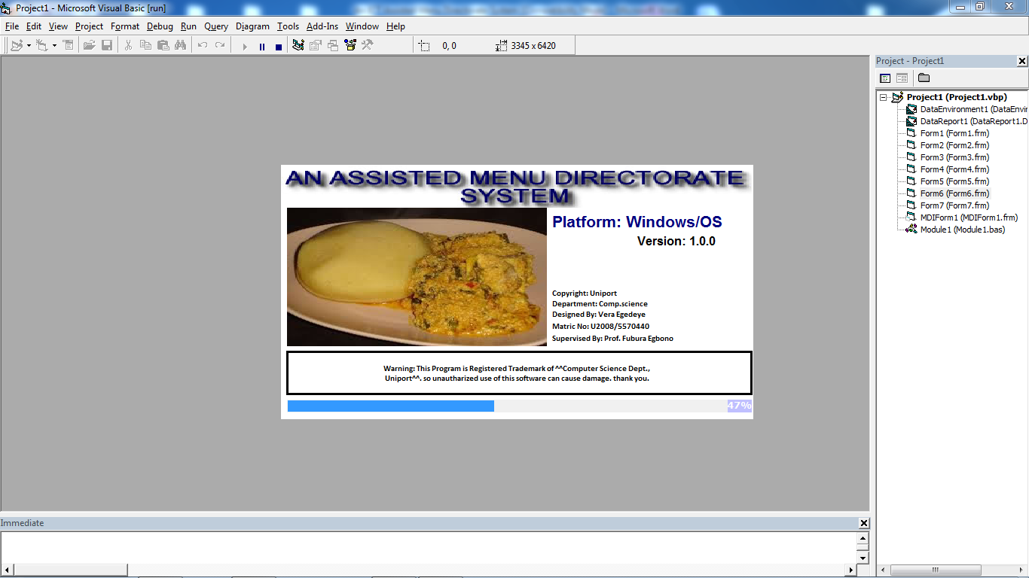

Home

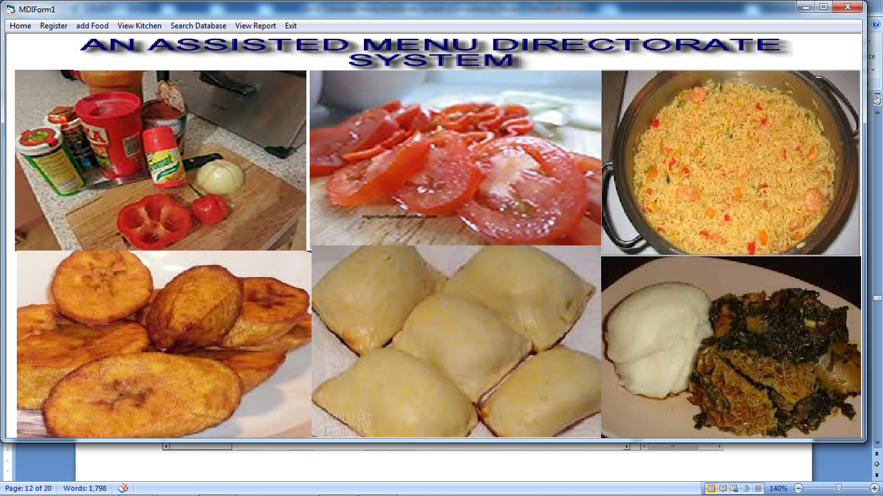

Register

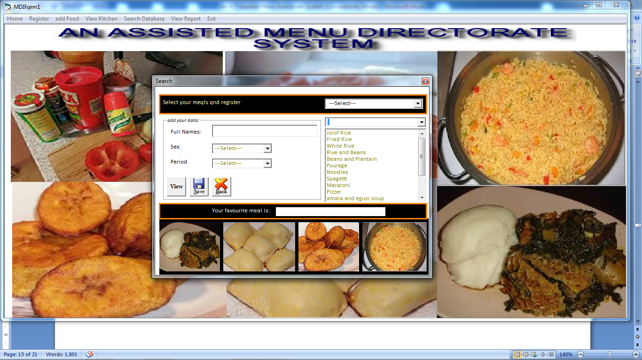

Add food

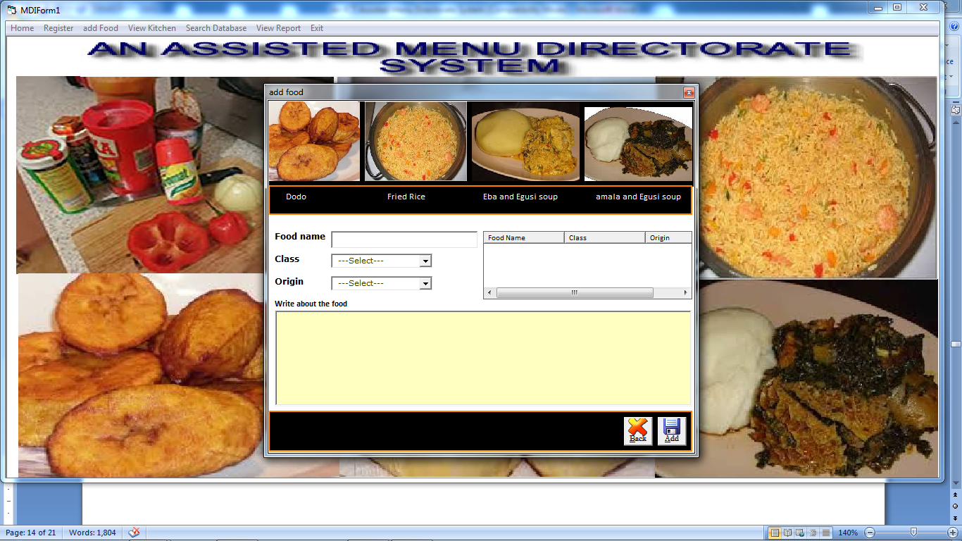

Report

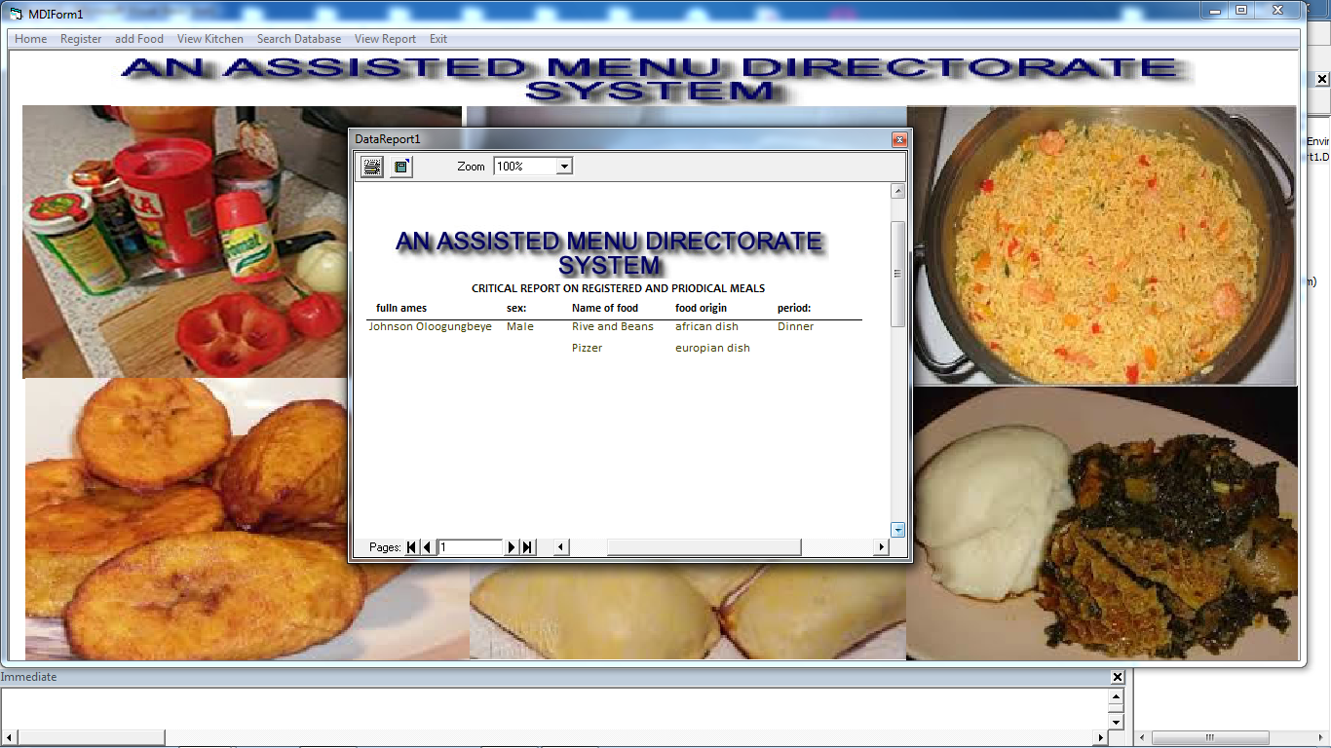

**4.4 Database Specification**

Access database was used in the design of the new system database. The structure of the data tables in the database includes:

|  |  |
| --- | --- |
| FILE NAME | TYPE |
| Name | Text |
| Sex | Text |
| Period | Text |
| Name of food | Text |
| Class of food | Text |
| Region of food | Text |
| Ingredients | Text |
| How to prepare | Text |

**4.5 Main Menu Design**

Top down system was used in the design of the new system. The main menu houses all other sub systems. Hence access to the sub systems are made through the main menu. Bellow is the diagram of the main menu.

MAIN MENU

View Report

Search database

View kitchen

Add food

Register

Exit

**4.6 Subsystem Design**

**4.6.1 Login Subsystem**

Enter Password

Login

Cancel

**4.6.2 Registration Subsystem**

Registration

Name

Sex

Period

Type of Meal

Favourite

Save

**4.6.3 Report Subsystem**

Report

Registered users

Saved meal

**4.7 System Flowchart**

ADD FOOD

ENTER PASSWORD

DISPLAY PASSWORD SCREEEN

DISPLAY MAIN MENU

SELECT OPTION

KITCHEN

REGISTRATION

SEARCH DATABASE

SAVE TO DISK

DISPLAY RESULTS

DO EXIT

**4.8 PROGRAM FLOWCHART**

START

SUPPLY PASSWORD

IS PASSWORD <= 3

IS PASSWORD CORRECT

NO YES

YES`

QUIT

DISPLAY MAIN MENU

YES

SELECTION OPTION (OPT)

IS OPT= INDIGENE REG.?

FULL NAME, SEX, AGE, PHONE NO LGA .ETC

YES

DA

IS OPT VIEW AVAILABLE DATABASE?

NO

LA

FULL NAME, SEX, AGE , PHONE NO LGA .ETC

YES

NO

FULL NAME, SEX, AGE , PHONE NO LGA .ETC

YES

DISPLAY RESULT

RS

BU

DA

PERFORM AILMENT REGISTRTION

PERFORM MEDICAL BUDGET ALLOCATION

SAVE TO DISK

PRINT RESULT

OUT

LA

PERFORM OPERATION INDIGENE REGISTRATION

HOTEL SERVICES

RENDERING

FEED FORMULATION

PERFORM ASSIGNMENT OF INDIGENE COMMENT

SAVE TO DISK

PRINT RESULT

OUT

**4.9 Program Modules Specification**

The new system developed was divided into program modules. Each module handles a specific operation in the software. We have module for the following operations.

**Login Page:** once the program is started, this module prompts for security login through the supply of a valid password.

**Search Database:** This module allows registered meals information to be searched for and displayed for the user.

**Kitchen:** This module gives information on a searched meal and gives information on how to cook it.

**Exit:** This module requests the user whether to exit or not, it prompts the user to enter either yes to quit or no to remain in the application.

**4.10 Choice of Programming Language**

So many programming languages were considered in the cause of designing this software. A lot of factors were put into consideration which includes electronic database access, data transmission via networks, database security, database retrieval electronically, multi user network access, electronic data capture, etc.

The choice for (virtual basic) VB 6.0 with Access Database was made to enable us achieves the above set objectives. Moreover, VB 6.0 is very user friendly and enables the design of an interface that can be modified programmatically. Also Access database is a robust database that can guarantee database integrity, database protection, and accommodate large database.

**CHPTER FIVE**

**5.0 RECOMMENDATION, SUMMARY AND CONCLUSIONS**

**5.1 Recommendation**

It suffices to say that for any meaningful computer based information management to be integrated into any organization, proper training and orientation has to be given to chefs. Proper training should be given to the users on how to handle the computer hardware especially during backup processes. In particular electronic storage media are usually sensitive to change in temperature or pressure and as such data, can be lost very easily. The users should also be briefed on the need and advantage of the current system and how it will equally assist them in their various field of work.

They should also be informed of the cost of maintaining this new system so that they will handle it with all carefulness. Training materials should not be presented in an informal way but with procedures like policies and form etc, they should be circulated to the personnel. This will at the end, generate the user appreciation and needed interest to operate the system.

**5.2 Summary**

At the end of this project work, I was able to design and develop software that can successfully handle an ICT assisted menu directorate system.

This work also will serve as an aid for people who wish to research more on this topic. Other benefits are:

**a)** Provision of facility for handling text electronically using powerful and sophisticated word processors to produce elegant and error free documents.

**b)** In addition to storing the data, direct data capture was implemented

The systematic approaches used during each phase of the software development provide a clear insight that would be of immense help to anyone carrying out research works in this area.

**5.3 Conclusions**

The development ICT assisted menu directorate system involved many phases. The approach used is a top-down one concentrating on *what* first, then *how* and moving to successive levels of details.

The first phase started with a detailed study of the problems and prospects of cooking a meal. In the course of this study, many problems were discovered to have hindered the effectiveness of the existing manual system. These problems, information needs, and activities were documented and later used as the basis for system design, which immediately followed the first phase. The design phase was concerned primarily with the specification of the system elements in a manner that best met the voter’s registration need. During this phase, strict adherence was made on proven software engineering principles and practices. To implement this design, a computer program was then written and tested.

It is hoped that effective implementation of this software product would eliminate many problems discovered during systems investigation.

**REFERENCES**

Christine Dell'Amore in Chicago (13 February 2009). "Cooking Gave Humans Edge Over Apes?". National Geographic News.

W. Wayt Gibbs and Nathan Myhrvold. "A New Spin on Cooking".

"Pennisi: Did Cooked Tubers Spur the Evolution of Big Brains?". Cogweb.ucla.edu. Retrieved 2013-11-07.

Organ, Chris (22 August 2011). "Phylogenetic rate shifts in feeding time during the evolution of Homo". PNAS. Retrieved 17 April 2012.

Bradt, Steve. "Why cooking counts | Harvard Gazette". News.harvard.edu. Retrieved 2013-11-07.

"Pennisi: Did Cooked Tubers Spur the Evolution of Big Brains?". Cogweb.ucla.edu. Retrieved 2012-01-31.

Gorman, RM (2008). "Cooking up bigger brains". Scientific American 298 (1): 102, 104–5. doi:10.1038/scientificamerican0108-102.

"06.14.99 - Meat-eating was essential for human evolution, says UC Berkeley anthropologist specializing in diet". Berkeley.edu. 1999-06-14. Retrieved 2012-01-31.

"Meat in the human diet: an anthropological perspective. - Free Online Library". Thefreelibrary.com. 2007-09-01. Retrieved 2012-01-31.

http://www.nordion.com/documents/the-history-of-food-irradiation.pdf

"The history of the food pyramid". Washington Post. 31 January 2011. Retrieved 2013-04-18.

"Cooking vegetables 'improves benefits'". BBC News. 2 June 1999. Retrieved 30 April 2010.

Safe Food Australia – A Guide to the Food Safety Standards

Noah ND, Bender AE, Reaidi GB, Gilbert RJ (Jul 1980). "NEWS, NOTES, AND EPIDEMIOLOGY". Br Med J 281 (6234): 236–7. PMC 1713670. PMID 7407532

**OUTPUT**

Loading Page



Home



Register



Add food



Report



**APPENDIX II**

**SOURCECODE**

Private Sub addFood\_Click()

Form2.Show

End Sub

Private Sub Exit\_Click()

Dim varResponse As Variant

varResponse = InputBox("Enter your choice in" & "order to exit the program", "Are you sure you want to exit the program?")

If varResponse = "yes" Then

MsgBox "Thank you for using this Software!"

'Unload Me

End

Else

MsgBox "That means you are not ready to quit,please try again!"

End If

End Sub

Private Sub Home\_Click()

MDIForm1.Show

End Sub

Private Sub Register\_Click()

Form1.Show

End Sub

Private Sub SearchDatabase\_Click()

Form3.Show

End Sub

Private Sub ViewKitchen\_Click()

Form3.Show

End Sub

Private Sub ViewReport\_Click()

DataReport1.Show

End Sub

Private Sub Combo1\_Change()

List1.Text = Combo1.Text

'List2.Text = Combo1.Text

End Sub

Private Sub Combo2\_Change()

List2.Text = Combo1.Text

End Sub

Private Sub Command5\_Click()

Set rse = db.OpenRecordset("choose")

rse.AddNew

rse!foodorigin = Combo2.Text

rse!Name = Combo1.Text

rse!favourite = Text2.Text

rse!fullnames = Text1.Text

rse!Sex = Combo3.Text

rse!period = Combo4.Text

rse.Update

rse.Close

MsgBox "Your record has saved", vbInformation, "Jambtech"

End Sub

Private Sub Command6\_Click()

If List1.Text = Combo1.Text Then

Text2.Text = Combo1.Text

ElseIf List2.Text = Combo2.Text Then

Text2.Text = Combo2.Text

End If

End Sub

Private Sub Command7\_Click()

Unload Me

MDIForm1.Show

End Sub

Private Sub Form\_Load()

Set db = DBEngine.OpenDatabase(App.Path & "\chef.mdb")

Text2.Locked = True

End Sub

Private Sub Label7\_Change()

Text1.Text = Label7.Caption

End Sub

Private Sub List1\_Click()

Combo1.Text = List1.Text

End Sub

Private Sub List2\_Click()

Combo1.Text = List2.Text

End Sub

Private Sub Text1\_Change()

Label7.Caption = Text1.Text

End Sub

Private Sub Command1\_Click()

End Sub

Private Sub Command2\_Click()

End Sub

Private Sub Command3\_Click()

Set rse = db.OpenRecordset("food")

rse.AddNew

rse!Name = Text1.Text

rse!Class = Combo2.Text

rse!Origin = Combo1.Text

rse!about = RichTextBox1.Text

rse.Update

rse.Close

MsgBox "Your record has saved", vbInformation, "Jambtech"

lvwinfo.ListItems.Clear

Set rse = db.OpenRecordset("food")

Do While rse.EOF = False

lvwinfo.ListItems.Add , , rse.Fields("Name").Value

lvwinfo.ListItems(lvwinfo.ListItems.Count).SubItems(1) = rse!Class

lvwinfo.ListItems(lvwinfo.ListItems.Count).SubItems(2) = rse!Origin

'lvwinfo.ListItems(lvwinfo.ListItems.Count).SubItems(3) = rse!Class

rse.MoveNext

Loop

Text1 = ""

Combo2.Text = ""

Combo1.Text = ""

RichTextBox1.Text = ""

End Sub

Private Sub Command4\_Click()

Unload Me

MDIForm1.Show

End Sub

Private Sub Form\_Load()

Set db = DBEngine.OpenDatabase(App.Path & "\chef.mdb")

Me.Left = (Screen.Width - Me.Width) / 2

Me.Top = (Screen.Height - Me.Height) / 2

'Text1.SetFocus

End Sub

Private Sub Combo1\_Click()

On Error Resume Next

If Combo1.Text = "" Then

MsgBox "Supply your valid Food Name", vbInformation, "Jambtech"

Combo1.SetFocus

Else

Set rse = db.OpenRecordset("select \* from food where name= '" & Combo1.Text & "'")

If rse.RecordCount = 0 Then

Else

Text1.Text = rse!Class

Text2.Text = rse!Origin

Label5.Caption = rse!about

End If

End If

End Sub

Private Sub Combo1\_GotFocus()

Set rse = db.OpenRecordset("select \* from food")

With Combo1

.Clear

While Not rse.EOF

.AddItem rse!Name

rse.MoveNext

Wend

End With

End Sub

Private Sub Command1\_Click()

End Sub

Private Sub Form\_Load()

Set db = DBEngine.OpenDatabase(App.Path & "\chef.mdb")

Option1.Value = False

Option2.Value = False

Option3.Value = False

End Sub

Private Sub Option1\_Click()

Form4.Command1.Visible = True

Form4.Show

Me.Hide

End Sub

Private Sub Option2\_Click()

Form4.Command2.Visible = True

Form4.Show

Me.Hide

End Sub

Private Sub Option3\_Click()

Form4.Command3.Visible = True

Form4.Show

Me.Hide

End Sub

Private Sub Command1\_Click()

Set dbase = DBEngine.OpenDatabase(App.Path & "\chef.mdb")

Set rse = dbase.OpenRecordset("select \* from food where name='" & Text1.Text & "'")

Do While rse.EOF = False

Form5.lvwinfo.ListItems.Add , , rse.Fields("name").Value

Form5.lvwinfo.ListItems(Form5.lvwinfo.ListItems.Count).SubItems(1) = rse!Class

Form5.lvwinfo.ListItems(Form5.lvwinfo.ListItems.Count).SubItems(2) = rse!Origin

rse.MoveNext

Loop

Form5.Show 1

End Sub

Private Sub Command2\_Click()

Set dbase = DBEngine.OpenDatabase(App.Path & "\chef.mdb")

Set rse = dbase.OpenRecordset("select \* from food where class='" & Text1.Text & "'")

Do While rse.EOF = False

Form5.lvwinfo.ListItems.Add , , rse.Fields("name").Value

Form5.lvwinfo.ListItems(Form5.lvwinfo.ListItems.Count).SubItems(1) = rse!Class

Form5.lvwinfo.ListItems(Form5.lvwinfo.ListItems.Count).SubItems(2) = rse!Origin

rse.MoveNext

Loop

Form5.Show 1

End Sub

Private Sub Command3\_Click()

Set dbase = DBEngine.OpenDatabase(App.Path & "\chef.mdb")

Set rse = dbase.OpenRecordset("select \* from food where origin='" & Text1.Text & "'")

Do While rse.EOF = False

Form5.lvwinfo.ListItems.Add , , rse.Fields("name").Value

Form5.lvwinfo.ListItems(Form5.lvwinfo.ListItems.Count).SubItems(1) = rse!Class

Form5.lvwinfo.ListItems(Form5.lvwinfo.ListItems.Count).SubItems(2) = rse!Origin

rse.MoveNext

Loop

Form5.Show 1

End Sub

Private Sub Form\_Load()

Command1.Visible = False

Command2.Visible = False

Command3.Visible = False

End Sub

Private Sub Command1\_Click()

Set dbase = DBEngine.OpenDatabase(App.Path & "\chef.mdb")

Set rse = dbase.OpenRecordset("select \* from food where name='" & Text1.Text & "'")

Do While rse.EOF = False

Form5.lvwinfo.ListItems.Add , , rse.Fields("name").Value

Form5.lvwinfo.ListItems(Form5.lvwinfo.ListItems.Count).SubItems(1) = rse!Class

Form5.lvwinfo.ListItems(Form5.lvwinfo.ListItems.Count).SubItems(2) = rse!Origin

rse.MoveNext

Loop

Form5.Show 1

End Sub

Private Sub Command2\_Click()

Set dbase = DBEngine.OpenDatabase(App.Path & "\chef.mdb")

Set rse = dbase.OpenRecordset("select \* from food where class='" & Text1.Text & "'")

Do While rse.EOF = False

Form5.lvwinfo.ListItems.Add , , rse.Fields("name").Value

Form5.lvwinfo.ListItems(Form5.lvwinfo.ListItems.Count).SubItems(1) = rse!Class

Form5.lvwinfo.ListItems(Form5.lvwinfo.ListItems.Count).SubItems(2) = rse!Origin

rse.MoveNext

Loop

Form5.Show 1

End Sub

Private Sub Command3\_Click()

Set dbase = DBEngine.OpenDatabase(App.Path & "\chef.mdb")

Set rse = dbase.OpenRecordset("select \* from food where origin='" & Text1.Text & "'")

Do While rse.EOF = False

Form5.lvwinfo.ListItems.Add , , rse.Fields("name").Value

Form5.lvwinfo.ListItems(Form5.lvwinfo.ListItems.Count).SubItems(1) = rse!Class

Form5.lvwinfo.ListItems(Form5.lvwinfo.ListItems.Count).SubItems(2) = rse!Origin

rse.MoveNext

Loop

Form5.Show 1

End Sub

Private Sub Form\_Load()

Command1.Visible = False

Command2.Visible = False

Command3.Visible = False

End Sub

Private Sub Command1\_Click()

Unload Me

Form6.Show

End Sub

Private Sub Command2\_Click()

'Private Sub Exit\_Click()

Dim varResponse As Variant

varResponse = InputBox("Enter your password in" & "order to enter this program")

If varResponse = "egedeye02" Then

MsgBox "Welcome into this Software!"

Unload Me

MDIForm1.Show

Else

MsgBox "The password is not correct,please try again!"

End If

End Sub