**DESIGN AND IMPLEMENTATION OF A COMPUTERIZED CHILD ABUSE**

**DATABASE MANAGEMENT SYSTEM**

**ABSTRACT**

The computerized child abuse database management system is a project proposed to create awareness among masses on the issues related to child abuse. The computerized system will keep tracks of all the suspicious incidents of child abuse by generating reports, aid law enforcement agency based on numerous details. Implementing this computerized system will play a crucial role in child welfare. The management system and data collection tools will meet with the Federal reporting requirements, it will also serve the information needs of an organizations, help inform management decisions and support caseworkers' interactions with children, youth, and families.

|  |  |  |
| --- | --- | --- |
| **TABLE OF CONTENT** | |  |
| CERTIFICATION .................................................................................................................... | | iii |
| DEDICATION ......................................................................................................................... | | iv |
| ACKNOWLEDGEMENTS ........................................................................................................ | | v |
| ABSTRACT ............................................................................................................................. | | vi |
| LIST OF TABLES.................................................................................................................... | | 10 |
| LIST OF FIGURES .................................................................................................................. | | 11 |
| CHAPTER ONE ....................................................................................................................... | | 12 |
| 1.1 | BACKGROUND OF THE STUDY .................................................................................... | 12 |
| 1.2 | STATEMENT OF THE PROBLEM ................................................................................... | 13 |
| 1.3 | AIM AND OBJECTIVES OF THE STUDY ....................................................................... | 13 |
| 1.4 | SCOPE OF THE STUDY .................................................................................................... | 13 |
| 1.5 | SIGNIFICANCE OF THE STUDY ..................................................................................... | 14 |
| 1.6 | LIMITATION OF THE STUDY ......................................................................................... | 14 |
| 1.7 | DEFINITION OF TERMS ................................................................................................... | 14 |
| CHAPTER TWO ...................................................................................................................... | | 16 |
| 2.1 | CONCEPT OF CHILD ABUSE AND NEGLECT ............................................................. | 16 |
| 2.2 | TYPES OF CHILD ABUSE AND NEGLECT ................................................................... | 16 |
| INCIDENCES OF CHILD ABUSE AND NEGLECT ............................................................... | | 18 |
| FACTORS AFFECTING THE CONTRIBUTING TO CHILD ABUSE AND NEGLECT ...... | | 18 |
| CONSEQUENCES OF CHILD ABUSE AND NEGLECT ....................................................... | | 20 |
| MEDICAL AND PHYSIOLOGICAL CONSEQUENCES ........................................................ | | 21 |
| COGNITIVE AND INTELLECTUAL CONSEQUENCES ...................................................... | | 23 |
|  | 7 |  |

|  |  |  |  |
| --- | --- | --- | --- |
| PSYCHOSOCIAL CONSEQUENCES ...................................................................................... | | | 24 |
| CHAPTER THREE .................................................................................................................. | | | 26 |
| 3.0 | SYSTEM STUDY AND INVESTIGATION ...................................................................... | | 26 |
| 3.0.1 | | INTERVIEWS .............................................................................................................. | 26 |
| 3.0.2 | | DOCUMENT REVIEW ............................................................................................... | 27 |
| 3.0.3 | | OBSERVATION .......................................................................................................... | 27 |
| 3.1 |  | REQUIREMENT SPECIFICATIONS ............................................................................. | 27 |
| 3.1.1 | | USER REQUIREMENTS ............................................................................................ | 27 |
| 3.1.2 | | FUNCTIONAL REQUIREMENTS ............................................................................. | 28 |
| 3.2 | SYSTEM REQUIREMENTS .............................................................................................. | | 28 |
| 3.2.1 | | SOFTWARE REQUIREMENTS ................................................................................. | 28 |
| 3.2.2 | | HARDWARE SPECIFICATIONS ............................................................................... | 28 |
| 3.3 | SYSTEM DESIGN .............................................................................................................. | | 29 |
| 3.3.1 | | CONCEPTUAL DESIGN ............................................................................................ | 29 |
| CHAPTER FOUR .................................................................................................................... | | | 31 |
| 4.0 | IMPLEMENTATION .......................................................................................................... | | 31 |
| 4.0.1 | | DIRECT IMPLEMENTATION ................................................................................... | 31 |
| 4.0.2 | | PARALLEL IMPLEMENTATION ............................................................................. | 31 |
| 4.1 | CODING AND DEBUGGING THE SYSTEM .................................................................. | | 32 |
| 4.2 | SYSTEM TESTING ............................................................................................................ | | 32 |
| 4.2.1 | | RESULTS FROM DIFFERENT TESTS ..................................................................... | 33 |
| 4.3 | LOGICAL DESIGN ............................................................................................................. | | 34 |
| 4.3.1 | | DATA FLOW DIAGRAMS ......................................................................................... | 34 |
|  |  | 8 |  |

4.5 GETTING STARTED WITH CHILD ABUSE MANAGEMENT SYSTEM 38

4.5.1 THE STARTUP OF THE SYSTEM 38

4.5.2 SYSTEM INTERFACES 40

CHAPTER FIVE 46

5.0 INTRODUCTION 46

5.1 DISCUSSION 46

5.2 LIMITATIONS 46

5.3 PROBLEMS ENCOUNTERED 47

5.4 RECOMMENDATIONS 48

5.5 CONCLUSION 49

REFERENCES 52

APPENDICES: 58

Interview Guide 58

Questions 58

9

**LIST OF TABLES**

Table 1: Showing Abuse Table

Table 2: Showing Children Table

Table 3: Showing User Admin

10

**LIST OF FIGURES**

Figure 1:

0Login Form Screen

Figure 2:

Admin Dashboard

Figure 3:

Children List

Figure 4:

Abuse

Figure 5:

Profile

Figure 6:

Case Report

11

**CHAPTER ONE**

**1.1** **BACKGROUND OF THE STUDY**

The rising violence against young people encompasses all forms of violence and affects persons aged 0 to 18. Child maltreatment (i.e. sexual and emotional abuse, neglect, or physical assault) is the most common form of violence between parents or other authority figures. Although all genders (boys and girls) are equally vulnerable to physical attack and mental neglect and abuse, females are more vulnerable to sexual abuse or violence, which can result in unplanned pregnancy or sexually transmitted illnesses. Peer violence and intimate partner violence, as well as child abuse, become increasingly inevitable when young individuals between these age groups enter adolescence. Preventable measures can be put in place to prevent violence towards children. To prevent and respond to violence against children, society, health care providers, and other organizations must work together to systematically address risk and protective variables at all four levels of risk (individual, relationship, community, society). The World Health Assembly (May 2016) passed a resolution endorsing the first-ever WHO global plan of action on strengthening the role of the health system in a national multisectoral response to child neglect, interpersonal violence, particularly against girls and women, and violence against children. When fully deployed, the online child abuse database management system will be an application designed to go beyond addressing the effects of child abuse to identifying the core cause and developing measures to avoid it. This is an application designed to track data based on reports of child abuse in order to assist lower crime rates. It will keep track of all scheme-related data in a single database. This automated system checks and generates reports of events involving abusive parents, physical and sexual abuse, and other types of abuse. The Child Abuse database will save important information on child abuse laws as well as information about children who are at danger. Misplacement of essential information or cases as a consequence of a huge volume of work handled, duplication or efforts owing to irregularity in

12

operations, and a lot of time spent searching for files or reports when needed for processing are all problems with appropriate documentation.

**1.2** **STATEMENT OF THE PROBLEM**

For a system to require some modification, there must be some existing problems associated with the old or existing system that prompted to it. This organization faces numerous problems due to the manual methods of recording include; Inefficient and ineffective security measures in order to avoid loss of data by unauthorized users. The keeping and retrieval of accurate data or records on child abuse, complainant and offenders which are poorly carried out, wrongly filed and placed, hence it is not easy to obtain accurate information the length of time required for processing client report is much, it results to unnecessary duplication of report and also causes loss of documents.

**1.3** **AIM AND OBJECTIVES OF THE STUDY**

The aim of this work is to design a comprehensive database management system for child abuse and the specific objectives are to.

1. To compute and achieve child abuse records
2. To process and achieve each record
3. To analyze each record
4. To produce event report in demand

**1.4** **SCOPE OF THE STUDY**

This research is a Nigerian based Computerized child Abuse Database management system; it was created with the goal of preventing and protecting children from abuse and neglect.

13

**1.5** **SIGNIFICANCE OF THE STUDY**

Child abuse and neglect are societal issues that affect a large number of young people, and something must be done to address them. To tackle this problem, a computerized child abuse and neglect database management system is required. The conclusions of the study will assist law enforcement agencies, organizations, and other agencies in resolving difficulties and obstacles connected with the inability to retain accurate records and reducing the loss of critical information or reported cases. Reduce the prevalence of child abuse across the country. Scholars who desire to undertake more research on the subject will benefit from this study.

**1.6** **LIMITATION OF THE STUDY**

The computerized system will be able to calculate the number of children who have been abused in recent years, as well as save complainant and offender data for quick retrieval. Because the system is web-based, it will require internet connectivity to access information on the platform.

**1.7** **DEFINITION OF TERMS**

1. **Child:** Child is defined as the dependent person in the custody of a parent or guardian for protection of his/her life.
2. **Abuse:** It is any deliberate act by a person, group of persons in the society designed to inflict on a child mentally, physically sexually or emotionally.
3. **Neglect:** This usually occur when families fail to or on their own part fail to provide the necessary need for their children such as food, medical care, being deprived of essential need of life.
4. **Violence:** Behavior involving physical force intended to hurt, damage, or kill someone or something.
5. **WHO**: World Health Organization.
6. **Online**: while connected to a computer or under computer control.

14

1. **Child Abuse:** This is a child this is physically, sexually, emotionally or psychologically maltreated by the parent, caregivers, teachers or group of persons.
2. **Offender:** This is a person who commits an illegal act. He/she is a criminal and guilty of an offence.
3. **Complainant:** A complainant is someone who makes a formal complaint. It is a phrase used in criminal law to describe a someone who claims that another person has committed a criminal conduct against him or her in a lawful manner. A person who reports a case or a crime is known as a reporter.

15

**CHAPTER TWO**

**2.1** **CONCEPT OF CHILD ABUSE AND NEGLECT**

Child abuse is described as inflicting or allowing harmful or offensive contact on a youngster's body, as well as any conversation or transaction that humiliates, shames, or frightens the child. Child abuse, according to some child development specialists, is defined as any act or omission that fails to nurture or upraise children (Brown and Salzinger, 2010).

Brown and Salzinger (2010) defined child abuse and neglect as "at the very least, any recent act or failure to act on the part of a parent or caretaker that results in death, serious physical or emotional harm, sexual abuse or exploitation, or an act or failure to act that poses an imminent risk of serious harm." Furthermore, the oxford-advanced learner's dictionary of modern English defines it as the crime of physically, sexually, or emotionally abusing a kid.

It should be noted that any child of any sex, race, religion and socioeconomic background could fall victim to child abuse and neglect (Chaffin, 2011).

**2.2** **TYPES OF CHILD ABUSE AND NEGLECT**

Any act of commission or omission by a parent or other caregiver that causes injury, the potential for damage, or the danger of harm to a child (0–18 years of age), even if the harm is unintentional, is considered child abuse and neglect (Gilbert et al., 2009). Physical abuse, sexual abuse, emotional maltreatment, neglect, and witnessing domestic violence are the five primary kinds of child maltreatment.

According to evidence, distinct types of abuse and neglect seldom occur in isolation, and children who are subjected to recurrent maltreatment are more likely to be subjected to numerous forms of abuse (Cancian and Caspar, 2008).

**EMOTIONAL ABUSE:** It's also known as verbal abuse, mental abuse, and psychosocial abuse. It comprises actions or inactions by parents or caregivers that have caused or may cause significant behavioral, cognitive, emotional, or mental problems. '

16

This can include parents/caretakers using extreme end/oy boxcar forms of punishments, such as confining a child in a closet or dork room or tying a child to a chair for long periods of time, or threatening or terrorizing a child less severe acts, but no less harmful ore belittling or rejecting treatment, using derogatory terms to describe the child, habitual scapegoat or blaming (Corso and Mercy, 2008).

**SEXUAL ABUSE:** the act of having sexual relations with a kid in an improper manner. Fondling a kid's genitals, forcing a youngster to fondle an adult's genitals, intercourse, incest, rape, soloing, exhibitionism, and sexual exploitation are all examples of sexual exploitation. To be considered child abuse, these acts must be performed by or be linked to a person who is responsible for the kid's care (e.g., a babysitter, a parent, or a daycare provider). If a stranger does these activities, it will be considered conditioned sexual assault and will be prosecuted by the police and criminal courts (Gilbert and Janson, 2009).

**NEGLECT**: the inability to provide a child's fundamental requirements Neglect may take many forms, including physical, educational, and emotional. Physical neglect might include failing to provide enough food or clothes, as well as failing to provide suitable medical care, supervision, or weather. safeguarding (haut or cots). Abandonment is a possibility. Included in this is educational negligence. Allowing extreme truancies due to a lack of proper scooting or specific educational requirements. Psychological neglect can include a lack of emotional support and love, failing to attend to the child, spousal abuse, and drug and alcohol abuse, including allowing the child to participate in drug and alcohol use. The act of inflicting bodily harm on a kid is known as physical abuse (Gillham, 2010). Brining, striking, punching, shaking, kicking, beating, or otherwise hurting a kid are examples of this. The harm was not caused by an accident; the parent or carer may not have planned to rush the kid. It might, however, be the result of excessive discipline or physical punishment that is unsuitable for the child's age (Gornick and Meyers, 2015).

17

**INCIDENCES OF CHILD ABUSE AND NEGLECT**

i) Child trafficking

'ii) Hawking on the street.

1. Begging in the street
2. Children living under the bridge
3. Children deprived of standard education
4. Exposing children to sexual harassments
5. Preventing child from proper medication
6. Child abduction

These and many more are incidences of child abuse in Nigeria

**FACTORS AFFECTING THE CONTRIBUTING TO CHILD ABUSE AND NEGLECT**

Abuse and neglect have a variety of effects on children and young people. Abuse can result in a wide range of symptoms, from minor aches and pains to devastating and life-threatening diseases (Jones and McCurdy, 2012). Abuse and neglect may have a variety of effects on children and adolescents, depending on a variety of factors:

* The age and developmental status of the child when abuse occurred;
* The severity of maltreatment;
* The frequency and duration of maltreatment;
* The relationship between the child and the perpetrator; and
* The type(s) of abuse/neglect.

So many variables have contributed to or exacerbated the prevalence of child abuse in Nigeria in one way or another. These factors might be as a result of specific behaviors and parental acts that have gotten out of hand and have harmed Nigerian children. Some of these elements are: -

18

**POVERTY:** In Nigeria, this issue has been identified as one of the leading causes of child maltreatment. It is blamed for the rise in the number of street children in Nigeria, according to critics. "Wherever there is a high level of poverty, such as in Nigeria today," they say, "naturally you see people resorting to begging on the streets for a living because they have lost jobs, dignity, and the resulting effect will gradually shift to street begging."(Jones, 2010).

Given the fact that Nigeria is a poor country, poor children's education is a result of poverty. Children's poor educational standards are a result of poverty, since Nigerian schools are so costly that only the wealthy can afford them, leaving the impoverished masses with little choice except to enroll in low-quality schools, stay at home, or go out on the streets asking for arms to help them. Poverty has caused a large number of children to sleep beneath bridges owing to the high cost of living and rent that the poor cannot pay. As a result, the kid is exposed to a number of hazards that may be harmful to his or her health and may finally lead to death.

**DIVORCE:** Divorce is one of the factors that has brought child abuse to a head; it has also ruined relationships etc.

In a situation where by a family/home is broken as a result of divorce, the children in such a home are left to themselves. To do whatever they which to do. At this point in time certain group influence that a detrimental to their behavioral way of life and otherwise.

**LACK OF ATTENTION:** anyone left to himself is prone to many things, parental love, care and attention truly matters in child upbringing. Lack of attention from parents to the children leaving them to house helps who tend to inculcate various ways of behavior into the children, this impacts actually makes them. Imagine a situation where 'both father and mother leaves home in the morning and is set to come back by midnight house, in this case the children set eye on their parents only on weekends not knowing what and what has transpired in their absence.

Until parents began to devote most of their time to the upbringing of their children, child abuse will

have an upper- hand in the society at large.

19

**DEATH:** So many orphans have been exposed to child abuse at a very high rate considering the fact that they do not have parents *any* longer who take care of them or look after them. Orphans who are left to their uncles and relatives after

**A** - the death of their parents tends to suffer child abuse due to some level of hatred and wickedness from their aunts/ uncles. This wicked uncle might send this orphan to go hawking which exposes them to risk of death by accident, sexual harassment, rape and kidnap etc. and also poor feeding, maltreating them and sometimes they are not sent to school.

**SOCIETAL INFLUENCE:** This is seen from an ideology that indulging in under aged sex refreshes the blood.

Following the context, so many men of high age grade tend to sleep or rather make love to maidens as old as their daughters all in the name of a quest for fresh blood which I don't think is obtainable in such an act but is an abuse to the teenager involved in such a mess. It is no longer news to hear that a father impregnates his own daughter causing her unnecessary pains which are not worth it.

**CONSEQUENCES OF CHILD ABUSE AND NEGLECT**

Maltreatment can have catastrophic effects. Clinicians have been studying the consequences of child abuse and neglect on children's physical, psychological, cognitive, and behavioral development for over 30 years. Minor injuries to serious brain damage and possibly death are among the physical effects. Chronic poor self-esteem to severe dissociation episodes are among the psychological repercussions. Abuse has a wide range of cognitive consequences, from attentional difficulties and learning disabilities to severe organic brain diseases. Abuse has a wide variety of behavioral effects, from poor peer interactions to extremely aggressive conduct. As a result, the repercussions of abuse and neglect have an impact on both the victims and the society in which they live.

20

Many complexities make it difficult to grasp the factors and relationships that exacerbate or mitigate the effects of abusive experiences. The majority of abused children do not exhibit signs of extreme distress. Although research has shown a link between child maltreatment and a range of short- and long-term repercussions, the impacts of child victimization on children, adolescents, and adults remain a source of great ambiguity and dispute. The link between the causes and consequences of child maltreatment is particularly thorny, because some factors (such as a child's low intelligence) may help to stimulate abusive behavior by the parent or caregiver, but low intelligence can also be a result of abusive experiences in early childhood.

**MEDICAL AND PHYSIOLOGICAL CONSEQUENCES**

Physical abuse in babies and young children can cause brain damage and even death (Dykes, 2010). The majority of mortality victims of abuse and neglect are children under the age of five. In 1991, an estimated 1,383 children died as a result of abuse or neglect, with abuse accounting for 64% of deaths and neglect accounting for 36%. However, because cause of death in child fatality records is frequently misclassified, the number of children killed by abuse and neglect might be substantially higher.

It is not necessary for a kid to be hit in the head to develop brain damage. According to Dykes (2010), babies who are violently shaken by their extremities or shoulders can suffer intracranial and intraocular hemorrhage without showing signs of external head trauma. As a result, early neglect and physical abuse have devastating consequences for their young victims.

Neglect may occur at any stage of a child's development, although it is more common in early childhood, when health experts, educators, and child welfare workers are more likely to notice it. Nonorganic failure to thrive in babies is linked to one type of child maltreatment. These babies' lack of physical development can be assessed using objective weight and height scales (Drotar, 2012). 21

When such infants acquire substantial weight after being admitted to the hospital or being removed from the family, neglect is typically assumed. Another kind of child neglect linked with certain young children is deprivational dwarfism, a medical term for children of short stature whose physical growth is hampered by a lack of dietary needs. The psychological effects of emotional neglect remain even after diagnosis and therapy. Factors that cause nonorganic failure to thrive and child maltreatment, according to Drotar (2012), should be distinguished from those that sustain these behaviors. Early on in the kid's neglectful conduct, the youngster may display stressful behaviors such as eating difficulties, irritability, or social responsiveness deficiencies, all of which impose additional demands on the parent's caretaking responsibilities. In certain situations, a "vicious cycle of accumulating psychological danger" is set in action when dietary deficiency is paired with increasing parental separation (Drotar, 2012). Eventually, the parent may come to see the kid as silent, ill, or inept, judgments that others who observe the child may not share. In the absence of growth indicators of nonorganic failure to thrive or deprivational dwarfism, clinical diagnosis of child neglect is quite difficult.

Abuse and neglect can lead to significant health issues, which can have a negative impact on a child's development and have irreversible long-term repercussions. Early research on physically abused children revealed substantial neuromotor impairments, including damage to the central nervous system, physical abnormalities, growth and mental retardation, and serious speech difficulties (Aber and Cicchetti, 2014). Children who have been physically abused show more minor neurologic symptoms, significant physical injuries, and skin marks and scars than their counterparts who have not been mistreated. Sexually abused children, as well as some physically neglected children, have displayed increased sexuality and signs of genital manipulation. The risk of sexually transmitted diseases, such as HIV, gonorrhea, and syphilis, is a particularly serious biological consequence of child and adolescent sexual abuse.

22

**COGNITIVE AND INTELLECTUAL CONSEQUENCES**

Clinically, abused children's cognitive and linguistic impairments have been identified (Abram, 2010). Children who have been abused or neglected but have no signs of neurological damage have exhibited delays in their intellectual development, particularly in the area of verbal intelligence. Abused youngsters have been reported to have poorer intellectual and cognitive functioning in several studies. Others, on the other hand, have observed no changes in cognitive and intellectual functioning, linguistic abilities, or verbal ability.

Problematic school performance (e.g., low grades, poor standardized test scores, and frequent grade retention) is a common finding in studies of physically abused and neglected children, with neglected children suffering the most. For sexually assaulted youngsters, the results are mixed.

Alessandri (2011) At the age of 5, physically injured 4-year-old children had aberrant patterns of social information processing, which were linked to aggressive conduct. Physically damaged children were considerably less sensitive to social cues, more likely to assign hostile intent, and less competent to manage personal issues than non-physically affected children. They propose that physical abuse impairs the development of social-information-processing processes, which in turn leads to chronic aggressive behavior in abused and neglected children, explaining probable cognitive impairments in these children. The "acquisition of a set of biased and inadequate ways of processing social provocation information" is linked to serious physical damage.

Differences in findings on the cognitive and intellectual effects of childhood maltreatment might be due to a failure to account for crucial variables like socioeconomic status and the statistical power of small sample sizes. Other possible explanations for the inconsistencies in this literature include earlier studies' tendency to aggregate different types of maltreatment (which may mask different consequences associated with specific types of child maltreatment) or the inclusion of children who 23

already had neurological dysfunction (which can dramatically influence cognitive and intellectual performance). Children with evident neurological abnormalities were omitted from more recent trials. However, abuse, particularly early maltreatment, can harm the central nervous system, resulting in cognitive problems in the future (Alfaro, 2011).

**PSYCHOSOCIAL CONSEQUENCES**

According to certain research, certain indications of extreme neglect (such as when a kid suffers from dehydration, diarrhea, or starvation without receiving proper treatment) can result in developmental delays, attention impairments, poor social skills, and emotional instability. Defects in the establishment of solid attachments to an adult caretaker in newborns and very young children have been reported as a result of physical child abuse. Poorly connected children are more likely to have low self-esteem and, as a result, have a poor perception of themselves than children who have not been maltreated. On self-report and parent-report measures, school-age victims of physical abuse had poorer self-esteem in numerous studies (Kaufman and Cicchetti, 1989), but other research found no changes ( Stovall, 2010).

Neglectful behavior can have particularly severe and powerful consequences in the early stages of a child's development. According to Drotar (2012), maternal detachment and lack of availability can impede the development of bonding and attachment between a child and his or her parent, affecting the neglected child's expectations of adult availability, affect, problem-solving, social relationships, and ability to cope with new or stressful situations.

At 18 months of age, nearly all of the children in this study whose mothers were psychologically unavailable were anxiously attached, with the majority of these being anxious avoidant (86 percent). These children were found to be angry, non-complacent, lacking in persistence, and displaying little positive affect when observed with their mothers in a problem-solving situation at 24 months and a teaching task at 42 months. The roughly 40-point drop in performance on the Bayley Scales of

Infant Development between 9 and 24 months was one of the most striking findings for these 24

youngsters. In the preschool classroom, these children presented varied and serious behavior problems.

There are no obvious links between parental practices that have emotionally or mentally harmful repercussions for children. While behaviors intended to terrify or intimidate a kid (such as frequent belittling or the destruction of a cherished toy or pet) have been linked to serious long-term effects (Vissing, 2012), the processes by which children perceive violent or negligent activities are little understood. Failure to offer age-appropriate care (such as parental availability and nurturing), cognitive stimulation, or success goals can have a significant psychological impact, particularly when these omissions occur during crucial developmental times for children and adolescents.

Inappropriate sexual behavior, such as frequent and overt self-stimulation, inappropriate sexual overtures toward other children and adults, and play and fantasy with sexual content, are commonly cited as symptoms of sexual abuse in studies that compare sexually abused with non-abused or nonclinical children. Across six studies of sexually abused preschoolers (those most likely to manifest such symptoms), approximately 35 percent of the abused children showed such behaviors. Sexual abuse has been linked to the start of sexual behavior in middle childhood on occasion. Because of variations in sampling, measuring equipment, and definitions of the end behavior, reported rates vary significantly. The lowest estimates (7%), based on a large study involving many well-functioning and older children, were the most conservative (Augoustinos, 2010). While sexualization may appear to be limited to children who have been sexually abused, inappropriate sexual behavior has been observed in children who have not been sexually abused.

Dissociation is a process that causes a disruption in the usually integrative processes of memory and identity in sexually abused children, particularly those molested by a family member (Ayoub and Milner, 2015). Many abused children may self-hypnotize, zone out, and disassociate themselves from their traumatic experiences. According to some clinical studies, severely abused children

25

appear to be immune to pain, less empathetic than their nonabused peers, and less able to express their own suffering than other children (Jacobson, 2010).

**CHAPTER THREE**

**3.0** **SYSTEM STUDY AND INVESTIGATION**

The chapter included a critical examination of the present Child Abuse Management System management system. This chapter explains the methods and strategies used to collect and analyze data to meet the project's goals. As a result, it encompasses the methodologies, techniques, design tools, approaches, and processes used to collect and evaluate data. Interviews, document analysis, and observation were among the approaches utilized.

**3.0.1** **INTERVIEWS**

While the researcher was asking questions regarding the present system, this approach was utilized to get information from Child Safety Monitoring Center administrators. Dr. Maxwell John, one of the Center's doctors and a senior administrator, Mrs. Agnes, the midwife and Warden, and Mrs. Halimah, the receptionist, were all interviewed. During the interviews, these individuals described the process they were involved in as well as the problems of abuse that the children faced, and the researcher was able to identify the problems and user requirements for the proposed system based on interviews with other staff members as well as some expectant mothers.

Reasons for using such a method;

* To obtain detailed information Personal perception opinions.
* To spell out ambiguities and a fall up of incomplete answers.

26

**3.0.2** **DOCUMENT REVIEW**

The researcher used this method to look over market documents such as child abuse records, abuse records, and case reports. This method aided the researcher in gathering various data for various events, and it served as a supplement to the information gathered from the Child Safety Monitoring Center interview

**3.0.3 OBSERVATION**

Observations were conducted in conjunction with visits to the Child Safety Monitoring Center, where the research was conducted, as well as participants and their daily activities, events, and their sequence, and associated processes. In this case, this technique aided the researcher in gaining a comprehensive understanding of the actions involved and how they were carried out.

**3.1** **REQUIREMENT SPECIFICATIONS**

The system's requirements specify what the system should do. As a result, it provides detailed documentation of requirements, which are divided into three categories: user requirements collection and analysis, functional requirements, and system requirements.

**3.1.1 USER REQUIREMENTS**

In this section, the user's desired features in the system were disclosed based on interviews and feedback from Child Safety Monitoring's employees and users who were using the system. The system should be able to;

* Provide user friendly interfaces for easy interactions.
* Allow users to enter data easily from the interface and is saved to the database.
* Print the necessary reports with the most accurate information.
* Restrict unauthorized login attempts to the system.

27

**3.1.2** **FUNCTIONAL REQUIREMENTS**

This section explains how the system helps users by guaranteeing efficient and successful operation.

As a result, the system is capable of:

* Allow registration of expectant Child willing to have Child Care Services of Child Safety Monitoring Center
* To enable the administrators to effectively track Expectant mothers Progress.
* To allow easy track record of child abuse.
* To provide adequate reports

**3.2** **SYSTEM REQUIREMENTS**

These were the requirements that had to be met in order for the system to have the necessary functionality. As a result, a description of the system's characteristics was required, which had to meet both software and hardware needs.

**3.2.1** **SOFTWARE REQUIREMENTS**

It took a mix of multiple software programs working together to achieve the system's goals, which included the following;

* Any windows bit operating software was used for efficient running of the system.
* PHP language was selected and used for code generation and interface designs.
* MySQL database software was used for database designs to store the data entries from the interface.

**3.2.2 HARDWARE SPECIFICATIONS**

28

The following Hardware specifications were considered in order to achieve the system's expected efficiency as per the study;

* The system can run efficiently on a computer with at least 1.2 Ghz Processor Speed, free space of 500Mb, with at least 512Gb of RAM.

**3.3** **SYSTEM DESIGN**

It refers to the art of defining the architecture, components, modules, interfaces, and data for the system to fulfill the project main objective.

The main goal of the design phase is to find the best possible design, within the limitations imposed by the requirement and the physical as well as social environment in which the system will operate.

**3.3.1** **CONCEPTUAL DESIGN**

The explicit development of the notion or concepts that a user needs to understand about what a product is, what it can accomplish, and how it is meant to be used is referred to as conceptual design. This entailed identifying a variety of entities and properties.

29

30

**CHAPTER FOUR**

**4.0** **IMPLEMENTATION**

There are mainly two forms of new systems implementation on which comprises of the direct form of implementation and the parallel one.

**4.0.1** **DIRECT IMPLEMENTATION**

The old system is directly cut over while the new system takes its course in this method of implementation. Users cease using the manual system and immediately begin utilizing the computer system in direct implementation. The advantage of this technique is that it does not require additional manpower, making it less expensive; but, if the new system fails to work properly, whether due to an expected fault or else, data may be lost since it was installed. As a result, I do not recommend using this method of system implementation for serious organizations that deal with serious information.

**4.0.2** **PARALLEL IMPLEMENTATION**

In this line, a new system is implemented alongside an old system, implying that both the new and old systems will be operational at the same time until the new system demonstrates its superiority to the old one. The parallel implementation technique is suggested over the direct cut because of the advantages it has over the direct cut.

31

**4.1** **CODING AND DEBUGGING THE SYSTEM**

Programming is a term used to describe the process of coding and debugging a system. The researcher utilized PHP and MySQL database systems in this area of research for the Child Abuse Management System for Child Safety Monitoring Centre.

**4.2** **SYSTEM TESTING**

System testing is an important part of Software Quality Assurance, since it is the last examination of the specification, design, and code. Testing is the process of running a software to look for flaws. An excellent test is one that has a chance of uncovering something that hasn't been discovered before.

Error that was not noticed. The goal of testing is to find and fix flaws in a system that has already been created. There is no such thing as a finished product if it hasn't been put The system's success hinges on its ability to test.

The logic of the developed system is checked during code testing. To do so, every module of the software is run to look for errors. Specification testing is examining the requirements that specify what the program should do and how it should function under various situations.

To find errors, unit testing focuses first on the modules in the proposed system. This allows for the detection of errors in the coding and logic contained solely within that module. Those that arise as a result of module interaction are initially avoided. Each module must be tested separately during the unit testing phase.

32

System testing examines the integration of each system module rather than the software as a whole. Individual module compatibility is the primary concern. One has to discover locations where modules have been built with various requirements of data lengths, type and data element name.

Following the installation of the created system, the most critical phases are testing and validation. System testing is carried out to guarantee that the implemented system is free of faults. The software must be run numerous times in order to identify faults in the system's various modules.

**Validation** is the process of testing new software for a developed system in a live environment, i.e., new software within an organization, to find out if there are any errors. The validation phase reveals any flaws or bugs in the system that have been developed. It will be discovered what practical difficulties the system faces when used in a real-world setting. The logic of the program can be examined by testing the code of the implemented software. A specification test is performed to see if the program's requirements are accurate under various situations. Aside from these tests, certain unique tests are carried out, as shown below:

**Peak Load Tests:** These determine whether the new system can handle the volume of activities when the system's processing demand is at its highest. The test revealed that the agency's new software is capable of handling demand during peak times.

Storage testing establishes the new system's ability to store transaction data on a disk or in other files. Due to the use of multiple hard disks, the proposed software has sufficient storage space.

**Performance Time Testing**: This check evaluates how long the system takes to process

transaction data.

**4.2.1** **RESULTS FROM DIFFERENT TESTS**

33

In accordance with the code testing on which the logic of the developed system was tested, it was discovered that in the drug issue module on the system, where after recording the Issue id by clicking on the drug id, the drug rates were supposed to appear per the quantity automatically, an error was discovered, and one had to manually enter the rates, which was later effectively covered.

Still, during system testing, it was attempted to input characters into fields that were supposed to be integers. For example, in the payment module, where the amount paid for various services is calculated, it was tested to see if it could accept character inputted data on which was inacceptable, demonstrating the system's validity.

**4.3** **LOGICAL DESIGN**

The logical design of the system included a description of the system's conceptual presentation of data flow, inputs, and outputs, which was accomplished by modeling, which included both theoretical and graphical representations of the system's architecture. On which the modeling was based, the following was done;

**4.3.1** **DATA FLOW DIAGRAMS**

This is a diagrammatic depiction of the system's information flow between the various entities and operations. The data flow diagram depicts how data flows through the system, but it does not depict program processing stages. It does, however, offer a logical description of what the system does. This diagram was used to show the business processes, their inputs and outputs, as well as the data flow between them and the data storage.

34

**CHILD ABUSE MANAGEMENT SYSTEM**

As previously stated, the physical design of a system is concerned with the actual physical execution of the logical design. This part covers the actual procedures of inputting, validating, and saving data in the Child Abuse Management System, as well as the physical structure of data storage, report formats, and the related database management system utilized. Using the MySQL Database Software, the researcher had to translate the expected schemas into actual database structures, mapping entities to tables, relationships to foreign keys, attributes to columns, primary unique identifiers to primary key constraints, and unique identifiers to unique key constraints during the physical design process.

The following were the different physical design;

**Table 1: Showing abuse table;**

|  |  |  |  |
| --- | --- | --- | --- |
| S/N | Names |  | Type |
|  |  |  |  |
| 1 | Id |  | Int |
|  |  |  |  |
| 2 | Abuse_id |  | Varchar |
|  |  |  |  |
| 3 | Type_abuse |  | Varchar |
|  |  |  |  |
| 4 | Abuse_by_name |  | Varchar |
|  |  |  |  |
| 5 | Abuse_by_phone |  | Varchar |
|  |  |  |  |
| 6 | Abuse_by_address |  | text |
|  |  |  |  |
| 7 | Abuse_by_email |  | Varchar |
|  |  |  |  |
|  |  | 35 |  |

|  |  |  |
| --- | --- | --- |
| 8 | Abuse_by_state | Varchar |
|  |  |  |
| 9 | Abuse_by_country | Varchar |
|  |  |  |
| 10 | Reported_station | Varchar |
|  |  |  |
| 11 | Reported_address | Varchar |
|  |  |  |
| 12 | Person_incharge | Varchar |
|  |  |  |
| 13 | Person_phone | Varchar |
|  |  |  |
| 14 | Person_email | Varchar |
|  |  |  |
| 15 | Person_address | text |
|  |  |  |
| 16 | Person_state | Varchar |
|  |  |  |
| 17 | Person_country | Varchar |
|  |  |  |
| 18 | Reporter_name | Varchar |
|  |  |  |
| 19 | Reporter_phone | Varchar |
|  |  |  |
| 20 | Reporter_email | varchar |
|  |  |  |
| 21 | Reporter_address | text |
|  |  |  |
| 22 | Reporter_state | varchar |
|  |  |  |
| 23 | Reporter_country | varchar |
|  |  |  |
| 24 | Datecreated | varchar |
|  |  |  |
| 25 | Status | varchar |
|  |  |  |

**Table 2: Showing children table;**

|  |  |  |  |
| --- | --- | --- | --- |
| S/N | Names |  | Type |
|  |  |  |  |
| 1 | Id |  | Int |
|  |  |  |  |
|  |  | 36 |  |

|  |  |  |
| --- | --- | --- |
| 2 | Fullname | Varchar |
|  |  |  |
| 3 | Address | text |
|  |  |  |
| 4 | State | longtext |
|  |  |  |
| 5 | Country | Varchar |
|  |  |  |
| 6 | Fathers_name | Varchar |
|  |  |  |
| 7 | Fathers_phonenumber | Varchar |
|  |  |  |
| 8 | Fathers_email | Varchar |
|  |  |  |
| 9 | Fathers_address | text |
|  |  |  |
| 10 | Fathers_state | Varchar |
|  |  |  |
| 11 | Fathers_country | Varchar |
|  |  |  |
| 12 | Mothers_name | Varchar |
|  |  |  |
| 13 | Mothers_phone | varchar |
|  |  |  |
| 14 | Mothers_email | varchar |
|  |  |  |
| 15 | Mothers_address | text |
|  |  |  |
| 16 | Mothers_state | varchar |
|  |  |  |
| 17 | Mothers_country | varchar |
|  |  |  |
| 18 | Abuse_id | varchar |
|  |  |  |
| 19 | Datecreated | varchar |
|  |  |  |

**Table 3: showing user_admin;**

|  |  |  |  |
| --- | --- | --- | --- |
| S/N | Names |  | Type |
|  |  |  |  |
| 1 | Id |  | Int |
|  |  |  |  |
|  |  | 37 |  |

|  |  |  |
| --- | --- | --- |
| 2 | Fullname | Varchar |
|  |  |  |
| 3 | Emailaddress | Varchar |
|  |  |  |
| 4 | Phonenumber | Varchar |
|  |  |  |
| 5 | Username | varchar |
|  |  |  |
| 6 | Password | varchar |
|  |  |  |
| 7 | Address | text |
|  |  |  |
| 8 | State | varchar |
|  |  |  |
| 9 | Country | varchar |
|  |  |  |

**4.5** **GETTING STARTED WITH CHILD ABUSE MANAGEMENT SYSTEM**

Following the completion of the system's final coding to ensure that it meets all of the requirements, it was converted into an executable file that can be installed on any machine that does not have PHP. To make the system execute its functions with just a single installation on any machine that meets the requirements outlined in Chapter III of the Report, all of the installation files are copied into a single directory in the program files, and a shortcut icon is placed on the desktop.

**4.5.1 THE STARTUP OF THE SYSTEM**

The starting is straightforward, with simply a double-click on the shortcut “Child Abuse Management System” bringing up a page displaying the log-on form, which requires credentials to continue using the system.

In any system to be used by more than one person, such as in an organization like a hospital, companies, or others that contain a lot of important information, the first thing any manager will 38

consider is information security. As a result, the researcher devised a login form that allows people to access the system even if they are not allowed. The system can only be accessed by valid users

who have the right user name and password.

39

**4.5.2 SYSTEM INTERFACES**

**Figure 1: Login Form Screen**

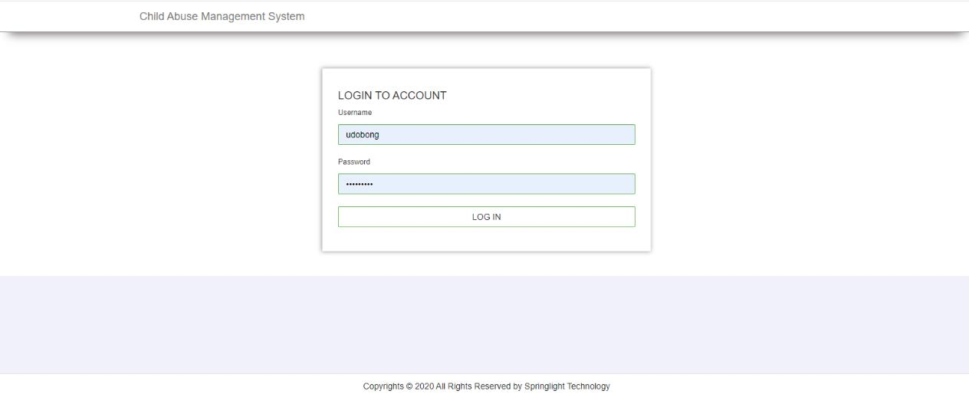

As seen in the image above, the login form has two text fields and two command buttons. Enter the correct user name and password in the appropriate text boxes, then click the "OK" command button, or click the "Cancel" command button to cancel the login form and prevent you from accessing the system.

40

**Figure** **2:** **Admin** **dashboard**

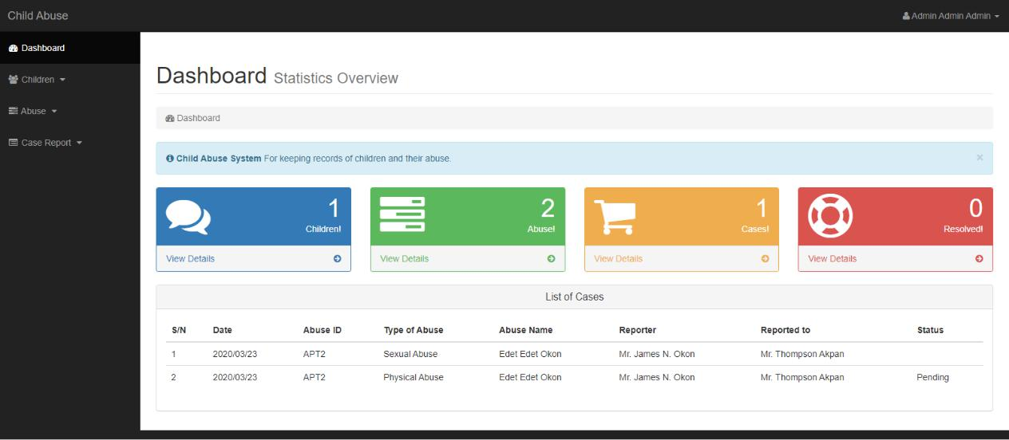

The main form serves as a hub for all of the system's pages, allowing you to access any section of the system based on your level of authentication. Some lawful users will not be able to access forms that are not relevant to them. Everything in the system will be accessible only to the administrator.

It is the primary page on which every user travel after logging in, and it contains most of the system's functions, such as various rights per user, such as editing users, and other functionalities

41

**Figure 3: Children List**

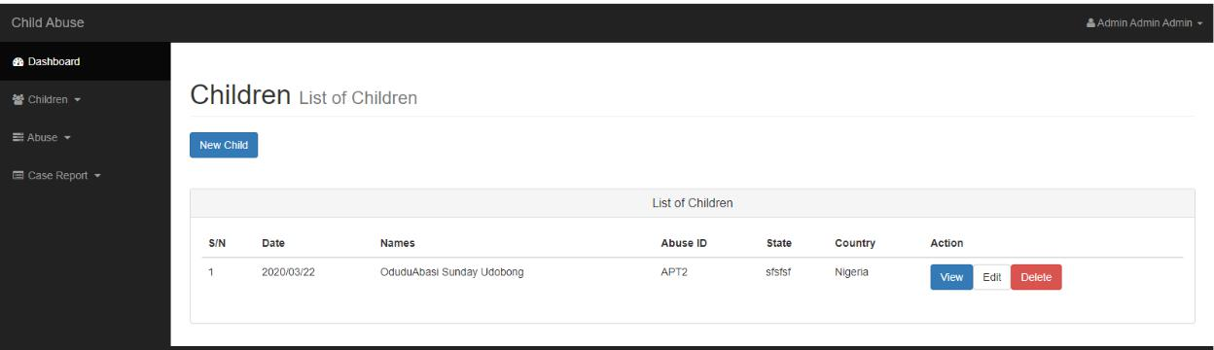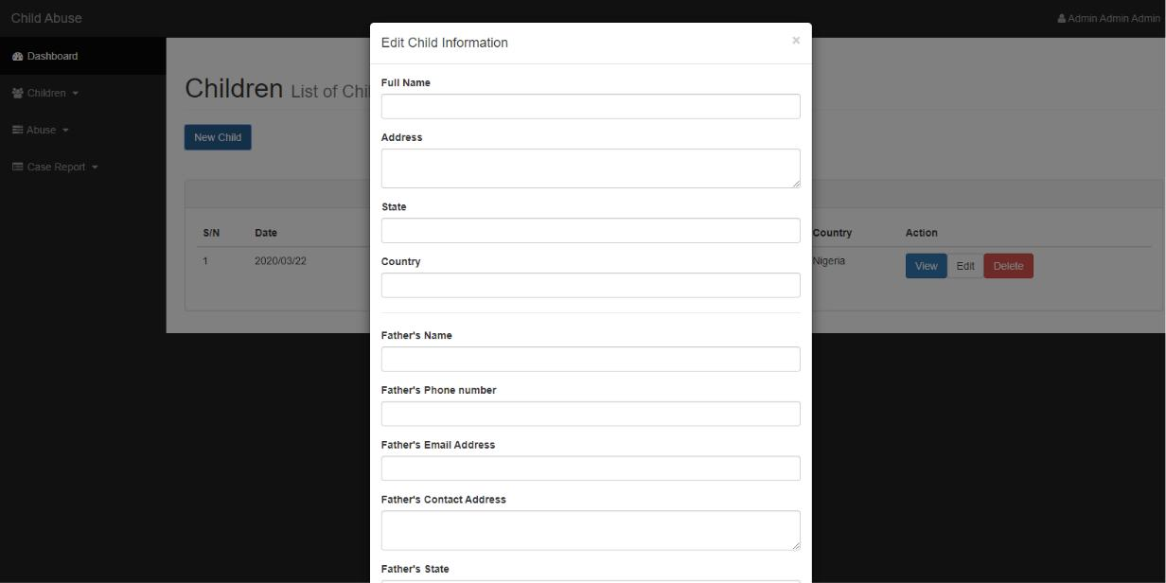

This is the form on which on which records all the information of patients.

**Figure 4: Abuse**

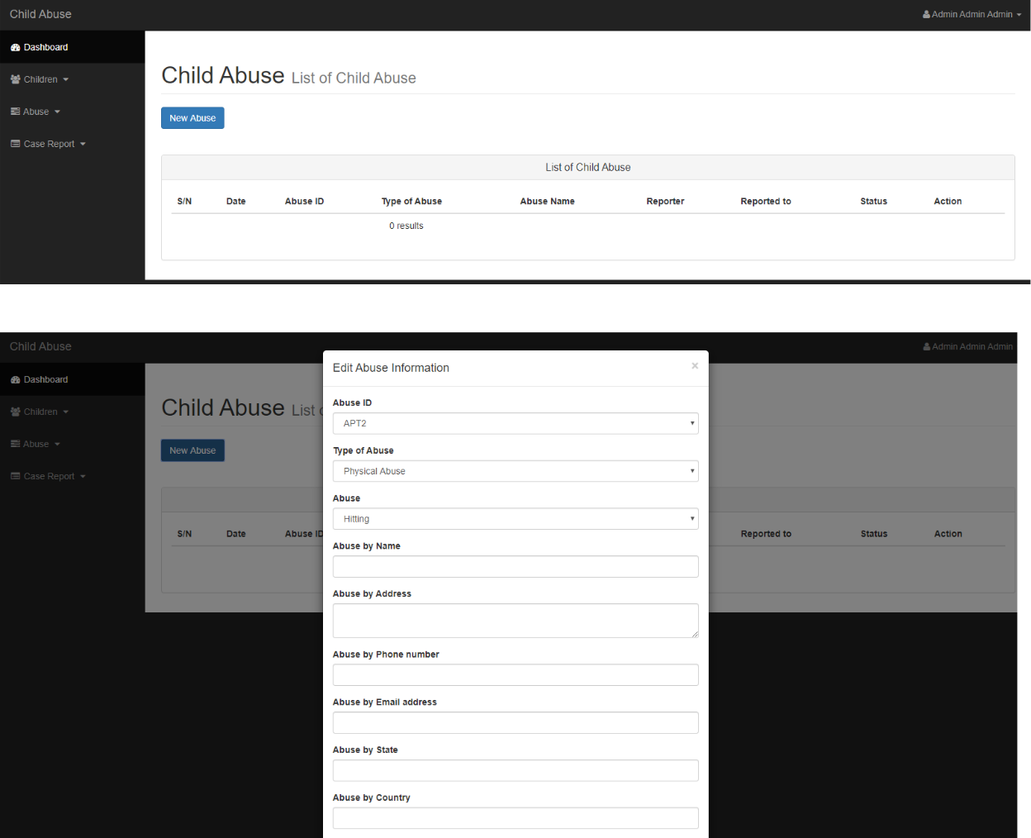

The above form is mainly used to enter the information of the abuse given to a child in different perspectives, for example, the abuse type, abuser’s information, reporter’s information, and reported station info.

43

**Figure** **5:** **Profile**

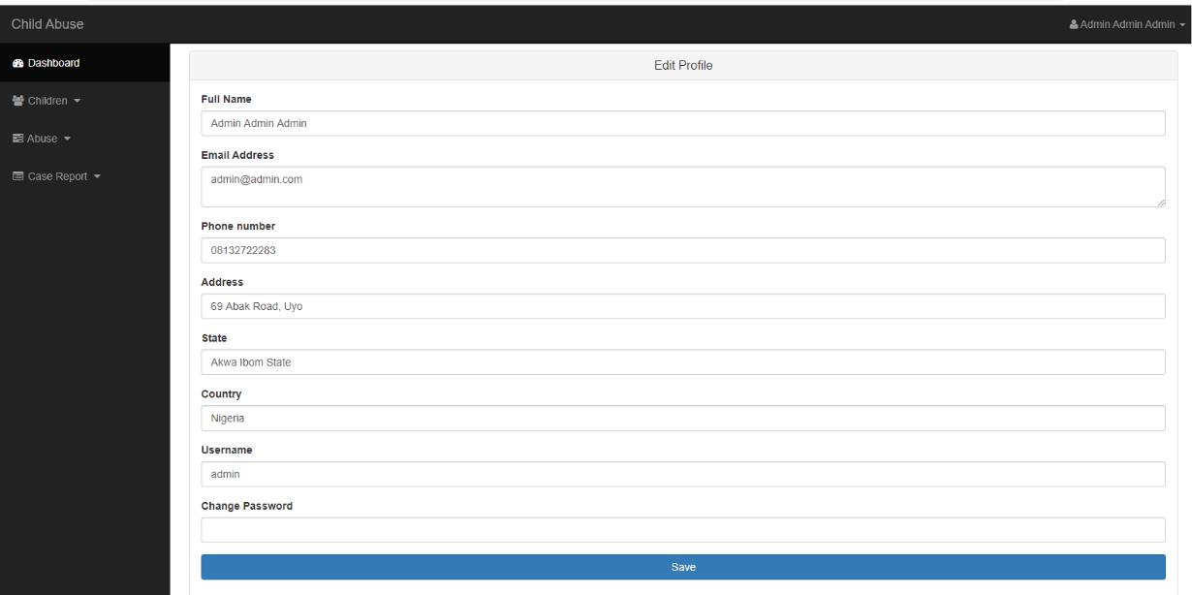

With this form, it makes the user or admin to change their profile information.

44

**Figure 6: Case Report**

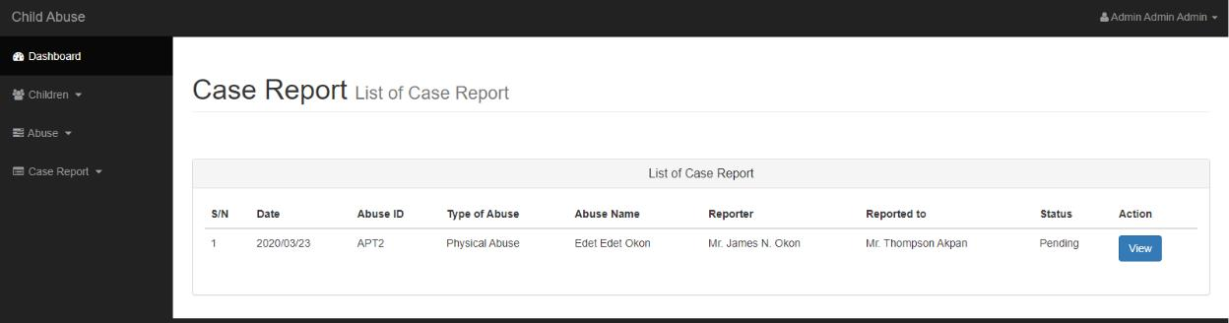

The above figure indicates the ways on case report of each abuse.

45

**CHAPTER FIVE**

**5.0** **INTRODUCTION**

This chapter gives a summary of the entire system with emphases on its achievements and limitations. There are also suggestions on possible areas of enhancement.

**5.1** **DISCUSSION**

The system was created to achieve the system's basic goal and specific objectives, which were proposed earlier in the development process. People, equipment, space, and processes make up a system. The researcher considered the input, processing, storing, and retrieval requirements for a successful system.

Security is always a major factor in every software development project. As a result, administrators should enlist the help of authorized individuals to manage the system. As a result, it is the responsibility of management to ensure internal controls and system security; the system can only be accessed by authorized users who have a login ID and password.

**5.2** **LIMITATIONS**

It is not usually possible to design a system that meets the needs of every user, therefore the system has the following limitations;

There are fixed queries that have been designed by the researcher. This means that the users cannot run queries of their choice unless the system is upgraded.

46

Project was quite limited since the project entails some components that required to be delivered on time with full functionality

Biased responses from some of the interviewees.

Lack of interest from some of the would-be users of the new system due to fear of loss of jobs as a result of the automation that the new system inhibits

**5.3** **PROBLEMS ENCOUNTERED**

As a system is one of the jobs that requires a lot of attention, the following issues were experienced throughout the development process of the System;

One of the most significant issues encountered, which was more of a general issue for all students working on projects at the institution, was a lack of time to allow for the creation of a software with greater features. Which we were initially given an ideal deadline at quick, which was handing in early September, but which was unexpectedly altered to a nearer date, resulting in compression of capabilities that would be incorporated in the system due to time constraints.

* Despite following standard programming standards, some parts did not function correctly, particularly in the viewing forms, which might be due to a computer memory problem

because PHP uses a lot of memory.

* Another issue encountered was limited access to better resources that were used in developing the system, specifically designing software such as Edrawer and Ud on which

internet access was always on and off, so even though they were downloaded, the best that could be obtained were trial versions that only worked for 15 – 30 days, causing the researchers' plans to come up with more unique and hi-tech solutions to be disorganized.

47

* The other issue was with research or requirements engineering, which required a lot of information from the medical center, and the research location was constantly busy, so the

researcher received limited attention because it was a large medical facility that operated 24 hours a day. a day in which the majority of criteria are obtained through observation and the remaining needs are obtained through one-on-one interviews.

* Lack of proper documentation about the existing system was another problem encountered on which was a big bottleneck for System development.
* During data collection process, the staff was reluctant to release any information, as it was even hard for the researcher to be given sample forms that were used to be used in child

abuse management Services with the fear that they might be supporting a competitor.

**5.4** **RECOMMENDATIONS**

First and foremost, it is critical that the Child Safety Monitoring Center continues to use the old manual system, as suggested in the report's implementation section, because the health center has a large number of clients, and system users must be trained to use the system because they may lose information that is critical, so users should first use the manual and then the automated system.

Similarly, as previously said, users must be taught on how to effectively use the new automated system. Basic computer knowledge will be required of users in order for them to appreciate the program's usefulness.

The system has a lot of space for development, but it may be used as a prototype to create a Child Abuse Management System, and additional features might be added because the study time was limited.

48

Lastly on the recommendation as hinted before in supplements of the recommendations about the limited time, the report is not containing all that is in the Project system as it was still under construction and the due to need of beating the deadline of Report handing in most of the Parts needed were included in the Report Living out little bits on which were under construction and changes will be made after the completion of the system by 26th of July.

**5.5** **CONCLUSION**

The hopes and dreams of the human race are created again in each kid who enters our planet. Children are the keepers of our basic future, a future that we have in our hands like never before. For the world has the knowledge, resources, and legal aims to provide each kid with the greatest possible start in life, in families that provide the love, care, and maturation that children require to grow, learn, and develop to their full potential.

Despite this, these children are subjected to a variety of mistreatments, including child labor, assault, abuse, neglect, and commercial sexual exploitation of minors. Children are more vulnerable to being injured, neglected, abused, or exploited than adults. Their survival is in danger and their full improvement is compromised. Violence against children happens inside families, in schools and communities.

In any event, the necessity to care for these youngsters arose in order to satisfy the growing and challenging demand. As a result, man vows to assist in mobilizing an unstoppable fight to abolish, once and for all, the poverty, bad health, violence, and discrimination that have blighted and ruined so many young lives at this point, it is necessary to understand what a child is and what child abuse and neglect are. “There isn't one acceptable age, which is considered a commendable meaning of the upper limit of childhood begins as far as the privilege to vote and

49

be voted in favor of, and the age thought about government service of youth and culture, and education as being upper limit of childhood differs... “ even internationally, there are different definitions of who a child appears to be. The OAU sanction characterizes a child as “each person below the ages of eighteen (18) years” despite the fact that there are divergent opinions and view with respect to what is the age limit of a child, it is the view of the author, that a child is anyone between the birth to the fruition of physiological/mental and physical improvement. As it were, anyone between zero of his/her introduction to the world to eighteen (18) years is a CHILD.

Child disregard is implied demonstration of oversight, dissent or notwithstanding giving essential needs, rights and deeds of the child by parents/ guardians which might possibly fundamentally disable the prosperity of a child. Disregard can likewise appear as insufficient arrangement of resources for the welfare of the child both now and in future.

child mind then again speaks to a region of programming focused at “child needing special protection measures”. There is child who are victims of or belong to, groups which are especially vulnerable to, various kinds of abuse, exploitation, violence and abandonment.

Vulnerable groups-incorporate children armed conflict or by other situations of emergency, children engaged in hazardous or exploitative labour, including those who are trafficked, children deprived of parental protection due to AIDS, children subjected to sexual exploitation and abuse, children living with disabilities and children in conflict with the law.

On account of the above situations, communities should be strengthened and families bolstered to give the vital care to enhance child survival, improvement. Families require learning, aptitudes, inspiration and support, they have to recognize what to do in particular conditions and ass the child develop and create, they require aptitudes to give suitable care and to take care of issues. They should be roused to attempt and to manage new practices. They require social and material help shape the network. Lastly require bolster frame the health centers/system, in the

50

form of accessible clinics responsible services and health workers should have to give effective advice, drugs, and more complex treatment when necessary.

51

**REFERENCES**

Aber, J.L., and Cicchetti, D (2014) The socio-emotional development of maltreated children: An empirical and theoretical analysis. Pp. 147-205 in H. Fitzgerald, B. Lester, and M. Yogman (eds.) *Theory and Research in Behavioral Pediatrics* Vol. II. New York: Plenum Press.

Abram, K. (2010) The problem of co-occurring disorders among jail detainees: Antisocial disorder, alcoholism, drug abuse, and depression. *Law and Human Behavior* 14:333-345.

Alessandri, S.M. (2011) Play and social behavior in maltreated preschoolers. *Development and Psycopathology* 3:191-205.

Alfaro, J.D (2011) Report on the relationship between child abuse and neglect and later socially deviant behavior. In R.J. Hunner and Y.E. Walker, eds., *Exploring the Relationship Between Child Abuse and Delinquency*. Montclair, NJ: Allanheld, Osmun.

Allen, D.M (2010) Young male prostitutes: A psychosocial study. *Archives of Sexual Behavior*

9:399-426.

Augoustinos, M. (2010) Developmental effects of child abuse: A number of recent findings.

*Child Abuse and Neglect* 11:15-27.

Ayoub, C.C., and Milner S.S. (2015) Failure to thrive parental indicators, types, and outcome.

*Child Abuse and Neglect* 9:491-499.

Barahal, R.M (2010) The social and cognitive development of abused children. *Journal of Consulting and Clinical Psychology* 53:335-343.

52

Bath, H. I., and Haapala. D. A (2013). “Intensive Family Preservation Services with Abused and Neglected Children: An Examination of Group Differences.” *Child Abuse* & *Neglect* 17(2): 213–225.

Beck, J.C (2010) Reports of childhood incest and current behavior of chronically hospitalized psychotic women. *American Journal of Psychitary* 144(11):1474-1476.

Benward, J., and Densen-Gerber, J (2015) Incest as a causative factor in antisocial behavior.

*Contemporary Drug Problems* 4:323-340.

Berger, L. M. (2010). “Socioeconomic Factors and Substandard Parenting.” *Social Service Review* 81(3): 485–522.

Berger, L. M. (2014). “Income, Family Structure, and Child Maltreatment Risk.” *Children and Youth Services Review* 26(8): 725–748.

Berger, L. M. (2015). “Income, Family Characteristics, and Physical Violence toward Children.” *Child Abuse & Neglect* 29(2): 107–133.

Bloom, H. S. (2011). *The Core Analytics of Randomized Experiments for Social Research*. New York: Manpower Demonstration Research Corporation.

Bonomi, R. S (2008). Association between self-reported health and physical and/or sexual abuse experienced before age 18. Child Abuse & Neglect, 32(7), 693-701.

Brown and Salzinger. S (2010). “A Longitudinal Analysis of Risk Factors for Child Maltreatment: Findings of a 17-Year Prospective Study of Officially Recorded and Self-Reported Child Abuse and Neglect.” *Child Abuse & Neglect* 22(11): 1065–1078.

Cancian, M and Caspar, E (2008). “Welfare and Child Support: Complements, not Substitutes.”

*Journal of Policy Analysis and Management* 27(2): 354–375.

53

Chaffin, M (2011). “Onset of Physical Abuse and Neglect: Psychiatric, Substance Abuse, and Social Risk Factors from Prospective Community Data.” *Child Abuse & Neglect* 20(3): 191–203.

Corso, P and Mercy, J. A (2011). “Health-Related Quality of Life among Adults Who Experienced Maltreatment during Childhood.” *American Journal of Public Health* 98(6): 1094.

Crouch, J. L and Milner, J. S. (2013). Effects of child neglect on children. Criminal Justice and Behavior, 20(1), 49-65. doi:10.1177/0093854893020001005

Culp, R. E (2011). Maltreated children's language and speech development: Abused, neglected, and abused and neglected. First Language, 11(33), 377-389. Dykes, J.P (2010) The effects of maltreatment on young children's socioemotional development: An attachment theory perspective. *Developmental Psychology* 23:406-414.

Drotar, J.L, (2012) The effects of maltreatment on development during early childhood: Recent studies and their theoretical, clinical and policy implications. Pp. 579-619 in D. Cicchetti and V. Carlson (eds.) *Child Maltreatment: Theory and Research on Causes and Consequences*. New York: Cambridge University Press.

Gilbert, U and Janson, U (2009). “Burden and Consequences of Child Maltreatment in High-Income Countries.” *The Lancet* 373(9657): 68–81.

Gillham, B (2010). “Unemployment Rates, Single Parent Density, and Indices of Child Poverty: Their Relationship to Different Categories of Child Abuse and Neglect.” *Child Abuse & Neglect* 22(2): 79–90.

Gornick, J. C. and Meyers, M. K (2015). *Families that Work: Policies for Reconciling*

*Parenthood and Employment*. New York: Russell Sage Foundation.

54

Greenfield, E. A. (2010). Child abuse as a life-course social determinant of adult health. Maturitas, 66(1), 51-55. doi:DOI: 10.1016/j.maturitas.2010.02.002

Jacobson, S.T (2010) Developmental outcomes in abused children: Consequences of parental abuse or a more general breakdown in caregiver behavior? *Behavior Therapist* 11:27-32.

Jones, E. D., and McCurdy, K (2012). “The Links between Types of Maltreatment and Demographic Characteristics of Children.” *Child Abuse & Neglect* 16(2): 201–215.

Jones, L. (2010). “Unemployment and Child Abuse.” *Families in Society* 71(10): 579–588. Larkin, H. (2009). Adverse childhood experiences linked to health risk behaviors. Policy and

Practice of Public Human Services, 67(3), 14-16.

Patterson, J.H (2009) A review of the short-term effects of childhood sexual abuse. *Child Abuse and Neglect* 15:537-556.

Rosenbaum, J.V (2011) Characteristics of adolescent incest sexual perpetrators: Preliminary findings. *Journal of Family Violence* 1(1):85-97.

Stovall, K (2010) Depressive characteristics of physically abused children. *Journal of Abnormal Child Psychology* 17:1-11.

Sylvestre, A and Mérette, C. (2010). Language delay in severely neglected children: A cumulative or specific effect of risk factors? Child Abuse & Neglect, 34(6), 414-428.

Trickett, P. K and McBride-Chang, C. (2015). The developmental impact of\ different forms of child abuse and neglect. Developmental Review 15, 311-337.

Twardosz, S and Lutzker, J. R. (2010). Child maltreatment and the developing brain: A review of neuroscience perspectives. Aggression and Violent Behavior, 15(1), 59-68. d

55

Vissing J.M (2012) The effects of child maltreatment on language development. *Child Abuse and Neglect* 6:299-305.

Woodhouse, B. B. (2011). Implications for children's rights in the united states. *An introduction to children's rights, 25-29.s*

Braker, Stone M & J.M Hellerstein (eds.) (1998). ”Reading in databases”. *Kaufmann San Francisco*

Hallmark, J; Garcia, C (1992). System migration experiences from the field. Information Technology & libraries, 11 (4), 345-358.

Hudgins, J; and Macklin, L. (2000). New materials, new processes: implementing digital imaging projects into existing work flow. Library collections, Acquisitions, &Technical services, 24(2), 189-204.

Laudon. Kand Laudon J (2002) management information systems, 7th Edition, Pearson Education Asia

Lewis. C. and Griffin M. (1997),, Human factors consideration in clinical applications of virtual reality.

Riva. G., (1999), Virtual Reality as a communication tool: a socio-cognitive analysis Teleoperators, and Virtual Environments

Siau, Keng (2003). *Advanced topics in database research*, volume 5 56

Shortell SM, Gillies RR, Anderson DA, Erickson KM, Mitchell JB. Remaking health care in America. San Francisco:

Yaspan, Arthur (1961). *Operation* *Research*. Vol 9, pp. 371-

57

**APPENDICES:**

**Interview Guide**

**Questions**

1. What are the strength of the current system on which the Child Safety Monitoring Center is using in line with the Child Abuse Management System?
2. What are its weaknesses in details?
3. What are the limitations of the current system used in the child monitoring center per Child Abuse Management?
4. What are the problems faced by the current system?
5. How would you want the new system to work per its perfection?
6. What are the main features that you may want to be included in the new system?
7. Who is supposed to be given what privilege per the activities in the Child Safety Monitoring Center in details, for example who is supposed to fill the Child Abuse information, or who is supposed to record the details?

58