# CHAPTER ONE

* 1. **INTRODUCTION**

Computerised Traffic Offence System is a powerful web based and database program that records all the traffic offences committed nationwide. The system helps the Federal Road Safety Commission keep adequate records of all traffic offences that has been committed and that will still be committed by road users and also maintain the databases of the commission (FRSC).

# BACKGROUND OF THE STUDY

Prior to the establishment of Federal Road Safety Commission in 1988, there was no concrete and sustained policy action to address the carnage on Nigerian roads. Earlier attempts in this direction were limited to discrete and isolated attempts by some states of the Federation and individuals.The unpleasant trend in the nation’s road traffic system which resulted in upsurage in road traffic accidents made the Federal Government initiate a search for a credible and effective response to the challenge. In February 1988, the Federal Government established the Federal Road Safety Commission through Decree No .45 of the 1988 as amended by Decree 35 of 1992 refered to in the statue books as the FRSC Act cap 141 laws of the Federation of Nigeria (LFN). Passed by the National Assembly as Federal Road Safety Commission (establishment) Act

200. Around the world road traffic injuries are a major public health challenges that requires concerted efforts for effective and sustained prevention.An estimated 1.2million people are killed in road crashes every year and as many as 50million suffer injuries. The world health organisation believes that these figures could increase by more than half over the next 20years unless there is a firm commitment to road safety and accident prevention, especially in Nigeria, most adults will know of someone who has been killed or injured in a road

traffic accident. It is a dead fact that many of these accidents and their consequences would have been avoided. Therefore the Computerised Traffic Offence System will help to keep records of all traffic offences committed by road users and also maintain the databases of the commission (FRSC).

# STATEMENT OF THE PROBLEM

The present system of traffic offence system which is the manual system known as (Notice of Offence Sheet) has alot of problems which are mentioned below:

TIME:Going by the present system of operation, time is consumed in the manual handling of operation involved in road traffic documentation.

COST:This is the greatest problem of ths Federal Road Safety Commission. The commission tends to lose alot of money running the agency manually.

DOCUMENT INTEGRITY:This is viewed in the contest of safety, in validity of the records in document files used in report generation. In terms of safety, the nature of the system makes it vulnerable to theft, fire or accidental destruction. This makes the system unsafe as the time needed to replace lost data or files is enormously large.

# PURPOSE OF THE STUDY

This study is designed to help Federal Road Safety Commission to document all road traffic offences incurred by the road users.This study also tries to give an in-depth look in the easiest and most effective way for the growth and development of the Federal Road Safety Commission of Nigeria, in order to control and render its services to Nigerians and other countries.

# SIGNIFICANCE OF THE STUDY

With the growth in information technology, the study offers numerous values to the Federal Road Safety Commission and any organisation that deals with offence documentation data/information. Huge files kept through the manual method in offices will no longer be there again because information will be stored on the computer with the help of the Computerised Traffic Offence System. It will help to keep a comprehensive record of traffic offence documented.

# OBJECTIVES OF THE STUDY

The objectives of the study are as follows:

* + - To provide better services to the public and users making the highway safe for motorists and other road users.
    - To keep records that are complete, integrated and up to date, also recommending works and devices designed to eliminate or minimise accidents on the highways and advising the Federal and State Government including the Federal Capital Territory Administration and relevant governmental agencies on the localities where such works and devices are requred.
    - To produce a system where information and output report will be produced or made available much faster, more accurately and more detailed to the commission and the public by educating motorist and members of the public on the importance of discipline on the highway.
    - Maintaining the validity period for drivers’ licences which shall be three years subject to renewal at the expiration of the validity period as well as designing,resgistering and producing vehicle plate number.
    - Conducting researches and also the standardization of highway traffic codes.

# SCOPE OF THE STUDY

This study is strived at finding out how effective the Computerization of Nigerian Road Safety Commission will improve the operation of the commission. However, the research is limited to traffic offence section.

# LIMITATIONS OF THE STUDY

Owing to the scope of this project as mentioned above, this project work is limited to computer literates. It is important to mention that time and cost was a major constraint in the course of fact finding. It is also wise to mention here that some information needed to work with was not collected because of the unwillingness of the agency to reveal such information.

# DEFINITION OF TERMS

* + - INFORMATION: This is the assembling of data into a meaningful form.
    - DATA: This is a fore runner of information. It is an unprocessed fact.
    - DATABASE: Is a collection of information that is related to a particular subject or purpose.
    - INTERNET: Is a collection of computer networks that operate to common standards and enable the computer and the program they run to communicate directly.
    - SOFTWARE: This is a logically written program that hardware uses to perform its operation.
    - FRSC: Federal Road Safety Commission is body responsible for the control of Road users in a country (Nigeria).
    - COMPUTERIZATION: Refers to the application of computer in performing operations.
    - SYSTEM: Is the collection of hardware, software,data information procedures and people.

# CHAPTER TWO

* 1. **LITERATURE REVIEW**

# AN OVERVIEW OF FEDERAL ROAD SAFETY COMMISSION

In February 1988, the Federal Government created the Federal Road Safety Commission through Decree No.45 of the 1988 as amened by Decree 35 of 1992 refered to in the statute of books as the FRSC Act cap 141 laws of the Federation of Nigeriav (LFN). Passed by the National Assembly as Federal Road Safety Commission (establishment) Act 2007. The functions of the commission generally relates to making the highway safe for motorist and other road users. Recommending works and devices designed to eliminate or minimize accidents on the highways and advising the Federal and State Governments including the Federal Capital Territory Administration and relevant governmental agencies on the localities where such works and devices are required,and educating motorists and members of the public on the importance of discipline on the highway. In particular the commission is charged with the responsibilities for preventing or minimizing accidents on the highway; clearing obstructions on any part of the highways; Educating drivers, motorists and other member of the public generally on the proper use of the highways; Designing and producing the driver’s license. Decade of action, the mission of safe road in Nigeria is to reduce road crash deaths and injuries by 50% by 2020. Safe Road in Nigeria is a response to United Nation’s Decade of Action for Road Safety. It is one of the initiatives of Federal Road Safety Commission of Nigeria to promote safety on our roads. Fact1: Road crashes kill more than HIV/AIDS and Malaria. Fact2: There’s someone you know who has been killed or injuried in a crash. Fact3: People are killed or injured in road crashes everyday. Fact4: All road crashes can be prevented. Fact5: Most crashes are caused by the driver’s behaviour and not always as a result of bad roads. Facts6: The ideal of a “Safe Road” in Nigria is more of changing our driving

behaviour than advocating for good road infrastructure. Fact7: We can reduce deaths and injuries due to crashes by 50% if we can make a commitiment to not drink and drive, not over speed, wear seat belts and not to use mobile devices when driving. The FRSC is currently headed by Ositadnma Benjamin Chidoka whose title is the Corps Marshal and Chief Executive (COMACE) the highest rank in the Corps ranking system. Prior to the impact of the establishment of Federal Road Safety Commission in 1988,there was no concrete and sustained policy action to address the carnage on Nigerian roads. Earlier attempts in this direction were limited to discrete and isolated attempts by some states of the federation and individuals. Notable among the efforts to institute a formdable road safety program was the effort of Shell Petroleum Development Company of Nigeria (SPDC) between 1960 and 1965. The effort of the Nigerian Army in the training of its offices and men on road safety in the early 1970s also contributed to road safety ideals and consciousness in Nigeria: The Nigeria Army started the first public Road Safety campaign in 1972 when it iniated an annaul Road Safety week. The First delibrate policy on road safety was the creatin in 1974 of the National Road Safety Commission (NRSC) by the then military government. The impact of the commission was however not sustained. In 1977,the Military Administration in Oyo state, Nigeria established the Oyo state Road Safety corps which made some local significant improvements in road safety and road discipline in the state that lasted till 1983, when it was disbanded by the federal government. With the continued dangerous trend of road traffic accidents in Nigeria then, which placed it as one of the most road traffic accident (RTA) prone countries worldwide (second to Ethiopia), the Nigerian government asw the need to establish the present Federal Road Safety Corps in 1988 to address the carnage on the highways.

# STATUTORY FUNCTIONS

The functions of the commission generally relates to:

* + - Making the highway safe for motorists and other road users.
    - Recommending works and devices designed to eliminate or minimize accidentss on the highways and advising the Federal and State Governments including the Federal Capital Territory Adminisration and relivant governmental agencies on the localities where such works and devices are required.
    - Educating motorists and members of the public on the importance of discipline on the highway.

In particular,the commission is charged with responsibilities as follows:

* + - Preventing or minimizing road accidents on the highway.
    - Clearing obstructions on any part of the highways.
    - Educating drivers, motorists and other members of the public generally on the proper use of the highways.
    - Designing and producing the driver’s license to be uesd by various categories of vehicle operators.
    - Determining, from time to time the requirements to be satisfied by an applicant for a driver’s license.
    - Designing and producing vehicle number plates.
    - The standardization of highway traffic codes.
    - Preventing or minimizing accidents on the highways.
    - Giving prompt attention and care to victims of accidents.
    - Conducting researches into causes of motor accidents and methods of preventing them and putting into use the result of such researches.
    - Determining and enforcing speed limits for all categories of roads and vehicles and controlling the use of speed limiting devices.
    - cooperating with bodies or agencies or groups in road safety activities or in prevention or accidents on the highways.
    - Making regulations in pursuance of any of the functions assigned to the corps by or under this Act.
    - Regulating the use of sirens, flashers and becon lights on vehicles other than ambulances and vehicles belonging to the Armed Forces, Nigeria Police, Fire service and other Paramilitary agencies.
    - Providing roadside and mobile clincs for the treatment of accident vicitims free of charge.
    - Regulating the use of mobile phones by motorists.
    - Regulating the use of seatbelts and other safety devices.
    - Regulating the use of motorcycles on the highways.
    - Maintaing the validity period for driver’s licences which shall be three years subject to renewal at the expiration of validity period.

In exercising these functions, members of the commission shall have power to arrest and prosecute persons reasonably suspected of having committed any traffic offence.

# REVIEW OF RELATED STUDIES

The increasing level of road traffic accidents (RTA) in Imo State and the consequent injuries and deaths sregthened the case for its regular analysis. Data on recorded cases of road traffic accidents were collected from the Motor Traffic Division (MTDRTR),the Nigerian Police Force, Divisional Headquarters Umuguma, Owerri West,Imo State Police command. Using the method of time series decomposition,traffic road accidents were characterised to have an upward trend and significant seasonal influences. Using the Chi-square test of significance, it was discovered that there were significant differences among the

various causes of accidents and accident cases (Minor,Fatal and Serious) with respect to types of vehicles involved over the years. Out of 5921 accident cases, reckless driving, inexprience and mechanical fault and road defects accounte for 30.1, 21.5 and 21.1% rspectively. Two motorcycles, motorcycle-vehicle and vehicle-vehicle crashes are the lead types and have resulted in 38.9, 37.5 and 14.9% of the total of 855 deaths recorded within the period of study. Furthermore, it was also found that private cars, minibuses and taxis accounted for most of the accidents with 94.7% of the total accidents. RTA results in the deaths of 1.2million people worldwide each injuries about 4 times this number (WHO 2004).

# SPEED LIMIT ON ROADS

The table above shows default speed limits for different roads under the Road Traffic Act 2004.

|  |  |
| --- | --- |
| TYPE OF ROAD | SPEED LIMIT |
| Motorway | 120km/h |
| National roads (Primary and  Secondary) | 100km/h |
| Non-National roads (regional and  local) | 80km/h |
| Road in built-up areas(cities and towns) | 50km/h |

# SPEED LIMITS FOR VEHICLES

The table below outlines the speed limits that apply to different vehicles.

|  |  |
| --- | --- |
| VEHICLE SPEED LIMIT | TYPE OF VEHICLE TO WHICH IT  APPLIES |
| 65km/h (On all roads) | A single or double deck bus or coach designed for carrying standing  passengers. |
| 80km/h (on all road) | A goods vehicle with a design gross vehicle weight of more than 3,500  kilograms. |
| 80km/h (on all roads) | Any vehicle towinga trailer, caravan,  horsebox or other attachment. |
| 80km/h (on all roads expcept motorways or dual carriage ways) | A single or double deck bus or coach that is not designed for carrying  standing passengers. |
| 100km/h (on all motorways or dual carriageways where no lower lmit is in  place) | A single or double deck bus or coach that is not designed for carrying  standing passengers. |

# CHALLENGES OF ROAD SAFETY

Despite technological advancement and improved environment including good conditions, the rate of road traffic accidentss continues to increase. According to David (1999), the second African Road Safety congress in Addis-Ababa, Ethiopia in 1989 revealed that the road safety situation in a developing Economic (especially Africa) still poses a great concern as shown in the following coparative statistics: At the global level: 500,000 persons die and 10

to 15million persons are injured every year in road accidents throughout the world and approximately 30% of these fatalities and injuries are experimented in developing countries. A recent analysis of Global Burden of Disease, in assesing changes in ranking order of disease burden for 15 leading causes in the world, shows that road traffic accidents ranked No. 9 in 1990 and will probably be No. 3 in the year 2020, if not properly checked and controlled. At the regional level: Research shows that road accidents are the second highest cause of death for the 5 to 44 years age group in Africa. The major challenge facing the Federal Road Safety Commission and other coordinating bodies is ack of compentent support staff and experts to assess the relevance of existing road safety. Programme implementation and continuity, funding and follow-up of the actions undertaken, are additional challenges. There is need for increased funding, the initiation of the in-depth studies and actions plan to improve Road Safety situaton at the national, sub-regional and regional levels. The essence is exchange of experiences and results in order to gradually increase available relevant knowledge.

# MEASURES TO PREVENT AND CONTROL ACCIDENT

We must adopt or acquire sufficient safety education to develop positive safety attitudes and habits. Road Safety eduvcation should be introduced in the primary schools among pupils. In addition, Teachers’ Guide, Posters, leaflets and an activity book should be published and distributed to all Head Teachers, Information Technology and Physical Education personnel, and the pupils of all primary schools. Talks on road safety should be delivered to Secondary schools and higher institutions in Nigeria.

* Planning or ordering the enivironment to make it accident free. Government should construct and maintain good road network in the

country. Enough road signs should be provided at strategic points to inform road users of sharp bends, pedestrian crossing, T-junctions, roundabouts, danger.The main ojectivies of campaign should be to reduce the annual road deaths to the bearest minimum. Increase level of awareness and understanding of traffic codes for pedestrians on the road. Develop responsible attitude amongst pedestrians toward their own safety.

* Regular maintance and repairs of vehicle is a vert important factor in the prevention of road accidents.Minimum vehicle safety standards should not be compromised, good maintenance culture should be encouraged.
* Avoidance of haste, confusion procrastinatiion while on the highway. Always drive at a speed limit which is reasonable, credible, acceptable by the FRSC and other road users. Overspeeding dangerous overtaking should be avoided. Drivers should always endeavour to abide by traffic rules, give correct, prompt, adequate and clear signals without any procrastination.
* There should be a constant consciousness of hazadous situations like reckless driving by other drivers, bad road network, mechanically defective vehicles, impairment of visibility on highways.
* Avoid the use of mobile phone whil driving.
* Make sure you use your seat belt.
* Avoid drink driving or driving under the influence of alcohol

# NOTICE OF OFFENCE SHEET

The table below is a typical example the manual method of convicting traffic offenders in Nigeria.

|  |  |  |  |  |  |
| --- | --- | --- | --- | --- | --- |
| S/NO | TICK  INFRINGEMENT | CODE | POINTS | PENALTY | CATEGORY |
| 1 | Assaulting Marshal  on duty | AMD | 10 | 10,000 | 2 |
| 2 | Attempting to corrupt  Marshal on duty | ACS | 10 | 10,000 | 2 |
| 3 | Caution sign  violation | CSV | 3 | 3,000 | 3 |
| 4 | Construction area  speed limit violation | CAV | 3 | 3,000 | 1 |
| 5 | Dangerous driving | DGD | 10 | 50,000 | 1 |
| 6 | Do not move  violation | DNM | 2 | 2,000 | 2 |
| 7 | Driver’s licence  violation | DLV | 10 | 10,000 | 2 |
| 8 | Driving under alcohol/drug  influence | DUI | 5 | 5,000 | 2 |
| 9 | Driving with worn-  out tyre | TYV | 3 | 3,000 | 1 |
| 10 | Driving with  expired/without spare tyre | EWT | 2 | 2,000 | 3 |
| 11 | Excessive smoke  emission | ESE | 5 | 5,000 | 1 |
| 12 | Failure to cover  unstable materials | FCM | 5 | 5,000 | 1 |
| 13 | Failure to fix red flag | FFF | 3 | 3,000 | 1 |

|  |  |  |  |  |  |
| --- | --- | --- | --- | --- | --- |
|  | on projected load |  |  |  |  |
| 14 | Failure to move over | FMO | 3 | 3,000 | 1 |
| 15 | Failure to report road  crash | FRC | 10 | 20,000 | 1 |
| 16 | Fire extinguisher  violation | FEV | 3 | 3,000 | 3 |
| 17 | Inadequate construction warning  sign | ICW | - | 50,000 | 1 |
| 18 | Light/sign violation | LSV | 2 | 2,000 | 2 |
| 19 | Medical personnel/hospital rejection of road  crash victim | RCV | - | 50,000 | 1 |
| 20 | Operating  mechanically defcient vehicle | MDV | 5 | 5,000 | 1 |
| 21 | Obstructing marshal on duty | OMD | 3 | 3,000 | 2 |
| 22 | Operating a vehicle  with forggd documents | OFD | 10 | 20,000 | 2 |
| 23 | Overloading | OVL | 10 | 10,000 | 1 |
| 24 | Passengers’ manifest  violation | PMV | 10 | 10,000 | 2 |
| 25 | Riding motorcycle | RMH | 2 | 2,000 | 1 |

|  |  |  |  |  |  |
| --- | --- | --- | --- | --- | --- |
|  | without usin crash  helmet |  |  |  |  |
| 26 | Road obstruction | ROB | 5 | 5,000 | 1 |
| 27 | Road marking  violation | RMV | 5 | 5,000 | 1 |
| 28 | Route violation | RTV | 10 | 10,000 | 1 |
| 29 | Seat belt use  violaation | SUV | 5 | 5,000 | 1 |
| 30 | Speed limit violation | SLV | 5 | 5,000 | 1 |
| 31 | Unauthorized removal/tampering  with road sign | UTS | 5 | 5,000 | 1 |
| 32 | Under aged  driving/riding | UDR | - | 10,000 | 1 |
| 33 | Use of phone while  driving | UPD | 4 | 4,000 | 1 |
| 34 | Vehicle licence  violation | VLV | 3 | 3,000 | 2 |
| 35 | Number plate  violation | NPV | 3 | 3,000 | 1 |
| 36 | Vehicle windshield violation | VWV | 3 | 3,000 | 1 |
| 37 | Wrongful overtaking | WOV | 3 | 3,000 | 1 |
| 38 | Projected load in excess of prescribed  limit | PLE | 3 | 3,000 | 1 |
| 39 | Vehicle mirror | VMV | 3 | 3,000 | 1 |

|  |  |  |  |  |  |
| --- | --- | --- | --- | --- | --- |
|  | violation |  |  |  |  |
| 40 | Learner driving  regulation violation | LDV | 10 | 3,000 | 1 |
| 41 | Child restraint violation | CRV | 6 | 3,000 | 1 |
| 42 | Child sitting position  violation | CPV | 6 | 3,000 | 1 |
| 43 | Driving right-hand  steering vehicle | DRV | 10 | 3,000 | 1 |
| 44 | Other  offences/violations | OFV | 2 | 3,000 | - |

NOTE:Custody fee on impounded motor Vehicle and Motorcycle/Tricycle is N200.00 and N100, respectively per day payable after initial 24 hours of grace.

# DATABASE MANAGEMENT SYSTEM

According to Brutus, from India; A Database Management System (DBMS) is a software system designed to efficiently store, reterieve, manipulate and query large amounts of data. Since the introduction of the relational data model in 1970, the database management system industry has grown to $100 billon dollars a year and increases more by 25% every year. With the new and emerging internet applictions posing new requirements in the DBMS design and implementation, the database market is expected to grow even faster, and database design and implementation techniques are constantly evolving to meet the new requirements. According to Micheal Stonebreaker’s Ingeres, DBMS are usually categorized according to the database model that they support. The data model tends to determine the query languages that are available to access the

database. A great deal of the internal engineering of a DBMS, however is independent of the data model and is concerned with managing factors such as performance, concurrency, integrity and recovery from hardware failures.In these areas there are large differences between products. According to professor Allen S. Lee, Managent Information System,MIS is a planned system of collecting, processing, storing and diseminating datd n the form of information needed to carryout the functions of mangement.According to Philip Kotler “ A marketing information system consist of people, equipment and procedures to gather, sort, analyze, evaluate and distribute needed, timely and accurate information to marketing decision makers.”(Kotler, Philip and Keller, Kevin Lane; marketing management,Pearson Education, 12Ed, 2006). The terms MIS and information system are often confused. Information system include systems that are not intended for decision making MIS is sometimes refered to,in a respective sense as Information Technology Management. That area of study should not be confused with Computer Science. IT service management is a practitioner-focused discipline. MIS has also some differences with Enterprise Resource Planning (ERP) as ERP incorporates elements that are not necessarily focused on decision support. Database normalization, sometimes refered to as canonical synthesis, is a technique for designing relational database tables to minimze duplication of information and n so doing,to safeguard the database against certain type of logical or structural problems,namely data anomalies. For example, when multiple instances of a given piece of information occur in a table,the possibility exists that these instances will not be kept consistent when the data within the table is updated, leading to a loss of data integrity. A table that is sufficiently normalized is vulnerable to problems of this kind, because its structure reflects the basic assumptions for when multiple instances of the same information should be represented by a single instance only.

# CHAPTER THREE

* 1. **RESEARCH METHODOLOGY AND SYSTEM ANALYSIS**

# RESEARCH METHODOLOGY

* + - PERSONAL INTERVIEW: Some of the management staff were interviewed to share their feeling and exprience about the manual system of processing and recording of traffic offenses. Their response was that the manual system which is known as the “Notice Of Offence Sheet” is highly cumbersome, boring and time consuming.They stressed tha te manual system has not helped them much, since they have offenders on a daily, weekly, mothly and yearly on a high rate and the number keeps increasing on a regular basis. Making their office to look like a market place with crowds of people trouping in and out of their office at all times.
    - OBSERVATION: A situation whereby file are litered around, makes the office look untidy and unkept. I observed that due to insuffient space for storage of this files the office looks very much like a warehouse or better still a stuffy storehouse than like an office. Having also noticed that searching for a particular offenders’ record is time consuming and stressful, this makes the manual system ineffective.
    - BROWSING METHOD: I ran lots of facts finding on the internet aid in my further research and aquisition of knowledge on Federal Road Safety commission concering their manual system of Traffic Offence and my desire to change the manual system to a computerised system.

# ANALYSIS OF THE EXISTING SYSTEM

The existing system is a method that has been carried out in terms of manual operation. A system in which all the methods of processing and storing offenders’ data/information is a manual procedure or approach. This approach is such that the mangement staff will the offenders’ data/information on a piece of paper or a register and kept in file cabinet or even on the desk of the officer in- charge. Critical analysis otf this system reveals tha it is a system prone to a lot of errors, careless handling, theft, flood, fire and other forms of accidents and it is not effective. Searching for someone’s record is time consuming and boring the system is such that the office is filled up with files which makes the office dirty and a resting place for pest. Careful analysis also shows that due to complexities of the manual system, informaton stored is difficult to retrieve. Also because of the inconsistency of the manuel system, at times file are lost because of mismanagement.

# OBJECTIVIES OF THE PROPOSED SYSTEM

Computerised traffic offence System has the objective of how the available technology can be integrated into an organized system for better data capturing and information flow. In fact, the objectives are:

* + - To create a platform that supports scheduling and easy administration
    - Create an enabling and closed circuit system that enhances effective supervision
    - Create a platform for easier processing, timely supervision from any traffic offender.
    - To generate a real time reports and trend graphing.

# ORANISATIONAL STRUCTURE

The oranisational structure or the oraganogram of the Federal Road Safety Commission is seen below:

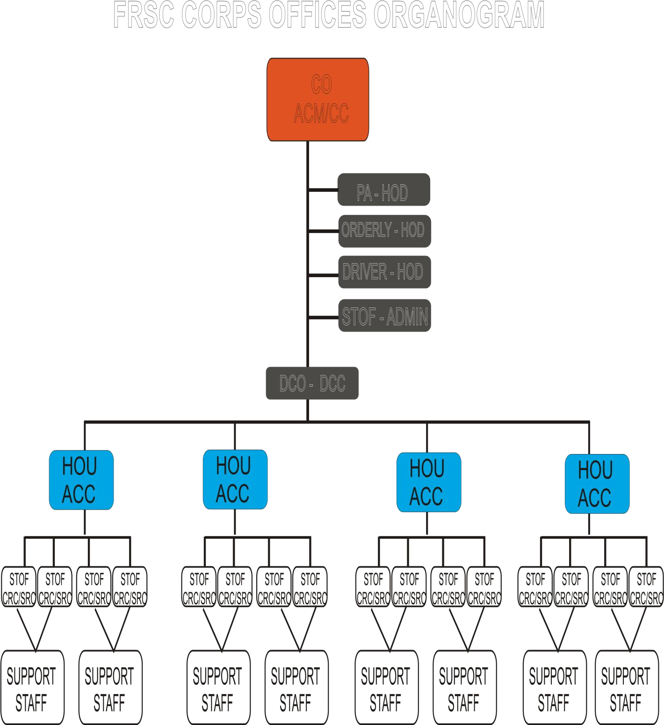

# INPUT ANALYSIS

In this phase, the primary activity is to find out the pattern of the input. And after careful observation, the searcher resolved using this variable as follows:

Name of Offender Address

City

Mobile number Offence and Penalty

# PROBLEMS OF THE EXISTING SYSTEM

A lot of problems are associated with the existing system, involves the use of manual system to store data/information. The system has proved defective as the objective ot the system has also failed. Among the problems associated with the existing system include the following:

* + - It can be easily damaged or destoryed
    - Data redundancy
    - Time wasted in searching/sorting for information
    - Poor security and protection
    - Misplacing and Mismanging of files

# JUSTIFICATION FOR THE NEW SYSTEM

It is expected that with the introduction of the new system, alot of positive changes will be noticed. The numerous problems associated with the manual system will be minimized to the bearest minimum, if not totally eradicated . Management staff that previously had difficulties in carrying out their duties

effectively, will now have to appreciate it, they will now work with joy and zeal and this will lead to a positive change and improvement in the functions of the Federal Road Safety Commission because of the visual approach of the development.

# CHAPTER FOUR

* 1. **SYSTEM DOCUMENTATION AND IMPLEMENTATION**

# HARDWARE AND SOFTWARE REQUIREMENTS

For the new system to work efficiently, the following hardware and software requirements must be certified.

# SOFTWARE REQUIREMENTS

* Windows operating system (98,2000,XP,Vista, window 7, Windows 8)
* MySQL V!>$># or higher Version

# HARDWARE REQUIREMENTS

On the part of hardware we have the Server and Client. And they of different requirements:

Server:

* Pentium IV 3.0GHZ or Higher
* 512MB of RAM or Higher
* 10MB of HARD disk Space or more
* CD-ROM52x or Higher version Client:
* Pentium III 113MHz or higher
* 64MB of RAM or Higher
* 256MB of Hard disk space
* CD-ROM 24x or higher

# CHOICE OF PROGRAMMING LANGUAGE

The scripting language selected to accomplish actualize the project is PERSONAL HOMEPAGE PREPROCESSOR popularly known as php. This choice was informed by the following features of the php scripting language:

* It is Open Source
* Closely integrated with MySQL database
* Has an inbuilt XML parser
* It is light weight and des not consume much server resources to render page
* Easy syntax flow supports

# INSTALLATION INSTRUCTION

To Install the software, insert the CD into a CD-ROM drive of the system that has met with the above software and hardware requirements then follow the steps below:

* Go to run;
* click browse button in the run dialog box
* Navigate to your CD-ROM driver and select it to open its content.
* Double click on the set up item to set the software up in the system
* Follow the on screen instruction to complete the setup

# DATABASE SPECIFICATIONS

The database specifications for the Computerised Traffic Offence System for the Federal Road Safety is seen below:

4.4.1

|  |  |  |  |  |
| --- | --- | --- | --- | --- |
| TABLE NAME | USER TABLE |  |  | |
| FIELD NAME | FIELD TYPE | FIELD SIZE | REMARK | |
| S/No | Long Integer |  |  | |
| UserName | Text | 50 | Unique | |
| Password | Text | 50 | Primary Key | |
| TABLE NAME | FIELD NAME | FIELD TYPE | FIELD  SIZE | REMARK |
| Upload_form  detail Table | Report Date | Varchar | 10 | Primary  key |
|  | License Number | Varchar | 50 | Foreign  Key |
|  | Car plate Number | Varchar | 50 | Foreign  Key |
|  | Offence class | Varchar | 50 | Foreign  Key |
|  | Offence Name | Varchar | 50 | - |
|  | Reporting  Marshal ID | Varchar | 50 | - |
|  | Marshal  Comments | Varchar | 50 | - |
| Search Details  table | Offenders Name | Varchar | 50 | Primary  Key |

# SYSTEM FLOWCHAT

Register

START

Register

Databa

Display Info

Processing Data



Databa

Verify User



Display Main

Database

STOP

* 1. **SYSTEM MAINTENANCE**

This is an ongoing process after implementation, its purpose being to ensure that the system continues to provide the desired services as planned. The user may make change to give the system additional capabilities. Since the computer industry is rapidly changing, where new versions of software come out in quick succession, maintenance would have to be carried out. This maintenance includes upgrading the installation and modifying the current version to conform to new industry standards.File maintenance would also include updating and expanding the database files, modifying the file structure to accommodate changes in the information requirement of the establishment.

# CHAPTER FIVE

* 1. **SUMMARY, RECOMMENDATION, SUGGESTED**

# STUDIES AND CONCLUSION

* 1. **SUMMARY**

Computerised Traffic Offence Documentation system is designed to overcome the problems encountered with the existing system (i.e manual) such as prone to attack, data redundancy, time wasted in searching for records, poor security and protection, misplacing and mismanaging of files. The new system is designed in such a way that records about each traffic offender is stored in a database for easy retrieval of data. The new system also helps the Federal Road Safety Commission to have an organised traffic offence documentation system to eradicate the use of the manual system.

# RECOMMENDATION

The following are the recommendation required in order to effectively use the new design are:

* + - The hardware and software requirement should be as specified.
    - Staff should have basic knowledge of computer operation, the Federal Government should budget funds for adequate training of all personnels and the staff of Commission should be paid well in order for them to work effectively and yeild maximum results.
    - The Federal Road Safety on their own part should employ well educated graduates with the right discipline and qualifications to occupy right positions to function effectively and improve their efforts to serve the nation and mankind better.

# SUGGESTED STUDIES

Due to limited resources, funds and time the researcher suggest that, other reseachers who wish to embark on the mission of further improvement of the Federal Road Safety Comission, should avocate for the adoption of the project which is the computerisation of Traffic Offence Documentation System. Reseachers should push for this project to be passed as a bill to the National Assembly and ensure it should be appovered for the welfare of the Nation.

# CONCLUSION

The Federal Road Safety Commission was established to control the rate of road traffic accidents and control road users. It is a good start towards the eradication of road accidents which has claimed alot of lifes, but the system used presently by the FRSC is the manual system which has alot of limits presently, back in the days when the commission was first established, the manual system was effective. But presently the world has gone global and so should the FRSC. They should embrace and develop the computerised ideal of documenting Traffic Offences to help them function better and achieve the goal for which it was established.

# REFERENCES

Blementhal, S.C (1999). *Management Information System*;New Jersey: Hall Inc. Eaglewood Publishers.

Brutus, L. (1991). *A Database Management Information System*; India: Division of Macmillam publishing.

David M.A (1999). *FRSC and the Imperatives of Road Traffic Safety in Nigeria*; Jos: Chohu Business Enterprise.

Federal Road Safety Commission Nigeria (2008).*Nigeria Highway Code*; Abuja:Detailwoks Ltd.

Federal Republic of Nigeria (2004).*National Road Traffic Regulations*;Lagos: Federal Government Press.

Federal Republic of Nigeria (1949).*Chapter 548. Road Traffic Act*;Lagos: Federal Government Press.

Federal Republic of Nigeria (1988).Decree No.45, 1988.

Frobose, H.J. (1989). Models For Self-Financing of Road Safety work in Developing Countries. Paper presented at the 2nd African Road SafetyCongress, Addis-Ababa.

Kotler,Philip and Keller, (2006).*Marketing Management* Twelfth Edition: Kevin Lane: Perason Education.

Microsoft Encarta Premium, (2009) Wikipidia, the Free Encycolpedia (2010)

UNIVERSAL RESOURCE LOCATOR (URL)

http://[www.FRSC.gov.ng/Offence](http://www.frsc.gov.ng/Offence) & penalty

http://[www.FRSC.gov.ng/Creating safe road in Nigeria.html](http://www.frsc.gov.ng/Creating%20safe%20road%20in%20Nigeria.html)

[http://www.FRSC.gov.ng/History.html](http://www.frsc.gov.ng/History.html)

http://www.the nigerianvoice.com

# APPENDIX A

<?php

/****************************************************************

***************************

* Filename: dbconnexception.php
* Classname: DbConnException
* Author: Tracersoft
* Description: Exception thrown if an attempted connection to MySQL fails or if an SQL database
* fails to open

*/

class DbConnException extends Exception

{

// Redefine the exception so message isn't optional

public function construct($message = 'Data Connection Error',$log, $code

= 0)

{

// make sure everything is assigned properly parent:: construct($message, $code);

//write error to log file

file_put_contents("../main/errorlog.txt",$log."\n",FILE_APPEN

D|LOCK_EX);

}

// custom string representation of object public function toString()

{

return CLASS . ":{$this->message}\n";

}

}//end class

?>

<?php

/****************************************************************

***************************

* Filename: queryexception.php
* Classname: QueryException
* Author: Tracersoft
* Description: Exception thrown if an attempted query on a MySQL fails, because of an
* incorrect data supplied during an INSERT or UPDATE

*/

class DataErrorException extends Exception

{

// Redefine the exception so message isn't optional

public function construct($message = 'Data Input Error',$log, $code = 0)

{

// make sure everything is assigned properly parent:: construct($message, $code);

//write error to log file

file_put_contents("../main/errorlog.txt",$log."\n",FILE_APPEN

D|LOCK_EX);

}

// custom string representation of object public function toString()

{

return CLASS . ":{$this->message}\n";

}

}

?>

<?php

require_once '../main/serverdata.php';

class Offender extends ServerData

{

private $h_db;

private $arr_cust_fmt = array("report_id" => "",

"offence_code" => "",

"license_num" => "", "car_plate_num" => "", "date_logged" => "", "marshall_ID_num" => "", "timestamp" => ""

);

/****************************************************************

***************************

* + Opens database connections and rethrows the DbConnException to the next application layer
  + @return nothing (constructor)

*/

public function construct()

{

try

{

$this->h_db = parent::databaseIgnite();

}

catch(DbConnException $e)

{

throw $e;//rethrow exception to next application layer

}

}

/***************************************************

*******************************************

* + Closes database connections
  + @return nothing

*/

public function destruct()

{

}

public function save($arr_details)

{

//aligns the final array for submission with the database table

layout

$arr_details = parent::array_keymatch_transfer($arr_details,$this->arr_cust_fmt);

//adds slashes to special characters

$arr_details = parent::array_slashes_ops("add",$arr_details);

//set default values

$arr_details['report_id'] = $this->getNewReportID();

$arr_details['timestamp'] = parent::getServerTimeStamp();

$tableName = "offenders_log_table";

$arr_keys = array_keys($arr_details);

$sql = "INSERT INTO ".$tableName." (";

//build the Column Names foreach ($arr_keys as $str_value)

{

$str_sql2 .= " $str_value,";

}

//Remove the last "," from the $str_sql2 string and append ")"

$str_sql2 = rtrim($str_sql2,',');

$str_sql2 .= ")";

//build Values

foreach ($arr_keys as $str_value)

{

$str_sql3 .= " '".$arr_details[$str_value]."',";

}

//Remove the last "," from the $str_sql3 string and append ")"

$str_sql3 = rtrim($str_sql3,',');

$str_sql3 .= ")";

$sql .= $str_sql2." VALUES (".$str_sql3;

//echo $sql; if(@mysql_query($sql,$this->h_db))

{

if(mysql_affected_rows($this->h_db) == 1)//checks

whether query executed

{

return true;//if query successful

}

else

return false;//if query failed

}

else

throw new QueryException("Report data saving failed, data error occurred!","Offender::save() -> Report Data Saving Query failed");

}

public function update($report_id,$arr_details)

{

if($this->verifyIfReportIDExists($report_id) == false)

throw new DataErrorException("Report to edit doesn't exist","Offender::update() -> Report with ID = $report_id doesn't exist");

//aligns the final array for submission with the database table

layout

$arr_details = parent::array_keymatch_transfer($arr_details,$this->arr_cust_fmt);

//adds slashes to special characters

$arr_details = parent::array_slashes_ops("add",$arr_details);

//set default values

$arr_details['report_id'] = $report_id;

$arr_details['timestamp'] = parent::getServerTimeStamp();

$tableName = "offenders_log_table";

$arr_keys = array_keys($arr_details);

$sql = "REPLACE INTO ".$tableName." (";

//build the Column Names foreach ($arr_keys as $str_value)

{

$str_sql2 .= " $str_value,";

}

//Remove the last "," from the $str_sql2 string and append ")"

$str_sql2 = rtrim($str_sql2,',');

$str_sql2 .= ")";

//build Values

foreach ($arr_keys as $str_value)

{

$str_sql3 .= " '".$arr_details[$str_value]."',";

}

//Remove the last "," from the $str_sql3 string and append ")"

$str_sql3 = rtrim($str_sql3,',');

$str_sql3 .= ")";

$sql .= $str_sql2." VALUES (".$str_sql3;

//echo $sql; if(@mysql_query($sql,$this->h_db))

{

if(mysql_affected_rows($this->h_db) >= 1)//checks

whether query executed

{

return true;//if query successful

}

else

return false;//if query failed

}

else

throw new QueryException("Report data saving failed, data error occurred!","Offender::update() -> Offender Data Saving Query failed");

}

public function load($report_id)

{

$sql = "SELECT * FROM offenders_log_table WHERE report_id='$report_id'";

if($result = @mysql_query($sql,$this->h_db))

{

$row = mysql_fetch_array($result,MYSQL_ASSOC);

$row = parent::array_slashes_ops("strip",$row);

return $row;

}

else

throw new QueryException("Report Details retrival error","Offender::load() => Report Details Retrival Query failed");

}

public function delete($report_id)

{

$sql = "DELETE FROM offenders_log_table WHERE report_id = '$report_id'";

if(@mysql_query($sql,$this->h_db))

{

if(mysql_affected_rows($this->h_db) >= 0)//checks

whether query executed

return true;//if query successful else

return false;//if query failed

}

else

throw new QueryException("Offence Removal Failed, Data Error occurred","Offender::delete() -> Offence removal failed for record_id=$report_id");

}

private function getNewReportID()

{

$b_id = $this->generateReportID();

while($this->verifyIfReportIDExists($b_id)):

$b_id = $this->generateReportID();

endwhile;

return $b_id;

}

private function generateReportID()

{

//retrieve present time of operation from the server

$timestamp = parent::getServerTimeStamp();

//generate a random number

$rnd = mt_rand(0,100);

$rnd2 = mt_rand(0,100);

//concatenates the appropriate strings together to form the

signal's id

$id = "rep_".(string)$timestamp.(string)$rnd.(string)$rnd2;

return $id;

}

private function verifyIfReportIDExists($report_id)

{

$sql = "SELECT report_id FROM offenders_log_table WHERE report_id='$report_id'";

if($result = @mysql_query($sql,$this->h_db))

{

if((@mysql_num_rows($result) >= 1)) return true;

else

return false;

}

else

throw new QueryException("Report ID duplication verification error","Report::verifyIfReportIDExists() -> ReportID duplication Verification Error");

}

}

?>

<?php

require_once "registry.php";

class ServerData

{

public $handler;

public $db_name = "frsc_db";

function construct()

{

}

function destruct()

{

}

/****************************************************************

**********

* + - function databaseIgnite() opens a connection to the MYSQL

server and

* + - opens the database specified by $db_name.

***************************************************

**********************/

public function databaseIgnite()

{

if($this->handler = @mysql_connect('localhost','root',''))

{

if(@mysql_select_db($this->db_name,$this->handler))

{

return $this->handler;

}

else

throw new DbConnException("Data Connection Error","ServerData::databaseIgnite() -> Unable to Select to Database");

}

else

throw new DbConnException("Data Connection Error","ServerData::databaseIgnite() -> Unable to Connect to Database");

}

/****************************************************************

***********

* + - Closes the connection to a database opened in the

databaseIgnite()

****************************************************************

***********/

public function databaseExtinguish()

{

@mysql_close($this->handler);

//echo"Destroyed";

}

/****************************************************************

*******

* + - function getServerDate() fetches the server date and returns

the

* + - date in the format yyyy-mm-dd.

*

*

****************************************************************

*******/

public function getServerDate()

{

$date = getdate();

if((int)$date['mday'] < 10)

$date['mday'] = "0".$date['mday'];

if((int)$date['mon'] < 10)

$date['mon'] = "0".$date['mon'];

$server_date = $date['year']."-".$date['mon']."-

".$date['mday'];

return $server_date;

}

/****************************************************************

*******

* + - function getServerTime() fetches the server time and returns

the

* + - time in the format hh-mm.

*

*

***************************************************

********************/

public function getServerTime()

{

$time = getdate(); if((int)$time['minutes'] < 10)

$time['minutes'] = "0".$time['minutes'];

if((int)$time['seconds'] < 10)

$time['seconds'] = "0".$time['seconds'];

$server_time =

$time['hours'].":".$time['minutes'].":".$time['seconds'];

return $server_time;

}

public function getServerTimeStamp()

{

$time = getdate();

if((int)$time['mon'] < 10)

$time['mon'] = "0".$time['mon'];

if((int)$time['mday'] < 10)

$time['mday'] = "0".$time['mday'];

if((int)$time['hours'] < 10)

$time['hours'] = "0".$time['hours'];

if((int)$time['minutes'] < 10)

$time['minutes'] = "0".$time['minutes'];

if((int)$time['seconds'] < 10)

$time['seconds'] = "0".$time['seconds'];

$time_stamp =

$time['year'].$time['mon'].$time['mday'].$time['hours'].$time['minutes'].$time['s econds'];

return $time_stamp;

}

public function getIndividualDateValues($date_str)

{

//copies individual date fields into variables listed on the left of

the operator

list($year, $month, $day) = explode('-', $date_str);

$arr_date['year'] = $year;

$arr_date['month'] = $month;

$arr_date['day'] = $day;

return $arr_date;

}

/****************************************************************

*******

* + - function formatTime() takes two string arguments

representing the

* + - hour and minutes for a particular time and returns the time in

the

* + - format hh-mm.

***************************************************

********************/

public function formatTime($hour,$min)

{

$time = $hour.":".$min; return $time;

}

/****************************************************************

*******

* + - function formatDate() takes three string arguments

representing the

* + - day, month and year for a particular date and returns the date

in the

* + - format dd-mm-yyyy.

***************************************************

********************/

public function formatDate($day,$month,$year)

{

$date = $day."-".$month."-".$year; return $date;

}

/****************************************************************

**********

*

* + - @return Array
    - @param $array_source Array
    - @param $array_dest Array
    - This method copies the values from $array_source Array to

$array_dest Array

* + - only when both Arrays have matching index keys.

*/

public function array_keymatch_transfer($array_source,$array_dest)

{

foreach($array_dest as $key => $value)

{

if(array_key_exists($key,$array_source))

{

$array_dest[$key] = $array_source[$key];

}

}

return $array_dest;

}

/****************************************************************

******************

*

* + - @return Array
    - @param $operation String
    - @param $arr_val Array
    - This method adds or strip slashes from the contents of the array $arr_val, when
    - the magic quotes option in PHP is turned OFF.

*/

public function array_slashes_ops($operation,$arr_val)

{

if(get_magic_quotes_runtime() == 0)//checks if magic quotes are turned on in PHP

{

if($operation == "add")//adds slashes

{

foreach($arr_val as $key => $value)

{

$arr_val[$key] = addslashes($value);

}

return $arr_val;

}

else if($operation == "strip")//strips slashes

{

foreach($arr_val as $key => $value)

{

$arr_val[$key] = stripslashes($value);

}

return $arr_val;

}

else//does nothing return $arr_val;

}

}

public function generateDateRangeForMonth($month,$year)

{

$arr_range = array("01" => "01-31",

"02" => "01-28",

"03" => "01-31",

"04" => "01-30",

"05" => "01-31",

"06" => "01-30",

"07" => "01-31",

"08" => "01-31",

"09" => "01-30",

"10" => "01-31",

"11" => "01-30",

"12" => "01-31"

);

//retrieve range

list($start,$end) = explode("-",$arr_range[$month]);

//check for leap year

if(($month == "02") && ($this->verifyLeapYear($year)))

{

$end = "29";

}

for($ctr = (int)$start;$ctr <= (int)$end;$ctr++)

{

if($ctr < 10)

$day = "0".(string)$ctr;

else

$day = (string)$ctr;

$arr_monthly_range[$ctr] = $year."-".$month."-".$day;

}

return $arr_monthly_range;

}

private function verifyLeapYear($year)

{

$ans = (int)$year % 4;

if($ans == 0)

return true; else

return false;

}

public function switchArrayToUpperCase($arr_val)

{

foreach($arr_val as $key => $value)

{

$arr_val[$key] = strtoupper($value);

}

return $arr_val;

}

/******************

* Calculate Age

*With this function you can calculate the age of a person

*Example:

*echo "Age is: " . calculateAge("1984-07-05");

*Result will be (23 Feb 2005) = 'Age is: 20'.

*calculate years of age (input string: YYYY-MM-DD)

* @param object $birthday
* @return

*/

public function calculateAge($birthday)

{

list($year,$month,$day) = explode("-",$birthday);

$year_diff = date("Y") - $year;

$month_diff = date("m") - $month;

$day_diff = date("d") - $day;

if ($month_diff < 0) $year_diff--;

elseif (($month_diff==0) && ($day_diff < 0)) $year_diff--;

return $year_diff;

}

public function convertDateToString($date_str)

{

$arr_date = $this->getIndividualDateValues($date_str);

//get timestamp

$timestamp = mktime(0,0,0,$arr_date['month'],$arr_date['day'],$arr_date['year']);

//format date

return date("jS F, Y",$timestamp);

}

}//end class

?>

APPENDIX B

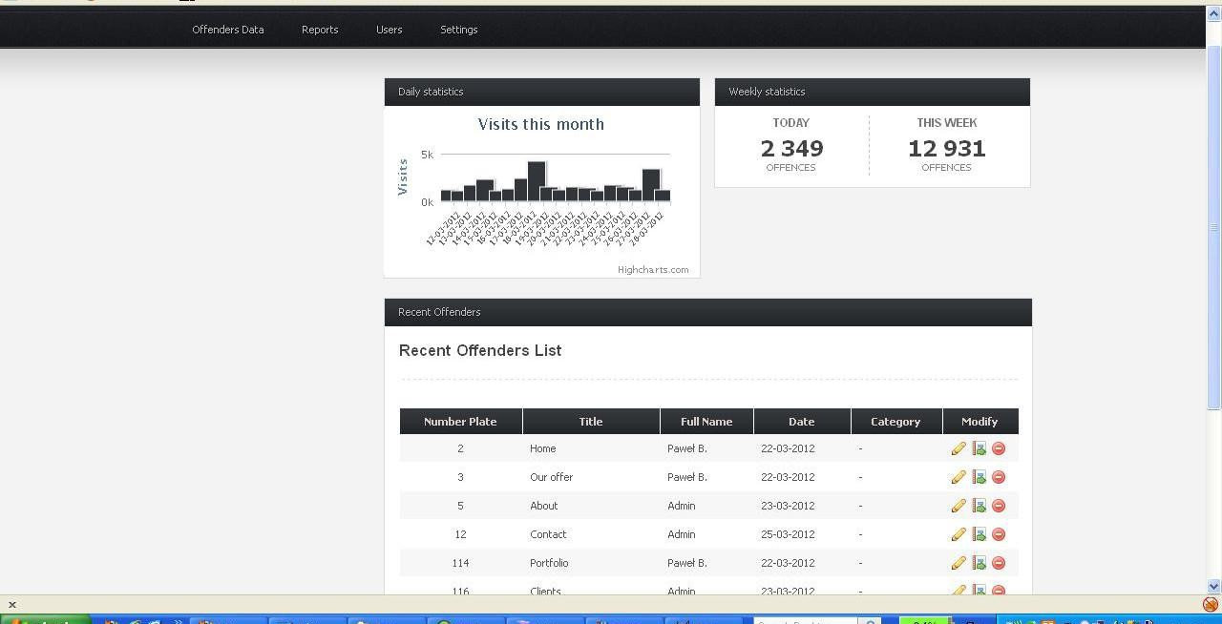

Report /Trend Graphing Page

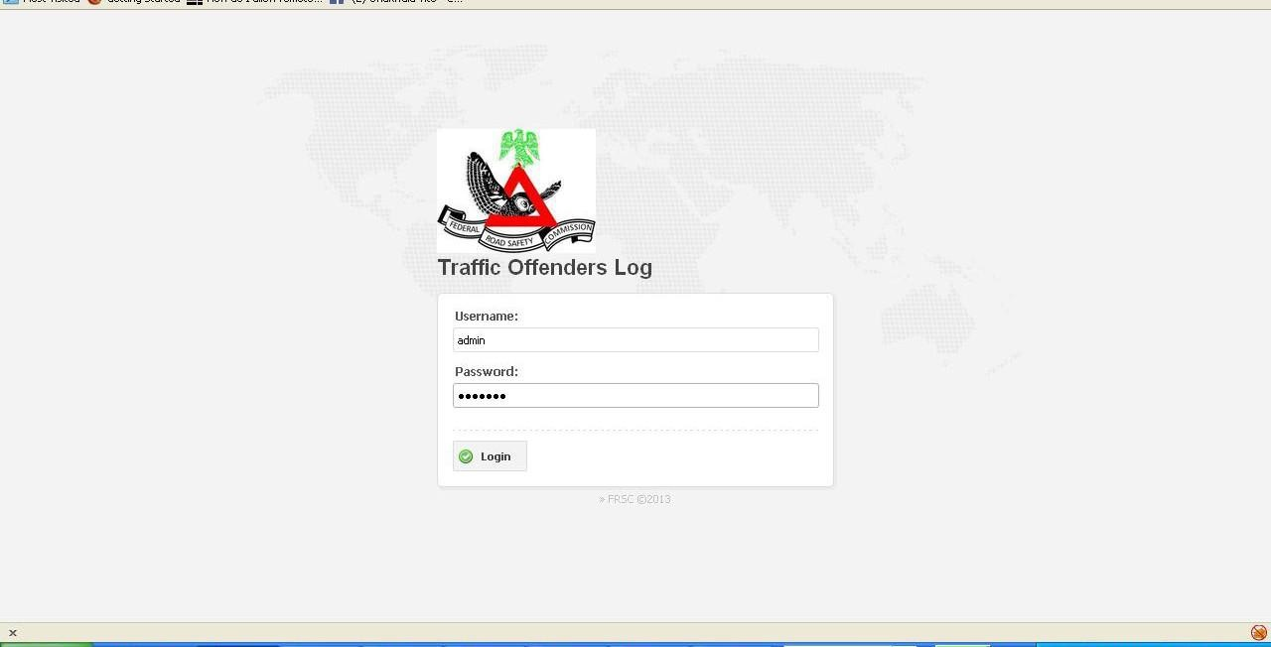

Login Page

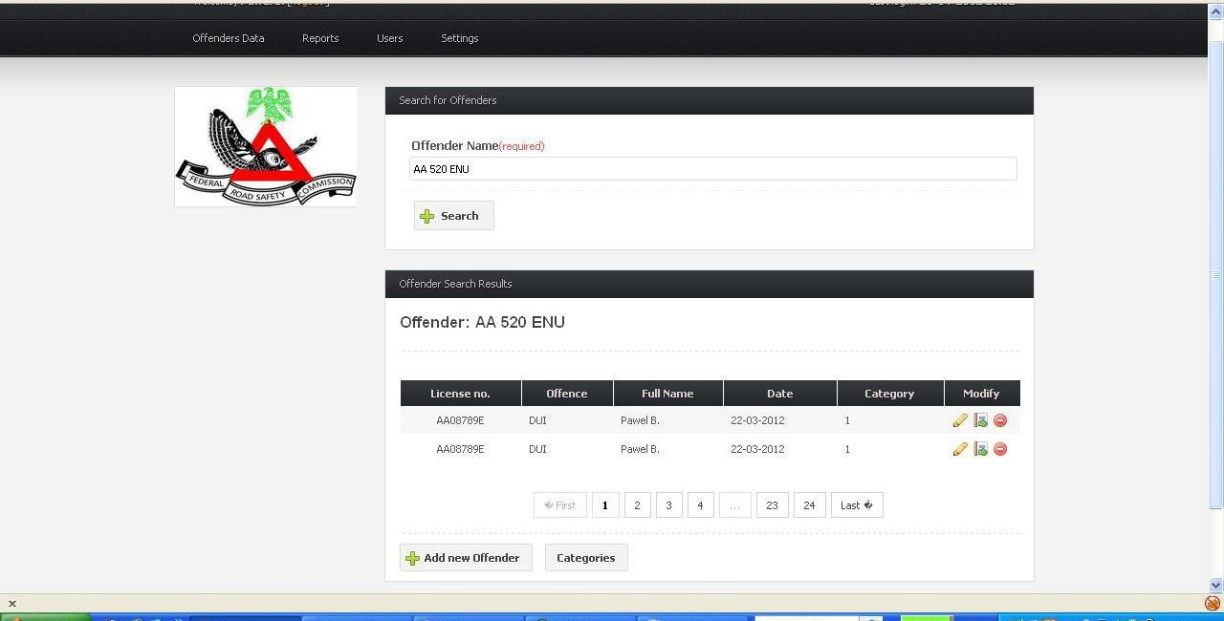

Search Page

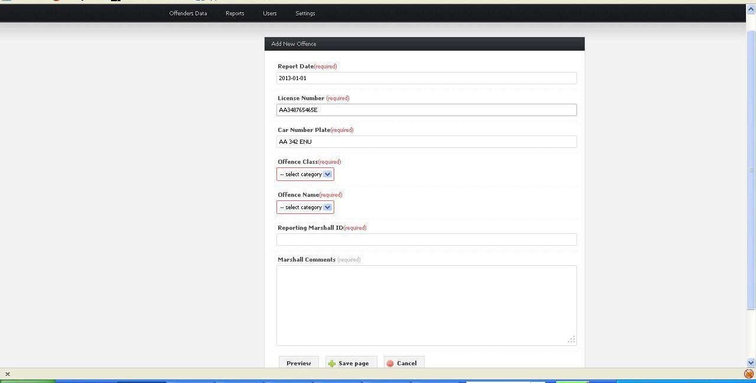

Offender Page