system does not offer opportunities for easy manipulation of data to provide managers an insight into transaction reports such as to rapid statistics for operation analysis, it does not provide instant access to information for controlling and directing the firm. At this point we can see that the world of rental service business lacks conclusion data in the relative effectiveness of manual information system versus computerized information system.

Different rental service centers at various level of activities with different critical level will agree that stress, confusion and errors increase with increase in volume of information as the transaction activities rises, and there is a great point where manual information system will not operate successfully.

In this respect, computerized rental service management information system has been developed to provide BRAHAM RENTALS with consistency, comprehensive and reasonable accurate information for planning directly and controlling the activities for which they are responsible and for making timely and effective decision.

# STATEMENT OF THE PROBLEM

There are problems faced by the management of BRAHAM RENTALS , this problems can be attributed to the fact that they use manual information processing in their activities. These problems include:

* Errors and inaccuracy since all computations are done manually.
* Updating activities are time consuming very poor and lacks accuracy.
* Lack of adequate information for decision making.
* Inconsistency and redundancy are often encountered in the information processing system for the generation of management information.
* Processing of information is usually time consuming and most times with undesired out

This project work is prompted by the problems of Braham Rentals to find a lasting solution to these problems.

# PURPOSE OF THE STUDY

The purpose of this study is to design a computerized information system that will replace the manual procedures of carrying out operations in the existing management information system of BRAHAM RENTAL SERVICES.

The designed system will be able to:-

1. make entries of all transactions made.
2. Make necessary equals of relevant information about all the transaction made between the firm and the client.
3. produce reports for managerial use to make good plans, Direct and control the activities in the firm as well as. Taking effective decision to suit any decision.

# AIMS AND OBJECTIVE

The aims and objectives of this project is to design a computerized rental services management information system for BRAHAM RENTAL SERVICES that will aid in the following:

* to reduce the average response time to management enquiry concerning transaction status.
* To produce timely accurate and up to date report for management purpose.
* To aid the administration and management to eliminate avoidable inefficiency.
* Finally to explore all capacities of computer in the area of speed, efficiency and security of data.

# SCOPE OF THE STUDY

The scope of this covers the normal operational procedures of data processing and information about all rental transactions made on BRAHAM RENTAL SERVICES. The project scope extends from the point of customers booking of items to the point these items are leased.

# LIMITATION OF THE STUDY

This work is limited to the application of computerized information management system in BRAHAM RENTAL SERVICES. However during the course of this project work, there are factors militated against my carrying out of this work. they include:-

* lack of time
* High cost of production
* lack of adequate research materials.

# ASSUMPTION

Some assumptions made while carrying out this work was that the data I collected from BRAHAM RENTAL SERVICES and some rental services centers was accurate and valid due to their maximum co-operation and interest with regards to the study concerned.

# DEFINITION OF TERMS

Some technical term have been used on this work and the whole system will be meaningless if the terms are not the explicitly explained.

**Data:** These are facts and figures which are examined to produce information

**File:** this is a collection or group of related records.

**Flowchart**: this is a system analysis tool that provide a graphical presentation of a sequence to represent the operation. **Information:** this refers to data that have been processed in such a way as to be useful to the recipient.

**Transaction:** this refers to business carried out between people, usually buying and selling of goods and services

**Record:** this is a written account of something that is kept, so that it can be looked at and used in future. It is also a set of related fields in a given system.

**Report:** information reaches to managers from the M.L.A by a virility of analysis statistics statement etc. which ear generally be referred to as reports.

**Rentals:** This is the act of making a payment; usually an amount fixed by contact made by a person or agency at specified intervals, in return for the right to occupy or use the property that person or agency

**Services:** this refers to a business whose work involves doing something for customers and not producing or buying and selling of goods.

**System:** A system is a network of the interrelated part of procedures that the joined together to efficiently accomplish a goal.

# CHAPTER TWO

**2.0 LITERATURE REVIEW**

Every organization can be said to have MIS (management information system) however imperfect it may seen. The frame work of the management information system may be openly stored by management, or it is painstakingly planned, developed and regularly evaluated for continuing efficiency with low level employees having limited access . however, the basic here is that MIS exist formally or informally in all organizations including rental companies or firms.

According to Dr Oziegbe education department, Collage of education. Ewuru in his book, organization can be defined as a

´ F R O O H F W L R Q R I S H R S O H

establish a hierarchy of authority in order to attain the common

goals. According to oxford dictionary, U H Q W D O F D Q

amount fixed by contact made by one person or agency or specified intervals in return for the right to occupy or use the property of another.

Every organization including rental services organization need information on which to base decision, to plan, to organize and to control its activities. To highlight the meaning of information, we shall see the various definition of information by different scholars.

+ R P H V % R Q Q - L Q Z R U O G µ S J

his been interpreted and understood by recipient of the message. Information can be viewed as data which have been analyzed summarized or processed in some other fashion to produce a message or report which can be understood by the recipient.

% X V L Q H V V ' L F W L R Q D U \ F

is accurate and timely, specific and organized for a purpose, presented within a context that gives it meaning and relevance, and can lead to an increase in understanding and decrease in

X Q F H U W D L Q W \ µ

' U 2 O L Y H U 0 L Q K L

V \ V W H P µ V D L G W K D W ´

summarized or processed in some other fashion to produce a message or report which is conventionally demanded as

´ P D Q D J H P H Q W L Q I R U P D W L

understood by recipient.

An information system includes people, procedures, hardware, software, and data all working together.

' R X K D 3 $ D L U H G W K D

so combined by nature or art as to form an integrate whole, and fashion, operate or move unison and often in obedience to some

R I F R Q W U R O µ

Some system are of particular interest to those who use computer in business information system in an organization.

Dogbar and Delenge Douglas, has this to say about information

system ´ L Q I R U P D W L R Q V \ V W H P

hardware, software and data, all working together too produce

D F F X U D W H D Q G W L P H O \ L

To facilitate the effectiveness of business activities both operational and management, there must be a systematic flow of information that flow throw a system within business

R U J D Q L ] D W L R Q

oduDctioQn tGo system2 .

L V R

D Q D O \ V L V µ S J

consisting of subsystems or procedures that work in a co- ordinated fashion to achieve some objectives.

Among the many organizations where MIS exist those that offer rental service happens to be among them. According to oxford dictionary, rental can be defined as amount fixed by one person or agency on specified intervals in return for the right to occupy or use the property of another

Renting is an agreement, where a payment is made for the temporary use of a good, service or property owned by another.

$ F F R U G L Q J W R : L N L S H G L

agreement where a payment is made for the temporary use of a

J R R G V H U Y L F H R U S U R S

If there were no need for information there would be no, need for automatic methods, its necessity has inspired to us to develop the information and data processing, techniques to produce the required information as economically and a quick as possible.

An information system is not different from any other system. It is a combination of hardware, software, infrastructure

and trained personnel organized to facilitate planning, control, coordination and decision making in an organization.

Information system receives input or data, processes it and produce output or information. In fact, if considering an organization as a system of subsystems specially for processing data and information to produce new information, these system will have to perform several routine tasks. These tasks includes checking files for accuracy, updating data files and record about customers, various listing of sales for the day, and producing routine operational documents such as manger reports.

Therefore, information system uses data and information as raw material for its processing function which produces. Useful information.

Information system here, is divided into two types: Operation information system which produces the information and document used for the routine operational of the organization and Management information system which produces needed information for effective decision making.

Kein Own defined management information system as the combination of human computer resources that results in the

collections, storage retrieval, communication and use of data for the purpose of efficient management of operation and for E X V L Q H V V S O D Q Q L Q J µ

Managers view the information system as a tool that provides them with the information they need to do their jobs. Managers even describe workers as being only as good as their tools, so too might managers be described. As a tool, the management information system assists in decision making, good decision require good information and the management information system provides accurate, timely, complete and consistent information.

There is high need for computer applications in management control as any organization requires a timely, complete accurate and speedy retrieval of information in order to satisfy its customers need.

However, information problems of the organization, feasibility and system studies are required before the introduction of computers as they can affect the information flow and decision making process. But be it as it may, their

effectiveness and help in achieving the goals of the organization cannot be over emphasized: the speed of a computer is such that, more information can be quickly retrieved than it was previously possible. With the help of computer business organizations can collect and store large volumes of data and information which can be analyzed qualitatively. This enables higher quality decision making and allows more successful attainment of business objectives.

Acquit O. said that there is high need for computer application in management control as any organization requires` a timely, complete, accurate and speedy retrieval of information promptly in order to satisfy its customers need.

# CHAPTER THREE

**SYSTEMS ANALYSIS AND METHODS**

# ANALYSIS OF THE EXISTING SYSTEM:-

This is the study and analysis of the already existing system to discover its main problem areas.

System investigation was the first step I took to get the scope of the problem in the existing management information system of BRAHAM RENTAL SERVICES. my findings is given below under the following:-

1 Existing information system;- The present BRAHAM RENTAL SERVICE management information system uses manual system and all the functions are carried out manually which include keeping tracks of all the transaction and service ( both quality of properties rented and payment made by client). This simply means that the information collection, processing, retrieval and generation of report for managerial use are manually operated.

(2) System Need Surveying:-

After discussing with the managing director and users of the information system, I decided that the Information flow is needed to be generated from the system.

# METHOD OF DATA COLLECTION.

I adopted some fact finding techniques which includes:

1. **Oral Interview:-** This is one of the techniques I used while collecting and gathering information from the key people of Braham rental services. It involves having a conversation and asking questions.
2. **Observation:-** I carried out the observation to see how information flow from person to person, their efficiency and speed in service delivery. The observation was not done secretly because the workers were informed that they were under observation.
3. **Written Document:-** i was granted access to their customer records and transaction entries which helped me to find facts about the transactions carried out in the organization, how transactions are being recorded, operational and procedural activities.

# DESCRITION OF THE EXISTING SYSTEM

BRAHAM RENTAL SERVICES is one of the many rental services organization in Abuja. With a work force of over 20 workers.

It has been in the business of renting different items to people used mainly for any kind of ceremonial activities, it has developed an image of rendering good services and renting of quality items to its clients. It has capacity to provide rental services in any kind of ceremony to more than 10 clients at once and even at the stipulated time as a result of extreme flexibility in its service schedule.

The service and items rented by BRAHAM RENTAL SERVICES to their clients include:-

* + 1. Canopies: they come in the following sizes:

mini midi maxi

1² 0x10m

1² 2x12m

1² 8x13m

* + 1. Tents: The tent are of three different sizes which include:-

mini midi maxi

1² 6 x16

2² 8x20

3² 0x30

* + 1. cooking vans
    2. cooling vans
    3. pots, spoons, plates and cups

(7) chairs and tables

The administrative staff of Braham Rentals includes:- The managing Director

The manager One supervisor

One secretary and three clerks

While non administrative staff includes:- Workers and drivers.

# OBJECTIVE OF THE EXISTING SYSTEM

The objective of the existing system using manual procedures are:-

1. To ensure that they overcome unavailability of computer system and services.
2. To ensure that reports generated for management uses are accurate, reliable and timely.
3. To reduce the charges and accounting error during transactions.
4. To improve overall efficiency in their business by ensuring that timely delivery and returns are made on properties rented.
5. To provide the manager with complete information based on manual processing for management decision.

# PROBLEMS OF THE EXISTING SYSTEM

1. The system is prone to errors and inaccuracy since all computations are done manually.
2. Updating activities are time consuming very poor and lacks accuracy.
3. Random storage and retrieval of required records are always difficult because the process has to be done over and over again.
4. Words like inconsistent, redundant and undefined apply to most co-operate information used to generates reports. Poor manipulation of all the information applicable to a newly defined problem is often tedious

# ORGANIZATION CHART OF BRAHAM RENTAL SERVICES

Managing Director

Manager

Clerk 3

Clerk 2

Clerk 1

Secretary

Supervisor

Workers

Drivers

Workers

Workers

From the organization chart:- The following duties are assigned to different post.

1. **MANAGING DIRECTOR:-** He directs, motivates human material resources at his disposal in the organization. He has the final say in the market.
2. **MANAGER:-** The manager offers helping hand to the managing director and he is entitled to take full responsibilities in the absence of the managing director.
3. **SUPERVISOR:-** The supervisor supervises, co-ordinates and monitor the various activities of the secretary and clerk under him.
4. **SECRETARY-** He see to the legal matters associated with the organization and takes the minutes of meeting conducted.
5. **CLERK:-** The clerk are staffs responsible for the clerical job such as referencing and making entries in the book of account as specified

# ORGANIZATION STRUCTURE

The Organization structure indicates the positions and lines of authority of employees within the organization. The following represents how the MIS of the existing system works:

1. Reports of the number of properties rented out at any given time are being generated to monitor the where about of their properties which are not in their packing store.
2. Reports on the amount deposited by every client on items and amount needed to be balanced while returning the properties are needed to monitor the time between booking and actual delivery service and date of return
3. Reports on the amount deposited by every client before rental and the amount needed to be balanced on the return of the properties are needed to monitor the accounts reports which are normally daily, weekly, monthly or yearly.

These reports may be generated daily, weekly or monthly as when needed. however the manager complained that reports being generated are usually incomplete. Inaccurate, late and out

of date. The problem appears to be that of the management information system not set up to handle the volume of work it has, and the problem affects the general effectiveness of the entire organization.

# INPUT, PROCESS AND OUTPUT ANALYSIS

The input analysis will be based on the materials used for entering the daily transaction made in Braham Rentals. The materials to be used are:-

(1) **TRANSACTION FORM:-** This form is used to make entries of transaction made between the organization and the clients, each booking delivery and return made must be entered in a separate transaction form for each client. A sample format for the transaction form is shown below:-

|  |  |  |  |  |
| --- | --- | --- | --- | --- |
| BRAHAM RENTAL SERVICES 17 SULTAN DASUKIROAD,  KUBWA - ABUJA  ' D W H « « « « « « «  1 D P H R I F O L H Q W « « « « « « « « «  $ G G U H V V R I & O L H Q W « « « « «  1 D W X U H R I 7 U D Q V D F W L R Q « | | | | |
| **ITEM DESCRIPTION** | **QUANTITY** | **UNIT PRICE** | **AMOUNT** |  |
|  |  |  |  |
|  |  |  |  |
|  |  |  |  |
|  |  |  |  |
|  |  |  |  |
|  |  |  |  |
|  |  |  |  |
|  |  |  |  |
|  | | | | |

1. **BOOKING REGISTER:-** This is used to make entries of any booking. The entries must be made from the transaction form after each booking of items.

The simple format is shown below:-

|  |  |  |  |  |  |  |
| --- | --- | --- | --- | --- | --- | --- |
| **NAME** | **ADDRESS** | **ITEM** | **QUANTITY** | **AMOUNT** | **DEPOSIT** | **DATE** |
|  |  |  |  |  |  |  |
|  |  |  |  |  |  |  |
|  |  |  |  |  |  |  |
|  |  |  |  |  |  |  |
|  |  |  |  |  |  |  |
|  |  |  |  |  |  |  |
|  |  |  |  |  |  |  |
|  |  |  |  |  |  |  |
|  |  |  |  |  |  |  |

1. **Delivery Register:-** This is used to make entries of all deliveries. The entries must be entered from the transaction form after each delivery made.

The sample format for delivery Register is shown below

|  |  |  |  |  |  |  |
| --- | --- | --- | --- | --- | --- | --- |
| **NAME** | **ADDRESS** | **ITEM** | **QUANTITY** | **AMOUNT**  **BALANCE** | **BALANCE** | **DATE** |
|  |  |  |  |  |  |  |
|  |  |  |  |  |  |  |
|  |  |  |  |  |  |  |

(4) **Return Register:-** This is used to make entries of all items returned. The entries must also be made from the transaction form after each return. The sample format for return register is here under.

|  |  |  |  |  |  |  |
| --- | --- | --- | --- | --- | --- | --- |
| **NAME** | **ADDRESS** | **ITEM** | **QUANTITY** | **AMOUNT**  **BALANCE** | **BALANCE** | **DATE** |
|  |  |  |  |  |  |  |
|  |  |  |  |  |  |  |
|  |  |  |  |  |  |  |

# TRANSACTION PROCESS

Before booking for items, the price list of all items available is given to the client. The client after going through the items will write out the one needed.

Then the secretary will enter those items and their corresponding amount in the transaction form.

After the entry, the from will be taken to the supervisor who takes charge at inspecting the transaction. If the supervisor

approves the transaction the secretary will now prepare a receipt for the client as the case maybe, A vat and handing channeling charge which is 100% of the actual amount is added to the actual amount charges for the entire items to make up the total amount charge for the transaction.

After the preparation of the receipt, the transaction form will be taken down to the clerk I from which entries will be made for booking.

On the delivery data, the transaction form will be used to enter all the items delivered with response to the items.

# OUTPUT ANALYSIS:-

The output analysis will be bounded on the master register it is where the secretary make up to date of the daily transaction using the three registers for booking, delivery and return entries are recorded into the mater register. This may be done daily. Weekly or monthly.

A Sample Format Of The Master Register.

|  |  |  |  |  |  |  |
| --- | --- | --- | --- | --- | --- | --- |
| **NAME** | **ADDRESS** | **ITEM** | **QUANTITY** | **AMOUNT**  **BALANCE** | **BALANCE** | **DATE** |
|  |  |  |  |  |  |  |
|  |  |  |  |  |  |  |
|  |  |  |  |  |  |  |

# ANALYSIS OF THE PROPOSED SYSTEM

The new management information system will be computerized i.e. all the functions will be carried out using computer systems which includes keeping tracks of all the transaction and services. the information collection, processing, retrieval and generation of report for managerial will be carried out using computer systems.

# JUSTIFICATION FOR THE PROPOSED SYSTEM

After having carefully and patiently examined the existing system with its short comings and limitations in its operation, a computerized management information system unlike the old system aims at achieving the following:

* + - 1. No manual computation, elimination of all tedious computation.
      2. Creation of an adequate data base system to calculate and facilitate the balance of daily transactions.
      3. To maintain up to date records for easy accessibility and generation of report and information for the management.
      4. & R P S X W H U · V Z R U N D W

processed and output given without delays

# Information Flow Diagram

Influence

Subject: Transaction Record form, organizational operations

Object:

Information

Decision making and Executive System

Information System

The information flow in BRAHAM RENTALS can be illustrated using a simple model with two components a subject and an object where the subject influence the object.

The transaction form organizational operations can be regarded as the subject that influence the actions of management which is regarded as object. In order words the interaction in the object environment can be seen as consisting of two component sub systems namely a system decision making and an executive information system. The information system produces input to the decision making and executive

system. that input consist of data, collection form, the subject in the case transaction environment & data generated in the decision making and executive system.

# CHAPTER FOUR

* 1. **SYSTEM DESIGN TESTING AND IMPLEMENTATION**

This is a complete description of the input, processing output and storage requirement for the computer program and the program design documentation which is used for on going reference during the steps in this program development. Also hierarchy charts are used to identify modules.

# INPUT SPECIFICATION

The input item specification shows the method of input, tells what data will be input to the program, and in what formation. It also tells the input devices to be used for the program include all the necessary data which forms the basic input to the system. It also includes all the necessary information to be used in the computation. The basic input to the system include:-

1. name of client
2. Address of client
3. Data of Delivery
4. Quantity of Rate items
5. Amount
6. Name of the day
7. Name of the month
8. File name
9. titles page

# INPUT PROCESSING:-

The input processing involves Data conversion of a computer readable medium form to human customary form. Any data input made either numeric or alphabetic will be processed from human to machine form for onward processing.

# INPUT ENTRY SCREEN

Menu entry screen

Name of Client

Address

|  |  |  |  |  |  |  |  |  |  |  |  |
| --- | --- | --- | --- | --- | --- | --- | --- | --- | --- | --- | --- |
| Transaction date | | |  | Delivery date | | |  | Return date | | |  |
|  |  |  |  |  |  |  |  |  |  |  |  |
|  | | | | | | | | | | | |

Quantity Rate Amount

Tents

Chairs

Cutleries

Canopies

Others

# OUTPUT SPECIFICATION

The output is what emerges from the computer system for the user to act upon. A program may with justification be judged by the quality of its output. The output derived and section tells the type of information to be produced, the output derived and method also shows the processing involved in the output. The output items for the new system are in form of prompt output, message output and instruction output. These output forms relates to operating the system itself. The output indicates to users that some input is required and more helpful what kind of information is required. The message and instruction output serves as the help message and the error message encountered.

# PROGRAM OUTPUT

This is the output of the new computerized information system  The welcome page

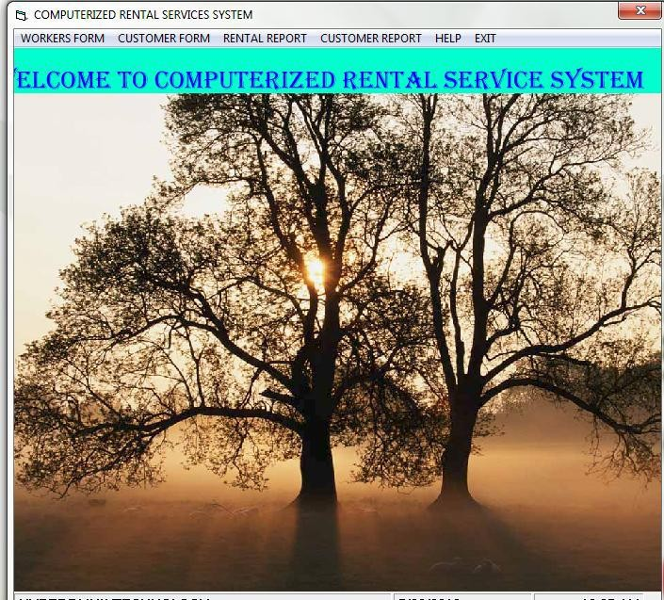

 The computerized system has an employee form for keeping records of all their staff. It is shown below

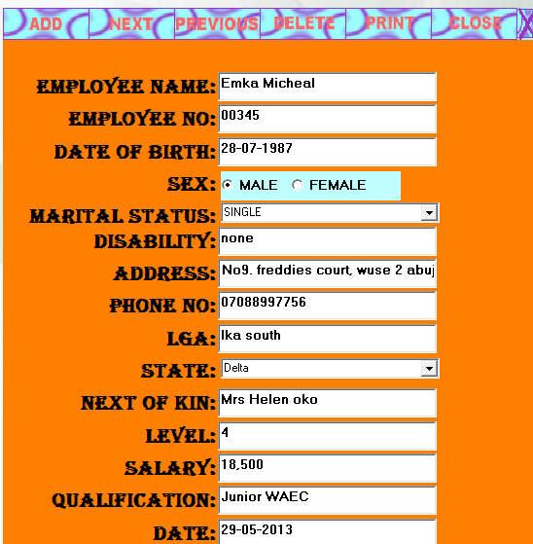

 Customers form: this is used to keep record of all customers and to provide a reliable database for the company

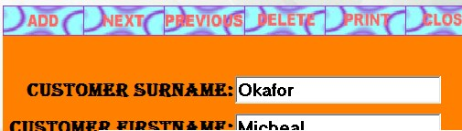

 The rental form: it is been used to make bookings of required items:

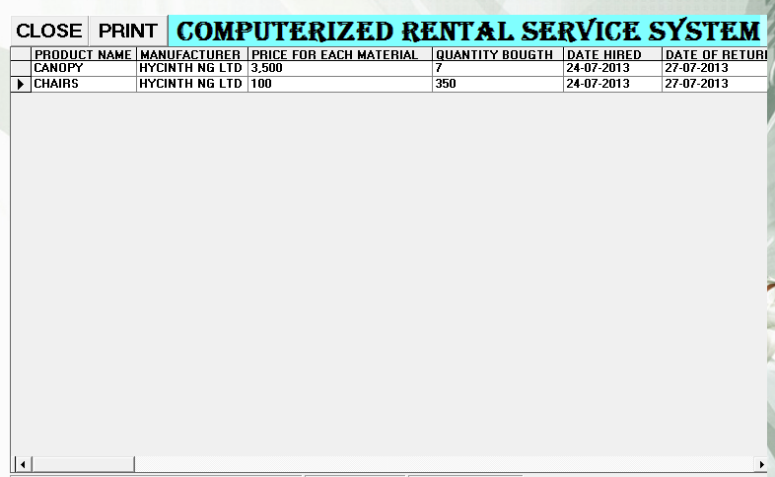

 The customer report form: this serves as a database of all customers.

# FILE DESIGN

In the design of computed rental services management information system, some file names are designed to be provided by the program menu but are Grouped under the following

# Master file

A file containing relatively permanent information that is used as a source of reference and it is used to update periodically. The master file is shown below:

|  |  |  |  |  |
| --- | --- | --- | --- | --- |
| **Field** | **Field** | **Field** | **Field** | **Remark** |
| No | Name | Types | Size |  |
| 1 | Cl- N | A | 45 | Client Name |
| 2 | D-Trans | A/N | 8 | Date of  Transaction |
| 4 | D-Del | A/N | 8 | Date of  Delivery |
| 5 | D- Ret | A/N | 8 | Date of Return |
| 6 | N-pa | N | 10 | Net pay |

* + 1. **Transaction File:** File that is not containing permanent information, may involve updating a number of files in the data base and it is done frequently. The transaction file is shown below:

|  |  |  |  |  |
| --- | --- | --- | --- | --- |
| **Field** | **Field** | **Field** | **Field** | **Remark** |
| No | Name | Type | Size |  |
| 1 | Client-  Name | A | 45 | Client Name |
| 2 | CL-Add | A/N | 50 | Client-Address |
| 3 | D-Tran | A/N | 8 | Date of  transaction |
| 4 | D-Del | A/N | 8 | Date of Delivery |
| 5 | D- Ret | A/N | 8 | Date of Return |
| 6 | N-Pay | N | 10 | Net pay |
| 7 | 1-Qty | A/N | 3 | Quantity of item |
| 8 | Item Desc. | A | 8 | Item description |

# PROCEDURE CHART

This is a chart that shows the procedure of carrying out transaction at Braham rentals

CLIENT BOOKING

VALIDATION OF BOOKING

DELIVERY OF BOOKED ITEMS

RETURNING OF DELIVERED ITEMS BY CLIENTS

VALIDATION OF RETURNED ITEMS.

# SYSTEM INFORMATION FLOWCHART

CLIENT TRANSACTION

KEY IN DATA THROUGH THE TERMINAL

CLIENT TRANSACTION ENQUIRIES CLIENT

FORM

DISPLAY CLIENT TRANSACTION

CLIENT FILE (MASTER FILE)

ON-LINE PROCESSING OF DATA AND INFORMATION

HARD COPY PROGRAM DESIGN

ADD IN MASTER FILE

HARD COPY OF THE OUTPUT, PRINT OUT FORMAT DECISION

UPDATING FILES

# FLOW CHARTS

**ENTRANCE PROCEDURE FLOWCHART**

INPUT EXE FN

INTEGRITY CHECK

START

GRAPHIC DESIGN

3 5 , 1 7

/ ( * $ /

³ < 2

8 6 (

IS ENTRY

GRANTED?

3 5 , 1 7 ³ (

LOGIN SECRET PASSWORD

MAIN MENU

# ENTRY PROCEDURE FLOWCHART FOR CHANGE OF PASSWORD (OPTION)

DISPLAY MAIN OPTION

MAIN MENU

DISPLAY MAIN MENU AND VIOLATE OPTIONS

IS OPTION 1

?

A

CHANGE PASSWORD

INPUT OPTION



A

IS OPTION 2

?

IS OPTION 3

?

IS OPTION 3

?

DISPLAY ERROR MESSAGE

CRATE LEGAL USER

CRATE LEGAL USER

EXIT TO MAIN MENU





DISPLAY ACCESS DENIED

IS GRATED

?



UPDATE DATA BASE

UPDATE DATA BASE

VERIFY PASSWORD

LOGIN NEW PASSWORD

RE-IDENTIFY PERSON

CHANGE PASSWORD

IDENTITY PERSON





WANT TO QUIT PROGRAM?

CONTINUE

MAIN MENU

STOP

* 1. **SYSTEM REQUIREMENT**

This system is designed to work on the following hardware and software configuration.

DOS VER 3.0 or higher (it is recommended that the user

use Ms D²OS 3.0 or a higher version. the program can work

with disk formatted by any version of Dos.

PROCESSOR:- IBM Ps 12 all models, pc, at, xt and most

IBM compactable and higher

OUTPUT DESIGN: LCD, CRT,VGA, EGVA, MONOCHROME.

STORAGE DEVICES: 20MB and above (Higher capacities will be

most Ideal).

MEMORY REQUIRMENT: At least 512kb base memory.

# CHAPTER FIVE

* 1. **SUMMARY, CONCLUSION AND RECOMENDATION**

# SUMMARY

With the numerous advantages of computer systems over manual system in terms of speed, accuracy, organization, ease of update and timely and efficient report for managerial use, the new computerized MIS system of Braham renrals with its organization and structure will eliminate the problem of inefficiency in service delivery due to the use of manual systems. The management will be provided with routine performance report of the organization for effective control and decision making.

# RECOMMENDATION

The following recommendation and suggestion will help the BRAHAM RENTALS SERVICE. LTD, in achieving their organization goals based on the new system

I will like to make the following recommendation:-

1. The management of Braham rental services should be fully computerized.
2. A management information system (MIS) should be established and all the branches of this company networked.
3. From all indication, this study explained well that the introduction of a computer to the MIS of rentals service organization in Nigeria will help in their overall efficiency and increase in productively. Introduction of computer will lead to effectiveness of rental service transaction in general.

# CONCLUSION

This project work has shown the benefits derived in using computerized information system in rental business transaction among which are effectiveness and efficiency in service delivery, generation of timing and accurate decision making and a host of other benefits.

# REFERENCES

Anan, J.J., & Graw, M.C (1991)W.

} ‰ µ o š. Lo]nd}on:vBroad

} v š

Street Press.

Douglas, Herbert (1995). Hypertext Pre-processor:California: Splash Bauer Inc.

Jack, W. (2010). Embedded Data Management and IntegratNioenw.

Pervasive Software, Inc.

York

John, W., & Joshua, D. (2002). Practical Postgre SQL. & D O L I R U Q L

Media.

Middleton, D., & Jasek, D. (1993). Digital Revolution for economic growth and DevelopmenIt.ndia: Sikkim Publisher.

Nandan, N. (1995). Unique Identification Authority of India (UIDA.I)

Delhi, India: Punjab Publisher.

Navvathe, E. (2005). Foundation of Database SysteNme.w Delhi: Pearson Education.

Okon, C. H. (2003). File Organization and Data ProcessinEgd. o: Moral Publication.

Ominde, S. H. (2007)P. opulation Growth and Economic Development in Africa.

Lagos: Ola Press.

Omoregie, K. O. (2003). Computer and Data ProcessingE: do: Moral Publication.

Ozsu, M. T., & Valduriez, K. (1999). Principles of Distributed Data Systems:

New York: Mc-Graw Hill Publisher.

Richard, W. (2007). Using Computer in an Information AgeN.ew York: Hill Publishing Company.

# APPENDIX I SOURCE CODES

SOURCE CODE VERSION 5.00

Object = "{EAB22AC0-30C1-11CF-A7EB-0000C05BAE0B}#1.1#0";

"ieframe.dll"

Object = "{831FDD16-0C5C-11D2-A9FC-0000F8754DA1}#2.1#0"; "MSCOMCTL.OCX"

Begin VB.Form MAIN

Caption = "COMPUTERIZED RENTALS SERVICES SYSTEM"

ClientHeight = 9555

ClientLeft = 120

ClientTop = 720

ClientWidth = 11895

Icon = "MAIN.frx":0000 LinkTopic = "Form1" MaxButton = 0 'False ScaleHeight = 9555

ScaleWidth = 11895 StartUpPosition = 2 'CenterScreen Begin VB.Frame Frame1

BorderStyle = 0 'None Height = 8295

Left = 0

TabIndex = 0

Top = 840

Width = 12255

Begin SHDocVwCtl.WebBrowser WebBrowser2

|  |  |
| --- | --- |
| Height | = 8295 |
| Left | = 0 |
| TabIndex | = 1 |
| Top | = 0 |
| Width | = 12375 |
| ExtentX | = 21828 |
| ExtentY | = 14631 |
| ViewMode | = 0 |
| Offline | = 0 |
| Silent | = 0 |

RegisterAsBrowser= 0

RegisterAsDropTarget= 1 AutoArrange = 0 'False NoClientEdge = 0 'False AlignLeft = 0 'False NoWebView = 0 'False HideFileNames = 0 'False SingleClick = 0 'False

SingleSelection = 0 'False NoFolders = 0 'False Transparent = 0 'False

ViewID = "{0057D0E0-3573-11CF-AE69-08002B2E1262}"

Location = "http:///" End

End

Begin MSComctlLib.StatusBar StatusBar1

|  |  |
| --- | --- |
| Align | = 2 'Align Bottom |
| Height | = 375 |
| Left | = 0 |
| TabIndex | = 2 |
| Top | = 9180 |
| Width | = 11895 |
| _ExtentX | = 20981 |
| _ExtentY | = 661 |
| _Version | = 393216 |

BeginProperty Panels {8E3867A5-8586-11D1-B16A-00C0F0283628}

NumPanels = 3

BeginProperty Panel1 {8E3867AB-8586-11D1-B16A-00C0F0283628}

Object.Width = 11818

MinWidth = 11818

Text = "BRAHAM RENTAL"

TextSave = "BRAHAM RENTAL"

EndProperty

BeginProperty Panel2 {8E3867AB-8586-11D1-B16A-00C0F0283628}

Style = 6

Object.Width = 3919

MinWidth = 3919 TextSave = "7/23/2013"

EndProperty

BeginProperty Panel3 {8E3867AB-8586-11D1-B16A-00C0F0283628}

|  |  |  |  |
| --- | --- | --- | --- |
| Style | = | 5 |  |
| Alignment |  | = | 2 |

Object.Width = 3134

MinWidth = 3134 TextSave = "4:34 AM"

EndProperty EndProperty

BeginProperty Font {0BE35203-8F91-11CE-9DE3-00AA004BB851}

|  |  |
| --- | --- |
| Name | = "MS Sans Serif" |
| Size | = 13.5 |
| Charset | = 0 |
| Weight | = 700 |
| Underline | = 0 'False |
| Italic | = 0 'False |

Strikethrough = 0 'False EndProperty

End

Begin SHDocVwCtl.WebBrowser WebBrowser1

|  |  |
| --- | --- |
| Height | = 975 |
| Left | = 0 |
| TabIndex | = 3 |
| Top | = 0 |
| Width | = 12375 |
| ExtentX | = 21828 |
| ExtentY | = 1720 |
| ViewMode | = 0 |
| Offline | = 0 |
| Silent | = 0 |

RegisterAsBrowser= 0

RegisterAsDropTarget= 1 AutoArrange = 0 'False NoClientEdge = 0 'False AlignLeft = 0 'False NoWebView = 0 'False HideFileNames = 0 'False SingleClick = 0 'False SingleSelection = 0 'False

NoFolders = 0 'False Transparent = 0 'False

ViewID = "{0057D0E0-3573-11CF-AE69-08002B2E1262}"

Location = "http:///" End

Begin VB.Menu MNUWORKERS Caption = "&WORKERS"

End

Begin VB.Menu MNURENTAL Caption = "&RENTAL FORM"

End

Begin VB.Menu MNUGEN Caption = "&GENERATE" Begin VB.Menu MNUREP

Caption = "REPORT" Begin VB.Menu MNURENREP

Caption = "RENTAL REPORT"

End

Begin VB.Menu MNUWORKREP

Caption = "WORKERS REPORT"

End End

End

Begin VB.Menu MNUHELP Caption = "&HELP"

End

Begin VB.Menu MNUEXIT Caption = "E&XT"

End End

Attribute VB_Name = "MAIN"

Attribute VB_GlobalNameSpace = False Attribute VB_Creatable = False Attribute VB_PredeclaredId = True Attribute VB_Exposed = False

Private Sub Form_Load()

WebBrowser1.Navigate "C:\Program Files\Project1\index.htm" WebBrowser2.Navigate "C:\Program Files\Project1\MAIN.html" End Sub

Private Sub MNUEXIT_Click() Unload Me

End

End Sub

Private Sub MNUHELP_Click() Me.Hide

HELP.Show

End Sub

Private Sub MNURENREP_Click() Me.Hide

RENTALREPORT.Show

End Sub

Private Sub MNURENTAL_Click() Me.Hide

RENTAL.Show

End Sub

Private Sub MNUWORKERS_Click() Me.Hide

WORKERS.Show

End Sub

Private Sub MNUWORKREP_Click() Me.Hide

WORKERREPORT.Show

End Sub

<html>

<head>

<meta http-equiv="Content-Language" content="en-us">

<meta http-equiv="Content-Type" content="text/html; charset=windows- 1252">

<title>New Page 1</title>

<style type="text/css">

<!--

.style2 {color: #660000}

-->

</style>

</head>

<body topmargin="0" leftmargin="0" rightmargin="0" bottommargin="0" marginwidth="0" marginheight="0" bgcolor="#999999">

<p>

<marquee style="font-family: Arial Black; font-size: 24pt; color: #008080; font-style: italic; font-weight: bold">

<span class="style2">WELCOME TO COMPUTERIZED RENTALS

SERVICES</span>

</marquee>

</p>

</body>

</html>

<!DOCTYPE html PUBLIC "-//W3C//DTD XHTML 1.0 Transitional//EN" ["http://www.w3.org/TR/xhtml1/D](http://www.w3.org/TR/xhtml1/DTD/xhtml1-transitional.dtd)T[D/xhtml1-transitional.dtd">](http://www.w3.org/TR/xhtml1/DTD/xhtml1-transitional.dtd)

<html [xmlns="http://www.w3.org/1999/xhtml">](http://www.w3.org/1999/xhtml)

<head>

<meta http-equiv="Content-Type" content="text/html; charset=iso-8859-1"

/>

<title>Untitled Document</title>

<style type="text/css">

<!--

body {

background-color: #99FF99; margin-left: 0px;

margin-top: 0px; margin-right: 0px; margin-bottom: 0px;

}

-->

</style></head>

<body>

<img src="MAIN.gif" width="800" height="600" />

</body>

</html>

67

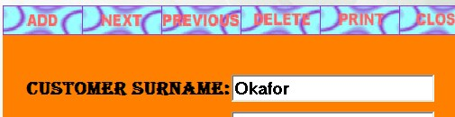

APPENDIX II

Program output (screen shots)

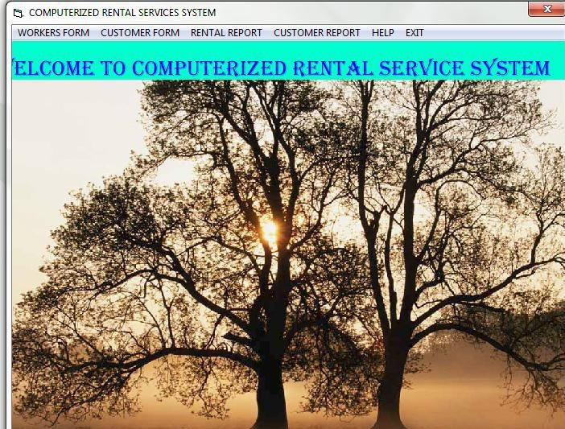

68

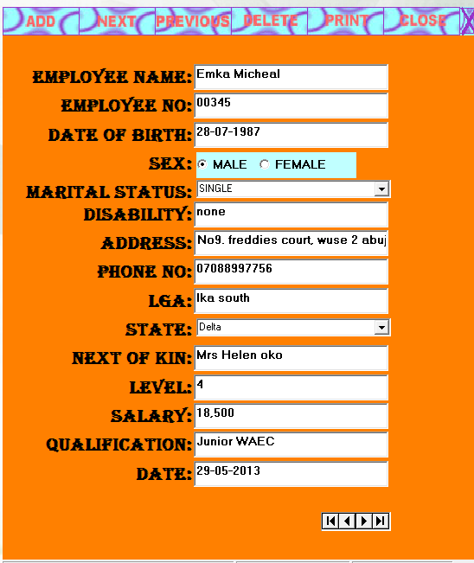

69



# CHAPTER ONE

**INTRODUCTION**

Most rental service firms today still use manual information system because their information needs are of moderate size and managers of such firms have probably been enjoying the manual system as regards to their relatively and comfortable low level of transaction activities.

With the high level of social activities been experienced, It is only the rental firms with very large information or high capacity of rental service with rapid rate of renting per item that are likely to survive pressure, and therefore should link information system to business strategy. With this pressure, there is a need to improve corporate effectiveness through their own involvement in system planning to ensure that business strategy is developed in the context of the computerized environment.

Among the many rental service centers, majority adopted a great variety of manual information system for management activities most of which are single file system. This single file

1