# CHAPTER ONE

* 1. **INTRODUCTION**

Material Procurement can be defined as the purchase of goods or services at a total cost of the optimum possible in the correct amount and quality of procurement. These goods and services are also purchased at the right time and location to express profit or the use of Government, business, business, or individuals by signing a contract.

The process of acquisition of goods or services that are required as a raw material (direct procurement) or for operating purposes (indirect procurement) a company or a person might call acquisition. The procurement process involves not only the purchase of commodities, but also the quality and quantity of controls. Typically, providers are listed and pre-determined by the contracting company. This makes the smoother process, the promotion of a good relationship between the buyer and the supplier.

The synonyms for procurement, which are the gain, purchase, and acquire, can shed light on the meaning of procurement. The procurement process may vary from company to company, and a Government entity can have a slightly different procurement process compared to a private company.

Acquisitions can also be defined simply as the procedure in which the goods or raw materials are purchased when prices are low. Procurement is advantageous if the goods are purchased in large quantities. E-procurement is another method

of electronic media is used for the acquisition or purchase of goods. Everything is processed electronically, the search for the right bidder delivery and payment. The procurement procedure may vary depending on the product and the uses of the product. Health team must be efficient and reliable, and the procurement process is carried out carefully in order prevent the defective equipment purchase. Another important factor that usually includes definitions of the procurement is the amount purchased the product. This is important because the quantity of purchased goods is inversely proportional to their cost.

Thus, acquisition is a process that is carried out by the company almost every individual and for their own personal benefit or benefits, involving the purchase of commodities by choosing the appropriate provider.

# Statement of the Problem

Most company’s are suffering some set backs due to their procurement system. Most often low quality goods are purchased and they end up loosing money. Also at times, they lack a steady supply, resulting to lack of materials for production, hence the need for computerization of bill of material processing system.

# Aims and Objectives of the Study

The main objective is to computerized bill of material processing system of business transactions. This will help the manager know when to make purchases of items, ascertain the exact number of each items or stock available, to

ascertain the materials that are either mostly or sparsely used as well as knowing the exact number of each material or items that are lacking thereby helping to improve workflow in the organization. Moreover to reduce time wasted in data processing and information retrieval. And finally to improve management activities, which will lead to improved productivity, accountability and business management of the organization.

# Purpose of the Study

This purpose of this study is to design a computerized bill of material processing system for a company. This will help in monitoring their material procurement.

# Significance of the Study

The project is aimed at designing, a new better alternative system to help the organization in material procurement thereby making the management system to be more effective. Also the software designed will help management to: -

1. Maintain a database of materials procured.
2. Safeguard data and information in the system.
3. Reduced workload in the present system.
4. Keep accurate record on material procurement
5. Reduce time wasted in data processing.

# Scope of Study

This project work is designed to cover all aspect of purchases of materials in a company. The system incorporates materials procurement recording and stock taking.

# Constraints and Limitations

During the process of this research work some drawbacks were encountered while trying to get adequate needed data and information.

They include the reluctance of the management of the firm under study to release vital information, which they feared would jeopardize the security of the organization. And secondly, time and financial constraints which had great influence to this work.

# Assumptions

It is assumed that all information gathered with respect to material procurement management information system is correct as implemented by computers.

# DEFINITION OF TERMS

**Procurement:** It can be defined as the purchase of goods or services at a total cost of the optimum possible in the correct amount and quality of procurement.

**Receipt:** Receipt is the process of accepting from sources, all materials or items used in the organization.

**Issue:** This is the process of giving out items from store to various departments in the organization.

**Computer Program**: This is a set of instruction that guides the computer on the action to perform.

**Flowchart:** This is graphical representation of step by step by which computer can follow to execute a task.

# CHAPTER TWO

* 1. **Review of Related Literature**

Almost all purchasing decisions include factors such as delivery and handling, marginal benefit, and price fluctuations. Procurement generally involves making buying decisions under conditions of scarcity. If good data is available, it is good practice to make use of economic analysis methods such as cost-benefit analysis or cost-utility analysis (Joseph B.O (1985).

An important distinction is made between analysis without risk and those with risk. Where risk is involved, either in the costs or the benefits, the concept of expected value may be employed.

Based on the consumption purposes of the acquired goods and services, procurement activities are often split into two distinct categories. The first category being direct, production-related procurement and the second being indirect, non-production-related procurement.

Direct procurement occurs in manufacturing settings only. It encompasses all items that are part of finished products, such as raw material, components and parts. Direct procurement, which is the focus in supply chain management, directly affects the production process of manufacturing firms. In contrast, indirect procurement activities concern “operating resources” that a company purchases to enable its operations (Everest P.I(2001). It comprises a wide variety of goods and services, from standardised low value items like office supplies and machine lubricants to complex and costly

products and services like heavy equipment and consulting services.

# Procurement vs Acquisition

The US Defense Acquisition University (DAU) defines procurement as the act of buying goods and services for the government.

Acquisition as the conceptualization, initiation, design, development, test, contracting, production, deployment, Logistics Support (LS), modification, and disposal of weapons and other systems, supplies, or services (including construction) to satisfy DoD needs, intended for use in or in support of military missions(DAU 2002).

Acquisition is therefore a much wider concept than procurement, covering the whole life cycle of acquired systems.

# Model of the Acquisition Process.

The process allows for a given system to enter the process at any of the development phases. For example, a system using unproven technology would enter at the beginning stages of the process and would proceed through a lengthy period of technology maturation, while a system based on mature and proven technologies might enter directly into engineering development or, conceivably, even production. The process itself includes four phases of development: Concept and Technology Development: is intended to explore alternative concepts based on assessments of operational needs, technology readiness, risk, and affordability.

Concept and Technology Development phase begins with concept exploration. During this stage, concept studies are undertaken to define alternative concepts and to provide information about capability and risk that would permit an objective comparison of competing concepts.

System Development and Demonstration phase. This phase could be entered directly as a result of a technological opportunity and urgent user need, as well as having come through concept and technology development.

The last, and longest, phase is the Sustainment and Disposal phase of the program. During this phase all necessary activities are accomplished to maintain and sustain the system in the field in the most cost-effective manner possible.

# Procurement systems

Another common procurement issue is the timing of purchases. Just-in-time (JIT) is a system of timing the purchases of consumables so as to keep inventory costs low. Just-in-time is commonly used by Japanese companies but widely adopted by many global manufacturers from the 1990s onwards.

In order to achieve greater economies of scale, an organization’s procurement functions may be joined into shared services. This combines several small procurement agents into one centralized procurement system.

# Procurement process

Procurement may also involve a bidding process i.e, Tendering. A company may want to purchase a given product or service. If the cost for that

product/service is over the threshold that has been established (eg: Company X policy: "any product/service desired that is over $1,000 requires a bidding process"), depending on policy or legal requirements, Company X is required to state the product/service

desired and make the contract open to the bidding process. Company X may have ten submitters that state the cost of the product/service they are willing to provide. Then, Company X will usually select the lowest bidder. If the lowest bidder is deemed incompetent to provide the desired product/service, Company X will then select the submitter who has the next best price, and is competent to provide the product/service. In the European Union there are strict rules on procurement processes that must be followed by public bodies, with contract value thresholds dictating what processes should be observed (relating to advertising the contract, the actual process etc).

# Procurement steps

Procurement life cycle in modern businesses usually consists of seven steps:

 Information gathering: If the potential customer does not already have an

established relationship with sales/ marketing functions of suppliers of needed products and services (P/S), it is necessary to search for suppliers who can satisfy the requirements.

 Supplier contact: When one or more suitable suppliers have been

identified, requests for quotation (RFQ), requests for proposals (RFP), requests for information (RFI) or requests for tender (RFT or ITT) may be advertised, or direct contact may be made with the suppliers.

 Background review: References for product/service quality are consulted,

and any requirements for follow-up services including installation, maintenance, and warranty are investigated. Samples of the P/S being considered may be examined, or trials undertaken.

 Negotiation: Negotiations are undertaken, and price, availability, and

customization possibilities are established. Delivery schedules are negotiated, and a contract to acquire the P/S is completed.

 Fulfillment: Supplier preparation, expediting, shipment, delivery, and

payment for the P/S are completed, based on contract terms. Installation and training may also be included.

 Consumption, maintenance, and disposal: During this phase, the company

evaluates the performance of the P/S and any accompanying service support, as they are consumed.

 Renewal: When the P/S has been consumed and/or disposed of, the

contract expires, or the product or service is to be re-ordered, company experience with the P/S is reviewed. If the P/S is to be re-ordered, the company determines whether to consider other suppliers or to continue with the same supplier.

# Procurement Quality

Procurement quality is a mixed measure of the quality of purchased products and the performance of the procurement process itself since there is, not only, a need to purchase quality products by companies, but also the need for quality companies to purchase products.

# Public Procurement

Public procurement generally is an important sector of the economy. In Europe, public procurement accounts for 16.3% of the Community GDP.

# Green Public Procurement

In Green public procurement (GPP), contracting authorities and entities take environmental issues into account when tendering for goods or services. The goal is to reduce the impact of the procurement on human health and the environment.

In the European Union, the Commission has adopted its Communication on public procurement for a better environment, where proposes a political target

of 50 % Green public procurement (GPP) to be reached by the Member States by the year 2010.

# CHAPTER THREE

* 1. **Methodology and Analysis of the Existing System**

# Fact Finding Method / Methodology

In gathering and collecting necessary data and information needed for system analysis, two major fact-finding techniques were used in this work and they are:

# Interview Method

This was done between the researcher and the sales representatives in the business outlet used for the studies. A questionnaire was presented to them in other to find out how they carry out their daily sales and purchases in the shop. Reliable facts were got based on the questions posed to them by the researcher.

# Reference to Written Text

Manuals used for documenting material procurement were studied and a lot of information concerning the system in question was obtained. Some forms that are necessary and available were assessed. These include bin card, purchases book, etc. These forms help in the design of the new system.

# Organizational Structure

CEO

General Manager

Personnel

Installation

Marketing

Procurement

Branch Manager

Fig 3.1

# Objectives of the Existing System

The objective of the existing system includes:  Recording of material procurement  Recording of material usage

 Keep Stock card for each material

# INPUT, PROCESS AND OUTPUT ANALYSIS

* + 1. **Input Analysis**

The input to the system contains information on the material procurement, supplier and quantity supplied. Here documentation of the invoice for the procurement is very necessary to keep track of the material procurement.

# Process Analysis

The procured material is used to update the material available in the company. This process helps to give the available material in the company and the total expenses involved in the procurement.

# Output Analysis

The output from the existing system is a report generated from the system, which gives report on the material procurement in the company.These outputs are used for decision making as to which of the material is out of stock.

# Information Flow Diagram

Database Administrator

Database Managers

Procurement officer

Suppliers

Fig 3.2

# Problem of the Existing System

The weaknesses of the existing system are highlighted below:

**Lack of Accuracy:** This situation creates problem in the sense that proper and adequate records is far fetched. Due to stress and weakness or human error, mistakes are often made in recording transactions.

**Loss of Information:** Due to fire outbreak, most vital information are lost as the whole documentation is paper work.

# Justification For The New System

The new system among other things will have the following characteristics which will improve the current system in use

1. Timely retrieval of information for the purpose of decision-making.
2. Accurate recording of transactions.
3. Safety of information as it will be stored on disk and have a back-up disk stored outside the environment.
4. Cost effective service delivery
5. Automation of most of the transaction processes thereby increasing effectiveness and efficiency.

# CHAPTER FOUR

* 1. **System Design, Testing and Implementation**

# Design Standards

As the new system is focusing on how to create computerized material procurement management information system, effort was made to present designs that will suite the research objectives. So, the design of the software will help the user achieve the following objectives.

 Have a workable form through which all the inputs will be made to the system.

 Generate a report that will be more meaningful to the management.

 Design of a menu driven program so that the forms will be neatly arranged and utilized.

 Create a modular programming interface for easy debugging.  Design a system that will be very fast in operation.

# Output Specification and Design

The output from the new application system is designed in such a way that it conveys meaningful information to both management and employees. It aims at providing the management with adequate, effective, well documented up-to- date and formatted output to help as a tool in planning and decision- making.

There are methods of generating reports in the new package. We have both Hard copies and Soft copies. The system is designed to generate outputs on the following:

|  |  |  |  |
| --- | --- | --- | --- |
|  | **Material Procurement Report** |  | |
| Date | Invoice No Item Description Qty | Rate | Amount |
| *** | *** *** *** | *** | *** |

# Input Specification and Design

The program designed involved some input forms in order to achieve or derived some required outputs. So some of the input forms used are as shown in the figures below.

# Material Procurement Invoice Entry

Description Stock ID

Qty Unit Price

Date Total Supplier

Fig 4.1

# File Design

Access database was used in storing the information used in this project. The database was integrated into the system so that the program can access and update the files.

# File Name: Procurement File.

|  |  |  |
| --- | --- | --- |
| **Field Name** | **Data Type** | **Size** |
| Item ID | Text | 20 |
| Description | Text | 100 |
| Qty | Integer | 2 |
| Cost per Unit | Single | 4 |
| Total | Single | 4 |
| Invoice No | Text | 20 |
| Supplier | Text | 50 |
| Date purchased | Date | 8 |

Fig 4.2

# Procedure Chart

Exit

Main Menu

Help

Material Procureme

stock

Query

Delete

Update

User’s Guide

Exit

Purchases

Material Procurement Report

Fig 4.3

Update

Repor

# System Flow-chart

Input data

Input From the Keyboard

Result Screen

To

Disk Storage

Output

(Report)

Processor

**Fig 4.4**

# System Requirement

The system requirement for better performance of this proposed system design include:

# Hardware Requirement

The new design will need the following hardware to work effectively

 A complete computer set of at lest Pentium II with a reasonable and sizeable hard disk space of at least 2GB.

 A networked environment to ensure the collection of data and records to central database storage device.

 The share able resource such as printers fax machines, scanners etc. Can also be connected so that users can make use of it.

# Software Requirement

For this system the basic software required is:

 Windows operating system (window 98 or window XP).  Visual Basic 6.0

 Utility software e.g Norton

# Operational Requirement

For the new system to be operational, a computer lab has to be put in place for the recording of the material procurement.

# Personnel Requirement

A total of 2 computer operators are needed to manage the computer centre. They will oversee the entry of data into the system.

# Chapter Five

* 1. **Implementation**

# Design Standards

As the new system is focusing on how to create computerized material procurement management information system, effort was made to present designs that will suite the research objectives. So, the design of the software will help the user achieve the following objectives.

 Have a workable form through which all the inputs will be made to the system.

 Generate a report that will be more meaningful to the management.

 Design of a menu driven program so that the forms will be neatly arranged and utilized.

 Create a modular programming interface for easy debugging.  Design a system that will be very fast in operation.

# Program Design

The system is designed to make use of menu driven technique. It start by displaying the menu page. The top down chart is used. The options on the main menu are selected by the user to execute one task or the other. On the close of the subprogram control is transferred back to the main program.

# Program Flow-chart

START

Item Description Item ID

Receipt No Unit Price Quantity Amount Supplier Date

More YES Entry

Fig 5.1

NO

STOP

Store On Disk

* + 1. **Pseudo Code**

Start

Enter the password Correct Password ?

If yes proceed to the main menu Else

Go to password entry form End if

Select menu option

If option is selected then Call the program module Else

End if

If option exit is selected end the program End

# Test Data / Test Run

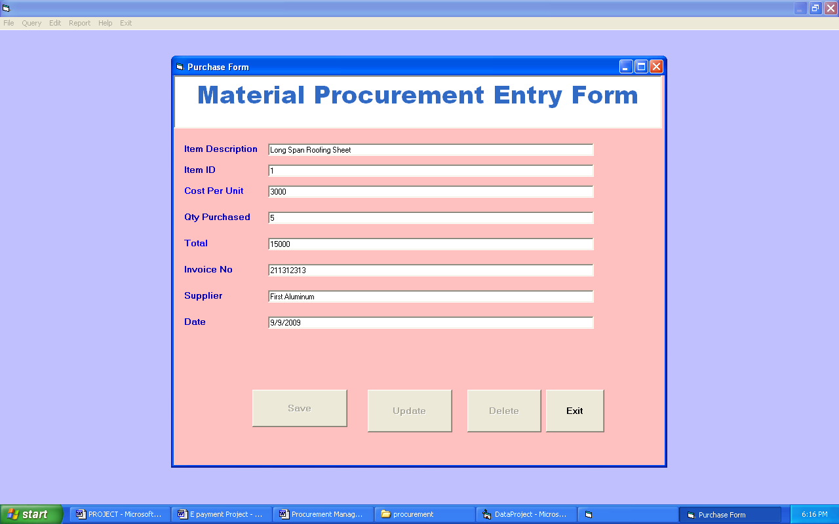

Fig 5.2

# Sample Reports

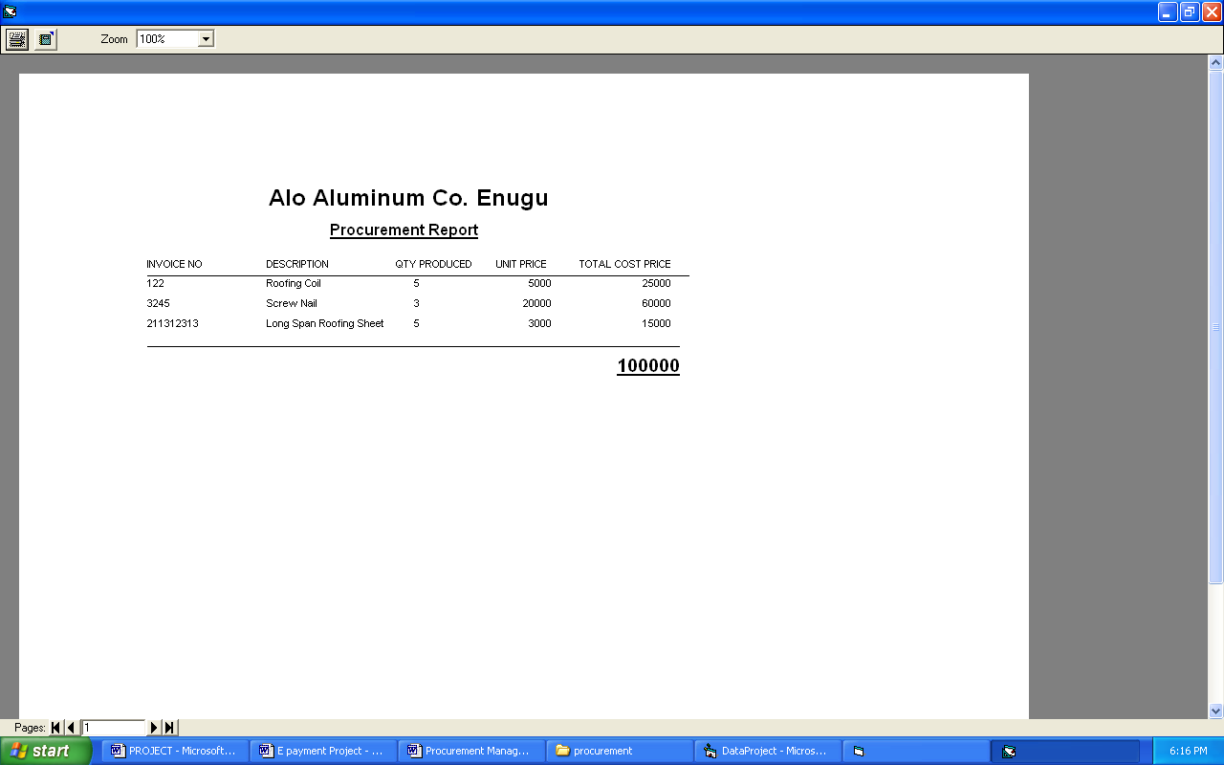

* 1. **User Training**

For the new system to function effectively, and efficiently, educating and training of staff is a necessary and compulsory condition. Training is conducted for the staff selected to do the job of keying in data and running of the system. The members of staff selected, are trained for a period of time on how to manipulate and operate the system so as to be acquainted with the computer and the system design. The staff members are also given procedural manuals to assist them in operating the system.

They are also educated on how to safeguard files in the system to avoid unauthorized user from gaining access to the system files.

# Cutover Process

This is the process of changing from the manual system to computerized system. When the entire procedure obtained in an organization is converted to automatic electronic mode.

In parallel method ,both the manual and computerized system are operated concurrently for sufficiently long period and their outputs compared periodically and possible discrepancies reconciled on the new system until all users are satisfied .The old system is discontinued when discrepancies are seen to have seized arising. It has the advantage of having an old system to fall back on, incase the new system fails. The disadvantage is the cost of running two systems side by side, both of which will achieve similar result. The researcher recommends the “parallel changeover” to avoid drastic problems that may arise due to failure of a newly developed system.

# Documentation

A system could be best maintained, if the following procedures are kept.

 One should install antivirus either Norton, Avast and others to prevent the system from virus attack.

 One should employ experienced operators to ensure correct operational procedures.

 The system should be kept in a cool environment either in an air- conditioned room or a well-ventilated room.

 The system should be covered with dust cover after usage.

 One should not drink or eat anything while using the computer.

# Program Documentation

The following steps can be used to install the software:

 Click the Start button at the left corner of the desktop taskbar and select Program from the menu that appears. From the new menu that opens from Program, select and click the Windows Explorer item.

 Select the drive (drive C:) that will contain the software by clicking the drive with the mouse.

 Open the File menu by clicking it and selecting New item and then another menu appears.

 From the new menu select and click Folder and then type the name of the folder. Type a name for example, “Procurement”

 Insert the CD containing the software into the CD drive.  Copy the inventory folder to drive C

# User Documentation

The following steps can be used to run the application.

1. Open Drive C
2. Double click on Procurement folder
3. Double click on Material Procurement.exe to run the program

# CHAPTER SIX

* 1. **RECOMMENDATION, SUMMARY AND CONCLUSION**

# Recommendation

It suffices to say that for any meaningful computer based information management to be integrated into any organization, proper training and orientation has to be given both staff and management. Proper training should be given to the data entry staff on how to handle the computer hardware especially during backup processes. In particular electronic storage media are usually sensitive to change in temperature or pressure and as such data, can be lost very easily. The staff should also be highlighted on the need and advantage of the system and how it will equally assist them in their various field of work.

They should also be informed of the cost of maintaining this new system so that they will handle it with all carefulness. Training materials should not be presented in formal way but with procedures like policies and form etc, they should be circulated to the personnel. This will at the end, generate appreciation and needed interest to operate the system.

# Summary

In the course of this study, we discovered that there are two ways in which a contract can originate: **unilaterally** or **bilaterally**

***Unilaterally***: Common form for contract is a relatively simple type of document called a **purchase order**. A purchase order is used when routine, standard cost items are needed. A purchase order is legally binding and should be specific.

***Bilaterally***: Procurement documents are used to solicit proposals from prospective sellers. The procurement document then becomes the basis for the seller's proposal. The following are examples of procurement documents:

**Request for quotation (RFQ)** from different suppliers: Items are of relatively low dollar value such as supplies and materials. A survey of potential suppliers is completed. The quotation request informing suppliers of the goods or services needed is sent to a scaled-down number of possible suppliers.

**Request for proposal (RFP)**: Items or services are usually high dollar and non- standard. Examples: construction project, a research and development project; a made-to-order, highly complex piece of machinery.

Blueprints, drawings, specifications, and other appropriate data should be included with proposal.

**Invitation for bid (IFB)**: Appropriate for high dollar, standard items.

A prerequisite to this process is a clear and accurate description of the supplies, equipment, and services required.

 Includes specifications, drawings, industry standards, performance requirements, etc.

 Must ensure fair competition among all bidders.

 Provisions should be stated in such a manner to avoid misinterpretation.

 Formal bids are submitted to the contracting department in sealed envelopes. All bids are opened at a specific time.

 In most cases, the contract award goes to the lowest responsible bidder. If not awarded to the lowest bidder, must document reasons, carefully.

 Type of contract is open to fraud, collusion, and other dishonest conduct. Hence, PM and contracting personnel must practice defined ethical business procedures.

# Conclusions

Having come to the end of the project work, I must mention that the use of computer in the society is becoming so relevant that no business transaction can be said to be complete without the involvement of the computer in transmitting information. Clear advantages of computerized material procurement management information system over those of manual method are high and should be encourage.

# REFERENCES

Arizona, R., (2011): Electronic Health Records*, about $500 Million at stake in digital move.* England: Smith and Sons.

Habib, J.L. (2010). EHRs, meaningful use, and a model EMR. *Drug Benefit Trends.* May 2010; 22(4):99-101.

Hoffman, S., & Podgurski, A. (2008). "Finding a Cure; The Case for Regulation and Oversight of Electronic Health Record Systems" (PDF).

*Harvard Journal of Law & Technology*

Laura, D. (2007). "Electronic Health Records: Interoperability Challenges and Patient's Right for Privacy". *Shidler Journal of Computer and Technology*

Robson, B., Baek, K. (2009*). The Engines of Hippocrates*. From the Dawn of Medicine to Medical and Pharmaceutical Informatics. USA: John Wiley & Sons

Starmer. K., Bratan, T., Byrne, E., Russell, J., & Potts, H.W.W. (2010).

*Adoption and non-adoption of a shared electronic summary care record*. England: John Wiley & Sons.

Tüttelmann, F., Luetjens C.M., Nieschlag, E. (2006)."Optimising workflow in andrology: a new electronic patient record and database*". Asian Journal of Andrology* March 2006

Wong, G., Bark, P., & Swinglehurst, D. (2009). “Tensions and paradoxes in electronic patient record research”. *A systematic literature review using the meta-narrative method.* Milbank Quarterly, 87(4), 729-88