ASSESSMENT OF DESIGN AND IMPLEMENTATION OF DOCUMENT VERIFICATION SYSTEM FOR ONLINE STUDENT ADMISSION (A CASE STUDY OF UNIVERSITY OF UYO)

ABSTRACT
Forgery has long crept into our educational system and, counterfeit and forged admission status / certificate and document have upper hand in various certificate and degrees awarding institution. Invalid studentship has become greater than valid studentship. The need for student admission verification system has become necessary to check mate and expunge invalid studentship, invalid document and invalid certificate yielding to authenticity of certificate and documents. This research work Designed and Implemented Student Verification System for University of Uyo. The proposed model is concerned with monitoring the studentship of students, keeping students basic academic record, tracking students if there is malpractice of any kind and, verifying every certificate of University of Uyo in the future and making sure fake admission is reduced drastically.
The system was designed and implemented with PHP, MYSQL, HTML, AJAX, and JAVASCRIPT Technologies.

CHAPTER ONE
INTRODUCTION
There are many different ways to define a system, but one method that may be understood literally in the context of computers is as a collection of the many pieces of hardware and software that make up a computer. According to Byron (2021), a system is a collection of components that work together toward the accomplishment of a certain objective. In a different meaning, a system is a set of components that are connected to one another or that interact with one another to create a coherent whole. A verification system, such as the one that is being developed for this project, is an application software that may be used to verify the rightful and legal ownership of someone or something by a collection, an organization, or a person. There are several types of verification systems, the most common of which are the address verification system, the adult verification system, and the card verification system, to name just a few. The purpose of a student verification system is to ascertain whether or not a student is now or formerly registered in an appropriate and legal manner. In this context, it is used to verify that a student belongs to or once belonged to an institution and to check that the student is correctly enrolled in a certain department that is conducting any of the institution's programs (Sikiru, 2019). This verification technique for students is also known as the Uniuyo Admission System. The Student Admission system uses the internet as its primary data repository. It is an electronic and computerized method of verifying a person's claim of studentship to an institution by means of their matriculation number (Mat No) being input, hence using an output clearly showing the truth or false of his or her claim to be a student at the institution. This method is referred to as e-verification..
1.1 BACKGROUND OF THE STUDY
In this day and age, computers have provided conclusive evidence on their origin. The introduction of computers into our society has resulted in a great deal of criticism over the threat that they represent to society. Those who are opposed to new technologies and computers often voice their concern that computers will one day be able to do the work of humans, which would inevitably lead to widespread unemployment. The critic was proven wrong by the fact that computers are present in virtually every aspect of modern life's frenetic pace. Moreover, the development of new technologies and computers continues to generate additional employment opportunities for people who identify themselves as being associated with such developments (Stella, 2016). Because of this, computers may now work alongside people in any profession that requires their expertise. Due to the fact that papers, certificates, and studentships may be forged at a high rate and in an easy manner, utilizing a computer in a negative way has resulted in a big issue with student identification and verification throughout the course of the previous several decades at large institutions. Falsifiers are ignorant to the fact that in today's fast-paced world, the computer has also functioned as an assistance in the decision-making process, as well as verification and authentication. This is because computers are so efficient in a variety of ways, including speed, precision, dependability, cost, and security, to name a few. In recent years, individuals have become more aware of the use of computers for verifying, authenticating, and other security-related activities, and this knowledge has been generated in them. These activities may be web-based (on the internet), or they can be window-based (Suhansa, 2021). The company makes use of a decision support system in addition to other systems such as management information systems and information systems. The use of expertise and sound principles as guiding factors in decision-making is common. The value of every degree is tied to the reputation of the academic institution that awarded it as well as the students it produced. Because dishonesty and forgery pose the greatest threat to the success of any academic institution, this threat must be countered with verification and authentication processes and systems. "In recent years, efforts have been made to integrate intelligence into computer systems, so that computers may be utilized to analyze vast volumes of organized and unstructured information for the sake of decision making." Said Uzoka, 1998.

1.2 STATEMENT OF PROBLEM
The epidemic of fake admission is ravaging the Nigerian tertiary institution as victims to such fraud are often left frustrated. Students are sometimes offered fake admission with fake documentations from fraudulent persons posing as University Officials. This practice has led to many students losing their time and money studying in a University where they are not authentic students(Uzoka, 2022).
Another Issue is that the admission verification process in most tertiary institutions in Nigeria is very strenuous. During the analysis and data collection of this project, it was discovered that there existed a manual form of verifying students’ admission status, and for future purpose by the Students Affairs Department of the University of Uyo.
That is to say that the process of daily task and activities are done manually which is quite unfortunate; manual procedural for over one million admitted students yearly, the execution is always delaying and reduces result output quality.
1.3 AIMS AND OBJECTIVES
- The importance of authentic verification of student admission system certificate cannot be overemphasized as the reputations of institution are affected in every counterfeit or forged document.
- To design and implement student verification system for University of Uyo, The system will –
- Prove the authenticity of students’ admission status thereby expunging forged and counterfeit admission status and document from circulation.
- Show the valid and legally registered student of University of Uyo.
- Prove its supremacy over the existing manual system of verification and identification.
- To highlight the importance of verifying and authenticating students for future purpose.
1.4 SCOPE OF THE STUDY
- The scope and focus of this study is on students’ admission verification system, to help validate students’ admission status via the keep of their basic academic information and bio data updated. Importantly, the student must choose to be students of University of Uyo.

- 1.5 DEFINITION OF TERMS
- University - a high-level educational institution in which students study for degrees and academic research is done.
- Verification - the process of establishing the truth, accuracy, or validity of something.
- Identification - the action or process of identifying someone or something or the fact of being identified.
- Manual - relating to or done with the hands.
- Window-based - Hardware and software that runs a version of Microsoft Windows.
- Invention - something, typically a process of development that has been invented.

CHAPTER TWO
LITERATURE REVIEW
2.2 Verification
2.2.1 What is verification?
The dictionary.com defines verification as “to ascertain the truth or correctness of, as by examination, research, or comparison”. It further gives reference to “prove the truth of, as by evidence or testimony; confirm; substantiate”.
In a recruitment process, hiring is based on the information presented while presentation skills and other factors only play a minor role. It is therefore paramount for an organization to ascertain the truthfulness of the information presented in the recruitment process. Every certificate should be treated with the worth as presented but its contents must be verified to be true and valid.
2.2.2 Manual verification process
Most organisation recruiting personnel trust the certificates as they are presented. They normally look at the holograms and the clarity of the other images or writings on the certificate and either qualify or disqualify a certificate. Trust levels are further gained when a candidate presents a certificate that is well known.
The printed certificates could have all the required watermarks and other security features such as holograms or school seals but the candidate acquired it illegally either from the school or from other sources.
A number of employers carry out a background information that includes contacting the referees provided in a resume as a check to authenticate the worthiness of the information provided. Mukami (2014), a human resources manager notes that human resources manager uses background info to check on the provided documents. In a situation where an employee connives with his referee this becomes difficult. Others adds up years also as a check to confirm if their exists any disparities.
2.2.3 Electronic Verification
Electronic verification refers to the use of computer or computer related methods to verify the authenticity of any provided document. This has not been widely used although its take shapes in various sectors of the economy globally or locally.
2.2.3.1 E-Verify
United States E-verify program is an internet based program widely used by over 500,000 users and verifies the employment eligibility based on the statutory form I-9. The E-Verify is the only free, fast, online service of its kind that verifies employees' data against millions of United states government records and provides results within as little as three to five seconds, according to the official website of united states department of homeland security. An employer fills in a form I-9 and submits it – the system checks the eligibility criteria of the candidate and replies with the eligibility status (US Department of Homeland Security, n.d.).
2.2.3.2 Credit Reference Bureau (A case of Kenya)
Credit reference bureaus complement the central bank of Kenya roles played by banks and other financial institutions in extending financial services within the Kenya’s economy (Central Bank of Kenya, n.d.). The lending institutions share credit worthiness of a prospective loan applicant. This allows banks to make decisions on loans issuance at a fast pace.
Banks work independently but share the payment history and in consequence a credit worthiness record is computed. In a similar way schools and colleges (plus other certificate issuance bodies) hold vital education data of all students who have passed in their institutions. Sharing this information with employers then can be the only way to which fake certificates or credentials can be eliminated.
2.3 Integrity and Legitimacy of Academic papers
The global demand for higher education currently exceeds the worlds existing university capacity. Consequently a shortfall has been created, raising concerns on the frustrated number of students who choose to purchase fraudulent credentials from counterfeits or diploma mills (Gollin, 2009). The employer can in turn make reference to academic papers that were fraudulently acquired (counterfeits).
As per the Havocscope (2014) Crime report counterfeits are on the increase despite the heightened control measures to curb them. Though the report is inclusive of all kinds of fake goods, counterfeits on academic papers is further aggravated by the ever growing technology space. The latest version of CorelDraw and Adobe Creative1 Suite includes tools to trace a scanned document and reproduce it with other details. The process is normally a success as most of the certificates have no formal verification parameters.
1 Corel Draw and Adobe Creative Suite. These are Desktop publishing tools and pre-printing that allows unlimited edits to graphics and include trace capability tools to trace even the color and minor details of a document. More information on http://www.coreldraw.com/us/product/graphic-design-software/ and http://www.adobe.com/

2.3.1 Attempted Verification Methods
a) Verified University Lists

These are lists that include all recognized institutions of higher learning or recognized by the respective ministries or governing bodies. An example list is published by UNESCO and is available at http://www.unesco.org/new/en/education/resources/unesco-portal-to-recognized-higher-education-institutions.
This method only verifies that the university or college one attended is verified or approved but fails to connect the authenticity of the purported owner of the document with the institution.
b) Verification Forms / Letters or Confidential Letters.

These methods attempt to get verification manually from the host institutions in regards to information sought in any application. An application for scholarship mostly uses this method. An application form normally has a section that is supposed to be filled from the school an applicant attended.
Another form of this method is when an applicant is supposed to disclose the referees or an institution where a confidential letter is sought.
This methods is normally manual and involves time and money. It is not the best in the information age.
c) Certified true Copies (CTC’c)

This method is commonly used where duplicate copies are required. An applicant duplicates his document normally via a photocopier and takes them to a certification authority that may include the document issuer or a commissioner of Oaths or a magistrate.
This method is still not the best as the law bindings only confirm - the copy is a copy of the original. If the original that was brought was not authentic the CTC will still hold. This then becomes a method with no 100% accuracy.
d) Security Holograms and Institution Seals

This is the most common method used in the paper documents. A hologram represents a security kind of a seal in the certificate body. Every university has its own seal mostly held under a key and lock. Its imprints are embodied in the certificate as a trust that the document is authentic.
Despite its widespread use it has a disadvantage in that the seals can be remade in the black market and its effective use is based on prior knowledge on how the imprint looks like.

2.3.2 Technology and Verification Illusion
2.3.2.1 The Illusion
Technology is poised to be a solution of a number of social or business problems, but can it be useful in document verification? Over the list discussed above, an additional approach to academic verification is possible in which the qualifications verification will be verified automatically via the same information security tools that are used in financial transactions and that permit a sharing logic over the internet.
The presence of a self and or automated verification process will wipe all academic qualification counterfeits. A lesson can be learnt from the money printing process though the problem is more than in money industry. Money is normally printed by a single institution and every country has its own standards. The issue with academic paper is that these are printed by different schools with new ones coming up every day to join a field with no certificates standards.
Technology avails the public key infrastructure and digital signatures as a preliminary solution to the certificate issue. This will however not work well as these will apply only to e-documents used, something not common with our institutions of higher learning. Our institutions provide hard copies of academic qualifications rendering technology impotent in the digital signatures sector, despite its widespread use in the e-commerce sector.
2.3.2.2 Web Services
The W3C definition states “a web service is a software system identified by a URI, whose public interfaces and bindings are defined and described using XML. Its definition can be discovered by other software systems. These systems interact in a manner described by its definition, ( Zimmermann, Tomlinson, & Peuser, 2003).
Web services provide an integration aspect between two or more systems allowing them to share data despite their different structural composition. Unlike digital signatures that rely on electronic documents, the e-recruitment system have components that require data entry or captured from certificates submitted. This information can then be used to verify authenticity of the documents provided the host institutions share the data and all work in a tier architecture.

REFERENCES

Barber, A. E. (1998). Recruiting employees. CA: Sage Publications.
Central Bank of Kenya. (n.d.). Credit Reference Bureaus. Retrieved July 12, 2014, from https://www.centralbank.go.ke/index.php/bank-supervision/credit-reference-bureaus
Chunguli, E. O. (2003). A survey of e-recruitment practices among commercial banks in Kenya . University of Nairobi.
Cullen, R. (2001). Addressing the digital divide. Online Information Review, Vol 25(5), PP 311 – 320.
Dictionary.com. (n.d.). Verify. Retrieved June 25, 2014, from http://dictionary.reference.com/browse/verify
Gall and Borg. (1989). Population in scientific Research, Paris.
Gollin, G. (2009). Verification of the Integrity and Legitimacy of Academic Credential Documents in an International Setting. Colleges and University, 84(4), 75-81.
Havocscope. (2014). Global Black Market Information. Retrieved July 17, 2014, from http://www.havocscope.com/tag/kenya/
Kenya Law Reports. (n.d.). The elections Act 2011 of the constitution of Kenya (No 24 of 2011).
Kerrin M, K. P. (2003). e-Recruitment: Is it Delivering? Report, Institute for Employment Studies. Retrieved from http://www.employment-studies.co.uk/pubs/summary.php?id=402
Lang , S., Laumer , S., Maier, C., & Eckhardt, A. (2011). Drivers, challenges and consequences of E-recruiting. 11 Proceedings of the 49th SIGMIS annual conference on Computer personnel research (pp. 26-35). Newyork: ACM.
Mugenda, O. M. , & Mugenda, A. G. (1999). Research Methods: Quantitative and Qualitative Approaches. Nairobi: Acts Press.
Mukami, T. (2014, January 11). Got FAKE Documents? How HR Managers Will Get You. Retrieved July 7, 2014, from http://www.careerpointkenya.co.ke/2014/01/11/fake-documents-how-hr-managers-will-get-you/ NationMaster. (n.d.). Kenya Crime Stats. Retrieved June 29, 2014, from http://www.nationmaster.com/country-info/profiles/Kenya/Crime
NIELSEN, J. (2006, June 26). Quantitative Studies: How Many Users to Test? Retrieved from NN Group: http://www.nngroup.com/articles/quantitative-studies-how-many-users/
Njoroge. (2002). Relationship between Mathematical Language and Students Republic of Kenya, Central Bureau. Ministry of Planning and National Development: The Population and Housing. Nairobi: Government Printer.
Nrip, N. K. (n.d.). E-Recruitment System in Indian Organizations and its Efficiency. Retrieved june 30, 2014, from Academia.edu: http://www.academia.edu/3760694/E-Recruitment_System_in_Indian_Organizations_and_its_Efficiency
Online Recruitment Systems. (n.d.). Online Recruitment Solutions. Retrieved june 25, 2014, from http://www.online-recruitment-solutions.com/
Otieno, D. (2013, September 2013). Kenya, land of fake goods, fake leaders, fake smiles. Retrieved June 26, 2014, from http://www.standardmedia.co.ke/?articleID=2000092585&story_title=kenya-land-of-fake-goods-fake-leaders-fake-smiles
Pearce, C. G., & Tuten, R. L. (2001). Internet recruiting in the banking industry. Business Communication Quarterly, 64(1), 9–18.
Phelan, C., & Wren, J. (2005-06). EXPLORING RELIABILITY IN ACADEMIC ASSESSMENT. Retrieved Nov 12, 2014, from https://www.uni.edu/chfasoa/reliabilityandvalidity.htm
Pin, J. R., Laorden M., & Sáenz-Diez I. (2001). Internet Recruiting Power: Opportunities and Effectiveness. Research paper, International Research Centre on Organizations (IRCO).
Powell, R. R. (1997). Basic Research Methods for Librarians. 68.
Recruit Advantage. (2012). Integration Approach for Recruiters and HR Professionals. White Paper, RecruitADvantage.
Rouse, M. (2012). e-recruiting. Retrieved June 25, 2014, from http://searchfinancialapplications.techtarget.com/definition/e-recruiting
Stone, D. L., Stone-Romero, E. F., & K., L. (2006). Factors affecting the acceptance and effectiveness of electronic human resource systems. Human Resource Management Review, 16(2), 229–244.
US Department of Homeland Security. (n.d.). What is E-Verify? Retrieved June 30, 2014, from http://www.uscis.gov/e-verify/what-e-verify
Virginiah Tech. (n.d.). Chapter 3. Retrieved August 03, 2014, from http://scholar.lib.vt.edu/theses/available/etd-82098-1946/unrestricted/chapter3.pdf
Zimmermann, O., Tomlinson, M., & Peuser, S. (2003). Perspectives on Web Services. Springer.

CHAPTER THREE

SYSTEM ANALYSIS AND DESIGN

3.1 INTRODUCTION

In this chapter the analysis of the proposal system and its design is discussed more. That is to say, what the proposal system- UNIUYO e-Verify, is made of, its features and how it is designed- its outputs, inputs and database. Likewise the tools and technology that are used are not left out.

3.2 SYSTEM ANALYSIS OF THE SYSTEM

A system is an harmonious arrangement of components hardware and software; that interact to achieve a common goal. ( Stella C.C and France A.E., 2006).

Analysis is the focus of system development and is the stage when system designers’ works at two levels - what to do and how to do. Analysis of students verification system (UNIUYO e-Verify) involves a detailed study of various operation performed by it.

29

Every system is created against at least a particular problem; that is systems are created to solve problems. This student admission and document verification system solves the problem of fraud, both in studentship and certificate and documents obtained from higher institution notably University of Uyo, Uyo Nigeria (UNIUYO).

The existing verification system is a manual one, this is, it uses manual method where a request usually via letter or memo is sent to the concerned institution to verify the studentship of a students or the degree of truth of a certificate or document. Every thing is done on paper.

In comparison with the manual system, student verification system is an automated system that simplifies the activities of the manual system with better integration and updates of the manual systems activities. This automated system is designed and developed with Hypertext Preprocessor (PHP) as it language, MYSQL, HTML, AJAX, and JAVASCRIPT Technologies.

30

System analysis squarely deals with the software development activities. Three basic stages are involved in designing and delivering a good student verification system (and any other system), namely;
A thorough analysis of the system. A problem understood is half solved.
Development of an effective automated system student admission and document verification system; to meet requirement in an effective and efficient way.
Developing, installation, testing of system components, training, management, programming, monitoring and delivery the system-student verification system; into production yields to successful construction and implementation of the system in the user’s environment.

3.3 CONSTRAINTS OF THE EXISTING SYSTEM
The existing system which is a manual system of student verification is associated with the following constraints or problems;

- Unreliability: this system (the existing system) can be manipulated since human beings are directly involved in the process of verification.

31

Human can be bribed, deceived and show favouritism but in the proposed automated system (UNIUYO e-Verify) these are not possible.

- Speed: this has to do with time,. It takes longer time to send an application letter for verification and the reply thereof when compared to the window based student verification system. The speed of the manual system is a snail’s speed.

- It increases paper work since it is not an electronic system. The paper work of the manual system is far greater than the paper work of the automated system.

- During the process of application for verification and reply to application, some important document might be lost.

- Un-confidentiality: privacy is not considered in the manual system, important and private information may be made open during the process of verification, as many people (more than two persons) are involved.

32
3.4 PROPOSED SYSTEM DESIGN

Students’ verification system is the proposal system and it is designed for institution of learning and is specifically restricted to University of Uyo, Nigeria. The system is designed to achieve the establishment objectives of the proposal system.

3.4.1 SYSTEM ALGORITHM DESIGN

Note that the proceeding algorithm is not in pseudo code neither is it written in any programming language but it is written in a natural language. Start

If Admin starter then do

If the file then do

If new then do

Read data

If update then do

Read data

End if

33
Else if exist then do

Close application

End if

10 if search then do

If by programme then do

Read programme

End if

Else if by faculty then do

Read faculty

End if

Else if by level then do

Read level

End if

Else if by department then do

Read department

End if

34
Else if unique search then do

Read mat no

End if

End if

- if verification then do If graduate then

Read mat no and name Else

If undergraduate then Read mat no and name End if

End if

If admin then do If add then do Read admin data start Add new admin
35
Else

If edit then do

Admin start

Read data

Update admin else

If delete then do

Read admin data

Delete admin

Else

If system operation then do

If add then do

If (item = programme or dept or course or status or faculty or level) then do

Read data

Else

If edit the do

If (item = programme or dept or course or status or faculty or level) then do

36
Read data

Update data

Else

If item = delete then do

If (item = programme or dept or course or status or faculty or level) then do

Read data

Delete data

End if

End if

If organization menu then do

If add then do

Read data

Else

If modify the do

Read data

Update data

37
Else

If delete then do

Read data

Delete data

End if

End if

If (organization or student) then do

If file then do

If exit then do

Close application

End if

End if

If search then do 10 // does the algorithm with line number 10 end if

If verification then do 20 // does the algorithm with line number 20

End if

End if

38
End

3.4.2 INPUT DESIGN

For there to be an output, there must be an input which must be processed to yield the required output. The input document used to record information of student’s admission and to verify student information thereafter makes up the input forms.

The supplied data on the input forms servers as the input to the system. These inputs are linked to the systems database and comparison is made with the pre-stored data in the database.

The verification form is shown on the clicking of any of the sub-menus. The required fields used as inputs in this form include Name and REG no.

Name of Student:

Registration Number:

Session:

Programme:

Department:

Faculty:
Document Name:

Picture Upload:

Add

Submit

Fig. 3.1 input form to add Administrator

3.4.3 INTERFACE DESIGN

This is the physical structure of the visible side of the system, mainly to the users. That is the front and of the system, which the users of the system interacts with, it comprises of both inputs and out put forms.

The interface of the system is a graphical user interface and not a command type; it is also an interactive, clear and not clumsy.

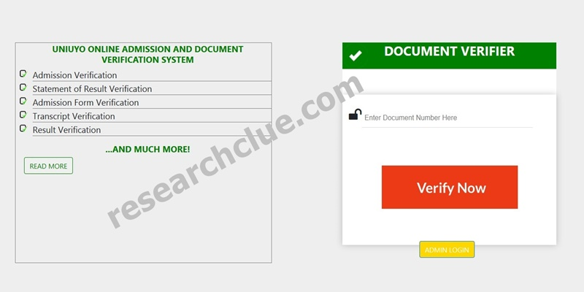
Fig. 3.2 The main interface form

3.4.4 OUTPUT DESIGN

After students details has been inputted into the student verification system, for verification the processed information or result appears on a form. This form that shows the output (result) is the output form.



Fig. 3.3a The Verification form

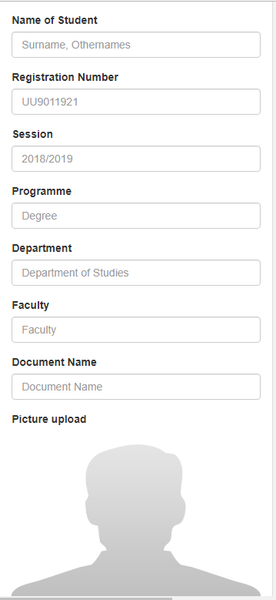

Fig. 3.3b The Verification Result form

3.4.5 SYSTEM DATABASE DESIGN

Database is a repository for data and information in an organized way to prevent redundancy and to preserve data integrity amongst others.

The design and implementation of the database is done on MYSQL server engine. This database consists of table of which some are.

Admin_user and edit_document. Each of these tables has their

column name (Field) and data types respectively. Notable, admin_user has

Fields | Data type
id | int
username | varchar
password | varchar
Table 3.1 company table

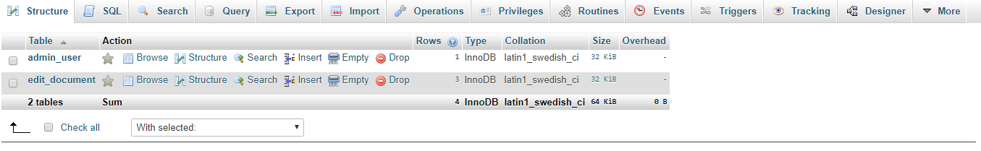

Fig 3.4 system’s database table for admin

3.5 TECHNOLOGY, TOOLS AND PROGRAMMING LANGUAGE USED

Web based application are developed systems or applications that are objects oriented and run on a web environment. Thus, it needs or no internet connection.

Hypertext Preprocessor (PHP) is an integrated Development Environment (IDE) developed for web programming. it can be used for development of different things such as, console programs, GUI (Graphical User Interface) application, web sites, web pages, web application and services (native code and managed codes and included).

PHP is an object oriental programming language used for developing a variety of applications that runs on web framework. PHP and Javascript is simple, powerful, type-safe objective oriented and encourages Rapid Application Development (RAD).
MYSQL server is a relational database management system (RDMBS) developed for database entry. it runs as a server giving access to a number of databases. The SQL is an acronym for structured Query Language, pronounced officially as “S.Q.L” but one often pronounced as “S-equ-el”.

47
CHAPTER FOUR

DESIGN AND IMPLEMENTATION

4.0 INTRODUCTION

This chapter focuses, on the requirements for this automated system’s implementation. Information about the installation is also discussed, moreover, the automated system is described in UML (Unified Modeling Language) and the use case diagram is given.

An automated system that is not implemental or is not successful implemented can not be used to perform well as the case may be. “Even after the development phase is over, the system project isn’t complete. The new system must be implemented or installed” (said Stella C.C. and Franca A.E, (2006)).

4.1 SYSTEM DESIGN

This automated system is designed using the SSADM (Structured System Analysis and Design Methodology and RAD (Rapid Application Development) Model which are object oriented. The UML which was
48

formulated by Booch, Rumbaugh and Jacobson in 1997 is used to describe the system and the use Case diagram shows the system design (Detail Design or design Overview). UML is a language for specifying, visualizing and constructing the artifacts of software system. A Use case diagram is one of the UMl diagrams. Others are sequence diagram, state diagram, collaboration diagram and so on.

A use case diagram shows typical interactions between a user (actor) and the computer system. As defined by Stella C. C. and Franca A.E. (2006) in their book principle of system analysis and design, use case are included in UML and it is a narrative document that describes the sequence of event of an actor using a system to complete a process.

4.2 SYSTEM DESCRIPTION

To describe this automated system, we apply a use case diagram which is graphical representation of the systems functionality by the different users. The use case diagram consist of actors use cases and arrows (for evens of flow.
49

The actors as concerned in this student admission and document verification system are Admin (Administrator) and student. The use cases are registration, update, search, verification, add admin, and modify Admin, Delete Admin, System Operations and organizations menu.

The system operation consists of Add, Edit and Delete of Programme, department, status, session and so on. The organization menu is meant for the registration of organization, editing and deleting likewise. The registration gives license to the organization to own and use the student admission and document verification system.

The use case diagram of this automated system – student admission and document verification system; is given below.

50

Student

Organisation

Registration
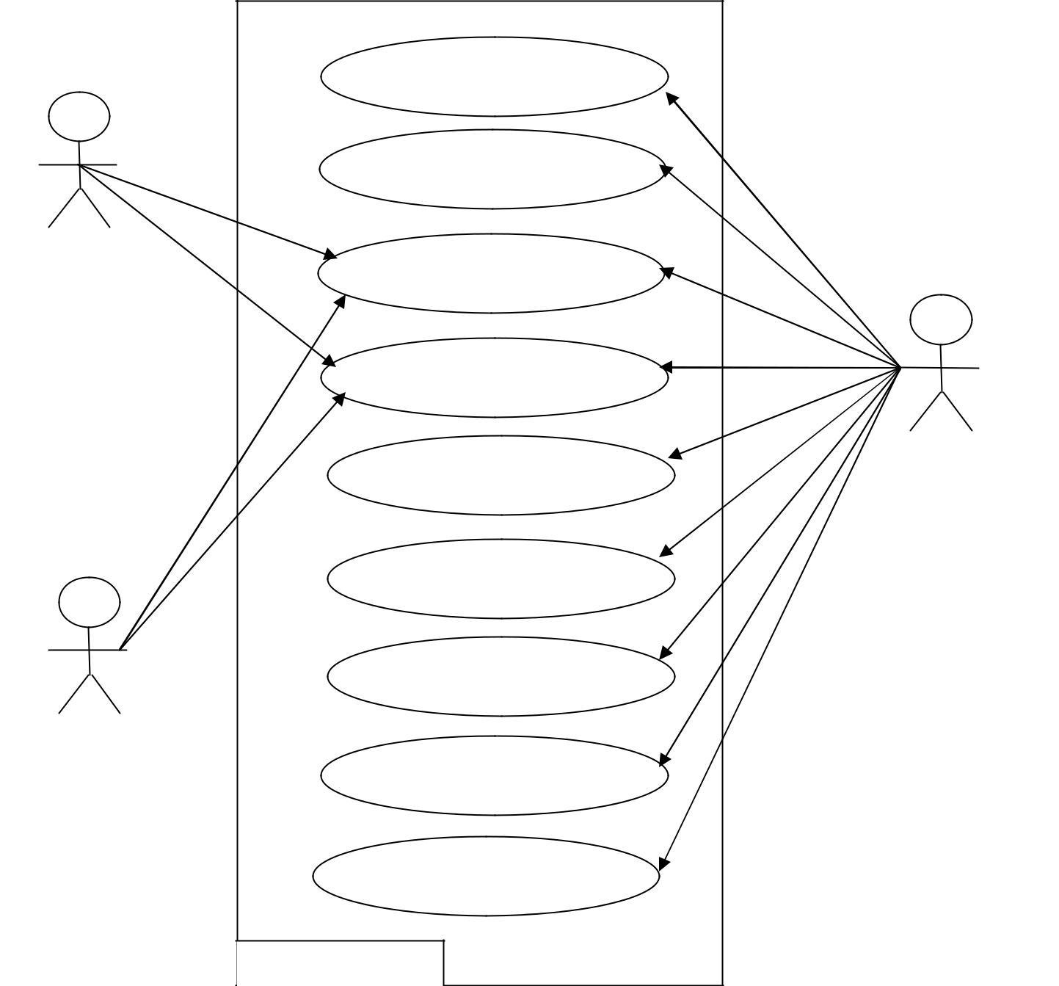

Update

Search

Verification

Add Admin | Admin

Modify Admin

Delete Admin

System Operations

Organisation Menu

System Boundary

Fig 4.1 Use Case Diagram - Shows the description of the student verification

system.

51

From the above use case diagram, after the log in process has been met, the system provides an abstraction based on the selection. Thus, if a student or an organization log-in, he/she can only see and perform two function - search and verification, apart from closing the application. When an administrator logs in, he/she can use all the system components.

4.3 SYSTEM IMPLEMENTATION

Designing or developing a system is one thing, another is implementing, not just implementing it, but the successful implementation.

Implementation of any information system or automated system depends on the hardware, software and people. Hence, the hardware being mainly a personal computer (PC) with printers, scanners and any peripheral that is needed. The software for the implementation of this automated system is MySQL server which serves as the database but there is no need for this software if a student or an organization desires to make use of it. The web browser must be a eligible to view the web system.

52

The people consist of the users of the system which encompasses of Administrators, organization and students. All the users must be trained and computer literates else the system’s aim and objective will be defeated.

4.4 HARDWARE REQUIREMENT

The following hardware components are needed

- Personal computer (PC) – a desktop or laptop

- Printer – a desk jet or inkjet

- Scanner – Preferably colour scanner pictures. The personal computer should have a minimum of

- Pentium 4 Processor

- 512 kb RAM

- GB Hard disk

4.5 SOFTWARE REQUIREMENT

The needed software is as follows:

- Web browser

53
- MySQL Server.

- Notepad++.

4.6 SYSTEM TESTING

Before a system is put into operation, its components programs must be tested to make sure. They work both individually and as a unit. Testing whether unit testing (individual testing) or individual testing, removes bugs from individual programs and system application. The testing of this system is done with life data and test data.

An automated system may have a hundred programs and a comprehensive database, all must be tested together to ensure harmony of operation. The purpose of system testing is to validate all software, input/output, databases and procedures and so on as the case may be.

4.7 SYSTEM REVIEW AND MAINTENANCE

After successful testing and implementation, system review and maintenance is necessary to do check and balances and for the following.

- Comparison of the system’s actual performance versus the anticipated performance objectives

- Assessment of each facet of the system with respect to present criteria.

- Correction of any error that may occur after its use for say one months;

- Updating of new features;

- Unexpected problems

4.8 INSTALLATION PROCEDURE

After the purchase of the software, insert the CD into a CD/DVD RW/ROM of the computer system you intend to have this software installed on. Then Run the inserted disk and follow the setup procedure, there after, the software will open if it has been successfully installed. This installed software does no open on its own but open on the users demand by double click on its icon or right click on the icon and click on open.

4.9 USERS GUIDE

Users of the software should take the following as a guide:

- Avoid the use of this software by a computer illiterate

- Ensure that you hardware and software meets the hardware requirements and software requirement as stipulated in 4.4 and 4.5 respectively.

- Regular maintenance should be done on the software to avoid unexpected problems.

56
CHAPTER FIVE
SUMMARY AND CONCLUSION
5.1 SUMMARY
Students’ admission and document verification is a major and important activity to any institution. The system that has been in existence is the manual system which has many defects as mentioned earlier in section 3.3 of this material. The merits of this automated system over the existing one are as follows

- Accuracy

- Reliability

- Reduced paper work

- Speed in processing time

- It cannot be manipulated

- Simple process

- Users friendliness with GUI

5.2 RECOMMENDATION

This work should not put a stop to research on student verification technology as biometrics technology, facial recognition and Iris recognition technologies can be integrated to the technology used in this system.

Despite the fact that the system is a window based system (application software), it should be re developed to a web based system but with stronger security measures to avert web hackers and theft.

Also, we strongly recommend this software for University of Uyo and other degree awarding institution.

5.3 CONCLUSION

Automated system has proved to be more successful when compared to manual systems.

Student verification system redefines the manual verification system, hence averts academic fraud and illegal studentship certificate and document.

58

Since the value of every degree is the reputation of the institution and the student produced, student verification system will in no distance time ‘pocket’ the manual verification system.

59
REFERENCE

Byron, S.G. (2001). Theory and Problems of Programming with visual basic Schaum’s Outline. McGraw – Hill USA.

Sikiru, O.A. (2009). Implementation of an Online Job recruitment system. An unpublished M.IT Thesis, University of Lagos, Nigeria.

Stella, C.C. and Franca, A.E (2006). Principles of System Analysis and Design. Rootprint and publisher, Benin city – Nigeria.

Suhansa, R., George, Y. and Ronald, W. (2011). Students verification system for Online Assessments: Botstering Quality and interigty of Distrance Learning. Journal of Industrial Technology. Volume 27 Number 3. P1-8.

Uzoka. (1998). Human Resources Management an unpublished M. Tech Thesis, federal University of Technology, Akure, Ondo State.

Byron, S.G. (2021). Theory and Problems of Programming with visual basic Schaum’s Outline. McGraw – Hill USA.

Sikiru, O.A. (2019). Implementation of an Online Job recruitment system. An unpublished M.IT Thesis, University of Lagos, Nigeria.

Stella, C.C. and Franca, A.E (2016). Principles of System Analysis and Design. Rootprint and publisher, Benin city – Nigeria.

Suhansa, R., George, Y. and Ronald, W. (2021). Students verification system for Online Assessments: Botstering Quality and interigty of Distrance Learning. Journal of Industrial Technology. Volume 27 Number 3. P1-8.

Uzoka. (2022). Human Resources Management an unpublished M. Tech Thesis, federal University of Technology, Akure, Ondo State.

WEBSTIES

www.atmae.org/jil/Article/rodchua-student-verification-system-07122011.Pdf (Accessed on: 23rd August 2011).

60
http://propakistani.pk/2009/01/25/hec-onlinedegree-verification-system-for-

students/ (visited on: 23rd August 2011)

www.zimbio.com/Nigeria+today/articles/qpgfit02wiR/Biometric+fingerprint+2011

+jamb+utme (Accessed on 10th October 2011) http://en.wikipedia.org/wiki/address-verification-system (Accessed on: 10th

October 2011).

http://en.wikipedia.orgwikie/adult-verifiation-system (Accessed on: 10th October

2011)

www.isbestate.il.USnews/2004/july16.htm/ (Accessed on: 1st November 2011).

http://en.wikipedia.org/wiki/microsoft-visual-studio (Accessed on: 10th November 2011).

www.aplusid.com/Education-C00718.html (Accessed on: 1st November, 2011).

61
APPENDIX (SOURCE CODES)
- View.php

<?php require_once ("database/database.php") ?>
<?php ob_start() ?>
<!DOCTYPE html>
<html lang="en">

<head>
<title>ONLINE ADMISSION AND DOCUMENT VERIFICATION SYSTEM</title>
<meta charset="utf-8">
<meta name="viewport" content="width=device-width, initial-scale=1, shrink-to-fit=no">
<!-- Bootstrap core CSS -->
<link href="template/css/bootstrap.min.css" rel="stylesheet">
<!-- <link href="template/css/style.css" rel="stylesheet">-->
<script src="template/js/jquery.js"></script>
<script src="template/js/bootstrap.min.js"></script>
</head>
<body style="background-color:#F2F3F4">

<div class="container-fluid" style="margin-top:60px;margin-left:20px;margin-right:20px ">
<div class="row">
<div class="col-md-2"></div>
<div class="col-md-8">
<div class="panel panel-default">
<div class="panel-body">
<?php
if (isset($_GET['document'])) {
$doucmentID=$_GET['document'];
$sn = 1;
$sql = "SELECT * FROM edit_document where documentID='$doucmentID'";
$result = $conn->query($sql);
if ($result->num_rows > 0) {

while($row = $result->fetch_assoc()) {
?>
<div class="row">
<div class="col-xs-3"><img src="doc/download.jpg" class="img-responsive" style="width:200px;height:150px"> </div>
<div class="col-xs-9"><h3 style="color:red" class="text-center"><b><u>OFFICE OF THE REGISTRAR</u></b></h3>
<h1 style="color:green;" class="text-center"><b>UNIVERSITY OF UYO</b></h1>
<h4 class="text-center"><b>P.M.B 1017, UYO, AKWA IBOM STATE, NIGERIA</b></h4>
<h6 class="text-center"><b>Website: www.uniuyo.edu.ng | Email:vc@uniuyo.edu.ng, registrar@uniuyo.edu.ng | Mobile: +234(0)-7017747407</b></h6>

</div>
</div> <hr style="border:solid 2px black">
<div class="row">
<div class="col-md-9">
<h4><b>Our Ref:</b> UU/SCE/ADM/19450</h4>
<h4><b>Date:</b> <?php echo $row['date_edited'] ?></h4>
</div>
<div class="col-md-3">
<img src="doc/<?php echo $row['documentupload'] ?>" class="img-responsive pull-right" style="height:50%;width: 50%;">

</div>
</div>
<div class="row">
<div class="col-md-12"><br>
<h4><b><i>Dear <?php echo $row['nameofstudent'] ?> - <?php echo $row['Registrationnumber'] ?></i></b></h4><br>
<h5 class="text-center"><b>NOTIFICATION OF ADMISSION STATUS INTO <?php echo $row['programme'] ?> PROGRAMME FOR THE <?php echo $row['Session'] ?>
ACADEMIC YEAR</b></h5>
<p class="text-justify">I am pleased to inform you that following your success in the just concluded Screening Exercise,
you have been offered <b>conditional admission</b> into the School of Continuing Education,
University of Uyo, to pursue a <b><?php echo $row['programme'] ?></b> programme in Guidance & Counseling in the
<b> Department of <?php echo $row['department'] ?></b>, Faculty of <b><?php echo $row['faculty'] ?></b> in the
<b><?php echo $row['Session'] ?> Academic Year.</b> Your <b>unconditional admission</b> will depend on your success after
the Screening/Registration processes.</p>
<p class="text-justify">You are please requested to note the following:</p>
<ol>
<li class="text-justify">You must pay the approved non-refundable acceptance fee through online transaction via
<b>https://uniuyo.edu.ng/eportals</b> and present the official receipt to the Screening Officer for
further Screening and Registration exercise.</li>
<li class="text-justify"> This offer will only be valid if on verification of your credentials at the time of registration it
is confirmed that your qualification satisfies the University minimum admission requirements.</li>
<li class="text-justify">You must come for screening with the following credentials:
<ol type="i"><li class="text-justify">The Original of your educational qualifications (Statement of Results/Certificates).<b>N/B: Case
of awaiting result(s) will not be accepted.</b> </li>
<li class="text-justify">Birth Certificate/Age Declaration</li>
<li class="text-justify">A letter of good conduct from your Village Head or a responsible member of your
community/or civil servant not below Grade Level 10 or its equivalent in the private sector.</li>
<li class="text-justify">Certificate of Local Government of origin</li>
</ol> </li>
<li class="text-justify">Before registration, you will be required to undergo a medical examination conducted by the
Health Centre, University of Uyo.</li>
<li class="text-justify">If the offer is accepted by you, you should present your credentials to the Screening Officer for
screening before you can pay the prescribed fees and then register for courses.</li>
</ol><br>
<h4><b>Accept our congratulations!</b></h4>
<h4>Administrative Secretary, School Of Continuing Education</h4>
<h4><b>For: Registrar</b></h4>

</div>

</div>
<hr style="border:solid 1px black">
<p class="text-center">This document can be verified online via <b>http://uniuyo.edu.ng/docverifier</b> using this code: <b><?php echo $row['documentID'] ?></b></p>
<?php
}
}}else{
header('location: index.php');
}
?>
</div>
</div>
</div>
<div class="col-md-2"></div>
</div>
</div>
<?php require ("footer.php") ?>

- Login.php
<?php require ("header.php") ?>
<div class="col-md-5">
<div class="panel panel-default">
<div class="panel-heading" style="background-color: #27AE60"><h4 class="panel-title text-center" style="color:#fff"><span class="glyphicon glyphicon-lock" style="color:#fff" ></span> <b>ADMIN LOGIN</b> </h4> </div>
<div class="panel-body">
<?php
if($_SERVER['REQUEST_METHOD']=="POST") {
if (isset($_POST['btnLogin'])) {
$Username= $_POST['txtUsername'];
$Password = $_POST['txtPassword'];
global $conn;
global $flagp;
$sql = "select * from admin_user where username='$Username' and password='$Password'";
$result = $conn->query($sql);
if ($result->num_rows > 0) {
setcookie("name", $Username, time()+3600,'/');
header('location: ./admin/');

} else {
echo " <div class=\"alert alert-warning\">
<a href=\"#\" class=\"close\" data-dismiss=\"alert\" aria-label=\"close\">&times;</a>
<strong>No Username or password found!!!</strong>
</div>";
}

}
}
?>
<form id="login" action="login.php" method="post" class="well">
<div class="form-group">
<div class="input-group">
<span class="input-group-addon"><em class="glyphicon glyphicon-user"></em> </span>
<input type="text" name="txtUsername" class="form-control" style="width:100%" placeholder="Username...">
</div>
</div>
<div class="form-group">
<div class="input-group">
<span class="input-group-addon"><em class="glyphicon glyphicon-log-in"></em> </span>
<input type="password" name="txtPassword" class="form-control" style="width:100%" placeholder="Password...">
</div>
</div>

<button class="btn btn-success text-center form-control" name="btnLogin">Login</button>
</form>
</div>
</div>
</div>
<?php require ("footer.php") ?>

- Index.php
<?php require ("header.php") ?>
<div class="col-md-5">
<div class="panel panel-default">
<div class="panel-heading" style="background-color: #27AE60"><h4 class="panel-title text-center" style="color:#fff"><span class="glyphicon glyphicon-ok" style="color:#fff" ></span> <b>DOCUMENT VERIFIER</b> </h4> </div>
<div class="panel-body">
<?php
if($_SERVER['REQUEST_METHOD']=="POST") {
if (isset($_POST['btnVerifyNow'])) {
$documentID = $_POST['txtDocumentID'];
global $conn;
global $flagp;
$sql = "select * from edit_document where documentID='$documentID'";
$result = $conn->query($sql);
if ($result->num_rows > 0) {
echo " <div class=\"alert alert-success\">
<a href=\"#\" class=\"close\" data-dismiss=\"alert\" aria-label=\"close\">&times;</a>
<strong>This document is valid</strong> <a href=\" ./view.php?document=$documentID\" target='_blank'>View</a>
</div>";
} else {
echo " <div class=\"alert alert-warning\">
<a href=\"#\" class=\"close\" data-dismiss=\"alert\" aria-label=\"close\">&times;</a>
<strong>The document does not exist!!!</strong>
</div>";
}

}
}
?>
<form id="login" action="index.php" method="post" class="well">
<div class="form-group">
<div class="input-group">
<span class="input-group-addon"><em class="glyphicon glyphicon-log-out"></em> </span>
<input type="text" name="txtDocumentID" class="form-control" style="width:100%" placeholder="Enter Document Number here...">
<div class="input-group-btn"><button name="btnVerifyNow" class="btn btn-success text-center">Verify Now</button></div>
</div>
</div>
</form>
<!-- <div class="alert alert-success alert-dismissible">-->
<!-- <a href="#" class="close" data-dismiss="alert" aria-label="close">&times;</a>-->
<!-- <strong>This document is valid</strong> <a href="#">View</a>-->
<!-- </div>-->
<!-- <div class="alert alert-warning alert-dismissible">-->
<!-- <a href="#" class="close" data-dismiss="alert" aria-label="close">&times;</a>-->
<!-- <strong>The document does not exist!!!</strong>-->
<!-- </div>-->

</div>
</div>
<a href="login.php" class="btn btn-warning text-center">Admin Login</a>
</div>

<?php require ("footer.php") ?>
- Header.php
<?php require_once ("database/database.php") ?>
<?php ob_start() ?>
<!DOCTYPE html>
<html lang="en">

<head>
<title>ONLINE ADMISSION AND DOCUMENT VERIFICATION SYSTEM</title>
<meta charset="utf-8">
<meta name="viewport" content="width=device-width, initial-scale=1, shrink-to-fit=no">
<!-- Bootstrap core CSS -->
<link href="template/css/bootstrap.min.css" rel="stylesheet">
<!-- <link href="template/css/style.css" rel="stylesheet">-->
<script src="template/js/jquery.js"></script>
<script src="template/js/bootstrap.min.js"></script>
</head>
<body style="background-color:#F2F3F4">

<div class="container-fluid" style="margin-top:60px;margin-left:20px;margin-right:20px ">
<div class="row">
<div class="col-md-5">
<h4 class="text-center" style="color:#27AE60"><b>UNIUYO ONLINE ADMISSION AND DOCUMENT VERIFICATION SYSTEM</b></h4>
<ul class="list-group">
<li class="list-group-item">
<span class="glyphicon glyphicon-check" style="color:#27AE60" ></span> Admission Verification
</li>
<li class="list-group-item">
<span class="glyphicon glyphicon-check" style="color:#27AE60"></span> Admission Verification
</li>
<li class="list-group-item">
<span class="glyphicon glyphicon-check" style="color:#27AE60" ></span> Statement of Result Verification
</li>
<li class="list-group-item">
<span class="glyphicon glyphicon-check" style="color:#27AE60" ></span> Admission Form verification
</li>
<li class="list-group-item">
<span class="glyphicon glyphicon-check" style="color:#27AE60"></span> Transcript Verification
</li>
<li class="list-group-item">
<span class="glyphicon glyphicon-check" style="color:#27AE60"></span> Result Verification
</li>
</ul>
<h4 class="text-center" style="color:#27AE60"><b>...AND MUCH MORE</b></h4>
<a href="#" class="btn btn-default" style="border-color:#27AE60">Read More</a>

</div>
<div class="col-md-2"></div>
- Footer.php
<!----Place your content here---->
</body>
</html>

- Admin.php
<?php require ("header.php") ?>

<div class="col-md-6">
<div class="panel panel-default">
<div class="panel-heading" style="background-color: #27AE60"><h4 class="panel-title text-center" style="color:#fff"><span class="glyphicon glyphicon-list-alt" style="color:#fff" ></span> <b>Admission Document List</b> </h4> </div>
<div class="panel-body table-responsive">

<table class="table table-striped table-hover">
<thead>
<tr>
<th>S/N</th>
<th>Document ID</th>
<th>Document Name</th>
<th>Department</th>
<th>View Document</th>
<th>Action</th>
</tr>
</thead>
<tbody>
<?php
$sn = 1;
$sql = "SELECT * FROM edit_document ORDER BY Registrationnumber DESC";
$result = $conn->query($sql);
if ($result->num_rows > 0) {

while($row = $result->fetch_assoc()) {
?>
<tr>
<td><?php echo $sn++; ?></td>
<td><?php echo $row['documentID'] ?></td>
<td><?php echo $row['documentname'] ?></td>
<td><?php echo $row['department'] ?></td>
<td><a href="../doc/<?php echo $row['documentupload'] ?>" target="_blank">View</a> </td>
<td><a href="index.php?edit=<?php echo $row['id'] ?>" class="btn btn-default">Edit</a> <a href="index.php?delete=<?php echo $row['id'] ?>" class="btn btn-danger">Delete</a></td>
</tr>
<?php
}
}
?>
</tbody>
</table>

</div>
</div>
</div>
<div class="col-md-3">
<div class="panel panel-default">
<div class="panel-heading" style="background-color: #27AE60"><h4 class="panel-title text-center" style="color:#fff"><span class="glyphicon glyphicon-plus" style="color:#fff" ></span> <b>Edit Document</b> </h4> </div>
<div class="panel-body">
<?php
if($_SERVER['REQUEST_METHOD']=="POST"){
if(isset($_POST['btnSubmit'])) {
$target_dir = "../doc/";
$target_file = $target_dir .
basename($_FILES["documentUploadFile"]["name"]);
if($_FILES["documentUploadFile"]["name"] !="") {
$file_name = $_FILES["documentUploadFile"]["name"];
}else{
$file_name= $txtPhotoUpload;
}
insert_document($_POST['txtNameofStudent'], $_POST['txtRegNumber'], $_POST['txtSession'], $_POST['txtDegree'], $_POST['txtDepartment'], $_POST['txtFaculty'], $_POST['txtDocumentName'],$file_name, $_POST['txtID']);
if (move_uploaded_file($_FILES["documentUploadFile"]["tmp_name"], $target_file)) {
echo " <div class=\"alert alert-success\">
<a href=\"#\" class=\"close\" data-dismiss=\"alert\" aria-label=\"close\">&times;</a>
Data Saved and uploaded.
</div>";
} else {
echo " <div class=\"alert alert-warning\">
<a href=\"#\" class=\"close\" data-dismiss=\"alert\" aria-label=\"close\">&times;</a>
Data Saved but not uploaded.
</div>";
}
}

}
?>
<form enctype="multipart/form-data" method="post" action="index.php">

<input type="hidden" id="txtID" name="txtID" value="<?php echo $txtID ?>">
<div class="form-group">
<label class="control-label">Name of Student</label>
<input type="text" class="form-control" placeholder="Surname, Othernames" id="txtNameofStudent" name="txtNameofStudent" value="<?php echo $txtNamei ?>">
</div>
<div class="form-group">
<label class="control-label">Registration Number</label>
<input type="text" class="form-control" placeholder="UU9011921" id="txtRegNumber" name="txtRegNumber" value="<?php echo $txtRegNoi ?>">
</div>
<div class="form-group">
<label class="control-label">Session</label>
<input type="text" class="form-control" placeholder="2018/2019" id="txtSession" name="txtSession" value="<?php echo $txtSessioni ?>">
</div>
<div class="form-group">
<label class="control-label">Programme</label>
<input type="text" class="form-control" placeholder="Degree" id="txtDegree" name="txtDegree" value="<?php echo $txtProgrammei ?>">
</div>
<div class="form-group">
<label class="control-label">Department</label>
<input type="text" class="form-control" placeholder="Department of Studies" id="txtDepartment" name="txtDepartment" value="<?php echo $txtDepartmenti ?>">
</div>
<div class="form-group">
<label class="control-label">Faculty</label>
<input type="text" class="form-control" placeholder="Faculty" id="txtFaculty" name="txtFaculty" value="<?php echo $txtFacultyi ?>">
</div>
<div class="form-group">
<label class="control-label">Document Name</label>
<input type="text" class="form-control" placeholder="Document Name" id="txtDocumentName" name="txtDocumentName" value="<?php echo $txtDocumenti ?>">
</div>
<div class="form-group">
<label class="control-label">Picture upload</label>
<img src="../doc/<?php echo $txtPhotoUpload ?>" class="img-responsive" id="photoImage" style="height:250px;width: 100%;">
<button class="btn btn-success form-control" id="btnAdd"><span>Add</span><input style="margin-left:-20px;margin-top: -30px;height: 50px;width:550px" type="file" id="documentUploadFile" name="documentUploadFile" class="filme" onchange="readImageURL(this)"></button>
</div><br><br>
<div class="form-group">
<button class="btn btn-success text-center form-control" name="btnSubmit" id="btnSubmit">Submit</button>
</div>
</form>
</div>
</div>
</div>
<style>
.filme{
opacity:0;
}
</style>
<script type="text/javascript">
function readImageURL(input) {
if (input.files && input.files[0]) {
var reader = new FileReader();
reader.onload = function (e) {
$('#photoImage')
.attr('src', e.target.result)
.width(100+'%')
};

reader.readAsDataURL(input.files[0]);
}
}
</script>
<?php require ("footer.php") ?>

