DESIGN AND IMPLEMENTATION
OF
ATTENDANCE MANAGEMENT SYSTEM

ABSTRACT
In this project, the development of an attendance management system using biometrics is proposed. Managing student attendance during lecture periods has become a difficult challenge. The ability to compute the attendance percentage becomes a major task as manual computation produces errors, and also wastes a lot of time. For the stated reason, an efficient attendance management system using biometrics is designed. This system takes attendance electronically with the help of a finger print device and the records of the attendance are stored in a database. Attendance is marked after student identification.
For student identification, a biometric (fingerprint) identification based system is used. This process however, eliminates the need for stationary materials and personnel for the keeping of records. Eighty candidates were used to test the system and success rate of 94% was recorded. The manual attendance system average execution time for eighty students was 17.83 seconds while it was 3.79 seconds for the automatic attendance management system using biometrics. The results showed improved performance over manual attendance management system. Attendance is marked after student identification.

TABLE OF CONTENT

Title Page i
Approval Page ii
Dedication iii
Acknowledgement iv
Abstract v
Table Of Content vii

CHAPTER ONE
1.1 Background of the Study
1.2 Statement of the Study
1.3 Aim and Objectives
1.4 Scope of the Study
1.5 Limitations of the Study
1.6 Significance of the Study
1.7 Operational Definition of Terms

CHAPTER TWO
Literature Review
2.1 Introduction
2.2 Biometric System
2.3 Biometric Functionality
2.4 Identification
2.5 Finger Print
2.6 Fingerprint Identification
2.7 Fingerprint Authentication

CHAPTER THREE
System Analysis and Methodology
3.1 Analysis of the Existing System
3.2 Problems with the Existing System
3.3 Analysis of the Proposed System
3.4 Benefits of the Proposed System
3.5 High Level Model of the Proposed System
3.6 Methodology
3.6.1 Source of Data
3.6.2 Method of Data Collection
3.6.2.1 Observations
3.6.2.2 Interview

CHAPTER FOUR
System Design and Implementation
4.1 Introduction
4.2 Justification of the Programming Language
4.3 Program Flowchart
4.4 Program Structure
4.5 Implementation Details
4.6 System Testing
4.7 Training and Re-Training Of Staff
4.8 Change over Procedure
4.8.1 Direct Change Over
4.8.2 Parallel Change Over
4.8.3 Pilot Change Over
4.8.4 Recommended Mode Of Change Over
4.9 Location and Installation
4.10 Maintenance
4.11 Program Documentation

CHAPTER FIVE
Summary and Conclusion
5.1 Summary
5.2 Recommendation
5.3 Conclusion
References

CHAPTER ONE
1.1 Background of the Study
In many institutions, and academic organizations, attendance is a very important criterion which is used for various purposes. These purposes include record keeping, assessment of students, and promotion of optimal and consistent attendance in class. In developing countries, a minimum percentage of class attendance is required in most institutions and this policy has not been adhered to, because of the various challenges the present method of taking attendance presents. This traditional method involves the use of sheets of paper or books in taking student attendance. This method could easily allow for impersonation and the attendance sheet could be stolen or lost. Taking of attendance is time consuming and it is difficult to ascertain the number of students that have made the minimum percentage and thus eligible for exam. Thus, there is a need for a system that would eliminate all of these trouble spots.
An attendance management system using biometrics would provide the needed solution. An attendance management system is a software developed for daily student attendance in schools and institutions. It facilitates access to the attendance of a particular student in a particular class. This system will also help in generating reports and evaluating the attendance eligibility of a student.
Rather than signing an attendance sheet, individuals will pass their thumb over the fingerprint scanner, the finger print is compared against a list of pre-registered users, and once a match is made, the individual will be registered as having attended that lecture.
The paper discusses related works in the problem domain; highlights the general overview of the proposed system; details design considerations of the system, both at the hardware and software level; discusses the operation and how the system was tested in conformity to system design and functional objectives; concludes the observations made; and makes recommendations for future improvement.
1.2 Statement of the Problem
The traditional system is still mostly used in lecture room or examination hall in most institution today. Lecturer or instructor will give out a sheet of paper containing list of student’s name to sign or in some cases, the student will be the ones to write their names, student id and matriculation number to indicate their presence for a particular class. Falsification in student attendance does occur rampantly in the traditional method.
For example, another student can easily sign an attendance on behalf of another student. In other to prevent this problem, it is necessary to develop an Authentication System for Students using fingerprint Biometric recognition that will be employed to track and keep the attendance of every student in a particular class. Fingerprint is unique feature for everyone compare to using barcode in smart cards. Therefore, this system designed in this project work is not based on the existing barcode system. Tracking and monitoring student time of attendance could be tedious, time consuming and more susceptible to errors. The security of the existing attendance system that are now use in classroom (signature system) can be easily compromised. Some students can master other student’s signature. Thereby, helping their colleague who are absent for a particular class to sign the attendance sheet using the duplicated signature. The Fingerprint Attendance monitoring system designed in this research work for student is a more secure platform where students mark their attendance with their fingerprint.
1.3 Aim and Objectives
The aim of the study is to design and develop a reliable, scalable and cost effective Fingerprint based Student Attendance Management system. This is to be achieved by the following objectives:
(i) To carry out the analysis of manual processes involved in class attendance and examination attendance.
(ii) To design a new system for the (i) above and
(iii) To implement the design using Microsoft Visual Basic 6.0.
1.4 Scope of the Study
The scope of this work is to develop an Attendance management System that will improve how attendance management is done by using fingerprint as a form authentication for proof of attending a class. The system will be a window based application developed using Microsoft Visual Basic.net as the preferred programming language for building the user interface and Microsoft Access for database design. It does not cover other aspects of biometric.
1.5 Limitations of the Study
The efficiency of the scanner can be reduced due to the roughages in the captured images which are often caused by worn-out or cut or dirt’s found on fingerprint. Therefore, there is every possibility that enrolled users can be rejected by the system. Also the scanner or sensor cannot distinguish between a real and an artificial finger, therefore it is possible to fool the scanner. In addition, if an enrolled fingerprint is been duplicated or spoof, it is not possible to change fingerprint as in the case of password because user finger biometric. Finally, since the system will be design using Visual Basic.net, it won’t be able to run on any other platforms other than Microsoft Window operating system.
1.6 Significance of the Study
The System for Students using fingerprint Biometric will eliminate the use of paper in manual signing processes and all the risk associated with it. One of the risks of using a paper in class attendance is that it can be easily misplaced and students cheat by signing for each other not present in the class thereby defeating the aim of taking the attendance. Tracking and monitoring students time of attendance could be tedious, time consuming and susceptible to error. Thus, the System will drastically reduce time needed to verify attendance data.
The System also allows the institution management to track or investigate student class attendance in a particular course having poor attendance thereby enabling the management to rectify the situation by providing the necessary interventions. The system provide high level of security whereby making it impossible for imposters and impersonators in making their ways to examination halls. The System using fingerprint Biometric will keep historical data making it easy for lecturers to access and grade students.
Fingerprint Based Student Attendance management System is extremely useful in institutions especially during classes, tutorials, laboratory sessions and examination during which heavy security are normally deploy to validate student’s identity in order to cob imposters, with the use of Authentication System the number of security personnel will be greatly reduce. Most lecturers’ handout sheet of paper for their class attendance, which can easily be misplaced or damaged and poses a lot of stress in cumulating grades for their students. The system allows the lecturer to monitor each student attendance, track down truants and take the appropriate action. Thus, the system eliminates all these downsides. The Authentication system is not only useful to the institutions and lecturers alone, even the students benefit a great deal by reducing the stress in queuing up which result in delay and often time in the damage of the attendance sheet. It also prevents mistakes and anomaly that is associated with manual signing in which student that attend a class are marked as not present thereby losing the mark accorded to the particular attendance due to multiple attendance sheet.

1.7 Operational Definition of Terms
Biometrics is physiological or behavioral characteristics unique to individuals, this Include Fingerprint, hand geometry, handwriting, iris, retinal, vein and voice.
PIN personal identification number.
Biometric Verification is any means by which a person can be uniquely identified by evaluating one or more distinguishing biological traits.
Scanner a device for examining, reading, or monitoring something in particular..
Fingerprint sensor is an electronic device used to capture a digital image of the fingerprint pattern.
Rapid Application Development is a concept that products can be developed faster and of higher quality.
Authentication is the process of determining whether someone or something is, in fact, who or what it declared to be.

CHAPTER TWO
LITERATURE REVIEW
2.1 INTRODUCTION
A number of related works exist on the application of different methods and principles to effectively monitor the attendance of students. In Shoewu, O, O.M. Olaniyi, and A. Lawson. (2011), an embedded computer based lecture attendance management system was proposed. The system provides an improvised electronic card and card reader serially interfaced to the digital computer system.
Kadry, S. and M. Smaili. (2010), used a wireless attendance management system that authenticates using the iris of the individual. The system uses an off-line iris recognition management system that can finish all the process including capturing the image of iris recognition, extracting minutiae, storing and matching.
Attendance Management has also been carried out using attendance software that uses passwords for authentication.
Cheng, K., L. Xiang, T. Hirota, and K. Ushijimaa. (2005), designed and implemented a system that authenticates the user based on passwords, this type of system allows for impersonation since the password can be shared or tampered with. Passwords could also be forgotten at times thereby preventing the user from accessing the system.
Other attendance solutions are RFID-based student attendance system and GSM-GPRS based student attendance system. These are all device-based solutions. While GSM-GPRS based systems use position of class for attendance marking which is not dynamic and if schedule or location of the class changes, wrong attendance might be marked. Problem with RFID Shoewu, O. and O. Badejo. (2006) based systems is that students have to carry RFID cards and also the RFID detectors are needed to be installed. Pankanti, S., S. Prabhakar, and A.K. Jain. (2002)
This system, however, is a cost effective simplified system that uses fingerprints for identification. The fingerprint is unique to each individual and cannot be shared. It allows students to register for lectures with ease and eliminate errors that are associated with attendance reports because the system generates reports at the end of the semester.

2.2 BIOMETRIC SYSTEM
The word “biometrics” comes from the Greek language and is derived from the words bio (life) and metric (to measure). Biometric systems use a person’s physical characteristics (like fingerprints, irises or veins), or behavioral characteristics (like voice, handwriting or typing rhythm) to determine their identity or to confirm that they are who they claim to be. (Bolle et al, 2003) Biometric data are highly unique to each individual, easily obtainable non-intrusively, time invariant (no significant changes over a period of time) and distinguishable by humans without much special training.(Jain, 1999). Biometric data are highly unique to each individual, easily obtainable non-intrusive, time invariant that is no changes over period of time, distinguishable by humans without much special trainings. Biometric identifiers are categorized as physiological versus behavioral characteristics.
A physiological biometric would identify ones voice, DNA, hand print, iris A behavioral biometrics is related to the behavior of a person, including typing rhythm, and signature (chang, 2005). The tradition or conventional means of access control include knowledge based methods such as password or pin and token based method such as passport, driver’s license, ID card. These methods are prone to fraud because pin numbers could be forgotten and hacked and the token could be lost, duplicated or stolen, to address the need for robust, reliable and fool proof personal identification, authentication and systems will necessarily require a biometric component. (calvin ,2007)
2.3 BIOMETRIC FUNCTIONALITY
Several aspects of human physiology, chemistry or behavior can be used for biometric authentication. The use of a selected biometric for specific applications involves the considerable factors which are
- Uniqueness
- Measurability
- Performance
- Universality
- Permanence (Jain et al, 1999)
2.4 IDENTIFICATION
A biometrics system searches the database for a match to the newly captured sample, and grants access if it is found. Using a fingerprint as part of the login process to a computer is an example of this mode.
2.5 FINGER PRINT
A fingerprint is the feature pattern of one finger (Figure 2.1). It is an impression of the friction ridges and furrows on all parts of a finger. These ridges and furrows present good similarities in each small local window, like parallelism and average width.
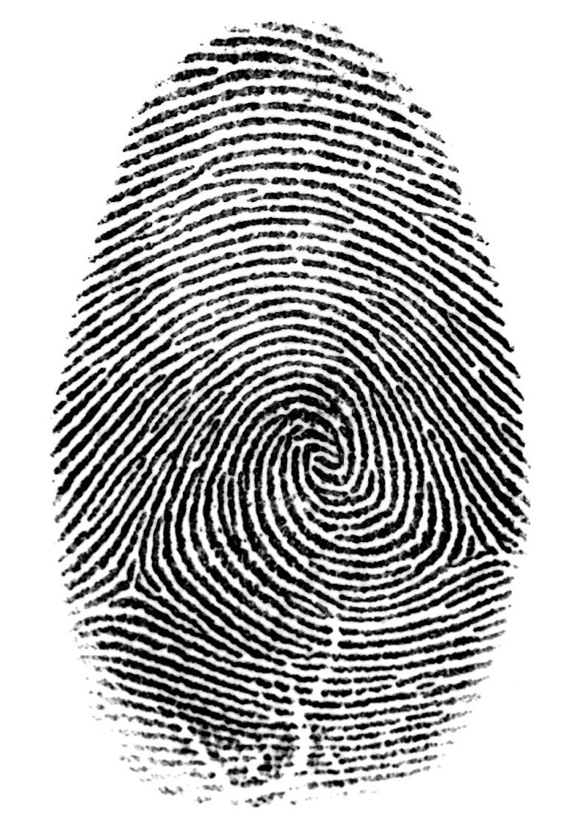
Figure 2.1 Fingerprint image from a sensor
However, shown by intensive research on fingerprint recognition, fingerprints are not distinguished by their ridges and furrows, but by features called Minutia, which are some abnormal points on the ridges (Figure 1.2). Among the variety of minutia types reported in literatures, two are mostly significant and in heavy usage:
Ridge ending - the abrupt end of a ridge
Ridge bifurcation - a single ridge that divides into two ridges

A fingerprint in its narrow sense is an impression left by the friction ridges of a human finger.olsen,(robert, 1972) In a wider use of the term, fingerprints are the traces of an impression from the friction ridges of any part of a human or other primate hand. A print from the foot can also leave an impression of friction ridges. A friction ridge is a raised portion of the epidermis on the digits (fingers and toes), the palm of the hand or the sole of the foot, consisting of one or more connected ridge units of friction ridge skin. These are sometimes known as "epidermal ridges" which are caused by the underlying interface between the dermal papillae of the dermis and the interpapillary (rete) pegs of the epidermis. These epidermal ridges serve to amplify vibrations triggered, for example, when fingertips brush across an uneven surface, better transmitting the signals to sensory nerves involved in fine texture perception
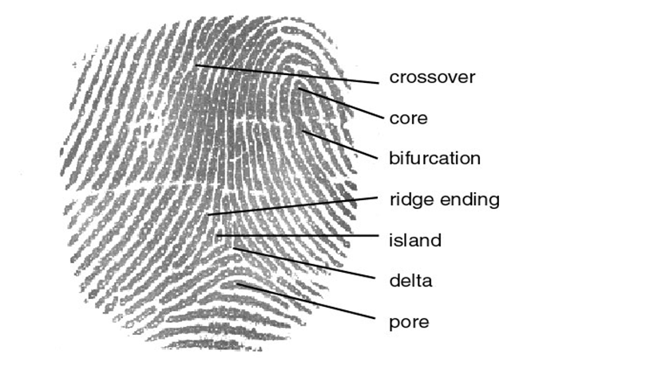
Fig. 2.2 features of finger print
2.6 FINGERPRINT IDENTIFICATION
Fingerprint identification is referred to as dactyloscopy is the process of comparing questioned and known fingerprint against another fingerprint to determine if the impressions are from the same finger or palm(Ashbaugh & David, 2013)
Fingerprints are made of a series of ridges and furrows on the surface of the finger and have a core around which patterns like swirls, loops, or arches are curved to ensure that each print is unique. (Maltoni, Jain, Maio, Prabhakar,2004)An arch is a pattern where the ridges enter from one side of the finger, rise in the center forming an arc, and then exit the other side of the finger. (Henry, Edward,1990)
The loop is a pattern where the ridges enter from one side of a finger, form a curve, and tend to exit from the same side they enter. In the whorl pattern, ridges form circularly around a central point on the finger. The ridges and furrows are characterized by irregularities known as minutiae, the distinctive feature upon which finger scanning technologies are based. Minutiae points are local ridge characteristics that occur at either a ridge bifurcation or a ridge ending. The ridge ending is the point at which a ridge terminates. Bifurcations are points at which a single ridge splits into two ridges. Minutiae and patterns are very important in the analysis of fingerprints since no two fingers have been shown to be identical.
It includes two sub-domains: one is fingerprint verification and the other is fingerprint identification
There are five stages involved in finger-scan verification
And identification:
1. Fingerprint Image Acquisition
2. Image Processing
3. Locating Distinctive Characteristics
4. Template Creation
5. Template Matching

2.7 FINGERPRINT AUTHENTICATION
Biometric authentication technologies such as face, finger, hand, iris, and speaker recognition are commercially available today and are already in use. (Fernando L. Podio: year) A biometric system is essentially a pattern recognition system that operates by acquiring biometric data from an individual, extracting a feature set from the acquired data, and comparing this feature set against the template set in the database. Depending on the context, a biometric system may operate either in verification mode or identification mode.(Anil, Arun and Salil,2004)

Verification mode: In the verification mode, the system validates a person’s identity by comparing the captured biometric data with her own biometric template(s) stored system database. In such a system, an individual who desires to be recognized claims an identity, usually via a PIN Personal Identification Number), a user name, a smart card, etc., and the system conducts a one-to-one comparison to determine whether the claim is true or not (e.g., “Does this biometric data belong to Bob?”). Identity verification is typically used for positive recognition, where the aim is to prevent multiple people from using the same identity. (O'Gorman, 2002.)

Identification mode: In the identification mode, the system recognizes an individual by searching the templates of all the users in the database for a match. Therefore, the system conducts a one-to-many comparison to establish an individual’s identity (or fails if the subject is not enrolled in the system database) without the subject having to claim an identity (e.g., “Whose biometric data is this?”). Identification is a critical component in negative recognition applications where the system establishes whether the person is who she (implicitly or explicitly) denies to be. The purpose of negative recognition is to prevent a single person from using multiple identities. Identification may also be used in positive recognition for convenience (the user is not required to claim an identity).
While traditional methods of personal recognition such as passwords, PINs, keys, and tokens may work for positive recognition, negative recognition can only be established through biometrics. (O'Gorman, 2002.)

CHAPTER THREE
SYSTEM ANALYSIS AND METHODOLOGY
3.1 ANALYSIS OF THE EXISTING SYSTEM
Since the use of fingerprint is yet to be introduced in higher institution of learning as prerequisite for lectures, entering the examination hall, impersonation and all form of exam malpractice has become the order of the day.
Students can boldly enter the examination hall with prohibited materials without being detected. Some who are not registered students of the institution often receive huge amount of money from registered students in order to help them in writing various examination, this they do with impurity.

3.2 PROBLEMS WITH THE EXISTING SYSTEM
The existing system which makes use of mostly manual technique of student verification such as photo cards which carries students’ passport photograph and details and this serve as an entry key into lecture/examination halls through verification by the examination supervisor. The problems with this method of verification are
- The manual photo cards are easily forged.
- These cards can be misplaced by the students.
- Time is wasted doing students’ verifications by the supervisors.

3.3 ANALYSIS OF THE PROPOSED SYSTEM
The proposed system provides solution to lecture/examination attendance problems through the use of attendance management software that is interfaced to a fingerprint device. The student bio-data (Matriculation number, Name, Gender and Date of Birth) and the fingerprint is enrolled first into the database. The fingerprint is captured using a fingerprint device.
For attendance, the student places his/ her finger over the fingerprint device and the student’s matriculation number is sent to the database as having attended that particular lecture. At the end of the semester, reports are generated to specify the students that are eligible for exams and percentage of times the student attended lecture.

3.4 BENEFITS OF THE PROPOSED SYSTEM
- Students who were once victims of impersonation will desist and take their studies serious.
- Impersonation and mercenary will be eradicated during examination.
- Lecturers will be encouraged to put in their best in order to avoid any occasion for cheating during examination.
- Strangers/unregistered students will be discouraged from entering the school premises.
- Virtually all the students will be encouraged to study hard since there will be no more room for impersonation.

3.5 HIGH LEVEL MODEL OF THE PROPOSED SYSTEM
HOME
STAFF
STUDENTS
STUDENT VERIFICATION
LOG IN
REGISTER

3.6 METHODOLOGY
This proposed attendance management system uses fingerprint identification. In identification, the system recognizes an individual by comparing his/her biometrics with every record in the database. In general, biometric identification consist of two stages:
i. Enrolment and
ii. Authentication

During enrolment, the biometrics of the user is captured (using a fingerprint reader, which are likely to be an optical, solid state or an ultrasound sensor or other suitable device) and the unique features are extracted and stored in a database as a template for the subject along with the student ID.
The objective of the enrolment module is to admit a student using his/her ID and fingerprints into a database after feature extraction. These features form a template that is used to determine the identity of the student, formulating the process of authentication. The enrolment process is carried out by an administrator in the attendance system.
During authentication, the biometrics of the user is captured again and the extracted features are compared (using a matching algorithm) with the ones already existing in the database to determine a match. The identification accuracy of a biometric system is measured with the false (impostor) acceptance rate (FAR) and the false (genuine individual) reject rate (FRR). The FAR/FRR ratios depend, among other factors, on the type of difficulty of the algorithms used in the fingerprint extraction. Usually, algorithms with high-medium complexity lead to acceptable low FRR/FAR.
However, as it becomes more complex the computational cost increases which leads to undesirable high processing times. Thus, the overall performance of the identification system should be evaluated in terms of FAR/FRR, computational cost and other factors such as security, size and cost.

3.6.1 SOURCE OF DATA
This is the research methodology that helps researchers to gather sources of information that will help building the new system. Some of the mode of data collection includes:
a. Interview
b. Observation

3.6.2 METHOD OF DATA COLLECTION
Various methods were used in gathering data from students which include interview and observation.
3.6.2.1 Observations
This is the direct aspect of data collection. In one of the just concluded exams, a lot of students were arrested because the invigilators discovered that they were unable to write their matriculation number correctly.
During their arrest, there was an up roar thereby disturbing other candidates in the hall from concentrating on their exams. This would have been prevented if biometric data machine had been introduced.
3.6.2.2 Interview
Having interviewed some students, over 80% of the students interviewed believed that the introduction of fingerprints detecting machine will go a long way to eradicating impersonation during examination especially in institution of higher learning.

CHAPTER FOUR
SYSTEM DESIGN AND IMPLEMENTATION
  - INTRODUCTION
An Automated Fingerprint Attendance System (AFAS) is a highly specialized system that records students’ attendance by comparing a single fingerprint image with the fingerprint images previously stored in a database. The Automated Fingerprint Identification system (AFIS) is the principle behind the AFAS.
The major factors in designing a fingerprint attendance system include: choosing the hardware and software components and integrating both to work together, defining the system working mode (verification or identification), dealing with poor quality images and other programming language exception, and defining administration and optimization policy .
  - JUSTIFICATION OF THE PROGRAMMING LANGUAGE
A program is a set of instruction that enables the computer system to function. A program implies a degree of completeness that is source code program comprises all statement and files necessary for complete interpretation or compilation and an executable program can be loaded into a given environment and executed independently of mother programs. The process of creating these instructions is called the out of programming.
In fact, any artificial language that can be used to define a sequence of instructions that can ultimately be processed and executed by the computer program. Many programming languages are currently in use today.
They include.
- VISUAL BASIC
- QBASIC
- ORACLE
- JAVA
- HTML
- ACCESS

Each of these languages has its own merits and demerits. Nevertheless, this research work was done to favour interactive processing rather than batch processing. Its interactive nature makes files processing more lively and makes for immediate response. The tutorial nature of interactive system enables a layman even to understand it easily and also for faster function. It is a stand. Alone program that will be accessed by the account department only, irrespective of the password.
On this note, the attendance management system was written with a well structured query language, visual basic in particular, because of the following reasons.
- The need to provide a graphic user interface (GUI) for the operator so as to enhance operations of the program.
- The simplicity
- And module oriented nature of the software.
- The ability of the software to connect to diverse database engineer, such as: ODBC, Data Access, SY base and the like.
- The fact that programs developed from visual basic can easily run on most windows operating system that has the VBARUN DLL files (without actually requiring the installation of the VB compiler).
- The fact that it has sufficient storage management and facilitates easy retrieval of information stored.
- It is user friendly and easy to code, red and understand, since it is English like.

4.3 PROGRAM FLOWCHART
The program flowchart is drawn from the job specification of the analyst. It consists of outline flowchart, which is an overview and sketch of the various procedures, while the detailed chart involves processing operating and procedures in the system. The system works on a central database. All outputs generated while running the program are also sorted in the central database until they are needed either for printing or viewing.
Normally, the program to suit the needs of the user will generate reports. And besides, the system has been designed to work on a multi-user to en-corporate time sharing facility.
(See Appendix for flowchart)

  - PROGRAM STRUCTURE
The program structure is a step that must follow the design of the output. The success of any system development depends more on the design and file output. This is because the coding of the program is done on the design inputs. The program for this system will thus be:
- Splash screen with messages
- Main form
- User ID and password.

The keyboard and the mouse are the basic input device used; the storage media used for processing are validated and verified before they are allowed. This input procedures designed as a part of the new system will improve the quality of the output.

4.5 IMPLEMENTATION DETAILS
To implement means to effect or carryout, this stage involves implementing the entire system on the database system and obtaining acceptance from its user. To achieve this, the system users have to be actively involved right from beginning of the project (developing or designing of the new database) to ensure a smooth implementation. Also, training of end user is essential for effective user of the database system in order to gain benefits from it. Implementation process usually takes much time than anticipated and should not be pushed too hard on the users. It requires a great deal of patience and perseverance to gradually and car fully implement the new system, as it would definitely change the work styles of many people in the institution. Based on this, the program implementation will assume the following shape:-
- Change over procedures
- Staff training and recruiting
- Location and installation

4.6 SYSTEM TESTING
The system was tested during debugging in the application development environment using test data. Many parts of the application as well as the variable are modules, which make up the system well traced and implemented.
4.7 TRAINING AND RE-TRAINING OF STAFF
For proper implementation and effective use of the database system, training and recruiting of staff to manage the system is very necessary. All staff must be at least computer literate, thus, conducting seminars and other tutorials to educate them on the importance and how to make use of the new system (database).
4.8 CHANGE OVER PROCEDURE
There are three ways of changing over to a new system; they include
- Direct change over
- Parallel change over
- Pilot change over

4.8.1 DIRECT CHANGE OVER
In this method of change over, the new system is used alone; no reference is made to any particular system. It involves the introduction of completely new system. The condition for this new system exist when there is no similarity between the existing and proposed system, also when there is slack of work and the analyst must be confident that the system must work.

4.8.2 PARALLEL CHANGE OVER
Here, the old and new systems are run concurrently using the same inputs. The outputs are compared and reason for differences resolved until new system has been proved satisfactory. At this point, the old system is discontinued and the new system takes its place.

4.8.3 PILOT CHANGE OVER
This involves the changing over of parts or small portions of the system, either in parallel or directly.

4.8.4 RECOMMENDED MODE OF CHANGE OVER
Having considered the various methods of change over, the author recommends that the parallel change over is used for implementing the new system. This is because; the method will give the management the time and facility of fully testing the new system while still retaining the existing system.
4.9 LOCATION AND INSTALLATION
The computer system should be located in a separate room and other equipment that will result to effective and efficient processing should be made available in the room. Such equipment includes;
- Ups (uninterruptible power supply)
- Air conditioner
- Tiles and curtains
- Dehumidifying equipment like water sensor
- Fire prevention equipment like fire extinguisher
- And proper ventilation system to dissipate heat and discourage dust.

4.10 MAINTENANCE
Once the implementation process is complete and the system is operational, there is a tendency to have a sign of relief but it is importance to follow up implementation with an evaluation process to ensure that the original objectives are being reached. Thus, program evaluation is defined as a detailed measure of performance against standard, which form a basis of comprise. On the other hand, program maintenance has to do with maintaining the system to ensure that the necessary subsystems are functioning and this may lead to at times possible updates to the database program. Attention should be given to various aspects like the user and the kind of work that will be done. Finally, time productivity and cost may be some criteria that will serve as standard of measuring the data base performance (new system).

4.11 PROGRAM DOCUMENTATION
Documentation is very important in the development of any software or any system. This is because documentation makes the system to be open to all users, and if it is not well documented it becomes difficult in its usage. That is why the system documentation has to be included in the specification document of the systems.
In making use of the system, the user who wishes to carryout any operations has to first boot on the system. And before using the software, he/she has to make sure that the software is properly installed in the system. The user can follow these steps:
- Insert the CD containing the software and then.
- Install the application
- Go to start button below on the desktop,
- Go to all programs and then click on Attendance system

The software is developed in such a way that anybody, whether with the knowledge of computer or not, he/she can access it. Meaning that the software is user friendly and is developed in such an interactive manner that any individual can run it.

CHAPTER FIVE
SUMMARY AND CONCLUSION
5.1 SUMMARY
The manual attendance system average execution time for eighty (80) students is approximately 30 minutes as against 10 minutes for this attendance management system using fingerprint identification. Reports generation for the attendance system takes approximately 30s. From the research carried out, it can be seen that the automatic attendance management system using fingerprint authentication is better and faster than the use sheets of paper.
5.2 RECOMMENDATION
The following suggestions should be considered in carrying out further work on this study:
- The system can be linked with the school’s central database so that the student registration phase can be eliminated and the bio-data can be directly from the database.
- The university should acquire the fingerprints of all students at admission.
- The components could be chosen and assembled in a commercialized manner: instead of a stand-alone fingerprint scanner and a laptop, the unit could have the fingerprint scanner, a small LCD screen and a keypad all attached to the wall of each classroom.
- The system could be modified into a web based system so that reports could be generated anywhere
- The system could be adapted for human resource use i.e. attendance, pension, payroll processing, etc.

5.3 CONCLUSION
The system successfully took the attendance both at lectures and examinations. The prototype successfully captured new fingerprints to be stored in the database; scanned fingerprints placed on the device sensor and compared them against those stored in the database successfully. The performance of the system was acceptable and would be considered for full implementation especially because of its short execution time and reports generation. Everyone who tested the system was pleased and interested in the product being developed for use in schools.

References
Ashbaugh, D. R. Quantitative-Qualitative Friction Ridge Analysis: An Introduction to Basic and Advanced Ridgeology; CRC Press: Boca Raton, FL, 1999.

Anil K. Jain, Arun Ross and Salil Prabhakar: “An Introduction to Biometric Recognition” IEEE Transactions
on Circuits and Systems for Video Technology, Special Issue on Image- and Video-Based Biometrics, Vol. 14,
No. 1, January 2004.

Bolle R, Connell J, et al. Guide to Biometrics, Springer, 2003.

Cheng, K., L. Xiang, T. Hirota, and K. Ushijimaa. 2005. “Effective Teaching for Large Classes with Rental PCs by Web System WTS”. Pro. Data Engineering Workshop (DEWS2005), 1D – d3 (in Japanese)

Maltoni D, Jain AK, Maio D, Prabhakar S, Handbook of Fingerprint
Recognition, Springer, 2004

Kadry, S. and M. Smaili. 2010. “Wireless Attendance Management System Based on Iris Recognition”

Olsen, Robert D. sir(1972). “the chemical composition of palmar sweat”. Fingerprint and identification magazine 53(10)

Pankanti, S., S. Prabhakar, and A.K. Jain. 2002. “On the Individuality of Fingerprints”. IEEE Transaction on Pattern Analysis and Machine Intelligence. 24(8)

Shoewu, O, O.M. Olaniyi, and A. Lawson. 2011. “Embedded Computer-Based Lecture Attendance Management System”. African Journal of Computing and ICT (Journal of IEEE Nigeria Computer Section). 4(3):27 – 36

Shoewu, O. and O. Badejo. 2006. “Radio Frequency Identification Technology: Development, Application and Security Issues”. Pacific Journal of Science and Technology. 7 (2):144-152

Flowchart
