## DESIGN AND IMPLEMENTASTION OF AN ONLINE RESOURCES FOR MARRIAGE CRISES RESOLUTION

BY

SANUSI MARDIYYA MUHAMMAD

BU/15C/IT/1824

COMPUTER SCIENCE [ INFORMATION SYSTEM MANAGEMENT ] BAZE UNIVERSITY

ABUJA

### September, 2020

DESIGN AND IMPLEMENTATION OF AN ONLINE RESOURCES FOR MARRIAGE CRISES RESOLUTION

Thesis Submitted in Partial Fulfilment of the Requirement for the Degree of

B. Sc.

In

Computer Science [ Information system management]

By

Sanusi Mardiyya Muhammad To

The Department of Computer Science Baze University, Abuja

September, 2020

# DECLARATION

This is to certify that this Thesis entitled [**online resources for marriage crises resolution**], which is submitted by [**Sanusi Mardiyya Muhammad**] in partial fulfilment of the requirement for the award of degree for B.Sc. in Information Technology to the Department of Computer Science, Baze University Abuja, Nigeria, comprises of only my original work and due acknowledgement has been made in the text to all other materials used.

Date: Date Month Year Name of Student: Mardiyya Muhammad Sanusi

**APPROVED BY** ……………………………

**Head**

Department of Computer Science

# CERTIFICATION

This is to certify that this Thesis entitled **online resources for marriage crises resolution**, which is submitted by **Sanusi Mardiyya Muhammad** in partial fulfilment of the requirement for the award of degree for B.Sc. in Information Technology to the Department of Computer Science, Baze University Abuja, Nigeria is a record of the candidate’s own work carried out by the candidate under my/our supervision. The matter embodied in this thesis is original and has not been submitted for the award of any other degree.

Date: Supervisor: Name

# APPROVAL

This is to certify that the research work, Dental Management System and the subsequent preparation by Sanusi Mardiyya Muhammad with BU/15C/IT/1824 has been approved by the Department of Computer Science, Faculty of Computing and Applied Science, Baze University, Abuja, Nigeria.

By

Professor Peter Ogedebe Date/Sign

1st Supervisor

Mr. Nasir Aboki

Date/Sign 2nd Supervisor

Dr. C. V. Uppin Date/Sign

Head, Department of Compuer Sciences

Prof. Mohammed Hammawa Baba Date/Sign Dean, Faculty of Computing and Applied Science

Prof. Ahmed Baita Garko

External Examiner Date/Sign

# DEDICATION

This project is dedicated to my family whose support is paramount to its successes. Thank you all

ACKNOWLEDGEMENT

I thank God Almighty for his mercy and grace that kept me all through my degree program. To my dearest parents Dr. Muhammad Sanusi and Dr. Aisha Abdullahi Ibrahim my unreserved gratitude for their protection, guidance and for providing me the necessary support, I appreciate you and I love you.

I am also grateful to BAZE UNIVERSITY for giving me the opportunity and guidance to go through this degree program.

My gratitude goes to my supervisors and lecturers Dr. C. V. Uppin, Professor Peter Ogedebe, Mr.Nasir Aboki, Mr. Abubakar Gaidam, Dr Amit Mishra, and Mr. Kvac. I thank them for their criticism, suggestion, advice, corrections and tutoring me throughout the program.

I also want to appreciate my Family Kawu Hussaini, Kawu Hassan, Fauziyya Muhammad, Hassan, Hussaina, Baffa, Abdul-Ahad, Aliyya and Abdul-Akhir who have been affected in every way possible by this quest.

I also want to thank everyone that contributed to the success of my degree program, my friends Hussaina Muhammad Sanusi, Salma Madugu,Fatima Zara, Fatima Nabali, Fatima Abubakar Shagari, Sadiya Gwadabe, Jabir Bello Gada, Usman Oyeleke.

This certainly has been a wonderful experience for me.

## ABSTRACT

Many married couples experience their relationship changes over time. During the first years of the relationship, they had spent many evenings just talking with each other. They wanted to share joys, hurts, and hearts. There was closeness between the two of them that just made them want to get to know one another more and more. This project is about those in need, it provides information, resources and marriage counseling through an online designed base. It also helps in linking those in need of a lawyer for anything regarding marriage, link to a court, a link to human right in the case of any domestic violence in the marriage.

# TABLE OF CONTENTS

ABSTRACT 12

LIST OF TABLES IX

LIST OF FIGURES X

LIST OF ABBREVIATIONS XI

CHAPTER 1: INTRODUCTION 18

* 1. OVERVIEW ERROR! BOOKMARK NOT DEFINED.
  2. BACKGROUND AND MOTIVATION ERROR! BOOKMARK NOT DEFINED.
  3. Statement of the Problem 3
  4. Aim and Objectives 4
  5. Significance of the Project 4
  6. Project Risks Assessment 4
  7. Scope/Project Organization 5

CHAPTER 2: LITERATURE REVIEW 7

* 1. Introduction 7
  2. Historical Overview 7
  3. Related Work 9
     1. Causes of Marital Crises 9
     2. TYPES OF CONFLICT: Solvable or Perpetual… 13
     3. SYMPTOMS OF DESTRUCTIVE CONFLICT 14
     4. ADDITIONAL GROUND RULES FOR GOOD CONFLIICT RESOLUTION 15
  4. METHODS ENGAGED IN RESOLUTION OF CONFICT 16
     1. IMPORTANCE OF CONFLICT RESOLUTION 18
  5. SUMMARY 19

CHAPTER 3: REQUIREMENTS, ANALYSIS, AND DESIGN 20

* 1. Overview 20
  2. Proposed Model 20
  3. Methodology 24
     1. Method 1 (Questionnaire) 25
  4. Tools and Techniques 25
  5. Ethical Consideration 25
  6. Requirement Analysis 25
  7. Requirements Specifications 26
     1. Functional Requirement Specifications 26
     2. Non-Functional Requirement Specifications 27
  8. System Design 28
     1. Application Architecture 29
     2. Use Case 33
     3. Data Design Error! Bookmark not defined.
     4. Activity Diagrams 35
     5. Dataflow Diagram 28
     6. Control Flow Diagram 36
     7. Entity-Relationship Diagram (ERD) 38
     8. User Interface Design 39
  9. Summary 40

CHAPTER 4: IMPLEMENTATION AND TESTING 41

* 1. Overview 42
  2. Main Features 43
  3. Implementation Problems 43
  4. Overcoming Implementation Problems 44
  5. Testing 47
     1. Tests Plans (for Unit Testing, Integration Testing, and System Testing) 48
     2. Test Suite (for Unit Testing, Integration Testing, and System Testing) 49
     3. Test Traceability Matrix (for Unit Testing, Integration Testing, and System

Testing 49

* + 1. Test Report Summary (for Unit Testing, Integration Testing, and System Testing) 49
    2. Error Reports and Corrections 50
  1. Use Guide 50
  2. Summary 52

CHAPTER 5: DISCUSSION, CONCLUSION, AND RECOMMENDATIONS 53

* 1. Overview 53
  2. Objective Assessment 53
  3. Limitations and Challenges 53
  4. Future Enhancements 53
  5. RECOMMENDATIONS ERROR! BOOKMARK NOT DEFINED.
  6. Summary 54

REFERENCES 55

APPENDICES 58

TABLE 1 Risk

#### LIST OF TABLES

### TABLE 2 Types of conflict TABLE 3 Test plans

TABLE 4 FUNCTIONAL REQUIREMENT SPECIFICATIONS TABLE 5 NON-FUNCTIONAL REQUIREMENT SPECIFICATIONS

# LIST OF FIGURES

Figure1:SDLC(Software Development Life Cycle 21

Figure 2: Waterfall Diagram 22

Figure 3: Agile development diagram 23

Figure 4: Data Flow Diagram(DFD) 28

Figure 5: Application architecture of the 30

Figure 6: Application architecture of the User 31

Figure 7: Application architecture of the Admin 32

Figure 8: Use Case 33

Figure 9: Activity Diagram… 35

Figure 10: Interface Design of the Home Page 38

Figure 11: Interface Design of user interface Page 39

Figure 12: Interface Design of the Register Page 40

Figure 13: Index page (Home) 43

Figure 14: Login… 43

Figure 15: Request Page 44

Figure 16: User Profile 45

Figure 17: FQA 45

**LIST OF ABBREVIATIONS**

SDLC Software development lifecycle

ERD Entity Relationship Diagram

DFD Data flow diagram

CHAPTER 1: INTRODUCTION

* 1. Overview

Many married couples experience that their relationship changes over time. During the first years of the relationship, they had spent many evenings just talking with each other. They wanted to share joys, hurts, and hearts. There was closeness between the two of them that just made them want to get to know one another more and more. Both were sure that they had found the soul mate they had been longing for. But as the relationship progresses, the constraints of everyday life seem to take control of their marriage: children, career, friends & relatives, {all very good in themselves, but in the end a burden for the marriage. Suddenly the couple has to realize that their relationship revolves more around such things and people than around each other. The closeness between the two seems to have disappeared and although both spouses realize how much they suffer from that, they have no idea how to deal with the emptiness that has crept into their marriage. It is on this concept that the researcher intends to undertake a study related to profound a solution with designing a platform for online marriage issues.

* 1. Background and Motivation

The family is a fundamental social institution occurring in all societies, although its particular forms differ substantially from place to place. Stark (1987) identifies four primary functions of the family to include the following: sexual relationships, economic cooperation among members, reproduction and, the educational function - socialization of children. Again, the family is defined as the basic unit of the society. In other words, the family provides the bricks for the building of the society. At any given time in human history, a family comes into existence each time a marriage is successfully contracted. This claim is corroborated from the holy teachings account of God's creation of Adam and Eve whom He accommodated in the 'Garden of Eden' and charged with the responsibility of procreating to fill the earth. Marriage is a covenant relationship between male and female spouses. The covenant nature of marriage provides a strong foundation and secure framework for spouses' commitment to each other. Covenant defines the marital responsibilities - of husband and wife toward nurturing and protecting their marriage. The couple is expected by their covenant to work hard to reach the level of relationship which protects the marriage from both internal and external negative forces (Zhekwo, 2009).

With the arrival of children, the family keeps expanding. This is true within the African context where marriage is seen basically as a process of procreation. A good marriage guarantees a peaceful and joyful atmosphere in the home, which is most suitable for bringing up healthy and happy children. Research has shown that children who grow up in such environments are more likely to excel in school and in all other aspects of life including their own marital life (Okon, 2010).

Experiences over the years have shown that at times a once blissful marital union turns sour. But before the table turned, the couples believed they were soul-mates as indicated in the way they worked together, walking hand-in-hand, exchanging pleasantries. Each partner then was a true friend, a confidant with good sense of humour ever willing to offer a helping hand to the other.

But as the table turns, couple soon realizes they no longer share the closeness feeling rather as strange bed fellows, speaking to each other only when it becomes absolutely necessary and inevitable. At this stage, some couples who are sensitive could start to wonder how they managed to get where the presently are - conflict has set in and of course if not properly handled at this stage may lead to crisis and eventual collapse of the marriage structure.

Every marriage is constantly under the influence of some external and internal pressures, a condition that it is somewhat inevitable that every marital union faces the dynamics of marital crisis. Crises are therefore a common feature in every union or association of two or more persons and marriage is not immune to this. If it is not so, why then do couples fright and argue? Why can't they just enjoy lasting peace? Didn't they get married to have a greater life together than in a single (unmarried) state? These are questions on issues that confirm that conflicts in marital unions might not be unusual and abnormal after all. What might be of serious concern would be why such minor misunderstandings that characterize a healthy union of people often snowballs into a conflict point. People will always have differences of opinions and expectations, what we do with these dissimilar viewpoints are what will characterize our lives and marriages. Great marriages are those that have learned how to utilize these variant shades of opinions and views so that they as a couple can grow.

In the first Annual Review of Psychology chapter on marital interaction, O.Leary & Smith (2011) noted that distressed couples emit more negative statements and fewer positive statements and show greater reciprocation of negative behaviors during problem-solving interactions. Indeed, level of negative affect reciprocity is more

consistent across different types of situations than is amount of negative or positive affect (Gottman 2011). With regard to behavioral sequences, escalating, negative sequences during conflict are associated with marital distress, and both frequency and sequences of negative behavior are more pronounced in couples where physical aggression is found (e.g. Burman et al 1992, Gottman 1994). In fact, one of the greatest challenges for couples locked into negative exchanges is to find an adaptive way of exiting from such cycles (Weiss & Heyman 2112). This is usually attempted through responses designed to repair the interaction (e.g. meta-communication, .You.re not listening to Me) that are typically delivered with negative affect (e.g. irritation, sadness). Distressed couples tend to respond to the negative affect, thereby continuing the cycle. This makes their interactions more structured and predictable. In contrast, non- distressed couples appear to be more responsive to the repair attempt and are thereby able to exit from negative exchanges early on. Their interaction sequences appear more random and less predictable (Weiss & Heyman 2012).

* 1. Statement of the problem

In Nigeria today, the rate at which marital couples experience divorce and re-marriage is quite alarming (Dada and Idowu, 2006). Many families have been and some are still seriously at war with themselves simply because of their failure to arrest, manage or resolve conflicting issues between couples or families. Many families are going through a lot of stress and hardships as a result of marital conflicts. The effects on the children, couples themselves and community are devastating, as had been observed by the researcher. This observation had put a burden on the researcher to carry out this study.

A problem with marital research is that the construct of marital satisfaction, adjustment, or some other synonym reflective of the quality of the marriage is poorly understood and assessed using omnibus measures consisting of nonequivalent item types. Because indices of marital satisfaction include reported

conflict, it can be argued that linking observed conflict to satisfaction simply shows that spouses behave in the way they say they do. For some applications, the use of omnibus satisfaction measures appears relatively non-problematic. However, increased conceptual clarity may offer empirical advantages. One proposal is to limit marital conflict in a more attractive and advance way for it resolutions which have not been observed where couples can share their differences and can reunite again. This approach need to opened new avenues of research, as may be through an online marriage

resolution conflict. This is because some couples may not be able to express their feelings openly due to secrecy but with this idea can be shared efficiently.

Though, attitudes, accessibility, and sentiment override Conceptualizing marital quality in terms of evaluative judgments links it to a broader field of attitude research in which an attitude is viewed as an association between the cognitive representation of an object and a summary evaluation of the object. The strength of this association indexes the degree to which the attitude is accessible and therefore influences information processing about the attitude object, behavior toward it, and so on. Using response latency as a measure of the accessibility of marital quality (evaluative judgments of the partner), this will help to express and show that accessibility moderates the relation between marital quality and attributions and expectations of partner behavior through an resolution process that needed to be shared online. Despite that many couples have no window to share their challenges and result to marriage conflict resolution process, it is in the interest of the researcher to correct or find a lasting way towards creating an online marriage conflict resolution process.

* 1. Aims and Objectives of the Study

In this study the following objectives were addressed:

* + 1. To determine caused/consequences of marital crises in the Nigerian society.
    2. To find a platform to which marriage conflict can be resolved.
    3. To develop an online platform and strategies for effective management of marital crises and resolution.
  1. Significance of the Projects

The significance of this project can be highlighted as follows;

1. To provide strategic platform to propagate a resourceful processes and practices towards marriage issues and needs.
2. To develop an online marriage system and information sharing system for solving marriage crisis among couples in the Nigerian society.
3. To emphasize the use of online management of marital crises and resolution using ICT globally oriented system.
4. To help promote a sustainable platform that will help couples discuss issues related to marital crisis resolution in Nigeria and help families within respective locations come together.
   1. Project Risk Assessment

The study project risk assessment of this research projects intends to be applied at the conception of the research idea. This Research projects are unique in that the innovation associated with research inherently involves risk. The risk assessment the research projects is centered primarily on planning and controlling of uncertainty. Research organizations are subject to similar risks to a corporate environment when executing their projects. The Risk assessment to be performed in the research projects is largely focused on specific technical aspects of the project rather than risks that may impact the success of the whole research project. The project report template makes no provision for the reporting of project risks and proposed treatments. A report into research project management at found that only half of projects had a documented project risk assessment completed. It is acknowledged that numerous attempts have been introduced to manage research risks through a range of policies; however those policies may have had negative impacts on achieving research goals.

RISK

|  |  |
| --- | --- |
| Inability to assess and carry out research due to loss of information in the process of accessing hardware/software resources | Be aware of and observe school IT security Procedures Secure Android mobile phone when not in use. |
| Defunct in Loss of work due to equipment Failure /loss. | Weekly data backup to H drive |
| Software availability (Unavailability of API’s). | Alternative API’s will be checked for. Software requirements will be identified in good time for possible contentious software |
| Access to the delivery of hardware component needed for creation of the software. | Hardware requirements will be identified in good time to be able to order them in good time |

* 1. Scope/Project Organization

The study will focus on investigating the issues that are faced by couples leading to marriage crisis that exist with the family. The researcher intends to establish a platform that will help resolve marriage problems through online resources towards managing marriage crisis and resolution.

With respect to the organization of the study, chapter one of the study will cover the background of the study which will give us an insight on the study, while we describe the literature review in Chapter 2 which consists of the historical view, literature review and summary of the chapter. In Chapter 3 this covers the researcher methodology the researcher intends to use. Chapter 4 shows us the implementation and testing of the work to be used. Finally chapter which covers other areas covered in the remaining the last chapters include discussions, conclusions, and recommendations.

CHAPTER 2: LITERATURE REVIEW

* 1. Introduction

This chapter intends to discuss about the issues that are related to the study. This covers the issues with connection on marriage, conflict and resolution. It will give us an insight towards understanding marriage crisis resolution before we shall reach a part where we shall discuss about the formulation for an online resource for marriage crisis resolution by firstly understanding what marriage crisis resolution is.

* 1. Historical overview of Marital Crisis

In the first *Annual Review of Psychology* chapter on marital interaction, O.Leary & Smith (2011) noted that distressed couples emit more negative statements and fewer positive statements and show greater reciprocation of negative behaviors during problem-solving interactions. Indeed, level of negative affect reciprocity is more consistent across different types of situations than is amount of negative or positive affect (Gottman 2011). With regard to behavioral sequences, escalating, negative sequences during conflict are associated with marital distress, and both frequency and sequences of negative behavior are more pronounced in couples where physical aggression is found (e.g. Burman et al 2009, Gottman 2010). In fact, one of the greatest challenges for couples locked into negative exchanges is to find an adaptive way of exiting from such cycles (Weiss & Heyman 2012). This is usually attempted through responses designed to repair the interaction (e.g. meta-communication, .You.re not listening to me.) that are typically delivered with negative affect (e.g. irritation, sadness). Distressed couples tend to respond to the negative affect, thereby continuing the cycle. This makes their interactions more structured and predictable. In contrast, non-distressed couples appear to be more responsive to the repair attempt and are thereby able to exit from negative exchanges early on. Their interaction sequences appear more random and less predictable (Weiss & Heyman 2012).

An interaction pattern in which the wife raises issues and the husband withdraws has often been noted by clinicians and has received empirical confirmation. For example,

Roberts & Krokoff (2010) found dissatisfied couples displayed more husband withdraw. Wife hostility sequences, whereas satisfied couples displayed more husband withdraw. Wife withdraws sequences. However, it appears that demand-withdraw patterns and the use of other influence tactics vary as a function of whose issue is being discussed during conflict (Heavey 1993, Sagrestano 1998). How frequent and stable is marital conflict?

Mc. Gonagle (1992) collected data from a community sample about the frequency of overt disagreements and found a modal response of once or twice a month. A subsample that kept diaries reported similar rates, and when contacted three years later, reported the same rate of disagreement. These findings are consistent with a broader literature indicating that patterns of coping tend to be stable across occasions (Stone & Neale 1984). Noller (1994) found that conflict patterns were stable over the first two years of marriage but that couples lower in satisfaction showed somewhat less stability, briefly becoming more positive in their reported response to conflict after the first year of marriage.

In short, there is greater net negativity, reciprocity of negative behavior, more sustained negative interaction, and escalation of negative interactions among distressed couples. Moreover, conflict behavior seems to be relatively stable over time (see Gottman 2011, Weiss & Heyman 2012).

Dating, newlywed, and established married couples complain about sources of conflict ranging from verbal and physical abusiveness to personal characteristics and behaviors (e.g. Buss 1989). Perceived inequity in division of labor is associated with both marital conflict (Kluwer et al 1996) and more male withdrawal in response to conflict (Kluwer et al 1997). Likewise, conflict over power is strongly related to marital dissatisfaction (Kurdek 1994, Vangelisti & Huston 2009). Reporting problems with spousal extramarital sex, problematic drinking, or drug use is predictive of divorce (Amato & Rogers 2012), as are

Wives, reports of husbands, jealousy and foolish spending of money. Similarly, reporting greater problem severity (Lindahl et al 2008) increases prediction of divorce. Even though it is often not reported to be a problem (Ehrensaft & Vivian 2011), relationship violence among newlyweds predicts divorce, as does the presence of psychological aggression (Rogge & Bradbury, unpublished observations).

Such findings highlight the need to be vigilant with regard to the effects of conflict area (Baucom 1996) and perceived problem difficulty. Some types of problems may be associated with poorer marital outcomes as well as poorer problem-solving behavior,

leading to spurious conclusions if problem-solving behavior is examined in isolation. Also, if some problem areas are associated with an elevated divorce rate, samples of intact couples selected later in marriage will underestimate the extent to which such problems occur and create difficulty for married couples (Glenn 2011). Finally, perceived efficacy or utility of problem discussion may vary with problem area, leading to changes in the relationship between problem-solving behavior and satisfaction as a function of problem area. Accordingly, investigations of how marriages succeed and fail may benefit from including assessments of problem content and personal resources (see Leonard & Roberts 2010).

* 1. Related works

What constitutes marital conflict has often been assumed to be self-evident (but see Fincham & Bradbury 1991, Margolin 1988), a circumstance that can be explained by reliance on observed spouse behavior during problem solving as the primary source of data for understanding marital conflict and by a movement away from the idiographic approach characteristic of early behavioral interventions. Two important problems that have resulted are complacency in identifying mechanisms of change, and a presumption those behavioral differences between the .average. conflictual and non-conflictual couple reflect the destructive characteristics of conflict.

* + 1. Causes and Consequences of Marital Crises

It is unrealistic to expect a marriage to be problem-free. After all, even well -matched marriage, partners are not perfectly compatible hence difficulties of some sort are inevitable. Just as rust can corrode metal under a coat of paint, a number of factors can eat away at an apparently successful marriage (Awake, 2008). Crises in homes or families do not just go unnoticed because wherever a crisis exists in the family, the atmosphere of such a family is everything but congenial, the atmosphere changes - a once happy, family would become chaotic and characterized further by teenage rebellion, child abuse, spousal violence, alcoholism, extra-marital affairs, gambling, drug addiction and in extreme cases health problems such as hypertension, heart-attack

/failure and emotional breakdown follow as consequences. Some affected couple becomes addicted to their work yet others develop varying degrees of mental disorder including psychotic and psychopathological health conditions.

Keeping away from strife is normal and proper. But the question remains 'whether we should or can handle these crises in order to avoid them developing into conflicts'.

Wasson (2010) while, counseling on 'How to keep hope alive during marriage crises' maintains that because of human desires, we will still have misunderstandings, differing opinions, selfish times, lazy moments etc.

Though in marriage such differences are presumed to melt away but as a couple, it is not always easy to give up that uniqueness or individualism in our everyday life. This is notably so because both husband: and wife have different habits, were nurtured from different socio-economic and psychological backgrounds, with different biological parentage hence different genetic makeup, different educational background, different personalities and different emotional scars (De. Haans, 1986)

Problems and attitudes regarding material things can divide families in many ways. Divisions may develop when marriage mates work securely and cultivate a "my money- your money" attitude (The Watch Bible and Tract Society, 1996). When a marriage starts to witness resentment, constant arguing, infidelity, bitter speech, hostile reactions to simple questions or minor mistakes, mistrust, bickering to mention a few, that marriage is prone to crisis in no distant time. A sudden loss of interest in normal family activities, a sudden need to leave home early to go to work and keeping of late hours after work, a sudden inability to please one's spouse, sudden and unexplained trips out of town are all symptomatic of a crisis-prone marital union (Amadi, 2009)**.**

* + 1. Causes of Marital Crises

Marital crises could originate from different sources some of which could be psychological and / or psychosomatic in nature. Tobin (2004) attesting to the above claim retorts that more and more marriages run into crisis and eventually pack up because one partner has a borderline personality disorder such as narcissist, antisocial, psychopathic personality disorders. These sort of people are abusers by nature where as some are even unaware or unconscious of their near helpless conditions.

**Social Incompatibility of Marriage Partners:** There is no doubt that some marriages have absolutely no foundation or basis for being contracted at the first instance. This is so because the pair is socially incompatible and may only manage to get along for a short while before signs of incompatibility would start to manifest. It would then be discovered that the couple are strange bed fellows - socially, religiously and ideologically. Crises are bound to ensue in a situation where a marriage partner sets high and unrealistic standards in the home. The fallibility of man is unquestionable and

as such it is not possible that such idealistic standards are realized. This is capable of degenerating into crisis in the home. Many married people become disillusioned when they discover that their union is not all they had expected and that their spouse is not quite what they had envisioned him/her to be (Awake, 2008). Additionally, some couples unrealistically expect to get more out of marriage than they put into it.

**Sexual Incompatibility:** Poor sexual-satisfaction on the part of a marital partner may spice up crisis in the union which not properly-.and timely detected and managed could lead to extramarital sexual affairs a situation that if on its own leads to disaffection and loss of trust.

**Extreme Sexual Orientation:** Extreme sexual orientation of one of a marriage partner is capable of endangering a marital union. Such orientations like homosexuality, lesbianism, bestiality, sodomy, oral sex, excessive sexual appetite especially when the other partner is at the other extreme of the scale can generate crisis in the homes. Most of the time, such extreme sexual behaviours or orientations are discovered rather too late or midway into the marriage that it becomes very difficult to pull out of the engagement. And when once a partner cannot get along crisis ensues.

**Extended Family Affairs/Issues:** Some once upon -a-time happy couples have had their marriages rocked for their inability to properly manage extended family issues. In most cases, women find it difficult to accommodate relations of the husband (especially mothers and sisters - in-law) and vice versa on the part of some husbands, a situation most marriage partners may find difficult to accommodate. Some men/women often quarrel with spouses whose interests are only on the betterment of their own relations. **Lack of Mutual Respect between Partners:** Mutual respect for one's spouse is critical for marital union sustenance and lack of it is a crisis factor capable of rocking even the strongest marital foundation of hitherto blissful homes. The Holy Bible admonishes couples thus: wives respect your husband who in turn should love their wives as they would their own body. One can quickly assume that each of the above mentioned conditions is a sine qua non for the other since a husband might find it difficult to continue to love a wife who doesn't respect him or his authority; neither would a wife respect the husband who does not love her. Respect and love are reciprocal variables in every marital union and as such, a spouse owes it an obligation to respect and love his/her marriage partner, failure which fans the embers of marital discord and discontent.

**Dishonesty and Moral Decadence:** Dishonest behaviour coupled with moral decadence in the family can generate crisis in the home. A situation where a couple cannot tell each other simple truth is not healthy for the union. Once such morality gap is discovered in any of the spouses, mistrust sets in and confidence gradually gets eroded with crisis eventually taking over the home front. Poor morality or decadent moral culture may unwittingly be imbibed by the children of such a family in which case the entire family fabric weakens due largely to an atmosphere of mutual mistrust that eventually envelops it. (Buckwell, 2010)

**Negligent Behaviour of Spouses:** Negligent behaviour on the part of marital partners is a critical crisis factor. In taking marital vows, a couple normally would promise to oblige the partner of his/her responsibility towards him/her, while avoiding indulgences that could mar their union. But experience has shown that soon after, some marriages collapsed on the strength of negligence of such avowed obligations. On this, a partner would start to feel cheated thus giving opportunity for tension to build up.

**Poor Marital Communication:** A factor that has occupied central position in all discourse concerning successful marriage is 'marital communication (Edger, 1996). Inability of spouses to communication effectively with each other is very unhealthy to the union. Effective marital communication entails that couples discuss issues, respond to questions, call for explanations and accept same timely (when given), as any delay may send out a wrong signal which a partner is bound to interpret same way. Effective marital communication can in fact assuage many other marital disquiets before they could degenerate into crisis situations. Put differently, poor marital communication has been blamed for some other marital problems that have even culminated into divorce or separation of spouses. Purposeful open dialogue between couples often tends to be overtaken by incessant arguments about anything, everything, and nothing; misinterpretation generates misunderstandings; verbal attacks are countered by keeping silence especially on the husband’s side (Awake, 2008).

**Unwholesome Social Behaviour:** Bickering, unnecessary criticisms, gossip or what may simple be tagged nagging has rocked some good families. It is not an over statement that majority of the women take to nagging instead of politely confronting their husbands with issues. Most men in turn do not take kindly to such threats and would go a long way to crushing such tendencies. This case of attack and counter attack

is crisis prone, as no reasonable man would want his authority as the family head be usurped.

**Management of Marital Crises:** Couples who are going through a marriage crisis are often tempted to brood over the days when they still saw each other through the blissful eyes of love. At the earlier stages of all marriages, partners are always caught in a whirlwind of passionate emotions thus making them incapable of finding any fault in each other. This is because this highly idealistic phase of marriage temporarily obscures the truth that a marriage is made up of two separate people with differing perspectives on life (www.savemymarriagetoday.com). But sooner or later, such partners will eventually come face to face with the realities of their differences and the experience can be very traumatic for some spouses; some are downright disgusted by suddenly realizing that their marriage is in fact far from the ideal perfect.

That a marriage which started out so wonderfully well could end up in such a woeful state is an experience that has kept many a disillusioned couple from denying the existence of marriage crisis starring them in the face. This situation often compels some marital partners to opt to reminisce a trouble-free past, wishing things could go back to what they were before. But notably, this kind of wishful thinking is damaging in the long run because one need to acknowledge all the aspects of the relationship, be it good or bad. However, dealing with the negative tendencies has to be constructive (www.saygmymama.qetoday.com). Affected couple should rather consider the root causes behind their present woes and address them accordingly. It must however be appreciated that relationship problems are not same as say a problem with your car or laptop which requires a straight-forward solution. Marriage is a complex socio- psychological relationship and consequently, a marital crisis is anything but simple.

Consequently taking the first step to deal with it is often the hardest. However, it must be done; otherwise, refusing to acknowledge and understand it is counterproductive.

* + 1. Types of Conflict: Solvable or Perpetual

When choosing to marry a particular person, you will inevitably be choosing a particular set of unsolvable problems you will be dealing with for the rest of your life. One researcher suggests that *69%* of conflicts within marriage are unsolvable. While perpetual problems cannot be solved, it is important to manage this conflict or it will lead to gridlock and emotional disengagement within the relationship. The table below outlines the differences in these types of conflict:

|  |  |
| --- | --- |
| **Solvable** | **Perpetual** |
| Situational | Centers on fundamental differences in personality or  Lifestyle |
| Less intense, simply about the topic | Generally more intense, deeper meaning behind the  Position |
| A solution can be found and maintained | The conflict keeps coming up |
| Solvable topics for one couple can be perpetual for another. |  |

Being aware of the perpetual conflicts within your relationship can be helpful. Simply labeling and identifying such conflicts as perpetual relieves tension in the relationship. In addition, here a few things you may consider as you work through perpetual conflicts in your relationship.

* + - * Acknowledge the problem and talk about it.
      * Remember that negative emotions are important and hold information about how to love each other better.
      * Seek to understand each other’s subjective realities.
      * Seek to approach the problem with good humor.
      * Communicate acceptance of your partner.
      * Don’t forget to continually build friendship within your marriage.
    1. Symptoms of destructive conflict

Every couple, no matter how good their marriage, will have occasional disagreements, misunderstandings and conflicts. Thus, when you have occasional conflict, don’t be alarmed. Rather, take the time necessary to work through the issues and move on.

However, researchers have found several types of conflict that you should be aware of and work to avoid.

1. Escalation - occurs when spouses, “respond back and forth negatively to each other, continually upping the ante so the conversation gets more and more

hostile. In escalation, negative comments spiral into increasing anger and frustration.”

1. Invalidation - “is a pattern in which one partner subtly or directly puts down the thoughts, feelings, or character of the other.”
2. Negative interpretations - “occur when one partner consistently believes that the motives of the other are more negative than is really the case.”
3. Withdrawal and avoidance - occur when one or both of the spouses, “shows an unwillingness to get into or stay with important discussions.”
4. Withdrawing refers to “shutting down” and trying to get out of a conversation, whereas avoidance is an attempt to keep the conversation from starting.

Another researcher has identified types of conflict that can be so poisonous to marriages that the researcher calls them the “Four Horsemen of the Apocalypse.”

1. Criticism - global negative statements about your spouse’s character or personality. For example, “Why do you keep putting your friends ahead of me? I always come last on your list. Are you avoiding spending time alone with me?”
2. Contempt - words or gestures that show your spouse that you are disgusted and repulsed with him or her. Contempt is fueled by long-simmering negative thoughts about your spouse. Sarcasm, cynicism, ridicule, name-calling, mocking, rolling your eyes, etc. are examples.
3. Defensiveness - instead of listening to your spouse’s position and talking through it, defensiveness is a way of blaming your spouse and often involves pointing out flaws in his or her behavior, opinions, etc.
4. Stonewalling - avoiding your spouse by shutting him or her out and not communicating. Stonewalling includes giving your spouse the “silent treatment.” While the intent of this is generally to avoid fighting, it also avoids the marriage.

Note that the chronic presence of the four types of conflict listed above predicts divorce by 82%. When you notice any of the above, try to find ways to resolve the conflict in a Christ-honoring way. Calming down and taking time to pray and talk through conflict can usually resolve it. However, if you find that you cannot seem to work through the conflict on your own, don’t hesitate to seek support and guidance from an elder, minister, mentor, counselor, etc.

* + 1. Additional ground rules for good conflict resolution

1. Stay on one topic: Trying to resolve multiple issues in one conversation can add confusion and more misunderstanding.
2. Don’t dredge up the past: Bringing up past words, actions, etc. can be very hurtful to your spouse and damage trust.
3. Avoid “You” statements: Starting sentences with accusations (even if they are true) will put your spouse on the defensive (“You never listen.”).
4. Use “I” statements: Speak from your perspective. “I feel frustrated when the garbage isn’t taken out after I have asked you to take care of it.”
5. Control the tone of your voice: *“A soft answer turned away wrath: but grievous words stir up anger.”* (*Proverbs 15:1*).
6. Seek first to understand: Negative emotions hold important information about how to love your spouse better.
7. Don’t lecture each other or treat your spouse like a child: Remember that we are “*heirs together of the grace of life*” (*1 Peter 3:7*) and that we should treat each other as such.

The steps of good problem solving

When you have an issue that isn’t solved through communication alone, go through the steps below. For minor issues, you can move through the steps fairly quickly. However, for emotionally-charged, difficult issues you should move through the steps slowly and deliberately.

1. Find an appropriate time and setting to discuss the issue (*Ecclesiastes 3:1*).
2. Decide what issue is going to be discussed.
3. Define the type of conflict – solvable or perpetual.
4. Define the problem clearly from both points of view.
5. State what you can agree on.
6. Brainstorm together for possible solutions.
7. Summarize, compromise, and agree upon a plan of action to try.
8. Pray to God for help to take the necessary steps and to make progress.
9. Identify a time to meet together again to evaluate your progress.
10. If you continue to have difficulty or cannot find a way to solve the issues on your own, seek counsel from an elder, minister, mentor, or counselor. *Proverbs 12:15* says, *“The way of a fool is right in his own eyes: but he that hearkened unto counsel is wise.”*
    1. Methods Engaged in Resolution of Conflict

The methods of performing conflict resolution in the traditional African societies are as follows: mediation, adjudication, reconciliation, arbitration and negotiation. It also includes employing extra-judicial devices and usage of legal maxims to persuade or convince the disputants about the implication or otherwise of their behavior. These methods have been effective in traditional African Society.

1. **Mediation:** Mediation is an old method of conflict management surrounded by secrecy. It involves non-coercive intervention of the mediators(s), called third party either to reduce or … go beyond or bring conflict to peaceful settlement. Olaoba, described mediation as a method of conflict resolution that had been so critical to traditional society. The mediators usually endeavoured that peace and harmony reigned supreme in the society at whatever level of mediation. This is also usually couched with the dictum of no victor no vanquished as buttressed by the maxim (Isurmona, 2005). If we apportion blame to the guilty person we must do the same to the other party in conflict. Mediators are sought from within the communities or societies of the parties concerned. Elders are respected as trustworthy mediators all over Africa, because of their accumulated experiences and wisdom. Their roles depend on traditions, circumstances and personalities, accordingly. These roles includes, pressurizing, making recommendations giving assessments, conveying suggestions on behalf of the parties, emphasizing relevant norms and rules, envisaging the situation if agreement is not reached, or repeating of the agreement already attained (Bright-Brock, 2001, p. 11).
2. **Adjudication**: In traditional African society, adjudication involves bringing all disputants in the conflict to a meeting usually in the chambers or compounds of family heads, quarter heads and palace court as the case maybe. Dialogue was linked with the ad judicatory processes in traditional (Olaoba, 2005).
3. **Reconciliation:** This was the most significant aspect of conflict resolution. It is the end product of adjudication. After the disputants have been persuaded to end the dispute, peace was restored. This restoration of peace and harmony was always anchored on the principle of give a little and get a little. This idea buttresses the idea of the disputing parties to give concessions. A feast was usually organized to confirm the readiness of the conflicting parties towards reaching points of compromise (Ibid). At least, as

characteristic of African traditional society, conflict resolution method is the use of arbitration. The reconciliation function is practiced by an authority figure that mediates between conflicting parties but is empowered to make binding judgments. The purpose is not to render a judgment in law but to reconcile the conflicting parties and its norms. The relationship between the authority and the community is cushioned by community representatives who advise authority (William, 2000, pp. 22-23).

1. **Negotiation:** Negotiation, the secret is to harmonize the interests of the party’s concerned. Thus, even when the conflict involves a member against his or her society, there is an emphasis on recuperation and reinsertion of errant member back into its place in society. The recovery of a dissident member can just as well be seen as the restoration of the harmony and integrity of the community, as the assertion of value consensus and social cohesion, so that the management of the conflict favours the concerns of both parties (Ibid, pp. 220-221). It is done on the representative level or quasi-representation. The Babaogun (patron) played the role of a representative in the sense of conflict resolution (Olaoba, 2005, pp. 220- 221).
   * 1. Importance of conflict resolution

Conflict resolution provides an opportunity to interact with the parties concerned, with the hope of at least reducing the scope, intensity and effects of conflicts. During formal and informal meetings, conflict resolution exercises permit a reassessment of views and claims as a basis for finding options to crisis and to divergent points of view. Those who organize conflict resolution exercises or meetings usually constitute the third party in a triangular arrangement and consist of traditional rulers (King, Chiefs, etc).

Conflict resolution in the plural societies can be quite complex, principally because of the determinate effects of culture and language symbolism. According to Airuch and Black (Onigun & Albert, 2001, p.16), ―it is quite dangerous to relegate culture to the background in conflict resolution‖. Although, culture is a marker of social differences, it should be regarded as an obstacle to conflict resolution in multi-ethnic/multi-cultural societies.

Conflict resolution performs a healing function in African societies. It provides opportunity for the examinations of alternative positive decision to resolve differences.

Failure to resolve conflict over access to commonly valued scarce resources, and over divergent perceptions of socio-political situations, has the high potential of degenerating into genocide or fratricide as it occurred among Ife-Modakeke in Yorubaland37 and

Tis-Jumen of Nigeria, and the Hutu-Tutsi of Burundi and Rwanda (Punier, 1995). Conflict resolution promotes consensus-building, social bridge reconstructions, and the re-enactment of order in society. Conflicts hardly break up societies (Otite, 2001, p. 9). For conflict resolution, the obvious implication is to view conflicts as non-isolated events in its social context. Such perspective is not narrowly focused on a conflict and its resolution. It takes into account the cultural setting and the social context. It looks at the history of preceding events which have led to the conflict concerned. And while concentrating on the conflict itself and process of resolving it, it takes possible implications for the future seriously. A wider look is taken than one which just includes the disputing parties, possible consequences for others in their families and social network are also taken into consideration. Potential effects on relationship and interests are envisaged.

* 1. Summary

From what has been explained from above. Many married couples experience that their relationship changes over time. During the first years of the relationship, they had spent many evenings just talking with each other. They wanted to share joys, hurts, and hearts. There was a closeness between the two of them that just made them want to get to know one another more and more. Both were sure that they had found the soul mate they had been longing for. But as the relationship progresses, the constraints of everyday life seem to take control of their marriage: children, career, friends & relatives, (all very good in themselves, but in the end a burden for the marriage.

Suddenly the couple has to realize that their relationship revolves more around such things and people than around each other. The closeness between the two seems to have disappeared and although both spouses realize how much they suffer from that, they have no idea how to deal with the emptiness that has crept into their marriage. It is of the view of this study that the researcher will propagate and design a way to which marriage solution approach can be discuss and solve using the online platform for the study.

CHAPTER 3: REQUIREMENTS AND ANALYSIS DESIGN

* 1. Overview

The chapter deals with methods of data collection that were used in the system study, source of data, questionnaire, tools used to design the system, system implementation, and design of the develop system. An investigation of the current manual system was carried out in order to determine the requirement specifications for the online recruitment system. Therefore the process of data collection involved identifying all the major activities and selective sampling to choose what activities should be considered for the development of the system. During the fact-finding process, the researcher used different techniques to study the existing situation.

The design of this research was based on structured system analysis and design methodology (SSADM). This describes how the objectives will be achieved. This includes the tools, techniques and methods that were used in the data collection, analysis, design and implementation of the proposed system.

* 1. Proposed Model

The research proposed model intends to seek ways towards introducing a platform that which bring ease in resolving marital conflict/crisis through the use of ICT designed method which will be ICT promotion based. Here the researcher’s intention is to show how the ICT platform will be designed to create a window of understanding on how the platform can come into application.

* 1. Methodology adopted

The methodology adopted is the Software Development Life Cycle Models and Methodologies. Software development life cycle (SDLC) is a series of phases that provide a common understanding of the software building process. However, the software will realized and developed from the business understanding and requirements elicitation phases to convert these business ideas and requirements into functions and features until its usage and operation to achieve the business needs is accomplished.

#### Figure 1: SDLC (Software Development Life Cycle.

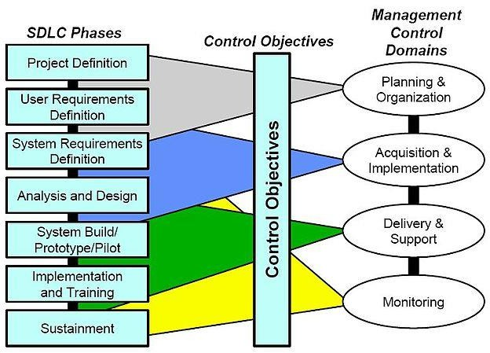

(source: <https://www.google.com/search?q=sdlc&source>)

#### WATERFALL METHODOLOGY

Waterfall is a sequential non-iterative design process. It involves six basic processes for which when each is completed, developer moves to the next step without moving backwards. This makes it inflexible to change. In a case where change must occur, the whole project has to be scratched from the beginning. This methodology creates no room for change; as a result, an extensive plan must be carried out from the beginning and then followed carefully.

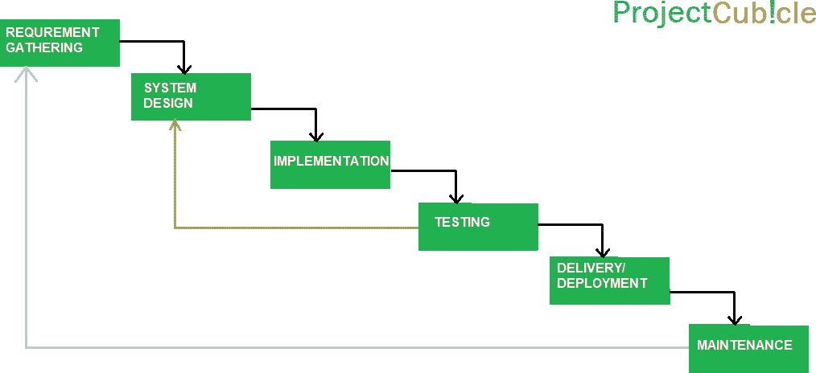

(source: https://[www.projectcubicle.com/wp-content/uploads/2018/04/Waterfall-](http://www.projectcubicle.com/wp-content/uploads/2018/04/Waterfall-) Project-Management.png)

Figure 2: Waterfall Diagram

#### Advantages of Waterfall Methodology

* Involves extensive planning. • It gives the client an exact picture of what the completed software will look like. This including budgeting and scheduling. • Waterfalls detailed documentation provides a backup in case of any unforeseen circumstances. • They are more suitable for large and complex projects.

#### Disadvantages of Waterfall Methodology

* It is inflexible to change. • Developer can’t go back to previous stage when a step is declared completed. • The whole product is tested at the end. Faults found at this stage are often very expensive to fix than when found earlier.
* This methodology does not take in account clients changing needs.

#### AGILE METHODOLOGY

Agile Methodology is an incremental software development process. It came as a solution to problems related to Waterfall Methodology. Requirements are iteratively

gathered and developed in small sprints weekly or monthly. At the end of each sprint, tests are run to discover faults or need for enhancement which will be implemented in the next sprint. It also involves its stakeholders in the process of development to make sure clients are satisfied. As a result, customer feedback is needed and incorporated into the design before the next sprint is run.

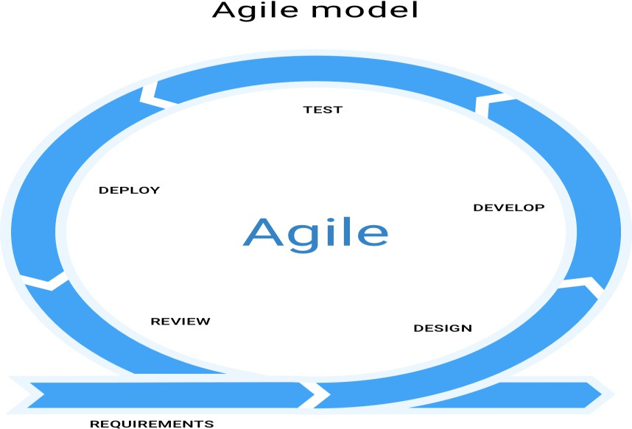

Figure 3: Agile development diagram

(source: https://producttribe.com/project-management/agile-sdlc-guide)

#### Advantages of Agile Methodology

* It allows changes to be made on the system. • It is easier to add features during system maintenance phase. • Customer feedback is of paramount importance. • Early testing allows less cost in bugs fixing.

#### Disadvantages of Agile Methodology

* Since some modules will be completed earlier than others, well defined interfaces are required like stubs and drivers. • Difficult sprints tend to be pushed to future development to ensure early and frequent software delivery. • Lack of detailed documentation fails to create back up in case of need for future reference.
  1. Methodology

The water fall model was developed with the “Iterative method”. The water fall model has been discussed above and its steps clearly shown. This methodology is suitable for the project at hand because the purpose of developing the system is to help couples resolve the problems they are facing at home on our online system. Unlike in agile methodology, it would be difficult to prioritize changes as a result of multiple stakeholders. In adopting the waterfall model, adequate time was taken to elicit requirements from clients to prevent catastrophic effects resulting from change of requirements.

This project work is used for the development of the online marriage crises resolution. Therefore, there are classified into phases according to the specific concerns and requirements of this project to ensure its success and for the following;

* Planning and Requirements: When developing a project, the first is to go through an initial planning stage to represent the specification documents, establish the software or hardware requirements and generally prepare for the next stages of the cycle.
* Analysis and Design: He next stages is the analysis to nail down the appropriate business logic, database models, and entity relationship diagram (ERD) will be required at this stage in the project. The design stage also occurs here, establishing any technical requirements (data layers, services, using use case, activity diagram etc.) that will be utilized in order to meet the needs of the analysis stage.
* Implementation: The actual implementation and coding process can now begin. All planning, analysis and design are documented up to this point and are coded and implementation into this initial iteration of the project.
* Testing: Once this current build iteration has been coded and implemented, the next step is to go through series of testing procedures to identify and locate any potential bugs or issues that have been hidden.
* Evaluation: Once all prior stages have been completed, it is time for a thorough evaluation of the development up to this stage. This allows the entire team, as well as clients, managers or other outside parties, to examine where the project is at, where it need to be, what can or should change, what should be included, and so on.

Hence, this is the entire iterative model, where by the built iteration of the software, as well as all feedback from the evaluation process, is brought back to the planning development stage at the top list, and the process repeats itself all over again.

* + 1. Method Questionnaire

Questionnaire is a very cheapest tools used in the requirement gathering, which allow facts to be gathered form a large number of people while maintaining some control above their responses. It contains questions asked to get statistically useful information about a specific topic.

A well designed questionnaire that is used effectively can gather information on both the overall performance of a system as well as information on specific components of the system both from employees and customers.

* 1. Tools and Techniques

The tools that ought to be used to make the work possible will be mostly computer based tools and requirements and also the techniques that will be used will be from the platform designed techniques which is done using many computer knowledge for designing software.

* 1. Ethical Consideration

The ethical consideration that will be followed with the logic use in designing software using the computer system requirements.

* 1. Requirements Analysis

This involves the tools that the researcher intends to use in making or designing the software that may be used for the work. This may come in the next aspect of our discussion. The following shall be used for analysis;

1. Dedicated application server with minimum specification, are as; Intel Core 2 Quad, Memory 2*2GB DDR3, Hard Disk 1 x 360 GB HDD SATA, Ethernet Card 10/100/1000 Mbps, Microsoft Windows 2003 Small Business Server.
2. Dedicated Microsoft SQL Server 2008 with minimum specification, are as; Intel Core 2 Quad Memory 2*2GB DDR3, Hard Disk 1 x 360 GB HDD SATA,

Ethernet Card 10/100/1000 Mbps, Microsoft Windows 2003 Small Business Server.

1. UPS with software to perform proper shutdown in case of power failure.
2. Wireless modem and Ethernet network card.
   1. Requirements Specification

System is a combination of software and hardware components, whose purpose is to provide services related to sales and purchase of goods. All the information is being stored in database, and retrieved when needed by means of display or print. There are three stakeholders involved in the system (Administrators, users and Bank). All the communication between the administrators and users has to be digitalized as part of this thesis and the communication with bank is out of the thesis scope. These requirements are elicited during informal meetings with the stakeholders within user. These requirements are divided into two main categories functional and non-functional requirements which are as following;

* + 1. Functional requirements

These include the functionalities under the different constraints that the proposed system should provide, according to the demands of all affected couples. From the system study, two couples were identified. These are systems accountant and the employee.

1. Users
   1. Shall be able to register
   2. Shall be able to express their problems.
   3. Shall be able to book appointment
2. Marriage Conflict Cases
   1. Shall be able to register
   2. Shall be able to post as new member
3. Administrator
   1. Shall be able to view registered members and couples needing resolution
   2. Shall be able to add new member’s categories
   3. Shall be able to view posted issues
   4. Shall be able to activate posted issues
   5. Shall be able to view conflict resolution cases
      1. Functional requirements

These include the services that the proposed system has to provide to the entire system users. The system will perform the following functionalities:

* Register new couples.
* Register new couples seeking resolution.
* Stores posted conflicts.
* Activate posted conflicts in marriage.
* Stores application.
  + 1. Non-functional requirements

These are constraints that should be imposed on the services provided by the proposed system. The system was designed to fulfill the following non-functional requirements.

* System should be complete and consistent that is, able to deal with all the possible outcomes during its operation.
* System should be robust that is, able to run on the specified platforms with no predictable failure.
* System should be able to sustain the heavy load offered to it due to network requests (provide high performance in all situations).
* The application shall Process data, load pages, browser refresh times, etc.. promptly
* All its operations should be correct, that is, should produce expected results when supplied with the right inputs.
* System should be reliable, up and running every time its operations are needed.
* System should verify/validate all user input and users must be notified in case of errors.
* The system should only allow system administrators to delete records.
* The application will be secured against hackers
* Application will be able to resist change without adapting its initial stable configuration – operational characteristics with growth.
  1. System Design

In this part, the tools that would be used in developing the system will be carefully discussed. The justifications and reason for choosing the specific tools will be also be discussed. Context diagrams and data flow diagrams (DFDS) were used for process modeling to show the logical flow of data and represent processes in the system. More so, entity relationship diagram (ERD) was used as the main tool for designing the database.

Registration

Marriage Seeker

Couples

Administrator

Account Profile

New cases Post

Resolution ekers

New post Category

Posted Cases

Available Issues

Account Profile

### Online Marriage Resolution System

Posted Cases

Post Activation Couples Applications

Registration

Couples Application

#### Figure 4: Data Flow Diagram(DFD)

* + 1. Application Architecture

This chapter includes the detailed design used to build the online application. The system's design is used to create the functions and operations of the gathered requirements in detail, including screen layouts, platform rules, process diagrams, and other documentation. The output of this chapter describes the new system which is defined as a collection of modules and subsystems. This design stage takes the initial input requirements that were identified in the approved requirements specification document. For each requirement, there is a set of one or more design elements that are produced using the different prototypes. These design elements describe the desired software features, in detail, including functional hierarchy diagrams, screen layouts, activity diagrams, and class diagrams. The intention of these diagrams is to describe the software in detail so that the system can develop the application with less additional design input. The system’s mock screen shots are shown later in this chapter.

Email/Phone number

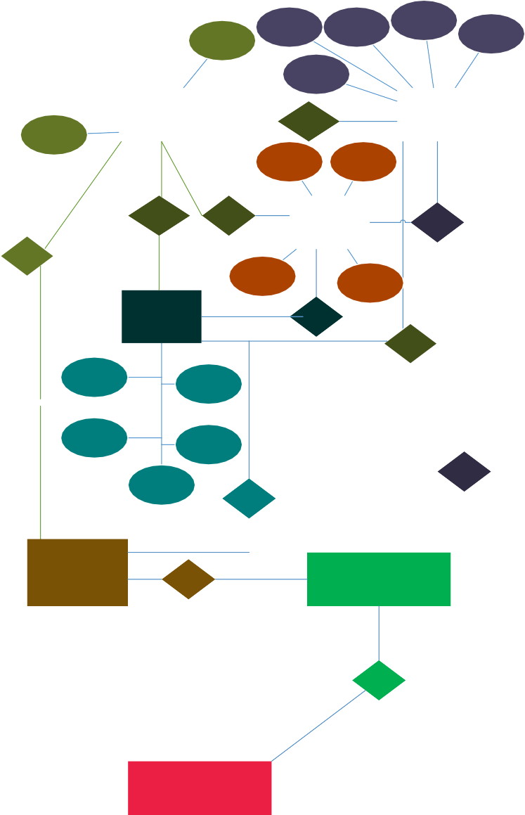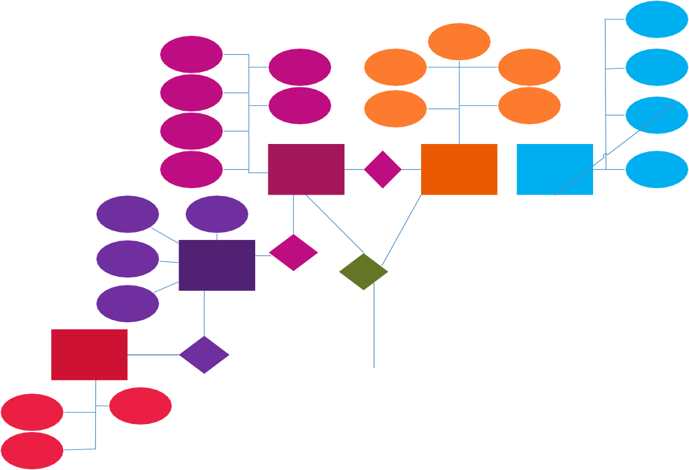

Dashboard

Inbox

has

Picture

Settings

Fix up time

Reciever

Message

Name

Address

Notification

appointment type

Sender

approved by

Email

Name

Dashboard

has

Appointment

Court Form

Purpose

sender name Message

sender email

Inbox

has

has

has

recieved time

Gender

Marital status

Gender

Email

working hour

Cases Handled

Sent Message

has

Name

Name

Reciever email

Sent time

Email

USER

book appointment

LAWYER

has

Message

Sign-up/sign-in

Contact

has

Book appointment

Sign-up/Sign-in

**PROBLEM FREE**

Activity

Sign-up/Sign-in

blog post

appointment blog comment

has

FAQs/Cases

About Us

has

Dashboard

**COUNSELLOR**

Sign-up/Sign-in

Direct counselee

Gender

Working hour

Post

Inbox

has

Email

Cases Handled

Post content

Poster name/pic/ email

Name

Post

Post

attachment

Name

Blog

has

contact us

Email

Subject

comment msg

Comments

Post time Post comment

subscribe

has

commentor email

has

can contact

Message

comment time

can check

Ghost User

Abuse Report

can subscribe

Subscriber

problem free

Figure 5: Application architecture

User

forget

password?

Sign in

reset password

get username/

email

input

username

input password

send password

reset code to email

verify password

reset code

get new password

if either of the input is wrong

reset password

dashboard

Figure 6: Application architecture of the user



**dashboard**

**Home**

**User**

sign in

open dashboard

show dashboard details

Request for appointment

Get appointment details

return counsellors/lawyers and infos

Return counsellors/lawyers and infos

choose counsellor/lawyer and appointment schedule

schedule appointment

send appointment schedule email

inbox scheduled appointment

**schedule appointment**

Figure7: Application architecture of admin

* + 1. Use Case

The system’s use case shows the user a detailed view of the system and how the actors would interact with each other and with the system. The explanation for each use case is then provided below the system use case for the administrator and the user, helping the user to understand who the actor’s areas are as well as giving the description for each use case along with its pre- and post-conditions that should be satisfied once the use case is implemented in the software.



Single Blog

<<extend>>

Registration

contact us <<include>>

Email

Guest

single Blog

<<extend>> Member Blog

contact us

<<include>>

Counsellor

User

dashboard

<<include>>

login

<<include>>

<<extend>>

<<extend>>

Book

Appointment

Fix

appointment

<<include>>

Lawyer

Request a

Lawyer

<<extend>>

Choose lawyer

fix

appointment

<<extend>>

Court

Direct to court

Court Order

#### Figure 8: Use Case Diagram

* + 1. Data Design

The users of the online application, based on their roles, are users and the administrators. These users are identified based on their preference.

* + - 1. **Admin:** The administrator is the owner of this online application. One must have a basic understanding of computers and the internet as well as prior knowledge for operating the eclipse and Java programming languages. The administrator is responsible for maintaining all the training documents required for the system. The administrator can perform the following functions:
         1. the Administrator to have the highest privilege to add, delete and modify
         2. View the activities going on the platform
      2. **Users:** The users of this online application are all users and administrators who would register to test the application. They must have basic understandings about

computers and the internet. The users should be able to perform the following functions using this system:

* + - * 1. View, browse, and select a category on the home page.
        2. View, add, and share stories on the blog.
        3. Sign-on/login using a username/email and password.
    1. Activity Diagram

This section lists the activity diagram and describes the flow of activities in the system. A detailed description is then given after the figure for each activity. Figure 7 provides the overview of the activity of online t application. The figure below demonstrates the activity flow for this online application. The flow of the application is similar for both the user and administrator. The flow begins when the user first runs the application home screen online application that appears in the web browser. The user can browse through the available list of categories and can choose either to select a category or to directly view his/her dashboard(profile). From the users dashboard the user can view more information from his/her dashboard(profile). The user can then decide to either continue from his/her dashboard(profile) or go back to the home page. After the user have selected the category the user is interested in either through his/her profile or home page, user can book an appointment with the registered administrator he/she want to see or you can send an email to the administrator the user want to see. Then you wait for the administrator to get back to you



Administrator

Users

Add, control, edit,

delete

View home, about

category, login

Single blog

View a member

Shared

Activity

Shared your

stories

View discussion

View Feedback

Reported cases

Resolution

Member

Discussion

#### Figure 9: Activity Diagram

* + 1. Data flow Diagram

1. **User Authentication:** This class is utilized to get user information from the database and is for authenticating the users. The class diagram in Figure 4 shows the methods that are used in this class and the description of each class is listed below.
2. **Authenticate User:** This message is used to authenticate a particular user who has provided the login credentials and wishes to login in the system. This method checks the credentials in the database.
3. **Check User Name/ Email:** This method checks to see if the provided username already exists in the database. If there is an existing user with the same name, then the user is prompted to select another username to create an account.
4. **Register User:** This method allows a new user to register for an online shopping-cart account by entering a valid username and password. If the username already exists in database, the user will be prompted to choose another name.
5. **Login User:** This method allows the existing users to log in to the database with the credentials they used for first registering into the application.
6. **DB Controller:** This class is used for getting users and product information from the database, and it is also used to update the database with the information about new-user registration, and user details.
7. **Initialize DB:** This method allows the initialization of a database on the first run of the application.
8. **Identify marital List:** This method fetches all items from the code/workspace into the database and allows the administrator to view information about the items.
9. **Retrieve User’s Details:** This role locates all the registered users in the database and also fetches any new user who registers by completing the user- authentication form.
10. **Get connected with conflict Details:** This role updates the row in the database with the details of the user who checks out the marital conflict details and successfully gets connected.
11. **Get resolution Details:** This role inputs the details of the resolution processes once the details are checked out and the request is successfully placed. This role updates the row in the database to show the details of resolution techniques that have been checked out.
12. **Get Checkout Information:** This method provides information about various marital resolution attitudes once the checkout method is called. This will further invoke the user-authentication method.
13. **Get User Authentication:** This method fetches the user-authentication information. The request order class is invoked once all three methods are successfully called. If the user authentication fails, the request-order class is not executed.
14. **Retrieve discussion Form Information:** This method is executed once user authentication is a success. If any of the information is incomplete or is invalid, then an error message is depicted.
15. **Get connected with other couples:** This method gets all the couples connected facing major marital crisis online. If the count of their issues is close ranging, then this function updates the discussion forum information, indicating that there is a discussion taking place for which then calls for interactive section for couples.

#### 3.8.7 User Interface Design

The two interface types found in the application are as follows:

**User Interface**: The user can browse through the available list of categories and can choose either to select a category or to directly view his/her dashboard(profile). From the users dashboard the user can view more information from his/her dashboard(profile). The user can then decide to either continue from his/her dashboard(profile) or go back to the home page. After the user have selected the category the user is interested in either through his/her profile or home page, user can book an appointment with the registered administrator he/she want to see or you can send an email to the administrator the user want to see. Then you wait for the administrator to get back to you.

#### Admin Interface

**Hardware Interface:** The online application shall provide minimum hardware requirements. The following hardware configurations are required for a PC using the

online application: Pentium processor, 32 MB of free hard-drive space, 128 MB of RAM.

**Software Interface:** This section lists the requirements that are needed to run the system efficiently. The operating system needed for the system to run effectively, the interface to run the application, the driver for running Java web applications, the integrated development environment to develop the application, and the third-party tool used for editing purposes are as follows:

1. Operating System: Windows (Vista/Windows 7) or MAC OS.
2. Web Brower: Internet Explorer (8.0 and above), Mozilla Firefox (3.0 and above), or Google Chrome.
3. Drivers: Java Runtime Environment.
4. Integrated Development Environment: Eclipse Juno or Apache Tomcat.
5. Third-Party Tool: Microsoft Word

Figure 10: User interface of the index page

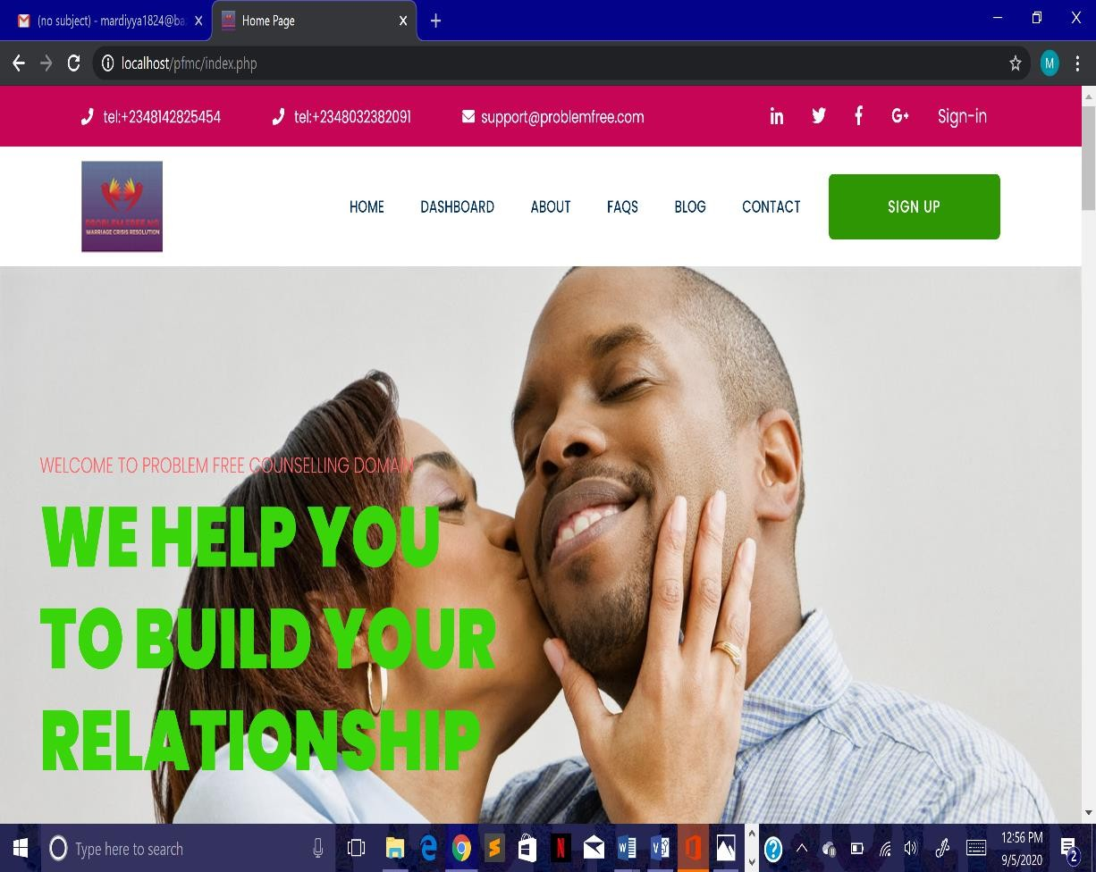

Figure 11: User interface of the users profile

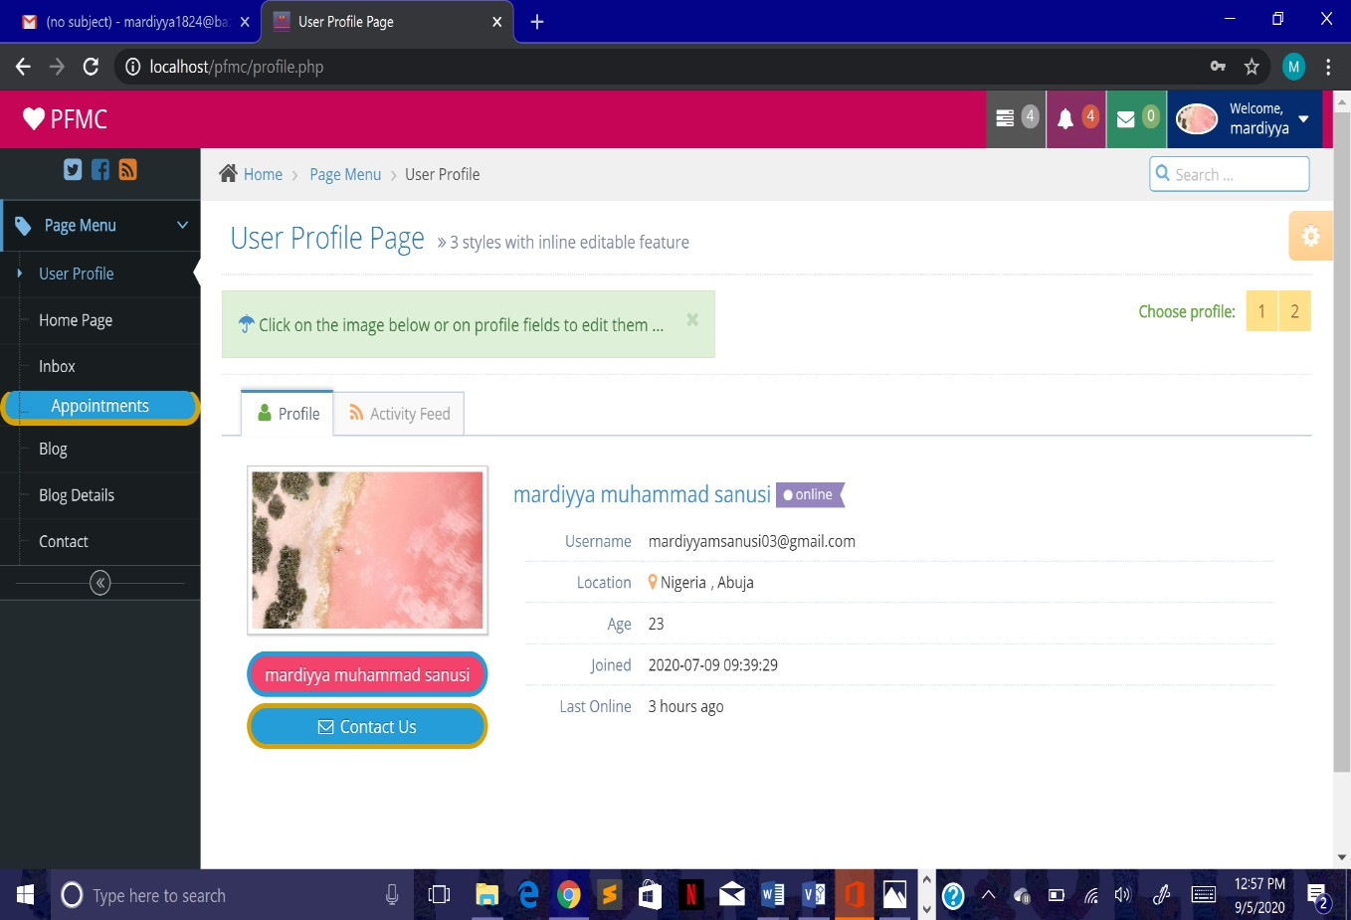

Figure 12: User Interface of the register page

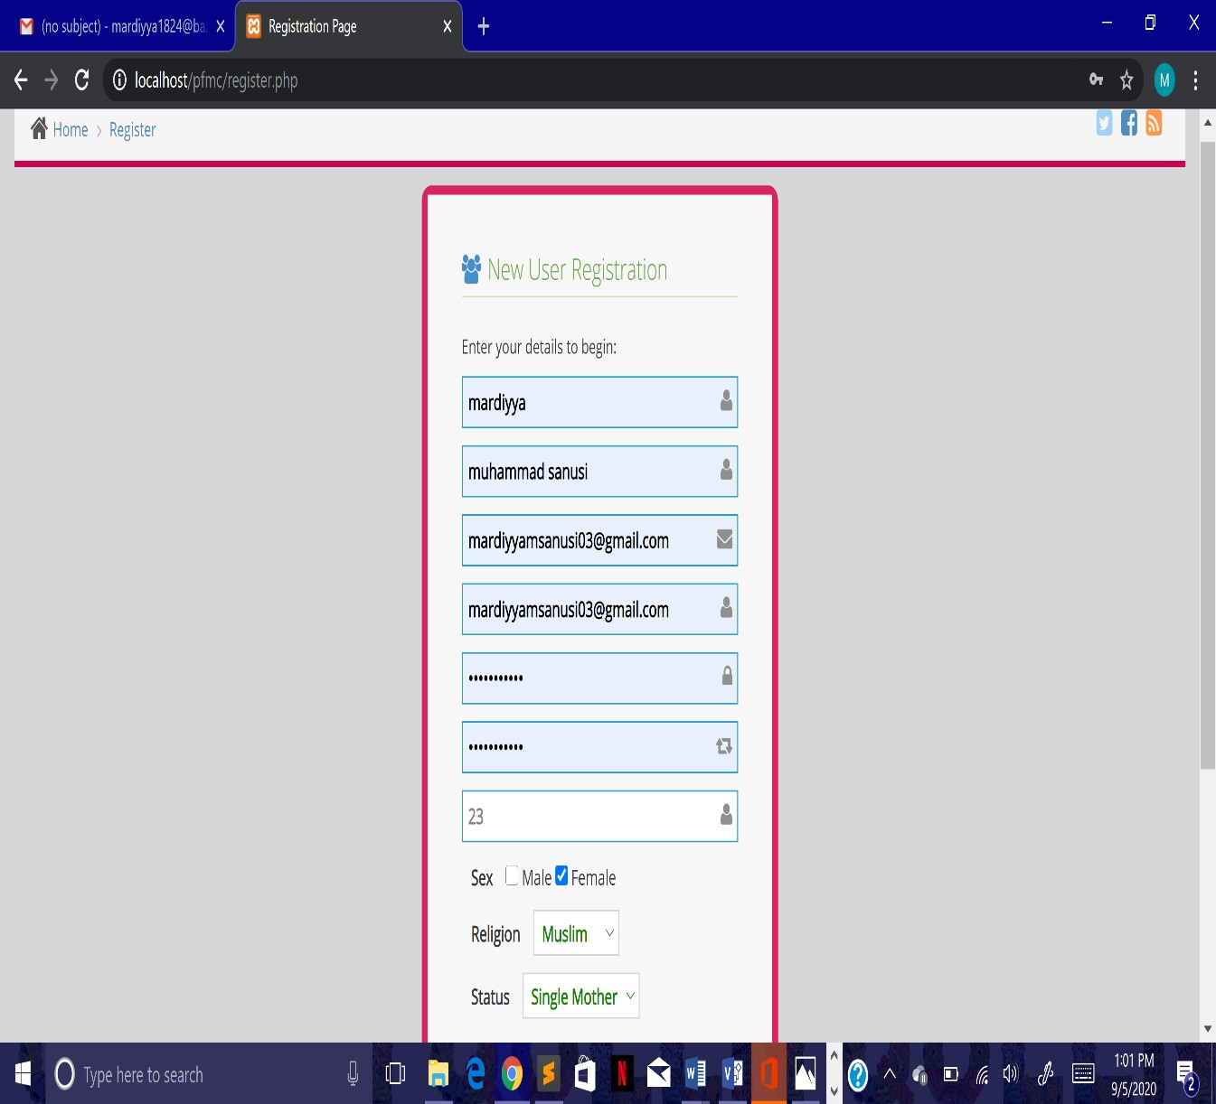

#### Summary

This chapter introduces us and gives us some significant ways to which the researcher intends to design a working application that will be used for an online marital crisis resolution by those interested in applying the online process of marriage resolution platform using ICT for couples and families in Nigeria.

CHAPTER 4: IMPLEMENTATION AND TESTING

* 1. Introduction

This chapter introduces the developed application with emphasis on how it was developed. This chapter further shows the methodologies used in testing the application. The implementation environment used to support the system was Microsoft windows xp and the main scripting languages used were php/JavaScript. Sample interfaces in use and source code is included in appendix.

* 1. Functions Provided By the System
* Register new couples.
* Register new couples seeking resolution.
* Stores posted conflicts.
* Activate posted conflicts in marriage.
* Stores application.
  + 1. The monitoring system

The relations were created using a java script that runs on a database that was created on a command prompt. Primary keys uniquely identify all entries and checks duplication while foreign keys link tables and enhance referential integrity. Data manipulation that is inserting, deleting, retrieving and ordering of outputs for any search was done at this level.

The system was designed under Linux environment to ensure better security implementations. The database was done using MySQL and php scripting because it’s fast processing especially under internet access.

* + 1. Data manipulation

SQL is used in the data manipulation i.e. inserting, deleting, retrieving and ordering of outputs for any search.

* + 1. Scripting

Scripting helps web pages come live by allowing the developer manipulate elements of a web page dynamically as a client browses that page. Php was used to make the system dynamic. Codes written such that the database is searched in a predetermined format using a user supplied clue.

* + 1. Interface

The interface was designed using hypertext markup language (html). This makes up the overall graphical user interface in which php was embedded to carry the appropriate Sql queries that fetch data from MySQL database.

* + 1. Form input design

MySQL and Php are used to enter data, change data, view and print data. Forms offer the most convenient layout for entering data, changing data, and viewing database. The following are forms that were created

* 1. Main features

Figure 13: index

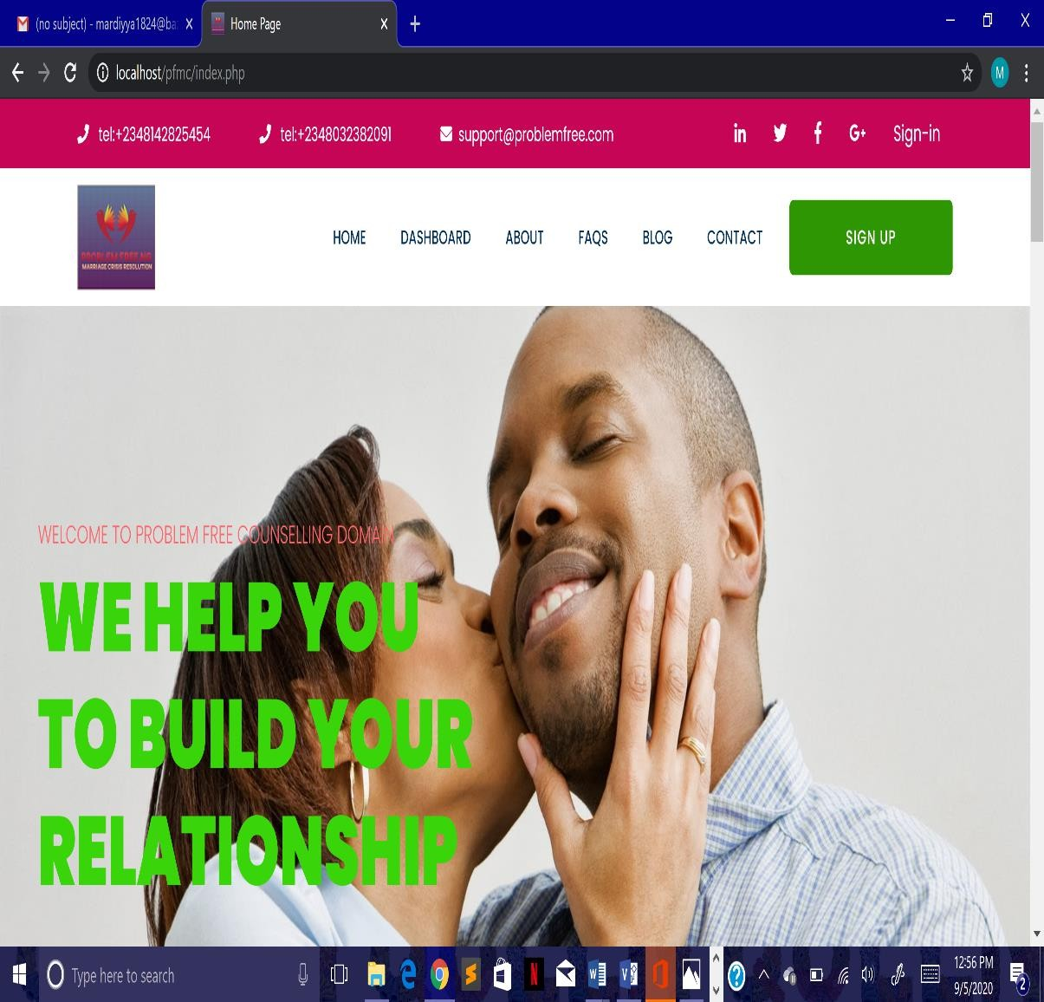

Figure 14: Login

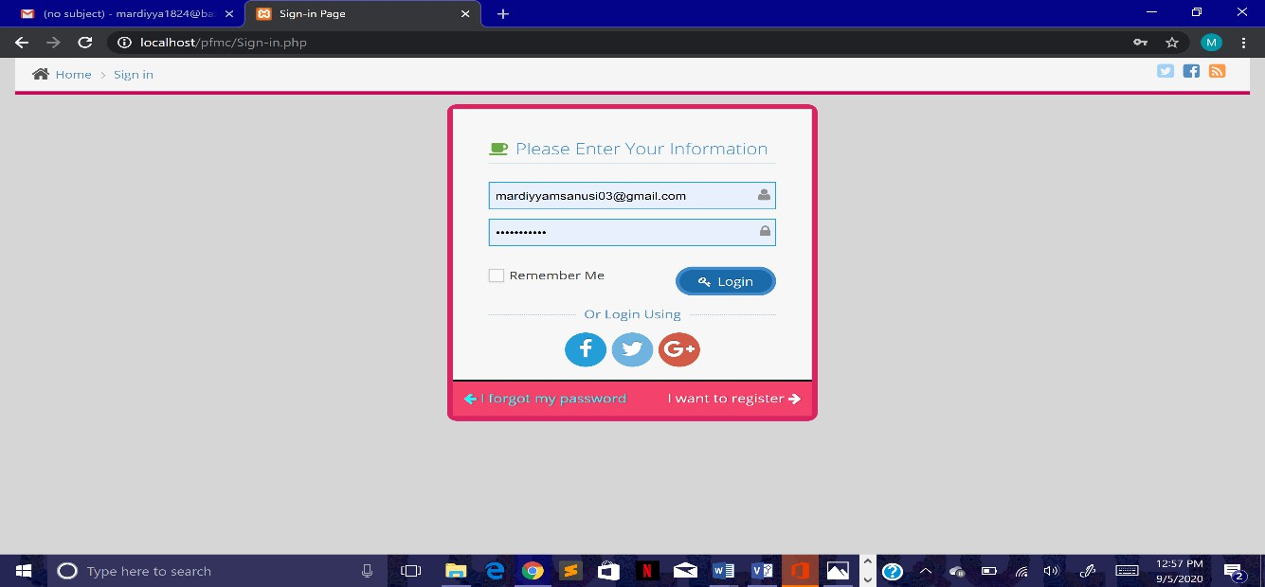

Figure 15: Request page

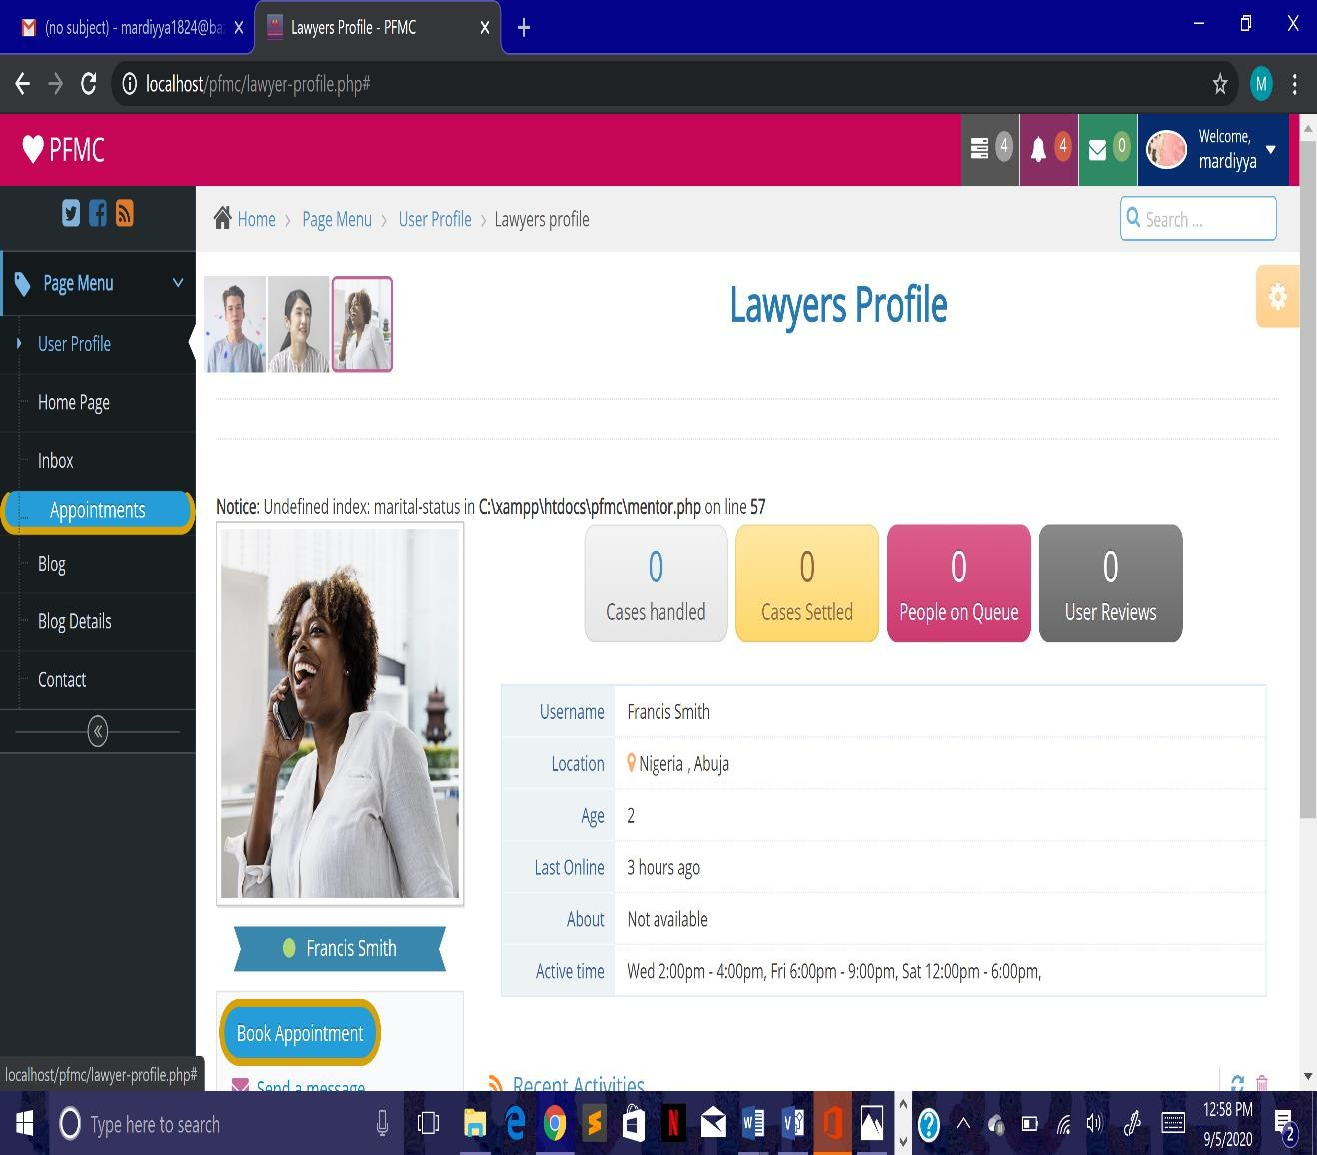

Figure 16: User profile

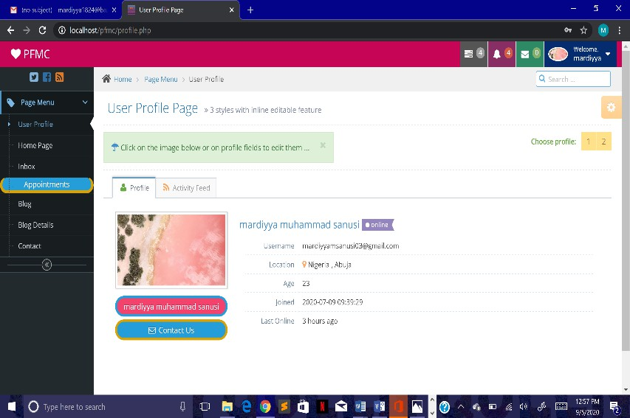

#### Figure 17: FQA

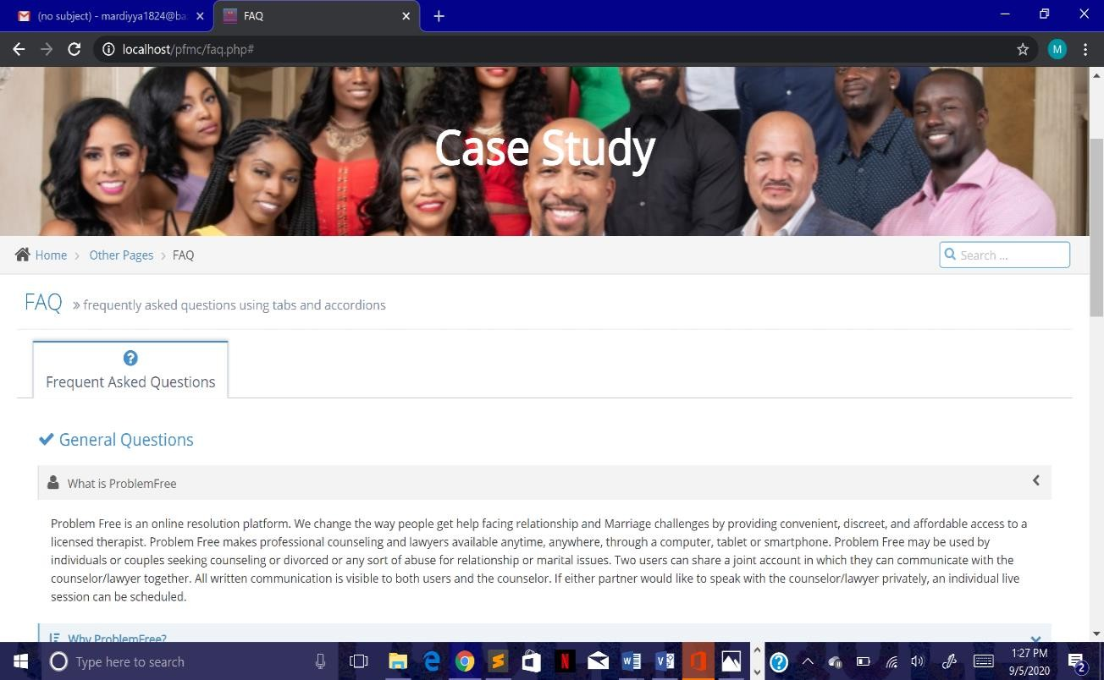

* 1. **System Testing and Validation**

Software testing is the process of checking the performance of a software program in order to ensure that it is working according to its designated requirement. Furthermore, this involved execution of the system in order to determine whether it matches its specification and executes as per the design. The following testing strategies were couples to carry out application testing of the online marriage resolution system.

#### Testing strategies

* + - 1. **User testing:** A number of users were randomly selected to test the system interfaces and to comment on the usability of the system.
      2. **Unit testing:** Each executable component of the system was tested for the desired functionality.
      3. **Functional or system testing:** Modules were integrated and tested as a whole. The different modules were integrated to come up with one functional system, the includes admin login, couples login and resolution seeker login which was then be tested as a whole to make sure that it meets the general objectives of the project.

#### Test plan

Test cases analysis and results

a. Login:

1) **Description:** These test case scenarios test the login function of the online marriage resolution system. The requirements are that if the user specifies a valid couple’s id and password he will be logged in to the system. Otherwise he/she cannot register. The test result is presented below (see table below).

Procedure specifications: in order for the test cases to be initialized, we open our browser and start our Xampp server which allows us to have access to the system, by clicking on the local host which brings us to our home page.

Procedure specifications: as in a (2) above.

|  |  |  |
| --- | --- | --- |
| **Test case** | **Test Scenario** | **Expected outcome** |
| Tc.1.1. Valid user name and password | Tc.1.2. Enter “aliyuabu” in user field  Tc.1.3. Enter “abualiyu” in password field  tc.1.4. Click on “log in” | Tc.1.5.login successful, user is logged in to the system. |
| Tc.1.6. Wrong password | Tc.1.6. Enter “aliyuabu” in user field  Tc.1.7. Enter “abuali” in password field  tc.1.9. Click on “log in” | Tc.1.8. Error  Tc.1.11. Login failure  Tc.1.12. User asked to login again. |
| Tc.1.13. Wrong username | Tc.1.14. Enter “abualiyu” in user field  Tc.1.15. Enter “aliyuabu” in password field  Tc.1.16. Click on “log in” | Tc.1.17. Error  Tc.1.18. Login failure  Tc.1.19. User asked to login again. |

#### Change password

Description:

These test case scenarios test the change password function of the online recruitment system. The requirements are the user should be able to change password to another than the default. The test result is presented table 2.

Procedure specifications: as in a (2) above.

|  |  |  |
| --- | --- | --- |
| **Test case** | **Test Scenario** | **Expected outcome** |
| Tc.1.142. Change password. | Tc.1.143. Open “preferences”.  Tc.1.144. Chose “change password”.  Tc.1.145. Enter “whatsup” in field “new password”  Tc.1.146. Enter “whatsup” in field “confirm password”  Tc.1.147. Click on “change password” button.  ” | Tc.1.148. Password is changed in database  Tc.1.149. The user is notified through a message box that the operation was carried out successfully. |
| Tc.1.150. Change password with invalid confirmation | Tc.1.151. Open “preferences”.  Tc.1.152. Chose “change password”.  Tc.1.153. Enter “whatsup” in field “new password” | Tc.1.156. No change in password takes places.  Tc.1.157. The password fields are emptied. |

|  |  |  |
| --- | --- | --- |
|  | Tc.1.154. Enter “what” in field “confirm password”  Tc.1.155. Click on “change password” button. |  |

1. Post new Scenarios
   1. Description: These test case scenarios test the how the couples can post a new on the online resolution system. The couples can find as many resolution contributions needed as much as possible when he is registered

#### View Resolution process Available

* 1. Description: These test case scenarios test the how a resolution seeker can view various resolution processes available in the system by clicking the resolutions category on the home page.

#### Admin login

* 1. Description: These test case scenarios test the admin login to view the registered couples, resolution seekers and new contributions tested
     + We have tested the couple’s login against this test plan and that the test results expected have been achieved successfully.
     + I have tested a representative sample of data including a range of unusual cases
     + There are no major issues preventing discussions go live.

#### System requirements

In order for the system to perform as expected, the following system specification for hardware and software, security and operations are required.

#### Table: Hardware Requirements

|  |  |
| --- | --- |
| Hardware | System requirement (minimum) |

|  |  |
| --- | --- |
| Processor | Intel pentium iv |
| Memory | 512 mb ram (1024 mb recommended). |
| Disk space | 2gb |
| Usb port | Version 2.0 |

1. **Table: Software Requirements**

|  |  |
| --- | --- |
| Software | System requirement |
| Operating system | Microsoft windows xp or higher |
| Web browser | Mozilla, ie etc |

* 1. Error Reports and Corrections

No error report was detected in testing stage.

* 1. User Guide

I install XAMP, SUBLINE TEXT with MICROSOFT SQL SERVER

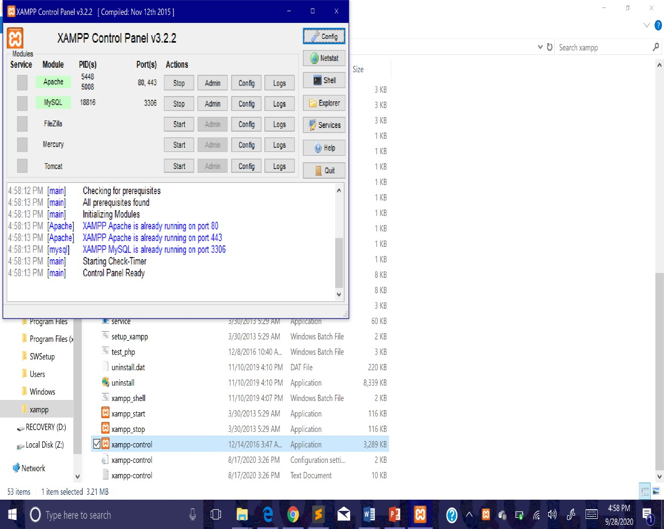

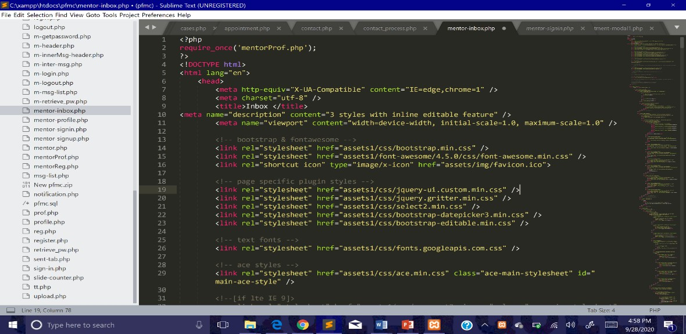

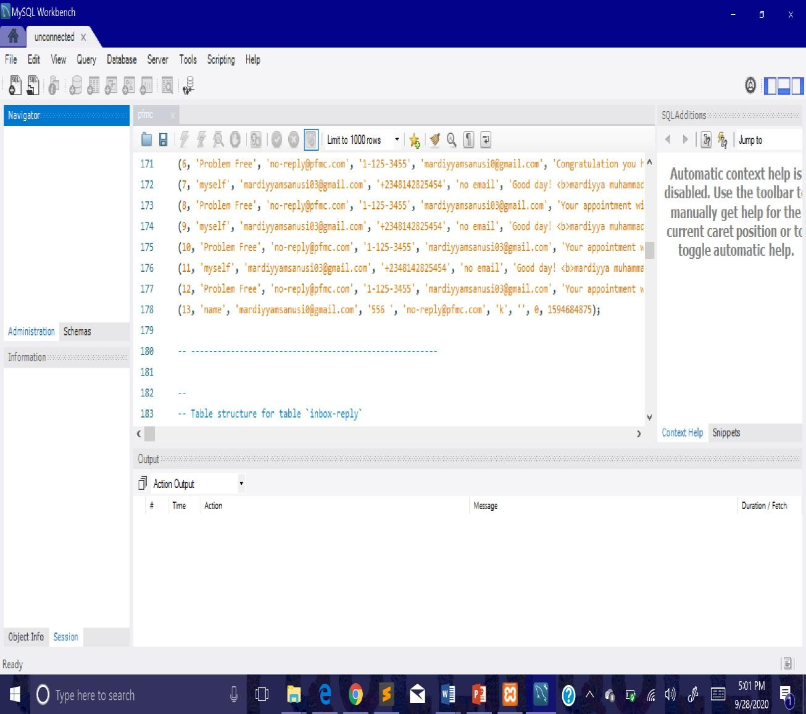

* 1. Summary

Chapter four of this document provides details as to how some aspect of the software were implemented discussing the IDE used, the kind of database used, and the hardware among others. The chapter also talks about the various testing the software was subjected to and how challenges faced during implementation were resolved.

#### CHAPTER 5: DISCUSSION, CONCLUSION, AND RECOMMENDATIONS

#### Introduction

This chapter consists of the concluding remarks from the project, the recommendations and future work that will lead to more of the research in the automation field (in relation to technology) as far as the recruitment is concern. We have seen how the functional requirements gathered during system study are represented in form of a model. The context diagram, data flow diagram, class diagram, the diagram were the modeling techniques used. They contributed in modeling both physical and conceptual models of the system. Besides modeling the system’s functionalities, usability prototypes were used to depict the interface of the modeled system. Finally, review was conducted to validate the both the models and their supportive prototypes. The review provides focus to the next increment as both negative and positive feedbacks were collected.

#### Objective Assessment

The achievements that were made out of this whole project are:

* + - Ability to write this document up to its standard
    - Ability to understand mostly how php/JavaScript works.
    - Ability to have a feel of how software development is in real life.
    - Ability to develop a platform on marriage crisis resolution

#### Limitations and Challenges

**The challenges that were faced are;**

* + - Hardware failure: while undertaking this project, the operating system of my computer crashed, I had to change my system completely
    - Money: the cost of hosting the application, registering a domain name and also fixing laptop**.**

#### Future Enhancements

* + - The user will be able to post on the blog
    - We will register with human right incase of domestic violence
    - We will add pre-marital counseling.

#### Recommendation

The online resolution centers/agencies should improve their existing system which is manual system by online system that can handle all the functionality of the system so this system will help the users the couples, resolution contributors and seeker and the administrator of the system so in that case they will gain profit for using the system.

#### Summary

The developed online marriage crises resolution system was successfully developed achieving all the stated objectives. The system allows a user to register and log into the system and select any category. All these functions were successfully designed.

#### References

Amadi U.P.N (2009): Gender Sensitivity Education and Sustainability of Africa's Dynamic Socials Values. A Paper Presented at a National Conference held at the Federal College of Education (Tech.) Umunze from 17th -22nd October.

Amato PR, Rogers SJ. 2012. A longitudinal study of marital problems and subsequent divorce. *J. Marriage Fam.* 59:612.24

Awake (2008): Marriages in Distress. How can you make your marriage a success? The Watch Tower Magazine (July edition). Pennsylvania: The Watch Tower and Tract Society.

Baucom DH, Epstein N, Rankin LA, Burnett CK. 1996. Understanding marital distress from a cognitive-behavioral orientation. In *Advances in Cognitive Therapy*, ed. KS Dobson, KD Craig, pp. 210.36. Thousand Oaks, CA: Sage

Bright-Brock Utre (2001). ―Indigenous Conflict Resolution in Africa‖. Institute of Educational Research, University of Oslo, pp. 8-11.

Buckwell, P.J. (2010): Marital Crisis Resolution Coping with Adultery. New York: Cowling Investigation incorporation.

Burman B, Margolin G. 1992. Analysis of the association between marital relationships and health problems: an interactional perspective. *Psychol. Bull.* 112:39.63

Dee Haans, W (1986): Keys to a Happy Marriage *http://www.thoughts-about- god.CQmdownloaded21/11/2010).*

Edger, D (1996): What will Make Marriage Work. Family Marital Relationships. In Sper, D (ed) Radio Bible Class. Michigan: Grand Rapids Incorporation.

Ehrensaft MK, Vivian D. 2011. Spouses. Reasons for not reporting existing marital aggression as a marital problem. *J. Fam. Psychol*. 10:443.54

Fincham FD, Bradbury TN. 1991. Marital conflict: towards a more complete integration of research and treatment. In *Advances in Family Intervention, Assessment and Theory*, ed. JP Vincent, 5:1.24. Greenwich, CT: JAI

Glenn ND. 2011. Quantitative research on marital quality in the 1980s: a critical review.

*J. Marriage Fam.* 52:818.31

Gottman JM, Markman HJ, Notarius CI. 2011. The topograpy of marital conflict: a sequential analysis of verbal and non-verbal behavior. *J. Marriage Fam.*

39:461.77

Heavey CL, Christensen A, Malamuth NM. 1995. The longitudinal impact of demand and withdrawal during marital conflict. *J. Consult. Clin. Psychol*. 63:797.801

Heyman RE, Eddy JM, Weiss RL, Vivian D.2012. Factor analysis of the marital interaction coding system MICS. *J. Fam. Psychol.* 9:209.15

Isurmona V.A. (ed.) (2005). *Problems of Peacemaking and Peace Keeping. Perspective on Peace and Conflict in Africa*, Ibadan: John Archers Publishers Ltd.

Kluwer ES, Heesink JAM, Van de Vliert E. 1997. The marital dynamics of conflict over the division of labor. *J. Marriage Fam.* 59:635.53

Kurdek LA. 1994. Areas of conflict of gay, lesbian, and heterosexual couples: What couples argue about influences relationship satisfaction. *J. Marriage Fam.* 56: 923.34

Lindahl K, Clements M, Markman H. 1998. The development of marriage: a nine-year perspective. See Bradbury 1998, pp. 205.36

Margolin G. 1988. Marital conflict is not marital conflict is not marital conflict. In *Social Learning and Systems Approaches to Marriage and the Family*, ed. R Peters, RJ McMahon, pp. 193.216. New York: Brunner/ Mazel

McGonagle KA, Kessler RC, Schiling EA. 1992. The frequency and determinants of marital disagreements in a community sample. *J. Soc. Pers. Relat.* 9:507.24

Noller P, Feeney JA, Bonnell D, Callan VJ. 1994. A longitudinal study of conflict in early marriage. *J. Soc. Pers. Relat.* 11: 233.52

O.Leary KD, Smith DA. 2011. Marital interactions. *Annu. Rev. Psychol.* 42:191.212

Olaoba, O.B. (2005). Ancestral Focus and the process of conflict resolution in Traditional African societies‖: Albert, A. O. (ed.) *In Perspectives on Peace and Conflict in Africa in Essays in Honour of General (Dr) Abdul Salam A, Abubakar*, Ibadan: John Archers Ltd.

Okon, I.E(2010): How to make your Marriage Work :Daily Sun Newspaper (Tuesday, May 25p.19).

Onigu, Otitie & Albert, I.O. (Eds.) (2001).*Community Conflicts in Nigeria, Management, Resolution and transformation*. Ibadan, Nigeria: Spectrum Books Limited.

Roberts LJ, Krokoff LJ. 1990. A time series analysis of withdrawal, hostility, and displeasure in satisfied and dissatisfied marriages. *J. Marriage Fam.* 52:95.105

Sagrestano LM, Christensen A, Heavey CL. 2010. Social influence techniques during marital conflict. *Pers. Relat*. 5:75.90

Stone AA, Neale JM. 1984. New measure of daily coping: development and preliminary results. *J. Pers. Soc. Psychol.* 46: 892.906

Punier, Gerard (1995). *The Rwanda Crisis: History of Genocide*. New York.

Vangelisti AL, Huston TL. 2009. Maintaining marital satisfaction and love. In

*Communication and Relational Maintenance*, ed. DJ Canary, L Stafford, pp.

165.86. New York: Academic

Wasson, N (2010): How to keep Hope Alive during a Marriage Crisis

*(*[*http://www.savemvmarriage.com/articfes /rnanagemenldownloaded29/1 1/2010*](http://www.savemvmarriage.com/articfes/rnanagemenldownloaded29/1%201/2010)*).*

Williams, Z.I. (ed.). (2000). Traditional Cures for Modern Conflict. *African Conflict Medicine 2000*, Lynne Reiner Publisher Inc, Pp22-23

Zhekwo, Y.K (2009): Defining the New Testament Logic on Divorce and Remarriage in a Pluralistic Context. London, Pickard Publications.

APPENDICES

Appendix A - Project Document

The detailed project specification document for design and implementation of online resources for marriage crises resolution

Detailed project specification Candidate Name: Sanusi Mardiyya Muhammad Student No: BU/15C/IT/1824

design and implementation of online resourses for marriage crises resolutiuon Course: B.Sc. Information System Management.

Appendix B - Questionnaire

The following proceeding are questions between Sanusi Mardiyya Muhammad and Mr & Mrs Samir on January 2020.

Question: Sanusi Mardiyya Muhammad: Hello Good Afternoon Answer: Mr & Mrs Samir: Good Afternoon

Question: Sanusi Mardiyya Muhammad: I am Mardiyya from Baze university. Am here to tell you about my project, which I think it will help you improve your marriage. Answer: Mr & Mrs Samir: Okay, We are listening.

Question: Sanusi Mardiyya Muhammad: please can you tell me all about the problems you are faced with? Answer: Mr & Mrs Samir : well yes, we have been having misunderstanding between us

Question: Sanusi Mardiyya Muhammad: thank you, but do you have any idea of what you want? Answer: Mr & Mrs. Smir: no. I leave it in your hands but I want something that would help our marriage.

Question: Sanusi Mardiyya Muhammad: ok thank you, i am current building a platform which provide resources for marriage crises resolution. If I’m to build this platform, do you think you will use it and do you think it will be of help to you? Answer: Mr & Mrs. Smir: yes, we will surely use it and we do think it will help us a lot.

Appendix C – Source Codes

Please refer to the CD-ROM Attached at the end of this document.