**DESIGN AND CONSTRUCTION OF JOURNAL BEARING DEMONSTRATION RIG**

**BY**

**INYAMA GODWIN OKECHUKWU ME/2008/101**

**DEPARTMENT OF MECHANICAL ENGINEERING FACULTY OF ENGINEERING**

**CARITAS UNIVERSITY ENUGU**

**AUGUST 2013**

# TITLE PAGE

# DESIGN AND CONSTRUCTION OF JOURNAL BEARING DEMONSTRATION RIG

### BY

**INYAMA GODWIN OKECHUKWU ME/2008/101**

### SUBMITTED TO THE DEPARTMENT OF MECHANICAL ENGINEERING IN PARTIAL FULFILLMENT OF THE REQUIREMENT FOR THE AWARD OF BACHELOR OF ENGINEERING (B.Engr.) IN MECHANICAL ENGINEERING

**AUGUST 2013**

##### CERTIFICATION

This is to certify that this project work the **“Design and Construction of a Journal Bearing Demonstration Rig”**, was carried out by **INYAMA GODWIN OKECHUKWU** with registration number **ME/2008/101** as a final year project submitted to the Department of Mechanical Engineering, Caritas University, Amorji-Nike, Emene, Enugu in fulfillment for the award of Bachelor of Engineering (B.Engr) in Mechanical Engineering.

Engr. Igwe Johnson

………………………. ……………………….

***(Project Supervisor) Date***

Engr. Ben Iyida

……………………….. …………………………

***(Head of Department) Date***

***Mechanical Engineering***

External Supervisor

……………………… ………………………....

##### Prof. A. O Odukwe *Date*

**DEDICATION**

This work is dedicated to the Almighty God for giving me the inspiration and grace to carry out this project successfully and also to my beloved mother, Mrs Grace Inyama and siblings, who have been sources of blessings to my life.

##### ACKNOWLEDGEMENT

I express my sincere and profound gratitude to my supervisor Engr. Igwe Johnson for his advice and encouragement. I specially thank him for his instructions and constructive criticisms which all lead to the success of this project work.

I am deeply indebted to my lecturers, Engr. S. Ezenwelu, Dr. Ujam, Dr. Nwankwojike Nduka, Engr. (Mrs.) Mary Onyia, Engr. Modestus, Engr. Ani, and others too numerous to mention, who have all been sources of wisdom throughout my undergraduate studies.

I also want to thank in a special way the Dean of the faculty of Engineering, Prof. S. N. Ojobor and the H.O.D. of the department of Mechanical Engineering, Engr. Ben Iyida, for being sources of motivation and inspiration to me.

I owe an unreserved appreciation to my mother Mrs. Grace Inyama for her love and support and also to my siblings, friends, and course mates.

Above all, to God be all glory and thanksgiving for his mercies and love towards me and the successful completion of my degree program.

##### ABSTRACT

The journal bearing demonstration rig is an apparatus which is used to study how pressure would vary around the section of a journal bearing at various speed of the shaft and loading conditions. The design of the journal bearing was done by the use of standard design procedures carefully stated within this work. The frame, the journal bearing, the journal shaft, the base plate and all relevant components of the apparatus were designed. Other parts not constructed were procured. The fabrication and construction processes were carried out in the workshop. The shaft to be used was machined on the lathe machine to the design specification. So also was the bearing to be used. This was all explicitly discussed in this report. Frame construction was carried out by welding process also stated in the work. The spring damper support was another constructed part. The assembly was done in such a way that the eccentricity between the bearing and the shaft would exist so as to get results. Relevant formulas, derivation and equation models were used in carrying out calculations used to get mathematical results that can be used to compare the experimental results. It is observed in the graph plotted from the experimental results, that the speed is proportionally or linear to the pressure build up in the journal bearing. The pressure tapping (h5), shows the highest reading on the manometer board, ranging from 76cm for 1144rpm to 25cm for 572rpm due to eccentricity of the two centers (shaft and journal bearing).

##### TABLE OF CONTENT

Title page i

Certification page ii

Dedication iii

Acknowledgment iv

Abstract v

Table of content vi

List of figures x

List of tables xi

CHAPTER ONE

* 1. Introduction 1
  2. Historical background 3
  3. Research problem 5
  4. Aims and objectives of this project 6
  5. Scope of this project 6

CHAPTER TWO

* 1. Literature review 7
  2. Theoretical background 10
     1. Basics of bearings 10
     2. Classification of bearings 10
     3. Hydrodynamic lubricated bearings 11
     4. Terms used in hydrodynamic journal bearing 12
     5. Assumptions in Hydrodynamic Lubricated bearings 14
     6. Important factors for thick oil film 14
     7. Properties of bearing materials 15
  3. Basic principle of Journal bearing 18
  4. Working principle of journal bearing 19
  5. Applications of Journal bearings 20

CHAPTER THREE

DESIGN AND CONSTRUCTION OF THE JOURNAL BEARING DEMONSTRATION RIG, AND EQUATION MODELS OF VARIOUS PARTS

* 1. Design of components 21
     1. The journal shaft 21
        1. Shaft analysis 21
        2. Design 23
        3. Dimensions 24
        4. Construction 24
     2. The journal bearing 25
        1. The design calculation 25
        2. Dimensions 31
        3. Construction 32
     3. The frame… 32
        1. Design 33
        2. Dimensions 33
     4. Construction 34
     5. The Base plate 35
        1. Design 35
        2. Dimensions 35
        3. Construction 35
     6. Electric motor 36
        1. Specification 37
        2. Reason for selection 37
     7. Coupling 38
        1. Reason for selection 38
     8. Oil pipes/tubes 38
        1. Reason for selection 39
     9. Fasteners 39
        1. Functions 39
     10. Lubricant (oil) 40
         1. Properties of lubricants 40
         2. Specification 42
         3. Reason for selection 42
     11. Oil collecting pan 42
     12. Oil reservoir/tank 42
     13. Spring damper support 42
  2. Design consideration and selection of materials 43
  3. Assembly of the apparatus 43
  4. Working principle of the journal bearing test rig 46
  5. Operating conditions 46
  6. Operating instructions 46
  7. Mathematical Models and Calculations 47
     1. Bearing Characteristics number for journal bearing 48
     2. Critical pressure of the journal bearing 48
     3. Sommerfeld number 49
     4. Heat generated in a journal bearing 49
     5. Heat dissipated by the journal bearing 50
     6. Calculation on pressure head 51
     7. Derivation of Sommerfeld’s and Reynold’s equation 51
     8. Derivation of Petroff’s equation 56

CHAPTER FOUR

DISCUSION OF RESULTS, MAINTENANCE INSTRUCTION, SAFETY PRECAUTIONS AND STORAGE

* 1. Discussion of results 61
  2. Maintenance instruction 61
  3. Safety precautions 62
  4. Storage 63

CHAPTER FIVE

PROJECT COST ANALYSIS, CHALLENGES, CONCLUSION AND RECOMMENDATION

* 1. Project Cost Analysis 64
  2. Challenges 66
  3. Conclusion 66
  4. Recommendation 67

REFERENCES 69

**APPENDIX A APPENDIX B APPENDIX C APPENDIX D APPENDIX E APPENDIX F APPENDIX G**

##### LIST OF FIGURES

|  |  |
| --- | --- |
| Fig 2.1 | Hydrodynamic Journal Bearing 12 |
| Fig 2.2 | Journal Bearing During Operation 18 |
| Fig 2.3 | Oil Film Pressure Distribution in Journal Bearing 20 |
| Fig 3.1 | Construction of the journal 24 |
| Fig 3.2 | Construction of the frame… 33 |
| Fig 3.3 | Frame Construction 34 |
| Fig 3.4 | Base Plate Construction 36 |
| Fig 3.5 | Electric Motor 37 |
| Fig 3.6 | Oil Pipes 38 |
| Fig 3.7 | First Phase of Assembly 44 |
| Fig 3.8 | Second Phase of Assembly 45 |
| Fig 3.9 | Third Phase of Assembly 45 |
| Fig 3.10 | Schematic Diagram of a Journal Bearing 51 |
| Fig 3.11 | Plain Journal Bearing Clearance versus Theta 55 |
| Fig 3.12 | Concentric Journal bearing 56 |
| Fig 4.1 | Graph of speed of rotation against the pressure build up………60 |

**LIST OF TABLES**

|  |  |
| --- | --- |
| Table 2.1 | Bearing Material Properties 17 |
| Table 3.1 | Dimension of the shaft 24 |
| Table 3.2 | Journal bearing operating value and parameter… 26 |
| Table 3.3 | Oil Types and Viscosities at Various Temperatures 28 |
| Table 3.4 | Dimensions of the Journal Bearing 32 |
| Table 3.5 | Dimension of the Frame… 34 |
| Table 3.6 | Dimensions of the Base Plate 35 |
| Table 3.7 | Specifications of the Electric Motor 37 |
| Table 3.8 | Specification of the Oil 42 |
| Table 4.1 | Results that shows variation of speed against pressure 59 |
| Table 5.1 | Cost analysis table… 65 |

### CHAPTER ONE

##### INTRODUCTION

Hydrodynamic journal bearings are typical critical power transmission components that carry high loads in different machines. In machine design, therefore, it is essential to know the true or expected operating conditions of the bearings. These operating conditions can be studied both by experimental and mathematical means, for example in test rig experiments, in field or laboratory tests with engines and by calculation or simulation.

Numerous studies of the operating conditions of hydrodynamic journal bearings have been made during the last decades. Still, the case is far from closed. For example, there are a limited number of studies that carry out an in- depth examination of the true operating conditions of bearings in true-scale experiments. There is also a need for experimental studies to verify the theoretical ones.

Fluid friction i.e. viscosity which exists in the lubricant being used is studied alongside the pressure effect which is being generated in the bearing, thus the effect of lubricants with different viscosities are considered.

A simple journal bearing consists of two rigid cylinders. The outer cylinder (bearing) wraps the inner rotating journal (shaft). A lubricant fills the small annular gap or clearance between the journal and the bearing. The amount of eccentricity of the journal is related to the pressure that will be generated in

the bearing to balance the radial load. The lubricant is supplied through a hole or a groove and may or may not extend all around the journal. The pressure around the journal is measured on various manometers by means of pressure pipe/tubes. This is done at various speeds to get the relationship between speed and the pressure.

##### HISTORICAL BACKGROUND

In the late 1880s, experiments were being conducted on the lubrication of bearing surfaces. The idea of “floating” a load on a film of oil grew from the experiments of Beauchamp Tower and the theoretical work of Osborne Reynolds.

Prior to the development of the pivoted shoe thrust bearing, marine propulsion relied on a “horseshoe” bearing which consisted of several equally spaced collars to share the load, each on a sector of a thrust plate. The parallel surfaces rubbed, wore, and produced considerable friction. Design unit loads were on the order of 40 psi. Comparison tests against a pivoted shoe thrust bearing of equal capacity showed that the pivoted shoe thrust bearing, at only 1/4 the size, had 1/7 the area but operated successfully with only 1/10 the frictional drag of the horseshoe bearing.

In 1896, inspired by the work of Osborne Reynolds, Albert Kingsbury conceived and tested a pivoted shoe thrust bearing. According to Dr. Kingsbury, the test bearings ran well. Small loads were applied first, on the order of 50 psi (which was typical of ship propeller shaft unit loads at the time). The loads were gradually increased, finally reaching 4000 psi, the speed being about 285 rpm.

In 1912, Albert Kingsbury was contracted by the Pennsylvania Water and Power Company to apply his design in their hydroelectric plant at Holtwood, PA. The existing roller bearings were causing extensive down times (several

outages a year) for inspections, repair and replacement. The first hydrodynamic pivoted shoe thrust bearing was installed in Unit 5 on June 22, 1912. At start-up of the 12,000 kW units, the bearing wiped. In resolving the reason for failure, much was learned about tolerances and finishes required for the hydrodynamic bearings to operate. After properly finishing the runner and fitting the bearing, the unit ran with continued good operation. This bearing, owing to its merit of running 75 years with negligible wear under a load of 220 tons, was designated by ASME as the 23rd International Historic Mechanical Engineering Landmark on June 27, 1987.

Since then, there has been series of progressive research carried out on bearings bringing to the advent of journal bearings which are not so different from the bearings designed by Osborne Reynolds and Albert Kingsbury which work on the same hydrodynamic lubrication system.

##### RESEARCH PROBLEM

The operating conditions of hydrodynamic journal bearings can be described by a set of tribological variables called key operating parameters. For example, the load level of a hydrodynamic journal bearing is described by two parameters: the specific load and the sliding speed. The key operating parameters most directly related to the bearing lubricant-shaft contact are the oil film temperature, oil film thickness and oil film pressure. These three key parameters can be determined by experimental or mathematical means with varying levels of complexity.

Until now, oil film pressure in hydrodynamic journal bearings has been studied mainly by mathematical means, because the experimental determination of oil film pressure has been a demanding or even an unfeasible task. Under real operating conditions, there are typically many practicalities that complicate the experimental determination of true oil film pressure in a certain point or at a certain moment. The oil film may be extremely thin and therefore sensitive to different disturbing factors, for example defects in geometry. In addition, the level of the oil film pressure may be extremely high or have a high level of dynamic variability.

##### AIM AND OBJECTIVE OF THE PROJECT

The research into the construction and design of the journal bearing apparatus has several reasons and purposes which need to be achieved and justified.

The main aim of the study was to determine the oil film pressure in hydrodynamic journal bearings carrying realistic loads. In addition, the relationship between the oil film pressure and other key operating parameters of journal bearings such as eccentricity and shaft speed was studied.

The study also included the determination of the relationship between the speed of rotation of the shaft, the pressure around the journal bearing and the oil thickness.

##### SCOPE OF THE PROJECT

The design and construction of journal bearing demonstration rig covers a very broad area. This area encompasses the design, design considerations, construction, assembly, working conditions and governing mathematical equations and laws. The design gives in depth details of the construction and fabrication of the apparatus. The working conditions consist of the loading, acting pressures and the variable operating speed which the journal bearing apparatus undergoes. Relevant design calculations and equations to include the Pressure head calculation, Sommerfeld’s equation and number, Petroff’s equation and Reynold’s equation to mention a few, are contained in this work.

### CHAPTER TWO

##### LITERATURE REVIEW

Some engineers, researchers and scientists have carried out works on hydrodynamic journal bearing. This chapter seeks to review their works and report their findings and observations.

Amith Hanumappa Reddy (2005) defines journal bearings as being used to support radial loads at extreme operating speeds and conditions where conventional bearings cannot operate. The journal and bearing system are supported by a thin lubricant film due to the hydrodynamic pressure distribution. To predict the bearing performance parameters, the compressible Reynolds equation was solved in their work.

Antti Valkonen (2009); journal bearings were defined as critical power transmission components that are carrying increasingly high loads because of the increasing power density in various machines. He went further to say that knowing the true operating conditions of hydrodynamic journal bearings is essential to machine design and oil film pressure is one of the key operating parameters describing the operating conditions in hydrodynamic journal bearings. Measuring the oil film pressure in bearings has been a demanding task and therefore the subject has been studied mainly by mathematical means.

L. Costa, A. S. Miranda and J.C.P. Clara (2003), in their work said that temperature distribution on the internal surface of the bearing, the flow rate of

the oil and the bearing eccentricity were measured in their experiment for different set of operating conditions under variable rotating speed of the shaft. They went on to say that quantitative information was provided which showed the effect of both shaft speed and load on the bearings. Their finding was that for low applied load the pressure was reduced. The experimental results also showed that for increased shaft speed, the pressure would rise. Thus, journal bearings are designed to operate at high specific loads and high rotational speed with good performance and under such conditions, a significant amount of heat is generated by viscous shearing in the oil raising its temperature and further more dictating the flow rate.

Another set of researchers that carried out work on the journal bearing are

R. S. Khurmi and J. K Gupta (1979), they discussed in their work that hydro dynamic lubricated bearings have a thick film of lubricant between the journal and the bearing. Pressure is built up in the clearance space when the journal is rotating about an axis that is eccentric with the bearing axis. The load can be supported by this fluid pressure without any actual contact between the journal and bearing. They went further to say that the load carrying ability of a hydrodynamic bearing arises simply because a viscous fluid resists being pushed around. Finally, under the proper conditions, resistance to motion will develop a pressure distribution in the lubricant film that can support a useful load. It was observed that the load supporting pressure in the bearing arises from

either the flow of a viscous fluid in a converging channel or the resistance of a viscous fluid to being squeezed out from between approaching surfaces.

Hamrock B., (2004), said that the amount of eccentricity adjusts itself until the load is balanced by the pressure generated in the converging lubricating film. The pressure generated and the load carrying capacity of the bearing depends on the shaft eccentricity, the angular velocity, the effective viscosity of the lubricant, the bearing dimensions and clearance.

Valkonen A., Juhanko J., and Kuosmanen P. (2010), in their work said that hydrodynamic journal bearings are critical power transmission components in various machines and, therefore, knowing the true operating conditions of hydrodynamic journal bearings is essential. Oil film pressure is one of the key parameters describing the operating conditions in hydrodynamic journal bearings. The aim of their study was to measure the oil film pressure in real hydrodynamic journal bearings under realistic operating conditions. A versatile bearing test rig with hydraulic loading system was used as the main test apparatus. The oil film pressure was measured by optical pressure sensors integrated in the bearing. Under real operating conditions, there are typically many practicalities that complicate the experimental determination of true oil film pressure. The oil film may be extremely thin and therefore sensitive to different disturbing factors. In addition, the oil film pressure may be extremely high or may have a high dynamic variation.

Dominic Antaluca, Dumitru Olaru and Daniel Nelias (2006), found out that the performance of a journal bearing, like the load-carrying capacity, lubricant film pressure, depend on the characteristics of the lubricant, the imposed geometry, shaft eccentricity and also on the working conditions.

Prata A. T., Ferriera R. T., Mile, D. E, and Bortoli, M. D. (1988), through their research found out that the solution of the Reynolds equation is determined using a control volume method, which allows mass conservation of the oil film to be always satisfied.

##### Theoretical Background 2.2.1Basics of bearings

Bearings have played a vital role in engineering. The main purpose of a bearing is to support a rotating shaft or play as intermediate between a rotating part and a stationary part.

##### Classification of bearings

Bearings can be classified as hydrodynamic and hydrostatic bearings. In hydrodynamic bearings, the lubricant is absorbed or forced into the system by the rotation of the bearing. Whereas in a hydrostatic bearing system, an external source like a pump is required to force the lubricant into the system. Journal bearings are mainly used for carrying axial loads or vertical loads.

##### Hydrodynamic Lubricated Bearings

A little consideration will show that when the bearing is supplied with sufficient lubricant, a pressure is build up in the clearance space when the journal is rotating about an axis that is eccentric with the bearing axis. The load can be supported by this fluid pressure without any actual contact between the journal and bearing. The load carrying ability of a hydrodynamic bearing arises simply because a viscous fluid resists being pushed around. Under the proper conditions, this resistance to motion will develop a pressure distribution in the lubricant film that can support a useful load. The load supporting pressure in hydrodynamic bearings arises from either

1. The flow of a viscous fluid in a converging channel (known as wedge film lubrication), or
2. The resistance of a viscous fluid to being squeezed out from between approaching surfaces (known as squeeze film lubrication).

Journal bearing is a hydrodynamic bearing where, due to rotation of the journal in the bearing the lubricant is forced into the system. The bearing has a rotating shaft guided by a bearing, which is fixed. The friction between bearing and shaft is reduced by means of lubricants with high viscosity. The lubricant flows between the shaft and the stationary bearing.

When the bearing is in running condition, there will be a pressure build up between the shaft and the bearing. The pressure should be tested for better performance and increased durability of the bearing.

##### Terms used in Hydrodynamic Journal Bearing

A hydrodynamic journal bearing is shown in Fig, in which O is the centre of the journal and O′ is the centre of the bearing.

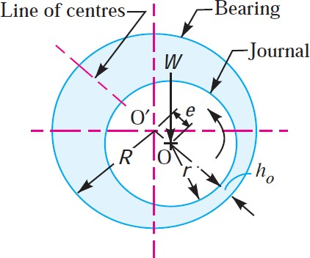

**Fig 2.1 Hydrodynamic Journal Bearing**

Let D = Diameter of the bearing,

d = Diameter of the journal, and L = Length of the bearing.

The following terms used in hydrodynamic journal bearing are important from the subject point of view:

* + - 1. **Diametral clearance**. It the difference between the diameters of the bearing and the journal. Mathematically, diametral clearance,

c = D – d (1)

**Note:** The diametral clearance (c) in a bearing should be small enough to produce the necessary velocity gradient, so that the pressure built up will

support the load. Also the small clearance has the advantage of decreasing side leakage. However, the allowance must be made for manufacturing tolerances in the journal and bushing. A commonly used clearance in industrial machines is

0.025 mm per cm of journal diameter.

* + - 1. **Radial clearance**. It is the difference between the radii of the bearing and the journal.

Mathematically, radial clearance,

𝑐1 = 𝑅 – 𝑟 = 𝐷−𝑑 = 𝐶…………. (2)

2 2

* + - 1. **Diametral clearance ratio**. It is the ratio of the diametral clearance to the diameter of the journal. Mathematically, diametral clearance ratio

#### = 𝐶 = 𝐷−𝑑 ………. (3)

2 2

* + - 1. **Eccentricity**. It is the radial distance between the centre (O) of the bearing and the displaced centre (O′) of the bearing under load. It is denoted by e.
      2. **Minimum oil film thickness**. It is the minimum distance between the

bearing and the journal, under complete lubrication condition. It is denoted by h0 and occurs at the line of centres as shown in Fig. 2.1. Its

𝑐

value may be assumed as 4.

* + - 1. **Attitude or eccentricity ratio**. It is the ratio of the eccentricity to the radial clearance. Mathematically, attitude or eccentricity ratio,

## 𝜀 = 𝑒

𝑐1

= 𝑐1−ℎ0

𝑐1

## = 1 − ℎ0

𝑐1

= 1 − 2ℎ0 (4)

𝑐

* + - 1. **Short and long bearing**. If the ratio of the length to the diameter of the

𝐿

journal (i.e.

𝑑

) is less than 1, then the bearing is said to be short bearing.

On the other hand, if 𝐿

𝑑

is greater than 1, then the bearing is known as

long bearing. When the length of the journal (L) is equal to the diameter of the journal (d), then the bearing is called square bearing.

##### Assumptions in Hydrodynamic Lubricated Bearings

The following are the basic assumptions used in the theory of hydrodynamic lubricated bearings:

* + - 1. The lubricant obeys Newton's law of viscous flow.
      2. The pressure is assumed to be constant throughout the film thickness.
      3. The lubricant is assumed to be incompressible.
      4. The viscosity is assumed to be constant throughout the film.
      5. The flow is one dimensional, i.e. the side leakage is neglected.

##### Important Factors for the Formation of Thick Oil Film in Hydrodynamic Lubricated Bearings

According to Reynolds, the following factors are essential for the formation of a thick film of oil in hydrodynamic lubricated bearings:

* + - 1. A continuous supply of oil.
      2. A relative motion between the two surfaces in a direction approximately tangential to the surfaces.
      3. The ability of one of the surfaces to take up a small inclination to the other surface in the direction of the relative motion.
      4. The line of action of resultant oil pressure must coincide with the line of action of the external load between the surfaces.

##### Properties of Bearing Materials

When the journal and the bearings are having proper lubrication i.e. there is a film of clean, non-corrosive lubricant in between, separating the two surfaces in contact, the only requirement of the bearing material is that they should have sufficient strength and rigidity. However, the conditions under which bearings must operate in service are generally far from ideal and thus the other properties as discussed below must be considered in selecting the best material.

* + - 1. **Compressive strength**. The maximum bearing pressure is considerably greater than the average pressure obtained by dividing the load to the projected area. Therefore the bearing material should have high compressive strength to withstand this maximum pressure so as to prevent extrusion or other permanent deformation of the bearing.
      2. **Fatigue strength**. The bearing material should have sufficient fatigue strength so that it can withstand repeated loads without developing surface fatigue cracks. It is of major importance in aircraft and automotive engines.
      3. **Conformability**. It is the ability of the bearing material to accommodate shaft deflections and bearing inaccuracies by plastic deformation (or creep) without excessive wear and heating.
      4. **Embeddability**. It is the ability of bearing material to accommodate (or embed) small particles of dust, grit etc., without scoring the material of the journal.
      5. **Bondability**. Many high capacity bearings are made by bonding one or more thin layers of a bearing material to a high strength steel shell. Thus, the strength of the bond i.e. bondability is an important consideration in selecting bearing material.
      6. **Corrosion resistance**. The bearing material should not corrode away under the action of lubricating oil. This property is of particular importance in internal combustion engines where the same oil is used to lubricate the cylinder walls and bearings. In the cylinder, the lubricating oil comes into contact with hot cylinder walls and may oxidise and collect carbon deposits from the walls.
      7. **Thermal conductivity**. The bearing material should be of high thermal conductivity so as to permit the rapid removal of the heat generated by friction.
      8. **Thermal expansion**. The bearing material should be of low coefficient of thermal expansion, so that when the bearing operates over a wide range of temperature, there is no undue change in the clearance.

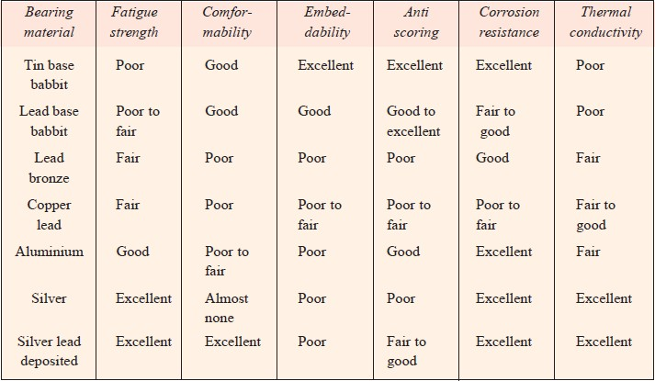All these properties as discussed above are, however, difficult to find in any particular bearing material. The various materials are used in practice, depending upon the requirement of the actual service conditions. The choice of material for any application must represent a compromise. The following table shows the comparison of some of the properties of more common metallic bearing materials.

**Table 2.1 Bearing Material Properties**

##### Basic Principle of Journal Bearings

Journal bearing also called as plain bearings are widely used in automobile applications, not restricting the smooth movement of the parts. Journal bearings consist of two parts, the shaft transmitting the motion also known as the journal and the sleeve guiding the shaft.

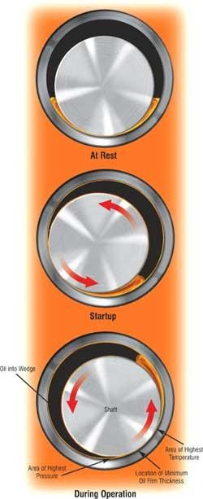

**Fig 2.2 Journal Bearing During Operation**

Both the parts are made of specific metal with good thermal properties and strength. The friction between two parts should be less in order to deliver the transmission with good efficiency. A thin film of lubricant is present between the two metal surfaces to prevent the direct contact between them also reducing friction.

The direct contact between metals may lead to damage of the shaft, or the sleeve leading to failure of the mechanism.

Load to the journal bearing can be of two types. Load applied on the shaft and load applied on the sleeve depending on the working conditions and type of applications used. In our case we are dealing with hydrodynamic bearing with load applied on the sleeve. Since the load is applied on the sleeve, the gap between the top layer of the shaft and the sleeve will be reduced forming a converging surface at the top, which on rotation of the shaft develops pressure inside the bearing.

##### Working Principle of Journal Bearing

Depending upon the type of application the two cases of journal bearing can be considered.

The journal shaft can be fixed and the sleeve can move perpendicular to the axis of the shaft. That is the sleeve can be self-positioning. The sleeve can be fixed and the journal shaft can be self-positing depending upon the load type.

Irrespective of the type of application in a journal bearing, the position of the journal or the sleeve is directly related to the external load. When the bearing is sufficiently supplied with lubrication and under zero loads, the journal shaft or sleeve will rotate concentrically within the bearing. When a load is applied the journal or sleeve moves eccentric position forming a wedge shape of oil film, where the load supporting pressure is generated.

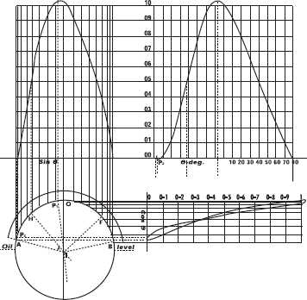

**Fig 2.3 Oil Film Pressure Distribution**

The clearance will be of the order of one thousandth of the diameter of journal.

##### Applications of Journal Bearings

Journal bearings are important for the development of internal combustion engines. They experience load that vary with both magnitude and direction, the load being caused by the pressure forces and inertial forces of the crank-slider mechanism.

They are also applied in locomotive and rail road cars, seven stage centrifugal compressors, horse power steam engine. The journal bearings used in the steam turbines of power generating stations are said to have reliabilities approaching 100 percent.

### CHAPTER THREE

##### DESIGN AND CONSTRUCTION OF THE JOURNAL BEARING DEMONSTRATION RIG, AND EQUATION MODELS OF VARIOUS PARTS

##### Design of Components

##### The journal shaft

A shaft is a rotating machine element which is used to transmit power from one place to another. The power is delivered to the shaft by some tangential force and the resultant torque (or twisting moment) set up within the shaft permits the power to be transferred to various machines linked up to the shaft.

##### Shaft analysis

Shaft type: transmission shaft

##### Stress in the shaft:

The stress acting in the shaft is due to the combined torsional and bending loads

##### Shafts Subjected to Combined Twisting Moment and Bending Moment

When the shaft is subjected to combined twisting moment and bending moment, then the shaft must be designed on the basis of the two moments simultaneously.Maximum shear stress theory or Guest's theory is used for ductile materials such as mild steel.

Let τ = Shear stress induced due to twisting moment, and

σb = Bending stress (tensile or compressive) induced due to bending moment. According to maximum shear stress theory, the maximum shear stress in the shaft,

…………………… (1) Substituting the values of τ and σb into eqn (1)

32𝑀

Where 𝜎𝑏 =

𝜋𝑑3

𝑟 = 16𝑇

3

𝜋𝑑

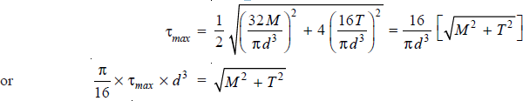

.....(2)

The expression √𝑀2 + 𝑇2 is known as equivalent twisting moment and is denoted by Te. The equivalent twisting moment may be defined as that twisting moment, which when acting alone, produces the same shear stress (τ) as the actual twisting moment. By limiting the maximum shear stress (τmax) equal to the allowable shear stress (τ) for the material, the equation (i) may be written as

………………………….(3) From this expression, diameter of the shaft (d) may be evaluated Assuming bending moment on the shaft, M = 1 × 106 Nmm

Assuming Torque = 1.5 × 106 Nmm

𝜎𝑡𝑢 = 700𝑀𝑃𝑎 = 700 × 106𝑃𝑎 = 700𝑁/𝑚𝑚2

Tu =500𝑀𝑃𝑎 = 500 × 106𝑃𝑎 = 500𝑁/𝑚𝑚2

Factor of Safety = 6 Allowable tensile stress

## 𝜎𝑡𝑢 𝑜𝑟 𝜎𝑏 = 𝜎𝑡𝑢

𝐹.𝑆

= 700

6

= 116.7 𝑁/𝑚𝑚2

Accoding to maximium shear stress theory, equivalent twisting moment,

𝑇𝑒 = √𝑀2 + 𝑇2……………………..(4)

𝑇𝑒 = √(1 × 106)2 + (1.5 × 106)2

𝑇𝑒 = 1.81 × 106𝑁𝑚𝑚

Also, 𝑇𝑒 = 𝜋

16

#### 𝑟𝑑3

1.81 × 106𝑁𝑚𝑚 = 𝜋

16

83.33 × 𝑑3

D= 48mm

The actual diameter of the shaft used was 49mm

##### The design of journal shaft

We know the shaft diameter as 49mm. the length of the shaft is gotten by considering the length of the room and also considering the coupling to be used. Hence a shaft of length 26cm was used, with a step provided for fitting to the coupling.

##### Dimensions

|  |  |
| --- | --- |
| Material | Mild steel |
| Length of shaft | 260mm |
| Diameter of shaft | 49mm |
| Length of step | 60mm |
| Diameter of step | 30mm |

**Table 3.1 Dimensions of the Journal Shaft**

##### Construction

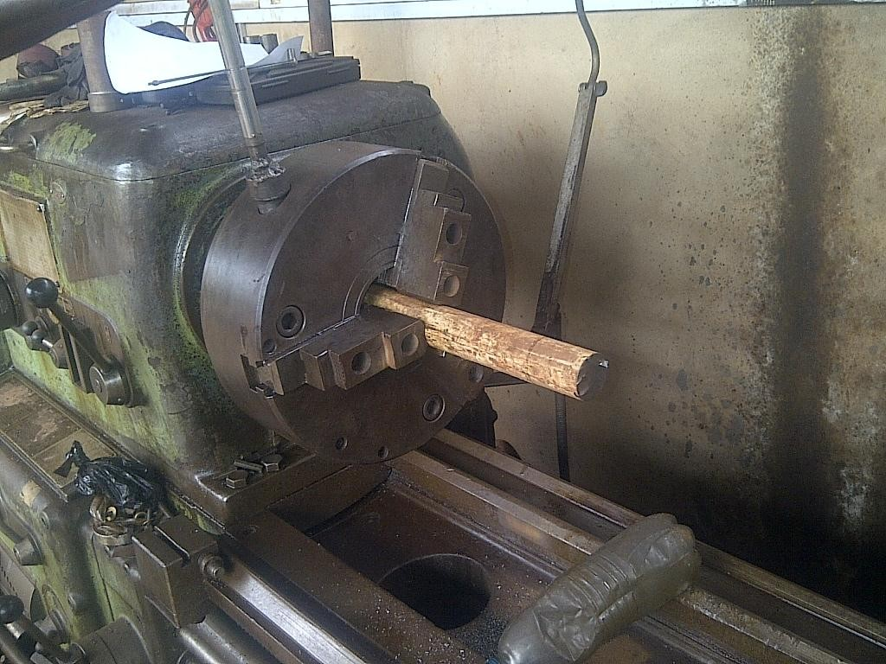

**Fig. 3.1 Construction of journal**

An iron rod of diameter 50mm and length 300mm was used to construct our required shaft. This was done as follows;

* + - * 1. The solid cylindrical rod was cut to a suitable length above the required length.
        2. The cut length was then placed on the spindle and held by a three jaw chuck on the lathe machine.
        3. The work piece was then machined to required lengths and dimensions.

##### The journal bearing

The journal bearing is designed in such a way that the shaft would be housed within it with one end sealed. The journal bearing would compose of inlet and outlet holes. The inlet hole would be bigger in diameter than the outlet. The outlet constitute of pressure output and the draining hole. Also, on the sealed end, a spring support was added to assist the bearing and hold it in position.

The material to be used as the journal bearing is a hollow cylindrical shaft made of mild steel with external diameter of 115mm and internal diameter of 53mm with a length of 150mm with a hole drilled around its circumference at 450 intervals and two additional holes for outlet and inlet of the oil to be used for lubrication. The bearing is completely sealed at one end.

##### Design Calculation

The following procedure may be adopted in designing journal bearings, when the bearing load, the diameter and the speed of the shaft are known:

Diameter = 49mm

Speed of the shaft = 1430rpm Assume load of = 300N

We are designing a light transmission shaft machinery for this project.

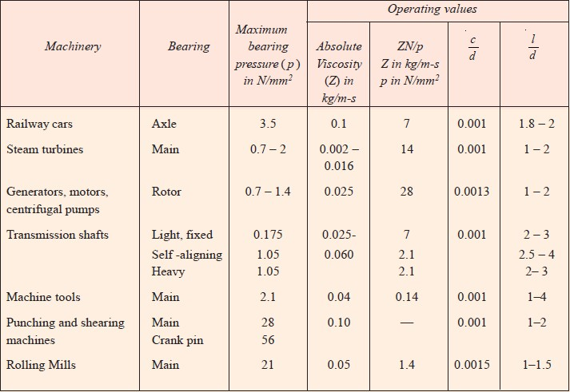

**Table 3.2 Journal Bearing Operating Values and Parameters**

Thus, from table 3.1,

Maximum bearing pressure (p) in N/mm2 = 0.175 Absolute viscosity (Z) in kg/m-s = 0.025 to 0.060

Bearing characteristic number (𝑍𝑁) = 7

𝑝

𝑐 ratio = 0.001

𝑑

𝐿 ratio = 2 to 3

𝑑

* + - * 1. Determine the journal bearing length by choosing a ratio of L / d from Table 3.1

Where ratio = 2 (minimum)

𝐿 = 2 ………………… (1)

𝑑

L= d x 2 = 49 x 2 = 98mm Where ratio = 3 (maximum)

L= d x 3 = 49 x 3 = 147mm

The actual length used in the journal bearing design is approximately 145mm

* + - * 1. The bearing pressure, p = 𝑊

𝐿𝑑

........(2)

from Table 3.1

Where w = bearing load

L = length of journal bearing D = diameter of shaft

p = 𝑊

𝐿𝑑

= 300

(145 x 49)

= 0.0419N/mm2

**Note:** pmax = 0.175N/mm2

* + - * 1. Assume a lubricant from Table and its operating temperature (t0). This temperature should be between 26.5°C and 60°C.

Lubricant = SAE 20 Operating temperature = 40oC Absolute viscosity = 0.042

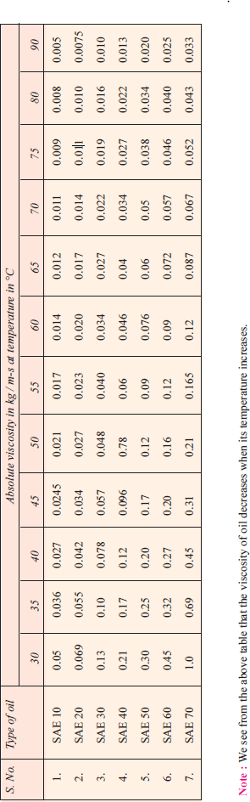

**Table 3.3 Oil Types and Viscosities at Various Temperatures**

* + - * 1. Determine the operating value of 𝑍𝑁 for the assumed bearing temperature

𝑝

and check this value with corresponding values in Table 3.1, to determine the possibility of maintaining fluid film operation

𝑍𝑁 = (0.042 x 1430)

𝑝 0.0419

= 1433.41

Minimum value = 7

Where Z = absolute vscosity N = r.p.m of the shaft P = Pressure

This tells us that the bearing would perform far better than expected for our

design specifications.

𝑐

* + - * 1. Assume a clearance ratio 𝑑 from Table 3.1

𝑐 = 0.001

𝑑

c = 0.001 x 49mm

= 0.049mm

This value is too small to be machined as it would require a high precision tool which is not readily available. Thus, a clearance of 4mm is to be used giving an internal diameter of 53mm for the bearing.

* + - * 1. Determine the coefficient of friction (μ)

µ = 33

(ZN) (d) + k …. (3) (when Z is in kg/m-s and p is in N/mm2)

108 p c

#### µ = ( 33 ) × 1433.41 × (49) + 0.002

108 4

#### µ= 7.794 × 10-3

* + - * 1. Calculate the heat generated and heat dissipated

Heat generated, Qg = µW

πdN (3)

60

Where μ = Coefficient of friction,

W = Load on the bearing in N V = Rubbing velocity in m/s

N = Speed of the journal in r.p.m.

Qg = 0.007794 × 300 × 3.669

= 8.57W

Heat dissipated, Qd = CA (tb - ta) Watts (4)

Where A = Projected area of the bearing in m2 = L× d, tb = Temperature of the bearing surface in °C

ta = Temperature of the surrounding air in °C C = heat dissipation coefficient in W/m2/°C

= 500W/m2/°C

Also, tb-ta = 0.5(to-ta) (5)

Where to= temp of oil film ta= temp of outside air

tb-ta = 0.5 (40 - 20)

= 10

Also, A= L × d (6)

= 0.145m × 0.049m

= 0.007105m2 Qd = 500 × 0.007105 ×10

=35W

Since the heat dissipated is more than the heat generated, the design is proper. Therefore, from the design calculations above, we have the following dimensions for the journal bearing to be constructed:

Diameter of shaft = 49mm Speed of the shaft = 1430rpm Bearing load = 300N

Inner diameter of bearing = 53mm Length of bearing = 145mm

Lubricant = SAE 20

##### Dimensions

|  |  |
| --- | --- |
| Materials | Mild steel |
| Length | 150mm |
| Inner diameter | 53mm |
| Outer diameter | 115mm |

|  |  |
| --- | --- |
| Diameter of Pressure outlets | 8mm |
| Diameter of Supply and drainage holes | 10mm |

**Table 3.4 Dimensions of the Journal Bearing**

Mild steel is not the appropriate material for the bearing. The best material is brass. It was not used because of its cost.

##### Construction

* + - * 1. The journal bearing is constructed on the lathe machine. The work piece is placed on the spindle and machined to the appropriate dimensions.
        2. A cover is machined also so as to cover one end of the journal bearing that the shaft would pass through. Also a hole is drilled and threaded so as to fit with the spring support.
        3. Holes with of equal diameter were drilled at 45o intervals ie (8 holes). At various lengths along the cross section.
        4. A bigger drilling bit was used to make two holes for the inlet and outlet points. Additional holes were provided for fitting of bolts
        5. Welding was also carried out to join the cover and some necessary components.

The other parts of the journal bearing demonstration rig includes; the frame, the base, the oil tank/reservoir, the collecting pan, the oil pipes/tubes, etc

##### The frame

A frame is a basic structural system designed to support other components of a physical construction. The journal bearing demonstration rig

frame supports the base plate, the motor, the journal bearing and all the various components of the apparatus.

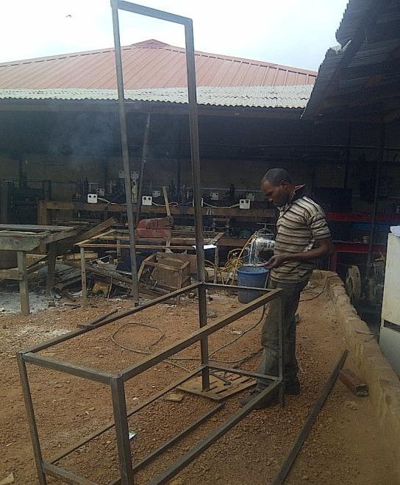

##### Design

**Fig 3.2 Construction of the Frame**

The frame was designed in such a way that it would constitute of a table and a vertical display board, so as to contain the motor, the journal bearing, the manometer tubes and oil tank. Also, additional supports were added to the frame to increase its rigidity.

##### Dimensions

|  |  |
| --- | --- |
| Length | 1400mm |
| Breadth | 570mm |
| Height of frame Height of table  Height of measuring panel | 2500mm 800mm  1700mm |
| Material used  Thickness | Steel bar  4mm |
| Section | Angular |

**Table 3.5 Dimensions of the Frame**

##### Construction

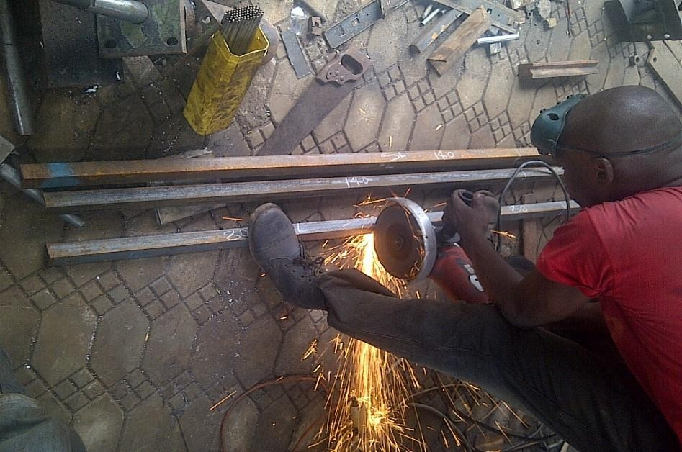

**Fig 3.3 Frame Construction**

The construction of the frame was carried out through the following procedures:

* + - * 1. The dimensions to be used were first measured on the angular bar by means of measuring tape.
        2. The required dimensions were then marked with a chalk.
        3. The marked lengths were then cut using an electric saw.
        4. The cut metal bars were then joined appropriately through arc welding process.
        5. The welded joints were then given a fine finish for aesthetics, and finally painted

##### The base plate

The base plate is a material placed on the frame on which all the structures are placed upon. Base plate can be a metal plate or wooden plate with a desired thickness which can carry the structures placed on it properly without failure.

##### The design

The base plate used in this construction work was a wooden plate of 1inch thickness. A wooden sheet of 8inches by 4inches was bought and cut to a suitable dimension. The remainder was kept for other purposes.

##### Dimension

|  |  |
| --- | --- |
| Material | Wood |
| Length | 1400mm |
| Width | 570mm |
| Thickness | 1inch |

**Table 3.6 Dimensions of Base Plate**

##### Construction

* + - * 1. The required dimensions were measured on the wooden sheet bought.
        2. The measurements were marked with a pencil.
        3. The marked points were now cut using a saw

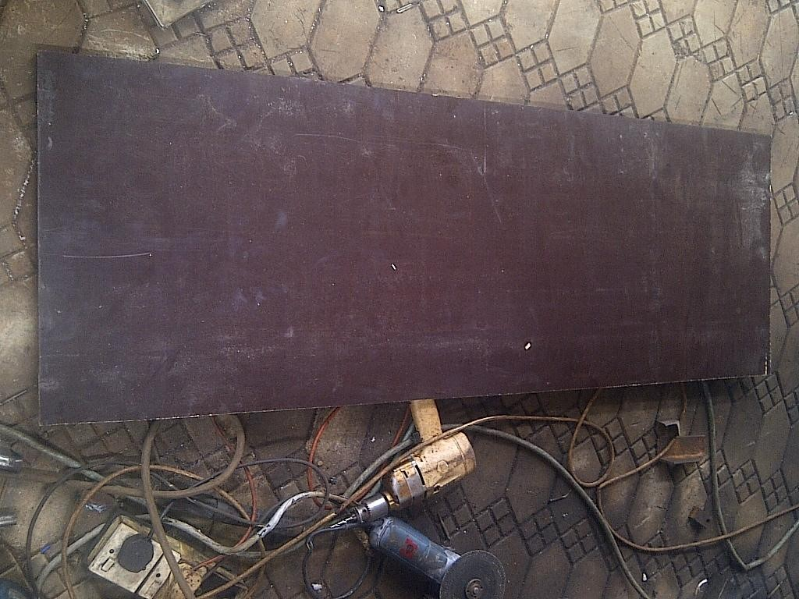

**Fig 3.4 Base Plate Construction**.

* + - * 1. The portions cut were that of the base plate and the manometer board.
        2. Holes were drilled for fastening to the frame.

##### Electric motor

An electric motor is an electric machine that converts electrical energy into mechanical energy. Electric motors operate through the interaction between a magnetic field and winding currents to generate force within the motor. A variable speed induction motor with the following specifications was used for this project;

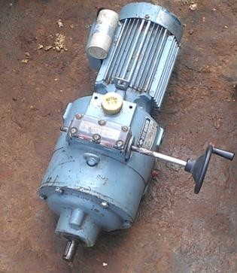

##### Specification

**Fig 3.5 Electric Motor**

|  |  |
| --- | --- |
| Power rating | 1hp (0.75kw) |
| Voltage rating | 380volts |
| Operating frequency: | 50 Hz |
| RPM | 1430 |

**Table 3.7 Specification of the Electric Motor**

##### Reason for selection

The reason for the selection of this motor is because the speed can be varied. This is necessary so as to get the pressure relationship with various speeds of the motor. Also the one phase system which the motor operates on was another reason.

##### Coupling

A coupling is a device used to connect two shafts together at their ends for the purpose of transmitting power. Couplings do not normally allow disconnection of shafts during operation. The primary aim of a coupling is to join two rotating equipment while permitting some degree of misalignment or end movement or both.

##### Reason for selection

* + - * 1. To introduce mechanical flexibility
        2. To reduce the transmission of shock loads.
        3. To alter the vibration characteristics of the rotating units.

##### Oil pipes and tubes

The oil pipes and tubes are for the easy flow of the lubricant from the tank to the bearing and also from bearing to the measuring panel. Also, owing to certain factors, an oil pipe was used to form the measuring panel with measurement being introduced behind to get readings.

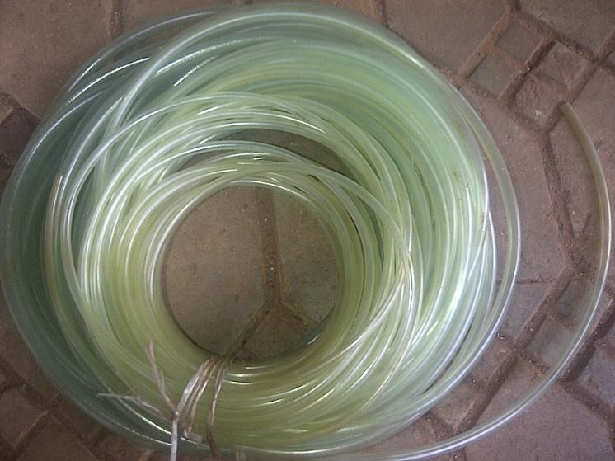

**Fig 3.6 Oil Pipes**

The oil pipes used for this apparatus were transparent pipes with10mm, 8mm and 5mm diameters. These pipes perform different functions. The 10mm pipes were used for the supply, the 8mm pipes were used for the measuring board and the 5mm pipes were used to get the pressure output from the journal bearing.

##### Reason for selection

The reasons for selecting the transparent pipes are

* + - * 1. To enable clear observation of the oil flow.
        2. To enable us measure pressure head as in the case of the panel pipes.

##### Fasteners

A fastener is a hardware device that mechanically joins or affixes two or more objects together. Examples include rivets, nails, bolts and nuts, washers, pins, screws, clips, adhesives etc.

The fasteners which were used in the apparatus include:

1. 17mm diameter bolt, 3inches long
2. 13mm diameter bolt, 2inches long with counter sunk head
3. 2 inches nails
4. 13mm washers
5. Epoxy gum

##### Functions

* + - * 1. The 17mm bolts were used to secure the motor and other parts in its position.
        2. The 13mm bolts were used to secure the base plate and the measurement panel to the board.
        3. The M8 bolts were used to affix bearing component.
        4. The nails are used to affix wooden components.
        5. Washers and nuts were used alongside the bolts to give additional supports.
        6. The gum was used to join the pipes

##### Lubricant (oil)

Lubricants are substances applied to the bearing, guiding, or contact surfaces of machinery to reduce friction between moving parts. The process of applying lubricants is called lubrication.

Lubricants enable machinery to function continuously by preventing abrasion, or so-called seizing, of metal parts caused by heat expansion. Some lubricants are also coolants and thus prevent material deformities caused by heat.

##### Properties of Lubricants

* + - * 1. **Viscosity**. It is the measure of degree of fluidity of a liquid. It is a physical property by virtue of which oil is able to form, retain and offer resistance to shearing a buffer film-under heat and pressure. The greater the heat and pressure, the greater viscosity is required of a lubricant to prevent thinning and squeezing out of the film.
        2. **Oiliness**. It is a joint property of the lubricant and the bearing surfaces in contact. It is a measure of the lubricating qualities under boundary conditions where base metal to metal is prevented only by absorbed film. There is no absolute measure of oiliness.
        3. **Density**. This property has no relation to lubricating value but is useful in changing the kinematic viscosity to absolute viscosity. Mathematically Absolute viscosity = ρ × Kinematic viscosity (in m2/s)

Where ρ = Density of the lubricating oil.

* + - * 1. **Viscosity index**. The term viscosity index is used to denote the degree of variation of viscosity with temperature.
        2. **Flash point**. It is the lowest temperature at which oil gives off sufficient vapour to support a momentary flash without actually setting fire to the oil when a flame is brought within 6 mm at the surface of the oil.
        3. **Fire point**. It is the temperature at which an oil gives off sufficient vapour to burn it continuously when ignited.
        4. **Pour point or freezing point**. It is the temperature at which an oil will cease to flow when cooled.

The lubricant used in this apparatus is housed in the reservoir from where it flows to the bearing.

##### Specification

|  |  |
| --- | --- |
| Oil type | SAE 20 |
| Volume | 3.5 litres |

**Table 3.8 Specification of the Oil**

##### Reason for selection

The main reason why this lubricant was used was because of its high viscosity index.

##### Oil collecting pan

The oil collecting pan is a containing vessel which is used when the oil in the journal bearing wants to be drained to avoid spillage on the base plate and the surrounding.

The oil collecting pan can be a metal or plastic container.

##### Oil reservoir

The oil reservoir is a container designed to store the lubricant and continuously supply the lubricant to the bearing when the apparatus is turned on. The oil reservoir used for this apparatus is a plastic container.

##### Spring damper Support

Supports are devices used to compensate for slight displacements in structures. The performance of a spring support is based on the preset helical coil springs which exert a variable supporting load. The spring support used in this apparatus was one constructed with a square pipe and two hollow pipes sealed at one end and also fitted properly with a desired spring.

The function of the spring damper support is to support the weight of the journal bearing and serve as a damper just in case there is transmitted vibration through the apparatus.

##### Design consideration and selection of materials

The considerations made in the design and the selection of the materials used in the construction of the various parts of the journal bearing apparatus includes:

* + 1. The strength of the material
    2. The ductility of material
    3. The dimensions of adjoining material
    4. The availability of the material
    5. The cost of the material
    6. The machinabilty of the material

##### Assembly of the journal bearing demonstration rig

The assembly of the journal bearing demonstration rig is done in three phases.

The first phase is the fixing of the base plate and measurement board on the frame and then fastening them.

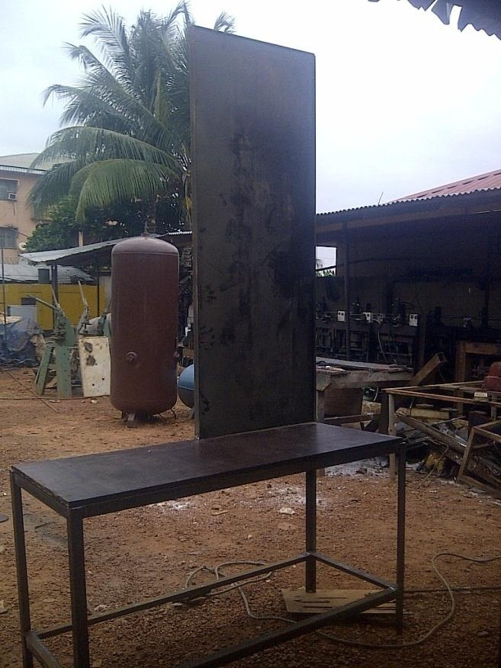

**Fig. 3.7 First Phase of Assembly**

The second phase consists of the shaft being connected to the coupling while the other end of the coupling is connected to the motor shaft and finally, fastening the motor to the base plate. The bearing is also fitted with its spring support.

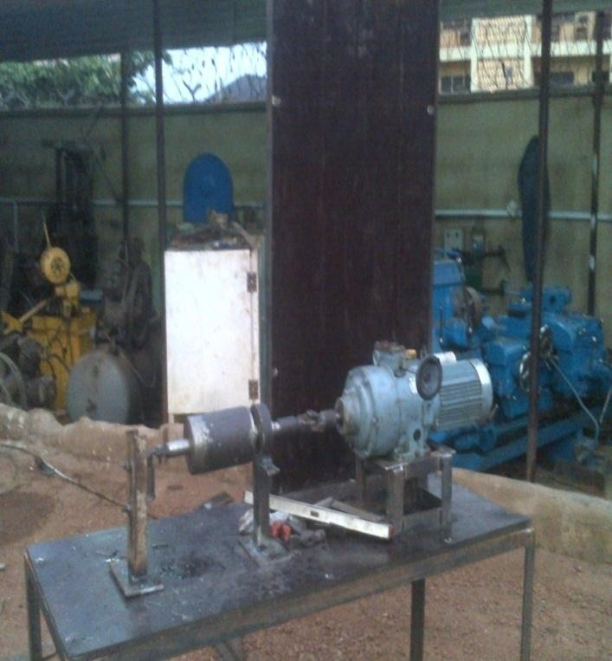

**Fig 3.8 Second Phase of Assembly**

The third and final phase consist of the oil tank being placed on the frame, the oil pipes and tubes also being connected to the bearing sleeves and also placed on the measurement board.

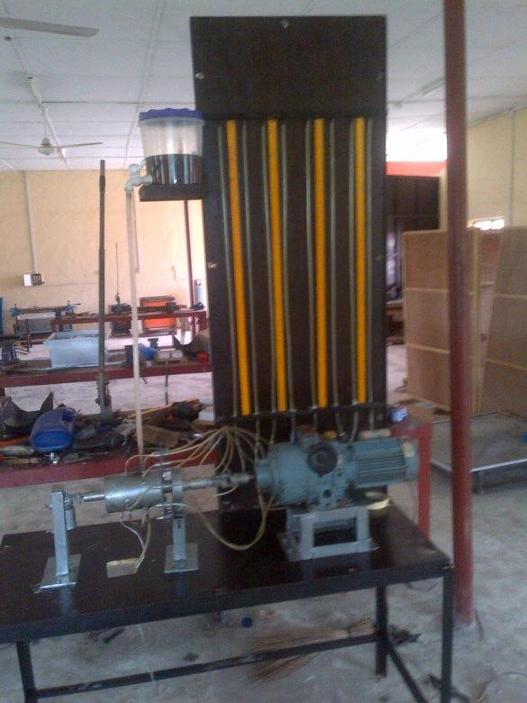

**Fig 3.9 Third Phase of Assembly**

##### Working principle of the journal bearing demonstration rig

* Oil tank at certain height creates a pressure head, which helps in easy moment of lubricant into the bearings.
* Due to rotation of the shaft and load on the sleeve, a load bearing pressure is created.
* In the region of load bearing pressure, the lubricant is pumped out through the holes provided on the sleeve.
* The oil from these holes is made to pass though tubes to the measuring panel.
* Pressure build up is seen on the pressure pipes and reading taken down
* Relevant graphs are plotted ie pressure head against speed of the motor as in this case.

##### Operating condition

* + 1. Ensure that the apparatus is run in a laboratory environment.
    2. Ensure that safety measures are readily available in the laboratory.
    3. Ensure that the operating temperature is between -25oC and 50oC.

##### Operating instructions

* + 1. Ensue operating conditions are suitable.
    2. Ensure that there is enough oil in the reservoir before starting the apparatus.
    3. Check if all the pressure pipes are properly fitted.
    4. Ensure that the required voltage is used to operate.
    5. Connect the motor to the power source and turn on the power.
    6. Vary the speed of the motor till effects can be seen on the measuring panel.
    7. Measure the pressure heads at various speeds of the motor.
    8. Disconnect the electric motor when all the required results have been gotten.

##### MATHEMATICAL EQUATIONS AND CALCULATIONS

* + 1. **Bearing Characteristic Number and Bearing Modulus for Journal Bearings**

The coefficient of friction in design of bearings is of great importance, because it affords a means for determining the loss of power due to bearing friction. It has been shown by experiments that the coefficient of friction for a full lubricated journal bearing is a function of three variables, i.e.

(i)

ZN

p (ii)

d l

c (iii) d

Therefore the coefficient of friction may be expressed as

## ZN d l

μ = φ { , , } (1)

## p c d

Where

μ = Coefficient of friction,

φ = A functional relationship,

Z = Absolute viscosity of the lubricant, in kg / m-s, N = Speed of the journal in r.p.m.,

p = Bearing pressure on the projected bearing area in N/mm2,

= Load on the journal ÷ (L× d) d = Diameter of the journal,

L = Length of the bearing, and

The factor

c = Diametral clearance.

𝑍𝑁

𝑃 is termed as bearing characteristic number and is a dimensionless

number. The variation of coefficient of friction with the operating values of bearing characteristic number (𝑍𝑁) as obtained by McKee brothers (S.A.

𝑃

McKee and T.R. McKee). The factor

𝑍𝑁

𝑃 helps to predict the performance of a

bearing.

##### Critical Pressure of the Journal Bearing

The pressure at which the oil film breaks down so that metal to metal contact begins, is known as critical pressure or the minimum operating pressure of the bearing. It may be obtained by the following empirical relation, i.e. Critical pressure or minimum operating pressure,

……….(2)

##### Sommerfeld Number

The Sommerfeld number is also a dimensionless parameter used extensively in the design of journal bearings. Mathematically,

Sommerfeld number = ZN (d)2 (3)

p c

For design purposes, its value is taken as follows

ZN (d)2 = 14.3 × 106 … (when Z is in kg/m-s and p is in N/mm2)

p c

##### Heat generated in a journal bearing

The heat generated in a bearing is due to the fluid friction and friction of the parts having relative motion. Mathematically, heat generated in a bearing,

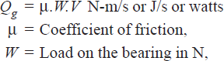

................... (4)

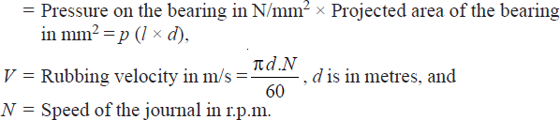

After the thermal equilibrium has been reached, heat will be dissipated at the outer surface of the bearing at the same rate at which it is generated in the oil film. The amount of heat dissipated will depend upon the temperature difference, size and mass of the radiating surface and on the amount of air flowing around the bearing. However, for the convenience in the bearing

design, the actual heat dissipated area may be expressed in terms of the projected area of the journal.

##### Heat dissipated by the bearing

**……….. (5)**

The value of C has been determined experimentally by O. Lasche. The values depend upon the type of bearing, its ventilation and the temperature difference. The average values of C (in W/m2/°C), for journal bearings may be taken as follows: For unventilated bearings (Still air)

= 140 to 420 W/m2/°C

For well ventilated bearings

= 490 to 1400 W/m2/°C

It has been shown by experiments that the temperature of the bearing (tb) is approximately mid-way between the temperature of the oil film (t0) and the temperature of the outside air (ta). In other words,

tb – ta =1 (t0 – ta) (6)

2

**Note:** if the heat generated is more than the heat dissipated, the design has to be changed

##### Calculation of pressure head

Pressure head at inlet and outlet can be calculated using the following formulas.

Inlet pressure

Pi = -γ * H1 (7)

Specific weight

γ = ρ * g (8)

Outlet pressure

Po = Pi – (γ * (H2-H1)) (9)

##### Derivation of the Sommerfeld’s Equation and Reynold’s Equation

If a load is applied to a journal as it rotates, it will be displaced from the centre of the bearing. With the lubricating film building up pressure to support the load, the displaced shaft reaches an equilibrium position, as shown in the Figure below (in exaggerated form).

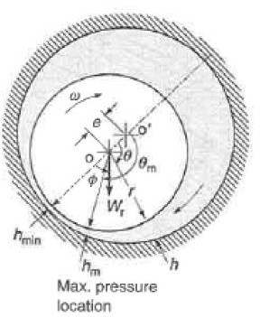

**Fig 3.10 Schematic Diagram of a Journal Bearing**

To summarize Figure, “r” is the radius of the shaft, omega (ω) is the angular velocity of the shaft, “ o ” is the center of the bearing, “o” is the center of the shaft or journal, and “e” represents the difference between the two (eccentricity). In addition, “hmin” is the minimum film thickness, “hm” is the thickness associated with maximum pressure, and “h” represents the thickness as a function of radial position, theta (θ).

For the laminar flow of a Newtonian fluid in two-dimensional Cartesian coordinates, the continuity and momentum equations are:

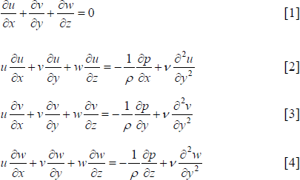

Reducing the momentum equations above using conventional thin film assumptions (i.e. there is no flow in the y-direction or z-direction, and the change in flow in the x direction is small and therefore can be neglected) results in the following governing equations:



Neglecting change in viscosity, Q, across the film thickness, h, allows for integration twice:



To solve Equation 6 for constants, boundary conditions must be applied:



Solving for the constants in Equation 6,

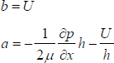

Therefore, the velocity profile is:



By integrating equation 7 across the film thickness, the **Reynold’s equation** is obtained.

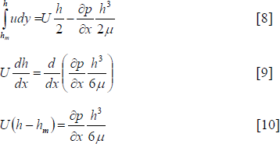

Rearranging to get in terms of pressure



Equation 11 above is the general equation used to calculate the differential pressure in a simplified journal bearing assuming concentric cylinders. In order to account for shaft eccentricity, the film thickness must vary with theta. The distance between the centers of the journal and bearing is known as the eccentricity, “e” (i.e., when the two are concentric, e is zero). If the shaft were to move fully to be in contact with the bearing surface, “e” will equal “c”, or the radial clearance of the bearing. Therefore,



Equation 11 represents the eccentricity ratio of any bearing due to loading. In this case, the eccentricity ratio must be 0 ≤ ε ≤ 1. Because of the eccentricity of the shaft, there is a location where the thickness of the film is at a minimum. Based on Equation 12, the minimum film thickness is:

In order to show the bearing clearance with respect to theta, the bearing can be “rolled out” to a two dimensional problem more like Cartesian coordinates, as in Figure below

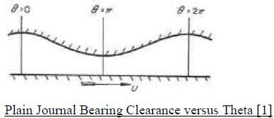**Fig 3.11**

In Figure 4.2 , hmin is shown at θ = π. To represent the line from 0 ≤ θ ≤ 2π based on Equation 13, the film thickness, “h”, can be shown as:

Substituting Equation 14 into Equation 11,





And integrating with respect to theta,





Applying the Sommerfeld solution to the integrated equation, this is evaluated at the boundary condition:



Solving for the constant, the pressure is shown as



##### Derivation of Petroff’s Equation

Related to work done by Sommerfeld, Petroff’s Law was developed to explain the phenomenon of bearing friction. Petroff's method of lubrication analysis assumed a concentric shaft and bearing, and produced the so-called Petroff equation. This equation, derived below, defines groups of relevant dimensionless parameters and predicts a coefficient of friction, even when the shaft is not concentric.

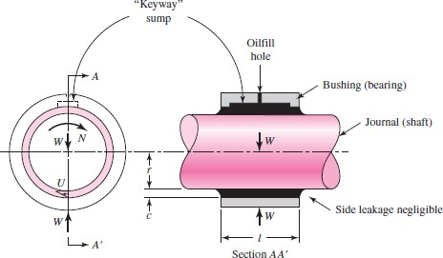

**Fig 3.12 Concentric Journal Bearing**

Considering a concentric shaft rotating inside a bearing, it can be assumed that the radial clearance space is completely filled with lubricant, the bearing is

subjected to a negligible load, the bearing is of sufficient length to neglect changes in flow at the ends, and that leakage is negligible. The surface velocity of the shaft is:



The lubricant shear stress is shown as [1]:



Assuming a constant rate of shear, the equation is integrated with respect to the radius:

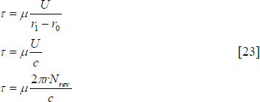

Where c is the gap clearance in the bearing. The amount of stress (i.e., pressure in Pascals) required to shear a fluid of a known viscosity is dependent on how much of the fluid is involved and how quickly the shearing of the fluid is occurring. Therefore, the circumference and rotational speed are also necessary in the shear stress equation above.

Knowing the force required over an area to shear a fluid is required in order to determine the amount of torque required to overcome this loss. Torque is defined as:

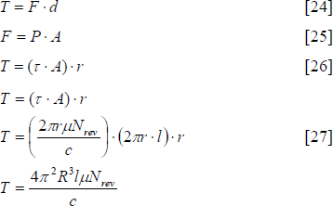

The torque required to move the shaft through the lubricating oil can be directly related to power (kW).

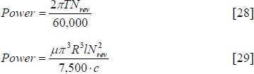

Even a small percentage of the power lost can result in a significant amount of heat being generated and transferred to the lubricating oil. Using the above equation, power lost in the bearing can be calculated based on known geometry and operating conditions at the bearing (e.g., the bearing RPM, oil density, bearing film).

### CHAPTER FOUR

**DISCUSSION OF RESULTS, MAINTENANCE INSTRUCTION, SAFETY PRECAUTIONS AND STORAGE**

THE READINGS FROM CONDUCTED EXPERIMENT OF VARYING SPEED TO DIFFERENCE IN PRESSURE AROUND THE JOURNAL BEARING

|  |  |  |  |  |  |  |  |  |
| --- | --- | --- | --- | --- | --- | --- | --- | --- |
| SPEED RANGE  Speed max. = 1430 RMP | H1  cm | H2  cm | H3  cm | H4  cm | H5  cm | H6  cm | H7  cm | AVERAGE HEIGHT  (cm) |
| 0.8 (1144) | 42 | 53 | 32 | 27 | 76 | 35 | 51 | 45.14 |
| 0.7 (1001) | 37 | 47 | 28 | 24 | 63 | 27 | 44 | 38.57 |
| 0.6 (858) | 28 | 40 | 19 | 22 | 58 | 17 | 33 | 31 |
| 0.5 (715) | 21 | 34 | 13 | 18 | 36 | 11 | 26 | 24.57 |
| 0.4 (572) | 16 | 27 | 8 | 11 | 25 | 6 | 18 | 15.86 |

**Table 4.1 Experimental results that shows variation of speed against pressure**

##### DISCUSSION OF RESULTS

Fig 4.1 is the graph of shaft speed of rotation (rpm) against the pressure build up in the journal bearing. It can be seen from the graph, that speed is proportion or linear to the pressure build up in the journal bearing. There are various pressure tapings in the journal bearing which are connected to the manometer readings. The pressure tapping (h5), indicate the highest reading on the manometer readings ranges from 76cm for 1144 rpm to 25cm for 572 rpm in table(4.1), due to eccentricity. The h5 is located at the exact point on the journal bearing where there is high pressure as a result of the eccentricity between the shaft and the journal bearing; that is the difference between the two centres (shaft and journal bearing).

From the experiment carried out, it was observed that the pressures heads at various outlets vary. Some were more than others. These various pressure heads were observed to reduce with reduction in shaft speed.

##### MAINTENANCE INSTRUCTION

It is very necessary to observe some maintenance rules so as to increase the life of the apparatus and ensure smooth running of the test rig whilst running experiments. Some of the maintenance instruction one has to observe include:

* + 1. Ensure that all the operation conditions are adhered to
    2. Also ensure that the operating instructions are obeyed
    3. Ensure that lubricant i.e. engine oil, is always in the bearing to avoid friction and excessive heat generation
    4. Ensure that the right kind of engine oil is used i.e. SAE 20
    5. Ensure that the apparatus is kept away from water to avoid rusting of metal parts.
    6. Ensure that the apparatus is run under the supervision of an engineer, technologist or technician with in depth knowledge of the working procedures.

##### Safety precautions

Safety can be defined to be the control of recognised hazards to achieve an acceptable level of risk. It is very necessary to observe some safety precautions in the course of carrying out experiments on the apparatus. The following are a few safety precautions;

* + 1. Place the electric motor at the minimum speed through the speed selector control before running the experiment.
    2. Ensure the bearing is well lubricated to avoid excessive heat generation.
    3. Ensure that the apparatus is turned off at any sign of danger.
    4. Disconnect the electric motor before carryout any maintenance work.
    5. Disconnect the electric motor from the power outlet when through with the experiment

##### Storage

Storage involves the various methods or actions for safe keeping of any material for future or later use. The apparatus can be stored in a laboratory. Whilst in storage, the electric motor should be disconnected from the power outlet. The engine oil should also be covered to prevent the entrance of impurities.

### CHAPTER FIVE

##### PROJECT COST ANALYSIS, CHALLENGES, CONCLUSION AND RECOMMENDATION

##### PROJECT COST ANALYSIS

|  |  |  |  |  |  |
| --- | --- | --- | --- | --- | --- |
| **S/N** | **Component** | **Specification** | **Quantity** | **Unit price** | **Bulk price** |
| 1. | Wood | 8feet X 4feet | 1 | 7000 | 7000 |
| 2. | Angular steel  bar | 18 feet, 4mm  diameter | 4 | 2300 | 9200 |
| 3. | Electric motor | 1hp with gear box | 1 | 30000 | 30000 |
| 4. | Steel rod | 5mm in diameter | 1 | 500 | 500 |
| 5. | Coupling |  | 1 | 2000 | 2000 |
| 6. | Friction  bearing |  | 1 | 500 | 500 |
| 7. | Oil seal |  | 2 | 200 | 400 |
| 8. | Rectangular  steel bar |  | 1 | 700 | 700 |
| 9. | Shaft rod | 50mm diameter | 1 | 5000 | 5000 |
| 10. | Hollow shaft | 40mm internal diameter, 118mm  external diameter | 1 | 6000 | 6000 |
| 11. | Spring |  | 2 | 500 | 1000 |
| 12. | Bolts, nuts  and washers |  |  | 2000 | 2000 |
| 13. | Nails | 1inch |  | 100 | 100 |
| 14. | Epoxy gum |  | 2 | 350 | 700 |

|  |  |  |  |  |  |
| --- | --- | --- | --- | --- | --- |
| 15. | Brake linings |  | 2 | 250 | 500 |
| 16. | Oil pipes and  tubes |  |  | 4000 | 4000 |
| 17. | Metre rule | 100cm | 5 | 250 | 1250 |
| 18. | Plastic  container |  | 1 | 500 | 500 |
| 19. | Tap |  | 1 | 400 | 400 |
| 20. | Aluminium  paint |  | 1 | 600 | 600 |
| 21. | Oil paint | Black | 1 | 400 | 400 |
| 22. | Kerosene |  |  | 280 | 280 |
| 23. | Brushes |  | 2 | 100 | 200 |
| 24. | Electrode |  |  | 300 | 300 |
| 25. | Workshop  labour |  |  | 50000 | 50000 |
| 26. | Transportation |  |  | 25000 | 25000 |
| 27. | Miscellaneous  expenses |  |  | 20000 | 20000 |
|  | | | | **TOTAL** | **N168,530** |

**Table 5.1 cost analysis table**

##### Challenges

During the course of this project, there were series of problems encountered. These problems made actualizing the project difficult to achieve. Some of these challenges include:

* + 1. The unavailability of desired project materials.
    2. The distance travelled so as to procure project materials.
    3. The most important challenge was the unavailability of finance.

##### Conclusion

The design and the construction of the journal bearing demonstration rig has cut through all the areas studied in mechanical engineering at the undergraduate level. These areas range from strength of materials, material selection, design, workshop process, manufacturing processes and technology, heat transfer, fluid mechanics, etc.

Through this project, the design and construction of journal bearing demonstration rig, we were able to have an idea of how a fluid film in a journal bearing can be used to build up pressure which can increase the load bearing capacity of the journal bearing. This is made evident by the pressure head calculation discussed and other relevant design calculations in this report. It is observed in the graph plotted from the experimental results, that the speed is proportionally or linear to the pressure build up in the journal bearing. The

pressure tapping (h5), shows the highest reading on the manometer readings ranging from 75cm for 1144rpm to 25cm for 572rpm due to eccentricity of the two centres (shaft and journal bearing)

Due to the fact that journal bearings have high load bearing capacity, we see them being applied in several areas where high reliabilities are required.

Furthermore, construction enhancement and experimental studies need to be done to consider all other parameters like loading and using different oil grades for the performance of the rig.

##### RECOMMENDATION

After successfully completing this project some recommendations are necessary to improve the operation of the journal bearing demonstration rig. This is due to some unforeseen errors either in the design of the apparatus, the assembly of the apparatus, or lapses observed during its operation. Some of these recommendations include:

* + 1. Further work needs to be carried out to reduce the vibration of the apparatus. This was observed during its running as the apparatus was being subjected too much vibration.
    2. The frame needs to be reinforced to allow rigidity of the apparatus. This can help in the vibration reduction and also to avoid dangling of the apparatus whilst in operation.
    3. Analysis needs to be conduction to determine while the shaft seizes when turned on. This might be due to the absence of some clearance in shaft fittings.
    4. The height of the oil tank needs to be reduced to a lower position due to a high pressure head at its current location which makes attaining steady state a challenge before readings are gotten.
    5. Oil leakages were observed at some parts of the apparatus. Efforts need to be made to seal up such areas so as to avoid pressure drop and errors in the collation results.
    6. Effort should be put into making the shaft carry load so as to get the relation between applied load, speed and pressure acting on the cross section of the journal bearing.

##### REFERENCES

Amith, H. R. (2005). *A Thesis on Hydrodynamic Analysis of Complaint Journal Bearings*. Louisiana: Louisiana University Press.

Antti, V. (2009). *A Thesis on Oil film pressure in hydrodynamic journal bearing*

Espo: Helsinki University Press.

Burrows, C. R., and Sahinkaya,M. N., (1982). *Frequency-Domain Estimation Of Linearized Oil-Film Coefficients*. ASME Journal of Lubrication Technology.

B. Hamrock. (2004). *Fundamentals Of Fluid Film Lubrication*, Marcel Dekker Inc.

Dmochowski, W., and Brockwell,K., (1995). *Dynamic Testing Of the Tilting Pad Journal Bearing*. STLE Tribology Transactions.

Dominic Antaluca et al., (2006). Romania: *Proceeding of VAREHD, Vol 12*.

Technical University of Lasig.

Khurmi, R.S., & Gupta, J.K. (2005). *A textbook of machine design*. New Delhi: Eurosia Publishing House (PVT) Ltd.

Parkins, D.W. (1995). A Journal on Measurement of Oil Film Journal Bearing Damping Coefficients-An Extension of the Selected Orbit Technique.

*ASME Journal of Tribology*, Vol. 117, (9), 696–701.

Parkins, D. W. (1979). A Journal on Theoretical and experimental determination of the dynamic characteristics of a hydrodynamic journal bearing*. ASME Journal of Lubrication Technology,* Vol.101, 129-139.

Prata, A.T. (1988). A Thesis on Dymamically Loaded Journal Bearing: Finite Volume Method Analysis. *International Compressor Engineering Comference*, Vol. 12, (12), 599.

Raajeshkrishna, R. G., & Vikrant, M. S. (2012). *Design of journal bearing test rig*. Karlskrona: Karlskrona Academic Press.

Valkonem, A., Juhanko, J., & kuosamanem P. (2010). An Article on Measurement of Oil Film Pressure*. Hydrodynamic Journal Bearing,* Vol. 76, (4) 34-56.

Wale, G. D., & Mba, D. A. (2005). *A Journal on Identifying and Minimizing Uncertainty for Experimental Journal Bearing Studies*. International Journal of Rotating Machinery, Volume 2005,Number 3, pp 221-231.

Zhao, S.X., Dai, X. D., Meng, G., & Zhu, J. (2005). *A Journal on An experimental study of Non-linear oil-film forces of a journal bearing, Journal of Sound and Vibration*. Vol. 287 (4-5), pg. 827-843.

##### APPENDIX A

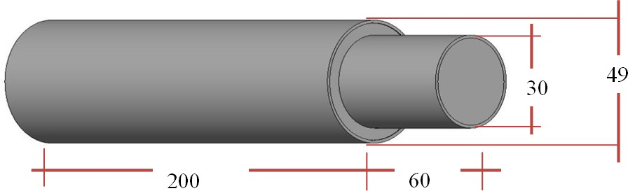

**SHAFT**

##### (All dimensions in mm)

**B**

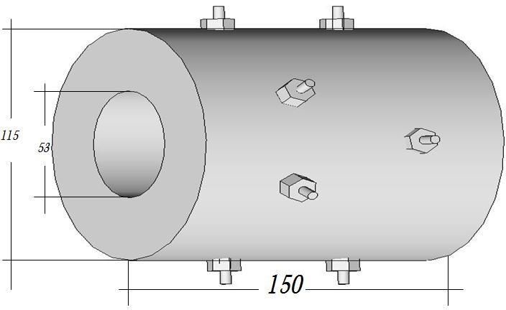

##### JOURNAL BEARING

**(All dimensions in mm)**

##### C

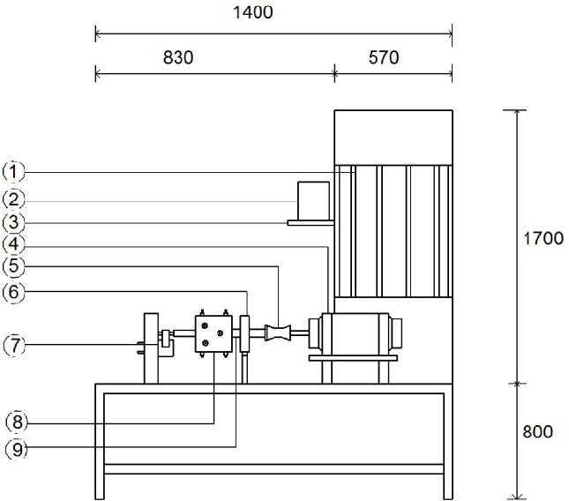

|  |  |
| --- | --- |
| NO | PART NAME |
| 1 | MANOMETER BOARD |
| 2 | OIL TANK |
| 3 | TANK HANGER |
| 4 | ELECTRIC MOTOR |
| 5 | COUPLING |
| 6 | SHAFT SUPPORT |
| 7 | SPRING DAMPER SUPPORT |
| 8 | JOURNAL BEARING |
| 9 | JOURNAL SHAFT |

**ASSEMBLY DRAWING OF THE JOURNAL BEARING DEMONSTRATION RIG**

##### (All dimensions in mm)

**D**

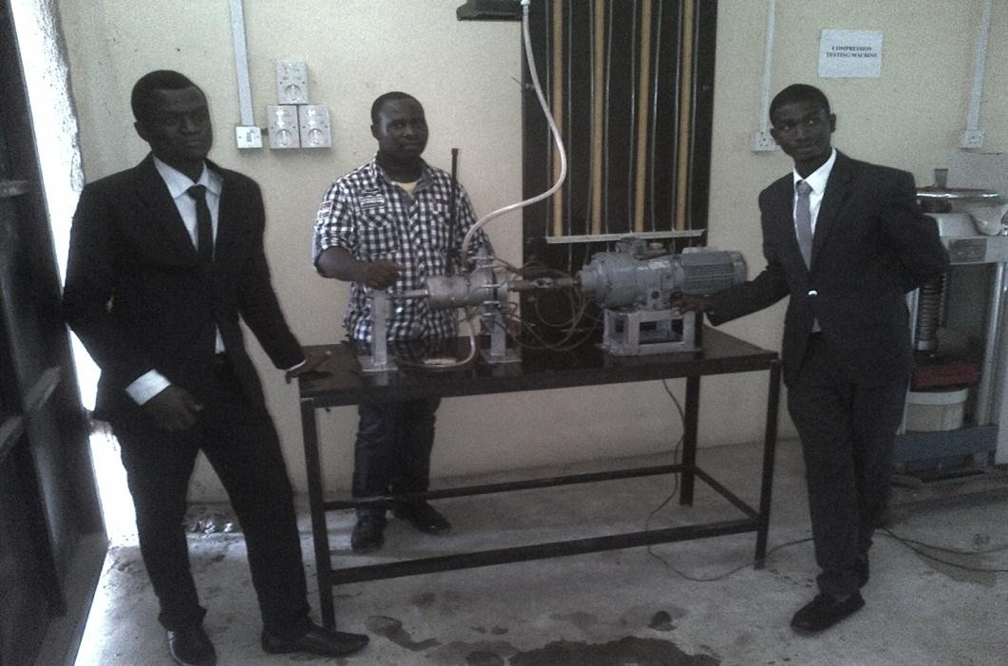

##### E

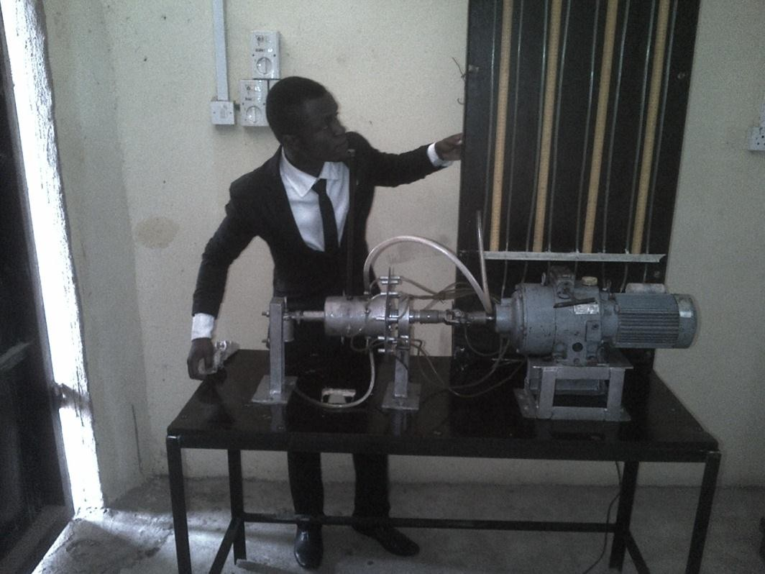

**F**

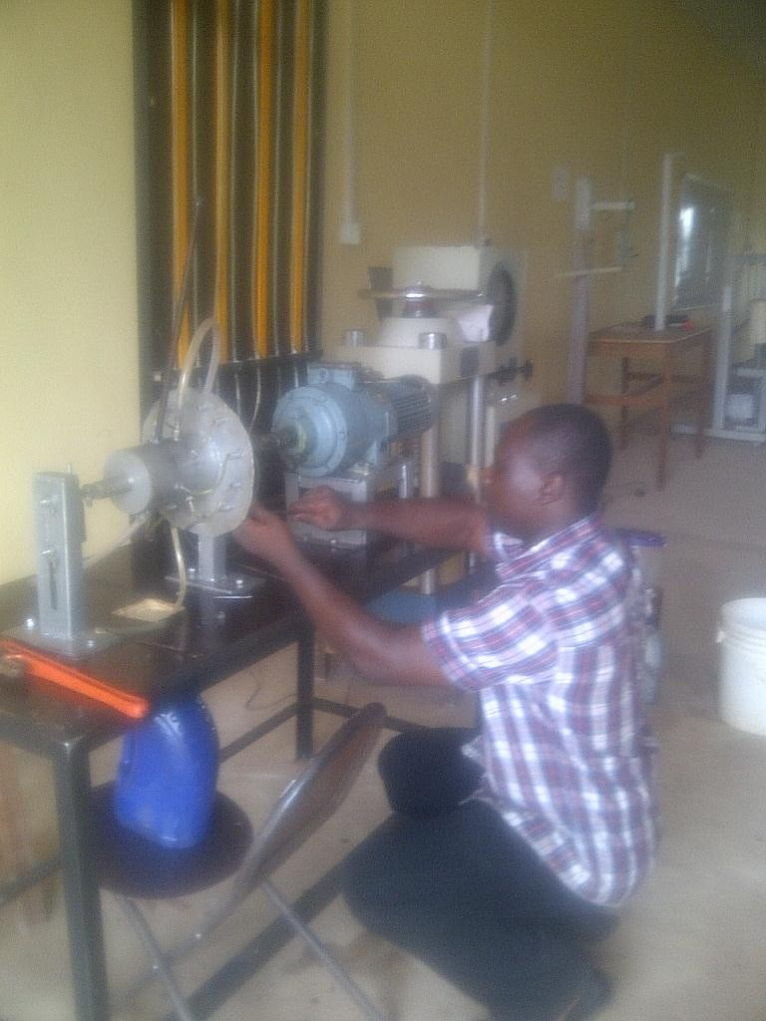

##### G

