DESIGN AND CONSTRUCTION OF AUTOMATIC QUICK BUZZER SYSTEM
ABSTRACT
Design and construction of automatic quick buzzer system was carried out in the research. Questionnaire was used to elicit the require information and the results obtained analysed using mean and percentages. Results of the analysis showed that in view of the performance and quality of quiz buzzer, state government and federal government should be readily available to provide necessary assistance for quiz buzzer research work as this will strengthen and encourage young engineers to build on the past knowledge. Finally, recommendations were made bared on the research findings.
CHAPTER ONE
1.0 INTRODUCTION

1.1 BACKGROUND OF THE STUDY

Quiz buzzers are used often at places like educational institutions where it is required for game shows and also in live quiz competitions broadcasted via television. A quiz buzzer allows any user to press the switch quickly in response to a question posed during competitions that are conducted in schools and colleges (Amos, & James, 2021). The pressed switch gives a buzzing sound or alarm for some duration of time and the reaction time is very small. Buzzer can also be used in different applications such as annunciator panels; electronic metronome microwave oven and other house hold application (Rocks, & Mazur, 2021).

Conventional systems require human intervention to decide which team has pressed the button and this system can be erroneous and even biased. Another problem arises when two members pressed the button at a negligible interval and it is difficult to guess who has pressed the buzzer first (Owen, 2022). Here we designed an automatic quiz buzzer system such that when more than one team presses the buzzer, the delay is accurately taken into account and number is displayed. We build the circuit using a microcontroller which scans the input from push buttons and displays the corresponding number on a display device. It is a simple circuit with minimum number of components and

1

In settings such as educational institutions, where the usage of quiz buzzers is essential for game shows and also in live quiz competitions that are transmitted via television, quiz buzzers are utilised frequently. Any user can quickly press the switch on a quiz buzzer in response to a question that is being presented during competitions that are held at educational institutions such as schools and colleges (Amos, & James, 2021). When the switch is activated, there is a beeping noise or an alarm that continues for a predetermined amount of time, and the response time is extremely quick. Buzzer is versatile and can be utilised in a variety of applications, including annunciator panels, electronic metronomes, microwave ovens, and other home appliances (Rocks, & Mazur, 2021).
Conventional methods necessitate human interaction in order to determine which team has pressed the button; however, this system is not only prone to error, but it can also be biassed. Another problem occurs when two members press the button at the same time or within a very short period of each other, making it impossible to determine who was the first to press the buzzer (Owen, 2022). Here, we developed an automatic quiz buzzer system in such a way that the delay is precisely taken into account and the number is displayed whenever more than one team clicks the buzzer. We construct the circuit with the help of a microcontroller, which reads the information sent by push buttons and shows the relevant number on a display device. It is a straightforward circuit, consisting of the fewest possible components and being free of any complexity (Amos, & James, 2021). The microcontroller computes and displays an exact number by taking into consideration the amount of time that elapses between each button press. The maximum number of teams that can be managed by this system is 8, although more teams can be managed by adding another set of 8 push buttons.

1.2 AIM AND OBJECTIVE

The aim of this project is to design and construction of automatic quiz buzzer system such that when more than one team presses the buzzer, the delay is accurately taken into account and number is displayed.

1.3 JUSTIFICATION OF THE STUDY

The circuit is a simple embedded system with a set of 8 push buttons being the input devices, a microcontroller as the controller and the output devices being a buzzer and a display. The whole operation is carried out by a microcontroller through a program written in C language and dumped inside the microcontroller. When one of the buttons is pressed, the buzzer starts ringing and the corresponding number is displayed on the liquid crystal display.

A quiz buzzer circuit can be implemented in several ways with the use of various controllers. These controllers include 555 timer and microcontrollers. The 555 timer based buzzer circuit is a simple and low-cost device wherein the time duration is determined by the resistor

2

and capacitor value (RC constant). A microcontroller based buzzer circuit is a programmable timer wherein the time duration can be varied by changing the program code of the microcontroller.

1.4 SCOPE OF THE STUDY

The whole design process involves six steps. First step requires designing the circuit; the second step is drawing the circuit on any software like Proteus. The third step involves writing the code using high level language or assembly language and then compiling it on a software platform like Kielu Vision. The fourth step is dumping the code in microcontroller and fifth step is simulating the circuit.

The circuit involves using five major components – a Microcontroller, 8 SPST push buttons, a buzzer and liquid crystal display. The microcontroller used in this case is AT89C51, an 8 bit microcontroller manufactured by Atmel.

Reset Circuit Design

The reset resistor is selected such that the voltage at the reset pin, across this resistor is at minimum of 1.2V and the width of the pulse applied to this pin is greater than 100ms. Here we select a resistor of 100K ohms and a capacitor of 10uF.

3

Oscillator Circuit Design

The oscillator circuit is designed using a crystal oscillator of 12 MHz and two ceramic capacitors each 15pF. The crystal is connected between pins 18 and 19 of the microcontroller

Microcontroller Interfacing Design

The set of 8 push buttons are interfaced to port P1 of the microcontroller and a buzzer is interfaced to the port pin P0.0. The liquid crystal display is interfaced to the microcontroller such that all the input pins are connected to port P2.

Microcontroller Code

The code can be written using C language or assembly language. Here we select to write the program in C language using Kielu Vision. This is accomplished by the following steps

- Create a new project on Kiel window and select the target.

- Create a new file under the project and write the code.

- Save the code with .c extension and add the file to the source group folder under the target folder.

- Configure flash tools and create the hex file.

- Compile the code by pressing F7.

4

Once the code is compiled and a hex file is created, next step is to dump the code into the microcontroller. Since here we are not using any hardware device, we simply use Proteus to dump the code. This is done by first drawing the circuit on Proteus and then adding the code to the microcontroller by right clicking on the device.

1.5 CONTRIBUTION TO KNOWLEDGE

Once the circuit is powered, the compiler will initialize the stack pointer and the variables having the non-zero initial values and perform other initialization process and then calls the main function. It then checks if any of the buttons is pressed. In other words the microcontroller scans for any of its input pins at port P1 to be zero or at logic low level. In case pressed, the display function is called by passing the corresponding number. The microcontroller then sends the relevant signals to the port connected to the liquid crystal display. The BCD to liquid crystal decoding operation is not required in this case as direct values are send to the port pins or the input pins of the liquid crystal display such that the corresponding LEDs start glowing and the number is displayed. Simultaneously, a high logic signal is also sent to the buzzer pin such that current flows through the device and the buzzer start ringing.

Applications of Quiz Buzzer Circuit

5

- This device can be used at quiz competitions organized at schools, colleges and other institutions.

- It can be also used for other games.

- It can be used as at public places like banks, restaurants as a digital token display system.

1.6 LIMITATIONS OF THE STUDY

- The microcontroller used is a CMOS device and is highly static and hence cannot be touched by bare hands.

- It is a low range circuit, i.e. it is not possible to operate the circuit remotely.

- It is a battery operated circuit and can easily run out of power once the battery life time ends.

- It is a theoretical circuit and in practical application may require some passive components and even designing a linear power supply circuit to power the circuit directly using the mains supply

6

CHAPTER TWO

2.0 LITERATURE REVIEW

2.1 HISTORY OF 8 CHANNEL QUIZ BUZZER CIRCUIT

Watson is an artificially intelligent computer system capable of answering questions posed in natural language, developed in Quiz Buzzer Deep QA project by a research team led by principal investigator David Ferrucci. Watson was named after IBM's first CEO and industrialist Thomas J. Watson. The computer system was specifically developed to answer questions with the quiz buzzer show Jeopardy! In 2011, Watson competed on Jeopardy! against former winners Brad Rutter and Ken Jennings. Watson received the first place prize of $1 million.

Watson had access to 200 million pages of structured and unstructured content consuming four terabytes of disk storage including the full text of Wikipedia, but was not connected to the Internet during the game. For each clue, Watson's three most probable responses were displayed on the television screen. Watson consistently outperformed its human opponents on the game's signaling device, but had trouble responding to a few categories, notably those having short clues containing only a few words.

7

In February 2013, IBM announced that Watson software system's first commercial application would be for utilization management decisions in lung cancer treatment at Memorial Sloan Kettering Cancer Center in conjunction with health insurance company WellPoint.[12] IBM Watson's former business chief Manoj Saxena says that 90% of nurses in the field who use Watson now follow its guidance

2.2 DESCRIPTION

Watson is a question answering (QA) computing system that IBM built to apply advanced natural language processing, information retrieval, knowledge representation, automated reasoning, and machine learning technologies to the field of open domain question answering.

The key difference between QA technology and document search is that document search takes a keyword query and returns a list of documents, ranked in order of relevance to the query (often based on popularity and page ranking), while QA technology takes a question expressed in natural language, seeks to understand it in much greater detail, and returns a precise answer to the question.

According to IBM, "more than 100 different techniques are used to analyze natural language, identify sources, find and generate hypotheses, find and score evidence, and merge and rank hypotheses.

8

2.3 SOFTWARE

Watson uses IBM's Deep Quiz Buzzer software and the Apache UIMA (Unstructured Information Management Architecture) framework. The system was written in various languages, including Java, C++, and Prolog, and runs on the SUSE Linux Enterprise Server 11 operating system using Apache Hadoop framework to provide distributed computing.

2.4 HARDWARE

The system is workload optimized, integrating massively parallel POWER7 processors and being built on IBM's DeepQA technology which it uses to generate hypotheses, gather massive evidence, and analyze data. Watson is composed of a cluster of ninety IBM Power 750 servers, each of which uses a 3.5 GHz POWER7 eight core processor, with four threads per core. In total, the system has 2,880 POWER7 processor threads and has 16 terabytes of RAM.

According to John Rennie, Watson can process 500 gigabytes, the equivalent of a million books, per second. IBM's master inventor and senior consultant Tony Pearson estimated Watson's hardware cost at about three million dollars. Its performance stands at 80 TeraFLOPs which is not enough to place it at Top 500 Supercomputers list. According to Rennie, the content was stored in Watson's RAM for the game because data stored on hard drives are too slow to access.

9

2.5 OPERATION

When playing Jeopardy! all players must wait until host Alex Trebek reads each clue in its entirety, after which a light is lit as a "ready" signal; the first to activate their buzzer button wins the chance to respond. Watson received the clues as electronic texts at the same moment they were made visible to the human players. It would then parse the clues into different keywords and sentence fragments in order to find statistically related phrases. Watson's main innovation was not in the creation of a new algorithm for this operation but rather its ability to quickly execute hundreds of proven language analysis algorithms simultaneously to find the correct answer. The more algorithms that find the same answer independently the more likely Watson is to be correct. Once Watson has a small number of potential solutions, it is able to check against its database to ascertain whether the solution makes sense. In a sequence of 20 mock games, human participants were able to use the average six to seven seconds that Watson needed to hear the clue and decide whether to signal for responding. During that time, Watson also has to evaluate the response and determine whether it is sufficiently confident in the result to signal. Part of the system used to win the Jeopardy! Contest was the electronic circuitry that receives the "ready" signal and then examined whether Watson's confidence level was great enough to activate the buzzer. Given the speed of this circuitry compared to the speed of

10

human reaction times, Watson's reaction time was faster than the human contestants except when the human anticipated (instead of reacted to) the ready signal. After signaling, Watson speaks with an electronic voice and gives the responses in Jeopardy! ‍'s‍ question format. Watson's voice was synthesized from recordings that actor Jeff Woodman made for an IBM text-to-speech program in 2004.

2.6 COMPARISON WITH HUMAN PLAYERS

Watson's basic working principle is to parse keywords in a clue while searching for related terms as responses. This gives Watson some advantages and disadvantages compared with human Jeopardy! Players. Watson has deficiencies in understanding the contexts of the clues. As a result, human players usually generate responses faster than Watson, especially to short clues. Watson's programming prevents it from using the popular tactic of buzzing before it is sure of its response. Watson has consistently better reaction time on the buzzer once it has generated a response, and is immune to human players' psychological tactics.

The Jeopardy! Staff used different means to notify Watson and the human players when to buzz, which was critical in many rounds. The humans were notified by a light, which took them tenths of a second to perceive. Watson was notified by an electronic signal and could activate the buzzer within about eight milliseconds. The humans

11

tried to compensate for the perception delay by anticipating the light, but the variation in the anticipation time was generally too great to fall within Watson's response time. Watson did not operate to anticipate the notification signal.

2.7 DEVELOPMENT

Since Deep Blue's victory over Garry Kasparov in chess in 1997, IBM had been on the hunt for a new challenge. In 2004, IBM Research manager Charles Lickel, over dinner with coworkers, noticed that the restaurant they were in had fallen silent. He soon discovered the cause of this evening hiatus: Ken Jennings, who was then in the middle of his successful 74-game run on Jeopardy!. Nearly the entire restaurant had piled toward the televisions, mid-meal, to watch the phenomenon. Intrigued by the quiz show as a possible challenge for IBM, Lickel passed the idea on, and in 2005, IBM Research executive Paul Horn backed Lickel up, pushing for someone in his department to take up the challenge of playing Jeopardy! with an IBM system. Though he initially had trouble finding any research staff willing to take on what looked to be a much more complex challenge than the wordless game of chess, eventually David Ferrucci took him up on the offer. In competitions managed by the United States government, Watson's predecessor, a system named Piquant, was usually able to respond correctly to only about 35% of clues and often required several minutes to respond. To compete successfully on Jeopardy!, Watson

12

would need to respond in no more than a few seconds, and at that time, the problems posed by the game show were deemed to be impossible to solve.

In initial tests run during 2006 by David Ferrucci, the senior manager of IBM's Semantic Analysis and Integration department, Watson was given 500 clues from past Jeopardy! programs. While the best real-life competitors buzzed in half the time and responded correctly to as many as 95% of clues, Watson's first pass could get only about 15% correct. During 2007, the IBM team was given three to five years and a staff of 15 people to solve the problems. By 2008, the developers had advanced Watson such that it could compete with Jeopardy! Champions. By February 2010, Watson could beat human Jeopardy! Contestants on a regular basis.

Although the system is primarily an IBM effort, Watson's development involved faculty and graduate students from Rensselaer Polytechnic Institute, Carnegie Mellon University, University of Massachusetts Amherst, the University of Southern California's Information Sciences Institute, the University of Texas at Austin, the Massachusetts Institute of Technology, and the University of Trento, as well as students from New York Medical College.

13

CHAPTER THREE

3.0 METHODOLOGY

3.1 DATA ANALYSIS AND DISCUSSION

This chapter introduces the various electronic components that used in implementation of this project. These components are broadly classified into:

Hardware design Software Design

3.2 HARDWARE DESIGN

The hardware design is into the modules for easy design, analysis and integration.

Power supply unit

Control and Processing unit Input unit

Output dashboard/interface

Each module was designed individually and then joined together to form a scientific calculator. The different modules are controlled by a series of C-programs linked into control unit.

14

Power Supply Unit

A long-life battery (mine has a dry cell battery "+9volt" cell that last for year) which provides free power.
Input Unit

The 4*4 and 3*3 keypad used in this design serves as an input unit through which the users communicates with the system.
Output Unit

The output unit is the LCD of calculator is a 16*2 LCD. It has a black-ground light which enhance readability in low light conditions.
Control Unit

The microcontroller is COMPO the Scientific calculator. It gives instruction, accepts input through the keypad, process it, and displays the processed output through the LCD.

BLOCK DIAGRAM OF HARDWARE COMPONET

 |  | CONTROL UNIT
POWER SUPLY UNIT |  | CONTROL UNIT |  | INPUT UNIT
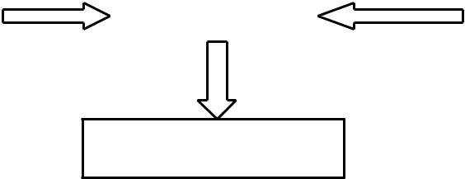

OUTPUT UNIT

Fig.3.1

Power Supply

The input to the circuit is applied from the regulated power supply. The AC input i.e. 230v from the main supply step down by the

15

transformer to 5v and is fed to a rectifier. The output obtained from the rectifier is fed to a filter to remove any AC components present even after rectification. Now, this voltage is given to a voltage regulator to obtain a pure constant dc voltage.
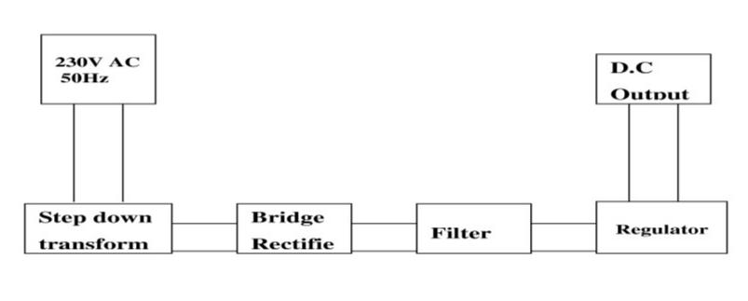
BLOCK DIAGRAM OF POWER UNIT

Fig.3.2

Transformer

Usually, Dc voltages are required to operate various electronic equipment and these voltages are 5v, 9v or 12v. But these voltages cannot be obtained directly. Thus the AC input available at the mains supply i.e. 230v is to be brought down to the required voltage level. This is done by a transformer. Thus a step down transformer is employed to decrease the voltage to a required level.
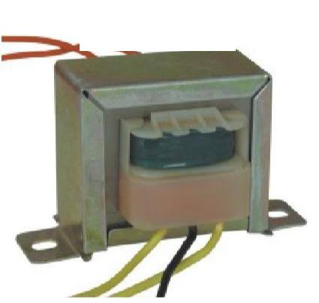

TRANSFORMER

Fig.3.3

16

Rectifier

The output from the transformer is fed to the rectifier. It converts A.C. into pulsating D.C. The rectification may be a half wave or a full wave rectifier. In the project, a bridge rectifier is used because of its merits like good stability wave rectification.
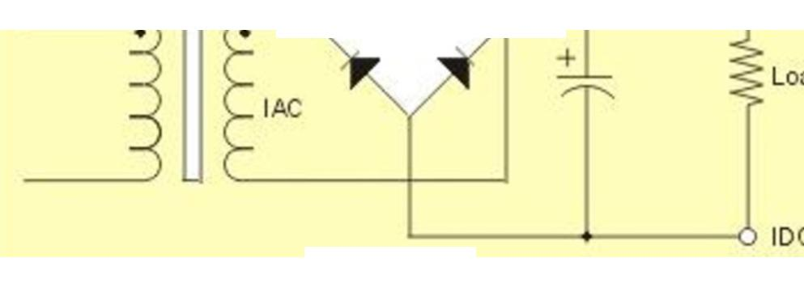
RECCTIFIER

Buzzer

Fig.3.4

The buzzer produces sound based on reverse of the piezoelectric effect. The generation of pressure variation or strain by the application of electric potential across a piezoelectric material is the underlying principle. These buzzers can be used to alert a user of an event corresponding to a switching action, counter signal or sensor input. They are also used in alarm circuits.

The buzzer produces a same noisy sound irrespective of the voltage variation applied to it. It consists of piezo crystals between two conductors. When a potential is applied across these crystals, they push on one conductor and pull on the other. This, push and pull action, results in a sound wave. Most buzzers produce sound in the range of 2 to 4 kHz.

17

The red lead is connected to the input and the black lead to the ground.

BUZZERS
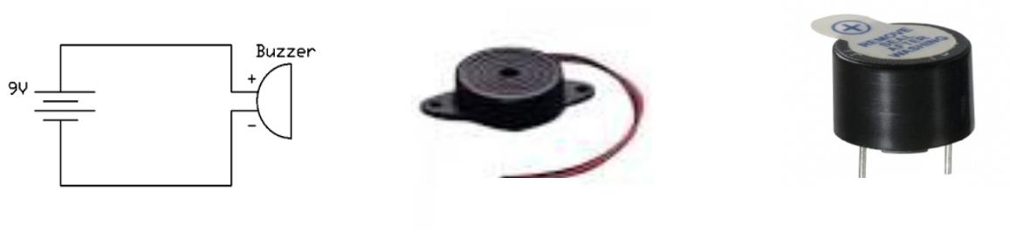

Fig.3.5 | Fig.3.6 | Fig.3.7

Push Buttons of Buzzer

A push-button (also spelled pushbutton) or simply button is a simple switch mechanism for controlling some aspect of a machine or a process. Buttons are typically made out of hard material, usually plastic or metal. The surface is usually flat or shaped to accommodate the human finger or hand, so as to be easily depressed or pushed. Buttons are most often biased switches, though even many un-biased buttons (due to their physical nature) require a spring to return to their un-pushed state. Different people use different terms for the "pushing" of the button, such as press, depress, mash, hit, and punch.

Uses

The "push-button" has been utilized in Quiz Buzzer, calculators, push-button telephones, kitchen appliances, and various other mechanical and electronic devices, home and commercial. In industrial and commercial applications, push

18

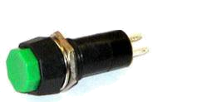
Push

Buttons
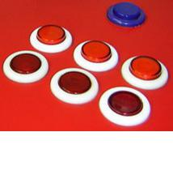

Fig.3.8 | Fig.3.9

3.3 SOFTWARE DESIGN

The Software design is into the modules for easy design, analysis and integration. The Quiz Buzzer Circuit has various components when designing and these are the components mention below their uses:

Microcontroller Capacitor

Diode

Switching Regulator

LCD (liquid Crystal Display) Crystal

Resistor

AT89C51 Microcontroller

A microcontroller has a dedicated input device and often (but not always) has a small LED or LCD display for output. A microcontroller also takes input from the device it is controlling and controls the device by sending signals to different components in the device. Microcontrollers are dedicated to one task and run one specific program. The proposed 8 Candidate Quiz Buzzer design is used in quiz competition when they use buzzer for opting their turn. The proposed design is a microcontroller (AT89C51) based design and we use an

19

AT89C51 microcontroller which belong s to the family of 8051 microcontrollers.
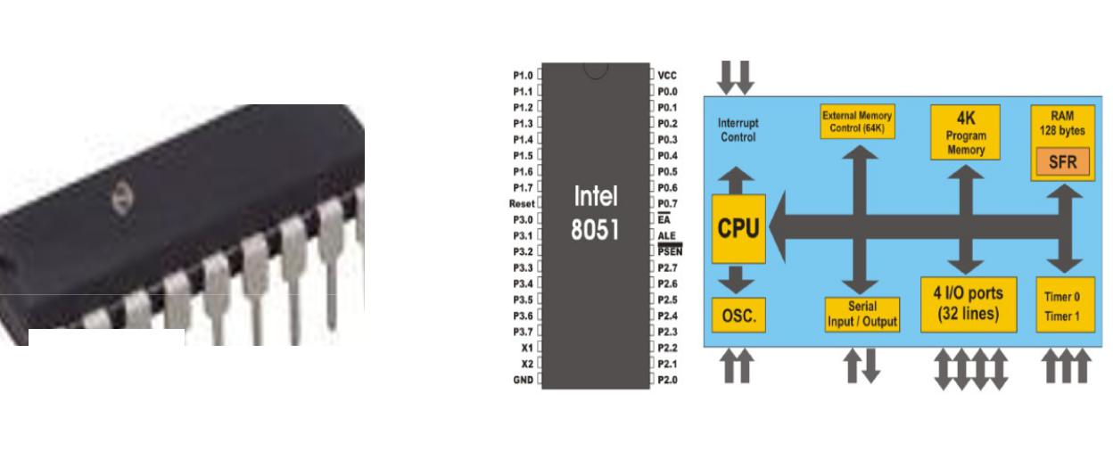

AT89C51 MICROCONTROLLER

Fig.3.10

Fig.3.11

Capacitor

Capacitor is an electronic component that stores electric charge . The capacitor is made of 2 close conductors (usually plates) that are separated by dielectric material. The plates accumulate electric charge when connected to power source.

One plate accumulates positive charge and the Lother plate accumulates negative charge.

The capacitance is the amount of electric charge that is stored in the capacitor at voltage of 1 Volt. The capacitance is measured in units of Farad (F). The capacitor disconnects current in direct current (DC) circuits and short circuit in alternating current (AC) circuits.
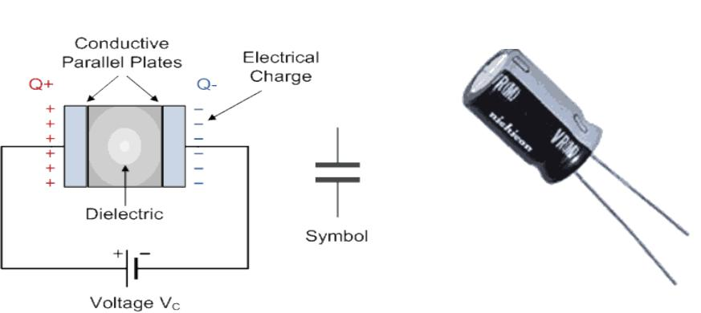
CAPACITORS
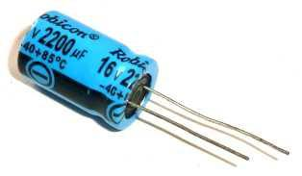

20

Fig.3.12

Diode

Fig.3.13

Fig.3.14

A diode is a specialized electronic electrodes called the anode and the cathode.

component with two

Most diodes are made with semiconductor materials such as silicon, germanium, or selenium. Some diodes are comprised of metal electrodes in a chamber evacuated or filled with a pure elemental gas at low pressure. Diodes can be used as rectifiers, signal limiters, voltage regulators, switches, signal modulators, signal mixers, signal demodulators, and oscillators. The fundamental property of a diode is its tendency to conduct electric current in only one direction.

DIODE

Anode Cathode

(+) (-)

Fig.3.14

Switching Regulator
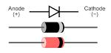

A switching regulator rapidly switches a series device on and off. The switch’s duty cycle sets the amount of charge transferred to the load. This is controlled by a feedback mechanism similar to that of a linear regulator. Switching regulators are efficient because the series

21

element is either fully conducting or switched off because it dissipates almost no power. Switching regulators are able to generate output voltages that are higher than the input voltage or of opposite polarity, unlike linear regulators.
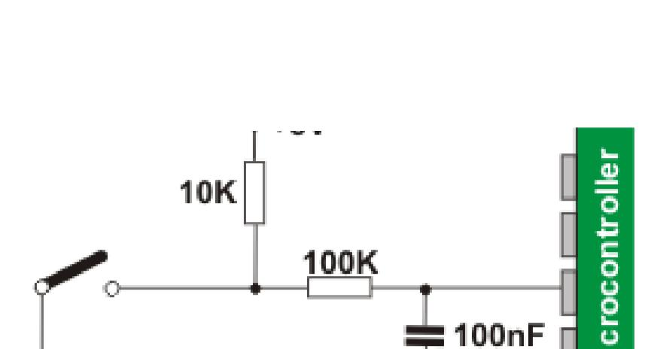

Fig.3.14

LCD (Liquid Crystal Display)SWITCHREGULATOR CIRCUIT

LCD (liquid crystal display) is the technology used for displays in notebook and other smaller computers. Like light-emitting diode (LED) and gas-plasma technologies, LCDs allow displays to be much thinner than cathode ray tube (CRT) technology. LCDs consume much less power than LED and gas-display displays because they work on the principle of blocking light rather than emitting it.

An LCD is made with either a passive matrix or an active matrix display grid. The active matrix LCD is also known as a thin film transistor (TFT) display. The passive matrix LCD has a grid of conductors with pixels located at each intersection in the grid. A current is sent across two conductors on the grid to control the light for any pixel. An active matrix has a transistor located at each pixel intersection, requiring less current to control the luminance of a pixel. For this reason, the current in an active matrix display can be switched

22

on and off more frequently; improving the screen refresh time (your mouse will appear to move more smoothly across the screen, for example). Some passive matrix LCD's have dual scanning, meaning that they scan the grid twice with current in the same time that it took for one scan in the original technology. However, active matrix is still a superior technology Liquid Crystal Display (LCD) technology, while we cannot live without it, comes with some advantages as well as some disadvantages. While earlier technologies were more reliant on Cathode Ray Tube (CRT) technology, LCD technology generally surpasses CRT technology for most applications. Yet, LCD technology continues to evolve and change. As mobile devices and Smartphone emerge, many applications are now reliant on LCD touch screen technology. The fact remains, LCD technology is very much needed to display our powerful online graphics, video, and text solutions.

LIQUID CRYSTAL DISPLAY (LCD)

Fig.3.15

Crystal
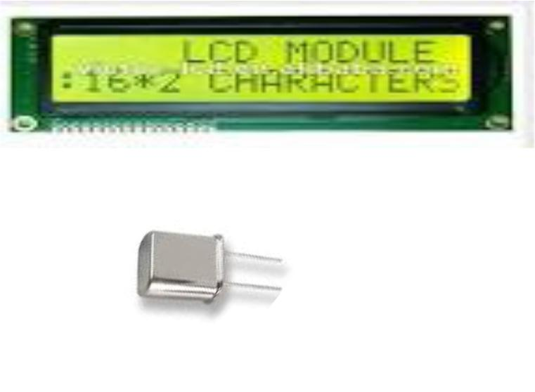

A crystal oscillator is an electronic oscillator circuit that uses the mechanical resonance of a vibrating crystal of piezoelectric material to create an electrical signal with a precise frequency. This frequency is

23

commonly used to keep track of time, as in quartz wristwatches, to provide a stable clock signal for digital integrated circuits, and to stabilize frequencies for radio transmitters and receivers. The most common type of piezoelectric resonator used is the quartz crystal, so oscillator circuits incorporating them became known as crystal oscillators, but other piezoelectric materials including polycrystalline ceramics are used in similar circuits. Quartz crystals are manufactured for frequencies from a few tens of kilohertz to hundreds of megahertz. More than two billion crystals are manufactured annually. Most are used for consumer devices such as wristwatches, clocks, radios, computers, and cell phones. Quartz crystals are also found inside test and measurement equipment, such as counters, signal generators, and oscilloscopes.

Fig.3.15

Transistor BC548
CRYSTAL OSCILLATOR

BC548 is general purpose silicon, NPN, bipolar junction transistor. It is used for amplification and switching purposes. The current gain may vary between 110 and 800. The maximum DC current gain is 800. Its equivalent transistors are 2N3904 and 2SC1815. These equivalent transistors however have different lead assignments. The variants BC548 are 548A, 548B and 548C which vary in range of current gain and other characteristics. The transistor terminals require a fixed DC

24

voltage to operate in the desired region of its characteristic curves. This known as biasing, For amplification applications, the transistor is biased such that it is partly on for all input conditions. The input signal at base is amplified and taken at the emitter. BC548 is used in common emitter configuration for amplifiers. The voltage divider is the commonly used biasing mode. For switching applications, transistor is biased so that it remains fully on if there is a signal at its base. In the absence of base signal, it gets completely off.
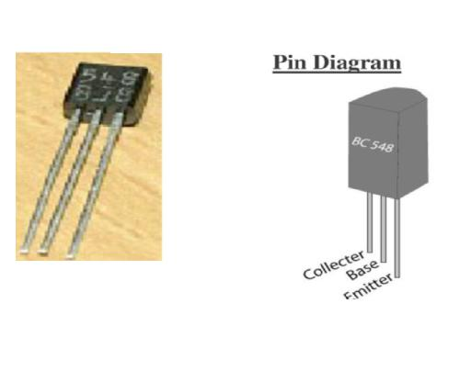

TRANSISTOR

Resistor | Fig.3.15
Resistor | Fig.3.15

- resistor is a passive two-terminal electrical component that implements electrical resistance as a circuit element. Resistors act to reduce current flow, and, at the same time, act to lower voltage levels

within circuits. | RESISTOR
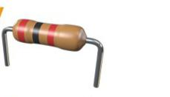

Fig.3.16 | Fig.3.17
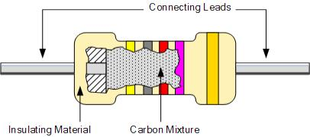

25

CHAPTER FOUR

4.1 TESTING AND IMPLEMENTATION

The following tests were carried out on the component used and overall circuit.
- CONTINUITY TEST
- SHORT CIRCUIT TEST

This test were carried out without ohms meter range of multimeter, below are the various test carried out on the component
4.2 COMPONENT TESTING

Test for Diode

A very good test you can do is to check a diode with your multimeter set to the ohmmeter setting. This is a simple test we can do to check whether it is good, open, or shorted.

So we take the ohmmeter and place it across the leads of the diode. The orientation is very important. Anode-Cathode Diode Resistance Test We first take the ohmmeter and place the positive probe on the anode of the diode (the black part of the diode_ and the negative probe on the cathode of the diode (the silver strip), as shown above. In this setup, the diode should read a moderately low resistance, maybe a few tens of thousands or low hundreds of thousands of ohms. For example, you may read 230KΩ.

26

Test for Atmega16 Microcontroller

After the ATMEGA micro controller has been installed on the circuits, the ohmmeter is used to check the resistance from the common ground to each of the terminals. To ensure that no component connected to the Atemega16 terminal is leaking. Before the Atemega16 was installed on the circuit, we use universal programmer to test if Atemega16 controller is OK, its legs will display green light to all the terminal which means the IC is in good condition.

Test for Resistor

Test for the current value of the resistor by connecting the Meyer probes, to its two terminals, with multi meter in ohmmeter ranges and the value were read.

Testing the Project Output

The project output test is done by placing the Atemega16 micro controller into the programmer socket. If the system is able to recognize the USB cable through the 2.0 USB port on the system, then the project is perfectly OK.

4.3 PROJECT LIMITATIONS

27

This project is not effectively function if the battery of the quiz buzzer is not in a good working condition, then a new and tested battery is needed to perform a good desirable output. Also the project will not work perfectly if any of the components is malfunctioning, for making it perfect we need to replace the malfunction components with good and reliable components.

4.4 PROBLEM FACED

Due to insufficient knowledge about programming, we had problem in generating hex code for Microcontroller. We later solved these problems through series of research on eBooks, internet, consulting our supervisor. The most difficulty we faced in the course of our project was the implantation of hardware due to lack of knowledge and research.

4.5 CIRCUIT DESCRIPTION

The quiz buzzer has eight inputs from P2.0 to 2.7 of the microcontroller 8051. An additional input is used which is named as reset and is assigned to p3.1. There are two reset in the MC. 1 is the master power on reset at pin no 9 while the other is user defined. Liquid Crystal Display is interfaced with the microcontroller at port 1 (pin no1.0 to 1.6). While a piezzo buzzer is connected to pin no. 1.7. A network of 10 μf capacitor and 8.2kΩ resistor with a push button in parallel is connected to pin no 9. This pin is used for master reset. In

28

order to reset the whole code in 8051 pin 9 must be kept at vcc for 2 clock cycle of microcontroller. Pin no. 31 is kept at high (EA). This pin is used for external access of memory. Since microcontroller has its own memory so we have to put at high logic level. A 12 hertz crystal oscillator is connected between XTAL1 and XTAL2 pin with 2, 30 pf capacitors grounded each. Pin no. 40 is given with 5 volt while pin no 20 is grounded. It must be noted that 8051 operates on 5 volts Vcc. Therefore a voltage regulator is used in order to convert (in a sense) 9 volt battery voltages to 5 volts.

4.6 BLOCK DIAGRAM
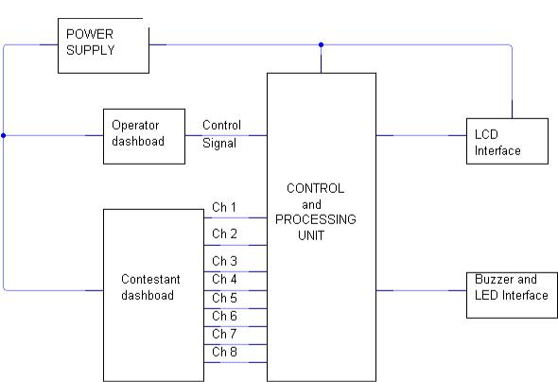

BLOCK DIAGRAM OF 8-CHANNEL QUIZ BUZZER

Fig.4.1

29

Circuit Connections:

In this circuit, the resistor R1 is connected between Vcc and discharge pin 8. Another resistor R2 is connected between the discharge pin 8 and the trigger pin2. The Pin2 and the threshold pin6 are shorted and connected through a capacitor. This capacitor charges through resistor R1 and R2 and discharges through R2. The Pin1 is connected to the ground for negative biasing, and the pin 5 is connected to the ground through the capacitor, and the pin3 is used as an output. The Pin 8 is connected to the potential divider of R1 and R2 resistors.

4.7 QUIZ BUZZER WORKING MODEL AND DESIGN

The AT89C51 microcontroller is a 40 pin package in which 32 pins can be used for input and output purposes. We use 8 switches and they are connected individually to port1 pins and we make a serial line for all the 8 switches so that they can be connected to a buzzer and when any switch is presses a buzzer is blown. We use a seven segment display to display the information of the switch which is presses.

The code for this application is written in such a way that when any input switch is presses the corresponding switch number is displayed in the LCD screen. The microcontroller works a clock frequency of 12 Mhz. the entire device requires a power supply of 5v

30

and we can provide it by using a battery source or by using a step down transformer from the power supply.
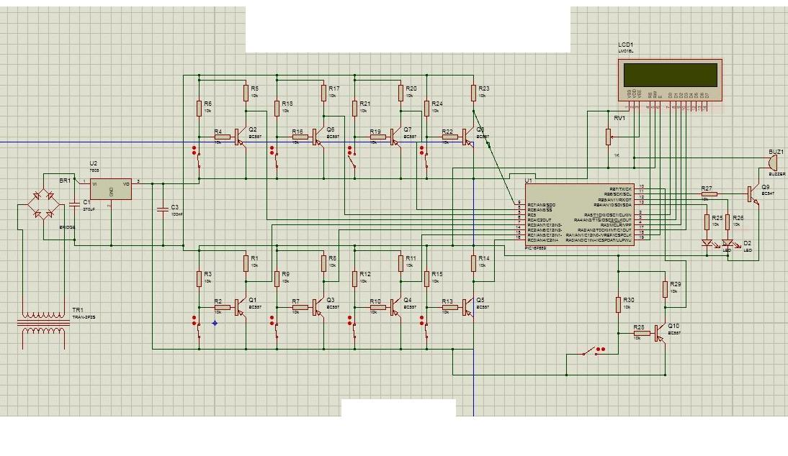
Quiz Buzzer Circuit Diagram

Fig.4.2

The AT89C51 microcontroller has an inbuilt flash memory of 8kb and we can reprogram it any number of times. We can use IC based design but the microcontroller design has less delay and can give quick responses.

31

CHAPTER FIVE

CONCLUSION AND RECOMMENDATION

5.0 CONCLUSIONS

Quiz buzzers are used often at places like educational institutions where it is required for game shows. Conventional systems require human intervention to decide which team has pressed the button and this system can be erroneous and even biased. Another problem arises when two members pressed the button at a negligible interval and it is difficult to guess who has pressed the buzzer first. Here we designed an automatic quiz buzzer system such that when more than one team presses the buzzer, the delay is accurately taken into account and number is displayed. We build the circuit using a microcontroller which scans the input from push buttons and displays the corresponding number on a display device. It is a simple circuit with minimum number of components and sans any complexities. The microcontroller takes into account the time delay between two buttons and the accurate number is displayed. Even though this system is only for 8 teams, more teams can be added by using another set of 8 push buttons.

The design, specification and implementation of 8channel quiz buzzer circuit using microcontroller illustrate well the concept of the

32

partition of control and data flow based on the virtual environment idea.

The basic idea of the software solution for a quiz buzzer circuit is to parse the string created by punch button and execute it if appropriate it sounds simple.

A Quiz buzzer circuit can be implemented in several ways with the use of various controllers. These controllers include 555 timers and microcontrollers. The 555 timer based buzzer circuit is a simple and low-cost device wherein the time duration is determined by the resistor and capacitor values (RC constant). A Microcontroller based buzzer circuit is a programmable timer wherein the time duration can be varied by changing the program code of the microcontroller. The following description of both these circuits will help you to compare both the circuits and their operations.

A timer can be operated in three modes such as monostable, astable and bistable for multivibrator circuits. The timer is used for generating pulses using pulse modulation technique. In a monostable mode, the output is set to high for a certain time period determined by the RC time constant when the timer is triggered at pin

- In a bistable mode, the triggering input is connected at pin 2. When the triggered input is low, the output of the circuit will be in high state.

33

The reset button is connected at pin 4, and if the input is low, then the output is also in a low state.

Once the circuit is powered, the compiler will initialize the stack pointer and the variables having the non-zero initial values and perform other initialization process and then calls the main function. It then checks if any of the buttons is pressed. In other words the microcontroller scans for any of its input pins at port P1 to be zero or at logic low level. In case pressed, the display function is called by passing the corresponding number. The microcontroller then sends the relevant signals to the port connected to the Liquid Crystal Display (LCD).

The BCD to Liquid Crystal Display (LCD) decoding operation is not required in this case as direct values are send to the port pins or the input pins of the liquid crystal display such that the corresponding LEDs start glowing and the number is displayed. Simultaneously, a high logic signal is also sent to the buzzer pin such that current flows through the device and the buzzer start ringing.

The state machine required by any software is a result of analysis and design. Before we start to specify a state machine we must work out a clear picture of the task that the state machine is to take over. The aim of introduction of the state machine in software is not to eliminate all “if then else” statements. No, the state machine is

34

required to take over the sequential (state dependent) part of the software control. For instance, the state machine should not be involved into checking whether the First contestant press the button and the buzzer make an alarm. If you start to define a state machine on that level you will get a monster that may be as difficult to understand as chaotic software with flags. In the design phase you have to identify the essential control problem that is to be realized by the state machine. The design is the most difficult and responsible part of the project. A design determines the quality of the software, in that case the quality of the control flow. The use of state machines in the software does not automatically guarantees a better result.

5.1 RECOMMENDATION

In view of the performance and quality of quiz buzzer, state government and federal government should be readily available to provide necessary assistance for quiz buzzer research work as this will strengthen and encourage young engineers to build on the past knowledge. Secondly, an institute for electronic work should be established with a standard laboratories or workshops for research purpose in the polytechnic for the proper use of under graduate student and to enhance productivity at large in technological advancement.

35

An automatic quiz buzzer system such that when more than one team presses the buzzer, the delay is accurately taken into account and number is displayed. We build the circuit using a microcontroller which scans the input from push buttons and displays the corresponding number on a display device.

5.2 REFERENCE

Rufus Giwa Polytechnic owo. General guides to Project Writing.

Horowitz, P.; and Winfield, H. 2002. The Art of Electronics, 2nd ed.

Cambridge Univ. Press, Cambridge, UK.

Rocks, G.; and Mazur, G.1993. Electrical motor controls. American Technical Publ., New-York, N.Y,USA.

Owen, B. 1995. Beginner’s Guide to Electronics 4th Ed. A Newness Technical Book, McGraw-Hill Companies Inc. New York, N.Y, USA.

Amos, S.W.; and James, M. 1981. Principles of transistor circuit: introduction to the design of amplifiers, receivers and digital circuits. 6th ed., hartnollsltd ., bodmin.UK.
Rocks, G.; and Mazur, G.2021. Electrical motor controls. American Technical Publ., New-York, N.Y,USA.

Owen, B. 2022. Beginner’s Guide to Electronics 4th Ed. A Newness Technical Book, McGraw-Hill Companies Inc. New York, N.Y, USA.

Amos, S.W.; and James, M. 2021. Principles of transistor circuit: introduction to the design of amplifiers, receivers and digital circuits. 6th ed., hartnollsltd ., bodmin.UK.

Faissler, W.L. 1991. An introduction to modern Electronics, Willey, New York, NY, USA.

IEEE P802.3ba 40Gb/s and 100Gb/s Ethernet Task Force, retrieved 2011-11-12.

36

Telecommunications Magazine Online, Americas January 2003, Issue Highlights, Online Exclusive: Broadband Access Maximum Performance, Retrieved on February 13, 2005.

Simmonds, A; Sandilands, P; van Ekert, L (2004). Ontology for Network Security Attack". Lecture Notes in Computer Science. Lecture Notes in
Computer Science 3285: 317–323.

doi:10.1007/978-3-540-30176-9_41. ISBN 978-3-540-23659-7.

"Bigger Monster, Weaker Chains: The Growth of an American Surveillance Society". American Civil Liberties Union. January 15, 2003. Retrieved March 13, 2009.

"Anonymous hacks UK government sites over 'draconian surveillance' ", Emil Protalinski, ZDNet, 7 April 2012, retrieved 12 March 2013

Theraja, B.L.; and Theraja, A.K. 2002. Electrical Technology, 21st ed. RanjendraRavida, New Delhi, India

37

