# CHAPTER ONE

* 1. **INTRODUCTION**

A Geographical Information System (GIS) is a system of hardware, software and procedures to facilitate the management, manipulation, analysis, modeling, representation and display of geo‐referenced data to solve complex problems regarding planning and management of resources. Functions of GIS include data entry, data display, data management, information retrieval and analysis. The applications of GIS include mapping locations, quantities and densities, finding distances and mapping and monitoring change. There are mainly three categories of geographic positioning systems to determine or track a user’s location, which have been designed and proposed over the years. These systems are mainly three categories:

 Global Positioning System, Wide-area Location System and Indoor Positioning System. Global Positioning System (GPS) receives signals from multiple satellites to determine the physical location of a user.

The limitation for this system is that it is inefficient for indoor use; alongside in urban areas it often possesses difficulties in receiving signals where high buildings shield the satellite signals.

Wide-area location systems are mainly based on cellular networks that involve measuring the signal strength, the angle of signal arrival and/or the time difference of signal arrival. The positioning information in wide-area location systems is highly limited by the cell size or cell coverage.

Several approaches have been proposed for indoor location sensing or indoor positioning system such as infrared sensing, radio frequency, ultrasonic and scene capture analysis. There are also a few technologies to use within indoor areas, such as GPS psudo lite, ultrasonic and cellular-based systems, which need considerable supporting devices and facilities. Each of these methods has their own advantages and disadvantages. Some are expensive to implement, while others are not very accurate. The Active Badge is the first location system. Radar, well-known approach, is an RF (Radio Frequency) system for locating and tracking users within large

structures. The approach is an empirical method and a signal propagation model. This procedure determines user location by combining signal strength measurements with signal propagation models. RF signal strength within building is affected by multipath propagation effects and absorption, resulting in non-linear behavior. The results show that the empirical method is superior in terms of accuracy with median resolution in the range of about 3m and the signal propagation model has 4.3m accuracy (median), but it makes deployment easier. The applications of indoor positioning are many, for instance, location-finding, indoor robots, inventory tracking, security, etc.

Geographic Information (GI) represents information that can be associated to a location on Earth, information about nature phenomena, natural, cultural and human resources in general. A GIS (Geographic Information System) represents an ensemble of hardware-software for capturing stocking, validating, managing, analyzing and visualizing data that have a geographic reference.

# BACKGRAOUND

**Application of Remote Sensing and GIS**

Function of an Information system is to improve one’s ability to make decisions. An Information system is a chain of operations starting from planning the observation and collection of data, to store and analysis of the data, to the use of the derived information in some decision making process. A GIS is an information system that is designed to work with data referenced to spatial or geographic coordinates. GIS is both a database system with specific capabilities for spatially referenced data, as well as a set of operation for working with data. There are three basic types of GIS applications which might also represent stages of development of a single GIS application.

 **Inventory Application**

Many times the first step in developing a GIS application is making an inventory of the features for a given geographic area. These features are represented in GIS as layers or themes of data. The emphasis at this stage of application development consists of updating and simple data retrieval.

 **Analysis Application**

Upon completion of the inventory stage, complex queries on

multiple layers can be performed using spatial and spatial analysis techniques.

 **Management Application**

More advanced spatial and modeling techniques are required to

support the decisions of managers and policy makers. This involves shifting of emphasis from basic geographic data handling to manipulation, analysis and modeling in order to solve real world problems.

 **Uses of Coastal GIS Packages**

1. Retrieval of information of any specific site.
2. Provision of summary data for planning purpose.
3. Graphical display for educational and public relation exercise.
4. Classification of coasts and management zone.
5. Predicting modeling to determine.
   1. Projections of coastal changes.
   2. Impacts of individual schemes.
   3. Impacts from changes of use.
   4. Impacts from natural calamities.
   5. **Statement of Problem:**

The application of GIS is so enormous that it is only limited to the mindset of the administrators and users. This project therefore focuses on the visualization and manipulation of geospatial information to support decision making in urban development and other areas the GIS can be applied.

* 1. **purpose of study:**

The purpose of this project is to support decision making with the use of geospatial information. With the help of a GIS you will have at your disposal the necessary instruments to analyze:

 The selection and analysis of the location;

 The profile, the dividing and the prospecting of the customers;  The potential of new marketing.

 Potential crime area  Topology and so on.

* 1. **Research Methodology:**

Hybrid method (quantitative and qualitative method) as both literature and text was used, interviews and direct observation of the subject matter.

* 1. **Objective of study:**

The main aim of the objective is to design and implement location retrieval system which will help To provide GIS for geospatial information visualization To provide goe-data manipulation via a web interface. Support decision making in urban businesses Support erosion control, business site

* 1. **Significance of study**:

To provide the thematic map of the major business areas in the state capital Awka.

* 1. **Scope of the study**:

This research work is to design software that will enable people or strangers in awka to locate places using a map, such as street, estate, house numbers, schools, police station etc through the use of location retrieval system using php and data.

* 1. **limitations of the study**:
     1. One of the limitations of the project is time as the researchers have to combine lectures with other activities involve in the course to obtain a degree in CARITS UNIVERSITY.
     2. The other limitation is literature as the topic is relatively new not too many materials are readily available for review.

# CHAPTER TWO

* + - 1. **LITRATURE REVIEW:** *Journal of Applied Computer Science,* no.1 (1) 2007, Suceava says “Geographic information (GI) represents information that can be associated to a location on Earth, information about nature phenomena, natural, cultural and human resources in general. A GIS

(Geographic Information System) represents an ensemble of hardware-software for capturing stocking, validating, managing, analyzing and visualizing dates that have a geographic reference”.

The NASA definition: “A GIS is a system associated with hardware, software and personal competent that works with data such as topographic, demographic, utilities as well as other resources containing geographic references”.

The GIS emphasizes on analyzing data, not on making maps. In other words a GIS should not be mistaken with a specialized software package; the maps represent a GIS product or a way to visualize a

certain analyzed data. Besides the specific methods and techniques, the GIS technology operates on data base (questionnaires, publications, inserted dates) and statistical analysis put in visualizations and spatial analysis offered through maps.

* + - 1. **General GIS disposal instrument**
         * The selection and analysis of the location;
         * The profile, the dividing and the prospecting of the customers ie in business;
         * Demographic tendencies
         * The potential of new marketing.

The geographic information systems (GIS) appeared as a necessity in solving the problems of stocking huge amounts of data and spatial tracking of the information in the given picture. Due to the development of the informational technology, as well as to the systems of transmission of dates in the network, GIS are spreading more and more, being used in various fields, including business. The GIS grew in the last decades, starting from systems with special destination, created by some organizations for their own interests, and

ending with more sophisticated systems that can be useful to various fields of activity. The first systems’ limitations reduced their use to only one way of application and they couldn’t serve the complex needs of the grand organizations, which is why more complex systems have been developed, systems which integrate more and more facilities with different areas of application. This development wasn’t determined so much by the technological necessities, but by the commercial goals: a growth in the sales volume, due to an overgrown users’ number of this particular system. The adding of these new facilities, however, involved a big price as: “The GIS these days are complicated, expensive, cannot be rolled on sophisticated computers, require long trainings and often programs of interface adjustment must be accomplished for the requests of the final customers. The Geographic Information Systems (GIS) are used for stocking and processing dates referring to the Earth’s surface. These dates contain thematic information as well as geometrical (spatial) information. For most applications, the thematic aspects of the description and the zone analysis are of major importance. Choosing the way in which

geography will be represented in a GIS depends on the thematic data and their use.

The information is considered geographic if it has measurement as well as localization or if it is an attribute of an element which has physical dimension (length, width, height, surface, etc.) or a relative aggregated size to a mob (for instance: the population in a district). Through spatial localization, we understand the occupation of a measurable position in the relative space from the surface of the Earth. There are two important ways through which you can deal with the problem of representing data referring to Earth's surface:

 If the Earth's surface is considered a continuous space, then the field's aspects are represented as attributes, and their values are considered to be functions of the field which depend on the position. The representation of such a, “field’’ in a geo-data base needs to show the surface as dots or finite cells, usually arranged in regular network or in a RASTER. The attributes’ values are evaluated for every dot or cell.

 The position and the orientation can be expressed when there is given a system of co-ordinates as a reference. The position of each point is given by a pair of co-ordinates. The orientation of the sides can be expressed through the angles that these sides make with the co-ordinate axes.

 The form and the size of the shapes can be expressed without any reference to the system of co-ordinates. These sizes can be calculated from the lengths of the sides of these figures and from the angles between these sides. This information is invariant through its nature to the transformations of co- ordinates (scales, rotation, and translation) that leaves the scale and the angles between the axes constant.

 The topologic relations between the objects can be described without making reference to their position, shape and size. These are relations such as ”inside”, “adjacent at”, “intersect”, etc. These relations are of immense importance for the analysis of spatial data.

# 23 APPLICATIONS OF THE GEOGRAPHICINFORMATION SYSTEM

From the GIS applications, we enumerate:

 Business, to satisfy the demanding requests of the clients, which find themselves in motion (mobile GIS) or in a static position.

 Cadastre.  Agriculture.  Forestry.

 Property improvements.

 Transports and telecommunications.  Local administration.

 Petroleum and gas.

 Environmental protection.  National defense and safety.  Financial-banks.

 Population’s evidence.

 Demography.

 The management of constructions activities.  Studies of impact upon the environment.

 The analysis of the erosion factors of the soil.

 The prognostication of the field’s degradation (through erosions, landslips, etc.).

 The optimization of the road traffic in the big urban traffic jams.

 The control of the pollution and the analysis of the environmental polluting factors.

 The analysis required when locating an objective.

 Marketing analysis (knowing the markets size, location etc.).  Demographic analyses.

 Fiscal inspection.

 Health’s condition evidence.

 The administration of movable personal heritage and other kinds.

 Communications through the help of graphical means.

 The administration of innate improvements and water management.

 Urbanism and territory systematization.

 The analysis of the social impact given by the urban development.

 Assistance in the decisions of public administrations.  The best capitalization of the natural resources.

 The geo and agro ecological division into districts.

 The study of the mechanism of the geo systems functioning under the conditions of a superior development of lands.

 The management and the exploitation of natural resources: soil, forest, etc.

 The evolution of the field’s occupations and the agricultural production prognosis.

 The correct establishment of the perceptive sums in the system of taxes.

 Analysis in the areas of: forestry, water, road and train tracks transport, the urban traffic.

**CHAPTER THREE**

**METHODOLOGY AND SYSTEM ANALYSIS OF THE PRESENT SYSTEM**

* 1. **INTRODUCTION**

This is a very important part in the development of an Information System and involves looking at an organization or system finding out how information is being handled at the moment. System analysis is defined as the step by step approach used to document the entire study of a particular system’s operation. This is normally done in order to discover errors that are associated with the present system, thereby suggesting a lasting solution to tackle and solve the problem. In addition, the basic objective of systems analysis is to ensure proper execution of the right decisions taken in that system. Moreover, systems analysis reveals major problem areas that should be discarded. But once the logical operations that generated poor performance in the old system are determined, the tendency that the new system will also yield the same poor re sult is highly reduced. System analysis is done to identify the

users need, to evaluate the system concept for feasibility, to perform economic and technical analysis, to allocate functions to hardware, software, people, and other system elements and to create a system definition that forms the foundation for all subsequent engineering work.

# DESIGN METHODOLOGY

The purpose for all system analysis is to find what information the system should manage, what fact to find and search for, how to find them and how to record them for usage. However, to execute these objectives, Structured System Analysis and Design Methodology (SSADM) were used. This is because; SSADM is an internationally accepted software engineering model mainly used in most object oriented analysis. It is a waterfall method by which a system can arrived at. The SSADM consist of vital techniques and stages. The three most important techniques that are used in SSADM are:

* + 1. **Logical Data Modeling (LDM):**

LDM is the process of identifying, modeling and documenting the data requirements of the system being designed.

* + 1. **Data Flow Modeling (DFM):**

DFM is the process of identifying, modeling and documenting how data move around in a system. Data flow modeling examines processes, data stores, external entities and data flow.

* + 1. **Entity Behavior Modeling (EBM)**

EBM is the process of identifying, modeling and documenting the event that affect each entity and the sequence in which it occurs. These the various phases/steps that are implemented in structured system analysis and design methodology and they are as follows:

# PROBLEM IDENTIFICATION

The basic problems and weaknesses associated with the present system were defined as stated in chapter one above. These problems however, eventually lead to the development of an enhanced and more active system to overcome the shortcomings and drawbacks of the present system. Hence, in identifying these problems, I will be able to clarify the new system’s objectives and users, desired inputs and outputs, and desired processing.

# FEASIBILITY STUDY

The feasibility study phase entails the investigation of possible and likely or ideas to be achieved, using the newly proposed system, during the

feasibility study/investigation data were collected via the following source:

* + - 1. **Oral Interview**

One on one interview was carried out with some lectures and students in other to gather information and facts on the present system, thereby creating room for development of a more effective system.

* + - 1. **Examination of some GIS**

The existing procedures of gathering data and records of the present system were examined in order to carry out the procedures of the new system more effectively.

* + - 1. **Examination of Documents**

Most documents used on the present system were examined to ensure that such documents attempt to record or transmit information which is used at some stages in the proposed system and also ensure that such document is clear and satisfy its purposes.

* + - 1. **Website Research**

Web documents were also used in the research of the topic.

# SYSTEMS ANALYSIS

The existing system and the objectives of the proposed system were analyzed. It’s observed that the proposed system will be more user friendly, convenient, fast storage and retrieval of data, via the use of a good management and information system. This process is also known as the specification phase.

# SYSTEM DESIGN

In the system design phase, two design processes were followed: Architectural design and detailed design processes. Architectural design process allows the entire program to be broken down into components called program modules. Then each of these modules in turn is designed, which is known as detailed design. The two resulting design documents describe “how the product performs its operations”.

# PROGRAM CODING

In the program coding, the logical requirements from flowcharts drawn from the proposed system were translated into a programming language i.e. numbers, letters, and symbols that make up the program

source code. To do this more effectively, php programming language is selected as an appropriate programming language because of the objects implemented in the proposed system in performing geographic information processing.

# PROGRAM TESTING

After coding the program, alpha testing method which involves desk- checking and debugging of the new program was used to ensure that the program source codes are free of errors. This is followed by beta testing method in which real-world data were used to ensure the stability of the new system, and to ensure that the expected outputs from the program was accurately achieved. Testing involves running each module of the program with a few data in order to detect any syntax, run time or logical errors.

# SYSTEM IMPLEMEMTATION

Here the entire program was tested using different data and system platform. During this phase, the software developers was able to document the users training and instructions on the changes the new system will introduce in the area of information management and decision making in GIS.

However, the operator’s manual and programmer’s documentation were prepared accordingly.

# SYSTEM MAINTENANCE

The maintenance used in the system is the enhancement maintenance (software update) which consists of changes to the specifications and the implementation of these changes.

# DOCUMENTATION

System documentation is done to perform two basic functions;

1. To enable the users to operate the program correctly; and
2. To enable another person to understand the program so that it may if necessary be modified or corrected by another programmer.

# METHOD OR SOURCE OF DATA COLLECTED

A thorough study of the present system requires gathering of data. The data gathered enables me to identify the strength and weaknesses of the present system. The three used for data collection in this project are:

 Interview of GIS experts.  Study of exiting systems.

 Visit to the location for which the system is developed for proper data collection.

# INTERVIEW

An interview with some GIS experts from this part of Nigeria was conducted. This enabled me to obtain detailed information which will be useful in the development of the new system.

# STUDY OF EXISTING SYSTEMS

I examined some MIS (management information systems) to see how data are stored and retrieved from a relational database system.

# REFERENCE TO WRITTEN DOCUMENTS

The researcher referenced to already written text by other scholars more facts. Details information was gathered through this means and this contributed much in the completion of this work.

# ANALYSIS OF PRESENT SYSTEM

The whole process of mapping (data visualization) and locational systems, were done manually till date in this part of the whole. Resource allocation by the government and site for some kind of business by entrepreneurs are poorly made because of the lack of a GIS that manage data and help in decision making.

# ADVANTAGES OF PRESENT SYSTEM

* 1. It is cheaper to implement and manage.
  2. Personnel in land and survey don’t need computer skill.
     1. **Disadvantages of the Present System**

1. The current system is very time consuming.
2. It is very difficult to analyze large geographical area.
3. It does not help manager to locate resource effectively

# ANALYSIS OF PROPOSED SYSTEM

To solve these problems personnel’s required a computerized system to handle all the works. They required a web based application that will provide a working environment that will be flexible and will provide ease of work and will reduce the time for report generation and other paper works.

# CHAREACTERSTIC OF THE PROPOSED SYSTEM

The geographic information system (GIS) developed has following features

1. In comparison to the present system the proposed system will be less time consuming and is more efficient in decision making.
2. Analysis will be very easy in proposed system as it is automated
3. Result will be very precise and accurate and will be declared in very short span of time because calculation and evaluations are done by the simulator itself.
4. The proposed system ensures managerial decision support timely.
   * 1. **Advantages of proposed system**
5. Information about a location is gotten with just one click of a button.
6. Areas lacking in resource can be determined with the system.
7. Security check can be achieved.
8. Place lacking social infrastructures can be determined.
9. Decision on where to site businesses is solved by the system
   * 1. **Disadvantages of the proposed System**
10. It is expensive to implement and manage.
11. Network problem may occur.

# HIGH LEVEL MODEL OF THE PROPOSED SYSTEM

The High Level Models (HLM) in the field of software constitutes the stage by stage decomposition process, which focuses on the logic flow of control in the entire program module. Though there are two high level model approaches namely;

Top-to –bottom and bottom –to- top approach. In the implementation of high level model for the new system (proposed), the top-to-bottom approach will be utilized, due to its merits over the bottom-to-top approach:

 Fewer operations errors (to reduce errors, because each module has to be processed separately, so programmers get larger amount of time for processing).

 Much less time consuming (each programming is only involved in a part of big project).

 Easy to maintain (if an error occurs in the output, it is easy to modify the module that is generating the error).



LOGIN FORM

MAINMENU

START

VIEW MAPS

ABOUT US

UPDATE

VIEW GI

|  |  |  |
| --- | --- | --- |
| DELETE | LOGOUT | HELP |

**Fig 3.3: A High Level Model of the proposed system**

# CHAPTER FOUR

* 1. **SYSTEM DESIGN, IMPLEMENTATION & TESTING**

This involves the building of the new system based on the identified problems. Program design involves solution statement and coding. The Top-down design approach would be adopted.

# OBJECTIVES OF THE DESIGN

The online geographical information system has following features:

 In comparison to the present system the proposed system will be less time consuming and is more efficient.

 Analysis will be very easy in proposed system as it is automated

# MAIN MENU (CONTROL CENTER)

The main menu for the Geographical information system consist of seven menus items;

These items will be viewed immediately after the display of the welcome screen and they are:

 Contact us  View GI

 Update data  Delete

 Logout

 Help menu

These above listed menus will serve as the gateway to various sub-menus



HELP

DELETE

UPDATE

VIEW GI

CONTACT US

MAINMENU

**Fig 4.1: A Control Structure**

# DATABASE SPECIFICATION

This comprises of all the data, fields and records collected and analyzed to help in creating a good database management system for the new system. These data and records are being represented in terms of Field Name, Data Type and description of the data.

# LOGIN INFORMATION FILE STRUCTURE

|  |  |  |  |
| --- | --- | --- | --- |
| S/N | IELD NAME | DATA TYPE | DESCRIPTION |
| 1 | Username | Text/varchar | User name |
| 2 | Password | Text/varchar | Password |

**Table 4.1: Login Table**

* + 1. **Update GIS**

|  |  |  |  |
| --- | --- | --- | --- |
| S/N | FIELD NAME | DATA TYPE | DESCRIPTION |
| 1 | Goe Object | Text | Type |
| 2 | Goename | Text | Name |
| 3 | Location | Text | Location |
| 4 | Address | Text | Address |
| 5 | Latitude | Text | Latitude |
| 6 | Longitude | Text | Longitude |
| 7 | Altitude | Text | Altitude |

**Table 4.2: Update / Add new Geo Object Table**

# 4.4 PROGRAM SPECIFICATION (PROGRAM STRUCTURE)

The modules stated in the main menu are being explained below.

IS OPTION ABOUT US



ABOUT US VIEW GI UPDATE

CLICK ON ANY OPTION

START

Yes A

No

IS OPTION VIEW GI

?

Yes B

No

IS OPTION UPDATE

Yes C

No

IS OPTION DELETE

?

Yes D

36

No

**Program Flowchart**



START

SPLASH SCREEN

USER LOGIN

DISPLAY ERROR

MASSAGE

ENTER USERNAME AND

PASSWORD

INVALID PASSWORD

OR USERNAME

CONFIRM USERNAME AND PASSWORD

IF



No

CORRECT

Yes

B

**Fig 4.3 Program flowchart for login/authentication**

**Program flowchart for information of GeoObjects**



**B**

VIEW GI

IS OPTION

VIEW GI

Yes

?

DISPLAY

VIEW GI

FORM

No

STOP

**Fig 4.4 Program flowchart for view GI**

**Program flowchart for about us**



**A**

ABOUT US

IS OPTION

ABOUT US

Yes

?

DISPLAY

ABOUT US INTERFACE

No

STOP

**Fig 4.5 Program flowchart for about us**

**Program flowchart for update the GIS with date**



C

UPDATE

IS OPTION UPDATE

Yes

?

DISPLAY

UPDATE FORM

No

STOP

**Fig 4.6 Program flowchart for update**

**Program Flowchart for deleting from data base**



D

DELETE RECORD

IS OPTION DELETE

Yes

DISPLAY DELETE

FORM

?

No

STOP

**Fig 4.7 Program flowchart for delete**

# INPUT SPECIFICATION

Input is the data that is feed into the computer to be processed in order to obtain the desired output. Input design is the designing of the forms in

which the data is entered. The following are the input design for the new system.

* + - * The new login form; where users are prompt to login.
      * Add data form; where user adds to database.

# OUTPUT SPECIFICATION

Output is the information obtained after data has been processed. The output of the new system depends on the type of information needed by the user. The media through which output can be obtained from the new system are Visual Display Unity (VDU) and print out from the Printer.

# DATA DICTIONARY

The term “data dictionary” is used by many, including myself, to denote a separate set of tables that describe the application tables. The data dictionary contains such information as column names, types and descriptive information such as titles, caption, and primary keys.

|  |  |  |  |
| --- | --- | --- | --- |
| S/N | FIELD NAME | DATA TYPE | DESCRIPTION |
| 1 | Username | Text | User name |
| 2 | Password | Text | Password |
| 3 | geoObjects | Text | geoobject |
| 4 | Name | Text | Name |
| 5 | Geoname | Text | geoname |
| 6 | Location | Text | location |
| 7 | Address | Text | address |
| 8 | Latitude | Text | latitude |
| 9 | longitude | Text | longitude |
| 10 | Altitude | Number | Altitude |

**Table 4.8: Data Dictionary**

# CHOICE OF PROGRAMMING LANGUAGE

The language used in this project is hypertext preprocessor (PHP).The choice of hypertext preprocessor (PHP) was because it is an object-oriented language meaning you do not have to start from beginning each time to write a program. It is also flexible. PHP has lots

of debugging facilities making it easy to trace and correct errors in the program. And because we need a server to implement this project PHP is the most ideal language to use.

# CODING

According to Reynolds (1999), coding is the presentation of the algorithms written for a particular task with the aid of a high level language that help to translate a simple code to machine code and produce the minimum output needed. After the development, the programmer uses the suitable programming language to present them as coded sequence of instruction or computer operations or execution.

# DEBUGGING

Debugging is the process of finding error (known as bugs), in a computer program. To debug a program you start with a known problem, isolate the source of the problem and then fix it. When someone says they have debugged a program, or removed the bugs in a program, this implies that they have design the program so that the bugs does not exist anymore. Debugging is a necessary process in almost software development

process, whether a commercial product an enterprise or personal application program. For complex program, debugging is done periodically throughout the development, because most computer programs and many programmed hard ware device contain thousand of lines of codes, about any new product is likely to contain a few bugs.

# TESTING

This is an exercise that puts a machine, processor system through a series of actions under actual or simulated environment/operating condition to ascertain its current status.

# DOCUMENTATION.

Documentation is an important part of implementation process. It serves as a method of communication among the people responsible for developing, implementing and maintain a computer based system. It is the description suitable documentation. Installing a newly designed system or modifying an establishment application requires a detailed record of that system design. Documentation is very important in diagnosing errors and making changes especially if the end user or system analysts who develop the system are no longer with the

organization. Guides on how to load and run the package has been included to serve the following objectives.

To enable the package to be used by anybody with manual computing knowledge.

To ensure continuity of development even if there is change in the designer.

To ensure that maintenance of the program can be carried out. To allow for program development at a later stage.

# IMPLEMENTATION.

Implementation enables programmers to work on modules in parallel and periodical testing and check on performance of the whole system slowed manageable growth in complexity without introducing untraceable bugs. It involves the training and user in the operation and of new information system. There is the need for a proper implantation for a well-designed system can fail if not properly implemented. For use in any institution, there user need some training on the data input formats and expected outputs.

# SYSTEM REQUIREMENTS

The system requirement of this work, is categorized into personnel requirement, hardware requirement and software requirement

# PERSONAL/MANPOWER REQUIREMENT:

A certified system administrator is required to grant access to user for power distribution monitoring database records.

# HARDWARE REQUIREMENT:

The hardware requirement for the aim of this project work to be achieved includes:

For Server

* + - * Intel Pentium III or above with
      * 512 MB RAM
      * 4 GB hard disk
      * Network Interface For Client
      * PC With
      * 256 MB RAM
      * Network Interface

# SOFTWARE REQUIREMENT

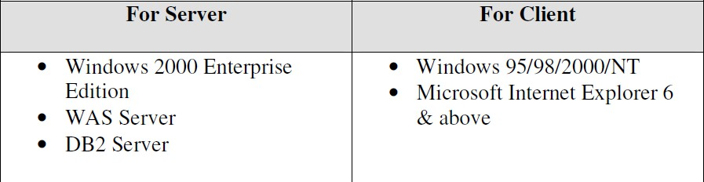System Software: The system must be in window 2000 advance server or higher.

# USER MANUAL

In this project, manuals are produced to direct the user on how to operate the new system. The operational guide manual guides the user on how to use the software. Firstly double click the setup file to install the software on your system. After installation an icon will be placed on your desktop. To use the software just double click on the icon on the desktop or go to the program file and select the software from there. Each user is supposed to possess a username and password to have access to the software.

# MAINTENANCE

Maintenance function begins once the system is fully implemented. This is the process of making modification after the working software has been delivered. It requires an understanding of the program. This is achieved by clearly studying the program code and associated documentation. There are usually two type of maintenance. Enhancement of the software due to changed in the every dynamic environment and corrective maintenance which is a result of errors discovered after delivering the software.

# CHAPTER FIVE

* 1. **SUMMARY**

The need for an effective and efficient geographical information system cannot be overemphasized. Owing to this, such system as this should be developed and used by government institutions and entrepreneurs who want to do productive business.

# RECOMMENDATION

The System is recommended to all government agencies for proper resource distribution and provision of basic infrastructure planning.

# CONCLUSION

The problems or challenges encountered with the manual operation have been identified, analyzed and a computerized solution has been developed to counter these challenges. This Web Application provides facility to analyze geodata. It saves time as it allows several forms of query to the system database to support decision making.

Administrator has a privilege to create, modify and delete geospatial information.

# REFERENCES

Anderson, R. Francis, B. Homer, A. (2001). Professional Asp. Net.

London: Wrox Press Ltd.

Brown, S. Burdick, R. (2001). Professional Jsp. London: Wrox Press Ltd.

Charp, S. (1994). Networking and Telecommunication. Technical Horizons

in Education. John Publishing.

Diwakar, H. and Marathe, M. (2001). The Architecture of a One Stop Web-Window. Sydney: SIGecom Exchange.

Flaughter, R. (1990). Computerized Adaptive Testing, Hills Dale.

New York: Acm Press.

Glass, H. (2000). Interpretation of International Book Store Market.

New Jersey: Vintage Publication.

Kubilus, J. (2000). Designing an E-commerce Site for Users.

Crossroad: Crossroads Press.

Nosike, C. (2002). Internet Literacy. Nigeria: UNN Press. Norman, A. (1994). The Design of Everyday Things. New York:

Doubleday Press.

Wagner, R. Daniels, K. Griffin, G. and Nasr, J. (1997).

Java Script Unleashed. London: Same Net Press.

[Http://aspnet.4gnys](http://aspnet.4gnys/) fromrolla.com/articles/011404-1.aspx for Relation between IIs and ASP.Net.

Appendix

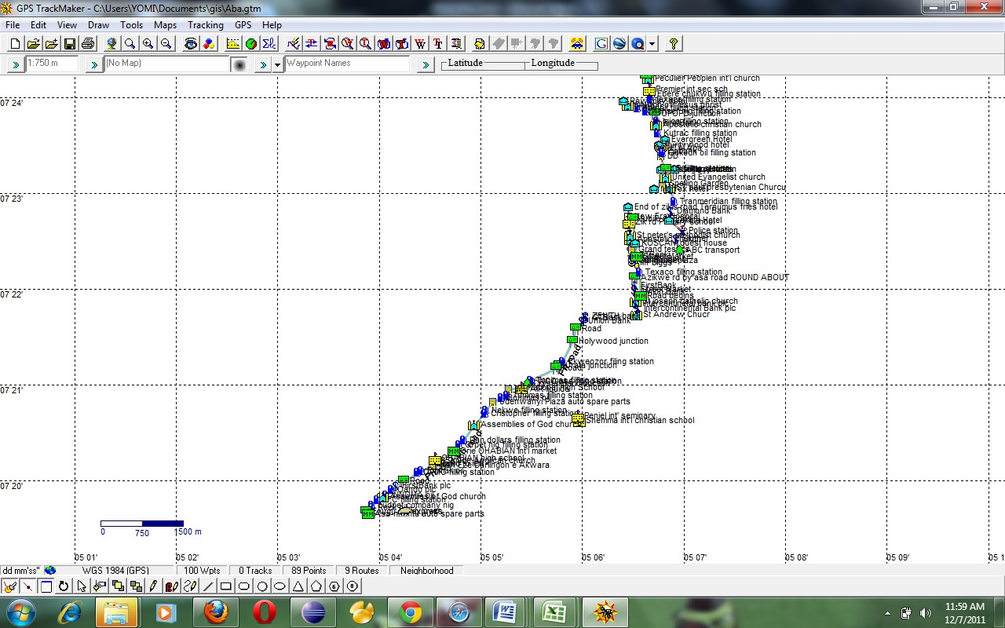

Data visualization AWKA case study..

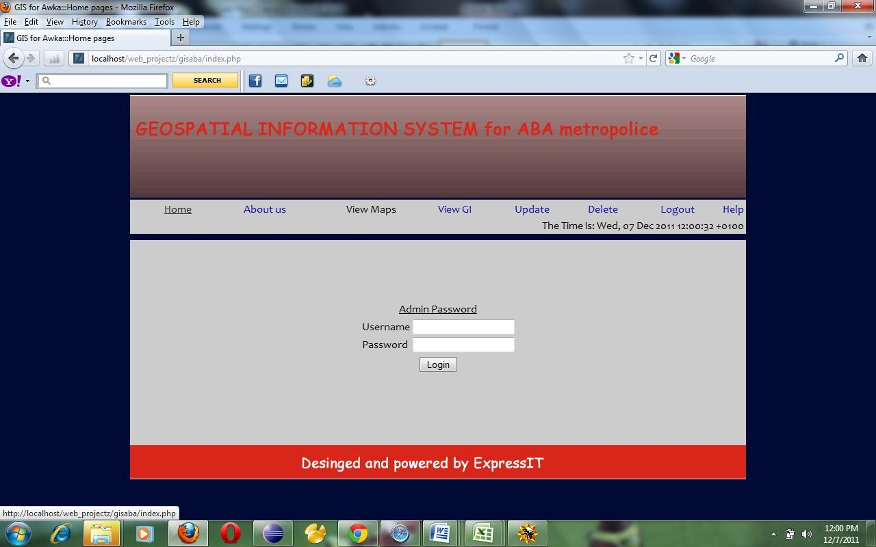

**Login page**

**<?php**

**//ini_set("display_errors","on"); session_start();**

**include_once 'DB_auth.php';**

**if(isset($_POST['submit']) && ($_POST['submit']=='Login')){**

**if(isset($_POST["username"]) && isset($_POST["password"])){**

**if(empty($_POST['username'])**

**|| empty($_POST['password'])){**

**$showMsg = "block";**

**$msg = "PASSWORD/USERNAME**

**empty fill and try again";**

**include 'html/index.inc';**

**exit();**

**}**

**$user = $_POST['username'];**

**$password = $_POST['password'];**

**$go = "SELECT * FROM admin WHERE username = '$user' AND password = '$password'";**

**$query = mysql_query($go);**

**$rows = mysql_fetch_assoc($query);**

**if($user == $rows['username'] &&**

**$password == $rows['password']){**

**$_SESSION["username"] =**

**$user;**

**$password;**

**$_SESSION["password"] =**

**$showMsg = "block";**

**$msg = "You are logged in**

**as ADMIN you can now visit other pages";**

**include 'about.php'; exit();**

**}**

**$showMsg = "block";**

**$msg = "PASSWORD/USERNAME COMBINATION IS WRONG PLZ TRY AGAIN";**

**include 'html/index.inc'; exit();**

**}**

**}**

**include "html/index.inc";**

**?>**

**Login code..**

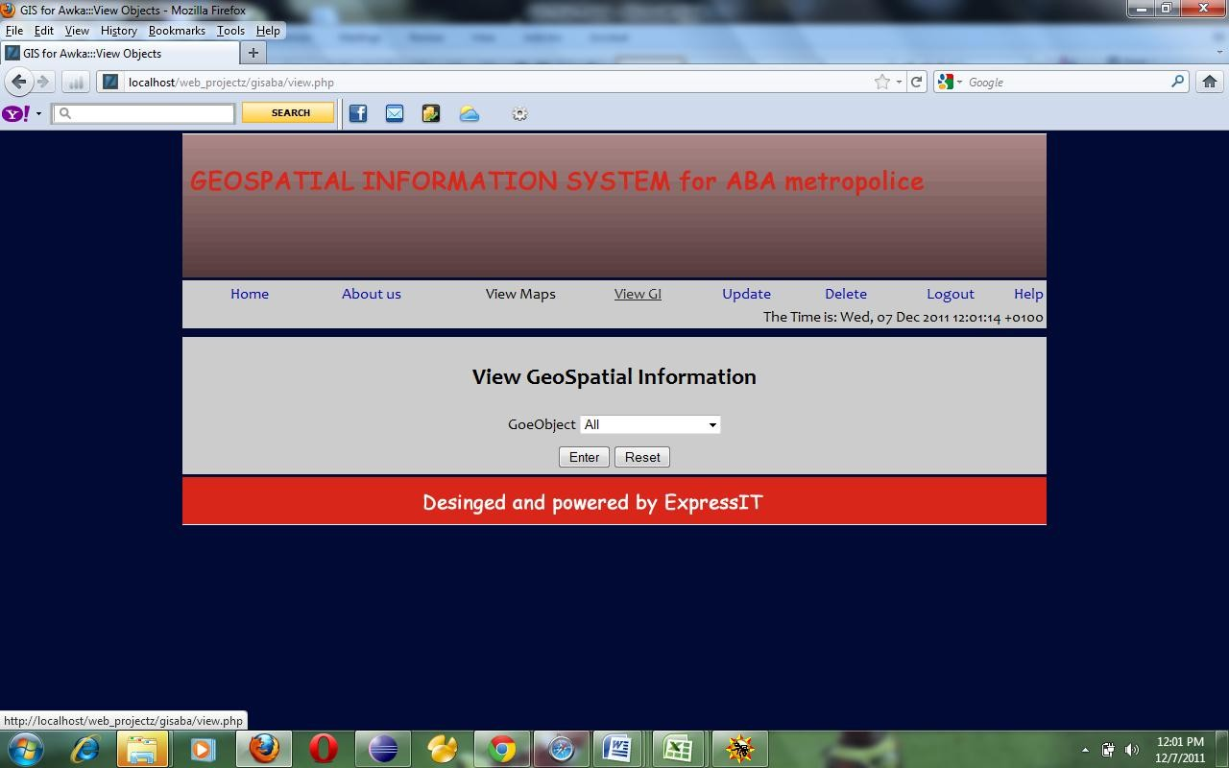

**View geoobject page**

**<?php session_start();**

**include "DB_auth.php"; include "session.php";**

**if(isset($_POST["submit"]) &&**

**$_POST["submit"]=="Enter"){**

**$geoobject = $_POST["geoobject"];**

**$sql = "SELECT* FROM main where geoobject = '$geoobject'";**

**$query = mysql_query($sql); if (!$query){**

**mysql_error();**

**}**

**$showMsg = "block";**

**$msg = "Connection lost ".**

**include ""; exit();**

**0){**

**$row = mysql_fetch_assoc($query); if (mysql_num_rows($query) ==**

**table ";**

**$showMsg = "block";**

**$msg = "No data found in**

**include ""; exit;**

**}**

**?>**

**<table align =*"center"*>**

**<tr>**

**<th><u> REPORT OF**

**ALL REGISTERED <?php echo $geoobject ?>**

**</u></th>**

**</tr>**

**</table>**

**<table cellspacing=*"10px"* border=*"0px"* align=*"center"*>**

**<tr>**

|  |  |  |  |
| --- | --- | --- | --- |
|  | | **<th** | **align** |
| **=*"left"*>** | **GeoObject </th>** |  |  |
|  |  | **<th align** |  |
| **=*"left"*>** | **GeoName </th>** |  |  |
|  |  | **<th** | **align** |
| **=*"left"*>** | **Location </th>** |  |  |
|  |  | **<th** | **align** |
| **=*"left"*>** | **address </th>** |  |  |
|  |  | **<th** | **align** |
| **=*"left"*>** | **latitude </th>** |  |  |
|  |  | **<th** | **align** |
| **=*"left"*>** | **longitude</th>** |  |  |
|  |  | **<th** | **align** |
| **=*"left"*>** | **altitude</th>** |  |  |
|  |  | **</tr>** |  |
|  | **<?php** |  |  |
|  | **if** | **($query** | **&&** |

**mysql_num_rows($query)) {**

**mysql_num_rows($query);**

**$numrows =**

**$rowcount = 0;**

**while ($row = mysql_fetch_array($query,MYSQL_BOTH)){**

**?>**

**<tr>**

**echo $row['geoobject']; ?>**

**<td>**

**<?php**

**</td>**

**echo $row['geoname']; ?>**

**<td>**

**<?php**

**</td>**

**echo $row['location']; ?>**

**<td>**

**<?php**

**</td>**

**echo $row['address']; ?>**

**<td>**

**<?php**

**</td>**

**echo $row['latitude']; ?>**

**<td>**

**<?php**

**</td>**

**echo $row['longitude']; ?>**

**<td>**

**<?php**

**</td>**

**echo $row['altitude'] . "M"; ?>**

**<td>**

**<?php**

**</td>**

**</tr>**

**<?php**

**++$rowcount;**

**}**

**}**

**mysql_free_result($query);**

**?>**

**</table>**

**<?php**

**}**

**?>**

**View geoobject code..**