DATA MINING TECHNIQUES IN ANALYSIS OF STUDENT COURSE OF STUDY
[A CASE STUDY OF OSUN STATE POLYTECHNIC, IREE.]

TABLE OF CONTENT
Title Page i
Certification ii
Dedication iii
Acknowledgment iv
Table of Contents v
Abstract vi
0
CHAPTER ONE: INTRODUCTION
1.1 General Overview 1
1.2 Statement of the Problem 2
1.3 Aim and Objectives of the Project 3
1.3.1 Aim 3
1.3.2 Objectives 3
1.4 Research Methodology 3
1.5 Significance of the Study 4
1.6 Scope of the Study 5
1.7 Limitations of the Study 5
1.8 Data Mining Review 5

CHAPTER TWO: LITERATURE REVIEWS
2.1 The Data Base 6
2.2 Database Management System 7
2.2.1 Structure Query Language (SQL) 9
2.3 Data Warehouse 9
2.4 Data Mining 10
2.4.1 The Scope of Data Mining 11
2.4.2 Data Mining Tasks 12
2.5 Other Approach of Data Mining 13
2.6 Knowledge Discovery in Database 14

CHAPTER THREE: METHODOLOGY
3.1 Data Mining Technique 16
3.2 Data Sampling 16
3.3 Business understanding 17
3.4 Data understanding 17
3.5 Data Preparation 18
3.6 Modeling 19
3.6.1 Descriptive Tool 19
3.6.2 Predictive Tool 20
3.6.3 Classification Model 20
3.6.4 Types of Classification Algorithm 21
3.7 Naïve Bayesian Algorithm 23
3.7.1 Data Required for Naïve Bayesian Models 23
3.7.2 Technical Notes 24

CHAPTER FOUR: SYSTEM DESIGN AND IMPLEMENTATION
4.1 Organization of Database Table and Field 26
4.2 Problem Definition 26
4.3 Stages involved in solving the problem 27

CHAPTER FIVE
Summary, Conclusion and recommendations
5.1 Summary and Conclusion 33
5.2 Recommendations 33
References
Appendix I
Appendix II

Abstract
Data mining has a great deal of attention in the information industry in recent year due to the wide availability of high amount of data and the useful information and knowledge. This project is based on the Application of Data mining techniques’ in Analysis of student course of study, that is, to predict course of study for a student that does not meet up with the school cutoff point for post uptime classification algorithm were used in analyzing the data with the incorporation of a relational data base management system. Conclusively, we have been able to develop software that will generate course of study for students in faculty of science and Engineering.

CHAPTER ONE
1.0 INTRODUCTION
1.1 General Overview
In recent years, the technology of database has become more advanced where large amount of data is required to be stored in the databases. Data mining then attract more attention to extract valuable information from the raw data that institution can use for decision-making process. It applies modern statistical and computation technologies to expose useful information hidden within the large database to remain competitiveness among educational field, the institution need deep and enough knowledge for a better assessment, evaluation, planning and decision-making. Data mining helps institution to use their current reporting capabilities to discover and identity the hidden patterns in database and hence can be used to predict performance of the student.
Data mining can be viewed as a result of the natural evolution of information technology because before 1960 when database and information technology had not evolved, analysis of data was basically the primitive file processing which would not give the appropriate useful information despites the huge amount of time consumed. The evolutionary path of data mining has been witnessed in the database industry in the development of the following database and information technology.
- Data collection and data creation
- Data management (including data warehouse and data preparation)
- Data analysis and understanding (involving data mining and data interpretation)
Moreover, data mining is also known as knowledge discovery in large database (KDD). Consequently, data mining consist of more than collecting and managing data; it also includes analysis and predictions. Important decision are often made based not on the information rich data stored in database but rather on decision maker’s institution, simply because maker does not have the tools to extract the valuable knowledge embedded in the vast amount of data.

1.2 Statement of the problem
It is not feasible for people to analyze great amounts of data without the assistance of appropriate computational tools. Therefore, the development of tools of an automatic and intelligent nature becomes essential for analyzing, interpreting, and correlating data in order to develop and select strategies in the context of each application. To serve this new context, the area of Knowledge Discovery in Databases (KDD), came into existence with great interest within the scientific, industrial, and commercial communities. The popular expression “Data Mining” is actually one of the stages of the Discovery of Knowledge in Databases. The term “KDD” was formally recognized in 1989 in reference to the broad concept of procuring knowledge from databases. One of the most popular definitions was proposed in 1996 by a group of researchers. According to Fayyad, et al. (1996): “KDD is a process with many stages, non-trivial, interactive, and iterative, for the identification of comprehensible, valid, and potentially useful patterns from large data sets”. It is of utmost desire to extract valuable information from large databases.
This research work therefore addresses the intelligent prediction of students’ course of study in higher institution based on the historical student academic data. This will facilitate better performance of students in high institutions.

1.3 Aim and Objectives of the Project
1.3.1 Aim
The aim of the research work is to develop a computer application software that will be able to predict student course of study in higher institution using classification algorithm.

1.3.2 Objectives
The following are the set of objectives addressed by the project work:
- To develop and populate student academic database
- To develop a computer application program that will be able to mine knowledge from the students’ academic database using Classification algorithm.
- To predict student course of study according to their Post UTME cutoff.
- To reduce the rate at which student admission is fortified.

1.4 Research Methodology
The executive of execution of research work includes the following;
- analysis of some data mining techniques i.e. data mining techniques yield the benefit of automation on existing software and hardware platforms, can be implemented on new system as existing platform are upgraded and new products developed.
- consideration of sources data record i.e. the admission office student database and the department student database.
- consultation with some database developers or technologist.
- browsing on internet to get access to some websites for relevant information.
- consultation with some professional statistical analy.st

1.5 Significant of the Study
The use of data mining technique in predicting student course of study is very significant and relevant in any academic institution where record of each student has been collected and stored in a database e.g system the need for knowledge discovery in academic environment may be at admission level or faculty level. The institution may want to know from which mode of admission does they have student with better result. The institution may want to know the student performance in general courses and reason for such performance. The institution may want to predict the number of student that is to be admitted to specific department and faculty so as to allocate reasonable amount of resources to various departments for the session

1.6 Scope of the Study
The research work has been centered on only ‘O’ level, pre degree or UTME science courses only.

1.7 Limitation of the study
The research work is limited to the Faculty of Science and Engineering of Osun State Polytechnic, IREE.

1.8 Data mining review
Data mining is process of extract hidden pattern from data. As more data is gathered, with the amount of data doubling every three years, data mining is becoming an increasingly important tool to transport this data into information. It is commonly used in a wide range of profiling practices, while data mining can be used to uncover patterns in data samples, it is important to be aware that the use of non representative sample of data may produce results that are not indicative of domain.
Similarly, data mining will not find pattern that may be present in the domain, if those was mined, there is a tendency for insufficiently knowledge consumer of the result to attribute magical abilities to data mining, treating the techniques as a sort of all seeing crystal.
CHAPTER TWO
2.0 LITERATURE REVIEW
2.1 The Database
This is a storage structure which is created to solve the problem encountered in the file structure. A database is a collection of interrelated data spread over one or more computer storage media (Shapiro 1996). It is meant to support the operation of an organization and it is efficient because it dos not waste of redundancy that is it does not waste storage space, space, process, or time or user storage space, process or time or user time. Database could be flat, that is nom relation as seen in COBOL language or relation seen in oracle, Microsoft access, MYSQL server, e.t.c these are several or database, some of which are:
- Transactional Database: This consists of a file where each record represents a transaction. A transaction typically includes a unique transaction identity number (trans__ID) and a list of time making up the transaction such as item purchased in a stored.
- object oriented database : these are based on the object oriented programming paradigm, where in general terms, each entity is considering as an object
- Object relation database: these are constructing based on object relation data model. These models extend the relation data model providing a rich data type for handling complex object and object orientation.
- spatial database: these database contain spatial related information like geography (MAP) database, VLB , CHIP design databases medical and satellite image database

2.2 Database Management System (DBMS)
Database management system (DBMS) is collection of program that enable you to stored, modify and extract information from a database. It allows organization to place control of database development on the hands of database administrators (DBMS) and their other specialists. A database management is a system software package that help the use of integrated collection of data record and file know as database. It allows different user application programs to easily access the same database. There are many different types of DBMS, ranging form small system that runs on mainframes. The following are examples of database application:
  - Computerized library system
  - automated teller machine
  - flight reservation systems
  - computerized parts inventory system

DBMSs, can differ widely. The terms Relational, Network, Flat and Hieratical all refer to the way a DBMSs organizes information internally. The internal organization can affect how quickly and flexibly you can extract information. Request for information from a database are made in the form of query which is stylized question for example, query.

SELECT ALL WHERE NAME=”SMITH” and AGE=”35|”
The information from a database can be presented in a variety of formats. Most DBMSs include a report writer program that enables you to output data in the form of a report. Many DBMSs also include a graphic component that enables you to output information in the form of graph and chart.

How do you know?
When you need?
A server?
How is server How much
Different from memory and
A desktop disk space will it need?

DATABASE MANAGEMENT
What are storage will I have to replace it
Area network in six month?

Can I use a high-end
Desktop in place of a serves? How much will a
Server cast?
Do I need more
Than one server?

2.2.1 Structure Query Language (SQL)
In order to effectively retrieve, update, delete or manipulate the database, a generated language which is structure Query language (SQL) is used. This language is easy to use because many database applications are design to handle Queries. The development of the structure Query language has ease programmers and database developing endless code to manipulate simple data in the structure.

2.3 Data Warehouse
Due to the fast growing tremendous amount of data collected and stored in large and numerous database which has far exceeded our human ability for comprehension without a powerful tool, a technology which provides a great boost to the database and information industry and make a huge number database and information respiratory available for transaction management, information retrieve and data analysis emerged. This technology is called data ware house. Data ware house technology include data cleansing, data integration and on-line analytical processing (OLAP), that is, analysis techniques with functionality such as summarization, consolidation and aggregation as the ability to view information from different angles.
A data ware house is a relation database management system (DBMSs) designed specifically to meet the needs of transaction processing system. It is any centralized data repository which can be queried for business benefit and provides data that is already transformed and summarized (Start Soft 2005)
Some features of a data ware house are:
- It is respiratory for information and record result
- Improves access to integrated data
- Ensure integrity and quality
- provides an historical perspective
- It is used for a variety of purpose
Data ware house collect information about subject than span an entire organization and thus its scope is enterprises, while data mart is a department subset of a data ware house, it focuses on selected subject and thus its scope is department wide. Although data ware house technology which consists of the OLAP tools support multidimensional analysis and decision making, addition data analysis such as data analysis classification, clustering and the characterization of data changes over time. This data analysis of data changes over time. This data analysis tool is called data mining tool which perform strategies, knowledge, scientific and medical research.

2.4 Data Mining
Data mining simply refers to extracting or “mining” knowledge from large amount of data. It is the process of discovering interesting knowledge from large amount of data stored either in databases, data ware house, or other information repositories.
Data mining is also refer to using variety of technique to identify nuggets of information or decision making knowledge in bodies of data, and extracting these in such a decision support, prediction, forecasting and estimation. By performing data mining, interesting knowledge, regularities or higher level information can be extracted from database and viewed or browse different angles. The discovering knowledge can be applied to decision making, process control, information management and data analysis system that cannot handle large amount of data
STATISTICS
MACHINE LEARNING
VISUALIZATION
DATABASE TECHNOLOGY
INFORMATION SCIENCE
OTHER DISCIPLINE
DATA MINING

2.4.1 The scope of data mining
Data mining derive it name from the similarities between the searching for valuable business information in a larger database for example, finding linked product in gigabytes of stored data and mining a mountain for a vein of valuable one. Both process required either sifting through an immense amount of material, or intelligently probing it to find exactly where the values reside.
- Automated prediction trend and behaviour. Data mining automated is the process of finding predictive information in a large database. A typical example of a predictive problem is targeted marketing. Other predictive problem includes forecasting, bankruptcy and other form of default and identifying segment of a population likely to respond similarly to given event.
- Automated discovering previous unknown patterns. Data mining tool sweep through database and identify previously hidden pattern in one step. An example of pattern discovery is the analysis of retail scale data to identify seemingly unrelated product that are often purchase together other pattern problem includes detecting anomalous that could represent data entry keying errors.

2.4.2 Data Mining Tasks
The objective of data mining is to identify valid novel, potentially useful, and understandable corrections and pattern in existing data. The task of data mining can be modeled as either predictive or descriptive in nature.
A predictive model makes a predictive about value of data using know result found from different data WHILE the descriptive model identifies patterns or relationship in data. Unlike the predictive model, a descriptive model server as away to explore the properties of the data examined, not to predict new properties predictive model data mining tasks include classification, prediction, regression and time series analysis. The descriptive task encompasses method such as clustering summarization, association rules and sequence analysis.
DATA MINING
PREDICTIVE
DESCRIPTIVE
Classification, Prediction, Regression, Time Series Analysis
Clustering, Summarization, Association rules, Sequence Analysis

2.5 Other Approach of Data Mining
Data mining approaches can yield the benefit of automation on existing software and hardware plant form and can be implemented on new system as existing plant form are upgraded and new product developed. When data mining are implemented on high performance parallel processing systems, they can analyze with more model to understand complex data. The most commonly used approaches of data mining are:
- Artificial Neutral Network: - Non- linear predictive model that learn though training and resemble biological natural network in structure.
- Decision Trees: - Tree shape structure that represent set of decisions. These decisions guarantee rules for the classification of dataset. Specific decision tree method include classification and regression tree (CART) and chi-square Automatic interaction detection(CHAID)
- Rules Induction:- In the extraction of useful if then rules from data based on statistical significant
- K-Means Clustering:- In mapping the k-means algorithm to FPGA(Field Programmable Gate Array) hardware we examined algorithm level transforms that dramatically increased the achievable parallelism. It is a common solution to the segmentation of multidimensional data. It is an iterative algorithm that assigns to each pixel a label indicating which of K cluster the pixel belong to the software implementation of K-means user floating-point arithmetical and Euclidean distances.

2.6 Knowledge discovery in database
Knowledge discovery in database in database is the finding of understanding knowledge in every large set of real word database. The steps in the process of knowledge discovery in database are as follow:
- Data Selection: this is the process of selecting or segmenting the data relevant to the analysis task is done from the database.
- Data Cleaning: this is the removal of noise and inconsistent data since data are usually contaminated by error in either the value of attributes or class. Data cleansing is done by reconfiguring the data to ensure a consistent format because data is draw from several sources
- Data Integration: this is a situation when multiple data sources may be combined. This can be done together with data cleansing as a preprocessing step where the resulting data are stored in a data ware house
- Data Transformation: this is where the data transformed or consolidated into forms appropriate for mining by performing summary or aggregate operation.
- Data Mining: this is an essential process where intelligent methods are applied in order to extract data patterns.
- Pattern Evaluation: This is to identify the truly interesting patterns knowledge based on some interestingness measures, interestingness measures are function used to guide the mining process or after discovering to evaluate the discovery patterns.
- Knowledge Presentation And Visualization: this is a process where visualization and knowledge presentation techniques are used to present the mined knowledge to the user
- The Pattern Identify by the system are interpreted into knowledge which can be use to support human decision making
CHAPTER THREE
3.0 Methodology
3.1 Data Mining Technique
There are various constraints that are consider in predicting student course of study from the types, there are two fundamental constraints that govern the prediction of student course of study. These are that all students must pass their UTME or pre-degree science subjects. There are many criteria used to ascertain the quality of data mining. Most common is that a student is not expected to go for a course that they does whether a data mining technique in predicting student course of study is good or not i.e. if it is usable by the faculty of science in university.

3.2 Data Sampling
The CRIPS-DM methodology suggested by Chapman etal .(2000) involve six phases, namely business understanding, data understanding, data preparation, modeling, evaluation and development
In this study, as the possible areas of test depend on the data available, and the detailed business objective cannot be identified until the data was studied. Consequently, this phase has to be performed in parallel with the data understanding and data preparation phase.
The initial phase of data understanding focuses understanding the objectives and requirement from the student registrar office the data understanding phase start with an initial data collection and proceeds with action in order to get familiar with the data.

BUSINESS UNDERSTANDING
DATA UNDERSTANDING
DATA PREPARATION
MODELING
EVALUATION

Fig. 3.1
3.3 Business Understanding
The first phase of CRIPS-DM is business understanding which focuses on project objectives and requirement from academic perspective, and converting this knowledge into a data mining problem definition as well as designing a preliminary plan to achieve the objectives to identify the research gap and the potential problems, literature study was carried out and relevant work as been identified. In the study, research relevant to education data and predicting student course of study were sought and suitable mining algorithm for predictive purpose were also selected

  - Data Understanding
The second phase is data understanding which begins with initial data collection. At this point, the data collection from the students needs to be and understood. In order to be familiar with data, the next step in data understand is to identify data quality problem, get some insight about the data and detect interesting subsets to form hypothesis so as to uncover the hidden information within the data collected, as a result of preprocessing phase the data quality problem will be identified

3.5 Data Preparation
Data preparation concern all activities needed to construct the final dataset for modeling purpose. The tasks are most likely to be carried out multiple times and may not be in any prescribe manner. Different datasets tend to expose new issues and challenges. With the goal in mind, it is important to choose the right data mining algorithms, techniques and tools which are expected to give best result with the provided data. Dependencies among different subsets of attributes are expected to be exhibited by different subsets of data. Most often, not all variable are used in analyzing and modeling process. This phase needs to be conducted repetitively for determining suitable attributes to be used as predictors and target (output).
To get full insight of data distribution and in identifying out liar, predictive analysis was conducted for exploratory purpose. In this study qualification upon entry and entry and examination results were consider as predictor variables.

3.6 Modeling
During the modeling phase, modeling techniques were selected and applied to the dataset used in the study. This phase include selecting an appropriate modeling technique, building the model and followed by assessment of model.
Subsequently, the model selection involves selecting appropriate technique for the problem, refine the models whenever is necessary in order to meet the requirement and other constraints. After reviewing data mining technique, the descriptive approaches employed in the study were identified, namely the classification method. Since the aim of the experiment was to study the pattern and getting some information within the enrollment data, no specific target has been identified. To this end, cluster were generated by classification method, and later used as target or output for predictive approach. As a result, the predictive method will be able to predict in which cluster the future student will falls into based on the enrollment information.

3.6.1 Descriptive Tool
Initially, descriptive statistics was carried out to investigation the nature of the database and the distribution of each attribute. Frequency tables were generated and the correlation analysis was also conducted to determine the relationship among the attributes, including cross tabulation analysis displays relationship between two or more categorical(nominal or ordinal) variable

3.6.2 Predictive Tool
As the cluster were generated through kohonen network, there cluster were then used as output for the methods. One predictive technique that is classification algorithm was employed to test the accuracies of the predictive model based on cluster.
BIAS
Att 1
Att 2
Att 3
Att n
BIAS
Input layer
[ consist of n input and a bias]
Hidden layer
[consist of 3 hidden unit and a bias]
Output layer [consist of 2 output unit]

Fig 3.1 The architecture of multilayer perception.
3.6.3 Classification Model
Among the predictive models, classification is probably the best understand of all data mining approaches. The common characteristic f classification tasks are;
  - Learning is supervised
  - The dependent variable is categorical
  - The model built of a able to assignment data to one of a set of well define classes.
The goal of classification is to built asset of the model that can be correctly predict the class of different objects. The input of these method is a set of object[ i.e. training data], the classes which these objects belong to and a set of variable describing different characteristics of the object (i.e. independent variable) once such a predictive model is built, it can be used to predict the class of objects for which classification is known as prior.
The key advantages of supervised leaning method over unsupervised learning method by having an explicit knowledge of the classes, the different object belong to these algorithm can perform an effective feature selection if that lead to better prediction accuracy.

3.6.4 Types of classification algorithm
The following are brief overview of some classification algorithm that algorithm that has been used in data mining and machine learning area and used as base algorithms.
- K-Nearest Neighbor(KNN) Algorithm: Is an instance-based learning algorithm on that is based on an distance foundation for pair of observation, such as Euclidean distance, one of the advantages of KNN is that it is well suited for multi-model classes as it’s classification, decision is based on a small neighborhood of similar objects.
- Naïve Bayesian(NB) Algorithm: Based for document classification and shown produce very good performance. The basic ideals is to use joint probabilities of categories to estimate the probabilities of categories given a document.
- Concept Vector Based (CB) algorithm: in vector is normalized so that is of unit length. The ideal behind the concept-based classification is extremely simple for each set of document belonging to the same class we compute its concept vector by summing up all vector in the class and normalize by it’s z-norm
- Singular Value Decomposition: Algorithms-here we use first singular vector as we use concept vector based algorithm
- For each class of training document in k nearest neighbor, compute first singular vector
- Compute cosine similarity between a give testing document and every singular vector
- Assign the testing document a class label which has largest cosine value.
- Variation of Native Bayesian Algorithm: Multinomial model of native Bayesian classification algorithm capture the word frequency information in document. So it requires the word frequency that is not weighted and normalized
However, we also tried with +Fn-scale word frequency data. This research work makes use of naïve Bayesian algorithm.

3.7 Naïve Bayesian Algorithm
Naïve Bayesian algorithm is classification algorithm provided by Microsoft SQL server analysis services for use in predictive modeling. The name naïve Bayesian derives from the fact that the algorithm uses Bayesian theorem but does take into account dependencies that may exit and therefore its assumption are said to be naïve. This algorithm is less computationally intense than other Microsoft algorithms, and therefore is useful for quickly generating mining models to discovered relationships between input columns and predictable columns.

3.7.1 Data required for Naïve Bayesian Models
When you prepare data for use in training a naïve Bayesian model, you should understand the requirement for the algorithm, including how much data is needed and how the data is used. The requirements for naïve Bayesian model are as follows;
    - A single key: Each model must contain one numeric or text column that uniquely identifies each record. Compound keys are not allowed.
    - Input columns: In a naïve Bayesian model, all column information about discretizing columns. For naïve Bayesian, it is important to ensure the input attribute are independent of each other.
    - A predictable column: The predictable attribute must contain discrete or discredited values. The values of the predictable column can be treated as input and frequently are to find relationships among the columns
3.7.2 Technical Notes
In this section are further details of the technical issues involved. Naïve Bayesian classifiers can handle arbitrary number of independent variables weather continuous or categorical. Given a set of variable,

X = ( X1, X2,X…………………Xd ),
We want to construct the posterior probability for the event Cj among a set of possible outcomes.
C = ( C1,C2,C………………..Cd ).
In a more familiar language, X is the predictors and C is the set of categorical levels present in the dependent variable. Using Bayesian rules :
P ( C/X1……..Xd )= P (C) P(X1,…..Xd/ C)/ P(X1……………Xd)
Where
P( Cj / X1……..Xd)

Is the posterior probability of class membership i.e. in probability of the class membership i.e. the probability that X belong to Cj
In practice we are only interested in the numerator of that fraction, since the denominator does not depend on C and the values of the features X1 are given, so that the denominator is effectively constant. The numerator is equivalent to the joint probability.

P( C, X1,……Xd) = P (C) P( X1/ C ) P( X2 / C, F1) P( X3 /C1, X1,X2)…….P ( Xn1 C, X1, X2, X3…….,Fd-1)

“Naïve” conditional independence assumption course into play :assure that each feature Xi is conditionally statistical independent of every other feature
Xj for j ≠ i
this means that
P ( C, X1 / C, Xj ) = P ( X1 / C) for i ≠ j and so the joint model can be express as
P ( C, X1,…Xd ) = P ( C ) P ( X1 / C ) P ( X2 / C ) P ( X3 / C )…..=P (C ) d╥/ i=1 P ( Xi/ C).

This means that under the above independence assumption, the condition distribution over the class variable can be expressed like this

P( C1 X1……Xd ) = ½ P (C ) d╥/ i=1 P (X1 / C )

Where Z (the evidence) is a scaling factor dependent only on
( X1,…..,Xd..
i.e. a constant if the values of the features variable are know.
Finally we can label a new case F with a class level Cj that achieves the highest posterior probability.
CHAPTER FOUR
4.0 SYSTEM DESIGN AND IMPLEMENTATION
4.1 ORGANIZATION OF DATABASE TABLE AND FIELD

THE DATABASE
FIELD NAME DATA TYPE SIZE KEY
Form number Number 8
Year Text 30
Date Data 12
Other Text 10
Session Text 10
Sex Text 10
Program Text 20
Subject Text 15
Grade Text 10
Score Number 10
Unit score Number

4.2 Problem Definition
Before the model can be constructed for classification model, a problem must be defined to understand what is needed to be activated. For instance, if the problem is to predict course of study for students that does not meet up with the school post UTME cutoff mark, with the student historical academic data, we can predict which course the student should be given in order not to fortified the admission.
The problem that deduced to be solved are predicting and classifying students according to different department in faculty of Science and Engineering of Osun State polytechnic, Iree. This will be alone by partition the data we have in the database and applying classification model to the system to predict the output , all or which are embedded in the code written, this problem will be solved step-step step in the following manner
4.3 Stages involved in solving the problem
4.3.1 First stage (welcome screen)

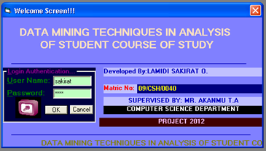
When a correct password is typed into the password box,”ok” button will be clicked to perform specific action and a welcome remark is supplied, a message box will display ”invalid password” try again on the screen to indicate that the password is invalid

    - Second Stage (Main Menu)
After the password has been correctly entered and the welcome remark is displayed, the next stage is the main menu, which opens the application on which all the steps mentioned concerning the data mining are going to be carried out. i.e it is the log on page to other part of the data mining steps.

    - Third Stage (File Menu)
After the log on page has been displayed, the next stage is the file menu which contain student registration, open registered candidate, “O” level subject and UTME/POST UTME subject and score entering.
- Student registration: Is the pages that contain Bio data of each student to be admitted to faculty of science and engineering of the institution.
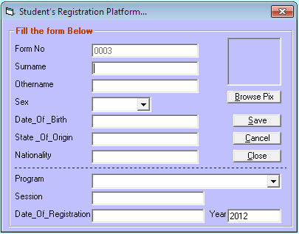
- Open registered candidate: is the page where we can view the registered student if the there is need for amendment.
- “O” level subject: Is the page where will be enter the “O” level subject of each student to be admitted to the faculty of science and engineering.
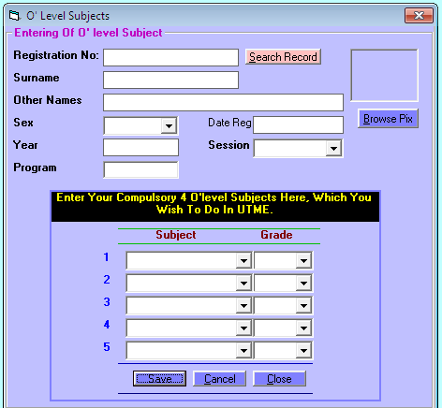
- UTME/POST UTME Scores Entering: is the page where will be enter the score of student UTME/POST UTME
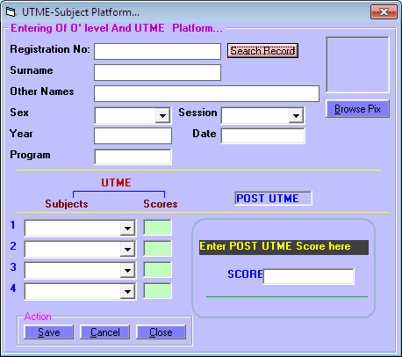

4.3.4 Fourth Stage (Utility Menu)
Utility menu contain UTME/POST UTME comparism platform and course of study platform.
UTME/POST UTME comparison platform is the page where we compare “O” level and UTME score of each student for administrative officer to be able to predicts course of each student.
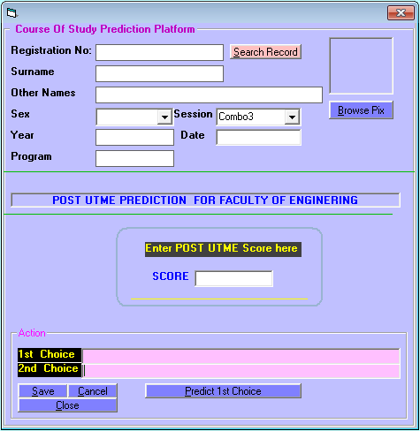

4.3.5 Fifth Stage (Admission Checking)
This is the page where the administrative officer can check the course of each student and the number of student and the number of student that has been admitted.
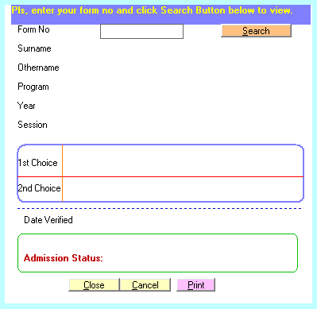

4.3.6 Sixth Stage (Report Menu)
Report menu contain the list of registered candidate which can be printed out and paste on the school notice board for student to check whenever they have been admitted and to check their course of study

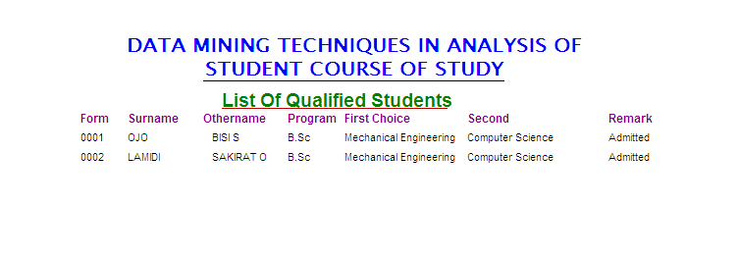

CHAPTER FIVE
5.0 SUMMARY, CONCLUSION AND RECOMMENDATION
5.1 Summary and Conclusion
From the project work, it has been seen that the student historical academic data which was quit rich with a lot of data summing up has been successfully analyzed. Some of the hidden information which had been growing periodically form session to session has been exposed inform of knowledge to be acted upon by the school authorities. This was possible by using data mining techniques which is classification model to discover the pattern in which student are admitted through different mode of entry like JAMB, POST UTME e.t.c over a wide period of time and also to predict the amount of student that the university may want to admit in the following session in order to allocate more resources to various department.

5.2 Recommendation
The effectiveness and efficiency of data mining technique for predicting student course of study has made it to be very useful to be solving real world problem in terms of decision making in schools, organization that have vast information in their data store or ware house. This is why it is highly recommended to utilized the functionality of data mining in area where large amount of data are stored in the database of data ware house where statistical analysis cannot discover the true patterns that were hidden in order to predict foreseen “what may eventually happen in feature or what is currently happening.

REFERENCES

Amazon.com (2005) “An overview of data mining techniques retrived october
27,2006 from http://www.amazon.com/execl obidos.htm

Anderson U. (2006), “Data mining what is data mining”, Retrieved December 17,
2006 from http://www.anderson.ucla.edu/datamining.htm

Chapman, p, Clinton, j, kerber, r, khabaza, t,-thomas, r, shearer, c& wirth, r.(2000).
CRIPSP-DM 1.0 step-by-step data mining guide, spss White paper technical
report, CRISP WP-0800

Dunham. M.H.(2003).Data mining introductory and advanced topics. Upper saddle
River, NJ: pearson Education, Inc

Edestein,H.(1997). Data mining: exploring the hidden trends in your data. DB2
online magazine. Available: http://www.db2mag.com(URL)

Efraim,T.;Jay,E.A; Tin-peng, L&Ramesh,S.(2003) Decision support and Business
intelligent systems, pearson Education

Fayyad, etal.(1996): The b road concept of procuring knowledge from data
bases.

Feldman, J.& Tung, R.(2001). Using data-based inquiry and decision making to
improve instruction, Ers spectrum,vol. 19,No. 3, pp10+9

Golding,P.& Mc Namarah, S.(2005). Predicting academic performance in the school
of computing & information technology(SCIT).35th ASEE/IEEE Froinitail In
Education Conference. Indianapolis.

Han, J.& Kamber, M.(2001). Data mining concept and techniques(morgan-kaufman
series of data management system), Academic press, san Diego

Lilan, J. (2001). Data mining as Driven by knowledge management in higer
education perisitence clustering and prediction presented at 2001 spss
public confrerence UCSF

Worthley R. (2012) Mining model content from naïve Bayesian models ( analysis
services-data mining)

APPENDIX I
SYSTEM FLOWCHART

START

Display Welcome Screen

Accept Password

Is password Correct?

DISPLAY MAIN MENU

FILE
UTILITY
ADMISSION CHECKING
REPORT
STUDENT REGISTRATION
O’ LEVEL SUBJECTS
O’ LEVEL/ UTME COMPARISON
COURSE PREDICTION
ADMISSION CHECKING
REPORT

START

Display Welcome Screen

Accept Password

Is password Correct?
No

Yes

DISPLAY MAIN MENU
- FILE
- UTILITY
- RESULT CHECKING
- REPORT
- EXIT
PROGRAM FLOWCHART
Is Option true?
Is Option true?
Process Require Information

Yes

No
Is Option true?
Is Option true?
Process Require Information
Process Require Information
Process Require Information
Yes

No
Yes

No Yes
STOP

