#### *DANIELLIA* PHARMACOGNOSTIC AND BIOLOGICAL STUDIES OF THE ROOT OF *OLIVERI* (ROLFE) HUTCH. & DALZ. (CAESALPINIACEAE)

**BY**

#### MUSA AISHA OIZA BSc. BOTANY

**M.Sc/PHARM-SCI/39741/04-05**

#### A THESIS SUBMITTED TO THE POSTGRADUATE SCHOOL, AHMADU BELLO UNIVERSITY IN PARTIAL FULFILLMENT FOR THE AWARD OF MASTER OF SCIENCE IN PHARMACOGNOSY

**THE DEPARTMENT OF PHARMACOGNOSY AND DRUG DEVELOPMENT, AHAMDU BELLO UNIVERSITY, ZARIA**

#### NIGERIA

**JULY, 2009**

#### DECLARATION

I declare that the work in this thesis entitled “Pharmacognostic and Biological studies of the root of *Daniellia oliveri* (Rolfe) Hutch. & Dalz. (Caesalpiniaceae)” has been performed by me in the Department of Pharmacognosy and Drug Development under the supervision of Dr H. Ibrahim and Prof. E.M. Abdurahman. The information derived from the literature has been duly acknowledged in the text and a list of references provided. No part of this thesis has been previously presented for another degree or diploma at any university.

Musa Aisha Oiza October 16, 2009

Name of student Signature Date

#### CERTIFICATION

This thesis entitled “PHARMACOGNOSTIC AND BIOLOGICAL STUDIES OF THE ROOT OF *DANIELLIA OLIVERI* (ROLFE) HUTCH. & DALZ.

(CAESALPINIACEAE)*”* by Musa Aisha Oiza, meets the regulations governing the award of the degree of Masters of Science in Pharmacognosy of Ahmadu Bello University, Zaria Nigeria, and is approved for its contribution to knowledge and literary presentation.

Dr. H. Ibrahim

B. PHARM.Sc, M.Sc., PhD

Department of Pharmacognosy and Drug Dev. Chairman, Supervisory Committee

Prof. E.M. Abdurahman

B. PHARM.Sc, M.Sc., M.B.A., PhD Department of Pharmacognosy and Drug Dev. Member, Supervisory Committee

Dr. K.Y. Musa

Date

Date

B.Sc., M.Sc., PhD

Department of Pharmacognosy and Drug Dev. Head of Department

Prof. S. A. Nkom

B.Sc., M.Sc., PhD Sociology Dean, Postgraduate School

Date

Date

#### DEDICATION

To my mother for her love, support and encouragement and also to my daughter Maryam.

#### ACKNOWLEDGEMENT

I am most grateful to Almighty Allah (SWT) whose grace has made the production of this thesis and hence the completion of this work a reality.

My gratitude goes to Dr. H. Ibrahim and Prof E. M. Abdurahman for supervising this research work.

I wish to sincerely thank Prof J.O. Ehinmidu, Department of Pharmaceutics and Pharmaceutical Microbiology, for his help, guidance and unending constructive criticism throughout the course of this work.

I express my sincere thanks which words could not express to the departmental staff, both academic and non academic, of the Department of Pharmacognosy and Drug Development; and also to Mr Solomon Anche, Mallam Ibrahim, and Mallam Umar Gallah of the Department of Biological Sciences; Mr Elijah Ella Department of Microbiology, and Mr Tanko, Department of Pharmaceutics and Pharmaceutical Microbiology; all of Ahmadu Bello University, Zaria.

My appreciation also goes to Dr. D.B. Dangora, Dr. E. Kogi , Dr. A. K. Adamu, Dr. G. I. Ndukwe, Prof. A. U. Ezealor and Prof. C. G. Vagime of the Department of Biological Sciences for their support and encouragement.

My heartfelt thanks go to my caring parents Alhaji Jimoh Musa and Hajiya Fatimah Jimoh for their support and encouragement during the course of this work; also to my siblings Abdulwahab, Hauwa, Usman and Mukhtar, my daughter Maryam and my husband Salihu Hamzat.

My regards also go to my friends and well wishers such as Mrs Bolanle Sulieman, Mrs Wandayi Amlabu, Mrs Raji H. M., Alfred Attah, Samson, Mrs Safiya Balarabe, Sylvester, Mathias, Yusuf, and Claire.

#### ABSTRACT

*Daniellia oliveri* is one of the most extensively utilized medicinal plants; it is a tree all of whose parts are used in Nigeria and some West African countries for the treatment of various ailments example the root is used as chewing stick. In the bid to standardize this plant, pharmacognostic and biological (*anti-Candida)* studies were carried out on its root and root bark*.* The anatomical and powdered samples of the root and root bark of *D. oliveri* were investigated for their microscopical profiles. The results indicated the presence of xylem and phloem tissues, parenchyma cells, cork cells, prisms of calcium oxalate crystals, abundant starch grains and secretory ducts. Phytochemical screening of the methanol extract and its fractions (ethyl acetate, n-butanol, and aqueous fractions) revealed the presence of carbohydrates, saponins, flavonoids, cardiac glycosides, steroids and tannins. The solvent system chloroform: methanol (7:3v/v) and n – butanol: acetic acid: water (2:1:2v/v) were found to be the best solvent systems for the separation of the constituents of the crude methanol extract and the different fractions using thin layer chromatography. Physico-chemical constants of the powdered root bark were determined; as 21.25+ 1.0 (total ash value), 21.75 + 1.0 (acid insoluble ash value), 11 + 1.0 (water

soluble extractive value), 15.33+ 2.4 (alcohol soluble extractive value) and 7 + 1.0 (moisture content). The total phenolic content of the root bark extracts of *D. oliveri* were also determined; as 57±4.55mgg-l (Crude methanol extract), 59.33±6.65mgg-l (ethylacetate fraction), 60±5.72mgg-l (n-butanol fraction), 17±0.00mgg-l (aqueous fraction) and 12±2.94mgg-l (Crude water extract). The methanol extract showed an LD50 of 565.69mgkg-l i.p in rats. The crude methanol extract is fungicidal with minimal inhibitory concentration of 1.5675mgml-l and minimal fungicidal concentration of 50 and

12.5 mgml-l. The aqueous fraction from the methanol extract is fungistatic with minimal inhibitory concentration of 150mgml-l while the crude water extract, ethyl acetate and n- butanol fractions of the root bark of *D. oliveri* showed no anti *Candida* activity. The results obtained from this research can be used for the preparation of a monograph for proper identification of this plant.

## CONTENTS

List Page

|  |  |
| --- | --- |
| Title page | - - - - - - - i |
| Declaration | - - - - - - - ii |
| Certification | - - - - - - - iii |
| Dedication - | - - - - - - - iv |
| Acknowledgment | - - - - - - v |
| Abstract | - - - - - - - vii |
| List of tables | - - - - - - - xiv |
| List of figures | - - - - - - - xv |
| List of plates | - - - - - - - xvi |
| **CHAPTER ONE**  1.0 Introduction | - - - - - - 1 |
| 1.1 Fungi | - *- - - - - -* 2 |

|  |  |  |  |  |  |  |  |  |  |
| --- | --- | --- | --- | --- | --- | --- | --- | --- | --- |
| 1.1.1 | *Candida species* | | - | - | - | - | - | - | 3 |
| 1.1.2 | Forms of Candidiasis- | |  | - | - | - | - | - | 5 |
| 1.1.3 | Signs - | - | - | - | - | - | - | - | 7 |
| 1.1.4 | Symptoms | - | - | - | - | - | - | - | 7 |
| 1.1.5 | Causes | - | - | - | - | - | - | - | 8 |
| 1.1.6 | Treatment | - | - | - | - | - | - | - | 9 |
| 1.1.7 | Plants used as antifungal agents | | | | - | - | - | - | 14 |
| 1.2 | Standardization of medicinal plants | | | | -` | - | - | - | 19 |
| 1.2.1 | Pharmacognostic standardization | | | | - | - | - | - | 19 |

1.2.2 Biological Standardization - - - - 21

* 1. Statement of Research problem - - - - 21
  2. Justification - - - - - - 22
  3. Hypothesis - - - - - - - 23

1.6 Aim - `- - - - - - - 23

1.7 Objectives - - - - - - - 23

CHAPTER TWO

* 1. Literature review - - - - - - 24
  2. Daniellia oliveri (Rolfe) Hutch. and Dalz. - - - 24
  3. Botanical Description - - - - - 24
  4. Ethnomedical uses of D. oliveri - - - - 25
  5. Biological activities from extracts of D. oliveri - - 26
  6. Phytochemical constituents of D. oliveri - - - 29
  7. Microscopical investigation of D. oliveri - - - 33

CHAPTER THREE

* 1. Materials and Methods - - - - - 35
  2. Collection, identification and preparation of

plant material - - - - - - - 35

* 1. Macroscopical examination of the powdered

root bark of D. oliveri - - - - - 35

* 1. Microscopical examination of the root and

powdered root bark D. oliveri - - - - 35

* + 1. Anatomical sectioning of the root of D. oliveri - - 35
    2. Microscopical examination of powdered root bark

of D. oliveri - - - - - - - 38

* 1. Chemomicroscopical examination of the root

bark of D. oliveri - - - - - - 39

* + 1. Test for cellulose - - - - - - 39
    2. Test for lignin - - - - - - 39
    3. Test for tannins - - - - - - 40
    4. Test for mucilage - - - - - - 40
    5. Test for starch - - - - - - 40
    6. Test for fats - - - - - - - 40
    7. Test for proteins - - - - - - 40
    8. Test for calcium oxalate crystals - - - - 41
    9. Test for calcium carbonate - - - - - 41
  1. Physico – chemical analytical methods - - - 41
     1. Determination of total ash value - - - - 41
     2. Determination of acid-insoluble ash value - - - 42
     3. Determination of moisture content - - - - 42
     4. Determination of extractive values - - - - 43
  2. Extraction and fractionation of methanol extract - - 44
  3. Phytochemical screening of methanol extract

and its fractions - - - - - - 46

* + 1. Test for carbohydrates - - - - - 46
    2. Test for saponins - - - - - - 47
    3. Test for flavonoids - - - - - - 48
    4. Test for cyanogenetic glycosides - - - - 48

|  |  |  |  |  |  |  |
| --- | --- | --- | --- | --- | --- | --- |
| 3.7.5 | Test for steroids / triterpenoids | - | - | - | - | 49 |
| 3.7.6 Test for anthraquinones - - - - - | | | | | | 49 |
| 3.7.7 Test for tannins - - - - - - | | | | | | 50 |
| 3.7.8 Test for alkaloids - - - - - - | | | | | | 50 |
| 3.7.9 Test for cardiac glycosides - - - - - | | | | | | 51 |
| 3.8 Thin layer chromatographic studies on methanol | | | | | |  |
| extract and fractions - - - - - - | | | | | | 52 |
| 3.9 Total phenolic content- - - - - - | | | | | | 53 |
| 3.10 Biological evaluation - - - - - - | | | | | | 53 |
| 3.10.1 Acute toxicity testing of the methanol extract - - | | | | | | 53 |
| 3.10.2 Anti *Candida* activity of water extract, methanol | | | | | |  |
| extract and its fractions - - - - - | | | | | | 54 |
| 3.10.2.1 Preparation of media - - - - - | | | | | | 54 |
| 3.10.2.2 Preparation of solvents - - - - - | | | | | | 55 |
| 3.10.2.3 Study population - - - - - - | | | | | | 56 |
| 3.10.2.4 Preparation of the test organism - - - - | | | | | | 56 |
| 3.10.2.5 Sensitivity test - - - - - - | | | | | | 58 |
| **CHAPTER FOUR** | | | | | |  |
| 4.0 Results - - - - - - - | | | | | | 61 |
| 4.1 Collection, identification and preparation of plant  materials - - - - - - - | | | | | | 61 |
| 4.2.1 Macroscopical analysis of the powdered root bark  of *D. oliveri - - - - - - -* | | | | | | 61 |
| 4.2.2 Microscopical examination of the powdered root | | | | | |  |

and root bark of *D. oliveri -* - - - - 64

* + 1. Chemomicroscopical examination of the powdered

root bark of *D. oliveri - - - - -* 68

* + 1. Physico-chemcial analytical method - - - 71
    2. Phytochemcal screening of the methanol extract and

its fractions - - - - - - - 71

* + 1. Thin layer chromatographic analysis of methanol extract and

the three different fractions - - - - - 75

* + 1. Total phenolic content - - - - - 79
    2. Biological evaluation - - - - - - 82
    3. Acute toxicity study of the methanol extract in mice - - 82
    4. Anti-*Candida* activity of the methanol extract and

its fractions - - - - - - - 84

* + - 1. Identification of isolates - - - - - 84
      2. Sensitivity test - - - - - - 87

5.0 Discussion - - - - - - - 94

6.0 Summary, conclusion and recommendations - - - 99

References - - - - - - - - 101

Appendix 1 - - - - - - - - 109

Appendix 2 - - - - - - - - 110

Appendix 3 - - - - - - - - 114

## LIST OF TABLES

Table Page

Table 1.1: List of plants used as anti fungal agents - - - - 15

Table 4.1: Chemomicroscopical investigation of

*Daniellia olvieri* root bark powder - - - - - 70

Table 4.2: Physico-chemical analysis of the powdered root bark of

*Daniellia olvieri - - - - - - -* 72

Table 4.3: Phytochemical screening of the methanol extract of the

root bark of *Daniellia oliveri* and its fractions *- - -* 73

Table 4.4: Thin layer chromatographic analysis on methanol extract and its three different fractions of *Daniellia oliveri - - - -* 77

Table 4.5: Concentrations of total phenolic contents of the root bark

extracts of *Daniellia oliveri - - - - -* 81

Table 4.6: Determination of median lethal dose (LD50) of the methanol

extract in mice intraperitoneally - - - - - 83

Table 4.7: Biochemical characterization of the five *Candida* species

isolates - - - - - - - - 86

Table 4.8: Zone of inhibition(mm) of Itraconazole against the clinical

isolates of *Candida sp. - - - - - -* 88

Table 4.9: Minimal inhibitory concentration (MIC) of *Daniellia oliveri* root bark methanol extract and its aqueous fractions against clinical

isolates of *Candida sp. - - - - - - 8*9

Table 4.10: Minimal fungicidal concentration (MFC) of *D. oliveri* root bark methanol extract and Intraconazole against clinical isolates of

*Candida sp. - - - - - - -* 90

|  |  |
| --- | --- |
|  | **LIST OF FIGURES** |
| Figures | Page |
| Figure 1: Amphotericin B | *- - - - - - -* 10 |
| Figure 2: Ketoconazole- | - - - - - - - 10 |
| Figure 3: Itraconazole | - - - - - - - 10 |
| Figure 4: Fluconazole - | - - - - - - - 11 |
| Figure 5: Clotrimazole - | - - - - - - - 11 |
| Figure 6: Nystatin - - | - - - - - - - 11 |
| Figure 7: Danielactone I | - - - - - - - 31 |

|  |  |  |  |  |  |  |  |  |  |
| --- | --- | --- | --- | --- | --- | --- | --- | --- | --- |
| Figure 8: Rutin | - | - | - | - | - | - | - | - | 31 |
| Figure 9: Narcissin | - | - | - | - | - | - | - | - | 31 |
| Figure 10: Quercimeritrin | | - | - | - | - | - | - | - | 32 |
| Figure 11: Quercitrin - | | - | - | - | - | - | - | - | 32 |
| Figure 12: Extraction of the powdered root bark of *Daniellia oliveri*  and fractionation of methanol extract - - - - | | | | | | | | | 45 |
| Figure 13: Microscopical features of powdered root | | | | | bark of *D. oliveri - -* | | | | 65 |
| Figure 14: Transverse section of *D. oliveri* root | | | | | - - - - | | | | 67 |
| Figure 15: Gallic acid calibration curve at 765nm | | | | | - - - - | | | | 80 |
| Figure 16: Fungicidal activity of 250mg/ml of the root bark methanol extract of *D. oliveri* against *Candida albicans* clinical isolates  at different time - - - - - - - | | | | | | | | | 92 |

Figure 17: Effects of varying fungicidal concentrations of methanol root bark extract of *D. oliveri* against *C. albicans* clinical

isolates - - - - - - - - 9

## LIST OF PLATES

Plates Page

Plate 1: *Daniellia oliveri* - - - - - 62

Plate 2: *Daniellia oliveri* roots - - - - 63

Plate 3: Morphology of *Candida albicans* under the

light microscope - - - - - - 85

Plate 4: Transverse section of *Daniellia oliveri* root - - 109

Plate 5: Thin layer chromatogram of methanol extract and

it’s fractions - - - - - - 114

#### CHAPTER ONE

* 1. **Introduction**

Medicinal plants are not only important to the millions of people for whom traditional medicine is the only resource for health care and to those who use plants for various purposes in their daily lives, but also serve as a source of new structures leading to drugs in all major disease areas. Traditional medicine practice in the treatment of diseases and infections have assumed a more scientific and wider dimension as the emphasis on ethnomedicine is on the increase, especially in the developing countries, where the primary health care needs of the populace are not easily met.

Today there are at least 120 distinct chemical substances derived from plants that are considered as important drugs currently in use in one or more countries in the world. Several of the drugs sold today are simple synthetic modifications or copies of the naturally obtained substances. For example, the drug Ipecac derived from *Cephaelis ipecacuanha* Brot. which was used for many years to induce vomiting mostly if someone accidently swallowed a poisonous or harmful substance; the plant chemical quinine which was discovered in a rainforest tree *Cinchona ledgeriana* Moens ex. Tremen 100 years ago, for many years the quinine chemical extracted from the bark of this tree was processed into pills for the treatment of malaria; cynarin drug derived from *Cynara scolymus* L. is still clinically in use today for liver problems and hypertension (Taylor, 2000).

This support for traditional medicine still needs the support and cooperation of the regulatory agencies in various countries to discourage the abuse and misuse of these herbal medicines.

The plant *Daniellia oliveri* (Rolfe) Hutch and Dalziel *(Caesalpiniaceae)* commonly known as African copaiba balsam is an indigenous African tree found extensively in Benin Republic, Cameroon, Chad, Gambia and Nigeria (Dalziel, 1955). This plant is particularly abundant in the Southern Guinea and derived Savanna Zones of Nigeria. It is known among the Hausas as ‘*maje,*’ Yorubas as ‘*iya*’ and the Ibos as ‘*ozabwa*’ (Keay *et al*., 1964).

Traditionally, the leaves, fruits, seeds, bark and root of this plant have been used in treatment of various ailments in Nigeria and some West African countries. The dried root and stem bark of this plant are used in Ivory Coast as chewing stick (Bhat *et al.,* 1990, Delaveau *et al*., 1979). In Nigeria it has been used in combination with other plants in management of HIV/AIDs patients (oral communication)

#### Fungi

The eukaryotic microbes are collectively called fungi. The fungi are medically significant, as agents in human disease, allergies, and mycotoxicoses(intoxications due to ingesting fungal toxins). Diseases resulting from fungal infections, primarily by yeasts and molds, are termed mycoses. Molds and yeasts are so widely distributed in air, dust, fomites, and even among the normal flora that humans are incessantly exposed to them.

Human mycotic disease, or mycosis (a disease process) is associated with true fungal pathogens that exhibit some degree of virulence or with opportunistic pathogens that take advantage of defective resistance (Talaro and Talaro, 2002).

##### CANDIDA SPECIES

Kingdom Fungi

Subkingdom Neomycota

Phylum Ascomycota

Subphylum Hemiascomycotina

Class Hemiascomycetes

Order Saccharomycetales

Family Candidaceae

Genus *Candida*

Species *albicans ascalaphidarum amphixiae antarctica atlantica atmosphaerica blattae arpophila cerambycidarum chauliodes corydalis dosseyi dubliniensis ergatensis fructus*

*glabrata*

*fermentati guilliermondii haemulonii insectamens*

*insectorum intermedia jeffresii kefyr krusei lusitaniae lyxosophila maltose*

*membranifaciens milleri*

*oleophila oregonensis parapsilosis quercitrusa sake shehatea*

*sinolaborantium sojae tomnochilae tenuis*

*tropicalis tsuchiyae utilis*

*viswanathii* (Wikipedia, 2009)

#### Candidiasis

Candidiasis is a primary or secondary mycotic infection caused by members of the genus *Candida.* There are more than 150 species of *Candida,* not more than ten cause infections in human (Kwon-Chung and Bennett, 1992). The most significant of the genus is *Candida albicans* Berkh. which is an endogenous organism. It can be found in 40 – 80% of normal human beings. These fungi live on all surfaces of our bodies. It may be present as a commensal or a pathogenic organism (Ryan and Ray, 2004). Infections with *Candida* usually occur when a patient has some alteration in cellular immunity, normal flora or normal physiology. Patients with decreased cellular immunity have decreased resistance to fungal infections. Prolonged antibiotic or steroid therapy destroys the

balance of normal flora in the intestine allowing the endogenous *Candida* to overcome the host. Invasive procedures, such as cardiac surgery and in-dwelling catheters, produce alterations in host physiology and some of these patients develop *Candida* infections (Wikipedia.org, 2008). Although it most frequently infects the skin and mucosa, *Candida* can cause pneumonia, septicemia or endocarditis in immuno-compromised patients.

In healthy individuals, a *Candida* infection is usually due to impaired epithelial barrier functions and occurs in all age groups, but is most common in the new born and the elderly. They usually remain superficial and respond readily to treatment (Wikipedia.org, 2008). *Candida* infections that reoccur may be a sign of more serious diseases such as diabetes, leukemia or AIDS. Systemic candidiasis is usually seen in patients with cell mediated immune deficiency, and those receiving aggressive cancer treatment, immunosuppression, or transplantation therapy (Zhang *et al.*, 2007).

#### Forms of Candidiasis

The various forms of Candidiasis and the most frequent causes of fungal infections of man are:

* + - 1. Oropharyngeal candidiasis: Including thrush, glossitis, stomatitis and angular chelitis (perleche) (Li *et al*., 2007).
      2. Cutaneous candidiasis; including intertrigo, diaper candidiasis, paronychia and onychomycosis (Pappas, 2006)
      3. Vulvovaginal candiasis and balanitis (Patel *et al*., 2004).
      4. Chronic mucocutaneous candidiasis (Pappas, 2006)
      5. Neonatal and congenital candidiasis (Long and Stevenson, 2005).
      6. Oesophageal candidiasis (Pappas, 2006)
      7. Gastrointestinal candidiasis (Krone *et al*., 2001)
      8. Pulmonary candidiasis (Pappas, 2006)
      9. Peritontis (Pappas, 2006)
      10. Urinary tract candidiasis (Pappas, 2006)
      11. Meningitis (Pappas, 2006)
      12. Hepatic and hepatosplenic candidiasis (Pappas, 2006)
      13. Endocarditis, myocarditis and pericarditis (Pappas, 2006)
      14. Candidemia and disseminated candidiasis (Pappas, 2006)
      15. Ocular candidiasis (Pappas, 2006)
      16. Osteoarticular candidiasis (Pappas, 2006)
      17. Pancreatic candidiasis (Pappas, 2006)
      18. Cardiac candidiasis, (Pappas, 2006)
      19. Brain and Nerves (CNS candidiasis) (Pappas, 2006)
      20. Bone and joint Candidiasis (Pappas, 2006)

Although diseases related to *Candida* have been known for centuries, the importance of these conditions has assumed increased relevance during the last two decades.

Bodey(1988) reported that a dramatic change in the epidemiology of infectious diseases has taken place with the advent of new chemotherapeutic agents, new immunosuppressive agents, organ transplantation, parenteral alimentation, broad- spectrum antibiotics and advanced surgical techniques. In this new scenario, fungal

infections have emerged as a critical issue in the compromised host. Among these, *Candida spp* are the most common fungal pathogens. *Candida spp* are also competing with the bacteria as one of the leading causes of nosocomial infections (Banerjee *et al*., 1991, Edmond *et al*., 1999).

#### Signs

There are four clinical forms of oral candidiasis, as follows:

1. **Moniliasis or Thrush:** a smooth creamy white or yellow coating on any oral surface (when the surface is wiped off a red underlying tissue is revealed).
2. **Erythematous:** Red, peeling patches, most commonly on the palate and tongue.
3. **Hyperplastic (chronic):** Extra tissue that can not readily be wiped off and may appear discolored because of staining caused by foods or tobacco.
4. **Angular Cheilitis:** Red cracks at the corners of the mouth, often covered by a pseudo membrane. Angular chelitis can occur with other forms of Candidiasis or appear separately. Angular chelitis from oral candidiasis has to be differentiated from similar cracks caused by vitamin B complex deficiency, dysmenorrheal, lip licking, loss of teeth or their wear, or sun exposure (Gottlieb, 1995).

#### Symptoms

The symptoms of oral candidiasis may be burning or painful sensations but most often is asymptomatic. Other symptoms that may be yeast connected include a craving for sugar,

alcohol or bread; digestive problems; fatigue, depression, and muscle or joint pains (Gottlieb, 1995).

#### Causes

This infection is initiated along with decreased host defense by a variety of different drug therapies, systemic diseases, or conditions that result in changes in the oral cavity.

* Broad-spectrum antibiotics increase susceptibility to oral *Candida*l infections by killing the beneficial gastro-intestinal bacterial flora that naturally inhibit *Candida*, thus disrupting the normal balance of organisms in the gut. When the normal balance of organisms in the mouth and gastro-intestinal tract is disrupted, the *Candida* organism can overgrow and become invasive
* Tricyclic antidepressants are associated with reduced salivary flow, which can lead to oral candidiasis.
* Birth control pills have hormonal effects that can lower a woman’s resistance to over growth of *Candida*.
* Glucocorticosteroid preparations appear to lower resistance to *Candida* by suppressing the immunity, both the non-specific inflammatory response and the T-lymphocyte response (Gottlieb, 1995).

People with systemic diseases like diabetes mellitus, hypothyroidism, hypoadrenalism and Sjogren’s syndrome (reduced saliva) are normally associated with oral *Candida* infections.

Dietary folate or iron deficiencies as well as radiation of the head and neck region may also predispose to candidiasis development.

The relatively acidic and anaerobic environment under the denture is ideal for yeast growth and this may result to denture stomatitis which is a chronic inflammatory condition under dentures or removable partials.

#### Treatment:

Fungal infections traditionally have been divided into two distinct classes: systemic and superficial. Candidiasis is a superficial mycosis and the major antifungal agents are described as either systemic or topical as many superficial mycoses can be treated either systemically or topically. The drugs used as topical agents are amphotericin B, clotrimazole and nystatin. Oral (systemic) drugs are fluconazole, itraconazole and ketoconazole (John, 2001).

OH



H3C OH

1

37

HO OH

CH3 OH OH OH OH

H3C

COOH OH

NH2

OH

**Fig.1: Amphotericin** **B** CH3

N

N

CH2 Cl

O

H3CC N N

O

OCH2 O

Cl

## Fig. 2: Ketoconazole

Cl Cl



CH2

N N

O O

H CH2O N N

N

N

O

N

## Fig. 3: Itraconazole

CHCH2CH3

CH3

OH

N

N

N

N N CH2 C CH2 N F

F

## Fig.4: Fluconazole

Cl

C

N

N

## Fig. 5: Clotrimazole

H3C

OH OH

OH



HO

CH3

OH OH OH CH

COOH

H3C

CH3

## Fig. 6: Nystatin

OH OH NH3

#### Amphotericin B

The drug (fig.1) has useful clinical activity against *Candida spp., Cryptococcus neoformans, Blastomyces dermatitidis, Histoplasma capsulatum, Sporothrix schenckii, Coccidioides immitis, Paracoccidioigdes braziliensis, Aspergillus spp., Penicillum marneffei,* and the agents of mucormycosis. Topical amphotericin B (FUNGIZONE) also is used for cutaneous and mucocutaneous candidiasis. A lotion, cream, and ointment are marketed. These preparations all contain 3% amphotericin B and are applied to the lesion two to four times daily (John, 2001).

**Ketoconazole**

Oral absorption of Ketoconazole (fig.2) varies among individuals, since an acidic environment is required for the dissolution of Ketoconazole. The ingestion of food has no significant effect on the maximal concentration of the drug achieved in plasma. After oral doses of 200, 400 and 800mg, peak plasma concentrations of Ketoconazole are approximately 4, 8 and 20µgml-l. The half-life of the drug increases with dose and it may be as long as 7 to 8 hours when the dose is 800mg. The efficacy of the drug is poor in immunosuppressed patients and in meningitis. The usual adult dose is 400mg taken once daily. Children are given 3.3 to 6.6mg/kg daily. Duration of therapy is 2 weeks for *Candida esophagitis*. The slow response to therapy has made Ketoconazole inappropriate for patients with severe or rapidly progressive mycoses. Hence, it’s use has been replaced with Itraconazole (John, 2001).

.

**Itraconazole**

Itraconazole (fig.3) is available as capsule and two solution formulations, one for oral and one for intravenous administration. The capsule form of the drug is best absorbed in the fed state, but the oral solution is better absorbed in the fasting state and provides, under that condition, peak plasma concentrations that are more than 150% of those obtained with capsule. The half-life of Itraconazole in the steady state is approximately 30 to 40 hours. Steady-state levels of itraconazole are not reached for 4 days and those of hydroxyitraconazole for 7 days. Patients with fluconazole-resistant oropharyngeal or esophageal thrush are given 100mg twice a day for 2 to 4 weeks (John, 2001).

### Fluconazole

Fluconazole (fig.4) is almost completely absorbed from the gastrointestinal tract. Concentrations in plasma are essentially the same whether the drug is given orally or intravenously, and bioavailability is not altered by food or gastric acidity. Peak plasma concentrations are 4 to 8µgml-l after repetitive doses of 100mg. Renal excretion accounts for over 90% of elimination, the elimination half-time is 25-30 hours. Fluconazole, 200mg on the first day and then 100mg daily for at least 2 weeks, is effective in oropharyngeal candidiasis. Esophageal candidiasis responds to 100 to 200mg daily (John, 2001).

### Clotrimazole

The cure rate of the drug (fig.5) with oral troches for oral and pharyngeal candidiasis may be as high as 100% in the immunocompetent host (John, 2001).

#### Nystatin

This drug (fig.6) is produced by *Streptomyces noursei*. It is structurally similar to Amphotericin B and has the same mechanism of action. This is useful only for candidiasis. Topical preparations include ointments, creams and powders, all of which contain 100,000Ug-l.

Powders are preferred for moist lesions and are applied two or three times a day. Creams or ointments are used twice daily.

An oral suspension that contains 100,000U of nystatin per milliliter is given four times a day. Premature and low-birth weight neonates should receive 1ml of this preparation, infants 2ml and children or adults 4 to 6 ml per dose. Older children and adults should be instructed to swish the drug around the mouth and then swallow. Nystatin suspension is usually effective for oral candidiasis of immunocompent host (John 2001).

#### Plants Used as Antifungal Agents

Many plant species have been used in traditional medicine for the treatment of various fungal diseases especially *Candida.* These plants have been a source of new pharmaceuticals (New drugs). Antifungal plants are either used in their crude extract forms or as isolated constituents. It has been found that the compounds flavonoids, terpenoids and essential oils, alkaloids, lectins and polypeptides, and phenolic and polyphenols are the major constituents in plants that show antifungal activities.

#### Table 1.1: List of plants used as antifungal agents

**Plant Extract used**

*Ajania fruticulosa* (Lebb.) Poljak (Asteraceae) Sesquiterpene lactones (Meng *et al*., 2001)

*Allium cepa* L. (Liliaceae) Aqueous extract (Shams *et al*., 2006)

*Allium sativum* L. (Liliaceae) Aqueous extract (Shams *et al*., 2006)

*Alpinia galanga* L. Willd. (Zingiberacae) Chloroform extracts (Phongpaichit *et al*.,

2005)

*Anogeissus leiocarpus* (D.C.) Guill. et Perr. (L.) (Combretaceae)

Hydroethanol extracts (Batawila *et al*., 2005)

*Anomospermum grandifolium* E. Chler (Menispermacea)

Dammarane saponins from methanol extract from stems. (Plaza *et al*; 2003)

*Astragalus auriculiformis* (Fabaceae) Steroidal saponins from rhizomes.

(Mandal *et al*., 2005)

*Astragalus verrucosus* Moris (Fabaceae) Steroidal saponins from rhizomes (Pistelli *et*

*al*., 2002)

*Baseonema acuminatum* P. Choux

*(*Asclepiadaceae)

Phenolic compounds from leaves (De Leo *et al*., 2004)

*Blumea balsamifer* (L.) (D.C.) (Asteraceae) Flavonoid luteolin (Ragasa *et al*., 2005)

*Boesenbergia pandurata* (Robx.) Schltr. (Zingiberaceae)

Chloroform extracts (Phongpaichit *et al*., 2005)

*Camelia sinensis* L. (Theaceae) Leaf extracts (Turchetti *et al*., 2005)

*Capsicum frutescens* L. (Solanaceae) Triterpene saponin(CAY-1) (Renault *et al*.,

2003)

*Citrus paradisis* Macf. (Rutaceae) Ethanol extracts (Cvetnic and Vladimir,

2004)

*Croton hutchinsonianus* Hosseus (Euphorbiaceae)

Phenolic compound (Athikomkulchal *et al*., 2006)

*Cudrania fruitcosa* (Roxburgh) Corner (Moraceae)

Isoprenylated xanthone and cudrafrutixanthone (Wang *et al*., 2005)

*Cyathobasis fruticulosa* (Bunge) Allen (Chenopodiaceae)

-carboline-, a tryptamine- and two phenylethylamine- derived alkaloids from the aerial parts and root (Bahceeuli *et al*., 2005)

*Datura metel* L. (Solanaceae) The alkaloid 2-(3,4-dimethyl 2,5-dihydro- 1H-pyrrol-2-yl)-1-methylethyl pentanoate (Dabur *et al*., 2005)

*Dioscorea cayenensis* Lam. Holl (Dioscoreaceae)

Steroidal saponins from rhizomes (Sauton *et al*., 2004(a) and Sauton *et al*., 2004(b))

*Echinops ellenbeckii* O. Hoffm. (Asteraceae) Hydroalcohol extract of the flower (Hymete

*et al*., 2005)

*Eupatorium bunifolium* H.B.K (Asteraceae) Methanol extracts (Muschietti *et al*., 2005)

*Gentianella nitida* Griseb (Gentianacee) Methanol extracts (Rojas *et al*., 2004)

*Hedera taurical* Carr. (Araliaceae) Steroidal saponins from rhizome (Mel’nichenko *et al*., 2003)

*Hypericum ternum* A. St.-Hill (Gutiferaceae) Chloroform and hexane extract (Fenner *et*

*al*., 2005)

*Juniperus comunis* L. (Cupressaceae) Essential oil (Cavaleiro *et al*., 2006)

*Lavandula angustifolia* Mill. (Lamiaceae) Linalool (D’Auria *et al*., 2005)

*Lycium chinense* Miller *(*Solanaceae) Phenolic acid from an ethyl acetate extract

of the root bark. (Lee *et al*., 2004)

*Mahonia aquifolium* (Pursh) Nutt. (Berberidaceae)

Stem bark, berberine and jatorrhizine (Slobodnikova *et al*., 2004)

*Ocimum gratissimum* L. (Lamiaceae) Essential oil (Nakamura *et al*., 2004)

*Pine pinaster* Ait. (Pinaceae) Phenolic compounds (Pinosylvin) (Lee *et al*., 2005)

*Pinus pinaster* Ait. (Pinaceae) Pcynogenol (Torras *et al*., 2005)

*Polyalthia suaveolens* Engler and Diels (Polygonaceae)

Leaves and stem barks (methanol extract) (Lamidi *et al*., 2005)

*Pterocaulon polystachyum D.C. (*Asteraceae) Methanol extract (Stein *et al*., 2005)

*Pulicaria odora* L. (Asteraceae) Phenolic compound (Ezoubeiri *et al*., 2005)

*Terminalia glaucescens* Planch. ex Benth. (L.) (Combretaceae)

Hydroethanol extracts (Batawila *et al*., 2005)

*Terminalia sericea* Burch ex D.C. (Combretaceae)

Extracts (Masoko *et al*., 2005)

*Terminalia triflora* L. (Griseb) Lillo (Combretaceae)

Methanol extracts (Muschietti *et al*.,2005)

*Thymbra capitata* (L.) Cav. (Lamiaceae) Essential oil (Salgueiro *et al*., 2004)

*Thymus vulgaris* L. (Lamiaceae) Essential oil (Giordani *et al*., 2004)

*Vincetoxicum stocksii* Ali and Khatoon (Asclepidaceae)

Extract (Zaidi and Crow, 2005)

*Yucca gloriosa* L. (Agavaceae) Flower extracts (alexin). (Favel *et al*., 2005)

*Zanthoxylum americanum* Mill. (Rutaceae) Leaf, fruit, stem, bark and root (Bafi *et al*.,

2005)

*Zizyphus lotus* (L.) Desf*.* (Rhamnaceae) Chloroform extracts (Lahlou *et al*., 2002)

*Zygophyllum fabago L.* (Zygophyllaceae) Extracts (Zaidi and Crow, 2005)

#### Standardization of Medicinal Plants

Standardization of medicinal plants is an obvious step towards a safer and more rational use by the traditional healer and medical scientists alike, as well as justification for pharmaceutical application of plant drugs. Standardization of medicinal plants is the process of prescribing a set of standards or characteristics adequately controllable which could form an official monograph or part thereof for a proposed plant drug preparation. A monograph is therefore a set of standard characteristics of a crude drug or drug preparation with its specific profile, pharmacognostically and pharmaceutically. Provision of a monograph for a drug is evidence of standardization for that drug. It carries with it an assurance of quality, safety, efficacy and reproducibility which are the most essential parameters in any national drug regulatory requirements for a dossier (African Pharmacopoeia, 1986).

Standardization process for medicinal plants can be classified into four main study groups namely: Pharmacognostical, Chemical, Biological and Pharmaceuticals.

#### Pharmacognostic Standardization

Pharmacognostic standardization provides over 80% of the requirements of a crude plant drug monograph for African Pharmacopoeia and more than 50% in any Pharmacopoeia all over the world. The following procedures are required to standardize a plant species:

1. Sensory perception: Consisting of careful judgement on odour and taste sensations, which often provide the simplest and quickest indication for drug

identity, purity or quality when compared with those perceptions described in the official monograph (African Pharmacopoeia, 1986).

1. Macroscopical description of vegetable drugs include the shape, size, morphological part, colour, surface characters, texture, fracture and characteristics of the broken surfaces, these are all useful in judging the identity, purity and to a certain extent, the quality of the crude drug (Evans, 2002).
2. Microscopy is the most objective and reliable among the pharmocognostic techniques. No two plant species will possess exactly the same cellular patterns qualitatively and quantitatively, in all respects. The use of microscopic features, also known as diagnostic characters, are indispensable for the identification of crude drugs especially when in powdered forms. Microscopic standards are divided into two: qualitative and quantitative microscopic standards.

Qualitative microscopic standards will include the types of epidermal cells, stomata, stone cells, fibres, trichomes, vascular members and the cell contents. Quantitative microscopic standards involve cellular micrometry or measurements of all the above tissue materials which can be measured accurately (African Pharmacopoeia, 1986).

1. Physico-chemical analytical method: this method includes total ash values, acid insoluble ash values, moisture content and yields to solvents (alcohol and water soluble extractive values) African Pharmacopoeia, 1986.

#### Biological Standardization

Biological or pharmacological standardization of medicinal plants involves finding the efficacy, toxicity and safety of medicinal plants.

Efficacy**:** the biological standardization of medicinal plants implies the expression of a definite bioactivity profile in dose-response manner including the pharmacological effects on different body organs suggesting side effects, contraindications effective and toxic dose-ranges. The pharmacology, bioactivity and the clinical response in relation to the effective dose-ranges must be standardized. Efficacy should be the next criterion besides toxicity of herbal selection for healthcare purposes (WHO, 1991).

For the toxicity and safety of medicinal plants, safety is always emphasized as the most crucial requirement and must override all other criteria for selection of traditional medicine. As a basic rule, proper documentation of a long period use of traditional medicine should be taken into consideration for safety assessment if there is no detailed toxicological report and this should form the basis for risk assessment. The toxicity of naturally occuring substances widely used in herbal medicine are potential for systemic toxicity, carcinogenicity and teratogenicity (WHO, 1991).

#### Statement of Research Problem

In the past few decades, a worldwide increase in the incidence of fungal infections has been observed as well as a rise in the resistance of some species of fungus to different fungicidals used in medicinal practice. Fungi are one of the most neglected pathogens, as

demonstrated by the fact that the amphotercin B, a polyene antibiotic discovered as long ago as 1956, is still used as a ‘gold standard’ for antifungal therapy (Maria, *et al*., 2007). The last two decades have witnessed a dramatic rise in the incidence of life threatening fungal infections especially in the increase of opportunistic fungal infections in human immunodeficiency virus- positive (HIV) patients and in others who are immunocompromised due to cancer chemotherapy and the indiscriminate use of antibiotics. The majority of clinically used anti-fungal for candidiasis have various drawbacks in terms of toxicity, efficacy and cost, and their frequent use has led to the emergence of resistant strains (Maria *et al*., 2007).

#### Justification

Anti fungal drugs are often prescribed for patients with oral candidiasis. However, the management of *Candida* infections faces a number of problems including, limited number of effective anti fungal agents, toxicity of the available antifungal agents and resistance of *Candida* to commonly used anti fungals. Relapse of *Candida* against antifungal agents makes it necessary to discover new classes of anti fungals and compounds that inhibit these resistant mechanisms. This has led to a search for therapeutic alternatives, particularly among medicinal plants used as antimicrobials among the traditional healers, and also there is a need for the preparation of a monograph for the proper identification of the plant *D. oliveri*.

#### Hypothesis

*Daniellia oliveri* Hutch. and Dalz. has anti-*Candida* activity. The activity might be due to the chemical constituents of the plant.

#### Aim

I To develop standards for inclusion in the development of a monograph for the root bark of *Daniellia oliveri* and

ii To justify uses of the plant in the management of oral fungal infection.

#### Objectives

1. To determine the macroscopic and microscopic features of the root of

*Daniellia oliveri*.

1. To determine the phytochemical constituents of the methanol extract and its fractions,
2. To investigate the anti-*Candida* properties of the crude methanol extract and its fractions, and
3. To determine the safety level (acute toxicity) of methanol extract of the root bark of *Daniellia oliveri.*

#### CHAPTER TWO

#### LITERATURE REVIEW

##### DANIELLIA OLIVERI

Kingdom Plantae

Subkingdom Tracheobionta

Division Magnoliophyta

Class Magnoliopsida

Subclass Rosidae

Order Fabales

Family Fabaceae

Genus Daniellia (Bennett)

Species Oliveri (Rolfe) Hutch and Dalziel

#### Botanical Description

The plant *D. oliveri* grows mostly in the moister savanna areas. It is a big tree of 18.29 – 24.38m high and reaching 3.66m in girth, sometimes larger. Bole usually twisted; sometimes clear of branches to fair height. Bark pale grey, thick, much fissured, flaking off in large irregular thin patches; slash dark red with fine white streaks, exuding sweet- smelling gummy, substance after sometime. Branches usually ascending at a narrow angle to the trunk with the branchlets forming an obconical crown flat at the top. Young foliage pinkish, the stipules 0.076m or more in length (Keay *et al*., 1964).

.

The leaves are with a glabrous common stalk 0.15-0.46m long swollen at the base, 4-9 pairs of leaflets 0.06m – 0.15m long by 0.04 – 0.08m. broad, ovate, very shortly acuminate, often very unequal at the base, usually broadly rounded on one side, sometimes slightly hairy on the nerves beneath but otherwise glabrous (Keay *et al*., 1964).

This plant flowers between December to February. The flowers are whitish, sweet- smelling, appearing while the tree is leafless or when the new leaves are sprouting, upright in stout many flowered rather flat terminal panicles with alternate horizontal branches up to 0.15m long, the whole inflorescence glabrous, sepals 0.01-0.02m long, up to 0.01m broad, 1 large petal 0.008 – 0.015m long, 10 conspicuous stamens up to 0.05m. long with glabrous filaments and small anthers, ovary glabrous, style slender, about 0.03m long (Keay *et al*., 1964).

Fruits between January to March. The fruits are flat leathery pods 0.05-0.09m. long by

0.03 – 0.05m broad, pale brown glabrous, more or less elliptic with the thickened upper edge curving down at the apex and the thin lower edge curving up at the base, seeds flattened, elliptic, about 0.032m long by 0.02m broad, attached by a little aril and a slender stalk up to 0.01m long (Keay *et al*., 1964).

* 1. **Ethnomedical Uses of *D. oliveri***

A decoction of the leaves and stem bark was used as refreshing lotion or bath, and also internally for colic and as mouth wash for toothache. The dried leaves and bark were

burned as a fumigation to relieve headache (Dalziel, 1955). The leaves are traditionally used in Nigeria to treat diabetes, gastro-intestinal disturbances, yellow fever, and as diuretic and aphrodisiac (Ahmadu *et al.,* 2003). The decoction of the barks of *D. oliveri*, *Vitex doniana* leaves and fruit of *Citrus aurantifolia* in water, when taken every morning, is good for treating Guinea worm and filariasis (Verger, 1995). Leaves are also used for wound dressing and circumcision, exudates from warmed leaves of *D. oliveri* are squeezed onto wounds (Igoli, 2005). A handful of leaflets when taken orally with seven “Aligator pepper” seeds are used to treat backaches and headaches. (Bhat *et al*., 1990).

In Togo, the root decoction is used for painful menstruation and dysmenorrhoea. The roots of *D. oliveri,* ground with black pepper and the roots of *Psidium guajava* in water and filtered, filtrate used to treat jaundice, hepatitis and liver cirrhosis (Hirt and Bindand, 1993). The root bark of *D. oliveri* is also used to treat rheumatism, lameness, and muscular inflammation (Mac Donald and Olorunfemi, 2000).

* 1. **Biological Activities from Extracts of *D. oliveri***

All the part of this plant have been shown to have biological activities and this was based on the ethnobotanical uses of the plant.

In Ivory Coast, the water extract of the dried root and stem of this plant were tested for their antibacterial activity against *Staphylococcus aureus,* the stem showed active

antibacterial activity while the root showed weak activity against this bacteria. (Delaveau

*et al*.,1979).

The methanol extract of *D. oliveri* stem bark showed a dose related activity on the induced ulcers. The 500mgkg-l extract had an activity (P<0.05) compared with vehicle. The reference drug, cimedtidine, used in the test at 100mg/kg did not show any activity in the ASA-induced ulcers.

The leaves of this plant were investigated for their antimicrobial activities. The n-butanol soluble part and its four chromatographic fractions and the aqueous fraction of the ethanol extract all showed antimicrobial activities. All the fractions showed activity against *staphylococcus aureus,* only the n-butanol extract showed activity against *Escherichia coli*. The n-butanol and aqueous fraction showed activity against *Pseudomonas aeruginosa*. A chromatographic fraction showed significant activity against the fungus *Tricophyton rubrum* (Ahmadu *et al*., 2004).

The effect of the extract on acetylcholine (Ach) induced contraction on rat duodenum was also assessed. Like the reference antagonist, atropine, used in the test, the extract showed a non-competitive antagonism on the induced contraction. This anti-spasmodic, effect of the extract could partly explain the anti-ulcer effect. The n-butanol soluble fraction of an aqueous solution of methanol extract of *D. oliveri* was subjected to pharmacological studies on isolated rat bladder smooth muscle. It had no effect on

purinergic neurotransmission but was a noncompetitive antagonist for muscarinic receptors (Onwukaeme *et al*., 1999 a).

The effect of the methanol extract of the stem bark and leaves of *D. oliveri* on the skeletal muscle of rats was investigated using the isolated phrenic nerve hemidiaphragm, muscle preparation. The methanol extract was found to possess neuromuscular blocking properties. The leaf extract appeared to act primarily by inhibiting the influx of extracellular calcium ion principally by inhibiting potassium ion channels. The inhibitory action of the stem bark extract appeared to be mediated by interference with transmitter release and an action on multiple sites (Onwukaeme *et al.*, 1999 b).

The antispasmodic activity of the n-butanol soluble part of the aqueous portion of the ethanol extract of leaves of *D. oliveri* was evaluated in vitro on isolated guinea pig ileum against three spasmogen: acetylcholine, histamine and barium chloride and on isolated rabbit jejunum against acetylcholine and barium chloride. From the experiment, it was discovered that the extract inhibited acetylcholine and histamine induced spasms in separate experiments, it then appears that the extract antagonizes both muscarine and histamine receptors. The extract also inhibited the barium chloride induced spasms, this indicated that the extract was also acting by the musculotropic route (Ahmadu *et al.,* 2003).

The work of Jegede *et al.,* 2006 revealed that the aqueous extract of the stem bark of this plant showed a significant (P<0.05) anti-nociceptive activity against acetic acid induced

writhing in mice at the tested doses of 50, 100, and 200mg/kg i.p; the dose of 200mg/kg ip caused a total anti-nociception up to 120 min. Also this study revealed that the extract (50, 100, 200mg/kg ip) reduced egg albumin-induced oedema in rats and this was significant (P < 0.05) only at doses of 100 and 200 mgkg-l ip. This model showed the anti-inflammatory property of the extract.

Jegede *et al.,* 2006 reported that the median lethal dose (LD50) using Lorke (1983) method, of the aqueous extract of *D. oliveri* stem bark on Swiss albino mice was 447.21mgkg-l ip. According to Lorke, 1983 estimated LD50 value >1g is considered safe; which means that this extract may probably not be safe. The acute toxicity studies on the ethanolic extract of the dried *D. oliveri* leaves using also Lorke (1983) method, it revealed that the leaves of this plant is relatively safe. The LD50 was 4gkg-l ip using mice (Ahmadu *et al.,* 2003).

* 1. **Phyto-chemical Constituents of *D. oliveri***

The oils of *D. oliveri* bark were found to comprise, exclusively of sesquiterpeniods a majority of which were hydrocarbons. This was obtained by the comparative analysis of the essential oils of this plant by, hydro-distillation of the bark performed by GC and GC/MS. Twenty-three components representing 92.2 – 97.7% of the oils were identified. The most abundant compounds were -copaene (6.0 – 12.0%), germacrene D(4.5-29.5%) and -cadiene (25.5-29.8%) (Menut, 1994).

A diterpene lactone has been isolated from the methanol extract of the wounded wood of *Daniellia oliveri*. The lactone has been named danielactone I (fig. 7) and is most probably a biotransformation product of the main compounds known, that is ozoic and daniellic acids (Olatunji, 2001).

The preliminary phytochemcial screening of the leaves revealed the presence of saponins, glycosides and tannins. Four flavonoid glycosides: rutin (fig.8), quercitin-3΄-0-methyl-3- 0--rhamnopyranosyl- (1 --> 6)--D-glucopyranoside (Narcissin) (fig.9), quercitrin (fig.11) and quercimeritrin (fig.10) were isolated from the n-butanol soluble portion of the aqueous part of the ethanol extract of the plant *Daniellia oliveri* (Ahmadu *et al,* 2004).

The leaves and stem bark of *D. oliveri* were screened phytochemcially, both were found to contain tannins, cardiac glycosidess and saponins (Onwukaeme *et al*., 1999a); in addition, the stem bark contained cyanogenetic glycosides (Onwukaeme *et al*; 1999b) and alkaloids (Jegede *et al.,* 2006). The cardiac glycoside components in the methanol extract of the bark were precipitated with acetone to yield a reddish-brown residue (Onwukaeme *et al.,* 1999a). The n-butanol soluble fraction of an aqueous solution of this residue tested positive for cardiac glycosides and was shown by TLC to contain steroidal compound. (Onwukaeme *et al*; 1999a).

H



Pr - i

H

H

H

## Fig. 7: Danielactone I



**Fig. 8: Rutin**

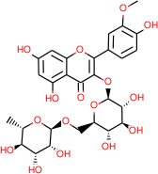

## Fig. 9: Narcissin



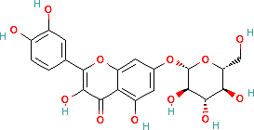

**Fig. 10: Quercimeritrin**



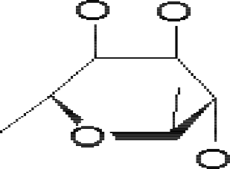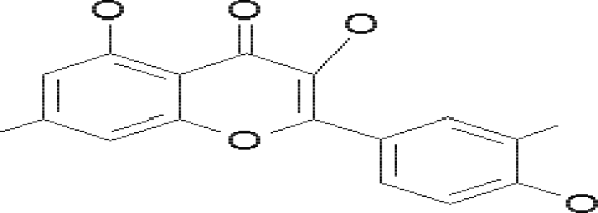

## Fig. 11: Quercitrin

* 1. **Microscopical Studies of *D. oliveri***

The microscopical studies of the transverse section of the stem bark of *D. oliveri* revealed an outer and inner bark, the bulk of which is made up of sclereids. The outermost part consists of several layers of cork cells. These cork cells occur in regular rows of small slightly thick walled, flat polygonal cells, closely packed in radial rows. The cells contained a reddish brown content in their lumen after bleaching with a 5% (w/v) sodium hypochlorite solution. The content gave a positive test for tannins on addition of 5% of ferric chloride. Parts of the cork layer are exfoliated. The cortex comprising of cortical parenchyma, sclereids and starch grains occur next to the cork cells without any distinct separation from cork layer. Embedded in the cortex are large and small groups of abundant sclereids. They are nearly equal in size, rounded, square or occasionally oblong in shape. They possess thick striated cell walls with pits, narrow lumen appearing more distinctly as the layer next to the outer most layer of cork cells. The cortex parenchyma are non-tangentially arranged, being made up of spherical, thin walled cells, containing abundant starch grains. The sclereids get bigger in size and smaller in number as they gradually occur towards the inner surface of the bark. They now occur mostly as clusters, with the cells being more oblong than spherical. The cortex now appears more visible towards the inner cortex. The spherical parenchyma cells of the cortex differentiate into medullary rays, which are tube-like towards the inner part of the cortex.

The phloem fibres are unicellular, lignified, slightly thickened on the cell wall possessing narrow lumen and pits. The medullary rays occur distinctly as a fine network of multiserriate nearly straight cells. They are thin walled in 3 to 4 rows separating dark

bands of phloem tissues. Prisms of calcium oxalate crystals occur abundantly in association with phloem fibres. The cells around the fibres contain single prism per cell. Spherical and thin walled phloem parenchyma along side medullary rays contains starch grains forming a sheath to each fibre group. The starch grain occur less in the inner bark as compared to the outer bark. The medullary rays tend to converge as they approach the inner stem as nearly parallel lines. The phloem fibres are arranged in tangential bands alternating with sieve fibres and phloem parenchyma. Separate and numerous bundles of secondary phloem tissues make up the inner bark.

The chemomicrosopical investigation of powdered sample of the stem bark revealed the presence of lignin, starch grains, tannins, calcium oxalate crystals and cutin (Jegede *et al.,* 2006).

#### CHAPTER THREE

#### MATERIALS AND METHODS

#### Collection, Identification and Preparation of Plant Materials

The root and root bark of the plant *D. oliveri* were collected in Zaria in July, 2006 in the early part of the day. These roots along with the leaves of the plant collected were taken to the Herbarium, Department of Biological Sciences, Ahmadu Bello University, Zaria for proper identification and was assigned a voucher number.

The root bark were separated from the roots and air-dried at room temperature for about 2 weeks. The dried root bark was then powdered in a wooden mortar and pestle. The powder was packed in air tight plastic container and stored in a cool dry place until required. Some fresh roots of this plant collected were immediately fixed in FAA (Formalin Acetic Acid) for microscopical studies.

#### Macroscopical Examination of the Root Bark of *D. oliveri*

This includes the determination of odour, taste, colour, shape, size and texture of the drug (Evans, 2002).

#### Microscopical Examination of the Root and Powdered Root Bark of *D. oliveri*

* + 1. **Anatomical Sectioning of the Root of *D. oliveri***

The method of Donald (1940) was adopted for the microscopical examination of *D. oliveri* root. This involves fixing the root of *D. oliveri* in Parafin wax. The method is described as follows:

After fixation in FAA (Formalin Acetic Alcohol) for at least 24 hours, the following procedures were carried out:

* + - 1. Rinse in water for 2 hours
      2. Dehydration which involves fixing the tissue in 30% of alcohol for 2 hours, 50% of Alcohol for 2 hours,

70% of Alcohol for 2 hours,

95% of Alcohol for 2 hours, Absolute Alcohol I for 2 hours and Absolute Alcohol I for 2 hours

* + - 1. Cleaning or de-alcoholization. As soon as the tissue was removed from Absolute Alcohol II, it was immediately fixed in:

Chloroform 1:3 Alcohol-for 2 hours, Chloroform 1:1 Alcohol – for 2 hours, Chloroform 3:1 Alcohol – for 2 hours, Absolute Chloroform I – for 2 hours and Absolute Chloroform II – for 2 hours.

* + - 1. Little parafin wax (600c) chips was added at a time at infiltration until chloroform no longer evaporate or impregnation process takes place in molten paraffin wax (600C) over night (24 hours).
      2. A solid watch glass was used to embed the tisssue in parafin wax; tissue can be kept in this position until it is time for sectioning.
      3. Sections were trimmed and mounted on the chick and then sectioned by using a microtone set at 5 microme. The sectioned tissue was placed on a clean slide

with the aid of an adhesive to stick it on the slide before staining. The adhesive used was Glycerin and albumin.

#### Staining procedure

1. Sections were dewaxed in two changes (2) xylene for 5 mins each
2. The sections were treated as follows:
   1. Absolute Alcohol I for 2 minutes,
   2. Absolute Alcohol II for 2 minutes,
   3. 95% Alcohol for 2 minutes,
   4. 70% Alcohol for 2 minutes,
   5. 50% Alcohol for 2 minutes,
   6. 30% Alcohol for 2 minutes and
   7. Distilled water for 2 minutes
3. Stained in safarin for 30 minutes,
4. Blum (Rinsed) in tap water 1 minute,
5. Rinsed in distilled water for 1 minute,
6. Destained in 70% Acid Alcohol for 30 seconds,
7. Passed through

* 70% Alcohol for 1 min
* 50% Alcohol for 1 min
* 30% Alcohol for 1 min

1. Washed in distilled water for 1 minute,
2. Counter stained in fast green 1 – 2 minutes,
3. Washed in tap water – 1 minute,
4. Wash in distilled water – 1 minute,
5. Passed through

* 30% Alcohol for 1 min
* 50% Alcohol for 1 min
* 70% Alcohol for 1 min
* 95% Alcohol for 1 min
* Absolute Alcohol 2 changes for 1 min each

1. Passed through 2 changes of xylene 5 minutes and
2. Finally mounted in D.P.X which was a mixture of distrene ( a polystyrene), a pastilizer (tricresyl phosphate) and xylene or Canada balsam. With cover slips now the permanent slides preparations are ready for viewing for microscopical characters.

#### Microscopical Examination of Powdered Root Bark of *D oliveri*

For the microscopical investigation of the powdered root bark the method described in African Pharmacopoeia (1986), was adopted. This involves heating the powdered root bark in chloral hydrate solution which helps to dissolve starch grains, aleurone grains, plastids, volatile oils, and expand collapsed and delicate tissue without an undue swelling action upon the cell walls and distortion of the tissue (African Pharmacopoeia, 1986). The microscopical characters to be observed include the diagnostic features of the

powdered root bark of *D. oliveri*, observable under a light microscope with or without the aid of chemical reagents.

#### Chemomicroscopical Examination of the Root Bark of *D. oliveri*

The chemomicroscopical examinations of the powdered root bark were done using the method described in Evans (2002) and African Pharmacopoeia (1986). This involve clearing the material by means of chloral hydrate and staining the materials using different staining reagents followed by observation under a compound microscope. The chemical constituents were examined as follows:

#### Test for Cellulose

The powdered root bark was mounted in N/50 iodine and allowed to stand for a minute, 66% sulphuric acid was then added to it. A blue to blue-violet colouration indicates the presence of cellulose (Evans, 2002).

#### Test for Lignin

The powdered sample was mounted in phloroglucinol and allowed to stand for about 2 minutes or until it becomes almost dry. A drop of concentrated hydrochloric acid was added. A pink or cherry red colour indicates the presence of lignified cell walls (African, Pharmacopoeia, 1986).

#### Test for Tannins

A drop of ferric chloride solution was added on to the powdered samples on a slide. A blue black or greenish black colouration indicates the presence of tannins (Evans, 2002).

#### Test for Mucilage

The powdered sample was mounted in Ruthenium red. Reddish or dark pink colouration indicates presence of mucilage (African, Pharmacopoeia,1986).

#### Test for Starch

The powdered sample was mounted in N/50 iodine. A bluish colouration indicates presence of starch (Evans, 2002).

#### Test for Fats and Fatty Oils

1-2 drops of Sudan iv were added to the powdered sample and allowed to stand for a few minutes or heat gently if necessary. Fatty substances are stained orange-red to red (Evans, 2002).

#### Test for Proteins

For this test 1% picric acid was used. Yellowish stains on the structures indicate presence of protein (Evans, 2002).

#### Test for Calcium Oxalate Crystals

The powdered samples was cleared in chloral hydrate solution. Calcium oxalate crystals are seen as bright structures of definite shape and size. On addition of 80% sulphuric acid and viewed under microscope, the disappearance of calcium oxalate crystals confirms their presence (Evans, 2002).

#### Test for Calcium Carbonate

The powdered sample was mounted in glycerol. The slide was irrigated with acetic acid solution. Evolution of gas indicates presence of calcium carbonate (Evans, 2002).

#### Physico-Chemical Analytical Methods

#### Determination of Total Ash Value

The total ash value is defined as the percentage ash produced by a plant material after incinerating the ground drug at as low a temperature as possible to remove all of the carbon.

4.0g of accurately weighed sample of the powdered drug were heated in a clean crucible until charred. Heat was gradually increased not exceeding 450˚C until the drug became almost white (ash). The crucible was cooled and weighed. The ash was again heated and weighed. The heating and weighing were repeated until weight become constant. The ash value was then calculated as follow:

% Ash value = Weight of residual ash X100

Weight of original sample

Three different determinations were carried out and the average was taken.

#### Determination of Acid-Insoluble Ash Value

This is a method used to measure the amount of silica, especially sand and siliceous earth, present in the drug.

The total ash obtained above was transferred to beaker containing 25ml of dilute Hydrochloric acids (2N). The mixture was boiled for five minutes and filtered through an ash less filter paper. The beaker and the crucible were rinsed with water and the washings were added to the content of the filter paper. The filter paper was then dried in the oven at 105˚C. The dried filter paper along with the residue was then transferred to a clean crucible and heated gently; the heat was increased until the filter paper was completely burnt. Heating was continued for 5 minutes to ensure complete burning of the ash less filter paper. The crucible was cooled and weighed. The acid insoluble ash value was calculated as follows:

% Acid insoluble ash value = Weight of residual ash X 100

Weight of original sample

Three different determination were carried out and the average value taken.

#### Determination of Moisture Content

Moisture content is the percentage quantity of water in a crude drug. The moisture content of *D. oliveri* was determined using the ‘Loss on Drying’ method as described by Brain and Turner, 1975. This method was adopted due to the fact that the materials do not contain compounds which are volatile at the drying temperature.

4.0g of powder was accurately measured and placed in a clean evaporating dish of known weight. The dish was placed in an oven at 105˚C, after one hour the weight of drug and dish were measured and returned to oven. The weighing was repeated after every 30 minutes until the weight became constant. The weight of water lost during was calculated with reference to the original weight of the plant as follows:

% Moisture content = Weight of moisture X 100

Original weight of sample

Three different determinations were carried out and the average was taken.

#### Determination of Extractive Values

**Water-Soluble Extractive Value:** Water-soluble extractive value is defined as the amount of the extractive in percentage of soluble material obtained after treating the plant material in chloroform water. The method described by Brain and Turner (1975) was used.

4.0g of the powdered drug was mixed with 100ml of distilled water in a conical flask and stopper. The flask was shaken using mechanical shaker for six hours and left to stand for 18 hours. The mixture was filtered; 20ml of the filtrate was taken into a clean evaporating dish and evaporated to dryness. The dish with the residue was then placed in an oven to dry and then weighed. Weighing and heating was continuously taken at ten minutes interval until constant. The water soluble extractive value was then calculated as follows:

% Water soluble extractive value = Weight of residue in 20ml extract X 100

20

Three different determinations were carried out and the average value was taken.

#### Alcohol-Soluble Extractive Value

The procedure is identical to that for the water-soluble extractive except that the extractive solvent here is alcohol (95% ethanol). This was determined using standard method (British Pharmacopoeia, 1980).

#### Extraction and Fractionation of Methanol Extract

1kg of the powdered root bark was extracted with 4 litres of methanol using cold maceration technique. The extract was concentrated to drying using rotary evaporator. Another 500g of the powdered root bark was extracted with 4 litres of distilled water using also cold maceration. This was concentrated to dryness over a water bath.

25g of the dried methanol extract (A) was dissolved in 250ml of distilled water and filtered. The filterate was partitioned with Petroleum ether to get the Petroleum ether soluble portion and aqueous soluble portion. The aqueous soluble portion was partitioned with Ethyl acetate to get the Ethyl acetate soluble portion (B) and the aqueous portion. The aqueous portion was partitioned with n-butanol to get 2 different fractions that is the n-butanol fraction (C) and aqueous fraction (D) (fig. 12).

Plant Root Bark (1kg)

+

Methanol

Marc Methanol Extract (A)

(52.48g)

25g

+

250ml Distilled water

Filterate (aqueous solution)

+

Petroleum Ether

Residue

Petroleum Ether Fraction Aqueous Fraction

+

Ethyl Acetate

Aqueous Fraction

+

n - Butanol

Ethyl Acetate Fraction (B) (50mg)

n – Butanol Fraction (C) (65mg)

Aqueous Fraction (D) (400mg)

**Fig 12: Flow-chart of the Extraction of the powdered root bark of *Daniellia oliveri***

#### and fractionation of Methanol Extract (Woo *et al*., 1980)

* 1. **Phytochemical Screening of Methanol Extract and Fractions**

Standard screening tests of the methanol extract and its fractions were carried out for the presence of various phytochemical constituents, using standard procedures.

#### Test for Carbohydrates

* + - 1. **Molisch's test (General test for carbohydrates):-** To 2ml of extract in a test tube was added a few drops of Molisch’s reagent, then a small amount of concentrated H2SO4 was carefully added to form a lower layer. A reddish colour at the interface indicates the presence of carbohydrate (Evans, 2002).

**ii Fehling’s test (Test for reducing sugars/combined reducing sugars):** 0.1g of the drug was dissolved in 5ml of water, 5ml of an equal mixture of Fehling’s solutions A and B was added and the mixture boiled in a water bath for 5 minutes. A brick red precipitate indicates the presence of free reducing sugar. If the above test is negative 0.2g of the drug solution was hydrolysed in water by boiling with 5ml of dilute hydrochloric acid for 5 minutes, 5ml of 10% of sodium hydroxide was added to neutralize the solution before adding an equal volume of a mixture of Fehling’s solutions of A and B and boiled. A brick red precipitate indicates the presence of combined reducing sugars (Evans, 2002).

* + - * 1. **Barfoed’s test**: 1ml of a dilute solution of the drug sample in water in a test tube was added to 1ml of Barfoed’s reagent in a test tube and heated in a water bath. A red precipitate indicates the presence of monosaccharide (Brain and Turner, 1975).
        2. **Selivanorff’s Test**: To a dilute solution of drug sample in water, a crystal of resorcinol and an equal volume of concentrated HCl was added to it and heated in a water bath. A rose colour produced indicates the presence of ketoses (Evans, 2002).
        3. **Test for pentoses**: To a small volume of an aqueous solution of the drug in s test tube, equal volume of hydrochloric acid containing a little of phloroglucinol was added and heated on a small flame. A red colour produced indicates the presence of pentose sugar (Evans, 2002).

#### Test for Saponins

* + - 1. **Frothing Test:** To 25ml of the extract was added 10ml of distilled water in a test tube. Shake the test tube vigorously for 30 seconds and it was allowed to stand in a vertical position and observed for over 30 minute’s period of time. A honey comb froth which persists for about 10 – 15 minutes indicates the presence of saponins in the drug sample (Silva *et al*., 1998).
      2. **Heamolysis Test:** To 2ml of the extract was added 2ml of 1.8% aqueous sodium chloride solution in a test tube and another test tube containing 2ml of distilled water which serve as control. 5 drops of animal blood was added to each of the test tube and the content were mixed gently by inverting the tubes. Tubes were observed for 15-30 minutes for haemolysis in tubes containing the extract and its absence in the control tube, which indicate the present of Saponins (Brain and Turner, 1975).

#### Test For Flavonoids

1. **Ferric Chloride test** – to 2ml of the extract in a test tube a few drops of 10% ferric chloride solution were added. A green or blue colour indicates the presence of phenolic nucleus (Evans, 2002).
2. **Shinoda’s Test:** Four pieces of magnesium chips were added to 5ml of the extract followed by a few drops of concentrated HCl. A pink or red color indicates the presence of flavonoids (Mahran, *et al.,* 1980).

**ii. Sodium hydroxide test** – 5ml of the extract in a test tube and an equal volume of 10% Sodium hydroxide was then added. A yellow solution indicates the presence of flavonoids. On addition of dilute hydrochloric acid, the solution would become colourless (Evans, 2002).

#### Test for Cyanogenetic Glycoside using Guignard Test (Sodium Picrate)

1g of the powdered drug was placed in a clean test tube and a few drops of water was added to it to moisten the drug. About 0.5ml of chloroform was also added to the test tube containing the drug sample to enhance the enzyme activity. A piece of freshly prepared sodium picrate paper was suspended above the drug by trapping the top edge between a cork and the test tube wall. Care was taken to ensure that the paper strip do not touch the walls of the tube. The closed test tube was placed on a water bath for 15 minutes. A brick red or maroon colour on the paper due to the release of hydrocyanic acid vapours indicates the presence of cyanogentic glycosides (Silva *et al*., 1998).

#### Test for Steroids / Triterpenoids

0.2g of the extract was dissolved in 10ml of Chloroform. This was stirred thoroughly for about 5 minutes and transferred into a test tube and added to it was 0.5mg of anhydrous Sodium Sulphate the mixture was gently shaken and filtered into 3 clean and dry test tubes (I, II and III). These were used for the following tests.

1. **Liebermann- Burchard Test**: Equal volume of acetic anhydride was added to test tube and mixed gently. 1ml of concentrated sulphuric acid was then added down the side of the test tube to form a lower layer. Colour changes were observed immediately and over a period of one hour. Colour change were compared with control tube III-blue to blue-green colour in the upper layer and a reddish ring indicates the presence of steroids and red, pink or purple colour indicates the presence of triterpenoids (Silva *et al.,* 1998).
2. **Salkowski’s Test (for steroidal ring):** Test tube II was held at angle 450 and 2-3 drops of concentrated sulphuric acid was added from the side of the test tube. A reddish brown ring at the interface indicates the presence of a steroidal ring (Sofowora, 1993).

#### Test for Anthraquinones

1. **Free Anthraquinones:** Small quantity of the extract was shaken with 10ml of benzene. The content was filtered and 5mls of 10% ammonia solution added to the filtrate, the presence of a pink, red or violet colour in the ammoniacal (lower) layer indicates the presence of free antrhaquinones (Evans, 2002).
2. **Borntrager’s Test**: 1g of powdered drug was boiled with 5ml of 10% hydrochloric acid for 2-3 minutes. The hot solution was filtered in a test tube and allowed to cool. 5ml of benzene was added to the filtrate in a separating funnel, the upper benzene layer was separated off and shaken gently in a test tube with half of its volume of 10% ammonium hydroxide. Rose pink to cherry red colour in the lower ammonia layer indicates the presence of anthraquinone (Evans, 2002).

#### Test for Tannins

1. **Ferric Chloride Test:** To 2ml of the extract in test tube 3-5 drops of 10% ferric chloride solution was added to it. A green or greenish-black precipitate indicates the presence of condensed tannins while a blue or brownish-blue precipitate shows the presence of hydrolysable tannins (Evans, 2002).
2. **Lead Acetate Test**: To 2ml of the extract 2 – 3 drops of Lead subacetate solution was added. A buff coloured (a coloured) precipitate indicates the presence of tannins (Brain and Turner, 1975).

#### Test for Alkaloids

1. **Extraction**

10ml of the methanol extract was dissolved in 5% sulphuric acid. This was filtered and placed in a 100ml separating funnel. The solution was made alkaline by the addition of dilute ammonia solution. An equal volume of chloroform was

added shook gently and the layer was allowed to separate. The chloroform layer was allowed to run off into a test tube. This was extracted with two quantities each of 5ml of dilute sulphuric acid.

1. **Tests**: to 1ml of the extract was added 3 drops of the following reagents: Mayer’s reagent, Wagner’s reagent, Dragendorff’s reagent, Hager’s reagent and Tannic acid.

Turbidity or precipitation with either of the above reagents was taken as evidence for the presence of alkaloids in the extracts being evaluated (Evans, 2002).

#### Test for Cardiac Glycosides

1. **Keller –Kiliani’s Test:** To 5ml of the extract was added three drops of strong lead sub-acetate solution and mixed thoroughly. This mixture was filtered. The filtrate was extracted (in a separating funnel) with 10ml of chloroform. The chloroform layer was run off into a beaker. This residue was dissolved in 1ml of glacial acetic acid containing trace of ferric chloride solution, and transferred to a dry test tube. With the test tube held at 450 angle, 1ml of concentrated sulphuric acid was allowed to run down the inside wall of the test tube and form a layer at the bottom. A reddish brown ring formed at the junction of two layers and the upper layers turns bluish green indicate the presence of Cardiac glycosides (Brain and Turner, 1975).
2. **Kedde Test for Cardenolide:** Small quantity of the extract was dissolved in pyridine and a few drops of sodium nitroprusside together with a few drops of 20% sodium hydroxide solution were added. A deep red colour, which fades to brownish yellow, indicates the presence of cardenolide (Kokate, 2002).

#### Thin Layer Chromatographic Studies on A, B, C and D.

The crude methanol extract and the fractions were monitored by TLC. The systems used were as follows.

1. Precoated silica gel plates
2. Solvent
   1. Chloroform: Methanol (7:3v/v) (Wagner and Sabine, 1996)
   2. Ethyl acetate: Water: Chloroform: n-Hexane: Methanol (5:2:2:1:1v/v) (Gibbons and Gray, 1998)
   3. Ethyl acetate: Water: Chloroform: Methanol (4:1:3:2v/v) (Gibbons and Gray, 1998)
   4. n-Butanol : Acetic acid:Water (2:1:1v/v)(Gibbons and Gray, 1998)
   5. n-Butanol: Acetic acid:Water (2:1:2v/v) (Gibbons and Gray, 1998)
3. Detecting Reagents
   1. Iodine
   2. Ferric chloride
   3. 10% Sulphuric acid
   4. Antimony trichloride (Gibbons and Gray, 1998)

#### Total Phenolic Content

The total phenolic content of the root bark extracts were determined separately using the method of Macdonald *et al.,* 2001 with modifications. Calibration curve was prepared by mixing methanol solution of gallic acid (1ml; 0.020-0.34mgml-1) with 2.5ml Folin- Ciocalteu reagent (diluted tenfold) and sodium carbonate(4ml, 0.7M). The absorbance was measured at 765nm and drew the calibration curve. One milliliter of the different root bark extracts and fractions (5gl-l) were also mixed with the reagents above and after

2 hours the absorbance was measured to determine total phenolic contents. All determinations were carried out in triplicate. The total content of phenolic compounds in the extracts and fractions in gallic acid equivalents (GAE) was calculated by the following formula:

T= C.V

M

Where T= total content of phenolic compounds, milligram per gram plant extract, in GAE; C= the concentration of gallic acid established from the calibration curve, milligram per milliliter; V= the volume of extract, milliliter; M= the weight of plant extract, gram.

#### Biological Evaluation

* + 1. **Acute toxicity testing of the methanol extract**

This was carried out based on the method described by Lorke, 1983. A batch (total) of 13 mice was used. The first 9 mice were divided into three groups of three mice each which form the first phase. The extract was administered intraperitoneally and the volume to be administered was calculated based on the body weight. These 3 groups received 10,100

and 1000 mgkg-l of the extract. The result obtained from these 3 groups was used to determine the next doses of the extract to be administered to the next sets of mice (remaining four mice) forming the second phase. The remaining four mice received 1600mgkg-l, 800mgkg-l, 400mg/kg and 200mgkg-l of the extract intraperitoneally. General signs and symptoms for toxicity and mortality were observed for 24 – 48 hours.

#### Anti *Candida* Activity of Water Extract, Methanol Extract, B, C and D.

* + - 1. **Preparation of Media**
         1. **Cornmeal Agar with 0.02% Tween 80, 10% Cycloheximide and 0.4% Chloraphenicol:** Seventeen grams (17g) of Cornmeal agar (CMA) were suspended in 900ml of distilled water boiled to dissolve properly. 0.02ml of Tween 80, 100ml of Cycloheximide and 0.4g of Chloramphenicol powder were all added to the corn-meal agar as it cools down to 420C. It was then dispense into sterile 50, bijou bottles in 20 millilitre volume and autoclaved at 1210C for 15 minutes (Ehinmidu, 2003)..
         2. **Subouraud Dextrose Agar (SDA):** Sixty five grams of dehydrated SDA was weighed into a beaker containing one litre of distilled water and dissolved in it properly by boiling it on a bunsen flame. It was dispensed into bijou bottles in 10 millilitre and 20 millilitres volume and autoclaved at 1210C for 15 minutes. After sterilization, the 10ml volume SDA bottles were slanted and allowed to set firmly to give agar slope (slants) FLUKA.
         3. **Sabouraud Dextrose Liquid Medium (SDLM):** This medium was prepared by dissolving 30 grams of SDLM powder in one litre of distilled water stirred to

dissolve and dispensed in 5 millilitres volume into 200 bijou bottles and autoclaved at 1210C for 15 minutes OXOID.

* + - * 1. **Recovery Medium (Sabouraud Dextrose Liquid Medium with 3.0%v/v Tween 80):** Three grams of SDLM was weighed into 100ml of distilled water in a beaker and stirred to dissolve completely, 3ml of tween 80 was added to it and dispensed in 5 millilitre volume into bijou bottles and autoclaved at 1210C for 15 minutes (Ehinmidu, 2003)..

#### Preparation of Solvent

* + - * 1. **Sterile Distilled Water (SDW):** One litre of distilled water (DW) was dispensed in 100ml volumes into 10 screw-capped bottles. These were then sterilized at 1210C

for 15 minutes.

* + - * 1. **Methanol:** Fifty percent methanol was used to dissolve plant extracts and the antifungal drug used. The test drugs were observed to dissolve very well in this concentration of alcohol.
        2. **Sterile Normal Saline:** Nine gram of Sodium Chloride was dissolved in 1 litre of distilled water. This was dispensed in 9ml into bijou bottles and sterilized at 1210C for 15 minutes. This solvent was used for making standard dilution of *Candida* sp (Ehinmidu, 2003).

#### Study Population

A total of thirty samples were collected, 20 from 200 and 500 level pharmaceutical sciences students and 10 samples from patients in the Dental section of the school of Basic Health in Kaduna.

#### Preparation of the Test Organism Isolation of *Candida sp*

1. **Collection of Samples**

Each patient was given a sterile swab stick to take their mouth swab. Each specimen received was labeled with the patients number and kept immediately in Sabourraud Dextrose Liquid Medium (SDLM) before being transported into the Laboratory.

#### Inoculation of Samples on Media

The samples were allowed to grow in the SDLM for 48 hours before being cultured on cornmeal agar with 0.02% Tween 80, 10% cyclo- heximide and 0.4% chloramphenicol. Those samples that gave growth were homogeneously mixed. A loop full of the sample was inoculated on SDA slants aseptically.

This same procedure was done for other samples that showed growth in the SDLM and incubated at 30˚C for 72 hours.

#### Identification of Isolates

The cultured plates were observed for the presence of growth of yeast cells; those plates that did not show any growth were discarded after one week of incubation.

The following investigations were carried out for positive plates (plates that showed growth).

#### Microscopic Characterizations Wet preparation

* + A drop of normal saline was placed on clean, grease free slide.
  + A little portion of *Candida* species colony from cornmeal agar plates was emulsified into the drop.
  + A drop of lacto-phenol cotton blue was added to check for the presence of chlamydospores and blastospores.
  + This was then covered with a cover slip.
  + The preparation was observed at x10 objective then confirmed with x 40 objective.

#### Biochemical Characterization

This was carried out using Oxoid Biochemical Identification System-Albicans (O.B.I.S albicans). The O.B.I.S. albicans is a two stage biochemical test that detects the presence of two enzymes, -galactosaminidase and L-proline amino-peptidase, using chromogenic substrates. These enzymes are produced by *C. albicans.* One or both enzymes may be absent in the other yeast species. This procedure uses cards impregnated with p - nitrophenyl-N-acetyl--D-galactosaminide (pNP-NAGal) and L-prolinyl-7-amido-4- methylcoumarin (PRO-AMC). Following addition of the O.B.I.S sodium hydroxide developer, the presence of -galactosaminidase is indicated by the formation of a yellow

colour. The addition of O.B.I.S dimethylaminocinnamaldehyde (DMAC) developer, indicates the presence of L-proline amino peptidase by the formation of a magenta colour. Absence of either enzyme (indicated by no colour change) confirms that the culture is not *C. albicans* (O.B.I.S albicans)*.*

After biochemical identification, the organisms were re-inoculated into SDA slant in triplicates as stock fungal cultures at 40C.

#### Sensitivity Test

All the *Candida* species isolates were subjected to sensitivity test using crude extract, fractions and standard drug (Itraconazole).

1. **Determination of Minimal Inhibitory Concentration (MIC):** Double strength 10ml of SDA was prepared and sterilized by autoclaving at 1210C for 15 minutes. Graded concentrations of Itraconazole in 10ml volume, ranging from 31.25ngml-l to 600gml-l were prepared different concentration of methanol extract were used, these ranges from 1.5675mgml-l to 500mgml-l, water extract ranges from 1.5675 – 200mgml-l, Aqueous fraction; 1.1656-300mgml-l, ethyl acetate fraction; 5-40mgml-l and n-Butanol fraction 3.5

– 28mgml-l were prepared aseptically with sterilized material and solvent systems. Where test agent was not soluble in water, 50% methanol was used. A two-fold dilution protocol was adopted.

The double strength SDA was melted to 450C and then mixed with equal volume of prepared test agents solutions and poured aseptically into glass Petri-dishes aseptically. This was allowed to solidify. Five pairs of sterilized paper discs were placed at

equidistantly at different points on the solidified SDA. A 3-step one in ten (1:10) dilution of the organisms was prepared to arrive at 1 in 1000 dilution. This contains approximately 106 cfuml-l. This standardized inoculum size of 106 cfuml-l was inoculated (0.1ml) aseptically directly on the paper discs set on the SDA. The inoculated plates were allowed to stand for one hour and then incubated at 30˚C for 72 hours. Each standardized test organism (isolates) was inoculated on a different pair of paper discs. Thus each SDA plate with a known concentration carried five different test organisms (isolates).

Reading of minimal inhibitory concentration was taken after incubation period of 24 hours. The lowest concentration of test agent that showed no growth was considered as the minimal inhibitory concentration (MIC). Positive control was set up to ensure viability of test organism and sterility of media (Presscot *et al*., 2005).

1. **Determination of Minimal Fungicidal Concentration (MFC):** The paper discs of isolates that did not show growth were transferred into a labeled bottle containing 5ml of sabouraud dextrose liquid medium with 3% tween 80. The addition of tween 80 stops the action of the test agent and allowed injured yeast cells to recover fast. The paper disc was removed using a sterile forcep. Each bottle was labeled for test isolate and concentration of test agents. The bottles containing paper discs were then incubated at 30˚C for 72 hours. The reading of minimal fungicidal concentration was taken after 72 hours incubation period. The lowest concentration of test agents that did not show visible growth in duplicates on the recovery liquid medium was considered as the minimum fungicidal concentration (Presscot *et al*., 2005).
2. **Determination of Rates of Kill:** This involves the inoculation of the fixed concentration of the plant extract with 108 cfuml-l of the test-fungal cells. At specified time interval, say 30, 60, 120 and 180 minutes, ten-fold dilutions are made with recovery diluents and these plated out for viable spores counting by pour plate technique using SDA with 5% tween 80 in duplicate. The plates were inoculated at 30˚c for 3 days. Viable spore counting were done and to determine the rate of kill, a graph of log of viable spore count will be plotted against time (Ehinmidu, 2003).

#### CHAPTER FOUR

* 1. **RESULTS**

#### COLLECTION, IDENTIFICAITON AND PREPARATIN OF PLANT MATERIALS

The leaves and root of *Daniellia oliveri* collected were taken to the herbarium section of the Department of Biological Sciences Ahmadu Bello University, Zaria and was assigned the voucher specimen number 7021. The picture of the plant growing in it’s natural habitat and the roots collected are shown on Plate 1 and 2 respectively.

#### Macroscopical Analysis of the root and powdered root bark of *D.oliveri*

The powdered root bark is brown in colour, odourless with astringent taste and rough in texture. The root bark of *Daniellia oliveri* curvature is double quill, it has short and fibrous fracture. The inner surface of the root bark is smooth while the outer surface is rough with a size range of 33.7-34.2mm.

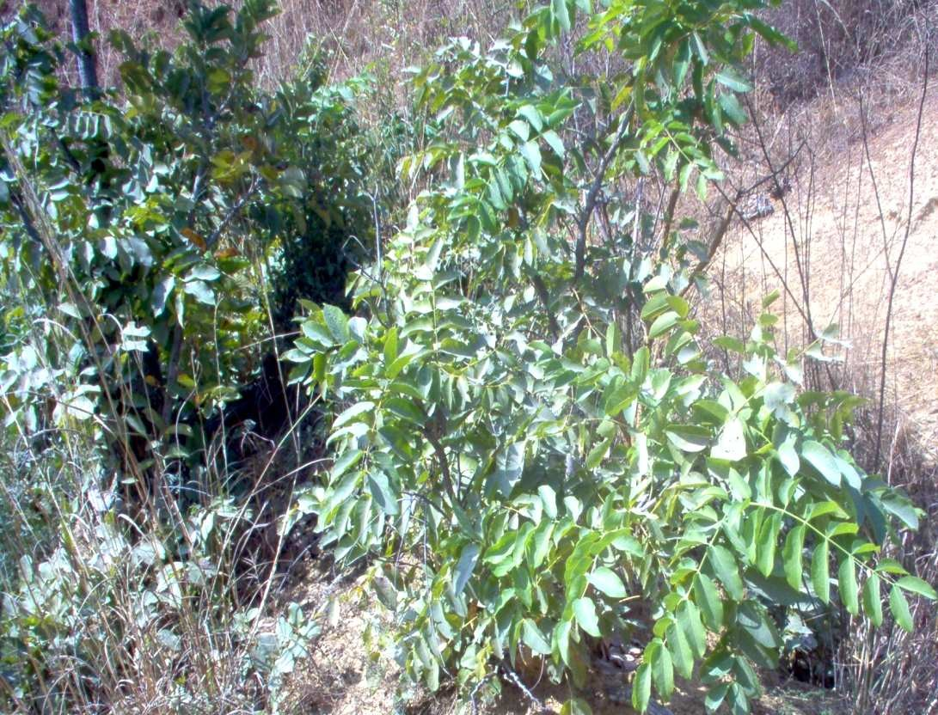

Plate 1: *Daniellia oliveri* Hutch. and Dalz.

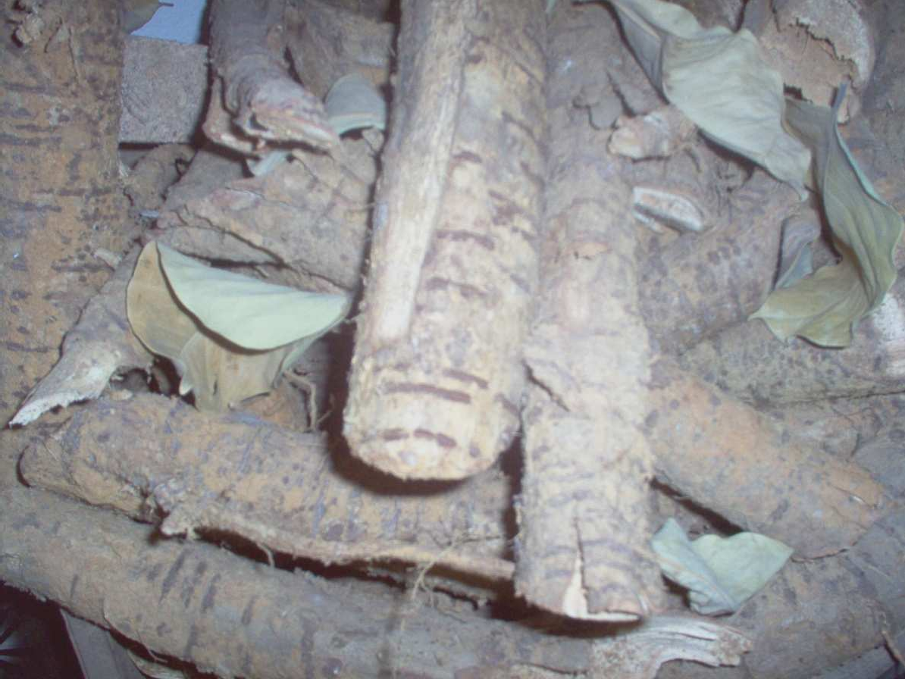

Plate 2: *Daniellia oliveri* roots

* + 1. **Microscopical Examination of the root of *D. oliveri.***

The microscopical examination of the powdered root and anatomical section revealed the following features (fig. 13):

1. Numerous groups of Phloem fibres, attached to it are some parenchyma cells, individual fibres are narrow with thick lignified walls, some with inconspicuous lumen and the size of the fibre is 220.82µm.
2. The calcium oxalate prisms have a high frequency of occurrence which are found scattered and also appear in parenchyma cells. The size of the calcium oxalate prism is 23.91µm.
3. Some of the parenchyma cells of the cortex are composed of reddish brown contents. The parenchyma cells are thin-walled.
4. Sclerenchyma cells are composed of doubled wall cells, polygonal in surface view, some filled with dense reddish-brown contents while some contain crystals of calcium oxalate prism and starch grains.
5. Numerous groups of secretary cells and ducts are present, the cells densely packed together which are found scattered in different cells, and they are reddish brown in colour.
6. Phloem sclereids are few in number, the individual cells are round and the walls are lignified.
7. Small spherical starch grains which are numerous in number are also present.

They are found in the cortex, cork cells and phloem cells and its size ranges between 12.53-15µm.

Cork cells

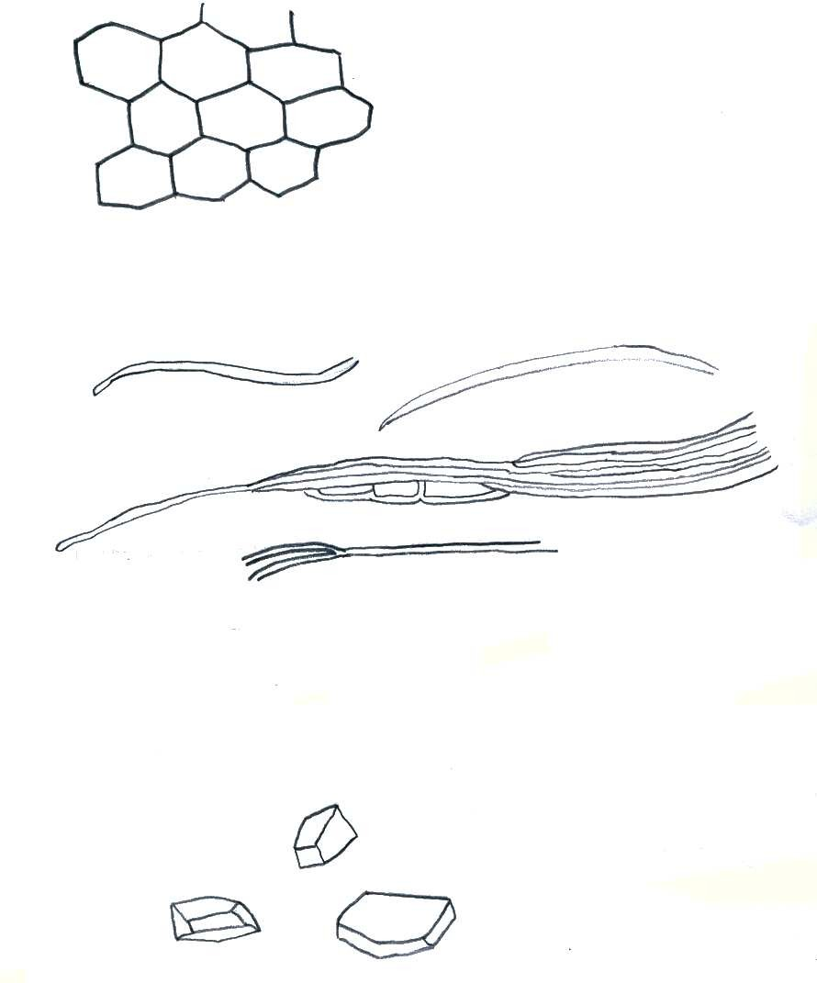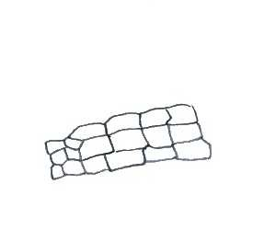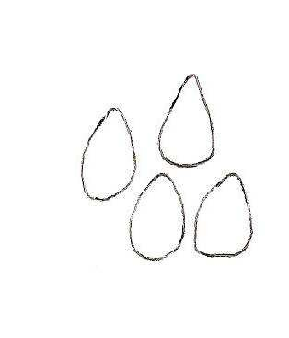

Parenchyma cells of the Cortex

Phloem fibres

Starch grains

Prisms of Calcium Oxalate

Mag x 100

**Fig. 13: Microscopical features of the powdered root bark of *Daniellia oliveri***

Secretary cells

Phloem fibres

Sclereids

Parenchyma cells

Parenchyma cells of the cortex

Mag x 100

## Fig. 13 Contd: Microscopical features of the powdered root bark of

**Figure 2: Transverse Section of *D. oliveri root***

***Daniellia oliveri***

Rhytoderm

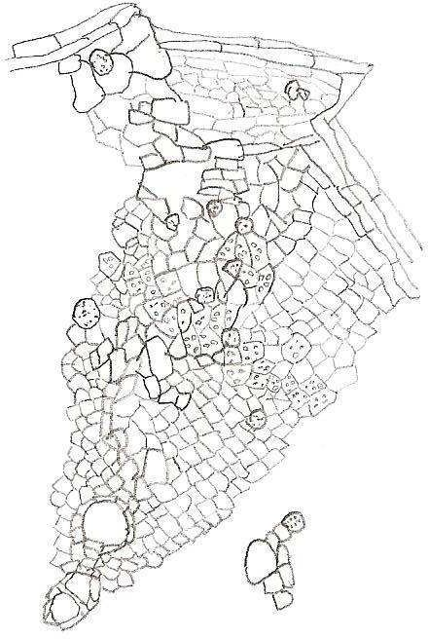

Phellem

Phellogen

Phelloderm

Cork cell

Parenchyma cells of cortex

Secretory duct

Sieve tubes

Companion cells

Phloem Cambium Xylem vessel

Parenchyma cells

Protoxylem

Metaxylem

**Fig 14: Transverse section of *Daniellia oliveri* root**

Mag x 100

The transverse section of *D. oliveri* (fig.14) shows the arrangement of structures of the fixed root of *Daniellia oliveri* viewed under a light compound microscope with mag.x100. The Rhytoderm which is the outer part of the root and outer part of the structures are lighter in colour (light brown) than the phellogen (polygonal cells which are continuous). They are dead and scattered tissues found on the surface. Directly below this is a protective tissue of the phellogen known as the phellem. The phelloderm is below the phellogen. The cells of the phelloderm are radially flattened and form a continuous tangential layer made up of a single layer. The cortex parenchyma are found next after the cork cells, the sieve tube members and companions cells are also next to this layer and they are made up of three layers. Separating the xylem vessels and the phloem is the cambium which are formed surrounding the xylem. Some of the xylems are made up of the proto and meta xylem. Secretory ducts are found on all part of the anatomical structures except the pith, they are more concentrated at the cortex. The pith are mainly of parenchymatous cells, thick walled and polygonal in shape.

* + 1. **Chemomicroscopical Examination of the Powdered Root Bark of *D. oliveri*** The chemomicroscopical examination of the powdered root bark of *D. oliveri* revealed the presence and absence of some chemicals in the cell walls and cell contents. Lignin, tannin, starch grains, mucilage, cellulose and calcium oxalate crystals were found to be present while fats and fatty oils, proteins and calcium carbonate were absent (Table 4.1). **Cellulose**: A blue black colouration was seen under the microscope when the powdered sample was mounted in N/50 iodine and 66% sulphuric acid and this was observed in the cortex.

**Lignin:** A cherry red colouration of the walls of the cork cells, sclereids and fibres were seen under the microscope.

**Tannins:** Greenish black colouration of the cork cells were seen.

**Mucilage:** There was a reddish colouration of the cortex when powdered sample were stained with ruthenium red.

**Starch:** Bluish colouration observed mostly in cortical parenchyma and cork cells. **Calcium oxalate crystals:** Bright prismatic crystals observed in cortical parenchyma and cork cells. These crystals disappeared on the addition of 80% sulphuric acid when viewed under the microscope.

#### Table 4.1: Result of chemomicroscopical investigation of *D oliveri* root bark powder Reagents Reaction Inference

Phloroglucinol + HCL Cherry red colouration of the walls

of cork cells, sclereids and fibres Ferric chloride solution Greenish-black colouration observed

in cork cells

N/50 iodine solution Bluish colouration in cortical

parenchyma and cork cells

Lignin present

Tannins(Condensed) present

Starch grains present

Ruthenium red solution Reddish colouration in the cortex Mucilage present N/50 iodine + 66% H2SO4 Blue black colouration Cellulose present Sudan III No orange-red colouration Fat and fatty oil

absent

Picric acid solution No yellow colouration Protein absent

80% H2SO4 The bright prismatic crystals disappeared on the addition of the reagent. Prismatic crystals found in parenchyma cells

Calcium oxalate crystals present

Glycerol + acetic acid solution

No evolution of gas Calcium carbonate absent

#### Physico-Chemical Analytical methods.

Table 4.3 shows the physico-chemical analysis of the powdered root bark of *D. oliveri* indicate that the alcohol soluble extractive value was higher than the water soluble extractive value, the moisture content of the powder was relatively very low and the acid insoluble ash value being higher than the total ash value (Table 4.2).

#### Phytochemical Screening of the Methanol Extract and its Fractions

The fractionation of the methanol extract dissolved in water with petroleum ether gave no petroleum ether soluble portion. The aqueous soluble portion which was further partitioned with ethyl acetate and n-Butanol gave the ethyl acetate fraction (B), n-Butanol fraction (C) and the aqueous fraction (D).

The preliminary phytochemical screening of A, B, C and D of the root bark of *D. oliveri* revealed that carbohydrate and saponins were found to be absent only in B. Flavonoids, tannins, and cardiac glycosides were found to be present in A, B, C and D while cyanogenetic glycoside, anthraquinones and alkaloids were absent in all. Only A(crude methanol extract) tested positive to steroids/triterpenoids using Liebermann-Burchard’s test and only aqueous fraction tested negative to Salkowskis test for steroids/triterpenoids (Table 4.3).

#### Table 4.2: Result of physico-chemical analysis of the powdered root bark of *D. oliveri*

**Evaluative parameters** *x* **SEM (% w/w)**

Total ash 21.25 ± 1.0

Acid insoluble ash 21.75 ± 1.0

Water soluble extractive 11±1.0

Alcohol soluble extractive 15.33±2.4

Moisture content 7±1.0

Key:

*x* - Mean

SEM - Standard error of mean

#### Table 4.3: Result of phytochemical screening of the methanol extract of the root bark of *D. oliveri* and its fractions.

|  |  |  |  |  |  |
| --- | --- | --- | --- | --- | --- |
| **Phytochemical**  **constituents** | **Test** | **A** | **B** | **C** | **D** |
| Carbohydrates | Molisch’s Fehling’s  Barfoed’s | ++  ++  ++ | --  --  -- | ++  ++  ++ | ++  ++  ++ |
|  | Selivanoff’s | ++ | -- | ++ | ++ |
| Saponins | Pentoses  Frothing | --  ++ | --  -- | --  ++ | --  ++ |
| Flavonoids | Haemolysis  Ferric chloride | ++  ++ | --  ++ | ++  ++ | ++  ++ |
|  | Sodium hydroxide  Shinoda’s | ++  ++ | ++  ++ | ++  ++ | ++  ++ |
| Cardiac Glycoside | Keller-kiliani’s  Kedde’s | ++  ++ | ++  ++ | ++  ++ | ++  ++ |
| Cyanogenetic Glycoside | Guignard’s(sodium  picrate) test | -- | -- | -- | -- |
| Steriods/Triterpenoids | Salkowski’s Liebermann-  Burchard’s | ++  ++ | ++  -- | ++  -- | --  -- |

|  |  |  |  |  |  |
| --- | --- | --- | --- | --- | --- |
| Anthraquinones | Borntrager’s Combined  anthraquinones | --  -- | --  -- | --  -- | --  -- |
|  | Free | -- | -- | -- | -- |
|  | anthraquinones |  |  |  |  |
| Tannins | Ferric chloride | ++ | ++ | ++ | ++ |
|  | Lead acetate | ++ | ++ | ++ | ++ |
| Alkaloids | Mayer’s | -- | -- | -- | -- |
|  | Dragendorff’s | -- | -- | -- | -- |
|  | Wagner’s | -- | -- | -- | -- |
|  | Hager’s | -- | -- | -- | -- |
|  | Tannic acid | -- | -- | -- | -- |
| Key: |  |  |  |  |  |
| ++ - present  -- - Absent   1. Methanol extract 2. Ethyacetate fraction 3. n-Butanol fraction 4. Aqueous fraction |  |  |  |  |  |

* + 1. **Thin Layer Chromatography on A, B, C and D.**

Thin layer chromatography was also used to study the three different fractions from the methanol extract and the crude methanol extract of the root bark of *D. oliveri* to know the different types or the number of metabolites likely to be present in each of the fractions using different solvent systems and spray reagents.

* + - 1. Ethyl acetate fraction developed with chloroform: methanol (7:3 v/v) detected with iodine gave 4 spots; this fraction developed in the same solvent system, detected with ferric chloride gave 3 spots. This solvent system that is chloroform: methanol (7:3 v/v) was the best solvent system for the separation of ethyl acetate fraction.
      2. Spot with Rf value 0.116 using ferric chloride is similar to the spot with Rf value 0.147 using iodine as detecting reagent. This means that the spot with Rf value 0.147 is a phenolic compound.
      3. Ethyl acetate fraction developed with chloroform: methanol (3:7 v/v) when detected with iodine gave 2 spots, with ferric chloride, it gave 1 spot. Spot with Rf value 0.844 detected with ferric chloride is same as spot with Rf value 0.837 detected with iodine.
      4. The methanol extract, aqueous fraction and n-butanol fraction developed with chloroform: methanol (7:3 v/v) gave 1 spot each when detected with ferric chloride. The phenolic compound detected in methanol and n- butanol using this same solvent system and detecting reagent have similar Rf values this means the phenolic compound present in methanol extract moved to the n-butanol fraction.
      5. n - butanol fraction developed with n- butanol: acetic acid: water (6:4:1v/v) gave 2 spots when detected with iodine.
      6. Aqueous and n-butanol fractions developed in ethyl acetate: water: chloroform: n-hexan: methanol (5:2:2:1:1v/v) detected with 10% sulphuric acid gave 2 spots for each.
      7. Aqueous fraction developed in n-butanol: acetic acid: water (2:1:2 v/v) detected with iodine gave 4 spots.
      8. n-butanol and methanol extract developed in n-butanol: acetic acid: water (2:1:2v/v) detected with iodine gave 2 spots each. The spot with Rf value of 0.759 was found in both the n-butanol fraction and methanol extract, this unsaturated compound in methanol extract move to the n-butanol fraction. The spot with Rf value 0.463 is similar to the spot with Rf value 0.474 in the aqueous fraction, this means that this particular unsaturated compound moved to the aqueous fraction. ix Methanol extract, n-butanol and aqueous fraction developed in n-butanol: acetic acid: water (2:1:2v/v) gave 5, 4 and 2 spots respectively when detected with antimony trichloride. The spot with Rf value 0.444 was found in both the n- butanol fraction and the aqueous fraction. This means that they are the same compound and their colours are also the same.

x Methanol extract, n-butanol fraction and aqueous fraction developed in n- butanol: acetic acid: water (2:1:2v/v) gave 1, 2 and 1 spots respectively when developed with ferric chloride. The spot with Rf value 0.040 was found in both the crude methanol extract and the aqueous fraction. The phenolic compound in the methanol extract moved to the aqueous fraction (Table 4.4).

#### Table 4.4: Thin layer chromatographic analysis of the methanol extract and the 3 different fraction of *D. oliveri* root bark

Rf/Colour

Fractions Solvent System Iodine 10%Sulphuric acid

Ferric chloride

Dragendorff Antim

ony trichl oride

Methanol chloroform:methanol (7:3v/v) 0.00a _ 0.07e _ _

|  |  |  |  |  |  |  |
| --- | --- | --- | --- | --- | --- | --- |
| Aqueous | chloroform:methanol (7:3v/v) | 0.13a | _ | 0.04e | _ | _ |
|  |  | 0.38b |  | 0.00e |  |  |

|  |  |  |  |  |  |  |
| --- | --- | --- | --- | --- | --- | --- |
| n-Butanol | chloroform:methanol (7:3v/v) | 0.06a | _ | 0.07e | _ | _ |
|  |  | 0.94c |  | 0.00e |  |  |

|  |  |  |  |  |  |  |
| --- | --- | --- | --- | --- | --- | --- |
| Ethylacet | chloroform:methanol (7:3v/v) | 0.32d | _ | 0.12e | _ | _ |
| ate |  | 0.74d |  | 0.67e |  |  |
|  |  | 0.82d |  | 0.93e |  |  |
|  |  | 0.15 d |  |  |  |  |
| Ethylacet | chloroform:methanol (3:7v/v) | 0.05d | _ | 0.84e | _ | _ |
| ate |  | 0.84d |  |  |  |  |

|  |  |  |  |  |  |  |
| --- | --- | --- | --- | --- | --- | --- |
| Aqueous | ethylacetate:water:chloroform:n- | _ | 0.05d | _ | _ | _ |
|  | hexane:methanol(5:2:2:1:1v/v) |  | 0.83b |  |  |  |

|  |  |  |  |  |  |  |
| --- | --- | --- | --- | --- | --- | --- |
| n-Butanol | ethylacetate:water:chloroform:n- | _ | 0.02d | _ | _ | _ |
|  | hexane:methanol(5:2:2:1:1v/v) |  | 0.55b |  |  |  |

|  |  |  |  |  |  |  |
| --- | --- | --- | --- | --- | --- | --- |
| Aqueous | n-butanol:acetic acid:water(2:1:2v/v) | 0.47d  0.56c  0.77d  0.88f | _ | 0.04e | _ | 0.27d  0.44d |
| n-Butanol | n-butanol:acetic | 0.76a | _ | 0.60e | _ | 0.27d |
|  | acid:water(2:1:2v/v) | 0.82d |  | 0.76e |  | 0.44d |
|  |  |  |  |  |  | 0.67d |
|  |  |  |  |  |  | 0.82d |
| Methanol | n-butanol:acetic | 0.46d | _ | 0.04e | _ | 0.04d |
|  | acid:water(2:1:2v/v) | 0.76d |  |  |  | 0.20d |
|  |  |  |  |  |  | 0.33d |
|  |  |  |  |  |  | 0.44d |
|  |  |  |  |  |  | 0.56d |
| n-Butanol | n-butanol:acetic | 0.29d | _ | _ | _ | _ |
|  | acid:water(6:4:1v/v) | 0.89d |  |  |  |  |

Key:

Iodine: Unsaturated compounds spray reagent. Ferric chloride: Phenolic compounds spray reagent 10% Sulphuric acid: Universal spray reagent

Rf: Retardation factor Antimony trichloride: Steriods spray reagent. a : Dark brown

b : Orange

c : Light brown

d : Brown

e : Greenish black

f : Yellow

#### Total Phenolic Content

The total phenolic content of the root bark extracts of *D. oliveri* measured by Folin Ciocalteu reagents in terms of gallic acid equivalent (GAE) were 57±4.55 mgg-l for crude methanol extract, 59.33±6.65mgg-l for ethyl acetate fraction, 60±5.72mgg-l for n-butanol fraction, 17±0.00mgg-l for aqueous fraction and12±2.94mgg-l for crude water extract (Table 4.5). The calibration curve for the gallic acid is as shown in fig.15.

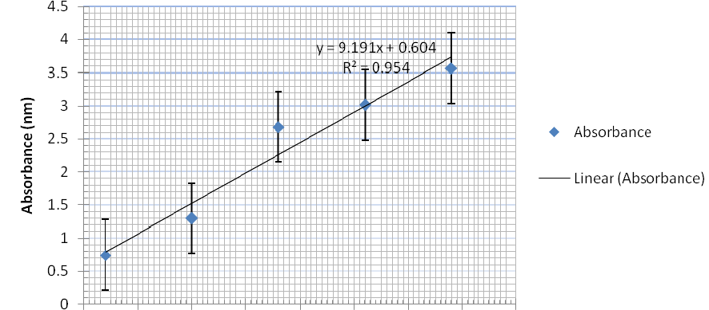

Concentration (mg/ml)

## Fig15: Gallic Acid Calibration curve at 765nm

#### Table 4.5: Concentrations of total phenolic contents of root bark extracts of

***Daniellia oliveri***

#### Extract Concentration(mg g-l)* GAE

Crude Methanol 57.00±4.55

Ethyl acetate 59.33±6.65

n-butanol 60.00±5.72

Aqueous 17.00±0.00

Crude Water 12.00±2.94

**\***Each value in the table was obtained by calculating the average of three experiments ±

standard deviation.

GAE- Gallic acid equivalent.

#### BIOLOGICAL EVALUATION

* + 1. **Acute toxicity study of methanol extract in Mice.**

In phase 1 of the study, the mice showed 100 percent survival for the first two doses (10 and 100 mgkg-l) and 66.67 percent death for the last dose (1000 mgkg-l). In phase 2 of the study, the mice showed 100 percent survival for doses 200 and 400 mgkg-l and 100 percent death for doses 800 and 1,600 mgkg-l. The LD50 of the methanol extract was calculated to be 565.69 mgkg-l i.p (Table 4.6).

The symptoms observed include slow rate of movement. The animals remained calm and resumed eating and activity 3 hours after extract administration. All the surviving mice recovered from the effects of the extract 24 hours later.

#### Table 4.6: Determination of median lethal dose (LD50) of the methanol extract in mice after intraperitoneal administration.

**Treatment group**

#### Number of animals

**Number of Death Percentage**

|  |  |  |  |  |
| --- | --- | --- | --- | --- |
| **group/dose (mg/kg)** | **used** |  |  | **survival** |
| **PHASE 1** |  |  |  |  |
| Extract (10)  Extract (100) |  | 3  3 | 0  0 | 100  100 |
| Extract (1000)  **PHASE 2** |  | 3 | 2 | 33.33 |
| Extract (200)  Extract (400) |  | 1  1 | 0  0 | 100  100 |
| Extract (800) |  | 1 | 1 | 0 |
| Extract (1,600) |  | 1 | 1 | 0 |

LD50 = 565.69mgkg-l body weight I.P

#### Anti- *Candida* activity of the crude extracts and methanol fractions.

* + - 1. **Identification of isolates**

Cultured plates that showed growth after incubation for 3 days were observed for the presence of growth of yeast cells. These were further identified using microscopic and biochemical characterization. It was observed that out of the 30 plates cultured only 5 (S3,s2 ,x1a,xib and ss) showed the presence of growth of yeast cells with a frequency of occurrence of 16.67%. When observed under the microscope, they all showed the presence of chlamydospores and compact clusters of blastospores are formed at regular intervals along the hyphae (Plate 3).

Table 4.7 shows the biochemical identification of the five isolates using Oxoid Biochemical Identification System-Albicans (O.B.I.S albicans). Isolates from plates S2 xib, Ss and Xia showed the presence of both enzymes which confirmed that they are *Candida albicans* while isolate from plate S3 showed absence of both enzymes indicating that it is not *Candida albicans*

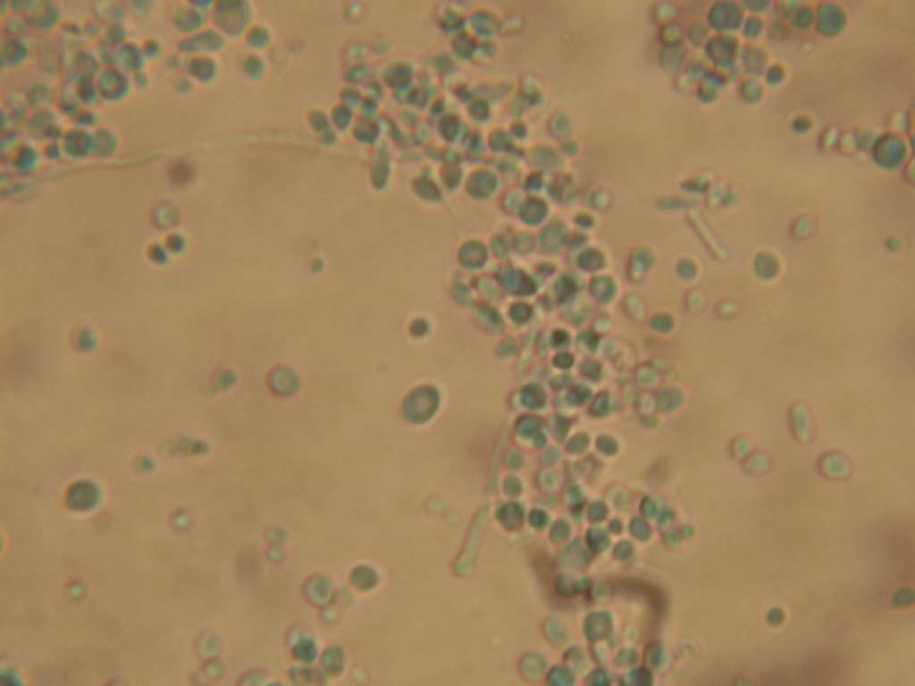

**Plate 3: Morphology of *Candida albicans* under the light microscope**

#### Mag X 400

**Table 4.7: Biochemical characterization of the five *Candida* species isolates.**

|  |  |  |
| --- | --- | --- |
| **Isolates (plates)** | **Enzymes β-galactosaminidase** | **L-proline amino- peptidase** |
| S3 | - | - |
| S2 | + | + |
| xib | + | + |
| S5 | + | + |
| xia | + | + |
| +- Present  -- Absent |  |  |

#### Sensitivity test.

The methanol extract of the root bark of *D. oliveri* showed no zone of inhibition against the five isolated *Candida sp.* The standard drug (Itraconazole) used showed zone of inhibition against the isolated *Candida sp;* from 400 – 1000µgml-l and the zone increases as the concentration increases except for isolate S5 (*Candida albicans)* which did not show increment in the size of the zone of inhibition from concentration 400-800µgml-l, but the zone of inhibition increased at 1000 µgml-l (Table 4.8).

#### ii Minimal inhibitory Concentration(MIC)

The methanol extract (A) of the root bark of *D. oliveri* showed ant*i -Candida* activity against the 5 clinical isolates of *Candia spp* at 1.5675 mgml-l, while the aqueous fraction

(D) of the methanol extract and itraconazoale displayed 150 mgml-l and 0.0315µgml-l as their respective MIC against the test organisms (Table 4.9).The water extract, fraction B and C of the methanol extract of the root bark of *D. oliveri* did not show anti- *Candida* activity.

#### Minimal fungicidal concentration

The minimal fungicidal concentration (MFC) of methanol extract of *D. oliveri* and the standard drug (Itraconazole) against the five *Candida spp* was 50 and 12.5mgml-l and 600µgml-l respectively (Table 4.10). The aqueous fraction (D) of the methanol extract did not show minimal fungicidal concentration against any of the isolated *Candida spp.*

#### Table 4.8: Zone of inhibition (mm) of Itraconazole against the clinical isolates of

|  |  |  |  |  |  |
| --- | --- | --- | --- | --- | --- |
| ***Candida species.*** |  | | | | |
| **Concentration** | ***Candida*** | ***Candida*** | ***Candida*** | ***Candida*** | ***Candida*** |
| **(µgml-l)** | ***albicans*** | ***spp*** | ***albicans*** | ***albicans*** | ***albicans*** |
| 400 | 27.5 | 24 | 24 | 28.5 | 25.5 |
| 600 | 28 | 28.5 | 24 | 29.5 | 30 |
| 800 | 34 | 33.5 | 24 | 33 | 34 |
| 1000 | 45.5 | 49 | 26 | 38 | 47.5 |

**Table 4.9: Minimal inhibitory concentration (MIC) of *D. oliveri* root bark methanol extracts and its aqueous fractions against clinical isolates of *Candida species***

|  |  |  |  |
| --- | --- | --- | --- |
| **Test organism** | **Methanol extract (mgml-l)** | **Aqueous**  **fraction (mgml-l)** | **Itraconazole (µgml-l)** |
| *C. albicans* | 1.5675 | 150 | 0.03125 |
| *C. albicans* | 1.5675 | 150 | 0.03125 |
| *C. albicans* | 1.5675 | 150 | 0.03125 |
| *Candida. spp* | 1.5675 | 150 | 0.03125 |
| *C. albicans* | 1.5675 | 150 | 0.03125 |

#### Table 4.10: Minimal Fungicidal Concentration (MFC) of *D. oliveri* root bark methanol extract and itraconazole against clinical isolates of *Candida sp*

|  |  |  |
| --- | --- | --- |
| **Test organism** | **Methanol extract**  **(mgml-l)** | **Itraconazole (µgml-l)** |
| *C. albicans* | 50 | 600 |
| *C. albicans* | 12.5 | 600 |
| *C. albicans* | 50 | 600 |
| *Candida. spp* | 50 | 600 |
| *C. albicans* | 50 | 600 |

1. **Rate of Kill**

The log cells survival/ml of *Candida albicans* decreases as the time of exposure of methanol extract of *D. oliveri* increases at constant concentration (Fig.16), the log cells survival/ml of *Candida albicans* decreases as the concentration of the methanol extract of

*D. oliveri* increases at constant time (Fig.17) also, There was complete death of the organism at a concentration of 250mgml-l of the crude methanol extract at 120 minutes.

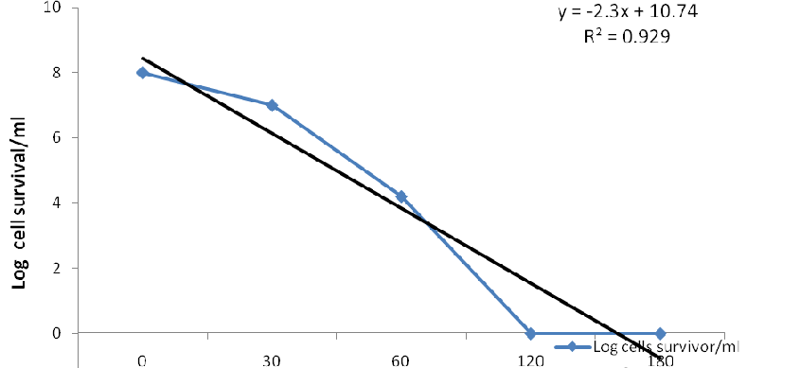

#### Time

**Fig. 16: Fungicidal activity of 250mgml-l of the root bark methanol extract of**

***Daniellia oliveri* against *Candida albican* clinical isolates at different time.**

9

y = -1.6x + 8.46 R² = 0.787

8

7

6

**Log Cells survival/ml**

5

4

Log cells survivor/ml

3 Linear (Log cells survivor/ml)

2

1

0

0 100 150 200 250

#### Concentration (mgml-l)

**.**

**Fig. 17: Effects of varying fungicidal concentrations of methanol root bark extract of *Daniellia oliveri* against *C. albicans* clinical isolates**

#### CHAPTER FIVE

**5.0 DISCUSSION**

The root of the plant *Daniellia oliveri* which has been used as chewing stick (Oral Communication) can be identified using some pharmacognostic characters. The powdered root bark is a brown powder which is odourless with astringent taste and rough in texture. The sensory perception that is odour and taste, often provide the simplest and quickest indication for drug identity, purity or quality (AP, 1986). The description of the odour and taste of the drug is very difficult, often; they can only be described, as characteristic and reference made to analyst’s memory while the colour is of use in indicating the general origin of the drug (Brain and Turner, 1975).

Microscopically, the important diagnostic features of the root bark of *D. oliveri* include the abundant phloem fibres, prisms calcium oxalate crystals, numerous groups of secretory cells and ducts, rounded phloem sclereids and spherically shaped starch grains. The microscopic and chemomicroscopic features of this plant are important anatomical characters which are used in the taxonomical classification of this plant and also in the proper identification of the plant.

The moisture value 7 + 1.0% is an indicative of the strorage quality of the powdered sample as it is within the acceptable range in African Pharmacopoeia, 1986; it also suggests that due to its low moisture content, it has the ability to retain its natural metabolites with any degradation. Hence, this does not support enzymatic activity and growth of micro-organisms as suggested by Brain and Turner, (1975). This implies that

the plant sample can be stored for a long time without significant degradation. The total ash and acid insoluble ash parameters detect the amount of organic and inorganic materials in the plant sample. Table 4.3 shows the physic-chemical analysis, extractive potency of the plant in alcohol and water values were significantly different from each other, with alcohol being higher than with water. This suggests that the use of alcohol as extraction solvent is better for the extraction of polar metabolites present in this plant.

The phytochemical evaluation of the crude methanol extract and its fractions showed the presence of chemical compounds present in the plant. Carbohydrates and saponin glycosides were found to be absent only in ethylacetate fraction. The type of sugar present in this extract is monosaccharide, reducing and ketoses. Evans, 2002 reported that all monosaccharides are reducing sugar which the findings of this work is in support of. Flavonoids, cardiac glycosides and tannins were found to be present in the crude methanolic extract and its fractions. The crude extract tested positive for steroids / triterpenoids using Lieberman –Burchard’s test while using the Salkwoski’s test, the aqueous fraction tested negative while the remaining fractions and the crude extract tested positive. This means that sterols are present in the crude methanol extract, B and C but absent in D.

The crude methanol extract and its fractions tested negative to cyanogenetic glysosides, anthraquinones and alkaloids. The confirmation of the presence of phenolic compounds in the crude methanol extract and its fractions which have been reported to show

antimicrobial activities (Maria *et al.*, 2007) support the local use of this plant for antimicrobial activity.

Thin layer chromatography (TLC) revealed the presence of different types of metabolites in the 3 fractions. The solvent system chloroform: methanol (7:3v/v) is the best solvent system to be used in the TLC separation of these fractions since this gave the highest number of spots. The green black colour obtained when the developed TLC plate of ethyl acetate fraction sprayed with ferric chloride indicated the presence of phenolic compounds (Ali, 2002).

The median lethal dose (LD50) of the crude methanol extract of *D. oliveri* root bark was 565.69mg/kg i.p, this is an indication that the extract may not be safe. According to Lorke (1983), estimated LD50 value > 1g is considered safe. This is of importance because a cumulative toxic effect could occur if the extract is taken over time.

The number of cultured plates that showed the growth of yeast cells was five out of the thirty cultured plates with a frequency of occurrence of 16.67%. This means that the frequency of occurrence of oral thrush is very low. The production of chlamydospores by the five isolates is a diagnostic feature of *Candida albicans* (Elmer *et al*., 1979). The biochemical identification of these isolates using oxoid biochemical identification system

–Albicans test kit showed that only isolates from platesS2, Xib, S5 and Xia are *Candida albicans.* Isolate from plates S3 is *Candida spp,* the species name is not known since this does not test positive to any of the two enzymes secreted by the species *albicans* but

when viewed under the microscope showed the presence of chlamydospores and compact clusters of blastophores which confirmed it to be a *Candida spp.*

Kwon-Chung and Bennett (1992) reported in their findings that *Candida albicans* causes almost 100% of cases of oropharyngeal candidiasis. This research work does not support this finding, as the frequency of isolated *Candida albicans* are 80%. Out of the five isolated plates 4 were *Candida albicans.*

Min *et al., (*1996) demonstrated that methanol extracts of medicinal herbs inhibit growth of *C. albicans*. The methanol extract of the root bark of this plant also supports this finding. The methanol extract showed a minimal inhibitory concentration (MIC) of 1.5675 mg/ml for all the positive isolates and minimal fungicidal concentration (MFC) of 50mg/ml for isolates Xia, S2, S3 and S5 and 12.5 mg/ml for isolates Xib.

The methanol extract showed no zone of inhibiton against the test *Candida* isolates but showed activity against these organisms when it comes in direct contact with them. This shows that the methanol extract does not diffuse into the Sabouraud dextrose agar unlike the standard antifungal agent used, that is Itraconazole, which showed zone of inhibition. The crude methanol extract has an anti-*Candida* activity against the test *Candida* isolated. It is fungicidal while the aqueous fraction (D) is fungistatic. However the ethyl acetate and n-butanol fraction do not display any anti-*Candida* activity.

From the determination of total phenolic content of the extracts and the fractions, the aqueous fraction(17.00± 0.00mgg-l) which is fungistatic contains lower amount of

phenolic compounds when compared to ethyl acetate(59.33± 6.65mgg-l) and n-butanol (60.00± 5.72mgg-l) fractions which do not show any anti- *Candida* activity. The group of phenolic compounds present in ethyl acetate and n-butanol fractions may not be the same as that present in the aqueous fraction which showed anti-Candida activity. Hence, the activity of the plant extracts may not be primarily due to only phenolic compounds present in the extract as observed in ethyl acetate and n-butanol fractions and water extract.

The active constituent which is present in methanol that makes it active might be that part which was present in the aqueous fraction (D). The standard anti-*Candida* agent used, that is itraconazole, showed a superior anti-*Candida* activity with MIC of 0.03125mgml-l and MFC of 600 µgml-l against the five test *Candida* isolates. The peak blood plasma level for itraconazole is 400 – 600ngml-l (Martinadale, 1996) and the MIC value of itraconazole that has fungistatic effect against this *Candida spp* is 0.03125mgml-l, hence the clinical test organism used in this study is not sensitive to Itraconazole.

The rate of kill of *Candida albicans* at different times and concentrations are as illustrated in Fig. 12 and 13 respectively. Generally, there was a rapid onset of kill followed by a slow rate of kill of test *Candida* cells. The rapidity and intensity of onset of action of the crude methanol extract at different times and concentrations showed clearly that this extract is strongly fungicidal. The shape of the death curve produced by methanol extract follows the normal death curve pattern and it is also similar to that produced by most anti fungal drugs (Ehinmidu *et al.,* 2000).

#### CHAPTER SIX

**6.0 SUMMARY, CONCLUSION AND RECOMMENDATIONS**

The details of the macro and microscopical features, quantitative evaluative parameters, preliminary phytochemical screening and chromatographic analysis were established for the powdered root bark of *Daniellia oloveri.* The thin layer chromatography separate the different metabolites present in all the fractions and the crude. LD50 value of the crude methanol extract of the root bark of *D. oliveri* is not safe. This extract has a minimal fungicidal concentration value of 50 mg/ml for isolates Xia, S2, S3 and S5 and 12.5mg/ml for isolates Xib. This means that the extract is fungicidal; the aqueous fraction is fungistatic while the ethyl acetate and n-butanol fractions have no anti-*Candida* activity. Therefore, the hypothesis was accepted, that is methanol extract has anti-*Candida* activity.

In conclusion, the methanol extract of this plant has anti-*Candida* activity and can be use as a new source of anti- *Candida* agents. The result obtained from the pharmacognostic studies of the root bark can be used for the proper identification of this drug from others and will also be useful in preparation of monographs on this plant.

It is therefore suggested that further work should be carried out on the crude methanol extract to know the metabolite actually responsible for the anti-*Candida* activity, identification of the chemical structures of the compounds. Chronic toxicity studies should be carried out and the toxic compounds identified.

Biochemical identification of isolate S3 to species level should also be carried out. This plant may find use in the management of AIDS patients and other immunocompromised persons especially patients treated in intensive care units (CUS), cancer patients receiving chemotherapy and organ transplant patients, since *Candida* are also responsible for a number of life threatening opportunities infections in these patients.

#### REFERENCES

African Pharmacopoeia. (1986) OAU/STRC Scientific Publication No.3. 1st Edition.

Lagos, Nigeria p. 128 – 142.

Ahmadu, A.A.; Haruna, A.K.; Garba, M. and Yaro, A.H. (2003) Antispasmadic Actions of the leaves of *Daniellia oliveri. Nigerian Journal Natural Product and Medicine.* 7:13 – 15.

Ahmadu, A.; Haruna, A.K.; Garba, M. Ehinmidu, J.O. and Sarker, S.D. (2004) Phytochemical and antimicrobial activities of the *Daniellia oliveri* leaves. *Fitoterapia* 75: 729 –32.

Ali, M. (2002). *Textbook of pharmacognosy*. CBS Publishers and Distributors. New Delhi. p. 63-147, 282 – 347.

Athikomkulchal, S.; Prawat, H.; Thasana, N.; Ruanarungsi, N. and Ruchirawat, S. (2006). Active antifungal substance from natural sources. *Chemical and Pharmaceutical Bulletin.* p. 54,262.

Bafi, N.F.; Arnason, J.T., Baker, J.; Smith, M.L. (2005). Antifungal constituents of northern prickly ash, *Zanthoxylum americanum* mill. *Phytomedicine* p. 12(5):370- 7.

Bahceeuli, A.K.; Kurnan, S.; Kolak, U.; Topcu, G.; Adou, E.; Kingston, D.G. (2005). Active antifungal substances from natural product. *Journal of Natural Product* p. 68, 956.

Banerjee, S. N., Emori, T.G., Culver, D. H., Gaynes, R.P., Jarvis, W. R., Horan, T., Edwards, J. R., Tolson, J., Henderson, T., Marone, W. J., and the National Noscomial Infections Surveillance System (1991). Secular trends in nosocomial primary bloodstream infections in the United States, 1980-1989*. American Journal of Medicine*. 91 (Suppl. 3B): 86S-89S.

Batawila, K.; Kokov, K.; Koumaglo, K.; Gbeassor, M.; De Foucalt, B.; Bouchet, P.; Akpagana, K. (2005). Active antifungal substances from natural sources. *Fitoterapia* p. 76,264.

Bhat, R.B.; Eterjere, E.O. and Oladipo, V.T. (1990) Ethnobotanical Studies from Central Nigeria. *Economic Botany p.*44 (3):382-90.

Bodey, G. P. (1988). The emergence of fungi as major hospital pathogens*. Journal of Hospital Infection* 11:411-26.

Brain K.R. and Tuner, T.D. (1975). *The Practical Evaluation of Phytopharmaceuticals*.

John Wright and Sons Ltd, Great Britain. p. 5, 81-84 and 90 - 111

British Pharmacopoeia (1980). London Her Majesty’s Stationary Office, University Press, Cambridge. 2:517-840

Cavaleiro, C; Pinto, E.; Goncalves, M.J. and Salgueiro, L. (2006). Antifungal activity of *Juniperus* essential oil against dermatophyte, *Aspergillus* and *Candida* strains. *Journal of Applied Microbiology.* p. 100, 1333-1338

Cvetnic, Z.; and Vladimir, S. (2004). Antimicrobial activity of grape fruit seed and pulp ethanolic extract. *Acta Pharmaceutica.* p. 54(3): 243-50.

D’Auria, F.D.; Tecca, M.; Strippoli, V.; Salvatore, G.; Battinelli, L.; Mazzanti, G. (2005). Antifungal activity of *Lavandula angustifolia* essential oil against *Candida albicans* yeast and mycelia form. *Medical Mycology*. p. 43(5):391-6.

Dabur, R.; Chhillar, A.K.; Yadav, V.; Kamal, P.K.; Gupta, J. and Sharma G.L (2005). In Vitro antifungal activity of 2-(3, 4-dimethyl-2,5-dihydro-1H-pyrrol-2-yl)-1- methylethyl pentanoate, a dihydropyrrole derivative. *Journal of Medical Microbiology* p. 54: 549-552.

Dalziel, J.M. (1955). *Useful Plants of West Tropical Africa*. Crown Agents for Oversea Publication, London. p. 401-02.

Delaveau, P.; Desvignes, A.; Adoux, E. and Tessier, A.M. (1979). Chewing Sticks from *Occidental Africa*, Chemical and Microbiological Screening. *Annales Pharmaceutiques Francaises. 37:185 – 190.*

De Leo, M.; Braca, A.; De Tomasi, N.; Norscia, I.; Morelli, I.; Bettinelli, L.; Mazzanti,

G. (2004). Phenolic compounds from *Baseonema acuminatum* leaves: isolation and antimicrobial activity. *Planta Medica. p*. 70:841-6.

Donald A.J. (1940). *Plant Micro technique*. McGraw-Hill Book Company New York and London p. 15 – 64, 126 – 154 and 182 – 203.

Edmond, M. B., Wallace, S. E., McClish, D. K., Pfaller, M. A., Jones, R. N., and Wenzel,

R. P. (1999). Nosocomial bloodstream infections in United States hospitals: A three-year analysis. *Clinical Infectious Diseases*. 29: 239-244.

Ehinmidu, J.O., Olurinola, P.F., Giwa, A. and Bonire, J.J(2000). Antifungal activity of Dibutyltindisalicylates and Clotrimazole against selected pathogenic fungi. *Journal of Phytomedicine and therapeutics*. 5(2)2000:88-91.

Ehinmidu, J.O. (2003). In-vitro antifungal activity of single and combined doses of some antifungal agents against clinical *Candida albicans* isolates in Zaria, Nigeria. *Nigerian Journal of Experimental and Applied Biology.* 5(2) 127-131.

Elmer, W.K, Stephen, D.A.; Dowel, V.R. and Herbert, M. S. (1979). *Colour Atlas and Textbook of Diagnostic Microbiology*. J.B. Lippincott Company Philadephia. Toronto, US.A. p. 414-420.

Evans, W.C. (2002). *Trease and Evans Pharmacognosy*. W.B. Saunders, Sydney, Toronto. 15th Edition. p. 513 -540, 191- 393.

Ezoubeiri, A.; Gadhi, C.A; Fdil, N.; Benharret, A.; Jana, M.; Vanhaelen, M. (2005). Isolation and antimicrobial activity of two phenolic compounds from *Pulicaria odora* L. *Journal of Ethnopharmacology.* p. 99(2):287-92.

Favel, A.; Kemertelidze, T.; Benidze, M.; Fallague, K.; Regli, P. (2005). Antifungal activity of steroidal glycosides from *Yucca gloriosa* L. *Phytotherapy Research* p. 19,158-161.

Fenner R.; Sortino, M.; Rates, S.M.; Dall’Agnol, R.; Ferraz, A.; Bernardi, A.P.; Albring D.C.; Nor, C., Van Poser, G.; Schapoval, E. and Zacchino, S. (2005). Antifungal activity of some Brazilian *Hypericum* species. *Phytomedicine* p. 12(3): 236-40.

Gibbons, S. and Gray, A.I (1998). Isolation by Planar Chromatography in Cannel, R.J (Editor) *methods in Biotechnology Natural Products Isolation*. Human Press Inc, Totowa, N.J. 4:209-245.

Giordani, R.; Regli, P. Kaloustian, J.; Mikail, C.; Abou, L. and Portugal, H. (2004). Antifungal effect of various essential oils against *Candida albicans.* Potentiation of antifungal action of amphotericine B by essential oil from *Thymus vulgaris. Phytotherapy Research*. p. 18(12):990-5.

Gottlieb, L.S. (1995) Oral yeast infections. Article from NOHA News, Vol. xx, No. 3, Summer 4 – 5.

Hirt, H.M. and Bindand, , M. (1993) La medicine naturelle en Afrique comment se soigner par les plantes tropicales Editions Centre de vulgarization gricole, B.P. 4008 Kinshasa 2, Republique du Zaire, p. 144.

Hymete, A.; Iversen, T.H.; Rohloff, J.; Erko, B. (2005). Screening of *Echinops ellenbeckii* and *Echinops longisetus* for biological activities and chemical constituents. *International journal of phytotherapy and phytopharmacology.* p. 12(9): 675-9.

Igoli, J.O.; Oogaji, O.G.; Tor-Anyiin, T.A.; and Igoli, N.P. (2005). Traditonal medicine practice amongst the Igede people of Nigeria. *African Journal of Tradition.* Part II. 2:134 – 152.

Jegede, I.A. Nwinyi, F.C.; Muazzam, I.; Akumka, D. D.; Njan, A.A.; and Shock M. (2006). Micromorphological, anti-nociceptive and anti-inflammatory

investigations of stem bark of *Daniellia oliveri. African Journal of Biotechnology*

5(10):930-35.

John, E.B. (2001). Antimicrobial Agents-Anifungal agents, in Goodman and Gilman’s. (Editors) *The Pharmacological Basis of Therapeutics*. Mc Graw-Hill Companies, Inc. United State of America. 10th Edition. p. 1295-1310.

Kathleen Park Talaro and Arthur Talaro (2002). *Foundations in Microbiology*. Mc Graw Hill Higher Education United State of America. 4th Edition. p.663-83.

Keay. R.W.J.; Onochie, C.F.A. and Stanfield, D.P. (1964). Nigerian Trees Vol. II Department of Forest Research, Ibadan p. 65 – 66.

Kokate, C.K., Purohit, A. and Gokhale S.B. (2002). *Pharmacognosy*. Nirali Prakashan.

18th edition. p. 108-109.

Krone, C., Elmer, G., Ely D., Fundenberg, H. and Thoreson J. (2001). “Does gastrointestinal *Candida albicans* prevent ubiquinone absorption?”. *Medical Hypotheses*. 57(5):570-2.

Kwon-Chung, K.J. and Bennett, J.E (1992). *Medical Mycology*. Lea and Febriger, Philadelphia.

Lahlou, M.; El Mahi, M.; Hamamouchi, J. (2002). Evaluation of antifungal and molluscidal activities of Moroccan *Zizyphyus lotus* (L.) Desf *Annales Pharmaceutiques Francaises.* p. 60(6):410-4.

Lamidi, M.; Digiorgio, C.; Delmas, F.; Favel, A.; Eyele, C.; Rondi, M.L.; Ollivier, E.; Uze, L.; Balansard, G. (2005). In vitro cytotoxic and antifungal activities of ethnopharmacologically selected Gabonese plants. *Journal of Ethnopharmacology* 102(2):185-90.

Lee, D.G.; Park, Y.; Kim, M.R.; Jung, H.J.; Sen, Y.B.; Hahm, K.S. and Woo, E.R. (2004). Antifungal effects of phenolic amides isolated from natural sources. *Biotechnology Letters*. p.26, 1125.

Lee, S.K.; Lee, H.J.; Min, H.Y.; Park, E.J.; Lee, K.M. Ahn, Y.H.; Cho, Y.J.; Pyee, J.H.

(2005). Antibacterial and antifungal activity of pinosylvin, a constituent of pine.

*Fitoterapia* p. 76(2):258-60.

Li, L.; Redding, S. and Dongari-Bagtzoglou, A. (2007). *Candida glabrata* and emerging oral opportunitistic Pathogen. *Journal of Dental Research.* 3:204-15.

Long, S.S. and Stevenson, D.K (2005) Reducing *Candida* infections during neonatal intensive care: Management choices, infection control, and fluconazole Prophylaxis. *Journal of Pediatrics*. p.147(2):135-41.

Lorke, D. (1983). A new approach to acute toxicity testing. *Archives of Toxicology*.

54:275-287.

Mac Donald, I. and Olorunfemi, D.I. (2000) Plants used for medicinal purposes by Koma people of Adamawa State, Nigeria. Indigenous knowledge and Development Monitor. November 2000. http://www.nufficon//ciran/ikdm/8-3/res- macdonald.html.

Mahran, G.H.; El-Hossary, G.A. and Mansour, W.M. (1980). A Phytochemical study of *Nymphaea lotus L*. growing in Egypt. *Journal of African Medicinal plants 3:87- 99.*

Mandal, P.; Sinha, S.P. and Mandal, N.C. A.P. Albring, D. and Nor, C.(2005). Antimicrobial activity of saponins from *Acacia auriculiformis. Fitoterpia*. p.76:462-5.

Maria, J.A.; Maria, A. and Paulina B. (2007) Active antifungal substances from natural sources. ARKIVOC. p 116-145

Martindale (1996). The Pharmacopolia. The council of Royal Pharmaceutical Society of great Britain. p. 408.3.

Masoka P.; Picard, J.; Eloff, J.N. (2005). Active antifungal substances from natural sources. *Ethnopharmacol* p. 99,301

McDonald, S., Prenzler, P.D., Autolovich, M. and Robards, K(2001). Phenolic content and antioxidant activity of olive oil extracts. *Food Chemistry.* 73:73-84.

Mel’nichenko. E.G.; Kirsanova, M.A.; Grishkovetes, V.I.; Tysh, L.V. and Krivorutchenko, I.L. (2003). Antimicrobial activity of saponins. *Mikrobiology.* p. 65, 8.

Meng, J.C; Hu, Y.F.; Chen, J.H., and Tan, R.X. (2001). Antifungal highly oxygenated guaianolides and other constituents from *Ajania fruticulosa. Phytochemistry* p. 58(7):1141-5.

Menut, C.; Lamaty, G.; Bessiere, J.M.; Ayedoun, M.A.; Setondji, J.; Samate, D. and Nacro M. (1994). Volatile constituents of *Daniellia oliveri.* from Benin and Burkina Faso. *Journal of Essential Oil Research.* 6(6): 647-9.

Min, B.S., Bang, K.H., Lee, J.S. and Bae, K.H. (1996). Screening of the antifungal activity from natural products against *Candida albicans* and *Penicillum aquellaneum*. *Yakhak Hoeii* 40:482-90.

Muschietti. L.; Derita, M.; Sulsen, V.; De Dios, J.; Ferrero, G; Zacchino, S. and Martino,

B. (2005)*.*In vitro antifungal assay of traditional Argentine medicinal plants.

*Ethnopharmacol.* p.102,233.

Nakamura, C.V.; Ishida K.; Faccin, L.C.; Filho, B.P; Cortez, D.A; Rozental, S.; De Souza, W.; Ueda, T. (2004). In vitro activity of essential oil from *Ocimum gratissimum* L. against four *Candida* species. *Research Microbiology*. p.155(7):579-86.

Olatunji, G. (2001). Diterpene lactone from the heartwood of *Daniellia oliveri. Cellulose Chemistry and Technology.* p. 34:5-6.

Onwukaeme, N.D.; Lot, T.Y. and Udoh, F.V. (1999) a. Effects of *Daniellia oliveri* Bark on Isolated Rat Bladder. *Phytotherapy Research.* 13(5): 416 – 8

Onwukaeme, N.U. and Udoh, F. (1999) b. Antiulcer activity of stem bark of *Daniellia oliveri. Nigerian Journal of Natural Products and Medicine.* Vol. 3.

Pappas, P.G. (2006). Invasive candidiasis. *Infectious Disease clinics of North America*.

20(3):485-506.

Patel, D.A. Gillespie, B., Sobel, J.D., Leaman, D., Nyirjesy, P. and Weitz, M.V (2004). Risk Factors from recurrent Vulvovaginal candidiasis in women receiving maintenance antifungal therapy: results of a prospective cohort study. *American Journal of obstetrics and Gynecology*. 190(3): 644-53.

Philip, L. and Graham, (2002) Review provided by Verimed Healthcare Network (2002) update

Phongpaichit, S.; Subhadairasakul, S.; and Wattarpiromsakul, C. (2005). Antifungal activities of extracts from Thai medicinal plants against opportunistic fungal pathogens associated with AIDS patient. *Mycoses* p. 48,333-338.

Pistelli L.; Bertoli, A.; Lepori, E.; Morelli, I. and Panizzi, L. (2002). Antimicrobial and antifungal activity of crude extracts and isolated saponins from *Astragalus verrucosus. Fitoterapia* p.73(4):336-9.

Plaza, A.; Cinco, M.; Tubaro, A.; Pizza, C. and Piacente, S. (2003). New triterpene glycosides from the stems of *Anomospermum grandifolium. Journal of Natural Product.* p. *66(12):1606-10.*

Prescott, L.M., John, P. H and Donald, A. K. (2005). *General Microbeic*. Fifth edition Mc Graw-Hill Newton. Pp282-5.

Ragasa, C.Y.; Co, A.L.; Rideout, J.A. (2005). Antifungal metabolites from *Blumea balsamifera. Natural Product Research.* p. 19(3):231-7.

Renault, S.; De Lucca, A.J.; Bove, S.; Bland, J.M.; Vigo, C. B, and Selitremikoff, C.P. (2003). Active antifungal substances from natural sources. *Medical Mycology*. p.4,75.

Rojas, R.; Doroteo, V.; Bustamante, B.; Baver, J.; Lock, O. (2004). Antimicrobial and free radical scavenging activityof *Gentianella nitida. Fitoterapia* p. 75,754-757.

Ryan, K.J., and Ray, C.G (2004). *Sherris Medical Microbiology*. Fourth edition. McGraw Hill. ISBN 0838585299.

Salgueiro, L.R.; Piato, E.; Goncalves, M.J.; Pina, C.; Cavaleiro, C.; Rodrigues, A.G. ; Palmeira, A.; Tavares, C.; Costa, S.; and Martinez, J. (2004). Active antifungal substances from natural sources. *Planta Medica*. p. 70,572.

Sauton, M.; Mitaine, A.C.; Miyamoto T.; Dongmo, A. and Lacaille, M.A (2004 a). A new steroidal saponin from *Dioscorea cayenesis. Chemical and Pharmaceutical Bulletin.* p. 52, 1353.

Sauton, M.; Mitaine, A.C; Miyamoto, T.; Dongmo, A. and Lacaille, M.A. (2004 b).

Active antifungal substances from natural sources. *Planta Medica*. p.70,90.

Shams, M.; Shokoohamiri, M.R.; Amirrajab, N.; Moghadasi, B.; Ghajari, A.; Zeini, F.; Sadeghi, G. (2006). In vitro antifungal activities of *Allium cepa, Allium sativum* and Ketoconazole against some pathogenic yeasts and dermatophytes. *Fitoterapia*. p.77(4):321-3.

Silva, G.L., Lee, I. and Kinghorn, D. A (1998). Special Problems with the Extraction of plants in Cannel, R.J. P. (Editor) *Methods in Biotechnology: Natural products Isolation.* Human Press Inc., Totowa, N.J.P 4:343-63.

Slobodnikova, L.; Kost’alova, D.; Labudova, D.; Kotulova, D. and Kettmann, V. (2004). Antimicrobial activity of *Mahonia aquifolium* crude extract and its major isolated alkaloids. *Phytotherapy Research*. p.18, 674.

Sofowora, A. (1993). *Medicinal Plants and Traditional Medicine in Africa*. Second Edition. Spectrum Books Limited. Ibadan; Nigeria, p.2.

Stein, A.C; Sortino, M.; Avancini, C.; Zacchino, S. and Von Poser, G. (2005). Ethnoveterinary medicine in the search of antimicrobial agents: antifungal activity of some species of *Pterocaulon* (Asteraceae). *Journal of Ethnopharmacology*. p.99(2): 211-4.

Talaro, K.P. and Talaro, A. (2002). *Foundations in Microbiology*. Fourth edition.

McGraw Hill companies, New York. p 144,362-372.

Taylor L. (2000). Plant based drugs and Medicine. Raintree Nutrition, Inc., Carson City, NV 89701.

Torras, M.A.; Faura, C.A.; Schonlau, F. and Rohdewald, P. (2005). Antimicrobial activity of pycnogenol. *Phytotherapy Research.* p.19,647.

Turchetti, B., Pinelli, P., Buzzini, P., Romani, A., Heimler, D.; Franconi, F. and Martini,

A. (2005). In vitro antimycotic activity of some plant extracts toward yeast and yeast like strain. *Phytotherapy Research.* p. 19, 44-9.

Verger, P.F. (1995). *Ewe: The use of plants in Yoruba society*. Editoria Schwarcz, Sao Paulo. p. 744.

Wagner, H and Sabine, B (1996). *Plant Drug Analysis. A thin layer chromatography Atlas.* Second edition. Thomas Press India.357pp

Wang, Y.H., Hou, A.J.; Zhu, G.F. Chen; D.F.; Sun, H.D. (2005). Cytotoxic and antifungal isoprenylated xanthones and flavonoids from *Crudrania fruticosa. Planta Medica*. p.71, 273.

[http://en.wikipedia.org/wiki/*Candida*_%28genus%29.](http://en.wikipedia.org/wiki/Candida_%28genus%29) April, 2008.

[http://en.wikipedia.org/wiki/*Candida*_%28genus%29.](http://en.wikipedia.org/wiki/Candida_%28genus%29) August, 2009.

WHO (1991). Traditional Medicine and modern health care: Progress report by the Director General. Document No. A44/10.22 March, 1991. World Health Organization, Geneva.

Woo, W.S., Shin, K.H. and Kang, S.S. (1980). Chemistry and Pharmacology of Flavone- C-Glycoside from *Zizyphus* Seeds. *The Korean journal of pharmacognosy.* P.141- 8.

Zaidi, M.A. and Crow, S.A.; Jr. (2005). Biologically active traditional medicinal herbs from Balochistan, Pakistan. *Journal of Ethnopharmacology.* p. 96:331-4.

Zhang, A.Y; Camp, W.L.; and Elewski, B.E. (2007) Advances in tropical and systemic antifungals. *Dermatolclinic*. 25(2): 165-83.

## APPENDIX I

Xylem Vessels

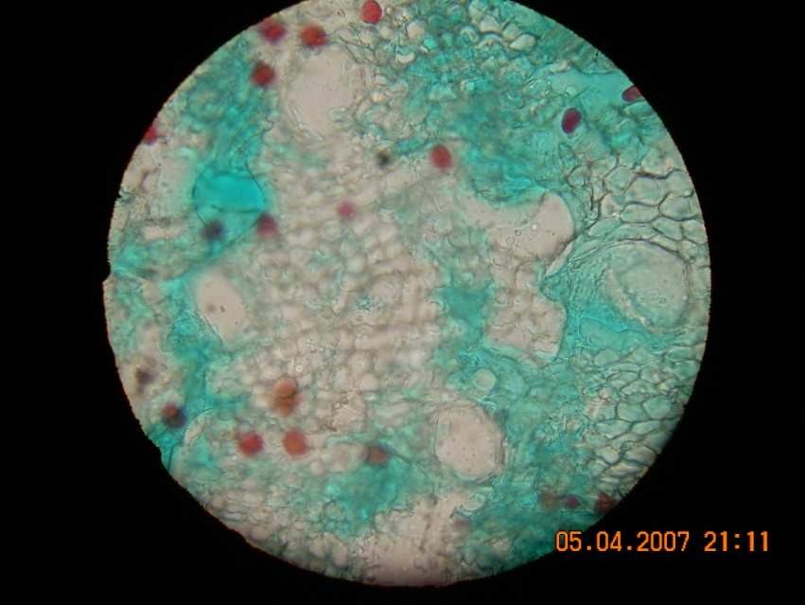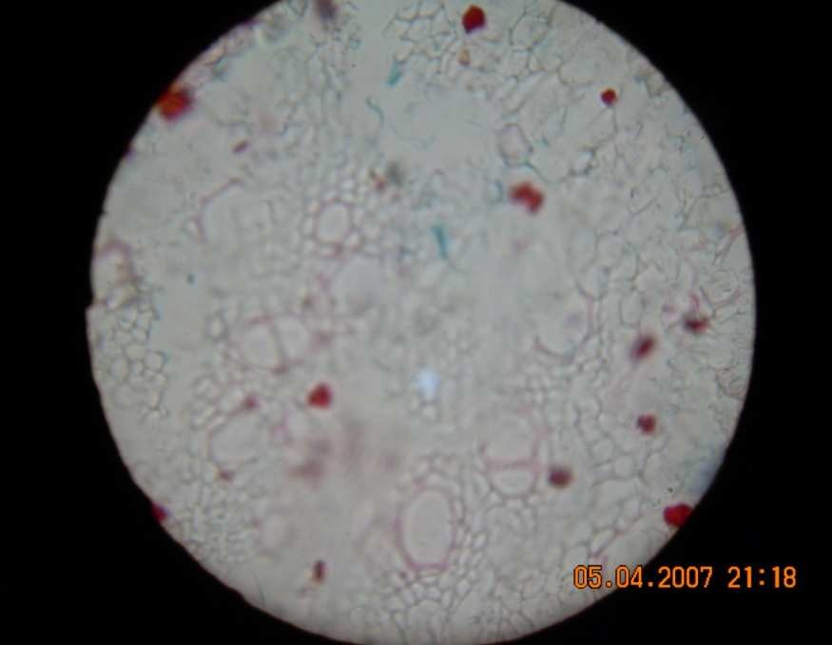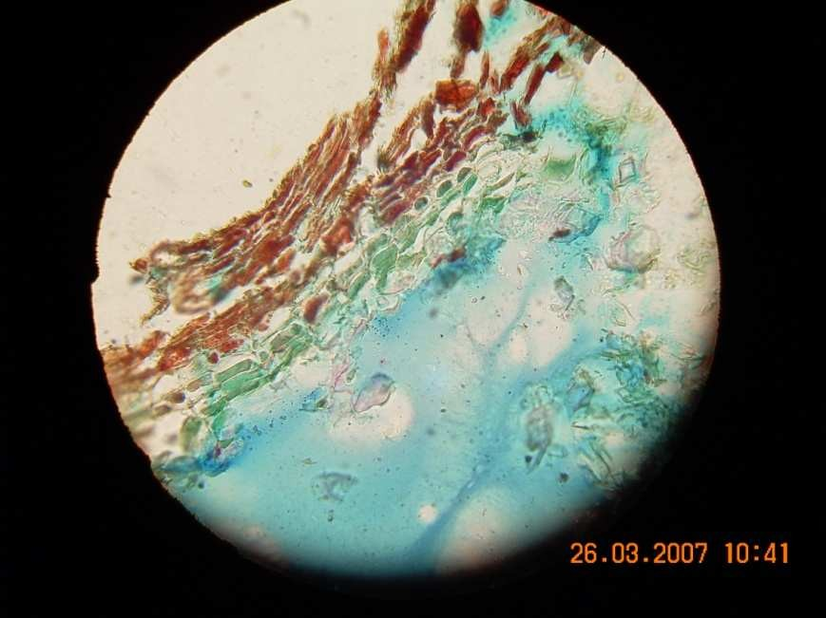

Parenchyma cells of the pith

Secretory ducts

Sieve tube

Phloem cell Cambium

Pith

Metaxylem Protoxylem Xylem vessels

Phellogen

Rhytoderm Phelloderm

Phellerm Cortex

Position of Phloem

**Plate 4: Transversection of *D. oliveri* root**

**APPENDIX 2**

# APPENDIX 2

#### QUANTITIATIVE EVALAUTION OF THE CRUDE DRUG

1. **Water-Soluble Extractive Value**

Weight of evapouration dish - 66g Weight of powdered drug - 5g

Weight of dish + 20ml Extract - 66.10g – 66g = 0.1g After evapourating - 66.10g Weight of residue from 20ml extract - 66.10g - 66g = 0.1g

If 20mls of water extract gave 0.1g of the dried residue. 100mls will give - xg

Xg - 100 x 0.1 = 0.5g 20

 Weight of residue form 100ml extract = 0.5g Percentage water extractive value

= Weight of residue in 100m/s x 100 = 0.5x 100 Weight of powder 1 5

= 10%

This was carried out three times with Standard Error of Mean (SEM) =

+ 1.0

#### Alcohol Extractive Value

Weight of evapourating dish - 47.0g Weight of powdered drug - 5g

Weight of dish + 20 ml Extract after Evaporating- 47.20g

Weight of residue from 20ml extracts - 47.20-47.0=0.2g

If 20ml of Alcoholic extract gave 0.2g of the dried residue 100ml will give xg

xg = 100 x 0.2 = 1g 20

Weight of residue from 100mls = 1g

Percentage Alcohol Extractive Value = Weight of residue in 100ml x 100

Weight of powder

= 1/5 x 100

= 20%

This was carried out three times with standard error of mean (SEM) =

|  |  |  |
| --- | --- | --- |
| + 2.4 |  | |
| **3.**  Weight | **Ash Value**  of crucible | – 23.13g |
| Weight | of powdered drug | - 4g |

Weight of crucible + Powdered drug before heating - 23.3 + 4

= 27.13g

Weight of crucible + ash after heating on a Bunsen burner (to get constant weight) Weight of crucible + ash - 24.00g

Heating for another 30 minutes - 23.99g Heating for another 30 minutes - 23.95g

Weight of crucible + ash - 24.00 + 23.99 + 23.95

3

= 22.98g

Weight of Ash = 23.98 – 23.13

= 0.85g

|  |  |  |  |
| --- | --- | --- | --- |
| Percentage Ash Value = | Weight of Ash | x | 100 |
|  | Weight of Drug |  | 1 |

= 0.85 x 100

4 1

= 21.25%

This was carried out three times with standard error of mean (SEM) of + 1.0

#### Acid Insoluble Ash Value

Weight of filter paper -1.13g Weight of filter paper + Residue -2g

Weight of residue = 2-1.13

= 0.87g

Percentage Acid insoluble ash value = 0.87 x 100

4 1

= 21.75g

This was carried out three times with standard error of mean (SEM) =+1.0.

#### Moisture content (Using Loss and Drying Method)

Weight of crucible after heating for: 30 min at 1050C - 39.8g 60min at 1050C - 39.7g

90min at 1050C - 39.5g

Average weight of crucible - 39.67g Weight of powdered drug - 4g

Weight of crucible + powdered drug after heating for: 1 hour - 43.43g

1 hour: 30min - 43.39g

2 hours - 43.39g

Constant weight of crucible powdered drug after heating - 43.39g Weight of crucible + powdered drug before heating - 43.67g

The total loss in weight:

= Weight of crucible + powdered drug before heating

= Weight of crucible + powdered drug after heating

= 43.67-43.39

= 0.28g

Percentage Moisture content = Total Loss in weight x 100

Weight of powder 1

= 0.28 x 100

4 1

= 7%

Carried out three times with standard error of mean =+ 1.0.

# APPENDIX 3

Solvent front

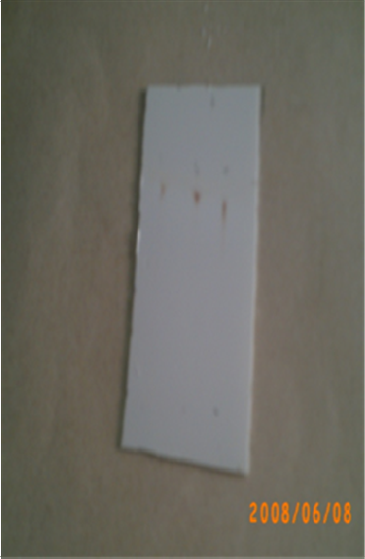

Spot b

Spot a

Spot a

Starting spot C

B A



olvent front pot d

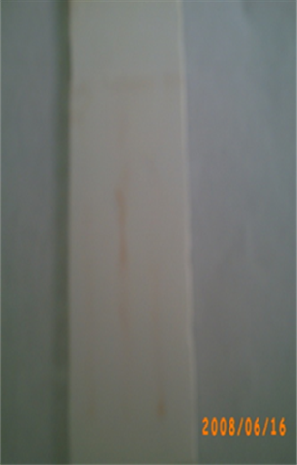

S S

S

S

S S

S

B

C

St

A

pot c

pot b

pot a pot a

pot a arting spot



## A: Methanol Extract B: n-butanol Fraction

**C: Ethyl acetate Fraction**

## Plate 5: Chromatograms of the methanol extract,aqueous and n- butanol fractions using n-butanol:acetic acid: water(2:1:2)

Solvent front Spot c

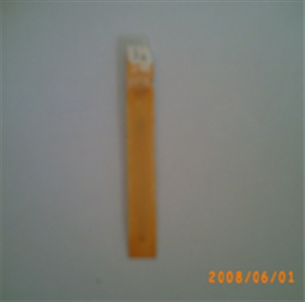

Spot b

Spot a Starting spot



Solvent front

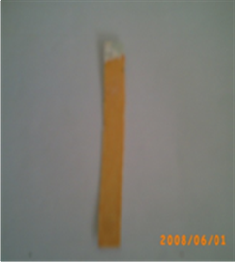

Spot a Starting spot





## Plate 5 Cont’d: Chromatograms of the methanol extract and the fractions using chloroform:methanol(7:3) and ferric chloride as the detecting reagent

Solvent front

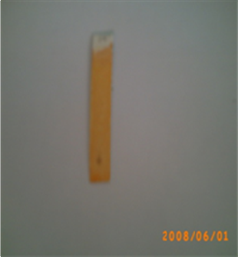

Spot a Starting spot



Solvent front

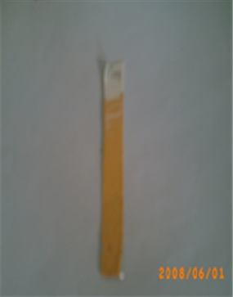

Spot b

Starting spot



## Plate 5 Cont’d: Chromatograms of the methanol extract and the fractions using chloroform:methanol(7:3) and ferric chloride as the detecting reagent

Solvent front Spot b

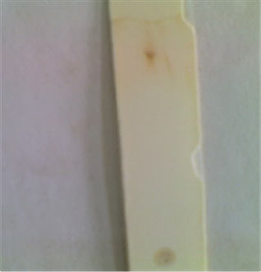

Spot a Starting spot



Solvent front

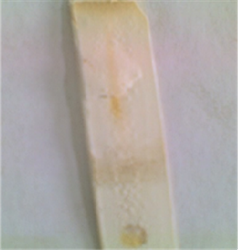

Spot b

Spot a Starting spot



## Plate 5 Cont’d: Chromatograms of the fractions using iodine as the detecting reagent

Solvent front Spot b

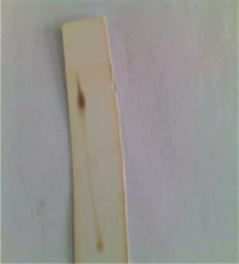

Spot a Starting spot



Solvent front Spot d

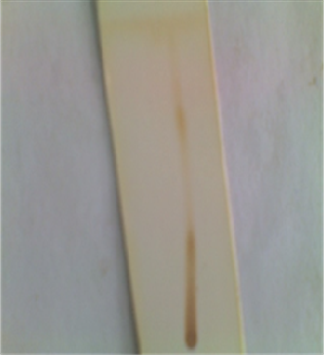

Spot c

Spot b

Spot a Starting spot



## Plate 5 Cont’d: Chromatograms of the fractions using iodine as the detecting reagent