**Nile University**

**Computer Studies & Information Technology Faculty Department of computer information system**

## Research Submitted in partial fulfilment for The degree of Bachelors (honors)

**In**

## Computer information system

**Development of mobile application for hotel reservation and Other services for foreigners in Sudan**

## submitted by:

Ahmad murtala Ahmad Abubakar Umar Faruk Abdulrazaq Zayyanu Maigishiri

## Supervised by:

### Uz. Sarah Hussein Adam Omer

February 2020

1

بسم ميحرلا نمحرلا هللا

حكيم

ا ْل م

ِلي

ا ْل ت

ك أَن

متَنَا إِنَّ

علَّ

الَّ ما

م لَ َنا

ْل ع

ك الَ

حانَ

ْب س

قَالُواْ

### They said, "Exalted are You; we have no knowledge except what You have taught us. Indeed, it is You who is the Knowing, the Wise"

سورة البقرة اآلية )23(

## Abstract

Information technology has expanded rapidly over the years as a result of fast growth of science and technology. Developing successful application to systems solutions is a major challenge for IT professionals and business managers. Application developers support organization’s business strategies, increasing customer satisfaction and business value to enterprise.

The application will provide a better way to help a foreigner, it will ease their mind in providing security, by efficiently and safely booking/reserving a hotel room before arrival to avoid roaming about the streets which could lead to theft.0 An application will be built for a foreigner, by designing the frontend and backend of the system which will provide necessary friendly features for the user to be able to use it.

The application will then be tested to check if it has fulfilled all that is required, and performing its functions effectively without any error or drawback. Some additional features will be suggested for future enhancement, since the world of information technology is always changing with regards to time.

The project consist of five chapters as follows:

1. Introduction
2. Literature review
3. System analysis and design
4. Implementation
5. Conclusion

**مستخلص البحث**

توسعععععو تكنولوليعععععا المعلومعععععات بسعععععرعة علعععععل معععععر السعععععني نتيلعععععة للنمعععععو السعععععريو للعلعععععوم

والتكنولوليععععا. و حتععععل نععععتمك معععع تطععععوير تطبيععععح نععععالم لحلععععوt الععععن م يعتبععععر تحعععع ى كبيععععر

لمتخصصعععععو تكنولوليعععععا المعلومعععععات ومععععع ير ا عمعععععا.t حيععععع يععععع عم مطعععععورو التطبيقعععععات

اسععععتراتيليات ا عمععععاt الخاصععععة بالم،سسععععةي ممععععا يليعععع معععع راععععا العمعععع وقيمععععة ا عمععععاt

للم،سسععات.ومعع خعع t œعع:ا التطبيععح سععو نععوفر طريقععة أفاععt لمسععاع ة االلانععن معع خعع t

لتلنععن التلععواt فععل

حيعع يععوفر الفنععا ا المتاحععة

بكفععا ة وأمععا

تععوفير ا معع ي حلععل الغععر

android

التطبيععععح بواسععععط

الشععععوار ممععععا يعععع، ى إلععععل السععععرقة واالحتيععععاt . تععععم تصععععميم

studio مععع خععع t تصعععميم وال عععة للمسعععتخ م بسعععيطة و ب عععا ك يعععر مععع الميعععلات حتعععل يكعععو

المسععتخ م قععا رة علععل اسععتخ ام ا بكععt سعع ول ويسععر. كمععا تععم تصععميم قاععع ة بيانععات باسععتخ ام

للتحقعععح ممعععا إ:ا كعععا قععع نفععع: كعععt معععا œعععو مطلعععون ي

اياعععا التطبيعععح قعععا ر علعععل

.xammp

وأ ا و ائف بفعالية و أ خطأ أو عين. م خ t التقارير.

مسععععععتقبليا ي عععععععالم

لتعليلالتطبيععععععح

تععععععم ااععععععافة بعععععععو المقترحععععععات فععععععل التوصععععععيات

تكنولوليا المعلومات فل تغير ائم .

حي بتكو المشرو م خمسة فصوt علل النحو التالو:

.1 المق مة

.3 ال راسات السابقة ومن لية البح

.2 تحليt وتصميم الن م

.4 التنفي:

.5 الخاتمة والتوصيات

## DEDICATION

This research paper is dedicated to our loving parents and respective parents who have been our source of motivation and inspiration. They have given us the drive and discipline us to tackle any task with enthusiasm and determination. Without their love and support this project would not have been a success.

## AKNOWLEDGEMENT

We thank Almighty Allah for giving us the ability and health to do this project and finish it successfully. We will also like to thank our project supervisor ustaza Sarah Hussein for her continuous support and guidance from the beginning until the end of our project, she has always been there to listen and give advice on the project. We will also like to show appreciation and gratitude to ustaza Omnia who did a lot and made sure that we have come out with satisfied and excellent result.

Special thanks goes to our parents, brothers, sisters and friends for their prayers and support, encouragement and assistance during the completion of this project.

**TABLE OF CONTENTS**

|  |  |  |
| --- | --- | --- |
| **Topic Number** | **Topic Name** | **Page Number** |
|  | Verse from Qur’an | Ⅰ |
| Abstract | Ⅱ |
| Abstract(in Arabic) | Ⅲ |
| Dedication | Ⅳ |
| Acknowledgement | Ⅴ |
| List of figures | Ⅸ |
| List of table | Ⅹ |
| **Introduction** |  |
| 1.1 | Overview | 1 |
| 1.2 | Research Background | 1 |
| 1.3 | Problem Statement | 2 |
| 1.4 | Research Objectives | 3 |
| 1.5 | Research Question | 3 |
| 1.6 | Methodology | 3 |
| 1.7 | Research significance | 4 |
| 1.8 | Research Organization | 4 |
|  | **Literature Review And Methodology** |  |
| 2.1 | Background | 5 |
| 2.2 | Services and Reservation | 6 |
| 2.2.1 | Types of Services Provided to a foreigner | 7 |
| 2.2.2 | Types of Reservation | 7 |
| 2.3 | Review Of Similar Applications | 7 |
| 2.3.1 | Trivago Application | 7 |
| 2.3.1.1 | Features of Trivago Applicatiom | 7 |
| 2.3.1.2 | Advantages Of Trivago Application | 8 |
| 2.3.1.3 | Disadvantages of Trivago Application | 8 |
| 2.3.2 | Holidayguru | 8 |
| 2.3.2.1 | Features Of Holidayguru | 8 |
| 2.3.3 | Hotwire | 9 |
| 2.3.3.1 | Features Of Hotwire | 9 |
| 2.3.4 | Agoda | 9 |

|  |  |  |
| --- | --- | --- |
| 2.3.4.1 | Features of Agoda | 9 |
| 2.3.5 | HotelTonight | 10 |
| 2.3.5.1 | Features Of HotelTonight | 10 |
| 2.3.6 | Similarities | 10 |
| 2.3.7 | Differences | 10 |
| 2.4 | Technical Review | 12 |
| 2.4.1 | Android And Android studio | 12 |
| 2.4.2 | Why Android Studio | 12 |
| 2.4.3 | Xampp | 12 |
| 2.4.3.1 | Features Of Xampp | 12 |
| 2.4.3.2 | Advantages Of Xampp | 13 |
| 2.4.3.3 | Disadvantages Of Xampp | 13 |
| 2.5.4 | Google Map | 13 |
| 2.5.4.1 | Features Of Google Map | 14 |
| 2.5.4.2 | Advantages Of Google Map | 14 |
| 2.5.4.3 | Disadvantages Of Google Map | 14 |
| 2.6.5 | Relationship Between Google Map And Android | 14 |
| 2.6.6 | Research method | 15 |
| 2.7 | Data collection method | 15 |
|  | **Analysis And Design** |  |
| 3.1 | Overview | 16 |
| 3.1.1 | Uml | 16 |
| 3.1.2 | Features of Uml | 16 |
| 3.1.3 | Advantages | 17 |
| 3.1.4 | Disadvantages | 17 |
| 3.2 | Requirement management | 17 |
| 3.3 | Functional requirement | 17 |
| 3.4 | Non-functional requirement | 18 |
| 3.5 | Feasibility study | 18 |
| 3.5.1 | Economic feasibility | 18 |
| 3.5.2 | Technical feasibility | 19 |
| 3.5.3 | Operational feasibility | 20 |
| 3.6 | Design phase | 20 |
| 3.6.1 | Use case diagram | 21 |
| 3.6.2 | Sequence diagram | 22 |
| 3.6.3 | Class diagram | 23 |
| 3.7 | design | 24 |

|  |  |  |
| --- | --- | --- |
|  | **Implementation** |  |
| 4.2 | Screens | 35 |
|  | **Conclusion and Recommendation** |  |
| 5.1 | Conclusion | 40 |
| 5.2 | Recommendation | 40 |
| 5.3 | references | 41 |
| 5.4 | appendix | 42 |

**LIST OF FIGURES**

|  |  |  |
| --- | --- | --- |
| **Number** | **Name** | **Page** |
| Fig 3.1 | Use case diagram | 21 |
| Fig .32 | Sequence diagram (user) | 22 |
| Fig 3.3 | Sequence diagram ( hotel) | 22 |
| Fig 3.4 | Class diagram | 23 |
| Fig 3.7.1 | Start | 24 |
| Fig 3.7.2 | Login | 25 |
| Fig 3.7.3 | Register | 26 |
| Fig 3.7.4 | Home | 27 |
| Fig 3.7.5 | Explore | 27 |
| Fig 3.7.6 | Rooms | 29 |
| Fig 3.7.7 | Facilities | 30 |
| Fig 3.7.8 | Book Room | 31 |
| Fig 3.7.9 | Review | 32 |
| Fig 3.7.10 | Other Services | 33 |
| Fig 3.7.11 | Map | 34 |
| Fig 4.1 | login screen | 35 |
| Fig 4.2 | Register screen | 36 |
| Fig 4.3 | book a room screen | 37 |
| Fig 4.4 | Review screen | 38 |
| Fig 4.5 | Map screen | 40 |

**LIST OF TABLES**

|  |  |  |
| --- | --- | --- |
| **Table** | **Name** | **Page** |
| Table 1 | Similarities and differences between related work | 11 |
| Table 2 | Economic feasibility | 19 |
| Table 3 | Technical feasibility | 19 |
| Table 4 | Technical feasibility software requirement | 20 |

11

# Chapter One Introduction

## Overview

This project is being developed to provide effective and efficient ways by which foreigner searches for nearest hotels, supermarkets, shops, restaurants, hospitals and schools. Compared to the current process, this application will try to eliminate the physical method of searching, booking/reserving hotels and ensure safety.

The development is going to be in great assistance to the user by providing the ability to book hotel, reserves a room/suit, and be transported comfortably and safely to the hotel as he arrives in a country without any problem.

It also offers the user the ability to search for shops, supermarkets, banks, schools, restaurants and many more.

Safety has been an important part of human lives, so there is a need to create easier way for a tourist to review a city, evaluate its hotels, banks, hospitals in order to achieve absolute security.

## Research Background

When we look at the rate by which people travel all over the world and always facing challenges with communication and money over the years result in the need to build an application that the user can efficiently book hotel, order food from a restaurant of his choice, view the nearest pharmacy and hospitals and others.

The level of street crime in Khartoum and other major Sudanese cities is low but increasing. Incidents of mobile phone and bag situation (including drive-by bag

snatching by thieves on motorbike), aggressive begging, petty theft and burglaries do occur.

Khartoum’s hotels are graded in accordance with star classification system. They range from small town hotels to the five star town and beach hotels. Restaurants, banks, supermarkets and also small shops are also vastly located in different areas.

## Problem statement

Security and quality control are vital issues to be discussed, as a foreigner wants to feel secure and be extremely comfortable when he enters a new city. Studies have shown that security and service quality has been receiving much attention because of its relationship to cost. It is therefore imperative to understand the context of both in the tourism industry and what its indicators are within individual organization.

A foreigner always faces difficulty in trying to get to know more about the city he’s in, the restaurants, hotels and hospitals close to him in case of any emergency, and the nearest shops. In a nutshell ease of accessibility.

The challenge associated with implementing security and tourism are significant as key to service quality is to meet or exceed tourist’s expectations. One problem with measuring satisfaction is that there may often be discrepancies between viewpoint and the understanding of what constitutes quality service.

Previous studies have not focused on quality control and methods to improve security performance in the tourism industry, as tourist don’t get full experience of the city they visited.

## Research objectives

At the end of this project we want to design an application that enables its user to reserve/book a hotel room, while the specific objectives are:

* + 1. To design a user friendly and language independent application.
    2. To design an application that helps foreigners view city’s nearest hotels, restaurants, supermarket, hospitals and shops, and schools.
    3. To design an application that saves money, stress and time.
    4. To design an application that ensures security to foreigners.
    5. To produce a report clearly showing the number of visitors that used the application

## Research Question

At the end of this project we want to create an application the enables its user to reserve a room efficiently and have himself delivered to the hotel and also be able to view the nearest restaurants, banks, hospitals, supermarkets, and schools.

## Methodology

This type of project deals with application. Therefore we are going to use the android studio, xampp software. This enables us to do the design, implementation and the database storage.

This software is chosen as it is the best to work with in the design of an application.

Google map is also going to be used.

## Research significance

This project contributes towards design of application that helps user to reserve a hotel room, and view the city’s banks, supermarket and hospitals. Therefore after its completion we want to achieve the following:

* + 1. Its user to be able to make reservations
    2. Its user to find the nearest hotels available, restaurants, hospitals, banks and many more.

The result of this study puts forth a simple application of security solution, ease of accessibility and also quality control that makes a user’s life very easy.

Technology is a growing field of study that is wide and other application developers in higher institution will use the findings of this project to study or gather more information or knowledge about hotel reservation and quality control implementation in service firms and also the contributions it has to employee performance and the economy at large.

## Research Organization

The project is divided into five chapters as follows:

* + 1. Chapter one: introduction.
    2. Chapter two: literature review.
    3. Chapter three: system analysis and design.
    4. Chapter four: implementation.
    5. Chapter five: conclusion and recommendation.

5

**Chapter two**

**Literature Review and Methodology**

## Background

Basically, the internet acts as one of the reservation avenue for foreigners. Foreigners can access all sorts of city’s-related information through the internet.

Recently, hoteliers have started turning to mobile hotel reservation in order to stay competitive and increase hotel’s revenue with the rapid growth of wireless internet, global navigation satellite system (GNSS) and global positioning system (GPS) as well as great demand of mobile phones/devices (wang et al, 2010).

Mobile hotel reservation can be defined as a location based online distribution information system that enables customers worldwide to reserve hotel rooms anytime, anywhere through the use of wireless internet, global navigation satellite system (GNSS), geographic information system (GIS), global positioning system (GPS) and mobile phones/devices such as iphone, blackberry and etc. (wang et al,2010).

A report from travel distribution report, 2007 stated that the differences between mobile hotel reservation and online hotel reservation are the specific applications in relation to mobility and accessibility as well as competence of anticipating customer’s demands. With this new technology, customers of 27 hotels that adopted MHR can install the hotel reservation application through their mobile phones/devices.

According to experts, hotel may be defined as an establishment whose primary business is providing lodging facilities for the general public and which furnishes services (Steadmon 2003).

Hotels both local and international are considered as the backbone of the tourism industry providing accommodation and other services to guest. (The routledge handbook of hotel chain management, 9, 2016).

Reservation is defined as an arrangement to have something (such as hotel room) held for one’s use (Miriam webster).

The term ‘reservation’ used in the context of a hotel, means the booking or reserving of a room (accommodation) by a guest. Reservations lead to reserving of a particular room for a particular guest for a given period of time. (National Institute of Open Schooling, January, 2013).

From the name hotel reservation we can see that it’s a combination of two nouns. Then hotel reservation application explains the ease by which a foreigner searches and reserves a hotel room, and also gives the user the ability to perform some more tasks such as searching for the nearest bank, restaurants, hospitals, supermarkets and shops. As one of the main goal of every foreign is to have an accommodation as he reaches his destination, and to view the city in general.

Therefore the author should analyze current system and try to bring out something better by the use of modern day technologies such as google maps.

## Services and Reservation

Service can be defined as the level of assistance provided by staff members to facilitate the purchase by the client. It also encompasses a raft of effort hotels makes to achieve pleasant customer experience for guest.

Reservation means booking or reserving a room (accommodation) by a guest.

## Types of services provided to a foreigner

* + - 1. Money exchange services
      2. Transportation services
      3. hospital and pharmacy services
      4. banks and supermarket services

## Types of reservation

* + - 1. Whitney system of reservation
      2. Central reservation system.

## Review of similar applications

In order to achieve our goal, we need to review similar applications. Therefore we need to acquire information on how it works and be able to develop an application that will conform standards and meet up user requirement.

## Trivago Application

Trivago is an online platform that simplifies the work of finding the best hotel to stay during a trip. The application enables the user to easily find hotels just by entering the destination which ends up showing endless options. User finds tons of options available at affordable prices, and even compaes the prices of different hotels.

## Features

* + - * + User gets hotels instantly by just entering destination
        + Searches best deals according to users stay
        + Find different hotels with amazing deals at one place
        + Uses filters such as prices, ratings and other search
        + Available for all devices

## Advantages

* + - * + Easy search method
        + Saves money and time
        + Provides security/ low risk
        + Application is accessible anytime

## Disadvantages

* + - * + Searches for just hotels
        + Doesn’t offer direct contact with the user
        + Third party booking

## Holidayguru

Holidayguru is one of the hottest applications nowadays for booking a hotel deal. The applications manages the users traveling and reservations. It also provides a large variety of different types of hotels and holiday plans.

## Features

* + - * + Notifies user when a new travel deal is introduced
        + Searches different variety of hotels
        + User can share deals with social media platforms
        + Available for all devices

## Hotwire

Hotwire is among the trustworthy traveling booking applications as information and deals provided by the application is hundred percent original. Along with last minute benefit, the application offers a variety of different traveling and booking sales. It provides amazing saving formulas as it claims to be cheap than the others.

## Features

* + - * + User books hotels straightforward
        + Offers discounts on famous hotels
        + Last minute booking
        + Available for all devices

## Agoda

Agoda is tourism application specially created for hotel booking deals. Finding hotel deals and accommodation is very fast through agoda. With one touch you can pplan and book your tie anywhere and anyime. Charging rates of accommodations are also present so that user can compare prices.

## Features

* + - * + user books hotels with a single touch on the app
        + detailed information if many hotels
        + prices of hotels can also be compared
        + available for all devices

## HotelTonight

Hoteltonight is a fine application that provides fine deals for the stay of tomorrow and beyond. It gives user discounts on empty rooms so that user can easily catch the most reasonable ones. Provides best deals and rates to its users whether in advance or last minute. It makes discovery and reservations of great hotels extremely easy.

## Features

* + - * + user easily books cheap rooms
        + user books room in advance
        + offers discounts on rooms
        + available for all devices

## Similarities

* Both are mobile applications
* Both applications search for hotels
* Both applications are accessible anywhere

## Differences

* Current application searches for both nearest hotels, hospitals, pharmacies, banks, supermarket and shops.
* Current application does not provide third party booking.

|  |  |  |
| --- | --- | --- |
| **Related work** | **Similarities** | **Differences** |
| Trivago | Mobile application Books hotels | Available for all device  Does not have other service such as views of city’s hospitals etc |
| holidayguru | mobile application books hotels | user checks to make the best deals |
| Agoda | Mobile application Books hotels | User deals with social media platform.  Available for all device |
| HotelTonight | Mobile application Books hotels | Last minute booking |

## Table 1: similarities and differences between related applications

* 1. **Technical Review**

At the end of this project, the author wants to create a mobile application using android studio (to create the application), and Google map (for user to view city).

## Android and Android Studio

Android is a mobile operating system developed by Google based kernel and designed primarily for touch screen mobile devices such as smart phones and tablets.

Android studio is the official IDE for android development, and with a single download includes everything you need to begin developing android applications.

## Why Android Studio

* + - * Flexible gradle based system
      * Build variants and multiple apk file generation
      * Code templates help build common application features
      * Rich layout editor with support from drag and drop theme editing
      * Official Google support and usual updates that need no migration

## Xampp

Xampp is a free open source cross-platform web server solution stack package developed by apache friends, consisting mainly of the apache http server, mariaDB database, and interpreter for scripts written in php and other perl programming languages. It makes transitioning from local test server to a live server possible.

## Features

* + - * + It has modules such as opensSSL, phpMyAdmin and mediaWiKi
        + Self-contained
        + Exist on a single computer

## Advantages

* + - * + Easy to install
        + Available for both windows and linux
        + Can be started and stooped with one command

## Disadvantages

* + - * + Configuration setting is tough

## Google Map

Google map is a web mapping service developed by google. It offers satellite imagery, aerial photography, street maps, full panoramic views of street, real time traffic conditions and route planning by foot, bicycle, car or air.

Google maps are used by over 1billion people every month (ppc land February 15th 2020).

## Features

* + - * + Get transportation direction
        + Find your location
        + Measures distance and ETA
        + Setting routes
        + Verbal instruction
        + Location sharing

## Advantages

* + - * + Easy to use
        + It can show the earth’s entire surface
        + It shows great details about a locality

## Disadvantages

* + - * + Limit accuracy
        + Use by criminals

## Relationship between Google Map and Android

In android, locations, directions or a map can be shared. User can share:

* + - * A place of business or address
      * A direction search
      * A street view image But user cannot share:
      * A map with user’s saved location, which are private
      * A map with a distance measurement
      * A screenshot or image of the map itself.

## Research Method

It is a way to transform the “art” of the system analysis and design into an “engineering- type” discipline. It explains the relationship amongst various

module and programs within the system. It also standardizes the approach to analysis and design.

The application was developed using android studio. With java as the programming language, and xampp as the backend database. This methodology aims at utilizing the common pages in the android studio and to provide a user friendly interface.

**Java**is a high-level programming language developed by Sun Microsystems. Java programs are interpreted by the java virtual machines which runs on multiple platforms.

**Xampp** is a free open source cross-platform web server solution stack package developed by apache friends, consisting mainly of the apache http server, mariaDB database, and interpreter for scripts written in php and other perl programming languages. It makes transitioning from local test server to a live server possible.

## Data Collection methods

The data is collected to from sources as follows:

* + 1. Interviewing many people
    2. Searching the world wide web
    3. References from lecture notes

16

# Chapter Three Analysis and Design

## Overview

Generally, UML is a broad term for describing methodologies for developing high quality information system, and this combines information technology, people and data to support requirement.

When developing a system, there is a need to research for information about the system and then analyze it to see if the information is accurate and good for the development.

System analysis is a process of collecting facts, identifying problems and decomposition of system into components, in order to fully understand the requirements of the system. In this project we use UML as the tool for analysis.

## UML

The Unified Modeling Language (UML) is a general-purpose, developmental modeling language in the field of software engineering that is intended to provide a standard way to visualize the design of a system.

## UML Features

* + - * Use Case diagram
      * Class diagram
      * Activity diagram
      * Sequence diagram
      * Communication diagram
      * Component diagram
      * Deployment diagram
      * Composite diagram
      * State machine diagram

## Advantages

* + - * Breaks complex systems into discrete pieces that can be understood easily
      * Easier to handover to new teams
      * Developers understand complex systems
      * Uml model is not a system or platform specific

## Disadvantages

* + - * Wastes time
      * Not always clear who benefits from the diagrams
      * Diagrams are sometimes complicated
      * Too much emphasis on the design.

## Requirement Management

This involves explicit documentation of the user’s requirement and keeping tracks of changes with respect to the requirement. It also analyses the system and the impact those changes will make on the system before taking them into consideration.

## Functional Requirement

* The application allows the user to create account and log in
* The application should allow user to book a room and receive booking confirmation and status via email
* It should allow user to view facilities of the hotel
* It enables user to view banks schools supermarkets and hospitals, and his/her current location via google map.

## Non Functional Requirements

* Compatibility : the application should be able to run on different types of devices such smartphones and laptops
* Speed : system should provide high speed to retrieve data
* Scalability : the application should be able to serve more users if new people are added
* Quality : the quality of pictures and layouts should be high
* Easy : easy to use the application
* Interface : friendly interfaces

## Feasibility Study

The feasibility study proposes conceptual solution to the project, it is used to gather broad data for management that help in making decision on whether to proceed with the project or not. This is done by performing the technical, economical and operational feasibility.

## Economic Feasibility

The development cost is calculated and the benefits of the application to the user and the contribution to the organization.

## Table 2 : Economic feasibility

|  |  |  |  |
| --- | --- | --- | --- |
| Item | specification | Qty | Unit cost |
| Pc | 2.7GHz Intel core i5 | 1 | 365,000 |
| Mobile phone | smartphone | 1 | 109,500 |
| Router | D-link 4G | 1 | 5,000 |

* + 1. **Technical Feasibility**

This analysis tries to find out whether the current technical resources can be upgraded or added in a manner that fulfils the request under consideration.

The technical issue usually raised during this stage include:

* + - * Does the technology exist to do what is suggested?
      * Do the proposed equipments have the technical capacity to hold the data required to use the application?
      * Will the proposed system provide adequate response to inquiries?
      * Can the application be upgraded if developed?

## 3.5.2.1 System Requirements

**Table 3 : Technical Feasibility hardware requirement**

|  |  |  |
| --- | --- | --- |
| Item | Specification | Qty |
| Pc | At least core i3 | 1 |
| Mobile | Smartphone | 1 |

## Table 4: technical feasibility software requirement

|  |  |
| --- | --- |
| Item | Specification |
| Android studio | 4.1 |
| Xampp | 8.0.1 |
| Visual studio code | 1.53.2 |
| Maps play services | 17.0.0 |
| Location play services | 17.0.0 |

* + 1. **Operational Feasibility**

This checks the level of acceptance of the system by the user. It involves the process of training the user to use the system efficiently. The user must not be threatened by the system, instead must accept it as a necessity.

## Design Phase

The design phase seeks to develop detailed specifications that emphasize the physical solution to the users information technology needs. The system requirements and logical descriptions of the entities, relationships, and attributes of the data that were documented during the requirement analysis phase are further refined and allocated into system and database design specifications that are organized in a way suitable for implementation within the constraints of a physical environment like computer, facilities and database.

The general idea about analysis is to break down a concept into parts in order to inspect and understand it, and also to restructure those parts in a way that makes sense.

## Use Case Diagram

The use case diagram below shows the interaction between the user and the function of the system.

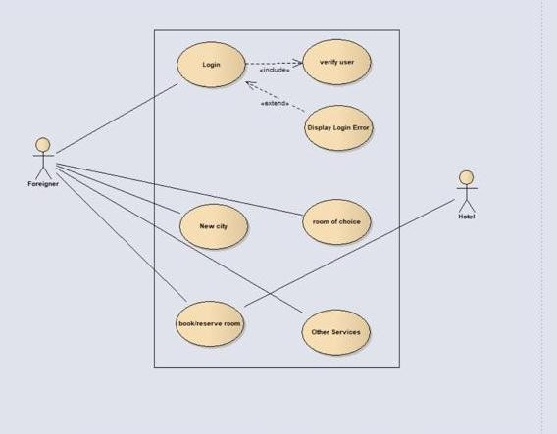

Figure 3.1 use case diagram

## Sequence Diagram

The sequence diagram shows the flow of the functionality of the system, showing how each a function is being carried out by the system.

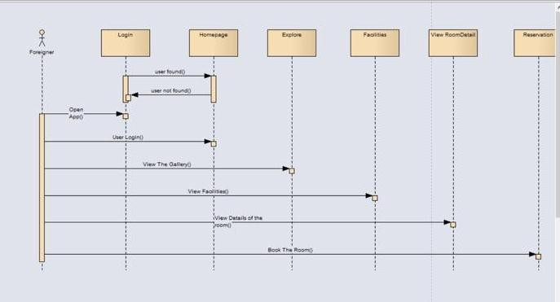

Figure 3.2 sequence diagram user

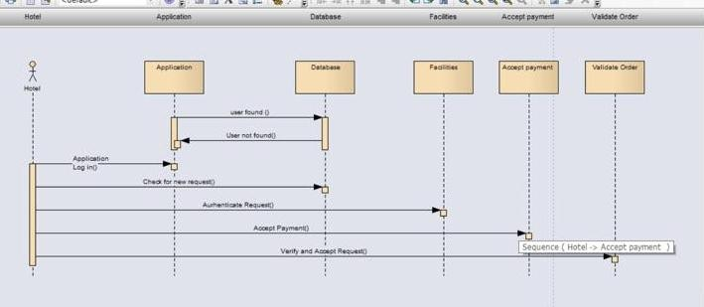

Figure 3.3 sequence diagram hotel

Hotel views the application’s data base, then views request of the foreigner, validates order and accepts cash payment.

## Class Diagram

This shows how the classes in the system interact with one another, using relationships such as inheritance, association and generalization. Each class has an attribute, which characterized that particular class, and also an operation which is the functions by which that class is performing.

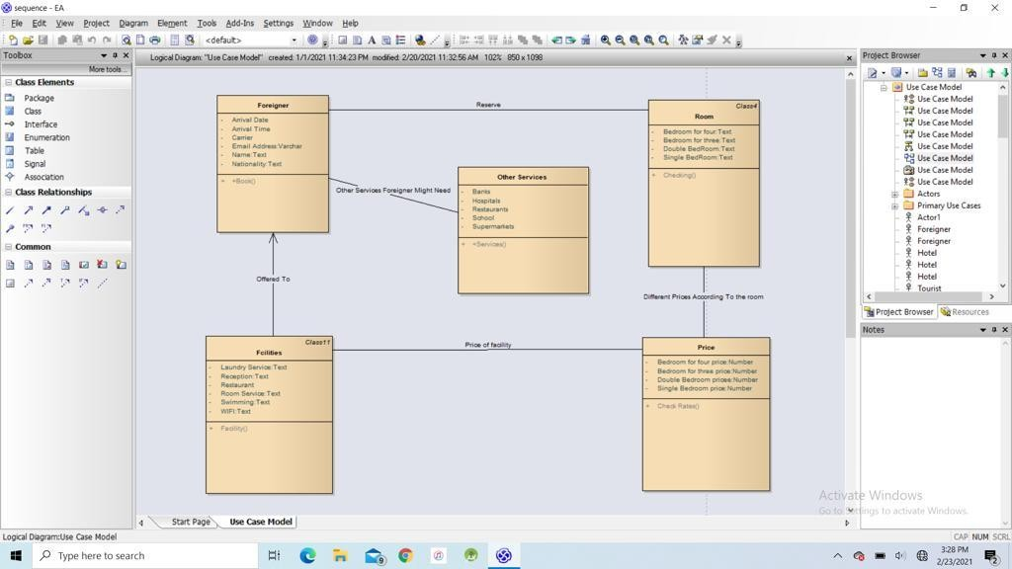

Figure 3.4 class diagram

## Design



Figure 3.7.1 : start screen

**Description :** Appears when the application is opened, shows the name of the application.

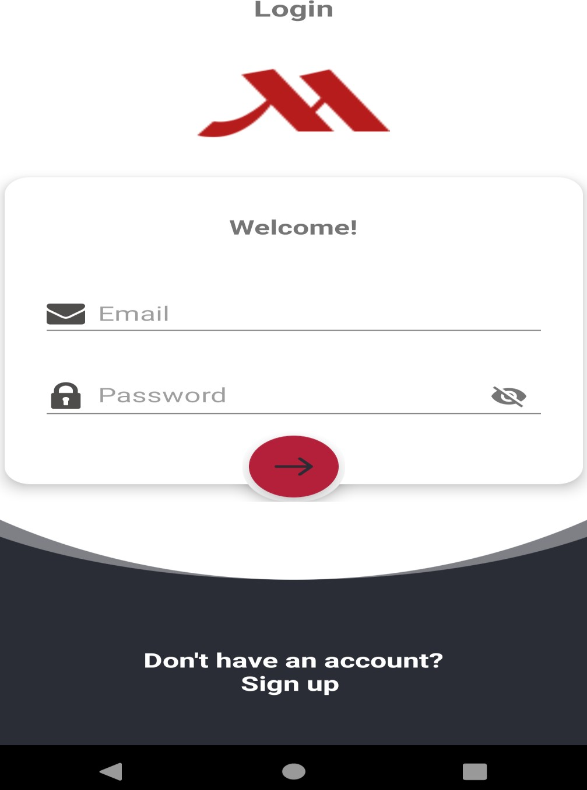

Figure 3.7.2: login

**Description** : login form with username and password is used to authenticate and gives user the ability to enter the application.

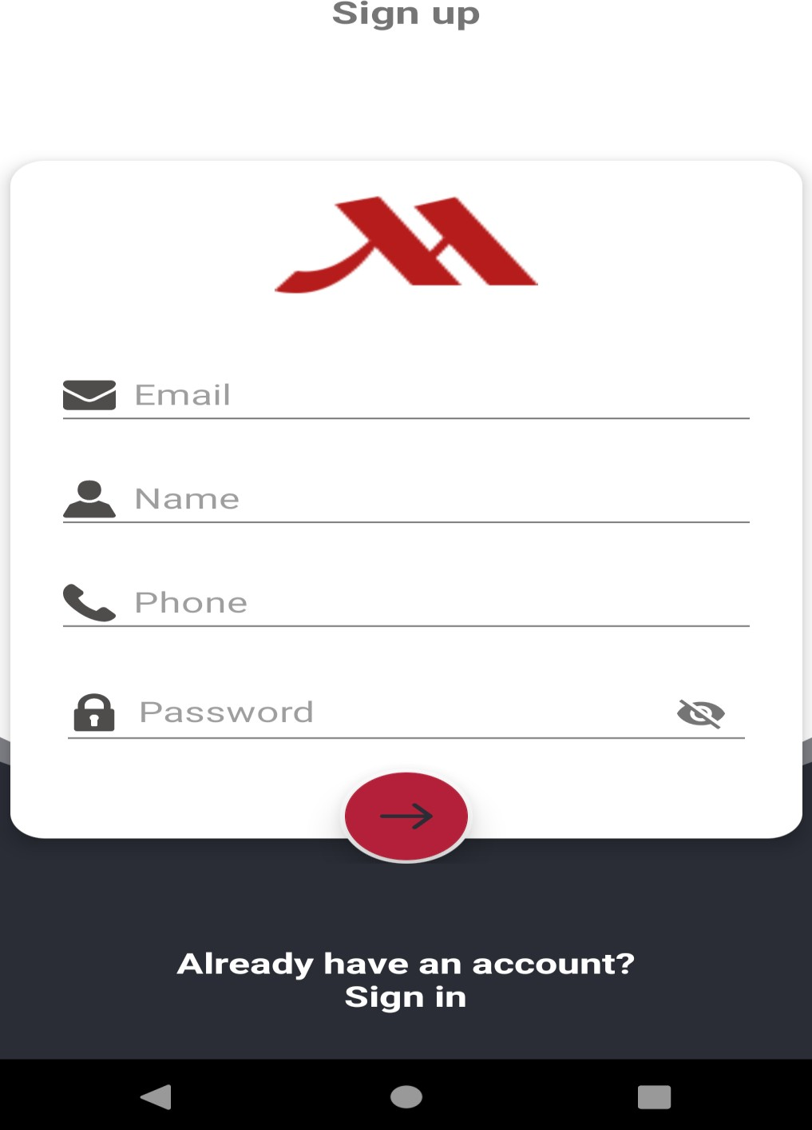

Figure 3.7.3 : register

**Description :** field for new user to fill that gives a user the ability to sign up for the first time.

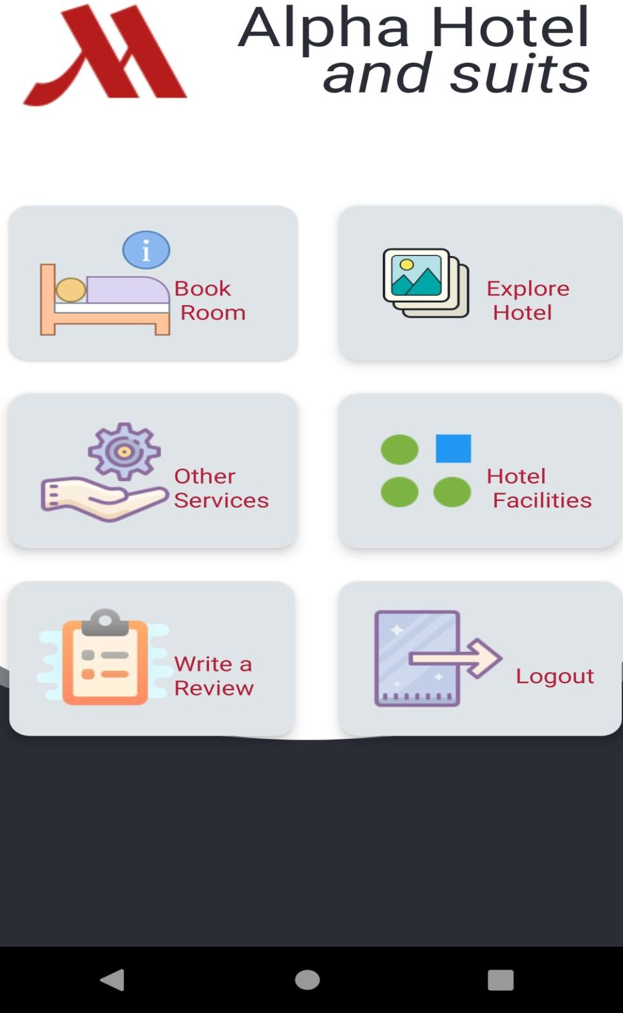

Figure 3.7.4 : home screen

**Description** : user selects what he wants to do

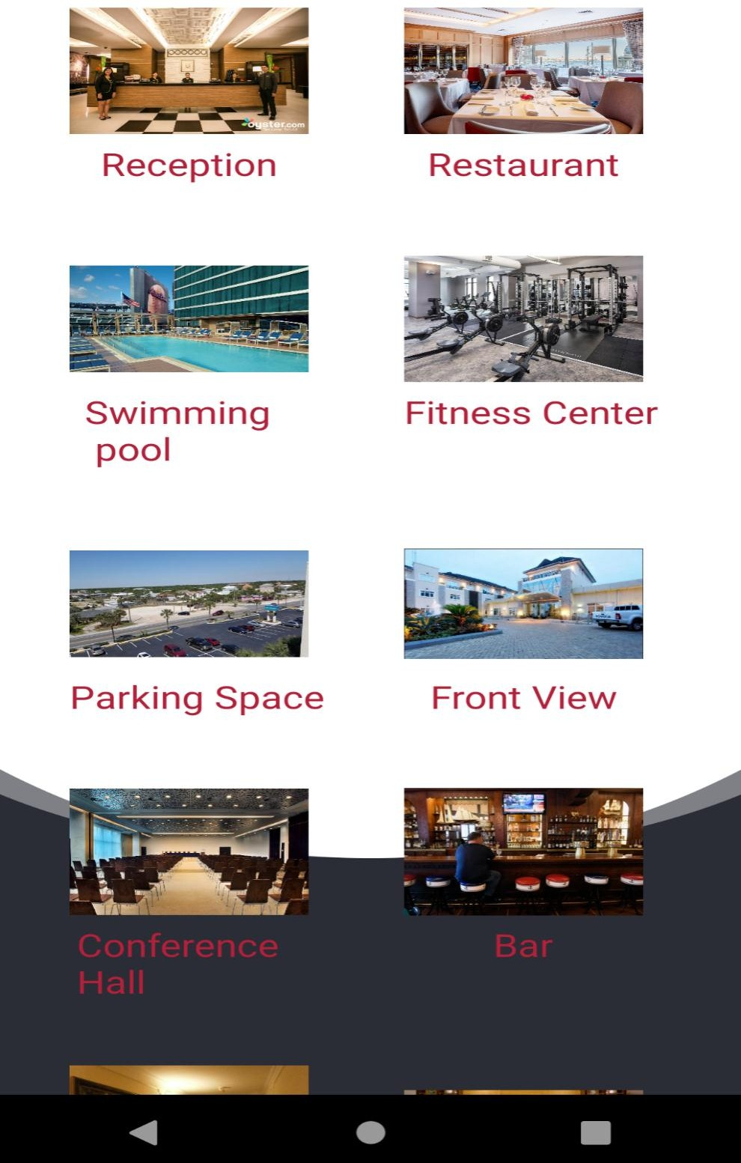

Figure 3.7.5 : explore

**Description :** picture representation of the hotel. i.e its rooms, parking space, bars

, gyms etc.

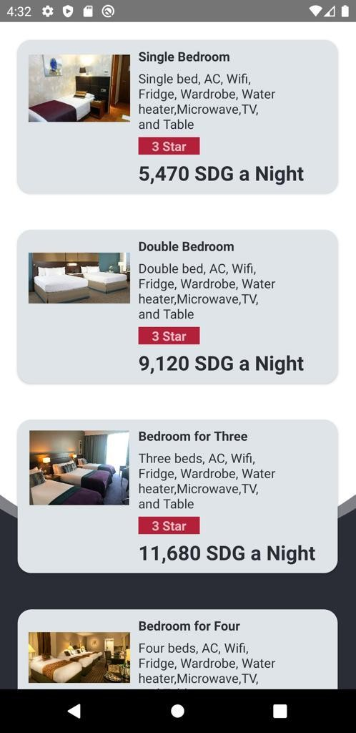

Figure 3.7.6: rooms

**Description** : classes and descriptions of each room in the hotel with prices, gives user the chance to see bedroom which he can afford.

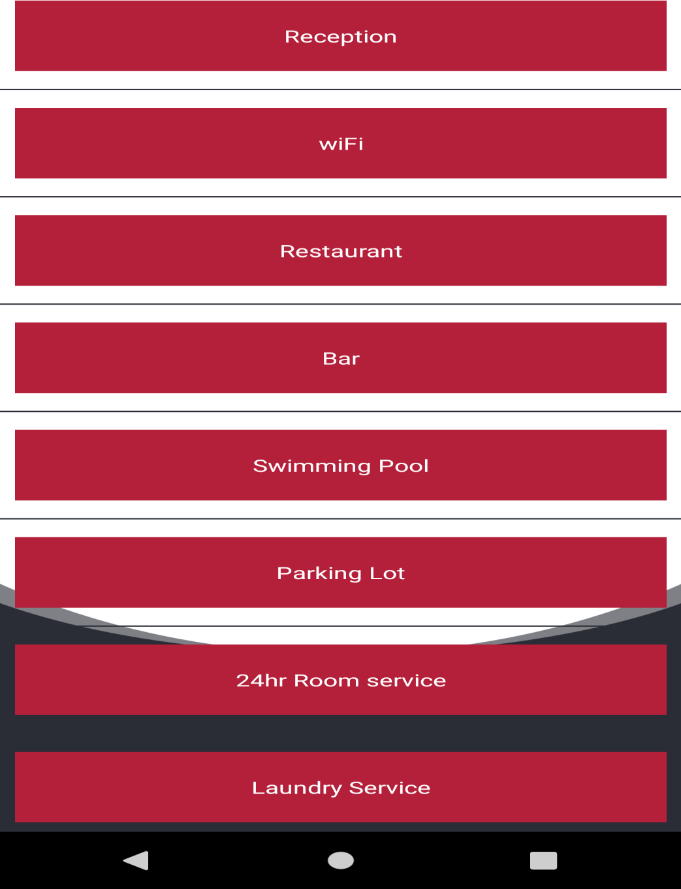

Figure 3.7.7: facilities

**Description :** shows list of facilities in the hotel for the user to view.

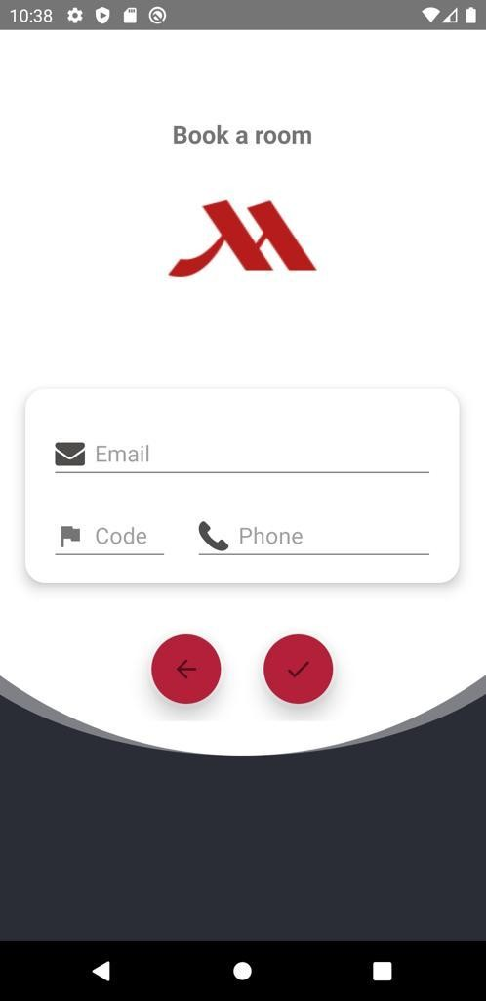

Figure 3.7.8 : book room

**Description :** form a user fills his details to be able to book/reserve a room. After submission, user will be contacted through his phone number and booking confirmation and status will be sent to the email.

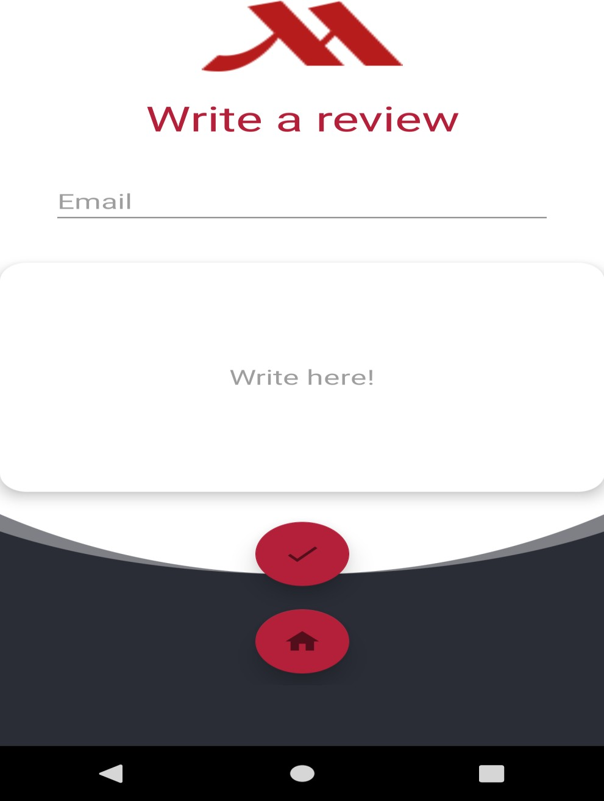

Figure 3.7.9 : Review

**Description :** gives review about the hotel or the application.

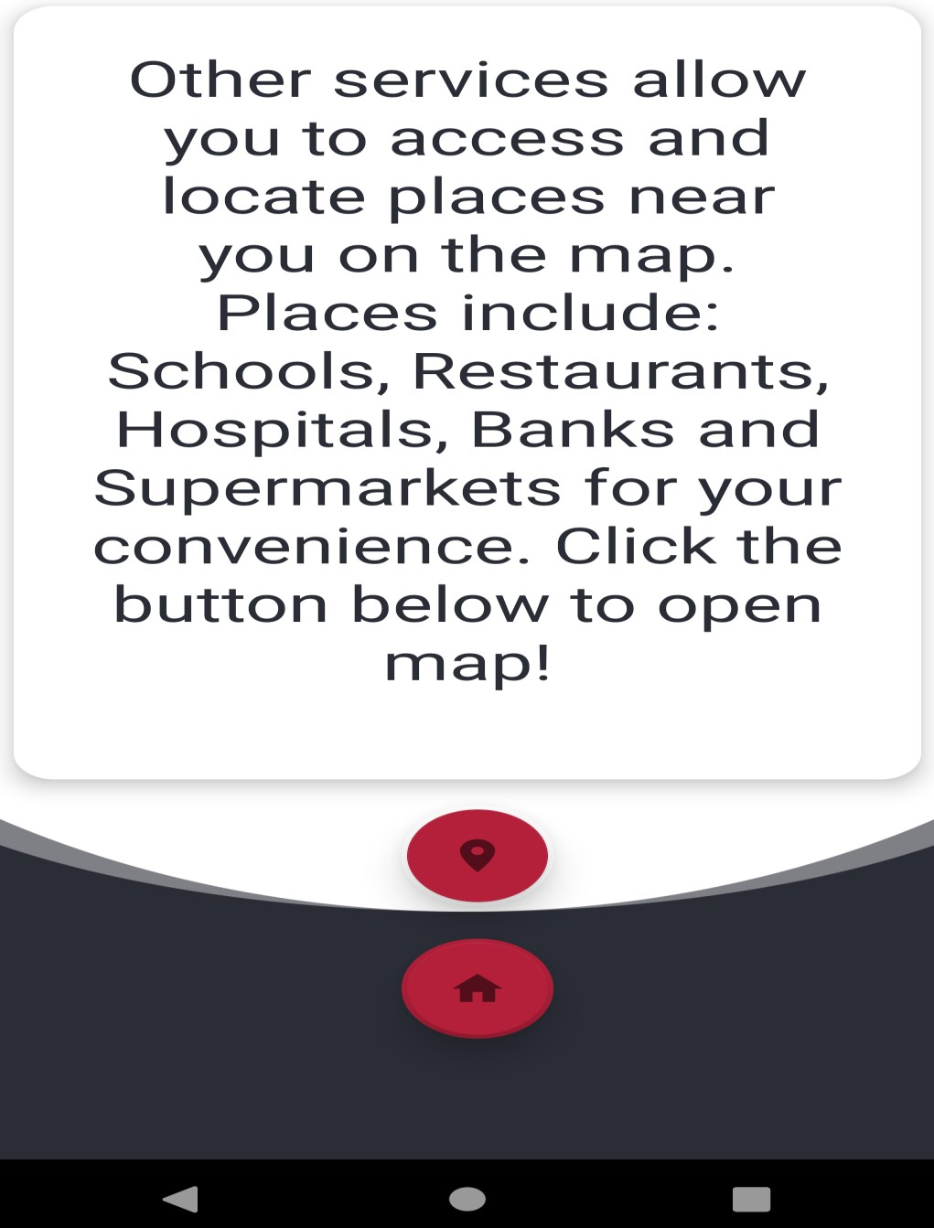

Figure 3.7.10 : other services

**Description :** a screen that lets you view other services of the application such as viewing hospitals, restaurants, shops, supermarkets, banks and schools on the map.

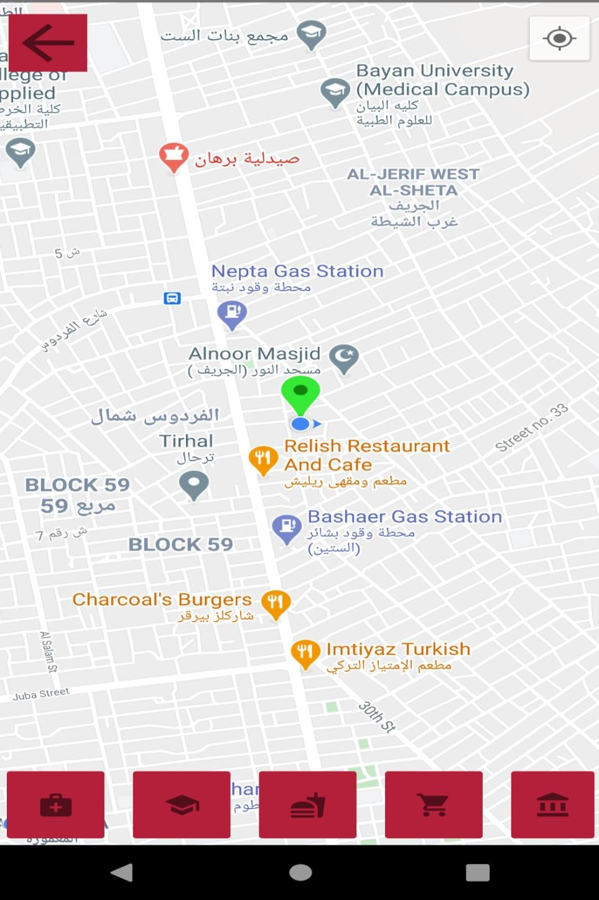

Figure 3.7.11 : map

**Description :** a google map that enables the user to see his current location, the location of nearest restaurants, hospitals, supermarkets, banks and schools.

35

# Chapter four Implementation

## 4.1 Implementation Screens

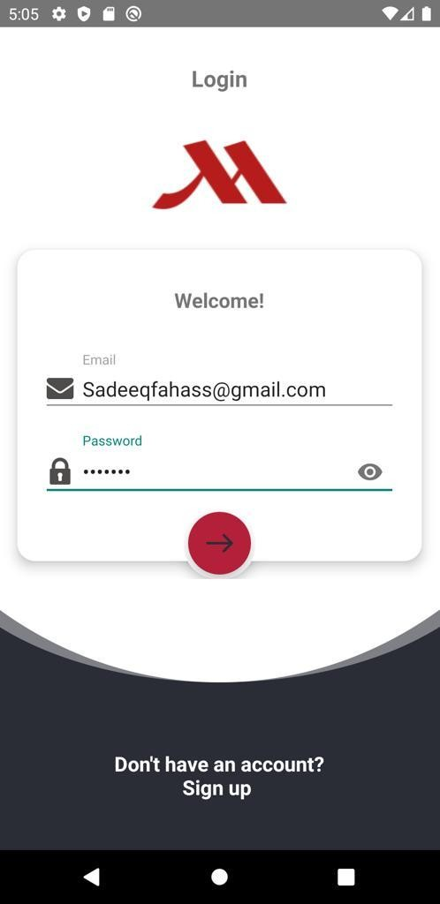

Fig 4.1 : login screen

Description: User enters email and password to get access

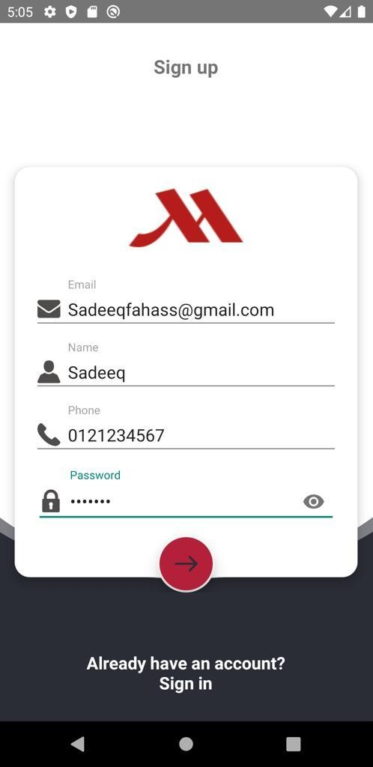

Fig 4.1 : Register

**Description:** new user enters email, name, phone number and password to register.

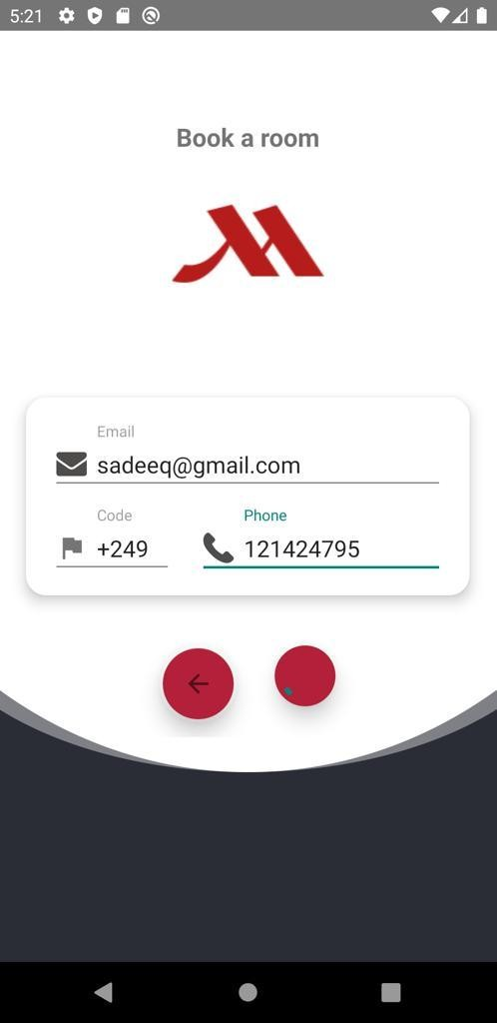

Fig 4.2 : Book A Room

**Description :** user enters email and phone number to book a room

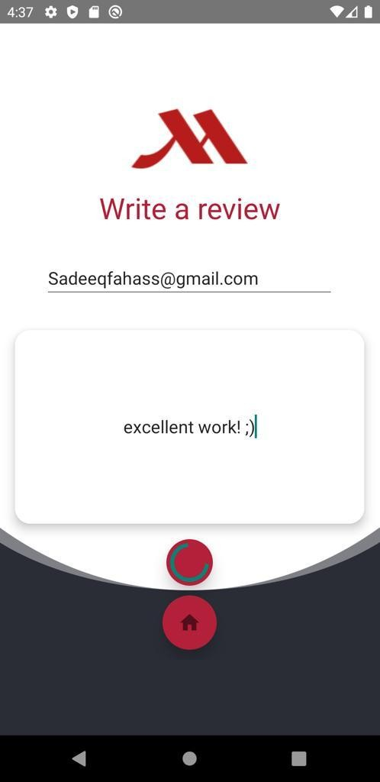

Fig 4.4: Review

Description : user writes down his email to give a review about the application

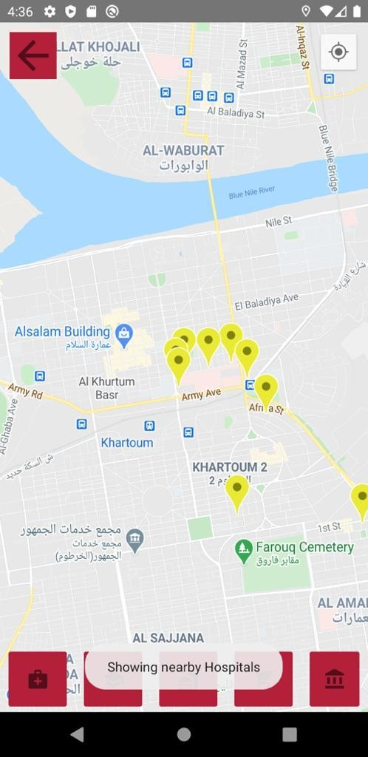

Fig 4.5: google map screen Description : user selects to view hospitals.

40

# Chapter Five Conclusion &Recommendation

## Conclusion

The objectives of the project were successfully achieved by performing intense tests on the application and its functionalities. The idea of reserving, viewing the city was converted into a system that will enhance and provide a better way in which they will be performed safely.

The application is very useful to foreigners by helping them choose the best hotel in a city. It has a google map that helps user to locate nearby hotels, shops, supermarkets, banks and schools, and also book available rooms in the hotel

This project overall gives the easier tool for searching nearby hotels, viewing the closest shops, supermarkets, banks and schools, saves time and provide effective security.

## Recommendation

The continuous growth of information technology always makes things dynamic, also user’s need is continuously changing therefore there is need to meet users need whenever they request for it. For the application, some future enhancement were suggested in order for it to perform other functionalities such as:

* + 1. Last minute booking.
    2. Directions to nearest hospitals, shop, supermarkets, banks and schools on the google map.
    3. Reviews and ratings of a particular room or a service.
  1. **Reference**

|  |  |  |
| --- | --- | --- |
| **Name** | **Reference** | **Page** |
| 1 | Raymond M Jr 1994, System Analysis and Design: An Organizational Approach. The Dryden Press U.S.A. | 16 |
| 2 | Manuel Kiessling, Beginning Mobile App Development with recent Native, 2015 – 2017 | 14 |
| 3 | J. F. DiMarizio , Beginning Android Programming with Android Studio, Fourth Edition, Indianapolis, John Wisely & sons, inc. 2017 | 15 |
| 4 | . Chryssa Aliferi, Android Programming Cookbook  Exelixis Media P.C., 2016 | 12 |
| 5 | Tutorial Points pvt, Android Tutorial, Tutorial Point (i)  pvt. Ltd 2014 | 42 |

## Appendix

Login.java

**package** com.example.hotel;

**import** androidx.appcompat.app.AppCompatActivity;

**import** android.content.Intent; **import** android.os.Bundle; **import** android.util.Patterns; **import** android.view.View; **import** android.widget.EditText;

**import** android.widget.ProgressBar; **import** android.widget.TextView; **import** android.widget.Toast;

**import** com.android.volley.AuthFailureError;

**import** com.android.volley.Request; **import** com.android.volley.RequestQueue; **import** com.android.volley.Response; **import** com.android.volley.VolleyError;

**import** com.android.volley.toolbox.StringRequest;

**import** com.android.volley.toolbox.Volley;

**import** com.google.android.material.floatingactionbutton.FloatingActionButton;

**import** org.json.JSONArray; **import** org.json.JSONException; **import** org.json.JSONObject;

**import** java.util.HashMap;

**import** java.util.Map;

**public class** Login **extends** AppCompatActivity { EditText **pwordl**, **emaill**;

TextView **regbtnl**;

ProgressBar **progressBar**; FloatingActionButton **logbtnl**;

**public static** String *URL_LOGIN* = **"**[**http://192.168.64.2/hotel/log.php"**](http://192.168.64.2/hotel/log.php);

@Override

**protected void** onCreate(Bundle savedInstanceState) {

**super**.onCreate(savedInstanceState); setContentView(R.layout.***activity_login***);

**emaill** = findViewById(R.id.***emaill***); **pwordl** = findViewById(R.id.***pwordl***); **logbtnl** = findViewById(R.id.***logbtnl***); **regbtnl** = findViewById(R.id.***regbtnl***);

**progressBar** = findViewById(R.id.***progressBar***);

**logbtnl**.setOnClickListener(**new** View.OnClickListener() { @Override

**public void** onClick(View v) {

String email = **emaill**.getText().toString().trim(); String password = **pwordl**.getText().toString().trim();

**if** (email.isEmpty() || password.isEmpty()){ **emaill**.setError(**"Please insert Email!"**); **pwordl**.setError(**"Please insert Password!"**);

}

**if** (!Patterns.***EMAIL_ADDRESS***.matcher(**emaill**.getText().toString()).matches()) {

**emaill**.setError(**"Enter a valid email"**); **emaill**.requestFocus();

**return**;

**else** {

}

Login (email, password);

}

}

});

**regbtnl**.setOnClickListener(view -> {

Intent i = **new** Intent(Login.**this**, Register.**class**); startActivity(i);

finish();

});

}

**public void** Login(String email, String password){

**progressBar**.setVisibility(View.***VISIBLE***); **logbtnl**.setVisibility(View.***GONE***);

StringRequest stringRequest = **new** StringRequest(Request.Method.***POST***, *URL_LOGIN*,

**new** Response.Listener<String>() { @Override

**public void** onResponse(String response) {

**try** {

JSONObject jsonObject = **new** JSONObject(response); String success = jsonObject.getString(**"success"**);

**if** (success.equals(**"1"**)){

Toast.*makeText*(Login.**this**, **"Login Successful!"**,Toast.***LENGTH_SHORT***).show(); Intent intent = **new** Intent(Login.**this**, Home.**class**);

startActivity(intent); finish();

**progressBar**.setVisibility(View.***GONE***);

}

**else** {

Toast.*makeText*(Login.**this**, **"Wrong Username or**

**Password!"**,Toast.***LENGTH_SHORT***).show(); **progressBar**.setVisibility(View.***GONE***); **logbtnl**.setVisibility(View.***VISIBLE***);

}

} **catch** (JSONException e) { e.printStackTrace();

**progressBar**.setVisibility(View.***GONE***);

**logbtnl**.setVisibility(View.***VISIBLE***);

Toast.*makeText*(Login.**this**, **"Error "** +e.toString(), Toast.***LENGTH_SHORT***).show();

}

}

},

**new** Response.ErrorListener() { @Override

**public void** onErrorResponse(VolleyError error) {

**progressBar**.setVisibility(View.***GONE***); **logbtnl**.setVisibility(View.***VISIBLE***);

Toast.*makeText*(Login.**this**, **"Error "** +error.toString(), Toast.***LENGTH_SHORT***).show();

}

})

{

@Override

**protected** Map<String, String> getParams() **throws** AuthFailureError { Map<String, String> params = **new** HashMap<>(); params.put(**"email"**, email);

params.put(**"password"**, password);

**return** params;

}

};

RequestQueue requestQueue = Volley.*newRequestQueue*(**this**); requestQueue.add(stringRequest);

}

}

Register.java

**package** com.example.hotel;

**import** androidx.appcompat.app.AppCompatActivity;

**import** android.content.Intent;

**import** android.content.SharedPreferences;

**import** android.os.Bundle;

**import** android.preference.PreferenceManager;

**import** android.text.TextUtils; **import** android.util.Patterns; **import** android.view.View; **import** android.widget.EditText;

**import** android.widget.ProgressBar; **import** android.widget.TextView; **import** android.widget.Toast;

**import** com.android.volley.AuthFailureError;

**import** com.android.volley.Request; **import** com.android.volley.RequestQueue; **import** com.android.volley.Response; **import** com.android.volley.VolleyError;

**import** com.android.volley.toolbox.StringRequest;

**import** com.android.volley.toolbox.Volley;

**import** com.google.android.material.floatingactionbutton.FloatingActionButton;

**import** org.json.JSONException;

**import** org.json.JSONObject;

**import** java.util.HashMap;

**import** java.util.Map;

**import** java.util.prefs.Preferences;

**public class** Register **extends** AppCompatActivity {

EditText **unamer**, **pwordr**, **emailr**, **phoner**; TextView **logbtnr**;

ProgressBar **progressBar**; FloatingActionButton **regbtnr**; SharedPreferences **preferences** ; SharedPreferences.Editor **editor**;

String **name1**,**email1**,**phone1**,**password1**;

**public static** String *URL_REGIST* = **"**[**http://192.168.64.2/hotel/reg.php**](http://192.168.64.2/hotel/reg.php)**"**;

@Override

**protected void** onCreate(Bundle savedInstanceState) {

**super**.onCreate(savedInstanceState); setContentView(R.layout.***activity_register***);

**unamer** = findViewById(R.id.***unamer***); **pwordr** = findViewById(R.id.***pwordr***); **emailr** = findViewById(R.id.***emailr***); **phoner** = findViewById(R.id.***phoner***); **logbtnr** = findViewById(R.id.***logbtnr***); **regbtnr** = findViewById(R.id.***regbtnr***);

**progressBar** = findViewById(R.id.***progressBar***);

**preferences** = PreferenceManager.*getDefaultSharedPreferences*(**this**);

**editor** = **preferences**.edit();

**final** String email = **this**.**emailr**.getText().toString().trim(); **regbtnr**.setOnClickListener(**new** View.OnClickListener() {

@Override

**public void** onClick(View v) {

**if** (TextUtils.*isEmpty*(**emailr**.getText().toString()) && TextUtils.*isEmpty*(**pwordr**.getText().toString()) && TextUtils.*isEmpty*(**unamer**.getText().toString()) && TextUtils.*isEmpty*(**phoner**.getText().toString())) {

**emailr**.setError(**"Please insert Email!"**); **unamer**.setError(**"Please insert Name!"**); **phoner**.setError(**"Please insert Phone Number!"**); **pwordr**.setError(**"Please insert Password!"**);

}

**if** (!Patterns.***EMAIL_ADDRESS***.matcher(**emailr**.getText().toString()).matches()) {

**emailr**.setError(**"Enter a valid email"**); **emailr**.requestFocus();

**return**;

}

**else** {

**editor**.putString(**"name"**, **unamer**.getText().toString()).apply(); **editor**.putString(**"email"**,**emailr**.getText().toString()).apply(); **editor**.putString(**"password"**,**pwordr**.getText().toString()).apply(); **editor**.putString(**"phone"**,**phoner**.getText().toString()).apply();

Regist();

}

}

});

**logbtnr**.setOnClickListener(**new** View.OnClickListener() { @Override

**public void** onClick(View v) {

Intent intent = **new** Intent(Register.**this**, Login.**class**); startActivity(intent);

}

});

}

**public void** Regist(){ **progressBar**.setVisibility(View.***VISIBLE***); **regbtnr**.setVisibility(View.***GONE***);

**name1**= **this**.**unamer**.getText().toString().trim(); **email1** = **this**.**emailr**.getText().toString().trim(); **password1** = **this**.**pwordr**.getText().toString().trim(); **phone1** = **this**.**phoner**.getText().toString().trim();

StringRequest stringRequest = **new** StringRequest(Request.Method.***POST***, *URL_REGIST*,

**new** Response.Listener<String>() { @Override

**public void** onResponse(String response) {

**try** {

JSONObject jsonObject = **new** JSONObject(response); String success = jsonObject.getString(**"success"**);

**if** (success.equals(**"1"**)){

Toast.*makeText*(Register.**this**, **"Registration Successful!"**, Toast.***LENGTH_SHORT***).show(); Intent intent = **new** Intent(Register.**this**, Login.**class**);

startActivity(intent); finish();

}

} **catch** (JSONException e) { e.printStackTrace();

Toast.*makeText*(Register.**this**, **"Something went wrong! "** + e.toString(),

Toast.***LENGTH_SHORT***).show(); **progressBar**.setVisibility(View.***GONE***); **regbtnr**.setVisibility(View.***VISIBLE***);

}

}

},

**new** Response.ErrorListener() { @Override

**public void** onErrorResponse(VolleyError error) {

Toast.*makeText*(Register.**this**, **"Something went wrong! "** + error.toString(), Toast.***LENGTH_SHORT***).show();

**progressBar**.setVisibility(View.***GONE***); **regbtnr**.setVisibility(View.***VISIBLE***);

}

})

{

@Override

**protected** Map<String, String> getParams() **throws** AuthFailureError { Map<String, String> params = **new** HashMap<>(); params.put(**"name"**, **name1**);

params.put(**"password"**, **password1**); params.put(**"email"**, **email1**); params.put(**"phone"**, **phone1**);

**return** params;

}

};

RequestQueue requestQueue = Volley.*newRequestQueue*(**this**); requestQueue.add(stringRequest);

}

}