CYTOLOGICAL EVALUATION OF SPUTUM SAMPLES IN WELDERS IN OWERRI METROPOLIS

ABSTRACT
Metal fume fever and pneumosiderosis is an occupational Lung disease acquired when welders are exposure to welding fumes and iron particles during their occupation. A total of one hundred and fifty four (154) sputum samples were collected for the purpose of this study. One hundred and four (104) sputum samples were collected from welders in different locations in owerri. While ﬁfty (50) sputum samples were collected from apparently healthy controls of non welders. The age range 21-30 years recorded highest with 46 (44.23%) frequency of occurrence, followed by age range of 31-40 years with 30 (28.84%) and the Least was from the age range of 51-60 years with 4 (3.85%) frequency of occurrence for the test subjects. The Length of the exposure to welding fumes and iron particles reveals that those exposed from 7-13 years recorded the highest with 30 (28.85%) frequency of occurrence followed by age range 1-6 years with 25 (24.04%) and the Least duration of exposure was recorded among the rest ranging from 27-33 years having 10 (9.61%) each. Many iron deposits were detected in the sputum specimen giving positive reactions with Perls Prussian Blue method with 37 (71.15%) frequency and only l5 (28.85%) recorded as Negative for test subjects. Papanicolaou method was adopted for this research; some cytological ﬁndings observed were variables. Long-term exposure to welding fumes and metallic dust particles, inadequate working ventilation as well as the unawareness of its effects were among the risk factors that increased the infection, even among the apparently healthy individual.

CHAPTER ONE
1.0 INTRODUCTION
Welding process involves joining metal parts by heating the pieces to melting temperature (Kimet et al., 2005). Soldering process as a type of welding produces various contaminants at a sufficient rate to cause both short term and long term health effects, especially if not properly controlled (Antonini et al., 1998). The metal composition of the generated fume during welding of metals is mostly dependent on the welding electrode or wire which is consumed during the process (Solano et al., 2006). Based on epidemiology more than two million workers worldwide perform welding process as part of their work duties (Solano et al., 2006). Previous studies showed that 22% of welders or solderers or persons working near welding or solderers were found to be suffering from occupational asthma and other lung diseases (Palmer et al.,1997).
One of the main limitations to study the adverse health effects of welding fumes is the variable environmental condition of the work places. This includes different ventilation qualities and also exposure to a number of other toxic materials such as asbestos, smoking, silica and organic solvent (Antonini et al., 1998).Chronic exposure to Welding fumes is also associated with a signiﬁcant reduction in lung function. There is growing evidence that welding fume exposure may be associated with increased cardiovascular disease. Although the exact mechanisms for cardiovascular disease are unknown, it seems that systemic inﬂammation resulting from occupational exposure to these fumes may be partly responsible for the increased cardiovascular risk in welders (Kimet et al., 2005). Fumes inhalation exposure for workers in conﬁned and poorly ventilated spaces have been found to exhibit more negative lung function than workers in chromium, and manganese. Nickel and hexavalent chromium are classiﬁed as potential occupational carcinogens (NIOSH 2003).
Generally, welding fumes and gases come from the base material; paints and coatings on the metal and covering the electrode; shielding gases; chemical reactions from arc ultraviolet light and heat; process and consumable; and contaminants in the air, such as vapours from cleaners and degreasers. Welding smoke can also irritate the eyes, nose, chest, and respiratory tract and cause coughing, shortness of breath, bronchitis, pulmonary edema (ﬂuid in the lungs), and pneumonitis (inﬂammation of the lung) Gastrointestinal effects, such as nausea, appetite loss, vomiting, cramps, and slow digestion, also have been associated with welding smoke. Some welding fume components and welding processes can be especially dangerous in a short period of time. Cadmium in welding fumes can be fatal in a short time. Ultraviolet radiation given off by welding reacts with oxygen and nitrogen in the air to form ozone and nitrogen oxides, which are deadly at high doses, irritate the nose and throat, and cause serious lung disease (Vicski, 2004). Studies show that welders and those involved in brazing, soldering, and metal cutting have an increased risk of lung cancer and possible larynx and urinary tract cancer. According to the AFSCME fact sheet, these ﬁndings are not surprising in view of the large quantity of toxic substances in welding smoke, including cancer-causing agents such as cadmium, nickel, beryllium, chromium, and arsenic. Pneumosiderosis or welder’s lung is an occupational lung disease, which is usually seen after chronic exposure to iron dust particles especially in welders and other metal workers (Imran et al, 2009). Siderosis is sufﬁx derived from a Greek word “sidero” meaning iron, while “Pneumo” is a preﬁx derives from Greek word meaning breath. Therefore, siderosis is a chronic inﬂammation of the lungs caused by excessive inhalation of dust containing iron salts or particles (American Heritage Dictionary; 2009). Siderosis is a form inhalation of iron or other metallic particles, excess of ill in blood, deposition of iron in the tissue. The tissues on which the iron can be deposited include the eye or skin which causes injury as the iron chemically reacts with cells and tissues (Fidan et al., 2005). Iron oxide present in welding material is the causative agent of pneumosiderosis. It can also be caused by powdered hematite (Strobel et al., 2002).
There are different metallic products which when exposed to the dust particles can affect the body such as Iron, Aluminum, silver, Nickel, magnesium etc. Although it takes years of exposure for a patient to become symptomatic, the symptoms are usually non-speciﬁc which most commonly includes shortness of breath, cough and sputum production. With continued exposure, patients can develop chronic interstitial lung disease, chronic bronchitis (regardless of smoking), decline in pulmonary function and persistent symptoms (Imran et al., 2009). Activities such as burning, welding, sawing, brazing, machining and grinding may result in the following effects if there is exposures to metallic products; the target organs is respiratory system.
- Acute effects through inhalation of metal dust into the eyes, skin and mucous membrane.
- Chronic effects that are associated with iron oxide which may result in benign pneumoconiosis called “siderosis”.

1.1 AIM
The general aim of this study is to evaluate the morphology of cells in Papanicoloau and Perls Prussian blue stained sputum samples of welders in Owerri, Imo State.
1.2 SPECIFIC OBJECTIVE
The speciﬁc objectives of this study include:
- To evaluate the effect of iron particles inhaled into the lungs on cellular morphology in sputa of welders.
- To determine the relationship between the electrode fumes inhalation and cellular atypia in sputa of welders.
- To establish the relationship between duration of exposure and cytological abnormalities in sputa of welders.
1.3 JUSTIFICATION/SIGNIFICANCE OF THE STUDY
There is increased campaign that the inhalation of Welding fumes, iron particles and other toxic gaseous compounds released from different iron and welding materials are etiologic to lung cancer and other respiratory tract problems. This study therefore, seeks to evaluate the effect of the welding fumes on the lungs epithelia cells. It is hoped that the conclusion that shall be reached may reveal the effect of the welding fumes and iron particles which will further inform welders on side effect of long period of exposure to these fumes.

CHAPTER TWO
2.0 LITERATURE REVIEW
Cytology (from Greek kντoς, kytos, "a hollow’ and -λoγ𝔦𝔞, -logia) is the study of cells (Kirpatrick; 1989). Cytology is that branch of life science that deals with the study of cells in terms of structure, function and chemistry. Robert Hock: is sometimes seen as the father of cytology (Bethesda; 2004). Based on the usage, Cytopathology is the study of cellular disease and the use of cellular changes for the diagnosis of disease. Cell biology is the study of (normal) cellular anatomy, function and chemistry.
2.1 SPUTUM: It is mucus that is coughed up from the lower airways. In medicine, sputum samples are usually used for microbiological investigations of respiratory infections and cytological investigations of respiratory systems. The best sputum samples contain very little saliva As saliva contaminates the sample with oral bacteria. This event is assessed by the clinical microbiologist by examining a Gram stain of the sputum. More than 25 squamous epithelial cells at low enlargement indicate salivary contamination (Richard; 2007).
- Individuals with chronic respiratory disorder (such as asthma, chronic bronchitis or emphysema) may be affected by any fumes or airborne particulate matter exposure (Powder technology inc.;2008). Inhalation of dust is irritating and may be harmful while inhalation of fumes may cause metal fume fever, characterized by ﬂu-like symptoms with metallic taste, fever, chills, cough, weakness, chest pain, muscle pain and increase white blood cell count which may cause lung damage. Severe over dose of iron dust particles may have corrosive effect on gastrointestinal system, with necrosis, perforation and stricture. Symptoms of abdominal pain, nausea, vomiting and diarrhea may be delayed several hours (Cheminfo et al., 2008). However, long term inhalation can cause siderosis, a benign pneumoconiosis. Long term exposure may cause effects to the liver, pancreas, gastrointestinal system, blood and cardiovascular system which may lead to diabetic and cardiac abnormalities. The preventive measures are respiratory protection by using dust/mist mask, dust/mist filter respirator (Cheminfo et al., 2008). Prognosis is generally favorable if strict avoidance from the iron dust is adopted (Imran et al., 2009).
2.1.1 TYPES OF SPUTUM
A) Bloody (hemoptysis) (Johnson et al., 2008).
- Blood-streaked sputum - inﬂammation of throat, bronchi; lung cancer
- Pink sputum evenly mixed with blood, from alveoli, small bronchi;
- Massive blood - cavitary tuberculosis of lung, lung abscess, bronchiectasis, infarction, embolism.
B) Rust colored- usually caused by pneumococcal bacteria (in pneumonia)
C) Purulent- containing pus. The sputum colour of patients with acute cough and no underlying chronic lung disease does not imply therapeutic consequences such as prescription of antibiotics (Little et al., 2005). The colour can provide hints as to effective treatment in chronic bronchitis patients (Stockley et al., 2000).
- A yellow-greenish (mucopurulent) colour suggest that treatment with antibiotics can reduce symptoms. Green color is caused by Neutrophil Myeloperoxidase.
- A white, milky, or opaque (muconoid) appearance often means that antibiotics will be ineffective in treating symptoms. This information may correlate with the presence of bacterial or viral infections, but current research does not support that generalization.
D) Foamy white - may come from obstruction or even edema.
E) Frothy pink - Pulmonary edema.
2.1.2 ASSESSMENT OF SPUTUM PRODUCTION
Normal respiratory tract secretions (phlegm) are minimal in volume and usually are cleared via the mucocilliary escalator to the pharynx for swallowing. Respiratory tract secretions that are abnormal in volume or consistency and must be expectorated (or cleared via suctioning) are called sputum. The assessment of sputum production should be part of the overall history and physical assessment of the patient and be conducted whenever secretion clearance takes place. Typically you evaluate the amount (volume) and color and consistency of the expectorated sputum. In addition, many recommend that sputum be assessed for odor.
A) Amount/Volume: Any production of sputum expectoration or suctioning is abnormal. When interviewing patients to obtain information about sputum production, one can help them estimate the amount or volume of sputum they produce by using familiar measures such as a teaspoon (about 5 ml), teaspoon (about 15 ml) or shot-glass full (about 30 mL). These same estimates are useful at the bedside, although more precise quantiﬁcation of volume can be obtained using a calibrated sputum cup (one with ml marking on the side). When quantifying the volume of sputum production over time, it is important that the patient be instructed to cxpuzmnme only into the proper container and to avoid expectorating oral secretions.
B) Color, Consistency and Odor: In terms of color, sputum typically is described as being either clear/white, pinkish, red, yellow, or green. In terms of consistency, sputum is typically described as being thin/watery, frothy or thick/viscous. In terms of odor, foul-smelling or fetid sputum indicates tissue necrosis. Clinically, color and consistency and odor together help describe the sputum ‘type’ as being mucoid, mucopurulent, purulent, and bloody. As indicated in the following table, this assessment can help identify the underlying disease or disorder.

TABLE: 1
Color, Consistency, and Odor
Types of Sputum Color and Consistency Likely Conditions
Mucoid Clear/white, thin to thick Asthma
Mucopurulent Clear to yellowish, thick Chronic bronchitis
Cystic fibrosis
Purulent  Bloody | Yellow to green, thick  Pink to red/dark red, thin (unless coagulated) | Pneumonia (blood-streaked)  Aspiration pneumonia  Bronchiectasis (fetid/foul-smelling, may separate into layers if left standing)  Lung abscess (fetid/foul smelling, may separate into layers if left standing).  Tuberculosis (red)  Lung cancer (red)  Pulmonary infarction (red)  Pulmonary edema (pink, watery, frothy)

2.1.3 SPUTUM CYTOLOGY
Sputum cytology examines a sample (mucus) % a imeope to determine whether abnormal cells are present. Sputum is not the same as saliva. Sputum is produced in the lungs and in the airways leading to the lungs. Sputum has some normal lung cells in it. Sputum cytology may be done to help detect certain noncancerous lung conditions. It may also be done when lung cancer is suspected.

2.2 WELDING
Welding is a fabrication or sculptural process that joins materials, usually metals or thermoplastics, by causing fusion, which is distinct from lower temperature metal-joining techniques such as brazing and soldering, which do not melt the base metal. In addition to melting the base metal, a ﬁller material is often added to the joint to form a pool of molten material (the weld pool) that cools to form a joint that can be as strong as the base material. Pressure may also be used in conjunction with heat, or by itself, to produce a weld. In 2003 NIOSH published a comprehensive review of scientiﬁc literature on health effects associated with welding. In the article, "Health Effects of Welding," it was noted that past investigations have found bronchitis, airway irritation, and other respiratory illnesses in large numbers of welders. However, critical differences between the studies and a shortage of dose/response data make it difﬁcult to compare results and conﬁdently link given exposures with given effects. As the article also noted, some studies have suggested that welding fumes may pose risks for lung cancer and nervous system damage. This is because such fumes may contain nickel, chromium, and manganese. Nickel and hexavalent are classiﬁed as potential occupational carcinogens (NIOSH, 2003).
2.2.1 TYPES OF WELDING PROCESSES
A) Arc welding
These processes use a welding power supply to create and maintain an electric arc between an electrode and the base material to melt metals at the welding point. They can use either direct (DC) or alternating (AC) current, and consumable non-consumable electrodes. The welding region is sometimes protected by some type of inert or semi-inert gas, known as a shielding gas, and filler material is sometimes used as well.
Power supplies
To supply the electrical power necessary for are welding processes, a variety of different power supplies can be used. The most common welding power supplies are constant current power supplies and constant voltage power supplies. In arc welding, the length of the arc is directly related to the voltage, and the amount of heat input is related to the current. Constant current power supplies are most often used for manual welding processes such as gas tungsten arc welding and shielded metal are welding, because they maintain a relatively constant current even as the voltage varies. This is important because in manual welding, it can be difficult to hold the electrode perfectly steady, and as a result, the arc length and thus voltage tend to ﬂuctuate. Constant voltage power supplies hold the voltage constant and vary the current, and as a result, are most often used for automated welding processes such as gas metal arc welding, flux cored are welding, and submerged arc welding. In these processes, arc length is kept constant, since any fluctuation in the distance between the wire and the base material is quickly rectified by a large change in current. For example, if the wire and the base material get too close, the current will rapidly increase, which in turn causes the heat to increase and the tip of the wire to melt, returning it to its original separation distance(Cary et al., 2005). The type of current used plays an important role in are welding. Consumable electrode processes such as shielded metal arc welding and gas metal an: ridding generally use direct current, but the electrode can be charged either positively or negatively. In welding, the positively charged anode will have a greater heat concentration, and as a result, changing the polarity of the electrode has an impact on weld properties. If the electronic is positively charged, the base metal will be hotter, increasing weld penetration and welding speed. Alternatively, a negatively charged electrode results in more shallow welds (Kalpakjian et al., 2001). Non consumable electrode processes, such as gas tungsten arc welding, can use either type of direct current, as well as alternating current. However, with direct current, because the electrode only creates the arc and does not provide ﬁller material, a positively charged electrode causes shallow welds, while a negatively charged electrode makes deeper welds (Lincoln; 1994). Alternating current rapidly moves between these two, resulting in medium-penetration welds. One disadvantage of AC, the fact that the arc must be re-ignited after every zero crossing, has been addressed with the invention of special power units that produce a square wave pattern instead of the normal sine wave, making rapid zero crossings possible and minimizing the effects of the problem (Weman et al., 2003).
Processes
One of the most common types of arc welding is shielded metal (SMAW Klas et al., 2003), it is also known as manual metal arc welding (MMA) or stick welding. Electric current is used to strike an arc between the base material and consumable electrode rod, which is made of filler material (typically steel) and is covered with a flux that protects the weld area from oxidation and contamination by producing carbon dioxide (CO₂) gas during the welding process. The electrode core itself acts as ﬁller material, making a separate filler unnecessary (Weman et al., 2003). The process is versatile and can be performed with relatively inexpensive equipment, making it well suited to shop jobs and ﬁeld work (Woman et al., 2003, Cary et al., 2005). An operator can become reasonably proficient with a modest amount of training and can achieve mastery with experience. Weld times are rather slow, since the consumable electrodes must be frequently replaced and because slag, the residue from the ﬂux, must be chipped away after welding (Weman et al.,2003). Furthermore, the process is generally limited to welding ferrous materials, though special electrodes have made possible the welding of cast iron, nickel, aluminum, copper, and other metals (Cary et al., 2005). Gas metal arc welding (GMAW), also known as inert gas or MIG welding, is a semi-automatic or automatic process that uses a continuous wire feed as an electrode and an inert or semi-inert gas mixture to protect the weld from contamination. Since the electrode is continuous, welding speeds are greater for GMAW than for SMAW (Lincoln; 1994). A related process, flux-cored arc welding (FCAW), uses similar equipment but uses wire consisting of a steel electrode surrounding a powder fill material. This cored wire is more expensive than the standard solid wire and can generate fumes and/or slag, but it permits even higher welding speed and greater metal penetration (Weman et al., 2003).
Gas tungsten arc welding (GTAW), or tungsten inert gas (TIG) welding, is a manual welding process that uses a non-consumable tungsten electrode, an inert or semi-inert gas mixture, and a separate filler material (Klas et al.,2003). Especially useful for welding thin materials, this method is characterized by a stable arc and high quality welds, but it requires significant operator skill and can only be accomplished at relatively low speeds (Klas et al.,2003). GTAW can be used on nearly all weldable metals, though it is most often applied to stainless steel and light metals. It is often used when quality welds are extremely important, such as in bicycle, aircraft and naval applications (Weman et al., 2003). A related process, plasma arc welding, also uses a tungsten electrode but uses plasma gas to make the arc. The arc is more concentrated than the GTAW arc, making transverse control more critical and thus generally restricting the technique to a mechanized process. Because of its stable current, the method can be used on a wider range of material thicknesses than can the GTAW process and it is much faster. It can be applied to all of the same materials as GTAW except magnesium, and automated Welding of stainless steel is one important application of the process. A variation of the process is plasma cutting, an efficient steel cutting process (Weman et al., 2003). Submerged arc welding (SAW) is a high-productivity welding method in which the arc is struck beneath a covering layer of ﬂux. This increases arc quality, since contaminants in the atmosphere are blocked by the ﬂux. The slag that forms on the weld generally comes off by itself, and combined with the use of a continuous wire feed, the weld deposition rate is high. Working conditions are much improved over other are welding processes, since the ﬂux hides the arc and almost no smoke is produced. The process is commonly med in industry, especially for large products and in the manufacture of welded pressure vessels (Weman et al., 2003). Other arc welding processes include atomic hydrogen welding, electroslag welding, electrogas welding, stud arc welding (Klas et al., 2003).

B) Gas welding
The most common gas welding process is oxyfuel welding, (Weman et al., 2003) also known as oxyacetylene Welding. It is one of the oldest and most versatile welding processes, but in recent it has become less popular in industrial applications. It is years still widely used for welding pipes and tubes, as well as repair work (Weman et al., 2003). The equipment is relatively inexpensive and simple, generally employing the combustion of acetylene in oxygen to produce a welding ﬂame temperature of about 3100 °C (Klas et al., 2003). The flame, since it is less concentrated than an electric arc, causes slower weld cooling, which can lead to greater residual stresses and weld distortion, though it eases the welding of high alloy steels. A similar process, generally called oxyfuel cutting, is used to cut metals (Weman et al., 2003).
C) Resistance welding
Resistance welding involves the generation of heat by passing current through the resistance caused by the contact between two or more metal surfaces. Small pools of molten metal are formed at the weld area as high current (1000-100,000 A) is passed through the metal (Weman et al., 2003) In general, resistance welding methods are efficient and cause little pollution, but their applications are somewhat limited and the equipman ma um be high (Klas et al., 2003).
D) Spot welder
Spot welding is a popular resistance welding method used to join overlapping metal sheets of up to 3mm thick (Weman et al., 2003). Two electrodes are simultaneously used to clamp the metal sheets together and to pass current through the sheets. The advantages of the method include efficient energy use, limited work piece deformation, high production rates, easy automation, and no required filler materials. Weld strength is signiﬁcantly lower than with other welding methods, making the process suitable for only certain applications. It is used extensively in the automotive industry-ordinary cars can have several thousand spot welds made by industrial robots. A specialized process, called shot welding, can be used to spot weld stainless steel (Weman et al., 2003). Like spot welding, seam welding relies on two electrodes to apply pressure and current to join metal sheets. However, instead of pointed electrodes, wheel-shaped electrodes roll along and often feed the work piece, making it possible to make long continuous welds. In the past, this process was used in the manufacture of beverage cans, but now its uses are more limited (Klas et al., 2003). Other resistance welding methods include bun welding (Jernberg et al., 1919). Flash welding, projection welding, and upset welding (Klas et al., 2003).
Energy beam
Energy beam welding methods, namely laser beam welding and electron beam welding, are relatively new processes that have become quite popular in high production applications. The two processes are quite similar, differing most notably in their source of power. Laser beam welding employs a highly focused laser beam, while electron beam welding is done in a vacuum and uses an electron beam. Both have a very high energy density, making deep weld penetration possible and minimizing the size of the weld area. Both processes are extremely fast, and are easily automated, making them highly productive. The primary disadvantages are their very high equipment costs (though these are decreasing) and a susceptibility to thermal cracking. Developments in this area include laser-hybrid welding, which uses principles from both laser beam welding and arc welding for even better weld properties, laser cladding, and x-ray welding (Weman et al., 2003).
Solid-state
Like the first welding process, forge welding, some modern welding methods do not involve the melting of the materials being joined. One of the most popular ultrasonic welding, is used to connect thin sheets or wires made of metal or thermoplastic by vibrating them at high frequency and under high pressure (Weman et al., 2003). The equipment and methods involved are similar to that of resistance welding, but instead of electric current, vibration provides energy input. Welding metals with this process does not involve melting the materials; instead, the weld is formed by introducing mechanical vibrations horizontally under pressure. When welding plastics, the materials should have similar melting temperatures, and the vibrations are introduced vertically. Ultrasonic welding is commonly med For making electrical connections out of aluminum or copper, and it is also a very common polymer welding process (Weman et al., 2003). Another common process, explosion welding, involves the joining of materials by pushing them together under extremely high pressure. The energy from the impact plasticizes the materials, forming a weld, even though only a limited amount of heat is generated. The process is commonly used for welding dissimilar materials, such as the welding of aluminum with steel in hulls or compound plates (Klas et al., 2003). Other solid-state welding processes include welding (including friction stir welding) (Stephan;2006), magnetic pulse welding, (Stephan; 2010). co-extrusion welding, cold welding, diffusion bonding, exothermic welding, high frequency welding, hot pressure welding, induction welding, and roll welding (Klas et al., 2003).
2.2.2 HEALTH EFFECTS OF WELDING
A) Metal Fume Fever
Symptoms
The symptoms of are nonspeciﬁc but are generally ﬂu like including:
- Fever
- Chills
- Nausea
- Headache
- Fatigue
- muscle aches
- Joint pains
A sweet or metallic taste in the mouth which distorts the taste of food and cigarettes is also normally reported along with a dry or irritated throat which may lead to hoarseness. Symptoms will normally disappear within 24 to 48 hour; and someone suffering from metal fume fever will usually feel well enough to return to work the next day despite the fact that they may still be feeling it a little bit under the weather. It often takes 4 days to fully recover. Symptoms can disappear over a long weekend of no exposure only to return when re-exposed.
Cause
The exact cause of metal fume fever is not known. The most plausible theory involves an immune reaction which occurs when inhaled metal oxide injure the cells lining the airways. This is thought to modify proteins in the lung. The modified proteins are then absorbed into the bloodstream, where they act as allergens. It is usually associated with inhaling zinc fumes, with all: believing that copper and magnesium can also cause the problem.
Diagnosis
Physical examination findings vary among persons exposed, depending largely upon the stage in the course of the syndrome during which examination occurs. Patients may present with wheezing or crackles in the lungs. They may also have an increased white blood cell count, and urine and blood plasma zinc levels may (unsurprisingly) be elevated. Chest X-ray findings are generally unremarkable. Diagnosis of metal fume fever can be difﬁcult, as the complaints are non-specific and resemble a number of other common illnesses. When respiratory symptoms are prominent, metal fume fever may be confused with acute bronchitis. The diagnosis is based primarily upon a history of exposure to metal oxide fumes. An interesting feature of metal fume fever involves rapid adaptation to the development of the syndrome following repeated metal oxide exposure. Those exposed daily may be immune. Workers with a history of recurrent metal fume fever often develop a tolerance to the fumes. This tolerance, however, is transient, and only persists through the work week. After a weekend hiatus, the tolerance has usually disappeared. This phenomenon of tolerance is what led to the name “Monday Fever“.
Treatment
Treatment of metal fume fever consists of bed rest, and symptomatic therapy (e.g. aspirin for headaches) as indicated.
Prognosis
The symptoms of metal fume fever are usually self-limiting, and dissipate rapidly upon removal from the source of metal fumes.
Depending on the metals involved, repeated exposure can lead to longer term illnesses such as bronchitis, pneumonia, pulmonary edema, nasal cancer and even bone damage.
Prevention
Prevention of metal fume fever in workers who are at potential risk involves avoidance of direct contact with potentially toxic fumes, improved engineering controls (exhaust ventilation systems), personal protective equipment (respirators), and education of workers regarding the features of the syndrome itself and proactive measures which can be taken to prevent its development.

Table: 2.3
Welding Chemical Agents, Fumes and Potential Health Effects
Welding Fume Toxicity Summary Table
Kidney Nervous Liver GI Lung
Aluminum X  Beryllium  Cadmium X X x | X  X  X  X  X  X  X  X  X  X
Chromium X X X  Cobalt X x  Copper x | X  X  X  X  X  X  X  X  X  X
Iron X X x  Lead X X x  Manganese X  Nickel X  Zinc x | X  X  X  X  X  X  X  X  X  X

Sourced from Klas et al., (2003)
A) Aluminum
Aluminum fumes can cause the following disorders, symptoms and health effects:
- Dementia
- Amyotropic lateral sclerosis: chronic progressive disease marked by gradual degeneration of the never cells in the central nervous system that controls voluntary muscle movement.
- Parkinsons dementia
- Alzheimers (not a clear link, speculation, more research needed)
B) Beryllium
Beryllium is sometimes used as a alloying element with copper other base metals.
- Acute exposure to high concentrations of beryllium can remit in chemical pneumonia.
Long-term exposure can result in:
- shortness of breath
- chronic cough
- significant weight loss, accompanied by fatigue and general weakness
- Berylliosis: a scarring of the lungs preventing exchange of oxygen and carbon dioxide
- Lung cancer
- Cadmium
Cadmium is used frequently as a rust-preventive coating on steel and also as an alloying element. Acute exposures to high concentrations or cadmium fumes can produce:
- several lung irritation
- pulmonary edema
- In some cases, death.
Long-term exposure to low levels of cadmium in air can result in:
- Emphysema (a disease affecting the ability of the lung to absorb oxygen) and can damage the kidneys.
- chronic obstructive pulmonary disease
- released enzymes from damaged cells in lungs results in irreversible damage.
Cadmium is classiﬁed by OSHA, NIOSH, and EPA as a potential human carcinogen.
Carbon Monoxide
Carbon monoxide is a gas usually formed by the incomplete combustion of various fuels. Welding and cutting may produce signiﬁcant amounts of carbon monoxide. In addition, welding operations that use carbon dioxide as the inert gas shield may produce hazardous concentrations of carbon monoxide in poorly ventilated areas. This is caused by a “breakdown" of shielding gas. Carbon monoxide is odorless, colorless and tasteless and cannot be readily detected by the senses. Common symptoms of overexposure include pounding of the heart, a dull headache, flashes before the eyes, dizziness, ringing in the ears, and nausea.
Chlorinated Hydrocarbon Solvents
Various chlorinated hydrocarbons are used in degreasing or other cleaning operations. The vapours of these solvents are a concern in welding and cutting because the heat and ultraviolet radiation from the arc will decompose the vapours and form highly toxic and imitating phosgene gas (See Phosgene).
C) Cobalt
Cobalt fume exposure can result in:
- Asthma
- Cumulative lung changes
- Dermatitis
D) Copper
Copper welding fumes exposure can result in:
- Nose and throat irritation
- Eye irritation
- Metal fume fever
- Edema (acute lung damage)
- Upper respiratory tract irritation
E) Fluorides
Fluoride compounds are found in the coatings of several types of ﬂuxes used in welding.
Exposure to these fluxes may irritate the eyes, nose, and throat. Repeated exposure to high concentrations of fluorides in air over a long period may cause pulmonary edema (ﬂuid in the lungs) and bone damage. Exposure to ﬂuoride dusts and ﬁ1mes has also produced skin rashes.
F) Iron Oxide
Iron is the principal alloying element in steel manufacture. During the welding process, iron fumes arise from both the base metal and the electrode. The primary acute effect of this exposure is irritation of nasal passages, throat, and lungs. Although long-term exposure to iron oxide fumes may result in iron pigmentation of the lungs, most authorities agree that these iron deposits in the lung are not dangerous. Disease associated with iron welding fume exposure include:
- siderosis (ﬁbrosis of the lungs caused by iron oxide exposure)
- lung function problems
- diabetes mellitus
G) Lead
The welding and cutting of lead-bearing alloys or metals whose surfaces have been painted with lead-based paint can generate lead oxide fumes.
Inhalation and ingestion of lead oxide fumes and other lead compounds will cause lead poisoning. Symptoms include: -
- metallic taste in the mouth
- loss of appetite
- nausea
- abdominal cramps
- insomnia

In time, anaemia and general weakness, chiefly in the muscles of the wrists, develop. Lead adversely affects the brain, central nervous system, circulatory system, reproductive system, and muscles. Other effects can include problems that affect the:
- skeletal systems
- reproductive systems
- gastrointestinal problems
- kidney problems
Peripheral neuropathy can also occur which is damage that interrupts communication between the brain and other parts of the body. Symptoms include problems with muscle movement, sensation in the extremities and pain.
I) Mercury
Mercury compounds are used to coat metals to prevent rust or inhibit foliage growth (marine paints). Under the intense heat of the arc or gas ﬂame, mercury vapours will be produced. Exposure to these vapours may produce stomach pain, diarrhea, kidney damage, or respiratory failure. Long-term exposure may produce tremors, emotional instability, and hearing damage.
J) Manganese
Exposure to fumes from manganese include:
- liver cirrhosis
- compulsive behaviour such as singing, ﬁghting and running
- irritability
- difficulty walking
- disturbance in speech
- magnesium (manganese encephalopathy, a condition that is similar to Parkinson's)
K)Magnesium
Exposure to magnesium fumes can cause metal fume fever and related symptoms such as muscle ache, fever and chills.
L) Nickel
Exposure to nickel welding fumes can cause:
- Nickel carbonyl is toxic (formed when carbon monoxide and nickel fumes combine)
- Respiratory tract carcinogen - can cause nasal cancer and lungs
M) Phosgene
Phosgene is formed by decomposition of chlorinated hydrocarbon solvents by ultraviolet radiation. It reacts with moisture in the lungs to produce hydrogen chloride, which in turn destroys lung tissue. For this reason, any use of chlorinated solvents should be well away from welding operations or any operation in which ultraviolet radiation or intense heat is generated.
N) Ozone
Ozone (O₃) is produced by ultraviolet light from the welding arc. Ozone is produced in greater quantities by gas metal arc welding (GMAW or short-are), gas tungsten arc welding (GTAW or and plasma arc cutting. Ozone is a highly active form of oxygen and can cause great to all mucous membranes. Symptoms of ozone exposure include headache, chest pain, and dryness of the upper respiratory tract. Excessive exposure can cause fluid in the lungs (pulmonary edema). Both nitrogen dioxide and ozone are thought to have long-term effects on the lungs.
O) Nitrogen Oxides
The ultraviolet light of the arc can produce nitrogen oxides (N0, N0₂), from the nitrogen (N) and oxygen (O₂) in the air. Nitrogen oxides are produced by gas metal arc welding (GMAW or short-arc), gas tungsten are welding (GTAW or heli-arc), and plasma arc cutting. Even greater quantities are formed if the shielding gas contains nitrogen. Nitrogen dioxide (N0₂), one of the oxides formed, has the greatest health effect. This gas is irritating to the eyes, nose and throat but dangerous concentrations can be inhaled without any immediate discomfort. High concentrations can cause shortness of breath, chest pain, and ﬂuid in the lungs (pulmonary edema).
P ) Vanadium
Fumes from vanadium are a skin and eye irritant. Other problems include:
- kidney damage
- nervous depression
- tumour
- cardiac palpitation
- abdominal –pain
- vomiting
- nausea
- gastrointestinal distress
Q) Zinc
Zinc is used in large quantities in the manufacture of brass, galvanized metals, and various other alloys. Inhalation of zinc oxide fumes can occur when welding or cutting on zinc-coated metals. Exposure to these fumes is known to cause metal fume fever. Symptoms of metal fume fever are very similar to those of common inﬂuenza. They include fever (rarely exceeding 102ºF), chills, nausea, dryness of the throat, cough, -fatigue, and general weakness and aching of the head and body. The victim may sweat profusely for a few hours, after which the body temperature begins to return to normal. The symptoms of metal fume fever have rarely, if ever, lasted beyond 24 hours. The subject can then appear to be more susceptible to the onset of this condition on mondays or on weekdays following a holiday than they are on other days.

CHAPTER THREE
3.0 MATERIALS AND METHODS
3.1 Study Area
This study was carried out in Owerri, Imo State of Nigeria.
Owerri population constitutes mainly traders, health Care workers (Physicians, Nurses, Medical Laboratory Scientists, and Pharmacists etc.), students, commercial transport service operators and iron construction workers (welders).
3.2 Study Population
One hundred and fifty four sputum samples were collected and analyzed within Owerri, Imo State. One hundred and four of the samples were collected from welders in different locations in Owerri, while the remaining fifty samples were collected from non-welders which were used as control. The fifty control subjects were apparently healthy and normal individuals with no present or past cases of any serious pulmonary disease.
3.3 Determination of Sample Size
Sample size will be calculated using the method as describe by Yaro Yamane (1967).n = N/1+N(e)2.
Where; n = sample size
N = Population size
E = Level of precision (0.05).
Applying the formula
n=250/1 +250(0.0025) =154
n=154. (Yaro, 1967).
3.4 Ethical Approval
Ethical clearance that was used to carry out this study was obtained from the ethics committee of Faculty of Health Sciences, Imo State University Owerri. Written informed consent was obtained from the participants.
3.5 Sample Collection
Early morning sputum samples were collected and used for the study. During sample collections, the individuals were instructed to rinse their mouths (buccal cavity) with water and then they were asked to take about four deep breath, then followed by a few short cough, then inhaled and coughed out forcefully and expectorated the sputum into clean sterile container. The samples were smeared on a clean grease free slide immediately after collection and promptly fixed in 95% ethanol.
3.6 STAINING
3.6.1 Papanicolaou and Perls Prussian Blue Techniques
Fifty-two smears were stained using Perls Prussian blue technique and Fifty-two smears stained with Papanicolaou Staining method and fifty control smears were stained; twenty-five control smears were stained using Perls Prussian blue technique and the other twenty-five with Papanicolaou staining method.

3.6.2 Papanicolaou staining procedure (George, 1943)
Smears were ﬁxed in 95% ethanol for 30 minutes and were passed through descending grades of alcohol (95%, 90%, 70% then water) for 30 seconds each were stained with Harris haematoxylin for 5 minutes and were rinsed in water then were differentiated in 1% acid alcohol for 15 seconds and were blued in tap water for 10 minutes and smears were rinsed in 70%, 90%, 95% ethanol. Smears were stained in OG6 for 2 minutes and were rinsed in three changes of 95% ethanol for 10 seconds each. Smears were stained in EA 36 for 2 minutes and were rinsed in three changes of 95% ethanol for 10 seconds each. Smears were dehydrated in ascending grades of alcohol (95% and then 2 changes of absolute ethanol) for 2 minutes each. Smears were cleared in xylene and mounted in DPX.
3.6.3 Perls Prussian blue technique:
Smears were fixed in 95% ethanol for 30 minutes and were hydrated in descending grades alcohol (95%, 90%, 70% and then water) for 30 seconds each. Smears were treated with equal volumes of 2% hydrochloric acid and 2% potassium ferrocyande for 30 minutes. Smears were rinsed in water for 5 minutes and were counter stained with 1% neutral red for 1 minute and rinsed in water. Smears were dehydrated in ascending grades of alcohols (70%, 90%, 95% and then of absolute ethanol) for 2 minutes each. Smears were cleared in xylene and mounted in DPX.
3.7 MICROSCOPY AND PHOTOMICROGRAPHY
The stained slides were examined using optical microscope and photomicrographs of suspected effects were taken
CHAPTER FOUR
4.0 RESULTS AND ANALYSIS
Table 1 shows the assessment of the age distribution from the test subjects of those 21-30 years has the highest frequency of occurrence 46 (44.23%), followed by 31-40 years with 30 representing 28.84%. The least frequency of occurrence was recorded among the age group of 51-60 years with 4(3.85).
Table 2 shows the exposure to metallic dust and welding fumes varied significantly among the test individuals. The highest frequency of individuals exposed to welding fumes was recorded amongst welders who have been welding for 7-13 years with frequency of 30(28.85%). Followed by those that have been welding for about 1-6 years with the frequency of 25(24.04%). The least exposure duration was recorded among those that have been welding for about 27-33 years with a frequency of 10(9.61%) as shown in
Table 3 also displays the papanicolaou staining pattern of the test individuals shows abnormal squamous cells with frequency of 30(57.69%), followed by inflammatory cells with frequency of 12(23.08%) and the least giant cell histocytes with frequency of 2(3.85%).
Table 4 shows the perls prussian blue staining pattern among test individuals showed the positive reactions of sputa of welders to the stain as a frequency of 37(71.15%) and the negative reaction was recorded with frequency of 15(28.85%).
TABLE 1: AGE DISTRIBUTION OF TEST INDIVIDUALS
Age Frequency Percentage
21-30
10-20 10 9.62
21-30 46 44.23
31-40 30 28.84
41-50 14 13.46
51-60 4 3.85
Total 104 100

TABLE 2: MARITAL STATUS DISTRIBUTION OF TEST INDIVIDUALS
Marital Status Frequency Percentage
Single 69 66.35
Married 35 33.65
Total 104 100

TABLE 3: MACROSCOPIC APPEARANCE PATTERN OF THE SPUTUM SAMPLES

Appearance of sputum Frequency Percentage
Black mucoid 20 19.23
Mucoid 26 25.0
Creamy 28 26.92
Foamy 20 19.23
Watery 10 9.62
Total 104 100
TABLE 4: DURATION OF EXPOSURE TO WELDING FUMES
Years of Exposure to Frequency Percentage
welding fumes
1-6 25 24.04
7-13 30 28.85
14-20 17 16.35
21-26 12 11.54
27-33 10 9.61
34-40 10 9.61
Total 104 100

TABLE 5: PAPANICULOAU STAINING PATTERN OF THE SPUTUM SAMPLES
Cell reaction Frequency Percentage
Abnormal squamous cells 30 57.69
Giant cell histocytes 2 3.85
Inflammatory cells 12 23.08
Dust cells 8 15.38
Total 52 100

TABLE 6: PERLES REACTION PATTERN
Cell reaction Frequency Percentage
Positive 37 71.15
Negative 15 28.85
Total 52 100
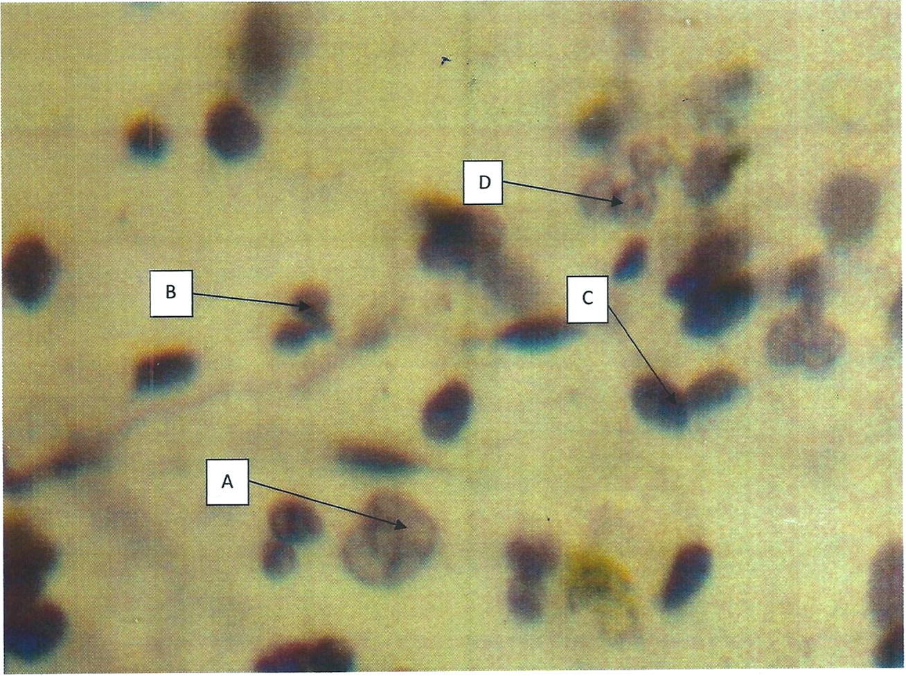
Plate 1: A shows evidence of neutrophils, B represents eosinophils in the smear. There is increased hyperchromasia of cells and they appear in clusters. Papanicoloau staining (x400)

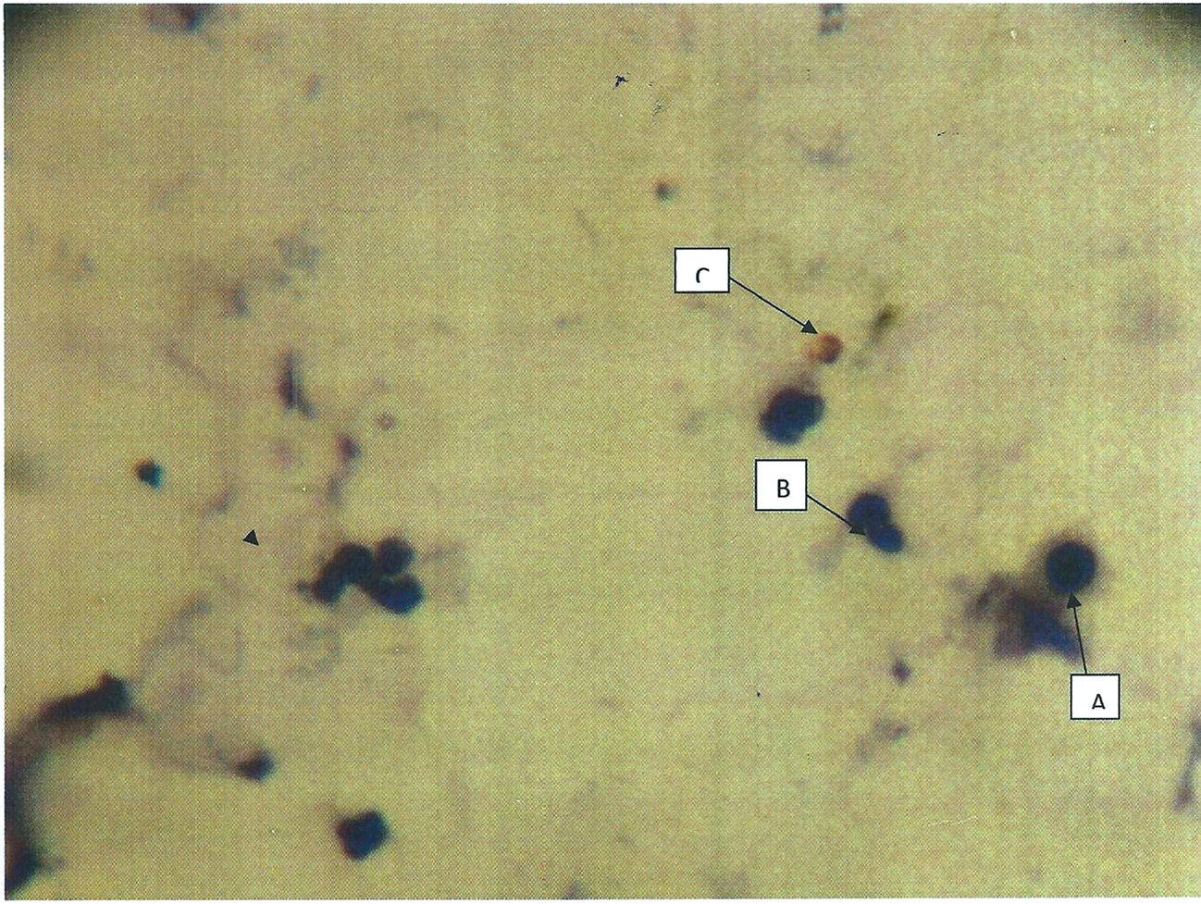
Plate 2: Cells appear in clusters and are densely hyperchromatic. Cellular pattern is suggestive of malignancy. Papanicolaou staining technique. (x200).

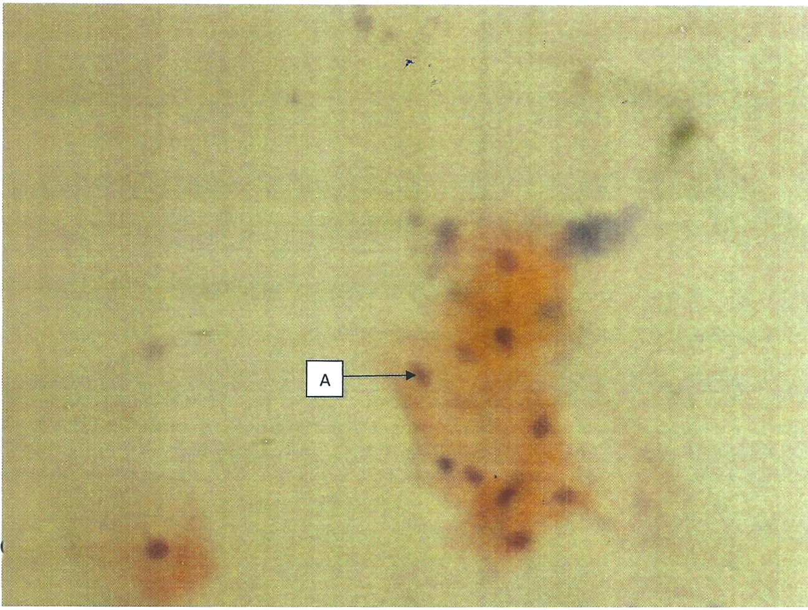
Plate 3: Above photomicrograph shows crowding of cells that are acidophilic. This picture mimicks malignancy. Stained by papanicolaou staining (x100).

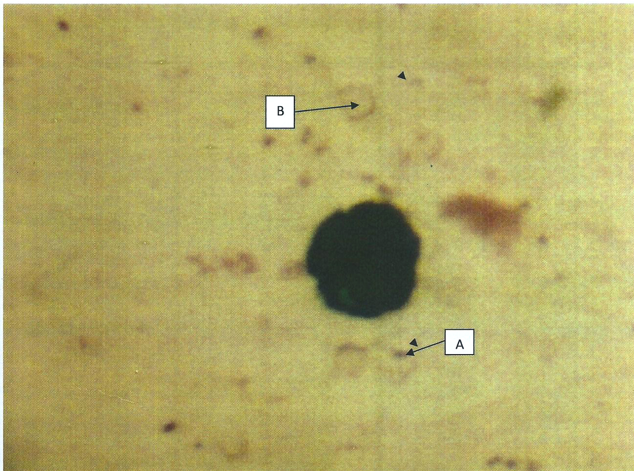
Plate 4: letter A is haemosiderin and ferric ion and B is an infiltrate nucleus. Perls Prussian blue (x100).

CHAPTER FIVE
5.0 DISCUSSION
There have been several literatures relating to this subject of study. However, several studies have been carried out on the occupational hazards following welding professions and which has been an object of research in the past decades as observed by (NIOSH, 2003).the results obtained from this study, shows the presence of abnormal squamous cells (57.69%) in the sputum specimens, which may be caused by excessive inhalation of welding electrode fumes released during the welding processes collaborated in the study by Palmer et al., (1997), who observed that 22% of welders suffer lung diseases. Abnormal squamous cell is at this level are capable of causing, lung injury and other respiratory tract damages and probably lung cancer, this work correlated also with the findings of Antonni et al., (1998), Umeafoekwe (2010), Vicki (2004), NIOSH (2003). Also, the presence of inflammatory cells (23.08%) can be stimulated due to inhalation of nickel, chromium, and manganese contained in electrode fumes and this agreed with the article of NIOSH (2003) which noted that welding fumes may pose risks for lung cancer and nervous system damages and these compounds are potential occupational carcinogens. The presence of inflammatory cells is associated with cardiovascular disease and systemic inflammation resulting from occupational exposure to welding fumes and was observed by Kimet et al., (2005). Acute inhalation of welding fumes triggers the presence of giant cells histocytes (3.85%) which can be seen in apparently healthy individuals, which is associated with tuberculosis. The presence of dust cells (15.38%) can be related to one measure of adequacy of sputum specimen. The presence of haemosiderin and ferric iron (71.15%) can be caused by poor ventilations and chronic inhalation of iron dust [particles which will lead to pneumosiderosis and this agrees well with the findings of Imram et al., (2009); Strobe et al., (2002). According to the findings of Sidan et al., (2005), iron dust particles can cause cell morphology changes and injuries can be caused when iron dust particle is deposited on cells and tissues of the respiratory tract. This correlated with the findings of Dai et al., (2009) on a 30 years old female working and grinding tungsten rod with exposure to metallic dust particles. The presence of negative (28.61%) is as a result of effective protective face mask and short term inhalations of iron dust particles as noted by Antonini et al., (1998).
5.1 CONCLUSION
From this already concluded study, it is seen there are many iron particles detected in sputum samples of welders also with evident morphological cellular changes due to inhaled fumes during the welding process over a long period of time. All these variations are as a result of long term exposure to iron dust and welding fumes as a result of poor ventilation in places where welding processes are carried out. These cell degenerations can also be seen among individuals residing around welding environments.
5.2 RECOMMENDATION
There should be strict avoidance of exposure to iron dust particles and metallic fumes coming out of welding electrodes. Places of welding processes should be well ventilated also. More importantly, the government should support welders in the importation of modern welding masks and dust filter aspirators to prevent them from inhaling the hazardous fumes and iron particles during their work.

REFERENCES
American Heritage Dictionary. (2009). The American Journal of Pathology of tissues.23(2) 66-77www.AHD.com/what is cytology?
Ammanagi, A.S., Dombale, V.D., Miskin, A.T., Dandagi, G.L., Sangolli, S.S. (2012) Sputum Cytology in Suspected Cases of Carcinoma of Lung (Sputum Cytology a Poor Man’s Bronchoscopy. Lungindia. 29(2):19-23.
Antonini, J.M., Clarke, R.W., Murthy, G.G., Streekanthan, P., Jenkins, N., Eager,
T.W. (2006) Freshly Generated Stainless Steel Welding Fumes
Induces Grater Lung Inflammation in Rats as Compared to Aged Fumes.
Toxicology. 98(3):77-86.
Antonini, G.M., Leonard, S.S., Roberts, J.R., Solano, L.C., Young, S.H., Shi, X. (2005). Effect of Stainless Steel Manual arc welding fume on free radical Production, DNA Damage and Apoptosis. Molecular Cell Biochemistry 297(3):17-23.
ASM International (2003). Trends in Welding Research. Materials Park, Ohio: ASM International. www.ASM.international/weldingresearch.com
Bethesda, M.D. (2004). Collection Development Manual of the National Library of Medicine (4th edition). Sauders publishers. India: 23-45.
Cary, H.B., Helzer, M., Scoth. C., (2005). Modern Welding Technology. Upper Saddle River, New Jersey: pp90-97.
CCINFO.(2008).www.themerck index.com/ccinfocytology.
Choi, Y.D., Han, C.W., Kim, J.H., Lee, J.S., Nam, J.H. (2008) Effectiveness of Sputum Cytology Using Thin Prep Method for Evaluation of Lung Cancer. Diagnostic Cytopathology. 36(5):167-171.
Dai J.H, Miao L.X, Xiao Y.L, Meng F.Q, Cai H.R, (2009); Giant Cell Interstitial pneumonia associated with hard metals: a case report and review of the literature’’ U.S National Library of Medicine. 23(2): 234-236.
Fidan, F., Esme, H., Unlu, M., Albayrak. R. and Dilek, F.H. (2005). Welder’s lung associated with pneumothorax. (2nd edition). Williams and Wilkins Inc
U.S.A.
Glass, W.I., Taylor, D.R., Donoghue, A.M. (1994). Chronic Interstitial Lung
Disease in a Welder of Galvanized Steel. (2nd edition). U.S. National
Library of Medicine. USA: pp90-94.
Gulec, M, Gruel, A, Armutcu, F. (2006). Vitamin E Protects Against Oxidative Damage Caused By Formaldehyde in the Liver and Plasma of Rats. Molecular Cell Biochemistry. 290(3):61-67.

Imran, K., Khalid, T.J., and Jennings, J.H. (2009). “A Welder with Pneumosiderosis: A Case Report” Journal of Scientific and Engineering. 26(2):45-48.
Johnson, A.L., Hampson, D.F., Hampson, N.B. (2008). Sputum Colour: Potential Implications for Clinical Practice. (4th edition). Sauders publishers. India:pp
453-657.
Kalpakjian, Serope; Steven R. Schmid (2001). Manufacturing Engineering and Technology.(2nd edition). Prentice Hall. USA. pp. 345-455.
Kim, J.Y., Chen, J.C., Boyce, P.D., Christiani, D.C. (2005). Exposure to welding
fumes is associated with acute systematic inflammatory responses.
Occupational environmental medicine. 62(2):157-163.
Kirkpatrick (1989). The Cassell Concise English Dictionary.(1st edition)
Watkins.London:p. 324-345.
Lincoln, E. (1994). The Procedure Handbook of Arc Welding.(1st edition).
Cleveland: Lincoln electric. USA:pp. 253-287.
Little P, Rumsby K, Kelly J, Watson L, Moore M, Warner G (2005). Information leaflet and antibiotic prescribing strategies for acute lower respiratory tract infection: a randomized controlled trial. Journal of American medical
associaton. 293(3):3029-3035.
Matti, S., Huuskonem, M.D., (1978). Sputum Cytology of asbestosis Patients; Scan Journal work environment and health. 4(2):284-294.
Ozdemir, O., Numanoglu, N., Gonullu, U., Savasi, A.D., Gurses, H. (1995); “chronic effects of welding exposure on pulmonary function tests and respiratory symptoms” Occupational Medicine. 43(2):56-59.
Palmer k, Crane G. (1997). Respiratory disease in workers exposed to colophony solder flux fumes: continuing health concerns. Occupational Medicine 47(2):491-498.
Powder technology inc. (2008). “ Material safety data sheet” archives of pathology
and Laboratory medicine. www.Powder technology inc.com/safety.
Richard F. leBlond. (2007). Diagonostics expectoration and Clinical Microbiology procedures handbook. American Society for Microbiology. 34(3):44-47.
Sjorgen, B, Hansen, KS, Kjuus, H, Person.(1994). Per-Gunnar. Exposure to
stainless steel welding fumes and lung cancer: a meta analysis.
Occupational environmental medicine. 51(2):335-336.

Solano, L.C., Zeidler-Erderly, P.C., Hubs, A.F., Reynolds, S.H., Roberts, J.R
Taylor, M.D. (2006). Welding fumes exposure and associated inflammatory
and hyperplastic changes in the lungs of tumour associated A/J mice. Toxicological Pathology. 34(3):364-372.
Stockley, R.A., O’Brien, C., Pye, A., Hill S.L (2000). Relationship of Sputum
colour to nature and outpatient management of acute
exacerbations of COPD. Chest. 117:1638-1645.
Sung, J.H., Choi, B.G., Maeng, S.H., Kim, S.J., Chung, H.C., Han, J.H. (2004).
Recovery from welding fume exposure induced lung fibrosis and
pulmonary changes in Sprague Dawley rats. Toxicological Science
82:608-613.
Umeafoekwe, J.U. (2010). Cytological study of the Respiratory Tract of Poultry feed mill workers. Research project in FSMLS-JUTH; Jos, Nigeria (Unpublished).
Vicki, B. (2003). “Health Effects of Welding” Journal of Critical Reviews in
Toxicology, 33(1):pp61-103.
Weman, Klas (2003). Welding processes hand book. New York, NY: CRC Press LLC. pp. 323-351.
Yu, I.I.J., Song, K.S., Maeng, S.H., Kim, S.J., Sung, J.H., Han, J.H. (2004).
Inflammatory and genotoxic responses during 30 days welding fume
exposure period. Toxicology. 154(3):105-115.

APPENDIX I
REAGENTS
Papanicolaou Staining
Eosin Azure 50
0.5% light green in 95% - 45ml alcohol
0.5% Bismark brown Y - 10ml
0.5% Eosin in 95% - 45ml
Phosphotungstic acid - 0.2g
Saturated aqueous lithium Cabonate – 1drop.
Perls Prussian Blue staining
Potassium ferricyande - 2%
Potassium ferricyande - 2g
Distilled water -100ml
HCL - 2%
Concentraed HCL - 2ml
Distilled water -100ml

APPENDIX II
MATERIALS USED
- Binocular light microscope
- Masking tape
-Distilled water
- Cover slips
- Hand cloves
-Laboratory coat
- Gloves
-Nose mask
- Staining racks
- DPX mountant
-Weighing balance
-Pipettes
-Reagent bottles
-Xylene
-Stop watch
-95% alcohol
-Slide box

