# CONTINUOUS QUALITY IMPROVEMENT IN A PRODUCTION LINE: NIGER DELTA UNIVERSITY TABLE WATER FACTORY, A CASE STUDY

**BY**

# MUNEMUNE EBITIMI ARTHUR (B. Eng, IUO) PG/19/016732/ENG

**IGBINEDION UNIVERSITY, OKADA**

# CONTINUOUS QUALITY IMPROVEMENT IN A PRODUCTION LINE: NIGER DELTA UNIVERSITY TABLE WATER FACTORY, A CASE STUDY

**BY**

# MUNEMUNE EBITIMI ARTHUR (B. Eng, IUO) PG/19/016732/ENG

**DEPARTMENT OF MECHANICAL ENGINEERING (ENGINEERING MANAGEMENT),**

# GEN. ABDUL SALAM ABUKAKAR COLLEGE OF ENGINEERING, IGBINEDION UNIVERSITY

**OKADA, EDO STATE, NIGERIA.**

# CONTINUOUS QUALITY IMPROVEMENT IN A PRODUCTION LINE: NIGER DELTA UNIVERSITY TABLE WATER FACTORY, A CASE STUDY

**BY**

# MUNEMUNE EBITIMI ARTHUR (B. Eng, IUO) PG/19/016732/ENG

**SUPERVISOR: ENGR. DR. ANDREW AMAGBON ERAMEH**

# CONTINUOUS QUALITY IMPROVEMENT IN A PRODUCTION LINE: NIGER DELTA UNIVERSITY TABLE WATER FACTORY, A CASE STUDY

**BY**

# MUNEMUNE EBITIMI ARTHUR (B. Eng, IUO) PG/19/016732/ENG

**Being a thesis submitted to the Gen. Abdul Salam Abukakar College Of Engineering in partial fulfillment of the requirements for the award of a Masterof Science (M.Sc) degree in Engineering Management of Igbinedion University, Okada, Edo State, Nigeria.**

# CERTIFICATION

### This research work, CONTINUOUS QUALITY IMPROVEMENT IN A PRODUCTION LINE: NIGER DELTA UNIVERSITY TABLE WATER FACTORY,

**A CASE STUDY,** was carried out in the Department of mechanical Engineering, Gen. Abdulsalami A. College of Engineering Igbinedion University, Okada, Edo State, by MUNEMUNE EBITIMI ARTHUR with Matric. PG/19/016732/ENG and is hereby certified.

……………………………… ……………………………….

Engr. (Dr.) Andrew Amagbon Erameh Date Project Supervisor

……………………………… ……………………………….

Engr. (Dr.) Andrew Amagbon Erameh Date Head of Department

……………………………… ………………………………. Engr. (Prof.) Date

External Examiner

PLAGIARISM TEST

DEDICATION

This project work is fondly dedicated to the loving memory of my late father, Mr. Munemune Arthur Ebunughe. Painfully departed in his prime; your children, by grace, walked through time, to keep your memory chime on mortal clime.

ACKNOWLEDGEMENT

I am grateful to God, for His grace which enabled me to complete this project and programme amidst the daunting challenges.

My first line of appreciation goes to my supervisor and HOD, Engr. (Dr.) Erameh A. A. for his scholarly supervision and guidance. To all my other lecturers, Engr. (Dr.) (Mrs) Kingsley-Omoyibo Q.A., Engr. Emifoniye E. U, Engr. Eze A. M. and Engr. (Mrs) Akhimien F., other lecturers, Engr. Adingwupu A.C. (Disscussant), Engr. Aregbe O., Engr. (Dr.) (Mrs) Ezugwu M.O and the entire staff of College of Engineering, I am indebted to you all for offering support during the critical stages of this project.

I would like to express my profound thanks to Dr. ThankGod Apere, Director, Directorate of Consultancy, Entrepreneurship, Research and Development, Niger Delta University (NDU). I am also indebted to Mr. Julius Egbefa, HOD, Quality Control Department of the NDU Water Factory, Bayelsa State for facilitating the data collection.

I do appreciate my family members, mother and siblings for prayers and support.

My deepest appreciation goes to my uncle, late HRH A. A Allison, for enlisting me to be part of the beneficiaries of the Federal Government Scholarship offered to the Chevron host communities as a result of the 16th January, 2012 K.S Endevour gas explosion in the coastal part of Southern –Ijaw LGA of Bayelsa State, which led to my Bachelor’s degree and was extended this to Master’s degree.

I must acknowledge the patience and sacrifices of my beloved wife, Munemune Gesiye Mercy, believing and following this lofty drive. She has been very supportive and considerate throughout my programme; outstandingly, she managed well the home front, striving with our children all alone, thus, keeping me at peace. You are loved dearly. Finally, to my lovely children, Aviel, Amiel, Aziel and Adiel, daddy loves you all.

TABLE OF CONTENTS

CERTIFICATION i

PLAGIARISM TEST ii

DEDICATION iii

ACKNOWLEDGEMENT iv

LIST OF TABLES viii

LIST OF FIGURES ix

ABSTRACT x

CHAPTER ONE 1

* 1. Background to the study 1
  2. Statement of the Problem 3
  3. Aim and Objectives of the Project Work 4
     1. Aim of the Project Work 4
     2. Objectives of the Project Work 4
  4. Scope of the Project Work 4
  5. Economic Importance of the Project Work 4

CHAPTER TWO 6

LITERATURE REVIEW 6

* 1. Introduction 6
  2. The Concept of Quality 6
  3. Dimensions of Quality 7
  4. Quality Costs 8
  5. Quality Improvement 11
  6. Continuous Quality Improvement 12
  7. Lean Methodology 12
     1. Concept and Meaning 12
     2. Types of Wastes 13
     3. Functional Modules 14
  8. Six Sigma Methodology 14
     1. Concept and Meaning 14
  9. Lean Six Sigma (LSS) 16
  10. Process Flow Chart (PFC) 17
  11. Process Stability Analysis 18
      1. Control Charts 18
  12. Process Capability Analysis 27
      1. Process Capability Indices (Ratios) 28
      2. Applications of Process Capability Indices 29
  13. Review of Applications of Lean Six Sigma (LSS): DMAIC methodology 30
      1. Statistical Process Control on Production: A Case Study of Some Basic Chemicals Used in Pure Water Production 30
      2. An approach for the application of statistical process control techniques for quality improvement of treated water 31
      3. Application of Statistical Quality Control in Monitoring the Production, Packaging and Marketing Process of Sachet Water 31
      4. Management of the Production Process of a Water Bottling Plant to Improve Quality: A Case Study 32
      5. The Application of Lean-Six-Sigma Methodology in the Manufacturing Sector: A Case Study of Nigerian Breweries 32
      6. Statistical Process Control Applied in the Chemical and Food Industry 34
  14. Review of Related Literatures 34

2.14.3 An assessment of sachet water quality in Zaria Area of Kaduna State, Nigeria 36

* 1. Water Quality Parameters 38
     1. Physicochemical Water Quality Parameters 38
  2. Research Gap 40

CHAPTER THREE 41

MATERIALS AND METHOD 41

* 1. Introduction 41
  2. Materials 41
  3. Methodology 44
     1. Define 44
     2. Measure 48

CHAPTER FOUR 52

RESULTS AND DISCUSSION 52

* 1. Data Analysis and Interpretation 52
     1. Descriptive Statistics 52
     2. Process stability Result 53
     3. Process Capability Result 66
  2. Findings 67

CHAPTER FIVE 69

CONCLUSION AND RECOMMENDATION 69

5.0 Conclusion 69

* 1. Recommendation 70
  2. Suggestions for Further Research 70

REFERENCES 72

APPENDICES 81

# LIST OF TABLES

TABLE 3 1 RAW WEEKLY MEAN VALUES OF WATER QUALITY PARAMETERS FROM JAN. – DEC. 2020 43

TABLE 3 2 CRITICAL TO QUALITY (CTQ) WATER PARAMETERS 45

TABLE 4. 1 *DESCRIPTIVE STATISTICS OF WATER QUALITY PARAMETER AND PARAMETRIC VALUES* 53

TABLE 4. 2 *I-CHART: TESTS AND FAILURE POINTS (WEEKS)* 64

TABLE 4. 3 *MR-CHART: TESTS AND FAILURE POINTS (WEEKS)* 65

TABLE 4. 4 *PARAMETERS AND FAILED TESTS* 66

TABLE 4. 5 *CONTROL CHART RUN TEST DESCRIPTION* 66

# LIST OF FIGURES

FIGURE 3. 1 NIGER DELTA UNIVERSITY TABLE WATER TREATMENT PROCESS CHART 46

FIGURE 4. 1 *I-MR CHART OF PH* 55

FIGURE 4. 2 *I-MR CHART OF CONDUCTIVITY* 56

FIGURE 4. 3 *I-MR CHART OF TURBIDITY* 57

FIGURE 4. 4 *I-MR CHART OF HARDNESS* 57

FIGURE 4. 5 *I-MR CHART OF ALKALINITY* 58

FIGURE 4. 6 *I-MR CHART OF CHLORIDE* 58

FIGURE 4. 7 *I-MR CHART OF TDS* 59

FIGURE 4. 8 *I-MR CHART OF NITRATE* 59

FIGURE 4. 9 *I-MR CHART OF SULPHATE* 60

FIGURE 4. 10 *I-MR CHART OF CALCIUM* 60

FIGURE 4. 11 *I-MR CHART OF MAGNESIUM* 61

FIGURE 4. 12 *I-MR CHART OF IRON* 61

FIGURE 4. 13 *I-MR CHART OF LEAD* 62

FIGURE 4. 14 *I-MR CHART OF COPPER* 62

FIGURE 4. 15 *I-MR CHART OF ZINC* 63

FIGURE 4. 16 *PROCESS CAPABILITY REPORT OF IRON* 67

APPENDIX 1 *FACTORS FOR CONTROL CHART CONSTANTS* 81

APPENDIX 2 PHYSICOCHEMICAL ANALYSIS FOR NDU TABLE WATER (TREATED WATER SAMPLE) 83

APPENDIX 3 NDU TABLE WATER FACTORY PRODUCTION PROCESS PHOTOGRAPHS 85

# ABSTRACT

Potable drinking water quality is a major concern, particularly as it is used for human consumption. Quality is a competitive weapon. It increases customer base, high profit margin and prevents business closure.

The aim of this research is to evaluate the current performance of the water production process stability and capability for enhanced continuous improvement using a specific set of tools from the Lean Six Sigma (LSS) methodology.

This research was carried on the mean weekly laboratory results of some of the physicochemical water parameters (pH, conductivity, turbidity, total hardness, total alkalinity, chloride, Total Dissolved solids (TDS), nitrates, sulphate, calcium, magnesium, iron, lead, copper and zinc) conducted for official regulatory purpose by the Quality Control Department of the Niger Delta University (NDU) Table Water Factory for 50 weeks, January to December, 2020.

The data obtained were analyzed using descriptive statistics and control charts with the use of Minitab 2021 ® Statistical software package. Control chart was applied in the analysis of water quality in this water factory, as it provides a clear pictorial view about the variability in the production line with respect to the parameters under review.

The values of the water quality parameters were found to be within the limits permitted by Standard Organization of Nigerian and World Health Organization standards for portable drinking water (exception of the minimum value of the pH obtained, 6.01, is less than the minimum standard value of 6.5 and the maximum value of Lead, 0.04, greater than the maximum permitted value of 0.01). The values of the parameters (except iron) in the control charts were beyond the conventional limits (upper and lower limits) at various points in time (week) throughout the period, hence, failed the test and indicated process variability due to assignable causes.. The results of the present research showed that, the water production process is not stable and capable due to occurrence of special causes of variability in the production line for all the parameters.

Since meeting specification limits is not sufficient to ensure good quality characteristics, the need for investigations to correct and control the variability of the process, hence, allowing improvement in the production line is, therefore, recommended.

* 1. **Background to the study**

# CHAPTER ONE

Quality is a competitive weapon (Ihunwo and kinigom, 2016). In today’s world, organizations strive at attaining high competitive edge in the global marketplace (Kandampully, 1998). This is done to ensure increased customer base, prevent loss of revenue and business closure (Gibbons, 2011). Therefore, satisfaction of customer expectation becomes a glaring focus in their organizational quality philosophy. One way of achieving this, is by continuous improvement in the business processes to be more effective and efficient in the resource utilization without devaluing the business in the eyes of the customer, as is the case of Toyota **(**Gibbons, 2011**).** Continuous improvement is the reduction in variability in process and product and it is one of the goals of quality. The effective implementation of continuous improvement by an organization is a key parameter for its success (Salah, et al, 2010 B).

There are many different conceptions, methods and tools that may be used to maintain the good quality level and help in continuous improvement in an organization (Smętkowska and Mrugalska 2018). Two of such methods, which were later integrated into one, are lean and six sigma. Lean production (also known as lean manufacturing, lean management or just lean) is a very popular managerial framework used for organizational improvement and focused on waste elimination and cost reduction (Titov, et al, 2016). According to (Salah, et al, 2009), Six Sigma is a collection of process improvement tools used in a series of projects in a systematic way to achieve high levels of stability. It is based on principles set up by quality experts, such as Deming, Juran, Shewart and Ishakawa. Also, (Salah, et al, 2009) in citing (Breyfogle, 2003); indicated that, the term Sigma is the sound of the Greek letter (σ) that is usually used to refer to the standard deviation which is a measure of the

variation or spread in a process output around its mean value (μ). Quantitatively, Six Sigma quality means only two defects per billion opportunities fall outside the upper and lower specification limits (Salah, et al, 2009).

However, there will be a drawback in continuous improvement running slow in their application if done separately (Salah, et al, 2010 A). Individually, lean manufacturing and Six Sigma are unable to reach the improvement rates that Lean Six Sigma (LSS) is achieving (Drohomeretski, et al, 2014). Therefore, their integration and deployment as Lean Six Sigma (LSS) approach in continuous improvement has proven to be the best methodologies widely accepted by various industries and regarded as state of the art (Salah, et al, 2009). Lean Six Sigma (LSS) is a combination of Six Sigma, a process-improvement methodology that focuses on delivering products at a lower cost, with improved quality and reduced cycle time by reducing process variation, and Lean, a process-improvement methodology that focuses on removing non-value-added activity and aligning production with customer requirements (Duffy, 2016). Lean Six Sigma (LSS) methodology creates an opportunity to improve the products, satisfying the customers’ needs and requirements and increasing profits and directs the management to treat the defect reducing defects ratio (Omoush, 2020). In (Salah, et al, 2009), George (2002) defines Lean Six Sigma (LSS) as a methodology that helps companies achieve better cost, quality, speed, customer satisfaction and rates of improvement. Lean Six Sigma (LSS) uses the define-measure-analyze-improve- control (DMAIC) process to solve problems, achieve customer satisfaction with regards to quality, delivery and cost (Salah, et al, 2010 B). The methodology is data centric with excellent tools that are powerful because they offer statistical validity (Salah, 2018).

### Statement of the Problem

Globalization has come with it the challenge of high competiveness among production and services related businesses. The need for meeting customer satisfaction is a yardstick every business is striving to attain in order to make an edge in the market place.

Most business organizations have rather leaned on quality policies inclined towards the end of production to detect product defects **(**Krishnamoorthi, et al 2018**).** This is product quality control with grave consequences in the form of internal failure and external failure costs such as scrap, rework or salvaged, retest and penalty for not meeting schedule and complaint adjustment, product return and warranty charges respectively (Krishnamoorthi, et al 2018). Rather, quality policies should be built around the process quality control, which will enable prevention of product defects.

Lean Six Sigma (LSS) has rapidly established itself as the key business process improvement strategy of choice for many companies **(**Hill, 2018). As asserted by (Uzorh, et al, 2019), currently in many companies, Lean Six Sigma is improving their results from the last years. Hence, an attempt can be made to replicate it in the potable water production industry too.

In view of the above, the research intend to deploy the Lean Six Sigma (LSS) approach to ensure continuous improvement of production process aimed at reduction in the process variability and the continuous improvement in process capabilities which will reduce waste in cost, improve product quality and enhance customer satisfaction.

* 1. **Aim and Objectives of the Project Work**

### Aim of the Project Work

The aim of this research is to evaluate the water production process stability and capability for enhanced continuous improvement using a specific set of tools from the Lean Six Sigma (LSS) methodology.

### Objectives of the Project Work

To achieve this aim, the following objectives would be pursued:

* + - 1. To collect data and measure the current performance
      2. Evaluate the process stability and capability
      3. Check for variance between laboratory and process results

## Scope of the Project Work

Lean Six Sigma (LSS) has been used across a wide range of industries to improve product delivery both from an effective and efficient standpoint. This research work reviewed the deployment of Lean Six Sigma (LSS) to the Niger Delta University table Water Factory, in particular the production process lines. Some of the physicochemical water quality parameters were determined due to the exigency of time and cost and all data shall be restricted to the primary source, the company.

## Economic Importance of the Project Work

According to (Bain et al, 2020), access to safe drinking water is recognized as a human right and has long been a goal of national and international policy, as captured by the United Nations’ Sustainable Development Goals (SDGs), which includes ambitious global targets for drinking water, sanitation and hygiene. However, (Weststrate et al, 2019) revealed that, there are shortcomings in the indicators for safe water, which fail to take water quality into account.

(Smeti, et al, 2007) indicated that, for some of the continuous chemical water quality characteristics, specification limits are given by the guidelines. However, (Smeti, et al, 2007) questioned, whether it is enough for these quality characteristics to be inside the specification limits. As such, (Smeti, 2007) stated that many authors like (Deming, 1986) have argued that meeting specification limits is not sufficient to ensure good quality water characteristics. To further highlight this need, (Follador et al, 2012) stated that, the physical, chemical and biological processes that characterize water quality endure large variations in time and space, and there is a need for a systematic monitoring program for a real estimate of the variation of water quality.

From the foregoing, the importance of this study cannot be over emphasized owing to the fact that, improving product and service quality on a continuous basis is the key to improving customer satisfaction, increasing productivity, and remaining competitive in the marketplace. In deploying Lean Six Sigma (LSS) approach in the potable water production at the Niger Delta University Water Factory, it will not only eliminate the need for final inspection, identify the causes of variation (if any) but equally improve the efficiency and effectiveness in the production process. The result will be an improvement in the production processes and direct increase in bottom line profitability as there will be reduction in waste associated with product defects, overproduction, waiting time, non-use of talents, transportation, inventory, motion and extra processing; process variability reduction; and continuous capability improvement, which will improve product quality and customer satisfaction.

The findings from this study will also in the long run reveal the benefits of Lean Six Sigma (LSS) approach to discover opportunities for improvement, make the improvements, and maintain the improved positions of the production process.

# CHAPTER TWO

# LITERATURE REVIEW

## Introduction

In this chapter, the concepts of quality and quality improvement, the improvement methodologies of Lean and Six Sigma is presented, as well as the integration of the two, Lean Six Sigma. Also discussed are the tools of Lean Six Sigma that are used in discovering opportunities for improvement, making the improvements, and maintaining the improved positions.

## The Concept of Quality

Quality is a relative term, generally used with reference to the end use of the product (Jayakumar and Raju 2016). This is corroborated, according **to** (Summers, 2018**),** by the American Society for Quality, which defines quality as a subjective term for which each person has his or her own definition.

However, in technical terms, several authorities have given their definitions of quality. As cited by (Summers, 2018), the American Society for Quality have two meanings: (1) the characteristics of a product or service that bear on its ability to satisfy stated or implied

needs and (2) a product or service free of deficiencies. The following professionals as cited

in (Summers, 2018) gave their definitions too. (Deming, 1986) describes quality as non- faulty systems. That non-faulty systems are error-free systems that have the ability to provide the consumer with a product or service as specified. (Juran, 1995) describes quality as fitness for use, while (Crosby, 1979) discusses quality as conformance to requirements and non-quality as nonconformance. According to the ISO 9000 standards as cited by (Krishnamoorthi, et al 2018), quality is defined as the “degree to which a set of inherent characteristics fulfills requirements. (Montgomery, 2009) argued that, a modern definition of quality is preferable, which is, quality is inversely proportional to variability. Hence, he noted that, this definition implies that if variability in the important characteristics of a product decreases, the quality of the product increases.

## Dimensions of Quality

Quality as many dimensions (Jayakumar and Raju, 2016), which could be objective and subjective as well. Dimensions of Quality are the various features / aspects of a product or service, which the customer uses to evaluate the product or service (Jayakumar and Raju, 2016).

As quoted by (Krishnamoorthi, et al 2018), Garvin expressed quality in several dimensions

1. Performance—the product’s ability to do the work it is supposed to do.
2. Features—things that add to convenience and comfort.
3. Reliability—the ability to perform without failure over time.
4. Conformance—the degree to which the product meets codes of a state or a community.
5. Durability—the length of time the product will last until it is discarded.
6. Serviceability—the ability for making repairs easily, quickly, and at a reasonable cost.
7. Aesthetics—sense appeal, such as color, sound, feel, and comfort.
8. Perceived quality—the impression the product creates in the customer’s mind.
9. Responsiveness – is the measure of how well the manufacturer of the product is able to adapt.

The above was also corroborated by (Jayakumar and Raju, 2016), however, added the ninth dimension, which is responsiveness.

## Quality Costs

Every manufacturing or service process incurs various types of costs to produce quality product or service satisfy the needs of customers. These categories of costs that are associated with producing, identifying, avoiding, or repairing products that do not meet requirements are called quality costs (Montgomery 2009). These costs, which are prevention, appraisal and failure costs were wrapped into the so-called P-A-F model first presented by Feigenbaum (Oakland, 2014). The prevention and appraisal costs are those incurred in producing quality products, while the costs of not producing quality, termed failure costs are further divided into internal failure costs, and external failure costs (Krishnamoorthi, et al 2018).

According to (Montgomery 2009); (Pyzdek and Keller, 2010); (Oakland, 2014); (Krishnamoorthi, et al 2018), the following are the components of the quality costs.

**Prevention Costs:** These are expenses incurred in preventing the production of defective products. Examples under this category includes:

**Quality Planning -** This is the cost incurred in preproduction activities such as a review of drawings, specifications and test procedures, and selection of process parameters and control procedures to assure the production of quality products.

**Product/Process Design** - Costs incurred during the design of the product or the selection of the production processes that are intended to improve the overall quality of the product.

**Training -** The cost of developing, preparing, implementing, operating, and maintaining formal training programs for quality.

**Process control** - The cost of process-control techniques, such as control charts, that monitor the manufacturing process in an effort to reduce variation and build quality into the product.

**Quality Data Acquisition and Analysis** -The cost of running the quality data system to acquire data on product and process performance; also the cost of analyzing these data to identify problems.

**Quality Information System** - Gathering information on quality, such as data on quality characteristics, the number and types of defectives produced, the quality performance of suppliers, complaints from customers, quality cost data, summarizing and publishing quality information for management.

**System Development** - The amount of time and material expended in creating a quality system, including the documentation of policies, procedures, and work instructions.

**Appraisal Cost**: This is the cost incurred in appraising the condition of a product or material with reference to requirements or specifications. The following are the major components of this cost:

**Product Inspection and Test -** The cost of checking the conformance of the product throughout its various stages of manufacturing, including final acceptance testing, packing and shipping checks, and any test done at the customer’s facilities prior to turning the product over to the customer. This also includes life testing, environmental testing, and reliability testing.

**Materials and Services Consumed** - The cost of material and products consumed in a

destructive test or devalued by reliability tests.

**Maintaining Accuracy of Test Equipment** - The cost of operating a system that keeps the measuring instruments and equipment in calibration.

**Internal Failure Cost:** These costs arise from defective units produced but getting detected before being shipped to the customer. This is the cost arising from the lack, or failure, of process control methods, resulting in defectives being produced. They includes:

**Scrap** -The net loss of labor, material, and overhead resulting from defective product that cannot economically be repaired or used.

**Rework or Rectification** - The correction of defective material or errors to meet the requirements.

**Retest** - The cost of re-examination and retesting of products that have undergone rework or other modifications.

**Downgrading** - A product that is usable but does not meet specifications may be downgraded and sold as ‘second quality’ at a different price.

**Failure Analysis**: The cost incurred to determine the causes of internal product or service failure.

**Downtime** - The cost of idle production facilities that results from nonconformance to requirements. The production line may be down because of nonconforming raw materials supplied by a supplier, which went undiscovered in receiving inspection.

**Yield Losses -** The cost of process yields that are lower than might be attainable by improved controls (for example, potable water containers that are overfilled because of excessive variability in the filling equipment).

**External Failure Costs:** These costs occur when the product does not perform satisfactorily after it is delivered to the customer. . Examples of external failure costs includes:

**Complaint Adjustment** - All costs of investigation and adjustment of justified complaints attributable to the nonconforming product.

**Returns and Recalls** - All costs associated with receipt, handling, and replacement of the nonconforming product or material that is returned from the field.

**Warranty Charges** - All costs involved in service to customers under warranty contracts.

**Liability Costs** - Costs or awards incurred from product liability litigation.

**Loss of Good Will** - The impact on reputation and image, which impinges directly on future prospects for sales.

**Repair and Servicing** - The costs of repair and servicing either of returned products or those in the field.

There exists a relationship between the qualities related costs of prevention, appraisal and failure and increasing quality awareness and improvement in the organization (Oakland, 2014). Citing British Standard BS 6143, (Oakland, 2014) stated that, where the quality awareness is low the total quality related costs are high, with the failure costs predominating. As awareness of the cost to the organization of failure gets off the ground, through initial investment in training, an increase in appraisal costs usually results. As the increased appraisal leads to investigations and further awareness, further investment in prevention is made to improve design features, processes and systems. As the preventive action takes effect, the failure and appraisal costs fall and the total costs reduce.

### Quality Improvement

(Montgomery, 2009) defined quality improvement as the reduction of variability in processes and products. He stated that, excessive variability in process performance often results in waste**.** This means, reduction of variability (elimination of the waste) leads to

improvement of the quality of the process and quality of the products (Krishnamoorthi, et al 2018). (Krishnamoorthi, et al 2018), further stated that, discovering problems or improvement opportunities in processes and making process improvements to achieve improved product quality and customer satisfaction is a non-ending, continuous process. This is where continuous quality improvement becomes so needful.

### Continuous Quality Improvement

This involves the set of activities used to ensure that the products and services meet requirements and are improved on a continuous basis (Montgomery, 2009). However, to achieve the triple factor of continuous quality improvement, which are, productivity, sustainability and value addition (Rostamkhani and Karbasian, 2020), both managerial and statistical methodologies are applied (Montgomery, 2009).

### Lean Methodology

### Concept and Meaning

The term “lean manufacturing” refers to the production system created by the Toyota Motor Corporation to deliver products of right quality, in right quantity, at the right price, to meet the needs of the customer (Krishnamoorthi, et al 2018). This technique originated during the quality evolution in Japan and Toyota (Rathilall and Singh 2018). Lean focuses on efficiency to produce products and services as fast as possible and at lowest cost (Supriyanto and Maftuhah, 2017). It is a set of tools and a process methodology that attempts to deliver the higher quality and make the processes more flexible and more responsive, all this at the lowest cost and in the least time possible. The key to achieving this is to determine and eliminate waste in the process **(**Marco, 2019). According to **(**Huval**,** 2016), lean manufacturing has become more prominent over the past years due to companies wanting to improve processes through the elimi,nation of waste and also accounts for throughput per

customer demand. Therefore, the concept of waste became one of the most important

concepts in quality improvement activities and the first idea by Taichi Ohno’s famous production philosophy from Toyota in the early 1990s (Supriyanto and Maftuhah, 2017).

### Types of Wastes

(Fitzmaurice, 2010), stated that, (Womack and Jones, 2003) refer to waste as human activities which absorb resources but do not create value. (Ali, 2016) quoting (Piercy and Rich, 2009), stated that, the most common acronym ‘DOWNTIME’ used to represent the different kinds of wastes.

1. **D**efects refers to the mistakes which require rectification. This includes anything that requires rework
2. **O**ver-production of goods that are not required or making more than is immediately required.
3. **W**aiting refers to goods awaiting processing or consumption. For instance people are waiting in a queue at multiple locations.
4. **N**on-utilised resources/talents. Not using the full potential of the staff or being disconnected from the customers and suppliers.
5. **T**ransportation of goods between processes without purpose. Manifestations include where the work is transferred from one person to another
6. **I**nventory half-completed products which are waiting to be processed are considered as unnecessary inventory.
7. **M**otion is the unnecessary movement of employees and products – people moving or working without producing. Meetings are motion in the sense that they are work without producing, unless a decision is made or information is produced during the meeting.
8. **E**xcess processing for goods and services that do not meet the customer needs. This is due to tighter tolerances.

### Functional Modules

As stated by (Krishnamoorthi, et al 2018), the lean system can be considered to have the following three major functional modules:

**Quality control**: The objective of this module is to deliver to the customer a product (or service) that is designed and produced such that it will meet their needs and delight them in its use.

**Quantity control**: This refers to producing only the amount of product the customer has requested, not more, not less. This type of “lean” production is in contrast to producing large quantities of products and stocking them in inventory in anticipation of customer demand.

**Waste and cost control**: Lean production achieves this through the Value Stream Map. A value stream map is a flow process chart that enables identifying those operations that add value to the product and those that do not add value. A value adding operation is one that contributes to converting the raw material into the product in the shape and form that the customer wants.

Many of the components of the lean system are indeed continuous improvement approaches to improve quality, eliminate waste, streamline operations, and reduce overall costs, thus enabling quality products delivered to the customer at the least price (Krishnamoorthi, et al 2018).

### Six Sigma Methodology

### Concept and Meaning

Six-sigma concept was introduced by Bill Smith in 1986, a senior engineer and scientist within Motorola’s communication division in response to problem associated with high warranty claims (Supriyanto and Maftuhah, 2017; Summers, 2018). This technique originated during the quality evolution in Japan and Motorola and was officially launched

at Motorola in 1987 to sustain final product quality by focusing on obtaining significantly higher conformance levels (Rathilall and Singh 2018).

**(**Tiberiu, 2013) has elaborated on Six Sigma in the following ways.

**Business Strategy:** It helps a business to strategize its plan of action and drive revenue increase, cost reduction and process improvements in all parts of the organization.

**Vision:** Six Sigma Methodology helps the senior management create a vision to provide defect free, positive environment to the organization.

**Benchmark:** Six Sigma Methodology helps in improving process metrics. Once the improved process metrics achieve stability; we can use Six Sigma methodology again to improve the newly stabilized process metrics.

**Goal:** It helps organizations to keep a stringent goal for themselves and work towards achieving them during the course of the year. Right use of the methodology often leads these organizations to achieve these goals.

**Statistical Measure:** Six Sigma is a data driven methodology. Statistical Analysis is used to identify root-causes of the problem. Additionally, Six Sigma methodology calculates the process performance using its own unit known as Sigma unit.

**Robust Methodology:** Six Sigma is the only methodology available in the market today which is a documented methodology for problem solving. If used in the right manner, Six Sigma improvements are clear proofs and they give high yielding returns.

Sigma is a Greek alphabetical letter σ representing standard deviation or the amount of variation within a given process (Oakland, 2014). In (Sambhe, 2012), Six Sigma is defined as a statistical measure of the performance of a process or product. When a process is running at a 6σ level it means that the process is six standard deviations away from the

customer specification limits, in other words only average of 3.4 defects are produced per million products **(**Tikkala**,** 2014).

A fundamental of six-sigma is the relationship between the output of a process known as the Y, and the inputs known as the Xs **(**Gibbons**,** 2011). According to (Gibbons, 2011), (De Feo and Barnard 2004), asserted that, what comes out of a process is determined by what goes in; the output Y is a function of the input Xs. In mathematical terms, this is stated as Y

= f (*x1*, *x2, xn).*

The basic goal of a six-sigma strategy is to reduce variation of performance characteristic. In order to improve the quality, it is imperative to measure quality variation and then developed potential strategies to reduce variation (Supriyanto and Maftuhah, 2017).

The benefits of Six Sigma in organizations has been enormous. According to **(**Tiberiu, 2013), Six Sigma in its evolutionary history has boosted Business Strategies into various aspects such as:

1. Improving Processes
2. Lowering Defects
3. Reducing Process Variability 4 Reducing Costs
4. Increasing Customer Satisfaction
5. Increasing Profit

### Lean Six Sigma (LSS)

Lean Six Sigma (LSS) is an integration of both Lean and Six Sigma philosophies and the reasons behind its creation mainly lie in the synergies these two distinct methods offer for each other (Tikkala, 2014). Lean and six-sigma both are emphasis of process flow. Lean

focuses on reduction of cost by eliminating all sorts of non-value adding activities or wastes. Six-sigma focuses on reduction of cost by systematically sorting cost of poor quality items along processes (Supriyanto and Maftuhah, 2017). According to (Rathilall and Singh, 2018), within the context of Lean, the objective is to eliminate waste throughout a manufacturing system whereas Six Sigma, concentrates on reducing defects in a process. Therefore, they can be seen as complementary as both bodies of knowledge are needed to effectively solve problems encountered by an organization.

(Shirey, 2017) stated that the application of Lean Six Sigma (LSS) for deploying quality improvement (QI) has proliferated in the 21st century, and is becoming the de facto approach for business and industry. Lean Six-Sigma (LSS) is an approach that has been proven and applied in many manufacturing floors (Supriyanto and Maftuhah, 2017). (Shirey, 2017) inferred that, because Lean Six Sigma (LSS) methodology is adaptable, researchers encourage trial applications in new fields, which can lead to success if applied carefully. According to (Huval, 2017), Lean Six Sigma is a structured method of implementing process improvements using its DMAIC—Define, Measure, Analyze, Improve, and Control strategy with a variety of tools. Lean Six Sigma (LSS) has the same DMAIC improvement process as the original Six Sigma, but in addition to Six Sigma tools, Lean tools are also incorporated into the different steps. Whereas Six Sigma mainly focuses on defect and variation reductions, Lean adds more focus on process standardization and simplification as well as waste reduction (Tikkala, 2014).

### Process Flow Chart (PFC)

The process flow chart (PFC) is a schematic representation of the operations, or activities, starting from raw material and leading to the production of the final product (Krishnamoorthi, et al 2018). It is used in the measure stage to document the current process, while in the analyze phase, is reviewed to reveal difficulties in the process that may

contribute to delays or even defects. In the flowchart, each task is represented by a symbol, which represent processes, decisions, storage, transportation, etc. (Montgomery, 2009, Pyzdek and Keller, 2010).

### Process Stability Analysis

This qualitative analysis is carried out to evaluate the variability of the routinely monitored quality parameters of a process or product by the use of control charts. The process is to analyze for issues and root causes **(**Shirey, 2017).

### Control Charts

The control chart is a graphical display of a quality characteristic that has been measured or computed from a sample versus the sample number or time (Montgomery, 2009). (Conceição, et al, 2018) in citing (Montgomery, 2004), stated that, control charts are hypothesis tests where the process is in a state of statistical control, that is, a plot point within the control limits is equivalent to not rejecting the statistical control hypothesis and a plot point out of bounds is equivalent to the rejection of this hypothesis. It is a development by Dr. Shewhart, to enhance the analysis of a process by showing how that process performs over time (Summer, 2018). The control chart displays the quality characteristic of interest plotted against time.

A control chart typically has a centerline (CL) and two control limits—an upper control limit (UCL) and a lower control limit (LCL). The centerline and control limits help define the in control central tendency and natural variability of the process, respectively. The centerline is almost always set equal to the arithmetic mean or expected value of the plotted statistic, so that approximately half of the subgroup values will fall on each side. The control limits are then usually set equal to the centerline plus and minus three theoretical standard deviations of the plotted values (Benneyan**,** 1998**).** The upper and lower control limits of

approximately ± 3 standard deviations on each side of the average are calculated from the data. The control limits contain 99.7% of the data from the system and cover the range of expected values for the process during the result of normal operations. The control chart assumes that the data come from a normal (bell-shaped or Gaussian) distribution (Young, et al 2019).

Control charts are plotted on a rectangular coordinate axis- vertical scale (ordinate) representing the statistical measures X̅ and R̅ and horizontal scale (abscissa) representing the sample number. Hours, dates or lot numbers may also be represented on the horizontal scale. Sample points, mean or range are indicated on chart by points, which may or may not be joined (Bhasin et al, 2016).

Control charts are used in two distinct phases. In the first phase, control charts are used retrospectively on a set of historical data to determine whether or not a process has been in statistical control, while in the second phase, it is used prospectively with samples taken sequentially over time to detect changes from an in-control process. (Smeti, et al, 2007, Montgomery, 2009).

Upper control limit (UCL)

Central line (CL)

Lower control limit (LCL)

Measurement

Time

Figure 2. 1 Typical form of control chart: Adapted from Nasir and Abubakar (2010)

### Purpose of Control charts

As indicated by (Benneyan, 1998 and Krishnamoorthi, et al 2018), control charts are valuable for several purposes throughout the process improvement cycle. These are:

1. Testing for and establishing a state of statistical control;
2. Monitoring an in-control process for changes in process and outcome quality;
3. Identifying, testing, and verifying process improvement opportunities.
4. To maintain a process at its current level
5. To control a process at a given target or nominal value
6. As a troubleshooting tool
7. As an acceptance tool

### Sources of Variation

A control chart is the tool used to monitor the variation in a process (Ihunwo and Kinigoma, 2016). (Jayakumar and Raju 2016, *Chero*, 2019, Kaustubh, 2019 and Tiberiu, 2013) expressed that, the sources of variation are:

**Common cause:** This is the natural variation that exists within any process therefore they are causes that are always part of the process. Their presence indicates that the process is in control and therefore, stable.

**Characteristics of Common Causes: (**Tiberiu, 2013)

* + Present all the time
  + Have a small effect individually
  + Result in random variation
  + Effect can be tolerated

**Special or assignable cause:** This is the variation that is attributable to specific circumstances. Their presence indicates that the process is out of control and therefore, not stable. This allows the operator to monitor the trends occurring in the process.

**Characteristics of Special Causes**: **(**Tiberius, 2013)

* + Not always present
  + Come from outside influences
  + Typically have bigger influence than common causes
  + Effect we want to hear about

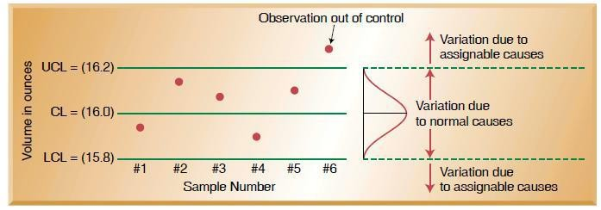

**Figure 2. 2 Types and Causes of Variation as seen in Wiley et al *2007***

### Characteristics Out of Control Process:

A pictorial description of the characteristics of an out of control process is shown in the figure 2.3 below.

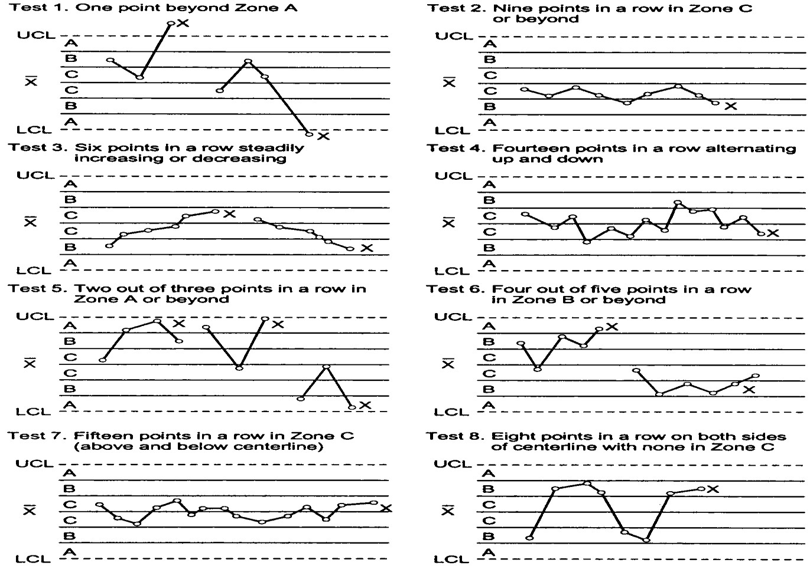

Figure 2. 3 Tests for out-of-control patterns on control charts Source: (**Pyzdek and Keller**, 2010)

### Types of Control Charts

Control charts are divided into two: measurement (variable) control charts, X-bar R, X-bar S, I-MR, among others and attribute control charts, *p, c, nP and u* (Montgomery, 2009, Pedro, 2019, Krishnamoorthi, et al 2018, and Ieren et al, 2020).

The equations for the control limits of the Control charts are (Montgomery, 2009, Chero, 2019, Krishnamoorthi, et al 2018, and Ieren et al, 2020):

### X-bar and R- charts:

The Mean and Range Charts (X-bar and R-charts) monitors the average and variation of a process based on process sample size of n =2 – 10 taken at varying times.

Equations for the control limits of the (X̅ ) Chart are:

UCL(𝑋̅) = 𝑋̿ + 𝐴3R̅ 2.1

CL(X̅) = 𝑋̿ 2.2

LCL(𝑋̅) = 𝑋̿ − 𝐴2R̅ 2.3

Equations for the control limits of the R-chart are:

UCL(R) = 𝐷4R̅ 2.4

CL(R) = R̅ 2.5

LCL(R) = 𝐷3R̅ 2.6

### X-bar and S- charts:

The Mean and Standard Deviation chart (X-bar and S- chart) is used to evaluate the stability of processes with variable data of samples size of n ≥ 10.

Equations for the control limits of the S-chart are:

UCL(R) = 𝐵4R̅ 2.7

CL(S) = S̅ 2.8

LCL(R) = 𝐵3R̅ 2.9

The values for d2, B3, B4 D3, and D4 are factors that give 3-sigma limits based on sample size chosen from standard tables given in the appendix 1.

### I-MR (X-MR) Charts:

The Shewhart Control Chart for Individuals measurements (X-chart or I-Chart) and Moving Range (MR) Chart is useful when the sample size used for process monitoring is *n* =1.

The control chart for individuals (X-chart) is normally used along with a chart for successive differences, which is known as a moving range chart (MR chart) with subgroup size *n* = 2. While the X-chart will keep track of the process mean, the MR chart will track the variability in the process. The moving range is the absolute value of the difference between the current value and the previous value. There will be no *R*-value corresponding to the first observation (Krishnamoorthi, et al 2018). The formulae of the I-MR (X-MR) Charts are given in equations 3.10 to 3.12 in chapter three.

### P-chart:

The P-chart is used to evaluate and monitor processes that produce defectives or nonconforming items. The items are countable and the sample size is not constant.

Equations for the control limits of the P-chart are:

p = 𝑛𝑝

𝑛

2.10

p̅ = ∑𝑛𝑝

∑𝑛

UCL(𝑃) = 𝑝̅ + 3√𝑝̅(1−𝑝̅}

𝑛

CL(𝑃) = 𝑝̅ 2.13

LCL(𝑃) = 𝑝̅ − 3√𝑝̅(1−𝑝̅}

𝑛

2.14

Where,

*P* = proportion or fraction defective in a sample np = Number of defectives

n= Number of samples inspected in a subgroup

*p̅* = average proportion defective

### C-chart:

The C-chart is used when there is a small number of countable defective items in a large population and the sample size is constant.

Equations for the control limits of the C-chart are:

c̅ = ∑𝑐

𝑛

2.15

UCL(𝐶) = 𝑐̅ + 3√𝑐̅ 2.16

CL(𝐶) = 𝑐̅ 2.17

LCL(𝐶) = 𝑐̅ − 3√𝑐̅ 2.18

Where,

*c =* number of defects in a sample unit c = number of samples

*c̅* = average of defects

### nP Chart:

It is used to evaluate the defective fraction when it is easy to count the number of defectives and the sample size is always constant. This chart cannot be used if *n* does not remain constant.

UCL(𝑛𝑃) = ̅𝑛̅̅𝑝̅ + 3√𝑛̅̅̅𝑝̅(1−𝑝̅}

𝑛

2.19

CL(𝑃) = ̅𝑛̅̅𝑝̅ 2.20

LCL(𝑛𝑃) = ̅𝑛̅̅𝑝̅ − 3√𝑛̅̅̅𝑝̅(1−𝑝̅}

𝑛

2.21

Where,

*nP* = number of defectives found in a sample n̅ p̅ = average of defectives units

### U Chart:

It is used when the defects in an item or product are countable and the sample size varies.

UCL(𝑈) = 𝑢̅ + 3√ 𝑢̅

𝑛𝑖

2.22

CL(𝑈) = 𝑢̅ 2.23

LCL(𝑈) = 𝑢̅ − 3√ 𝑢̅

𝑛𝑖

2.24

*U =* number of defects per (standard) unit

*u̅* = average of the *u* values from the sample units ni = number of standard units in each sample unit

The choice of control chart is graphically displayed by the algorithm in

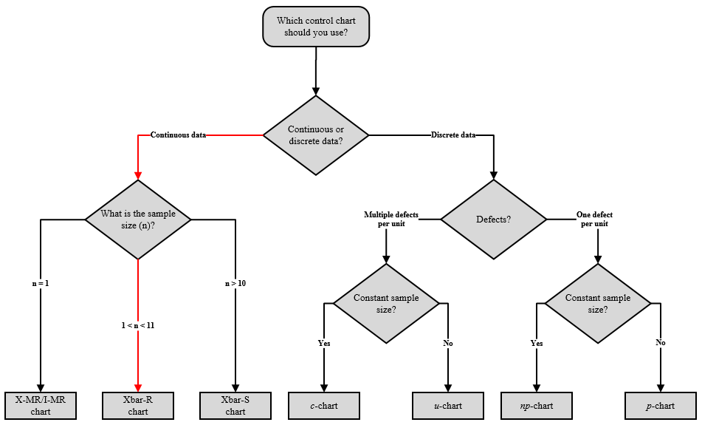

**Figure 2. 4 Algorithm to select the type of control chart**

Source: (Ieren et al, 2020).

### Process Capability Analysis

Process capability analysis is a formal study to estimate process capability, which usually measures functional parameters or critical-to-quality characteristics on the product and not the process itself (Montgomery, 2009). Process capability studies indicate if a process is capable of producing virtually all-conforming product (Erameh et al, 2016).

(Jayakumar and Raju 2016), stated that, by definition, process capability is the minimum spread of a specific measurement variation which will include 99.73% of the measurements from the given process. From a normal curve, 99.73% of the area lies between -3б to + 3б, therefore, process capability, also known as the natural tolerance, is equal to six sigma (process capability = 6б) (Jayakumar and Raju, 2016). Put another way, only 0.27% of the process output will fall outside the natural tolerance limits, which corresponds to 2700 nonconforming parts per million. (Montgomery, 2009).

### Process Capability Indices (Ratios)

A process capability index is a numerical summary that compares the behavior of a product or process characteristic to engineering specifications (Erameh et al, 2016). The short term process capability is generally specified using these two indices, *C*p and *C*pk (Young et al, 2019).

The following views by these authors give highlights of the difference in the functions of these indices. The process capability ratio, *Cp,* measures the spread of the specifications relative to the six-sigma spread in the process. That is, the specification width is divided by six sigma (6 standard deviations). It defines the process variability. Process Capability Index, Cpk, is a ratio that, measures the potential for a process to generate defective outputs relative to either upper or lower specifications. It is a simple number which measures how close a process is running to its specification limits, relative to the natural variability of the process. (Montgomery, 2009, Jayakumar and Raju, 2016 and Krishnamoorthi, et al 2018). As stated by (Krishnamoorthi, et al 2018), the *C*pk is a superior index for measuring the capability of a process, because it checks on process centering as well as process variability. (Conceição, et al, 2018) asserted that, the Cp measures the potential capacity of the process, while the variable Cpk measures the actual capacity of the process allowing to evaluate if the process will be able to reach the desired value. (Erameh et al, 2016) indicated that, the *Cp* is the process capability for two-sided specification limit, irrespective of process center, whereas, the *C*pk is the process capability for two-sided specification limits accounting for process centering.

A large value of the index indicates that the current process is capable of producing parts that, in all likelihood, will meet or exceed the customer’s requirements (Erameh et al, 2016). Though, customers usually demand *C*p and *C*pk values of 1.33 or greater. However, if the process does not fully meet the specifications, it could be due to excess variability or the

lack of centering of the process that is causing values outside of specification (Krishnamoorthi, et al 2018).

In the use of these indices, the process must be in stability as confirm by control charts (Aslan, 2016). This is necessary because a process that is in-control may not be fully capable of producing products that meet the customer’s specifications (Krishnamoorthi, et al 2018). Another general assumption relates to the normality for the process (Krishnamoorthi, et al 2018).

The formulae of these process capability indices are given in equations 3.10 to 3.12 in chapter three.

### Applications of Process Capability Indices

As indicated by (Erameh et al, 2016), more and more efforts have been devoted to studies and applications of process capability indices. Among the several applications are the following:

* + - * Effective tools for the continuous improvement of quality, productivity and managerial decisions.
      * Serve as tools for complementary system of measurement of process performance.
      * Comparing controlled process output to the specification limit desired.
      * Relates the voice of the customer (specification limits) to the voice of the process
      * Reduces complex information about the process to a single number
      * Communicates how well the process has performed
      * Establishes priorities for improvement activities by suppliers for different characteristics
      * Indicates expected future performance, for stable or predictable processes
      * Allows the quantification by how well a process can produce acceptable product
      * Assess the effect of a process change by comparing capability indices calculated before and after the change

## Review of Applications of Lean Six Sigma (LSS): DMAIC methodology

In order to show the significance and reliability of Lean Six Sigma, a review of related literature was done. Since Lean Six Sigma is a structured method of implementing process improvements using its DMAIC methodology, literatures which revealed the different tools in the application of its various phases are therefore reviewed to provide support to validate my use of the Define and Measure phases of the Lean Six Sigma to make recommendations to ensure continuous quality improvement in the Niger Delta Water factory.

### Statistical Process Control on Production: A Case Study of Some Basic Chemicals Used in Pure Water Production

(Nasir and Abubakar , 2010), in their research, indicated that, in any production process, regardless of how well designed or carefully maintained it is, a certain amount of inherent or natural variability will always exits, Such variability like background noise. When the variability is small, we usually consider this an acceptable level of process performance or the process is within the process control. A process that is operating in the presence of assignable causes is said to be out of control. A data set collected from randomly selected packaged water producers referred to as “Pure water producers” and subjected to laboratory test of the of the level of some basic chemicals used in the production of pure water, such as pH, conductivity (μS/cm; Lead (Pb); Aluminum (Al) and Chloride (Cl).

The test shows that most of the chemicals used are out of process control. This is danger to health of the consumers.

### An approach for the application of statistical process control techniques for quality improvement of treated water

(Smeti et al. (2007), applied statistical process control techniques for quality improvement of treated water in Athens Water Supply and Sewerage Company (EYDAP SA). The measurements of turbidity, residual chlorine and aluminium in the Polydendri tank for the year 2004 were of particular interest due to their potential fluctuations during the aforementioned time interval. They noted that, although the chemical parameters of the

Polydendri treated water tank were found to be within the specified limits of the 98/83/EEC Directive (with the exception of only one value for turbidity), statistical process control techniques can contribute to the improvement of the water quality, as the control charts aim to detect the occurrence of special cause of variability so that investigation of the process and corrective action may be undertaken before problems accumulate.

### Application of Statistical Quality Control in Monitoring the Production,

**Packaging and Marketing Process of Sachet Water**

(Ieren et al 2020), also in their research employed statistical quality control approach to monitor process stability in a Table Water manufacturing company. Quality control tools such as p-chart, u-chart, X-bar and R charts as well as process capability chart were used to observe field data obtained from the sachet water manufacturing company on important processes of sachet water production and marketing for 30 working days. This was done to check if the processes were in control or out of control and to verify the capability of the marketing process of the product meeting preset specifications. With this, the statistical control charts suitable for the processes were constructed using package “qcc” in R software version 3.6.1. The results from p-chart and u-chart showed that the production and packaging process of the product is not in control and hence the need for further investigations and corrective measures to prevent variability in the process and thus allowing improvement in the quality of the product. Also, the results from X-bar and R charts showed that the marking process was in statistical process control in respects of the product sales recorded by the four independent marketers, with no assignable cause of

variation. It also revealed that, the product marketing process has low capability of successfully attending the preset specification limits in respect of the product sales and hence generating low profit for the company.

### Management of the Production Process of a Water Bottling Plant to Improve Quality: A Case Study

(Ihunwo and Kinigoma, 2016), in their paper examined the management of the production process of a water bottling plant to improve quality: using a water bottling company as a case study. The objectives of the research were primarily to apply statistical process control (SPC) to manage the production process to improve quality and streamline the production process to reduce waste. Data generated by the process before and during this research were collected using data collection tools that were specifically developed by this research. Data analysis was done both qualitatively and quantitatively using control charts and visual basic dot net computer software carefully developed for the process. The results of the qualitative analysis revealed that pH, conductivity and total dissolved solids (TDS) in water increased during rainy season and decreased during dry season due to high level of contamination, water run-offs and stagnation in rainy season than dry season. Also the results from the quantitative analysis showed that the water treatment plant produced 11,814 defectives resulting to a monetary loss of ₦200,838. However, with the introduction and application of SPC, the company experienced a remarkable reduction in waste generation, showing a percentage defect/cost reduction of about 89.6%. Proper data management, documentation, employee involvement, and top management commitment were recommended to improve quality.

### The Application of Lean-Six-Sigma Methodology in the Manufacturing Sector:

**A Case Study of Nigerian Breweries**

(Uzorh et al 2018) research on the application of lean six sigma methodology in the manufacturing company was carried out in the Nigerian Breweries at Enugu. Nigerian

Breweries was selected for the study because it has many production lines, operation systems and management strategies which were not so developed. The main objective of this study was to determine how application of lean six sigma can be used to minimize product and time wastes statistically. Three production lines (line A, B and C) were considered and data were collected in each production line. DMAIC methodology was used for identification of compatible lean techniques and strategies for the minimization of defects and rejects bottles in each production line. The statistical tools used for the analysis of data obtained were histogram, box plot, pareto-charts, one-way ANOVA, cause-effect diagram and control charts. The result obtained from the analysis showed that the two (2) defects on the labelling in line A occurred at the beginning of the batch production. In line B the capsule machine produced some bottles without capsule. Line A and B were well centred between the limits 20 and 40kg while line C shifted to the left with more samples under lower specification limit of 20kg. The result obtained from scatter plot chart showed the possible relationship between the variables of oxygen and vacuum based on the pressure exerted on the cork. Capability analysis result showed that the corking machine in line B was working in a capable process with number of expected defects in overall performance less than 0.13% which was much better than the one in line

A. Line A had 0.17% of bottles rejected in the filling machine which showed that 0.028% were mistakes of the normal variability of the process. VSM analysis result showed that 32mins from the lead time were not value added actives, thus only 28.2% was value added time. Though the greater time was in the inventory before the washing machines. A reduction of 37.7% in value added time was achieved through elimination of buffers. The cause-effect diagram provided the main priorities to control and solve the problem of number of defects in each production line. However, this work had provided the necessary tools and techniques needed to eliminate product and time wastes in any manufacturing

company. The study recommended the adoption of the output of this work to other similar company.

### Statistical Process Control Applied in the Chemical and Food Industry

(Chero, 2019), in using Statistical Process Control (SPC) as a tool, applied statistical control charts in the chemical and food industrial processes and highlighted their advantages in the control of processes. For the study, the control data of the processes of 4 industrial plants was used: rectified ethyl alcohol distillation plant, asparagus processing plant, soluble coffee production plant and light liquid fuel production plant. The deductive methodology was applied, based on the type of data: variable or attribute, constant or variable sampling, evaluation of the defective fraction, number of defects, variability of processes. With this, the statistical control chart suitable for the process was selected. The results showed that in the food industry the np and p charts can be used to evaluate the defective fraction and for the number of defects, as was the case in asparagus cans, u and c graphs are used. To control variables, the charts used were XmR, XbarR, Xbar Trend, Fixed limits and XbarS. It was concluded that the control charts in the chemical and food processes is not only applicable, but it allows predicting the behavior of the process and alerts when it tends to go out of control, thus allowing improving the quality.

## Review of Related Literatures

### Physicochemical and Microbiological Analysis of Selected Sachet Water Vended in Akure, Ondo State, Nigeria

In their current work, (Abideen et al, 2020) focused on physicochemical and microbiological analysis of selected sachet water vended in Akure, Ondo State, Nigeria. Five samples of sachet (A= Primus table water; B= Bofa table water; C= Zion table water, D=Aktols table water and E=Edna table water) water obtained from five different areas were analyzed for physicochemical and microbiological parameters using standard analytical methods of

Association of official Analytical chemists (AOAC). The result of microbial analysis revealed that all the water samples referred to as samples A, B, C, D and E respectively had total plate count of 7.0cfu/ml, 4.0cfu/ml, 1.0cfu/ml, 15.0cfu/ml, and 3.0cfu/ml respectively. This showed that sample A, B, C, D, and E did not exceed the standard of total plate counts. The entire samples resulted at 0 counts for Escherichia coli. Samples A, B, C, D and E tested negative for Coliform test, Fungi test and Salmonella shigella test. The chemical analysis showed that all the samples meet up with the recommended standard of pH (6.5-8.5) by World Health Organization (WHO), United Nations International Children’s Emergency Fund (UNICEF) Standard ganization of Nigeria (SON) and National Agency for Drug and Administration Control (NAFDAC). The temperatures were not significantly different and did not exceed standard limit of 370C. The total dissolved solid also did not exceed the limit of 500ppm as recommended by World Health Organization /United Nations International Children’s Emergency Fund (WHO/UNICEF) and the conductivity limit was not exceeded. All the samples did not exceed limits for zinc, chloride, iron, nitrate, nitrite and flouride which are 0.3mg/l, 250mg/l, 0.3mg/l, 50mg/l, 0.3mg/l and 15 mg/l respectively. All the samples were significantly different for each parameter except for lead, copper, free chlorine and manganese of which the entire sample were all the same.

### Potability assessment of packaged sachet water sold within a tertiary institution in southwestern Nigeria.

(Opafola et al, 2019), in their research examined the potability of the packaged sachet water being marketed within the Federal University of Agriculture, Abeokuta (FUNAAB) campus. Seven sachet water brands were purchased randomly and the physicochemical and bacteriological qualities were determined. The results acquired are as follows: pH, 6.57–

6.79 ± 0.02; electrical conductivity (EC), 0–145.00 ± 5.00 lScm_1, turbidity, 0.00–0.59 ±

0.02 NTU; total dissolved solids (TDS) 0.00–70.00 ± 0.00 mg/L; total suspended solids

(TSS), 0.00–0.01 ± 0.00 mg/L; calcium, 42.00–161.00 ± 1.00 mg/L; iron, 0.65–1.25 ± 0.05

mg/L; alkalinity, 0.65–1.25 ± 0.05 mg/L; sulphate, 0.95–33.71 ± 0.01 mg/L; and nitrate, 0.01–0.04 ± 0.00 mg/L. Magnesium and phosphate were below detection level. The odour and taste were also unobjectionable. The physicochemical test results conformed with the World Health Organization World Health Organisation (WHO) (2004) and Nigerian Standard for Drinking Water Quality (NSDWQ) standards for drinking water. However, bacteriological analysis established the presence of total bacteria count in all water samples (100%) while two brands, (sample C and G), of the packaged sachet water (28.57%) were contaminated with total coliforms which failed to comply with WHO and NSDWQ standard. The analysed physicochemical and bacteriological parameters of the water samples exhibited significant differences (P < 0.05). Sustainable measures such as scientific examination of the water quality during preproduction, production and postproduction stages to determine the means of access of contaminants as its directly affect public health and safely should be routinely performed by the water producers.

* + 1. **An assessment of sachet water quality in Zaria Area of Kaduna State, Nigeria** In this study, (Yusuf, et al, 2015) conducted the physico-chemical analysis of 21 brands of sachet water packaged within Zaria metropolis was evaluated to compare their compliance with World Health Organisation (WHO) and Nigerian Industrial Standard (NIS) threshold limits using standard analytical methods. The parameters evaluated include: colour, taste, odour, pH, chloride, potassium, calcium, electric conductivity, oxygen demand (OD), biological oxygen demand (BOD) and total dissolve solid (TDS) while coliform counts were only determined for sixteen brands using standard methods. The results from the laboratory analysis showed that all samples were tasteless, colourless and odourless; most of the physico-chemical parameters conform with WHO and NIS permissible limits except coliform count in which 100% of the sachet did not conform to the WHO threshold limits.

Only 25% of sachet water did not conform to NIS threshold limits. The t-test result reveals that there is no significant difference between the sachet water properties with the WHO and NIS standard. The results of this study indicate that sachet drinking water produced or sold in Zaria is relatively of good quality for human consumption but there is need to improve the biological treatment to perfect its portability.

### Assessment of water quality for selected boreholes and sachets water in Maigatari Town, Jigawa State, Nigeria

(Musa et al, 2018), examined eight water samples collected, four from different vendors of sachet water and four from different boreholes across Maigatari town. The samples were analyzed for pH using pH meter; Electrical Conductivity using a conductivity meter; while Turbidity of the water using turbidity meter. TDS and TSS using TDS meter. The electron microscope was used to determine the microbial counts. The results of the analysis revealed the range of values for the four (4) sachet and borehole waters respectively as pH (7 – 7.6) and (6 – 6.3); Conductivity (181 – 600) and (413 – 998) µS/m; Turbidity (0 – 2) and (1 – 2)

NTU; Total Dissolve Solids (128 – 219) and (131 – 405) Mg/L; Total Suspended Solids (62

– 85) and (71 – 88) Mg/L; Total Solids (227 – 288) and (215 – 476) Mg/L; Microbes (0 –

1) and (0 – 3) cfu/mL; Total Hardness (41.5 – 111) and (50.1 – 123.3) Mg/L. The result also revealed strong positive correlation between pH and Conductivity (0.780); pH and TDS (0.875); pH and Microbes (1.046); turbidity and TS (0.906); Turbidity and Hardness (0.933); TS and Hardness (0.972) in sachet water. While Strong positive correlation existed between Conductivity and TDS (0.861); Conductivity and TSS (0.809); TDS and TSS (0.941) in borehole water. The water quality parameters analyzed were within the threshold of the Standard Organization of Nigeria (SON) with the exception of very few in one or the other samples. The parameters were significantly related to one another. It was however,

recommended that the water vendors should improve the drinking water quality of their

products and the officials of the Standard Organization of Nigeria (SON) should ensure strict adherence to regulations for drinking water quality.

## Water Quality Parameters

In citing (Spellman, 2013 and Alley, 2007), (Omer, 2019) stated that, **the** most popular definition of water quality is “it is the physical, chemical, and biological characteristics of water.

### Physicochemical Water Quality Parameters

**Turbidity**: Its presence in drinking water is esthetically unacceptable (Omer, 2019), increase the cost of water treatment (Davis, 2010), harbour microorganisms and shield them from the disinfection process (Edzwald, 2010), and entraps heavy metals such as mercury, chromium, lead, cadmium and many hazardous organic pollutants (Cole et al, 1999).

**Conductivity**: Significant changes in conductivity can be indicators of how effluent or pollutant from other sources flows into the water source (Choo-in, 2019).

**pH**: Excessively high and low pHs can be detrimental for the use of water (Omer, 2019). A high pH makes the taste bitter and decreases the effectiveness of the chlorine disinfection, thereby causing the need for additional chlorine (DeZuane, 1997). Low-pH water will corrode or dissolve metals and other substances (APHA, 2005). Heavy metals such as cadmium, lead, and chromium dissolve more easily in highly acidic water (lower pH) (Omer, 2019). This is important because many heavy metals become much more toxic when dissolved in water (DeZuane, 1997).

**Total Hardness**: Hardness is a term used to express the properties of highly mineralized waters (APHA, 2005). The dissolved minerals in water cause problems such as scale deposits in hot water pipes and difficulty in producing lather with soap (Davis, 2010).

**Alkalinity**: The high levels of either acidity or alkalinity in water may be an indication of industrial or chemical pollution (Omer, 2019).

**Total Dissolved Solids (TDS)**: The presence of high levels of Total Dissolved Solids (TDS**)** in water may be objectionable to consumers owing to the resulting taste and to excessive scaling in water pipes, heaters, boilers, and household appliances (WHO, 2003)

**Chloride**: Chloride in drinking water do not cause any harmful effects on public health, but high concentrations can cause an unpleasant salty taste for most people (Omer, 2019). Chlorides are not usually harmful to people; however, the sodium part of table salt has been connected to kidney and heart diseases (WHO, 1996).

**Sulphate**: If high concentrations are consumed in drinking water, there may be objectionable tastes or unwanted laxative effects (Davis and David, 2008). but there is no significant danger to public health (Omer, 2019).

**Nitrate**: A high concentration of nitrate in surface water can stimulate the rapid growth of the algae which degrades the water quality (Tchobanoglous et al, 2003) Excessive nitrate concentration (more than 10 mg/L) in drinking water causes an immediate and severe health threat to infants (Tchobanoglous et al, 1985).

**Fluoride**: Excessive amounts of fluoride cause discolored teeth, a condition known as dental fluorosis (Davis, 2010, Tchobanoglous et al, 1985, Davis and David, 2008).

**Iron and manganese**: Although iron (Fe) and manganese (Mn) do not cause health

problems, they impart a noticeable bitter taste to drinking water even at very low concentration (APHA, 2005, Davis, 2010). These ions can also cause black or brown stains on laundry and plumbing fixtures (Chatterjee, 2001).

**Copper and zinc**: Copper (Cu) and zinc (Zn) are nontoxic if found in small concentrations

(APHA, 2005). They can cause undesirable tastes in drinking water (Omer, 2019). At high concentrations, zinc imparts a milky appearance to the water (APHA, 2005).

**Calcium**: Calcium is the primary constituent of water hardness, hence, excessive accumulation of CaCO3 in boilers, hot water heaters, heat exchangers, and associated piping affects heat transfer and could lead to plugging of the piping.

**Magnesium**: MAGNESIUM (Mg2+) ions cause the greatest portion of hardness in naturally occurring waters (Spellman, 2017).

**Lead**: The impact of lead on neurodevelopmental effects in children even at low levels of exposure is well established (Levallois et al, 2018).

## Research Gap

The Lean Six Sigma’s DMAIC methodology to improve production process is very rarely seen as far as potable water production industries are concerned. Most of the studies are focused on the laboratory analysis of the physical, chemical and bacteriological water quality parameters as far as water production is in question. This clearly shows the variance between process and laboratory results of finished water quality parameters. Process focused work has not yet been appropriately employed, which can address the root causes of process variability and enhance process capabilities in quality water production, through some comprehensive and sustainable strategies like, the Lean Six Sigma’s DMAIC methodology

# CHAPTER THREE

* 1. **Introduction**

# MATERIALS AND METHOD

**Place of application:** In order to achieved the stated objectives of this research, a study of lean six sigma methodology was done and two of the DMAIC phases, Define and Measure were carried out using a water production industry (Niger Delta University Table Water Factory) as a case study. The Niger Delta University Table Water Factory produces potable table water product in water bottles sizes of 35cl, 50cl and 75cl. The raw water is extracted from ground well source, goes through a treatment process as described in Fig 3.1 below and the product subjected to careful quality tests with the most modern machinery.

### Materials

**Data:** Table 3.1 shows the available data of the raw mean weekly values of some of the physico-chemical quality parameters of the factory’s treated raw water collected from January through December 2020, covering the two seasons of the year. They are the results of the laboratory physico-chemical analysis conducted on the treated raw water product before packaging by the water quality control department. They were inputted by the water factory staff as part of the normal work practices related to documentation for regulatory purpose, hence, secondary in nature. The data were extracted from the original sheet shown in APPENDIX 2 into spreadsheet format to enable exporting into the Minitab Statistical software application for processing.

**Sample Size:** It is necessary to collect a minimum of 25 sample of data. The data available shows 50 samples of mean weekly sample test results with size *n* =1.

**Physico-Chemical Analysis:** The turbidity was measured using Turbidimeter HACH2100Q. The titrimetric method was used in determining the total alkalinity and total

hardness. The pH and conductivity was determined with a pH/ conductivity meter (Model: 2500wx pH/ Conductivity meter).

The determination of the minerals; calcium, chloride, nitrates, sulphate and magnesium was achieved by the use of Spectrophotometer, Jenway 6305, while the following heavy metals; copper, iron, lead and zinc were determined using Atomic absorption spectrocopy, ASC- 7000.

**Software:** The Minitab 2021 ® Statistical software package was used to carry out both the qualitative and quantitative analyses, production of control charts and any additional statistical tests that would aid decision-making. The decision to use this particular package followed the reference with regards to its use (Montgomery, 2009; Krishnamoorthi, et al 2018) and its availability to the author. Furthermore, the package is very user friendly and has the capability of performing the necessary analyses.

### Table 3 1 Raw weekly mean values of water quality parameters from Jan. – Dec. 2020

|  |  |  |  |  |  |  |  |  |  |  |  |  |  |  |  |  |
| --- | --- | --- | --- | --- | --- | --- | --- | --- | --- | --- | --- | --- | --- | --- | --- | --- |
| Unit | |  | µs/cm | NTU | mg/L | mg/L | mg/L | mg/L | mg/L | mg/L | mg/L | mg/L | mg/L | mg/L | mg/L | mg/L |
| Parameter | | pH | Conductivity | Turbidity | Hardness | Alkanity | Choliride | Tot. Dis. Solids | Nitrate | Sulphate | Calcium | Magnesium | Iron | Lead | Copper | Zinc |
| Month | Week |  |  |  |  |  |  |  |  |  |  |  |  |  |  |  |
| Jan | 1 | 6.86 | 12 | 0.1 | 12.5 | 16.5 | 6.88 | 8.91 | 1 | 1.3 | 6.51 | 0.15 | 0.01 | 0 | 0.02 | 0.14 |
| 2 | 6.91 | 11 | 0.08 | 11.6 | 12.1 | 6.92 | 6.23 | 0.63 | 1.14 | 7.21 | 0.14 | 0.04 | 0.02 | 0.02 | 0.09 |
| 3 | 6.73 | 8 | 0.06 | 13 | 12 | 7.13 | 11.4 | 1.22 | 1.09 | 3.02 | 0.14 | 0.04 | 0.03 | 0.05 | 0.08 |
| 4 | 7.04 | 6 | 0 | 15.1 | 11.9 | 7.45 | 2.03 | 1.04 | 1.05 | 5.13 | 0.14 | 0 | 0.01 | 0.03 | 0.01 |
| Feb | 5 | 7 | 15 | 0.11 | 13.4 | 12 | 8.22 | 1.03 | 1.08 | 1.26 | 5.21 | 0.29 | 0.08 | 0.02 | 0.01 | 0.3 |
| 6 | 6.98 | 28.2 | 0.02 | 15 | 12.1 | 6.41 | 6.24 | 1 | 1.41 | 8.13 | 0.41 | 0.01 | 0.03 | 0.03 | 0.03 |
| 7 | 6.63 | 15.4 | 0.01 | 10.2 | 10.7 | 8.09 | 6.13 | 1 | 1.03 | 3.22 | 0.61 | 0.02 | 0.04 | 0.03 | 0.15 |
| 8 | 6.72 | 18.3 | 0 | 9.39 | 12 | 7.05 | 7.41 | 1.01 | 1 | 4.91 | 0.84 | 0.03 | 0 | 0.07 | 0.01 |
| Mar | 9 | 6.6 | 7.03 | 0 | 17.5 | 10 | 5.81 | 5.2 | 0.64 | 1.05 | 8.31 | 6.48 | 0.04 | 0.04 | 0.02 | 0.03 |
| 10 | 6.45 | 8.91 | 0 | 12.3 | 9.64 | 6.92 | 6.01 | 0.32 | 1.12 | 10.1 | 9.21 | 0.08 | 0 | 0 | 0 |
| 11 | 6.01 | 15.1 | 0.08 | 11.1 | 8.31 | 5.73 | 7.24 | 1.04 | 1.1 | 12.6 | 9.14 | 0.06 | 0.01 | 0 | 0 |
| 12 | 6.5 | 22.1 | 0.16 | 10.3 | 8.94 | 6.44 | 6.53 | 1 | 1.62 | 15.1 | 13.2 | 0.05 | 0 | 0 | 0 |
| Apr | 13 | 6.59 | 19.4 | 0.07 | 12.4 | 14 | 7.32 | 7.11 | 0.87 | 0.81 | 16 | 14.5 | 0.03 | 0 | 0 | 0 |
| 14 | 6.62 | 11 | 0.97 | 13.5 | 13.1 | 8.61 | 4.28 | 1.21 | 0.74 | 9.63 | 11.3 | 0.08 | 0 | 0 | 0 |
| 15 | 6.87 | 9.32 | 1 | 14.6 | 15.6 | 9.22 | 5.96 | 0.43 | 0.95 | 8.11 | 16.1 | 0.07 | 0 | 0 | 0 |
| 16 | 6.96 | 11 | 1.04 | 10 | 17.5 | 5.51 | 6.71 | 0.52 | 0.83 | 7.59 | 6.02 | 0.06 | 0 | 0 | 0 |
| May | 17 | 7.02 | 15.4 | 1 | 11.1 | 19 | 6.43 | 8.32 | 0.61 | 0.62 | 8.82 | 10.1 | 0.09 | 0.01 | 0 | 0 |
| 18 | 7 | 16.3 | 1.2 | 10.2 | 22.4 | 8.65 | 9.44 | 0.92 | 1.06 | 10.2 | 4.11 | 0.02 | 0.02 | 0 | 0 |
| 19 | 7.08 | 15.4 | 0 | 7.33 | 25.1 | 11 | 6.5 | 1 | 1.09 | 10.3 | 3.2 | 0.08 | 0 | 0 | 0 |
| 20 | 7 | 9.81 | 0 | 22 | 21.9 | 5.08 | 8.12 | 1.08 | 1 | 11 | 4.16 | 0.04 | 0 | 0 | 0 |
| 21 | 6.91 | 10 | 0 | 19 | 17.4 | 6 | 4.93 | 0.67 | 1.31 | 9.68 | 4.21 | 0.03 | 0 | 0 | 0 |
| June | 22 | 6.63 | 12.1 | 0.82 | 21.3 | 16.1 | 8.53 | 5.01 | 0.21 | 1.28 | 9.92 | 3 | 0.03 | 0 | 0 | 0 |
| 23 | 6.74 | 10 | 0.7 | 18.2 | 17.1 | 7.41 | 6.28 | 0.41 | 1.01 | 8.51 | 11.2 | 0.06 | 0 | 0 | 0 |
| 24 | 6.86 | 25.1 | 0.54 | 17.4 | 18.2 | 6.62 | 7.41 | 1.32 | 1.05 | 9.62 | 12.2 | 0.09 | 0 | 0 | 0 |
| 25 | 6.85 | 14.2 | 0.1 | 16.3 | 17.6 | 8.11 | 9.62 | 1.07 | 1.13 | 11.4 | 5.43 | 0.04 | 0.01 | 0 | 0.01 |
| July | 26 | 6.9 | 11.3 | 0.08 | 12 | 23.1 | 5.31 | 8.04 | 1.67 | 1.33 | 12.1 | 1.23 | 0.05 | 0.02 | 0 | 0 |
| 27 | 7.1 | 10 | 0.01 | 13.4 | 25.1 | 6.92 | 7.43 | 0.95 | 1.14 | 16.4 | 0.92 | 0.05 | 0.03 | 0 | 0 |
| 28 | 7 | 10.1 | 0.06 | 15.1 | 21.3 | 5.41 | 6.11 | 0.88 | 0.96 | 17.5 | 0.51 | 0.07 | 0.04 | 0 | 0 |
| 29 | 6.82 | 12.2 | 0 | 17.1 | 20.2 | 6.55 | 7.28 | 1.07 | 0.81 | 19.3 | 0.21 | 0.08 | 0.03 | 0 | 0 |
| 30 | 6.66 | 17 | 0.01 | 10.6 | 19.5 | 7.81 | 5.43 | 1.21 | 0.32 | 16.4 | 0.43 | 0.03 | 0.02 | 0 | 0.01 |
| Aug | 31 | 6.63 | 8.93 | 0.31 | 28.4 | 20.1 | 9.61 | 6.1 | 1.11 | 0.41 | 12.1 | 0.31 | 0.06 | 0.01 | 0 | 0 |
| 32 | 7.02 | 10.1 | 0.64 | 19 | 22.2 | 5.19 | 5.41 | 0.96 | 1.21 | 9.83 | 0.68 | 0.07 | 0.01 | 0 | 0 |
| 33 | 6.83 | 12.4 | 0.72 | 18.1 | 25.6 | 6.32 | 4.31 | 0.85 | 1 | 8.22 | 0.66 | 0.03 | 0.01 | 0 | 0 |
| 34 | 6.8 | 15 | 0.51 | 11.4 | 19.5 | 5.14 | 6.5 | 0.72 | 0.42 | 6.59 | 0.98 | 0.02 | 0 | 0 | 0 |
| Sept | 35 | 6.82 | 11.7 | 0.43 | 10.1 | 21.8 | 10 | 8.91 | 0.93 | 1.31 | 7.48 | 0.81 | 0.05 | 0.01 | 0 | 0 |
| 36 | 6.99 | 12.1 | 0.08 | 18.3 | 20.8 | 11.1 | 4.32 | 0.81 | 0.86 | 7.03 | 0.93 | 0.03 | 0.01 | 0 | 0 |
| 37 | 7.21 | 14 | 0.11 | 16.4 | 22.2 | 6.51 | 5.11 | 1.02 | 0.62 | 9.08 | 0.74 | 0.05 | 0.01 | 0 | 0 |
| 38 | 6.63 | 11.3 | 0.31 | 17.3 | 20 | 8.34 | 6.01 | 1.08 | 1.55 | 10 | 0.83 | 0.04 | 0 | 0 | 0 |
| Oct | 39 | 6.98 | 8.66 | 0.44 | 10.5 | 16.2 | 9.62 | 7.03 | 1 | 1.67 | 11.2 | 0.91 | 0.09 | 0.03 | 0 | 0 |
| 40 | 7 | 13.1 | 0.52 | 9.83 | 22.1 | 6.65 | 7.17 | 1.12 | 1.17 | 12.8 | 0.64 | 0.03 | 0.03 | 0 | 0 |
| 41 | 7.12 | 18.2 | 0 | 12.4 | 17.5 | 8.21 | 9.03 | 1.35 | 1.32 | 7.44 | 0.59 | 0.04 | 0 | 0 | 0 |
| 42 | 6.77 | 17.1 | 0 | 11.2 | 16.3 | 7.33 | 4.15 | 1.61 | 1.53 | 6.93 | 0.88 | 0.06 | 0 | 0 | 0 |
| 43 | 6.81 | 15 | 0 | 16 | 11.9 | 5.41 | 4.06 | 0.87 | 1.62 | 4.9 | 0.95 | 0.06 | 0 | 0 | 0 |
| Nov | 44 | 6.86 | 10 | 0 | 19.1 | 14.3 | 6.81 | 6.34 | 0.21 | 1.14 | 6.73 | 0.64 | 0.02 | 0 | 0.01 | 0 |
| 45 | 6.67 | 8.93 | 0.19 | 7.21 | 18.2 | 6.92 | 6.78 | 1.05 | 1.31 | 9.31 | 0.95 | 0.01 | 0 | 0 | 0 |
| 46 | 6.63 | 10.7 | 0.08 | 13.3 | 12.1 | 7.42 | 4.01 | 1 | 1.52 | 8.11 | 0.68 | 0.01 | 0 | 0 | 0 |
| 47 | 6.92 | 12 | 1.02 | 12.4 | 11.4 | 5.91 | 5.21 | 0.93 | 1.61 | 6.42 | 0.71 | 0.01 | 0 | 0 | 0 |
| Dec | 48 | 7.01 | 14.6 | 1.35 | 8.69 | 13.3 | 8.07 | 6.33 | 0.81 | 1.21 | 7.31 | 0.52 | 0.03 | 0 | 0 | 0 |
| 49 | 6.78 | 13.2 | 1.21 | 11 | 12 | 6.94 | 4 | 1.01 | 1.04 | 6.41 | 0.63 | 0.04 | 0 | 0 | 0 |
| 50 | 6.63 | 13.2 | 0 | 14.3 | 11.8 | 5.28 | 2.93 | 1.32 | 1.11 | 5.2 | 0.74 | 0.01 | 0 | 0 | 0 |

### Methodology

The research methodology “DMAIC” is a logical and structured approach to problem solving and process improvement, which has five phases (Salih, 2015).

**DMAIC**: DMAIC is an acronym for Define, Measure, Analyze, Improve and Control. It is the term used to describe the phases of the approach taken in a Six Sigma project to achieve continuous improvement (Salah, et al, 2009; Pyzdex and Keller, 2010), but is an applicable framework to follow in Lean Six Sigma (LSS) interventions (Shirey, 2017).

This research work is limited to only deploy some aspects of the two phases of the DMAIC process, which are the Define and Measurement phases.

### Define

In this phase, the critical to quality (CTQ) parameters were identified and the raw water treatment process flow chart displayed.

**Voice of Customer:** The internal critical to quality (CTQ) parameters that relate to the

wants and needs of the customer (critical to customer -CTC) were determined (Salih, 2015)**.** These are the standard physicochemical quality parameters of potable drinking water values obtained from World Health Organization (WHO, 2004) and Nigerian Standards for Drinking Water Quality, Nigerian Industrial Standard (SON**,** 2015), which serves as voice of customer.

**Critical to Quality (CTQ) Table:** These are the customer’s needs, requirements and expectations of the potable drinking water put in a measurable way. Each critical to quality **(**CTQ) has a metric and target value (Rakuša, 2016). The following physicochemical quality parameters were determined in this research, turbidity, pH, conductivity, total hardness, total alkalinity, chloride, Total Dissolved solids (TDS), nitrates, sulphate, calcium, magnesium, iron, lead, copper and zinc.

**Table 3 2 Critical to Quality (CTQ) water parameters**

Source: Extracted from Nigerian Industrial Standard NIS-554-2015, Nigerian Standards for Drinking Water Quality and World Health Organization (WHO, 2004)

**Process Chart:** The process chart given in Figure 3.1, below shows the different processes involved in the raw water treatment in the water factory. Pictures of the different process machineries used are shown in APPENDIX



Pressure Tank System

Filtration

Intake System

Sedimentation

& Coagulation

Aeration

Fiberglass System

Reverse Osmosis

Ozone Generation



Ultraviolet light Sterilization

**Figure 3. 1** Niger Delta University Table Water Treatment Process chart

**Intake System**: The raw water is withdrawn from ground source and conveyed to the aeration tank by mechanical pump.

**Aeration**: Water is exposed to the atmosphere, which oxidizes taste and odour causing volatile gases and oxidizes iron (converts dissolved Iron (II) oxide, Fe2+ to Iron (III) oxide, Fe3+). A mechanical aerator is used in this process, which has three compartments.

**Coagulation and Sedimentation:** The aerated water is sent into the sedimentation tank to allow the colloidal particles of Iron (III) oxide (Fe3+) to destabilize and coagulate in small units. Sedimentation occurs by gravity and effects separation of the suspended solids from the coagulants, which settle at the bottom.

**Filtration**: The slow sand process involves a replication of granular filtration process consisting of multimedia system of seven tanks. Materials used are activated white stones, coarse sand, fine sand and activated carbon (coconut shells-acting as adsorbent). It enables removal of flocculated and particulate matters, colloidal matters, micro-organisms and colour.

**Pressure tank system:** This mechanical system, which uses pressure pumps, is also a filtration process, replicated in three stages, eliminates gases – ammonia, nitrate, sulphide, etc.

**Fiberglass System**: It is a mechanical system, which works on the turbidity and boosts the pH of the water.

**Reverse osmosis:** This process removes dissolved substances (e.g. nitrate and arsenic) and some organics in the water and monitors the conductivity of the water.

**Ozone generation:** This process produces and injects ozone into the water mechanically. It boosts the oxygen demand of the water, eliminates microbial activities and disinfects the

water.

**Ultra-Violet Light Sterilization:** This is a mechanical system which allows the penetration of ultra-violet light to disinfect the water.

### Measure

This phase involved measurement of the current performance of the product to find out performance gaps. It involved data collection and measuring the performance baseline of the product quality parameters (Mansur, 2016).

**Data Collection:** The method of data collection for this research work was of secondary nature. The data was collected directly from the quality control department of the water factory. This was informed by the fact that, the project, being an applied research work, requires accuracy of the data to help reduce the error that might probably occur in the course of data collection and hence, the accuracy of data will give confidentiality of the results.

**Performance Measurement:** This is focused on determining the process stability and process capability of the raw water treatment production line. For the process stability, control charts are used, while for the short term process capability, the quality efficiency parameters, *C*p and *C*pk are used.

### Process Stability Analysis:

In this research, the Shewhart Control Chart for Individuals measurements (X-chart or I- Chart) and Moving Range (MR) Chart were used to analyze the quality parameters of the potable drinking water. This became necessary because the process of data collection is slow or the data are collected over a period of time, output may be too homogeneous over short time intervals, most appropriate for batch processes, where the within batch variation is so small relative to between-batch variation and the sample size n =1 (Smeti et al, 2007; Montgomery, 2009; Pyzdek and Keller, 2010; Krishnamoorthi, et al 2018). The limits of the Shewhart Control Chart for Individuals measurements (X-chart or I-Chart) and Moving

Range (MR) Chart are calculated using the formulae given in equations 3.1 to 3.7 below (Montgomery, 2009, Chero, 2019 and Krishnamoorthi, et al 2018).

UCL(̅X) = X̅ + 3 ̅𝑀̅̅̅𝑅̅

𝑑2

3.1

CL(X) = X̅ 3.2

LCL(̅X) = X̅ − 3 𝑀̅̅̅̅𝑅̅

𝑑2

̅𝑀̅̅̅𝑅̅̅𝑖 = |𝑥𝑖 − 𝑥𝑖−1| 3.4

Equations for the control limits of the Moving Range (MR) Chart:

UCL(R) = 𝐷4̅𝑀̅̅̅𝑅̅ 3.5

CL(R) = R̅ 3.6

LCL(R) = 𝐷3𝑀̅̅̅̅𝑅̅ 3.7

Where,

UCL = upper control limit CL = centerline

LCL = lower control limit

𝑋̿= the average of the sample mean R̅ = average range of the samples X̅= sample mean

S̅ = average standard deviation of the samples

̅𝑀̅̅̅𝑅̅= mean of moving range of samples

The values for d2, D3, and D4 are factors that give 3-sigma limits based on sample size chosen from standard tables given in the appendix 1.

**Process Capability Analysis:** This quantitative analysis was carried to evaluate the process meeting and confirming the specification. This is assessed by using the most common quality efficiency parameters, Cp and Cpk, also known as capability indices or ratios. The quality efficiency parameters, Cp and Cpk, are calculated using the formulae given in equations 3.10 and 3.12 below.

Krishnamoorthi, et al 2018).

𝐶𝑝

= 𝑈𝑆𝐿−𝐿𝑆𝐿

6𝜎

3.8

Where,

USL = Upper specification limit LSL = Lower specification limit

USL-LSL = the voice of the customer or the specification width

б = the standard deviation of the process, which falls within the specification limit. It defines the voice of the process or process width.

### Interpretation:

Cp > 1: process meets specification

Cp < 1: process does not meets specification

Cp = 1: process just meets specification: To be exact, 99.73% of the process output is within specification.

𝐶𝑝𝑘

= min(𝑈𝑆𝐿−µ),(µ−𝐿𝑆𝐿)

3𝜎

3.9

Where,

µ = process mean

### Interpretation:

Cpk > 1: process confirms specification

Cpk < 1: process does not conform specification Cpk = 1: process just conforms specification

Cp = Cpk: process is centred

# CHAPTER FOUR

# RESULTS AND DISCUSSION

## Data Analysis and Interpretation

The data obtained were analyzed using descriptive statistics and control charts with the use of Minitab 2021 ® Statistical software package.

### Descriptive Statistics

The descriptive statistics shows the mean, standard deviation, standard error of mean, minimum and maximum values of the fifteen (15) quality water parameters of interest tested from the treated water from January-December, 2020, alongside with Standard Organization of Nigerian (SON, 2015) and World Health Organization (WHO, 2004) parametric values as given in Table 4.1

**Table 4. 1 *Descriptive statistics of water quality parameter and parametric values***

|  |  |  |  |  |  |  |  |  |
| --- | --- | --- | --- | --- | --- | --- | --- | --- |
| Parameter | Sample  size | Mean | SEM | SD | Minimum | Maximum | Parametric Value | |
| WHO | SON |
| pH | 50 | 6.823 | 0.0299 | 0.2112 | 6.01 | 7.21 | 6.5 -7.5 | 6.5 - 8.5 |
| Conductivit | 50 | 13.146 | 0.614 | 4.343 | 6 | 28.21 | 1000µs/cm |  |
| Turbidity | 50 | 0.3228 | 0.0579 | 0.4094 | 0 | 1.35 | 5 NTU | 5 NTU |
| Hardness | 50 | 13.967 | 0.585 | 4.134 | 7.21 | 28.41 | 100mg/L | 150mg/L |
| Alkanity | 50 | 16.594 | 0.666 | 4.707 | 8.31 | 25.6 | 200mg/L |  |
| Chloride | 50 | 7.207 | 0.209 | 1.477 | 5.08 | 11.12 | 250mg/L | 250mg/L |
| TDS | 50 | 6.241 | 0.275 | 1.944 | 1.03 | 11.41 | 500mg/L | 500mg/L |
| Nitrate | 50 | 0.9368 | 0.043 | 0.3041 | 0.21 | 1.67 | 10mg/L | 50mg/L |
| Sulphate | 50 | 1.1048 | 0.0437 | 0.3092 | 0.32 | 1.67 | 250mg/L | 100mg/L |
| Calcium | 50 | 9.303 | 0.512 | 3.62 | 3.02 | 19.31 | 70mg/L | 30mg/L |
| Magnesium | 50 | 3.287 | 0.629 | 4.451 | 0.136 | 16.14 | 30mg/L | 20mg/L |
| Iron | 50 | 0.0444 | 0.00348 | 0.02459 | 0 | 0.09 | 0.3mg/L | 0.3mg/L |
| Lead | 50 | 0.01 | 0.00183 | 0.01294 | 0 | 0.04 | 0.01mg/L | 0.01mg/L |
| Copper | 50 | 0.0063 | 0.00199 | 0.01408 | 0 | 0.071 | 1.0mg/L | 1.0mg/L |
| Zinc | 50 | 0.01782 | 0.00735 | 0.052 | 0 | 0.303 | 5mg/L | 3mg/L |

SEM = Standard error of mean SD = Standard deviation

TDS = Total Dissolved Solids

From Table 4.1, the mean values of the water quality parameters turbidity, pH, conductivity, total hardness, total alkalinity, chloride, Total Dissolved solids (TDS), nitrates, sulphate, calcium, magnesium, iron, copper and zinc are less than the maximum permitted by Standard Organization of Nigerian (SON, 2015) and World Health Organization (WHO, 2004) standards for portable drinking water. However, the maximum value of Lead, 0.04, is greater than the maximum permitted value of 0.01, while, the minimum value of the pH obtained, 6.01, is less than the minimum standard value of 6.5.

### Process stability Result

The results of the water treatment process stability analysis of the water factory for the 50 weeks period are shown by the I-MR plotted charts in Figures 4.1 to 4.15. Using equations

3. 1 to 3.9 given in chapter three above and the Minitab 2021 ® Statistical software package,

these charts were plotted, with the use of the measurement (variable) data according to the time order, from week 1 through week 50 given in Table 4.1.

The upper and lower control limits of the charts plotted, otherwise called action limits, are the conventional limits at three sigma (standard deviations) from either side of the centre line (mean) and are explicitly shown in the charts. However, these Shewhart control charts are mostly appropriate to detect large variations and less sensitive to small variations in the process. For improved effectiveness, some criteria have been recommended for detecting non-random patterns called runs rules. The runs rules are based on runs of consecutive points increasing/decreasing above and below the centre line. These are the tests numbering 2 to 8 in Table 4.6 (Smeti etal, 2007, Pyzdek and Keller, 2010 and Minitab 2021 ® Statistical software package).

The I-chart and MR chart run tests for out of control (special causes) based on the Minitab 2021 ® Statistical software package and the summaries of the failure points per week, extracted from the charts, for the various parameters are given in Table 4.3 and Table 4. 4 respectively. Based on the above, it implies that, all the failed tests indicated as 1 in Table

4.3 and Table 4.4 are large variations, with averages and ranges outside the lower and upper control limits (which are respectively three-sigma (standard deviations) below and above the mean with 99.73% level of confidence) of the water production process.

The charts indicates that the production line of the water factory is found to be out of control and therefore, statistically unstable, for the period under consideration. This simply implies, there is an assignable cause of variation in the production processes. Hence, there is a high chance of unexpected level of process variation and also significant high level of naturally occurring variations in the processes. It is suggestive, to state, that, required are, investigations and corrective measures to check and remove the assignable cause to bring process stability.

Table 4.5 shows a general summary of the parameters and the I-MR plotted charts failed tests. It reveals that, the pH failed at 4 tests, conductivity at 1, turbidity at 5, total hardness at 4, alkalinity at 5, chloride at 1, Total Dissolved solids (TDS) at 2, nitrates at 3, sulphate at 4, calcium at 5, magnesium at 6, iron at 1, lead at 5, copper at 5 and zinc at 5. All these failures occurred at different points in time as shown in Table 4.3 and Table 4.4. However, those failed tests numbered 2, 3, 4, 5, 6, 7 and 8 are signals of small variations in the process. While the use of runs rules come with improving the ability of the control charts to detect small variations they can significantly ruined the in-control average run length. Therefore, caution need be employed in their use (Smeti et al, 2007).

The results generally show that, the water treatment process is out of control. This means, there is a lot of process variability due to assignable causes for the various quality parameters under review.

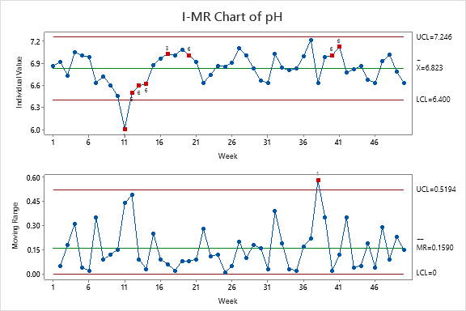

**Figure 4. 1 *I-MR chart of pH***

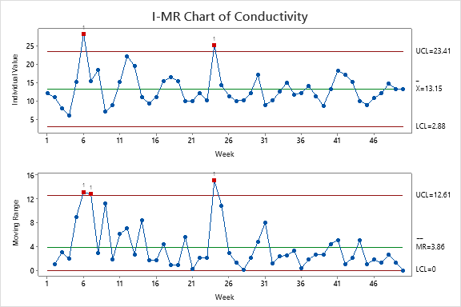

**Figure 4. 2 *I-MR chart of Conductivity***

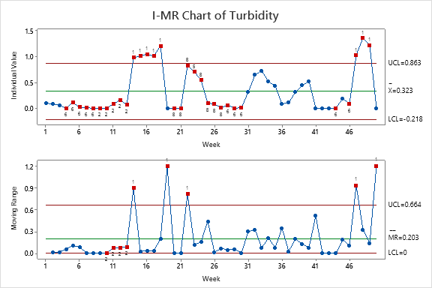

**Figure 4. 3 *I-MR chart of Turbidity***

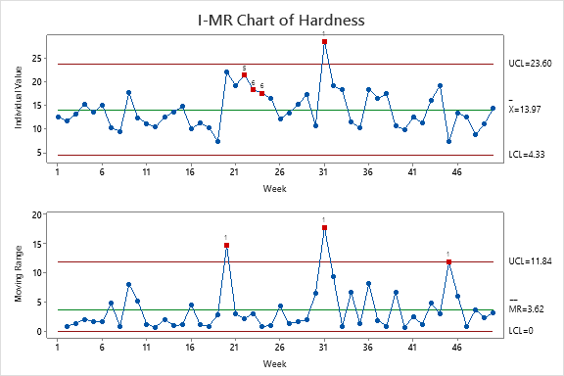

**Figure 4. 4 *I-MR chart of Hardness***

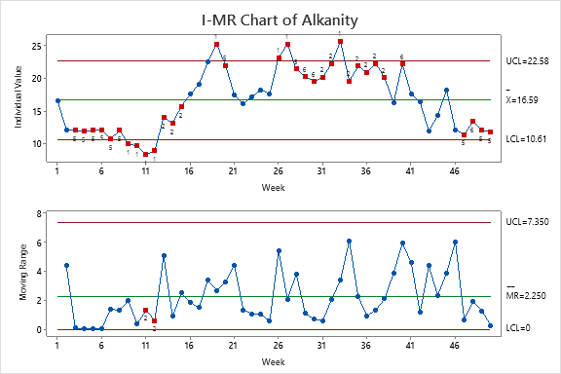

**Figure 4. 5 *I-MR chart of Alkalinity***

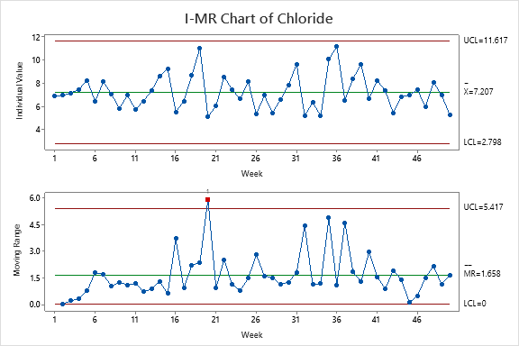

**Figure 4. 6 *I-MR chart of Chloride***

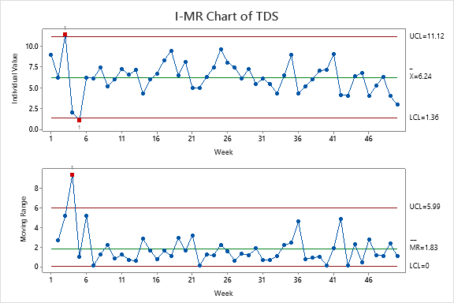

**Figure 4. 7 *I-MR chart of TDS***

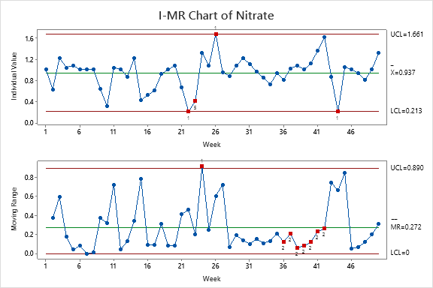

**Figure 4. 8 *I-MR chart of Nitrate***

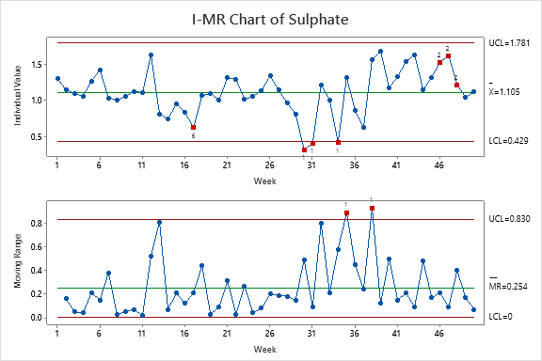

**Figure 4. 9 *I-MR chart of Sulphate***

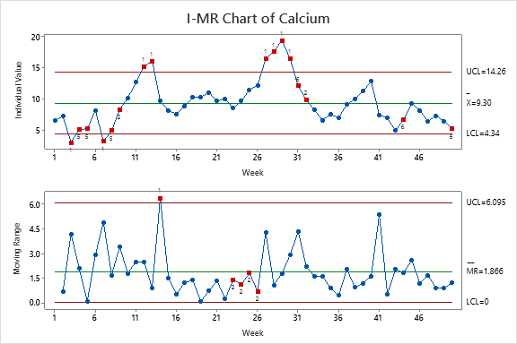

**Figure 4. 10 *I-MR chart of Calcium***

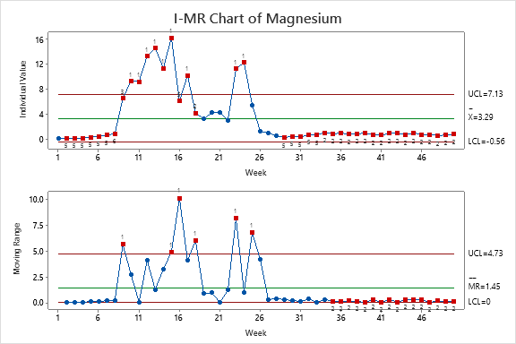

**Figure 4. 11 *I-MR chart of Magnesium***

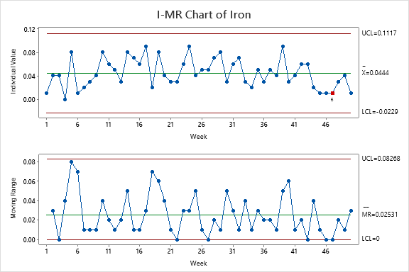

**Figure 4. 12 *I-MR chart of Iron***

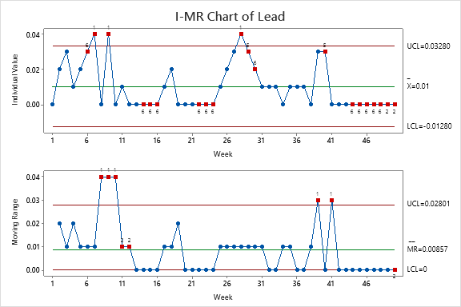

**Figure 4. 13 *I-MR chart of Lead***

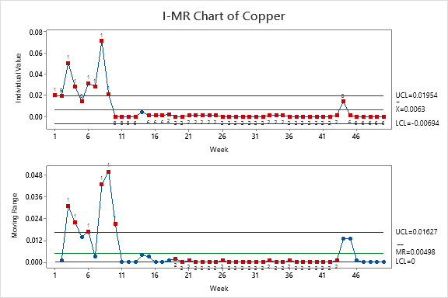

**Figure 4. 14 *I-MR chart of Copper***

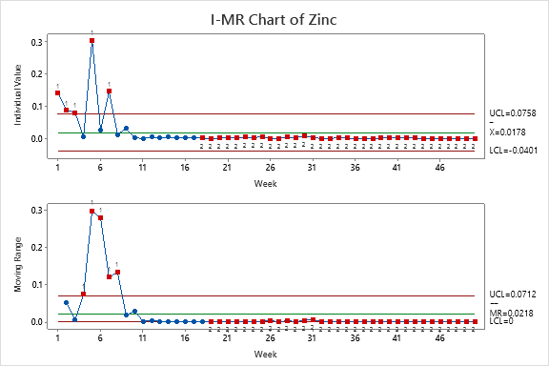

**Figure 4. 15 *I-MR chart of Zinc***

**Table 4. 2 *I-Chart: Tests and failure points (weeks)***

|  |  |  |  |  |  |  |  |  |  |  |  |  |  |  |  |  |
| --- | --- | --- | --- | --- | --- | --- | --- | --- | --- | --- | --- | --- | --- | --- | --- | --- |
| Month | Week | pH | Conductivity | Turbidity | Hardness | Alkanity | Choliride | Total Dissolved Solids | Nitrate | Sulphate | Calcium | Magnesium | Iron | Lead | Copper | Zinc |
| Jan | 1 |  |  |  |  |  |  |  |  |  |  |  |  |  | 1 | 1 |
|  | 2 |  |  |  |  |  |  |  |  |  |  |  |  |  | 5 | 1,5 |
|  | 3 |  |  |  |  | 5 |  | 1 |  |  | 1 | 5 |  |  | 1,5 | 1,5 |
|  | 4 |  |  | 6 |  | 5 |  |  |  |  | 5,6 | 5,6 |  |  | 1,5,6 |  |
| Feb | 5 |  |  | 6 |  | 5,6 |  | 1,5 |  |  | 5,6 | 5,6 |  |  | 6 | 1,5,6 |
|  | 6 |  | 1 | 6 |  | 5,6 |  |  |  |  |  | 5,6 |  | 6 | 1,5,6 |  |
|  | 7 |  |  | 6 |  | 5,6 |  |  |  |  | 1,5,6 | 5,6 |  | 1,5,6 | 1,5,6 | 1,5 |
|  | 8 |  |  | 6,8 |  | 5,6 |  |  |  |  | 5,6 | 6.8 |  |  | 1,5,6 |  |
| Mar | 9 |  |  | 2,6,8 | 1,2,5,6,8 | |  |  |  |  | 2 | 3,8 |  | 1,5,6 | ,2,5,6 |  |
|  | 10 |  |  | 2,6,8 | 1,2,5,6,8 | |  |  |  |  | 1,3.5,8 | |  |  |  |  |
|  | 11 | 1, 5,6 |  | 2,6,8 | 1,2,5,6,8 | |  |  |  |  |  | 1,5,8 |  |  |  |  |
|  | 12 | 5,6 |  | 2 | 1,2,5,6,8 | |  |  |  |  | 1,5 | ,5,6,8 |  |  |  |  |
| Apr | 13 | 6 |  | 2,6 |  | 2,6,8 |  |  |  |  | 1,3,5 | ,5,6,8 |  |  | 6 |  |
|  | 14 | 6 |  | 1 |  | 2,6,8 |  |  |  |  | 1,5,6,8 | |  | 6 |  |  |
|  | 15 |  |  | 1,5 |  | 2 |  |  |  |  |  | 5,6,8 |  | 6 | 6 |  |
|  | 16 |  |  | 1,5 |  |  |  |  |  |  |  | 5,6,8 |  | 6 | 6 |  |
| May | 17 | 3 |  | 1,5,6 |  |  |  |  |  | 6 | 1,2,5,6,8 | |  |  | 6 |  |
|  | 18 |  |  | 1,5,6 |  |  |  |  |  |  |  | 2 |  |  | 2,6 | 2 |
|  | 19 |  |  |  |  | 5 |  |  |  |  |  |  |  |  | 2,6 | 2 |
|  | 20 | 6 |  |  |  | 5,6 |  |  |  |  |  |  |  |  | 2,6 | 2 |
|  | 21 |  |  |  |  |  |  |  |  |  |  |  |  |  | 2,6 | 2 |
| June | 22 |  |  |  | 5 |  |  |  | 1 |  |  |  |  | 6 | 2,6 | 2,7 |
|  | 23 |  |  | 5 | 6 |  |  |  |  |  |  | 1 |  | 6 | 2,6 | 2,7 |
|  | 24 |  | 1 |  | 6 |  |  |  |  |  |  | 1,5 |  | 6 | 2,6 | 2,7 |
|  | 25 |  |  |  |  |  |  |  |  |  |  |  |  |  | 2,6 | 2,7 |
| July | 26 |  |  |  |  | 1 |  |  | 1 |  |  |  |  |  | 2,6,8 | 2,7 |
|  | 27 |  |  |  |  | 1,5 |  |  |  |  | 1 |  |  |  | 2,6,8 | 2,7 |
|  | 28 |  |  | 6 |  | 5 |  |  |  |  | 1,5,6 |  |  | 1,5 | 2,6,8 | 2,7 |
|  | 29 |  |  | 6 |  | 6 |  |  |  | 1,3,5,6 | | 5,6 |  | 5,6 | 2,6,8 | 2,7 |
|  | 30 |  |  | 6 |  | 6 |  |  |  | 1 | 1,5,6 | 5,6,8 |  | 6 | 2,6,8 | 2,7 |
| Aug | 31 |  |  |  | 1 | 2,6 |  |  |  | 1.5 | 6 | 5,6,8 |  |  | 2,6,8 | 2,7 |
|  | 32 |  |  |  |  | 2,6 |  |  |  |  | 2 | 5,6,8 |  |  | 2,6,8 | 2,7 |
|  | 33 |  |  |  | 1,2,5,6,8 | |  |  |  |  |  | 5,6,8 |  |  | 2,6,8 | 2,7 |
|  | 34 |  |  |  |  | 2,6,8 |  |  |  | 1 |  | 6,8 |  |  | 2,6,8 | 2,7 |
| Sept | 35 |  |  |  | 2,5,6,8 | |  |  |  |  |  | 6,8 |  |  | 2,6,8 | 2,7 |
|  | 36 |  |  |  | 2,5,6,8 | |  |  |  |  |  | 6,8 |  |  | 2,6,8 | 2,7 |
|  | 37 |  |  |  | 2,5,6,8 | |  |  |  |  |  | 6,8 |  |  | 2,6,8 | 2,7 |
|  | 38 |  |  |  |  | 2,6,8 |  |  |  |  |  | 6,8 |  |  | 2,6,8 | 2,7 |
| Oct | 39 |  |  |  |  |  |  |  |  |  |  | 6,8 |  |  | 2,6,8 | 2,7 |
|  | 40 | 6 |  |  |  | 6 |  |  |  |  |  | 6,8 |  | 5 | 2,6,8 | 2,7 |
|  | 41 | 6 |  |  |  |  |  |  |  |  |  | 5,6,8 |  |  | 2,6,8 | 2,7 |
|  | 42 |  |  |  |  |  |  |  |  |  |  | 6,8 |  |  | 2,6,8 | 2,7 |
|  | 43 |  |  |  |  |  |  |  |  |  |  | 6,8 |  |  | 2,6,8 | 2,7 |
| Nov | 44 |  |  | 6 |  |  |  |  | 1 |  | 6 | 6,8 |  | 6 | 6,8 | 2,7 |
|  | 45 |  |  |  |  |  |  |  |  |  |  | 6,8 |  | 6,8 | 6,8 | 2,7 |
|  | 46 |  |  | 6 |  |  |  |  |  | 2 |  | 5,6,8 |  | 6,8 | 6,8 | 2,7 |
|  | 47 |  |  | 1 |  | 5,6 |  |  |  | 2 |  | 5,6,8 | 6 | 6,8 | 6,8 | 2,7 |
| Dec | 48 |  |  | 1,5 |  | 6 |  |  |  | 2 |  | 5,6,8 |  | 6,8 | 6,8 | 2,7 |
|  | 49 |  |  | 1,5 |  | 5,6 |  |  |  |  |  | 5,6,8 |  | 2,6,8 | 6,8 | 2,7 |
|  | 50 |  |  |  |  | 5,6 |  |  |  |  | 6 | 6,8 |  | 2,6,8 | 6,8 | 2,7 |

**Table 4. 3 *MR-Chart: Tests and failure points (weeks)***

|  |  |  |  |  |  |  |  |  |  |  |  |  |  |  |  |  |
| --- | --- | --- | --- | --- | --- | --- | --- | --- | --- | --- | --- | --- | --- | --- | --- | --- |
| Month | Week | pH | Conductivity | Turbidity | Hardness | Alkanity | Choliride | Total Dissolved Solids | Nitrate | Sulphate | Calcium | Magnesium | Iron | Lead | Copper | Zinc |
| Jan | 1 |  |  |  |  |  |  |  |  |  |  |  |  |  |  |  |
|  | 2 |  |  |  |  |  |  |  |  |  |  |  |  |  |  |  |
|  | 3 |  |  |  |  |  |  |  |  |  |  |  |  |  | 1 |  |
|  | 4 |  |  |  |  |  |  | 1 |  |  |  |  |  |  | 1 | 1 |
| Feb | 5 |  |  |  |  |  |  |  |  |  |  |  |  |  |  | 1 |
|  | 6 |  | 1 |  |  |  |  |  |  |  |  |  |  |  | 1 | 1 |
|  | 7 |  | 1 |  |  |  |  |  |  |  |  |  |  |  |  | 1 |
|  | 8 |  |  |  |  |  |  |  |  |  |  |  |  | 1 | 1 | 1 |
| Mar | 9 |  |  |  |  |  |  |  |  |  |  | 1 |  | 1 | 1 |  |
|  | 10 |  |  |  |  |  |  |  |  |  |  |  |  | 1,2 |  |  |
|  | 11 |  |  |  |  | 1 |  |  |  |  |  |  |  | 2 |  |  |
|  | 12 |  |  |  |  | 1 |  |  |  |  |  |  |  | 2 |  |  |
| Apr | 13 |  |  |  |  |  |  |  |  |  |  |  |  |  |  |  |
|  | 14 |  |  | 1 |  |  |  |  |  |  | 1 |  |  |  |  |  |
|  | 15 |  |  |  |  |  |  |  |  |  |  | 1 |  |  |  |  |
|  | 16 |  |  |  |  |  |  |  |  |  |  | 1 |  |  |  |  |
| May | 17 |  |  |  |  |  |  |  |  |  |  |  |  |  |  |  |
|  | 18 |  |  |  |  |  |  |  |  |  |  | 1 |  |  |  |  |
|  | 19 |  |  | 1 |  |  |  |  |  |  |  |  |  |  | 2 | 2 |
|  | 20 |  |  |  | 1 |  | 1 |  |  |  |  |  |  |  | 2 | 2 |
|  | 21 |  |  |  |  |  |  |  |  |  |  |  |  |  | 2 | 2 |
| June | 22 |  |  | 1 |  |  |  |  |  |  |  |  |  |  | 2 | 2 |
|  | 23 |  |  |  |  |  |  |  |  |  | 2 | 1 |  |  | 2 | 2 |
|  | 24 |  | 1 |  |  |  |  |  | 1 |  | 2 |  |  |  | 2 | 2 |
|  | 25 |  |  |  |  |  |  |  |  |  | 2 | 1 |  |  | 2 | 2 |
| July | 26 |  |  |  |  |  |  |  |  |  | 2 |  |  |  | 2 | 2 |
|  | 27 |  |  |  |  |  |  |  |  |  |  |  |  |  | 2 | 2 |
|  | 28 |  |  |  |  |  |  |  |  |  |  |  |  |  | 2 | 2 |
|  | 29 |  |  |  |  |  |  |  |  |  |  |  |  |  | 2 | 2 |
|  | 30 |  |  |  |  |  |  |  |  |  |  |  |  |  | 2 | 2 |
| Aug | 31 |  |  |  | 1 |  |  |  |  |  |  |  |  |  | 2 | 2 |
|  | 32 |  |  |  |  |  |  |  |  |  |  |  |  |  | 2 | 2 |
|  | 33 |  |  |  |  |  |  |  |  |  |  |  |  |  | 2 | 2 |
|  | 34 |  |  |  |  |  |  |  |  |  |  |  |  |  | 2 | 2 |
| Sept | 35 |  |  |  |  |  |  |  |  | 1 |  | 2 |  |  | 2 | 2 |
|  | 36 |  |  |  |  |  |  |  | 2 |  |  | 2 |  |  | 2 | 2 |
|  | 37 |  |  |  |  |  |  |  | 2 |  |  | 2 |  |  | 2 | 2 |
|  | 38 | 1 |  |  |  |  |  |  | 2 | 1 |  | 2 |  |  | 2 | 2 |
| Oct | 39 |  |  |  |  |  |  |  | 2 |  |  | 2 |  | 1 | 2 | 2 |
|  | 40 |  |  |  |  |  |  |  | 2 |  |  | 2 |  |  | 2 | 2 |
|  | 41 |  |  |  |  |  |  |  | 2 |  |  | 2 |  | 1 | 2 | 2 |
|  | 42 |  |  |  |  |  |  |  | 2 |  |  | 2 |  |  | 2 | 2 |
|  | 43 |  |  |  |  |  |  |  |  |  |  | 2 |  |  | 2 | 2 |
| Nov | 44 |  |  |  |  |  |  |  |  |  |  | 2 |  |  |  |  |
|  | 45 |  |  |  | 1 |  |  |  |  |  |  | 2 |  |  |  |  |
|  | 46 |  |  |  |  |  |  |  |  |  |  | 2 |  |  |  |  |
|  | 47 |  |  | 1 |  |  |  |  |  |  |  | 2 |  |  |  |  |
| Dec | 48 |  |  |  |  |  |  |  |  |  |  | 2 |  |  |  |  |
|  | 49 |  |  |  |  |  |  |  |  |  |  | 2 |  |  |  |  |
|  | 50 |  |  | 1 |  |  |  |  |  |  |  | 2 |  | 2 |  |  |

**Table 4. 4 *Parameters and failed tests***

1 Failed FailedFailedFailedFailedFailedFailedFa

2

3 Failed

4

1. Failed
2. Failed

7

8

Failed

Failed

FailedF

Tot

I-MRChart Tests

pH

Conductivity

Turbidity

Hardness

Alkanity

Choliride

Total Dissolved Solids

Nitrate

ulphate

ium

ium

**Table 4. 5 *Control Chart Run Test Description***

**Test Description**

1. One point more than 3.00 standard deviations from center line.
2. 9 points in a row on same side of center line.
3. 6 points in a row all increasing or all decreasing.
4. 4 out of 5 points more than 1 standard de
5. 2 out of 3 points more than 2
6. 4 out of 5 points m
7. 15 poin 8

### Process Capability Result

The MR charts show that, the all parameters except iron failed test 1, which is the conventional test of three sigma (standard deviations) from either side of the centre line. Here, it is assumed that, this is the only test for a process in control. Hence, the process capability analysis is carried out on iron only.

Considering equations 3.8 and 3.9 from chapter three and using the Minitab 2021 ® Statistical software package, the data of iron from Table 4.1, was used to construct a process capability chart as shown in Figure 16.

The result of the process capability of iron shows that, the capability index, Cp = 2.23, being greater than 1, (Cp = 2.23 > 1), means the process meets specification. However, the ratio, Cpk = 0.66, being less than 1, (Cpk = 0.66 < 1), hence, the process does not confirm the specification.

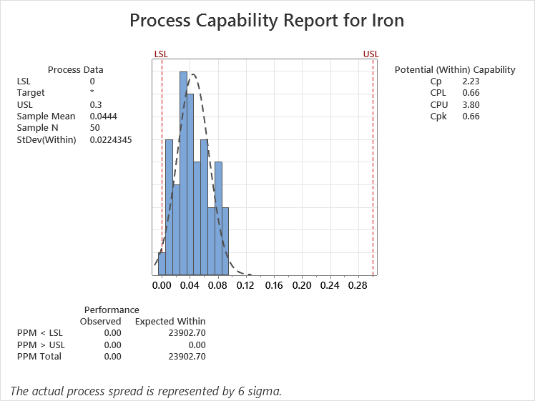

**Figure 4. 16 *Process Capability Report of Iron***

## Findings

* + 1. There is an assignable cause of variation in the production process. Hence, there is a high chance of unexpected level of process variation and also significant high level of naturally occurring variations in the processes.
    2. The argument that, the values of water quality parameters meeting specification limits is not sufficient to ensure good quality water characteristics is confirmed because there exists variance between laboratory and process results of finished water quality parameters. While the laboratory results of the water quality parameters turbidity, pH, conductivity, total hardness, total alkalinity, chloride, Total Dissolved solids (TDS), nitrates, sulphate, calcium, magnesium, iron, copper and zinc are within the range permitted by Standard Organization of Nigerian (SON, 2015) and World Health Organization (WHO, 2004) standards for portable drinking water, the process stability results indicates, the process is out of control, except iron.

# CHAPTER FIVE

# CONCLUSION AND RECOMMENDATION

5.0 **Conclusion**

In this study, the Niger Delta University Table Water Factory production line was evaluated for its current performance. The process stability and capability was assessed for some of the water quality physicochemical parameters as appropriate. These parameters are pH, conductivity, turbidity, total hardness, total alkalinity, chloride, Total Dissolved solids (TDS), nitrates, sulphate, calcium, magnesium, iron, lead, copper and zinc. Their values were extracted from the laboratory test results conducted by the quality control department of the factory for official regulatory purpose over 50 weeks, running from January through December, 2020. The purpose is to ascertain that, the water factory’s product reaching its consumers is of excellent quality, complying with the relative regulations and ensure continuous improvement.

The study involved the use of the Minitab 2021 ® Statistical software package to carry out both the stability and capability analyses, and display control charts to aid decision-making.

The quality parameters of the Niger Delta University Table Water Factory treated water were found to be within the limits permitted by Standard Organization of Nigerian (SON, 2015) and World Health Organization (WHO. 2004) standards for portable drinking water, with the exception of the minimum value of the pH obtained, 6.01, which is less than the minimum standard value of 6.5 and the maximum value of Lead, 0.04, which is greater than the maximum permitted value of 0.01.

However, the process stability analysis detected the occurrence of special cause of variability in the production line for all the parameters. Since a process must be in statistical process control to enable carry out the process capability analysis, this was only done for one parameter, which is iron. This was based on the assumption that, the run rules were ignored. Its result revealed that, the process meets specification (Cp= 2.23 > 1), however, the process does not confirm the specification (Cpk = 0.66 < 1).

### Recommendation

For the fact that continuous improvement is paramount for consumer satisfaction and competitiveness, it is recommended as follows:

* + - This research study, as shown by the I-MR charts, has established that, assignable causes are attributed to the causes of variation in the process, therefore, need for investigations to correct and control the variability of the process, hence, allowing improvement in the production line.
    - The corrective and control of the out of control production process as shown by the I-MR charts should be subjected to deploying the appropriate tools in the DMAIC methodology, which could not be covered under this study.
    - The water factory workers’ sensitization, education and involvement for quality production should be enhanced.
    - The management and staff of the water factory should embrace water quality with the view of continuous process improvement by going on quality training programs on scheduled basis.
    - Water quality assessment should also include statistical process control and not be limited to just the laboratory analysis.

### Suggestions for Further Research

Upon considering the limitations of this study the researcher identified areas which need to be investigated and enhanced. This will provide a complete deployment of the Lean Six Sigma (LSS) DMAIC methodology and as such, recommends as follows:

* Further research should be done to properly identify the variance between laboratory and process results of finished water quality parameters. This would show more opportunities for discovering the real life situations for optimal performance of Lean Six Sigma (LSS) (LSS) DMAIC methodology and the actual expected continuous quality improvement.
  + - This nature of quality improvement evaluation should be extended to include the bacteriological water quality parameter as well.

# REFERENCES

Abideen A. A., Olasupo A. D., Muraina T. A., Uthman T. A., Oyekanmi H. A. (2020). Physicochemical and Microbiological Analysis of Selected Sachet Water Vended in Akure, Ondo State, Nigeria. *International Journal of Academic and Applied Research (IJAAR),* 4(5): pp, 47-52

Ali, A. (2016). Exploring lean strategy for service quality improvements in UK based airline (Doctoral dissertation, Brunel University London).

Alley E. R. (2007). Water Quality Control Handbook. Vol. 2. New York: McGraw-Hill

APHA (2005). Standard Methods for the Examination of Water and Wastewater. 21st ed. Washington, DC: American Public Health Association

Aslan, N. Y. (2016). Minimizing the defect rate using six sigma DMAIC method; a case study in SUPSAN AŞ. (Master’s Thesis, KADİR HAS University)

Bain, R., Johnston, R., and Slaymaker, T. (2020). Drinking water quality and the SDGs. *npj*

*Clean Water,* 3(1): pp, 1-3.

Benneyan, J. C. (1998). Use and interpretation of statistical quality control charts*. International Journal for Quality in Health Care*, 10(1): pp, 69-73.

Bhasin, S., Shukla, A. N., Shrivastava, S., and Mishra, U. (2016). Control Chart Model for Assessment of Water Quality of a Tropical River-Kshipra Ujjain, India. *Haya: The Saudi Journal of Life Sciences*, 1(1), 51-64.

Bos, R., Roaf, V., Payen, G., J Rousse, M., Latorre, C., McCleod, N., & Alves, D. (2016). Manual on the human rights to safe drinking water and sanitation for practitioners (p. 120). IWA Publishing.

Breyfogle III, F. W. (2003). Implementing six sigma: smarter solutions using statistical methods. John Wiley & Sons.

Chatterjee A. (2001). Water Supply Waste Disposal and Environmental Pollution Engineering (Including Odour, Noise and Air Pollution and its Control). 7th ed. Delhi: Khanna Publishers

Chero, P. P. A. (2019). Statistical Process Control Applied in the Chemical and Food Industry*. Journal of Material Sciences & Engineering* 8(531): pp 2.

Choo-in, S. (2019). The relationship between the total dissolved solids and the conductivity value of drinking water, surface water, and waste water. In *The 2019 International Academic Research Conference in Amsterdam* (pp. 11-16).

Cole S, Codling I, Parr W, Zabel T, (1999). Nature E, Heritage SN. Guidelines for Managing Water Quality Impacts within UK European Marine Sites

Conceição, K. Z. D., Boas, M. A. V., Sampaio, S. C., Remor, M. B., & Bonaparte, D. I. (2018). Statistical control of the process applied to the monitoring of the water quality index. *Engenharia Agrícola*, 38, pp, 951-960.

Crosby, P. B. (1979): Quality Is Free*.* New York: Penguin Books

Davis M, L, David A. (2008). Introduction to Environmental Engineering. 4th ed. New York: McGraw-Hill Companies.

Davis M. L (2010). Water and Wastewater Engineering—Design Principles and Practice. New York: McGraw-Hill

Davis, J. M. (2016). The development and evaluation of a lean six sigma advanced manufacturing methodologies course for aeronautical engineering technology curriculum (Doctoral dissertation, Purdue University).

De Feo, J. A. and Barnard, W. W. (2004): Juran Quality Performance Breakthrough Methods. McGraw-Hill, New York.

De Gracia Manceñido, S. (2013). The implementation of Lean Six Sigma methodology in the wine sector: an analysis of a wine bottling line in Trentino (Bachelor's thesis, Universitat Politècnica de Catalunya).

Deming, W. E. (1986): Out of the Crisis*.* Cambridge, MA: MIT Press.

DeZuane J. (1997). Handbook of Drinking Water Quality. 2nd ed. New York: John Wiley & Sons

Drohomeretski, E., Gouvea da Costa, S. E., Pinheiro de Lima, E., & Garbuio, P. A. D. R. (2014). Lean, Six Sigma and Lean Six Sigma: an analysis based on operations strategy*. International Journal of Production Research,* 52(3): pp, 804-824.

Duffy, W. (2016). Factory Drilling: A Lean Manufacturing Approach to Drilling Operations (Doctoral dissertation, University of Leoben).

Edzwald JK (2010). Water Quality and Treatment a Handbook on Drinking Water. New York: McGraw-Hill

Erameh, A. A., Raji, N. A., Durojaye, R. O., & Yussouff, A. A. (2016). Process capability analysis of a centre lathe turning process. *Engineering*, *8*(03): pp, 79.

Fitzmaurice, I. (2010). The effects of implementing a Lean Six Sigma tool, Visual Process Controls, to improve month-end activities in a finance department–An Empirical Case Study. *National University of Ireland*.

Follador F. A. C., Márcio A. Vilas Boas, Marlise Schoenhals, Eliane Hermes and Clovis Rech (2012); Tabular CUSUM Control Charts of Chemical Variables Applied to the Control of Surface Water Quality*; Eng. Agríc., Jaboticabal,* 32(5): pp 951-960.

George, M.L. (2002): Lean Six Sigma, Combining Six Sigma Quality with Lean speed, McGraw-Hill, New York, NY

Gibbons, P. M. (2011). The development of a value improvement model for repetitive processes (Doctoral dissertation, University of Bristol).

Hill, J., Thomas, A. J., Mason-Jones, R. K., & El-Kateb, S. (2018). The implementation of a Lean Six Sigma framework to enhance operational performance in an MRO facility. *Production and Manufacturing Research*, *6*(1): pp, 26-48.

Huval, O. P. (2016). Lean Six Sigma Methodology Used to Improve Machine Availability in a Manufacturing Process. University of Louisiana at Lafayette.

Ieren, T. G., Kuje, S., Asongo, A. I., & Eraikhuemen, I. B. (2020*).* Application of Statistical Quality Control in Monitoring the Production, Packaging and Marketing Process of Sachet Water*. Journal of Scientific Research and Reports,* 26(9): pp, 32-45*.*

Ihunwo K. C. and Kinigoma B. S. (2016): Management of the Production Process of A Water Bottling Plant To Improve Quality: A Case Study; *International Journal of Advanced Academic Research | Engineering |* 2(2):

Jayakumar V and Raju R (2016): Total Quality Management. 3rd ed. ISBN 978-93-83103- 11-9

Juran, J. M. (1995): A History of Managing for Quality. Milwaukee, WI: ASQC Quality Press.

Kale K. (2019): Process Improvement in a Plastic Manufacturing Industry using Six Sigma Tools; Proceedings of the International Conference on Industrial Engineering and Operations Management Toronto, Canada.

Kandampully, J. (1998). Service quality to service loyalty: A relationship which goes beyond customer services. *Total Quality Management*, *9*(6): pp, 431-443.

Krishnamoorthi, K. S., Krishnamoorthi, V. R., & Pennathur, A. (2019). A First course in quality engineering: integrating statistical and management methods of quality. CRC press. ISBN 9781498764216

Levallois, P., Barn, P., Valcke, M., Gauvin, D., & Kosatsky, T. (2018). Public Health Consequences of Lead in Drinking Water. *Current environmental health reports*, *5*(2): pp 255–262.

Mahendru, S., & Singh, B. (2015). DMAIC-Measuring the PVC Pipe Manufacturing Process. *American Journal of Economics, Finance and Management*, 1 (4): pp, 293-303.

Mansur, A. (2016). Plastic Injection Quality Controlling Using the Lean Six Sigma and FMEA Method. In *IOP Conference Series: Materials Science and Engineering*; 105(1): pp 012006.

Marco M. R. (2019). Impact of Lean Six Sigma on Sustainability: Relationships and framework for their integration (Master’s Thesis, Lund University)

Mauch, P. D. (2009). Quality management: theory and application. CRC press. Montgomery, D. C, Woodall, W. H., Spitzner, D. J. and Gupta, S. (2004). Using control charts to monitor process and product quality profiles. *Journal of Quality Technology*, *36*(3): pp, 309-320.

Montgomery, D. C. (2009). Introduction to statistical quality control. John Wiley & Sons. Six edition. ISSN: 978-0-470-16992-6

Nasir, M. A. K., & Abubakar, U. S. M. A. N. (2010). Analysis of pure water production: a case study of ten (10) randomly selected pure water firms in Minna, Niger state. *Global Journal of Mathematics and Stat*istics *2*(2): pp, 153-159.

Musa, D. M., Garba, Y. I., Yusuf, M. S. and Ishaq, A. (2018). Assessment of water quality for selected boreholes and sachets water in Maigatari Town, Jigawa State, Nigeria. *Bayero Journal of Pure and Applied Sciences*, *11*(2): pp, 122-127.

Oakland, J. S. (2014): Total quality management and operational excellence: text with c*ases*. Routledge.

Omoush, M. M. (2020): Lean Six Sigma effect on the Quality of the Products in Jordanian Food Companies: The Moderating Role of the Manufacturing Process. *International Review of Management and Marketing*, *10*(6): pp 1.

Opafola, O. T., Oladepo, K. T., Ajibade, F. O., & David, A. O. (2020). Potability assessment of packaged sachet water sold within a tertiary institution in southwestern Nigeria. *Journal of King Saud University-Science*, *32*(3): pp, 1999-2004.

PHAM, J., & Chau, T. B. (2017). Application of Lean Six Sigma in engineering enterprises (Doctoral dissertation, Masaryk University, Faculty of Economics and Administration).

Piercy, N. and Rich, N. (2009*)*. Lean transformation in the pure service environment: the case of the call service centre. *International Journal of Operations and Production Management* 29(1): pp, 54-76.

Pyzdek T. and Keller P. A. (2003): The Six Sigma Handbook; A Complete Guide for Green

Belts, Black Belts, and Managers at All Levels, 3rd ed. McGraw-Hill, New York.

Rakuša, S. (2016). Business process improvement using Lean Six Sigma: an example of improving the onboarding process (Doctoral dissertation, Univerza v Ljubljani, Fakulteta za družbene vede).

Rathilall, R. and Singh, S. (2018). A Lean Six Sigma framework to enhance the competitiveness in selected automotive component manufacturing organizations. *South African journal of economic and management sciences*, *21*(1): pp, 1-13.

Rostamkhani, R. and Karbasian, M. (2020). Quality Engineering Techniques: An Innovative and Creative Process Model. CRC Press.

Salah S., J. A. Carretero and A. Rahim (2009): Six Sigma and Total Quality Management (TQM): similarities, differences and relationship; *International Journal of* Six Sigma and Competitive Advantage, 5 (3): pp, 237-250

Salah S., J. A. Carretero and A. Rahim (2010 A): The integration of six sigma and lean management; [*International Journal of Lean Six Sigma*](https://www.emerald.com/insight/publication/issn/2040-4166), 1(3): pp, 249-274 Salah S., J. A. Carretero and A. Rahim (2010 B): The integration of quality Management and continuous improvement methodologies with management systems; *International Journal of Productivity and Quality Management,* 6(3): pp, 269-288

Salah, S. (2017). Lean Six Sigma and innovation: comparison and

relationship. *International Journal of Business Excellence*, *13*(4): pp, 479-493.

Salah, S. (2018) Lean Six Sigma and innovation: comparison and relationship*, International*

*Journal of Business Excellence,* 13(4): pp, 479-493

Salih, M. S. M. M., & Elmadina, M. A. E. O. M. (2015). Application of Lean Six Sigma Methodology to Improve Quality in Cold air Factory.

Sambhe, R. U. (2012). Six Sigma practice for quality improvement–A case study of Indian auto ancillary unit*. IOSR Journal of Mechanical and Civil Engineering,* 4(4): pp 26-42

Schulze, E. (1986). Guidelines for Drinking‐Water Quality. Vol. 2. Health Criteria and Other Supporting Information. 335 Seiten. World Health Organization, Geneva 1984. Preis: 35.–Sw. fr.

Shah, C. R. (2017). Which Physical, Chemical and Biological Parameters of water

determine its quality? DOI: [10.13140/RG.2.2.29178.90569](http://dx.doi.org/10.13140/RG.2.2.29178.90569)

Shirey, W. T. (2017). Application of Lean Six Sigma to Improve Service in Healthcare Facilities Management: A Case Study (Doctoral dissertation, Arizona State University).

Smeti, E. M., Thanasoulias, N. C., Kousouris, L. P., & Tzoumerkas, P. C. (2007): An approach for the application of statistical process control techniques for quality improvement of treated water. *Desalination*, *213*(1-3): pp, 273-281.

Smętkowska, M., & Mrugalska, B. (2018). Using Six Sigma DMAIC to improve the quality of the production process: a case study. *Procedia-Social and Behavioral Sciences*, *238*, pp, 590-596.

Spellman FR (2017). Handbook of Water and Wastewater Treatment Plant Operations. 3rd ed. Boca Raton: CRC press

Standards Organization of Nigeria (SON), 2015. Nigerian Standards for Drinking Water Quality. Nigerian Industrial Standards NIS 554.

Summers D. C. S (2018); Quality, Sixth ed.. | New York: Pearson: ISBN: 9780134413358

Supriyanto, H., & Maftuhah, D. I. (2017). A lean six-sigma manufacturing process case study. *International Journal of Mechanical Engineering and Technology*, *8*(7): pp, 498- 509.

Tchobanoglous G, Burton FL, Stensel H. D. Metcalf & Eddy (2003). Wastewater Engineering: Treatment and Reuse. 4th ed. New Delhi: Tata McGraw-Hill Limited.

Tchobanoglous G, Peavy H. S., Rowe D. R. (1985). Environmental Engineering. New York: McGraw-Hill Interamericana

Tiberiu Dragusin (2013): Six Sigma Revealed by International Six Sigma Institute; Training Book (2nd ed.)

Tikkala, S. (2014). Lean Six Sigma in a manufacturing lead time improvement project (Master’s Thesis, Lappeenranta University of Technology)

Titov, S., Nikulchev, E., Bubnov, G., & Biryukov, A. (2016). Impact of Lean Production Initiatives on Quality: Theoretical Analysis and Empirical Research*. Quality-Access to Success,* 1(150): pp, 57-60.

Usman, A. and Kontagora, N. M. (2010). Statistical process control on production: a case study of some basic chemicals used in pure water production. *Pakistan Journal of Nutrition*, *9*(4): pp, 387-391.

Uzorh, A. C, Nnanna, I. and Olanrewaju, F. (2019): The Application of Lean-Six-Sigma Methodology in the Manufacturing Sector: A Case Study of Nigerian Breweries*; IOSR Journal of Mechanical and Civil Engineering;* 15(6): pp, 74-93

Weststrate, J., Dijkstra, G., Eshuis, J., Gianoli, A., & Rusca, M. (2019). The sustainable development goal on water and sanitation: Learning from the millennium development goals. *Social Indicators Research,* 143(2): pp, 795-810.

Wiley R.K., Dan R.R and Sander S.R. (2007). Statistical Quality Control. 3rd edition. ISSN: 223-43212

Womack, J. P., & Jones, D. T. (2003). Banish waste and create wealth in your corporation*. Recuperado de* [*http://www.*](http://www/) *kvimis. co. in/sites/kvimis. co. in/files/ebook_attachments/James.*

World Health Organization (WHO. (1996). Guidelines for Drinking-Water Quality, Vol. 2, Health criteria and other supporting information.

World Health Organization (WHO. (2003). Guidelines for drinking-water quality. In *Guidelines for drinking-water quality*. World Health Organization (WHO).

World Health Organization (WHO. (2004). Guidelines for Drinking Water Quality; WHO press, Geneva, Switzerland, pp. 355–398.

Young, T. M., Lebow, P. K., Lebow, S., & Taylor, A. (2019). SPC handbook for the treated wood industries. *Knoxville, TN: University of Tennessee Institute of Agriculture, Center for Renewable Carbon. 78: pp*, 1-78.

Yusuf, Y. O., Jimoh, A. I., Onaolapo, E. O., and Dabo, Y. (2015). An assessment of sachet water quality in Zaria Area of Kaduna State, Nigeria. *Journal of Geography and Regional Planning*, *8*(7): pp, 174-180.

# APPENDICES

**APPENDIX 1 *Factors for Control Chart Constants***

|  |  |  |  |  |  |  |  |
| --- | --- | --- | --- | --- | --- | --- | --- |
| n | A2 | A3 | B3 | B4 | D3 | D4 | d2 |
| 2 | 1.88 | 2.659 | 0 | 3.267 | 0 | 3.267 | 1.128 |
| 3 | 1.023 | 1.954 | 0 | 2.568 | 0 | 2.574 | 1.693 |
| 4 | 0.729 | 1.628 | 0 | 2.266 | 0 | 2.282 | 2.059 |
| 5 | 0.577 | 1.427 | 0 | 2.089 | 0 | 2.114 | 2.326 |
| 6 | 0.483 | 1.287 | 0.03 | 1.97 | 0 | 2.004 | 2.534 |
| 7 | 0.419 | 1.182 | 0.118 | 1.882 | 0.076 | 1.924 | 2.704 |
| 8 | 0.373 | 1.099 | 0.185 | 1.815 | 0.136 | 1.864 | 2.847 |
| 9 | 0.337 | 1.032 | 0.239 | 1.761 | 0.184 | 1.816 | 2.97 |
| 10 | 0.308 | 0.975 | 0.284 | 1.716 | 0.223 | 1.777 | 3.078 |
| 11 | 0.285 | 0.927 | 0.321 | 1.679 | 0.256 | 1.744 | 3.173 |
| 12 | 0.266 | 0.886 | 0.354 | 1.646 | 0.283 | 1.717 | 3.258 |
| 13 | 0.249 | 0.85 | 0.382 | 1.618 | 0.307 | 1.693 | 3.336 |
| 14 | 0.235 | 0.817 | 0.406 | 1.594 | 0.328 | 1.672 | 3.407 |
| 15 | 0.223 | 0.789 | 0.428 | 1.572 | 0.347 | 1.653 | 3.472 |

Source: (Abridged) from Table A4, of A First Course in Quality Engineering Integrating Statistical and Management Methods of Quality. 3rd ed. (Krishnamoorthi, 2018)

**APPENDIX 2 Physicochemical analysis for NDU Table Water (Treated Water Sample)**

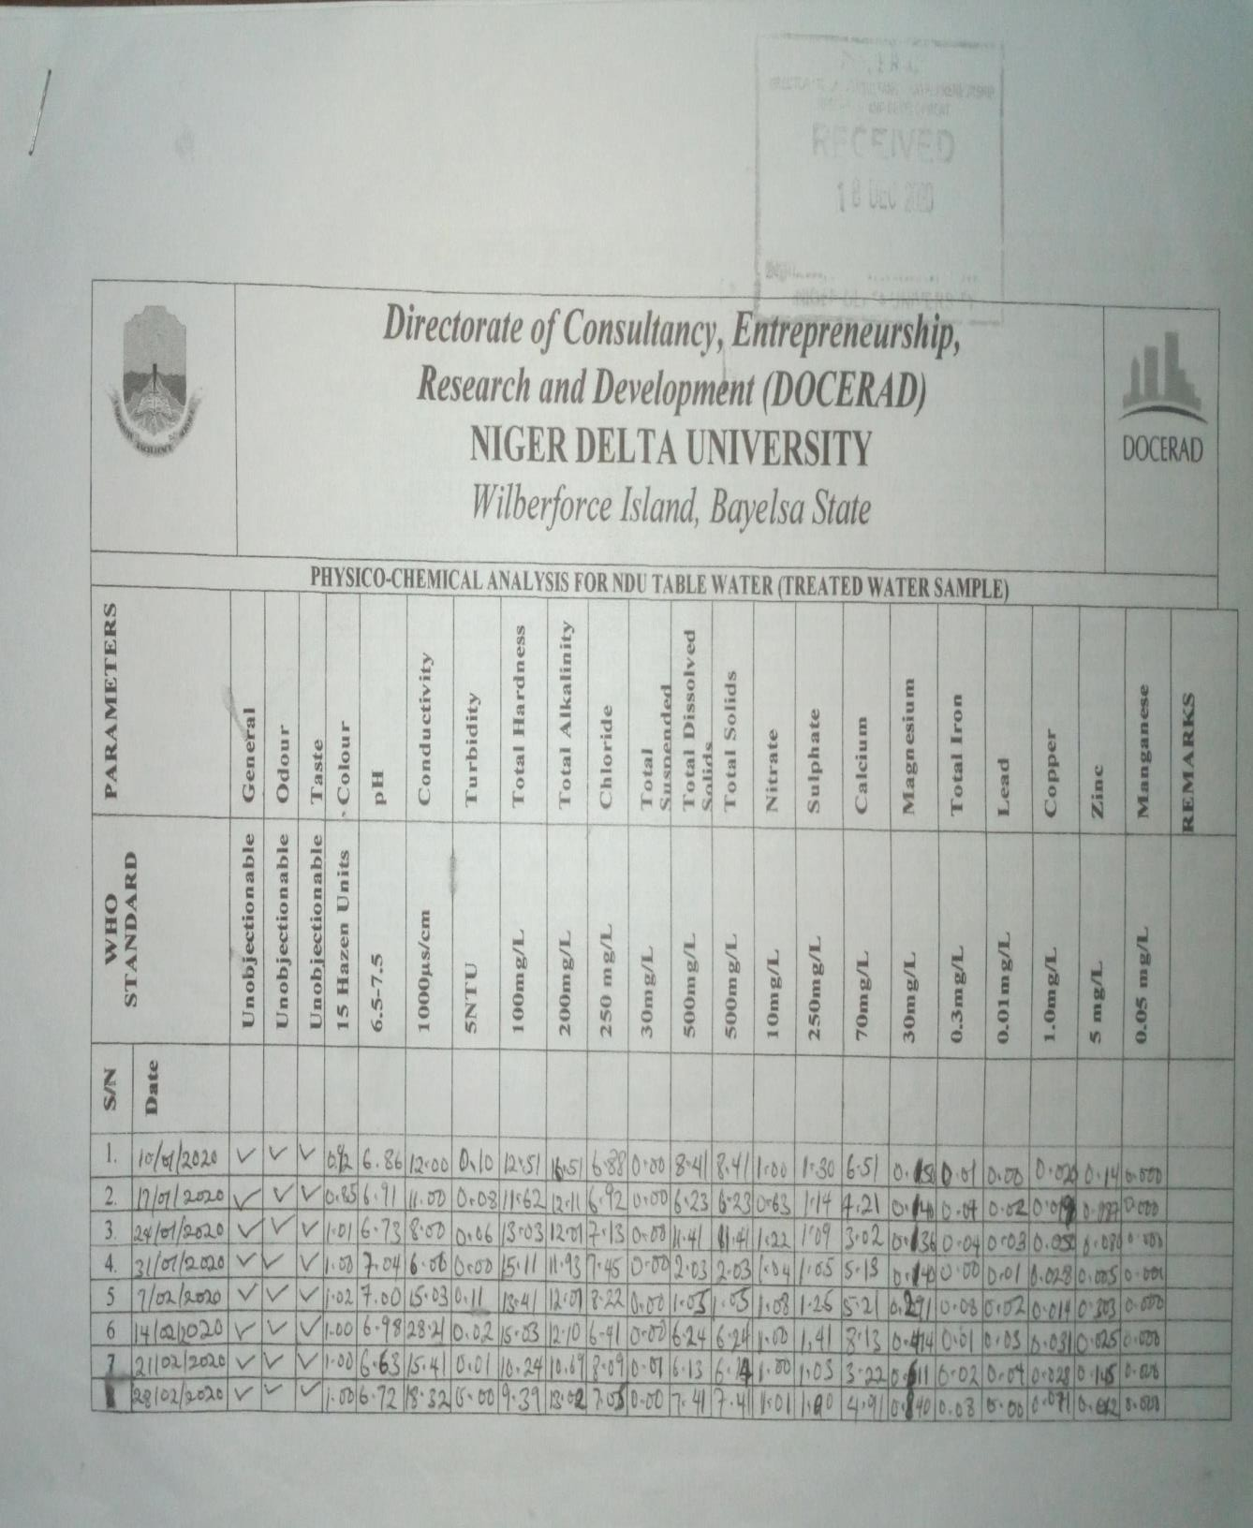

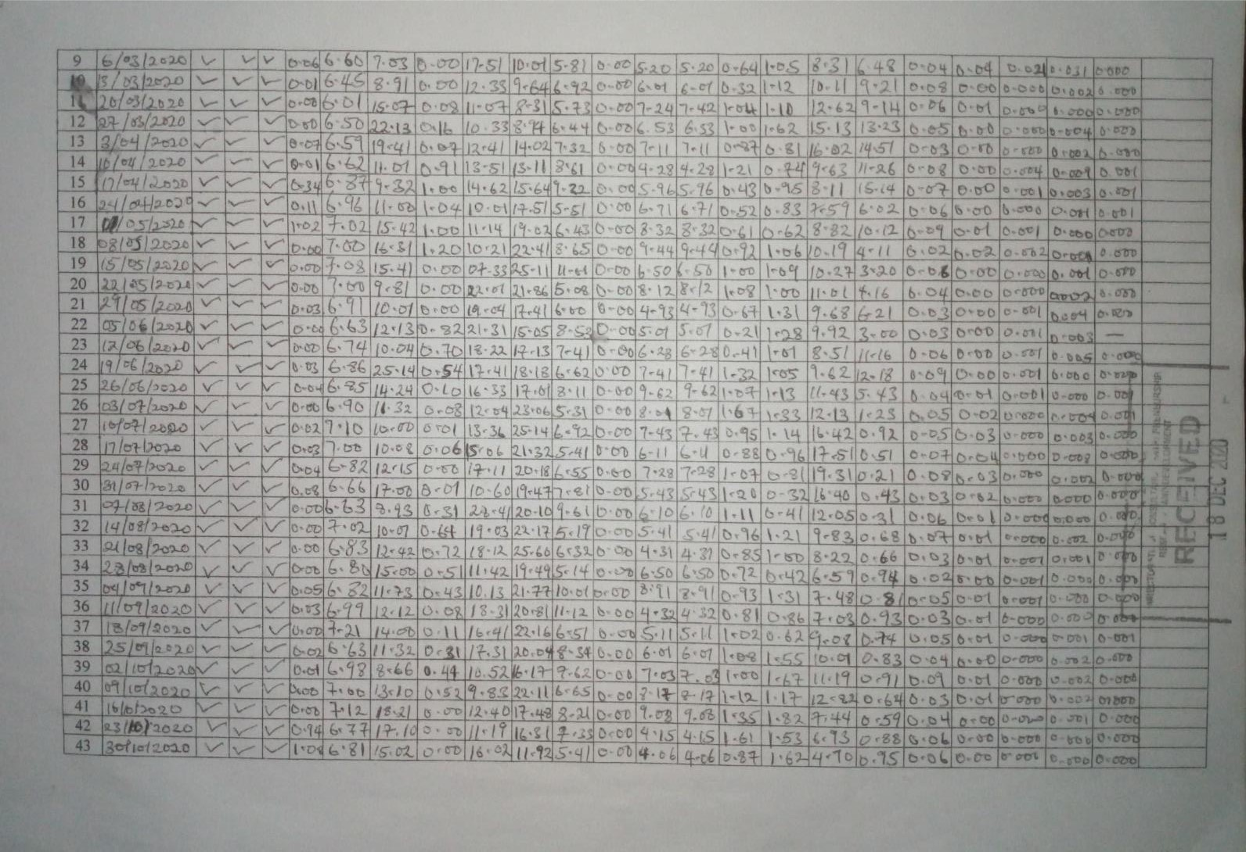

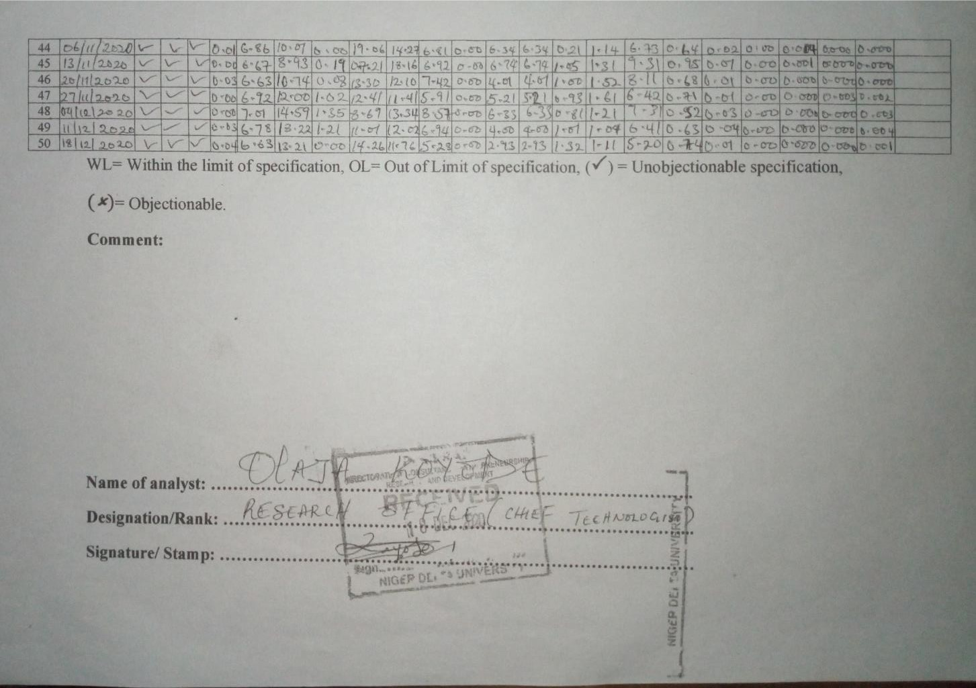

**APPENDIX 3 NDU Table Water Factory Production Process Photographs**

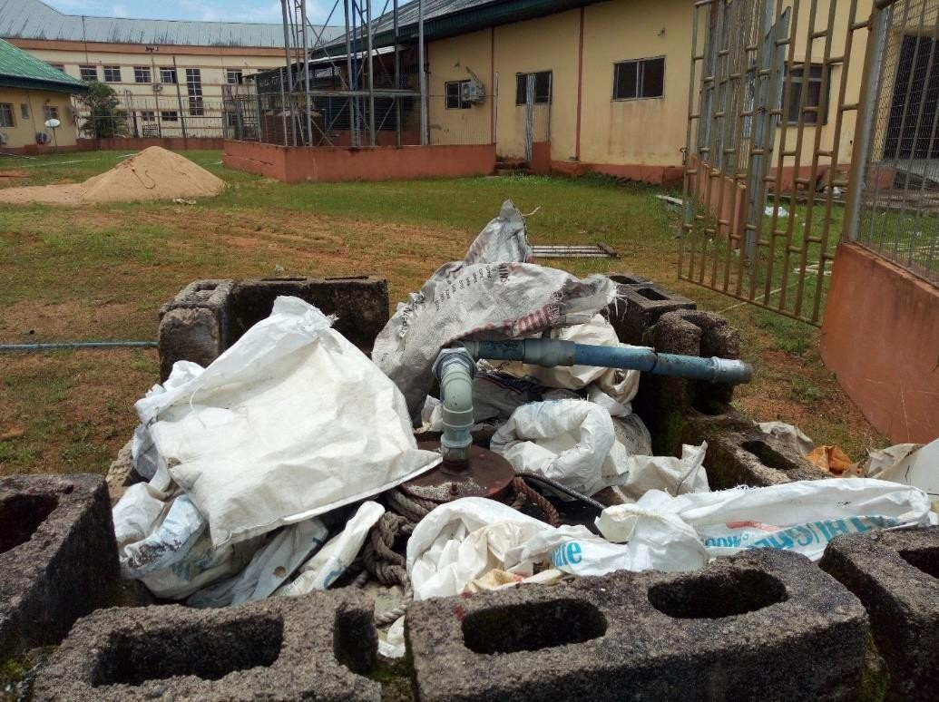

Raw Water Intake System (Ground source)

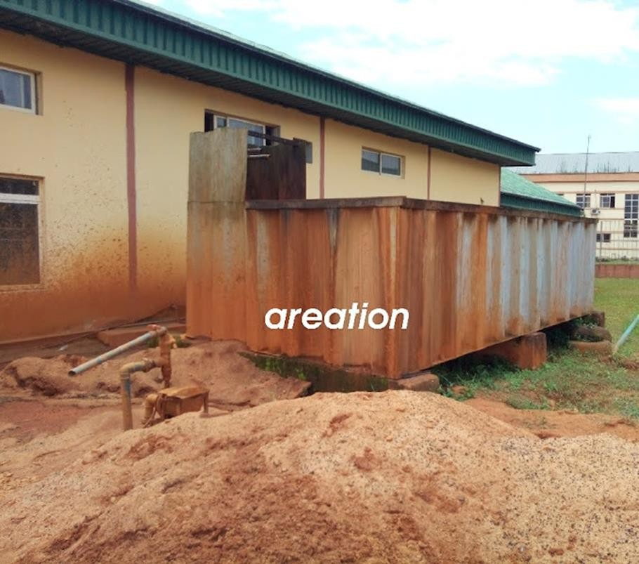

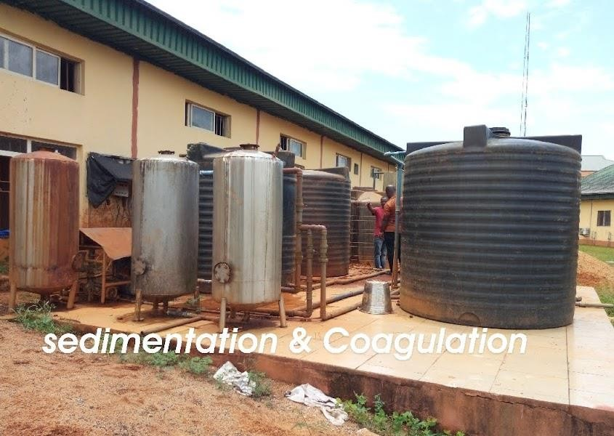Aeration System

Sedimentation and Coagulation

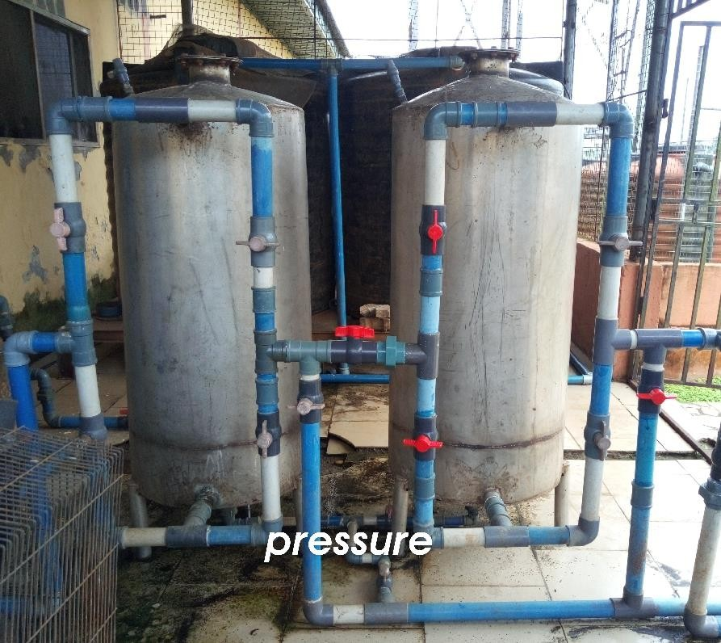

Pressure Tank System

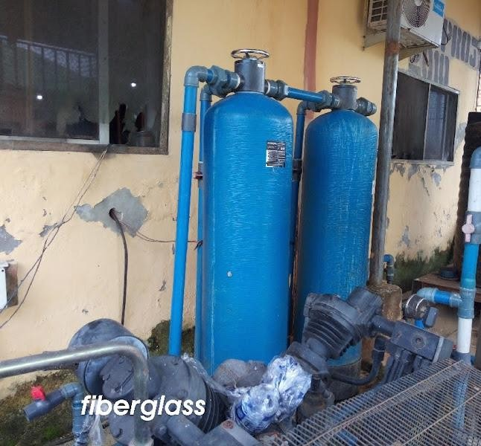

Fiberglass System

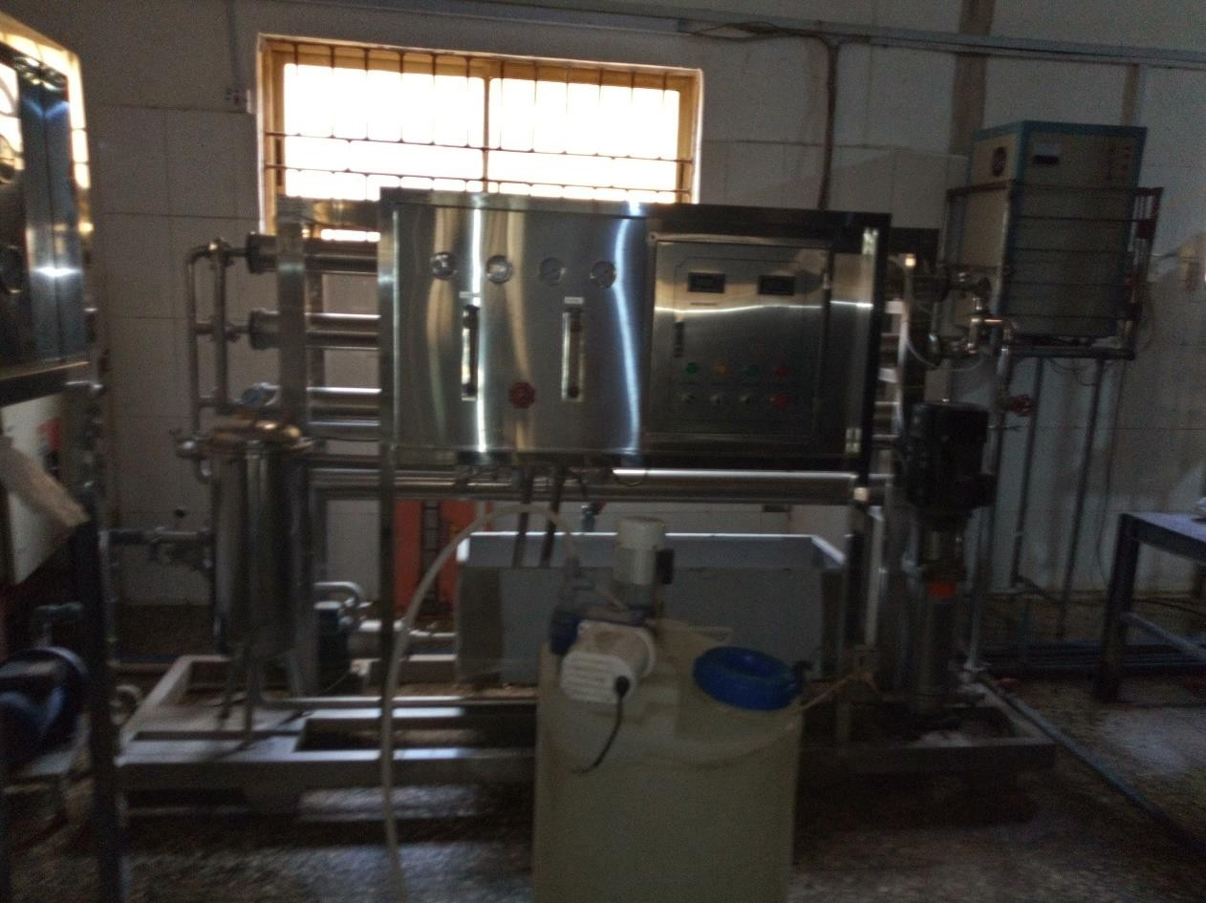

Reverse Osmosis

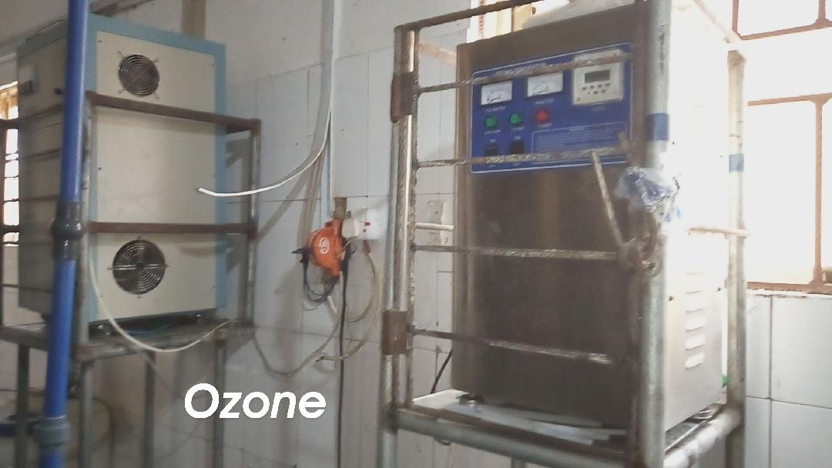

Ozone generation