# CONSTRUCTION OF MICROCONTROLLER BASED VEHICLE SPEED ALARM.

**BY**

# JIAGBOGU NNAEMEKA NNAETO EE/2007/167

**SUBMITED IN PARTIAL FULFILLMENT OF THE REQUIREMENT FOR THE AWARD OF BACHELOR OF ENGINEERING (B.ENG)**

# TO

**DEPARTMENT OF ELECTRICAL ELECTRONIC ENGINEERING FACULTY OF ENGINEERING**

# CARITAS UNIVERSITY, AMORJI-NIKE, ENUGU

**AUGUST 2012**

APPROVAL PAGE

This project has been read and approved by the undersigned as with the requirement at the department of Electrical Electronic Engineering of Caritas University Amorji Nike Enugu for the award of Bachelor of Engineering (B.Eng.) in Electrical Electronic Engineering.

Engr. Ejimorfor Date

(Project supervisor)

Engr. Ejimofor Date

(Head of Department)

External Supervisor Date

DEDICATION

This project is dedicated to Almighty God and to my parents Engr. & Mrs. EJ Jiagbogu and to my beloved brothers and sisters whose ever loving kindness and support has seen me through my years of studies and to my late grandfather sir J. Ndu Jiagbogu.

ACKNOWLEDGEMENT

I wish to express my immense gratitude to God Almighty for his mercy, guidance and protection towards me for seeing me through the rigors of this work.

I am greatly indebted to my supervisor Engr. Ejimofor for his kind gesture and whose critics lead to the achievement of this work.

I also will remain grateful to the tremendous contribution of my lecturers Engr. Ojobor (the Dean of Engineering Faculty), Engr. Ejimofor (Head of Electrical Electronic Engineering Department), Engr. Mbah, Engr. Ochi, and all the staff of Electrical Electronic Engineering both academic and non academic staff for their intellectual upbringing.

My special appreciation goes to my loving parents Engr. & Mrs. EJ jiagbogu, my grandparent, my uncles and aunties, my brothers and sisters whose moral and financial support cannot be over emphasized.

Also my sincere gratitude and special regards to my friends too many to mention whose encouragement also lead to the success of this work.

ABSTRACT

The project is based on Construction of microcontroller vehicle speed alarm system which automatically warns the driver by activating a panic alarm which is triggered on when the driver exceeds the speed limit set in the system which also stops the alarm when the speed is reduced below the set speed limit. A speedometer system is used to monitor the speed of the car. The voltage output of the speedometer system is used to set the time the alarm comes on. The other component parts of the system are power unit which comprises of 5volts regulator and diode for reverse voltage prevention, micro controller, analog to digital converter (ADC), LED, resistors, transistors, wires and potentiometer. By proper steps, time and knowledge, one was able to couple the components together to achieve the desired functions which are stated in the various chapters of this report. This system can be used for road safety and measures taken to prevent accident caused by over speeding.

TABLE OF CONTENTS PAGE

Title page i

Approval page ii

Dedication iii

Acknowledgement iv

Abstract v

Table of contents vi

List of figures ix

List of table’s x

CHAPTER ONE: INTRODUCTION

* 1. Background of the study 1
  2. The aim and objective 2
  3. Scope of the project 2
  4. Project report organization 3

CHAPTER TWO: LITERATURE REVIEW

* 1. Historical background 4
  2. Speedometer 5
  3. Voltage regulator 8
  4. Transformer 9
  5. Diodes 9
  6. The opt-coupler 11
  7. Potentiometer 13
  8. Transistor 14
  9. Resistor 17
  10. Microcontroller 19

CHAPTER THREE: SYSTEM OPERATION

* 1. Block diagram of the project 23
  2. Circuit diagram and operation 25

CHAPTER FOUR: SYSTEM DESIGN AND CONSTRUCTION

* 1. Software designing 32
  2. Calculating led resistor value 33
  3. Constructed system circuit 34

CHAPTER FIVE: TEST OF RESULTS, PACKAGING

* 1. Testing of the individual components 36
  2. Unit by unit testing 36
  3. System testing 36
  4. Integration 36
  5. Packaging 36

CHAPTER SIX: CONCLUSION AND RECOMMENDATION

* 1. Conclusion 38
  2. Problems encountered and solutions 38
  3. Suggestion for further improvements 38
  4. Recommendation 38

APPENDIX A: List of system components 40

APPENDIX B: Component cost table 41

APPENDIX C: System source code 43

BIBLIOGRAPHY 55

LIST OF FIGURES

PAGE

Fig1.1: A modern speedometer 2

Fig2.1: A7805 voltage regulator 8

Fig2.2: Diagram of step down transformer 9

Fig2.3: Diode and its symbol 9

Fig2.4: Diode curve graph 10

Fig2.5: Opt-isolator with phototransistor 12

Fig2.6: LED and its circuit symbol 12

Fig2.7: Potentiometer 14

Fig2.8: Transistor symbol 15

Fig2.9: Resistor and its symbol 17

Fig2.10: Resistor with colour bands 18

Fig2.11: The pin layout of the microcontroller 21

Fig2.12: Architecture of the PIC16F88 microcontroller 22

Fig3.1: Block diagram of the project 23

Fig 3.2: Flow chart 24

Fig3.3: Power supply diagram 26

Fig3.4: Hall Effect module 27

Fig3.5: LED integrated to the control unit (microcontroller) 30

Fig3.6: Complete system diagram 31

Fig4.1: Calculating LED resistor value 33

Fig4.2: System unit 34

LIST OF TABLES

PAGE

Table 2.1: The data sheet 16

Table 2.2: Colour code and tolerance 17

Appendix B Component cost analysis table 41

# CHAPTER ONE: INTRODUCTION

# BACKGROUND OF THE STUDY

The dashboard instrument cluster in a car organizes a variety of sensors and gauges, including the oil pressure gauge, coolant temperature gauge, [fuel level](http://auto.howstuffworks.com/fuel-gauge.htm) [gauge](http://auto.howstuffworks.com/fuel-gauge.htm), tachometer and more. But the most prominent gauge and perhaps the most important, at least in terms of how many times you look at it while driving is the **speedometer**. The job of the speedometer is to indicate the speed of a car in miles per hour, kilometers per hour or both. Even in late-model cars, it's an analog device that uses a needle to point to a specific speed, which the driver reads as a number printed on a dial.

As with any emerging technology, the first speedometers were expensive and available only as options. It wasn't until 1910 that automobile manufacturers began to include the speedometer as standard equipment. One of the first speedometer suppliers was **Otto Schulze Auto meter (OSA)**, a legacy company of Siemens VDO Automotive AG, one of the leading developers of modern instrument clusters. The first OSA speedometer was built in 1923 and its basic design didn't change significantly for 60 years. In this project report, high lights will be on the history of speedometers, how they work and digitalization of speedometer, add-on speed checker, and what the future may hold for speedometer design, below is a pictorial overview of a speedometer.

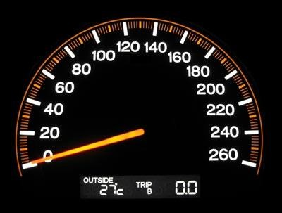

Fig1.1: A modern speedometer.

# THE AIM AND OBJECTIVE OF THE PROJECT

* + - To design a digital speedometer.
    - Incorporate a speed monitor with respect to set threshold.

# SCOPE OF THE PROJECT

* + - Actualization of speed using analog to digital conversion technique;
    - Displaying the analog value in a digital format using an alphanumeric LCD display;
    - Entering the speed limit using keyboard built around to push to make switches (mode and adjustment keys)
    - Implementing hall -effect technique.

# PROJECT REPORT ORGANIZATION

The chapter one is the introductory chapter of the project, chapter two highlights on the literature review of the project, chapter three highlights on the system operation chapter four circuit design and implementation, chapter five testing and results of the project, chapter six summary, recommendation and conclusion of the project non-chapter pages are: the reference page and appendix.

# CHAPTER TWO: LITERATURE REVIEW

# HISTORICAL BACKGROUND

A **speedometer** is a [gauge](http://en.wikipedia.org/wiki/Gauge_%28instrument%29) that measures and displays the instantaneous [speed](http://en.wikipedia.org/wiki/Speed) of a land vehicle. Now universally fitted to [motor vehicles](http://en.wikipedia.org/wiki/Motor_vehicle), they started to be available as options in the 1900s, and as standard equipment from about 1910 onwards.[[1]](http://en.wikipedia.org/wiki/Speedometer#cite_note-hsw-0) Speedometers for other vehicles have specific names and use other means of sensing speed. For a boat, this is a [pit log](http://en.wikipedia.org/wiki/Pit_log). For an aircraft, this is an [airspeed](http://en.wikipedia.org/wiki/Airspeed_indicator) [indicator](http://en.wikipedia.org/wiki/Airspeed_indicator).

The speedometer was invented by the [Croatian](http://en.wikipedia.org/wiki/Croatia) [Josip Belusic](http://en.wikipedia.org/wiki/Josip_Belu%C5%A1i%C4%87) in 1888, and was originally called a velocimeter.

The eddy current speedometer has been used for over a century and is still in use. Until the 1980s and the appearance of electronic speedometers it was the only type commonly used.

Originally patented by a German, Otto Schulze on 7 October 1902, it uses a rotating flexible cable usually driven by gearing linked to the output of the vehicle's transmission. The early Volkswagen Beetle and many motorcycles, however, use a cable driven from a front wheel.

When the car or motorcycle is in motion, a speedometer gear assembly will turn a speedometer cable which then turns the speedometer mechanism itself. A small permanent magnet affixed to the speedometer cable interacts with a small aluminum cup (called a *speed cup*) attached to the shaft of the pointer on the analogue speedometer instrument. As the magnet rotates near the cup, the changing magnetic field produces eddy currents in the cup, which themselves produce

another magnetic field. The effect is that the magnet exerts a torque on the cup, "dragging" it, and thus the speedometer pointer, in the direction of its rotation with no mechanical connection between them.

The pointer shaft is held toward zero by a fine torsion spring. The torque on the cup increases with the speed of rotation of the magnet (which is driven by the car's transmission). Thus an increase in the speed of the car will twist the cup and speedometer pointer against the spring. The cup and pointer will turn until the torque of the eddy currents on the cup is balanced by the opposing torque of the spring, and then stop. Since the torque on the cup is exactly proportional to the car's speed, and the spring's deflection is proportional to the torque, the angle of the pointer is also proportional to the speed. At a given speed the pointer will remain motionless and pointing to the appropriate number on the speedometer's dial.

The return spring is calibrated such that a given revolution speed of the cable corresponds to a specific speed indication on the speedometer. This calibration must take into account several factors, including ratios of the tail shaft gears that drive the flexible cable, the final drive ratio in the differential, and the diameter of the driven tires.

# SPEEDOMETERS

Many modern speedometers are electronic. In designs derived from earlier eddy- current models, a rotation sensor mounted in the transmission delivers a series of electronic pulses whose frequency corresponds to the (average) rotational speed of the driveshaft, and therefore the vehicle's speed, assuming the wheels have full traction. The sensor is typically a set of one or more magnets mounted on the output shaft or (in transaxles) differential crown wheel or a toothed metal disk

positioned between a magnet and a magnetic field sensor. As the part in question turns, the magnets or teeth pass beneath the sensor, each time producing a pulse in the sensor as they affect the strength of the magnetic field it is measuring. Alternatively, in more recent designs, some manufactures rely on pulses coming from the ABS wheel sensors.

A computer converts the pulses to a speed and displays this speed on an electronically-controlled, analog-style needle or a digital display. Pulse information is also used for a variety of other purposes by the ECU or full-vehicle control system, e.g. triggering ABS or traction control, calculating average trip speed, or more mundanely to increment the odometer in place of it being turned directly by the speedometer cable.

Another early form of electronic speedometer relies upon the interaction between a precision watch mechanism and a mechanical pulsate driven by the car's wheel or transmission. The watch mechanism endeavors to push the speedometer pointer toward zero, while the vehicle-driven pulsation tries to push it toward infinity. The position of the speedometer pointer reflects the relative magnitudes of the outputs of the two mechanisms. The illustration above boil up in the implementation of the ***hall-effect technique,*** the induced voltage as its result is converted to digital using the analog to digital conversion technique.

Hall Effect is an electrical effect that occurs under certain conditions when an electrical conductor is subject to a magnetic field or a region of space influenced by a magnet or other magnetizing objects (*see* Magnetism). Studies of the Hall Effect have led to a better understanding of the electronic properties of solids, such as conduction in metals and *semiconductors,* which are materials that conduct electricity better than electrical insulators but not as well as electrical conductors.

The Hall Effect occurs when a conductor or semiconductor carrying an electric current is placed in a magnetic field. A voltage, called the Hall voltage, is created across the conductor or semiconductor perpendicular to both the current and the magnetic field. This voltage arises because the magnetic field distorts the flow of electrons or other charge carriers that constitute the current, pushing the charged particles to one side of the conductor.

The Hall voltage is proportional to the current and magnetic field and inversely proportional to the number of electrons or other charged particles. For instance, the Hall voltage across a metal is much smaller than across a semiconductor carrying the same current in the same magnetic field because the metal contains more charged particles than the semiconductor.

This effect was discovered in 1879 by American physicist Edwin Hall. German physicist Klaus-Olaf von Klitzing won the 1985 Nobel Prize in physics for his discovery of the quantum Hall effect, which helps explain electrical movements in atoms. The ***Hall Effect*** is useful in the study of plasmas a state of matter in which some or all of the atoms or molecules are separated into ions, or particles with net electric charges and the study of *magneto hydrodynamics,* the interaction between magnetic fields and conducting liquids. The function of a variety of electric meters and measuring instruments, such as ammeters, wattmeter’s, magnetic compasses, and position sensing devices, as well as power-transforming solid-state devices known as transducers, are based on the ***Hall Effect.***

# VOLTAGE REGULATOR

Voltage Regulator (also called a "regulator") has only three legs and appears to be a comparatively simple device but it is actually a very complex integrated circuit. A regulator converts varying input voltage and produces a constant "regulated" output voltage. Voltage regulators are available in a variety of outputs, typically 5 volts, 9 volts and 12 volts. The last two digits in the name indicate the output voltage.

|  |  |  |
| --- | --- | --- |
| regulators4.gif (1351 bytes)  Symbol for a Voltage Regul  This device looks like a Transi but it is actually a com Integrated Circuit. | regulator.jpg (4601 bytes)  A LM7805 Regulat | regulators3 |

# Fig. 2.1 A 7805 Voltage regulator

After rectification we have full 15v on the positive end and to obtain the 5v required to drive the microcontroller a voltage regulator (LM7805) is connected to the circuit. This particular type of voltage regulator ensures that only 5v passes through to the other side. Hence, the above power supply design of the system can operate on +5v and +15v as well as 0v level.

# TRANSFORMER

The voltage transformer is a device that step-up or step-down the input voltage to the specified voltage which is determined by the turns ration of the primary ad secondary side [1]. In this case we are considering a step-down mode configuration. Due to the large current drain by the LED display, our secondary current I2 is made sufficient enough to supply the demanded current.

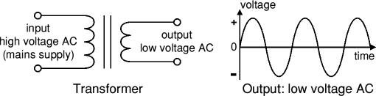

# Fig. 2.2 Diagram of step down transformer Transformer Equation

E1/E2 = N1/N2 = I2/I1

Where E = Voltage

N = No of turns I = current

Numbers 1 =primary, 2 = secondary

# DIODES





Figure 2.3: Diode and its symbol:

# FUNCTION OF DIODE

Diodes allow electricity to flow in only one direction. The arrow of the circuit symbol shows the direction in which the current can flow. Diodes are the electrical version of a valve and early diodes were actually called valves.

# FORWARD VOLTAGE DROP

Electricity uses up a little energy pushing its way through the diode, rather like a person pushing through a door with a spring. This means that there is a small voltage across a conducting diode, it is called the forward voltage drop and is about 0.7V for all normal diodes which are made from silicon. The forward voltage drop of a diode is almost constant whatever the current passing through the diode so they have a very steep characteristic (current-voltage graph).

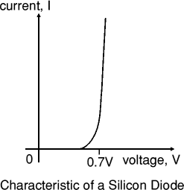

Figure 2.4: Diode curve graph

# REVERSE VOLTAGE

When a reverse voltage is applied a perfect diode does not conduct, but all real diodes leak a very tiny current of a few µA or less. This can be ignored in most

circuits because it will be very much smaller than the current flowing in the forward direction. However, all diodes have a maximum reverse voltage (usually 50V or more) and if this is exceeded the diode will fail and pass a large current in the reverse direction, this is called breakdown.

Ordinary diodes can be split into two types: Signal diodes which pass small currents of 100mA or less and Rectifier diodes which can pass large currents. In addition there are LEDs (which have their own page) and Zener diodes.

# CONNECTING AND SOLDERING OF DIODE

Diodes must be connected the correct way round, the diagram may be labeled A or

+ for anode and K or - for cathode (yes, it really is k, not c, for cathode!). The cathode is marked by a line painted on the body. Diodes are labeled with their code in small print; you may need a magnifying glass to read this on small signal diodes!

Small signal diodes can be damaged by heat when soldering, but the risk is small unless you are using a germanium diode (codes beginning OA...) in which case you should use a heat sink clipped to the lead between the joint and the diode body. A standard crocodile clip can be used as a heat sink. Rectifier diodes are quite robust and no special precautions are needed for soldering them.

# THE OPT COUPLER

In [electronics](http://en.wikipedia.org/wiki/Electronics), an opt-isolator, also called an opt coupler, photo coupler, or optical isolator, is "an electronic device designed to transfer electrical signals by utilizing light waves to provide coupling with electrical isolation between its input and

output". The main purpose of an opt-isolator is "to prevent [high voltages](http://en.wikipedia.org/wiki/High_voltage) or rapidly changing voltages on one side of the circuit from damaging components or distorting transmissions on the other side." Commercially available opt-isolators withstand input-to-output voltages up to 10 [kV](http://en.wikipedia.org/wiki/Volt)../../USER/Downloads/Opto- isolator.htm - cite_note-H145-3 and voltage transients with speeds up to 10 kV/[μs](http://en.wikipedia.org/wiki/Microsecond).

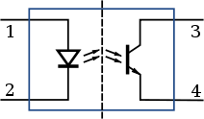

Fig2. 5: Diagram of an opt-isolator

The diagram is showing source of light (LED) on the left, dielectric barrier at the center and sensor (phototransistor) on the right.

# LIGHT EMITTING DIODES (LED)

LED connections

Figure 2.6: LED and its symbol:

# LEDS CONNECTING AND SOLDERING

LEDs must be connected the correct way round, the diagram may be labelled or + for anode and k or - for cathode (yes, it really is k, not c, for cathode!). The cathode is the short lead and there may be a slight flat on the body of round LEDs. If you can see inside the LED the cathode is the larger electrode (but this is not an official identification method). LEDs can be damaged by heat when soldering, but the risk is small unless you are very slow. No special precautions are needed for soldering most LEDs.

# POTENTIOMETER

A potentiometer informally, a pot, in electronics technology is a component, a three-[terminal](http://en.wikipedia.org/wiki/Terminal_%28electronics%29) [resistor](http://en.wikipedia.org/wiki/Resistor) with a sliding contact that forms an adjustable [voltage](http://en.wikipedia.org/wiki/Voltage_divider) [divider](http://en.wikipedia.org/wiki/Voltage_divider). If only two terminals are used, one end and the wiper, it acts as a variable resistor or rheostat.

In [circuit theory and measurement a potentiometer](http://en.wikipedia.org/wiki/Potentiometer_%28measuring_instrument%29) is essentially a voltage divider used for measuring [electric potential](http://en.wikipedia.org/wiki/Electric_potential) (voltage); the component is an implementation of the same principle, hence its name.

Potentiometers are commonly used to control electrical devices such as volume controls on audio equipment. Potentiometers operated by a mechanism can be used as position [transducers](http://en.wikipedia.org/wiki/Transducer), for example, in a [joystick](http://en.wikipedia.org/wiki/Joystick).

Potentiometers are rarely used to directly control significant power (more than a [watt](http://en.wikipedia.org/wiki/Watt)), since the power dissipated in the potentiometer would be comparable to the power in the controlled load (see [infinite switch](http://en.wikipedia.org/wiki/Infinite_switch)). Instead they are used to adjust the level of analog signals (e.g. [volume](http://en.wikipedia.org/wiki/Loudness) controls on [audio equipment](http://en.wikipedia.org/wiki/Audio_equipment)), and as

control inputs for electronic circuits. For example, a light [dimmer](http://en.wikipedia.org/wiki/Dimmer) uses a potentiometer to control the switching of a [TRIAC](http://en.wikipedia.org/wiki/TRIAC) and so indirectly to control the brightness of lamps.

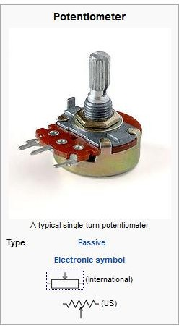

# Fig.2.7: Potentiometer

* 1. **TRANSISTORS**

Transistors can be distinguished by their type:

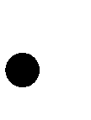pnp or npn Germanium or silicon

Audio frequency or radio frequency Switching or amplification

Low level or medium or power.

The first important point your should remember is that you can replace npn with pnp type because npn requires a positive collector voltage with respect to the base while a pnp requires negative collector voltage with respect to the base(their biasing mode is rather opposite).

Silicon transistor is preferred over the pnp type because they have small leakage current than the germanium. The electrical symbols of the npn and pnp is in the figure below

Base

Collector

Base

Colle ctor

Pn P

Emitter

NpN

Emitter

Figure 2.8: Transistor symbol:

The transistor was used in the driving of the seven segment, LED and relay in my circuit design; the major factor that I consider was the hfe of the transistor this guide me in choosing my base resistor; hfe=Ic/Ib where Ic is the collector current, Ib base current and hfe is the transistor gain . The data sheet of the transistor was provided and distributed free on net so I consider their parameter for choosing the transistors that I used. The one I used was C945 which I attached the data sheet below.

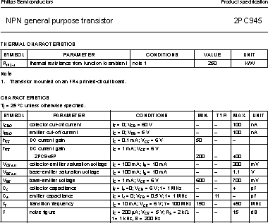

Table 2.1

Considering the transistor gain (hfe); Hfe = Ic/Ib.

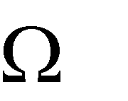The Vb=base voltage, Vb determine the biased state of the transistor. To bias the transistor. The 12v relay has rate 400 =Rc, since Ic=Vc/Rc.

Relay rating voltage= 12v, reactance= 400

Therefore Ic= Vc/Rc Ic=12/400=0.03

Ib=Vb/RbVb=5v,Rb=1000 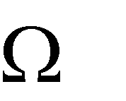

Ib=5/1000= 0.005 A =5mA. Hfe= 0.03/0.005= 6

# Resistors



Figure 2.9: Resistor and its symbol:

# FUNCTIONS OF RESISTOR

Resistors restrict the flow of electric current, for example a resistor is placed in series with a light-emitting diode (LED) to limit the current passing through the LED circuit.

# CONNECTING AND SOLDERING OF RESISTOR

Resistors may be connected either way round. They are not damaged by heat when soldering.

# RESISTOR VALUES - THE RESISTOR COLOUR CODE

Resistance is measured in ohms; the symbol for ohm is an omega .

1 is quite small so resistor values are often given in k and M . 1 k = 1000 1 M = 1000000 . Each colour represents a number as shown in the table.

|  |  |  |  |  |  |  |  |  |  |  |  |  |  |  |
| --- | --- | --- | --- | --- | --- | --- | --- | --- | --- | --- | --- | --- | --- | --- |
|  | Black | brown | | red | | orange | | Yellow | green | Blue | | Violet | grey | White |
|  | 0 | 1 | | 2 | | 3 | | 4 | 5 | 6 | | 7 | 8 | 9 |
| Tolerance | | | brown | | red | | Gold | | Silver | | no colour | | | |
| Percentage | | | 1 | | 2 | | 5 | | 10 | | 20 | | | |

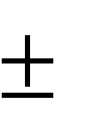Table 2.2: Colour code and tolerance

Most resistors have 4 bands:

The first band gives the first digit.

The second band gives the second digit.

The third band indicates the number of zeros.

The fourth band is used to shows the tolerance (precision) of the resistor, this may be ignored for almost all circuits but further details are given below.



1st band 2nd band 3rd band 4th band Figure 2.10: Resistor with colour bands

This resistor has red (2), violet (7), yellow (4 zeros) and gold bands. So its value is 270000 = 270 k . On circuit diagrams the ohms is usually omitted and the value is written 70K. Small value resistors (less than 10 ohm)

The standard colour code cannot show values of less than 10 . To show these small values two special colours are used for the third band: gold which means

× 0.1 and silver which means × 0.01. The first and second bands represent the digits as normal. For example: red, violet, gold bands represent 27 × 0.1 = 2.7 green, blue, silver bands represent 56 × 0.01 = 0.56

# TOLERANCE OF RESISTORS (FOURTH BAND OF COLOUR CODE)

The tolerance of a resistor is shown by the fourth band of the colour code. Tolerance is the precision of the resistor and it is given as a percentage. For example a 390 resistor with a tolerance of ±10% will have a value within 10% of 390 , between 390 - 39 = 351 and 390 + 39 = 429 (39 is 10% of 390). A

special colour code is used for the fourth band tolerance: silver ±10%, gold ±5%, red ±2%, brown ±1%. If no fourth band is shown the tolerance is ±20%.

# MICROCONTROLLER

(The PIC16f88 Microcontroller)

18/20-Pin Enhanced FLASH Microcontrollers with nanoWatt Technology **Low Power Features:**

* Power Managed modes:
* Primary RUN XT, RC oscillator, 87 μA, 1 MHz, 2V
* RC_RUN 7 μA, 31.25 kHz, 2V
* SEC_RUN 14 μA, 32 kHz, 2V
* SLEEP 0.2 μA, 2V
* Timer1 oscillator 1.3 μA, 32 kHz, 2V
* Watchdog Timer 0.7 μA, 2V
* Two-Speed Oscillator Start-up

# Oscillators:

* Three Crystal modes:
* LP, XT, HS up to 20 MHz
* Two External RC modes
* One External Clock mode:
* ECIO up to 20 MHz
* Internal oscillator block:
* 8 user selectable frequencies: 31 kHz,

125 kHz, 250 kHz, 500 kHz, 1 MHz, 2 MHz,

4 MHz, 8 MHz

# Peripheral Features:

* Capture, Compare, PWM (CCP) module:
* Capture is 16-bit, max. Resolution is 12.5 ns
* Compare is 16-bit, max. Resolution is 200 ns
* PWM max. Resolution is 10-bit
* 10-bit, 7-channel Analog-to-Digital Converter
* Synchronous Serial Port (SSP) with SPI™ (Master/Slave) and I2C™ (Slave)
* Universal Synchronous Asynchronous Receiver Transmitter (USART/SCI) with 9-bit address Detection:
* RS-232 operation using internal oscillator (No external crystal required)
* Dual Analog Comparator module:
* Programmable on-chip voltage reference
* Programmable input multiplexing from device Inputs and internal voltage reference
* Comparator outputs are externally accessible

# Special Microcontroller Features:

* 100,000 erase/write cycles Enhanced FLASH Program memory typical
* 1,000,000 typical erase/write cycles EEPROM Data memory typical
* EEPROM Data Retention: > 40 years
* In-Circuit Serial Programming™ (ICSP™) - Via two pins
* Processor read/write access to program memory
* Low Voltage Programming
* In-Circuit Debugging via two pins
* Extended Watchdog Timer (WDT):
* Programmable period from 1 ms to 268s
* Wide operating voltage range: 2.0V to 5.5V

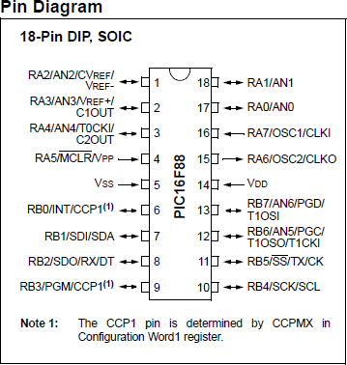

**Figure 2.11: The Pin layout of the Microcontroller.**

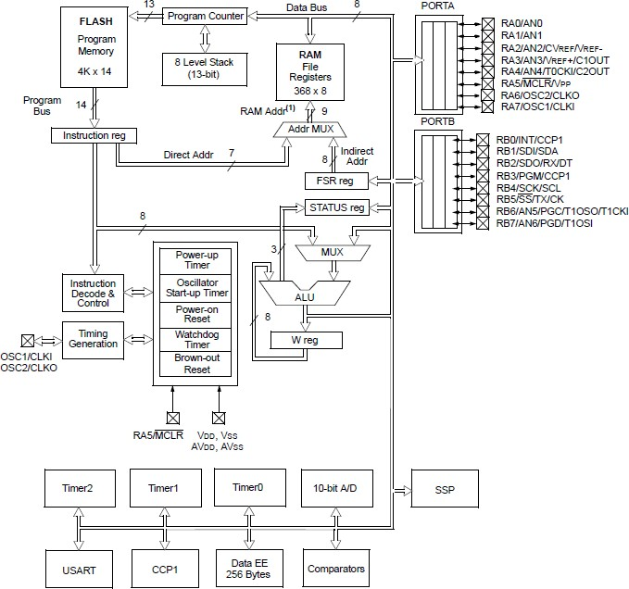

Fig 2.12: Architecture of the PIC16f88 microcontroller

# CHAPTER THREE: SYSTEM OPERATION

# BLOCK DIAGRAM OF THE PROJECT



**Control unit**

**Current sensing module**

**Voltage sensing unit**

**Display module**

**Load**

**Relay module**

**Transistor driver**

Power supply unit

Figure 3.1 Block diagram of the Project

The flow chart of the project really helped me in actualization of it. Below is the flow chart for the system designing and construction approach, the flow chart is in the next page.

Start

**System design analysis**

**Hardware design**

**Software design**

.

**Unit integration**

**Firmware**

**Unit test**

**Packaging**

**End**

Figure 3.2 Flow Chart

# CIRCUIT DIAGRAM AND OPERATION

The system comprises of few blocks which was illustrate as follows the power supply module, the control unit, the transistor switching module, hall-effect module, opt coupler module, keyboard module, display module, panic alarm module and analog to digital conversion (ADC) which help to simplify the hardware since the microcontroller contains it internally, all the unit are hardwired and tested as classified then were concatenated before generating the actual software the controls the system.

# POWER SUPPLY UNIT

The power supply unit is built around a 12v automotive accumulator (car battery), then a voltage regulator is connected to tailor down the unregulated DC voltage to

+5volts dc via voltage regulator (78L05) These serves as the power supply. A decoupling capacitor is connected across the +5v and ground reference of the power to filter or reject the transient noise generated by the microcontroller and associate components in the circuit at run time.

# THE DIODE

The diode (D1 in the figure below) used in the design is to protect the system from being damage whenever the battery polarity is altered or not properly connected. The protection lies on the characteristics and unique behavior of diode (semiconductor), since diodes allows current flow only in one direction when it attains its conducting voltage (this is maintained provided the applied voltage is below it break down voltage rating such info can be source from the detailed information of a given diode).

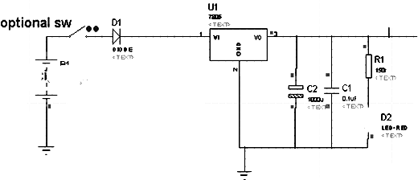

Fig3.3 Power supply Diagram

B1 is a rechargeable battery (car battery) although the unit can be power from a DC power source of 10-15 volts, optional SW represent the ignition switch this will cause the system to run at zero power whenever the automobile is powered, but in the actual design a cigarette connector was used for easy test installation in car,U1 is the voltage regulators integrated circuit that regulates the input power to potential difference of +5v and 0v used for the control circuit and associates, the capacitors were used for decoupling ( filter off the transient noise generated by the control unit and associates.

# POTENTIOMETER MODULE THE

The potentiometer is built around the constantan and a fixed resistance, the unit form the voltage divider, the voltage across the constantan is directly proportional to the length of the wire (since resistance of a wire varies with length) thus the control unit read in the sampled voltage at the voltage divider was uses for the system calibration since LED illumination increase with increase in current in variable it increase the gain of the phototransistor couple since the light strikes the base of the photo transistor the supply voltage of the potentiometer or variable resistor come from the hall effect module.

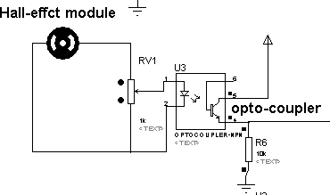

Fig 3.4 Hall Effect module

The RV1 represents a variable resistance, it slider effects change in voltage as the slide drift up or down gaining or loosing potential. The slider divides the resistance to form a voltage divider network; the slider voltage is applied across the LED couple in U3.

# THE HALL EFFECT MODULE

The hall effect voltage is applied the RV1 and U3 LED, the speedometer cable transmits the centrifugal effect to the dynamo since the change in the speed of an automobile cause change in centrifugal effect the voltage generated by the dynamo is also affected; the relationship between current, voltage, and resistance is given by Ohm’s law. This law states that the amount of current passing through a conductor is directly proportional to the voltage across the conductor and inversely proportional to the resistance of the conductor. Ohm’s law can be expressed as an equation, *V* = *IR,* where *V* is the difference in volts between two locations (called the potential difference), *I* is the amount of current in amperes that is flowing between these two points, and *R* is the resistance in ohms of the conductor between the two locations of interest. *V* = *IR* can also be written *R* = *V/I* and *I* = *V/R.* If any two of the quantities are known, the third can be calculated. For example, if Hall

Effect voltage produces a potential difference of 5 volts and 0v is applied across the series resistance with LED is assume 1000Ω, then the current that flows through the LED is determined mathematically by this equation:

*I* = *V/R*

*V* = 5vand *R* = 1K Ω (1000Ω)

5/1000 = 50 mili-amps neglecting the diode drop.

# THE OPT-COUPLER MODULE

The opt-couple consists of a light emitting diode and photo transistor, the LED is the source of light for biasing of the photo transistor, the transistor gain is determined by the intensity of the LED, the photo transistor has a series pull down resistor (10K Ω), the same resistor ground the analog to digital conversion port to ground while the LED is reverse biased (cut off) which occurs when the vehicle is at still. The resistor also make the port not be at tri-state then potential difference across the pull down resistor and ground is converted o digital during run time.

# THE DISPLAY

The Display was built around a liquid crystal display (**LCD**) module 0f 2 rows by 16 columns, 5X8 dot pixel alphanumeric display; the system was wired to operate in a 4bit mode, this mode the upper 4 bits (**D4-D7**) interfacing pin of the LCD is used with the read/write (R/W) pin connected to the ground since zero logic is for writing and logic one for reading from the LCD. During run time the LCD command and control are sent via the data bus (**D4-D7**) and the control bus (**RS**

resister select and **E** enable) line using the necessary algorithm provided from the manufacturer datasheet.

# THE CONTROL UNIT

The control unit is built around an 8 bit microcontroller integrated circuit (PIC16F88) at run time the controller used the arrange instruction sequence stored at is read only memory (ROM), generated using the compiler which generates the machine language. The control used its internal analog to digital converter module to convert the analog; the digital equivalent is sent to the display module via the interface ports and the keyboard state are checked as well at their designated port and action are execute base on the assigned command during design time. These ports of the controller are set to function as an analog input or digital IO (input/output).

. A code (soft ware) was written in C language the generated machine code were transferred into the flash memory of the controller with a boot loading programming device, this act known as firmware (integration of soft ware and hardware to achieve a task electronically).

The controller reset is not hardware reset rather it was selected during design time; the resetting cause the system to reset at power up so that the CPU will always start it program execution from the system reset vector, the chip is set to run with its internal oscillator this help simplifies the circuit design and also improve the efficiency and functionality if the system. The source code is at the appendix page.

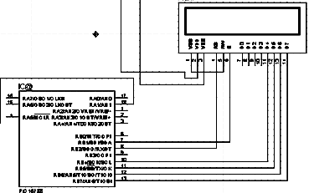

Fig3.5 LCD interfaced to the control unit (Microcontroller)

# THE COMPLETE SYSTEM SCHEMATIC

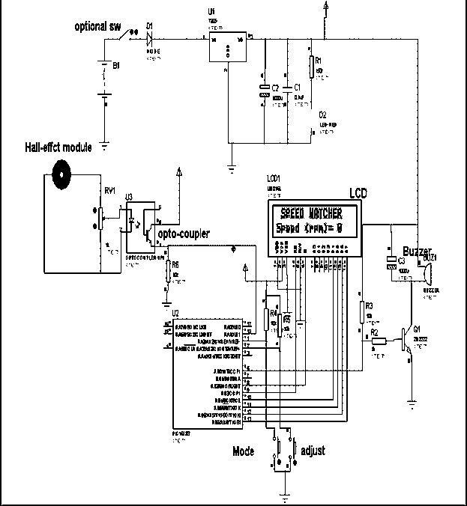

Fig: 3.6 Complete system diagram

# CHAPTER FOUR: SYSTEM DESIGN AND CONSTRUCTION

The designing of the project was done complying with the basic rules in electronic designing and construction the components used had been described in the previous chapter. The construction is made in modules start from the power supply, then sensing part, the control part and the display unit.

# SOFTWARE DESIGNING

There are hundreds of programming languages each was develop to solve a particular type of problem. Most traditional languages such as Basic, C, COBOL, FOTRAN, PL/I, AND PASCAL are procedural languages. That is, the program sequence determines the exact sequence of operations programming language is a free field language. Precedence of the operator determines the order of operation. Comments are used to document the software; preprocessor directives are special operations that occur first. Global declarations provide modular building blocks. Declarations are the basic operations .Function declarations allow for one routine to call another. Compound statements are the more complex operations. Global variables are permanent and can be shared. Local variables are temporary and are private Source files makes it easier to maintain large projects.

The software was designed using simple device C compiler (SDCC) C compiler which contains the header file of the Microcontroller (PIC16f88).It used virtual conventional C programming language keywords and syntax. The program environment is where the code are written, compile and debug .It will generate an Intel hex file (content of the system ROM) which is transfer into the microcontroller via a computer interfaced programming device.

# CALCULATING AN LED RESISTOR VALUE

An LED must have a resistor connected in series to limit the current through the LED; otherwise it will burn out almost instantly.

The resistor value, R is given

By: R = (VS – VD) / I), VS = supply voltage VD = LED voltage (usually 1.6V, but 4V for blue and white LEDs) I = LED current (e.g. 16mA), this must be less than the maximum permitted current.

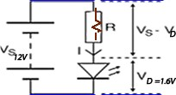

Figure 4.1: calculating LED resistor value

If the calculated value is not available choose the nearest standard resistor value which is greater, so that the current will be a little less than you chose. In fact you may wish to choose a greater resistor value to reduce the current (to increase battery life for example) but this will make the LED less bright.

# CONSTRUCTED SYSTEM CIRCUIT

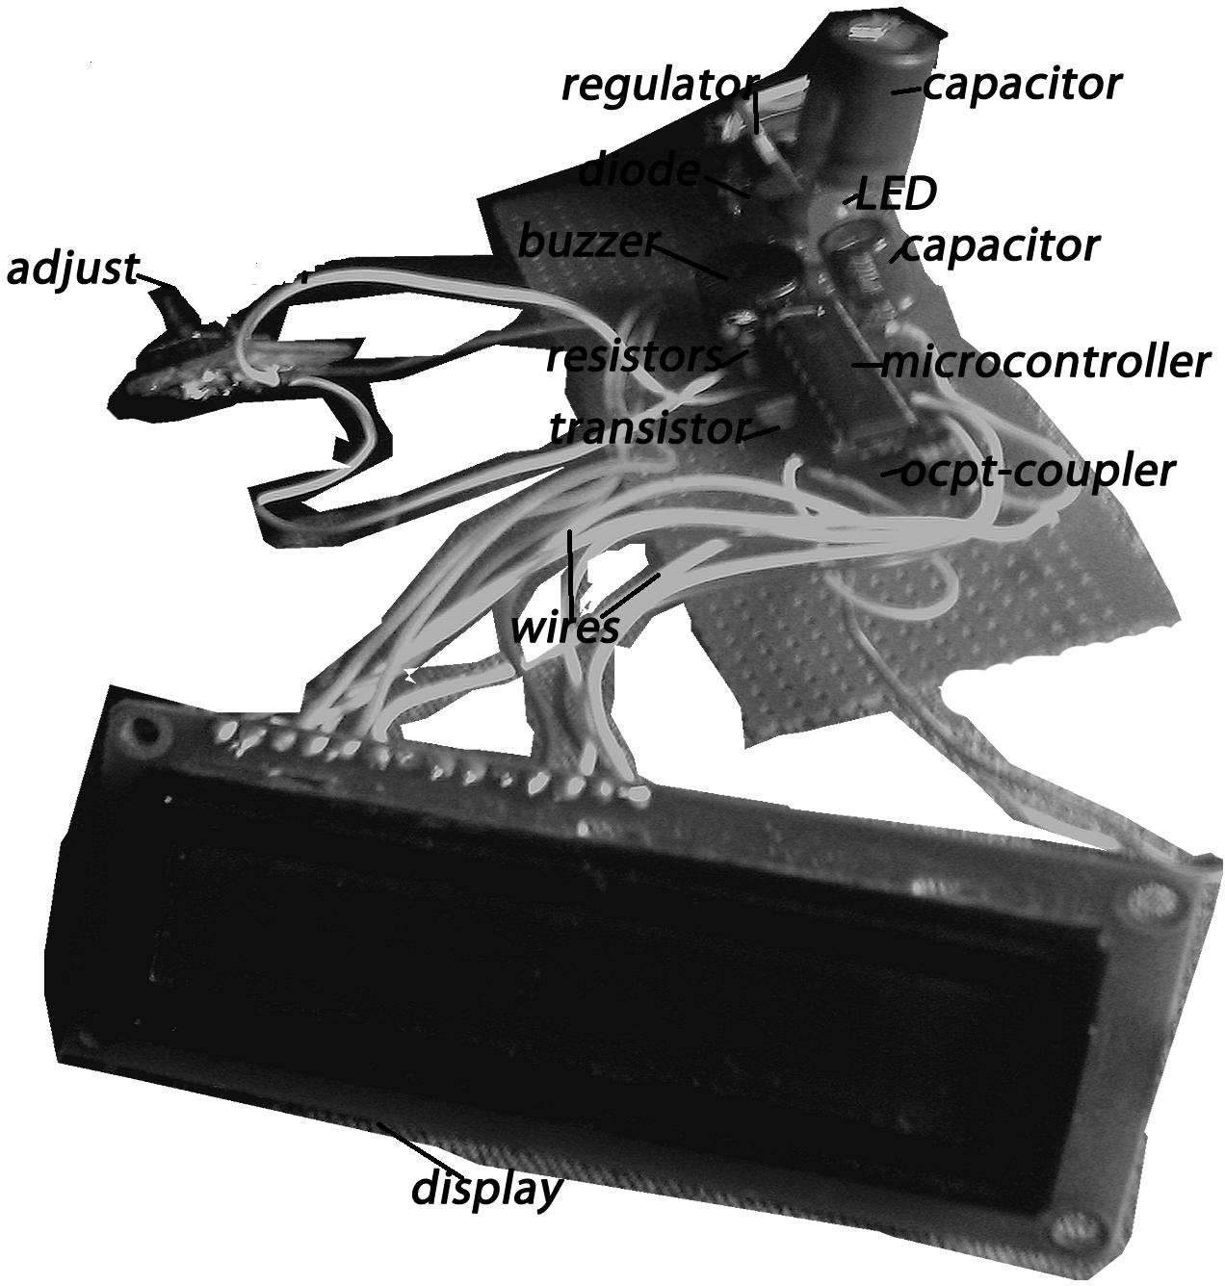

Fig 4.2: System unit

The system is made of the list of these various components listed below: Display unit

Microcontroller Transistor Resistors Capacitors Diodes

LED

Wires

Opt-coupler Mode adjustment Buzzer Regulator

# CHAPTER FIVE: TESTS OF RESULTS AND PACKAGING

# TESTING OF THE INDIVIDUAL COMPONENTS

Components should be tested individually before fiddling with it so as to remove he bad ones .This test will be satisfied test measures for individual components which are basically used of the multi-meter (e.g. testing of transistor, diodes, LEDs are every other component that will be used in the project.

# UNIT BY UNIT TESTING

These involve wiring up of circuitry and testing and satisfy its functions before soldering.

Examples are building of power supply stage of the project testing and confirming that is functional before soldering.

# SYSTEM TESTING

Involves the testing of the entire circuitry and cross examine it for errors like short circuits ,lead flux joining unwanted links ,proper insertion IC pin layout and also checking if ICs of these pin number but different function are slotted in their proper base. After this check cross examine once again before powering the system.

# INTERGRATON

The integration of the units that made up the circuit and testing them now as unified system. Here if the project in not working properly as assumed necessary changes can now be made until a desirable outcome is attained.

# PACKAGING

Every quality and good product is often determined by packaging. Credit is awarded to properly packaged project. After he integrating and final testing of the project I now mad choice of package considering cost as well durability elegance, I then choose to embark on metallic casing where the said project was housed. Before construction of his package I considered the size of the project and maintenance factor which need may arise. There are some other medium for packing the project like plastic package this would have been a better option but due to cost of producing it and wood was another option but considering it’s relatively cheaper but beauty of the project was put into consideration.

# CHAPTER SIX: CONCLUSON AND RECOMMENDATION

# CONCLUSION

The design was actualized to using the basic rule in electrical and electronic designing and was implemented in real time; the design was installed in a vehicle and then the analog speedometer unit was replace with my designed project and it worked perfectly, thanks to my supervisor and o’mara.digiba both contributed immensely in the actualization of my goal.

# PROBLEMS ENCOUNTERED AND SOLUTIONS

The buzzer was resetting the system which to troubleshooting that almost winding up my design, the problem was figured out when the buzzer was disconnected from the system power; solution an electrolytic capacitor was connected across the buzzer.

# SUGGESTIONS FOR FURTHER IMPROVEMENTS

The transmission line cable should be eliminated and the hall-effect module be fabricated and attached directly to the gearbox but still detachable for easy maintenance, elimination of the hall-effect and introducing a wireless communication using GPS (global positioning satellite).

# RECOMMENDATION

This project exhibit simplicity and power of the 8bit nano watt technology microcontroller (PIC16f88) from Microchip Inc., the use of the internal peripherals reduces the number of discrete components to be used thus increasing the performances and error prone.

Guided by findings, conclusions and output of this project the researcher feels obliged to make this situational recommendation as regard to the case study and construction, which the researcher belief if properly implemented by road users will minimize or eliminate the rate of road accident in the country.

# APPENDIX A

**LIST OF SYSTEM COMPONENTS.**

Microcontroller AT89c51 ATMEL product 1

9DIP (dual in package)IC socket 1

12volts / 500 milliamps relay 1

IN4001 (rectifying diode) 4

3300micro-farad capacitor (25v/electrolytic) 1

10 micro-farad capacitor (16v/electrolytic) 7

3300 microfarad capacitor (electrolytic) 1

Micro-farad capacitor (non-electrolytic) 1

C945(npn transistor) 6

78x05 (voltage regulator)… 1

1 kilo ohms resistor 6

10 kilo ohms resistor 6

22kohms resistor… 13

LED (red, green and amber light emitting diode)… 13

# APPENDIX B COMPONENT COST ANALYSIS TABLE

|  |  |  |  |  |
| --- | --- | --- | --- | --- |
| S/N | MATERIALS | QUANTITY | PRICE / UNIT (NAIRA) | TOTAL COST |
| 1 | VERO BOARD | 1 | 120:00 | 120:00 |
| 2 | 9 DIP (IC BASE) | 1 | 40:00 | 40:00 |
| 7 | 3300 MIRO-FARARD CAPACITOR | 1 | 45:00 | 45:00 |
| 10 | 10 MIRO-FARARD CAPACITOR | 1 | 10:00 | 10:00 |
| 11 | IN4001 (RECTIFYING DIODE | 4 | 5:00 | 80:00 |
| 11 | LED | 13 | 5:00 | 5:00 |
| 14 | PIC16F88 | 1 | 1200:00 | 1200:00 |
| 15 | RESISTORS | 39 | 5:00 | 195:00 |
| 16 | CONNECTOR WIRES | 1YARD | 250:00 | 250:00 |
| 17 | MAINS CONDUCTORS WIRE | 1 | 40:00 | 40:00 |
| 19 | SOLDERING LEAD | 5YARDS | 20;00 | 100:00 |
| 20 | SOLDERING IRON | 1 | 150:00 | 150:00 |
| 21 | PACKAGING | 1 | 1200:00 | 1200:00 |
| 22 | INTERNET BROWSING | 5 | 250:00 | 1250:00 |
| 22 | MISCELLENOUS |  |  | 3500:00 |

|  |  |  |  |  |
| --- | --- | --- | --- | --- |
| 23 | TRANSFORMERS | 1 |  | 150:50 |
|  |  |  | TOTAL | 8,335 |

# APPENDIX C SYSTEM SOURCE CODE

unsigned long adval, power,power1,power2,adval1;

#define buzzer portb.0 #define set_mode porta.2

#define adjust porta.3 unsigned char kase , unit;

unsigned int a,b,c,d, volt; #pragma CLOCK_FREQ 4000000

#include <system.h>

void eeprom_write(unsigned char addr, unsigned char data)

{

intcon.7=0; eecon1.1=0;

eeadr=addr; //MOVWF EEADR ; Data Memory eedata=data;

eecon1.7=0; eecon1.2=1; intcon.7=0; eecon2=0x55; eecon2=0xaa; eecon1.1=1; eecon1.2=0; return;

}

unsigned char eeprom_read(unsigned char addr)

{

//BANKSEL EEADR ; Select Bank of EEADR eeadr=addr; //MOVWF EEADR ; Data Memory Address

eecon1.7=0;//BCF EECON1, EEPGD; Point to Data memory

eecon1.0=1; //BSF EECON1, RD ; EE Read addr=eedata;

return addr;

}

void blink(int j,int k)

{

delay_ms(10);

while(j>0)

{j--;// portb.2=0; buzzer=1;delay_ms(k);delay_ms(k);

buzzer=0;delay_ms(k);delay_ms(k);

}

return;

}

void wait_us(){

unsigned char wait_count ; asm

{

MOVLW d'45'

MOVWF _wait_count

}

while( wait_count > 0 ){

-- wait_count ;

}

}

void lcd_strobe(){ portb.2 =1;

portb.2 = 0;

}

void lcd_byte( unsigned char c ){ portb = (portb & 0x0f);

portb = (portb | (c & 0xf0)); lcd_strobe();

portb = (portb & 0x0f); portb = (portb | (c << 4));

lcd_strobe(); wait_us();

}

void lcd_putch( unsigned char c ){

portb.3 = 1 ; // 'pin 3 of prt b as high lcd_byte(c);

}

void lcd_putcmd( unsigned char c ){ portb.3 = 0;

lcd_byte(c);

}

void lcd_init(){ portb.3 = 0;

delay_ms(50);

portb = (portb & 0x0f); portb = (portb | 0x30);

lcd_strobe(); delay_ms(5); lcd_strobe(); wait_us(); lcd_strobe();

|  |  |  |
| --- | --- | --- |
| delay_ms(5); |  | |
| portb = (portb | & | 0x0f); |
| portb = (portb | | | 0x20); |
| lcd_strobe(); |  |  |

wait_us(); lcd_putcmd(0x28);

lcd_putcmd(0x08); lcd_putcmd(0x0C); lcd_putcmd(0x06); lcd_putcmd(0x02);

}

void lcd_clear(){ lcd_putcmd(0x01);

delay_ms(2);

}

void lcd_puts(unsigned char *lcd_string)

{

while (*lcd_string)

{

lcd_putch(*lcd_string++);

// if(*lcd_string==22){*lcd_string=0};

}

}

//gotoXy(column, row);

void gotoXy(unsigned char x,unsigned char y)

{

if(x<40)

{

if(y) x|=0b01000000; x|=0b10000000;

lcd_putcmd(x);

}

return;

}

void adc_init(){

// 'pin A0 is for analog input

adcon1 = ( 10000000b ) ; // 'setting for only AN0 and ref of vss and vdd, Fosc/8

// 'setting for channel AN0 and Fosc/8 for 4Mhz, start AD

}

void adc_read(){

adcon0 = ( 01001001b ) ;

adcon0.0 = 1; // 'Turn On the A/D asm

{

nop

}

adcon0.2 = 1; // 'Start Conversion

//while (adcon0.2=1){;} delay_ms(1);

adcon0.2 = 0; // end conversion

if (adresh==0){ adval = (adresl * 100) / 204;}

if (adresh==1){ adval = ((adresl * 100) / 204) + 125;} if (adresh==2){ adval = ((adresl * 100) / 204) + 250;} if (adresh==3){ adval = ((adresl * 100) / 204) + 375;} adval1=(adresh <<8 )+adresl;

delay_ms(1); return;

} void convert(unsigned int intstr){ unsigned int intco=0;char cnt=0; if(intstr==0){lcd_putch(48); return;};

if(intstr!=0 && intstr<9 ){lcd_putch(48 + (intstr

%10)) ; return;};

if(intstr>9 && intstr<99){lcd_putch(48 + (intstr / 10) %10) ;lcd_putch(48 + (intstr %10)) ; return;};

if(intstr>99 && intstr < 999){lcd_putch(48 + (intstr / 100) %10) ;lcd_putch(48 + (intstr / 10) %10)

;lcd_putch(48 + (intstr %10)) ; return;};

if(intstr>999 && intstr < 9999){ lcd_putch(48 + (intstr / 1000) %10) ;lcd_putch(48 + (intstr / 100)

%10) ;lcd_putch(48 + (intstr / 10) %10) ;lcd_putch(48 + (intstr %10)) ; return;};

}

void main (void){ adc_init();

ansel = 00001011b; // 'AN0 on (RA0) trisb =0 ;

trisb.1 =1 ; portb.1=1;

trisa = 11111111b; // '0 = Output, 1 = Input

osccon = 01110000b ; //'internal oscillator @ 8MHz

cmcon = 00000111b; //'comparators off ansel = 00000011b ;

refresh:unit=0; volt=eeprom_read(0);

adc_init();

lcd_init(); //Initialize the LCD to appropriate format

lcd_clear(); //clears the lcd

lcd_puts(" ");lcd_putcmd(0x40);

lcd_putch(0xe); lcd_putch(0x11); lcd_putch(0x11); lcd_putch(0x11); lcd_putch(0x11); lcd_putch(0x11); lcd_putch(0x11); lcd_putch(0x11); lcd_putch(08); lcd_putch(12); lcd_putch(14); lcd_putch(31); lcd_putch(14); lcd_putch(12); lcd_putch(8); lcd_putch(0x1f); lcd_putch(0xe); lcd_putch(0x1b); lcd_putch(0x11); lcd_putch(0x11); lcd_putch(0x11); lcd_putch(0x1F); lcd_putch(0x1F); lcd_putch(0x1f); lcd_putch(0xe);

lcd_putch(0x1b); lcd_putch(0x11); lcd_putch(0x11); lcd_putch(0x1F); lcd_putch(0x1F); lcd_putch(0x1F); lcd_putch(0x1f); lcd_putch(0xe); lcd_putch(0x1b); lcd_putch(0x11); lcd_putch(0x1F); lcd_putch(0x1F); lcd_putch(0x1F); lcd_putch(0x1F); lcd_putch(0x1f); lcd_putch(0xe); lcd_putch(0x1b); lcd_putch(0x1F); lcd_putch(0x1F); lcd_putch(0x1F); lcd_putch(0x1F); lcd_putch(0x1F); lcd_putch(0x1f); lcd_putch(0xe); lcd_putch(0x1F);

lcd_putch(0x1F); lcd_putch(0x1F); lcd_putch(0x1F); lcd_putch(0x1F); lcd_putch(0x1F); lcd_putch(0x1f);

a=0;

while (1){

if(a>0) goto over; adc_read();

gotoXy(0,0);

if(adval < (volt)){lcd_puts(" SPEED WATCHER ");;}; if(adval > volt ){ lcd_puts(" OVER SPEEDING ");;

blink(1,1000);

buzzer=1; blink(1,1000); buzzer=0; blink(1,1000); };

gotoXy(0,1); lcd_puts("Speed (rpm)= ");

gotoXy(12,1);lcd_puts(" "); gotoXy(13,1);

convert(adval);

if((adval > volt || adval==volt) && a==0)

{

buzzer=1; blink(1,1000); buzzer=0; blink(1,1000);

};

over:

/***************************get power instance**********************************/

if(set_mode==0)

{

delay_ms(100); while(set_mode==0){;} if(set_mode==1)

{

buzzer=1; blink(1,200); buzzer=0; blink(1,200);

++a; if(a==4){a=portb.0=0;} gotoXy(0,0);

lcd_puts(" Mode(");;convert(a); lcd_puts(")

");

gotoXy(15,0);

lcd_putch(0x01);lcd_putch(0x01);lcd_putch(0x01); gotoXy(0,1);

if (a==1)lcd_puts("INCREMENT ");

if (a==2)lcd_puts("DECREMENT "); if (a==3)lcd_puts("SAVE ");

gotoXy(15,1); lcd_putch(0x01);lcd_putch(0x01);

}

}

if (adjust==0 && a>0)

{

delay_ms(100); if(adjust==0 && a==1)

{

++volt; if(volt==251){volt=250;}

}

if(adjust==0 && a==2)

{

--volt; if(volt==49){volt=50;;}

}

if(adjust==0 && a==3)

{

eeprom_write(0,volt); a=0;

}

gotoXy(0,1);

lcd_puts("Set_Speed= "); convert(volt); lcd_puts(" ");

gotoXy(15,1); lcd_putch(0x01);lcd_putch(0x01);lcd_putch(0x01);

buzzer=1;

blink(1,200); buzzer=0; blink(1,100);

}

delay_ms(1); }}

# BIBLIOGRAPHY

Bannatyne R Prentice Hall, (1998). *Speedometers* 2nd edition UK: University Press (ISBN-13-840406-2)

Jane Leavy (2010). *The Last Boy: Mickey Mantle and the End of America's Childhood*. HarperCollins. Page 91.( ISBN 9780060883522)

Letters Patent No. 79,965. Text accessed 26 February 2006 Microsoft Encarta 2009. © 1993-2008 Article on “*Speedometers”*

John Wiley & sons New York (1977), *Practical digital design*

1st edition

Paul Horowitz ,Winfield Hill. second edition: *The art of electronics*

(ISBN 0-521-49846-5)

Wray W.Greenfield J,b(1959), *Using microprocessor and microcomputers*

Scherz, Paul (2006) "*Practical Electronics for Inventors*,"

p. 589. McGraw-Hill/TAB Electronics. ISBN: 978-0070580787.