1

CONSTRUCTION OF CAR TOUCH INTRUDER ALARM

5

ABSTRACT

The main objective of this project was to ensure a proper security to car being parked in garage against theft or an intruder. The circuit uses three NE555 timers; one of the NE555 was wired as a monostable oscillator and remaining two were wired as tone generator and amplified to obtain a maximum audible sound. However, pin 2 of the first NE555 was used as sensor part .When pin 2 has contact with human body or hand it will activate the IC1 which will also bias transistor and this transistor was wired in a way that once it is powered it will close circuit thereby passing a negative supply voltage to tone generator circuit and outputted out through a loud speaker or buzzer. This device functions as a major security device against car-theft as stated above. It is an electronic device that is connected to the battery of the car it is being installed in and gets activated when the car engine is switched off and the car stationed at a place. The device is not seen but, it has an indicator light which shows that the alarm has been activated. When the body of the car is touched by human hand, it sends a negative signal to the device which needs a negative pulse to get activated; it sends this negative from the human hand to the tone generator IC which triggers the alarm.
6

TABLE OF CONTENT

Title Page ...…………………………………………………………………….i

Certification…………………………………………………………………….ii

Dedication ……………………………………………………………………...iii

Acknowledgement …………………………………………………………….. iv

Abstract ………………………………………………………………………….v

Table of content ………………………………………………………………...vi

List of Symbols ………………………………………………………………. vii

CHAPTER ONE: Introduction

1.1 Background of study…………………………………………………… 1

1.2 Aims and objectives…………………………………………………… 3

CHAPTER TWO: Literature Review……………………………………….4

CHAPTER THREE: Specification and operation of system component

3.1 Description of NE55 Timer…………………………………………….12

3.2 Description of Resistor………………………………………………. 14

3.3 Description of Capacitor…………………………………………….. 16

3.4 Description of Diode………………………………………………… 27

3.5 Description of Transformer …………………………………………… 32
7

3.6 Description of Loud Speaker and Buzzer……………………………… 41

3.7 Description of Transistor………………………………………………. 43

- 8 Description of L.E.D………………………………………………….. 47

CHAPTER FOUR: Operation of system and its circuit and block diagram

4.1 Operation of circuit ………………………………………………… …55

4.2 The circuit diagram………………………………………………….. ..57

4.3 The block diagram………………………………………………………58

CHAPTER FIVE: Construction, Testing and Packaging

5.1 Values of components………………………………………………….59

5.2 Assembly………………………………………………………………60

5.3 A schematic diagram of the finished work…………………………….63

CHAPTER SIX: Conclusion and Recommendation

6.1 Conclusion ………………………………………………………….. .64

6.2 Recommendation …………………………………. …. ……… .….65

6.3 Observations ………………………………………………………..66

6.4 Dificulties…………………………………………………….. …57

6.5 References…………………………………………………. …………68
8

LIST OF SYMBOLS

NAME SYMBOLS
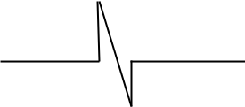

Resistor

Transistor

Diode
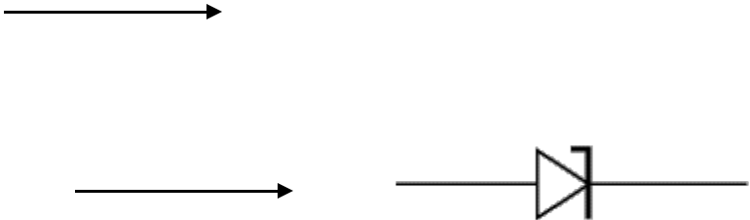

Zener diode

Trimmer capacitor


Polarized capacitor
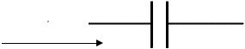

Unpolarized capacitor


Variable capacitor
9

CHAPTER ONE: INTRODUCTION

1.1. Background of the Study

The first car alarm was a primitive contraption that utilized a bell or horn connected to the drive shaft. It was created by an unnamed Nebraska inventor in June 20th, 1920. It utilizes the drive shaft to operate its own bell or horn signal when the car is properly moved. This is just a little talk on a car alarm but not a car touch intruder alarm which is a modern, more advanced, and more reliable type of car alarm.

This car touch sensitive alarm project consist of three NE555 timer IC, the first NE555 was wired as monostable multi-vibrator and the remaining two were wired as tone generator. When the sensor is touch or has contact with human hand perhaps body, IC1 is triggered at its pin 2 and output pin 3 goes high for a time period previously set by the values of R4 (10M) and Q1 (transistor) was bias via R3 and this transistor is in such a way that once it was biased it will supply a negative voltage to tone generator thereby making two NE555 timer which was know as
10

(tone generator) to oscillate to make a bell sound through the buzzer. The tone generators are configured as an astable multi-vibrator whose oscillation frequency can be varied with the help of PR1 and PR2. By adjusting the values of PR1 and PR2, modifications on the tone are possible.

The reset button is used to set or open circuit the system back to its initial stage. The system is powered with 12V power supply voltage.

The first chapter of this project is narrating on the introduction, the concept of the system and also the aims and objective. Chapter two is all about literature review. Chapter three talks about specification and operation of system component. Chapter four is operation of system. Chapter five is about construction, testing and packaging. Chapter six is conclusion, observation, recommendation and References.
11

1.2 AIM AND OBJECTIVE

The main aim and objective of the design and construction this project is to create a comfort in the minds of vehicle owners or users when their vehicles are parked or stationed anywhere without much fear of car-theft.
12

CHAPTER TWO: LITERATURE REVIEW

Works have been done by various authors and scholars on related topics but rarely one can find any scholar who has talked about or published an article on this very work (car touch intruder alarm).

Till date I feel am one of the first to go into such a research, owing to the fact that this exact work as scarce to find during my research. Although related works or articles wee done by some scholars; like the:

Kaduna State University, Computer Science Department. They talked about the “automatic alarms of various kinds though the car alarm was briefly talked about. Their modes of operation, limitations, e.t.c were talked on.

There are very few reviews on this topic, I think am among one of the very first scholars to review on this exact topic and should be reviewed on by future scholars who intend researching on this work.

People like Karl Benz, the owner of Mercedes Benz and Henry Ford, the owner of Ford cars who saw the need for this car alarm in the 70’s
13

and 80’s started using these alarms in their products. Today, almost every car in the world today comes with this car alarms and even more advanced security systems.

There fore, it can be said that car intruder alarms are the founding fathers of all car security systems.

Below are descriptions of the components used in achieving this work:

NE555 TIMER

The 555 timer is an integrated circuit (IC) that is used as a pulse wave from generator in digital equipment. It is a universal thriving circuit and this device cay be make to work as an ASTABLE in multi-vibrator to produce a square wave output and a MONOSTABLE to produce a one-shot pulse. The logic states of the output are from 4.5 to above 16v maximum.

RESISTOR

14

It is a component that opposes the flow of current through it. A pure resistor possesses only resistance, no capacitor or inductance, but all practical resistors possess some small amount of capacitance or inductance. Usually these are sufficiently small to be negligible.

They are constructed from a mixture of carbon of the materials in proportions that give the required amount of resistance. They can be connected on series, parallel or the combination of the both.

They can also be connected to protect devices such as transistor and diode against excess current.

Resistor can be fixed or variable. It is measured in ohms.

CAPACITOR

Capacitors store electric charge. They are used with resistors in timing circuits because it takes time for a capacitor to fill with charge. They are used to smooth varying DC supplies by acting as a reservoir of charge. They are also used in filter circuits because capacitors easily pass AC (changing) signals but they block DC (constant) signals.
15

Capacitance

This is a measure of a capacitor's ability to store charge. A large capacitance means that more charge can be stored. Capacitance is measured in farads, symbol F. However 1F is very large, so prefixes are used to show the smaller values.

Three prefixes (multipliers) are used, µ (micro), n (nano) and p (pico):

DIODES

Diodes allow electricity to flow in only one direction. The arrow of the

circuit symbol shows the direction in which the current can flow. Diodes

are the electrical version of a valve and early diodes were actually called

valves.

TRANSFORMER

BASIC TRANSFORMER - The basic transformer is an electrical device that transfers alternating-current energy from one circuit to another circuit by magnetic coupling of the primary and secondary windings of the transformer. This is accomplished through mutual inductance (M).
16

The coefficient of coupling (K) of a transformer is dependent upon the size and shape of the coils, their relative positions, and the characteristic of the core between the two coils. An ideal transformer is one where all the magnetic lines of flux produced by the primary cut the entire secondary. The higher the K of the transformer, the higher is the transfer of the energy.

The voltage applied to the primary winding causes current to flow in the primary.

This current generates a magnetic field, generating a counter emf (cemf) which has the opposite phase to that of the applied voltage. The magnetic field generated by the current in the primary also cuts the secondary winding and induces a voltage in this winding.

LOUDSPEAKER

Loudspeakers are output transducers which convert an electrical signal to sound. Usually they are called 'speakers'. They require a driver circuit, such as a 555 astable or an audio amplifier, to provide a signal. There is
17

a wide range available, but for many electronics projects a 300mW miniature loudspeaker is ideal. This type is about 70mm diameter and it is usually available with resistances of 8 and 64. If a project specifies a 64 speaker you must use this higher resistance to prevent damage to the driving circuit.

BUZZER AND BLEEPER

These devices are output transducers converting electrical energy to sound. They contain an internal oscillator to produce the sound which is set at about 400Hz for buzzers and about 3 kHz for bleepers.

- Buzzers have a voltage rating but it is only approximate, for example 6V and 12V buzzers can be used with a 9V supply. Their typical current is about 25mA.

- Bleepers have wide voltage ranges, such as 3-30V, and they pass a low current of about 10mA.

- Buzzers and bleepers must be connected the right way round, their

18

red lead is positive (+).

TRANSISTOR

It is a device that consisting of three regions doped semiconductor

material (Base, Collector and Emitter) that amplifies and also switches

signals.

Function

Transistors amplify current, for example they can be used to amplify the small output current from a logic IC so that it can operate a lamp, relay or other high current device. In many circuits a resistor is used to convert the changing current to a changing voltage, so the transistor is being used to amplify voltage.

A transistor may be used as a switch (either fully on with maximum current, or fully off with no current) and as an amplifier (always partly on).
19

The amount of current amplification is called the current gain, symbol hFE.

LED (LIGHT EMITTING DIODE)

LEDS emit light when an electric current passes through them.

CHAPTER THREE: SPECIFICATION AND OPERATION OF

SYSTEM COMPONENT

Component specifications are:

- NE555 timer II. Resistor III. Capacitors IV. Diode

V. Transformer

VI. Buzzer and loud speaker

VII. Transistor

VIII. Light emitting diode (L .E. D)

Other specifications are:

20

a) Casing etc.

3.1 DESCRIPTION OF NE555 TIMER

NE555 TIMER

The 555 timer is an integrated circuit (IC) that is used as a pulse wave from generator in digital equipment. It is a universal thriving circuit and this device cay be make to work as an ASTABLE in multi-vibrator to produce a square wave output and a MONOSTABLE to produce a one-shot pulse. The logic states of the output are from 4.5 to above 16v maximum.

Below are pins configuration of NE555 timer.

- THE RESET: this pin is used to reset the timer
21

- THE THRESHOLD: this determines when the output switches change state from 0 and 1 logic levels. This voltage is developed across the capacitor in an external resistor-capacitor (RC circuit). This RC network is used to set the timing, oscillator and frequency of the operation of the device,

- THE DISCHARGE LEAD: it is the one that produces the discharge path of the RC network and this lead is also involve in the recovers of circuit to the next stage of the output pulse.

- THE CONTROL VOLTAGE LEAD: in most operation this lead is not used. It must be wire grounded through decoupling capacitor to ground. This is to eliminate noise but by applying an external direct current (d.c) to the control voltage lead the internal operation will change.

- THE OUTPUT LEAD: this gives out square wave pulse.
22

- THE TRIGGER LEAD: this contributes for the output generation.

- POSITIVE SUPPLY LEAD: is used for powering the IC

3.2 DESCRIPTION OF RESISTOR

It is a component that opposes the flow of current through it. A pure resistor possesses only resistance, no capacitor or inductance, but all practical resistors possess some small amount of capacitance or inductance. Usually these are sufficiently small to be negligible.

They are constructed from a mixture of carbon of the materials in proportions that give the required amount of resistance. They can be connected on series, parallel or the combination of the both.
23

They can also be connected to protect devices such as transistor and diode against excess current.

Resistor can be fixed or variable. It is measured in ohms.
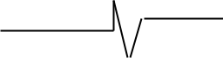

Fig.1.0. showing the circuit symbol of a resistor

TYPES OF RESISTOR

- variable resistor

- rheostat resistor

- potentiometer resistor

- fixed resistor

Table 1.0: A table showing the resistor colour code

COLOUR | FIRST | SECOND | THIRD | TOLERANCE
 | BAND | BAND | BAND
BLACK | _ | 0 | X10

24

BROWN | 1 | 0 |  | ±1%
RED | 2 | 00 |  | ±2%
ORANGE | 3 | 000
YELLOW | 4 | 0000
GREEN | 5 | 00000
BLUE | 6 | 000000
VIOLET | 7 | 0000000
GREY | 8 | 00000000
WHITE | 9 | 000000000
GOLD | _ | _ | X0.1 | ±5%
SILIVER | _ | _ | X0.01 | ±10%

3.3 DESCRIPTION OF CAPACITOR

Function

Capacitors store electric charge. They are used with resistors in timing circuits because it takes time for a capacitor to fill with charge. They are used to smooth varying DC supplies by acting as a reservoir of charge. They are also used in filter circuits because capacitors easily pass AC (changing) signals but they block DC (constant) signals.
25

Capacitance

This is a measure of a capacitor's ability to store charge. A large capacitance means that more charge can be stored. Capacitance is measured in farads, symbol F. However 1F is very large, so prefixes are used to show the smaller values.

Three prefixes (multipliers) are used, µ (micro), n (nano) and p (pico):

- µ means 10⁻⁶ (millionth), so 1000000µF = 1F

- n means 10⁻⁹ (thousand-millionth), so 1000nF = 1µF

- p means 10⁻¹² (million-millionth), so 1000pF = 1nF

Capacitor values can be very difficult to find because there are many types of capacitor with different labeling systems!

There are many types of capacitor but they can be split into two groups, polarised and unpolarised. Each group has its own circuit symbol.

Polarised capacitors (large values, 1µF +)

26
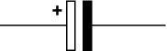

Fig1.1: showing circuit symbol of polarised capacitor

Electrolytic Capacitors

Electrolytic capacitors are polarised and they must be connected the correct way round, at least one of their leads will be marked + or -. They are not damaged by heat when soldering.

There are two designs of electrolytic capacitors; axial where the leads are attached to each end (220µF in picture) and radial where both leads are at the same end (10µF in picture). Radial capacitors tend to be a little smaller and they stand upright on the circuit board.

It is easy to find the value of electrolytic capacitors because they are clearly printed with their capacitance and voltage rating. The voltage rating can be quite low (6V for example) and it should always be checked when selecting an electrolytic capacitor. If the project parts list does not specify a voltage, choose a capacitor with a rating which is
27

greater than the project's power supply voltage. 25V is a sensible minimum for most battery circuits.

Tantalum Bead Capacitors

Tantalum bead capacitors are polarised and have low voltage ratings like electrolytic capacitors. They are expensive but very small, so they are used where a large capacitance is needed in a small size.

Modern tantalum bead capacitors are printed with their capacitance, voltage and polarity in full. However older ones use a colour-code system which has two stripes (for the two digits) and a spot of colour for the number of zeros to give the value in µF. The standard colour code is used, but for the spot, grey is used to mean × 0.01 and white means

- 0.1 so that values of less than 10µF can be shown. A third colour stripe near the leads shows the voltage (yellow 6.3V, black 10V, green 16V, blue 20V, grey 25V, white 30V, pink 35V). The positive (+) lead is to the right when the spot is facing you: 'when the spot is in sight, the positive is to the right'.
 |  |  |  |  |  |  | 28
For | example: | blue, | grey, | black | spot | means | 68µF
For | example: | blue, | grey, | white | spot | means | 6.8µF
For | example: | blue, | grey, | grey | spot | means | 0.68µF

Unpolarised capacitors (small values, up to 1µF)
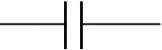

Fig 1.2: showing the circuit symbol of an unpolarised capacitor.

Small value capacitors are unpolarised and may be connected either way round. They are not damaged by heat when soldering, except for one unusual type (polystyrene). They have high voltage ratings of at least 50V, usually 250V or so. It can be difficult to find the values of these small capacitors because there are many types of them and several different labeling systems!
29

Many small value capacitors have their value printed but without a multiplier, so you need to use experience to work out what the multiplier should be!

For example 0.1 means 0.1µF = 100nF.

Sometimes the multiplier is used in place of the decimal point:

For example: 4n7 means 4.7nF.

Capacitor Number Code

A number code is often used on small capacitors where printing is difficult:


- the 1st number is the 1st digit,

- the 2nd number is the 2nd digit,

- the 3rd number is the number of zeros to give the capacitance in pF.

- Ignore any letters - they just indicate tolerance and voltage rating.

For example: 102 means 1000pF = 1nF (not 102pF!)

30

For example: 472J means 4700pF = 4.7nF (J means 5% tolerance). Capacitor Colour Code

A colour code was used on polyester capacitors for many years. It is now obsolete, but of course there are many still around. The colours should be read like the resistor code, the top three colour bands giving the value in pF. Ignore the 4th band (tolerance) and 5th band (voltage rating).

For example:



brown, black, orange means 10000pF = 10nF = 0.01µF.


Note that there are no gaps between the colour bands, so 2 identical bands actually appear as a wide band.



For example:


wide red, yellow means 220nF = 0.22µF.


Polystyrene Capacitors

31

This type is rarely used now. Their value (in pF) is normally printed without units. Polystyrene capacitors can be damaged by heat when soldering (it melts the polystyrene!) so you should use a heat sink (such as a crocodile clip). Clip the heat sink to the lead between the capacitor and the joint.

Real capacitor values (the E3 and E6 series)

You may have noticed that capacitors are not available with every possible value, for example 22µF and 47µF are readily available, but 25µF and 50µF are not!

Why is this? Imagine that you decided to make capacitors every 10µF giving 10, 20, 30, 40, 50 and so on. That seems fine, but what happens when you reach 1000? It would be pointless to make 1000, 1010, 1020, 1030 and so on because for these values 10 is a very small difference,
32

too small to be noticeable in most circuits and capacitors cannot be made with that accuracy.

To produce a sensible range of capacitor values you need to increase the size of the 'step' as the value increases. The standard capacitor values are based on this idea and they form a series which follows the same pattern for every multiple of ten.

The E3 series (3 values for each multiple of ten)

10, 22, 47, ... then it continues 100, 220, 470, 1000, 2200, 4700, 10000 etc. Notice how the step size increases as the value increases (values roughly double each time).

The E6 series (6 values for each multiple of ten) 10, 15, 22, 33, 47, 68 ... then it continues 100, 150, 220, 330, 470, 680,1000 etc.

Notice how this is the E3 series with an extra value in the gaps.

The E3 series is the one most frequently used for capacitors because many types cannot be made with very accurate values.
33

Variable capacitors
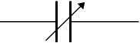

Fig 1.3 showing the circuit symbol of Variable capacitor

Variable capacitors are mostly used in radio tuning circuits and they are sometimes called 'tuning capacitors'. They have very small capacitance values, typically between 100pF and 500pF (100pF = 0.0001µF). The type illustrated usually has trimmers built in (for making small adjustments - see below) as well as the main variable capacitor.

Many variable capacitors have very short spindles which are not suitable for the standard knobs used for variable resistors and rotary switches. It would be wise to check that a suitable knob is available before ordering a variable capacitor.

Variable capacitors are not normally used in timing circuits because their capacitance is too small to be practical and the range of values available is very limited. Instead timing circuits use a fixed capacitor and a variable resistor if it is necessary to vary the time period.
34

Trimmer capacitor
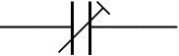

Fig.1.4 showing the circuit symbol of Trimmer Capacitor.

Trimmer capacitors (trimmers) are miniature variable capacitors. They are designed to be mounted directly onto the circuit board and adjusted only when the circuit is built.

A small screwdriver or similar tool is required to adjust trimmers. The

process of adjusting them requires patience because the presence of your

hand and the tool will slightly change the capacitance of the circuit in

the region of the trimmer!

Trimmer capacitors are only available with very small capacitances,

normally less than 100pF. It is impossible to reduce their capacitance to

zero, so they are usually specified by their minimum and maximum

values, for example 2-10pF.
35

Trimmers are the capacitor equivalent of presets which are miniature variable resistors.

3.4 DESCRIPTION OF DIODE

Function
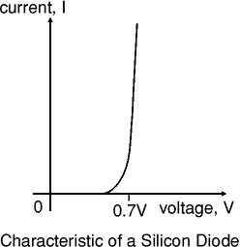

Diodes allow electricity to flow in only one direction. The arrow of the circuit symbol shows the direction in which the current can flow. Diodes are the electrical version of a valve and early diodes were actually called valves.
36

Forward Voltage Drop

Electricity uses up a little energy pushing its way through the diode, rather like a person pushing through a door with a spring. This means that there is a small voltage across a conducting diode, it is called the forward voltage drop and is about 0.7V for all normal diodes which are made from silicon. The forward voltage drop of a diode is almost constant whatever the current passing through the diode so they have a very steep characteristic (current-voltage graph).

Reverse Voltage

When a reverse voltage is applied a perfect diode does not conduct, but all real diodes leak a very tiny current of a few µA or less. This can be ignored in most circuits because it will be very much smaller than the current flowing in the forward direction. However, all diodes have a maximum reverse voltage (usually 50V or more) and if this is exceeded the diode will fail and pass a large current in the reverse direction, this is called breakdown.
37

Ordinary diodes can be split into two types: Signal diodes which pass small currents of 100mA or less and Rectifier diodes which can pass large currents. In addition there are LEDs (which have their own page) and Zener diodes (at the bottom of this page).

Connecting and soldering
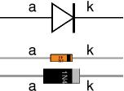

Fig. 1.6 Diagram showing a diode and how to connect and solder. Diodes must be connected the correct way round, the diagram may be labeled a or + for anode and k or - for cathode (yes, it really is k, not c, for cathode!). The cathode is marked by a line painted on the body. Diodes are labeled with their code in small print; you may need a magnifying glass to read this on small signal diodes!

Small signal diodes can be damaged by heat when soldering, but the risk is small unless you are using a germanium diode (codes beginning OA...) in which case you should use a heat sink clipped to the lead
38

between the joint and the diode body. A standard crocodile clip can be used as a heat sink.

Rectifier diodes are quite robust and no special precautions are needed for soldering them.

Testing diodes

You can use a multimeter or a simple tester (battery, resistor and LED) to check that a diode conducts in one direction but not the other. A lamp may be used to test a rectifier diode, but do NOT use a lamp to test a signal diode because the large current passed by the lamp will destroy the diode!

Signal diodes (small current)

Signal diodes are used to process information (electrical signals) in circuits, so they are only required to pass small currents of up to 100mA.

General purpose signal diodes such as the 1N4148 are made from silicon and have a forward voltage drop of 0.7V.
39

Germanium diodes such as the OA90 have a lower forward voltage drop of 0.2V and this makes them suitable to use in radio circuits as detectors which extract the audio signal from the weak radio signal. For general use, where the size of the forward voltage drop is less important, silicon diodes are better because they are less easily damaged by heat when soldering, they have a lower resistance when conducting, and they have very low leakage currents when a reverse voltage is applied.

Bridge rectifiers
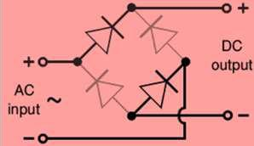

Fig.1.7 showing several ways of connecting diodes to make rectifier convert AC to DC.

There are several ways of connecting diodes to make a rectifier to convert AC to DC. The bridge rectifier is one of them and it is available
40

in special packages containing the four diodes required. Bridge rectifiers are rated by their maximum current and maximum reverse voltage. They have four leads or terminals: the two DC outputs are labelled + and -, the two AC inputs are labelled .

The diagram shows the operation of a bridge rectifier as it converts AC to DC. Notice how alternate pairs of diodes conduct.

Zener diodes
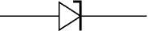

Fig. 1.8 showing the circuit symbol of a Zener
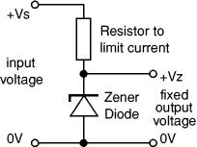

Diode.

Zener diodes are used to maintain a fixed voltage. They are designed to 'breakdown' in a reliable and non-destructive way so that they

can be used in reverse to maintain a fixed voltage across their terminals. The diagram shows how they are connected, with a resistor in series to limit the current.
41

Zener diodes can be distinguished from ordinary diodes by their code and breakdown voltage which are printed on them. Zener diode codes begin BZX... or BZY... Their breakdown voltage is printed with V in place of a decimal point, so 4V7 means 4.7V for example.

Zener diodes are rated by their breakdown voltage and maximum power:

- The minimum voltage available is 2.4V.

- Power ratings of 400mW and 1.3W are common.

3.5 DESCRIPTION OF TRANSFORMER

BASIC TRANSFORMER - The basic transformer is an electrical device that transfers alternating-current energy from one circuit to another circuit by magnetic coupling of the primary and secondary windings of the transformer. This is accomplished through mutual inductance (M). The coefficient of coupling (K) of a transformer is dependent upon the size and shape of the coils, their relative positions, and the characteristic of the core between the two coils. An ideal transformer is one where all the magnetic lines of flux produced by the primary cut the entire
42

secondary. The higher the K of the transformer, the higher is the transfer of the energy.

The voltage applied to the primary winding causes current to flow in the primary.

This current generates a magnetic field, generating a counter emf (cemf) which has the opposite phase to that of the applied voltage. The magnetic field generated by the current in the primary also cuts the secondary winding and induces a voltage in this winding.
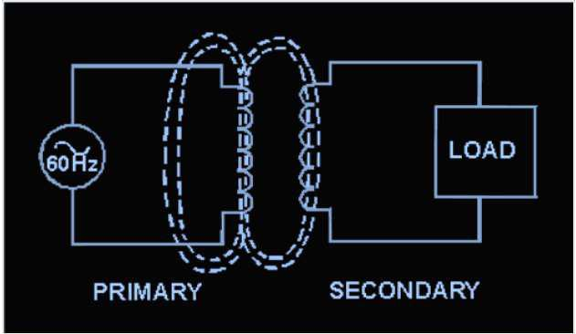

TRANSFORMER CONSTRUCTION - A TRANSFORMER consists of two coils of insulated wire wound on a core. The primary winding is usually wound onto a form, and then wrapped with an insulating

43

material such as paper or cloth. The secondary winding is then wound on top of the primary and both windings are wrapped with insulating material. The windings are then fitted onto the core of the transformer. Cores come in various shapes and materials. The most common materials are air, soft iron, and laminated steel.

The most common types of transformers are the shell-core and the hollow-core types. The type and shape of the core is dependent on the intended use of the transformer and the voltage applied to the current in the primary winding.
44
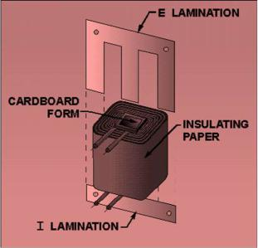

EXCITING CURRENT - When voltage is applied to the primary of a transformer, exciting current flows in the primary.

The current causes a magnetic field to be set up around both the primary and the secondary windings. The moving flux causes a voltage to be induced into the secondary winding, countering the effects of the counter emf in the primary.

PHASE - When the secondary winding is connected to a load, causing current to flow in the secondary, the magnetic field decreases
45

momentarily. The primary then draws more current, restoring the magnetic field to almost its original magnitude. The phase of the current flowing in the secondary circuit is dependent upon the phase of the voltage impressed across the primary and the direction of the winding of the secondary.

If the secondary were wound in the same direction as the primary, the phase would be the same. If wound opposite to the primary, the phase would be reversed.

This is shown on a schematic drawing by the use of phasing dots. The dots mean that the leads of the primary and secondary have the same phase. The lack of phasing dots on a schematic means a phase reversal.
46
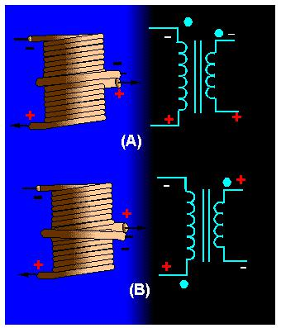

TURNS RATIO - The TURNS RATIO of a transformer is the ratio of the number of turns of wire in the primary winding to the number of turns in the secondary winding. When the turns ratio is stated, the number representing turns on the primary is always stated first. For example, a 1:2 turns ratio means the secondary has twice the number of turns as the primary. In this example, the voltage across the secondary is two times the voltage applied to the primary.
47
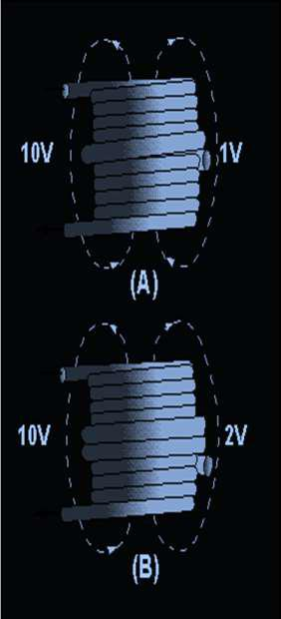

POWER AND CURRENT RATIOS - The power and current ratios of a transformer are dependent on the fact that power delivered to the secondary is always equal to the power delivered to the primary minus the losses of the transformer. This will always be true, regardless of the number of secondary windings. Using the law of power and current, it can be stated that current through the transformer is the inverse of the voltage or turns ratio, with power remaining the same or less, regardless of the number of secondaries.
48

Voltage Ratio

The voltage of the windings in a transformer is directly

proportional to the number of turns on the coils. This relationship

is expressed in Equation.

VP /VS NP/ NS

Where

VP = voltage on primary coil

VS = voltage on secondary coil

NP = number of turns on the primary coil NS = number of turns on the secondary coil

The ratio of primary voltage to secondary voltage is known as

the voltage ratio (VR).

As mentioned previously, the ratio of primary turns of wire to secondary turns of wire is known as the turns ratio (TR). By substituting into the Equation (above), we find that the voltage ratio is equal to the turns ratio.

VR = TR A voltage ratio of 1:5 means that for each volt on the primary, there will be 5 volts on the secondary. If the secondary
49

voltage of a transformer is greater than the primary voltage, the transformer is referred to as a "step-up" transformer. A ratio of 5:1 means that for every 5 volts on the primary, there will only be 1 volt on the secondary. When secondary voltage is less than primary voltage, the transformer is referred to as a "step-down" transformer. Figure 2 Example 1: A transformer (Figure 2) reduces voltage from 120

volts in the primary to 6 volts in the secondary.

If the primary winding has 300 turns and the secondary has 15 turns, find the voltage and turns ratio.

Solution:

VR =VP /VS =120/ 60= 20/ 1= 20:1

TR= NP /NS =300/ 15 = 20/ 1= 20:1

Rev.
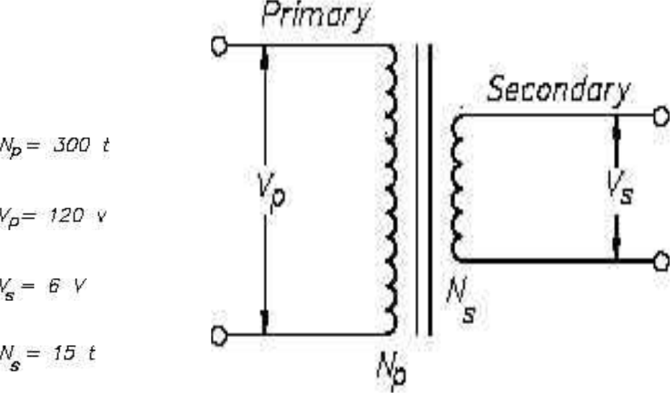
50

3.6 DESCRIPTION OF LOUD SPEAKER AND BUZZER

Loudspeaker

Loudspeakers are output transducers which convert an electrical signal to sound. Usually they are called 'speakers'. They require a driver circuit, such as a 555 astable or an audio amplifier, to provide a signal. There is a wide range available, but for many electronics projects a 300mW miniature loudspeaker is ideal. This type is about 70mm diameter and it is usually available with resistances of 8 and 64. If a project specifies a 64 speaker you must use this higher resistance to prevent damage to the driving circuit.

- Most circuits used to drive loudspeakers produce an audio (AC) signal which is combined with a constant DC signal. The DC will make a large current flow through the speaker due to its low resistance, possibly damaging both the speaker and the driving circuit. To prevent this happening a large value electrolytic capacitor is connected in series with the speaker, this blocks DC but passes audio (AC) signals. See capacitor coupling.
51

- Loudspeakers may be connected either way round except in stereo circuits when the + and - markings on their terminals must be observed to ensure the two speakers are in phase.

- Correct polarity must always be observed for large speakers in cabinets because the cabinet may contain a small circuit (a 'crossover network') which diverts the high frequency signals to a small speaker (a 'tweeter') because the large main speaker is poor at reproducing them.

- Miniature loudspeakers can also be used as a microphone and they work surprisingly well, certainly good enough for speech in an intercom system for example.

Buzzer and Bleeper

These devices are output transducers converting electrical energy to sound. They contain an internal oscillator to produce the sound which is set at about 400Hz for buzzers and about 3 kHz for bleepers.
52

- Buzzers have a voltage rating but it is only approximate, for example 6V and 12V buzzers can be used with a 9V supply. Their typical current is about 25mA.

- Bleepers have wide voltage ranges, such as 3-30V, and they pass a low current of about 10mA.

- Buzzers and bleepers must be connected the right way round, their red lead is positive.

3.7. DESCRIPTION OF TRANSISTOR

It is a device consisting of three region doped semiconductor material (Base, Collector and Emitter) that amplifies and also switch signals.

Function

Transistors amplify current, for example they can be used to amplify the small output current from a logic IC so that it can operate a lamp, relay or other high current device. In many circuits a resistor is used to
53

convert the changing current to a changing voltage, so the transistor is being used to amplify voltage.

A transistor may be used as a switch (either fully on with maximum current, or fully off with no current) and as an amplifier (always partly on).

The amount of current amplification is called the current gain, symbol hFE.

Types of transistor
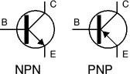

Fig. 1.9 showing the two types of transistor circuit symbols.

There are two types of standard transistors, NPN and PNP, with different circuit symbols. The letters refer to the layers of semiconductor material used to make the transistor. Most transistors used today are
54

NPN because this is the easiest type to make from silicon. If you are new to electronics it is best to start by learning how to use NPN transistors.

The leads are labelled base (B), collector (C) and emitter (E). These terms refer to the internal operation of a transistor but they are not much help in understanding how a transistor is used, so just treat them as labels!

A Darlington pair is two transistors connected together to give a very high current gain.

Testing a transistor

Transistors can be damaged by heat when soldering or by misuse in a circuit. If you suspect that a transistor may be damaged there are two easy ways to test it.
55

1. Testing with a multimeter
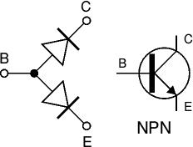

Fig.2.0: Testing an NPN Transistor.

Use a multimeter or a simple tester (battery, resistor and LED) to check each pair of leads for conduction. Set a digital multimeter to diode test and an analogue multimeter to a low resistance range.

Test each pair of leads both ways (six tests in total):

- The base-emitter (BE) junction should behave like a diode and conduct one way only.

- The base-collector (BC) junction should behave like a diode and conduct one way only.

- The collector-emitter (CE) should not conduct either way.
56

The diagram shows how the junctions behave in an NPN transistor. The diodes are reversed in a PNP transistor but the same test procedure can be used.

3.8. DESCRIPTION OF LED (LIGHT EMITTING DIODE)

Function

LEDs emit light when an electric current passes through them.

Connecting and soldering

LEDs must be connected the correct way round, the diagram may be labelled a or + for anode and k or - for cathode (yes, it really is k, not c, for cathode!). The cathode is the short lead and there may be a slight flat on the body of round LEDs. If you can see inside the LED the cathode is the larger electrode (but this is not an official identification method). LEDs can be damaged by heat when soldering, but the risk is small unless you are very slow. No special precautions are needed for soldering most LED
57

Testing an LED
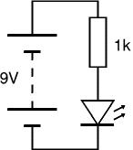

Fig 2.1 showing the testing of LED.

Never connect LED directly to a battery or power supply!

It will be destroyed almost instantly because too much current will pass through and burn it out.

LEDs must have a resistor in series to limit the current to a safe value, for quick testing purposes a 1k resistor is suitable for most LEDs if your supply voltage is 12V or less. Remember to connect the LED the correct way round!
58

Colours of LEDs

LEDs are available in red, orange, amber, yellow, green, blue and white.

Blue and white LEDs are much more expensive than the other colours.

The colour of an LED is determined by the semiconductor material, not by the colouring of the 'package' (the plastic body). LEDs of all colours are available in uncoloured packages which may be diffused (milky) or clear (often described as 'water clear'). The coloured packages are also available as diffused (the standard type) or transparent.

Tri-colour LEDs

The most popular type of tri-colour LED has a red and a green LED combined in one package with three leads. They are called tri-colour because mixed red and green light appears to be yellow and this is produced when both the red and green LEDs are on.

The diagram shows the construction of a tri-colour LED. Note the different lengths of the three leads. The centre lead (k) is the common
59

cathode for both LEDs, the outer leads (a1 and a2) are the anodes to the LEDs allowing each one to be lit separately, or both together to give the

third colour

Bi-colour LEDs

A bi-colour LED has two LEDs wired in 'inverse parallel' (one forwards, one backwards) combined in one package with two leads. Only one of the LEDs can be lit at one time and they are less useful than the tri-colour LEDs described above.

Sizes, Shapes and Viewing angles of LEDs

LEDs are available in a wide variety of sizes and shapes. The 'standard' LED has a round cross-section of 5mm diameter and this is probably the best type for general use, but 3mm round LEDs are also popular.

Round cross-section LEDs are frequently used and they are very easy to install on boxes by drilling a hole of the LED diameter, adding a spot of glue will help to hold the LED if necessary. LED clips are also available
60

to secure LEDs in holes. Other cross-section shapes include square, rectangular and triangular.

As well as a variety of colours, sizes and shapes, LEDs also vary in their viewing angle. This tells you how much the beam of light spreads out. Standard LEDs have a viewing angle of 60° but others have a narrow beam of 30° or less.

Calculating an LED resistor value
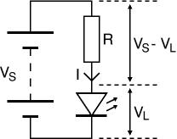

An LED must have a resistor connected in series to limit the current through the LED, otherwise it will burn out almost instantly.

The resistor value, R is given by:

 |  |  |  | R=(VS-VL)/I
VS |  | = |  | supply |  |  | voltage
VL | = | LED voltage (usually 2V, but 4V for blue and white LEDs)
I | = | LED current | (e.g. 10mA = 0.01A, or |  |  |  | 20mA = 0.02A)

61

Make sure the LED current you choose is less than the maximum permitted and convert the current to amps (A) so the calculation will

give the resistor value in ohms (). To convert mA to A divide the current in mA by 1000 because 1mA = 0.001A.

If the calculated value is not available choose the nearest standard resistor value which is greater, so that the current will be a little less than you chose. In fact you may wish to choose a greater resistor value to reduce the current (to increase battery life for example) but this will make the LED less bright.

For example

If the supply voltage VS = 9V, and you have a red LED (VL = 2V), requiring a current I = 20mA = 0.020A,

R = (9V - 2V) / 0.02A = 350, so choose 390 (the nearest standard value which is greater).
62

Working out the LED resistor formula using Ohm's law

Ohm's law says that the resistance of the resistor, R = V/I, where:

V = voltage across the resistor (= VS - VL in this case)

I = the current through the resistor. So, R = (VS - VL) / I

Connecting LEDs in series
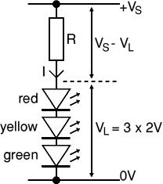

Fig.2.2 showing the connection of LED in series.

If you wish to have several LEDs on at the same time it may be possible to connect them in series. This prolongs battery life by lighting several LEDs with the same current as just one LED.
63

All the LEDs connected in series pass the same current so it is best if they are all the same type. The power supply must have sufficient voltage to provide about 2V for each LED (4V for blue and white) plus at least another 2V for the resistor. To work out a value for the resistor you must add up all the LED voltages and use this for VL.

Example;

Calculations:

A red, a yellow and a green LED in series need a supply voltage of at least 3 × 2V + 2V = 8V, so a 9V battery would be ideal. VL = 2V + 2V + 2V = 6V (the three LED voltages added up). If the supply voltage VS is 9V and the current I must be 15mA = 0.015A, Resistor R = (VS - VL) / I = (9 - 6) / 0.015 = 3 / 0.015 = 200, so choose R = 220 (the nearest standard value which is greater).
64

CHAPTER FOUR: OPERATION OF SYSTEM AND ITS CIRCUIT AND BLOCK DIAGRAMS.

4.1. OPERATION OF CIRCUIT

(Car Touch Intruder Alarm)

This project is powered with 12 volts power supply. This power supply is gotten from power source (power holding) and transformer is used to step it down to 1 volt and rectified with the help of diode as a rectifier (that is to say converting an alternating current (A.C) to direct current (D.C) and smoothed. This is to remove the A.C ripple from the circuit. However, it is power to the circuit or system.

This system makes use of the three NE555 timer. This is an integrated circuit (I.C) that has eight pins configuration and each pin has its function and operation and can be used to construct a circuit like monostable, astable vibrator etc.
65

The first NE555 timer is wired as monostable vibrator and this monostable will give a low voltage when pin 2 of the I.C is connected to negative power supply. However, since this I.C needs a negative supply to give a low output, a jumper wire is used to project the pin 2 of the I.C to the metal body of the system and this part is known as the sensor part.

Human body has a charge inside and this charge can be transferred out. Perhaps; hand or body contact to another and this charge will be transferred to the system once it is being touched and the negative charge in human body will be transferred and the system will be energized. The pin 3 of the I.C is the output pin and this is connected to the tone generator, from tone to amplifier circuit to obtain an audible output and finally, connected to a buzzer or loud speaker.
66

CHAPTER FIVE: CONSTRUCTION, TESTING AND PACKAGING

5.1. Values of component required to be assembled to obtain a car touch sensitive alarm.

The values are as follows:

- IC1: NE555 Timer ( has eight pins terminal number from 1-8)

- IC2: NE555 Timer ( has eight pins terminal number from 1-8)

- IC3: NE555 Timer ( has eight pins terminal number from 1-8)

- Buzzer ( has two terminal positive and negative)

- R1:10M ( has two pins terminal)

- R2: 10K ( has two pins terminal)

- R3: 100 ohms ( has two pins terminal)

- R4: 2.2K ( has two pins terminal)

- R5: 2.2K ( has two pins terminal)

- C1: 47uF electrolytic capacitor ( has two pins terminal positive and negative)
67

- C2: 47uF electrolytic capacitor ( has two pins terminal positive and negative)

- C3: 104 ceramic capacitor ( has two terminal non polarity)

- C4: 1uF electrolytic capacitor ( has two pins terminal positive and negative)

- Q1: C1815 Transistor ( has three pins terminal base, collector and emitter)

- D1: Diode ( has two pins terminal known as Anode and Cathode )

- PR1: (20k variable Resistor)

- PR2: (10k variable Resistor)

- Vcc: positive supply voltage

- Ground: negative supply voltage

5.2. ASSEMBLING:

Pin 2 of IC1 is known as sensor. vcc is connected to pin 8 of IC1, pin 8 of IC2, pin 8 of IC3 and vcc is connecting to pin 4 of IC1, IC2 and IC3. One pin of R1 is connected to vcc and the remaining pin is connected to pin 7 of IC1. Pin 7 of IC1 is connected to pin 6 with a jumper wire. The
68

positive terminal of C1 is connected to pin 7 of IC1 while the negative terminal is connected to ground. One pin of R2 is connected to vcc and the other one is connected to pin 4 of IC1. Pin 1 of IC1 is connected to ground. Anode of D1is connected to pin 3 of IC1, while the cathode is connected to one pin of R3and the remaining pin of R3 is connected to Q1 base terminal, emitter of Q1 is connected to ground while the collector terminal is connected to pin 1 of IC2 and also to pin 1 of IC3. Positive terminal of C2 is connected to pin 2 of IC2 while the negative terminal is connected to ground. PR1 is connected between pin 7 and pin 6 of IC2. R4 is connected between pin 7 of IC2 and vcc.pin 3 of IC2 is connected at pin 5 of IC3. One pin of R5 is connected to vcc while the remaining pin is connected to pin 7 of IC3. PR2 is connected between pin 7 and pin 6 of IC3. Positive terminal of C3 is connected to pin 2 of IC3 while the negative terminal is connected to ground. Positive terminal of C4 is connected to pin 3 of IC3 while the negative terminal is connected to positive terminal buzzer and the negative terminal of buzzer is connected to ground.
69
70

CHAPTER SIX: CONCLUSION AND RECOMMENDATION

6.1. CONCLUSION

71

This project has basic steps taken in the design and construction of car intruder alarm in an electrical/ electronics workshop, these workshops which are well equipped, model for students of electrical/electronics to enhance and impact in them adequate knowledge on the various electrical devices and components.

Again, different electronics components were studied under this condition like Resistor, Transistor, Capacitor, Rectifier, Led etc. their functions, properties and types even Transformer (12) volts was used as the project makes use of a lot of electronic devices.

6.2. RECOMMENDATION
72

First, I thank N.U.C (National University Commission) and this great Institution for allowing us such opportunities, which increases the technological know-how of students.

I recommend that this work should be researched more by future scholars as there are only but few of this work that has been researched on. There are many other forms of alarms that are more advanced like the touch alarm and be worked on.

Also, I recommend that every car user should endeavor to own or install a car touch intruder alarm in their cars because; it is very effective and relevant.

OBSERVATION AND DIFFICULTY ENCOUNTER

73

6.2. OBSERVATIONS:

➢ We discover that decreasing R4 1k and PR1 20k value and increase C1 100uf value that being connected IC2 (NE555) will cause increase in period ( timing period will increase)

➢ We also discover that increasing the R1 (15k) value will affect the frequency by increasing the frequency.

➢ We observed that at each clocking or signal at output of NE555 timer, the IC3 (HCF4017BE) decoder will decode the signal however, giving an output at output pins. Note: each pins is decoding one after another.

➢ We discovered that connecting a jumper wire from pin 15 to any output pin of IC3 HCF4017 will not allow the decoder to decode beyond the pin on which its output is connected (block).
74

6.3. DIFFICULTIES ENCOUNTERED ON THE SYSTEM

❖ To obtain IR (infrared Receiver) was

not ease.

❖ To obtain a neat or nice soldering was

not ease.

❖ Fake component was another problem

we encounter.

❖ Problem of POWER HOLDING

(unsteady power).

❖ Fluctuation of voltage.

- The difference in the name of components between the dealers and student inside the market.
- Deriving the final stage on the Vero board.
75

6.5. REFERENCES

Floyd, T.L. (1997). Digital Fundamental.

Prentice-Hall International Inc, New Delhi, 6th

Edition.

Horowitz, P, Klinfield, H. (1995). The Art of Electronics. Cambridge University Press, London.

Maxda, F.F. (1984).Discrete Electronics Components.

Cambridge University Press, London.
76

Richards C. (1973). Electronic Display and Data.

Systems.Mc Graw-Hill, New York.

Sloich Matsumoto; “Electronic Display Devices”

Theraja, B.L, Theraja,A.K.(2000). Electrical Technology.

S. Chand & Company Ltd, New Delhi.

