COMPUTERIZED TRANSCRIPT MANAGEMENT SYSTEM (A CASE STUDY OF CARITAS UNIVERSITY)

ABSTRACT

This project is a computerized information management for transcript management which will help to over-come the undesirable problem associated with misplacement of student records, student’s grades, slow and strenuous accessibility of student report and record, inaccurate record keeping and poor information management within the schools. Here the aims and objectives of the study will be easily retrieved with increased data security, and there will be reduction in the amount of resources, which will lower the cost of processing of student transcript, since information is stored in a database with reduced data redundancy. This will also prevent over-working of personnel and reduce in the bulkiness of file and record. This program developed/designed will ensure easy flow of information in the school (caritas university), and accurate information management in all school.

v
 |  |  |  | TABLE OF CONTENT
Title -- |  | - | - | - | - | - | - | - | - | - | - | -i
Approval page |  |  | - | - | - | - | - | - | - | - | - | -ii
Dedication |  | - | - | - | - | - | - | - | - | - | - | -iii
Acknowledgement |  |  |  | - | - | - | - | - | - | - | - | -iv
Abstract |  | - | - | - | - | - | - | - | - | - | - | -v
Table of content |  |  | - | - | - | - | -- | - | - | - | - | -vi
CHAPTER ONE
1.0 | Introduction |  |  | - | - | - | - | - | - | - | - | -1
1.1 | Background of the study |  |  |  |  | - | - | - | - | - | - | -3
1.2 | Statement of Problem |  |  |  | - | - | - | - | - | - | - | -4
1.3 | Aims and Objectives of the Study |  |  |  |  |  | - | - | - | - | - | -5
1.4 | Significance of the Study - |  |  |  |  | - | - | - | - | - | -- | -6
1.5 | Scope of the Study - |  |  |  | - | - | -- | -- | - | - | - | -6
1.6 | Limitation of the Study |  |  |  | - | - | - | - | - | - | - | -6
1.7 | Organization of Work |  |  |  | - | - | - | - | - | - | - | -6

CHAPTER TWO

LITERATURE REVIEW

2.0 Information Management - - - - - - -8

2.1 The role of management information system in decisions making in

the university - - - - - - - - 14

CHAPTER THREE

RESEARCH METHODOLOGY AND SYSTEM ANALYSIS

3.0 | Definition of System Analysis |  |  |  |  | - | - | - | - | - | 18
3.1 | Aims of System Analysis |  |  |  | - | - | - | - | - | - | 18
3.2 | Analysis of the old System of Transcript Information
 | System | - | - | - | - | - | - | - | - | - | 19

vi
3.3 | Problem associated with old System - |  |  | - | - | - | - | 19
3.4 | The need for a new system | - | - | - | - | - | - | 20

CHAPTER FOUR

SYSTEM DESIGN

4.0 | System Design | - | - | - | - | - | - | - | - | 21
4.1 | Input Design - | - | - | - | - | - | - | - | - | 21
4.2 | Output Design | - | - | - | - | - | - | - | - | 23
4.3 | Processing Design | - | - | - | - | - | - | - | - | 24
4.4. Overview of Database Design - |  |  |  |  | - | - | - | - | - | 28

CHAPTER FIVE

SUMMARY, RECOMMENDATION AND CONCLUSION

5.0 Summary | - | - | - | - | - | - | - | - | - | 35
5. 1 Conclusion | - | - | - | - | - | - | - | - | - | 35
5.2 Recommendation |  | - | - | - | - | -- | - | - | - | 36
References | - | - | - | - | - | - | - | - | - | 37
Appendixes | - | - | - | - | - | - | - | - | - | 39
Appendix interface |  | - | - | - | - | - | - | - | - | 55

vii
CHAPTER ONE

1.0 INTRODUCTION

There were three fundamentally distinct education systems in Nigeria in 1990. The indigenous system, Quranic Schools and formal European-style education institutions. In the rural areas where the majority lived, children learned the skills of farming and other work, as well as the duties of adulthood, from participation in the community, this process was of ten supplemented by age based schools in which groups of young boys were instructed in community responsibilities by mature men. By the 1970s, education experts were asking how the system could be integrated into the more formal schooling of the young, but the question remained unresolved by 1990.

Western-style education came to Nigeria with the missionaries in the mid-Nineteenth century. Although the first mission school was founded in 1843 by Methodists, it was the Anglican Church missionary society that pushed forward in the early 1850s to found a chain of missions and schools. Followed quickly in the late 1850s by the Roman Catholics in 1887 in what is now Southern Nigeria, an education department was founded that began setting curricum requirement and administered grants to the mission societies. By 1914, when North and South were United into one colony, there were fifty-nine government and ninety-one
1
mission primary schools in the South; all eleven secondary schools, except for king’s college in Lagos, work run by the missions.

The education system focused strongly on examinations. In 1916 Fredrick Lugard, first governor of the Unified Colony, set up a school inspectorate. Discipline, building and adequacy of teaching staff were to be inspected, but the most points given to a school’s performance went to the numbers and ranking of it’s examinations results. This stress on examination was still used in 1990 to judge educational results and to obtain qualification for jobs in government and the private sector.

As more information is made available in a variety of formats and media and in a variety of locations, the need to manage information/data efficiently becomes more and more critical. Both staff and public users want access to stored information and want to access it more efficiently. It is the university policy to improve both the efficiency and effectiveness of result processing operations (student record/grades), and services through the implementation of A computerized transcript management system.

2
1.1 Background of the study

Caritas university, Amorji Nike, Enugu, is a private university approved by the federal government of Nigeria on December 16, 2004. it was officially opened on January 21, 2005 by the Federal Ministry for Education, Prof. Fabian Osuji, the formal opening was on January 31, 2005. The pioneer students of 250 matriculated on May 28, 2005 in beautiful ceremony that attracted dignitaries both church and state. It is the second Catholic University in Nigeria founded by Rev. Fr. Prof. Emmanuel Paul Matthew Edeh CSSP, OFR. Although he founded the school, the proprietor of the University is the congregation of sisters, the Saviour, a religious congregation of Nums founded by him.

The vision of Caritas university is to reserve some of our wandering and teaming youth from further slide into academic and moral decay, and development and transformation of our society through sound and adulterated education. It’s mission is to discover, sanctify and apply the knowledge of science, environment central and engineering for human well-being and sound development of man for better society.

Caritas university’s goal is to give efficacy to the university’s motto and to it’s philosophy of education. We embrace not only sound education for professional skills and competency in various fields; but also maintain strict discipline. We train the mind, body, soul and spirit in the exercise
3
of obedience and self control. The students must not only be intellectually and professionally prepared for different tasks and roles in the world, they must also be morally equipped to face the world itself with all its tensions, conflicts, challenges and contradictions, we achieve this with the help of God Almighty who is with us always.

The philosophy is to promote sound education for professional skills and competencies in various fields with strict discipline. By discipline the university meant the training of the mind, body and soul and spirit to obedience and self control. Also to prepare the students to be intellectually and professionally sound for different tasks and roles in the word with its tensions, conflict, challenges and contradictions.

The university operates faculty system. Presently, the university operates six faculties. Education and Arts, Engineering, Environmental Sciences, Management, Social Sciences and Natural Sciences.

1.2 Statement of Problem

This project research was conducted exclusively conducted in a caritas university located in a highly populated area that attends to too many students at a time, hence this research was able to track problem such as misplacement of student records, student’s grades, slow and

4
strenuous accessibility to students report and record, inaccurate record keeping and poor information management within the schools.

1.3 Aims and Objectives of the Study

The aim of this study is to identify the problems inherent in the existing system of transcript management systems, and to proffer a remedy to the existing problem. The solutions are as follows:

- Record and reports of students will be easily retrieved with increased data security.

- There will be reduction in the amount of resources, which in turn will lower the cost of processing of student’s transcripts, since information will be stored in a database with reduced data Redundancy.

- School personnel can attend to many student without being over worked.

- There will be reduction in time used in retrieval of student’s files.

- Reduction in bulkiness of files and record.

- It will make available the storage room that was used for storage of files.

5
1.4 Significance of the Study

The project research haven’t identify the problem that was existing in the old system of operation , is designed specifically to come up with a more resound and effective system that will not only counteract this problem but also provides a detailed future plan that will give room for more information technological improvement in the transcript sector.

1.5 Scope of the Study

This research work are limited to providing a digital transcript’s information management system that will handle electronically both students and staff record , to enable easy accessibility and information flow within the university.

1.6 Limitation of the Study

This research work is limited to providing a more reliable information management system that will handle electronically the record of both student and staff within the university.

1.7 Organization of Work

This project work was arranged specifically arranged in chapters, hence it follows the order: Chapter One: General Introduction, Chapter Two:
6
Literature Review, Chapter Three: System Analysis, Chapter Four

System Design, and System Implementation, Chapter five: Summary,

Conclusion and Recommendation.

7
CHAPTER TWO

LITERATURE REVIEW

2.0 Information Management

The introduction of computer into information technology has massively improved the information need of organization; the success of this machine is dependent on the knowledge base. Therefore, one can be prompted to ask aloud “what is a computer”? Funk E. C. (1980) defined a computer as an electronic device that can perform automatically and at a high speed a sequence of logical operations according to instructions given to it inform of a pre-arranged program.

Another author, Anigbogu, S.D. (2000) defined a computer as an electronic device capable of accepting data and instructions, processing the data based on the instructions to generate result or output in such a manner that is yet to be equaled by any other known machine to man kind.

Similarly, another author Chimezie, F.O. (1990) defined it by saying that “computers are looked upon as obedient servants who are ever ready to free man from tedious procedures and produce results as compared with human computing time”. Yet another author, Obilikwu, P. (1995) defined computer as a machine that is capable of accepting input data,

8
store and process the data based on instructions given by the computer user and in this way produce expected results, generally called output. These definitions of computer would lead us to answer the question “what is a program?. In his definition, Obilikwu, P. (1995) defined a program as a sequence of instructions given to the computer to perform a specific operation. From Encarta Encyclopedia, computer program is a set of instructions that directs a computer perform some processing function or combination of functions.
This above definitions of computer clearly demonstrated the limitless area of operation of computer in as much as such task is programmable computer is applicable in virtually all areas of human endeavour ranging from Agriculture, education, business, sports, entertainment, medicine, constriction and military etc.

French, C.S. (1992) in his book titled “Computer Science” fourth edition, he relates the relevance of computer to management and stated that “a company needs information in which to base decisions concerning the current operations and future plans. It requires the information to be timely and accurate”. He then cited the example of the use of computer in the area of management control to production and stated “production must be able to respond quickly to changes in demand and other

9
circumstances to do so requires the provision of up to date information which is accurate and timely”.

Aluko, A.O. (1991) in a paper stated that “in virtually any job whether cerical, technical, business or professional, whether it is a banking, medicine, education etc. Computers are useful tools” and that “computers are tools with which we calculate, measure, assess, store, retrieve, regulate and monitor information. Hence, the blood and life wire of any system is information. A typical system (Education, management etc) cannot survive without good management information system (MIS).

Management information system (MIS) are information systems, typically computer-based that are used without an organization. The concept of management information system is a complex variable although Murdick, R. (1971) simplified it when he said “there is probably no more challenging and diversified subject than management theory, system theory and computer science”.

Computerization is a social process for proving access to and support for computer equipment to be used in activities such as teaching, accounting, writing, designing, circuits, file processing etc. Computerization entails social choices about the level of appropriate

10
investment and control over equipment and expertise, as well as choices of equipments.

Dunlop and Kling (1991), by the early 1990’s computing and telecommunications accounted for half of the capital investments made by private firms. However, paper (1980), Fergenbaum and McCorduck (1983) and Yourdon (1986) stated that the most fervent advocates of computerization have argued that the actual pace of computerization in schools, factories and homes is too slow.

Taylor (1980), computer-based education includes both computer-assisted instruction programs that interact with students in a dialogue and a broader array of educational computer applications such as simulations or instruction. In computer programming, there is major national push for extended application of computer-based education at educational levels. For example, in the mid 1980s private several colleges and universities required all their freshmen students to buy a specific kind of micro computers, and other invested heavily in visions of “wired campus”.

Kling (1983), computer-based education has been promoted with two different underlying ideologies in all levels of education. Some educators argue that computer-based instructional approaches can help. Fulfill the traditional values of progressive education. The simulation of
11
intellectual curiosity, initiative and democratic experience. For examples, Cyert (1984) has argued that computerized universities are qualitatively different than traditional universities. College students with micro computers in their dorm room will be more stimulated to learn because they will have easy access to instructional materials and more interesting problems to solve.

Papert (1979) argues that in a new computer base school cultivate, students will no longer simply be taught mathematics. These visions portray an enchanted social order transformed by advanced computing technologies. Other advocates are a bitless romantic, but not less enthusiastic.

For example, Cole (1972) argues. Because of the insatiable desire of students for more and more information at a higher level of complexity and more sophisticated level of utilization…. More effective means of
communication must be used…. Computers can provide a unique vehicle

for this transmission.

King (1986), others emphasize a labour – market pragmatism that we label “vocational matching.” In this view people will need computer skills, such as programming, to compete in future labour markets and to participate in a highly automated society; a responsible school will teach some of these skills today.
12
Kling (1986), advocate of computer-based education promote a utopian image of computer-using schools as places where students learn in a cheerful, cooperative setting and where all teachers can be supportive, enthusiastic mentors.

Hence, it is important to note that computer based education goes a long way in helping the students as well as the staff to effectively make use of the computerized management system. It also helps in convincing the stakeholders of the importance and need for adopting the computerized transcript management system as it provides effective and accurate handling of student’s files.

Therefore, a computerized transcript management system is usually a system, which is implemented with a computer to achieve the utmost efficiency and desired goals. In well developed countries, where education system are computerized. Thus a personalized software that captures the entire education business process and makes all operation accessible via the web, thus allowing schools to effectively serve all stakeholders students, lectures, administrators and percent. But in this case (Transcript Management System) it provides functionalities including Grading, Records keeping, information management within the school, easy retrieval and data security.

13
2.1 THE ROLE OF MANAGEMENT INFORMATION SYSTEM IN DECISIONS MAKING IN THE UNIVERSITY.

The role of information in decision making cannot be overemphasized. Effective decision making demands accurate, timely and relevant information. According to Aminu (1986), information resource is one of the major issues and indices of university planning. Where the relevant information required for planning are not available at the appropriate time, there is bound to be poor planning, inappropriate decision making, poor priority of needs, defective programming or scheduling of activities. Hence, the university system will not be efficient and effective in it’s operation. Poor management information system have been identified as a bottleneck in the successful management of universities in Nigeria (NUC, 1987). The more complex an organization’s structure is, the greater the need for coordination within and between sections and

departments. However, central to the needed coordination is information. This view is buttressed by Murdick and Ross (1971), when they opined that: Information is absolutely essential to the survival of an organization. As organization grow, the pressure of scale, complexity and an increased rate of change make adequate information processing capacity inevitable, if effective control, consequent upon coordinate of individual activities is to be achieved.
14
Thus, the information needed for effective decision making in universities cannot be provided from people’s often deficient memories. Moreover, it is impossible to plan activities over a long period of time effectively without effective information. Information is supposed to be created through the discipline of enquiry and research with peer moderation to ensure, validity and societal influence. The knowledge to be created or established must be stored to ensure continuity of reason, and adaptive academic pursuit. The stored information must then be recalled at will and be disseminated for use in taking decisions, which are in the interest of the society at large. According to Knight (2005). There are mechanisms that drive continuous investment in bricks and mortar education and deny the expenditures that would establish virtual universities by means of telecommunication networks. Even if they wanted to, administrators are restricted in their freedom to move in this direction by traditional funding formulae. Promotion and tenure procedures are seen as banners in the universities. In many institutions, the primary requirements for promotion and for tenure procedures are publications in traditional journals and teaching in traditional classrooms. A major federal government contribution is it’s booster plan to computerized information in the United Schools (Ekere, 1990). With these improvements, the information resource still presents a major
15
issue on educational management in the country. Particularly with the universities, one wonders the essence of their acquiring communication gadgets and the scope of their applications. Studies have revealed that in most sophisticated organization both manual and computer based system are used; in fact both are held to be complementary in information handling procedures. (Sanders, 1983). Obi (2003), Fabunmi (2003) and Adebayo (2007) has stressed the need for management information systems in making effective decisions in
education institutions. In recognition of the important role of information to the survival of the university system, the NUC introduced the computerized management information system to the Nigerian universities. The MIS idea was conceived during a conference jointly organized by NUC and the British Council in Kaduna in 1987. In conjunction with overseas Development Administration (ODA), the project took in 1989 in four pilot universities, namely Federal University of technology, mina, and university of Ilorin, University of Lagos and University of Nigeria, Nsukka. The importance of MIS in decision making can be realized from its aims and objectives. The aim of MIS is to develop a viable system to maximize the effective use of modern data approach to management practices. It is also aimed assisting managers and operating personnel, to produce timely and accurate information not
16
only to decide present and future operations, but also to pinpoint potential problems that need to be rectified. According to NUC (1987), the objectives of MIS project in the universities are:
- To standardize the system of obtaining reports and statistical information from the various universities on students, stall, financial matters and library.
- To record such information on diskettes or tapes at the universities and send to NUC for budgeting, information storage, analysis and retrieval purposes.
- To ensure that such information are accurate and timely.

- To organize information for planning, budgeting and decision making.

- To help the universities put in place effective management system and improve utilization of resources.

Based on these objectives, it is expected that MIS will assist the universities in decision making on various issues in their operations. To this end, efforts are made by the universities in the areas of the acquisition and use of computers in information processing, computer literacy, establishment of computer services units among others.

17
CHAPTER THREE

RESEARCH METHODOLOGY AND SYSTEM ANALYSIS

3.0 Definition of System Analysis

System analysis is defined as the comprehensive study of an existing system to discover the areas of its functional limitation. This is the tool that helps me a lot in gaining an understanding of the existing system and what is required of it. It is a structural process that I used in collecting and analyzing facts in respect to systems operation of transcript information systems and procedures in order to get a full appreciation of the situation so that an effective computerized information management system may be designed and implemented. (Bill, 2009)

3.1 Aims of System Analysis

The best objectives of system analysis is to find the mode of operation of the existing system of transcript information and its limitation so that a computer based system can be designed and fully implemented in order to solve the problems associated with the existing system.

18
3.2 Analysis of the old System of Transcript Information System.

Some secondary schools provide class rank and standardized scores on student transcripts. Even if your high school provides Scholastic Aptitude Test (SAT) scores and AP test scores on a transcript, double-check the college application requirements. Colleges may require separate reporting of SAT and AP test scores for verification purposes.

Mainly the process involves in processing of transcript is a very manual process, that involves movement of files from one location to another, and endless waiting for the authorization of the transcript, the crude process starts from application for transcript in the registrar office, and the movement to the university bank for payment.

3.3 Problem associated with old System

During my analysis of the existing system of transcript information system in the course of my Project Research, I observed some problems that were inherent in the existing system and there are listed below as follows:

- Monotonous storage of record

- Bulkiness and heaviness of files

19
- Misplacement of student grade record due to negligence on the part of workers.

- Slow and strenuous retrieval of records and report of students.

- The system is not cost effective

- Inaccurate diagnoses due to wrong record keeping

3.4 The need for a new system

Because of the problems inherent in the existing system in the transcript system, the need for computerization becomes imperatives. These are listed below as follows:

- Record and reports of students will be easily retrieved with increased data security.

- There will be reduction in the amount of resources, which in turn will lower the cost of medical service, since information will be stored in a database with reduced data Redundancy.

- School personnel can attend to students without being over worked.

- There will be reduction in time used in retrieval of student files.

- Reduction in bulkiness of files and record.

- It will make available the storage room that was used for storage of files.

20
CHAPTER FOUR

SYSTEM DESIGN

4.0 System Design

This is the process of designing or building the new system after a detailed study of the objectives of schools. It is stage in which the research actually plans the life cycle of a system and all the work associated with the various stages of the system life cycle. The main aim of this design is to achieve a new system that is better than the old system in terms of efficiency and service with the introduction of a computer aided system. The design will make extensive use of the menu driven approach, which routes program of interest and ensure that the user inputs is not inconsistent for easy access path information.

4.1 Input Design

4.1.1 Overview of Input Design

This involves the steps of algorithm that was used to design the input of the new system i.e. inputting data into the system.

21
 |  | First name |  |  | middle name |  |  |  |  |  |  |  | last name
 |  | Age |  |  | gender |  |  | address |  |  |  |  | nationality
 |  | State |  | occupation |  |  |  | marital |  |  |  |  | email
 |  | Telephone
 |  | Registration No. Faculty |  |  |  |  |  | Department
 |  | Current Level |  |  |  | Semester |  |  |  |  | Grade Point |  |  |  |  | Class

Fig1. Input Interface

22
4.2 Output Design

4.2.1 Overview of Output Design

This design brings out the feedback of the result of any input that is being made in the system. The design is shown in just one form:
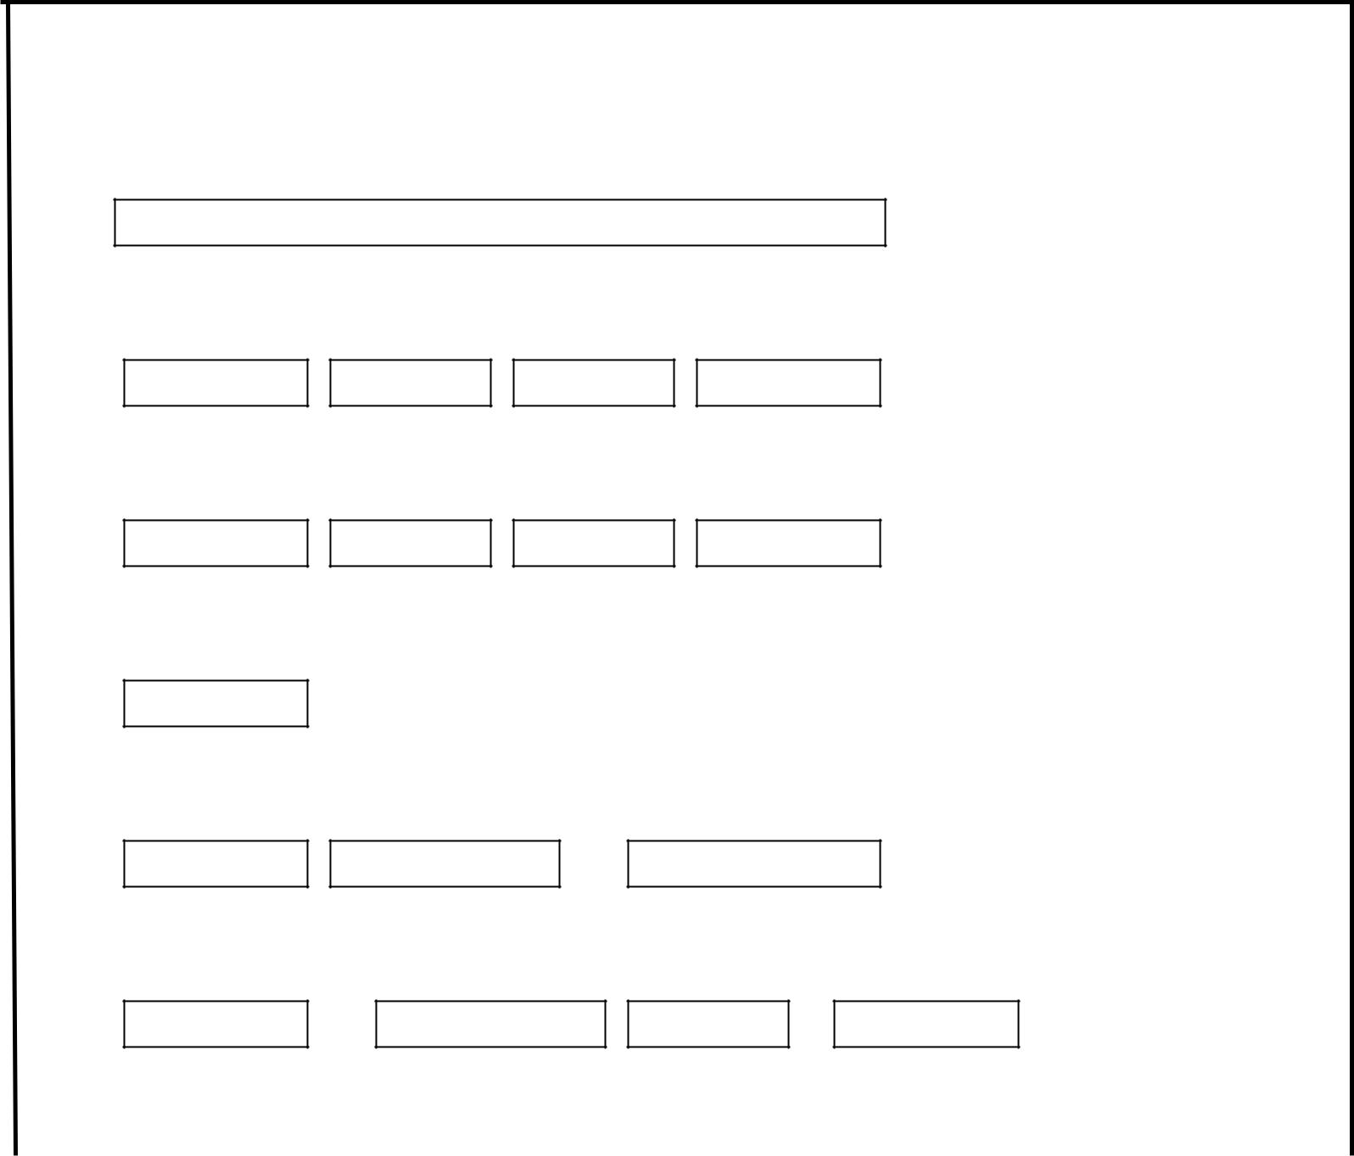

First name middle name last name

Age gender address nationality

State occupation marital email

Telephone

Registration No. Faculty Department

Current Level Semester Grade Point Class

23
Fig2. Output Interface

4.3 Processing Design

4.3.1 Overall System

The need for computerized information management system for the transcript process is of great importance, due to some of the problem that were encountered with the old system due to that, in the course of my Project Research, I tried to develop a system that will counteract some of these problems, the system was built in Visual Basic.Net, a programming language that I termed will best solve most of the problem that were encountered in the old system. The new system was designed considering the evaluation of already existing process of information processing, the system was not meant to add or remove from the already existing process, but it was meant to improve the way that these information are been processed, to enhance speed and accuracy in the system.

24

4.4.1.1 Overall System Flowchart
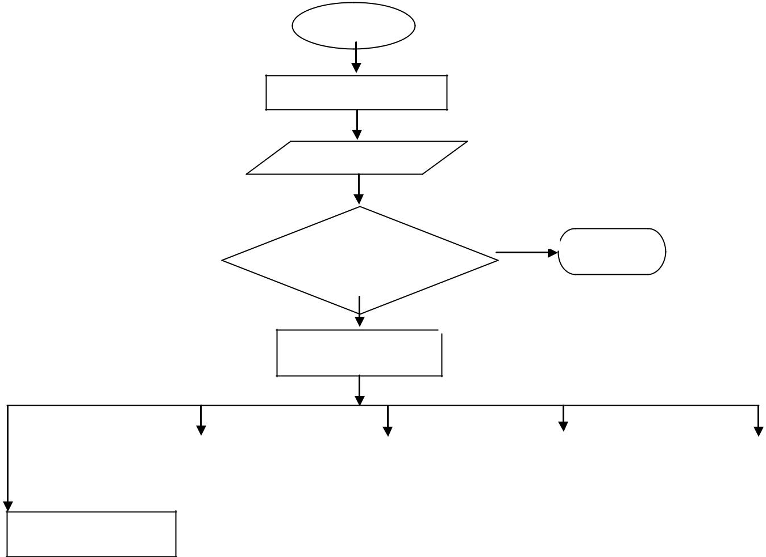

START

SPLASH SCREEN

PASSWORD

 | NO
IS PASSWORD | STOP
PASSED

YES

MAINFORM

 |  |  |  | Search
Add Department |  | REGISTRATIO |  | Search |  | Profile
 |  | N

Tools

Fig3: The Whole System Flowchart

4.4.2 Input Processing

With respect to the input of data, it has to undergo certain degree of data processing before it could give the required output with this at hand we can conclude that all input in this system needs to be processed.

25

4.4.2.1Flowchart: The flowchart below shows the input processing.
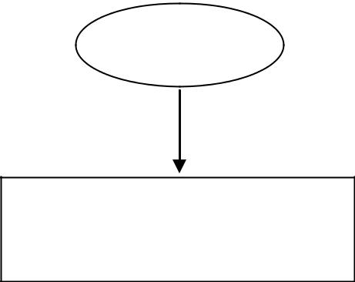

START

ADD STUDENT
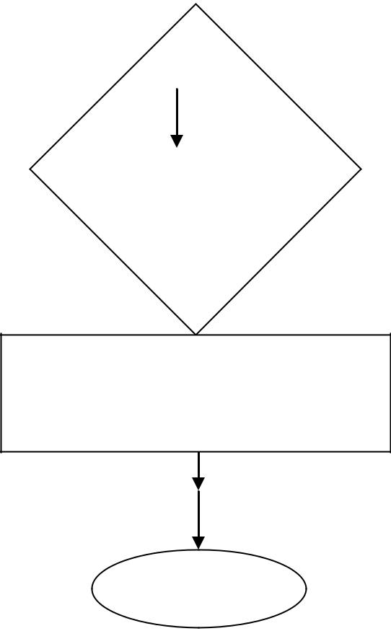

VERIFY IF
STUDENT‘S
DATAARE

CORRECT

REGISTRATION IS

SUCCESSFUL

STOP

26

Fig 4: Input Flowchart

4.4.3 Output Design

This is what is given out specifically when a particular data that is inputted into the computer are processed, hence for output process to be complete and to take place effectively there is a necessity for the input to be feed into the computer for processing to effectively take place.

4.4.3.1Flowchart: This shows the processing order of the system output.
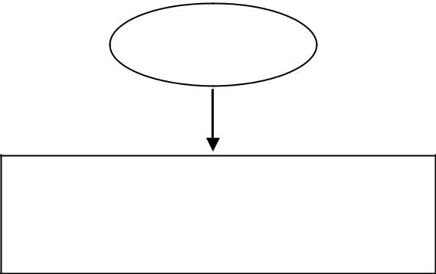

START

DISPLAY STUDENTDATA
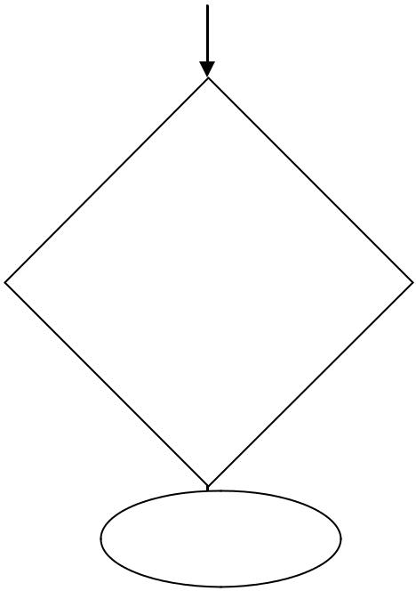

IS STUDENT
DATA

DISPLAYED

STOP

27
Fig 5: OUTPUT FLOWCHART

DATABASE DESIGN

4.4. Overview of Database Design

This part actually portrays the database file that was used in this program in order to

House and store information in the program, for this program to work effectively, there are many database that are used for used specifically for managing of the information and data of the program.
The databases that are in the program are stipulated below as follows:

- Department and faculty

- Profile Table

- Semester Record

- User Data

SYSTEM IMPLEMENTATTION

4.5.1 Language Implementation

The need for computerized information management system is of great importance, due to some of the problem that were encountered with the old system due to that, in the course of my Project Research, I tried to develop a system that will counteract some of these problems, the system was built in Visual Basic 6.0, a programming language that I
28
termed will best solve most of the problem that were encountered in the old system. The new system was designed considering the evaluation of already existing process of information processing, the system was not meant to add or remove from the already existing process, but it was meant to improve the way that these information are been processed.

4.5.2 Input Specification

Hence in the input specification of the program, there are many functions that are specifically designed to handle the input processing of the program and ensure that it gets to database at any point in time after processing of the data. Some of the input specification of this program is as follows: Add Department, Registration.

4.5.3 Add Department Form

Add Department: This is a form used specifically for addition of new departments to the transcript system, and it also synced the added departments with other processes.

29
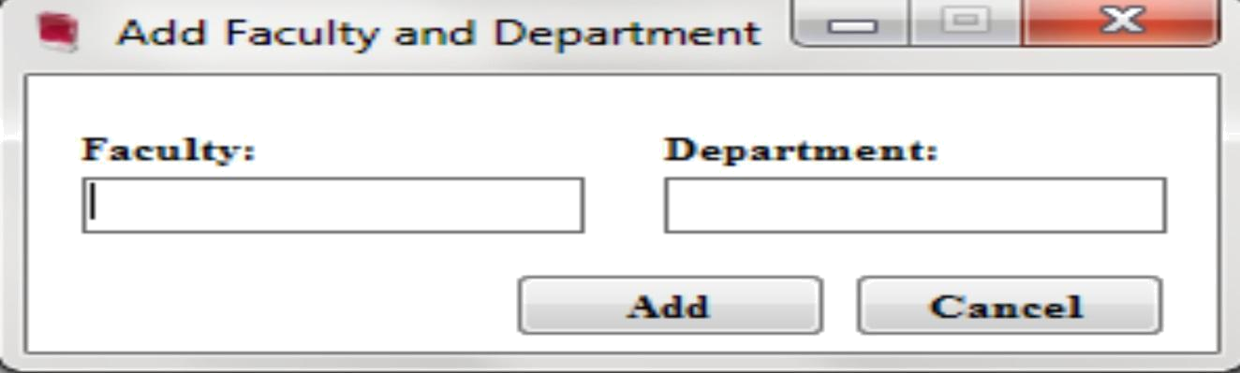

Fig 6: Admission Form

4.5.4 Output Specification

This has to do specifically with those controls and component that are responsible for the view of the result of the data stored in the database after processing, this specification to be represented effectively in the program, there are some of the component of the program that portrays the output specification of the program and some of this components are: Search, Profile, Approve.

4.5.5 Search: This tool is designed specifically to enhance the searching capability of the software, and also making the detail more clear for better understanding.

30
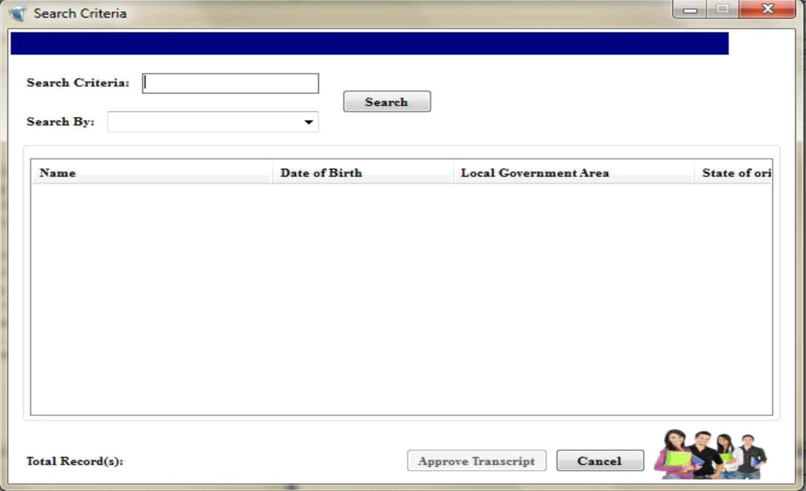

Fig 7: Search Form

4.5.6 Implementation of the new system

Implementation is the period when the new system is put into use. For the system Implementation to be effective, the following areas of activities were to be carried out Effective. They include:
- Conversion of old files

- Education and training of staff

- Change over procedure

31

4.5.7 Conversion of Files

This process involves converting records of physical files to electronic files according to the laid down procedures. It requires plenty of time and carefulness because there are many files, where each files contains many records.

4.5.8 Education and Training of staff

It is vital that the staff of the user department have extensive knowledge of the new system functions. It is important for the effective use of the new system in the school

4.5.9 System Requirement

System requirement are those things, needed for the efficient working of the new system. These include:

- Software Requirement

- Hard Requirement

4.5.10 Software Requirement

Software refers to a set of program that is executable by the computer to perform a task. software requirement: are those software that are

32
required by the new system for its effective function. Windows XP operating system is most preferable for the new system to function.

4.5.11 Hard ware Requirement

Hardware refers to the physical component of the computer. This houses the software, the combinations of hardware and software is vital for the effective running of the new system that was designed for transcript management. The hardware requirements that are needed for the effective running of the new system are stipulated below as follows:

- Monitor ( VGA,SVGA or LCD)

- Keyboard

- Pentium IV

- Server

- LAN Network

4.5.12 System Testing

System Testing completes the system work, which has been able to change the manual ways information management in school, to a computerized method. It serves as a great improvement, eliminating the inefficiency in the manual method.

33
4.5.13 System Installation

To use the system the following task should be performed, as listed below as follows:

- Plug the socket very well and all the connectors to the system.

- Boot your computer

- Run the program

34
CHAPTER FIVE

SUMMARY, RECOMMENDATION AND CONCLUSION

5.0 Summary

In the course of my Project Research, I find out that a computer aided information management makes it more convenient, efficient and produces an accurate information management generally in all schools. This is opposed to the manual method, which is stressful, time consuming prone to mistakes due to human nature and inconvenient. This will not only facilitate information processing in the school, but will go a long way in improving the overall general service of the university, since information department is the pillar post of the schools

5. 1 Conclusion

In conclusion, haven carried out a detailed and comprehensive research on schools as institution , there by laying down the problems that this

institution faces as regards to information management and dissemination which in essence is one of the paramount needs of schools, a system was design which encompasses and counteract many of this problems that was observed on the old system, hence all schools is now been advice to make use of this valuable tool to improve to a

35
great extent, the information requirement of this information which in essence will improve efficiency.

5.2 Recommendation

Having seen the usefulness of a computer based information management system to school, I recommend the following to the schools, stipulated below as follows:

- They should computerize all the department of the school, to ensure easy flow of information in the schools.
- They should ensure that all the staff of the user department are adequately trained to ensure smooth implementation of the new system.

- Even after computerization of the whole department, they ensure

that all the system are linked to one central local network, protected with high security measures

- Advocate and educate stake holders and service providers to use transcript’s information for planning.

- Formulation and development of policy guidelines on the use of information, data collection.

36

REFERENCES

Anigbogu, S. O. (2000). Computer application and operation First Edition. Awka, Anambra: Optimum Press.

Adebayo, F. A. (2007). Management Information System for Managers.

Ado Ekiti : Green Line Publishers.

Bill, T. (2009). Echrome Transcript Management System. London:

Princeton University Press.

Benly, H. C., & Brusell, G. C. (2009). School Computerization, 6th Edition. U.S.A: Kleen University Press.

Blementhal, S. C. (1969). Management Information System. New Jersey: Prentice Hall Inc.

Caplinskas, A. (1996). Program Systems Engineering Fundamentals.

Institute of Mathematics and Informatics, Vol. 2. Vilnius, Literriania.

Electronic School Information. (2010). Retrieved on 2010-08-13.

From htt.p.//www.myschool.com.

Ekwere C.E. (1990). Evaluation of Management Information System in Universities. Lagos: Longman Publishers.

37

37

Simanaukas, L. (1997): Analysis of Informatics Systems. Vilnius,

Lithuania: Vilnius University Press.

38

38

APPENDIX 1

FORM REGISTRATION CODE:

Imports System.Data.OleDb

Public Class frmRegistration
Const English As Integer = 2

Const GeneralBiology As Integer = 3
Const GeneralChemistry As Integer = 2
Const GeneralChemistryII As Integer = 3
Const PracticalChemistry As Integer = 1

Const ElemenatryMaths As Integer = 3
Const GeneralPhysics As Integer = 3
Const BasicPracticalPhysics As Integer = 1
Const IntroductionToStatistics As Integer = 3
Const NigerianCulture As Integer = 2
Const Biothics As Integer = 1
Dim tempEnglish, tempBiology, tempChemistry, tempChemistryII, tempPracticalChemistry, tempElementaryMaths As Integer

Dim tempGeneralPhysics, tempPracticalPhysics, tempIntroductionStatistic, tempNigerianPeople, tempBiothics As Integer

Dim tempCourseTotal As Integer
Dim tempGP As Decimal

Dim tempEnglishII, tempFrench, tempGeneralPhysicsII, tempPhysicsLaboratory, tempBasicChemistry, tempIntroductionComputer As Integer

Dim tempElementaryMathsII, tempElementaryMathsIII As Integer Private Sub CalculateGetGP()

'get and map the grade point of txtenglish If txtEnglish.Text = "A" Then

'return 5
tempEnglish = 5
ElseIf txtEnglish.Text = "B" Then

'return 4
tempEnglish = 4
ElseIf txtEnglish.Text = "C" Then

'return 3

39
tempEnglish = 3
ElseIf txtEnglish.Text = "D" Then
'return 2

tempEnglish = 2
ElseIf txtEnglish.Text = "E" Then
'Return 1
tempEnglish = 1
ElseIf txtEnglish.Text = "F" Then
'return 0

tempEnglish = 0

End If

'get the mark of txtbiology
If txtBiology.Text = "A" Then

'return 5
tempBiology = 5
ElseIf txtBiology.Text = "B" Then
'return 4
tempBiology = 4
ElseIf txtBiology.Text = "C" Then
'return 3
tempBiology = 3

ElseIf txtBiology.Text = "D" Then
'return 2
tempBiology = 2

ElseIf txtBiology.Text = "E" Then
'return 1
tempBiology = 1
ElseIf txtBiology.Text = "F" Then
'return 0
tempBiology = 0
End If

'get the mark for general chemistry
If txtChemistry.Text = "A" Then
'return 5

tempChemistry = 5
ElseIf txtChemistry.Text = "B" Then
'return 4

tempChemistry = 4

40
ElseIf txtChemistry.Text = "C" Then
'return 3
tempChemistry = 3

ElseIf txtChemistry.Text = "D" Then
'return 2
tempChemistry = 2
ElseIf txtChemistry.Text = "E" Then
'return 1
tempChemistry = 1

ElseIf txtChemistry.Text = "F" Then

'return 0
tempChemistry = 0
End If

'get the mark for General chemistry II If txtChemistryII.Text = "A" Then

'return 5
tempChemistryII = 5
ElseIf txtChemistryII.Text = "B" Then 'return 4

tempChemistryII = 4
ElseIf txtChemistryII.Text = "C" Then 'return 3

tempChemistryII = 3
ElseIf txtChemistryII.Text = "D" Then 'return 2

tempChemistryII = 2
ElseIf txtChemistryII.Text = "E" Then 'return 1

tempChemistryII = 1

ElseIf txtChemistryII.Text = "F" Then 'retturn 0

tempChemistryII = 0
End If

'get the mark of txtPracticalchemistry
If txtPracticalChemistry.Text = "A" Then

''return 5
tempPracticalChemistry = 5
ElseIf txtPracticalChemistry.Text = "B" Then 'return 4

41
tempPracticalChemistry = 4
ElseIf txtPracticalChemistry.Text = "C" Then 'return 3

tempPracticalChemistry = 3
ElseIf txtPracticalChemistry.Text = "D" Then 'return 2

tempPracticalChemistry = 2
ElseIf txtPracticalChemistry.Text = "E" Then 'return 1

tempPracticalChemistry = 1

ElseIf txtPracticalChemistry.Text = "F" Then 'return 0

tempPracticalChemistry = 0
End If

'get the mark of txtelementarymaths
If txtElementaryMaths.Text = "A" Then
'return 5
tempElementaryMaths = 5
ElseIf txtElementaryMaths.Text = "B" Then 'return 4

tempElementaryMaths = 4
ElseIf txtElementaryMaths.Text = "C" Then 'retrun 3

tempElementaryMaths = 3
ElseIf txtElementaryMaths.Text = "D" Then 'return 2

tempElementaryMaths = 2
ElseIf txtElementaryMaths.Text = "E" Then 'return 1
tempElementaryMaths = 1
ElseIf txtElementaryMaths.Text = "F" Then 'return 0

tempElementaryMaths = 0
End If

'get the mark of General Physics
If txtGeneralPhysics.Text = "A" Then
'return 5
tempGeneralPhysics = 5

ElseIf txtGeneralPhysics.Text = "B" Then

42
'return 4
tempGeneralPhysics = 4
ElseIf txtGeneralPhysics.Text = "C" Then 'return 3

tempGeneralPhysics = 3
ElseIf txtGeneralPhysics.Text = "D" Then 'return 2

tempGeneralPhysics = 2
ElseIf txtGeneralPhysics.Text = "E" Then 'return 1

tempGeneralPhysics = 1
ElseIf txtGeneralPhysics.Text = "F" Then 'return 0
tempGeneralPhysics = 0
End If

''get the mark of Basic Practical physics If txtPracticalPhysics.Text = "A" Then

'return 5
tempPracticalPhysics = 5
ElseIf txtPracticalPhysics.Text = "B" Then 'return 4

tempPracticalPhysics = 4
ElseIf txtPracticalPhysics.Text = "C" Then 'return 3
tempPracticalPhysics = 3
ElseIf txtPracticalPhysics.Text = "D" Then 'Return 2

tempPracticalPhysics = 2
ElseIf txtPracticalPhysics.Text = "E" Then tempGeneralPhysics = 1

ElseIf txtPracticalPhysics.Text = "F" Then 'return 0

tempPracticalPhysics = 0
End If

'get the mark for Introduction statistical
If txtIntroductionStatistics.Text = "A" Then
'return 5
tempIntroductionStatistic = 5

ElseIf txtIntroductionStatistics.Text = "B" Then

43
'return 4
tempIntroductionStatistic = 4
ElseIf txtIntroductionStatistics.Text = "C" Then 'return 3

tempIntroductionStatistic = 3
ElseIf txtIntroductionStatistics.Text = "D" Then 'return 2

tempIntroductionStatistic = 2
ElseIf txtIntroductionStatistics.Text = "E" Then 'return 1

tempIntroductionStatistic = 1
ElseIf txtIntroductionStatistics.Text = "F" Then 'return 0
tempIntroductionStatistic = 0
End If

'get the mark of nigerians peoples and culture If txtNigerianPeoples.Text = "A" Then

'return 5
tempNigerianPeople = 5
ElseIf txtNigerianPeoples.Text = "B" Then 'return 4

tempNigerianPeople = 4
ElseIf txtNigerianPeoples.Text = "C" Then 'return 3
tempNigerianPeople = 3
ElseIf txtNigerianPeoples.Text = "D" Then 'return 2

tempNigerianPeople = 2
ElseIf txtNigerianPeoples.Text = "E" Then 'return 1

tempNigerianPeople = 1
ElseIf txtNigerianPeoples.Text = "F" Then 'return = 0

End If

'get the mark of
If txtBiothics.Text = "A" Then
'return 5
tempBiothics = 5

ElseIf txtBiothics.Text = "B" Then

44
'return 4
tempBiothics = 4
ElseIf txtBiothics.Text = "C" Then

'return 3
tempBiothics = 3
ElseIf txtBiothics.Text = "D" Then
'return 2
tempBiothics = 2
ElseIf txtBiothics.Text = "E" Then

'return 1

tempBiothics = 1
ElseIf txtBiothics.Text = "F" Then
'return 0
tempBiothics = 0

End If
'get the total score from each course
tempCourseTotal = tempEnglish + tempBiology + tempChemistry
- tempChemistryII + tempPracticalChemistry + _ tempElementaryMaths + tempGeneralPhysics +

tempPracticalPhysics + tempIntroductionStatistic + _ tempNigerianPeople + tempBiothics

'get the current grade point of the student tempGP = tempCourseTotal / 11 txtGradepoint.Text = FormatNumber(tempGP, 2)

End Sub
Private Sub SaveDataToDatabase()

'calling up a subrountine to compute the Gp before strorage
CalculateGetGP()
TRANSConnection()
Dim con As New OleDbConnection(connection)
Dim sqlcmd As String
con.Open()
sqlcmd = "INSERT INTO SEMESTERRECORD " & _

"(NAME,DATEOFBIRTH,LOCALGOVERNMENT,STATEOFORIGIN,RESIDEN TIALADDRESS,TELEPHONENUMBER," & _

"NEXTOFKIN,RELATIONSHIP,REGISTRATIONNUMBER,FACULTY,DEPART MENT,CURRENTLEVEL," & _

45

"SEMESTER,CURRENTGRADEPOINT,ENGLISH,BIOLOGY,GENERALCHEMI STRY,GENERALCHEMISTRYII,PRACTICALCHEMISTRY," & _

"ELEMENTARYMATHS,GENERALPHYSICS,BASICPRACTICALPHYSICS,INT ROSTATISTICS,NIGERIANPEOPLE,BIOTHICS)" & _

"VALUES('" & txtName.Text & "','" & txtDateofBirth.Text & "','" & txtLocalGov.Text & "','" & txtState.Text & "','" & _

txtResidentialAddress.Text & "','" & txtTelephone.Text & "','" & txtNextofkin.Text & "','" & _

cboRelationship.Text & "','" & txtRegistrationNumber.Text & "','" & cboFaculty.Text & "','" & _

cboDepartment.Text & "','" & cboLevel.Text & "','" & cboSemester.Text & "','" & txtGradepoint.Text & _

"','" & txtEnglish.Text & "','" & txtBiology.Text & "','" & txtChemistry.Text & "','" & txtChemistryII.Text & _

"','" & txtPracticalChemistry.Text & "','" & txtElementaryMaths.Text & "','" & txtGeneralPhysics.Text & _

"','" & txtPracticalPhysics.Text & "','" & txtIntroductionStatistics.Text & "','" & txtNigerianPeoples.Text & "','" & txtBiothics.Text & "')"

Dim command As New OleDbCommand(sqlcmd, con)
Dim count As Integer = command.ExecuteNonQuery()
MsgBox("The record was saved successfully",
MsgBoxStyle.Information, "itranx")
btnConfirm.Text = "&Confirm"

End Sub

Private Sub btnCompute_Click(ByVal sender As System.Object, ByVal

- As System.EventArgs) Handles btnCompute.Click 'calling up a sunrountine

CalculateGetGP()
End Sub

Private Sub btnConfirm_Click(ByVal sender As System.Object, ByVal e As System.EventArgs) Handles btnConfirm.Click

'calling up a subrountine
SaveDataToDatabase()
End Sub

46
Private Sub frmRegistration_Load(ByVal sender As System.Object, ByVal e As System.EventArgs) Handles MyBase.Load

End Sub

Private Sub btnCancel_Click(ByVal sender As System.Object, ByVal e As System.EventArgs) Handles btnCancel.Click

Me.Close()
End Sub

End Class

47

APPLICATION CONFIGURATION <?xml version=" 1.0"?> <configuration>

<system.diagnostics>
<sources>
<!-- This section defines the logging configuration for My.Application.Log -->

<source name ="DefaultSource" switchName="DefaultSwitch"> <listeners>

<add name="FileLog"/>
<!-- Uncomment the below section to write to the Application Event Log -->

<!--<add name="EventLog"/>--> </listeners>

</source>
</sources>
<switches>
<add name="DefaultSwitch" value="Information"/> </switches>

<sharedListeners>
<add name="FileLog"
type="Microsoft.VisualBasic.Logging.FileLogTraceListener, Microsoft.VisualBasic, Version=8.0.0.0, Culture=neutral, PublicKeyToken=b03f5f7f11d50a3a, processorArchitecture=MSIL" initializeData="FileLogWriter"/>

<!-- Uncomment the below section and replace APPLICATION_NAME with the name of your application to write to the Application Event Log -->

<!--<add name="EventLog" type="System.Diagnostics.EventLogTraceListener" initializeData="APPLICATION_NAME"/> -->

</sharedListeners>
</system.diagnostics>
<startup><supportedRuntime version="v4.0"

sku=".NETFramework,Version=v4.0"/></startup></configuration>

48

APPENDIX 2 (INTERFACES)

APPENDIX A: Itranx
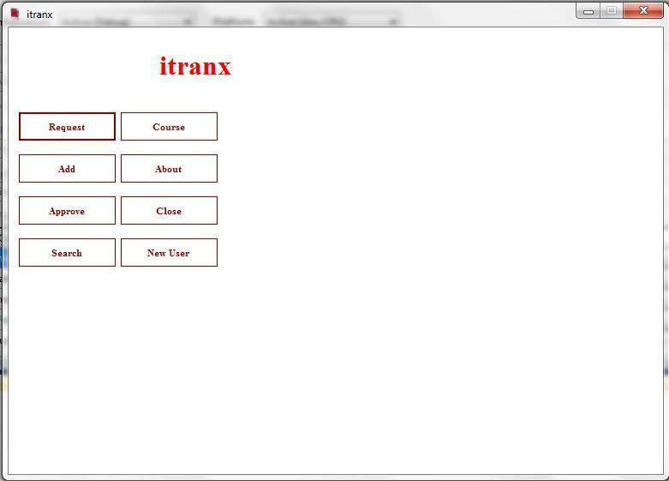

49

APPENDIX B: Students Registration Form
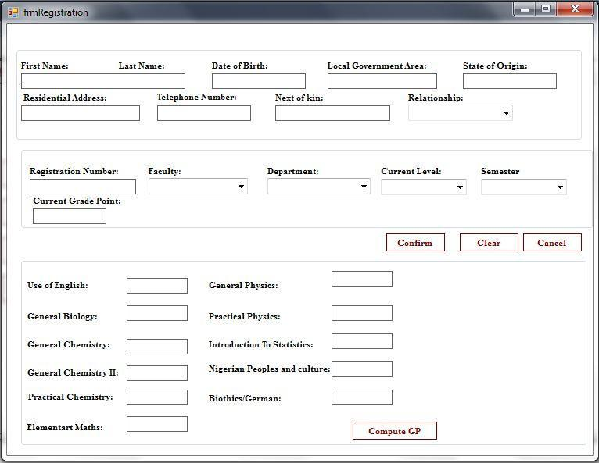

50

APPENDIX C: Search Criteria
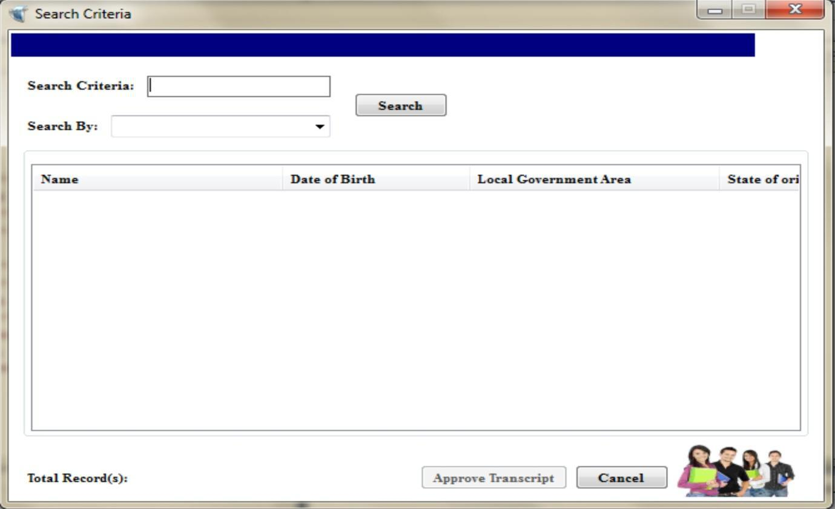

APPENDIX D: Add Faculty and Department
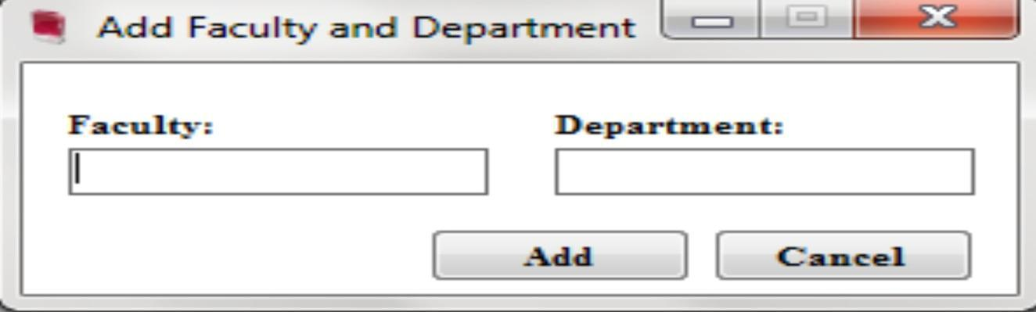

51

