COMPUTERIZED LAND INFORMATION SYSTEM

Abstract
Land is a free gift of nature and a factor of production, land tenure is the name given, particularly in common law systems, to the legal regime in which land is owned by an individual, due to the fact that Keeping record of lands and their owners has been a great task to government and the governed, access to land information proves difficult that most times people are defrauded due to lack of land information, illegal sales of lands without the consent of the owner are very common etc. This work ‘Computerized Land information system’ is designed to help keep record of land which includes: the size of the land, Location of the land, the type of houses to be built on such lands, the owners of purchased Lands and so on. Therefore this, software is developed to keep record of land information system. As such making it easy to keep detail information on land size, location, ownership and type of house to be built on the land and also easy accessibility of stored records, hence the record in this software will be stored in a database. I recommend that the ministry of Land and Housing Enugu sees and embraces this work for convenient and efficient way to keep information of land. This application has been developed to run on visual basic 6.0 environment.

CHAPTER ONE
1.0 INTRODUCTION
1.1 BACKGROUND OF THE STUDY
Land use, land valuation, is among the oldest questions in economic theory, (Shavell, 2004). Land is an essential input (factor of production) for agriculture, and agriculture is by far the most important economic activity in preindustrial societies. With the advent of industrialization, important new uses for land emerge, as sites for factories, warehouses, offices, and urban agglomerations. Also, the value of real property taking the form of man-made structures and machinery increases relative to the value of land alone. The concept of real property eventually comes to encompass effectively all forms of tangible fixed capital. With the rise of extractive industries, real property comes to encompass natural capital. With the rise of tourism and leisure, real property comes to include scenic and other amenity values.
Starting in the 1960s, as part of the emerging field of law and economics, economists and legal scholars began to study the property rights enjoyed by tenants under the various estates, and the economic benefits and costs of the various estates, (Epstein,2007). This resulted in a much improved understanding of the property rights enjoyed by tenants under the various estates. These include the right to:
- Decide how a piece of real property is used;
- Exclude others from enjoying the property;
- Transfer (alienate) some or all of these rights to others on mutually agreeable terms;
- Nature and consequences of transaction costs when changing and transferring estates.
1.1 STATEMENT OF THE PROBLEM
- Keeping record of lands and their owners has been a great task to government and the governed.
- Access to land information proves difficult that most times people are defrauded due to lack of land information.
- Illegal sales of lands without the consent of the owner are very common.
- Certificate of occupancy is usually a problem. Litigation which results to death and destruction
- Valuation of land for the purpose of paying tax to government is not achieved. Hence the need for computerization of land information system.
1.2 OBJECTIVES OF THE STUDY
The objective of this study is to develop a software that will keep information on:
- Land size, Land location, Land owners, Land use information.
- To facilitate the preparation of certificate of occupancy.
- To assist the prospective buyers to ascertain the ownership and availability of the property.
- To enhance preparation of lease.
- To forestall land speculation, with its attendant violence, destruction of lives and property.
- To promote land information security.

1.3 PURPOSE OF THE STUDY
The purpose of this work is to make land information accessible to both government and individuals who may like to acquire land property.

1.4 SIGNIFICANCE OF THE STUDY
The project work will help in a good number of ways to make land information available to users. The software developed can:
- Keep a database of all the lands in the state
- Enable retrieval of land information
- Guide buyers on how to buy and who to meet
- Educate buyers on the type of house to build in an area for proper town planning.

1.5 SCOPE OF THE STUDY
This research work is limited to land information storage and retrieval using ministry of land and housing Enugu as a case study. The software developed will be carried out using Visual Basic to manage the database.

1.6 CONSTRAINTS AND LIMITATIONS
Due to technical difficulties, limited access to confidential data, the information gathered was limited to house acquisition, usage and property ownership laws. All aspects left out were due to time and also confidentiality of some property documents.

1.7 DEFINATION OF TERMS
Databases: A systematically arranged collection of computer data, structured so that it can be automatically retrieved or manipulated. It is also called databank.
Fee tail. Under common law, this is hereditary, non-transferable ownership of real property.
Feudal land ownership, a system of mutual obligations under which a royal or noble personage granted a fiefdom
Life Estate. Under common law, this is an interest in real property that ends at death.
Leasehold or rental. Under both common law and civil law, land may be leased or rented by its owner to another party; a wide range of arrangements are possible, ranging from very short terms to the 99-year leases, allowing various degrees of freedom in the use of the property.
Property is any physical or intangible entity that is owned by a person or jointly by a group of persons.
CHAPTER TWO
2.0 LITERATURE REVIEW
2.1 LAND PROPERTY
Property is any physical or intangible entity that is owned by a person or jointly by a group of persons (Bethell, 1998). Depending on the nature of the property, an owner of property has the right to consume, sell, rent, mortgage, transfer, exchange or destroy their property, and/or to exclude others from doing these things. Important widely recognized types of property include real property (land), personal property (physical possessions belonging to a person), private property (property owned by legal persons or business entities), public property (state owned or publicly owned and available possessions) and intellectual property (exclusive rights over artistic creations, inventions, etc.), although the latter is not always as widely recognized or enforced. A title, or a right of ownership, establishes the relation between the property and other persons, assuring the owner the right to dispose of the property as they see fit. Some philosophers assert that property rights arise from social convention. Others find origins for them in morality or natural law.
Various scholarly disciplines (such as law, economics, anthropology or sociology) may treat the concept more systematically, but definitions vary within and between fields. Scholars in the social sciences frequently conceive of property as a bundle of rights. They stress that property is not a relationship between people and things, but a relationship between people with regard to things.
Property is usually thought of as being defined and protected by the local sovereignty. Ownership, however, does not necessarily equate with sovereignty. If ownership gave supreme authority, it would be sovereignty, not ownership. These are two different concepts.
Public property is any property that is controlled by a state or by a whole community (Ankerl, (1978). Private property is any property that is not public property. Private property may be under the control of a single person or by a group of persons jointly.
Modern property rights are based on conceptions of ownership and possession as belonging to legal persons, even if the legal person is not a natural person. In most countries, corporations, for example, have legal rights similar to those of citizens. Therefore, the corporation is a juristic person or artificial legal entity, under a concept that some refer to as "corporate personhood".
Property rights are protected in the current laws of most states, usually in their constitution or in a bill of rights. Protection is also prescribed in the United Nations' Universal Declaration of Human Rights, Article 17, and in the European Convention on Human Rights (ECHR), Protocol 1.
Traditional principles of property rights include:
- Control of the use of the property
- The right to any benefit from the property (examples: mining rights and rent)
- A right to transfer or sell the property
- A right to exclude others from the property.
Traditional property rights do not include:
- Uses that unreasonably interfere with the property rights of another private party (the right of quiet enjoyment)
- Uses that unreasonably interfere with public property rights, including uses that interfere with public health, safety, peace or convenience.
Not every person or entity with an interest in a given piece of property may be able to exercise all possible property rights. For example, as a lessee of a particular piece of property, you may not sell the property, because a tenant is only in possession and does not have title to transfer. Similarly, while you are a lessee, the owner cannot use their right to exclude or to keep you from the property, or, if they do, you may be entitled to stop paying rent or sue for access.
Further, property may be held in a number of forms, such as through joint ownership, community property, sole ownership or lease. These different types of ownership may complicate an owner's ability to exercise property rights unilaterally. For example, if two people own a single piece of land as joint tenants then, depending on the law in the jurisdiction, each may have limited recourse for the actions of the other. For example, one of the owners might sell their interest in the property to a stranger whom the other owner does not particularly like.
Legal systems have evolved to cover transactions and disputes that arise over the possession, use, transfer, and disposal of property, most particularly involving contracts. Positive law defines such rights, and the judiciary is used to adjudicate and to enforce property rights.
According to Adam Smith, the expectation of profit from "improving one's stock of capital" rests on private property rights. It is an assumption central to capitalism that property rights encourage their holders to develop the property, generate wealth, and efficiently allocate resources based on the operation of markets. From this has evolved the modern conception of property as a right enforced by positive law, in the expectation that this will produce more wealth and better standards of living.
In his text The Common Law, Oliver Wendell Holmes describes property as having two fundamental aspects. The first is possession, which can be defined as control over a resource based on the practical inability of another to contradict the ends of the possessor. The second is title, which is the expectation that others will recognize rights to control resource, even when it is not in possession. He elaborates the differences between these two concepts, and proposes a history of how they came to be attached to persons, as opposed to families or entities such as the church.
CLASSICAL LIBERALS, OBJECTIVISTS, AND RELETED TRADITIONS
Most thinkers from these traditions subscribe to the labour theory of property. They hold that you own your own life, and it follows that you must own the products of that life, and that those products can be traded in free exchange with others.
"Every man has a property in his own person. This nobody has a right to, but himself." (John Locke, Second Treatise on Civil Government)
"The reason why men enter into society is the preservation of their property." (John Locke, Second Treatise on Civil Government)
"Life, liberty, and property do not exist because men have made laws. On the contrary, it was the fact that life, liberty, and property existed beforehand that caused men to make laws in the first place." (Frédéric Bastiat, The Law)
Socialism's fundamental principles are centered on a critique of this concept, stating, among other things, that the cost of defending property is higher than the returns from private property ownership, and that, even when property rights encourage their holders to develop their property or generate wealth, they do so only for their own benefit, which may not coincide with benefit to other people or to society at large.
Libertarian socialism generally accepts property rights, but with a short abandonment period. In other words, a person must make (more or less) continuous use of the item or else lose ownership rights. This is usually referred to as "possession property" or "usufruct". Thus, in this usufruct system, absentee ownership is illegitimate and workers own the machines or other equipment that they work with.
Communism argues that only collective ownership of the means of production through a polity (though not necessarily a state) will assure the minimization of unequal or unjust outcomes and the maximization of benefits, and that therefore private property (which in communist theory is limited to capital) should be abolished.
Both communism and some kinds of socialism have also upheld the notion that private property is inherently illegitimate. This argument centres mainly on the idea that creation of private property always benefits one class over another, giving rise to domination through the use of this private property. Communists are not opposed to personal property that is "hard-won, self-acquired, self-earned" (Communist Manifesto) by members of the proletariat.
There exist many theories. One is the relatively rare first possession theory of property, where ownership of something is seen as justified simply by someone seizing something before someone else does. Perhaps one of the most popular is the natural rights definition of property rights as advanced by John Locke. Locke advanced the theory that when one mixes one’s labour with nature, one gains a relationship with that part of nature with which the labour is mixed, subject to the limitation that there should be "enough, and as good, left in common for others."
From the RERUM NOVARUM, (Pope Leo XIII) wrote "It is surely undeniable that, when a man engages in remunerative labour, the impelling reason and motive of his work is to obtain property, and thereafter to hold it as his very own."
Anthropology studies the diverse systems of ownership, rights of use and transfer, and possession under the term "theories of property." Western legal theory is based, as mentioned, on the owner of property being a legal person. However, not all property systems are founded on this basis.
In every culture studied, ownership and possession is the subject of custom and regulation, and "law" where the term can meaningfully be applied. Many tribal cultures balance individual ownership with the laws of collective groups: tribes, families, associations and nations. For example the 1839 Cherokee Constitution frames the issue in these terms as expressed in the following:
Section. 2. The lands of the Cherokee Nation shall remain common property; but the improvements made thereon, and in the possession of the citizens respectively who made, or may rightfully be in possession of them: Provided, that the citizens of the Nation possessing exclusive and indefeasible right to their improvements, as expressed in this article, shall possess no right or power to dispose of their improvements, in any manner whatever, to the United States, individual States, or to individual citizens thereof; and that, whenever any citizen shall remove with his effects out of the limits of this Nation, and become a citizen of any other government, all his rights and privileges as a citizen of this Nation shall cease: Provided, nevertheless, That the National Council shall have power to re-admit, by law, to all the rights of citizenship, any such person or persons who may, at any time, desire to return to the Nation, on memorializing the National Council for such readmission.
Communal property systems describe ownership as belonging to the entire social and political unit (Bird, 1994). Such arrangements can under certain conditions erode to open access resources. This development has been critiqued by the tragedy of the commons.
Corporate systems describe ownership as being attached to an identifiable group with an identifiable responsible individual. The Roman property law was based on such a corporate system.
Different societies may have different theories of property for differing types of ownership. Pauline Peters argued that property systems are not isolable from the social fabric, and notions of property may not be stated as such, but instead may be framed in negative terms: for example the taboo system among Polynesian peoples.
In medieval and Renaissance Europe the term "property" essentially referred to land. Much rethinking has come to be regarded as only a special case of the property genus. This rethinking was inspired by at least three broad features of early modern Europe: the surge of commerce, the breakdown of efforts to prohibit interest (then called "usury"), and the development of centralized national monarchies ( Blackstone, 1765-69).
In Ancient philosophy, Urukagina, the king of the Sumerian city-state Lagash, established the first laws that forbade compelling the sale of property.
This text, written in approximately 1300 B.C. by modern dating, or 2000 B.C. by traditional dating (assuming Mosaic authorship), were a blanket early protection of private property.
Aristotle, in Politics, advocates "private property" He argues that self-interest leads to neglect of the commons. "That which is common to the greatest number has the least care bestowed upon it. Every one thinks chiefly of his own, hardly at all of the common interest; and only when he is himself concerned as an individual."
In addition he says that when property is common, there are natural problems that arise due to differences in labour: "If they do not share equally enjoyments and toils, those who labour much and get little will necessarily complain of those who labour little and receive or consume much. But indeed there is always a difficulty in men living together and having all human relations in common, but especially in their having common property." (Politics, 1261b34)
The principal writings of Thomas Hobbes appeared between 1640 and 1651—during and immediately following the war between forces loyal to King Charles I and those loyal to Parliament. In his own words, Hobbes' reflection began with the idea of "giving to every man his own," a phrase he drew from the writings of Cicero. But he wondered: How can anybody call anything his own? He concluded: My own can only truly be mine if there is one unambiguously strongest power in the realm, and that power treats it as mine, protecting its status as such.
A contemporary of Hobbes, James Harrington, reacted differently to the same tumult; he considered property natural but not inevitable. The author of 'Oceana', he may have been the first political theorist to postulate that political power is a consequence, not the cause, of the distribution of property. He said that the worst possible situation is one in which the commoners have half a nation's property, with crown and nobility holding the other half—a circumstance fraught with instability and violence. A much better situation (a stable republic) will exist once the commoners own most property, he suggested.
In later years, the ranks of Harrington's admirers included American revolutionary and founder John Adams.
Another member of the Hobbes/Harrington generation, Sir Robert Filmer, reached conclusions much like Hobbes', but through Biblical exegesis. Filmer said that the institution of kingship is analogous to that of fatherhood, that subjects are but children, whether obedient or unruly, and that property rights are akin to the household goods that a father may dole out among his children—his to take back and dispose of according to his pleasure.
In the following generation, John Locke sought to answer Filmer, creating a rationale for a balanced constitution in which the monarch had a part to play, but not an overwhelming part. Since Filmer's views essentially require that the Stuart family be uniquely descended from the patriarchs of the Bible, and since even in the late seventeenth century that was a difficult view to uphold, Locke attacked Filmer's views in his First Treatise on Government, freeing him to set out his own views in the Second Treatise on Civil Government. Therein, Locke imagined a pre-social world, the unhappy residents of which create a social contract. They would, he allowed, create a monarchy, but its task would be to execute the will of an elected legislature.
"To this end" he wrote, meaning the end of their own long life and peace, "it is that men give up all their natural power to the society they enter into, and the community put the legislative power into such hands as they think fit, with this trust, that they shall be governed by declared laws, or else their peace, quiet, and property will still be at the same uncertainty as it was in the state of nature."
Even when it keeps to proper legislative form, though, Locke held that there are limits to what a government established by such a contract might rightly do.
"It cannot be supposed that [the hypothetical contractors] they should intend, had they a power so to do, to give any one or more an absolute arbitrary power over their persons and estates, and put a force into the magistrate's hand to execute his unlimited will arbitrarily upon them; this were to put themselves into a worse condition than the state of nature, wherein they had a liberty to defend their right against the injuries of others, and were upon equal terms of force to maintain it, whether invaded by a single man or many in combination. Whereas by supposing they have given up themselves to the absolute arbitrary power and will of a legislator, they have disarmed themselves, and armed him to make a prey of them when he pleases..."
Note that both "persons and estates" are to be protected from the arbitrary power of any magistrate, inclusive of the "power and will of a legislator." In Lockean terms, depredations against an estate are just as plausible a justification for resistance and revolution as are those against persons. In neither case are subjects required to allow themselves to become prey.
To explain the ownership of property Locke advanced a labor theory of property.
In the 1760s, William Blackstone sought to codify the English common law. In his famous Commentaries on the Laws of England he wrote that "every wanton and causeless restraint of the will of the subject, whether produced by a monarch, nobility, or a popular assembly is a degree of tyranny."
How should such tyranny be prevented or resisted? Through property rights, Blackstone thought, which is why he emphasized that indemnification, must be awarded a non-consenting owner whose property is taken by eminent domain, and that a property owner is protected against physical invasion of his property by the laws of trespass and nuisance. Indeed, he wrote that a landowner is free to kill any stranger on his property between dusk and dawn, even an agent of the King, since it isn't reasonable to expect him to recognize the King's agents in the dark.
In contrast to the figures discussed in this section thus far, David Hume lived a relatively quiet life that had settled down to a relatively stable social and political structure. He lived the life of a solitary writer until 1763 when, at 52 years of age, he went off to Paris to work at the British embassy.
In contrast, one might think, to his outrage-generating works on religion and his skeptical views in epistemology, Hume's views on law and property were quite conservative.
He did not believe in hypothetical contracts or in the love of mankind in general, and sought to ground politics upon actual human beings as one knows them. "In general," he wrote, "it may be affirmed that there is no such passion in human mind, as the love of mankind, merely as such, independent of personal qualities, or services, or of relation to us." Existing customs should not lightly be disregarded, because they have come to be what they are as a result of human nature. With this endorsement of custom comes an endorsement of existing governments, because he conceived of the two as complementary: "A regard for liberty, though a laudable passion, ought commonly to be subordinate to a reverence for established government."
These views led to a view on property rights that might today be described as legal positivism. There are property rights because of and to the extent that the existing law, supported by social customs, secure them. He offered some practical home-spun advice on the general subject, though, as when he referred to avarice as "the spur of industry," and expressed concern about excessive levels of taxation, which "destroy industry, by engendering despair."
By the mid 19th century, the industrial revolution had transformed England and had begun in France. The established conception of what constitutes property expanded beyond land to encompass scarce goods in general. In France, the revolution of the 1790s had led to large-scale confiscation of land formerly owned by church and king. The restoration of the monarchy led to claims by those dispossessed to have their former lands returned. Furthermore, the labour theory of value popularized by classical economists such as Adam Smith and David Ricardo were utilized by a new ideology called socialism to critique the relations of property to other economic issues, such as profit, rent, interest, and wage-labour. Thus, property was no longer an esoteric philosophical question, but a political issue of substantial concern.
Charles Comte, in (Traité de la propriété, 1834), attempted to justify the legitimacy of private property in response to the Bourbon Restoration. According to David Hart, Comte had three main points: "firstly, that interference by the state over the centuries in property ownership has had dire consequences for justice as well as for economic productivity; secondly, that property is legitimate when it emerges in such a way as not to harm anyone; and thirdly, that historically some, but by no means all, property which has evolved has done so legitimately, with the implication that the present distribution of property is a complex mixture of legitimately and illegitimately held titles." (The Radical Liberalism of Charles Comte and Charles Dunoyer) Comte, as Proudhon later did, rejected Roman legal tradition with its toleration of slavery. He posited a communal "national" property consisting of non-scarce goods, such as land in ancient hunter-gatherer societies. Since agriculture was so much more efficient than hunting and gathering, private property appropriated by someone for farming left remaining hunter-gatherers with more land per person, and hence did not harm them. Thus this type of land appropriation did not violate the Lockean proviso - there was "still enough, and as good left." Comte's analysis would be used by later theorists in response to the socialist critique on property.
In his 1849 treatise what is Property?, Pierre Proudhon answers with "Property is theft!" In natural resources, he sees two types of property, de jure property (legal title) and de facto property (physical possession), and argues that the former is illegitimate. Proudhon's conclusion is that "property, to be just and possible, must necessarily have equality for its condition."
His analysis of the product of labour upon natural resources as property (usufruct) is more nuanced. He asserts that land itself cannot be property, yet it should be held by individual possessors as stewards of mankind with the product of labour being the property of the producer. Proudhon reasoned that any wealth gained without labour was stolen from those who laboured to create that wealth. Even a voluntary contract to surrender the product of labour to an employer was theft, according to Proudhon, since the controller of natural resources had no moral right to charge others for the use of that which he did not labour to create and therefore did not own.
Proudhon's theory of property greatly influenced the budding socialist movement, inspiring anarchist theorists such as Mikhail Bakunin who modified Proudhon's ideas, as well as antagonizing theorists like Karl Marx.
Frédéric Bastiat's main treatise on property can be found in chapter 8 of his book (Economic Harmonies 1850). In a radical departure from traditional property theory, he defines property not as a physical object, but rather as a relationship between people with respect to an object. Thus, saying one owns a glass of water is merely verbal shorthand for I may justly gift or trade this water to another person. In essence, what one owns is not the object but the value of the object. By "value," Bastiat apparently means market value; he emphasizes that this is quite different from utility. "In our relations with one another, we are not owners of the utility of things, but of their value, and value is the appraisal made of reciprocal services."
Strongly disputing Proudhon's equality-based argument, Bastiat theorizes that, as a result of technological progress and the division of labour, the stock of communal wealth increases over time; that the hours of work an unskilled labourer expends to buy e.g. 100 litres of wheat decreases over time, thus amounting to "gratis" satisfaction. Thus, private property continually destroys itself, becoming transformed into communal wealth. The increasing proportion of communal wealth to private property results in a tendency toward equality of mankind. "Since the human race started from the point of greatest poverty, that is, from the point where there were the most obstacles to be overcome, it is clear that all that has been gained from one era to the next has been due to the spirit of property."
This transformation of private property into the communal domain, Bastiat points out, does not imply that private property will ever totally disappear. This is because man, as he progresses, continually invents new and more sophisticated needs and desires.
Among contemporary political thinkers who believe that natural persons enjoy rights to own property and to enter into contracts, there are two views about John Locke. On the one hand there are ardent Locke admirers, such as W.H. Hutt, 1956, who praised Locke for laying down the "quintessence of individualism." On the other hand, there are those such as Richard Pipes who think that Locke's arguments are weak, and that undue reliance thereon has weakened the cause of individualism in recent times. Pipes has written that Locke's work "marked a regression because it rested on the concept of Natural Law" rather than upon Harrington's sociological framework.
Hernando de Soto has argued that an important characteristic of capitalist market economy is the functioning state protection of property rights in a formal property system where ownership and transactions are clearly recorded (Hernando De Soto and Francis Cheneval, 2006). These property rights and the whole formal system of property make possible:
- Greater independence for individuals from local community arrangements to protect their assets;
- Clear, provable, and protectable ownership;
- The standardization and integration of property rules and property information in the country as a whole;
- Increased trust arising from a greater certainty of punishment for cheating in economic transactions;
- More formal and complex written statements of ownership that permit the easier assumption of shared risk and ownership in companies, and insurance against risk;
- Greater availability of loans for new projects, since more things could be used as collateral for the loans;
- Easier access to and more reliable information regarding such things as credit history and the worth of assets;
- Increased fungibility, standardization and transferability of statements documenting the ownership of property, which paves the way for structures such as national markets for companies and the easy transportation of property through complex networks of individuals and other entities;
- Greater protection of biodiversity due to minimizing of shifting agriculture practices.
The International Federation of Surveyors (FIG, 1995) defines a cadastre as a parcel based and up-to-date land information system containing a record of interests in land (e.g. rights, restrictions and responsibilities). It usually includes a geometric description of land parcels linked to other records describing the nature of the interests, ownership or control of those interests, and often the value of the parcel and its improvements. It may be established for fiscal purposes (valuation and taxation), legal purposes (conveyancy), to assist in the management of land and land-use planning (planning and administration), and enables sustainable development and environmental improvement. The cadastral infrastructure includes a unique identification of the land parcels deriving from the cadastral surveys. The cadastral identification is then seen as the core component of any land information system. It is argued that within the next ten years such land information systems will form an integral part of a model of our man made and natural environment (Hvidegaard, J. 1998). The model will build on the core cadastral and topographic data sets which will be complete on a country wide basis and kept up-to date.
The focus will be on providing land information to the mass market to support the land market, financial and business sectors, environmental management, land
administration, urban systems and community information systems
A vision for the future role of the cadastre in a global land management perspective should reflect this scenario of IT development (Enemark, S. 1997). This means that the cadastral systems must provide adequate information on the land parcels to be presented in a variety of interfaces. The design and maintenance of cadastral systems must reflect this multipurpose use.
A cadastral vision of the future, as presented in the UN Bogor Declaration 1996, is to: “develop modern cadastral infrastructures that facilitate efficient land and property markets, protect the land rights of all, and support long term sustainable development and land management”.

2.2 LAND TENURE
Land tenure is the name given, particularly in common law systems, to the legal regime in which land is owned by an individual, who is said to "hold" the land (the French verb "tenir" means "to hold"; "tenant" is the present participle of "tenir") (Williamson, I.1997). The sovereign monarch, known as The Crown, held land in its own right. All private owners are either its tenants or sub-tenants. The term "tenure" is used to signify the relationship between tenant and lord, not the relationship between tenant and land.
Over history, many different forms of land ownership, i.e., ways of owning land, have been established.
A landholder or landowner is a holder of the estate in land with considerable rights of ownership or, simply put, an owner of land.
Historically in the system of feudalism, the lords who received land directly from the Crown were called tenants in chief. They doled out portions of their land to lesser tenants in exchange for services, who in turn divided it among even lesser tenants. This process i.e. that of granting subordinate tenancies-is known as subinfeudation. In this way, all individuals except the monarch were said to hold the land "of" someone else.
Historically, it was usual for there to be reciprocal duties between lord and tenant. There were different kinds of tenure to fit various kinds of duties that a tenant might owe to a lord. For instance, a military tenure might be by knight-service, requiring the tenant to supply the lord with a number of armed horsemen. The concept of tenure has since evolved into other forms, such as leases and estates.
There are a great variety of modes of land ownership and tenure:
a. Traditional land tenure. For example, most of the indigenous nations or tribes of North America had no formal notion of land ownership. When Europeans first came to North America, they sometimes simply disregarded traditional land tenure and simply seized land; more often, they accommodated traditional land tenure by recognizing it as aboriginal title. This theory formed the basis for (often unequal and often abused) treaties with indigenous peoples.
b. Ownership of land by swearing to make productive use of it. In several developing countries as Egypt, Senegal, this method is still presently in use. In Senegal, it is mentioned as "mise en valeur du zones du terroir"and in Egypt, it is called Wadaa al-yad.
- Allodial title, a system in which real property is owned absolutely free and clear of any superior landlord or sovereign. True allodial title is rare, with most property ownership in the common law world (Australia, Canada, Ireland, New Zealand, United Kingdom, United States) being in fee simple. Allodial title is alienable, in that it may be conveyed, devised, gifted, or mortgaged by the owner, and may also be distressed and restrained for collection of taxes or private debts or condemned (eminent domain) by the government.
- Feudal land ownership, a system of mutual obligations under which a royal or noble personage granted a fiefdom — some degree of interest in the use or revenues of a given parcel of land — in exchange for a claim on services such as military service or simply maintenance of the land in which the lord continued to have an interest. This pattern obtained from the level of high nobility as vassals of a monarch down to lesser nobility whose only vassals were their serfs.
- Fee simple. Under common law, this is the most complete ownership interest one can have in real property, other than the rare Allodial title. The holder can typically freely sell or otherwise transfer that interest or use it to secure a mortgage loan. This picture of "complete ownership" is, of course, complicated by the obligation in most places to pay a property tax and by the fact that if the land is mortgaged, there will be a claim on it in the form of a lien. In modern societies, this is the most common form of land ownership.
- Native title. In Australia, native title is a common law concept that recognizes that some indigenous people have certain land rights that derive from their traditional laws and customs. Native title can co-exist with non-indigenous proprietary rights and in some cases different indigenous groups can exercise their native title over the same land.
- Life estate. Under common law, this is an interest in real property that ends at death. The holder has the use of the land for life, but typically no ability to transfer that interest or to use it to secure a mortgage loan.
- Fee tail. Under common law, this is hereditary, non-transferable ownership of real property. A similar concept, the legitime, exists in civil and Roman law; the legitime limits the extent to which one may disinherit an heir.
- Leasehold or rental. Under both common law and civil law, land may be leased or rented by its owner to another party; a wide range of arrangements are possible, ranging from very short terms to the 99-year leases common in the United Kingdom, and allowing various degrees of freedom in the use of the property.
- Rights to use a commons, which may include such rights as the use of a road or the right to graze one's animals on commonly owned land.
- Sharecropping, under which one has use of agricultural land owned by another person in exchange for a share of the resulting crop or livestock.
- Easements, which allow one to make certain specific uses of land that is owned by someone else. The most classic easement is right-of-way, but it could also include (for example) the right to run an electrical power line across someone else's land. In addition, there are various forms of collective ownership, which typically take either the form of membership in a cooperative, or shares in a corporation, which owns the land (typically by fee simple, but possibly under other arrangements). There are also various hybrids: in many communist states, government ownership of most agricultural land has combined in various ways with tenure for farming collectives.
CHAPTER THREE
DESCRIPTION AND ANALYSIS OF THE EXISTING SYSTEM
  - GENERAL ANALYSIS OF THE EXISTING SYSTEM
In Ministry of land and housing Enugu state, land information is documented manually. Files are created for different plots of land. These files are kept in a file cabinet. In the file, all the details of the property owner, land size and location is documented. Any form of transfer or sales is equally recorded on the file manually.

  - FACTS FINDING METHOD
During the research work, data needed for the project was gathered from various sources. In gathering and collecting necessary data and information needed for system analysis, one major fact-finding technique was used in this work and it is:
- Secondary Source
The secondary data was obtained by the researcher from the ministry of lands and housing Enugu, Library source, journals and Internet downloads.

3.3 OBJECTIVES OF THE EXISTING SYSTEM
The objective of this existing system is to keep information on:
- Land size
- Land location
- Land owners
- Land use information
3.4 ORGANIZATIONAL STRUCTURE

Land Allocation
Director Lands
Director Housing
Secretary
Valuation Unit
Urban Development
Estate Agents
Commissioner for Land

Fig.3.4.1 Organizational structure
3.5 INPUT, PROCESS AND OUTPUT ANALYSIS
3.5.1 Input Analysis
The input to the new system is the land acquisition form. This form is used to record all the details concerning the land and its ownership. Both the name, address, and other information relating to the owner is documented here.

3.5.2 Process Analysis
The information gathered was processed into a more meaningful format for entry into the system.
3.5.3 Output Analysis
The output from the system designed is generated from the system inputs. More of the output generated is on land information.
3.6 INFORMATION FLOW DIAGRAM
Commissioner for land

Directors

Estate agents
Land Owners

Land users

3.7 PROBLEMS OF THE EXISTING SYSTEM
Due to the manual means being used in keeping land information, a lot of problems are encountered which includes:
- Delay in processing files
- Loss of vital documents as the filing system is manual
- Damage of documents due to fire incident.
- Illegal removal of files by fraudulent staff leading to insecurity.

3.8 JUSTIFICATION FOR THE NEW SYSTEM
The new system is designed to solve problems affecting the manual system in use. It is design to be computerised thereby relieving both the customers and staff from much stress as experienced in the manual system.
This system will do the analysing and storing of information either automatically or interactively.
The proposed system will also have some other feature like:
- Accuracy in the handling of data.
- Fast rate of operation and excellent responses time
- Easy way of back up or duplicating data in diskettes in case of data loss.
- Better storage and faster retrieval system.

CHAPTER FOUR
4.0 SYSTEM DESIGN
  - DESIGN STANDARDS
The new system designed for keeping land information system will among other things:
- Have a workable form through which all the inputs will be made to the system.
- Have a well formatted output on land information
- Enable search on the land database
- Create a modular programming interface for easy debugging.
- Design a system that will be very fast in operation.

  - OUTPUT SPECIFICATION AND DESIGN
Output from the system is in form of documents. Majority of the outputs caries information relating to land allocations. The outputs are presented in a text format and some of the information derived from the database.

4.3 INPUT SPECIFICATION AND DESIGN
The program designed involved some input forms in order to achieve or derived some required outputs. These forms relate to land allocation information.

Fig 4.3.1
Land Allocation Form
App No ------------------------------------------------------------
Name of Applicant ------------------------------------------------
Address ------------------------------------------------------------
Date------------------------------------------------------------
State ------------------------------------------------------------
Nationality ------------------------------------------------------------
Occupation ------------------------------------------------------------
Block No in Layout----------------------------------------------------
Plot No ------------------------------------------------------------
Plot Size ------------------------------------------------------------
LGA Situated ------------------------------------------------------------
Use of Land ------------------------------------------------------------
Amount Paid ------------------------------------------------------------
Receipt No ------------------------------------------------------------
Occupancy No ------------------------------------------------------------

4.4 FILE DESIGN
Access database was used in storing the information used in this project. The database was integrated into the system that the program access and update the files. The structure of the database is as follows.
Land File
Field Name | Type | Size
App No | Text | 20
Name | Text | 50
Address | Text | 100
Date | Date/Time | 8
State | Text | 20
Nationality | Text | 30
Occupation | Text | 30
Block No in Layout | Numeric | 30
Plot No | Numeric | 30
Plot Size | Text | 10
LGA Situated | Text | 20
Use of Land | Text | 40
Amount Paid | Single | 4
Receipt No | Text | 20
Occupancy No | Numeric | 30
4.5 PROCEDURE CHART
Main menu
Land
Allocation n
Update
Delete
Search
Plot
Report
List of Land Allocations
Exit

Fig. 4.5.1 Procedure Chart.

Input data

Input from the
Keyboard

REPORT
CPU
Report

Output
Disk
Storage

4.7 SYSTEM REQUIREMENTS

In order to realize this project, the following software and hardware components were used:

Hardware Requirements

In the cost of the design, the software developed needed the following hardware for an effective and efficient operation of the new system.

Intel Computer System.
- At least 1GB RAM.
- Enhanced keyboard.
- At least 12OGB hard disk.
- V.G.A, a coloured monitor.
- An uninterruptible power supply (UPS) units
- LaserJet or DeskJet printer.
Software Requirements
The software requirements includes:-
- A window 98 or higher version for faster processing
- Microsoft Access
- Visual Studio development environment (version 6.0).

PROGRAM FLOWCHART
Start
Select Option From The menu
Land?
Register Land Allocation information
Update?
Update the information
Search?
Find land allocation information
Yes
Yes
Yes
No
No
No
Report?
Display land allocation register
Yes
No
stop

Fig 4.7.1
CHAPTER FIVE
SUMMARY, RECOMMENDATIONS AND CONCLUSION
5.1 Summary
The doctrine of land ownership has much importance today; its influence still lingers in some areas. The concepts of landlord and tenant have been recycled to refer to the modern relationship of the parties to land which is held under a lease. It has been pointed out by Professor F.H. Lawson in Introduction to the Laws of Property (1958), however, that the landlord-tenant relationship never really fitted into the feudal system and was rather an "alien commercial element".
The doctrine of tenure did not apply to personality (personal property). However, the relationship of bailment in the case of chattels closely resembles the landlord-tenant relationship that can be created in land. So, much emphasis has been laid on the need for a proper documentation of land owners information to enable the public and government access land information at any time.
5.3 RECOMMENDATION
The research project has elaborated much on the use and need for a computerised land information system. Much work is still needed as the ministry of land and housing Enugu has to make provisions for the implementation of the software developed, organize staff training, and establish maintenance services on the software.

CONCLUSION
Real property and personal property are the main classifications of property in the common law. Real property refers to land and the improvements made by human efforts—buildings, machinery, the acquisition of various property rights, and the like. Real property is also termed realty, real estate, and immovable property.
In countries with personal ownership of real property, civil law protects the status in realty markets, where realtors work in realty selling real estate. Scottish civil law calls it heritable property, and in France it is said to be immobiliser.
To be of any value a claim to any property must be accompanied by a verifiable and legal property description. Such a description could make use of natural boundaries such as river and roads, or make use of purpose made markers such as cairns, posts, survey marks, etc.
So the land information system contains details on the land size, location, ownership and land use.

REFERENCES
Ankerl, G. 1978, "Beyond Monopoly Capitalism and Monopoly
Socialism:Distributive Justice in a Competitive Society." Cambridge MA
Baker, S., M., Richardson, D., and Young, S. (1997) The Politics of
Sustainable Development: Theory and Practice within the European
Union. London, Routledge.
Baker, J. 1990 An Introduction to English Legal History (3rd edition)
Bastiat, F. 1850. Economic Harmonies. W. Hayden Boyers, trans. George
B. de Huszar, ed. Liberty Fund
Bethell, T. 1998. The Noblest Triumph: Property and Prosperity through the
Ages. New York: St. Martin's Press.
Bird, R.M. (1994) Financing Local Services: Pattern, Problems and
Possibilities. Paper prepared for Global Report on Human
Settlements, University of Toronto.
Blackstone, W. 1765-69. Commentaries on the Laws of England, 4 vols.
Oxford Univ. Press.
Butterworths. A, A. and Yadama, G.N. July (1997) How do Local
Institutions mediate Market and Population Pressures on Resources?
Development and Change 28(3), pp 435-465Bloomington, Indiana.
Enemark, S. (1994) Evaluation of the Cadastral Reform in Denmark –
Training the Old Lady for the Skateboard. Proceedings of FIG
Commission 7, the FIG XX International Congress, Melbourne,
Australia, pp 703.3/1-11.
Enemark, S. (1997) Concepts of Cadastral Systems – General Overview
and Examples from throughout the World. Department of
Development and Planning, Publication Series no 214, Aalborg
University, Denmark.
Enemark, S. (1999) The EU Compendium of Spatial Planning Systems and
Policies: Denmark.
Hernando S, 1989. The Other Path. Harper & Row.
Hernando D, S. and Cheneval , F.( 2006). Realizing Property Rights.
Ruffer & Rub.
Hvidegaard, J. (1998) What’s the Use of a Digital Cadastral Map.
Proceedings of FIG Commission 7,the FIG XXI International
Congress, Brighton, UK, pp 438-448.
John, P. 2004, "A History of World Societies".
Boston: Houghton Mifflin Company
Nadin, V. (1999) Sustainability from a National Spatial Planning
Perspective. Proceedings of OECD conference on A New Role for
Spatial Planning, Paris, March 1999, pp 130-140.
North, D.C. (1996) Institutions, Institutional Change and Economic
Performance. Cambridge, University Press.
Richard Pipes, 1999. Property and Freedom.
International Federation of Surveyors (1995) Statement on the Cadastre.
FIG publications no 11, Canberra, Australia.
United Nations, Economic Commission for Europe (1996) Land
Administration Guidelines. New York and Geneva, 1996.
Williamson, I. (1997) A Land Information Vision for Victoria. Land
Victoria, Melbourne, Australia.
World Commission on Environment and Development (1987) Our
Common Future (the Brundtland Report). Oxford, Oxford University
Press.
Journals
Ellickson, R. (1993), "Land PDF (6.40 MB)", Yale Law Journal
Edwin, F. (2010), A Biological Basis of Rights, 19 Southern California
Interdisciplinary Law Journal 195
URL (Universal Resource Locator)
Www.wikipeadia.com

APPENDIX A
WELCOME SCREEN

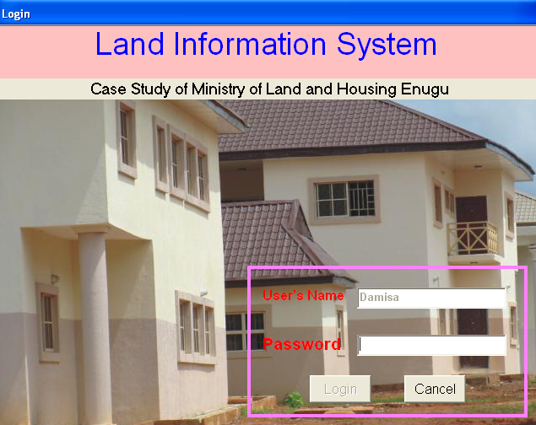
Login Form

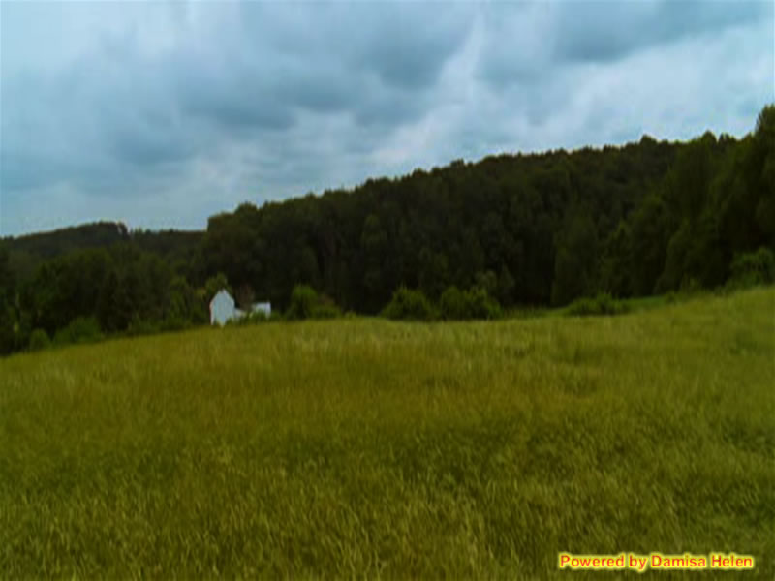
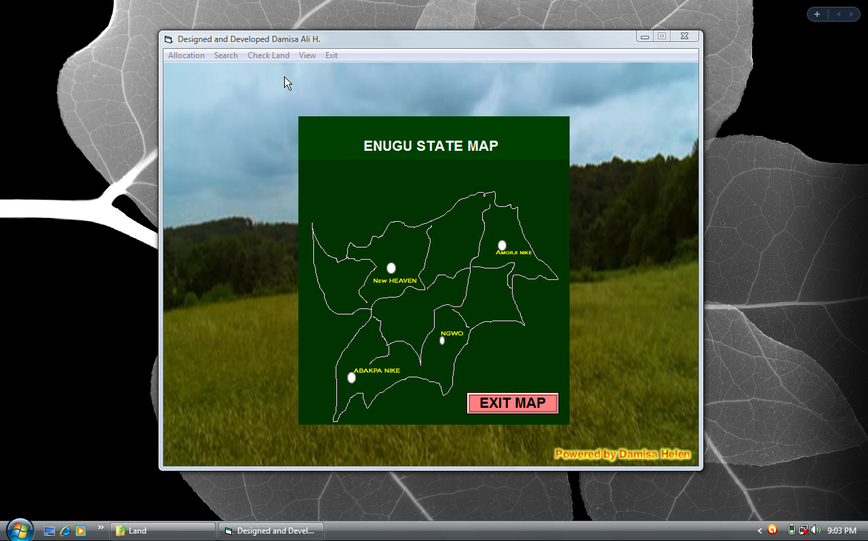

APPENDIX B
SAMPLE INPUT
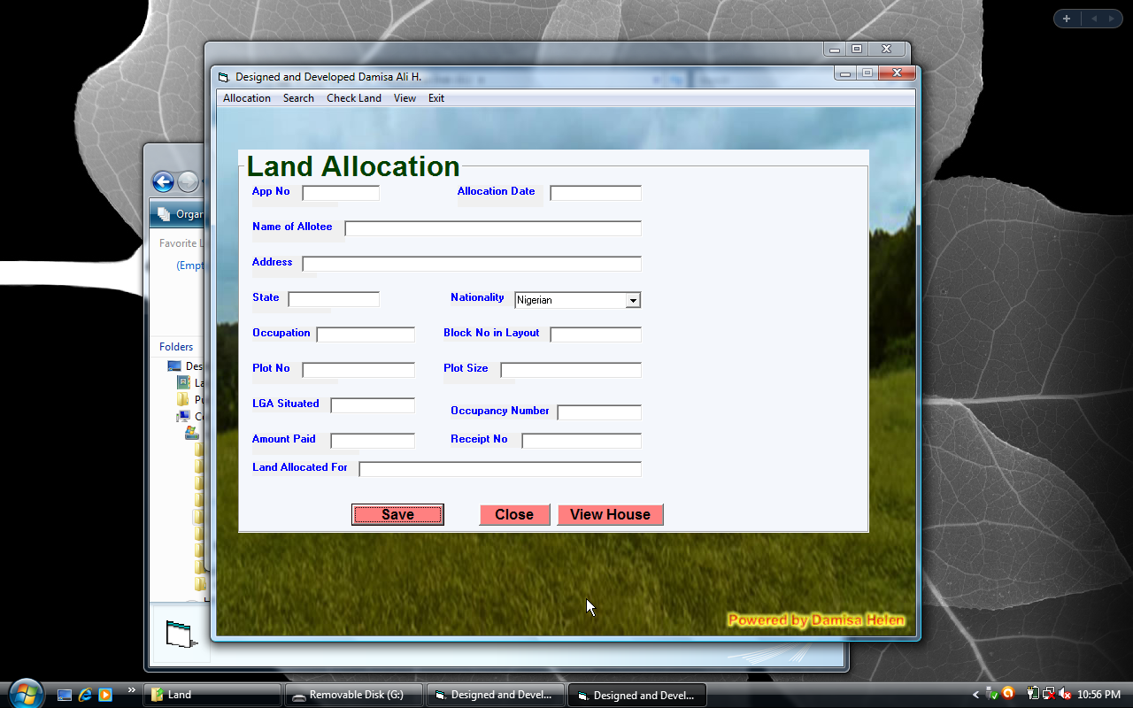
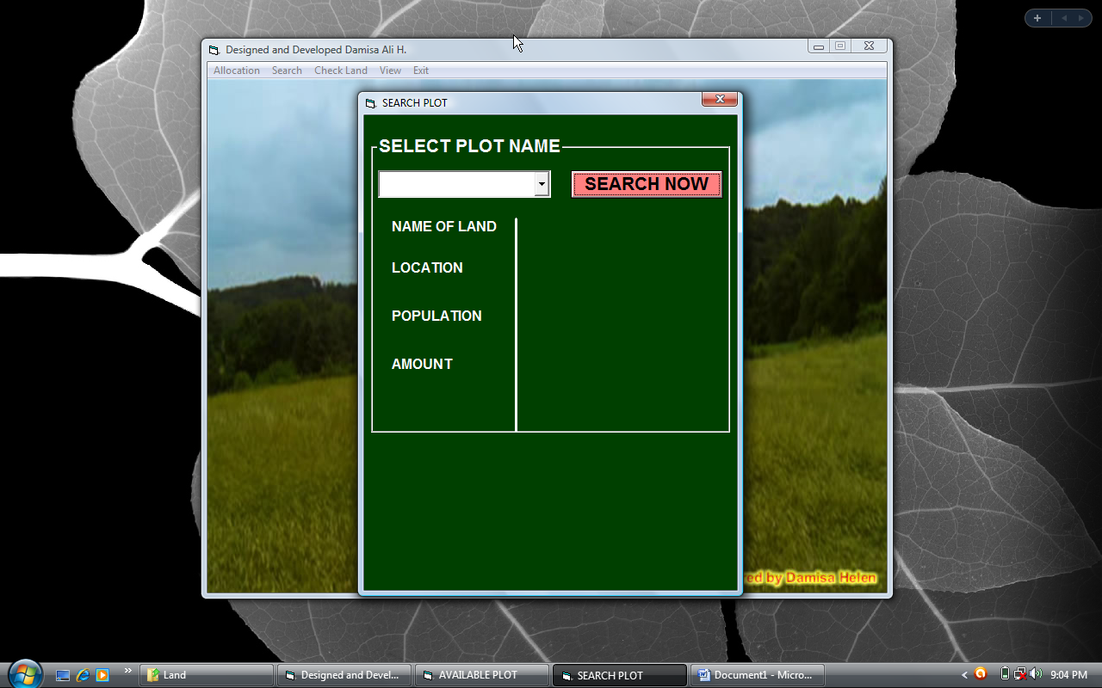

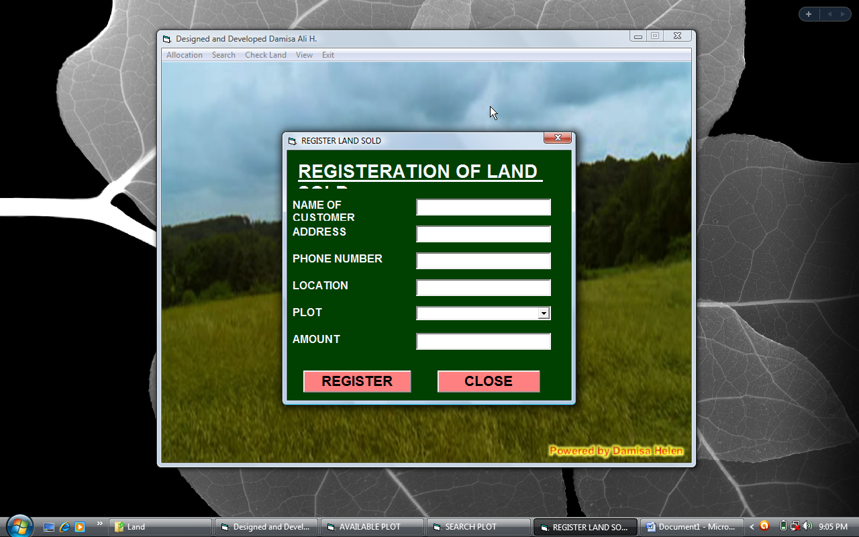

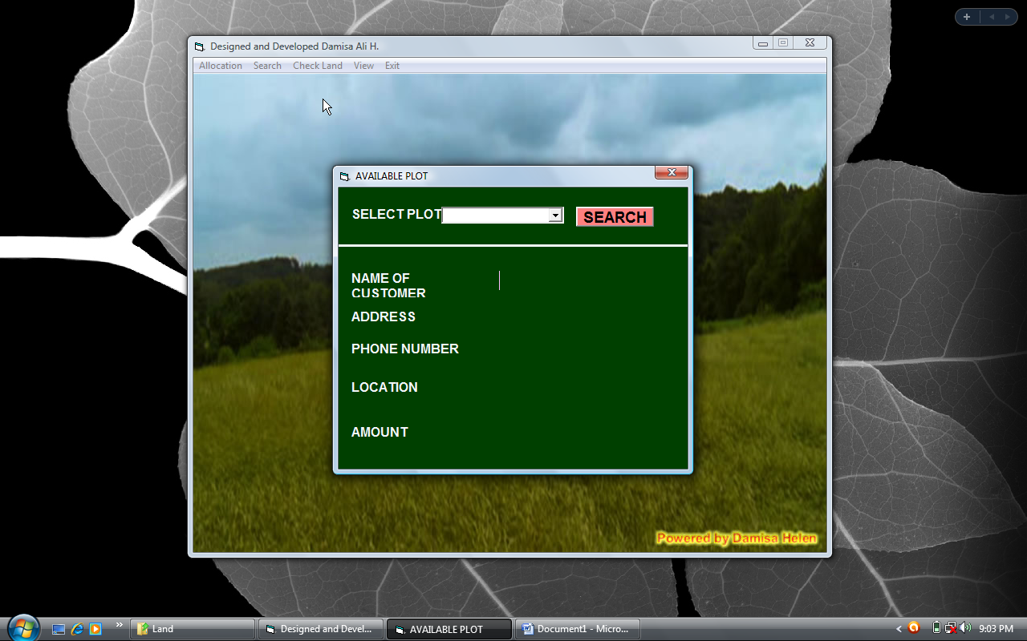

APPENDIX C
SAMPLE OUTPUT

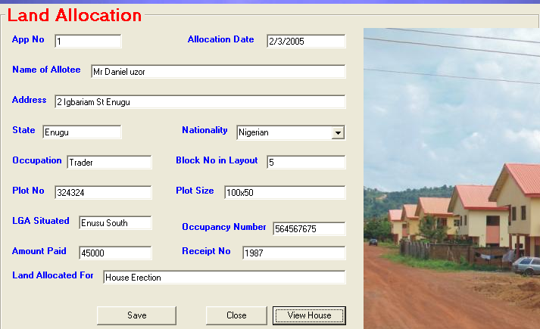
Land Allocation Form
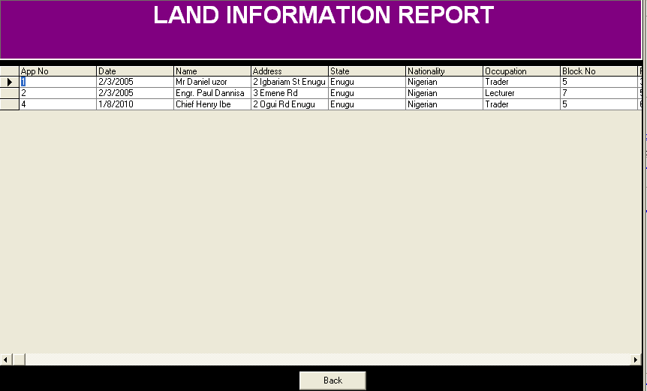

Report Form

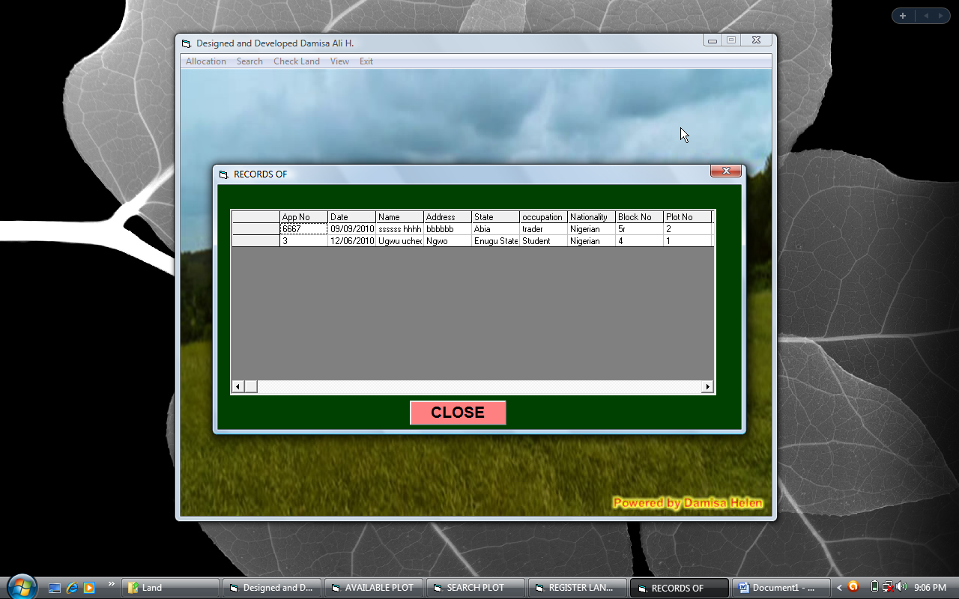

APPENDIX D
SOURCE CODE

Private Sub ach_Click()
view.Show
End Sub

Private Sub cmdclose_Click()
frmmenu.frmland.Visible = False

End Sub

Private Sub cmdclosesearch_Click()
frmmenu.Frame1.Visible = False
End Sub

Private Sub cmdsave_Click()
frmmenu.Data1.Recordset.AddNew
frmmenu.Data1.Recordset.Fields("App No") = frmmenu.Text1.Text
frmmenu.Data1.Recordset.Fields("date") = frmmenu.Text2.Text
frmmenu.Data1.Recordset.Fields("name") = frmmenu.Text3.Text
frmmenu.Data1.Recordset.Fields("address") = frmmenu.Text4.Text
frmmenu.Data1.Recordset.Fields("state") = frmmenu.Text5.Text
frmmenu.Data1.Recordset.Fields("nationality") = frmmenu.Combo1.Text
frmmenu.Data1.Recordset.Fields("occupation") = frmmenu.Text6.Text
frmmenu.Data1.Recordset.Fields("block no") = frmmenu.Text7.Text
frmmenu.Data1.Recordset.Fields("plot no") = frmmenu.Text8.Text
frmmenu.Data1.Recordset.Fields("plot size") = frmmenu.Text9.Text
frmmenu.Data1.Recordset.Fields("lga situated") = frmmenu.Text10.Text
frmmenu.Data1.Recordset.Fields("occupancy no") = frmmenu.Text11.Text
frmmenu.Data1.Recordset.Fields("amount paid") = frmmenu.Text12.Text
frmmenu.Data1.Recordset.Fields("reciept no") = frmmenu.Text13.Text
frmmenu.Data1.Recordset.Fields("uses of land") = frmmenu.Text14.Text
frmmenu.Data1.Recordset.Update
frmmenu.Text1.Text = ""
frmmenu.Text2.Text = ""
frmmenu.Text3.Text = ""
frmmenu.Text4.Text = ""
frmmenu.Text5.Text = ""
frmmenu.Text6.Text = ""
frmmenu.Text7.Text = ""
frmmenu.Text8.Text = ""
frmmenu.Text9.Text = ""
frmmenu.Text10.Text = ""
frmmenu.Text11.Text = ""
frmmenu.Text12.Text = ""
frmmenu.Text13.Text = ""
frmmenu.Text14.Text = ""

End Sub

Private Sub cmdsearch_Click()
frmmenu.Data1.Recordset.MoveFirst
Do Until frmmenu.Data1.Recordset.EOF
If frmmenu.Data1.Recordset.Fields("Plot No") = frmmenu.Combo2.Text Then
frmmenu.Text1.Text = frmmenu.Data1.Recordset.Fields("App No")
frmmenu.Text2.Text = frmmenu.Data1.Recordset.Fields("date")
frmmenu.Text3.Text = frmmenu.Data1.Recordset.Fields("name")
frmmenu.Text4.Text = frmmenu.Data1.Recordset.Fields("address")
frmmenu.Text5.Text = frmmenu.Data1.Recordset.Fields("state")
frmmenu.Combo1.Text = frmmenu.Data1.Recordset.Fields("nationality")
frmmenu.Text6.Text = frmmenu.Data1.Recordset.Fields("occupation")
frmmenu.Text7.Text = frmmenu.Data1.Recordset.Fields("block no")
frmmenu.Text8.Text = frmmenu.Data1.Recordset.Fields("plot no")
frmmenu.Text9.Text = frmmenu.Data1.Recordset.Fields("plot size")
frmmenu.Text10.Text = frmmenu.Data1.Recordset.Fields("lga situated")
frmmenu.Text11.Text = frmmenu.Data1.Recordset.Fields("occupancy no")
frmmenu.Text12.Text = frmmenu.Data1.Recordset.Fields("amount paid")
frmmenu.Text13.Text = frmmenu.Data1.Recordset.Fields("reciept no")
frmmenu.Text14.Text = frmmenu.Data1.Recordset.Fields("uses of land")
frmmenu.Frame1.Visible = False
frmmenu.frmland.Visible = True
Exit Do
Else
frmmenu.Data1.Recordset.MoveNext
End If
Loop
End Sub

Private Sub Command1_Click()
On Error Resume Next

Image1.Picture = LoadPicture("c:\land\" + Text1.Text + ".jpg")

End Sub

Private Sub exit_Click()
End
End Sub

Private Sub Form_Load()
frmmenu.Hide
frmaccess.Show
End Sub

Private Sub ll_Click()
search.Show
End Sub

Private Sub mnuallocation_Click()
frmmenu.Text1.Text = ""
frmmenu.Text2.Text = ""
frmmenu.Text3.Text = ""
frmmenu.Text4.Text = ""
frmmenu.Text5.Text = ""
frmmenu.Text6.Text = ""
frmmenu.Text7.Text = ""
frmmenu.Text8.Text = ""
frmmenu.Text9.Text = ""
frmmenu.Text10.Text = ""
frmmenu.Text11.Text = ""
frmmenu.Text12.Text = ""
frmmenu.Text13.Text = ""
frmmenu.Text14.Text = ""
frmmenu.frmland.Visible = True
End Sub

Private Sub mnudelete_Click()
frmmenu.Data1.Recordset.MoveFirst
Do Until frmmenu.Data1.Recordset.EOF
If frmmenu.Data1.Recordset.Fields("Plot No") = frmmenu.Combo2.Text Then
frmmenu.Data1.Recordset.Delete
frmmenu.Text1.Text = ""
frmmenu.Text2.Text = ""
frmmenu.Text3.Text = ""
frmmenu.Text4.Text = ""
frmmenu.Text5.Text = ""
frmmenu.Text6.Text = ""
frmmenu.Text7.Text = ""
frmmenu.Text8.Text = ""
frmmenu.Text9.Text = ""
frmmenu.Text10.Text = ""
frmmenu.Text11.Text = ""
frmmenu.Text12.Text = ""
frmmenu.Text13.Text = ""
frmmenu.Text14.Text = ""
MsgBox ("Sucessfully Deleted")
Exit Do
Else
frmmenu.Data1.Recordset.MoveNext
End If
Loop
End Sub

Private Sub mnulist_Click()
frmlistoflands.Show
frmlistoflands.Data1.Refresh
frmlistoflands.DBGrid1.Refresh
End Sub

Private Sub mnuplotp_Click()
frmmenu.Combo2.Clear
frmmenu.Frame1.Visible = True
frmmenu.Data1.Recordset.MoveFirst
Do Until frmmenu.Data1.Recordset.EOF
frmmenu.Combo2.AddItem frmmenu.Data1.Recordset.Fields("Plot No")
frmmenu.Data1.Recordset.MoveNext
Loop
End Sub

Private Sub mnuupdate_Click()
frmmenu.Data1.Recordset.MoveFirst
Do Until frmmenu.Data1.Recordset.EOF
If frmmenu.Data1.Recordset.Fields("Plot No") = frmmenu.Combo2.Text Then
frmmenu.Data1.Recordset.Edit
frmmenu.Data1.Recordset.Fields("App No") = frmmenu.Text1.Text
frmmenu.Data1.Recordset.Fields("date") = frmmenu.Text2.Text
frmmenu.Data1.Recordset.Fields("name") = frmmenu.Text3.Text
frmmenu.Data1.Recordset.Fields("address") = frmmenu.Text4.Text
frmmenu.Data1.Recordset.Fields("state") = frmmenu.Text5.Text
frmmenu.Data1.Recordset.Fields("nationality") = frmmenu.Combo1.Text
frmmenu.Data1.Recordset.Fields("occupation") = frmmenu.Text6.Text
frmmenu.Data1.Recordset.Fields("block no") = frmmenu.Text7.Text
frmmenu.Data1.Recordset.Fields("plot no") = frmmenu.Text8.Text
frmmenu.Data1.Recordset.Fields("plot size") = frmmenu.Text9.Text
frmmenu.Data1.Recordset.Fields("lga situated") = frmmenu.Text10.Text
frmmenu.Data1.Recordset.Fields("occupancy no") = frmmenu.Text11.Text
frmmenu.Data1.Recordset.Fields("amount paid") = frmmenu.Text12.Text
frmmenu.Data1.Recordset.Fields("reciept no") = frmmenu.Text13.Text
frmmenu.Data1.Recordset.Fields("uses of land") = frmmenu.Text14.Text
frmmenu.Data1.Recordset.Update
frmmenu.Text1.Text = ""
frmmenu.Text2.Text = ""
frmmenu.Text3.Text = ""
frmmenu.Text4.Text = ""
frmmenu.Text5.Text = ""
frmmenu.Text6.Text = ""
frmmenu.Text7.Text = ""
frmmenu.Text8.Text = ""
frmmenu.Text9.Text = ""
frmmenu.Text10.Text = ""
frmmenu.Text11.Text = ""
frmmenu.Text12.Text = ""
frmmenu.Text13.Text = ""
frmmenu.Text14.Text = ""
MsgBox ("Update successfully processed")

Exit Do
Else
frmmenu.Data1.Recordset.MoveNext
End If
Loop
End Sub

Private Sub rch_Click()
reg.Show
End Sub

Private Sub rr_Click()
rep.Show
End Sub

Private Sub vch_Click()
map.Show
End Sub
Private Sub Command1_Click()
On Error Resume Next
Image1.Picture = LoadPicture("c:\land\" + Text1.Text + ".jpg")
End Sub
Private Sub exit_Click()
End
End Sub
Private Sub Form_Load()
frmmenu.Hide
frmaccess.Show
End Sub

Private Sub mnuallocation_Click()
frmmenu.Text1.Text = ""
frmmenu.Text2.Text = ""
frmmenu.Text3.Text = ""
frmmenu.Text4.Text = ""
frmmenu.Text5.Text = ""
frmmenu.Text6.Text = ""
frmmenu.Text7.Text = ""
frmmenu.Text8.Text = ""
frmmenu.Text9.Text = ""
frmmenu.Text10.Text = ""
frmmenu.Text11.Text = ""
frmmenu.Text12.Text = ""
frmmenu.Text13.Text = ""
frmmenu.Text14.Text = ""
frmmenu.frmland.Visible = True
End Sub

Private Sub mnudelete_Click()
frmmenu.Data1.Recordset.MoveFirst
Do Until frmmenu.Data1.Recordset.EOF
If frmmenu.Data1.Recordset.Fields("App No") = frmmenu.Combo2.Text Then
frmmenu.Data1.Recordset.Delete
frmmenu.Text1.Text = ""
frmmenu.Text2.Text = ""
frmmenu.Text3.Text = ""
frmmenu.Text4.Text = ""
frmmenu.Text5.Text = ""
frmmenu.Text6.Text = ""
frmmenu.Text7.Text = ""
frmmenu.Text8.Text = ""
frmmenu.Text9.Text = ""
frmmenu.Text10.Text = ""
frmmenu.Text11.Text = ""
frmmenu.Text12.Text = ""
frmmenu.Text13.Text = ""
frmmenu.Text14.Text = ""

Exit Do
Else
frmmenu.Data1.Recordset.MoveNext
End If
Loop
End Sub

Private Sub mnulist_Click()
frmlistoflands.Show
frmlistoflands.Data1.Refresh
frmlistoflands.DBGrid1.Refresh
End Sub

Private Sub mnuplotp_Click()
frmmenu.Combo2.Clear
frmmenu.Frame1.Visible = True
frmmenu.Data1.Recordset.MoveFirst
Do Until frmmenu.Data1.Recordset.EOF
frmmenu.Combo2.AddItem frmmenu.Data1.Recordset.Fields("App No")
frmmenu.Data1.Recordset.MoveNext
Loop
End Sub

Private Sub mnuupdate_Click()
frmmenu.Data1.Recordset.MoveFirst
Do Until frmmenu.Data1.Recordset.EOF
If frmmenu.Data1.Recordset.Fields("App No") = frmmenu.Combo2.Text Then
frmmenu.Data1.Recordset.Edit
frmmenu.Data1.Recordset.Fields("App No") = frmmenu.Text1.Text
frmmenu.Data1.Recordset.Fields("date") = frmmenu.Text2.Text
frmmenu.Data1.Recordset.Fields("name") = frmmenu.Text3.Text
frmmenu.Data1.Recordset.Fields("address") = frmmenu.Text4.Text
frmmenu.Data1.Recordset.Fields("state") = frmmenu.Text5.Text
frmmenu.Data1.Recordset.Fields("nationality") = frmmenu.Combo1.Text
frmmenu.Data1.Recordset.Fields("occupation") = frmmenu.Text6.Text
frmmenu.Data1.Recordset.Fields("block no") = frmmenu.Text7.Text
frmmenu.Data1.Recordset.Fields("plot no") = frmmenu.Text8.Text
frmmenu.Data1.Recordset.Fields("plot size") = frmmenu.Text9.Text
frmmenu.Data1.Recordset.Fields("lga situated") = frmmenu.Text10.Text
frmmenu.Data1.Recordset.Fields("occupancy no") = frmmenu.Text11.Text
frmmenu.Data1.Recordset.Fields("amount paid") = frmmenu.Text12.Text
frmmenu.Data1.Recordset.Fields("receipt no") = frmmenu.Text13.Text
frmmenu.Data1.Recordset.Fields("uses of land") = frmmenu.Text14.Text
frmmenu.Data1.Recordset.Update
frmmenu.Text1.Text = ""
frmmenu.Text2.Text = ""
frmmenu.Text3.Text = ""
frmmenu.Text4.Text = ""
frmmenu.Text5.Text = ""
frmmenu.Text6.Text = ""
frmmenu.Text7.Text = ""
frmmenu.Text8.Text = ""
frmmenu.Text9.Text = ""
frmmenu.Text10.Text = ""
frmmenu.Text11.Text = ""
frmmenu.Text12.Text = ""
frmmenu.Text13.Text = ""
frmmenu.Text14.Text = ""

Exit Do
Else
frmmenu.Data1.Recordset.MoveNext
End If
Loop
End Sub
Option Explicit

Public LoginSucceeded As Boolean

Private Sub cmdCancel_Click()
'set the global var to false
'to denote a failed login
LoginSucceeded = False
Me.Hide
End
End Sub

Private Sub cmdOK_Click()
'check for correct password
If LCase$(txtpass) = "land" Then
'place code to here to pass the
'success to the calling sub
'setting a global var is the easiest
LoginSucceeded = True
Me.Hide
frmmenu.Show
Else
MsgBox "Invalid Password, try again!", , "Login"
txtpass.SetFocus
SendKeys "{Home}+{End}"
End If
End Sub

Private Sub txtpass_Change()
If Len(txtpass.Text) > 0 Then
cmdOK.Enabled = True
Else
cmdOK.Enabled = False
End If
End Sub

Private Sub txtpass_KeyPress(KeyAscii As Integer)
If KeyAscii = 13 Then
If LCase$(txtpass) = "land" Then
'place code to here to pass the
'success to the calling sub
'setting a global var is the easiest
LoginSucceeded = True
Me.Hide
frmmenu.Show
Else
MsgBox "Invalid Password, try again!", , "Login"
txtpass.SetFocus
SendKeys "{Home}+{End}"
End If
End If
End Sub

Private Sub Command1_Click()
If Data1.Recordset.Fields("plot") <> Combo1.Text Then
MsgBox ("The Land is Avialable you can buy it")
Exit Sub
End If

Data1.Recordset.MoveFirst
Do Until Data1.Recordset.EOF
If Data1.Recordset.Fields("plot") = Combo1.Text Then
Text1.Text = Data1.Recordset.Fields("Name")
Text2.Text = Data1.Recordset.Fields("Address")
Text3.Text = Data1.Recordset.Fields("Phone")
Text6.Text = Data1.Recordset.Fields("amount")
Text4.Text = Data1.Recordset.Fields("location")

Exit Do
Else
Data1.Recordset.MoveNext
End If
Loop
End Sub
Private Sub Command1_Click()

Data1.Recordset.MoveFirst
Do Until Data1.Recordset.EOF
If Data1.Recordset.Fields("land") = Combo1.Text Then
Label5.Caption = Data1.Recordset.Fields("land")
Label6.Caption = Data1.Recordset.Fields("location")
Label7.Caption = Data1.Recordset.Fields("population")
Label8.Caption = Data1.Recordset.Fields("amount")

Exit Do
Else
Data1.Recordset.MoveNext
End If
Loop
On Error Resume Next

Image1.Picture = LoadPicture("c:\land\" + Combo1.Text + ".jpg")
End Sub

Private Sub Form_Load()
Label5.Caption = ""
Label6.Caption = ""
Label7.Caption = ""
Label8.Caption = ""
End Sub

