COMPUTERIZED INFORMATION SYSTEM FOR SMALL BUSINESS ENTERPRISE (CASE STUDY TEXACO FILLING STATION)

ABSTRACT
This study was conducted on the premise that if quality business information is provided to small business enterprises, socio-economic transformation could be achieved. The study emanated from the problem where business enterprises were found to depend on “word of mouth” and “Pen/paper method” rather than any meaningful formal mechanism for accessing information efficiently. The aim of this study was, therefore, to design an information system for small business enterprises using Texaco Filling Station as the case study. Using interviews, information about business flow was collected from business policy-makers in Texaco Company. The main findings indicate that Texaco Filling Station is lagging behind in the use of Information and Communication Technologies (ICTs). There is lack of familiarity with changing technology – especially the Internet. Although the company is making a fundamental contribution to Nigeria’s economy, they face serious challenges, such as insecurity of data, lack of trained information professionals and appropriate technology to access electronic information.
The study concludes that the company need an efficient, effective mechanism to provide the required business information flow. Hence, a computerised information system (CIS) was designed to address their needs. The developed system uses web-based technologies to provide smooth business flow in terms of finance management, staff management and economic information as well as contact information. PHP programming language was used for the system front-end design while MySQL database was used for data storage. Information are processed by means any internet enabled device.

CHAPTER ONE
INTRODUCTION
  - Background of the Study
The last two decades of the twentieth century saw the creation of a completely new global marketplace which established a new foundation for the twenty-first century global economy (Javalgi and White 2012). This economy has not only accelerated global trade competition, but it has also increased the need to access relevant business information. As a backdrop to the broader theme of this thesis - and in order to provide sufficient background for this study - it is important to examine the contemporary business trends in a global context.
For millions of companies throughout the world, whether large or small, conducting business, globally, is now imperative. In this era of globalisation, the international marketing of services has become a topic of discourse for various constituencies, including governments, private enterprises, academics, and individuals, alike. According to Sharma and Bhagwat (2016), recent research findings suggest that information flow is the bloodline of any business-operating unit irrespective of its size and the scope of its operation. In the present customised and globalised business environment, where geographical distances are of no consequence to customer-supplier relationships, an organisation's competency in information systems (IS) has become one of the key measures of its survival (Sharma and Bhagwat 2016). There is emerging consensus that, globally, businesses are growing faster than ever before. Rising trade and investments are creating national wealth and consumer affluence especially in developing countries. A convergence of tastes and preferences of consumers across the globe is increasing demand for global brands and services. Technological advancement especially in information technology is making the world more and more borderless and increasingly competitive.
Access to quality business information is essential for conducting business. However, access to quality business information, to a large extent, is dictated by the existence and exploitation of effective business information systems and services by business entrepreneurs. China for instance, provides a lesson and success story of the effective exploitation of a business information system and service. In China, the development of BOTIS (British Overseas Trade Intelligence Services) and other interventions has resulted in an efficient provision of information related to companies, products, markets, business opportunities and technical data for business communities, worldwide (Drew 2015:57). The provision of business information has facilitated trade and business operations and created multiple employment opportunities. Undeniably, different nations’ economies are becoming more and more economically interdependent creating a dominant, powerful economic force in which individual nations might not be as potent as they are collectively.
There are a vast number of information services available, today, and it is a recognised fact that information is a crucial element in any successful market economy (De Lange, Britz, Boon and 2013). Information is a major resource that businesses require for monitoring environmental trends, products, services, markets, regulations, customers; for forecasting future events; for countering competitors’ strategies; and for developing new products (Ikoja-Odongo 2012:5). The success or failure of business activities depends on how information is handled and utilised (Nigeria, Ministry of Planning and Economic Development 2018:18). For company like Texaco Filling Station, this implies that for progress, there calls for the timely provision and use of quality information.
1.2 Statement of the Problem
According to Shokane (2013), information is a crucial resource in gaining a sustainable, competitive advantage for modern business enterprises. Despite this importance and the structural changes in economic development in Nigeria, Texaco Filling Station operates in a business environment characterised by fragmented and incomplete information where an awareness of markets, technology, policies, regulations and finance is limited. There is no meaningful information system in place to facilitate efficient and effective access to business information by business enterprises. Traders and other small companies are simply “out of the loop” in developing strategic business relationships that occur more frequently.
An interview with the boards of the company established that the majority of business enterprises depended on “word of mouth” and “paper/pen method”. They did not have any meaningful mechanism for accessing relevant information on business resources without hassles. The problem of access to quality business information is, generally, attributed to poor information systems. These poor information systems and services have necessitated a study to investigate and to propose an appropriate business information system design for Texaco business enterprises. The proposed system curbs the problem of data management, storage and finance management.
1.3 Aim and Objectives of the Study
The main aim of this study is to design a computerised system for small business enterprise using Texaco Filling Station as the case study. To achieve the stated aim, the following specific objectives were laid out:
- Design using web based technologies an information system to manage the sales of Texaco Filling Station
- Make the system interfaces easy to use with proper navigation and search tool for easy search of sales history information
- Implement a financial management system to analyse profit and loss of the company
- The system should be secured enough and be able to give information to only authorised users irrespective of their location
1.4 Scope of the Study
The study focuses on the main aspects that contribute to a business information system in Texaco Filling Station by investigating the business activities; the business information needs; the sources of business information; the means used by business enterprises to access business information; and the problems being faced in accessing business information. The study was restricted to the senior management level of the company which includes; Warehouse and Port Operations, Audit, Accounts, Marketing, Human Resource and Administration and Security Departments. This study, however, does not attempt to establish how business information is utilised by the said company.
1.5 Significance of the Study
Although most companies have a sort of CIS in place, most of them have not invested time into ensuring that the system is robust and able to provide
management with the information needed for decision making. This study therefore encourages companies with CIS systems to upgrade and those without to go for a robust system thereby gaining benefits, which will help to improve their business.
For business enterprise like Texaco, an information system would provide the required information that would assist in
- Decision-making.
- Establishing sources and costs of inputs.
- Determining the nature of which staff to employ.
- Monitoring changes in exchange rates.
- Forecasting sales.
- Pump sales management.
Finally, the study would serve as a source of reference to the general public and academia, and stimulate interest in further research into this area.
1.6 Limitation of the Study
This study is intended to provide simple software which helps the company to automate management processes like pump management, petrol purchase and staff management. This software does not provide a full automation as the Enterprise Resources Planning (ERP) software available in the market. It is beyond the scope of the project to provide real time tracking of fuel purchase processes in the company and provide the tools to analyze the finance.
1.7 Project Organisation
This study is developed under five chapters. The first chapter introduces the research topic, stating the background of the intended project, statement of the problems, project objectives, its significance to the society and overall scope. The second chapter reviews related literature on ICT in small business enterprise. It analysis previous research works, their limitations and need for the development of better computerized information management system. The third chapter discusses the methodology used for the project development, the limitations of the currently used CIS and reasons the intended system should be chosen over the current system. It also showcases the design processes of the new system using UML diagrams. Chapter four showcases the actual running of the developed system. Here proper tests are done to check the strength of the developed system. The developed system is analyzed to determine its conformation with the stated objectives. Chapter five gives the summary of the project, gives the conclusion and recommends approaches for better system.
1.8 Definition OF Terms
- System prototype. Prototype is a working model of the system which helps to communicate a new product's design and functionality (Cooper, 2001).
- Electronic Data Interchange (EDI). Electronic data interchange is the way of transferring information via electronic means (Business dictionary.com, 2010)
- Computerised Business information System is, the use of computer technologies to profitably increase the production of goods and services for financial transactions; guard against business risks; and promote the economic development of a country.

CHAPTER TWO
REVIEW OF RELATED LITERATURE
2.1 CORE CONCEPT OF INFORMATION TECHNOLOGY
Information systems are one of the most important infrastructures for modern enterprises (Lee, Hwang and Wang 2016). Lippeveld, Sauerborn and Bodart (2010:2) maintain that an information system is any collection of components that work together to achieve a common objective. From another perspective, Aiyepeku (2011) and Omekwu (2013:448) define an information system as “anything” that delivers information that is useful to the consumers or to the user of the system. The concept, “anything”, implies any mechanism that would ensure that the right person accesses quality information from the right source; at the right time; and from a convenient location. More specifically, Thoburn, et al. (2010) define an information system as a set of interrelated components that collect/retrieve, process, store, and distribute information to support decision-making and control in an organisation. In addition to supporting decision-making through coordination and control, information systems may also help managers and workers analyse problems; visualise complex subjects; and create new products. Thus, information systems (ISs) should be at the heart of any responsive organisation. In this study, all interrelated components working together to produce quality information for business enterprises constitute a business information system. The information system concepts – interacting components - include: input, processing, control, output or quality information, procedures, feedback and system interface. These concepts are discussed below.

2.1.1 Input
Input involves capturing and assembling elements that enter the system and have to be processed. An important consideration for the CIS proposed for Texaco Filling Station is that the input for the system should have a significant effect on the output which is considered to be important. The indiscriminate collection and accumulation of information can be wasteful in the long run. Having access to up-to-date, accurate, relevant and timely information is an important consideration for an efficient information system. Neelameghan (2012:27) observes that even if the best data is not always available, it is necessary to be aware of the attributes of the data being input into a system and that a practical method of filtering out useless data should be used from time to time. Assigning relevant parameters for rating the data can be such a filtering mechanism. This should not be a once only exercise, such as at the time of selecting data for input. As users need changes, so data usefulness changes. Hence, there should be a planned updating process to maintain the databases - as a whole - at an optimal level of usefulness.
Basically, in this study, the input into the business information system relates to the better understanding of business activities; business information needs; and sources of data or information required by the users. Without a proper understanding of those, the quality of input into the system can be compromised and, ultimately, this affects the quality of output. These important issues for a business information system for Texaco Filling Station are covered, broadly, in Chapter 3.
2.1.2 Processing
Information has become one of the most important resources for contemporary society. This is especially true for business and commercial ventures. Businesses create markets for their products and services through innovation, quality management, improved customer service, strategic planning and a host of other approaches and techniques. For these efforts to succeed, businesses require access to information that is relevant, current, accurate and comprehensive. Unfortunately, while today's business decision-makers may
have electronic access to thousands of information resources, they often lack the time and the skills needed to search for - and retrieve - information; to interpret it; to synthesise it; and to apply it to their decision-making processes (Agada 1995). The result is that businesses often fail to take full advantage of the abundance of business information at their disposal. Business managers need "capsulated" information which has been processed and rendered meaningful in the context of their business decisions (Agada 1995). Consequently, business information workers/librarians need to design information services for such clientele - based on a proper diagnosis of their business information needs. This makes the concept of information processing prominent in any information
system. Processing involves transformation processes that convert input into output (Lucey 2017).
An example is the conversion of a technically produced document into a useable format or the conversion of a report produced in a printed format into an audio-visual format for an illiterate business community to utilise. Information processing entails a systematic process of adding value to information services. These value-added components would include - but are not limited to - information analysis, synthesis, editing, translating and transforming its symbolic and media formats (Agada 2015). Information processing also ensures currency; accuracy; pertinence; comprehensiveness; ease of comprehension – for example, on a technical level and in presentation style; and convenience of use – for example, in timing and format of coding. The better the quality of processing, the more value can be attached to the end product or output.

2.1.3 Control
Control involves activities that measure deviations from planned performance and it provides information upon which corrective action can be taken - if required - either to alter future performance to conform to the original plan of the system or to modify the original plans (Lucey 1987:13). The control function, then, makes necessary adjustments to a system’s input and processing components to ensure that it produces proper output. This calls for standards that specify actual performance. These standards are called the sensors and their achievements have a great deal to do with the management team of the information system. How well-equipped are the information providers or specialists to ensure that what is processed measures up to the expectations of the business community?
2.1.4 Output - quality information
Output - quality information - is the end product of a transformation process within an information system (Lucey 2017:30). The term, “information”, appears as a fundamental concept not only in the study of information systems of organisations/enterprises but also in the theory of other subjects, like communication, library studies, economics and cybernetics (Avgerou and Cornford 2018: 112). Although the quality of output – quality information - depends highly on input and processing and control measures exercised, adequate care needs to be taken into consideration of the distribution or dissemination of the output to the right users. Which appropriate means should be used? Should it be by means of online delivery, television, radio, notice-boards or the telephone? The study analyses the information phenomena in order to understand what information and the characteristics of quality information entails.

2.1.4.1 Quality information - an element of information systems
According to Moyi (2010), information is seen less, solely, as a mechanism of control and much more as a strategic weapon. A number of other authors, such as Bell (2016); Sturges and Neill (2018) agree that the lack of information impacts negatively on the development process. Information constitutes what the organization 'knows' about its environment and its tasks, and thus creates a basis for action (Choo 2017). Information not only creates entrepreneurial awareness, but also increases the knowledge base and inculcates new personal attitudes and characteristics. Information provides the main conduit through which new ventures are founded; new technologies are diffused; and small enterprises mature into large formal concerns. Because information plays such an important role in almost every human activity, its value in the development process has been a topic of extensive debate (Meyer 2005). Thomas and Ballard (2015:25) distinguish two types of assets that businesses possess. The first one is visible assets and the second - the invisible assets – is information. Information is an agent of coordination and control and serves as the glue that holds organisations, the business community, franchises, supply chains and distribution channels together.
The recognition of the value of information in business activities and, especially, as a product of an information system, builds in a sense of serious commitment to the system development process. However, a fundamental issue is to take into account the characteristics of information that make it valuable.
2.1.4.2 Quality information as an ingredient for productivity and the need for a system
The information provided by the information system is considered crucial and is always determined by the decision-maker (Bharati and Berg 2013). In some studies, information quality has not been considered separately, but rather as an integral part of user satisfaction or user information satisfaction (Iivari 1987). Competitive strength lies, essentially, in productivity which is reflected in the quality of the products relative to their cost and in the efficiency with which products are delivered to the market. The information accuracy, completeness, relevance andtimeliness are important aspects of quality required in information for correct and productive decision-making. A better-informed business manager can choose from among many different offers and he/she will select the one that fits his/her enterprise best. This depends on the quality of the business information received. Possessing quality business information gives a firm the competitive edge over other firms and it enhances a better understanding of market trends and possible areas in which to invest capital. Therefore, the need for quality information is crucial and calls for efficient mechanisms - information systems – to collect, process, store, retrieve and disseminate information. The quality of information has much do with the control measures instituted within an information system. The efficient flow of business information in Texaco Filling Station would, therefore, depend on the appropriateness of the information system designed. Without a well-designed information system that can enhance access to quality business information efficiently, it would prove difficult to participate in the information economy. Given this scenario, what kind of business information system design should, therefore, be proposed to promote efficient access to quality business information in Texaco Filling Station?
2.1.4.3 Competitive advantage as a characteristic of information
Economists contend that there are some fundamental ways in which information differs from other organisational resources, and those differences form the basis of some of the emerging e-business models (Pant and Ravichandran 2011). Often the information component of the business is valued higher than the rest of the business. This is because information is the life-blood of a business and without it no planning or decisions-making can take place. Information can be sold at a profit or it can be given away for free - in lieu of some other benefit. The economics of such business models are very attractive due to the unique characteristics of information products. There is a need to treat information as a key business resource and to plan properly for its use. If this is done effectively, a business may, then, turn information from a burden into a major source of competitive advantage. Firstly, information is costly to produce, but has nearly zero marginal cost to reproduce. That is why there is a growing concern about the effectiveness of information systems in relation
to the benefits for business. This implies that the reproduction of information - as a service - should be integrated into the business information system for Texaco Filling Station. Secondly, sharing information adds value to information for both the sender and the receiver of the information. Thirdly, information goods and services must be priced - based on the value they hold for users and not based on the costs of producing/reproducing the information. These characteristics make selling information products a relatively scalable and high-margin business. Could this make it a reason for the designed business information system to sell information produced through the system to business
enterprises? Although a detailed analysis of selling information to the business
community is beyond the scope of this study, it is a good pointer to areas of concern in a follow-up study. Whatever competitive advantage is attached to information, it is important to note that - like a human being - information has life.
2.1.4.4 Half-life of information
Whether information is used for control and co-ordination in a business activity or sold as a product, its value is dependent on its half-life. The half-life of information refers to how quickly information becomes outdated or obsolete. Some information has a long half-life, while other information has a very short half-life. Pant and Ravichandran (2011) contend that news and stock quotes have a shorter halflife than commentaries and analytical reports. The claim is that "modern businesses must operate in real-time." This relates to the means used in the provision of, or access to, information. The faster the means is adopted, the faster information is transmitted. It is also important that problems that hinder information flow are addressed in any system if the real time of information flow is to be achieved.
Generally, the half-life of information is a function of its timely dissemination and sharing. Consequently, the speed at which information needs to be exchanged between processes becomes an important information
infrastructure design issue. This is why the consideration of means of access to business information and problems hindering access are important and are treated as part of the functional requirements. Unless the information from any information system actually contributes something new and useful to the user of the system, it is a waste of resources. According to Lippeveld, Sauerborn and Bodart (2010:33), the implicit assumptions underlying information systems are twofold: first that good data, once available, will be transformed into useful information which, in turn, will influence decisions in all business transactions. Second, that such information-based decisions will lead to a more effective and appropriate use of scarce resources through better procedures, programmes, and policies, the execution of which will lead to a new set of data which will then stimulate further decisions, and so forth in a spiral fashion. However, the adopted procedures of operations are also important to enable information to be easily accessed. The following section provides a pointer to the need for appropriate procedures to facilitate access to quality business information.

2.2 RELATED RELEVANT REVIEWS
A look at the plurality of theories - used in information systems research and practice - indicates that they can be found in a few, widely, influential reference theories. Reference theories refer to the intellectual constructs that provide general principles for making sense of the world. Kersten (2016) argues that theories influence the way we think; the way we interpret our world; and the actions we take. Avgerou and Cornford (2018) point out that theories are often explicitly used as a conceptual vehicle to conduct research and guide practice - for example, to determine questions for investigation or issues to be dealt with; to present them in conceptual terms; and to determine appropriate methods for their investigation. It is for this reason that this study identified one main and three other theories considered relevant to the study that helped guide the investigation - indicated below, under each theory. The main theory is the Metcalf Theory and the other three theories are the Actor-Network Theory, the Systems Theory and the Organisational Theory.
2.2.1 The Metcalf Theory
The Metcalf Theory states that the usefulness - or utility - of a system equals the square of the number of users (Pant and Ravichandran 2011:88). The central point of this theory is that any system should endeavour to increase its utilisation by attracting many users. However, usage of the system will depend on its usefulness to the users. The number of users of a system depends on the quality of the services provided through the system. For the system to have value, the coverage of the users’ real needs; the availability of preferred information sources; and the format in which information is accessed are
important factors. The number of users of the system will - to a large extent - depend on the system’s capability to meet the needs of its users. The greater the number of people who use a system because of the value attached to the system, the more challenges and innovativeness are created in the system’s operations. Given this argument, it is reasonable, therefore, to assume that the greater the number of people, machines, and networks that interact with one another through a business information system, the higher its value. This implies that the designed system should be broad in interest coverage and
focus on the real needs of the users. The implication of the Metcalf Theory for this study is that the wide range of business information needs of the business like Texaco Filling Station; the sources preferred to access business information; and the information formats preferred should be established. If the users’ needs; the sources of information; and the information formats preferred are properly established, a higher value of usefulness of the system would be achieved that creates global communities of customers, business partners and suppliers Texaco Filling Station.
2.2.2 The Actor-Network Theory (ANT)
It is vital to understand the main actors that drive information systems processes both human and non-human. According to The Actor-Network Theory (ANT) - society is regarded as a socio-technical web where technical objects participate in building heterogeneous networks that bring together actors of all types - whether human or nonhuman (Braa and Hedberg 2002:114). ANT claims that any actor, whether it is a person, an object or an organization, is equally important to a social network. As such, societal order is an effect caused by a smooth-running actor network (Actor-Network Theory Encyclopaedia 2016). ANT is distinguished from other network theories in that an actor network contains not merely people, but objects and organisations. In developing an information system where a bottom-up alignment of heterogeneous actors is required, the ANT is important to consider. In terms of this theory, Monteiro (2010) - in Braa and Hedberg (2012:115) - sees it as heterogeneous in that there is an open-ended array of “things” that need to be aligned, including work routines, structures, training and societal roles. This is important because it provides a theoretical base to consider: when drawing
up the information flow of a system, the institutional structure of the sector should also be identified (Braa and Hedberg 2002:119). For instance, how should the CIS interface with the environment in which it is operating? Should the CIS be a closed or a flexible one?
This theory taught the researcher about the need to identify the institutions at a macro level to interface with the CIS (see Figure 8.2).
Although the controversy surrounding ANT is caused by its lack of distinction between people and objects, a commonly held view is that people are fundamentally different from animals and also fundamentally different from objects; Actor-Network Theory Encyclopaedia 2006). In addressing this controversy, people were considered very important for the design of the CIS. In mapping the business information systems structure, it is important to note that people are the active, skilled agents who produce, sustain and transform social life. The system should, for example, be user friendly; the business community should be comfortable with the language used; and Texaco Filling Station should appreciate the skills required for information systems usage. To achieve this, the study identified the language preferred; the ICT literacy needs of the business community; and adopted the bottom-up approach of system users’ involvement for the design. The bottom-up approach is where the opinion and interest of the main users of the information system are established before the policy-makers make contributions. This helped in the design of user supportive information systems for business enterprises like Texaco Filling Station.

2.2.3 The Systems Theory
Systems theory or systematic is an interdisciplinary field which studies systems as a hole (Wikipedia 2017). System theory is basically concerned with problems of relationships of structures, and of interdependence, rather than with the constant attributes of objects. The factual content regarding information systems can also be viewed from the Systems Theory enunciated by Lucey (2017:29) who maintains that the systems approach - also known as systems thinking or General Systems Theory (GST) - does not provide a ready-made list of answers to organisational or societal problems. Instead, it recognises organisations or communities as an example of complex entities with multiple relationships and helps to avoid taking a blinkered and mechanistic approach to the examination of organisational operations and problems.
Rather than being an end in itself, the Systems Theory is a way of looking at things. It is an internally consistent method of scholarly inquiry that can be applied to all areas of social science. For example, looking at - and attending to – the information needs of a business enterprise, without understanding the problems faced, might be a blundering effort towards an efficient information system design. It was imperative that this study should use the Systems Theory approach to establish the interrelated factors that contribute to a successful accession of the required business information. The holistic approach - used to identify the interrelated factors, such as the business activities carried out; business information needs; sources; means preferred; and problems faced, for the supply of quality business information was important in the design of the business information system proposed in Chapter 8. However, the weakness of the Systems Theory is that it ignores issues of power and status that influence small group decision-making, particularly when groups are embedded in large organisations (Kersten 2010). For example, should the influence of the experienced and influential SMEs managers in the business community be ignored? To avoid this loophole the CISD proposed a link with informal systems.
2.2.4 The Organisational Theory
The fourth theory that was important for this study - and that contributed to the development of the issues to investigate - is the Organisational Theory. The theory states that the success of any innovation in information systems depends on the effectiveness of management within an organisation (Avgerou and Cornford 2018). Originally, the Organisational Theory stressed the technical requirements of the work activities of organisations. In the 1970s the rise of the Systems Theory forced scientists to view organisations as open systems that interacted with their environment. Information systems often incorporate - or build on - the requirements of the stakeholders. Strassman’s research (2010) notes that in collecting data from firms that have invested in - and have hope in - a system, managerial effectiveness is the most significant factor predicting the success of information system innovations. This theory raises the question of managing the flow of information at a district level of each of the sub-regions in Nigeria. Although this study does not claim to have included the structural and managerial arrangement of the local government system in Nigeria and of the Nigerian National Chamber of Commerce and Industry - based on the organisational theory - it was imperative to make the respondents decide on possible appropriate managerial structures for business information in the districts. One of the weaknesses of the Organisational Theory - that this study had to address – is the assumption that all organisations are, somehow, alike (HRM Guide 2006). This assumption was addressed by considering all the SMEs from the sub-regions in Awka, Anambra State to be different in business activities, needs and preferences. This enabled the involvement of equal proportion of the SMEs per sub-region - in the study. Though the underpinning point in understanding an information system design lies in the concepts and theories applied, the culture-neutral consideration factor is essential. The section below examines the need to have an information system that values the culture of the community it serves.
2.3 SYSTEM DESIGN STRATEGIC DIRECTION
The type of data and information needed for planning, management, marketing and operation of business enterprises activities and programmes cover a wide range. They need to be selected from different sources, processed, consolidated and repackaged for effective and convenient use by the different user groups among the business enterprises. Evidently, the design and development of information systems and services that can provide such value-added information calls for close interaction and collaboration between the information system designer/information specialist and the users of the information system and services. The interaction and collaboration the researcher/information specialist had with the users [the SMEs] of the proposed information system and the DFD structure - produced in Chapter three - helped in producing a strategic system design. In other words, the design requirements for the study were derived from Chapter 6 – the findings - and the DFD. Based on the information systems concepts, the logical design elements include: input, process, control, output, procedures, feedback and interface. The design structure is produced in diagram form and explained in Chapter three.
2.4 SUMMARY
The significance of concepts and theories for a study like this lies in guiding the researcher’s understanding of the theoretical and conceptual basis upon which information systems can be designed. This gives the researcher the ideological picture for the study. Given the change in market expectations and the demands for new products in communities, a shift in the bottom-top approach in information systems design - based on proper analysis - is vital. Conceptually, the input, process, control, output, procedures, feedback and interface - as key concepts for the design and appropriate labels based on
the research terms - were used. On the theoretical side, the study used four relevant theories – the Metcalf Theory, the Actor-Network Theory, the System Theory and the Organisational Theory - to guide the study in terms of functional requirements determination. The next chapter examines the variables of the study in relation to the concepts discussed in this chapter.

CHAPTER THREE
METHODOLOGY AND SYSTEM DESIGN
3.1 Introduction
This section showcases the analysis and design of the computerized system. This chapter gives a detail explanation of how the proposed system works. The current system has its own strength but it has a lot of loop holes which the proposed system fixed. UML diagrams are used to show design processes.
3.2 Existing System
With the manual system, supply of products is done by Texaco Filling Station filling an order form from various fuel sites. The form is then sent to the head office by transport, no telephone call or email is used as correspondence. Replenishing stocks at various fuel stations takes 48 hours. After 48 hours and there is no supply at the fuel station after 48 hours, the station managers or supervisors follow up at the head office. Measurement of stocks at the fuel stations is done by using dip sticks and the meter reading from the fuel pump. There is a daily tank dipping to check the level of the tank and the meter reading of the fuel pump to enable the station check the stock left and the variance. Daily sales are recorded in the sales record book which can lead to inaccurate data entry record.
3.3 Analysis of the Proposed System
With the automated system, supply of fuel products to various fuel stations is managed by the head office with the aid of the fuel station management system software that tracks products sold at each station without station managers filling and sending order forms. Fuel station attendants have a login page to key in amount of money and volume sold to each customer and the attendants only access the sales and volume page to see how much volume and amount generated by each attendant. They cannot access any other pages. Also these system is designed in such a way that anytime fuel attendants serves customers, the volume delivered and the amount sold is linked to a database at the back-end office which records all the total sales and volume sold daily. This solution deals with the issue of attendants going to enter sales and volume delivery at the back office. This system will process the entire data keyed in by the User/Manager daily and will produce reports for the day and provides complete data for management as well.
The system is secure, user-friendly as the User/Manager has to log in his/her page to perform any work. Users will be authenticated or identified by username and password. The automated system gives real-time information to management. Management will be able to make managerial decision in time. At a glance on their computer they can view how much has been sold at each station and the volume needed to be replenished. The automated system ensures more control and better accountability. This system allows you to view and analyse data of fuel stations from your computer to create 23 accurate reports easily and efficiently. Manual error of recording in books is eliminated which ensures that real-time electronic reports can be generated.
3.4 Advantages of the Proposed System
A recommended solution to achieve the objectives of Texaco Petroleum Limited was to design and implement a computerised information system for tracking the performance of fuel stations which could be utilized at all management levels. With the manual system, supply of fuel products is done by fuel stations managers filling an order forms from various fuel sites. The form is then sent to the head office by transport, no telephone call or email is used as correspondence. Manual ordering of fuel is very time consuming whilst with the automated system, supply of fuel products to various fuel stations is managed by the head office with the aid of the fuel station management system software that tracks sales, supply and stocks at each station without station managers filling and sending order forms. This system will process the entire data processing by users’/managers login into the system. The system will provide complete data for management as well and produce daily reports. There is an improved process quality and real-time monitoring of fuel stations and a centralized monitoring of all business processes. Secondly, with the manual system, there are no back-ups of records in some of the fuel stations in the event of fire outbreak or natural disaster.
The automated system has a graphical user interface (GUI) that provides functionality to display real-time and historical data. The fuel management system performs fuel inventory management which leads to stock accuracy and documentation of fuel sales. The automated system also optimizes stock replenishment and a detailed reporting system. The benefits of having automated system are;
- Improving the speed of decision-makers with real time information•
- Ability to access fuel management system by users over the internet.•
- Creating a reporting system that produces reports based on user specified parameters.
- Centralized database that provides a single source of common information and faster retrieval.
The system was deployed at Texaco fuel station to test the feasibility regarding the use of the proposed fuel management system in fuel marketing companies.

3.4 Design Methodology and Justification
Agile development approach was used for the development of this system. Agile development methods have been seen to excel in fast-changing environments based on historical experiences. (Ambler, 2002). Claims of agile approach lie mainly in its ability to build high quality systems in speedy and short time periods and ensure system flexibility to respond to changes with no descent into chaos (Boehm, 2002). The principle of agile development is that design and testing is integrated throughout the lifecycle, enabling regular testing and inspection of the working product/service as it develops. This allows the owners to make adjustments if necessary and gives the product team early sight of any quality issues. Agile development principles improve active, ‘user’ involvement throughout the product and service development and a very cooperative collaborative approach. ‘Agile methods are a popular alternative to the traditional systems development life cycle. Agile methods place considerable emphasis on flexible requirements and frequent interaction with users. This method skips detailed systems analysis and aim at delivering a new application in the shortest possible time. The major advantage of all agile methods is that they result in fast development of applications so that users can have them within weeks rather than months or years. Users do not have to wait long for system modifications, whether they are required because of programmer errors or because users have second thought about some features’.
3.5 System Design
3.5.1 System Architecture
The system architecture defines the infrastructure common to the developed systems and the interfaces of components that will be included in the system. Designing of information system for fuel station architecture is the most critical factor of overall enterprise systems. The fuel station management system architecture is based upon innovative web application service architecture. This system architecture provides access to users, manage data sources, connect them to the fuel manager application and allow users to access them in common formats.
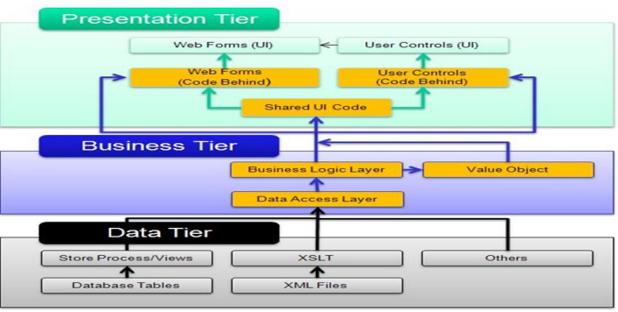
Fig 3.1 System Architecture
3.6 Unified Modeling Language
3.6.1 Activity Diagram
Activity diagram is a very important diagram in UML which describes dynamic aspects of the system. Activity diagram is basically a flow chart to represent the flow of events from one activity to another activity. The activity can be described as an operation of the system, so the control flow is drawn from one operation to another. This flow can be sequential, branched or concurrent. The activity can help to describe the flow of control of the target system, such as the exploring complex business rules and operations, describing the use-case also the business process. Activity diagrams are often used to depict a particular use case and may illustrate the different ways that an activity could happen and end (Kendall & Kendall, 2011)
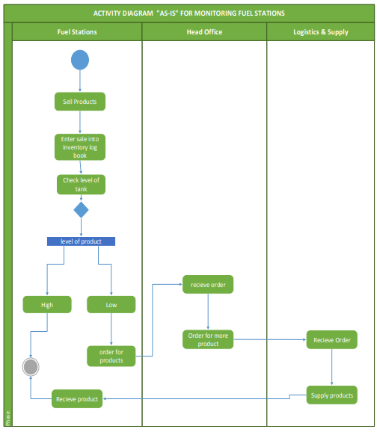
Fig 3.2 Activity Diagram

3.8.2 Class Diagram
A Class diagram is a UML structure diagram which shows the overall structure of the designed system at the level of classes and interfaces, shows their features, constraints, relationships, associations, generalizations, dependencies etc. Class diagram provides an overview of the target system by describing the objects and classes inside the system and the relationships between them. Class diagram show the relationship between classes in a system. Class level is the level on which programming is done; class diagrams do not depict any particular activity or process but only portrays the static features of the system (Kendall & Kendall, 2011)
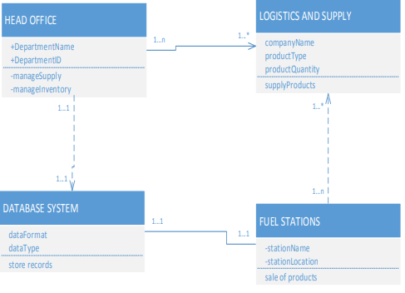
Fig 3.3 Class Diagram
3.6.3 Use Case Diagram
The Use-Case is the foundational requirements for identifying and specifying the standards required to support exchange of data and reference development implementations and tools to ensure consistent and reliable adoption of the data exchange standards. These use cases address the requirements of a broad range of interests including customers, departments, Banks, their significant and other stakeholders, providers, vendors, standards organizations. A use-case is a methodology used in system analysis to identify, clarify, and organize system requirements. These Use-Cases describe:
- The operational context for the data exchange
- The stakeholders with an interest in the Use-Case
- The flow of information must be supported by the data exchange
- The types of data and their specifications required in the data exchange
The newly developed system offers two main functionalities to the end user. The first functionality allows managers and supervisors to monitor the volumes of fuel delivery and the revenue generated by the fuel stations. The second functionality also allows the corporate head office to track and monitor each service stations volume of fuel used, daily sales, amount generated by each fuel station and the volume of fuel needed to be replaced by the corporate office.
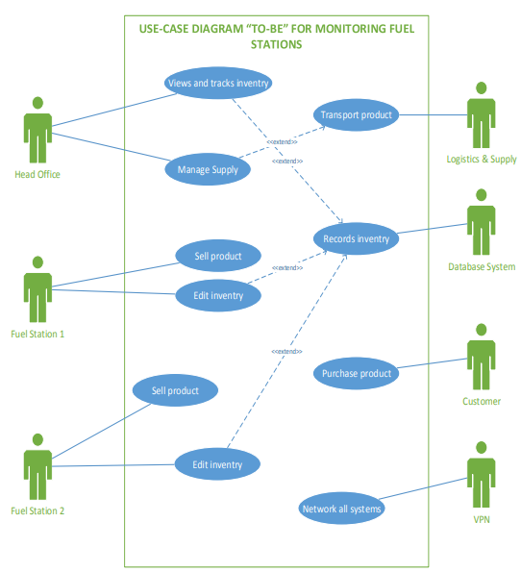
Fig 3.3 Use-case diagram
3.8.4 Sequence Diagram
The sequence diagram is the most common kind of interaction diagram, which focuses on the message interchange between a numbers of lifelines. Sequence diagram describes an interaction by focusing on the sequence of message that is exchanged, along with their corresponding occurrence specifications on the lifelines. UML sequence diagrams model the flow of logic within your system in a visual manner, enabling you both to document and validate your logic, and are commonly used for both analysis and design purposes. Sequence diagrams are the most popular UML artefact for dynamic modelling, which focuses on identifying the behaviour within your system. Most often sequence diagrams are used to depict activities in a use case. They are used to derive the relationships between objects in a system. Sequence diagrams are used to illustrate activities in use scenarios to make the activities follow in a more logical order for analysis. (Kendall & Kendall, 2011).
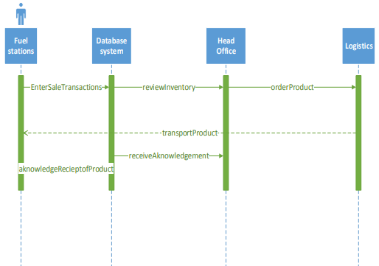

Fig 3.4 Sequence Diagram

CHAPTER FOUR
SYSTEM IMPLEMENTATION
4.1 Introduction
This section shows the actual running of the system. The choice of design tools are made known. The system software and hardware requirements are also listed. Snapshots of the system implementation are displayed. Finally the system is tested and found fool-proof.
4.2 Choice of Development Tools
This section is broadly divided into system platform, Integrated Development Environment, Programming Language and database tool. These are discussed below.
4.2.1 System Platform
The system works on all internet enabled device which meets the entire requirement for the proper functioning of the project.
4.2.2 Integrated Development Environment (IDE)
Visual studio code editor was used in implementing this project. It is a cross-platform IDE for PHP. This editor makes the work pretty easier to handle as it provides an editor for PHP, HTML and JavaScript with on-the-fly code analysis, error prevention and automated refactoring for PHP and JavaScript code.
4.2.3 Choice of Programming Language
PHP was chosen as the programming language which serves as the client to enable me to create the input and output forms while the MySQL database was used as the database server. PHP is a framework (programming) for development of enterprise application using object oriented programming. For most software applications there exists a wide variety of languages in which the application may be implemented. Apart from mere suitability of the programming languages, many factors influenced the use of PHP as the programming language for the source code shown in the APPENDIX and the oracle database as the server.
Reasons for Choosing PHP
- Speed: Being a compiled language, it is very fast and speed is important in database application.
- Environment: It can run in windows.
- Efficient: The final code tends to be compact and run quickly.
- Portability: If compiled, it can be executed in different machines with alteration of source code.
- Maintainability: To ensure maintainability, this program is broken into modules and each module assigned a specific function. This will make maintenance of the system easier.
- Security: it has proper backups, quality control mechanism for all modules and unauthorized access to sensitive data is prohibited.
4.2.4 Database Implementation (MySQL)
The database implementation is the process of installation of database software, configuration and customization, running, testing, integrating with applications.
The following are steps in the implementation phase:
- Install the DBMS.
- Tune the setup variables according to the hardware, software and usage conditions.
- Create the database and tables.
- Load the data.
- Set up the users and security.
- Implement the backup regime.
Why MySQL was used
- MySQL maintains a high level of security compared to others such as Oracle, Microsoft SQL, and Access.
- MySQL database ensures maximum data throughput (i.e. accepting of data with ease).
- MySQL database has a very high data storage capacity limit, several nanobyte and terabytes
- MySQL is supported by many operating system platform e.g. Linux, Mac, windows and DOS
- MySQL has several data management and administrative services.
- MySQL comes with built-in front end (client) and back end (DB sever) programming architecture. This makes oracle a suitable application development framework.
- MySQL has data backup and recovery management services
4.3 System Requirements
The system requirement can be classified into two categories: Hardware Requirement and Software Requirement
- Hardware Requirement:
- CPU 4 processor or higher.
- Memory 2 GB or higher.
- Hard disk 160 GB or higher.
- Network card.
- Windows operating system.
- Software Requirement:
- Local Server (WAMP or XAMPP)
- Browser
4.4 System Interfaces
- Login
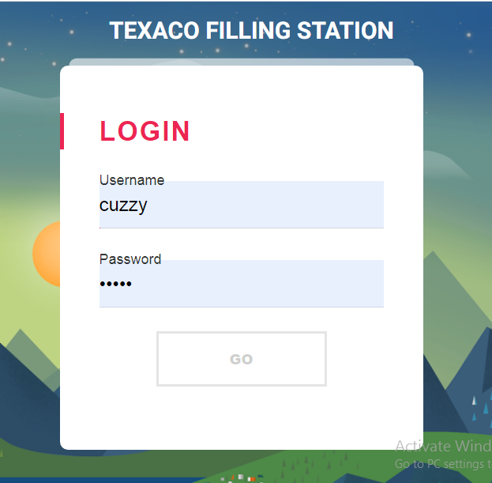
Fig 4.1 Login

- Supplies
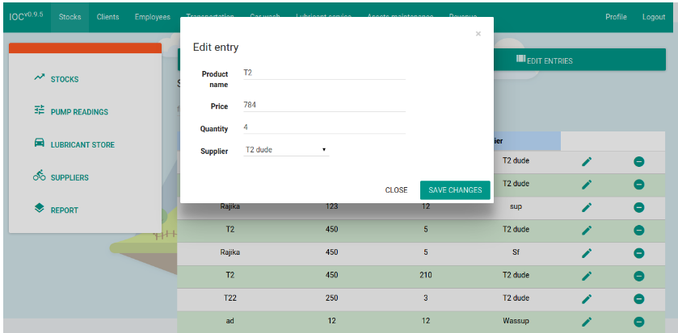
Fig 4.2 Supplies

4.5 System Testing and Evaluation
The proposed system was implemented at the Texaco fuel station for testing and evaluation of fuel products. An installed fuel pump was linked to the back-end office computer which has the fuel management system application installed on it. The station received fuel product of 45000 liters of super and 40000 litres of diesel which was discharge into the underground tanks. The manager of the fuel station entered the details of fuel product received into the fuel station web application. The fuel attendant started selling the fuel products to customers who came to buy fuel from the fuel station. The fuel attendant enters the amount to be purchased and the volume required by customers on the totalizer reading of the pump. Information entered into the totalizer reading of the pump is automatically updated into the database of the back-end office fuel management system application. As customers purchased the fuel products from the fuel station, the stock level kept reducing. In view of the fact that, the Texaco fuel station has a high patronage rate, the stock level was set at 20,000 litres for super and diesel. Each product was being monitored daily to see the stock level. After four working days the web-application of the fuel management system at the back-end office indicated that the super product has reached its desktop level of 20000 litres, therefore there was a need to replenish stock of the super product. This occurred when the manager accessed the web-application to monitor the stock of fuel product. It was observed that super products sell faster at the Awka branch of the Texaco fuel station. The manager was impressed by the quality of information, the speed of access to information, back-up and security measures that the fuel management system presents to the fuel station. There was no need for managers and supervisors to use dip-sticks to measure stock level of fuel products in the underground fuel tanks. Also the manager was able to generate sales reports, stock reports, supply reports, and to conduct a trend analysis of various product sales. At the station level the proposed fuel management system enables managers to track product sales and performance of the fuel station.

CHAPTER FIVE
SUMMARY, CONCLUSION AND RECOMMENDATION
5.1 Summary
The architecture consists of a UML system design. The adoption of SQL server for data and services interfaces and Web service application which is PHP framework for implementing the data services, allows the users to create and manage work flows and data analysis. This architecture has a potential use for managing fuel in rapid response systems. The current monitoring and tracking models of Texaco fuel stations has been a manual system. Fuel tanks are measured with Dip sticks to check the level of fuel in the tanks. Theft and fraud sometimes takes place among fuel attendants leading to numerous complaints by station managers. Daily sales are recorded in sales books which can lead to inaccurate data recorded. Replenishing stocks at Texaco Petroleum fuel stations takes 48 hours. Station managers fill an order forms to order for products. If there is no supply at the fuel 65 stations after 48 hours, the station managers or supervisors follow up at the head office.
The problem with the existing system include lack of provisions of protected and secured system to fall on in case of natural disaster such as fires, flood and earth quake. Delay in locating and retrieving records during audit to ensure integrity of records. With the fuel station management system developed, the head office tracks and monitor products of all their fuel stations and replenishes them depending on how fast stock reaches its desk-top level at each fuel station site. An overview of a fuel management system has been tested at Texaco Filling Station and the results of the test run can be found in the appendix reports. The benefits of fuel station management system if adopted by Texaco Limited ensures that sales reports, stock reports and supply reports can be generated quickly without demanding it from any fuel station. The quickness in generation of the reports is due to the fact that through the use of the fuel management system, data processing and analysis are faster and more accurate, hence Managers can instantly access different information which leads to easy and quick decision making. This is evidence during the test-run of the fuel management system Texaco Filling Station to generate reports needed for decision making. The fuel management system has the ability to perform sales entry, data processing, data security, reports such as sales report, supply report and stock report. All these functions of the system will enable Texaco Petroleum Limited to run its operations smoothly in a much more effective and efficient manner. The result from the research confirms that fuel management system performs several tasks at the fuel station which are satisfactory.
5.2 Conclusion
Using the computerised information system by Texaco Limited will enable its fuel stations run its financial operations right from sales, stock taking, replenishing stocks, supply reports and data processing to security of sales and stocks. The developed system will enhance the company confidence to track products of its service stations so as to get value for money. It will also eliminate shortfall declaration of amount generated by station managers. Also, the system will offer a user friendly interaction, enabling the company to achieve its objectives in managing fuel stations. It was found out during the test stage that using fuel station management system, sales reports, stock reports, stock level of the fuel in tanks, supply reports can be generated quickly. Texaco Petroleum Limited can use the fuel station management system to analyse the fuel stations performance in terms of sales and in doing this, the company can always monitor the performance of its fuel stations. It was also observed that the fuel management system is quicker in generating reports due to the fact that reconciliation between the fuel stations and the head office can be done simply, faster and more accurate hence managers and the head office representative can access information from the fuel stations which will lead to easy and quicker decision making. The fuel management system developed can handle large volumes of data with ease. Training of staff at all levels of the organization is critical to fully utilizing the capabilities of the fuel station management system. In addition, because deploying such a system represents a new way of providing customer service, training Texaco fuel station staff in how best to use the developed system.
Finally, the company will have the advantage to monitor and manage site operations in real-time since the operation is supported by a web-based application so that stock figures are always viewable, current and fuel deliveries can be identified immediately. It is therefore viable to advice that Texaco Limited actually adapt the use of fuel station management system.
5.3 Recommendations
The use of fuel station management system will solve the limitation problems in the manual processes of fuel station management system, therefore the need for Texaco Petroleum and the rest of the oil marketing companies to use this system is recommended. The system has the potential of meeting the needs and objectives of the comapny which will play a vital role in monitoring the strategic progress of all Total fuel stations through a feedback information system. I strongly recommend that the company and the other oil marketing companies in the country should adopt the utilization of fuel station management system that provide enormous tasks and provide the comapny with accurate, efficient and timely reports. However, the fuel management system developed will actually serve as an asset than a liability to business operations and it would therefore be of great necessity to recommend to Texaco Petroleum Limited the fuel station management system to implement this system and embrace the quality idea of establishing it so as to improve on its operations in terms of efficiency and effectiveness.
5.4 Future Work
In developed countries like Germany, United Kingdom and other European countries, they use Franklin Instrument systems for monitoring of fuel stations. An equally developed system like the fuel station management system has been developed, which is user friendly and web-based. More research should be carried out about fuel station management system to eliminate the manual system of managing fuel at Texaco Petroleum Limited. Further research studies also needs to be conducted to establish and enhance automation in measuring stocks in tanks to eliminate the manual system of measuring stocks using dip-sticks. Fuel management system will enhance complete fuel inventory reconciliation by providing automatic tank gauges to the fuel site underground tank to serve as a complete sensor detection tool. Tank gauge measures can help you begin physical inventory of stocks underground using the gauge sensors which can appear on your personal computer without using dip-sticks to measure the volume of fuel underground. With the tank gauge installed in the underground tank, which is a hardware component, these will enable fuel reconciliation to be done with ease eliminating the manual process of measuring. The fuel reconciliation enables you to know what is coming in and what is being dispensed by combining dispensing data with the underground tank inventory data. Fuel tank gauges will improve fuel security, accountability and control for fuel sites and eliminate errors in the manual systems thereby improving accuracy, efficiency and productivity. Above all, it will also improve fuel tracking and elimination of theft.

REFERENCES
Javalgi RG & White, DS. 2012. Strategic challenges for the marketing of services internationally. International Marketing Review, 19(6): 563-581. Available: http://www.emeraldinsight. com/Insight/ View ContentServlet?Filename=Published/Emera ldFullTextArticle /Articles/ 0360190601.html [accessed 16th September 2016].
Sharma, MK & Bhagwat, R. 2016. Practice of information systems: evidence from select Indian SMEs. Journal of Manufacturing Technology Management, 17(2): 199-223
Drew, J. 2015. Chinese business information: a review. Management Decision, 33(5):57-62.
De Lange, M, Britz, JJ & Boon, JA. 2013. Information sector: critical review of selected readings with specific reference to South Africa. South African Journal of Library and
Information Science, 61 (1): 1-10.
Ikoja-Odongo, JR. 2012. Mapping information systems and services in Uganda: an overview. International information and Library Review, 34:309-334.
Shokane, JK. 2013. The use of business information by small and medium-sized enterprises in Acornhoek. South Africa Journal of Library & Information Science. 69(1).
Lee, YL, Hwang, SL & Wang, EMY. 2016. An integrated framework for continuous improvement on user satisfaction of information systems. Industrial Management & Data Systems, 106 (4):581-595
Lippeveld, T, Sauerborn, R & Bodart C. 2010. Design and implementation of health information systems. Geneva: World Health Organisation
Aiyepeku, WO. 2011. Toward a national information and informatics policy (Commissioned paper presented at the seminar on Libraries and Information Services for National Development, Lagos, 17-19, September, p.29
Omekwu, C. 2013. National agricultural information management system in Nigeria: a conceptual framework: Library Review, 52(9): 444 - 451.
Thoburn JG, Arunachalam, S & Gunasekaran, A. 2000. Tracing of information links empirically (TILE) in small and medium sized enterprises (SMEs). Logistics Information 228 Management, 13(4): 248-255
Neelameghan, A. 2012. Information for small enterprises. Bangalore: Sarada Ranganathan Endowment for Library Science
Lucey, T. 2017. Management information systems. 5th ed. London: DP Publications.
Agada, J. 2015. Analysis of Information Repackaging (IR) processes using the Instructional Systems Design (ISD) model. Journal of Instructional Science and Technology, 1(1)
Avgerou, C & Cornford, T. 2018. Developing information systems: concepts, issues and practice, 2 ed. Hampshire: Macmillan Press
Moyi, E. 2010. An analysis of the information-search process in micro and small manufacturing enterprises.
Bell, S. 2016. Information systems planning and operation in less developed countries. Part 1: Planning and operational concerns. Journal of Information Science, 12(5): 231-245
Sturges, P & Neill, R. 2018. The quiet struggle: information and libraries for the people ofAfrica. 2nd ed. London: Mansell.
Choo, CW. 2017. Information seeking in organizations: epistemic contexts and contests. Information Research, 12(2) paper 298.
Thomas, R & Ballard, M. 2015. Business information: technologies and strategies. Gloss: Stanley Publishers
Bharati, P & Berg D. 2013. Managing information systems for service quality: a study from the other side. Information Technology & People, 16(2): 183-202.
Pant, S & Ravichandran, V. 2011. A framework for information systems planning for ebusiness. Logistics information management, 14(1-2): 85-99.
Lippeveld, T, Sauerborn, R & Bodart C. 2010. Design and implementation of health information systems. Geneva: World Health Organisation.
Kersten, GE. 2016. Theories of small group communication. Available:
http://www.mhhe.com/socscience/comm/group/students/theory.htm [accessed 4thNovember 2019]
Monteiro, E. 2010. Actor network theory and information infrastructure, in The dynamics of corporate information infrastructures, edited by C.U. Ciborra, K. Braa, A. Cordella, B. Dahlbom, A. Failla, O. Hanseth, V. Hepso, J. Ljungberg, E. Monteiro and K. A. Simon.
New York:Oxford University Press.
Braa, J & Hedberg, C. 2012. The struggle for district-based health information systems in South Africa. Information society, 18: 113-127
Strassmann, P. 2010. The business values of computers- an executive’s guide. Connecticut: Information Economics Press.

APPENDIX
Source code
<div>
<div class="panel panel-warning">
<div class="panel-heading">
<h3 class="panel-title"></h3>
</div>
<div class="panel-body">
<a href="revenue/income" class="btn btn-flat btn-primary" id="income">
<i class="mdi-navigation-arrow-forward"></i> Income</a>
<a href="revenue/expenses" class="btn btn-flat btn-primary" id="expenses">
<i class="mdi-navigation-arrow-back"></i> Expenses</a>
<a href="revenue/payment" class="btn btn-flat btn-primary" id="payment">
<i class="mdi-notification-play-install"></i> Payment</a>
<a href="revenue/report" class="btn btn-flat btn-primary" id="report">
<i class="mdi-social-poll"></i> Report</a>
</div>

<script type="text/javascript">
function hashCheck(url){
var hashURL = url.split('-');
//if(typeof hashURL[1] == 'string'){
return hashURL[1];
//}
}

$('#income').click(function(e2){
e2.preventDefault();
var id = $(this).attr('id');

$('#subloader').load('/IOC/revenue/' + id,function(){
//console.log('income !');
$('#subloader').hide();
$('#subloader').fadeIn('fast');
window.location.hash = "";
window.location.hash = "/revenue/" + id;
});
});
$('#expenses').click(function(e2){
e2.preventDefault();
var id = $(this).attr('id');

$('#subloader').load('/IOC/revenue/' + id,function(){
//console.log('expenses !');
$('#subloader').hide();
$('#subloader').fadeIn('fast');
window.location.hash = "";
window.location.hash = "/revenue/" + id;
});
});

$('#payment').click(function(e2){
e2.preventDefault();
var id=$(this).attr('id');

$('#subloader').load('/IOC/revenue/'+id,function(){
//console.log('payment');
$('#subloader').hide();
$('#subloader').fadeIn('fast');
window.location.hash = "";
window.location.hash = "/revenue/" + id;
});
});

$('#report').click(function(e2){
e2.preventDefault();
var id = $(this).attr('id');

$('#subloader').load('/IOC/revenue/' + id,function(){
//console.log('report !');
$('#subloader').hide();
$('#subloader').fadeIn('fast');
window.location.hash = "";
window.location.hash = "/revenue/" + id;
});
});

</script>
</div>
</div>

