# COMPOSTING OF TANNERY WASTE WITH SAWDUST FOR PRODUCTION OF ORGANIC MANURE

**BY**

# AHMADU USMAN MTECH/SLS/2017/6845

**A THESIS SUBMITTED TO THE SCHOOL OF POSTGRADUATE SCHOOL FEDERAL UNIVERSITY OF TECHNOLOGY, MINNA, NIGERIA IN PARTIAL FULFILMENT OF THE REQUIREMENTS FOR THE AWARD OF DEGREE OF MASTER OF TECHNOLOGY (M.TECH) IN MICROBIOLOGY (ENVIRONMENTAL MICROBIOLOGY)**

# AUGUST, 2021

**ABSTRACT**

The utilisation of tannery waste (TW) in combination with sawdust (SD) as compost manure for agricultural use was studied. The two wastes samples were collected and mixed in the ratios (TW/SD) 1:1, 1:5, 5:1, 1:10 and 10:1, respectively. Composting bin was used during the process. The composting was done for 6 weeks under aerobic condition with frequent turning for proper aeration. Microbiological and physicochemical parameters of the samples (tannery waste and sawdust), experimental soil (SL), as well as the finished compost were determined using standard methods. The microorganisms isolated from the wastes (TW, SD and SL) were species of *Bacillus*, *Escherichia*, *Micrococcus*, *Proteus*, *Pseudomonas*, *Streptococcus*, *Staphylococcus* (bacteria) *Aspergillus*, *Mucor*, *Tricophyton*, *Rhizopus*, *Penicillium*, *Fusarium*, *Candida* and *Saccharomyces* (fungi). The resultant compost was obtained 42 days after being composted; it was odourless, stable and had earthly smell. The pH of the matured compost ranged from 7.30 to 8.05 (moderately alkaline), total organic carbon (14.84% to 24.33%), carbon to nitrogen ratio ranged from 10.96 to 31.46, phosphorus content (2.55 to 3.48%), potassium content (0.961 to 2.912%) and heavy metals such as (Cr, Pb, Cd, Zn, Hg, Fe, Mg) were within the permissible limits for matured quality compost. The germination index (emergence) was significantly high (p<0.05) in all treatments including the control. The resultant compost was used to assess the growth parameters (leaves, height and stem girth) and yield performances of maize plants. Maize plants treated with compost (TW/SD 1:1), supported good growth pattern as well as seed formation, while maize plants treated with compost (TW/SD 1:10) had poorest response which resulted in stunted growth with smaller leaf sizes as well as narrowest stem girth. Compost (TW/SD 10:1) supported good growth pattern of the maize plants with significant increase in height, stem girth and leaf length (with extensive leaf sizes and greenish). This suggests that the nutrient content of the compost (TW/SD 10:1) was utilized by the plants for their growth. Height of maize treated with TW/SD 1:1 on maize was not significantly (p>0.05) different from Amazing organic fertilizer (commercial). The yield of maize was obtained 102 days after planting. The mean yield of maize raised with the compost TW/SD ranged from 0.4±0.05kg to 1.5±0.01kg. The highest yield of 1.5±0.01kg obtained with TW/SD 1:1 was significantly different (p<0.05) from TW/SD 10:1. The results obtained suggest that tannery waste/sawdust compost in the right combination can be applied for the improvement of soil organic matter and boost food production.

# TABLE OF CONTENTS

**Contents Page**

Cover Page

Title Page

i Declaration ii Certification

iii Dedication

iv Acknowledgements v

Abstract vi

Table of Contents vii

List of Tables xii

List of Figures

xiii

List of Plates xiv

# CHAPTER ONE

* 1. **INTRODUCTION 1**
  2. Background to the Study 1
  3. Statement of the Research Problem 4
  4. Justification for the Study 4

1.4.1 Aim and Objectives of the Study

5

# CHAPTER TWO

* 1. **LITERATURE REVIEW 6**
  2. Composition of Tannery Wastes 6
  3. Contents of the Waste water generated/Heavy Metals in Tannery Waste 6
  4. Effects of Tannery Wastes in the Environment 7
  5. Wood Wastes in Nigeria 8
  6. Bulking Agents and their Role in Composting 9
  7. What is Compost? 10
     1. Advantages of compost 11
     2. Disadvantages of compost 12
     3. Problems associated with composting 12
  8. Types of Composting 13
     1. Aerobic composting 13
     2. Anaerobic composting 14
     3. Stages of composting 16
        1. Mesophilic phase 16
        2. Thermophilic phase 16
        3. Cooling stage 17
        4. Maturing stage 17
  9. Factors Affecting Composting Process 18
     1. Temperature 18
     2. Moisture 18
     3. pH 19
     4. Oxygen 19
     5. Carbon to nitrogen (C:N) ratio 20
     6. Microbial population 20
  10. Method of Composting 21
      1. Static pile 21
      2. In-vessel or enclosed composting 22
      3. Bin composting 22
      4. Windrow composting 23
      5. Vermicomposting 23
  11. Commercial Organic Manure in Nigeria 24

# CHAPTER THREE

* 1. **MATERIALS AND METHODS 26**
  2. Collection and Processing of Waste Materials for Composting 26
  3. Microbiological Analysis of Samples 26
  4. Characterisation and Identification of Bacterial Isolates from the Tannery 27

Waste, Sawdust, Soil and Compost Samples

* + 1. Bacterial isolates 27
    2. Moulds isolates 31
    3. Yeasts isolates 32
  1. Determination of Physicochemical Parameters of Samples 32
     1. Determination of temperature 32
     2. Determination of pH and electrical conductivity (EC) 33
     3. Determination of organic carbon 33
     4. Determination of total nitrogen 34
     5. Determination of carbon to nitrogen (C:N) ratio 35
     6. Determination of phosphorus 35
     7. Determination of moisture 36
     8. Heavy metals analysis using atomic absorption spectrophotometer (AAS) 37
  2. Composting Process 38
     1. Experimental design and treatment 38
     2. Monitoring of the compost 41
     3. Sample collection during composting 41
     4. Compost sampling and analysis 41
  3. Determination of Qualities of Compost Produced 42
  4. Field Studies 42
     1. Description of experimental site 42
     2. Collection of maize and test for viability 43
     3. Experimental plot preparation and sowing of maize 43
     4. Seed germination and germination potential 43
     5. Application of compost manure and fertilizers 44
     6. Monitoring of plant growth parameters 44
  5. Statistical Analysis 45

# CHAPTER FOUR

* 1. **RESULTS AND DISCUSSION 46**
  2. Results 46
     1. Microbiological properties of Tannery Wastes, Sawdust and Soil 46
     2. Identity and frequency of occurrence of bacterial isolates 47
     3. Identity and frequency of occurrence of fungi isolates 51
     4. Microbial counts during tannery waste/sawdust composting process 56
     5. Microorganisms identified during tannery waste/sawdust composting 58
     6. Physicochemical properties of Tannery Waste (TW), Sawdust (SD) 60

And Soil (SL)

* + 1. Heavy Metal Contents of Tannery Waste (TW), Sawdust (SD) and Soil 62

(SL)

* + 1. Physicochemical properties of the compost 64
       1. Temperature profile during composting of tannery waste (TW) with sawdust 66

(SD)

* + - 1. pH profile during composting of tannery waste (TW) with sawdust (SD) 67
      2. Moisture content of the compost 69
    1. Efficacy of Compost in the Field 70
       1. The germination index (emergence percentage) of maize 72
       2. The effect of compost produced on the plant height 72
       3. Effects of compost on leaf length 74
       4. The effect of compost on stem girth 75
       5. Effect of compost produced on maize yield 77
  1. Discussion 78

# CHAPTER FIVE

* 1. **CONCLUSION AND RECOMMENTATIONS 94**
  2. Conclusion 94
  3. Recommendations 95

# REFERENCES 97

**APPENDICES 108**

# LIST OF TABLES

**Table Page**

* 1. : Bacterial and fungal counts of tannery waste (TW), sawdust (SD) and 46

soil (SL)

* 1. : Cultural and biochemical characteristics of bacterial isolates from tannery 48

waste (TW), sawdust (SD) and soil (SL)

* 1. : Frequency of occurrence of bacteria in tannery waste (TW), sawdust (SD) 50

and soil (SL)

* 1. : Cultural and morphological characteristics of fungi isolates on Sabouraud 52

dextrose agar from tannery waste (TW), sawdust (SD) and soil (SL)

* 1. : Morphological, biochemical and physiological characteristics of yeast 54

isolates from compost

* 1. : Frequency of occurrence of fungi in tannery waste (TW), sawdust (SD) and

55 soil (SL)

* 1. : Microbial isolates identified at different stages of composting process 59
  2. : Physicochemical properties of tannery waste (TW), sawdust (SD) and soil 61

(SL) used

* 1. : Heavy metal content of the tannery waste (TW), sawdust (SD) and soil (SL) 63
  2. : Germination index (% emergence) of maize planted in soil amended with 71

compost

* 1. : Yield of maize planted in soil amended with compost produced 77

# LIST OF FIGURES

**Figure Page**

* 1. : Bacterial counts during composting of tannery waste (TW) with 57

sawdust (SD)

* 1. : Fungal counts during composting of tannery waste (TW) with sawdust 57

(SD)

* 1. : Temperature profile of tannery waste/sawdust (TW/SD) compost 66
  2. : pH of tannery waste/sawdust compost 68
  3. : Moisture content of tannery waste/sawdust compost 69
  4. : Effects of compost on plant height 73
  5. : Effect of compost on leaf length 74
  6. : Effects of compost on stem girth 76

# LIST OF PLATES

**Plate Page**

Ia: Tannery waste (TW) 39

Ib: Sawdust (SD) 39

II: Composting of tannery waste (TW)/sawdust (SD) 40

# CHAPTER ONE

* 1. **INTRODUCTION**

# Background to the Study

Composting of organic waste is a bio-oxidative procedure comprising partial humification of organic matter and mineralisation, producing stabilised finishing product known as compost, free from pathogens, phytotoxicity and humic properties (Elnasikh and Satti, 2017). It is an aerobic biological method which utilizes naturally occurring microorganisms to convert biodegradable organic matter into humus-like product. The aerobic composting is the process of disintegration of organic substrates in the presence of oxygen which powers microbial action (Nwankwo *et al*., 2014). The procedure destroy pathogens, transforms nitrogen from unstable ammonia to stable organic forms, minimizes the quantity of the waste and enriches the nature of the waste (Agyarko-Mintah *et al*., 2016). During composting process diverse microbial communities obliterate organic matters into simpler nutrients. It may be supplementary effective when the moisture content is exact according to material of the compost, and the carbon to nitrogen ratio (Batham *et al*., 2013).

Compost is made by decaying any organic materials such as sawdust, domestic garbage, straw, lawn dipping, and plant materials (Argun *et al.*, 2017). It has dual exceptional effects on soils, essentially on nutrient deficient soils. It replaces the missed soil organic constituents and provides plant nutrients (Olowoake *et al.*, 2018). Naturally, compost use to soil affects both variety as well as size of microbial populations with enzyme actions, as majority of the processes in soil are facilitated by enzymes from microbial source (Weerasinghe and De Silva, 2017). Conversely, the enhancement of soil

microbes as well influences plant growth through the presence of plant growth promoting hormone and rise of nutrient accessibility. Additionally, compost can improve crop yields due to nutrient release during disintegration and mineralization (Weerasinghe and De Silva, 2017).

Composting and co-composting are among the native procedures obtainable for the removal of solid waste pollution merged with resource renewal through stabilizing mixed types of organic wastes (Anwar *et al*., 2015). As in the production procedures, the application of large-scale composting fetches better economic advantages. Co- composting of other than a single type of waste can be a more feasible management process of solid wastes (Anwar *et al*., 2015). It is a technique of handling many brands of organic wastes. Most extensively used co-composted ingredients are animal waste product with agro-wastes for example stalk, rice straw, sawdust, corn stalk, wheat straw (Anwar *et al*., 2015). The adding of bulking agent for composting heightens substrate properties such as air space, pH, moisture content, carbon-to-nitrogen (C:N) ratio, mechanical structure and particle density, affecting entirely the disintegration rate (Anwar *et al*., 2015). Composting has been frequently acknowledged as an environmental friendly alternative approach of recycling organic solid wastes (Ijah, 2006; Ezeagu *et al*., 2017a). Additionally, making good soil amendment, composting is a unique method of reducing the quantity of wastes that are sent to landfills, burnt or left in a way that cause contamination of land or water bodies. These wastes, which were one time put in the landfills, have gradually been prepared into useful products. Therefore, composting can be a skill of choice for the conversion of tannery solid wastes into a compost material with a high agronomic value, especially in the instance

of dehairing wastes, where the concentrations of heavy metals are less. Currently, there is little information concerning composting of tannery waste with sawdust as an organic amendment.

Bulking agents are augmented in the composting course for different reasons as energy source for microbes, proper air circulation through the mixed wastes by enhancing porosity, appropriate absorption and to heighten the degradation of composting materials (Zhou *et al*., 2014). Sawdust is a by-product of cutting, drilling, grinding, sanding, or else crushing wood with a saw or other tool; it is made of fine particles of wood. Therefore, is a carbonaceous organic substance which has a very rich carbon to nitrogen ratio (Betham *et al*., 2013). The sawdust is cheap and common accessible bulking agent. Thus, it holds potential as contributing to the carbon source for increasing soil organic matter when applied. It is a very frequent bulking agent utilized in composting which furnishes the free air space, moisture control and retain the carbon to nitrogen ratio (Zhou *et al.*, 2014).

Tanning involves the handling of hides and skins to transform and maintain them into leather which will be preserved and fit for various brands of applications (Mohammed *et al*., 2017). The use and unusable hides and skins in proportion to the excess process chemicals and water comprise liquid and solid wastes in the tannery (Mohammed *et al*., 2017). There are different modes of tanning system which include; the chrome tanning as well as vegetable tanning (does not involve chromium). In the treatment of raw hide and skin, sulphuric acid and salt are employed, and later treated with the solution of chromium salts. In the tannery, chromium, hydrochloric acid, formic acid, sulphuric

acid, caustic potash, caustic soda, arsenic sulphate, sodium arsenite, soda ash are used

for numerous tanning processes such as liming, de-liming, soaking, tanning (Tinni *et al*., 2014). Also vegetable tannins are applied to re-tan leather particularly at the local tanning level by the application of plant materials (such as the pods, tree bark) which comprises condensed or hydrolysable tannins (Tijjani, 2014).

# Statement of the Research Problem

The chemical fertilizers are expensive and cause harm to the environment. Besides, not all farmers can get access to chemical fertilizers. Tanneries and wood industries in the country are growing and both produce a lot of wastes. Often these wastes are dumped unattended, and thus result in polluting the environment producing horrible odour especially the tannery waste. The wastes (tannery and sawdust) are abundant in areas dominated by tanning and wood work activities constituting waste disposal problem. However, the wastes can be converted to useful products.

# Justification for the Study

Extensive use of soil for years, combined with wrong use of agro-chemicals, has generated in many locations leading problems of soil nutrient degradation and heavy metal contamination in most of Nigerian soils. Therefore, there is the need to lessen environmental problems by using cheaper organic manure obtained through bioconversion of toxic industrial waste. Tannery waste and sawdust can be converted into compost which is very useful in agriculture. Most of these wastes are organic in nature which means they are biodegradable. Studies establish that the fundamental to sustainable agricultural production and long term productivity of agro-ecosystems are procedures that conserve organic matter in the soil (Dinesh *et al*., 2012).

The present work was focused on making compost from tannery waste combined with sawdust as bulking agent. Recycling of organic wastes such as tannery wastes for agricultural use become very necessary so as to be adopted or used where poor quality soils exist (with depleted nutrients) and reduce over dependency on chemical fertilizers; which can result in soil health problems. The use of compost improves soil structure, water permeability and soil fertility. Organic amendments can also promote plant health, and even increase yields.

# Aim and Objectives of the Study

The aim of the study was to convert tannery waste into organic manure by composting with sawdust. The objectives of the study were to:

* + 1. determine the microbiological and physicochemical properties of tannery waste, sawdust and soil
    2. characterise and identify the microbial isolates
    3. produce organic manure from tannery waste using sawdust as bulking agent
    4. characterise the organic manure produced
    5. determine the efficacy of the organic manure produced in the field using maize as a test crop

# CHAPTER TWO

* 1. **LITERATURE REVIEW**

# Composition of Tannery Wastes

Tannery waste is made up of hair waste (made by sheep or goat skin treatment), trimmings (undesirable portions detached of skins and hides) and fleshings (solid waste produced during the tanning process) (Framis, 2018). The major constituent of individual tannery waste flow depends on the type of raw materials, handling stage and mode of processing. Mostly, the composition of waste produced during the tanning manufacturing process characteristically comprises liquefied waste, solid waste and even gases (Framis, 2018). Solid wastes generated from tanneries depend on the mode of processing applied, locally produced equipment and machines that lack accuracy thus more waste is produced. The solid waste generated in tanneries include: hairs, chrome sludge, fleshing, buffing dust, crust and finished leather trimmings (Ugya and Aziz, 2016).

# Contents of the Waste water generated/Heavy Metals in Tannery Waste

Waste water generated from many tannery industries contains toxic contaminants. Human activities have stimulated greatly in polluting the ecosystem with heavy metals as a results of industrial activities and hi-tech in the tannery sector. Heavy metals are a group of metals and metalloids with atomic densities greater than 5.0 g/cm3 as common defining factor (Wijayawardena *et al.,* 2016). Chromium is the most important metal in tannery waste. Unnecessary discharge of heavy metals into the environment due to tanning activities has created a general problem globally. Most of the chemicals used are toxic to aquatic and human life causing in food pollution and short life possibility (Bulus *et al*., 2018). Numerous heavy metals are present in tannery wastes (effluents,

sludge and solid). The most prominent ones are Chromium, Cadmium, Nickel, Lead, Cobalt, Copper, Manganese, and Zinc. The concentration of these metals relies on the amount of the waste involved (Isah and Jimoh, 2015).

# Effects of Tannery Wastes in the Environment

Pollution of environment is one of the most terrible environmental crisis to which people living in areas where tanning activities are carried out may encounter. Most of the local tannery industries have been built in an unplanned manner and exist as small, medium and large industries (Ugya and Aziz, 2016). These unplanned tanneries cause environmental pollution. The most unsafe environmental impact is unpleasant odour to the surrounding areas which produces environmental contamination (Tinni *et al.*, 2014). Most tanneries lack environmental supervision as well as treatment facilities. Consequently, they only release their wastes into the environment producing critical ecological and health complications precisely in rural as well as urban areas (Framis, 2018). The act of discharging untreated tannery wastes in the environment is that it favours the growth of methanogens which might produce excessive methane thereby contributing to global warming and greenhouse effect (Rabah and Ibrahim, 2010). Throughout the tanning process, huge quantities of pollutant overflows are discharged into the immediate land and water sources affecting the aquatic living creatures (Gupta *et al*., 2014). These discharges may have a variety of chemicals such as chromium sulphate, non-ionic wetting agents, sodium sulphate and may pile up in the surrounding environments of the tannery and predispose the dwellers to serious health hazards such as dermatological, gastrointestinal and other diseases (Rabah and Ibrahim, 2010; Tinni

*et al.*, 2014; Affiang *et al*., 2018).

# Wood Wastes in Nigeria

Sawmills are responsible for over 93% of the whole wood processing industries in Nigeria. The operations at these sawmills have caused the creation of huge quantity of wood wastes (Ikenyiri *et al.*, 2019). Quite a lot of wood wastes such as bark, slabs, sawdust, and split wood are produced during the process. Sawdust being plant material is made up of three parts making complex polymer; these are cellulose (a polysaccharide made up of linear chain of several hundred to many thousands of β(1 → 4) D- glucose units), hemicellulose (a polysaccharide linked with cellulose and contributed to the structural constituent on the tree, comprising of single iterating sugar unit linked β-(1 → 4) with branch points (1 → 2), (1 → 3), and/or (1 → 6), and lignin (lignins are unstructured, very complex, predominantly aromatic, polymers of phenylpropane units that are considered to be a coating substance. The three dimensional polymer consist of Carbon-Carbon and C-O-C bonds (Buraimoh *et al*., 2015; Mansor *et al.*, 2019).

Municipal and industrial operations generate wood wastes. The projected amount of sawdust created annually in Nigeria is estimated to be around 1.8 million tonnes, and the amount for wood residues to be roughly 5.2million tonnes per year (Akhator *et al*., 2017). Owing to poor handling methods these enormous amount of wood wastes are thrown away as untreated and unwanted materials, into the environment where pollution is generated. Discarding methods such as dumping on road edges or in drainages, water bodies, heaping at industrial locations and open air burning are repeated practices. Wood wastes generated from sawmills are utilized as bulking agent, in cooking,

mulching, beddings for poultries and animals, applied by farmers as farm manure, used to protect yam seedlings from extreme water and sun heats. Amount of wood waste produced in Nigeria is persistently on the rise.

# Bulking Agents and their Role in Composting

Bulking agents are fragments of material (sawdust, food wastes, rice husk) capable to create an effective structure which retains free ventilation spaces within the waste. The adding of a bulking agent for composting heightens substrate stuffs such as aeration, pH, moisture content, carbon to nitrogen (C:N) ratio, particle density and mechanical structure affecting completely the decomposition rate (Anwar *et al*., 2015), and reduce the composting period as well as enriched nutritive values of compost (Batham *et al*., 2013). Additionally, the possibility of using a material created by composting as an organic amendment relies on the quality of the product in relation to its nutrients content, its maturity and stability. Various bulking agents are used in dissimilar composting processes such as agricultural waste, industrial waste, food waste, composting of weeds as well as vermicomposting (Anwar *et al*., 2015). It has been revealed in a study that bulking agents such as sawdust, rice bran and rice husk increase the disintegration and resulted in exact high-quality compost (Batham *et al*., 2013).

The use of bulking agents in composting process is very useful and efficient for creating high-quality, time efficient and cost effective compost. There are several instances of efficiency of bulking agents in composting as augmented nutritive value, fast degradation of materials which earns bulking agent a very valuable composting material. For the greater results of composting, bulking agents should be utilized in a

precise concentration with compost material (Anwar *et al*., 2015). Low moisture

bulking agents (peat, straw, peanut shells, sawdust, rice husk) usage are very suitable in the composting of wet materials like pig manure (Batham *et al*., 2013). The bulking agents applied in composting play a very vital role to restraint the problem of the moisture content for the right composting, and it also reduces the problem of odour by preserving the moisture in composting (Batham *et al*., 2013).

# What is Compost?

Organic matter that has been decomposed as result of the activities of community of living organisms (actinomycetes, bacteria, fungi, earthworms, maggots) in a process known as composting is termed compost. This practice recycles different organic materials otherwise considered as waste products and creates a soil conditioner. Compost is abundant in nutrients that support the growth of plants (Olowoake *et al.*, 2018). Compost form manures from the decayed refuse such as leaves, twigs, crop residues, stubble, hedge clippings, water hyacinth, sawdust and tannery sludge (Batham *et al*., 2013). It is a dark brown, brittle and earthly smell when is ready for use. Random mixing of the decomposing material will hasten the process and give more uniform product. Compost is not fertilizer but organic manure; instead it is used for structural amendment of the soil. However, it is likely to get fertilizer in superior quality by adding enough nitrogen, phosphorus and potassium to the compost (Argun *et al*., 2017). It is used in gardens, horticulture, organic farming, landscaping.

# Advantages of compost

Compost causes increase in the organic matter content of the soil in which it is applied, the water permeability of the soil with low permeability, the space ratio between soil particles and subsequently the water holding capacity of the soil (Manyapu *et al*., 2017; Ayilara *et al.*, 2020). It boosts root growth by easing the movement of plants roots. It also makes it easier to develop the soil. Humus prevents nitrogen from mixing into the ground water by providing nitrogen retention. Humus rich soil makes it possible for grown up plants to be healthier, more resilient to diseases and detrimental effects (Argun *et al*., 2017). Good quality compost comprises high organic matter content in addition to at least of non-organic material. Therefore, the need for chemical and agricultural struggle is reduced. In addition, application of compost also reduces soil erosion, recovers soil structure and increase water permeability (Manyapu *et al*., 2017).

Compost recovers the biological, chemical and physical properties of soils (Weerasinghe and De Silva, 2017). Compost made from plant wastes comprises all the nutrients required by plants and are made accessible to them, when applied to soils (Weerasinghe and De Silva, 2017). The nutrients depleted from the soil are augmented back to the soil for use by plants. Also, compost encompasses these nutrients particularly nitrogen, potassium, phosphorus, and calcium in organic combination and when it decays, these nutrients are released in accessible form for the utilisation of plants (Verma and Verma, 2012).

# Disadvantages of compost

The main disadvantages of composting are the following: Large scale composting for example, aerated static pile as well as windrow composting occupies vast areas. There is the possible introduction of pathogens to the soil and it can also attract insects. During composting, it loses virtually half the obtainable nitrogen and emits greenhouse gases. It requires having a composting area where adverse environmental effect (such as control rainfall overflow) is averted from the composting area. It can produce odour at the initial stage of composting, depending on type of starting materials applied and odour control is a common problem, prolonged mineralization period (Ayilara *et al.*, 2020). Immature compost can be detrimental to plant roots as well as the growth (Elnasikh and Satti, 2017). Repeated as well as high usage of compost in some situations result in the buildup of metals, spare trace pollutants in the soil over period, may include some pathogens that can survive extreme temperature to some degree, inadequate nutrient content and longer maturity period (Ayilara *et al.*, 2020). Uncertainty in nutrients composition (low) is attributed to compost, thus it has to be added in large quantities for fruitful outcomes (Marwanto *et al.*, 2020).

# Problems associated with Composting

Most often problems identified are due to presence of foreign matters such as glasses, plastics, bones (Hammed, 2015). It is hard to make with liquid manure and certain manures might require a carbon source. Other problems connected with composting are inadequate oxygen levels to facilitate the disintegration of compost; compost microbes essentially require a moist environment because they survive in the water layers surrounding composting organic matter particles (Tiquia, 2005). The ideal moisture and turning rate equally differ significantly depending on kind of raw material applied.

# Types of Composting

There are two important types of composting; these include the aerobic and anaerobic:

# Aerobic composting

Aerobic composting is the decomposition of organic wastes in the presence of oxygen; products from this approach include carbon dioxide (CO2), ammonia (NH3), heat and water (Batham *et al*., 2013). Organic matter usually disintegrates in the presence of oxygen, mainly as an outcome of the energy created from the aerobic respiration (Mehta and Sirari, 2018). Any significant variation inhibits the degradation process. The composting process could be more functioning when the carbon to nitrogen ratio and moisture are right according to material of compost (Batham *et al*., 2013). Aerobic microorganisms use oxygen to nourish upon organic matter to develop their cell protoplasm from nutrients present into the raw material of compost.

Primarily, mesophilic organisms (growth temperature range 20 - 45 oC) grow fast due to suitable presence of available amino acids and sugars. The common mesophilic microorganisms are *Alternaria, Aspergillus, Bacillus, Cladosporium, Flavobacterium, Mucor, Humicola, Penicillium, Pseudomonas* and *Streptomyces* (Mehta and Sirari, 2018). With correct accessibility of reasonable amount of nutrient source these microorganisms grow fast and produce heat by their own metabolism and rise the temperature of heap to the point where their own action become repressed. Then numerous thermophilic fungi (*Absidia, Aspergillus, Chaetomium, Mucor, Sporotrichum, Humicola, Torula* (yeast) and *Thermoascus*), thermophilic bacteria (*Bacillus* and *Thermus*) and few actinomycetes (*Micropolyspora, Thermoactinomyces*,

*Thermomonospora* and *Streptomyces*) continue the process of rising heap temperature up to 65oC - 70oC or higher. The requirement of this peak heating period is that it can destroy most of the pathogens and weed seeds that can pollute the compost and later on soil as well as crops which are in touch of this compost (Mehta and Sirari, 2018).

# Anaerobic composting

Anaerobic composting is the decomposition of organic wastes in the lack of oxygen, the products being ammonia (NH3), carbon dioxide (CO2), methane (CH4) and inconsequential amount of other organic acids and gases. Anaerobic composting was habitually used to compost human sewage sludge as well as animal manure; nevertheless it has become more frequent for some municipal solid wastes as well as green wastes to be handled in this manner (Tweib *et al*., 2011). The anaerobic disintegration results in the breakdown of organic compounds by the effort of anaerobic microbes. Anaerobic microorganisms use phosphorus, nitrogen with other nutrients to develop their cell protoplasm. The key part of anaerobic composting is the breakdown of organic matter through depletion process; but the last product is subject to have aerobic oxidation. There are no implications of this oxidation procedure on utilization of material as it is required for a short period (Mehta and Sirari, 2018).

Four main stages occur during anaerobic composting process: hydrolysis, acidogenesis, acetogenesis and methanogenesis:

* + - 1. The early stage is hydrolysis where the fermentative microorganisms (*Streptococcus* and *Enterobacterium*) breakdown the insoluble complex organic matter, such as cellulose into soluble molecules of fatty acids, amino

acids and sugars. The hydrolytic activity is a rate limiting factor as it is having an important impact on raw material with high organic content (Shah *et al.*, 2014; Mehta and Sirari, 2018).

* + - 1. The second stage of anaerobic decomposition (*i.e.* acidogenesis) involves extra breakdown of remaining complex molecules into smaller intermediate compounds such as acetate, hydrogen and carbon dioxide by acidogenic (fermentative) bacteria (Zaeni *et al.*, 2019). Examples of bacteria involved in this process are *Escherichia, Bacillus, Clostridium, Flavobacterium, Micrococcus* and *Pseudomonas* (Shah *et al.*, 2014).
      2. In the third stage of anaerobic digestion, simple molecules generated through the acidogenesis stage are extra digested up to acetic acid, with carbon dioxide and hydrogen by acetogenesis. The prominent bacteria of this phase are *Acetobacter woodii, Clostridium aceticum* and *Clostridium termoautotrophicum* (Mehta and Sirari, 2018).
      3. The last phase is methanogenesis, methane is created by bacteria named methane formers (e.g. *Methanobacillus, Methanosarcina* and *Methanobacterum*) (Mehta and Sirari, 2018; Khan *et al*., 2018). Methane forming bacteria are obligate aerobes, and require low quantity of oxygen. The production of methane is performed frequently by means of reduction of CO2 performed by autotrophic methane bacteria. In this process H2 is consumed, which creates favourable conditions for the growth of acid bacteria to produce short chain organic acids in acidification stage and as a result lower production of H2 in acetogenic stage

is achieved (Shah *et al.*, 2014). However, reducing the concentration of hydrogen leads to acetate reaction, which is considered as the leading reaction of methane production (Khan *et al*., 2018).

# Stages of composting

Four composting phases are distinct assenting to the temperature, which is directly proportional to the biological action within the composting process (Tweib *et al*., 2011). These stages are:

# Mesophilic phase

The mesophilic temperature range is 20oC - 40oC. At room temperature, mesophilic microbes (such as *Bacillus*, *Pseudomonas*, *Micrococcus*, *Staphylococcus, Aspergillus*, *Candida, Penicillium*, *Saccharomyces*) rapidly multiply in vegetal mass. As a result of metabolic activity, temperature rises and organic acids are generated lowering the pH. In this phase, different microbial communities initiate decomposition of organic matter into simpler nutrients (Anwar *et al*., 2015). The mesophilic bacteria raise the temperature of the compost heap to thermophilic phase (40oC - 60oC) (Lim *et al.*, 2013).

# Thermophilic phase

On the attainment of temperature of 40oC, thermophilic microbes (such as *Bacillus subtilis*, *Thermus, Aspergillus fumigatus, Mucor*) begin their activity, converting nitrogen into ammonia, and the pH turns alkaline. At 60oC, those thermophilic fungi vanish and actinomycetes and sporigen bacteria emerge which decompose waxes, proteins and complex carbohydrates such as cellulose and hemicellulose, the key

structural molecules in plants. Thermophilic temperatures are established due to heat production. The upper temperatures attained during this stage seem to be the highly significant factor in killing heat-sensitive microbes (Anwar *et al*., 2015).

# Cooling stage

Once temperature falls below 60oC, mesophilic microbes recolonise the substrate and the number of microorganisms that decompose cellulose or starch is increased, among them are bacteria and fungi (Elnasikh and Satti, 2017). Below 40oC, the mesophilic action resumes and the pH slightly decline.

# Maturing stage

In a period of several months at ambient temperature, secondary reactions occur, basically condensation as well as polymerization of humus. Mature compost heaps become more even and less active to the microorganisms though mesophilic microorganisms recolonise the compost. The finishing composting material becomes black to dark brown in colour that upsurges the amount of humus. The particle size of mature compost is close to soil-like texture and the ratio of carbon to nitrogen (C:N) reduces, the exchange capacity of the material rises and pH close to neutral (Mehta and Sirari, 2018).

# Factors Affecting Composting Process

As in any biological process, the factors affecting the rate and speed of composting are of numerous kinds: type of waste to be treated, composting method, environmental

conditions, microorganisms, nutrition (carbon and nitrogen), oxygen, and moisture. Other factors affecting the speed of composting include temperature, pH, volume and surface size/particle size. Constant inspection and control of these factors are important to quick compost maturity.

# Temperature

Temperature is an important yardstick of how clearly the composting process is continuing and how abundant oxygen is actually utilized. Optimal temperature range of 35oC - 55oC is important for the effective elimination of pathogens, parasites and weed seeds (Anwar *et al*., 2015). If the temperature gets higher or lower, the activity of beneficial composting microorganisms are negatively affected, this results to immature and non-effective composts. Thus, for good composting product temperature is a key factor and it can be controlled by aeration and turning of compost (Mehta and Sirari, 2018).

# Moisture

Ideal moisture range is 40 - 60%. Should larger amount of moisture be present, water could block every pore in the heap, and the process develops an anaerobic one, resulting in organic material rotting. If the process becomes too slow in the opposite case, it reduces the activity of microorganisms. Moisture contents will depend on the type of constituents selected; fibrous material must be in the range 50 - 60% (Van-der Wurff *et al*., 2016).

# pH

The compost contains number of microbes that operate well below neutral to acid conditions. This happens in a pH range of 5.5 to 8. Microorganisms react differently to it: fungi can defy a pH range of 5.0 to 8.0, and bacteria prefer a near neutral pH of 6.0 to

7.5 (Mehta and Sirari, 2018). The pH determines microbial activity and also behaves as an indicator of progression of the process. The organic acids are produced during the early phases of disintegration, which favours the growth of fungi and the breakdown of cellulose and lignin. At the mesophilic phase, pH level starts to drop because of the action of acid-forming bacteria. When this acidification stage finishes, the pH rises up to 8.0 and to 8.5 at the termination of the process. While a considerable fall on pH value might result in anaerobic conditions, upper values may cause loss of nitrogen through the volatilization of ammonia (Framis, 2018). At the latter stage of the composting procedure, the compost becomes established at pH range of 6 to 8.

# Oxygen

Composting is an aerobic process. In aerobic composting oxygen is a primary restricting factor. Oxygen concentration depends on factors like material type, texture, moisture, tossing frequency and the availability of forced ventilation. The growth of aerobic microorganisms is directly influenced by the oxygen supply. Slighter supply of oxygen to compost heap can limit the growth of aerobic microbes and also leads to slower decomposition of raw organic materials. In addition, correct aeration reduces excess heat, water vapour and other gases stuck in the heap. Thus, suitable aeration is required for capable composting, and can be attained by monitoring the particle size of raw materials used in composting and also with the continual turning of the heap (Mehta and

Sirari, 2018).

# Carbon to Nitrogen (C:N) ratio

Carbon and nitrogen are main components of organic matter. The C:N ratio is one of the key factors influencing the quality of compost. The acceptable quality of any compost depends on a well-balanced C:N ratio range of 25 - 35. Higher C:N ratios make the course less quickly as there is a surplus of degradable carbon for the microbes, but very low C:N ratios show an excess of nitrogen which might be missing from the process (Macias‑Corral *et al.*, 2019), transforms into ammonia. Therefore, inadequate C:N ratios may need to be improved by adding additional material to obtain a stable content of both elements. Wastes having different C:N ratios must be efficiently mixed so as ensure well-balanced compost. Organic materials with high C:N ratio are straw, leaves, dry hay, sawdust, branches (Anwar *et al*., 2015). Low C:N ratios are found in young vegetables, animal faeces and slaughter-house residues. Anwar *et al*. (2015) reported that different studies have shown variation ranges of C:N ratios (14 - 40) for maturity of quality compost.

# Microbial population

In composting process a wide range of bacteria, fungi and actinomycetes population are responsible for the completion of the aerobic decomposition of organic matter (Tweib *et al*., 2011). Microbes can degrade more complex molecules such as hemicellulose, lignin or starch. They are more plentifully present in the late phases of composting, when the majority of easily degradable substrates have already been used up. Fungi often form hyphae, which are strands of cells that are noticeable to the naked eye. The fungi are

more important in the later stages of composting, when more resistant substances are being decomposed, such as lignin, hemicellulose and pectin (Van der Wuff *et al*., 2016).

# Method of Composting

There are various methods of composting systems. Irrespective of size, satisfactorily managed composting systems share a few compositions such as adequate microbes capable to digest organic materials, as well as enough oxygen, suitable moisture, nutrients for microorganisms (steady carbon to nitrogen ratio), an adequate volume of material to allow the microbial population to grow and flourish in order to decompose organic waste (Argun *et al*., 2017). A number of composting methods are used by community scale and farm-scale set ups:

# Static pile

A compost heap that is prepared and then left completely unturned is named as a static pile. They are made on the ground without any equipment or piping underneath, though they may be covered, for example by a tarpaulin. Aeration can only be established if there is a high percentage of porosity (above 60 %) and high bulking materials available in the pile (Manyapu *et al*., 2017). With adequate porosity, the pile may still achieve high temperatures and maintain some level of aerobic activity. A static pile will only work suitably if it is getting sufficient airflow. Absence of oxygen will lead to anaerobic breakdown of materials and the production of methane, a powerful greenhouse gas. The pile can be inspected to gauge its progress.

# In-vessel or enclosed composting

This is the latest technology which is motivating the interest of various composters and researchers. This is very advanced process of composting. The entire system is enclosed in tank or a vessel. There is an opening exhaust for release of toxic gases and odour which get sieved through biofilters fixed at the exhaust unit (Manyapu *et al*., 2017). The airing is supplied also by turning of the container or through aeration pumps, to keep constant air flow rate. Since the entire system is surrounded, moisture is well- maintained within itself therefore lessening the dependence on water. The best moisture content 40-60% can be conserved easily. A thermophilic condition which is favourable for aerobic thermophilic bacteria can be attained due to the avoidance of heat loss (Manyapu *et al*., 2017). Meanwhile, the inside environment is unaffected by the external conditions. In-vessel composting can be used regardless of the climate condition of the place.

# Bin composting

Composting in a bin basically refers to any process that employs the use of open or closed container. It is the most common home composting system adopted to reduce wastes. This choice is mostly applied for small scale composting, smaller quantities of compost and yard wastes (Vich *et al*., 2017). It is stress free practice adaptable to various sustainable agricultural plots, suitable for gardeners. Bins can be made from plastics, wood or concrete and may or may not have forced aeration, and is usually sheltered (Vaverková *et al.*, 2014).

# Windrow composting

This term is usually used for a pile of arranged raw materials. This is the common method used as large scale composting in farming due to the fact that it requires large size of site where the pile mixture of organic materials forms long narrow pile known as windrow. The pile is rotated mechanically using windrow turner, manure spreader or bucket loader. Turning improves the aeration and enables all the raw materials vulnerable to the microorganisms to colonise (Manyapu *et al*., 2017). Heat, water vapour and other gases are emitted from the pile. The compost is turned manually using scrapers or spades and is aerated naturally. This method of composting is simple and can be changed according to the place and circumstances.

# Vermicomposting

Vermicomposting is a non-thermophilic composting method using different species of earthworms to produce a blend of peat-like products of decayed organic residues (Ebrahimi *et al*., 2019). The most commonly used earthworms include: *Eisenia foetida, Eurdilus eugeniae* and *Lumbricus rubellus* (Manyapu *et al*., 2017). It encompasses the bio-oxidation and stabilization of organic material by mutual action of earthworms and microbes (Mengistu *et al*., 2017). The worms consume the organic matter and mix up with essential enzymes and hormones in their belly. They expel the residue in form of worm casting which contains essential plant nutrients which plants can simply take up. Thus, it promotes a large and active microbial biodiversity population in the soil as compared to composts produced by the thermal process. The thermophilic condition is not suitable for worms but pathogens and weed seeds get killed in vermicomposting. Vermicomposting can be done in small containers (Vaverková *et al.,* 2014) to large

tanks with a thatched roof. The major problems of vermicomposting are declining

number of worms during the process of composting, longer time for the earthworms to digest organic matter and convert it into a suitable soil amendment, high cost of maintenance (requires knowledge in worms/handling), and perceptible odour. Therefore, vermicomposting allows biotransformation of wastes into valued organic manure (Sosnecka *et al.*, 2016).

# Commercial Organic Manure in Nigeria

Due to the depleted/poor soil quality in northern Nigeria, farmers use organic manure to improve the soil fertility. This practice of using organic manure has been there for over four to more decades. However, with the introduction of chemical fertilizers most farmers overlook the use of organic materials for agriculture (Usman and Kundiri, 2016). Over 80% of all the fertilizers used in Nigeria by farmers are imported. The price of inorganic fertilizer bag (50 kg) at the open market ranges from eight thousand Naira (~~N~~8, 000) to fourteen thousand Naira (~~N~~14, 000). This price is above the capacity

farmers can afford, if this is not checked or substituted it will affect agricultural products (yields). Hence, animal manures are frequently obtainable as own-farm made manure from the livestock kept by the farmers. Organic manure is also produced and obtainable at the commercial livestock farms, Fulani settlement, poultry farms and abattoirs (Olayide *et al*., 2009). Organic manure is inexpensive and more effective than chemical fertilizer (Babasola *et al.*, 2017). In Nigeria, the commercial organic fertilizers were used mostly by vegetable farmers (particularly by those who grow *Amarantus* sp. (African spinach, Alaiho), *Telfairia occidentalis* (fluted pumpkin leaf), *Corchorus* (local name Ewedu, Ayoyo) plants. Fasina (2016) reported the existence of an organic fertilizer plant in Ondo State, Nigeria since 2006, and noted that the

patronage of commercial organic fertilizers was less than that of inorganic fertilizers. The investigator attributed it to lack of awareness about the effectiveness and reliability of these commercial organic fertilizers.

Other organic fertilizers that are produced in Nigeria include Amazing organic fertilizer, C & C Compost, Compost PLUS, Nano organic fertilizer; Grade A organic fertilizer, Grade B organic fertilizer. The Amazing organic fertilizer is produced in Minna, behind Hajj camp, Niger State. The products are sold within and outside the Niger State. C & C Compost Services Limited is a fertilizer distributor in Owerri, Imo State. Elpis Enterprises is also a distributor of organic liquid fertilizer made from poultry dropping located in Lagos, Nigeria. Nano organic fertilizer is produced in Kaduna. Compost PLUS is produced by EarthCare Nigeria Limited, Lagos. It is odourless, non-toxic and scientifically verified.

Organic fertilizers imported into Nigeria and are used by the farmers include: D. I. Grow Organic Foliar Liquid Fertilizer, Neem Organic Fertilizer, Agric-Zyme 3x (Organic Fertilizers and Soil Conditioner, King Humus Plus (Organic Soil Conditioner and Growth Stimulant), Castor Cake (Organic Fertilizer), Super Fifty Fertilizer (Organic seaweed extract), these organic fertilizers are manufactured from India, Philippine and Ireland respectively.

# CHAPTER THREE

* 1. **MATERIALS AND METHODS**

# Collection and Processing of Waste Materials for Composting

1. Tannery waste was collected from local tannery at Sabon layi, Gombi Local Government Area of Adamawa State, Nigeria, and was conveyed in clean polythene bags to the Microbiology Laboratory, Federal University of Technology, Minna, Nigeria. Sample (20Kg) of tannery wastes was collected, dried in the sun for five days, and stored in a polythene bags, prior to analysis as well as composting.
2. The sawdust was collected from wood workshop at Mypa Road Bosso, Bosso Local Government Area, Niger State, Nigeria. Sample (20Kg) of fresh sawdust was partly air dried at room temperature for two days and then dried in the sun for three days. These wastes were packed in polythene bags, so as to prevent contamination with some other wastes and stored at room temperature until required.

# Microbiological Analysis of Samples

A sample from the raw materials (tannery waste, sawdust) and composted materials (tannery waste/sawdust mixtures) at each stage of composting (0, 7, 14, 21, 28, 35 and 42 days) was analysed for total aerobic bacteria and fungi (yeasts and moulds) as described by Ahmed *et al*. (2007). A series of dilutions were prepared using sterile distilled water. In this procedure, a sample suspension was made by adding 1.0g sample to 10ml distilled water and was mixed well. Each suspension was serially diluted. One milliliter (1.0ml) was introduced onto plates with nutrient agar (NA) and Sabouraud dextrose agar (SDA), for the count of bacteria and fungi (moulds and yeasts) each. The NA plates were incubated at 30oC for 24-48 hours, whereas the SDA plates were incubated at room temperature for 3-5 days. The colonies which grew were counted and expressed as colony forming units per gramme (cfu/g) of sample. Pure isolates were

obtained by repeated subculturing on media used for the primary isolation. Pure isolates were preserved on agar slants for further characterisation and identification.

# Characterisation and Identification of Bacterial Isolates from the Tannery Waste, Sawdust, Soil and Compost Samples

The bacterial isolates were characterised based on their morphological, cultural and biochemical tests which included: Gram’s staining, production of catalase, oxidase, urease, coagulase, indole, H2S, motility, Methyl Red and Voges Proskauer (MR-VP), and sugar fermentation. Biochemical tests and gram staining of each isolate was carried out using standard routines as illustrated by Cheesbrough (2006). The characteristics and identities of the isolates were confirmed by matching their characteristics with those of known taxa using Bergey’s Manual of Systematic Bacteriology (Garitty *et al.*, 2005).

# Bacterial isolates

1. **Gram staining**

A wire loop was heated until red hot to sterilize and was permitted to cool. A loopful of the isolate was picked and smeared on a clean grease free slide, air dried, heat fixed and was laid on staining rack. Droplets of crystal violet stain were poured on the smear for 60 seconds after which it was washed with clean water. Lugol’s iodine was covered for 30 seconds and washed with clean water. The slides were decolourised quickly (few seconds) with acetone-alcohol and were rinsed with clean water. Safranine stain was added to the slides for 30 seconds and was rinsed with clean water. Slides were permitted to air dry and were observed under the microscope using 100x objective lens

with oil immersion added onto slide (Cheesbrough, 2006).

# Catalase test

Two droplets of 3% hydrogen peroxide (H2O2) added on both end of grease free slide was labeled 1 and 2. With the aid of a clean glass rod, the test organism was placed in droplet 1, and was checked for gas bubbling, while droplet 2 served as control. Observed result was reported as positive or negative based on the evolution of bubbles or gas formed (Cheesbrough, 2006).

# Oxidase test

Three (3) droplets of afresh made oxidase reagent (tetraethyl-p-phenylenediamine dihydrochloride) was laid on a piece of filter paper on a clean Petri dish. A sterilized wire loop was involved to pick the test organism and smeared on the filter. The presence of blue-purple colouration in ten (10) seconds signified a positive reaction, whereas the nonappearance of blue-purple colouration after fifteen (15) seconds was noted as negative (Cheesbrough, 2006).

# Citrate test

Twenty four point eight grams (24.8g) of Simmon’s citrate agar was measured and dissolved in 100mL of distilled water by warming. Then it was poured into test tubes. The citrate agar in the test tube was sterilised by autoclaving at 121 oC for 15 minutes. The test tubes were put in an angular position for the agar to solidify into a slant. The test organisms were streaked into the citrate agar slants and were incubated at 37 oC for 24 hours. Colouration change from green to blue showed a positive result; whereas no colour change (green colour maintained) revealed a negative result (Cheesbrough,

2006).

# Indole test

Peptone water was prepared conforming to the manufacturer’s guide and was introduced into bijou bottle. The test organisms were inoculated in to the peptone water and were incubated at 37 oC for 24 hours. Then 0.5mL of Kovac’s reagent was added to each test tube and observed within 10 minutes. Presence of red colouration ring at the reagent layer was confirmed as positive, whereas nonappearance of colour ring showed negative results (Cheesbrough, 2006).

# Urease test

Bacterial isolates were inoculated in urea agar slants in bijou bottles and were incubated at 37 oC for 24 hours. Bright pink (or red) colouration showed a positive reaction while negative reaction was shown by the lack of colouration (the colour was pale yellow) (Cheesbrough, 2006).

# Coagulase test

The test was done using 18 - 24 hours older culture. A loopful of bacterium was combined with normal saline solution on a glass slide. A drop of undiluted plasma was added to the suspension and mixed for five seconds. A coagulase positive result was showed by clumping of colonies (Abiola and Oyetayo, 2016).

# Motility test

Motility medium was produced in test tube using 10g of peptone, 5g of agar-agar, and 5g of sodium chloride (NaCl) per litre. It was sterilised by autoclaving at 121 oC for 15 minutes. The bacterial isolates were inoculated into a sterile motility medium by

stabbing with a sterile needle to a depth of approximately 2cm just near the middle of the medium. The tubes were incubated at 37 oC for 18 hours. Organisms that grown merely along the line of stabbing as compared to the control was noted as non-motile, while those that grown and diffused into the medium away from line of stabbing causing turbidity (rendering the medium opaque or unclear) was noted as non-motile (Cheesbrough, 2006).

# Methyl Red (MR) and Voges Prokauer (VP) test

The bacterial isolates were inoculated into test tubes containing 2mL of sterile glucose phosphate peptone water labeled 1 and 2, and were incubated at 37 oC for 48 hours. To test tube 1, four droplets of methyl red reagent was put using Pasteur’s pipette; it was shaken lightly to mix and examined for colour change. Negative or positive M-R inference was indicated by yellow colour and bright red rings on the surface of the medium respectively. To the tube 2, one (1) milliliter of 40% Potassium hydroxide (KOH) and 3 mL of 5% alcoholic alpha-naphthol was added and shaken vigorously. It was allowed to stay for three (3) minutes. A pink colour formed within 2-3 minutes was confirmed as positive V-P reaction whereas no colour changes (remained black) showed negative reaction (Cheesbrough, 2006).

# Carbohydrate utilization test (acid and gas production from carbohydrate)

One hundred millilitres (100mL) of peptone water was formulated with the addition of two grammes (2g) of the test sugar (lactose, D-glucose, sucrose) and 0.08g of phenol red added as marker. Five milliliters (5mL) of the mixture was put into test tubes and sterilized by autoclaving at 121 oC for 15 minutes along with Durham’s tube within the

medium and was permitted to cool. Afterward, test organisms were introduced into the sterile medium, and the control devoid of inoculation of the test organism was set up. It was incubated at 37 oC for 24-48 hours after which the medium was examined for colour change from red to orange indicative of acid production (Cheesbrough, 2006). Gas production was revealed by a void at the end of the Durham’s tube.

# Moulds isolates

Moulds isolates obtained from the tannery waste, sawdust, soil and compost were characterised based on their cultural characteristics (macroscopy); colour, colony surface as well as reverse, and morphological characteristics (microscopy); type of asexual spore appearance, characteristics of spore head, nature of hyphae, colour of aerial and surface mycelium (Rabah and Ibrahim, 2010; Bello *et al.*, 2020). Wet mount was made by adding a droplet of Lactophenol cotton blue on a clean grease free glass slide and a fragment of fungal growth was laid and teased out. A cover slip was laid on the sample (of organism to be identified) and was viewed under the microscope with 10

× and 40 × objective lens. The identification was done using the schemes of Watanabe (2010).

# Yeasts isolates

Yeasts isolates from the wastes, soil and compost samples were characterised based on biochemical, morphological and physiological characteristics such as the capability to grow at different temperatures, ferment sugar and growth in various concentrations of ethanol (Cheesbrough, 2006). The identification was done using the scheme of Barnett *et al*. (1990).

# Determination of Physicochemical Parameters of Samples

The tannery waste, sawdust, soil and compost samples were analysed for their physicochemical properties.

# Determination of temperature

Temperature of the samples was measured using mercury in glass thermometer. This was accompanied by immersing the thermometer into the sample and the reading was taken. The mercury level was regarded as the temperature of the sample and was stated in oC. The thermometer was allowed in the sample for about two minutes before the reading was recorded (Umar *et al*., 2017). Readings were taken weekly at a depth of 40 cm at different points within the bin. The composting period was maintained for 42 days.

# Determination of pH and electrical conductivity (EC)

For pH determination, 10g of sample was weighed into an extraction cup and 10ml of distilled water was dispensed. It was tolerated to stay for 15 minutes. With the aid of mechanical shaker, the sample was shaken for 30 minutes at 150 rpm (revolution per minute), and was permitted to remain for 10 minutes. The pH meter was adjusted using buffer of pH 7.0 and 4.4, then the conductor of the pH meter was inserted into the mixture and the displayed pH value was recorded as described by Rabah and Ibrahim (2010).

The electrical conductivity (EC) was performed on filtered extract of 1:5 (w/v) samples to distilled water ratio. The conductance cell was rinsed with distilled water. The cell was immersed into solution of sample and the reading was observed on EC meter. Conductivity was displayed on mS Cm-1 (Ameen *et al.*, 2016).

# Determination of organic carbon

Organic carbon content was determined by the Walkley – Black (1934) wet oxidation method. Two gramme (2g) of sample was weighed into a 500ml capacity conical flask. Twenty (20) millilitres of concentrated sulphuric acid and ten (10) millilitres of 1N K2Cr2O7 were added. The flask was swirled gently and permitted to settle on a porcelain sheet for 30 minutes. Two hundred millilitres (200 ml) of distilled water and 10 ml of H3PO4 were gently added. Few droplets of diphenylamine marker were added and the excess dichromate ion (Cr2O7 2−) in the combination was back titrated with ferrous concentration until the colour of the solution changed to green and the volume used for the titration was recorded. A blank sample was run concurrently (Gonda, 2015).

The organic carbon content of sample was calculated using equation 3.1



(3.1)

Where,





(Including a correction factor for a supposed 70% oxidation carbon)

# Determination of total nitrogen

The nitrogen contents of the samples were determined using the Kjeldahl method (Sez- Plaza *et al*., 2013). Five grammes (5g) of the sample was weighed into the digestion tube and moistened with distilled water. Twenty millilitres (20ml) of concentrated H2SO4 and 5g of catalyst were added to the mixture. The digestion flask with the mixture was heated first at a temperature of 80 oC and later the temperature was elevated to 350 oC. The content of the digestion flask was heated until the volume was reduced to 3-4 ml. The content of the digestion flask was cool and the quantity made up to 100 ml in a volumetric flasks. Ten milliliters (10ml) of each sample digest was dispensed by methods of pipette into a Kjeldahl distillation apparatus. To this, 20 ml of 40 % NaOH was added and distilled (Gonda, 2015). Distillate was collected over 10 ml of 4 % boric acid and three drops of mixed indicator in a 250 ml conical flask for 5 minutes. The existence of nitrogen gave a light blue colour. Two hundred millilitres (200 ml) of the distillate were titrated with 0.1 N HCl till the colour turned from light blue to gray and rapidly flashed to pink. A blank was conducted with the solution sample using equation 3.2

(3.2)

Where,







# Determination of carbon to nitrogen (C:N) ratio

The C:N ratio was evaluated using the separate values of organic carbon (OC) and total nitrogen (TN) (Mengistu *et al*., 2017).

# Determination of phosphorus

Determination of total phosphorus in the raw organic waste was achieved spectrophotometrically, using the Mo (molybdo-vanadate) blue colour technique of Murphy and Riley (1962), and Hammed (2015). Ammonium molybdate; antimony potassium tartrate; 2.5M H2SO4 (148 ml conc. H2SO4 diluted to 1 litre); potassium hydrogen phosphate (KH2PO4); ascorbic acid; P- Nitrophenol (0.25 % wt/vol); 5M NaOH and 5M HCl were used. From ammonium molybdate, 12g were dissolved in 250ml of distilled water. Also, 0.2908 g of antimony potassium tartrate was dissolved in 100 ml of distilled water. The two dissolved reagents were added to 1000 ml of 2.5M H2SO4 and mixed carefully before being made up to 2 litres (Hammed, 2015). Then, the mixture was labeled as **A** and stored in pyrex glass vessel in dark cool temperature. At the time of analysis 0.528 g of ascorbic acid was dissolved in 100 ml of the reagent **A** above. It was then mixed thoroughly and labeled as **B**. From the digested sample, 5 ml was pipetted into 50 ml volumetric flask and then made up to 40 ml with distilled water. To this solution was added 4 ml of reagent **B** and the mixture was carefully mixed. The absorbance of the coloured solution was matched against a reagent blank at 882 nm,

after waiting for 30 mins.

Total Phosphorus in the sample was calculated as follows using equation 3.3

(3.3)

Where,





# Determination of moisture

Moisture was ascertained by oven dry method. Two grammes (2g) of well-mixed sample was thoroughly weighed in clean dried crucible (W1). The crucible was left in an oven at 105 oC until a constant weight was achieved. The crucible was laid in the dessicator for 30 minutes to cool off. After being cooled, it was weighed again (W2). Moisture content was determined as weight loss upon drying in an oven at 105 oC to a constant weight as described by Mengistu *et al*. (2017). The percentage moisture was evaluated using the subsequent formula 3.4:

(3.4)



Where,





# Heavy metals analysis using atomic absorption spectrophotometer (AAS)

Atomic Absorption Spectrophometer was used for the analysis of Lead (Pb), Calcium (Ca), Copper (Cu), Cobalt (Co), Magnesium (Mg), Sodium (Na), Iron (Fe), Chromium (Cr), Potassium (K) and Zinc (Zn). Sample (0.48 - 0.52g) was weighed into a clean ceramic crucible and was recorded to the proximate 0.001g. An empty crucible for a blank included was placed in a cool muffle furnace and temperature was raised to 500 oC over an interval of 2 hours. It was further allowed to remain at 500 oC for an extra 2 hours. It was later allowed to cool within the oven particularly when ashing was done overnight (Zhou *et al*., 2014). Samples removed from the oven were not allowed to come into contact with breeze. The ashed samples were transferred into the labeled 50 ml centrifuge tubes. The crucible was washed with 5ml of distilled water into the centrifuge tube. Again the crucible was cleaned with aqua regia, and was replicated two more time to make total volume of 20ml. The sample was vortexed for accurate mixing. The samples were centrifuged at 3000 rpm for 10 minutes. The supernatant was poured into clean vials for micro and macro nutrients determination in Atomic Absorption Spectrophotometer (AA WIN 500 PG Instrument) and were run to get the readings (Sugasini and Rajagopal, 2015).

# Composting Process

The process chosen was speedy composting process that took six weeks (42 days) (Kolade *et al.*, 2006). The composting process entails four major parts: oxygen, organic matter, microorganisms and moisture. The process involves daily turning (manually) of

the compost so as to enable the microbes to get adequate oxygen to speed up their disintegration activities. Additionally, frequent turning stops the compost from over- heating, which kills the microbes and drives the composting process to resume from the origin.

# Experimental design and treatment

The composting feedstock comprised tannery waste (TW) and sawdust (SD) as a bulking agent (Plate Ia and Ib respectively).

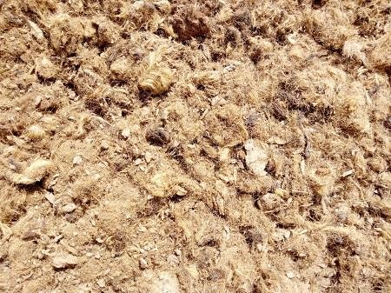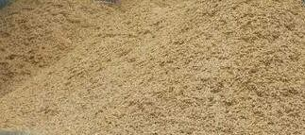

**Plate Ia:** Tannery waste (TW) **Plate Ib:** Sawdust (SD)

The composting processes were carried out in a 20 litres capacity plastic container (Vich *et al.*, 2017), mixed together and was put in different ratios. The samples (tannery waste and sawdust) were weighed using weighing `balance (Amput Electronic Scale, Model 5000G 5Kg 0.1G Digital) separately before mixing. The experiment was small

scale composting which was laid out in double replications. The treatment comprised five levels of tannery waste with sawdust mixed together. The tannery waste with sawdust was mixed in the following ratios: TW/SD 1:1, 1:5, 5:1, 1:10 and 10:1 respectively. One kilogram (1.0Kg) of tannery waste was mixed with 1.0Kg of sawdust in the ratio of 1:1 (TW/SD). Sample of 0.4Kg of tannery waste was mixed with 2.0Kg of sawdust in the ratio of 1:5 (TW/SD 1:5). Also 0.4Kg of sawdust was mixed with 2.0Kg of tannery waste in the ratio 5:1 (TW/SD 5:1). Sample of 4.0Kg of tannery waste was mixed with 0.4Kg of sawdust in the ratio 10:1 (TW/SD 10:1), in reverse of the mixture 4.0Kg of sawdust was mixed with 0.4Kg of tannery qwaste in the ratio 1:10 (TW/SD). The composting mixture was prepared for each treatment and was composted for 42 days in a 20 litres plastic bin following the method described by Zhou *et al*. (2014) and Vich *et al*. (2017). The bins were kept in a shade to keep away from adverse sunlight and rainfall (Plate II).

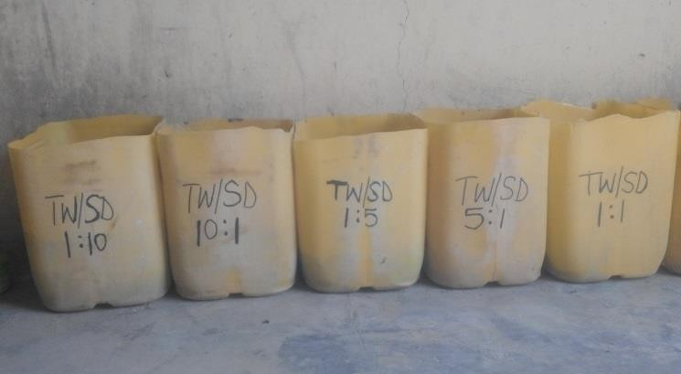

**Plate II:** Composting of tannery waste (TW)/sawdust (SD)

# Monitoring of the compost

The compost was turned manually every day for the attainment of aerobic condition throughout the six weeks of composting period and was moistened by the addition of water to retain moisture level of 50% and above according to Mehta and Sirari (2018).

# Sample collection during composting

Composted materials (TW/SD) were collected every week (at interval), for 42 days from different parts (top, centre and bottom) at intervals of ten centimeter (10cm) from one portion to another in the composting bin and mixed systematically for use in physicochemical and microbiological analysis (Ahmed *et al.*, 2007).

# Compost sampling and analysis

To assess the numerous biological, chemical and physical changes of the compost, samples were collected from distinct portions of the composting mixture of each ratio. Samples in polythene bags were sealed and transported to the Central Services

Laboratory of the National Cereals Research Institute, Badeggi, Niger State, Nigeria, for physicochemical analysis as described in Section 3.4 of the present study.

Microbiological analysis was performed within the Department of Microbiology, Federal University of Technology, Minna, Niger State, Nigeria following standard methods as stated in Sections 3.2 of the present study.

# Determination of Qualities of Compost Produced

The chemical and physical parameters of compost were determined with emphasis on the parameters such as nitrogen, pH, organic carbon, moisture content, carbon to nitrogen ratio (C:N), phosphorus, potassium, electrical conductivity and organic matter (as in section 3.4) as described by Ameen *et al.* (2016). Heavy metal analysis was also conducted. Other qualities are the physical parameters of the compost which include: appearance, colour and odour, were used to validate the maturity and stability of the compost manure produced (Hammed, 2015).

# Field Studies

The effectiveness of the organic manure produced was tested in a field study conducted at the biological garden of the Department of Biological Sciences, Federal University of Technology, Minna, Niger State, Nigeria.

# Description of experimental site

Minna is the capital of Niger State of Nigeria, and is densely populated having land area of roughly 6,784 square kilometres. The capital lies on latitude DMS: 9 o 35’ 0.8”N and longitude DMS: 6o 32’ 46.74”E or 9.583555 and 6.546316 respectively. It lies in the middle belt of Nigeria and falls within the temperature humid which tallies with the Guinea savannah region and Tropical hinterland of the nation (Simmon *et al*., 2018). The town is characterized by warm and dry climate, daily average humidity at 44.4%, and has yearly rainfall of 1334 mm averagely. The wet season commences on the average in April and last till October. The utmost mean monthly rainfall is in September with roughly 300mm; temperature rarely drops less than 22 oC, and the highest above 40 oC in February/March, and 35 oC within the months of November and December (Simmon *et al*., 2018).

# Collection of maize and test for viability

The maize variety used was Open Pollinated Variety (OPV) Seed SUWAN-1-R from Premier Seed Nigeria Limited obtained from Agro-chemical dealer store at Tudun Fulani, Minna, Niger State, Nigeria. The viability test was based on seed germination. This was performed by arranging maize grains on a damp towel. The towel was doubled over to maintain moisture, one of the conditions for germination. It was kept in a warm environment and the seeds were monitored daily for germination to occur in three days (Ezeagu *et al*., 2017b).

# Experimental plot preparation and sowing of maize

The experimental plot (7.7m × 3.3m) was located at Biological Sciences Department Garden, Bosso Campus, Federal University of Technology, Minna, Niger State, Nigeria.

Ridges were raised using hoe at 0.4m length and at a distance of 0.65m between ridges on a plot size 0.96m × 0.41m respectively. The maize was hand sown (in August, 2019) by planting three seeds per hole of 5cm deep at a gap of 25cm separately as described by Law-Ogbomo *et al*. (2012).

# Seed germination and germination potential

After 3 days the seeds were observed for emergence. Germination refers to the projection of a shoot or root from the seed testa (coat), while emergence is the visible penetration of the shoot above the soil surface (Kader, 2005). Germination potential was the index used to calculate the germination uniformity and seed germination rate. Germination potential is given by using equation 3.5 (Liu *et al*., 2015):

(3.5)

# Application of compost manure and fertilizers

Compost manure was applied by mixing with the soil before planting (Tanimu *et al*., 2013). The inorganic fertilizer that was used as positive control (NPK: 20:10:10), was applied two weeks after planting (WAP) by placing the fertilizer around the maize 5cm and was buried as described by Olowoboko *et al*. (2017). Another control Amazing organic fertilizer (commercial fertilizer) was also applied to the maize plants two weeks after planting. The fertilizers (NPK 20:10:10 and Amazing organic fertilizer) were also applied four weeks and eight weeks after planting along with the compost produced respectively.

# Monitoring of plant growth parameters

The maize plants were reduced (thinned) from three to two plants each stance a week after planting. Manual weeding was applied throughout the experiment set up as described by Ebrahimi *et al*. (2019). The growth vigour rate was determined by taking the measurement of six (6) maize plants for each row every two weeks and average reading was recorded (Olowoake *et al*., 2018). Plant height was measured as the interval from the bottom of the plant to the height of the first tassel branch and ear height as the interval to the node holding the higher ear (Hammed, 2015). This was achieved through direct observation method (DOM) using a meter rule as reported by Usman *et al*. (2013). Leaf length was determined by hand to the nearest centimeter from the leaf apex to the part at which the lamina was fused to the petiole as described by Ezeagu *et al.* (2017b). The agronomic data observed were plant height, leaf length and stem girth (recorded in centimeter) using metric rule and crop yield by weighing scale (in kilogramme).

# Statistical Analysis

Data acquired from the laboratory were analysed using simple descriptive statistics involving frequency and percentages while data collected from the field study were analyzed using one-way analysis of variance (ANOVA) and Duncan’s test were applied to test the difference between mean values obtained among the treatments at 5% level of significance using SPSS software (Version 21. IBM SPSS). Differences were considered significant at p< 0.05.

# CHAPTER FOUR

* 1. **RESULTS AND DISCUSSION**

# Results

* + 1. **Microbiological Properties of Tannery Wastes, Sawdust and Soil**

The counts for isolated microorganisms from tannery waste (TW), sawdust (SD) and soil (SL) are presented in Table 4.1. The bacterial counts in tannery waste (TW), sawdust (SD) and soil (SL) were 14.0 × 106 cfu/g, 18.4 × 106 cfu/g and 10.0 × 106 cfu/g respectively, whereas the fungal counts from tannery waste (TW), sawdust (SD) and soil (SL) were 1.1 × 104 cfu/g, 1.6 × 104 cfu/g and 6.0 × 104 cfu/g respectively.

# Table 4.1: Bacterial and fungal counts of tannery waste (TW), sawdust (SD) and soil (SL) used

|  |  |  |
| --- | --- | --- |
| Sample | Bacterial counts (cfu/g) | Fungal (molds and yeasts) counts  (cfu/g) |
| Tannery waste (TW) | 14.0 × 106 | 1.1 × 104 |
| Sawdust (SD) | 18.4 × 106 | 1.6 × 104 |
| Soil (SL) | 10.0 × 106 | 6.0 × 104 |

cfu/g: colony forming units per gramme

# Identity and frequency of occurrence of bacterial isolates

The cultural and biochemical characteristics of bacterial isolates from the tannery waste (TW), sawdust (SD) and soil (SL) respectively are presented in Table 4.2. The bacterial isolates identified include: *Bacillus subtilis, Enterococcus faecalis, Escherichia coli, Micrococcus luteus, Staphylococcus aureus, Pseudomonas aeruginosa, Proteus mirabilis* and *Streptococcus faecalis* (Table 4.2; Appendix A)*.*The isolates *Pseudomonas aeruginosa* (10.53%), *Bacillus subtilis* (8.77%) and *Bacillus subtilis* (10.53%) had high frequencies of occurrence in TW, SD and SL respectively, while *Proteus mirabilis* (1.75%), *Escherichia coli* (1.75%) and *Pseudomonas aeruginosa/Micrococcus luteus* had the least frequencies of occurrence in TW, SD, and SL, respectively (Table 4.3). Generally, *B. subtilis* were more frequently encountered (26.32%) followed by *P. aeruginosa* (19.29%) and *E. coli* (12.28%). It was observed

that *S. aureus* and *Enterococcus faecalis* had the least frequencies (3.51%) of occurrence (Table 4.3).

**Table 4.2: Cultural and biochemical characteristics of bacterial isolates from tannery waste (TW), sawdust (SD) and soil (SL)**

|  |  |  |  |  |  |  |  |  |  |  |  |  |  |  |  |  |  |  |
| --- | --- | --- | --- | --- | --- | --- | --- | --- | --- | --- | --- | --- | --- | --- | --- | --- | --- | --- |
| Sample code | Colonial morphology | Microscopy | Gram | Catalase | Coagulase | Urease | Indole | Citrate | Methyl Red | Voges Proskauer | Glucose | Lactose | Sucrose | Motility | H2S | Gas | Acid | Probable organism |
| TW1 | Colonies  yellow | Coccus | + | + | - | - | - | - | + | - | + | - | + | - | - | - | *+* | *Micrococcus luteus* |
| SL1 | Small glistening  and irregular | Rod | - | + | - | + | - | + | - | + | + | - | + | + | + | + |  | *Proteus mirabilis* |
| TW2 | Pink irregular, smooth,  entire | Rod | - | + | - | - | + | - | + | - | + | + | - | + | - | + | *-* | *Escherichia coli* |
| SL2 | Dry surface usually large,  irregular | Rod | + | + | - | - | - | + | - | + | + | - | - | - | - | + | *+* | *Bacillus subtilis* |

|  |  |  |  |  |  |  |  |  |  |  |  |  |  |  |  |  |  |  |
| --- | --- | --- | --- | --- | --- | --- | --- | --- | --- | --- | --- | --- | --- | --- | --- | --- | --- | --- |
| Sample code | Colonial morphology | Microscopy | Gram | Catalase | Coagulase | Urease | Indole | Cittrate | Methyl Red | Voges Proskauer | Glucose | Lactose | Sucrose | Motility | H2S | Gas | Acid | Probable organism |
| TW3 | Golden yellow, colonies  spherical | Cocci in cluster | + | + | + | - | - | + | + | - | + | + |  | + | + | + | *+* | *Staphylococcus aureus* |
| SD1 | Fuzzy white | Rod | + | - | - | - | - | + | - | + | + | + | + | + | - | + |  | *Bacillus subtilis* |
| SL3 | Smooth  white colonies | Cocci | + | - | - | - | - | - | - | + | + | + | + | - | - | - | *-* | *Streptococcus faecalis* |
| SL4 | Small,  spherical colonies | Cocci | + | - | - | - | - | - | - | + | + | + | + | - | - | - | *-* | *Enterococcus faecalis* |
| TW4 | Greenish  colouration | Rod | - | + | - | - | - | + | + | - | + | + | + | + | - | - |  | *Pseudomonas*  *aeroginesa* |
| SL5 | Brightly  yellow | Cocci | + | + | - | - | - | - | + | - | + | - | + | - | - | - |  | *Micrococcus luteus* |

Keys: TW: Tannery waste, SD: Sawdust, SL: Soil, +: Positive, - : Negative, H2S: Hydrogen sulphide

# Table 4.3: Frequency of occurrence of bacteria in tannery waste (TW), sawdust (SD) and soil (SL)

|  |  |  |  |  |
| --- | --- | --- | --- | --- |
| Bacteria | Tannery waste (TW) | Sawdust (SD) | Soil (SL) | Total |
| *Bacillus subtilis* | 4 (7.02) | 5 (8.77) | 6 (10.53) | 15 (26.32) |
| *Escherichia coli* | 4 (7.02) | 1 (1.75) | 2 (3.51) | 7 (12.28) |
| *Enterococcus faecalis* | 2 (3.51) | 0 (0.00) | 0 (0.00) | 2 (3.51) |
| *Micrococcus luteus* | 2 (3.51) | 3 (5.26) | 1 (1.75) | 6 (10.52) |
| *Staphylococcus aureus* | 2 (3.51) | 0 (0.00) | 0 (0.00) | 2 (3.51) |
| *Streptococcus faecalis* | 2 (3.51) | 5 (8.77) | 3 (5.26) | 10 (17.54) |
| *Pseudomonas aeruginosa* | 6 (10.53) | 4 (7.02) | 1 (1.75) | 11 (19.29) |
| *Proteus mirabilis* | 1 (1.75) | 3 (5.26) | 0 (0.00) | 4 (7.01) |
| Total | 23 (40.36) | 21 (36.83) | 13 (22.80) | 57 (100) |

Number in parenthesis is percentage (%) frequency of occurrence

# Identity and frequency of occurrence of fungi isolates

Table 4.4 and Table 4.5 show the moulds and yeasts respectively identified in tannery waste (TW), sawdust (SD) and soil (SL). The moulds were species of *Aspergillus, Paecilomyces, Fusarium, Mucor, Tricophyton* and *Rhizospus* (Table 4.4). The yeasts were species of *Candida* and *Saccharomyces* (Table 4.5). The frequencies of occurrence of fungi in tannery waste (TW), sawdust (SD) and soil (SL) are presented in Table 4.6. The frequency of occurrence of *Aspergillus niger* in tannery waste (TW), sawdust (SD) and soil (SL) were (7.94%), (7.94%) and (6.35%), while *Aspergillus flavus* had (4.76%), (6.35%) and (7.94%), and *Penicillium chrysogenum* had (3.17%), 4(6.35%) and 6(9.52%) respectively. The lowest frequency of occurrence was recorded with *Tricophyton rubrum* (1.59%) in tannery waste. Generally, *A. niger* had the uppermost frequency of occurrence (22.22%) trailed by *A. flavus* and *P. chrysogenum* with 19.05% respectively. The fungus *Tricophyton rubrum* had the lowest frequency of occurrence (1.59%) (Table 4.6). The yeasts, *Candida albicans* had a total frequency of 6.34%, while *Saccharomyces cerevisiae* had 9.52%. *S. cerevisiae* occurred in tannery waste (TW), sawdust (SD) and soil (SL), while *C. albicans* occurred in TW and SD only (Table 4.6).

# Table 4.4: Cultural and morphological characteristics of fungi isolates on Sabouraud dextrose agar from tannery waste (TW), sawdust (SD) and soil (SL)

|  |  |  |  |
| --- | --- | --- | --- |
| Isolate code | Cultural characteristics | Morphological characteristics | Probable organism |
| A- 1 TW  SL | The initial growth was white turning black, darkly pigmented colony; reverse turning white | Dark brown large globose conidial head, septate hyphae, hyaline smooth-walled conidiophores towards the vesicle. Conidial heads were biseriate. | *Aspergillus niger* |
| A- 2 SD TW SL | Growth was very rapid, maturing in three days. Surface yellow to green with a white border. Texture was often floccose, and whole was velvety to woolly. Pale yellowish reverse | Septate hyphae with fairly long conidiophores. Vesicles are spherical to elongate. Radial biseriate or entirely uniseriate. Conidia were globose to ellipsoidal with smooth to finely roughened walls. | *Aspergillus flavus* |
| A- 3 SL | Blue-green powdery and pale yellow on reverse | Short smooth-walled conidiophores and septate hyphae. Typical columnar uniseriate conidial heads and conidial shaped terminal vesicle. | *Aspergillus fumigatus* |
| A- 4 SL | Colonies developed fast and yellowish in colour to rust or light brown. The surface of the colony was powdery. Reverse was cream, pink, yellow or light brown. | Hyphae were hyaline and septate. Phialides were swollen at the bases, and occur in pairs, verticillate heads. Phialides were far spaced, and V shaped. | *Paecilomyces lilacinum* |
| A- 5 SL | Grew fast to produce off- white floccose (cottony) colonies with the aerial mycelia becoming tinged in purple. The reverse was pale to yellow. | Hyphae were septate. Conidiophores were slightly short and non-septate. The conidiophores were singly; possess microconidia, macroconidia and phialides. The fusiform macroconidia were curved (appeared sickle- shaped). | *Fusarium oxysporum* |

|  |  |  |  |
| --- | --- | --- | --- |
| A- 6 SL | Blue-green with while aerial colony and reverse was reddish brown | Septate hyphae. Branched conidiophores. Phaliades were in brush-like in spherical shapes. | *Penicillium notatum* |
| A- 7 SD SL | Blue-green, soft and smooth with slight white powder on the surface. Growth was moderately rapid and reverse was yellowish. | Hyphae septate, hyaline. Conidiophores were or branched. Phialides were in brush-like clusters at the ends of the conidiophores; conidia were unicellular, round and pigmented. | *Penicillium chrysogenum* |
| A- 8 TW | Colonies grew slowly and were white to buff, at first smooth, becoming fluffy. The reverse was pale. | Hyphae are hyaline and septate. The morphology of the various species varies, depending upon the growth of smooth‑walled macroconidia and microconidia. | *Trichophyton rubrum* |
| A- 9 SD SL | Colonies grew rapidly, filling the culture plate within a few days. White to grey cotton candy was first observed and subsequently colonies darken with time. Reverse was light to white. | The hyphae were broad, aseptate and ribbon‑like. Long sporangiophores, unbranched and with terminal, round sporangia. Sporangiospores were oval, and smooth walled. | *Mucor mucedo* |
| A- 10 SL SD | Colonies were cottony and grew rapidly turned yellow with age becoming grey to black. Reverse was white | Long sporangiosphores, no septa, sporangiosphores were unbranched, mycelia marked by many stolons | *Rhizopus microscopus* |
| A- 11 TW SD | Grew fast in culture, reaching maturity in as little as three days. Colonies were cream coloured, entire, smooth, raised and butyrous. | The cells appeared purple and oval in shape. | *Candida albicans* |
| A- 12 SD | Flat smooth, cream in colour and glistening | Unicellular, globose and budding hyphae were lacking | *Saccharomyces cerevisiae* |

**Table 4.5: Morphological, biochemical and physiological characteristics of yeast isolates from compost**

|  |  |  |  |  |  |  |  |  |
| --- | --- | --- | --- | --- | --- | --- | --- | --- |
| Isolates code | Shape of colony | Colour of colony | Gram reaction | Sugar fermentation Suc Glu Lac Fru Man Mal | Temperature tolerance (oC)  25 30 37 | Flocculation test | Growth at 10% ethanol | Probable organism |
| A- 11 | Spherical | Creamy | + | + + - + - + | + + + | - | + | *Saccharomyces cerevisiae* |
| A-12 | Small with budding cell | Cream | + | - + - - + + | + + + | + | - | *Candida albicans* |

Keys: Suc= Sucrose, Glu= Glucose, Lac= Lactose, Fruc= Fructose, Man= Mannose, Mal= Maltose, + =Positive, - = Negative

# Table 4.6: Frequency of occurrence of fungi in tannery waste (TW), sawdust (SD) and soil (SL)

|  |  |  |  |  |
| --- | --- | --- | --- | --- |
| Fungi | Tannery waste (TW) | Sawdust (SD) | Soil (SL) | Total |
| *Aspergillus niger* | 5 (7.94) | 5 (7.94) | 4 (6.35) | 14 (22.22) |
| *Aspergillus flavus* | 3 (4.76) | 4 (6.35) | 5 (7.94) | 12 (19.05) |
| *Aspergillus fumigatus* | 0 (0.00) | 0 (0.00) | 3 (4.76) | 3 (4.76) |
| *Tricophyton rubrum* | 1(1.59) | 0 (0.00) | 0 (0.00) | 1 (1.59) |
| *Saccharomyces cerevisiae* | 2 (3.17) | 3 (4.76) | 1 (1.59) | 6 (9.52) |
| *Candida albicans* | 2 (3.17) | 2 (3.17) | 0 (0.00) | 4 (6.34) |
| *Mucor mucedo* | 0 (0.00) | 1 (1.59) | 2 (3.17) | 3 (4.76) |
| *Rhizopus microsporus* | 0 (0.00) | 1 (1.59) | 2(3.17) | 3 (4.76) |
| *Penicillium chrysogenum* | 2 (3.17) | 4 (6.35) | 6 (9.52) | 12 (19.05) |
| *Penicillium notatum* | 1 (1.59) | 2 (3.17) | 2 (3.17) | 5 (7.94) |
| Total | 16 (25.40) | 22 (34.92) | 25 (39.68) | 63 (100) |

Number in parenthesis is percentage (%) frequency of occurrence

# Microbial counts during tannery waste/sawdust composting process

The bacterial counts recorded during tannery waste/sawdust (TW/SD) composting ranged from 54 × 106 cfu/g to 164 × 106 cfu/g for TW/SD 1:1, 52× 106 cfu/g to 180 × 106 cfu/g for TW/SD 1:5 over a period of 42 days (Appendix B). For TW/SD 5:1, TW/SD 1:10 and TW/SD 10:1, the bacterial counts ranged from 62 × 106 cfu/g to 160 × 106 cfu/g, 44 × 106 cfu/g to 140 × 106 cfu/g, and 32 × 106 cfu/g to 162 × 106 cfu/g respectively over the same period (Appendix B). Generally, it was observed that the bacterial counts increased within 7 days after which counts decreased gradually till the end of the composting process, that is, after 42 days (Fig. 4.1). TW/SD 1:5 supported the highest bacterial counts followed by TW/SD 5:1, TW/SD 10:1, TW/SD 1:1, and TW/SD 1:10 in that order (Fig. 4.1).

The fungal counts recorded during tannery waste/sawdust (TW/SD) composting ranged from 4 × 104 cfu/g to 36 × 104 cfu/g for TW/SD 1:1, 7× 104 cfu/g to 40 × 104 cfu/g for TW/SD 1:5 over a period of 42 days (Appendix C). For TW/SD 5:1, TW/SD 1:10 and TW/SD 10:1, the fungal counts ranged from 4 × 104 cfu/g to 20 × 104 cfu/g, 6 × 104 cfu/g to 24 × 104 cfu/g, and 2 × 104 cfu/g to 18 × 104 cfu/g respectively over the same period (Appendix C). Typically, it was observed that the fungal counts increased between 0 and 7 days after which counts decreased steadily till the end of the composting process that is after 42 days (Fig. 4.2). TW/SD 1:5 supported the highest fungal counts followed by TW/SD 1:1, TW/SD 1:10, TW/SD 5:1, and TW/SD 10:1, in that order (Fig. 4.2).

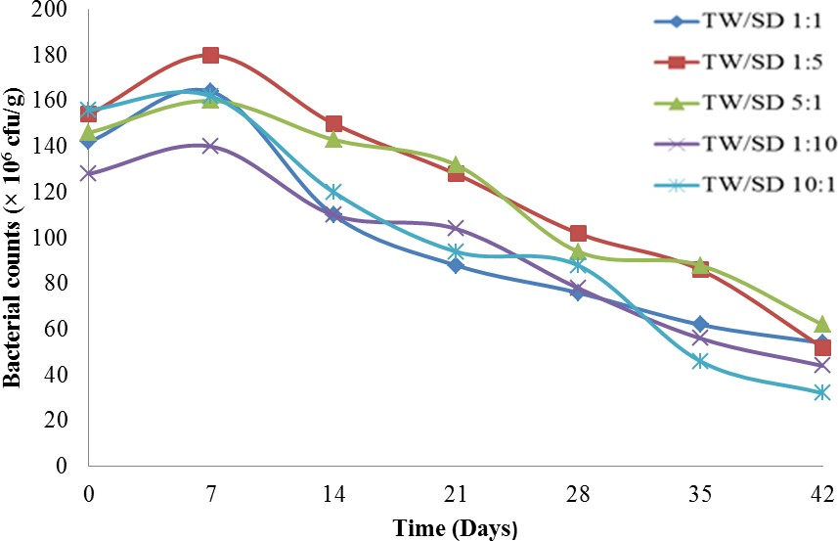

**Figure 4.1:** Bacterial counts during composting of tannery waste (TW) with sawdust (SD)

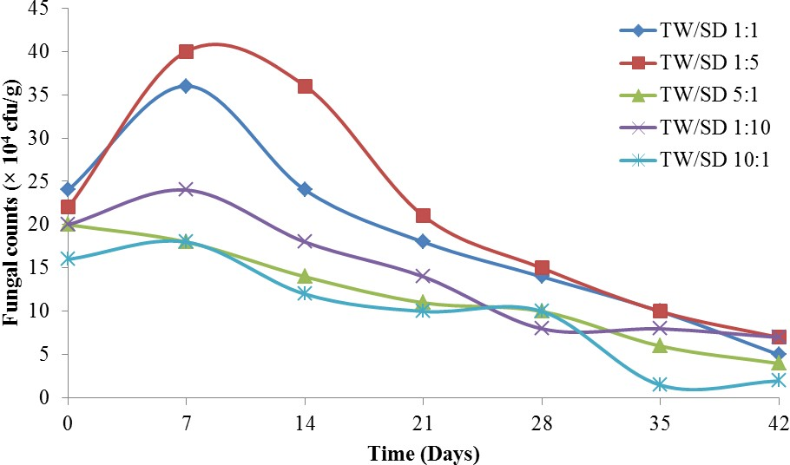

**Figure 4.2:** Fungal counts during composting of tannery waste (TW) with sawdust (SD)

# Microorganisms identified during tannery waste/sawdust composting

The microbial isolates identified during the composting periods are presented in Table

4.7. At the mesophilic temperature range (<40 oC) (0 – 7 days) the following bacterial species were identified: *Staphylococcus aureus, Bacillus subtilis, Micrococcus luteus, Pseudomonas aeruginosa, Proteus mirabilis* and *Streptococcus faecalis,* while the fungi species identified at this stage were: *Aspergillus niger, Aspergillus flavus, Penicillium chrysogenum, Saccharomyces cerevisiae* and *Candida albicans.* At the thermophilic temperature range (>40 oC) (14 days of composting), the following bacterial isolates were identified: *Bacillus subtilis*, *Pseudomonas aeruginosa, Micrococcus luteus* and *Staphylococcus aureus,* while the fungi species identified at this stage were *Aspergillus fumigatus* and *Aspergillus niger.* At the curing/maturing stage (about 35 days of composting process), few bacterial species were identified: *Pseudomonas aeroginosa* and *Bacillus subtilis.* The fungi species identified at this stage were *Aspergillus flavus, Aspergillus niger, Mucor mucedo, Fusarium oxysporum, Penicillium chrysogenum* and *Paecilomyces lilacinus* (Table 4.7)*.*

# Table 4.7: Microbial isolates identified at different stages of composting process

|  |  |  |
| --- | --- | --- |
| Stages of composting | Bacteria | Fungi (Moulds and Yeasts) |
| Mesophilic Temperature (<40 oC)  Thermophilic Temperature (>40 oC)  Curing/Maturing | *Staphylococcus aureus Bacillus subtilis Micrococcus luteus Proteus mirabilis Pseudomonas aeruginosa Streptococcus faecalis*  *Bacillus subtilis Micrococcus luteus Staphylococcus aureus Pseudomonas aeruginosa*  *Bacillus subtilis Pseudomonas aeruginosa* | *Aspergillus niger Aspergillus flavus Penicillium chrysogenum Mucor mucedo Saccharomyces cerevisiae Candida albicans*  *Aspergillus fumigatus Aspergillus niger*  *Aspergillus flavus Aspergillus niger Fusarium oxysporum Mucor mucedo Penicillium chrysogenum*  *Paecilomyces lilacinus* |

Keys: oC: Degree centigrade, <: less than, >: greater than

# Physicochemical properties of Tannery Waste (TW), Sawdust (SD) and Soil (SL)

The major physicochemical properties of the tannery waste (TW), sawdust (SD) and soil (SL) are presented in Table 4.8. The tannery waste (TW) was moderately alkaline (pH 7.92), with organic carbon (40%), nitrogen content of 0.87%, and a carbon to nitrogen ratio of 45.98. The sawdust (SD) was strongly acidic (pH 4.69), having organic carbon of 43%, total nitrogen of 0.76%, and a carbon to nitrogen ratio of 56.58. The results revealed that the soil had a pH of 5.9 which is moderately acidic, soil texture was sandy, with total organic carbon of 10.96%, low nitrogen content of (0.36%), humus content (1.96%), carbon to nitrogen ratio of the soil was 30.47, phosphorus content (4.20 mg/kg), and moisture of 15.20% (Table 4.8). Tannery waste and sawdust had high phosphorus contents of 31.00 mg/kg and 25.00 mg/kg respectively (Table 4.8).

# Table 4.8: Physicochemical properties of tannery waste (TW), sawdust (SD) and soil (SL) used

|  |  |  |  |
| --- | --- | --- | --- |
| Parameter | Tannery waste | Sawdust | Soil |
| pH | 7.92 | 4.69 | 5.90 |
| Colour | Dark brown | Brown | NA |
| Organic Carbon (%) | 40.00 | 43.00 | 10.96 |
| Total Nitrogen (%) | 0.87 | 0.76 | 0.36 |
| Carbon to Nitrogen (C:N) | 45.98 | 56.58 | 30.47 |
| Phosphorus (mg/kg) | 31.00 | 25.00 | 4.20 |
| Electrical conductivity (mS/cm) | 41.00 | 37.00 | 34.00 |
| Moisture (%)  Humus (%) | 6.08  NA | 9.50  NA | 15.20  1.96 |

NA: Not Available, Mg/kg: Milligramme per kilogram, mS/cm: Millisiemens per centimeter

* + 1. **Heavy Metal Contents of Tannery Waste (TW), Sawdust (SD) and Soil (SL)** Heavy metal analysis was conducted on the tannery waste (TW), sawdust (SD) and soil (SL) and the results (Table 4.9) revealed that tannery waste (TW) had the highest chromium content (1.149 mg/kg), while lowest was Cr content (0.332 mg/kg) was detected in the soil (SL). The Lead contents were high; the highest content was detected in the soil (SL) (2.653 mg/kg), while the least content was observed in tannery waste (1.046 mg/kg). The potassium content of the sawdust (SD) was higher (37.530 mg/kg) than that of the soil (0.101 mg/kg) and tannery waste (25.037 mg/kg). The magnesium content of the tannery waste (TW) was 26.372 mg/kg (highest), while the soil had the lowest value (2.550 mg/kg). Other heavy metals and their concentrations detected in the TW, SD and SL are presented in Table 4.8. The heavy metals were Zn, Hg, Cd, Fe and Cu. The concentrations of these metals in soil (SL) were higher than the concentrations observed in either TW or SD (Table 4.9).

# Table 4.9: Heavy metal content of the tannery waste (TW), sawdust (SD) and soil (SL)

|  |  |  |  |
| --- | --- | --- | --- |
| Heavy metal | Tannery waste (TW) | Sawdust (SD) | Soil (SL) |
| Chromium (Cr) mg/kg | 1.149 | 0.936 | 0.332 |
| Lead (Pb) mg/kg | 1.046 | 1.157 | 2.653 |
| Zinc (Zn) mg/kg | 2.052 | 2.264 | 15.409 |
| Mercury (Hg) mg/kg | 0.064 | 0.087 | 0.975 |
| Cadmium (Cd) mg/kg | 0.169 | 0.160 | 0.036 |
| Iron (Fe) mg/kg | 2.512 | 3.438 | 18.351 |
| Copper (Cu) mg/kg | 1.041 | 1.357 | 14.472 |
| Magnesium (Mg) mg/kg | 26.372 | 25.187 | 2.502 |
| Sodium (Na) mg/kg | 21.164 | 13.552 | 0.451 |
| Potassium (K) mg/kg | 25.037 | 37.530 | 0.108 |

Mg/kg: Milligramme per kilogramme

# Physicochemical properties of the compost

The physicochemical properties of the compost at the start of composting process (day zero) are presented in Appendix H7. The mean pH of the mixture ranged from 3.9±0.4 to 5.1±0.1 with the higher values recorded in TW/SD 1:10 (pH 5.1). The lowest mean pH was observed in TW/SD 5:1 (pH 3.9±0.4). The nitrogen content ranged from 0.71±0.02% to 2.3±0.1%, with TW/SD 10:1 having the highest nitrogen values of 2.3±0.1%. The least mean value (0.71±0.02 %) for nitrogen was observed in TW/SD 5:1. The organic carbon values mean ranged from 12.52±0.0% to 34.54±2.02%, with the highest value in TW/SD 10:1 (34.54±2.02%). The lowest value was recorded in TW/SD 1:1 (12.52±0.0%). The carbon to nitrogen ratio was highest in TW/SD 5:1 (42.56±0.64), while the lowest was observed in TW/SD 1:1 (13.45±0.99). The heavy metals content was also analyzed. Zinc ranged from 1.37±0.07 mg/kg to 2.26±0.0 mg/kg, with the highest in TW/SD 1:5 (2.26±0.0 mg/kg). The least value was observed with TW/SD 1:1 (1.37 mg/kg). Iron content ranged from 1.48±0.03 mg/kg to 2.79±0.43 mg/kg, with TW/SD 1:5 having the highest value (2.79±0.43mg/kg). The lowest value (1.48±0.03 mg/kg) was observed at TW/SD 1:1 (Appendix H7). Chromium (Cr), Cd, Pb and Hg were also detected in the samples but in much smaller quantities (Appendix H7).

Analysis of compost samples after 42 days revealed that the pH increased greatly in all treatments (Appendix H8) and ranged from 7.30±0.0 (TW/SD 1:1) to 8.05±0.05 (TW/SD 10:1). The total organic carbon (TOC) ranged from 14.84±0.2 to 24.33±0.33%, with TW/SD (10:1) having the highest TOC value of 24.33±0.33%. The least value (14.84±0.2%) was observed with TW/SD 1:10. The carbon to nitrogen (C:N) ratio of the compost ranged from 10.96±0.0 to 31.46±1.0, with TW/SD (1:5) having the highest

value of 31.46±1.0. The lowest value (10.96±0.0) for C:N was recorded with TW/SD (10:1). The lead (Pb) content of the compost ranged from 8.91±0.01 to 38.69±0.0 mg/kg, with TW/SD (5:1) having the highest Pb value of 38.69±0.0 mg/kg. The least value (8.91±0.01 mg/kg) for Pb was observed at TW/SD (10:1). The zinc (Zn) content ranged from 137.10±0.0 mg/kg to 471.0±1.00 mg/kg, with the highest value (471.0±1.00 mg/kg) at TW/SD (1:1), and the lowest value (8.91±0.01 mg/kg) was observed at TW/SD (1:10). The phosphorus (P) content ranged from 2.55±0.05 to 3.48±0.0%, while the potassium (K) content ranged from 0.961±0.0 to 2.956±0.04%, with TW/SD (1:1) having the highest potassium value of 2.956±0.04%. The lowest value (0.961±0.0%) for potassium was observed at TW/SD (1:5) (Appendix H8). Generally, it was observed that electrical conductivity, chromium and iron contents of the compost were lower (after 42 days) than the amount that were detected in the TW/SD mix (to form compost) at the start of the composting process.

# Temperature profile during composting of tannery waste (TW) with sawdust (SD)

The temperatures recorded during the composting period are presented in Figure 4.3. There were variations in temperature across the composting process. At the beginning of the composting process (zero day) temperature ranged from 33 oC to 34.3 oC, and increased sharply after 7 days to 39 – 58 oC for TW/SD 5:1 and TW/SD 1:10 (Fig. 4.3). As the composting process progressed, the temperature in all treatments decreased gradually till the end of composting after 42 days. At day 28 lower temperature (32 oC) were observed at TW/SD 5:1 and 1:10, while the highest temperature (38 oC) was recorded at TW/SD 10:1. At day 35, temperature of 30 oC was recorded in composted mixtures TW/SD (1:10 and 1:5 respectively). The temperature (34 oC) was observed at TW/SD (10:1). At the end of composting at day 42, TW/SD (10:1) had 31.4 oC, while TW/SD (1:1) had 30.5 oC (Fig. 4.3).

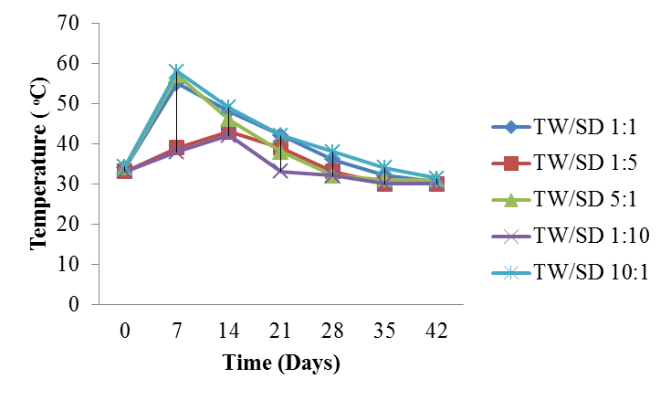

**Figure 4.3:** Temperature profile of tannery waste/sawdust (TW/SD) compost

# pH profile during composting of tannery waste (TW) with sawdust (SD)

The pH profile of the mixed TW/SD (1:1, 1:5, 5:1, 1:10 and 10:1) at different times of the composting process are presented in Figure 4.4. At start of the composting process (zero day), pH across the mixture were acidic and ranged from 3.9 to 5.1, with the highest pH value (5.1) observed at TW/SD 10:1, while the least pH value (3.9) was observed at TW/SD 5:1, and at ambient temperature. At day 7, the pH increased and ranged from 5.2 to 6.8. The higest pH value (6.8) was recorded at TW/SD 1:1, while the lowest value (5.2) was recorded at TW/SD 10:1. At day 14, the composted mixtures (TW/SD) were still acidic and ranged from 5.1 to 6.5, with the highest pH value (6.5) observed at TW/SD 1:1, while the least value (5.1) was at TW/SD 5:1. At day 21 the pH ranged from 6.2 to 6.9 with the highest pH (6.9) at TW/SD 1:1, while the lowest pH (6.2) was at TW/SD 10:1. As the composting progressed (day 28) the pH values ranged from slightly acidic (6.9) to alkaline (7.5) with the least value (6.9) recorded at TW/SD 1:5. The highest pH (7.5) was observed at TW/SD (5:1). At day 35, the pH of the composted mixtures ranged from 7 to 8.6, with the higher pH value (8.6) at TW/SD 5:1. At day 42, the highest pH (8.1) was observed at TW/SD 10:1, while the lowest pH (7.3) was at TW/SD 1:1 (Fig. 4.4).

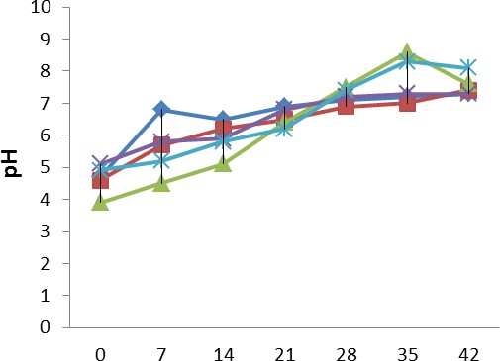

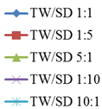

**Time(Days) Figure 4.4:** pH of tannery waste/sawdust compost

# Moisture content of the compost

The initial moisture content of the TW/SD (1:1, 1:5, 5:1, 1:10 and 10:1 respectively) compost ranged between 40% and 60% (Figure 4.5). The moisture content decreased slightly between 14 and 28 days in all treatments. However, at day 35, the moisture content increased slightly and reached 48, 45, 49, 50 and 47% at TW/SD 1:1, 1:5, 5:1,

1:10 and 10:1 respectively after day 42 (Fig. 4. 5).

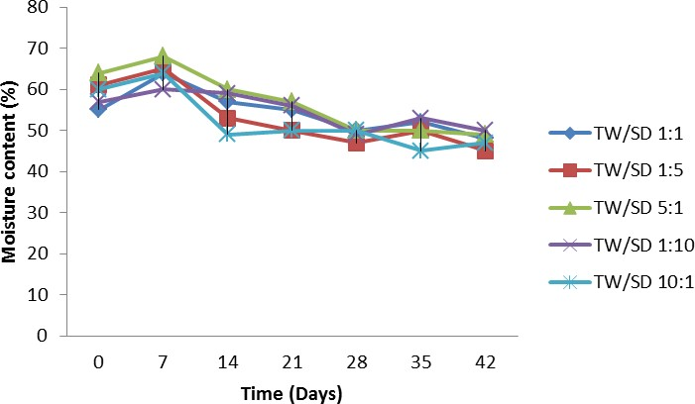

**Figure 4.5:** Moisture content of tannery waste/sawdust compost

# Efficacy of Compost in the Field

* + - 1. **The germination index (emergence percentage) of maize**

Table 4.10 shows the germination index (% emergence) of maize planted in soil amended with compost. The mean emergence ranged from 27.39±4.61 to 60.75±4.5%, 60.75±4.5% - 100±0.0%, and 94.59±2.89 – 100±0.0% for day 4, 5 and 6 respectively. Four days after cultivation of the maize seeds, TW/SD 5:1 and TW/SD 10:1 recorded 44.34±4.1% emergence, while TW/SD 1:1 recorded 27.78% emergence. At fifth (5) day of cultivation TW/SD 1:1 had 60.75±4.5% emergence, while TW/SD 1:10 recorded 100±0.0% emergence. After 6 days of cultivation of the maize seeds only TW/SD 5:1 recorded 94.46±2.11% emergence as compared to 100±0.0% in all other treatments including unfertilized soil (Table 4.10).

# Table 4.10: Germination index (% emergence) of maize planted in soil amended with compost

|  |  |  |  |
| --- | --- | --- | --- |
| Treatments | Day four (4) | Day five (5) | Day six (6) |
| TW/SD 1:1 | 27.39±4.61a | 60.75±4.5a | 100±0.0b |
| TW/SD 1:5 | 33.26±2.9b | 88.89±0.0e | 100±0.0b |
| TW/SD 5:1 | 44.34±4.1d | 72.22±2.0b | 94.4±2.11a |
| TW/SD 1:10 | 33.47±1.15b | 100±0.0g | 100±0.0b |
| TW/SD 10:1 | 44.36±2.11d | 94.59±2.89e | 100±0.0b |
| No manure | 27.39±3.14a | 81.84±2.26d | 100±0.0b |
| Amazing organic fertilizer (Commercial) | 38.51±3.62c | 94.4±3.05f | 100±0.0b |
| NPK fertilizer (20:10:10) | 61.11±1.11e | 77.57±2.57c | 100±0.0b |

Keys: TW: Tannery waste, SD: Sawdust, NPK: Nitrogen Phosphorus Potassium

Mean values represented by different letters along same column are significantly different from each other at p<0.05

# The effect of compost produced on the plant height

The effect of compost on maize plant heights is presented in Figure 4.6. Two (2) weeks after planting (WAP), plant heights were almost the same; the mean values ranged from 13.5±0.8 to 15.0±0.2 cm. The lowest mean value (13.5 ±0.8cm) was observed in maize plants raised with TW/SD 5:1, while the highest mean value (15.0±0.2cm) was recorded at TW/SD 10:1. At 4 WAP the heights ranged from 44.3±2.8 to 86.0±4.1cm, with the highest mean value (86.0±4.1cm) recorded at TW/SD 10:1. The lowest mean height (44.3±2.8cm) was at TW/SD (1:10). Six (6) and eight (8) weeks after planting, the maize plants from TW/SD 10:1 was significantly high in height with mean values of 123.6±6.5cm and 154±6.19cm respectively. Maize heights (100.0±7.8cm, 119.8±19.4cm and 121.5±9.2 cm) recorded at TW/SD 1:1 at 6, 8 and 10 WAP respectively, had remarkable growth compared to control and TW/SD 1:10. At 8 and 10 WAP lowest plant heights (66.5±6.5cm and 69.5±6.5cm respectively), were recorded at TW/SD 1:10, while the highest value (154.0±6.19cm and 155.8±5.6cm) were recorded at TW/SD 10:1 (Figure 4.6). At 8 WAP treated maize plants at TW/SD 1:1 were the first to produce tassels among the treatments.

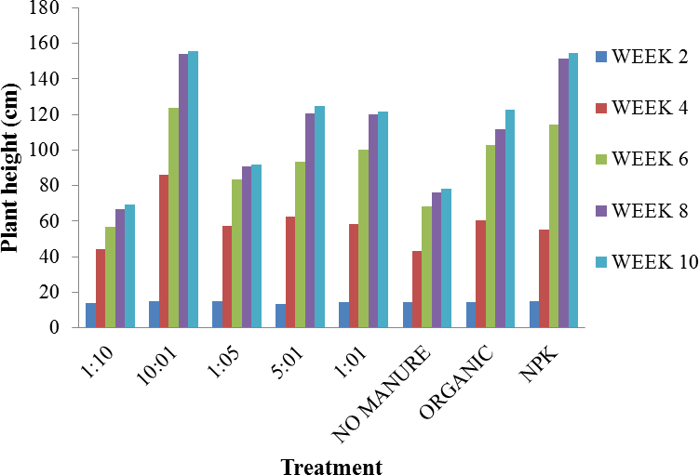

**Figure 4.6:** Effects of compost on plant height

# Effects of compost on leaf length

The effects of the compost (TW/SD 1:1, 1:5, 5:1, 1:10 and 10:1 respectively) on leaf length are presented in Figure 4.7. At 2 WAP the leaves were almost of equal length (5.8±0.1 - 6.5±0.1cm). The highest mean value for leaf length of 6.5±0.1cm was recorded at TW/SD 10:1, while the least value (5.8±0.1cm) was observed in plants raised with TW/SD (1:1). At 4 and 6 WAP the leaf lengths ranged from 37.0±1.9cm to 61.6±2.3cm and 51.3±4.0cm - 81.5±3.8cm respectively, with the highest leaf lenght (61.6±2.3cm and 81.5±3.8cm) observed at TW/SD 10:1, while the least leaf length, (37.0±1.9cm and 51.3±4.0cm respectively) were recorded at TW/SD 1:10. At 8 and 10 WAP the mean leaf lengths were (83.5±3.1cm and 83.5±3.10cm) higher at TW/SD 10:1, than other treatments while the least values (53.8±3.5cm and 54.8±3.2cm) were observed at TW/SD 1:10.

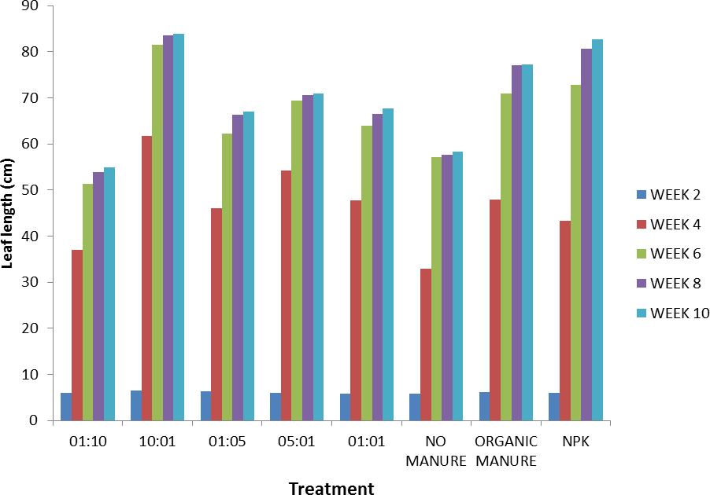

**Figure 4.7:** Effect of compost on leaf length

# The effect of compost on stem girth

The stem girths of the maize plants were recorded in centimeter (cm) across the treatments. At 2 weeks after planting (WAP) the stem girth were between 1.1±0cm cm and 1.2±0cm for all treatments (Fig. 4.8). At 4 and 6 WAP the stem girth ranged from 2.2.±0.1cm to 4.0±0cm and 2.8±0.2cm to 4.8±0cm respectively, with the highest stem girth (4.0±0cm and 4.8±0cm) recorded at TW/SD 10:1. The lowest stem girth were 2.2.±0.1cm and 2.8±0.2cm observed at TW/SD 1:10. At 8 and 10 WAP the stem girth of maize plants raised with TW/SD 1:10 had least values of 2.9±0.2cm and 3.0±0.2cm respectively, while highest stem girth of 4.8±0.1cm and 4.9±0.13cm respectively were observed at TW/SD 10:1.

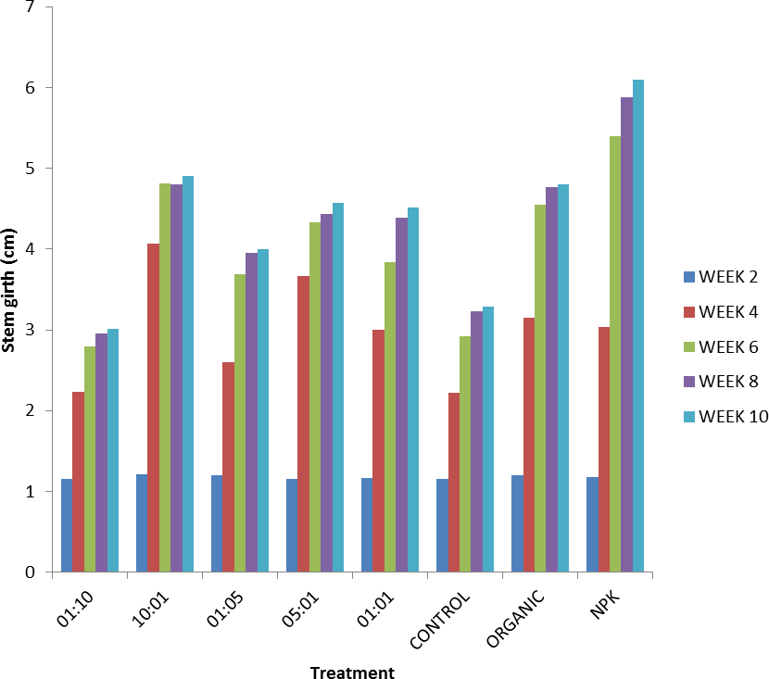

**Figure 4.8:** Effects of compost on stem girth

# Effect of compost produced on maize yield

Maize plants raised with the compost TW/SD (1:1, 1:5, 5:1, 1:10 and 10:1 respectively) had yield. The yield from the compost TW/SD 1:1 was 1.5±0.01kg, followed by TW/SD 1:5 with 1.4±0.05kg, while TW/SD (10:1) recorded 1.3±0.01kg. Maize plants raised with TW/SD 1:5 had a yield of 0.7±0.0kg, and the least was observed in TW/SD 1:10 with 0.4±0.05kg (Table 4.11).

# Table 4.11: Yield of maize planted in soil amended with compost produced

|  |  |
| --- | --- |
| Treatments | Yield of maize (Kg) |
| TW/SD 1:1 | 1.5±0.1bc |
| TW/SD 1:5 | 0.7±0.0a |
| TW/SD 5:1 | 1.4±0.05bc |
| TW/SD 1:10 | 0.4±0.05a |
| TW/SD 10:1 | 1.3±0.1b |
| No manure | 0.5±0.03a |
| Amazing organic fertilizer (Commercial) | 1.2±0.0b |
| NPK fertilizer (20:10:10) | 1.8±0.3c |

Mean values represented by different letters along same column are significantly different from each other at p<0.05

# Discussion

The bacterial counts in tannery waste (TW), sawdust (SD) and soil (SL) were in the range 10.0 × 106 cfu/g to 18.4 × 106 cfu/g respectively, while the fungal counts ranged from 1.1 × 104 cfu/g - 6.0 × 104 cfu/g respectively. Many researchers have reported the microbial counts of tannery wastes, sawdust and soil. Das *et al.* (2017) reported that the microbial load in tannery waste samples contained massive counts of bacteria and fungi in the average 108 cfu/g; higher bacterial and fungal counts for sawdust waste was similarly reported by Haseena *et al.* (2016) and Idu e*t al.* (2019). Emmanuel *et al.* (2017a) reported that the fungal counts of soil samples (20.0 x 103 cfu/g) and tannery effluent discharges comparatively higher in control land fill than those of tannery waste polluted landfill (5.6 x 103 cfu/g) and tannery waste effluent (4.6 x 103 cfu/ml). The higher microbial counts might be due to the available nutrients (carbon, nitrogen or energy) present in the wastes, which are required for proliferation and survival of microorganisms. Adebola *et al.* (2019) evaluated the microbial loads of the soil (from fadama, hydromorphic and uncultivated field) of National Cereal Research Institute rice field, Badeggi, Niger State, Nigeria; and found that some bacterial and fungal species were higher in hydromorphic and in uncultivated soil. Wani *et al.* (2018) reported that higher microbial counts were observed in forest soils and lower in agricultural soils of North western zone of Kashmir, possibly because of the fact that greater carbon source in the form of organic matter existed in the forest soils as compared to other land use systems.

The study showed that the isolated bacteria from the tannery waste were *Bacillus subtilis, Micrococcus luteus, Escherichia coli, Staphylococcus aureus, Streptococcus faecalis, Proteus mirabilis* and *Pseudomonas aeruginosa*, *w*hile the fungi (moulds and

yeasts) species isolated were *Aspergillus niger, Aspergillus flavus, Penicillium notatum, Penicillium chrysogenum, Trichophyton rubrum, Mucor mucedo, Rhizospus microsporum, Saccharomyces cerevisiae* and *Candida albicans*. Different studies have shown that tannery wastes habour common indigenous microorganisms present in the soil. These include: *Bacillus subtilis, Micrococcus luteus, Pseudomonas aeruginosa, Aspergillus niger* and *Penicillium chrysogenum* (Emmanuel *et al.*, 2017b; Mohammed *et al*., 2017; Adebola *et al*., 2019). Lennox *et al.* (2010) reported that these indigenous bacterial and fungal isolates played significant role in the degradation of sawdust. The microbial species such as *Bacillus, Pseudomonas, Aspergillus, Mucor, Saccharomyces,* have strong decomposing ability to solid wastes and use it for carbon and energy generation. The high levels of nitrogen and proteins available on animal skins might favour the growth of microorganisms. Emmanuel *et al*. (2017a) reported similar microbial population from dumpsites in Abakaliki Metropolis, Nigeria, with the strong biodegradation ability.

Soil is a common reservoir for microorganisms as saprophytes or pathogens. Similar, microbial isolates were observed in this study. Different microbial populations are maintained by soil thus the organisms play a vital function in ecosystem level processes such as, nutrient cycling as well as decomposition of organic matter (Wani *et al*., 2018). Akpomie (2013) observed *Saccharomyces cerevisiae* from tannery effluent sample. Gbolagunte and Silas (2016) also isolated *Aspergillus flavus, Aspergillus fumigatus, Aspergillus niger,* from landfills and tannery waste and most of these fungi are waste degraders. Similarly, Umar *et al.* (2017) reported the occurrence of similar bacterial isolates (*Bacillus subtilis, Proteus mirabilis, Pseudomonas aeruginosa* and *Streptococcus faecalis*) in tannery effluent. The detection of *Escherichia coli* in tannery

waste (TW) could be due to contact with faecal material, while *Staphylococcus aureus*

could be as a result of insanitary condition of the tanning surrounding/environment.

The frequency of occurrence of bacterial isolates revealed that *Bacillus subtilis* had (26.32%), *Pseudomonas aeruginosa* had (19.29%), *Streptococcus faecalis* (17.54%), and *E. coli* (12.28%). The bacteria, *Staphylococcus aureus* and *Enterococcus faecalis* had the lowest frequency of occurrence (3.51%) each (Table 4.4). This agrees with the results of Chukwuemeka *et al.* (2013) and Akinnibosun and Ayejuyoni (2015). These bacterial species (*Bacillus, E. coli, Streptococcus, Pseudomonas*) have been engaged in rapid decomposition organic and inorganic compounds, and use for growth (as sole source of carbon and energy). Mohammed *et al.* (2017) also reported higher occurrence of some bacterial species in tannery effluents, and these bacteria participate in the breakdown of organic and inorganic compounds. However, these results differed from the study of Adebola *et al.* (2019) who reported highest percentage frequency occurrence of *Micrococcus luteus* (24.99%), *P. aeruginosa* (23.79%), and the least percentage frequency of occurrence of *Staphylococcus aureus* (5.84%) and *Escherichia coli* (4.32%) in rice field soil. The difference in results might be attributed to high organic matter presence favouring their growth and proliferation.

The frequencies of occurrence of fungi in tannery waste (TW) (25.40%), sawdust (SD) (34.92%) and soil (SL) (39.68%) were high (Table 4.4). *Aspergillus niger* had (22.22%), followed by *Aspergillus flavus* and *Penicillium chrysogenum* (19.05%), while *Tricophyton rubrum* had the lowest frequency of occurrence (1.59%). Adebola *et al.* (2019) reported the percentage frequency occurrence of fungal species in rice field soils of Badeggi, Niger State, Nigeria, which include *Aspergillus niger* (24.28%), *Aspergillus flavus* (23.33%), *Mucor* sp. (4.47%), and attributed the highest frequency of *Aspergillus*

sp., to farming activities observed on the soils as well as the usage of fertilizers. Akpomie and Ejechi (2016) reported the occurrence of *Aspergillus niger* and *Penicillium chrysogenum* as the major isolates of tannery samples. Bello *et al.* (2020) observed the percentage occurrences of fungal species of *Aspergillus* and *Penicillium* with (20%), and (10%) respectively in soil polluted with tannery waste, whereas in an unpolluted soil fungal isolates obtained were *Aspergillus* (30%), *Fusarium* (10%), *Mucor* (10%), *Rhizopus* (10%) and *Penicillium* (10%). Microbes that possessed hydrolyzing activities tend to prevail.

The physicochemical characteristics of tannery waste (TW), sawdust (SD) and soil (SL) are shown in Table 4.7. The tannery waste pH (7.92) was alkaline in nature. The alkaline nature of the tannery waste was probably due the chemicals such as liming materials, bicarbonates, carbonates, hydroxides phosphates, sodium hydroxide, sodium hypochlorite, chlorides, and other compounds used in the different stages of tanning process. These agree with the findings of Mahdi *et al.* (2007); Parveen *et al.* (2017) and Framis, (2018) who reported that the tannery waste were strongly alkaline. The pH (4.69) of the sawdust was strongly acidic. Omosebi and Adekunle (2018) reported lower pH (4.36, acidic) for sawdust. The acidity might be due to the type of tree species used. Ikenyiri *et al.* (2019) reported the pH values variations of some wood sawdust; soft wood (5.29 - 5.48, strongly acidic), hard wood (5.75 - 6.18, moderately acidic) and that the variations in pH values depend on wood species. The soil pH obtained in this study was 5.9. The result is in agreement with Ezeagu *et al.* (2017b) who found the pH of the soil of the Federal University of Technology Minna, Niger State, Nigeria to be 5.93. Abdulhamid *et al.* (2015) also reported the pH values of some soil samples in Minna, analyzed from seven different farms to range from 5.77 to 7.70, and that the soil pH was

normal for plant growth. The pH range of the three samples used in this study was within the ideal values for the growth of bacteria (6 – 7.5) and fungi (5.5 - 8.0) (Ahmed *et al*., 2007; Mehta and Sirari, 2018).

The organic carbon (40%), total nitrogen (0.87%), C:N ratio (45.98), and potassium contents (25.037%), of tannery wastes used in this study (Table 4.7) were high. Owing to the high organic carbon as well as high nitrogen contents, tannery wastes are a suitable source of plant nitrogen (Nabavinia *et al.*, 2015). Jeyapandiyan *et al.* (2017) reported the results of the physicochemical characterization of the semi-finished tannery sludge to be pH (7.94), organic carbon (22.5%), total nitrogen (0.44%), C:N ratio (51.13), potassium (0.22%) and phosphorus (0.12%) and attributed these contents to additives. These variations in results might be attributed to different samples being used, and coupled to environmental factors. The high potassium might be attributed to ash added and vegetable tanning that the animal skins were exposed to during tanning process. Some other researchers reported lower results for potassium concentration in tannery waste with range from 0.02 to 2.6% (Ahmed *et al*., 2007; Nabavinia *et al.,* 2015).

The physicochemical properties of sawdust used in this study were organic carbon (43%), total nitrogen (0.76%), C:N ratio (56.58), and potassium (37.53%). The sawdust was rich in organic carbon content and had high carbon to nitrogen ratio as well as electrical conductivity. Similar results were reported by Mahdi *et al.* (2007) who conducted their work on the characterisation and composting of tannery sludge. The organic carbon of sawdust obtained in this study was 43%. Other researchers recorded organic carbon content for sawdust to be 54% (Nwankwo *et al.*, 2014; Ogunwande *et al*., 2014). The variations in organic carbon content could be due different plants species

that generated the sawdust. Abdulhamid *et al.* (2015) reported the electrical conductivity range of values 17 – 37 mS/cm for soil samples from farms in Minna. The carbon to nitrogen ratio (C:N) were in the range of 10.70 to 43.00, with the highest C:N of 43.00 recorded for sawdust (SD), and the least was observed in soil (SL). Dan *et al.* (2018) reported higher C:N ratio (499.64) for sawdust used in composting. Generally, sawdust has wide variations of C:N ratio depending on the wood species.

The total nitrogen content obtained in this study was soil (0.36%), sawdust (0.76%) and tannery waste (0.87%). Jeyapandiyan *et al.* (2017) reported the total nitrogen contents of some raw materials used in composting including coir pith (0.31%), raw sludge (0.44%) and poultry waste (3.21%). Nitrogen is the most vital nutrients for plants; it plays a significant role in ecosystem and is influenced by organic processes. Tannery wastes having high nitrogen content might supply utilizable nutrients to microorganisms for survival, growth and the capability for degradation. The tannery waste (TW) had high phosphorus content of 31.00mg/kg. Nabavinia *et al.* (2015) reported that collagens in tannery waste possessed enough phosphorus which could serve as good substitute for phosphorus fertilizer, which exhibited substantial outcomes for rice (*Oryza sativa* L.).

Heavy metal analysis revealed that tannery waste (TW) had the highest chromium content (1.149 mg/kg), while the lowest amount was detected in soil (SL) (0.332 mg/kg). Chromium is one of the chemicals used by tanners during tanning process. However, in large quantity, it is detrimental to living organisms. Parveen *et al.* (2017) reported that chromium (Cr) is toxic to living organisms owing to their bioaccumulation and non-biodegradable properties.

The Lead (Pb) contents were high; the highest content was detected in the soil (SL) (2.653 mg/kg), while the least amount was observed in tannery waste (1.046 mg/kg).

Generally, lead (Pb) in Minna soils is dispersed from industrial waste such as old paint, storage batteries, and plumbing hardware) dumped in and around agricultural lands, moved to farms by excess water (Ahaneku and Sadiq, 2014). Okoye and Iteyere (2014) attributed lead distribution to atmospheric deposition as well as weathering of minerals. The potassium content of the sawdust (SD) was higher than that of the soil and tannery waste, while the magnesium content of the tannery waste (TW) was higher than that of the soil. Ogbonna *et al.* (2012) observed high metal content such as potassium (39.36 mg/kg) and magnesium (32.41 mg/kg) from Utisoils in Port Harcourt, Nigeria.

Other heavy metals and their concentrations detected in the TW, SD and SL are presented in Table 4.8. The heavy metals were Zn, Hg, Cd, Fe and Cu. The concentrations of these metals in soil (SL) were higher than those observed in either TW or SD (Table 4.8). Amadi *et al.* (2017) reported that a high level of zinc in the soil could impede the uptake of copper, which is a microelement for plants utilization. In addition, too much concentration of zinc in soil can cause phytotoxic effect on germinating seeds. Iyaka and Kakulu (2009) studied the heavy metal content of soil samples from cultivated farmlands in Minna, Niger State, Nigeria and found higher concentration of copper (Cu) above 12.0mg/kg, and the zinc contents varied from 2.8ppm to 41ppm which is lower. Both copper and zinc are trace elements required by living organisms in less quantity. However, higher concentration in the soil might cause contamination and thus affect plants growth. The high Cu, Zn and Fe contents obtained in this study might be due to the use of agrochemicals. In general, the concentration of heavy metals in Niger State soils varied with the location. Abdulhamid *et al*. (2015) reported the average concentrations of metals in some farms soil in Minna as follows: Cd (0.76 mg/kg), Cu (23.60 mg/kg), Fe (2065.90 mg/kg).

Microbiological properties of the compost have been studied. The common mesophilic microbial species identified in the mesophilic stage were *Bacillus subtilis, Pseudomonas aeruginosa, Aspergillus niger, Mucor mucedo* and *Penicillium chrysogenum* The most dominant species identified in this study were the most probable compost microbes reported by different researchers. This finding is in agreement with Mehta and Sirari (2018) who reported the occurrence of such microbes during mesophilic stage of composting (temperature between 20 and 40oC). Similarly, Chinakwe *et al.* (2019) reported microbial isolates such as *Bacillus, E. coli, Micrococcus, Proteus, Pseudomonas, Staphylococcus, Streptococcus, Aspergillus, Candida albicans*, *Fusarium*, *Mucor*, *Rhizopus* and *Saccharomyces* species during composting of some organic wastes in greenhouse. Mesophilic microbes are known to be the most prevalent degraders of different organic waste materials, and their occurrence in the compost relied on the type of organic waste involved, pH and the temperature of the composting materials. Ezeagu *et al.* (2017b) also observed similar species of microbes in a study conducted on enhanced biodegradation of organic municipal solid wastes for organic fertilizer production.

Yeasts were also observed during the composting period probably due to the degradation role they played on the organic waste. This corroborates with the work of Ezeagu *et al.* (2017a) who also reported that the yeast *Saccharomyces cerevisiae* aided the waste degradation. Fungi are the major constituents of the microbial biomass, and their comparative significance varies greatly with the degradation of organic matter content of the composting mixture. In this study, the numbers of fungi isolates observed during the composting period were many with tannery waste to sawdust ratios (TW/SD 1:5 and TW/SD 1:10 each) samples were plentiful. This might be connected to the

presence of cellulose material and the acidity (pH) of the sawdust which favoured the heavy growth of fungi, as they like acidic growth medium. Ezeagu *et al.* (2017a) also observed that the fungi *Aspergillus niger* had the ability to degrade cellulose by enzymatic (cellulase) hydrolysis of sawdust.

The fungal counts were more at the initial days of composting (acidic condition) than towards the end of the process when the composted mixtures (TW/SD) turned alkaline. This result is in agreement with the report of Ezeagu *et al.* (2017a) who revealed that acidic pH value favoured the growth of moulds and yeasts. Fatunla *et al.* (2016) conducted microbial counts of the fresh mixture (sewage sludge/sawdust) which showed that bacterial and fungal counts were higher at the beginning of composting and the values significantly decreased after 40 days of in-vessel composting.

During the thermophilic stage of composting the occurrence of *Bacillus, Micrococcus, Pseudomonas, Staphylococcus* and *Aspergillus* were observed. Chinakwe *et al.* (2019) also reported similar microbes but with the exception *Staphylococcus.* The decline in microbial counts might be as a result of depletion of nutrients within the compost. It was observed that the numbers of *Aspergillus* species in this study were higher than the other mould isolates. This study corroborates with Haas *et al*. (2016) who also found the persistence of *Aspergillus* species within the compost during composting. This might be because thermophilic fungi grow and persevere during the rotting process due to generation of heat. In addition, Escobar and Solarte (2015) reported the domination of the genera *Aspergillus* and *Penicillium* associated with organic manure obtained by composting of agricultural waste.

The mould *Paecilomyces lilacinus* was isolated from the compost (TW/SD). The presence of *Paecilomyces lilacinus* in composted material is an indication that, with

further characterization and analysis, the composted TW/SD will not only serve as manure but could also do the work of bio-control agent for soil nematodes treatment. This study validated the findings of Ahmad *et al.* (2019) who also reported the isolation of *Paecilomyces lilacinus* from the faeces, manure and soil. Bhat *et al.* (2012) reported that the fungi *Paecilomyces lilacinus* (as potential bio-control agents) protects plant roots from pathogens (root knot nematodes), increased plant growth stimulation and leaf yield. Similarly, Aziz *et al.* (2018) reported that studies have shown successful nematode control by *Paecilomyces lilacinus.*

The temperature recorded during the composting process was not above 58oC, but fell within the range (> 55oC) stipulated for composts manure with rice husk by Ogunwande *et al*. (2014), who established that the ability to attain maturity quicker was by the rate of decrease of the carbon to nitrogen ratio. Verma *et al.* (2014) also reported the ideal temperature range for composting to be between 55 oC and 60 oC. The increase rate of biological disintegration of organic materials and the rate of temperature rise is attributed to microbial activity, and the rise in temperature was observed within a few days of making the compost. Mehta and Sirari (2018) reported that most pathogens die at 55 oC and above, but for the destruction of weed seeds temperature about 65 oC and above is required (Anwar *et al.*, 2015). Heat production arises from microbial activity; during the composting process there was an early increase in temperature, then declined and later stabilised as microbial action declined due to depletion of organic matter. After 42 days (six weeks), the temperature decreased entirely reaching room temperature levels. Furthermore, the period in which the composting took place was between June and July, 2019 during wet season when the outdoor temperature was not quite high which could be the reason higher temperature above 60 oC was not attained.

Subsequently, compost turning and moisture improvement caused no temperature rise which is an indication of compost maturity. The rise and fall in temperature could also be attributed to the size (quantity) of the mixture, the type of raw material used (especially the sawdust) and composting bin. Microbes with their metabolic activities within the composting material cause a rise in temperature as they decompose the materials (Verma *et al.*, 2014).

The composting process of TW/SD was achieved in 42 days (six weeks) and the qualities of the compost were good. Similar duration (42 days) was reported in the composting of palm kenel cake (PKC), goat manure and poultry droppings by Kolade *et al.* (2006). Zakarya *et al.* (2018) reported the composting of food waste with rice straw ash to maturity in 30 days. Physical characteristics of the resultant compost were compared to the minimum Nigerian standard that is required of matured compost (Hammed, 2015). These include pH (5.5 – 8.5), colour (dark brown to black) though variable, with pleasant earthly smell, free from non-biodegradable materials (glasses, plastics, metals, stones) (Appendix H1 – H6).

The pH profile obtained in the 42 days of composting TW/SD ranged from 7.30 to 8.05 (moderately alkaline). However, pH of matured compost relies on the types of raw material which was being used and decomposed. Too much nitrogen could trigger an increase in the pH level which is harmful to certain microorganisms. Various organic wastes used for composting had different ranges of pH. Ameen *et al.* (2016) suggested a range of pH from 6.9 to 8.3 at the end of composting. The pH obtained in this study, was compared with the Nigerian minimum quality standards for finished compost as well as Thailand, and California (Hammed, 2015), and the pH fell within the accepted quality standards for finished compost.

The total organic carbon of the matured compost ranged from 14.84% to 24.33%. These results are comparable with the objects reported by Khater (2015) who found the total organic carbon of compost in the range of 16.6 – 23.89%. The carbon to nitrogen ratio of the compost obtained in this study ranged from 10.96 to 31.46. Anwar *et al.* (2015) reported that different studies have revealed wide ranges of C:N ratio (14 - 40) for quality and maturity of compost.

Escobar and Solarte (2015) reported that the higher C:N ratio (>40), the microbes require sufficient time to disintegrate waste due to shortage of nitrogen declining composting activity, significant temperature rises can cause loss of nitrogen in ammonical form yielding low C:N ratio. Some of the characteristics observed in the finished compost include: pH (7.30 – 8.05), colour (dark to brown), pleasant earthly smell and absence of non-biodegradable materials such as glasses, stones, plastics. Compost maturity relied on many factors such as characteristics of primary wastes materials (C:N ratio, moisture, organic matter, pH and porosity) as well as process situations. Thus, the compost produced is of good quality. Lim *et al.* (2013) reported that the use of mature compost is of great significance because direct use of organic matters into the soil may generate toxins and threaten the environment. It was very difficult to ascertain which compost got matured before others, however based on temperature readings and C:N ratio, TW/SD 1:1 matured before TW/SD 5:1 and TW/SD 10:1, while TW/SD 1:5 and TW/SD 1:10 took a longer time to mature probably due to slow rate of decomposition. The slow rate of decomposition could be due to the high ratio of sawdust to tannery waste in the composting mixture. Lennox *et al.* (2019) reported that microbial degradation of sawdust was very difficult due to the presence of lignin, a highly recalcitrant constituent.

The phosphorus content in the compost ranged from 2.55 to 3.48% with TW/SD 10:1 having the highest phosphorus value of 3.48%, while the lowest value (2.55%) was observed at TW/SD 1:10. These results are different from the findings of Ezeagu *et al.* (2017a) where lower value for available phosphorus (0.9 - 2.48%) were obtained. These differences could be attributed to the initial waste material used during co-composting and the microbial mineralisation of the element. The potassium content of the compost ranged from 0.961 to 2.912% (Appendix H8). This is different from the findings of Mahdi *et al.* (2007) who reported the potassium content of tannery sludge to be 0.415

%. Potassium is an essential element required by plants. The slight differences in the elemental composition of the compost could be due to the ratio of the combined wastes (co-composted materials).

The lead (Pb) content of the compost ranged from 8.91±0.01 to 38.69±0.0 mg/kg, with TW/SD 5:1 having the highest Pb content of 38.69±0.0mg/kg. The least value (8.91±0.01mg/kg) for Pb was observed at TW/SD 10:1. Excessive Chromium (Cr) concentration in compost is one of the central elements that hamper its use due to bioaccumulation and toxicity ability of this metal. Tibu *et al*. (2019) reported the increased concentration of Cr, Cd, Zn, and Pb content in compost. The heavy metal concentrations in the compost produced were within the limit of Danish, Canadian Compost Quality standards and California quality standard for finished compost (Hammed, 2015) (Appendix H8). Excess Lead content in compost might affect seed germination (phytotoxicity), plant physiological growth and development. Lead is identified to encourage a wide range of toxic effects to living organisms (animals and plants), such as biochemical, morphological and physiological in origin (Pourrut *et al*., 2011).

The zinc (Zn) content ranged from 137.10±0.0 to 471.20±1.00mg/kg, the highest value (471.20±1.00mg/kg) was observed at TW/SD 1:1. The lowest value (137.10±0.0mg/kg) was observed at TW/SD 1:10. Dan *et al.* (2018) reported the trace metals of final compost of sludge and wood sawdust after 40 days as Zn (34.12±1.10mg/kg), Cr (0.38±0.0mg/kg), Cu (0.45±0.07mg/kg), and Cd (0.13mg/kg). Similarly, Jimoh and Sabo (2013) reported the heavy metal concentrations of municipal dumpsite compost as Cu (34.50 to 262.06mg/kg), Cr (30.76 to 107.68mg/kg), Fe (18.18 to 109.08mg/kg), Pb (13.80 to 62.07mg/kg), and Zn (52.18 to 547.82mg/kg). These differences may be due to differences in samples used during the composting period.

The resultant compost (TW/SD) produced were applied as treatment to maize plants. The ability of the maize seeds to germinate in all treatment showed that the compost TW/SD (1:1, 1:5, 5:1, 1:10 and 10:1 respectively) had no phytotoxic effects on the maize plants. Jeyapandiyan *et al.* (2017) and Tibu *et al.* (2019) have reported that compost displaying more than 80% germination index is free from phytotoxic compounds and maturity is satisfactory.

Compost TW/SD 10:1 supported good growth pattern. At two weeks after planting the plants height were almost the same in the different treatments (Figure 4.7). At four, six and eight weeks after planting, the maize plants had shown significant increase in height, stem girth and leaf length. During the growing period it was observed that, with this compost mix (TW/SD 10:1), the leaves were greenish with extensive leaf sizes. This suggests that the nutrient content of the compost (TW/SD 10:1) was being utilized by the plants for their growth. Organic manure has specific characteristics nature of slow release of nutrients (Makinde and Ayoola, 2010). For vegetable plants such as spinach, fluted pumpkin, sorrels, cabbage, salads, this particular ratio might be

recommended, since the leaves are of interest most. Olowoake *et al.* (2018) acknowledged that compost enriched crop yield by improving nutrients status and microbial action in the soil.

Maize plants treated with compost (TW/SD 1:1), supported good growth pattern as well as seed formation. This result is in agreement with Weerasinghe and De Silva (2017) who reported the use of compost made from municipal solid waste (MSW) to grow *Zea mays* (maize), and found that the best soil compost ratios that significantly improved the growth parameters of maize was 1:1 followed by 1:0.5. In addition, it was in this treatment (TW/SD 1:1), that tassels were produced eight weeks (56 days) after planting which resulted in the production of good seeds as well as yield. Khan (2015) reported that compost use heightens days to tasselling. This suggests that when this compost (TW/SD 1:1) is applied to cereals and legumes good harvest could be obtained, since the seeds are of interest.

Maize plants treated with compost (TW/SD 1:10) had poorest response on the plants, resulting in stunted growth with smaller leaf sizes as well as narrowest stem girth. The plants were the last to produce tassels which led to poorest cob formation/seeds and to some extent without seeds formed. This might be attributed to the ratio of sawdust being higher than the tannery waste used, coupled with the slow decomposition of sawdust, as longer period might have been required for complete disintegration and mineralisation. Lennox *et al.* (2019) reported that sawdust takes averagely 180 days to disintegrate or be incorporated into the soil due to lack of nitrogen. Moreover, sawdust is short in nitrogen when compared with other bulking agent such as straw, rice bran and leaves (Anwar *et al.,* 2015).

Maize plants treated with NPK fertilizer caused (p<0.05) significant increase in plant height with the tallest plant reaching 203cm, leaf length as well as stem girth. This might have been so because NPK fertilizer that was applied released its nutrients rapidly as against compost (TW/SD), which releases nutrients gradually and takes longer time for mineralization to occur. Makinde and Ayoola (2010) reported that inorganic fertilizers are branded to have uniqueness of fast discharge of their nutrient contents. Olowoboko *et al.* (2017) reported that maize plant requires sufficient supply of nutrients particularly the macro-elements (NPK) for optimal growth and yield. Controlled plot (No manure) had the lowest values for the plant qualities, probably due to lack of essential nutrients.

Maize yield were obtained 102 days after planting (i.e., 14 weeks and four days). The results of this study are within the range reported by Usman *et al*. (2013) who studied the weekly performances of maize plants through harvesting period of (106 days after planting) under sandy soil managed with different organic materials treatment. The mean yields of maize plants raised from the compost TW/SD 1:1 was 1.5±0.01kg, followed by TW/SD 1:5 with 1.4±0.05kg, while TW/SD (10:1) recorded 1.3±0.01kg. Maize plants raised with TW/SD 1:5 had a yield of 0.7±0.0kg, and the least was observed in TW/SD 1:10 with 0.4±0.05kg.

The results showed the better yield output under plot treated with compost TW/SD 1:1, followed by TW/SD 5:1, and then TW/SD 10:1. However, maize treated with compost TW/SD 1:10 had poorest yield when compared with no manure (control) plot. The yields differed significantly among the compost ratios as well as the controls (with or without fertilizer).

# CONCLUSIONS AND RECOMMENDATIONS

* 1. **Conclusions**

Microorganisms are diverse in nature and can be found in every environment. Their presence helps in the decomposition and recycling of organic matter faster. Tannery waste (TW), sawdust (SD) and soil (SL) harboured different microbial species including

*M. luteus, E. coli, S. aureus, B. subtilis, S. faecalis, E. faecalis, P. aeruginosa, P. mirabilis* (bacteria), and species of *Aspergillus, Paecilomyces, Fusarium, Mucor, Tricophyton, Rhizospus, Candida* and *Saccharomyces* (fungi)*.* The bacterial counts in TW, SD and SL ranged from 10.0 × 106 cfu/g to 18.4 × 106 cfu/g respectively, while the fungal counts ranged from 1.1 × 104 cfu/g to 6.0 × 104 cfu/g respectively.

The physicochemical study revealed high organic carbon (40 - 42%), potassium (25.03

– 37.53%), C:N ratio (45.98 – 56.58) in both tannery wastes and sawdust. Beside, TW had higher pH (7.92) and phosphorus (31.0mg/kg) and SD with pH 4.69 and phosphorus of 25.0 mg/kg.

The heavy metals detected in the TW, SD and SL were Cr, Pb, Mg, Zn, Hg, Cd, Fe, Na, P and Cu. The concentrations ranged from 0.064mg/kg to 26.372mg/kg in TW, 0.087 – 37.510mg/kg in SD and 0.036 – 18.35mg/kg in SL. SL contained higher amount of Zn (15.409mg/kg, Fe (18.351mg/kg) and Cu (14.472mg/kg) than when TW (2.052, 2.512 and 1.041mg/kg) or SD (2.264, 3.438 and 1.357mg/kg).

Some of the characteristics of the finished compost were: pH (7.30 to 8.05), colour (dark to brown), pleasant earthly smell and absence of non-biodegradable materials such as glasses. In addition the finished compost had total organic carbon of 14.84% to 24.33%, carbon to nitrogen ratio (10.96 to 31.46), phosphorus (2.55 to 3.48%), and

potassium (0.961 to 2.912%). Heavy metals were found to be within the permissible limit for mature and quality compost.

TW/SD 1:1 compost was more effective than all other composts, followed by TW/SD 10:1 when plant parameters such as height, leaf length, stem girth and yields were considered. Thus, the best compost ratio to improve the growth parameters of maize plants was TW/SD 1:1 followed by TW/SD 10:1. The compost TW/SD 1:10 showed negative effects on plant parameters such as height (stunted growth), leaves (burning of the leaves), stems (thinner) as well as yields (poor seed forms). Depending on the ratio of TW/SD compost used maize plants growth and yields were affected positively or negatively.

# Recommendations It is recommended that:

* + 1. Composting is a means of reducing organic waste materials from the environment. Unattended dumps of tannery waste and sawdust on the environment can generate pollution. Thus, by using the composting method these wastes can be recycled through bioconversion for agricultural use thereby reducing the huge wastes content from the environment.
    2. It is recommended that TW/SD 1:1 compost be used on maize plants for crop yield.
    3. Research should be directed towards improving the quality of the organic manure by using varying ratios in making TW/SD and other bulking agents.
    4. Microorganisms are important in organic waste, composting should be translated into slurry for enhanced composting, improved maturity and stability of compost.
    5. The process of composting of organic wastes should be encouraged as this will boost plant yield and create job (entrepreneur).

**REFERENCES**

Abiola, C., & Oyetayo, O. V. (2016). Isolation and Biochemical Characterization of Microorganisms Associated with the Fermentation of Kersting’s Groundnut (*Macrotyloma geocarpum*). *Reasearch Journal of Microbiology,* 11, 47-55.

Abdulhamid, Z., Agbaji, B. E., Gimba, C. E., & Agbaji, S. A. (2015) Physicochemical Parameters and Heavy Metals Content of Soil Samples from Farms in Minna. *International Letters of Chemistry, Physics and Astronomy,* 58, 154-163.

Adebola, M. O. Aremu, M. B., & Okafor, H. (2019). Microbial Load And Physico Chemical Properties Of Soil In National Cereal Research Institute Rice Field, Badeggi, Nigeria. *Benson Idahosa University Journal of Basic and Applied Sciences*, 4(1), 39 – 50.

Affiang, S. D., Ggamde, G., Okolo, V. N., Buba, M. A., & Pascallina, P. L. (2018). EnvironmentalEffects of the Main Constituents of Tannery Effluents (A Review). *American Journal of Engineering Research*, 7 (4), 210 - 214.

Agyarko-Mintah, E., Cowie, A., Zwieten, V. L., Singh, P. B., Smillie, R., Harden, S., & Fornasier, F. (2016). Biochar Lowers Ammonia Emission and Improves Nitrogen Retention in Poultry Litter Composting. *Journal of Waste Management*, 12, 1-9.

Ahaneku, E. I., & Sadiq, O. B. (2014). Assessment of Heavy Metals in Nigerian Agricultural Soils. *Polish Journal of Environmental Studies,* 23(4), 1091-1100.

Ahmad, Z. R., Sidi, B. B., Endrawati, D., Ekawasti, F., & Chaeran, B. (2019). *Paecilomyces lilacinus* and *P.variotii* as a Predator of Nematode and Trematode Eggs. *Earth and Environmental Science*, 299, 1-7.

Ahmed, M., Idris, A., & Omar, S. R. S. (2007). Physicochemical Characterization of Compost of the Industrial Tannery Sludge. *Journal of Engineering Science and Technology*, 2(1), 81-94.

Akhator, P., Obanor, A., & Ugeg, A. (2017). Nigerian Wood Waste: A Potential Resource for Economic Development. *Journal of Applied Science and EnvironmentalManagement*, 21(2), 246 – 251.

Akinnibosun, F. I., & Ayejuyoni, T. P. (2015). Assessment of Microbial Population and Physico-Chemical Properties of Abattoir Effluent-Contaminated Soils in Benin City, Nigeria. *Journal of Tropical Agriculture, Food, Environment and Extension*, 14(3), 1-6.

Akpomie, O. O. (2013). Optimization and Characterization of Indigenous Microorganisms Isolated from Tannery Effluents in Nigeria. *International Research Journal of Environment* Sciences, 2(10), 14-21.

Akpomie, O. O., & Ejechi, B. O. (2016) Bioremediation of Soil Contaminated with Tannery Effluent by Combined Treatment with Cow Dung and Microorganisms Isolated from Tannery Effluent. *Journal of Bioremediation and Biodegradation,* 7(4), 1-5.

Amadi, A. N., Ebieme, E. E., Musa, A., Olashinde, P. I., Ameh, I. M., & Shuaibu, A. M. (2017). Utility of Pollution Indices in Assessment of Soil Quality around Madaga Gold Mining Site, Niger State, North-Central Nigeria. *Ife Journal of Science,* 19 (2), 417 – 430.

Ameen, A., Ahmad, J., Munir, N., & Raza, S. (2016). Physical and Chemical Analysis of Compost to Check its Maturity and Stability. *European Journal of Pharmaceutical and Medical Research*, 3(5), 84 - 87.

Anwar, Z., Irshad, M., Fareed, I., & Saleem, A. (2015). Characterization and Recycling of Organic Waste after Co-composting: A Review. *Journal of Agricultural Science,* 7(4), 1-12.

Argun, A. Y., Karacali, A., Calisir, U., & Kilinc, N. (2017). Composting as a Waste Management Method. *Journal of International Environmental Application & Science,* 12(3), 244-255.

Ayilara, S. M., Olanrewaju, S. O., Babalola, O. O., & Odeyemi, O. (2020). Waste Management through Composting: Challenges and Potentials. *Sustainability*, 12 (4456), 1- 23.

Aziz, H. N., and Zainol, N. (2018). Isolation and Identification of Soil Fungi Isolates from Forest Soil for Flooded Soil Recovery. *IOP Conference Series: Materials Science andEngineering*, 342, 1-9.

Babasola, O. J., Olaoye, J. I., Alalade, A. O., Matanmi, M. B., & Olorunfemi O. D. (2017). Factors Affecting the Use of Organic Fertilizer among Vegetable Farmers in Kwara State, Nigeria. *Tanzania Journal of Agricultural Sciences*, 16 (1), 46-53.

Barnett, J. A., Payne, R. W., & Yarrow, D. (1990). *Yeasts: Characteristics and Identification*. 2nd Edition, Cambridge: Cambridge University Press.

Batham, M., Gupta, R.. & Tiwari, A. (2013). Implementation of Bulking Agents in Composting: A Review. *Journal of Bioremediation and Biodegradation,* 4(7), 1-3.

Bello, Y. A., Mohammed, D. S. S., & Ijah, U. J. J. (2020). Screening and Molecular Identification of Fungi Isolated from Soil with Potential for Bioremediation of Tannery Waste Polluted Soil. *Equity Journal of Science and Technology,* 7(1), 6-15.

Bhat, Y. M., Wani, A., & Fazal, M. (2012). Effect of *Paecilomyces lilacinus* and Plant Growth Promoting Rhizobacteria on *Meloidogyne incognita* Inoculated Black gram, *Vigna mungo* Plants. *Journal of Biopesticide,* 5(1), 36-43.

Bulus, H., Ezeh, E. C., Danladi, H., Igbehinadun, O. J., & Shekarri, T. B. (2018). Determination of Heavy Metals in Tannery Wastes. *International Journal of Agricultural and Biosystems Engineering*, 3(3), 78-81.

Buraimoh, M. O., Ilori, O. M., Amund, O. O., Michel Jr, C. F., & Grewal, K.S. (2015)**.** Assessment of Bacterial Degradation of Lignocellulosic Residues (sawdust) in a Tropical Estuarine Microcosm using Improvised Floating raft Equipment. *International Biodeterioration & Biodegradation*, 104, 186-193.

Cheesbrough, M. (2006). District Laboratory Practice in Tropical Countries, (Low price edition). The Press Syndicate of the University of Cambridge, pp. 64.

Chinakwe, C. E., Ibekwe, I. V., Ofoh, C. M., Nwogwugwu, U. N., Adeleye, A. S., Chinakwe, O. P., Nwachukwu, N. I., & Ihejirika, E. C. (2019). Effect of Temperature Changes on the Bacterial and Fungal Succession Patterns during Composting of Some Organic Wastes in Greenhouse. *Journal of Advances in Microbiology,* 15(1), 1-10.

Chukwuemeka, V. E., Ndukaku, Y. O., & Danielle, C. U. (2013). Microbiological and Physicochemical Assessment of Soil Contaminated with Lairage Effluent in Umuahia, Abia State, Nigeria. *Journal of Pharmacy and Biological Sciences,* 8 (2), 50*-*56.

Dan, E. U., Shuaibu, S. E., Fatunla, O.K., & Ekpo, V. F. (2018). Physicochemical Profile of Sludge – Wood Sawdust Compost. *Chemistry Research Journal*,3(4), 184-192.

Das, C. N., Hossaini, F., & Munshi, K. S. (2017). Influence of Tannery Wastes and the Surrounding Environment of Tannery Industries on Microbial Growth and Proliferation. *Stamford Journal of Microbiology*, 7 (1), 14-18.

Dinesh, R., Srinivasan. V., Ganeshamutrhry, A. N., & Hamza, S. (2012). *Effects of Organic Fertilizers on Biological Parameters Influencing Soil Quality and Productivity.* In: Organic Fertilizers (pp 1-290). Rajeev Pratap Singh. Nova Science Publishers, Inc. New York.

Ebrahimi, E., Asadi, G., & Niemsdorff, F. P. (2019). A Field Study on the Effect of Organic Soil Conditioners with Different Placements on Dry Matter and Yield of Tomato (*Lycopersicon esculentum* L.). *International Journal of Recycling of Organic Waste in Agriculture*, 8, 59-66.

Elnasikh, H. M., & Satti, A. A. (2017). Potentially of Organic Manures in Supporting Sustainable Agriculture in Sudan. *Environment and Natural Resources International Journal*, 2(1), 1-26.

Emmanuel, U., Ifeanyichukwu, I., Chika, E., Chike, O., & Chinyere, N. (2017a). Isolation and Characterization of Bacteria and Fungi Associated With Biodegradation of Municipal Solid Wastes in Abakaliki Metropolis, Nigeria.

*International Journal of Environment, Agriculture and Biotechnology*, 2 (3), 1294 – 1304.

Emmanuel, S. D., Gbolagunte, G. O., Okoduwa, S. I. R., Banjo, K., Sule, S. A., & Balarabe, B. M. (2017b). Characterization of Chromophile Fungal Isolates from Landfill Polluted By Tannery Effluent. *Journal of Biotechnology Research*, 3 (10), 75-84.

Escobar, N., & Solarte, V. (2015). Microbial Diversity Associated with Organic Fertilzer Obtained by Composting of Agricultural Waste. *International Journal of Bioscience, Biochemistry and Bioinformatics,* 5 (2), 70 – 79.

Ezeagu, G. G., Ijah, U. J. J., Abioye, O. P., & Dauda , B. E. N. (2017a). Activities of Locally Formulated and Commercial Effective Microorganisms in Composting of Organic Solid Wastes. *Journal of Advances of Microbiology*, 6 (3), 1 – 15.

Ezeagu, G. G., Ijah, U. J. J., Abioye, O. P., & Dauda , B. E. N. (2017b). Efficacy of Organic Fertilizers Produced Using Locally Formulated Effective Microorganisms on the Growth and Yield Responses on Maize. *Asian Journal of Biotechnology and Bioresources Technology*, 2 (1), 1 – 9.

Fasina, O. O. (2016). Comparative Analysis of the Use of Organic and Inorganic Fertilizers by Arable Crop Farmers in Ondo State, Nigeria. *Journal of Organics*, 3(1), 1 – 13.

Fatunla, K., Inam, E., Essien, J., Dan, E., Odon, A., Kang, S., & Semple, T. K. (2017). Influence of Composting and Thermal Processing on the Survival of Microbial Pathogens and Nutritional Status of Nigeria Sewage Sludge. *International Journal of Recycling Organic Waste Agriculture*, 6, 301–310.

Framis, P. C. (2018). *Assessment of Tannery Solid Waste Management A Case of Sheba Leather Industry* in Wukro (Ethiopia) (pp 1-92) Escola Tecnica Superiord’Enginyeria Industrial de Barcelona.

Garrity, G. M., Brenner, D. J., Krieg, N. R., & Staley, J. T. (2005). *Bergey’s Manual of Systematic Bacteriology*. 2nd Edition Springer, USA. PP. 323-359.

Gbolagunte, D. G., & Silas, D. E. (2016). Acclimatization Potential Isolated Fungi from Tannery Waste and Land fill to Various Chrome Concentrations. *American Journal of Research Communication*, 4(10), 10-18.

Gonda, A. (2015). Integrated Management of Composted Cattle Manure and Mineral Fertilizer for Improved Pearl Millet and Cowpea Yields under Strip Cropping Systemin Niger. PhD Thesis, Kwame Nkrumah University of Science and Technology, Kumasi, Ghana.

Gupta, P., Asthana, M., Kumar, A., & Barun, S. (2014). Physicochemical Analysis and Microbial Diversity of Yamuna Water and Industrial Effluents. *International Journal of Applied Sciences and Biotechnology,* 2(2), 199-205.

Haas, D., Lesch, S., Buzina, W., Galler, H., Gutschi, M. A., Habib, J., Pfeifer, B., Luxner, J., & Reinthaler, F. F. (2016). Culturable Fungi in Potting Soils and Compost. *Medical Mycology*, 54, 825–834.

Hammed, B. T. (2015). Effect of Nutrient-Rich Alternatives on Quality of Compost Made From Market Wastes. PhD Thesis University of Ibadan, Ibadan, Nigeria.

Hammed, B. T., Oloruntoba, O. E., & Ana, E. E. R. G. (2019). Enhancing Growth Yield of Crops with Nutrient-Enriched Organic Fertilizer at Wet and Dry Seasons in Ensuring Climate-smart Agriculture. *International Journal of Recycling of Organic Waste in Agriculture,* 8(1), 81- 92.

Haseena, A., Nishad, M. V., & Balasundaran, M. (2016). A Consortium of Thermophilic Microorganisms for Aerobic Composting. *Journal of Environmental Science, Toxicology and Food Technology*, 10 (1), 49-56.

Idu, E. G. Nwaubani, D. A., & Inyang, M. P. (2019). Isolation, Characterization and Identification of Bacteria Emanating from Sawdust Generated in Ahiake Saw mill, Umuahia,Abia State, Nigeria. *International Journal of Scientific & Engineering Research*, 10(6), 1547-1555.

Ijah, U. J. J. (2006). Solid Waste Management by Enhanced Composting: Opportunities and Challenges for Organic Farming in Nigeria. *Proceedings of the Fourth Annual National Conference of the Senate on the Nigerian Environment,* Port Harcourt, Nigeria, pp. 77 – 100.

Ikenyiri, P. N., Abowei, F. M. N., Ukpaka C. P., & Amadi, S. A. (2019). Characterization and Physicochemical Properties of Wood Sawdust in Niger area, Nigeria. *Chemistry International,* 5(3), 190-197.

Isa, B. K., & Jimoh, W. L. O. (2015). Assessment of Heavy Metals in Tannery Solid Waste from Challawa Industrial Estate, Kano State, Nigeria. *International Journal of Research and Environmental Studies*, 2, 33 – 40.

Iyaka, Y. A., & Kakulu, S. E. (2009). Copper and Zinc Contents in Urban Agricultural Soils of Niger State, Nigeria. *African Research Review*, 3 (3), 23-33.

Jeyapandiyan, N., Doraisamy, P., & Meheswari, M. (2017). Effect of Composting on Physicochemical Properties of Semi-Finished Tannery Sludge. *Advances in Research*, 12(2), 1-7.

Jimoh, W. L. O., and Sabo, Y. (2013). Evaluation of Physicochemical Properties and Heavy Metals Concentration in Municipal Dumpsite Compost in Kano Metropolis, Nigeria. *Chemical Search Journal*, 4(2), 26 – 30.

Kader, M. (2005). A Comparison of Seed Germination Calculation Formulae and the Associated Interpretation of Resulting Data. *Journal & Proceedings of the Royal Society of NewSouth Wales,* 138, 65-75.

Khan, A. A. (2015). Influence of Compost Application and Seed Rates on Production Potential of Late Sown Maize on High Elevation in Swat–Pakistan. *Journal of Environment and Earth Science*, 5(5), 36-40.

Khan, M. U., Chniti, S., Owaid, M.N., Hussain, M.B., & Shariati, M.A. (2018). An Overview on Properties and Internal Characteristics of Anaerobic Bioreactors of Food Waste. *Journal of Nutritional Health and Food Engineering,* 8(4), 319‒322.

Khater, E. S. G. (2015). Some Physical and Chemical Properties of Compost.

*International Journal of Waste Resources*, 5 (1), 1 – 5.

Kokhia, M. (2015). Composting: Advantages and Disadvantages. *Proceedings of the Institute* of *Zoology,* Ilia State University 3/5, K. Cholokashvili Ave.,0162, Tbilisi, Georgia 1 - 11.

Kolade, O. O., Coker, O. A., Sridhar, C. K. M., & Adeoye, O. G. (2006). Palm Kenel Waste Management through Composting and Crop Production. *Journal of EnvironmentalHealth Research*, 5(2), 81-85.

Law-Ogbomo, E. K., Osaigbovo, U. A., & Ekwueme, I. (2012). Agronomic Efficacy of Compost Manure and NPK Fertilizer on some Soil Chemical Properties and Maize Production in an Utisol Environment. *Journal of Applied and Natural Science,* 4(2), 172-177.

Lennox, J. A., Abriba, C., Alabi, N. B., & Akubuenyi, C. F. (2010). Comparative degradation of Sawdust by Microorganisms Isolated from it. *African Journal of Microbiology Research*, 4(17), 1804-1807.

Lennox, J. A., John, A. A., Godwin E., & Etim, B. T. (2019). Characterization of Products from Sawdust Biodegradation using Selected Microbial Culture Isolated from it. *African Journal of Biotechnology,* 18(29), 857-864.

Lim, Y. L., Chua, S. L., & Lee, T. C. (2013). Composting and Microbiological Additive Effects on Composting. *Environmental Science An Indian Journal*, 8(9), 333 343.

Liu, M., Li, M., Liu, K., & Sui, N. (2015). Effects of Drought Stress on Seed Germination and Seedling Growth of Different Maize Varieties. *Journal of Agricultural Science,* 7, 231 -240.

Macias‑Corral, M. A., Cueto‑Wong, J. A., Moran‑Martinez, J., & Reynoso‑Cuevas, L. (2019). Effect of Different initial C/N ratio of Cow Manure and Straw on Microbial Quality of Compost. *International Journal of Recycling of Organic Waste in Agriculture,* 8 (1), 357–365.

Mahdi, A., Azni, I., & Omar, S. R. S. (2007). Characterisation and Composting of Tannery Sludge. *Malaysian Journal of Soil Science*, 11, 71-80.

Makinde, E. A., & Ayoola, T. O. (2010). Growth, Yield and NPK Uptake by Maize with Complementary Organic and In organic Fertilizers. *African Journal of Food Agriculture Nutrition and Development*, 10 (3), 2203-2217.

Mansor, A. M., Lim, J. S., Ani, F. N., Hashim, H., & Ho, W. S. (2019). Characteristics of Cellulose, Hemicellulose and Lignin of MD2 Pineapple Biomass. *Chemical Engineering Transactions*, 72, 79-84.

Manyapu, V., Shukla, S., Kumar, S., & Rajendra, K. (2017). In-Vessel Composting: A Rapid Technology for Conversion of Biowaste into Compost. *Open Access International Journal of Science and Engineering*, 2(9), 58-63.

Marwanto, M., Wati, S. P., Romeida, A., Handajaningsih, M., Siswanto, U., Adiprasetyo, T., Murcitro, B.G. & Hidayat, H. (2020). Bio-fortified Compost as A Substitute for Chemical N Fertilizer for Growth, N Accumulation, and Yield of Sweet Corn. *Akta Agrosia*, 22(2), 84-94.

Mehta, M. C., & Sirari, K. (2018). Comparative Study of Aerobic and Anaerobic Composting for Better Understanding of Organic Waste Management: A Mini Review. *Plant Archives*, 18(1), 44-48.

Mengistu, T., Gebrekidan, H., Kibret, K., Woldetsadik, K., Shimelis, B., & Yadav, H. (2017). Comparative Effectiveness of Different Composting Methods on the Stabilization, Maturation and Sanitization of Municipal Organic Solid Wastes and Dried Faecal Sludge Mixtures. *Environmental System Research*, 6(5), 1-16.

Mohammed, S. S. D., Orukotan, A. A., & Abdullahi, H. (2017). Physicochemical and Bacterial Assessment of Tannery Effluent from Samaru-Zaria, Kaduna State, Nigeria. *Journal of Applied Science and Environment Management*, 21(4), 734

-740.

Murphy, J., & Riley, J. P. (1962). Method of Phosphorus Determination in soil samples.

*Analytical Chemistry Acta*, 2(27), 31-36.

Nabavinia, F., Emami, H., Astaraee, A., & Lakzian, A. (2015). Effect of Tannery Wastesand Biochar on Soil Chemical and Physicochemical Properties and Growth

Traits of Radish. *Internatinational Agrophysics.,* 29, 333 - 339.

Nwankwo, A. C., Edoho, S., & Mohammed, A. (2014). Recycling of Sawdust and Water Hyacinth into Compost. *International Journal of Engineering Science Invention*,

3(7), 72-76.

Ogbonna, N. D., Nnaemeka O., Isirimah, O. N., & Princewill, E. (2012). Effect of Organic`Waste Compost and Microbial Activity on the Growth of Maize in the Utisoils in Port Harcourt, Nigeria. *African Journal of Biotechnology,* 11 (62), 12546

- 12554.

Ogunwande, G. A., Ogunjimi, L.A. O., & Osunade, J. A. (2014). Fate of Compost Nutrients as Affected by Co-composting of Chicken and Swine Manures. *International Agrophysics*, 28, 177-184.

Okoye, C. O., & Iteyere, P. O. (2014). Physio-Chemical Characteristics of Warri River, DeltaState – Nigeria and Possible Implications. *International Journal of Engineering Research & Technology*, 3 (4), 795 – 802.

Olayide, O., Alene, A., Ikpi, A., & Nziguheba, G. (2009). Manure Marketing in the Savannas of Nigeria: Implications for Sustainable Food Security. *Journal of Food, Agriculture & Environment,* 7 (2), 540 - 545.

Olowoake, A. A., Osunlola, S. O., & Ojo, A. J. (2018). Influence of compost supplemented with Jatropha cake on Soil Fertility, Growth, and Yield of Maize (*Zea mays* L.) in a degraded Soil of Ilorin, Nigeria. *International Journal of Recycling of Organic Waste in Agriculture*, 7, 67–73.

Olowoboko, O. T., Onsanya, O. O., Salami, O. T., & Azeez, O.J. (2017). Growth and Uptakein Maize as Influenced by NPK Fertilizer in Green House Experiment. *International Journal of Plant & Soil Science*, 17(3), 1-10.

Omosebi, F. T., & Adekunle, V. A. J. (2018). Evaluation of the Nutrient Properties of Different Biodegradable Waste Composts and Sawdust. *Applied Tropical Agriculture,* 23 (1), 112 - 119.

Parveen, S., Bharose, R., & Singh, D. (2017). Assessment of Physico-Chemical Properties of Tannery Waste Water and Its Impact on Fresh Water Quality. *International Journal of Current Microbiology and Applied Sciences,* 6 (4), 1879-1887.

Pourrut, B., Shahid, M., Dumat, C., Winterton, P., & Pinelli, E. (2011). Lead Uptake, Toxicity and Detoxification in Plants. *Review of Environmental Contamination and Toxicology,* 213, 113 -136.

Rabah, A. B., & Ibrahim, L. M. (2010). Physico-Chemical and Microbiological Characterization of Soils Laden with Tannery Effluents in Sokoto, Nigeria. *Nigerian Journal of Basic and Applied Science*, 18(1), 65-71.

Santosh, N. C., Keerti, C., & Manju, S. (2018). Composting as an Eco-Friendly Method to Recycle Organic Waste. *Progress in Petrochemical Science,* 2(5), 252 – 254.

Sez-Plaza, P., Michaowski, T., Navas, J. M., Asuero, G. A., & Wybraniec, S. (2013) An Overview of the Kjeldahl Method of Nitrogen Determination. Part I. Early History, Chemistry of the Procedure, and Titrimetric Finish. *Critical Reviews in Analytical Chemistry*, 43 (4), 178 - 223.

Shah, A. F., Mahmood, Q., Shah, M. M., Pervez, A., & Asad, A. S. (2014). Microbial Ecology of Anaerobic Digesters: The Key Players of Anaerobiosis. *The Scientific World Journal*, 1-21.

Simmon, R. F., Duntoye, D. B., & Oyewole, K. (2018). The Effects of Urbanization on Micro- climate of Minna Urban Area. *Journal of Geography, Environment and Earth Science International*, 15(1), 1-13.

Sosnecka, A., Kacprzak, M., & Rorat, A. (2016). Vermicomposting As an Alternative Way of Biodegradable Waste Management for Small Municipalities. *Journal of Ecological Engineering,* 17(3), 91-96.

Sugasini, A., & Rajagopal, K. (2015). Characterization of Physicochemical Parameters and Heavy Metals Analysis of Tannery Effluent. *International Journal of Current Microbiology Applied Science*, 4(9), 349-359.

Tanimu, J., Uyovbisere, O. E., Lyocks, J. W. S., & Tanimu, Y. (2013). Effects of Cow Dung on the Growth and Development of Maize Crop. *Greener Journal of Agricultural Sciences,* 3(5), 371-383.

Tibu, C., Annang, Y. T., Solomon, N., & Yirenya‑Tawiah, D. (2019). Effect of the Composting Process on Physicochemical Properties and Concentration of Heavy Metals in Market Waste with Additive Materials in the Ga West Municipality, Ghana. *International Journal of Recycling of Organic Waste in Agriculture*, 8, 393 - 403.

Tijjani, M. B. (2014). Impact of Tannery Effluents on the Quality of Environmental Samples and Bioremediation Potentials of Microbial Isolates. A PhD Dissertation Submitted to the School of Postgraduate Studies, Ahmadu Bello University, Zaria, Nigeria.

Tinni, H. S., Islam, A. M., Fatima, K., & Ali, A. M. (2014). Impact of Tanneries Waste Disposal on Environment in Some Selected Areas of Dhaka City Corporation. *Journal of Environmental Science & Natural Resources,* 7(1), 149 –156.

Tiquia, S. M. (2005). Microbiological Parameters as Indicators of Compost Maturity. *Journal of Applied Microbiology*, 99, 816–828.

Tweib, A. S., Abd-Rahman, R., & Kalil, S. M. (2011). A Literature Review on the Composting. *International Conference on Environment and Industrial Innovation*, 12, 1- 4.

Ugya, A. Y., & Aziz, A. (2016). A Concise Review on the Effect of Tannery Wastewater onAquatic Fauna. *Merit Research Journal of Medicine and Medical Sciences,* 4(11), 476- 479.

Umar, M., Ibrahim, A. M., Mustapha, B. M., Mohammed, B. I., Tashi, T. U., Obafemi, A., & Ahmad, I. G. (2017). Physicochemical Analysis and Microbiological

Assessment of Tannery Effluent Discharged from Tanneries around Nigeria’s Kano industrial Estates. *Journal of Advances in Microbiology*, 2(1), 1-12.

Usha, B. (2018). Agriculture and the Dark Side of Chemical Fertilizers. *Environmental Analysis and Ecology Studies,* 3(1), 198 – 201.

Usman, S., & Kundiri, M. A. (2016). Values of Organic Materials as Fertilizers to Northern Nigerian Crop Production Systems. *Journal of Soil Science and Environmental Management*, 7(12), 204-211.

Usman, S., Maikai, M. A., Aminu, A., & Koko, S. I. (2013). Weekly Performance of Maize Plant under Sandy Soil Managed with Dissimilar Organic Materials. *Journal of Agriculture and Veterinary Science*, 2 (2), 43-53.

Van-der Wurff, A. W. G., Fuchs, J. G., Raviv, M., & Termorshuizen, A. J. (2016).

*Handbook for Composting and Compost Use in Organic Horticulture*, (pp 1

-108). BioGreenhouse COST Action FA.

Vaverková, M., Adamcová, D., & Klapsiová, V. (2014). Do The Degradable/Biodegradable Plastic Materials Decompose In Domestic Compost Bin? *Proceedings of Ecopole*, 8(1), 87-94.

Verma, P. J., & Verma, R. (2012). *Organic Fertilizers and Their Impact on Agricultural Production System.* In: Organic Fertilizers Editor: Rajeev Pratap Singh. (pp 234

-290). Nova Science Publishers, Inc.

Verma, R., Maurya, B. R., Meena, V. S., Regar, K. L., Jat, L. K., Madhuri, M., & Parvati, D. (2014). Studies on Temperature Fluctuation and Moisture Changes in Different Methods of Composting. *Trends in Biosciences*, 7(24), 4085-4089.

Vich, V. D., Miyamoto, P. H., Queiroz, M. L., & Zanta, M. V. (2017). Household Food Waste Composting using a Small-scale Composter. *Ambiente & Água – An Interdisciplinary Journal of Applied Science,*12 (5), 718 -729.

Walkley, A., & Black, I. A. (1934). Method of Total Organic Carbon Determination in Soil Samples. *Soil Science,* 37, 29-38.

Wani, S. F., Akhter, F., Mir, S., Baba, A. Z., Maqbool, S., Zargar, Y. M., & Un Nabi, S. (2018). Assessment of Soil Microbial Status under Different Land Use Systems in North Western Zone of Kashmir. *International Journal of Current Microbiology and Applied Sciences*, *7*(8), 266-279.

Watanabe, T. (2010). Pictorial Atlas of Soil and Seed Fungi: *Morphologies of Cultured Fungi and Key to Species*. CRC Press, Boca Raton, Florida, Pp. 35-189.

Weerasinghe, T. K., & De Silva I. H. W. K. (2017). Effect of Applying Different Ratios of Compost Made of Municipal Solid Waste on the Growth of *Zea mays* L. (Corn). *Journal of Soil Science and Environmental Management*, 8(3), 52-60.

Wijayawardena, M. A. A., Megharaj, M., & Naidu, R. (2016). "Exposure, Toxicity, Health Impacts and Bioavailability of Heavy Metal Mixtures", in D. L. Sparks, *Advances in Agronomy,* 138, 175–234.

Zaeni, A., Susilowati, P. E., Harlia,, O., & Rasmin, N. (2019). Anaerobic Digestion of Solid and Liquid Organic Waste with Microorganism from Manure. *Earth and EnvironmentalScience*, 299, 1 – 8.

Zakarya, I. A., Khalib, S. N. B., & Ramzi, M. N. (2018). Effect of pH, Temperature and Moisture Content during Composting of Rice Straw Burning at Different Temperature with Food Waste and Effective Microorganisms. E3S Web Conference, 34, 1 – 9.

Zhou, Y., Selvam, A., & Wong, J. W. C. (2014). Evaluation of Humic Substances during Co-composting of Food Waste, Sawdust and Chinese Medicinal Herbal Residues. *Bioresource Technology,* 168, 229-234.

# APPENDIX

**Appendix A: Summary of bacterial and fungi isolated from tannery waste (TW), sawdust (SD) and soil (SL)**

|  |  |  |
| --- | --- | --- |
| Sample | Bacteria | Fungi (Mold and Yeast) |
| Tannery waste (TW)  Sawdust (SD)  Soil (SL) | *Staphylococcus aureus Streptococcus faecalis Pseudomonas aeruginosa Bacillus subtilis Micrococcus luteus Proteus mirabilis Escherichia coli Enterococcus faecalis*  *Bacillus subtilis Micrococcus luteus Streptococcus faecalis Pseudomonas aeruginosa*  *Bacillus subtilis Pseudomonas aeruginosa Streptococcus faecalis Micrococcus luteus Proteus mirabilis*  *Escherichia coli* | *Aspergillus niger Aspergillus flavus Penicillium chrysogenum Tricophyton rubrum Saccharomyces cerevisiae Candida albicans*  *Aspergillus niger Aspergillus flavus Mucor mucedo*  *Penicillium chrysogenum Saccharomyces cerevisiae*  *Aspergillus flavus Aspergillus fumigatus Aspergillus niger Mucor mucedo*  *Penicillium chrysogenum*  *Rhizospus microsporus* |

# Appendix B: Bacterial counts (× 106 cfu/g) during co-composting of tannery waste (TW) with sawdust (SD)

|  |  |  |  |  |  |  |  |
| --- | --- | --- | --- | --- | --- | --- | --- |
| Treatment | 0 | 7 | 14 | Time (days)  21 | 28 | 35 | 42 |
| TW/SD 1:1 | 142±3.0a | 164±3.0ab | 110±0.0a | 88±8.0a | 76±4.0a | 62±2.0b | 54±4.0bc |
| TW/SD 1:5 | 154±1.0a | 180±0.0b | 150±5.0b | 128±8.0b | 102±1.0bc | 86±5.0c | 52±2.0bc |
| TW/SD 5:1 | 146±20.0a | 160±15ab | 143±1.0b | 132±7.0b | 94±6.0bc | 88±0.0c | 62±3.0c |
| TW/SD 1:10 | 128±2.0a | 140±0.0a | 110±8.0a | 104±0.0a | 78±5.0ab | 56±0.0bc | 44±1.0b |
| TW/SD 10:1 | 156±30.0a | 162±12.0ab | 120±8.0a | 94±4.0a | 88±4.0abc | 46±4.0a | 32±3.0a |

Mean values represented by different letters along same column are significantly different from each other at p<0.05

# Appendix C: Fungal counts (× 104 cfu/g) during co-composting of tannery waste (TW) with sawdust (SD)

|  |  |  |  |  |  |  |  |
| --- | --- | --- | --- | --- | --- | --- | --- |
| Treatment | 0 | 7 | 14 | Time (days)  21 | 28 | 35 | 42 |
| TW/SD 1:1 | 24±6.0a | 36±1.0a | 24±1.0b | 18±3.0a | 14±3.0 | 10±1.0a | 5±1.0b |
| TW/SD 1:5 | 22±2.0a | 40±11.0a | 36±3.0c | 21±8.0a | 15±1.0 | 10±2.0a | 7±2.0b |
| TW/SD 5:1 | 20±4.0a | 18±0.0a | 14±3.0a | 11±2.0a | 10±2.0 | 6±0.0a | 4±1.0b |
| TW/SD 1:10 | 20±7.0a | 24±11.0a | 18±1.0bc | 14±0.0a | 8±1.0 | 8±0.0a | 7±1.0b |
| TW/SD 10:1 | 16±4.0a | 18±1.0a | 12±2.0a | 10±2.0a | 10±3.0 | 1.5±1.5a | 2±1.0a |

Mean values represented by different letters along same column are significantly different from each other at p<0.05

# Appendix D: Temperature profile of tannery waste/sawdust (TW/SD) compost

|  |  |  |  |  |  |
| --- | --- | --- | --- | --- | --- |
| Time (days) | TW/SD 1:1 | TW/SD 1:5 | TW/SD 5:1 | TW/SD 1:10 | TW/SD 10:1 |
| 0 | 34 | 33 | 34 | 33 | 34.3 |
| 7 | 55 | 39 | 57 | 38 | 58 |
| 14 | 48 | 43 | 46 | 42 | 49 |
| 21 | 42 | 39 | 38 | 33 | 42 |
| 28 | 36 | 33 | 32 | 32 | 38 |
| 35 | 32 | 30 | 31 | 30 | 34 |
| 42 | 30.5 | 30 | 31 | 30 | 31.4 |

**Appendix E: pH of tannery waste/sawdust compost**

|  |  |  |  |  |  |
| --- | --- | --- | --- | --- | --- |
| Time days | TW/SD  (1:1) | TW/SD  (1:5) | TW/SD  (5:1) | TW/SD  (1:10) | TW/SD  (10:1) |
| 0 | 4.7 | 4.6 | 3.9 | 5.1 | 4.9 |
| 7 | 6.8 | 5.6 | 5.4 | 5.7 | 5.2 |
| 14 | 6.5 | 6.3 | 5.1 | 5.3 | 6.1 |
| 21 | 6.9 | 6.6 | 6.5 | 6.4 | 6.2 |
| 28 | 7.2 | 6.9 | 7.5 | 7.1 | 7.3 |
| 35 | 8.2 | 7.2 | 8.6 | 7.2 | 7.7 |
| 42 | 7.4 | 7.3 | 7.6 | 7.3 | 8.05 |

# Appendix F: Moisture content of tannery waste/sawdust (TW/SD) compost

|  |  |  |  |  |  |
| --- | --- | --- | --- | --- | --- |
| Time days | TW/SD  (1:1) | TW/SD  (1:5) | TW/SD  (5:1) | TW/SD  (1:10) | TW/SD  (10:1) |
| 0 | 55 | 61 | 64 | 57 | 60 |
| 7 | 64 | 65 | 68 | 60 | 64 |
| 14 | 57 | 53 | 60 | 59 | 49 |
| 21 | 55 | 50 | 57 | 56 | 50 |
| 28 | 50 | 47 | 50 | 49 | 50 |
| 35 | 52 | 50 | 50 | 53 | 45 |
| 42 | 48 | 45 | 49 | 50 | 47 |

**Appendix G: Fungal plates/isolates from the compost produced**

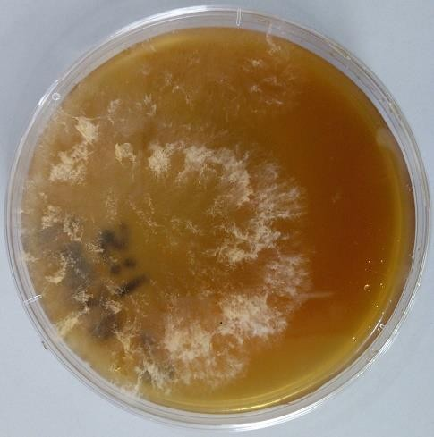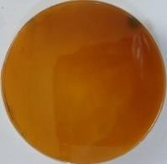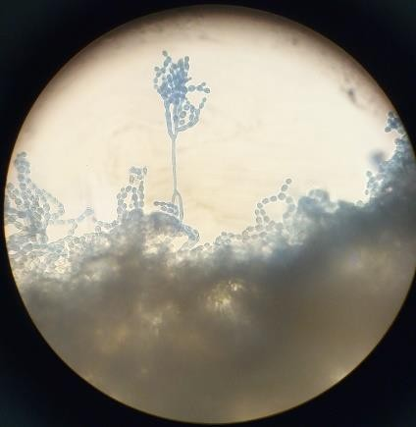

**1a:** *Paecilomyces lilacinus* **1b:** *Paecilomyces lilacinus* **1c:** *Paecilomyces lilacinus*

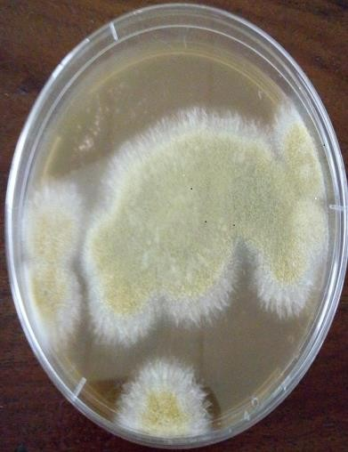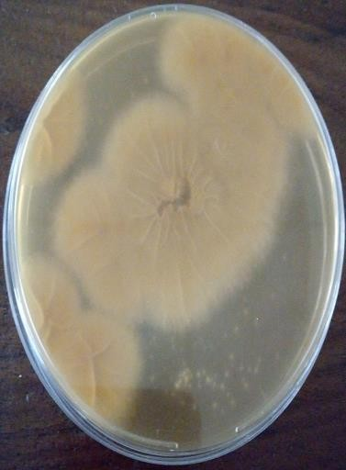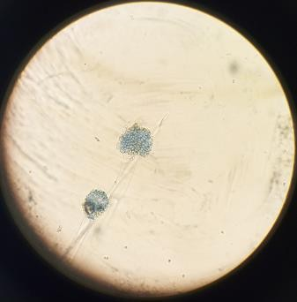

**2a:** *Aspergillus flavus* **2b:** *Aspergillus flavus* **2c:** *Aspergillus flavus*

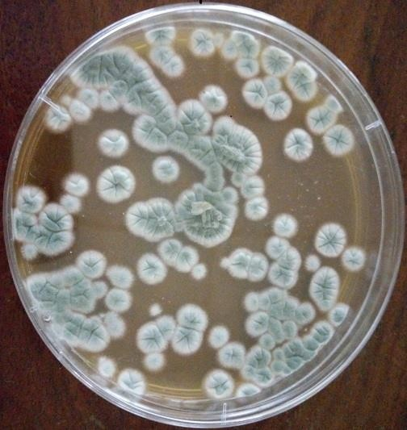

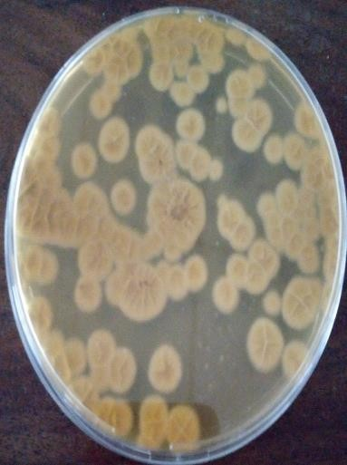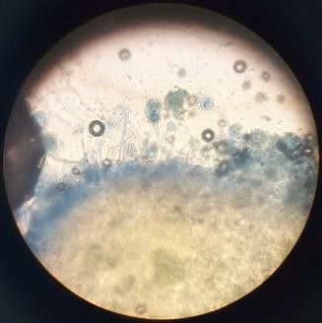

**3a:** *Penicillium chrysogenum* **3b:** *Penicillium chrysogenum* **3c:** *P. chrysogenum*

a=Surface characteristics, b=Reverse side, c=Microscopic characteristics view (×40 objective)

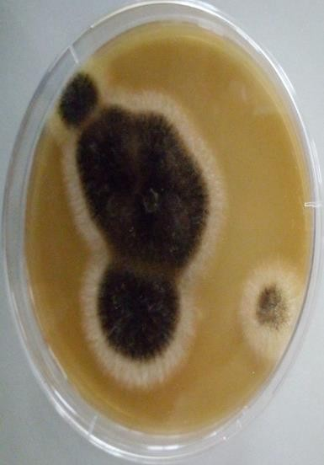 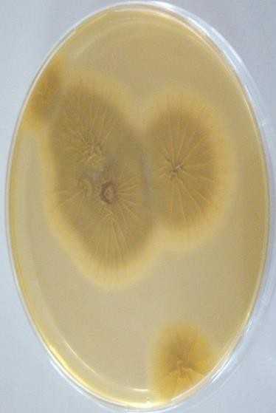 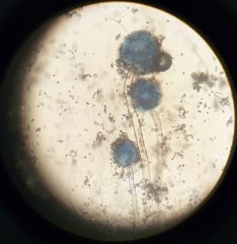

**4a:** *Aspergillus niger* **4b:** *Aspergillus niger* **4c:** *Aspergillus niger*

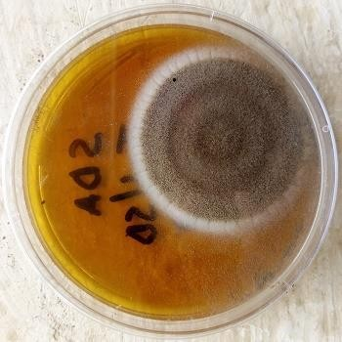

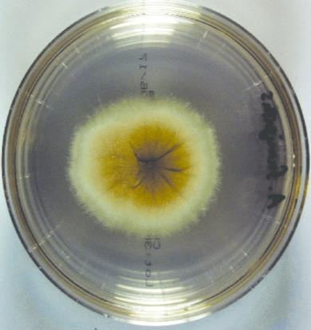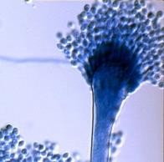

**5a:** *Aspergillus fumigatus* **5b:** *Aspergillus fumigatus* **5c:** *Aspergillus fumigatus*

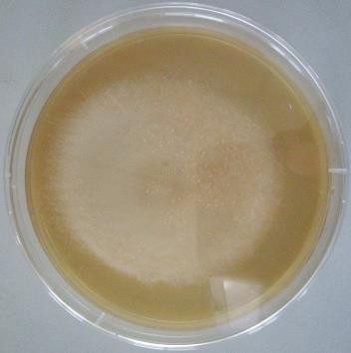

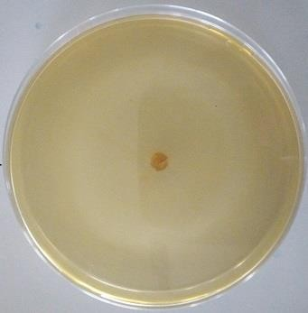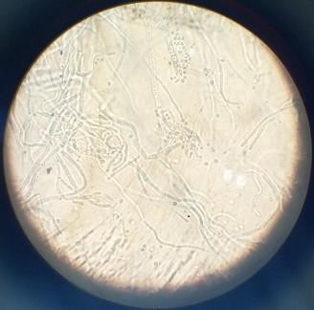

**6a:** *Mucor* sp **6b:** *Mucor s*p **6c:** *Mucor* sp

a=Surface characteristics, b=Reverse side, c=Microscopic characteristics view (×40 objective)

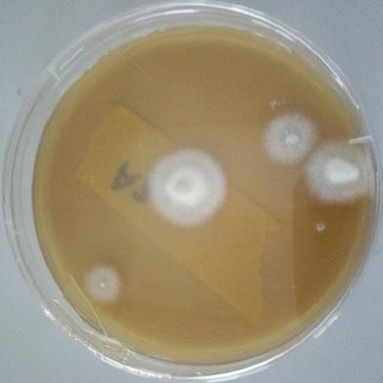

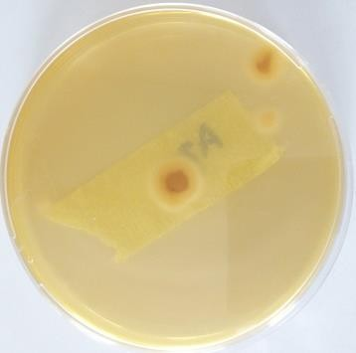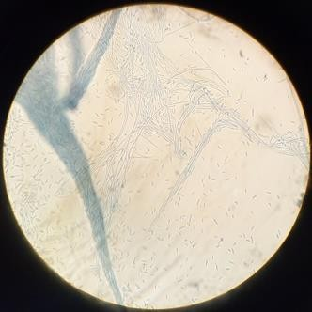

**7a:** *Fusarium oxysporum* **7b:** *Fusarium oxysporum* **7c:** *Fusarium oxysporum*

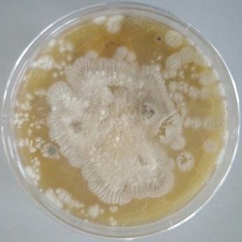

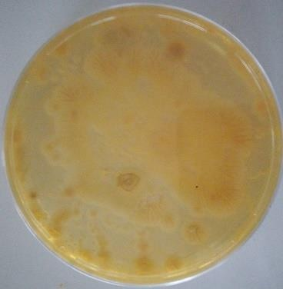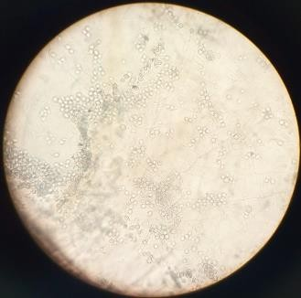

**8a:** *Tricophyton* sp **8b:** *Tricophyton* sp **8c:** *Tricophyton* sp

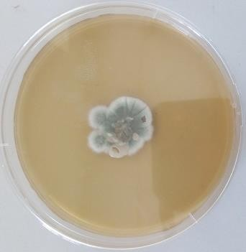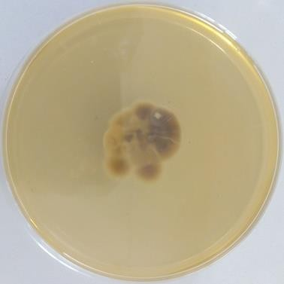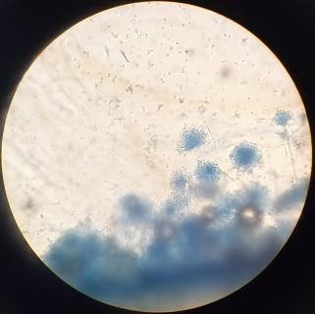

**9a:** *Penicillium* sp **9b:** *Penicillium* sp **9c:** *Penicillium* sp

a=Surface characteristics, b=Reverse side, c=Microscopic characteristics view (×40 objective)

# Appendix H: Compost Standards/Guidelines in Some Selected Countries

There is no straight approach to offer an outline as to compost quality standards as they occur in the world, and how they originated. Currently, some European countries have agreed on definite standards and several other nations, plus Nigeria, are in the course of adoption. Appendices (H1- H6) present some variation of recognised and published standards in Nigeria and other selected countries of the world.

# Appendix H1: National Minimum Quality Standards for Compost (Nigerian)

|  |  |
| --- | --- |
| Parameters | National Standard |
| Odour Colour Texture Pathogens  Moisture content pH  Total Organic Carbon C : N Ratio  Nitrogen (N) Phosphorus (P) Potassium (K)  Non-biodegradable materials (glass, metal, plastic,stones, slugs. | Odourless Variable Variable None  15 to 25%  6.5 to 7.5  At least 20%  10 to 15  1.0 to 4.0%  1.5 to 3.0%  1.0 to 1.5%  Free |

**Source:** Hammed (2015)

# Appendix H2: Compost quality standard in Thailand

|  |  |
| --- | --- |
| Property | Compost Quality Standard |
| pH  Conductivity (mS/cm) N (%,w/w)  P (%,w/w)  K (%,w/w) C/N  Germination index (%) Cd (mg/kg)  Cr (mg/kg) Cu (mg/kg) Pb (mg/kg) | 5.5-8.5  ≤ 3.5  ≥ 1.0  ≥ 0.5  ≥ 0.5  ≤ 20  ≥ 80  ≤ 5.0  ≤ 300  ≤ 500  ≤ 500 |

**Source:** Hammed (2015)

# Appendix H3: Heavy metal standards for compost in Germany

|  |  |  |
| --- | --- | --- |
| Elements | Max. Conc. Recommended(mg/kg) | German Standard (mg/kg) |
| Pb Cu Zn Cr Ni Cd Hg | 75  50  200  75  30  0.75  0.5 | 150  150  500  150  50  3  3 |

**Source:** Hammed (2015)

# Appendix H4: Heavy metal standard in Danish composts (mg/kg of dry matter)

|  |  |
| --- | --- |
| Heavy metal | Limit Values |
| Pb Cd Hg Ni | 120 (80 for private gardens)  0.8  1.2  30 |

**Source:** Hammed (2015)

# Appendix H5: Canadian Council of Ministers of the Environment heavy metal standards in compost (mg/kg of dry weight)

|  |  |
| --- | --- |
| Trace Elements | Concentration |
| Arsenic (As) Cobalt (Co) Chromium (Cr) Copper (Cu) Molybdenum (Mo) Nickel (Ni) Selenium (Se) Zinc (Zn)  Others Cadmium (Cd) Mercury (Hg) Lead (Pb) | 13  34  210  400  5  62  2  700  3  0.8  150 |

**Source:** Hammed (2015)

# Appendix H6: California quality standard for finished compost

|  |  |
| --- | --- |
| Indicator | Quality Standard for Finished Compost |
| Visual Physical  Odour Nutrient  Microbiological | All material is dark brown (black indicates possible burning). Parent material is no longer visible.  Structure is mixture of fine and medium size particle and humus crumbs.  Moisture: 30-40%, Fine Texture (all below 1/8" mesh)  Smells like rich humus from the forest floor; no ammonia or anaerobic odour.  Carbon: Nitrogen Ratio <17:1  Total Organic Matter 20-35%  Total Nitrogen 1.0-2.0%  Nitrate Nitrogen 250-350 mgkg-1  Nitrite Nitrogen 0 mgkg-1  Sulfide 0 mgkg-1  Ammonium 0 or trace  pH 6.5-8.5  Cation Exchange  Capacity (CEC) >60 Cmolkg-1  Humic Acid Content 5-15%  ERGS Reading 5,000-15,000 mS/cm  Heterotrophic Plate Count 1 x 108 - 1 x 1010 CFU/gdw Anaerobic Plate Count Aerobes: Anaerobes at 10:1 or greater  Yeasts and Molds 1 x 103 - 1 x 105 CFU/gdw  Actinomycetes 1 x 106 - 1 x 108 CFU/gdw  Pseudomonads 1 x 103 - 1 x 106 CFU/gdw  Nitrogen-Fixing Bacteria 1 x 103 - 1 x 106 CFU/gdw Compost Maturity >50% on Maturity Index at  dilution rate appropriate for compost application.  Compost Stability <100 mg O2/Kg compost dry solids-hour  *E. coli* < 3 *E. coli*/g  Fecal Coliforms <1000 MPN/g of dry solids  *Salmonella* < 3 MPN/4g total solids |

**Source:** Hammed (2015)

# Appendix H7: Physicochemical properties of tannery waste (TW)/sawdust (SD) mix at start of composting process (day zero)

|  |  |  |  |  |  |  |  |  |  |  |  |  |  |  |  |  |
| --- | --- | --- | --- | --- | --- | --- | --- | --- | --- | --- | --- | --- | --- | --- | --- | --- |
| **Treatment** | **pH** | **Total organic carbon (%)** | **Nitrogen (%)** | **Carbon to Nitrogen ratio (C:N)** | **Electrical conductivity (mS/cm)** | **Moisture (%)** | **Chromium (Mg/kg)** | **Cadmium (Mg/kg)** | **Lead (Mg/kg)** | **Mercury (Mg/kg)** | **Iron (Mg/kg)** | **Zinc (Mg/kg)** | **Calcium (Mg/kg)** | **Sodium (Mg/kg)** | **Potassium (Mg/kg)** | **Phosphorus (Mg/kg)** |
| **TW/SD1:1** | **4.7±0.2a** | **12.52±0.0a** | **0.93±0.0b** | **13.45±0.9a** | **60±1.0a** | **19±1.0ab** | **0.51±0.0a** | **0.08±0.01a** | **0.62±0.02ab** | **0.033±0.0 a** | **1.48±0.03a** | **1.37±0.07a** | **27.94±0.04d** | **52.44±0.44c** | **6.21±0.01e** | **3.57±0.03b** |
| **TW/SD1:5** | **4.6±0.0a** | **22.12±1.9b** | **1.27±0.0c** | **17.36±0.8a** | **69±0.0b** | **14±1.0a** | **0.7±0.05b** | **0.11±0.01a** | **0.73±0.03bc** | **0.07±0.02a** | **2.79±0.43c** | **2.26±0.0c** | **12.82±0.02a** | **48.17±0.07b** | **4.37±0.02b** | **4.19±0.01c** |
| **TW/SD5:1** | **3.9±0.4a** | **27.87±2.4b** | **0.71±0.0a** | **42.56±0.6c** | **75±1.0c** | **20±3.0ab** | **0.44±0.04a** | **0.26±0.02c** | **0.46±0.05a** | **0.05±0.00a** | **2.05±0.05ab** | **1.8±0.0b** | **25.36±0.06c** | **55.23±0.03d** | **4.56±0.06c** | **4.27±0.02c** |
| **TW/SD1:10** | **5.1±0.1a** | **24.45±0.5b** | **1.01±0.0b** | **24.22±2.9b** | **58±3.0a** | **17±2.0ab** | **0.82±0.01c** | **0.17±0.0b** | **0.85±0.03c** | **0.03±0.01a** | **1.94±0.0ab** | **1.39±0.0a** | **22.07±0.07b** | **38.32±0.02a** | **3.98±0.0a** | **3.42±0.02a** |
| **TW/SD10:1** | **4.9±0.7a** | **34.52±2.0c** | **2.30±0.1d** | **14.37±0.8a** | **72±1.0bc** | **21±0.0a** | **0.73±0.02**  **bc** | **0.24±0.02c** | **0.59±0.09ab** | **0.06±0.02a** | **2.54±0.04bc** | **1.42±0.02a** | **30.82±0.82e** | **84.67±0.07e** | **4.85±0.05d** | **4.75±0.05d** |

Mg/kg: Milligramme per kilogramme, mS/cm: Millisiemens per centimeter, %: Percentage

Mean values represented by different letters along same column are significantly different from each other at p<0.05

# Appendix H8: Physicochemical properties of compost produced after six weeks (42 days)

|  |  |  |  |  |  |  |  |  |  |  |  |  |  |  |  |  |
| --- | --- | --- | --- | --- | --- | --- | --- | --- | --- | --- | --- | --- | --- | --- | --- | --- |
| **Treatments** | **pH** | **Total organic carbon (%)** | **Nitrogen (%)** | **Carbon to**  **Nitrogen ratio (C:N)** | **Electrical**  **conductivity (mS/cm)** | **Moisture (%)** | **Chromium (Mg/kg)** | **Cadmium (Mg/kg)** | **Lead (Mg/kg)** | **Mercury (Mg/kg)** | **Iron (Mg/kg)** | **Zinc (Mg/kg)** | **Calcium (Mg/kg)** | **Sodium (Mg/kg)** | **Potassium (Mg/kg)** | **Phosphorus (Mg/kg)** |
| **TW/SD1:1** | **7.3±0.0a** | **16.22±0.02b** | **0.78±0.0bc** | **20.8±0.8c** | **48±0.0a** | **18±3.0a** | **0.203±0.02c** | **0.02±0.0a** | **30.01±0.005d** | **0.108±0.003b** | **0.371±0.001b** | **471.0±1.00a** | **15.52±0.52c** | **28.0±0.06c** | **2.956±0.044d** | **2.82±0.02b** |
| **TW/SD1:5** | **7.44±0.04a** | **17.3±0.3c** | **0.55±0.05b** | **31.46±1.0d** | **50±3.0ab** | **34±0.0b** | **0.016±0.002a** | **0.037±0.007b** | **25.15±0.145c** | **0.291±0.001d** | **0.695±0.005e** | **199.4±0.55b** | **1.05±0.05a** | **12.1±0.10a** | **0.961±0.0a** | **3.07±0.0c** |
| **TW/SD5:1** | **7.65±0.65a** | **22.7±0.0d** | **0.165±0.002a** | **13.4±0.0b** | **56±1.0bc** | **23±1.0a** | **0.404±0.002d** | **0.26±0.0d** | **38.69±0.0e** | **0.035±0.005a** | **0.512±0.000d** | **363.1±0.06c** | **11.3±0.0b** | **44.7±0.25d** | **1.335±0.015b** | **3.14±0.14c** |
| **TW/SD1:10** | **7.36±0.06a** | **14.84±0.2a** | **0.95±0.02c** | **15.62±0.62b** | **49±1.0a** | **36±1.0b** | **0.112±0.002b** | **0.107±0.002c** | **14.03±0.003b** | **0.382±0.002e** | **0.485±0.000c** | **137.1±0.00a** | **10.05±0.03b** | **20.3±0.00b** | **1.55±0.05c** | **2.55±0.05a** |
| **TW/SD10:1** | **8.05±0.05a** | **24.33±0.33e** | **2.22±0.22e** | **10.96±0.0a** | **62±2.0c** | **22±0.5a** | **0.213±0.013b** | **0.324±0.0e** | **8.91±0.01a** | **0.248±0.0c** | **0.248±0.005a** | **394.5±0.47d** | **16.7±0.7c** | **78.8±0.80e** | **1.323±0.023b** | **3.48±0.0d** |

Mg/kg: Milligramme per kilogramme, mS/cm: Millisiemens per centimeter, %: Percentage

Mean values represented by different letters along same column are significantly different from each other at p<0.05

# Appendix I: Effect of treatments application on maize plant parameters

|  |  |  |  |  |  |  |  |  |  |  |  |  |  |  |  |
| --- | --- | --- | --- | --- | --- | --- | --- | --- | --- | --- | --- | --- | --- | --- | --- |
| **WAP** |  |  |  |  | **PLANT PARAMETERS MEASURED IN CENTIMETRE (cm)** | | | | | |  |  |  |  |  |
|  |  |  | **Plant height (cm)** | |  |  | **Leaf length (cm)** | | |  |  | **Stem girth (cm)** | | |  |
|  | **2** | **4** | **6** | **8** | **10** | **2** | **4** | **6** | **8** | **10** | **2** | **4** | **6** | **8** | **10** |
| **TW/SD 1:10** | **14.1±0.1**  **a** | **44.3±2.8**  **b** | **56.6±3.3b**  **c** | **66.5±6 .5c** | **69.5±6.5c** | **6.0±0.2**  **a** | **37.0±1.9**  **b** | **51.3±4.0**  **c** | **53.8±3.5**  **c** | **54.8±3.2c** | **1.1±0.0**  **a** | **2.2±0.1**  **b** | **2.8±0.2b** | **2.9±0.2c** | **3.0±0.2c** |
| **TW/SD 10:1** | **15.0±0.2**  **a** | **86.0±4.1**  **b** | **123.6±6.5**  **c** | **154±6.19d** | **155.8±5.6d** | **6.5±0.2**  **a** | **61.6±2.3**  **b** | **81.5±3.8**  **c** | **83.5±3.1**  **c** | **83.8±3.1c** | **1.2±0.0**  **a** | **4.0±0.0**  **b** | **4.8±0.1c** | **4.8±0.1c** | **4.9±0.13**  **c** |
| **TW/SD 1:5** | **14.8±0.4**  **a** | **57.5±2.7**  **b** | **83.1±5.3c** | **90.6±5.6c** | **91.6±5.5c** | **6.3±0.2**  **a** | **46.0±2.3**  **b** | **62.1±3.0**  **c** | **66.3±2.2**  **c** | **67.0±2.1c** | **1.2±0.0**  **a** | **2.6±0.1**  **b** | **3.6±0.1c** | **3.9±0.1c**  **d** | **4.0±0.1d** |
| **TW/SD 5:1** | **13.5±0.8**  **a** | **62.6±2.0**  **b** | **93.5±0.9c** | **120.5±7.6c** | **124.8±7.1c** | **6±0.3a** | **54.1±3.1**  **b** | **69.3±1.6**  **c** | **70.63.0c** | **71.02.8c** | **1.1±0.0**  **a** | **3.6±0.2**  **b** | **4.3±0.2c** | **4.4±0.1c** | **4.5±0.1c** |
| **TW/SD 1:1** | **14.6±0.2**  **a** | **58.1±2.5**  **b** | **100.0±7.8**  **c** | **119.8±19.4**  **c** | **121.5±9.2c** | **5.8±0.1**  **a** | **47.8±0.9**  **b** | **64.0±3.8**  **c** | **66.5±4.3**  **c** | **67.6±3.8c** | **1.1±0.0**  **a** | **3.0±0.1**  **b** | **3.8±0.2b**  **c** | **4.3±0.4c** | **4.5±0.3c** |
| **No manure** | **14.2±0.2**  **a** | **43.1±0.8**  **b** | **68.5±1.2c** | **76.1±2.3d** | **78.3±2.3d** | **5.8±0.1**  **a** | **33.0±1.1**  **b** | **57.1±2.3**  **c** | **57.6±2.3**  **c** | **58.3±2.5c** | **1.1±0.0**  **a** | **2.2±0.0**  **b** | **2.9±0.0c** | **3.2±0.0d** | **3.2±0.0d** |
| **Organic fertilizer** | **14.3±0.4**  **a** | **60.5±4.2**  **b** | **102.8±7.1**  **c** | **111.8±11.0**  **c** | **122.69.8c** | **6.1±0.1**  **a** | **48.0±2.9**  **b** | **71.0±4.5**  **c** | **77.0±3.7**  **c** | **77.1±4.4c**  **d** | **1.2±0.0**  **a** | **3.1±0.1**  **b** | **4.5±0.2c** | **4.7±0.1c** | **4.8±0.2c** |
| **NPK**  **fertilizer** | **14.7±0.1**  **a** | **55.1±2.3**  **b** | **114.3±6.1**  **c** | **151.5±11.2**  **d** | **154.3±11.1**  **d** | **6.0±0.0**  **a** | **43.3±1.4**  **b** | **72.8±4.9**  **c** | **80.6±2.7**  **d** | **82.6±3.0d** | **1.1±0.0**  **a** | **3.0±0.1**  **b** | **5.4±5.8c** | **5.8±0.2c** | **6.1±0.3c** |

Mean values represented by different letters along same row are significantly different from each other at p<0.05

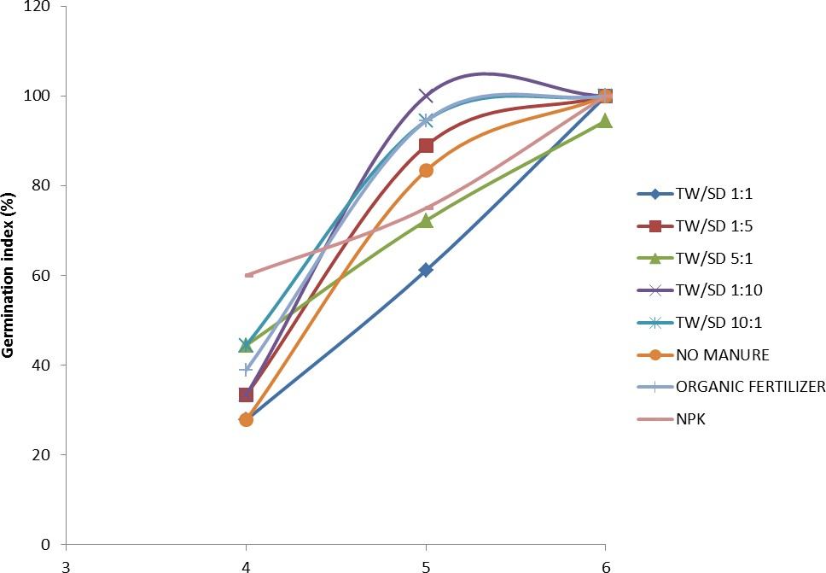

# Time (Days)

**Appendix J:** Germination index (% emergence) of maize seeds recorded from day four through six

# Appendix K: Days to Maize crop growth stages

|  |  |  |
| --- | --- | --- |
| Growth stage | Days | Date |
| Sown | 0 | 03/08/2019 |
| Crop emergence | 4 | 07/08/2019 |
| Fourth leaf stage | 21 | 24/08/2019 |
| First tasselling | 54 | 19/09/2019 |
| 80% Tasselling | 62 | 27/09/2019 |
| Physiological maturity | 85 | 20/10/2019 |

|  |  |  |
| --- | --- | --- |
| Harvest maturity | 102 | 02/11/2019 |

**APPENDIX L**

MEAN OF PLANT HEIGHT IN CENTIMETRE (CM)

**Report**

|  |  |  |  |  |  |  |  |  |  |
| --- | --- | --- | --- | --- | --- | --- | --- | --- | --- |
| TREATMENT_HEIGHT | | TW/SD 1:10 | TW/SD 10:1 | TW/SD 1:5 | TW/SD 5:1 | TW/SD 1:1 | CONTROL | ORGANIC FERTILIZER | NPK |
|  | Mean | 14.133 | 15.000 | 14.833 | 13.500 | 14.617 | 14.233 | 14.350 | 14.700 |
| WEEK 2 | Std. Error of Mean | .1764 | .2582 | .4014 | .8851 | .2428 | .2275 | .4646 | .1095 |
|  | Mean | 44.333 | 86.000 | 57.500 | 62.667 | 58.167 | 43.167 | 60.500 | 55.167 |
| WEEK 4 | Std. Error of  Mean | 2.8713 | 4.1553 | 2.7538 | 2.0111 | 2.5874 | .8724 | 4.2485 | 2.3010 |
|  | Mean | 56.667 | 123.667 | 83.167 | 93.500 | 100.000 | 68.500 | 102.833 | 114.333 |
| WEEK 6 | Std. Error of  Mean | 3.3632 | 1.2824 | 5.3754 | .9574 | 7.8401 | 1.2315 | 7.1059 | 6.1028 |
|  | Mean | 66.500 | 154.000 | 90.667 | 120.500 | 119.833 | 76.167 | 111.833 | 151.500 |
| WEEK 8 | Std. Error of  Mean | 6.5612 | 6.1914 | 5.6253 | 7.6278 | 19.3536 | 2.4687 | 11.0164 | 11.2153 |
|  | Mean | 69.500 | 155.833 | 91.667 | 124.833 | 121.500 | 78.333 | 122.667 | 154.333 |
| WEEK 10 | Std. Error of  Mean | 6.5612 | 5.6120 | 5.5056 | 7.1992 | 19.4023 | 2.3476 | 9.8748 | 11.1166 |
|  | Mean | 50.227 | 106.900 | 67.567 | 83.000 | 82.823 | 56.080 | 82.437 | 98.007 |
| Total | Std. Error of Mean | 4.1884 | 9.9031 | 5.7132 | 7.9172 | 9.2910 | 4.5792 | 8.0746 | 10.6789 |

# ONE WAY ANOVA

**ANOVA**

|  |  |  |  |  |  |  |
| --- | --- | --- | --- | --- | --- | --- |
|  | | Sum of Squares | df | Mean Square | F | Sig. |
|  | Between Groups | 12091.299 | 4 | 3022.825 | 23.835 | .000 |
| TW/SD 1:10 | Within Groups | 3170.600 | 25 | 126.824 |  |  |
|  | Total | 15261.899 | 29 |  |  |  |
|  | Between Groups | 82658.533 | 4 | 20664.633 | 193.913 | .000 |
| TW/SD 10:1 | Within Groups | 2664.167 | 25 | 106.567 |  |  |
|  | Total | 85322.700 | 29 |  |  |  |
|  | Between Groups | 25439.533 | 4 | 6359.883 | 53.755 | .000 |
| TW/SD 1:5 | Within Groups | 2957.833 | 25 | 118.313 |  |  |
|  | Total | 28397.367 | 29 |  |  |  |
|  | Between Groups | 51061.333 | 4 | 12765.333 | 91.899 | .000 |
| TW/SD 5:1 | Within Groups | 3472.667 | 25 | 138.907 |  |  |
|  | Total | 54534.000 | 29 |  |  |  |
|  | Between Groups | 50524.579 | 4 | 12631.145 | 12.849 | .000 |
| TW/SD 1:1 | Within Groups | 24576.935 | 25 | 983.077 |  |  |
|  | Total | 75101.514 | 29 |  |  |  |
|  | Between Groups | 17825.035 | 4 | 4456.259 | 266.489 | .000 |
| CONTROL | Within Groups | 418.053 | 25 | 16.722 |  |  |
|  | Total | 18243.088 | 29 |  |  |  |
|  | Between Groups | 48093.915 | 4 | 12023.479 | 34.835 | .000 |
| ORGANIC  FERTILIZER | Within Groups | 8628.975 | 25 | 345.159 |  |  |
|  | Total | 56722.890 | 29 |  |  |  |
|  | Between Groups | 90456.339 | 4 | 22614.085 | 64.557 | .000 |
| NPK | Within Groups | 8757.360 | 25 | 350.294 |  |  |
|  | Total | 99213.699 | 29 |  |  |  |

# APPENDIX J: POST HOC TEST

**Homogeneous Subsets**

# TW/SD 1:10

Duncana

|  |  |  |  |  |
| --- | --- | --- | --- | --- |
| TREATMENT_HEIGHT | N | Subset for alpha = 0.05 | | |
| 1 | 2 | 3 |
| WEEK 2 | 6 | 14.133 |  |  |
| WEEK 4 | 6 |  | 44.333 |  |
| WEEK 6 | 6 |  | 56.667 | 56.667 |
| WEEK 8 | 6 |  |  | 66.500 |
| WEEK 10 | 6 |  |  | 69.500 |
| Sig. |  | 1.000 | .069 | .072 |

Mean for groups in homogeneous subsets are displayed.

a. Uses Harmonic Mean Sample Size = 6.000.

# TW/SD 10:1

Duncana

|  |  |  |  |  |  |
| --- | --- | --- | --- | --- | --- |
| TREATMENT_HEIGHT | N | Subset for alpha = 0.05 | | | |
| 1 | 2 | 3 | 4 |
| WEEK 2 | 6 | 15.000 |  |  |  |
| WEEK 4 | 6 |  | 86.000 |  |  |
| WEEK 6 | 6 |  |  | 123.667 |  |
| WEEK 8 | 6 |  |  |  | 154.000 |
| WEEK 10 | 6 |  |  |  | 155.833 |
| Sig. |  | 1.000 | 1.000 | 1.000 | .761 |

Mean for groups in homogeneous subsets are displayed.

a. Uses Harmonic Mean Sample Size = 6.000.

# TW/SD 1:5

Duncana

|  |  |  |  |  |
| --- | --- | --- | --- | --- |
| TREATMENT_HEIGHT | N | Subset for alpha = 0.05 | | |
| 1 | 2 | 3 |
| WEEK 2 | 6 | 14.833 |  |  |
| WEEK 4 | 6 |  | 57.500 |  |
| WEEK 6 | 6 |  |  | 83.167 |
| WEEK 8 | 6 |  |  | 90.667 |
| WEEK 10 | 6 |  |  | 91.667 |
| Sig. |  | 1.000 | 1.000 | .213 |

Mean for groups in homogeneous subsets are displayed.

a. Uses Harmonic Mean Sample Size = 6.000.

# TW/SD 5:1

Duncana

|  |  |  |  |  |  |
| --- | --- | --- | --- | --- | --- |
| TREATMENT_HEIGHT | N | Subset for alpha = 0.05 | | | |
| 1 | 2 | 3 | 4 |
| WEEK 2 | 6 | 13.500 |  |  |  |
| WEEK 4 | 6 |  | 62.667 |  |  |
| WEEK 6 | 6 |  |  | 93.500 |  |
| WEEK 8 | 6 |  |  |  | 120.500 |
| WEEK 10 | 6 |  |  |  | 124.833 |
| Sig. |  | 1.000 | 1.000 | 1.000 | .530 |

Mean for groups in homogeneous subsets are displayed.

a. Uses Harmonic Mean Sample Size = 6.000.

# TW/SD 1:1

Duncana

|  |  |  |  |  |
| --- | --- | --- | --- | --- |
| TREATMENT_HEIGHT | N | Subset for alpha = 0.05 | | |
| 1 | 2 | 3 |
| WEEK 2 | 6 | 14.617 |  |  |
| WEEK 4 | 6 |  | 58.167 |  |
| WEEK 6 | 6 |  |  | 100.000 |
| WEEK 8 | 6 |  |  | 119.833 |
| WEEK 10 | 6 |  |  | 121.500 |
| Sig. |  | 1.000 | 1.000 | .273 |

Mean for groups in homogeneous subsets are displayed.

a. Uses Harmonic Mean Sample Size = 6.000.

# CONTROL (NO MANURE)

Duncana

|  |  |  |  |  |  |
| --- | --- | --- | --- | --- | --- |
| TREATMENT_HEIGHT | N | Subset for alpha = 0.05 | | | |
| 1 | 2 | 3 | 4 |
| WEEK 2 | 6 | 14.233 |  |  |  |
| WEEK 4 | 6 |  | 43.167 |  |  |
| WEEK 6 | 6 |  |  | 68.500 |  |
| WEEK 8 | 6 |  |  |  | 76.167 |
| WEEK 10 | 6 |  |  |  | 78.333 |
| Sig. |  | 1.000 | 1.000 | 1.000 | .368 |

Mean for groups in homogeneous subsets are displayed.

a. Uses Harmonic Mean Sample Size = 6.000.

# AMAZING ORGANIC FERTILIZER

Duncana

|  |  |  |  |  |
| --- | --- | --- | --- | --- |
| TREATMENT_HEIGHT | N | Subset for alpha = 0.05 | | |
| 1 | 2 | 3 |
| WEEK 2 | 6 | 14.350 |  |  |
| WEEK 4 | 6 |  | 60.500 |  |
| WEEK 6 | 6 |  |  | 102.833 |
| WEEK 8 | 6 |  |  | 111.833 |
| WEEK 10 | 6 |  |  | 122.667 |
| Sig. |  | 1.000 | 1.000 | .092 |

Mean for groups in homogeneous subsets are displayed.

a. Uses Harmonic Mean Sample Size = 6.000.

# NPK (20:10:10)

Duncana

|  |  |  |  |  |  |
| --- | --- | --- | --- | --- | --- |
| TREATMENT_HEIGHT | N | Subset for alpha = 0.05 | | | |
| 1 | 2 | 3 | 4 |
| WEEK 2 | 6 | 14.700 | 55.167 | 114.333 |  |
| WEEK 4 | 6 |  |
| WEEK 6 | 6 |  |
| WEEK 8 | 6 | 151.500 |
| WEEK 10 | 6 | 154.333 |

|  |  |  |  |  |  |
| --- | --- | --- | --- | --- | --- |
| Sig. |  | 1.000 | 1.000 | 1.000 | .795 |

Mean for groups in homogeneous subsets are displayed.

a. Uses Harmonic Mean Sample Size = 6.000.