# COMPOSITIONAL CHARACTERIZATION AND INDUSTRIAL APPLICATION OF KUTIGI CLAY OCCURRENCE, CENTRAL BIDA BASIN, NIGERIA

**BY**

# OGBEUN, Oluwabunmi Sarah MTech/SPS/2017/6950

**DEPARTMENT OF GEOLOGY FEDERAL UNIVERSITY OF TECHNOLOGY**

# MINNA

**SEPTEMBER, 2021**

# COMPOSITIONAL CHARACTERIZATION AND INDUSTRIAL APPLICATION OF KUTIGI CLAY OCCURRENCE, CENTRAL BIDA BASIN, NIGERIA

**BY**

# OGBEUN, Oluwabunmi Sarah MTech/SPS/2017/6950

**A THESIS SUBMITTED TO THE POSTGRADUATE SCHOOL FEDERAL UNIVERSITY OF TECHNOLOGY, MINNA, NIGERIA IN PARTIAL FULFILMENT OF THE REQUIREMENTS FOR THE AWARD OF THE DEGREE OF MASTER OF TECHNOLOGY IN GEOLOGY (MINERAL EXPLORATION).**

# SEPTEMBER, 2021

**ABSTRACT**

This study investigated the physical, mineralogical and geochemical properties of Kutigi clay deposit in the central Bida Basin of Nigeria. The previous studies on the clay deposit have focused solely on estimating its reserves and on the mineralogical and geochemical properties. Attention was not given to identifying its potential industrial usage with respect to its physical properties. The result from field study shows the stratigraphy position of the clay deposit to be a bed within the Enagi Formation and occurs as irregular lenticular structures within the sandstones, siltstones and ironstones. Results of physical test analysis indicate a liquid limit, plastic limit and the plasticity index values of the clays range from 16.20 to 32.25 %, 9.00 to

27.00 % and 2.28 to 10.56 % respectively. This implies that the clays are generally of low to medium compressibility, low swelling and low to medium plasticity. The low shrinkage values shrinkage values of 3.76 %, 3.99 %, 4.78 %, 5.05 %, 4.28 %, 5.79 %, 6.6%, and 6 % respectively suggest that the clay is a suitable raw material for the ceramics industries. Mineralogical analysis reveals kaolinite as the dominant clay mineral and quartz as the dominant non-clay mineral. Geochemical analysis shows significant amounts of SiO2, (50.02 wt %), and Al2O3, (35.70%), while the other oxides Fe2O3, Na2O, TiO2, CaO, MgO and P2O5 are significantly low. The Kaolinite content of (32.52 wt %) is much lower than the amount (93 - 99 wt %) required for paper coating, thereby making the clay deposit unsuitable for this purpose. The comparison of the mineralogy and chemical composition of the study clay with the specifications of paper, ceramics, pharmaceutical and cosmetics industrial shows that they are not suitable unless with beneficiation.

|  |  |  |
| --- | --- | --- |
|  | **TABLE OF CONTENTS** |  |
| **Content** |  | **Page** |
| Title page |  | i |
| Declaration |  | ii |
| Certification |  | iii |
| Dedication |  | iv |
| Acknowledgements |  | v |
| Abstract |  | vi |
| Table of Contents |  | vii |
| List of Tables |  | x |
| List of Figures |  | xi |
| List of Plates  **CHAPTER ONE** |  | xii |

* 1. INTRODUCTION 1
  2. Background to the Study 1
  3. Formation of Clay 3
     1. Weathering 5
  4. Distribution of Clay in Nigeria 6
  5. Properties of Clay Materials 7
  6. Industrial Application of Clay 8
     1. Ceramic industry 9
     2. Construction industry 9
     3. Pharmaceutical industry 10
     4. Paper industry 10
     5. Textile and paint industry 11
  7. Specification for use 11
  8. Statement of the Research Problem 13
  9. Justification of the Study 13
  10. Aim and Objectives 13
  11. Scope of the study 14
  12. The Study Area 14
      1. Location, extent and accessibility 14
      2. Relief and drainage 15
      3. Climate and vegetation 16
      4. Settlement and land use 16
  13. Regional Geology and Structural Setting 17
      1. Stratigraphy and sedimentation of bida basin 19
      2. Bida sandstone formation 21
      3. Sakpe ironstone formation 21
      4. Enagi siltstone formation 22
      5. Batati ironstone 22
      6. Lokoja formation 25
      7. Patti formation 26
      8. Agbaja ironstone 26

CHAPTER TWO

* 1. LITERATURE REVIEW 28
  2. Previous works 28

CHAPTER THREE

* 1. MATERIALS AND METHODS 33
  2. Fieldwork and Sample Collection 33
  3. Laboratory Analysis 34
     1. Geotechnical tests 34
     2. Shrinkage limit test 35
     3. X-Ray diffraction (XRD) analysis 36
     4. X-Ray fluorescence (XRF) analysis 36

CHAPTER FOUR

* 1. RESULT AND DISCUSSION 38
  2. Field Relationship 38
  3. Laboratory Result 44
     1. Atterberg’s limit and shrinkage test 44
     2. X-Ray diffraction r result 45
     3. Geochemical result 52
  4. Industrial potentials of kutigi clay deposits 60
     1. Uses and specification 61

CHAPTER FIVE: CONCLUSION

* 1. CONCLUSION AND RECOMMENDATIONS 67
  2. Conclusion 67
  3. Recommendations 68

REFERENCES 69

|  |  |  |
| --- | --- | --- |
|  | **LIST OF TABLES** |  |
| **Table** |  | **Page** |
| 1.1 | Specification for use Of Kaolin in Some Selected Industries | 11 |
| 4.1 | Geotechnical Result of Kutigi Clay Deposit | 44 |
| 4.2 | Percentage Minerals Composition of the Study Clay | 50 |
| 4.3 | The Samples Mineral Average Compares to other know Clay Deposit in Nigeria | 52 |
| 4.4 | Summary of the Major Oxide of Kutigi Clay Deposit | 53 |
| 4.5 | Major Oxide of the Study Clay Compared to other Clay Occurrence in Nigeria | 60 |
| 4.6 | Industrial Specification for Paper Coating | 62 |
| 4.7 | Industrial Specification for Paper Filler | 63 |
| 4.8 | Industrial Specification for Ceramics | 64 |
| 4.9 | Industrial Specification for Pharmaceutics and Cosmetics Industry | 66 |

|  |  |  |
| --- | --- | --- |
|  | **LIST OF FIGURES** |  |
| **Figure** |  | **Page** |
| 1.1 | Tectonic Settings and Processes Involved in Recycling Clay Minerals | 5 |
| 1.2 | Locations of Some Industrial Clay Mineral Deposits in Nigeria | 7 |
| 1.3 | Geological Map of Bida Basin Showing the Location of the Study Area | 15 |
| 1.4 | Geological Map of Nigeria Showing the Location of Bida Basin | 17 |
| 1.5 | Geographical Subdivision of Bida into Northern, Central and Southern Parts | 19 |
| 1.6 | Stratigraphic Successions in the Bida Basin | 20 |
| 4.1 | Lithological Section of KTG1 | 40 |
| 4.2 | Lithological Section of KTG2 | 43 |
| 4.3 | X-Ray Diffratograph for Sample KTG1A | 46 |
| 4.4 | X-Ray Diffratograph for Sample KTG1G | 47 |
| 4.5 | X-Ray Diffratograph for Sample KTG2B | 48 |
| 4.6 | X-Ray Diffratograph for Sample KTG2F | 49 |
| 4.7 | Chart of Percentage Mineralogical Composition of the Study Clay | 51 |
| 4.8 | Chart of Major Oxide of the Study Clay | 54 |
| 4.9 | Chart of Average Major Oxide Composition of the Study Clay | 56 |
| 4.10 | A-CN-K Diagram (After Nebsitt and Young, 1982) with Plots of Study Clay | 57 |
| 4.11 | Binary Diagram of Depositional Environment Differentiation of Study Clays | 58 |

|  |  |  |
| --- | --- | --- |
|  | **LIST OF PLATES** |  |
| **Plate** |  | **Page** |
| I. | Lithological Section of Clay Capped with Iron Stone | 38 |
| II. | Exposed Massive Clay with Tinted Red Colour at KTG 1 | 39 |
| III. | Clay Occurring as Irregular Lenticular Structures at KTG2 | 41 |
| IV. | Clay with Milky White Colour at KTG2 | 41 |

# CHAPTER ONE

# INTRODUCTION

# Background to the Study

The joint nomenclature committees of the Association Internationale pour l‟Etude des Argiles (AIPEA) and the Clay Minerals Society (CMS) have defined „clay‟ as a naturally occurring geological material composed primarily of fine-grained minerals, which is generally plastic at appropriate water contents and will harden when dried or fired (Guggenheim *et al.,* 1995). It is also applicable to all small-sized particles, normally <2 μm, found in soils, sediments or as alteration products of rocks (López- Galindo *et al*., 2007). Most geologists, however, refer to sheet silicates when they speak of clay minerals (Adamu & Duru, 2020). Clay is richly found in soil, sedimentary rocks and hydrothermal deposits (Omang *et al.,* 2019).

Clay mineral-rich deposits are usually formed in two principal ways: (i) by sedimentary processes by which parent minerals are weathered in situ to form predominantly a Kaolinitic clay rich residual soil and (ii) by primary hydrothermal alteration of the host rock. In geologic context, clays are sedimentary deposits constituted by accumulations from chemical weathering rocks (Adamu & Duru, 2020).

Two classes of clays are defined on the basis of their location relative to the parent rocks: (i) primary or residual; and (ii) secondary or transported or sedimentary clays (Punmia *et al*., 2005; Arora 2008). Primary deposits are formed directly from hydrothermal alteration of volcanic and granitic rocks with examples as hydrothermal and volcanic clay types. Secondary clay deposits are products of chemical weathering of pre-existing rocks during which alumino-silicates are altered into clays, such as residual and sedimentary clays. However, clay can further be classified on the basis of genetic and industrial characteristics (Omang *et al.,* 2019).

1

In many instances, clay materials are formed in one environment by the accumulation or alteration of clay minerals formed in others. Thus the geological history of a clay material, and consequently its properties and behavior, may depend on many environments (Al- Ani & Sarapaa, 2008).

Clay contains the phyllosilicate minerals, they are chemically hydrous aluminium silicates, and composed mainly of silica, alumina or magnesium and water. These components impart plasticity to the clay and harden when dried or fired. They also contain impurities known as associated minerals such as potassium, sodium, calcium, iron and organic matter in small amounts; these minerals tend to reduce clay plasticity (Al- Ani & Sarapaa, 2008).

Clay minerals are among the most important and abundant raw mineral of industrial minerals and has variety of uses depending on factors such as clay mineral constituent, non-clay mineral components, presence of organic matter, type and nature of exchangeable ions and soluble salt, texture and structure (Onyeobi *et al.,* 2013). Millions of tons are utilized annually in a large variety of applications such as in geology, the process industries, agriculture, environmental remediation and construction (Al-Ani & Sarapaa, 2008 & Murray, 2003). Their use falls into two contrasting, broad classes:

1. Usage that utilise their inertness and stability. A large variety of industrial uses are also related to the unique rheological properties of clay and clay mineral dispersions.
2. Usage that utilise their reactivity and catalytic activity (Harvey & Lagaly, 2013).

Geological origin and environment of formation play an important role in the type of clay mineral a clay deposit contain such that small variation in the content of a particular clay deposit drastically changes the physical properties and geochemical characteristic of the clay (Alvarez *et al*., 2017 & Oyebanjo *et al*., 2020).

2

In industrial applications of clays four types of clays are distinguishes: (i) bentonites with montmorillonite as the principal clay mineral constituent, (ii) kaolin containing kaolinite, (iii) palygorskite and sepiolite, and (iv) „common clays‟ which often contain illite/smectite mixed-layer minerals (Bergaya & Lagaly, 2013). In some cases the clay is used for its chemical composition such as kaolin for use as a raw material to make fibreglass or clays and shales in the mix to make cement. For a particular clay to be used it must meet the industrial specification.

The physical and chemical properties of particular clay minerals are dependent on the structure and composition of the clay and account for most differences in their physical and chemical properties (Omang *et al*., 2019). For instances the structure and composition of major industrial clay such as kaolin, smectites, and palygorskite– sepiolite are very different even though the fundamental building blocks, which are the tetrahedral and octahedral sheets, are similar. However, the arrangement and composition of the octahedral and tetrahedral sheets account for major and minor differences in the physical and chemical properties that control the applications of a particular clay mineral (Murray, 2006). For this reason, understanding these properties of clay is of great importance as it provides valuable information on the selection of more suitable clay in industrial application (Semiz & Celik, 2020). This research investigates the potential industrial application of Kutigi clay using the physical, mineralogy and chemical characteristics.

# Formation of Clay

The understanding of the formation of clay mineral is important in that the properties of clay minerals are origin dependent (Murray, 2007). Clay minerals occur in weathering crusts and soils, continental and marine sediments, volcanic deposits, geothermal fields, altered wallrock produced by the intrusion of plutonic rocks and hydrothermal fluids,

3

and very low grade metamorphic rocks (Galan *et al*., 2013). This account for the different in the physical and physio-chemical properties of clay mineral formed in one geological environment to another, for example the physical and physio-chemical properties of a kaolin group mineral formed in one environment may be considerably different from kaolin formed in another. Properties of hydrothermal, residual, and sedimentary kaolin are clearly different, but kaolin of similar origins usually has comparable properties (Galan *et al*., 1998).

During weathering processes many common igneous and metamorphic rock-forming silicates are destroyed while minerals such as micas, quartz and some heavy minerals which are highly resistant to alteration in the soil forming environment are inherited directly, change in environmental condition such as solution composition allow the minerals to evolve by subtracting (degradation) or adding (aggradation) elements to exchangeable and structural positions (Galan *et al*., 2013). Subtraction (degradation) occurs during weathering and soil formation, subaqueous alteration (halmyrolysis), and degrading diagenesis. Processes resulting in the addition of chemical constituents (aggradation) occur in soils, during sedimentation, and during diagenesis (Bergaya *et al.,* 2006). Merriman (2005) stated that almost all of the common rock-forming minerals are capable of forming clay minerals during weathering with exception of quartz; his clay cycle (Figure 1.1) illustrates the processes and pathways associated with recycling clay minerals in the earth crust.

4

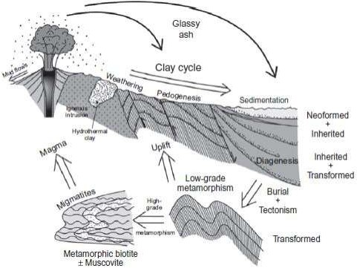

Figure 1.1: Tectonic settings and processes involved in recycling

Clay minerals (Merriman, 2005).

Keller (1970) identify six processes that are responsible for the formation of clay minerals: (1) crystallization from solution, equivalent; (2) replacement by clay minerals;

(3) weathering of silicate minerals and rocks (not clay minerals); (4) weathering of other clay minerals; (5) diagenesis, reconstitution, and ion exchange; and (6) hydrothermal alteration of minerals and rocks.

# Weathering

The physical disintegration and chemical decomposition at -5C  T  25C, leads to the transformation of original rock-forming minerals into clay minerals and soluble elements (Merriman, 2005). Primary factors that influence the transformation of the rock forming minerals into clay minerals include rock type, climate (rainfall and temperature), time, topography (affecting the water and rock ratio through drainage), and the presence of organisms and organic matter (Galan and Ferell, 2013), for example

sectite is most likely to form from acidic and basic igneous parent rocks when the 5

annual rainfall is low, and kaolinite is more abundant when the rainfall is high. Abundant K+ and Al3+ in a granitic terrane favour the formation of illite in climates with moderate rainfall while Illite may not form in regions of basic igneous rocks. In areas of high rainfall, the alteration suite is dominated by mixtures of kaolinite and halloysite with vermiculite and gibbsite. This relationship was derived from a study of califomia soils (Barshad, 1966).

During weathering, most clay minerals formed by incongruent dissolution of unstable silicates. Reaction of the unstable minerals with less soluble compounds can produce new clay minerals by transformation. Direct precipitation from solution can also give rise to new formed clay minerals with compositions that are very different from those of the (dissolved) parent minerals by incongruent precipitation. Extensive leaching may promote the formation of simple oxides and flush away most alkali and alkaline earth ions. A soil or weathered rock may contain inherited minerals, degraded minerals, amorphous substances, ions in solution, or newly formed minerals, depending on the degree of hydrolysis and the saturation state of minerals in the soil solution thus most clay contain inherited clay minerals (Galan and Ferell, 2013). Feldspars in rocks are usually weathered to produce clay mineral as show in equation 2.1

# 4KAlSi3O8 + 4H+ + 2H2O → 4K+ + Al4Si4O10 (OH)8 + 8SiO2 2.1

**Feldspar Hydrogen water Potassium Kaolinite quartz**

# Distribution of Clay in Nigeria

Clay has a wide spread occurrence in the world, in Nigeria clay is widely distributed and occurs both as residual and sedimentary clay. More than 80 clay deposits have been reported from many regions in Nigeria (Akhirevbulu & Ogunbajo, 2011), having varying properties probably due to geological differences (Kefas *et al.,* 2007). Consequently, such clays as Azare clay, Amire clay, Dura clay, Nsu clay, Ukpor clay,

6

Enugu fireclay, Jos kaolin, Afuze clay, Usen clay, Uzalla clay, Kankara kaolin, and Getzo kaolin have been characterized and found useful applications for bricks, pottery and refractory uses (Benneth (2008), Omotoyinbo and Oluwole (2008) and Abuh *et al*.(2014)

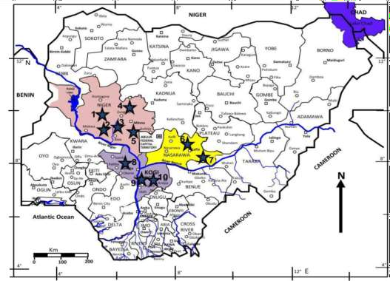

Figure 1.2: locations of some industrial clay mineral deposits in Nigeria (Obaje *et al.,* 2019)

# Properties of Clay Materials

The physicochemical properties of a particular clay mineral are largely dependent on its structure and composition. The structure and composition of the major industrial clays,

i.e. kaolins, smectites and illite are very different even though each is comprised of octahedral and tetrahedral sheets as their basic building blocks The octahedral and tetrahedral sheets arrangement and composition in various clay minerals account for the differences in their physical and chemical properties which contribute to most clay

7

application or end use (Murray, 2007). The important physicochemical properties related to the application of clay materials include:

* 1. Plasticity
  2. Grit content
  3. Conductivity
  4. Particle size, shape and distribution
  5. Mineralogy
  6. Chemistry
  7. Ion exchange capacity

(i) Brightness and colour

# Industrial Application of Clay

Several authors have discussed clay mineral applications and although some are historical, they are essential to our present understanding of how and why the clay minerals have such an extensive industrial utilization. Some of these are (Konta (1995), Galan (1996), Murray (2007) & Obaje *et al.* (2013).

Clay minerals are important in industrial minerals applications, millions of tons are utilized annually in various applications such as the process industries, agriculture, and environmental remediation and construction industries. The important characteristics relating to the applications of clay minerals are particle size and shape, surface chemistry, surface area, surface charge, and other properties specific to particular applications, including viscosity, colour, plasticity, green, dry and fired strength, absorption and adsorption, abrasion and pH. In all applications, the clay minerals perform a function and are not just inert components of the system (Al-Ani & Sarapaa, 2008)

8

# Ceramic industry

The characteristic property of clay to be mouldable leading to enhanced cohesive properties with adequate plasticity without undergoing excessive cracking and breakage of clay have made it one of the major raw material for the ceramics industry. Clay in ceramics must not contain carbonates since these ions contribute to clay swelling leading to crack in the ceramics formation (Dondi *et al.,* 2014)

Obaje *et al*. (2013) group major use of clay material in the manufacture of several ceramic products, namely:

* + - 1. Ceramic in electrical industry for the manufacture of electrical insulators, motor brushes and battery carbons.
      2. Laboratory and engineering ceramics such as jet nozzles, crucible, pestle mortars, rocket motors and spark plugs.
      3. Domestic ceramics for the manufacture of table wares, dinner ware, flower vases and dental wares such as artificial teeth.
      4. Ceramic in building materials for the manufacture of tiles, stoneware pipes, domestic sanitary wares, and fittings for sewage and drainage

# Construction industry

Clays and bricks are used as construction raw materials. Bricks are made up of 100% earth materials which include shales, clays, and fine-grained lateritic soils. Kaolin with low plasticity is found to be more suitable for the manufacture of white Portland cement (Konadu *et al.,* 2013). In General Structural products in the construction industry are mainly popular with non-plastic clays which is commonly kaolin based. However, plastic clays in the right proportions with non-clay materials have been successful for the production of bricks (Asamoah *et al.,* 2018).

9

# Pharmaceutical industry

Clay materials used in drugs and other health benefits are processed natural clays. The chemical and structural features are prime factors influencing the use of clay in pharmaceutical, cosmetic, food packaging and other health applications (Emamifar, 2011) The ideal characteristics of clay for health uses is hampered by the presence of impurities (Aguzzi *et al.,* 2011). Some components of the interlayer elements and certain ionic attachments to the surface may be biologically unfriendly.

The inclusions of elements such as arsenide, zirconium, mercury, lead, lithium, cobalt, copper, nickel, molybdenum and vanadium in the clay minerals are potentially toxic to biological systems (Tiburu *et al.,* 2017). The medical properties of clay minerals have been known for centuries. They are especially consumed by geophagic people and especially pregnant women. The mineral component of clay such as iron, calcium, and zinc, improves health. However, these clays are mostly unprocessed hence contains potentially toxic contaminants such as arsenide, zirconium, mercury, lead, lithium, cobalt, copper, nickel, molybdenum and vanadium (Choy *et al*., 2007). These toxic elements unknowingly affect individual‟s health. The health applications of clay minerals may encompass biomedical applications, and food packaging (Asantewah *et al.,* 2016). Clays, especially kaolinite, have been used for centuries in pharmaceutical preparations of intestinal adsorbent drugs and other therapeutically useful applications. Clays such as montmorillonite, kaolinite and attapulgite are used in the preparation of pastes, ointments and body lotions. These clays are used in cosmetic formulations because of their adsorption properties (Harvey & largely, 2013).

# Paper industry

One of the most important applications of kaolin is coating and filling paper. As filler, the kaolin is mixed with the cellulose fibres in wood pulp and as a coating; the kaolin is

10

mixed with water, adhesives, and various additives and coated onto the surface of the paper (Murray, 2006). The coating makes the paper sheet smoother, brighter, glossier, more opaque, and most importantly, improves the printability (Bundy, 1993). Paper that is not coated is made up of cellulose fibres interwoven in a random and open configuration. Uncoated paper does not meet the stringent requirements for high quality printing and particularly multicolour printing. The fine particle size and platy shape of kaolinite are ideal for imparting a smooth, dense surface that is uniformly porous. This gives the paper more uniform ink receptivity (Murray, 2006).

# Textile and paint industry

Textiles are expected to improve in the quality of material and dye-ability. The fabric industries are required to enhance clothing characteristics such as susceptibility to flame and thermal degradation (Asamoah *et al.,* 2018). Textiles coated with thin layer of nanoclay as compared to raw textiles have improved characteristics. In addition, textiles coated nanoclay of bentonite, acid and electrolyte admixtures improve dye-ability. Nanoclay interacts with both direct and basic dye through favourable ion exchange and hydrogen bonding.

Nanoclay increases water content (Malakul *et al.,* 1998); this enables the quality of paint through increased diffusion of dye colour. Clays are found to increase the stability efficiency of paints which are basically oil emulsions (Li & Jaroniec, 2003). Clays in emulsions which is due to their adsorptive character, absorbs water to prevent water penetration into paint which could degrade paint (Balaras *et al.,* 2000).

# Specification for use

Clay is used in either raw or processed form for various Industries and contains impurities such as SiO2, Fe2O3, TiO2, CaO, MgO and Na2O which should be kept low as per the standard specifications. Apart from these, physical properties such as plasticity,

11

brightness, colour, grit content, particle size and conductivity play an important role in deciding about the end use of clay (Chatterjee, 2009). Table 1.1 shows some selected industries and specification for use of Kaolin.

# Table 1.1: Specification for use of Kaolin in some selected industries.

|  |  |  |  |  |
| --- | --- | --- | --- | --- |
| **Chemical Composition** | **Paper Coating** | **Paper Filler** | **Ceramics** | **Pharmaceutics and cosmetics** |
| **SiO2** | 45 – 49 | 46 – 48 | 48 -50 | 44.621 - 46.4 |
| **Al2O3** | 36 – 38 | 37 – 38 | 36 – 37 | 38.1 – 39.5 |
| **Fe2O3** | 0.5- 1.0 | 0.5 -1.0 | 0.6 -1 | 0.1 – 0.2 |
| **MnO** | **-** | - | - |  |
| **MgO** | **-** | - | - | 0.1 - 0.2 |
| **CaO** | **-** | - | - | 0.1 – 0.2 |
| **Na2O** | **-** | - | - | 0 – 0.1 |
| **K2O** | 0.5 - 1.5 | 0.5 - 1.5 | 1.2 – 2.7 | 0 – 0.2 |
| **TiO2** | 0.5 - 1.3 | 0.5 - 1.5 | 0.02 – 0.1 | 0 – 1.4 |
| **P2O5** | **-** | - | - |  |
| **SO2** | **-** | - | - |  |
| **L.O.I** |  |  | 11.2 – 12.5 | 13.8 – 13.9 |
| **Mineralogical** |  |  |  |  |
| **Composition** |  |  |  |  |
| **Kaolinite** | 93 – 99 | 90 – 95 |  |  |
| **Quartz** | **-** | - |  |  |
| **IIIite/Mica** | 7 -10 | 5 – 10 |  |  |
| **Ti + Fe Minerals** |  |  |  |  |
| **Others** | 0 - 0.3 | 3 – 0.3 |  |  |

Paper coating, paper filler and ceramic standards (Siddiqui *et al.,* 2005) Pharmaceutics and cosmetics range (Lopez-Galindo *et al.,* 2007).

12

# Statement of the Research Problem

Some research works on Kutigi clay deposit were conducted by Alabi (2015) and Akhirevbulu *et al*. (2010). Alabi (2015) investigated their mineralogy and geochemical characteristics while Akhirevbulu *et al*. (2010) studied the geology and mineralogical composition of the clay. There have been no work that ascertained the physical properties of the deposit, nor combined the physical properties with their mineralogy and geochemistry to identify the potential industrial uses of the clay deposit. This work therefore tends to investigate the industrial uses of the clay as a function of its physical characteristics, mineralogy and geochemistry.

# Justification of the Study

The total reserve of Kutigi clay deposits was estimated to be about 672,579 tons (Alabi, 2005). Despite this abundant reserve, not very much of the clay has been properly utilised. This is an important issue especially at this period when the Federal Government of Nigeria is placing bans on the importation of some products to give room for local content in Nigeria industries. It is therefore important that this study be carried out so as to determine the physical characteristics, mineralogy and geochemistry of the Kutigi clay deposit in other to establish their suitability for different industrial uses.

# Aim and Objectives

The aim of this research is to ascertain the potentials industrial usage of Kutigi clay deposits using the attribute of their physical characteristics, mineralogy and geochemistry.

The objectives are to:

1. Establish the lithological section for the deposits

13

1. Determine the clay‟s moisture content, plasticity index, plastic limit, liquid limit and shrinkage limit
2. Establish the mineralogical composition of the clay using X-Ray Diffraction spectrometry technique
3. Establish the elemental composition of the clay using X-Ray Fluorescence technique
4. Identify the possible industrial uses of the clay on the basis of the established physical, mineralogical and chemical analyses.

# Scope of the Study

This study involved determining the industrial potential of the Kutigi clay deposit in central Bida Basin. The physical, mineralogical and chemical attributes of the clay deposits will be used to deduce what uses the clay can be put into when compare with specific standard or specification for use of clay in different industries. The result of this study will also be compared with similar studies done in Nigeria. Reserve evaluation of the clay deposit in the study area will not be considered in this work.

# The Study Area

# Location, extent and accessibility

The study area is part of the Bida Basin and is situated in Lavun Local Government Area of Niger State. The Bida basin is bounded to the north and south by Precambrian basement rocks. The largest portion of the basin occurred at the southern half of Niger state, which formed the central portion of the basin that constitutes the study area (Figure 1.3). Kutigi is the major town in the area, while the surrounding villages include Kusogi, Shebe, Makufu, Fazhi and Ruga.

14

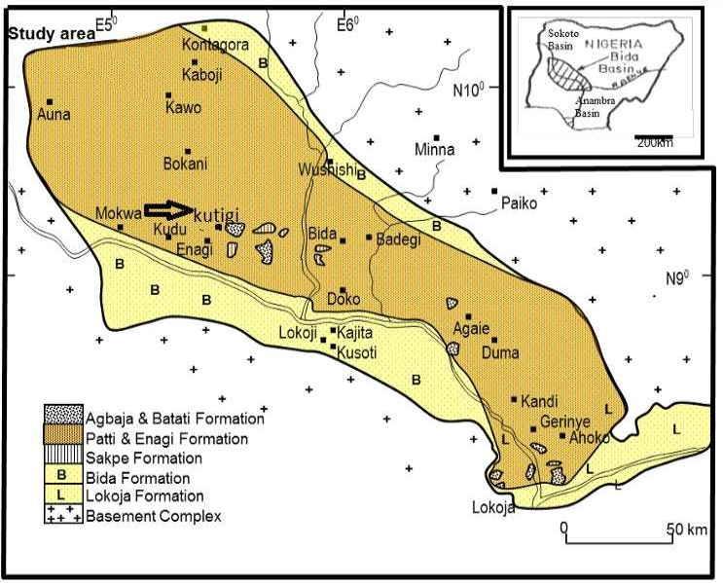

Figure 1.3: Geological map of Bida Basin showing the location of the study area (Modified after Okosun *et al*., 2007)

# Relief and drainage.

The landform of the study area is made up of flat lying to gently rolling plains consisting of clays of various colours within thin cover of ferruginous sandstone; this continuity is broken by residual hills, which are conical or flat topped. The area is mark by a NW-SE and a NE-SE running ridges which are composed of laterite. The area is well drained by river Toro which run near Kusogi village and flow in the NE direction of Egbako SW. Streams that enters river Toro as tributaries are seasonal and forms a dendritic drainage pattern which strongly suggest that the terrain is composed of lithological, structural and topographic homogeneity basement, which created fault patterns trending northeast-southwest and northwest-southeast (Kogbe, 1981).

15

# Climates and vegetation

The study area lies within the Guinea climate region of Nigeria climate regions marked by dry Season (November – March) and wet/raining season (April - October) with highest amount of rain recorded in the month of July. Its annual rainfall have been determined by the Department of Geography, Federal University of Technology, Minna to amount between 1270 mm – 1524 mm, spread over the month of April – October with the highest amount received in the month of July. Mean annual temperatures are between 22°C and 33°C although there could also be local climatic changes (Akhirevbulu *et al.,* 2010).

Two air masses dominate the climate of the study area: the maritime air mass (moisture laden) influence by south - west trade wind and the tropical continental air mass (Harmattan). The tropical continental air mass (Harmattan) is responsible for low relative humidity, high day temperature of about 36°C, dry and dusty, while the maritime air mass (moisture laden) is responsible for the rainfall and low temperature. The vegetation is of typical Guinea Savanna belt of the West Africa rich in grasses of average Height of 2 to 3 meters and also fire-resistance trees which reach up to 18 meters in height. The trees and grasses are interspersed and become gradually small and less luxuriant in appearance. Acacia‟s trees of between 3 to 6 meters high are found on the plains, they have thick leaves and thorns. Flood plains are characterized by tall grasses and scanty palm trees of average height of 7 meters. The common trees are baobab, kapko, acacia, shear- butter and locust-beans plant (Alabi, 2005).

# Settlements and land use

The main settlement within the study area is Kutigi, other settlement found within the area include Kusogi, shebe, Makufu, Fazhi and Ruga. The land is used mainly for farming. Places with clay cover are more intensely cultivated than areas with

16

ferruginous sandstone, which are usually bare and dry and may contain hard lateritic cover on the surface. Crops cultivated in the area include yams, maize, rice and cassava.

# Regional Geology and Structural Setting

The study area falls within the Bida Basin. The Basin is a NW-SE trending inland basin, stretching from Shegwa (NW) to Dekina (SE). It is approximately 350 km long and varies in width from 75 to 150 km. It is roughly elliptical in ground plan and runs perpendicularly to the western margin of the NE-SW trending Benue Trough Complex (Rahaman *et al.,* 2018). The central part of the basin where the study area is located is the largest and occurs in the southern half of Niger State (Akhirevbulu *et al.,* 2010). The Bida Basin is one of the younger sedimentary basins in Africa (Campanian - Maastrichitian) and is bounded in the NW and SE by the basement complex (Figure 1.4).

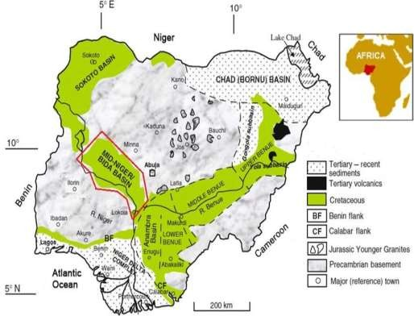

Figure 1.4: Geological map of Nigeria showing the location of Bida

Basin (Obaje, 2009)

17

The basin is described as a “down warped basin” because the epeirogenesis responsible for the basin genesis is closely connected with the crustal movement of the Santonian Orogeny of South-eastern Nigeria and the nearby Benue valley (Adeleye, 1973). Several authors have expressed different view on the genesis of Bida Basin. King (1950) and Kennedy (1965) described the Bida Basin as rift bounded tensional structure produced by faulting associated with the Benue Trough system and the drifting apart of the Africa and Brazilian Plates. They noted the possibility that the bounding rift faults of this asymmetrical rift structure may have been obliterated by subsequent erosion.

However, Landsat imagery interpretations and seismic data across the Bida Basin suggested that the basin is bounded by a system of linear NW - SE fault Kogbe *et al*. (1981) which supported a rift model. Gravity data (Ojo & Ajakaye, 1989) also confirm a central positive anomaly flanked by negative anomalies of rift structures. Whiteman (1982) suggested that the Bida Basin was formed from simple cratonic sag, whilst Braide (1992a) advance a wrench fault tectonic model for the basin. Kogbe *et al*. (1981) related the origin of the basin to the isostatic subsidence that have been induced by tectonic activity associated with the Younger Granite emplacement in the Jurassic and to a lesser extent Benue Trough, which resulted in the outflow of material from the lower part of the Niger lineament. Geophysical data (Adeniyi, 1985; 1986) suggested that up to 3.5 kilometres of sediments may have accumulated in the deepest part of the Bida basin. The first major marine incursion was suspected to have taken place during the early part of the uppermost Maastrichtian phase from the south via the Anambra basin, at the uppermost Maastrichtian period. The peak of the marine transgression was reached during which very extensive sandstones and thick kaolinite beds of the Patti Formation in the southern Bida basin was deposited (Akande *et al.,* 2005).

18

# Stratigraphy and sedimentation of bida basin

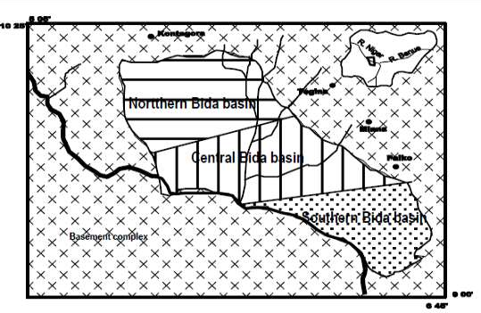Stratigraphically, Bida Basin is divided into the southern and northern part. The southern sector consists mainly of Lokoja Sandstone, Patti Formation and Agbaja Ironstone while the north sector is composes of Bida Sandstone, Sakpe Ironstone, Enagi Siltstone and Batati Ironstone (Adeleye, 1973 & Obaje, 2009). Braide (1992a) divided the Bida Basin in to southern, central and northern part geographically with the aim of establishing the syntectonic fluvial sedimentation of the central part of the basin (Figure 1.5). The northern part is considered to extend from Kontagora to Kudu/Wushishi areas to the southeast; the central sector extends from Lemu to Katcha/Baro area while the southern sector extends from Gulu/Baro area and makes contact with the Benue Trough. Economic resources associated with the basin are ironstone, clay and laterite.

Figure 1.5: Geographical subdivision of Bida into Northern, Central and Southern parts (Alabi 2017 modified after Braide, 1992a)

The Bida Basin has a buried Precambrian to Paleozoic basement complex that is overlain directly by rounded to sub-rounded coarse conglomerates, clay, sand, and pebble mixtures with cross stratified sandstones locally with scattered pebbles, cobbles

19

and boulders. The oldest sediments that are exposed in the Bida basin are of Maestrichtian age, but sedimentation might have started earlier because beneath the Bida area itself, there may be as much as 3225m of sediments, as estimated from aeromagnetic mapping.

The stratigraphy and sedimentation of the upper Cretaceous rocks of the basin have been studied in detail and documented by Adeleye and Dessauvagie (1972). The sedimentation of northern Bida Basin has been proposed by several workers. Among these workers are Braide (1992b), Adeleye and Dessauvagie (1972), Murat (1972) and Whiteman (1982). In the central part of the basin around Bida, four mapable stratigraphic units are recognizable in the area comprising the Bida Sandstone (including the Doko and Jima members), Sakpe Ironstone, Enagi Siltstone and Batati Ironstone that were correlated with three stratigraphic units in the southern South Bida basin comprising of the Lokoja Formation, Patti Formation and Agbaja ironstone (figure 1.6).

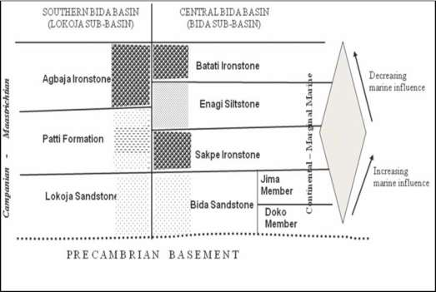

Figure 1.6: Stratigraphic successions in the Bida Basin (Akande *et al.,* 2005 and Obaje, 2009)

20

# Bida sandstone

The Bida sandstone Formation consists of two members, the upper Jima Sandstone Member with a total thickness of 90 meters and overlies the lower Doko Sandstone Member with a thickness of 182 meters. The Doko sandstone member consists of arkoses, feldsparthic sandstone and quartz sandstone. Smaller amounts of lithic – feldsparthic sandstone, sub greywackes, sandy siltstone and intra – formational breccias occurs (Adeleye, 1973). Along the Zungeru-Bida road, close to Zungeru, near the northern margin of the basin, coarse grained sandstone and basal conglomerates crop out overlying schist. The conglomerates are quartzitic and range in size from pebbles (2-8centimeters across) to gravel. The pebbles have clay ironstone cement. The basal conglomerate may be part of the Doko member.

The Jima Member consists of quartzose sandstone, brownish, massive beds cross- stratified with subsidiary greywacke, siltstone, claystone and breccias. Rapid facies change typifies the member. Leaf impressions are the only trace fossil which have been found and occur mainly in the argillaceous rocks. The age of the Bida Sandstone Formation has been proposed by Adeleye and Dessauvagie (1972) to be late Cretaceous (Campanian-Maastrichtian).

Sedimentological evidence indicates deposition in a braided stream environment for the Doko Sandstone member, while Jima member is deposited under lower stream energy than that which Prevailed during the deposition of the Doko member (Whiteman, 1982). The presence of leaves and ferruginous channel margin deposits is taken to indicate deposition under tropical to subtropical conditions (Adeleye, 1973).

# Sakpe formation

The Sakpe Formation is divided into the Baro and wuya ironstone members by (Adeleye, 1973). The wuya member consists mainly of oolitic and pistolitic ironstones 21

with minor claystone developed locally. It has a thickness of about 5m. The Baro member consists of oolithic ironstones and ferruginous sandstones which are locally pyritic and concretionary. Rapid facies change characterizes the unit and gradation exists between ferruginous and quartzose facies (Adeleye, 1973). The member caps the entire Baro plateau and the thickness varies, attaining a maximum of 3meters. The Baro and Wuya members are considered to be lateral equivalents (Whiteman, 1982). Fossils found in the Wuya member were Turritella, Faunus and a bivalve indent, while the Baro Member yielded fossil wood and basal burrows which were identified as Skolithus (Adeleye, 1973).

The occurrence of Faunus is taken by Adeleye (1973) to indicate a Maastrichtian age for the Sakpe ironstone Formation, but Turritella is known to range in Nigeria down into rocks as old as Cenomanian. Adeleye (1973) holds the view that the Sakpe Ironstone Formation was deposited under marine condition in a sea which was not connected with southern Nigeria but with Tethys via a northerly connection situated in the Sokoto area of the Iullemmeden Basin. Whiteman (1982) however holds the view that a more substantial case can be made for a connection with the south in which he believes that the late Campanian sea in which the Nkporo and Araromi marine shale were laid down transgressed into the Bida basin and that the Sakpe and Batati ironstone formations were probably laid down during this transgression. Whiteman (1982) holds the view that the most that can be said about the age of the Sakpe-Enagi and Batati units is that they are late Cretaceous. This he deduced from the few fossils that were found in the formation and their limited variety.

# Enagi siltstone

This formation was proposed by Adeleye (1973) to consist of siltstone with subordinate amounts of sandstones, siltstone-sandstone admixtures and claystone. The Formation

22

occurs just below the tops of the major mesas such as the Doko and Nupe plateau. It has a thickness of between 30 – 60 meters. The age is classed as Maastrichtian because of its stratigraphic position between the Sakpe ironstone and Batati ironstone (Adeleye, 1973).

Adeleye (1973) suggest a fluviatile environment of deposition which was as a result of the withdrawal of the Tethys north wards. The grain size, lithology, structures and flora, according to him indicate deposition under flood plain condition. He considers the Enagi siltstone Formation to be the lateral equivalent of the Lokoja carbonaceous and shaly sandstone or Patti Formation. However Whiteman (1982) and Murat (1972) believe that the late Campanian deposits were laid down in the Bida basin which was a side basin adjacent to the Anambra Basin. This formation ranges in thickness between 9 meters and 60 meters, and is well exposed below mesas at Enagi and Doko area. Adeleye (1973) suggested continental origin of this formation.

# Batati ironstone

The Batati Ironstone Formation is subdivided into the Edozhigi ironstone member and the Kutigi ironstone member. Where the two members occur together the Edozhigi member rests uncomformably on the Kutigi member (Adeleye, 1973).

The Edozhigi member consists of goethitic and oolitic ironstone, whereas the Kutigi member consists of mixed goethitic and kaolinitic oolites. The Kutigi member has a maximum thickness of 3 meters, while the Edozhigi member has a maximum thickness of 15 meters. Adeleye (1973) has listed the following fossils from the Batati ironstone formation. Ostrea, lopha, venericardia, cardidea, Faunus beyenburgi, Faunus miskalensis, turritella, and burrows of Alpheus sp. This assemblage according to Adeleye (1973) indicates an age not older than Maastrichtian, although these trace fossils are said to range into the Eocene (Whiteman 1982). The assemblage is also taken

23

to indicate a second marine transgression into the central Nupe basin, Adeleye (1973). Murat (1972) and Whiteman (1982) however hold the view that Sakpe and Batati assemblage are Campanian in age; that they were laid down during the late Campanian marine transgression. The authors also believe that the assemblage could also indicate a late Cretaceous age.

Braide (1992b) recognized six (6) broad lithofacies from which he interpreted the sedimentary paleoenvironment. The six facies and their reconstructed paleoenvironments are:

* + - 1. Fanglomerate facies interpreted as part of an alluvial fan channel environment.
      2. A cross-stratified sandstone facies interpreted as a fluvial channel environment
      3. A siltstone facies interpreted as a flood plain environment.
      4. A facies of epsilon cross-stratification inferred to represent point bar deposition.
      5. A variegated siltstone facies interpreted as the remnant of extensive pond deposits.
      6. A facies of organic accumulation interpreted to reflect concentrated vegetal debris.

He concluded that the consanguineous association of the facies demonstrated an ancient meandering fluvial environment developed from alluvial fans and braided fluvial channels in poorly drained flood plains, and sedimentation was in response to syntectonism. Braide (1992b) subdivided the alluvial fans into three lithofacies: proximal, mid-fan, and distal fan facies. The proximal fan facies have poorly sorted massive base-of-slope breccias, conglomerates and pebbly sandstone. The mid-fan

24

facies consists of pebbly sandstone and clast supported pebble and cobble conglomerate, while the distal fan facies consist of fine sandstone with horizontal planar lamination and ripple cross lamination, Braide (1992b) also distinguished flood basin and lacustrine facies in the northern sector of the basin.

A coarsening-upward sequence may indicate a possible control on sediment by tectonic activity (Braide 1992b). Okosun *et al*. (2007) recognized five main interpretative facies within the Bida sandstone outcrops based on the environment of deposition; (i) Alluvial fan (ii) Lacustrine (iii) Fluvial channel (iv) Flood plain (v) Mire. The Alluvial fan facies comprise of conglomerates, breccias and sandstone; lacustrine facies comprise of siltstones, sandy and silty mudstones; flood plain facies consist of fine grained sandstone, siltstone and mudstone; fluvial channel consists basically of sandstones which are coarse, medium and fine grained; the mire facies comprises brown to black peat and lignite beds interbedded with siltstone and mudstones. Adeleye (1973) recovered fossils from the ironstone and suggested marine excursion by Tethy Sea responsible for marine condition for the oolites. Murat (1972) and Whiteman (1982) suggested the ironstone from Sakpe and Batati are of Maastichian.

# Lokoja formation

The Lokoja Formation formed part of the basal unit that overlying the basement complex unconformably and is a lateral equivalent of the Bida sandstone. It is composed of sub-angular to rounded quartz pebbles in clay matrix. Lithologic units in this formation range from conglomerates, fine to very coarse-grained sandstone, siltstones and claystone. Predominant sandstone facies vary from milky to purple in colour and massive to cross-stratified. Generally, they are poorly sorted and composed mainly of quartz and feldspar, thus texturally and mineralogically immature (Ojo,

25

1992). This formation has been interpreted as continental (alluvial fan) deposit (Braide, 1992b)

# Patti formation

The Patti Formation is about 70 – 100 meters thick and is well exposed along Abaji Koton-karfi road cut, overlain the Lokoja formation. This formation consists of sandstone, siltstone, claystone and shale and is predominantly fine-grained lateral extension of Enagi Siltstone and part of Sakpe Ironstone in the central Bida basin. The sandstone unit of this Formation is more mineralogical and textural mature compared to the Lokoja formation Ojo and Akande (2003).

# Agbaja ironstone

This the topmost and lateral equivalent of the Batati Formation in the Central Bida basin, overlaying the Patti Formation and formed the lateritic capping for the Campanian –Maastrichian deposits. Three sub-facies of Oolitic, Concretional and Massive Ironstones have been described. Marine influence wave action which re- worked kaolin mud into concentric Oolites often with nuclei of Pyrite or Siderite that have been replaced by iron oxides has been reported by Ladipo *et al*. (1994). Sedimentation in the Bida basin possibly started in the middle to late Maastrichian time with alluvia fan system and braided alluvial channels which flanked the north – west to south – east faulted- bounded margins of the Basin. The first major marine transgression took place by the early part of the uppermost Maastrichian phase from the south via Anambra Basin with continued transgression estuarine to shallow marine condition prevailed, accompanied by part of reworking of the Sandstones. At the period of uppermost Maastrichian, the peak of transgression was reached during which very extensive sandstones and thick kaolinite beds of the Patti formation were deposited. The

26

end of Maastrichian phase marked the period of rapid regression (Adeleye, 1989) and formation of the Upper (Batati and Agbaja) Ironstone members.

27

# CHAPTER TWO

# LITERATURE REVIEW

# Previous Works

Adeleye (1971) and Adeleye and Dessauvagie (1972), identified the presence of clay deposits in the middle Niger Basin associated with the Nupe Sandstone (Bida Sandstone). They studied the stratigraphic succession in the area and reported the direct overlying of the basement complex by a coarse conglomerate and clay-sandstone admixture. According to Adeleye (1973), the conglomerates were themselves overlaid by sandstones, subsidiary clay stones and siltstones. All the clay occurrences investigated fall within the Cretaceous - Maastrichtian Middle Niger Basin (Bida basin). Adeleye (1973) reported three main types of clay in Bida basin which include; (I) earthy brown to red lateritic clays; (ii) grey ball clay and (iii) white-silty clays. The lateritic clay occurs beneath thin to thick covers of laterite within sections on the mesas. Red stains of laterite are noticeable on these clays which grade into white – sandy kaolin within the peneplains. The grey ball – clays within the Bida basin occur on alluvial plains of rivers, which are derived from the feldspar rich basement rocks.

Adegoke (1979) also studied clays in parts of Bida basin. He worked on the structural properties of these clays at temperatures of 600°C - 1000°C. All the clay occurrences investigated fall within the Cretaceous Maastrichtian in middle Niger Basin (Bida Basin). The two main types of clays in the area are the earthy brownish to red lateritic clays and the greyish ball clays. There are also the whitish and silty kaolinites. The lateritic clay occurs beneath thin to thick covers of laterite on residual hills. The earthy lateritic clays are ubiquitous in occurrence. The greyish ball- clays within the Bida Basin occur on alluvial plains of rivers. These are seemingly secondarily derived clays

28

deposited from suspension load in the streams. They are generally plastic in nature (Akhirevbulu & Ogunbajo, 2011).

Some studies however have evaluated the industrial potentials of selected clay deposits in Nigeria. Alabi (2005) studied clay deposit in parts of central Bida basin in Kutigi town he visited two hills containing clay; the first occurrence is located on a hill east of Kutigi village. The second clay occurrence is to the west of Kutigi town which he called location A and Location B respectively. He explored and estimated the reserve extent of the clay deposits. Geophysical evidence suggests that the total reserve of the Kutigi clay deposits are estimated to about 672,579 tons, with an aerial extent of about 57,400m2 of clay bed in location A, and also an area extent of 300m2 in location B.

Alabi (2005) chemical analysis show the high dominance of SiO2 66%, Al2O2 26.87%, TiO2 1.45%, Fe2O3 0.99 %, while the remaining 4.69% represents other elements in trace amount. He reported that Kutigi clay occur as residual clay due to the weathering of feldspar from feldspathic sandstone. The clay was noted to be suitable as raw material to the ceramic, paper, refractory and paint industries respectively.

Akhirevbulu *et al*. (2010) and Akhirevbulu and Ogunbajo (2011) studied the Geology and mineralogy of clay occurrences around Kutigi. The results of the mineralogical composition of the clay show that the dominant minerals present are kaolinite and quartz, while illite occur as traces. Kaolinite alone constitutes about 43.64%, quartz constitutes about 54.55% while illite constitute about 1.18%. Based on the results from the geological mapping and x-Ray Diffraction analysis, they suggest that the clay can be utilized in the manufacture of ceramics, refractory bricks, paper, paint and fertilizers.

Ojo *et al.* (2011) investigate the sedimentological and geochemical study of Maastrichtian clays in Bida Basin and ascertained their industrial applicability; samples were collected from the Agbaja southern Bida Basin and Share Northern Bida Basin.

29

The clays are dominated by SiO2 and Al2O3 and are found to compare favourably with the plastic fire clay of St Louis and Florida active Kaolinite and many known sedimentary clays in Nigeria. From the result of the physical and geochemical analyses it was concluded that the clay are kaolinitic clays that can be beneficiated to high grade raw material suitable for use in paint, ceramics, earth and sanitary wares and chemicals industries. The high SiO2 but low CaO, MgO and Na2O show that the clays in both locations are amenable to beneficiation to achieve appropriate grade for manufacturing of sanitary hard wares. Another significant characteristic of the clays is their low concentrations of the heavy metals and thus meeting the specifications for raw material in the chemical industries for the manufacture of powder, metallurgical products, and as a catalyst.

Omang *et al.* (2019) characterized Kaolin deposits within Okpella and its environs using the mineralogical and geochemical constituents of the major oxides present with a view to determining its applicability for industrial purposes. They reveal that the origin of the Okpella kaolin is of sedimentary type formed by the decomposition of some igneous rocks and later transported and is deposited in its present position unlike the clay deposit in Kutigi reported by Alabi (2005) to be of residual origin due to the weathering of feldspar from feldspathic sandstone. On the basis of the mineralogical and chemical analyses result it was concluded that Okpella Kaolin deposits can be used for industrial applications such as the production of ceramic tiles, Portland cements and as pigments in paint production, and as fillers for papermaking.

Onyekuru *et al.* (2018) review the mineralogical and geochemical properties of clay deposits in some parts of South-eastern Nigeria in order to ascertain the quantity and quality of the deposits for economic purposes. The studied location includes the Mamu Formation (Uturu and Ikpankwu), Ajali Formation (Uturu), Nsukka Formation

30

(Ikpankwu), Imo Shale (Ezinnachi), Ameki Formation (Ohiya) and Benin Formation (Awommama and Orlu). Mineralogical analysis showed the presence of kaolinite, bentonite, dickite, quartz and iron minerals in the clay deposits. Kaolinite and quartz were the most dominant minerals as they occurred in all the samples. Bentonite occurred only in samples from Awomamma and Orlu indicating a possible source from the adjoining Cameroun volcanic. Dickite occurred in association with kaolinite, showing progressive replacement in the Ohiya II clay unit, while iron minerals were common in clays from Ikpankwu and Uturu sections.

The iron minerals caused the occurrence of concretions and extreme coloration of clays from both sections and could ensure colour effects on finished products. It was concluded that the presence of iron minerals in these clays would constitute huge challenges for their usage in industries, especially for paper and rubber production, low iron content in clays from Njaba, Ohiya I and II would potentially make the dominant kaolin mineral useful in white body production. Their geochemical analysis revealed that the samples from the study area are rich in alumina Al2O3 Compared with some industrial specifications, the clay deposits in the study area can be used as raw materials for the production of pottery, bricks, ceramics, refractories, paper, earthenware and paints. The low alumina-iron ratio in the samples from Uturu and Ikpankwu deposits would render the clays suitable for the production of good quality cement.

In another survey of clay deposits in Dukku, Jega and Yauri in Kebbi State, Nigeria, the physical and chemical properties of some selected clays deposits were analyzed in other to determine their suitability for industrial application. The chemical composition shows high dominance of SiO2 and Al2O3 in all the samples. SiO2 (52.45 - 55.85), Al2O3 (30.58 – 37.32) and minor compounds: MgO (2.41 - 1.10), Fe2O3 (11.00 - 2.30), CaO

(1.0 – 3.50), K2O (0.2 - 0.55), TiO2 (0.02 – 0.25), and Na2O (0.04 – 0.50) which are

31

within acceptable limits. It was reported that the chemical compositions determined when compared with standard recommended properties of clays showed that only Dukku and Yauri deposits characterized possessed the right properties for refractory and fireclay brick production while the presence of high Fe2O3 content reduces quality of products. The physical analysis results depict the Dukku and Yauri clays have properties within the acceptable range according to international standard for fireclay, and refractory production (Salihu & Suleiman 2018).

32

# CHAPTER THREE

# MATERIALS AND METHODS

# Fieldwork and Sample Collection

Two hills containing clay were visited. The first hill was assigned KTG 1 and the second hill KTG 2 for easy identification. A total of thirteen samples were collected randomly in area where the clay was well exposed, Seven from Location KTG 1 and Six from Location KTG 2 respectively with the aid of a digger and geological hammer. In some cases the samples were divided in two halves, making a total of twenty six samples to enable a better representative for the various laboratories analysis.

All samples were properly labelled and arranged in bags for the various laboratories analyses. The samples were labelled from KTG 1A, KTG 1B to KTG 1G for Location KTG 1 and for Location KTG 2 the samples were labelled KTG 2A, KTG 2B to KTG 2F respectively. A Global Position System was used to indicate the coordinates of the areas where the clay sample was collected and the coordinates were recorded in a field notebook. The clay was studied and observed in hand specimen for their colour and texture while the exposed clay was observed and described instu based on the relationship between the clay and other lithology. A measuring tape was used to record the thickness of the overburden and the thickness of the beds. A lithological section was produced for KTG1 and KTG2 from instu measurements of bed thickness and observed attributes. Photograph of the clay occurrence and other observed features that are relevant to the study were taken with the aid of a camera. All measurements, field observation were recorded and documented in a field notebook.

33

# Laboratory Analysis

Various analyses which include Atterberg‟s limit and shrinkage limit test, X-Ray Diffraction (XRD) and X-Ray Fluorescence (XRF) analyses were carried out on the clay samples collected within the study area. The test carried out on the samples can be classified into physical and geochemical. The physical method employed include the Atterberg‟s limit and Shrinkage limit test to determine the physical properties, eight samples were used for these test. The Atterberg‟s limit tests were carried out at the Department of Geology laboratory, Federal University of Technology, Minna, Nigeria. The Shrinkage was carried out at the Nigeria Geological Survey Research Laboratory, Kaduna. X-Ray Diffraction was employed to determine the mineralogical composition of the clay. Four samples were selected for this test. Eleven samples were analyses for elemental composition using the X-Ray Fluorescence.The XRD and XRF were carried out at the Nigeria Geological Survey Research Laboratory, Kaduna.

# Geotechnical tests

The geotechnical tests were undertaken to ascertain the physical characteristics of the clay such as liquid limit, plastic limit and moisture content. The objective was to establish the characteristics of the clay and to obtain the clay parameters required for comparison with various industrial standard specifications.

BS1377 method was used to carry out the test. The clay samples were pulverized thoroughly with a mortar and pestle. Water was added to the sample, mixed and then moulded to enable a thread of 1/8 in diameter to roll around the cone. Uniform roll pressure was applied throughout. The mould was put in a container with a known weight, weighed, dried in an oven, cooled and reweighed.

The moisture content of the clay was determined and recorded. The water content at which measureable shear strength was first apparent was recorded as the liquid limit and

34

it marked the boundary between the liquid and plastic states. The plastic limit is the water content at which a paste is formed and thread 1/8 diameter rolled around without crumbling. This marks the boundary between the plastic and the semi-solid states while the plasticity index is the range of water content throughout which a soil exhibits plastic properties.

The Atterberg limits (liquid limit = LL and plastic limit = PL), entail changes in moisture content which vary with consistency of clay samples from solid state to liquid state. Three main Atterberg‟s limits conducted on the clay samples include:

* + - 1. Liquid-limit (LL) – which is the moisture content at which the soil has such small shear strength so that it can close a groove of standard width when stirred in a specified manner.
      2. Plastic limit (PL) – which is the water content at which the soil rolled into a thread of specified size crumbles (a specified size of 3mm diameter)

1. Plasticity index (PI Plasticity
2. index (PI = LL–PL) was calculated as the difference
3. between the liquid limit (LL) and the plastic limit (PL)= LL–PL) was calculated as the difference between the liquid limit (LL) and the plastic limit (PL)
4. Shrinkage limit- which is the water content that is just sufficient to fill the pores of the soil when the soil is at the minimum volume after drying.

# Shrinkage limit test

For the shrinkage tests, between 10 and 20gm samples were made into pellets and fired at 950℃ - 1100℃ in a furnace. After four hours the furnace was allowed to cool down to room temperature and the diameter of the fire pellets were measured. The difference between the dry and fired diameters of the pellets gave the percentage shrinkage.

35

# X-Ray diffraction analysis

Four samples of clay were analysed using X-ray Diffraction, which is based on constructive interference of monochromatic X-rays and a crystalline sample. These X- rays are generated by a cathode ray tube, filtered to produce monochromatic radiation, collimated to concentrate, and directed toward the sample.

The interaction of the incident rays with the sample produces constructive interference (and a diffracted ray) when conditions satisfy Bragg's Law (*n*λ=2*d* sin θ). This law relates the wavelength of electromagnetic radiation to the diffraction angle and the lattice spacing in a crystalline sample. These diffracted X-rays are then detected, processed and counted. By scanning the sample through a range of 2θangles, all possible diffraction directions of the lattice should be attained due to the random orientation of the powdered material. Conversion of the diffraction peaks to d-spacing allows identification of the mineral because each mineral has a set of unique d-spacing. Typically, this is achieved by comparison of d-spacing with standard reference patterns. The samples collected from the field were pulverized to -75μm, mounted on a glass slide and bombarded with X-rays. The X-rays are diffracted by planes of atoms in the crystal structure and patterns were produced. The diffraction patterns were recorded at scan range of 1-75 degree with a K-alpha 1 and K-alpha 2 radiations. The test was carried out at the Nigeria Geological Survey Research Laboratory, Kaduna.

# X-Ray fluorescence analysis

Eleven clay samples were analysed for major and trace elements by X-Ray Fluorescence technique. This is made possible by the behaviour of atoms that constituted mineral phases of the geomaterial, when they interact with radiation. When materials are excited with high-energy and short wavelength radiation (X-rays), they can become ionized. If the energy of the radiation is sufficient to dislodge a tightly-held

36

inner electron, the atom becomes unstable and an outer electron replaces the missing inner electron.

When this happens, energy is released due to the decreased binding energy of the inner electron orbital compared with an outer one. The emitted radiation is of lower energy than the primary incident X-rays and is termed fluorescent radiation. Because the energy of the emitted photon is characteristic of a transition between specific electron orbital in a particular element, the resulting fluorescent X-rays can be used to detect the abundances of elements that are present in the sample. One gram of pulverized rock samples were mixed with four grams of the flux lithium tetraborate acid and introduced in to the crucible. A bead was produced after heating to about 200C. The bead was introduced into the sample cup and was carefully placed on the sample charger of Energy Dispersive X-ray Fluorescence machine. The test was carried out at the Nigeria Geological Survey Research Laboratory, Kaduna.

37

# CHAPTER FOUR

* 1. **RESULTS AND DISCUSSION**

# Field Relationship

Two hills were observed to contain clay within the study area and were noted location KTG1 and location KTG2. Location KTG1 is located on a hill that contains two beds of clay exposed by erosion, with varying heights and distance from each other. The hill is steep and has very poor vegetation covers. The first bed at the base of the unit contains clay that ranges between 1m to about 2.5m thickness and is overlain by laterite of about 1.21m, and capped by a thin layer of ironstone overburden (Plate ).

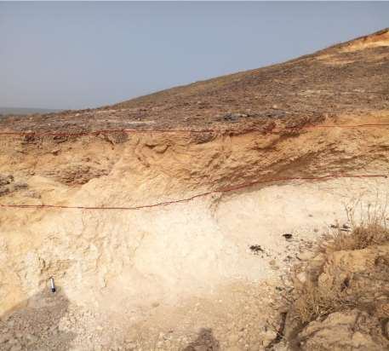

Iron Stone

Laterite

Clay

Plate : Lithological section of clay capped with Iron stone at KTG 1. N 009 12 02, E 005 35 22

.

38

The second bed of clay occurs at the top with varying distance range of about 1 meter from the first bed of clay. The clay deposit with thickness of about 1.5 to 5.3 meter was observed to be massively exposed due to erosion, and is overlain by a thin layer of Ironstone overburden. Both locations contain clay that feels gritty to touch between fingers in hand specimen and varies from white to brownish white with a reddish stain colouration which is as a result of the ironstone overburden (Plate ).

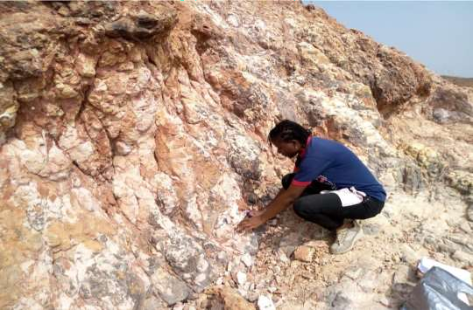

Plate : Exposed massive clay with tinted red colour at KTG 1 N 009 11 55, E 005 35 59

The lithological section of KTG1 as observed on the field (Figure 4.1) shows medium grain sandstone of about 0.21m and is overlain by intercalation of siltstone – sandstone and claystone with height of about 1.5m. The siltstone – sandstone and claystone admixture is directly overlain by a massive claystone of about 5.3m in height and is tinted with a red stain, overlaying the admixture of siltstone – sandstone and claystone is an oolitic ironstone overburden of about 1.1m in height. The ironstone overburden

39

produce iron-rich percolating water resulting in iron oxide to be deposited along the clay profile downward which explain the tinted red stain on the clay.

1cm =1m KUTIGI Enagi and Batati

**FO RM ATIO N**

**ME M BE R**

**Bed No**

**Thickness ( m)**

**Lithology**

**Silt VF**

**F M**

**C**

**Vc**

**Gravel Pebbles Cobbles Boulders**

**Paleo- current**

Kutigi

1.1M

Batati

**C lay**

Oolitic Ironstone

Massive claystone with tinted red stain

Formation

o

Clay

ne

st

KEY

Ironstone Clay stone

5.3M

Siltstone Sandstone

Red stain

Siltstone

Enagi

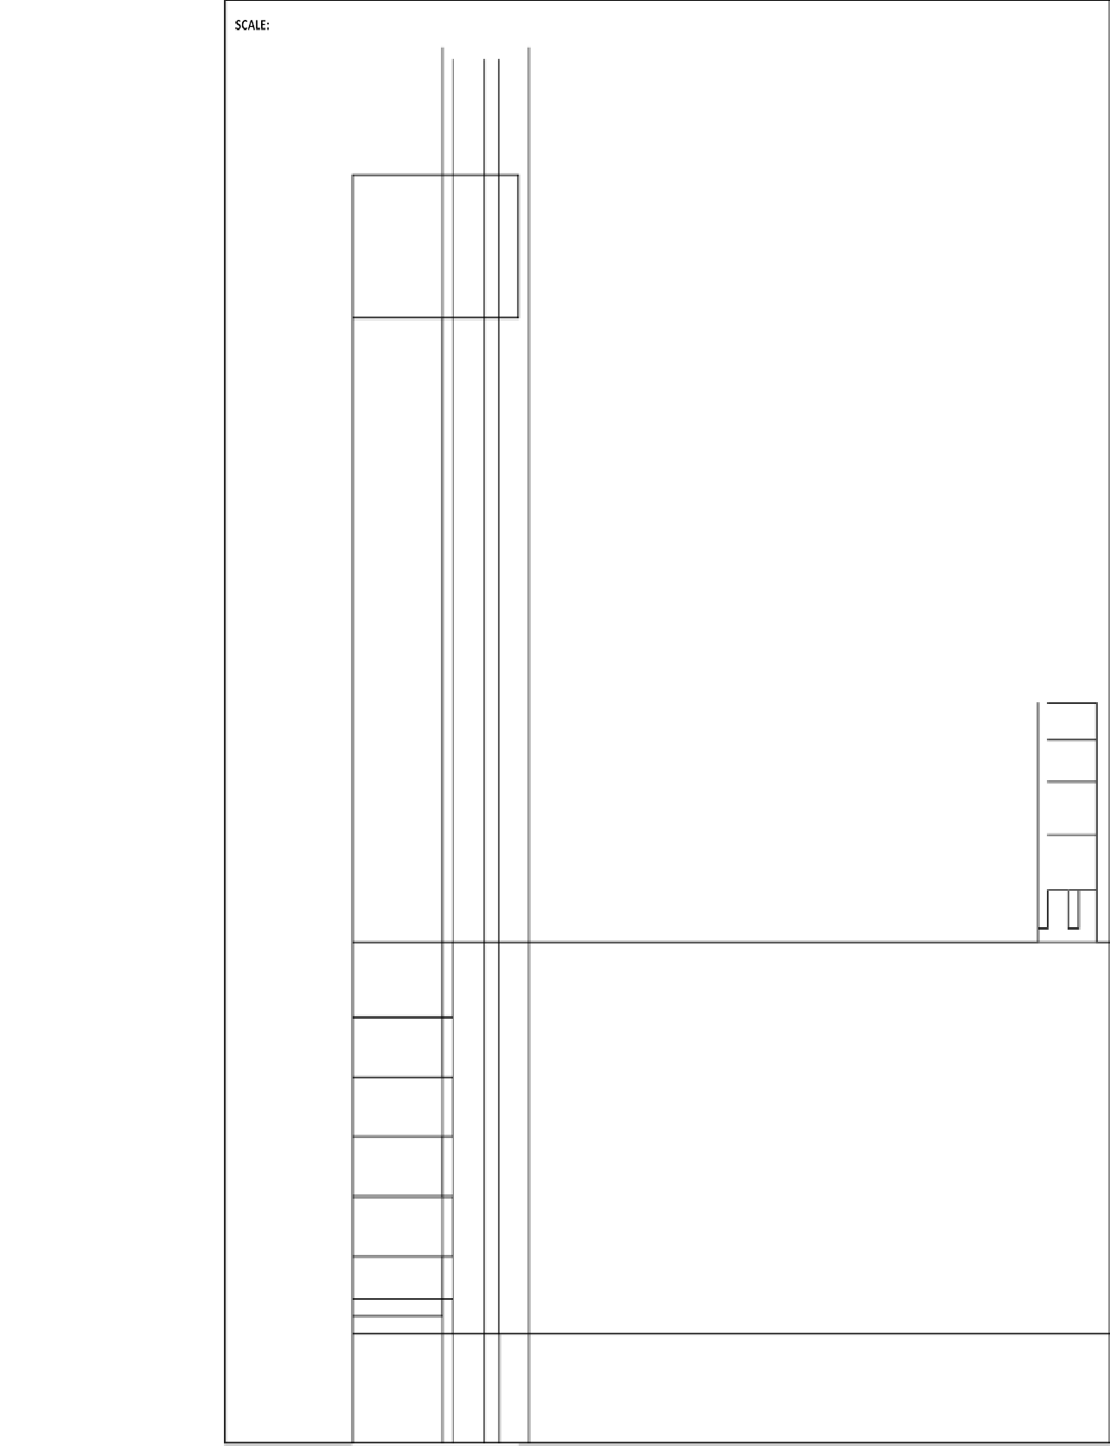

1.5

M

0.21m

Intercalation of siltstone and claystone. The claystone colour ranges from brownish white to milky white while the siltstone is whitish

Medium grain sandstone

Figure 4.1: Lithological Section of KTG1

40

and

Claystone

Sand stone

The second clay Location KTG2 occurred on a hill of about 1km from the first location KTG1, the clay occurs as irregular lenticular structures (Plate) within the sandstones, siltstones and ironstones. The clay is generally milky white to pure white in colour (Plate V), fine grained in texture and feels very smooth to gritty when rubbed between the fingers. The smoothness and the grittiness can be attributed to the presence of quartz residuals in the deposit (Omang *et al*., 2019). The evidences as observed on the field revealed the lithostratigraphic position of the study clay to be a bed within the Enagi Formation.

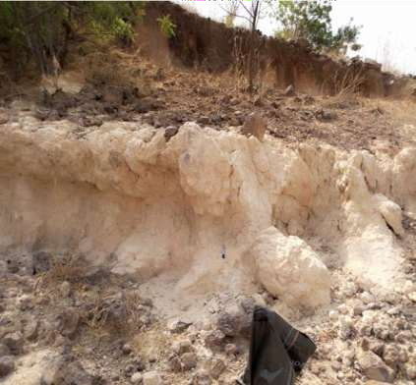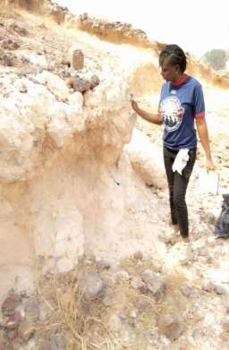

Irregular

Lenticular

Plate : Clay occurring as irregular Lenticular structures at KTG2,

9 9 49N, 6 1 24E

Plate V: clay with milky white colour at KTG2, 9 9 49N, 6 1 25E

41

The stratigraphy of KTG2 (Figure 4.2) show medium grain sandstone of about 3m overlain by admixture of siltstone and claystone with an average height of about 4.5m, and directly overlain by massive claystone of about 3.2m. The claystone is capped by ironstone overburden of about 1.6m.

42

1cm =1m KUTIG2

1.6M

Batati

0.3M

3.2M

4.5M

Formation

Enagi and Batati Kutigi

Oolitic ironstone

ferruginized clay stone

Massive milky white fine grain clay stone with a lenticular nodular structure. The structure is a post diagenetic feature probably due to weathering

Ironstone

claystone Claystone

KEY

Ironstone Clay stone F/clay stone

Siltstone

Sandston e

lenticular structure

Intercalation of siltstone and claystone. The claystone colour ranges from brownish white to milky white while the siltstone is whitish

Enagi

Siltstone and Claystone

3M

Medium grain sandstone

Sandstone

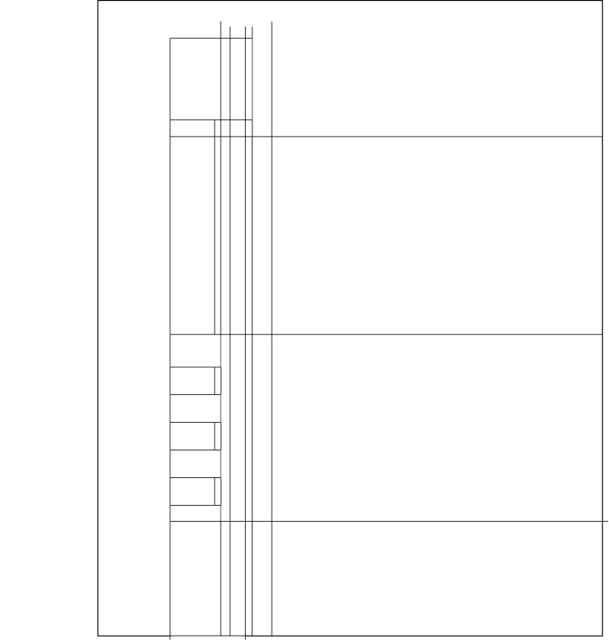

Note: f = ferruginized

Figure 4.2: Lithological section of KTG2 43

# Laboratory Result

Results of all the physical and chemical analyses are presented in (Tables 4.1 to 4.3). The Atterberg‟s limit test and Shrinkage test are presented in percentage. The results of the mineralogical analysis and geochemical results are equally presented in percentages.

# Atterberg’s limit and shrinkage test

The results of the moisture contents, Atterberg‟s limits and shrinkage limit of the geotechnical analysis of Kutigi clay deposits are presented in (Table 4.1). The average moisture content of the study clay show very low value of about 0.88%. The Atterberg‟s limit (which comprises liquid limit (LL), plastic limit (PL), plasticity index (PI), and shrinkage limits (SL)) are as follow; an average liquid limit of about 23.65%, plastic limit of about 17.01%, plasticity index of about 6.63%, and a linear shrinkage limit of about 5.03%.

# Table 4.1: Geotechnical result of Kutigi clay deposit

|  |  |  |  |  |  |  |  |  |  |  |
| --- | --- | --- | --- | --- | --- | --- | --- | --- | --- | --- |
| **SAMPLE** | **KTG 1A** | **KTG 1C** | **KTG 1F** | **KTG 1G** | **KTG 2A** | **KTG 2B** | **KTG 2D** | **KTG 2F** | **Range** | **Average** |
| **Moisture**  **content (%)** | 0.35 | 0.56 | 0.69 | 0.98 | 1.3 | 1.0 | 1.28 | 0.92 | 0.35 – 1.28 | 0.88 |
| **Liquid limit (%)** | 18.31 | 22.41 | 20.09 | 32.25 | 16.20 | 30.01 | 31.78 | 18.20 | 16.20 - 32.25 | 23.65 |
| **Plastic limit (%)** | 13.01 | 16.19 | 17.81 | 22.10 | 9.00 | 27.00 | 21.22 | 9.76 | 9.00 – 27.00 | 17.01 |
| **Plasticity Index (%)** | 5.3 | 6.22 | 2.28 | 10.15 | 7.20 | 3.11 | 10.56 | 8.24 | 2.28 – 10.56 | 6.63 |
| **Shrinkage limit (%)** | 3.76 | 3.99 | 4.78 | 5.05 | 4.28 | 5.79 | 6.6 | 6 | 3.76 - 6.6 | 5.03 |

44

The liquid limit range from 16.20 to 32.25 %, plastic limit from 9.00 to 27.00 % and the plasticity index values of the clays from 2.28 to 10.56 % respectively suggesting that the clays are generally of low to medium compressibility, low swelling and low to medium plasticity. Plasticity of clays is one of the most important parameters affecting the determination of clay material production and production processes (Murray 2007), its gives their suitability for commercial exploitation in the ceramic industries. The low plasticity index (10%) of clay indicate non-plastic clay (Siddiqui *et al*., 2005). This is probably as a result of high quartz and non-clay minerals content as observed in the mineralogy of the study clay. Plasticity can be increased by removal of non-clay components.

Punmia *et al.* (2005) gave classification of degree of clay expansion on the basis of percentage linear shrinkage of clay into expansive (5–8%) and non -critical expansive (5%). The result of firing and shrinkage tests indicate that fresh pellets measuring 4, 5, 6, 7, 8, 9, 10 and 11cm respectively show appreciable shrinkage after firing at 950 –

1100o C with the shrinkage values of 3.76 %, 3.99 %, 4.78 %, 5.05 %, 4.28 %, 5.79 %, 6.6%, and 6 %, respectively. The range from 3.76 to 6.6% of the study clay fall between non-expansive clay categories. This can be explain by absent of expansive clay minerals like montmorillonite in the study clay.

# X-ray diffraction result

The XRD results revealed that the KTG1A sample consist mainly of Kaolinite, Biottite and Quartz (Figure 4.3). Sample from KTG1G consists of Quartz and Kaolinite (Figure 4.4). Sample KTG2B consist of Kaolinite, Muscovite and Quartz (Figure 4.5). The KTG2F sample consists Kaolinite, Muscovite, Dickite and Quartz (Figure 4.6).

45

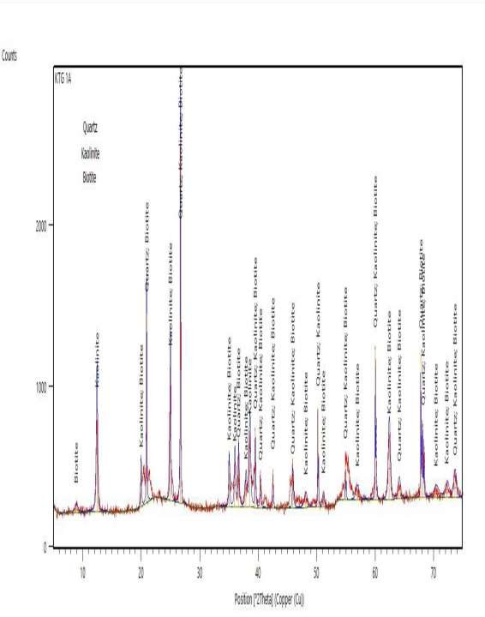

Figure 4.3: X- ray diffractograph for Sample KTG 1A

46

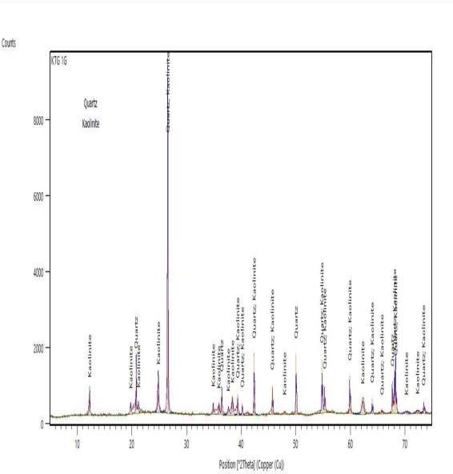

Figure 4.4: X- ray diffractograph for Sample KTG 1G

47

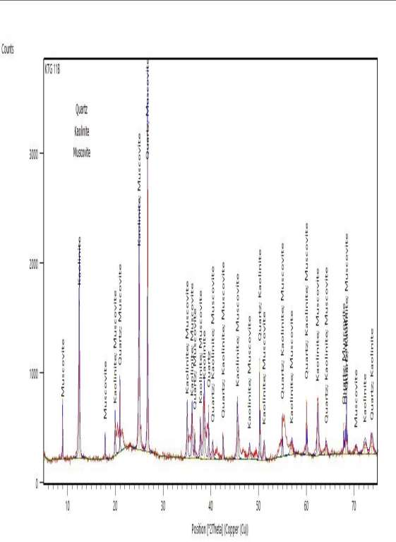

Figure 4.5: X- ray diffractograph for Sample KTG 2B

48

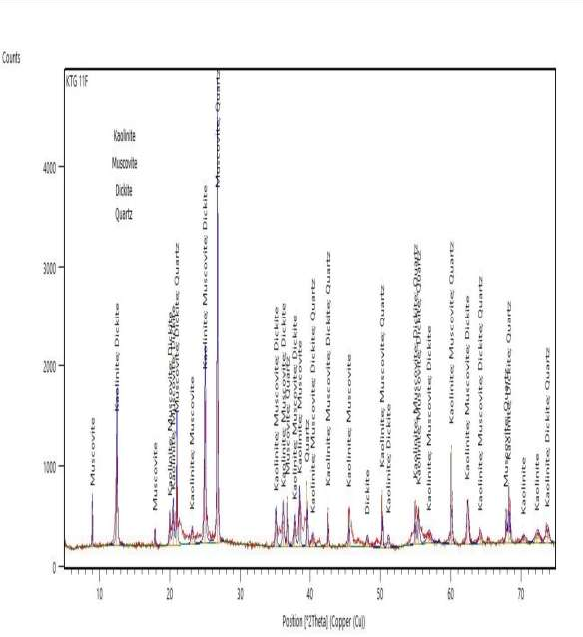

Figure 4.6: X- ray diffractograph for Sample KTG 2F

49

The mineralogical percentage composition are resented in (Table 4.2). The clay consist mainly of Kaolinite as the major clay mineral with average of 32.52% and quartz as the dominate non-clay mineral with average of 49.98%.

# Table 4.2: percentage minerals composition of the study clays

|  |  |  |  |  |  |
| --- | --- | --- | --- | --- | --- |
| **Mineral names** | **KTG 1A**  **%** | **KTG 1G**  **%** | **KTG 2B**  **%** | **KTG 2F**  **%** | **Average** |
| **Quartz** | 54.64 | 68.75 | 46.24 | 30.3 | 49.98 |
| **Kaolinite** | 37.11 | 31.25 | 32.25 | 29.5 | 32.52 |
| **Biotite** | 8.25 | - | - |  | 8.25 |
| **Muscovite** | - | - | 21.51 | 17.2 | 19.35 |
| **Dickite** | - | - | - | 22.9 | 22.9 |
| **Total** | 100 | 100 | 100 | 100 | 100 |

KTG1A and KTG2F clay sample contain the highest amount of Kaolinite with 37.11% and 29.5% respectively; Kaolinite and Dickite constitute the clay minerals. Quartz was identified in all the diffractograms, Biottie was identified in sample KTG1A, and Muscovite in sample KTG2B and KTG2 (Figure 4.7)

50

80

70

60

50

40

30

20

Quartz

Kaolinite Biotite Muscovite

Dickite

10

0

KTG 1A

KTG 1G

KTG 2B

KTG 2F

Figure 4.7: Chart of percentage mineralogical

Composition of the study clay

The study clay is dominated by kaolinite clay mineral; this confirms the study clay to be kaolin. The high content of quartz explains the grittiness of the clay and resistance of quartz to weathering during formation of the study clay and also suggests the clay to be residual clay. The mineral assemblage of the study clay is similar except for KTG 1, suggesting same source rock. Absent of feldspar in the study sample indicate complete destruction and alteration of feldspar composition from the basement rock adjacent to the basin into kaolinite during deposition into the basin. Muscovite are associated with felsic granite rock, therefore the present of muscovite in sample KTG2B and KTG2F indicate source of material of the study clay to be from the felsic rocks of the basement complex, present of muscovite may also suggest incomplete weathering within the basin.

The average mineralogical composition of different clay deposits in Nigeria compared with Kutigi clay (Table 4.3) indicates that kaolinite compare non favourably with Eruku/Lakiri, Obudu udesi and Ubulu-uku/Awo omama clay, with Eruku/Lakiri having the highest percentage of kaolinite. Quartz is the highest non clay mineral with Ubulu-

51

uku clay and Duku clays having the highest amount of Quartz. Muscovite is the minor mineral with the study clay, having the highest amount of muscovite. The variation in mineralogical percentage composition among the clay occurrence compared is due to geological differences (kefas *et al*., 2007).

# Table 4.3: The samples mineral average compared to other know clay deposit in Nigeria

|  |  |  |  |  |  |
| --- | --- | --- | --- | --- | --- |
| **Mineral names** | **This study** | **Duku clay** | **Obudu udesi** | **Eruku Lakiri** | **Ubulu uku Awo omama** |
| **Quartz** | 49.98 | 23 | 20.28 | 21 | 37 |
| **Kaolinite** | 32.52 | 43 | 62.50 | 83 | 62 |
| **Biotite** | 8.25 | - | - |  | - |
| **Muscovite** | 19.35 | - | 7.53 | 5 | - |
| **Dickite** | 22.9 |  |  |  |  |
| **Others** | - | 34 | 10 | 2 | 2 |
| **Total** | 100 | 100 | 100 | 100 | 100 |

Duku clay Obudu udesi Eruku/Lakiri

Ubulu uku/Awo omama

(Salihu & Suleiman, 2018) (Adamu & Duru, 2020) (Oyebanjo *et al.,* 2020) (Oyebanjo *et al.,* 2020)

# Geochemistry result.

The major oxide compositions of the Kutigi clay deposit analyses of 11 clay sample are presented in (Table 4.4).

52

# Table 4.4: summary of the major oxide of Kutigi clay deposit

|  |  |  |  |  |  |  |  |  |  |  |  |  |  |  |
| --- | --- | --- | --- | --- | --- | --- | --- | --- | --- | --- | --- | --- | --- | --- |
| Major  Oxides% | **KTG1A** | **KTG1C** | **KTG1**  **D** | **KTG1F** | **KTG1**  **G** | **KTG2A** | **KTG2B** | **KTG2D** | **KTG2E** | **KTG2F** | **KTG2G** | **Range** | | **Average** |
|  |  |  |  |  |  |  |  |  |  |  |  | 44.52 - | |  |
| SiO2 | 44.90 | 48.85 | 47.52 | 45.82 | 46.20 | 47.35 | 50.02 | 44.52 | 47.79 | 45.75 | 46.31 | 50.02 | | 46.82 |
|  |  |  |  |  |  |  |  |  |  |  |  | 33.03 - | |  |
| Al2O3 | 35.14 | 35.29 | 38.80 | 34.75 | 36.50 | 38.01 | 33.03 | 36.00 | 34.40 | 34.46 | 33.47 | 38.80 | | 35.44 |
| Fe2O3 | 1.59 | 1.52 | 1.01 | 1.45 | 0.82 | 1.00 | 0.85 | 0.51 | 1.23 | 0.73 | 1.08 | 0.51 | - 1.59 | 1.07 |
| TiO2 | 0.90 | 0.65 | 0.52 | 0.45 | 0.60 | 0.62 | 0.54 | 0.58 | 0.53 | 0.52 | 0.60 | 0.45 | - 0.90 | 0.59 |
| K2O | 0.92 | 0.87 | 0.90 | 1.06 | 0.85 | 1.01 | 0.79 | 0.40 | 0.64 | 0.84 | 0.85 | 0.40 | - 1.06 | 0.83 |
| Na2O | 0.80 | 1.53 | 2.14 | 1.05 | 0.75 | 1.34 | 0.98 | 0.87 | 0.68 | 1.20 | 0.72 | 0.68 | - 2.14 | 1.09 |
| CaO | 0.06 | 0.03 | 0.06 | 0.04 | 0.62 | 0.05 | 0.04 | 0.20 | 0.05 | 0.03 | 0.60 | 0.03 | - 0.62 | 0.16 |
| MgO | 0.32 | 0.30 | 0.32 | 0.28 | 0.30 | 0.33 | 0.30 | 0.34 | 0.35 | 0.30 | 0.29 | 0.28 | - 0.35 | 0.31 |
| MnO | 0.08 | 0.05 | 0.15 | 0.02 | 0.05 | 0.05 | 0.06 | 0.02 | 0.04 | 0.02 | 0.04 | 0.02 | - 0.15 | 0.05 |
| P2O5 | 0.02 | 0.03 | 0.03 | 0.03 | 0.02 | 0.04 | 0.02 | 0.01 | 0.03 | 0.02 | 0.04 | 0.01 | - 0.04 | 0.02 |
| LOI | 15.14 | 12.50 | 8.55 | 14.70 | 13.68 | 10.20 | 13.37 | 16.37 | 14.06 | 15.93 | 16.00 | 8.55 | - 16.37 | 13.68 |
| TOTAL | 99.87 | 101.6 | 100 | 99.65 | 100.38 | 100 | 100 | 99.82 | 99.80 | 99.80 | 100 | 99.6 | - 101.6 | 100.08 |
| CIA 92.60 – | | | | | | | | | | | | | | |
| 95.07 | | 93.55 | 92.60 | 94.17 | 94.19 | 94.06 | 94.88 | 96.07 | 96.16 | 94.33 | 93.91 96.16 94.45 | | | |

CIA = Al2O3/ (Al2O3+CaO+Na2O+K2O)*100 CIA = Chemical index of alteration

53

59

The most abundant oxides are SiO2, and Al2O3, whereas TiO2, CaO, K2O MnO, MgO, (average concentrations 1 wt %) were presented in small quantities. SiO2 has the highest composition with average of 46.33% and range from between 44. 52 wt % to 50.02 wt %, in the samples. KTG2B contain the highest amount of SiO2 of 50.02 wt %. Al2O3 is the second most abundant oxide. It has an average composition of 35.70% and ranges from between 33.03 to 38.80 wt%. KTG1D contains the highest Al2O3 of 38.80%.

The other oxides Fe2O3, Na2O, TiO2, CaO, MgO and P2O5 are significantly low except KTG1D clay sample having the highest amount of Na2O (2.14%). The Fe2O2 ranges from between 0.51 wt % to 1.59 wt %, TiO2 from 0.45 to 0.90. Cao, Na2O and K2O have average of 0.16 wt %, 1.6 wt % and 0.83 wt % respectively. The MgO and MnO ranges from 0.28 wt % to 0.35 wt % and 0.02 wt % to 0.15 wt % respectively while Loss of Ignition (LOI) ranges from 8.55 to 16.35 wt % (Figure 4.4).

Figure 4.8: Chart of major oxide of the study clay

60

50

40

30

SiO2

Al2O3 Fe2O3 TiO2 K2O Na2O

CaO

20

MgO

10

MnO

P2O5

0

LOI

KTG1A KTG1C KTG1D KTG1F KTG1G KTG2A KTG2B KTG2D KTG2E KTG2F KTG2G

54

Chemically, the standard composition of pure Kaolin clay is dominated by SiO2 range form (47-50%), Al2O3 range from (34 -37%), loss on Ignition range from (10-12.5%), and small amounts of other oxide like Fe2O3, TiO2, CaO, MgO, K2O and Na2O are invariably present in nature (Chatterjee, 2009). This implies that the clay deposit from Kutigi is a Kaolin clay as the major oxide falls between this ranges. The predominance of SiO2 and Al2O3 are mainly associated with quartz and kaolinite minerals (Oyebanjo *et al.,* 2020). The average ratio of the study clay between SiO2 and Al2O3 is found as 1.32%. This value is lower than the normal value which is generally found in pure kaolinite as 1.18% (Semiz & Celik, 2020).

Alabi (2017) proposed LOI of sedimentary clay to be  6% while that of in-situ basement clays to range between 0.5 -5.5%. Therefore the study clay with LOI of between 8.55% and 16.37% suggest the study clay to be of sedimentary occurrence. Rocks rich in feldspar contain high concentration of Na2O, K2O and CaO. The feldspar generally weathered to form kaolinite clay mineral by complete alteration of feldspar through leaching away of Na2O, K2O and CaO. Therefore the low content of Na2O, K2O, CaO and MgO, in the study clay (Figure 4.5) suggest intensive weathering and destruction of feldspar and mica during transportation before deposition in the basin.

55

Figure 4.9: Chart of average major oxide composition of the study clay

**Average Major Oxide composition**

50

45

40

35

30

25

20

average

15

10

5

0

SiO2 Al2O3 Fe2O3 TiO2 K2O Na2O CaO MgO MnO P2O5 LOI

The low content of MgO and CaO suggest the source rock for the formation of the study clay is not carbonate or dolomitic but suggest felsic source rock. Slightly high content of Fe2O3 in the study clay suggest contamination of the clay by the iron –rich percolating water from the over burden iron-stone resulting in Fe2O3 deposited along the profile downward which explain the tint red or pink stain on the clay. This was confirmed from non-detection of iron oxide minerals like hematite or Goethe from the mineralogical content of the study clay. The relative insignificant proportion of P2O5 and MnO is indicative of high degree of leaching. The low content of P2O5 may also be explained by the concentration of accessory minerals like monazite in silicic source rock.

The weathering intensity plot after Nebsitt & Young (1982) using the ternary diagrams of chemical index of alteration CIA= Al2O3/ (Al2O3 + CaO + Na2O + K2O) * 100) was employed to deduced weathering trend and intensity. The chemical index of alteration (CIA) of the study clay range from 92.6% to 96.16%.

56

McLennan & Taylor (1991) suggest CIA values of residual clays to range from 85 to 100%, this further confirmed the study clay to be residual clay. The major oxide composition of the study clay confirms depletion of element such as Na, Ca, and Mg during the weathering process of the adjacent basement rock as the degree of weathering is determined from values of the remaining elements. CIA ranges from 50% - 65% reflect weak weathering, 65% - 85% intermediate weathering while 85% - 100% reflect strong weathering. The CIA values of the clay samples range between 92.6% to 96.16%, and plot near Kaolinite (Figure 4.6), indicating strong intensive weathering of the source rock.

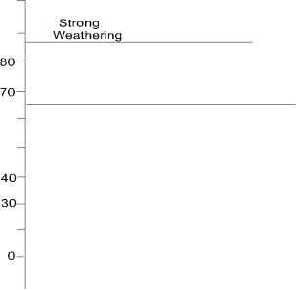





A= Al2O3 C = CaO K = K2O

Figure 4.10: A-CN-K diagram (after Nebsitt & Young, 1982) with plots of study clay

The plot of non-marine source against marine clay source after Ratcliffe et al., (2007) using clay Fe2O3 % against MgO% (Figure 4.7) support the non-marine source of the kaolin

57



 



Figure 4:11: Binary diagram of depositional environment differentiation (after Ratcliffe *et al.,* 2007) with plots of study clays



Marine clays generally contain suite of clay minerals of illite, kaolinite, chlorite, and mix-layer clays, whereas non-marine clays are rich in Kaolinite and small amount of illite. Generally, non-marine clay minerals are differentiated from marine clay minerals by their low concentration of MgO, high concentration of SiO2 and Fe2O3 while marine clay minerals has high concentration of MgO, low concentration of SiO2 and Fe2O3 (Alabi, 2005). This behavior was observed from the major oxide percentage of the study clay further confirming non marine source of the study clay.

Sequence to previous workers observations and suggestions, Adeleye (1971) and Braide (1992a), the sediments supply of the Bida basin (Bida sandstone Formation and Sakpe Iron Formation) during the Campanian are favored by marine incursion. The Enagi Formation is favored by continental sediment supply during the Maastichian while Batati Ironstone Formation is by marine supply, suggesting

the basin has experienced two phases of marine incursion during the upper 58

Campanian and upper Maastrichian (Alabi *et al*., 2018), this explained the non- marine source of the study clay.

A comparison of the chemical composition of the studied clays with some Nigerian clay deposits shows that the average compositions of SiO2 and Fe2O3 in the studied clays are similar to Okpella clay (Omang *et al*., 2019). The clay deposit of Akerebiata clay (Olusola *et al.,* 2014), Share clay North Bida Basin (Ojo *et al.,* 2011) and Dukku clay Kebbi (Salihu & Suleiman, 2018) are observed to be more enriched in SiO2 than those of the study area.

The Dukku clay Kebbi (Salihu & Suleiman, 2018) Al2O3 composition of 35.50 wt

% compared more favourably with the Kutigi clay deposit though the MgO and CaO content of 1.90 wt % and 2.10 wt % respectively is slightly high than the study clay MgO and CaO composition of 0.31 wt % and 0.16 wt % respectively. The average chemical composition of obudu clay compare not favourable with the study clay, SiO2 and Fe2O3 of obudu clay are higher while Al2O3 is lower than the study clay as show in (Table 4.5). The variations in chemical composition among the clay deposits compared may probably be due to geological differences (Kefas *et al.,* 2007).

59

# Table 4.5: Major oxide of the study clay compared to other clay occurrence in Nigeria

|  |  |  |  |  |  |  |
| --- | --- | --- | --- | --- | --- | --- |
| **Major Oxides** | **This** |  | | | | |
| **%** | **Study** | **A** | **B** | **C** | **D** | **E** |
| **SiO2** | 46.82 | 40.55 | 58.09 | 55.59 | 58.10 | 57.24 |
| **Al2O3** | 35.44 | 21.67 | 21.86 | 35.50 | 26.99 | 19.56 |
| **Fe2O3** | 1.07 | 0.95 | 2.74 | 4.50 | 1.52 | 7.99 |
| **TiO2** | 0.59 | 1.90 | 0.92 | 0.02 | 1.75 | 0.87 |
| **K2O** | 0.83 | 3.50 | 0.79 | - | 0.32 | 0.89 |
| **Na2O** | 1.09 | - | 0.66 | - | 0.09 | 0.45 |
| **CaO** | 0.16 | - | 1.51 | 2.10 | 0.04 | 0.62 |
| **MgO** | 0.31 | - | 0.22 | 1.90 | 0.06 | 0.98 |
| **MnO** | 0.05 | - | 0.13 | - | 0.01 | 0.07 |
| **P2O5** | 0.02 | 0.94 |  | - | 0.07 | 0.05 |
| **LOI** | 13.68 | - | 13.08 |  | - | 11.0 |

A= Okpella clay

B = Akerebiata clay C= Dukku clay kebbi

D =Share clay North Bida Basin E = Obudu clay

(Omang *et al*., 2019) (Olusola *et al.,* 2014) (Salihu & Suleiman 2018) (Ojo *et al*., 2011)

(Adamu & Duru, 2020)

# Industrial potentials of Kutigi clay deposits

Generally, there are no universally accepted procedure for characterization and standard industrial specifications of the desired properties of clay. There are many different specifications outlined by purchasers for many end uses. However, some organizations with the help of industries, have established useful standards that have wide applications. For instance, Tables 4.6 to Table 4.9 presents a comparison of the mineralogy and chemical composition of the studied clays studied with the specifications for Kaolin clays for paper, ceramics, pharmaceutical and cosmetics industries. The Table shows clearly that the studied

60

clays do not meet the specifications of these industries but with beneficiation the study clay can find use in ceramics and paper industries

# Uses and specification

**In paper industry:** Kaolin is use for coating and filling paper, as a filler, the Kaolin is mixed with the cellulose fibres in wood pulp. As coating, the Kaolin is mixed with water, adhesives and various additives and coated onto the surface of the paper. This makes the paper sheet smoother, brighter, glossier, more opaque and improves the printability (Murray, 2006).

**Coating:** Clay is used as a coating material in high quality white paper to make the surface glazed. It is obvious that clay should be as white as possible. Fe2O3 imparts color and hence is objectionable. Grit is highly objectionable as it will spoil the smoothness of the surface of the paper. CaO will absorb water and will result in crumbling of clayey ingredient of the finished paper on exposure to air. So, both are objectionable. Grain size should be ultra-fine (for very high quality paper below 2 micron size is preferable), and more important is the uniformity of the size, because, otherwise, surface of the paper will not be smooth. Besides, fine particles provide a very large surface area which facilitates retention of the clay (the ratio of the clay added during manufacture to the clay which remains in the finished paper).

The Al2O3 content (35.44%) of Kutigi clay deposit is low as compared to the 37– 38% Al2O3 content specification. Fe2O3 and TiO2 values fall within the specification range (Table 4.6). The Xray diffraction patterns show the presence of low kaolinite with high percentage of quartz. Montmorillonite is not present; the study clay will required the removal of quartz for its usefulness in publication- grade paper.

61

# Table 4.6: Industrial specification for Paper Coating

**(Siddiqui *et al.,* 2005)**

|  |  |  |  |
| --- | --- | --- | --- |
| **Chemical**  **Composition** | **This**  **Study** | **Paper**  **Coating** | **Remark** |
| **SiO2** | 46.82 | 45 – 49 | Within range |
| **Al2O3** | 35.44 | 36 – 38 | Slightl deviant |
| **Fe2O3** | 1.07 | 0.5- 1.0 | Within range |
| **K2O** | 0.83 | 0.5 - 1.5 | Within range |
| **TiO2** | 0.59 | 0.5 - 1.3 | Within range |
| **Mineralogical** |  |  |  |
| **Composition** |  |  |  |
| **Kaolinite** | 32.52 | 93 – 99 | Deviant |
| **Quartz** | 49.98 | - |  |
| **IIIite/Mica** | 8.25 | 7 -10 | Within range |

**Filler:** It is used in varieties of papers, cardboards, hard boards to impart evenness to the surface by occupying the interstices between cellulose fibers. Particle size is the most critical parameter coloring matters is also undesirable

The SiO2 content (46.82%) of Kutigi clay deposit is in range as compared to the 46 - 48% SiO2 content specification. Al2O3 content (35.44%) of Kutigi kaolin is low as compared to the 37–38% Al2O3 content specification. Fe2O3, K2O and TiO2 values fall within the specification range (Table 4.7). The mineralogy content of the Kutigi clay show the presence of dominant kaolinite content of 32.52% much lower than the standard specification of 90-95%. The present of Quartz in higher

62

content compared to specification makes it undesirable for paper filler industry. It will require the removal of quartz for its usefulness in paper filler industry.

# Table 4.7: Industrial specification for paper filler (Siddiqui et al., 2005)

|  |  |  |  |
| --- | --- | --- | --- |
| **Chemical**  **Composition** | **This Study** | **Paper Filler** | **Remark** |
| **SiO2** | 46.82 | 46 – 48 | Within range |
| **Al2O3** | 35.44 | 37 – 38 | Deviant |
| **Fe2O3** | 1.07 | 0.5 -1.0 | Within range |
| **K2O** | 0.83 | 0.5 - 1.5 | Within range |
| **TiO2** | 0.59 | 0.5 - 1.5 | Within range |
| **Mineralogical** |  |  |  |
| **Composition** |  |  |  |
| **Kaolinite** | 32.52 | 90 – 95 | Deviant |
| **Quartz** | 49.98 |  |  |
| **IIIite/Mica** | 8.25 | 5 – 10 | Within range |

**In ceramic applications:** Kaolin are utilized in a wide range of ceramics products, these include dinnerware, sanitary ware, tile, electrical porcelain, pottery, and refractories. The ceramic properties of clay materials are variable depending on the clay mineral composition and such properties as particle size distribution, presence of organic material, and the non-clay mineral composition. The clay mineral composition is the most important factor determining ceramic properties. Kaolinite is the most important clay mineral used in ceramic applications because of its physical and chemical properties that are imparted to ceramic processing and finished products (Murray, 2006). The key to ceramic use

63

is low Fe2O3 content and a good fired brightness and casting rate (Siddiqui *et al.,* 2005). Kutigi clay Fe2O3 content is within the range of specification (Table 4.8). The mineralogical are not suitable for ceramic. The chemical composition of Kutigi clay deposit does not conform to the required range. Although the geotechnical with low shrinkage limit values are within the range of the specifications required for the production of porcelain and wall and floor tiles.

# Table 4.8: Industrial specification for ceramics (Siddiqui *et al.,* 2005) & (Ike *et al.,* 2021)

|  |  |  |  |
| --- | --- | --- | --- |
| **Chemical**  **Composition** | **This Study**  **%** | **Ceramics**  **%** | **Remark** |
| **SiO2** | 46.82 | 48 -50 | Slightly deviant |
| **Al2O3** | 35.44 | 36 – 37 | Slightly deviant |
| **Fe2O3** | 1.07 | 0.6 -1 | Slightly deviant |
| **K2O** | 0.83 | 1.2 – 2.7 | Slightly deviant |
| **TiO2** | 0.59 | 0.02 – 0.1 | Within range |
| **LOL** | 13.68 | 11.2 – 12.5 | Slightly deviant |
| **MINERALOGICAL COMPOSITION** |  |  |  |
| **Kaolinite** | 32.52 | 61.60 | deviant |
| **Quartz** | 49.98 | 2.30 | deviant |
| **IIIite/Mica** | 8.25 |  | deviant |
| **GEOTECHNICAL** |  |  |  |
| **Liquid limit** | 23.65 | 26.88 | Slightly deviant |
| **Plasticity limit** | 17.01 | 15.51 | Slightly deviant |
| **Plasticity index** | 6.63 | 10.38 | deviant |
| **Shrinkage limit** | 3.76 -6.6 | 0.25 – 6.2 | Within range |
|  | 64 |  |  |

**In pharmaceutical and cosmetic industry:** Kaolin specifications for pharmaceutical or cosmetic purposes are usually merged as one, although the aim and purpose for use are different (López-Galindo *et al*., 2007). In pharmaceutical Kaolin is used as an absorptive for gastro-intestinal disorders, as a tablet or capsule diluent, as a suspending agent, in poultices and for dusting in surgical operations, as an absorptive to absorb toxins and harmful bacteria in addition to forming a soothing protective coating on inflamed mucous membrane in the digestive tract. Kaolin is used as a suspending agent for pectin in the well-known product kaopectate. Kaolin is also commonly used as a diluent in capsules and tablets. In tablets, it aids in making the tablet strong and dense when the tablet is compressed (Murray, 2006).

In the cosmetic industry kaolin is use mostly in baby powder and body powder. The other major use of kaolin in cosmetics is in face packs and masks. Up to 5% of the formulation can be a fine, particle size kaolin. A recent use of kaolin is in the formulation of a hair conditioner. The kaolin adds body to fine hair, which increases the apparent hair volume (Murray, 2006). For these uses very careful sterilization is necessary as clay is generally heavily contaminated with pathogenic micro-organisms. Clay for medicinal purpose must be free from the toxic substances like lead, arsenic and other heavy metals. Most of the major oxide content of Kutigi clay are slightly deviant from specification range, and the mineralogy is not suitable for Pharmaceutics and cosmetics industry (Table 4.8).

65

# Table 4.9: Industrial specification for Pharmaceutics and cosmetics industry (Lopez-Galindo *et al*., 2007).

|  |  |  |  |
| --- | --- | --- | --- |
| Chemical  Composition | This Study | Pharmaceutics and  cosmetics | Remark |
| SiO2 | 46.82 | 44.62 - 46.4 | Within range |
| Al2O3 | 35.44 | 38.1 – 39.5 | Slightly deviant |
| Fe2O3 | 1.07 | 0.1 – 0.2 | Slightly deviant |
| MgO | 0.31 | 0.1 - 0.2 | deviant |
| CaO | 0.16 | 0.1 – 0.2 | deviant |
| Na2O | 1.09 | 0 – 0.1 | deviant |
| K2O | 0.83 | 0 – 0.2 | deviant |
| TiO2 | 0.59 | 0 – 1.4 | Within range |
| LOL | 13.68 | 13.8 – 13.9 | Within range |

66

# CHAPTER FIVE

# CONCLUSION AND RECOMMENDATIONS

# Conclusion

This study conducted an investigation of the physical, mineralogical and geochemical properties of Kutigi clay deposits with the aim of determining its industrial application. Results from field study revealed the stratigraphic position of the study clay to be a bed within the Enagi siltstone formation and occurs as irregular lenticular structures within the sandstones, siltstones and ironstones.

The clay is generally milky white to pure white in colour, fine to medium grained in texture and feels very smooth to less gritty when rubbed between the fingers. The smoothness and the grittiness can be attributed to the presence of quartz residuals in the deposit. Results of physical properties analyses indicate a liquid limit, plastic limit and the plasticity index values of the clays range from 16.20 to

32.25 %, 9.00 to 27.00 % and 2.28 to 10.56 % respectively. This shows that the clays are generally of low to medium compressibility, low swelling and low to medium plasticity. The low shrinkage values shrinkage values of 3.76 %, 3.99 %,

4.78 %, 5.05 %, 4.28 %, 5.79 %, 6.6%, and 6 % respectively suggest that the clay is a suitable raw material for the ceramics a industries.

Clay minerals found in the deposits are Kaolinite and Dickite. Quartz constitutes the highest non-clay mineral content in the deposit with an average content value of 49.98%. The high quartz content does not make them industrially useful unless with beneficiation.

The chemical composition shows high content value of SiO2 and Al2O3 with average 46.82% and 35.44% respectively and minor compounds range of MgO (0.28 -0.35), Fe2O3 (0.51- 1.59), CaO (0.03–0.62), K2O (0.40-1.06), TiO2 (0.45–

67

0.90), and Na2O (0.68 –2.14) which are within acceptable limits for paper coating paper filler.

The comparison of the physical properties, mineralogy and chemical composition of the study clay with the specifications of some Industrial clay shows that they are not suitable for most Industry unless with beneficiation.

# 5.2 Recommendations

Paper industry should be encouraged to begin exploitation of the clay deposit also the ceramics industry can be approached to utilize the deposit

68

# REFERENCES

Abuh, M. A., Abia-Bassey, N., Udeinya, T. C., Nwannewuihe, H. U., Abong, A. A., & Akpomie, K. G. (2014). Industrial potentials of Adiabo clay in Calabar municipal of Cross River State, South-South Nigeria. *Pacific Journal of Science and Technology*, 15(1), 63–75.

Adamu. C. I., & Duru, C. C. (2020). Composition geotechnical characteristics and the potential for industrial use of some clay bodies in obudu and its environs southeastern Nigeria. *Geotech Geology Engineer*. doi.org/10.1007/s10706-020-01424-0.

Adegoke, O.S. (1979). Eocene Stratigraphy of Southern Nigeria. *Bureau de Recherches Geologiques et Minieres*, 69, 3-48.

Adeleye, D. R. (1971). *Stratigraphy and Sedimentation of the upper Cretaceous strata round Bida, Nigeria*. Unpublished PhD. Thesis, University of Ibadan Nigeria.

Adeleye, D. R. (1973). Origin of Ironstones: an example from Middle – Niger valley, Nigeria*. Journal of Sedimentary Petrology*, 43(13), 709 – 727.

Adeleye, D. R. (1989). *The Geology of the middle Niger Basin:* C. A. Kogbe (Editor), Geology of Nigeria (2nd ed.). Jos, Nigeria: Rock view publishing Ltd, 335-339

Adeleye, D. R., & Dessauvagie, T. F. J. (1972). *Stratigraphy of the Niger embayment near Bida, Nigeria:* Africa Geology. Ibadan, Nigeria: University of Ibadan Press, 181 – 186.

Adeniyi, J. O. (1985). Ground total magnetic intensity in part of Nupe basin and the adjacent Basement Complex, Niger State, Nigeria. *Nigerian Journal of Applied Science*, 3(2), 67 – 78.

Adeniyi, J.O. (1986). Polynomial regional surfaces and two – dimensional models in parts ofthe Nupe Basin and the adjacent Basement Complex, Niger State, Nigeria. *Nigerian Journal of Applied Science*, 4(2), 25 – 34.

Aguzzi, C., Sandri, G., Cerezo, P., Carazo, E., & Viseras, C. (2011). *Clay Minerals*, 7(10), 22-36.

Akande, S. O., Ojo, O. J., & Erdtmann, B. D. (2005). Paleoenvironments, Organic Petrology and Rock Eval studies on source rock facies of the Campanian

69

to Maastrichtian Patti Formation, southern Bida basin, Nigeria. *Journal of African Earth Sciences*, 41, 394-406.

Akhirevbulu, O. E., Amadasun, C. V. O., Ogunbajo, M. I., & Ujuanbi, O. (2010). The Geology and Mineralogy of Clay Occurrences around Kutigi Central Bida Basin, Nigeria. *Ethiopian Journal of Environmental Studies and Management*, 3(3).

Akhirevbulu, O. E. & Ogunbajo, M. I. (2011). The Geotechnical Properties of Clay Occurrences around Kutigi Central Bida Basin, Nigeria. *Ethiopian Journal of Environmental Studies and Management*, 4(1), doi:10.4314/ejesm.v4i1.3.

Alabi, A. A. (2005). *Exploration and reserve estimation of clay-A case study of the Kutigi clay deposit of Bida Basin*. Unpublished MTech Thesis, Federal University of Technology Minna, Nigeria.

Alabi, A. A. (2015). Mineralogy and Geochemical Characteristics of Clay Occurrence in Central Bida Basin Northwestern Nigeria. *Journal of Natural Sciences Research,* 5(20).

Alabi, A. A. (2017). *Geology and Provenance of Clay Deposits in Parts of Central Bida Basin, Nigeria.* Unpublished PhD, Ahmadu Bello University Zaria, Nigeria.

Alabi A. A., Garba, I., Danbatta, U. A., & Najime, T. (2018). Depositional Environment and Paleo-redox Indicator of the Maastrichian-Campanian Clay in Central Bida Basin, NW Nigeria: Insight from Geochemistry and Sedimentology. *Journal of Geosciences and Geomatics,* 6(3), 147- 152, doi: 10.12691/jgg-6-3-5

Alvarez Acevedo, N. I., Rocha, M. C. G., & Bertolino, L. C. (2017). Mineralogical Characterization of Natural Clays from Brazilian Southeast Region for Industrial Applications. *Ceramica*, 63, 253-262, doi.org/10.1590/0366-69132017633662045.

Al Ani, T., & Sarapää, O. (2008). Clay and clay mineralogy. *Geological Survey of Finland Report*, M19/3232/2008/41, Espoo.

Arora, K. R. (2008). Soil mechanics and foundation engineering, (7th ed.). Delhi, India: Nai Sarak.

Asamoah, R. B., Nyanyan kson, E., Annan, E., Agyei –Tuffour, B., Efafavi1, J. K., Kan-Dapaah, K., Apalangya-alangya., V. A., Damoah amoah, L. N.,

70

Dodoo –Arhin, D., Tiburuburu, E. K., Kwofie, S. K., Onwona – Agyeman, B., & Yaya, A. (2018). Industrial applications of clay materials from Ghana (A Review). *Oriental Journal of Chemistry,* 34(4) 1719-1734, doi:org/10.13005/ojc/340403

Asantewah, M., Korankye, M., Darko, G., & Dodd, M. (2016). *Toxicology Reports*, 134, 644–651.

Balaras, C. A., Droutsa, K., Argiriou, A. A., & Asimakopoulos, D. N. (2000).

*Energy and buildings,* 31(2), 143-54.

Barshad, I. (1966). Effect of a variation in precipitation on the nature of clay mineral formation in soils from acid and basic igneous rocks. In: Heller, L., Weiss, A. (Eds.), Proceedings of the International Clay Conference, Jerusalem, Israel Program for Scientific Translation, Jerusalem, 1, 167– 173.

Benneth, C. C. (2008). Settling behavior of kaolinite clay in the absence of flocculants. *Pacific Journal of Science and Technology*, 9(1), 212–218.

Bergaya, F., Theng B. K. G., & Lagaly G. (2006). Handbook of Clay Science. Developments in Clay Science Series. *Geological Magazine,* 145(03), xxi- 1224, doi: 10.1017/S001675680800438X

Bergaya, F., & Lagaly, G. (2013). Clays and Clay Minerals, and Clay Science. *Developments in Clay Science*, 5, 1-19, doi:10.1016/S1572- 4352(05)01001-9

Braide, P. S. (1992a). Alluvial fan depositional model in tBida Basin. *Journal of mining and Geology Nigeria,* 28(1), 65 –73.

Braide, P. S. (1992b). Syntectonic fluvial sedimentation in the central Bida Basin.

*Journal of mining and Geology Nigeria,* 28(1), 55 –64.

Bundy, W. M. (1993). The diverse industrial applications of kaolin. In H. H. Murray, W. M. Bundy & C. C. Harvey, (Eds.), *Kaolin Genesis and Utilization* (Pp. 43–73). New York: science press

Chatterjee, K. K. (2009). *Uses of industrial minerals, rocks, and freshwater*. New York: Nova science.

Choy, J. H., Choi, S. J., Oh, J. M., & Park, T. (2007). Clay. *Applied Clay Science*, *36*(1), 22-32.

71

Dondi, M., Raimondo, M., & Zanelli, C. (2014). Clay and bodies for ceramic tiles: Reprisal and techbological classification. *Applied Clay Science,* 96, 91–109, doi:10.1016/jclay.2014.01.013

Emamifar, A. (2011). Advances in nanocomposite technology. *IntechOpen,* 1, 12- 15.

Galan, E., Aparicio, P., González, I., & Miras, R. A. (1998). Contribution of multivariate analysis to the correlation of some properties of kaolin with its mineralogical and chemical composition. *Clay Minerals.* 33, 65-75. doi: 10.1180/000985598545435.

Galan, E., Brigitte, M., & Theng, B. (2013). Structure and mineralogy of clay minerals. *Developments in Clay Science*. 5, 21-81, doi:10.1016/B978-0- 08-098258-8.00002-X.

Galan, E., & Ferrell, R. E. (2013). Genesis of clay minerals. *Developments in clay Science.* doi:10.1016/B978-0-08-098258-8.00003-1.

Galan, E. (1996). Properties and applications of Palygorskite ± sepiolite clays.

*Clay Mineral*, 31, 443-445.

Guggenheim, S., Martin, R. T., Alietti, A., Drits, V. A., Formoso, M., Galan, E., Koster, H. M., Morgan, D. J., Paquet, H., Watanabe, T., Bain, D. C.,

Ferrell, R. E., Bish, D., Fanning, D. S., Kodama, H., & Wicks, F. J. (1995). Definition of clay and clay mineral: Joint report of the AIPEA nomenclature and CMS nomenclature committees. *Clay and Clay Minerals*, 43, 255-256, doi:10.1346/CCMN.1995.0430213

Harvey, C. C., & Lagaly, G. (2013). Developments in clay science. 5, 245-460, doi: 10.1346/00098600360733447.

Ike, J., Ezeh, H., Eyankware, M., & Haruna, A. (2021). Mineralogical and Geochemical Assessment of Edda Clays for Possible Use in the Ceramics Industry, Afikpo Sub- Basin, Nigeria. *Journal of Geological Research, 3*(2), doi:10.3564/jgr.v3i2.2964.

Kefas, H. M., Patrick, O. D., & Chiroma, M.T. (2007). Characterization of Mayo- Belwa clay. *Leonardo Electronic Journal of Practices and Technologies,* 6(11), 123–130

Keller, W. D. (1970). Environmental aspects of clay minerals. Sediment. *Petrol,*

40, 798–813.

72

Kennedy, W. Q., (1965). *The influence of basement structure on the evolution of the coastal (Mesozoic and Tertiary) basins. In Recent Basins around Africa* (pp. 35-47). London: The Institute of Petroleum Geologists Society press.

King, L. C., (1950). Outline and distribution of Gondwanaland. *Geological Magazine* 87, 353- 35.

Kogbe, C. A., Ajakaiye, D. E., & Matheis, G., (1981). Confirmation of a Rift Structure along the Mid-Niger Valley, Nigeria. *Journal of Earth Science,* 1, 127-131.

Konadu, D.S., Dodoo-Arhin, D., Annan, E., Buabeng, F.P., Yaya, A., & Agyei- Tuffour, B. (2013). Fabrication and characterization of Ghanaian bauxite red mud-clay composite bricks for construction applications*. American Journal of Mineral Material Science*, 3, 110–119

Konta, J. (1995). Clays and Man: Clay Raw Materials in the Service of Man.

*Apply Clay Science,* 10, 275-335.

Ladipo, K. O., Akande, S. O. & Mucke, A. (1994). Genesis of Ironstones from Middle Niger Sedimentary Basin, evidence from Sedimentological Ore Microscope and Geochemical Studies. *Journal of Mining and Geology*, 30, 161-168.

Li, Z., & Jaroniec, M. (2003). *Chemistry of materials*, 15(6), 1327-33.

López-Galindo, A., Viseras, C., & Cerez, P. (2007). Compositional, technical and safety specifications of clays to be used as pharmaceutical and cosmetic products. *Applied Clay Science*, 36(1-3), 51-63, doi.org/10.1016/j.clay.2006.06.016.

Malakul, P., Srinivasan, K.R., & Wang, H.Y. (1998). *Industrial & engineering chemistry research*, 37(11), 4296-4301.

McLennan, S., & Taylor, S. (1991). Sedimentary rocks and crustal evolution: tectonic setting and secular trends. *The Journal of Geology, 99*(1), 1-21.

Merriman, R. (2005). Clay minerals and sedimentary basin theory. *European Journal of Mineralogy*. 17, 7-20, doi:10.1127/0935-1221/2005/0017-0007.

Murat, R. C., (1972). Stratigraphy and paleogeography of the Cretaceous and lower Tertiary in southern Nigeria. In T.F.J. Dessauvagie, & A. J.

73

Whiteman (Eds), African Geology. (pp. 251 – 266.) Ibadan: University of Ibadan Press.

Murray, H. H. (2003). Clays and clay minerals in Jordan. *Clay mineral.* 51-709, doi: 10.1346/00098600360733447.

Murray, H. H. (2006). Applied Clay Mineralogy: Occurrences, processing and applications of kaolins, bentonites, palygorskite-sepiolite, and common clays. *Developments in Clay Science*, (pp.85-87). Rio de janeiro, Brazil: Elsevier press

Murray H. H., (2007). Occurrences, processing and applications of Kaolins, Bentonites, Palygorskite -Sepiolite and common clays. *Applied clay mineralogy.* 55 (6), 644-645.

Nebsitt, H. W., & Young, G. M. (1982). Chemical Process Affecting Alkalis and Alkaline Earth Metals during weathering. *Geochemical mineral Composition. 44*, 1659-666.

Obaja, S. O., Omada, J. I., & Dambatta, U. A. (2013). Clays and their industrial applications; Synoptic Review. *International Journal of science and technology.* 3(5), 264-270.

Obaje N. G. (2009). Geology and Mineral Resources of Nigeria, Lecture Notes in Earth Sciences. *C_Springer-Verlag Berlin Heidelberg*, 120, 72 – 97, doi: 10.1007/978-3-540-92685-6 1

Obaje, G., Ozoji, T., Nathaniel, G., & Umar, M., & Aweda, A. (2019). Mapping and Characterization of Some Industrial Mineral Deposits in North- Central Nigeria as Raw Materials for Industrialization. *International Journal of Sciences: Basic and Applied Research* 48. 160- 182.

Ojo, O. J. (1992). *Petroleum Geology and Sedimentology of Patti Formation, Bida Basin, Nigeria.* In O.S. Adegoke (Editor). Cretaceous Sequences in the Southern Bida Basin, Nigeria (1st ed.). Ibadan, Nigeria: Mosorun Publishers.

Ojo, O. J., & Akande, S. O. (2003). Facies Relationships and Depositional Environment of the Upper Cretaceous Lokoja Formation in the Bida Basin, Nigeria. *Journal of Mining and Geology*, 39, 39-48.

Ojo, O. J., Suraj, A. A., Temitope, M. A., & Aminat, O. A. (2011). Sedimentological and geochemical studies of Maastrichtian clays in Bida

74

Basin, Nigeria: Implication for resource potential. *Centrepoint Journal (Science Edition),* 17 (2), 71-88.

Ojo, S. B., & Ajakaye, D. E. (1989). Preliminary Interpretation of Gravity Measurement in the Middle Niger Basin Area, Nigeria. In C. A. Kogbe (Eds.), Geology of Nigeria, second edition. (pp.347 – 358). Lagos, Nigeria: Elizabethan Publishing Co.

Okosun, E. A., Goro, A. I., Olobaniyi, S. B., Shekwolo, P. D., & Nwosu, J. E. (2007). Stratigraphy of Bida Formation, Bida Basin, Nigeria. *Borno Journal of Geology,* 4(2), 23 – 37.

Olusola, J. O., Suraj, A. A., & Alhassan, N. (2014). Geochemical and Mineralogical Studies of Kaolinitic Clays in Parts of Ilorin, Southwestern Basement Rock Area, Nigeria. *Universal Journal of Geoscience.* (2)7, 212-221, doi:10.13189/ujg.2014.020704.

Omang, B.O., Kudamnya, E.A., Owolabi, A.O., Odey, J., Aniwetalu, E.A. and Ako, T.A. (2019). Characterization of kaolin deposits in Okpella and environs southern, Nigeria. *International Journal of Geosciences*, 10, 317- 327.

Omotoyinbo, J. A., & Oluwole, O. O. (2008). Working properties of some selected refractory clay deposits in South Western Nigeria. Journal of Minerals & Materials Characterization & Engineering, 7(3), 233–245.

Onyekuru, S. O., Iwuoha P. O., Iwuagwu C. J., Nwozor K. K., & Opara K. D. (2018). Mineralogical and geochemical properties of clay deposits in parts of southeastern Nigeria. *International Journal of Physical Sciences,* 13(14), 217-229.

Onyeobi, T. U., Imeokparia, E. G., Ilegiuno, O.A., & Egbuniwe, I. G. (2013). Compositional, geotechnical and industrial characteristics of some clay bodies in southern Nigeria. *Journal of Geography and Geology*, 5 (2), 73- 84.

Oyebanjo, O., Ekosse, G., & Odiyo. J. (2020). Physio-Chemical, Mineralogical, and Chemical Characterization of Cretaceous–Paleogene/Neogene Kaolins within Eastern Dahomey and Niger Delta Basins from Nigeria: Possible Industrial Applications. *Minerals,* 10, 670, doi: 10.3390/min10080670.

Punmia, B., Jain A. K., Jain-Arum, K. (2005). Soil mechanics and foundations. (16th ed). New Delhi: Laxmi,

75

Rahaman, M. A. O., Fadiya, S. L., Adekola, S. A., Coker, S. J., Bale, R. B.,

Olawoki, O. A., Omada, I. J., Obaje, N. G., Akinsanpe, O. T., Ojo, G. A., & Akande, W. (2018). A revised stratigraphy of the Bida Basin, Nigeria. *Journal of African Earth Sciences.* 151.

doi:10.1016/j.jafrearsci.2018.11.016.

Ratcliffe, K. T., Morton, A., Ritcey, D., & Evenchick, C. E. (2007). Whole rock geochemistry and heavy mineral analysis as exploration tools in the Bowser and Sustut Basins, British Colombia, Canada. *Journal of Canadian Petroleum Geology,* 55,320–37, doi: org/10.2113/gscpgbull.55.4.320.

Salihu, S. A., & Suleiman, I. Y. (2018). Comparative analysis of physical and chemical characteristics of selected clays deposits found in Kebbi State, Nigeria. *International Journal of Physical Sciences,* 13(10), 163-17. doi:0.5897/IJPS2018.4727

Semiz, B., & Celik, S. B. (2020). Mineralogical and geochemical characteristics of Belevi clay deposits at Denizli, SW Turkey: industrial raw material potential. *Arabian Journal of Geosciences,* 13, 313, doi.org/10.1007/s12517-020-05292-z.

Siddiqui, M. A., Ahmeda, Z., & Saleemi, A. A. (2005). Evaluation of Swat kaolin deposits of Pakistan for industrial uses. *Applied Clay Science.* 29, 55-72

Tiburu, E. K., Kankpeyeng, B. W., Nkumbaan, S. N., Salifu, A. A., & Zhuang, A. (2017). Biomaterials and Biomedical Engineering. *Journal of Biomimetics,* 30, 45-60.

Whiteman, A. (1982). Nigeria*:* Its Petroleum geology, Resources and potential. (pp. 82 – 86) London: Graham and Trotman Ltd.

76