COMPARATIVE RELATIVE BIOAVAILABILITY STUDIES OF SIX BRANDS OF OFLOXACIN MARKETED IN ZARIA

By

SALISU AWWALU

M.Sc. / Pharm. Sci./3542 / 11-12

A Thesis submitted to the School of Post Graduate Studies, Ahmadu Bello University, Zaria In partial fulfillment of the requirements for the Award of
Masters Degree in Pharmaceutical Chemistry

Department of Pharmaceutical and Medicinal Chemistry, Faculty of Pharmaceutical Science Ahmadu Bello University, Zaria, Nigeria

November, 2014

Declaration

I hereby declare that the work in this thesis titled “comparative relative bioavailability studies of six brands of ofloxacin marketed in Zaria” was performed by me in the Department of Pharmaceutical and Medicinal Chemistry, under the supervision of Dr. M. A. Usman and Dr.
A.Y. Idris. The information derived from the literature has been duly acknowledged in the text and a list of references provided. No part of this work has been presented for another degree or diploma in any institution.

Name Signature Date

Certification

This thesis titled “comparative relative bioavailability studies of six brands of ofloxacin marketed in Zaria” meets the regulations governing the award of the degree of M.Sc. Pharmaceutical Chemistry of the Ahmadu Bello University, and is approved for its contribution to knowledge and literary presentation.

Chairman, Supervisory Committee Date (Dr. M.A. Usman)

Member, Supervisory Committee Date (Dr. A.Y. Idris)

Head of Department Date

(Dr. A. M. Musa)

Dean, School of Postgraduate Studies Date (Prof. A. H. Zoaka)

Acknowledgement

All praise and thanks are to Almighty Allah for seeing me through this work. I also wish to acknowledge my sincere gratitude and prayers to my supervisors Dr. M. A. Usman and Dr. A.Y. Idris for their guidance, patience, tolerance, understanding and commitment for the actualization of this work. I also wish to express my appreciation to all the lecturers and members of staff of the Department of Pharmaceutical and Medicinal Chemistry, A.B.U., Zaria especially the ones that taught us during the course work year. Also my gratitude goes to Malam Ilyasu Chief Technologist and Malam Umar for assisting me with the UV/VIS Spectrophotometric analysis.
I must also acknowledge My Parents for their love, prayers and moral support. I also acknowledge my wife and my son (Fadila aka Ummu Muhammad and Muhammad) for their love, prayers and understanding. I also appreciate my Brothers and Sisters for their prayers and support.

ABSTRACT

This study was aimed at assessing the comparative bioavailability of six brands of ofloxacin marketed in Zaria.
Comparative bioavailability studies of six brands of ofloxacin marketed in Zaria was successfully conducted. Quality assessment was conducted on the randomly selected six brands of ofloxacin marketed in Zaria. Identification test, assay, weight variation, friability, disintegration time and dissolution rate were determined according to BP 2009. Cheap, simple and accurate U. V. Spectrophotometry method for analysis of ofloxacin in GAA from saliva sample at 295nm was developed and validated based on ICH guideline. Calibration curve was constructed within the range of 3-18µg/ml and validated. The developed method was then employed in the comparative bioavailability studies of six brands of ofloxacin with a washout period of one week.

All the brands were found to have the labeled active ingredient. The six brands passed the assay as they were within the accepted range of 99.8-102%. Weight variation was conducted and all the brands passed as their percentage deviations were less than 5%. Similarly all the brands passed the friability except Brand E with more than 1% friability. Disintegration test reveals that all the brands disintegrate in less than 15minutes and all the brands passed the dissolution rate as more than 85% of the active ingredient was released in 30 minutes. The percentage recovery of the developed method was within the accepted range of 98 - 102%. Calibration curve was linear within the range of 3-18µg/ml as the correlation co-efficient was 0.998. The regression equation was y= 0.092x + 0.008. All the brands were well tolerated by the subjects as no adverse effects were reported. The mean Cmax (µg/ml) of brands B, C, E and F were found to be significantly

(p≥0.05) different from that of the brand A (innovator) while brand D was not significantly (p≥0.05) different (16.66 ± 1.41, 11.7 ± 1.83, 9.82 ± 0.67, 16.25 ± 2.54, 15.35 ± 1.43 and 11.99
± 0.37 for brand A, B, C, D, E, and F respectively). The mean tmax (hr) of brand C and D were found to be statistically similar (p≥0.05) with that of the innovator while that of brand B, E and F were significantly (p≥0.05) different from that of the innovator (3.5 ± 0.2, 4.0 ± 1.83, 3.5 ± 0.61,
4.5 ± 0.61, 2 ± 0.45 and 2.5 ± 0.22 for brand A, B, C, D, E, and F respectively). For AUC0-8 (µg/ml.h), the values of brands B and D were found to be statistically similar (p≥0.05) with that of the innovator while the values of brands C, E and F were significantly (p≥0.05) different from that of the innovator (72.68 ± 3.58, 56.53 ± 13.26, 43.24 ± 4.25, 100.40 ± 16.01, 92.74 ± 6.75 and 28.17 ± 0.62 for brand A, B, C, D, E, and F respectively). The elimination half life (t1/2□ (h)) of brands B and C were statistically similar (p≥0.05) with that of the innovator while brands D, E and F half life values were significantly (p≥0.05) different from that of the innovator (3.08
± 0.11, 2.89 ± 0.27, 3.01 ± 0.09, 4.27 ± 0.02, 4.23 ± 0.09 and 1.63 ± 0.02 for brand A, B, C, D,

E, and F respectively).

Brand D was found to be comparatively bioavailable with the innovator. Therefore, it could be used in preference to the innovator due to its cheap price compared to the innovator. Brand B, C, E and F were not comparatively bioavailable as both the rate and extent of absorption were significantly different at p≥0.05 level of significance.

Table of contents Pg №

Title page i
Certification ii
Acknowledgement iii
Abstract v
Table of contents vii
List of Tables xi
List of Figures xiii
List of Appendices xiv
Abbreviations xvi

Chapter One

  - Introduction 1
  - Theoretical framework 2
  - Statement of the research problem 3
  - Justification of the research 4
  - Aim of the research 4
  - Specific objectives 4
  - Null hypothesis 4
  - Alternate hypothesis 4
Chapter Two
  - Literature review 5
  - Ofloxacin general property 5
  - Analytical profiles of ofloxacin 6
    - Compendial methods of analysis 6
    - Literature method of analysis 7
  - Mechanism of action 9
  - Absorption and bioavailability 9
  - Metabolism 10
  - Excretion 11
  - Therapeutic uses 11
  - Adverse effect 11
  - Relation between dissolution test and bioavailability 12
Chapter Three
  - Materials and Method 14
  - Materials 14
    - Drugs 14
    - Glass wares and Accessories 14
    - Equipment 14
    - Reagents 15
  - Method 16
    - Purchase of ofloxacin tablet 16
    - Inspection of NAFDAC label requirement 16
    - Identification test 16
    - Assay of ofloxacin tablet content 16
    - Uniformity of weight 17
    - Disintegration test 17
    - Dissolution rate 17
    - Friability test 18
    - Identification of standard ofloxacin powder 18
    - Selection of solvent 18
    - Preparation of stock solution 18
    - Determination of wavelength of maximum absorption 19
    - Determination of pH of maximum absorption 19
    - Validation of the developed analytical method 19
    - Extraction procedure 20
    - Percentage recovery 20
    - Preparation of calibration curve 21
    - Protocol of the study 22
    - Study drug 22
    - Study design 22
    - Pharmacokinetic analysis 23

Chapter Four
- Result 24
  - Identification of ofloxacin powder 24
  - Identification of ofloxacin in the tablets 24
  - Quality control result 26
    - Assay 26
    - Weight variation 27
    - Friability and Disintegration time 28

    - Dissolution test 29
  - Analytical method result 30
    - Determination of wavelength of maximum absorption 31
    - Effect of pH on wavelength of maximum absorption 32
  - Result for validation parameter 33
    - Intra-day precision 34
    - Inter-day precision 35
    - Accuracy and percentage recovery 36
4.5.3 Linearity of the method 37
  - Result of In-vivo Studies 39
    - Salivary concentration of ofloxacin detected for the various tablet brands 39
  - Result for comparism of pharmacokinetic parameters of Brand A 41
and other brands

Chapter Five
  - Discussion 46
  - Conclusion 50
  - Recommendation 50
References 51
Appendices 55

List of Tables
Table 4.1: | Label information of six different brands of ofloxacin tablets | 24
Table 4.2: | Absorbance of Ofloxacin tablet at 440nm | 25
Table 4.3: | Assay of ofloxacin tablet content | 26
Table 4.4: | Uniformity of weight (mean ± SD) and their mean
 | percentage deviation | 27
Table 4.5: | Percentage friability and disintegration time | 28
Table 4.6: | Dissolution rate in 0.1N HCl at thirty minutes (30min) | 29
Table 4.7: | Effect of pH on wavelength of maximum absorption | 31
Table 4.8: | Intra-day precision of 10µg/ml ofloxacin solution | 32
Table 4.9: | Inter-day precision of 10µg/ml ofloxacin solution | 33
Table 4.10: | Accuracy and percentage recovery of standard ofloxacin
 | powder spiked into blank saliva | 34
Table 4.11: | Summary of validation parameter of the developed method | 35
Table 4.12: | Linearity study of ofloxacin | 36
Table 4.13: | Mean salivary concentration of the various brands | 38
Table 4.14: | Mean pharmacokinetic parameters comparism
 | between brand A and B | 41
Table 4.15: | Mean pharmacokinetic parameters comparism
 | between brand A and C | 42
Table 4.16: | Mean pharmacokinetic parameters comparism
 | between brand A and D | 43
Table 4.17: | Mean pharmacokinetic parameters comparism
 | between brand A and E | 44

Table 4.18: Mean pharmacokinetic parameters comparism
between brand A and F 45

List of figures
Figure 2.1: Ofloxacin chemical structure 5
Figure 4.1: Scanned spectrum of 10µg/ml of ofloxacin standard powder
at 200 – 400nm 28
Figure 4.2: Absorbance of 10µg/ml of ofloxacin standard powder at pH 5 30
Figure 4.3: Calibration curve of ofloxacin 36
Figure 4.4: Graph showing the super imposed mean salivary concentration–time
graph of all brands 38

List of Appendices
- Label information of six different brands of ofloxacin tablets (200mg). 53
- Weight (mg) variation raw data 53
- Friability test raw data 56
- Disintegration test raw data 56
- Dissolution rate at t₃₀ raw data 56
- Preparation of 0.1N HCl 56
- Preparation of 0.1N NaOH 56
- Preparation of pH solution 57
- FTIR spectrum of ofloxacin standard powder 58
- Reference IR spectral of ofloxacin 59
- Scanned spectrum of 10µg/ml of ofloxacin standard powder
at 200 – 400nm 60
- Absorbance of 10µg/ml of ofloxacin standard powder at pH 4 61
- Absorbance of 10µg/ml of ofloxacin standard powder at pH 7 62
- Absorbance of 10µg/ml of ofloxacin standard powder at pH 9 63
- Absorbance of 10µg/ml of ofloxacin standard powder at pH 10 64
- Precision raw data 65
- Calibration curve of ofloxacin 65
- Sample of conversion of obtained absorbances into concentrations 65
- Mean salivary concentration-time graph of brand A 66
- Mean salivary concentration-time graph of brand B 66
- Mean salivary concentration-time graph of brand C 67

- Mean salivary concentration-time graph of brand D 67
- Mean salivary concentration-time graph of brand E 68
- Mean salivary concentration-time graph of brand F 68

List of Abbreviations

ADME | absorption, distribution, metabolism and excretion
AUC | area under the curve
AUMC | area under the moment curve
BP | British pharmacopoeia
CL | clearance
Cmax | maximum plasma concentration
F (%f) | bioavailability
GMP | good manufacturing practice
HPLC | high performance liquid chromatography
ICH | international conference on harmonization
IP | Indian pharmacopoeia
Ka | absorption rate constant)
Ke (K or Kel) | elimination rate constant
KgF | kilogram force
MRT | mean residence time
NAFDAC | Nigeria agency for food and drug administration
PR | percentage recovery
RSD | relative standard deviation
SD | standard deviation
SEM | standard error of the mean
t1/2 | absorption half life
Tmax | time to reach maximum plasma concentration
U.V | ultraviolet
USP | United state pharmacopoeia

Vd volume of distribution

Λmax maximum wavelength

PPM Part per million

GAA Glacial acetic acid

CHAPTER ONE

Introduction

Bioavailability is defined as the fractional extent to which a dose of drug reaches its site of action. Pharmacokinetic describes the time course of a drug in the body, encompassing absorption, distribution, metabolism, and excretion (also known as ADME). Simply put, it describes what the body does to the drug (Timothy, 2006). The biological, physiological, and physicochemical factors, which influence the transfer processes of drugs in the body, also influence the rate and extent of ADME of those drugs in the body (Larry, 2008). The three primary processes of pharmacokinetics are absorption, distribution, and elimination (Katzung, 2004). Absorption is the movement of a drug from its site of administration into the central compartment and the extent to which this occurs (Iain, 2006). After absorption or systemic administration into the bloodstream, a drug is distributed into interstitial and intracellular fluids depending on the physicochemical properties of the drug. The rate and extent of drug distribution into tissues depend on the cardiac output, regional blood flow, capillary permeability, and tissue perfusion (Timothy, 2006). Metabolism is the chemical conversion of the drug molecule, usually through an enzymatic reaction, into another chemical entity referred to as a metabolite. The metabolite may have the same, or different, pharmacological effect as the parent drug, or even cause toxic side effects (Larry, 2008). When this reaction generates more polar, inactive metabolites that are readily excreted, the process is termed biotransformation. While excretion is the irreversible removal of drug from the body and commonly occurs via the kidney or biliary tract (Larry, 2008). Pharmacokinetic parameters include bioavailability (F or %F), area under the curve (AUC), maximum plasma concentration (C_{max}), time to reach maximum concentration (T_{max}), clearance (Cl), volume of

distribution (Vd), terminal half-life (t_{1/2}), elimination rate constant (k_{e}, K or K_{el}) and mean residence time (MRT).

Theoretical Framework

UV-Visible spectrophotometry is one of the most frequently employed technique in pharmaceutical analysis. It involves measuring the amount of ultraviolet or visible radiation absorbed by a substance in solution (Behera et al. 2012 and David, 2000).

In qualitative analysis, organic compounds can be identified by use of spectrophotometer, if any recorded data is available, and quantitative spectrophotometric analysis is used to ascertain the quantity of molecular species absorbing the radiation. Spectrophotometric technique is simple, rapid, moderately specific and applicable to small quantities of compounds (Behera et al. 2012).

Quantitative analysis basically relates concentration of analyte and the intensity of light absorbed. In addition, features of absorption spectra such as the molar absorptivity, spectral position, and shape and breadth of the absorption band are related to molecular structure and environment and therefore can be used for qualitative analysis (Behera et al. 2012).

Quantification of medicinal substance using spectrophotometer may be carried out by preparing solution in transparent solvent and measuring it’s absorbance at suitable wavelength. The wavelength normally selected is wavelength of maximum absorption (λmax), where small error in setting the wavelength scale has little effect on measured absorbance. Ideally, concentration should be adjusted to give an absorbance of approximately 0.9, around which the accuracy and precision of the measurements is optimal (Behera et al. 2012 and David, 2000).

Ofloxacin could be analysed using UV spectrophotometer due to its chromophoric groups. However, it has been reported by Fish and Chow (1997) that ofloxacin has two active metabolites namely; desmethylofloxacin, and ofloxacin N-oxide. UV spectrophotometer does

not discriminate between the parent drug and the metabolites in biological fluid due to the fact that they are of similar structures (Joseph, 1995).

However, it is permissible to employ UV spectrophotometer since more than 90% of administered ofloxacin is excreted unchanged and also the two metabolites are said to be active (Joseph, 1995).

It has been reported by Gauy (1992) that ofloxacin penetrates well into saliva and its concentration in the saliva correlates well with serum levels. Therefore, saliva was chosen as the biological sample.

Statement of the Research Problem

Considering the fact that there are many brands of ofloxacin tablet and it is claimed that generic drugs are inferior to brand name products (WHO, 1993). It is therefore important to carry comparative bioavailabity studies of these brands to assess their bioequivalence. This will go a long way in providing information on available options for the prescribers.

Justification of the Research Problem

Considering the proliferation of several brands of ofloxacin tablet dosage form and the general believe that generic drugs are inferior to brand name products. There is a need to carryout comparative relative bioavailability studies of various formulations of ofloxacin.

Aim of the Research

To carry out comparative relative bioavailability studies of various formulations of ofloxacin.

Specific Objectives

  - To carry out pharmaceutical equivalent studies on ofloxacin tablets.

  - To develop and validate UV spectrophotometric method for analysis of ofloxacin.

  - To study the bioavailability of various brands of ofloxacin tablets.

Null Hypothesis

There is no significant difference in bioavailability and biopharmaceutics between the different brands of ofloxacin.

Alternate Hypothesis

There is significant difference in bioavailability and biopharmaceutics between the different brands of ofloxacin.

CHAPTER TWO

  - LITERETURE REVIEW

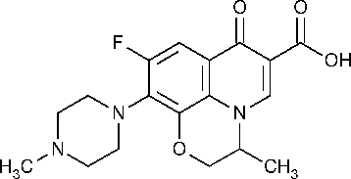

Figure 2.1: Ofloxacin Chemical structure

Ofloxacin General Property

    - Molecular formula - C₁₈H₂₀FN₃O₄.

    - Molecular weight – 361.3675.

    - Route of administration – oral or ophthalmic route.

    - Physical state – solid.

    - Melting point – 250 – 257ºC.

    - Water solubility – 28.3 mg/ml.

    - Log P/ Hydrophobicity – 2.1.

    - Protein binding – 32%.

    - Half life – 6 - 9 hrs.

    - Absorption – Bioavailability of Ofloxacin in tablet formulation is approximately 98%

    - Stability and Storage - Ofloxacin tablets should be stored below 30□C (86□F) in a well-closed container.
(Streubel, et al. 2003, Tadakazu and Yoshiharu, 2005, Lynne, et al. 2000 and Sean, 2009).

Analytical Profiles of Ofloxacin

Compendial methods of analysis

      - Identification methods for the drug substances

The European Pharmacopoeia recommends the use of infrared absorption spectrophotometry for the identification of the pure drug

      - Tests

Absorbance:

Dissolve 0.5 g in 0.1 M hydrochloric acid and dilute to 100 ml with the same solvent. The absorbance of the solution measured at 440 nm is not greater than 0.25.

Optical rotation:

Dissolve 0.300 g in a mixture of 10 volumes of methanol R and 40 volumes of methylene chloride R and dilute to 10 ml with the same mixture of solvents. The optical rotation is - 0.10⁰ to +0.10⁰.

Assay:

Dissolve 0.300 g in 100 ml of anhydrous acetic acid R. Titrate with 0.1 M perchloric acid determining the end-point potentiometrically.
1 ml of 0.1 M perchloric acid is equivalent to 36.14 mg of C₁₈H₂₀FN₃O₄.

Heavy metals:

2.0 g complies with limit test C for heavy metals (10 ppm). Prepare the standard using 2 ml of lead standard solution (10 ppm Pb) R.

Loss on drying:

Not more than 0.2%, determined on 1.000 g by drying at 100–105⁰C for 4 h.

Sulfate ash:

Not more than 0.1%, determined on 1.0 g.

Reported literature methods of analysis

      - Titration method

Four DNA topisomerase (gyrase) inhibitors, including ofloxacin (alone or in mixture with other drugs), were determined by titration method. Tablets containing ofloxacin were extracted 3 times with 30 ml methanol. A portion of the solution was mixed with 2 ml water and the resulting solution was titrated with aqueous 5mM NaOH, 5mM tetrabutylammonium hydroxide, or 5 mM AgNO₃ by adding 0.1 ml increments at 2 min intervals.
The end point was detected by conductimetry (Belal et. al. 1999).

      - Spectrophotometric methods

An extractive spectrophotometric method was developed for determination of ofloxacin in bulk and pharmaceutical dosage form (Suslu and Tamer, 2003). These methods are based on the formation of yellow ion-pair complexes between the basic nitrogen of the drug and bromophenol blue and bromocresol purple as sulfophthalein dyes in phthalate buffer pH 3.0 and 3.1 respectively. The formed complexes were extracted with chloroform and measured at

414 nm for ofloxacin–bromophenol blue and 408 nm for ofloxacin–bromocresol purple. Beer’s law was obeyed in the range 0.87– 17.35 and 0.58–14.46 mg/ml for ofloxacin– bromophenol blue and ofloxacin–bromocresol purple, respectively.
Quan, et al. (2002) reported a net charge-transfer complex that formed by reaction of ofloxacin with p-nitrophenol. This complex had strong absorbance at 302 nm while ofloxacin had no absorbance at the same wavelength. The linear calibration range was 2–80 mg/ml for the drug.
Ballesteros et al. (2002) developed a method for the determination of trace amounts of ofloxacin in human urine and serum sample based on solid phase spectrofluorimetry. The relative fluorescence intensity of ofloxacin fixed on Sephadex SP C-25 gel was measured and emission was 294 and 494 nm respectively. The linear concentration range of application was 0.5–16.0 ng/ml of ofloxacin, with relative standard deviation (RSD) of 1.1% and detection limit of 0.14 ng/ml. Recovery level of the method reached 100% in all cases.
A simple, rapid, accurate and sensitive spectrophotometric method for the determination of ofloxacin in pharmaceutical formulations was described by Amin (Amin, 2000). This method is based on the formation of an ion pair with Sudan III in aqueous acetone medium (40% acetone (v/v).The colored products are measured at 565 nm. Beer’s law is obeyed in the range 0.4–8.8 mg/ml. The results obtained showed good recoveries of ±1.5% with RSD of 0.83%.

      - Chemiluminescence methods

A flow-injection chemiluminescence (CL) method was described for the determination of three fluoroquinolones; including ofloxacin (Liang, et al. 2004). The method is based on these compounds of the weak CL from peroxynitrous acid. The linear range is 3 ×10⁻⁷ to

3×10⁻⁵ for ofloxacin. The detection limit (S/N = 3) is 1.1×10⁻⁷mol l⁻¹. The recoveries were 96–106% (n= 5).
Other methods include;

        - High-performance liquid chromatographic methods (HPLC) (Samanidou et al. 2003).

        - Capillary electrophoresis (CE) (Zhang et al. 2001).

        - Microbiological methods (British Pharmacopoeia, 2007).

Mechanism of Action

Ofloxacin acts by targeting bacterial DNA gyrase and topoisomerase IV. In gram-positive bacteria, topoisomerase IV is the primary target while in gram-negative bacteria, DNA gyrase is the primary quinolone target (Petri, 2006).

Absorption and Bioavailability

Owing to the presence of piperazinyl group at position 7 of the 4-quinolone methylated nucleus, ofloxacin has great bioavailability compared with other fluoroquinolones. It is rapidly and well absorbed from the gastrointestinal tract and oral bioavailability is almost complete in healthy-fasting adults. The peak plasma concentration of 3–5 µg/ml is achieved 1–2 h after single 400 mg dose by mouth (Sean, 2009). It undergoes minimal first pass metabolism. Absorption time may be delayed by the presence of food or when complexed with minerals such as ferrous, ferric, or calcium; however, the extent of absorption is not affected (Sean, 2009).

The plasma half-life ranges from 5 to 8 h in normal healthy human. It is 20-32% bound to plasma protein and is widely distributed into body tissues and fluids following oral administration. The apparent volume of distribution of the drug averages 2.4–3.5 l/kg following oral or intravenous administration. It is distributed into bone, cartilage, bile, skin, sputum, bronchial secretions, pleural effusions, tonsils, saliva, gingival mucosa, nasal secretions, aqueous humor, tears, sweat, lung, blister fluid, pancreatic fluid, ascitic fluid, peritoneal fluid, gynecologic tissue, vaginal fluid, cervix, ovary, semen, prostatic fluid, prostatic tissue, and cerebrospinal fluid. Ofloxacin concentrations in the tissues or fluids are more than that of serum concentrations. The drug crosses the placenta and found in amniotic fluid. It is also found in mammalian milk in a moderate concentration after oral administration (Sean, 2009 and Katzung, 2004).

Metabolism

Ofloxacin is metabolized in the liver at the piperazinyl moiety following oral doses. Unlike other fluoroquinolones, ofloxacin structure contains an oxazine ring linking the nitrogen at position 1 and carbon at position 8 of the quinolone nucleus. This fused ring results in low metabolism of the drug in vivo. Nearly 90% of the administered dose is excreted unchanged in the urine within 48 h following single oral dose of ofloxacin and less than 10% of the compound is excreted as metabolites (Ichihara, et al. 1984). Two metabolites of Ofloxacin, desmethylofloxacin, and ofloxacin N-oxide have been identified at low concentrations in human urine (Fish and Chow, 1997). The former metabolite has moderate antibacterial activity, while the other has only minimal microbiological activity. A third metabolite, ofloxacin β-D-glucuronide, which does not have any activity, is eliminated by biliary excretion in humans and recently, it has been found in urine (Verho, et al. 1986).

Excretion

Ofloxacin is excreted mainly (90%) unchanged by the kidney via active tubular secretion and glomerular filtration with an elimination half-life of 5–7.5 h. Ofloxacin is found in breast milk. The drug crosses the placenta and found in relatively high concentration in cord blood and amniotic fluid (Sean, 2009, Katzung, 2004 and Petri, 2006).

Therapeutic uses

It is used in urinary tract infections, bacterial respiratory tract infections, gastrointestinal infections, and Infection by pneumocystis jiroveci etc (Petri, 2006).

Adverse Effect

Fluoroquinolones are extremely well tolerated. The most common effects are nausea, vomiting, and diarrhea. Occasionally, headache, dizziness, insomnia, skin rash, or abnormal liver function tests develop. Fluoroquinolones may damage growing cartilage and cause arthropathy. Thus, they are not routinely recommended for use in patients under 18 years of age. However, the arthropathy is reversible, and there is a growing consensus that fluoroquinolones may be used in children in some cases (eg, for treatment of pseudomonal infections in patients with cystic fibrosis). Tendinitis, a rare complication that has been reported in adults, is potentially more serious because of the risk of tendon rupture. They should be avoided during pregnancy in the absence of specific data documenting their safety (Sean, 2009, Katzung 2004 and William, 2006).

Relation between Dissolution test and Bioavailability

Edwards in 1951 was the first to appreciate that following the oral administration of solid dosage forms, if the absorption process of drug from the gastrointestinal tract is rapid, then the rate of dissolution of that drug can be the step which controls its appearance in the body. In fact, he postulated that the dissolution of an aspirin tablet in the stomach and intestine would be the rate process controlling the absorption of aspirin into the blood stream (Edwards, 1951). However, Nelson in 1957 was the first to explicitly relate the blood levels of orally administered theophylline salts to their in vitro dissolution rates (Nelson, 1957). He used a non-disintegrating drug pellet, (mounted on a glass side so that only the upper face was exposed), placed at the bottom of a 600mL beaker in such a manner that it could not rotate when the dissolution medium was stirred at 500 rpm.
In mid 1960s to early 1970s a number of studies demonstrating the effect of dissolution on the bioavailability of a variety of drugs were reported in the literature. Two reports were published in 1963 and 1964 drawing attention to the lack of full clinical effect for two brands of tolbutamide marketed in Canada (Campagna et al., 1963, Levy et. al., 1964). These tablets were shown to have long disintegration times as well as slow dissolution characteristics (Levy, 1964). Besides, a slight change in formulation of an experimental tolbutamide preparation was shown to produce significantly lower blood levels and hypoglycemic effect (Varley, 1968). In 1968, Martin et al. reported significant differences in the bioavailability between different brands of sodium diphenylhydantoin, chloramphenicol and sulfisoxazole. MacLeod et al. (1972) reported greater than 20% difference in peak concentration and area under the serum concentration–time curve for three ampicillin products. In late sixties it was realized that differences in product formulation could lead to large differences in speed of onset, intensity and duration of drug response. At that time the term “bioavailability” was

coined to describe either the extent to which a particular drug is utilized pharmacologically or, more strictly, the fraction of dose reaching the general circulation.

CHAPTER THREE

MATERIALS AND METHOD

Material

Drugs

Six Brands of 200mg ofloxacin tablets

Standard powder of ofloxacin was donated by May and Baker

Glass wares and accessories

2×250ml Extraction tubes (Pyrex England) 2×100ml measuring cylinders (Pyrex England)
2×100ml and 2×250ml conical flasks (Pyrex England) 2×25ml and 2×50ml beakers (Pyrex England)
6×10ml test tubes (Pyrex England) 6×15ml centrifuge tubes (Pyrex England)
2×25ml,2×50ml and 2×100ml volumetric flasks (Pyrex England) 20×Filter paper

Equipments

Electronic weighing balance (Metlers Pr 63 Switzerland) Tablet friabilator (Erweka TA3, Germany) Disintegration apparatus (Erwaka G.M.B.H Germany)

Tablet hardness tester (Monsanto, Philip Harries Ltd, England) Centrifugation machine (Gallen Kamp, Philip Harries Ltd, England) Gallen Kamp Hot Air Oven (Philip Harries Ltd, England)
Porcelain pestle and mortar

Thermometer (Mc Donald Scientific International, England) Dissolution machine (DA-6D, Veego Scientific devices Mumbai, India) UV Spectrophotometer (Helios Zeta, Model 164617)
Stop watch (Smith England clock system)

Reagents

Glacial acetic acid (BPH Chemical, England) Distilled water (BPH Chemical, England) Ethanol (BPH Chemical, England)
Methanol (BPH Chemical, England) Glacial acetic (BPH Chemical, England) N-hexane (BPH Chemical, England) Chloroform (BPH Chemical, England) Conc. HCl (BPH Chemical, England) NaOH pallet (BPH Chemical, England)

Method

Purchase of ofloxacin tablet

Six brands of ofloxacin tablets were purchased from Sabon Gari Market, Zaria, Kaduna and were then coded as A, B, C, D, E and F. Brand A considered as innovator (see Appendix 1).

Inspection of NAFDAC label requirement

Addresses of manufacturers, batch numbers, manufacturing dates and expiry dates were recorded for all the brands and only products within the expiry date were used.

Identification test

Ofloxacin was identified in all the six brands according to BP 2009 as follows; three tablets were randomly picked and crushed in a porcelain pestle and mortar. 0.5g equivalent of the ofloxacin powdered tablets was weighed. This was then extracted with five portions of 20ml 0.1N HCl. Absorbance of solution was taken at 440nm. Ofloxacin is present if the maximum absorbance is not greater than 0.25.

Assay of ofloxacin tablet content

BP 2009 method of ofloxacin assay was adopted and modified as follows; three tablets of ofloxacin were crushed in a porcelain pestle and mortar. 0.3g equivalent of ofloxacin powdered tablets was weighed. It was then dissolved in 100 ml of anhydrous acetic acid R and two drops of gentian violet was added. This is then titrated with 0.1 M perchloric acid. End-point was determined by yellowish green coloration.

1 ml of 0.1 M perchloric acid is equivalent to 36.14 mg of C₁₈H₂₀FN₃O.

Uniformity of weight

Twenty (20) tablets were individually weighed on an analytical balance. The mean weights were calculated followed by the 5% percentage deviation from the mean weight. The same procedure was repeated for all the brands.

Disintegration test

Six tablets were randomly selected from each brand and placed in the six basket units of Erweka disintegration machine, Germany, in 0.1N HCl solution, maintained at 37 ±10⁰C. The time taken for all the tablet particles in each unit to pass through the mesh was recorded. The mean time for the six tablets was taken as the disintegration time.

Dissolution rate

The dissolution rates for all the six brands were determined using Erweka dissolution apparatus Germany. The dissolution medium was 0.1N HCl maintained at 37± 0.5⁰C. The basket was rotated at a rotational speed of 100rpm. 10ml samples were withdrawn at 30 minutes. The amounts of ofloxacin in the collected samples were determined spectrophotometrically at 290nm. All measurements were conducted in triplicate.

Friability test

Roche friabilator was used to carry out the friability test. Ten (10) tablets from each brand were taken and weighed and then placed on the friabilator, which was then operated for four
(4) min at 25 rpm (100 revolutions). The tablets were de-dusted, reweighed and the difference in tablet weight was determined and percentage friability was calculated as follows:
Friability (%) = (W₁- W₂ / W₁) 100

Where, W1 = original weight and, W2 = final weight

    - Identification of standard ofloxacin powder

This was done according to BP 2009; an IR spectrum of ofloxacin standard was taken and the finger print region was compared with the standard IR spectra of ofloxacin powder.

Selection of solvent

The solubility studies of Ofloxacin were conducted in distilled water, ethanol, methanol, chloroform, glacial acetic acid and hexane.10mg of standard Ofloxacin powder was dissolved in each solvent at room temperature and then observed.

Preparation of stock solution

10mg of Ofloxacin standard powder was dissolved in 20ml glacial acetic acid contained in 100ml volumetric flask and was made up to 100ml with the same solvent. Therefore, making 100 µg/mL solution.

Determination of wavelength of maximum absorption

1ml was withdrawn from the stock solution into a 10ml volumetric flask and made up to 10ml with 1% v/v glacial acetic acid to make 10µg/ml solution. This was then scanned through the workable wavelength (200-400nm) so as to obtain the wavelength of maximum absorption.

Determination of pH of maximum absorption

10ml was withdrawn from the stock solution of the standard powder and then made up to 100ml with 1% v/v glacial acetic acid to obtain 10µg/ml solutions. 5ml each of the prepared 10µg/ml solutions were pipetted into five different 10ml test tubes and labeled pH 4, 5, 8, 9 and 10. 2ml of the prepared pH solutions were added accordingly and vortex mixed. The prepared solutions of the standard powder containing the different pH values were scanned at 200-400nm so as to obtain pH of maximum absorption.

Validation of the developed analytical method

The developed method was validated for its linearity, precision, accuracy and percentage recovery according to ICH guideline.
      - Linearity

This was established by least square method using Microsoft excel 2010.

      - Precision

This is done by actual determination of 6 replicates of a fixed concentration of the drug (10µg/ml) within the Beer’s range and finding out the absorbance by the proposed method. It consists of;

Intra-day precision (within day precision):

This essentially consists of determining the absorbance of 10µg/ml solution buffered with pH5 solution for six times at the interval of one hour.

Inter-day precision (between day precision):

This essentially consists of determining the absorbance of 10µg/ml solution buffered with pH5 solution three times for three different days

      - Accuracy

The accuracy of the proposed method was tested by recovery studies at 80%, 100%, and 120% by adding 4.4, 2.5 and 1.2ml to 5ml of 15µg/ml solution contained in three 10ml test tubes thereby yielding 8, 10 and 12µg/ml solutions.

Extraction procedure

Micele et al. (1979) method of ofloxacin extraction was adopted and modified as follows; 2ml saliva was mixed with 2ml of the extracting solvent (1% v/v glacial acetic acid) and buffered with 1ml of pH 5. This was then vertex mixed for 2 minutes and then centrifuged at 3g for 10 minutes. 2ml of the supernatant was taken and absorbance recorded at 295 nm.

Percentage recovery

2ml blank saliva was collected prior to drug administration and then vortex mixed with 1ml pH 5 buffer solution together with the 2ml of extracting solvent (1% v/v glacial acetic acid).This was then centrifuged at 3g for 10 min and 2ml supernatant was collected thereby forming the blank solution.
Two 200mg tablets were then given to a volunteer with adequate water after overnight fasting. 4ml saliva was collected after two hours (2hrs) of drug administration and then divided into two equal parts in two test tubes labeled A and B. 1ml of pH 5 buffer solution was also added together with 2ml of the extracting solvent into test tube A. This was then centrifuged at 3g for 10minutes. 2ml supernatant was then collected and the absorbance was then measured at 295nm against the previously prepared blank. 0.46ml of the standard solution of ofloxacin was added into test tube B to make 5µg/ml solution and then extracted. 2ml supernatant was then collected and the absorbance was then measured at 295nm against the previously prepared blank.

Percentage recovery = Conc. in B - 3µg/ml × 100
Conc. in A

Preparation of calibration curve

0.3, 0.6, 0.9, 1.2, 1.5, and 1.8 ml of the stock solution were withdrawn into six labeled test tubes and then made up to 10ml with glacial acetic acid making 3µg/ml -18µg/ml solutions. Fifteen (15) ml saliva was collected from a volunteer with the aid of chewing gum to stimulate salivation and centrifuged. The supernatant was collected thereby discarding the mucus and particulate matters. 2ml of each of the prepared 3µg/ml -18µg/ml solutions were measured into labeled test tubes followed by adding 1ml of pH 5 and spiked with 2ml of the saliva. 2ml of glacial acetic acid was then added as the extracting solvent. The solutions were vortex mixed for one minute and then centrifuged at 3g for 10 minutes so as to obtain a clear solution. 5ml of the supernatants were withdrawn and their absorbance recorded at 295nm.
The absorbance were plotted against concentrations with the aid of Microsoft excel 2007.

Protocol of the study

Six healthy, nonsmoking, non alcoholic and free from liver and kidney disease adult male volunteers (mean age ± SD, 26.375 ± 5.449; range 22 -37 years and mean weight 55± 5.45 kg) were selected for enrollment in the study. Subjects were included in the study after normal findings from physical examination and previous medical history. Prior to any screening procedures, a written consent was obtained from each subject participating in this study after adequate explanation of the aims, methods, objective, and potential hazards of the study were made.

Study drug

Six brands of 200mg Ofloxacin tablets were purchased from Sabon Gari Market, Zaria, Kaduna and were then coded as brand A, B, C, D, E, and F. Brand A was considered as the innovator.

Study design

After an overnight fast, the volunteers were made to rinse their mouths, and 5ml saliva was collected prior to drug administration with the aid of chewing gum. Volunteers were then administered two 200mg innovator with adequate water. Food was withheld until after 2hrs of drug administration (this is the time when maximum plasma concentration is said to occur). About 5ml of saliva sample was collected at time 30 min 1, 2, 3, 4, 5, 6, 7 and 8 hours. Saliva samples were stored at - 20ºC (it has been shown that at this temperature no reaction is said to occur) and analyzed the next day. The same procedures were repeated for the remaining five brands with a wash out period of one week.

Pharmacokinetic analysis

Pharmacokinetic parameters were determined by residual method while AUC was determined by trapezoidal method. Results were expressed as mean ± SEM and statistical analysis was done using student’s t-test at 95% confidence interval.

CHAPTER FOUR

4. Results

Table 4.1: Label Information of six different brands of ofloxacin tablets

S/ ¶ | Product code | Batch | ¶ | Mfg. Date | Exp. Date | Price/10unit
 |  | (NAFDAC | ¶ | • |  | ( )G
1 | $ | IG006A (04-0885) |  | Jan-11 | Dec 2015 | 1200
2 | $ | RA 1001 (A4-3914) |  | Aug-11 | Jul 2014 | 200
3 | $ | N-496 |  | Jun-12 | May 2015 | 200
 |  | (A4-2783)
4 | $ | V0102R |  | Feb-12 | Jan 2014 | 200
 |  | (A4-2047)
5 | $ | 111016 |  | Oct-11 | Oct 2014 | 200
 |  | (A4-5948)
6 | $ | Do-10002 (A4-2719) |  | May-10 | Apr 2013 | 200

All the brands passed the NAFDAC requirements as shown above

Identification of Ofloxacin Powder

The IR spectrum of ofloxacin powder was found to be super imposable with the standard IR spectra of ofloxacin as shown in appendix 9 and 10.

Identification of Ofloxacin in the Tablets

All the brands passed the identification test as none of them have absorbance of greater than

0.25 at 440nm.

Table 4.2: Absorbance of Ofloxacin tablet at 440nm

S/№ | Brands | Absorbance
1 | Brand A | 0.222
2 | Brand B | 0.233
3 | Brand C | 0.189
4 | Brand D | 0.201
5 | Brand E | 0.178
6 | Brand F | 0.235

  - Quality Control Result

Assay:

All the brands except C passed the test as their % content were within the accepted limit (99.8-102 %.)

Table 4.3: Assay of Ofloxacin Tablet Content

Brands | % content | Remark
Brand A | 100 | Passed
Brand B | 100 | Passed
Brand C | 99 | Failed
Brand D | 99.8 | Passed
Brand E | 101 | Passed
Brand F | 100 | Passed

    - : Weight variation:

All the brands passed the weight variation test as their % mean deviation was less than 5%.

Table 4.4: Uniformity of weight (mean ± SD) and their mean percentage deviation

Brands Weight variation(mg) ± SD % mean deviation

( n=20)

Brand A | 401 ± 3 | 0.224
Brand B | 865 ± 13 | 1.098
Brand C | 405 ± 5 | 1.235
Brand D | 663 ± 19 | 2.353
Brand E | 409 ± 11 | 2.298
Brand F | 614 ± 8 | 1.107

    - Friability and Disintegration time:

All the brands passed the friability test except brand E with percentage friabilities of > 1% and their disintegration time were less than 30minutes.

Table 4.5: Percentage Friability and Disintegration time

Brands | % Friability | Disintegration(min) ± SD
 | (n=6) | (n=6)
Brand A | 0.000 | 7.89 ± 0.418
Brand B | 0.000 | 7.86 ± 0.673
Brand C | 0.000 | 3.05 ± 0.329
Brand D | 0.754 | 4.82 ± 2.887
Brand E | 1.463 | 6.50 ± 1.335
Brand F | 0.000 | 3.00 ± 0.794

    - Dissolution test:

All the brands passed as more than 85% of the drug is released at 30min.

Table 4.6: Dissolution rate in 0.1N HCl at thirty minutes (30min).

Brands | % release( t = 30min) | Remarks
Brand A | 94 | Passed
Brand B | 93 | Passed
Brand C | 94 | Passed
Brand D | 91 | Passed
Brand E | 92 | Passed
Brand F | 92 | Passed

  - Analytical Method Result

Determination of wavelength of maximum absorption

295nm was obtained as an analytical wavelength after scanning of 10µg/ml solution of

ofloxacin at pH5 through the workable wavelength (200-400nm).
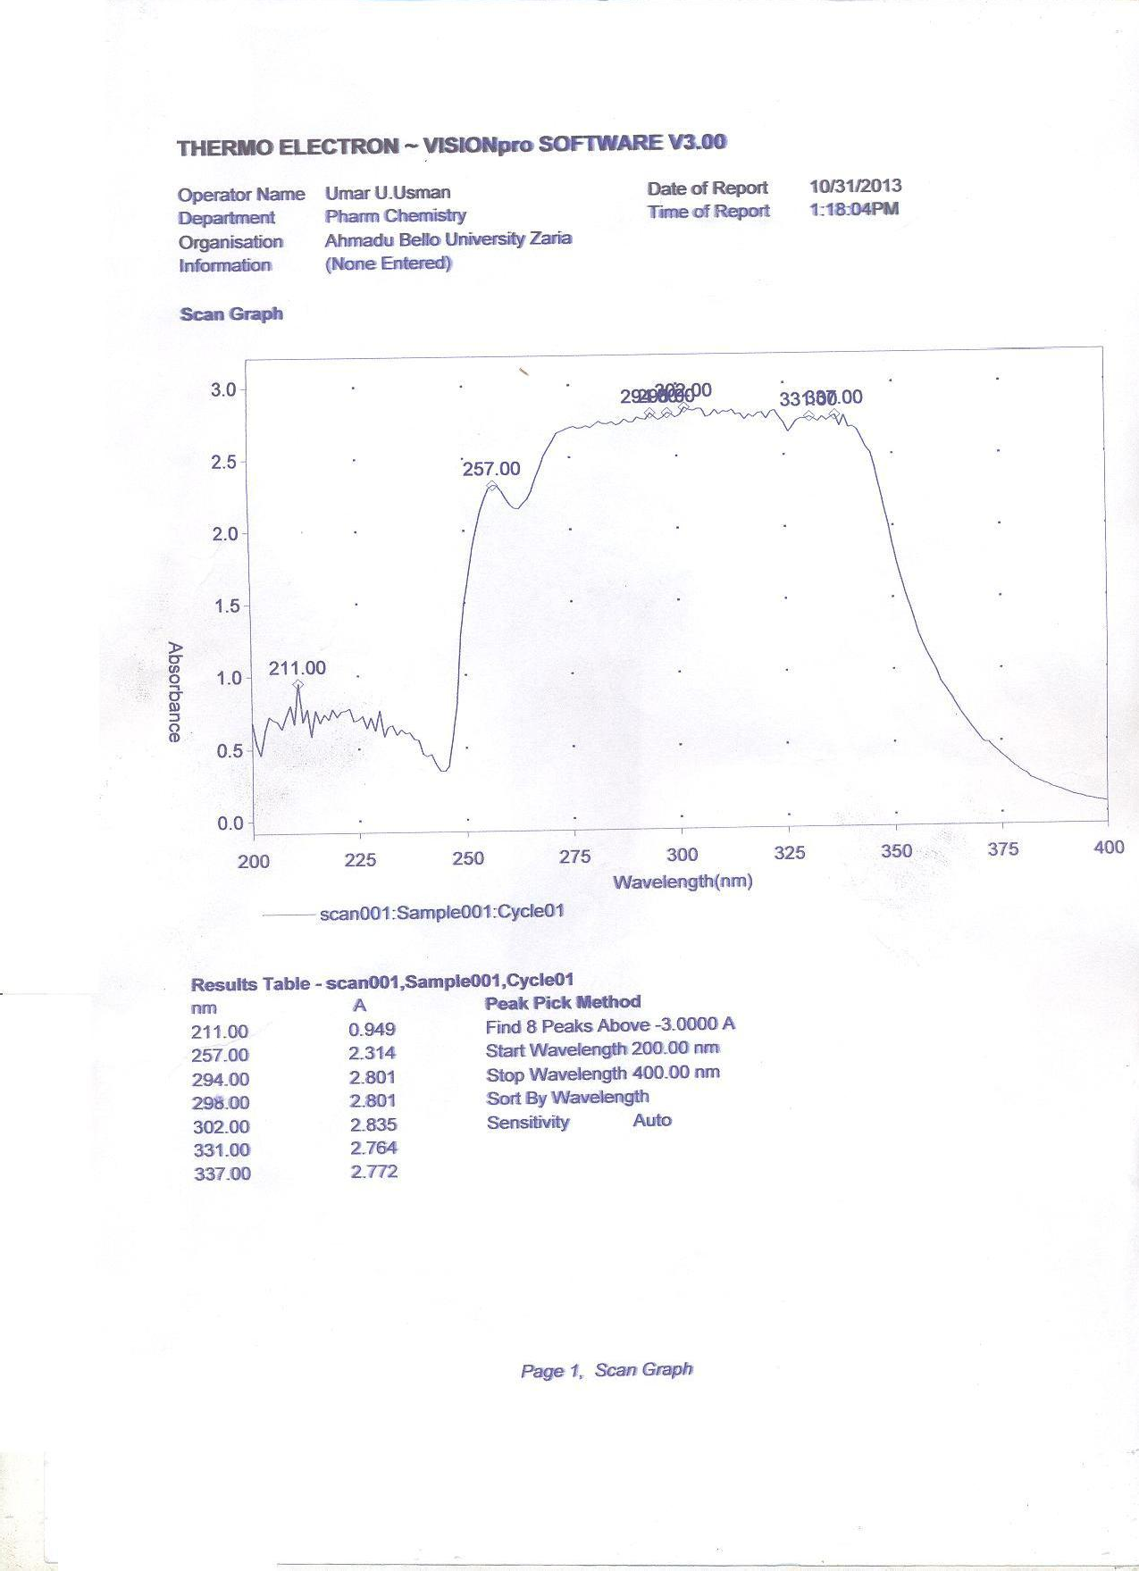

Figure 4.1: Scanned spectrum of 10µg/ml of ofloxacin standard powder at 200 – 400nm

    - Effect of pH on wavelength of maximum absorption

pH 5 was found to be the pH of maximum absorption

Table 4.7: Effect of pH on Wavelength of Maximum Absorption

pH | Absorbance
5 | 1.091
7 | 0.248
9 | 0.252
10 | 1.028

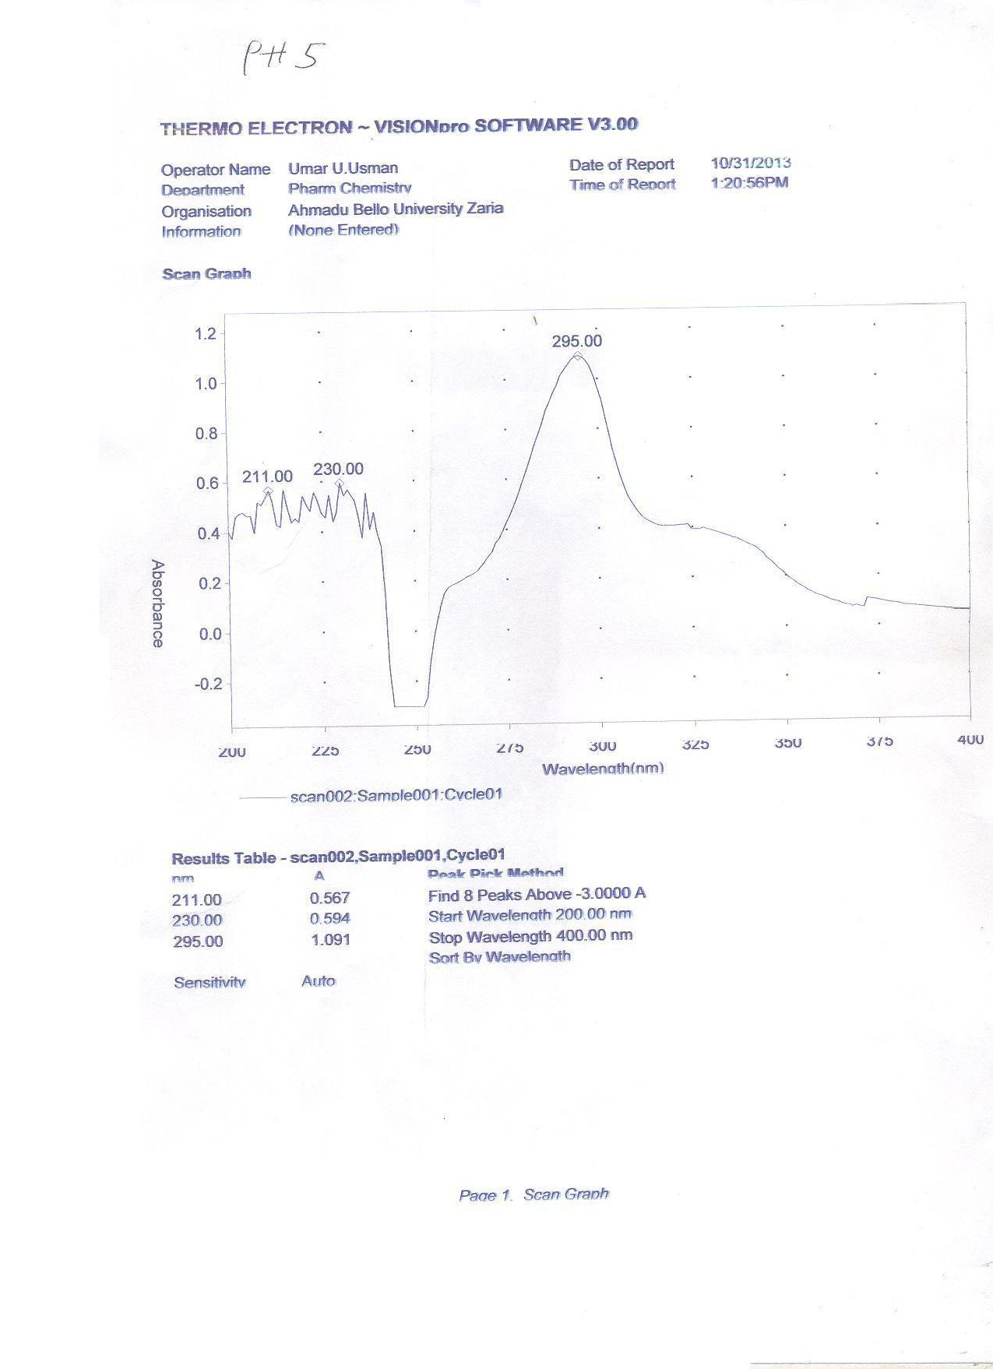

Figure 4.2: Absorbance of 10µg/ml of ofloxacin standard powder at pH 5

Results for Validation Parameter

    - Intra-day precision

Percentage relative standard deviation (% RSD) is less than 2 hence; there is agreement between replicated measurements (precise).

Table 4.8: Intra-day Precision of 10µg/ml Ofloxacin Solution

 | 6 | ‹ | Absorbance
1 |  |  | 0.961
2 |  |  | 0.982
3 |  |  | 0.971
4 |  |  | 0.971
5 |  |  | 0.984
6 |  |  | 0.984
Mean ± SD 0.98 ± 0.009

RSD 0.875%

    - Inter-day precision:

Percentage relative standard deviation (%RSD) is less than 2 hence; there is agreement between replicated measurements (precise).

Table 4.9: Inter-day Precision of 10µg/ml Ofloxacin Solution

6 ‹ Absorbance

1 | 0.991
2 | 0.991
3 | 0.976
4 | 0.976
5 | 0.961
6 | 0.982
Mean ± SD | 0.980 ± 0.01
RSD | 1.05%

Accuracy and percentage recovery:

The percentage recovery was found to be within the accepted limit of 98-102%.

Table 4.10: Accuracy and Percentage Recovery of Standard Ofloxacin Powder Spiked into Blank Saliva

 | 6 | Amo‹ unt added (µg/ml)  n = 3 | Amount found (µg/ml)  n = 3 | Percentage recovery (%)
1 |  | 8 | 7.9 | 99
2 |  | 10 | 9.8 | 98
3 |  | 12 | 11.8 | 99

Table 4.11: Summary of Validation Parameter of the Developed Method

S/№ | Parameter | Result obtained
1 | λmax | 295nm
2 | Range | 3-15µg/ml
3 | Regression equation | y = 0.092x + 0.008
4 | Coefficient of correlation | 0.999
5 | Intercept | 0.008
6 | Accuracy | 98-99%
7 | Precision:
 | Intra-day(%RSD) | 0.875
 | Inter-day(%RSD) | 1.05

4.5.3 Linearity of the method:

The method was found to obey Beer lamberts’ law in the concentration range of 3-18µg/ml as Coefficient of correlation was 0.999.

Table 4.12: Linearity Study of Ofloxacin

S/№ | Conc.(µg/ml) | Absorbance
1 | 3 | 0.28
2 | 6 | 0.568
3 | 9 | 0.842
4 | 12 | 1.126
5 | 15 | 1.38
6 | 18 | 1.677

y = 0.092x + 0.008 R = 0.999

v ~ R P l u o •
Calibration curve of ofloxacin
1.8
1.6
1.4
1.2
1
0.8
0.6
0.4
0.2
0
0
5
10
} v
15
v š Œ
20
š ] }
absorbance

Figure 4.3: Calibration Curve of Ofloxacin

  - Result of In-vivo Studies

4.6.1 Salivary concentration of ofloxacin detected for the various tablet brands The mean salivary concentrations of the various brands reveal maximum plasma concentration (Cmax) range of 9.82-16.66µg/ml at 2-4.4hr.

Table 4.13: Mean Salivary Concentration of the Various Brands

Time(hr) Concentration(µg/ml)
A | B | C | D | E | F
0.5 0.000 | 4.093 | 5.709 | 8.569 | 10.507 | 3.185
1 6.353 | 0.000 | 6.245 | 10.109 | 14.183 | 1.725
2 7.187 | 0.000 | 7.252 | 14.801 | 13.009 | 7.813
3 10.489 | 6.766 | 5.576 | 15.073 | 13.009 | 5.949
4 16.000 | 11.701 | 3.152 | 13.545 | 11.570 | 3.185
5 8.272 | 8.841 | 7.136 | 5.366 | 11.386 | 1.020
6 11.085 | 4.707 | 8.250 | 15.576 | 13.950 | 3.112
7 11.726 | 7.289 | 3.108 | 12.306 | 13.882 | 2.473
8 6.303 | 8.775 | 2.623 | 9.735 | 10.119 | 1.053

18
16
14
12
10
8
6
4
brand A
brand B brand C brand D brand E brand F
2
0
0
2
4
6
8
10

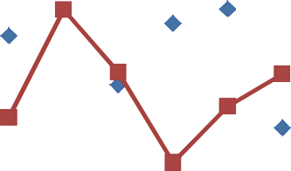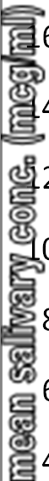Figure 4.4: Graph showing the super imposed mean salivary concentration–time graph of all Brand

  - Result for Comparism of Pharmacokinetic Parameters of Brand A and other Brands

Table 4.14: Mean Pharmacokinetic Parameters Comparism between Brand A and B

Pharmacokinetic  parameter | Brand A | Brand B | P-value
Cmax(µg/ml) | 16.66 ± 1.41 | 11.70 ± 1.83 | P<0.05
Tmax(hr) | 3.5 ± 0.20 | 4.00 ± 1.83 | P<0.05
Ke(µg/ml/h) | 0.23 ± 0.01 | 0.24 ± 0.02 | P>0.05
Ka(µg/ml/h) | 1.73 ± 0.15 | 1.01 ± 0.18 | P<0.05
t_{1/2β}(hr) | 3.08 ± 0.11 | 2.89 ± 0.27 | P>0.05
t_{1/2α}(hr) | 0.41 ± 0.03 | 0.91 ± 0.23 | P<0.05
AUC₀₋₈(µg/ml.h) | 72.68 ± 3.58 | 56.53 ± 13.26 | P>0.05
AUC_{0-∞}(µg/ml.h) | 100.33 ± 4.24 | 100.59 ± 25.94 | P>0.05
Vd(ml) | 25088.14 ± 2120.79 | 40035.26 ± 6247.63 | P<0.05
Cl(ml/h) | 5585.22 ± 275.16 | 10560.91 ± 2479.51 | P<0.05

Table 4.15: Mean Pharmacokinetic Parameters Comparism between Brand A and C

Pharmacokinetic  parameter | Brand A | Brand C | P-value
Cmax(µg/ml) | 6.66 ± 1.41 | 9.82 ± 0.67 | P<0.05
Tmax(hr) | 3.5 ± 0.20 | 3.5 ± 0.61 | P>0.05
Ke(µg/ml/h) | 0.23 ± 0.01 | 0.23 ± 0.01 | P>0.05
 |  | 1.61 ± 0.26 | P>0.05

Ka(µg/ml/h) 1.73 ± 0.15

t_{1/2β}(h) 3.08 ± 0.11

t_{1/2α}(h) 0.41 ± 0.03

AUC₀₋₈(µg/ml.h) 72.68 ± 3.58

3.01 ± 0.09 P>0.05

0.51 ± 0.08 P>0.05

43.24 ± 4.25 P<0.05

54.17 ± 2.03 P<0.05

41903.78 ± 2871.53 P<0.05

AUC_{0-∞}(µg/ml.h) 100.33 ± 4.24 9817.98 ± 964.14 P<0.05

Vd(ml) 25088.14 ± 2120.79

Cl(ml/h) 5585.22 ± 275.16

Table 4.16: Mean Pharmacokinetic Parameters Comparism between Brand A and D

Pharmacokinetic  parameter | Brand A | Brand D | P-value
Cmax(µg/ml) | 16.66 ± 1.41 | 16.25 ± 2.54 | P>0.05
Tmax(hr) | 3.5 ± 0.20 | 4.5 ± 0.61 | P>0.05

0.16 ± 0.00 P<0.05

0.44 ± 0.03 P<0.05
Ke(µg/ml/h) | 0.23 ± 0.01
Ka(µg/ml/h) | 1.73 ± 0.15
t_{1/2β}(h) | 3.08 ± 0.11
t_{1/2α}(h) | 0.41 ± 0.03
AUC₀₋₈(µg/ml.h) | 72.68 ± 3.58
AUC_{0-∞}(µg/ml.h) | 100.33 ± 4.24
Vd(ml) | 25088.14 ± 2120.79
Cl(ml/h) | 5585.22 ± 275.16

4.27 ± 0.02 P<0.05

1.60 ± 0.09 P<0.05

100.40 ± 16.01 P>0.05

160.38 ± 20.88 P>0.05

28829.59 ± 4501.34 P>0.05

4701.11 ± 1919.20 P>0.05

Table 4.17: Mean Pharmacokinetic Parameters Comparism between Brand A and E

Pharmacokinetic Brand A parameter
Cmax(µg/ml) 16.66 ± 1.41

Tmax(hr) 3.5 ± 0.20
Brand E P-value

15.35 ±1.43 P<0.05

2 ± 0.45 P<0.05

0.16 ± 0.00 P<0.05
Ke(µg/ml/h) | 0.23 ± 0.01
Ka(µg/ml/h) | 1.73 ± 0.15
t_{1/2β}(h) | 3.08 ± 0.11
t_{1/2α}(h) | 0.41 ± 0.03
AUC₀₋₈(µg/ml.h) | 72.68 ± 3.58
AUC_{0-∞}(µg/ml.h) | 100.33 ± 4.24
Vd(ml) | 25088.14 ± 2120.79
Cl(ml/h) | 5585.22 ± 275.16

0.55 ± 0.03 P>0.05

4.23 ± 0.09 P<0.05

1.29 ± 0.07 P<0.05

92.74 ± 6.75 P<0.05

154.12 ± 8.96 P<0.05

27228.22 ± 2526.23 P<0.05

4430.25 ± 322.06 P<0.05

Table 4.18: Mean Pharmacokinetic Parameters Comparism between Brand A and F

Pharmacokinetic Brand A parameter
Cmax(µg/ml) 16.66 ± 1.41

Tmax(hr) 3.5 ± 0.20

Ke(µg/ml/h) 0.23 ± 0.01

Ka(µg/ml/h) 1.73 ± 0.15

t_{1/2β}(h) 3.08 ± 0.11

t_{1/2α}(h) 0.41 ± 0.03

AUC0-8(µg/ml.h) 72.68 ± 3.58
Brand F P-value

11.99 ± 0.37 P<0.05

2.5 ± 0.22 P<0.05

0.43 ± 0.01 P<0.05

1.22 ± 0.31 P>0.05

1.63 ± 0.02 P<0.05

0.77 ± 0.19 P<0.05

28.17 ± 0.62 P<0.05

30.56 ± 0.39 P<0.05

33525.24 ± 1040.56 P<0.05

14233.13 ± 307.81 P<0.05

AUC0-∞(µg/ml.h) 100.33 ± 4.24

Vd(ml) 25088.14 ± 2120.79

Cl(ml/h) 5585.22 ± 275.16

CHAPTER FIVE

5.1 Discussion

Quality assessments are conducted in order to choose the best and affordable brands so as to obtain better therapeutic outcome. This may official or non official methods (Compendial or non-Compendial standard).The Compendial standards are weight variation, assay, and disintegration test and dissolution rate while the non Compendial standards are crushing strength and friability test. However, United state Pharmacopoeia (USP, 1995) included friability test among its official test. Presently, over 10 brands of ofloxacin tablets are available in Zaria market leading to difficulty faced by the pharmacist and the physician in the course of selection. All the brands passed the BP 2009 identification test as none had absorbance greater than 440nm in 0.1N HCl. Results of the assay indicated that all the brands were within the accepted limit except brand C as shown on Table 4.3. All the brands passed the weight uniformity test as none deviated from the mean weight by more than 5% as

specified in British pharmacopoeia (BP, 2009). The percentage weight deviation was within the range of 0.224-2.353% as shown in Table 4.4. This indicates that good manufacturing practice (GMP) was adhered to during granulation and compression stages of the tableting. Sunday et al. 2010 conducted the same study on nine brands of ofloxacin tablets and found a maximum percentage deviation of 0.045%. British Pharmacopoeia (BP, 1998) stated that percentage friability should not be more than 1%. This is a very important parameter as it indicates how tablets withstand the rigors of transportation without undergoing chipping at the edges. All the brands passed the friability test except brand E with percentage friability of 1.463% as shown in Table 4.5. A similar study was conducted on nine brands of ofloxacin by Sunday et al. 2010 and found a maximum of 0.095% while Badu et al. 2011 had a maximum of 0.075% on five brands. Furthermore, all the brands disintegrated in less than 30minutes as prescribed in British Pharmacopoeia (BP, 2009). This indicated that the various brands will have their active ingredient available in the system for absorption. Sunday et al. 2010 carried out a similar study on nine brands of ofloxacin tablets and found out that all the brands passed the test. There is strong correlation between dissolution rate and bioavailability of drugs. British Pharmacopoeia (BP, 2009) specifies that not less than 80% w/w of the active drug should be release at 30minutes. Dissolution testing plays important role in quality assessments as it provides information on batch-batch consistency of drug release from tablets and as an in vitro surrogate for in vivo performance (Dressman et al. 1998). All the brands passed the dissolution test as they released more than 90% of the drug within 30minutes as shown in Table 4.6. Ngwuluka et al. 2009 conducted similar study on six brands of ciprofloxacin and found out that all the brands passed the test.

Cheap, specific and selective UV spectrophotometric method for analysis of ofloxacin in biological sample was developed. The method was validated according to international

conference on Harmonization (ICH) guideline. Wavelength of maximum absorbance was obtained at 295nm when 10µg/ml ofloxacin solution was scanned through workable wavelength. Maximum absorbance was recorded at pH 5. Arun, et al. 2011 obtained Wavelength of maximum absorbance at 293nm in 0.1N HCl while Gautem, et al. 2012 obtained 295nm in 0.1N HCl at pH 1.2. Beer-Lambert □s law was obeyed in the concentrations of 3-18µg/ml as the correlation co-efficient was 0.999. Precision of the developed method was established by evaluating intra-day and inter-day precisions. Relative standard deviation (RSD) values for intra-day and inter-day precisions were 0.875 and 1.05 respectively. The values were within the normal limit of <0.5-2% indicating that the developed method have good repeatability. The percentage recovery was found within the range of 98-99% which is within the accepted limit of 98-102% (Chan, 2008).The developed method is simple, inexpensive, precise and accurate and therefore can be used for the analysis of ofloxacin from biological sample.

All the brands were well tolerated by the subjects as no adverse effects were reported. Brand A was considered as the innovator while brands B, C, D, E and F were considered as generics. The mean saliva concentration time curve of the six brands was found not to be similar and not super imposable except brand D as shown in figure 4.4. The mean Cmax (µg/ml) of brands B, C, E and F were found to be significantly different from that of the brand A (innovator) while brand D was not significantly different ( 16.66 ± 1.41, 11.7 ± 1.83, 9.82 ± 0.67, 16.25 ± 2.54, 15.35 ± 1.43 and 11.99 ± 0.37 for brand A, B, C, D, E, and F
respectively). The mean tmax (hr) of brand C and D were found to be statistically similar with that of the innovator while that of brand B, E and F were significantly different from that of the innovator ( 3.5 ± 0.2, 4.0 ± 1.83, 3.5 ± 0.61, 4.5 ± 0.61, 2 ± 0.45 and 2.5 ± 0.22 for
brand A, B, C, D, E, and F respectively). For AUC0-8 (µg/ml.h), the values of brands B and D

were found to be statistically similar with that of the innovator while the values of brands C, E and F were significantly different from that of the innovator (72.68 ± 3.58, 56.53 ± 13.26, 43.24 ± 4.25, 100.40 ± 16.01, 92.74 ± 6.75 and 28.17 ± 0.62 for brand A, B, C, D, E, and F
respectively). The mean AUC0-∞ (µg/ml.h) of brands B and D were found to have no significant difference with that the innovator while brands C, E and F values were significantly different from that of the innovator ( 100.33 ± 4.24, 100.59 ± 25.94, 54.17 ±
2.03, 160.38 ± 20.88, 154.12 ± 8.96 and 30.56 ± 0.39 for brand A, B, C, D, E, and F

respectively ).The elimination half life (t1/2 □ (h)) of brands B and C were statistically similar with that of the innovator while brands D, E and F half life values were significantly different from that of the innovator ( 3.08 ± 0.11, 2.89 ± 0.27, 3.01 ± 0.09, 4.27 ± 0.02, 4.23 ±
0.09 and 1.63 ± 0.02 for brand A, B, C, D, E, and F respectively ). Furthermore, the elimination rate constant (Ke) for brands C and B were similar while brands D, E and F were significantly different ( 0.23 ± 0.01, .24 ± 0.02, 0.23 ± 0.01, 0.16 ± 0.00, 0.16 ± 0.00 and 0.43
± 0.01 for brand A, B, C, D, E, and F respectively ).The Cmax was in the range of 9.82 – 16.66µg/ml against 1.82 – 1.98µg/ml reported by Rajani, et al. 2010 while Hemanth Kumar and Gurumurthy, 2003 reported an average of 4.88µg/ml. Likewise, tmax in the range of 2 – 4.5hr against 2hr reported by Rajani, et al. 2010 and 1.33hr reported by Hemanth Kumar, et al. 2004. In this research, Vd was found to be within the range of 25-42 Litres which is lower than 121-135 Litres after 200mg intravenous dose reported by Gauy, et al. 1991 and 82.61-
168.7 Litres after 200mg oral dose reported by Hameed, et al. 2002. AUC was found to be 28.17-100.40µg/ml.h higher than 15.27µg/ml.h reported by Edoka, et al. 1997 and 8.744- 22.93µg/ml.h reported by Hameed, et al. 2002. In this research CL was 4.43-10.56ml/h lower than 8.722-22.87ml/h after 200mg oral dose reported by Hameed, et al. 2002. The elimination half life in this research (1.63-4.27h) was lower than 4.98h after 200mg intravenous dose reported by Gauy, et al. 1992 and 4.9h reported by Orlando, et al. 1992. The

elimination rate constant (Ke) was found to be 0.16-0.43µg/ml/h which was lower than 0.083-0.647µg/ml/h after 200mg oral dose reported by Hameed, et al. 2002. Absorption rate constant was found to be 0.44-1.73µg/ml/h which was lower than 1.214-23.93µg/ml/h after 200mg oral dose reported by Hameed, A. et al. 2002 and 2.26µg/ml/h reported by Yuan, et al. 1992. All the above differences could be due to differences in race, genetic makeup and regional variations (circadian rhymes). Brand D was found to be comparatively bioavailable with the innovator as both the rate (Cmax and Tmax) and the extent (AUC0-∞ and Cmax) were comparable while brands B, C, E and F were found not to be comparably bioavailable with the innovator.

Conclusion

All the six brands passed the conducted physicochemical tests which include label requirements, identification test, assay, weight uniformity test, friability, dissolution rate and disintegration test. An accurate, simple and cheap UV spectrophotometric method for the analysis of ofloxacin in saliva was developed and validated according to ICH guideline. Brand D was found to be comparatively bioavailable with the innovator. Therefore, could be used in preference to the innovator due to it cheap price compared to the innovator.
Brand B, C, E and F were not comparatively bioavailable as both the rate and extent of absorption was significantly different at p≥0.05 level of significance.

Recommendation

Comparative bioavailability studies of ofloxacin should be conducted frequently as more brands are continuously manufactured so as to ensure better therapeutic outcome, prevent

toxicity and emergence of resistance. Furthermore, pharmacokinetic parameters of drugs, most especially antibiotics, should be established as there are genetic, racial and circadian differences among populations.

References

Amin, A. S. (2000). RP-HPLC Method for simultaneous estimation of ciprofloxacin.
Mikrochim Acta 134(1): 89-94.

Arun, K. D. Siva, T. K. Loya, H. Umadevi, K. Kothakota, V. Kishant, K. and Pradhan, A. (2011). Validated UV-Spectrophotometric Method for the Estimation of Ofloxacin in Bulk and Pharmaceutical Dosage Form. International Journal of Pharmaceutical & Biological Archives, 2(4):1157-1161.
Babu, G. D. Sree, D. Swetha, A, A. and Satya, G. T. (2011). Comparative assessment of the quality control measurements of multisource ofloxacin tablets marketed in India. International journal of applied pharmaceutics. Vol 3, PP. 31-33.
Ballesteros, O. Vilchez J. L. and Navalon, A. J. (2002). Determination of the antibacterial ofloxacin in human urine and saliva samples by solid phase spectrofluorimetry. Pharmaceutical Biomedical Analysis. 30(4): 1103-1110.

Behera, S. Subhajit, G. Fahad, A. Saayak, S. and Sritoma. B. (2012). UV-Visible spectrophotometric method development and validation of assay of paracetamol tablet formulation. Analytical and Bioanalytical Techniques. 3(1): 151-154.
Belal, F., Rizk, M., Aly F. A., and El-Enany, N. M. (1999). Determination of some pharmaceutically important 4- quinolone in dosage form. Chemical Analysis. 44(1): 763-767.

Birkett D. (2003). Generics - equal or not? Australian Prescriber; 3(26): 85-7.

British Pharmacopoeia (2007). Volume 111 Her Majesty s ™Stationary Office London, pp. 1357-1358.

British Pharmacopoeia (2009). Volume I, II & III Monographs: Medicinal and Pharmaceutical Substances Ofloxacin. Her majesty stationary office, London. PP. 4317-6586.
Campagna, F.A., Cureton, G., Mirigian, R.A. and Nelson, E. (1963). Inactive prednisone tablets. USP XVI. J. Pharm. Sci. 52(1): 605–606.

Chan, C. C. (2008). Analytical method validation: principles and practices. In pharmaceutical manufacturing hand book: Regulations and quality. John Willey and Sons, Inc. PP. 727-742.
David G. W. (2000). Pharmaceutical analysis. Churchill Livingstone, Edinburgh, London, PP. 76 – 91.
Dressman, J. B., Amidon, G. L., Reppas, C., Shah, V. P. (1998). Dissolution testing as a prognostic tool for oral drug absorption: immediate release dosage forms. Pharmaceutical research. 15 (1): 11-22.
Eboka, C. J. Okar, R. S. Akerele, J. O. and Aigbavboa, S. O. (1997). Kinetics of absorption and elimination of Ofloxacin in humans after oral and rectal administration. Journal of clinical pharmacology and thearpeutics. 23(1): 217-220.

Edwards, L.J. (1951). The dissolution and diffusion of aspirin in aqueous media. Transaction of the Faraday Society. 47(1): 1191–1210.

European Pharmecopeia, 4th edn., Council of Europe, Strasbourg, 2002, p. 1661.

Fish, D. N and Chow, A. T. (1997). The clinical pharmacokinetics of levofloxacin. Clinical Pharmacokinetic. 32(1): 101-119.
Gautam, S. Mahaveer, S. and Sai, G. (2012). Development of A Rapid and Sensitive Spectrofluorimetric Method for the Estimation of Ofloxacin in Bulk and Formulations. International journal of pharmaceutical and chemical sciences. 4(1): 3-8.
Gauy, D. K. Track and Flor, S. (1991). Safety and pharmacokinetics of single dose intravenous Ofloxacin in healthy volunteers. International journal of clinical pharmacology. 11(3): 203-209.

Gauy, D. R. Opsahl, J. A. Mcmahom, R. Vargas, G. R. Matzke and Flor, S. (1992). Safty and pharmacokinetics of multiple doses of intravenous Ofloxacin in healthy volunteers. Antimicrobial agents chemotherapy. 36: 308-312.

Guay, D.R. (1992). The role of the fluoroquinolones. Pharmacotherapy. 7: 71-85.

Hameed, A. Tahira, I. Muhammad, N. Faiz, B. Tayyab, T. B. Shafaqat, A and Farwa, N. (2002). Pharmacokinetics of Ofloxacin in male volunteers following oral administration. Pakistan journal of biological sciences. 5(10): 1098-1100.

Hemanth Kumar, A. K. and Gurumurthy P. (2004). Ofloxacin pharmacokinetics in saliva
Indian J Pharmacol, Vol 36: 2:80-83

Iain, L. O. B. (2006). Pharmacokinetics and Pharmacodynamics: The Dynamics of Drug Absorption, Distribution, Action, and Elimination. In: Goodman and Gilman the pharmacology basis of therapeutics. McGraw-Hill Companies, Inc. pp. 1-20.
ICH Q2B (1996). Guideline Validation of Analytical Procedures Methodology. European Agency for the Evaluation of medicinal product Human medicine Evaluation. Ref. CPMP / ICH / 381 / 96
ICH Topic Q2A (1995). Validation of analytical methods, Definition and Terminology. European Agency for the Evaluation of medicinal product Human medicine Evaluation. Ref. CPMP / ICH / 381 / 95. PP. 1-6.
Ichihara, N. H. Tachizawa and Tsumura, M. (1984). Phase 1 study on DL-8280.
Chemotherapy, 32, PP. 118-149.

Joseph, C. (1995). Special problems with biological fluids In: The analysis of Drugs in Biological Fluids. CRC Press, New York, London. 2nd edition, pp. 59-61.
Katzung, B. G. (2004). Basic and clinical pharmacology. The McGraw-Hill Companies Inc. PP. 34-50.
Larry, A. B. (2008). Applied Clinical Pharmacokinetics. McGraw-Hill Companies, Inc. PP. 19-38.
Levy, G. (1964). Effect of dosage form properties on therapeutic efficacy of tolbutamide tablets. Can Med Assoc J. 90(16): 978–979.

Liang, Y-D. Song, J-F. and Yang, X-F. (2004). Determination of norfloxacin using a terbium-sensitized electrogenerated Chemiluminescence method. Anaytica. Chimica. Acta. 510, 21-28.
Lynne W., John H.C. and John T.F. (2000). Amoxicillin release from a floating dosage form based on Alginates International Journal Pharm 210: 45-49.

MacLeod, C., Rabin, H., Ruedy, J., Caron, M., Zarowny, D. and Davies, R. (1972). Comparative bioavailability of three brands of ampicillin. Can. Med. Assoc. J. 107: 203– 209.

Martin, C.M., Rubin, M., O’Malley,W.G., Garagusi,V.F., McCauley, C.E. (1968). Brand, generic drugs differ in man. JAMA 205 (medical news section), 1: 23.

Nelson, E. (1957). Solution rate of theophylline salts and effects from oral administration.
Journal America Pharmaceutical Association. 46(1): 607–614.

Ngwuluka, N. C. Lawal, K. P. Olorunfemi O. and Ochekpe N. A. (2009). Post-market in vitro bioequivalence study of six brands of ciprofloxacin tablets/caplets in Jos, Nigeria. Scientific Research and Essay. 4 (4): 298-305.
Orlando, R. Sawadogo, A Migliobi, P.A. Cappellazzo, M. G. and Palatini, P. (1992). Oral disposition kinetics of Ofloxacin in patients with compensated Liver cirrhosis. Chemotherapy. 36(3): 1-6.

Petri, W. P. (2006). Sulfonamide, trimethoprim - sulfamethoxazole, quinolones, and agents for urinary tract infections. In: Brunton, L. L., Lazo, J. S. and Parker, K. L. (Eds), Goodman and Gilman the pharmacology basis of therapeutics. McGraw-Hill Companies, Inc. pp. 189-220.
Quan, H. Bai, X. H. Song, Y. H and Fenxi-Shiyanshi. (2002). Ofloxacin 21(1): 64-68.

Rajani, S. Manila, H. Panna, T. Saha, R. N. (2010). Comparative Bioavailability of Two Brands of Ofloxacin in Healthy Human Volunteers. Journal of Bioequivalence and Bioavailability. 2(3): 055-058.
Samanidou, V.F. Demetriou, C.E. and Papadoyannis, I.N. (2003). Direct determination of four fluoroquinolones, enoxacin, norfloxacin, ofloxacin and ciprofloxacin, in pharmaceuticals and blood serum by HPLC. Analytical Bioanalytical Chemistry. 373(5): 623-629.

Sean, C. S. (2007). Antibacterials. In: Martindale The Complete Drug Reference. The Pharmaceutical Press, London, UK, pp. 159-165.

Streubel, A. Siepmann, J. and Bodmeier, R. (2003). Floating matrix tablets based on low density foam powder effects of formulation and processing parameters on drug release. European Journal of Pharmaceutical Sciences 18(1): 37-45.

Sunday, O. Awofisayo, Oladoja, A. Awofisayo, Nse E. and Imo E. U. (2010). Comparative Assessment of the Quality Control Measurements of Multisource Ofloxacin Tablets Marketed in Nigeria. Dissolution Technologies. 16(1):16-29
Suslu, I. and Tamer, A. (2003). Application of bromocresol purple for the extractive- spectrophotometric determination of ofloxacin. Analytical Letter. 36(6): 1163-1181.

Tadakazu, T. Yoshiharu, M. (2005). Preparation of amoxicillin intragastric buoyant sustained release tablets and the dissolution characteristics. J Cont Rel; Article in press. Accepted 24 Oct. 2005.

Timothy, T. S. (2006). Pharmacokinetics. In: Charles, R. C. and Robert, E. S. Modern pharmacology with clinical applications. A soft copy. PP. 48-55.
Varley, A.B. (1968). The generic inequivalence of drugs. JAMA 206, 1745–1748.

Verho, M. Dagrosa, E. E. and Malerczyk, V. (1986). Clinical pharmacology of ofloxacin: a new chemotherapeutic agent belonging to the gyrase inhibitor group. Pub med gov Infection, 14(Suppl. 1), S47.
WHO (1993). How to investigate Drug Use in Health Facilities. Selected Drug Use Indicators. World Health Organisation, Department of Essential Drug and Medicine Policy: Geneva, 10.

Yuen, G. J. Drusano, G. L. Brooks, J. and Flor, S. (1992). Use of nonlinear, mixed-effects modeling for population analysis of Ofloxacin: effect of age on oral drug pharmacokinetics. Pharmacotherapy. 12(3): 88-92.

Zhang, S.S. Liu, H.X. Wu Y.J. and Yu, C.L. (2001). On-column amperometric detection of ofloxacin and pasiniazid in urine by capillary electrophoresis with an improved fractured joint and small detection cell. Analyst. 126(4): 441-445.

Appendices

- Label information of six different brands of ofloxacin tablets (200mg).

S/ ¶ | Product code | Batch ¶  (NAFDAC | ¶ | Mfg. Date  • | Exp. Date | Price/10unit
1 | $ | IG006A |  | Jan-11 | Dec-15 | 1200*
 |  | (04-0885)
2 | $ | RA 1001 (A4-3914) |  | Aug-11 | Jul-14 | 200*
3 | $ | N-496 (A4-2783) |  | Jun-12 | May-15 | 200*
4 | = | V0102R (A4-2047) |  | Feb-12 | Jan-14 | 200*
5 | $ | 111016 (A4-5948) |  | Oct-11 | Oct-14 | 200*
6 | $ | Do-10002 (A4-2719) |  | May-10 | Apr-13 | 200*
All the brands passed the NAFDAC requirements as shown above

Weight (mg) variation raw data

Brand | A | Brand | B | Brand C | Brand D | Brand E | Brand | F
0.40 | 0.85 |  | 0.41 |  | 0.64 | 0.39 | 0.61
0.40 | 0.87 |  | 0.41 |  | 0.64 | 0.41 | 0.62
0.40 | 0.85 |  | 0.40 |  | 0.67 | 0.41 | 0.63
0.40 | 0.85 |  | 0.41 |  | 0.66 | 0.42 | 0.62
0.40 | 0.87 |  | 0.40 |  | 0.68 | 0.39 | 0.61
0.41 | 0.86 |  | 0.41 |  | 0.68 | 0.42 | 0.61
0.40 | 0.87 |  | 0.40 |  | 0.70 | 0.42 | 0.60
0.40 | 0.89 |  | 0.40 |  | 0.65 | 0.41 | 0.61
0.40 | 0.87 |  | 0.40 |  | 0.66 | 0.42 | 0.61
0.40 | 0.87 |  | 0.40 |  | 0.65 | 0.40 | 0.61
- Friability test raw data

Brand A Brand B Brand C Brand D Brand E Brand F
Initial weight (mg) | 4.00 | 8.66 | 4.04 | 6.63 |  | 4.10 |  | 6.15
Final weight (mg) | 4.00 | 8.66 | 4.04 | 6.58 | 4.04 |  | 6.15

Disintegration test raw data

Brand | A | Brand | B | Brand | C | Brand | D | Brand E | Brand | F
7.49 | 7.18 |  | 2.43 |  | 2.01 |  | 4.10 |  | 2.30
7.50 | 7.28 |  | 3.04 |  | 3.08 |  | 6.45 |  | 2.42
7.54 | 7.30 |  | 3.05 |  | 3.50 |  | 6.50 |  | 2.59
8.20 | 8.41 |  | 3.10 |  | 3.34 |  | 6.59 |  | 3.05
8.30 | 8.42 |  | 3.19 |  | 8.37 |  | 7.28 |  | 3.15
8.31 | 8.59 |  | 3.45 |  | 8.59 |  | 8.09 |  | 4.46

- Dissolution rate at t₃₀ raw data

Brand | A | Brand | B | Brand | C | Brand | D | Brand E | Brand | F
2.311 | 2.292 |  | 2.311 |  | 3.040 |  | 3.036 |  | 3.061

Preparation of 0.1N HCl

1.7ml of the conc. HCl solution was measured and made up to 200ml with distilled water to make 200ml of 0.1N HCl solution as follows:
C1 = 12N, V1 =? C2 = 0.1N and V2 = 200ml C1 V1 = C2 V2, 12 × V1 = 0.1 × 200
V1 = 1.7ml

Preparation of 0.1N NaOH

16g of NaOH was weighed and then dissolved into 200ml of distilled water contained in 500ml volumetric flask to make 200ml 2M NaOH solution as follows:
V = 200ml (0.2ml), Conc. = 2M, Mol = 0.2 × 2, Mol = 0.4ml Mass = Mol × Mass 0.4 × 40, Mass = 16g

Preparation of pH solution

pH solution of 4 and 8 were prepared by dissolving each of the pH 4 and pH 5 buffer tablets into 100ml distilled water. pH 5, 9 and 10 were made by adjusting the previous once with either 0.1N HCl or 0.1N NaOH as the case may be.

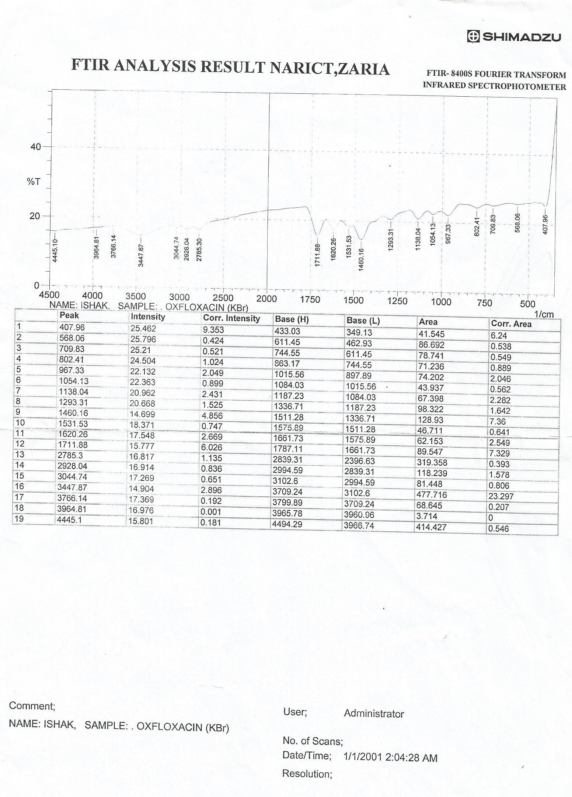

FTIR spectrum of ofloxacin standard powder

- Reference IR spectrum of ofloxacin
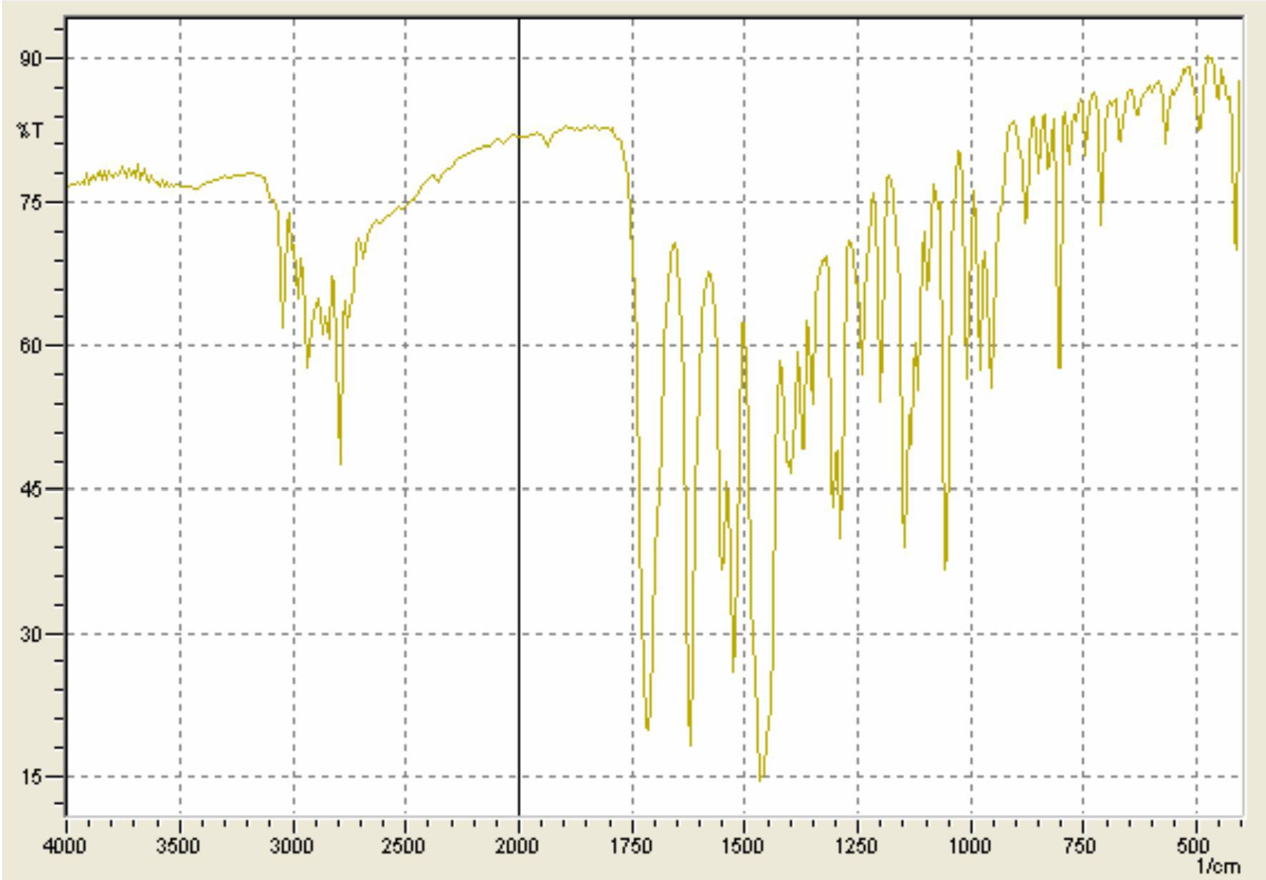

Scanned UV Spectrum of 10µg/ml of ofloxacin standard powder at 200 – 400nm
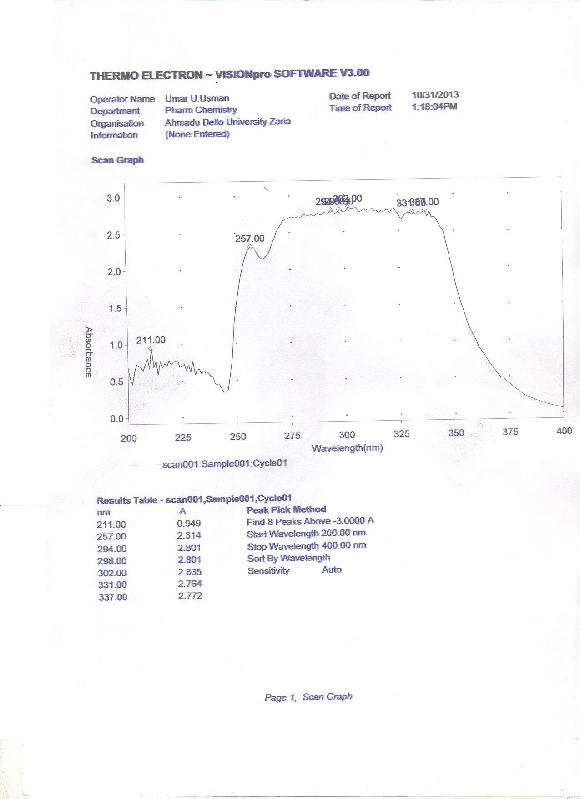

- Absorbance of 10µg/ml of ofloxacin standard powder at pH 4

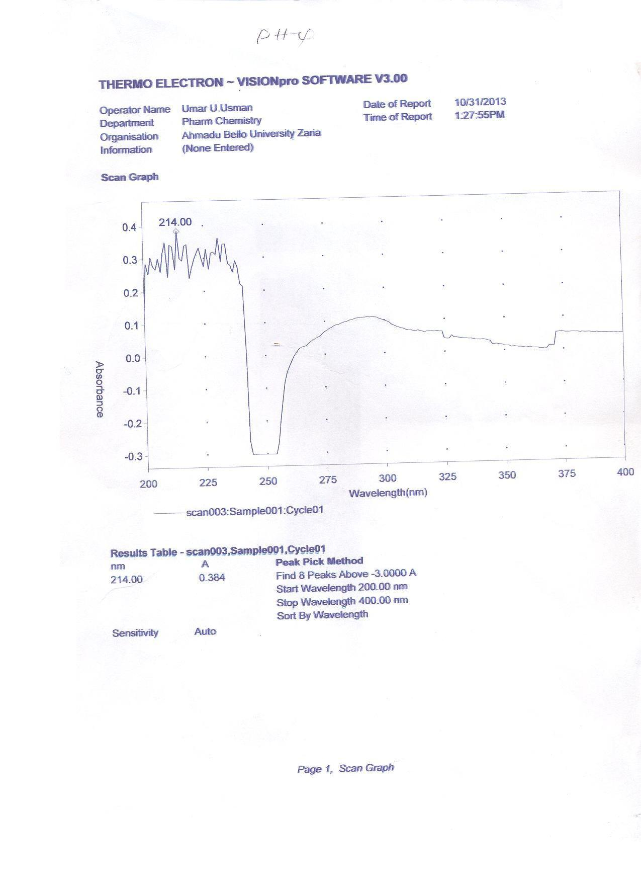

Absorbance of 10µg/ml of ofloxacin standard powder at pH 7
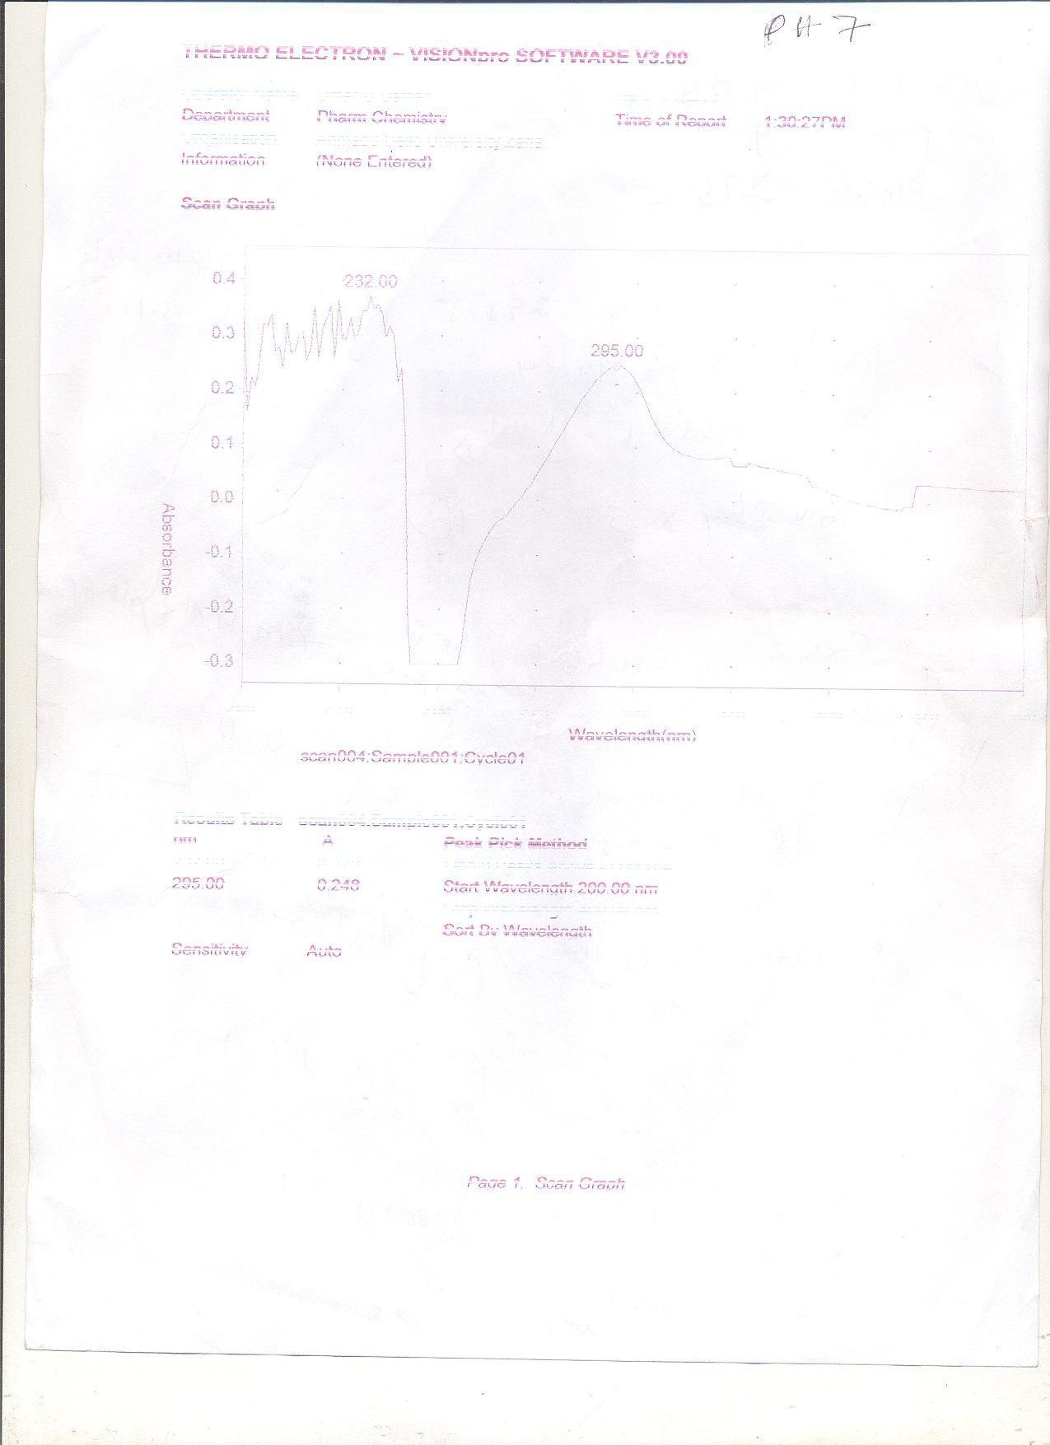

- Absorbance of 10µg/ml of ofloxacin standard powder at pH 9
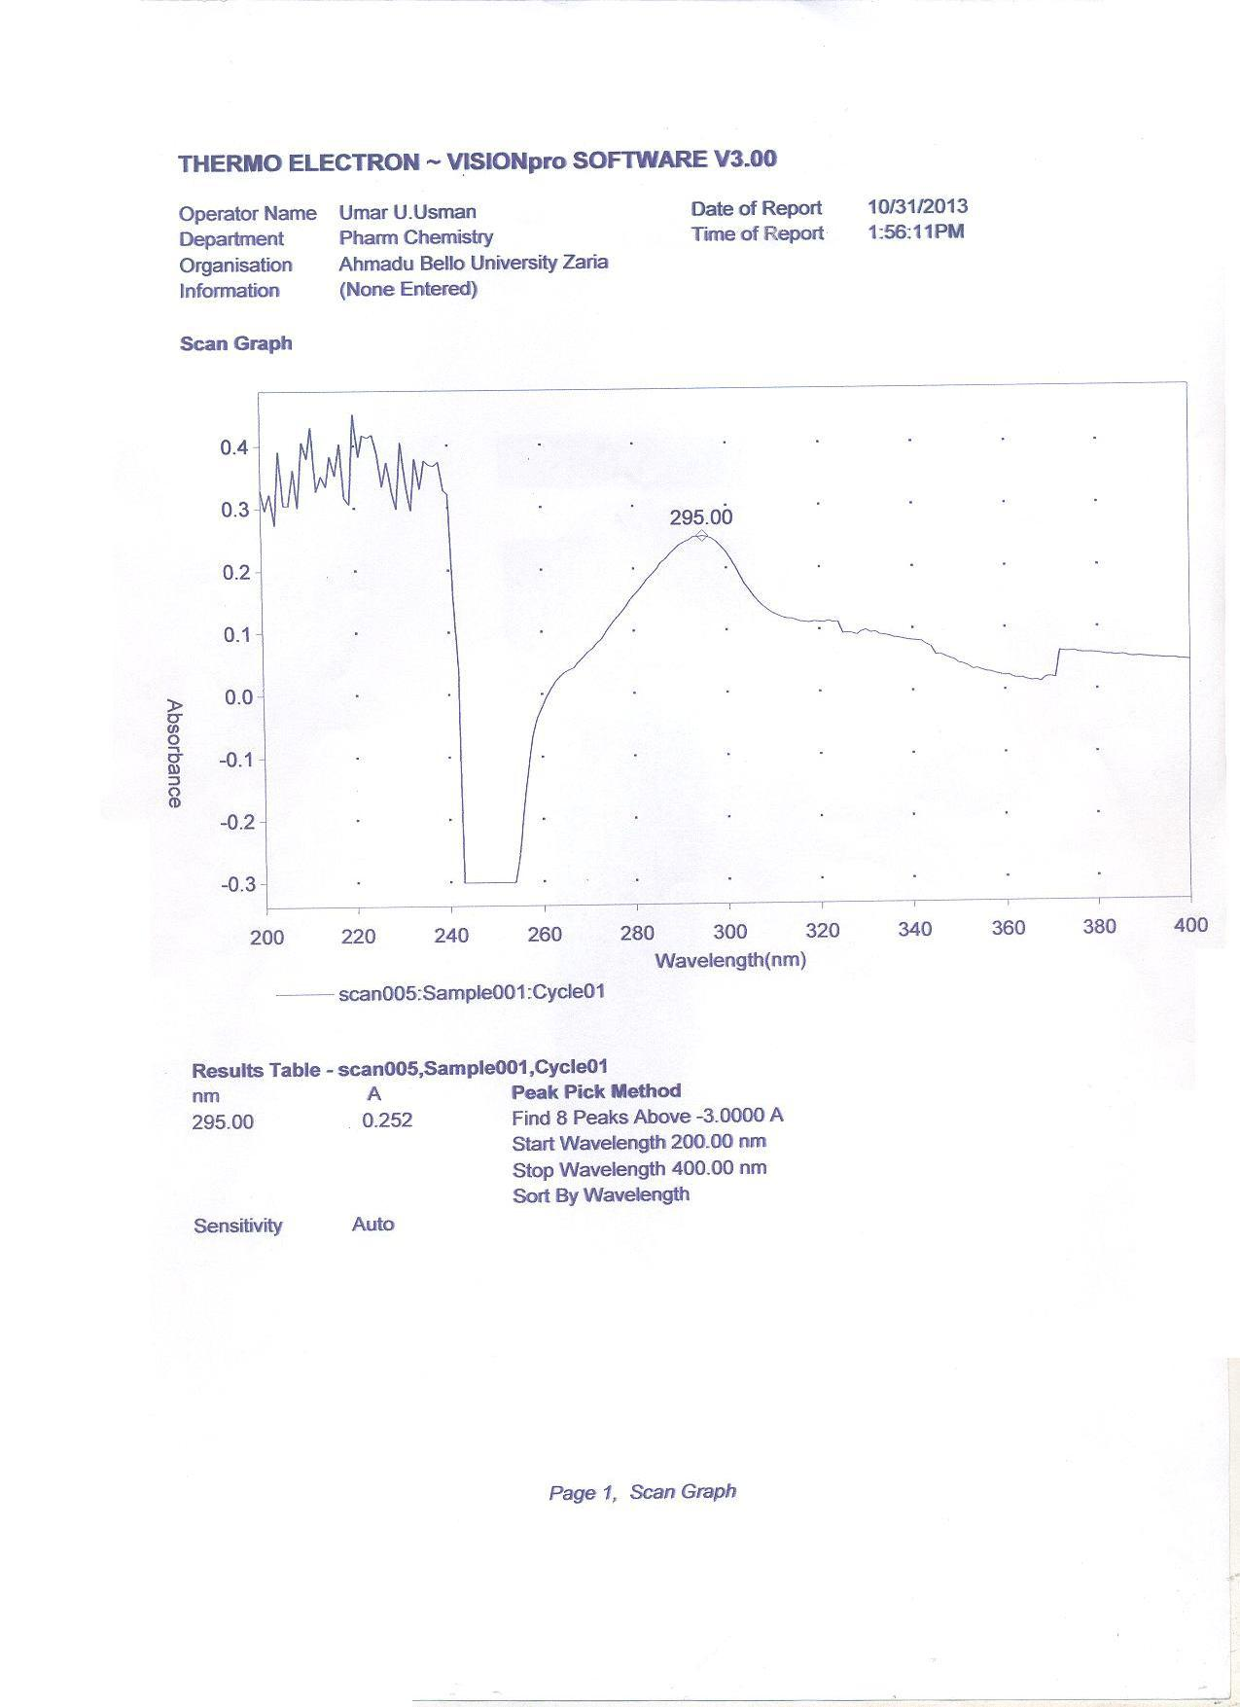

Absorbance of 10µg/ml of ofloxacin standard powder at pH 10
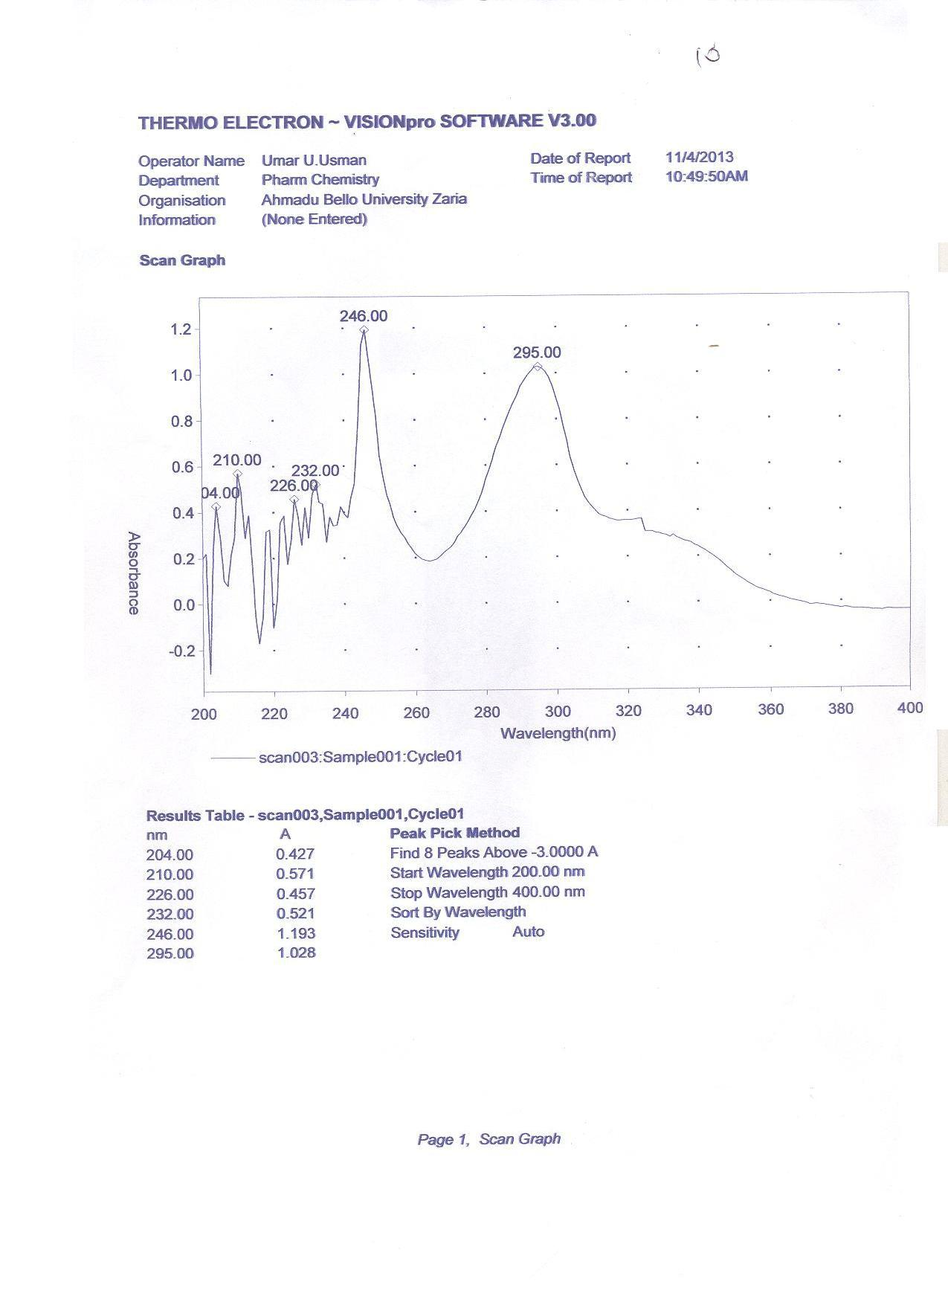

- Precision raw data

Intra-day | inter-day
0.991 | 0.961
0.991 | 0.982
0.976 | 0.971
0.976 | 0.971
0.961 | 0.984
0.982 | 0.984

Calibration curve of ofloxacin

y = 0.092x + 0.008 R = 0.999

v ~ R P l u o •
Calibration curve of ofloxacin
1.8
1.6
1.4
1.2
1
0.8
0.6
0.4
0.2
0
0
5
10
} v
15
v š Œ
20
š ] }
absorbance

Sample of conversion of obtained absorbances into concentrations

Time(hr) | Absorbance | Concentration
0.3 | -0.301 | 0.000
1 | 0.669 | 7.185
2 | 0.722 | 7.761
3 | 0.718 | 7.717
4 | 1.102 | 11.891
5 | 0.625 | 6.707
6 | 1.292 | 13.946
7 | 1.500 | 16.217
8 | 0.336 | 3.565

- Mean salivary concentration-time graph of brand A
16

14

12

10

8

6

4
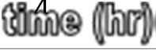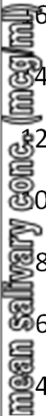
18
2

0
0
1
2
3
5
6
7
8
9

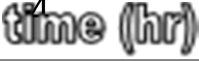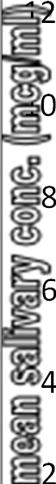Mean salivary concentration-time graph of brand B
4
14

12

10

8

6

4

2

0
0
1
2
3
4
5
6
7
8
9

- Mean salivary concentration-time graph of brand C
7

6

5

4

3

2
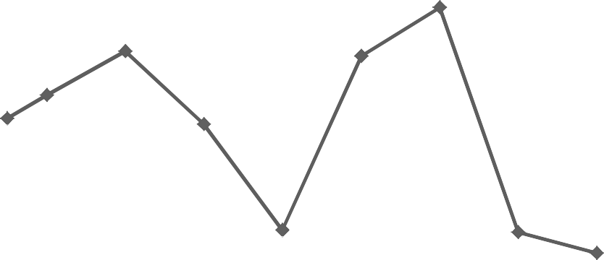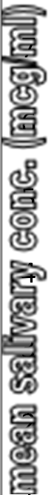
9

8
1

0
0
1
2
3
4
6
7
8
9

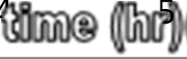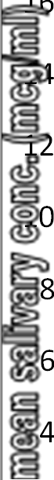Mean salivary concentration-time graph of brand D
5

18

16

14

12

10

8

6

4

2

0
0
1
2
3
4
5
6
7
8
9

- Mean salivary concentration-time graph of brand E
14

12

10

8

6

4
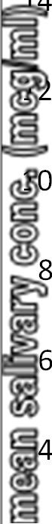
16
2

0
0
1
2
3
4
6
7
8
9

Mean salivary concentration-time graph of brand F
5
9

8

7

6

5

4

3

2

1

0
0
1
2
3
4
5
6
7
8
9

Z

