## COMPARATIVE PHARMACOGNOSTIC STUDIES OF THE LEAVES OF

***SOLANUM INCANUM* LINN AND *SOLANUM MELONGENA* LINN (SOLANACEAE)**

### BY

**MUSA YUSUF DIBAL**

### DEPARTMENT OF PHARMACOGNOSY AND DRUG DEVELOPMENT FACULTY OF PHARMACEUTICAL SCIENCES

**AHMADU BELLO UNIVERSITY, ZARIA NIGERIA**

### SEPTEMBER, 2016

**COMPARATIVE PHARMACOGNOSTIC STUDIES OF THE LEAVES OF *SOLANUM INCANUM* LINN AND *SOLANUM MELONGENA* LINN (SOLANACEAE)**

### BY

**Musa Yusuf DIBAL**

### B. Pharm (UniMaid) 2010, P13PHPD8006

**A DISSERTATION SUBMITTED TO THE SCHOOL OF POSTGRADUATE STUDIES, AHMADU BELLO UNIVERSITY, ZARIA**

### IN PARTIAL FULFILLMENT OF THE REQUIREMENT FOR THE AWARD OF A MASTER OF SCIENCE DEGREE IN PHARMACOGNOSY

**DEPARTMENT OF PHARMACOGNOSY AND DRUG DEVELOPMENT FACULTY OF PHARMACEUTICAL SCIENCES**

### AHMADU BELLO UNIVERSITY, ZARIA NIGERIA

**SEPTEMBER, 2016**

## DECLARATION

I declare that the work in this dissertation entitled “Comparative Pharmacognostic Studies of the Leaves of *Solanum incanum* Linn and *Solanum melongena* Linn (Solanaceae)” was carried out by me in the Department of Pharmacognosy and Drug Development, Ahmadu Bello University, Zaria. The information derived from the literature has been duly acknowledged in the text and list of references provided. No part of this dissertation was previously presented for another degree or diploma at this or any other institution.

## Musa Yusuf DIBAL

**---------------------------**

## --------------------------

**----------------------**

**Name of Student Signature Date**

# CERTIFICATION

This dissertation entitled “Comparative Pharmacognostic Studies of the Leaves of *Solanum incanum* Linn and *Solanum melongena* Linn (Solanaceae)” by Musa Yusuf, DIBAL meets the regulations governing the award of the degree of Master of Science in Pharmacognosy of the Ahmadu Bello University, Zaria and is approved for its contribution to knowledge and literary presentation.

**…………………………………. ------------------------ Dr. G. Ibrahim, B.Sc, M.Sc, Ph.D. Date** Chairman, Supervisory Committee,

Department of Pharmacognosy and Drug Development,

Ahmadu Bello University, Zaria.

## --------------------------------------- ------------------------

**Dr. U. H. Danmalam, B.Sc, M.Sc, Ph.D. Date**

Member, Supervisory Committee, Department of Pharmacognosy and Drug Development,

Ahmadu Bello University, Zaria.

## ------------------------------------- ------------------------

**Dr. G. Ibrahim Date**

Head, Department of Pharmacognosy and Drug Development,

Ahmadu Bello University, Zaria.

## Prof. K. Bala Date

Dean, School of Post graduate Studies Ahmadu Bello University, Zaria.

# DEDICATION

This research work is dedicated to the loving memory of my beloved parents, Prof. and Mrs Yusufu Y. Dibal. May their gentle souls continue to rest in peace, Amen.

## ACKNOWLEDGEMENT

First of all, I express my sincere gratitude and appreciation to God Almighty for the Grace He gave me to do this project.

My special thanks and appreciation goes to my supervisors Dr. G. Ibrahim and Dr. U. H. Danmalam for always being there to guide and correct me throughout the period of my research and for the enormous encouragement and knowledge they have given me throughout my studies, may God richly reward them abundantly.

I am very grateful to my beloved wife Hyelsinta for her love, patience and support that has motivated and inspired me throughout the course of my studies.

I wish to also express my special thanks to my family and friends who supported me morally and otherwise, Peter Y. Dibal, Danjuma Y. Dibal, Maryamu S. Balami, Anjikwi Y. Dibal, Arziki Y. Dibal and to my very good and mutual friends Troy S. Malgwi and Harami Joshua.

Lastly, my special regards and appreciation goes to my colleagues for their support and concern in the course of my studies to mention but a few are Nuhu Aliyu, Zakir, Khadija Imam, Shehu Sani.

# ABSTRACT

*Solanum incanum* Linn. and *Solanum melongena* Linn (Solanaceae) are both shrubs or trees found in the sub-Saharan Africa and the Middle East. Both are called „gauta‟ among the Hausa community of Northern Nigeria and „Tarku‟ among the Bura/Babar speaking people of Southern Borno of North Eastern Nigeria. They are widely used in traditional medicine for the treatment of pain related illnesses such as sore throat, angina, stomach-ache, colic, headache, painful menstruation, liver pain and pain caused by onchocerciasis, pleurisy, pneumonia and rheumatism. Microscopic, chemo-microscopic, quantitative evaluative and thin layer chromatographic (TLC) studies were carried out on the leaves of both plant species using standard pharmacognostic procedures. Elemental analysis using Instrumental Neutron Activation Analysis (INAA) technique was also carried out on the two plant species. Organoleptically, leaves of both plants were green in colour and distinct in odour, but *S. incanum* had a more bitter taste than *S. melongena.* Microscopically, leaves of both plants had predominantly anisocytic stomata of different sizes on the adaxial surface, while anomocytic stomata were predominant on the abaxial surfaces. Numerous non glandular stellate trichomes of different sizes were observed on the abaxial surface of both plants. Epidermal cells with wavy anticlinal walls were observed on both surfaces of the two plant species. Transversely, the leaves of both plants were dorsiventral with multilacunar vascular bundles. Calcium oxalate crystal (prism), starch grains (oval-shaped) and xylem vessels (spiral) were observed. Quantitative-leaf microscopy of the two plants had shown that *S. melongena* had a higher vein-islet termination number (4.80) than *S. incanum* (3.40). They also differ in their stomatal numbers and indices: 4.00 and 6.80 (upper epidermis) and 12.00 and 20.50 (lower epidermis) in *S. melongena* were higher than 2.00 and

3.70 (upper epidermis) and 8.00 and 13.30 (lower epidermis) in *S. incanum* respectively, but had

the same palisade ratio (4.60) and vein-islet number (2.60)*.* Chemomicroscopic studies showed that both plants had all features tested in common, namely cellulose, lignin, starch, tannins, mucilage, fats and fixed oils and calcium oxalate crystals were present, while calcium carbonate was absent. Physicochemical analysis (%w/w) revealed that water-soluble ash (10.2%) and water-soluble extractive value (19.2%) were higher in *S. melongena* than in *S. incanum* (8.4%) and (18%) respectively. While moisture content (4.1%), total ash (20.5%), acid-insoluble ash (7.0%) and alcohol-soluble extractives (12.4%) were found to be higher in *S. incanum* than in *S. melongena* (3.5%), (19.0%), (6.0%) and (9.6%) respectively. Quantitative estimation of alkaloids in the leaves of the two plants revealed that *S. incanum* (8.0%) had a slightly higher percentage of alkaloid than *S. melongena* (5.0%). The mineral element concentrations (ppm) of the leaf powder of the two plants were found to vary considerably. Generally, *S. incanum* was found to contain more mineral elements both in number and concentrations than *S. melongena*. Uranium (0.026+0.007) the potentially toxic element and Neodymium (11.000+3.000) were only present in *S. incanum*. The percentage yield of the ethanol extract obtained revealed that

*S. incanum* (2.42%) had a higher percentage yield than *S. melongena* (1.29%). Phytochemical screening on the ethanol extracts of both plants showed that they had all the phytochemicals tested in common namely; alkaloids, carbohydrate, flavonoids, cardiac glycoside, tannins and saponins were present while anthraquinone was absent. Thin Layer Chromatographic analysis of the crude ethanol extract showed several numbers of spots with different Rf values. Chromatographic analysis of the alkaloid extract of *S. incanum* and *S. melongena* also showed several numbers of spots with different Rf values. The results of this study show that *Solanum incanum* and *S. melongena* possess some similar morphological, anatomical and phytochemical characteristics. They were found to differ in respect to their histological features,

physicochemical parameters and elemental mineral contents. The result can be useful in setting some diagnostic indices for the differentiation, identification, authentication and the preparation of the monograph of the two plants.

## TABLE OF CONTENTS

**CONTENT PAGE**

Title …………………………………………………………………….. ii Declaration ..…………………………………………………………… iii Certification iv

Dedication v

Acknowledgement vi

Abstract ..……………………………………………………………….. vii

Table Contents..………………………………………………………… x

List of Tables..………………………………………………………….. xvi

List of Plates..…………………………………………………………… xvii

List of Figures xviii

List of Appendices xix

CHAPTER ONE

1.0 INTRODUCTION 1

1.1 Pharmacognostic Studies..……………………………………………….. 1

* 1. Standardization of Crude Drugs 2
  2. Phytochemistry 4
  3. Statement of Research Problem 4
  4. Justification 4
  5. Aim and Objectives of the Research..……………………………………. 5
  6. Research Hypothesis 5

CHAPTER TWO

* 1. LITERATURE REVIEW 6
  2. The Family Solanaceae 6
  3. The genus Solanum 6
  4. Chemistry of the genus Solanum 7
  5. The species Solanum incanum and S. melongena 10
     1. Solanum incanum Linn. 10
     2. Solanum melongena Linn. 10
  6. Previous Research on Solanum incanum and S. melongena..……………. 12
     1. Previous Research on Solanum incanum ..………………………………… 12
     2. Previous Research on Solanum melongena 13
  7. Traditional Uses/ Economic Importance 13

2.6.1 Solanum incanum ..………………………………………………………. 13

2.6.2 Solanum melongena 14

CHAPTER THREE

* 1. MATERIALS AND METHODS 15
  2. Equipments, Solvents and Reagents/Solutions..…………………………. 15

3.1.1 Equipments..……………………………………………………………… 15

3.1.2 Reagents/ Solutions/Solvents 15

* 1. Collection and Identification of Solanum incanum Linn. and 16

S. melongena Linn.

* 1. Preparation of Herbarium Specimens of Solanum incanum and 17

S. melongena

* 1. Preparation of Plant Samples ..………………………………………….. 17
  2. Organoleptic Studies on Solanum incanum and S. melongena Leaves 17
  3. Microscopic Studies of the Leaves of Solanum incanum and..…………... 17

S. melongena

* + 1. Calibration of Eyepiece Micrometer 17
    2. Anatomical Studies 18
    3. Chemo-microscopic Studies 19
       1. Cell Wall Materials 19
       2. Cell inclusions 20
    4. Determinaton of Microscopical Leaf Constants..………………………….. 20
  1. Determination of Physical Constants on Solanum incanum ..…………… 22

and S. melongena Leaves

* 1. Elemental Analysis of the Leaves of Solanum incanum and S. melongena 24
  2. Phytochemical Analysis 25
     1. Extraction of the Powdered Leaf of Solanum incanum and S. melongena…. 25
     2. Phytochemical Screening of the Ethanolic Leaf Extract of Solanum incanum

and S. melongena 25

### Thin Layer Chromatographic Analysis on the Ethanol Leaf extracts …. 29

**of *Solanum incanum* and *S. melongena***

### Quatitative Estimation of Alkaloids in the Leaves of *S. incanum* and …… 30

***S. melongena***

### Specific Test for Steroidal Glycoalkaloids in the Leaves of *S. incanum* ……. 31

**and *S. melongena***

3.12.1 Extraction of Alkaloid ..…………………………………………………. 30

3.12.2 Phytochemical Screening of the Alkaloid Leaf Extract of *Solanum* 32

*incanum* and *S. melongena*

### Thin Layer Chromatographic Analysis on the Alkaloid Leaf Extracts of 33

***Solanum incanum* and *S. melongena***

### CHAPTER FOUR

* 1. **RESULTS** 34
  2. **Organoleptic Studies on *Solanum incanum* and *S. melongena* Leaves** 35

### Microscopic / Quantitative-leaf Microscopic / Chemo-microscopic 35

**Studies on the leaves of *Solanum incanum* and *S. melongena***

* + 1. Anatomical Sections and Powder of Leaves 35
    2. Chemo-microscopic Studies 42
       1. Cell Wall Materials 42
       2. Cell inclusions 42
  1. **Quantitative – Leaf Microscopic Studies on *Solanum incanum*** 43

**and *S. melongena***

* 1. **Determination of Physical Constants on *Solanum incanum* ……………..** 44

**and *S. melongena* Leaves**

* 1. **Elemental Analysis on *Solanum incanum* and *S. melongena* Leaf ………** 44

### Powders

* 1. **Phytochemical Analysis** 46
     1. Extraction of *Solanum incanum* and *S. melongena* Leaf Powders 46
     2. Phytochemical Studies on *Solanum incanum* and *S. melongena* 46

Ethanol Leaf Extracts

* + 1. Thin Layer Chromatographic Analysis on *Solanum incanum* and 49

*S. melongena* Crude Ethanol extracts

* 1. **Quatitative Estimation of Alkaloids in Leaves of *Solanum incanum*** 51

**and *S. melongena***

### Specific Test for Steroidal Glycoalkaloids in the Leaves of *S. incanum* 52

**and *S. melongena***

* + 1. Phytochemical Screening of the Alkaloid Leaf Extract of *Solanum* 52

*incanum* and *S. melongena*

* + 1. Thin Layer Chromatographic Analysis on *Solanum incanum* and 53

*S. melongena* Alkaloid Extracts

### CHAPTER FIVE

### 5.0 DISCUSSION 57

### CHAPTER SIX

### SUMMARY, CONCLUSION AND RECOMMENDATIONS …………… 65

### Summary 65

### Conclusion 67

### Recommendations 68

### REFERENCES 69

### APPENDICES 77

|  |  |  |
| --- | --- | --- |
| **TABLE** | **LIST OF TABLES** | **PAGE** |
| 2.1 | Macroscopic Features of *Solanum incanum* and *S. melongena* | 12 |
|  | Leaves |  |
| 4.1 | Organoleptic Features of *Solanum incanum* and *S. melongena* | 35 |
|  | Leaves |  |
| 4.2 | Microscopic Features of the Upper and Lower Epidermises of the Leaves of *Solanum incanum* and *S. melongena* | 36 |
| 4.3 | Quantitative-leaf Microscopic Features of *Solanum incanum*  and *S. melongena* | 43 |
| 4.4 | Physicochemical parameters from the Leaf Powders of  *Solanum incanum* and *S. melongena* | 44 |
| 4.5 | Elemental Mineral Contents of *Solanum incanum* and  *S. melongena* | 45 |
| 4.6 | Percentage Yield of Ethanol Extracts of *Solanum incanum* and  *S. melongena* Leaf Powder | 46 |
| 4.7 | TLC Profile of Crude Ethanol Extract of *S. incanum* and | 51 |
|  | *S. melongena* |  |
| 4.8 | Quatitative Estimation of Alkaloids in Leaves of  *Solanum incanum* and *S. melongena* | 52 |
| 4.9 | TLC Profile of theAlkaloid Extract of *S. incanum* and  *S. melongena* | 56 |

|  |  |  |
| --- | --- | --- |
| **PLATE** | **LIST OF PLATES** | **PAGE** |
| I | *Solanum incanum* in its cultivated habitat X 400 | 34 |
| II | *Solanum melongena* in its cultivated habitat X 400 | 34 |
| III | *Solanum incanum* Upper Epidermis X 400 | 37 |
| IV | *Solanum melongena* Upper Epidermis X 400 | 37 |
| V | *Solanum incanum* Lower Epidermis X 400 | 38 |
| VI | *Solanum melongena* Lower Epidermis X 400 | 38 |
| VII | Stellate Trichome on the Lower Epidermis of *S. incanum* x400 | 39 |
| VIII | Stellate Trichome on the Lower Epidermis of *S. melongena* x400 | 39 |
| IX | Transverse Section across the midrib of the Leaf of *Solanum incanum* | 40 |
| X | Transverse Section across the midrib of the Leaf of *Solanum melongena* | 40 |
| XI | Longitudinal Section through the midrib of the Leaf | 41 |
|  | of *Solanum incanum* |  |
| XII | Longitudinal Section through the midrib of the Leaf | 41 |
|  | of *Solanum melongena* |  |
| XIII | Chromatogram developed in B:A:W (6:1:1) and sprayed with p-anisaldehyde | 49 |
| XIV | Chromatogram developed in B:A:W (6:1:1) and sprayed with Dragendorff‟s reagent | 50 |
| XV | Chromatogram developed in B:A:W (6:1:1) and sprayed with ferric chloride | 50 |
| XVI a & b | Chromatogram of *S. incanum* and *S. melongena* developed in Chloroform (100%) and sprayed with P-anisaldehide. | 54 |
| XVII | Chromatogram of *S. incanum* and *S. melongena* developed in Chloroform (100%) and sprayed with Lieberman-Burchard‟s Reagent | 55 |

## LIST OF FIGURES

**FIGURE PAGE**

1.1 Types of Glycoalkaloids and 9

their Sugar Moeties in Solanum Species

* 1. Flow-Chart Showing the Method of Extraction of Alkaloids 31

from *Solanum incanum* and *S. melongena*

|  |  |  |
| --- | --- | --- |
| **APPENDIX** | **LIST OF APPENDICES** | **PAGE** |
| A | *Solanum incanum* Leaves; X 400 | 77 |
| B | *Solanum melongena* Leaves; X 400 | 77 |
| C | Details of the Calculation Procedures of Physical Constant Determination | 78 |

### CHAPTER ONE

* 1. **INTRODUCTION**

### Pharmacognostic Studies

Pharmacognosy being concerned with the description and identification of a plant including its history, commerce, collection, preparation and storage is of fundamental importance particularly for pharmacopoeial identification and quality control purpose. Pharmacognosy is the study of medicine derived from natural source. It is the study of the physical, chemical, biochemical and biological properties of drug substances of natural origin. Pharmacognostic studies of plant drugs involves the sources of drug, the morphological character, histological characters, chemical constituents and their qualitative test, various physicochemical test and pharmacological action of the drug or the active constituents (Ghani, 1990). It also includes the commercial varieties, substitutes, adulterants and any other quality control of the drugs. Pharmacognostic studies ensure plant identity and lays down standardization parameters which helps in preventing adulterations (Chanda, 2014).

Authentication of medicinal plants is of paramount importance in ensuring quality and safety of crude drugs. Pharmacognostic study not only gives the authentication but also quality, purity and standard of the plant drug. An authentication and quality assessment of herbal material deals with the Pharmacognosy that is based on macroscopic and microscopic characters (Heinrich, 2000). According to WHO (1998), the macroscopical and microscopical description of a medicinal plant is the first step towards establishing the identity and the degree of purity of such material. The pharmacognostic parameters are reliable and inexpensive criteria for confirmation of the identity of crude drugs (Evans, 2006). Unlike taxonomic identification, pharmacognostic study includes parameters which help in identifying adulteration in dry powder form also, this is necessary because once the plant is dried and made into powder form, it loses its morphological identity and easily prone to

adulteration (Chanda, 2014). The WHO assembly in number of resolutions has emphasized the need to ensure quality control of medicinal plant products by using modern techniques and applying suitable standards (Panchawat *et al.,* 2010).

Problems associated with incorrect identification, substitution and adulteration of plant material, sometimes accidental, sometimes deliberate, had not gone unnoticed by those who use the plant materials. Ahmad *et al*., (2010) and Khan *et al*., (2000) observed that in herbal markets of India and Pakistan, sometimes entirely different taxa are being sold under the same local or common name. The most common error is one common vernacular name is given to two or more entirely different species (Dineshkumar, 2007). Therefore, systematic identification is becoming essential in order to produce standardized finished herbal products.

### Standardization of Crude Drugs

According to World Health Organization, medicinal plants would be the best source to obtain a variety of drugs. Therefore, such plants should be investigated to better understand their properties, safety and efficacy (Nascimento *et al*., 2000).The plant-based, traditional medicine systems continues to play an essential role in health care, with about 80% of the world‟s inhabitants relying mainly on traditional medicines for their primary health care (Owolabi *et al*., 2007).

In the Western world, as people are becoming aware of the potency and side effects of synthetic drugs, there is an increasing interest in plant-based medications. The increase in demand for herbal medicines may lead to indiscriminate and unscientific collection, misidentification, and adulteration without any standards for quality of the material (Shazia *et al*., 2011). Medicinal plant materials are being adulterated in commerce due to many reasons such as similar morphological features, same name as written in classical text, presence of similar active principles in the substituted plant which may badly affect the therapeutic

activity of the finished products ([Chandima](http://www.ncbi.nlm.nih.gov/pubmed/?term=Wijayasiriwardena%20C%5Bauth%5D) and [Sirimal,](http://www.ncbi.nlm.nih.gov/pubmed/?term=Premakumara%20S%5Bauth%5D) 2012). Substitution or adulteration of a particular genuine drug with other species due to demand exceeding the supply of the original species, is rampant in the present trade scenario. As a result, proper authentication of the drug for safe administration as a herbal medicine assumes paramount significance (Lalitha *et al*., 2012).

According to Handa (2004), the majority of medicinal plants used by the herbal drug industry and local communities come from wild collection. The raw materials used by the drug industry and communities in large cities, towns and regions are generally procured through market channels and are sometimes found adulterated.

Standardization of herbal medicines is the process of prescribing a set of standards or inherent characteristics, constant parameters, definitive qualitative and quantitative values that carry an assurance of quality, efficacy, safety and reproducibility. It is the process of developing and agreeing upon technical standards. Specific standards are worked out by experimentation and observations, which would lead to the process of prescribing a set of characteristics exhibited by the particular herbal medicine. Hence standardization is a tool in the quality control process (Kunle *et al.*, 2012).

Describing herbal drugs in a systematic manner is based on multiple approaches of pharmacognostic, taxonomic and chemical analysis, including documentation of their biological and geographical source, cultivation, collection, processing, morphological, microscopic and chemical characters (Shazia *et al.,* 2011). Generally, all medicines, whether they are synthetic or of plant origin, should fulfil the basic requirements of being safe and effective (EMEA, 2005; WHO, 2002c)

### Phytochemistry

Phytochemistry deals with the enormous different types of organic substances that are not only elaborated but also accumulated by plants. The detailed phytochemical study of an unknown plant may be accomplished right from extraction of plant materials to the elaborated study of their biological characteristics (Ashutosh, 2003).

Phytochemicals produced in plants that are mostly of therapeutic value are called secondary metabolites, they are complex organic molecules biosynthesized from primary plant metabolites in plant cells. Secondary metabolites are typically produced in a specific organ, tissue, or cell type at specific stages of development (e.g., during flower, fruit, seed or seedling development). They can be present in the plant in an active state or as a prodrug that becomes activated upon wounding, infection or in the body of an herbivore. Their concentration in a given plant often varies during a 24-hour period (Raver *et al*., 1999).

### Statement of Research Problem

The similarity in form and morphology among the widely distributed plants in Nigeria has led to confusion and misunderstanding in identifying them as well as adulteration in forms of substitution with closely related species. The biggest problems in Nigeria with herbal medicine are a lack of standardization and safety regulations (Rapheal, 2011); this has also led to misunderstanding and adulteration when dealing with the plants.

### Justification

The challenges of morphological and taxonomic identification of *Solanum incanum* and *S. melongena* was reported in the works of Lester and Hasan (1990). Both species of the genus Solanum are widely found in the African continent most especially in tropical regions. They are abundant in Nigeria and are mostly regarded as the same plant except for the difference in

fruit physical appearance. This assumption has led to adulteration in form of substitution of the two plant species.

Both plants are widely consumed in Northern Nigeria, the leaves of *Solanum incanum* is mostly confused with the closely related *S. melongena.* They are used for the treatment of several disease conditions namely earache, menstrual pain, asthma, dyspepsia, allergic rhinitis, constipation (Burkill, 2000; Bello *et al*., 2005) in different parts of the world. Despite their widespread consumption and medicinal uses, these two plant species have not been standardized. Therefore, the need for standardization and establishment of their diagnostic and morphological characteristics to prevent adulteration in form of substitution by the users is paramount.

### Aim and Objectives of the Research

**Overall Aim**

To establish the pharmacognostic standards of the leaves of both *Solanum incanum* and *S. melongena* with a view to ensure their quality and prevent their adulteration.

### Objectives

* + 1. To evaluate some morphological and physical characters of the leaves of

*Solanum incanum* and *S. melongena*.

* + 1. To determine and compare some of the elemental contents of the leaves of the two plants.
    2. To determine and compare some of the phytochemicals present in the leaves of the two plants.

### Research Hypothesis

*Solanum incanum* and *S. melongena* possess similar and differing morphological, physical, elemental and phytochemical characteristics.

### CHAPTER TWO

* 1. **LITERATURE REVIEW**

### The Family Solanaceae

The family Solanaceae or nightshades are an economically important family of flowering plants. The family ranges from annual and perennial herbs to shrubs, and small trees, and includes a number of important agricultural crops, medicinal plants, spices, weeds, and ornamentals (Evans, 2002). The Solanaceae consists of about 98 genera and some 2,700 species with a great diversity of habitats, morphology and ecology (Olmstead and Bohs, 2007).

Members of the family have simple leaves with herbaceous, leathery or modified spines. Most species of the family have bisexual flowers (hermaphrodites), some are monoecious/dioecious, perianth present, and calyx united. The corolla has five sepals and petals whose shape varies from long to tubular/rotate/campanulate and have Seeds that are predominantly small, round and flat (Tamboia *et al*., 1996). The family is well-known for production of wide varieties of secondary metabolites including, alkaloids, flavonoids, terpenes, steroidal saponins e.t.c. (Evans, 2002). The family contains a wide range of alkaloids which are of great taxonomic interest. Types of alkaloid recorded are tropane, alkaloidal amine indole, isoquinoline, purine, pyrazole, pyridine, pyrrolidine, quinazolizidine, steroid alkaloids and glycoalkaloids. Other constituents include steroidal saponins, coumarins, flavones, carotenoids and anthraquinones (Evans, 2002).

### The Genus Solanum

*Solanum* is the largest genus of the family Solanaceae and one of the largest among the angiosperms with the potential for great food security in the developing world (Kochhar,

1981 and Nee, 1999). It is a large and diverse genus of flowering plants, including two food crops of the highest economic importance, the potato and the tomato. Solanum species show a wide range of growing habits, such as annual and perennials, vines, subshrubs, shrubs, and small trees. The genus was established by Carl Linnaeus in 1753 (Tsao and Lo, 2006).

*Solanum* is one of the ten most species-rich genera of flowering plants and has approximately 1400 species that occur on all continents except Antarctica in a wide variety of habitats from deserts to mountain slopes high above treeline (Frodin, 2004). Three crops in particular have been bred and harvested for consumption by humans for centuries, and are now cultivated on a global scale: Tomato: *S. lycopersicum*, Potato: *S. tuberosum*, Eggplant: *S. melongena*. Majority of the members of this family are widely used in folk medicine (Tania, 2007).

### Chemistry of the Genus Solanum

The genus Solanum is rich in alkaloids which are widely distributed in all parts of the plants (Cronquist, 1981). Unlike some other members of the family Solanaceae mostly containing tropane alkaloids, the genus Solanum is distinguished by its variety and productivity of alkaloids joined to sugar moieties called steroidal glycoalkaloids (Harrison, 1990 and Blankemeyer *et al.*, 1998).

Certain glycoalkaloids, such as solasonine and solamargine, stand out economically because their chemical structures are very similar to steroidal hormones and therefore have been proposed to be used as an important source for the production of medicines, such as contraceptives and steroidal anti-inflammatory drugs (Goswami *et al*., 2003). These compounds bear the same aglycone, solasodine, and differ from each other only in the nature of the involved trioses, namely, solatriose for solasonine and chacotriose for solamargine. Sana *et al*., (2015) reported the presence of solamargine and solasonine in the leaves, stems

and roots of *S. incanum*. It has been reported that while solamargine and solasonine are in fruits of eggplant, solanine and chaconine are found in the leaves of this plant (Chen and Miller, 2001).

Glycoalkaloids have also been studied for their antidiabetic (Yoshikawa *et al.*, 2007), antifungal (Fewell *et al.*, 1994), antiparasitic (Hall *et al*., 2006), and mostly for their anticancer properties (Cham, 2007 and Kuo *et al*., 2000). Solasonine and Solamargine showed selective cytotoxicity against cancer cells in relation to normal cells (Cham and Daunter, 1990).

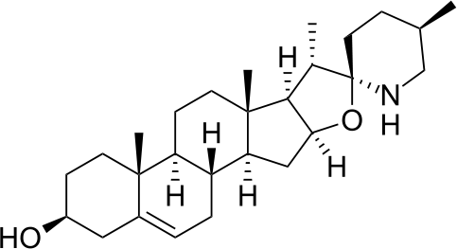

* + 1. Solasodine
    2. 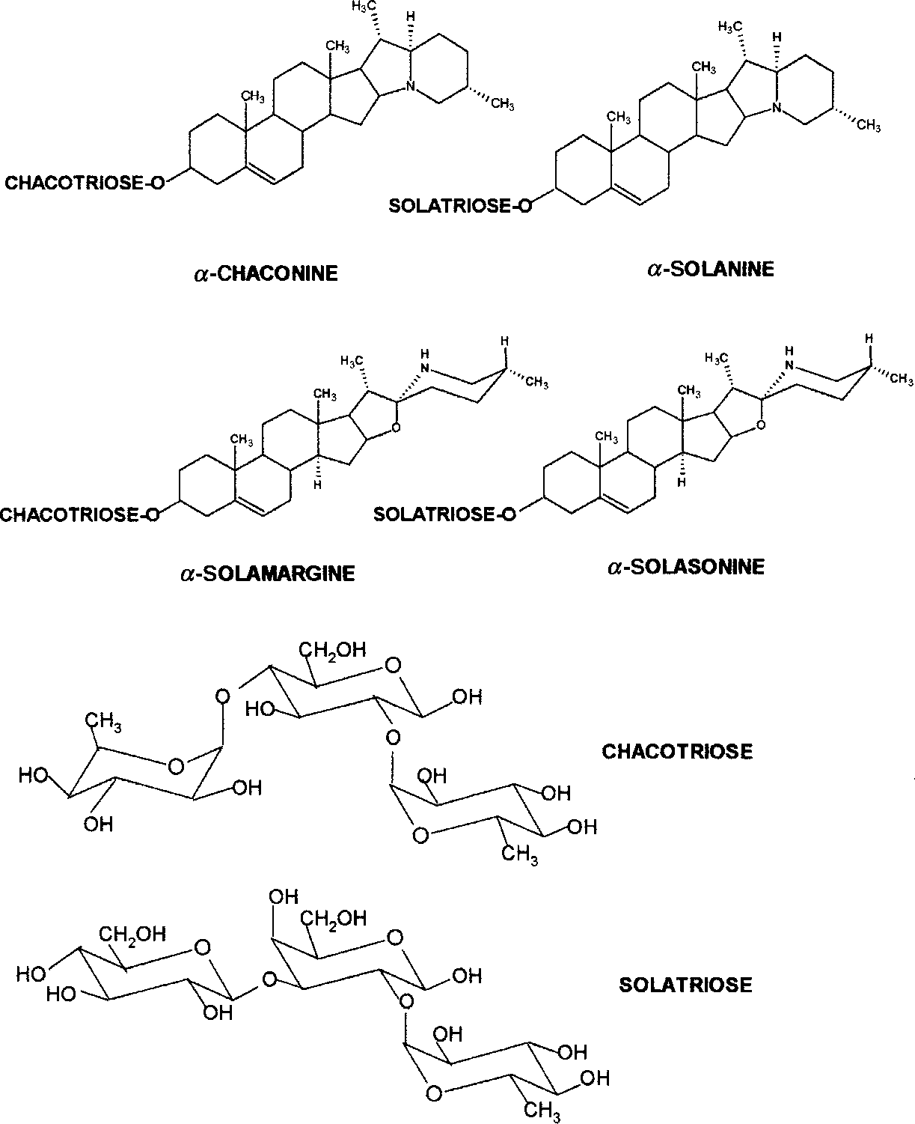(c)

(d)

(e)

(f)

(g)

### Figure 1.1 (a-g): Types of Glycoalkaloids and their Sugar Moeties from Solanum Species (Lina *et al*., 2003)

* 1. **The Species *Solanum incanum* and *Solanum melongena***
     1. ***Solanum incanum* Linn.**

*Solanum incanum* Linn. commonly called the bitter apple or African eggplant in English (GRIN, 2006). In Northern Nigeria among the Hausa speaking people it is commonly called

„gauta‟, or „gautan daaci‟, while among the Bura/Babar speaking people of Southern Borno of North Eastern Nigeria, it is commonly called „Tarku‟. It is an erect or spreading shrub up to 3m tall, occasionally a small tree (Matu, 2008).

It is a specie of nightshade native to Sub-Saharan Africa and the Middle East, Eastwards to India. *Solanum incanum* is a controversial plant because it was given different descriptions by different authors and these descriptions vary widely (Hutchinson and Dalziel, 1963).

* + 1. ***Solanum melongena* Linn.**

*Solanum melongena* Linn. commonly called the eggplant, in British English as aubergine and also known as melongena, garden egg, or guinea squash (Sihachakr *et al.*, 1994). It is a specie of nightshade widely grown in all continents except the Antarctica. It grows 40 to 150cm (16 to 57in) tall, it is known in South Asia and South Africa as brinjal (Doijode, 2001). Among the Hausa speaking people of Northern Nigeria, it is commonly called „Yalo‟ or „Gautan Bello‟.

Earlier work by Dalziel (1936) suggested that there was a relationship between the wild *S. incanum* and *S. melongena,* and that many edible forms are included in *S. incanum* complex. Both *S. incanum* and *S. melongena* are classified in accordance to Carl Linneaus system of classification 1753, as follows:

Kingdom: *Plantae*

Subkingdom: *Viridaeplantae*

Infra kingdom: *Streptophyta* Division: *Tracheophyta* Subdivision: *Spermatophyta* Infradivision: *Angiospermae* Class: *Magnoliopsida* Subclass: *Asteridae*

Order: *Solanales* Family: *Solanaceae* Genus: *Solanum* L.

Species: *Solanum incanum* Linn*, S. melongena* Linn.

### Common and Vernacular Names

English – *Solanum incanum*- Thorn apple, Bitter apple, Sodom‟s apple (GRIN, 2006)

- *Solanum melongena*- Garden egg, Aubergine (Sihachakr *et al.*, 1994) Hausa – *Solanum incanum*- Gauta, Gautan dacii,

*Solanum melongena*-Gauta, Gautan Bello

Bura –*Solanum incanum*- Tarku

*Solanum melongena-*Tarku

Macroscopically, leaves of the two plants are alternately arranged, have simple lamina with palmate venation. They also have long petiole, acute apex, oblique base and pubescent surfaces.

Both leaves, *S. incanum* (30.0 x 17.0cm) and *S. melongena* (20.0 x 15cm) have an undulately-lobed margin, and are lanceolate-ovate in shape (Table 2.1 and Appendix 1) (Matu, 2008 and Doijode, 2001).

**Table 2.1: Macroscopic Features of *Solanum incanum* and *S. melongena* Leaves**

|  |  |  |
| --- | --- | --- |
| **FEATURES** | **Descriptions**  ***S. incanum*** | ***S. melongena*** |
| Arrangement | Alternate | Alternate |
| Petiole | Long petiole | Long petiole |
| Stipules | Absent | Absent |
| Lamina: i. Dimension | 30.0 x 17.0cm | 20.0 x 15cm |
| ii. Composition | Simple | Simple |
| iii. Shape | Lanceolate – Ovate | Lanceolate - Ovate |
| iv. Venation | Palmate | Palmate |
| v. Margin | Undulately - Lobed | Undulately - Lobed |
| vi. Apex | Acute | Acute |
| vii. Base | Oblique | Oblique |
| viii. Surface | Pubescent | Pubescent |
| ix. Texture | Soft | Soft |

* 1. **Previous Research on *Solanum incanum* and *S. melongena***
     1. **Previous Research on *Solanum incanum***

The presence of Phytochemicals: alkaloids, flavonoids, carbohydrates, glycosides, phenols, steroids, tannins, resins and proteins were reported in the fruit extract of *S. incanum* by Indhumathi and Mohandass (2013). Auta *et al.,* (2011) reported the presence of minerals and heavy metals: sodium, potassium, zinc, copper, cadmium and chromium in the fruits of

*S. incanum*. Ethanol fruit extract of *S. incanum* was found to possess significant antimicrobial activity (Indhumathi and Mohandass, 2014). An investigation for the effect of *Solanum*

*incanum* on post prandial blood concentrations of normoglycemic Nigerians showed a significant reduction in blood glucose levels at most post prandial times and for area under the curve values (Okolie *et al.,* 2009). Studies carried out on *S. incanum* showed that it has antinociceptive effects in the two thermal nociception test models in mice as well as antipyretic effects in rats (Mwonjoria *et al*., 2011).

* + 1. **Previous Research on *Solanum melongena***

The fresh, ripe fruits of *S. melongena* were reported to have hypolidemic potentials in hypercholesterolemia induced in white rabbits (Odetola *et al*., 2004). The leaves of *S. melongena* were reported to possess analgesic effect in albino mice (Mutalik *et al*., 2003). Sudheesh *et al*., (1999) reported the presence of antioxidant activity in the fruit of *S. melongena* in normal and cholesterol-fed rats.

### Traditional Uses/ Economic Importance

#### Solanum incanum

In West Africa, leaves and fruits of certain cultivars are edible (Matu, 2008).Most of the medicinal uses of *Solanum incanum* are based on its analgesic properties. Throughout tropical Africa it has been used for sore throat, angina, stomach-ache, colic, headache, painful menstruation, liver pain and pain caused by onchocerciasis, pleurisy, pneumonia and rheumatism. For these purposes, leaf, root and fruit decoctions are gargled or drunk, roots are chewed and sap swallowed, leaf paste, root infusions and pounded fruits are applied externally or rubbed into scarifications, leaf sap is used for washing painful areas, and ash of burnt plants is mixed with fat and applied externally (Burkill, 2000).

The herb is used by several East African communities as a remedy for toothache, stomach- ache, fever, chest pains, snake bite and ear ache (Kokwaro, 1993).

In Oman, the leaves, fruits (berries) and roots of *S. incanum* are used as a traditional medicine to treat bruised fingers, dyspepsia, earache, and haemorrhoids (Ghazanfar and Al-Al-Sabahi, 1993).

#### Solanum melongena

*Solanum. melongena* have indigenous medicinal uses, which range from weight reduction to treatment of several ailments including asthma, skin infections and constipation. Various part of the plant are used in decoction for curing ailments such as diabetes, leprosy, gonorrhea, cholera, bronchitis, dysuria, dysentery, asthenia and haemorrhoids (Gill, 1992; Bello *et al*., 2005).

### CHAPTER THREE

* 1. **MATERIALS AND METHODS**

### Equipments, Solvents and Reagents/Solutions

### Equipments

The following equipments were used for the research:

Ashless Filter papers Camera Lucida Compound microscopes Dessicator

Filter papers

Laboratory glass wares (Funnel, Conical flask, Beakers, Measuring cylinders) Mechanical Shaker

Microtome (C 740527, Cambridge Instrumental Company Ltd, London, England) Micrometers

Photographic camera Plant press

Razor blades

Slides and cover slips Sieves

Stage micrometer and Occular lens

TLC plates (Silica gel G with aluminium backing, Merck, Germany) Weighing balance

Water bath

### Reagents/ Solutions/Solvents

Anisaldehyde (Sigma Aldrich)

Chloral hydrate

Chloroform (Sigma Aldrich) Dragendorff‟s reagent Ethanol

Formalin Fehling‟s solution Glycerol Hydrochloric acid

Libermann-Burchard‟s reagent Mayer‟s reagent

Methylene blue Molisch‟s reagent Paraffin Wax Phloroglucinol Safranin

Sodium Hypochlorite

* 1. **Collection and Identification of *S. incanum* Linn. and *S. melongena* Linn.**

*Solanum incanum* and *S. melongena* were collected during their flowering stages from Hunkuyi area of Kudan local Government Area of Kaduna State in March 2015. They were identified at the Herbarium section of the Department of Biological Sciences, Ahmadu Bello University, Zaria.

* 1. **Preparation of Herbarium Specimens of *Solanum incanum* and *S. melongena*** Herbarium specimens of *S. incanum* and *S. melongena* were prepared according to the method by Walters, (1963) and deposited in the herbarium section of the Department of Biological Sciences Ahmadu Bello University, Zaria where voucher specimen numbers 47 and 2453 were assigned respectively.

### Preparation of Plant Samples

Fresh samples of the leaves of *S. incanum* and *S. melongena* were used for microscopic studies, while the bulk of the leaves of the two plants collected were air dried under shade and pulverized. The powdered leaves were then sieved to obtain the powdered plant materials. They were then labelled appropriately and stored in airtight containers until further needed.

* 1. **Organoleptic Studies on *Solanum incanum* and *S. melongena* Leaves**

Their organoleptic properties namely colour, odour and taste were examined. Examinations were made with naked eyes and the results were recorded with the appropriate terms as described in quality control methods for medicinal plants (WHO, 1998).

* 1. **Microscopic Studies of the Leaves of *Solanum incanum* and *S. melongena***

### Calibration of Eyepiece Micrometer

Eyepiece micrometer was calibrated using the standard stage micrometer under x10 and x40 objective in accordance to the method described in quality control methods for medicinal plants (WHO, 1998). Microscopic measurements of the diagnostic features of *S. incanum* and

*S. melongena* were carried out using the calibrated eyepiece micrometer.

### Anatomical Studies

Microscopic examination on the fresh and powdered leaves of the two plant species were carried out and features were described using terminologies according to Ahlam and Bouran (2011).

### Method:

**Fixation:** the fresh leaves of *S. incanum* and *S. melongena* were dipped into the fixative Formal Acetic Acid (FAA) (70% ethanol, 40% formalin and glacial acetic acid) at the ratio 90:5:5 and was allowed to stand for 24 hours.

**Dehydration:** the sample above was transferred into 30%, 50%, 70%, 95% and 100% graded ethanol for 2 hours each.

**Clearing:** the sample was transferred into Ethanol: Chloroform (75:25), Ethanol: Chloroform (50:50), Ethanol: Chloroform (25:75) and 100% chloroform after 2 hours each as well.

**Infiltration and Embedding:** chips of paraffin wax were added slowly into the leaf sample and was left to stand for 24 hours before transferring it into an oven at 60oC. After melting, the paraffin containing the sample was transferred into the embedding box and allowed to solidify. It was then trimmed and mounted on the microtome to get the transverse and longitudinal section of the leaf. Both sections were then transferred on to glass slides.

**Staining:** the sections of the leaf were then dewaxed in xylene by changing twice for 5 minutes each. They were then hydrated in 95%, 70%, 50% and 30% ethanol for 2 minutes each. The sections were then transferred into safranin and left to stand for 30minutes before washing with water. They were transferred into 0.5%HCl in 70% ethanol shortly before dipping them into fast green for 2 minutes and washed with water again. Both sections were further dehydrated in 30%, 50%, 70%, 95% and 100% ethanol for 2 minutes each and cleared in xylene for another 2 minutes. Gum (Balsam) was sprayed along the transverse and longitudinal sections and cover slip was placed (Ahlam and Bouran, 2011). Both sections

were then observed under the microscope and appropriate images were taken with a photographic camera and documented.

Microscopic features of the leaves of both plants such as type, nature and size of epidermal cells, stomata, trichomes, xylem elements and calcium oxalate were observed. Measurements in five (5) different determinations were carried out on the epidermal tissue with the aid of calibrated eyepiece micrometer (WHO, 1998).

### Chemo-microscopic Studies

Powdered samples of the leaves of the two species were used for this study to detect the presence of cell wall materials and cell inclusions. Finely ground samples of the two plants were cleared in a test tube containing 70% chloral hydrate solution. They were boiled on a water bath for about thirty minutes to remove obscuring materials. The cleared samples were then mounted with dilute glycerol onto a microscope slide. Using various detecting reagents the presence of cell wall materials and cell inclusions were detected in accordance to WHO (1998) guidelines.

#### Cell wall Materials

* + - * 1. ***Test for Cellulose***

Small amount of the cleared powdered leaves were separately placed on a slide and a drop of N/50 iodine added and left for a minute, followed by a drop of 66% sulphuric acid. The appearance of bluish colour was considered positive for cellulose on cell walls of the cells.

#### Test for Lignin

Small amount of the cleared powered leaves were separately placed on a slide and a drop of phloroglucinol added followed by a drop of concentrated HCl. Appearance of red stain or coloration was considered as positive for lignins.

#### Test for Gums and Mucilage

To a small portion of the cleared leaf powder of each of the two plants, a drop of ruthenium red was added. Appearance of pink colouration was considered positive for gums and mucilages.

#### Cell inclusions

* + - * 1. ***Test for Starch***

To a small portion of the cleared leaf powder of each of the two plants, N/50 iodine was added. Appearance of blue-black or reddish-blue colouration on some grains was considered positive for starch.

#### Test Tannins

To a small portion of the cleared leaf powder of each of the two plants, 5% ferric chloride solution was added. Appearance of greenish black colour was considered positive for tannins.

#### Test for Fats and Oils

To a small portion of the cleared leaf powder of each of the two plants, a drop of Sudan (IV) reagent was added and allowed to stand for a minute. Appearance of orange red was considered positive for fatty substances.

#### Test for Calcium Oxalates and Calcium Carbonates

To a small portion of the cleared leaf powder of each of the two plants, HCl was added, dissolution of crystals in the powdered drug without effervescence was considered positive for calcium oxalate. While slow dissolution with effervescence was considered as positive for calcium carbonate.

### Determinaton of Microscopical Leaf Constants

This involves counting the specific histological features of the leaf. Five constants of the leaves of both *S. incanum* and *S. melongena* were determined.

#### Palisade Ratio

Section from the upper epidermis of each plant was cleared with boiling 70% chloral hydrate solution and mounted on a clean microscope slide with dilute glycerol and examined with x40 objective. A camera lucida was set up and the palisade ratio determined in groups of four contagious cells and the average taken (Evans, 2002).

#### Stomatal Number

Section from the upper and lower epidermis of each plant was cleared with boiling 70% chloral hydrate solution and mounted on a clean microscope slide with dilute glycerol. A camera lucida was set up. With the aid of a stage micrometer a paper was divided into squares of 1mm2 using x10 objective. The stomata was traced and counted in the fields on a single section of the leaf of each of the two plants and the average number of stomata per mm2 of epidermis was calculated (Evans, 2002).

#### Stomatal Index

Sections of the epidermal portion of the leaves were mounted and examined as in stomatal number determination, except that here both stomatal and epidermal cells were counted. The stomatal index was calculated in accordance with Evans (2002).

Stomatal Index = Number of Stomata x 100 No. of Epidermal Cells + No. of Stomata

#### Vein-islet Number

It was determined by boiling pieces of leaf of the plants in a test-tube containing 70% chloral hydrate solution, followed by treatment with 10% hydrochloric acid to remove calcium oxalate crystals to enhance visibility. A cameral lucida was set up and by means of a stage micrometer the paper was divided into squares of 1 mm2 using x10 objective. The stage micrometer was then replaced by the cleared preparation of the leaf and the veins traced in four contiguous squares that is a rectangle 1mm x 4mm. Each vein was traced and areas

which were completely enclosed by veins were counted and those that were not completely enclosed were excluded (Evans, 2002).

#### Veinlet Termination Number

It was determined for both *S. incanum* and *S. melongena* using a camera Lucida set up as in vein-islet number but here the termination number in each square was counted but the vein- islet were excluded (Evans, 2002).

* 1. **Determination of Physicochemical Parameters on *Solanum incanum* and *S. melongena* Leaves**

Six physicochemical parameters were determined for the powdered leaves of the two plant species namely moisture content, ash value, acid insoluble ash, water soluble ash value, alcohol and water extractive values. Five different determinations were carried out for each parameter and the average taken. The methods outlined by WHO (1998) on quality control methods for medicinal plant materials was used.

### Moisture Content

It is the quantity of moisture present in a plant material. Moisture content of the leaves of *Solanum incanum* and *S. melongena* was determined by loss on drying method. 3.0g each of the powdered leaves of the two plants was accurately weighed and placed in some clean, dried evaporating dishes of known weights. They were placed in an oven and heated at a temperature of 105oC for a 1 hour, then cooled in a dessicator and re-weighed. Heating and weighing was repeated until a constant weight was obtained. The weight loss on drying was computed following the formula below:

%Moisture content = Weight of Water lost x 100

Original Weight of Sample

### Total Ash Value

This is the ash remaining after ignition of medicinal plants. 2g of powdered plant materials were accurately weighed and placed separately in a crucible of known weight. It was heated gently and the heat gradually increased until it was white indicating the absence of carbon. It was allowed to cool in a desiccator and weighed; this was repeated until a constant weight was obtained. The total ash value of each of the two plant species were determined as a percentage with the formula below

Total Ash Value (%) = Weight of Residual Ash x 100

Initial Weight of Sample

### Acid-insoluble Ash

This is the residue that remains after boiling the total ash with dilute hydrochloric acid. This was determined separately for each of the plants leaves. 25ml of dilute hydrochloric acid was added to the crucible containing each of the ash. It was covered with a watch glass and gently boiled for 5mins. The watch glass was rinsed with 5ml of hot water and the liquid added to the crucible. The insoluble matter was collected on an ashless filter-paper and washed with hot water until the filtrate was neutral. The filter-paper containing the insoluble matter was transferred to the original crucible, dried in an oven and ignited to a constant weight. The residue was allowed to cool in a suitable desiccator for 30 minutes and then weighed without delay. The acid-insoluble ash was then calculated as a percentage for each of the two plants with the formula

Acid-Insoluble Ash (%) = Weight of Residual Ash x 100

Initial Weight of Sample

### Water-Soluble Ash

The water-soluble ash value of the powdered leaves of *S. incanum* and *S. melongena* was determined separately. The ash obtained following method described in (b) above was used. It was determined following the same procedure as in (c) above, except that water was used

instead of diluted hydrochloric acid. The water-soluble ash was determined as percentage for each of the two plants with the formula

Water-Soluble Ash (%) = Int. Wt. of Ash - Wt. of Res. Ash x 100

Initial Weight of Sample

### Alcohol-Soluble Extractive Value

This is the amount of extractive in percentage of a plant sample with alcohol. 4g of each of the plant material was separately weighed in a conical flask. 100ml of ethanol was added and macerated for 24 hours, during which the mixture was frequently shaken within the first 6hours using a mechanical shaker. It was filtered and 25ml of the filtrate transferred into an evaporating dish of known weight and evaporated to dryness on a water bath. It was dried to a constant weight, the percentage of alcohol-soluble extractive value was then determined for each of the two plants as

Alcohol-Soluble Extractive Value (%) = Weight of Residue in 25ml extract x 4 x 100

Initial weight of sample

### Water-Soluble Extractive Value

This is the amount of extractive in percentage of a plant sample with water. Same procedure as in alcohol-soluble extractive value was repeated here for the two plants, but solvent for extraction here was water.

Water-Soluble Extractive Value (%) = Weight of Residue in 25ml extract x 4 x 100

Initial weight of sample

* 1. **Elemental Analysis of the Leaves of *Solanum incanum* and *S. melongena*** This was done on the powdered leaf (0.25g) of the plants separately using the Neutron Activation Analysis (NAA) technique at the Centre for Energy Research and Training, Ahmadu Bello University, Zaria.

The samples and standards were irradiated simultaneously using the Nigerian Research Reactor-1 (NIRR-1) swimming pool -type reactor operating at 31.5kw via the Pneumatic Rabbit System that operates at a pressure of 0.5MPa. During short irradiation, the samples were irradiated for 5 mins. at a neutron fluxes 2.5x1011n.m-2.s-1 in the outer irradiation channel B4 of the reactor and then cooled outside the reactor for about 2-15 minutes before the first round of counting was performed for 10 minutes at the position height of 2cm just above the surface of the High-purity Germanium (HPGe) detector. The second round of counting for the long irradiation was done for 1 hour after 9-11 days waiting periods for cooling to determine radionuclides with half-lives in the order of days. The concentrations of the elements in the activated samples were calculated quantitatively using the gamma-ray spectrum analysis softwares packages known Winspan 2004 (Yamusa *et al*., 2013).

### Phytochemical Analysis

* + 1. **Extraction of the Powdered Leaf of *Solanum incanum* and *S. melongena***

300g of powdered *S. incanum* and *S. melongena* were extracted separately using maceration method with aqueous ethanol (70%v/v) in a glass jar for 3 days (72 hours), at room temperature with gradual agitation. The extracts were filtered and evaporated to dryness on a boiling water bath to obtain the crude extracts which were stored properly for further use.

* + 1. **Phytochemical Screening of the Ethanolic Leaf Extract of *Solanum incanum***

**and *S. melongena***

### Test for Alkaloids:-

Ethanol extracts (0.5g) of both plants were separately placed in a test tube. 5ml of hydrochloric acid was added to each test tube and boiled on a water bath; it was cooled and filtered. To a small amount of fresh filtrate, ammonia solution was added to make it alkaline by testing with litmus paper. 1ml chloroform was added and shaken gently, layers were

allowed to separate and chloroform layer pipetted into another test-tube. To the chloroform layer 5ml of dilute HCl was added and allowed to form separate layers, the chloroform layer was discarded while the aqueous layer was used to test the presence of alkaloids with Mayer‟s, Dragendorff‟s and Wagner‟s reagents (Mohammed, 2002).

To 1ml of each filtrate, 0.5ml of Mayer‟s reagent was added dropwise, formation of a cream coloured precipitate was considered positive for Mayer‟s test. To a second 1ml of each filtrate, 0.5ml of Dragendorff‟s reagent was added dropwise, formation of orange-red precipitate was considered positive for Dragendorff‟s test. While to a third 1ml of each filtrate, 0.5ml of Wagner‟s reagent was added dropwise, formation of brownish-red precipitate was considered positive for Wagner‟s test (Evans, 2002).

### Test for Carbohydrates

#### Molisch’s Test

Ethanol extract (0.5g) of the plants was separately dissolved in distilled water contained in separate test tubes and filtered. 4 drops of Molisch reagent was added followed by small amount of conc. H2SO4 by the side of the test tube, appearance of purple coloured ring at the interphase as a result of interaction between Molisch reagent and 5-hydroxymethylfurfural was considered positive (Silver *et al.*, 1998).

#### Fehling’s Test

To 0.5g of both plants in separate test tubes, 1ml of distilled water was added. The test tubes was then placed on a water bath to heat, equal volumes of Fehling‟s solutions A and B was added drop by drop into the test tube. Appearance of brick-red precipitation was considered positive for the presence of reducing compounds (Evans, 2002).

### Test for Flavonoids

#### Shinoda’s Test

To 0.5g each of both plant extracts in separate test tubes, 2ml methanol was added and allowed to dissolve. 4 drops of concentrated HCl was then added followed by some chips of magnesium metal. Appearance of orange colour was considered positive for flavones, red- crimson for flavonols and pink-magneta for flavonones (Silver *et. al.*, 1998).

#### Sodium Hydroxide Test

Equal volume of the two plant extracts were reconstituted with water and filtered, 5ml each was taken and 10% NaOH separately added. A yellow solution which becomes colourless on addition of dilute HCl was considered positive (Silver *et al.*, 1998).

### Test for Cardiac Glycosides

#### Keller-Keliani’s Test

To 0.5g of both plants in separate test tubes, 2ml glacial acetic acid containing a drop of ferric chloride solution was added and allowed to dissolve; 1ml of concentrated sulphuric acid was then carefully added to form a lower layer. A brown ring formed at the interface indicates the presence of deoxy sugar (Evans, 2002).

#### Kedde’s Test

To 0.5g of both plants in separate test tubes, 1ml of 2% solution of 3, 5- dinitrobenzoic acid in 95% methanol was added. The solution was made alkaline with 5% sodium hydroxide, appearance of purple-blue colour was considered positive for cardenloides (Sofowora, 2008).

### Test for Sterols and Triterpenoids

#### Salkowski’s Test

To 0.5g of both plants in separate test tubes, 2ml chloroform was added, dissolved and filtered. 3ml concentrated sulphuric acid was then carefully added to the filtrate to form a

layer. A reddish brown coloration at the interface was considered positive for steroidal ring (Sofowora, 2008).

#### Lieberman-Burchard’s Reaction

To 0.5g of ethanol extract of the two plants in separate test tubes, 2ml acetic anhydride and 2ml chloroform were added gently and shaken. 1ml concentrated sulphuric acid was then added at the bottom, formation of a reddish green or violet-brown ring was considered positive for the presence of steroid/terpenoid (Evans, 2002).

### Test for Tannins

#### Ferric Chloride Test

Both extracts (0.5g) were stirred separately with 10ml of distilled water and then filtered. Few drops of 1% ferric chloride solution were added to 2ml of the filtrate. Occurrence of a blue-black (hydrolysable tannins) or brownish green (condensed tannins) precipitate was considered positive for tannins (Evans, 2002).

#### Bromine Solution Test

To 0.5g of the extracts in different test tubes, 3 drops of bromine water was added, formation of a blue coloured precipitate was considered positive for tannins (Evans, 2002).

### Test for Saponins

#### (i) Frothing Test

To 0.5g of ethanol extract of the plants in different test-tube, 5ml of water was added and shaken for 15sec. The occurrence of a frothing column persisting for at least 15 minutes was considered evidence for the presence of saponins (Sofowora, 2008).

#### (iii) Haemolysis Test

To 0.5g of the ethanol extract of the two plants in separate test tubes, 2ml distilled water was added. To separate test tubes, 2ml sodium chloride solution was added. To one of the test tubes, 2ml distilled water was added and to the other one 2ml of ethanol extract of the two

plants was added separately. 5 drops of freshly preserved blood was added to each of the test tubes and allowed to stand for some times. Haemolysis of red blood cells in the test tube containing the extract was considered positive for this reaction (Brain and Turner, 1975).

### Test for Anthraquinones

#### Borntrager’s Test

To 1g of each plant extract 10ml benzene was added and shaken for 5mins, they were filtered and 5ml of 10% ammonia solution added to the filtrate. The mixture was shaken and the presence of a pink, red, or violet colour in the ammonia (lower) phase was considered positive for the presence of free anthraquinones (Evans, 2002).

#### (ii) Modified Borntrager’s Test

To 1g of each plant extract, 10ml dilute HCl was added and boiled for 5mins, they were then filtered while hot. The filtrate was shaken with 5ml of benzene, the benzene layer separated and to half its volume 3ml 10% ammonia solution added. A pink, red, or violet coloration in the ammonia phase (lower layer) indicated the presence of combined anthraquinone derivatives in the extracts (Sofowora, 1993).

* 1. **Thin Layer Chromatographic Analysis on the Ethanol Leaf Extracts of *Solanum incanum* and *S. melongena***

Pre-coated silica gel plates (10 x 2.5cm) were used and were individually spotted with ethanol leaf extract of the two plants. Spots were allowed to dry and were developed with the solvent system namely n-butanol: acetic acid: water (6:1:1) in a chromatographic tank. Visualization of the chromatogram was carried out using general and specific detecting reagents including: sulphuric acid, Dragendorff and Ferric chloride. Rf values were then calculated (Gibbons and Gray, 1998).

* 1. **Quatitative Estimation of Alkaloids in the Leaves of *S. incanum* and *S. melongena*** Weighed sample (5g) was put into a 250ml beaker followed by 200ml of 10% acetic acid in ethanol added and covered and allowed to stand for 4h. It was filtered and the extract concentrated on a water bath to one-quarter of the original volume. Concentrated ammonium hydroxide was added dropwise to the extract until the precipitation was complete. The whole solution was allowed to settle and the precipitate collected and washed with dilute ammonium hydroxide and then filtered. The residue was the alkaloid, which was dried and weighed (Harborne, 1973).
  2. **Specific Test for Steroidal Glycoalkaloids in the Leaves of *Solanum incanum* and**

***S. melongena***

### Extraction of Alkaloid

Modification of the method outlined by Kokate, (1994) was adopted. 30g of powdered *S. incanum* and *S. melongena* were individually defatted using 300ml petroleum ether (40- 60%). They were then decanted and the residue allowed to dry to completely remove the petroleum ether. Both samples were then extracted separately using maceration method with 5% H2SO4 in 50% ethanol in a glass jar for 3days (72 hours). The extracts were filtered, evaporated to dryness on a boiling water bath and separated into two portions each. To the 1st portion, Mayer‟s reagent was added to confirm presence of alkaloid, afterwards the 2nd portion was adjusted to PH 8 by basifiying with NaOH. The basic extracts (liberated alkaloids) were individually transferred into a separating funnel and extracted with chloroform which formed two layers. The chloroform layer was distilled off to yield the alkaloid extract.

**Figure 3.1 Flow Chart Showing the Method of Extraction of Alkaloids from *S. incanum* and *S. melongena***

Powdered plant material

* + - 1. Petroleum ether (40-60%)
      2. 5% H2SO4 in 50% ethanol

Supernatant Marc

1st portion 2nd portion

Discard

0.1 ml Mayers reagent

Formation of buff ppt. indicates presence of

1. NaOH added until alkaline
2. Extract with chloroform
3. Separate two layers

alkaloids

Aqueous layer Chloroform layer

Concentrate to obtain the alkaloid extract

* + 1. **Phytochemical Screening of the Alkaloid Leaf Extract of *Solanum incanum* and**

#### S. melongena

***i. Mayer’s Test***

To 1ml of each filtrate, 0.5ml of Mayer‟s reagent was added dropwise, formation of a cream coloured precipitate was considered positive for Mayer‟s test.

#### ii Dragendorff’s Test

To 1ml of each filtrate, 0.5ml of Dragendorff‟s reagent was added dropwise, formation of orange-red precipitate was considered positive for Dragendorff‟s test.

#### Wagner’s Test

To a 1ml of each filtrate, 0.5ml of Wagner‟s reagent was added dropwise, formation of brownish-red precipitate was considered positive for Wagner‟s test (Evans, 2002).

#### Molisch’s Test

Alkaloid extract (0.5g) of the plants was separately dissolved in distilled water contained in separate test tubes and filtered. 4 drops of Molisch reagent was added followed by small amount of conc. H2SO4 by the side of the test tube, appearance of purple coloured ring at the interphase as a result of interaction between Molisch reagent and 5- hydroxymethylfurfural was considered positive (Silver *et al.*, 1998).

#### Salkowski’s Test

To 0.5g of both plants in separate test tubes, 2ml chloroform was added, dissolved and filtered. 3ml concentrated sulphuric acid was then carefully added to the filtrate to form a layer. A reddish brown coloration at the interface was considered positive for steroidal ring (Sofowora, 2008).

#### Lieberman-Burchard’s Reaction

To 0.5g of alkaloid extract of the two plants in separate test tubes, 2ml acetic anhydride and 2ml chloroform were added gently and shaken. 1ml concentrated sulphuric acid was then added at the bottom, formation of a reddish green or violet-brown ring was considered positive for the presence of steroid/terpenoid (Evans, 2002).

* 1. **Thin Layer Chromatographic Analysis on the Alkaloid Leaf Extracts of *Solanum incanum* and *S. melongena***

Pre-coated silica gel plates (10 x 2.5cm) were used and were individually spotted with alkaloid leaf extract of the two plants. Spots were allowed to dry and were developed with the solvent system namely chloroform (100%) in a chromatographic tank. Visualization of the chromatogram was carried out using p-anisaldehyde-sulphuric acid. Rf values were then calculated (Gibbons and Gray, 1998).

### CHAPTER FOUR

* 1. **RESULTS**

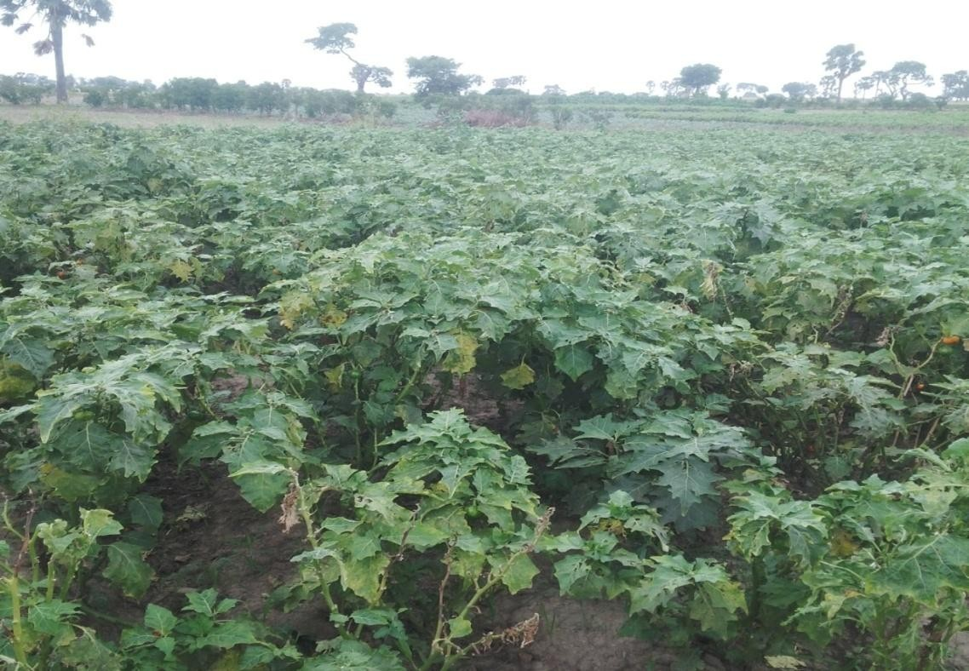

**Plate I: *Solanum incanum* in its cultivated habitat X 400**

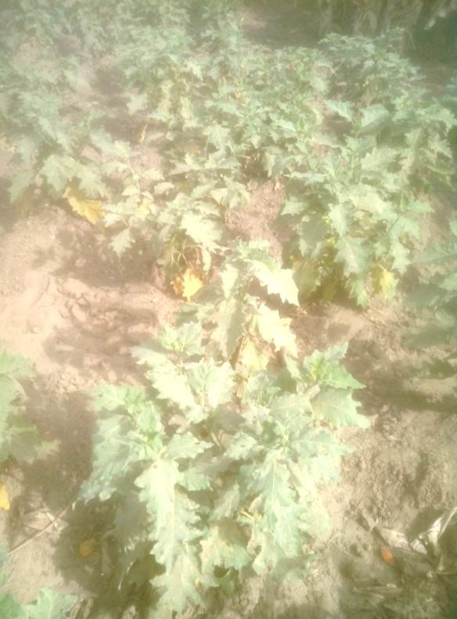

**Plate II: *Solanum melongena* in its cultivated habitat X 400**

* 1. **Organoleptic Studies on *Solanum incanum* and *S. melongena* Leaves** Organoleptically, both leaves were green in colour and distinct in odour, but *S. incanum* had a more bitter taste than *S. melongena* (Table 4.1).

**Table 4.1: Organoleptic Features of *Solanum incanum* and *S. melongena* Leaves FEATURES Descriptions**

#### S. incanum S. melongena

1. Colour Greenish More greenish
2. Odour Distinct Distinct
3. Taste More bitter Bitter
   1. **Microscopic / Quantitative-leaf Microscopic / Chemo-microscopic Studies on the leaves of *Solanum incanum* and *S. melongena***

### Anatomical Sections and Powder of Leaves

Microscopic features identified in the leaves of the two plants include: Anisocytic stomata (1.98 - 2.24 - 2.64µm of length and 0.99 – 1.58 – 2.31µm of width in *S. incanum* and

1.98 – 2.18 – 2.64µm of length and 0.99 – 1.42 – 1.98µm of width in *S. melongena*) were identified on the adaxial surfaces of the leaf while both anomocytic and anisocytic stomata on the abaxial surfaces of the leaf (Plate III, IV, V & VI).

Lignified non glandular multiradiate stellate trichomes (12.24 – 16.70 – 19.04µm of length and 2.72 – 3.13 – 4.08µm of width in *S. incanum* while 13.60 – 27.75 – 39.44µm of length and 2.72 – 3.13 – 4.08µm of width in *S. melongena*) were observed on the lamina and in the midrib of both leaves of *S. incanum* and *S. melongena* (Plate VII & VIII). Unequal slightly wavy to deep wavy epidermal cells (3.30 – 3.63 – 3.96µm of length and 1.32 – 1.65 –

1.98µm) with polygonal shape and anticlinal walls were observed in the midrib and lamina of both plants.

Calcium oxalate crystal of the single prism type (0.33 – 0.46 – 0.66µm of length and 0.16 –

0.26 – 0.33µm of width) was observed in powdered leaves and along the upper and lower epidermis of the transverse section of the leaves of both plants (Plate IX & X). Oval-shaped starch grains (0.13 – 0.16 – 0.19µm of length and 0.01 – 0.13 – 0.16µm of width) were also identified in the powders and within the epidermal cells of both plants.

### Table 4.2: Microscopic Features of the Upper and Lower Epidermis of the Leaves of

***Solanum incanum* and *S. melongena***

### Characters Observations

***S. incanum S. melongena***

### Upper Epidermis

Epidermal Cells Polygonal in shape Polygonal in shape Anticlinal walls Slightly wavy Slightly wavy

Stomata Anisocytic Anisocytic

(2.24µm L and 1.58µm W) (2.18µm L and 1.42µm W)

Trichomes Absent Absent

### Lower Epidermis

Epidermal Cells Polygonal in shape Polygonal in shape (3.63µm L and 1.65µm W) (3.63µm L and 1.65µm W)

Anticlinal walls Deeply wavy Deeply wavy

Stomata Anomocytic Anomocytic and Anisocytic and Anisocytic

(2.24µm L and 1.58µm W) (2.18µm L and 1.42µm W)

Trichomes Multiradiate stellate Multiradiate stellate (16.70µm L and 3.13µm W) (27.75µm L and 3.13µm W)

**Keys:** L = Length; W = Width

Anisocytic Stoma

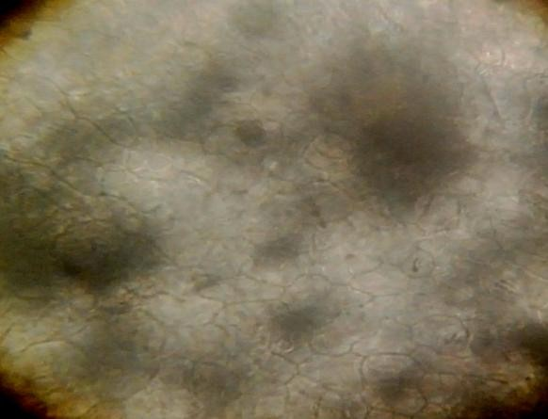

Epidermal cell

**Plate III: *Solanum incanum* Upper Epidermis (x400)**

Epidermal cell

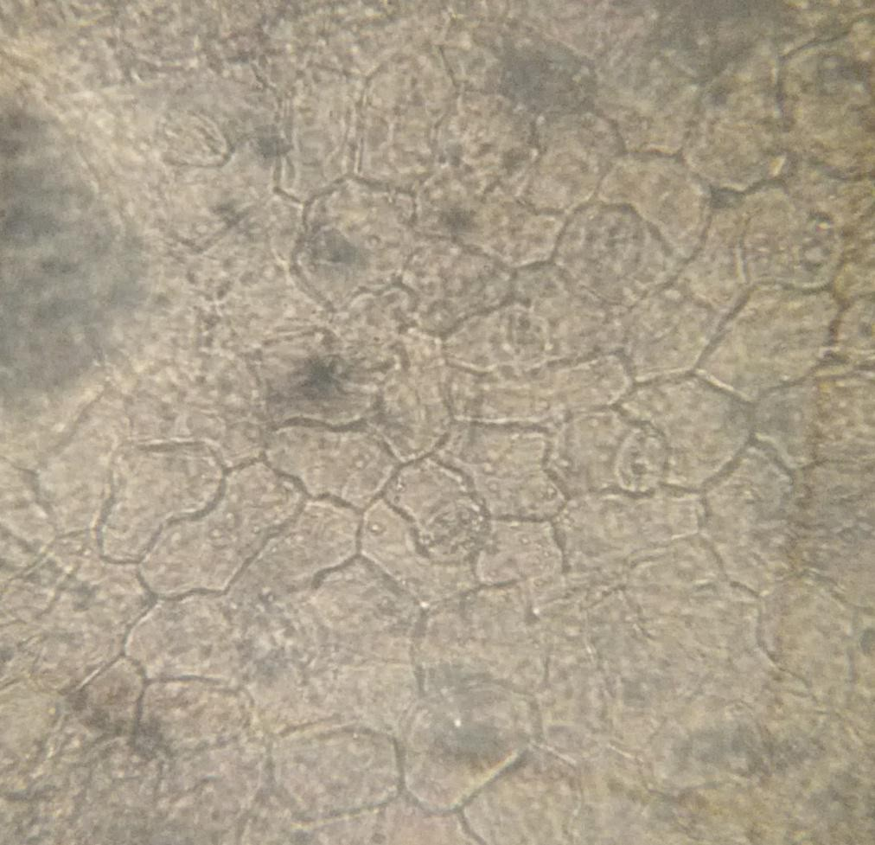

Anisocytic Stoma

**Plate IV: *Solanum melongena* Upper Epidermis (x400)**

Anomocytic stoma

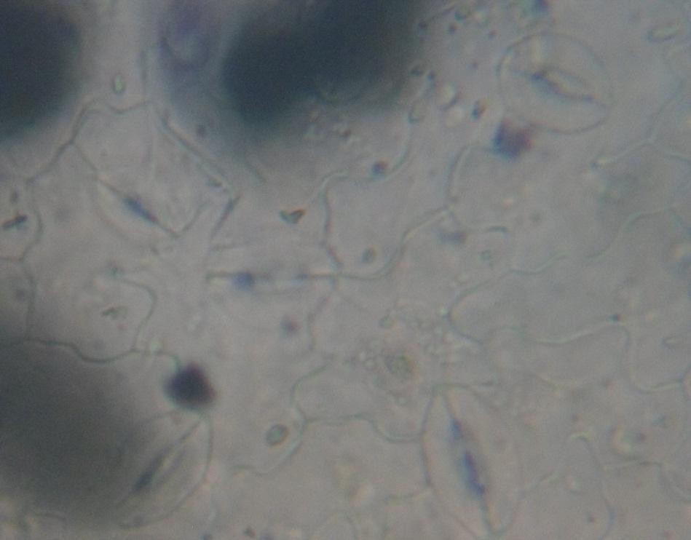

Epidermal cell

**Plate V: *Solanum incanum* Lower Epidermis (x400)**

Anomocytic stoma

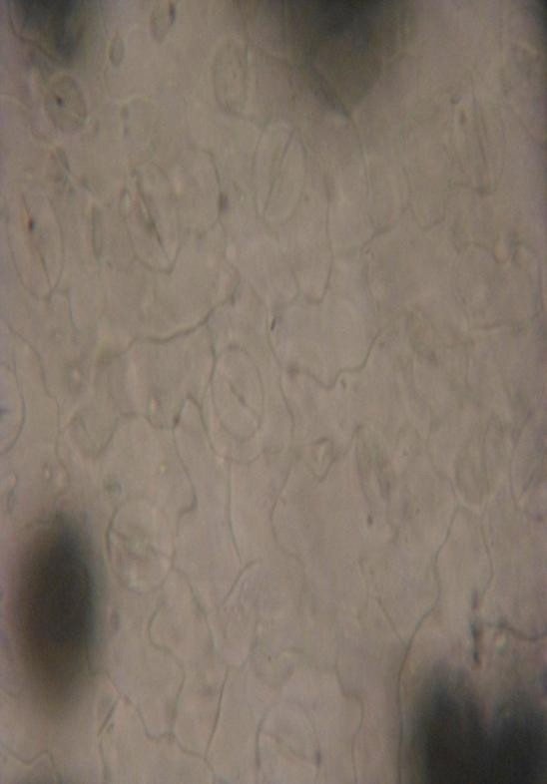

Epidermal cell

**Plate VI: *Solanum melongena* Lower Epidermis (x400)**

Stellate Trichome

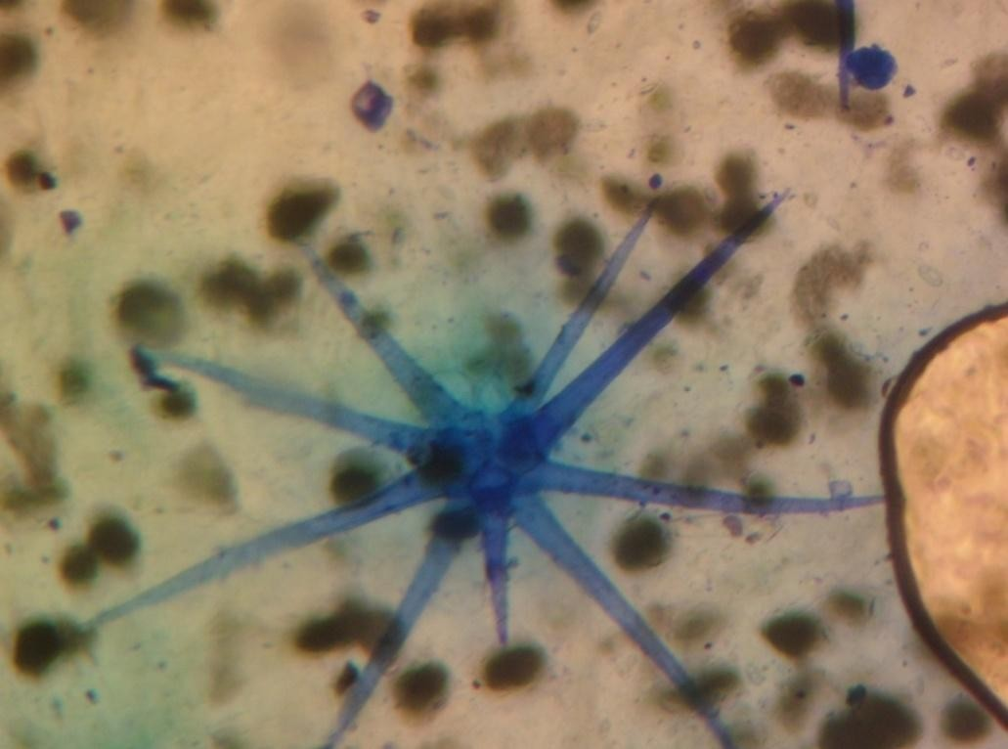

### Plate VII: Stellate Trichome on the Lower Epidermis of *S. incanum* (x400)

Stellate Trichome

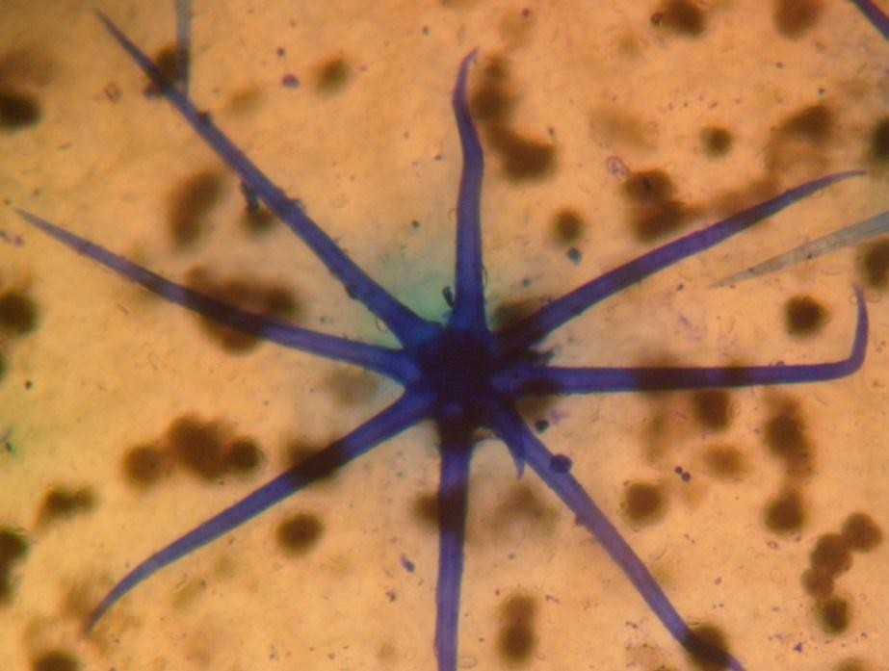

**Plate VIII: Stellate Trichome on the Lower Epidermis of both *S. incanum* and *S. melongena* (x400)**

The transverse sections of the leaves of *S. incanum* and *S. melongena* were dorsiventral with a single layer of upper and lower epidermis and a layer of compact elongated palisade cells below the upper epidermis (Plate IX & X). Below the palisade cells are the spongy mesophyll

tissues which lie above the xylem element consisting of 4-6 strands. Longitudinal sections through the midrib tissue of both plants revealed the presence of spiral-shaped vessels, phloem and sclerenchyma (Plate XI & XII).

Upper Epidermis Palisade cells Xylem

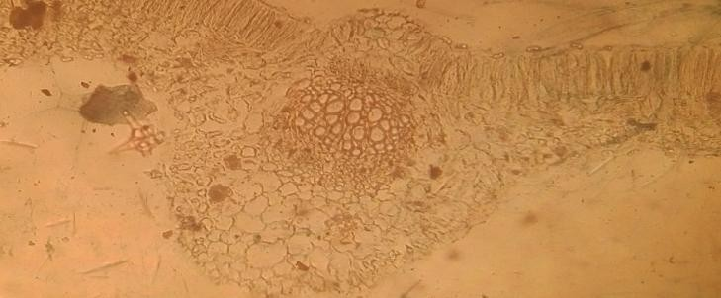

Phloem

Collenchyma

Lower Epidermis

### Plate IX: Transverse section across the midrib of the leaf of *Solanum incanum* (x400)

Upper Epidermis Palisade cells

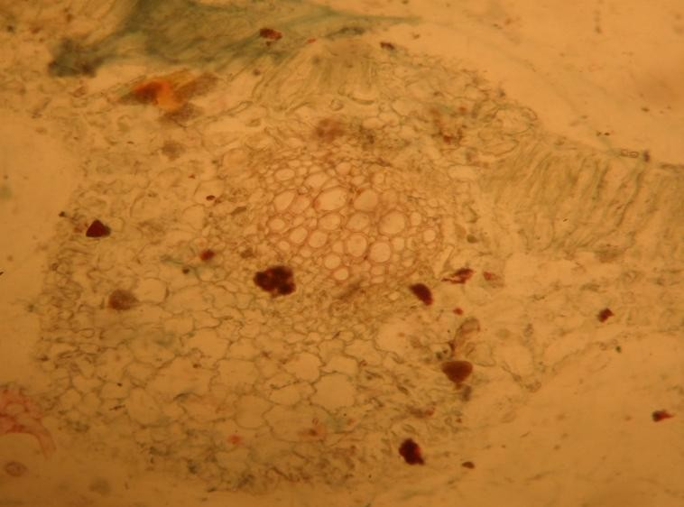

Xylem Phloem

Collenchyma

Lower Epidermis

**Plate X: Transverse section across the midrib of the leaf of *Solanum melongena* (x400)**

Phloem Spiral vessel

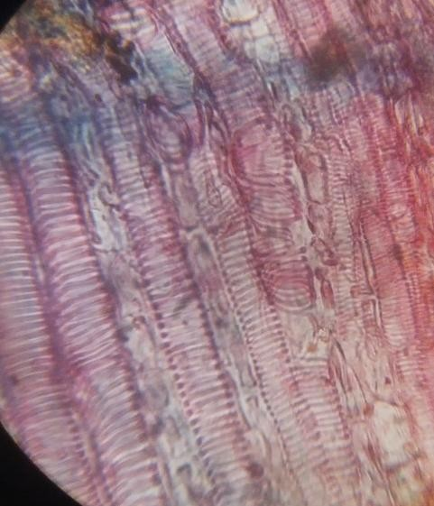

### Plate XI: Longitudinal Section through the midrib of the Leaf of *Solanum incanum*

**(x400)**

oem

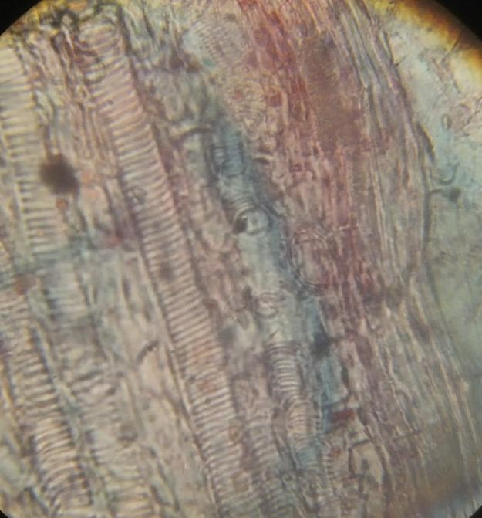

Fibres

Phl

Spira

l vessel

**Plate XII: Longitudinal Section through the midrib of the Leaf of *Solanum melongena***

### (x400)

* + 1. **Chemo-microscopic Studies**

Several types of cell wall materials and cell inclusions were identified in the leaves of

*Solanum incanum* and *S. melongena* as:

#### Cell wall Materials

1. ***Test for Cellulose***

Blue colour was observed on the walls of the epidermal cells when tested with chlor-zinc iodine, which indicated the presence of cellulose in the two plants.

#### Test for Lignin

Red stain was observed on the walls of some lignified cell in the two plants when tested phloroglucinol and HCl which indicated the presence of lignin.

#### Test for Gums and Mucilage

Pink colour was observed in the epidermis and vascular tissues of both plants when treated with ruthenium red, which indicated the presence of mucilage in both plants.

#### Cell inclusions

1. ***Test for Starch***

Blue-black colour on some grains within the chloroplast and in the leaf powder was obtained in both plants when tested with N/50 iodine, which indicated the presence of starch.

#### Test for Fats and Fixed oils

Orange red colour was observed in some parenchyma cells of both plants when treated with Sudan IV solution which indicated the presence of fats and fixed oils.

#### Test for Tannins

Greenish black colour in some parenchyma cells was observed in both plants when treated with 5% ferric chloride solution, which indicated the presence of tannins in both plants.

#### Test for Calcium Oxalate Crystals

Brightly coloured crystals disappeared upon addition of the acid HCl without effervescence in both plants, which indicated the presence of calcium oxalate crystals.

#### Test for Calcium Carbonates

No effervescence was observed upon disappearance of crystals in the cell of the two plants. This indicated absence of calcium carbonates.

* 1. **Quantitative – Leaf Microscopic Studies on *Solanum incanum* and *S. melongena*** Quantitative-leaf microscopic studies revealed that, stomatal number (2.0 and 8.0) and indices (3.7 and 13.3) were lower in *Solanum incanum* than in *S. melongena* (4.0 and 12.0) and (6.8 and 20.5) respectively. Palisade ratio and vein-islet were the same in both plants (4.6) and (2.6). Vein-islet termination number was however lower in *S. incanum* (3.4) than in

*S. melongena* (4.8) (Table 4.3).

**Table 4.3: Quantitative-leaf Microscopic Features of *Solanum incanum* and *S. melongena***

DETERMINATIONS * MEAN VALUES

*S. incanum S. melongena*

### Upper Epidermis

Palisade ratio 4.0 – 4.6 – 5.3 3.8 – 4.6 – 5.3

Stomatal number 1.0 – 2.0 – 3.0 3.0 – 4.0– 5.0

Stomatal index 2.1 – 3.7 – 4.6 6.4 – 6.8 – 7.4

### Lower Epidermis

Stomatal number 5.0 – 8.0 – 11.0 10.0 – 12.0 – 14.0

Stomatal index 11.1 – 13.3 – 15.5 15.7 – 20.5 – 24.5

Vein-islet number 1.0 – 2.6 – 4 .0 2.0 – 2.6 – 4.0

Veinlet termination number 2.0 – 3.4 – 5.0 4.0 – 4.8 – 6.0

* Mean Values of 5 Counts

* 1. **Determination of Physicochemical Parameters on *Solanum incanum* and *S. melongena* Leaves**

Physicochemical parameters determined from the leaf powder of the two plant species on the average (%w/w) were moisture content, total ash values, acid – insoluble and water soluble ash values, and alcohol and water extractives (Table 4.4).

### Table 4.4: Physicochemical Parameters from the Leaf Powders of *Solanum incanum*

**and *S. melongena***

|  |  |  |
| --- | --- | --- |
|  | ***S. incanum*** | ***S. melongena*** |
| Moisture content | 4.13+ 0.003 | 3.46+ 0.002 |
| Ash – value | 20.50+ 0.006 | 19.00+ 0.020 |
| Acid – insoluble ash | 7.00+0.007 | 6.00+ 0.010 |
| Water – soluble ash | 8.40 + 0.010 | 10.20+ 0.050 |
| Alcohol – soluble extractives | 12.40 + 1.990 | 9.60+ 2.500 |
| Water – soluble extractives | 18.00 + 1.360 | 19.20 + 3.450 |

### PARAMETER * MEAN + SEM (% W/W)

* Mean Values of 5 Counts

* 1. **Elemental Analysis on *Solanum incanum* and *S. melongena* Leaf Powders**

A wide range of mineral elements (essential and trace) were found in the finely ground leaf powder of the two plants. The concentrations in parts per millon (ppm) of leaf powder of various elements in the plants were expressed as Concentration + Error. The concentration of Ca (37580+789) in *S. incanum* was found to be higher than that of *S. melongena* (23510+635), and was also found to be the element with the highest concentration among all the elements detected in both plants. Uranium (U) (0.026+0.007) and Neodymium (Nd) (11+3) were only present in *S. incanum*. U (0.026+0.007) was also found to be the element with the least concentration in *S. incanum* while Arsenic (As) (0.06+0.01) was found to be

the element with the least concentration in *S. melongena*. Copper (Cu) was found to be absent in both plants (Table 4.5).

**Table 4.5: Elemental Mineral Contents of *Solanum incanum* and *S. melongena***

|  |  |  |
| --- | --- | --- |
| **ELEMENT** | ***S. incanum* (ppm)** | ***S. melongena* (ppm)** |
| Mg | 11130+ 134 | 5987+ 323 |
| Al | 3281+33 | 3679+33 |
| Cl | 12640+76 | 11280+79 |
| Ca | 37580+789 | 23510+635 |
| V | 4.0+0.4 | 3.8+0.4 |
| Cu | BDL | BDL |
| Mn | 144.2+0.4 | 214.5+0.5 |
| Sr | 161+10 | 95.6+9.5 |
| Na | 334+1 | 233.4+0.7 |
| K | 21740+109 | 26930+108 |
| As | 0.052+0.011 | 0.06+0.01 |
| La | 7.55+0.05 | 4.77+0.04 |
| Sm | 0.78+0.01 | 0.520+0.005 |
| U | 0.026+0.007 | BDL |
| Sc | 0.61+0.02 | 0.47+0.02 |
| Cr | 2.2+0.4 | 2.06+0.47 |
| Fe | 1771+83 | 1391+78 |
| Co | 0.27+0.03 | 0.39+0.03 |
| Zn | 53.5+4.7 | 45+6 |
| Br | 8.1+0.6 | 10.3+0.7 |
| Rb | 95+4 | 146+4 |
| Ba | 507+22 | 349+20 |
| Nd | 11+3 | BDL |
| Eu | 0.14+0.04 | 0.20+0.03 |
| Yb | 0.8+0.1 | 0.51+0.10 |
| Th | 0.40+0.02 | 0.34+0.02 |

* + - BDL – Below Detection Limit
    - ppm – Part Per Million

### Phytochemical Analysis

* + 1. **Extraction of *Solanum incanum* and *S. melongena* Leaf Powders**

The percentage yield of extracts per quantities (300g of the plant material) obtained in each of the two plant species after maceration were presented in Table 4.6.

**Table 4.6: Percentage Yield of Ethanol Extracts of *Solanum incanum* and *S. melongena***

### in 300g Leaf Powders

|  |  |  |
| --- | --- | --- |
| **PLANT** | **AMOUNT (g)** | **% YIELD** |
| *S. incanum* | 7.26 | 2.42 |
| *S. melongena* | 3.88 | 1.29 |

* + 1. **Phytochemical Studies on *Solanum incanum* and *S. melongena* Ethanol Leaf Extracts**

Various phytochemical constituents were identified from the extracts of each of the two plants as:

### Test for Alkaloids

Creamy coloured precipitates was observed with Mayer‟s reagent, orange-red precipitates was observed with Dragendorff‟s reagent while brownish-red precipitates were observed with Wagner‟s reagent in both plants. Precipitates observed with the three reagents indicated positive chemical test for alkaloids.

### Test for Carohydrates

#### Molish’s Test

Purple colour was observed in the ethanol extracts of both plants when tested with Molisch‟s reagent, which indicated a positive chemical test for carbohydrates.

#### Fehling’s Test

Brick – red precipitate was observed in the ethanol extracts of both plants when tested with Fehling‟s solution, which indicated a positive chemical test for reducing compounds.

### Test for Flavonoids

#### Shinoda’s Test

Red – crimson colour was obtained in the ethanol extracts of both species when tested with HCl and chips of magnesium metal, which indicated a positive chemical test for flavonols.

#### Sodium Hydroxide Test

Yellow colour was obtained in the ethanol extracts of both species when tested with 10% NaOH, which indicated a positive chemical test for flavonoids.

### Test for Cardiac Glycosides

#### Keller-Keliani’s Test

A brown ring was obtained in the ethanol extracts of both species when tested with glacial acetic acid and sulphuric acid, which indicated a positive chemical test for deoxy sugar.

#### Kedde’s Test

A purple-blue colour was observed in the ethanol extracts of both plants when tested with 3, 5-dinitrobenzoic acid and sodium hydroxide. This indicated a positive chemical test for cardenolides.

### Test for Sterols and Terpenoids

#### Salkowski’s Test

A reddish – brown colouration was obtained in the ethanol extracts of both species when tested with chloroform and concentrated sulphuric acid, which indicated a positive chemical test for a steroidal ring.

#### Lieberman-Burchard’s Reaction

A reddish-brown ring was obtained in the ethanol extracts of both species when tested with acetic acid, chloroform and concentrated sulphuric acid, which indicated a positive chemical test for sterols/terpenoids.

### Test for Tannins

#### Ferric Chloride Test

A blue-black colouration was obtained in the ethanol extracts of both species when tested with 1% ferric chloride solution, which indicated a positive chemical test for hydrolysable tannins.

#### Bromine Solution Test

A blue coloured precipitate was obtained in the ethanol extracts of both species when tested with bromine water, which indicated a positive chemical test for tannins.

### Test for Saponins

#### Frothing Test

Persistent frothing column was observed in the ethanol extracts of both species when shaken vigorously, which indicated a positive physical test for saponins.

#### Haemolysis Test

Haemolysis in the test-tube containing the extracts of both species was observed when tested with sodium chloride, which indicated a positive test for saponins.

### Test for Anthraquinones

#### Borntrager’s Test

Brown colour was observed in both plant species at the ammonia (lower) phase of the mixture, which indicated absence of free anthraquinone.

#### Modified Borntrager’s Test

Greenish brown colouration was observed in both plant species at the ammonia (lower) phase of the mixture, which indicated absence of combined anthraquinone.

* + 1. **Thin Layer Chromatographic Analysis on *Solanum incanum* and *S. melongena***

### Crude Ethanol extracts

Good seaparation of compounds and a clear chromatogram was obtained with n-butanol- acetic acid-water (B:A:W) (6:1:1) solvent system (Plate XV) (Table 4.7).

b

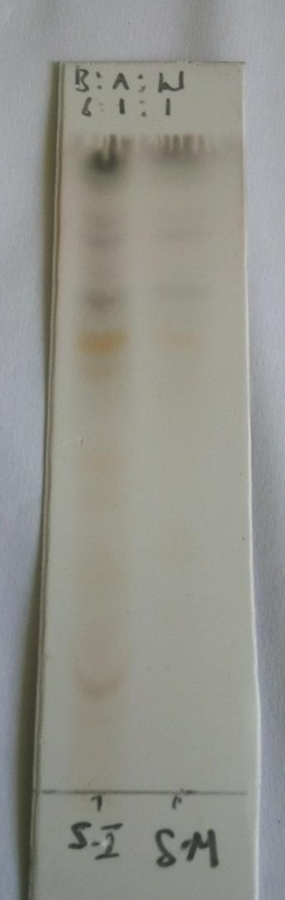

a

c

d e

f

g

Sp

ot origin

### Plate XIII: Chromatogram developed in B:A:W (6:1:1) and sprayed with p- anisaldehyde

Spot origin

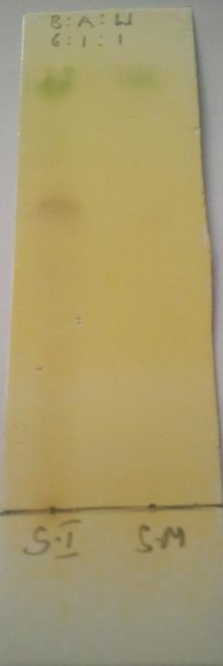

a

### Plate XIV: Chromatogram developed in B:A:W (6:1:1) and sprayed with Dragendorff’s reagent

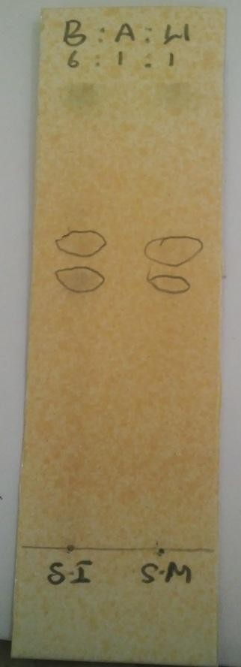

a

b

**Plate XV: Chromatogram developed in B:A:W (6:1:1) and sprayed with ferric chloride**

**Table 4.7: TLC Profile of Crude Ethanol Extract of *S. incanum* and *S. melongena***

### SPOT COLOURS Rf VALUES

#### S. incanum S. melongena S. incanum S. melongena

|  |  |  |  |
| --- | --- | --- | --- |
| **P-anisaldehyde** |  | | |
| a- ash | ash | 0.87 | 0.87 |
| b- pink | pink | 0.84 | 0.84 |
| c- brown | brown | 0.73 | 0.73 |
| d- orange | orange | 0.67 | 0.67 |
| e- Light brown | Light brown | 0.60 | 0.60 |
| f- yellow | yellow | 0.49 | 0.49 |
| g- brown | - | 0.30 | - |
| **Dragendorff’s Reagent** | | | |
| Brown | brown | 0.63 | 0.63 |
| **Ferric chloride** |  |  |  |
| a- brown | brown | 0.64 | 0.64 |
| b- brown | brown | 0.58 | 0.58 |

* 1. **Quantitative Estimation of Alkaloids in Leaves of *Solanum incanum* and**

#### S. melongena

Quantitative estimation of alkaloids in the leaves of *S. incanum* and *S. melongena* revealed that *S. incanum* (0.08mg) had a higher alkaloidal content than *S. melongena* (0.05mg) in 1g of the sample materials (Table 4.8).

**Table 4.8: Quatitative Estimation of Alkaloids in Leaves of *Solanum incanum* and**

***S. melongena***

### Plant Amount of alkaloid Percentage

**in 1g of sample (mg) in 1g of sample ( %)**

*Solanum incanum* 0.08 8.00

*Solanum melongena* 0.05 5.00

### Specific Test for Steroidal Glycoalkaloids in the Leaves of *S. incanum* and

#### S. melongena

* + 1. **Phytochemical Screening of the Alkaloid Leaf Extract of *Solanum incanum* and *S.***

#### Melongena

1. ***Mayer’s Test***

Creamy coloured precipitates was observed with Mayer‟s reagent in both plants, indicating a positive test for alkaloid.

#### Dragendorff’s Test

Orange-red precipitates was observed with Dragendorff‟s reagent in both plants, indicating a positive test for alkaloid.

#### Wagner’s Test

Brownish-red precipitates were observed with Wagner‟s reagent in both plants, indicating a positive chemical test for alkaloid.

#### Molisch’s Test

Purple colour was observed in the alkaloid extracts of both plants when tested with Molisch‟s reagent, which indicated a positive chemical test for carbohydrates.

#### Salkowski’s Test

A reddish – brown colouration was obtained in the ethanol extracts of both species when tested with chloroform and concentrated sulphuric acid, which indicated a positive chemical test for a steroidal ring.

#### Lieberman-Burchard Test

A reddish-brown ring was obtained in the alkaloid extracts of both species when tested with acetic acid, chloroform and concentrated sulphuric acid, which indicated a positive chemical test for steroids/terpenoids.

* + 1. **Thin Layer Chromatographic Analysis on *Solanum incanum* and *S. melongena***

### Alkaloid Extracts

Chloroform (100%) was found to be the best solvent that gave good seaparation of compounds and a clear chromatogram compared to all solvent system tested (Plate XVI: a & b and XVIII) and (Table 4.9).

Solvent front

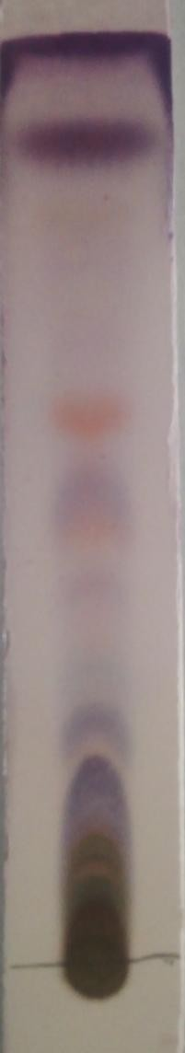

j

f

e

d

c

b

a

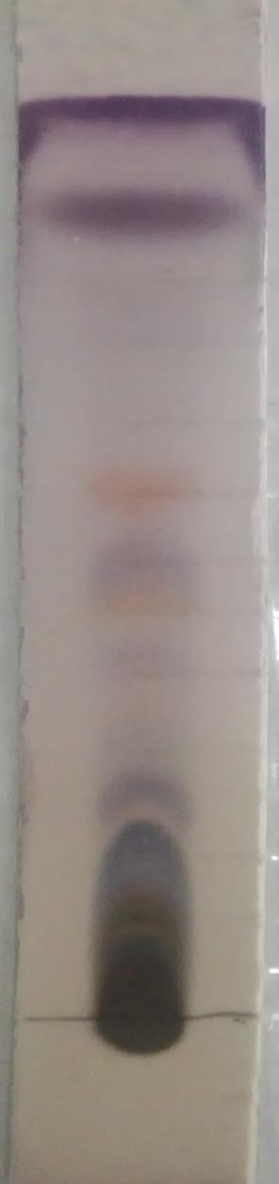

So

l

k

j i

f

e

lvent front

m

m

l

k

i

h h

g g

d

c

b a

Spot origin

# a

**b**

### Plate XVI a: Chromatogram of *S. incanum* developed in Chloroform (100%) and

**sprayed with P-anisaldehide-sulphuric acid.**

### b: Chromatogram of *S. melongena* developed in Chloroform (100%) and sprayed with P-anisaldehide-sulphuric acid.

lvent front

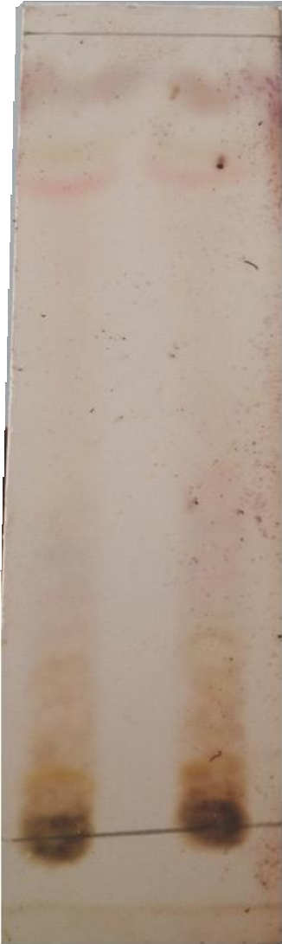

So

c

b

a

**S. I**

**S. M**

### Plate XVII: Chromatogram of *S. incanum* and *S. melongena* developed in Chloroform (100%) and sprayed with Liberman-Burchard’s reagent.

|  |  |  |  |  |  |
| --- | --- | --- | --- | --- | --- |
| **Table 4.9: TLC Profile of Alkaloid Extract of *S. incanum* and *S. melongena*** | | | | | |
| **SPOT COLOURS**  ***S. incanum S. melongena*** | | ***S. incanum*** | **Rf VALUES**  ***S. melongena*** |  |  |
| **P-anisaldehyde** | |  |  |  |  |
| a- blue-black blue-black | | 0.04 |  | 0.04 |  |
| b- grey grey | | 0.08 |  | 0.08 |  |
| c- blue-black blue-black | | 0.16 |  | 0.16 |  |
| d- purple purple | | 0.22 |  | 0.22 |  |
| e- light-blue light-blue | | 0.26 |  | 0.26 |  |
| f- pink pink | | 0.37 |  | 0.37 |  |
| g- orange orange | | 0.41 |  | 0.41 |  |
| h- pink pink | | 0.49 |  | 0.49 |  |
| i- orange orange | | 0.56 |  | 0.56 |  |
| j- light-blue | light-blue | 0.62 | 0.62 | | |
| k- ash | ash | 0.72 | 0.72 | | |
| l- grey | grey | 0.81 | 0.81 | | |
| m- purple | purple | 0.88 | 0.88 | | |
| **Lieberman-Burchard’s** | | | | | |
| a- pink | pink | 0.82 | 0.82 | | |
| b- grey | grey | 0.84 | 0.84 | | |
| c- brown | brown | 0.93 | 0.93 | | |

**CHAPTER FIVE**

### 5.0 DISCUSSION

Organoleptically, both plants were green in colour and distinct in odour, but *S. incanum* had a more bitter taste than *S. melongena*.

Microscopic examinations of the leaves *S. incanum* and *S. melongena* reveal that both plants had some similar diagnostic features. Those similar diagnostic features identified were the predominant anisocytic (Ranunculaceous) stomata on the adaxial surfaces of the leaves and the widely anomocytic (Cruciferous) with few anisocytic stomata present on abaxial surfaces of the leaves. Epidermal cells with slightly (adaxially) to deeply (abaxially) wavy anticlinal walls and lignified non glandular multiradiate covering stellate trichomes present only on the abaxial surfaces and the midrib portion of the leaves were identified. The occurrence of the above mentioned characteristic features in both planst is supported by the work of Adedeji *et al.*, (2007) who reported that anomocytic to anisocytic and occasionally brachy-paracytic stomata and nonglandular multiradiate stellate trichomes occur in the family Solanaceae and specifically the genus Solanum. Periyanayagam *et al*., (2015) also reported the presence of both anisocytic and anomocytic stomata in *Solanum torvum*. However, the two plants were found to differ in the sizes of their stomata and trichomes (2.24µm length and 1.58µm width of stomata and 16.70µm length and 3.13 width of trichome in *S. incanum* while 2.18µm length and 1.42 µm width of stomata and 27.75µm length and 3.13 µm width of trichome in

*S. melongena*).

Transverse section of the leaves across the midrib portion reveals that the leaves were dorsiventral. This is a good diagnostic and distinguishing anatomical feature of the leaves because most dicotyledonous leaves are known to be dorsiventral (Dutta, 2003). Both leaves showed a single layer of upper and lower epidermis with a layer of compact elongated

palisade cells below the upper epidermis. Below the palisade cells are the spongy mesophyll tissues which lie above the xylem element consisting of 4-6 strands. Their calcium oxalate crystals occur as prisms (0.33 – 0.46 – 0.66µm of length and 0.16 – 0.26 – 0.33µm of width) and were found along the upper and lower epidermis of the transverse section of the leaves of both plants. Anatomical features of the internal structures of plant drugs provides an important diagnostic features for the identification of both entire and powdered crude drugs and also detection of adulterants in plant materials (Ghani, 1990). Macro and microscopical evaluation of crude drugs is aimed at identification of the correct variety and detection of adulterants (WHO, 1996).

Quantitative-leaf microscopy of the two plants shows that *S. melongena* had a higher vein- islet termination number (4.8) than *S. incanum* (3.4). They also differ in their stomatal number and indices; 4.0 and 6.8 (upper epidermis) and 12.0 and 20.5 (lower epidermis) in *S. melongena* were higher than 2.0 and 3.7 (upper epidermis) and 8.0 and 13.3 (lower epidermis) in *S. incanum* respectively, but had the same palisade ratio (4.6) and vein-islet number (2.6). The values obtained are known to vary quite widely according to environmental conditions in which the plant was grown (Brain and Turner, 1975). An early investigation by Timmerman as reported by Evans, (2009) indicated that stomatal numbers are useless in distinguishing between closely allied species, but that in certain cases the ratio between the numbers of stomata on two surfaces may be of diagnostic importance. Brain and Tuner (1975) also reported that stomatal index is a more useful value as it is less subjected to variations with external conditions. Furthermore, Evans, (2009) reported that vein-islet and termination number may appear to vary according to the preliminary treatment the leaf has received.

Chemomicroscopical studies of the powered leaves of the both plants were found to have cell wall materials (cellulose, lignin, and mucilage) and cell inclusions (starch, tannins, fats and fixed oils and calcium oxalate crystals) but calcium carbornate was absent. The study of cell wall materials and cell inclusions is of considerable diagnostic importance because it helps in the identification and authentication of the plant material. For example, the Solanaceous leaves may be distinguished from one another by the nature of their type of calcium oxalate crystals, belladonna by its sandy crystals, strammonium by its cluster crystals and henbane by its single and twin prisms (Evans, 2002).

Physicochemical parameters (%w/w) revealed that water-soluble ash (10.2%) and water- soluble extractive value (19.20%) were higher in *S. melongena* than in *S. incanum* (8.4 and 18.00% respectively). While moisture content (4.11%), total ash (20.5%), acid-insoluble ash (7.0%) and alcohol-soluble extractives (12.40%) were found to be higher in *S. incanum* than in *S. melongena* (3.46, 19.0, 6 and 9.60% respectively). Quantitative evaluation is an important parameter in setting standard for crude drugs and detecting adulterants (Evans, 2002) and values obtained are used as criteria to judge the identity and purity of crude drug (WHO, 1996). The moisture content of the leaves of both plants fall within the acceptable limit since the general moisture content requirement of crude drugs is expected not to exceed 14% (A. P., 1986). Therefore, *S. melongena* which had lower moisture content compared to

*S. incanum* implies that, it is more resist to microbial degradation and can be stored for a longer period of time. The total and acid-insoluble ash represents both the physiological ash (from plant tissues) and non-physiological ash (from extraneous matter) adhering to the surface of crude drugs A. P. (1986). Total ash (20.5%) and acid-insoluble ash (7.0) in *S. incanum* were found to be slightly higher than that in *S. melongena* (19.0 and 6% respectively), which implies that *S. incanum* had slightly more of physiological and extraneous matter inherent to it therefore suggesting it to be a little less pure than *S.*

*melongena* since according to WHO (1996), total ash is used as a criteria to judge the identity and purity of drugs. Alcohol and water soluble extractive values are useful for the identification of exhausted drugs. The amount of the extract that drug yields in a solvent is often an approximate measure of the amount of certain constituents that the drug contains (Sirivastava and Sharad, 2006). The alcohol-soluble extractives (34.4%) in *S. incanum* were found to be higher than that of *S. melongena* (32.4%) which implies that alcohol is a better extractive of *S. incanum* than *S. melongena*. The water-soluble extractive of *S. melongena* (40%) was however slightly higher than that of *S. incanum* (39.6%) which implies that water is a better extractive of *S. melongena*.

Throughout the world, there is increasing interest in the importance of dietary minerals in the prevention of several diseases (Saraf and Samant, 2013). Fortification refers to the addition of mineral nutrients to a commonly eaten food. Both iron fortification of wheat flour and iodine fortification of salt are examples of fortification strategies that have produced excellent results (FAO/WHO, 1998). Minerals are of critical importance in the diet, even though they comprise only 4–6% of the human body. However, lack of knowledge of the elemental constituents of these medicinal plants often poses danger to consumers as some may contain toxic elements. Also, the dose rate of many of these medicinal plants is not well defined and left to the judgement of the users. This can sometimes cause problems to users, as the probability of taking overdose to speed up healing is highly elevated, ignorant of the dangers in doing so. Thus, screening of the elemental composition of *S. incanum* and *S. melongena* is highly essential.

The mineral element concentrations in the leaf powder of the plants *S. incanum* and *S. melongena* reveal that the two plants differ in respect to their elemental mineral content. Generally, *S. incanum* was found to contain more mineral elements both in number and

concentrations than *S. melongena* (Table 4.7). Uranium (0.026+0.007) the potentially toxic element and Neodymium (11.00+3.00) were only present in *S. incanum* but where absent in

*S. melongena*. Although both plants contain most of the macro (Ca, Mg, Na, K, Cl, S e.t.c) and micro (Fe, Zn, Mn, Co e.t.c) nutrients with the exception of Cu, their concentrations vary remarkably, with *S. incanum* having higher concentrations of most nutrients.

Calcium content in *S. incanum* (37580+789) was observed to be the element with the highest concentration of all elements analysed in both plants of this work, higher than in *S. melongena* (23510+635). High content of Calcium is required for mineralization and enhancement of the qualities of bones and teeth (Charles, 1992). Calcium is essential for the normal clotting of blood, by stimulating the release of thromboplastin from the blood platelets, it is also essential for relief of stress, proper functioning of the heart and nervous systems as well as for normal function of muscle system. The health of the muscles and nerves depends on calcium. It is required for the absorption of dietary vitamin B, for the synthesis of the neurotransmitter acetylcholine, for the activation of enzymes such as the pancreatic lypase. It helps to regulate the activity of skeletal muscle, heart and many other tissues (Lokhande *et al*., 2010). The recommended daily dietary allowance of Calcium for children and adolescent is between 500 and 1300 mg, while for adult‟s is1200mg (DRIC, 2010).

Magnesium levels were found to be higher in *S. incanum* (11130+ 134) than in *S. melongena* (5987+ 323), therefore suggesting that *S. incanum* is a better dietary supplement of Magnesium than *S. melongena*. Magnesium is an essential component of bone, cartilage and the crustacean exoskeleton. Magnesium is an activator of several key enzyme systems, including kinases, mutases, muscle ATPases, and the enzymes cholinesterase. Through its role in enzyme activation, magnesium (like calcium) stimulates muscle and nerve irritability

(contraction), is involved in the regulation of intracellular acid-base balance, and plays an important role in carbohydrate, protein and lipid metabolism.

Sodium in *S. incanum* (334+1) was found to be higher than that of *S. melongena* (233.4+0.7). Although the main function of sodium is to control the volume of fluid and to maintain the acid-base equilibrium in human body (Lokhande *et al*., 2010), sodium also has an effect on muscle irritability, and plays a specific role in the absorption of carbohydrate.

Chlorine in *S. incanum* (12640+76) was also found to be higher than that in *S. melongena* (11280+79). Chlorine is essential for the regulation of osmotic pressue and acid-base balance. Chlorine also plays a specific role in the transport of oxygen and carbon dioxide in the blood, and the maintenance of digestive juice pH (Debrah *et al*., 2011).

Potassium in *S. incanum* (21740+109) was however to be lower than that of *S. melongena* (26930+108). Potassium regulates intracellular osmotic pressue and acid-base balance, plays a vital role as electrolyte in the blood and for the smooth flow of communication signals from cell to cell. Like sodium, potassium has a stimulating effect on muscle irritability; it is also required for glycogen and protein sysnthesis, and the metabolic breakdown of glucose (Prag and Bhanu 2013).

Iron in *S. incanum* (1771+83) was found to be higher than that in *S. melongena* (1391+78). Iron is an essential component of the respiratory pigments haemoglobin and myoglobin. Iron is an essential component of various enzyme systems including the cytochromes, catalases, peroxidases, and the enzymes xanthine and aldehyde oxidase, and succinic dehydrogenase. As a component of the respiratory pigments and enzymes concerned in tissue oxidation, iron is essential for oxygen and electron transport within the body (Sigel, 1978). Iron deficiency is the most prevalent nutritional deficiency in humans (Reddy *et al*., 1987).

The percentage yield of the ethanol extract obtained out of 300g of the powdered leaves of each plant reveals that *S. incanum* (2.42%) had a higher percentage yield than *S. melongena* (1.29%) suggesting that ethanol is a better extractive of *S. incanum* than *S. melongena*.

Results of phytochemical screening on the ethanol extracts of the two plants showed that the two plants had the same chemical constituents (alkaloids, carbohydrate, flavonoids, cardiac glycoside, tannins and saponins). The presence of these phytochemicals in the two plants is supported by the works of Sundari *et al*., (2013) who reported the presence of the phytochemicals in three species of the genus Solanum.

Thin Layer Chromatographic (TLC) analysis on the crude ethanol extracts of *S. incanum* and

*S. melongena* reveals the presence of different constituents in both plants. Seven spots with different Rf values were observed in *S. incanum* while six spots in *S. melongena* when both were developed with n-butanol-acetic acid-water (B:A:W) (6:1:1) solvent system and sprayed with P-anisaldehyde. The spots in *S. incanum* were more clearly visible than in *S. melongena* suggesting more quantity of the components in *S. incanum* than *S. melongena*. The Rf value of the 5th component (e-Light brown; 0.60) in the chromatogram sprayed with P-anisaldehyde slightly coincided with the Rf value of spot in the chromatogram sprayed with Dragendorff‟s reagent (Rf – 0.63) possibly suggesting the presence of the same constituent (alkaloid) in both chromatograms.

Quantitative estimation of alkaloids in the leaves of the two plants reveals that *S. incanum* (8%) had a slightly higher percentage of alkaloid in 1g of the powdered sample than *S. melongena* (5%).

Phytochemical screening on the alkaloid leaf extract of *S. incanum* and *S. melongena* showed a positive result for Mayer‟s, Dragendorff‟s and Wagner‟s test, confirming the presence of

alkaloid in the extract. Lieberman-Burchard and Salkowski‟s tests showed a positive result, confirming the presence of a steroidal nucleus. Additionally, both extracts gave a positive result to Molisch‟s test which supports their presence in a glycosidic form. The above positive chemical reactions therefore revealed the presence of glycoalkaloids (steroidal alkaloids) in both plants. Shabana *et al*., (2013) also reported the presence of steroidal glycoalkaloid in the fruit peels of *S. melongena* after a positive result was obtained with Molisch‟s, Lieberman-Burchard‟s and Salkowski‟s tests. Blankmeyer *et al*., (1998) reported solasonine and solamargine to be the two major glycoalkaloid found in eggplants and at least

100 other species of Solanum. Furthermore, solasodine, has been found in about 200 Solanum species (Dinan *et al*., 2001). Fukuhara and Kubo, (1991) reported the presence of glycoalkaloids (Solasonine and Solamargine) in *S. incanum*. Therefore the alkaloids (glycoalkaloids) in the genus Solanum serves as important chemotaxonomic markers in the genus.

Thin layer chromatographic analysis of the alkaloid extract of both plants reveals the presence of numerous constituents in both plants although the chromatogram still showed the presence of some unresolved constituents from the origin. 13 spots with different Rf values ( a- 0.04, b- 0.08, c- 0.16, d- 0.22, e- 0.26, f- 0.37, g- 0.41, h- 0.49, i- 0.56, j- 0.62, k- 0.72, l-

0.81, m- 0.88) were observed in both *S. incanum* and *S. melongena* when the chromatogram was sprayed with p-anisaldehyde/sulphuric acid. 3 spots (a- pink; 0.82, b- grey; 0.84, c- brown; 0.93) were observed in each plant when the chromatogram was sprayed with Lieberman Burchard‟s reagent. Ginzberg *et al*., (2009) reported that more than 80 different steroidal glycoalkalods have been identified in various potato (Solanum) species.

### CHAPTER SIX

* 1. **SUMMARY, CONCLUSION AND RECOMMENDATIONS**

### Summary

Organoleptically, both were green in colour and distinct in odour, but *S. incanum* had a more bitter taste than *S. melongena*. Microscopically, leaves of both plants had predominantly anisocytic stomata on the adaxial surface, while both anisocytic and anomocytic stomata were found on the abaxial surface. They were numerous non glandular stellate trichomes on the abaxial surface both plants. Transversely, the leaves of both plants were dorsiventral multilacunar vascular bundles. Calcium oxalate crystal (prism), starch grains (oval-shaped), xylem vessels (spiral) were observed.

Quantitative-leaf microscopy revealed that *S. melongena* had a higher vein-islet termination number (4.8) than that of *S. incanum* (3.4). They both had the same palisade ratio (4.6) and vein-islet number (2.6), but also differ in their stomatal number and indices; 4.0 and 6.8 (upper epidermis) and 12.0 and 20.51 (lower epidermis) in *S. melongena* were higher than that of *S. incanum* (2 and 3.69) and (8 and 13.30) respectively.

Chemomicroscopic studies showed that both plants had all features tested in common, which includes presence of cellulose, lignin, starch, tannins, mucilage, fats and fixed oils and calcium oxalate crystals while absence of calcium carbonate.

Physicochemical analysis (%w/w) revealed that water-soluble ash (10.2%) and water-soluble extractive value (19.20%) were higher in *S. melongena* than in *S. incanum* (8.4 and 18.00% respectively). While moisture content (4.11%), total ash (20.5%), acid-insoluble ash (7.0%) and alcohol-soluble extractives (12.40%) were found to be higher in *S. incanum* than in *S. melongena* (3.46, 19.0, 6 and 9.60% respectively).

Quantitative estimation of alkaloids in the leaves of the two plants reveals that *S. incanum* (8%) had a slightly higher percentage of alkaloid in 1g of the powdered sample than *S. melongena* (5%).

The mineral element concentrations parts per million of the leaf powder of the two plants were found to differ considerably. Generally, *S. incanum* was found to contain more mineral elements both in number and concentrations than *S. melongena*. Uranium (0.026+0.007) the potentially toxic element and Nd (11+3.000) were only present in *S. incanum* but where absent in *S. melongena*. Although both plants contain most of the macro (Ca, Mg, Na, K, Cl, S e.t.c) and micro (Fe, Zn, Mn, Co e.t.c) nutrients with the exception of Cu.

The percentage yield of the ethanol extract obtained out of 300g of the powdered leaves of each plant reveals that *S. incanum* (2.42%) had a higher percentage yield than *S. melongena* (1.29%). The results of phytochemical screening on the ethanol extracts of the two plants showed both plants had all the phytochemicals tested in common (alkaloids, carbohydrate, flavonoids, cardiac glycoside, tannins and saponins). The presence of steroidal glycoalkaloids were observed in the alkaloid extract of both plants. Thin Layer Chromatographic analysis of the ethanol extract showed seven spots with different Rf values in *S. incanum* while six spots in *S. melongena* when the chromatogram developed in n-butanol-acetic acid-water (B:A:W) (6:1:1) solvent system was sprayed with P-anisaldehyde, one spot each was observed when sprayed with Dragendorff‟s reagent while two spots each when sprayed with ferric chloride. On the other hand, TLC analysis of the alkaloid extract revealed 13 spots with different Rf values in each plant material when sprayed with p-anisaldehyde and 3 spots when sprayed with Lieberman-Burchard‟s reagent.

### Conclusion

The present studies had established:

* + 1. Morphologically, that *Solanum incanum* and *S. melongena* had some diagnostic features in common such as predominant anisocytic stomata on the adaxial surfaces of both plants and anomocytic stomata on the abaxial surfaces, multiradiate stellate trichome on only the abaxial surfaces of both plants, polygonal shaped epidermal cells, prism-shaped calcium oxalate crystals and oval- shaped starch grains. The two plants also had similar palisade ratio (4.6) and vein- islet (2.6) but however, differ in respect to their stomatal number (2.0 and 8.0) and indices (3.7 and 13.3) in *Solanum incanum* while (4.0 and 12.0) and (6.8 and 20.5) in *S. melongena*. The two plants were also found to differ with respect to their physicochemical parameters namely; moisture content (4.13 and 3.46), ash-value (20.50 and 19.00), acid-insoluble ash (7.00 and 6.00), water-soluble ash (8.40 and 10.20), alcohol-soluble extractives (12.40 and 9.60) and water-soluble extractive values (18.00 and 19.20) respectively.
    2. Elemental contents of *S. incanum* and *S. melongena* were found to differ considerably in all elements detected, notable to mention is the concentration of calcium in *S. incanum* (37580+789) as against (23510+635) in *S. melongena*, magnesium (11130+ 134) in *S. incanum* as against (5987+ 323) in *S. melongena* and the presence of U (0.026+0.007) and Nd (11+3) in *S. incanum* which were absent in *S. melongena.*
    3. Phytochemical constituents namely; alkaloids, flavonoids, cardiac glycosides, tannins, carbohydrates, saponins were found to be common in both *S. incanum* and *S. melongena*, but they were found to differ in their quantitative alkaloidal

content (0.08mg and 0.05mg) and ethanol extraction percentage yield (2.42%and 1.29%) respectively.

The results of this study indicate that *Solanum incanum* and *S. melongena* possess some similar morphological, anatomical and phytochemical characteristics. They were found to differ in respect to their histological features, physicochemical parameters and elemental mineral contents. The result can be useful in setting some diagnostic indices for the easy and inexpensive identification, authentication and the preparation of the monograph of the two plants.

### Recommendations

It is recommended that more research work should be carried out to establish the pharmacognostic profile of the other parts of the two plants for inclusion into the Nigerian/African Pharmacopeia which will assist in solving the problem of morphological confusion existing between these two plants.

It is recommended that detailed phytochemical studies should be carried out on the two plants with a view of identifying and isolating the active components in the two plants.

Biological studies should be carried out on the isolated active compounds to establish their therapeutic claims in areas not established.

Further work should also be done on the taxonomic profile of the two plants to as well solve the problem of taxonomic confusion existing between them.

### REFERENCE

*African Pharmacopoiea* (1986). Organization of African Unity/ Scientific Technical and Research Commission. 2 (1): 123, 140-145.

Adedeji, O., Ajuwon, O.Y., and Babawale, O.O. (2007). Foliar Epidermal Studies, Organographic Distribution and Taxonomic Importance of Trichomes in the Family Solanaceae. *International Journal of Botany*, 3: 276-282.

Ahlam, S. E., and Bouran, I. A. (2011). Microscopic Studies on the Leaf and Petiole of

*Vernonia amygdalina* Del. *Advances in Applied Sciences Research*, 2(2): 398-406.

Ahmad, M., Khan, M. A., Zafar, M., Arshad, M., Sultana,S., Abbasi, B. H., and Din, S.U. (2010). Use of Chemotaxonomic Markers for Misidentified Medicinal Plants used in Traditional Medicines. *Journal of Medicinal Plant Research*, 4(13): 1244-1252.

Auta, R.: James, S. A.: Auta, T. and Sofa, E. M. (2011) Nutritive Value and Phytochemical Composition of Processed *Solanum incanum* (bitter garden egg), *Science World Journal*, 6(3): 5-6.

Ashutosh, K. (2003). Phytochemistry. *Pharmacognosy* and *Pharmacobiotechnology* (2nd ed.).

London: New Age International, pp. 19-20.

Bello, S. O., Muhammed, B. Y., Gammaniel, K. S., Abdu-Ayugel, K. S., Ahmed, H., Njoku,

C. H., Pindiga, U. H. and Salka, A. M. (2005). Preliminary Evaluation of the Toxicity and some Pharmacological Properties of Aqueous Crude Extract of *Solanum melongena. Research Journal of Agricultural and Biological Sciences*, 1: 1-9.

Blankemeyer, J. T., McWilliams, M. L., Rayburn, J. R., Weissenberg, M., and Friedman, M. (1998). Developmental Toxicology of Solamargine and Solasonine Glycoalkaloids in Frog Embryos. *Food and Chemical Toxicology*, 36(5): 383–389.

Brain, K. R. and Turner, T. D. (1975). *The Practical Evaluation of Phytopharmaceuticals*.

Wright-Scientechnica, Bristol. p.166.

Burkill, H.M. (2000). *The Useful Plants of West Tropical Africa.* 2nd Edition. Volume 5, Families S–Z, Addenda. Royal Botanic Gardens, Kew, Richmond, United Kingdom. p.686 .

Cham, B. E. and Daunter, B. (1990). Solasodine Glycosides. Selective Cytotoxicity for Cancer Cells and Inhibition of Cytotoxicity by Rhamnose in mice with Sarcoma 180. *Cancer Letters*, 55(3): 221–225.

Cham, B. E. (2007). Solasodine Rhamnosyl Glycosides Specifically Bind Cancer Cell Receptors and Induce Apoptosis and Necrosis. Treatment for Skin Cancer and Hope for Internal Cancers. *Research in Biological Sciences*, 2(4): 503–514.

Chanda, S. (2014). Importance of Pharmacognostic Study of Medicinal Plants: An Overview. *Journal of Pharmacognosy and Phytochemistry,* 2(5): 69-73

[Chandima, W.](http://www.ncbi.nlm.nih.gov/pubmed/?term=Wijayasiriwardena%20C%5Bauth%5D) and [Sirimal, P](http://www.ncbi.nlm.nih.gov/pubmed/?term=Premakumara%20S%5Bauth%5D). (2012). Comparative Powder Microscopy of *Alpinia calcarata* Roscoe and *Alpinia galanga* (Linn.) Wild. *International Quarterly Journal of Research in Ayurveda*, 33(3): 441–443.

Charles, P. (1992). Calcium Absorption and Calcium Bio-availability. *Journal of international Medicine*, p.231.

Chen, Z. and Miller, R. (2001). Steroidal Alkaloids in Solanaceous Vegetable Crops.

*Horticultural Review,* 25: 171-196.

Cronquist, A. (1981). An Integrated System of Classification of Flowering Plants. Colombia university press, New York. p.1262.

Dalziel, J. M. (1936). *The Useful Plants of West Tropical Africa*. Crown Agents for Overseas Government and Administration, London.

Debrah, S. K., Ayivor, J.E., Denutsui, D., Buah–Kwofie, A., Forson, A., and Nuviadenu C. (2011). Elemental Evaluation of some Herbal Plants used in Ghana using INAA. *Scholars Research Library*, 3(5): 202-207.

Dinan L., Bourne P., and Whiting P. (2001). Phytoecdysteroid profiles in seeds of Sida spp. (Malvaceae). *Phytochemical Analysis*, 12:110-119.

Dineshkumar, C. (2007). Pharmacognosy can Help Minimize Accidental Misuse of Herbal Medicine. *Current Science*, 93: 1356-1358.

Doijode, S. D. (2001). *Seed Storage of Horticultural Crops*. Haworth Press: ISBN 1-56022- 901-2 p.157.

DRIC, (2010).Committee to Review Dietary Reference Intakes for Vitamin D and Calcium, Food and Nutrition Board, Institute of Medicine. Dietary Reference Intakes for Calcium and Vitamin D. Washington, DC: National Academy Press.

Dutta, A. C. (2003). *Botany for Degree Students* (6th edn ., pp 532). Oxford University press.

EMEA, (2005). Guidelines on Quality of Herbal Medicinal Products/Traditional Medicinal Products, *EMEA/CVMP/814OO Review*. European Agency for the Evaluation of Medicinal Products (EMEA), London.

Evans, W. C. (2002). *Trease and Evans Pharmacognosy* (15th edn.), London: W.B. Saunders Company Ltd, pp 10-11, 538-540, 545-546.

FAO/WHO. (1998). Vitamin and Mineral Requirements in Human Nutrition: *Report of a joint FAO/WHO expert consultation*, Bangkok, Thailand. Pp. 21–30.

Fewell, A. M., Roddick, J. G. and Weissenberg, M. (1994). Interactions between the Glycoalkaloids Solasonine and Solamarrgine in Relation to Inhibition of Fungal Growth. *Phytochemistry*, 37(4): 1007–1011.

Frodin, D. (2004). History and Concepts of Big Plant Genera. *Taxon* 53: 753–776.

Fukuhara, K.and Kubo, I., (1991). Isolation of Steroidal Glycoalkaloids from *Solanum incanum* by two Countercurrent Chromatographic Methods. *Phytochemistry,* 30(2): 485-687.

Ghani, (1990). *Introduction to Pharmacognosy*. Ahmadu Bello University, Press Ltd. 1st Edition. p.187.

Ghazanfar, S. Al-Sabahi A. (1993). Medicinal Plants of Northern and Central Oman (Arabia).

*Economic Botany*, 47: 89–98.

Gibbon S. and Gray, A. I., (1998). Isolation by Planar chromatography In: Cannell R.J.P (ed), *Methods in Biotechnology*. Natural Product Isolation. Human Press, New Jersey, Pp. 209-245.

Gill, L. S. (1992). Ethnomedical Uses of Plants in Nigeria*.* University of Benin Press. Benin, Nigeria. P. 215 Harrison, D. M. (1990). Steroidal Alkaloids, *Natural Product Reports*, 7(2): 139–147.

Ginzberg, I., Tokuhisa, J. G., and Veilleux R. E. (2009). Potato Steroidal Glycoalkaloids: Biosynthesis and Genetic Manipulation. *European Association for Potato Research*, 52: 1-15.

Goswami, A., Kotoky, R., Rastogi, R. C., and Ghosh, A. C. (2003). A One-pot Efficient Process for 16-dehydropregnenolone Acetate. *Organic Process Research and Development*, 7(3): 306–308.

GRIN(2006). Germplasm Resources Information Network. *Solanum incanum* L. United States Department of Agriculture.

Guenther, W. and Konieczynski, P. (2003). Speciation of Mg, Mn, and Zn in Extracts of Medicinal Plants. *Analytical and Bioanalytical Chemistry Journal*, p.375, 1067.

Handa, S. S. (2004). Indian Efforts for Quality Control and Standardization of Herbal drugs/products. *Proceedings of the 1st Joint Workshop on Quality Control and Standardization of Traditional Medicine-Indo-China experience*; Jan. 8-10.

Hall, C. A., Hobby, T., and Cipollini, M. (2006). Efficacy and Mechanisms of *α*-Solasonine- and *α*-solamargine-induced Cytolysis on two Strains of *Trypanosoma cruzi*. *Journal of Chemical Ecology*, 32(11): 2405–2416.

Harbone J. B. (1973). *Phytochemical methods*. Chapman and Hall, Ltd., London, Pp 49-188. Harrison, D. M. (1990). Steroidal Alkaloids, *Natural Product Reports*, 7(2): 139–147.

Heinrich, M. (2000). Ethnobotany and its Role in Drug Development. *Phytotherapy Research,* 14: 479.

Hutchinson, J., and Dalziel, J. M. (1963). *Flora of West Tropical Africa.*Second edn., F. N. Hepper, London.

Indhumathi, T., and Mohandass, S. (2013). Identification of bioactive compounds in *Solanum incanum* fruit by TLC and HPTLC. *International Journal of Scientific Research*, 2 (6), 1-4.

Indhumathi, T., and Mohandass, S. (2014). Efficacy of Ethanolic Extract of *Solanum incanum* Fruit Extract for its Antimicrobial Activity. *International Journal of Current Microbiology and Applied Science,* 3(6), 939-949.

Khan, M. A., Khan, T., and Ahmad, Z. (2000). Neem used as Medicine. *Hamdard Medicus Journal,* 43 (3), 212-221.

Kochhar, S. L. (1981). Tropical Crops. *A textbook of Economic Botany*. New Delhi : Macmillan Publication.

Kokate, C. K. (1994). *Practical Pharmacognosy*(4th edn). New Delhi, M. J. Jain, pp149-150. Kokwaro, J. (1993). *Medicinal plants of East Africa* (2nd edn). East Africa Literature Bureau,

Nairobi, 3: 222-223.

Kunle, O. F., Egharevba, H. O., and Ahmadu, P. O. (2012). Standardization of Herbal Medicines - A Review. *International Journal of Biodiversity and Conservation* 4(3): 101-112.

Kuo, K. W., Hsu, S. H., Li, Y. P. (2000). Anticancer Activity Evaluation of the Solanum Glycoalkaloid Solamargine: Triggering Apoptosis in Human Hepatoma Cells. *Biochemical Pharmacology*, 60(12): 1865–1873.

Lalitha, S., John, S. A., Pisharath, M. D., Krishnamurthy, K. V., Venkatasubramanian P. (2012). [Comparative Pharmacognosy of Medicinal Plant Species used as Prsniparni.](http://pharmacy279.rssing.com/browser.php?indx=7557744&item=24) *International Journal of Green Pharmacy*, 6(4): 303-309.

Lester, R. N. and Hasan, S. M. Z. (1990). The Distinction between *Solanum incanum* L. and

*Solanum insanum* L. (Solanaceae). *Taxon* 39 (3): 521-523.

Lina, A. C., Ramon, M., Bernardo, C., James, O. C., Alfredo, U., and Luis L. (2003).

Toxicological Effects of α-Solamargine in Experimental Animals.

*Phytotherapy Research,* 17: 254 – 258.

Lokhande, R., Singare, P. and Hale, M. (2010). Study on Mineral Content of Some Ayurvedic Indian Medicinal Plants by Instrumental Neutron Activation Analysis and AAS Technique. Health Science Journal, 4(3): 157 - 168.

Matu E.N., (2008). *Solanum incanum* L. *PROTA (Plant Resources of Tropical Africa)*; Wageningen Netherlands. Edited by Schmelzer, G.H. & Gurib-Fakim.

Mohammed, A. (2002). *Text book of Pharmacognosy* (2nd edn). New Delhi: Satish Kumar Jain for CBS Publishers and Distributors, pp. 138, 283.

Mutalik, S., Paridhavi, K., Rao, C.M., Udupa, N. (2003).Antipyretic and Analgesic Effect of Leaves of *Solanum melongena* Linn. in Rodents. *Indian Journal of Pharmacology*, 35: 312-5.

Mwonjoria, J. K., Kariuki, H. N., Waweru, F. N. (2011). The Antinociceptive Antipyretic Effects of *Solanum incanum* (Lin.) in Animal Models. *International Journal of Phytopharmacology*. 2(1): 22-26.

Nascimento, G.F., Juliana, L., Paulo, C. F., Giuliana, L. S., (2000). Antibacterial Activity of Plant Extracts and Phytochemicals on Antibiotic Resistant Bacteria. *Brazilian Journal of Microbiology*, 31: 247-256.

Nee, M. (1999).Synopsis of Solanum in the New World. In Nee M, Symon, D. E., Lester, R.

N. and Jessop, J. P. Solanaceae IV, *Advances in Biology and Utilization*. Royal Botanic Gardens, Kew, Pp 285-333.

Olmstead, R.G., and Bohs, L. (2007). A Summary of Molecular Systematic Research in Solanaceae: 1982-2006. *Acta Horticulturae*, 45: 255-268.

Okolie V. U., Chinwe O. E., Ijeoma E. and Pauline O. E. (2009). Investigation of the Effect of *Solanum incanum* on Postprandial Blood Glucose Concentration of Normoglycemic Nigerians. *Pakistan Journal of Nutrition* 8 (10): 1631-1635.

Odetola, A. A., Iranloye, Y.O. and Akinloye, O. (2004). Hypolipidaemic Potentials of *Solanum melongena* and *Solanum gilo* on Hypercholestrolemic Rabbits. *Pakistan Journal of Nutrition*, 3 (3): 180-187.

Owolabi, J., Omogbai, E. K., and Obasuy, I. O. (2007). Antifungal and Antibacterial Activities of the Ethanolic and Aqueous Extract of *Kigella africana* (Bignoniaceae) stem bark. *African Journal of Biotechnol*ogy, 6: 882-885.

Panchawat, S., Rathore, K. S., and Ssisodia R. K. (2010). Standardization and Evaluation of Herbal Drug Formulations. *Alternative medicine*, 15: 43-47.

Periyanayagam, K., Gokila, S. and Balasubramaniam, K. G. (2015). Pharmacognostic And Phytochemical Profile of the Leaves of *Solanum torvum* Swartz (Solanaceae) - The Assesment of its Quality. *World Journal of Pharmacy and Pharmaceutical Sciences*, 4(5): 1772.

Prag, A. P. and Bhanu, R. (2013). Multi-elemental Determination in Metanolic Soxhlet Leaf Extract of *Semecarpus anacrdium* (Linn.F.) by ICP-AES Technique. *Asian Journal of Pharmarceutical Clinical Research*, 6(3): 132-137.

Rapheal, E. C. (2011). Traditional Medicine in Nigeria: Current Status and the Future.

*Research Journal of Pharmacology*, 5(6): 90-94.

Raver, P. H., Evert, R., and Eichhorn, S. (1999). *Biology of Plants*. New York, W. H. Freeman and Company, pp.32-34.

Reddy, M. B., Chidambaram, M.V. and Bates, G.W. (1987) In: Winkelmann, G., Helm, Van der D. and Neilands, J.B. Eds., *Iron Transport in Microbes, Plants and Animals*, VCH, New York.

Saraf, A., and Samant A. (2013). Evaluation of Some Minerals and Trace Elements in

*Achyranthe saspera* Linn. *International Journal of Pharma Sciences* 3(3): 229-233.

Sana, S., Al Sinani, E., A. Eltayeb, Y. T., Kamal, Masood S., Khan and Ahmad, S. (2015). Variations in the Cytotoxic Glycoalkaloids Solamargine and Solasonine in Different Parts of the *Solanum incanum* Plant during its Growth and Development in Oman. [*Journal of Taibah University for Science*](http://www.sciencedirect.com/science/journal/16583655)*,4-8* doi:[10.1016/j.jtusci.2014.11.013](http://dx.doi.org/10.1016/j.jtusci.2014.11.013).

Shabana, M. M., Salama, M. M., Ezzat, S. H., and Ismail L. R. (2013). In Vitro and In Vivo Anticancer Activity of the Fruit Peels of Solanum melongena L. against Hepatocellular Carcinoma. *Journal of Carcinogenesis and Mutagenesis*, 4(3): 1-6.

Shazia, S., AjabKhan, M., Mushtaq, A., Asghari, B., Muhammad, Z. and Shinwari, K. (2011). Authentication of Herbal Medicine Neem (*Azadirachta indica* A. Juss.) by Using Taxonomic and Pharmacognostic Techniques. *Pakistan Journal of Botany*, 43: 141-150.

Sihachakr, D., Daunay, M.C., Serraf, I., Chaput, M. H., Mussio, I., Haricourt, R., Rotino L and Ducreux, G. (1994). Somatic Hybridization of Eggplant (*Solanum melongena* L.) with its Close and Wild Relatives. In Bajaj YPS (ed). *Biotechnology in Agriculture and Forestry: Somatic Hybridization in Crop Improvement*, pp. 255-278.

Sigel, H. Ed. (1978) Iron in Model and Natural Compounds. *Metals in Biological Systems*, Marcel Dekker, New York, p.**7**.

Srivastava, T., and Sharad, A. (2006). Pharmacognostic evaluation of *Curcuma haritha* Linn.

*Journal of Science and Industrial Research*, 65: 916-92.

Sundari, G. S., Rekha, S., and Parvathi, A. (2013). Phytochemical Evaluation of three Species of Solanum L. *International Journal of Research in Ayurveda and Pharmacy* 4(3): 420-425.

Sudheesh, S., Sandhya, C., Saraj, K.A., Vijayalakshmi N. R. (1999). Antioxidant Activity of Flavonoids from *Solanum melongena*. *Phytotherapy Research*, 13: 393-396.

Sofowora, E. A. (2008). *Medicinal Plants and Traditional Medicine in Africa* (3rdedn).

Spectrum Books Ltd., Ibadan, Nigeria, p.202.

Silver, L. G., Lee, I. and Kinghorn, D. A., (1998). Special Problem with the Extraction of Plants: *Natural Product Isolation* (Cannel, R. J. P. Ed.). Human Press Inc. pp. 103- 107; 343-364.

Tamboia, T., Cipollini, M. L., Levey, D .J. (1996). An Evaluation of Vertebrate Seed Dispersal Syndromes in Four Species of Black Nightshade (Solanum sect. Solanum). *Oecologia*, 107: 522-532.

Tania, M. S., Silva, I., Jefferson, R. B., Batista, M. M., Agra, M. F. and Celso, A. (2007). Brine Shrimp Biossay of some Specie of Solanum from North-Eastern Brazil. *Brazilian Journal of Pharmacognosy*, 17(1): 35-38.

Tsao, S. and Lo, H. (2006). Vegetables: Types and Biology. *Handbook of Food Science, Technology, and Engineering* by Yiu H. Hui. CRC Press.

Walters, E. M. P. (1963). *Elementary Botany for Tropical Africa*. George Allen and Unwin Ltd. London, pp.99-100.

WHO (1996): *Quality Assurance of Pharmaceuticals*: A compilation of Guidelines and Related Materials, Good Manufacturing Practices and Inspection. World Health Organization, Geneva 2.

WHO (1998). Quality Control Methods for Medicinal Plant Materials, *WHO Geneva document*, pp.28-31.

WHO (2002c).*General Guidelines for Methodologies on Research and Evaluation of Traditional Medicine*. World Health Organization, Geneva.

Yamusa, Y.A., Ahmed, Y.A., Musa, Y., Kasim, S. A., Tukur, M. and Bilal. (2013). Multi- Elemental Analysis of Local Millet and Wheat by Instrumental Neutron Activation Analysis Using NIRR-1 Facility. *International Journal of Multidisciplinary Sciences and Engineering*, 4(7): 9-13.

Yoshikawa, M., Nakamura, S., Ozaki, K., Kumahara, A., Morikawa, T. and Matsuda, H. (2007).“Structures of Steroidal Alkaloid Oligoglycosides, Robeneosides A and B, and Antidiabetogenic Constituents from the Brazilian Medicinal Plant *Solanum lycocarpum*. *Journal of Natural Products*, 70(2): 210–214.

### APPENDICES

**Appendix A: *Solanum incanum* Leaves; x400**

Acute apex

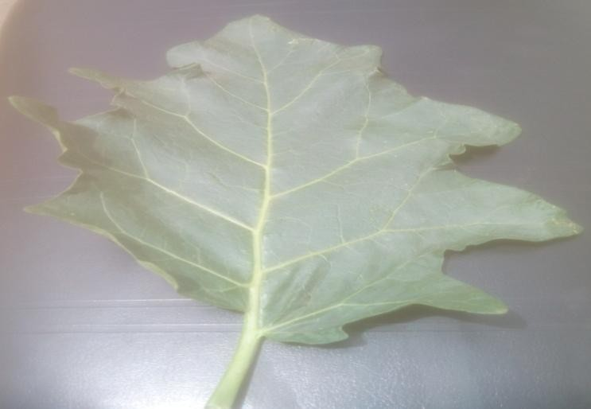

Undulately-lobed margin

Oblique base

**Appendix B: *Solanum melongena* Leaves x400**

Acute apex

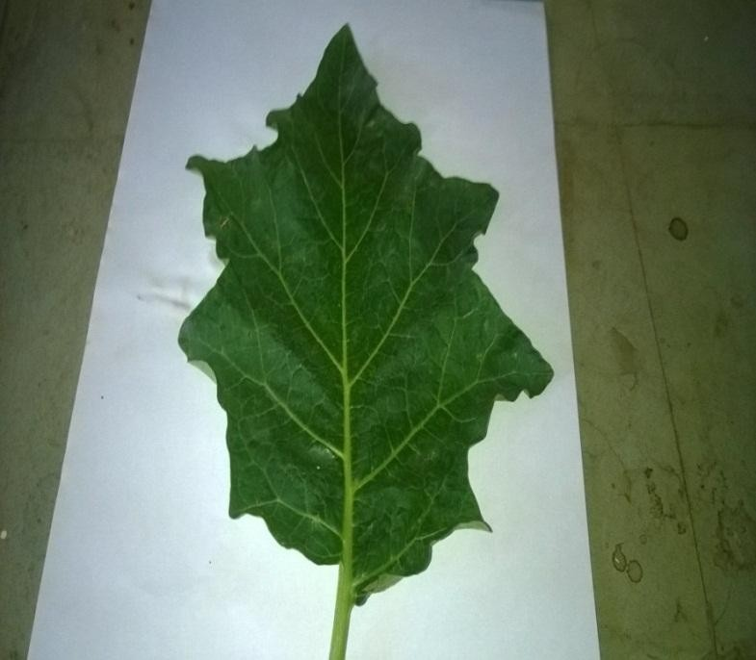

Undulately-lobed margin

Oblique base Petiole

### Appendix C: Details of the Calculation Procedure of Physical Constants Determination

1. **Moisture Content**

*Solanum incanum*

a. Weight of evaporating dish (W1) = 47.18

Initial Weight of dish + drug (W2) =50.18

Initial weight of drug (W3) = 3g

Final weight of evaporating dish + drug (W4) = 50.06 Loss in weight (W) = W2 – W4 = 0.12g

b. W1 = 44.77 W2 = 47.77

W3 = 3.00

W4 = 47.65 W = 0.12g

c. W1 = 49.75 W2 = 52.75

W3= 3.00

W4 = 52.62 W = 0.13g d. W = 0.12

e. W = 0.13

Average loss in weight = 0.12+0.12+0.13+0.12+0.13

5

= 0.124+0.01

% moisture content = 0.124 x 100

3

= 4.13%

*Solanum melongena*

a. Weight of evaporating dish (W1) = 21.79

Initial Weight of dish + drug (W2) =24.79

Initial weight of drug (W3) = 3g

Final weight of evaporating dish + drug (W4) = 24.69 Loss in weight (W) = W2 – W4 = 0.1

b. W1 = 37.80 W2 = 40.80

W3 = 3.00

W4 = 40.70 W = 0.1g

c. W1 = 38.67 W2 = 41.67

W3= 3.00

W4 = 41.56 W = 0.11g

Average loss in weight = 0.1+0.1+0.11+0.1+0.11

5

= 0.104+0.01

% moisture content = 0.104 x 100

3

= 3.46%

### Total Ash Value

*Solanum incanum*

a. Weight of crucible (W1) = 21.79

Initial weight of crucible + drug (W2) = 23.79 Initial weight of powdered (W3) = 2.00

Final weight of crucible + drug (W4) = 22.19 Loss in weight (W) = W4- W1

= 22.19 – 21.79

= 0.40

b. W1 = 37.80 W2 = 39.80

W3 = 2.00

W4 = 38.22

W = 0.42 c. W1 = 38.67

W2 = 40.67

W3 = 2.00

W4 = 39.08

W = 0.41 d. W = 0.40 e W = 0.41

Average total ash = 0.40 + 0.42 + 0.41+0.40+0.41

5

= 0.41

% total ash = 0.41 x 100

2

= 20.5%

*Solanum melongena*

a. Weight of crucible (W1) = 21.79 Initial weight of crucible + drug (W2) = 23.79 Initial weight of powdered (W3) = 2.00

Final weight of crucible + drug (W4) = 22.16 Loss in weight (W) = W4- W1

= 22.16 – 21.79

= 0.37g

b. W1 = 37.80 W2 = 39.80

W3 = 2.00

W4 = 38.16

W = 0.36 c. W1 = 38.67

W2 = 40.67

W3 = 2.00

W4 = 39.08

W = 0.41

Average total ash = 0.37 + 0.36 + 0.41+0.36+0.41

5

= 0.38

% total ash = 0.38 x 100

2

= 19%

### (ii) Acid Insoluble Value

*Solanum incanum*

a. Weight of crucible (W1) = 21.79 Initial weight of crucible + residue (W2) = 21.92

Initial weight of powdered (W3) = 2.00

Weight of residue (W) = W2 – W1

= 21.92 – 21.79

= 0.13g

b. W1 = 37.80 W2 = 37.95

W3 = 2.00 W = 0.13g

c. W1 = 38.67 W2 = 38.80

W3 = 2.00 W = 0.13g

d. W = 0.15

e. W = 0.13

Average acid-insoluble ash = 0.13 + 0.15 + 0.13+0.13+0.15

5

= 0.14

% acid-insoluble ash = 0.14 x 100

2

= 7%

*Solanum melongena*

a. Weight of crucible (W1) = 21.79 Initial weight of crucible + residue (W2) = 21.89

Initial weight of powdered (W3) = 2.00

Weight of residue (W) = W2 – W1

= 21.89 – 21.79

= 0.10g

b. W1 = 37.80 W2 = 37.93

W3 = 2.00 W = 0.13g

c. W1 = 38.67 W2 = 38.77

W3 = 2.00 W = 0.10g

d. W = 0.13

e. W = 0.13

Average acid-insoluble ash = 0.10 + 0.13 + 0.10+0.13+0.13

5

= 0.12

% acid-insoluble ash = 0.12 x 100

2

= 6%