COMPARATIVE PHARMACOGNOSTIC AND BIOLOGICAL STUDIES ON THE LEAVES OF VERNONIA AMYGDALINA DEL. AND

VERNONIA KOTSCHYANASCH. BIP. (ASTERACEAE)

BY

GARBA IBRAHIM

DEPARTMENT OF PHARMACOGNOSY AND DRUG DEVELOPMENT AHMADU BELLO UNIVERSITY, ZARIA - NIGERIA

# FEBRUARY, 2009

COMPARATIVE PHARMACOGNOSTIC AND BIOLOGICAL STUDIES ON THE LEAVES OF VERNONIA AMYGDALINA DEL. AND

VERNONIA KOTSCHYANASCH. BIP. (ASTERACEAE)

## BY

### GARBA IBRAHIM

B. Sc. APPLIED BIOLOGY (B.U.K.);

M. Sc. PHARMACOGNOSY(A.B.U.) (Ph. D. /PHARM. Sc./35904/200-12002)

### BEING

A DISSERTATION SUBMITTED TO THE POSTGRADUATE SCHOOL, AHMADU BELLO UNIVERSITY, ZARIA

### IN PARTIAL FULFILMENT FOR THE AWARD OF DOCTOR OF PHILOSOPHY DEGREE IN PHARMACOGNOSY

DEPARTMENT OF PHARMACOGN OSY AND DRUG DEVELOPMENT,

### FACULTY OF PHARMACEUTICAL SCIENCES, AHMADU BELLO UNIVERSITY,

ZARIA – NIGERIA

## FEBRUARY, 2009

### DECLARATION

I declare that the work in the dissertation entitCleodmparative Pharmacognostic and Biological Studies on the Leaves of Vernonia amygdalina Del. and Vernonia kotschyana Sch. Bip. (Asteraceae) has been performed by me in the Department of Pharmacognosy and Drug Development under the supervision of Prof. E. M. Abdurahman, Dr. H. Ibrahim and Prof. N. D. G. Ibrahim.

The information derived from the literature has been duly acknowledged in the text and a list of references provided. No part of this dissertation was previously presented for another degree or diploma at any university.

Name of Student Signature Date

### CERTIFICATION

This dissertation entitled COMPARATIVE PHARMACOGNOSTIC AND BIOLOGICAL STUDIES ON THE LEAVES OF VERNONIA AMYGDALINA DEL. AND VERNONIA KOTSCHYANA SCH. BIP. (ASTERACEAE) by Mal. Garba

Ibrahim meets the regulations governing the award of the degreDeoocftor of Philosophy in Pharmacognsoy of Ahmadu Bello Universityand is approved for its contribution to knowledgeand literary presentation.

Prof. E. M. Abdurahman; B. Pharm. Sc.; M. Sc.; Ph. D. Date

Chairman, Supervisory Committee, Department of Pharmacognosy and Drug Development,

Ahmadu Bello University, Zaria.

Dr. H. Ibrahim ; B. Pharm.; M. Sc.; Ph. D. Date

Member, Supervisory Committee, Department of Pharmacognosy and Drug Development,

Ahmadu Bello University, Zaria.

Prof. N. D. G. Ibrahim; DVM; M. Sc.; Ph. D. Date

Member, Supervisory Committee, Department of Veterinary Pathology and Microbiology,

Ahmadu Bello University, Zaria.

Dr. K. Y. Musa; B. Sc.; M. Sc.; Ph. D. Date

Head, Department of Pharmacognosy and Drug Development,

Ahmadu Bello University, Zaria.

Prof. S. A. Nkom Date

Dean,PostgraduateSchool, Ahmadu Bello University, Zaria.

### DEDICATION

This work is dedicated to mpyarents Alh. Ibrahim Lawal and Malama Halimah Idris; my beloved wife: Zakiyya; our daughte:r Halimatu Sa’adiya(Ummi) and son: Ibrahim (Khalifah).

### ACKNOWLE DGEMENT

All praise and thanks be to the Almighty Allah, the owner of everyone and everything, who enabled me to successfully complete this historic and laudable project in my life time.

I wish to express mysinceregratitude toProf. E. M. Abdurahman ofhte Department of Pharmacognosy and Drug Development, Ahmadu Bello University, Zaria, for his effective

supervision of teh work, reading of the entire manuscr,ipct onstructive criticisms,

corrections and other advice given to me in spite of his heavy rseisbpiliotines.

My sincere thanksgo to Dr. H. Ibrahim, Department of Phramacognosy and Drug Development and rPof. N. D. G. Ibrahim, Department of Veterinary Pathology and Microbiology, both of Ahmadu Bello University, Zar,iafor their effective co-supervisoi n, reading of the manuscripts, corrections, constructive criticaisnmdsadvice.

My profound and sicnere gratitude and appreciatiogno to my parents,for their parental support and guidance to meM.ay the Almighty Allah reward them abundantlay,men.

This dissertation has been completed wf **i**nthancial support from theUniversity Board of Research and Monitoring, ABU, ZariaA,. B. U. Carnegie Corporation and MacArthur Foundation projectsI.am very grateful for their financial assistance.

Finally, I wish to extend my sincere gratitude to all members of,sbtaoftfh academic and non-academi,c of my Department in particular and other Departments of the Faculty of Pharmaceutical Sciences, Ahmadu Bello University, Zamryia,brothers, sisters anrdiefnds

for their contributions toward the success of this research work.

### ABSTRACT

Vernonia amygdalinaDel. andV. kotschyanaSch. Bip.(Asteraceaea) re respectivelyshrub or treeand annual herbfound commonly in tropical and subtropical countrieTsh. ey are employed in ethn-omedicine in the treatment of many ailme**n**tasmely stomach ache, gingivitis, rheumatisms, chistosomiasis, fevers ancodugh, which are associated with pains and inflammation.sMacroscopic, microscocp,ichemo-microscopic, quantitative eavluative

and thin layer chromatographic studibeys using standard pharmacognostic methods of evaluationswere carried out on both plant speciEesle. mental analysisby using Energy Dispersive X-ray Fluorescence (EDXRFt)echnique; analgesic and an-tini flammatory studies by respectively using acetic ac-iindduced writhing in mice and carrageaen-n induced hind paw oedemina rats’ methodswerecarried out on tehtwo plants.

Macroscopci ally, leaves ofthe two plant specieswere found to have somesimilar and differing diagnostic feature. sLeavesof both plant speciews ere alternately arrangewd ith acute apices, symmetrical bases and pubescent su. rLfaecaevses ofV. amygdalinawere relatively smaller (12.0 x 5.7 cm) than thoseVo. fkotschyana(17.0 x 6.7 cm)and both were petiolat.eLeaves of the former plantwere lanceolatein shape with serrated margin while those of the latter one weerelliptical in shape with dented marg. iOn rganoleptically, leaves ofV. amygdalina weremore greenishin colour and bitterin taste thanthose ofV. kotschyana, although,both planst had distinct odour.

Microscopically, leaves ofV. amygdalinahad epidermal cells with slightlbyeadedwavy anticlinal walls while those oVf . kotschyanahad deeply wavy anticlinawl alls. Numerous anomocytic stomata(abaxiallyand adaxially), unicellular and fewuniseriatemulticellular coveringtrichomeswere identifiedin both plants. Few uniseriatemulticellular glandular trichomeswith warty surfacewere found only inV. kotschyanaleaves.

Transversely, the leaves of bothplant species were dorsiventr**a**nl d hadmultilacunar vascular bundle.sCalcium oxalate crystal(sprism and rosett)e, starch grains(oval-shaped,) xylem vessels(reticulate and spir)aland fibreswere foundin the fresh and powdedre leaves of both plants.

Quantitative-leaf microscopy revealed tha,t

palisade rati,o

vein-islet and veinlte

termination numberwere higher in V. kotschyan,a5.2, 12.7 and 16,.5than thosein V. amygdalina, 4.1, 6.2 and 10.7respectively. Stomatal numbersand indiceswere higher in the latter plan:t 265.2 and 19.1(upper epidermi)sand 312.1 and 38.(1lower epidermi)s thanthosein the former on:e118.3 and 17.1 and 227.3 and 2r8e.s3pectively.

Physical constant(s%w/w) showed thaVt . kotschyanahadhigher moisture content (5%.0) than V. amygdalina(4.5%). However,the latterplant had higher total ash value (11%.0) than the formerone (8.0%), although, both plants had similar acid-insoluble ash value (1.5%). Water-soluble as,h alcohol and water extractivevalues were higher inV.

amygdalina: 4.5, 14.0 and 22.%5 respectively.

than those in V. kotschyan:a 4.2, 13.5, and 18%.5

Mineral element concentrationins milligram (mg) per 1.0 g of the leaf powders of the two plant species vary considerablTyh. e V. kotschyanawas found to contain more mineral elements thanV. amygdalina. Uranium (0.007±LDL mg) was foundonly in the latterplant.

Potassium, calcium, manganeasned iron (althoughwith varied concentration)s were of common occurrencien bothplants.

The yield of extracts per 800 g leaf powders of the two plashnotsw that, the petroleum ether extract was more inV. kotschyana(98.72 g) than inV. amygdalina(92.61 g.) However,the ethanoel xtractwas more in the latteprlant (221.94 g) than in the formeorne (195.25 g). Phytochemical investigation on the extraocf ttshe plants showed that, both plants contained similarconstituents namely tanninfsla, vonoids and saponi.nsFixed oils and alkaloidswere detected inV. kotschyanaonly.

The acute toxicity study on the ethanol leaf extractosf the two planst show that V.

amygdalinawas relatively more toxic2(88.5 mg/kg) thanV. kotschyana(471.2 mg/kg) body weighti.p. to the experimental mice.

Fractionatedcrudeflavonoids and saponinpser 150.0 gof the ethanol leaf extractsof the two plants show that, V. amygdalinahad higher pecrentage yield of crude flavonoids (1.43%) than V. kotschyana(1.35%). However, the latter plant specihead higher percentage yield of crude saponins (2.97%) than the former o2n.e21(%). The thin layer

chromatographicanalysis carried out on the crude ethanol extracts, flavonoids and saponins ofV. amygdalinaand V. kotschyanashowedthe presence of different types of flavonoids and saopnins in both plant species. Thcerude extracst of both plants gave brown coloured spots when exposed to iodine vapour. The crude exatnradcftlsavonoids fraction were found tohaverange of colour(yellow, purple, brown and greesnp) otsand Rf values (0.55 – 0.95) when they were visualized by expoesutro concentrated ammonia vapour. However, the crude extracts and saponins were found tobhroawven, purple, blue, yellow and greencolours and Rf values (58 - 0.95) when sprayed withLiebermann- Burchard’s reagent followed by heating at 1o0C5.

The analgesic studieson the ethanol leaf extractosf both planst, show thatV. kotschyana (V. K. E. E.) producedsignificantly (p<0.05)higher inhibition (74.6%)at 50 mg/kgthan that (71.9%) of V. amygdalina(V. A. E. E.) at 100 mg/kgagainstacetic acid-induced writhing in mice when comparedwith the negative control (normal saline) gro. uTphe effectswerecomparable tothat producedby ketoprofen(67.5%)at 10 mg/kgthat was used aspositive controlgroup.

The crude flavonoids of both plasntshow significant (p<0.05) and dos-edependant analgesicactivities. The V. kotschyanacrude flavonoids (V.K. C. F.) offered higher inhibition (99.0%) than that(97.0%) of V. amygdalina(V. A. C. F.) both at 100 mg/kg against acetic ac-idinduced writhing in micewhen compared with the negative control group. The activitieswere comparable tothat produced bythe controlketoprofen (58.0%) groupat 10 mg/kg.

The significant (p<0.05)and dos-edependant analgesaicctivities produced by the crude saponins from the two planstshow that, thecrude saponinosf V. kotschyana(V. K. C. S.) hadhigher inhibitory effect (97.0%) than that(78.0%) of V. amygdalina(V. A. C. S.)both

at 100 mg/kg against acetic ac-idinduced writhing in micewhen comparedwith the negative controgl roup. The controlketoprofengroupproduced(58.0%)inhibitory effectat 10 mg/kg.

The anti-inflammatory studies on th**e**thanol extracts of thetwo plantsshow that V. kotschyana(V. K. E. E.) and V. amygdalina(V. A. E. E.) offered significanlty (p<0.05) similar inhibition (45.5%)at 50 and 100 mg/k,gagainst carrageenan-induced oedema in ratswhencomparedwith the negative contro(lnormal saline)group. Theactivity of both plant extractswas lower than that produced by keptr**o** fen (63.6%) at 10 mg/kgthat was used as the posvitei control.

The crude flavonoids ofV. amygdalina(V.A.C.F) offered significantly(p<0.05) higher dose-dependant inhibitory effect (45%.5) at 100 mg/kgthan that(36.7%)of V. kotschyana (V. K. C. F.) at 50 mg/kgagainstcarrageeann-inducedoedema in ratws hencomparedwith the negative controgl roup. This effect was lower than that produced btyhe control ketoprofengroup(50.0%) at 10 mg/kg.

The crude saponins oVf. amygdalina(V. A. C. S.) producedsignificantly (p<0.05)higher dose-dependantinhibition (50.0%) thanthat (40.9%)of V. kotschyana(V. K. C. S.)both at 100 mg/kgagainst carrageeann-induced oedema in ratswhen compared withthe negative controgl roup.Thecontrolketoprofengroupproduced similar effect5(0.0%) at 10 mg/kg.

The various diagnostic features identified from the results of pharmacognostic studies on

V. amygdalinaand V. kotschyanaleaves, would significantly aid inidentifying and differentiating themT. he significant analgesic and a-nintfilammatory acitvities of the crude ethanol leaf extracs,t flavonoids and saponins of both plant species had grseuaptlpyorted

the traditional claims of using the plant species in the management of tooth ache, stomach ache, rheumatismand gingivitis, which are associatewdith pains and inflammation. sThe

two plant species coultdherefore,serve as potential sources of both analgesic and- inflammatory drugsfrom medicinal plants.

anti

### TABLE OF CONTENTS

CONTENT PAGE

Title Page ii

Declaration iii

Certification iv

Dedication v

Acknowledgement vi

Abstract vii

Contents xi

List of Tables xvii i

List of Figures xx

List of Plates xxii

List of Appendices xxii i

Abbreviations xxvii

CHAPTER ONE

* 1. INTRODUCTION 1
  2. Traditional Medicines 1
  3. Medicinal Plants 2
  4. Phytochemistry of Glycosides 4
     1. Types of Glycosides 4
     2. Properites of Glycosides 9
     3. Flavonoids 9
     4. Saponins 14
  5. Toxicity 17
  6. Nociception (Pain) 17
     1. Concepts of Nociceptio(nPain) 17
     2. Mechanism of Pain Sensation and Sites of Action of Analgesics 19
  7. Inflammation 22
     1. Concept of nI flammation 22
     2. Mechanism of Inflammation 24
  8. Some Analgesics and An-itniflammatory Drugs 26
     1. Non selective Cyclooxygenase (Cox) Inhibitors 26
     2. Selective Cyclooxygena-s2e(Cox-2) Inhibitors 26
  9. Carrageenan as the Inflammatory Atgen 27
  10. Ketoprofen as the Standard Analgesic and -Ainnftlai mmatory

Drug 29

* 1. Some Medicinal Plants/Constituents with Analgesic and/or Anti-inflammatory Activities 31
  2. Statement of Research Problems 39
  3. Justification of the Study 39
  4. Aims andObjectives of the Study 40
  5. Statement of ResearcHhypothesis 41
  6. Statement oNf ull Hypothesis 41

CHAPTER TWO

* 1. LITERATURE REVIEW 43
  2. The Family Asteraceae 43
  3. The GenusVernoniaSchreb. 44
  4. The SpeciesV: ernonia amygdalinaDel. andV. kotschyanaSch.

Bip. 44

* 1. Ethno-medical Uses oVf ernoniaamygdalinaandV. kotschyana 45
     1. Ethno-medical Uses oVf ernoniaamygdalina 45
     2. Ethno-medical Uses oVf ernoniakotschyana 45
     3. Traditional Hausa-Fulani Uses ofVernoniaamygdalinaand V. kotschyana 45
  2. Previous Research oVnernonia amygdalinaandV. kotschyana 46
     1. Previous Research oVnernonia amygdalina 46
     2. Previous Research oVnernonia kotschyana 51

CHAPTER THREE

* 1. MATERIALS AND METHODS 55
  2. Equipments, Solvents and Reagents/ Solutions 55
     1. Equipments 55
     2. Solvents 56
     3. Reagents / Solutions 56
  3. Collection and Identificationof VernoniaamygdalinaDel. and

V. kotschyanaSch. Bip. 58

* 1. Preparation ofHerbarium Specimens oVfernonia amygdalina

andV. kotschyana 58

* 1. Preparation oVf ernonia amygdalinaandV. kotschyanaLeaves 59
  2. Macroscopic Studies on Vernonia amygdalina and V. kotschyanaLeaves 59
  3. Calibration of Eyepiece Micrometer 59
  4. Microscopic/Chem-omicroscopicQ/ uantitative-leaf Microscopic Studies onVernonia amygdalinaandV. kotschyanaLeaves 60
     1. Anatomical Sections and Powder of Leaves 60
     2. Chemo-microscopicStudies 60
     3. Quantitative-leaf MicroscopicStudies 62
  5. Determination of Physical Constants Voenrnonia amygdalina

andV. kotschyanaLeaves 65

* 1. Elemental Analysis onVernoniaamygdalinaand V. kotschyana

Leaf Powders 68

* 1. Extraction of Vernonia amygdalina and V. kotschyanaLeaf Powders 69
  2. Phytochemical Studies onVernonia amygdalina and V. kotschyanaEthanolLeaf Extracts 69
  3. Fractionation of the Ethanol Extracts Voef rnonia amygdalina

andV. kotschyanaLeaves 76

* 1. Chemical Identfication of theCrude Flavonoids and Saponins from Vernonia amygdalina and V. kotschyanaEthanol Leaf Extracts

78

* 1. Thin Layer Chromatographic Analysis oVnernonia amygdalina andV. kotschyanaCrude EthanoLl eaf Extracts, Flavonoids and Saponins

80

* 1. Experimental Animals 81
  2. Acute Toxicity Studies (LD50) on V. amygdalina and V. 81

kotschyanaEthanolLeaf Extracts

* 1. Analgesic Studies on Vernonia amygdalinaand V. kotschyana Crude EthanoLl eaf Extracts, Flavonoids and Saponins 82
  2. Anti-inflammatory Studies onVernonia amygdalina and V. kotschyana Crude Ethanol Leaf Extracts, Flavonoids and saponins

83

* 1. Statistical Analyses 84

### CHAPTER FOUR

* 1. RESULTS 85
  2. Collection andIdentification of VernoniaamygdalinaDel. and

V. kotschyanaSch. Bip. 85

* 1. Preparation ofHerbarium Specimens oVfernonia amygdalina

andV. kotschyana 85

* 1. Preparation oVf ernonia amygdalinaandV. kotschyanaLeaves 88
  2. Macroscopic Studies on Vernonia amygdalina and V. kotschyanaLeaves 88
  3. Calibration of Eyepiece Micrometer 91
  4. Microscopic/Chem-omicroscopic/Quantitativ-eleaf Microscopic Studies onVernonia amygdalinaandV. kotschyanaLeaves 91
     1. Anatomical Sections and PowdoefrLeaves 91
     2. Chemo-MicroscopicStudies 99
     3. Quantitative-Leaf MicroscopicStudies 102
  5. Determination of Physical Constants Voenrnonia amygdalina

andV. kotschyanaLeaves 104

* 1. Elemental Analysis onVernoniaamygdalinaand V. kotschayna

Leaf Powders 106

* 1. Extraction of Vernonia amygdalina and V. kotschyanaLeaf Powders 108
  2. Phytochemical Studies onVernonia amygdalina and V. kotschyanaEthanol Leaf Extracts

110

* 1. Fractionation of the Ethanol Extracts Voef rnonia amygdalina

andV. kotschyanaLeaves 116

* 1. Chemical Identification of theCrude Flavonoids and Saponins from Vernonia amygdalina and V. kotschyanaEthanol Leaf Extracts
  2. Thin Layer Chromatographic Analysis oVnernonia amygdalina andV. kotschyanaCrude EthanoLl eaf Extracts, Flavonoids and Saponins

118

122

* 1. Acute Toxicity Studies(LD50) on Vernonia amygdalinaand V. kotschyanaEthanolLeaf Extracts 126
  2. Analgesic Studies on Vernonia amygdalinaand V. kotschyana

Crude EthanoLl eaf Extracts, Flavonoids and Saponins 129

* 1. Anti-inflammatory Studies onVernonia amygdalina and V. kotschyana Crude Ethanol Leaf Extracts, Flavonoids and Saponins

138

|  |  |  |
| --- | --- | --- |
|  | CHAPTER FIVE |  |
| 5.0 | DISCUSSION | 147 |
|  | CHAPTER SIX |  |
| 6.0 | SUMMARY, CONCLUSION AND RECOMMENDATIONS | 162 |
| 6.1 | Summary | 162 |
| 6.2 | Conclusion | 167 |
| 6.3 | Recommendatiosn | 168 |
|  | REFERENCES | 170 |

### LIST OF TABLES

TABLE PAGE

1.1 Some ImportatnClasses of Flavonoids and their Biological Significance 12

* 1. Macroscopic Features of Vernonia amygdalina and V. kotschyanaLeaves 90
  2. Chemo-microscopic Features of theLeaves of Vernonia amygdalinaandV. kostchyana 101
  3. Quantitative-leaf Microscopic Features from Vernonia amygdalinaandV. kotschyana 103
  4. Physical Constants from the Leaf Powsdeorf Vernonia amygdalinaandV. kotschyana 104
  5. Concentrations of Some Elements Vinernonia amygdalina

and V. kotschyanLaeaf Powders 107

* 1. Percentage Yield of the Petroleum thEer and Ethanol ExtractsPer 800g ofVernoniaamygdalinaandV. kotschyana Leaf Powdesr

109

* 1. Some Phytochemical Constituents from the Leaf Extracts of Vernonia amygdalinaandV. kotschyana 115
  2. PercentageYield of Crude Flavonoids and SaponinPser 150g of Vernonia amygdalina and V. kotschyanaEthanol Leaf Extracts

117

* 1. ChemicalIdentifications of Crude Flavonoids froVmernonia amygdalinaandV. kotschyanaEthanol Leaf Extracts 120
  2. Chemical Identifications of Crude Saponins froVmernonia amygdalinaandV. kotschyanaEthanol Leaf Extracts 121
  3. Crude Ethanol Extracts oVf ernonia amygdalinaand V. kotschyana Leaves when chromatographed on Precoated TLC Plates, Exposed to Iodine, Concentrated Ammonia Vapour and Lieberman-Bnurchard Reagent Respectively 124
  4. Crude Flavonoids and SaponinsVoefrnonia amygdalinaand

V. kotschyanawhen Chromatographed on Precoated TLC Plates, exposed to Concentrated AmmonViapour and Sprayed with Lieberman-Bnurchard’s Reagent followed by Heating at 10o5C Respectively 125

4.13(a-b) LD50 Determination ofVernonia amygdalina Ethanol Leaf

Extract inMice 127

4.14(a-b) LD50 Determination ofVernonia kotschyanaEthanol Leaf

Extract inMice 128

* 1. Analgesic Activities of Vernonia amygdalina and V. kotschyanaEthanol Extracts(V. A. E. E. and V. K. E. E.) against Acetic Acid-Induced Writhingin Mice 130
  2. Analgesic Activities of Vernonia amygdalina and V. kotschyanaCrudeFlavonoids(V. A. C. F. and V. K. C. F.) against Acetic Acid-Induced Writhing in Mice
  3. Analgesic Activities of Vernonia amygdalina and V. kotschyanaCrude Saponins (V. A. C. S. and V. K. C. S.)

133

against Acetic Acid-Induced Writhing in Mice 136

* 1. Anti-inflammatory Activities ofVernoniaamygdalinaand V. kotschyana Ethanol Extracts(V. A. E. E. and V. K. E. E.) against Carrageea**n**-Induced Oedema in Rats 139
  2. Anti-inflammatory Activities ofVernonia amygdalinaand

V. kotschyanaCrude Flavonoids(V. A. C. F. and V. K. C. F.) against Carrageea**n**-Induced Oedema in Rats 142

* 1. Anti-inflammatory Activities ofVernonia amygdalinaand

V. kotschyanaCrude Saponins (V. A. C. S. anVd. K. C. S.) against Carragee**n**a-Induced Oedema in Rats

145

### LIST OF FIGURES

FIGURE PAGE

* 1. Examples of the Different Classes of Glycosides 8
  2. Biosynthetic Pathways of Various Classes of Flavonoids 13
  3. Chemical Structures of the Two Classes of Saponins and Their Dehydrogenation Derivatives 16
  4. Nervous Pathways Mediating Pain aned Sthites of Action of 21

Analgesics

* 1. Schematic Illustration of Inflammatory Mechanism 25
  2. ChemicalStructure of Carrageenan 28
  3. Chemical Structure of Ketoprofen 30
  4. Chemical Structures of Some Flavonoids frVo.mamygdalina 48
  5. Chemical Structures of Some Saponins froVm. amygdalina

andV. kotschyana 53

3.1 Schematic Chart for Fractionation of Flavonoids and Saponins 77

* 1. (a & b) Vernonia amygdalinaandV. kotschyanaLeaves; x1 89
  2. (a & b) Surface Preparation from the Upper Eprmidies of Vernonia amygdalinaandV. kotschyanaLeaves; x400 93
  3. (a & b) SurfacePreparations from the Lower EpidermoifsVernonia amygdalinaandV. kotschyanaLeaves; x400 94
  4. (a & b) Transverse Sections across Mthiedrib of Vernoniaamygdailna

andV. kotschyanaLeaves; x400 96

* 1. (a & b) Some Microscopic Diagnostic Features from Powdered Leaves

of Vernonia amygdalinaandV. kotschyan;ax400 98

* 1. Effects ofVernonia amygdalinaandV. kotschyanaEthanol Extracts (V.
     1. E. E. and V.K. E. E.) against Acetic Ac-idInduced Writhing in Mice 131
  2. Effects ofV. amygdalinaand V. kotschyanaCrude Flavonoids (V. A. C

F. and V. K. C. F.) against Acetic Ac-Iidnduced Writhing in Mice 134

* 1. Effects of Vernonia amygdalinaand V. kotschyanaCrude Saponins (V.
     1. C. S. and V. K. C. S.) against Acetic A-cInidduced Writhing in Mice 137
  2. Effects ofVernonia amygdalinaandV. kotschayna Ethanol Extracts (V.
     1. E. E. and V. K. E. E.) against Carragee-nInadnuced Oedema in Rats 140
  3. Effects ofV. amygdalinaand V. kotschyanaCrude Flavonoids (V. A. C.

F. and V. K. C.F.) against Carrageen-aI **n**duced Oedema in Rats 143

* 1. Effects ofV. amygdalinaandV. kotschyanaCrude Saponins (V. A. C. S. and V. K. C. S.) against Carragee-nIandnuced Oedema in Rats 146

|  |  |  |
| --- | --- | --- |
|  | LIST OF PLATES |  |
| PLATE |  | PAGE |
| I | Stems, Leaves and FlowersVoefrnonia amygdalina | 86 |
| II | Stems, Leaves and FlowersVoefrnoniakotschyana | 87 |

### LIST OF APPENDICES

APPENDIX PAGE

|  |  |  |
| --- | --- | --- |
| A(a&b) | Vernonia amygdalinaandV. kotschyanaLeaves; x1 | 182 |
| B(a&b) | Surface Preparation from the Upper EpidermiVs eorfnoniaamygdalina andV. kotschyanaLeaves; x400 | 183 |
| C(a&b) | Surface Preparations from the Lower Epidermis Voef rnonia amygdalina andV. kotschyanaLeaves; x400 | 184 |
| D | Details of the Calculation ProceduresPohfysical ConstantDsetermination | 185 |
| E | Procedures foSr tatistical Analyses | 188 |
| F | Statistical Analysis of theAnalgesicStudy onVernonia amygdalina EthanolExtract (VAEE) at 25mg/kg inMice i.p. versusNormalSaline (negative control) | 190 |
| G | Statistical Analysis of the Analgesic StudyVoenrnonia amygdalina Ethanol Extract (VAEE) at 5m0 g/kg in Micei.p. versus Normal Saline (negative control) | 191 |
| H | Statistical Analysis of the AnalgesSictudy onVernonia amygdalina Ethanol Extract (VAEE) at 10m0 g/kg in Micei.p. versus Normal Saline (negative control) | 192 |
| I | Statistical Analysis otfhe Analgesic study oVnernonia kotschyana Ethanol Extract (VKEE) at 2m5 g/kg in micei.p. versus Normal Saline (negative control) | 193 |
| J | Statistical Analysis of the Analgesic StudyVoenrnonia kotschyana Ethanol Extract (VKEE) ta50 mg/kg in Micei.p. versus Normal Saline (negative control) | 194 |
| K | Statistical Analysis of the Analgesic StudyVoenrnonia kotschyana Ethanol Extract (VKEE) at 10m0 g/kg in Micei.p. versus Normal Saline(negative control) | 195 |
| L | Statistical Analysis of the Analgesic StudyVoenrnonia amygdalina  Crude Flavonoids (VACF) at 2m5g/kg in Micei.p. versus Normal Saline (negative control) | 196 |

|  |  |  |
| --- | --- | --- |
| M | Statistical Analysis of the AnalgecsSi tudy onVernonia amygdalina Crude Flavonoids (VACF) at 5m0g/kg in Micei.p. versus Normal Saline (negative control) | 197 |
| N | Statistical Analysis of the Analgesic StudyVoenrnonia amygdalina Crude Flavonoids (VACF) at 10m0g/kg in Micei.p. versus Normal Saline (negative control) | 198 |
| O | Statistical Analysis of the Analgesic StudyVoenrnonia kotschyana Crude Flavonoids (VKCF) at 2m5g/kg in Micei.p. versus Normal Saline (negative control) | 199 |
| P | Statistical Analysis of the Analgesic Study Voenrnonia kotschyana Crude Flavonoids (VKCF) at 5m0g/kg in Micei.p. versus Normal Saline (negative control) | 200 |
| Q | Statistical Analysis of the Analgesic StudyVoenrnonia kotschyana Crude Flavonoids (VKC)Fat 100mg/kg in Micei.p. versus Normal Saline (negative control) | 201 |
| R | Statistical Analysis of the Analgesic StudyVoenrnonia amygdalina Crude Saponins (VACS) at 2m5g/kg in Micei.p. versus Normal Saline(negative contrlo) | 202 |
| S | Statistical Analysis of the Analgesic StudyVoenrnonia amygdalina Crude Saponins (VACS) at 5m0g/kg in Micei.p. versus Normal Saline(negative control) | 203 |
| T | Statistical Analysis of thAe nalgesic Study onVernonia amygdalina Crude Saponins (VACS) at 10m0g/kg in Micei.p. versus Normal Saline(negative control) | 204 |
| U | Statistical Analysis of the Analgesic StudyVoenrnonia kotschyana Crude Saponins (VKCS) at 2m5g/kg in Micei.p. versus Normal Saline(negative control) | 205 |
| V | Statistical Analysis of the Analgesic StudyVoenrnonia kotschyana Crude saponins (VKCS) at 5m0g/kg in Micei.p. versus Normal Saline (negative control) | 206 |
| W | Statistical Analysis of the AnalgesictuSdy onVernonia kotschyana Crude Saponins (VKCS) at 10m0g/kg in Micei.p. versus Normal Saline (negative control) | 207 |
| X | Statistical Analysis of the An-tini flammatory Study onVernonia amygdalinaEthanol Extract (VAEE) at 2m5 g/kg in Ratsi.p. versus |  |

|  |  |  |
| --- | --- | --- |
|  | Normal Saline (negative control) | 208 |
| Y | Statistical Analysis of the An-tini flammatory Study onVernonia amygdalinaEthanol Extract (VAEE) at 5m0 g/kg in Ratsi.p. versus Normal Saline (negative control) | 209 |
| Z | Statistical Analysis of the Ant-**i** nflammatory Study onVernonia amygdalinaEthanol Extract (VAEE) at 10m0 g/kg in Ratsi.p. versus Normal saline (negative control) | 210 |
| AA | Statistical Analysis of the An-tini flammatory Study onVernonia kotschyanaEthanol Extract (VKEE) at 2m5 g/kg in Ratsi.p. versus Normal Saline (negative control) | 211 |
| AB | Statistical Analysis of the An-tini flammatory Study onVernonia kotschyanaEthanol Extract (VKEE) at 5m0 g/kg in Ratsi.p. versus Normal Saline(negativecontrol) | 212 |
| AC | Statistical Analysis of the An-tini flammatory Study on Vernonia kotschyanaEthanol Extract (VKEE) at 100mg/kg in Ratsi.p. versus Normal Saline (negative control) | 213 |
| AD | Statistical Analysis of the An-tini flammatory Study onVernonia amygdalinaCrude Flavonoids (VACF) at 2m5g/kg in Ratsi.p. versus Normal Saline (negative control) | 214 |
| AE | Statistical Analysis of the An-tini flammatory Study onVernonia amygdalinaCrude Flavonoids (VACF) at 5m0g/kg in Ratsi.p. versusNormal Saline (negative control) | 215 |
| AF | Statistical Analysis of the An-tini flammatory Study onVernonia amygdalinaCrude Flavonoids (VACF) at 10m0g/kg in Ratsi.p. versus Normal Saline (negative control) | 216 |
| AG | Statistical Analysis of the Ant-**i** nflammatory Study onVernonia kotschyanaCrude Flavonoids (VKCF) at 2m5g/kg in Ratsi.p. versus Normal Saline (negative control) | 217 |
| AH | Statistical Analysis of the An-tini flammatory Study onVernonia kotschyanaCrude Flavonoids(VKCF) at 50mg/kg in Ratsi.p. versus Normal Saline (negative control) | 218 |
| AI | Statistical Analysis of the An-tini flammatory Study onVernonia  kotschyanaCrude Flavonoids (VKCF) at 10m0g/kg in Ratsi.p. versus Normal Saline (negative control) | 219 |

|  |  |  |
| --- | --- | --- |
| AJ | Statistical Analysis of the an-itni flammatory Study onVernonia amygdalinaCrude Saponins (VACS) at 2m5g/kg in Ratsi.p. versus Normal Saline (negative control) | 220 |
| AK | Statistical Analysis of the An-tini flammatory Study onVernonia amygdalinaCrude Saponins (VACS) at 5m0g/kg in Ratsi.p. versus Normal Saline (negative control) | 221 |
| AL | Statistical Analysis of the An-tini flammatory Study onVernonia amygdalinaCrude Saponins (VACS) at 10m0g/kg in Ratsi.p. versus Normal Saline (negative control) | 222 |
| AM | Statistical Analysis of the An-tini flammatory Study onVernonia kotschyanaCrude Saponins (VKCS) at 2m5g/kg in Ratsi.p. versus Normal Saline(negative control) | 223 |
| AN | Statistical Analysis of the nAti-inflammatory Study onVernonia kotschyanaCrude Saponins (VKCS) at 5m0g/kg in Ratsi.p. versus Normal Saline (negative control) | 224 |
| AO | Statistical Analysis of the An-tini flammatory Study onVernonia kotschyanaCrude Saponins (VKCS) at 10m0g/kg inRatsi.p. versus Normal Saline (negative control) | 225 |
| AP | Statistical Analysis of Ketoprofen (10 mg/kg) used as a standard Analgesic in micei.p. versus Normal Saline (negative control) when Evaluating Crude Extracts of the two Plants | 226 |
| AQ | Statistical Analysis of Ketoprofen (10 mg/kg) used as a Standard  Analgesic in Micei.p. versus Normal Saline (negative control) when Evaluating Crude Flavonoids and Saponins of the two plants | 227 |

### ABBREVIATIONS

mP= Micrometer

CINC = Cytokine Induced Neutrophil Chem-aottractant Conc.= Concentration

COX-2 = Cyclooxygenas-e2 CX3C = Chemokine 3C CXC = C-X- Chemokine Df = Degree of Fredom

DFd = Difference Frequency Distortion DFn = Data File Number

ELAM = Endothelial Leukocyte Ahdesion Molecule

F = Fisher's F Ratio (statistics; usually written in italics) Ft. = Feet

HUVEC = Human Umbilical Vein Endothelial Cell

i.p. = Intraperitoneal

IC50 = Median Inhibition Concentration ICAM = Intercellular Adhesion Molecule IFN = Interferon Nucleus

IL = Interleukin (cytokine)

iNOS = Inducible Nitric Oxide Synthase (enzyme)

JNK = Jun N-terminal Kinase

kB (NF-kB) = kappa B (Nuclear Fact-okrappa B) kB = kappa B

Kg = Kilogram

LDL = Least Detectable Limit LOD = Limit of Detection

LPS = Lipoprotein Polysaccharide

MCP = Monocyte Chemotactic Protein mg = Milligram

mg/kg = Milligram per kilogram

MIP = Macrophage Inflammatory Protein ml = Milliliter

mm= Millimeter

mm2 = Millimeter Square

MMP = Matrix Metalloproteinase mRNA = Messenger Ribonucleic Acid NF-kB = Nuclear Factor kappa B

NO = Necrotic Obsession NOx = Necrotic Obsessio-xn

NRK = Normal Rat Kidney or No-**n**eoplastic Rat Kidney NSAIDs = Non-steroidal Ant-iinflammatory Drugs

PGE = Prostaglandin E

PMA = Progressive Muscular Atrophy RAW = Renal Atrophei d Wall

RBL = Rat Basophilic Leukemia S.C.= Subcutaneous

SDF = Strong Ce-ldl erived Factor SW = Stab Wound

THP = Thyroid Hormon-ebinding Protein TLC = Thin Layer Chromatography TNF = Tumour Necrosis Factor

V. amygdalina= Vernonia amygdalina

V. kotschyana= Vernonia kotschyana

V.A.C.F. = Vernonia amygdalinaCrude Flavonoids

V.A.C.S. =Vernonia amygdalinaCrude Saponins

V.A.E.E. =Vernonia amygdalinaEthanol Extract

V.K.C.F. = Vernonia kotschyanCa rude Flavonoids

V.K.C.S. =Vernonia kotschyanCa rude Saponins

V.K.E.E. =Vernonia kotschyanEathanol Extract V/v = Volume by volume

VCAM = Vascular Cell Adhesion Molecule W/v = Weight by volume

## CHAPTER ONE

### INTRODUCTION

* 1. Traditional Medicines

Traditional medicines are defined as “the total combination of knowledge and practices, whether explicable or not, used in diagnosing, preventing or eliminating a physical, mental or social disease whicmh ay rely exclusively on past experience and observation handed down from generation to generation, verbally or in writing” (Sofowora, 1993).

The desire to take medicines is one feature which distingumishaens from his fellow

creaturesB(ean, 1968)M. edicinal herbs were found in the personal effeocf tasn "ice man,"

whose body was frozen in the Swiss Alps fmorore than 5000 yearsCa( passo, 1998). However, ht euncertain composition of many herbal products raises quesatbioonust their safety. There is also the lack of evidence suggesting that herbshamvaey harmful interactions with prescription drugs. The result is that, such adveefrfesects of herbs are probably underreported. Meanwhile, systemsa**t**uicdies, such as those identifying adverse reactions to drugsa,re hindered because herbal preparations are often not stizaendard

(Peter, 2001).

The effectiveness of a modern drug is ultimately judged by the results of clinical trials. Ordinarily, such trials are designed to test the assumption that a drug's pharmacologic activity will favourably affect a disease proc,eswshich in turn is viewed in terms of a physiologic model. Clinical trials yield convincing results, however, only if they are conducted in accordance with certain principles, for instance, to ensure elimination of bias

and reduce the possibility that relt**s**uoccurred merely by chance. Trials must also use drug preparations with consistent pharmacologic properties. These principles apply to all drugs, whether they originate as traditional remedies or in precepts of molecular biology. Indeed, such principleshave successfully guided Digitalis from medicinal plant to modern drug and these principles apply to the evaluation of today's herbal medicines (Peter, 2001).

By the early 20th century, it was understood that activities of medicines derived from medicinal plants such as Digitalis (foxglove) were influenced by certain factors. These include, the time when the leaves are gathered, climatic and soil conditions as well as the manner in which the drug is prepared for the market. Clearly, plants have ingsrewdiitehnt

therapeutic activity, but their preparations must be standardized to yield consistent products. These will therefore, be given in doses that are maximally safe and effective (Linden-Baumet al., 1971). Bioassays must be based on biological modeclhs asus toxicity

tests which are not available for the health claims made by traditional herbalists on many popular herbs. Since, their active ingredients responsible for the plants’ activities have not been identified and their chemical analysis has lidmivtealue. In addition, if the active ingredients of an herb were known, it would remain unclear whether the crude herb would be preferable to its purified active principle or otherwise. In the absence of definitive information in this regard, such traditiaolnherbal preparations as Digitalis leaf and Opium have been replaced by such drugs as digoxin and codeine, respectiveleyt(aGl.o, l1d941).

* 1. Medicinal Plants

The quest for research on medicinal plants and their constituents was first used by the Austrian physician; Schmidt in 1811. During the 19th century and the beginning of the 20th century the research encompassed the study of the physical, chemical, biochemical and biological properties of drugs. This comprises drug substances or potentiaol rdrugs

drug substances of natural origin and the search for new drugs from other natural sources. The importance of plants in synthesizing large variety of chemical constituents beside their basic metabolites needs to be emphasized. Chemical constituentsy naalkmaelol ids, terpenes, glycosides, and a host of others are believed to be of no apparent importance to the plants’ own life. However, they are believed to possess prominent effects on animal systems and some important therapeutic properties. These dreisnul**t**heeir uses in the treatment and prevention of many human and animal diseases for thousands of years. On this basis, a plant is regarded as medicinal if, in one or more of its organs, it contains

substances that can be used for therapeutic purposweshicohr are precursors for the

synthesis of useful drugs (Sofowora, 1993).

Medicinal plants have contributed immensely to the development of orthodox medicine. These includequininefrom Cinchonabark, reserpinefrom Rauwolfiaroots,digitoxin from Digitalis leaves, atropine from Belladonna roots and leaves,hyoscyamine from Hyoscyamusand Datura leaves and roots. Others acreoniine from Conium fruits, morphinefrom Opium capsule, esnnosidesfrom Cassialeaves,colchicinefrom Colchicum

corm andvincristineandvinblastinefrom Catharanthusroots (Sofowora, 1981).

United Nations Commission for Trade and Development (UNCTAD) reported that about 33 per cent of modern drugs in developing countries are derived from medicinal plants. However, if microbesare added, according to Sofowora (1981), 60 per cent of the modern drugs would be of natural origin. Some literatures claim that over 80 per cent of the presen-tday medicines are either obtained directly or indirectly from medicinal plants (Myers, 1982). Hence, medicinal plants remain the primary source of many drugs used in orthodox medicine in the developed countries (Sofowora, 1993).

* 1. Phytochemistry of Glycosides

These are complex organic molecules occurring in plants in conjugation withr suga

moieties, mostly monosaccharide. The sugar molecules may be one or more. They exert therapeutically important effects on humans and animals. Glycosides, upon enzymatic or acid hydrolysis, give one or more sugar moieties and non sugar moiety. The suiegtayr mo

is called glycone and the non sugar moiety is the aglycone or genin. The sugars involved in

J O \ F R V L G H V D U H R I G-D-gLlucoI seI.

Other sugars involved are galactose, mannose, rhamnose, digitoxose maanrdoscey

H U H

(Kokateet al.,2002).

* + 1. Types of Glycosides

1. According to chemical nature of aglycone moiety, they are groupetdheintf**o**llowing:
2. Anthraquinone or Anthracene Glycosides: Examples are sennosides A faonudndBin Cassia angsutifolia (Leguminosae) used as purgative; hypericin froHmypericum perforatum(Leguminosae) used as a-ndteipressant.
3. Sterol or Cardiac Glycosides: Examples are digitoxin froDmigitalis purpurea (Scrophulariaceae) used as cardiotonic; strophanthinm frSotrophanthus kombe (Apocynaceae) used as cardiotonic.
4. Saponin Glycosides: Examples are glycyrrhizin fromGlycyrrhiza glabra (Leguminosae) used as expectorant and in the treatment of peptic ulcer; senegin from Polygala senega(Polygalaceae) used satsimulants.
5. Cyanogenetic or Cyanophoric Glycosides: Examples are amygdalin Pf**r**oumnus amygdalus(Rosaceae) used as demulcent and sedative; prunasinPf**r**uonmus serotina (Rosaceae) used as mild sedative and flavouring agent.
6. Isothiocyanate Glyocsides: Example is sinigrin fromBrassica nigra(Cruciferae) used as counter irritant and emetic.
7. Flavonol Glycosides: Examples are rutin froFmagopyrum esculentum(Polygonaceae) used in the treatment of capillary bleeding; silybin frSomilybus marianum (Asteraceae) used in the treatment of liver disorder.
8. Coumarin and Furanocoumarin Glycosides: Examples are visnfarogmin Ammi

visnaga (Umbelliferae) used as smooth muscle relaxant; cantharidin fCroamntharis vasicatoria(Meloidae) used as counr tierritant.

1. Aldehyde Glycosides: Example is glu-cvoanillin from Vanilla planifolia (Orchidaceae) used as flavouring agent.
2. Phenol Glycosides: Example is arbutin froAmritostaphylos uvaurs(iEricaceae) used as diuretic in urethritis.
3. Steroidal Glycoalkaloids: Example is solasodine fromSolanum khasianum (Solanaceae) used for steroidal synthesis.
4. Miscellaneous Bitter Glycosides: Examples are gentiopicrin frGoemntiana lutea

(Gentianaceae) used as bitter and stomachic tonic; lawsomn Lfraowsonia inermis

(Lythraceae) used as antifungal (Kokeateal.,2002).

1. Glycosides may also be classified on the basis of their therapeutic activity into different groups such as cathartics, cardiotonics, laxatives, analgesic-sr,heaunmtiatics and nati-

ulcers. Examples are digitoxin and strophanthin are used as cardiotonics; sennosides are used as laxatives and salicin is used as analgesic.

1. Glycosides are sometimes classified on the basis of their glycone moiety as glucosides with glucose; rhamnosides with rhamnose; pentosides with pentose like ribose.
2. Another classification is by considering the linkage between glycone and aglycone

portions. Basically, glycosidic linkages occurred by interaction–OoHf group of glycone

and hydrogenH() coming from any of the radicals such as C-OHH, , -SH and–NH present

on the aglycone part; examples and chemical structures of the different classes (Figure 1.1) are as follows:

1. C-glycosides: Some of the anthraquinone glycosides example caidsecas:roGslycone-

OH + HC-aglycone glyco-nCe-aglycone + H2O

1. N-glycosides: Typical representative is nucleoside:

Glycone-OH + HN-aglycone glyco-nNe-aglycone + H2O

1. ) O-glycosides: Common among higher plantasmexple sennosides:

Glycone-OH + HO-aglycone glyco-nOe-aglycone + H2O

1. S-glycosides: Restricted to isothiocyanate glycosides such as sinigrin: Glycone-OH + HS-aglycone glyco-nSe-aglycone + H2O (Kokateet al., 2002).

C 6 H 11 O 5 O O OH

CH 2 OH

C 6 H 11 O 5

**C - Glycoside: Cascaroside A**

NH 2

N N

N N

C 5 H 9 O 4

**N - Glycoside: Adenosine**

C 6H 11 O 5O O OH

COOH COOH

C 6H 11 O 5O

O OH

##### O - Glycoside: Sennoside A

C 3H5 C S C6H11 O5

N O SO 3K

##### S - Glycoside: Sinigrin

Figure 1.1: Examples of the Different Classes of Glycosides (Balbeata al., 1976; Kokateet al.,2002)

* + 1. Properties of Glycosides

Glycosides contain sugars but their physical, chemical and therapeutic properties are dictated by the aglycone portion. The sugar moiety facilitates absorption of glycosides and helps in the transportation of aglycone pioonrt to the site of action. Glycosides are crystalline or amorphous substances which are soluble in water and dilute alcohol. They

are insoluble in organic solvents like chloroform or ether. The aglycone portion is soluble in non-polar solvents such as b**e**nnze or ether. Glycosides are easily hydrolyzed by water, mineral acids and enzymes. They show optical activity, normally with laevo rotatory effects. Glycosides do not reduce Fehling’s solution until they are hydrolyzed. They are believed to participate ignrowth regulation and protection of plants (Kokea**t** eal.,2002).

* + 1. Flavonoids

Flavonoids are the largest group of naturally occurring phenols in plants in both free and combined (glycosidic) states. They occur mostly in higher plants and in yosusnugesti in

their cell sap. Flavonoids occur commonly in flowers, leaves and fruits of plant families such as Polygonaceae, Rutaceae, Asteraceae (Compositae), Leguminosae and Umbelliferae (Balbaaet al.,1976).

They are derivatives of Ben-zo-pyrone and thier basic structure is composed o1f5C(C6-

C3-C6) body of flavone. They differ from other phenolic substances in the degree of oxidation of their central pyran ring and very fundamentally, in their biological properties. In some classes of flavonoids (thleavfanones, for example) members are colourless.

However, members of other classes (the anthocyanins, for example) are always coloured and known aspigmentsof flowers or other plant partsA.nthocyaninsare normally red or yellow; their colour is pH-dependent. Blue pigments are achieved by chelate formation with certain metal ions such as3F+ oer Al3+ (Sengbusch, 2003).

The variability of the flavonoids is largely based on the hydroxylation and/ or methylation pattern of the three ring systems. A correlnatbioetween two flavonoids points often to a

relationship between the producing plant species. The different classes within the group are distinguished by the additional oxygen, hetrocyclic ring and hydroxyl groups distribution pattern. They have thereforeropven to be suitable traits for the study of the phylogenetic relations between higher plants (Sengbusch, 2003). Emerenectiaanlo. (2001) reported

that, flavonoids such as flavones have been shown to be good taxonomic markers for Asteraceae (Compositae).

They are generally soluble in water and alcohol but insoluble in organic solvents. The genins are only sparingly soluble in water but soluble in ether. Flavonoids dissolve in alkalis such as sodium, potassium or ammonium hydroxides giving yellow so,lutions

which turn colourless upon addition of acid (Balbeat aal.,1976).

Flavonoids have various medicinal and pharmaceutical uses that include the following:

1. Rutin fromFagopyrum esculentumis used in the treatment of capillary bleeding.
2. Hesperidinfrom unripe green citrus fruits is used against capillary fragility.
3. Silybin and silycristinfrom Silybus marianumare used in liver disorders.
4. Gingkolides fromGingko bilobaare used in vascular disorders.
5. Luteolin and nobiletinare used as alngaesic and an-t**i**nflammatory agents (Kokat**e**t al., 2002).

As far back as 1975, the number of identified flavonoids was estimated to be more than 2000. Some important representatives of flavonoids and their biological significance are

given in Table 1.1.Some of their chemical structures are given in Figure 1.2 (Sengbusch, 2003).

Table 1.1: Some Important Classes of Flavonoids and their Biological Significance

|  |  |  |
| --- | --- | --- |
| CLASS | NUMBER OF MEMBERS | BIOLOGICAL SIGNIFICANCE |
| Anthocyanin(s) | 250 | Red and blue pigments |
| Chalcones | 60 | Yellow pigments |
| Aurones | 20 | Yellow pigments |

Flavones 350

Cream-coloured pigments of flowers

Flavonols 350

Feeding repellents in leaves

Dihydrochalcones 10 Some taste bitter

Proanthocyanidins 50 Astringent substances

Catechins 40

Some have properties like those of tannins

Isoflavonoids 15

Oestrogen effect, toxic for fungi

(Sengbusch, 2003)

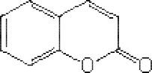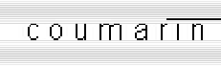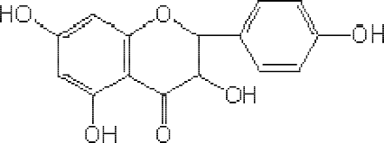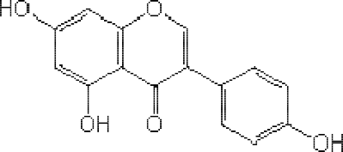

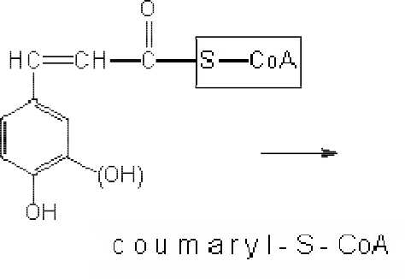



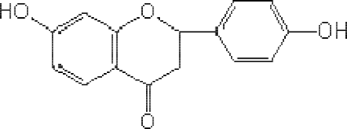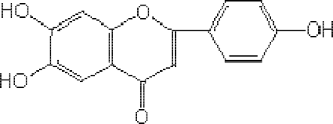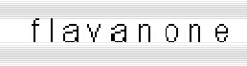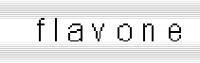

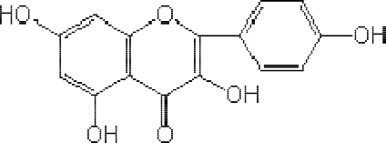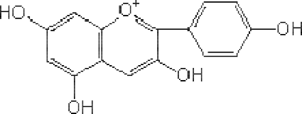

Figure 1.2: Biosynthetic Pathways of Various Classes of Flavonoids (Sengbusch, 2003)

* + 1. Saponins

Saponins are a group of plant glycosides which share, in varying degrees, two common properties, namely:

1. They foam in aqueous solution.
2. They cause haemoliyssof red blood cells.

The aglycones of the saponins are collectively called sapogenins and more poisonous saponins are referred to as sapotoxins. Saponins occur in cell sap of plant families such as Asteraceae (Compositae), Rosaceae, PolygalaScecaroep, hulariaceae and Caryophyllaceae.

They also occur in monocotyledonous plant families such as Dioscoreaceae, Amaryllidaceae and Liliaceae (Balbeataal.,1976).

Basically, there are two types of saponins namely, the stero-id27s) a(Cnd triterpenoidsC(-

30). They are characterized by a skeleton derived of th-cea3rb0on precursor oxidosqualene

or are derivatives of isoprene units to which glycosyl residues are attached. Carbohydrate chains are usually attached at C3 and/or C17 atom which may consis-8t oufni1ts (Vincken et al., 2007). The kind and positions of the substituents do not seem to be plant order-specific. The various classes of saponins are given in Figure 1.3 (Beatlbaal.a,

1976).

They are differentiated by the fact that, upon dehydrogioennabty selenium at 36oC0 , steroids give Diel’s hydrocarbon (Methyl cyclopentanophenanthrene) whereas

triterpenoids give naphthalene or picene (Dibenz phenanthrene). The steroidal saponins are

less widely distributed in plants than the triterpenoid oneslba(Baaet al., 1976; Kokateet al., 2002).

Saponins have bitter acrid taste and are usually irritating to mucus membrane of eyes and nose. They are highly toxic when injected into the blood stream but are comparatively harmless if taken orally. They are tcoxtio cold blooded animals and so are often used as fish poisons. Saponins are usually extracted from plants by hot water and alcohol. They are precipitated by diethyl ether after concentrating the extract (Baeltbala.,1976).

Steroid saponins includeethfollowings:

1. Sarsaponinfsrom Salixspecies
2. Digitoninfrom seeds oDf igitalis purpureaandD. lanata
3. Dioscinfrom Dioscoreaspecies

Triterpenoid saponins include the followin-gs:

1. Calendula saponinfrsom Calendula officinalis
2. Glycyrrhizic acidfrom Glycyrrhizaspecies
3. Quillaia saponinsfrom Quillaia saponaria
4. Primula saponinfsrom Primula species (Kokat**e**t al., 2002).

O

21

20 22 25 27

#### 29 30

18

O 24

#### 17 23

19 13 16

#### 1

2 9 15

8

#### 10

(20)

1 25

#### 19 20

22

#### 18 17 28

3 5 7

#### 4 6

Steroid 16

#### 27

2

6

Dehydrogenation wit Selenium at 36o0C

3

#### 23 24

Triterpenoid

Dehydrogenation wit Selenium at 36o0C

(21)

Diel’s hydrocarbon

(22)

Picene

(24)

Naphthalene

(23)

Figure 1.3: Chemical Structures of the Two Classes of Saponins and Their Dehydrogenation Derivatives (Balbaaet al.,1976).

* 1. Toxicity

Toxicity is the degree to which a substance is poisonous (Martin, 2002). Plant crude drug evaluation must encompass the study of its possible toxicity and/or safety margin. The toxicity of a substance may be one of the following types.

1. Acute toxicity: A subject is exposed to a single or multiple (large enough) doses of toxic agents for over a period of 24 hours and observation for effects may continue for 7 to 14 days.
2. Sub-acutetoxicity: Arises from frequent repeated exposure of subject to small doses of an agent which is sufficient in any of the single doses to produce deleterious effects over a period of 30 to 90 days.
3. Chronic toxicity: Arises from repeated and continuoexupsosure of a subject to small doses of a toxic agent, which may not be eliminated from the body, accumulate to toxic level and last for over a period of 90 days (Bucks, 1976).
   1. Nociception (Pain)
      1. Concepts of Nociception (Pain)

Nociception or pani is an unpleasant sensation, which ranges from mild discomfort to

agonized distress associated with real or potential tissue damage. It is a response to

impulses from the peripheral nerves in damaged tissues. The impulses pass to the nerves in the spinal cord where they are subjected to a ‘gate control’. The gate modifies the subsequent passage of the impulses according to descending controls from the brain (Martin, 2002). Ant-inociception is synonymous to analgesia, which implies the loss of pain impressoin without loss of tactile sense (Stewart and Brooks, 1963).

The knowledge of the genesis of pain has led to the understanding that, certain pain mediators such as hydrogen and potassium ions, kinins, biogenic amines, hista- mine, 5

hydroxytryptamine (seronin) and metabolites of arachidonic acid (prostaglandins and leocotrienes) evoke pain when liberated in the tissues. The generation of pain is closely related to other tissue reactions such as inflammation and allergy (Katzung, 2001).

Pain may have dieffrent causes but variety of peripheral and central neuronal structures might contribute to its processing information. However, a noxious stimulus when applied to some parts of the body, serves as its initial event. Apparently, a subgroup of afferent nerve fibres transfer the information to the central nervous system and these units are referred to as nociceptors (Bessou and Perl, 1969).

Three classes of nociceptors have been found in the mammalian skin (including man) and these include the following:

1. Unmyelinated C fibres: These are excited by noxious heat and mechanical stimulus in the noxious range. These units are referred to as polymodal nocicepto-MrsHoruCnits and

are defined by their responses to mechanical and heat stimuli and their connductio

velocities (<2m/s).

1. Myelinated: These are slowly conducting-dAelta units that are excited by high threshold mechanosensitive (HTM)-dAelta units. Their conduction velocities are usually

<20m/s in rats and <30m/s in humans.

1. A-delta units: Thesehave similar conduction velocities to those found in group (b) and are excited by strong mechanical stimuli and heat. They are referred t-oMaHs uAnits (Andriaensenet al., 1983).
   * 1. Mechanism of Pain Sensation and Sites of Action of Analgesics

The sequence of events that underpin pain sensatiobnasisically presented in the ordaesr

follows (McQuay (1992).

1. Noxious stimuli are directed by receptors in p-saeinsitive tissues.
2. The signal generated by these receptors is transferred by seenrsvoersy, nthrough the dorsal root ganglia, to the dorsal horn of the spinal cord.
3. The signal received through the peripheral sensory mechanisms is processed by the spinal cord segment and transferred via ascending spinal cord pathways to various parts of the brain.
4. The signals received in the thalamic nuclei, periventricular grey matter, an-dstbermain

reticular formations are processed and passed on to the sensory cortex, giving off the sensation of pain.

Signals received in several sites, but ipcaurlat rly in the reticular formation and medullar, descend through polysynaptic pathways, to the dorsal horn of the spinal cord, where they may either facilitate or inhibit activity. The schematic diagram (Figure 1.4) is given below in accordance with McQuya(1992).

General Anaesthetics

Ascending Spina Pathways

Thalamus

Cortex

Opiates

Tractotomy

Opiates

Dorsal Horn of Spinal Cord

Local Anaesthetics

Sensory Fibres

Aspirin

Nociceptive Nerv Endings

Figure 1.4: Nervous Pathways Mediating Pain and the Sites of Action of Analgesics (McQuay, 1929)

* 1. Inflammation
     1. Concept of Inflammation

Inflammation is a body defensive response of the local microcirculation to tissue injury. This arises from cell damages due to mechanical trauma, chemical, physical and thermal injury, antigen-antibody reactions and infections. Redness, heat, swelling, pain and loss of function of the affected areas are the cardinal signs of inflammation (Bowman and Rand, 1980). It is an attempt by the body to restore and maintain homeostasis after indjuisry an

an integral part of body defensMe.ost of the body defense elements are located in the blood. Inflammation is the means by which body defense cells and defense chemicals leave the blood and enter the tissuaeround the injured or infected s.iteInflammation is essentially beneficial; however, excess or prolonged inflammation can caus(eKhaaisremr,

2001).

The primary physical effect of the inflammatory response is for blood circulation to increase around the affected area. The blood vessels arousnitde tohfeinflammation dilate, allowing increased blood flow to the area. Gaps appear in the cell walls surrounding the area, allowing the larger cells of the blood, i.e. the immune cells, to pass through. As a

result of the increased blood flow, the immupnr**e**sence is strengthened. All the different types of cells that constitute the immune system congregate at the site of inflammation, along with a large supply of proteins, which fuel the immune response. There is an increase in body heat, which can itshealfve an an-tbi iotic effect, swinging the balance of chemical reactions in favour of the host (Bessou and Perl, 1969).

The main symptoms of the inflammatory response are therefore described as ifnollows

accordance withKaiser(2001).

1. The tissues inthe area arered and warm, as a result of the large amount of blood reaching the site.
2. The tissues in the area asrweollen, due to the increased amount of blood and proteins that are present.
3. The area ispainful, due the expansion of tissuecsa,using mechanical pressure on nerve cells, and also due to the presence of pain mediators (Kaiser,. 2001)

Inflammatory responses occur in three distinct phases, which are apparently mediated by different mechanisms. Gallient al. (1992) reported that mayndifferent mechanisms are involved in the inflammatory process. Phases of inflammatroersyponse include the following:

1. An acute transient phase, which is characterized by local vasodilation and increased capillary permeability.
2. A delayed, su-bacute phase, which is most prominently characterized by infiltration of leucocytes and phagocytes.
3. A chronic proliferative phase, characterized by tissue degeneration and ,fiwbrhoiscihs

leads to total loss of tissu.es

Basically, there are two types oinfflammation: acute and chronic inflammation. Acute inflammation is essential to body defenCseh.ronic inflammation, however, can result in considerable tissue damage and sca.rrWinigth prolonged increased capillary permeability, neutrophils continually laeve the blood and accumulate in the tissue at the infected or injured site.As they discharge their lysosomal contents and oxidizing agents, surrounding tissue is destroyed and eventually replaced with scar tissue (Kennedy., 2001)

* + 1. Mechanism of Infal mmation

Following injury or infection,proinflammatory cytokines (a wide variety of intercellular regulatory proteins that control every aspect of body defeannsde)chemokines (cytokines that promote inflammation by enabling white blood cells to adhoertheet inner surface of blood vessels and be che-mtaoctically attracted to the injured or infected tissuaerse)

released. Mast cells in the connective tissue as well as basophils, neutrophils and platelets leave the blood from injured capillaries, asntdimulate the synthesis of vasodilatosrusch as histamine, leukotrienes, bradykinins, and prostaglandins (Vane and Botting, 1987).

- 55 -

Certain products of the complement pathways (two biochemical pathways involved- in non

specific body defense) complenmteproteins produced. They promote inflammation, phagocytosis and lysis of membra-bnoeund cells that are recognized by the immune system. The products: C5a and C3a can also trigger mast cells to release their vasodilators. Vasodilationis a reversible opening of the junctional zones between endothelial cells and

consequenlyt leads tomacroscopic manifestation of inflammation (Kaiser, 20(0F1ig) ure

1.5).

InflammationCharacterized bPain, Swelling andRedness

Increase Blood Vessels Permeability

Synthesis ofVasodilators

Injury and/orInfection

Pro-inflammatoryCytokines ad Chemokines

Figure 1.5: Schematic Illustration of Inflammatory Mechanism(Vane andBotting, 1987)

* 1. Some Analgesics and An-tiinflammatory Drugs

Analgesics and no-nsteroidal ant-**i**nflammatory drugs (NSAIDs) are either classified as non selecivt e cyclooxygenase (Cox) inhibitors or cyclooxygen-2as(eCox-2) inhibitors.

Cyclooxygenases are of two types (i) cyclooxyge-n1as(Ce ox-1) that is found in normal cells and tissues and (ii) cyclooxygen-a2se(Cox-2) that are induced in setting of inflammation by cytokines and inflammatory mediators (Seibeetrtal., 1997). Chemical classification of these drugs is given as:

* + 1. Non selective Cyclooxygenase (Cox) Inhibitors

1. Salicylic acid derivatives: aspirin, sodium salicylate, choline magnesiumctyrliasateli, salsalate, diflunisal, sulfasalazine, olsalazine.
2. Para-aminophenol derivatives: acetaminophen (paracetamol).
3. Indole and indene acetic acids: indomethacin, sulindane.
4. Hetroaryl acetic acids: tolmetin, diclofenae, ketorolae.
5. Arylpropionic acids: ibuprofen, naproxen, flurbiprofen, ketoprofen, fenoprofen, oxaprozin.
6. Anthracitic acids (fenamates): mefenamic acid, meclofenamic acid.
7. Enolic acids: oxicam (piroxicam, meloxicam).
8. Alkanones: nabumetone (Robert and Morrow, 2001).
   * 1. Selective Cyclooxygena-s2e(Cox-2) Inhibitors
9. Diaryl substituted furanones: rofecoxib.
10. Diaryl substituted pyrozoles: celecoxib.
11. Indole acetic acids: etodolae.
12. Sulfonanilides: nimesulide (Robert and Morrow, 2001).

Analgesics and no-snteroidal ant-iinflammatory drugs (NSAIDs) have some side effects. They have the potential of inducing gastric and intestinal ulcer. This effect can sometimes be accompanied by anaemia due to blood loss. Users of non selective NSAIDs on a chronic basis havaebout three time greater risk for serious adverse gastrointestinal events compared to nonusers. However, NSAIDs vary considerably in their tendency to cause such erosion and ulcer (Gabreietlal., 1991).

* 1. Carrageenan as the Inflammatory Agent

Carragenean is synonymously called Chondrus extract, Irish moss extract (Figure 1.6). It is

a sulphated polysaccharide extract of sea weed called carrageen or irish moss (red algae) known asChondrus crispus(Rhodophyceae). The algae were commonly found growing on

the North Atlantic coast of Europe and North America. It is found in the intercellular

matrix and cell wall of the algae and constitutes abou-8t 06%0 of its dry weight. It is a

water soluble colloid, dried to form free flowing powder. Its molecular weisigh1t0,000-

50,000 and is stable at pH 9.0. Depending on the position of sulphate and the presence or absence of anhydrogalactose; two types of carrageenan are known, namkealpyptahe(k)

D Q G W K H O-carDragePenaEn cGontaDins-gDalactose, 3, 6 anhydrFousD U U

D- J D O D F W R V H D -QcarrGageenanHconVtainWs-gDaHlactoUse and V X O

its mono and disulphate ester. Th-ecakrrageenan is a good gelling ageWn Z- K L O

carrageenan type is n-ognelling but a good thickener (Kokaetet al.,2002).

Carrageenan induces inflammation, first by causing the release of histamine and serotonin and secondly by causing the release of bradykinin, protease, prostagalandndliynsosome (Crunckhon and Meacock, 1971).

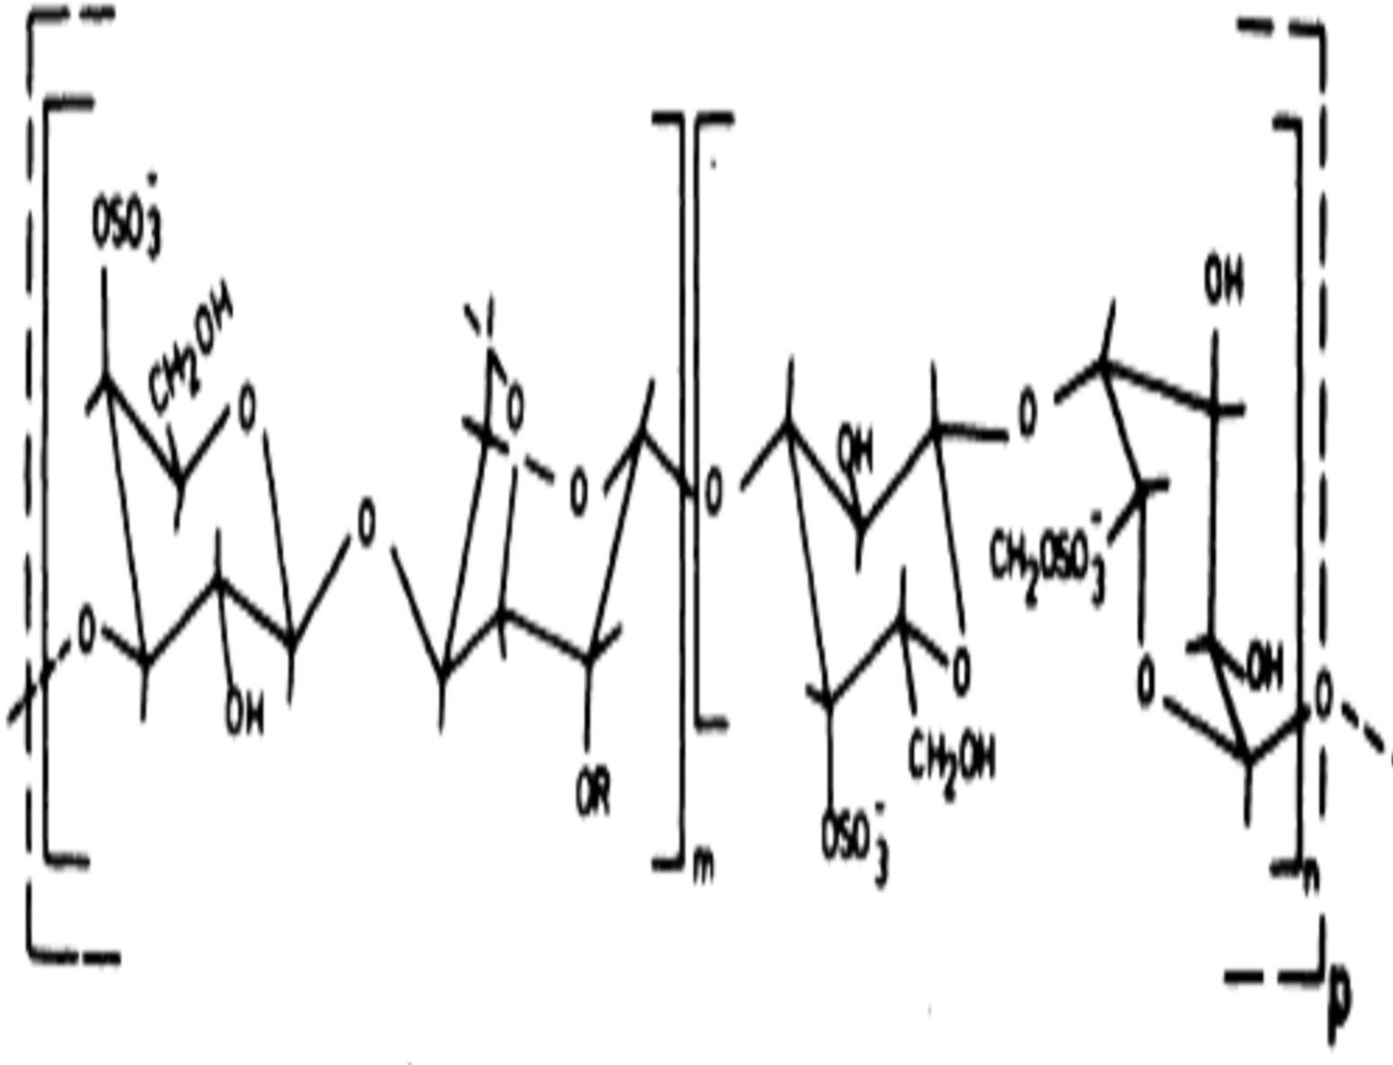Figure

1.6:

Chemi

cal struct ure of Carra geena

n (Rees, 1981)

Note: R = H for kappa carrageenan and R = -SfoOr lambda crarageenan

3

* 1. Ketoprofen as the Standard Analgesic and An-tiinflammatory Drug

Ketoprofen also called Keton®a(l Figure 1.7) is a phenyl propionic acdiderivative: 2-(3- benzoylphenyl-)propionic acid(C16H14O3). It is one of the propionicacids with analgesic

and antipyretic effects. It is most commonly used for muscoskeletal pain, joint problems, and soft tissue injury (Kantor, 1986K).etoprofenbelongs to a group of medicines called non-steroidal ant-**i**nflammatory drugs (NSAIDs). It acts by blocking orinhibiting the production of a chemical (prostaglandin) which the body produces in response to injury or certain diseases. This prostaglandin would otherwise go on to cause swellinga,ndpain

inflammation (Chishinan, 200.6)

It inhibits both cyclooxygenase (nonselectively) and lipoxygenase. It is indicated in rheumatoid arthritis, osteoarthritis, gout, dysmenorrhoear and other painful conditions but it negatively affects the central nervsosuystem (Katzung, 2007).

O

Its side effects include gastrointestinal ulcers, drop in red blood cell count (a result of gastrointestinal bleeding), and rarely kidney damage, protein loss, and bleeding disorders. It should therefore be used with caution inasecs of liver or kidney disease, or gastrointestinal problems (Forney, 2007).

CO2H

Figure 1.7: Chemical Structure of Ketoprofen(Kantor, 1986)

* 1. Some Medicinal Plants/Constituents with Analgesic and/or An-ti inflammatory Activities

A substantial body of evidence obtained froinm-vivo and in-vitro studies show that, various plan-tderived compounds with an-itniflammatory properties exert their effects through the modulation of the cytokine system (Habtemari2a0m0,0). For instance, flavonoids, a class of compounds widely distributed throughout the plant kingdom, possess interesting an-tinflammatory actions (Middleton, 1998).

Xagorari et al. (2001) reported that luteolin, quercetin, luteoli-nglu7coside and the isoflavonoid genistein inhibited LPS (lipopolysacchar-ide)V W L P X O D W H interleukin-6 release in RAW 264.7 macrophages. However, eriodictyol and hesperetin

R Q O \ L Q K L E L W H G 7 1 ) . in-vivoUandH O H D

was capable fodecreasing both PMA and oxazolo-inneduced allergic ear oedema. Luteolin significantly reduced LP-Sstimulated ICAM-1 expression in the liver of LPSSa( lmonella enteriditis)-treated mice.

A study demonstrated that chronic administration of luteolin siciganniftly attenuated ovalbumin-induced airway bronchoconstriction and bronchial h-yrpeearctivity. Moreover, the same treatment with luteolin was capable of reducing the levels of b-4otahnIdL IL-5.

However, it induced an increaV H L Q , ) 1 L Q W K H mice (Daset al., 2003).

It has been demonstrated that a citrus polymethoxyflavonoid, nobiletin (5, 6, 7,•8- , 3

hexamethoxyflavone) effectively inhibits the production of P2 GanEd proMMP-9 in rabbit synovial fibroblasts (Ishiwaet al., 2000). Lin et al. (2003) have shown that nobiletin

suppressed I-L -induced production of PG2Ein human synovial fibroblasts cells. This

decreased the expression of - IL

-. , /

-6 7mR1NA)s

.in J774DA.1Q G

macrophages (at a concentration of 32 µM). These results allowed the authors to suggest that nobiletin could be a candidate for the development of a nove-ilnaflanmti matory or immunomodulatory drug.

Baicalin, baicalein and wogonin are flavonoids presienntScutellaria baicalensisG. (Lamiaceae), a plant used in the treatment of a variety of inflammatory diseases such as bronchitis, nephritis, hepatitis, asthma, and atopic dermatitis (Ketubaol., 1984). The an-ti

inflammatory activities of these flavonoidhsave been attributed firstly, to their antioxidant properties and secondly, to their ability to inhibit L-PinSduced NO production and iNOS

gene expression, as well as the increase in T) N. O H Y H O V et al., E \ 5

2001).

Li et al. (2000) demonstrated that baicalin significantly inhibited the binding of several

chemokines. These include CXC, [stromal -cdeelrl ived factor (SDF-) . -8]; CDC Q G

[macrophage inflammatory prointe(MIP)- D Q G P R- Q R F \

2). It also inhibits C lymphotactin (Ltn)] to human leukocytes or cells transfected with chemokine receptors.

Baicalein prevented eotaxin production and the mRNA eotaxin expression in human

fibroblasts stimulated with IL- S O X V

in-7vitro1

st)ud.ies, the c-o & R Q

injection of baicalein with interleuk-in8 (IL-8) significantly inhibited IL-8-elicited neutrophil infiltration in rat skin. However, baicalin failed to block CX3C chemokine

fractalkine Q H X U R W D F W L Q

- R U R

0WR K V HWU

including baicalein inhibit IL- - - and7 th1rom) bin-.induced endothelial leukocyte

adhesion molecu-le1 (ELAM-1) and ICAM-1 expression in cultured human umbilical vein endothelial clels (HUVEC) (Kimuraet al., 2001).

Sartor et al. (2002) reported that different flavonoids such as flavones (baicalein), anthocyanidins (delphinidin and pelargonidin), flavanols [epigallocat-e3c-hgianllate], flavonols [morin and quercetin]and other comopunds with antioxidant properties were highly effective in inhibiting the activities of leukocyte elastase, M-2MPand MMP-9.

Such actions might explain the a-nintfilammatory, antiangiogenic, a-nintivasive and antimetastatic properties described for theosmepcounds.

Kang et al. (2001) reported that hypericin, an active componenHt yopfericum perforatum

L. (Hypericaceae), significantly inhibited in a concentra-tdioenpendent manner -I1L2

production in LPS-activated macrophages. Hypericin potently inhibitheed at ctivation of the IL-12 gene promoter, suggesting that hypericin negatively regula-t1e2d pILroduction

at the transcription level. Borekt al. (1999) have demonstrated that hypericin inhibits

PMA- D Q

-Ginduced 7acti1vati)on .of N-F

% E \ D P H F K D Q

pathways. These results might explain some known biological activities of hypericin, including its reported antirheumatic effects.

It has been demonstrated that a methanolitcracetx of the root cortex ofPaeonia suffruticosaA. (Ranunculaceae), known as mudanpi, inhibited in a concent-**r**aetliaotned manner the secretion of -I8L and MCP-1 induced by PMA in human monocytic U937 cells (Oh et al.,2003).

Chou (2003) demonstrated a**t**h the main active compound oPfaeonia suffruticos;a

paeonol(2 -h•ydroxy-4 -m•ethoxyacetophenone), exhibited analgesic and-inafnlatimmatory effects in the rat model of carragee-neavnoked thermal hyperalgesia. The analgesic and

anti-inflammatory effects of paeonol are associated with its ability to inhibit in a concentration-dependent manner the formation of several-inpfrloammatory cytokines

V X F

-K1-

D -6V),Das Qwe7lGl a1s th)e ,.ov-e/prroductio,n o/f NO and PG2E. In

addition, the effects of paeonol are also associated with an increase in t-he anti

inflammatory cytokine IL-10, with inhibition of neutrophil infiltration and iNOS and COX-2 protein expression. Thus, paeonol represents a potential candidate for the development of a new a-nintiflammatory therapy.

Tsudaet al. (2002) reported that oral administratiofna typical anthocyanin, cyanidin- 3

O- -D-glucoside, suppressed the zymo-sinadnuced inflammatory response in rats.

Treatment of cyanidin-3O- -D-glucoside also reduced the elevation ofxNO - 7 1 ) .

IL-6 and CINC-1 concentrations. Furthermore, cyanid-inO-3 -D-glucoside normalised the

lev H O V R I V H Y H2-mUacrDogloObulin, albDumFin aXnd tWransHferrin S K in the serum of rats treated with zymosan.

Rhizome of Curcuma longa L. (Zingiberaceae) was found to contain curcumin (polyphenols) that presents a high interest alesada compound to develop new clinically relevant ant-**i**nflammatory drugs. Apart from its effect on inflammatory events, this

compound significantly blocked

-IL12 mediated T cell proliferation and

1Th

differentiation, an action that possibly implies itsiliatybto reduce the production of p-ro

inflammatory cytokines (Natarajan and Bright, 2002).

Curcuminwas found to significantly dow-n

U H J X

-OinduDcedWincrHease in WMM-PK H 7

13 mRNA and protein expression in primary human chondrocytes and SW1353 cells by a

mechanism involving the inhibition of N- F -ju%n and JNK F(Liaciniet al., 2003).

Moreover, curcumin significantly inhibited the increase of both- IL D Q G

chronic model of inflammation in rats (Banerjeeteal., 2003).

Hemateinis a compound isolated fromCaesalpinia sappanLinn (Leguminosae), a plant employed in oriental medicine as anaalgnesic or an-tinflammatory (Ohet al., 1998). Hematein was efficacious in reducing the expression of VC-1AMin the aorta of hypercholesterolemic New Zealand rabbits. It has been reported that an extract of Tripterygium wilfordii Hook (Celastraceae) mardkley inhibited mRNA synthesis and protein expression of MM-P3 and MMP-13, induced by the pr-oinflammatory cytokines

IL- -

, D/

Q G 7 1 ) . D V D V V H V V

chondrocytes. The extract could be useful as a sourceteamnpdlate for novel antiarthritic and cartilag-eprotective drugs (Ohet al., 2001).

Celastroldecreased the production of the -proL Q I O D P P D W - R U \ LF

human monocytes and macrophages. Celastrol (3 mg/kg) has also been reportedt to inhibi

rat adjuvan-tinduced arthritis, thus confirming its reporteind-vitro anti-inflammatory properties. It has been proposed that celasmtrigohl t be useful for improving performance

in memory, learning and psychomotor activities, and common features of the neurodegenerative diseases accompanied by inflammation, such as Alzheimer’s disease.

The terpenic saponin kalopanaxsaponin isAolated from Kalopanax pictus Nakai

(Araliace D H S U H Y H Q W H G W K H I R U

with LPS at concentrations up to 5 µM. The compound was found to be a useful substance in pain and inflammation (Kimet al.,2002).

Sesquiterpene pyridine alkaloids To.f wilfordii, namedwilfornines A, B and C, as well as several other related compounds, showed significant inhibitory effects on the production of

a range of pr-o

L Q I O D P P D W R U- \

-4, IFL-2\ anWd IFR,N-

/N L Q L H Q

human peripheral mononuclear cellsu(aDnet al.,2001).

Sesquiterpene lactones including cynaropicrin, reynosin and santamfraormineroots of

Saussurea lappa 5 D G & R P S R V L-acWtivatDed RHAW L Q

264.7 cells. They are found to be potential sources of analgesicanatin-idnflammatory agents (Choet al., 1998).

Junget al. (1998) reported that reynoseinxhibited a concentratio-dnependent inhibition of CINC-1 formation in NRK-52E rat kidney epithelial cells stimulated with LPS. Moreover, the diterpenes casearinols AndaB and casearinones A and isBolated fromCasearia guianensisJ. (Flacourtiaceae) were found to be effective in reducing the expression of ICAM-1 and VCAM-1 in THP-1 human monocytes (Hunt**e**tr al.,1997).

Terpinen-4-ol, the main constituent of the ensstieal oil of Melaleuca alternifolia(Maiden

D Q G % H W F K H & K H H O - 0 - \ U W D

8, IL-10 according to an assessment in -LaPcStivated human peripheral blood monocytes (Hart et al.,2000).

Crocus sativusL. (saffron) aqueous and ethanolic maceration extracts of stigma and petals

were evaluated for analgesic and -ainftliammatory activities. The extracts exhibited

antinociceptive activity against acetic a-cinidduced writhing. Naloxone partially blocked only the antinociceptive activity of the stigma aqueous extract. Only the stigma extracts

showed weak to moderate effect against acute inflammation. In chronic inflammation, both aqueous and ethanolic stigma extracts, as well as ethanolic petal extCra.cstaotivf us L. (saffron) exerted an-tini flammatory effects. Phytochemical screening of the extracts

indicated the presence of flavonoids, tannins and anthocyanins in the petal aqueous and ethanolic extracts. Alkaloids and saponins were found in the stigmauasqaunedo ethanolic extracts H( osseinzadehandYounesi, 2002).

Sanguinarine is found in the root oSfanguinaria canadensitshat is commonly called bloodroot (Papaveraceae) that was used extensbivyelynumerous Native American societies for blood tonificationand purification, pain relief, wound healing, fevers, and numerousother purposes. The use of a medicinal botanical as autsounaiclly indicates that the botanical has the ability to enhancceertain immune responses. It is uncertain what is meant by "blood purification" in terms of modern medicine (Chaturv**e**tdai l, 1997).

In-vitro, sanguinarinesuppressed human peripheral blood neutrophil function, including chemotaxis, adhesion, oxidative burst, degranulation, and phagocaytnodsiws,as nontoxic

at all concentrations tested. aItlso strongly inhibited the activation of nuclear transcription factor B (NF- B), which is involved in the induction of numeroupsroinflammatory mediators. Sanguinarine suppressed- NBFactivation by preventing phosphorylation and



degradation oifnhibitory B, which prevents entry of N-FB into the nucleus (Chaturvedi et al, 1997).

F



Preparations ofHamamelis virginiana (commonly called witch hazel) of the family

Hamamelidaceae were taken by Native Americans for pain relief, caonld ,fevers. A

crude alcohol and water extract Hof. virginiana, as well as fractions in which the

hamamelitannin content warseduced by lutra-filtration, were assessed for their a-nti

inflammatory activities in severalin-vitro and in-vivo experimental systemsI.n-vitro, elastase, a proteolytic enzyme participatii**n**gthe inflammatory response, was inhibited most potently bythe fraction cotnaining the highest concentration of hamamelitanannind,

this fraction exhibited the strongest antioxidant activity (Erdelmeetiearl.,1996).

Sambucus nigra(black elder; Caprifoliaceae family) is one of maSnaymbucusspecies used by Native Americans rforheumatismand fever. A methanol, and particularly butanol and chloroform extracts oSf . nigraleaves, had significantliynhibited lipopolysaccharide (LPS)-induced synthesis of tumonrecrosis factor (TNF- ) by human peripheral blood mononucleacr ells but had minimal effect on interleukin (-IL1 and IL-1ßproduction. Oral

)



administration of an aqueous extractthoef aerial parts oSf . nigra before a carrageenan

injectionsignificantly inhibited hind-paw edema in mice (Yesiladeat al.,1997).

EchinaceaangustifoliaLinn. (Compositae)the narrow-leafed purple coneflower, has long been used by Native Americans for pain relief and wound treatamseannt, antidote against various poisons, and for symptoms associwatiethdthe common cold (Moerman, 1986).

* 1. Statement of Research Problems

Many Nigerian medicinal plants like their counterparts world wide possess various similar and confusing macr-omorphological and cyt-omorphological features in common. These posed great difficulties to their proper identification and differentiation fromcltohseely related ones.

Pain and inflammation are manifestations of a number of diseases. These diseases may be as a result of dietary imbalance, biochemical reactions, microbial infections and many other infectious diseases that are manifested in formaionf apnd inflammatory responses.

Infectious diseases such as Acquired Immunodeficiency Syndrome (AIDS), anthrax, cancer, arthritis, gingivitis, diarrhea account for millions of deaths every year (Dara, 2004). Although the great majority of these deaths uorccin developing countries, infectious diseases are not confined by international borders and therefore, present a substantial threat to populations in all parts of the world. As such pains and inflammatory responses of varied degrees are seen as majoeratthsr to both animal and human health worldwide.

* 1. Justification of the Study

African countries especially Nigeria are blessed with enormous medicinal plant resources. However, only few plants have been evaluated as potential analgesic and-/or anti

inflammatory agents in the whole African continent. Even for the few plants that have been studied, pharmacognostic standards for their identities and their mineral element content have not been established. The active principles responsible for the an**a**nlgde/osircant-i

inflammatory properties were not identified.

Research on botanicals used by indigenous populations has gebneeranllyconfined toin- vitro screenings of individual plants othreir constituents for their antibacterial, antiviral, analgesic oranti-inflammatoryactivities. The fact that a botanical was traditionaulslyed for wound healing, fever, infection, edema, or rheumdaitsicease is taken as an indicator that the plant should be testefodr its analgesic and/or a-nintiflammatory properties.

Although severailn-vitro assays can be used to test for -ainnftlai mmatory activities, most screening procedures include inhibition of cyclooxygenaansde 5-lipoxygenase. These 2 enzymes are central to the pathwapyrsoducing thromboxanes, prostaglandins,d an

leukotrienes (Borcherest al.,2000).

Further research in these areas will go a long way in revealing the potential of the commonly available plants to possibly serve as cheap and efficient sources of analgesic and/or ant-**i** nflammatory drugs of interantional standards.

Therefore, the search for phytochemical constituents that possess antinociceptive and/or anti-inflammatory activities is worthy of consideration in drug discovery from medicinal plants worldwide.

* 1. Aims and Objectives of the Study

1. To provide macroscopic, microscopic, quantita-tlievaef/chemo-microscopic and solvent extractive standards for the identification of these plants.
2. To determine and compare some of the mineral element concentrations of the two plants.
3. To determine and compare the median lethal dose5(0)LDvalues of the two plants in laboratory mice.
4. To evaluate and compare the analgesic and/o-rinafnlatmi matory activities of the crude

extracts of the two plants in laboratory mice and rats respectively.

1. To fractionate the crude extracts of the two plants into crude flavonoids and saponins fractions.
2. To evaluate and compare the analgesic and/o-rinafnlatmi the crude flavonoids and saponins of the two plants.

matory activities of each of

1. To provive scientific evidence for the eth-nmoedical uses oVf ernonia amygdalina andV. kotschyanain alleviating pains and inflammations.
2. To statistically analyze and compare the results obtained from the analgesic a- nd anti

inflammatory studies on software.

eth two plants by using Student-ttest in GraghPad Prism

* 1. Statement of Research Hypothesis

Vernonia amygdalinaand V. kotschyanapossess similar and differing macroscopical, microscopical, quantitative/chem-moicroscopical and elemental diagsntioc features. The crude ethanol extracts, flavonoids and saponoifntshe two plantshave analgesic and/or

anti-inflammatory activities that support their traditional uses in the management of diseases such as stomach ache, head ache, pains of the njodingtisngaivitis, which are associated with pains and inflammations.

* 1. Statement ofNull Hypothesis

Vernonia amygdalina and V. kotschyana do not possess similar and differing macroscopical, microscopical, quantitative/che- **m**iocroscopical and elemental dginaostic features. The crude ethanol extracts, flavonoids and sapofnitnhse two plantshave no analgesic and/or an-itni flammatory activities that do not support their traditional uses in the management of diseases such as stomach ache, head ache, pthaeinjsoiontfs and gingivitis, which are associated with pains and inflammations.

## CHAPTER TWO

### LITERATURE REVIEW

* 1. The Family Asteraceae

The largest family of flowering plants that contains abou0t 9g0enera and some 13,000 species. Members are herbs, shrubs or rarely small trees or climbers. Leaves are alternate or opposite, simple or variously divided. Flowers are crowded into heads with capitula

single or few-flowered, which can be unisexual, mhearphrodite or neuter. Corolla is

sympetalous, stamen epipetalous and filaments/ anthers are free. Ovary is inferior and Fruits (achene) are sessile, sometimes beaked (Hutchinson and Dalziel, 1963).

Members are known to store carbohydrate as polyfrucntoostea,bly inulin and commonly

producing polyacetylenes which are borne in the -rceasninals. Polyacetylenes are

characterized by the presence of cyclic, aromatic or heterocycli-cgreonudp; bitter sesquiterpenes (especially sesquiterpene lactones), terpveonlaotidile essential oils and often one or another sort of alkaloids, notably the pyrrolizidine alkaloids, but without iridoid compounds. They are usually not tanniferous, or at least not strongly so. They generally lack ellagic acid and proanthocyanins obcuctasionally cyanogenic, crystals of

calcium oxalates seldom present in some of the cells of parenchymatous tissues; nodes trilacunar to multilacunar (Cronquist, 1981). Asteraceae are known to contain pyridine, quinoline alkaloids and occasionally ditenrpees. Glycosides, saponins, flavonoids and tannins are their chief constituents and flavonoids are used as taxonomic markers (Evans, 1999).

* 1. The GenusVernonia Schreb.

The genus has about 60 members athreattrees, shrubs or woody climbers. They are characterized by involucral bracts with coloured or whitish appendages; capit-u3lacm1.3 or more diameters; achenes often black and ribbed; p-aspeptaues more or less uniform. They are usually deciduous and buff in colour and leaves are often toothed (Hountchins and Dalziel, 1963).

* 1. The SpeciesV: ernonia amygdalinaDel. and V. kotschyanaSch. Bip.

Vernoniaamygdalinais a shrub or small tree-165 feet high with striate, pubescent stems, branchlets becoming glabrous. Its florets were s-wsce**e**nt ted, white; ehads are broad, pappus buff or reddish. This plant specie is common and often planted. On the other hand

V. kotschyanais a shrub with erect, pithy, striate, sparsely pubescent stems.-5It fiese2t high; florets pale mauve in heads, and are short (Hustocnhinand Dalziel, 1963).

Both species are commonly found in the tropical and subtropical countries. In Nigeria, they are commonly found in the Northern and southern parts. Although, it is onlyV.the

amygdalinathat is commonly planted and cultivated, tohteher specie is wildly available. They are classified in according to Sanogo (2005) as follows:

Kingdom: Plantae Division: Magnoliophyta Class: Magnoliopsida Order: Asterales Family: Asteraceae

Genus: Vernonia

Species:Vernonia amygdalinaDel. andV. kotschyanaSch. Bip.

* 1. Ethno-medical Uses ofVernonia amygdalinaand V. kotschyana
     1. Ethno-medical Uses ofVernonia amygdalina

Vernonia amygdalinais used for whooping cough, improvement of contraction during labour, schistosomiasis, abortion, and ritnilfiety in barren women (Bullough and Leary, 1982). It is also used for diabetes, fever reduction, and a-pnhoanrmaceutical solution in

form of infusion to persistent fever. Infusion of this plant specie is also used for head ache, and joint pains assocteiad with AIDS (Senyonga and Brehony, 1993). Its roots have been used for gingivitis and tooth ache due to its proven antimicrobial activity (Eluejtobaal.,

2005).

* + 1. Ethno-medical Uses ofVernonia kotschyana

Vernonia kotschyanais used for stomach hac,e tuberculosis, head ache, gastric ulcers,

gingivitis and gastrointestinal disorders (Germaent oal.,1996).

The roots fromV. kotschyanaSch. Bip. are used in Malian folk medicine for the treatment of gastritis, gastroduodenal ulcers, as an aid tolioarmaete digestion and as a wound healing remedy (Isawumei t al., 2004).

* + 1. Traditional Hausa-Fulani Uses ofVernonia amygdalinaand V. kotschyana

Some Haus-aFulani medical traditional herberlists in row-saannyi district of Malumfashi local government raea of Katsina state, when consulted reported some of the traditional medicinal uses oVf ernonia amygdalina(Shiwaka) andV. kotschyana(Kumbura Fage).

Leaf decoction of the two plant species is used in the management of fever, head ache,

pains of the joints and stomach ache. It is also used as a mouth wash in cases of bleeding and swollen gums. Developing stemsVo.f amygdalinaare excellent substitute to tooth paste. Leaves of plants especially thoseV.oaf mygdalinaare used as vegetables. They are usedas antidiabetic agents and as fish poisons in the eastern part of Nigeria (Iebtrahl.i,m

2002).

* 1. Previous Research onVernonia amygdalinaand V. kotschyana
     1. Previous Research oVnernonia amygdalina

A chemical study carried out by Oke (1965) tohne leaves oVf . amygdalinareported the presence of oxalate, cyanide and minerals. The content of oxalate and cyanide was very low but alluminium was significantly high and could cause toxicity. The calcium content was found to be about –47 per centand as such could provide the daily requirement for

this element /mineral. Thus the plant could be an important dietary component; for which its leaves are used as vegetable in Nigeria and many other countries.

Chloroform extract ofV. amygdalinawas found to show a significant inhibitory activity

in-vitro against cells derived from human carcinoma of the nasopharynx carried out in tissue culture. Isolation and structure elucidation revealed the extract to contain two new cytotoxic sesquiterpenecltaones– Vernodalinand Vernomygdin. Mass spectrometry and elemental analysis showed tha1t9 CH20 O7 and C19 H25 O7 were their molecular formulae respectively (Kupchaent al.,1969).

It was found that aqueous/ methanol extractsV.ofamygdalinashowed anibt acterial activity againstStaphylococcusaureus, S. albus, Proteus specaiensd Escherichia coliand even againsPt seudomonas aeruginos(Oagunlana and Ramstad, 1975).

Acute toxicity assessment oVn. amygdalinamethanol and aqueous extracts show the plant to have LD50 values of 1000 and 2000 (mg / kig.p) . respectively in mice. However, the aqueous extract in rabbits has an50LvDalue of 1,012 mg /kg body weighi.pt . (Rwangabo

et al., 1986).

Phytochemical studies oVn . amygdalinarevealed three new stigmanste-type steroid glycosides. They were identified as Vernoniosid4e, BA2 and B3 as well as the aglycone of A4. Vernonioside A4 and its aglycone were bitter, whereas others were not (Jeistaakla., 1993).

Igile et al., (1994), reported that chemical anpdesctroscopic studies on the leavesVo. f

amygdalinarevealed the presence of three flavones: luteolin, luteo-0li-n -7gElucuronoside

and luteolin 7–0-

-gElucoside (Figure 2.1) and luteolin–07-

-gElucuronoside was the most

abundant. They were found to be ioaxnitdants, with luteolin being a more significantly potent antioxidant than the synthetic butylated hyd-rt**o**xluyene at the same concentration of 15 mg / L. The two others have lower activity than that of luteolin and butylated hydroxy-toluene.

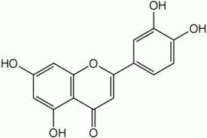

R

Luteolin 7–0- -gElucoside: R = -DE-glucopyranosyl

Luteolin 7–0- -gElucuronoside: R = -DE-glucuronopyranosyl

Figure 2.1: Chemical Structures of Some Flavonoids fromVernonia amygdalina(Igile et al.,1994)

Elemental analysis and laboratory experiment by Iegtileal. (1995) with mice fed diets containing alcohol extract or purified saponinsVo. famygdalina was carried out. It was observed to have no negative effect on the feeding performance of mice fed amended diets. However, it significantly reduced the body weight and increased urinary and fecal output of the mice. At necropsy, liver weights wer**e**dur ced and stomach and small intestines were enlarged in treated groups.

Comparative anatomical studies Von. amygdalinaand Talinum triangulareshowed the

plant to have numerous trichomes on the epidermis of young stems. The outer cortical part is composed of strands of sclerenchymatous fibers alternating with strands of phloem toward periphery. Leaves were dorsiventrally flattened and slightly pubescent with ranunculaceous stomata and medullated vascular cylinder (Nwosu, 1999).

Ogboli et al. (2000) reported that,V. amygdalinapetroleum ether and ethanol extracts were found to have potential curative effect on experimental schistosomiasis in mice.

Ibrahim (2001) discovered thaVt . amygdalinahas a spermatogenic stimulating and melanin depigmentationff**e**ct in albino rats (wistar strains).

Ethanol leaf and roo-bt ark extracts ofV. amygdalinawere found to possess significant antimalarial activities against dr-usgensitivePlasmodium bergheiin mice in-vivo (Abosi and Roseroka, 2003).

The aqueous extcrat of V. amygdalinawas found to elicitin-vivo hepatoprotectivity through antioxidant activity on acetaminop-hiendnuced hepatic damage in mice (Iwalokun et al., 2006).

The aqueous leaf extract Vo.f amygdalinaDel. (Compositae) givein.p. produced a dos- e

related fall in blood sugar. A dose of 80 mg/kg body weight in adult rabbit prod maximum lowering of blood sugar in both fasted normal and alloxanized rabbit fasting blood sugar in normoglycaemic rabbits was reduced from 96 mg% to 48 m

h. In alloxanized rabbits, the blood sugar was reduced from the mean value of 520 300 mg% in 8 h. The hypoglycaemic effects were compared with those of tolbu The blood sugar lowering effect of the plant extract may involve a mechanismantoedt rel

to insulin secretion (Akah and Okafor, 2006).

The ethanol leaf extract oVf. amygdalinawas found to be safe and active for use in e-thno

medicine, especially in ethn-toherapy of diabetes mellitus in rats (Ekeptoal., 2007).

The aqueous leaf exatcrts ofV. amygdalinawas found to have significanint -vitro and in- vivo anthelmintic activities against the chicken parasAitsecaridia galli and can be integrated in indigenous chicken health management system (Seiat malb.,a2007).

Aqueous extract oVf . amygdalinainfused intragastrically at a dose of m10g/ml to rats induced a significant increase in acid output which was reduced by, ranitidminge/k(g5

b.w.) and atropine (1.µ2Mol/kg b.w.). Moreover the extract evoked a d-odseependent contraction of the guinea pig ileum at a dose range of m0.g6/ml to 66mg/ml which was

inhibited by atropine at 2.×4 10

8í – 2.4 × 10 6í M (Owu et al., 2008).

The methanol extract oVf ernonia amygdalinaleaves was found to have lip-liodwering effects in rats fed a highhoc lesterol diet when compared with a standard hypolipidemic

drug, questran and probably the plant might serve as a new potential natural product for the treatment of hyperlipidemia (Oluwatoseint al., 2008).

Possible combined efficacy of ethanol extraocftVs . amygdalinaandAzadirachta indicain management of diabetes were studiVed. .amygdalinaextract alone was most potent in blood glucose reduction mechanism while A. indica extract was most potent in protecting the liver against damage in diabetic essta. tHowever, combination of the two plant extracts provides the wholistic efficacy desired in the management of diabetes (Eetbaoln.,g2008).

* + 1. Previous Research oVnernonia kotschyana

According to Deeni and Hussain (1994V)., kotschyanawas found topossess varied

antimicrobial activities against a wide range of microbes notably bacteria, yeast and fungi at various concentrations of its extracts.

The ethanol extract oVf . kotschyanawas reported to be active against a wide variety of bacterial speices includingSalmonellaspecies andStaphylococcus aureuIst.s extract was found to contain alkaloids (Deeni and Hussa1i9n9, 4).

The aqueous extract oVf. kotschyanawas found to possess significant antiulcer activity in male rats (Sanogeot al.,1996).

Phytochemical constituents identified from both aerial and underground parVts. of

kotschyanainclude, flavonoid glycosides, sesquiterpene lactones, steroid glycosides and alkaloids (Sanogoet al.,1998).

The roots ofV. kotschyanawere reported to contnaivarious types of steroidal glycosides such as vernoniosides1,DD2, D3, F1 and F2 (Figure 2.2.) Aqueous root extract oVf . kotschyanawas found to have gast-rporotective properties against etha-ninodluced ulcers in-vivo in rats. It also contain acidic lpyosaccharide fraction with complement fixing ability and T-cell independent induction of-cBell proliferationin-vitro (Sanogoet al.,1998).



Vernonioside S: R =-D-glucopyranosyl

Vernonioside 1: R = H

Vernonioside F2: R = -DE-xylopyranosyl

Vernonioside 1: R = R1 = H

Vernonioside D2: R = H, R1 = -DE-xylopyranosyl Vernonioside D3: R = -DE-glucopyranosyl, R1 = H

Figure 2.2: Chemical Structures of Some Saponins fromVernonia amygdalinaand

V. kotschyana(Jisaka et al.,1993; Sanogoet al.,1998)

Fractions isolated from both the 50°C and the 100°C water extraVct.skoftschyanawere

found to have immunomodulating activities. The active principles were identified as acidic polysacchairde fractions, containing pectic arabinogalactan type II structures, which showed both complement fixing ability and-cTell independent induction of -cBell proliferation in-vitro. Some activity was also observed on macrophages. This might provide additionlasupport for the popular use of the plant to improve intestinal health (Nergardet al., 2004).

Structure and immunological characteristics of the pectic arabinogalactan Vk2a from the roots ofV. kotschyanaSch. Bip. ex Walp. were investigated, after emnazytic digestion of

the galacturonanmoiety and the side chains of the rhamnogalacturonan structure of Vk2a. All the enzyme resistant fractions expressed potent complement fixation and induction of B-cell mitogenic activity, which indicates that, there mabye several and possibly structurally differentactive sitesinvolved in the bioactivity of Vk2a (Nergaredt al., 2005).

Structures of three pectic arabinogalactans, one Vfro. mkotschyana(Vk2a) and two from Cochlospermum tinctorium(Ct50A1 and Ct50A2), their complement fixation and induction of B-cell proliferation in-vitro were compared. The polysaccharide Vk2a expressed potent biological activity in both assays compared with Ct50A1 and Ct50A2. The Vk2a possessed a very high molecular weight (1150 ±kD2a0) compared with Ct50A1 and Ct50A2 which both showed a polydisperse nature with the highest molecular weight polymers in each fraction estimated at ~105 kDa (Ct1a) and 640 ± 100 kDa (Ct2a), respectively C( ecilieet al., 2006).

## CHAPTER THREE

### MATERIALS AND METHODS

* 1. Equipments, Solvents and Reagents/ Solutions
     1. Equipments

The following equipments were used for the research. Sieve size no. 0.6 mm

Cardboard papers Slides and cover slips Beakers

Compound microscope Camera lucida Micrometers Measuring cylinders Weighing balance Mechanical shaker Razor blades

Funnels Vernier caliper Conical flasks

Photographic camera Filter papers

Ashless filter papers Water bath

Desiccators

Cages /Feeding bottles

* + 1. Solvenst

All solvents used for this research were of analytical grades (B.P).

Ethyl acetate n-Butanol Xylene Chloroform Water

Ether Ethanol

Petroleum ether Methanol

* + 1. Reagents / Solutions

All reagents and/ or solutions used for this research wereaolyftiacnal grade. Ammonia solution (10 and 25 percent)

Chloral hydrate Solution (70 percent) Concentrated hydrochloric acid Hydrochloric acid (10 percent) Hydrochloric acid (2N)

Methylene blue

Potassium hydroxide (5 percent) Sodium hydroxide (10 percent)

Acetic acid (0.6% v/v)

Ketona®l

(Ketoprofen)

Carrageenan (1% w/v)

All reagents / solutions were prepeadraccording to Ciulei (1994)as follows:

1. Carl Price’s Reagent(Antimony (iii) Trichloride)

This was prepared by dissolving 25 g of antimony (i**i**ci)htlroride in 75 ml chloroform.

1. Dragendorff’s Reagent:

This was prepared by dissolving 0.85 g of basic bismuth nitrate in a mixture of 40 ml of water and 10 ml of acetic acid. A solution of 8 g potassium iodide dissolved in 20 ml of water was added adnhomogenized. This, when kept in a dark flagon, may be used-3for 2

months.

1. Fehling’s Solution(Cupric–Alkaline solution)
   1. A 34.66 g of copper (ii) sulphate dissolved in 200 ml of water and diluted to 500 ml.
   2. A 173 g of sodium and potassiutamrtrate and 100 g of sodium hydroxide dissolved in 300 ml of water and then diluted to 500 ml, after cooling. Equal volumes of solution 1 and 2 were mixed immediately before use.
2. Mayer’s Reagent

This was prepared by dissolving 1.35 g of mercuricorcidhel in 60 ml of water and then 5 g

of potassium iodide in 10 ml of water added and then diluted to 100 ml with water.

1. Molisch’s Reagent

This contained (i) not less than 17 per cent v/v of sulphuric ac2iSd0(4H) and (ii) 20 percent thymol in alcohol.

1. Phloroglucinol (1 per cent) in Alcohol

This was prepared by dissolving 1 g of phloroglucinol in 100 ml of alcohol.

* 1. Collection and Identification ofVernonia amygdalinaDel. and V. kotschyana Sch. Bip.

Sample ofVernonia amygdalinaDel. and V. kotschyanaSch. Bip. were collected during

their flowering stages in January and October, 2002 respectively. They were collected from Ruwan-sanyi of Malumfashi Local Government area of Katsina State. Theyidweenrteified

first in the field based otnheir botanical and taxonomic characteristics as described earlier by Hutchinson and Dalziel (1958; 1963) and Irvine (1961); secondly, by direct comparison with authentic samples at the Herbarium by the Taxonomists / Herbarium keeper (Mr. U.

S. Gallah) ofthe Department of Biological Sciences, Ahmadu Bello University, Zaria.

Fresh leaves of both plants were used for some microscopic studies while the bulk were carefully air dried at room temperature, powdered, sieved and then kept in a cool and dry place,protected from sun, for experimental purposes.

* 1. Preparation of Herbarium Specimens ofVernonia amygdalinaand V. kotschyana

The collected samples of the plants were separately arranged between pieces of

newspapers. These were then insertedwebeent more sheets of papers and placed on flat

boards. Other boards were placed on top and these were weighed down with building blocks. The wet outer newspapers were change on alternate days until the specimens were completely dried. The dried sampleserwe carefully removed from the drying papers.

These were placed and fastened on thick white plain mounting sheets. Information cards indicating locality, botanical and vernacular names, habitat and date of specimen collection were affixed on the herbariumsheets. The herbarium sheets were later put in folded cardboard papers and these were occasionally placed under the sun to prevent mould growth. They were preserved with methylated spirit and mercury chloride (Walters, 1963).

* 1. Preparation of Vernonia amygdalinaand V. kotschyanaLeaves

The bulk and air dried leaves of each of the two plants were separate-rlyedsuizc**e** d with

pestle and mortar. They were sieved with 0.6 mm mesh sieve size to obtain the powdered crude plant materials. They were labelepdpraopriately, stored in tightly closed containers

and kept in a good place for use during the reseach.

* 1. Macroscopic Studies onVernonia amygdalinaand V. kotschyanaLeaves

Macroscopic observations carried out on the leaves of the two plant specliueds;e inc

observations of the macroscopic appearance of the leaves, such as surface appearance, dimension, and point of attachment, lamina structure in terms of shape, composition, incision, venation, margin, apex, and base. Their organoleptic properties,y nt**a**mst**e**l,

odour and colour were determined. Examinations were made with naked eyes/hand lens and the results were recorded (Brain and Turner, 1E9v7a5n; s, 1996).

* 1. Calibration of Eyepiece Micrometer

Eyepiece micrometer was calibrated by using the satradndstage micrometer, under x40 objective in accordance with Brain and Turner (1975). Microscopic measurements of the diagnostic features oVf . amygdalinaand V. kotschyanawere carried out by using the calibrated eyepiece micrometer.

* 1. Microscopic/ Chemo-microscopic /Quantitative-leaf Microscopic Studies on Vernonia amygdalinaand V. kotschyanaLeaves
     1. Anatomical Sections and Powder of Leaves

Microscopic examinations on the fresh and powdered leaves of the two plant species to analyticallyassess their microscopic features were carried out. Surface preparations were made by peeling off the upper and lower epidermis of the fresh leaves of both plants. Transverse sections of their leaves were also prepared with the aid of razor blades. Small amounts of the finely ground powdered leaves were used for the microscopy. They were cleared in 70% chloral hydrate solution on a microscope slide (sections from fresh leaves) and in tes-**t** ubes (finely ground leaves) by heating on Bunsen flame and b**o**inlinwgater

bath respectively. They were mounted by using diluted glycerol and examined with the microscope (Brain and Turner, 1975).

Microscopic features of these plants, such as the type, nature and size of the epidermal cells, trichomes, stomata, fibrexsy,lem elements, and even calcium oxalate crystals were observed. Measurements were done with the aid of calibrated eyepiece micrometer (Evans, 1996).

* + 1. Chemo-microscopic Studies

These were carried out on the powdered leaves of the two plant spSemcaielsl .amount of the finely ground powdered leaves of each of the two plants was cleared in-tuabetest

containing 70% chloral hydrate solution. They were boiled on a -wb**at**ehrfor about thirty minutes to remove obscuring materials. The cleared sampslemwouanted on a microscope slide, using dilute glycerol. Using various detecting reagents, the presence of some cell inclusions and cell wall materials were detected in accordance with Brain and Turner (1975); Evans (1996a)s follows:

1. Test for Cellulose

To a small amount of the cleared leaf powder of each of the two plants-,zcinhcloior dine

was added. The occurrence of blue colour would be considered positive for cellulose on cell walls of epidermal cells.

1. Test for Lignins

To a small amount ofhte cleared leaf powder of each of the two plants, phloroglucinol solution and concentrated HCl were added. Red stain of lignified walls would be considered positive for lignins.

1. Test for Tannins

To a small amount of the cleared leaf powder of eactheotfwo plants, 5% ferric chloride solution was added. Greenish black colour in some parenchyma cells would be considered positive for tannins.

1. Test for Starch

To a small amount of the cleared leaf powder of each of the two plants, N/50 iodine was added. Blue-black colouration on some grains would be considered positive for starch.

1. Test for Mucilages

To a small amount of the cleared leaf powder of each of the two plants, ruthenium red was added. Pink colouration in mucila-gceontaining cellswithin the epidermis would be considered positive for mucilaginous walls.

1. Test for Calcium Oxalate Crystals

To a small amount of the cleared leaf powder of each of the two plants, 28S0O%4 aHcid was added. Brightly coloured crystals which disappeuapreodn addition of acid would be considered positive for calcium oxalate crystals.

1. Test for Calcium carbonates (CaCO3)

To a small amount of the cleared leaf powder of each of the two plants, 28S0O%4 aHcid was added. Calcium carbonate deposit dissuoplvoen addition of acid with effervescence. This would be considered positive for calcium carbonates.

1. Test for Fixed Oils and Fats

To a prepared transverse section of the leaf of each of the plants separately, few drops of Sudan IV solution were addeadnd observed for few minutes. The appearance of a red

colouration indicates the presence of fixed oils and fBartasin( and Turner, 1975; Evans,

1996).

* + 1. Quantitative-leaf Microscopic Studies

Determination of the various physical constants was caorruiet don the leaves of the two plants. These include stomatal number, stomatal index, palisade rati–oi,slveet i**n**umber

and vein-let termination number. Sections of fresh leaves from the two plant species were cleared in boiling 70% chloral hydrate soluntioand mounted with diluted glycerol on microscope slides and examined. Counting of microscopic features such as stomata, palisade cells were done with the aid of a Camera lucida, as described by Evans (1996).

1. Palisade Ratio

The average number of psaalide cells beneath the upper epidermisVf.oar mygdalinaand

V. kotschyanaleaves was determined. Section from the upper epidermis was cleared with boiling 70% chloral hydrate solution and mounted on a clean microscope slide with diluted glycerol and examnied with x40 objective. A Camera lucida was arranged, the epidermal cells and palisade cells lying beneath them were traced. Groups of 4 epidermal cells were traced, and their outlines linked to make them conspicuous. Palisade cells lying beneath each gor up were focused, traced and counted. Those included were ones that are more than half covered by epidermal cells. The figure obtained was divided by 4 and this gave the palisade ratio of that group (Brain and Turner, 1975).

1. Stomatal Number

The average number of stomata per square millimeter of epidermis of upper and lower sides of the leaves oVf. amygdalinaandV. kotschyanawas determined. Sections from the upper and lower epidermis of the leaves of the plants were cleared with 70% chloral hydrate solution and mounted on a microscope slides with diluted glycerol.

A Camera lucida was set up, with the aid of stage micrometer, a paper was divided into squares of 1 m2musing a X10 objective. The stage micrometer was replaced by the cleared prepartaions or sections. The stomata were traced and counted in the fields on a single section of the leaves of each of the two plants and the average number of stomata per mm2 of epidermis was calculatedEv(ans, 1996).

Stomatal Number =Average Number of Smtoata

Square Millimeter of Epidermis

1. Stomatal Index

The percentage proportion of the ultimate divisions of the epidermis of a leaf, which have been converted into stomata, of each of the two plants was determined. Sections of the epidermal portion of the leaves were mounted and examined as described in (a) earlier. It was only that in each field viewed, both stomata and epidermal cells were counted. The stomatal index was calculated in accordance with Evans (1996).

Stomatal Index = Number of Stomata X 100 No. of Epidermal Cells + No. of Stomata

1. Vein–islet Number

The number of vei–nislet (the minute area of photosynthetic tissues encircled by the ultimate division of conducting strandsp)er mm2 was calculated in four contagious millimeter squares, in the central part of the laminaV.oaf mygdalinaand V. kotschyana

leaf midway between the midrib and the margin. It was determined by boiling pieces of leaf of the plants in a te-stut be containing 70% chloral hydrate solution. This was followed

by treatment with hydrochloric acid (10% v/v) to remove calcium oxalate crystals that will consequently enhance visibility.

A camera lucida was set up and by means of a stage micrometer; the psapdeivr idwead

into 1 mm2 using X10 objective. The stage micrometer was then replaced by cleared preparations of the leaf and the veins were traced in 4 contagious squares. That is a rectangle of 1 mm x 4 mm. Each vein was traced and areas which were ceolymplet

enclosed by veins were counted and those that were not completely enclosed were excluded (Evans, 1996).

1. Vein-let Termination Number

The number of vei-nlet termination per mm2 of V. amygdalinaand V. kotschyanaleaf surface was determined. A carma elucida was set up as described earlier and paper was divided into squares of m2mand vein-let terminations in each square were counted to get the vein-let termination numberE(vans, 1996).

* 1. Determination of Physical Constants onVernonia amygdalinaand V. kotschyanaLeaves

Physical constants namely, extractive (water and alcohol) values, moisture content, total ash, acid–insoluble ash and wat-esroluble ash were determined on the leaf powder of the plants (Appendix I).

1. Moisture Content

The moisture content of the powdered leaves of eacVh. oamf ygdalinaand V. kotschyana

was determined. In a crucible 2 g of the powdered leaves of the plants was weighed separately. It was then heated for 1 hour atoC1,05cooled in a desiccator and-wr**e** ighed.

This was repeated for five times until a constant weight was obtained. This was because the method adopted was based on loss on drying. The moisture content was determined as percentage for each of the two plants (Brain and Turner, 1975) as:

Moisture Content (%) =Weight of Water Lost x 100

Original Weight of Sample

1. Total Ash

The total ash of the powdered leavesVo. famygdalinaandV. kotschyanawas determined.

In a crucible 2 g of the powdedreleaves of the plants was weighed separately. It was heated gently until the material is charred at a temperature ooCf .45It0was heated until all

the carbon has been removed, cooled and weighed. The total ash value of each of the two plant species apsercentage was determined (Brain and Turner, 1975) as follows:

Total Ash Value (%) =Weight of Residual Ashx 100

Initial Weight of Sample

1. Acid- Insoluble Ash

The acid-insoluble ash value for the powdered l**e**savofV. amygdalinaand V. kotschyana

was determined separately. The ash obtained in (d) above together with the crucible, were quantitatively and carefully transferred into a beaker, containing 25 ml of diluted hydrochloric acid. It was boiled for 5 mitneus and the insoluble ash was collected on an ashless filter paper. The beaker containing the acid and crucible were washed with hot water. The washings were passed through the ashless filter paper continuously until it was free from acid. The residuenda filter paper were dried gently in an oven. It was ignited in

a tarred crucible, cooled and weighed. The-aincsidoluble ash as percentage for each of the two plants was determined (Brain and Turner, 1975) as follows:

Acid-Insoluble Ash (%) =Weight ofResidual Ashx 100

Initial Weight of Sample

1. Water-Soluble Ash

The wate-rsoluble ash value of the powdered leavesV.oaf mygdalinaand V. kotschyana

was determined separately. The ash obtained following method described in (b) was used. It was determined, following the same procedure in (c) except that water was used instead of diluted hydrochloric acid. The wat-esor luble ash as percentage for each of the two plants was determined (Brain and Turner, 1975) as follows.

Water-Soluble Ash (%)= Int. Wt. of Ash–Wt. of Res. Ash x 100

Initial Weight of Sample

1. Alcohol-Soluble Extractive Value

This is the amount of extractive in percentage of a plant sample with alcohol. To 10 g of powdered leaves oVf . amygdalina and V. kotschyanaseparately in a stoppard flask, 100

ml ethanol was added and macerated for 24 hours. The mixture was frequently shaken during the first 6 hours using a flask shaker. The mixture was filtered and 20 ml of the filtrate was evaporatetdo dryness in a beaker in each case. It was dried to a constant weight on a boiling water bath. The percentage of alc-soohloulble extractive value was determined for each of the two plants (Brain and Turner, 1975) as:

Alcohol-Soluble Extractive Value%( ) = Wt. of Residue x 5x 100

Weight of Sample

1. Water-Soluble Extractive Value

This is the amount of extractive in percentage of a plant sample with water. To 10 g of powdered leaves oVf . amygdalinaand V. kotschyanaseparately in a stopaprd flask, 100

ml chloroform-water was added and macerated for 24 hours. The mixture was frequently shaken, during the first 6 hours, using a flask shaker. The mixture was filtered and 20 ml of the filtrate was evaporated to dryness in a beaker on angbowiali te-rbath for each of the

two plants. These were dried to constant weight and the percentage-sowluabteler

extractive value was determined in accordance with Brain and Turner (1975) as:

Water–Soluble Extractive Value (%) W= t. of Residue x5x 100

Weight of Sample

* 1. Elemental Analysis onVernonia amygdalinaand V. kotschyanaLeaf Powders

Method outlined by Idris (1999) was adopted. This was done on the leaf powder of the

plants separately by using an Energy Dispersiv-erayX Fluorescence (EDXRF)

transmission emission technique (at the Centre for Energy Research and Training, Ahmadu Bello University, Zaria). The EDXRF system consists of a 925 1M09BCqd annular isotopic source with a Canberra Si (Li) detector having a resolution of 17a0t e5V.9 KeV. The X-

ray spectra were acquired with a computer based MCA card (Trump 8k). T-huep set

provides for dea-dtime correction and pi-leup rejection. Sensitivity calibration of the system was performed using thick foils of pure metals (Ti, Fe, C,oC, uN, iZn, Zr, Nb, Mo, Sn, Ta, Pb) and of stable chemical compounds (3K, **C**oaCo3, Ce2O3, Wo3, Tho2, U3O8).

Concentration of some mineral elements per gram of the leaf powder was determined and expressed in milligram (mg) for each of the plants.

* 1. Extraction of Vernonia amygdalinaand V. kotschyanaLeaf Powders

Petroleum ether (6-080) was used to extract 800 g of the dried powdered plant material of

V. amygdalinaandV. kotschyanaseparately, continuously by using Soxhlet for a period of 18 hours. The macrs of the two plant leaf powders were later exhaustively extracted with

ethanol (96%v/v) separately. The extracts obtained were evaporated to dryness on a boiling water bath to obtain the crude extract of the two plants (Ciulei, 1994; Brain and Turner, 1975).

* 1. Phytochemical Studies onVernonia amygdalinaand V. kotschyanaEthanol Leaf Extracts

Phytochemical investigation was carried out on the extracts from the powdered leVa.ves of

amygdalinaandV. kotschyanaseparately in order to testrftohe presence of some chemical constituents in these plants. This was carried out following standard procedures.

1. Test for Alkaloids

To 1 g of the powdered leaves Vo.f amygdalinaand V. kotschyanaseparately in a test tube, 10 ml of acid alcohol waasdded and boiled on a water bath. It was cooled and filtered. To 3 ml of the filtrate 3 drops of Dragendorff’s reagent was added. The occurrence of an oran-gr**e**d precipitate indicates the presence of alkaloids. When no precipitate was observed, then atosmall amount of fresh filtrate, a small quantity of diluted ammonia was added to make it alkaline by testing with litmus paper. Five (ml) of

chloroform was then added, layers were allowed to separate and chloroform layer was pipetted into another te-stut be.

The chloroform layer was extracted with 10 ml of diluted hydrochloric acid and the chloroform was discarded. The extract was divided into five portions, 3 drops of Dragendorff’s, Mayer’s, Wagner’s and Hager’s reagents were respectively addeed to th

first, second, third and forth portions of the extract. A turbidity or precipitate formed compared with the fifth untreated portion indicates the presence of alkaloids (Mohammed, 2002).

1. Test for Phenolic Compounds

To 2 ml of ethanol extract of thpeowdered leaves oVf . amygdalinaand V. kotschyana separately in a te-stut be, 2 ml of water was added. To it 5 drops of 5% ferric chloride solution were added. Blacki-shgreen colour would be considered positive for phenolic compounds (Evans, 1996).

1. Test for Tannins
2. Lead Acetate Test

To 2 ml of ethanol extract of the powdered leavesV.oaf mygdalinaand V. kotschyana separately in a te-stut be, 2 ml of water was added. To it 5 drops of lead acetate solution were added. Coloured precitates indeictahte presence of tannins (Kokae**t**eal.,2002).

1. Bromine Solution Test

To 0.2 g of the ethanoelxtract of the powdered leavesVo.famygdalinaandV. kotschyana separately, 3 ml of water was added and shaken. To the solution 1 ml bromine solustion wa

added. Appearance of blue colour indicates the presence of condensed tannins (Mohammed, 2002).

1. Ammonia Solution Test

To 0.2 g of the ethanoelxtract of the powdered leavesVo.famygdalinaandV. kotschyana separately, 3 ml of water was added, ksehnaand filtered. To the filtrate, 3 ml of 25% ammonia solution was added and the solution was exposed to the air. The appearance of a slowly forming green colouration indicates the presence of chlorogenic acid (Kokate, 2002).

1. Test for Carbohydrates
2. Molisch’s Test

To 0.2 g of each of the ethanol extractVo. famygdalinaand V. kotschyanaseparately in a

test tube, 5 ml of boiling water was added and cooled. To it 5 drops of Molisch’s reagent were added. Small amount of concentrate2SdOH4 was carefully added from the side of the

test tubes to form lower layers. Formation of purple colouration indicates the presence of carbohydrates (Evans, 1996).

1. Fehling’s Test

To 1 ml of ethanol extract of the powdered leavesV.oaf mygdalinaand V. kotschyana separately in a test tube, 2 ml of water was added. To it 1 ml of Fehling’s solutions A and B were added and heated on a boiling water bath for 15 minutes. A–rberdicpkrecipitate indicates the presence of reducing compounds (Ciulei, 1994).

1. Methylene Blue Test

To 2 ml of aqueous extract of the powdered leaveVs. oafmygdalinaand V. kotschyana separately in a test tube, 10 ml of acetone was added drop wise. The thick precipitate formed was separated by filtration. It was washed awlcithohol and stained with methylene

blue (specific stains). The occurrence of a violet or blue precipitate denotes the presence of mucilage (Cuilei, 1994).

1. Test for Anthracenes B( orntrager’s Reaction)

To 2 ml concentrated ethanol extract of the powedelreaves ofV. amygdalinaand V. kotschyanaseparately in a te-s**t**ube, 2 ml of 10% HCl solution was added. To it 2 ml of 25 per cent ammonia solution was added with gentle shaking. A cherish red colour of the alkaline solution indicates the presenceeomfodols- aglycones of anthracenosides in an oxidized form (Ciulei, 1994).

1. Test for Coumarins

To 0.2 g of ethanol extract of the powdered leaveVs .oaf mygdalinaand V. kotschyana separately in a te-stut be, 2 ml of water was added and heated. Thueoauqs solution was divided into two equal volumes in two t-etsutbes. To one of the te-tsutbes, 0.5 ml of 10%

ammonia solution was added. The other - **t**uebset served as reference control. The

occurrence of a blue or green fluorescence under U.V. lighttheinalkaline solution indicates the presence of coumarins (Ciulei, 1994).

1. Test for Flavonoids
2. Ferric Chloride Test

To 0.2 g of theethanol extract of the powdered leavesV.oaf mygdalinaandV. kotschyana separately in a test tub8e,ml of distilled water and 5 drops of 10% ferric chloride solution were added together. Green or blue precipitates indicate the presence of phenolic nucleus (Musa, 2005).

1. Lead Acetate Test

To 5 ml of theethanol extract of the powdered leavesV.ofamygdalni a andV. kotschyana separately,a solution of lead acetate solution was added. A yellow precipitate indicates presence of flavonoids (Musa, 2005).

1. Sodium Hydroxide Test

To an equal volume of theethanol extract of the powdered leavesV.ofamygdalina and V. kotschyanaseparatel,y 5 ml of 10% NaOH was added. Yellow colouration indicates presence of flavonoids (Musa, 2005).

1. Shinoda Test

To 0.1 g of theethanol extract of the powdered leavesV.oaf mygdalinaandV. kotschyana separatley, 5 ml water was added and warmed on water bath for five minutes, filtered and cooled. To the filtrate, few pieces of magnesium turnings and five drops of hydrochloric acid were added. A pink colouration indicates the presence of flavonoids (Beat lbaal.,a

1976).

1. Amyl Alcohol Test

To 0.2 g of the ethanoelxtract of the powdered leavesVo.famygdalinaandV. kotschyana separately, 5ml of water was added. This was shaken with 4 ml of amyl alcohol. Yellow colour indicates the presence of flavodnonui cleus (Musa, 2005).

1. Test for Saponins (Steroids /triterpenoids)
2. Frothing Test

To 0.2 g of ethanol extract of the powdered leaveVs .oaf mygdalinaand V. kotschyana separately in a te-stube, 5 ml of water was added. It was shaken for 15utmesin. The occurrence of a frothing column of at least 1 cm in height, persisting for at least an hour was taken as a preliminary evidence for the presence of saponins (Sofowora, 1993).

1. Haemolysis Test

To 0.2 g of theethanol extract of the powdereledaves ofV. amygdalinaandV. kotschyana separately,2 ml of distilled water was added. To two test tubes, 2 ml of 1.8 per cent sodium chloride solution was put. To one of the-**t**uebstes, 2 ml distille-dwater was added and to the other one, 2.0 ml of creudextract was added. The concentration of sodium chloride in each te-sttube is now isotonic with bloo-sderum. Five drops of a freshly

collected and preserved (5% v/v of 3.8% w/v sodium citrate solution in blood) blood were then added to each of the tesbtetus. The tes- **t**ubes were inverted gently to mix the contents and allow standing for sometimes. Haemolysis in the-tutebset containing the crude extract

but not in the control indicates the presence of saponins (Brain and Turner, 1975).

1. Liebermann -Burchard’s Reaction

To 0.2 g of ethanol extract of the powdered leaveVs .oaf mygdalinaand V. kotschyana separately in a te-stut be, 2 ml acetic anhydride and 2 ml chloroform were added. The

solution was transferred to a dried -tetusbte and 2 ml of concerna**t** ed sulphuric acid

(H2SO4) was added with a pipette from the bottom. At the junction of the two liquids a

formation of a reddish brown or violet brown ring, the upper layer being bluish green or violet indicates the presence of sterols and triterpesnpeescetively (Ciulei, 1994).

1. Salkowski’s Test

To 0.2 g of ethanol extract of the powdered leaveVs .oaf mygdalinaand V. kotschyana separately in te-sttube, 2 ml chloroform was added. Sulphuric acid was carefully added from the side of the te-stut beto form a lower layer. A reddis-bhrown colour at the interface indicates the presence of a steroidal ring (Sofowora, 1993).

1. Test for Carotenoids (Carl Price’s Reaction)

To 0.2 g of petroleum ether extract of the powdered leaveVs. oafmygdalinaand V. kotschyanaseparately, 5 ml of a saturated solution of antimony trichloride in chloroform was added. On addition of concentrated sulphuric acid, the carotenoids usually turn deep blue or bluish green (Ciulei, 1994).

1. Test for Fixed Oils and Fats

To 1 ml of the petroleum ether extract of the leavesV.oaf mygdalinaand V. kotschyana separately in te-sttube, 1 ml of 1% copper sulphate solution was added and mixed. Five drops of 10% sodium hydroxide solution was then added. Formation of a clear blue solution shows the presence of glycerine (Kokeatteal.,2002).

1. Test for Resins

To 0.5 g of the ethanol extract Vof. amygdalinaand V. kotschyanaseparately in atest

tube, 5 ml of 10% potassium permanganate solution was added and heated. Odour of

benzadl ehyde due to oxidation of benzoic acid indicates the presence of resins (Brain and Turner, 1975).

1. Test for Cyanophore Glycosides (Guignard’s reaction)

Strips of white filter paper were dipped in to 1 per cent solution of picric acid, drained and then dipped in to 10 per cent of sodium carbonate solution and drained. Bruised and moistened fresh leaves of eachVo. famygdalinaand V. kotschyanawere separately put in

to small flasks. Strips of the prepared sodium picrate paper were suspended abpolavnet the

materials by trapping them with corks. Hydrocyanic acid liberation would be detected by a change in the colour of sodium picrate paper from yellow to brick red due to formation of sodium isopurpurate (Balbaeat al., 1976).

* 1. Fractionation of the Ethanol Extracts ofVernonia amygdalinaand V. kotschyanaLeaves

This was aimed at obtaining the crude flavonoids and saponins from the ethanol extracts of

V. amygdalinaand V. kotschyana(i.e. V. A. E. E. and V. K. E. E.). One hundred andyfift

(150) g of the crude ethanol extract was used for each of the plants by using the slightly

modified method oWf oo et al. (1980) as shown in the schematic chart (Figure 3.1).

Pet-ether extraction (Soxhlet)

Marc

Pet-etherExtract

800 g PowderedPlant Material

Ethanol Extraction (Soxhlet)

EthanolExtract

Marc

2O and Partitioned with

Diluted with H

Diethyl Ether (1:5)

AqueousFraction

EtherFraction

Partitioned with n-Butanol Saturated with Water

n-ButanolFraction

ed with 1% KOH

Solution

Partitio

Aqueous Fraction

n

h Diluted HCl and Partitioned with n-ButanolSaturated with Water

Acidified wit

KOH Fraction

* n-ButanolFraction(Saponins)

* n-ButanolFraction(Flavonoids)

HCl Fraction

Figure 3.1: Schematic Chart for Fractionation of Flavonoids and SaponinsW( oo et al.,1980)

* 1. Chemical Identification of the Crude Flavonoids and Saponins fromVernonia amygdalinaand V. kotschyanaEthanol Leaf Extracts

1. Identification of Flavonoids

This was carried out on the crude flavonoids obtained from the fractionation procedures on the ethanol extracts oVf. amygdalinaandV. kotschyanaas follows:

1. Ferric Chloride Test

To 0.2 g of the crude flavonoids, 8 ml of distilled water was added. Five drops of 10% ferric chloride solution was added together. Green or blue precipitates indicate the presence of phenolic nucleus (Musa, 2005).

1. Lead Acetate Test

To 5 ml of the crued flavonoids aqueous solution, 2 ml of lead acetate solution was added. Yellow precipitates indicate the presence of flavonoids (Musa, 2005).

1. Sodium Hydroxide Test

To an equal volume of the crude flavonoids, 5 ml of 10% NaOH was added. Yellow colouration indicates presence of flavonoids (Musa, 2005).

1. Shinoda Test

To 0.1 g of the crude flavonoids ethanol was added and boiled on water bath for 5 minutes, filtered and cooled. To the filtrate, few pieces of magnesium turnings androfepws dof

hydrochloric acid was added. A pink colouration indicates the presence of flavonoids (Balbaaet al.,1976).

1. Amyl Alcohol Test

To 0.3 g of the crude flavonoids 10 ml water was added. To 5 ml of the solution 4 ml of amyl alcohol was addednda shaken. Yellow colour indicates the presence of flavonoid nucleus (Balbaa, 1976; Musa, 2005).

1. Identification of Saponins

This was carried out on the crude saponins obtained from the fractionation procedures on the ethanol extracts of boVth. amygdalina andV. kotschyanaas follows:

1. Frothing Test

To 0.2 g of the crude saponins in a test tube, 2 ml of water was added and shaken vigorously. Appearance of a copious froth persisting for at least an hour would be considered positive for saponinso(foSwora, 1993).

1. Haemolysis Test

To 0.2 g of the crude saponins in a test tube, 2 ml of distilled water was added. To two test tubes, 2 ml of 1.8 per cent sodium chloride solution was added. To one of the test tubes, 2 ml distilled-water was added antod the other one, 2 ml of crude saponins was added. The concentration of sodium chloride in each test tube is now isotonic with –bloseordum. Five

drops of a freshly and preserved (5% v/v of 3.8 w/v sodium citrate solution in blood) collected blood washten added to each of the t-etusbt es. The te-sttubes were inverted

gently to mix the contents and allow standing for some times. Haemolysis in the test tube containing the crude saponins but not in the control one indicates saponins (Brain and Turner, 1975.)

1. Liebermann -Burchard’s Reaction

To 0.2 g of the crude saponins in to a dry test tube, 2 ml acetic anhydride and 2ml chloroform were added and gently shaken. By means of a pipette, 1 ml concentrated sulphuric acid was added at the bottom. At the rsaetipnag level of the two liquids, a reddish green or viole-tbrown ring will be formed. Bluish superior layer indicates sterols while violet indicates triterpenes (Ciulei, 1994).

1. Salkowski’s Test

To 0.2 g of of the crude saponins in a dry-**t**eusbte, 2ml chloroform was added. Sulphuric acid was carefully added from the side of the-**t**uebste to form a lower layer. A reddi-sh

brown colour at the interface indicates the presence of a steroidal ring (Sofowora, 1993).

* 1. Thin Layer Chromatographic Analysis on Vernonia amygdalinaand V. kotschyanaCrude Ethanol Leaf Extracts, Flavonoids and Saponins

This was carried out on the ethanol extracts, crude flavonoids and saponins of the two plant species.

Methods of Igileet al. (1994; 1995) wereslightly modified and used for the analysis. Crude ethanol extracts, flavonoids and saponins (0.3 g) from the plants were separately dissolved in methanol. These were spotted on silica gel precoated Thin Layer Chromatographic plates (DC Fertigflatten, Mke)rcand co-chromatographed. Developing

solvent used was -Bnutanol: Glacial acetic acid: Water (50:20:30) in a developing chromatographic tank, by dipping spotted and dried plates into the tank and covered over a period of 40 minutes. Developed plates werroeubght out and allowed to dry.

Visualization was carried out by using general and specific detecting reagents. Plates of the crude ethanol extacts of both plants were separately exposed to iodine vapour, concentrated ammonia vapour and Lieberm-Baunrnchard’s reagents. Plates from the crude flavonoids and saponins of the two plant species were respectively visualized by exposure to concentrated ammonia vapour and spraying with Lieber-mBaunrcnhard’s reagent: chloroform: acetic anhydride: concentrated sulphuarcicid (5:1:1) followed by heating at 105oC. Number of spots, colours and retardation factorf sva(Rlues): Distance moved by

the solute from point of origin/Distance traveled by the solvent front, for each of the spots were determined and recorded.

* 1. Experimental Animals

Two hundred and fifty adult Wister rats and Swiss albino mice of both sexes were obtained from the Animal house of the Department of Pharmacology and Clinical Pharmacy, Ahmadu Bello University, Zaria and used for the experiments. Twheerye kept in we-ll

ventilated room and fed with standard ECWA grower mash. The animals were allowed

access to food and wataedr libitum. The animals’ care and handling were conducted in

compliance with the National Regulations for Animal Research. Thegsuelatrieons are consistent with Ahmadu Bello University Animal Research and Ethics Guidelines.

* 1. Acute Toxicity Studies (LD50) on Vernonia amygdalinaand V. kotschyana Ethanol Leaf Extracts

These were carried out on the ethanol extracVt .oaf mygdalina and V. kotschyana(i.e.

V.A.E.E. and V.K.E.E.) separatelMy.ethod of Lorke (1983) was used for the experiment by using Swiss albino mice. In the first phase, mice were divided into 3 groups of 3 mice each. They were administered 10, 100 and 10g00exmtract/ kg body weighi.tp. and were

observed for 24 hours. In the second phase, mice were divided into 4 groups of 1 mouse each and were administered 140, 225, 370 and 600 mg extract/kg body wi.pe.ight

consequent upon the results of the first phasinea.l FLD50 was calculated by determining

the geometric mean of the doses from the groups for which 0/1 and 1/1 death was observed.

* 1. Analgesic Studies on Vernonia amygdalina and V. kotschyana Crude Ethanol

Leaf Ex tracts, Flavonoids and Saponins

These were carried out on the ethanol extracVt .oaf mygdalinaand V. kotschyana(i.e.

V.A.E.E. and V.K.E.E.), the crude flavonoids (i.e. V.A.C.F. and V.K.C.F.) and the crude saponins (i.e. V.A.C.S. and V.K.C.S.) ex**t**readcfrom the two plant species separately.

The method outlined bKyoster et al. (1959) which is also called the acetic a-icniduced writhing in mice, was used for the experiments. Swiss albino mice were divided in 5 groups of 5 mice each. Group I (negveaticontrol) received normal saline (0.9% w/v NaCl solution); Groups II, III and IV were respectively administered 25, 50 and 100 mg extract or crude saponins or crude flavonoids /kg body we**i**g.ph;t Group V (positive control) received ketoprofen at a doosef 10 mg/kg body weighit.p. Thirty (30) minutes later, all

the groups were treated with acetic acid (0.6% i.vp/)v. They were placed in individual

cages and observed. The numbers of abdominal constrictions were counted 5 minutes later

after acetic acid ijnection for a period of 10 minutes. Percentage inhibition of writhing was calculated by using the formula:

Inhibition (%) =Mean No. of Writhing -(ve control)– Mean No. of Writhing (treatedx) 100 MeanNo. of Writhing (-ve control)

* 1. Anti-inflammatory Studies on Vernonia amygdalinaand V. kotschyanaCrude Ethanol Leaf Extracts, Flavonoids and Saponins

These were carried out on the ethanol extractVs. oafmygdalinaand V. kotschyana(i.e.

V.A.E.E. and V.K.E.E.), the crude flavonoids (i.e. V.A.C.F. and V.K.C.F.) and the crude saponins (i.e. V.A.C.S. and V.K.C.S.) extracted from the two plants separately.

The method described by Winter and Nuss (19w6a3s) used for the experiment inhiwch carrageenan was used as the inflammatory agent. Wister rats were grouped into 5 groups of 5 rats each. The first group (negative control) received normal saline (0.9% w/v NaCl solution). The II, III and IV groups were administered 25, 50 and 100 mtragcet xor crude saponins or crude flavonoids /kg body weigi.hpt. respectively. The V group (positive control) received 10 mg/kg of ketoprofen. Thirty (30) minutes later, all the groups were administered 0.1 ml of 1% w/v carrageenan solution in the-pslaunbtar of the right hind

paw limb. Oedema as paw diameter (cm) was measured at 0, 1, 2, 3, 4, and 5 hours after carrageenan injection by using vernier caliper. Percentage inhibition of the oedema was determined by using the formu-la:

Inhibition (%) =Mean Paw Diameter-v(e control)– Mean Paw Diameter (treatexd1)00 Mean Paw Diameter-v(e control)

* 1. Statistical Analyses

The results obtained from the experiments on the two plants were expressedna±s Mea

Standard Error of Mean (Mean ± SEM). They were analyzed by using stutd-etenstt’sin Graphpad Prism Software. Differences between control and treated groups (i.e. Df. = 4) at probability level (p<0.05) were considered significant (Crosland, 1980).

## CHAPTER FOUR

### RESULTS

* 1. Collection and Identification ofVernonia amygdalinaDel. and V. kotschyana Sch. Bip.

Vernonia amygdalinaand V. kotschyanaplants were collected from Ruw-aSnanyi area of Malumfashi Local Government Area, Katsina State, in January and October, 2002 respectively. They were identified by the Taxonomist (Mr. U. S. Gallah) of the Department of Biological Sciences, Ahmadu Bello University, Zaria.

* 1. Preparation ofHerbarium Specimens ofVernonia amygdalinaand V. kotschyana

Herbarium specimens oVf. amygdalinaandV. kotschyana(Plates I and II) respectively

were prepared, preserved (with methylated spirit and mercury chloride) and stored. Their voucher specimen numbers were 675 and 2624 respectively.

flower

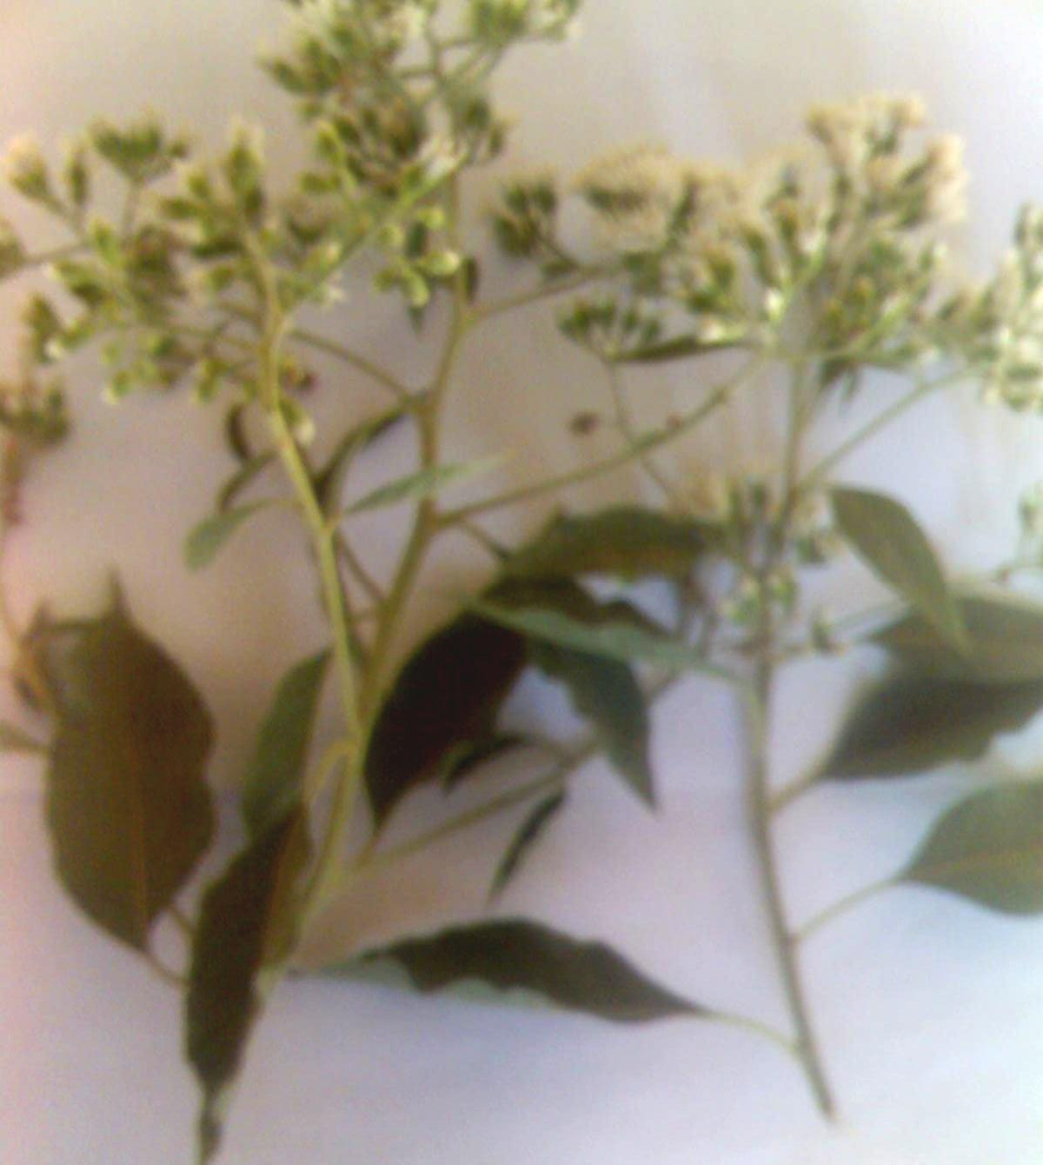

stem

leaf

Plate I: Stems, Leaves and Flowers oVfernonia amygdalina

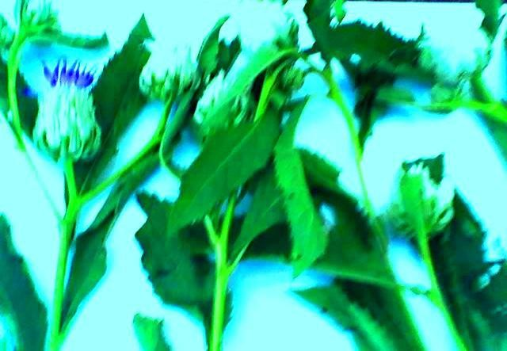

flower

leaf

stem

Plate II: Stems, Leaves and Flowers oVf ernonia kotschyana

* 1. Preparation of Vernonia amygdalinaand V. kotschyanaLeaves

Two (2.0) kg of the leaf powder of each of the two plants were obtained. They were labelled V. amygdalina and V. kotschyanaleaf powders and stored in tightly closed containers. These were subsequently used for (a) quant-ilteaatifvemicroscopy, (b) solvent extractive value determinations and (c) Soxhlet extraction.

* 1. Macroscopic Studies onVernonia amygdalinaand V. kotschyanaLeaves

Macroscopically, leaves of the two plant species were found to be alternately arranged, had simple lamni a with reticulate venation. They had acute apex, symmetrical base and pubescent surface.

The leaves oVf . amygdalina(12.0 x 5.7 cm) had long petiole, serrated margin and were lanceolate in shape while those Vo.f kotschyana(17.0 x 6.7 cm) had very shtopretiole, dented margin and were elliptical in shape with characteristic axillary buds (Figure 4.1 (a & b). Organoleptically,V. amygdalinaleaves were more greenish in colour and bitter in taste than those oVf. kotschyan.aHowever, both plants have dinisctt odour (Table 4.1; Appendix A).

acute apex

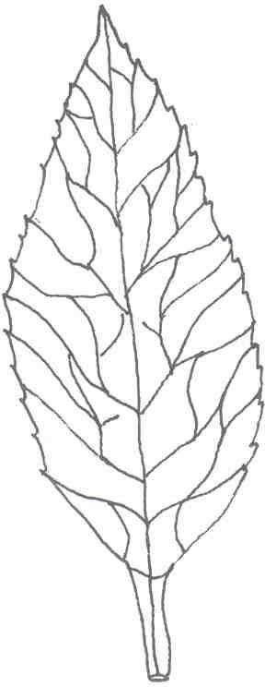

serrated margin

midrib

lamina base

long petiole

* + 1. Vernonia amygdalinaLeaf

acute apex

dentate margin

lamina bas

very short petiole



* + 1. Vernonia kotschyanaLeaf

Figure 4.1 (a & b): Vernonia amygdalinaand V. kotschyanaLeaves; x1

Note: (a) the serrated and dented margin and (b) the lanceolate and elliptical shape of

1. amygdalinaandV. kotschyanaleaf respectively.

Table 4.1: Macroscopic Features oVf ernonia amygdalinaand V. kotschyana Leaves

FEATURES DESCRIPTIONS

V. amygdalina V. kotschyana

Arrangement Alternate Alternate

Petiole Long petiole Very short petiole Lamina: i. Dimension 12.0 x 5.7 cm 17.0 x 6.7 cm

|  |  |  |
| --- | --- | --- |
| ii. Composition | Simple | Simple |
| iii Shape | Lanceolate | Elliptical |
| iv. Venation | Reticulate | Reticulate |
| v. Margin | Serrated | Dented |
| vi. Apex | Acute | Acute |
| vii. Base | Symmetrical | Symmetrical |
| viii. Surface | Pubescent | Pubescent |
| ix. Texture | Soft | Papery |

Organoleptic properties:

* 1. Colour
  2. Odour
  3. Taste

More greenish Distinct

More bitter

Greenish Distinct Bitter

* 1. Calibration of Eyepiece Micrometer

Under x40 objective the 4th0small eyepiece micrometer division coincided with theth 10 small stage micrometer division. The calibration factor was therefore calculated as:

40 small eyepiece = 10 small stage micrometer divisions micrometer divisions

Since, 1 small stage micrometer division = m1P0

40 small eyepiece = 100mP(10x10) micrometer divisions

?1 small eyepiece 1=00 mP

micrometer division 40

1 small eyepiece = 2.5mP micrometer division

?Calibration factor = 2.5 mP

* 1. Microscopic/ Chemo-microscopic/ Quantitative-leaf Microscopic Studies on Vernonia amygdalinaand V. kotschyanaLeaves
     1. Anatomical Sections and Powder of Leaves

Microscopic features identified in the leeasv of the two plants include: Anomocytic

stomata (18.6- 18.75 - V. amygdalina—andP22.05- 2L2.2Q- V.

kotschyana). Stomata with -46 subsidiary cells surrounding the guard cells occurred on the abaxial and adaxial leaf surfaces in bpoltahnts. Epidermal cells with slightly beaded wavy

anticlinal walls were found inV. amygdalina(29.85- 30.0- whereas those iVn. — P

kotschyana(37.35 - 37.5 - — P Z H U H G uniseriate multicellular coevring trichomes (62.35- 62.5 - — P midrib portion of V. amygdalinaleaf. However, unicellular and uniseriate multicellular covering trichomes (124.8-5125.0- — P D Q G

trichomes with wraty surface (87.35- 87.5- — P R F F

portions ofV. kotschyanaleaf (Figure 4.2 (a & b); Appendix B and Figure 4.3 (a & b); Appendix C).

anomocytic stomata

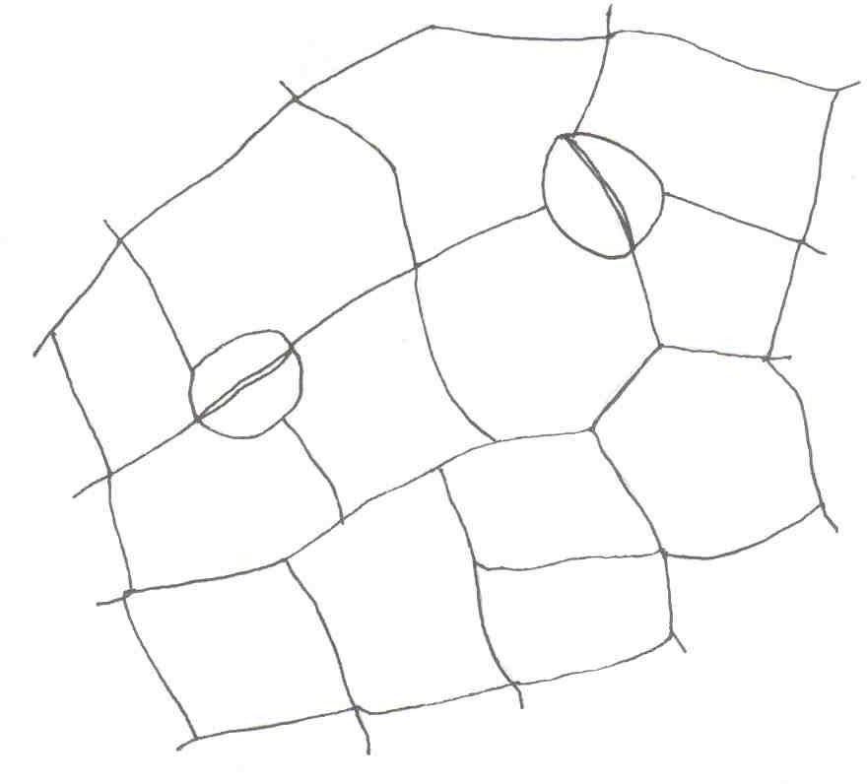

epidermal cell

* + - 1. Vernonia amygdalinaUpper Epidermis

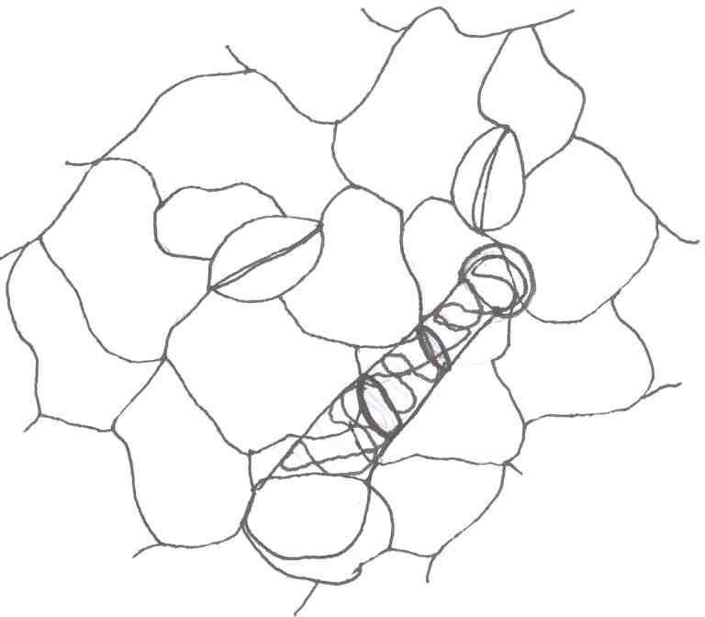

anomocytic stomata

glandular trichome

epidermal cell

* + - 1. Vernonia kotschyanaUpper Epidermis

Figure 4.2 (a & b): Surface Preparation from the Upper Epidermis ofVernonia amygdalinaand V. kotschyanaLeaves; x400

Note: (a) The anomocytic stomata in boVth. amygdalinaandV. kotschyanaupper

epidermis and (b) the glandular trichome with warty surfcVe. iknotschyanaonly.

epidermal cell

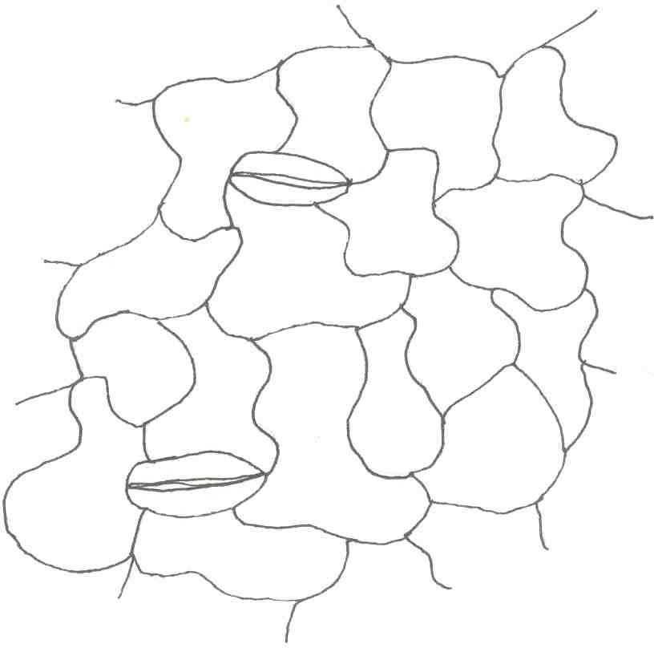

anomocytic stomata

* + - * 1. Vernonia amygdalinaLower Epidermis

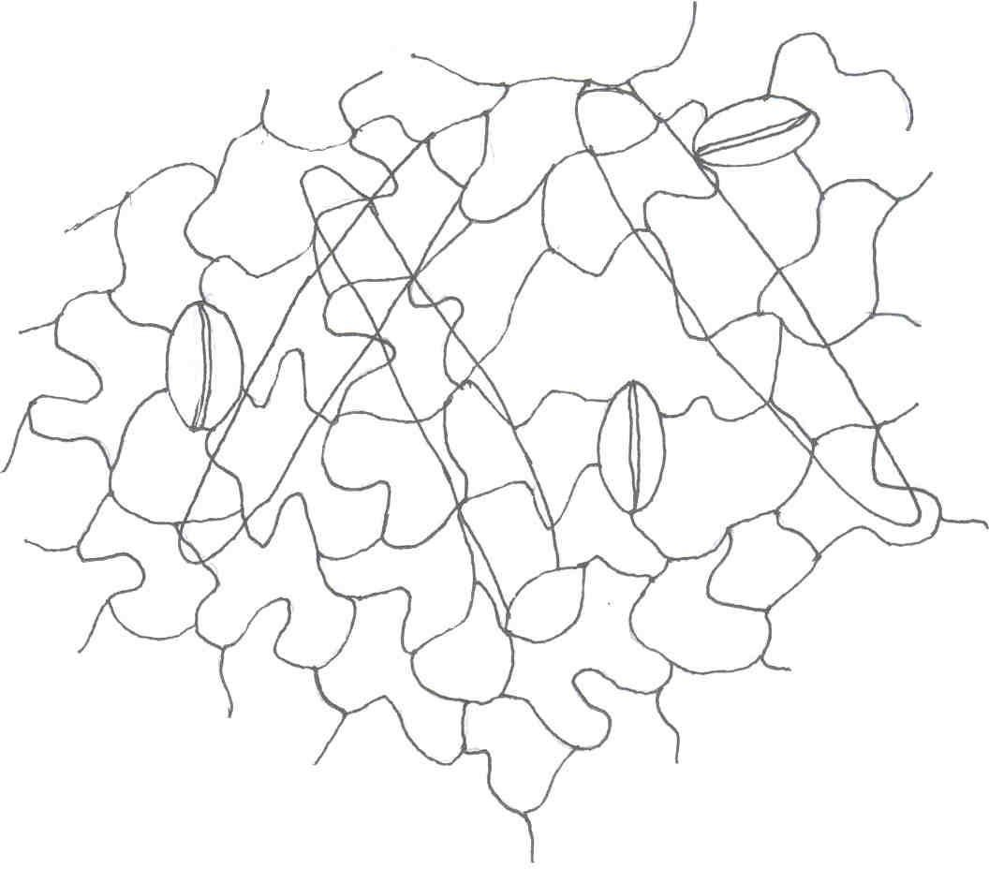

epidermal ce

anomocytic stoma

covering trichom

* + - * 1. Vernonia kotschyanaLower Epidermis

Figure 4.3 (a & b): Surface Preparations from the Lower Epidermis of Vernonia amygdalinaand V. kotschyanaLeaves; x400

Note: (a) The slightly and deeply wavy epidermal cells in the lower epidermiVs . of amygdalinaand V. kotschyanarespectively and (b) the numerous covering trichomeVs. in kotschyanaonly.

Transversely, the leaves oVf. amygdalinaand V. kotschyanawere dorsiventra. l The palisade tissues occurred beneath the upper epidermis only and were differentiated from the spongy mesophyll tissues (with much airspace in between) above the lower epidermis. Xylem elements were of the lacunar type which consist-6ofs4trands of teh conducting elements (Figure 4.4 (a & b)).