# COMPARATIVE *IN-VITRO* BIOEQUIVALENCE STUDIES OF DIFFERENT SAMPLES OF TINIDAZOLE TABLETS

**BY**

**ABDULRAHMAN, Muntaka M.Sc. / Pharm. Sci. /20531 /2012-2013**

**A DISSERTATION SUBMITTED TO THE SCHOOL OF POST GRADUATE STUDIES, AHMADU BELLO UNIVERSITY, ZARIA.**

**IN PARTIAL FULFILLMENT OF THE REQUIREMENTS FOR THE AWARD OF A**

**MASTER OF SCIENCE DEGREE IN PHARMACEUTICAL CHEMISTRY.**

**DEPARTMENT OF PHARMACEUTICAL AND MEDICINAL CHEMISTRY, FACULTY OF PHARMACEUTICAL SCIENCE,**

**AHMADU BELLO UNIVERSITY, ZARIA, NIGERIA.**

**FEBUARY, 2017**

# DECLARATION

I hereby declare that the work in this dissertation titled ―Comparative *In-Vitro* Bioequivalence Studies of Different Samples of Tinidazole Tablets.‖ was performed by me in the Department of Pharmaceutical and Medicinal Chemistry, under the supervision of Dr. Aminu Musa and Prof. A.Y. Idris. The information derived from the literature has been duly acknowledged in the text and a list of references provided. No part of this work has been presented for another degree or diploma in any institution.

**ABDULRAHMAN, Muntaka Signature Date (M.Sc./Pharm. Sci./20531/2012-2013)**

# CERTIFICATION

This dissertation titled ―Comparative *In-vitro* Bioequivalence Studies of Different Samples of Tinidazole Tablets.‖ meets the regulations governing the award of the degree of M.Sc. Pharmaceutical Chemistry of the Ahmadu Bello University, and is approved for its contribution to knowledge and literary presentation.

**(Dr. Aminu Musa) Signature Date Chairman, Supervisory Committee**

**(Prof. A.Y. Idris) Signature Date Member, Supervisory Committee**

**(Prof. A. M. Musa) Signature Date Head of Department**

**(Prof. K. Bala) Signature Date Dean, School of Postgraduate Studies**

# ACKNOWLEDGEMENT

In the name of Allah, the most Beneficent, the most Merciful. All praise be to Allah, the almighty creator, whom we worship and beseech for help. Nothing on earth nor heaven can be attainable without His due knowledge and permission, for He is Omniscient, Omnipotent and Eternal. May the peace and blessing of Allah (SWT) be upon his last messenger, our beloved prophet Mohammed (SAW), his families and companions in general, ameen.

―Honour is given to whom honour is due‖, my utmost thanks and profound gratitude goes to my brother and my mentor Dr Aminu Musa, who supervised the whole research work and supported me throughout the program, may Allah reward him abundantly. My sincere appreciation also goes to Prof. A.Y Idris for his concern, motivation, support and assistance, may Allah reward him. To Prof. Aliyu Musa, Dr Magaji, and Dr MI Abdullahi, I thank you so much for your contributions and the various roles you played toward the success of this program. May Allah reward you abundantly. You will all be remembered forever.

I also acknowledge the contributions of my parents, colleagues, friends, Malam Umar, Malam Nuhu, Malam Abdulrashid, Salis Auwal, Amina Jega¸ Nasir Ibrahim, Jibril, Simon BG, Aminu Isah, Inuwa, Hussain, Aminu, Abdulrashid Umar, Safyan, Lila and so on.

Finally, I thank and praise Allah for making it possible for me and providing me with the sufficient health and material resources I require throughout the time frame of this program which is unfortunately the most troubling, most challenging and most expensive encounter in my life so far. To my late sister, Aisha Nakano who died from sickle cell crises, may Allah grant you His paradise. You will be remembered among the historic moments that make life interesting

# ABSTRACT

Health care professionals are faced with a large number of multisource products from which therapeutically equivalent products are being selected for various reasons. Consequently, an increased availability and use of generic products has been seen during the last four decades. Like most drugs, various brands of tinidazole tablets are available in Nigeria. This research was aimed at conducting an *in-vitro* bioequivalence studies on different samples of tinidazole tablets using simulated dissolution profiles. Four tablet samples of different brands of tinidazole were randomly purchased from major pharmaceutical shops within Kaduna metropolis and coded A, B, C and D. Quality control studies were conducted on each of the samples in accordance to standard procedures. Three UV spectrophotometric methods for the determination of tinidazole in simulated gastric, intestinal and blood pH were developed and validated. *In vitro* bioavailability study was then carried out using the dissolution test in the three media on each of the four samples. Bioavailability and bioequivalence of the various samples of tinidazole were studied using the *in vitro- in vivo* correlation (IVIVC) studies. The results of the studies indicated that the four tablet samples of tinidazole passed the weight uniformity test and the percentage friability test, but the disintegration test revealed that three out the four samples (including the innovator product, sample C) disintegrated in less than 15 minutes, except sample B which showed a non-uniform pattern of disintegration and failed to disintegrate even after 15 minutes. The three developed spectrophometric methods for the determination of tinidazole in simulated gastric, intestinal and blood pH were found to be linear in the ranges of 10-60, 2.5-40, and 5-50 µg/mL respectively. The regression equations of their calibration graphs and correlation coefficient were found to be y =

0.0263x - 0.035 and 0.998, y = 0.027x + 0.057 and 0.998; y = 0.029x - 0.014 and 0.994

for the simulated gastric, intestinal and blood pHs respectively. The bioavailabilities of all the four samples as measured using IVIVC studies were found to be 100 % in simulated blood pH. The bioavailabilities of brands A, B, C and D in simulated gastric pH were found to be 66.5, 85.8, 92.7 and 72.24 % respectively. In simulated intestinal pH, the bioavailabilities were 79.79, 90.57, 78.99, and 71.07 % for samples A, B, C and D respectively. The bioequivalence of samples A, B and D as a measure of similarity factor (*f2*) with respect to sample C (the innovator product) showed differences in bioavailability patterns which indicate the four tablet samples of tinidazole are not bioequivalent and cannot be used interchangeably. This is because none of the other three samples reach the similarity level of at least 50 % when compared to the innovator sample.

In conclusion, quality control parameters of the four tablet samples of tinidazole studied were established and from the *in vitro* bioequivalent studies, the four samples of tinidazole tablets are not bioequivalent.

# TABLE OF CONTENTS

DECLARATION ii

CERTIFICATION iii

ACKNOWLEDGEMENT iv

ABSTRACT v

TABLE OF CONTENT vii

LIST OF TABLES xi

LIST OF FIGURES xii

ABBREVIATIONS xiv

CHAPTER ONE 1

* 1. INTRODUCTION 1
  2. Bioequivalence 3
  3. Pharmacokinetics 6
     1. Bioavailability 6
     2. Absorption 7
     3. Distribution 8
     4. Metabolism 8
     5. Excretion 10
  4. Theoretical Framework 11
  5. Statement of Research Problem 12
  6. Justification of Studies 13
  7. Aim and Objectives of the Research 13
     1. Aim 13
     2. Objectives 14
  8. Hypothesis 14

CHAPTER TWO 15

* 1. LITERATURE REVIEW 15
  2. General Properties of Tinidazole 15
  3. 5-Nitro Imidazole Derivatives 16
  4. Tinidazole 18
     1. Pharmacokinetics and bioavailability of tinidazole 18
     2. Methods of assessing bioavailability of tinidazole 19
     3. Analytical methods of analysing tinidazole 22
  5. Biopharmaceutics Classification System (BCS) 28
     1. Class I 30
     2. Class II 30
     3. Class III 30
     4. Class IV 31
     5. Intrinsic dissolution 32

2.6 *In Vivo* Quality Assessment of Drug Products 38

CHAPTER THREE 40

* 1. MATERIALS AND METHOD 40
  2. Materials 40
     1. Drugs 40
     2. Glass wares and accessories 40
     3. Equipment 40
     4. Reagents 41
  3. Methods 42
     1. Quality control studies of tinidazole tablets and standard powder 42
     2. UV Spectrophotometric methods development 45
     3. Validation of the developed analytical methods 46
     4. Bioequivalence and bioavailability of the samples of tinidazole tablets 47

CHAPTER FOUR 49

* 1. RESULTS 49
  2. Collection and Quality Control of Samples 49
     1. Samples 49
     2. Identification of tinidazole in tablet sample and standard powder 50
  3. Assay of Tinidazole in Tablets and Pure Standard Powder. 51
     1. Assay 51
  4. Quality Control Studies 52
     1. Weight variation: 52
     2. Friability 53
     3. Disintegration test 54
  5. Analytical Methods Development 55
     1. Wavelength of maximum absorption 55
     2. : Linearity of the methods 59
  6. In Vitro Bioavailability Studies 66
  7. In vitro-In vivo Correlation (IVIVC) Studies 66
     1. Dissolution profiles of tinidazole tablets (samples A, B, C and D) 66
     2. Determination of bioequivalence among tinidazole tablet samples using similarity factor of samples A, B, and D when compared to sample C 70

CHAPTER FIVE 73

* 1. DISCUSSION 73
  2. Quality Control 73
  3. Analytical Methods 74
  4. In vitro Bioavailability Studies 74
  5. In vitro-In vivo Correlation Studies 75

CHAPTER SIX 77

* 1. SUMMARY, CONCLUSION AND RECOMMENDATIONS 77
  2. Summary 77
  3. Conclusion 78
  4. Recommendations 79

REFRENCES 80

APPENDIX VII 93

* 1. Infrared Spectra Identification of Tinidazole Tablets and Standard Powder 94
  2. UV-Visible Spectra Identification of Tinidazole Tablets and Standard Powder 99
  3. BP 2009 specification for tinidazole identification 104
  4. Result of the Assay 104
  5. In *vitro* Dissolution studies at gastric pH using 0.1N HCl 104
  6. In *vitro* dissolution studies at intestinal pH (6.8) using phosphate buffer 106
  7. In *vitro* dissolution studies at blood pH (7.4) using phosphate buffer 108

# LIST OF TABLES

Table 4.1 Label Information of four different brands of tinidazole tablets. 52

Table 4.2 Melting point determination of tinidazole tablets and standard powder. 53

Table 4.3 Percentage content of tinidazole assayed tablets and standard powder. 65

Table 4.4 Uniformity of weight of tinidazole tablets. 66

Table 4.5 Friability test of tinidazole tablets. 67

Table 4.6 Disintegration times for tinidazole tablets in minutes. 68

Table 4.7 Validation parameters for the analytical methods. 78

Table 4.8 *In vitro* bioavailability of tinidazole tablets brands in simulated

Biological pHs. 79

Table 4.12 Similarity factor of samples A, B and D when compared to sample C

at gastric pH 83

Table 4.13 Similarity factor of samples A, B and D when compared to sample C

at intestinal pH… 84

Table 4.14 Similarity factor of samples A, B and D when compared to sample C

at blood pH………………………………………………………………., 85

# LIST OF FIGURES

Figure 2.1: Chemical Structure of Tinidazole (1-[2-(ethylsulfonyl) ethyl]-2-methyl-5-

nitroimidazole) 16

Figure 2.2: commonly used and available nitroimidazoles. 17

Figure 2.3: Nitroimidazoles under clinical trials. 17

Figure 4.1: UV spectral Scan in 0.1N HCl 56

Figure 4.2: UV spectral scan in phosphate buffer pH 6.8. 57

Figure 4.3: UV spectral scan in phosphate buffer 7.4. 58

Figure 4.4: Calibration curve of tinidazole in 0.1N HCl (gastric pH). 60

Figure 4.5: Calibration curve of tinidazole in phosphate buffer (6.8). 62

Figure 4.6: Calibration curve of tinidazole in phosphate buffer (7.4). 64

Figure 4.7: Percentage content of tinidazole dissolve from the different tinidazole tablet brands in gastric pH… 67

Figure 4.8: Percentage content of tinidazole dissolve from the different tinidazole tablet brands in phosphate buffer pH (6.8) 68

Figure 4.9: Percentage content of tinidazole dissolve from the different tinidazole tablet brands in phosphate buffer pH (7.4)… 69

Figure 7.1: IR spectra of sample A. 92

Figure 7.2: IR spectra of sample B 93

Figure 7.3: IR spectra of sample C 94

Figure 7.4: IR spectra of sample D. 95

Figure 7.5: IR spectra of sample E (Standard powder) 96

Figure 7.6: UV spectra of sample A. 97

Figure 7.7: UV spectra of sample B 98

Figure 7.8: UV spectra of sample C 99

Figure 7.9: UV spectra of sample D. 100

Figure 7.10: UV spectra of sample E (Standard powder) 101

# ABBREVIATIONS

% Per Cent

BP British Pharmacopoeia F Force

FDA Federal Drug Agency g Gram

ICH International Convention/Council on Harmonisation IP International Pharmacopoeia

kg kilogram Max Maximum µg Microgram

mg Milligram

min Minute

mL Milllitre

nm Nanometre

RSD Relative Standard Deviation s Second

oC Degree Celsius

USP United State Pharmacopoeia UV Ultraviolet

WHO World Health Organisation λ Wave Length

*f*2 Similarity Factor

|  |  |
| --- | --- |
| US FDA | United State Food and Drug Administration |
| GMP | Good Manufacturing Practice |
| BCS | Biopharmaceutical Classification System |
| AUC | Area under concentration-time curve |
| IVIVC | *In vitro- in vivo* correlation |
| CPMP | Committee for Proprietary Medicinal Products |
| SUPAC | Scale-up and post Approval Changes |
| CYP | Cytochrome enzyme |
| CDSCO | Central Drugs Standard Control Organization |
| LOD | Limit of Detection |
| LOQ | Limit of Quantitation |
| HPLC | High Performance Liquid Chromatography |
| F | Bioavailability |

# CHAPTER ONE

# INTRODUCTION

Demonstration of bioequivalence using *in vitro* dissolution test is considered to be among the most appropriate methods of ensuring therapeutic equivalence between two or more medicinal products containing the same active pharmaceutical ingredient(s) and should be conducted for assessment of medicinal products in addition to other *in vitro* assessments used for quality control purposes. Such studies need to be carefully design taking into account biopharmaceutical, ethical, medical, pharmacokinetic, analytical and statistical considerations Central Drugs Standard Control Organization (CDSCO, 2005). Bioequivalence studies are conducted on generic products in place of animal studies, clinical studies and/ or bioavailability studies (Shargel *et al.,* 2007). Throughout the world, more than 40 years of research have been devoted to characterizing the biopharmaceutical properties of drugs. Several guidelines have been published and all pharmacopoeias include a description of dissolution testing and today, dissolution studies are the most frequently used tools in the development, characterization, assessment of bioequivalence and utilization process of both immediate and controlled-release oral formulations (Dressmann *et al*., 1998). The formulation and implementation of regulations concerning bioavailability of drugs made considerable attention to correlation of *in vitro* dissolution rate with *in vivo* bioavailability **(**Emami, 2006). The main objective of an *in vitro–in vivo* correlation (IVIVC) is to serve as a surrogate for *in vivo* bioavailability studies. When *in vitro- in vivo* correlations are established on a formulation, then dissolution specifications can be used as a means of controlling the bioavailability, hence a substitute for human bioequivalence studies and support for bio waivers (Olaniyi *et al*., 2001). IVIVC defines a

direct relationship between *in-vivo* and *in-vitro* data such that measurement of an *in-vitro* dissolution rate alone is sufficient to determine the biopharmaceutical rate of the dosage form (Cardot *et al*., 2007). IVIVC studies could be employed to establish dissolution specifications, support and validate the use of dissolution methods. This is because the IVIVC includes *in vivo* relevance to the *in vitro* dissolution specifications (Akanni *et al.,* 2000). IVIVC studies can also be used for quality control in the development of new pharmaceuticals, to reduce the number of human studies during formulation development. United States pharmacopoeia defines IVIVC as the establishment of a relationship between a biological property or a parameter derived from a biological property produced by dosage form and the physicochemical property of the same dosage form. Typically the parameter derived from the biological property is AUC or C max while the physicochemical property is the *in-vitro* dissolution profile as a surrogate for human studies (Leeson *et al*., 1995). From biopharmaceutical point of view, IVIVC is a predictive mathematical treatment describing the relationship between an *in vitro* property of a dosage form (usually the rate or extent of drug release) and a relevant *in vivo* response (e.g. plasma or urine drug concentrations or amount of drug absorbed). Dissolution rate is a critical parameter of pharmaceutical dosage forms because the active pharmaceutical ingredient needs to be dissolved before it can be absorbed. *In vitro* dissolution testing is important to screen formulations during development, ensure batch-to-batch quality control during production for evaluating candidate formulations and for understanding the possible risks related to specific gastrointestinal factors such as potential for dose dumping, effects of food on bioavailability and interaction with excipients (Dressmann *et al*., 1998).

Moreover, simulated dissolution method can be employed to correlate the bioequivalence of tabulated drugs. It is essentially the numerical integration of a set of differential equations that coordinate well-characterized physical actions which occur during dissolution, including but not limited to changes in particle size distributions for both active and excipient ingredients, as well as changes in the microclimate (surface) and medium bulk pH as formulation constituents dissolve. Similarly, it track changes in the microclimate and bulk pH levels against time in addition to many experimental 'phases' as one may like to mimic the *in vivo* environment which can be helpful when trying to design an *in vitro* dissolution method to achieve a meaningful [IVIVC](http://www.simulations-plus.com/Products.aspx?pID=11&mID=12) (Dakkuri and Shah, 1982). Single Simulation is conducted based on the properties of the compound (whether measured or predicted through the ADMET Predictor Model formulation information). Simulated *in vitro* dissolution setup could easily run to predict the time course changes in amount (or percent) dissolved for any ingredient in the product. IVIVC is now recommended by various regulatory bodies applicable mostly to drug dosage forms for oral routes and sustained release products. It is also a useful tool for drug dosage form development, because a successful correlation can assist in the selection of drug formulation with appropriate and acceptable dissolution criteria depending on its predictiveness, it can serve as a forecast or surrogate for further bioequivalence studies (Pernarowski, 2005).

## Bioequivalence

In the past, dosage forms of a drug from different manufacturers and even different lots of preparations from a single manufacturer sometimes differed in their bioavailability. Such differences were seen primarily among oral dosage forms of poorly soluble, slowly absorbed drugs such as metronidazole (FLAGYL®; a 5-nitroimidazole derivative). When first

introduced, the generic form was not bioequivalent because the generic manufacturer was not able to mimic the proprietary process used to micro size the drug for absorption initially. Bioequivalence is a term in pharmacokinetics use to assess the expected *in vivo* biological equivalence of two proprietary preparations of a drug. If two or more products are said to be bioequivalent it means that they would be expected to be, for all intents and purposes, the same. Birkett (2003) defined bioequivalence by stating that, "two or more pharmaceutical products are bioequivalent if they are pharmaceutically equivalent and their bioavailabilities after administration in the same molar dose are similar to such a degree that their effects, with respect to both efficacy and safety, can be expected to be essentially the same. Pharmaceutical equivalence implies the same amount of the same active substance(s), in the same dosage form, for the same route of administration and meeting the same or comparable standards (FDA, 2011). Drug products are considered to be pharmaceutical equivalents if they contain the same active ingredients and are identical in strength or concentration, dosage form, and route of administration. Two pharmaceutically equivalent drug products are considered to be bioequivalent when the rates and extents of bioavailability of the active ingredient in the two products are not significantly different under suitable test conditions (Holford, 2003).

The United States Food and Drug Administration (FDA, 2003) has also defined bioequivalence as, "the absence of a significant difference in the rate and extent to which the active ingredient or active moiety in pharmaceutical equivalents or pharmaceutical alternatives becomes available at the site of drug action when administered at the same molar dose under similar conditions in an appropriately designed study. Bioequivalence studies are conducted for the comparison of medicinal products containing same active substance. The studies should be aimed at critically assessing the possibility of alternate use of these

products. Bioequivalence is actually the comparison of the bioavailability of two drug products. The European Committee for Proprietary Medicinal Products (CPMP) guidance on bioavailability and bioequivalence confers the concept of therapeutic equivalence as: ―A medicinal product is therapeutically equivalent with another product if it contains the same active substance or therapeutic moiety and, clinically, shows the same efficacy and safety as that product, whose efficacy and safety has been established. However, in determining bioequivalence, for example, between two or more products such as a commercially available brand products and a potential to be marketed generic product, pharmacokinetic studies are conducted whereby each of the preparations are administered in a cross-over study to volunteer subjects, generally healthy individuals but occasionally in patients. Serum/plasma samples are obtained at regular intervals and assayed for parent drug (or occasionally metabolite) concentration. Occasionally, blood concentration levels are neither feasible nor possible to compare the products (e.g. inhaled corticosteroids), then pharmacodynamic end points rather than pharmacokinetic endpoints are used for comparison. For a pharmacokinetic comparison, the plasma concentration data are used to assess key pharmacokinetic parameters such as area under the curve (AUC), peak concentration (C max), time to peak concentration (T max), and absorption lag time (t lag). Testing should be conducted at several different doses, especially when the drug displays non-linear pharmacokinetics. (Larry, 2008) In addition to data from bioequivalence studies, other data may need to be submitted to meet regulatory requirements for bioequivalence.

Such evidence may include analytical method validation and IVIVC studies **(**Amidon *et al*., 1995).

## Pharmacokinetics

Pharmacokinetic describes the time course of a drug in the body, encompassing absorption, distribution, metabolism, and excretion (also known as ADME). Simply put, it describes what the body does to the drug (Timothy, 2006). The biological, physiological, and physicochemical factors, which influence the transfer processes of drugs in the body, also influence the rate and extent of ADME of those drugs in the body (Larry, 2008). The three primary processes of pharmacokinetics are absorption, distribution, and elimination (Holford, 2003).

## Bioavailability

In the 2003 United States Food and Drug Administration (FDA) guidance, bioavailability was defined as: ―the rate and extent to which the active ingredient or active moiety is absorbed from a drug product and becomes available at the site of action. For drug products that are not intended to be absorbed into the blood stream, bioavailability may be assessed by measurements intended to reflect the rate and extent to which the active ingredient or active moiety becomes available at the site of action‖ FDA, (2003).

According to World Health Organization (WHO) guideline, bioavailability is defined as:

―the rate and extent to which the active drug ingredient or therapeutic moiety is absorbed from a drug product and becomes available at the site of drug action‖ (WHO, 1986). Bioavailability is the fraction of unchanged drug reaching the systemic circulation following administration by any route. The area under the blood concentration-time curve (AUC) is a common measure of the extent of bioavailability for a drug given by a particular route. For drugs administered orally, bioavailability is usually determined by

comparing the area under the concentration–time curve (AUC) in the systemic circulation after oral ingestion with the AUC after IV dosing.

For an intravenous dose of the drug, bioavailability is assumed to be equal to unity but for a drug administered orally, bioavailability may be less than 100 % for two main reasons namely: Incomplete extent of absorption and first-pass elimination (Iain, 2006). Moreover, bioavailability is the fractional rate and extent to which a dose of drug reaches its site of action. It’s important to distinguish between the rate and extent of drug absorption and the amount of drug that ultimately reaches the systemic circulation. The amount of the drug that reaches the systemic circulation depends not only on the administered dose but also on the fraction of the dose (*F*) that is absorbed and escapes any first-pass elimination. This fraction is the drug's bioavailability (Holford, 2003).

## Absorption

This is the movement of a drug from its site of administration into the central compartment and the extent to which this occurs. For solid dosage forms, absorption first requires dissolution of the tablet or capsule, thus liberating the drug. The clinician is concerned primarily with bioavailability rather than absorption (Iain, 2006). The rate of absorption is determined by the site of administration and the drug formulation. Both the rate of absorption and the extent of input can influence the clinical effectiveness of a drug (Holford, 2003). A fraction of the administered and absorbed dose of drug will be inactivated or diverted before it can reach the general circulation and be distributed to its sites of action If the metabolic or excretory capacity of the liver for the drug is large, bioavailability will be reduced substantially (the first-pass effect). This decrease in availability is a function of the drug physicochemical properties and anatomical site from which absorption takes place;

these anatomical, physiological, physicochemical and pathological factors can influence bioavailability and the choice of the route of drug administration (Katzung, 2004; Goodmann 2006).

Moreover, the amount of drug that enters the body depends on the patient's compliance with the prescribed regimen and on the rate and extent of transfer from the site of administration into the blood.

## Distribution

After absorption or systemic administration into the bloodstream, the drug is then distributed into interstitial and intracellular fluids depending on the physicochemical properties of the drug. The rate and extent of drug distribution into tissues depend on the cardiac output, regional blood flow, capillary permeability, and tissue perfusion (Timothy, 2006). Lipid solubility and transmembrane pH gradients are important determinants of uptake for drugs that are either weak acids or bases. However, in general, ion trapping is associated with transmembrane pH gradient which is not large because the pH difference between tissue and blood (approximately 7.0 to 7.4) is small. The more important determinant of blood-tissue partitioning is the relative binding of drug to plasma proteins and tissue macromolecules (Katzung, 2004).

## Metabolism

An alternative process that can lead to the termination or alteration of biologic activity is metabolism; it is the chemical conversion of the drug molecule, usually through an enzymatic reaction, into another chemical entity referred to as a metabolite*.* The process is also termed biotransformation (Larry, 2008). Pharmacologically active organic molecules tend to be lipophilic and remain unionized or only partially ionized at physiologic pH; the

lipophilic characteristics of drugs that promote their passage through biological membranes and subsequent access to their site of action also serve to hinder their excretion from the body. The metabolism of drugs and other xenobiotics into more hydrophilic metabolites is essential for their elimination from the body, as well as for termination of their biological and pharmacological activity. In general, biotransformation reactions generate more polar, inactive metabolites that are readily excreted from the body. However, in some cases, metabolites with potent biological activity or toxic properties are generated. Many of the enzyme systems that transform drugs to inactive metabolites also generate biologically active metabolites of endogenous compounds, for example steroid biosynthesis. Drug metabolism or biotransformation reactions are classified as either phase I, Functionalization reactions or phase II, biosynthetic (conjugation) reactions.

Phase I reactions introduce by unmasking a functional group (-OH, -NH2, -SH) or expose a functional group on the parent compound such as occurs in hydrolysis reactions. Phase I reactions generally result in the loss of pharmacological activity, although there are examples of retention or enhancement of activity. In rare instances, metabolism is associated with an altered pharmacological activity. Pro drugs are pharmacologically inactive compounds designed to maximize the amount of the active species that reaches its site of action. Inactive pro-drugs are converted rapidly to biologically active metabolites often by the hydrolysis of an ester or amide linkage. Such is the case with a number of angiotensin- converting enzyme (ACE) inhibitors employed in the management of high blood pressure. Moreover, phase II conjugation reactions lead to the formation of a covalent linkage between a functional group on the parent compound or phase I metabolite and endogenously derived glucuronic acid, sulfate, glutathione, amino acids, or acetate. These highly polar

conjugates generally are inactive and are excreted rapidly in the urine and faeces. An example of an active conjugate is the 6-glucuronide metabolite of *morphine,* which is a more potent analgesic than its parent. The enzyme systems involved in the biotransformation of drugs are localized primarily in the liver, although every tissue examined has some metabolic activity. Other organs with significant metabolic capacity include the GI tract, kidneys, and lungs (Katzung, 2004; Iain, 2006).

## Excretion

This is the irreversible removal of drug from the body and commonly occurs via the kidney or biliary tract. Drugs are eliminated from the body either unchanged by the process of excretion or converted to metabolites. Excretory organs, the lung excluded, eliminate polar compounds more efficiently than substances with high lipid solubility. Lipid-soluble drugs thus are not readily eliminated until they are metabolized to more polar compounds. The kidney is the most important organ for excreting drugs and their metabolites. Renal excretion of unchanged drug plays only a modest role in the overall elimination of most therapeutic agents because lipophilic compounds filtered through the glomerulus are largely reabsorbed into the systemic circulation during passage through the renal tubules. Substances excreted in the faeces are principally unabsorbed. Orally ingested drugs or drug metabolites excreted either in the bile or secreted directly into the intestinal tract and not reabsorbed. Excretion of drugs in breast milk is important not because of the amounts eliminated, but because the excreted drugs are potential sources of unwanted pharmacological effects in the nursing infant. Excretion from the lung is important mainly for the elimination of anesthetic gases (Katzung, 2004; Iain, 2006).

## Theoretical Framework

Accurate *in vitro* dissolution tests can be employed as a regulatory tool for the replacement of certain bioequivalence studies. The intrinsic dissolution test is a tool for determining the solubility of drugs within the scope of the BCS (Michele *et al****.,*** 2011). The introduction of the biopharmaceutics classification system in 1995 as a result of continuous effort on mathematical analysis to elucidate the kinetics and dynamics of drug processes in the gastro-intestinal track (GIT) These steps certainly reduce timelines in drug evaluation process including unnecessary drug exposure in healthy volunteers hence allowing the prediction of *in vivo* pharmacokinetics profile of orally administered drugs. It also allows solubility determination depending on the ionization characterististics of the test drug in standard buffer solutions described by the pharmacopeias to be determined using a validated assays, UV-Visible spectrophotometry is among the most frequently employed techniques in pharmaceutical analysis. It involves measuring the amount of ultraviolet or visible radiation absorbed by a substance in solution (David, 2000; Behera *et al.,* 2012).

In qualitative analysis, organic compounds can be identified by use of UV spectrophotometer, though not a very reliable tool for identification compared to infrared spectroscopy and melting points determination. Spectrophotometric technique is simple, rapid, economical, reproducible, yet reliable, moderately specific and applicable to small quantities of compounds (Behera *et al.,* 2012).

Quantitative analysis using UV/ Visible spectroscopy basically relates the concentration of analyte and the intensity of light absorbed. In addition, features of absorption spectra such as the molar absorptivity, spectral position, and shape and breadth of the absorption band are related to molecular structure and environment and therefore can be used for qualitative

analysis. With the aid of UV spectroscopy alone, methods of analysis can be developed; validated or even modification of an already existing method can be made and re-validated (Behera *et al.,* 2012).

Quantification of medicinal substance using UV spectrophotometer may be carried out by preparing solution in a clear transparent solvent and measuring it’s absorbance at suitable wavelength. The wavelength normally selected is wavelength of maximum absorption (λmax), where small error in setting the wavelength scale has little effect on measured absorbance. Ideally, concentration should be adjusted to give an absorbance of approximately 0.9 around which the accuracy and precision of the measurements are optimal (Behera *et al.,* 2012; David, 2000).Tinidazole can as well be analysed using UV spectrophotometer due to its chromophoric groups

## Statement of Research Problem

In the last four decades, there is an increased use of generic drug products in order to lower the healthcare cost. With increased availability and use of these generic drug products, prescribers are encountered with a large number of multisource products from which they have to select therapeutically equivalent products. Generic substitution is of concern not only for healthcare professionals but also for pharmaceutical industries, consumers and government officials. Many research papers have pointed out the concern regarding standards for approval of generic products, which may not always ensure therapeutic equivalence (Chen and Lesko, 2001; Boix-Montanes, 2011). The potential non equivalence of different preparations of the same drug has been a matter of concern. Reinforced regulatory requirements have resulted in few documented cases of non-equivalence between approved drug products in recent years. Several brands of tinidazole tablets exist in addition

to its several other dosage forms particularly capsules because of the claim that tinidazole capsules are more potent and well complied with, by patients than there tablet counterparts because of its bitter and metallic taste. Similarly, it is claimed that generic drugs are inferior to brand name products (WHO, 1993).

## Justification of Studies

Parasitic and bacterial infections of the gastrointestinal tract are responsible for significant morbidity and mortality worldwide (Pierce and Kirkpatric, 2009) with substantial increase of *trichomoniasis* infection among African women (Schineider *et al*., 1998).The weakness of the regulatory agencies in Nigeria may be responsible for increase in the prevalence of fake drugs. Several tablet and capsule brands of tinidazole are marketed in Nigeria. It is therefore important to carryout comparative *in-vitro* bioavailability studies of different brands of tinidazole in order to assess their bioequivalences. Biopharmaceutics classification system (BCS) is a tool associated with dissolution and absorption model which are the key parameters for control drug dissolution and absorption. The system classifies drugs on the basis of their solubility and permeability in the GIT utilizing IVIVC as a surrogate for *in vivo* availability of drugs and assist in supporting bio wavers (Drewe and Guitard, 1993). Tinidazole belong to class 3 of the biopharmaceutics classification system (BCS). It has low permeability but possess good solubility in the ranges of acidic pH.

## Aim and Objectives of the Research

## Aim

To conduct an *in-vitro* bioequivalence studies on four different tablet brands of tinidazole using their dissolution profiles in simulated biological fluids

## Objectives

* + - 1. To carry out quality control studies on four different tablet samples of tinidazole samples
      2. To develop and validate UV spectrophotometric method for the analysis of tinidazole in simulated gastric, intestinal and blood dissolution media.
      3. To carry out *in-vitro* bioavailability studies on the four different tablet samples of tinidazole in simulated gastric, intestinal and blood pH’s
      4. To study the bioequivalence and interchangeability of various samples from different brands of tinidazole tablets.

## Hypothesis

There is no significant difference in *in-vitro* bioequivalence and biopharmaceutics between the different brands of tinidazole tablets

# CHAPTER TWO

# LITERATURE REVIEW

## General Properties of Tinidazole

Tinidazole is an antiparasitic, antibacterial drug belonging to the family of nitroimidazoles with potent activity against protozoans. Chemically, it is 1-[2-(ethyl sulphonyl) ethyl] – 2- methyl – 5- nitro – 1H- imidazole with it a molecular formula of C8H13N3O4S and a molecular weight of 247.27152 gmol-1. It exist as a solid, almost white or pale yellow, crystalline powder with a melting point range of 125 to 128 °C practically insoluble in water, sparingly soluble in chloroform, acetone and methanol and has a Solubility –Log P/ Hydrophobicity of 0.7. It is stored at controlled room temperature of 20-25 °C; excursions are permitted within 15-30 °C and protected from sunlight and moisture. It is usually administered via the Oral, Rectal or Intravenous routes. Tablets are stored below 30 oC in a well-closed container (Naikwade *et al*., 2008). The British Pharmacopoeia 2009 recommends the use of melting point determination and infrared absorption spectrophotometry as the first line of identification of the pure tinidazole powder and its formulations while ultraviolet and visible absorption spectrophotometry and thin layer chromatography as second line identification.

**Figure- 2.1:** Chemical Structure of Tinidazole (1-[2-(ethylsulfonyl) ethyl]-2-methyl- 5- nitroimidazole)

## 5-Nitro Imidazole Derivatives

5-Nitroimidazoles drugs are a well-established group of antiprotozoal and antibacterial agents that have potential to inhibit the growth of anaerobic bacteria and certain anaerobic protozoa, for example *Trichomonas vaginalis*, *Entamoeba histolytica* and *Giardia lamblia* (Amit *et al*., 2013). After the discovery of imidazoles drugs, many protozoa and bacteria have developed resistance towards the older imidazoles in the market. Due to this fact, medicinal chemists work on this pharmacophore and develop new hybrid molecules which may give lead molecule for further studies. Many modifications have been done on 5- nitroimidazole nucleus and new hybrid molecules have been synthesized but yet there is a huge scope of modification for future advancement. The Imidazole moiety exhibit wide range of biological activities **(**Amit and Rawat, 2013).

The importance of imidazole is due to the fact that a significant number of drugs still in use today contain this moiety and several 5-nitroimidazole derivatives such as metronidazole, ornidazole, secnidazole, ronidazole, azomycin and tinidazole, are use in the treatment of conditions like bacterial *vaginosis*, *endometriti*s, dental infections, In combination with other antibiotic to treat H.pylori infection in peptic ulcer disease, post

operatively for anaerobic infections, protozoan infection like *giardiasis, trichomoniasis*, Hepatic & intestinal *amoebiasis*, skin and soft tissue infections, *Peritonitis*, Pneumonia and Lung abscess. Other biological activities of therapeutic importance include radio sensitizers in treatment of cancer, control of fertility and use as antitubercular agent (Gunay *et al*., 1999)**.** 5-nitroimidazole derivatives are use and tested in enzyme assays against HIV-1 recombinant reverse transcriptase; they are also tested in cell-based assays (Amidon *et al*., 2005).

Tinidazole Metronidazole Ornidazole

Secnidazole Dimetridazole

Azomycin

## Figure 2.2: Commonly used and available Nitro-imidazoles

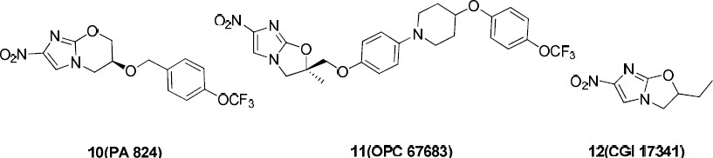

**Figure 2.3 Nitro- imidazoles under clinical trials.**

*Adapted from* [*http://en.wikipedia.org/wiki/Tinidazole*](http://en.wikipedia.org/wiki/Tinidazole)(*2013*)

## Tinidazole

Tinidazole, a synthetic nitroimidazole, is a structural analogue of metronidazole and a second generation 2-methyl- [5-nitroimidazole](http://pubchem.ncbi.nlm.nih.gov/compound/5-nitroimidazole) derivative with antibacterial and antiprotozoal property. It has been widely used with established efficacy and acceptable tolerability for the treatment of *trichomoniasis, giardiasis, amebiasis,* and *amebic liver abscess.* Oral delivery has become a widely accepted route of administration (Amit *et al.,* 2013). Although the mechanism of action has not been fully elucidated, it has been suggested that tinidazole is metabolized and yields [nitrite](http://pubchem.ncbi.nlm.nih.gov/compound/nitrite) anions and [metronidazole](http://pubchem.ncbi.nlm.nih.gov/compound/metronidazole). [Metronidazole'](http://pubchem.ncbi.nlm.nih.gov/compound/Metronidazole)s nitro group in turn is reduced via the parasite ferredoxin, thereby generating a series of free nitro radicals including nitro anions. Toxicity is achieved via depletion of sulfhydryl groups and DNA strand breaks with multiple hits having an additive effect and ultimately leading to cell death (Fung *et al*., 2005).

In another view, the nitro-group of tinidazole is reduced by cell extracts of trichomonas. The free nitro-radical generated as a result of this reduction may be responsible for the antiprotozoal activity. Chemically reduced tinidazole was shown to release nitrites and cause damage to purified bacterial DNA *in vitro*. Additionally, the drug caused DNA base changes in bacterial cells and DNA strand breakage in mammalian cells (Madhuri *et al.,* 2011)

## Pharmacokinetics and bioavailability of tinidazole

The most common route of administration of tinidazole is oral (Madhuri *et al.,* 2011) and under fasting conditions it is absorbed rapidly and completely (100 %) and distributes to all tissues and body fluids, it readily crosses the blood-brain barrier with an apparent volume of distribution of about 50 L, protein binding of 12 % and attain bioavailability

of 88 and 129 % with a mean of 99 % fallowing a single oral dose administration (Madhuri *et al.,* 2011). It has a biological half life of 12-14 hours and is significantly metabolized in humans prior to excretion. It is partly metabolized by oxidation, hydroxylation and conjugation. It is the major drug-related constituent in plasma after human treatment, along with a small amount of the 2-hydroxymethyl metabolite. Tinidazole is bio transformed mainly by CYP3A4. In an *in vitro* metabolic drug interaction study, tinidazole concentrations of up to 75 μg/mL did not inhibit the enzyme activities of CYP1A2, CYP2B6, CYP2C9, CYP2D6, CYP2E1, and CYP3A4 (Madhuri *et al.,* 2011). The plasma half-life of tinidazole is approximately 12-14 hours and concentrations similar to those found in the plasma have been achieved in bile, breast milk, CSF, saliva, and a variety of body tissues. It crosses the placenta readily. Only 12 % is reported to be bound to plasma proteins. Tinidazole is excreted by the liver and the kidneys. Tinidazole is excreted in the urine mainly as unchanged drug (approximately 20- 25 % of the administered dose). Approximately 12 % of the drug is excreted in the feces (Sweetman, 2005).

## Methods of assessing bioavailability of tinidazole

There are several direct and indirect methods of assessing bioavailability in humans. The selection of a method depends on the purpose of the study, analytical method of drug measurement, and nature of the drug product. For tinidazole, pharmacokinetics and *in vitro* dissolution methods are the most commonly employed.

* + - 1. *Pharmacokinetic method*

This is the measurement of the active drug substance or its metabolite(s) in biological fluids such as blood, plasma, urine, saliva, bile, sweat, milk, breath, faeces and other tissues.

* + - 1. *In-vitro dissolution test*

This is done in selected case where *in vitro-in vivo* correlation has been established for such drug product (Olaniyi *et al.,* 2001).

Other methods that have proved to be useful in assessing bioavailability are;

* + - 1. *Acute pharmacologic effect*

This is an acute pharmacologic effect such as effect on pupil diameter, heart rate or blood pressure can be useful as an index of drug bioavailability. This may require demonstration of dose related responses.

* + - 1. *Clinical observation*

These are observations such as lack of response (therapeutic failure) good response or toxicity in patients receiving similar drug products may be used to determine drug bioavailability.

The various pharmacokinetic parameters usually employed in evaluating bioavailability include.

*AUC*-: this is the area under the plasma concentration-time curve and it reflects the total amount of active drug reaching the systemic circulation. The total amount of drug in the systemic circulation is defined by the AUC and for drugs administered orally, the AUC is determined using the trapezoidal rule. The oral bioavailability F defines how much drug gets into the systemic circulation after oral ingestion. It is usually defined by comparison

of AUC in the systemic circulation after oral ingestion with the AUC after IV dosing, i.e. the fraction (F) of drug that gets into the body after oral (po) versus IV administration:

AUCPO

F = AUCIV

The AUC is often less after oral administration as compared with IV administration and the F may have any value up to one which indicates complete assimilation as in intravenous route but not for oral route

*C max*-: This is the maximum plasma drug concentration obtained after administration of drug.

*Half-life (t1/2)*-: is the time it takes for the plasma concentration or the amount of drug in the body to be reduced by 50 %. Also the time required to change the amount of drug in the body by one-half during elimination is called (*t*1/2) elimination. The time course of drug in the body will depend on both the volume of distribution and the clearance, so the half-life is a derived parameter that changes as a function of both clearance and volume of distribution. This is logical since the larger the Vd, the longer the t½, i.e. it takes longer to remove drug from deep within the tissues and the greater the CL, the shorter the t½. A useful approximate relationship between the clinically relevant half-life, clearance, and volume of distribution at steady state is given by

(*t*1/2) = 0.693 xVd

CL

The rate constant for elimination that reflects the fraction of drug removed from the compartment per unit of time. This rate constant is inversely related to the half-life of the drug given by the equation (*k* = 0.693/*t*1/2) (Iain, 2006).

*Clearance-:* This is the measure of the body's ability to eliminate a particular drug in a unit time; thus, clearance may decreases owing to a disease processes that affect drug metabolism and elimination.

*Volume of distribution (V)-:* this relates the amount of drug in the body to the concentration of drug (*C*) in the blood or plasma depending on the fluid measured. This volume does not necessarily refer to an identifiable physiological volume but rather to the fluid volume that would be required to contain the entire drug in the body at the same concentration measured in the blood or plasma (katzung, 2004; Iain, 2006).

Tmax –: This is the time of maximum plasma concentration, it corresponds to the time required to reach maximum drug concentration. At Tmax, rate of absorption equals rate of elimination. Absorption continues after Tmax but at a slower rate.

## Analytical methods of analysing tinidazole

Tinidazole can be quantified and analysed by several methods both *in vitro* and *in vivo*. These include spectrophotometric, chromatographic, titrimetric methods etc. Tinidazole have such chromophoric groups which will enable its analysis both in pure form and in bulk and pharmaceutical dosage forms. Spectrophotometric technique is simple, rapid, moderately specific and applicable to small quantities of compounds (Behera *et al*., 2012). It’s sensitive, easily accessible, economical, and reproducible and allows for the simultaneous estimation of two or more compounds.

* + - 1. *UV Spectrophotometry for the analysis of tinidazole*

Spectrophotometry is a method that involved the measurement or the quantitative measurement of the reflection or transmission properties of materials in a solution as a function of wavelength by determining the amount of light absorbed in the ultraviolet,

infrared, or visible spectrum (Soovali *et al*., 2006). It’s widely used in clinical chemistry to calculate the concentration of substances in solution. It is also a method to measure or quantify how much a chemical substance absorb light by measuring the intensity of light as a beam of light passes through the sample. Spectrophotometry is also be defined as a method used to measure how much a chemical substance absorbs light by measuring the intensity of light as a beam of the light passes through the sample (David, 2000) as such its quantitative measurement of the reflection or transmission properties of a chemical agent as a function of wavelength.

The Beer-Lambert law is applied to analyze concentrations of an absorbing species in solution (Soovali *et al*., 2006). Lambert's Law states that each layer of equal thickness of an absorbing medium absorbs an equal fraction of the radiant energy that traverses it. The fraction of radiant energy transmitted by a given thickness of the absorbing medium is independent of the intensity of the incident radiation, provided that the radiation does not alter the physical or chemical state of the medium. If the intensity of the incident radiation is *Io* and that of the transmitted light is *l*, then the fraction transmitted is:

*l*/*lo* = T

The % transmission is:

%T = *l*/*lo* x 100

The Beer-Lambert Law states that the concentration of a substance in solution is directly proportional to the absorbance A, of the solution.

Absorbance A = constant x concentration x cell length

The law is only true for monochromatic light that is light of a single wavelength or narrow band of wavelengths, and provided that the physical or chemical state of the substance

does not change with concentration. When monochromatic radiation passes through a homogeneous solution in a cell, the intensity of the emitted radiation depends upon the thickness (l) and the concentration (C) of the solution. Mathematically, absorbance is related to percentage transmittance T by the expression:

A = log10 (*I*o/*I*) = log10 (100/T) = KCL

Where L is the length of the radiation path through the sample, c is the concentration of absorbing molecules in that path, and k is the extinction coefficient - a constant dependent only on the nature of the molecule and the wavelength of the radiation.

While UV-Vis spectrometry is of limited use for sample identification, it is an effective tool for quantitative measurements of light in the near-ultraviolet (UV) and visible (vis) range of the electromagnetic spectrum has an energy of about 150– 400 kJ mol-1. The energy of the light is used to promote electrons from the ground state to an excited state. A spectrum is obtained when the absorption of light is measured as a function of its frequency or wavelength. Molecules with electrons in delocalized aromatic systems often absorb light in the near-UV (150–400 nm) or the visible (400–800 nm) region. Absorption spectroscopy is usually performed with molecules dissolved in a transparent solvent, such as in aqueous buffers. The absorbance of a solute depends linearly on its concentration and therefore absorption spectroscopy is ideally suited for quantitative measurements. David, 2000)

The wavelength of absorption and the strength of absorbance of a molecule depend not only on the chemical nature but also on the molecular environment of its chromophores. Absorption spectroscopy is therefore an excellent technique for following ligand-binding

reactions, enzyme catalysis and conformational transitions in proteins and nucleic acids. Spectroscopic measurements are very sensitive and non-destructive, and require only small amounts of material for analysis (Bigio and Mourant, 1997).

Tinidazole can be analysed using UV spectrophotometric methods due to its chromophoric groups and several spectrophotometric analytical methods of tinidazole analysis have been reported.

Singh *et al*., (2011) reported three methods for the analysis of tinidazole tablet dosage form using UV spectrophotometry. The first method was based on colorimetric determination of tinidazole in 0.5 N NaOH. It shows a λmax of 368.6 nm and linearity range of 20-150 µg/mL .The second method was based on direct estimation of tinidazole in 0.5 N HCl at the λmax of 279.2 nm, this method was found to be linear in the range of 50-150 µg/mL. The third method was based on difference in absorbance between tinidazole dilution in 0.5 N NaOH and tinidazole in 0.5 N HCl in reference cell, the differential absorption spectra was recorded, it shows a maxima at 368.8 and a minima at 276 nm within the range of 20-120 µg/mL. The methods were validated by determining the accuracy, precision and LOD, LOQ and recovery studies. The LOD and LOQ values for the methods are of 5.98, 15.0 µg/mL, 5.98, 19.93 µg/mL, 50.08 and 18.95 µg/mL respectively.

Kothapalli *et al*., (2011) reported another method for the estimation of tinidazole in bulk and pharmaceutical dosage form. 0.1N HCl was chosen as the solvent system and the λmax was found to be 278 nm. This method was linear in the range of 10-80 μg/mL and regression equation of the calibration graph and correlation coefficient were found to be y

= 0.026x - 0.042 and 0.999 respectively. The % RSD values for both intraday and interday precision were less than 1 %. The recovery of the drug from the sample ranged between

99.12 and 100.96 %.

Alhemiary and Saleh (2012) report two spectrophotometric methods for the determination of tinidazole either in pure form or in their tablets form using promethazine and ethyl vanillin reagents in pharmaceutical preparations. The methods were based on the reduction of the nitro group to an amino group. The reduction of tinidazole was carried out with zinc powder, zinc dust and concentrated HCl at 90 ± 5 °C for 15 min in water. Method A is based on Schiff's basses reaction using ethyl vanillin reagent and measurement of the yellow coloured species (λmax: 470 nm),whereas method B is based on oxidative coupling reaction used promethazine hydrochloride reagent and sodium hypochlorite oxidation agent in alkaline medium to form red colour measurable at 525 nm. The working conditions of both methods have been optimized. Regression analysis of Beer’s law plots showed good correlation in the concentration ranges of 5-65 and 2-50 μg/mL for methods A and B, respectively. The apparent molar absorptivity and Sandell sensitivity values he calculated are 3.214x103 and 1.028x104 l mol-1 cm-1, and 0.0769 and 0.0267 μg cm-2,with LOD 0.552 μg mL- 1and 0.285 μg mL-1, LOQ 1.840 μg mL-1 and 0.942 μg mL-1,respectively, for methods A and B. They successfully applied the methods in the determination of tinidazole in bulk drug and its formulations. As he reported, excipients used as additives in formulations did not interfere with his method and Statistical treatment of the experimental results indicated that the accuracy and precision of the methods are analytically acceptable. The validity of the methods was evaluated by parallel determination of an established procedure and recovery studies.

Rao *et al*. (2011) reported spectrophotometric methods for the determination of tinidazole formulation and serum. This method is based on the measurement of the absorbance of the signal at 368 nm yielded by bathochromic shift during alkaline hydrolysis of tinidazole in

0.1 N NaOH. The method is linear within the range of 1–30 μg mL−1, and the detection and quantification limits are 0.07 and 0.25 μg mL−1, respectively. The precision of the method, expressed as the relative standard deviation, is 0.19 % for a tinidazole concentration of 15 μg mL−1. The method was applied to the analysis of tinidazole in pharmaceutical formulations and serum.

Gummadi *et al.* (2012) reported two UV spectroscopic methods for simultaneous estimation of ciprofloxacin and tinidazole in tablet dosage form. Method A employs solving of simultaneous equations based on the measurement of absorbance at two wavelengths, 271 nm and 318 nm which are the λmax values of ciprofloxacin and tinidazole respectively in phosphate buffer (pH 6.8). Method B is based on the principle of Q-Analysis wherein the absorbance was measured at 292 nm (iso-absorptive point) and

271 nm (λ max of ciprofloxacin) in phosphate buffer (pH 6.8). Ciprofloxacin and tinidazole show linearity at all the selected wavelengths and obey Beer’s law in the concentration range of 10-35 μg/mL and 10-80 μg/mL respectively. Recovery studies for ciprofloxacin and tinidazole were performed and the percentage recovery for both the drugs was obtained in the range of 98.1-99.7 % (Method A) and 98.0-100.4 % (Method B) confirming the accuracy of the proposed method. Both the methods showed good reproducibility and recovery with % RSD less than 2.

* + - 1. *HPLC methods of analyzing tinidazole tablets*

Chromatography is a technique which separates components in a mixture due to the differing time taken for each component to travel through a stationary phase when carried through it by a mobile phase. The analytical technique of High Performance Liquid Chromatography (HPLC) is used extensively throughout the pharmaceutical industry. It is used to provide information on the composition of drug related samples. The information obtained may be qualitative, indicating what compounds are present in the sample or quantitative, providing the actual amounts of compounds in the sample. HPLC is used at all the different stages in the creation of a new drug, and also is used routinely during drug manufacture. The aim of the analysis will depend on both the nature of the sample and the stage of development. Siddartha *et al*., (2013) reported a simple high performance reversed phase liquid chromatographic method for the estimation of tinidazole in bulk drug sample and pharmaceutical dosage form. The method was developed using ss wakosil II. C18, (250 x 4.6 mm) 5 μm column with mobile phase composition of acetonitrile and phosphate buffer 3:1 (pH 5), flow rate of 1.0 mL/min and UV detection at 295 nm. Linearity of the method was observed over a concentration range of 10‐80 µg/mL. The accuracy of the proposed method was determined by recovery studies and it was found to be 101‐103 % his proposed method was validated and the results conformed to ICH parameters.

## Biopharmaceutics Classification System (BCS)

The Biopharmaceutics Classification System (BCS) is a scientific framework or tool that was created to categorize drugs into different groups according to their aqueous solubility and intestinal permeability characteristics. Through a combination of these factors and

physiological parameters, it is possible to understand the absorption behavior of a drug in the gastrointestinal tract, thus contributing to cost and time reductions in drug development, quality control as well as reducing exposure of human subjects during *in vivo* trials while screening (Brahmankar and Jaiswal, 2009). Solubility is attained by determining the equilibrium under conditions of physiological pH, while different methods may be employed for evaluating permeability. On the other hand, the intrinsic dissolution rate (IDR), may present greater correlation to the *in vivo* dissolution dynamic than the solubility test.

The bioavailability of a certain drug contained in a dosage form depends on a series of factors, including the physicochemical characteristics of its formulation and the physiological state of the patient’s gastrointestinal tract, is very important for successful treatment (Zhu *et al****.,*** 2009).There exist several characteristic properties relating to the absorption process that are worth emphasizing which include the biopharmaceutical factors viz solubility, dissolution, chemical stability, permeability, and first-pass effect. Pharmaceutical factors viz formulation, dosage form. Physiological factors viz renal clearance, biological half-life, protein binding and volume of distribution, pH, enzymes and intestinal motility. (These control the rate and the extent to which the drug reaches the site of action which in turn leads to the evaluation of solubility, permeability as well as physicochemical parameters during new drug development. In 1995, (BCS) was proposed by Amidon and his collaborators to facilitate this work. This system considers that the dissolution and intestinal permeability of the active substance are the fundamental parameters in the rate and extent of absorption. Drugs are organized into four classes according to their solubility and permeability characteristics. (Amidon *et al*., 1995).

According to the BCS, different methods can be used to evaluate solubility, intestinal permeability, and *in vitro* dissolution in the classification of drugs, and several of them are recommended by the FDA. Accordingly, drugs may be divided into four groups according to their solubility and permeability each of which presents special characteristics (Roa *et al.,* 2011).

## Class I

Drugs in this class have good permeability unless they are unstable in the gastrointestinal tract or if they undergo first-pass metabolism. Because they also have good solubility, the limiting factor for their absorption is the gastric emptying time. Immediate-release solid dosage forms that contain drugs with these characteristics are potential candidates for biowaivers from bioequivalence studies.

## Class II

Despite having good permeability, the drugs classified in this group present solubility issues, thus dissolution becomes a limiting factor in absorption. The use of well-defined formulations or pharmaceutical techniques, such as complexation with cyclodextrins or reduction in particle size, among others, may facilitate dissolution and consequently increase oral bioavailability. However, *in vitro* dissolution tests should mirror the *in vivo* dissolution properties perfectly.

## Class III

This comprises drugs with good solubility and reduced permeability; the latter is considered a limiting factor for absorption. It is important that the dosage forms that contain this type of drug release it quickly to maximize contact time with the intestinal

epithelium; however, absorption may be affected by the influence of physiological variables, such as intestinal residence time and luminal content.

## Class IV

This is the class that researchers find most challenging, because these drugs present oral bioavailability issues due to reduced solubility and permeability.

Another point to be considered is the difficulty in correctly determining solubility, whether through experimental variables such as temperature variation, filtration, and quantity of material or factors inherent to the substance itself, which can affect the result and generate considerable data dispersion. Among these factors, alterations in the crystalline structure (solvates, hydrates, and polymorphs) or the formation of salts during the test can be cited but the main purpose of the BCS is to create a regulatory tool to substitute several bioequivalence tests for *in vitro* dissolution tests (Amidon *et al.,* 1995).

* 1. ***In Vitro* Quality Assessment of Drug Products**

The quality of drug product especially oral solid dosage forms such as tablets and capsules are often assessed by carrying out certain *in vitro* tests as contained in the monographs of various pharmacopoeias. Such test include: assay of active ingredients; weight uniformity; content uniformity; hardness; friability; disintegration and dissolution tests. These are to ensure batch to batch uniformity of quality during manufacturing processes. The general assumption was that if the physical and chemical integrity of a drug product were assured, satisfactory pharmacologic or therapeutic performance would be obtained (Shargel *et al*., 2007).

## Intrinsic dissolution

Dissolution test is an *in vitro* physicochemical testing of solid oral dosage form. It determines the amount of active ingredient(s) released from a solid oral dosage from, such as from tablets or capsules, using a known volume of dissolution medium, with a predetermined length of time. The general principle of dissolution test is that the solid dosage form is tested under uniform agitation in an attempt to achieve dissolution. Agitation is accomplished by either using stirrer inside the apparatus or rotating the container holding the dosage form. *In vitro* dissolution test can be used to guide formulation development, identify critical manufacturing variables, monitor formulation quality from batch to batch, predict *in vitro* performance, monitor manufacturing process, assure batch to batch product performance and serve as a surrogate for bioavailability and bioequivalence. Skinner and Kanfer (1992) suggested that the main physicochemical aspects pertaining to drug absorption are the intrinsic dissolution rate and solubility. Because these two parameters are highly dependent on pH, their influence on absorption could easily be determined by the entire pH range of the gastrointestinal tract. Intrinsic dissolution is the dissolution of a pure active substance, and the determination of the dissolution rate can be important during the development of new molecules, because with small quantities of material, it is possible to execute the test and predict potential problems (Skinner *et al*., 1992).

Accordingly, the intrinsic dissolution rate (IDR) is defined as the dissolution rate of a pure active substance, where the conditions of surface area, temperature, agitation, and medium pH and ionic strength are all constant. Thus, it is possible to obtain data on the chemical purity and equivalence of drugs from different sources. This information is related to the

variability of raw material available on the market, which results from distinctive synthesis processes, especially in the final stages of crystallization, and may lead to different particle sizes, degrees of hydration, habits, and crystalline forms for a single drug (Milani *et al*., 2009). The IDR can be obtained by employing a specific device for this purpose, where the compressed drug is exposed in a dissolution medium over a constant surface area, and its value is expressed in mg cm-2 s-1 Applications for intrinsic dissolution tests are related to their use as a tool in the characterization of solid-state drugs, such as the determination of thermodynamic parameters associated with transition from crystalline phases, degrees of hydration, the investigation of the phenomenon of mass transfer in the dissolution process, the evaluation of the dissolution rate of a drug in different media (variation of pH or use of surfactants), and the relationship between the dissolution rate of an active substance and that of its crystalline form (Bartolomei *et al.,* 2006).

Recent studies have proved the usefulness of the IDR in determining solubility in the sphere of the BCS. Because this test is not related to equilibrium but rather to the rate, there is expected to be a greater correlation in the *in vivo* dissolution dynamic than in the solubility test. In a conventional solubility test, where a quantity of a drug is kept under constant agitation and temperature until the solution is saturated, any determination of the actual solubility of the material may be compromised because of possible occurrences of recrystallization, which may result in alteration of the crystalline form, and hydrate and solvate formation (Milani *et al*., 2009).

* + - 1. *Determination of dissolution*

The choice of dissolution apparatus varies from one drug to another, depending on the nature of the drug. Conditions employed for the *in vitro* dissolution test are made in such a way to give the best and reproducible results for the particular drug under test. Such conditions include the size and shape of the dissolution vessel, the agitation rate, temperature of the dissolution medium which for most dissolution test is temperature of 37 oC which is similar to the *in vivo* temperature. The nature and volume of the dissolution media is also important e.g. simulated gastric fluid, simulated intestinal fluid, water, 0.1N HCl, phosphate and acetate buffer depending on the nature of the drug and the location in the gastro-intestinal tract where the drug is expected to dissolve. The volume of the dissolution medium ranges from 500 mL to 1000 mL. Formulation composition and the manufacturing process generally influence in vitro drug dissolution. The BCS classifies a drug product as rapidly dissolving when no less than 85 % of the labelled amount of the drug substance dissolves in 30 min using the following USP Apparatus 1 (basket) at 100 rpm or USP Apparatus 2 (paddle) at 50 rpm. Dissolution medium volume of 900 mL or less in each of the following

1. 0.1 N HCI or simulated gastric fluid (SGF) USP without enzymes
2. A pH 4.5 buffer
3. A pH 6.8 to 9.0 buffer or simulated intestinal fluid (SIF) USP without enzymes

The similarity factor (*f*2) for test versus reference profile comparisons should be greater than 50 (i.e., *f*2 value between 50 and 100 suggests the two dissolution profiles are similar) (Singh *et al*., 2011).



Where *Rt* and *Tt* are the cumulative percentage dissolved at time point *t* for reference and test products, respectively, and *n* is the number of pool points. According to the BCS guidance, the test and reference dissolution profiles are considered similar if both products have at least 80 % dissolution in 15 min or if comparison of profiles by the *f*2 test results in an *f*2 value of at least 50. To allow for the use of mean data, the coefficient of variation should not be more than 20 % at earlier time points (e.g., 10 min) and should not be more than 10 % at other times (Singh *et al*., 2011). Dissolution performance is influenced by both the physicochemical properties of the substance and the prevailing physiological conditions in the GI tract, which varies between the fasted- and fed-states as well as within and among subjects. Within the key *in vivo* parameters influencing drug product dissolution performance There was consensus that the *f*2 test is not necessary when the two products each provide at least 85 % dissolution in 30 min. A profile comparison test (e.g., *f*2 or a single time point comparison) would be necessary when at least one product has 85

% dissolution between 30 and 60 min. The number of time points sampled need not be extraordinary; sampling can be as infrequent as every 30 min (i.e., two samples over 60 min). The *f*2 acceptance criterion (*f*2 ≥ 50) can be lowered with justification that considers underlying biopharmaceutics characteristics and risk based factors for example dissolution results from the most relevant pH (Amidon *et al.,* 2005). Using this method studies have been conducted on the *in vitro* dissolution profiles with *in vivo* pharmacokinetic

parameters of some commercial brands of aspirin tablets marketed in Nigeria (Bamigbola, 2012).

* + - 1. *Relation between dissolution test and bioavailability*

In biologic systems, drug dissolution in an aqueous medium is an important condition for systemic absorption and subsequent bioavailability. The rate at which drugs with poor aqueous solubility dissolve from an intact or disintegrated solid dosage form in the gastro intestinal tract often controls the rate of systemic absorption of the drug.

Dissolution therefore, is the process by which a drug substance is released from the dosage form into a dissolution medium. A drug administered in a tablet or capsule form must be released, dissolved and reach its site of action before it can exert a pharmacological response.

Dissolution of drug in the body represents the end of the release process and precedes the absorption of drugs from solid dosage forms. Various theories of tablet dissolution that have been proffered include: The diffusion layer model, the Noyes-Whitney theory, the Wagner’s, the Kitazawa, the El-Yazigi, the Carstensen’s theories, the Danckwert’s model (Olaniyi *et al*., 2001). Edwards in 1951 was the first to appreciate that following the oral administration of solid dosage forms, if the absorption process of drug from the gastrointestinal tract is rapid, then the rate of dissolution of that drug can be the step which controls its appearance in the body. In fact, he postulated that the dissolution of an aspirin tablet in the stomach and intestine would be the rate process controlling the absorption of aspirin into the blood stream (Edwards *et al*., 1951). However, Nelson in 1957 was the first to explicitly relate the blood levels of orally administered theophylline salts to their *in vitro* dissolution rate (Nelson, 1957). He used a non-disintegrating drug pellet, (mounted

on a glass side so that only the upper face was exposed), placed at the bottom of a 600 mL beaker in such a manner that it could not rotate when the dissolution medium was stirred at 500 rpm. In mid 1960s to early 1970s a number of studies demonstrating the effect of dissolution on the bioavailability of a variety of drugs were reported in the literature. Two reports were published in 1963 and 1964 drawing attention to the lack of full clinical effect for two brands of tolbutamide marketed in Canada (Levy *et al.,* 1980). These tablets were shown to have long disintegration times as well as slow dissolution characteristics (Levy, 1980). Besides, a slight change in formulation of an experimental tolbutamide preparation was shown to produce significantly lower blood levels and hypoglycemic effect (Varley, 1968). Martin *et al.* (1968) reported significant differences in the bioavailability between different brands of sodium diphenylhydantoin, chloramphenicol and sulfisoxazole.

MacLeod *et al.* (1972) reported greater than 20 % difference in peak concentration and area under the serum concentration–time curve for three ampicillin products. In late sixties it was realized that differences in product formulation could lead to large differences in speed of onset, intensity and duration of drug response. At that time the term

―bioavailability‖ was coined to describe either the extent to which a particular drug is utilized pharmacologically or, more strictly, the fraction of dose reaching the general circulation (Lobenberg *et al.,* 2000)

Dissolution kinetics of a drug product can be influenced by various factors such as

1. The physicochemical characteristics of the drug substance e.g. particle size, particle shape, polymorphism, crystal form, salt ester formation.
2. Formulation factors such as the nature and amount of excipients e.g. diluents, disintegrants, binders, lubricants, etc.
3. Manufacturing procedures such as the method of granulation, the size and density of the granules, moisture content, age of the granules, compressional force used in tabletting process, the quality of the personnel, the sophistication of the equipment and level of in process quality control (Olaniyi *et al*., 2001).

Drug in the body particularly, in the gastrointestinal tract, is considered to be dissolving in an aqueous environment. Therefore, temperature of the medium and the agitation rate also affect the rate drug dissolution. The *in vivo* temperature is maintained at a constant temperature of 37 oC, and the agitation (primarily peristaltic movement in the gastrointestinal tract) is reasonably constant (Olaniyi, 2000; Olaniyi *et al*., 2001).

## *In Vivo* Quality Assessment of Drug Products

In addition to the *in vitro* quality assessment of drug products as prescribed in various pharmacopeias, *in vivo* bioavailability requirement is now an essential parameter in quality control of a number of medicinal products, particularly, those which have low or high therapeutic index or those which are poorly water soluble. This became necessary in view of apparent inadequacy of the *in vitro* pharmacopoeia tests which did not take into consideration whether or not the active ingredient would be released from the dosage form, or at what rate it gets into the biologic system **(**Olaniyi, 2000). Many formulations were produced and marketed that satisfied all the required legal standards but which were not therapeutically active **(**Akanni *et al*., 1993).

Events and certain realizations have revealed that percentage chemical strength was not the sole criterion for clinical effectiveness. It became obvious that a dosage form must not

only contain the correct amount of labelled drugs, but must also release the drugs on administration for absorption in the patient. So apart from chemical purity and percentage strength, bioavailability, clinical efficacy and safety became additional criteria for effective product development. It is now recognized that various physicochemical properties and formulation factors can influence the biologic availability of medicaments from dosage form in the body system (Olaniyi *et al****.,*** 2001).

# CHAPTER THREE

# MATERIALS AND METHOD

## Materials

## Drugs

Four different samples of tinidazole tablets (500 mg) and standard powder of tinidazole.

## Glass wares and accessories

2×250 mL Extraction tubes (Pyrex England) 2×100 mL measuring cylinders (Pyrex England)

2×100 mL and 2×250 mL conical flasks (Pyrex England) 2×25 mL and 2×50 mL beakers (Pyrex England)

6×10 mL test tubes (Pyrex England)

6×15 mL centrifuge tubes (Pyrex England)

2×25 mL, 2×50 mL and 2×100 mL volumetric flasks (Pyrex England) 20×Filter paper

## Equipment

Electronic weighing balance (Metlers Pr 63 Switzerland). Tablet friabilator (Erweka TA3, Germany).

Disintegration apparatus (Erweka G.M.B.H Germany)

Tablet hardness tester (Monsanto, Philip Harries Ltd, England) Centrifugation machine (Gallen Kamp, Philip Harries Ltd, England) Gallen Kamp Hot Air Oven (Philip Harries Ltd, England)

Porcelain pestle and mortar

Thermometer (Mc Donald Scientific International, England)

Dissolution machine (DA-6D, Veego Scientific devices Mumbai, India) UV Spectrophotometer (Helios Zeta and Model 164617)

Stop watch (Smith England clock system)

## Reagents

Glacial acetic acid (BPH Chemical, England) Distilled water (BPH Chemical, England) Methanol (BPH Chemical, England) Disodium Hydrogen Orthophosphate Potasium Dihydrogen Orthophosphate Sodium Chloride (BPH Chemical, England) Conc. HCl (BPH Chemical, England)

KOH pallet (BPH Chemical, England)

The solvent used for solubility studies of tinidazole tablets and standard powder are; distilled water, 0.1N HCl, Methanol, Chloroform, glacial Acetic acid and Acetone.

* + - 1. *Preparation of buffer solutions Stock solution of tinidazole*

A quantity of pure tinidazole powder (0.01 g) was weighed and transferred into a 100 mL beaker containing 100 mL of 0.1N HCl solution to prepare a stock solution of 100 µg/mL. This was also performed using the phosphate buffer solutions prepared.

*Simulated gastric PH* (2/3).

50 mL of 2M HCl was measured using a 50 mL volumetric flask, transferred into 1 litre volumetric flask containing sufficient distilled water and then made up to 1litre with distilled water.

*Simulated Intestinal PH (6.8)*

28.80 g of disodium hydrogen orthophosphate and 11.45 g of potassium dihydrogen orthophosphate were weighed and dissolved in sufficient distilled water and then transferred into a 1litre volumetric flask and make up to 1litre.

*Simulated Blood PH (7.4)*

13.8 g of disodium hydrogen orthoposphate, 1.9 g of potassium dihyrogen orthophosphate and 80 g of sodium chloride were weighed on a scale and transferred into 1000 mL of distilled water and made to dissolve with stirring to ensure content uniformity

## Methods

## Quality control studies of tinidazole tablets and standard powder

* + - 1. *Acquisition of tinidazole tablets and standard powder*

Four samples of tinidazole tablets were purchased from the major pharmaceutical Shops in Kaduna metropolis and were then coded as A, B, C and D. Samples C is the reference listed or innovator product, addresses of manufacturers, batch numbers, manufacturing dates and expiry dates were recorded for all the samples and only products within the expiry date were used. Similarly the standard tinidazole powder was obtained from Pharmaceutical Chemistry Department, University of Lagos, Nigeria.

* + - 1. *Identification test*

Tinidazole was identified in the standard powder in according to BP 2009 as follows; a quantity (0.2 g) of the tinidazole powder was weighed and divided into two separate portions. One of the portions was used for Melting point determination while the other for FTIR spectral analysis. Thereafter, another 10 mg was weighed and dissolved into 100 mL of methanol, (1 mL) of the resulting solution was pipetted and diluted to 10 mL with the

same solvent. Absorbance of the solution was taken between the UV ranges of 220 to 350 nm; the wavelength of maximum absorption was recorded.

Tinidazole was then identified in the entire tinidazole tablet samples procured in accordance to BP 2009 specification as follows; three tablets were randomly picked from each tablet brand and powdered using a porcelain pestle and mortar. A quantity of the powder equivalent to 0.5 g of the tinidazole was weighed and extracted with 20 mL acetone; the extract was then heated on a water bath and allowed to dry. Two separate portions were taken for Melting point determination and FTIR spectral analysis. Thereafter 10 mg equivalent was separately measured and dissolved into 100 mL of methanol, (1 mL) of the resulting solution was pipetted and diluted to 10 mL with the same solvent. Absorbance of the solution was taken between the UV ranges of 220 to 350 nm; the wavelength of maximum absorption was recorded.

* + - 1. *Assay of tinidazole in tablet and standard powder*

BP 2009 method of tinidazole assay was adopted as follows: for the standard tinidazole powder, 0.150 g of the standard powder was weighed and dissolved in 25 mL of anhydrous acetic acid R and two drops of crystal violet indicator was added. This was then titrated with 0.1 M perchloric acid.

For assay of the tablets, a quantity equivalent to 0.150 g of tinidazole was weighed and dissolved in 25 mL of anhydrous acetic acid R and two drops of crystal violet indicator was added then titrated with 0.1 M perchloric acid. End-point was determined by yellowish green coloration. Each 1 mL of 0.1 M perchloric acid consumed is equivalent to

24.73 mg of C8H13 N3O4S.

* + - 1. *Uniformity of weight*

Twelve (12) tablets from each sample were individually weighed on an analytical balance. The mean weights were calculated followed by percentage deviation from the mean weight.

* + - 1. *Disintegration test*

Six tablets were randomly selected from each sample and respectively placed in the six basket units of Erweka disintegration machine, containing 0.1 N HCl solution, maintained at a temperature of 37 ± 0.5 0C. The time taken for all the tablet particles in each unit to pass through the mesh was recorded. The mean time for the six tablets was taken as the disintegration time.

* + - 1. *Friability test*

Roche friabilator was used to carry out the friability test, Ten tablets from each sample were taken and weighed and then placed on the friabilator, which was then operated for four (4) min at 25 rpm (100 revolutions). The tablets were de-dusted, reweighed and the difference in tablet weight was determined and percentage friability was calculated as follows:

Friability (%) = (W1- W2 / W1) 100

Where, W1 = original weight and, W2 = final weight

* + - 1. *In vitro bioavailability studies*

The *in vitro* bioavailability of each sample of tinidazole tablets was studied by determining its dissolution rate at 37 0C in simulated gastric pH (0.1 N HCl ), simulated intestinal pH (phosphate buffer pH 6.8) and simulated blood pH (phosphate buffer 7.4). The Erweka dissolution apparatus used is maintained at 37± 0.5 0C. The basket was

rotated at a rotational speed of 100 rpm.5 mL samples were withdrawn at every 10 minutes interval and replaced by 5 mL of same solvent. The tinidazole samples collected were tested spectrophotometrically to obtain the absorbencies which will be converted into concentration terms using the developed and validated methods. The concentrations obtained will be used to determine the area under concentration-time curves (AUC) for each of the simulated pHs.

All measurements were conducted in triplicates.

## UV Spectrophotometric methods development

* + - 1. *Determination of wavelength of maximum absorption Method 1: Tinidazole in 0.1N HCl*

A solution (10 µg/mL) of pure tinidazole was prepared in 0.1N HCl and scanned through the workable wavelength of (200-400 nm) so as to obtain the wavelength of maximum absorption. A calibration curve of tinidazole in 0.1 N HCl was prepared by preparing serial dilutions of 60, 50, 40, 30, 20 and 10 µg/mL from the stock solution of tinidazole. The absorbances of the solutions were determined at the wavelength of maximum absorption recorded. The absorbance obtained were plotted against their corresponding concentrations with the aid of Microsoft excel 2007.

*Method 2: Tinidazole in phosphate buffer pH 6.8*

A solution (10 µg/mL) of pure tinidazole was prepared in the phosphate buffer pH 6.8 prepared and scanned through the workable wavelength of (200-400 nm) so as to obtain the wavelength of maximum absorption. A calibration curve of tinidazole in phosphate buffer pH 6.8 was prepared by preparing serial dilutions of 40, 20, 10, 5 and 2.5 µg/mL from the stock solution of tinidazole. The absorbences of the solutions were determined at

the wavelength of maximum absorption recorded. The absorbences obtained were plotted against their corresponding concentrations with the aid of Microsoft excel 2007.

*Method 3: Tinidazole in phosphate buffer pH 7.4*

A solution (10 µg/mL) of pure tinidazole was prepared in the phosphate buffer pH 7.4 prepared and scanned through the workable wavelength of (200-400 nm) so as to obtain the wavelength of maximum absorption. A calibration curve of tinidazole in phosphate buffer pH 7.4 was prepared by preparing serial dilutions of 50,40,30,20, 10 and 5 µg/mL from the stock solution of tinidazole. The absorbances of the solutions were determined at the wavelength of maximum absorption recorded. The absorbances obtained were plotted against their corresponding concerntrations with the aid of Microsoft excel 2007.

## Validation of the developed analytical methods

The developed method was validated for its linearity, precision, accuracy and percentage recovery according to ICH guideline.

* + - 1. *Linearity*

This was established by least square method using Microsoft excel 2010.

* + - 1. *Precision*

This was done by actual determination of 6 replicates of a fixed concentration of the drug (10 μg/mL) within the Beer’s range and finding out the absorbance by the proposed methods. It consists of;

*Intra-day precision (within day precision)*:

This essentially consists of determining the absorbance of 10 μg/mL buffered solutions for six times at the interval of one hour.

*Inter-day precision (between day precision):*

This essentially consists of determining the absorbance of 10 μg/mL buffered solutions three times for three different days.

* + - 1. *Accuracy*

The accuracies of the proposed methods were tested by standard addition method and recovery studies method. In the standard addition method utilised, 10 µg/mL stock concentration of pure tinidazole powder was prepared and analysed repeatedly for five different times while in recovery studies method, 80, 100, and 120 % of the stock was prepared by adding 4.4, 2.5 and 1.2 mL to make up 5 mL of 15µg/ml solution contained in three 10 mL test tubes thereby yielding 8, 10 and 12 µg/mL solutions. It then expressed as

% relative error using**:** (% Er) = X-µ /µ x100

## Bioequivalence and bioavailability of the samples of tinidazole tablets

The bioequivalence of each tablet sample was compared in relation to the innovator product (sample C) by determining the similarity factor (*f*2) of their dissolution profiles which is achieved by the following formular.



Where:

*f* 2 is the similarity factor for test against the reference dissolutions profiles

*Rt* is the cumulative percentage dissolved at different time points *t* for reference sample (sample C)

*Tt* is the cumulative percentage dissolved at different time points *t* for test products, samples A, B and D respectively, and *n* is the number of pool points.

Note: According to the BCS guidance, the test and reference dissolution profiles are considered similar if both products have at least 80 % dissolution in 15 min or if comparison of profiles by the *f*2 test results in an *f*2 value of at least 50.

The oral availability is determined by comparing the dissolution in the simulated gastric and simulated intestinal pHs to that of simulated blood pH which represent the intravenous dosing. i.e. the fraction (F) of drug that gets into the body after oral (po) versus IV

administration:

F = AUCPO

AUCIV

# CHAPTER FOUR

# RESULTS

## Collection and Quality Control of Samples

## Samples

The tablets purchased were checked to ensure that they are taken in good shape and properly labelled. The manufacturing and expiration dates the four samples of tinidazole studied as shown in Table 4.1**:**

## Table 4.1: Label Information of four different samples of tinidazole tablets

|  |  |  |  |  |
| --- | --- | --- | --- | --- |
| **S/№** | **Product code** | **Batch №** | **Mfg. Date** | **Exp. Date** |
| 1 | Sample A | A063E1005 | Oct-11 | Dec 2015 |
| 2 | Sample B | 12TNX07 | Aug-12 | Jul 2016 |
| 3 | Sample C | N-4001 | Jun-14 | Feb- 2016 |
| 4 | Sample D | J3044 | Feb-13 | Oct- 2016 |

## Identification of tinidazole in tablet sample and standard powder

* + - 1. *Melting point determination*

The extracted portion of the different tablet samples alongside the pure standard tinidazole powder were identified by determining their melting points as in Table 4.2

## Table 4.2: Melting point determination result

|  |  |  |
| --- | --- | --- |
| **S/No** | **Brands** | **Temp. Range 0C** |
| **1** | A | 127-130 |
| **2** | B | 126-129 |
| **3** | C | 124 -127 |
| **4** | D | 126-129 |
| **5** | Std powder | 124-127 |

Note: The melting point range of tinidazole is between 125 to 128 °C (BP 2009)

* + - 1. *Infrared spectroscopic identification of tinidazole tablets and standard powder*

The extracted portion of the different tablet samples alongside the pure standard tinidazole powder were identified by running their IR spectra’s and the result represented in Figures

* 1. to 7.5 at the appendix section.
     + 1. *UV -Visible spectroscopic identification of tinidazole tablets and standard powder*

All the tablet samples and the standard powder UV spectroscopic identification method passed the identification test as their absorbance is within the spectral range of 220 nm to

350 nm and absorption maximum of 310 nm (BP 2009) as indicated in the figures 7.6 to

7.10 in the appendix section.

## Assay of Tinidazole in Tablets and Pure Standard Powder.

## Assay:

Not all the brands passed the test as their % content slightly deviate from the acceptable limit of (95-105 %.) Brands B and D were very close to passing (Table 4.3).

**Table 4.3: Percentage content of tinidazole assayed in tablet samples**

|  |  |  |
| --- | --- | --- |
| **Brands** | **% content** | **Remark** |
| Brand A Brand B Brand C Brand D  Std powder | 101  94.56  100.7  94.56  98.1 | Passed Failed Passed Failed  Passed |

## Quality Control Studies

## Weight variation:

All the samples passed the weight variation test as their percentage mean deviation was less than 5 % as illustrated in Table 4.4

## Table 4.4: Uniformity of weight (mean ± SD) and their mean percentage deviation

|  |
| --- |
| **Brands Weight Variation(g) ± SD % Mean Deviation**  **( n=20)** |
| Brand A 0.68 ±0 .02 0.045  Brand B 0.75 ± 0.023 0.015  Brand C 0.67 ± 0.015 0.005  Brand D 0.70 ± 0.02 0.006 |

**Note:** Acceptable limit of weight uniformity test is less than 5 % of the mean percentage deviation

## Friability

All the samples passed the friability test with percentage friability’s of less than 1 % weight difference as shown in table 4.5

## Table 4.5: Friability test

|  |  |  |  |  |  |
| --- | --- | --- | --- | --- | --- |
| **S/no** | **Samples** | **Initial weight (g)** | **Final weight (g)** | **Difference (g)** | **Percentage** |
| **1** | Sample A | 3.40 | 3.40 | 0.00 | 0.00 |
| **2** | Sample B | 3.88 | 3.88 | 0.00 | 0.00 |
| **3** | Sample C | 3.38 | 3.37 | 0.01 | 0.296 |
| **4** | Sample D | 3.50 | 3.50 | 0.00 | 0.00 |

**Note:** Normal friability value for uncoated tablets is less than 1 % of the tablet initial weight

## Disintegration test

The disintegration test result (in minutes) as illustrated in Table 4.6

## Table 4.6: Disintegration time in minutes.

|  |  |  |  |  |
| --- | --- | --- | --- | --- |
| **S/No** |  | **Disintegration times (minutes)** | |  |
| **Tabs** | **Sample A** | **Sample B** | **Sample C** | **Sample D** |
| **1** | **4.38** | **11.00** | **7.15** | **4.40** |
| **2** | **4.40** | **50. 29** | **7.10** | **3.30** |
| **3** | **4.50** | **31.20** | **9.10** | **3.10** |
| **4** | **4.50** | **35.50** | **12.20** | **4.00** |
| **5** | **4.50** | **36.30** | **14.15** | **4.10** |

**Note:** Normal disintegration time for uncoated tablets is less than 15 minutes

## Analytical Methods Development

## Wavelength of maximum absorption

The wavelength of maximum absorption for tinidazole in 0.1N HCl, phosphate buffers pH

6.8 and pH 7.4 were found to be 275, 279 and 278 nm respectively as shown in their UV spectra ( figures 4.1 to 4.3)

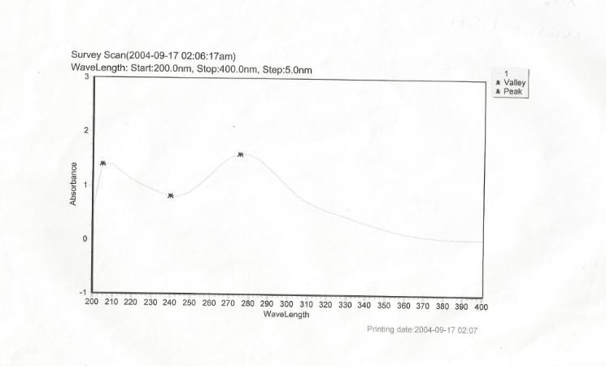

**Figure 4.1: UV spectrum of tinidazole in 0.1 N HCl**

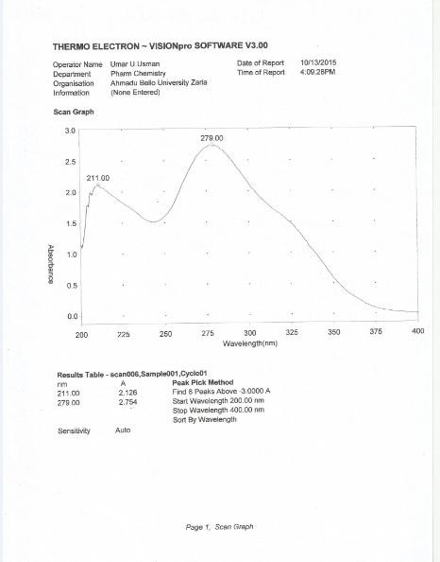

**Figure 4.2: UV spectrum of tinidazole in phosphate buffer pH 6.8**

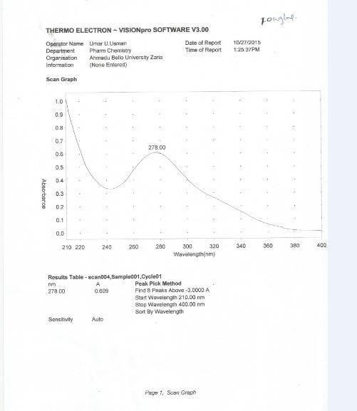

**Figure 4.3: UV spectrum of tinidazole in phosphate buffer 7.4**

## : Linearity of the methods

The methods were found to obey Beer lamberts’ law within the concentration ranges used for the calibration curve in each dissolution media.

* + - 1. *Linearity of tinidazole in 0.1N HCl (simulated gastric pH)*

The calibration curve of tinidazole in 0.1N HCl (figure 4.4) gave a very good linearity in the concentration range of 10-60 µg/mL. The regression equation of (y = 0.263x-0.035) and the plot of the concentration against absorbencies gave a correlation coefficient (r) of 0.998.

N.B: **r =√r2**

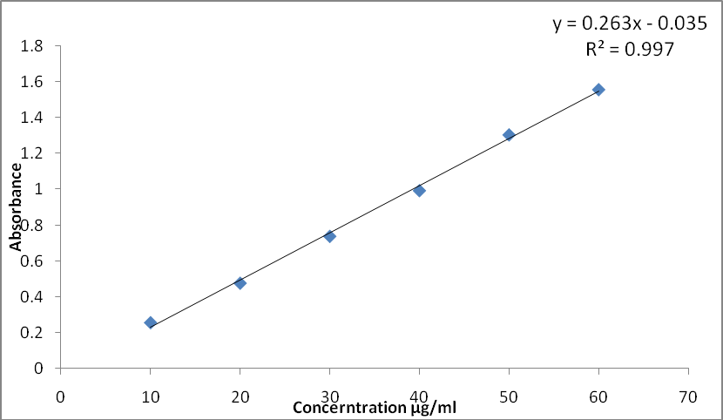

## Figure 4.4: Calibration curve of tinidazole in 0.1N HCl (Simulated gastric pH)

* + - 1. *Linearity of tinidazole in phosphate buffer 6.8 (Simulated intestinal pH)*

The calibration curve of tinidazole in phosphate buffer pH 9.0 (figure 4.5) gave a very good linearity in the concentration range of 2.5-40 µg/mL. The regression equation of (y = 0.27x+0.057) and the plot of the concentration against absorbencies gave a correlation coefficient (r) of 0.998.

N.B: **r =√r2**

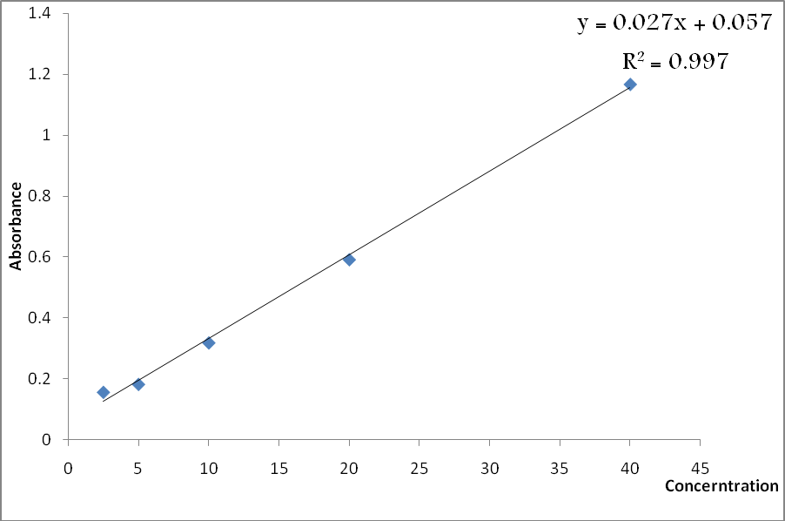

## Figure 4.5: Calibration curve of tinidazole in phosphate buffer 6.8 (Simulated intestinal pH)

* + - 1. *Linearity of tinidazole in phosphate buffer of pH 7.4 (Blood pH)*

The calibration curve of tinidazole in phosphate buffer 7.4 (simulated blood pH) (figure 4.6) gave a very good linearity in the concentration range of 5-50 µg/mL. The regression equation of (y = 0.29x-0.014) and the plot of the concentration against absorbencies gave a correlation coefficient (r) of 0.995.

N.B: **r =√r2**

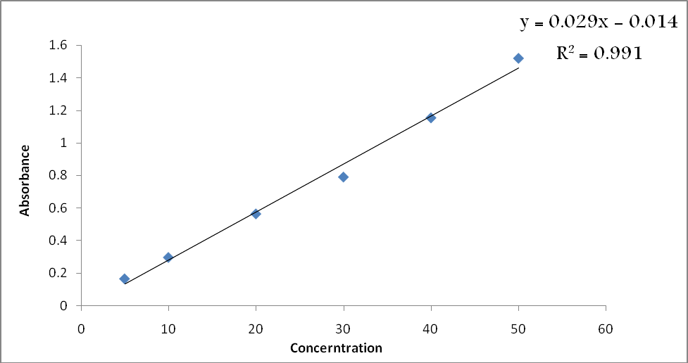

## Figure 4.6: Calibration curve of tinidazole in phosphate buffer 7.4 (Simulated blood pH)

**Table 4.7: Validation parameters for the analytical methods**

|  |  |  |  |
| --- | --- | --- | --- |
| **Parameters** | **0.1N HCl method** | **Po4 buffer pH 6.8** | **Po4 buffer pH 7.4** |
| **Accuracy (% Er)** | 3.80 | 4.165 | 4.14 |
| **Presicision (% RSD) Interday**  **Intraday** | 0.3205  0.3087 | 0.8899  0.3520 | 1.1445  0.8102 |

N.B: Accuracy (% Er) **=** Percentage Relative Error (acceptable range < 5 %).

% RSD = Percentage Relative Standard Deviation < 2 %.

* 1. ***In Vitro* Bioavailability Studies**

The *in-vitro* bioavailabilities for each of the tablet samples in simulated gastric, intestinal and blood pH are shown in Table 4.8. All the tablet brands attained an *in vitro* bioavailability of 100 % in simulated blood pH. However, in simulated gastric and intestinal pH, varying bioavailabilities were observed (Table 4.8) detail calculations of the bioavailabilities are shown in appendix.

## Table 4.8: *In vitro* bioavailability of tinidazole tablets in simulated biological pHs

Bioavailability (%)

|  |  |  |  |
| --- | --- | --- | --- |
| **Samples** | **Simulated gastric pH** | **Simulated intestinal pH** | **Simulated blood pH** |
| **A** | 66.49 | 79.97 | 100 |
| **B** | 85.80 | 90.57 | 100 |
| **C** | 92.69 | 78.99 | 100 |
| **D** | 72.24 | 71.07 | 100 |

* 1. ***In vitro-In vivo* Correlation (IVIVC) Studies**

## Dissolution profiles of tinidazole tablets (samples A, B, C and D)

The dissolution profiles of tinidazole tablets in the simulated gastric, intestinal and blood pH are shown in the figures 4.7 to 4.9

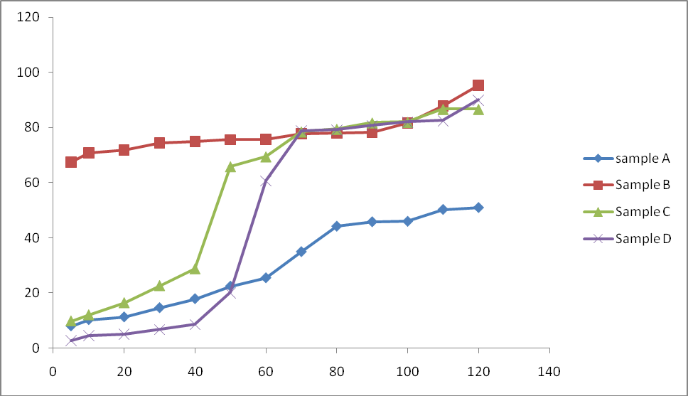

Time

**Figure 4.7: Percentage content of tinidazole dissolved from the different tablet samples of tinidazole in simulated gastric pH**

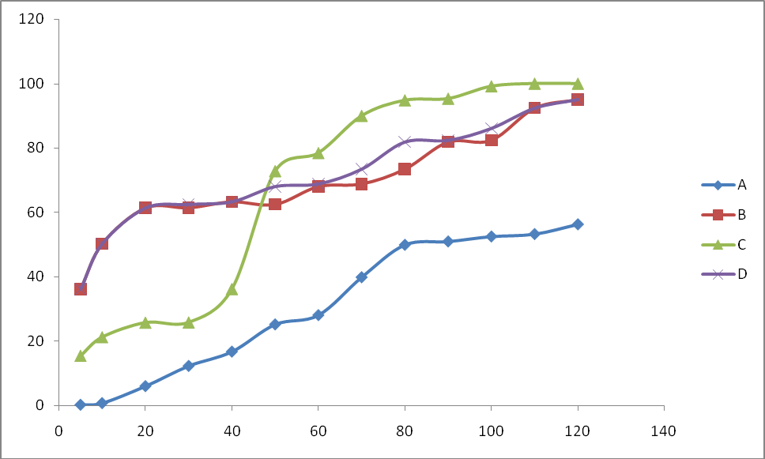

Time

**Figure 4.8: Percentage content of tinidazole dissolved for the different tablet samples of tinidazole in phosphate buffer 6.8 (Simulated intestinal pH)**

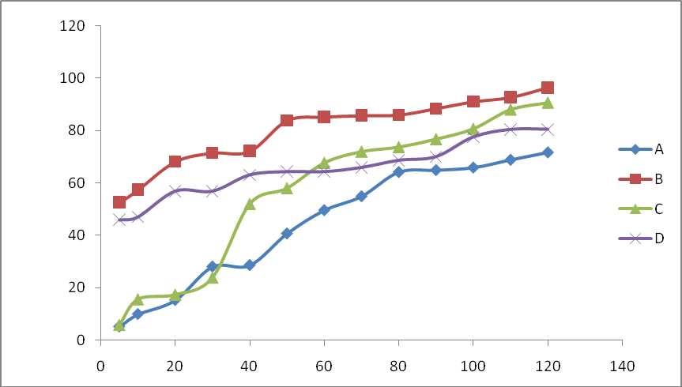

Time

P

e r c e n t a g e

d i s s o v l e d

**Figure 4.9: Percentage content of tinidazole dissolved for the different tablet samples of tinidazole in phosphate buffer 7.4 (Simulated blood pH)**

## Determination of bioequivalence among tinidazole tablet samples using similarity factor of samples A, B, and D when compared to sample C

* + - 1. *In simulated gastric pH (0.1N HCl).*

## Table 4.9: Similarity factor of samples A, B and D when compared to sample C in simulated gastric pH

|  |  |  |
| --- | --- | --- |
| **S/No** | **Sample** | **Similarity Factor(*f2*)** |
| **1** | A | 24 |
| **2** | B | 20 |
| **3** | D | 37 |

**Note:** Samples with *f2* value ≥ 50 are considered bioequivalent to the innovator product (sample C)

* + - 1. *In simulated intestinal pH (phosphate buffer pH 6.8)*

## Table 4.10: Similarity factor of samples A, B and D when compared to sample C in simulated intestinal pH

|  |  |  |
| --- | --- | --- |
| **S/No** | **Sample** | **Similarity Factor (*f2*)** |
| **1** | A | 19 |
| **2** | B | 29 |
| **3** | D | 30 |

**Note:** samples with *f*2 value ≥ 50 are considered bioequivalent to the innovator product (sample C)

* + - 1. *In simulated blood pH (phosphate buffer pH 7.4)*

## Table 4.11: Similarity factor of samples A, B and D when compared to sample C in simulated blood pH

|  |  |  |
| --- | --- | --- |
| **S/No** | **Sample** | **Similarity Factor (*f*2)** |
| **1** | A | 41 |
| **2** | B | 23 |
| **3** | D | 30 |

**Note:** samples with *f*2 value ≥ 50 are considered bioequivalent to the innovator product (sample C).

# CHAPTER FIVE

# DISCUSSION

## Quality Control

Quality control assessments are often conducted based on the general assumption that ―if the physical and chemical integrity of a drug product was assured, satisfactory pharmacologic or therapeutic performance will be obtained‖ (Shargel *et al*., 2007). Melting point, IR spectra and the UV spectra for standard tinidazole powder and the entire test samples under studies were similar to those of tinidazole as specified by B.P 2009. Similar findings were also reported by Okunrobo, (2007). The result of the assay conducted was slightly greater or less than the normal range. Although, the changes were not significant since the difference is small but Okunrobo (2007) suggested that excipients may or may not have direct effect on the assay method. Sequel to that, he suggested that the extracted powder and the tablet equivalent should be recrystalized before the assay is conducted. All the samples passed the weight uniformity test as none deviated from the mean weight by more than 5 % specified in the British Pharmacopoeia (BP, 2009). This indicates that good manufacturing practice (GMP) was adhered to during granulation and compression stages of the tabulating. Similarly, the percentage friability of all the brands which should be less than 1 % according to BP 2009 was also attained; this indicates that the tablets will be capable of withstanding the rigors of transportation without undergoing chipping at the edges. The disintegration test for all tablets which should be less than 15 minutes as prescribed in BP, 2009 revealed that three out of the four samples including the innovator product (sample C) disintegrated in less than 15 minutes. However, sample B showed a non uniform pattern of disintegration with only one out of the five tested tablets

disintegrating in < 15 minutes (Table 4.6). This may affect the bioavailability of the sample because tablets must disintegrate before they get absorbed and have their active ingredient available systemically.

## Analytical Methods

All the developed methods were found to obey the Beer Lamberts’ law within the concentration ranges used for the calibration. Good coefficients of correlation for all the methods in each pH media were obtained, which clearly showed the direct proportional relationship and high correlation between absorbance (A) and the respective concentrations (C). All the validation parameters were found to be within the ICH guidelines acceptable and permissible limits.

* 1. ***In vitro* Bioavailability Studies**

Systemic absorption of most drug products consists of a succession of rate processes. These processes include: (i) disintegration of the drug product and subsequent release of the drug; (ii) dissolution of the drug in an aqueous environment: and (iii) absorption across cell membrane into the systemic circulation. In the process of drug disintegration, dissolution and absorption, the rate at which drug reaches the circulatory system is determined by the slowest step in the sequence (Olaniyi, 2000). For an intravenous dose of the drug, the bioavailability is assumed to be equal to unity, but for a drug administered orally, bioavailability may be less than 100 % for two main reasons namely, incomplete extent of absorption and first-pass elimination (Holford, 2003). The method adopted for the determination of area under concentration –time curve (AUC) for each of the tablet brands of the tinidazole showed that the result of the bioavailability studies was fairly complied with this assumption and reveal that, bioavailabilities of samples A and B were

higher at the simulated intestinal pH than the simulated gastric pH while that of sample D were somewhat similar in both the simulated gastric and intestinal pH, but for sample C which is also the innovator product, it appears to have greater bioavailability at gastric pH than the intestinal. This disparity and variation may be attributed to differences in the technology of formulation of these tablets.

* 1. ***In vitro-In vivo* Correlation Studies**

Generally, demonstration of bioequivalence is the most appropriate method of ensuring therapeutic equivalence between two drug products. The BCS guidance or criteria use to estimate the bioequivalence and product sameness between the test and reference drug through their dissolution profiles indicated that none of the products have at least 80 % dissolution in 30 minutes, not even sample C which is the innovator product. Only sample B appears to have a dissolution of between 60 to 70 % within 30 to 50 minutes but at earlier time points (e.g. 10 minutes), it appears to have low dissolution which rises rapidly unlike for the other brands that rises gradually. A comparison of the dissolution profiles based on the similarity factor (*f*2,) revealed that none attained product sameness when compared to the innovator as none has *f*2 value of at least 50. From the dissolution behaviour of the present study, tinidazole tablets brands modestly adhered to and belong to class III of the BCS guide (Brahmankar *et al.,* 2009). In biopharmaceutics classification system (BCS), a drug product which belong to class 3 because of its water solubility, then dissolution rate become the rate limiting step, which controls the absorption and bioavailability parameters of oral drug product. This criterion makes tinidazole a good candidate for IV-IVC evaluation.

According to Sweetman, (2005), tinidazole is rapidly and almost completely absorbed when administered orally and achieve a peak plasma concentration in 2 hours after administration. This is somewhat justified for samples B, C and D as their percentage dissolution is greater than or equal to 80 % in all the three biological pHs but for sample A the percentage is less than or equal to 60 %.Similarly, in simulated blood pH where the expected bioavailability is 100 %, the percentage dissolved for sample A is less than 80 %.

# CHAPTER SIX

# SUMMARY, CONCLUSION AND RECOMMENDATIONS

## Summary

Proper standardization of assessment methods used to predict *in vivo* bioavailability of tinidazole tablet using dissolution test to characterize the quality and performance of the product from its bioequivalence requirements, supporting waivers for other bioequivalence requirements and accepting product sameness under SUPAC (Scale-Up and Post-Approval Changes) related changes. This research was aimed at conducting an *in-vitro* bioequivalence studies on different brands of tinidazole tablets market within Kaduna metropolitan using simulated dissolution profiles. Routine quality control test are use as quarantine tools for oral medications for the purpose of quality assurance are conducted in accordance to BP 2009 descriptions. Standard tinidazole powder and the samples under investigation were identified, assayed and tested for the various quality control procedures. Accurate *in vitro* dissolution test which were correlated with the *in vivo* bioavailability were conducted in simulated gastric, intestinal and blood pH’s after three spectrophotometric methods in the simulated pH was developed, validated and use to obtain the concentrations terms for the *in vitro* bioavailability studies.

The results of the studies indicated that the four tablet brands of tinidazole passed the weight uniformity test and the percentage friability tests, but the disintegration test revealed that three out the four brands (including the innovator product, sample C) disintegrated in less than 15 minutes, except sample B which showed a non-uniform pattern of disintegration and failed to disintegrate even after 15 minutes. The three developed spectrophometric methods for the determination of tinidazole in simulated

gastric, intestinal and blood pH were found to be linear in the ranges of 10-60, 2.5-40, and 5-50 µg/mL respectively. The regression equations of their calibration graphs and correlation coefficient were found to be y = 0.0263x - 0.035 and 0.998, y = 0.027x + 0.057 and 0.998; y = 0.029x - 0.014 and 0.994 for the simulated gastric, intestinal and blood pHs respectively. The bioavailabilities of all the four brands as measured using IVIVC studies and were found to be 100 % in simulated blood pH. The bioavailabilities of brands A, B, C and D in simulated gastric pH were found to be 66.5, 85.8, 92.7 and 72.24 % respectively. In simulated intestinal pH, the bioavailabilities were 79.79, 90.57, 78.99, and

71.07 % for brands A, B, C and D respectively. The bioequivalence of brands A, B and D as a measure of similarity factor (*f2*) with respect to brand C (the innovator product) showed differences in bioavailability patterns which indicate the four tablet brands of tinidazole are not bioequivalent and cannot be used interchangeably. This is because none of the other three brands reach the similarity level of at least 50 % when compared to the innovator brand.

## Conclusion

In conclusion, the various quality control test conducted according to BP 2009 and the three UV spectrophotometric methods developed and validated according to ICH guidelines for the analysis of different tablet brands of tinidazole in simulated gastric, intestinal and blood pH indicated that the four brands of tinidazole tablet were found not to be bioequivalent.

## Recommendations

* + - * 1. The regulatory agencies should mandate on assessments to be conducted before and after batches of drugs particularly antibiotics, are being release into the market for public usage.
        2. The regulatory agencies should checkmate and trace these weaknesses from the distribution channels so as to improve on and reduce the recurrence of these incidences.
        3. Simple and reliable methods should be developed which gives signal for early detection of bio inequivalence, and will be able to discriminate among the different degrees of product performance which is an indicator of how well the product will perform *in vivo* and Similarly, the studies can also be extrapolated and be conducted *in vivo*
        4. In addition to similarity factor use in the present studies, difference factor can also be use as marker for the *in vitro* bioequivalence studies.

# REFRENCES

Abid, M., Agarwal, S. M., and Azam, A. (2008). Synthesis and antiamoebic activity of metronidazole thiosemicarbazone analogues; *European Journal of Medicinal Chemistry*; *43*(9), 2035-2039.

Agrawal, S., Ashokraj, Y., Bharatam, P., Pillai, O., and Panchagnula, R. (2004). Solid-state Characterization of Rifampicin samples and its Biopharmaceutic Relevance. *European Journal of Pharmaceutical Sciences*; 22 (2–3), 127–144.

Akanni, O.O., and Olaniyi, A.A. (1993). Towards better quality assurance of drug and food Bioequivalence of medicinal products, (1st edn). *Department of Pharmaceutical Chemistry, University of Ibadan, Nigeria pp 125 -135.*

Alhemiary, N. A., and Saleh, M. H. (2012). Spectrophotometric determination of tinidazole using promethazine and ethyl vanillin reagents in pharmaceutical preparations. *Journal Acta Pharm*, *4*(6), 2152-60.

Amidon, G. L., Lennernas, H., Shah, V. P., and Crison, J. R. A. (1995). A theoretical basis for a biopharmaceutic drug classification the correlation of *in vitro* drug product dissolution and *in vivo* bioavailability. *Pharmaceutical Research Journal, 12* (3), 413–419.

Amidon, G. L., Lennernäs, H., Shah, V.P., Crison, J.R., Lennernäs, H., and Abrahamsson,

H. (2005). A theoretical basis for a biopharmaceutic drug B. The use of biopharmaceutic classification of drugs in drug discovery and development: current status and future extension; *Journal Pharmacy and Pharmacology, 57*, 273–285.

Amit, A., Rawat, D. S., and Rawat, M. S. M. (2013). 5-Nitroimidazole derivatives: A scope of modification for medicinal chemists; *Research Journal of Chemical. Science*, *3*(7), 104-113.

Atia, A. J. K. (2009). Synthesis and antibacterial activities of new metronidazole and imidazole derivatives; *European Journal of Medicinal Chemistry*; *14*(7), 2431- 2446.

Ayres, C., Burke, W., Dickinson, P., Kirk, G., Pugh, R., Sharma Singh, G. and Kittlety, R. (2007). Intrinsic dissolution rate determinations in early development and

relevance to *in vivo* performance. *American Pharmaceutical Review*, *10* (1), 74– 78.

Azarmi S., Roa, W., and Löbenberg, R. (2007). Current perspectives in dissolution testing of conventional and novel dosage forms. *International Journal of Pharmacy*, *328* (1), 12–21.

Baka, E., Comer, J. E., and Novák, T. K. (2008). Study of equilibrium solubility measurement by saturation shake-flask method using hydrochlorothiazide as model compound; *Journal of Pharmacy and Biomedical Analysis*., *46* (2), 335– 341.

Bamigbola, E. A. (2012). Correlation of *in vitro* dissolution profiles with *in vivo* pharmacokinetic parameters of some commercial brands of aspirin tablets marketed in Nigeria. INTECH Open Access Publisher.

Banahan, B. F. and Kolassa, E. M. (1997). A physician survey on generic drugs and substitution of critical dose medications; *Archive of Internal Medicine*, 157, 2080- 2088.

Bartolomei, M., Bertocchi, P., Antoniella, E., and Rodomonte, A. (2006). Physico- chemical characterisation and intrinsic dissolution studies of a new hydrate form of diclofenac sodium: comparison with anhydrous form; *Journal of Pharmaceutical and Biomedical Analysis*, *40*(5), 1105-1113.

Behera, S., Subhajit, G., Fahad, A., Saayak, S., and Sritoma, B. (2012). UV-Visible spectrophotometric method development and validation of assay of paracetamol tablet formulation. *Analytical and Bioanalytical Techniques.* 3(1): 151-154.

Berger, C. M., Tsinman, O., Voloboy, D., Lipp, D., Stones, S., and Avdeef, A. (2007). Technical note: miniaturized intrinsic dissolution rate (Mini-IDR (TM)) measurement of griseofulvin and carbamazepine. *Dissolution Technology*, *14*(4), 39-41.

Bertinaria, M., Galli, U., Sorba, G., Fruttero, R., Gasco, A., Brenciaglia, M. I., and Dubini, F. (2003). Synthesis and anti‐helicobacter pylori properties of NO‐donor/metronidazole hybrids and related compounds; *Journal of Drug Development Research*, *60*(3), 225-239.

Bigio, I. J.,and Mourant, J. R. (1997). Ultraviolet and visible spectroscopies for tissue diagnostics: fluorescence spectroscopy and elastic-scattering spectroscopy. *Physics in medicine and biology*, *42*(5), 803.

Birkett, D. J. (2003). Generics-equal or not?; *Australian Prescriber*, *26*(4), 85-86.

Boix-Montanes, A. (2011). Relevance of equivalence assessment of topical products based on the dermatopharmacokinetics approach; *European Journal of Pharmaceutical Sciences,* 42 (3), 173-9.

Bombale, M. V., Kadam, S. S., and Dhaneshwar, S. R. (1997). Simultaneous spectrophotometric estimation of Ciprofloxacin and Tinidazole from a combined dosage form. *Indian Journal of Pharmaceutical Sciences*, *59*(5), 265.

Brahmankar, D. M., and Jaiswal, S. B. (2009). Biopharmaceutics and Pharmacokinetics: Pharmacokinetics. *Vallabh Prakashan Journal*, 399-401.

Brancha, S. K. and Hutt, A. J. (2012). 13 Regulatory perspectives on the development of new stereoisomeric drugs; *Drug Stereochemistry: Analytical Methods and Pharmacology*, 240.

British Pharmacopoeia (2007). Volume I, II & III Monographs: Medicinal and Pharmaceutical Substances *Tinidazole. Her majesty stationary office, London*.

PP. 1357-1358.

British Pharmacopoeia (2009). Volume I, II & III Monographs: Medicinal and Pharmaceutical Substances tinidazole. *Her majesty stationary office, London*. PP. 4317-6586.

Cardot, J.M., Beyssac, E., and Alric M (2007). *In vitro-In vivo* correlation; *Importance of dissolution in IVIVC* Dissolution Technologies 14(1) 15.

Carlin, L. Y. A. and Hussain, A. S. (2000). Feasibility studies of intrinsic dissolution rate as an alternative method to determine BCS solubility membership; In *AAPS annual meeting*.

Central Drugs Standard Control Organization (CDSCO) (2005). Guidelines for bioavailability and bioequivalence studies. Directorate General of Health Services, Ministry of Health and Family Welfare, Government of India, New

Delhi. Available from:

[*http://cdsco.nic.in/html/BE%20Guidelines%20Draft%20Ver10%20March%2016,*](http://cdsco.nic.in/html/BE%20Guidelines%20Draft%20Ver10%20March%2016%2C%25)

[*%*](http://cdsco.nic.in/html/BE%20Guidelines%20Draft%20Ver10%20March%2016%2C%25) *2005.pdf*

Chadha, R., Venisetty, P. K., and Prasanth, S. (2003). Medicinal Significance of Nitroimidazoles-Some Recent Advances. *Journal of Scientitic & Industrial Research*, *62*, 659-665.

Chen, M. L. and Lesko, L. J. (2001). Individual bioequivalence revisited, *Clinical Pharmacokinetics*, 40 (10), 701-6.

Chen, Y., Zhang, G. G., Liu, L. and Porter, W. (Eds.). (2009). *Developing solid oral dosage forms: pharmaceutical theory and practice*. Academic press. PP. 727-742.

Daharwal, S. J., SARAF, S., and Saraf, S. (2008). Spectrophotometric Methods For Estimation Of Ofloxacin and Tinidazole From Tablet Dosage Form. *The Indian pharmacist*, *7*(69), 73-79.

Dakkuri, A., and Shah, A. C. (1982). Dissolution methodology: An overview. *Journal of Pharmaceutical Technology; pp 28 -32.*

Darling, A. (2002). Validation of biopharmaceutical purification processes for virus clearance evaluation. *Molecular Biotechnology*, *21*(1), 57-83.

David, G. W. (2000). *Pharmaceutical analysis.* Churchill Livingstone, Edinburgh, London, PP. 76 – 91

Demirayak, S., Karaburun, A. Ç., and Kiraz, N. (1999). Synthesis and antibacterial activities of some 1-[2-(substituted pyrrol-1-yl) ethyl]-2-methyl-5-nitroimidazole derivatives. *European Journal of Medicinal Chemistry*, *34*(3), 275-278.

Dokoumetzidis, A., and Macheras, P. (2006). A century of dissolution research: from Noyes and Whitney to the biopharmaceutics classification system. *International Journal of Pharmaceutics*, *321*(1), 1-11.

Dressman, J. B., Amidon, G. L., Reppas, C., and Shah, V. P. (1998). Dissolution testing as a prognostic tool for oral drug absorption: immediate release dosage forms. *Pharmaceutical Research*, *15*(1), 11-22.

Drewe, J, and Guitard, P, (1993). ―*In vitro In vivo* Correlation for Modified Release Formulations‖, *Journal of Pharmaceutical Sciences*, 82(2): 132-137

Edwards, D. I. (1986). Reduction of nitroimidazoles *in vitro* and DNA damage;

*Biochemical Pharmacology Journal*, *35*(1), 53-58.

Edwards, D. I. (1993). Nitroimidazole drugs-action and resistance mechanisms I. Mechanism of action; *Journal of Antimicrobial Chemotherapy*, *31*(1), 9-20.

Edwards, J., Rowland, M., Riegelman, S., Harris, P. A. and Sholkoff, S. D. (1951) Absorption kinetics of aspirin in man following oral administration of aqueous solution; *Journal of Pharmaceutical Sciences, 61:379-385*

Emami, J. (2006). *In vitro–in vivo* correlation: from theory to applications. *Journal of Pharmacy and Pharmaceutical Sciences*, *9*(2), 169-189.

FDA (2011). CFR - Code of Federal Regulations Title 21 - Part 320 Bioavailability and bioequivalence requirement. U.S. Department of Health and Human Services. Food and Drug Administration, Center for Drug Evaluation and Research (CDER). Available from: <http://www.accessdata.fda.gov/scripts/cdrh/cfdocs/cfcfr/> cfrsearch.cfm?cfrpart=320

FDA, U. (2003). Draft guidance for industry: bioavailability and bioequivalence studies for nasal aerosols and nasal sprays for local action. *Rockville (MD): Center for Drug Evaluation and Research, US Department of Health and Human Services*.

Fung, H. B. and Doan, T. L. (2005). Tinidazole: a nitroimidazole antiprotozoal agent.

*Clinical therapeutics*, *27*(12), 1859-1884.

Gajendran, J., Kraemer, J.and Knudsen, S. R. (2008). Product performance test for medicated chewing gums. In *Pharmacopeial Forum* 34, (3), pp. 843-847.

Gibson, M. (Ed.). (2009). *Pharmaceutical preformulation and formulation: a practical guide from candidate drug selection to commercial dosage form*. pp. 71-9

Goodman, L. S., and Gilman, A. (2006). Pharmacokinetics and Pharmacodynamics: The dynamics of drug absorption, distribution, action, and elimination. *The Pharmacological Basis of Therapeutics (11th edn.). New York: McGraw Hill*. pp. 1-20

Gummadi, S., Thota, D., Varri, S. V., Vaddi, P., and Jillella, V. L. N. S. R. (2012). Development and validation of UV spectroscopic methods for simultaneous estimation of ciprofloxacin and tinidazole in tablet formulation. *World Journal of Chemistry* 3 (2): 83-86

Günay, N. S., Çapan, G., Ulusoy, N., Ergenç, N., Ötük, G. and Kaya, D.(1999). 5- Nitroimidazole derivatives as possible antibacterial and antifungal agents. *Il Farmaco*, *54*(11), 826-831.

Hardwidge, E. A., Sarapu, A. C. and Laughlin, W. C. (1978). Comparison of operational characteristics of different dissolution testing systems; *Journal of Pharmaceutical Sciences*, *67*(12), 1732-1735.

Holford, N. H. G. (2003) Pharmacokinetic and pharmacodynamic principles.In: Katzung,

B. G. *Basic and Clinical Pharmacology*. The McGraw-Hill Companies Inc. PP. 34-50

Iain, L. O. B. (2006). Pharmacokinetics and Pharmacodynamics: The Dynamics of Drug Absorption, Distribution, Action, and Elimination. In: Goodman and Gilman *The Pharmacology Basis of Therapeutics*. McGraw-Hill Companies, Inc. pp. 1-20.

Issa, M. G. and Ferraz, H. G. (2011). Intrinsic dissolution as a tool for evaluating drug solubility in accordance with the biopharmaceutics classification system. *Dissolution Technology*, *18*(3), 6-11.

Katzung, B. G. (2004). *Basic and Clinical pharmacology*. The McGraw-Hill Companies Inc. PP. 34-50.

Kim, M. S., Jin, S. J., Kim, J. S., Park, H. J., Song, H. S., Neubert, R. H., and Hwang, S. J. (2008). Preparation, characterization and *in vivo* evaluation of amorphous atorvastatin calcium nanoparticles using supercritical antisolvent (SAS) process; *European Journal of Pharmaceutics and Biopharmaceutics*, *69*(2), 454-465.

Kothapalli, U., Vandana, K., Dash, A. K., Kishore, T. S., Harika, L., and Pradhan, K. K. (2011). A Validated UV-Spectrophotometric Method for the Estimation of Tinidazole in Bulk and Pharmaceutical Dosage Form. *International Journal of Pharmaceutical and Biological Archives*, *2*(4), 1152-1156.

Kowalski, P. and Bieniecki, M. (2006). Pharmacokinetics and bioavailability study of l- ornithine–l-aspartate in healthy volunteers—A comparative study of two oral

formulations. *Journal of Pharmaceutical and Biomedical Analysis*, *41*(3), 1061- 1064.

Krishnaiah, Y. S. R., Devi, A. S., Muzib, Y. I., Karthikeyan, R. S., and Satyanarayana, V. (2001). Estimation of Tinidazole in pharmaceutical dosage forms by reverse phase HPLC. *Acta Ciencia Indica Chemistry*, *27*(3), 109-112.

Ku, M. S. (2008). Use of the biopharmaceutical classification system in early drug development; *The AAPS Journal*, *10*(1), 208-212.

Kumar, L., Jain, A., Lal, N., Sarswat, A., Jangir, S., Kumar, L. and Siddiqi, M. I. (2011). Potentiating Metronidazole Scaffold against Resistant Trichomonas: Design, Synthesis, Biology and 3D–QSAR Analysis. *ACS Medicinal Chemistry letters*, *3*(2), 83-87.

Kumar, L., Sarswat, A., Lal, N., Sharma, V. L., Jain, A., Kumar, R. and Gupta, G. (2010). Imidazole derivatives as possible microbicides with dual protection; *European Journal of Medicinal Chemistry*, *45*(2), 817-824.

Kumar, N., Rohilla, R. K., Roy, N., and Rawat, D. S. (2009). Synthesis and antibacterial activity evaluation of metronidazole–triazole conjugates; *Bioorganic & Medicinal Chemistry Letters*, *19*(5), 1396-1398.

Lamp, K. C., Freeman, C. D., Klutman, N. E., and Lacy, M. K. (1999). Pharmacokinetics and pharmacodynamics of the nitroimidazole antimicrobials; *Clinical Pharmacokinetics*, *36*(5), 353-373.

Larry, A. B. (2008). *Applied Clinical Pharmacokinetics*. McGraw-Hill Companies, Inc.

PP. 19-38.

Lawrence, X. Y., Carlin, A. S., Amidon, G. L., and Hussain, A. S. (2004). Feasibility studies of utilizing disk intrinsic dissolution rate to classify drugs; *International Journal of Pharmaceutics*, *270*(1), 221-227.

Leeson, L. J. (1995). *In vitro/in vivo* correlations; *Drug Information Journal*, *29*(3), 903- 915.

Lehto, P., Aaltonen, J., Niemelä, P., Rantanen, J., Hirvonen, J., Tanninen, V. P. and Peltonen, L. (2008). Simultaneous measurement of liquid-phase and solid-phase

transformation kinetics in rotating disc and channel flow cell dissolution devices;

*International Journal of Pharmaceutics*, *363*(1), 66-72.

Lennernäs, H. and Abrahamsson, B. (2005). The use of biopharmaceutic classification of drugs in drug discovery and development: current status and future extension; *Journal of Pharmacy and Pharmacology*, *57*(3), 273-285.

Lennernäs, H., Shah, V. P., Crison, J. R. and Amidon, G. L. (1995). A Theoretical Basis for a biopharmaceutic drug classification: The correlation of *in vitro* drug product dissolution and *in vivo* bioavailability.

Levy, G. (1964). Effect of dosage form properties on therapeutic efficacy of tolbutamide tablets. *Canadian Medical Association Journal.* 90(16): 978–979.

Levy, G. (1980). Clinical pharmacokinetics of salicylates: a re‐assessment; *British Journal of Clinical Pharmacology*, *10*(S2), 285S-290S.

Lindenberg, M., Kopp, S. and Dressman, J. B. (2004). Classification of orally administered drugs on the World Health Organization Model list of Essential Medicines according to the biopharmaceutics classification system; *European Journal of Pharmaceutics and Biopharmaceutics*, *58*(2), 265-278.

Lipka, E. and Amidon, G. L. (1999). Setting bioequivalence requirements for drug development based on preclinical data: optimizing oral drug delivery systems; *Journal of Controlled Release Formulation, 62*(1), 41-49.

Löbenberg, R. and Amidon, G. L. (2000). Modern bioavailability, bioequivalence and biopharmaceutics classification system. New scientific approaches to international regulatory standards; *European Journal of Pharmaceutics and Biopharmaceutics*, *50*(1), 3-12.

MacLeod, C., Rabin, H., Ruedy, J., Caron, M., Zarowny, D. and Davies, R. (1972). Comparative bioavailability of three brands of ampicillin; *Canadian Medical Association Journal*. 107: 203–209.

Madhuri, K., kumar, M.S., and kalyani, L (2011). A review on tinidazole. *International Journal of Pharmaceutical, Chemical and Biological Sciences;* 1(1), 38 - 42

Mandal, T. K., Chiao, C. S. and Ace, L. N. (1995). Evaluation of *in vitro/in vivo* correlation utilizing a rotating basket-paddle dissolution apparatus; *Drug Development and Industrial Pharmacy Journal*, *21*(13), 1529-1543.

Mao, W. J., Lv, P. C., Shi, L., Li, H. Q. and Zhu, H. L. (2009). Synthesis, molecular docking and biological evaluation of metronidazole derivatives as potent Helicobacter pylori urease inhibitors; *Bioorganic & medicinal chemistry*, *17*(21), 7531-7536.

Martin, C.M., Rubin, M., O’Malley,W.G., Garagusi,V.F. and McCauley, C.E. (1968).

Brand, generic drugs differ in man*. JAMA 205 (medical news section)*, 1: 23.

Milani, P., Barzegar-Jalali, M., Azimi, M. and Valizadeh, H. (2009). Biopharmaceutical classification of drugs using intrinsic dissolution rate (IDR) and rat intestinal permeability; *European Journal of Pharmaceutics and Biopharmaceutics*, *73*(1), 102-106.

Monograph, F. F. (2009). The United States Pharmacopeia and National Formulary USP 32-NF 27; The United States Pharmacopeial Convention. *Inc.: Rockville, MD*, 2598.

Müller, M. (1986). Reductive activation of nitroimidazoles in anaerobic microorganisms.

*Biochemical Pharmacology*, *35*(1), 37-41.

Naikwade,S. R., kulkami, P. P., Jather, S. R and Bajaj, A.N (2008) Development of time and pH dependant colon specific delivery of tinidazole; *Indian Journal of Pharmaceutics* 16 (3) 119-127

Nelson, E. (1957). Solution rate of theophylline salts and effects from oral administration;

*Journal America Pharmaceutical Association.* 46(1): 607–614.

Okunrobo, L.O (2007). Titrimetric and Spectrophotometric determination of tinidazole Tablets; *World Journal of Chemistry* 2 (2): 63-66

Olaniyi, A. A. (2000). Principles of drug quality assurance and pharmaceutical analysis.

*Moruso publishers*, *5*, 232-247.

Olaniyi, A. A., Babalola, C. P., Oladeinde, F. and Adegoke, A. (2001). Towards better quality assurance of drugs; In *Proceedings of the 4th National Workshop* (pp. 70- 73).

Panchagnula, R. and Thomas, N. S (2000). Biopharmaceutics and pharmacokinetics in drug research; *International Journal of Pharm*acy, *201*, 131–150.

Panzade, P. D., and Mahadik, K. R. (2001). Simultaneous estimation of ofloxacin and tinidazole in tablet dosage form; *Indian drugs-Bombay-*, *38*(7), 368-370.

Pelkonen, O., Boobis, A. R. and Gundert-Remy, U. (2001). *In vitro* prediction of gastrointestinal absorption and bioavailability: an experts' meeting report; *European Journal of Clinical Pharmacology*, *57*(9), 621-629.

Peltonen, L., Liljeroth, P., Heikkilä, T., Kontturi, K., and Hirvonen, J. (2003). Dissolution testing of acetylsalicylic acid by a channel flow method—correlation to USP basket and intrinsic dissolution methods; *European Journal of Pharmaceutical Sciences*, *19*(5), 395-401.

Pernarowski, M. (2005); Dissolution methodology. In J.T. Carstensen (edn). Dissolution Technology. *Washington, D.C. Academy of Pharmaceutical Sciences, pp 58*

Pharmacopoeia, B. (2009). Medicinal and pharmaceutical substances. *London; The Stationery Office*.

Pierce, K. K., and Kirkpatrick, B. D. (2009). Update on human infections caused by intestinal protozoa. *Current opinion in gastroenterology*, *25*(1), 12-17.

Raju, K. N., Swamy, T. G. and Rao, A. L. (2011). Development and validation of RP- HPLC method for the determination of montelukast sodium in bulk and in pharmaceutical formulation; *International Journal of Pharmaceutical, Chemical and Biological Sciences*, *1*(1), 12-16.

Rao, K. S., Banerjee, A., and Keshar, N. K. (2011). Spectrophotometric methods for the simultaneous estimation of ofloxacin and tinidazole in bulk and pharmaceutical dosage form. *Chronicles of Young Scientists*, *2*(2), 98.

Saadeh, H. A., Mosleh, I. M., Al-Bakri, A. G. and Mubarak, M. S. (2010). Synthesis and antimicrobial activity of new 1, 2, 4-triazole-3-thiol metronidazole derivatives. *Monatshefte für Chemie-Chemical Monthly*, *141*(4), 471-478.

Saadeh, H. A., Mosleh, I. M., and El-Abadelah, M. M. (2009). New synthesis and antiparasitic activity of model 5-aryl-1-methyl-4-nitroimidazoles; *Molecules*, *14*(8), 2758-2767.

Schneider, H., Coetzee, D. J., Fehler, H. G., and Bellingan, A. (1998). Screening for sexually transmitted diseases in rural South African women; *Sexually Transmitted Infections*, *74*, S147.

Šehić, S., Betz, G., Hadžidedić, Š., El-Arini, S. K., and Leuenberger, H. (2010). Investigation of intrinsic dissolution behavior of different carbamazepine samples; *International Journal of Pharmaceutics*, *386*(1), 77-90.

Shargel, L., Wu-Pong, S., and Yu, A. B. (2007). *Applied Biopharmaceutics and Pharmacokinetics*. McGraw-Hill.pp 12-9

Siddartha, B., Babu, I. S., Parthiban, C., Prathyusha, V., Sowmya, B., and Madhavi, C. (2013). Method development and method validation for the estimation of Tinidazole in bulk and pharmaceutical dosage form by RP-HPLC. *Indo American Journal of Pharmaceutical Research*, *3*(9), 7455-7461.

Singh, R., Maithani, M., Saraf, S. K., Saraf, S., and Gupta, R. C. (2011). Simultaneous estimation of ciprofloxacin hydrochloride, ofloxacin, tinidazole and ornidazole by reverse phase–high performance liquid chromatography; *Eurasian Journal of Analytical Chemistry*, *4*(2), 161-167.

Skinner, M., and Kanfer, I. (1992). Intrinsic dissolution rate and solubility studies on josamycin, a macrolide antibiotic; *International Journal of Pharmaceutics*, *88*(1), 151-158.

Smith, R. V. (1981). JT Stewart Textbook of Biopharmaceutic Analysis—A Description of Methods for the Determination of Drugs in Biologic Fluids; *Lea and Febiger, Philadelphia*, 140.

Smolen, V. F., and Erb, R. J. (1977). Predictive conversion of *in vitro* drug dissolution data into *in vivo* drug response versus time profiles exemplified for plasma levels of warfarin. *Journal of Pharmaceutical Sciences*, *66*(3), 297-304.

Soovalli, L., Room, E.I., and Leito, I (2006). Uncertainty sources in UV-Visible Spectrophometric measurement. *Accreditation and quality assurance*, 11(5) 246- 255

Sweetman SC (Ed), (2005); Martindale: The Complete Drug Reference. London: Pharmaceutical Press. Electronic version

*The British Pharmacopoeia*, the Stationary Office: London, 2009; pp A310–A311.

Timothy, T. S. (2006). Pharmacokinetics. In: Charles, R. C. and Robert, E. S. *Modern pharmacology with clinical applications.* A soft copy. PP. 48-55.

Tocher, J. H. and Edwards, D. I. (1992). The interaction of reduced metronidazole with DNA bases and nucleosides. *International Journal of Radiation, Oncology, Biology and Physics*, *22*(4), 661-663.

Tocher, J. H. and Edwards, D. I. (1994). Evidence for the direct interaction of reduced metronidazole derivatives with DNA bases. *Biochemical pharmacology*, *48*(6), 1089-1094.

Tsinman, K., Avdeef, A., Tsinman, O. and Voloboy, D. (2009). Powder dissolution method for estimating rotating disk intrinsic dissolution rates of low solubility drugs. *Pharmaceutical research*, *26*(9), 2093-2100.

Varma, M. V., Khandavilli, S., Ashokraj, Y., Jain, A., Dhanikula, A., Sood, A., and Agrawal, S. (2004). Biopharmaceutic classification system: a scientific framework for pharmacokinetic optimization in drug research; *Current drug metabolism*, *5*(5), 375-388.

Viegas, T. X., Curatella, R. U., Van Winkle, L. L., and Brinker, G. (2001). Measurement of intrinsic drug dissolution rates using two types of apparatus; *Pharmaceutical Technology Journal*, *25*(6), 44-53.

Vogelpoel, H., Welink, J., Amidon, G. L., Junginger, H. E., Midha, K. K., Möller, H., and Barends, D. M. (2004). Biowaiver monographs for immediate release solid oral dosage forms based on biopharmaceutics classification system (BCS) literature data: Verapamil hydrochloride, propranolol hydrochloride, and atenolol; *Journal of Pharmaceutical Sciences*, *93*(8), 1945-1956.

Wang, J., and Flanagan, D. R. (2009). Fundamentals of dissolution; *Developing Solid Oral Dosage Forms Pharmaceutical Theory and Practice*, *1*.

WHO (1993). How to investigate Drug Use in Health Facilities. Selected Drug Use Indicators. World Health Organisation, Department of Essential Drug and Medicine Policy: *Geneva*, 10.

Winter, M. E. (2010). *Basic clinical pharmacokinetics*. Wolters Kluwer/Lippincott Williams & Wilkins Health,pp 82-94

Zettler, P. J. (2015). Challenging Federal Oversight of Pharmaceuticals: Preemption Beyond Products Liability; *Available at SSRN*.

Zhao, H., Yu, L. X., Amidon, G. L., Polli, J. E., Mehta, M. U., Conner, D. P.,and Hussain, A. S. (2002). Biopharmaceutics classification system; the scientific basis for biowaiver extensions. *Pharmaceutical Research Journal*, *19*(7), 921-925.

# APPENDIX VII

* 1. Infrared Spectra Identification of Tinidazole Tablets and Standard Powder 94
  2. UV-Visible Spectra Identification of Tinidazole Tablets and Standard Powder 99
  3. BP 2009 specification for tinidazole identification 104
  4. Result of the Assay 104
  5. In *vitro* Dissolution studies at gastric pH using 0.1N HCl 104
  6. In *vitro* dissolution studies at intestinal pH (6.8) using phosphate buffer 106
  7. In *vitro* dissolution studies at blood pH (7.4) using phosphate buffer 108

## Scan0002cInfrared Spectra Identification of Tinidazole Tablets and Standard Powder

**Figure 7.1: IR spectrum of sample A**

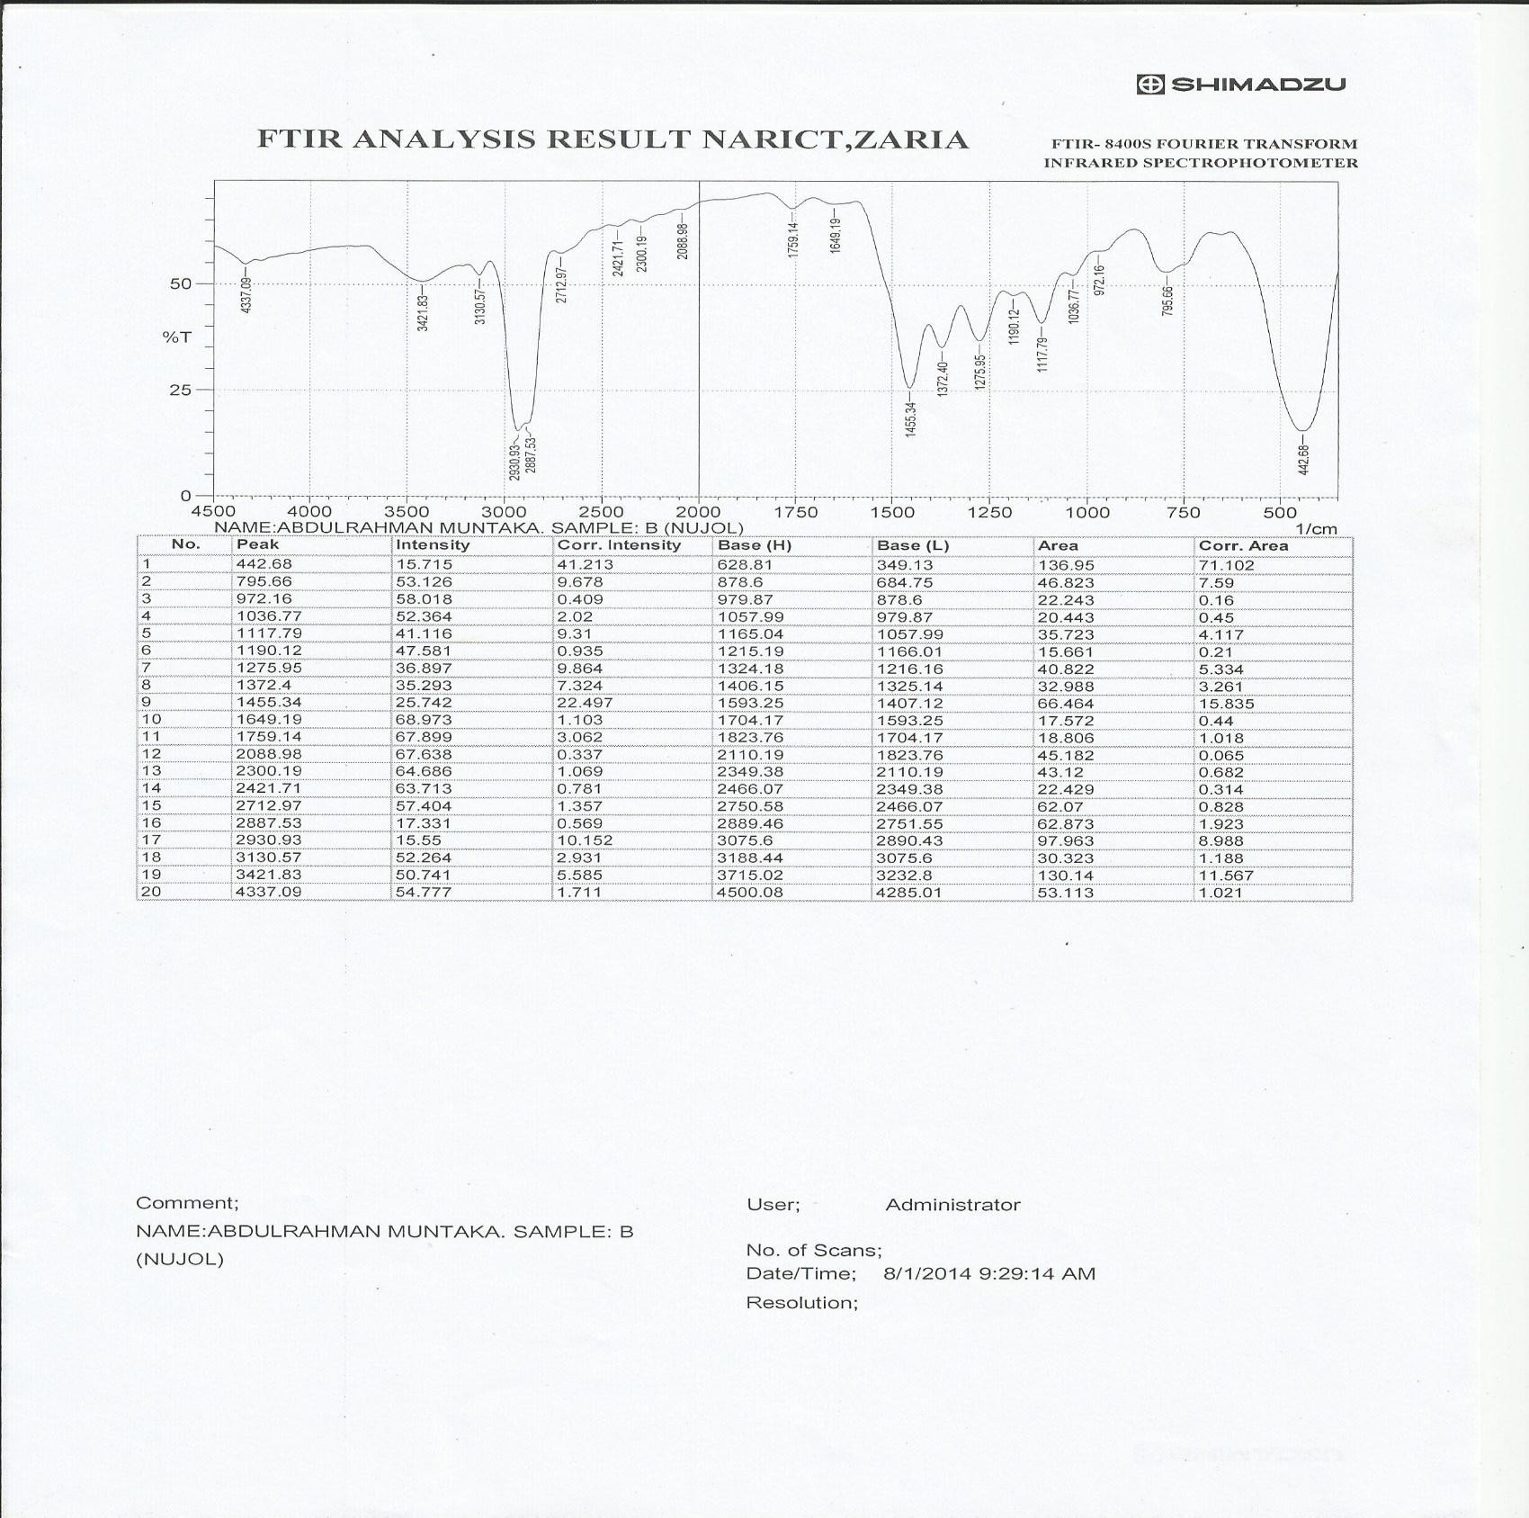

**Figure 7.2: IR spectrum of sample B**

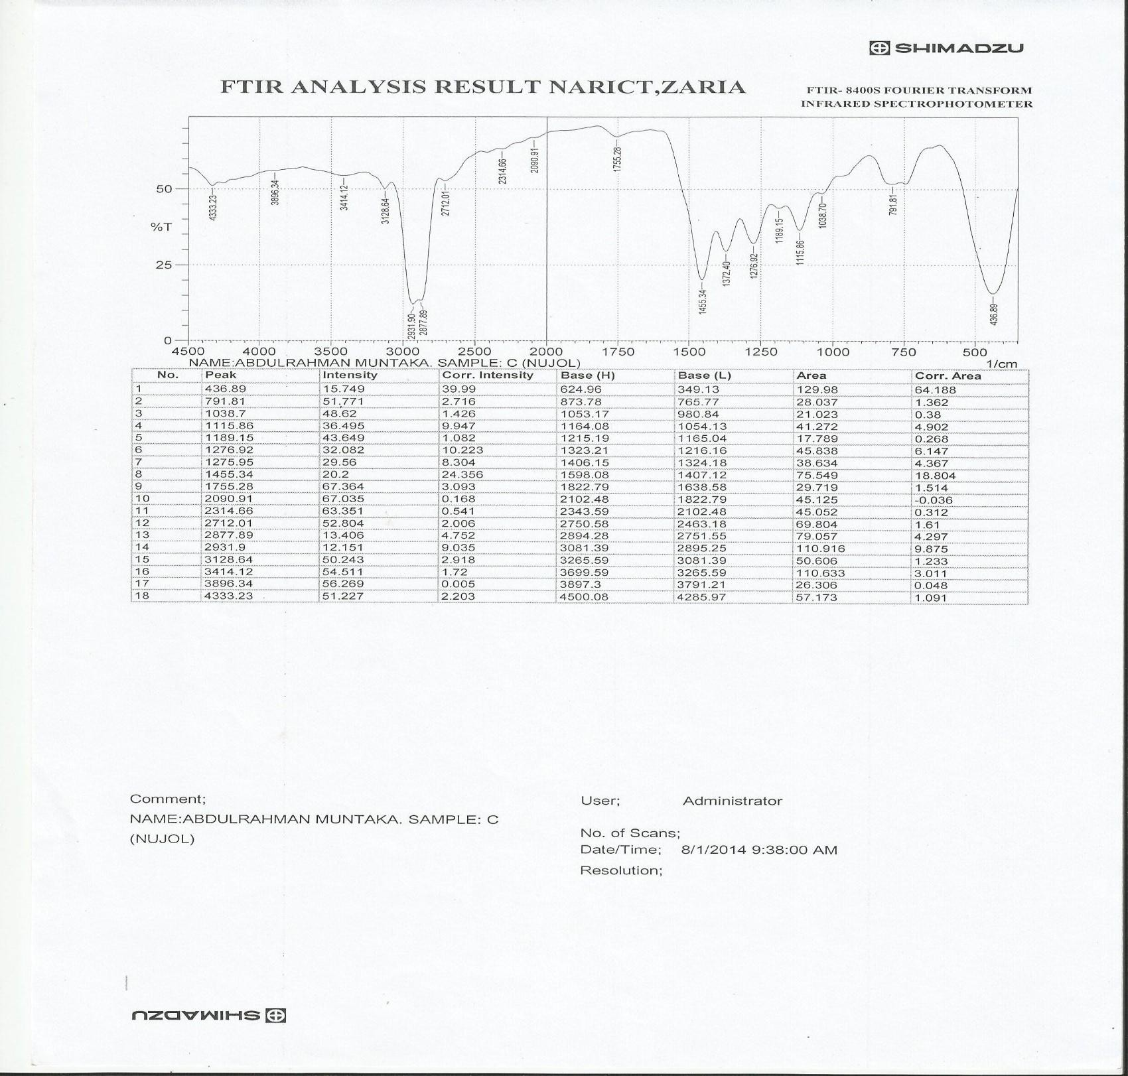

**Figure 7.3: IR spectrum of sample C**

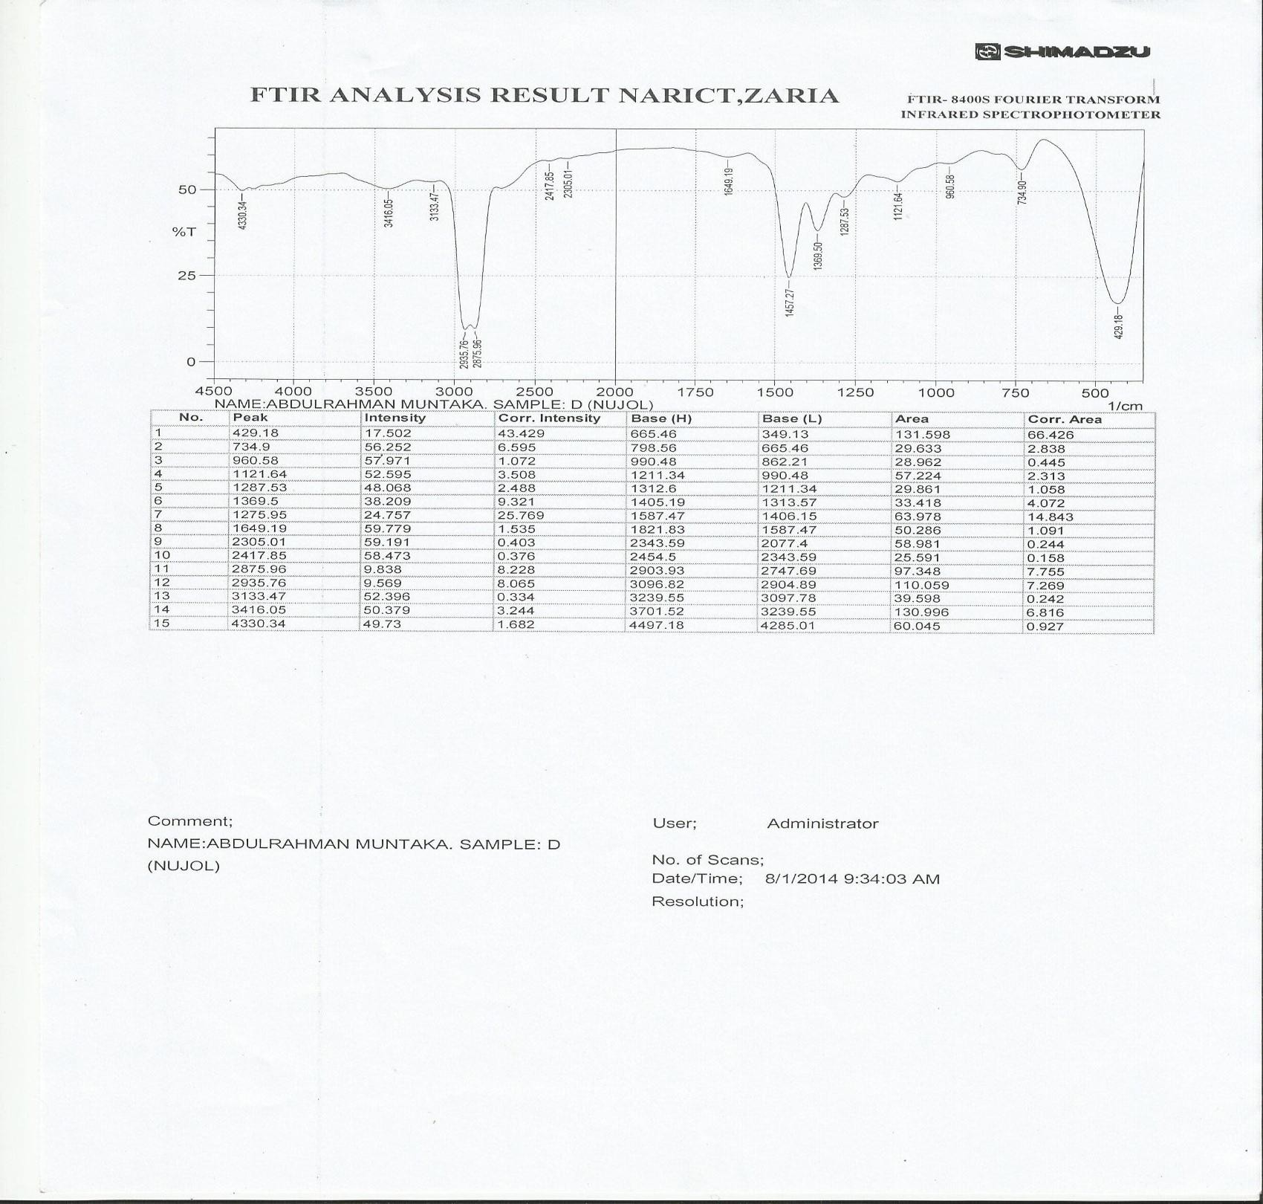

**Figure 7.4: IR spectrum of sample D**

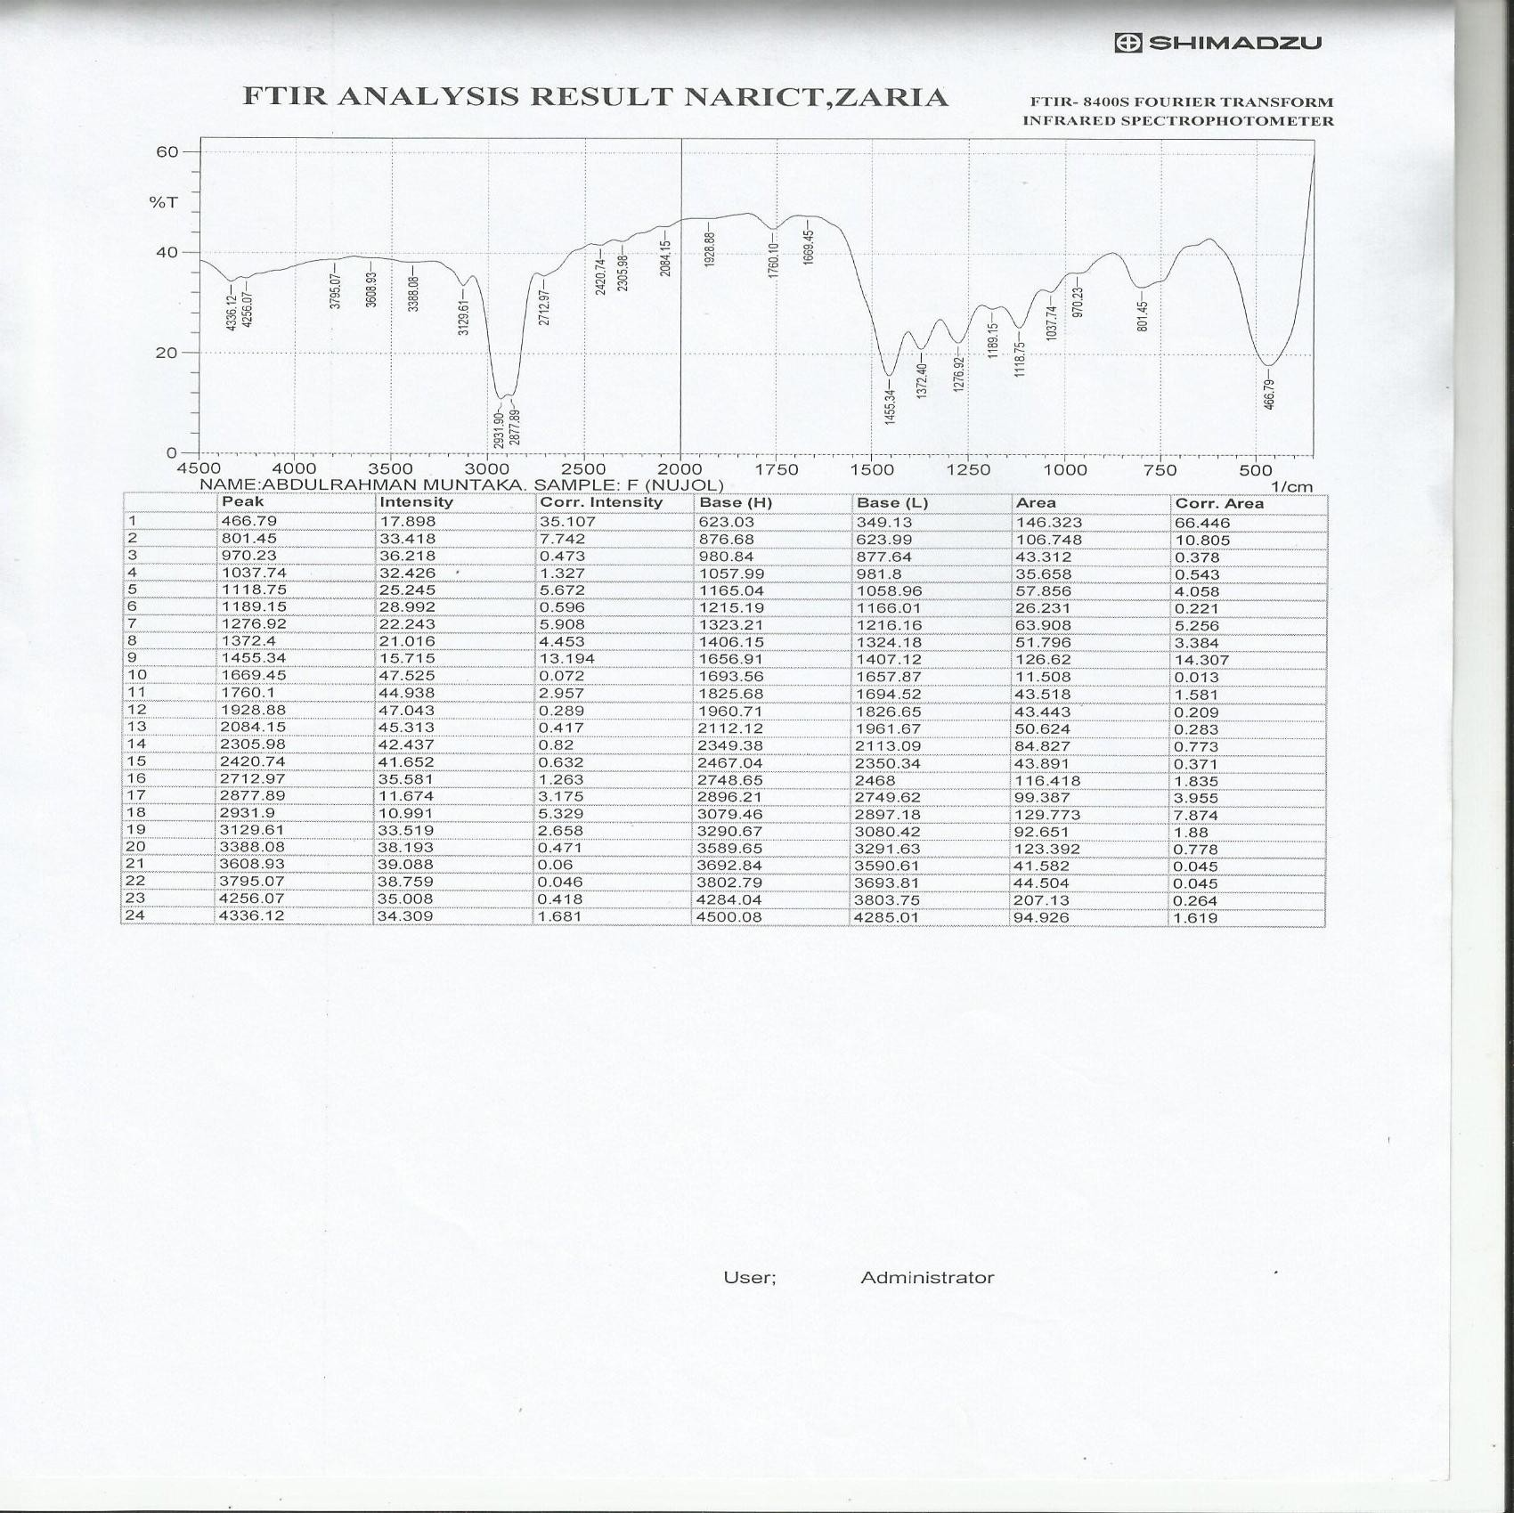

**Figure 7.5: IR spectrum of sample E (Standard powder)**

## UV-Visible Spectra Identification of Tinidazole Tablets and Standard Powder

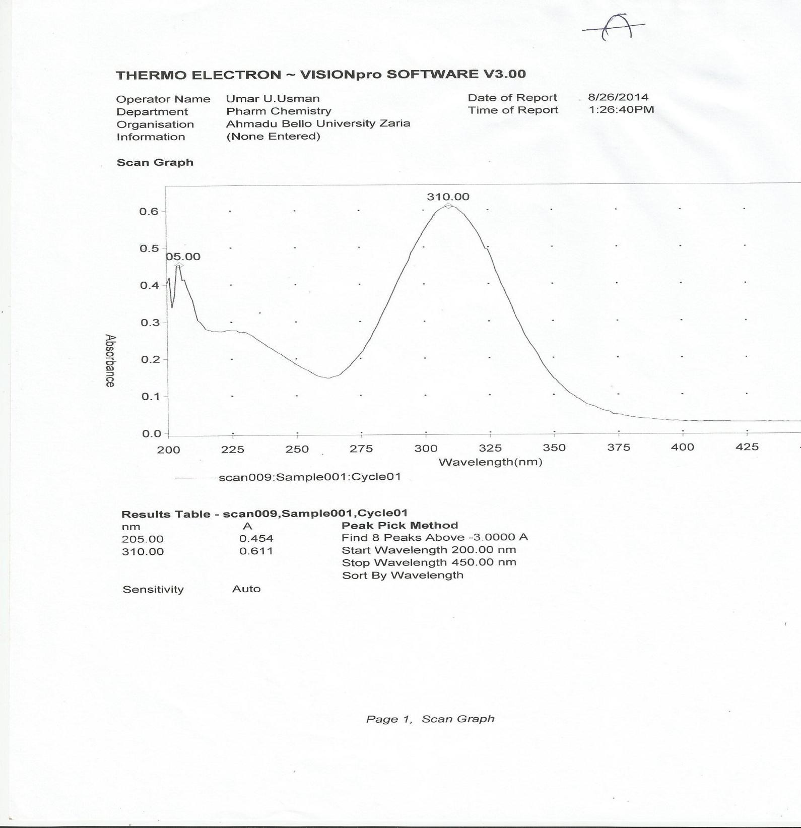

**Figure 7.6: UV spectrum of sample A**

99

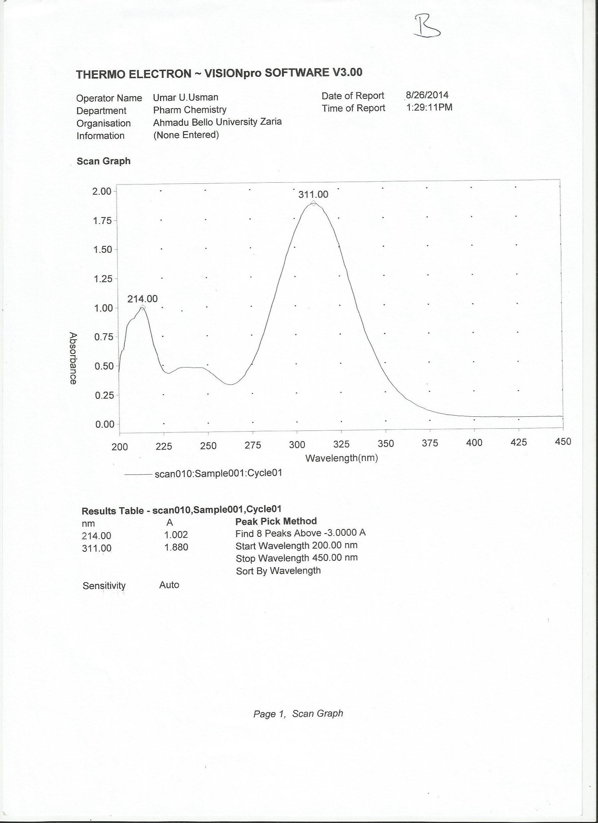

**Figure 4.7: UV spectrum of sample B**

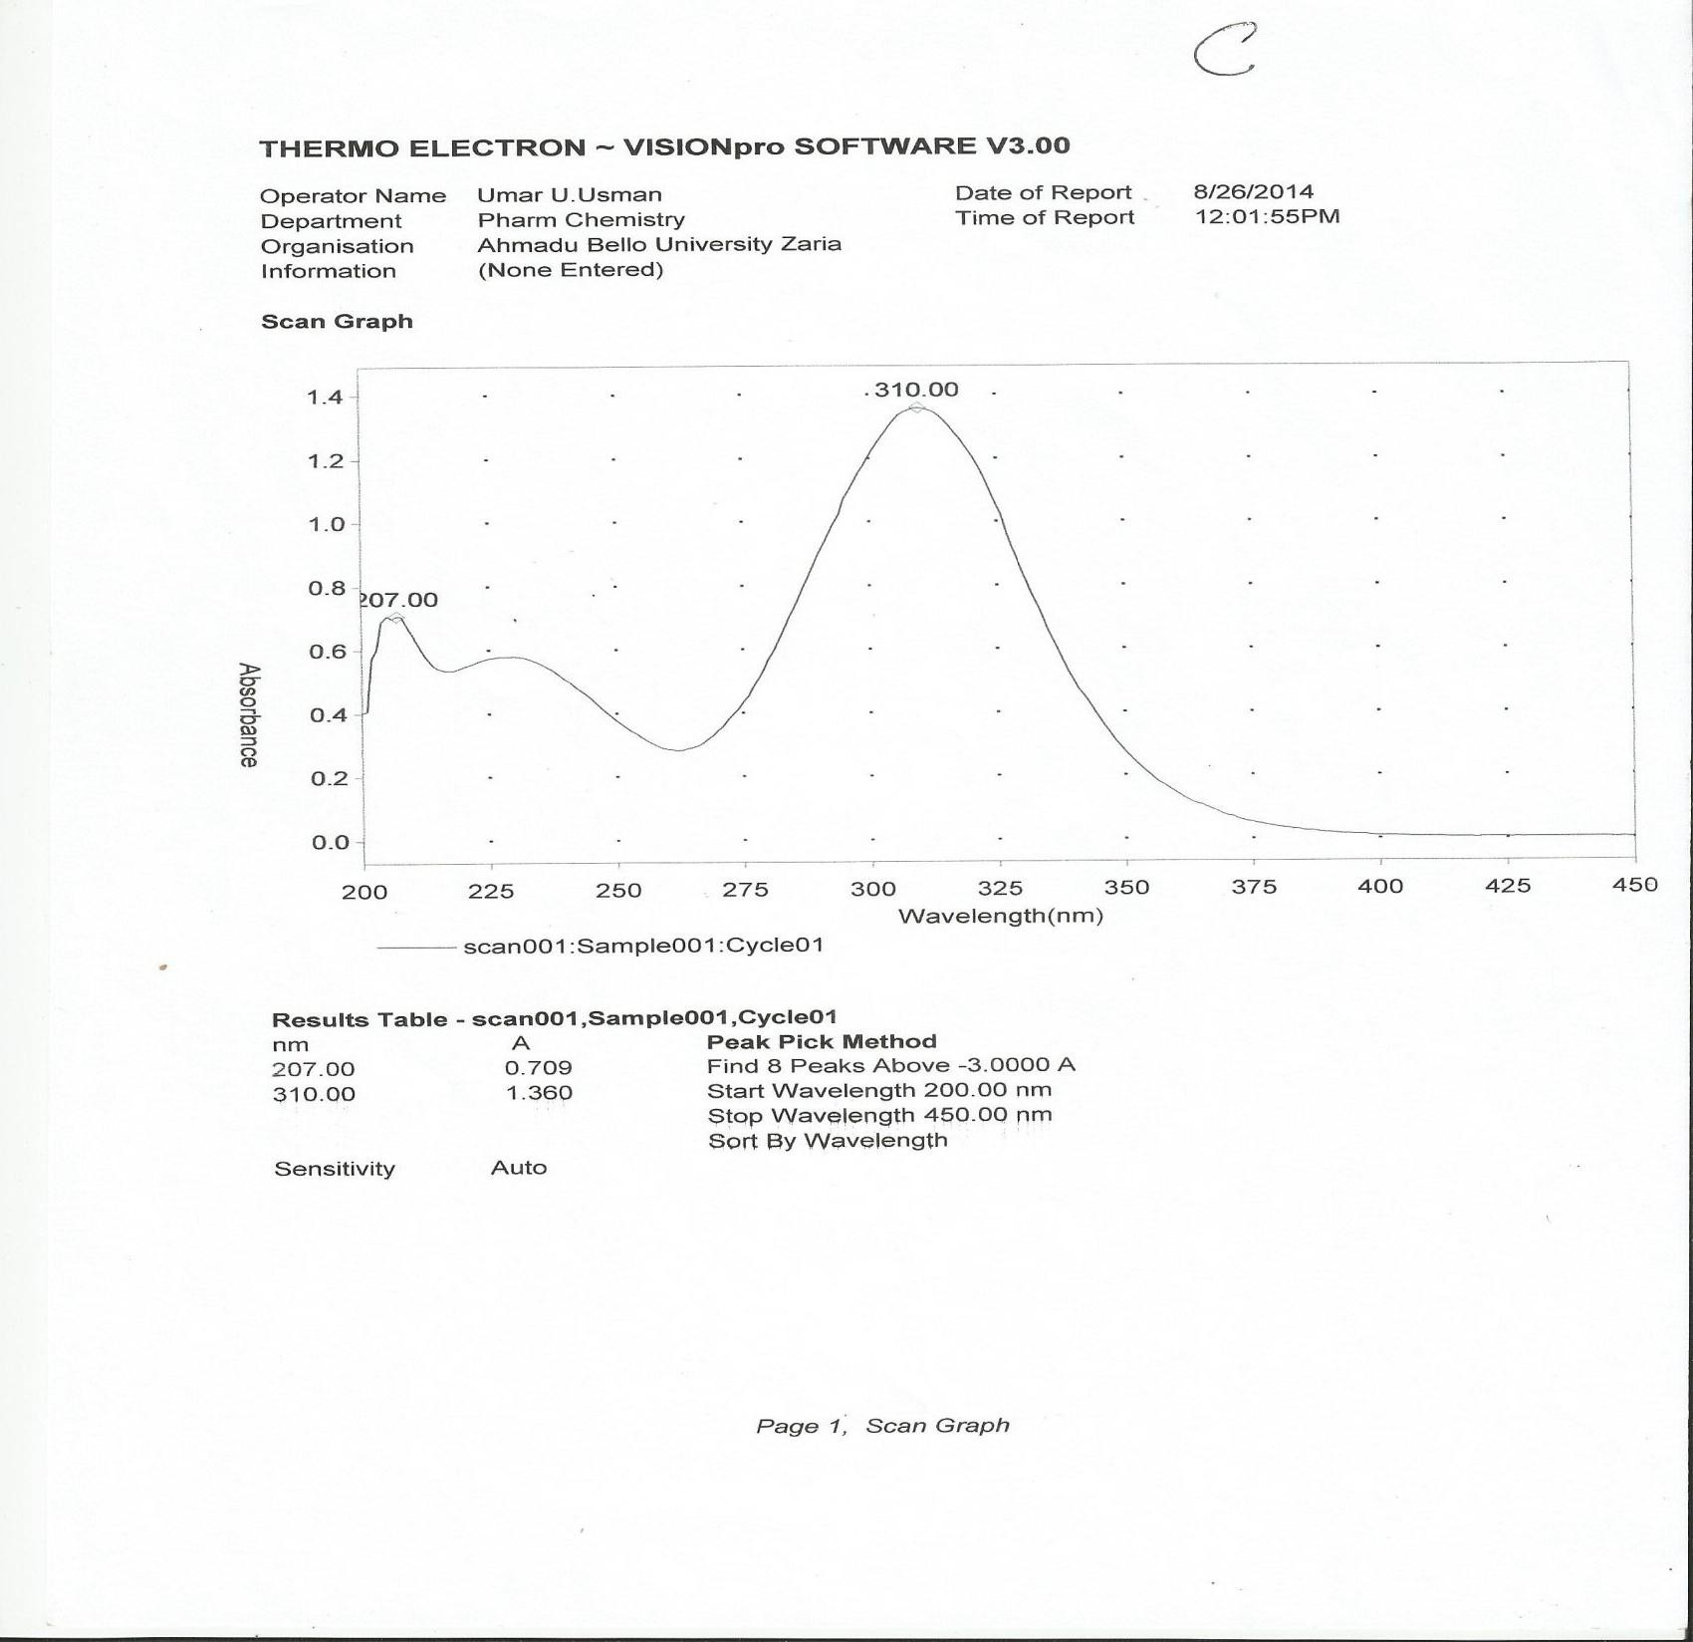

**Figure 4.8: UV spectrum of sample C**

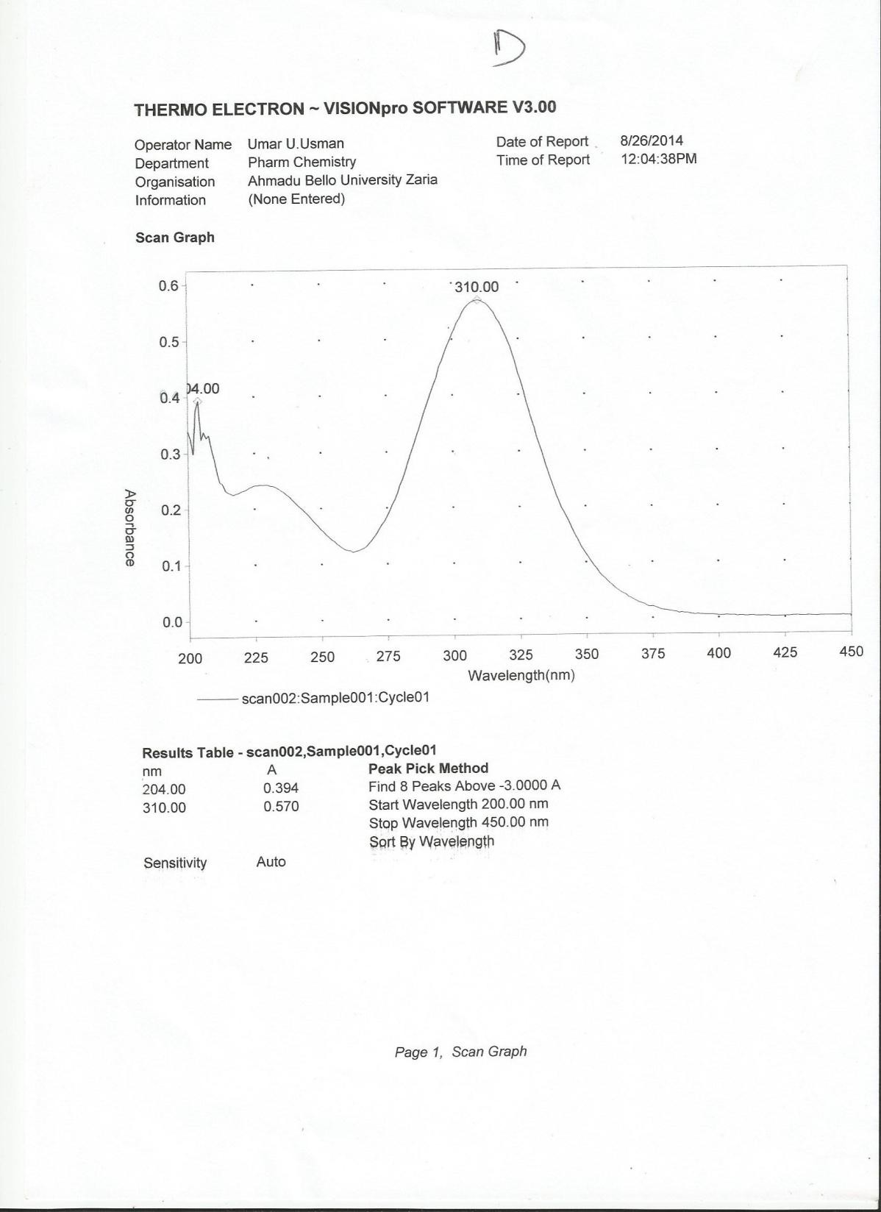

**Figure 4.9: UV spectrum of sample D**

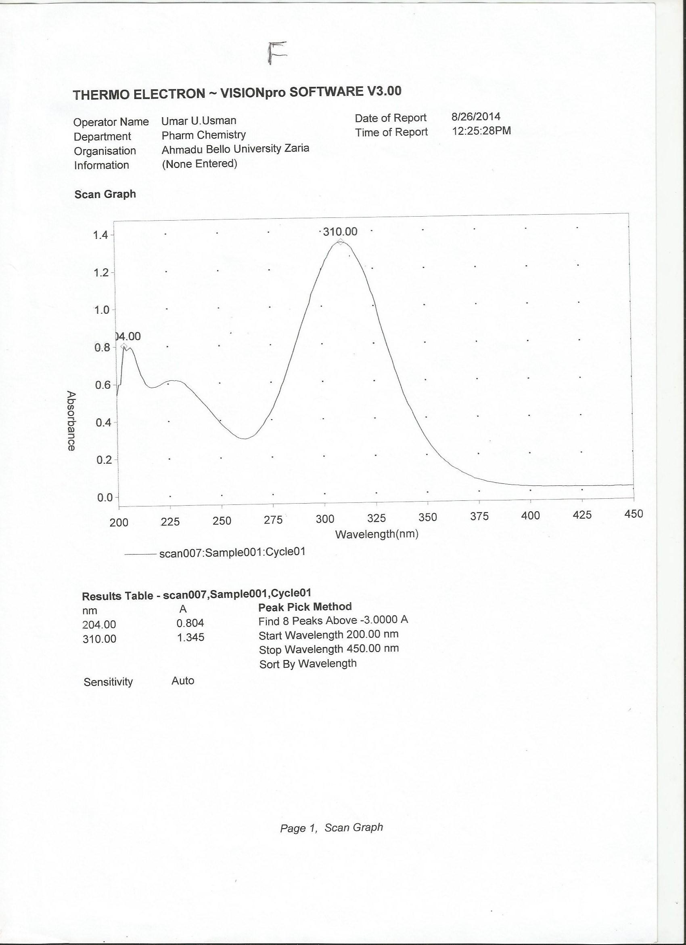

**Figure 4.10: UV spectrum of sample E (Standard powder)**

## BP 2009 specification for tinidazole identification

According to BP 2009, the first line identification tools for tinidazole pure powder and tablets are the melting point determination and the FTIR spectroscopy. The standard melting point of tinidazole pure powder, is in the range of 125 °C to 128 °C based on that, the melting of standard powder and each brand was also determine

## Result of the Assay

|  |  |  |  |  |  |
| --- | --- | --- | --- | --- | --- |
| **Brands** | **A** | **B** | **C** | **D** | **Std Powder** |
| **Vol of 0.1N**  **HClO3 (Ext.)** | 8.0 mL | 7.8 mL | 8.30 mL | 8.10 mL | 8.00 mL |
| **Vol of 0.1N**  **HClO3 (Unex.)** | 8.4 mL | 7.5 mL | 8.00 mL | 7.20 mL | 8.00 mL |
| **Average**  **Amount** | 202.70 mg | 189.12 mg | 201.47 mg | 189.12 mg | 197.84 mg |

Note: Each 1ml of perchloric acid utilized is equivalent to 24.73 mg

.

## In vitro Dissolution studies at gastric pH using 0.1N HCl

Table 4.11

|  |  |  |  |  |  |  |  |  |
| --- | --- | --- | --- | --- | --- | --- | --- | --- |
| conc/mg | mg/ml | time | C1+C2 | dt | AUC=Linear | AUC  total |  |  |
| Sample  A |  |  |  |  |  |  |  |  |
| 0 | 0 | 0 | 0 |  | 0 |  |  |  |
| 39.92395 | 0.039924 | 5 | 0.039924 | 5 | 0.099809886 | 0.09981 |  |  |
| 51.3308 | 0.051331 | 10 | 0.091255 | 5 | 0.228136882 | 0.327947 |  |  |
| 56.27376 | 0.056274 | 20 | 0.107605 | 10 | 0.538022814 | 0.86597 |  |  |
| 73.0038 | 0.073004 | 30 | 0.129278 | 10 | 0.646387833 | 1.512357 |  |  |
| 89.35361 | 0.089354 | 40 | 0.162357 | 10 | 0.811787072 | 2.324144 |  |  |
| 112.1673 | 0.112167 | 50 | 0.201521 | 10 | 1.007604563 | 3.331749 | F | 66.49823 |

|  |  |  |  |  |  |  |  |  |
| --- | --- | --- | --- | --- | --- | --- | --- | --- |
| 127.3764 | 0.127376 | 60 | 0.239544 | 10 | 1.197718631 | 4.529468 |  |  |
| 174.9049 | 0.174905 | 70 | 0.302281 | 10 | 1.511406844 | 6.040875 |  |  |
| 221.2928 | 0.221293 | 80 | 0.396198 | 10 | 1.980988593 | 8.021863 |  |  |
| 229.2776 | 0.229278 | 90 | 0.45057 | 10 | 2.252851711 | 10.27471 |  |  |
| 230.038 | 0.230038 | 100 | 0.459316 | 10 | 2.296577947 | 12.57129 |  |  |
| 251.711 | 0.251711 | 110 | 0.481749 | 10 | 2.408745247 | 14.98004 |  |  |
| 255.1331 | 0.255133 | 120 | 0.506844 | 10 | 2.534220532 | 17.51426 |  |  |
| Sample B |  |  |  |  |  |  |  |  |
| 0 | 0 | 0 |  |  | 0 |  |  |  |
| 306.8821 | 0.306882 | 5 | 0.306882 | 5 | 0.767205323 | 0.767205 |  |  |
| 313.9924 | 0.313992 | 10 | 0.620875 | 5 | 1.552186312 | 2.319392 |  |  |
| 315.9354 | 0.315935 | 20 | 0.629928 | 10 | 3.149638783 | 5.46903 |  |  |
| 318.8631 | 0.318863 | 30 | 0.634798 | 10 | 3.173992395 | 8.643023 |  |  |
| 314.9049 | 0.314905 | 40 | 0.633768 | 10 | 3.168840304 | 11.81186 |  |  |
| 319.9468 | 0.319947 | 50 | 0.634852 | 10 | 3.174258555 | 14.98612 | F | 85.80369 |
| 322.327 | 0.322327 | 60 | 0.642274 | 10 | 3.211368821 | 18.19749 |  |  |
| 324.5932 | 0.324593 | 70 | 0.64692 | 10 | 3.23460076 | 21.43209 |  |  |
| 329.3536 | 0.329354 | 80 | 0.653947 | 10 | 3.26973384 | 24.70183 |  |  |
| 330.8745 | 0.330875 | 90 | 0.660228 | 10 | 3.301140684 | 28.00297 |  |  |
| 337.9848 | 0.337985 | 100 | 0.668859 | 10 | 3.344296578 | 31.34726 |  |  |
| 339.1635 | 0.339163 | 110 | 0.677148 | 10 | 3.385741445 | 34.733 |  |  |
| 476.8061 | 0.476806 | 120 | 0.81597 | 10 | 4.079847909 | 38.81285 |  |  |
| Sample C |  |  |  |  |  |  |  |  |
| 0 | 0 | 0 | 0 | 0 | 0 |  |  |  |
| 49.04943 | 0.049049 | 5 | 0.049049 | 5 | 0.122623574 | 0.122624 |  |  |
| 60.07605 | 0.060076 | 10 | 0.109125 | 5 | 0.272813688 | 0.395437 |  |  |
| 82.12928 | 0.082129 | 20 | 0.142205 | 10 | 0.711026616 | 1.106464 |  |  |
| 113.308 | 0.113308 | 30 | 0.195437 | 10 | 0.977186312 | 2.08365 |  |  |
| 143.7262 | 0.143726 | 40 | 0.257034 | 10 | 1.285171103 | 3.368821 | F | 92.69813 |
| 229.2776 | 0.229278 | 50 | 0.373004 | 10 | 1.865019011 | 5.23384 |  |  |
| 317.1483 | 0.317148 | 60 | 0.546426 | 10 | 2.732129278 | 7.96597 |  |  |
| 332.3954 | 0.332395 | 70 | 0.649544 | 10 | 3.247718631 | 11.21369 |  |  |
| 379.2395 | 0.37924 | 80 | 0.711635 | 10 | 3.558174905 | 14.77186 |  |  |
| 408.7452 | 0.408745 | 90 | 0.787985 | 10 | 3.939923954 | 18.71179 |  |  |
| 409.8859 | 0.409886 | 100 | 0.818631 | 10 | 4.093155894 | 22.80494 |  |  |
| 413.4601 | 0.41346 | 110 | 0.823346 | 10 | 4.116730038 | 26.92167 |  |  |
| 413.4601 | 0.41346 | 120 | 0.82692 | 10 | 4.13460076 | 31.05627 |  |  |

|  |  |  |  |  |  |  |  |  |
| --- | --- | --- | --- | --- | --- | --- | --- | --- |
| Sample  D |  |  |  |  |  |  |  |  |
| 0 | 0 | 0 | 0 | 0 | 0 | 0 |  |  |
| 14.06844 | 0.014068 | 5 | 0.014068 | 5 | 0.035171103 | 0.035171 |  |  |
| 23.19392 | 0.023194 | 10 | 0.037262 | 5 | 0.093155894 | 0.128327 |  |  |
| 27.75665 | 0.027757 | 20 | 0.050951 | 10 | 0.254752852 | 0.38308 |  |  |
| 30.03802 | 0.030038 | 30 | 0.057795 | 10 | 0.288973384 | 0.672053 |  |  |
| 43.72624 | 0.043726 | 40 | 0.073764 | 10 | 0.368821293 | 1.040875 | F | 72.24223 |
| 102.2814 | 0.102281 | 50 | 0.146008 | 10 | 0.730038023 | 1.770913 |  |  |
| 304.1825 | 0.304183 | 60 | 0.406464 | 10 | 2.032319392 | 3.803232 |  |  |
| 393.1559 | 0.393156 | 70 | 0.697338 | 10 | 3.486692015 | 7.289924 |  |  |
| 399.6198 | 0.39962 | 80 | 0.792776 | 10 | 3.963878327 | 11.2538 |  |  |
| 400.7605 | 0.40076 | 90 | 0.80038 | 10 | 4.001901141 | 15.2557 |  |  |
| 406.0837 | 0.406084 | 100 | 0.806844 | 10 | 4.034220532 | 19.28992 |  |  |
| 412.5475 | 0.412548 | 110 | 0.818631 | 10 | 4.093155894 | 23.38308 |  |  |
| 450.5703 | 0.45057 | 120 | 0.863118 | 10 | 4.315589354 | 27.69867 |  |  |

## In vitro dissolution studies at intestinal pH (6.8) using phosphate buffer

|  |  |  |  |  |  |  |  |  |
| --- | --- | --- | --- | --- | --- | --- | --- | --- |
| mg | mg/ml | time | C1+C2 | dt | AUC=  linear | AUC  total | Bioav. |  |
| B |  |  |  |  |  |  |  |  |
| 0 | 0 | 0 | 0 | 0 | 0 | 0 |  |  |
| 180.7407 | 0.180741 | 5 | 0.180741 | 5 | 0.45185185 | 0.451852 |  |  |
| 251.4815 | 0.251481 | 10 | 0.432222 | 5 | 1.08055556 | 1.532407 |  |  |
| 307.037 | 0.307037 | 20 | 0.558519 | 10 | 2.79259259 | 4.325 |  |  |
| 307.4074 | 0.307407 | 30 | 0.614444 | 10 | 3.07222222 | 7.397222 |  |  |
| 316.6667 | 0.316667 | 40 | 0.624074 | 10 | 3.12037037 | 10.51759 | F | 90.56718 |
| 312.5926 | 0.312593 | 50 | 0.629259 | 10 | 3.1462963 | 13.66389 |  |  |
| 340.3704 | 0.34037 | 60 | 0.652963 | 10 | 3.26481481 | 16.9287 |  |  |
| 344.4444 | 0.344444 | 70 | 0.684815 | 10 | 3.42407407 | 20.35278 |  |  |
| 367.4074 | 0.367407 | 80 | 0.711852 | 10 | 3.55925926 | 23.91204 |  |  |
| 409.6296 | 0.40963 | 90 | 0.777037 | 10 | 3.88518519 | 27.79722 |  |  |
| 412.2222 | 0.412222 | 100 | 0.821852 | 10 | 4.10925926 | 31.90648 |  |  |
| 462.2222 | 0.462222 | 110 | 0.874444 | 10 | 4.37222222 | 36.2787 |  |  |
| 475.5556 | 0.475556 | 120 | 0.937778 | 10 | 4.68888889 | 40.96759 |  |  |

|  |  |  |  |  |  |  |  |  |
| --- | --- | --- | --- | --- | --- | --- | --- | --- |
| A |  |  |  |  |  |  |  |  |
| 0 | 0 | 0 |  |  | 0 |  |  |  |
| 0.740741 | 0.000741 | 5 | 0.000741 | 5 | 0.00185185 | 0.001852 |  |  |
| 3.333333 | 0.003333 | 10 | 0.004074 | 5 | 0.02037037 | 0.022222 |  |  |
| 29.62963 | 0.02963 | 20 | 0.032963 | 10 | 0.32962963 | 0.351852 |  |  |
| 61.11111 | 0.061111 | 30 | 0.090741 | 10 | 1.36111111 | 1.712963 |  |  |
| 83.33333 | 0.083333 | 40 | 0.144444 | 10 | 2.88888889 | 4.601852 |  |  |
| 125.5556 | 0.125556 | 50 | 0.208889 | 10 | 5.22222222 | 9.824074 |  |  |
| 140 | 0.14 | 60 | 0.265556 | 10 | 7.96666667 | 17.79074 | F | 79.96984 |
| 198.8889 | 0.198889 | 70 | 0.338889 | 10 | 11.8611111 | 29.65185 |  |  |
| 249.2593 | 0.249259 | 80 | 0.448148 | 10 | 17.9259259 | 47.57778 |  |  |
| 254.4444 | 0.254444 | 90 | 0.503704 | 10 | 22.6666667 | 70.24444 |  |  |
| 262.2222 | 0.262222 | 100 | 0.516667 | 10 | 25.8333333 | 96.07778 |  |  |
| 265.9259 | 0.265926 | 110 | 0.528148 | 10 | 29.0481481 | 125.1259 |  |  |
| 281.1111 | 0.281111 | 120 | 0.547037 | 10 | 32.8222222 | 157.9481 |  |  |
| D |  |  |  |  |  |  |  |  |
| 0 | 0 | 0 | 0 | 0 | 0 | 0 |  |  |
| 180.7407 | 0.180741 | 5 | 0.180741 | 5 | 0.45185185 | 0.451852 |  |  |
| 251.4815 | 0.251481 | 10 | 0.432222 | 5 | 1.08055556 | 1.532407 |  |  |
| 307.037 | 0.307037 | 20 | 0.558519 | 10 | 2.79259259 | 4.325 |  |  |
| 312.5926 | 0.312593 | 30 | 0.61963 | 10 | 3.09814815 | 7.423148 |  |  |
| 316.6667 | 0.316667 | 40 | 0.629259 | 10 | 3.1462963 | 10.56944 |  |  |
| 340.3704 | 0.34037 | 50 | 0.657037 | 10 | 3.28518519 | 13.85463 | F | 71.0663 |
| 344.4444 | 0.344444 | 60 | 0.684815 | 10 | 3.42407407 | 17.2787 |  |  |
| 367.4074 | 0.367407 | 70 | 0.711852 | 10 | 3.55925926 | 20.83796 |  |  |
| 409.6296 | 0.40963 | 80 | 0.777037 | 10 | 3.88518519 | 24.72315 |  |  |
| 412.2222 | 0.412222 | 90 | 0.821852 | 10 | 4.10925926 | 28.83241 |  |  |
| 430.7407 | 0.430741 | 100 | 0.842963 | 10 | 4.21481481 | 33.04722 |  |  |
| 462.2222 | 0.462222 | 110 | 0.892963 | 10 | 4.46481481 | 37.51204 |  |  |
| 475.5556 | 0.475556 | 120 | 0.937778 | 10 | 4.68888889 | 42.20093 |  |  |
| C |  |  |  |  |  |  |  |  |
| 0 | 0 | 0 | 0 | 0 | 0 | 0 |  |  |
| 77.03704 | 0.077037 | 5 | 0.077037 | 5 | 0.19259259 | 0.192593 |  |  |
| 105.9259 | 0.105926 | 10 | 0.182963 | 5 | 0.45740741 | 0.65 |  |  |
| 128.5185 | 0.128519 | 20 | 0.234444 | 10 | 1.17222222 | 1.822222 |  |  |

|  |  |  |  |  |  |  |  |  |
| --- | --- | --- | --- | --- | --- | --- | --- | --- |
| 128.8889 | 0.128889 | 30 | 0.257407 | 10 | 1.28703704 | 3.109259 |  |  |
| 180.7407 | 0.180741 | 40 | 0.30963 | 10 | 1.54814815 | 4.657407 | F | 78.9902 |
| 364.0741 | 0.364074 | 50 | 0.544815 | 10 | 2.72407407 | 7.381481 |  |  |
| 392.2222 | 0.392222 | 60 | 0.756296 | 10 | 3.78148148 | 11.16296 |  |  |
| 450 | 0.45 | 70 | 0.842222 | 10 | 4.21111111 | 15.37407 |  |  |
| 474.0741 | 0.474074 | 80 | 0.924074 | 10 | 4.62037037 | 19.99444 |  |  |
| 476.6667 | 0.476667 | 90 | 0.950741 | 10 | 4.7537037 | 24.74815 |  |  |
| 495.9259 | 0.495926 | 100 | 0.972593 | 10 | 4.86296296 | 29.61111 |  |  |
| 512.2222 | 0.512222 | 110 | 1.008148 | 10 | 5.04074074 | 34.65185 |  |  |
| 530.3704 | 0.53037 | 120 | 1.042593 | 10 | 5.21296296 | 39.86481 |  |  |

## 7.7 In vitro dissolution studies at blood pH (7.4) using phosphate buffer

|  |  |  |  |  |  |  |  |  |
| --- | --- | --- | --- | --- | --- | --- | --- | --- |
| mg | mg/ml | time | C1+C2 | dt | AUC=  linear | AUC  total |  |  |
| A |  |  |  |  |  |  |  |  |
| 0 | 0 | 0 | 0 | 0 | 0 | 0 |  |  |
| 25.8620  7 | 0.02586  2 | 5 | 0.02586  2 | 5 | 0.0646551  7 | 0.06465  5 |  |  |
| 49.6551  7 | 0.04965  5 | 10 | 0.07551  7 | 5 | 0.1887931 | 0.25344  8 |  |  |
| 76.5517  2 | 0.07655  2 | 20 | 0.12620  7 | 10 | 0.6310344  8 | 0.88448  3 |  |  |
| 140.344  8 | 0.14034  5 | 30 | 0.21689  7 | 10 | 1.0844827  6 | 1.96896  6 | F | 100 |
| 143.103  4 | 0.14310  3 | 40 | 0.28344  8 | 10 | 1.4172413  8 | 3.38620  7 |  |  |
| 203.448  3 | 0.20344  8 | 50 | 0.34655  2 | 10 | 1.7327586  2 | 5.11896  6 |  |  |
| 247.931 | 0.24793  1 | 60 | 0.45137  9 | 10 | 2.2568965  5 | 7.37586  2 |  |  |
| 274.482  8 | 0.27448  3 | 70 | 0.52241  4 | 10 | 2.6120689  7 | 9.98793  1 |  |  |
| 320.689  7 | 0.32069 | 80 | 0.59517  2 | 10 | 2.9758620  7 | 12.9637  9 |  |  |
| 324.482  8 | 0.32448  3 | 90 | 0.64517  2 | 10 | 3.2258620  7 | 16.1896  6 |  |  |
| 329.310  3 | 0.32931 | 100 | 0.65379  3 | 10 | 3.2689655  2 | 19.4586  2 |  |  |
| 344.137  9 | 0.34413  8 | 110 | 0.67344  8 | 10 | 3.3672413  8 | 22.8258  6 |  |  |
| 358.275  9 | 0.35827  6 | 120 | 0.70241  4 | 10 | 3.5120689  7 | 26.3379  3 |  |  |

|  |  |  |  |  |  |  |  |  |
| --- | --- | --- | --- | --- | --- | --- | --- | --- |
| C |  |  |  |  |  |  |  |  |
| 0 | 0 | 0 | 0 | 0 | 0 | 0 |  |  |
| 30 | 0.03 | 5 | 0.03 | 5 | 0.075 | 0.075 |  |  |
| 78.9655  2 | 0.07896  6 | 10 | 0.10896  6 | 5 | 0.2724137  9 | 0.34741  4 |  |  |
| 87.2413  8 | 0.08724  1 | 20 | 0.16620  7 | 10 | 0.8310344  8 | 1.17844  8 |  |  |
| 120 | 0.12 | 30 | 0.20724  1 | 10 | 1.0362069 | 2.21465  5 |  |  |
| 260 | 0.26 | 40 | 0.38 | 10 | 1.9 | 4.11465  5 |  |  |
| 290 | 0.29 | 50 | 0.55 | 10 | 2.75 | 6.86465  5 | F | 100 |
| 338.275  9 | 0.33827  6 | 60 | 0.62827  6 | 10 | 3.1413793  1 | 10.0060  3 |  |  |
| 359.655  2 | 0.35965  5 | 70 | 0.69793  1 | 10 | 3.4896551  7 | 13.4956  9 |  |  |
| 368.275  9 | 0.36827  6 | 80 | 0.72793  1 | 10 | 3.6396551  7 | 17.1353  4 |  |  |
| 383.448  3 | 0.38344  8 | 90 | 0.75172  4 | 10 | 3.7586206  9 | 20.8939  7 |  |  |
| 403.103  4 | 0.40310  3 | 100 | 0.78655  2 | 10 | 3.9327586  2 | 24.8267  2 |  |  |
| 439.655  2 | 0.43965  5 | 110 | 0.84275  9 | 10 | 4.2137931 | 29.0405  2 |  |  |
| 452.758  6 | 0.45275  9 | 120 | 0.89241  4 | 10 | 4.4620689  7 | 33.5025  9 |  |  |
| B |  |  |  |  |  |  |  |  |
| 0 | 0 | 0 | 0 | 0 | 0 | 0 |  |  |
| 262.413  8 | 0.26241  4 | 5 | 0.26241  4 | 5 | 0.6560344  8 | 0.65603  4 |  |  |
| 286.896  6 | 0.28689  7 | 10 | 0.54931 | 5 | 1.3732758  6 | 2.02931 |  |  |
| 287.931 | 0.28793  1 | 20 | 0.57482  8 | 10 | 2.8741379  3 | 4.90344  8 |  |  |
| 340.689  7 | 0.34069 | 30 | 0.62862  1 | 10 | 3.1431034  5 | 8.04655  2 |  |  |
| 357.241  4 | 0.35724  1 | 40 | 0.69793  1 | 10 | 3.4896551  7 | 11.5362  1 |  |  |
| 360.344  8 | 0.36034  5 | 50 | 0.71758  6 | 10 | 3.5879310  3 | 15.1241  4 | F | 100 |
| 418.965  5 | 0.41896  6 | 60 | 0.77931 | 10 | 3.8965517  2 | 19.0206  9 |  |  |
| 425.862 | 0.42586 | 70 | 0.84482 | 10 | 4.2241379 | 23.2448 |  |  |

|  |  |  |  |  |  |  |  |  |
| --- | --- | --- | --- | --- | --- | --- | --- | --- |
| 1 | 2 |  | 8 |  | 3 | 3 |  |  |
| 428.275  9 | 0.42827  6 | 80 | 0.85413  8 | 10 | 4.2706896  6 | 27.5155  2 |  |  |
| 429.655  2 | 0.42965  5 | 90 | 0.85793  1 | 10 | 4.2896551  7 | 31.8051  7 |  |  |
| 441.724  1 | 0.44172  4 | 100 | 0.87137  9 | 10 | 4.3568965  5 | 36.1620  7 |  |  |
| 454.827  6 | 0.45482  8 | 110 | 0.89655  2 | 10 | 4.4827586  2 | 40.6448  3 |  |  |
| 463.103  4 | 0.46310  3 | 120 | 0.91793  1 | 10 | 4.5896551  7 | 45.2344  8 |  |  |
| D |  |  |  |  |  |  |  |  |
| 0 | 0 | 0 | 0 | 0 | 0 | 0 |  |  |
| 229.310  3 | 0.22931 | 5 | 0.22931 | 5 | 0.5732758  6 | 0.57327  6 |  |  |
| 235.172  4 | 0.23517  2 | 10 | 0.46448  3 | 5 | 1.1612069 | 1.73448  3 |  |  |
| 284.482  8 | 0.28448  3 | 20 | 0.51965  5 | 10 | 2.5982758  6 | 4.33275  9 |  |  |
| 284.482  8 | 0.28448  3 | 30 | 0.56896  6 | 10 | 2.8448275  9 | 7.17758  6 |  |  |
| 315.517  2 | 0.31551  7 | 40 | 0.6 | 10 | 3 | 10.1775  9 | F | 100 |
| 321.724  1 | 0.32172  4 | 50 | 0.63724  1 | 10 | 3.1862069 | 13.3637  9 |  |  |
| 321.724  1 | 0.32172  4 | 60 | 0.64344  8 | 10 | 3.2172413  8 | 16.5810  3 |  |  |
| 329.655  2 | 0.32965  5 | 70 | 0.65137  9 | 10 | 3.2568965  5 | 19.8379  3 |  |  |
| 343.448  3 | 0.34344  8 | 80 | 0.67310  3 | 10 | 3.3655172  4 | 23.2034  5 |  |  |
| 350.344  8 | 0.35034  5 | 90 | 0.69379  3 | 10 | 3.4689655  2 | 26.6724  1 |  |  |
| 387.931 | 0.38793  1 | 100 | 0.73827  6 | 10 | 3.6913793  1 | 30.3637  9 |  |  |
| 402.413  8 | 0.40241  4 | 110 | 0.79034  5 | 10 | 3.9517241  4 | 34.3155  2 |  |  |
| 402.758  6 | 0.40275  9 | 120 | 0.80517  2 | 10 | 4.0258620  7 | 38.3413  8 |  |  |