COMPARATIVE ECONOMICS OF PETROLEUM PRODUCTION OPTIMIZATION TECHNIQUES

ABSTRACT

Hydrocarbon production in the petroleum industry is often constrained by reservoir heterogeneity, deliverability and capacity of surface facilities, also optimization technique in the petroleum industry requires execution of several iterative runs by comparing various solutions until an optimum or satisfactory solution is found.

In this study a comparative economic analysis to aid the optimization of petroleum production was done. Two key variables, tubing sizes and choke sizes were considered, their sensitivity to production was also determined.

A prudent approach to optimizing petroleum production is by statistical and sensitivity analysis, specifically, Nodal Analysis and @Risk software were used in this work. The nodal analysis procedure consists of selecting a division point or node in the well, the system at that point was analyzed differently to optimize performance in the most economical manner, an integral analysis of the entire production system was also considered. Using @Risk software (Monte Carlo simulation), risk analysis of the objective function was done. Monte Carlo simulation sampling is a traditional technique for using random or pseudo-random numbers to sample from a probability distribution.

Substantial findings of this study shows that the tubing size of 1.90-inch had an optimal rate of production for deeper reservoir conditions used in this research using the Nodal analysis technique, also Monte Carlo simulation proves that the price of oil has the highest impact on profit for the probabilistic period of 5, 10, and 15 years followed by the rate of production while the cost of tubing has the least effect.

LIST OF TABLES

Table 2.1: Production rate and flowing bottom-hole pressure data used to construct the IPR curve……………………………………………………………………………………….9

Table 2.2. Flowing bottom-hole pressure and production flow rate that is used to determing the outflow performance relationship curve…………………...........................................11

Table 4.1. Test data for tubing and choke sizes selection for production optimization…...24

Table 4.2. Data used to plot the IPR curve for a reservoir pressure of 1872.094 psia……………………………………………………………………………………….24

Table 4.3. Tubing sizes of 2.875, 2.375, 3.5, 1.90 inches with their various tubing head pressures and bottom-hole flowing pressures………………………………...…………..25

Table 4.4. Production Rates for various choke sizes……………………………………...26

Table 4.5. Cost of tubing for a reservoir condition of R1………………………………..33

Table 4.6. Cost of tubing for a reservoir condition of R2………………………………..33

Table 4.7. Cost of tubing for a reservoir condition of R3………………………..………33

Table 4.8. Summary window for Risk input data with a depth of 4262 ft and 1872.094 psia reservoir pressure……………………………………………………………………34

Table 4.9. Summary window for profit with a depth of 10232 ft and 4809.040 psia reservoir pressure………………………...………………………………………………35

Table 4.10. Summary window for profit with a depth of 14072 ft and 6531.264 psia reservoir pressure………………...………………………………………………………36

vi

LIST OF FIGURES

Figure 2.1. Illustrating the IPR Curve where qmax=736 stb/d, Pr=2400 Psi……………………………………………………...…………………………………10

Figure 2.2. Graph indicating the OPR Curve…………………………………………….11

Figure 2.3. Positive choke………………………………………………………………..13

Figure 2.4. Adjustable choke……………………………………………………………..13

Figure 3.1. Schematic showing a typical Nodal Analysis of various pressure losses in the production system………………………………………………………………………..19

Figure 4.1. Tubing IPR curve and vertical left performance with depth of 4264 ft………………………………………………………………………………...………..27

Figure 4.2. Production Rates of various choke sizes and wellhead pressure with 4264 ft depth……………………………………………………………………………………...28

Figure 4.3. Illustract the Tubing IPR curve with the production rates of various tubing sizes and wellhead pressure with 10232 ft depth………………………………………...29

Figure 4.4. Represent production rates of various choke sizes and wellhead pressure having depth of 10232 ft…………………………………………………………………30

Figure 4.5 shows that the rates of production increases with increasing tubing size with various wellhead pressure along the tubing IPR curve…………………………………..31

Figure 4.6. Indicates the production rates as it increases with increasing choke size……..32

Figure 4.7. Profit for the periods of 5, 10, and 15years with reservoir conditions of R1 for

- tubing size of 1.90-inch………………………………………………………………...37

vii

Figure 4.8. Show the profit for the periods of 5, 10, and 15years with reservoir conditions of R1 for a tubing size of 2.375-inch……………………………………………………...38

Figure 4.9. Represent the profit for the periods of 5, 10, and 15years with a reservoir condition of R1 for a tubing size of 2.875-inch…………………………………………...39

Figure 4.10. Diagram profit for the periods of 5, 10, and 15years with a reservoir conditon of R1 for a tubing size of 3.5-inch……………………………………………..40

Figure 4.11. Profit for the probability density periods of 5, 10, and 15years with a reservoir condition R2 for a tubing size of 1.90-inch……………………………………41

Figure 4.12. Profit for the periods of 5, 10, and 15years with a reservoir condition R2 for

- tubing size of 2.375-inch……………………………………………………………….42

Figure 4.13. Profit for the periods of 5, 10, and 15years with a reservoir condition R2 for

- tubing size of 2.875-inch……………………………………………………………….43

Figure 4.14. Profit for the periods of 5, 10, and 15years with a reservoir condition R2 for

- tubing size of 3.5-inch………………………………………………………………….44

Figure 4.15. Profit for the periods of 5, 10, and 15years with a reservoir condition R3 for

- tubing size of 1.90-inch………………………………………………………………...45

Figure 4.16. Profit for the periods of 5, 10, and 15years with a reservoir condition R3 for

- tubing size of 2.375-inch……………………………………………………………….46

Figure 4.17. Profit for the periods of 5, 10, and 15years with a reservoir condition R3 for

- tubing size of 2.875-inch……………………………………………………………….47

Figure 4.18. Profit for the periods of 5, 10, and 15years with a reservoir condition R3 for a tubing size of 3.5-inch……………………………………………………………………48

viii

Figure 4.19. Diagram representing a Tonado chart……………………………………….49

Figure 4.20. Diagram representing a Tonado chart……………………………………….49

Figure 4.21. Diagram representing a Tonado chart 50

ix

 |  | TABLE OF CONTENTS
ABSTRACT ....................................................................................................................... |  |  | iii
DEDICATION .................................................................................................................... |  |  | v
LIST OF TABLES ............................................................................................................. |  |  | vi
LIST OF FIGURES .......................................................................................................... |  |  | vii
CHAPTER ONE: ................................................................................................................ |  |  | 1
1.1 | Background of the Study ......................................................................................... |  | 1
1.2 | Statement of Problem ............................................................................................... |  | 3
1.3 | Aim and Objective of the Thesis ............................................................................. |  | 3
1.4 | Organization of the Thesis ....................................................................................... |  | 3
CHAPTER TWO: ............................................................................................................... |  |  | 5
2.1 | Overview of Petroleum Production Optimization Techniques. ............................... |  | 5
2.2 | The Petroleum Production Optimization Techniques. ............................................. |  | 5
2.3 | Production Optimization Based on Surface Tubing ................................................ |  | 7
2.4 | Production Inflow Performance Relationship (IPR) ................................................ |  | 8
2.4.1 |  | Vogel’s Equation .............................................................................................. | 8
2.5 | Production Outflow Performance Relationship (OPR).......................................... |  | 10
2.6 | Chokes Performance in Production Optimization ................................................. |  | 12
2.7 | Tubing Performance in Production Optimization .................................................. |  | 14
CHAPTER THREE .......................................................................................................... |  |  | 16
3.0 | Methodology .......................................................................................................... |  | 16
3.1 | Introduction ............................................................................................................ |  | 16
3.2 | Statistical and Sensitivity Analysis ........................................................................ |  | 16
3.2.1Overview of Nodal Analysis .......................................................................... |  |  | 17
3.2.2 |  | @Risk Software ............................................................................................. | 19
CHAPTER FOUR ............................................................................................................. |  |  | 21
4.1 | Introduction ............................................................................................................ |  | 21
4.2 | Gilbert’s Correlation for Selecting Choke Sizes .................................................... |  | 22

x

4.3 Economic Analysis of Various Tubing Sizes 33

CHAPTER FIVE 51

5.0 Conclusion and Recommendation 51

5.1 Conclusions 51

5.2 Recommendations 51

REFERENCES 52

APPENDIX 54

xi

CHAPTER ONE:

1.0 INTRODUCTION

1.1 BACKGROUND OF THE STUDY

Hydrocarbon production in the petroleum industry are often constrained by reservoir heterogeneity, deliverability and capacity of surface facilities. As optimization algorithms and reservoir simulation techniques continue to develop and computing power continues to increase, upstream oil and gas facilities previously assumed not to be candidates for advanced control or optimization have being given new considerations (Clay et al., 1998).

An optimization technique is a procedure which is executed iteratively by comparing various solutions till an optimum or a satisfactory solution is found.

However, Wang (2003) addressed some problems associated with optimizing the production rates, lift gas rates, and well connections to flow lines subject to multiple flow rate and pressure constraints to achieve certain short-term operational goals. This problem is being faced in many mature fields and is an important element to consider in planning the development of a new field.

Nonlinear Optimization, also known as nonlinear programming has proven itself as a useful technique to reduce costs and to support other objectives, especially in the refinery industry whereas linear optimization is a method applicable for the solution of problems in which the objective function and the constraints appear as linear functions of the decision variables. The constraint equations may be in the form of equalities or inequalities. Furthermore, it had been used to determine the most efficient way of achieving optimal outcome for example, to maximize profit or to minimize cost in a given mathematical model. It can be applied to numerous fields like business or economics situations, and also in solving engineering problems. It is useful in modeling diverse types of problems in planning, routing, scheduling, assignment and design.

Carroll (1990) applied a multivariate optimization techniques to a field produced by a single well. The model used in his research includes a single oil well field. However, only the separator model was compositional, and no engineering parameters were allowed to vary with time. He used two types of optimization routines that is, Gradient methods and Polytope methods. However, Ravindran (1992) applying the same technique but allowed for gas-lift and engineering parameters to vary with time. Again, Fujii in 1993 improved the technique by allowing a network of wells connected at the surface, he also studied the utility of genetic algorithms for petroleum engineering optimization.

Regarding some paper view, the application of optimization techniques to solve problems in the upstream sector of petroleum Exploration and Production has been surprisingly limited not taking into account the enormous important of the E&P activities to the hydrocarbon enterprise and to the global energy systems and the economy as a whole.

Over time, development in the petroleum industry resulted in optimization methods improving in its ability to handle various problems. In optimization of a design, the design objective could be to minimize the cost of production or to maximize the efficiency of production.

In this work methodology used include Statistical and Sensitivity Methods:

- Nodal Analysis

- @Risk Software (Monte Carlo simulation)

These methods above will be used to identify key variables, the most sensitive variables of production, and evaluate optimization techniques.

1.2 STATEMENT OF PROBLEM

In previous works done by many researchers, they investigated many optimization techniques for tackling the reservoir problem which involve much simpler reservoir representations than those employed by the simulators. Saputelli et al., (2005) even argued that multivariable optimization has not fully penetrated the hydrocarbon industry sector of the E&P activities. This research will emphasis mainly on the comparative economic analysis of petroleum production optimization techniques since it was not taken into consideration by the many researchers who discuss the petroleum production optimization techniques.

1.3 AIM AND OBJECTIVES OF THE THESIS

The aim of this research is to do a comparative economics Analysis of petroleum production optimization techniques in optimizing the tubing and choke sizes, using the idea of economic analysis while the objectives include:

- To identify key variables that affects tubing and choke sizes production optimization.

- To determine the sensitivity of tubing and choke sizes for production optimization.

- To evaluate the techniques required in the optimization of tubing and choke sizes.

- To perform economic analysis on the optimal tubing and choke sizes selected.

1.4 ORGANIZATION OF THE THESIS

This thesis work consisted of five chapters as well as the references and appendices. Chapter one comprised the introductory part which unveiled the study and gave the background, statement of the problems, purpose and objectives of the thesis, and the organization of the thesis.

The second chapter presented literatures review that comprised of previous work done by other researchers on the subject matter, while chapter three focuses on the methodology.
3

Chapter four consisted of data presentation, interpretation, and discussion of the findings and chapter five concludes and gives recommendation followed by references and appendices.

CHAPTER TWO:

2.0 LITERATURE REVIEWS

2.1 OVERVIEW OF PETROLEUM PRODUCTION OPTIMIZATION

TECHNIQUES.

Optimization of production operations can is key in increasing production rates and reducing production cost. In the later part of the 1940s, a mathematical optimized field was introduced (Lenstra et. al., 1991). Regardless of its short history in the petroleum industries it has been developed into a more advanced field with deep specialization and great diversification. It also include numerical techniques such as linear and nonlinear optimization, integer programming, network flow theory and dynamic optimization and combinatorial optimization, stochastic programming, and so on.

2.2 THE PETROLEUM PRODUCTION OPTIMIZATION TECHNIQUES.

In the oil and gas industries most commercial reservoir simulators and flow rate constraints on facilities are handle sequentially by ad-hoc rules. In addition to the reservoir simulators, the optimization of lift gas is separately done from well rates allocation. As regard to the nonlinear nature of the optimization problem and complex interaction, the results from such procedure can be unsatisfactory.

In September 2003, Wang et al. presented in one of their paper, a procedure for the simultaneous optimization of well rate, lift gas rates, and connections of wells subject to multiple pressure, flow rate and velocity constraints. When they performed the technique, it was successful but its limitation was in handling flow interactions among wells when allocating well rate and lift-gas rates.

In that regard, a new formulation for the problem of simultaneously optimization of the allocation of well rates and lift gas rates was extended using the research work of Wang et al., In that extension the optimization problem was solved by a sequential quadratic programming algorithm, which is a derivative-based nonlinear optimization algorithm. However the result obtained from the extended work of Wang et. al. showed that the
procedure is capable of handling flow interactions among wells and can also be applied to a variety of optimization problems of varying complexities and sizes.

Carroll (1990) investigated the effectiveness of using the nonlinear optimization techniques to optimize the performance of hydrocarbon producing wells. In his study he said that the performance of producing well is a function of several variables such as choke size, tubing size and the perforation of density. Despite the used of nonlinear optimization techniques to investigate wells performance he also investigated several different optimization methods in his study: Newton’s method, Modified Newton’s method with cholesky factorization, Nodal analysis, and the Polytope Heuristic. Finding from his work on the Multivariate production systems optimization shows the performance of Newton’s method can greatly be improved by including a line search procedure and a modification to ensure a direction of descent. For a nonsmooth functions, the polytope heuristic delivers an effective alternative to a derivative-based method; while the finite difference approximations are greatly affected by the size of the finite difference interval for the same non-smooth functions.

He summarized his research into two points in which he said nonlinear optimization techniques can be successfully applied to production system optimization and nonlinear optimization of a production system model is an intelligent alternative to exhaustive iteration of a production system model.

According to Wang et. al., the production of oil, water, and gas is a facility constrained in many mature hydrocarbon fields around the world. The optimization for such fields are the use of existing surface facilities that is key to increasing well rate or reducing the costs of production. In their research the production of hydrocarbon is subject to many flow rate constraints at the separators, pressure constraints at specific nodes at the gathering system, total gas-lift volume and maximum velocity constraints for pipelines. They formulated the problem in their work as mixed integer nonlinear optimization problem and they used heuristic nonlinear optimization 0method to resolve this problem. They tested the heuristic nonlinear optimization method in the Gulf of Mexico oil field and also applied same to the

Prudhoe Bay field in Alaska. The outcome of this method took into account the effectiveness of production optimization and the business values of the developed tools.

Obiajulu Joseph Isebor (2009) address the solution of the fully constrained production optimization problem in his thesis using different constraint handling techniques in his investigation. In a more practical scenarios, the solution of production optimization problems is usually subject to the physical and economic constraints. These physical and economic constraints can be nonlinearly related to the optimization variables. Some different handling techniques used include the sequential quadratic programming approach, Penalty function approach, filter method and hybrid method. In the application of these techniques the result indicates that the gradient-based sequential quadratic programming, general pattern search with filter and a hybrid method combining the genetic algorithm with a robust penalty function treatment and an efficient local search method are the most promising to use in the process of constrained production optimization.

2.3 PRODUCTION OPTIMIZATION BASED ON SURFACE TUBING

In the petroleum production industries the tubing is one of the most important component parts in the system of production of a flowing well and is the main channel for oil and gas field development. However the pressure drop for lifting fluid from the bottom hole to the surface can be up to 80% of the total pressure drop of the oil and gas well system. Again, an optimum tubing size must be used in any hydrocarbon production systems. If the production tubing is undersized there will be limited amount of production rate which will be due to the increase friction resistance caused be excessive flow velocity. Therefore, the sensitivity analysis of tubing sizes should be carried out using the nodal analysis technique. For that reason the sensitivity analysis of tubing sizes required during the production period can easily be determined.

Furthermore, to ensure flow from the wellbore to separator for the produced fluid, the minimum wellhead tubing pressure (Pwh) should be achieved on the basis of the surface pipe network design and the specific well location. However the wellhead tubing pressure can also be derived in accordance with the amount of pressure entering, surface flow line

size, path of surface flow line, and flow rate in the pipeline. However, if a choke is needed to controlling the flowing well production, the choke pressure differential through the choke should be added. Therefore the wellhead tubing Pwh under the minimum separator pressure can be obtained. Obviously, the wellhead tubing pressure is related to the production rate in the petroleum industries. In so doing, the higher the production rate, the higher the minimum wellhead tubing pressure Pwh required (Renpu, 2011).

2.4 PRODUCTION INFLOW PERFORMANCE RELATIONSHIP (IPR)

The inflow performance for a well is the relationship between the flow of the well, Q and the flowing bottom-hole pressure of the well, Pwf. It is also represented by the behavior of a reservoir in producing the oil through the well. For a heterogeneous reservoir the inflow performance might differ from one well to another. The IPR is commonly defined in term of a plot of surface production rate (Q in Stb/d) versus flowing bottom-hole pressure (Pwf in psia) on a Cartesian coordinate. It is defined as IPR curve and is very useful in estimating well capacity, designing tubing string and scheduling an artificial lift method (Lyons, 2004).

2.4.1 Vogel’s equation

In 1968, Vogel proposed the well-known inflow performance relationship (IPR) equation for the solution-gas drive conditions. It is also one of the methods of predicting well’s inflow performance under a two phase flow conditions (Ibrahim, 2007).

The method is,
q = q_{max} [1 | − 0.2( | ^{P}wf | ) − 0.8( | ^{P}wf | ) | 2 | ] | 2.1
q = q_{max} [1 | − 0.2( | P_{r} | ) − 0.8( |  | ) |  | ] | 2.1
 |  | P_{r} |  | P_{r}

Where:

q = Flow rate, stb/d;

qmax = Maximum flow rate, stb/d;

Pwf = Flowing bottom-hole pressure, Psi;

Pr = Reservoir pressure, Psi.

Table 2.1: Production rate and flowing bottom-hole pressure data used to construct the IPR curve.

pwf (psia) | q (stb/day)
500 | 680
800 | 622
1200 | 515
1500 | 414
2000 | 204
2400 | 0
Source: William C. Lyons, 2004

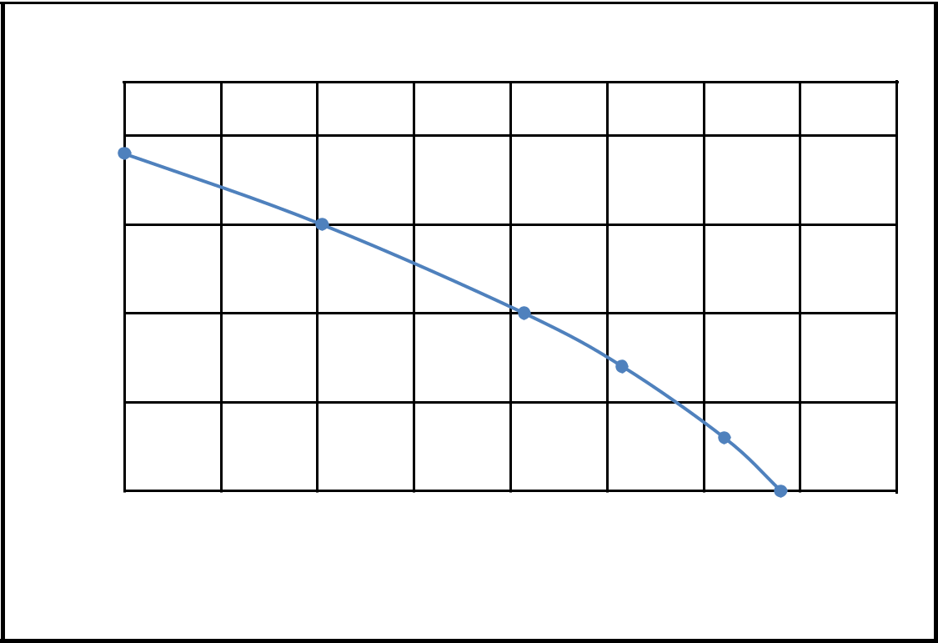

Inflow Performance Relationship (IPR) Curve

pwf (psia)

2500

2000

1500

1000

500

0 100 200 300 400 500 600 700 800

q (stb/day)

IPR Curve

Figure 2.1: Illustrating the Inflow Performance Relationship (IPR) Curve where qmax=736 stb/d, Pr=2400 psia.

2.5 PRODUCTION OUTFLOW PERFORMANCE RELATIONSHIP (OPR)

The outflow performance shows the relationship between the total tubing pressure drop and a surface pressure valve along with the total liquid flow rate. Though, the tubing pressure drop is essentially the sum of the surface pressure, the hydrostatic pressure drop of the fluid column which composed of the liquid holdup or liquid accumulated in the tubing, the weight of the gas and the frictional prssure loss that results from the flow of liquid out of the well.

Again, it involves fluid that flow through the production tubular, the wellhead and the surface flowline. In actual sense, the analysis of fluid flow involves the determination of the pressure drop across each segment of the production flowing system. In the industries, it is a complex problem because it deals with the multiphase flow of fluid involving the

simultaneous flow of oil, gas, and water which make the pressure drop dependent on many variables and some are interdependent. In the performance of outflow there is no availability for the determination of pressure drop in vertical, horizontal, and inclined pipies (Abdel-Aal et al., 2009).

Table 2.2: Flowing bottomhole pressure and production flow rate that required in the determination of the outflow performance relationship (OPR) curve

pwf (psia) | q (stb/day)
11178.24 | 40853.670
9817.409 | 35249.973
8704.663 | 30815.037
7651.399 | 26496.624
6686.632 | 22178.211
Source: (Wan Renpu, 2011).
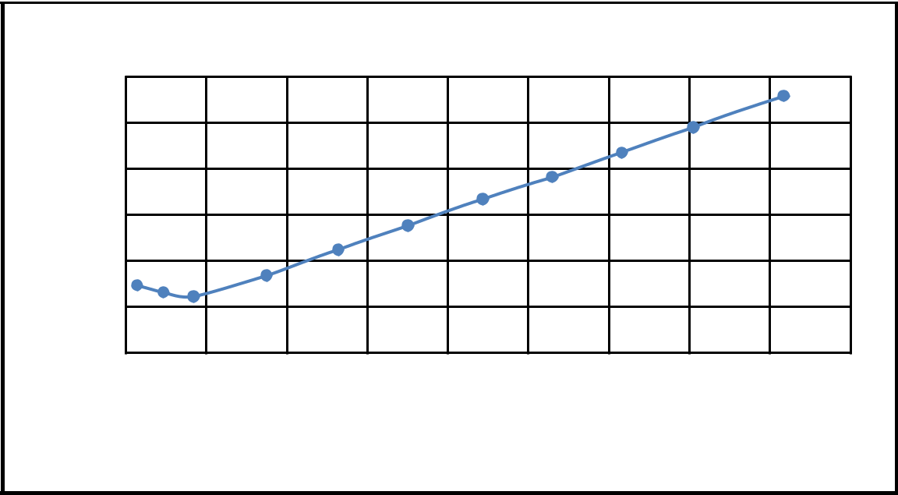

Outflow Performance Relationship Curve

12000

pwf (psia)

10000

8000

6000

4000

2000

0

0 5000 10000 15000 20000 25000 30000 35000 40000 45000

q (stb/day)

OPR Curve

Figure 2.2. Graph indicating the Outflow Performance Relationship (OPR) Curve.

2.6 CHOKES PERFORMANCE IN PRODUCTION OPTIMIZATION

In petroleum production, a choke is a restriction in a flow-line that causes the pressure drop or reduces the rate of flow through an outlet. The purpose of the choke is to provide precise control of wellhead flow rates in surface production application involving oil, gas and enhanced recovery. Chokes are capable of causing large pressure drop. Typically, in a flowing well, the choke is used to maintain a back pressure in the reservoir while allowing an optimum flow of gas or oil. This is often necessary to ensure effective production over the life of the well. Again, the control of flowing wells is usually done with chokes. However, there are basically two types of wellhead chokes commonly available in the industries namely: Positive (Fixed) chokes and Adjustable chokes. The pressure drop of the choke is determined by the flow of the medium through the internal diameter of a fixed orifice which is often called a bean. The positive (fixed) choke is generally used where the flow conditions do not change over a period of time in that the changing of the bean requires a shutdown of the flow through the choke. Again, adjustable chokes are used when there is an anticipated need to change the flow rate periodically (G. V. Chilingarian et al., 1975).

Choke is typically sized in 64th of an inch. On the other hand, chokes are most commonly set at the surface but there are down-hole chokes used mostly offshore. In the petroleum industry, fixing the wellhead pressure means placing a choke at the wellhead and, thus, the flowing bottom-hole pressure and production rate. The flow rate in a flowing well is usually restricted by pressure constraints of the surface equipment. However, the ideal condition is when small variation in downstream pressure do not affect the tubing head pressure flowing pressure. This may implies that the fluid flow through the choke at velocities greater than that of sound. This is a critical flow of the fluid. A good rule of thumb is a tubing head pressure that is double the average flow line pressure (Lyons, 2004).

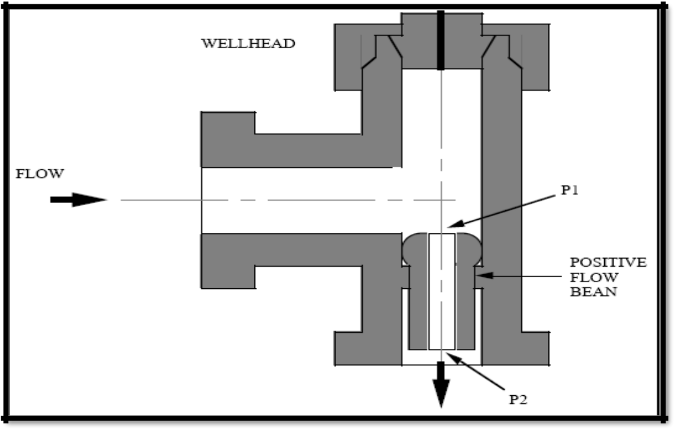

Figure 2.3. Positive choke (from Golan and Whitson, 1986).
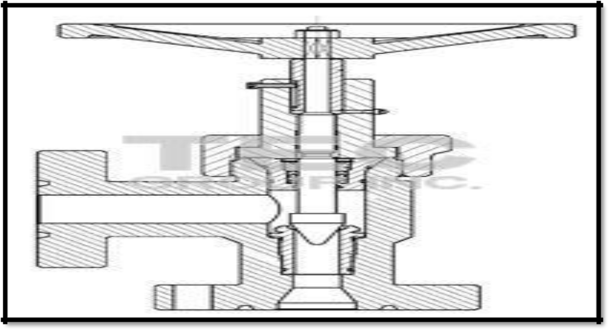

Figure 2.4. Adjustable choke (Courtesy of S.I.I. Willis, Long Beach, Calif.., and Mr. Mathew L.

Philippe).

Fixed and adjustable chokes are used in a variety of applications with surface production equipment. When using chokes for production, the major differences is the absence of heater. The rate of flow can be controlled using choke in enhanced oil recovery application whereby fluids and gases are injected into the reservoir. Because choke must operate in a wide variety of corrosive and harsh environments, components must be constructed using material designed specimen to provide maximum performance. Chokes can be customized in the petroleum sectors to meet the requirements of any specific application (G.V. Chilingarian et al, 1975).

As it relate to the performance of choke in production optimization Gilbert proposed a method in 1974 to estimate a parameter of fluid flowing through the outlet:
_{P =} 435 GLR^{0.546}q |  |  | 2.2
tf
tf | _{S}1.89
Where:

Ptf = Pwh, Wellhead pressure, psi

GLR = Gas-liquid ratio, scf/bbl

q = Gross liquid flow rate, bbl/day

S = Choke (Bean) size, 64th of an inch

Using the equation 2.2, a choke performance graph for different choke sizes can be obtained and plotted with the IRP and TPR curve to help in the production of the well.

2.7 TUBING PERFORMANCE IN PRODUCTION OPTIMIZATION

The tubing performance represents the vertical flow along the production tubing and it shows the performance of the well producing from the bottom-hole to the surface. The TPR also show the relationship between the flow rate in the tubing and flowing bottom-hole pressure, and is affected by pressure losses experienced due to restrictions in the tubing and chokes, valves and connections.

The fluid composition and behavior of the fluid phases in the specific completion design will determine the shape of the curve. The TPR is used with the inflow performance relationship (IPR) to predict the performance of a specific well.

For an efficient operations in the oil and gas industries the knowledge of tubing performance of flowing wells is very important, the present and future performance of the wells may also be evaluated. The flowing bottom-hole pressure of a well varies with production rates for a given wellhead pressure. Plotting these two flowing parameters against each other on a Cartesian coordinate will yield a curve called the tubing performance curve (TPR) (Lyons, 2004).

CHAPTER THREE

3.0 METHODOLOGY

3.1 INTRODUCTION

In this research work, methodology used is qualitative. A qualitative methodology involved describing in details specific situation using research tools like interviews, surveys, and observations. In this type of approach the researchers tends to be inductive which means that they develop a theory or look for a pattern of meaning on the basis of the data that they collected. This involves moving from the specific to the general and is sometimes called a bottom-up approach.

3.2 STATISTICAL AND SENSITIVITY ANALYSIS

Sensitivity analysis is any systematic, common sense technique that is used to understand how risks are estimated and in particular, risk-based decisions are dependent on variability and uncertainty in the factors contributing to risk. In short, it identify what is “driving” the risk estimates. However, it is also used in both point estimate and probabilistic approaches to identify and rank important sources of variability as well as important sources of uncertainty. Similarly, in a probabilistic model, there may be uncertainty regarding the choice of a probability distribution. For example, lognormal and gamma distributions may be equally reasonable for characterizing variability in an input variable. A simple exploratory approach would be to run separate Monte Carlo simulations with each distribution in order to determine the effect that each particular source of uncertainty may have on risk estimates within the reasonable maximum exposure (RME) range of 90th to 99.9th percentile. For guiding the complexity of the analysis and communicating important results a quantitative information provided by sensitivity analysis is important (Cullen and Frey, 1999).

It can also involve more complex mathematical and statistical methods such as correlation and regression analysis to determine which factor in a risk model contribute mostly to the variance in the risk estimate. The complexity generally stems from the fact that multiple

sources of variability and uncertainty are influencing a risk estimate at the same time and sources may not act independently. An input variable contributes significantly to the output risk distribution if it is both highly variable and the variability propagates through the algebraic risk equation to the model output. Changes to the distribution of a variable with a high sensitivity could have a profound impact on the risk estimate, whereas even large changes to the distribution of a low sensitivity variable may have a minimal impact on the final result. Information from sensitivity analysis can be important when trying to determine where to focus additional resources (Iman and Helton, 1988).

3.2.1 Overview of Nodal Analysis

Nodal analysis views the total producing system as a group of components potentially encompassing reservoir rock irregularities. Completions such as gravel pack, open or closed perforations, open hole, vertical flow strings, restrictions, multi-lateral branches, integrated gathering networks, compressors, pump stations, and metering locations. An improper design of any one component, or a mismatch of components adversely affects the performance of the entire system. The major function of a system-wide analysis is to increase well rates. It identifies bottlenecks and serves as a framework for the design of efficient field wide flow systems, which include wells, artificial lift, gathering lines and manifolds. Nodal analysis is also used in planning new field development together with reservoir simulation and analytical tools.

However it consists of selecting a division point or node in the well and dividing the system at this point to a optimize performance in the most economical manner. Although the entire production system is analyzed as a total unit, interacting components, electrical circuits, complex pipeline networks, and centrifugal pumping are evaluated individually using this method. Locations of excessive flow resistance or pressure drop in any part of the network are identified.

Many factors are used to maximize production from discovery wells to those ready to be abandoned which include establishing a relationship between flow rate and pressure drop

within each component in the system; using gradient correlations and selection procedures; and deciding when to use artificial lift to maintain a required production rate.

Eventually, nodal analysis determines the daily operating policy by forecasting the performance of the various elements that make up a completion and production system. This is executed with the objective of optimizing the completion design to suit the reservoir deliverability, to identify restrictions or limitations present in the production system and subsequently, to determine any means of improving the production efficiency (Schlumberger Oilfield Glossary, 2006).

However, nodal analysis have it limitation only on an oilfield that have a small number of wells which is due to its trail-and-error nature in the industries (Kosmidis et al., 2004). For instance, a typical execution of nodal analysis requires that by holding all other parameters fixed, a single variable is varied to inspect the value of this variable that produces the optimal value.

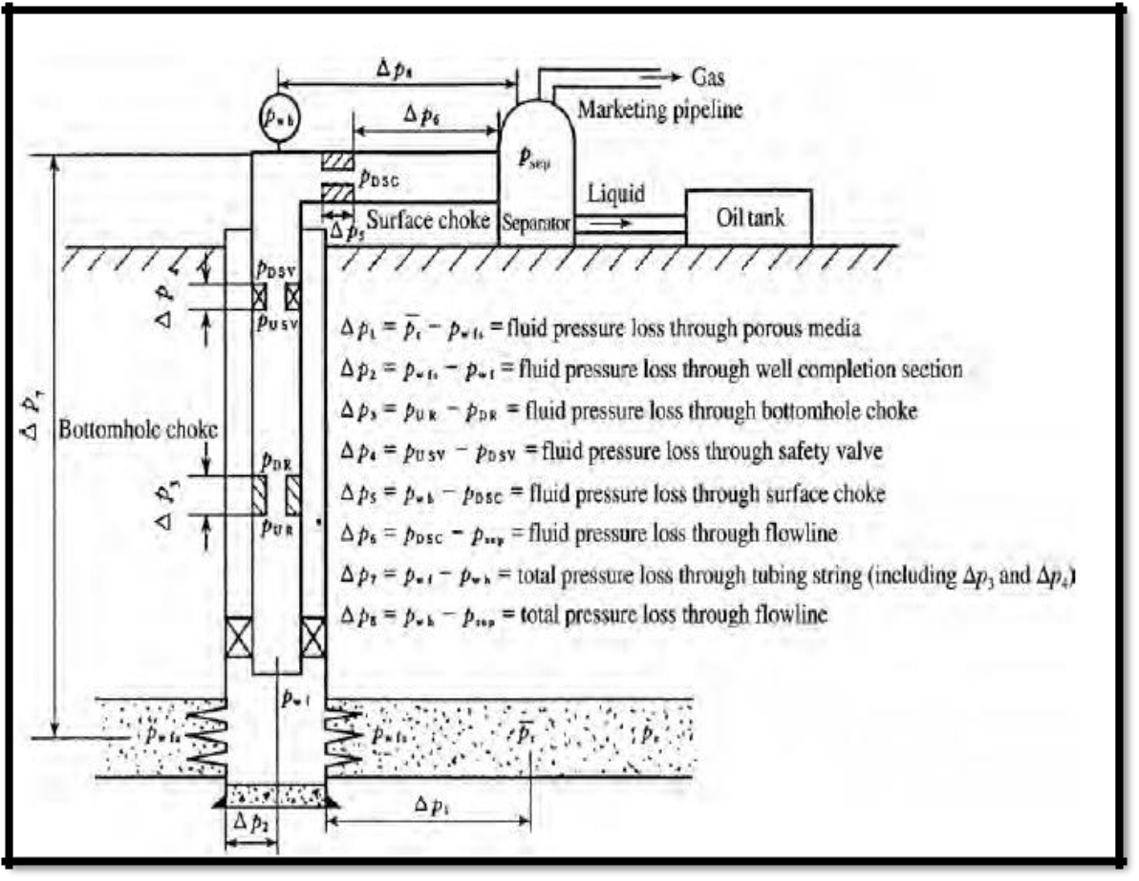

Figure 3.1. Schematic showing a typical Nodal Analysis of various pressure losses in the production system.

3.2.2 @RISK SOFTWARE

@Risk is a tool that performs risk analysis using Monte Carlo and Latin Hypercube Simulation Sampling. Monte Carlo simulation sampling refers to the traditional technique for using random or pseudo-random numbers to sample from a probability distribution. It sampling techniques are entirely random in principle that is any given sample value may fall anywhere within the range of the input distribution. With enough iterations, Monte Carlo simulation sampling recreates the input distribution through sampling. By contrast, Latin Hypercube simulation sampling stratifies the input probability distributions. With this sampling type, @Risk or Risk Optimizer divides the cumulative curve into equal

intervals on the cumulative probability scale, then take a random value for each interval of the input distribution (Iledare, 2014).

Therefore, for even modest sample sizes, the Latin Hypercube method makes all or nearly all of the sample means fall within a small fraction of the standard error. This is usually desirable, particularly in @RISK when you are performing just one simulation. And when you're performing multiple simulations, their means will be much closer together with Latin Hypercube than with Monte Carlo; this is why the Latin Hypercube method makes simulations converge faster than Monte Carlo (Iledare, 2014).

@RISK also helps you plan the best risk management strategies through the integration of Risk Optimizer which combines Monte Carlo simulation with the latest solving technology to optimize any spreadsheet with uncertain values.

It has the best procedure for identifying the key variables affecting the range and shape of the results. It is a regression sensitivity option. @Risk is second to Crystal Ball in terms of resources (Sugiyama, 2007).

It provides sensitivity and scenario analyses to determine the critical factors in models. Sensitivity analysis is used to rank the distribution functions in model according to their impact or response on outputs. Sensitivity analysis pre-screens all inputs based on their precedence in formulas to outputs in model thereby reducing irrelevant data. In addition, @RISK make input function to select a formula whose value will be treated as an @RISK input for sensitivity analysis. In this way multiple distributions can be combined into a single input streamlining the sensitivity reports.

CHAPTER FOUR

4.0 DATA FINDING AND ANALYSIS
4.1 INTRODUCTION

In this chapter, three reservoir conditions of tubing sizes and choke sizes where determining to give the optimal production and to satisfy the economics needed in order to optimize production and reduce cost.

In determining the tubing sizes and choke sizes that optimizes production, the following equations were used: Vogel and Gilbert Correlations in order to computing various parameters. These equations are:

q
^{qmax} ⁼ _{1 − 0.2} (Pwf) _{− 0.8} (Pwf)²

P_{r} P_{r}
- = q_{max} [1 − 0.2 (^{Pwf}) − 0.8 (^{Pwf})²]

P_{r}P_{r}

Where:
q_{max} = Maximum rate of production, stb/day
q = Rate of production, stb/day
P_{wf} = Flowing bottomhole pressure, psia
P_{r} = Reservoir pressure, psia
q
^{P}wf ^{= P}r ⁻ ⁽_{J}⁾

4.1
4.2

4.3

J = [0.2 | ^{q}max | + 1.6 | ^{q}max | (P | )] | 4.4
 | P_{r} |  | P_{r} | wf

Where:

J= Productivity index, stb/d/psia;
q_{max} = Maximum rate of production, stb/day;
P_{wf} = Flowing bottomhole pressure, psia;
P_{r} = Reservoir pressure, psia

4.2 GILBERT’S CORRELATION FOR SELECTING CHOKE SIZES

The below equation was developed by Gilbert to estimate a parameter of fluid flow through orifice.
P = | 435GLR^{0.546}q |  | 4.5
wh | _{d}1.89
Where:

Pwh= Wellhead pressure, psia;

GLR= Gas liquid ratio, scf/stb

q= Rate of production, stb/day

d= Choke size in 1/63 of an inch;

Gilbert’s derive the equation above by using a regular daily individual well production data that was obtained from ten section field in California. In that data, he noticed that an error of 1/128-inch in bean size can give an error of 5 to 20% in pressure estimates. Under such

conditions the rate of flow is not affected by downstream pressure. Actually, this last limitation is of small practical significance since chokes are usually selected to operate at critical flow conditions so that the well’s flow rate is not affected by changes in flow-line pressure. Again, in the type of formula used, it is assumed that actual mixture velocities through the bean exceed the speed of sound, for such condition the downstream or flow-line pressure has no effect upon the tubing pressure. Thus, the equation applies for tubing head pressure of at least 70% greater than the flow-line pressure (Renpu, 2011).

Again, from Gilbert correlation in equation 1.4 the formula for determining the sizes of choke can be written as:
 | _{P q}1.89
d = | wh | 4.6
d = | 435GLR^{0.546} | 4.6

Where:

d= Choke size in 1/64 of an inch;

Pwh= Wellhead pressure, psia;

q= Rate of production, stb/day;

GLR= Gas-liquid ratio, scf/stb

Table 4.1: Test data for tubing and choke sizes selection for production optimization.

 | Pr (Psia) |  |  |  |  | Pwf (Psia) |  | Q (stb/day) |  | Qmax (stb/day) |  | J (stb/d/psia)
 | 1872.094 |  |  |  |  | 600 |  | 500 |  | 696.548 |  |  | 0.265
Table 4.2: Data used to plot the IPR curve for a reservoir condition of 1872.094psia
 | Depth(ft) |  |  |  | Pr (Psia) |  | GLR (scf/stb) |  | Pwf (Psia) |  | Qmax (stb/day) |  | Q (stb/day)
 | 4264 |  | 1872.094 |  |  |  |  | 1219 | 1872.096 |  | 696.548 |  | 0
 | 4264 |  | 1872.094 |  |  |  |  | 1219 | 1400 |  | 696.548 |  | 280.737
 | 4264 |  | 1872.094 |  |  |  |  | 1219 | 1000 |  | 696.548 |  | 463.138
 | 4264 |  | 1872.094 |  |  |  |  | 1219 | 800 |  | 696.548 |  | 535.259
 | 4264 |  | 1872.094 |  |  |  |  | 1219 | 600 |  | 696.548 |  | 594.661
 | 4264 |  | 1872.094 |  |  |  |  | 1219 | 500 |  | 696.548 |  | 619.592

Table 4.3: Tubing sizes of 2.875, 2.375, 3.5, 1.90 inches with their various tubing head pressures and bottom-hole flowing pressures.

 | Tubing |  |  |  | Tubing
 | 2.875-in |  |  |  | 2.375-in
THP(Psia) | Q |  | Pwf (Psia) | THP (Psia) | Q (stb/day) | Pwf (Psia)
THP(Psia) | (stb/day)
235 | 100 |  | 808 | 235 | 100 | 630
235 | 200 |  | 741 | 235 | 200 | 624
235 | 400 |  | 700 | 235 | 400 | 620
235 | 600 |  | 800 | 235 | 600 | 680
 | Tubing |  |  |  | Tubing
 | 3.5-in |  |  |  | 1.90-in
THP(Psia) | Q |  | Pwf(Psia) | THP(Psia) | Q (stb/day) | Pwf(Psia)
THP(Psia) | (stb/day)
235 | 100 |  | 890 | 235 | 100 | 707
235 | 200 |  | 808 | 235 | 200 | 680
235 | 400 |  | 746 | 235 | 400 | 714
235 | 600 |  | 751 | 235 | 600 | 802

Table 4.4: Production rate for various choke sizes.

 |  |  |  |  | Choke Sizes
 | Parameters |  |  | d1 | d2 | d4 | d5
q (stb/d) |  | Pwf (Psia) | Pwh (Psia) | 16/64-in | 24/64-in | 35/64-in | 60/64-in
100 |  | 1495.032 | 700 | 272.545 | 586.476 | 1196.570 | 3314.030
200 |  | 1117.971 | 502 | 195.453 | 420.587 | 858.114 | 2376.630
400 |  | 363.849 | 27 | 10.512 | 22.621 | 46.154 | 127.827
600 |  | 0 | 0 | 0 | 0 | 0 | 0

In these reservoir conditions, the reservoir pressures are 1872.094, 4809.040, and 6531.264 psia with 500 stb/day production rate as shown in the appendix, where the reservoir pressure 1872.094 psia is indicated as reservoir one (R1) while 4809.040 psia is reservoir two (R2) and 6431. 264 psia is reservoir three (R3).

It also show the test bottom-hole flowing pressure of each table listed above as 600, 2000, and 3000 psia in which equation 1.2 was used to obtained the maximum rate of production shown in table 4.1, 4.5 and 4.9. Moreover, their productivity indices are 0.265, 0.136 and 0.1134stb/d/psia.

Under the given reservoir conditions in table 4.2, 4.6 and 4.10 using equation 1.3, various rates of production were determined for different bottom-hole flowing pressures and a graph of rates of production were plotted against bottom-hole flowing pressures in Figure 4.1 to 4.6 in order to determine the inflow performance relationship (IPR) curve. The IPR curve tells us how the oil is flowing from the reservoir to wellbore. Again, these tables illustrates the bottom-hole flowing pressures values that were used in obtaining various rates of production. It also show their respective gas-liquid ratio of 1219, 492 and 249 scf/stb. The IPR curves are shown in Figure 4.1, 4.2, 4.3, 4.4 below.

In the test data the tubing head pressure of 235, 457, and 195 psia for table 4.3, 4.7 and 4.11 were given with their bottom-hole flowing pressures read from Gilbert’s correlation chart using the rates of production; 100, 200, 400, and 600 stb/day against the above THP

to obtained our bottom-hole flowing pressure. These values are shown on tables listed previously.

Using equation 1.4 various bottomhole pressures were computed and the production rates were calculated for various choke sizes using equation 1.6. These figures are given in table 4.4, 4.8 and 4.12. These values were used to plot a graph of production rates of various choke sizes against wellhead pressures (Pwh).
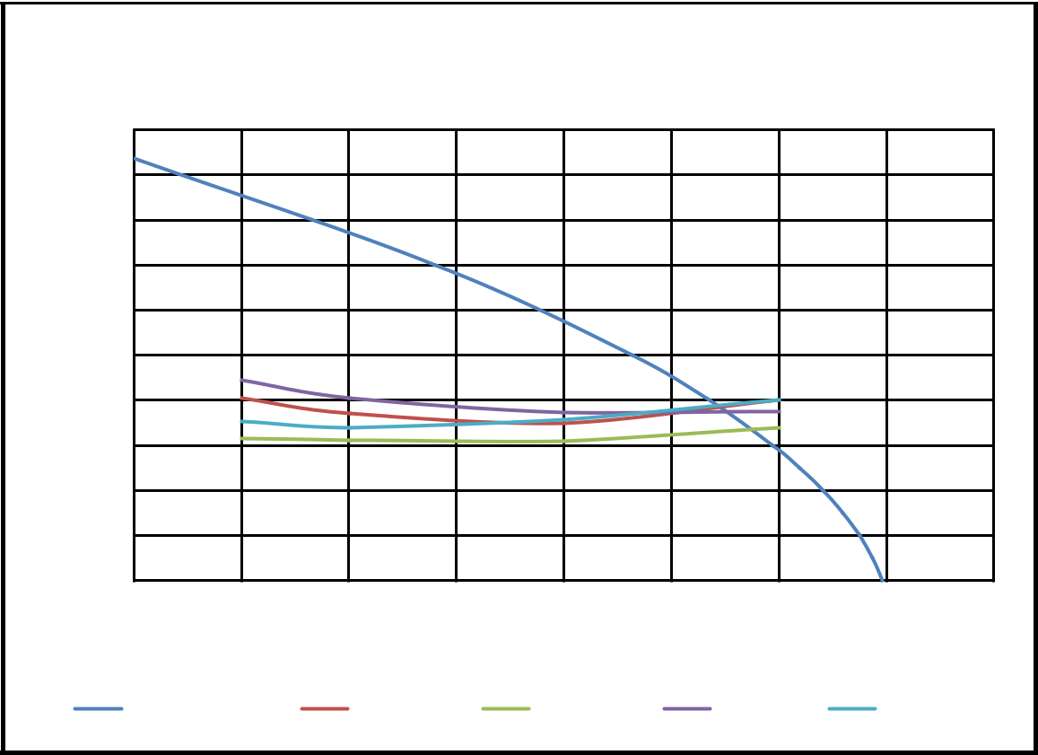

Tubing Sizes

pwf (psia)

2000

1800

1600

1400

1200

1000

800

600

400

200

0

0 100 200 300 400 500 600 700 800

q (stb/day)

Tubing IPR 2.875-in 2.375-in 3.50-in 1.90-in

Figure 4.1. Tubing Inflow performance relationship (IPR) curve and vertical left performance with depth of 4264 ft.

Figure 4.1 shows that the tubing size 2.375-inches gives the maximum rate of production of 572 stb/day at a reservoir condition of 1872. 094 psia which is at a shallower depth of 4264 ft.

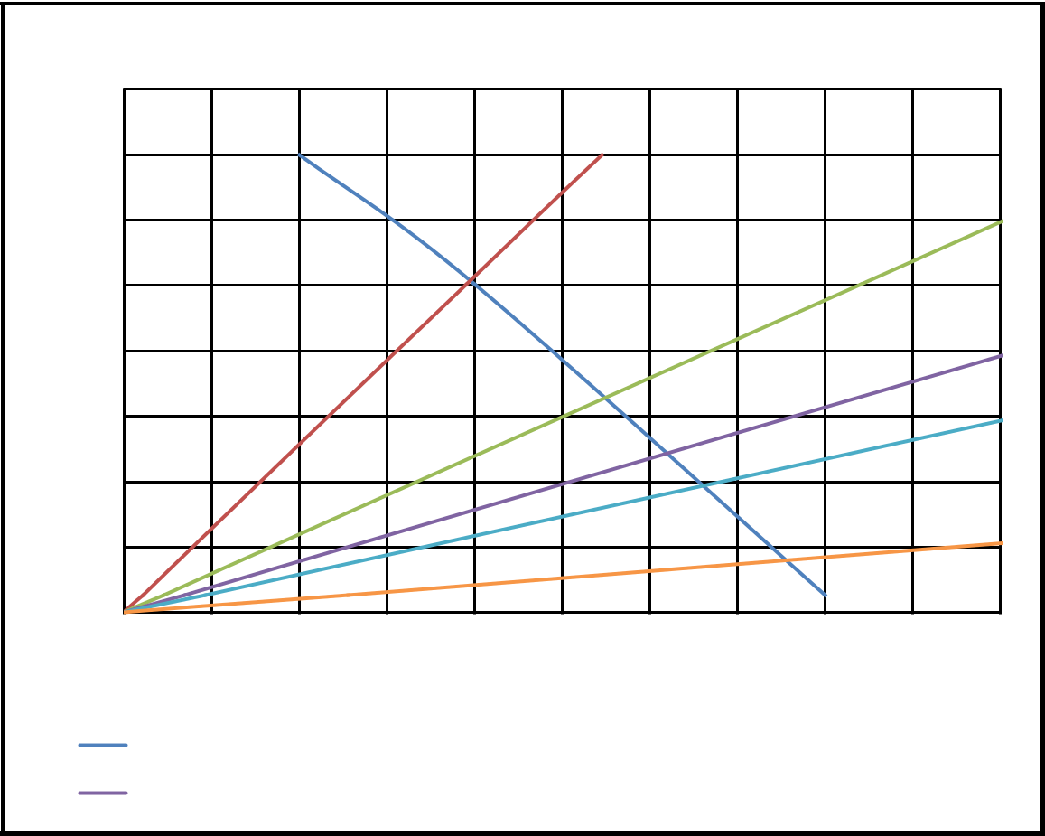

Choke Sizes

pwh (psia)

800

700

600

500

400

300

200

100

0

0 50 100 150 200 250 300 350 400 450 500

q (stb/day)

Choke IPR |  | 16/64-inch |  | 24/64-inch
30/64-inch |  | 35/64-inch |  | 60/64-inch

Figure 4.2. Production Rates various choke sizes and wellhead pressure with 4264 ft depth.

In Figure 4.2, the production rates increases with increasing choke size. For 60/64-in choke size the operational condition gives a production rate of 380 stb/day, the highest among the choke sizes considered.

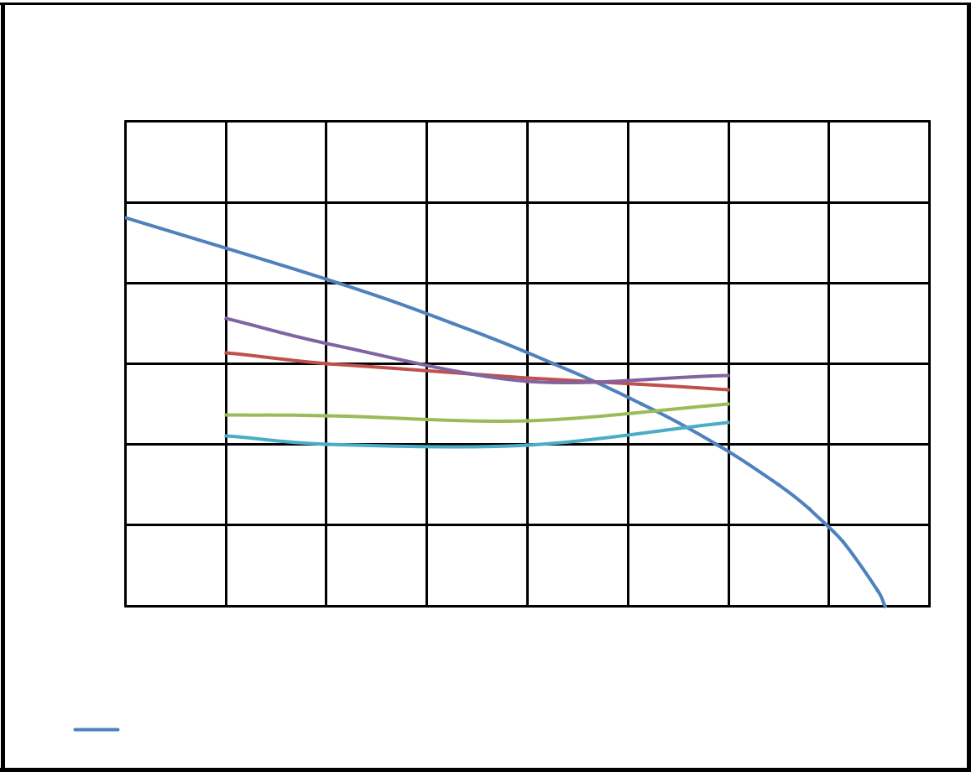

Tubing Sizes

pwf (psia)

6000

5000

4000

3000

2000

1000

0

0 | 100 | 200 |  | 300 | 400 |  |  | 500 |  | 600 | 700 |  | 800
 |  |  |  |  | q (stb/day)
Tubing IPR |  |  | 2.875-in |  |  |  | 2.375-in |  |  | 3.50-in |  |  | 1.90-in

Figure 4.3. Illustract the Tubing IPR curve with the production rates of various tubing sizes and wellhead pressure with 10232 ft depth.

Figure 4.3 shows that the tubing size of 1.90-inches gives the maximum rate of production of 560 stb/day at a reservoir condition of 4809.040 psia.

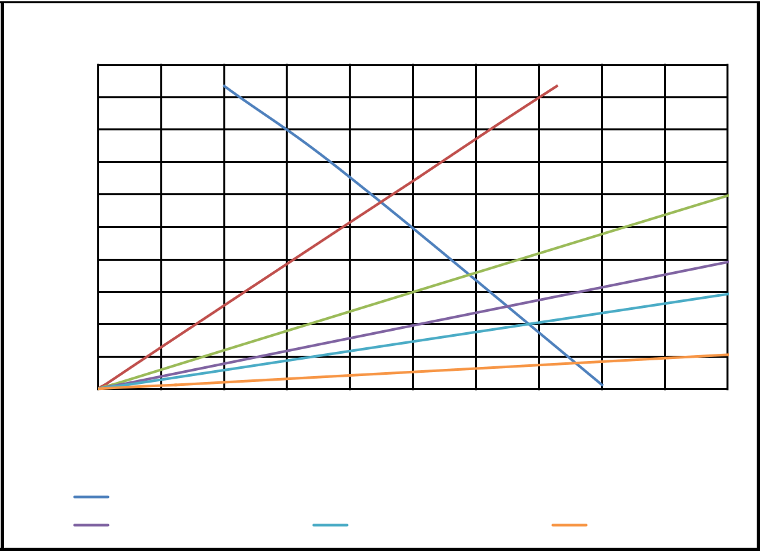

Choke Sizes

pwh (psia)

1000

900

800

700

600

500

400

300

200

100

0

0 50 100 150 200 250 300 350 400 450 500

 | q (stb/day)
Choke IPR |  | 16/64-inch |  | 24/64-inch
30/64-inch |  | 35/64-inch |  | 60/64-inch

Figure 4.4. Represent production rates of various choke sizes and wellhead pressure having depth of 10232 ft.

Looking at the choke size of 60/64-inch in Figure 4.4, the rates of production increases with increase in the size of choke which have a production rate of 380 stb/day with the reservior condition of 4090.040 psia.

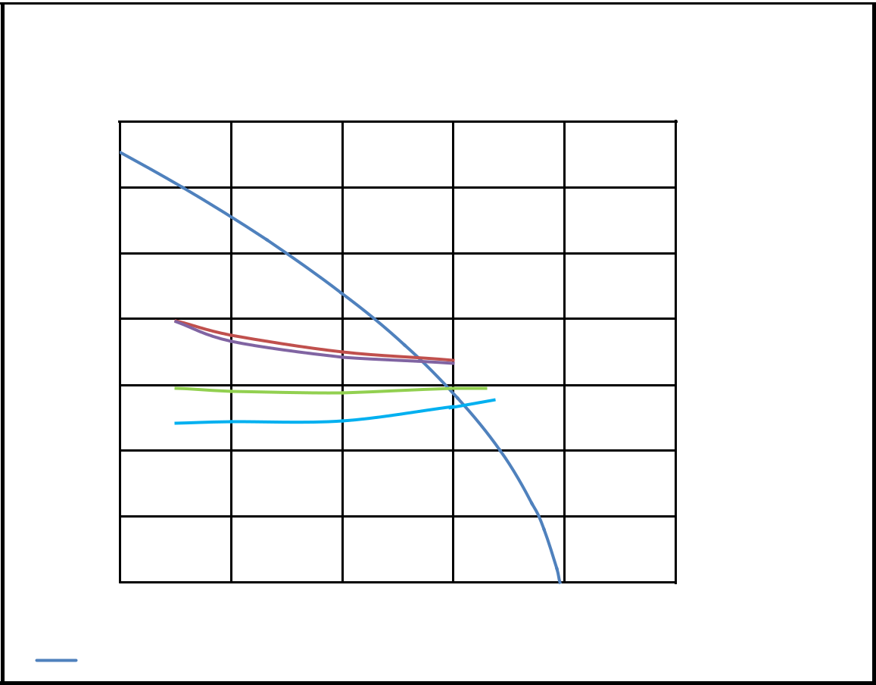

Tubing Sizes

pwf (psia)

7000

6000

5000

4000

3000

2000

1000

0
0 | 200 |  | 400 | 600 |  | 800 |  | 1000
 |  |  | q (stb/day)
Tubing IPR |  |  | 2.875-in |  | 2.375-in |  |  | 3.50-in |  | 1.90-in

Figure 4.5 shows that the rates of production increases with increasing tubing size with various wellhead pressure along the tubing IPR curve.

In Figure 4.5 above the tubing size of 1.90-inches gives the maximum rate of production of 619 stb/day at a reservoir pressure of 6531.264 psia and a depth of 14072 ft.

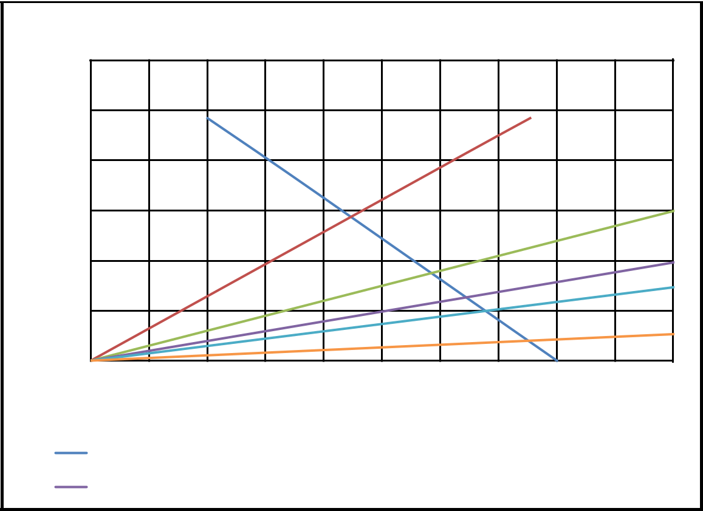

Choke Sizes

pwh (psia)

1200

1000

800

600

400

200

0

0 50 100 150 200 250 300 350 400 450 500

q (stb/day)

Choke IPR |  | 16/64-inch |  | 24/64-inch
30/64-inch |  | 35/64-inch |  | 60/64-inch

Figure 4.6. Indicates the production rates as it increases with increasing choke size.

For a choke size 60/64-in the operational condition gives a production rate of 360 stb/day, the highest among the choke sizes considered.

It was observed from the above tables and figures that pressure increases with increasing depth.

4.3 ECONOMIC ANALYSIS OF VARIOUS TUBING SIZES

For the economic analysis, three (3) periods were used, that is 5, 10, and 15 years. The economic analysis was done using four(4) tubing sizes which include 1.90, 2.375, 2.875, and 3.5 inches with different prices for the three reservoir conditions R1, R2, and R3. Again, the diagram illustrated in Figure 4.1, 4.3, and 4.5 was used to read the production rates for all the conditions stated in table 4.5, 4.6, and 4.7. Furthermore, equation 1.7 and 1.8 was used to estimate the revenues and profits for each production tubing sizes for the various reservoir conditions R1, R2, and R3 resepectively.
Revenues($) = (Prod. rate)(Prod. Period)(Oil Price)(365) |  |  |  |  |  |  |  |  |  |  |  |  |  |  |  | 4.7
Profit ($) = (Revenues) − (Tubing Cost) |  |  |  |  |  |  |  |  |  |  |  |  |  |  |  |  | 4.8
Table 4.5: Cost of tubing for a reservoir condition of R1
Tubing size (in) |  | Q (stb/d) |  |  | Period (yrs) |  |  | Price ($/stb)Revenue ($) |  |  |  | Tubing cost ($) |  |  |  |  |  | Profit ($)
1.900 |  | 542 |  |  | 10 |  |  | 75 | 148372500 |  | 500000 |  |  |  |  |  | 147872500
2.375 |  | 572 |  |  | 10 |  |  | 75 | 156585000 |  | 560000 |  |  |  |  |  | 156025000
2.875 |  | 542 |  |  | 10 |  |  | 75 | 148372500 |  | 620000 |  |  |  |  |  | 147752500
3.500 |  | 551 |  |  | 10 |  |  | 75 | 150836250 |  | 700000 |  |  |  |  |  | 150136250
Table 4.6: Cost of tubing for a reservoir condition of R2
Tubing size (in) |  | Q (stb/d) | Period (yrs) |  |  | Price ($/stb) |  |  | Revenue ($ |  |  | )Tubing cost ($) |  |  |  |  |  | Profit ($)
1.900 |  | 560 |  |  | 10 |  |  | 75 | 153300000 |  |  | 700000 |  |  |  |  | 152600000
2.375 |  | 530 |  |  | 10 |  |  | 75 | 145087500 |  |  | 760000 |  |  |  |  | 144327500
2.875 |  | 475 |  |  | 10 |  |  | 75 | 130031250 |  |  | 820000 |  |  |  |  | 129211250
3.500 |  | 475 |  |  | 10 |  |  | 75 | 130031250 |  |  | 900000 |  |  |  |  | 129131250
Table 4.7: Cost of tubing for a reservoir condition of R3
Tubing size (in) |  | Q (stb/d) |  | Period (yrs) |  |  | Price ($/stb) |  |  | Revenue ($) |  |  | Tubing cost ($) |  |  |  |  | Profit ($)
1.900 |  | 619 |  |  | 10 |  |  | 75 |  | 169451250 |  |  | 1000000 |  |  |  |  | 168451250
2.375 |  | 585 |  |  | 10 |  |  | 75 |  | 160143750 |  |  | 1060000 |  |  |  |  | 159083750
2.875 |  | 550 |  |  | 10 |  |  | 75 |  | 150562500 |  |  | 1120000 |  |  |  |  | 149442500
3.500 |  | 548 |  |  | 10 |  |  | 75 |  | 150015000 |  |  | 1200000 |  |  |  |  | 148815000

The above tables shows various parameters such as tubing sizes, production rates, production period, revenues, tubing cost and profit. In order to estimate the Revenues in the tables above, equation 1.7 was used while equation 1.8 were use to determine the profit in the table 4.5, 4.6 and 4.7. After determining the revenues and profits it was use in Monte Carlo simulation to estimates the profit on production for 5, 10, and 15 years.

Table 4.8: Summary window for Risk input data with a depth of 4262 ft and 1872.094 psia reservoir pressure.
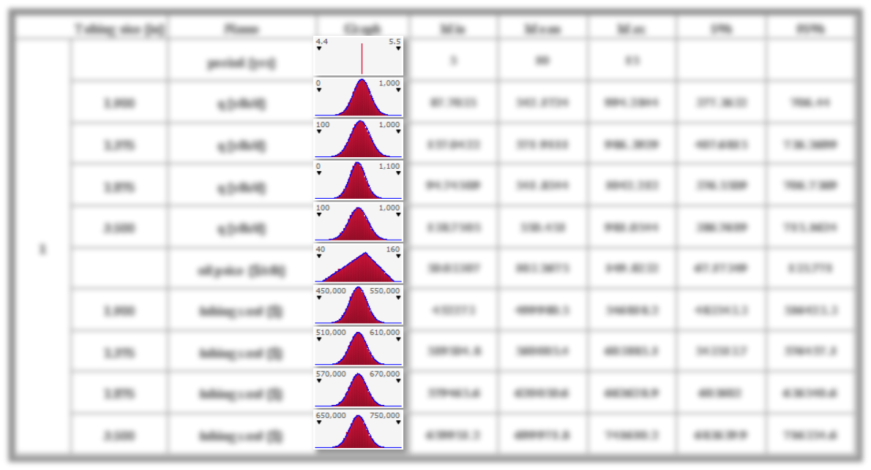

 | Tubing size (in) | Name | Graph | Min | Mean | Max | 5% | 95%
 |  | period (yrs) |  | 5 | 10 | 15
 | 1.900 | q (stb/d) |  | 87.7035 | 542.1724 | 994.2844 | 377.3632 | 706.44
 | 2.375 | q (stb/d) |  | 157.0422 | 571.9111 | 986.3929 | 407.6815 | 736.2699
 | 2.875 | q (stb/d) |  | 94.74509 | 541.8544 | 1042.212 | 376.5509 | 706.7369
 | 3.500 | q (stb/d) |  | 138.7505 | 550.451 | 981.0544 | 386.7619 | 715.1624
1
1 |  | oil price ($/stb) |  | 50.03307 | 103.2675 | 149.8232 | 67.17349 | 135.771
 | 1.900 | tubing cost ($) |  | 452273 | 499980.5 | 546818.2 | 483543.3 | 516423.3
 | 2.375 | tubing cost ($) |  | 519504.8 | 560005.4 | 603885.1 | 543513.7 | 576457.1
 | 2.875 | tubing cost ($) |  | 579465.6 | 620050.6 | 662628.9 | 603602 | 636540.6
 | 3.500 | tubing cost ($) |  | 659951.2 | 699971.8 | 741610.2 | 683639.9 | 716354.6

Considering a set of probability distributions such as Normal and Triangular for an uncertain inputs of production rate, oil price and tubing cost from table 4.8 it shows that at a tubing size of 1.9 inch the production rate will be 377.363 stb/d for a 5% confidence and 706.44 stb/d for a 95% confidence. It is also noted that at a tubing sizes of 2.375, 2.875, and 3.5 inches the production rates at 5% confidence are 407.682, 376.551, and 386.762 stb/d respectively while at 95% it will be 736.269, 706.737, and 715.162 stb/d respectively.

For oil price, it was illustrated that at 5% and 95% confidence it will estimated at 67.174 and 135.771 $/stb respectively. Furthermore, the cost of a production tubing at 1.9, 2.375,

2.875, and 3.5 inches was assume to be 483543.3, 543513.7, 603602, and 683639.9 respectively.

Finally, the @Risk simulation was ran using a periods of 5, 10, and 15 years as minimum, mean, and maximum.

Table 4.9: Summary window for profit with a depth of 10232 ft and 4809.040 psia reservoir pressure.
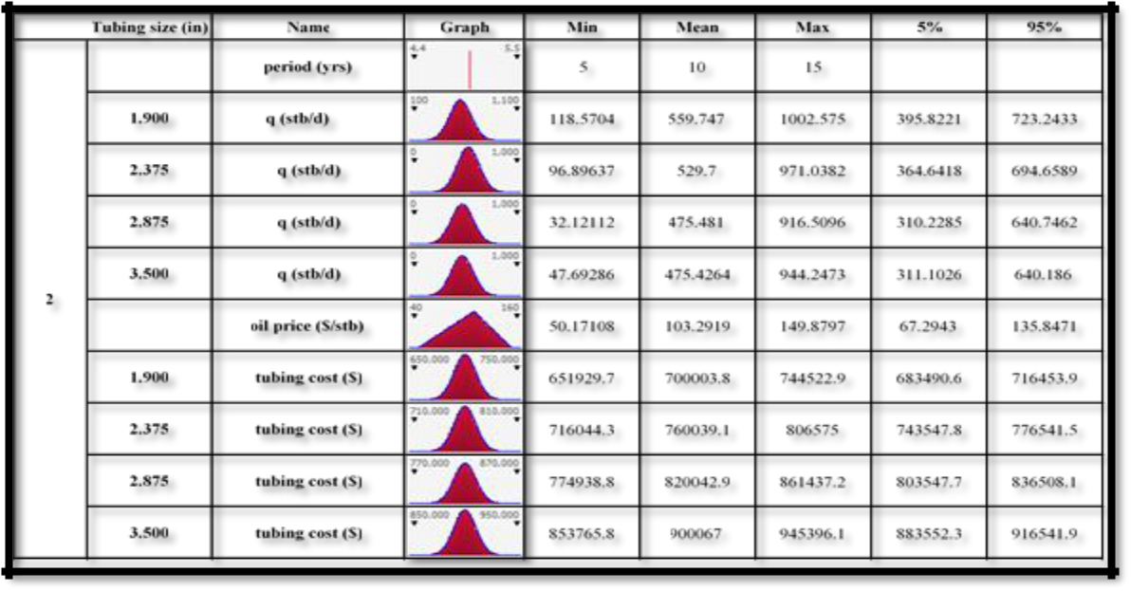

Table 4.9 shows the probability distributions of production rate, oil price, and tubing cost using Normal and Triangular for an uncertain inputs that were run using table 4.5, 4.5, and 4.6 with the input variables of production rate, oil price, and tubing cost using the period of 5, 10, and 15 years which indicate the minimum, mean, and maximum. As indicated in Table 4.9, a tubing size of 1.9 inch with a 5% confidence level, the production rate will be 395.822 stb/d and 723.243 stb/d for a 95% confidence level. Furthermore, it is indicated that at a tubing sizes of 2.375, 2.875, and 3.5 inches the production rates at 5% confidence are 364.642, 310.229, and 311.103 stb/d respectively while at 95% the production rates will be 694.659, 640.746, and 640.186 stb/d respectively.

It was also illustrated in Table 4.9, that the oil price at 5% and 95% confidence was shown to be 67.294 and 135.847 $/stb respctively. Also, the tubing cost for a tubing sizes of 1.9, 2.375, 2.875, and 3.5 inches are 683490.6, 743547.8, 803547.7, and 883552.3 US Dollars respctively at 5% chance while at 95% chance, the tubing cost are 716453.9, 776541.5, 836508.1, and 916541.9 US Dollars respctively.

Table 4.10: Summary window for profit with a depth of 14072 ft and 6531.264 psia reservoir pressure.
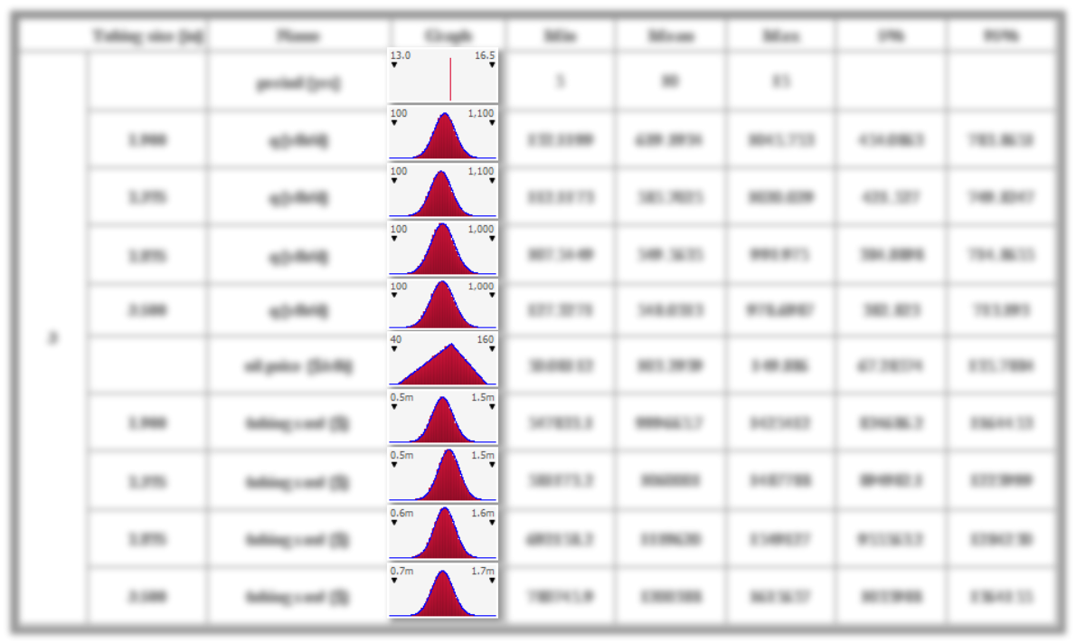

 | Tubing size (in) | Name | Graph | Min | Mean | Max | 5% | 95%
 |  | period (yrs) |  | 5 | 10 | 15
 | 1.900 | q (stb/d) |  | 132.1199 | 619.1934 | 1045.753 | 454.0863 | 783.8651
 | 2.375 | q (stb/d) |  | 112.1173 | 585.7025 | 1020.029 | 421.527 | 749.8247
 | 2.875 | q (stb/d) |  | 107.5449 | 549.5635 | 991.975 | 384.8898 | 714.8655
 | 3.500 | q (stb/d) |  | 127.3271 | 548.0313 | 978.6987 | 382.823 | 713.193
3
3 |  | oil price ($/stb) |  | 50.08112 | 103.2939 | 149.886 | 67.28574 | 135.7884
 | 1.900 | tubing cost ($) |  | 547833.1 | 999665.7 | 1425412 | 834686.2 | 1164453
 | 2.375 | tubing cost ($) |  | 581173.2 | 1060001 | 1487788 | 894982.1 | 1223999
 | 2.875 | tubing cost ($) |  | 692158.2 | 1119620 | 1549127 | 955563.2 | 1284230
 | 3.500 | tubing cost ($) |  | 780745.9 | 1200388 | 1615657 | 1035988 | 1364155

The results display in Table 4.10 shows 90% confidence interval with periods of 5, 10, and 15 years which specify the minimum, mean, and maximum. With the production tubing sizes of 1.9, 2.375, 2.875, and 3.5 in, normal distribution was placed on the production rates in Table 4.10. As specified in the Table 4.10, the oil price varies from 67.286-135.788 within a 90% interval. Using similar tubing sizes above the tubing costs for a 90% confidence was stated on Table 4.10.

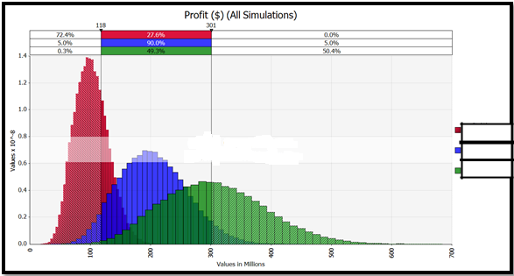

5yrs

10yrs

15yrs

Figure 4.7. Profit for the periods of 5, 10, and 15years with reservoir conditions of R1 for a tubing size of 1.90-inch.

As indicated in Figure 4.7, the red on the graph shows the probability density of profit for 5 years and the blue indicates the probability density of profit for a period of 10 years while the green represents the probability density of profit for a 15 years period. As shown in table 4.5 the deterministic profit for a tubing size of 1.90-inch is $148 millions.

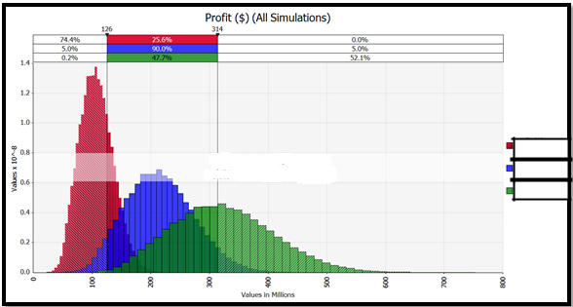

5yrs

10yrs

15yrs

Figure 4.8. Profit for the periods of 5, 10, and 15years with reservoir conditions of R1 for a tubing size of 2.375-inch.

As shown in Table 4.5 above the deterministic profit for a tubing size of 2.375-inch is $156 millions. Figure 4.8 represent the three probability densities of profits for 5, 10, and 15 years which are red, blue, and green respectively.

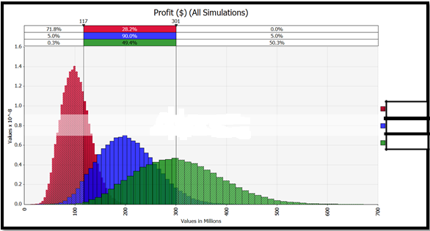

5yrs

10yrs

15yrs

Figure 4.9: Profit for the periods of 5, 10, and 15years with a reservoir condition of R1 for a tubing size of 2.875-inch.

From the sensitivity analysis shown in Figure 4.9, the red, blue, and green represent the probability density of profit for 5, 10, 15 years. Recall it was noted in table 4.5 that the deterministic profit obtain while using a tubing size of 2.875-inch is $148 millions under a reservoir conditon of R1.

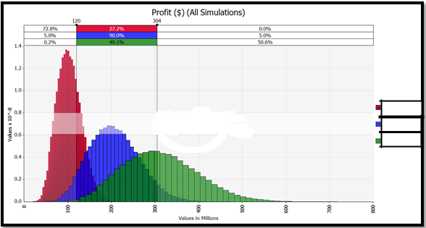

5yrs

10yrs

15yrs

Figure 4.10: Profit for the periods of 5, 10, and 15years with a reservoir conditon of R1 for a tubing size of 3.5-inch.

In Figure 4.10, the red on the graph above represents the probability density of profit for 5 years period while the blue specifies the probability density of profit for a period of 10 years and the green denote the probability density of profit for a 15 years period. A $150 millions deterministic profit was determine for a tubing size of 3.5-inch which is shown in Table 4.5.

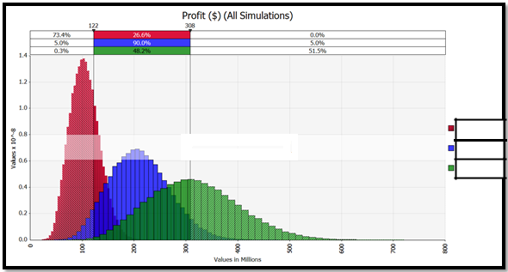

5yrs

10yrs

15yrs

Figure 4.11: Profit for the probability density periods of 5, 10, and 15years with a reservoir condition R2 for a tubing size of 1.90-inch.

Looking at the second reservoir condition R2 which is shown in table 4.6 with a tubing size of 1.90-inch in which the profit was obtain to be $153 millions after running the various variables in Monte Carlo simulation. However, illustrated in Figure 4.11, the probability density of profit for a 5 years period as red while the blue specify the probability density for a 10 years period and for 15 years period as green color.

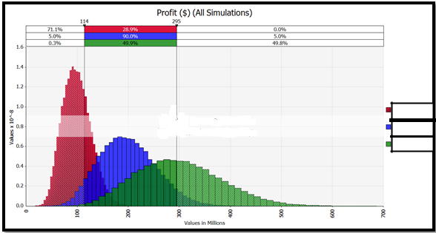

5yrs

10yrs

15yrs

Figure 4.12. Profit for the periods of 5, 10, and 15years with a reservoir condition R2 for a tubing size of 2.375-inch.

In this sensitivity analysis, it is observed that for a tubing size of 2.375-inches with a reservoir condition R2 which is shown in table 4.6 the profit was $144 millions after running 30000 iterations using variables such as production rate, oil price, etc in Monte Carlo simulation. Again taking the above diagram above in Figure 4.12, the probability density of profit for a 5 years period is represented as red while the blue specifies the probability density for a 10 years period and for 15 years period is represented with the green color.

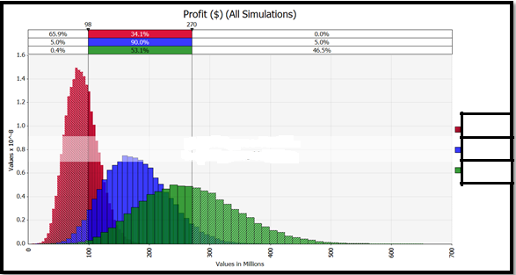

5yrs

10yrs

15yrs

Figure 4.13: Profit for the periods of 5, 10, and 15years with a reservoir condition R2 for a tubing size of 2.875-inch.

In this sensitivity analysis, it was observed that for a tubing size of 2.875-inches with a reservoir condition R2 which is shown in table 4.6 the profit was $129 millions using variables such as production rate, oil price, etc in the Monte Carlo simulation. However, the above diagram in Figure 4.13 presents a probability density of profit for a 5 years period as red while the blue specify the probability density for a 10 years period and for a 15 years period as green.

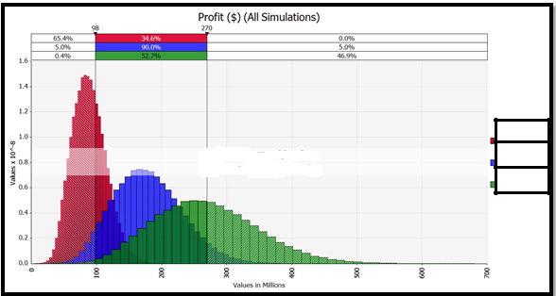

5yrs

10yrs

15yrs

Figure 4.14: Profit for the periods of 5, 10, and 15years with a reservoir condition R2 for a tubing size of 3.5-inch.

Figure 4.14 presents the probability density of profit for a 5 years period as red while the blue specify the probability density for a 10 years period and for a 15 years period as green. In this sensitivity analysis conducted, it was observed for a tubing size of 3.5-inches from a reservoir condition R2 shown in table 4.6 that the profit for running such tubing size was $129 millions after several iterations with input variables such as production rate, oil price, etc.

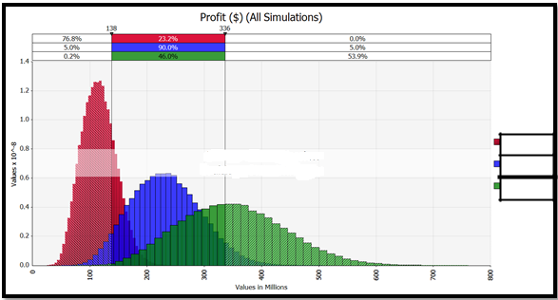

5yrs

10yrs

15yrs

Figure 4.15: Profit for the periods of 5, 10, and 15years with a reservoir condition R3 for a tubing size of 1.90-inch.

In addition to evaluating the confidence interval (i.e. given a probability level and finding the relevant income values), the probability of a given income can be determined using table 4.7 in which the profit for a production tubing of 1.90-inch will be $168 millions. Figure 4.15 presents the probability density for 5, 10, and 15 years period which is indicated as red, blue, and green repectively.

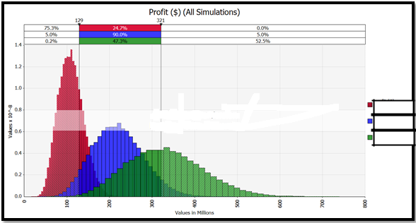

5yrs

10yrs

15yrs

Figure 4.16: Profit for the periods of 5, 10, and 15years with a reservoir condition R3 for a tubing size of 2.375-inch.

In estimating the probability density of a Monte Carlo simulation, there were many iterations that was ran. Figure 4.16 indicates a three years periods which is 5, 10, and 15 years as red, blue and green respectively. Furthermore, the deterministic profit from a production tubing size of 2.375-inches shown in table 4.15 is $159 millions with a reservoir condition R3 respectively.

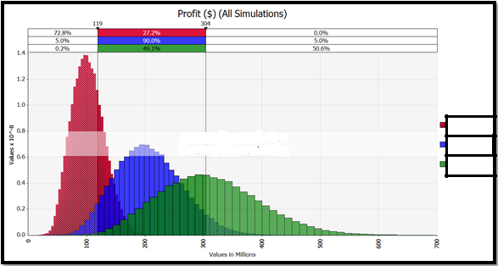

5yrs

10yrs

15yrs

Figure 4.17: Profit for the periods of 5, 10, and 15years with a reservoir condition R3 for a tubing size of 2.875-inch.

In the evaluation of the confidence interval and in finding the relevant income values, the probability of a given income can be determine for a production tubing of 2.875-inch for a deterministic profit of $149 millions shown in Table 4.7, the profit with a reservoir condition of R3 is shown in Figure 4.17, 90% confidence for probability density of 5, 10, and 15 years period were indicated as red, blue, and green respectively.

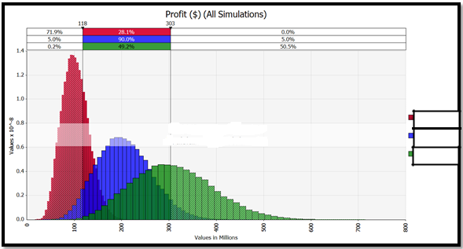

5yrs

10yrs

15yrs

Figure 4.18: Profit for the periods of 5, 10, and 15years with a reservoir condition R3 for a tubing size of 3.5-inch.

For a production tubing size of 3.5-inches the deterministic profit shown in table 4.7 is $148.8 millions with a reservoir condition of R3. Figure 4.18 shows that after running several iterations using a Monte Carlo simulation, the probability density periods of 5, 10, and 15 years are illustrates as red, blue, and green colors respectively.

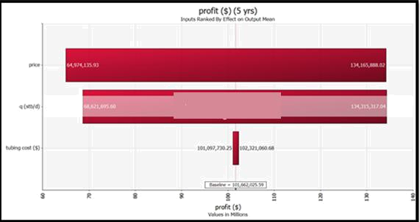

Figure 4.19: Tornado chart for parameters that impact profit
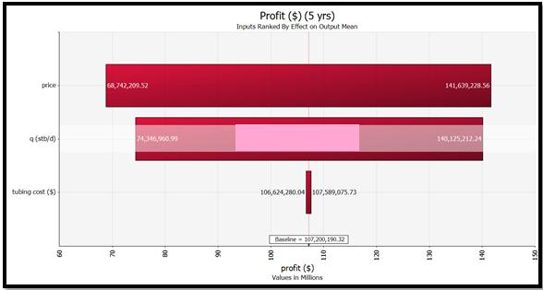

Figure 4.20: Tornado chart for parameters that impact profit

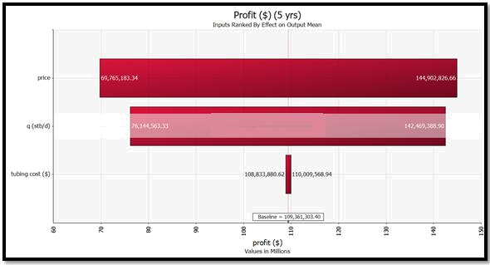

Figure 4.21: Tornado chart for parameters that impact profit

From Figure 4.19, 4.20, and 4.21, it was observed that for all reservoir conditions that is R1, R2, and R3, and for all period ivestigated that is 5, 10, and 15 year periods of simulation runs, the price of oil has the greatest impact on the profit followed by the rates of production and lastly the tubing size which has very little effect on the profits generated during these periods.

CHAPTER FIVE

5.0 CONCLUSION AND RECOMMENDATION

5.1 CONCLUSIONS

- This study has been able to address the problem of production optimization using four (4) production tubing sizes and a five (5) choke sizes.

- It was observed that at a depth of 4264 ft, the optimal tubing size was 2.375-inches with a rate of production (Q) of 572 stb/d while at a higher depth of 10232 and 14076 ft, the optimal tubing size were both 1.90-inch with the rate of production

(Q) 560 and 619 stb/d respectively.

- Regards to choke size, it was observed from the results obtained that all reservoir conditions required similar chokes sizes of 60/64 of an inch for optimal production with all having approximately the same rate of production (Q).

- . Results shows that the tubing size of 1.90-inches generate more revenue and profit regardless of the cost of tubing.

- Sensitivity study shows that the price of oil and rate of production greatly impact profit generation while the cost of tubing have a very little effect on profit.

5.2 RECOMMENDATIONS

- Alternatively, other function approximation methods like linear and nonlinear optimization could be interesting to implement with this optimization problem to improve accuracy.

- Perhaps the biggest improvement would be to demonstrate the use of different objective criteria in the optimization process. This would clearly demonstrate the inherent advantages of nonlinear optimization over exhaustive iteration.

REFERENCES

Abel Taher MD. Ibraham, “Optimization of Gas Lift System in Large Field,” (2007).

Ali, H. M., Batchelor, A.S.J., Beale, E.M.L., and Beasley, J.F, “Mathematical Models to Help Manage the Oil Resources of Kuwait,” unpublished manuscript,” (1983).

Aronofsky, J. S., and Lee, A. S. “A Linear Programming Model for Scheduling Crude Oil Production,” J. Petro. Tech,” (July 1958).

Attra, H. D., Wise, H. B., and Black, W. M. “Application of Optimizing Techniques for Studying Field Producing Operations,” J. Petro. Tech.,” (January 1961).

Boyun Guo, William C. Lyons, & Ali Ghalambor, “Petroleum Production Engineering, A Computer Assisted Approach,” (2007).

Charnes, A., and Cooper, W. W.: “Management Models and Industrial Applications of Linear Programming”, Vol. II, John Wiley & Sons, NY,” (1961).

Clay, R.M., Stoisits, R.F., Pritchett, M.D., Rood, R.C., and Cologgi, J.R., 1998. “An Approach to Real-Time Optimization of the Central Gas Facility at the Prudhoe Bay Field”, paper SPE 49123 presented at the SPE Annual Technical Conference and Exhibition held in New Orleans, Louisiana, 27-30 September.

Fujii, Hikari and Home, Roland: “Multivariate Production Systems Optimization in Pipeline Networks,” MS report, Stanford U., Stanford, CA,” (1993).

G.V. Chilingarian, J.O. Robertson, S. Kumar, “Surface Operation in Petroleum Production, I,” (1975).

Hussen K. Abdel-Aal, Mohamed A. Aggour, Mohamed A. Fahim, “Petroleum & Gas Field Processing,” (2009).

James Aubrey Carroll: “Multivariate production systems optimization,” (December 1990).

M.A. Al-Sahlawi, H.K. Abdel-Aal, & Bakr A. Bakr, “ Petroleum Economics & Engineering, Second Edition,” (1992).

McFarland, J. W., Lasdon, L., and Loose, V.: “Development Planning and Management of Petroleum Reservoirs Using Tank Models and Nonlinear Programming,” Operations Research,” (Mar. 1984).

Pangju Wang, “Development and Applications of production optimization techniques for petroleum fields”, ((2003).

Ravindran, N. “Multivariate Optimization of Production Systems - the Time Dimension,” MS report, Stanford U., Stanford, CA,” (1992).

Sam Sugiyama, “Monte Carlo Simulation/Risk Analysis on a Spreadsheet: Review of three Software packages,” (Feb. 2007).

Wan Renpu, “Advanced Well Completion,” (2001).

William C. Lyons, “Standard Handbook of Petroleum & Natural Gas Engineering, Volume II,” (Oct. 2004).

Wumi Iledare’ “ Petroleum Economics Lecture Note,” (2014).

APPENDIX

Table 4.8: Tubing and choke sizes selection for production optimization from a set of test data.

Pr (Psia) | Pwf (Psia) | Q (stb/day) | Qmax (stb/day) | J (stb/d/psia)
4809.04 | 2000 | 500 | 755.7062 | 0.136

Table 4.9: Illustrate a reservoir condition of 4809.04 psia from a data set that was used to plot the Inflow Performance relationship (IPR) curve.

Depth(ft) | Pr (Psia) | GLR (scf/stb) | Pwf (Psia) | Qmax(stb/day) | Q (stb/day)
10232 | 4809.04 | 492 | 4809.04 | 755.706 | 0
10232 | 4809.04 | 492 | 4000 | 755.706 | 211.732
10232 | 4809.04 | 492 | 3500 | 755.706 | 325.476
10232 | 4809.04 | 492 | 3000 | 755.706 | 426.149
10232 | 4809.04 | 492 | 2500 | 755.706 | 513.752
10232 | 4809.04 | 492 | 2000 | 755.706 | 588.284
10232 | 4809.04 | 492 | 1500 | 755.706 | 649.747
10232 | 4809.04 | 492 | 1200 | 755.706 | 680.349
10232 | 4809.04 | 492 | 800 | 755.706 | 713.833
10232 | 4809.04 | 492 | 200 | 755.706 | 748.375
10232 | 4809.04 | 492 | 0 | 755.706 | 755.706

Table 4.10: Showing a tubing sizes of 2.875-in and 2.375-in with their various tubing head pressures and bottom-hole flowing pressures.

 | Tubing |  |  | Tubing
 | 2.875-in |  |  | 2.375-in
THP (Psia) | Q (stb/day) | Pwf (Psia) | THP (Psia) | Q (stb/day) | Pwf (Psia)
457 | 100 | 2700 | 457 | 100 | 2500
457 | 200 | 2500 | 457 | 200 | 2366
457 | 400 | 2400 | 457 | 400 | 2309
457 | 600 | 2602 | 457 | 600 | 2492
 | Tubing |  |  | Tubing
 | 3.5-in |  |  | 1.90-in
THP (Psia) | Q (stb/day) | Pwf (Psia) | THP (Psia) | Q (stb/day) | Pwf (Psia)
457 | 100 | 3100 | 235 | 100 | 2087
457 | 200 | 2899 | 235 | 200 | 2070
457 | 400 | 2900 | 235 | 400 | 2040
457 | 600 | 3000 | 235 | 600 | 2100

Table 4.11: Illustrate the rates of production for various choke sizes.

 |  |  | Choke Sizes
Parameters |  | d1 | d2 | d3 |  | d4 | d5
q (stb/d) | Pwf (Psia) | 16/64-in | 24/64-in | 30/64-in | 35/64-in |  | 60/64-in
100 | 4073.711 | 364.042 | 783.364 | 1194.33 |  | 1598.28 | 4426.6
200 | 3338.382 | 254.634 | 547.936 | 835.391 |  | 1117.94 | 3096.25
400 | 1867.724 | 5.062 | 10.892 | 16.606 |  | 22.222 | 61.546
600 | 397.065 | 0 | 0 | 0 |  | 0 | 0

Table 4.12: Selection for production optimization from a set of test data for tubing and choke sizes.

Pr (Psia) | Pwf (Psia) | Q (stb/day) | Qmax (stb/day) | J (stb/d/psia)
6531.26 | 3000 | 500 | 792.125 | 0.1134

Table 4.13: Reservoir condition of 6531.26 psia from test data that were used to plot the Inflow Performance relationship (IPR) curve.

Depth(ft) | Pr (Psia) | GLR (scf/stb) | Pwf (Psia) | Qmax (stb/day) | Q (stb/day)
14076 | 6531.26 | 249 | 6531 | 1000 | 0
14076 | 6531.26 | 249 | 6000 | 792.125 | 111.786
14076 | 6531.26 | 249 | 5200 | 792.125 | 264.297
14076 | 6531.26 | 249 | 4400 | 792.125 | 397.793
14076 | 6531.26 | 249 | 3600 | 792.125 | 512.274
14076 | 6531.26 | 249 | 2800 | 792.125 | 607.739
14076 | 6531.26 | 249 | 2000 | 792.125 | 684.19
14076 | 6531.26 | 249 | 1200 | 792.125 | 741.625
14076 | 6531.26 | 249 | 800 | 792.125 | 763.213
14076 | 6531.26 | 249 | 200 | 792.125 | 786.679
14076 | 6531.26 | 249 | 0 | 792.125 | 792.125

Table 4.14: Indicates the tubing sizes of 2.875, 2.375, 3.5, 1.90 inches with their various tubing head pressures and bottom-hole flowing pressures.

 | Tubing |  |  | Tubing
 | 2.875-in |  |  | 2.375-in
THP (Psia) | Q (stb/day) | Pwf (Psia) | THP (Psia) | Q (stb/day) | Pwf (Psia)
195 | 100 | 4437 | 235 | 100 | 3828
195 | 200 | 4295 | 235 | 200 | 3792
195 | 400 | 4180 | 235 | 400 | 3812
195 | 600 | 4300 | 235 | 600 | 3848

 | Tubing |  |  | Tubing
 | 3.5-in |  |  | 1.90-in
THP (Psia) | Q (stb/day) | Pwf (Psia) | THP (Psia) | Q (stb/day) | Pwf (Psia)
195 | 100 | 4701 | 235 | 100 | 3117
195 | 200 | 4528 | 235 | 200 | 3000
195 | 400 | 4350 | 235 | 400 | 3063
195 | 600 | 4477 | 235 | 600 | 3170

Table 4.15: Show the rates of production for various choke sizes.

 |  |  |  |  |  |  | Choke Sizes
 | Parameters |  |  |  | d1 | d2 | d3 | d4 | d5
q (stb/d) |  | Pwf (Psia) | Pwh (Psia) |  | 16/64-in | 24/64-in | 30/64-in | 35/64-in | 60/64-in
100 |  | 5649.45 |  | 969 | 377.279 | 811.849 | 1237.76 | 1656.4 | 4587.57
200 |  | 4767.44 |  | 650 | 182.994 | 393.77 | 600.357 | 803.414 | 2225.14
400 |  | 3003.61 |  | 0 | 0 | 0 | 0 | 0 | 0
600 |  | 1239.78 |  | 0 | 0 | 0 | 0 | 0 | 0

