**COMPARATIVE ANALYSIS OF THE STRENGTH OF CONCRETE MADE FROM VARIOUS AGGREGATE**

**ABSTRACT**

Highly automated brick plants exist in Nigeria. Soil-cement blocks are also produced to keep unit cost of blocks down and affordable; but some characteristics of the soil-cement blocks needed to be improved by use of highly sandy concrete aggregates in the production. This paper demonstration the influence of concrete aggregates on compressive and tensile strength, the initial rate of water absorption (IRA) water absorption, surface porosity and pore size, stress-strain relationships and elastic properties of soil-cement blocks. Also the strength of the cement stabilized blocks of literate soil was determined in the soil laboratory with a view to have an alternative in the building industry, after which an analysis of the existing laterite soil was done. Results indicate that IRA is inversely proportional to concrete aggregates while rate of moisture absorption is directly proportional to concrete aggregates. Soil-cement block modules varied between 2000 and 6000 MPa.

**CHAPTER ONE**

**INTRODUCTION**

This work was to present in one weight, the fundamental and practical information in the filed of the comparative analysis of the strength of concrete made from various aggregate which may be useful to people involve in civil and structural engineering and particularly, those that found pleasure in the design and related structure.

Due to the strength/high cost of various aggregate in the market the comparative analysis of strength of concrete indifferent aggregate have revealed that one can definitely substituted in various aggregate by using the mixture design of ration in different aggregate in building to reduce the mixture ration of aggregate or used any of the aggregates.

Where their is no granite stone washed gravel most black gravel is there no black gravel must in such area there will be surface gravel in the project is going to be sited.

A great effort have been made through out this work although it is limited in scope to asses their suitability as stand and concrete aggregate.

High cost of building materials has been the bane of construction industry in the developing countries of the world as a result of importation of most of the building materials. As prices increase sharply, there is a growing awareness to relate research to local materials as alternatives for the construction of functional but low-cost dwellings both in the urban and rural areas of Nigeria. One of such local material that is being researched is lateritic soil. Lateritic soil has been one of the major building materials in Nigeria for a long time. The main reason lies on the fact that it is readily available and the cost of procuring it is relatively low.

Concrete aggregates in soil possesses other advantages which makes it potentially a very good and appropriate material for construction, especially for the construction of rural structures in the developing countries. These merits include little or no specialized skilled labour required for laterized sandcrete blocks production and for its use in other construction works; and laterized concrete structures have potentially sufficient strength compared with that of normal concrete (Lasisi and Ogunjimi,1984).

In July 1976, the Nigerian Mining Corporation was directed to proceed with establishment of seven clay brick plants in Nigeria with annual production capacity of fifteen million normal size bricks (figure 1). Clay deposits for use by these plants were identified (Proda 1970, 1971, 1975a, 1975b and 1975c) as shown in table 1. Rather than studying, and developing the traditional technology, Nigeria automatically copied a highly automated brick making which is capital intensive and therefore, kept the unit cost of bricks too high for the average Nigerian to afford. The Nigerian Building and Road Research Institute (NIBRRI) thereafter introduced the soil - cement blocks using manual press for its production. This kept unit cost of the soil cement block down and affordable, but some characteristics of the soil-cement blocks needed to be improved by use of highly sandy concrete aggregates; which are already being used as fills in Nigeria (Otoko 2014)

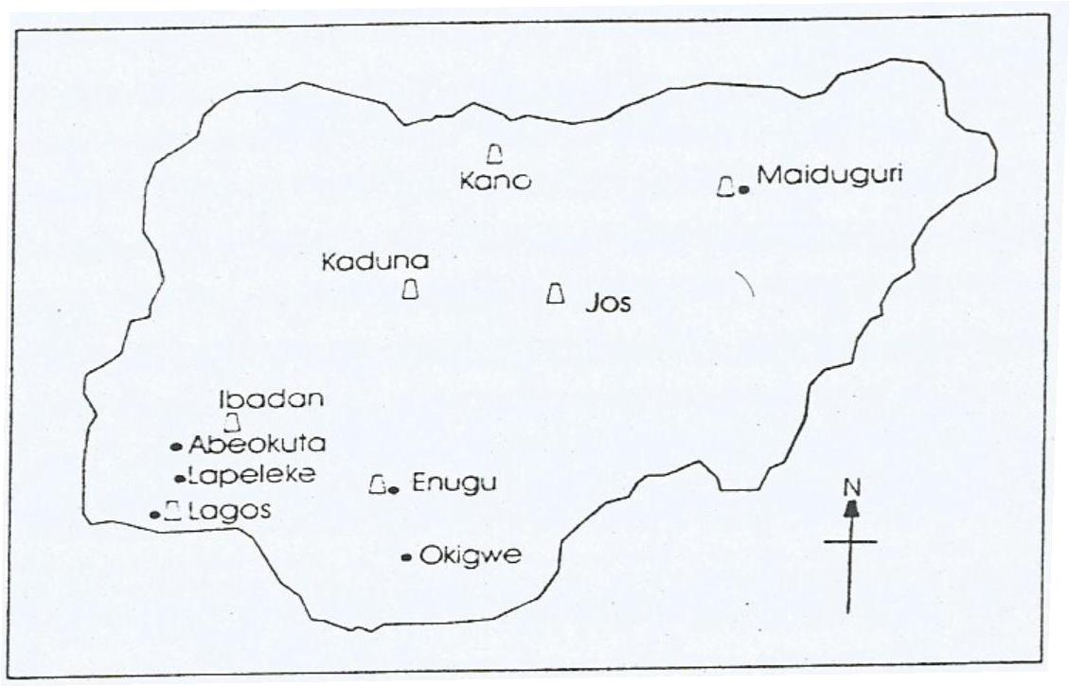

**Figure 1:** Brick Plants In Nigeria.

**Key**

 Brick plants owned by the Nigerian Mining Cooperation.

* Bricks plants owned by Private entrepreneurs.

1.2 PROJECT OBJECTIVE

This case study the comparative analysis of the strength of concrete made from various aggregates.

The project implement the following analysis.

1. To determine the analysis in the existing aggregates and evaluate it’s suitability for use as a good building of aggregates by means of various laboratory tests.

2. To determine the strength of concrete cube in difference aggregates in soil laboratory with a view to have on alternative in the building construction.

3. To effect the reduction of rising in the building construction by using deference aggregates.

This paper demonstrates the influence of concrete aggregates on compressive and tensile strength, the initial rate of water absorption (IRA) water absorption, surface porosity and pore size, stress-strain relationships and elastic properties of soil-cement blocks. Also the strength of the cement stabilized blocks of literate soil was determined in the soil laboratory with a view to have an alternative in the building industry, after which an analysis of the existing laterite soil was done.

**1.3 PARTICLE SIZE DISTRIBUTION**

It has been stated that maximum size and grading of aggregates are very important find aggregate result in uneconomical mixes where as very coarse –grained soils result in harsh unworkable mixes.

The mean size or grading of many aggregate can be obtained by passing the materials in a set of sieves consisting usually of certain standard sizes. The sieves number is been expressed as the member per inches.

The sieve analysis should also conformed to the B. S. 410of 1969 for sieves for purpose of testing the procedure involve in making sieve analysis should also conform to the B. S. standard method that is involved in carrying out the sieve analysis of time and coarse aggregate.

The aggregate were carefully washed to eliminate dust particles and some other of organics mater present in it so the aggregate should be dust and dust free of any kind. After the wash of aggregate were kept to dry in a place for 24 hours with kept help of electric oven.

The particle were weight and e recorded the % retained passing sieve at each times the graph below shows the result got from each case.

**PROJECT BUILDING MATERIALS**

**Table 1: Principal clay deposits in Nigeria.**

|  |  |  |
| --- | --- | --- |
| **S/No** | **State** | **Location of principal deposits** |
| 1. | Benue and Plateau State | Jos, Ropp and Markurdi areas |
|  |  |  |
| 2. | Imo, Ebonyi, Enugu and Anambra States | Enugu, Ezi Akwu, Ekwe and Agbahara |
|  |  |  |
| 3. | Kano State | Kano and Rimi areas |
|  |  |  |
| 4. | Lagos State | Epe, Ikorodu and Badagry areas |
|  |  |  |
| 5. | Edo and Delta States | Benin city, Sapele and Ugheli areas |
|  |  |  |
| 6. | Borno State | Maiduguri and Gombe areas |
|  |  |  |
| 7 | Sokoto State | Sokoto and Kuban village |
|  |  |  |
| 8. | Rivers State | Port Harcourt and Andoni areas |
|  |  |  |
| 9. | Akwa Ibom and Cross River State | Ekpene Obom area |
|  |  |  |
| 10. | Ogun State | Abeokuta and Ijebu-Ode areas |
|  |  |  |

Lateritic weathering products derived from rock types of various parts of Nigeria may not be the same. The concrete aggregates of the geological zone 1 (Dry flat country) of the Niger Delta, Nigeria is used for this study (see fig. 2)

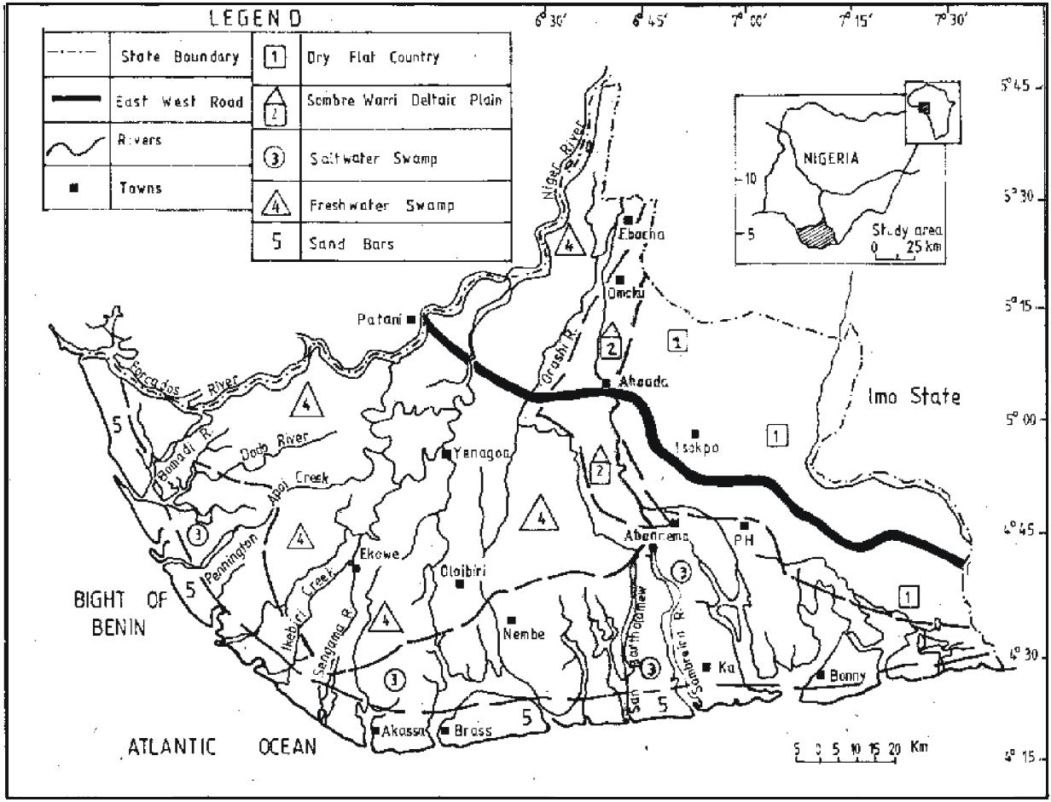

Imo State

Delta State

Abia State

Akwa Ibom State

**Figure 2:** Geomorphologic Zones of the Niger Delta, Nigeria.

**CHAPTER TWO**

**LITERATURE REVEIW**

**CONCRETE**

Continuous research efforts have established concrete as a versatile material. Concrete required for extensive construction activity can be made available since all the ingredients of concrete are of geological origin. The most widely used construction material is concrete, commonly made by mixing Portland cement with sand, crushed rock and water. The world consumption of concrete is estimated at ten billion tonnes every year or one tonne for every human being .

**AGGREGATE**

Aggregate is defined as mineral constituents of concrete in granular or particular form, usually comprising both coarse and fine fraction. About 70 to 80 percent of the volume of concrete is occupied by aggregate. The properties of aggregate influence the characteristic on its fresh state, strength, durability and structural performance on its hardened state. It is not surprising that aggregate quality is important. Aggregate is cheaper than cement and it is therefore economical by mixing the large quantities of the former and small quantities of the latter. Using aggregate is not only for economical reason but also it has certain technical advantages over concrete, which has higher volume stability and better durability than hydrated cement paste (Nevelie 1995).

**AGGREGATE CLASSIFICATION**

Aggregates are classified into two major types: fine and coarse.

Fine aggregate, often called sand (BS 882: 1992), is not larger than

5 mm in size and coarse aggregate comprises material at least with a size of 5 mm. In the United States, the division of aggregate made at No.4 ASTM sieve is 4.75 mm in size (Neville 2003).

Concrete can be seen as a composite material consisting of three phases, mortar, mortar with aggregate face, and the coarse phase. Coarse aggregate in normal concrete is made up of fragments of rock that have high strength. The compressive strength of concrete depends on water cement ratio, degree of compaction, aggregate cement ratio, the bond between mortar and aggregate, grading, shape, strength and aggregate size [1].

There are many factors that affect the strength of concrete but only partially discussed in this paper. The hydration of cement tricalcium silicate and dicalcium silicate hydrate is a major contributor to the strength of hydrated cement paste. Concrete strength is inversely proportional to the water cement ratio. The temperature and different water cement ratio influence to the concrete strength. Water cement ratio significantly influences the gel-space in concrete. Concrete with high cement water ratio will produce more voids. During the hydration reaction of water and cement concrete will produce a space. These spaces will be filled by a solid gel during hydration. Solid gel filling process depends on the type of cement and the concrete age. Time and temperature are two factors that to determine the process concrete hydration will achieve. Hydration process occurs more comprehensive in every fine cement particles and a faster rate because of the larger surface area. If Aggregate-cement ratio too high it can make concrete mix rough and can cause separation of the coarse aggregate. This phenomenon will affect concrete compressive strength. The concrete has hardened more quickly in a short time. Mostly types of cement to reach ultimate strength at about 70% -80% after the age of 28 days [2].

The combined aggregate 10mm and 5 mm size can achieve compressive strength up to 160 Mpa at 28 days [3]. Mineral content in coarse aggregate also influence to the bond strength of the aggregate-concrete mix. Normal concrete compressive strength at 28 days for the granite aggregate is 30 MPa [4]. Aggregate shape and texture can help to improve the strength of concrete. Spherical shape suitable for use and easy to compact concrete and also give higher strength if compare to flat form or flake form, sharp, long, uneven or angular. If too hard compacted its can affect the workability and reduce the compressive strength. All types of voids including gel pores, capillary pores and air voids will affect the strength of concrete for allowing water seepage. Porosity can be defined as a total percentage of pore voids that contribute to the entire volume of concrete permeability.

Curing also contribute to the preservation of concrete strength. Water needed to maintain the moisture for the hydration process of concrete to achieve maturity of 28 days. It has been proven that the curing is done by soaking the concrete into water and curing by packing in an impervious bag can produce a comparable level of concrete strength [2]. Steam curing method and immersed in water has shown that the best method of curing compared to the soaking in water. [4].

The compressive strength of the concrete can be reduced to 30% due to inorganic compounds [2]. The clay and foreign material in the aggregate can affect the strength of concrete. Dirt or clay dust will reduce the bond between the surface aggregates. According to the British Standard coarse aggregate should not contain clay, silt or fine dust than 1% of the aggregate weight [5]. Additional mixture allowed is less than 5% by weight of cement added to the concrete mix at the time.

**STUDY JUSTIFICATION.**

From preliminary works, the closest construction element with laterite as part of its material in masonry is the compressed laterized earth brick stabilized usually with cement or lime. The use of this brick is either in the rural areas or in a low cost housing project. Unfortunately, despite the establishment of about twenty brick manufacturing plants in Nigeria since 1976 and the low-cost of locally produced bricks, their application in the building construction industry has not gained much popularity except in very few occasions where the government took the initiative to deliberately utilise stabilized compressed lateritic and clay soil like the case of Aco Hi Tech in Lugbe, Abuja and few others (Joshua and Lawal, 2011). Hence, this study seeks to find a way of incorporating laterite in the production of sandcrete hollow blocks.

Sandcrete blocks are constructional masonry units that have been generally accepted to the extent that when an average individual thinks of building, the default mind-set is the use of sandcrete hollow blocks. Hence, this research seeks to find a way of incorporating the use of laterite in its production for a probable cost reduction, local content utilisation, creation of local employment and development of indigenous technology as a result of its ready availability

**LIMITATIONS TO PREVIOUS STUDY**

Previous work on the geological study of concrete aggregates in Nigeria dwells mainly on their distribution, classification, depth extent, general nature and formation (Faniran 1970, 1972, 1974 and 1978; Adekoya et al 1978).

Although much work has been done on the geotechnical study of concrete aggregates (Ola 1978, 1980a, 1980b; Alao 1983, Otoko 1985, 1987, 1988, 1997 and 2000) most especially in connection with foundation and embankment problems, little or no attention has been paid to compacted concrete aggregates (Omine and Yasufuku 2005, ONigeria and Iba 2009).

This paper therefore, focuses on the use of concrete aggregates for soil - cement production. Currently, more than 100 types of soil - cement making machines are available in the world market (Kiren 1986). More details on soil - cement block technology can be found in Walker at al 2000; Houben and Guillaud 1994; Walker 1999, 2004; Middleton 1952; Dept of HUD 1955; Fitzmaurice 1958; Lunt 1980; Heathcote 1991; Venkatarama and Jagadish 1995; Walker and Stace 1997; Venkatarama and Jagadish 1993.

The major findings from these studies include the fact that ideal soil for soil-cement block production must be sandy, containing predominantly non - expansive clay minerals (like Kaolinite) and having sand content ˃ 65% clay fraction of about 10% and dry unit weight ˃ 18kN/m3. However, there is additional need to study the strength, absorption characteristics and elastic properties of the soil-cement blocks using sandy concrete aggregates and which is the subject of this study.

3

**CHAPTER THREE**

**EXPERIMENTAL PROCEDURES**

Manual operated block making machine was used to produce 305 x 143 x 100mm soil-cement blocks. The blocks are stacked and then cured by spraying water for 28days, and thereafter, allowed to dry in the laboratory for 30days before tests were carried out on them.

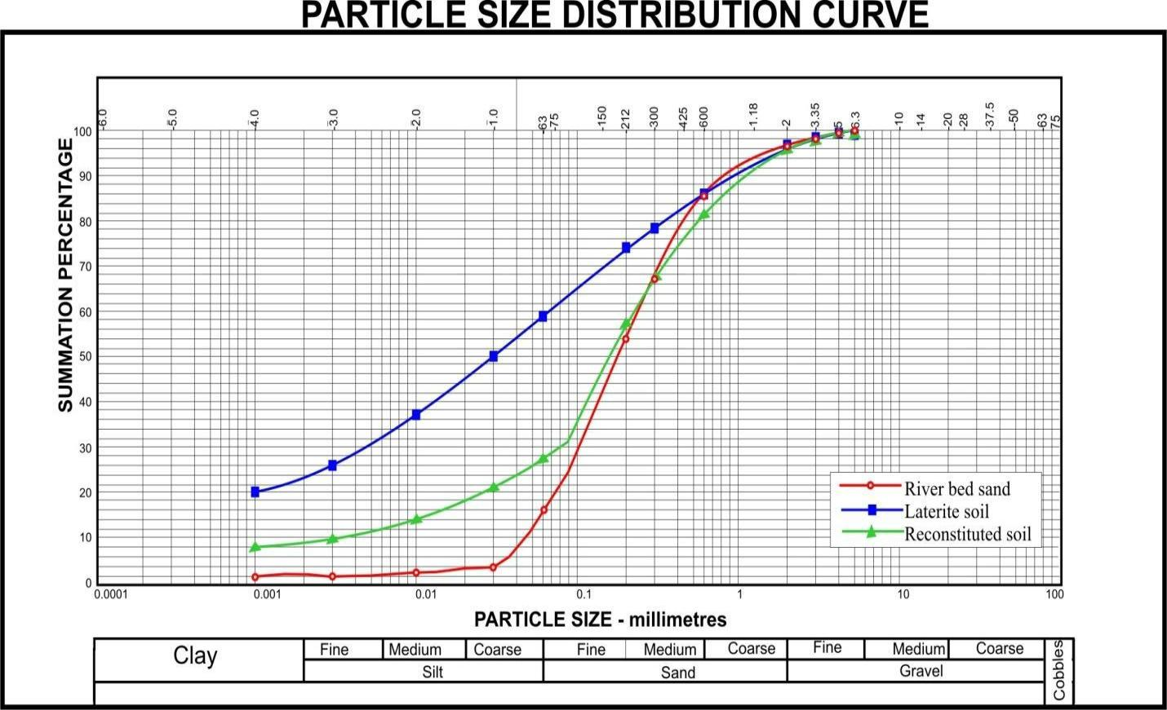

**Figure 3:** Particle Size Distribution for Sand, Laterite Soil and Reconstituted Soil.

Locally available reddish brown laterite obtained from Elelenwo area of Port Harcourt (fig. 2) was used for the block production. Its clay fraction was 20%; while the liquid limit, plastic limit and plasticity index of the soil was 43.5%, 20.8% and 22.7% respectively. As the clay content was more than 10%, it became necessary to reconstitute the clay by adding natural bed sand (specific gravity of 2.50 and clay fraction of 5%) to it, in order to bring down the clay fraction of the mix (mix ratio of soil to sand was 1.2 by weight). The resulting mix contained 9% clay, 18% silt and 73% sand as shown in the grain size distribution of the laterite sand and the reconstituted soil - sand mixture (fig. 3).

The soil-cement blocks designated B1, B2, B3 and B4 were produced with 6%, 8%, 10% and 12% concrete aggregates respectively; while the following characteristics were examined: Initial rate of absorption, water absorption, rate of moisture absorption, wet and dry compressive strength, flexural strength, direct tensile strength, stress-strain characteristics of the block.

1. **Initial Rate Of Absorption (IRA) And Water Absorption.**

Determination of the initial rate of absorption for soil cement blocks and the water absorption of the blocks were determined in accordance with ASTM C 67 - 94 (1995) and BS 3921 (1985) respectively.

1. **Rate Of Moisture Absorption.**

The soil-cement blocks were dried in an oven at 60 c and then allowed to cool down to ambient temperature. The dry weight of the block is measured before soaking it in water for 0.5, 1, 2, 5, 10, 15, 30, 120 and 140 minutes. Thereafter, the wet weight of the blocks were measured. Calculation of the percentage saturation is with respect to dry weight. The soaking duration are plotted against the block water absorption in fig. 4.

1. **Wet Compressive Strength**

The soil-cement blocks were soaked in water for 48hrs prior to testing. Standard calibrated crushing machine was used to crush the saturated blocks of 305x143x100mm to failure, in order to determine its wet compressive strength in accordance with BS 1881 - 116 : 1983 and defined by P = F/A

Where F is the failure load and A is the cross sectional area of the specimen.

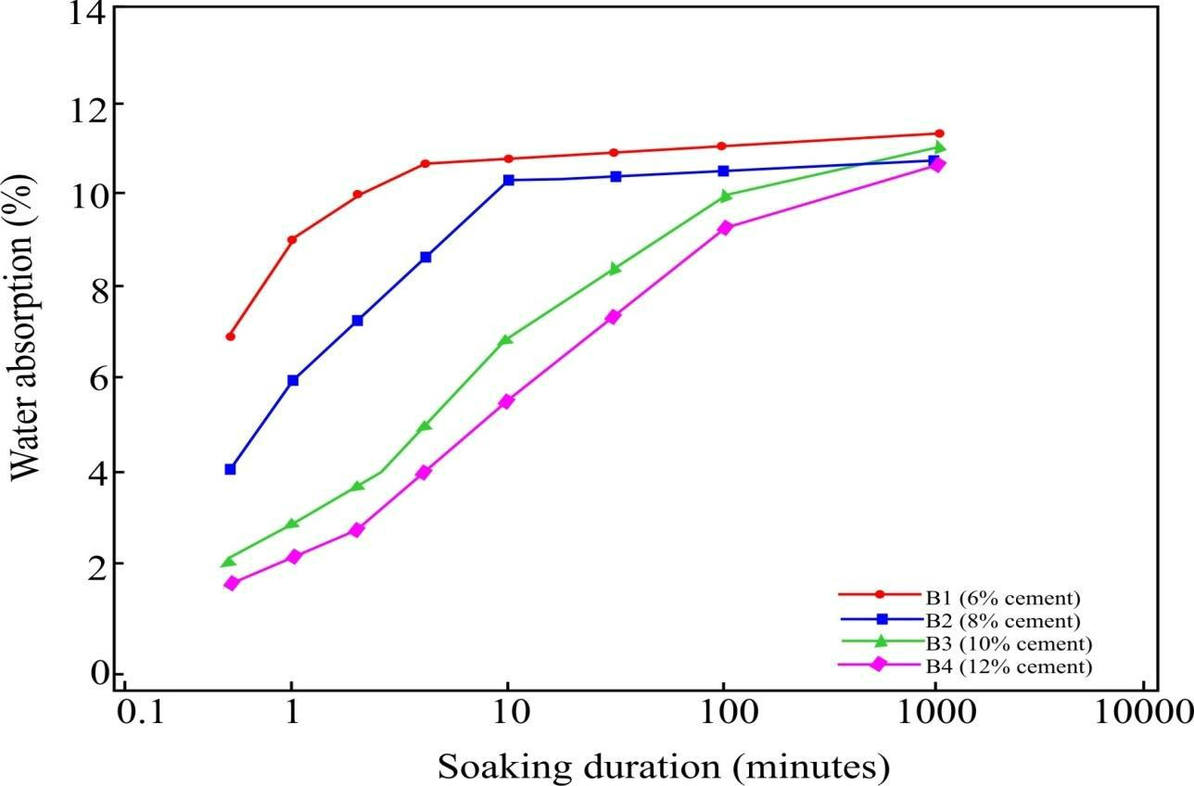

**Figure 4:** Variation of Water Absorption with Soaking Duration.

1. **Flexural Strength.**

For flexural strength test, the 48 hours soaked blocks were tested with point loading in accordance with BS EN 12390 - 5 : 2009.

1. **Tensile Strength.**

For tensile strength tests, the 48 hours soaked blocks were pulled in direct tension with the help of steel brackets in a universal testing machine.

1. **Stress-Strain Characteristics.**

The soil-cement blocks were soaked in water for 48 hours prior to testing. Standard calibrated crushing machine was used at a constant piston displacement of 1.25mm per minute. The stress strain characteristics is thus determined. Two points were fixed on the longitudinal face of the block from where the longitudinal strains were measured over a gauge length of 200mm.

**CHAPTER FOUR**

**RESULTS AND DISCUSSIONS**

Soil-cement blocks of laterite soil-sand mixes with four different concrete aggregatess (6%, 8%, 10% and 12%) were examined and various characteristics like compressive strength, flexural strength, tensile strength, IRA, water absorption and stress-strain characteristics of the soil-cement blocks discussion as follows:

1. **Strength And Water Absorption Of The Soil-Cement Blocks.**

Table 2 gives the test results for all the parameters tested together with the mean values and the range (minimum and maximum) or coefficient of variation; while fig. 5 shows the variation of compressive strength with concrete aggregates; while fig. 6 shows the variation of flexural and tensile strength of the blocks with concrete aggregates and fig. 7 shows the variation of the IRA values with concrete aggregates of the block. All these and table 2 show that: wet compressive strength of the soil-cement is in the range of 3.15MPa to 7.20MPa for concrete aggregates range (6 to 12%) tested. The compression strength increased with increased concrete aggregates (fig. 5).

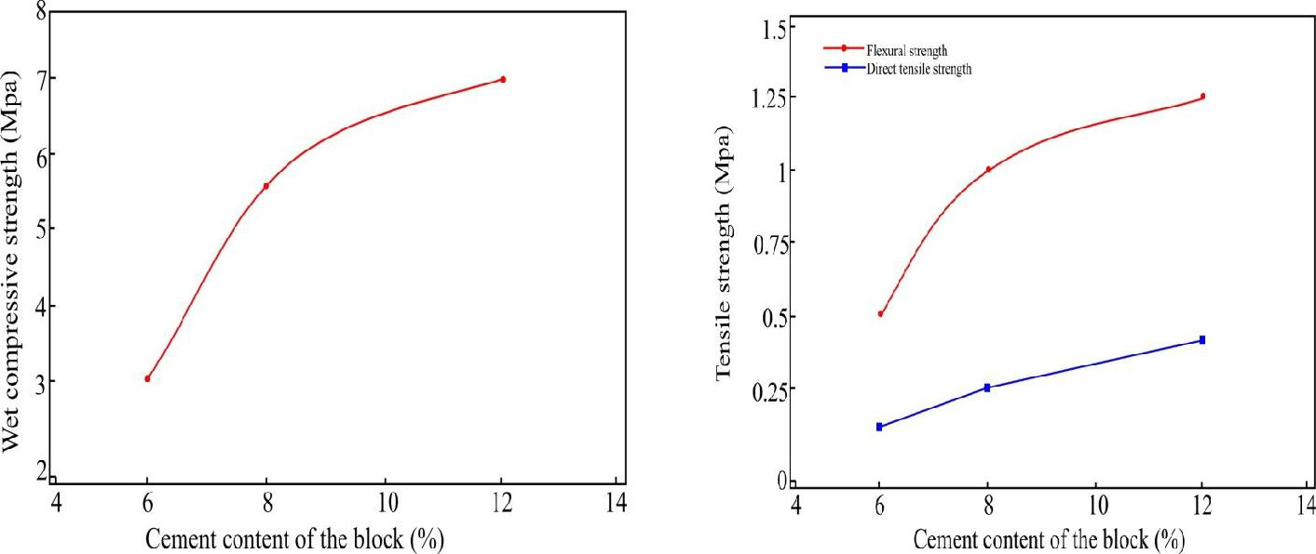

**Figure 5:** Variation of Compressive

Strength with Concrete aggregates.

**Figure 6:** Variation of Tensile

Strength with Concrete aggregates.

The flexural and direct tensile strength also increased with increase in the concrete aggregates (fig. 6). There is also a linear relationship between IRA and the concrete aggregates (fig. 7). IRA values of blocks reduced significantly with the increase in concrete aggregates. Comparing with the values in table 2, the IRA values for fired clay bricks is in the range of 1.3 to 3.5kg/m2/ minute (Sarangapani 1993). The features exhibited in fig. 4 on terms of water absorption clearly indicate that the rate of moisture absorption slows down as the percentage of cement in the block increases.

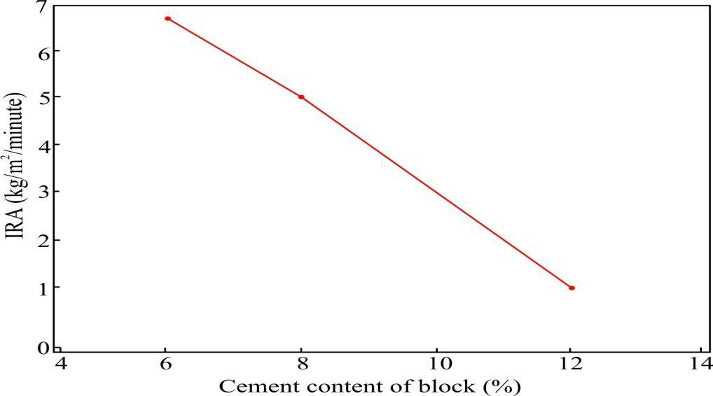

**Figure 7:** Variation of IRA Values with Concrete aggregates.

**Table 2 - Characteristics of soil-cement blocks**

|  |  |  |  |  |  |  |  |  |
| --- | --- | --- | --- | --- | --- | --- | --- | --- |
| Characteristics of Blocks | | | | Designation of Blocks | |  |  |  |
|  |  |  |  | B1 | B2 | B3 | B4 |  |
| Concrete aggregates (%) (by weight) | | | | 6 | 8 | 10 | 12 |  |
| Compressive strength | | | Mean value | 3.15 | 5.50 | 6.11 | 7.20 |  |
| (MPa) |  |  |  |  |  |  |  |  |
|  |  | No. of specimen | 20 | 20 | 20 | 20 |  |
|  |  |  |  |
|  |  | |  |  |  |  |  |  |
| Flexural | strength | | Mean value | 0.45 | 0.95 | 1.06 | 1.21 |  |
| (MPa) |  |  |  |  |  |  |  |  |
|  |  | Range | 0.39-0.65 | 0.72-1.11 | 0.97-1.23 | 1.05-1.32 |  |
|  |  |  |  |
|  |  |  |  |  |  |  |  |  |
|  |  |  | No. of specimen | 6 | 6 | 6 | 6 |  |
|  |  | |  |  |  |  |  |  |
| Tensile | strength | | Mean value | 0.19 | 0.27 | 0.36 | 0.45 |  |
| (MPa) |  |  |  |  |  |  |  |  |
|  |  | Range | 0.15-0.23 | 0.20-0.35 | 0.25-0.45 | 0.35-0.54 |  |
|  |  |  |  |
|  |  |  |  |  |  |  |  |  |
|  |  |  | No. of specimen | 6 | 6 | 6 | 6 |  |
|  |  |  |  |  |  |  |  |  |
| Initial | Rate | of | Mean value | 6.3 | 4.7 | 1.1 | 1.5 |  |
| Absorption | | (IRA) |  |  |  |  |  |  |
| Range | 4.0-8.1 | 3.0-6.5 | 1.0-1.5 | 1.2-1.7 |  |
| (kg/m2/minute | |  |  |
|  |  |  |  |  |  |  |
|  |  |  | No. of specimen | 6 | 6 | 6 | 6 |  |
|  | | |  |  |  |  |  |  |
| Water absorption (%) | | | Mean value | 11.9 | 10.9 | 11.1 | 11.5 |  |
|  |  |  |  |  |  |  |  |  |
|  |  |  | Range | 11.2-12.5 | 10.0-12.0 | 10.2-12.1 | 10.3-12.2 |  |
|  |  |  |  |  |  |  |  |  |
|  |  |  | No. of specimen | 6 | 6 | 6 | 6 |  |
|  |  |  |  |  |  |  |  |  |

1. **The Stress Strain Characteristics Of Soil-Cement Blocks.**

The results of the stress-strain characteristics of blocks are tabulated in Table 3; while the compressive stress with longitudinal strain are plotted in fig 8. The variation of the modulus with concrete aggregates are shown in fig 9. The stress strain curves showed linear relationship initially, but as the stresses are increased, the curves become non-linear and show softening behaviour. The initial tangent modulus and secant modulus show the same trend, which values are shown in Table 3, together with the ultimate strain values.

**Table 3: Stress Strain Characteristics of Soil-Cement Blocks**

|  |  |  |  |  |
| --- | --- | --- | --- | --- |
| Stress strain characteristics | Block designation | |  |  |
|  | B1 | B2 | B3 | B4 |
| Initial Tangent Modulus (MPa) | 2305 | 5650 | 5780 | 5980 |
| Secant Modulus (MPa) |  |  |  |  |
| (at 25% of ultimate stress) | 1990 | 4891 | 4950 | 5150 |
| Ultimate strain value | 0.0029 | 0.0031 | 0.0033 | 0.0035 |

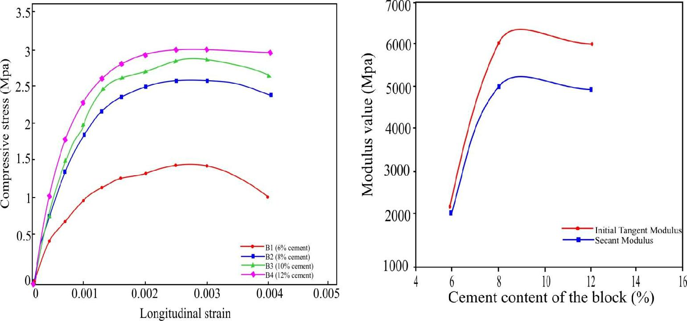

**Figure 8:** Stress-strain relationship

for Soil-Cement blocks.

**Figure 9:** Variation of modulus

values with Concrete aggregates.

**CHAPTER FIVE**

**SUMMARY AND CONCLUSIONS**

Characteristics of soil-cement blocks using highly sandy laterite mixtures were examined. The compressive, flexural and direct tensile strength of soil-cement blocks are directly proportional to the concrete aggregates, while the IRA is inversely proportional to the concrete aggregates. The saturated moisture content (tNigerial water absorption of the soil-cement blocks) does not depend much on concrete aggregates. Rate of moisture absorption decreased with increase in concrete aggregates.

The modulus values for various blocks are in the range of 1990 MPa to 5980 MPa. The ultimate strain value for the blocks lie in very close range of 0.0029, to 0.0035.

In conclusion, there is a gradual shift towards use of highly sandy soils for soil-cement block production. This paper has demonstrated how the compressive strength and water absorption properties of soil-cement are influenced by using highly sandy lateritic soil for soil-cement block production.

**RECOMMENDATION**

Tests have been conducted to evaluate the suitability of lateritic soils within the boundaries of Nigeria and its effect on the strength of sandcrete blocks when used to replace the conventional fine aggregate. The study recommends that block moulding Industries within Nigeria need to adhere strictly adhere to standard practice by incorporating lateritic soil not greater than 20% of the aggregate used in their sandcrete block production as a way of reducing the production cost as well as a corresponding reduction in the market price of sandcrete blocks.

**REFERENCES.**

1. **Adekoya, J.A, Irokanulo, B.G., & Ladipo, K** (1978). Report on the investigation for bauxite at Works Hillsnear Oju, Benue State. Unpublished Report Geol. Surv. Nigeria.
2. **Alao, S. A**. (1983). Geology and engineering properties of concrete aggregates from Ilorin, Nigeria.*Eng. Geol.*19: 111-118.
3. **ASTM C 67-94.** (1995). ‘Standard Test Methods of Sampling and Testing Brick and Structural Clay Tile’,

American Society for Testing and Materials.

1. **BS 3921** (1985). 'Specification for clay bricks-compressive testing and water absorption tests'.

**[5] BS EN 12390-5** (2009). 'Testing hardened concrete flexural strength of test specimens.

1. **Dept. of H.U.D.** (1955). ‘Earth for Homes’ Dept. of Housing and Urban Development, Division of Internationalaffairs, Washington, D.C., 20410.
2. **Faniran, A.** (1970). Landform examples from Nigeria. No.2. The deep weathering (duricrust) profile.*Nigerian**geographical Journal* 13: 87-88.
3. **Faniran, A.** (1972) Depth and pattern of weathering in the Nigerian Precambrian basement complex rocks areas:A preliminary report. In*: Dessauvagie, T. F. J. & Whiteman, A. J. (Eds.), African Geology, Geol. Dept. University of* *Ibadan, Nigeria.*
4. **Faniran, A.** (1974). The depth, profile and significance of deep weathering in Nigeria.*Journal Tropic geogr*.,

38: 19 – 30.

1. **Faniran, A.** (1978). Deep weathering duricrust and soils in humid tropics. Savanna 7 (1): 1–55.
2. **Fitzmaurice Robert, F.** (1958). ‘Manual on Stabilized Soil Construction for Housing’, (U.N. Technical

Assistance Programme, New York).

1. **Heathcote, K.** (1991). ‘Compressive strength of cement stabilized pressed earth blocks’,*Building Research**and Information* **19**(2) 101–105.
2. **Houben, H. and Guilland, H.** (1994). ‘Earth Construction—A Comprehensive Guide’ (Intermediate

Technology Publication, London).

1. **IS: 3495-1992.** (1992). ‘Methods of Tests for Burnt Building Bricks—Part 2 Determination of WaterAbsorption’, Bureau of Indian Standards, New Delhi, India.
2. **Kiren Mukerjee.** (1986). ‘Soil Block Presses’, Report on Global Survey, German Appropriate TechnologyExchange, Dag-Hammerxjold-weg, 1, 6236, Eschborn.
3. **Lunt, M.G.** (Feb. 1980). ‘Stabilized soil blocks for buildings’,*Overseas Building Notes*(No. 184) 1–15.
4. **Middleton, G.F.** (1952). Revised by Schneider, L.M., ‘Earthwall Construction’, Bulletin 5, National Building

Technology Centre, P.O. Box 30, Chatswood 2057, 1987.

1. **Ola. S. A.** (1978). the geology and geotechnical properties of the black cotton soils of northern eastern Nigeria.,*eng. Geol.* 12:375-391.
2. **Ola, S. A.** (1980a). Permeability of three compacted tropical soils*. Q. J. Eng. Geol. London.,*13: 87–95.
3. **Ola. S. A.** (1980b). Some foundation design problems in the Sokoto area of North-Western Nigeria. Proc. ofthe 7th regional Conference for Africa on soil Mech. *And foundation Eng. Accra p* 267 – 275.
4. **Otoko, G. R.** (1985) A study of the strength of compacted fills based on embankment failures. M.Sc. Thesis,University of London.
5. **Otoko, G. R.** (1987). A study of five embankment slope failures. Proc. sixth. Regional Conference for African

on soil Mech. and Foundation Engineering, Lagos. Pp. 363 – 370.

**[23] Otoko, G. R.** (1988a). The analysis of slope stability - A state of the arts

review.

Proc. of the International

Conference on Soil Movements and their control, Nsukka, pp. 136 – 153.

1. **Otoko, G. R.** (1988b). The suitability of ‘Chikoko’ mud as fill for embankments. Proc. of the 2ndNational

conf. on Technological Dev. and Nigeria Industries, Ilorin, Nigeria.

1. **Otoko, G. R.** (1997). Stability of foundation and slopes in deltaic clays of the Niger Delta, Nigeria. Ph.DThesis. University of Science and Technology, Port Harcourt, Nigeria.
2. **Otoko, G. R.** (2000). Stability of Road Cuts and Embankments in the Yenegoa area of the Niger Delta, NSETechnical Transactions, Lagos (Inpress). Vol. 35, No. 4.
3. **Otoko, G.R** (2014). Strength Characteristics Of Compacted Tropical Deltaic Lateritic Fills. EuropeanInternational Journal of Science and Technology. Vol 3. No 1. pp 1-9.
4. **Proda** (1970). Survey of clay deposits in the Bendel State of Nigeria: Report to the ministry of Trade, Industryand Co-operations (Industries Division). Benin City.
5. **Proda** (1971). Clay deposits in Benue- Plateau State of Nigeria- Deposition and suitability to structural bricksand pottery wares- Reports to the Government of the Benue Plateau State of Nigeria.
6. **Proda** (1975a). Clay deposits in the East Central State, Nigeria- A Pre- Feasibility Study- Report to theNigerian Mining Corperation.

**[31] Proda** (1975b). Estimation of clay reserves at waram- Kaduna Prospectors (Nig.) Limited- Report to theGovernment of Benue- Plateau State of Nigeria.

1. **Proda** (1975c). Estimation of clay reserves at Awkunanaw, Enugu: Report to the Nigerian Mining Corperation.

**[33] Sarangapani, G.** (1993). ‘Studies on the strength of brick masonry’, Ph. D Thesis,Indian Institute of Science, Bangalore, India.

Dept.of Civil Engineering,

**[34] Venkatarama Reddy, B.V. and Jagadish, K.S.**

(1993). ‘The static compaction of

soils’,*Geotechnique* **43** (2)

337–341. CrossRef.

1. **Venkatarama Reddy, B.V. & Jagadish, K.S.** (September 1995). ‘Influence of soilcomposition on thestrength and durability of soil-cement blocks’, *The Indian Concrete Journal* ,517–524.
2. **Walker, P. & Stace, T.** (Nov. 1997). ‘Properties of some cement stabilized compressed earth blocks andmortars’,*Mater. Struct.* **30** 545–551.
3. **Walker, P.** (1999). ‘Bond characteristics of earth block masonry.’*Journal of Materials in Civil Engineering**(ASCE)* **11**(**3**) 249–256. CrossRef.
4. **Walker, P., Venkatarama Reddy, B.V., Mesbah, A. & Morel, J.-C.** (October 2000).‘The case forcompressed earth block construction’, Proc. 6th Intl. Seminar on Structural Masonry for Developing Countries, Bangalore, India, , 27–35.
5. **Walker, P.J.** (2004).‘Strength and erosion characteristics of earth blocks and earth block masonry,’*Journal of**Materials in Civil Engineering (ASCE)* **16**(5) 497–506. CrossRef.