COMPARATIVE ANALYSIS OF FIELD PERFORMANCES OF TWO DIFFERENT FARM TRACTORS

## ABSTRACT

A simplified comparative test procedure was developed and adopted to produce information to help farmers and other researchers in the selection and optimisation of tractors. Two different makes of farm tractors, MF 285 and New Holland TT 75 were compared in 96 field performance tests and 24 test conditions on the Indaloke series, sandy loam soil of the research fields of National Cereal Research Institute (NCRI), Badeggi, Niger State Nigeria. The criteria for the choice of the two test tractors were: traction system, age since purchased and put to use, Power Range (40 – 60 kW) and availability. The performance criteria used were fuel efficiency (kW.h/l) and power delivery efficiency (DBP/PTO ratio). Four categorical variables were used in the comparison, these were tractor make (MF 285 vs New Holland TT 75), soil condition (untilled vs tilled), working depth (7 cm, 10 cm and 15 cm), and no-load engine speed (rated vs reduced engine speed). Analysis of variance (ANOVA) was used to determine the statistical significance of the difference between the tractors operating in different settings and field conditions. Results indicate that NH TT 75 tractor exhibited higher field speeds in all test conditions when compared with the MF 285. With all test conditions combined, MF 285 tractor exhibited 21.3 % fuel advantage over NH TT 75 tractor. But when the two tractors were set at rated no-load engine speeds and operated at a working depth of 10 cm, NH TT 75 tractor demonstrated higher power delivery efficiency (0.297) as against MF 285 tractor (0.262).When the performances of the two tractors were combined, they indicated higher fuel efficiency (18.3 % difference) and power delivery efficiency (5.2 % difference) in tilled soil condition as compared to the untilled. MF 285 tractor indicated improvement in both fuel and power delivery efficiencies on a specific working condition when adjusted from rated no-load engine speed to the reduced no-load engine speed, while NH TT 75 tractor indicated no difference. Combining the working conditions, both tractors exhibited optimal performance when throttles are set at the reduced (1800 rpm) no-load engine speeds and operated at 15 cm working depth. Therefore, it was deduced that MF 285 tractor is best suitable to the study area from the standpoint of economy compared to the New Holland TT 75. However, when the timeliness of tillage operation is at stake, NH TT 75 tractor appeared to be the best choice owing to its higher field speed over MF 285.

## CHAPTER ONE

* 1. **INTRODUCTION**

## Background to the Study

The invention of tractors by the turn of the 20th century revolutionized agriculture. Sooner than thought, farm tractor took its key position as a prime mover in the Engine Power Technology (EPT). EPT is the highest and most modern level of agricultural mechanization technology (Oni, 2004). Tractors took over almost all manual work, which take a lot of time and energy of farmers.

Tractor is a vehicle specifically designed to deliver a high tractive effort (or torque) at slow speeds for the purposes of hauling a trailer or machinery used in agriculture or construction. Most commonly, the term is used to describe the distinctive farm vehicle. Agricultural implements may be towed behind or mounted on the tractor, and the tractor may also provide a source of power if the implement is mechanized. Another common use of the term "tractor unit", describes the power unit of a semi-trailer truck. The word tractor was taken from Latin, being the agent noun of trahere "to pull" (Mifflin, 2000). The first recorded use of the word meaning "an engine or vehicle for pulling wagons or ploughs" occurred in 1901, displacing the earlier term traction engine.

In view of ecological, sociological and agronomical variations, it will be logical to say that: for any nation to have successful agricultural industries, it must begin with viable manufacture of agricultural machineries and equipments. It was in recognition of this fact that various nations of the world took bold steps based on indigenous engineering initiatives to research, design and manufacture wide range of tractors and implements suitable to their terrain.

On the issue of Africa and Nigeria in particular, despite the ‘AG25’ Initiative and other past attempts on the mechanization and tractorization of Nigerian agriculture using adequate indigenous technology, we still depended on mass importation of tractors. They either come

as finished products or are assembled in one of the plants in Nigeria; this is indicated in the report of Odigboh and Onwualu (1994). Most of these tractors come from a wide range of manufacturers from different parts of the world with little or no idea of our peculiar terrain; and are imported without due consultation of our agricultural engineers.

There had been two tractor assembly plants established in Nigeria in the 1970s. These were the Nigeria Trucks Manufacturers (NTM), assemblers of Fiat tractors as well as Fiat trucks, situated at Kano; and the Steyr Nigeria Ltd., assemblers of Steyr tractors and Steyr trucks situated at Bauchi. It is rather disheartening that both companies have folded up or seized to perform the functions for which they were established. Even while in operation both companies were complementing their tractors with imported implements and equipment, a situation that did not make for the completeness of the marketability of their products (Oni, 2005). In recent years, at least three more tractor assembly plants were established in the country. By 2009, Parco Gateway Integrated Tractor Assembly Plant, assemblers of Sonalika Agricultural tractors situated at Abeokuta was established (http://www.vanguardngr.com). By 2008, Affcot Nigeria Plc tractor assembly plant located at Enugu was established (http://www.thisday.ng). In 2005 tractor assembly plant of Mahindra and Mahindra Limited was established in Nigeria and situated at Ibadan. But we are still looking forward to see that the establishment of these tractor assembly plants being able to move the Nigerian agriculture to the next level.

## The ‘AG 25’ Initiative

In the past 5 years, the federal government has laid solid foundation in the transformation of agriculture and rural development sub-sector towards attainment of massive food production and food security in the country. In 2001, during Obasanjo regime, it stamped into law a new

agricultural policy to further drive home it’s commitment to it course (http:// www.punchng.com).

This recent support to the sector triggered Rogers Stephens, 60 years old United Kingdom based agricultural engineer to visit the nation. Rogers was in this country 26 years ago when he was appointed project manager for the large-scale farm mechanization project the nation was embarking on. This time he came showing indigenous agricultural machinery called The AG 25 Multi purpose tractor which is seen as the first indigenous based tractor for Nigeria. According to him, the AG 25 tractors are specifically built for Nigerian farms. It is a pioneer model in a new generation of multi-role tractors, a concept that was pioneered in UK by Trantor’s high-speed tractor which he was closely involved in. Therefore, his expectation is that he would earn the federal government support to enable him set up an ultra-modern manufacturing facility capable of producing more of this indigenous machinery (http:// www.punchng.com).

With the wise saying: “if we can think enough what we have will be enough”, and taking into account our crop, soil and socioeconomic conditions, we can explore modern experimental procedures and analysis, to evolve a comparative test techniques with the sole aim of selecting from the expanding spectrum of tractor makes and models imported into the country as to which is best suitable to our terrain.

## Tractors in use in Nigeria and Other OPEC Countries

As reported by Makanjuola *et al*. (1991), in Haque (2000), initially with the oil boom of 1974/75, the growth of tractor population in Nigeria was very fast. From less than 1000 tractors by 1971/72, it increased to over 7500 tractors by 1974/75. After this, the growth has been very slow. This can be observed from the figures of 1980, 1985, 1990, and 1996 which were 8600, 10300, 11500 and 11900 (FAO, 1998). The slow growth rate can be linked to the general

neglect of agricultural sector in preference to oil sector after the oil boom. However, judging from the available data on the tractor use in other oil producing countries, it could be seen that the problem is peculiar only for Nigeria.

Among the OPEC (Organization of Petroleum Exporting Countries) countries, Iran had the highest number of 367,207 tractors in the year 2011 followed by Algeria (93,000 tractors), Indonesia (70,000 units) and others (Table 1.1). Nigeria had only 30,000 tractors. Only one OPEC country, Iran had more than one hundred thousand tractors. However, in terms of level of mechanization, Nigeria’s situation is the worst among all the OPEC countries. In 2011, Nigeria had 1,012 hectares per tractor, while countries like Kuwait, Libya and Venezuela had 56, 53 and 54 hectares per tractor respectively.

## Table 1.1: Tractors in Use in OPEC Countries in 2011

|  |  |  |  |
| --- | --- | --- | --- |
| **Country** | **Arable Land x 1000**  **ha1** | **Number of**  **Tractors2** | **ha/tractor** |
| Algeria | 7,521 | 93,000 | 81 |
| Gabon | 325 | 1,500 | 217 |
| Indonesia | 17,941 | 70,000 | 256 |
| Iran | 17,750 | 367,207 | 48 |
| Iraq | 5,500 | 49,600 | 111 |
| Kuwait | 5 | 89 | 56 |
| Libya | 1,815 | 34,000 | 53 |
| Nigeria | 30,371 | 30,000 | 1,012 |
| Qatar | 13 | 73 | 178 |
| Saudi Arabia | 3,700 | 9,500 | 389 |
| United Arab Emirates | 35 | 380 | 92 |
| Venezuela | 2,650 | 49,000 | 54 |

**Source: Haque (2000); NationMaster.com (2011)**

## Statement of the Problem

Recent tractor innovations and introduction have provided farmers with numerous options on the makes and models of wheeled and tracked (or belted) tractors. There is continuing need for independent information about the performances of such options. To facilitate the choice of optimum option suitable for a particular terrain, researchers have come up with different comparative test procedures that were designed to produce information to help the farmers and

policy makers in the selection and optimization of appropriate tractors as well as traction systems.

However, it is estimated that there are about 10,000 tractors all over the country with over 50 percent of them malfunctioned (Kalu, 2010). The indiscriminate importation of tractors into the country and their eventual breakdowns, however, could be directly linked to several militating factors which include:

1. Lack of classified data and information on the suitability, adaptability and performance of commercially available agricultural tractors as related to the types and conditions of soil and crops.
2. Inadequate research programs and extension services.
3. Absence of incentives for indigenous design and manufacture of agricultural equipment.
4. Inadequate repair and maintenance facilities.

These and several other factors are as a result of long time neglect of the agricultural sector following the discovery of oil in the country during late 40s, and these are what prompted us to focus on this study.

## Aim and Objectives

The aim of this study is to compare the field performances of two different makes of two- wheel drive (4x2) farm tractors.

In order to achieve the stated aim, the following specific objectives are paramount:

* + 1. To determine an on-farm performance for the two tractor makes which could help the farmers and farm managers lower operating cost by ensuring tractors are set and operated optimally for their tillage operations.
    2. To determine the effects of operating conditions on each tractor.

The criteria for performance comparison are:

* + - 1. Fuel Efficiency, kW.h/l
      2. Power Delivery Efficiency, DBP/PTO power ratio

## Justification of the Study

The study is aimed at conducting comparative field performance tests which would generate information useful for farmers and agricultural ministries in selecting among the two common makes of two-wheel drive (4 x 2) farm tractors, from the stand point of economy and farm power needs.

## Scope / Limitation of the Study

The scope of this research work is limited only to the performance evaluation and analysis of two different makes of two-wheel drive tractors in untilled and tilled soil conditions. The two tractors (MF285 and New Holland TT 75) were tested over similar ranges of loads and speeds.

## CHAPTER TWO

* 1. **LITERATURE REVIEW**

## Evolution of Farm Tractors

The first powered farm implements in the early 1800s were portable steam engines on wheels that could be used to drive mechanical farm machinery by way of a flexible belt (Floren, 2012). Around 1850, the first traction engines were developed from these, and were widely adopted for agricultural use. The first tractors were steam-powered ploughing engines. They were used in pairs, placed on either side of a field to haul a plough back and forth between them using a wire cable. Where soil conditions permits, steam tractors were used to direct-haul ploughs, else ploughing engines were used for cable-hauled ploughing instead. Steam-powered agricultural engines remained in use well into the 20th century until reliable internal combustion engines had been developed.

In 1892, John Froelich invented and built the first gasoline/petrol-powered tractor in Clayton County, Iowa, USA. After receiving a patent Froelich started up the Waterloo Gasoline Engine Company (Floren, 2012).

After graduating from the University of Wisconsin, Charles W. Hart and Charles H. Parr developed a two-cylinder gasoline engine and set up their business in Charles City, Iowa. In 1903 the firm built fifteen "tractors". A term with Latin roots coined by Hart and Parr and a combination of the words traction and power. The 14,000 pound (6350.4kg) is the oldest surviving internal combustion engine tractor in the United States and is on display at the Smithsonian National Museum of American History in Washington D.C. The two-cylinder engine has a unique hit-and-miss firing cycle that produced 30 horsepower at the belt and 18 at the drawbar.

In Britain, the first recorded tractor sale was the oil-burning Hornsby-Ackroyd Patent Safety Oil Traction engine, in 1897. However, the first commercially successful design was Dan

Albone's three-wheel Ivel tractor of 1902. In 1908, the Saunderson Tractor and Implement Co. of Bedford introduced a four-wheel design, and went on to become the largest tractor manufacturer outside the U.S. at that time. While unpopular at first, these gasoline-powered machines began to catch on in the 1910s when they became smaller and more affordable.

Henry Ford introduced the Fordson, the first mass-produced tractor in 1917. They were built in the U.S., Ireland, England and Russia, and by 1923, Fordson had 77 % of the U.S. market. The Fordson dispensed with a frame, using the strength of the engine block to hold the machine together. By the 1920s, tractors with a gasoline-powered internal combustion engine had become the norm.

In recent years, numerous tractor models have been produced from such countries who latter launched themselves into arena of world producers of tractors. Such countries include Argentina, Belarus, China, Germany, India, Iran, Italy, Japan, Pakistan, Poland, South Korea, Turkey, etc

## Operating System and Features of Farm Tractor

* + 1. **Engine and fuels**

The predecessors of modern tractors, traction engines, used steam engines for power. Since the turn of the 20th century, internal combustion engines have been the power source of choice. Between 1900 and 1960, gasoline was the predominant fuel, with kerosene and ethanol being common alternatives. Generally, one engine could burn any of those, although cold starting was easiest on gasoline. Often a small auxiliary fuel tank was available to hold gasoline for cold starting and warm-up, while the main fuel tank held whatever fuel was most convenient or least expensive for the particular farmer. Dieselization (introduction of diesel as a fuel) gained momentum starting in the 1960s, and modern farm tractors usually employ diesel engines, which range in power output from 18 to 575 horsepower (15 to 480 kW). Size and

output are dependent on application, with smaller tractors for lawn mowing, landscaping, orchard work, and truck farming, and larger tractors for vast fields of wheat, maize, soy, and other bulk crops. Liquefied petroleum gas (LPG) or propane also have been used as tractor fuels, but require special pressurized fuel tanks and filling equipment so are less prevalent in most markets (Floren, 2012).

## Transmission

Most of older farm tractors use a manual transmission. They have several gear ratios, typically 3 to 6, sometimes multiplied into 2 or 3 ranges. This arrangement provides a set of discrete ratios that, combined with the varying of the throttle, allow final-drive speeds from less than one mile per hour up to about 25 miles per hour (40 km/h), with the lower speeds used for working the land and the highest speeds used on the road. Slow, controllable speeds are necessary for most operations that are performed with a tractor. They help give the farmer a larger degree of control in certain situations, such as fieldwork. However, when traveling on public roads, the slow operating speeds can cause problems, such as long queues or tailbacks, which can delay or annoy motorists in cars and trucks (http://ezinearticles.com).

Older tractors usually have unsynchronized transmission design, which often requires that the operator stop the tractor in order to shift between gears. This mode of use is inherently unsuited to some of the work that tractors do, and has been circumvented in various ways over the years. For existing unsynchronized tractors, the methods of circumvention are double clutching or power-shifting, both of which require the operator to rely on skill to speed-match the gears while shifting. Both of these solutions are undesirable from a risk-mitigation standpoint because of what can go wrong if the operator makes a mistake, transmission damage is possible, and loss of vehicle control can occur if the tractor is towing a heavy load either uphill or downhill; something that tractors often do. Therefore, operator's manuals for most of these tractors state that one must always stop the tractor before shifting, and they do

not even mention the alternatives. As already said, that mode of use is inherently unsuited to some of the work that tractors do, so better options were pursued for newer tractor designs.

In these, unsynchronized transmission designs were replaced with synchronization or with a continuously variable transmission (CVT). Either a synchronized manual transmission with enough available gear ratios (often achieved with dual ranges, high and low) or a CVT allow the engine speed to be matched to the desired final-drive speed while keeping engine speed within the appropriate rpm range for power generation (the working range) (whereas throttling back to achieve the desired final-drive speed is a trade-off that leaves the working range). The problems, solutions, and developments described here also describe the history of transmission evolution in semi-trailer trucks. The biggest difference is fleet turnover; whereas most of the old road tractors have long since been scrapped, many of the old farm tractors are still in use (Floren, 2012).

## Drawbars

Until the 1950s, ploughs and other tillage equipment usually were connected to the tractor via a drawbar, or a proprietary connecting system. The classic drawbar is simply a steel bar attached to the tractor (or in some cases, as in the early Fordsons, cast as part of the rear transmission housing) to which the hitch of the implement was attached with a pin or by a loop and clevis. The implement could be readily attached and removed, allowing the tractor to be used for other purposes on a daily basis. If the tractor was equipped with a swinging drawbar, the drawbar could be set at the centre or offset from centre to allow the tractor to run outside the path of the implement (Klancher, Leffingwell, Morland and Pripps, 2003).

The drawbar system necessitated that the implement have its own running gear (usually wheels) and in the case of a plough, chisel cultivator or harrow, some sort of lift mechanism to raise it out of the ground at turns or for transport. Drawbars necessarily posed a rollover risk depending on how the tractive torque was applied. The Fordsons tractors (of which more

units were produced and placed in service than any other farm tractor) was extremely prone to roll over backwards due to an excessively short wheelbase. The linkage between the implement and the tractor usually had some slack, which could lead to jerky starts and greater wear and tear on the tractor and the equipment (Klancher *et al.*, 2003).

Drawbars were appropriate to the dawn of mechanization, because they were very simple in concept and because as the tractor replaced the horse, existing horse-drawn implements usually already had running gear. As the history of mechanization progressed, however, the advantages of other hitching systems became apparent, leading to new developments. Depending on the function for which a tractor is used, however, the drawbar is still one of the usual means of attaching an implement to a tractor.

## Fixed Mounts

Some tractor manufacturers produced matching equipment that could be directly mounted on the tractor. Examples included front-end loaders, belly mowers, row crop cultivators, corn pickers and corn planters. In most cases, these fixed mounts were proprietary and unique to each make of tractor, so that an implement produced by John Deere, for example, could not be attached to a Minneapolis Moline tractor. Another disadvantage was that mounting usually required some time and labour, resulting in the implement being semi-permanently attached with bolts or other mounting hardware. Usually it was impractical to remove the implement and reinstall it on a day-to-day basis. As a result, the tractor was unavailable for other uses and dedicated to a single use for an appreciable period of time. An implement generally would be mounted at the beginning of its season of use (such as tillage, planting or harvesting) and removed only when the likely use season had ended (Klancher *et al.*, 2003).

## Three-Point Hitches and Quick Hitches

The drawbar system was virtually the exclusive method of attaching implements (other than direct attachment to the tractor) before Harry Ferguson developed the three-point hitch.

Equipment attached to the three-point hitch can be raised or lowered hydraulically with a control lever. The equipment attached to the three-point hitch is usually completely supported by the tractor. Another way to attach an implement is via a Quick Hitch, which is attached to the three-point hitch. This enables a single person to attach an implement quicker and put the person in less danger when attaching the implement.

The three-point hitch revolutionized farm tractors and their implements. Almost every tractor today features Ferguson's 3 point linkage or a derivative of it. The three-point hitch allows for easy attachment and detachment of implements while allowing the implement to function as a part of the tractor almost as if it were attached by a fixed mount. Previously, when the implement hit an obstacle the towing link would break or the tractor could flip over. Ferguson's genius was to combine a connection via two lower and one upper lift arms that were connected to a hydraulic lifting ram. The ram was in turn connected to the upper of the 3 links so that increased drag (as when a plough hits a rock) caused the hydraulics to lift the implement until the obstacle was passed (Klancher *et al.*, 2003).

## Power Take-Off (PTO) Systems and Hydraulics

In addition to towing an implement or supplying tractive power through the wheels, most tractors have a means to transfer power to another machine such as a baler, swather, or mower. Unless it functions solely by pulling it through or over the ground, a towed implement needs its own power source (such as a baler or combine with a separate engine) or else a means of transmitting power from the tractor to the mechanical operations of the equipment).

Early tractors used belts or cables wrapped around the flywheel or a separate belt pulley to power stationary equipment, such as a threshing machine, buzz saw, silage blower, or stationary baler. In most cases, it was not practical for the tractor and equipment to move with a flexible belt or cable between them, so this system necessitated that the tractor remain in one

location with the work brought to the equipment, or that the tractor be relocated at each turn and the power set-up reapplied (as in cable-drawn ploughing systems used in early steam tractor operations).

Modern tractors use a power take-off (PTO) shaft to provide rotary power to machinery that may be stationary or pulled. The PTO shaft generally is at the rear of the tractor, and can be connected to an implement that is towed by either a drawbar or a three-point hitch. This eliminates the need for a separate implement-mounted power source, which is almost never seen in modern farm equipment. Virtually all modern tractors can also provide external hydraulic fluid and electrical power to the equipment they are towing, by either hoses or wires.

## Classification of Tractors

Tractors can be generally classified as wheel (two-wheel drive, two-wheel drive with front wheel assist, four-wheel drive (often with articulated steering), or track laying tractors (with either two or four powered rubber tracks) (CIGR,1999). This classification is illustrated in figure 2.1.

Agricultural Tractors

Wheel Tractors

Track Laying Tractors

Two Axle Tractors

One Axle Tractors (“Walking Tractor”)

Full Track, Steering By Final Drive

## Figure 2.1 General Classification of Farm Tractor By Traction Devices

Four-Wheel Drive (4X4)

Half Track Conventional Steering

Two -Wheel Drive (4X2) Tractors

Source: CIGR (1999)

**Two-Wheel Tractors:** Two-wheel tractor or walking tractor are generic terms understood in the USA and in parts of Europe to represent a single-axle tractor, self-powered and propelled, which can pull various farm implements such as a wagon, a small cultivator or harrow, or a single-bottom plough. The operator usually walks behind it or rides the implement being towed. A number of terms used to identify two-wheel tractors, includes "iron-ox; walking tractor; Kubota; mechanical ox; ox-machine; power tiller; rotary hoe, rotary plough, rotary tiller; Rotavator and tok-tok". Regions where two-wheel tractors are especially prevalent today include India, China, and Southeast Asia.

**Four – Wheel Tractors:** These belong to the category of two-axle tractor. The classic four wheel farm tractor is a simple open vehicle, with two very large driving wheels on an axle below and slightly behind a single seat (the seat and steering wheel consequently are in the centre), and the engine in front of the driver, with two steerable wheels below the engine compartment. Two major configurations are known: two-wheel drive (2WD) and four-wheel drive (4WD) that is 4x2 and 4x4 respectively. 4×2 means a four-wheel vehicle in which engine power is transmitted to only two axle-ends: the front two in front-wheel drive or the rear two

in rear-wheel drive. Four-wheel drive, 4WD, or 4×4 ("four by four") is a four-wheeled vehicle with a drive train that allows all four wheels to receive torque from the engine simultaneously. Powering all four wheels provides better control and traction.

In abbreviations such as 4×4, the first figure is normally taken as the total number of wheels and the second is normally taken as the number of powered wheels (the numbers are actually axle-ends to allow for more than one wheel on each end of an axle).

Four-wheel drive tractors began to appear in the 1960s. Some four-wheel drive tractors have the standard "two large, two small" configuration typical of smaller tractors, while some have four large powered wheels. The larger tractors are typically an articulated centre-hinged design steered by hydraulic cylinders that move the forward power unit while the trailing unit is not steered separately

**Track Laying Tractors:** This is the "Caterpillar" or "crawler" type of tracked tractor suitable for localities with heavy or wet soils, due to superior traction and floatation. These were usually manoeuvred through the use of turning brake pedals and separate track clutches operated by levers rather than a steering wheel.

In the early 21st century, articulated or non-articulated, steerable multi-track "tractors" have largely supplanted the "Caterpillar" type for farm use. Larger types of modern farm tractors include articulated four wheel or eight wheel drive units with one or two power units which are hinged in the middle and steered by hydraulic clutches or pumps. A relatively recent development is the replacement of wheels or steel crawler-type tracks with flexible steel- reinforced rubber tracks, usually powered by hydrostatic or completely hydraulic driving mechanisms. The configuration of these tractors bears little resemblance to the classic farm tractor design. Typical types of tractors are shown in plates I – III.

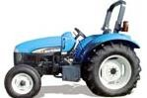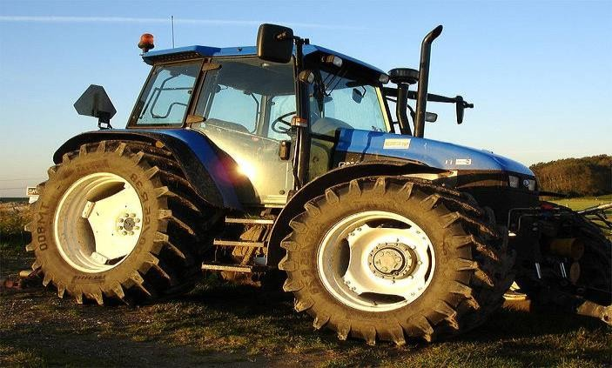

**P**

## Plate II: Modern 4x4 WD Tractor

**late I: Modern 4 x 2 WD Tractor**

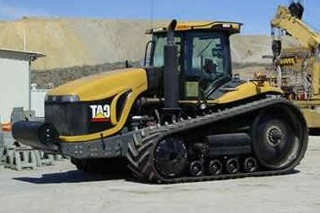

**Plate III: Rubber Tracked Crawler Tractor**

## Uses of Tractors

**Farm Tractors:** The most common use of the term "tractor" is for the vehicles used on farms. The farm tractor is used for pulling or pushing agricultural machinery or trailers, for ploughing, tilling, disking, harrowing, planting, and similar tasks.

A variety of specialty farm tractors have been developed for particular uses. These include "row crop" tractors with adjustable tread width to allow the tractor to pass down rows of corn, tomatoes or other crops without crushing the plants, "Wheatland" or "standard" tractors with non-adjustable fixed wheels and a lower centre of gravity for ploughing and other heavy field work for broadcast crops, and "high crop" tractors with adjustable tread and increased ground clearance, often used in the cultivation of cotton and other high-growing row crop plant operations, and "utility tractors", typically smaller tractors with a low centre of gravity and short turning radius, used for general purposes around the farmstead. Many utility tractors are used for non-farm grading, landscape maintenance and excavation purposes, particularly with loaders, backhoes, pallet forks and similar devices. Small garden or lawn tractors designed for suburban and semi-rural gardening and landscape maintenance also exist in a variety of configurations.

# **Compact Utility Tractor:** A Compact Utility Tractor, also called a CUT is a smaller version of an agricultural tractor but designed primarily for landscaping and estate management type tasks rather than for planting and harvesting on a commercial scale. Typical CUTs range in from 20 to 50 horsepower (15-37 kW) with available power take off (PTO) horsepower ranging from 15 to 45 hp (11-34 kW). CUTs are often equipped with both a mid-mounted PTO and a standard rear PTO, especially those below 40 horsepower (30 kW). The mid-mount PTO shaft typically rotates at/near 2,000 rpms and is typically used to power such implements as mid-mount finish mower, a front mounted snow blower or front mounted rotary broom. The rear PTO is standardized at 540 rpms for the North American markets, but in some parts of the world a dual

540/1,000 rpm PTO is standard and implements are available for either standard in those markets (Lite, 2011).

# One of the most common attachments for a Compact Utility Tractor is the front-end loader or FEL. Like the larger agricultural tractors, a CUT will have an adjustable three- point hitch that is hydraulically controlled. Typically, a CUT will have four-wheel drive, or more correctly 4 wheel assist. Modern Compact Utility Tractors often feature a Hydrostatic transmission, but many variants of gear drive transmissions are also offered from low priced simple gear transmissions to synchronized transmissions to advanced glide-shift transmissions.

Compact Utility Tractors require special smaller implements than full size agricultural tractors. Very common implements include the box blade, the grader blade, the landscape rake, the post hole digger (or post hole auger), the rotary cutter (also called a slasher or a brush hog), a mid or rear mount finish mower, broadcast seeder, subsoiler and the rototillerr (also rotary tiller). In northern climates, a rear mounted snow blower is very common, on smaller CUTs some models are available with front mounted snow blowers that are powered by a mid-PTO shaft. There are many more implement brands than there are tractor brands offering CUT owners a wide selection of choice.

For small-scale farming or large scale gardening, there are some planting and harvesting implements sized for CUTs. One and two row planting units are commonly available as are cultivators, sprayers and different types of seeders (slit, rotary and drop).

**Garden Tractors**: Garden Tractors (also called Mini Tractors) are small, light and simple tractors designed for use in domestic gardens. Garden Tractors are usually designed primarily for cutting grass, being fitted with horizontal rotary cutting decks. Visually, the distinction between a garden tractor and a ride-on lawnmower is often hard to make; generally garden

tractors are more sturdily built, with stronger frames, axles and transmissions rated for ground- engaging applications. Garden Tractors are generally capable of mounting other implements such as harrows, cultivators/rotavators, sweepers, rollers and dozer-blades. Like ride-on mowers, garden tractors generally have a vertical-crankshaft engine with a belt-drive to a transaxle-type transmission (usually of 4 or 5 speeds, although some may also have two-speed reduction gearboxes or a hydrostatic drive).

Front-engine tractor layout machines designed primarily for cutting grass and light towing are called lawn tractors; and heavier duty tractors of the same overall size, often shaft driven, are called garden tractors. The primary differences between a lawn tractor and a garden tractor are the transmission torque handling capability, frame durability, the rear wheels (garden tractors almost always have multiple mounting bolts, while most lawn tractors have a single bolt or clip on the hub), and the ability to attach ground engaging equipment such as ploughs or disk- harrows. Many makers of agricultural tractors have made (or continue to make) ranges of garden tractors, such as Case, Massey-Ferguson, International Harvester and John Deere (Lite, 2011).

**Engineering Tractors**: The durability and engine power of tractors made them very suitable for engineering tasks. Tractors can be fitted with engineering tools such as [dozer blade,](http://en.wikipedia.org/wiki/Bulldozer) [bucket,](http://en.wikipedia.org/wiki/Loader_(equipment)) [hoe,](http://en.wikipedia.org/wiki/Hoe_(equipment)) ripper, and so on. The most common attachments for the front of a tractor are [dozer blade](http://en.wikipedia.org/wiki/Bulldozer) or a [bucket.](http://en.wikipedia.org/wiki/Bucket) When attached with engineering tools the tractor is called an [engineering vehicle](http://en.wikipedia.org/wiki/Engineering_vehicle) (Lite, 2011).

A bulldozer is a track-type tractor attached with blade in the front and a rope-winch behind. Bulldozers are very powerful tractors and have excellent ground-hold, as their main tasks are to push or drag things. Bulldozers have been further modified over time to evolve into new machines which are capable of working in ways that the original bulldozer can not. One example is that loader tractors were created by removing the blade and substituting a large

volume bucket and hydraulic arms which can raise and lower the bucket, thus making it useful for scooping up earth, rock and similar loose material to load it into trucks.

A front-loader or loader is a tractor with an engineering tool, which consists of two hydraulic powered arms on either side of the front engine compartment and a tilting implement. This is usually a wide open box called a bucket but other common attachments are a pallet fork and a bale grappler.

Other modifications to the original bulldozer include making the machine smaller to let it operate in small work areas where movement is limited. There are also tiny wheeled loaders, officially called Skid-steer loaders but nicknamed "Bobcat" after the original manufacturer, which are particularly suited for small excavation projects in confined areas.

**Backhoe loader**: The most common variation of the classic farm tractor is the hoe, also called a hoe-loader. As the name implies, it has a loader assembly on the front and a backhoe on the back. Backhoes attach to a 3 point hitch on farm or industrial tractors. Industrial tractors are often heavier in construction particularly with regards to the use of steel grill for protection from rocks and the use of construction tires. When the backhoe is permanently attached, the machine usually has a seat that can swivel to the rear to face the hoe controls. Removable backhoe attachments usually have a separate seat on the attachment.

Backhoe-loaders are very common and can be used for a wide variety of tasks: construction, small demolitions, light transportation of building materials, powering building equipment, digging holes, loading trucks, breaking asphalt and paving roads. Some buckets have a retractable bottom, enabling them to empty their load more quickly and efficiently. Buckets with retractable bottoms are also often used for grading and scratching off sand. The front assembly may be a removable attachment or permanently mounted. Often the bucket can be replaced with other devices or tools. Their relatively small frame and precise control make

backhoe-loaders very useful and common in urban engineering projects such as construction and repairs in areas too small for larger equipment.

Automobile Conversion Tractors ("Hoover Wagons”): The ingenuity of farm mechanics, coupled in some cases with manufacturer assistance, resulted in the conversion of automobiles for use as farm tractors at various times. In the United States, this began early in the development of vehicles powered by internal combustion engine, with blacksmiths and amateur mechanics tinkering in their shops. During the Great Depression, several manufacturers including Montgomery Ward, marketed after-market kits for converting Model T Fords for use as tractors (sometimes known as "Hoover Wagons", although this term was usually reserved for automobiles converted to horse-drawn buggy use when gasoline was unavailable or unaffordable).During World War II, a shortage of tractors in Europe led to the development of the so-called EPA tractor (EPA was a chain of discount stores and it was often used to signify something lacking in quality). An EPA tractor was simply an automobile, truck or lorry, with the passenger space cut off behind the front seats, equipped with two gearboxes in a row (Lite, 2011).

## Tractor Performance Criteria

The performance of a farm tractor can be expressed in different ways. From the available sources, the criterion that best describes the performance depends largely upon the intended use of the tractor (Turner, 1993).

1. The tractors size: - the number of ploughs it can pull under average condition.
2. The maximum drawbar pull is often used in carrying or evaluating tractors. Drawbar pull is seriously affected by soil or test track conditions and by the gear ratio and the ballast being carried. Power is a function of velocity and drawbar pull; hence drawbar

pull partly describes the ability to do work. Maximum drawbar power (Pdb) is normally the most useful criterion for farm tractors.

1. The maximum PTO power (PPTO) developed is a useful criterion for farmers who use a tractor extensively on machine requiring PTO drive.
2. Fuel consumption is another criterion that can be used to indicate directly or indirectly the efficiency of the tractor.
3. Torque curve or lugging ability – it is a way of measuring the stability or pulling ability of an engine as the engine is slowed down because of increased load. For tractors, the drawbar pull versus speed, for a single gear and open throttle is the most useful method of interpretation, since this method considers the effects of transmission and traction.

## Power Measurement Methods

**Definition of terms:-**

**Power: -** the rate of doing work. A unit of power is Nm/s or Watts. It is also measured in hp (horsepower).

1 hp = 0.746 kW, 1,000 W = 1kW.

**Brake Power: -** the power of the engine crankshaft. The engine may be stripped of part or all its accessories. It is otherwise called effective power and it is 10-12% less than the indicated power.

**PTO power: -** the power delivered by a tractor through its PTO shaft.

**Drawbar Power: -** the power of a tractor measured at the end of drawbar, it is the product of the drawbar pull and the velocity of the operation.

**Friction Power: -** the power required to operate/run the engine at any given speed without production of useful work. It is usually measured with a suitable electric dynamometer that runs the engine. It represents the friction and the pumping losses of an engine.

**Indicated power: -** this is the power developed by the engine as a result of the pressure in the combustion chamber and the volumes produced by the reciprocating components of the engine, and it is expressed as (Liljedahl, Carleton, Turnquist and Smith 1989).

*P*  *Pe LANn*

2.1

*i* 60  *C*

Where Pi = indicate power kW,

Pe = mean effective pressure, Pa (N/m2)

L = length of stroke, m; A = area of piston bore, m2

N = engine speed in rpm; n= number of cylinders C = 1 or 2 for 2 and 4 stroke engines respectively.

Gross indicated power = Net brake power + Friction power

**Maximum brake power: -** is the maximum power an engine will develop with the throttle fully open at specific speed. With tractor engines, the maximum power is measured at rated speed.

**Observed power:-** the power obtained at the dynamometer without any correction for the atmospheric temperature, pressure and or vapour pressure.

**Corrected power:-** power obtained by correcting observed power to standard conditions of sea-level pressure (1.013x105 Pa), 15.50C temperature and zero vapour pressure.

**Kilowatt-hour:-** one kilowatt working for one hour. It is 3.6x106 Joules of work.

**Dynamometer:-** an instrument for determining power, usually by independent measurement of force, time, and the distance through which the force is moved. Dynamometers may be classified as brake, drawbar, or torsion according to the manner in which force is being applied. Also they may be classified as absorption or transmission, depending on the disposition of the energy.

## Absorption Dynamometer

An absorption dynamometer measures the power applied and at the same time converts it to some other form of energy, usually, heat. Examples of absorption dynamometer are;

1. Prony brake dynamometer the most elementary form of absorption dynamometer.
2. Hydraulic dynamometer
3. The air brake or fan brakes dynamometer

All absorption dynamometers, which are used to measure power use the relation (Liljedahl *et al*., 1989):

*Power*  2 *nT* , *kW*

60, 000

2.2

Where n = engine speed in revolution per minute (rpm).

T = torque developed (Nm).

## Shop-Type Dynamometer

This type of dynamometer is used primarily as an indication of the condition of the engine; it is also used in the process of adjusting or turning an engine and in indicating to customers the improvement in a tractor engine as a result of overhaul, maintenance or adjustment. Shop type dynamometer generally employs a pressure gauge to measure the force on the resisting torque arm. The PTO speed is usually measured by a direct reading of speed indicator (Liljedahl *et al*., 1989).

## Drawbar Dynamometer

Drawbar dynamometers are commonly employed to determine the drawbar pull of power units or to ascertain the draft of field implements. Examples of drawbar dynamometers are:- spring dynamometer. Hydraulic drawbar dynamometer and strain gauge dynamometer (Bukola, 2004).

* Spring Dynamometer –the simplest and the most common types of drawbar dynamometers, unit consist of a spring that elongates under tension and shortens under compression. It is suitable for rough measurements of forces, because of rapid variations in load such are commonly found in connection with agricultural implements.
* Hydraulic Dynamometer uses hydraulic cylinder to transmit power from the drawbar force to the dynamometer car. The pressure is measured by a pressure transmitter, the signal from which goes to the recorder and a computer. The hydraulic cylinder for measuring drawbar pull has an advantage over a spring dynamometer in that fluctuation can be damped by throttling valve.
* Strain gauge dynamometer- one method of measuring the drawbar pull is by means of a dynamometer that uses electrical resistance strain gauge to sense the strain.

## Torsional Dynamometer

Torsion dynamometers are developed as a result of the machinery operated by tractor power take off shafts. A typical example of torsion dynamometers is the torque meter (strain gauge type).

## Chassis Dynamometer

The testing of tractors outdoors has some limitations due to weather. One method of avoiding some difficulties of outdoor testing is the use of chassis dynamometer. The tractor is restrained from forward movement, and the drive wheels are placed on a drum that is part of an absorption dynamometer. Temperature can be better regulated when testing a tractor on a chassis dynamometer (Bukola, 2004).

## Power Estimation: Field Method

It is often desired to know the approximate power being developed by a tractor in the field. If the accuracy of strain-gauge types of torque meter is not needed, an estimate of the tractor power output can be obtained by measuring the manifold pressure. A relationship between the manifold pressure and the power is first obtained by a dynamometer test. The curve is correct only for full throttle or governor setting. Since manifold pressure is not controlled on a diesel tractor, a relationship between manifold pressure and power cannot be obtained for a given no load engine speed, a curve can be plotted of PTO power versus fuel consumption (Bukola, 2004).

## Engine Performance

Fig. 2.2 gives the result of a typical test of a tractor engine whose crankshaft is attached directly to a dynamometer. The same engine when placed in its tractor chassis would have to a less power through the power take off because of losses due to gears, hydraulic pumps e.t.c. The power rating of trucks and automobile engines usually are the results of a dynamometer test of the engine removed from its chassis (Liljedahl *et al*., 1989).

2 5 0



SAE N (TYPI

RFORMANCE NSTALLATION)

PE

L I

ET

CA

(2)

E

NC

MA

OR

RF

PE

SS

RO

E G

SA

(1)

2)

(

)

(2

(1)

1)

(

2 4 0

2 2 0

2 0 0

Torque Nm

Power output kW

Engine speed rev/min

Maximum Rated 2600 rev/min

**Figure 2.2: Performance curves for Perkins 4.236 Diesel Engine**

Source: Liljedahl *et al. (1989)*

## Efficiency of Tractor Engines

An important criterion of the engine performance is its thermal efficiency. It can be expressed in percentages, but it is easier to express the efficiency as the ratio of the out put power (PTO or Draw bar power) to the mass of fuel burned per hour. On the other hand, it is a ratio of the amount of heat actually contained in the fuel. (Adgidzi, 2002). About 30% of thermal Energy from fuel is converted to effective power; the rest (of thermal energy) is used in overcoming

mechanical losses, 10 % heating the cooling liquid, engine 45 %, and thermal losses through exhaust gasses 15 %.

Fig. 2.3 gives the fuel efficiency of tractors at Nebraska for petrol in 1976 and for diesel in 1984. The graph represents data from the PTO Varying power and fuel consumption test, which indicate the tractors ability to convert potential energy (fuel) into useful work. Since the efficiency is expressed in kW.h/l. From the graph, it is clear that diesel engines have greater efficiency than the petrol engines (Liljedahl *et al*., 1989).

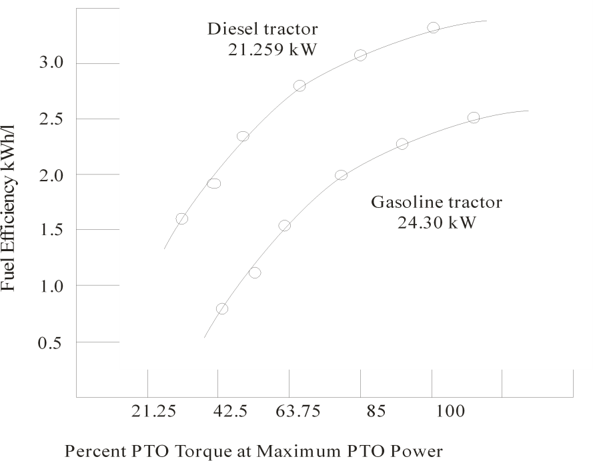

**Figure 2.3: Average fuel efficiency of gasoline tractor tested in 1976 and diesel tractor tested in 1984 at Nebraska** (Liljedah*l et al.,* 1989)

Fuel efficiency (FE) of a tractor in kW.h/l is calculated as (Zoz, Turner and Shell*,* 2002):

*FE*  *DBP*

*FC*

2.3

where DBP = Draw bar power [kW] FC = Fuel consumption [l/h]

## Fuel Economy of a Tractor

This is characterized by the specific fuel consumption determined by dividing the hourly fuel consumption of the engine by its power out put at the PTO or Draw bar.

The specific fuel consumption is related as follow (Grisso, Perumpral, Vaughan, Robertson and Pitman*.,* 2010):

SVFC =

FC DBP

(l/kW.h)

2.4

Where SVFC = Specific volumetric fuel consumption (l/kW.h)

FC = Fuel consumption (l/h)

DBP = Draw bar power (kW)

## Field Performance of Farm Tractors

The power performance of farm tractors is the most important informative item needed by farm machinery managers (Hunt, 1995). The tractor is the base of the machinery system. It is often the most used machine in the farm and is frequently the most expensive.

People working in all areas of farm mechanization have a need for information relating to the performance of tractor in the field. This need extends its self all the way from Engineers designing the tractor implement to the ultimate user, the farmer himself. Often, the design of new tractors and equipment is based upon experience with the acceptable units in the field rather than upon actual performance criteria (Zoz and Grisso, 2003).

Perhaps, the best tractor performance data available at present comes from Nebraska test results. This information is readily available and useful to manufacturers and farmers as well. Its usefulness is generally limited to comparisons between tractor models. The results of power- take-off tests have more application than those of drawbar tests (Macmillan, 2002) because they

can be used directly, allowing for differences between the tractors of a given or different models. The drawbar tests do not have such a direct application because they are conducted upon a surface which is unchanging (e.g. concrete track). Therefore, the economic farm management requires a careful matching of tractor's capability to the farm power needs. Reliable unbiased performance data, based on tests of sample model is fundamental to good farm machinery management.

## Tractor Performance Test

**Historical Perspectives**: The need for a reliable performance data arose in the early days of tractor manufacturing (Hunt,1995). In 1919, W.F. Grozier, a farmer as well as a legislator, introduced mandatory tractor tests legislation in the Nebraska House of Representatives to provide farmers with unbiased information about tractors performance. The bill passed and the Nebraska Tractor Test Board was created and given authority to require tractors offered for sale in Nebraska to be tested before being issued a sale permit. The University of Nebraska Lincoln was selected as the testing agency. While the law applied only to Nebraska sales, the industry accepted the results worldwide.

**Evolution of Test Procedures:** The test procedures have evolved over the years to accommodate changes in tractor technology. The test standards were codified by the then American Society of Agricultural Engineers (ASAE) in 1937. A joint standard was issued by the ASAE (now ASABE) and the Society of Automobile Engineers (SAE) in 1964. Past tests have help evaluate such innovations as dual drive wheels, turbochargers, radial tires, new transmissions and efficiency of various fuels.

## OECD Tractor Test Codes

As tractor manufacturers developed world wide markets, a need aroused for an international tractor test procedure to avoid redundant tests in each national market (Hunt,2001). The organization for economic cooperation and development (OECD) approved internationally recognized tractor testing procedures and named the Farm and Industrial Equipment Institute (later renamed as the Equipment Manufacture Institute - EMI) as a "Designated Authority" for OCED testing. In 1986, the Nebraska legislature voted to accept the results of either the SAE / ASAE or OECD tractors test in 1988, The Nebraska test facility began OECD test as well as their traditional ones. University of Nebraska Lincoln reviewed the provisions for OECD testing at the 1988 winter meeting of the ASAE. Five different tractors test codes were listed (Hunt,2001).

Code I Standard or full test performance code which consists of PTO, Drawbar, Hydraulic power, 3-point linkage lift, centres of gravity, braking, and sound level tests.

Code II Restricted standard performance code which has the same PTO test but drawbar tests are conducted without ballast.

Code III A dynamic protective structure test.

Code IV A static protective structure test.

Code V A noise measurement test.

## Conventional Tractor Performance Tests

* + 1. **Preparation for Testing**

As reported in Hunt (1995), the manufacturer selects the tractor to be tested and certifies that it is a stock model. Each tractor is equipped with the common power consuming units such

as power steering, hydraulics, alternators e.t.c. An official representative of the company is usually present during the test to see that the tractor give of optimum performance, Additional weight may be added to the tractor as ballast if desired. The static tire loads inflation pressures must conform to the limitation set by Tire and Rim Association.

The engine crank case is drained and refilled with new oil conforming to the specifications in the manufacturers' manual. This manual is also used for selecting the proper fuel. The tractor is operated for several hours prior to testing to provide a representative test after the pistons and bearings "wear-in". Adjustment of tractor is permitted at this time. Instrumentation for measuring engine rpm, fan speed, temperature and pressure, and fuel consumption are installed.

## PTO Performance

Engine power performance is tested by connecting a dynamometer to tractors PTO shaft. During a preliminary run, the manufacturer's representative may make adjustments for injector pump volume and timing. These settings must be maintained for the remaining tests. The manually operated governor control is set to provide the high idle (no-load) engine speed specified by the manufacturer. During the PTO runs, ambient air temperature of approximately 240C (750 F) is maintained and barometers readings should be above 96.6 kPa.

Power is measured at the rated engine speed specified by the manufacturer. Maximum power may be obtained at other than rated speed and is conducted for 2 hours. When the P.T.O speed for these tests, differ from the ASAE and SAE standards additional rum is made at other the 540 or 1,000 rpm standard. The varying power and fuel consumption test provide a machinery manager with data on fuel efficiency at part loads. These tests record the fuel consumption and power developed during six test loadings decreasing from maximum to no load.

## Drawbar Performance

Drawbar pull tests are performed in all transmission gears between one gear below the one at which 15% drive wheel slip occurs and that for a maximum speed of 16.1 km/hr [10 MPH]. In each test, the governor control is set for maximum speed (high idle) and the horizontal drawbar load increased until the maximum drawbar power is obtained. Measurements are taken of pull, speed, power slip, fuel consumption and sound.

A second set of tests investigates part loads performance. Drawbar loads of 75 % and 50 % of the load at rated engine speed are applied in a gear close to 7.5 km/hr [4.6 MPH] and in the gear where maximum drawbar power was obtained in the previous tests.

Additional tests may be conducted. The manufactures may wish to a test at reduced engine speed, ballast-aided performance, performance with and without MFWD, alternate tire configurations. The procedure specify that distribution and total tractor weight will be in accordance with limits set by the tractor manufacturers, tire manufacturers and roll-over protection certification. The weight shall include fuel tanks and an 80Kg operator. Front end ballast can only be provided by a standard weight package and or front tire ballast supplied or recommended by the manufacturer.

## Three Point Hitch Test

The tractor is tested on the same rear tires used during the drawbar tests. The front tires of two wheel drive and front-wheel drive assist tractors may be of any size or ply offered by the tractor manufacturer as long as they properly match the rear tires. A quick attaching coupler is used on all category III and IV hitches and on any tractor on which it is offered as standard equipment, but the quick coupler is not considered part of the load lifted by the hitch.

## Hydraulic Lift Capacity and Flow

The hydraulic lift capacity is measured in a special test stand. A frame is fitted to the three

point hitch links and measurements of lift capacity are taken at the hitch point and 61cm behind the lower horizontal hitch links. The load is generally applied with a hydraulic cylinder and the links move stepwise through the lift range. The number that is reported is 90 % of the load which can be carried throughout the lift range.

A second test determines the pressure /flow relationship and performance of the hydraulic system for supplying power to external cylinders and motors. Measurements reported are pump flow rates minimum pressure at rated engine speeds and the pressure flow at maximum hydraulic power.

## AFMRC Simplified Tractor Performance Measurement System

Engineers at Alberta Farm Machinery Research Centre (AFMRC) have developed simple performance measurement system and technique to provide the benefits of traction performance measurement to farmers. The AFMRC system addresses each of the four necessary measurements for performance calculation by making a simple measurement of either the actual value or an acceptable substitute. Three of the variables, vehicle ground speed, traction surface speed and vehicle draft load, can be measured with relatively small effort and are measured directly; one variable, power input to the traction device is difficult to measure directly. The AFMRC system instead measures engine speed and computes a value for the power input. The system uses an on board data acquisition system designed to be easy to use and quickly portable between vehicles. The instrumentation and data acquisition system is powered by the vehicle and operated by the vehicle operator.

## Traction Input Power Measurements

* + 1. **P.T.O Substitute Method**

As indicated in the research conducted by Turner (1993), the most direct and accurate

approach to produce a traction input power substitute from engine speed can be refereed to as the p.t.o substitute method. This method requires measuring the p.t.o. power developed as a function of engine speed at the full throttle position .For this method, the tractor is hooked to a p.t.o. dynamometer. With the tractor at full throttle engine speed and the p.t.o power produced are recorded as the load is increased across the full range the engine from the no-load high idle point down to the engine stall point. The resulting data is graphed and reduced to a set of two curves~ and the intersection point or transition speed for the two curves. The first curve is fit to the variable load part of the engine curve from high speed idle down to the transition speed. The second is fit to the variable speed part of the curve from the transition speed down to the stall point. The resulting mathematical description is then entered into the data acquisition system and used in computing the percent power delivered during the field test.

An advantage to p.t.o. substitute method is that it give absolute values of percentage power deliver and can thus be used to compare between different tractors as well as between changes on the same tractor. Zoz *et al.*(2002) note the similarity of the ratio of drawbar power over p.t.o. power through tractive efficiency. A disadvantage to this method is that, it can only be used if the tractor has a p.t.o and the researcher has access to p.t.o. dynamometer.

## Approximate Engine Power Method

The second method as highlighted in Turner (1993) of converting from engine speed to a traction power substitute is to develop an approximate engine power curve and is use in the same way as the p.t.o power curve discussed above. These methods referred to as the Approximate Engine Power method, and allow traction efficiency comparisons between changes on a given tractor. For this method, initial field tests are used to determine the engine curve shape and fit coefficients. The necessary data is produced and used as follows:

* + - 1. First, several specific tests are run. A complete draft load test is run in a very

low gear that allows high levels of slip at low engine loads. Another complete test is run in a gear well above the normal working range to produce high engine loads at low slip levels. In each case, intermittent data snapshots are recorded across the full range of the tractor from zero loads up to either very high wheel slip or near engine stall. Similar tests are also run in one or two normal working gears.

* + - 1. The developed drawbar power from all these tests is plotted against engine speed. The graph should show a transition speed where the engine effectively comes off the governor and reaches full fuel flow.
      2. Using only data from the low gear test or tests, an appropriate curve is fit to the data from the maximum speed down to the transition speed.
      3. Using only data from the high gear test or tests, an appropriate curve is fit to the data from the transition speed down to the minimum engine speed.
      4. The behaviour of the two fitted curve is noted near the transition speed. If the curves intersect but not at the transition speed, the speed where they intersect is defined as the new transition speed. If the curves do not intersect or at least come close, additional data points should be included in the fit to bring the defined curves together.
      5. Finally, an average ratio of drawbar power to engine power is selected. The numerator for this ratio is the measured drawbar power at the manufacturers rated speed for the tractor and can be taken from the previous graph. The denominator should be the manufacturers rated engine power at the same speed. If the manufacturers rated power level is not known, a ratio of 0.75 is used. The value selected is arbitrary and, while it moves the curve to the approximate level of an actual engine curve, and this makes the data look more appropriate.

These steps adequately define an approximate engine curve and the resulting mathematical description is then entered into the data acquisition system and used in computing the percent power delivered during the field tests.

## Assumed Engine Power Method

The third and least accurate way to change engine speed to a traction power substitute according to Turner (1993) is to obtain a manufacturer supplied engine power curve for the type of engine in the tractor and use that curve in the same way as the previously discussed curves. This method is referred to as the assumed engine power method, and has a disadvantage in that it may not reflect actual condition of the engine in the tractor being tested. The method will show the direction of relative changes in traction variable for a given tractor.

Within the AFMRC system a form implement is used as a dynamometer to provide traction load. The implement can very depending on what is available but must be drawn and not mounted. A chisel ploughs or field cultivator works well since it is easy to adjust draft by changing the operating depth. The best results are obtained with implements that some what over sized for the tractor being tested since this ensures adequate loads in the lower gears. As always test results are most useful when done on as level and uniform ground condition as possible.

## The Tractor Drawbar Performance Predictor Chart

Hunt (2001) suggested the use of the tractor drawbar performance predictor chart in performance comparison of farm tractors. The chart was based upon average tire performance curves on four surfaces. Three weight transfer coefficients are used for each soil type. The chart was designed such that easily obtained or readily measurable inputs can be used. For instance drawbar pulls are based upon static rear weight rather than the more illusive dynamic weight. Travel speeds are entered at the "no load" or advertised speed rather than the actual speed which

is itself a function of wheel slip. While the axle horsepower is not generally known, it is used for accuracy where it may be known or can be obtained.

With the chart, the expected performance of any tractor regardless of size can be determined. All that is necessary is that a reasonable relationship between tractor weight and tire size be maintained which is in effect specifies that a realistic ground contact pressure be maintained.

The chart assumes steady state conditions exist and is truly applicable only on level surfaces. Any point within the tractors operating range may be analyzed so long as the proper data is entered for that point (i.e. if other than rated speed is used, the proper axle horsepower and travel speed for that point must be used).

The following describes the various components of the chart (see appendix A).

1. Soil Conditions

**Concrete:** The data used for concrete represent what might be expected from Nebraska tests. The pull to weight ratio from the chart could not be expected from brand new tires with full bar height. Tests have shown however that bar height has little effect on efficiency of the tire and hence, the curve for drawbar horsepower might still be expected, if the wheel slip can be maintained at the proper level. This characteristic allows the use of horsepower curve for concrete to estimate the axle horse power of a tractor from Nebraska test results.

**Firm soil:** The firm soil curves represent a soil which is of relatively high strength with low sinkage. Much of the data was collected on soil where a cover crop was growing.

**Tilled soil:** the titled soil curves represent a lower strength or loose soil condition. Much of the data was obtained from soil which had been ploughed and then disked once to level out the surface. Some of the data was obtained on soil which had been prepared with rotary

tiller.

**Soft or sandy:** This could represent a field which had just been deep ploughed or a soil with very low strength and much sinkage.

1. Weight Transfer Coefficients (DWC):

The curves within each soil type represent typical weight transfer conditions for the implement hitch types shown. The total weight transfer to the rear wheels equals drawbar pull x DWC.

Values of DWC used on the chart are

* + Integral hitch mounted = 0.65
  + Semi-integral = 0.45
  + Towed = 0.25

Values of DWC are not constant and are a function of implement actually in use (light or heavy, close coupled or far back, and with varying amounts of vertical force), a function of time due to soil variations and a certain extent are a function of pull it self. The values used are typical however, and interpolation between curves can be done if actual values are known.

DWC for concreted (horizontal drawbar pull) = drawbar height / wheel base 2.5

The implement can very depending on what is available but must be drawn and not mounted. A chisel plough or filed cultivator works well since it is easy to adjust draft by changing the operating depth the best results are obtained with implements that some what over sized for the tractor being tested since this ensures adequate loads in the lower gears. As always test results are most useful when done on as level and uniform ground condition as possible.

1. Travel Reduction of Drive Wheels (TR)

All travel reductions are based upon zero being the self propelled point on pull on the drawbar. Travel reduction (slippage) can be determined from a distance or wheel revolution basis.

1. Travel speeds

The travel speed should be based upon the loaded radius obtained from the tire free roll. Speeds based upon design loaded radius are generally sufficient.

1. Rear Weight (RWS):

The Static Rear Weight of the tractor is used.

1. Axle Horsepower (AHP):

The horsepower available at the axle of a tractor is not generally known but it is used on the chart for sake of accuracy. Several means are available to estimate the axle horsepower of tractors.

1. Typical power transmission efficiencies of tractor with gears type transmissions are shown in figure 2.4. From this chart it can be seen that the ratio of pto horse power to axle horse power is approximately 0.96. A reasonable estimate of axle horsepower can therefore be made.

Axle horsepower = 0.96 x PTO hp 2.6

1. Also from figure 2.4 it can be seen that maximum tire efficiency expected on concrete is 0.92 Therefore for the gear or travel speed where maximum horsepower was obtained on concrete (Nebraska test).

Maximum horsepower = max. Drawbar hp on concrete / 0.92 2.7

78-81

**NET ENGINE**

## Figure 2.4: Typical Power Transmission Efficiencies

96-98 %

90-87

90-87

85-89

94-96

**Axle**

**Transmission Input**

86-89 %

**Drawbar**

**P T O**

Source: Hunt (2001)

However, the variability of tire alone on concrete is much less and the average tire performance curve on concrete can be used to determine axle horsepower from Nebraska test for any gear or travel speed.

i.. Determine drawbar horsepower and travel reduction from Nebraska test.

1. .Determine average tire performance efficiency (DB HP/ AHP) on concrete from the chart for above travel reduction.
2. Axle horse power = drawbar horsepower on concrete x tire efficiency ration at appropriate travel reduction concrete.

2.8

After the axle horsepower of a tractor has been determine the chart can be used to determine

the expected performance on the other soil. The chart can be entered at any point where values are known or can be assumed. The normal point of enter is at the tractor "no-load" travel speed. With the chart, the expected drawbar pull, travel speed and drawbar horsepower can be determine. A typical chart is shown in the appendix A.

## Recent Comparative Tests on Tractors

* + 1. **Comparison on Texas soils**

Shell, Zoz and Turner (1997) reported on tests comparing field performance of Rubber Belt and MFWD tractors in Texas soils. The objective of the research was to compare the performances of a mechanical front wheel drive (MFWD) and a Rubber track (belted) tractor in representative Texas soil over many conditions. The criteria for performance comparison were fuel efficiency [kW.h/l] and power delivery efficiency DB/PTO power ratio. Both tractors were tested on a p.t.o dynamometers in the lab prior to field test. In addition to p.t.o power and torque, fuel consumption and efficiency were measured using a positive displacement fuel flow transducer. These data were regressed with engine rpm and diesel injector pump rack position in voltage to predict fuel flow and engine torque in the field. (The fuel flow transducer was not used as part of instrumentation package in the field). Regression formulas were derived from data collected with engine under 100 %, 85 %, and 75 % of 85

% (64 %) p.t.o torque loads at full throttle, rated engine speed and at 1800 rpm (reduced engine speed no-load). The coefficients derived from these regressions were excellent predictors. To allow for statistical analysis of the effects of field and operating conditions on each tractor, the study was design to compare the two tractors over six categorical variables, 2 tractor types, 2 soil types, 2 soil conditions, 2 engine speeds, 3 engine torques and three vehicle traction ratio (VTR). The two dependent variable were fuel efficiency, kW.h /L and power delivery efficiency. Vehicle traction ratio was considered in this study to be the ratio of draw bar pull to static load on tractor, pull / weight. The analysis of variance (ANOVA)

was use as the statistical procedure in this study because it was designed to compare the combined effect of a group of variables (independent variables) on a dependent variable. Therefore, the 2x2x2x2x3x3 factorial design was used requiring 144 test conditions; data was replicated five times in each test condition (matrix) for a total of 720 test or data files.

Test were conducted in strips of approximately 122 m for a duration of approximately 50 seconds with little steering. Test in each matrix were initiated and data collected after the tillage tools (chisel plough) was lowered and torques and field speed were consistent. Draft load and transmissions gears were manipulated to put the tractors in the proper VTR and torque ranges for each test matrix. Full field test were also conducted to compare the two tractors by chiselling a given sized field with each tractors using a typical farming procedure.

## Comparison on Southern Alberta Soils

Turner, Shell and Zoz (1997) conducted a comparison of field performances of robber belted and mechanical assisted front wheel drive (MFWD) tractors in southern Alberta soils. The tests were designed to produce information to help in the selection and optimization of appropriate traction system in a mid-size row crop tractor package. Two deferent belted tractors and two similar radial tire equipped MFWD tractors were tested in tilled and untilled clay loam soil conditions representative of the northern Great Plains. All the tractors were instrumented and adjusted over similar ranges of loads and speeds.

In order to remove the effect of rating differences and engine power variability, and because traction performance is ultimately determined by the amount of available power that can be transferred to the ground, traction performance result were compared using power delivery efficiency, or the percentage of the power that can be delivered to the ground. The power value that was use as the input power in these tests was the equivalent p.t.o power. This p.t.o power was calculated from the engine speed using the PTO substitute method detailed by Turner, (1993). Using power delivery efficiency as the basis for comparisons allowed the

performance comparisons of the total tractor systems.

All the tractors were ballasted for a target weight of 17,200 kg and adjusted to factory suggested optimum weight distributions and tire pressure. All the tests sequences were run in a manner and under conditions as similar as possible for each tractor. A floating hitch chisel plough was used as the load unit for all the tests and pull was assumed to act in a horizontal plane. Two different instrumentations systems and 3 different procedures were used in the comparisons. Engineers at AFMRC had previously developed a performance measurement system and procedure for simplified tractor performance measurement, (Tuner, 1993). This test sequence determines the efficiency of traction system for farm or practical point of view. Tests using this procedure and instrumentation are referred to as the AFMRC sequence. Data from these tests were evaluated without post processing and with minimum refinement and as much as possible from the viewpoint of a farmer.

Engineers at SWTS (South Western Texas State) had also previously developed instrumentation and procedure to provide traction performance measurements, and tests using this instrumentation and procedure are referred to as SWTS sequence. The design of SWTS test sequence was similar to the design described by Shell *et al.* (1997), in tests conducted in Texas soil. This design was used to allow for an analysis of the effects of field and operating conditions on each tractor. Differences between tractor and their significance on two performance criteria: power delivery and fuel efficiency were determined by an analysis of variance. The four categorical variables were tractor type, soil condition, vehicle traction ratio (VTR), and engine torque. A test was initiated by lowering the tillage tool in the ground. The tractor computer was toggled to start saving data after the pulls and torque loads for that test were consistent. Data were collected for approximately 50 seconds duration. All tests were blocked by the four categories. This technique kept the variances small and allowed for determination of level of significance.

The same field and soil conditions identified in the AFMRC test sequence were used. The SWTS method of dealing with engine torque and vehicle traction ratio was different from the AFMRC sequence. The SWTS test design used VTRs of 0.3, 0.4, 0.5 and 0.6; and toque ranges of 75 %, 35 %, 95 % and 105% where 100 % toque was the torques of rated engine speed. The AFMRC sequence used VTRs and torques across the full tractor operation range. All SWTS data were analyzed using the statistical package SPSS for windows.

A third test procedure used on the research was full field test (full field sequence). The sequence was comparatively developed, evaluated and used during the test. This test sequence was designed to represent typical on farm use of the tractors and to produce information similar to what a farmers would base decision on i.e. how quickly a job could be completed and how much fuel a job required. This test consisted of working the tractors in a standard way at a defined engine loading rate for about 2 hours. During the test run, the AFMRC or the SWTS instrumentation package was used to provide a time history of the entire test. Elapsed time, total area worked and total fuel used were manually recorded following each run and used to calculate performance comparisons for the tractors.

## CHAPTER THREE

* 1. **MATERIALS AND METHODS**

The experiment was conducted on the Indaloke series, sandy loam soil of the research fields of National Cereal Research Institute, (NCRI) Badeggi, Niger State Nigeria. The two test tractors are MF 285 from Dan-Abu Farms and New Holland TT75 from Etsu Nupe Farms. The criteria for the choice of the two test tractors are:

1. Traction System
2. Age since purchased and put to use
3. Power Range (40 – 60 kW)
4. Availability

## Test Procedure

Prior to the field tests, the engine PTO power produced, engine speed and fuel consumed versus engine load for both tractors were obtained from Nebraska Tractor Test Laboratory (NTTL) reports for the two tractor makes. PTO power produced and fuel consumed were regressed as indicated in Zoz and Grisso (2003) with engine rpm and diesel injector pump rack position to predict PTO power and fuel consumption levels from engine speed during field tests. Regression formulae were derived from these data collected with engines under full throttle, rated engine speed and at reduced engine speed (1800 rpm). The coefficients derived from these regressions are excellent predictors (Shell *et al.,* 1997).

There is need to use a design that would allow statistical analysis of the effects of the field and operating conditions on each tractor. To achieve this, the study was designed to compare the two tractors over four categorical variables: 2 tractor makes (MF 285 vs New Holland TT 75), 2 soil conditions (untilled vs tilled), 2 engine speeds (rated vs reduced engine speed) and 3 implement depths (7 cm, 10 cm and 15 cm). The two dependent variables are fuel efficiency,

kW.h/l and power delivering efficiency ratio. The factorial designs requiring 2x2x2x3 (24) test conditions was used. Data were replicated four times in each test condition (matrix) to give a total of 96 tests. The means of these replications were used so as to allow all possible combinations of levels of factors to be investigated.

## Experimental Matrix Plan for the Field Tests

The design table for the 2x2x2x3 full factorial experiment used for the tests is shown in Tables 3.1a to 3.1d, for the two tractors tested under untilled and tilled soil conditions and throttle set at their rated and reduced engine speeds.

## Table 3.1a: Experimental Matrix for the Two Tractors Tested in Untilled Soil Condition, Throttle set at Rated Engine Speeds

|  |  |  |  |  |  |  |  |  |  |
| --- | --- | --- | --- | --- | --- | --- | --- | --- | --- |
| **Working** | **Slip** | **Engine** | **Speed** | **Pull** | **Fuel** | **DBP** | **PTO** | **Fuel Eff.** | **DBP/PTO** |
| **Depth.**  cm | % | rpm | Km/h | kN | **Consum.**  l/h | kW | kW | Kw.h/l | Ratio |
|  |  |  |  |  | **MF 285** |  |  |  |  |

7 i

ii iii iv

**Average**

10 i ii iii iv

**Average**

15 i ii iii iv

**Average**

7 i

ii iii iv

**Average**

10 i ii iii iv

**Average**

15 i ii iii iv

**Average**

**NEW HOLLAND TT75**

## Table 3.1b: Experimental Matrix for the Two Tractors Tested in Untilled Soil Condition, Throttle set at Reduced Engine Speeds

**Working Depth.** cm

7 i

ii iii iv

## Average

10 i ii iii iv

## Average

15 i ii iii iv

## Average

**Slip**

%

## Engine

rpm

## Speed

Km/h

## Pull

kN

**Fuel Consum.** l/h

## MF 285

**DBP**

kW

**PTO**

kW

## Fuel Eff.

Kw.h/l

## DBP/PTO

Ratio

7 i

ii iii iv

## Average

10 i ii iii iv

## Average

15 i ii iii iv

## Average

**NEW HOLLAND TT75**

## Table 3.1c: Experimental Matrix for the Two Tractors Tested in Tilled Soil Condition, Throttle set at Rated Engine Speeds

**Working Depth.** cm

7 i

ii iii iv

## Average

10 i ii iii iv

## Average

15 i ii iii iv

## Average

**Slip**

%

## Engine

rpm

## Speed

Km/h

## Pull

kN

**Fuel Consum.** l/h

## MF 285

**DBP**

kW

**PTO**

kW

## Fuel Eff.

Kw.h/l

## DBP/PTO

Ratio

7 i

ii iii iv

## Average

10 i ii iii iv

## Average

15 i ii iii iv

## Average

**NEW HOLLAND TT75**

## Table 3.1d: Experimental Matrix for the Two Tractors Tested in Tilled Soil Condition, Throttle set at Reduced Engine Speeds

**Working Depth.** cm

7 i

ii iii iv

## Average

10 i ii iii iv

## Average

15 i ii iii iv

## Average

**Slip**

%

## Engine

rpm

## Speed

Km/h

## Pull

kN

**Fuel Consum.** l/h

## MF 285

**DBP**

kW

**PTO**

kW

## Fuel Eff.

Kw.h/l

## DBP/PTO

Ratio

7 i

ii iii iv

## Average

10 i ii iii iv

## Average

15 i ii iii iv

## Average

**NEW HOLLAND TT75**

With tires in correct inflation pressures, both tractors were operated in the untilled and tilled field conditions using a rectangular framed three-button disc plough as a load and tested on the normal operating gears (i.e. gear one and two). Implement working depth used were 7, 10 and 15 cm. Test on each matrix was initiated and data taken after tillage implement was

lowered while engine and field speeds were kept constant.

The statistical procedure employed to analyze the data was Analysis of variance (ANOVA) using the statistical package SPSSTM for Windows. The photographs of the test tractors on the field are presented in plates IV – XI.

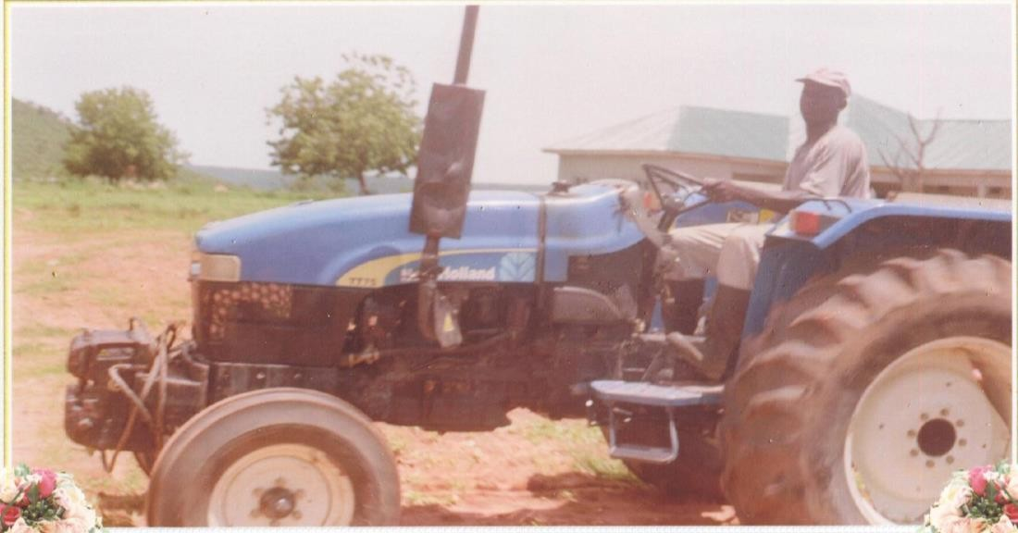

**Plate IV: Test Tractor New Holland TT 75**

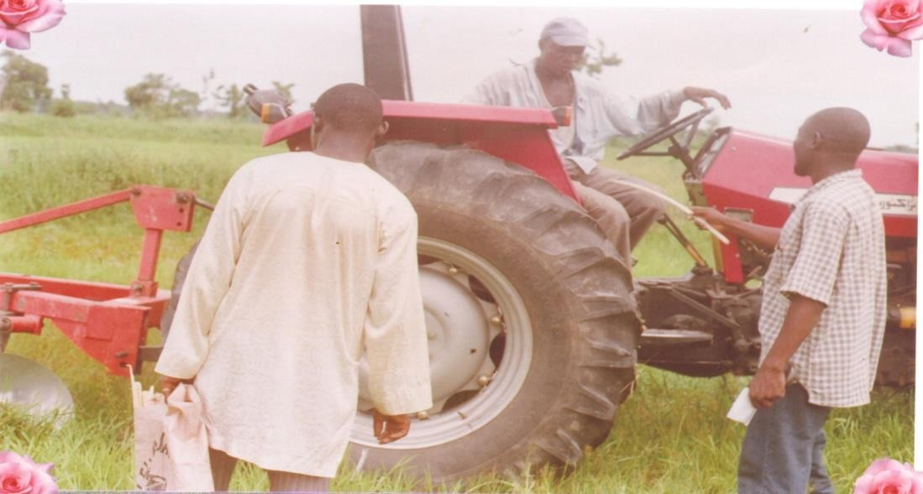

**Plate V: MF 285 Tractor Being Prepared for Field test**

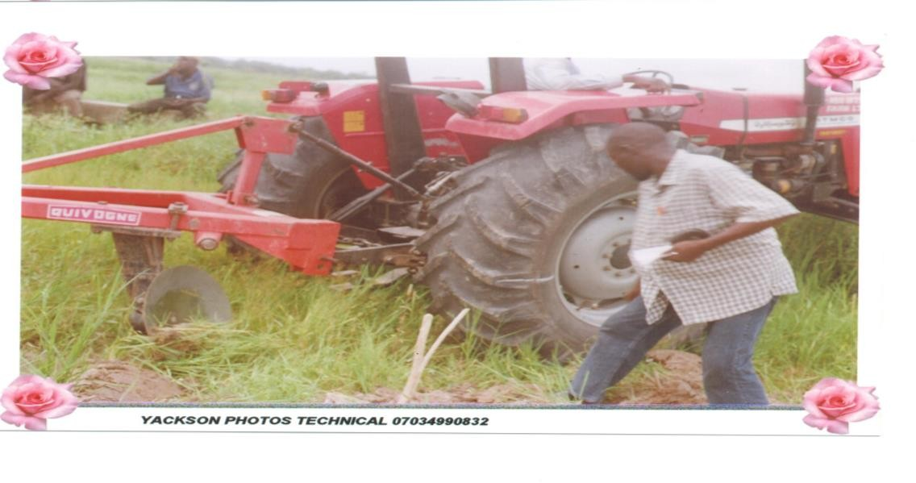

**Plate VI: Measuring the Wheel Slip of MF 285 Tractor in Untilled Soil Condition**

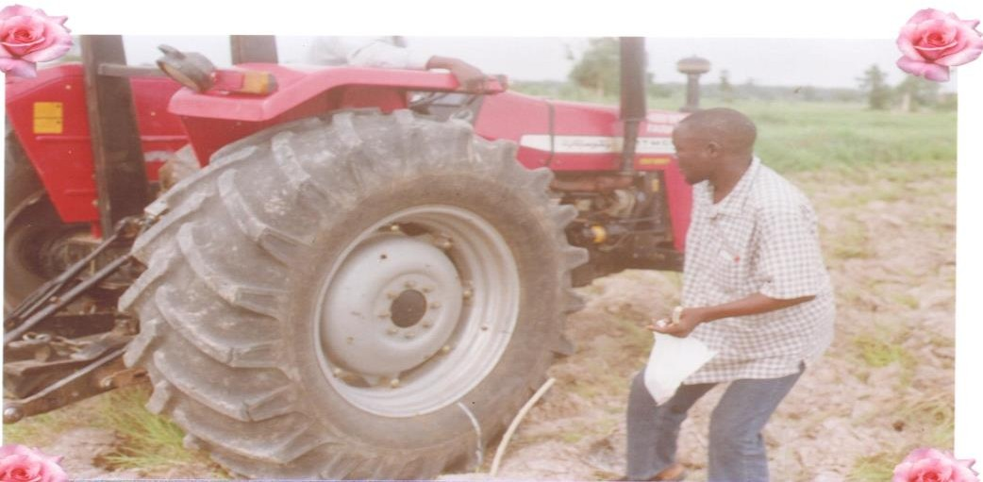

**Plate VII: Measuring the Wheel Slip of MF 285 Tractor in Tilled Soil**

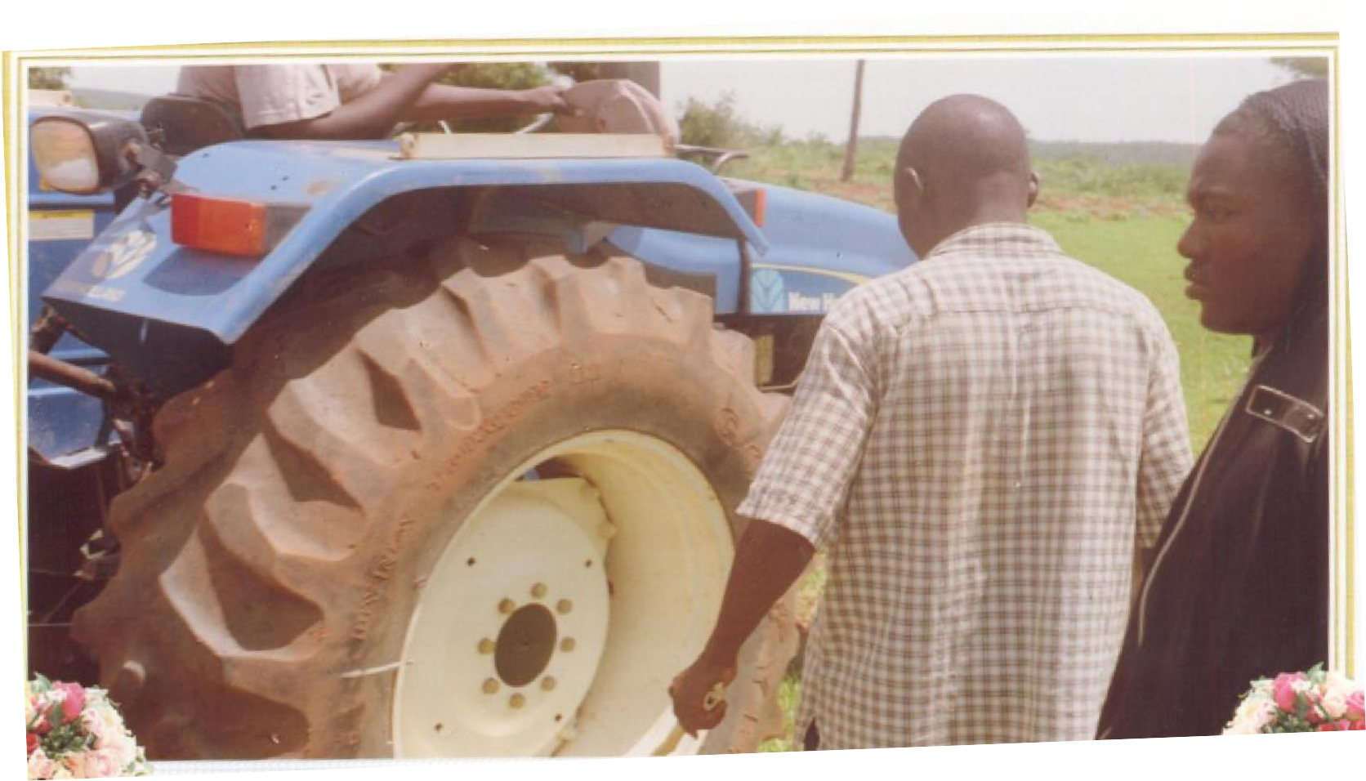

**Plate VIII: Measuring the Wheel Slip of the New Holland TT 75 Tractor on the Untilled Soil**

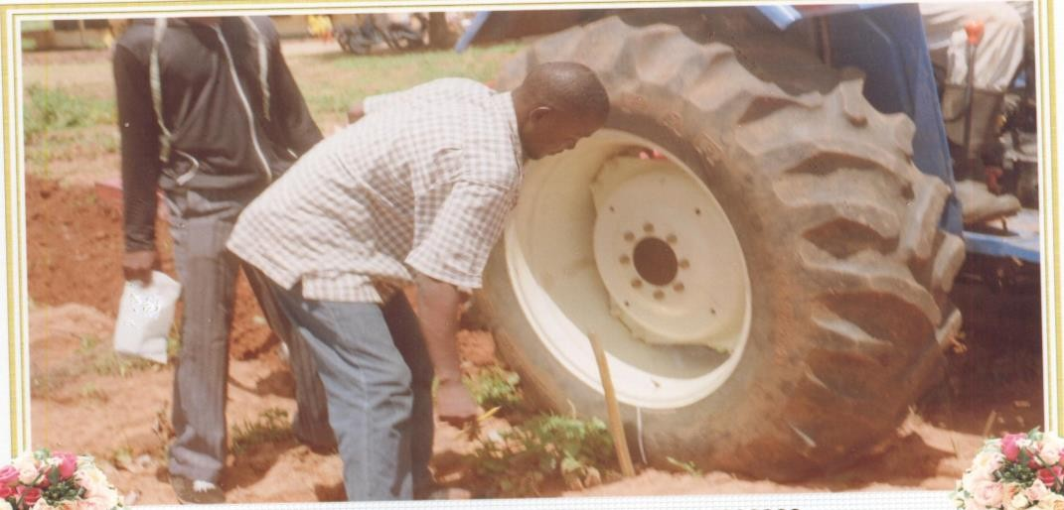

**Plate IX: New Holland TT 75 Tractor on the Tilled Soil Condition**

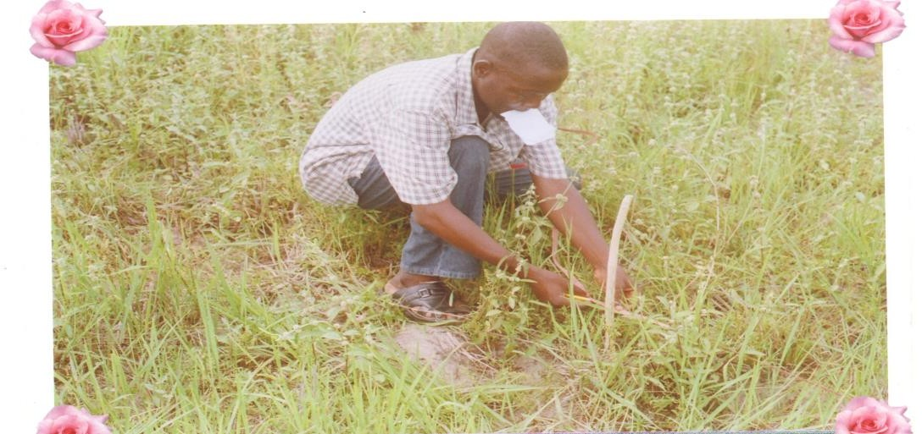

**Plate X: Taking linear Measurements in an Untilled Soil**



**Plate XI: Taking Linear Measurement on the Tilled Soil**

## The Specifications of the Test Tractors

The specifications of the two test tractors used are presented in Table 3.2. The two tractors were equipped with normal speedometers to measure field speed (km/h) and engine speed (rpm).

**Table 3.2: The Specifications of the Two Test Tractors**

## Specification

**Tractor Model**

## MF 285 New Holland

|  |  |  |  |
| --- | --- | --- | --- |
|  | | | **TT75** |
| PTO Power (kW), at Rated | Engine Speed -RES | 61.14 | 46.52 |
| Rated Engine Speed (rpm) |  | 2000 | 2500 |
| Weight (kg) | Front | 1079.57 | 853 |
|  | Rear | 2390.47 | 1512 |
|  | Total | 3470.04 | 2365 |
| Tire Size | Front | 7.5 R 16 | 7.5 R16 |
|  | Rear | 18.4 R 30 | 16.9 R 30 |
| Tire Pressure (kPa) | Front | 103 | 220 |
|  | Rear | 83 | 85 |
| Height of Drawbar (mm) | | 584.2 | 485 |
| Wheel Base (mm) | | 2255.5 | 2150 |
| Age of the tractors since purchased and put to use | | 1 year 5 months | 1 year 8 months |
| Date of Manufacture | | 2008 | 2009 |

Source: Manufacturer’s specifications (Appendices B and C) and Manuals

In order to remove the effects of engine power rating differences, over powering or engine power variability, results were compared using power delivery efficiency - the ratio of power at the drawbar divided by the power produced by the engine, and fuel efficiency, which is the ratio of drawbar power to the fuel consumption at that power level. This kept the comparisons of the capabilities of the traction power delivery system independent of the engine systems they were associated with (Turner, 1993 and Zoz *et al*., 2002).

## Measured Parameters

The tractor performance parameters that were measured in the field and the methods used are presented in Table 3.3.

## Table 3.3: Measured Parameters

|  |  |  |
| --- | --- | --- |
| **Parameters** | **Method** | **Units** |
| Vehicle Speed (S) | Direct measurement by taking note of time taken by the tractors to cover the  predetermined distance. | km/h |
| Wheel Slip (Travel Reduction). | Fixed revolution approach. This was done by measuring distances covered with and without load at 5 revolutions of the wheels. Wheel slip was taken as the percentage of difference in distances to the distance covered without load (FAO,  1994). | Percentage, (%) |
| Engine (Crank shaft) Speed | Directly measured from the speedometers  attached to the tractors | rev/min - rpm |

* 1. **Predicted Parameters**

The tractor performance parameters that could not be measured directly in the field but predicted and the methods used are presented in Table 3.4.

## Table 3.4 Predicted Parameters and Methods of Prediction

|  |  |  |
| --- | --- | --- |
| **Parameters** | **Method** | **Units** |
| Draft (Pull)  Engine Fuel Consumption  Engine (PTO) Power Level | Tractors drawbar performance predictor chart pointed out in Hunt (2001).  Regression of Nebraska Tractor Test Laboratory (NTTL) test data for the two tractors (Zoz and Grisso, 2003).  Regression of Nebraska Tractor Test Laboratory (NTTL) test data for the two tractors (Zoz and Grisso, 2003). | kN l/h  kW |

* 1. **Computed Parameters**

The equations used for computing the performance parameters are as presented (Liljedahl *et al*., 1989 and Zoz *et al*., 2002):

Drawbar Power (DBP) is calculated as:

*DBP*  *P*.*S* (*kW* ) 3.6

3.1

Where P = pull (kN), S = vehicle speed (km/h)

Power Delivery Efficiency (PDE) is calculated as:

*PDE*  *DBP* (*ratio*)

*PPTO*

where PPTO = PTO power (kW)

Fuel Efficiency (FE), kW.h/l is calculated as:

3.2

FE =

DBP [kW]

Fuel Consumption [l/h]

3.3

## Soil Parameters

The tests were conducted in the research fields of National Cereals Research Institute, (NRCI) Badeggi. Untilled and tilled soil conditions were considered. The untitled condition was taken as soil that has not been tilled or disturbed since the last crop has been harvested, and having the crop residue or growing grasses. Tilled soil was taken as the one that has been disc- ploughed to a depth of about 15 cm (Turner *et al.*, 1997). The specific parameters of the field obtained were presented in table 3.5.

## Table 3.5: Specific Parameters of the Field

|  |  |  |  |  |  |  |  |
| --- | --- | --- | --- | --- | --- | --- | --- |
| **Soil Type** | **Classification** | |  | **Depth (cm)** | **Bulk**  **Density (g/cm3)** | **Cone**  **Index (N/cm2)** | **Shear**  **Strength (MPa)** |
| Indaloke Series | **USDA FAO / UNESCO** | | | 0 – 27 | 1.35 | 72.17 | 0.038 |
| Tropofluvent Dystric Fluvisol | | | | | | | |
| **Physical Characteristics** | | | | | | | |
| **Profile** | **Depth(cm)** |  | **Composition (%)** | |  | **Textural Class** | |
| **Sand** | **Silt** | **Clay** |

|  |  |  |  |  |  |
| --- | --- | --- | --- | --- | --- |
| A | 0 - 27 | 79.2 | 9.2 | 11.6 | Sandy loam |

**CHAPTER FOUR**

## RESULTS AND DISCUSSION

* 1. **Results**

## Results of Test Data for MF 285 and NH TT 75 Tractors from Nebraska Tractor Test Laboratory (NTTL)

The equations generated from segmented regression analysis prior to the field test were presented for the two tractor makes in Table 4.1.

## Table 4.1: Segmented Regressions Equations from the Laboratory Test Data for MF 285 and NH TT 75 Tractors from Nebraska Tractor Test Laboratory (NTTL)

|  |  |  |
| --- | --- | --- |
| **Regression Equations** | **Regression of Tractor Makes** | |
| **MF 285 (ITMCO 285)** | **NEW HOLLAND TT 75** |
| Fuel consumption ( y)  **l/h** | Y1 = -0.0866 X +196.74, R2 = 0.944  Y2 = 0.0124X – 5.4838, R2 = 0.889 | Y 1 = - 0.0584 X +165.95, R2 =  0.991  Y 2 = 0.0028 X +7.4663, R2 =  0.748 |
| PTO power (y)  **kW** | Y 1 = -0.403 X + 890.00, R2 =  0.965  Y 2 = 0.021X + 16.569 R2 = 0.836 | Y 1 = -0.246 X + 681.02, R2 =  0.979  Y 2 = -0.001X + 46.05, R2 = 0.982 |
| The X and Y in both equations are independent and dependent variables, respectively. The independent variable: X in both equations is the engine speed in rev/min. The two equations for both dependent variables are the resulting mathematical descriptions of the lower and upper segments of the plotted curves (See appendix D). | | |

* + 1. **Results of the Field Test of the Two Tractors**

The field data taken for the two tractors in the untilled soil condition with the throttles set at the rated engine speeds and across all implement working depths are presented in Table 4.2.

## Table 4.2: Performance Data of the Two Tractors in Untilled Soil Condition, Throttle set at Rated Engine Speeds

|  |  |  |  |  |  |  |  |  |  |
| --- | --- | --- | --- | --- | --- | --- | --- | --- | --- |
| **Working Depth.**  cm | **Slip**  % | **Engine**  rpm | **Speed**  Km/h | **Pull**  kN | **Fuel Consum.**  l/h | **DBP**  kW | **PTO**  kW | **Fuel Eff.**  Kw.h/l | **DBP/PTO**  Ratio |
|  |  |  |  |  | **MF 285** |  |  |  |  |
| 7 | 4.48 | 1435 | 6.0088 | 5.628 | 12.3102 | 9.39373 | 46.704 | 0.7631 | 0.2011 |
|  | 4.60 | 1430 | 5.9855 | 5.628 | 12.2482 | 9.35732 | 46.599 | 0.764 | 0.2008 |
|  | 4.45 | 1435 | 6.0107 | 5.628 | 12.3102 | 9.39668 | 46.704 | 0.7633 | 0.2012 |
|  | 4.50 | 1435 | 6.0075 | 5.628 | 12.3102 | 9.39176 | 46.704 | 0.7629 | 0.2011 |
| **Average** | **4.51** | **1433.8** | **6.0031** | **5.628** | **12.2947** | **9.38487** | **46.67775** | **0.7633** | **0.2011** |
| 10 | 6.66 | 1400 | 5.7638 | 8.208 | 11.8762 | 13.1416 | 45.969 | 1.1065 | 0.2859 |
|  | 6.60 | 1400 | 5.7675 | 7.973 | 11.8762 | 12.7735 | 45.969 | 1.0756 | 0.2779 |
|  | 6.61 | 1400 | 5.7669 | 7.973 | 11.8762 | 12.7721 | 45.969 | 1.0754 | 0.2778 |
|  | 6.61 | 1400 | 5.7669 | 7.973 | 11.8762 | 12.7721 | 45.969 | 1.0754 | 0.2778 |
| **Average** | **6.62** | **1400** | **5.7663** | **8.032** | **11.8762** | **12.8648** | **45.969** | **1.0832** | **0.2799** |
| 15 | 9.75 | 1355 | 5.4390 | 11.256 | 11.3182 | 17.006 | 45.024 | 1.5025 | 0.3777 |
|  | 9.70 | 1355 | 5.4420 | 11.256 | 11.3182 | 17.0154 | 45.024 | 1.5034 | 0.3779 |
|  | 9.50 | 1360 | 5.4690 | 10.787 | 11.3802 | 16.3873 | 45.129 | 1.44 | 0.3631 |
|  | 10.0 | 1350 | 5.4091 | 11.725 | 11.2562 | 17.6171 | 44.919 | 1.5651 | 0.3922 |
| **Average** | **9.94** | **1355** | **5.4398** | **11.256** | **11.3182** | **17.0064** | **45.024** | **1.5027** | **0.3777** |
| **NEW HOLLAND TT75** | | | | | | | | | |
| 7 | 4.99 | 1780 | 7.0584 | 4.005 | 12.4503 | 7.85246 | 44.270 | 0.6307 | 0.1774 |
|  | 5.00 | 1780 | 7.0576 | 4.005 | 12.4503 | 7.85163 | 44.270 | 0.6306 | 0.1774 |
|  | 5.30 | 1775 | 7.0197 | 4.153 | 12.4363 | 8.09804 | 44.275 | 0.6512 | 0.1829 |
|  | 5.31 | 1775 | 7.0190 | 4.153 | 12.4363 | 8.09719 | 44.275 | 0.6511 | 0.1829 |
| **Average** | **5.15** | **1777.5** | **7.0387** | **4.079** | **12.4433** | **7.97483** | **44.2725** | **0.6409** | **0.1801** |
| 10 | 7.00 | 1745 | 6.8016 | 5.488 | 12.3523 | 10.3687 | 44.305 | 0.8394 | 0.234 |
|  | 6.95 | 1745 | 6.8053 | 5.488 | 12.3523 | 10.3743 | 44.305 | 0.8399 | 0.2342 |
|  | 6.99 | 1745 | 6.8024 | 5.488 | 12.3523 | 10.3698 | 44.305 | 0.8395 | 0.2341 |
|  | 7.10 | 1740 | 6.7790 | 5.488 | 12.3383 | 10.3342 | 44.310 | 0.8376 | 0.2332 |
| **Average** | **7.01** | **1743.8** | **6.7971** | **5.488** | **12.3488** | **10.3618** | **44.30625** | **0.8391** | **0.2339** |
| 15 | 10.80 | 1675 | 6.3177 | 7.713 | 12.1563 | 13.5356 | 44.375 | 1.1135 | 0.305 |
|  | 11.01 | 1670 | 6.2881 | 7.713 | 12.1423 | 13.4723 | 44.380 | 1.1095 | 0.3036 |
|  | 11.00 | 1670 | 6.2888 | 7.713 | 12.1423 | 13.4738 | 44.380 | 1.1097 | 0.3036 |
|  | 10.94 | 1670 | 6.2931 | 7.713 | 12.1423 | 13.4829 | 44.380 | 1.1104 | 0.3038 |
| **Average** | **10.94** | **1671.3** | **6.2969** | **7.713** | **12.1458** | **13.4912** | **44.37875** | **1.1108** | **0.304** |

The data taken for the two tractors in the untilled soil condition with the throttles set at the reduced engine speeds (1800 rpm) and across all implement working depth are presented in Table 4.3.

## Table 4.3: Performance Data of the Two Tractors in Untilled Soil Condition and Throttles set at Reduced Engine Speeds (1800 rpm)

|  |  |  |  |  |  |  |  |  |  |
| --- | --- | --- | --- | --- | --- | --- | --- | --- | --- |
| **Working Depth.** cm | **Slip**  % | **Engine**  RPM | **Speed**  km/h | **Pull**  kN | **Fuel Consum.** l/h | **DBP**  kW | **PTO**  kW | **Fuel Eff.**  kW.h/l | **DBP/PTO**  Ratio |
|  |  |  |  |  | **MF 285** |  |  |  |  |
| 7 | 4.30 | 1435 | 6.0201 | 5.159 | 12.3102 | 8.62714 | 46.704 | 0.7008 | 0.1847 |
|  | 4.43 | 1435 | 6.0119 | 5.394 | 12.3102 | 9.00787 | 46.704 | 0.7317 | 0.1929 |
|  | 4.33 | 1435 | 6.0182 | 5.159 | 12.3102 | 8.62444 | 46.704 | 0.7006 | 0.1847 |
|  | 4.31 | 1435 | 6.0195 | 5.159 | 12.3102 | 8.62624 | 46.704 | 0.7007 | 0.1847 |
| **Average** | **4.343** | **1435** | **6.0174** | **5.2178** | **12.3102** | **8.72142** | **46.704** | **0.7085** | **0.1867** |
| 10 | 5.89 | 1410 | 5.8424 | 7.270 | 12.0002 | 11.7985 | 46.179 | 0.9832 | 0.2555 |
|  | 6.11 | 1410 | 5.8288 | 7.504 | 12.0002 | 12.1498 | 46.179 | 1.0125 | 0.2631 |
|  | 6.10 | 1410 | 5.8294 | 7.504 | 12.0002 | 12.1511 | 46.179 | 1.0126 | 0.2631 |
|  | 6.00 | 1410 | 5.8356 | 7.504 | 12.0002 | 12.164 | 46.179 | 1.0137 | 0.2634 |
| **Average** | **6.025** | **1410** | **5.8341** | **7.4455** | **12.0002** | **12.0658** | **46.179** | **1.0055** | **0.2613** |
| 15 | 9.80 | 1355 | 5.4360 | 11.256 | 11.3182 | 16.9965 | 45.024 | 1.5017 | 0.3775 |
|  | 10.01 | 1350 | 5.4085 | 11.725 | 11.2562 | 17.6151 | 44.919 | 1.5649 | 0.3922 |
|  | 9.91 | 1350 | 5.4145 | 11.491 | 11.2562 | 17.2828 | 44.919 | 1.5354 | 0.3848 |
|  | 10.00 | 1350 | 5.4091 | 11.725 | 11.2562 | 17.6171 | 44.919 | 1.5651 | 0.3922 |
| **Average** | **9.93** | **1351.3** | **5.4170** | **11.549** | **11.2717** | **17.3779** | **44.945** | **1.5418** | **0.3867** |
| **NEW HOLLAND TT75** | | | | | | | | | |
| 7 | 5.01 | 1780 | 7.0569 | 4.005 | 12.4503 | 7.8508 | 44.270 | 0.6306 | 0.1773 |
|  | 5.00 | 1780 | 7.0576 | 4.005 | 12.4503 | 7.85163 | 44.270 | 0.6306 | 0.1774 |
|  | 5.00 | 1780 | 7.0576 | 4.005 | 12.4503 | 7.85163 | 44.270 | 0.6306 | 0.1774 |
|  | 5.02 | 1780 | 7.0562 | 4.005 | 12.4503 | 7.84998 | 44.270 | 0.6305 | 0.1773 |
| **Average** | **5.01** | **1780** | **7.0571** | **4.005** | **12.4503** | **7.85101** | **44.270** | **0.6306** | **0.1773** |
| 10 | 7.12 | 1740 | 6.7775 | 5.488 | 12.3383 | 10.332 | 44.310 | 0.8374 | 0.2332 |
|  | 7.12 | 1740 | 6.7775 | 5.488 | 12.3383 | 10.332 | 44.310 | 0.8374 | 0.2332 |
|  | 7.10 | 1740 | 6.7790 | 5.488 | 12.3383 | 10.3342 | 44.310 | 0.8376 | 0.2332 |
|  | 7.08 | 1740 | 6.7805 | 5.488 | 12.3383 | 10.3364 | 44.310 | 0.8378 | 0.2333 |
| **Average** | **7.12** | **1740** | **6.7786** | **5.488** | **12.3383** | **10.3337** | **44.310** | **0.8375** | **0.2332** |
| 15 | 11.06 | 1670 | 6.2846 | 7.713 | 12.1423 | 13.4647 | 44.380 | 1.1089 | 0.3034 |
|  | 11.01 | 1670 | 6.2881 | 7.713 | 12.1423 | 13.4723 | 44.380 | 1.1095 | 0.3036 |
|  | 10.98 | 1670 | 6.2902 | 7.713 | 12.1423 | 13.4768 | 44.380 | 1.1099 | 0.3037 |
|  | 11.01 | 1670 | 6.2881 | 7.713 | 12.1423 | 13.4723 | 44.380 | 1.1095 | 0.3036 |
| **Average** | **11.02** | **1670** | **6.2878** | **7.713** | **12.1423** | **13.4715** | **44.380** | **1.1095** | **0.3035** |

The field performance data taken for the two tractors in tilled soil condition with the throttles set at the rated engine speeds and across all implement working depths are presented in Table 4.4.

## Table 4.4: Performance Data for the Two Tractors in Tilled Soil Condition with Throttles set at Rated Engine Speeds

|  |  |  |  |  |  |  |  |  |  |
| --- | --- | --- | --- | --- | --- | --- | --- | --- | --- |
| **Working Depth.** Cm | **Slip**  % | **Engine**  RPM | **Speed**  km/h | **Pull**  kN | **Fuel Consum**. l/h | **DBP**  kW | **PTO**  kW | **Fuel Eff.**  kW.h/l | **DBP/PTO**  Ratio |
|  |  |  |  |  | **MF 285** |  |  |  |  |
| 7 | 5.50 | 1420 | 5.8978 | 6.801 | 12.1242 | 11.142 | 46.389 | 0.9190 | 0.2402 |
|  | 5.50 | 1420 | 5.8978 | 6.801 | 12.1242 | 11.142 | 46.389 | 0.9190 | 0.2402 |
|  | 5.20 | 1420 | 5.9166 | 6.332 | 12.1242 | 10.4066 | 46.389 | 0.8583 | 0.2243 |
|  | 5.30 | 1420 | 5.9103 | 6.566 | 12.1242 | 10.7798 | 46.389 | 0.8891 | 0.2324 |
| **Average** | **5.38** | **1420** | **5.9056** | **6.625** | **12.1242** | **10.8676** | **46.389** | **0.8964** | **0.2343** |
| 10 | 6.63 | 1400 | 5.7657 | 7.973 | 11.8762 | 12.7694 | 45.969 | 1.0752 | 0.2778 |
|  | 6.60 | 1400 | 5.7675 | 7.973 | 11.8762 | 12.7735 | 45.969 | 1.0756 | 0.2779 |
|  | 6.60 | 1400 | 5.7675 | 7.035 | 11.8762 | 11.2707 | 45.969 | 0.9490 | 0.2452 |
|  | 6.61 | 1400 | 5.7669 | 7.035 | 11.8762 | 11.2695 | 45.969 | 0.9489 | 0.2452 |
| **Average** | **6.61** | **1400** | **5.7669** | **7.504** | **11.8762** | **12.0208** | **45.969** | **1.0122** | **0.2615** |
| 15 | 15.00 | 1275 | 4.8982 | 15.243 | 10.3262 | 20.7398 | 43.344 | 2.0085 | 0.4785 |
|  | 14.80 | 1280 | 4.9238 | 14.774 | 10.3882 | 20.2067 | 43.449 | 1.9452 | 0.4651 |
|  | 14.80 | 1280 | 4.9267 | 14.774 | 10.3882 | 20.2186 | 43.449 | 1.9463 | 0.4653 |
|  | 14.80 | 1280 | 4.9238 | 14.774 | 10.3882 | 20.2067 | 43.449 | 1.9452 | 0.4651 |
| **Average** | **14.80** | **1278.8** | **4.9181** | **14.891** | **10.3727** | **20.3429** | **43.42275** | **1.9613** | **0.4685** |
| **NEW HOLLAND TT75** | | | | | | | | | |
| 7 | 6.60 | 1750 | 6.8463 | 5.340 | 12.3663 | 10.1554 | 44.300 | 0.8212 | 0.2292 |
|  | 6.48 | 1755 | 6.8705 | 5.340 | 12.3803 | 10.1913 | 44.295 | 0.8232 | 0.2301 |
|  | 6.55 | 1750 | 6.8500 | 5.340 | 12.3663 | 10.1608 | 44.300 | 0.8217 | 0.2294 |
|  | 6.50 | 1755 | 6.8691 | 5.340 | 12.3803 | 10.1891 | 44.295 | 0.823 | 0.2300 |
| **Average** | **6.53** | **1752.5** | **6.859** | **5.340** | **12.3733** | **10.1741** | **44.2975** | **0.8223** | **0.2297** |
| 10 | 10.10 | 1685 | 6.3962 | 7.416 | 12.1843 | 13.1762 | 44.365 | 1.0814 | 0.2970 |
|  | 10.10 | 1685 | 6.3969 | 7.416 | 12.1843 | 13.1777 | 44.365 | 1.0815 | 0.2970 |
|  | 9.970 | 1690 | 6.421 | 7.416 | 12.1983 | 13.2273 | 44.360 | 1.0844 | 0.2982 |
|  | 10.10 | 1685 | 6.3969 | 7.416 | 12.1843 | 13.1777 | 44.365 | 1.0815 | 0.2970 |
| **Average** | **10.10** | **1686.3** | **6.4028** | **7.416** | **12.1878** | **13.1897** | **44.36375** | **1.0822** | **0.2973** |
| 15 | 16.80 | 1560 | 5.5770 | 9.938 | 11.8343 | 15.3956 | 44.490 | 1.3009 | 0.3460 |
|  | 17.00 | 1555 | 5.5499 | 9.938 | 11.8203 | 15.3207 | 44.495 | 1.2961 | 0.3443 |
|  | 16.80 | 1560 | 5.5750 | 9.938 | 11.8343 | 15.39 | 44.490 | 1.3005 | 0.3459 |
|  | 16.80 | 1560 | 5.5763 | 9.938 | 11.8343 | 15.3937 | 44.490 | 1.3008 | 0.3460 |
| **Average** | **16.90** | **1558.8** | **5.5695** | **9.938** | **11.8308** | **15.375** | **44.49125** | **1.2996** | **0.3456** |

The field performance data taken for the two tractors in the tilled soil condition with the throttles set at the reduced engine speeds and across all implement working depths are presented in Table 4.5.

## Table 4.5: Performance Data for the Two Tractors in Tilled Soil Condition with Throttles set at Reduced Engine Speeds (1800 rpm)

|  |  |  |  |  |  |  |  |  |  |
| --- | --- | --- | --- | --- | --- | --- | --- | --- | --- |
| **Working Depth.**  cm | **Slip**  % | **Engine**  RPM | **Speed**  km/h | **Pull**  kN | **Fuel Consum.**  l/h | **DBP**  kW | **PTO**  kW | **Fuel Eff.**  kW.h/l | **DBP/PTO**  Ratio |
|  |  |  |  |  | **MF 285** |  |  |  |  |
| 7 | 5.35 | 1420 | 5.9072 | 6.801 | 12.1242 | 11.1597 | 46.389 | 0.9204 | 0.2406 |
|  | 5.36 | 1420 | 5.9066 | 6.801 | 12.1242 | 11.1585 | 46.389 | 0.9204 | 0.2405 |
|  | 5.36 | 1420 | 5.9066 | 6.801 | 12.1242 | 11.1585 | 46.389 | 0.9204 | 0.2405 |
|  | 5.40 | 1420 | 5.9041 | 6.801 | 12.1242 | 11.1538 | 46.389 | 0.92 | 0.2404 |
| **Average** | **5.37** | **1420** | **5.9061** | **6.801** | **12.1242** | **11.1576** | **46.389** | **0.9203** | **0.2405** |
| 10 | 8.11 | 1380 | 5.6137 | 9.615 | 11.6282 | 14.9931 | 45.549 | 1.2894 | 0.3292 |
|  | 7.99 | 1380 | 5.6210 | 9.615 | 11.6282 | 15.0127 | 45.549 | 1.2911 | 0.3296 |
|  | 8.12 | 1380 | 5.6130 | 9.615 | 11.6282 | 14.9915 | 45.549 | 1.2892 | 0.3291 |
|  | 8.00 | 1380 | 5.6204 | 9.380 | 11.6282 | 14.6442 | 45.549 | 1.2594 | 0.3215 |
| **Average** | **8.06** | **1380** | **5.6170** | **9.5563** | **11.6282** | **14.9104** | **45.549** | **1.2823** | **0.3273** |
| 15 | 14.82 | 1280 | 4.9226 | 14.774 | 10.3882 | 20.202 | 43.449 | 1.9447 | 0.4650 |
|  | 14.80 | 1280 | 4.9238 | 14.774 | 10.3882 | 20.2067 | 43.449 | 1.9452 | 0.4651 |
|  | 15.10 | 1275 | 4.8924 | 15.243 | 10.3262 | 20.7154 | 43.344 | 2.0061 | 0.4779 |
|  | 15.10 | 1275 | 4.8924 | 15.243 | 10.3262 | 20.7154 | 43.344 | 2.0061 | 0.4779 |
| **Average** | **14.96** | **1277.5** | **4.9078** | **15.009** | **10.3572** | **20.4599** | **43.3965** | **1.9755** | **0.4715** |
| **NEW HOLLAND TT75** | | | | | | | | | |
| 7 | 6.59 | 1750 | 6.8470 | 5.340 | 12.3663 | 10.1565 | 44.300 | 0.8213 | 0.2293 |
|  | 6.61 | 1750 | 6.8456 | 5.340 | 12.3663 | 10.1543 | 44.300 | 0.8211 | 0.2292 |
|  | 6.60 | 1750 | 6.8463 | 5.340 | 12.3663 | 10.1554 | 44.300 | 0.8212 | 0.2292 |
|  | 6.60 | 1750 | 6.8463 | 5.340 | 12.3663 | 10.1554 | 44.300 | 0.8212 | 0.2292 |
| **Average** | **6.60** | **1750** | **6.8463** | **5.340** | **12.3663** | **10.1554** | **44.300** | **0.8212** | **0.2292** |
| 10 | 10.00 | 1690 | 6.4189 | 7.416 | 12.1983 | 13.2229 | 44.360 | 1.084 | 0.2981 |
|  | 9.99 | 1690 | 6.4196 | 7.416 | 12.1983 | 13.2244 | 44.360 | 1.0841 | 0.2981 |
|  | 10.12 | 1685 | 6.3955 | 7.416 | 12.1843 | 13.1747 | 44.365 | 1.0813 | 0.2970 |
|  | 10.10 | 1685 | 6.3969 | 7.416 | 12.1843 | 13.1777 | 44.365 | 1.0815 | 0.2970 |
| **Average** | **10.05** | **1687.5** | **6.4077** | **7.416** | **12.1913** | **13.1999** | **44.3625** | **1.0827** | **0.2975** |
| 15 | 17.00 | 1555 | 5.5499 | 9.938 | 11.8203 | 15.3207 | 44.495 | 1.2961 | 0.3443 |
|  | 16.98 | 1555 | 5.5512 | 9.938 | 11.8203 | 15.3244 | 44.495 | 1.2965 | 0.3444 |
|  | 16.98 | 1555 | 5.5512 | 9.938 | 11.8203 | 15.3244 | 44.495 | 1.2965 | 0.3444 |
|  | 17.10 | 1555 | 5.5432 | 9.938 | 11.8203 | 15.3023 | 44.495 | 1.2946 | 0.3439 |
| **Average** | **17.02** | **1555** | **5.5489** | **9.938** | **11.8203** | **15.318** | **44.495** | **1.2959** | **0.3443** |

* + 1. **Statistical Analysis**

## Descriptive Statistics: Power Delivery Efficiency

Table 4.6 presents the means and standard deviations (SD) of power delivery efficiency of the two tractors with throttles set at the rated engine speeds across all test conditions.

## Table 4.6: Descriptive Statistics with Power Delivery Efficiency as Dependent Variable for MF 285 and New Holland TT 75 Tractors with throttles at Rated Engine Speeds

|  |  |  |  |  |  |  |
| --- | --- | --- | --- | --- | --- | --- |
| **Engine Speed** | **Tractor Make** | **working depth** | **Soil Condition** | **Mean** | **Std. Deviation** | **N** |
|  | **MF 285** | 7 cm | untilled soil | .201050 | .0001732 | 4 |
|  |  |  | tilled soil | .234275 | .0075988 | 4 |
|  |  |  | Total | .217663 | .0184434 | 8 |
|  |  | 10 cm | untilled soil | .279850 | .0040336 | 4 |
|  |  |  | tilled soil | .261525 | .0188505 | 4 |
| **Rated Engine Speed** |  |  | Total | .270687 | .0159752 | 8 |
| **(2000 rpm)** |  | 15cm | untilled soil | .377725 | .0118806 | 4 |
|  |  |  | tilled soil | .468500 | .0066673 | 4 |
|  |  |  | Total | .423112 | .0493342 | 8 |
|  |  | Total | untilled soil | .286208 | .0757646 | 12 |
|  |  |  | tilled soil | .321433 | .1098054 | 12 |
|  |  |  | **Total** | **.303821** | **.0939975** | **24** |
|  | **NH TT75** | 7 cm | untilled soil | .180150 | .0031754 | 4 |
|  |  |  | tilled soil | .229675 | .0004425 | 4 |
|  |  |  | Total | .204913 | .0265553 | 8 |
|  |  | 10 cm | untilled soil | .233875 | .0004573 | 4 |
|  |  |  | tilled soil | .297300 | .0006000 | 4 |
| **Rated Engine Speed (2500 rpm)** |  |  | Total | .265588 | .0339057 | 8 |
|  |  | 15cm | untilled soil | .304000 | .0006733 | 4 |
|  |  |  | Tilled soil | .345550 | .0008347 | 4 |
|  |  |  | Total | .324775 | .0222205 | 8 |
|  |  | Total | untilled soil | .239342 | .0529916 | 12 |
|  |  |  | tilled soil | .290842 | .0496424 | 12 |
|  |  |  | **Total** | **.265092** | **.0566878** | **24** |

Table 4.7 presents the means and standard deviations (SD) of power delivery efficiency of the two tractors with throttles set at the reduced engine speeds across all test conditions.

## Table 4.7: Descriptive Statistics with Power Delivery Efficiency as Dependent Variable for MF 285 and New Holland TT 75 Tractors with throttles at Reduced Engine Speeds

|  |  |  |  |  |  |  |
| --- | --- | --- | --- | --- | --- | --- |
| **Engine Speed** | **Tractor Make** | **working depth** | **Soil Condition** | **Mean** | **Std. Deviation** | **N** |
|  | **MF 285** | 7 cm | untilled soil | .186750 | .0041000 | 4 |
|  |  |  | tilled soil | .240500 | .0000816 | 4 |
|  |  |  | Total | .213625 | .0288557 | 8 |
|  |  | 10 cm | untilled soil | .261275 | .0038526 | 4 |
|  |  |  | tilled soil | .327350 | .0039060 | 4 |
| **Reduced Engine Speed**  **(1800 rpm)** |  |  | Total | .294313 | .0355007 | 8 |
|  |  | 15cm | untilled soil | .386675 | .0070415 | 4 |
|  |  |  | tilled soil | .471475 | .0074191 | 4 |
|  |  |  | Total | .429075 | .0458195 | 8 |
|  |  | Total | untilled soil | .278233 | .0862919 | 12 |
|  |  |  | tilled soil | .346442 | .0995886 | 12 |
|  |  |  | **Total** | **.312338** | **.0975616** | **24** |
|  | **NH TT75** | 7 cm | untilled soil | .177350 | .0000577 | 4 |
|  |  |  | tilled soil | .229225 | .0000500 | 4 |
|  |  |  | Total | .203288 | .0277284 | 8 |
|  |  | 10 cm | untilled soil | .233225 | .0000500 | 4 |
|  |  |  | tilled soil | .297550 | .0006351 | 4 |
| **Reduced Engine Speed**  **(1800 rpm)** |  |  | Total | .265387 | .034385 | 8 |
|  |  | 15cm | untilled soil | .303575 | .0001258 | 4 |
|  |  |  | tilled soil | .344250 | .0002380 | 4 |
|  |  |  | Total | .323912 | .0217424 | 8 |
|  |  | Total | untilled soil | .238050 | .0539404 | 12 |
|  |  |  | tilled soil | .290342 | .0493362 | 12 |
|  |  |  | **Total** | **.264196** | **.0571749** | **24** |

* + - 1. **Descriptive Statistics: Fuel Efficiency**

The means and standard deviations (SD) of fuel efficiency for the two tractors with throttles set at the rated engine speed across all test conditions are presented in Table 4.8.

## Table 4.8: Descriptive Statistics, Fuel Efficiency as Dependent Variable for the MF 285 and New Holland TT 75 Tractors with Throttles at the Rated Engine Speeds

|  |  |  |  |  |  |  |
| --- | --- | --- | --- | --- | --- | --- |
| **Engine Speed** | **Tractor Make** | **working depth** | **Soil Condition** | **Mean** | **Std. Deviation** | **N** |
|  | **MF 285** | 7 cm | untilled soil | .763325 | .0004787 | 4 |
|  |  |  | Tilled soil | .896350 | .0290196 | 4 |
|  |  |  | Total | .829838 | .0735997 | 8 |
|  |  | 10 cm | untilled soil | 1.083225 | .0155170 | 4 |
|  |  |  | Tilled soil | 1.012175 | .0730061 | 4 |
| **Rated Engine Speed** |  |  | Total | 1.047700 | .0618849 | 8 |
| **(2000 rpm)** |  | 15cm | untilled soil | 1.502750 | .0510737 | 4 |
|  |  |  | Tilled soil | 1.961300 | .0314709 | 4 |
|  |  |  | Total | 1.732025 | .2482318 | 8 |
|  |  | Total | untilled soil | 1.116433 | .3174707 | 12 |
|  |  |  | Tilled soil | 1.289942 | .5002409 | 12 |
|  |  |  | **Total** | **1.203188** | **.4192097** | **24** |
|  | **NH TT75** | 7 cm | untilled soil | .640900 | .0118358 | 4 |
|  |  |  | tilled soil | .822275 | .0009777 | 4 |
|  |  |  | Total | .731588 | .0972603 | 8 |
|  |  | 10 cm | untilled soil | .839100 | .0010231 | 4 |
|  |  |  | tilled soil | 1.082200 | .0014674 | 4 |
| **Rated Engine Speed** |  |  | Total | .960650 | .1299477 | 8 |
| **(2500 rpm)** |  | 15cm | untilled soil | 1.110775 | .0018572 | 4 |
|  |  |  | tilled soil | 1.299575 | .0023229 | 4 |
|  |  |  | Total | 1.205175 | .1009366 | 8 |
|  |  | Total | untilled soil | .863592 | .2012682 | 12 |
|  |  |  | tilled soil | 1.068017 | .2037965 | 12 |
|  |  |  | **Total** | **.965804** | **.2239175** | **24** |

The means and standard deviations (SD) of fuel efficiency for the two tractors with throttles set at the reduced engine speed across all test conditions are presented in Table 4.9.

## Table 4.9: Descriptive Statistics, Fuel Efficiency as Dependent Variable for the MF 285 and New Holland TT 75 Tractors with Throttles at the Reduced Engine Speeds

|  |  |  |  |  |  |  |
| --- | --- | --- | --- | --- | --- | --- |
| **Engine Speed** | **Tractor Make** | **working depth** | **Soil Condition** | **Mean** | **Std. Deviation** | **N** |
|  | **MF 285** | 7 cm | untilled soil | .708450 | .0155002 | 4 |
|  |  |  | tilled soil | .920300 | .0002000 | 4 |
|  |  |  | Total | .814375 | .1136924 | 8 |
|  |  | 10 cm | untilled soil | 1.005500 | .0148766 | 4 |
|  |  |  | tilled soil | 1.282275 | .0152738 | 4 |
| **Reduced Engine Speed** |  |  | Total | 1.143888 | .1485995 | 8 |
| **(1800 rpm)** |  | 15cm | untilled soil | 1.541775 | .0301412 | 4 |
|  |  |  | tilled soil | 1.975525 | .0353056 | 4 |
|  |  |  | Total | 1.758650 | .2338324 | 8 |
|  |  | Total | untilled soil | 1.085242 | .3606968 | 12 |
|  |  |  | tilled soil | 1.392700 | .4577217 | 12 |
|  |  |  | **Total** | **1.238971** | **.4325309** | **24** |
|  | **NH TT75** | 7 cm | untilled soil | .630575 | .0000500 | 4 |
|  |  |  | tilled soil | .821200 | .0000816 | 4 |
|  |  |  | Total | .725888 | .1018934 | 8 |
|  |  | 10 cm | untilled soil | .837550 | .0001915 | 4 |
|  |  |  | tilled soil | 1.082725 | .0015327 | 4 |
| **Reduced Engine Speed** |  |  | Total | .960138 | .1310555 | 8 |
| **(1800 rpm)** |  | 15cm | untilled soil | 1.109450 | .0004123 | 4 |
|  |  |  | tilled soil | 1.295925 | .0009032 | 4 |
|  |  |  | Total | 1.202688 | .0996772 | 8 |
|  |  | Total | untilled soil | .859192 | .2048177 | 12 |
|  |  |  | tilled soil | 1.066617 | .2027748 | 12 |
|  |  |  | **Total** | **.962904** | **.2257257** | **24** |

* + - 1. **Analysis of Variance ANOVA: Fuel and Power Delivery Efficiencies**

Table 4.10 Presents the analysis of variance (ANOVA) for the fuel efficiency.

## Table 4.10 Analysis of Variance (ANOVA) for Fuel Efficiency as Dependent Variable

|  |  |  |  |  |  |
| --- | --- | --- | --- | --- | --- |
| **Source** | **Sum of Squares (SS)** | **df** | **Mean Sum of Square** | **F** | **Sig.** |
| Engine rpm | .006 | 1 | .006 | 11.961 | .001 |
| Tractor | 1.582 | 1 | 1.582 | 2916.110 | <.0001 |
| Depth | 8.023 | 2 | 4.011 | 7395.262 | <.0001 |
| Soil | 1.196 | 1 | 1.196 | 2204.307 | <.0001 |
| Engine rpm * Tractor | .009 | 1 | .009 | 16.552 | <.0001 |
| Engine rpm * Depth | .014 | 2 | .007 | 12.795 | <.0001 |
| Tractor * Depth | .980 | 2 | .490 | 902.962 | <.0001 |
| Tractor * Soil | .007 | 1 | .007 | 13.210 | .001 |
| Depth * Soil | .105 | 2 | .053 | 97.214 | <.0001 |
| Engine rpm * Soil | .028 | 1 | .028 | 51.865 | <.0001 |
| Engine rpm * Tractor * Depth | .012 | 2 | .006 | 10.701 | <.0001 |
| Engine rpm * Tractor * Soil | .026 | 1 | .026 | 47.420 | <.0001 |
| Engine rpm * Depth * Soil | .037 | 2 | .019 | 34.409 | <.0001 |
| Tractor * Depth * Soil | .167 | 2 | .083 | 153.731 | <.0001 |
| Engine rpm * Tractor * Depth * Soil | .037 | 2 | .018 | 33.850 | <.0001 |
| Error | .039 | 72 | .001 |  |  |
| Total | 126.894 | 96 |  |  |  |

Table 4.11 presents the analysis of variance (ANOVA) for the power delivery efficiency.

## Table 4.11 ANOVA for Power Delivery Efficiency as Dependent Variable

|  |  |  |  |  |  |
| --- | --- | --- | --- | --- | --- |
| **Source** | **Sum of Squares** | **df** | **Mean Square** | **F** | **Sig.** |
| Engine rpm | .000 | 1 | .000 | 10.736 | .002 |
| Tractor | .045 | 1 | .045 | 1394.977 | <.0001 |
| Depth | .445 | 2 | .222 | 6851.389 | <.0001 |
| Soil | .064 | 1 | .064 | 1984.464 | <.0001 |
| Engine rpm * Tractor | .001 | 1 | .001 | 16.377 | <.0001 |
| Engine rpm * Depth | .001 | 2 | .000 | 13.327 | <.0001 |
| Tractor * Depth | .041 | 2 | .020 | 630.441 | <.0001 |
| Engine rpm * Soil | .002 | 1 | .002 | 52.717 | <.0001 |
| Depth * Soil | .002 | 2 | .001 | 30.189 | <.0001 |
| Tractor * Soil | 1.93E-007 | 1 | 1.93E-007 | .006 | .939 |
| Engine rpm * Tractor * Soil | .002 |  | .002 | 47.890 | <.0001 |
| Engine rpm * Tractor * Depth | .001 | 2 | .000 | 10.914 | <.0001 |
| Engine rpm * Depth * Soil | .002 | 2 | .001 | 34.074 | <.0001 |
| Tractor * Depth * Soil | .008 | 2 | .004 | 118.011 | <.0001 |
| Engine rpm * Tractor * Depth * Soil | .002 | 2 | .001 | 32.500 | <.0001 |
| Error | .002 | 72 | 3.25E-005 |  |  |
| Total | 8.490 | 96 |  |  |  |

* + 1. **Results of the Effects of Interacting Factors on Dependent Variables**

## 4.1.4. Effects of Factor Interactions on the Fuel Efficiency

Figure 4.1 presents the effects of factor interactions: tractor make*soil condition (that is tractor make interacting with the soil condition) on the fuel efficiency.

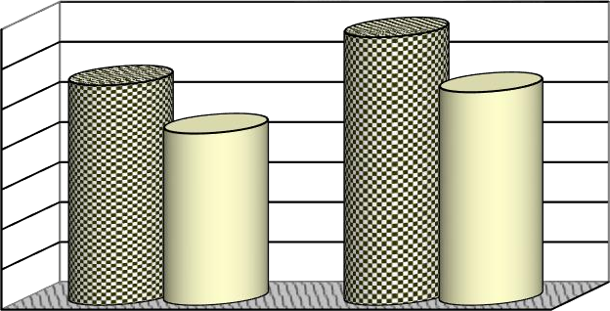

1.4

1.2

1

0.8

0.6

0.4

0.2

0

**1.341**

**1.101**

**1.067**

**0.861**

MF 285

NH TT 75

**Tractor Make**

Untilled Soil

Tilled Soil

**Fuel Efficiency (kW.h/l)**

## Figure 4.1: Fuel Efficiency - Tractor Make*Soil condition (p. <0.001)

Figure 4.2 presents the effects of factor interactions: working depth*soil condition on the fuel efficiency of the two tractors combined.



1.8

1.6

1.4

1.2

1

0.8

0.6

0.4

0.2

0

**1.633**

**1.316**

**1.115**

**0.941**

**0.865**

**0.686**

15

10

**Working Depth, cm**

7

Untilled Soil

Tilled Soil

**Fuel Efficiency, kW.h/l**

## Figure 4.2: Fuel Efficiency (Both Tractors) Depth*Soil condition (p < 0.0001)

Figure 4.3 presents the effects of three factor interactions: tractor make*depth*soil condition on the fuel efficiency.

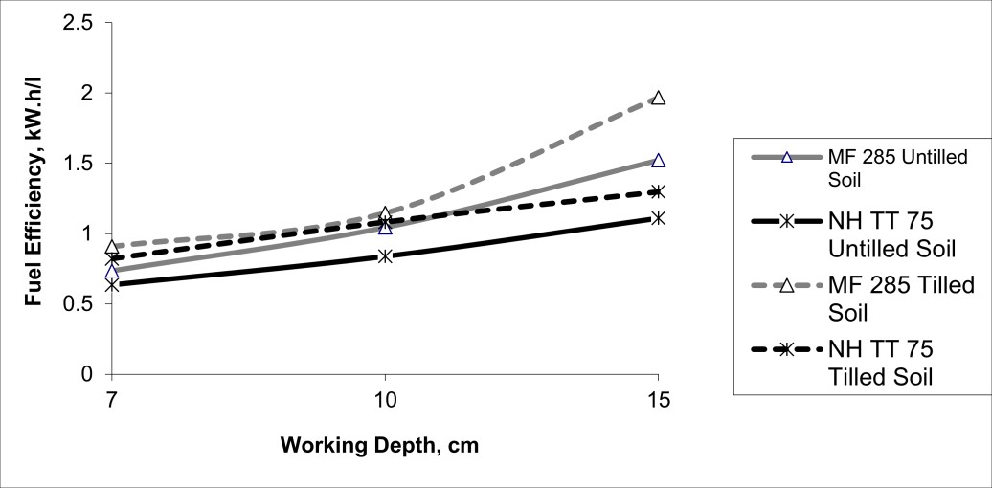

**Figure 4.3: Fuel Efficiency - Tractor*Depth*Soil condition**

## 4.1.4.2 Effects of Factor Interactions on the Power Delivery Efficiency

Figure 4.4 presents the effects of factor interactions: tractor make*depth (that is tractor make interacting with working depth) on the power delivery efficiency ratio.

|  |  |  |  |  |  |  |  |
| --- | --- | --- | --- | --- | --- | --- | --- |
| **0.45** |  |  | **0.426** |  |  |  |  |
| **0.4** |  |  |  |  |  |  |
| **0.35** |  |  | **0.324** |  |  |  |
| **0.3** |  | **0.283** |  |  |  |  |
| **0.25**  **0.2**  **0.15**  **0.1** | **0.2160.204**  **0.35**  **0.3**  **0.25** | **0.282**  **0.239** | **0.334**  **0.291** |  |  | **MF 285** |
| **0.05**  **0** | **0.2**  **0.15** |  |  |  |  | **MF 285** |  |
| **Deliv** | **0.71** | **10** | **15** |  |  | **NH TT 75** |  |
| **ower** | **0.05** | **Working Depth, cm** |  |  |  |  |  |

**Figure 4.4: Power DeliveUnrtiylledESfoifl iciency - TTillredaScoitl or Make*Depth**

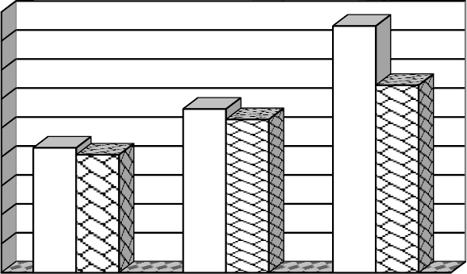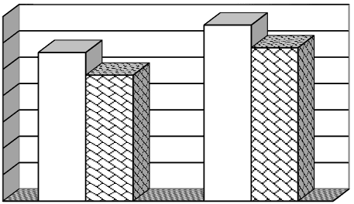

**0.265**

**0**



**NH TT 75**



**Power Delivery Efficiency, ratio**

**P**

**ery Efficiency, Ratio**

**Soil Conditions**

## Figure 4.5: Power Delivery Efficiency-Tractor Make*Soil condition

Figure 4.5 presents the effects of factor interactions: tractor make*soil condition (that is tractors interacting with soil condition) on the power delivery efficiency ratio.

Figure 4.6 presents the effects of three factor interactions: tractor make*engine rpm*soil condition on the power delivery efficiency ratio.

**0.4**



**Power Delivery Efficiency, ratio**

**0.38**

**0.36**

**MF 285 Untilled Soil NH TT 75 Untilled Soil MF 285 Tilled**

**NH TT 75 Tilled**

**0.34**



**0.32**

**0.3**

**0.28**

**0.26**

**0.24**

**0.22**

**0.2**

**Rated Engine Speed Reduced Engine Speed No-load Engine Speed**

## Figure 4.6: Power Delivery Efficiency - Tractor Make*Engine rpm*Soil

Figure 4.7 presents the effects of four factor interactions: Engine rpm* Tractor *Soil * Depth on the power delivery efficiency ratio.

**0.5**

**0.45**

**Power Delivery Efficiency, ratio**

**0.4**

**0.35**

**0.3**

**0.25**

**0.2**

**0.15**

**0.1**

**0.05**

**0**

**7 cm - Untilled**



**7 cm - Tilled**

**10 cm- Untilled**

**10 cm- Tilled**

**15cm- Untilled**

**MF 285 at Rated rpm**

**MF 285 at Reduced rpm**

**NH TT 75 at Rated rpm**

**NH TT 75 at Reduced rpm**

**15 cm- Tilled**

**Working Depth Against Soil Condition**

## Figure 4.7: Power Delivery Efficiency- Engine rpm*Tractor*Soil*Depth

* 1. **Discussion of Results**

The tables 4.1 presents the equations generated from segmented regression analysis of laboratory test data for Mf 285 and NH TT 75 tractors from Nebraska Tractor Test Laboratory (NTTL); these equations were used to predict fuel consumption (l/h) and PTO power (kW) from engine speeds for the two tractors during field tests. Tables 4.2 – 4.5 presents measured, predicted and calculated parameters recorded for the two tractors (MF 285 and New Holland TT 75) tested under different combinations of two engine no-load speeds (throttles settings), three working depths and two soil conditions. The mean fuel and power delivery efficiency ratio for the two tractors at each test condition was determined and presented in the tables of results.

## Factors Effects on Fuel Efficiency of the Test Tractors Main Factors Effects

Univariate tests were conducted to analyze the effects of independent variables (engine speed, tractor make, working depths and soil condition) on the dependent variables (fuel efficiency and power delivery ratio). The effects of these categorical variables are illustrated in Table

4.10. The main effects, tractor, depth and soil are significant (p<0.0001), while engine rpm is significant (p 0.001); this is in agreement with the findings of Shell *et al.* (1997), where soil condition was found to have a significant effect on the fuel efficiency of the test tractors. The descriptive statistics in Table 4.8 revealed that the Tractor Make main effect on fuel with 21.30

% MF 285 fuel advantage over NH TT 75 tractor across all soil conditions. For the main effect of soil condition, untilled vs tilled, soil has a significant impact on fuel efficiency, untilled soil 0.981 vs tilled soil 1.204, a 18.30 % difference for the two tractors combined; MF 285 17.90

% difference and New Holland TT75 19.6 % difference. The main effect Engine rpm: rated engine speed vs reduced engine speed is also significant, MF 285 exhibited 1.203 kW.h/l and

1.239 kW.h/l fuel efficiency at rated and reduced engine speeds respectively, NH TT 75 exhibits 0.965 kW.h/l and 0.963 kW.h/l at rated and reduced engine speeds respectively. Other significant main effect is working depth (7 cm, 10 cm and 15 cm deep), the two tractors exhibit

their highest fuel efficiency ratio at the working depth of 15cm across all field conditions. MF 285 - 1.522, 1.968 and NH TT 75 – 1.110, 1.298 on the untilled and tilled soil conditions respectively.

## Interactions Effect

As is evident through ANOVA in Table 4.10, all factor interactions appeared to have significant effects on the fuel efficiency of the test tractors. The factor interaction (combination) of much interest to this study: tractor make interacting with soil condition (Tractor*Soil) is significant at (p<0.001). All other factor interactions are significant at (p<0.0001). However, the significance of the interactions effects on fuel efficiency could be better explained through the graphs shown in Figures 4.1- 4.3.

Considering the interaction: Tractor Make*Soil condition (p<0.001) illustrated in figure 4.1, the NH TT 75 tractor’s fuel efficiency is more affected by soil condition than MF 285. New Holland TT 75 exhibited 23.93 % difference in fuel efficiency between untilled and tilled soil condition and across all working depths, while MF 285 exhibited 21.18 %. The two tractors combined exhibited their highest fuel efficiency at 15 cm working depth on tilled soil condition (1.633 kW.h/l); this is visible in figure 4.2. This indicated that the two tractors will be economically advantageous if operated at working depth of about 15 cm.

For the three way interactions: Tractor*Soil*Depth, figure 4.3 shows that MF 285 tractor exhibited higher fuel efficiency in tilled soil over untilled as did NH TT 75 both at the same depth 15 cm. it could be seen that the two tractors perform best on the tilled soil condition.

For the four ways interaction: Engine rpm * Tractor * Depth * Soil (p<0.0001), both tractors showed their best performance in the tilled soil condition with throttles set at 1800 rpm (reduced engine speed, no-load) and working depth of 15 cm.

## Factors Effect on Power Delivery Efficiency of the Test Tractors

The Analysis of Variance (ANOVA) for power delivery efficiency is presented in Table 4.11. The same four categorical variables were tested to determine their effects on the other performance criterion, power delivery efficiency (ratio).

## Main Factor Effects

The analysis revealed that all four main effects are significant to power delivery efficiency (DBP/PTO ratio). When considering the main effect, Tractor Make, MF 285 tractor showed

0.308 DBP/PTO ratio compared to 0.265 for the New Holland (NH) TT 75 (p< 0.0001).

Working depth is also a significant main effect (p<0.0001) with 15 cm depth as the best, having power delivery ratio 0.375 as compared to 0.274 and 0.204 for working depths 10 cm and 7 cm respectively. On the main effect of Soil Condition, tilled soil conditions resulted in

5.20 % higher power delivery ratio than untilled surfaces 0.312 vs 0.260. Considering the other significant main effect: Engine rpm (p <0.002), the two tractors combined exhibited better performance ratios with the throttles adjusted to the reduced engine speed (1800 rpm) than with rated speed; 0.288 power delivery ratio at reduced engine speeds against 0.284 at rated engine speeds. Comparing with the findings of the similar work on the southern Alberta soils reported in Turner *et al.,* (1997), all other main factors except soil condition has significant effect on the PDE of the test tractors.

## Interactions Effect

Analysis of variance in Table 4.11 revealed that all the interaction effects with the exception of Tractor*Soil interaction (p 0.939) are significant (p< 0.0001) on power delivery efficiency. When looking at the Tractor*Depth interaction, figure 4.4, it could be seen that MF 285 exhibited its best power ratio at the working depth of 15 cm over all field conditions with 0.426, so also NH TT 75 with 0.324. It is evident also from figure 4.4 that, at the shallower working depth (7 cm), MF 285 exhibited smaller advantage 5.88 % over NH TT 75 comparing to 15 cm working depth, which exhibits 31.48 % advantage.

The influence of soil condition on the power delivery performance of both tractors is illustrated in figure 4.5. Both tractors performed better on tilled soil condition for all the working depths and throttle settings when compared to the untilled. MF 285 exhibited 18.44 % and NH TT 75

21.76 % difference in power performances in untilled vs tilled soil condition; this implied that NH TT 75 tractor’s power performance is better influenced by soil condition than that of MF 285.

The line graph (Fig. 4.6) illustrates the three way interaction, Tractor*Engine rpm*Soil condition, (p<0.0001). The lines representing NH TT 75 tractor on both soil conditions is almost parallel to the horizontal axis with the tilled on top, while the lines representing the MF 285 show a decline on both soil condition when moving from rated engine speed to reduced engine speed. The graph illustrates that the NH TT 75 tractor power performance is rather stable over the two engine (idle) speeds.

The four way interaction: Engine rpm*Tractor*Soil*Depth (p<0.0001), is shown in figure 4.7. The lines represent the two tractors at two different throttle settings (rated and reduced engine speeds-no load). There was no considerable difference between the two tractors on the shallower working depth of 7 cm across all working conditions. The two lines representing NH TT 75 tractor overlapped, indicating that the tractor exhibited the same power delivery performance when operated with throttle set at either rated or reduced engine speed on a particular working condition. NH TT 75 tractor demonstrated better performance over MF 285 tractor when operated on the working depth of 10 cm in tilled soil condition with throttles set at rated engine speeds.

## CHAPTER FIVE

* 1. **CONCLUSIONS AND RECOMMENDATIONS**

## Conclusions

Two different makes of farm tractors, MF 285 and New Holland TT 75 tractor were compared in 96 field performance tests and 24 test conditions on Indaloke series, sandy loam soil of research fields of NCRI, Badeggi. The performance criteria used were fuel efficiency (kW.h/l) and power delivery efficiency (DBP/PTO ratio). Four categorical variables were used in the comparison. Analysis of the results led to the following findings:

1. With all test conditions combined, MF 285 tractor exhibited 21.30 % fuel advantage over NH TT 75 tractor. But when the two tractors are set at rated no-load engine speeds and operated at the working depth of 10 cm, tilled soil condition, NH TT 75 tractor demonstrated higher power delivery efficiency (0.297) against MF 285 tractor (0.262)
2. When combined the two tractors indicated higher fuel efficiency (18.30 % difference) and power delivery efficiency (5.20 % difference) in tilled soil condition as compared to the untilled.
3. MF 285 tractor indicated improvement in both fuel and power delivery efficiency on a specific working condition when adjusted from rated no-load engine speed to the reduced no-load engine speed, while NH TT 75 tractor indicated no difference.
4. Combining the working conditions, both tractors exhibited optimal performance when throttles are set to the reduced (1800 rpm) no-load engine speeds and operated at 15 cm working depth.
5. New Holland TT 75 tractor exhibited relatively higher field speed across all the test conditions when compared to the MF 285.

## Recommendations

In view of the conclusions made above, the following recommendations are made:

i. MF 285 tractor is recommended to be more suitable to our terrain than New Holland TT 75; however, where timeliness of tillage operations is at stake, New Holland TT 75

tractor is recommended as the better option owing to its higher field speed than MF 285.

1. The farm managers should ensure that MF 285 and New Holland TT 75 Tractors to be use for their farm operations have their throttles initially set at 1800 rpm (reduced no- load engine speed). This is to allow the efficient and economical performance of the two tractors.
2. The two tractors be operated at a deeper working or implement depth for all tillage operations.
3. For the farms with the two tractors in possession or where a farmer has a rented services of the tractors at disposal for the same rate, it could be recommended that New Holland TT 75 tractor be employed for secondary tillage operations, while MF 285 for primary tillage operations.
4. The test procedure be improved by involving the comparison of more than two tractor makes; and tests be conducted on several locations across the country.
5. The modern onboard data acquisition be incorporated on the tractors so as to allow for higher accuracy, flexibility and replications in on-field data capturing.
6. National Centre for Agricultural Mechanization (NCAM), Ilorin in addition to the performance evaluation of tractors brought to her, should improve on and adopt this comparative test sequence with the aim of recommending to the federal government the best suitable and more economical to our ecological terrain among the wide range of farm tractor makes which are already or about to be imported into the country.

## REFERENCES:

Adgidzi, D. (2002). Fuel Consumption of Tractor Engines. Unpublished lecture paper. Department of Agricultural and Bioresources Engineering, F. U. T. Minna, Nigeria.

ASAE (2003). *ASAE Standards*: Agricultural Machinery Management Data. ASAE D497.4 February, 2003. St. Joseph, Michigan: ASAE.

Bukola, A. F. (2004). Comparison of Theoretically Determined Operational characteristics of Existing (Diesel) and Compressed Natural Gas (CNG) Tractor Engines. An unpublished M.Eng. Thesis, Department of Agricultural and Bioresources Engineering, Federal University of Technology Minna, Nigeria.

CIGR (1999). CIGR *Handbook of Agricultural Engineering.* Volume III. St. Joseph Michigan: American Society of Agricultural Engineers.

Dwyer, M. J. (1987). Prediction of Drawbar Performance. *Journal of Terramechanics*, Vol.

24 No. 27.

FAO (1994). *Testing and Evaluation of Agricultural Machinery and Equipment: Principles and Practices*. FAO Agricultural Bulletin No.110, Rome: Food and Agriculture Organization of the United Nations.

FAO (1998). *FAO Production Year Book 1997.* Rome: FAO.

Floren, M. (2012). *History and Evolution of Tractors.* Retrieved on July 26, 2012 from [www.tractor-depot.com/the-history-and-evolution-of-tractors](http://www.tractor-depot.com/the-history-and-evolution-of-tractors)

Grisso, R. D., Kocher M. F. and Vaughan, D. H. (2004). Predicting Tractor Fuel Consumption. *Biological System Engineering Publication*, Lincoln: University of Nebraska-Lincoln. Vol. 20(5), pp.553-561.

Grisso, R. D., Perumpral, J. V., Vaughan, D. H., Robertson, G. T. and Pitman, R. (2010). Predicting Tractor Diesel Fuel Consumption. *Virginia Cooperative Extension publication,* 442-073. Retrieved on March 5, 2011 from [http://www.pubs.ext.vt.edu/442/442-073.](http://www.pubs.ext.vt.edu/442/442-073)

Haque, M. A. (2000). A Comparison of Tractor Use between Nigeria and Some other Countries of the World. University of Maiduguri, Faculty of Engineering Seminar Series. Volume 1, Number 1.

Hunt, D. (1995). *Farm Power and Machinery Management*. Ames: Iowa State University Press.

Hunt, D. (2001). *Farm Power and Machinery Management*. (10th Edition). Ames: Iowa State University Press.

Klancher, L.; Leffingwell, R.; Morland, A. and Pripps, R. N. (2003). *Farm Tractors.* Retrieved from <http://books.google.com/tractors>

Kalu, O. (2010). Why I am in the Race. Presidential Aspirant Manifestos. Retrieved on December 8, 2010 from <http://www.sunnewsonline.com/webpages/columnists/kalu/2010/kalu-dec-04-2010>

Liljedahl, J. B; Carleton,W. M.; Turnquist, P. K. and Smith, D. W. (1989). Tractors and Their Power Units (3rd Edition). New York, NY: John Wiley & Sons.

Lite, Z. (2011). *Farm Tractors and Their Uses.* Retrieved on January 10, 2012 from [www.zimbio.com/tractors/articles](http://www.zimbio.com/tractors/articles)

Makanjuola, G. A.; Abinbola, T. O. and Anazodo, U. G. N. (1991). Agricultural Mechanization Policies and Strategies in Nigeria. In: Agricultural Mechanization Policies and Strategies in Africa: Case studies from Commonwealth African Countries. Common Wealth Secretariat, London, pp. 189-216.

Macmillan, R. H. (2002). *The Mechanics of Tractor – Implement Performance: Theory and Worked Examples.* Retrieved on April 4, 2012 from [www.scribd.com/doc/56468537/Tractor-Mechanics](http://www.scribd.com/doc/56468537/Tractor-Mechanics)

Mifflin, H. (2000). *The American Heritage Dictionary of the English Language* (Fourth ed.). Boston and New York: Houghton Mifflin. pp. 1829. Retrieved on November 18, 2011 from [http://www.houghtonmifflinbooks.com](http://www.houghtonmifflinbooks.com/)

NationMaster.com (2011). *Facts and Statistic*. Tractor Use by Country. Retrieved on November 18, 2011 from <http://www.nationmaster.com/red/graph/agr_tra-> agriculture-tractors.

Odigboh, E. U. and Onwualu, A. P. (1994). Mechanization of Agriculture in Nigeria: A critical appraisal. *Journal of Agricultural Technology,* National Board for Technical Education, Kaduna Nigeria, 2: 1-58.

Oni, K. C. (2004). Creating a Competitive Edge through Agricultural Mechanization. A paper presented at the 3rd Agricultural Summit of the Nigerian Economic Summit Group held at Benin City, Edo State. December 2004.

Oni, K. C. (2005). Socio-economic Impact of Tractor Assembly Plants in Nigeria. Paper presented at the commissioning of the tractor assembly plant of Mahindra and Mahindra Limited in Nigeria held at Ibadan, Oyo state, 15th September, 2005.

Shell, L. R., Zoz, F. M., and Turner R. J. (1997). Field Performance of Rubber Belt and MFWD Tractors in Texas Soils. In Belt and Tire Traction in agricultural Vehicles. SAE Paper 972729. Warrendale, Pennsylvania: SAE.

Turner, R. J. (1993). A Simple System for Determining Tractive Performance in the Field.

ASAE Paper No. 93-1574. St. Joseph, Michigan: ASAE.

Turner, R. J., Shell, L. R. and Zoz, F. M. (1997). Field Performance of Rubber Belt and MFWD Tractors in Southern Alberta Soils. In Belt and Tire Traction in agricultural Vehicles. *SAE Paper 972730*. Warrendale, Pennsylvania: SAE.

Zoz, F. M., Turner, R. J. and Shell, L. R. (2002). Power Delivery Efficiency: A Valid Measure of Belt and Tire Tractor Performance. *ASAE Transactions* 45(3), pp.509-518. St. Joseph, Michigan: ASAE.

Zoz, F. M. and Grisso, R. D. (2003). Traction and Tractor Performance. *ASAE Distinguished Lecture Series. No.27.* St. Joseph, Michigan: ASAE.

## APPENDICES

**Appendix A: Tractor Drawbar Performance Predictor Chart**

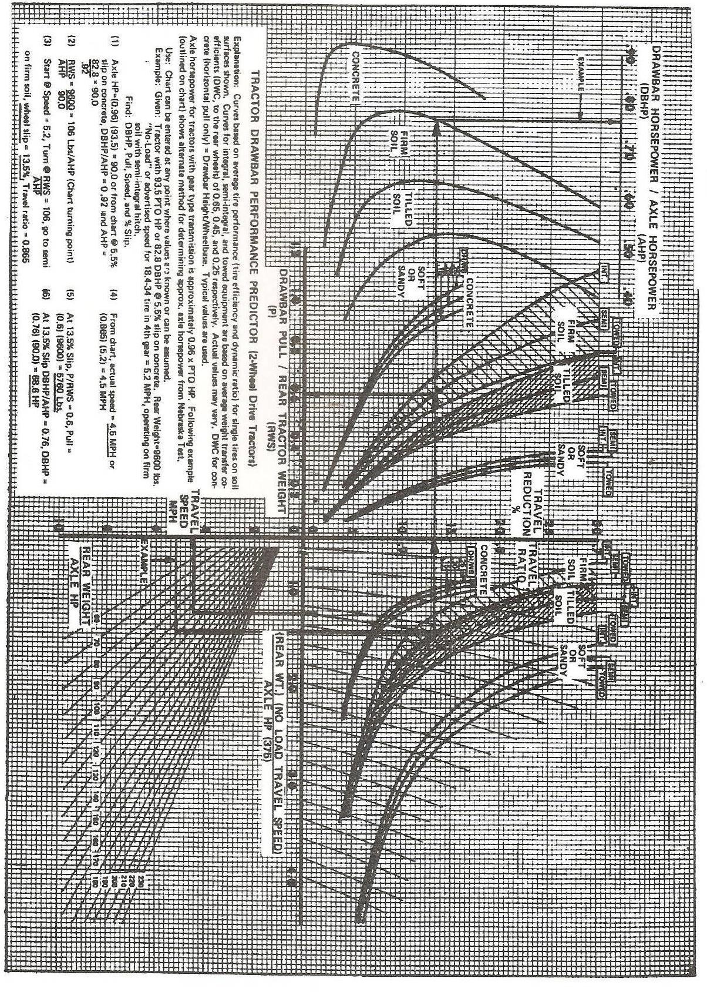

## Appendix B: Nebraska Tractor Test Report for MF 285 Tractor

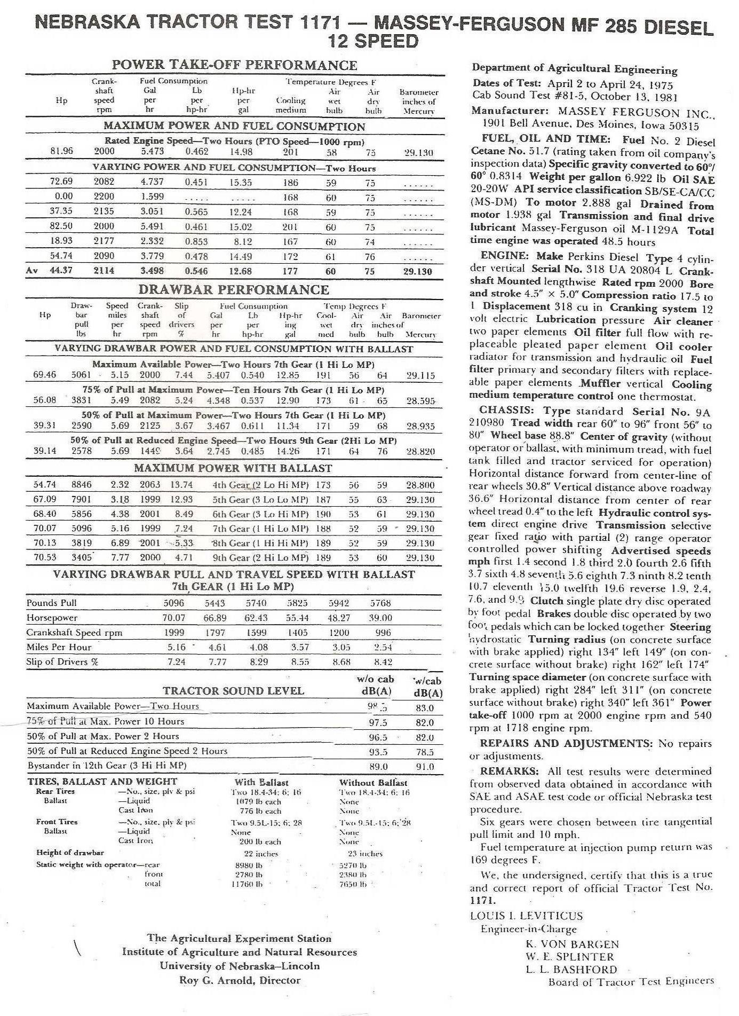

**Appendix C: Nebraska Tractor Test Report for New Holland TT 75 Tractor**

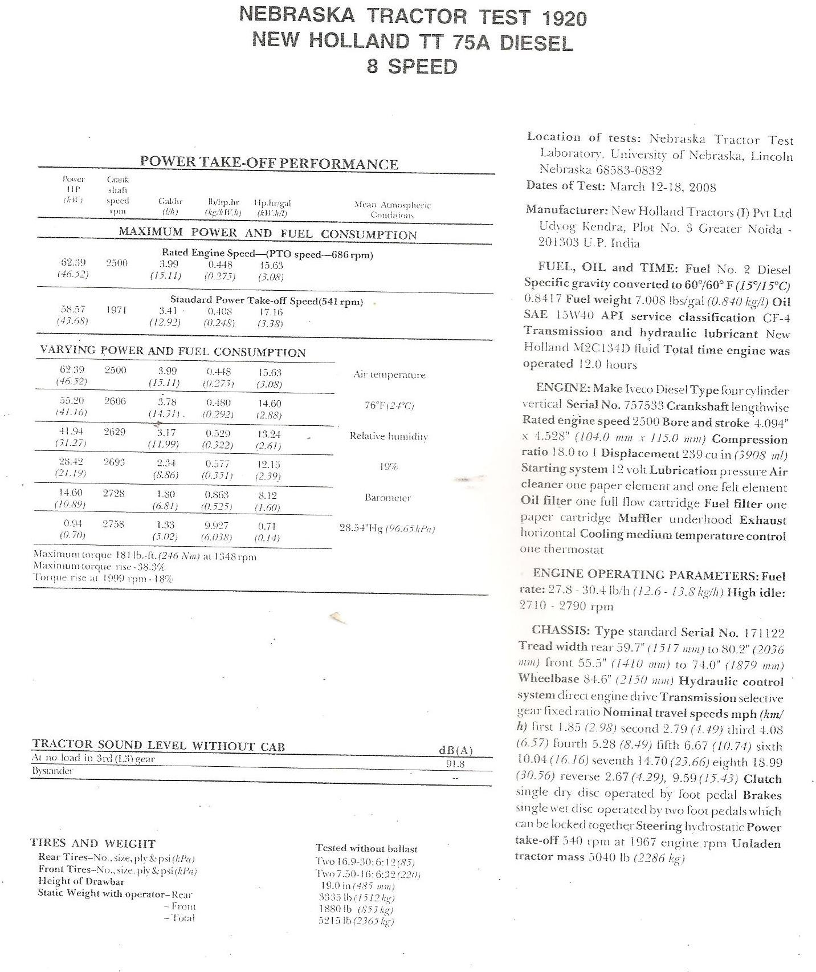

## Appendix D: Fitted Curves

**Fitted Curves for MF 285 Tractor PTO Power VS Engine Speed**

**Regression**

70

60

50

40

30

20

10

0

1400

y = 0.021x + 16.569

R² = 0.8359

y = -0.4037x + 890.07

R² = 0.9648

1600 1800

2000

2200

**Engine Speed, rpm**

**PTO Power, kW**

**Plotted from Nebraska Tractor Test 1171- Massey Ferguson MF 285 Test Data.**

**Fitted Curve for MF 285 Tractor Fuel Consumption VS Engine Speed Regression**

25

20

y = 0.0124x - 5.4838 R² = 0.8899

15

10

5

y = -0.0866x + 196.74 R² = 0.944

0

1200

1400

1600

1800

2000

2200

2400

**Engine Speed, rpm**

**Fuel Consumption, l/h**

**Plotted from Nebraska Tractor Test 1171- Massey Ferguson MF 285 Test Data.**

## Plotted from Nebraska Tractor Test 1920 - New Holland TT 75 Test Data.



**Fitted Curves for New Holland TT 75 Tractor PTO Power VS Engine**

**Speed Regression**

80

70

60 y = -0.001x + 46.05

R2 = 0.9820

50

40

30

20

10

0

1000

y = -0.246x + 681.02

R2 = 0.9786

1500

2000

**Engine Speed, rpm**

2500

3000

**Fitted Curves for New Holland TT 75 Tractor Fuel Consumption**

**VS Engine Speed Regression.**

30

25

20

y = 0.0028x + 7.4663

R² = 0.7481

15

10

5 y = -0.0584x + 165.95

R² = 0.9914

0

1000

1500

2000

**Engine Speed, rpm**

2500

3000

**Fuel Consumption, l/h**

**PTO Power, kW**

**Plotted from Nebraska Tractor Test 1920 - New Holland TT 75 Test Data.**

## Appendix E:

**Descriptive Statistics with Power Delivery Efficiency as Dependent Variable for MF 285 and New Holland TT 75 Tractors.**

|  |  |  |  |  |  |  |
| --- | --- | --- | --- | --- | --- | --- |
| **Engine Speed** | **Tractor Make** | **working depth** | **Soil Condition** | **Mean** | **Std. Deviation** | **N** |
|  | **MF 285** | 15cm | untilled soil | .377725 | .0118806 | 4 |
|  |  |  | tilled soil | .468500 | .0066673 | 4 |
|  |  |  | Total | .423112 | .0493342 | 8 |
|  |  | 10 cm | untilled soil | .279850 | .0040336 | 4 |
|  |  |  | tilled soil | .261525 | .0188505 | 4 |
| **Rated Engine Speed** |  |  | Total | .270687 | .0159752 | 8 |
| (2000 rpm) |  | 7 cm | untilled soil | .201050 | .0001732 | 4 |
|  |  |  | tilled soil | .234275 | .0075988 | 4 |
|  |  |  | Total | .217663 | .0184434 | 8 |
|  |  | Total | untilled soil | .286208 | .0757646 | 12 |
|  |  |  | tilled soil | .321433 | .1098054 | 12 |
|  |  |  | **Total** | **.303821** | **.0939975** | **24** |
|  | **NH TT75** | 15cm | untilled soil | .304000 | .0006733 | 4 |
|  |  |  | Tilled soil | .345550 | .0008347 | 4 |
|  |  |  | Total | .324775 | .0222205 | 8 |
|  |  | 10 cm | untilled soil | .233875 | .0004573 | 4 |
|  |  |  | tilled soil | .297300 | .0006000 | 4 |
|  |  |  | Total | .265588 | .0339057 | 8 |
| **Rated Engine Speed** |  | 7 cm | untilled soil | .180150 | .0031754 | 4 |
| (2500 rpm) |  |  | tilled soil | .229675 | .0004425 | 4 |
|  |  |  | Total | .204913 | .0265553 | 8 |
|  |  | Total | untilled soil | .239342 | .0529916 | 12 |
|  |  |  | tilled soil | .290842 | .0496424 | 12 |
|  |  |  | **Total** | **.265092** | **.0566878** | **24** |
|  | Total | 15cm | untilled soil | .340863 | .0401703 | 8 |
|  |  |  | tilled soil | .407025 | .0658666 | 8 |
|  |  |  | Total | .373944 | .0628089 | 16 |
|  |  | 10 cm | untilled soil | .256863 | .0247179 | 8 |
|  |  |  | tilled soil | .279413 | .0227622 | 8 |
|  |  |  | Total | .268138 | .0257393 | 16 |
|  |  | 7 cm | untilled soil | .190600 | .0113639 | 8 |
|  |  |  | tilled soil | .231975 | .0055567 | 8 |
|  |  |  | Total | .211288 | .0230473 | 16 |

|  |  |  |  |  |  |  |
| --- | --- | --- | --- | --- | --- | --- |
|  |  | Total | untilled soil | .262775 | .0682741 | 24 |
|  |  |  | tilled soil | .306138 | .0847894 | 24 |
|  |  |  | **Total** | **.284456** | **.0792421** | **48** |
|  | **MF 285** | 15cm | untilled soil | .386675 | .0070415 | 4 |
|  |  |  | tilled soil | .471475 | .0074191 | 4 |
| **Reduced Engine Speed** |  |  | Total | .429075 | .0458195 | 8 |
| **(1800 rpm)** |  | 10 cm | untilled soil | .261275 | .0038526 | 4 |
|  |  |  | tilled soil | .327350 | .0039060 | 4 |
|  |  |  | Total | .294313 | .0355007 | 8 |
|  |  | 7 cm | untilled soil | .186750 | .0041000 | 4 |
|  |  |  | tilled soil | .240500 | .0000816 | 4 |
|  |  |  | Total | .213625 | .0288557 | 8 |
|  |  | Total | untilled soil | .278233 | .0862919 | 12 |
|  |  |  | tilled soil | .346442 | .0995886 | 12 |
|  |  |  | **Total** | **.312338** | **.0975616** | **24** |
|  | **NH TT75** | 15cm | untilled soil | .303575 | .0001258 | 4 |
|  |  |  | tilled soil | .344250 | .0002380 | 4 |
|  |  |  | Total | .323912 | .0217424 | 8 |
|  |  | 10 cm | untilled soil | .233225 | .0000500 | 4 |
|  |  |  | tilled soil | .297550 | .0006351 | 4 |
|  |  |  | Total | .265387 | .034385 | 8 |
| **Reduced Engine Speed** |  | 7 cm | untilled soil | .177350 | .0000577 | 4 |
| **(1800 rpm)** |  |  | tilled soil | .229225 | .0000500 | 4 |
|  |  |  | Total | .203288 | .0277284 | 8 |
|  |  | Total | untilled soil | .238050 | .0539404 | 12 |
|  |  |  | tilled soil | .290342 | .0493362 | 12 |
|  |  |  | **Total** | **.264196** | **.0571749** | **24** |
|  | Total | 15cm | untilled soil | .345125 | .0446575 | 8 |
|  |  |  | tilled soil | .407862 | .0681780 | 8 |
|  |  |  | Total | .376494 | .0644162 | 16 |
|  |  | 10 cm | untilled soil | .247250 | .0152040 | 8 |
|  |  |  | tilled soil | .312450 | .0161381 | 8 |
|  |  |  | Total | .279850 | .0369192 | 16 |
|  |  | 7 cm | untilled soil | .182050 | .0056966 | 8 |
|  |  |  | tilled soil | .234862 | .0060271 | 8 |
|  |  |  | Total | .208456 | .0278545 | 16 |
|  |  | Total | untilled soil | .258142 | .0733078 | 24 |
|  |  |  | tilled soil | .318392 | .0820272 | 24 |
|  |  |  | **Total** | **.288267** | **.0827606** | **48** |
| **Total** | **MF 285** | 15cm | untilled soil | .382200 | .0102288 | 8 |
|  |  |  | tilled soil | .469988 | .0067208 | 8 |
|  |  |  | Total | .426094 | .0460978 | 16 |
|  |  | 10 cm | untilled soil | .270563 | .0105789 | 8 |
|  |  |  | tilled soil | .294438 | .0373739 | 8 |

|  |  |  |  |  |  |
| --- | --- | --- | --- | --- | --- |
|  |  | Total | .282500 | .0292588 | 16 |
|  | 7 cm | untilled soil | .193900 | .0081020 | 8 |
|  |  | tilled soil | .237388 | .0059851 | 8 |
|  |  | Total | .215644 | .0234874 | 16 |
|  | Total | untilled soil | .282221 | .0795186 | 24 |
|  |  | tilled soil | .333938 | .1033101 | 24 |
|  |  | **Total** | **.308079** | **.0948692** | **48** |
| **NH TT75** | 15cm | untilled soil | .303788 | .0005027 | 8 |
|  |  | tilled soil | .344900 | .0008976 | 8 |
|  |  | Total | .324344 | .0212420 | 16 |
|  | 10 cm | untilled soil | .233550 | .0004598 | 8 |
|  |  | tilled soil | .297425 | .0005874 | 8 |
|  |  | Total | .265488 | .0329888 | 16 |
|  | 7 cm | untilled soil | .178750 | .0025618 | 8 |
|  |  | tilled soil | .229450 | .0003780 | 8 |
|  |  | Total | .204100 | .0262411 | 16 |
|  | Total | untilled soil | .238696 | .0522970 | 24 |
|  |  | tilled soil | .290592 | .0484024 | 24 |
|  |  | **Total** | **.264644** | **.0563248** | **48** |
| Total | 15cm | untilled soil | .342994 | .0410920 | 16 |
|  |  | tilled soil | .407444 | .0647608 | 16 |
|  |  | Total | .375219 | .0625965 | 32 |
|  | 10 cm | untilled soil | .252056 | .0204362 | 16 |
|  |  | tilled soil | .295931 | .0255809 | 16 |
|  |  | Total | .273994 | .0318669 | 32 |
|  | 7 cm | untilled soil | .186325 | .0097418 | 16 |
|  |  | tilled soil | .233419 | .0057952 | 16 |
|  |  | Total | .209872 | .0251895 | 32 |
|  | Total | untilled soil | .260458 | .0701171 | 48 |
|  |  | tilled soil | .312265 | .0827595 | 48 |
|  |  | **Grand Mean** | **.286361** | **.0806157** | **96** |

**Appendix F:**

**Descriptive Statistics, Fuel Efficiency as Dependent Variable for the MF 285 and New Holland TT 75 Tractors with Throttles at the Rated Engine Speeds**

|  |  |  |  |  |  |  |
| --- | --- | --- | --- | --- | --- | --- |
| **Engine Speed** | **Tractor Make** | **working depth** | **Soil Condition** | **Mean** | **Std. Deviation** | **N** |
|  | **MF 285** | 15cm | untilled soil | 1.502750 | .0510737 | 4 |
|  |  |  | Tilled soil | 1.961300 | .0314709 | 4 |
|  |  |  | Total | 1.732025 | .2482318 | 8 |
|  |  | 10 cm | untilled soil | 1.083225 | .0155170 | 4 |
|  |  |  | Tilled soil | 1.012175 | .0730061 | 4 |
| **Rated Engine Speed** |  |  | Total | 1.047700 | .0618849 | 8 |
|  |  | 7 cm | untilled soil | .763325 | .0004787 | 4 |
|  |  |  | Tilled soil | .896350 | .0290196 | 4 |
|  |  |  | Total | .829838 | .0735997 | 8 |
|  |  | Total | untilled soil | 1.116433 | .3174707 | 12 |
|  |  |  | Tilled soil | 1.289942 | .5002409 | 12 |
|  |  |  | **Total** | **1.203188** | **.4192097** | **24** |
|  | **NH TT75** | 15cm | untilled soil | 1.110775 | .0018572 | 4 |
|  |  |  | tilled soil | 1.299575 | .0023229 | 4 |
|  |  |  | Total | 1.205175 | .1009366 | 8 |
|  |  | 10 cm | untilled soil | .839100 | .0010231 | 4 |

|  |  |  |  |  |  |
| --- | --- | --- | --- | --- | --- |
|  |  | tilled soil | 1.082200 | .0014674 | 4 |
|  |  | Total | .960650 | .1299477 | 8 |
| **Rated Engine Speed** | 7 cm | untilled soil | .640900 | .0118358 | 4 |
|  |  | tilled soil | .822275 | .0009777 | 4 |
|  |  | Total | .731588 | .0972603 | 8 |
|  | Total | untilled soil | .863592 | .2012682 | 12 |
|  |  | tilled soil | 1.068017 | .2037965 | 12 |
|  |  | **Total** | **.965804** | **.2239175** | **24** |
| Total | 15cm | untilled soil | 1.306763 | .2121740 | 8 |
|  |  | tilled soil | 1.630438 | .3543097 | 8 |
|  |  | Total | 1.468600 | .3279161 | 16 |
|  | 10 cm | untilled soil | .961163 | .1308868 | 8 |
|  |  | tilled soil | 1.047187 | .0607138 | 8 |
|  |  | Total | 1.004175 | .1081122 | 16 |
|  | 7 cm | untilled soil | .702113 | .0658968 | 8 |
|  |  | tilled soil | .859313 | .0439212 | 8 |
|  |  | Total | .780713 | .0975526 | 16 |
|  | Total | untilled soil | .990012 | .2902649 | 24 |
|  |  | tilled soil | 1.178979 | .3903743 | 24 |
|  |  | **Total** | **1.084496** | **.3534437** | **48** |
| **MF 285** | 15cm | untilled soil | 1.541775 | .0301412 | 4 |
|  |  | tilled soil | 1.975525 | .0353056 | 4 |
|  |  | Total | 1.758650 | .2338324 | 8 |
| **Reduced Engine Speed (1800 rpm)** | 10 cm | untilled soil | 1.005500 | .0148766 | 4 |
|  |  | tilled soil | 1.282275 | .0152738 | 4 |
|  |  | Total | 1.143888 | .1485995 | 8 |
|  | 7 cm | untilled soil | .708450 | .0155002 | 4 |
|  |  | tilled soil | .920300 | .0002000 | 4 |
|  |  | Total | .814375 | .1136924 | 8 |
|  | Total | untilled soil | 1.085242 | .3606968 | 12 |
|  |  | tilled soil | 1.392700 | .4577217 | 12 |
|  |  | **Total** | **1.238971** | **.4325309** | **24** |
| **NH TT75** | 15cm | untilled soil | 1.109450 | .0004123 | 4 |
|  |  | tilled soil | 1.295925 | .0009032 | 4 |
|  |  | Total | 1.202688 | .0996772 | 8 |
|  | 10 cm | untilled soil | .837550 | .0001915 | 4 |
|  |  | tilled soil | 1.082725 | .0015327 | 4 |
| **Reduced Engine Speed (1800 rpm)** |  | Total | .960138 | .1310555 | 8 |
|  | 7 cm | untilled soil | .630575 | .0000500 | 4 |
|  |  | tilled soil | .821200 | .0000816 | 4 |
|  |  | Total | .725888 | .1018934 | 8 |
|  | Total | untilled soil | .859192 | .2048177 | 12 |
|  |  | tilled soil | 1.066617 | .2027748 | 12 |
|  |  | **Total** | **.962904** | **.2257257** | **24** |

|  |  |  |  |  |  |  |
| --- | --- | --- | --- | --- | --- | --- |
|  | Total | 15cm | untilled soil | 1.325612 | .2319285 | 8 |
|  |  |  | tilled soil | 1.635725 | .3639965 | 8 |
|  |  |  | Total | 1.480669 | .3355264 | 16 |
|  |  | 10 cm | untilled soil | .921525 | .0902999 | 8 |
|  |  |  | tilled soil | 1.182500 | .1071363 | 8 |
|  |  |  | Total | 1.052013 | .1652992 | 16 |
|  |  | 7 cm | untilled soil | .669513 | .0428449 | 8 |
|  |  |  | Tilled soil | .870750 | .0529714 | 8 |
|  |  |  | Total | .770131 | .1138647 | 16 |
|  |  | Total | untilled soil | .972217 | .3092184 | 24 |
|  |  |  | Tilled soil | 1.229658 | .3841918 | 24 |
|  |  |  | **Total** | **1.100937** | **.3687056** | **48** |
| **Total** | **MF 285** | 15cm | untilled soil | 1.522262 | .0440729 | 8 |
|  |  |  | Tilled soil | 1.968413 | .0318824 | 8 |
|  |  |  | Total | 1.745338 | .2333683 | 16 |
|  |  | 10 cm | untilled soil | 1.044363 | .0438644 | 8 |
|  |  |  | Tilled soil | 1.147225 | .1524081 | 8 |
|  |  |  | Total | 1.095794 | .1206618 | 16 |
|  |  | 7 cm | untilled soil | .735888 | .0310391 | 8 |
|  |  |  | Tilled soil | .908325 | .0229089 | 8 |
|  |  |  | Total | .822106 | .0928642 | 16 |
|  |  | Total | untilled soil | 1.100838 | .3326851 | 24 |
|  |  |  | Tilled soil | 1.341321 | .4718422 | 24 |
|  |  |  | **Total** | **1.221079** | **.4217547** | **48** |
|  | **NH TT75** | 15cm | untilled soil | 1.110113 | .0014327 | 8 |
|  |  |  | tilled soil | 1.297750 | .0025433 | 8 |
|  |  |  | Total | 1.203931 | .0969161 | 16 |
|  |  | 10 cm | untilled soil | .838325 | .0010727 | 8 |
|  |  |  | tilled soil | 1.082462 | .0014172 | 8 |
|  |  |  | Total | .960394 | .1260779 | 16 |
|  |  | 7 cm | untilled soil | .635738 | .0095130 | 8 |
|  |  |  | tilled soil | .821738 | .0008618 | 8 |
|  |  |  | Total | .728737 | .0962714 | 16 |
|  |  | Total | untilled soil | .861392 | .1986002 | 24 |
|  |  |  | tilled soil | 1.067317 | .1988192 | 24 |
|  |  |  | **Total** | **.964354** | **.2224237** | **48** |
|  | **Total** | 15cm | untilled soil | 1.316187 | 2149545 | 16 |
|  |  |  | tilled soil | 1.633081 | .3470171 | 16 |
|  |  |  | Total | 1.474634 | .3264061 | 32 |
|  |  | 10 cm | untilled soil | .941344 | .1105388 | 16 |
|  |  |  | tilled soil | 1.114844 | .1093582 | 16 |
|  |  |  | Total | 1.028094 | .1395256 | 32 |
|  |  | 7 cm | untilled soil | .685813 | .0562717 | 16 |
|  |  |  | tilled soil | .865031 | .0473769 | 16 |
|  |  |  | Total | .775422 | .1044372 | 32 |

|  |  |  |  |  |
| --- | --- | --- | --- | --- |
| Total | untilled soil | .981115 | .2968202 | 48 |
|  | tilled soil | 1.204319 | .3840078 | 48 |
|  | **Grand Mean** | **1.092717** | **.3593445** | **96** |