#### CHAPTER ONE

**INTRODUCTION**

#### Background of the Study

Slavery cum slave trade was a constituent part of the social system in Africa as in other parts of the world. During the old slavery era, people became slaves as a result of economic default, seizure as war captives, purchase and voluntary submission among other reasons. According to Falk (1997), “Whether in Niger Delta, in Igbo country, or in Yoruba land, slaves were the principal source of investment to indicate wealth” (p.96). More so, the possession of slaves was regarded as adding dignity to a man and enhancing his social status just as the custom of having many wives. The work on the farms and the households were basically done by slaves.

The idea of slavery could be seen clearly as members of the community would readily sell the members of their own group who committed certain crimes or the members of other groups captured in war. This pattern is called domestic slavery. There was however another status in most Nigerian societies often confused with domestic slavery. This was a condition of voluntary servitude. In an era when any unprotected man or woman exposed himself to the loss of personal freedom, submitting to the protection of a powerful man amounted to an insurance against slavery or external aggression. A rare type of slavery was one connected with donating captives or local criminals to the deities. The victim was virtually ostracized. He had little social contact with the group but was not otherwise ill-treated. There was of course, the horrible possibility that the slave belonging to a god might be no more than a reserve offering to be sacrificed to the god at the appropriate time. The manner in which domestic slaves were treated varied from society to society.

Captives of war from other communities could be sold, used for sacrifice or could be eaten. Those who were absorbed into economic life of a family did not have a very bad time. They worked for their masters but also were subsequently given their own pieces of land. They often became so linked with the families of their masters that there was hardly any difference in the manner of their living and that of their masters. In some cases, they could marry free born women, but the prejudice against slaves was so strong as to make such marriages very rare. According to Anene (1966), “The tilling of the soil, household chores, the care of the harem and so forth, were recognized assignments for slaves” (p.95). The larger the household, the greater were his requirement for slaves, concubines and servants. In Muslim and some non-muslim communities where trade was developed, the slaves were employed as beasts of burden and even as currency.Anene (1966) maintains that:

Nowhere were slaves more completely integrated into the family of the owner than among the coast communities of Nigeria. Generally, the owner puts the slaves into the house of one of his wives. These women became the mothers of the slaves and treated them as if they were their own sons. The slaves naturally still laboured under some disabilities. (p.95).

In many of these communities, slaves rose to become leaders of houses and some attained authority in the general affairs of communities. Many kingdoms traced their origin to people who were first acquired as slaves.

No doubt, slavery and slave trade have been an age long practice in Nigerian communities and in fact Africa and other parts of the world. However, the Nigerian internal slave trade before the Europeans came was not as cruel as the slave trade to America. Following the discovery of America, many Europeans left their own homes to settle in the New World. These European settlers started opening up rich gold and silver mines in the New World and began cultivating sugar cane, tobacco, cotton, ginger and coffee on plantations in the tropical and sub-tropical areas of North and South America and the West Indies. As the work in the

mines and on the plantations increased, the settlers realized that the natives of the Americans and the island were not strong enough to undertake such heavy works. Firstly, they turned to the Indians but the Indians were too weak to stand up to the rigours of the work involved. The local Indians were being wiped out through subjection to arduous plantation labour and it was out of solitude for these Indians that Bishop Las Casas petitioned the High Roman Emperor to allow the importation of negroe slaves.As captured by Afolalu (1969) “the importation of negroes from West Africa was encouraged by Las Casas. The first Bishop of Mexico thought that it would relieve the Indians whose suffering were immense and whose fate was at the danger of extermination” (p.69).

The Portuguese traders had taken slaves from West Africa back to Portugal. These men were found to be very strong. Therefore, when the European adventurers, including missionaries, miners and farmers decided to look elsewhere for workers, they decided to use the people of Africa. It was said that an African slave could do as much work as four Indians. Isichei (1973) lamented the outcome of the relationship between Nigeria and Europe thus: “it was the tragedy of the coastal peoples that this new opportunities was to take the form of a trade in slaves” (p.45). There was colossal boost, moving from domestic and voluntary slavery to a wholesale traffick in human beings for sale and export. The pains and horrors of the transactions became the most iniquitous of transaction in human history. Such pains include physical torture, suffocation in slave ships, diseases, hunger and thirst, paralysis or even death.

The implication of the trade in human beings to Africa can be visualized in the words of Falk(1997), “the slave trade took different forms and had different effects in various parts of the continents. It was most complex in West Africa, and its effects were most profoundly felt in Nigeria” (p.96). Through the acquisition of firearms, some of the coastal people acquired a new power. There was persistent warfare among West African States. The tribes that had long standing hostilities toward one another took the opportunities to sell members of the

neighbouring tribe as slaves. Wars of aggression specifically to secure slaves were promoted. African chiefs, European and Arab traders used their power for national gain without compunction for the lives lost, the families disrupted and the agony of parents who lost their children. The world was seemingly struck with blindness and failed to perceive the inhumanity of the slave trade until a group of Christian humanitarians decided to tackle this apparent injustice and human degradation with total commitment to ensure its eradication.

Being aware of the ugly effects of the old slave trade on Nigeria and the concentrated, dedicated, persistent and sustained fight against the trade by the Clapham Christian movement, a reflection on the woes of the modern slavery usually referred to as ‘human trafficking’ becomes very necessary. Just as the old slave trade, the modern slavery entail transporting Nigerian youths, women and children to other lands with the aim of engaging them in slavery.The old slaves labored in plantations while today’s slaves are degraded to a more shameful and deadly activities such as prostitution, organ sale, domestic servitude, hawking, begging and drug peddling, among others. Human trafficking, child labour, kidnapping, forced labour, human right abuse, neglect, injustice, oppression and suppression and all other forms of man’s inhumanity to fellow man should bother the contemporary human right activists, humanitarians and religious practitioners in Nigeria; especially, the Christian community. If this ugly trend is not addressed properly and urgently too, more harms will be done to the nation and individuals; diseases, death, wickedness, corruption, human abuses, moral decay and bad national image will be overwhelming.

#### Statement of the Problem

Human trafficking in the modern times appears to be the resurgence of the old slavery and slave trade. The brutal and painful effects of the old slave trade are not yet totally healed while the modern slavery is subtly causing more havocs than the former. Human trafficking in Nigeria is assuming more complex dimensions in an increasing proportion without any

sign of sure remedy in view. There is gross right abuse and injustice evident in child labour, domestic servitude, sale of babies and human organs, begging, prostitution among others.It seems the Christians in Nigeria, especially those with social influence and wealth have not noticed why or how they can be outstandingly involved in the fight against these ugly developments.The implication of human merchandizing are adverse to individuals and the nation: bad name, economic sabotage, physical pain, psychological trauma, death, disease, cultural erosion, poverty, criminality, wickedness, sin, violence, fear, insurgence, rebellion and many other woes.

#### Purpose of the Study

The main purpose of this study revolves around discovering the issues involved in human trafficking with a view to proffering solutions to the saga.

To investigate the meaning and content of slavery and slave trade.

To examine the effects of Saharan and Trans-Atlantic slave trade on the individual and corporate interests of the nation.

To state the motivations for the fight against the earlier trafficking in human beings with a view to re-enacting such motivations in the present fight against the modern trafficking.

To assess the relationship between the old slavery and the modern slavery.

To find out the extent that modern human trafficking is affecting Nigerian society.

To analyze the Clapham anti-slavery approach to the fight against slavery and slave trade.

To investigate how today’s Christian evangelicals can bring their faith and spiritual convictions to bear in the ongoing fight against trafficking Nigerian citizens.

To proffer solution to human trafficking in all its ramifications.

#### Significance of the Study

This study is of immense benefits to human right activists and educated professionals. Itis no doubt be a veritable tool or compass to galvanize their efforts and reactivate their vision and passion. Students of religion, theology, history, political science and conflict resolution will be better informed by this work; as it serves as a reference for academic researches, character formation and moral guide to students and teachers. From this work, Christian elites, politicians, law makers, influential leaders and other faith-based organisations will draw inspiration and motivation to be fully involved in the fight against human trafficking. Security agencies, government and non-governmental anti-human trafficking agencies in Nigeria can get vital information and knowledge on how they can improve on their fight against modern slavery. This work serves as a revelation to the society on the crimes of inhumanity that exist around us. The different strategies employed by the early slave abolitionists will be a model for all those that set to fight human trafficking in Nigeria today.

#### Scope of the Study

By periodization, thisstudy covers two periods. This periodization is necessitated by the prolonged war against the trade in human beings in Africa. In attempt to capture the operations of the old slavery, the study examines how the slave trade was conducted in the old Nigerian regions of West Africa. The work dwells more on the modern human trafficking involving Nigerians within Nigerian States and across the world in the modern time. The research also examines the solutions to human trafficking via the activities of the government and non-governmental organizations, with a challenge to Christian Churches and organizations in Nigeria to synergize with other anti-human trafficking agencies in the fight against human trafficking.

#### Methodology

The methods adopted in collecting data for this study include the primary and the secondary sources. Because of the nature of human trafficking, direct evidences were established by

visiting some old slave trading centres, and conducting some oral interviews which were reflected in the work. The research referred to existing works done by scholars and researchers such as journals, articles, text books, and internet materials. In order to fully understand the issues involved in the study, the research adopted the historical and phenomenological approaches in the data analysis. The research topic is a historical discourse, and thus, the historical method of data analysis was adopted. This method emphasizes the systematic collection and objective evaluation of data related to past occurrences, to help explain present events. The essence of also adopting the phenomenological approach of data analysis is to describe human trafficking as it is being practiced and experienced by the victims and the society.

#### Definition of Terms

The basic concepts which will be defined in this work in order to understand the topic of study are Clapham, Anti-Slavery, Approach and Human Trafficking.

#### Clapham

Shelley (2008) gave a descriptive definition of Clapham as a hamlet, three miles from London which became the general headquarters for Evangelical Crusades. The village was the country residence of a group of wealthy and ardent Evangelicals who knew what it was to practice “Saintliness in daily life and to live with eternity in view” (p. 366). Hanks (1992) and Renwick (1958) agree that Clapham is a street where John Thornton, a banker and merchant’s house was located. It was in his house that the saints met for prayer and Bible study. They were bound together by their common desire to further the gospel and above all, to bring about the abolition of the slave trade. Also situated in that street is the Church of Holy Trinity, Clapham Common Northside, London. The Holy Trinity Clapham became the focus for what became known as the Clapham Sect. Clapham was actually a village in London. Hardman (n.d.) asserts that Clapham was a peasant village that later grew into a residential centre with some two thousand inhabitants, three miles distant from London.

Historians often speak of those group of evangelicals so. In the context of this work, Clapham is synonymous with the popularity and fame achieved through Christian humanitarianism of those who lived and met in the street of Clapham.

#### Anti-Slavery

*Anti* means opposite, opposed, against. According to Webster (2006), it means opposite of or preventing. If we detach the prefix ‘anti’ the key word is slavery. By implication, whatever slavery stands for or represents, attaching the prefix ‘anti’ shows disagreement, opposition or attack against slavery. Slavery as defined by High Court of Allahabad in India in 1880 (cited by Nwabueze and Ugwonno, 2010) is when another person exercises power or control over another person to restrain the person’s personal liberty and to dispose of a person’s labour against his will without lawful authority. This definition appears to ignore modern slaves who could be lawfully employed, but the condition of service is so humiliating. A slave is a person who is legally owned by someone else who works as a servant for that person and who has no personal freedom. To slave is to work hard with little or no rest. Anti-slavery entails the opposition and resistance to all forms of unlawful servitude or oppression. Such opposition can be physical, legal, verbal, written, media or even spiritual. Any form of energy exerted towards freeing humanity from bondage- physical, mental or otherwise can equally be seen as anti-slavery. In the context of this work, anti-slavery is associated with the activities of Christian humanitarians and evangelicals to abolish the traffick of negroes to the outside world to engage them in hard and unrewarding labours; effort to alleviate the suffering of Africans. It is a war against man’s inhumanity to his fellow man for personal or group interests.

#### Approach/Model

According to Hornby (2015), approach has to do with a way of dealing with somebody or something; a way of doing or thinking about something such as a problem or a task. The word ‘approach’ in this study is synonymous with an ideal or a model to follow or copy in

attempt to solve a specific problem. Therefore, we shall use approach and model interchangeably in this study. Hornby (2015) defined ‘model’ as something such as a system that can be copied by other people. A person or thing that is considered an excellent example of something. Something which a copy can be based on, especially because it is an extremely good example of its type.The New Webster (1993) saw the word ‘model’ as a person or thing considered as an object for imitation. Model is something that is copied or used as the basis for a related idea, process or system; a simplified version of something complex used in analyzing and solving problems or making predictions. Other words used for model according to Thesaurus (2009) include: classical, prototypical, archetypal, typical, classic, exemplary, ideal, consummate, standard and representative. Approach in the context of this study represents an ideal to be emulated or referred to for inspiration. An ideal to be explored or adopted in solving or addressing present challenges and problems. Noble characteristics or values that can be helpful in solving a problemwhen replicated**.** A model that inspires further activity or an ideal to be emulated.

#### Human Trafficking

Anti-Slavery International (2008) sees human trafficking as consisting of the transport and or trade of people, women, children and men from one area to another for the purpose of forcing them into slavery conditions. Amujiri (2009) defined this phenomenon as “a process of commercialization of human beings for the sole purpose of making profit by exploiting the person concerned” (p.44). For Nmah (2008), “human trafficking is regarded as a situation whereby human beings are transported from their place of origin to a strange land for the purpose of cheap labour, prostitution and for economy reasons” (p.84). It is a replacement of old pattern of slavery targeted at exploitation.

Benson (2012) asserts that whichever way it is viewed, human trafficking is a crime against humanity. The illegal trading in human beings for the purposes of reproductive slavery, commercial sexual exploitation, forced labour cannot be anything more than crime.

Okpalakunne (2006) defines human trafficking as “an illegal trade in human beings be it within the country or between (local) one country and another (international). It could also involve trading in children or adults for various purposes and by individuals or organizations” (p16). The Trafficking in Persons Prohibition Law Enforcement and Administration Act, 2003 defines human trafficking to include all acts or attempted acts involved in the recruitment, transportation within or across Nigerian borders, purchases, sales, transfer, receipt or harbouring of persons involving the use of deception, coercion or debt bondage for the purpose of placing or holding the person whether for or not in voluntary servitude (domestic, sexual or reproductive) in forced or bonded labour, or in slavery-like conditions.

Human trafficking is not only when the victims are taken outside the country, it equally involves the transportation and abuse of person’s rights and exploitation for personal or group gains and interest within and outside the country. The topic of this research reflects the resurgence and prevalence of human trafficking in Nigeria with particular reference to the old pattern of the trafficking which the Clapham Christian Evangelicals fought against, leaving an example for the contemporary Christian community.

#### CHAPTER TWO

**LITERATURE REVIEW**

The task of this chapter is to review and analyze the ideas of different authors and scholars who have written on the subjects related to the topic of this dissertation. The relevant areas to be reviewed in this study include slavery, slave trade, human trafficking, social injustice, human rights and other social issues that affect human dignity and freedom. There are different forms of man’s inhumanity to fellow man in the quest to satisfy selfish social, economic and religious whims and caprices. Literature review is not a haphazard, thoughtless and indiscriminate activity, but an organized one. This review has been arranged under conceptual framework, theoretical framework, empirical studies and a general summary.

#### Conceptual Framework

The essence of this section is to understand the contextual meaning of this study. Concept deals with the meaning or idea of any subject being discussed.According to Ogugua (2013):

Any concept that can be misunderstood is likely going to be misunderstood. This is so because concepts that are not properly analyzed and put into their right parameters must be misunderstood and easily too, as such to minimize such occurrences and avoid semantic distortions, we have to show carefully and delineate properly what concept means. (p.99).

Macionis, Benoit and Jansson (1999) in their sociological discourse see concept as a “mental construct that represents an aspect of the world, inevitably in somewhat simplified form” (p.6). Human trafficking for slavery purposes like sexual exploitation, domestic servitude, forced or hard cheap labour, illegal adoption, forced organ removal or human ritual is so rife

in Nigeria. Two hundred years after the abolition of the Trans-Atlantic slave trade, the trafficking of Nigerian children continues unabated.

Today’s slaves exist in the brothels, in the factories and construction sites, on the streets. They are unpaid or underpaid workers, child hawkers, domestic servants, sexually abused children and prostitutes, child soldiers and cotton miners. Slavery here mainly comes from people trafficked illegally within the nation and across the borders with promises of better life: jobs, education and wealth. The conceptual framework has been divided into three sub- sections which include: the old slavery and slave trade; Clapham Sect; and modern slavery and human trafficking.

#### Old Slavery and Slave Trade

Slavery is servitude of an inhuman nature. Conservapedia (2008) saw slavery as involuntary servitude to another person such that the person held in bondage is considered to be a property. The master exercises control and command over the slave either through property like ownership of the slave or by right to command the slave. The slave image or status is diminished to the point where he is treated as a thing or an object. Though the old pattern of slavery is not popular today, there are however reported cases of areas that are still practicing the old pattern of slavery. Such Nations as Mauritania, Niger, China, Sudan, Islamic countries, some Latin American countries; these countries still practice slavery in its ancient form. According to Conservapedia (cited by Nwabueze and Ugwonno, 2010) “in Niger, about 80% of the population are slaves although government of that nation has stated on several occasions that no form of slavery exists in that country” (p.710).

Referring to the old slavery, Anene (1966) recalled that “the trans-Saharan trade in slaves had unique features which were more hideous than the sea-borne trade to America. Many of the slaves were young women and eunuchs. The long march across the desert and the heavy mortality it involved has no parallel in the tale of negro suffering”(p.105). The terrible

experience of the slaves shows that slavery is synonymous with pains and suffering. The importance attached to the negro slave trade by the European powers is best illustrated by the manner in which a British company was organized for the trade. The British who had acquired many Islands in the Caribbean realized that the Islands were suitable for the production of sugar. The demand for labour for the care of the cane and its harvesting for processing into sugar and rum could be met by importing the negroes. Britain also had to supply the tobacco plantation needs of the Southern colonies of North America, and exploit the opportunities for profit offered by the Spanish plantation. Thus, from the British point of view, the slave could be big business which requires an effective trade organization.

The brutality of the old slavery was depicted by the British vice-consul, Benghazi (cited by Anene 1966), the slaves were emaciated to mere skeleton, their long thin legs and arms and the unnatural size and prominence of their knees and elbows, hands and feet, giving them a most repulsive and shocking appearance. And even greater number of these slaves succumbed to the thirst and agony of the slavery route and the whips of the slavers which were in constant use.The Atlantic slave trade had its own horror for African slave. After the long march to the coast, the slaves chained together were herded in Barracoons until they could be sold. The sickening conditions aboard ship and the notorious Atlantic sea-passage defy description. Through disease, suicide or suffocation, a considerable proportion of the slaves never reached their destination. The old slavery afflicted Africans with physical and psychological pains. Most of the effects have been adjudged harsh and adverse to societal welfare.

Writing on the pains of slavery to victims, Buah (1970) emphasized that when the slaves were captured, they were put in chains and dragged along down to the coast to start their journey in misery to the unknown world. As well as being chained, the slaves had to carry heavy loads of other goods which the agents had bought for re-sale to the European

merchants. This made their journey more unbearable. Special overseers, who treated the slaves very harshly, were employed to bring the captured slaves down to the coast. Mungo Park (cited in Buah 1970) said:

The slaves greatly fear a journey towards the coast, for the slave traders keep them always fastened together and watch very closely to prevent their escape. They are commonly fastened by the right leg of one to the left leg of another; they can walk, though very slowly. Every four slaves are also fastened by the necks with a strong rope. In the night their hands too are tied up. Those who complain have fastened to one leg a heavy piece of wood three feet long. (p.60).

The story of slave trade is that of suffering, pain, frustration, poverty and death.

#### The Clapham Sect

The word ‘Clapham’ in this work is derived from the community where the Christian humanitarians who championed the war against slavery and slave trade met and lived. As could be seen in the definition of terms, Clapham is a village, a street or infact a specific geographical setting in Britain. The village gained popularity in relation to the abolition of slave trade. The application of this term in this research shows the significance, purpose, initiative and right activism generated by some prominent evangelical Christians who met at the venue; as a place or person can earn notoriety or popularity based on the activities that take place in that environment. Shelley (2008) described the Clapham Street as the place where the saints in common met for prayer, and Bible study at Thornton’s house. They were bound together by their common desire to further the gospel and above all, to bring about the abolition of the slave trade.

Stephens (Cited by Nwadialor 2016) describes the Clapham Sect as a network of friends and families in England who were powerfully bound together by their shared moral and spiritual values, by their religious mission and social activism, by their love for each other and by

marriage. They were a group of social reformers and preachers whose emphasis was on the social responsibility of taking the gospel message to the whole world. For Nwadialor (2016), “Clapham Sect was a gathering of a group of people with the same passion and zeal for the cause of the gospel to meet the needs of the afflicted and dejected in the world” (p.142).

After nearly three centuries of callous indifferences to negro suffering, the conscience of religious and humanitarian groups in Western Europe and in America was roused against the iniquitous traffick. The passion for action against slave trade according to Falk (1997) was aroused as a result of the revival of Christianity in Europe and America during the eighteenth century. This revival brought about an effective renewal of Christian enterprise in Africa.Infact, it was seen as the motivating power behind far reaching social reforms at home and produced amazing record of self-denying services overseas. As a result of new conception of social justice, some Christians were worried and appalled at the evils of slave trade and exposed them to the public. Though the pope and some African chiefs were said to have protested against the trade in 1514 and 1526 respectively, no visible action was taken. The Society of Friends probably from England, according to Falk (1997) were pioneers for the abolition of the slave trade and of slavery as an institution of society. The society made her first recorded protest against the trade in 1688 and relapsed in their duty until 1758. In 1758, at the Friends yearly meeting, the Assembly was moved by a sense of her neglected duty. In Britain the friends organized support for abolition and made plans to educate the public on the subject in 1773, they appointed a committee for the purpose. As a result of this effort, the Society for the Abolition of Slave Trade was formed. Some of the members of the committee who resolved to dedicate their lives to uprooting the evil of slavery and slave trade include GranvilleSharp,Thomas Clarkson, William Wilberforce, John Venn, Zachary Macaulay, James Stephen, Charles Grant and others. Historians came to refer to those men as Clapham Sect. They were often known as Clapham Sect because they met in the house of Henry Thornton at Clapham Common.

In the British parliament, members, sympathetic to the cause of the negro, attempted to mobilize opinion against the slave trade both inside and outside parliament. They worked zealously for the abolition of slavery. The abolition bill was passed by the British parliament in 1807 and came into effect on January 2, 1808. The impact of the pressure of the Clapham Sect can be felt in the burdened and concerned expression of Pitt, the British Prime Minister (cited by Anene, 1966): “How can we hesitate a moment to abolish this commerce in human flesh which has so long disgraced our country and which our example will contribute to abolish in every corner of the globe?” (p.103). It was a prolonged battle, but was later won as the trade was declared illegal for British subjects, much however, remained to be done before the trade could be ended. France, America, Spain and Portugal slavers still hovered around to seize slaves which British subjects were being compelled to abandon. Various abolition measures were taken until 1833 when the Emancipation Act, freeing the slaves in the sprawling British empire was passed. The excitement that filled the air among the negro populace was depicted by Trevelyan (cited by Shelley, 2008):

On the last night of slavery, the negroes in our West Indian Islands went up on the hill-tops to watch the sun rise, bringing them freedom as its first rays struck the waters. But far away in the forests of central Africa, in the heart of darkness yet unexplored, none understood or regarded the day. Yet it was a dark continent which was most deeply affected of all. Before the exploitation of Europe had well begun, the most powerful of the nations that were to control its destiny had decided that slavery should not be the relation of the Black man to the White. (p.369).

True, the fight to abolish slavery was officially considered accomplished in 1833, but the traffick persisted. Whenever slaves were found on a ship, they were liberated and taken to a colony established for liberated slaves. They were introduced to the Christian faith and given an opportunity to receive an education.

What is crucial and inspiring about Clapham are the activities of those Christian crusaders who made the village a rallying point and general headquarters for antislavery mobilization. Historians refer to them as the Clapham sect even though scholars say they were more like “a closely knit family “or “saints in common”. Mckenzie (2010) insists that the group was not a sect because it has no distinctively separate beliefs from the current of evangelical Christianity that has resulted from the 18th century Methodist revivals. Rather, it was a group that stirred the Puritan heritage of the established Church of England and challenged the formalism and corruption of the 18th century Christianity. According to Newman (2010), the group was never more than 25 persons, but they were people of interest, many chose to live close to each other in the village of Clapham, near London. There at Clapham they discussed the wrongs and injustices of their country against the negroes and the battles they would need to fight to establish righteousness, they agreed to arouse complacent leaders to put a stop to the inhuman slave trade. The Clapham sect has been described as a shining and perfect example of how a society, perhaps the world itself can be influenced, re-shapened and revolutionized by a few men of ability and devotion. The implications of and the extent of slave trade became so critical that the fight championed by the Clapham sect becomes imperative and a model for tackling the modern slavery evident in human trafficking.

Through the activities of the Clapham sect, according to Ogbu (1978), in 1807 British subjects were prohibited from engaging in the slave trade and in 1833 slavery was abolished in the British empire. Great efforts were made by the philanthropists in Britain to stop the movement of slaves from the West Coast of Africa to the Americas. The movement for the abolition of slavery was accompanied by the activities of Sir Thomas Fowell Buxton to substitute slave trade with legitimate trade. His *The Slave Trade and itsRemedy* was widely read in philanthropic circles. It made three important points: Firstly, the antislavery patrols of the Royal Navy should be made more effective. Secondly there should be treaties containing anti-slave trading clauses with the Chiefs. Thirdly, the Niger should be opened as a high way

to the interior by the combined efforts of government, traders and missionaries. Buxton visualized freed slaves from Sierra Leone returning to Nigeria from where they had been taken and forming little cells of civilization. The issues raised by Buxton prompted the 1841 Niger Expedition.

As chronicled by Ogbu (1978),the Society for the Extinction of the Slave Trade and the Civilization of Africa was formed in 1840. It drew together those people in Great Britain who were interested in Africa and acted as a pressure group on the government. The result was that in the following year, an Expedition of three ships was sent out to the Niger whose mouth had only been recently established. Amongst the members of the expedition were the Reverend J. F. Schon, a German missionary of CMS, and a young African Catechist, the freed slave, Samuel Ajayi Crowther. The expedition attempted to introduce legitimate trade into the basin of the Niger and Benue Rivers and establish Model Farm at their confluence. Farming and evangelism were connected, one of Buxton’s slogans was ‘the Bible and plough must regenerate Africa’. Religion was to work hand in hand with commerce and scientific investigation and the government sponsored the expedition. It was not until later that Christianity was to be presented as an isolated facet of civilization and its acceptance or rejection to become less related to the acceptance or rejection of other facets of western life.

The 1807 Act was a culmination of abolitionist efforts in Parliament to get the British Government to outlaw the shipment of Africans across the Atlantic to the sugar cane plantations of the southern states of America. To make the law effective, British ships were sent to patrol the seas in the Gulf of Guinea, to stop and search all ships making the trans- Atlantic voyage, and to arrest the captain if his ship was found to be carrying slaves, who were immediately declared free. Many arrests were made by the patrol ships, and many Africans who had given themselves up for lost as slaves in distant unknown plantations, found themselves freed by the British. They had now been torn away from their immediate village and their families on the day when fellow Africans had captured them in war, or in the

night in which a slave raiding gang had surprised them; next from their people on the day they were sold to different traders in one of the slave markets of the interior and then marched to the coast; and finally from their country on the day the ship of the white slave trader who had bought a large number of them set sail from the coastal slave depot.

#### Modern Slavery and Human Trafficking

The Global Freedom Network (2013) defines modern slavery and human trafficking as an umbrella term referring to the systematic removal of an individual’s freedom. It encompasses human trafficking including prostitution, forced labour, slavery, child prostitution, rape, pornography, sexual abuse and worst forms of child labour, debt bondage and any other forms of modem slavery and human trafficking. From this position we can see human trafficking as an aspect of right abuse. The Global Freedom Network further asserts that it is estimated that between twelve and twenty-seven million people are enslaved into forced labour and sexual exploitation. Each year, about two million people are victims of sexual trafficking, sixty percent of whom are girls. Annually around twenty thousand people are forced or deceived into giving up an organ like liver, kidney, pancreas, cornea, lung or even heart.

United Nations (2012) see Human Trafficking as the recruitment, transportation, transfer, harbouring, or receipt of persons by means of threat or the use of force or other means of coercion, of abduction or fraud, of deception, of the abuse of power or a position of vulnerability or the giving or receiving of payments, of benefits to achieve the consent of a person having control over another person, for the purpose of exploitation. Such exploitation shall include as a minimum prostitution or other forms of sexual exploitation, forced labour or services, slavery or practice similar to slavery, servitude or the removal of organs. It is a situation where the victims usually children, girls and younger persons are taken away from their homelands to cities within their country or across the borders to other countries,

capitalizing on their vulnerability to exploit them for economic advantage. Child trafficking is an act against the law but traffickers still continue in the dirty business. It is a situation where some men or women in the cities visit rural areas and meet parents or convince the children to join them to the cities for a greener pasture. From different works of life, people have diverse views and definitions of human trafficking: an organized criminal activity in which human beings are treated as possessions to be controlled and exploited; a serious crime and a grave violation of human rights where every year thousands of men, women and children are exploited; a modern slavery which involves controlling a person through force, fraud, or coercion to exploit the victim for forced labour or sexual abuse.

Oloko (cited by Okpalakunne, 2006) said that child trafficking in Nigeria consists of both national and transnational recruitment and movement of children for the purposes of providing cheap maniputable and exploitable labour through the use of these children for domestic and agricultural work, begging, unregulated industrial work and street trading. Professor Sarah Oloko of the University of Lagos as cited by Okpalakunne classified trafficking into three types:

* + - 1. Child trafficking
      2. Trafficking in Women and Girls
      3. Trafficking in Men

‘Modern slavery and human trafficking’ is an umbrella term referring to the systematic removal of an individual’s freedom. It encompasses the following types of modern slavery: Human trafficking including forced prostitution, Slavery, forced labour, Children in armed conflict, child prostitution, sale of children and child pornography, worst forms of child labour, debt bondage and forced marriage.

Okoro (2011) sees child trafficking as transporting, transferring, harbouring or receiving a person through the use of force, coercion or other means such as abduction, fraud, deception,

abuse of power and giving or receiving of payments to achieve the control or consent of the person or that of their custodian. All these are done for the purpose of exploiting them.

The Nation (2011) noted that “human trafficking is a little recognized crime that involves controlling or attempting to control a person by force, fraud, debt bondage or coercion or sexual exploitation or forced labour “. (p.12). Chukwu (2009) distinguished between human- psyche and human physical trafficking as both sides of human trafficking. While the former leaves one at his social milieu, the latter lifts one to another social environment. Thus, for Chukwu, “Human trafficking is the illegal or disreputable activity of selling human beings for a price to be carrying out our desired services” (p.95).

Earlier human trafficking called ‘slave trade’ was the physical abduction, conquering and raiding of communities by armed bandits, capturing the inhabitants and disposing of these captives to British traders for onward transportation to America and other parts of Europe, a trade variously described as Triangular Tradeand Trans-Atlantic slave trade. Modern human- trafficking also involves physically transferring able bodied young men and women to countries outside Nigeria for services like prostitution, factory hands, and household servants to the aged and the senile, as well as drug traffickers to drug barons. These are the palpable denials of the physical body of its tribal root which might be regained afterwards, possibly by one’s volition. On the other hand, the human psyche trafficking leaves one unperturbed and makes the victim feel he is becoming more relevant or civilized. The blind chase after everything Europe and America, and the obvious consequence of schooling people out from their root, of changing people’s thought as regards their cultural values and of making people disdain their language, is a veritable vehicle for cultural retention and transmission. These people are not physically removed, but they are physically overwhelmed in holding out a culture little known in their own enclave.

##### Human Rights’ Abuse

To understand human trafficking as it is today, we must see the phenomenon as an abuse of human rights. When human beings are trafficked and enslaved, it is an abuse of humanity which is also protected by both national and international human right charters. The concept of human trafficking takes the form of rights abuse and violation, injustice, wickedness, corruption, while the Clapham anti-slavery movement symbolizes human right activism, protection and promotion. Anti-slavery movement represents true religious faith in action, advocating and pursuing freedom using divine and professional strategies. Nmah (2008) asserts that “human rights mean equality in terms of political, economic, cultural, religious, social and among other affairs” (p.185). There is widespread and gross violation of human rights throughout the world. According to Nmah (2008), the middle ages actually experienced religious superstition, ignorance and intolerance, with the intermingling of the races in Europe in the early Middle Ages, Christianity had to struggle against the inhuman institutions of the Germanic and Slavic races.

Liberty is for Christians not to submit to the yoke of slavery. Right from the days of Francis De Victoria in the 16th century, eminent Jurists have not failed to see that the protection of the rights of men and human values is a factor with which the international bodies or community must concern themselves. This gave birth to the defence of the enslaved and exploited and the issue of minorities. Iwe (2003) maintains that the main purpose, character and import of the declaration of human rights is that it is a common standard of achievement for all people and all nations, to the end that every individual and every organ of the society, keeping the declaration constantly in mind, shall strive by teaching and education to promote respect for these rights and freedoms and by progressive measures, national and international, to secure their universal and effective recognition and observance, both among the peoples of member states themselves, and among the peoples of territories under their jurisdiction. Nmah (2008) opines that it is the duty of the church to educate and civilize the people on these rights. The

New Testament of the Christian Bible has love as the cornerstone of life, that is, practical love.

##### Rape

Rape characterizes modern human trafficking as victims are sexually and violently abused. Those who are not willing to comply to sex are compelled to do so. Modern human trafficking is synonymous with violent or forced sexual harassment. Trafficking and violence related exploitation of women and children are all prohibited by the declaration of human rights. Trafficking entails sexual abuse and rape. According to Waje (2008) “the word ‘rape’ derives from a Latin word meaning “to seize”. In rape the perpetrator seizes the victim’s body and engages in sexual activity without his or her consent. Violence is used both for intimidation and for sexual gratification” (p.273).Rape is a topic that is rarely mentioned in male-dominated African societies. At best, a woman who has been raped may tell her mother and may be a close friend about her ordeal. If others were to learn what had happened, they might assume that she had actually wanted the sexual encounter. She might find herself labeled as a prostitute and have difficulty finding a man to marry her. This code of silence meant that many had been raped with impunity. Presently, some girls are trafficked and confined to a place to gratify sexual desires of traffickers or other sexual clients.

##### Pornography

Some trafficked persons are used for pornography. According to Parillo (1986), the definition of pornography varies according to time and place. Not every written, visual, or spoken presentation of sexual interaction or genitals is pornographic: “pornographic material depicts both normal and abnormal sexual behaviour in a way designed to stimulate the consumer and induces violent, disrespect for and degradation of the subject” (p.129). Exposure to pornographic material in the United States is widespread. A recent study documented by Stimson with a representative sample of adults found that 84 percent of men and 69 percent

of women had been exposed to written or pictorial depictions of explicit sexual activities. Traffickers lure their victims to nude and erotic photographing. The evil of human trafficking is breeding and multiplying other vices. The moral decay it generates is affecting many other innocent children who explore internet facilities and Nigerian movies. Graham (1966) said that “pornography is anything that depicts lewdness in such a way as to create impure thoughts and lusts” (p.33). The sewers continue to flow, destroying the moral fabric of the society until they have become one of the greatest threats to security. O’Donovan (2000) defined pornography as pictures, videos, films or printed materials which are made for the purpose of stimulating people sexually. The power of pictures, videos, cinema films and even written stories to stimulate people sexually is well known. Men are especially tempted by what they see with their eyes. Many kinds of advert use this fact to attract interest in the products they want to sell. They do this by displaying beautiful women often seductively dressed, alongside their products. According to Brownmiller (cited in Parillo, 1986):

The gut distaste that a majority of women feel when we look at pornography … comes, I think from the gut knowledge that we and our bodies are being stripped, exposed, and contorted for the purpose of ridicule to bolster that ‘masculine esteem’ which gets its kick and sense of power from viewing females as anonymous, panting play things, adult toys, dehumanized objects to be used, abused, broken and discarded. (p.129).

Many Nigerian ladies are used for pornography within and outside the country: Human image trafficking. Man and woman with perverse mind know very well the power of sexually explicit material and the weakness of men in particular to this kind of temptation so they produce it in order to make money. According to O’ Donovan (2000) “In a detailed study and investigation conducted in the United States in 1985, it was found that more than eighty-five percent of all commercially produced pornographic material in America was controlled by

organized criminals” (p.98). Human trafficking is an organized criminal activity today.In the words of Graham (1966):

So-called artistic realism, which is both the goal and guiding star of some parts of the motion picture industry in Europe and America, adds up to filth rottenness, dirt, and animated pornography that are feeding our youth with poison. No wonder young people are sexually sophisticated at sixteen. We are corrupting the imagination and taste of a whole generation. Love is perverted to Sodom lust. Sensibilities are so hardened that domestic crimes and international atrocities are accepted as matter of course. No one can doubt that dirty appetites are becoming the principle satisfaction of life. In this way, we are permitting the diabolic to triumph. (pp.33-34).

Pornography is one of the most powerful addictions known to man in 1985 and 1986, the United States Attorney General Office held ten days of learning on pornography. According to O’Donovan (2000), many of the people giving testimonies during these hearings were individuals whose lives had been destroyed through addiction to pornography. Three thousand pages of testimony were included in the US government report. These testimonies proved beyond any doubt the extremely addictive power of pornography and its potential to destroy marriages and families. Even more frightening is the fact that rapists have admitted to getting many of their ideas for criminal acts from the pornographic material they have used. Our world today is deep into this evil via YouTube, Face Book, Cyber and other Social Media.

##### Prostitution

In trying to understand the issues involved in human trafficking, we must examine one of the principal reasons for trafficking which is prostitution. The word “prostitution” according to Waje (2004) is derived from the Latin word “*prostituere*”, which means to expose something for public sale. Prostitutes sell sexual pleasure in exchange for a reward, which may be

financial, or some special favour, such favours as admission into tertiary institutions, car, appointment or employment, accommodation and others. A more comprehensive definition is that given by James Wilson (cited in Waje, 2004): “the practice of engaging in sexual activity for immediate compensation in money or other valuables in which affections and emotional investment are minimal or absent, and in which the selection of sexual partners is relatively indiscriminate” (p.283). For Stimson (1986), “the sex industry in our society is extremely profitable. A great deal of money is spent on sexually explicit materials and purchase of sexual services of men and women” “(p.128). The definition of prostitution given by Waje emphasizes three important points:Firstly, prostitution involves immediate compensation; secondly, there is little or no affection or emotional involvement between the prostitute and the client, and thirdly all that the client wants is someone to whom she can provide temporary sexual gratification and all that matters to the prostitute is that the client pays. There are women who have freely chosen this line of work and there are others who have been intimidated into working as prostitutes or children who have been coerced or sold into the sex industry by their parents, family members or sexual predators. Sex and child abuse are prevalent everywhere in our society.

##### Child Abuse

Human trafficking involves child abuse as most of the victims are children or minors.

UNICEF (cited by Amujiri, 2009) defined child abuse as

proportional harm (which can be physical, verbal or emotional) that results from human action or inaction that is proscribed and preventable or a manifestation of inadequate child care by parents and caretakers towards children of less than 18 years of age. (p.44).

African Network for Prevention and Protection Against Child Abuse and Neglect (ANPPAN) sees child abuse as any deliberate act by person, group or society designed to inflict harm on a child or prevent it from normal, physical, emotional and moral development.Abonyi (2009)

asserts that child abuse and neglect include tampering with the rights of the child, child prostitution and pornography, child labour and child circumcision and genital cutting, all forms of physical abuse, several forms of mental torture of the child, the use of child in combat or war, early and child marriage, abortion and child abandonment, battering, violent acts, kicking and slapping, force labour, economic exploitation and street hawking, rejection, denial and deprivation, child used as beggars in the street, withdrawal of love among others.

Human trafficking may not be an outright sale of human being for cheap labour but it has the entire semblance. Nwabueze and Ugwonno (2009) noted that cases of children being used as slaves or in labour camps have been reported in China. Various forms of modern slavery take the shape of early child or girl child marriage which still exists in Northern part of Nigeria and other Islamic countries. Trafficking in girls for prostitution, used for house helps is still rampant in Africa and beyond. No matter the cause of trafficking for slavery, the fact remains that slavery is inhuman and illegal.

O ‘Donovan (2000) sees injustice as one of the several mega problems that are destroying the African continent. There is poverty beyond imagination, there is oppressive corruption among government officials and other human elements in the society. There is terrible economic problems and unemployment. There are more crimes in the cities than ever before, the streets are filled with homeless and handicapped people. There is widespread prostitution and an epidemic of sexually transmitted diseases greater than any time in history. There is widespread despair, depression and hopelessness. The news is really bad as it concerns the modern trends of human trafficking, the resurgence of slavery and slave trade in a modern form. There is pain, poverty, frustration, deceit, exploitation, abuse, illiteracy, violence and death. There are all kinds of human right abuses, child labour and horrible criminality, marginalization and impunity in Nigeria today, returning the slave camp in the country. The emphasis of this work is on the freedom of humanity from all forms of dehumanization, degradation, abuse, exploitation and suppression. It is a call for the emancipation and

rehabilitation of those who are already in slavery and to stop further human enslavement in all its ramifications.

#### Theoretical Framework

Theories are ideas that provide explanation to something. Ebigbo (2009) sees a theory as an analytic structure designed to explain a set of observations. It defines this set of distinct observations as a class of phenomena and makes assertions about the underlying reality that brings about or affects this class. Theories are used to proffer solution to a discovered problem, through appraising what other people say or have said concerning the same problem. Theories are intended to be an accurate, predictive description of the natural world. Sometimes those conclusions derived from the theory may not clearly inform us about the world or the nature of the theory.

Most of the theories used in the study of religion are borrowed from social sciences especially sociology. According to Macionis, Bernoit and Jansson (1999):

While the sociological perspective provides us with a unique vantage point from which to observe our social world, theory helps us to meaningfully organize and explain the linkage between specific observations we make. A theory is a statement of how and why specific facts are related. (p.4).

Sociologists are guided by one or more general framework of theoretical paradigms. Macionis, Bernoit and Janson (1999) defined a theoretical paradigm or framework as “a set of fundamental assumptions that guides thinking and research”(p.4). Each theoretical framework focuses the researcher’s attention on particular type of question about how society is organized, and on different explanations about why certain patterns are found in society. Heralambus and Heald (2001) posit that no amount of theory can wholly explain or account for the infinite amount of data that exist or encompass the endless ways of viewing reality. To them, a theory is “a set of ideas, which provides explanation for something” (p.521).

Sociological thinking is a recent historical phenomenon. The discipline of sociology emerged as product of particular social force in Europe during the nineteenth century. French sociologist, Auguste Comte coined the term *sociology* in 1838.The four major theoretical frameworks to be considered for this study include the sociological theory, functionalist theory, the social conflicts theory and the elites’ theory.

#### Sociological Theory

Sociology emerged as focus was given to understanding how society actually operates. Auguste Comte argued for a scientific approach in studying society. He divided history into three distinct eras, which he labelled the theological stage, the Metaphysical stage and the scientific stage. The latter he called positivism, or the path to understanding based on science.

In the study of religion men like Emile Durkheim and H.C.Wells use the sociological theories to guess or find how religion began. According to Iwuagwu (1998) they came to the conclusion that both religion and morality were evolved by man to preserve the society. Many religious scholars tried to point out the errors in their theory of origin of religion which implies that the society created religious norms and morality to preserve the society. However, the place of this theory in our study is its connection to the actions and the inactions of the society and how they affect lives and patterns of behaviour in that society. The moral value created by any given society affects the conducts of the members of that society. The members of a society create values and norms that guide them. When a society sees slavery as normal life, they cannot have guilty conscience when they enslave others, neither will they see anything wrong with slavery experiences and issues.

#### The Functionalist Theory

The functionalist theory emphasizes the contribution of religion towards the attainment of some degree of social solidarity, values, consensus, harmony and integration between its parts. Durkheim (cited by Haralambus and Holborn, 2000) maintain that social life is impossible without the shared values and moral beliefs that form the collective conscience. In their absence, there would be no social order, social control, solidarity or cooperation and the unity of the group is threatened. Christianity as a religion has a sensitive role to play in the society especially in the area of moral rectitude. The house divided against itself cannot stand, but collapses. Graham (1966) noted that the life of Jesus reveals that he was interested in man’s response to the social problem he faces. According to Graham (1966):

Since Jesus Christ walked the earth, the thinking of the world concerning social matters has changed radically. Because of him the world witnessed a new reverence for human life and learned something of the dignity and worth of man. Three out of every five men whom Paul passed on the streets of Rome were slaves. It was Christ’s assertion that every individual has immeasurable value in the sight of God, and it was this message that helped eventually to free the slaves. (p.168)

When Jesus lived on earth, no one was his special pet whether on account of riches or of poverty. Rank and social distinction meant nothing to him. It was for man as man that Christ cared. The coming of Jesus Christ has changed the conduct of much of the world. Christians have given their lives to help their neighbours to relieve poverty, to care for the sick. Many hospitals, orphanages, institutions for the poor, and asylums have their origin in him. The social consciences of man was deepened by Jesus coming. The history of the Christian church through the centuries with its triumphs and its failures alike, points to the fact that Christ has sensitized the life of the world. Because of Jesus, woman has been lifted to her present position.

Adelaja (2008) asserts that “it is time to shift our thinking from hiding in Church to ruling our promised land” (p.24). Adelaja further posits:

Today the church needs to bring people and nations out of the desert where they have been wandering. The kingdom of God is God’s total answer to man’s total problem. It is synonymous with God’s will and ways. When he says, “your kingdom come” (Luke 11:2), it means through you and me. Every gift and talent we have is to be exercised to start social organizations and charities of the kingdom. Believers need to start social organizations, and charities that will be strong social movement that captivate people’s attention. We need to find effective ways to serve the homeless, the troubled, the orphan, the beaten, the addicted, the criminal, and the helpless. (p.25).

The structural-functional paradigm is a framework for building theory based on the assumption that society is a complex system whose parts work together to promote stability. Two basic components of this paradigm are social structure or a relatively stable pattern of social behaviour and social function, which refers to consequences of a social pattern for the operation of society as a whole. Auguste Comte, Herbert Spencer and Emile Durkheim were the early sociologists that used this perspective. In critically evaluating this perspective, it is pointed out that it is a conservative approach to the study of society which tends to ignore tension and conflict in social systems. Functionalist perspective emphasizes the positive roles of religion in the society and tends to ignore its dysfunctional aspects. With its preoccupation with harmony, integration and solidarity, it neglects the many instances where religion can be seen as a disruptive or divisive force. As in the case of human trafficking where Islamic religion is said to favour and encourage begging or even in Christianity where those who enslaved Africans believed they were enslaving them to save them from hell. They believed that Africa is a dark continent, fetish and has no access to the gospel so by trafficking them to Europe they would be saved from hell and offered the gospel which would ultimately save their souls.

Sometime, religion has favoured discrimination and inequality especially in gender-related issues. The socio-cultural setting of the Jewish world particularly in the way women were perceived and treated are well known than other religions, there was a very strong patriarchal emphasis. The fact is that the general or dominant view of women was based on a patriarchal or male dominated culture, which was closely identified with and entrenched in the religious systems of the Jews. Legally women were in a position of inferiority to the extent that a wife was possessed by her husband. As a matter of fact, a woman has no identity of her own. She is a property, regarded and seen as a daughter, then a wife and next a mother. She has no human dignity but a created image of man. Worse, she is dehumanized.

Robert Morton further developed and applied Durkheim’s Deviance functional theory. Emile Durkheim asserted that deviance is an integral part of all societies and serves four major functions. These include: (1) affirming cultural values and norms, (2) clarifying moral boundaries, (3) promoting social unity, and (4) encouraging social change. According to Morton (cited by Macionis, Benoit and Jansson 1999), deviance is encouraged by the day-to- day operation of society. Analysis using this Theory-*Merton’s strain theory* points out imbalance between socially endorsed means available to different groups of people and the widely held goals and values of society. This structured inequality of opportunity makes some people prone to *anomie*. This implies to a case of structured injustice in the society. Researchers like Richard Cloward and Lloyd Ohlin attempted to extend the work of Merton, utilizing the relative opportunity theory. They argue that criminal deviance occurs when there is limited opportunity to achieve success.

The symbolic-interaction paradigm is a framework for building theory based on the everyday interactions of individuals. The structural-functional and social conflict paradigms focus on a macro-level orientation meaning a concern with large scale patterns that characterize society as a whole. An alternative approach is to take a micro-level orientation, meaning a concern

with small scale patterns of social interaction in specific settings. People are seen as interacting in terms of shared symbols and meanings. This approach shows how certain group’s orientation can affect the value system and dispositions which can affect the larger society. Some persons, groups and tribes can allow indiscriminate sex, hawking or even domestic servitude. Such orientation can affect the entire society wherever such individuals or groups migrate to. Now that urbanization is at its peak, leading to massive migration to cites, such individuals can consciously engage in illicit deals. There are some societies that can even use their wives to host their friends sexually. For instance, most northerners see nothing wrong with migrating for hawking and begging. In critically analyzing this view, focus is on how individuals personally experience society. This approach does not allow us to generate findings to establish broad general patterns.

#### Social Conflict Theory

The Social conflict theory is a framework for building theory based on the assumption that society is a complex system characterized by inequality and conflict that generate social change. Social differences rather than social integration are the view of using this framework. Social inequality, evident in the poor becoming poorer and the rich becoming richer is the bane of many social ills, vices and crises that are ravaging Africa; the quest to survive and belong in a society that is trampling on the poor. Karl Marx is perhaps the most famous social scientist associated with this view of society. Nellie McClung, a well-known first- wave Canadian Feminist used the social conflict theory to raise the standing of women through her political activity and writing.

According to Ugwoke (2002), there is glaring case of inequality of opportunities, and the disadvantaged members of the society are marginalized. It could therefore be argued that crimes such as trafficking, child labour and abuse and other related vices perpetrated by the disadvantaged groups such as the poor or the unemployed in Nigeria can be explained from

the perspective of social conflict resulting from injustice. Rawls (cited in Sibani, 2014) noted that in a just society, there are principles set to see to the proper distribution of goods and services. These principles are the principles of social justice. They provide a way of assigning rights and duties in the institution of society and they define the appropriate distribution of the benefit and burdens of social co-operation. Social justice stipulates the way in which burdens and resources should be distributed so that every individual is favoured by this distribution. This type of justice caters for the welfare of the individual with respect to his relation with others in the community, family or state in his effort to contribute to the realization of the common good. Social justice is the virtue which moves an individual as a member of the society to promote the common good of that society, knowing fully well that he benefits from the prosperity of the society. But where such individual does not benefit from the prosperity, he can work against the common good of the society in order to have his personal share of the goodies.

All kinds of materialistic vices are inevitable in a society which encourages free enterprises and private accumulation of wealth. Where wealth and the wealthy are highly valued, honoured and glorified, in a situation where a powerful group are honoured with titles because of their wealth, even when the source of the wealth is dubious, with utter contempt for and neglect of the poverty and deprivation of the mass majority, and where this mass majority feel cheated and marginalized, out of frustration or desperation, they either take themselves to be slaves, or do anything to betray or sale others into servitude.

A critical evaluation of this paradigm raises concern that social unity is ignored, and that in focusing on change, objectivity may be lost. While acknowledging the fact that the issues of human trafficking, child labour and abuse are unconnected with poverty, unemployment, wickedness and corruption, traffickers can be checked if the Christians prayerfully and

prudently look into the law of liberty in the Bible and launch an organized campaign against all forms of injustice, abuse, wickedness and corruption in our society.

Obi (1976) asserts that “as long as one section of mankind is under the subjugation of another section, the stability of peace and the existence of freedom on this planet is illusory” (p.3). All over the society, we find few people having best of food, the best of clothes, the best of transportation, the best of living quarters, the best of education, the best of health facilities and other best amenities of life, the masses subsist from hand to mouth, neither truly living nor dead. The implication of these can be seen in the struggle to survive evident in both voluntary and involuntary slavery. Both the trafficked and the trafficker are affected by this factor.

According to Marx (cited by Haralambos and Holborn, 2000) religion is an illusion which eases the pain produced by exploitation and oppression. On stratification, Marx’s analysis holds that social stratification ensures some people gain advantages at the expense of others. His view of social stratification is based on his observations of industrialization in Europe during the second half of the nineteenth century. He saw a class division dominated by capitalists, or people who own factories and other productive businesses, and the proletariat, or people who sell their productive labour. At the core of Marx’s analysis of capitalism is social conflict, or struggle among segments of society over valued resources. A major element of the workers’ condition was alienation or the experience of powerlessness in social life. According to Macionis, Benoit and Jansson (1999):

For Marx, it was the growth of capitalism, not the industrial revolution which caused the increasing scale of social life during the nineteenth century. He saw the profit motive, which emphasized self-interest and greed as a force that broke down social ties which bound small scale communities. (p.231).

Oha (2012) asserts:

There is hardly a day when somebody or group of persons does not complain about injustice. This massive outcry, when put together, seems to overwhelm the country that many of its citizens become quite negative and pessimistic about life today. To some, death is preferred to life. They curse the day they were born, at every little provocation. These desperate poor and illiterate parents with large extended family system ignore completely the consequences of street hawking by children and feed on the proceeds of the sales by these children. (p.130).

Those maids and male servants in Nigeria, the dregs of the society abandoned by their helpless parents because of poverty are often exploited by their employers in favour of cheap labour. They rise earlier than others and retire to bed last. Watson (1984) emphasized the distinction between the rich and the poor which often generates resentment:

Industrialization produced wealth, but it did not share out that wealth evenly. The result was resentment. Even before 1914 the conflict between rich and poor, between capital and labour was producing violence in many countries among Britain, Russia and France. Industrial relations grew increasingly bitter, the workers wanted a fairer share of the wealth their work produced. They pressed their employers and government for concession and sometimes through demonstration and rebellion. Frequently the workers turned to socialism and communism which held out the promise of a more equal distribution of wealth. (p.72).

Vast differences existing in wealth in Nigeria is the bane of diverse social ills and crimes. Debtors are expected to pay what they owe, the rich intend to become richer while the poor struggles to come out of poverty by all means.

Marx describes religion as the sigh of the oppressed creature, the sentiment of a heartless world, and the soul of soulless condition. Though this view did not capture all the true

essence of religion, it should however be understood that there is a whole lot of lessons, idea and sense to be deduced from Marx’s views. Religion can be a very powerful tool for reconstruction, unity or even division and destruction, depending on the approaches of the religious practitioners or teachers. Whenever man is disappointed by the society, he looks up to the divine, his maker for solace, sustenance, comfort and recognition. Religion is the conscience of the people. Most religions for instance, Christianity brings soul renewal and advocates social welfare. The relevance and attractiveness of any religion is dependent on its positive impact on the practitioners. Change of heart is what will help address societal vices and only religion can change human heart. Laws can compel to action in a most hypocritical manner but cannot bring spiritual renewal and moral integrity. The marks on the body of a leopard are not what actually makes it a leopard, rather, its leopardness is in the inside (the heart).

Machen (1923) posits that Christianity if directed toward another world, what becomes of the social gospel, thus though Christianity is individualistic, it is not only individualistic, it provides fully for the social needs of man. The social element in Christianity is found not only in communion between men and God, but also in communion between man and man. Marx dubbed religion the “Opium of the Masses” and “the sigh of the oppressed creature” to show how relevant religion is to the consolation of the oppressed, the suffering and the exploited. It is both an expression of real suffering and a protest against suffering.

#### Elites’ Theory

Parry (1997) defined ‘Elite’ as “the small minority who appear to play an exceptionally influential part in political and social affairs or that group who appears to wield control over crucial policies”. (p.13). Elitism according to Prestus (cited by Osakwe, 2002) is a pattern of decision making characterized by limited mass participation in community issues, and the domination of the country by small groups of special or general leaders. In Nigeria, the

power elites according to Babangida (1989), are those few who by birth, and more by education and access to opportunity, are in position of leadersip and have influence in different professions, academics, armed forces, bureaucracy industry, agriculture and commerce, in the media houses, court and councils of our traditional and political associations.

The Elites theory is a class analysis approach in political science to understand public policy. The hypothesis underlying the elite theory according to Olaniyi (1995) are: that in every society there exists minority of the population which makes major decisions, such decisions are usually referred to as political decision; that elites include those who occupy political power or seek to influence governmental decisions, that there is circulation of elites and that there areno change in the society about the composition or structure of the elites. According to Osakwe (2002):

The argument of the elite theorists is that to talk of a government in which all takes part in decision making is a farce. What we have in practice is government by a minority known as rulers or oligarchy protecting the selfish interest of that group that is minority-ruling class.(p.182).

The elites are considered to be the best or most important group a country can boast of because of their power, talent, education and wealth. Such people dominate the decision making process. Osakwe (2002) asserts that “the Nigerian elites make, interpret and implement laws that govern the society … the Nigerian elites unlike their counterparts in developed countries are corrupt” (p.182). The explanatory framework in this study is how elites with human concern can use their position to protect the interest of the oppressed and secure their freedom. Wand (1946) states:

The chief glory of the evangelical Clapham sect had been the support they gave to the proposal for the abolition of the slave trade ... They brought the case in parliament

from 1787, and in 1792 they succeeded in passing a motion for gradual abolition … The party’s neglect of the industrial movement was to some slight extent atoned for by the efforts made on behalf of education. It was the church that led the way in the education of the poor. (p.227).

Thompson (1972) wrote:

Now evangelism has re-emerged, through department of evangelism in the churches and extra-church movements such as the fellowship of Christian athletes, campus crusade for Christ, inter-varsity Christian fellowship… I thoroughly approve these efforts, I want them also to be concerned for the social sins of our times and to correct not only man’s souls but their social behaviour. (p.116).

Having examined various theories under this subheading, three basic theoretical frameworks will be applied in this work at various points and in different degrees. The first among the three theories proposed in this research is the functionalist theory which emphasizes the contribution of religion towards the attainment of some degree of social solidarity, values, consensus, harmony and integration. Christian values can go a long way to addressing the issues of slavery and human trafficking in Nigeria if those values are espoused, emphasized and applied in the war against human trafficking. The appeal to human conscience is a good strategy for moral reform. Many efforts have been made to stop human trafficking cum slavery and other corrupt tendencies, but according to Adukwu (2002), all those revolutionary crusades and commissions were designed to instil discipline and effect positive change in the Nigerian way of life, they succeeded only in compelling Nigerians to adhere to a routine of outward discipline.

However, noting the shortcoming of this theory as it ignores the many instances where religion can be seen as a disruptive or divisive force instead of being instrument of harmony, integration and solidarity, the research also corroborates the Social Conflict Theory. This

theory presumes that the society is characterized by inequality and conflict which compel people to act in certain ways. Social inequality evident in poverty and injustice is the bane of many social vices of which human trafficking for slavery and abuse is the result. The trafficked or enslaved are vulnerable because of poverty and lack while the traffickers want to meet up with the societal demands of being rich to be respected. Poor man is said to have no friends and to be relevant, poverty must be overcome. The essence of this theoretical framework is to advocate for economic wellbeing of the masses to save them from vulnerability to abuse and corruption.

The elites’ theory is equally relevant in this work as it shows the reality in the society in a capitalist economy like ours in Nigeria. The few that are privileged to direct the economy and influence policies can wild a stronger and more fruitful influence towards ending human slavery. If those elites with corrupt attitudes have change of hearts and if those who have already had change of hearts due to the influence of Christianity can take bold steps, using their political and financial influences to fight human trafficking, the expected change will definitely come. The religious elites can become the sharpest instruments in curbing the menace of human trafficking in Nigeria today. Religion can be a very powerful tool for change when powerful religious men and women religiously, intellectually, politically and economically take the stage towards moral rebirth and societal transformation. The Clapham Christian Evangelicals were among the elites of their own time and they used their spiritual convictions and political influence to advocate for the abolition of slave trade in the British Parliament.

#### Empirical Studies

According to the New Webster (1993) and Hornby (2015) empirical studies entail the making use of experience, trial and error, or experiment, rather than theory, ideas or systematic knowledge. It is the practical and visible evidence or reality of any phenomenon

under examination.Several evidences abound, showing the extent of human trafficking in Nigeria and across the borders. Reliable data on the smuggling of migrants is hard to obtain, but the cases recorded is of growing concern. Those established evidences of cases of slavery and human trafficking will be discussed under six sub-sections. This will help to buttress the relevance of the theories adopted in this research.

#### Nigeria as a Human Trafficking Nation

According to Udemezue (2011), it is a known fact that Nigeria is a source, transit, and destination country for women and children subjected to forced labour and sex trafficking. Trafficked Nigerian children and women are recruited from rural, and to a lesser extent urban areas within the country’s borders- women, and girls for domestic servitude and sex trafficking, and boys for forced labour in street vending, domestic servitude, mining, stone quarries, agriculture and begging. Udemezue argues that the modern day slavery is not yet over because Nigerian women and children are still being taken from Nigeria to other West and Central African countries including Gabon, Cameroun, Ghana, Chad, Benin, Togo, Niger, Burkinafaso, the Central African Republic, Gambia, as well as South Africa, for the same purpose. Reports indicate significant numbers of Nigerian women are living in situations of forced prostitution in Mali and Cote D’ivore. Children from West African countries like Benin, Togo and Ghana are forced to work in Nigeria, and many are subjected to hazardous labour in Nigeria’s granite mines. Nigerian women and girls mostly from Benin City, the Edo State capital are taken to Italy for forced prostitution and others are taken to Spain, the Netherlands, Germany, Turkey, Belgium, Denmark, France, Sweden, Switzerland, Norway, Ireland, Greece, and Russia for the same purposes. Nigerian women and children are recruited and transported to destinations in North Africa and the Middle East including Saudi Arabia, the United Arab Emirates, Lebanon, Egypt, Libya, and Morocco, where they are held captive in the sex trade or situations of forced labour. Odunayo (2013) points that eighty percent of women trafficked to Italy come from Benin City in southern Nigeria. Citing

United Nations office on drugs and crimes, Odunayo asserts that Nigeria is among the top eight countries in the world with the highest human trafficking rates. Nigeria’s largest sex markets exist inside Benin, such areas as Time Out, Fun Paradise, Ljj in Sapele road, Jonvee, De Konsolate Nite Club, and many other areas are major sex markets in Benin from where the home based prostitutes mobilize and some graduate to international sex workers. Alake (quoted by Abawuru, 2005) asserts:

It is germane to mention in passing, that the abject and ruinous poverty in the land surprise development experts all around the world, who still find it hard to believe this kind of retrogressive experience in the sixth largest oil producing nation in the world. (p.15).

#### Factors that Encourage Trafficking in Persons

Beside poverty, other factors which encourage trafficking are high level of illiteracy, unemployment and poor standard of living. Reacting to incidence of forced prostitution, Guest (2003) asserts that “visitors to Italy this summer might be taken aback by the number of African prostitutes competing for their attention with Italy’s fabulous tourist attractions. They may be even more startled to learn that many of these young women are being held in a state of virtual slavery” (p.5). Guest cited the case of a woman who was lucky enough to escape. She had been offered the chance to travel to Germany to work as an apprentice hair- dresser. She was instead taken to Italy and within a day of arriving, she was told she would have to earn 90 million lire ($50,000) from prostitution just to purchase her freedom. An encounter that would have meant her having sex with 3,000 clients. Twenty-five days and many clients, later this young woman managed to escape with the help of an Italian charity.

Such case is rare as at least 15,000 Nigerian prostitutes are thought to be working the street in Italy and as many as a third might have been lured there under deception.

Daily in recent times, news headlines show the number of Nigerians being deported from Europe, especially Italy which appears to be the centre for trafficked Nigerians. What many do not hear about is that from 700,000 to 4,000,000 people world-wide fall victims yearly to deception, coercion and fraud which characterize human trafficking. Guest (2003) posits that Nigeria is the largest exporter of female prostitutes in Europe making up about 90% after Russia, Asia and the Dalkan States like Albania. About 600 Nigerian girls are in jail all over Southern Europe by 2001; one hundred and sixty were in Italy alone. Mahula of Nigerian Immigration Service (NIS) (cited by Daily Champion, 2003) observes that from reports and analysis, the major factor that pushes Nigerian girls and boys into prostitution and hard labour is poverty. Most of the girls deported from Europe and the rest of the world left Nigeria due to poor economic background.

Okoro (2015) citing one of the prostitutes in Calabar said:

I am not doing this because I enjoy doing it, but hardship pushed me into it, unlike most girls here, who would tell you they were compelled to join the business, I opted to be doing it as the only viable way to assist my siblings and parents…. (p.33).

Another prostitute called Joy, said she only came to visit her aunt who invited her to come and stay with her in Calabar and learn to trade but the aunt got Joy into the business. She is now happily doing the business, as she is now used to it.According to Adeoye (cited by Ani, 2015) under-aged children trafficked to Nigeria are used for child labour and cheap labour:

The kids come mostly from Togo and Benin Republic. Most times, they come through a network. Infact, I refer to it as an extension of ancient slave trade. Simply put it, it is a modern slavery. From the story I got from some of them, their fathers gave them out to be used as child labourers. The parents are paid token from whatever the middle

men get from whoever that is using the child. They are mostly used for manual labour, domestic chores or even street hawking. I know of a few networks in Satellite town and Lekki axis of Lagos State. I think it has really gone all over. It is a trade that is done underground; just like slave trade. (p.51).

Nejuvie (2008) infers that, “Globally child trafficking is a multi-billion-dollar business and one of the fastest growing organized crimes with an estimated 1.2 million victims per year of which 32 percent, are Africans. Nigeria has a large share of that proportion” (p.17). Nejuvie cited a case of a Nigerian girl, Sarah and Mary who learned about a smart businessman who placed girls and boys in good jobs abroad. They were told that rich families were looking for house-keepers. They did not have to pay anything on advance, everything would be arranged; visa and all other paper works. They would even be given a few dollars as pocket money until they started their jobs and were able to start repaying the debt in small instalments. After travelling for four days, they ended up in Burkina Faso where they were sold to Madam Franca and forced to work long shifts in her brothel room, and to pay back the loan to Madam, each girl needed to sleep with as many as 20 men every day. The girls were beaten and mistreated. Among the 171 Nigerians deported from Libya in February 2007 were those their friends told how they could cross to Italy, acquire wealth and own houses.

The trafficking of young people for the purpose of domestic service, prostitution and other forms of exploitative labour is a wide-spread phenomenon in Nigeria. In view of the clandestine nature of trafficking, accurate figures are hard to get. It is estimated that there are 15 million children engaged in child labour in Nigeria with 40 percent of them at risk of being trafficked both internally and externally for domestic and forced labour, prostitution, entertainment, pornography, armed conflict, and sometimes ritual killings. Between October and December 2013, over 500 children from the Republic of Benin were rescued from granite quarries and repatriated back to their country of origin through a joint effort of UNICEF in Nigeria and Benin. Similarly, Nigeria has recently seen an increased number of repatriation

of trafficking victims from many foreign countries such as UK, Italy, Netherlands, USA, Belgium, Ireland, Saudi Arabia and South Africa. As estimated by Nejuvie (2008):

Internal trafficking of children in Nigeria was also reported to be for the purpose of forced labour (32 percent), domestic labour (31) percent and prostitution (30) percent. Boys are mostly trafficked from the South-eastern states of Imo, Abia and Akwa Ibom to Gabon, Equatorial Guinea and Congo, while those from Kwara go to Togo as far as Mali to work on plantations. (p.17).

Citing Ebigbo, (Nejuvie 2008) posits that the average age of trafficked victims is 15 years who are engaged in sex trade outside the country with 60 percent to 80 percent of girls in sex outside the country found in Italy. Over 700 are in Italy while Belgium and Netherlands are experiencing an upsurge in number of Nigerian girls.

#### United Action Against Human Trafficking

United action against human trafficking is the panacea to human trafficking in Nigeria. The government, non-government and Christian organizations must see the modern day slavery as a surmountable challenge. Across the world, in Europe and America, certain groups have been committed to fighting slavery and slave trade. Apart from the significant roles played by Clapham Sect abolitionists who operated from England, the Tappan brothers and William Lloyd Garrison, who began publishing an abolitionist journal, *The Liberator* in 1831 were the principal organizers in December 1833, at Philadelphia, of the American Anti-slavery society. The primary concern of the society was the denunciation of slavery as a moral evil. Its members called for immediate action to free the slaves, they launched a massive propaganda campaign in 1835. It flooded the slave states in America with abolitionist literature, sent agents throughout the North to organize state and local anti-slavery societies, and poured petitions into Congress demanding the abolition of slavery in the District of Columbia.

The abolitionists were at first widely denounced and abused. Mobs attacked them in the North, Southerners burned anti-slavery pamphlets and in some areas excluded them from the mails; and Congress imposed the gag rule to avoid considering their petitions. These actions and the murder of abolitionist editor, Elijah P. Lovejoy in 1837 led many to fear for their constitutional rights. However, the abolitionists shrewdly exploited these fears and anti- slavery sentiment spread rapidly in the North. By 1838, more than 1,350 anti-slavery societies existed with almost 250,000 members including many women.

Although the abolitionists united in denouncing the African slavery, they disagreed among themselves as to how their goal might be best reached. Garrison (cited by United States History Encyclopedia, 2012) believed in moral suasion as the only weapon; he and his followers also argued that women be allowed to participate fully in anti-slavery societies, thus disturbing more conservative members. When the Garrisonians passed such a resolution at the society’s 1840 convention, a large group led by the Tappan brothers withdrew and formed the American and Foreign Anti-Slavery Society. The abolitionists were never again united as a single movement.

Unity in the fight against any common enemy is very crucial for more effective and quicker result. Writing on the role of the Catholic Church during the American civil war, Summers (2011) observed that it was the unity of the Catholic Church which proved unique among American Christianity. While Protestant denominations split over theological and sectional lines, the Catholic Church stood as the only major Church which remained united during the war. In the fight against slave trade,an anti-slavery lobby was organized in 1842 and its influence grew and Abolitionists hoped to convert the south through the Churches until the withdrawal of Southern Methodists in 1844 and Baptists in 1845 from association with their Northern brethren. The passage of more stringent fugitive slave laws in 1850 increased abolitionist activity. However, after the opening of the civil war, insistent abolitionists

demanded for immediate freeing of slaves, supported by radical Republicans in congress, pushed President Lincoln in his decision to issue the Emancipation Proclamation.

#### The United Methodist Church

According to Groove-skipper (2012), the faith community is really starting to rise up to the issue of human trafficking. As an owner of a non-profit wellness company, Groove-skipper said she met a 13year old girl who was so disruptive that she nearly barred her from the classroom until the day, the girl showed up with her younger sister. The instructor felt strongly that something was wrong and reported her concern. An investigation revealed that the girl’s grandmother was hiring them out for sex in return for drugs. The youngest girl had a sexually transmitted disease.

The fight against all forms of human trafficking has been the mission of this Methodist female pastor. Victims are often women, children and immigrants ensnared by forced labour, sexual exploitation and domestic servitude. In 2008, with the seed money from her Church, Lake Magdalene United Methodist Church, Tampa, Groove-Skipper started Heart Dance Foundation, a Christian outreach programme that provides support for human trafficking victims, mentorship for at-risk youths and educational awareness, volunteer visit to strip clubs monthly, delivering cookies, cakes and devotional booklets. Spiritual retreats help women and children recover from trauma. Other Methodist Churches in America like City United Methodist Church and St. John’s UMC Winter Haven raise funds and increase community awareness of trafficking. Nationally, the United Methodist Church in the 2008 Book of Discipline are committed to using every relevant gift of God in the battle to end human trafficking. United Methodist women several years ago formed the human trafficking prevention and awareness team. According to Ewert (2013), Florida ranks third in the nation for the hotline calls about suspected trafficking, and according to a 2011 report by the National Human Trafficking Resource Centre, Miami and Tampa are among the top twenty human trafficking jurisdictions targeted by the United States Department of Justice. Various

sources estimate the number of trafficking victims in the United States at 18,000 to 50,000 annually, with profits in billions of dollars.

Churches have often been accused of being slow to responding to efforts to combating sex trade while ignoring the problem of forced labour. Illegally forcing people to work is an everyday occurrence, agriculture, hospitality, landscaping, door to door slaves and carnivals are among some of the more common places forced labour occurs. Some people arrive America with legal work visas, only to become enslaved. Rodriguez recalled a woman who worked 80 hours a week and received a negative 9 dollars pay cheque. She actually owed the company that brought her into the country. The immigrants are literally held in debt bondage. As of August 2012, more than 130 people in the Tampa Bay area of America had been arrested on human trafficking charges with nearly 50 convictions. Nearly 200 people were identified as potential victims. Churches seeking ways to help often form partnership with non-profits, or social service agencies that work directly with victims.

The Orlando-based Faith Alliance to End Slavery and Trafficking is a coalition of area churches that co-ordinates efforts against human trafficking. The organization also partners with the Greater Orlando Human Trafficking Task Force. Orange City United Methodist church organizes fund-raising banquets with chef-prepared dinner. The proceeds go to non- profit making faith alliance partners that provide housing and support for victims. This is a Church with a big and passionate heart, trying to do her part in such a tragic situation. The Orange City UMC donate items such as clothing, deodorant and brushes to settle the victims. According to Ewert (2013), in February 2013, church members of St. John’s United Methodist Winter Haven, began selling T-shirts with a logo opposing human trafficking and provided a lifeline number to call for help. Funds from the proceeds benefit effort to help victims. As people wear the T-shirts in public places like airport, shopping malls, motor parks and churches, the phone number may be a lifeline to people in trouble. With this approach,

they recorded a lot of success as trafficked persons are found virtually everywhere, even right at the backyards and neighbourhood.

The United Methodist women and its parent organization, the Women’s Division as reported by Ewert have focused on fighting human trafficking for more than a decade both locally and internationally. The protection project offers training to educate members about human trafficking and offers practical suggestions for actions they can take in their own communities. Church members are also educated about how to identity where trafficking victims may be working and about how to interact with local law enforcement agents. This not only creates awareness but a practical understanding of trafficking. The Church also offers various resources for members such as the Human Trafficking Fact Sheet, Human Trafficking: A Resource for preventing, protecting, prosecuting, and Voices of Human Trafficking. As an organization, the United Methodist Church partners with the National Immigrant Justice Centre, the Julian Centre, Stand Against Human Trafficking, the Centre for Victims and Human Rights and others.

How we can get the church in Nigeria involved in this fight remains the focus of this work, bearing in mind that Nigeria has been spotted as the key source and destination of trafficked persons in the world. Balogun (n.d.) observes that as the world’s second largest and fastest growing criminal industry, human trafficking has led to the enslavement of nearly 27million people around the world. Citing the United States Development of State, he estimates that 14,500-17,500 people are trafficked into the United States each year.

#### Anglican Alliance

According to Anglican Alliance (2014), there are many important initiatives in different parts of Anglican Communion. This is in response to the shocking and heart-breaking account of men, women and children who have been trafficked and enslaved. The focus of this team is on the prevention of trafficking and slavery, protection and support for survivors, prosecution

of perpetrators, and policy and advocacy work with government and the private sector. The

issue of human slavery is a growing global crisis, with recent estimates of nearly 30 million people oppressed in slavery in almost every part of the world. The issue has been raised in every regional consultation held by the Anglican Alliance, and so has now been identified as a global priority. This initiative led to the ecumenical and inter-faith initiative which the Archbishop of Canterbury and the Pope jointly committed to tackle human slavery through the Global Freedom Network which was officially launched in Rome in March, 2014. The team collaborates with other faith communities and secular partners to end modern slavery. The movement is committed to reviewing and reflecting on the current work by Churches in the Communion against trafficking and slavery, while also learning about other faith-based and secular approaches. This will include analysis of work in prevention, protecting of survivors, prosecution of perpetrators, policy work to strengthen legislation and to make recommendations on collaborating more effectively in partnership. To deepen the spiritual foundation of the movement, the participants have time for prayer and reflection. The joint statement by the Global Freedom Network signatories which underscores the searing personal destructiveness of modern slavery and human trafficking calls for urgent action by all other Christian Churches and global faith.

Justin (cited by Anglican Alliance, 2014) shows that Anglicans and Roman Catholics have since 1966 been in serious and prayerful dialogue with each other, to seek the unity that Christ wills for his Church in the world. Jesus said, “That they may be one”. This imperative has inspired and sustained the Anglican-Roman Catholic International Commission and the International Anglican Roman Catholic Commission for Unity and Mission, for many years as an act of faith. In the words of Justin:

We are now being challenged in these days to find more profound ways of putting our ministry and mission where our faith is; and being called into a deeper unity on the side of the poor and in the cause of the justice and righteousness of God. For this reason, the new Global Freedom Network is being

created to join the struggle against modern slavery and human trafficking from a faith base, so that we might witness God’s compassion and act for the benefit of those who are abducted, enslaved and abused. Many are already engaged in the struggle and we join them with much to learn as well as much to contribute. All are called to join common cause to end this crime and suffering. The more we share the pain and oppression of the poor and suffering in the name of God, the more God will draw us closer to each other because we need each other’s strength and support to make the kind of difference that is needed. We are struggling against evil in secret places and in deeply entrenched networks of malice and cruelty. No one of us is strong enough but together we are ready for the challenge God is placing before us today and we know that he will strength us so that all people may live in freedom and dignity.

May God help this Alliance to produce the expected results. Other similar Christian Alliances are seriously and urgently needed among Christian denominations and organizations in Nigeria.

#### Global Freedom Network

The Global Freedom Network has some of its earliest roots in the deep concerns about modern slavery shared when Archbishop Justin Welby visited Pope Francis in June, 2013, followed by a conference held at the Vatican in early November same year, on the initiative of Pope Francis, the Pontifical Academics of Science and Social Science (PASS), Bishop Sanchez Sorondo, Mr. Andrew Forrest, John McCarthy, Australian Ambassador to the Holy see, Archbishop David and Antonia Stampalija, a faith based strategic planner from Western Australia helped to facilitate the process that led to the

network being created. The Network has a muslin representative partner on its council and seeks to include other faiths overtime, as there are needs to bring a multi-faith approach to this multi-national tragedy.

The Global Freedom Network explores the instruments of faith, prayers, fasting and almsgiving to end the physical, economic, and sexual exploitation of men, women and children which condemns 30 million people to dehumanization and degradation. All avenues and pathways to galvanize global action to eradicate modern slavery and human trafficking are committed to by all parties concerned in the fight. The joint statement establishing the Global Freedom Network reads:

Our world must be freed of these terrible evils and crimes against humanity. Every hand and heart must be joined to bring this freedom to all those who are trapped and are suffering. This agreement is a beginning and a pledge. The victims of modern slavery and human trafficking will not be forgotten or ignored: everyone will know their story. We will walk with them to freedom.

This solemn vow and commitment of the groups that make up the Global Freedom Network is a depiction of the resolve and eagerness to contribute towards eradicating slavery. The battle demands passionate results and strong will to achieve success.

#### Summary of Literature Review

Through the review of relevant works above, there is a clear evidence of the prevalence of slavery and human trafficking in Nigeria. There are many groups that have been committed to fighting this menace: the government and non-governmental organizations. The work examined the commitment of Churches in America and Britain through the United Methodist Church, Anglican Communion and the Roman Catholic. While the impact of the Christian Churches are felt in many other parts of the world, Nigerian Churches and other faith based organizations have not shown any noticeable concern in the fight. It has been observed that

most of the existing works on the campaign against human trafficking stressed on the contributions of government and non-governmental organizations towards the struggle for the eradication of the modern slavery. As such, it does appear that the church has not joined her voice to the struggle. That is the gap that this study has set out to fill. This research is very crucial in the contemporary Nigerian society where the issues of right abuse, oppression, suppression, usurpation, intimidation and gross injustice are felt virtually everywhere, eating deep like cankerworms into the fabrics of our society. Global Freedom Network (2014) noted that we are now being challenged in these days to find more profound and realistic ways of putting our ministry and mission where our faith is, and being called into deeper unity on the side of the poor and in the cause of the justice and righteousness of God. Christians must join the struggle against modern slavery and human trafficking from a faith base, so that we might witness God’s compassion and act for the benefit of those who are abducted, enslaved and abused in this terrible crime.

**CHAPTER THREE**

## SLAVERY AND SLAVE TRADE IN AFRICA

To understand the impact of the Clapham Sect in the abolition of the old slavery and slave trade, it is very important to examine the genesis, the operations and the pains of the trade in human beings. Also for the fact that we are being faced with modern human trafficking which demands holistic attention and remedy, we must tell and understand the story behind this ugly trend and how the present traffick in persons is a resurgence of the old slave trade. This will help us to analyze, compare and contrast the old and modern human trafficking in Nigeria. This chapter is therefore designed to capture the issues involved in the slave trade in the old African society with particular focus on the involvement of the Europeans, the ugly effects and quest for the abolition.

#### Slave Trade and its History in Africa

Slavery is an age long practice in Africa as in many other parts of the world. Falk (1997) admits that “slavery was a constituent part of the social system in West Africa” (p.96). This assertion was strengthened by Anene (1966) that the retention of captives taken in battle was a recognized practice among every people even before the beginning of written history. The ancient records of the Assyrians, the Egyptians, the Phoenicians, the Hebrews, the Persians, the Indians and the Chinese are full of references to slave and the types of labour on which they were usually employed. With the Greeks and Romans, the practice of slavery reached new heights. The economy came to be dependent upon slave labour. The Greek colonies in the Mediterranean were founded by Greek pirates who descended on the towns and sold the population into slavery. Ninety percent of the population of the Greece consisted of slaves, and according to the Greek philosopher, Aristotle (cited by Anene 1966), “Certain people are naturally free, others are naturally slaves.For these latter, slavery is both just and expedient” (p.92). No doubt, throughout history, some men have been masters and others have served

them as servants or slaves.Buah (1978) however, maintains that “some men may be richer, more intelligent, more handsome, or more pleasant than others, but no one can be more a human being than another” (p.55).

The Greek leisured class found slavery convenient. The population of the Roman Empire comprised more slaves than free men. The slaves were drawn from Britain, Europe, Asia and Africa to occupy positions as tillers of the soil, labourers, servants, court jesters, cooks, hair dressers, musicians and gladiators. Other European groups equally brutally enslaved not only their weaker neighbors but their own lower classes as well. Slavery existed in ancient Greece and ancient Egypt. Nwabueze and Ugwonno (2010) assert that:

During the Roman Empire, prisoners of war were converted to slaves. Slavery existed in Europe and America in various degrees in the ancient times up till the 20th century when serious efforts were made to ban this activity by individual countries. (p. 410).

In China and Asian countries, the institution of slavery persisted well into modern times. What is therefore remarkable about slavery in Africa is that it was from Africa alone that large sections of the population, were until recent times, deported as slaves to other parts of the world.According to Adetoro (1965):

People were made slaves for three reasons, they could be made slaves if they were taken prisoners in a war or battle. People were made slaves if they had done something which was very wrong. People could also be made slaves if they owed debts which they could not pay. (p.25).

Other ways people became slaves were chiefs and headmen who often sold as slaves people they did not like. Sometimes people became slaves because their village or tribal group gave them as gift to a powerful chief or over lord. Achebe (1984) cited a case where Ikemefuna

was given to the village of Umuofia by their neighbours to avoid war and bloodshed. A lot of people especially children were stolen and sold as slaves. The children of slaves also automatically became the slaves of the master of their parents. The early Africans saw nothing wrong in making others slaves. It was believed that might is right. Most people did not think it was wrong to use force against the weak. If a weak man became stronger, he often found some weaker persons to attack. Paden (1970) asserts:

Whether in the Niger, in Igbo country, or in Yoruba-land, slaves were the principal source of investment to indicate wealth. The possession of slaves was regarded as adding dignity to a man and enhancing his social status, much as did the custom of having several wives. In Yoruba country the work in the farms and in the households was basically done by slaves. Slaves dominated Yoruba-land and Efik people. (p.253).

Buah (1978) noted that in the early days, slaves had no right whatever. They belonged to their master in much the same way as domestic animals, such as dogs, cats, sheep, goats, and horses belonged to their owners. And just as the owner of a domestic animal could do whatever he wanted with the animal, so the master of a slave could treat his slave in any way.He could sell his slave or even kill him as victim of human sacrifice, if the slave was no longer useful.

As captured by Anene (1966), the transformation from slavery to serfdom and then to freedom was already in process of completion by the end of the medieval period. Buah (1978) posits that the place of the slave was taken by the Serf in the middle ages. The period when history could not be written (over 4000 years ago) down is called the prehistoric period. After prehistoric times, Europeans have usually divided history into three main periods to help us in our study of history. The first period dates from the beginning of written history to about AD.476. This is the period of ancient history. From about AD 476-1400 is the medieval

period or the Middle Ages. Thus from the middle ages, the serf had some rights, he could not be treated as a beast, nor could he be killed by the master of the manor. However, he was not a free man, he was attached to the land on which he worked and he owed many rents and services to the lord of the land. There are no serfs in modern times. The serf’s place has been taken by the worker who works for the owner of business or industry; for his services he receives money as wages. The modern worker, unlike the ancient slave and the serf of the Middle Ages is free to do as he likes, although if he cannot find any other way of earning a living, he may have to accept bad treatment from his employer- a reflection of the twenty- first century slavery where people allow others, usually ‘well-to-do’ to abuse them temporarily, hoping to accumulate their own wealth in future and so be free from the slaver. In most parts of Africa, things were different. Buah (1970) averred:

The early African slave enjoyed a great deal of freedom. Among the Akan people in what is now Ghana … if the slave behaved well and served his master faithfully, he was regarded as part of the household and was allowed to own property. At a certain point in life, he was often given his freedom. (p.57).

Anene (1966) emphasized that it is obviously unwise to generalize about the institution of slavery in Africa. There is evidence that some African groups had no place for slaves in their social system. For instance, the nomadic Masai and similar groups were interested only in capturing cattle and getting rid of the cattle-owners who dared to oppose them. They captured no slaves.

At first when the social and economic organization of African communities was very simple, the institution of slavery did not have a recognized place in the social system. No social distinctions would exist between individuals and there was no room for the employment of slave labour. The idea of slavery might however still be perfectly clear as members of their own group who committed certain crimes or the members of other groups captured in war. It

is perhaps reasonable to assume that the more sedentary the people became, the more likely were they to require the assistance of slaves. At first, captives of war are used for the continuous labour involved in Agriculture. In such a society, the local social and economic system would not necessarily depend upon, but was certainly interwoven with, what came to be called domestic slavery. This was a condition of voluntary servitude.

In discussing slavery in African society, a basic distinction must be made between slaves who were captured from other groups in war and those who voluntarily gave themselves up in order to enter into a master-servant relationship with a protector. Closely related to this category were pawns for debts. These were people who gave themselves into the bondage of creditors, for unpaid debts either incurred by themselves or by a relative. In his *History of the Yorubas,* Johnson (cited by Anene, 1966) clearly distinguishes between the ‘Iwofa’ system which he considers a part and parcel of the Yoruba social system and ‘slavery’ which he claims is an extraneous institution. As regards the first, Johnson says, it has been compared to slavery by those ignorant of the legal conditions ruling the system but an Iwofa is a free man, his social status remains the same, his civil and political rights are intact, and he is only subject to his master in the same universal sense that a borrower is servant to the lender; in some societies, the personal services of a man bonded for debt counted towards the liquidation of the debt and therefore of the slave status. It is reasonable to assume that in many cases, a well behaved and energetic pawn could abruptly end his servitude by marrying the daughter of his creditors, or a bondswoman, by marrying her creditor.

With more sophisticated communities, particularly with those which had become Islamized, slavery formed the very basis of the social and economic system. In some cases, wealth and property consisted almost entirely in slaves. In some North African and Sudan states, eunuchs were acquired as reliable harem-keepers, courters and guards of the palace. In spite of the fact that some eunuchs attained positions of eminence, we cannot but shudder in retrospect at the horror involved in this type of slavery. In these countries, the Koran

expressly permitted the faithful to possess slaves. The economic structure came to depend heavily on a system of slavery. Slaves became a matter of necessity. The more land a Muslim aristocrat possessed, the more slaves he required to cultivate it.

Despite the fact that slavery, particularly the ancient form has become unpopular, some countries in Africa still have enslaved population. According to Nwabueze and Ugwonno (2010), In Mauritania, it is estimated that up to 600,000 men, women and children, about 20% of the population are currently enslaved. Many of them are used for bonded labour. In Niger, about 80% of the population are slaves. Slavery is also said to exist in China, Sudan, Islamic countries, part of Africa and some Latin American countries. These countries still practice slavery in its ancient form.

#### Trade in African Slaves

This section will discuss the trade in African slaves from three major angles: The Trans- Saharan and Trans-Atlantic Slave Trading and the discovery of the New World.

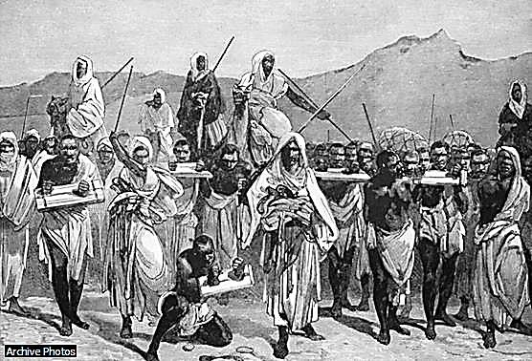

#### Fig. 1 Arab Slave Traders

This 19th-century engraving depicts an Arab slave trading caravan transporting black African slaves across the Sahara. The trans-Saharan slave trade developed in the 7th and 8th centuries, as Muslim Arabs conquered most of North Africa. The trade grew significantly from the 10th to the 15th century and peaked in the mid-19th century.

**Source**: Archive Photos from **Microsoft ® Encarta ® 2009.** © 1993-2008 Microsoft Corporation.

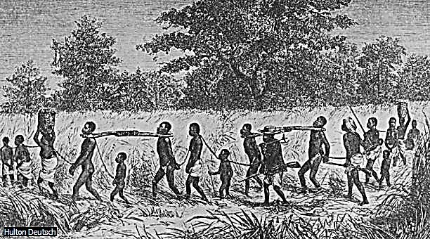

#### Fig. 2 Slavery in Central Africa About 1800

More than ten million slaves were transported against their will to the Americas during the nearly three centuries of the Atlantic slave trade. This illustration depicts African traders escorting fettered slaves to coastal shipping ports to be sold to European traders.

**Source**: Hulton Deutsch photos from Microsoft ® Encarta ® 2009. © 1993-2008 Microsoft Corporation.

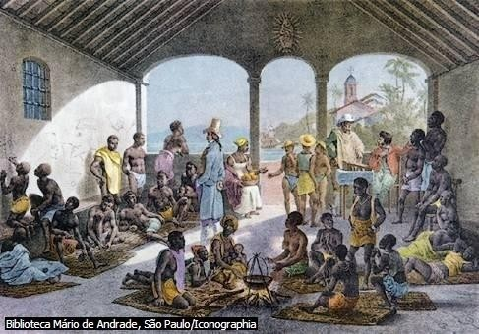

#### Fig. 3 Trade in African Slaves

From the 16th to the 19th centuries, trade in enslaved Africans played a major role in the economies of European colonies in the Americas. African slaves provided most of the laborers on islands in the Caribbean and on plantations in Brazil. This illustration shows a slave market in the Portuguese colony of Brazil. In 1888 Brazil became the last Latin American country to emancipate all its slaves.

**Source**: Photos from Biblioteca Mário de Andrade, São Paulo/Iconographia

**Microsoft ® Encarta ® 2009.** © 1993-2008 Microsoft Corporation.

#### The Trans-Saharan Trade

Afolalu (1969) pointed out that the Trans-Sahara trade was the most important outside contact between West Africa and the outside world until the 16th Centurywhen the Trans- Atlantic trade grew to rival it. The trade routes were of very great antiquity and are said to have begun as far back as 1000 BC. There were at least two well established trade routes between West Africa and North Africa from very early times –

* + - * A western route from Morocco to the Senegal and Niger.
      * A central route from Tripoli through Ghadames to Ghat and Hogger to the Niger.

By the 5th Century B.C., there had grown a flourishing trade between North African centres and the Western Sudan. The Carthaginians made several expeditions into the Sahara in order to get directly into the source of the riches of West Africa. Articles of trade were mainly in animals such as monkeys, lions, panthers, elephants, precious stones, emeralds and slaves.

With the introduction of the camel into the Sahara Desert about the first century A.D; there grew up a great number of trade routes which constituted a complicated network of routes across the Sahara Desert. The camel with its flat hoofs which make walking in the desert easy, its rich eye-lashes and ability to withstand drought and thirst was singularly suited as beast of burden for the desert. The migrations of people into West Africa and other areas of tropical Africa followed these routes. The routes were therefore of very great commercial, cultural, social and religious significance. The Moslem preachers and traders came along these routes. To Ogunsola (1977), “The main Trans-Saharan trade route had its centre in Bornu” (p.44). The Bornu trade routes connected Tripoli, Cairo and the kingdoms South of Egypt. Gold was not exported through the Eastern trade route but slaves were exported instead. Slaves were exported to North Africa and sold to the Arabs as house-hold servants. Ogunsola (1977) maintains that “It is worth noting that conversely, European slaves were

sold to African Chieftains during this period. Mansa Musa of Mali had some Turkish slaves” (p.44).

Trade with North Africa opened the Sudan to the influence of the Mediterranean countries, trade began in a larger scale than before. Main items of trade were fire-arms, salt, swords, liquors, cloth, kola, gold-dust and slaves. Exportation of fire-arms encouraged and intensified inter-tribal wars, which ruined most African states. Inter-tribal wars led to a slave trade across the desert. Many thousands of people were transported to North Africa. Slaves moved through the Sahara Desert suffered untold hardship. The journey across the desert often took several weeks. It was full of dangers from the winds, from robbers and from the lack of food and water. The most important thing which West Africa got from North Africa was salt.

There is evidence that in Ancient Egypt, African slaves were acquired not only for domestic work but also for the construction of such colossal projects as the Pyramids. The Egyptian hieroglyphics have also revealed that Pigmy slaves were employed during the dynastic period to act as court jesters. It is therefore clear that the sale of African slaves must have begun at a very early date. Anene (1966) opines that the first Africans to be sold out of Africa must have been the Nubians who lived South of Egypt. From Egypt they were sold to Europe and the Middle East; hence the constant reference in the literature of Greece and Rome to Ethiopian slaves. During the Carthegenian period in North Africa, vast numbers of slaves were employed in the cultivation of estates. Labour requirements stimulated trade in slaves between North Africa and the Sudan. The extent of the negro slave trade is not clear but detailed studies of cemeteries have yielded many skulls of a Negroid character. The Carthegenian army included many negroes. Carthegenian demands for slaves from the Sudan were to initiate the tragic traffick which lasted till the end of the nineteenth century.

Another important source for the early slave trade was East Africa. The majority of slaves from there found their way to Asia. A guide book for navigation and trade written about A.D

80 by a Greek seaman mentions slaves as one of the exports of East Africa. It is clear that the Arabs, Persians and Indians who found their way to the coast were already indulging in the slave trade. Early Chinese books described how Africans were enticed by food and were then caught and carried off for slaves. The extent of which the North-Eastern and Eastern portions of Africa must have been exploited for slavery is demonstrated in the stories of slave revolts which have been preserved. The ruler of Bagdad was said to had apparently initiated the policy of enrolling Zinj slaves in his army. When the slaves realized their large number, they chose a leader called ‘Lord of the Blacks’ and revolted. There was also a time when tens of thousands of African slaves captured and sacked Basra and for fourteen years, dominated the Euphrates basin. African slaves were also being exported in large numbers into India. In the Muslim kingdom, the African slaves were dragged into the army by the ruler who was reputed to have possessed over eight thousand of them.

The Arab incursion into the Magrib and the Sahara inevitably stimulated the out flow of slaves from West Africa. The Muslim preachers have also traders, and the slave was the inevitable article of trade. The links between West Africa, the Mediterranean and the Middle East were multiplied and sustained by caravans which dominated the Sahara trade. Slavery was the greatest inducement for camel men to risk the hazards of the Trans-Saharan journey. In these cases, enormous quantities of slaves were required.

The Medieval kingdoms of West Africa derived great wealth from the export of not only gold but slaves. The capital of the old Ghana, Kumbi was noted for its slave market and which was no doubt kept well supplied raids on the peoples living to the South. The name ‘Demdem’ was given by the Arabs to the slaves which they purchased in the Ghana slave markets. When the empire of Ghana was over thrown by the Almoravids, Kumbi was sacked and many of its inhabitants were carried off to be sold as slaves in North Africa. Mansa Musa of the Mali Empire on his pilgrimage to Mecca in 1324, was said to have crossed the African continent with a convoy of five hundred slaves carrying gold articles. Other pilgrims

combined trade in slaves with their religious objectives, and took along slaves to barter for the goods of the Middle East. There is also the ample evidence that the rulers of Hausa states were extensive dealers in slaves. The early expansion of Bornu-Kanem towards the region South-East of Lake Chad was actuated by a desire to acquire new areas from which to capture negro slaves for the export trade to Egypt and North Africa.

#### The Trans-Atlantic Trade

This entails trade that connects countries on both sides of the Atlantic Ocean, involving crossing the Atlantic Ocean. Ogunsola (1977) observes that:

When the Portuguese sailed the Atlantic Ocean to West Africa in 1415, looking for gold, they discovered a sea route which eventually replaced the old and dangerous caravan routes across the Sahara. Trade was gradually diverted Southwards to the coast and to the Europeans who came across Atlantic Ocean to trade with the coastal people. (p.45).

Baur (2009) noted that there was one seemingly insurmountable obstacle to circumnavigate Africa out of Europe; the Green Sea of Darkness supposed to begun at beyond Cape Bojador and from which there was no return. Cape Bojador was at the latitude of the Canary Island on the Saharan Coast just 40km into the sea, constantly assaulted by violent waves and currents, stormy winds and strange fogs, all of which gave birth to the Seamen’s belief that if anyone sailed beyond it, the devil would raise a gigantic hand and seize him. Twelve unsuccessful attempts were made in fifteen years, till one of Dom Henrique’s ship, under captain Gil Eanes rounded the cape in 1434.

The man who set out to find a new way to the Indies was Dom Henrique, third son of king Joaol of Portugal. He became known as Henry the Navigator. He considered the whole enterprise as part of the crusade, the age long (722-1492) war to throw off the yoke of

Muslim occupation from Spain and Portugal. At this time the Moors, as the Muslims were called, still had a strong hold in the rulership of Southern Spain which had withstood all attacks, Prince Henry decided to carry the war into the Moorish land itself. In a bold expedition, he took Ceuta, the African town facing Gibrattar in 1415. It was possible to hold Ceuta permanently, but a further frontal attack on the enemy seemed impossible. So Henry conceived the plan of outflanking the Moors by Sea. The Portuguese armada, would find a way around Africa and supported by other European Princes to attack the enemy from the rear. He built an observatory and for the rest of his life, he studied the possibility of navigation. Baur (2009) asserts that: “Year after year he sent out ships that penetrated further and further into the unknown seas along the African Coast” (p.45). For Dom Henrique it was at first the opening of a way to attack the Moors from the rear. He looked for allies among the European Princes but found none. The Pope was also anxious to invite one Prester John, the Emperor of Ethiopia to join in the Church Union and crusade against the Muslims.

Also European merchants envied the valuable caravan trade in gold, salt and slaves across the Sahara Desert and the oriental trade which passed through Moslem lands. The merchants were therefore anxious to encourage voyages of exploration which might provide easier and cheaper trade routes. Naturally, scientists and geographers were eager to learn of what lay behind the unknown seas. Sailors and scientists were especially serious about the land beyond Cape Bojador which many superstitions surrounded. Sailors believed that beyond this point was a dark sea where ghosts would turn white men black and white men would be devoured by wild beasts

At Sagres on the South Coast of Portugal, Henry established a school of navigation where he collected round him pilots, cartographers, scientists and ship builders. By yearly expeditions, each being charged to penetrate a little further than its predecessor into unknown, the Portuguese made steady progress and reached as far as Malaguetta Coast. In 1434, Gil Eannes rounded Cape Bojador. Afolalu (1969) infers: “this was a spectacular achievement as

it destroyed forever the tales and superstitions associated with the Cape” (p.23). Still in 1441 a new expedition went beyond Cape Bojador and reached Cape Blanc in Mauritania, bringing the Portuguese for the first time into contact with negro Africans. They got some slaves, whom the sailors acquired in exchange for European trade goods. Those slaves were taken to Portugal where they were trained as interpreters and were baptized. With this contact and success recorded, the possibility of a lucrative trade in gold and slaves with Africa was a reality with good prospects. In the hope of tapping the trans-Saharan gold trade, Portugal erected a trade post on the nearby Arguin Island. Trans-Atlantic route boosted the ungodly deal in African slaves to a disastrous dimension in the following centuries, when slaves were transported as far as the Americas.

#### The Discovery of the New World

The first European country to export slaves from Africa was Portugal. In 1441 when Prince Henry’s Seamen reached the West African coast looking for the sea route to India, they captured 12 men, women and children and brought them back to Portugal as slaves. Within seven years nearly a thousand slaves had been taken away and sold at the Lisbon slave market. The Portuguese and Spanish explorers had originally set up provision stations for ship sailing South around the African continent enroute to the East Indies and mainland Asia. With the discovery of the New World and the development of its vast resources, there was a demand for labourers for the mines and plantations. The provisioning stations of West Africa became slave trading Ports. Afolalu (1969) wrote:

But whereas at first the discovery of the route to India made the collection of slaves comparatively unprofitable, Columbus discovery of the West Indies and America made the trade most profitable venture. The discovery of America therefore was responsible for the greatest increase in the slave trade that the world had known. (p.67).

Following the discovery of America, many Europeans left their own homes to settle in the New World. The English, the Dutch, the French and others founded colonies on the Island of the West Indies and in North America. From the very beginning, these European settlers started to open up rich gold and silver mines in the New World. They began cultivating sugar cane, tobacco, cotton, ginger, indigo and coffee in a large scale in the tropical and sub- tropical areas of the land.

As the work in the mines and on the plantations increased, the demand for labourers became immense. Neither the Spaniards nor the Portuguese could provide enough people. They equally realized that the nations of the Americans and the Island were not strong enough to undertake such heavy work. Firstly, as depicted by Afolalu (1969) they turned to Indians, but the Indians were too weak to stand up to the rigours of the work involved. Many died because they did not have the strength required. The situation was saved by the importing of negroes from West Africa. The first of these negroes arrived in 1510. Rodney (1972) confirms that:

The massive trade in human beings from Africa was a response to external factor. At first, the labour was needed in Portugal, Spain and in Atlantic Islands such as Saotome, Cape Verde and the Canaries, then came the period when the Greater Antilles and the Spanish American mainland needed replacements for the Indians who were victims of genocide, and then the demands of Carribean and mainland plantation societies to be met. (p.90).

Some religious men like Las Casas, the first Bishop of Mexico spoke out against the ill- treatment of the natives whose sufferings were immense and whose fate was at the danger of extermination. They persuaded the owners of the mines and plantations to look elsewhere for men and women to replace the American Indians. The Portuguese traders having taken slaves from West Africa back to Portugal, found them to be very strong. Thus, when the European

adventurers, miners and farmers decided to look elsewhere for workers, they decided to use the people of Africa.

It is on record that Portugal inaugurated the slave trade between Western Africa and Europe. They had the first of many chartered companies to trade in African gold and slaves. The slave trade grew rapidly when the New World was discovered and a few negro slaves admitted to the West Indies proved such a success that the traffick grew enormously and became so competitive. Portugal was leading in the slave trade from Africa to the Western hemisphere in the 16th century. In the 17th century, the English and the Dutch successfully challenged the Portuguese monopoly of the overseas trade and quickly displaced them in West Africa.

The trade routes between Europe, West Africa, and the New World soon formed a triangle. From the European posts, manufactured goods were shipped to West Africa and traded for slaves. The slaves were carried to the countries of the New World and traded for such produce as sugar, coffee, tobacco, cotton, silver, and gold. This cargo was then sold to the European markets.

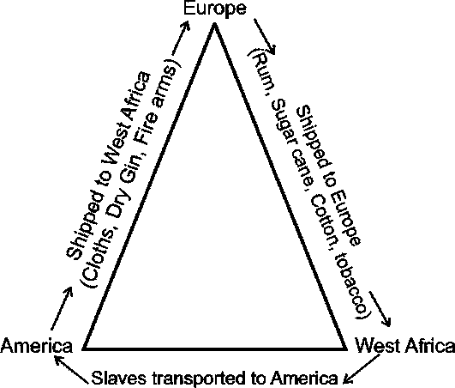

The above figure as illustrated by Ogunsola (1977) depicts the triangular nature of the slave trade.Falk (1997) vented his lamentation thus:

The slave trade developed into an enormous blemish on modern history. Greed dominated the scene and power ruled; there was no consideration for the next person. African chiefs and European and Arab traders used their power for material gain without compunction for the lives lost, the families disrupted, and the agony of parents who lost their children. The world was seemingly struck with blindness and failed to perceive the inhumanity of the slave trade. (p.96).

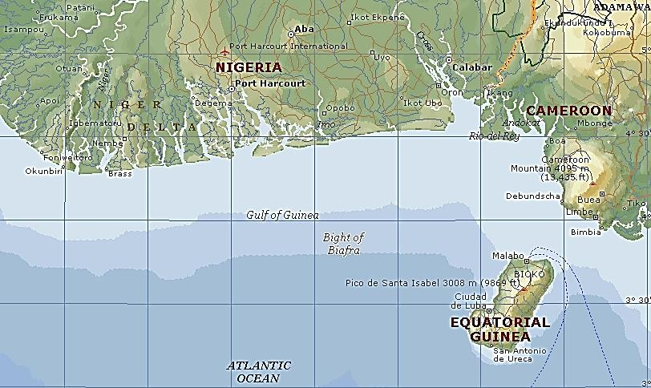

***Map 1 Showing the Bight of Biafra: An old slave centre***

**Source: Microsoft Encarta 2009. © 1993-2008 Microsoft Corporation.**

Bight of Biafra, also Bight of Bonny, bay in western Africa, in the eastern part of the Gulf of Guinea, 600 km (400 mi) long. The Bight of Biafra extends from the mouth of the Niger River in Nigeria to Cape Lopez, Gabon, and is fed by the Niger, Cross, and Sanaga rivers. Islands in the bay include Bioko (formerly Fernando Póo), São Tomé, and Príncipe. Principal ports include Malabo, Equatorial Guinea; Port Harcourt and Calabar, Nigeria; Douala, Cameroon; and Libreville, Gabon. From the 16th century to the 19th century, the Bight of Biafra was a slave trading centre. However, after the British outlawed the practice in 1807, palm oil trade became a chief economic activity. In the 1950s petroleum was discovered in the Bight of Biafra and has become an important economic resource for the region.

It was estimated that over 20 million Africans were taken into slavery. The percentage distribution of slaves by origin to few areas are shown in the table below:

|  |  |  |  |
| --- | --- | --- | --- |
| Origin | North America  % | Jamaica  1655 – 1800 | France  1751 – 1800 |
| Angola | 24.5 | 17.5 | 45.2 |
| Bight of Benin | 4.3 | 13.8 | 28.0 |
| Bight of Biafra | 23.3 | 28.4 | 8.5 |
| Gold Coast | 15.9 | 25.5 | 6.4 |
| Mozambique – Madagascar | 1.6 | -- | 1.6 |
| Senegambia | 13.3 | 3.7 | 5.4 |
| Sierra Leone | 5.5 | 10.9 | 0.9 |
| Windward Coast | 11.4 | -- | 2.3 |
| Unknown | 0.2 | 0.3 | 1.6 |
| Total | 100.0 | 100.0 | 100.0 |

#### Table 1: Old Slave Trade Percentage distribution

**Source:** Extract from George E. Simpson’s book ‘Black Religions’ in the New World, New York: Columbia University Press, 1978 p.7.

Simpson (1978) noted that slaves were shipped from eight coastal regions in Africa, even though the actual origins in the interior were uncertain: 1. Senegambia, including the Gambia and Senegal of today; 2. Sierra Leone, a region somewhat larger than the present country; 3. a region consisting mainly of the present Ivory Coast and Liberia; 4. The Gold Coast roughly coterminous with the present day Ghana; 5. The Bight of Benin region from the Volta to the Benin River , the core of which in the eighteenth century was the more limited area known as the “slave coast” of present day Togo and Dahomey; 6. The Bight of Biafra, centreed on the Niger-Delta and the mouths of the Cross and Duala rivers to the east; 7. Central Africa, corresponding roughly with the present day Angola; and 8. South eastern Africa from the Cape of Good Hope to Cape Delgado and including Madagascar. The real centre of the slave trade was tropical America. Approximately half of the slaves were brought to South America, 42 per cent to the Caribbean Islands, 2 percent to Middle America, and 7 percent to British North America. According to Simpson (1978), “probably the Atlantic fringe from Brazil through the Guianas to the Caribbean Coast and Islands received 90 percent of the trade” (p.5).

* 1. **Slave Trade in Nigeria**

The essence of this section is to narrow down the scope of this discourse to the states that make up the present Nigerian nation. There was no country known as Nigeria until 1914 when the Northern and Southern Protectorates were amalgamated. Even though Nigeria nation was not recognized as a separate entity or country in West Africa, yet its people are recognized and represented in Igbo, Yoruba, Niger Delta, Hausa, Efik and other tribes under the Bight of Biafra. Falk (1997) acknowledges that the slave trade took different forms and had different effects in various parts of the continent. It was most complex in West Africa, and its effects were most profoundly felt in Nigeria. To Isichei (1973):

It was the tragedy of the Costal peoples that this new opportunity was to take the form of a trade in slaves. Although the Portugal had first only limited use for slaves, the situation was soon transformed by development in the New World. (p.45).

Captain Adams (cited by Isichei, 1973) who undertook ten slaving voyages to Africa between 1786 and 1800 stated that 20,000 slaves were sold annually at Bonny, 16,000 of them Ibos. Over a twenty-year period, he estimated that 320,000 Ibos had been sold to European slavers in Bonny, and 50,000 at Old and New Calabar. Throughout the period of the slave trade, the vast majority of the slaves purchased at the Delta Ports were Igbos. Isichei asserted that “indeed, Iboland, with its dense population and many small independent states, was particularly, susceptible to exploitation of this kind” (p.46).Most of the Igbo slaves were obtained by kidnapping. The great bulk of them were such as had been taken in piratical excursions, or by treachery and surprise.

According to E. Okoronkwo (personal communication, 14th March 2016), his father Okoroji Otti was the principal slave dealer in Arochukwu. He bought slaves under special

arrangements where some chiefs and slave dealers supplied slave victims who were dispatched to work for him as hunters, farmers, palm oil and kernel processors. Such victims were deceived by their sellers on the pretense of accompanying them to Okoroji’s compound for message only to abandon them, having collected money or its equivalent on their heads.

The states of Lagos, Bonny and many others were ruled by Chiefs who themselves made fortunes out of the slave transactions. The slaves were produced by an interminable chain of middle men which ramified into all parts of the hinter land. Nigeria was a favourite haunt for European pirates who were not averse to organizing local raids of their own. The Portuguese traded with Benin by buying pepper, ivory and slaves in exchange for firearms, coral beads and clothes. The king had a virtual monopoly of external trade. No one could trade directly with the foreigners except on the orders of the king. Benin also served as a coastal outlet of Oyo Kingdom.

Much of the early contacts which Oyo had with Europeans was through Benin in the 16th century, up to the first half of the 18th century. According to Afolalu (1969), Benin was an expanding and progressive flourishing kingdom. At its zenith in the 18thcentury, the kingdom reached as far East Bonny and Onitsha, as far West as Lagos and Port Novo on the coastal and Ondo province in the West. By the end of the 18th century, Benin was on decline. Benin kingdom became too aggressive and warlike. There was a great decline in prosperity. This situation was due to the demoralizing effects of the slave trade. The need for slaves to sell to the European slave traders on the coast made incessant raids of the neighboring territories a regular feature of life in the kingdom. As the demand for slaves increased, so also Benin slave raiding was increased.

The slave trade affected all the Niger-Delta states. Calabar which was founded by Efiks in 1600 grew and prospered as a result of trans-Atlantic trade. It was a most important Port for the supply of slaves in the 18th century. The Itsekiri kingdom of Warri, Iboland, Bornu and Hausa states and others were actually engrossed in slave trade. According to Afolalu (1969), there were three principal trade routes through which slaves were taken outside Iboland:

1. The Northern route from Nike to Ogurugu to Iddah in the North
2. The South-Eastern route from Awka to Bende to Arochukwu to Calabar and Bonny. Through this route slaves were sold to middlemen who sold them to slave traders on the coast.
3. The Eastern route across the Cross River.

The Aros were astute and shrewd traders who established their commercial hegemony over the Ibos and Ibibios. They were shielded by the Ebini Ukpabi Oracle, the strongest and long juju which was highly revered. The success of the Europeans in the demolition of the Oracle spelt doom for the area, and exposed them to massive enslavement as they became victims of slave trade.

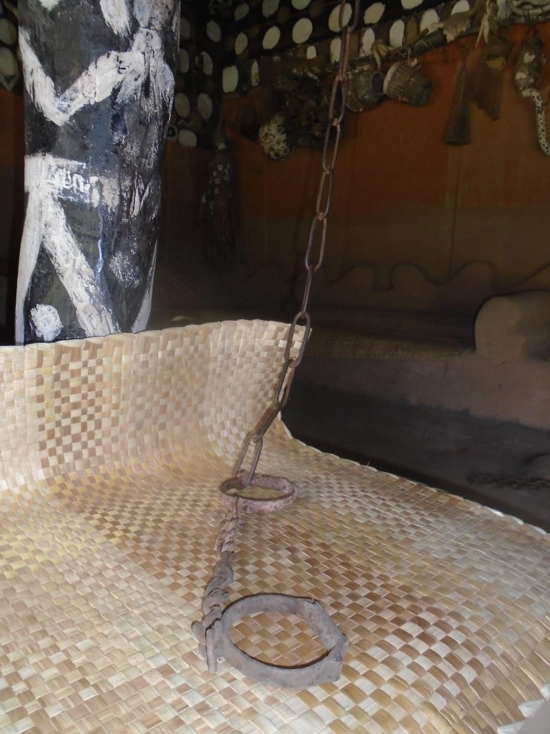**Fig. 4** Showing slave chain and rings found in Mazi Okoroji’s house at Ujari in Arochukwu.(14-03-16).

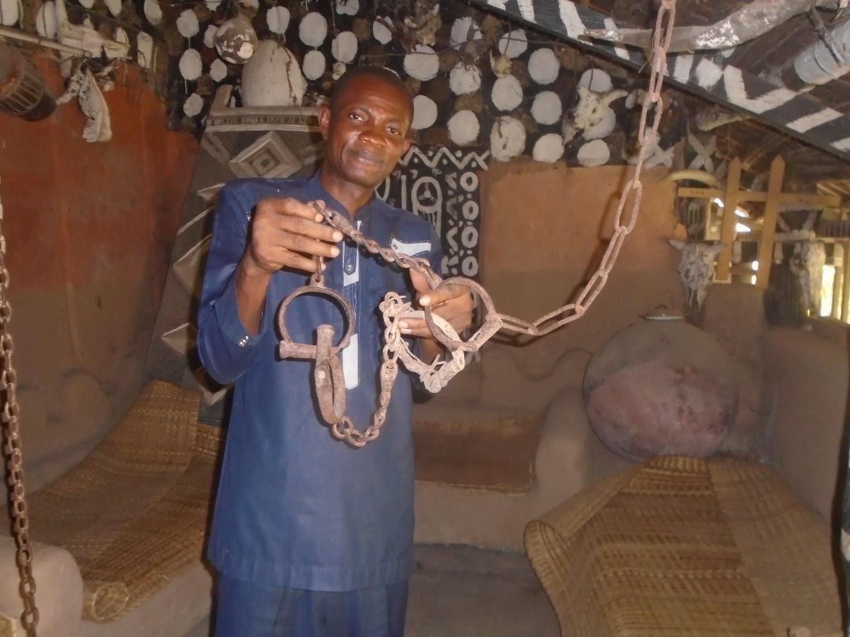

**Fig. 5** The researcher showing multiple slave rings and chain (14-03-16).

**Source:** Mr. Okoroji’s compound of Ndiokoroji, Ujari in Arochukwu Abia State.

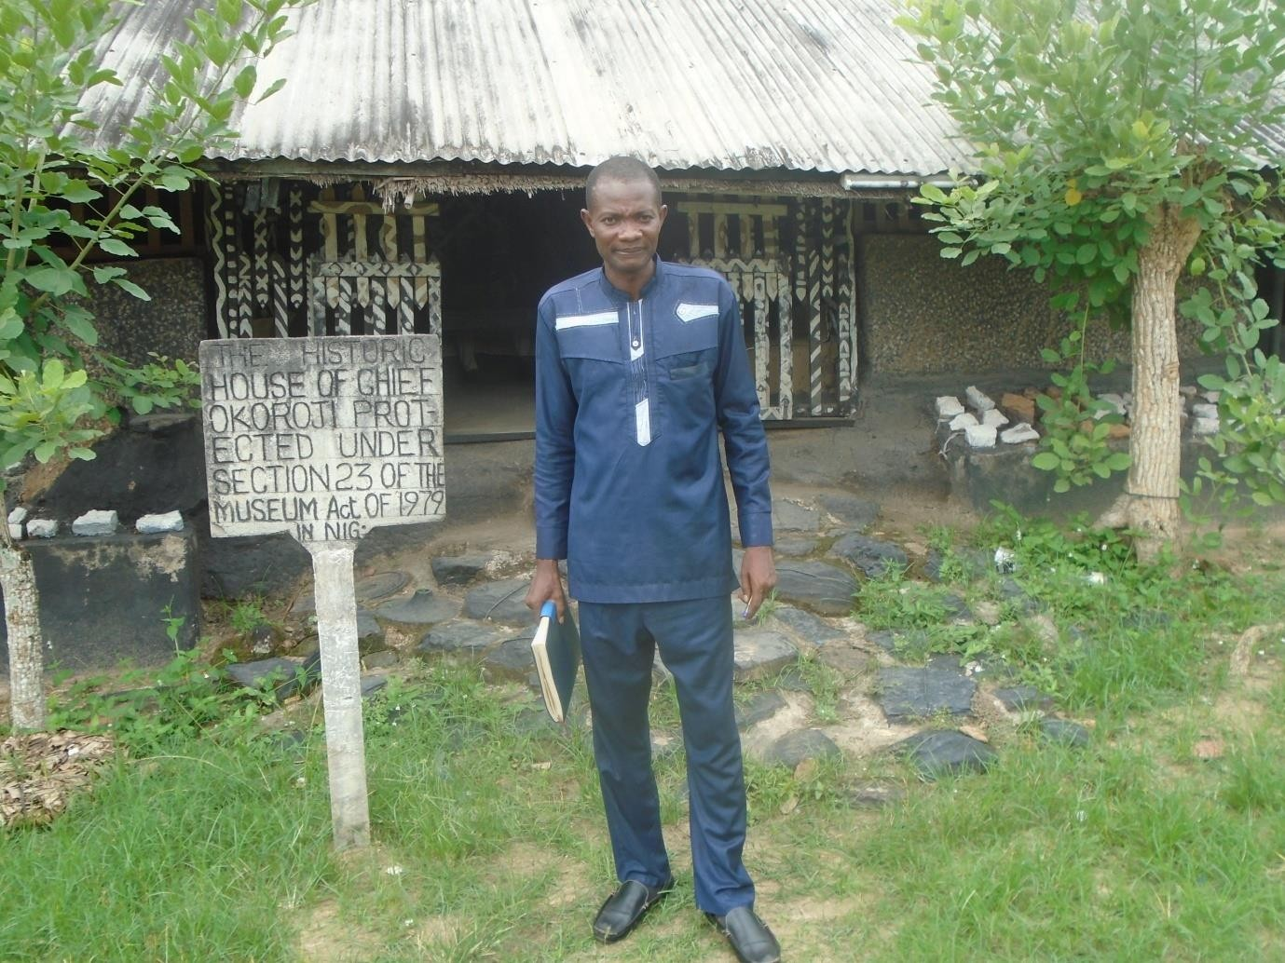

**Fig. 6** The researcher standing in front of Mazi Okoroji Otti’s compound in Ujari Arochukwu, 14th March, 2016

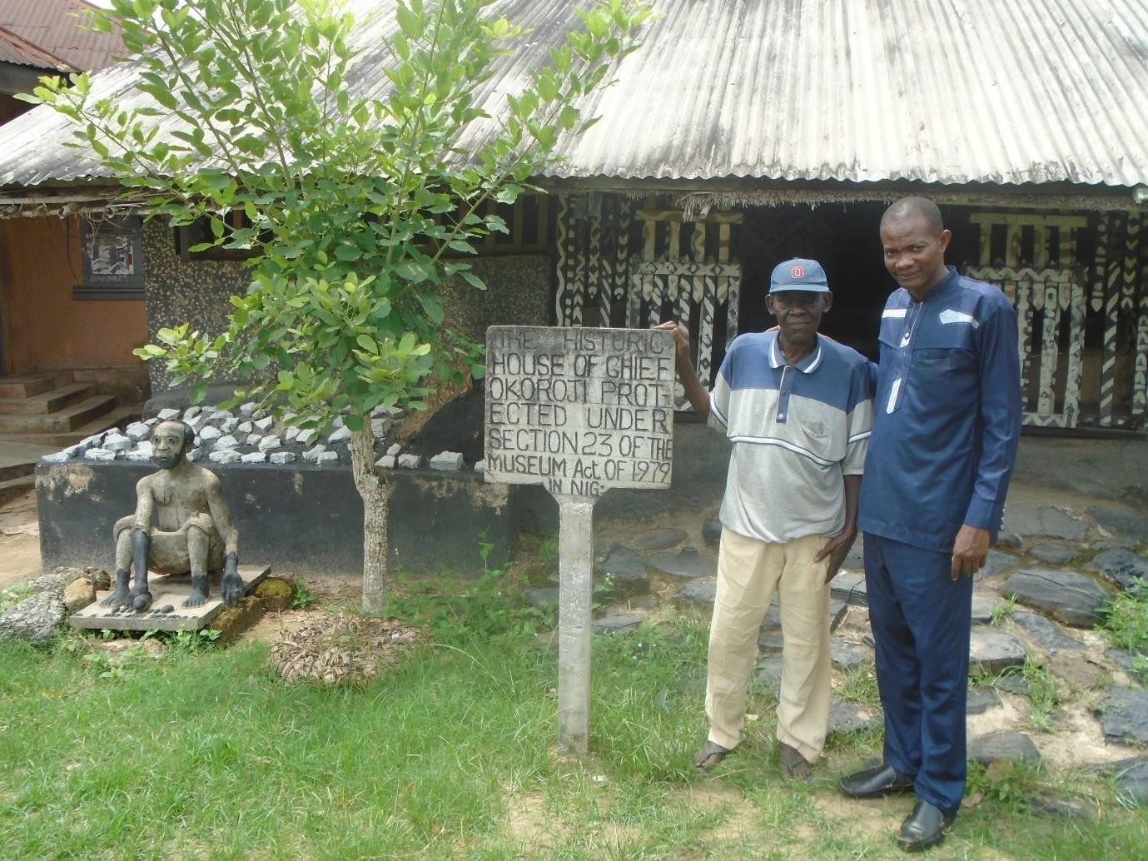

**Fig. 7** The researcher standing with Mazi Ezuma Okoronkwo, the son of Okoroji Otti Source: Chief Okoroji”s Compound in Ujari-Arochukwu, 14th March 2016

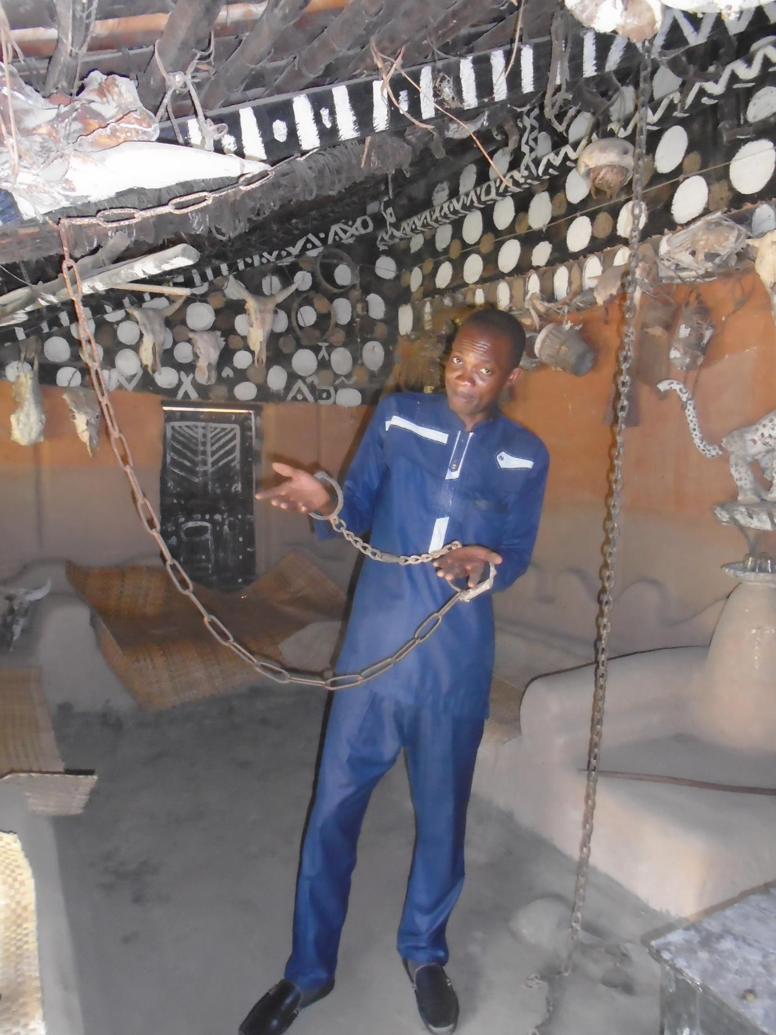

**Fig. 8.** Showing the researcher experimenting the slave rings.

Source: Chief Okoroji’s historic Museum in Ndiokoroji village, Ujari-Arochukwu:14th March, 2016

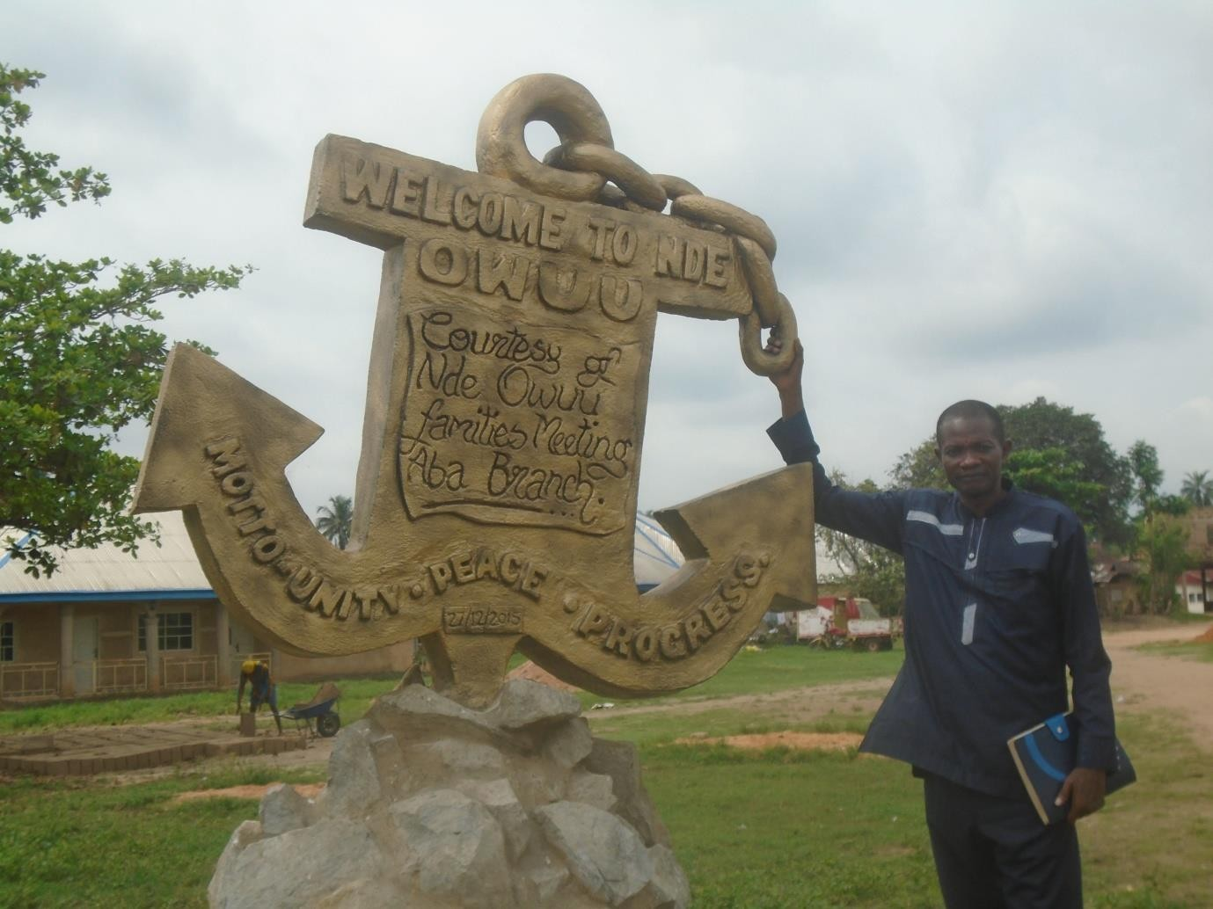

**Fig. 9.** Showing a slave chain sculpture which is a reminiscence of the old slavery days: initial chain of bondage has become the bond of communal unity

**Source**: Nde-owuu village square in Ibom community of Arochukwu, 14 th March,2016

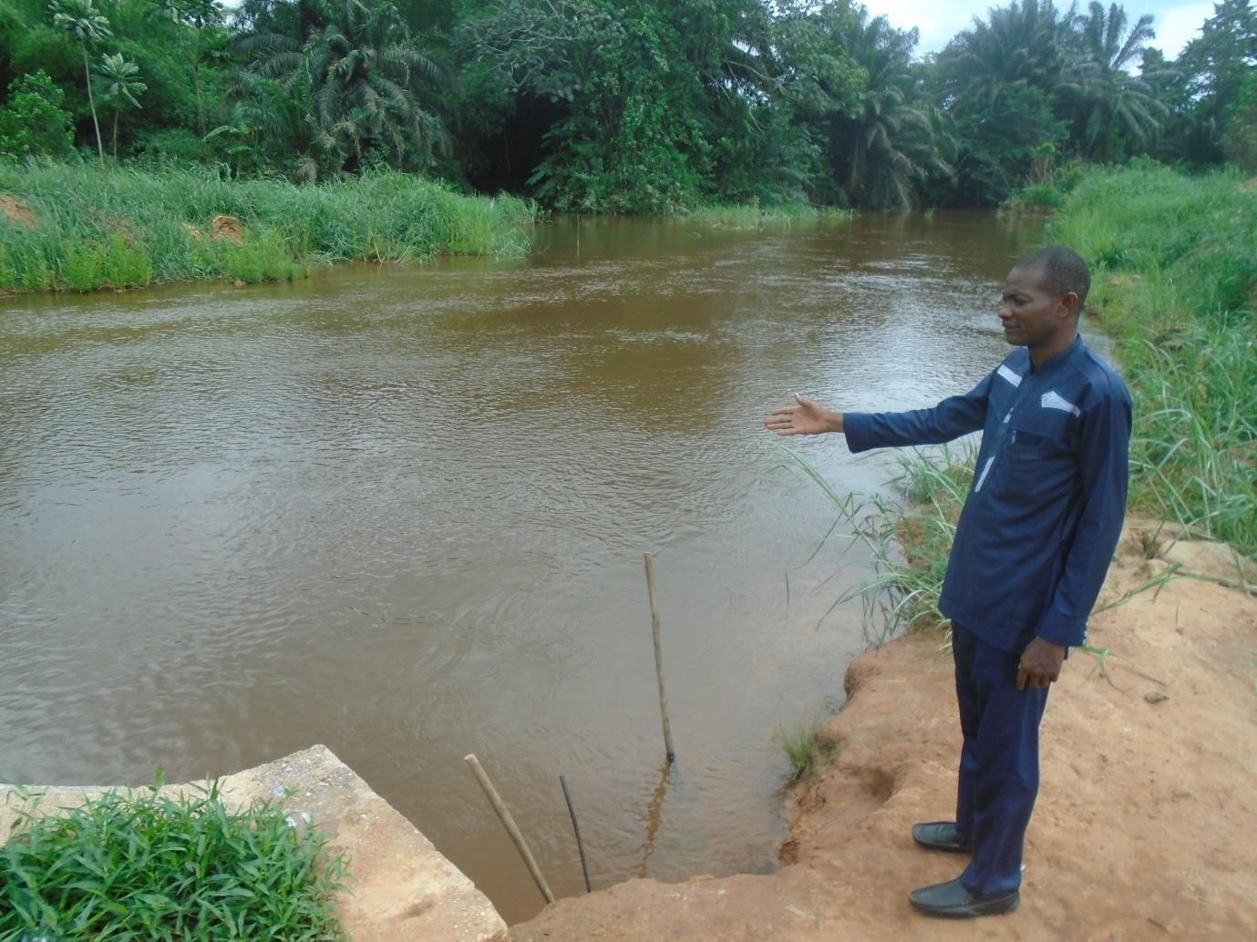

**Fig. 10.** Showing Nkaanu River, a slave trade route between Arochukwu and Bende criss- crossing Cross Rivers( Pix by the researcher’s companion, Daniel Kanu, 14-03-16).

**Source:** Bende, Abia State, Nigeria

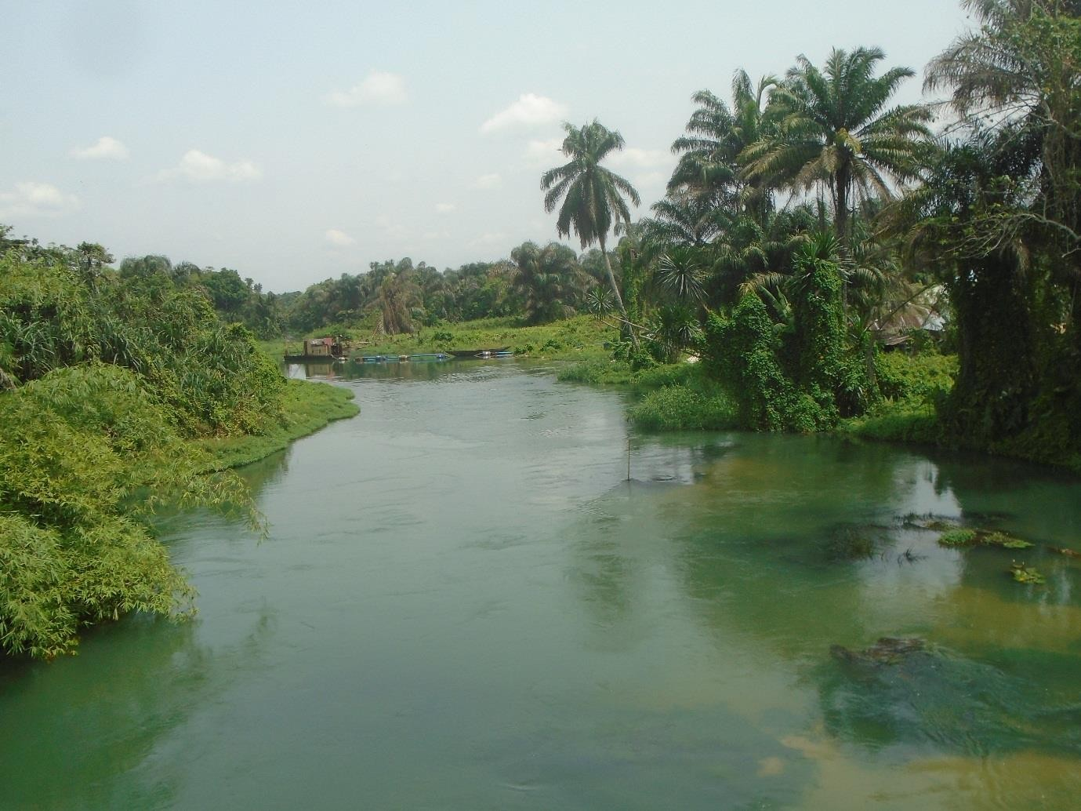

**Fig. 11.** Views the Blue River in Azumini,( Abia State) a popular slave trading route to Bonny, Cross River and Rivers States, 15-03-16

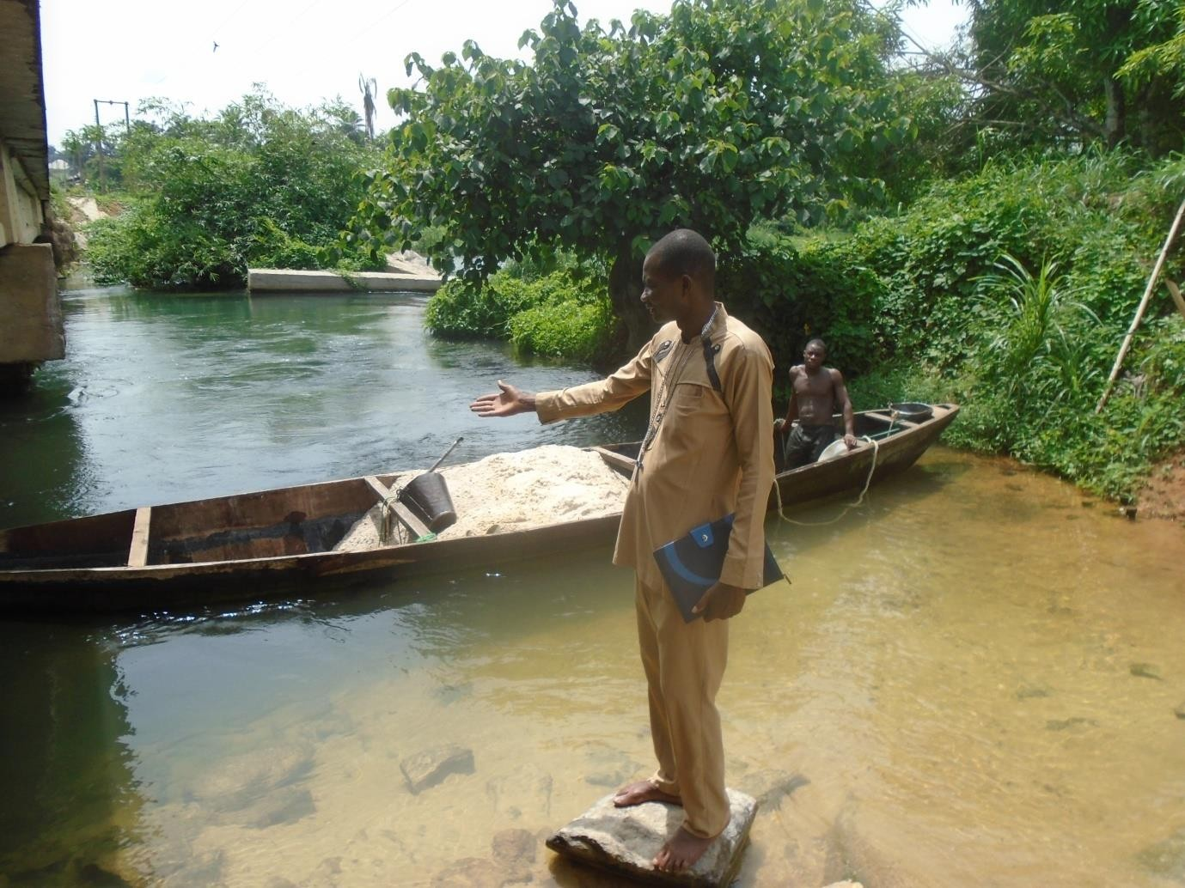

**Fig.12**. The researcher standing near a boat on Azumini Blue River

**Source:**Azumini in Ukwa East L.G.A., Abia State, Nigeria (Pix by the researcher’s Companion, 13-03-16)



**Fig. 13.** Shows the calabash that contained medicine used for calming down stubborn Slaves to hypnotize and calm them down to implicit submission

**Source**: Mazi Okoroji’s house in Ujari, Arochukwu, 14th March 2016



**Fig.14.** Showing the researcher holding the Medicine calabash for controlling stubborn slaves

**Source:** Chief Okoroji Museum in Ujari-Arochukwu, Abia State, Nigeria-14-03-16

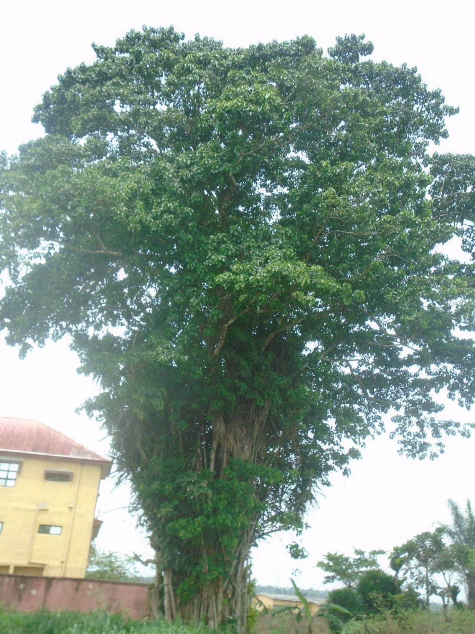

**Fig. 15.** Showing an Ancient tree standing at Nwaebule market, a former slave market at Azumini Ndoki, Ukwa East LG.A., Abia State, Nigeria (13th Maqrch, 2016)

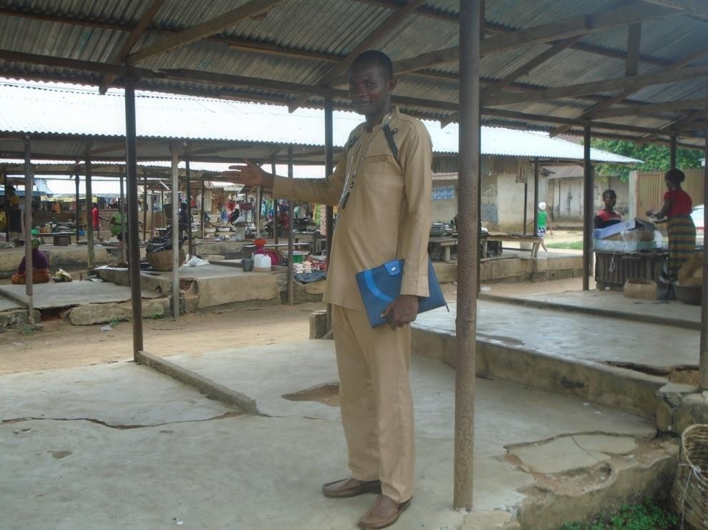

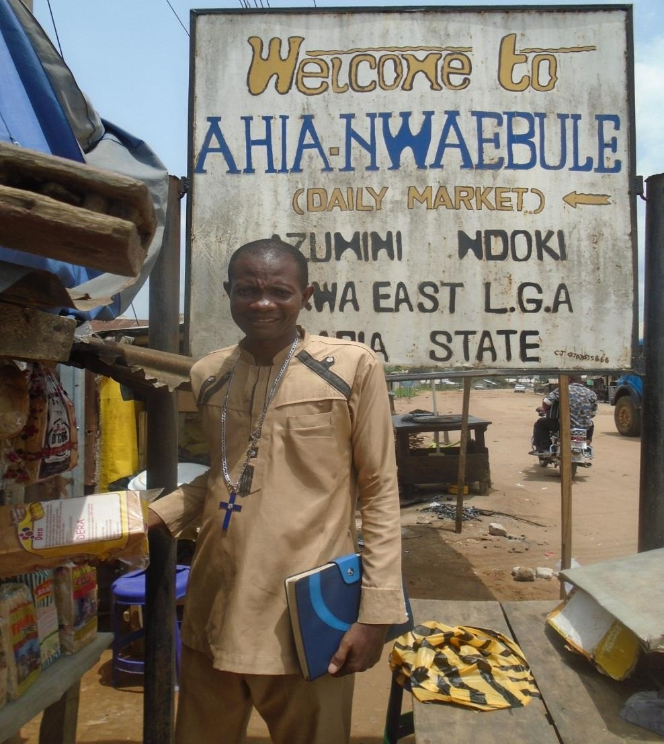

**Fig. 16.** Showing the researcher shopping in Ahia Nwaebule, a former slave market at Azumini-Ndoki in Ukwa East L.G.A, Abia State (very close to the Blue Sea, slaves- transporting route) 15- 03- 17

**Fig. 17:** The Ohambele Ancient Mango Tree near Onwo (river) where captured people were tied before being sold out into slavery.

**Source:** Ohambele, Onwo River Traders route in Ukwa East L.G.A. (pix by Goodluck Digital Photos, Obohia Ndoki, Abia State, 30th May 2017).

According to Ajayi and Espie (1965), the slave trade provided a lucrative source of wealth that the coastal settlements underwent remarkable political and social developments. City states emerged. The most important were Warri, Sapele (Itsekiri and Urhobo), Brass, Akassa, Twon, Nembe (Ijaw), Buguma, Abonnema, Bakana (Kalabari), Bonny (Ibeno) and Creek Town, Henshaw Town and Duke Town (Efik). “Inter-house rivalry was a constant menace to stability and if there was a weak king, civil war invariably threatened” (p.305).

After the abolition of slave trade in Europe, many Nigerian communities still retained the slaves they captured. In the 1850s, the plantation slaves in Calabar organized themselves under their own leaders to protect their members against the arbitrary exactions of their masters.The slave society was aimed primarily at the Ekpe society which was the instrument at the disposal of the Calabar rulers for keeping their slave population in complete subjugation. As soon as the slaves had organized their own sacred society known as the ‘Order of Blood’, they not only defied the authority of the Ekpe society but threatened to invade Duke Town. Civil war was averted only by the intervention of the British consul, merchants and missionaries.

Isichei (1970) wrote extensively on slave trade and its effects in Igbo country. According to her, Iboland was one of the areas of West Africa most seriously affected by the slave trade asthey were exported as slaves throughout the whole period of the trade. When the Barbot brothers visited the Delta in the late seventeenth century, they described how Bonny and Kalabari had become the main centres of the trade. Their people would go to the inland markets in their great trade canoes, exchanging European goods and fish for slaves, and a certain amount of Ivory.

The eighteenth century has been rated as the period when the largest numbers of slaves were exported to Europe (1701-1810). During this period, the trade was dominated by the English who drew the bulk of their slaves from the Iboland. Ikime (1969) maintained that throughout the period of the slave trade, the vast majority of the slaves purchased at the Delta ports were Ibos, though some were Ibibios, and those sold in the Western Delta were mainly Urhobos. The effect of slave trade in Igbo nation in particular and Nigeria– Africa as a whole will be discussed in the subsequent sections of this work.

### The Agents of Slave Trading

To Rodney (1972), much guilty consciences have been created by the slave trade. Europeans know that they carried on the illegal trade, and Africans are equally aware that the trade would have been very difficult if not impossible if certain Africans did not co- operate with the slave ships. To ease their guilty conscience, Europeans try to throw the major blame of responsibility for the slave trade on the Africans. Some European scholars have been influenced to write that the African chiefs were responsible for the tragedy and that Europeans merely turned to buy the captives as though without Europeans demand, there would have been captives sitting on the beach by the millions. For Rodney, it was European capitalism which set slavery and the Atlantic slave trade in motion. Thus, the trade in human beings from Africa was a response to external influence. Portugal, Spain, England, France, Holland, Sweden, Denmark, America, Africans, Arabs, Missionaries and other groups, individuals or nations were involved in slave trading. As Spain had no colonies in Africa, the Spanish settlers in America agreed to buy from Portugal the slaves they needed in the New World. The trade reached its peak in eighteenth century and other European countries joined the scramble for African slaves.

As early as the 16th century, the Europeans particularly the Spaniards had been shipping African slaves to their colonies in South America to work in the mines. Britain joined this trade in 1662 when John Hawkins persuaded other British traders to join with him in shipping slaves to the Americas. From Lisbon, the dealers in slaves loaded their ships with dry gin, rum, firearms, swords, cloths, ornamental goods and other items and sailed to the West African coasts. These items of trade were exchanged for slaves. The slave trade was encouraged indirectly by the gold miners and the tobacco, cotton and sugar- cane plantation investors in the Americas.The slave trade was organized as a commercial enterprise. Liverpool and Bristol grew rich on the slave trade and the trade was often referred to as ‘the great support of our people’. Liverpool boasted of being the principal slaving port not only in England but in Europe.

The other Western European powers were of course, not to be outdone by the British. The Dutch founded a company for the West African trade and set up ports in order to challenge the positions of the other rivals. The Portuguese, the French, the Dutch, Danes, Germans, Swedes, Spaniards and the British were all involved in the traffick in Negros. They built ships designed to carry the largest number of slaves in the minimum deck- space. The African chiefs have been grossly indicted in the sale of their subjects and neighbours. Buah (1970) asserts:

The European slave dealers did not generally go themselves into the interior of Africa to buy slaves. They had agents who bought the slaves mainly from the chiefs and brought them down to the European castles on the coast. (pp. 57-59).

Local African potentates obtained the slaves and transacted sales with the European slavers on the coast. For instance, in Nigeria, the states of Lagos, Bonny, Benin and many others were ruled by chiefs who themselves made fortunes out of the slave transaction.

The slaves were therefore produced by an interminable chain of middlemen, which ramified into all parts of the hinterland. The provisioning stations of West Africa became slave-raiding ports. The new market greatly encouraged slave raiding. The chiefs of Benin coast took the opportunity to enrich themselves and by bargaining with the competing European powers. The desire for European goods seduced many African chiefs into co-operating with the traffick, consciously helping to inflict much misery on their brothers and unconsciously co-operating in the destruction of their own dignity. Thus for Adetoro (1969), “All the blame should not be put on the Europeans who took part in it. Our own people were as much to blame” (p.27).

The African rulers had a certain status and authority and when bamboozled with European goods, they began to use that position to raid outside their societies as well as to exploit internally by victimizing some of their subjects. In the simplest of societies where there were no kings, it proved impossible for Europeans to strike up the alliance which was necessary to carry on a trade in captives on the coast. The tribes that had long- standing hostilities toward one another took the opportunity to capture and sell members of the neighbouring tribes as slaves. The Europeans were content that war-like African rulers should make war against their weaker neighbours in order to maintain the flow of slaves to the stations established along the West African coast.

According to the report written by the Propaganda Fide, Secretary to the Portuguese ambassador for the Kongo in 1833 (cited by Baur, 2009),

The greatest hindrance of missions is the slave trade, operated by the (Portuguese) Christians of Angola. It renders our religion odious to the Africans who keep in mind their chains instead of seeing the freedom brought to them by Jesus Christ. (p.94).

Early missionaries have been associated with slave trade. What perhaps was most detrimental to the work of evangelization was the sad fact that Portuguese priests and religious men actively participated in the slave trade. While people tolerated that laymen engaged in the infamous trade, they found it bad and unbearable when it was done by religious priests. The participation was not only a scandal but it almost entirely diverted them from their pastoral ministry.

Writing on the reasons for the failure of the early missionaries in West Africa, Agwu (1978) added that inadequate funds hampered the work. “Most Portuguese missionaries took to slave trading to cope with their financial requirements. The Spanish Jesuits too also traded in slaves from Angola to Brazil in order to support themselves” (p.12). The quest for wealth, and desire to trade resulted to missionary work being sacrificed. Some clergy missionaries were reprobates whose moral lives were questionable and were involved in a number of illegal activities. Afonso (cited by Buar, 2009) wrote:

Unfortunately, the life of “These holy servants’ was anything but holy: Although they were regular canons bound to a common life of poverty, they at once started living in separate houses, filled with slave girls. They gave great scandal and people laughed at the king, saying that “everything was a lie.” (p.59).

On the European side, cupidity was also to blame. But how could the Christian conscience permit slavery. True, Christianity had grown up in a world where slavery was an undisputed institution. Thomas Aquinas and other theologians restricted enslavement to non-Christian prisoners captured in a just war, limiting it in practice to Muslims, who also prohibited the enslavement of their faithful. Consequently, Pope Nicholas V and his successors felt justified in giving to the Portuguese crusaders the permission to subdue and enslave pagans and all other infidels and enemies of Christ along the Guinea coast.

This point was never clarified in Rome, perhaps because Africa remained the “dark continent”, beyond the Europeans range of knowledge and interest. The Pope and other religious leaders in Europe were rather concerned about the enslavement of Indians in America, which was severally condemned. Meanwhile, the Portuguese crafted the argument which in the eyes of most Europeans seemed to justify the slave trade. In the interior of Africa, they argued, there were very underdeveloped tribes which led to a sub- human life, similar to animals. Through enslavement they would learn a more decent way of life and the captured slaves when baptized, they could win citizenship in heaven. But if they remained in their own regions where a missionary would never penetrate, they would die in their sins and go to hell. This argument taken from the report of the first Capuchin Prefect shows to what extent the rigorous application of the then generally accepted principle “outside the church there is no salvation” could lead. The worst thing that could happen to an already baptized slave was, in the eyes of the Capuchins, to be sold to heretics, i.e. to Protestant country, where they would loose the Catholic faith and certainly, their eternal salvation. Hence they prohibited selling of baptized slaves to Protestant traders. Pope Clement XI in 1711 approved such a view when he permitted the baptism of the king of Angola, provided he would give up selling slave to heretics.

We could see that during about three centuries of exploration, that the European Christendom and early missionaries tolerated slave trade and closed their eyes to its evil and excesses. It was latter that they slowly began to perceive that it contradicted the dignity of the human person. Thus, when in the 19th century, missionaries became the main antagonists of the trade, there still remained in their sub-conscious minds, the image and perception of the ‘sub-human’ African which in turn infected Euro-African relations like a virus.

Another significant agents of the slave trade were the Arab traders and Muslim missionaries. We have already discussed the slave trade via the Sahara Desert and the Atlantic. We must point out that Arab traders were engrossed in slave trade in Africa as far back as the seventh century. Islam insisted that a Muslim should not buy a fellow Muslim into slavery, so that Arabs who had become Muslim turned to Africa for slaves. The slave trade across the Sahara brought great misery as did the slave trade across the Atlantic. Johnston (cited by Buah 1978) gave this vivid picture:

When they entered the desert country, they began to see signs of the slave trade across the desert. Round most of the wells where they stopped to get water, there were hundreds of human bones lying about in thousands. These were the bones of slaves who had died of thirst or hunger and were then left by the caravans. The road to the Sudan, indeed, was lined on either side by human bones. (p.65).

Jones (1958) asserts that:

It is one of the harsh and unpalatable facts of history that the principal-almost the only industry of tropical Africa for many centuries was the trade in slaves carried on mainly by the Christian people of Western Europe and by Muslim Arabs. (p.89).

The missionaries of both Christianity and Islam were grossly indicted in the slave trade. Their quest for financial gain made them use their missionary enterprise and the opportunity to trade in African slaves, thereby abandoning their primary assignment. This hindered the earlier evangelization as it became a stigma to the faith they wanted to spread. We shall see the implications of their involvement in the slave trade in the next subheading.

### The Effects of Slave Trade in Nigeria.

The effects of the long centuries of trafficking in Nigerian slaves on the development of the nation can never be fully ascertained or quantified. Some writers maintain that whatever evils the trade brought to negroes and other African nation-states, in the end, Africa received some benefits. Such writers infer that after the abolition of the trade, the Europeans increased their trade in other goods and in this way, they helped Africa to develop partially. Buah (1970) however argues that the permanent evils of the trade greatly overshadow the benefits which the European brought to Africa after the abolition of the trade. Such benefits could have been brought without slave trade. Rodney (1972) is of the view that “when one tries to measure the effect of European slave trading in African continent, it is very essential to realize that one is measuring the effect of social violence rather than trade in any normal sense of the word” (p.109).

Growth of violence and tribal wars in Nigerian communities were evident, the chiefs and headsmen sold people they did not like to European slavers but the supply was below the demand. They influenced the Africans to fight one another to get enough slaves for sale. Slave raiding became rampant, through the supply of guns, machetes, small canons and strong drinks. The strong drink makes them quarrel while the weapons help them to fight and raid for slaves. War began to be fought between one community and another for the sole purpose of getting prisoners for sale to the Europeans, and even inside a given community, a ruler may be tempted to exploit his own subjects and capture them for sale. Anene (1966) asserts that, “The disintegration of the Yoruba empire was not unconnected with the constant raiding for slaves which was one of the objectives of those involved in the civil wars which dominated the 19th century’’ (p.107). Early Portuguese accounts of Benin spoke of an organized and developed city known for orderliness and peace. Benin took to slave trade, she required no longer only slave to sacrifice to the gods but also

slave for export and thus by the end of 19th century, Benin had earned herself the notorious reputation of being the “city of blood”. The annual incursion of the state of Dahomey into Yoruba land and into the territories of her neighborhood were undertaken to amass slaves required for export and for sacrificial rites. Falk (1997) posits that, “Wars of aggression specifically to secure slaves were promoted” (p.97).

Another significant effect of slave trade in Nigeria is depopulation. The slave trade helped to destroy the growth of population in Nigeria. Some writers are not realistic; they seem to demean this truth by claiming that much of the loss of population was due to infant deaths, disease, famine and unhealthy climate. It has been estimated that the European slavery in the Atlantic was responsible for the removal of between 18 and 24 million strong people from West Africa alone. This does not account for the many millions who died in slave raid and enroute to Europe via Sahara Desert and the Atlantic. Africa lost about one hundred thousand men and women annually, and those were men and women who were in their prime between 18 and 40 years. Adetoro (1965) insists that the march to the coast was a terrible one. Those who could not keep up with the rest were whipped without mercy. If they would not go on, or if they were too ill to move, they were killed or left to die. Once on board ship, the slaves were often packed so tightly together that they could not sit up. They had to lie on one side most of the time, they had not enough food, water or fresh air, hundreds died before the ship reached West Indies or America. Terrible disease often broke out, and the slaves may be thrown into the water to prevent further spread.

Slave trade inflicted Nigerians with physical pains and psychological trauma. The slave raids and the subsequent painful experience of those caught put fears in the African communities. The Africans felt that they were inferior to the Europeans. The march to the coast and the suffocation in the ships designed to carry the largest number of slaves in the

minimum deck-space. Some become permanently paralyzed. In the words of Davidson (1992):

They came ashore in nakedness and hunger, but were lucky to be alive. The months before had been a living nightmare; for many now the deliverance from that nightmare would be a brief prelude to death itself. The slave trade had begun to kill them, disease would finish the job. And whatever the survivors would then remember could be only a series of jagged and traumatized sufferings. Seized from their villages along the West African coastland, these once able-bodied men and women had been dragged to slave prisons on the coast itself, infamous barracoons where, well-guarded by their captors, they had lingered for weeks, even months, until a slaving ship bound for the Americas at last come by, and anchored for just long enough to buy them from their captors. (p.21).

Once they were aboard the slave ship for the Americas, their misery became worse. According to such statistics as may be found, about one in seven of all the captives shipped for the Americas were dead before the voyage was over. Adetoro (1969) emphasized that before the slaves were packed in the ship, the traders marked them with the buyer-mark by burning their skins with red-hot iron. They were then put into the bottom of the ship called a *hold*. These holds were very low and damp and the slave could not sit up or change side. There were so many in a small space, and the food and water was poor, that sometimes less than half of all the slaves in the ship ever got to the new world alive. The voyage across the Atlantic often took between forty and fifty days. At the end of it, the slave that were still alive began a new and terrible life. Many of them were sold to sugar planters in the West Indies or tobacco farmers in English countries of North America. The rest were sold in Central America and in Brazil.

Slave trade brought disintegration and anarchic state of affairs in Nigeria. Rodney (1972) infers that in those societies with ruling groups, the association with Europeans was easily established; and afterwards, Europe hardened the existing internal class divisions and created new ones. Benin in Nigeria affords an example of African state which through the prevalence of the slave trade, diverted their energies from the peaceful development of politics, arts and culture to pre-occupation with slaving wars and wanton destruction. Benin was in existence before the Portuguese initiated the sea-borne slave trade. Early Portuguese accounts of Benin spoke of orderliness. The disintegration of the Yoruba Empire is not unconnected with the constant raiding for slaves which was one of the objectives of the groups involved on the civic wars which dominated the nineteenth century. The anarchic state of affairs resulting from slaving was probably worse among poorly organized African communities. The absence of political integration exposed these communities to the ravages of their more powerful neighbors or of Arab adventurers. There were many regions in Africa to which broken communities fled. For instance, the thickly forested area to the east of the Cross River Basin became the home of the splinter and often undefinable groups fleeing from the Benue spring board of Fulani slaving raids. The inaccessible height of Adamawa Mountains offered refuge to formally peaceful pagans whom the Adamawa Fulani raided for slaves. Instances of communities fragmented and driven from their original homes are too innumerable to be listed. It is hardly surprising that many of these fugitive communities remained highly suspicious of outsiders well into the twentieth century.

Similar to the loss of population, slave trade usurped Nigeria her man-power. Isichei (1973) recollected that over the centuries of the slave trade, Iboland lost large numbers of its strongest members in their prime. Their homeland was deprived, not only of their labour, which expended on the plantations, helped Europe accumulate the capital for her

subsequent industrialization, it was deprived of the new skills they might have developed, and the children they would have had. The centuries of the slave trade had many effects on the quality of life for those left behind. Marx (cited in Rodney, 1972) commented on the way that European capitalists tied Africa. He pointed out that what was good for Europeans was obtained at the expense of untold suffering by Africans. Marx noted that:

The discovery of gold and silver in America, the extirpation, enslavement and entombment in mines of the aboriginal population, the turning of Africa into a commercial warren for the hunting of black skins signalized the rosy dawn of the era of capitalist production. (p.96).

The long period of slavery almost completely undermined all elements of civilizing growth in Africa. The achievements of mediaeval times in many areas were obliterated by the wholesale traffick in human beings and were forgotten. Africans became mere instruments to serve the ends of white men. Isichei (1973) avers that:

We shall never know precisely to how great an extent the economic development of Iboland was hindered by it-by lost capacities and energies of her exiled sons and their descendants, and by the economic consequences of the insecurity it engendered. But it is clear that even from a purely economic stand point, Iboland lost greatly by it.(p.56).

Nigerian societies’ activity was affected both directly and indirectly by population loss. So long as the population density was low, then human beings viewed as units of labour were far more important than other factors of production such as land. The massive loss to the African labour force was made more critical because it was composed of able bodied young men and young women. Slave buyers preferred their victims between the ages of 15 and 35, and preferably in the early twenties. Captives were shipped outside

instead of being utilized within any given African community for creating wealth from nature. In any case, slaving prevented the remaining population from effectively engaging in agriculture and industry, and it employed professional slave hunters and warriors to destroy rather than build. The European slave trade was economically totally irrational from the view point of African development. Western Europe and Africa had a relationship which ensured the transfer of wealth from Africa to Europe. The contention is that over that period, Africa helped to develop Western Europe in the same proportion Western Europe helped to under-develop Africa. Development cannot be seen purely as an economic affair, but rather as an overall social process which is dependent upon the outcome of man’s efforts to deal with his natural environment. The European slave trade was a direct block, in removing millions of youths and young adults who are the human agents from whom inventiveness springs. Those who remained in areas badly hit by slave capturing were pre-occupied about their freedom and security rather than with improvements in production.

Man’s exploitation of fellow man became rife. Slavers resorted to all kinds of stratagems to continue to make even greater profits after the abolition law was passed. Many Nigeria coast chieftains who had become accustomed to the ready profit of the slave trade were reluctant to abandon the sale of their own people. Without the promise of adequate compensation, it was unlikely that the Niger coast chiefs of Bonny, Brass, Calabar and so forth would have agreed to sign the ‘slave treaties’ with the British officers of the Preventive Navy. The sporadic incidents of kidnapping ravaging the South-East of Nigeria is not unconnected with the impact of the old slave trade. Kidnappers insist on ransom before freeing kidnapped persons. The Niger Delta regions of Nigeria aggravated kidnapping and militancy which is a replication of the slave raids of past centuries. It is alleged that the chiefs of the Niger Delta are the architects of the unrest in those areas. It

started as a reaction against white oil workers and graduated to bunkering and kidnapping of those who can produce a huge amount as ransom. This has spread to other states in Nigeria like Abia, Imo, Lagos among others. Isichei (1973) believes that “Brutalities and injustices which affect only a minority can have a profoundly corrupting effect on any human society” (p. 47).

The trade had a corrupting and brutalizing effect on the Delta and Igbo interior. The evidence available suggests that most slaves were obtained by kidnapping. The Delta traders told an English slaver in the 1760s that the great bulk of the slave were such as had been taken by kidnapping, treachery and surprise. Olaudah Equiano was kidnapped at the age of ten in 1755 from Ikwuano in the present day Abia State of Nigeria and his autobiography gives a vivid account of the prevalence of kidnapping at the time. Another boy kidnapped elsewhere in Iboland who was to end his life as an Anglican deacon again bore witness to kidnapping. When the Linguist, Koelle was collecting material in Sierra Leone from Africans who had been sold into slavery, rescued by the British Naval Squadron and resettled in Sierra Leone, he found that three of his Igbo informants had been kidnapped. These evidences show the extent the slave trade influenced the social life of the contemporary Africans.

The implication of slave trade is partly developmental to some Nigerian states, some made wealth out of the trade. As corroborated by Ajayi and Espie (1965), the slave trade provided a lucrative source of wealth with the result that the coast settlements underwent remarkable political and social developments. City States emerged. The most important were Warri, Sapele (Itsekiriand Urhobo), Brass, Akassa,, Twon, Nembe (Ijaw),Buguma, Abonnema, Bakana (Kalabari), Bonny (Ibeno), and Creek Town, Henshaw Town and Duke town (Efik). Superficially, the Delta States appeared to benefit for their middle man role. It gave them wealth and power they could never have attained by catching fish and

making salt, yet even in the Delta, the losses were probably greater than the gains. The wealth, according to Isichei (1973), became a curse: “The Delta traders often accumulated great wealth but their wealth remained unproductive” (p.53).

Duke Ephraim of Calabar was said to have imported a house from Europe. He did not live in it but filled it with assorted European objects which were soon in a state of confusion and decay. King Perekule of Bonny accumulated and buried enormous manillas, silver and brass wares, arms and ammunitions, copper rods for war canoes and numerous coral and glass beads. Often, their wealth was lost as fire periodically ravaged the Delta States. Sometimes it was dispersed in holocausts of hopeless slaves at a rich man’s funeral; a combination of brutality and waste. O.K. Orji (personal communication, 14th march 2016) noted that slave trade helped to develop Arochukwu technologically. According to Orji, the Aros got guns, lamps, ornaments and other materials which helped the local producers to improve the quality of such locally made materials. For E. Okoronkwo (personal communication, 14th March 2016), slave trade helped their father, Okoroji Otti, to gain popularity. Except for these flimsy benefits, slave business did not give the Aro people, and in fact the entire Igbo race any significant meaningful development.

Political institutions of many Nigerian societies particularly Igbo were altered. Political changes of this kind were in themselves, not necessarily good or bad. It seems that many Igbo states went through a political evolution whereby the rule of a single natural leader gave way to a situation where political practice and activity were shared by those who had acquired it by purchase. They formed societies to protect their rights and to guarantee a profit from their investment by securing payments from new members. Much graver in the implication of this political change was the disregard for human life which the slave

trade engendered, and which in turn led to the corruption and distortion of religious customs and traditions.

Religious and cultural imperialism is a byproduct of slave trade. Arts and culture were destroyed. Nigerians were uprooted from their cultural root and planted in a new culture. The European slavers spread their culture through those slavers. English language becoming the *lingua franca* of Nigeria has its root on slave trading, advanced by colonialism.Food, dressing, family life, and cultural values of Africa were exchanged for that of Europe. As noted earlier in this work, the first slaves captured across Cape Bojador were taken to Portugal and were later used as interpreters in their homeland. The loss of culture was noticed among those freed slaves settled in Sierra Leone. There were lots of differences between their value system and that of those who were never taken out of the nation. The influence of Christianity over traditional religion is a case in point. Davidson (1992) observed that “No matter how much they spoke in defense of the virtues of Africans cultures, the “modernizers” were necessarily standing on the ground of European culture” (p.35). Afolalu (1969) concurs that there emerged in the colony one single creole people with a culture based on a grafting of European Christian culture.

The slave trade hindered exploration and missionary work into the interiors of Nigeria. As soon as the slave trade became dominant in the Afro-European relations which followed the penetration, further incentive to penetration into the interior was killed, European slave traders in fear of their lives, preferred to stay on the coast and trade for slaves through African middlemen on the coast. Afolalu (1969) asserts that “the attitude of the Africans to Europeans was hostile. The Africans regarded all Europeans they met as slave traders”(p.125). Thus, the steady progress in penetration would have continued and expanded greatly when other European powers joined in discovery, despite all physical obstacles, had it not been for the slave trade. It was not until the slave trade was

abolished that new interest in scientific, cultural, religious, social and political affairs began to develop in Africa.

Poverty and economic set back became so glaring in Nigeria as a result of slave trade.While the ordinary people of Nigeria were poverty-stricken, disenchanted and homeless,the chiefs were making fortune out of the trade. However, the chiefs and other European middle men became so much engrossed in the trade that they ignored other income generating occupations of the people prior to Europeans slave trade. Farming, mining, hunting, trade in palm oil and kernel, weaving etcetera were abandoned. As a result, the people found it extremely difficult to readjust to the cultural business of the peopleafter the abolition of slave trade. They spent most of the money realized from slave trade in buying European manufactured foods. Slave trading virtually became the more attractive business of Nigerians who now were importing those products they could produce. Ajayi and Espie (1965) believe that:

It was precisely because the states had so geared themselves to exploiting the slave trade that its abolition brought not a feeling of relief but a real challenge to the ability of the states to readapt themselves to a new type of economic relationship with Europe. (p.258).

The Yoruba states are assumed to provide the classic example of the evil effects of the slave trade in West Africa. It has been suggested that the slave trade, by introducing new economic factors which conflicted with the traditional constitutional arrangements, must take responsibility for the collapse of the Old Oyo Empire.

European slave trade advanced domestic slavery in Nigeria and other parts of West Africa. The slave trade made many communities open for attack. For instance, the open society drew adventurers from different parts of the Yoruba country to Ibadan to seek

their fortunes, and helped to make Ibadan not only populous and turbulent but also powerful. The economic base of Ibadan’s ‘military might’ depended not on the overseas slave trade but on the exploitation of domestic slaves recruited from wars. The slaves were used in farming plantations, in hamlet around the city, or drafted into armies which on annual exercises went to war to recruit more slaves. By creating a large empire, Ibadan brought under its country a great number of towns and villages which paid tribute in cowries or in kind, and whose resources were used to purchase arms and ammunitions along the coast.

The effects of the trading in Nigerian slaves can never be fully comprehended or quantified. The permanent evil of the trade greatly overshadows the benefit which the Europeans brought to Africa. Europe used both the material, physical and mental resources of the Africans to develop Europe, as the presumed benefits brought to Africa could have been without trade in human beings. Slave trade affected the dignity of Africans. Anene (1966) citing the recent analysis of the South African situation (apartheid), recalls that the settlers who acquired the Africans as slaves began to look upon them as uncivilized, heathen and inferior beings. Slavery was the beginning of the deep-rooted contemptuous prejudices which are likely to die hard and has not been completely eradicated from the consciousness of the Europeans. The psychological trauma, the usurpation of man-power, the sorrow left in many families, the chaos, disunity and violence, depopulation, hardship, under-development, general insecurity and corruption cannot be completely assessed.

#### The Abolition of Slave Trade

It is obvious that different revolutions contributed to the globalization of slave trade,

however, there are some revolutions that actually assisted in the abolition of slave trade. Such revolutions as pointed out by Afolalu (1971) include the industrial revolution, economic

revolution, the evangelical revival and political revolution. Buah (1970) describes the word ‘Revolution’ as meaning a complete and rapid change. The change may be in the type of government in a country, it may also refer to changes in men’s way of life and of thinking; revolution can also take place in ways of producing to satisfy man’s needs. The five major important revolutions which have greatly influenced the world are:

1. The American Revolution
2. The French Revolution
3. The Industrial Revolution
4. The Russian Revolution**.**
5. The abolition of slave trade

All these revolutions brought about very radical change in the society. As it concerns this study, the most important revolutions that influenced the abolition of slave trade include the industrial, economic, evangelical and political revolutions.

Referring to the Industrial Revolution, it brought dynamic changes in productive methods. Work with the aid of machinery is not only more economic than manual but it is also faster. Until the 18th Century, most goods were made of hand usually through slave labour. This is why we actually use the word manufacture from two Latin words: *Manus* which means ‘a hand’ and *facere* which means ‘to make’. According to Buah (1970) “there was no way of producing goods quickly and easily, nor was there any way of sending goods for sale quickly from one place to another, but during the eighteenth century, men began to invent many useful machines” (p. 78). These inventions had an important influence on the lives of people everywhere, goods could be produced in large quantities. The coming of the steamer and railway engine meant that goods could be transported with greater speed and safely than before. Factories sprang up. Many people left the countryside to work in the factories in

towns while the importation of slaves equally increased. Men no longer depended on the land

for their livelihood, but on the wages they earned. On the other hand, the implication of this development to the abolition of slave trade as captured by Afolalu (1971) is that mechanized was found to be cheaper than slave labour and makes cost less to maintain than slaves. Therefore, agitation for the abolition of the slave trade in the latter half of the 18th century and early in the 19th century was much vocal in Britain than elsewhere because Britain, being the first nation to be industrialized realized earlier than many others that slave labour was not as profitable as mechanized labour.

Economic Revolution and its impact on slave abolition was reflected on the work of a celebrated German economist, published in 1776 entitled ‘*Wealth of Nations’*. In the book, Adam Smith advocated Laissez Faire, that is freedom of economic activity. He pointed out that slave labour was not profitable to either the slave owners or the slave themselves. He further argued that slave labour was demoralizing, ruinous to the soul of the slaves, their owners and the field on which they work. The slaves had no interest in the improvement of the arability of the land as he is compelled to do the work whereas a free farmer holding his own piece of land is interested in maintaining the fertility of the soil and improving yields. This of course strengthened the cause of the abolitionists. The following table shows the dissident attitudes of the slaves in America which could have heightened the quest for abolition of the trade:

|  |  |  |  |
| --- | --- | --- | --- |
| Date | State | Location | Account of Incident |
| 1691 | Virginia | Middlesex County | Revolt led by Mingoe; ravaged plantations in Rappahannock County, taking livestock, two guns, and more. |
| 1708 | New York | Newton, Long Island | Slave rebellion, seven whites killed; rebels captured and executed. |
| 1739 | Maryland | Annapolis | Betrayal of a conspiracy involving about 200 slaves, who planned to seize the capitol building and establish their own government. At least one of the leading rebels was executed. |
| 1739 | North Carolina | Stono River | The Stono Rebellion involved more than 60 slaves, led by an Angolan named Jemmy, who killed around 20 whites, seized property, |

|  |  |  |  |
| --- | --- | --- | --- |
|  |  |  | including guns, and burned several homes before being confronted and eventually defeated by the militia. A contemporary account indicates that within the first two days of the revolt the militia company 'kill'd twenty odd more, and took about 40; who were immediately some shot, some hang'd, and some Gibbeted alive.' In some instances, those who were shot were decapitated and their heads were displayed on mile posts and doorsteps. |
| 1792 | Virginia North Carolina | In Virginia, Norfolk, Portsmouth, Hampton, Northampton County, and two western counties now part of West Virginia. In North Carolina, area around Newbern. | Alleged conspiracy of about 900 armed blacks to attack Norfolk and Portsmouth, with the massacre of the inhabitants. |
| 1800 | Virginia | Henrico County | Revolt of a very large number of slaves, led by Gabriel, slave of Thomas Prosser. The plot was well organized but failed, due to disclosure by two slaves and inclement weather. Gabriel was captured and hanged; about 35 blacks were executed in all. The estimated number of those involved ranged widely from 1,000 to 10,000 or more. |
| 1816 | Florida | Apalachicola Bay | Fort erected by British during the War of 1812 was taken over by Seminoles, who were then pushed out by 300 fugitive slaves who used the fort as a base for raiding plantations. United States troops attacked the fort and caused its magazine to explode, killing about 270 enslaved blacks. Only about 40 survived. |
| 1822 | South Carolina | Charleston | Denmark Vesey's plot to revolt was one of the most serious, widespread, and carefully planned conspiracies. Vesey, a free black, was the only nonslave involved in the revolt. The plan to take Charleston was foiled by betrayals and the arrest of coconspirators Peter Toyas and Mingo Harth. The estimated total number of slaves involved in the uprising varied from 6,600 to 9,000. Of those, 131 were arrested and 37 were hanged, including Vesey. |
| 1831 | Virginia | Southampton County | Major slave revolt led by Nat Turner. The revolt began August 22, 1831, with the participation of Turner and five others. Turner first killed his master and his family. From this point the insurrection grew, including about 70 slaves by the morning of August 23, by which time the rebels had covered about 32 km (20 mi) and had killed at least 57 whites. The slaves planned to |

|  |  |  |  |
| --- | --- | --- | --- |
|  |  |  | attack Jerusalem, the county seat, in order to procure arms. When they stopped at a nearby plantation to recruit more slaves, the band was attacked by white militiamen, who were soon joined by hundreds of other soldiers. Many slaves were massacred during the engagement and apparently in reprisal, as many as 100. Nat Turner eluded capture until October 30; he was tried, convicted, and then hanged on November  11. Sixteen slaves and three free blacks had already been executed. |
| 1831 | Virginia North Carolina | In Virginia, Richmond, Nansemond, Surry, and Prince George counties. | Rumors and reports of plots during 1831. About  11 slaves were convicted in these counties, several were arrested in Norfolk and Fredericksburg, and 40 were jailed in Nansemond. Reports circulated of 2,000 to 3,000 blacks hiding in the Great Dismal Swamp (which extends from Southampton County into North Carolina). There was widespread militia activity as well as declarations of martial law, lynchings, arrests, beatings, and executions of blacks. |
| 1837 | Louisiana | Rapides Parish | This plot, which was said to have been better planned and managed than any before, was betrayed by a slave. The revolt was to have begun in Alexandria but was delayed by a disagreement over how much killing of whites was to take place. Three free blacks and 50 to 60 slaves were arrested. The free blacks and nine slaves were hanged, and several were sentenced to life imprisonment. Two whites, one of whom was killed, were said to have been implicated. Federal troops were sent to the area to restore order. |
| 1840 | Louisiana | Parishes of Avoyelles, Rapides, St. Landry, Lafayette, Iberville, Vermillion, and St.  Martin | Reports circulated of large-scale conspiracies, with the alleged involvement of whites in some cases. In Iberville, 400 slaves rebelled but were easily defeated. Widespread arrests and executions occurred in all the areas. Blacks in Rapides and Avoyelles parishes had planned a mass flight to Mexico, but the plot was betrayed by its leader. Many of those implicated were lynched; authorities intervened to stop the slaughter. |
| 1845 | Maryland | St. Mary's, Charles, and Prince George's counties | About 75 slaves, armed with a gun, a pistol, and the rest with scythes, swords, and clubs, set out for the free state of Pennsylvania. They were attacked near Rockville, about 80 km (50 mi) short of their goal. Several were shot, and 31 were captured and jailed. One free black was found guilty of complicity; one leader was hanged; the remaining participants were sold out |

|  |  |  |  |
| --- | --- | --- | --- |
|  |  |  | of the state. |
| 1849 | Georgia | St. Mary's | About 300 slaves planned to seize a steamboat and flee to the British West Indies. The plot was exposed and suppressed when the boat's arrival was delayed. |
| 1853 | Louisiana | New Orleans | A free black man discovered and disclosed a plan of rebellion that involved whites, including a man named Dyson, formerly of Jamaica, who claimed to have the agreement of 100 whites to participate. Albert, a slave involved in the plot, claimed that the conspirators numbered 2,500. Albert, Dyson, and about 20 slaves were arrested. Their fates are unknown. |
| 1856 | Tennessee | Fayette County | Thirty slaves and a white man were arrested in connection with plot believed to extend to 'the surrounding counties and states.' Unrest in Montgomery County in the north central part of the state and across the border in the iron foundries of Louisa, Kentucky, confirmed the plot. Many slaves and one white man were arrested. Conspiracies also were discovered in Obion (western Tennessee), Fulton, Kentucky, and in New Madrid and Scott counties in Missouri. There is some evidence that the white militant abolitionist John Fairfield was involved in the Tennessee plots. |
| 1858 | Mississippi | Coffeesville | About 55 slaves belonging to the widow of former president James K. Polk refused to submit to whippings, took up implements, and barricaded themselves. Approximately 75 armed men overpowered the rebels. All the slaves were whipped, and four of the leaders were held for trial, of whom two were condemned to death. |
| 1858 | Virginia | Harpers Ferry | Ardent white abolitionist John Brown and a band of 21 men---16 white and 5 black---raided the federal arsenal at Harpers Ferry, Virginia, with the aim of procuring arms to support a widespread slave revolt in the area. At the end of a siege lasting 36 hours, Brown and 4 men were captured, 7 escaped, and 10 were killed. Brown and the others captured were executed. |
| 1860 | North Carolina | Plymouth in Washington County | Many slaves were arrested in connection with a conspiracy of about 300 slaves to march on Plymouth, set fire to the town, seize money and weapons, and commandeer vessels for escape. |
| 1860 | Alabama | Pine Level, Autaugaville, Prattville, Haynesville | Several hundred blacks, along with a number of whites, plotted to rebel and redistribute the property of local slave owners. The proposed division of property was alleged to have extended to include land, homes, mules, and household |

|  |  |  |  |
| --- | --- | --- | --- |
|  |  |  | furniture. At least 25 blacks and four whites were executed. |
| 1862 | Mississippi | Adams County | The plot of a serious slave revolt, led by a black man named Orange, was discovered. Field slaves had communicated with escaped slaves, or maroons. It also was asserted that a white man, painted to look black, was implicated. Several leaders were hanged. Two other outbreaks are recorded in the state during July 1862. |
| 1862 | Virginia | Culpeper County | A widespread plot was reported. Seventeen blacks, free and slave, were executed. Copies of the Emancipation Proclamation were found among them. |
| 1862 | Kentucky | Henry County | Several fires were set, destroying numerous houses and barns. A general feeling of insecurity among whites was reported; in New Castle some 60 slaves paraded, 'singing political songs and shouting for Lincoln,' while no one dared to stop them. |
| 1864 | North Carolina | Currituck and Camden counties | Reports of 'wild and terrible consequences of the negro raids in this obscure . . . theatre of the war. About 400-500 blacks, setting fires, committing all sorts of horrible crimes upon the inhabitants.' |
| 1864 | Alabama | Troy | Plans for widespread rebellion revealed, opinion declared that white men, 'deserters and escaped Yankee prisoners,' were prominent in their formulation. This incident is the last known slave conspiracy within the present borders of the United States. |

**Table 2.** Showing major slave rebellions and conspiracies

**Source:** Herbert Aptheker, *negro Slave Revolts in the United States, 1526-1860;* Herbert Aptheker, *American negro Slave Revolts.*

Evangelical Revival brought a change in man’s attitude to religious and social affairs. According to Afolalu (1971) “Early in the 18th century, the Church of England was poor and devoid of vigorous spiritual life” (p.98). Agwu (1998) observes that the 18th century was a period when the Counter Reformation was over. The bitter words between the Roman Catholics and the Protestants were over. The inquisitions were also over except that it left England denying the Roman Catholics legal rights and France could not allow Protestants worship there anymore. People in both places felt tired of killing one another and never

wanted to see such horrors anymore. The rich and the educated ones openly despised Christianity while the poor whom no one preached spent their time on crime and women. The clergy became worldly, lazy, ignorant and corrupt. Laymen became careless and sceptical. Church going ceased to be fashionable. In Europe the church was dull and plagued by anti- clerical and radical critics. It was at such a time as this that a wonderful awakening from God came to the whole of Great Britain.

Some names associated with the Revival include John Wesley, Charles Wesley, George Whitefield, Griffith Jones, Daniel Rowlands, and Howell Harris. John Wesley, a priest of the Anglican Church rose to preach for reform in morals and quality of the priests and the Church of his time. Bishops enjoyed themselves in luxurious life and laziness. Blasphemy and brutality were prevalent, this 18th century was therefore an age in dire need of revival and at the Oxford University, the Wesley brothers and few others began a fellowship which greatly influenced the University community. John Wesley’s preaching offended the Church authority. As he was not allowed to preach in any Anglican Church he turned to the open air, travelling all-round the countryside on horseback with 40,000 sermons to his credit. He travelled through the length and breadth of Britain preaching in market places, on village greens, Pitheads, in short, anywhere men could be found and would listen to his sermons. He appealed to the poor and blamed the rich for being selfish. His preaching appealed to the poor and down-trodden who flocked around him. His preaching also made honest aristocrats and rich men think about their obligations to their neighbours and so started the Evangelical movement which sought among other things improved living conditions for workers and freedom for slaves. The evangelical group being men of influence and mainly members of parliament could make government act according to their wishes. They were instrumental in getting the government to take interest in abolishing the slave trade.

Another important factor that assisted in the abolition is political Revolutions. The American revolt against British Imperialism and the French Revolution against the *ancien regime* did a lot to orientate man’s idea about his relations to other man. In both revolutions, freedom and liberty of man was the keynote. The American congress at Philadelphia in 1776 (cited by Afolalu, 1971) in declaring the thirteen American colonies independent of Britain asserted: “We hold these truths to be self-evident that all men are created equal, that they are endowed by their creator with inalienable rights that among these rights, are life, liberty and pursuit of happiness” (p.99). The French Revolution which began in 1789 had as its, slogan “liberty, equality and fraternity”. From this new outlook grew with tremendous emphasis on freedom ideas against which slavery and slave trade stand condemned.

### Anti-slavery Movements

The motivation and inspiration to fight slavery and slave trade has been attributed to the revival of Christianity in Europe and America during the eighteenth century, which brought exceptional renewal of Christian enterprise in Africa. As a result of the new perception of social justice, some Christians were awakened and appalled at the evil of slave trade and exposed them to the public. Shelley (2008) agrees that “impelled by the enthusiasm of the Methodist revival, the evangelicals viewed the social ills of British society as a call to dedicated service. They threw themselves into reform causes for the neglected and the oppressed” (p.366). At the opening of the age of progress, the greatest power in English religious life was the evangelical movement, sparked and spread by John Wesley and George Whitefield. The major marks of the movement were its intense personal piety, usually springing from a conversion experience, and its aggressive concern for Christian service in the world. Both of these were nourished by devotion to the Bible, and both were directed by the central themes of the 18th century revival; God’s

love revealed in Christ, the necessity of salvation through faith, and the new birth experience wrought by the Holy Spirit.

Not long after the slave trade began, some religious people started to attack the trade and insist that it should be stopped. In the year 1514 as chronicled by Buah (1978), Pope Leo X wrote: “Not only the Christian religion but nature cries out against slavery and the slave trade” (p.62). As cited earlier in this work, Las Casas, a priest who was interested in the welfare of the Indians who were being used as slaves in plantations had suggested that the Spaniards should acquire slaves from elsewhere to do the dehumanizing work. But when he saw the cruel treatment of the African slaves, he spoke out violently against the inhuman trade.

As early as 1526, King Nzinga Mbemba of Congo wrote to the King of Portugal and requested him to stop his men from buying slaves in his Kingdom.All these protests fell into deaf ears. Buah (1978) asserts that in 1713, an agreement called the treaty of Utrecht was signed by certain European powers. By this treaty, Britain had the sole right called the ‘Asiento’ to supply 4,800 slaves a year to Spanish America. The King Agaja of Dahomey (now Benin) sent a similar protest against slave trade to British government. Another King in what is called Senegal today voiced a strong protest in 1788.Until the nineteenth century, those who had the power to stop the slave trade did not listen to the pleas or protest. It is not hard to discover the reason for this. The wealth of Europe of that time depended largely upon the slave trade. Parliament had the power to stop slavery, but some of their members were themselves owners of rich plantations and mines.

Yet, there were always men with human feelings who kept on protesting against the slave trade. Anene (1966) and Adetoro (1965) referred to the Quakers at the beginning of the fight. In England, a religious group of people called Quakers first spoke against the slave

trade. At a big meeting in 1727, they said the trade was against the wishes of God. Any person who took part in the slave trade could not be a Quaker. In America, the Quakers made a rule in 1766, that any member who would not set his slaves free would seize being a Quaker. This was one of the first crucial steps to be taken against the slave trade. The first victory occurred in 1772 following Mansfield judgment in the case of a slave who escaped from his master.

### The Mansfield Judgment

The government made the first step to end the slave trade in 1772. In that year, a negro slave called James Somerset followed his master to England. He refused to go back to the plantation in the West Indies. His master was very angry and took Somerset to court. The judge, Lord Chief Justice Mansfield said that a slave was not a slave anymore as soon as he sets his foot on English soils. This judgment became famous and people called it the ‘Mansfield Judgment’. The implication of this judgment was that all the slaves who were in England at that time became free men. Four years after the judgment of Mansfield, a man called David Hartley asked the British government to declare the slave trade contrary to the law of God and rights of men. Only few people supported the motion and so nothing was done.

### The Committee for the Abolition of the Slave Trade

In Britain, a group called ‘the friends’ also organized support for abolition and made plans to educate the public on the subject. In 1773, they appointed a committee for this purpose. As a result of their effort, Society for the Abolition of Slave Trade was formed; Thomas Clarkson and Granville Sharp were members of the standing committee. Falk (1997) said that Granville Sharp became intensely interested in the suffering negro slaves who were brought to England by visiting West Indian planters. He studied law and

eventually succeeded in securing from Mansfield the famous judgment of 1772. Granville Sharp was joined in his struggle against slavery by William Wilberforce and others who were later referred to as the Clapham Sect. While reserving our full discussion on the Clapham Sect for the next chapter, it is important also to note that the success of the 1772 judgment in favour of slaves was a significant victory. The court declared that slavery was not supported by English law and slavery was therefore illegal in England. This judgment automatically set free slaves throughout England, Wales and Ireland. This case was followed by another runaway slave, Joseph Knight in 1778. This reinforced the previous judgment. However, although Lord Mansfield’s decision was very important in the attempts to stop slave trade, it was nonetheless, not enough. The British parliament had to pass a law against the trade before final victory would be won.

#### CHAPTER FOUR

**THE CLAPHAM ANTI-SLAVERY MOVEMENT AND THE ABOLITION OF SLAVE TRADE**

In this chapter we shall discuss the role played by the Clapham Sect in the abolition of slave trade in Britain, America and in fact, the old Nigerian regions of West Africa.

#### The Clapham Sect

Most outstanding in the fight against slavery and slave trade was the group historians refer to as Clapham Sect. In the words of Murray (cited by Shelley 2008), “The uplifting of man has been the work of a chosen few” (p.364). To this day, evangelical Christians regard this group as a model of Christian social concern. Hanks (1992), observes that the greatest influence for good during the evangelical revival was probably a group of Christians known as “The saints” later termed the ‘Clapham Sect’. They were not sect in the normal usage of the term. But a band of well-to-do Anglican Evangelicals who lived in the village of Clapham, three miles south-west of West-Minster, and worshipped at the Parish Church. Shelley (2008) gave a vivid picture of the Clapham community. He noted that the general headquarters for evangelical crusades was a hamlet then three miles from London called Clapham. The village was the country residence of a group of wealthy and ardent evangelicals who knew what it was to practice “saintliness” in daily life and to live with eternity in view. A number of them owned their own magnificent houses in the village, while others in the group visited Clapham often and lived with their co-labourers.

Richard (2011), inferred that the Clapham Sect will be remembered because they shared a common commitment to Jesus Christ and a clear sense of calling. They were committed to lifelong friendship and mutual submission was the norm. Their advocacy was marked by careful research, planning and strategy. They worship both privately and publicly, gathering

twice weekly at the Clapham Church. Their friendships were inclusive and focused on the essentials. Wilberforce was a Wesleyan and his friend, Henry Thornton was a Calvinist. They focused on accomplishing their set goals. They made no dichotomy between evangelism and social action. They recognized each other’s passions and supported one another in addressing them.

The group found a spiritual guide in the Minister of the Parish Church, John Venn. They often met for Bible study, conversation, and prayer in the oval library of a wealthy banker, Henry Thornton. Agwu (1998) asserts that these evangelicals who were mainly members of Parliament made the village of Clapham near London, the Centre of evangelicalism in the 1790s. They saw themselves as trustees under God to use their favoured social position and wealth in ameliorating the ills of society. As described by Shelley (2008), they were like a ‘closely knit family’.

A host of other evangelical causes sallied forth from the quiet little Clapham. The Church Missionary Society (1799), the British and Foreign Bible Society (1804), the Society for Bettering the Condition of the Poor (1796), the Society for the Reformation of Prison Discipline and many more. The greatest labour of all, however, centred on the campaign against slavery. The first battle was for the abolition of the slave trade - that is the capturing of negroes in Africa, and shipping them for sale to the West-Indies. Eulogizing the group, Renwick (1968) averred that what was known as the Clapham sect by the historians furnishes us with a remarkable example of the deep spiritual devotion, missionary zeal and practical Christianity of Anglican Church Evangelicals towards the end of the eighteenth century. Its members belonged mostly to the upper class. They began to meet together for prayer and Bible study because of the grave situation which presented itself at the time of the French Revolution and held their meetings in Clapham, in the neighbourhood of which

most of them lived. It was largely as a result of their efforts that the odious traffick of slave trading was abolished in the British Empire at the beginning of the nineteenth century.

#### Membership of Clapham Sect

There were many individuals who resolved to dedicate their lives to uprooting the evil of slavery. They included Granville Sharp, William Wilberforce, Thomas Clarkson, Zachary Macaulay, John Venn, James Stephen, Charles Grant, Hannah More, Henry Thornton, Charles Simeon, William Dillwyn and Thomas Fowell Buxton. William Wilberforce (1759 - 1833) became more popular and outstanding in the fight because of his parliamentary position and influence. According to Shelley (2008), the unquestionable leader of the sect was Wilberforce. He found a galaxy of talents in his circle of friends: John Shore (Lord Teign Mouth), the Governor-General of Indies; Charles Grant, Chairman of the East Indies Company; James Stephen Sr., under Secretary for the colonies; Zachary Macaulay, editor of the Christian Observer; Thomas Clarkson, an abolitionist leader; and others. William Wilberforce took up the question with untiring energy and finally persuaded William Pitt to promote a Bill for the total abolition of the slave trade many individual members of the Clapham Sect played sensitive, significant, active, and pertinent roles in the abolition of slave trade according to their individual potentials and capabilities. However, this section will discuss the three key leaders of the group at different times and stages in the fight against slave trade. The first and pioneer leader of the group was Granville Sharp. He handed over to William Wilberforce while Fowell Buxton took over from Wilberforce.

#### Granville Sharp

Born in Durham, England in 1735, as a young boy he became an apprentice to a cloth merchant in London. He left the trade and became a clerk in a government department store which kept stock of guns and other weapons. He became passionate about the suffering of the negro slaves when he visited the Indian plantation. He studied law with the intention of

helping the slaves. 1n 1765, he made friends with a negro slave called Jonathan Strong. Jonathan’s master threw him in prison. Sharp took up the case and Jonathan was later set free. Sharp also took up another case of James Somersett which ended in the famous Mansfield judgment of 1772. Ogunsola (1971) asserts that “the abolition of the slave trade became a judicial issue in 1772 when Granville Sharp in a court action, defended and successfully, pleaded the release of a slave named Somersett” (p.49).

In 1783, the slave trade abolitionists appointed a committee under the chairmanship of Granville Sharp to fight for the freedom of the slaves in West Indies and to discourage the slave trade on the coast of Africa. According to Afolalu (1969) “It was Granville Sharp who raised the whole issue of whether slavery was legal in England” (p.99). Granville never married and he died in London in 1813. He was the pioneering leader of the abolition. He handed over to William Wilberforce.

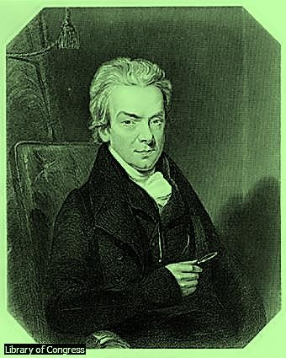

#### Fig. 17. William Wilberforce

British statesman and abolitionist William Wilberforce was the chief spokesperson in the House of Commons for a movement during the late 18th and early 19th centuries to abolish Britain’s slave trade. After the British Parliament outlawed the slave trade in 1807, Wilberforce worked for the emancipation of slaves in all British colonies.

**Source**: Library of Congress **Microsoft Encarta 2009.** © 1993-2008 Microsoft Corporation

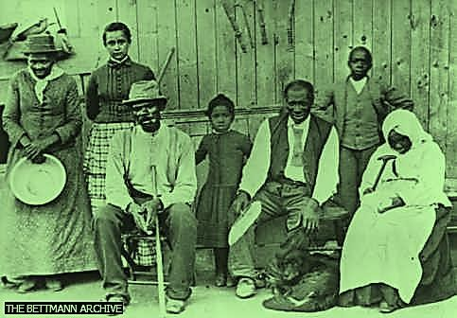

#### Fig. 18. Escaped Slaves with Harriet Tubman

Harriet Tubman, far left, holding basin, stands with one of the groups of slaves she led to freedom. Tubman was one of the most famous leaders of the Underground Railroad, a system of people who helped slaves to freedom. Tubman herself escaped slavery in Maryland in 1849 via the Underground Railroad. Once free, she vowed to return to help other slaves escape. The American Government immortalized her in 2016 in the country’s $20 currency. **Source**: THE BETTMANN ARCHIVE **Microsoft Encarta 2009.** © 1993-2008 Microsoft Corporation..

#### William Wilberforce

It seems most of the discussions on the abolition fight revolves around Wilberforce for many obvious reasons. According to Hanks (1992), Wilberforce was born in Hull, Yorkshire in 1759. He was the son of a wealthy merchant. As chronicled by Hunt (2008), William’s father died when he was young and for a time was brought up by an aunt and uncle. His family could trace its ancestry back to Saxon times. They were successful merchants, and his grandfather had twice been mayor of the town. Hanks (1992) asserts:

As a child, he was rather delicate and shortsighted, but blessed with intelligence. He was sent to the local grammar school at the age of seven where he was taught Writing, French, Arithmetic and Latin and his elocution was said to be a model for the rest of the school. (p.219).

After the death of the father, he was sent to live in Wimbledon with an aunt and uncle who were staunch evangelicals. William came under the influence of his aunt who was a strong supporter of John Wesley and the Methodist movement. The young boy became interested in Methodism. Disturbed by this development, the mother brought him back home. In fact, his grandfather was said to have threatened that if Williams turns Methodist, he would not have a six-pence of his. In order to divert him from the religious life, he was introduced to the social life of the principal families of the town at a very tender age of twelve: Theatre, supper parties, cards and race meetings at York. He first completed his education at Pocklington school and then at St. John’s College Cambridge. According to Hanks (1992), Wilberforce was shocked by the behaviour of his fellow students and later wrote: “I was introduced on the very first night of my arrival to as licentious a set of men as can well be conceived. They drank hard, and their conversation was even worse than their lives” (p.468). One of Wilberforce’s friends at university was William Pitt, who was later to become Britain’s youngest Prime Minister.

William Wilberforce decided on a career in politics. At the age of twenty, he became Member of Parliament for Hull after defeating his opponent, Lord Rockingham, in a Parliamentary election in 1780. While he took his responsibility seriously, he also entered fully into London social life. He received frequent invitations to the homes of aristocracy, and the rich, and became a firm favourite at supper parties. Possessed of great charm, he was amusing, quick-witted and had a good singing voice.

Wilberforce made two tours of the continent with the company of Isaac Milner, a Christian school master from Hull, when they spent time reading the Bible together. By the end of his second trip, Wilberforce was able to declare that he ‘fully believed’. He decided to place himself completely at God’s disposal and dedicated his life and fortune to the service of God. Following the conversion of Wilberforce to evangelical Christianity in 1784, news of his decision became known and even people like Pitt expressed their admiration for him. His mother was however unhappy when she heard the report but she soon discovered the truth and was no more displeased.Wilberforce joined the Clapham sect and became so interested in social reform and was eventually approached by Lady Middleton, to use his power as an MP to bring an end to slave trade. He sought advice from John Newton at St. Woolnoth, London who urged him to use his position for God and wrote prophetically as (cited by Hank 1992), “It is hoped and believed that the Lord has raised you up for the good of the church and for the good of the nation” (p.220).

After considering how best to serve God, he recorded in his diary ‘God Almighty has set before me two great objects, the suppression of the slave trade and the reformation of manners’. As a member of the evangelical movement, Wilberforce was sympathetic to Mrs. Middleton’s request. It was not until 12th May, 1789, that he made his first speech against the slave trade.Wilberforce spoke to the house for three and half hours, outlining the evils of the trade and according to Hanks (1992), his speech was described as “impressive and eloquent” (p.221). Support for the cause began to grow, and eminent people like Jeremy Bentham, Lord

Canning and the Duke of Gloucester allied themselves with his aims. John Wesley wrote to him from his death-bed, urging him ‘in the name of God’ to oppose that ‘execrable villainy’. Wilberforce along with Thomas Clarkson and Granville Sharp was now seen as one of the leaders of the anti-slavery movement. Most of Wilberforce’s Tory colleagues in the House of Commons were opposed to any restriction on the slave trade as many English men considered the trade inseparably linked with the commerce and national security of Great Britain. At first, he had to rely on the support of Whigs such as Charles Fox, Richard Brimsley Sheridan, William Grenville and Henry Broughman. When William Wilberforce presented his first bill to abolish the slave trade in 1791, it was easily defeated by 163 votes to 88. From 1791, a bill was presented almost every year in parliament and the abolitionists were out-voted eleven times, once by a mere seventeen votes. The slavery lobby in the house was firmly entrenched and the opposition persuaded MPs that there would be an economic collapse, should the bill be passed.

Wilberforce refused to be beaten and in 1805 the House of Commons passed a bill that made it unlawful for any British subject to transport slaves, but the measure was blocked by the House of Lords. Grenville and his foreign secretary, Charles Fox, were strong opponents of the slave trade. Fox and Wilberforce led the campaign in the House of Commons, whereas Grenville had the task of persuading the House of Lords to accept the measure. The movement gradually gained ground and in 1807, the House of Common finally passed a bill to abolish the slave trade. Reminiscing the scenario following the abolition, Shelley (2008)

wrote:

Finally, victory crowned their labour. On 23rd February 1807, the back of the opposition was broken. Enthusiasm in the house mounted with the impassioned speeches of supporters of abolition. When one member reached a brilliant contrast of Wilberforce and Napoleon, the staid old house cast off its traditional conventions, rose to its feet, burst into cheers and made the roof echo to an ovation seldom heard in

parliament. Wilberforce, overcome with emotion, sat bent in his chair, his head in his hand and tear streaming down his face. (p.369).

The bill became law on 25thMarch 1807.After the abolition of slavery, there was yet another battle to be fought, to abolish the institution of slavery and set free those thousands of captives who were still in chains, labouring in the West-Indies. Wilberforce continued the battle for complete emancipation, however was growing older, and though still a member of parliament, gave over the control of the emancipation movement to Fowell Buxton MP, who was already working for penal reform. Buxton was a wise choice. In 1825, Wilberforce was forced by ill health to retire from politics but continued to maintain fatherly interest in the campaign.After ten years of parliamentary struggle, the bill for the Abolition of slavery in the British colonies was passed on 25th July, 1833. Due to Wilberforce insistence, a clause was inserted giving the slave owners twenty million pounds (£20million) compensation. According to Wilberforce (cited by Hanks 1992) “Thank God that I should have lived to witness a day in which England is willing to give twenty million sterling for the abolition of slavery” (p.222).

Wilberforce’s other great objectives included that of fighting vice and immorality. He opined that severe punishment such as hanging did little to deal with the root cause of the problem, but rather it was to repress that general spirit of licentiousness which is the parent of every species of vice’. He founded the Proclamation Society with the aim of enforcing existing laws on duelling, lotteries, drunkenness, blasphemy and other unacceptable forms of social behavior. Soon Wilberforce became a sort of guardian of public morals and after the success of the anti-slavery bill, was regarded by many as a guide to the nation’s conscience. In parliament, he worked to promote a variety of humanitarian causes and vehemently opposed the misuse of Sunday. His effort ensured that one rest day in a week was granted.

Wilberforce married Barbara Spooner, the daughter of a country banker at the age of thirty- eight. He died four days after the passage of the emancipation bill in 1833. His body was laid to rest in the north Transept of West-Minister Abbey, near to that of his friend, Pitt. Wilberforce, though did not initiate the opposition to slavery, but he was the obvious choice to champion the cause and his charm, popularity, perseverance, wisdom and faith helped win the fight. He possessed all the natural qualities for outstanding leadership: ample wealth, a liberal education and unusual talents. Some called him the ‘*Nightingale of the House of Commons*’. In his own words (cited by Shelley 2008), “my walk is a public one: my business is in the world, and I must mix in the Assembly of men or quit the part which providence seemed to have assigned me” (p.367). Hanks (1992) described Wilberforce as ‘Impetuously generous’; his transparent kindliness and simplicity made him lovable even to his opponent, and he came to occupy a unique position in the nation as one who was respected by people of all walks of life” (p. 223).His effort helped shape the future of missionary work in Africa.

#### Sir Thomas Fowell Buxton

Thomas Buxton was born at Earls Colne, in Essex England in 1786. He attended Trinity College, Dublin and became a beer-maker. He was a Quaker. Buxton became a member of Parliament in 1818 and was among the strong antislavery parliamentarians. He succeeded Wilberforce as the leader of the abolition team in 1825 following the retirement of William Wilberforce from the House of Commons.Thomas Buxton had earlier started working for penal reform. He formed the society for the mitigation and gradual abolition of slavery. This was because to grant the slaves freedom immediately would lead to the ruin of the slaves and their masters. They must first be trained and educated for freedom. Like the biblical Joshua who led the people of Israel into the promised land, Buxton had to lead the Anti-slavery Movement to victory in 1833 and made further plans to replace the trade with a legitimate one. In the words of Shelley (2008), Wilberforce “enlisted the skills, however, of a young

evangelical, Thomas Fowell Buxton, to assume leadership of the “holy enterprise.” Buxton was a wise choice” (p.369).

In the first half of the 19th century, the slave trade was still such a lucrative business even in its illegal form that it seemed to increase despite the policing action of the British Army, which intercepted many slave ships. The hinterland chiefs lacking other commodities for export went on supplying European traders with fresh cargoes of slave. Thus in 1839, Buxton published a book called *The African slave trade and its Remedy* proposing to replace slave trade with legitimate trade. He posits that African agriculture should be developed to the extent that its exported produce would become more profitable than that of slaves. As a result of the book, a new society was started to get men to do ordinary trade with Africa and to bring Christianity.

Buxton suggested building a settlement at the Niger-Benue confluence, where Africans should be trained in modern agricultural methods. British rule would guarantee security and the material progress should be accompanied by the spiritual one of Christian missions. This programme, gained the support of the British Government. This prompted the 1841 Niger Expedition. Agricultural specialists, African farmers and two missionaries of the Church Missionary Society, were sent to explore this avenue. Due to malaria, the death toll of Europeans was so high that all the survivors returned after six weeks.It was Buxton who advocated that only evangelization, exploitation of the natural resources and expansion of trade in Africa and systematic colonization of Africa could rid Africa of the slave trade and slavery. According to Afolalu (1969) with the recommendations of Buxton- Bible and the Plough:

From about 1840 until the European occupation of West Africa, both the negative policy of physical attack on slave traders and the positive steps advocated by Buxton were put into practice. Lagos was captured in 1851 and the British Naval patrol continued its work. Missionaries flocked to West Africa, preaching and offering

protection to runaway slaves. Traders made steady and systematic advance into West African interior. Treaties were made with African rulers to abolish the slave trade and slavery by the various advancing governments in West Africa, especially the British and the French, as they established their control over West Africa. In 1900, the various countries of West Africa were taking shape. (p.104).

Buxton was made a baronet for his work. He died in 1845 and was known in England as “the friend of Africa”. His work ensured the grass root abolition of slave trade in Africa.

#### The Activities of Clapham Sect

The first significant activity of the Clapham Sect is the fight against slavery and slave trade. In the British parliament, members of the Clapham expressed their sympathy to the cause of the negro. They formed an abolition committee which attempted to mobilize opinion against the slave trade both inside and outside parliament. Under the leadership of Wilberforce, the Clapham friends were closely knit together in intimacy and solidarity. At the Clapham mansions, they held what they chose to call their “Cabinet Council”. They discussed the wrongs and injustices of their country and the battles they would need to fight to establish righteousness. And thereafter, in parliament and out, they moved as one body, delegating to each man the work he could do best to accomplish their common purposes.

The growing influence and passion of Abolition Committee was reflected in a speech by Pitt, the British prime minister (cited by Anene, 1966) “how can we hesitate a moment to abolish this commerce in human flesh which has so long disgraced our country and which our example will contribute to abolish in every corner of the globe?” (p.103). In 1789, Wilberforce made his first speech in the House of Commons on the traffick in slaves. He recognized immediately that eloquence alone would never overthrow the commercial interests in the sale of human beings. He needed reliable information, so he called upon his Clapham colleagues for assistance. Two years later, after exhaustive preparation, Wilberforce

delivered another speech to Commons, seeking to introduce a bill to prevent further importation of slaves into the West Indies. Citing Wilberforce (Shelley 2008) asserts: “never, never will we desist till we have wiped away this scandal from the Christian name, released ourselves from the load of guilt and extinguished every trace of this bloody traffick” (p.368).

Though oratory was inadequate, support was growing stage by stage. The Clapham Sect learned two basics of politics in a democracy: first was how to create public opinion and second was how to bring pressure of that opinion on the government. Thus, those Evangelicals fanned the flame and carried the fire to parliament where Wilberforce and four colleagues from Clapham – the ‘saints’ in commons tried to arouse complacent leaders to put a stop to the inhuman slave trade. The Clapham Sect were foremost in promoting schemes for social betterment throughout the land and in this respect, favourably influenced the legislature. Renwick (1968) observed that apart from the abolition of slavery, the most outstanding achievements of the Clapham Sect was the part taken by its members, along with others, in forming in 1799, the Church Missionary Society, now the largest society of its kind in the British Commonwealth.

In addition to notable members of the group like Wilberforce, Charles Grant, Granville Sharp and others, men like Simeon of Cambridge, whose missionary zeal was amazing, and Thomas Scott, the Bible commentator were connected to its foundation. The society spread to India, West Africa, the Niger, Victoria Nyanza, Egypt, Palestine, Persia, China and Japan. Among the outstanding men who served the society was Henry Martin, a senior Wrangler who has been described as Cambridge’s greatest missionary, and whose memory is perpetuated by the Henry Martin Hall in that city. He took up missionary work in Calacutta in 1806, and in a short time translated the New Testament and the English Church Prayer Book into Hindustani.

The bold steps taken by those Anglican Evangelicals known as the Clapham Sect and the success achieved against slavery has left in great measure, indelible impression in the activities of the Anglican Communion in Britain today. According to Carnegie (cited by Anglican Alliance, 2014), it is truly shocking and heart breaking to hear the accounts of men, women and children who have been trafficked and enslaved. There are many important initiatives in different parts of the Anglican Communion. This consultation is to enable them learn together from their experiences and to shape a stronger collective response to end this crime against humanity.

Anglicans from across the Communion gathered in Rome, Italy from 3rd to 7th November, 2014 to discuss their churches work to end human trafficking and modern slavery. The consultation was convened by the Anglican Alliance and hosted by the Archbishop of Canterbury’s representative to the Holy See, Archbishop Sir David Moxon. The purpose of the consultation was to learn about the work of churches around the Anglican Communion in tackling modern slavery and human trafficking. The group reflected on the most effective approaches and agreed on recommendations for a communion-wide response. These focus on the prevention of trafficking and slavery, protection and support for survivors, prosecution of perpetrators, and policy and advocacy work with government and the private sectors.

The issue of human slavery is a growing global crisis, with recent estimates of nearly 30 million people oppressed in slavery in almost every part of the world. The issue has been raised in every regional consultation held by the Anglican Alliance, and so has now been identified as a global priority. The Archbishop of Canterbury and the Pope have jointly committed to tackle human slavery, giving their blessing to the ecumenical and inter-faith initiative through the Global Freedom Network launched in Rome in March, 2014. The essence of the gathering was to consider how Anglican Communion can be more effective in working together and collaborating with other faith communities and secular partners to end modern slavery. Though a huge and daunting challenge, there is a resolve to face the

challenge as evil will thrive if humanity stands by and does nothing while the most vulnerable suffers at the hands of traffickers. The joint statement of the Global Freedom Network signatories which underscores the searing personal destructiveness of modern slavery and human trafficking calls for urgent action by all other Christian churches and global faiths.

The old slavery abolitionists foresaw the challenges the abolition of slavery would pose. That was why a land was acquired for their resettlement. Anene (1966) acknowledges that “the establishment of Freetown was a practical measure undertaken by British Philanthropists to settle emancipated slaves at Sierra Leone” (p.108). Agwu (1998) observes that these freed slaves settled in Sierra Leone were taught various trades. Attention was given to boys to learn different trades which made it possible for the colony to produce carpenters, bricklayers, surveyors, smiths and tailors. To crown the development of education, the Fourah Bay College was established by the CMS founded by the Clapham Evangelicals. The school started with 6 students among whom was Samuel Ajayi Crowther. Crowther was rescued from a slave ship by the British Naval Patrol Squadron in 1823. Fifty years later, Fourah Bay was affiliated to the University of Durham. This enabled Africans to obtain University degrees in their native soil.

One of the abolitionists, Zachary Macaulay became the first Governor of Freetown. Fowell Buxton initiated the Niger Mission with the intention of replacing the slave trade with a legitimate trade. We could see how the effort of those European Christian humanitarians brought relief to freed slaves and other good things to Nigeria in particular and West Africa in general. Agwu (1998) asserts:

The Christian Missionaries came into Sierra Leone in the critical period in the history of the colony. It was a period when the services of all types of humanitarians were really required; the missionaries rose up to the occasion by giving valuable selfless

services to the colony. As a result, they produced lasting and enduring impact in the colony. From the colony, the products of missionaries were of valuable usefulness to the rest of West Africa. The colony became a lamp in a dark place which eventually provided the whole of West Africa with very bright light. (p.22).

Granville Sharp and William Wilberforce and other British humanitarians had aimed for a Christian colony with a Christian charter and peopled by Christians of African descent. It did not take long for their dreams to materialize as Freetown was chosen for the experiment. Whenever slaves were liberated, they were taken to the colony and confronted with Christian faith and given an opportunity to receive an education.

The first professional class of West Africans was produced in Sierra Leone. Examples were John Thorpe, the first African Lawyer (1848); J.D. Horton, the first medical doctor (1850); Samuel Ajayi Crowther, the first African Bishop (1864); Samuel Lewis, the first African Knight (1896). Samuel Lewis was the first Newspaper owner and editor and the first to be given Cambridge and Oxford degrees. The Creole from Sierra Leone also sat in the legislative council of the Gambia and Nigeria; in Ghana, they served as colonial treasurer, and registrar of Supreme Court, district officers and post-master-generals; in Gambia, a Creole was the Chief Justice. These Sierra Leone emigrants were to have an immense influence in West Africa, for they brought new ideas and aspirations to the peoples they settled among and can be regarded as among the pioneers of African nationalism.

#### The Role of British Parliament

Bills were presented, pressure mounted, consciences appealed to and alternatives to slave trade recommended by the humanitarians who were coincidentally members of the parliament. Those with vested interest in the trade fought against the abolition until the majority were attracted to the motion. At a point, Wilberforce had to appeal to his friend Pitt to use his influence as the Prime Minister to facilitate the passage of the abolition bill. It was

until 23rd February 1807 that enthusiasm in the House of Commons mounted with the passionate speeches of supporters of abolition and the abolition bill was passed.

According to Hunt (2008) Wilberforce had argued that at this time in 1807, slaves were not ready to be granted their freedom. He pointed out in a pamphlet that he wrote in 1807 that ‘it would be wrong to emancipate the slaves as this could cause enormous ruins to the slaves and the slave owners. The certainty of the passage of the Emancipation Act freeing the slaves in the sprawling British Empire came on July 25, 1833 four days before Wilberforce died. The group influenced the government to make plans on how to care for those freed slaves. There were about 14,000 slaves in England and should they be set free, they needed somewhere to settle. At their suggestion, the colony of Sierra Leone was founded in West Africa for freed Slaves.The roles of the parliament in the abolition of slavery and slave trade can be summarized thus:

* + 1. Passage of law in 1807 abolishing the slave trade throughout the British Empire.
    2. Declaring and classifying the slave trade as a felony punishable in 1811.
    3. Passage of the Emancipation Bill in 1833 which guarantees the evacuation of freed slaves and recaptives to Freetown (freeing all slaves owned by British subjects).
    4. Approved the payment of (20 million pounds to compensate slave owners).

#### The Abolition Strategies

Political and material influence boosted the impact of the abolitionists. Every member of the Clapham Sect has a significant role to play in the fight against slave trade. The pioneer leader of the group, Granville Sharp was a Lawyer and a member of the parliament. John Thornton in whose house the group met was a wealthy banker and merchant. Zachary Macaulay was an estate manager and a member of parliament. Renwick (1968) noted that “Zachary Macaulay had seen the evils of it while managing an estate in Jamaica” (p.178).

William Wilberforce whom Shelley (2008) described as the unquestionable leader of the Clapham Sect was a great orator and member of the parliament. Prime Minister William Pitt once said that Wilberforce had the greatest natural eloquence he had ever known. He was as a matter of fact referred to as ‘the Nightingale of the House of Commons’. John Venn was the Minister of the parish church whom they found a spiritual guide in and whom historians described as a ‘man of culture and sanctified good sense’. We see great potentials working as a team. Shelley (2008) described this unity of purpose thus: “it was a remarkable fraternity” (p.367). Writing further on the strategies of the Clapham Sect, Shelley asserts:

The Evangelicals secured petitions, they published quality abolitionist literature; they lectured on public platforms; they campaigned on bill boards. They used all the modern means of publicity. Non-conformists rallied in support, and for the first time in history, women participated in a political contest. (p.368).

Those Evangelicals actually fanned the flame and carried the fire to parliament where Wilberforce and his colleagues tried to influence others to support the fight.In the parliament and out, the group moved as one body, delegating each man the work he could do best to accomplish their common and collective purposes. The group embarked on indepth research for information that will buttress their position. The group recognized that eloquence alone would not convince those with commercial interest that slave trade was inhuman. They needed reliable information and enough preparation before addressing the House of Commons.

These Christians at Clapham demonstrated how effective an instrument Christian literature could be in disseminating ideas of the right kind. Wilberforce founded the Christian observer in 1801 and exposed the evils of slavery. James Stephen followed along the same lines. Zachary Macaulay edited the Anti-slavery Monthly Reporter, a magazine devoted to fight the Slave trade and slavery. Thomas Clarkson by his travels and visits to many English Ports was

able to supply the committee with up to-date facts and figures. The vigorous pamphlets of Hannah Moore led to the founding of the Religious Tract Society which had done a work of priceless value throughout the years. The Clapham group used all methods of propaganda at their disposal to influence parliament to legislate against slave trade and slavery. Coupland (cited in Richard 2011) observes that the Clapham Sect was a remarkable fraternity in its closeness, and in its affinity. They did not only live in one little village; but had one character, one mind, one way of life. They were mostly made up of rich class, living in large roomy houses, they were generous givers to the poor. They could mostly have been of leisure but they all devoted their lives to public service.

* They used their Spiritual conviction and humanitarian conscience to advocate for the oppressed negroes.
* They used their wealth and positions as Members of Parliament to influence the passage of law against Slavery in Britain.
* They acted as a pressure group on the government of the day.
* They appropriated every possible available means to campaign against slavery and to appeal to the conscience of other elites.
* Their publications, including tracts on anti-slavery were widely circulated with well- researched up to date facts and figures about the inhumanity of slavery and the ordeals of the slaves.
* There was adequate division of labour according to individual talents and potentials
* They were so vocal, consistent and persistent in their quest for freedom until they achieved success.
* They took proactive steps to cushion the adverse effects the abolition could cause on the slaves and the society by acquiring land for their resettlement, and rehabilitation.
* They catered for the spiritual, material and mental needs of the ex-slaves by introducing them to Christian faith, legitimate trade, quality education and skills.

#### The Persistence of Slave Trade

The Slave Trade was abolished by the British government in 1807 and slavery throughout the British Empire in 1833. These actions took place outside Africa, and could not affect West Africa directly, hence the slave trade was not effectively checked. But even then, a form of domestic slavery, and indentured labour continued to exist in many places. Through persuasion and treaties with Spain, Portugal, United States of America and Denmark, they tried to stop the trade internationally.

Both the Portuguese and the Spanish were initially very much against abolition. In order to get these countries to agree to abolition and the right of search and seizure of slave ships found in transit, according to Ogunsola (1977), Britain had to offer them some compensation. However, “most of the treaties signed by the committed nations were not honoured, while Holland and the USA deliberately refused to agree to the right of search …” (p.49). It was not until 1865, that slavery came to an end in the USA. In the West African colonies themselves, people continued the trade secretly.

Infact, Flint (1965) observed that between 1807 and 1838, the anti-slavery forces in British politics were unable to concentrate their attention on West Africa, for during this time they were engaged in the great political campaign to abolish slavery in British colonies, which centreed on West Indies question. In 1833 the trade was abolished but for the next five years, the humanitarians were busy, attacking the system of apprenticeship in the West Indies whereby freed slaves (negroes), were bound to their ex-masters during a transitional period. Such apprenticeship was abolished in 1838. Almost immediately, Fowell Buxton swung the energies of the government around to West Africa. Fowell Buxton’s followers were appalled by the discovery that the Atlantic slave trade has as a matter of fact, increased since Britain

had begun her campaign against it in 1807. They therefore concluded that the policy of patrolling the West African coast with the Naval Squadron had not yielded any significant result. In the words of Anene (1966):

Although the squadron was usually able to rescue about three thousand slaves a year, it was clear that as long as large number of slaves were in demand in the New World and as long as the other Western European Powers were indifferent, slavers would resort to all kinds of strategies to continue to make even greater profits than when the trade was an open one. It should also be remembered that many African coast Chieftains who had become accustomed to the ready profit of the slave trade were reluctant to abandon the sale of their own people. (pp.103-4).

Even the extinction of Atlantic slave trade did not rid Africa of the trade. The export of slaves in the direction of West and North Africa was intensified and this equally affected some West African communities. The trans-Saharan trade in slaves had unique features which were more hideous than the sea-borne trade to America. The Nile and the Sahara trade routes provided other avenues for the export of negroes to North Africa and the Mediterranean. The wars precipitated by the Fulani Jihad in Hausa land and in Adamawa provided opportunities for the capture of ‘pagans’ for the slave trade. Bornu continually raided the regions south of Lake Chad for slaves. In Kano, Katsina and so forth, there were open slave markets. Without the promise of adequate compensation, it was unlikely that the Niger coast chiefs of Bonny, Brass, and Calabar and others would have agreed to sign the ‘slave treaties’ with the British officers of the Preventive Navy. It was later that Portugal, Spain, France and then the United States gradually began to co-operate with the British government. The abolition of slavery in American States and the virtual blockade of Brazil more or less marked the end of the Atlantic slave trade.

Inspite of all the measures taken to stop the trade in Africa, it was realized that African chiefs who based their livelihood on slavery disliked the abolition. They were therefore unwilling to

co-operate with the British to stamp out the nefarious trade. The part played by African chiefs to frustrate the abolition of the slave trade was regrettable when viewed from the objective of the abolitionists. Contrary to the objectives, these chiefs felt that they would be economically ruined if they gave up without compensation or an adequate lucrative substitute. Fowell Buxton’s recommendations were explored while force was used on many chiefs, leading to loss of many lives, money and property.

#### Anti-Slavery Wars

As noted in the previous section, after the fight to abolish slave trade was officially won, the traffick persisted. Therefore, the enforcement of the law became the task of the British Navy. As a result of its patrol of the West African coast, captured African slaves were restored to the African coast. In order to avoid capture and seizure, slave dealers dropped their human cargoes into the sea at the approach of British war ships. Britain therefore had to introduce the Equipment Treaty which legally authorized British warships to arrest slave ships found with slaving equipment even though no slaves were found on board when such ship were intercepted and arrested.

However, the increasing costs of the maintenance of the British naval squadron stationed in West Africa to rescue slaves became a subject of critical debate in England. Some British people wanted parliament to withdraw the squadron in order to cut down government expenses. Some opined that slaves should be moved to Brazilian sugar plantations so as to sustain British trade there. As a result, some who were vocally attacking the slave trade began to change their minds and supported the continuation of the trade.

Meanwhile, the naval squadron at first found it difficult to stop and arrest foreign ships as such actions could lead to open war. Most European countries regard the right of search as interference with their sovereign powers and right. Although Britain entered into anti-slavery

treaties with other European nations, these nations did not take positive steps to enforce the Anti-slave trade laws against their citizens found trading in slaves. The efficiency of naval ships on the West coast of Africa was seriously in doubt. Apart from the long and expansive coasts which a few war ships could not guard effectively, British war ships alone, without the co-operation and assistance of other European navies could not impose a complete embargo upon the exportation of slave to America.

The West African coast was so expansive with many hiding places that slave ships escaped capture. The squadron could not intercept ships flying foreign flags of countries which had not granted the right of search. Furthermore, the crews of naval patrol suffered from malaria and other tropical diseases and the death toll was high among them. African chiefs were eager to sell more slaves. Slave ships were too difficult and risky to capture on the high seas. Those crews of the slaving ships might put up a fight of resistance and capture their attackers since they were well armed.

The British Government, however, persuaded other countries to agree to reciprocal treaties, granting the right of search to one another of ships suspected of carrying slaves or slaving equipment. The Equipment treaties signed in 1842 made it possible to capture slave ships with slaving equipment as before then, it was possible for a slave ship to throw her slaves into the sea when approached by the patrol team. Thus, after the granting of reciprocal search treaties, slave traders of many nations were brought to justice and their slaves were set to go to their countries of origin or settle in Sierra Leone.

Despite all the efforts made by the British and other governments to rid West Africa of the slave trade, reports of explorers and visitors to West Africa show clearly that the slave trade was widely carried on at even a higher rate than before. Falk (1997) insists that “the British navy patrolled the coast and succeeded in reducing the traffick, but it continued until the Arabs were defeated on the mainland in 1888-1891” (p.100). Explorers and missionaries like

David Livingstone and Mary Slessor encountered those slave traders in Africa. They became aware of the problem of the slave trade and they saw men, women and children seized and cruelly sold as un-paid labourers, and sent back accurate reports to England. They advocated the promotion of the legitimate sale of European articles in the slave market than trading in slaves, introducing the negro family into the corporate body of nations which would lead them into the blessing of civilization and Christianity.

The new approach of ending slavery espoused by Thomas Fowell Buxton in his book “The African Slave Trade and its Remedy”, published in 1839 was explored. In the book, Buxton advocated that only evangelization, exploitation of natural resources, expansion of legitimate trade and systematic colonization of Africa could stop slave trade and slavery. Between 1841 and 1850, Britain had to persuade the coastal chiefs or use force against them in order to stop them from harbouring or trading with the European slave traders. Nana of Itsekiri and Jaja of Opobo were arrested and deported. Kosoko of Lagos was also found guilty of continuing the slave trade and he was dethroned. It was abolished in the oil River protectorate which came into being in August 1891 and in most of the Yorubaland after 1893 when the Niger coast protectorate was established. In 1900, the various countries of West Africa were taking shape, coming under the government of the British and French. The slave trade was abolished in Northern Nigeria in 1901.

#### 4.7 The Implication of the Abolition of Slave Trade

The abolition of slave trade had both negative and positive implications in Nigerian society. Considering the problems of the abolition in Europe and America, Agwu (1998) asserts that “the ex-slaves had become a socialliability. The freed slaves were jobless, roaming the streets of Europe to the effects that most of them became bandits while their women took to prostitution” (p.14). According to Afolalu (1971), after the American war of Independence, 1774-1783 many negro slaves who were loyal to the British government and who had fought on the side of Britain had to leave the United States. Some went to the Bahamas, some to

Nova Scotia and many went to Britain. In Britain since Lord Mansfield’s judgment of 1772, slaves who went to England were free men. Though they were free, there were no means of livelihood other than begging. This deplorable condition was hateful to many Britons for these negroes were destitute and homeless and constituted a nuisance to many English people.Therefore, in order to relieve these negroes of their suffering and to remove them from the English streets where they were hated, the Clapham Sect under the leadership of William Wilberforce and Granville Sharp formed a ‘committee for relieving the black poor’. This committee planned to establish a settlement in West-Africa to settle the negroes perhaps, on their own soil. The initiative was approved by the government. In pursuance of this, the British government bought a small piece of land of 20 square miles from King Tom and Naibana in Sierra Leone.

The establishment of Sierra Leone is the by-product of the abolition of slave trade. Apart for the purpose of settling the negroes on their soil, Agwu (1998) posits that another purpose of founding the colony of Sierra Leone was to civilize by Europeanizing the Africans whereby Freetown will be a base for propagating European ideas, values, religion, education and culture. The foundation of Freetown was laid in 1787. The humanitarians founded the colony as the new home for the freed slaves who could no longer trace their homes or countries of origin. Some of these slaves were partially educated and some had training in trades like tailoring, printing, carpentry and brick making which they introduced on reaching Africa. The settlers were remarkable in the history of West Africa, because they were the pioneers in the fields of education, in the civil service and in spreading Christianity. The creoles turned out many Catechists, Bishops and teachers who assisted the Europeans in the spread of Christianity and education in West Africa. From among the settlers emerged the earliest civil servants, lawyers, judges, doctors and engineers in West Africa. The group led the way in trade and commerce in a more advanced way. Ogunsola (1977) noted that “the influence of the creoles on the educational, religious and commercial lives of the people of West Africa

was so great that they could be rightly regarded next to the Europeans as educators of the Africans” (p.54).

Though the abolition of slave trade brought back the Africans to their root to champion economic, political and social change, their arrival to Freetown posed a lot of challenges. The early months were very difficult. It was raining, the rain made cultivation and building impossible. The settlers were so miserable and disheartened that many deserted the colony and joined slaving bands and other slave deals. Mortality rate was high, eighty-six persons died within the first four months. By the end of 1792, only sixty-five remained out of the first settlers of over one thousand that left Nova Scotia and arrived Sierra Leone in 1792. Agwu (1998) summarized the problem of the colony as climatic, agricultural, engaging in slave traffick, French military attack, military attack by natives ‘Temne’ and disunity among the settlers.

Traditional ways of life were discouraged. All the settlers were to be Europeanized in the form of wearing English dresses, eating with cutleries and answering English names. Gradually, the various tribes of settlers fused into what was called Creole. There emerged in the colony one single Creole people with a culture based on grafting of European Christian culture on African traditional cultures. This distinctive Creole culture was made possible under the British colonial government and the Christian missionaries of the period.

The abolition of slave trade in Europe and America confronted West Africa with colonialism, first experimented in Sierra Leone. In order to end the slave trade in African communities which was aggravated by the abolition in Europe and America, many African communities came under the protection of the British and French governments. Flint (1965) posits that liberated Africans played a considerable part, together with white missionaries in involving the British in the politics of Yorubaland. British Missionaries here were following the return of the Egba exiles from Sierra Leone to Abeokuta, Lagos, and Badagry and it was these

developments as well as pressure from British traders, which eventually produced British interference in the politics of Lagos and culminated in the annexation of Lagos. The British began to interfere in the politics not only of Lagos, but of Bonny and Calabar. The scramble for West Africa increased. When the British and French government began its imperial expansion in West Africa, it relied on the creoles for personnel of the civil service both at junior and senior cadres of service and in the judiciary. In 1925, nearly 80% of the lawyers in Nigeria were of Sierra Leone origin.

The attempt to stop slave trade had resulted in the involvement of the British government in Nigeria politics. Lagos was conquered and Kosoko, a chief slave dealer was deposed in 1851. Lagos and its district were made a colony in 1861 in order to stamp out the slave trade finally at its source. The annexation of Lagos brought the end of African rule in Lagos. Politically, the Lagos colony chiefs lost their sovereign rights to Britain. This loss of sovereignty was not regained until 1960 when Nigeria became independent. The Creoles were initially used in the administration of the colonies. At a point those creoles became victims of imperialism.

The imperial government used all the means at its disposal to remove them from the position of influence they held. They were discriminated against everywhere, they lost their professional post as leading clergymen, businessmen, civil servants and so on. Their trade was obstructed and paralyzed. They were expelled from many places in West Africa. They became poor and their place of pride in West Africa declined. The policy of discrimination against the creoles and mistrust of them was evident throughout the colonial administration. Like other educated elites in other parts of British-controlled West Africa, they suffered from the colonial system which treated enlightened natives with contempt. This contempt gave rise to *nationalism* and emergence of the African independent churches. The Christian missions which helped the establishment of British rule in West Africa also began to work for its end. Between 1888-1892 each of the Protestant Mission Societies like Church Missionary Society,

Methodist Missionary Society and the Baptist experienced a revolt within their membership which led to the establishment of an African church. The church became the meeting place for the development and expression of nationalist feelings and ideas. The educated West Africans were equipped for nationalist task by their learning. The study of the Bible and the teaching of the missionaries have taught the early converts the idea of equality, justice and no racial prejudice. When such ideas were not employed in church administration, those Africans became unhappy. Their study of classics and the history of revolutions of colonial peoples in the struggle against imperialists encouraged these converts to develop nationalist ideas.

The abolition of the slave trade was the prerequisite for successfully planting Christianity in Nigeria. The abolition of slave trade was followed by a general expansion of missionary activities. Slave trade was among the reasons why the 15th century mission to Africa failed; the chaotic and unsettled conditions in which the slaves were raided and captured. The abolition assured them of a favourable atmosphere to successfully propagate Christianity. Most of these ex-slaves in Sierra Leone had embraced Christianity in Britain and America and so they brought their new faith with them. They were bubbling with zeal. The coming of these Christians into Freetown was very helpful to the planting of Christianity in Sierra Leone and other parts of West Africa as they were genuine Christians, very zealous to bring the Christian faith to their native soil. In the words of Agwu (1998):

From the colony, the products of the missionaries were of valuable usefulness to the rest of West Africa. The colony became a lamp in a dark place which eventually provided the whole of West Africa with very bright light. (p.22).

Lovett (cited by Falk 1997) upholds that the success of the anti-slavery movement was not only an achievement of Christian men, but also an indispensable prerequisite for the planting of Christianity in Nigeria. When peace was restored, the expansion of Christianity and its

civilizing influence has helped in the areas of development of education, economy, African literature, African church and nationalism, manpower and restoration of peace.

In some areas, the abolition of slave trade promoted the economy while other areas suffered serious setback. Lagos suffered politically but gained tremendously economically. It became an important Sea-port which handled most Nigerians exports and imports. Eventually, Lagos became the national capital where most European trading firms had their bases for commercial activities. Here also, missionary activities with their base at Badagry began to widen into Abeokuta, Ibadan, Oyo and Ijebu-Ode. The abolition of the slave trade spelt doom for Benin. It disrupted the economy, and caused a loss of revenue. In retaliation, Benin closed all its trade routes. Both European traders and missionaries were stopped from carrying on their commercial and religious activities. The attempt made to appeal to the Benins to stop the slave trade, substitute it with legitimate trade and allow the missionaries to do their work unfortunately ended in what the Europeans termed the ‘Benin Massacre of 1897’ and the subsequent conquest of Benin. In order to re-establish legitimate trade, the British had to use force at Arochukwu and Calabar and declared the areas British protectorates. Aros had dominated the local markets of Igbo and Ibibio, they specialized in the buying and selling of slaves, and it was indeed through them that the coast communities received slaves and as oracle agents and traders, they wielded tremendous influence, they deployed mercenaries in Igbo and Ibibio inter village wars in order to facilitate the capture of slave for export. When the British intruded into the country toward the end of the nineteenth century, they believed that there was an Aro- empire, and grossly exaggerated the role of the Aro in Igbo and Ibibio village affairs. The result was that at the first opportunity after the abolition of slave trade, the local British representatives mounted a colossal military expedition which destroyed the long juju shrine of the Aros *Ibini Ukpabi* and subsequently subdued one Igbo and Ibibio village group after another. The next chapter will take us into a concentrated discussion on the modern human trafficking and its eradication in Nigeria.

#### CHAPTER FIVE

**MODERN HUMAN TRAFFICKING AND ITS ERADICATION IN NIGERIA**

#### Human Trafficking in Nigeria

Human trafficking is an organized criminal activity in which human beings are treated as possessions to be controlled and exploited. Human trafficking has truly become a global threat to vulnerable men, women and children world-wide. It is an injustice that affects millions of people every year. Nigeria acts as a source, transit and destination country for trafficking children to Europe, the Middle-East and other countries throughout Africa. UNICEF has estimated that over 1.2 million children world-wide are trafficked each year, mainly young women and girls are trafficked to Europe and other destinations, and there is growing evidence for the involvement of Nigerian criminal network.

The trafficking of children for the purpose of domestic service, prostitution and other forms of exploitative labour is a widespread phenomenon in Nigeria. Children and women are recruited with promises of well paid jobs in urban centres within the country or abroad, realizing too late that they have been lured into a debt bond. Deception are used to take victims away from their families. There is yet no reliable statistic of the number of children trafficked internally and externally primarily because of the clandestine nature of this ugly and shameful phenomenon. The causes of children and women trafficking are numerous.They include poverty, desperation to escape violence, corruption and wickedness, unemployment, illiteracy and ignorance, urbanization challenges and the quest for a better life, erosion of societal ethical values and the worship of modern idols of materialism, among others.

The highest rates of child trafficking in Nigeria are found in the Niger-Delta region. In Edo state where the recent trend in human trafficking was said to have started in Nigeria, it is alleged that business transactions existed between the natives and Italians when the Nigerian

economy was more robust. These Nigerians visited Italy to buy shoes, gold and clothing to sell in Nigeria. However, when sex business became more lucrative in Italy, coupled with economic failure in Nigeria, their women shifted to sex business and involved their relations and friends until the business began to boom.According to Dave-Odigie (2014), the victims most of whom are pre-teens, teenagers and mostly females are taken far away from their homelands to cities within their country or across national boundaries and exploited for optimum economic benefits. Many of them are engaged in cheap labour such as domestic servants, hawkers, beggars, prostitutes or put into other forms of servitude akin to slavery.According to UNOD (2015) whether nationally or international, human trafficking is an epidemic which has been described as the second largest criminal activity behind sale of illegal arms in Nigeria. Regrettably, Nigeria is a source, transit and destination country, for trafficking persons, ranking highest in Africa and among the top eight countries with the highest human trafficking rates in the world.

Internal trafficking of women, children and youths is not a new phenomenon in Nigeria. It has been going on with the trafficking of people from major cities such as Lagos, Abuja, Kano, Kaduna, Calabar, Onitsha, Aba, Warri, and Port-Harcourt, predominantly for exploitative domestic work, scavenging, begging, hawking and prostitution. In most cities, the busy schedules of families who are predominantly working class makes high demand for domestic servant imperative, while those who can no longer cope with the cost of living in the cities, deploy their maids and other house helps to menial jobs to sustain the family and pay other bills. UNICEF (cited by Oha 2012) noted that about eight million Nigerian children are into exploitative child labour. It is estimated that 70% of the children trafficked to Italy are from Africa, while 60% of this number are Nigerians. Oha (2012) asserts that private transit camps exist in Akwa-Ibom, Calabar and Ondo States, where children transported from the south Eastern States are put into hard labour before being trafficked for prostitution in countries like Gabon, Equatorial Guinea, Togo, Italy, South Africa, Thailand and so on.

Nmah (2008) equally observed that Italy, Belgium, and Netherlands are said to be experiencing an upsurge in the number of Nigerian girls who are trafficked there. Citing UNICEF, he noted that no fewer than 46 percent of trafficked Nigerian children were forced into prostitution and cheap labour in 2004. Some 21 percent of the children were engaged in domestic labour, while 8 percent were used in pornography.

Most of the boys trafficked to Gabon, Equatorial Guinea and Congo were from Cross River, Imo, Abia and Akwa-Ibom States in the southern part of the country, while those from Togo and Mali were sent to work in plantation. In 2003 alone, more than 100 girls were intercepted by immigration officers at the Kamba border in Kebbi State. Immigration officers arrested also no fewer than 115 big time child traffickers at the Illela border in Sokoto State. The police in Lagos intercepted 64 children concealed in a refrigerator truck on March 5, 2005. The children were found dehydrated because of the inhuman manner they were packed into a container en-route a neighbouring West African country. This is a depiction and reminder of the old slavery when Nigerian slaves were packed into a slave ship to Europe. According to July 2014 Channels Television report, three Nigerians, Olusoji Oluwafemi 44, John Olayinka 45 and Florence Obadiaru 48 have been jailed for a total of 13 years in the United Kingdom for being the London connection in a global trafficking conspiracy. Amujiri (2009) inferred that an estimated 158 million children aged 5 to 14 are engaged in child labour, one in six children in the world. Millions of children are engaged in hazardous situation or conditions such as working in mines, working with chemicals and pesticides in Agriculture, or working with dangerous machinery. “They are everywhere but invisibly toiling as domestic servants in homes, labouring behind the walls of workshops, hidden from view in plantations” (p.58). The situation contravenes the United Nations declaration of human right which guarantees, among other things the unconditional right of the child to life.

Adding his own voice to the human trafficking menace in Nigeria, Chukwu (2009) observes that earlier human trafficking was physical abduction, conquering and raiding of communities

by armed bandits, capturing the inhabitants and disposing of those captives to British traders for onward transportation to America,the modern human trafficking also involves physically transferring able bodied young men and women to countries outside Nigeria for services like prostitution, factory hands, house-hold servants to the aged and the senile, as well as drug traffickers to drug barons. These are the palpable denials of the physical body of its tribal root which might be regained afterwards; possibly by one’s volition. On the contrary, the human psyche trafficking leaves one unperturbed and makes the victim consider himself becoming more civilized. Thus, according to Chukwu (2009):

Human psyche trafficking and human physical trafficking diverge, the former leaves one at his social milieu, the latter lifts one to another social environment. The English Language invading Africa is changing Africa’s world views, wrecking cultural perspectives and gradually overpowering many languages. This bare-faced blow on indigenous languages, pivotal channels for cultural transmission and retention has made many start thinking in English, acting out English culture, believing in everything English and dreaming or living perpetually as the English. (p.94).

Human trafficking entails the sale of babies. In States like Abia, Ebonyi, Rivers, Lagos, and Anambra, there have been many reported cases of Hospitals, Clinics, Orphanages, Doctors and Nurses who keep teenagers and single mothers who do not want to keep their babies after birth to provide them shelter and care while they are pregnant and sell off their babies for a premium to couples that need them. Okalibe (2007) decried the baby market in Lagos thus:

A baby girl goes for N150,000 while price tag for a male child is pegged at N200,000.

For twins, you cannot pay anything less than N450,000 although you might be lucky to get some discount but the prices remain unchanged for single birth. (p.12).

The owners of the babies are made to sign papers renouncing their rights to the babies as well as swear to oaths of secrecy. The Good Shepherd Orphanage in Lagos was reported to be

engaged in illegal adoption of babies as well as sheltering of their babies at birth. Many of those babies sold, one cannot determine what became of them.

At this juncture, it is important to note that African countries like Cote D’Ivoire, Cameroun, Gabon, Equatorial Guinea, Mali, Benin Republic, Libya, Algeria, and Morocco are some of the destination points for trafficked Nigerians.Nejuvie (2008) notifies that private transit camps have been reported to exist in Akwa-Ibom, Cross River and Ondo States where children are transported from the South-Eastern States and forced into hard labour and prostitution. Ebigbo (2008) identified the common routes in the West Coast to Mali, Morocco, and then by boat to Spain or west Coast of Nigeria to Libya and Saudi Arabia. He also identified travelling across the Sahara Desert as means of transportation for over 90% of the victims, others through airports, seaports and bush paths.

In Europe, Nigerians are trafficked to countries like Belgium, Spain, Germany, United Kingdom and Italy. The trend for Nigerian women and girls trafficked to Europe is to be used as domestic servants, whereas in Italy, prostitution is the main work that they usually end up doing. Venezuela in South America is a recent addition to the destination point in the Middle East. Nigeria has road links with Niger Republic and it provides the route to North Africa, the Middle East and Europe. Most of the trafficked persons are deceived into believing that their destination would be Europe but most of them end up in some African countries like Benin Republic or other countries other than Europe.

According to a Premium Times investigative reporter, Ovuorie (cited by Channels Television 2014),there was a case of an escapee who narrated her ordeal in the traffickers’ den. According to her story, the twenty-year-old victim, a senior secondary school student in Edo State before she was trafficked said she escaped from Burkina Faso with the help of a Burkinabe after one month of prostitution. She also stated that her male trafficker resided in Benin City. She had been made to believe that she would be taken to Europe but she ended

up in Burkina Faso. She was deceived by a friend’s brother’s promise of a job in Europe. She mentioned that the trafficking ring use the Saki-route in Oyo State to cross girls into Burkina Faso and Mali. She also revealed that girls, most of them below fourteen years are beaten and starved to subdue them into doing the bidding of their Madams. She also alerted that the illicit trade thrives with the connivance of some security agents. Dave-Odigie (2014) chronicles that from March 2002 to April 2004 alone, the Saudi Arabia authorities deported nine thousand, nine-hundred and fifty (9,950) women and one thousand, two hundred and thirty (1,230) under age and accompanied children. Investigation revealed that the majority of the women deported from Saudi Arabia are from Kano, Borno, Adamawa, Yobe, Nassarawa, Sokoto, Plateau, Niger, Kebbi, Kwara, Zamfara, Jigawa, Gombe, Bauchi and Taraba States.

Reflecting the reasons for trafficking Nigerian children, Daily Champion (Aug.17, 2010) asserts:

In their new places of ‘enslavement’ most of these children, who are lucky are put to work (illegally) as domestic servants or factory hands. The unlucky ones are deployed to sundry brothels as child prostitutes, a fate that is not spared the domestic servant- types who are subjected more often than not to physical and sexual violence by their masters and mistresses. (p.10).

Some of those trafficked children are even bred as repositories of human organs that are harvested by devilish cartels to satisfy the organ needs of the affluent who are known to regularly visit South Africa and India for such organ transplant operations.

Nigerian children are working in cocoa plantation in Cote D’ Ivoire as slaves. Benson (2012) emphasized that on the fore-front of promoting human trafficking are the activities of many fishermen who ply their trade on Lake Volta. They are known for using child slaves trafficked from both within Ghana and surrounding countries. A non-governmental organization based in Ghana “Challenging Heights” (cited by Benson 2012) estimates that

over 24,000 children in Ghana fall victim to the worst forms of child labour annually, many of whom are forced into dangerous work in the fishing industry. These activities persist despite anti-slavery and anti-trafficking laws due to the lack of funding for the law enforcement, the lack of strong social stigma against the practice and the lucrative nature of the business.

Mesce (2006) noted that traffickers also sell their victims for other purposes, depending on the needs of the country or regions. For instance, China’s one-child policy and India’s preference for girls both of which have led to a significant gender imbalance in some areas, have also prompted traffickers to fill a demand for brides. In West Africa, children often are trafficked for cheap labour, girls as domestic servants and boys for farm work. In Uganda and other crises-ridden zones, rebels abduct boys to use as soldiers and girls to use as sex slaves.

The Police in Ogun State arrested three suspected human traffickers with twenty-six children in 2015. The suspects were taking the children from Kano to Lagos State for menial jobs. As reported by the Ogun State Police Commissioner, Ali (cited by Olatunji, 2015) “Their mission in Lagos, according to the suspects is to take them to do some menial jobs which, if you look at them, they do not even know what they are in for” (p.7). The victims comprising 25 girls and one boy with their traffickers were arrested at the Ibafo Motor Park, Obafemi Owede Local Government Area of the State. This was following a tip-off from some residents of the area. Early January 2016, security agents arrested 48 human traffickers in Calabar. On January 21st, 2016, the Nigerian Navy intercepted over 100 children and 30 adults in a ship in Calabar, coming from Gabon. As chronicled by Sotade (2007), there was a case of Anita, a teenager from Akwa-Ibom State who had a gory story to tell. She was at one of the International Labour Organization (ILO) Conventions in Geneva to relate her ordeal in the hands of child traffickers. Orphaned at 11 years, she was put in the care of a relative who really maltreated her. To end her sufferings, she met a friend who introduced her to an Aunt who resides in Lagos and the friend’s Aunt promised to bring Anita down to Lagos to assist

in her Salon business and also learn the vocation. But in getting to Lagos, the Aunt subjected her to prostitution in a brothel at the tender age of 12 until the Women Consortium of Nigeria (WOCON) was able to rescue her from the brothel when she was 15 years old. She was then rehabilitated and trained as hair dresser and she now runs her own business. Anita’s case that was brought before the International Community is one of the few lucky cases of children who have been rescued from the clutches of a heinous crime against humanity.

UNICEF report (cited by Ponle, 2004) puts the estimate of children population in Nigeria at 64 Million while the average of trafficked children, especially girls is 15 years. Out of the girls in sex trade in Europe, 60 percent to 70 percent are in Italy, while Belgium and the Netherlands are experiencing an upsurge in the number of Nigerian girls. It says that about eight million Nigerian children are engaged in exploitative labour. Putting them at a great risk of human trafficking as 43 percent of them are based in the Southern border towns of Calabar, Port Harcourt and Owerri. On the average, 19 children daily pass through Nigeria’s borders especially at Seme, Maiduguri, Sokoto and Calabar.

A United States (US) Department of state trafficking report released in 2000 found that crime rings and loosely connected criminal networks trafficked between 45,000 and 50,000 women and children into the United states annually. Many of such victims are from West Africa, particularly Nigeria. The United Nations’ Children Education Fund (cited by Daily Champion, 2010) disclosed that in its recent Child Rights meeting in Uyo, Akwa-Ibom State, that about 200 children monthly or 24,000 per year from the five states in the South East zone of the country are trafficked to South Africa and other parts of the world.

According to United States, State department data, (cited by Benson 2012) an estimated 600,000 to 820,000 men, women and children are trafficked across international borders each year, approximately 80% are women and girls and up to 50 percent are minors. The data also illustrates that the majority of transnational victims are trafficked into commercial sexual

exploitation. The alarming enslavement of people for purposes of labour exploitation, often in their own countries is a form of human trafficking that can be hard to track from afar. While there are no exact statistics on the number of people affected globally, several reports have cited that some 25 million people throughout the world are at any given time victims of human trafficking.

Mesce (2006) asserts that every day in countries around the world, thousands of women, girls and children are bought and sold, traded like chattel in a multi-billion-dollar global market place of sexual exploitation, forced labour, and domestic servitude. Because it is difficult to reliably assess the extent of the practice, the U.S. government which collects trafficking data world-wide as (cited by Mesce 2006) estimates that as many as 800,000 people are trafficked across international borders each year, and when victims who are trafficked within their countries are added, the number soars to between 2 million and 4 million. About 80% of trafficked victims are women and girls, and as many as half are minors. The World Bank report asserts that a large majority of trafficked female are under the age of 25, more than half are from 18 to 25 and most are forced into commercial sex work. Traffickers take in more than 9.5 billion dollars annually, and the risk they will be caught, prosecuted and convicted remains slim.

The Lagos NAPTIP zonal co-ordinator, Morka (cited by Okpalakunne, 2006) revealed that an average of 100 children pass through Nigeria’s border towns of Seme in Lagos State, Gamboron Ngella in Borno State, Illela in Sokoto State, Shaki in Oyo State, through the creeks of Calabar and Oron and a host of others as either servants or labourers on the farms of Gabon, Equatorial Guinea, Morocco among others. “It is estimated that about 8 million Nigeria children are engaged in exploitative child labour, putting them at great risk of human trafficking, as 43 percent of them are based in Southern border towns of Calabar, Port Harcourt and Owerri” (p.16). Morka recalled that between March and May, 2005 at Murtala

Muhammed International Airport, Ikeja Lagos, the Nigeria Immigration Service (NIS) clamped down on the illegal deal which deploys different strategies to beat security check points at the boarding gates.

Notwithstanding new revelations about the menace of human trafficking, Idemudia (cited by Okpalakunne 2006) refuted the idea that human trafficking is on increase in Nigeria. She rather maintains that it is really not on the increase but just that people are becoming more aware and are speaking more about it, unlike before when it was like an underground business that nobody wanted to talk about, now with more people coming out to talk about it, there is more awareness about it and as such, people are talking more about it and whenever you talk about an issue, it will appear as if it is on the increase. According to Idemudia, “I believe that with more people being aware of it and more cases being reported, then the chances of the practices being eliminated is very certain” (p.35).

While appreciating the position of Idemudia, we must continue to alert the public on the new cases and strategies of trafficking Nigerian children so that the anti-trafficking wars can be stepped up. The International Labour Organization (ILO) statistics(in Akinbode, 2006) points to Nigeria as a major source, transit and destination for women and children trafficked for forced labour and sexual exploitation. Inspite of the legislations, the reality on ground is that trafficking in the country has assumed an international dimension with criminals smuggling women and children across the country’s porous borders. In March 2005, the nation witnessed the shocking revelation of the strange arrest by the police of 67 children whose ages range between 4 and 16 cramped in a refrigerated truck. They were apprehended on their way from Mokwa in Niger State to Amukoko, a suburb of Lagos. We cannot imagine the number of children who in similar circumstances have passed our police men and other security agents on the roads and across the borders. NAPTIP and UNICEF (cited by Nejuvie 2008) in their situation assessment of child trafficking in Southern Nigerian States posits that

46 percent of repatriated victims of external trafficking in Nigeria are children with a female to male ratio of 7:3. They are engaged mainly in prostitution (46%), domestic labour (15%) and entertainment (8%). The rough Statistical analysis of trafficking cases in Nigeria is tabulated as follows:

(A)

|  |  |  |
| --- | --- | --- |
| 1. | Age range | 4 - 28 |
| 2. | Female - Male Ratio | 7:3 |

(B)

|  |  |
| --- | --- |
| Purpose | (Percentage) |
| Prostitution | 46% |
| Domestic Labour | 21% |
| Pornography | 8% |
| Entertainment | 8% |
| Others | 17% |
| Total | 100% |

#### Table 2 –Modern Slavery: Human Trafficking

**Source**: UNICEF and NAPTIP reports in The Guardian, July 10 2008.

The above tables reflect the ratio and rough statistics of human trafficking cases in Nigeria.

Table (A) Shows that the age range of the majority of trafficked victims are between 4 – 28 years. Within this age range, the majority are always girls and female minors.

Table (B) Shows the percentage distribution of the reasons for trafficking. By this majority of the persons trafficked within and outside Nigeria are for prostitution followed by domestic or hard and cheap labour.

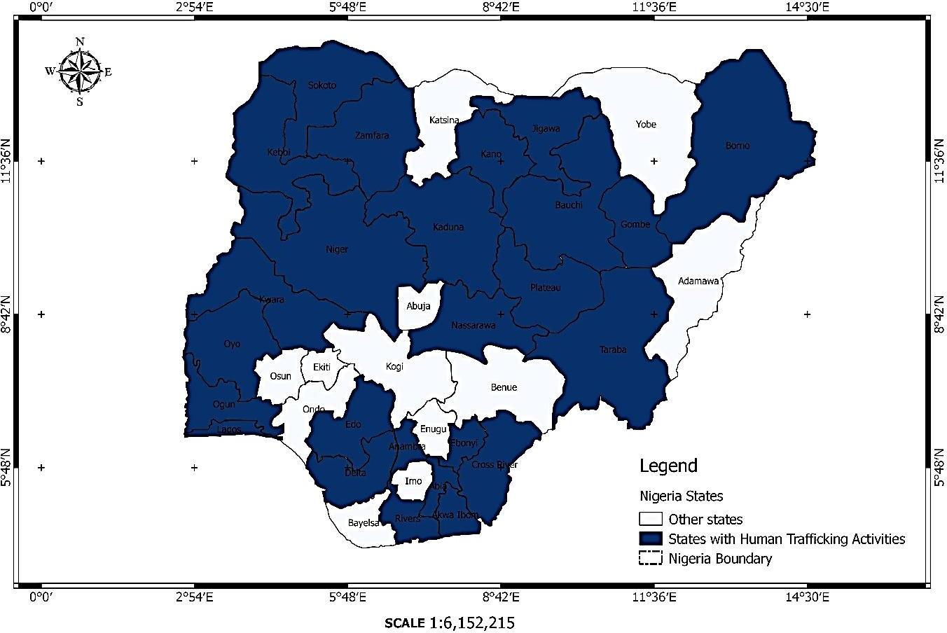

**Map 2.** Showing states with high human trafficking activities in Nigeria.

**Source**: Drawn by the cartography laboratory of Nnamdi Azikiwe University, Awka based on the information used in this research work (5th February, 2016).

**NOTE**: There is no State in Nigeria that does not have traces of human trafficking. The above map is to represent the states with high human trafficking cases. The documentation of the cases of human trafficking is still insufficient due to the subtle nature of the illegal business. There are however reports in this work showing also that there have been cases of human trafficking in Katsina, Imo, Yobe and Abuja.

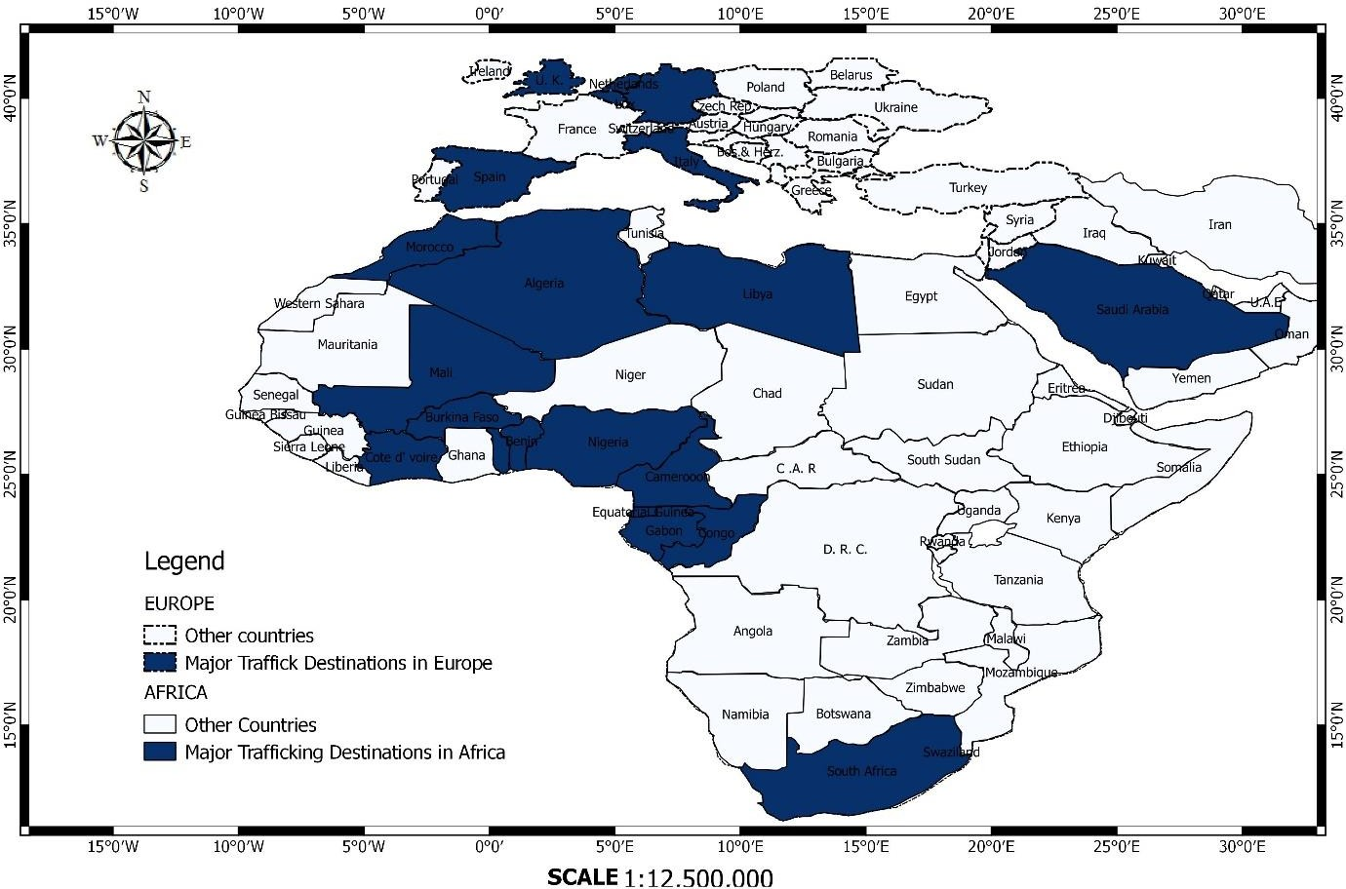

**Map 3**. Showing major human trafficking destinations across Africa and Europe.

**Source**: Drawn by the Department of Geography, Cartography laboratory, UNIZIK, Awka based on the information used in this research work (5th February, 2016).

#### Reasons for Human Trafficking

The key reasons why children, men and women are trafficked or transported to strange lands are to put them under slave condition like cheap labour, hard labour, domestic help, hawking, sale of human body parts or the whole person for ritual purposes or damaged organs replacement, prostitution, illegal adoption, begging, agents of violence or fake religious miracle-actors, forced or early marriage, and other forms of slavery conditions. Among the various reasons for human trafficking in Nigeria, this work will discuss the following: prostitution, begging, hawking, cheap unpaid labour and organ sale.

#### Prostitution

Ethically, prostitution and sex trafficking are social evils that affect the lives of millions of women and children in Nigeria, Africa and the entire world. There is of course, also male prostitution but this is less common than female prostitution. According to Parrillo and Stemson (1986) “prostitution and sex trafficking were almost unknown in traditional African societies. While there were loose women in every community, they did not sell sex as a way of making money” (p.282). The word prostitution is derived from the Latin ‘*prostituere*’ which means to expose something for public sale. Prostitutes sell sexual pleasure in exchange for a reward, which may be monetary or some special favour. A more comprehensive definition of prostitution is that it is the practice of engaging in sexual activity for immediate compensation in money or other valuables, in which the selection of sexual partners is relatively indiscriminate. Parillo and Stemson (1986) assert that:

A distinction is sometimes made between “free prostitution” involving women who have freely chosen this line of work, and “forced “prostitution”, involving women who have been intimidated into working as prostitutes or children who have been coerced or sold into the sex industry by their parents, family members or sexual predators. (p.283).

Whatever be the circumstance that leads girls into prostitution, the fact remains that there is little point attempting to distinguish between free and forced prostitution. Sex trafficking is against both the law of God, nature and societal norms and values, and its effects are entirely bad, even though money and other material things could be realized, the gains are often curses in disguise.

A distinction is also sometimes made between local prostitution and international prostitution. Local prostitution involves the sale of sex by local prostitutes within a town or city. According to Okoro (2015), young girls ranging from the ages of 15 to 25 now engage in the trade either for survival or forced to do so by their so-called aunties and relatives, who use them as sex slaves. We see them in big cities like Abuja, Lagos, Onitsha, Warri, Calabar, and Port Harcourt etc. Socialites and ‘big boys’ in town patronize the commercial sex workers. Some rich men (clients) pay for the service of the women of easy circumstances for a long period of time, even for years. While the older sex workers pay rent to proprietors of the brothels where they live, the neophytes, used as sex slaves pay to their madams who brought them from the village under the pretext of engaging them in decent business. There are sex hawkers who are usually seen outside, working for their respective bosses who pay them based on the amount of money they are able to generate in a day. Okoro (2015) asserts that “while Madams/bosses go home with about N 5,000 daily, the young girls doing the job

go home with N 2,000 on a good day” (p.33). There are clients, all those who buy sex in legal

brothels, adult stores, massage parlours, bars, strip clubs, motels and the like. Without them, the industry would be forced to shut down in Nigeria.

Otti (2016) revealed that over five million young Nigerian women are presently living in Europe as prostitutes with an increasing number flowing to Dubai every year. More shocking revelations came recently when an unidentified Nigerian gave out her virgin daughter for 55,000 Euros to become a prostitute in Europe. The sordid revelation was disclosed by the Spanish police when five members of a criminal network that specializes in luring Nigerian

women into prostitution in different parts of Madrid and the Canary Islands were arrested. Findings revealed that two of the suspects were arrested in Madrid while three others were picked up in Arrecife. Otti (2016) acknowledged that these young women underwent fetish rite of initiation with an oath of compliance administered by a voodoo doctor in a remote shrine in Nigeria. They were threatened with stern warning that violators would pay with their lives or become mad throughout life time. These victims, often deposit finger nails, hairs, underwear and other personal items in the Juju pot inside shrines as collaterals and warned by the voodoo doctors that they would be monitored spiritually till they fulfill the bargain. An international organization comprising mostly Nigerians have networks that fish for vulnerable young girls including virgins, with a juicy offer of better life in Europe. While some of the ladies are told in clear terms that they would go into prostitution on arrival in Europe, the virgins or the religious among them are often deceived with promises of lucrative jobs, further studies or scholarships. These networks which have underground cells in many states, including Abuja, Lagos, Edo, Anambra and several other states operate discreetly. They also maintain regional network with other African countries like Benin Republic, Senegal, Togo, Ghana, among others. The victims are often recruited and kept in various transit camps, where they are gradually initiated into the art of marathon sex in preparation for the bigger sex markets in Europe.

These young girls recruited by the group in Nigeria are subsequently moved from African countries such as Benin and Senegal where they are provided with false documents, most often using fake names and residential addresses. They are lectured on how to get to Madrid without having problems with the Police at different airports. Once in Madrid, the new recruits are taken to a home where they are locked up for days to evade the police. Subsequently the victims had to go to the office of refugee and tell a false story, soliciting for international protection. According to police investigations (cited by Otti 2016), while in hiding, the young girls are encouraged to become pregnant so that they could appeal to the

humanitarian conscience of their host country. Once they become pregnant, they would subsequently plead to be granted refugee status on the alibi that they would be stoned to death or flogged in public square if they return to their Islamic families with their unborn baby. Some victims confuse the police by claiming that they escaped from Boko Haram attack from the North-east and would be killed if they ever returned to Nigeria. Immediately they acquire residential permits, these young ladies would gradually melt into the big sex market in Europe to ply their trade. According to the police sources, the gang that specializes in recruiting these women was formed more than 20 years ago in Nigeria and was also known for sending scam letters by email asking recipients to send money, or proposing marriage to single women in Europe purposely to acquire citizenship. Reacting to the trafficking saga, a Nigerian born Spanish and politician, Helen Mukoro (cited by Otti 2016) said that Nigerian women are counted in great numbers among the prostitutes in Europe. Mukoro who had lived in Spain for over 20 years, expressed regret that Africa loses her beautiful brides to sex business in foreign countries:

These Nigerian ladies live in subhuman conditions abroad often becoming sex slaves for a stipulated period for pimps and traffickers that paid their trips to Europe. It is estimated that in Italy alone, between 10,000 and 20,000 Nigerian women work as prostitutes to survive and send as much money as possible to their families back home. In the Diaspora, there are more than five million Nigerian prostitutes. (p.14).

These prostitutes are brutally rubbed of sexual innocence and exposed to traumatic experiences by men who see them as mere objects of comfort. For most of those women who come into prostitution from existing base of premarital promiscuity, the transition is not traumatic, and for some, it may even be the beginning of a kind of life much more comfortable and subject to less pressure. In the world of those prostitutes, dehumanization is understatement. They work and live on road sides in Europe. They also assault tourists.

These illegal migrants use various ways to get to Europe from sub-Sahara Africa. Some of them also use false passports. By the passage of Mauritania and Algeria, they end up in the Spanish or Italian coast after crossing the Mediterranean in a boat owned by criminal structures. Few lucky ones among them travel in a plane organized by those same criminal groups. These women undergo extreme cruelty in the hands of the Nigerian mafias that ferry them through Algeria borders. They pass from one location to another. Mukoro (2016) informs that the Nigeria women who aspire to cross the border into Spain or Italy, are ritually raped by members of the union turn by turn. The leader of the team determines when they can get pregnant and if they become pregnant, the child is owned by the chairman of the union, who will use the baby the way he likes.

According to figure released by police and civil guard in 2012, 976 Nigerian mafias that specialize in human trafficking were discovered in Spain. According to the report (cited by Otti 2016), Nigerian prostitutes reached to 12,305, and tripled in 2015. Those controlling the mafia groups smile to the bank every day. Girls in their ring generate 350 to 500 Euros. These sex slaves enjoy no weekends for stoppage by menstruation. The Nigerian mafias have expanded their cells and maintain strong presence in many countries of Europe. European Police (Europol) itself acknowledges in several of its reports how these groups have settled in Spain, Italy, the Netherlands and Estonia, among other places peddling cocaine, trafficking women and children or perpetrating scams that rip-off their unsuspecting victims. The covenant of these mafia groups are so strong that members quit the cult at the risk of death.

The national police in Spain (cited by Otti, 2016) noted that the girls have debt that can reach 160,000 Euros with their pimps for the trip to Spain and other advanced countries and must end up paying more before escaping the street. As soon as they pay up their debt, they continue with the street life and even become mommies when they are too old for prostitution, enslave those who come after them and get paid too. With the proceeds of prostitution, these groups buy expensive cars, jewelries and other luxury goods which are

stocked in vehicles and shipped to Nigeria. The proceeds from the goods will be reinvested in the trafficking of people not only prostitutes but also in illegal immigration and the most cruel of all, the trafficking of children. Babies taken from their mothers are crossed over in boats in the arms of strangers, who carry the babies as their own so they may not be deported from Europe and will become part of the vicious circle.

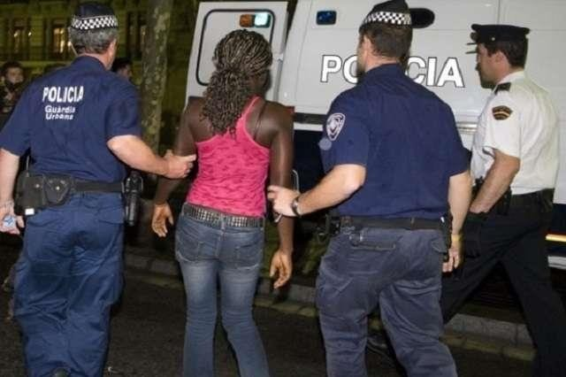

**Fig. 19.** Shows a Nigerian Prostitute arrested by Spanish Police in 2015

**Source**: Daily Sun Tuesday, February9, 2016 pp. 14-15.

International prostitution is an industry for it involves a large number of individuals, institutions and whole societies co-operating in the exploitation of women and children. There are those who lure girls with promises of work, often seemingly respectable work in other regions or countries. They are guilty of sex trafficking. As captured by Hughes (2008) the “process that delivers victims into prostitution, it includes the recruitment, habouring, movement, and methods by which victims are compelled to stay in prostitution, whether by violence, coercion, threat, debt, or cultural manipulation” (p.284). These victims may be from the same city or country as the exploiters, or they may be trafficked from other countries or continents. According to Parillo and Stemson (1986):

Forgers and corrupt officials provide the documentation that makes it possible for the victims to travel. Corrupt police can be bribed to ignore the existence of brothels and massage parlours, and the plight of the women in them. The operators of these brothels often work in association with criminal gangs, drug pushers and the like. They maintain a network of pimps who offer to provide prostitutes for visiting businessmen, politicians, tourists, celebrities, sports teams. They will even arrange to supply prostitutes of specific ages and races. (p.284).

No doubt, there can be no supply of women and children without the male demand for the sex of prostitution. Without the sex industry’s commodification of women and children, without the direct or tacit approval of governments in fostering sex tourism, for example, or zoned areas of prostitution; and without the exporting of Western sexual liberalism that depicts prostitution as sexual pleasure and liberation, calls it work, and tell us that prostitution is about a woman’s right to control her body, the trade would not have continued. The demand for sex comes mainly from men, although there is also a developing trend in which women pay younger men for sex. The reasons why people patronize prostitutes include the following as streamlined by Parillo and Stemson (1986):

1. Desire for temporary sexual pleasure without commitment. Clients have no interest in a permanent relationship but only want to satisfy their immediate desire
2. Compensation for an unsatisfactory sexual relationship with a wife or husband
3. Separation from a spouse by business travel or war
4. Relaxation while on holiday, often known as ‘sex tourism’
5. Indulging exotic tastes. In many Western countries, men are now wanting to have sex with cheaper and more exotic women from developing countries or with children. These taste play into sexual trafficking and the child sex trade

As long as people crave for sex and are prepared to pay for it, the sex trade will likely die hard. That is why it is critical that attempts to combat prostitution and sex trafficking do not focus only on the prostitutes but also on their clients and syndicates.

#### Begging

Trafficking for organized begging takes place mostly in the Northern part of Nigeria initially until recently when it is becoming so rampant in other parts of Nigeria. It is a common practice to see physically challenged or disabled persons who are lured into begging business in major cities. Some of the Alhajis or mallams transport trailer-load of persons with diverse disabilities to cities like Onitsha, Lagos, Aba among others to beg and they bring back return each day. Such cases are now pervading Eastern Nigeria especially among those from Ebonyi state who fastly constitute nuisance on the streets and along the major roads in the cities. Port Harcourt road in Aba, and Upper Iweka in Onitsha have a lot of them, begging for alms. Some are trained to feign being mad, blind or injured. Some wear bandages soaked in blood, claiming to have had accident. Many have been discovered and exposed to the public. Those beggars do this practically without rewards other than daily meals. They are brainwashed and denied opportunity and access to formal education. Some beggars hide guns inside refuse

dumps where their cohorts use them for robbery at night to beat security check points. Some beg in the name of one charity organization or the other which actually does not exist or are into human exploitation.

There was a case of one Mr. Nwanga as reported in Saturday Sun, March 10, 2012, whom a group of suspected fraudsters converted to a money-making machine through begging for alms. He suffered the ailment known as *Scrota Hernia*; the fraudsters was led by one Julius Igbokwe with Nwanga’s laminated photograph. Pa Nwanga with his supposedly helpers trekked round the streets of Enugu, begging for alms half-naked. After each day’s business, he was giving a paltry sum of N200. This deceit was exposed when they relocated to Lagos.

There are many others who make fortune out of people’s misfortune through organized begging. According to Chukwu (2008) one Umaru Keffi was arrested by the Saudi Arabian government and handed over to an agent of Nigerian government for trafficking hundreds of girls and children to Saudi Arabia and other European countries under the cloak of religion. Since helping the less privileged in society is one of the pillars of Islam, Umaru pretended he was taking care of them but he sent them to different homes of his clients for use as domestic or sex slaves. He was also involved in trafficking disabled beggars to big cities. They begged and made money which they returned to him on daily basis.

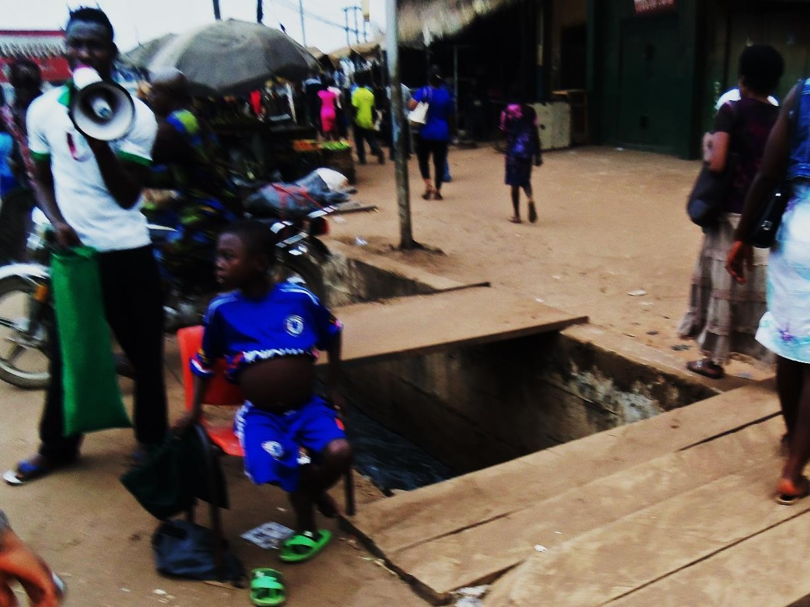

**Fig. 20.** Showing a child used for begging at Upper Iweka, Onitsha Anambra State by a presumed charity organization. Captured by the research at Upper Iweka, Onitsha on 6th February, 2016

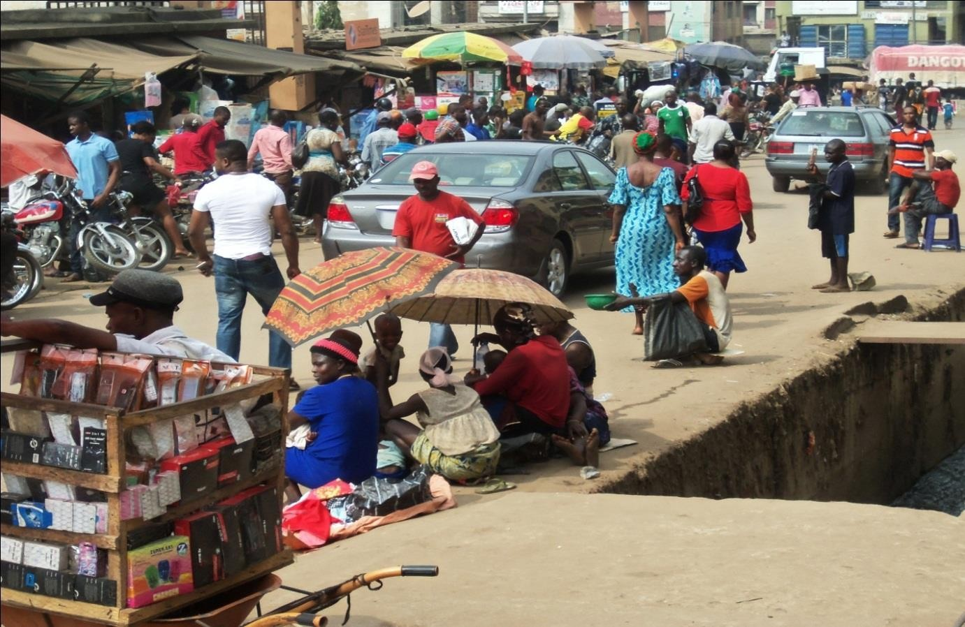

**Fig. 21**. Showing beggars at Upper Iweka Onitsha often paraded by some trafficking agents who bring them from remote villages usually from Ebonyi State. Captured by the researcher on 26th February, 2016

#### Hawking

Hawking is another reason why children are being trafficked. In a country like Nigeria, women in the cities visit rural areas and meet mothers who they think can easily agree for them to take their daughters or sons to the city where they stay. The poor parents usually think that the person they handed over their children will take care of them properly and send them to school, not knowing that they have subjected their children to hawking. Child trafficking often leads to hawking and child labour. Child labour in Nigeria is the employment of children under the age of 18 in a manner that restricts or prevents them from education. Hawking entails carrying of wares or goods for sale, it means moving to sell things by going from place to place asking people to buy them. There are those who use wheel-truck and there are side walk hawkers. The majority of Nigerian parents are poor and that is why many send out their wards to hawk. Some parents themselves had been hawkers themselves and so they see nothing wrong with this activity and it largely reflect their value representation. The city women usually go to some other parts of the rural areas to gather as many children they want and finally travel to the cities with them. When the children get to the cities, they would be surprised to see that they were trafficked and hence are stranded, not knowing how to make their ways back to their locations or their parents. Those city women use them for business; handing some over to other people who subject them to hawking on the streets, domestic servitude and other cheap or hard child labours.

#### Cheap Labour

Child labour, usually cheap labour is growing in Nigeria on daily basis. Writing on *The new face of slavery*, Ani (2014) recounted:

When a Briton, William Wilberforce was championing the campaign against slave trade, he did that because of his regard for the sanctity of human lives. Slavery reduced humanity to nothingness. So when in 1807, an Act for the abolition of slave

trade came into being, it was a big relief to most African countries, especially those that were British colonies.(p.51).

Today however, slavery has assumed another dimension. There is a growing cartel and network of men and women across the West African coast, which employs the service of under-age children and ferry them across Nigeria for cheap labour. Most of them work as nannies, house-maids, washer men and women, hawkers, security guards as well as labourers in building sites in Nigerian cities. According to Ani (2014):

The bulk of these innocent children are from Togo, Benin Republic, Sierra Leone and sometimes, Ghana. Most of the times, they are willingly contracted to the merchants or slave masters by their parents who in turn receive peanuts from the masters at the end of every month. A large number of those under age children are found mostly in building sites across the States.(p.51).

A casual visit to some building sites in fast growing urban and sub-urban countries in Lagos and Abuja will be enough eye-openers. These kids mix cement and gravel and serve the mason, using head pans, they also carry blocks which they serve the brick layers. They do not have any permanent address apart from the uncompleted buildings at the site. They look haggard, unkept, malnourished and lethargic, exposed to cold, mosquito bites, rape, bad gangs, and other dangers. Their condition is pitiable but they are helpless, as they have been given away by their parents and guardians in exchange for little money. A fourteen-year-old Beninnoise kid, called Taye who was a victim of child labour at Tokumo Street, satellite town Lagos said they were paid N3000 at the end of every month while they receive N300

chop money every day. Most often they feed on bread, garri and soft drinks.

The US Department of Labour in its 2010 report claims that Nigeria is witnessing the worst forms of child labour. Child workers include street vendors, shoe shiners, apprentice mechanics, carpenters, vulcanizers, tailors, barbers and domestic servants. These children

typically work long hours and for little pay, with their families. Some children are exposed to dangerous and unhealthy environments. Child labour is more common among children of illiterates. On average, in the South-Western zone of Nigeria, there is higher work burden for working children. About one third of working children obtain no benefit from their employer and child labour among pupils affects their learning ability. It creates room for lack of seriousness and interest in school work, poor memory, learning difficulty and under achievement in school.

There are many other reasons why human being is trafficked. Some are used for rituals, damaged organ replacement and drug trafficker for drug barons. Some are forced into criminal activities such as militancy, hired assassins, conscripted soldiers and terrorists. Some victims kidnapped by Boko Haram terrorist groups are now members of the sect, unleashing havoc on the society as suicide bombers. Some are recruited to fake miracles within and outside the country for fake prophets and pastors; they act as sick people, cripple, deaf, dumb, mad, or even dead people during crusades and claim being healed after prayers. This attracts ignorant crowds who are in turn duped of their money and other valuables. Some young girls are kidnapped and held hostage for sexual abuse and baby manufacturing. Such cases have been reported in Abia State where some gang of human traffickers, held young girls hostage under thorough security surveillance, arranging men who impregnate them and hiring special doctors who attend to them until delivery. The babies are sold to ritualists and illegal adopters. One of the victims escaped and alerted the police.

Similar to this is blood donation; some lure innocent and unsuspecting children to parting with their blood. As reported by Igbokwe (2013), a 23-year-old Olusola Opeyemi and his accomplices were apprehended at Orile Agege area of Lagos, whose duty is to take a pint of blood from kids and pay them N1, 500. He was able to lure few boys who in turn spread the

news to others. Excited, the students promised not to let their parents know what they were into. They sold the blood to medical doctors at a higher price. Some of the victims said

Olusola told them that they were helping people who need blood to survive. Some said the money helped them to buy things that their parents could not afford to buy for them like phone. They used the money to eat to replenish the blood. Many in the area lost weight, one man said his son died as a result. Some husbands accused their wives of not feeding the children well while other parents accused fellow students of bewitching their own children at school. According to Igbokwe (2013):

Operating from a shop located at No.23 Owolabi Owotoye Street Orile- Agege, where he sold medical equipment and other articles, Opeyemi and other suspects had convinced their victims that parting with some quantity of blood will fetch them money while not putting them at risk. The unsuspecting students, had fallen for their antics and therefore freely gave their blood at a fee of N1,500. (p.13).

There are many of such cases in Nigeria today. As widely reported by the media in May 2017, a Nigerian father gave out his 15-year-old son to a human trafficker at N8,000. This

shows the extent of frustration and desperation orchestrated by poverty and moral decline in the world today.

#### Human Organ Sale

According to Chugh (2015)**,** an alarming surge in renal diseases, diabetes and high blood pressure is driving the global demand for kidneys, which greatly exceeds supply. The near universal ban on sale of human organs coupled with a wide-spread reluctance in many cultures to donate kidneys even after death means that patients often must spend years hooked up to dialysis machines unless they find a willing donor. This gapping hole between demand and the legal supply of kidneys is being filled by what may be the world’s biggest black market for organs, which criss-crosses India, Nepal, Bangladesh, Pakistan, Sri Lanka and Iran. According to Chugh (2015), in recent years, Sri Lanka’s capital Colombo has become the new nerve centre of this network where most transplant operations are carried

out. The country has attracted kidney buyers from as far afield as Israel and the United States. This development came after India tightened its rules in organ exchange in 2008, following the arrest of a “kidney kingpin” running one of world’s largest kidney trafficking ring. Many donors are also taken to Iran, the only country in the world where selling kidney is legal. As reported by Al-Jezeera (2015) many agents in India and Bangladesh work with doctors and hospitals who offer “complete packages” to foreign recipients with prizes ranging from

$53,000 to $122,000.

Chugh (2015) observed that social media has catapulted the trade in human organs to a new dimension. Brokers use face book pages fashioned as kidney and transplant support groups. “Once the demand for a particular match is relayed to the broker, all it takes is a single post promising monetary compensation in exchange for a healthy kidney” (p.19). The messages often look as if they are posted by a distressed relative who is urgently looking for a particular blood match donor, suggesting a quick transaction. The brokers mostly target healthy and non-smoking donors in their 20s or early 30s, preferably men since they can more easily travel abroad alone. Those who already have passports are given preference. Once trust is established, the potential donor is then sent for pre-arranged blood tests and a tissue typing test in chosen pathology laboratories. If the match is good, arrangements are made for the operation. The brokers have contacts with those who can arrange the necessary documents within few days.

According to the brokers as reported by Al-Jazeera, donors who already possess passport are paid roughly 400,000 rupees ($6,000), part of which is paid two days before the operation. Others whose passports are arranged by the brokers receive up to 300,000 rupees ($4,500). The private hospitals regularly pay immigration officials at the airport for an inducement called‘*no-questions-asked’*entry into the country. They know people travelling with those brokers are donors when they ask for a tourist visa on arrival.

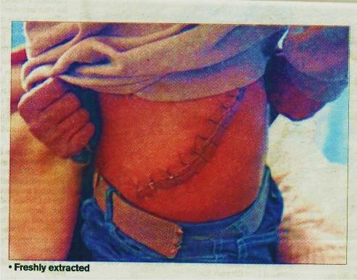

**Fig. 22** showing a victim of freshly extracted kidney in India (India is among the top kidney exporters.World Health Organisation report (2015) alerted that 2000 Indians sell their kidneys, with many of them going to foreigners.

**Source**: Saturday Sun October 24, 2015: pp.18-19

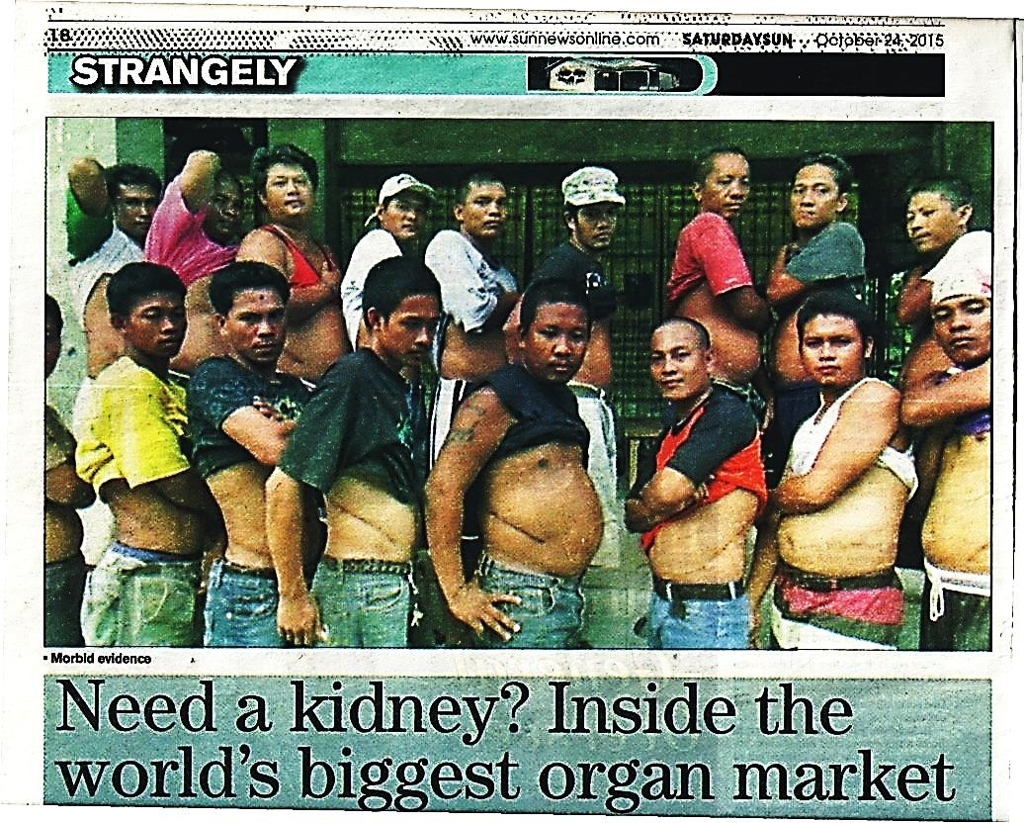

**Fig. 23** showing those disposing their kidneys in the human organ market in India.

**Source:** Saturday Sun October 24.2015: pp.18-19

**Note:** Some Nigerian human traffickers are now exploring the organ markets across the world. Though no Nigerian is among those in the above picture, Nigerian children are still victims of organ sales in different parts of the world. Most of them are drugged to unconsciousness before the extraction of their vital organs.

#### Human Trafficking Strategies in Nigeria

Violence, coercion and deception have been identified as the key strategies human traffickers employ to take victims away from their families. Global Freedom Network (2014) informs us that between twelve and twenty-seven million people world-wide are enslaved into forced labour, about two million people are victims of sexual trafficking, 60% of whom are girls. Human organ trafficking is rife as around 20,000 people are forced or deceived into giving up an organ (liver, kidney, pancreas, cornea, lung, or even heart).

#### 5.3. 1 Deception

Parents with large family are often prone to these traffickers deceit in giving away some of their female children to city residents or even strangers promising a better life for them. Some use abduction, fraud, abuse, or power, a position of vulnerability, the giving or receiving of benefits to achieve the consent of a person having control over the child for the purpose of exploitation. The victims are often provided with fake passports, assuring them of comfort and cool job in Europe. Like the case of Oluwafemi whom officers of immigration discovered he was using his laptop to forge documents and fake visas. He was arrested and jailed. He had more than 60 images of fake documents in his laptop.

#### Coercion

Dozens of women are being smuggled into Britain and other locations as sex slaves every year under the threat of black magic curses. Close to 160 Nigerian victims rescued in 2013 as reported by Channels Television (2014) had been subjected to series of sinister rituals aimed at terrifying them into submission. They were taken to witch doctors that cut them, rubbed black powder in their wounds and threatened them with death if they ran away from their captors. In some cases, young women are forced to sleep in coffins, drink chicken hearts soaked in alcohol or sacrifice intimate items. According to Ovuorie cited by Channels Television, the rites involve checking the horoscope of each girl as well as collecting some

of her blood, finger-nails, hair, and wears. These rituals are simply a method of controlling the women. It is very powerful and some of them who come from places where juju power is revered see nothing wrong with those rituals. There are very strong beliefs that one must adhere to what is said and vows made or very bad thing will happen to the person and family. The girls are forced into controlled prostitution as they have no possible way which they can support themselves in that country. Along the road leading up to the border, police and customs officers wave and greet the traffickers, demanding for their own share.

#### Modern Technology

With the world shrinking into a global village, the contacts with individuals, cities, nations and continents have become easier, thereby making human trafficking a more complex phenomenon. The earlier contacts with the outside world were via the Sahara, and then the coastal lands and recently the network of transportations, communication and technology create more opportunities for human trafficking. Some victims are not easily noticed as the business is sophisticatedly and subtly organized. Some are arranged through phones, face- book and other internet connections. Unfortunately, some victims happily and voluntarily surrender themselves to traffickers, sometimes with the consent of parents and guardians who want better life for their families. The agents of human trafficking entail Parents, Guardians, Politicians, Pastors, Imams, businessmen and women, hospitals, charity motherless homes, security agents, government functionaries and some disgruntled individuals and groups in the society.

According to The Guardian (2003), in some cases, children are simply kidnapped and sold to greedy middlemen who then ferry them into neighbouring African countries or to Europe to work. Female children are particularly vulnerable. Sometimes they are raped and subjected to all forms of indignities. Others are sold or deceived into travelling to Europe with promises of

instant and stupendous wealth. Some dubious returnees paint a rosy picture of life in Europe and America, thus making the naïve yearn for the luxury of being there.

Mesce (2006) confirms that victims are often lured by promises of a better life but unaware of the horrors that usually await them. They are transported through a web of trafficking routes that circle the globe, from Nepal to India, from Thailand to Saudi Arabia, from Russia to Germany. Some are taken from villages to the cities in their own countries. Many who fall prey to traffickers are enticed with false promises of good jobs, schooling or marriage. Some are kidnapped, still others are sold by their families, sometimes on the naïve hope of giving their child a better life and in other cases for the money. Okpalakunne (2006) posits that:

In most cases, the victims do not have the exact knowledge of the purpose for which they are being transported. Some are tricked into seeking employment, vocational training or educational opportunities elsewhere. The traffickers may pay their passage but the victims would be expected to make a refund after they had got a job (mostly prostitution) in their new settlement. (p.16).

Morka (2006) noted that at Seme border, traffickers use motor bikes to cross the boarders to neigbouring Benin. Traffickers deploy different tactics to beat security personnel at the various entry points due to the nation’s porous border. There have been a significant increase on the activities of internal traffickers ranging from using orphanages to front child trafficking, exploiting children and women, using for child labour and prostitution as applicable. Under aged children from rural areas (community) are brought to cities to serve as domestic servants and hawkers. The Nation (2011) advanced that violence and psychological intimidation are used to coerce the victims to sell their bodies for money. Miyasaki (2011) also inferred that “they can be lured by offers of a job, a meal or a place to stay, access to drugs or a relationship, then are manipulated by traffickers until they feel trapped”. (p.17).

Instead of physical bonds, a battery of psychological tactics often restrain victims. Traffickers often outsmart the police and in some cases operate with the complicity of law enforcement.

#### The Root Causes of Human Trafficking

Motivations for human trafficking have been adduced to increased quest for materialistic values among youths facilitated by peer pressure. Nmah (2008) asserts that human trafficking is “an index of poverty, neediness, subsistence living or general deprivations” (p.84). For Amujiri (2009) the causes of this ungodly inhuman and unpatriotic menace include stress experienced in family, breakdown of values, the size of family, porous nature of our border, tradition, culture, religion, peer pressure, lack of information, weakness of our law, socio-economic situation and having unwanted babies. Oha (2012) asserts that “as a result of unemployment and poor standard of living nationwide, many youths especially boys resort to checking out” (p.133).

In the words of Limlim (cited by Olayinka 2007), there is a strong linkage between being poor and those that are being trafficked. However, being poor does not necessarily make one to submit himself to trafficking. There are other major considerations why trafficking take place. For example, some household that are not necessarily poor are actually giving up their children willingly to trafficking because they think that they will go out and bring more riches. So the greed, the urge for more sometimes aid these daring decision of going into trafficking but majority of them who are victims of trafficking are actually from poor communities and homes. Another cause is the loss of values. There is the need to question the essence with which many communities have lost the attachment to the dignity of their socio-cultural heritage and surrendered those values in pursuit of material gains.

On the side of security, one of the intractable problem is the capacity of law enforcement agencies including the immigration and the police officials in monitoring and reporting cases, as well as patrolling borders. To Ponle (2004) economic recessions, increasing

unemployment, grinding poverty, rapid urbanization, a weak institutional framework, a breakdown of the extended family system and perverted value system, women’s and children’s vulnerability, low status of female child, corruption, global markets for sex, high demand for cheap and submissive child labour, growing neglect of shelter rights for children, youths desire for emancipation through migration, age-old traditions among others contribute to human trafficking.

Nejuvie (2008) advances that there are diverse reasons why many Nigerian children are vulnerable to trafficking, melding widespread poverty, large family size, urbanization with deteriorating public services, low literacy level and high school dropout rates. The demand for cheap commercial sex workers in countries of destinations strongly contributes to the growth of this phenomenon and the success of this criminal network. Parents with a large family often over burdened with the care of too many children are prone to the traffickers deceit in giving away some of their children to city residents or even strangers promising a better life for them.

Traffickers also exploit the trust of people rooted in a widespread, culturally accepted common practice in West Africa of placement and fostering as part of the extended family safety net. In some instances, desperately poor and uninformed parents willingly co-operate with the traffickers, giving away their children in exchange for a small fee. In the hands of unscrupulous guardians, these children are increasingly trafficked, and exploited for money. The poor economic situation in Nigeria has led to unemployment and high rates of school dropout. These circumstances have created a large pool of inactive and unengaged children and adolescents who are much more vulnerable to trafficking than their peers who go to school. The motivation, especially of teenagers, to find work away from home is often driven by the increasing taste for material things.

Guest (2003) noted that “the case of lack of job, food, money, clothing, housing force Nigerian youths to head towards the Northern deserts enroute to Italy and policing our

borders is questionable” (p.5). Nigerian Women’s rights organizations reported that hundreds of Nigerian women and girls hoping to escape poverty and discrimination at home voluntarily migrated to Europe in response to job offers as domestic workers or waitresses. Upon arrival, many found themselves trapped in forced prostitution, saddled with exorbitant debts, and forced to work under brutal conditions, forbidden to refuse any customer, women who dared to resist encountered harsh punishment from their employers, including physical assault. Some clients also sexually and physically attack the women, other clients rob them. Their status as illegal migrants make the women keep silent to avoid deportation. Therefore, it can be said that poverty, illiteracy, poor family planning, rapid urbanization, lack of opportunities for parents to properly care for their children, sometimes occasioned by unemployment by parents, being too busy for their children or by broken homes lead to trafficking in persons.

Daily Champion (2010) avers that the reason Nigerians from the South East zone of the country can see 24,000 of their children being trafficked annually could be placed squarely at the door steps of those in authority at the local, state, and federal levels who are not providing good governance in all its ramifications. Changes in mentality that rapid urbanization and dislocation bring to homogenous societies where the cultural policy had been unity, and care for one another. It then was that no matter how many children an Igbo family produced or how indigent the family was, there will always be members of the extended family network to take over a handful of the children to train in school, skill or trade. This was a cultural mindset that has since been eroded. It is now survival of the fittest, family members no longer want to care but can care to exploit. The Guardian (2003) further observed that the incidence of child being taken abroad to work for peanuts has increased at an alarming rate. In a sense, it is a warped response to the level of poverty which has gradually but steadily crept into the fabric of the nation. Some parents have resolved to making wealth off their children by giving them out as child workers.

Mesce (2006) said that it is a high profit, low risk enterprise fueled by the globalization that connects much of the world and facilitates movement of people, goods and services across international borders, it is driven by a demand for cheap labour and an expanding sex industry that includes tourists seeking sex with children. Trafficking feeds upon the effects of poverty and the subordination of women. Lack of education and information, few income opportunities, and violence and discrimination provide a steady stream of vulnerable women and children. Okpalakunne (2006) laments that the country is characterized with unemployment, lack of social amenities, economic instability, devalued local currencies, low standard of living which have led to migration from the country to developed nations and migration from poor neighbouring countries facilitated by free movement in ECOWAS region.

Considering illiteracy as one of the factors that facilitate trafficking, Morka (in Okpalakunne, 2006) maintains that women with little or no education are vulnerable to being trafficked especially internal trafficking. In many parts of the country, children hardly go to school, they either rear cattle or work in farms to help their parents. The girls are forced into early marriages and not given the opportunity to attend at least secondary education. The illiterates and school dropouts cannot compete favourably with those that have acquired a certain level of education in getting employment in the scarce labour market. Olateru–Olagbegi (cited by Sotade, 2007) said that lack of access to education in some remote areas force parents to allow their children go and work in towns and cities. The WOCON boss cited the case of Ajegunle, a remote community in Ogun state, where they discovered that there were no primary schools and the nearest one was about six kilometers away. Because of the people’s poor economic status, they found it difficult to send their children to school. With the children being less occupied, giving them out to strangers as domestic helps therefore became a lucrative business.

Common trafficking victims according to Miyasaki (2011) include immigrants and the drug addicted, poor and abused. Young people with nowhere to live and no means of support also are vulnerable to exploitation. According to Okoro (2011) trafficked persons are majorly from poor background, predominantly from the rural areas. The trafficked persons are moved to cities for the purpose of forced domestic servitude, hazardous jobs, and commercial sex work as prostitute, street trading and hawking.

At this point, it is safe to say that the causes of the trafficking menace is not unconnected with poverty, desperation to escape violence, corruption, unemployment, illiteracy and ignorance, wickedness, security lapses and others. Dave-Odigie (2014.) noted that the reason has close linkage between poverty and widespread illiteracy as well as unsafe and uninformed migration. Poverty, unemployment, collapse of the protective environment as a result of the laxity of security agents in discharging their duties, ignorance of victims and desperation to be rich. Poverty has been identified as the principal driving force behind this trade and the most visible cause of vulnerability of women and children to trafficking in Nigeria.

According to Camara (in O’Donovan 1970), 20% of the world’s population possess 80 percent of the world’s resources: if so, the 20 percent who are keeping 80 percent in a situation which is often sub-human- are they or are they not responsible for the violence and hatred which are beginning to break out all over the world? Richer nations exploit the poorer nations. Often the rich are wealthy because they have oppressed the poor. According to UN Human Development Report (2005), Africa is the only part of the developing world where living standards have fallen over the decades. Taking Nigeria as an example, in 1992 some 41.8% of Nigeria’s population subsisted on less than one Dollar per household per day. By 1996, this number had grown to 46.3%, and by 1999, to 65%. UNICEF points out that Nigerian children born in 2005 have a life expectancy of 44years, and that of every 1000 children born, 100 die before their first birthday. Some 38% of children under five suffer

from stunted growth due to malnutrition or disease, only 48% of the population have access to safe drinking water. Some 43% of the Population are illiterates.

According to UN Nigerian Human Development (2005), poverty manifests itself in many ways; some of the most common are “prostitution, exposure to risk, corruption, robbery, street life, increased unemployment, living in squalor, shanties, shackles, high infant mortality, acute malnutrition, short life expectancy, human degradation, living in overcrowded and often poorly ventilated homes” (p.138). Nigerian populace is in lack, they are not benefitting from their rich natural resources; they need better education, food, violence-free society, honest government, and the need for Christians to live out their faith.

Lack of opportunities and unemployment, corruption and instability and (or) armed conflict contribute to human trafficking. Some parents may pay for their children to be taken to another country, in the hope that they will gain employment and a better life abroad. Alternatively, children may be sold to traffickers by their parents, or kidnapped by such groups. Street children are particularly susceptible to becoming trafficking victims, as are children who have been stigmatized or suffer other forms of discrimination. In the Niger Delta, children who are discriminated against as witches are extremely at risk as they are usually rejected by their families and communities, and often live on the streets.

An ILO/IPEC reports (cited by Dave-Odigie, 2014) found out that 40 percent of Nigerians street children and hawkers are trafficked persons. These are children who are from poor deplorable backgrounds and so due to lack of opportunity at home and with or without their consent are trafficked. The contemporary society is bedeviled with a serious gap between the rich and the poor. Many parents claim that they cannot afford to keep their children in school because the economic survival of their households depends on the proceeds of the sales by these kids. Poverty has therefore been identified as the principal driving force behind this trade and the most visible cause for vulnerability of women and children to

human trafficking. For Oha (2012), poverty is the major root cause of child hawking while the quest for wealth and wickedness form the root cause of Child trafficking.

Another factor is the collapse of societal ethical values. In some communities in Nigeria, the wealthy are accorded honour, title and respect without bothering to find out the source of their wealth. This at times makes people engage in all sorts of crimes and vices to acquire wealth. Some parent are ready to handover their wards to such people for mentorship. The society classifies people into groups of the ‘*haves*’ and the ‘*have nots*’ and some people out of desperation to belong to better social class or at least pull through the poverty line, fall into the racketeering bait. In the past, according to Oha (2012), the system of the society had operated three classes of people namely: The higher echelon, the middle class and the lower class of people. However, the present system has either by design or by accident tried to stamp out the middle class and allow only two classes to exist. The higher echelon is considerably few in population. They are people of affluence and influence who direct the nation’s resources at their whims and caprices. They own estates in almost all the states in Nigeria and overseas. Only a few in this class consider the plight of the lower class. Thus, the number who cares about the welfare of the poor and the common man is very few.

The second class referred to as the middle class constitute those who are struggling to find their feet on the ground and maintain the status quo, but who contend with the fact that many things have fallen apart. Some of the members of this class operate with extra consciousness in their spending or else risk joining the third class. The ownership of a house or landed property must be by prudent planning and budgeting while the training of children and wards to avoid their engagement in hawking is painstakingly done. Although sending their children to highly qualitative school seems to be their utmost desire, but too many things compete for their scarce resources and this places them on the scale of preference theory. Too many of them battle daily with family stress, job demands, life hassles, energy crisis, car maintenance challenges and extended family problems.

The third class being the lower class lives in abject poverty. Many in this group move about with hurt of failures, disappointment, hunger crisis, unemployment crisis, and lack of access to quality medical care and delivery system. They constantly cry about injustice. To some, death is preferred to life. They curse themselves at every little provocation. This desperate group with large extended family system ignores completely the consequences of street hawking and exposing their wards to trafficking to get proceeds for feeding and family up- keep.

Due to high rate of poverty, many Nigerians of school age are not in school because they cannot afford it, or because they want to conquer poverty first. Thus those with minimal or no education to secure good jobs often fall easy prey to traffickers, who deceive them with tales of good jobs in the cities in the case of internal trafficking and greener pastures abroad for trafficking across borders. Even when some of those young people have some education, but are not able to get jobs, they feel that they could find jobs elsewhere and of course, this makes them very vulnerable to the manipulation of the traffickers who bank heavily on their misery.

Unemployment is a sensitive causative factor for human trafficking. The rate of unemployment is very high in Nigeria, leading to desperation of a lot of people. Most of the traffickers have advanced their schemes through the media and internet. They pay for advertisement on radio and television, informing the unemployed youth about the opportunity for jobs and university education overseas only to use them and make fortunes in brothels and factory sites within and outside Nigeria. What worries the media houses is the money for the advert and all the necessary attractive jingles will be done without any equivocation. Sappor (cited by Jet, 2014) said “it is so sad that Nigeria is a land where milk and honey flow, yet, there is so much poverty” (p.50).

Some scholars agree that reasons for the rise in cases of human trafficking include the vulnerability of women and children, the perceived low state of girl child, the high incidence

of corruption, as well as the high expanding global market for sex and cheap labour. Another school of thought blames it on the global economic recession, global warming resulting to climate change which have made some areas prone to floods and force many people to become refugees or relocate to other areas. Other cases include bad governance, technology, industrial growth, erosion of old family, religious, social, cultural and ethical values. These developed countries are often craze for cheap labour from developing countries.

In the areas where there is conflict or war, people are forced to migrate to safer places, usually urban centres. In some states in Nigeria like Ebonyi, Benue and some parts of Northern Nigeria where there are sporadic armed and violent communal conflicts, the youths are easily trafficked. Some young people are afraid of evil men and women in the village who make dangerous charms and poisons and to escape pre-mature death, they escape to city without plans.

Greed is a human trafficking causative factor. Investigations reveal that greed rather than poverty accounts more for human trafficking. According to Amujiri (2009), “some of the trafficked persons are from rich homes. Some rich parents encourage their daughter to go to Italy and prostitute and send them dollars” (p.47). Previously, people tried to protect their family name. They were afraid of doing anything that could tarnish or bring their family name to disrepute. What is important today is to make the money and the family will be respected. Many youths because of this materialistic tendency, and pressure from their peer groups, opt for immediate cash which they are not sure how or when they will succeed. Some youths go to the streets to hawk or to beg, even in foreign countries.

Poor state of security is another factor that encourages human trafficking. There is a collapse of the protective environment as a result of the laxity of security agents in discharging their duties. Negligence on their part account for why most of the trafficked persons pass through immigration with fake visas which are undetected at the point they are checked. Negligence of duties may be attributed to poor salary for the security agents or sheer corruption which

has become endemic in Nigeria. Some victims confess that security agents are part of the deal as they connive with the traffickers and let them pass through check points at airports or land borders unchecked. According to Agbu (2003), the road and sea links or boundaries of Nigeria with her neighboring countries are extensive and are difficult and expensive to patrol effectively. As a result, citizens from other African countries who have intra-State conflict in their countries of origin use this porosity to flee across international borders to enter into the country as refugees and some of them end up doing menial jobs in Nigeria or fall prey to the traffickers who engage them negatively. Political instability in various African countries contribute to human trafficking.

Urbanization is one of the major sociological changes taking place in Africa at the end of the twentieth century. Young Nigerians are moving to the city in large numbers, hoping to escape the hard work of the farm and the predictable routines of village life. Life in the cities sounds far more exciting and interesting than life in the village. These young ones seeing their friends from the cities seemingly better off than they, want to go to the cities by every available means. They even go for the traffickers to be recruited. What they often find in the city afterwards is something different. O’Donovan (2000) infers that most cities are crowded, dirty, dangerous, impersonal and unfriendly. There are trash, disease, crime and a general lack of concern by people on the street for the welfare of one another. There are helpless handicapped people hoping for a handout. There is materialism, pride, lust, greed and selfish indifference instead of the gentle, supportive community most young people would have experienced at home. There is often hypocrisy, betrayal, dishonesty, deception, corruption and tribalism at the work place; if the young person is lucky to get a job. There is drug abuse and alcoholism, gangsterism, crime, strong temptation and impersonal selfish individualism in business and even in the church. Nights are filled with insecurity and the fear of robbery, rape and break-ins. Infact, the city falls far below the ideal that young persons imagined. Even if they find jobs, their money seems to disappear overnight with the high costs of

housing, transportation, food, clothing, utilities and other expenses they never thought about in the village. With the urban challenges some allow themselves to be trafficked while others become agents of trafficking. Some are forced to become sales girls and prostitutes, servicing their boss and outsiders sexually to meet up with city bills. Some come back to take their friends in the village and introduce them to immoral and obnoxious businesses.

Poor or lack of family planning is another factor advanced by scholars on the cause of human trafficking. The size of the family and the number of children in it who require care and attention place a special demand on the family which if it becomes unbearable, may lead to human trafficking to ease the burden. Such increases the level of stress experienced in the family. Some are polygamous families who manufacture large numbers of children which they cannot cater for. Having unwanted baby can aggravate the situation. Some girls get unwanted pregnancy, adding such bastard child to the already stressed up family, thereby generating more problems. The result of all these can be the survival of the fittest, leading to mass poverty, and sending the children to presumed helpers who are actually into traffick in persons. Such distressed families are sure havens for human traffickers. Eze (2008) is of the view that weakness of our law is contributory to human trafficking. Lack of stringent punishment met on the culprits encourages traffickers.

#### The Effects of Human Trafficking in Nigeria

The effects of human trafficking on the individuals and the society are many. Those effects are detrimental to the social, economic, political and religious well-being of Nigeria developmentally, morally and in her relationship with the rest of the world. Some of the consequences include death, corruption, violence, criminality, kidnapping, frustration of destinies, increase in prostitution and rape, poverty, illiteracy, sexual transmitted diseases, moral decline, abortion, curses on families and the land, early sexual activities, bad name, psychological traumas and diversion of human potential to destructive ends among others.

Oha (2012) for instance, agrees that hawking and child trafficking leads to loss of lives by accident, exposure to violence and crime, increase in prostitution and sexual transmitted diseases and increase in school dropouts. Akindeju (cited by Chiegboka 2002) lamented thus:

Traffickers are treating our humanity like an exchangeable ‘cargo’ and their profiteering pimps to satisfy grotesque monetary desires. Can you imagine anyone still in slave trade at this age and time? What happened to the fundamental human rights? We would want to ask how the traffickers could be so callous? One wonders if they also have human blood flowing in them. Apparently, they make a fortune from this very despicable act. (p. 15).

Ponle (2004) observes that trafficked children have been known to develop, among others, impaired knowledge, poor identity, ego problems, loss of self-esteem, emotional insecurity and could be juvenile delinquent. Apart from presenting a bad image which the country is battling to redeem, the menace has contributed to increased diseases and early deaths, arising from poor health, sexually transmitted diseases, including HIV and AIDS. It has thus diminished human and national development. Guest (2003) opines that traffickers are splitting families and undermining confidence in the rule of law. They are even starting to recruit in schools. Alarmingly, the rot is beginning to spread into all the States of Nigeria. Thousands of Nigerian prostitutes have been rounded up and deported back to Nigeria with barely a day’s notice. The deportation policy play hands of the pimps and traffickers, who often denounce veteran prostitutes to the police when they are close to paying off their debt with the aim of securing new and younger victims. The deportation does not address the abuse that is flourishing on Italy’s streets. The real folly of deportation is that it adds to the stress of the woman. Many of whom are infected with the HIV-AIDS virus and this make their reintegration much harder. This in turn adds to the burden on the financially stripped Nigerian authorities.

Some employers denounce trafficked women to immigration officials as illegal aliens. The result is always deportation for the victims, often under inhuman conditions. The victims are compelled to do things that deprive them their sense of dignity and self-respect. In some North African countries, there are Nigerians who have remained stranded for years owing to lack of means to get to their destination. Many have lost their lives. Benson (2012) observes that most of the children trafficked are below 10 years but the strain, pain and sadness in their eyes is pitiable. At such a tender age where innocence should reign supreme, where motherly love, care and attention should surround them everywhere, they have seen it all-abuse, torture, starvation, hard labour and deep hunger pangs. They are there to be used and abused and at the complete mercy of their captors, sometimes a restaurant owner, who decides their fate whichever the wind blows. Some are sold into homes where they double up as cook, steward, washer woman, gardener and sex slave. The only life they have ever is waking up in the morning to the drudgery of the day and satisfying their master at night time when they are not in the mood for the many prostitutes that come with them night after night. At barely five, some have been kidnapped on their way to the school or errand for their parents (mostly from African countries) and sold to slavery. That begins their tale of sorrow and tears. The CNN freedom project periodically showcases under aged persons made to work in farms and factories against their will and with their parents having no idea where they are. For Benson (2012), Human trafficking is a deadly menace, killing its victims slowly by the day, destroying their sense of self-worth and dignity, reducing them to even lesser than animals, where their collective destinies is shaped after the whims of some dirty food seller in a market or a brothel operator somewhere on the street or some other red light districts scattered all over the world. Describing the plight of trafficked victims, Mesce (2006) asserts that trafficking victims find themselves trapped. When they arrive at their destinations they are often confined, their travel documents seized and they cannot speak the local language. Many are held in debt bondage, forced to work as prostitutes for little or no money until they can repay their traffickers amounts so grossly inflated that their bondage become never-

ending. Victims often are intimidated into submission, they may be gang-raped, beaten, drugged, starved and imprisoned. Those forced into prostitution report having to service 10 – 25 clients every night, and sometimes more. They are always at the high risk of contracting sexually transmitted infections. Those who become pregnant may be forced to have abortions, which often are performed by untrained providers in unhygienic conditions. These unsafe abortions can result in chronic reproductive health problems or even death. Some women are forced to take contraceptives, pills or injections or be sterilized. Fears of contracting HIV/AIDS has led traffickers to target younger girls and women sometimes 10 or even younger because they are perceived to be less likely to be infected with virus. The vaginal and anal tissues of these younger victims are easily torn, putting them at increased risk of contracting HIV. Traffickers are always ruthless and extremely violent in the treatment of their human cargo (trafficked persons). In some cases, the trafficked victims are subjected to go through voodoo rituals compliance and debt bondage in form of economic exploitation.

Olayinka (2007) is of the view that while some parts of the world are benefitting from the ignoble trade, Africa and in fact Nigeria is being deprived of its resources and a drain in its development. Ebigbo (in Nejuvie 2008) summarizes the negative effects of human trafficking as loss of lives, increasing prevalence of STDs, increase in violence and crime rate, increased school dropouts, impaired child development, poor national image and massive deportation of Nigerians.

The youths and children who engage in hawking are exposed to dangerous environmental situations. The way and manners the hawkers pursue fast moving vehicles expose them to accidents. Some of them in order to sell their products and meet up with the target of ‘Oga’ or ‘Madam’ collide with oncoming vehicles and sustain serious life-threatening injuries or even loose their lives. Thousands of Africans especially Nigerians have lost their lives via the Mediterranean Sea in the process of migrating to Europe through Libya. There are many sea

and desert routes that are too dangerous and many Nigerian youths loose their lives daily and unaccounted for. Annually, there have been new cases of sea mishaps involving youths and children who are being ferried to Europe via the Mediterranean Sea. The Nigerian Television Authority in January 2017, alerted that about 4,900 people lost their lives in 2016 and most of them were Nigerians.

Child trafficking especially in girls has increased prostitution. The gory tales of Nigerian girls doing sex work in Italy and other European countries is denting Nigeria’s image in the global community. According to Ugwu (cited by Amujiri, 2009) Nigerian children mostly girls between the ages of 10 and 18 years are used for forced labour and sex toys in Gabon, Equatorial Guinea, Cameroun, Guinea, Republic of Benin, Cote D’Ivoire and Saudi Arabia. Human trafficking has exposed many Nigerians to sexually transmitted diseases and abortion. Upon arrival at their destinations, victims are placed in conditions controlled by traffickers while they are exploited to earn illicit revenues. The traffickers also prey on victim’s fear that authorities in the foreign country will prosecute or deport them if they raise their voice or ask for help. Oha (2012) maintains that:

Child trafficking could trigger early sexual activities in under aged children, and this may expose them to a lot of dangers, including the dreaded ‘Acquired Immune Deficiency Syndrome’ AIDS. And because of the psychological feelings of the trafficked child, she may end up a prostitute and distributor of sexually transmitted diseases (STDs). (p.137).

Some of those trafficked are often raped. Many young girls that hawk goods on the street expose themselves to rape and other sexual abuses. The prospective male customer may pretend to be nice and lure the girl where she is raped. Cases of rape are on increase in Nigeria. The word rape is derived from a Latin word meaning ‘to seize’. In rape, the

perpetrator seizes the victim’s body and engage in sexual activity without her consent, violence is used both for intimidation and for sexual gratification.

Human trafficking exposes the youths to violence and criminal activities. Many of them who have become drug addicts create artificial scenes of confusion with crowds just to indulge in criminal activities. Many of these hawkers are experts in stealing wrist watches, snatching necklaces and ladies hand bags or handsets, pick-pocketing and free-for-all fighting. Most of these hawkers sleep under bridges and uncompleted buildings where they are exposed to crimes, cultism and smoking of Indian hemp (cannabis) and taking other hard drugs and alcoholics. Because of a lot of exposure to negative things, they can form a group that goes out to steal people’s property. They are averse to good morals. Out of hunger and frustration, they can be used as tugs and assassins. They can make plans on how to troop into areas and steal. Some loose their lives or are shot by security men in the course of this crime. These children from the experience they had from stealing in their young age sometimes end up being highway armed robbers, terrorizing the whole state. They become a problem to the community by robbing various individual homes, Government establishments, banks, markets and other places they feel they can realize much money.

Most of the ladies that are taken to Europe for prostitution are properly trained on how to pick pockets so that they can also steal valuables from their sex customers. Organized criminal groups which traffick women in Nigeria have multifaceted port-folios of which the trade in women is one part of their criminal profiles. Using female recruiters who conclude contracts with girls and manipulating voodoo traditions, they are able to force compliance through psychological as well as physical pressure. The physical pressure also manifests in various significant human rights violations as children are abandoned in recipient countries or cities and women pressured to work in the most physically dangerous conditions at the lowest

end of the prostitution markets, usually as street-walkers, exposed to the elements with physical violence against human being common.

In his chilling accounts of child slavery, Eke (2008) cited a case of the discovery of a slave camp in Ibadan-Nigeria by the police which shows how evil men have used religion to perpetrate evil. In the camp, 23 youths between the ages of 13 and 27 were subjected to inhuman treatment by a certain Alfa Abdult Ganiyu Imoniyi. Imoniyi pretending to be an Islamic scholar, deceived parents who gave him custody of their children, but he turned the victims into animals, feeding them with excreta. Though he claimed that some of the children in his camp were hemp addicts, that he was teaching them the way of Allah, however, the condition of the camp and the pathetic accounts of the victims proved he is indeed, a criminal and a human trafficker.

Human trafficking leads to denial of education opportunities. Aja-Nwachukwu (cited by Amujiri, 2009) said that “Nigeria accounts for over 11 million out of 70 million children who are out of school in the world” (p.52). The government of Nigeria is working to improve the standard of education as the most efficient way through which the society can face the challenge of tomorrow by promoting literacy and adult education, science and vocational training for all. However, the merchants of child trafficking, as cited by Oha (2012) mercilessly lure these children to futile living: the act of trafficking impairs a child’s development and at the end, most of these youths are massively deported to struggle with frustration. The children trafficked have no time to go to school as they are always busy, making money for their boss. The people that sent them to street or overseas are only after the money they will earn from the traffick, they are not interested in the children’s future, some madams starve those children when they fail to make enough money or meet the expected target.

Itua (2014) in his commentary on ‘World Population Day’ noted that the chairman of the National Population Commission, Eze Duru-Iheoma has revealed that Nigeria’s teenage population between ages 10 and 24 years has risen to 60 million from 44 million in 2006. According to the 2006 census, young people aged between 10 and 24 years stood at 44, 470,448 representing 33.1 percent of the total national population. In 2014, it increased to 60,447,431. By 2020 the number is expected to reach 73,188,057 out of a projected population of 221 million. Already, the population of Nigeria is around 170 million. According to Ben Bruce in his ‘Common Sense’ Silver-bird broadcast, 1st October 2015, Nigeria is ranked one of the largest in population in the whole world, just behind China, India and USA. The growth rate is the fastest in the world without a corresponding economic growth. The chairman of (NPC) stated that illiteracy, unemployment and lack of access to sexual reproductive health services and commodities are the major challenges inhibiting nations from investing nationally in young people and therefore requires massive investment in education, social and health sector. Ndhulovu (cited by Itua, 2014) insists that it does not just help to talk about young people without investing in them “they are not provided with quality education and lifelong skills to survive and there have not been sufficient effort to protect the child who suffers most where resources are scarce” (p.8).

So many young people are all over the streets selling wares. Many who were taken to the city with promises of being trained in school and later abandoned are forced to struggle for living. Adverse environmental exposures, including child abuse and human trafficking affect the health condition of the child adversely. Those whose organs like kidney, liver, pancreas etcetra were removed are often sick or prone to premature death. Just like the case of human blood trafficking where children of Oyewole Junior High School, Lagos were lured to donate their blood secretly and illegally.

Human trafficking deprives the country of its human resources. Though majority of the people trafficked are semi-illiterates or illiterates, some literate and talented people, including

university graduates are also trafficked out. The quest for greener pasture or quick survival makes them vulnerable to abuse. Human trafficking is usurping Nigeria of talents and human resources which could have been developed and deployed to relevant areas in the nation. Some talented artists and musicians are forced into drug abuse which misdirects or frustrates their careers.

The effects of human trafficking to individuals, families, state, nation and the entire world can never be over emphasized. It is a cycle of evils. It is a sign of moral decline and attracts curses, chaos and conflicts. In the words of Amujiri (2009), the implication of child abuse and human trafficking is the “proliferation of social idiots in our society” (p.59). Many of them are sexually abused which leads to unwanted pregnancy and birth of babies that are never cared for – no father. Human trafficking leads to human rights abuse. The situation contravenes the United Nation’s declaration on human rights. Abused children are not only low on the indices of social, moral and physical development, but their cognitive development is equally affected. Human trafficking is denting Nigeria’s image abroad.

#### Anti-HumanTrafficking Agencies in Nigeria

Various government and non-governmental organizations, bilateral and multilateral institutions, donor agencies and local NGOs have been assisting the country to curtail this crime against humanity and development. Such agencies include the ministry of labour, women affairs and information, UNICEF, International Labour Organization (ILO), International Organization for Migration (IOM), USSAID and few non-governmental organizations. It is evident in Nigeria that various conventions, policies and laws are in place for child survival, development, protection and participation. It is however doubtful if the criminal provisions in the comprehensive anti-trafficking law passed in 2003 has been tested.

#### NAPTIP

The immediate past‘Acting Director’ of this organization, Alhaji Abdulrazak Dangiri (cited by Anumihe, 2016) estimated the number of trafficked victims annually to 5000. The newly appointed Director General of this organization Julie Okah Donli in attemptto step up the fight against human trafficking mandated all the NGOs and the consultants in Nigeria dealing with issues of human trafficking to seek clearance from the Of|fice of the National Security Adviser (ONSA).The head, Press and Public Relations, NAPTIP Josiah Emerole called the non-governmental organizations and consultants to register so as to enable the agency compile the list and forward to National Security Adviser’s (NSA) office for clearance. This is to help to sensitize and monitor those organizations running shelters and homes for rescued victims of trafficking. National Agency for the Prohibition of Traffick in Persons and Other related Matters (NAPTIP) came into being on the 26th of August, 2003, with the appointment of its pioneer Executive Secretary/Chief Executive, Mrs. Carol Ndaguba. The Agency which is the creation of Trafficking in Persons (Prohibition) Law Enforcement and Administration Act, 2003 is the Federal Government of Nigeria’s response to addressing the scourge of trafficking in persons in Nigeria and its attendant human abuses in its entire ramification. It is also a fulfillment of her international obligation under the trafficking in persons protocol, supplementing the Transnational Organized Crime Convention (TOC). Nigeria became signatory to the Transnational Organized Crime Convention and its trafficking in Persons Protocol on the 13th December, 2000. Article 5 of the said trafficking protocol enjoins State parties to criminalize practices and conducts that subject human beings to all forms of exploitation which includes in the minimum sexual and labour exploitation.NAPTIP work in partnership with other bodies like United Nations Children Education Fund (UNICEF) to sensitive the public on this menace.

The former executive secretary, Carol Ndaguba (cited by Abawuru 2005) urged the public not to see child trafficking as a norm but as a process of trafficking house help, especially to

people who maltreat and abuse them. The body requests that the ministry of labour approves that household labour could only be carried out through official agent and a standard salary scale paid. In attempt to discourage trafficking, NAPTIP officers stormed Edo and invaded the shrine where they recovered pictures of several people who had been trafficked abroad. The report released in 2011 shows that Nigeria is among those who are really co-operating maximally to the global fight against human trafficking.

As reported by Udemezue (2011), the United States of America’s Secretary of State, Mrs. Hilary Clinton on Monday June 27, released the 2011 and the 11th annual trafficking in persons (TIP) report which ranked the 184 countries into three different tiers. The ranking saw Nigeria maintaining the tier 1 status for three years running. Experts however believe that this ranking does not exonerate the country from the fact that Nigeria is still witnessing many cases of modern day slavery which has entrapped and continues to entrap so many women and children across the country.

From the classification, it should be borne in mind that countries assessed as fully complying with the minimum standards for the elimination of severe forms of trafficking set forth in the Trafficking Victims Protection Act (TVPA) are classified as tier 1. Countries assessed as not fully complying with the minimum standards but making significant efforts to bring themselves into compliance with those minimum standards are classified as tier 2. While countries assessed as not complying with the minimum standards or making significant efforts to bring themselves into compliance are classified as tier 3. The ranking depends on the collaborative method of reports involving ambassadors, embassies, non-governmental organizations and trafficking in persons team based in Washington. According to TIP Report (cited by Udemezue 2011): “While most countries have enacted anti-trafficking legislation and have adopted anti-frameworks to improve their law enforcement and victim protection, it is time for all governments to ensure that they are making substantial and lasting impact on this crime” (p.38).

The report also called on all governments to raise the bar on what qualifies as success in combating traffick in persons and urged countries to move beyond simply managing their trafficking problems towards guaranteeing that victims have true access to justice and that their traffickers are held accountable. Reacting to the report, the past executive secretary of (NAPTIP) Simon Egede noted that the ranking does not call for celebration but rather it is a further clarion call for partners to close ranks and work together for the benefit of the Nigerian weak and vulnerable. The NAPTIP boss acknowledged that more Nigerian children though not trafficked are being stigmatized as witches and wizards in some states of the federation.

In appraising the activities of the government through its NAPTIP agency, findings have revealed that the federal government fully complied with the minimum standards for the elimination of trafficking. Over the last few years, the Nigerian government sustained a modest number of trafficking prosecutions as well as the provision of assistance to several hundreds of trafficking victims, though it has not demonstrated an increase in its anti- trafficking law enforcement efforts.

As observed by Udemezue (2011), the government claimed to have increased the budget allocation to NAPTIP to 7 million dollars in 2010 but the amount actually disbursed was never disclosed. The apparent increase in referrals to NAPTIP of cases involving non trafficking crimes against children such as Pedophilia and baby selling appears to have burdened the organization. Many promises made to the organization were never fulfilled. For instance, the longstanding plans to relocate NAPTIP’s flagship shelter for victims in a Lagos building abandoned by the National Security Service were reportedly not fulfilled. Other victims shelters operated below their full capacity, offered limited reintegration services, and were not always well maintained. Udemezue (2011) alerted that:

Despite the documented magnitude of the problem of Nigerian trafficking victims in countries around the world, the government inconsistently employed measures to provide services to repatriated victims, and did not make public the number of victims it repatriated during the year. (p.39).

In September, 2010, the NAPTIP executive secretary and some senior officials travelled to Mali where they investigated reports that 20,000 to 40,000 Nigerians women were being held there in forced prostitution and despite identifying a considerable number of such victims, officials took no apparent action to engage Malian government to rescue victims or arrest traffickers in the subsequent six months before the close of the reporting period. It is of great concern that inspite of the senior NAPTIP officials’ regular travel abroad during the year it did not yield discernable results in terms of arrests of traffickers or rescue of victims.

To achieve greater results, government should ensure that the activities of NAPTIP are adequately funded, particularly for protection of victims; increase investigations, prosecutions and convictions of labour trafficking offences; impose adequate sentences on convicted trafficking offenders, including imprisonment whenever appropriate. There is the need to train police and immigration officials to identify trafficking victims among vulnerable population such as women in prostitution and young females travelling with non-family members, ensure that NAPTIP’s official’s foreign travel for fact-finding and training does not detract from the agency’s core mission of investigating and prosecuting trafficking offenders and protecting victims. Government should vigorously pursue investigation of cases to ultimate prosecution, provide Nigerian led specialized training to all NAPTIP counsellors and make the training mandatory before assigning an individual to a position in a shelter.

Government is to increase the provision of educational and vocational training services to victims at government shelters, improve the state of the victims tents, develop a formal system to track the number of victims repatriated from abroad, initiate cooperation with other

countries officials to rescue Nigerian trafficking victims in those countries, and prosecute their exploiters and take proactive measures to investigate and prosecute government officials suspected of trafficking related corruption and complicity in trafficking offences.

In prosecuting the offenders, research has revealed that the government did not demonstrate progress in its anti-trafficking law enforcement efforts to combat trafficking. The 2003 Trafficking in Persons Law Enforcement and Administration Act, amended in 2005 to increase penalties for trafficking offenders, prohibiting all forms of human trafficking. The provision of the law prescribed penalties of five years’ imprisonment, a 645 dollars fine or both for labour trafficking. This law is stringent enough to punish traffickers but the law is written to allow convicted offenders to pay a fine in lieu of prison term for labour trafficking or attempted trafficking offences, which is a penalty that is not proportionate to the crime committed. The law prescribes 10 to 15 years’ imprisonment for sex trafficking offences. These penalties are sufficiently stringent and commensurate with penalties prescribed for other serious crimes such as rape. The fact is that most of those convicted paid fines and did not serve a prison sentence. Investigation reveal that there is poor funding to galvanize the activities of NAPTIP. Investigations are often not provided with funds for travel or access to a vehicle to investigate trafficking cases, and the agency rely almost entirely on foreign donors funding for operation and training of staff.

Although NAPTIP demonstrated a sustained strong ability to obtain conviction from the prosecutions it initiated, less than nine percent of investigations conducted in 2011 resulted in prosecutions, suggesting a need for increased specialized investigation skills among its officials. The government has not provided specialized training to its officials on how to recognize, investigate and prosecute trafficking case. The frequency with which officials are re-assigned to positions outside their area of expertise undermine their effectiveness even after training. While it is obvious that trafficking related offences occur frequently, the government has not actually initiated any investigations, pursue prosecutions, or obtain

convictions of government officials for involvement in trafficking related offences. There has been low demonstration of appreciable progress in government’s efforts to protect trafficking victims.

Some police officers and even immigration officers extort money from women in prostitution and sex trafficking deals. According to trafficking data cited by Udemezue (2011), a total of 932 trafficking victims were identified in 2011 and of this number, 540 were victims of forced labour and 392 were victims of sex trafficking, approximately half were children. The government does not have a formal procedure in place to repatriate and reintegrate Nigerian victims subjected to trafficking abroad, and does not provide information on the number of such victims cared for or rehabilitated each year. This accounts for the difficulty in having an official or reliable statistics of victims of human trafficking.

Non-governmental organizations attend to repatriated victims often from Lagos International Airport when NAPTIP is not prompt in arriving to take care of the victims. No doubt, the government is becoming more aware and sensitive about the ugly incidents of trafficking. Udemezue (2011) acknowledges that federal government has tried to prevent human trafficking through campaigns to raise awareness and educate the public about the dangers of trafficking. NAPTIP’s Public Enlightenment Unit has continued to conduct national and local programme through radio and print media, in all regions of the country to raise awareness about trafficking, including the use of fraudulent recruitment for jobs abroad. The objective of these and several related programmes is to sensitize vulnerable people, sharpen public awareness of trends and tricks traffickers use to lure victims, warn parents and encourage community members to participate in efforts to prevent trafficking.

Nigeria is not to wrestle with human trafficking dilemma alone. In 2007, Italy and Nigeria drafted a “Re-admission Agreement” under which Italy will support the reintegration of deported prostitutes while allowing more legal immigration from Nigeria. It is time for the

government of destination countries of trafficking victims, especially Italy to get serious and cooperate with Nigeria. Guest (2003) observes that “when it comes to slavery, the Italian government must not be allowed to hide behind its usual reputation for incompetence” (p.5).

The arrest and prosecution of Nigerian and Ghanaian nationals by Italian authorities in 2003 for operating a mafia-like smuggling and prostitution ring gives credence to the theory that only well-organized triangular syndicate operating in West Africa and Europe, in collaboration with crooked immigration officials in both continents could make it possible for a young girl from Edo, Akwa-Ibom, Imo, Lagos all in Nigeria who has never been anywhere to wake up and find herself on the streets of Italy, Britain, Belgium or Germany with false papers and job, not as a house help nurse, factory or restaurant worker, but as prostitute. Recently, 43 Nigerians were deported from Germany, Italy and Belgium in February, 2017.

NAPTIP reaffirmed its commitment to fight human trafficking via its boss, Simon Egbede in 2009. As captured by Uchechukwu (2009), the NAPTIP boss assured Nigerians that he would step up efforts towards investigations and prosecution of human traffickers so as to usher in an era of zero tolerance to the menace. Within 2009, the security officials arrested 60 girls who were trying to cross to Maiduguri’s borders. The agency vowed to beef up vigilance around all the nation’s borders to ensure the trans-border human trafficking is nip in the bud. The emphasis was on investigation and prosecution. There was a Memorandum of Understanding (MoU) which commits the Royal Netherland Embassy to support NAPTIP with a grant worth 25,000 Euros for the purchase of forensic equipment to assist the Agency in its operations. The Nigerian National Assembly re-enacted the Trafficking in Persons Prohibition Law Enforcement and Administration Acts of 2003 which now empowers NAPTIP to focus strictly on human trafficking related matters to enable it to carry out its mandate maximally and increase penalty for offenders. Nigerian Education Research and Development Council (NERDC) has equally signed an understanding with NAPTIP to infuse

anti-trafficking issues into the curricula of primary and secondary schools in Nigeria. The Question is, has this agreement been implemented?

According to Channels Television (2014), bilateral co-operation agreements with Italy, the Netherlands, the Nordic countries, France and the United Kingdom among others have led to the dismantling of several international criminal trafficking networks; rescuing more than 4,000 victims and convicted more than 100 traffickers between 2008 and 2010.

The agency also focused its operation on the area of counselling and rehabilitation. Egbede (cited by Uchechukwu 2009), enthused:

The International organizations such as the European Union (EU), United Nations among others are fully in support of the fight against human trafficking and I and my team would work relentlessly to make sure that our youths have a better deal in life. The era of promising non-existent goodies outside the shores of this country is over. We are saying no to human trafficking. ‘Enough is enough’. (p.2).

Matching words with action is more important in the anti-human trafficking fight. The government has the big task not only of law making and policy formulation, but also ensuring the enforcement and implementation of such laws and policies. There is also the need to adequately sensitize the general populace on the laws and policies, while establishing machinery that would ensure that traffickers and their aides are immediately apprehended and brought to book. Communities and community leaders have a major and more direct role to play than the government particularly in the case of the communities where children are trafficked. Oloko (in Okpalakunne, 2006) said that “the community leaders should be enlightened on the socio-psychological problems that emanate as consequences from child trafficking” (p.16).

The government should come up with more policies to address the issue of human trafficking and forced labour. There is need to review most of the legislations on the ground, the law, the

conventions and the statues that exist in the country for section that address human trafficking. Terris (in Akinbode, 2006) believes that it is attractive for advocates of national and international human rights and criminal justice to talk about ‘the rule of law’, of the ‘imperative of justice’ and the vital mission of ending impunity but the law does not stand alone. Courts are relatively small institutions with few real powers, operating alongside much larger institutions like governments that have whole armies at their back-and-call. They function best in a larger political and social arena, amid complementary institutions designed, among other things to fight poverty, support co-existence and nurture a vibrant cultural life. It is therefore imperative for government to provide structures for rehabilitation and reintegration of victims of trafficking and ensure effective enforcement of existing laws. There must be effective monitoring of the borders to check movement of persons and more importantly, government should create employment for young girls and school leavers who are usually the victims of forced prostitution due to bad economy. In enforcing the relevant laws on trafficking of young ones, we must be encouraged by the fact that the traffickers act- stole the victims’ rights to be children in the arms of their loved ones. And to look to the other way as a result of tradition or material gain is to mortgage the future of our youths and to fail in the all-important mission of ending impunity in the act of trafficking.

Nigerian government fully complies with the minimum standards for combating and eliminating human trafficking as initiated in the United Nations Convention against Transnational Organized Crimes (UNTOC) and its protocols. Okoro (2015) infers that “government has criminalized every aspect of human trafficking offence from participating as an accomplice in trafficking offences to organizing or directing others to commit trafficking” (p.35). In 2009, the government convicted 25 human trafficking offenders and provided case for 1,109 victims. The conviction is still very minimal compared to trafficking cases registered annually.

NAPTIP being the Agency of government in the fight to combat, prevent and suppress human trafficking ought to employ systematic procedures to identify victims among high risk persons such as young women or girls and non-family members. Ensure victims’ rights, safety, care and welfare and promote their freedom,integrate, prosecute and convict offenders. In 2011 they investigated 149 cases, prosecuted 26 and convicted 25 of trafficking offences under the 2003 traffick in persons Act. Victims are encouraged to assist with investigation and prosecution of traffickers and also serve as witness in all NAPTIP cases. Victims could also seek redress through civil suits against trafficking, or claim funds from the Victims Trust Fund (VTF) set up in 2009 through which assets confiscated from traffickers are transferred to victims. The Trust Fund Committee is chaired by the minister of Justice and meets four times per year, NAPTIP undertake strong efforts to raise awareness of human trafficking to all citizens, especially parents and vulnerable groups; sharpen and expose current trends on how they lure victims and warn parents. They create awareness to grassroots and vulnerable groups through annual race against trafficking, convenes conferences for secondary school students on human trafficking and launches state and national working groups against it. Nejuvie (2008) noted that NAPTIP helps in investigation, rescue and rehabilitation. For instance, working closely with the police in Ebonyi state, a 28- year-old Mrs. Nneka Oyi-Okoro was sentenced to 14 years imprisonment with an option of fine by a Federal High Court in Ebonyi State in 2008.

There now exists a Children’s Rights Act approved by the National Assembly and signed by the President into law, which domesticates the UN Convention on the Rights of the child and AU charter on the rights and welfare of the child. However, across the states, only a handful of State Assemblies have passed the law. This has hampered a uniform enforcement of the law across the country. There exist an Anti-trafficking and Child Labour Act and an institution to enforce it. Nigeria has ratified ILO Convention 138 and 182 on the minimum wage and the worst forms of child labour respectively. In 2008, Nigerian and Beninese

authorities implemented the terms of their joint anti-trafficking plan of action by, repatriating 47 Beninese children found trafficked to some of Nigeria’s stone quarries during the year. NAPTIP also collaborated with Togolese officials to repatriate two victims back to Togo. Nejuvie (2008) postulates that NAPTIP provided trainers and other personnel to assist a foreign donor to train 34 government counsellors on strategies for caring for trafficking victims. NAPTIP encourages victims to participate in investigation and prosecutions of trafficking crimes, as victim’s testimonies are usually required to prosecute traffickers.

NAPTIP being the agency created to check child labour and trafficking and to drag offenders in Nigeria before the law in conjunction with UNICEF has been waging a heroic war against this menace. The battle is however made harder by the fact that child trafficking has become a well - organized business in the country. It is said that the child trafficking racket is the fastest growing organized crime globally with about 1.2 million victims annually, 32 percent of which number comes from Africa. The countries listed as major sources of trafficked persons are Thailand, China, Nigeria, Albania, Bulgaria, Belarus, Moldova and Ukraine. The appearance of Nigeria in this list poses grave dangers on the image and integrity of the nation. Thailand, Japan, Israel, Belgium, the Netherlands, Germany, Italy, Turkey and the United States were listed as the most common destinations.

In 2004, NAPTIP reported that 46 percent of Nigerian victims of transnational trafficking are children, with the majority of them being girls trafficked for commercial sexual exploitation. An increasing trend, reported on widely in 2007 by United Kingdom’s urban centres, including London, Birmingham and Manchester for domestic servitude and forced labour in restaurants and shops shows that most of the victims are Nigerians while other African Countries move through Lagos.

Fighting human trafficking is by no means easy unless the root cause is dealt with. Some Nigerians hide in containers or lorries that could convey them to other countries. Aformer

Executive Secretary of the National Agency for the Prohibition of Traffick in Persons and other related matters (NAPTIP) Mrs. Beatrice Jedy-Agba in a Press Release (2014) urged state and local governments to make concerted efforts that would ensure that children remained in schools during school hour instead of roaming the streets on child labour related engagements. She also appealed to state government to continue to make qualitative education accessible to all children in their states of origin as a way of reducing poverty which is a predisposing factor for human trafficking. NAPTIP has been trying to sensitive the public and relevant stakeholders in the states and rural communities on the scourge of human trafficking and the dangers it passes to communal co-existence and national development. They promise to engage Airlines and travel Agencies operating in Nigeria on their responsibilities in the fight against human trafficking. The newly appointed NAPTIP boss, Alhaji Abdulrazak Dangiri, under President Buhari’s administration, has not unveilied his full anti-human trafficking agenda for Nigeria. The present NAPTIP boss reported that about 5,000 Nigerians are working as prostitutes in Mali even as 37 ladies were arrested as they were being trafficked to Mali in March 2017.

#### WOCON

On the side of the non-government organizations in Nigeria, Women’s Consortium of Nigeria (WOCON), has been on the fore front of the battle against the trafficking of women and children in Nigeria. They pioneered the campaign against trafficking of women on March 8, 1997 in Lagos and has since engaged in sensitization, awareness and advocacy campaigns at endemic source, receiving and transit communities for human trafficking. Notable among those areas include Warri and Sapele in Delta State, Ibara Orile, Abeokuta, Ajegunle, Idi- Iroko in Ogun State; Afikpo, Ezillo, Ntezi and Nkalagu in Ebonyi State; Lagos; Edo, Oyo and their environs.

The Women's Consortium of Nigeria was founded by Mrs. Bisi Olateru Olagbegi, a lawyer and human right activist. WOCON was established in 1995 to fill the vacuum in the area of implementation and enforcement of women’s rights following the awareness and enlightenment already created by the several NGOs. Women's Consortium of Nigeria (WOCON) is a member of the coalition for an International Criminal Court (ICC) and a United Nation accredited NGO for the Conference on the establishment of International Criminal Court (ICC) and follow up action in Rome, June 1998. At the International level,WOCON is a member of End Child Prostitution, Child Pornography and Trafficking in Children for sexual purposes (ECPAT), focal point for Global Alliance against Trafficking in Women (GAATW).

On the regional level, WOCON is a network member of Women in Law and Development in Africa (WiLDAF) - a network of NGOs and individuals committed to the promotion of women's right with its headquarters in Harare, Zimbabwe. Nationally WOCON is a member of the Transition Monitoring Group (TMG), a coalition of NGOs in Nigeria focusing on elections observation, monitoring the electoral process and civic education for sustainable Democracy in Nigeria.WOCON is also the coordinating member of the National Coalition against Trafficking in Persons (NACATIP).WOCON has been engaging in various activities for the enforcement of rights of women and children, particularly in girl-child and for the entrenchment of sustainable democratic system and good governance in Nigeria. The activities include:

1. The Pioneer launching of the campaign against trafficking in women at the Lagos City Hall on the 8th March, 1997.
2. Collaboration with other NGOs on 16 days activism on violence against women- 25th Nov-10th Dec., 1997 and 25th Nov.-10th Dec., 1998 in Lagos.
3. Organization of a national workshop on trafficking in women in Nigeria-The modern slavery on Dec. 2,1999 as part of 16 days activism on gender violence.
4. Conduct of an information gathering and study of stakeholders in trafficking in women in partnership with the Advocacy Project.
5. Produced and disseminated to over 6000 recipients with the collaboration of the Advocacy Project E-mail series "ON THE RECORD" titled "Girls for Sale-The Scandal of Trafficking from Nigeria" -June 2000.
6. Organization of a press conference on trafficking in women in collaboration with Advocacy Project (a US based Organization) in 2000. Supported by Public Affairs Department United States Embassy.
7. Workshop on reproductive health and gender violence funded by the Pacific Institute for Women's Health International Health and Development Associates, July 2000.
8. Conduct of research on trafficking in women commissioned by the Netherlands embassy, June-Oct 2000.
9. Conducted seminar on fight against child trafficking, Lome, 15th -17th May 2000.
10. The Director Bisi Olateru-Olagbegi was part of the Human Rights lobby group at the negotiations for the Protocol on Trafficking in Human Beings especially women and children in Vienna Oct., 2000.
11. WOCON is appointed focal point for the production of the African regional handbook on human rights practices and trafficking in persons.
12. Participated in ECPAT African meeting on child prostitution and sexual exploitation - Nov 2000
13. GAATW African Consultation meeting on Regional Handbook on Human Rights and Trafficking in Women and Children –Dec., 2000
14. WOCON is also the national coordinating headquarters for the Nigerian National Coalition against Trafficking in Persons (NACATIP).
15. Withdrawal of child domestic servants and child prostitutes for integration in Lagos from Aug-July supported by International Labour Organization (ILO) International Programme on Elimination of Child Abuse (IPEC) from Aug., 2001-Jan. 2003.
16. Training of trainers on trafficking in women and children applying human rights standard supported by Global Alliance against Trafficking in Women (GAATW) June 2002.

#### WOTCLEF

Women Trafficking and Child Labour Eradication Foundation (WOTCLEF) has also been involved in the prosecution of traffickers, protection of victims, rehabilitation, retaining and counseling of repatriated trafficked people. WOTCLEF is a non-governmental organisation (NGO) initiated and founded in 1999 by Her Excellency, Chief (Mrs.) Amina Titi Atiku Abubakar, wife of the former Vice President of the Federal Republic of Nigeria. It is committed to building an international coalition that restores human dignity through empowerment, capacity building, and advocacy. WOTCLEF works towards the eradication of trafficking in persons, child labour, and violent abuses of the rights of women and children.WOTCLEF engages in a diverse range of strategies designed to achieve the organisation's mandate. These strategies include:

* 1. Providing trafficked people with counselling and other services to help them successfully reintegrate into society;
  2. Providing primary, secondary, and tertiary education assistance to economically poor students;
  3. Running a rehabilitation centre that offers lodging, protection, school assistance, meals, and vocational training;
  4. Training youth in life skills, empowerment, confidence, and character;
  5. Campaigning against human trafficking and child exploitation;
  6. Developing training materials, conducting research, and publishing best practices;
  7. Advocating for the rights of trafficked persons; and
  8. Running a voluntary counselling and testing (VCT) programme.

WOTCLEF conducts widespread counter-trafficking campaigns which include workshops, seminars, conferences, State-by-State campaign tours, media advocacy, and musical concerts. WOTCLEF also sponsors television programme that, according to the organisers, attempts to depict the operation of traffickers, how they recruit, and all the risks and dangers associated with the practice. In addition, they run a campaign against child labour, specifically related to the use of underage boys who are recruited as bus conductors. For the campaign, which was designed for parents, bus drivers, and the general public, WOTCLEF held a workshop with executive members of the Nigerian Union of Road Transport Workers (NURTW). They also produced stickers for the buses that inform bus drivers and riders about the campaign, and that it is an offence to employ underage boys as bus conductors. Their youth programme employs a peer-to-peer training strategy. Recognising that youth often learn better from each other, the programme is carried out by previous graduates, rather than adult trainers. Through these various activities, WOTCLEF aims to reach a wide range of people, from survivors of trafficking to high-level policy makers, and therefore the organisation considers itself in a position to encourage and advocate for change across the full spectrum of society.

According to the organisers, WOTCLEF's direct legislative advocacy led to the enactment of the Trafficking in Persons (Prohibition) Law Enforcement and Administration Act, 2003, and the subsequent establishment of the National Agency for Prohibition of Traffick in

Personsand Other Related Matters (NAPTIP) by the Federal Government of Nigeria. In 2001, Her Excellency presented a private bill before lawmakers. President Obasanjo signed the bill into law on July 14, 2003. The law provides for the investigation and prosecution of, and stiff penalties for traffickers. The organisers say that NAPTIP is currently the focal point for all counter-trafficking programmes and activities in Nigeria. In July 2003, the United Nations Economic and Social Council (ECOSOC) granted WOTCLEF a Special Consultative Status. This status gives WOTCLEF the opportunity to maintain regular presence at United Nations' meetings and conferences that are relevant to WOTCLEF's programmes and activities. While appreciating the activities of WOTCLEF and IDIA RENAISSANCE, Chiegboka (2002) asserts that these well-known agencies have contributed immensely through research, enlightenment, sensitization and awareness campaigns to educate people on the evils of trafficking, prostitution and child labour.

#### IDIA RENAISSANCE

This Organization was founded by Mrs. Eki Igbinedion, the wife of a former Governor of Edo State. It was her resolve to nip the problem in the bud that culminated into the establishment of Idia Renaissance. Igbinedum (cited by Guest, 2003) expressed her resolve to utilize every available forum to speak out against this malaise that is increasingly being associated with Edo State. In her words:

As a people, we can no longer afford to turn a blind eye and watch our girls being sent to early graves through prostitution. Many of them return with deadly diseases that soon terminate their lives, leaving their wealth to others. It is the very reason why I have initiated the Idia Renaissance.(p.6).

The rationale behind the conception of this non-governmental organization was to champion a mission to promote healthy cultural values to fight these vices. Its advocacy campaign is aimed at turning unskilled young girls into skilled, and empower citizens who can, through industry, sustain themselves and even contribute meaningfully to alleviate the poverty of their

homes. The Organization has achieved so much. With a 9-million-naira take-off grant from the Edo State Government, the Organization was able to establish centres in the outskirts of Benin City to offer skills training in computer-secretarial studies, fashion designing, home economics, cosmetology as well as comprehensive counselling. Also on completion of their training, graduates of the centre are entitled to soft loans from the Edo State Micro- CreditScheme, to set up their own small scale businesses and be self-reliant. This is a wonderful incentive which as chronicled by Guest (2003), many young girls enrolled while some have completed their programmes and received incentives to start business. The Organization is set to establish acquisition centres in all the Local Government Areas of Edo State. For credibility, the Centre is being managed by The Joint Committee on the Restoration of the Dignity of Womanhood, made up of Idia Renaissance and members of the committee in support of the dignity of woman of the Catholic Church.

There are few other Organizations that are making remarkable contributions to the crusade against prostitution and other aspects of human trafficking. An example of such Organization is Rehab Home, founded by Rev. Emeka Eniola, a trained water Engineer. The organization began in 1992 and the founder has been going to hotels and motels to preach to commercial sex workers who are trapped all over the nation, and save them from destruction. Rescued women undergo various training at the Lagos State Women Development Centre, Ogba Lagos. All of them are provided with apartments of their own, rented by the Organization.

The churches and para-church organizations in Nigeria have not been heard on a very serious andemphatic note unlike her counter parts in America, England and other parts of the world. The United Methodist Church, the Anglican Communion, and the Roman Catholics are fighting human trafficking in their respective domains. The Church in Nigeria both as denominations or ecumenical movements have not shown much significant zeal in the fight against human trafficking in Nigeria. Instead, some just preach against this phenomenon and still allow or collaborate in the sale of babies in their mission hospitals in the name of

‘adoption’. The efffort of Omega Power Ministry based in Port Harcourt to remove prostitutes from streets and brothels is a welcome development and a bold step towards getting rid of prostitution in Nigeria.

The Church and Para-Church organizations in Nigeria can rise to the occasion and stem this ugly tide. The fighting spirit and strategy are not yet enough. Many of those who fought for abolition in the 18th and 19th centuries were inspired by the conviction of their Christian faith. Non-conformism in particular was associated with the abolition. William Clarkson and Thomas Buxton were both committed Quakers, while the Church of Holy Trinity Clapham Common Northside London became the focus for what became the focus for what became known as the Clapham Sect, a group of Evangelical Christians. The faith community is huge and can wild a very strong influence if they can rise to these issues. Imagine a situation where the Methodist, Anglican, Roman Catholic and the Pentecostal Churches in Nigeria rise against human trafficking in principle and practice, using their educated professionals and ecumenical bodies like Christian Association of Nigeria (CAN), Christian Council of Nigeria (CCN), and Pentecostal Fellowship of Nigeria (PFN). The result will be amazing.

#### Panacea to Human Trafficking in Nigeria

The government, religious bodies and humanitarian organizations must synergize to rid Nigeria of the modern slavery. While advocating this kind of co-operation, the research still places the Christian community in exclusive list, demanding its special attention and contribution to the fight.Despite all efforts at the local and international levels to curb the crime, child trafficking remains an intractable problem in Nigeria and West Africa as the traffickers are able to beat immigration to carry out their nefarious activities. Co-operation between countries involved in child trafficking both the source and receiving nations has been advocated as the surest way to check the crime. The trade in children under any guise is

evil and flourishes where and when there is insensitive rulers or bad governance and where stiffer sanctions are not being applied or imposed on those caught committing this heinous crime, not only against the children of the South East zone of Nigeria but Africa as a whole.

No matter the cause or causes, the federal and state governments, cultural and traditional rulers and the church must rise up to meet the need for social safety nets and for better management of resources of the region so that no child is left without some reasonable level of education and sustenance. Parents should also not be put in positions where the sale or renting out of their children for money would become the only way to survive. The security agents at the borders must be compelled to do their work properly. They must wake up to their duties. They should be able to spot such children at the point of exit, there is also the need for public enlightenment. Many parents hardly know what their wards get into once they are taken away. People should be educated that these fantastic stories which some returnees paint about the luxury of life in Europe are spurious. Apart from enlightening citizens about the dangers of going abroad on false promises, programme for training and empowering returnees are paramount. Awodein (2006) opined that the majority of Nigerian children can be assisted because many are out of desperation engaged in work harmful to their health, safety, and morals. Stakeholders comprising the ministry of Employment, Labour and Productivity, international development agencies like UNICEF and ILO, and NGOs must take the initiative to compile a list for the attention of government.

Child labour and child trafficking are complex issues that demand a comprehensive and integrated solution. The solution must have four key elements namely: prevention, protection, prosecution and rehabilitation. Measures to eliminate child labour, especially its worst forms must include a wide range of economic and social programme to support children and their families. It is commendable that government has passed relevant laws at the federal level but this is one half of the solution. The other half is faithfully and strictly implementing the laws by eliminating factors that predispose to child labour and trafficking and funding the key law

enforcement agencies adequately. Awodein (2006) further posits that a national policy on the elimination of the worst forms of child labour recognized in international instruments should be implemented by the government. Government should in accordance with the provision of Article 4 of Convention 82 consult all stake-holders to designate the genus of child labour which is harmful to health, safety and morals of children. In the area of sex for example, Nigeria may like Thailand, pass laws that impose greater penalties for involvement in commercial sex with children.

Research should be intensified to close the knowledge gap on the worst form of child labour and their prevalence in Nigeria. Government must design strategies that protect the privacy and identities of victims freed from trafficking in particular and must be able to win the confidence of the victims as they represent the best source of information to tackle the evil of trafficking that result in exploitative labour. To successfully eliminate the scourge, there must be prosecution. Prosecution seems to be the major challenge for law enforcement agencies. Many are unwilling to act as witnesses in the court for fear of reprisals from traffickers. They fear for themselves and their families. This makes investigation and prosecution more tedious but it underscores the need for protective measures for victims. Delay in the system of administration of justice is a key factor exploited by traffickers and their lawyers to frustrate the system and discredit the laws as unworkable. Such smart practice intimately emboldens other traffickers in the nefarious act.

To combat trafficking, all leakage have to be mended. To do this effectively, the challenges and constraints have to be critically examined and solutions proffered along the lines of governmental, community, organizational, institutional, and individual responsibilities towards combating human trafficking. Campaigns targeting the sending communities, creation of awareness as to the plight of trafficked persons, their places of employment, particularly using visual and simulations would erase the excuse of ignorance on the parts of families of what the victims are subjected to by employers and others alike.

The formation of vigilance group in each community is recommended. These groups are expected to be vigilant and do a close monitor of their neighbours’ activities, which are suspicious and alert the relevant authorities. There should be constant training to understand traffickers as they continue to change their tactics and routes as the law enforcement become stricter and with growing public awareness. According to Idemudia (2006), when people are trained and communities mobilized to address the issues, they see more of it, things that they saw in the past that they did not recognize as human trafficking, they are aware of it and they report and that is actually the approach necessary to address and combat human trafficking and forced labour in Nigeria. Idemudia argues that human trafficking is not on the increase rather the awareness level is on the increase and as a result, it appears that the business is on the increase.

Akinbode (2006) noted that while important success have been recorded by government agencies and non-governmental organizations, there is still a need to reach the generality of the people, particularly the grass-root level, where many are yet to be informed about laws and agencies working against trafficking, domesticating international human rights standards with regards to trafficked persons in the law court is also still inadequate. If certain sections of the Nigeria human trafficking law are taken with seriousness, many middle class and upper class Nigerians who abhor many girl children as domestic workers, without sending them to school would be in trouble with the law. But in a situation where the government and the citizen are not responsive to the plight of children, nobody takes enforcement procedure seriously. How does one reconcile the fact that just two years after the passage of the Child’s Right Act, a Lagos crowd in the full glare of a national television mobbed a 12-year-old boy to death; and with a busy police station less than 200 meters to the scene of the event. Similar incident was witnessed in Port-Harcourt in 2014 where a community mobbed some students of the University of Port-Harcourt and brutally killed them. All these happen in a country that has agreed and signed the convention of the right of the child and is supposed to harness its

progressive potentials. Article 19 of the convention mandates State parties to ensure children are protected from being treated cruelly and violently while article 35 enjoined state to make sure they prevent children from being stolen or sold for any reason whatsoever.

With regards to enforcing human rights violations through the courts, the human rights community had hoped that with the return to civilian rule, there would be more fertile breeding ground for successful human rights litigation efforts, but the reality is that human rights law is a specialized field that lawyers in the private sector seem to find difficult to handle or interpret except for those who work in the few human rights organizations around. For instance, a law graduate who did not study public international law at Masters Level will find it difficult to overcome the challenges posed by human rights litigations. According to Akinbode (2006), in spite of some victories in few landmark cases on human rights, most of the judges in the High Courts and even Higher Courts do not possess interpretative knowledge of current human rights norms and standard.

Men and women of good will must rise up to fight this evil; bold journalists must write about these evils; politicians must come out and put enabling environment for children to be protected and for these criminals to be brought to book. At the regional ECOWAS and ECCAS Conference for ECOWAS and central African countries in Abuja in 2006 to tackle this problem, the Executive Secretary of ECOWAS Mohammed Ibn Chambers (cited by Sotade 2007) painted a grim picture of the situation in West Africa and estimated the number of people trafficked every year in the sub-region to between 200,000 and 800,000. He opined that “this offence is a crime so serious, so pervasive and so dynamic that only a coordinated and vigorous effort of all states will be able to address it successfully” (p.15). The capacity of law enforcement agencies like the immigration and police officials in monitoring and reporting cases, as well as patrolling borders, needs to be enhanced.

We are aware of the efforts being made by the government, non-government organizations like UNICEF, UNO, WOTCLEF, WOCOM, ILO, IDIA RENAISSANCE and few churches

and para-church organizations, which includes discouraging child hawking, human trafficking of children and child labour like filling of potholes on major streets by children, research, enlightenment, sensitization, and awareness campaigns to educate people on the evils of trafficking, prostitution and child labour, their rehabilitation programmes for victims among others, yet these efforts seem not to have yielded enough positive results. More efforts, different strategies and methods, therefore need to be explored to discourage parents from releasing their children and wards into streets for hawking sundry wares like sachet water, electronics, bread, juice, drinks, eggs, fried plantain chips, cashew nuts etc.

#### Discouraging Human Trafficking

The society should endeavour to discourage human trafficking of children, speak against it and expose the perpetrators. The critical issue is that some parents permit it as a result of poverty. Some victims are equally comfortable being enslaved or trafficked. Nmah (2008) cited the response of some children aged between 10 to 14 years rescued on July 15, 2007 by the police at Ekiadolor along Benin–Ore high way thus: “We are no security threat to the nation. Since the nation cannot feed us, we prefer to be beggars in another country than to beg for food in our own land” (p.36). You can see the desperation, they were gapped and loaded in a container aboard a Mercedes Benz lorry heading toward Sagamu in Ogun State, probably travelling to neighbouring West African country where they were expected to work as labourers.

#### Public Enlightenment

Ignorance of parents, guardians, and the youth must be healed through grassroots public enlightenment, concerning the implication of exposing the children to human traffickers. The National Orientation Agency (NOA) can handle the challenge if it gives it attention. If one

half of energy and zeal given to political campaign is given to enlightenment on human trafficking, the menace will abate. During the 2015 general election in Nigeria, different non- governmental organizations championed powerful and heartwarming campaigns in favour of their favoured candidates. The Transformation Ambassadors of Nigerian (TAN) dominated the scene using the media, the internet posters, bill boards, fliers, rallies and all other forms of propaganda. They did a lot of research favouring the activities of their choice candidates. In this war against human trafficking, enlightenment is paramount.

## Protection of Human Rights

In August 2003, the Nigerian Government formally adopted the International Labour Organization (ILO) conventions setting a minimum age for the employment of children, such law and Child’s Rights Act should be implemented provided adequate plans are made for the economic and educational welfare of every Nigerian child. The negative effects of capitalism can be cushioned by government incentives to every Nigerian family. In any capitalist economy, it is always the survival of the fittest, except for a well-planned government intervention.

Oha (2012) proposed legal aspect of the fight against child trafficking – enforcement of laws made protecting child’s right and promulgating more stringent laws to this effect is very crucial, law enforcement agencies should commence moves on arresting and prosecuting those involved in the crime of child trafficking and other forms of child abuse. The government and NGOs that work to ensure that the children are not dehumanized should step up action, they should mobilize their officials to monitor and be able to get their parents and treat them as the law provides. Those who needed

empowerment should be adequately empowered. Similar to this also is for the law

enforcement agents to devise adequate measures to make motor parks, seaports, borders and airports impossible for the traffickers to traffick human beings within Nigeria and to various European countries.Free and compulsory education should be introduced and implemented, Government should make it a point of duty to empower her citizenry. Income generating skills should be taught both to those in school (literate) and the illiterates.

## Employment

There is the urgent need to wage a formidable war against poverty in Nigeria. Both the educated and the illiterates should have a place. In a situation where few people control the fortunes and wealth of the nation, those who cannot cope are prone to trafficking. Obi (1971) asserts that “as long as one section of mankind is under the subjugation of another section, the stability of peace and the existence of freedom on this planet is illusory” (p.3). Corruption and indiscipline in government should be checked. It is no longer news that parents send their children to the street not by choice but because of poverty. According to Uzochukwu (n.d.): when any child is caught hawking, the government, NGO officials should trace the family and know the condition of the family, if there is need to empower the family and enroll the children in school. Amujiri (2009) affirms that “the ability to successfully reduce poverty is the starting point of victory over child abuse and human trafficking” (p.61).

Human governments have the authority to take actions which will help to reduce conditions of extreme poverty. The problem is that governments often do not make the right decisions or do not know what to do. Worse yet, many government officials are greedy, selfish and corrupt and are not willing to take the actions that would help

solve the problems of unemployment and poverty, such officials seem interested only

in their own wealth, power and influence. At times, some governments even oppose those individuals and agencies that try to help.

Research reveals that neglect, psychological and physical abuse and a number of child abuses are associated with poverty. Everybody must be involved in the campaign against human trafficking-Individuals, communities, organizations, frontline professionals, faith groups, businesses, schools, charity groups or organizations, transport unions and agencies. The masses should be equipped to understand what trafficking really is, how it affects them and what they can do about it, locally. Every instance of trafficking involves a person being trafficked from a community into another community. Thus the communities must work together to prevent it. Dissemination of information is necessary. A much responsibility for preventing child abuse and human trafficking depend upon community members, street or yard people to report abuse to relevant authorities and agencies. There should be grassroot re- orientation.

## Surveillance

Transport owners and agencies should be fully involved as almost all the cases of human trafficking involve one means of transportation or the other. At motor parks, seaports and airports, adequate surveillance will definitely expose traffickers. Security agents in those stations should be up and doing, avoiding all forms of bribery. Non- governmental organizations can monitor the activities of government and be able to express their view as the need arises. Human trafficking is no doubt a clear case of child abuse.

## Religious Faith

Nigeria is a country with multi religious groups, major among these groups are Christianity, Islam and traditional religions. The emphasis, belief and practices of each group differ and thus, there is constant misunderstanding and conflicts among the practitioners. But what is more significant and paramount is their common acknowledgment and belief in a supreme God with ethical values and teachings on moral and human freedom. No doubt, religion enlivens human conscience. Religion seems to be the last resort and succor of the oppressed. When the government abandons its populace to the ravages of abuse and exploitation, when individuals and humanitarian organizations appear insensitive or handicapped, the oppressed appeal to the Supreme Being, the creator and owner of all. No wonder Karl Marx described religion as the “opium of the masses”. If religion and religious leaders fail to bring the expected succour, frustration creeps in and death is imminent.

Every human society is guided by rules and regulations. These rules and regulations cum norms draw inspiration from the religious beliefs: God, god(s), deities, divinities and other objects of worship people fear to disobey so as to escape their wrath. This had helped check crime in the old African societies. Religion provides mankind with moral values by which to live. No society can really exist without moral values. According to Nmah (2004), “every religion whether Christianity, Islam and African traditional Religion etc. has moral values which regulate and harmonize human life” (p.176). Religion has contributed immensely in putting to an end certain obnoxious practices which existed in our society. Through the influence of Christianity, traditions and practices which were based on ignorance such as killing of twins, and their mothers, slavery, human sacrifice among others, have become only memories of past history. Religion brings salvation and emancipation for people from economic, social, and political enslavement. Nmah (2004) further asserts that:

In Nigeria, both Christianity and Islam preach the fatherhood of God and the brotherhood of men. Some religious movements that we have in Nigeria serve also to

provide a sense of “belonging and identity” (cultural and social) to all Nigerians… Even beyond this, a sense of belonging affects people’s understanding of whom they are and their place in the universe. (p.178).

The church and para-church organizations which represent the Christian community in religion must exonerate herself from every indictment on human right abuse if she must stand her ground in waging war against the gross abuse of human rights in Nigeria. According to Oduyoye (1986), “ when we are willing to see the humanity of the other, then we can begin the task of understanding a Christian anthropology” (p.137).

Amujiri (2009) cited how a medical Doctor in the employment of a Catholic hospital, Immaculate Heart Umudike, Dunkofia Local Government Area of Anambra State was arrested by the police for alleged theft of three babies, whom he sold at the cost of N170,000 each. Luck ran out on the Doctor when some of those he sold the babies came back to him for more purchase and were immediately apprehended following a tip off. Nmah (2008) maintains that: “The church should support the government in the quest to stop child labour and human trafficking through preaching, evangelism, seminars and workshops. The church should create awareness to the populace on the danger of child abuse and prostitution” (p.88).

The mission of God is that of freedom to humanity. The mission of the biblical Moses to Egypt in Exodus was to emancipate the oppressed, afflicted, enslaved, discriminated and marginalized Israelites in the land of Egypt. Jesus Christ came to address social inequality and prejudice by deflating the ego of the Pharisees, and the biased Samaritan woman. The church does not only partner with the government but should establish an independent organization as pressure groups against any legislation that is detrimental to sound morality and human right. There should be the organization of Christian elites, professionals, lawyers, experts and activists who should teach, counsel and protect those around them. God is for the whole world. Human rights world over should be emphasized by the church through her leaders and other elites. According to Okwueze (2002), Prophet Amos did not keep quiet on

the evil of taking bribe in order to turn back the man who has come, asking for justice in his case. Eze (2002) infers that “from the look of things, religion is the only reliable source of rectitude and the religious leaders should join hands together to salvage the nation” (p.270).

The traditional religion still has a critical role to play in the issues of human right. World campaign for Human Rights (1994) in her plan of action for the elimination of harmful traditional practices affecting the health of women and children, insists that wide ranging motivational campaigns should be launched to educate parents to value the worth of a girl child, so as to eliminate biases. Some traditions accuse some children of witchcraft which stigmatizes and alienates them from their environment. Some trafficked persons are usually controlled by rituals, especially when such women and children come from a region where juju is revered. Efforts should be made to remove misconceptions in religious teachings which reinforce the relegation of women.

The Islamic religion emphasizes principles of human freedom. Using religion as a disguise is evil and must be checked among the Muslim brotherhood. Street children are known to be homeless children who are below the age of eighteen (18), seen wondering along the streets begging for money and help from the pedestrians, business, and car owners. These children in most cases have no homes and no mother to call their own. Their mother gave birth to them and left them to keep wandering. Street children are common in most Islamic countries and countries that have tribes which practice Islam like Afghanistan, Egypt, India, Nigeria and others.

Uzochukwu (2014) insists that there are some religious practices and beliefs that send the children to the streets to start begging for money. Some of these children in the course of carrying out their religious duties fall prey to some hungry men in the society. This is a situation whereby some children are sent out by their leader to go to the streets of the country and beg for food and money. Some in the process of doing this find their ways to other

locations of the country where they save money and start hawking on the streets. Those people are the ‘Amajiris’.

## The Role of the Media

A recent study on media perception of child trafficking in Nigeria as reflected by Ponle (2004) shows that although many media parade development pages and programmes, children issues attract far less significance compared to other facets of development in terms of frequency, prominence and depth. The perception is now based on various factors and this calls for intensified use of development communication to bring about positive social orientation and change. Ponle (2004) further asserts that “as societal watchdog and change agents who are supposed to possess high level of awareness, as well as to defend the mighty and the low, journalists should exhibit more commitment to children’s issues including child labour, child trafficking”(p. 65). An immediate challenge to tackle human trafficking is for the journalist to be knowledgeable enough to enable him impart quality information. Therefore there is need for constant exposure in the form of training to be acquainted with the issues involved in trafficking and the dynamics of the trade. Constraints which include cultural resistance, risks attached in obtaining information, funding, inadequate operational facilities and clash of interests between the practitioner and his publishers are all surmountable.

Information gathering and disseminating on child trafficking could be enhanced through networking in media, collaborating with stakeholders, enhanced interactions with communities, victims, NGOs, government agencies, Unions, employers and even the adversary stakeholders like traffickers. The media should pressurize and demand

from the government to implement the relevant anti trafficking laws for the overall benefit of children, mothers, women and youths while monitoring and constantly making government accountable to the people. The national and international law condemn child trafficking, so our media should be part of the global movement against child trafficking. Global attention is increasing, focusing on child trafficking as profits from the criminal activity can finance more crimes and violence in Nigeria.

Using investigative precision, and advocacy reportorial styles, and interpreting jargons and statistics into plain language for understanding, stories can always wear a human face, for development issues are about human beings. The image of the nation can be redeemed through the concerted effort of the media. The journalists need to sensitize the children on the need to report cases of abuse, child trafficking and labour, encourage them to contribute articles to newspapers and encourage the establishment of media component into child’s right’s clubs in schools and children parliament, acting dramas on the morality of turning a fellow human being into a commodity which can be purchased or sold.

The media has a very crucial role to play both for sensitization and protection of human rights in Nigeria. The efficacy of the social media in addressing vices in the society is not in doubt: the radio, television, newspapers and magazines. According to Nwabueze and Ugwonno (2010), the social media play a very vital role in creating awareness on issues in every society. They expand the reach and widen the horizon of information sharing such that efforts to restrict or censor such information within a specific nation, state or locality becomes futile. A typical example of the power of social media is the dissemination of information on the events that followed the presidential election of Iran in 2009. The government of Iran actually attempted to

restrict post-election information to the world by banning foreign journalists and media operations in the country and censoring local media coverage. However, step by step accounts of the anti-government rallies and government brutality against protesters were disseminated to the entire world via social media such as YouTube and Twitter. People made contributions and condemned the actions of the Iranian government against her civilian populace who were expressing their feelings non- violently.

The alarming rate of human right abuses in Nigeria requires meaningful discussion and review by the social media community. It is true that government owned radio and television stations could discourage broadcasting or showing certain actions that depict government failures, the world is already a global village. Independent and non-government owned stations can cover and broadcast such incidents. Apart from such independent stations like AIT, the world’s global search light is always on.

The awareness created via the media can spark off protests and demonstrations against modem human trafficking. People can share their experiences, opinions or information on modern slavery such as bonded labour, child and forced marriage, forced labour, trafficking, and child labour, and make contributions on how to eradicate the vices. Some of those rescued can also be interviewed on their experiences during the slavery and this will help to leak some sensitive information about the operations of the traffickers. ECOWAS (2013) asserts that the roles of the media include agenda setting; holding public office holders accountable, advocacy, mobilization of the society and promoting alliances to achieve the desired results in these important areas

of eradicating human trafficking and strengthening child protection measures. The media should be factual and non sentimental in disseminating information.

People can share photographs of horrific experience of slavery via the media. This could further convince the social media community on the urgency of the need to eradicate such vice of the society. According to Nwabueze and Ugwonno (2010), “Social media provides an avenue for victims of modern slavery to relate their experience to the public and expose their captors and masters” (p.712). But victims are often scared from exposing their experiences to the public to avoid stigmatization or for fear of the unknown. Nevertheless, the media is a veritable platform for information sharing and distribution. It constitutes viable communication channel for engaging, enraging, sensitizing and mobilizing the public, including the government and security agencies against such vice as modern slavery.

## The Role of the Family

The fathers of the second Vatican Council (cited by Chiegboka 2002)) opines that since parents have conferred life on their children, they have a most solemn obligation to educate their offspring.Hence parents must be acknowledged as the first and foremost educators of their children.Their role as educators is so decisive that scarcely anything can compensate for their failure in it. For it devolves on parents to create a family atmosphere as animated with love and reverence for God and others that well- rounded personal and social development will be fostered among the children. Hence the family is the first school of those social virtues which every society needs. No wonder Igbinedion (2001) maintained that prostitution, whetherlocal or international has never been part of African culture. She querried why the issue of trafficking for

prostitution came to the present messy state. In her view, parents as the custodians of culture must take the blame for the increasing involvement of their daughters in this debasing transaction. Many mothers actively encourage their daughters, withdraw them from school, and sell their property to put up the huge sums needed by the so- called sponsors to ferry their often-unsuspecting daughters to Italy and other European countries. Family is at the foundation of the fight against human trafficking to achieve success locally, nationally and globally.

## Restoring Social Justice in Nigeria

Human Trafficking and Slavery are clear cases of social injustice in Nigeria. Injustice is one of the several mega problems that are destroying Nigeria. According to O’Donovan (2000):

There is a breakdown of justice, law and order in many places today. Innocent people are abused, tortured, raped and murdered every day, and the offenders are not punished. Children starve to death or die from other causes on the streets of the cities and no one sees or cares. Government officials use their power to torture their people and nothing is done. Heads of state order thousands of innocent victims to be tortured and killed. The perpetrators are then given protection and political asylum by governments in other countries, where they live out their days in luxury in well-guarded states. Justice is not done. The innocent are killed, the helpless are trampled, the guilty escape punishment. (p.25).

Social justice entail equal respect and treatment, equitable distribution of resources and seeking the overall interest of the generality of the citizens of the country. The

need to work for social justice in Nigeria is imperative. Generally in Nigeria, social justice eludes many. Majority of Nigerians lack access to basic social justice due to the greed of a few. Social entitlements of citizens are being cornered by a few individuals thereby impoverishing the citizenry. Despite Nigeria’s enormous resources, the citizens are yet to make significant progress in the area of the social entitlements of citizens. This obvious wide gap between the rich and the poor, with its attendant frustration and mistrust often leads to social strife and upheavals, thereby heightening conflicts and insecurity. This situation had left the citizens with no alternative than to ventilate their frustrations, pains and dissatisfaction on others. Those abused today can rise tomorrow and develop the heart of avenging on others citing the adage that states that “snake which had never swallowed another can never grow”. Peace can only be maintained where citizens are treated justly and fairly. There are numerous victims of social injustice and persecution within our communities that cannot seek redress through the conventional judicial system. Many of such people have languished silently in pains as they lack the capacity to get justice. People are to be treated fairly wherever they may reside in Nigeria.

Utomi (2015) attributed the uprising against the state such as the Boko Haram insurgence, the Niger Delta militancy, OPC and Bakassi vigilantes to the level of social injustice currently prevailing in Nigeria, which is reaching alarming heights. These social injustices are becoming so glaringly obvious to the common man on the street and this had led to a large spectrum of our population to losefaith in Nigeria. And this is something that the Federal Government has to address to avoid further damages. The most recent protest and yearning for independence and cessation by Indigenous People of Biafra (IPOB) under the leadership of Nnamdi Kanu, Biafra

Independent Movement led by Chief Ralph Uwazuike and the Movement for the Actualization of the Soverign State of Biafra (MASSOB) led by Mr. Uchenna Madu are reactions towards the social injustice in Nigeria. No matter how the government tries to suppress such uprisings, it will be a futile effort unless the lives of the people or regions involved in the protests are improved, and their share of the national cake allocated to them. While the church, para-church and non-governmental organizations have a stake in restoring social justice by her advocacy and pressure, the onios lies with the government whose duty it is to protect the interest of her citizens. International Monetary Fund report (cited by Utomi, 2015) shows that 85 percent of Nigeria’s resources are consumed by 1 percent of her population, leaving the remaining 99 percent to share the balance of 15 percent. The Federal government will therefore do well by paying greater attention to the welfare of the average Nigerian and begin to take action that creates a level playing ground and provides for social justice in Nigeria.

Nigerians have divided opinion about the President Buhari’s capacity to restore social justice, considering his antecedents. Some critics of his previous administration accused him of extreme brutality on those who were dissident to his policies. Many were jailed or executed on trivial offences. Others see him as the right man for Nigeria social injustice and indiscipline but noted that he cannot go beyond the dictates of democracy obtainable in the present civilian administration. Buhari operated as a military man whose orders were so powerful and forceful. However, prior to his election on 28thMarch, 2015 election, Buhari had responded to his human right criticism by saying that if elected in general election, he will follow the rule of the law, there will be access to justice for all Nigerians and respect for fundamental

human rights. Our laws are good but lack sincere interpretation and implementation. The poor are easily caught and punished by the law while the rich more often escape. The Economic and Financial Crimes Commission (EFCC) and Independent Corrupt Practices Commission (ICPC) have been accused of being partial. They have become instruments of witch-hunting political opponents. Buhari’s administration has just begun its war against corruption leading to the prosecution of many past leaders by the Economic and Financial Crimes Commission (EFCC). The president has been accused of witch hunting those from the opposition party and his appointments favour more of the northerners. The whole atmosphere in Nigeria is causing pain to the citizens. The president while addressing the Nigerians in Kenya in February, 2016 expressed his frustration by asserting that the judiciary is his greatest problem in his war against corruption. He noted that if it were during his military regime, he would have sacked many of them. The president seems to be finding it very difficult to fulfil his campaign promises especially as it concerns upholding the rule of law. The law makers have been at loggerheads with the Buhari administration evident in the delay budget passage and rejection of some ambassadorial nominees of the President.

#### Clapham Therapy: A model for Nigerian Christians

Though we have discussed the activities of the Clapham Christian humanitarians with particular reference to their fight against slave trade, their motivations and strategies, the essence of this section is to see more clearly how the Clapham ideals can be appropriated by the Christian community in Nigeria especially through their elites, to eradicate modern human trafficking in Nigeria today. We are in the twenty-first century and in Nigerian environment, so we shall appraise how Nigerian Churches have fared in the fight against

modern slavery thereby motivating churches and Christian organizations to be at the fore front of the anti-human trafficking crusades in Nigeria.

The basic motivation and inspiration to fight slave trade and champion other social reforms was the spiritual conviction of the Clapham Christian humanitarians. The group tried to convince the British government and the entire English Society that God created man in his own image to enjoy freedom. In other words, the crusade against slavery was a moral crusade born out of the spirituality of those Christians that lived and met in Clapham. Subscribing to this position, Finn (n.d.), asserts that Clapham spirituality is a model on how contemporary evangelicals can thoughtfully and effectively combine the twin emphasis on personal spiritual formation and faith inspired social activism to promote the cause of the gospel. Their anti- slavery motivations were grounded in their faith.

The Clapham Christians used their political influence to seek reforms in the moral lives of the people of their time. Their positions in the British Parliament according to Kanayo (2016) helped them to work for different reforms: such as the prison reforms, prevention of cruel sports, suspension of game laws and lottery, among others. They were the foremost in promoting schemes for social betterment throughout the land and in this respect, favourably influenced the legislature. HyIson Smith (1988) asserts that “the sect established the practice of politics as a true Christian vocation” (p.93). They used their positions to influence the policies of the government.

Another important area of the Clapham group’s approach to social reforms was making use of their wealth to promote humanitarian welfare. They saw themselves as trustees under God to use their favoured social influence and material wealth to ameliorate the ills of the society. They sponsored and supported several missionary and Bible societies, publication of anti- slavery pamphlets and tracts, and also researches on the ills of the society. These Christians demonstrated how effective an instrument Christian literature could be in disseminating ideas of the right kind. They were instrumental in founding schools and promoting education.

The group were very much interested in the welfare of the less privileged and the abused in the society. In 1833 all slaves in British territory were emancipated. Members of the Clapham evangelicals, with the purpose of showing how the negroes ought to be treated founded the colony of Sierra Leone where one of their colleagues, Zachary Macaulay had been the governor for seven years. Thus according to Agwu (1998), “one actually gives credit to the Clapham sect who pioneered Christian philanthropy and created institutions for Christian missions and humanitarian services” (p.5). The founding of Sierra Leone was a proactive measure to ameliorate the plights of the ex-slaves. The settlement in Sierra Leone was to relieve the suffering of the black poor. It became the base for the prohibition of the slave trade in West Africa and for rehabilitation and empowerment of the freed slaves; they were introduced to Western education, handiworks, legitimate trade, agricultural skills and industry. The Fourah Bay College was established in 1827 by the Church Missionary Society founded by the Clapham Sect in 1799. The school helped to train manpower for the evangelization and education of Nigeria and other West African regions. This education initiative enabled many Nigerians to obtain University degrees in their African native soil and train missionaries of African descent.The anti-slavery movement championed by the Clapham group was a herculean one. Though the war lasted, there courage and perseverance never waned. They were resilient and resolute, they were united in purpose, they were a perfect match and appropriated individual potentials and gifts in fighting a common course.

#### Understanding the Foundation of the Early Church

The early church understood correctly how the gospel should minister to the whole person. Referring to the ministry of Christ, O’Donovan (2000) noted that Jesus healed those who were sick, fed the hungry, cast out demons from many people, cleansed the lepers, taught the people, counselled and encouraged people; he also forgave sinners. God in the garden of Eden provided clothes for Adam and Eve. His ultimate goal was that human beings might become whole persons by entering into personal relationship with God. But for that to

happen, he had to touch people at the point of their great needs. In the history of the growth of the Christian church throughout the world, the majority of the first converts to Christ in every community were people who were helped in ways they could understand. James 2:15- 16 asserts: “suppose a brother or sister is without clothes and daily food. If one of you says to him, ‘go, I wish you well; keep warm and well fed’ but does nothing about his physical needs, what good is it? Apostle Paul holds similar view in Acts 20:35, “in everything I did, I showed you that by this kind of hard work, we must help the weak, remembering the words of the Lord Jesus himself said, “it is more blessed to give than to receive”. A holistic ministry to fellow human beings is the pattern of the New Testament Church.

#### Appraising the Humanitarian Activities of Churches in Nigeria Today

This study acknowledges the commitment of the various church denominations and Christian organizations in Nigeria towards caring for the less privileged in the society. The Methodists, Anglicans, Roman Catholics, Presbyterians, Baptists, Lutherans, the Pentecostals among others engage in one care ministry or the other. There are lunatics rehab centres, and other rehabilitation homes run by church or Christian organizations in Nigeria. There are many Christian ecumenical organizations like the Christian Association of Nigeria (CAN), Christian Council of Nigeria (CCN), Pentecostal Fellowship of Nigeria (PFN) and others, but their co-operate humanitarian activities are not well pronounced nor any meaningful impact felt especially as it concerns the cases of human trafficking in Nigeria today. Most of these Christian ecumenical organizations are more political than humanitarian. There are many charity homes and organizations founded by Christians and churches but those organizations are not doing enough. According to P.H.C. Akaya (personal communication 26th May, 2017), modern slavery and human trafficking is on the increase and greed is the major cause. The result of this is increase of immorality in the society. Assessing the contributions of the Christian Association of Nigeria and the Anglican Communion Nigeria, Akaya maintains that their response to the menace of human trafficking is very poor and the churches’ charity and

humanitarian organizations are very weak in the fight against modern slavery and human right abuses. Akaya recommends that the church should establish anti-slavery groups or clubs saddled with the responsibility of campaigning against all forms of human slavery and abuse. He further advocates teaching and economic empowerment as veritable means to discourage human trafficking. The church should render selfless service to the destitute and victims of trafficking. There should be joint forces from the Christian Community against this rising ugly menace.

The Methodist Diocese of Aba has no special programme aimed at checking human trafficking activities. Methodist Care Ministry (MCM) of the Diocese focuses on the widows or orphans, prisons and other less privileged individuals. The Lay President of the Diocese,

U. Maduka (Oral Communication, 20th February, 2017) said the Diocese had however made some efforts in the past to address human trafficking related issues on the streets of Aba, especially those who were being paraded as lunatics and beggars by suspected human traffickers who were using them to make wealth for themselves. The Methodist church championed the fight via the government until they were evacuated from the streets. This effort notwithstanding, the church has no designed plan to maintain the fight as beggars of all categories have taken over Aba city and streets.

U. Duru (Personal Communication, May 31, 2017) observes that the quest for material gain is the reason for human trafficking and sees the contributions of the church to the fight as inadequate. An honest assessment of the activities of the churches and Christians in Nigeria against modern slavery reveals that the contemporary church in Nigeria has a very big lacuna in the fight against human trafficking, leaving the government and few other non- governmental organizations to fight alone. It is therefore very imperative that the church should be fully involved in the fight as the custodians of spiritual and moral reformation. They are seen as the ideal catalysts and advocates of human welfare and socio-economic freedom, emancipation and human right protection.

#### Re-enacting the Clapham Ideal

God is glorified when human beings reflect His loving and holy character. The interest of this section is on how the contemporary church can mobilize her elites to champion the fight against modern slavery in Nigeria. God enabled the biblical Nehemiah, a cup bearer to a Persian King to mobilize the people of God to physically restore the walls of Jerusalem and to spiritually restore the Lord’s people to the real faith in God. The same mighty God used St. Francis of Assisi to found a world-wide missionary organization and a ministry to the poor, God enabled the Clapham Evangelicals to abolish the practice of slavery in the largest empire in the world though the effort took a very long time of discouraging and difficult work and experience. In the end, God gave success.

Christians in Nigeria must translate their conviction to action. Faith without work is dead. Like the Clapham Sect according to Nwadialor (2016), our spiritual conviction and transformation must inspire us to serve others through acts of mercy and clear gospel proclamation. Christians should use whatever public influence they might have for the sake of pursuing peace, unity and enduring values especially among the defenseless in our society. The Christian charity and humanitarian organizations and schools should target the victims of oppression and abuse as demonstrated by the Clapham group; saving them and catering for their needs through the provision of foods, clothes, medical care, quality free education and economic empowerment. Christians in politics or governance should advocate the emancipation and resettlement and rehabilitation of victims of trafficking. The prototype of the camps for the Internally Displaced Persons (IDPs) established by the Nigerian government to cater for the victims of Boko Haram insurgence can be established to cater for the rescued victims of human trafficking of the well-to-do Christians and church organizations to rehabilitate the victims before re-integrating them into the society and re- uniting them with their family members. This was exactly the approach of the Clapham Sect which led to the establishment of Sierra Leone. Many people are suffering in Nigeria and

need succour and solace. There are many victims of child labour and abuse who cannot access legal or socio-economic justice.

True Christianity in the mind of God is such that takes care of the poor, the oppressed, the rejected, the voiceless, the orphan, the trafficked, widows, the sick among others. The Nigerian Christian elites in politics, business and different professions should see where they can fit into the fight against modern slavery. Christians should seek political offices to enable them tackle injustice, correct societal vices, promote human welfare and bring glory to God. Nmah (2008) posits that the church authorities are represented in Nigeria by Archbishops, Bishops, Priests, Pastors, Deacons and to an extent the laity. By this, Christianity can throw its influence and moral inclination against criminal practices and elements perpetrated against human life such as rigging of election, looting public funds, militancy, thuggery, political assassinations and the likes by the politicians and the bigots. Christianity has always sought to protect human life from inhuman treatment and dangers to which the sacredness of life is exposed. For Nmah (2008), politics in Nigeria is associated with principalities and powers, that is, those that possesses something of demonic influence, which Christians must struggle against “unfortunately, Christian politicians have failed in Nigerian politics since they could not blend politics with Biblical values” (p.60).

Nigerian Christians should endeavor to identify themselves with true democracy. It is the duty of the church leaders to ensure that the faithful adhere to the Biblical ideals in order to make the difference. The church is in a society ruled by government of men whose activities determine the comfort or misery of all. Nmah (2008) insists that it behooves the leadership of the church to interfere, intervene, interface, influence, arbitrate, re-order or even change the relationship or attitude of the people. Iwe (1985) advocates that the object of the church in politics should be essentially humanitarian in order to restore human dignity, right and human values. This is exactly the ideal that the Clapham Christian humanitarians represented in the

nineteenth Century England. The church should be the moral watch-dog of the nation in politics and see that power is behind justice in the society and that power and right are exercised with due responsibility, accountability and within the confines of democratic values. Our Christian leaders’ affinity with those in power should afford them the opportunity to advocate for social justice, equity and fairness. They must be called to order where necessary and encouraged to constantly make and influence laws that will lift the masses out of poverty, oppression, suppression, abuse and marginalization. The publication of quality antislavery books, journals, magazines, articles and tracts should be championed by the church. The church investment in education and economic ventures is encouraged to boost employment opportunities and raise fund for humanitarian works. Lectures and seminars should be organized from time to time, using every available platform.

The core Christian moral values should be encouraged and designed for families and children upbringing. The organs in the church should talk about the dangers of human trafficking during youths, men or women fellowship meetings. The children Sunday school teachers should teach our children what constitute modern slavery. The church is a spiritual organization and should prayerfully teach and preach with passion to ensure soul transformation. A transformed life cannot engage in human trafficking.

## Fundamental Rights of Men

With our understanding of what human trafficking is and the issues involved, it is important we examine what human right represents and we can see clearly how human trafficking is a clear case of right abuse. Orabueze and Ogbazi (2013) argue that in order to forestall the anarchical situation, which caused humanity millions of lives and untold sorrow because of the first and second World Wars, the preamble to the charter of the United Nations reaffirms faith in the fundamental human rights in the dignity and worth of the human person, in the equal right of men and women.

From 1945 in San Franscisco when the five founding members which includes Britain, France, United States of America, China and Russia which make up the United Nations Organization adopted and ratified this charter, it has helped in the maintenance of world peace and security. In other to achieve these noble objectives, it has persuaded almost all the countries on the face of the earth to adopt, ratify and domesticate its International Bill of Rights, which comprises Universal Declaration of Human Rights (1948), International Covenant in Civil and Political Rights (1966) and International Covenant on Economic, Social, and Cultural Rights (1966). The Universal Declaration of Human Rights, for instance recognizes the fact that all human beings are born free and equal in dignity and rights. It proceeds to emphasize the universality of the application of the rights and freedom it embodies. This provision is also reiterated in the two covenants that make up the bill of rights. As far back as 1948, the declaration provides the right to freedom from discrimination, when it states that everyone is entitled to the rights and freedom set forth in this Declaration, without distinction of any kind, such as race, colour, sex, language, religion, political or other opinion, national or social origin, property, birth or other status.

Nmah (2003) defined ‘Rights’ as “Proper authority or claim, the state of being justly entitled to something, something to which one has a just claim; something one may do or have by law” (p.91). Rights are set of freedoms divinely and legally provided for humanity. Human rights are those rights that all people are or should be entitled to; such as fair hearing in a court of law, access to medical care, education and other incentives, coupled with freedom of religion.

Iwe (1986) noted that “before the rise of the United Nations Organization, the protection of the fundamental rights of men could take the form of unilateral or

multilateral intervention on behalf of the oppressed” (p.12). The Nigeria constitution as amended and gazetted in 2011 enumerated the fundamental human rights. Every person has the right to life, and one shall not be deprived intentionally of his life, save in execution of the sentence of a court in respect of a criminal offence of which he has been found guilty. Every individual is entitled to respect that no person shall be subjected to torture or to inhuman or degrading treatment, no person shall be in slavery or servitude; and required to perform forced or compulsory labour. The law equally provides personal liberty, fair hearing, privacy of citizens, their homes, correspondence, communications, thought, conscience and religion including freedom of expression and opinions, right to assemble and associate with other persons. Right to move freely throughout Nigeria and reside in any part thereof. Some of these liberties are enshrined in section 33 of Nigerian constitution. Nmah (2008) maintains that:

Human rights represent demands or claims, which individuals or groups make on society. Some of which are protected by law and have become part of legal document while others remain aspirations to be attained in the future. Human rights could equally denote moral claims, which are continually evolving. (p.91).

United Nations (2002) asserts that “human rights are universal legal guarantees, protecting individuals and groups against actions by governments that interfere with fundamental freedoms and human dignity” (p.13). The basic features of human rights are:

* Internationally guaranteed
* Legally protected
* Focus on the dignity of human beings
* Protect individuals and groups
* Oblige state and state actors
* Cannot be waived or taken away
* Equal and inter-dependent
* Universal

Examples of human rights as stipulated by United Nations (2002) are freedom of association, expression, assembly and movement; right to life, freedom from torture and cruel, inhuman or degrading treatment or punishment; freedom from arbitrary arrest or detention; right to a fair trial; freedom from discrimination; right to equal protection of the law; freedom from arbitrary interference with privacy, family, home or correspondence; right of asylum; right to nationality. Freedom of thought, conscience and religion; right to vote and to take part in government, right to just and favourable working conditions; right to adequate food, shelter, clothing and social security, right to health; right to education, right to participate in cultural life.

The rate of neglect of human freedom in Nigeria is so alarming. Child labour and human trafficking are very sensitive and persistent areas of human rights abuse in Nigeria. Abuse entails tampering with the right of the child: child prostitution and pornography, child labour and slavery, all forms of physical abuse, mental torture, using a child in wars, early and child marriage, violent acts, economic exploitation and

street hawking, rejection, denial, deprivation, starvation, malnourishment, children used as beggars, withdrawal of love, and lack of proper care.

Guest (2003) is of the view that trafficking did not occur in a vacuum. Violations of women’s human rights in countries of origin including State, tolerated sex discrimination, domestic violence and rampant sexual violence contributed to women’s vulnerability to abuse whether the women travelled voluntarily, found themselves tricked into migrating, or was sold into the sex industry or sweatshops, trafficking victims suffered horribly similar human rights violation. Stripped of their passports, often unable to speak the local language, sold as chattel, and terrified of local law enforcement authorities and their traffickers, many women and girls struggled to pay off the enormously inflated debts owed to traffickers; others attempted to escape. In the countries of destination, women encountered violence, State complicity, detention and deportation.

Children are particularly vulnerable because of their age and circumstances. As a result, most societies make special laws to protect them from rampaging adults. The Child Rights Bill fits into this category. Some less than patriotic persons had kicked against passing the bill, citing culture and tradition. All parent and guardians should be made to know that sending a child off to work is against the laws of the land. It violates the rights of the child to education and freedom. In most cases, some parents live off the children. This is bitterly reprehensible. While their counter parts are in school learning, such children are exposed to the vagaries of the weather and environment. Some do not have any decent place to live in.

The government should ensure that violators of the right of children are punished according to the laws of the land. It should be possible to enforce the laws prohibiting the use of children as workers. The syndicate which specializes in the nefarious business should be smashed. Also government should work hard to create a suitable environment for the youths. Vocational centres should be set up which would provide an avenue for children to acquire relevant training. Benson (2012) acknowledged that the African Commission on Human and People’s Rights, meeting at its 47th ordinary session in Banjul the Gambia, from May 12 to 26, 2010 recognized that human trafficking is a global challenge that necessitates a global response and that the right to be protected from trafficking is also protected by other International and Regional Conventions and covenants which protect the rights to life, integrity and security of the persons, and offers protection against forced labour.

Awodein (2006) noted that the works classified as child labour are determined by international laws or regulations or by the competent authority concerned after consultation with the organization or employers concerned, taking into consideration relevant international standards. Such standards entail: work which expose children to physical, psychological or sexual abuse; work under ground, under water, at dangerous heights or confined places; work with dangerous machinery, equipment and tools of which involves manual handling or transport of heavy loads; work in an unhealthy environment which may for example expose children to hazardous substance, agents or process, temperatures, noise levels or vibrations damaging to their health, work under particularly difficult conditions such as work for long hours or during the night or work where the child is unreasonably confined to the premises of the employer. The only exception granted by this law is that after consultation with

employers and workers organizations, government may by law authorize employment or work for children from age 16 provided that health, safety and morals of children are fully protected and that the children have received adequate instruction or vocational training on the branch of activity.

Defining and combating trafficking according to Akinbode (2006) has a history that is slippery and full of restrictive trends that often infringe on the right and protection of migrants, migrant workers, women and children globally. The concept first appeared in the late 1800 and early 1900 in European conferences and meetings to curb the white slavery trade in women from Europe to Arab and Eastern States as concubines or prostitutes of girls and women across and within national boundaries for prostitution purposes. The first agreement and conventions on the issue of trafficking identified trafficking as the movement of women for immoral purposes which is more of prostitution. In 1949, the United Nations General Assembly adopted the convention for suppression of the trafficking in persons and of the exploitation of the prostitution of others, replacing all the treatise adopted earlier in the century. It obliges state parties to punish any person who:

1. Procures, entices or leads away for purposes of prostitution of another person, even with the consent of that person.
2. Exploits the prostitution of another person, even with the consent of that person, and Article 2:1, keeps or manages or knowingly finances or takes part in the financing of a brothel.
3. Knowingly lets or rent a building or other place or any part thereof for the purpose of prostitution of others.

The provisions of this agreement leaves out the many people who may be trafficked for purposes other than prostitution- children for domestic work, illegal adoption, begging and factory workers.

Presently, through the efforts of non-state actors, particularly the network of organizations called the Human Rights Caucus, there emerged a working definition with the term trafficking in laws, policies and programmes not being restricted to sexual exploitation but extensive enough to cover other identified purposes without ambiguity. This eventually became the official definition in the UN protocol to prevent, suppress trafficking in persons, especially women and Children in November, 2000. This protocol supplements the UN convention against Trans National Organized Crime. As referred to by Akinbode (2006), at a United Nations Conference in Palermo, Italy in December 2000, representatives from over 80 countries signed the instrument. It was scheduled to enter into force after 40 countries have ratified it. The focus of the trafficking protocol are: to prevent and combat trafficking in persons, paying particular attention to women and children; to protect and assist the victims of such trafficking with full respect for their human rights and to promote cooperation among state parties in order to meet those objectives.

Olayinka (2007) avers that African child is indeed a child who is growing under difficult environment, a child who is developing in adverse condition when the children of their age mates in other parts of the world are actually enjoying growth, and conditions that will enable them become productive adults and citizens of the world. Children grow in a state of degradation in Nigeria, degradation of decision, degradation of tradition and degradation of development in general and so the effect of poverty on the child is actually greater on the adult because the child who grows at

infancy with poverty may not be able to fit into the society, and may not be able to develop his full potential.

## Human Right Activism in Nigeria: An Assessment

Human trafficking is a crime that communities and individuals need to recognize as a truly offensive assault on basic human rights and is much more pervasive than commonly believed. Nigeria as a country has domesticated international human right standard with regards to trafficking in children and women, through the enactment of different laws at national and state levels. The Nigeria Constitution 1999 as amended, section 34 affords every individual respect for his or her dignity and forbids torture or inhuman and degrading treatment, slavery and servitude. Section 223-225 of the criminal code, applicable in the southern Nigeria also prohibits the trafficking of human being, likewise the penal code. And recently, the law against Human Trafficking and Prostitution was passed with the Child Right Acts 2003 to protect the child’s bodily integrity. Some States like Edo have also passed legislation prohibiting trafficking in women. However, Akinbode (2006) maintains that it is in the area of domesticating the enforcement procedures that are grossly found wanting.

Right activism in Nigeria has been evolving over the years and seems to be growing stronger and taking proper shape. This is evident in the recent awareness on the issues of human right and the establishment of different human rights agencies. Government, groups, institutions, organizations, individuals and churches are becoming more conscious of the prevalent right abuses in Nigeria. It is however, one thing to be aware and talk about this phenomenon and another thing to take the necessary steps and actions that could bring the necessary, needed changes. To be human right activist is to be a human right defender. Human rights activists address any human right abuse,

they seek to promote and protect civil and political rights and as well as the promotion, protection and realization of economic, social, cultural cum religious rights. Human rights activists equally address any human rights concerns like execution, torture, arbitrary arrest and detention, female genital mutilation, discrimination, employment issues, forced evictions, access to health care, and toxic waste and its impact on the environment. Such defenders are active in support of human rights to life, to food and water, to the highest attainable standard of health, to adequate housing, to a name and a nationality, to education, to freedom of movement and to non-discrimination. They sometimes address the rights of categories of persons, for example women’s rights, children’s rights, the rights of indigenous persons, the right of refugees and internally displaced persons, and the rights of national, linguistic or sexual minorities. Robinson (2002) posits:

It is our role to alert governments and the world community to the daily reality that these standards are too often ignored or unfulfilled and to be a voice for the victims of human rights violations everywhere. It is also our role to press the international community to take the steps to prevent violations, including support for the right to development. (p.1).

As it concerns human trafficking which results to forced labour, prostitution and begging, the right activists according to COATNET (n.d.) are expected to:

* + - 1. Raise public awareness about trafficking in human beings.
      2. Fight the root causes of vulnerability, such as poverty and lack of job alternatives,
      3. Advocate for migration and economic policies that reduce the vulnerability of people to trafficking.
      4. Advocate for better anti-trafficking laws that more effectively protect victims and punish traffickers.
      5. Co-operate with authorities, churches, and relevant civil society actors to challenge the phenomenon of human trafficking.
      6. Help trafficking survivors start a new life.

The proactive action of human right activists are most needed in our contemporary Nigeria society where abuses and illegalities are glaringly getting out of hand.

Generally, the language of human right activism in Nigeria is important. Some argue that the style of language of human right activists is predominantly violent, harsh and incapable of achieving the crucial goals and visions of human right activism in Nigeria. According to Balogun (n.d.), there is need to inject humane linguistic items that reflect a measure of respect, integrity and modesty in the language style of human right activists. This is necessary to achieve dialogue, understanding and consensus on controversial issues among human right activists, government functionaries and stakeholders in Nigeria. There are some divergent conceptions of different aspects of human right by different right activists.

Even as it concerns hawking, prostitution and child labour, understandings differ. There can never be a perfect agreement among right activists but there are some issues that need consensus among right activists to achieve maximum result. Meanwhile, it is

important the right activists mind the language they use on one another. The common enemy they are fighting is human right abuse.

Some individuals use the police, army and other law enforcement agents as weapons of oppression, suppression and persecution to ordinary people in the society. Those with the means and connection perform illegal duties under the cloak of government agents of law and order. The level of intimidation on the roads associated with the illegal activities of government agencies is so embarrassing. Such illegal activities involve conniving with touts ‘*Agboros*’ to extort money and brutalize motorists, market women and men, arresting, maiming and detaining innocent citizens, and giving false evidences and accusations, aiding criminality in high and low places, directly and indirectly. A case of such incidents is that of a 52-year-old Mrs. Josephine Mba, mother of four and dealer in food stuff and provision who was reportedly killed by four men who acted for the government of Rivers State sanitation agency on 24th March, 2011. As reported by Agunwanze (2011):

The men four in number, had demanded to collect sanitation fee of N3,500.

Having paid, Mrs. Mba presented her receipt. Apparently angry that the woman had paid and therefore would not give them tip, the sanitation agency operatives pounced on her and attempted to take away a bag of rice from her shop. The four men turned her into a punching bag. As they battered her, she slumped and died on the spot. (p.5).

As at the time of the report, no action had been taken. There are many other cases more pathetic than that. Recently in 2015 the bus drivers in Port Harcourt city protested shooting their colleague for trying to escape paying N100 to the police. In

cases of this nature, human right activists are expected to act. The National Human Rights Commission boss in Nigeria Prof. Bem Angwe is recently taking some proactive steps towards addressing the plights of those who are in Nigerian prisons and soldiers’ abuse of the rights of citizens. Some are in prison without any conviction by the court, while others are unjustly imprisoned and tortured. We must examine the roles of the government, the church and other non-governmental organizations in human right activism in Nigeria.

## The Government

It is the exclusive role of the government to protect the rights of its citizens. The government makes laws, interprets and enforces the law through its different structures and agencies. The legislature, executive and judiciary through their shared responsibilities promote and protect the rights of the masses against any abuse, while each arm also acts as ‘checks and balances’ to ensure that no organ acts arbitrarily which could tantamount to abuse of power.

The National Human Rights Commission (NHRC) was established by NHRC Act, 1995, as amended by the NHRC Act 2010 in line with the resolution of the United Nations General Assembly which enjoins all member States to establish National Human Right Institution for the promotion and protection of human rights. The commission serves as an extra-judicial mechanism for the enhancement of the enjoyment of human rights. Its establishment is aimed at creating an enabling environment for the promotion, protection and enforcement of human rights. It also provides avenues for public enlightenment, research and dialogue in order to raise awareness on human rights issues. The Nigerian government established the National

Agency for the Prohibition of Trafficking in Persons and other Related matters (NAPTIP) to fight for the rights of those who are being trafficked and abused within and outside the nation.

The Nigerian National Assembly for instance, re-enacted the Trafficking in Persons (Prohibition) Law Enforcement and Administration Act of 2003 (TIPPLEA) which now empowers NAPTIP to focus strictly on human trafficking related matters, enables it to carry out its mandate maximally and increase penalty for offenders. The re- enactment of the TIPPLEA is in furtherance of a request presented to the National Assembly by the Agency urging it to look into the TIPPLEA Act of 2003 as amended with its various lapses and impediments. These lapses as alleged by the agency, have over the years truncated the legal and overall efforts of NAPTIP in adequately convicting offenders of human trafficking.

Other government agencies empowered to help and protect the abuse of human rights include the police, customs and adhoc agencies set up in different states. Those arrested by the officials are expected to be brought to a court of competent jurisdiction and if convicted is to serve the necessary punishment as provided by, in the constitution and other Prohibition Acts. Any sabotage or compromise by those government agencies will not augur well with the nation in the fight against human trafficking and child labour. Odusile (2011) referring to the corruption among some security agentsasserts that “the Nigerian police can be very effective, even negatively, any time it wants to be” (p.22). Those government agencies can be very effective in the fight against trafficking when the ranks and files are rid of corrupt practices.

## Non-Governmental Organizations (NGOs)

The impact of a well-organized private organizations can never be under estimated in the protection of human rights. They mount pressures on the government to be active and prompt in dispensing justice. They get information on the cases of right abuse and relay such information to the government and the public through various means. The roles of the non-governmental organizations include promotion of human rights, organizing research study on the incidents of trafficking in Nigeria, launching campaign and awareness through rallies, programmes for the withdrawal and rescue of trafficked children and their reintegration or reunion with parents and guardians, provision of school materials and fees for victims, collaboration with European and local NGOs and individuals, establishing income generating cooperative ventures, mobilization of community participation particularly, strategic stakeholders such as the traditional and community leaders, women, children, transporters, hotel workers and youths for the prevention of human trafficking and protection of trafficked persons.

Women Consortium of Nigeria WOCON in May 2000 used the trafficking cases it documented to advocate within Nigeria for, among other things, repatriation procedure guaranteeing victims safety and respect for their human rights, as well as health care and counselling services. Other NGOs who have been actively involved in the rehabilitation of trafficked children include Women Trafficking and Child Labour Foundation (WOTCLEF) founded by Mrs. Titi Abubakar, Idia Renaissance and National Council of Women Societies (NCWS). WOCON in particular, according to Sotade (2007) has not only helped in rescuing kids from the hands of their captors, but also helped in addressing the roots of the matter, especially poverty in communities notorious for selling children into harsh labour. Citing the Executive Director of

WOCON, Olateru-Olagbegi, (cited by Sotade 2007) noted that the organization has a programme with ILO International Programme for Eradication of Child Labour (ILO/ILOPEC) whereby children are withdrawn as domestic servants and child prostitutes from brothels:

The withdrawal was not only a temporary or total withdrawal, but was also designed to build the children’s capacity for future survival. We know that they cannot continue to be domestic servants or prostitutes for the rest of their lives, so we try to place them in schools, if they are willing or their employers agree. But for adults, they learn vocational skills, with some basic literacy education in about 15 centres around Lagos headed by retired teachers and experienced counsellors who also double as teachers. We also try to sensitize employers of the trafficked children that it is basically a human right abuse and crime. (p.15).

The organization takes its campaign to border town in Lagos, Ogun and Ebonyi states where the children are being largely recruited. In these communities, WOCON organizes sensitization programmes for the communities in order to prevent further child trafficking and build up the capacity of parents who give out their children to traffickers by giving them skillful training in economic ventures. WOCON has a project for soap making, and vaseline production in Ebonyi and Ogun States where victims are taught how to tye-dye and are also given equipment to start off their economic lives which is their reason for trading their children for money.

#### International Organizations

The United Nations Convention against Transnational Organized Crime adopted by General Assembly and which opened for signature by member states in Palermo Italy on December

12 – 15, 2000 recognizes human trafficking in one of its protocols as a serious crime. UNODC (2006) calls trafficking a silent offence that is seldom reported and often involves close relatives of the victim. The protocol which entered into force on December 25, 2003 is the first globally legally binding instrument with agreed definition on trafficking in persons and its intention is to facilitate convergence in national approaches with regards to the establishment of domestic criminal offences that would support efficient international cooperation in investigating and prosecuting trafficking in persons cases in addition to protecting and assisting the victims of trafficking in persons with full respect for their human rights.

The International Labour Organization’s (ILO) contributions in the fight against human trafficking enumerated by Idemudia (in Okpalakunne, 2006) include raising awareness about the ills and consequences of human trafficking and forced labour in Nigeria, sensitization of groups and associations especially the most vulnerable groups, building up the confidence of the vulnerable, their knowledge level, building capacity of large number of people, government agencies, news dealing with work on human trafficking, providing technical support to enable them work more effectively. The organization works with government, the Nigeria Labour Congress (NLC), and Nigeria Employers Consultative Forum. The representative of ILO in Nigeria Idemudia (2006) asserts:

We have also tried to encourage the government to come up with more policies to address the issue of human trafficking and forced labour. And our strategy was to review most of the legislations on the ground, the law, the convention, the statues that exist in the country for section that address human trafficking. (p.35).

International Labour Organization make recommendations to the government to strengthen weak policies and come up with new laws.

UNICEF has the international global mandate to support countries to ensure greater capacity in the actualization of the rights of the child. The organization gives attention to eliminating poverty which exposes many children to trafficking. The question of poverty, when poverty is being discussed in Nigeria, when poverty is being examined at government level, the attention is focused on the adults’ unemployment. It is focused on production and micro- credits and all these interventions that would very well address poverty; but poverty of adults. According to Limlim, the Deputy Representative of UNICEF in Nigeria (cited by Olayinka 2007), it is very well known that majority of poverty stricken people in Africa are women and children. In terms of addressing poverty, UNICEF has been trying to identify the vulnerability of the different categories of families and human beings and where there is no data, it ensures that data is available. UNICEF is supporting the government and the communities to actually promote access to education which is aimed at ensuring that all children go to school up to the age of 18 so that by that time they can now earn a skill that will catapult them out of poverty range. Getting out of poverty is when you get the right education competences then you can comport yourself in such a manner that you can design your future and exit from the poverty line. There are about 8 million children out of school in Nigeria.

On the demand to end human trafficking, UNICEF is working in partnership with bodies that are fighting human trafficking. UNICEF is also questioning the roles of the Western countries in the whole episode of human trafficking. For example, prostitution does not have additional law that tighten children involvement. According to Olayinka (2007) UNICEF is supporting Nigeria to have agreement with other countries such as England, Spain, and Italy. Limlim ( in Olayinka 2007) asserts:

We have had meetings with the embassies of those countries for example to look at their migration laws with a view to detecting cases of trafficking and I am happy to

report that many of the embassies are now willing to make sure that they do not promote the activities of these traffickers in any way. (p.19)

These traffickers, inspite of the riches that abound in these recipient countries do not have access to insurance or health care, they actually ended up not having any sorts of rights due to the pressures on those countries from UNICEF. Even the media in those countries according to Limlim are now showing how human trafficking is destroying humanity in Africa.

Another International agency that assists in the fight against trafficking in persons is the United Nations Convention against Transnational Organized Crime (UNTOC). This anti- trafficking agency assists countries in their efforts to implement the protocols to prevent, suppress and punish trafficking in persons all over the world. They provide constituency and consensus on effective step to take on the phenomenon of trafficking in persons, help countries to develop local capacities and expertise in drafting laws, creates anti-trafficking strategies and tools for cross border investigation and prosecution and also provide resources to implement them.

In July 2006, a regional conference was jointly organized by ECOWAS in Abuja, with active participation of NAPTIP and supported by UNICEF, ILO, UNODC, IOM and the office of the special adviser on trafficking in persons. The essence of the conference was to share countries experiences and develop a common platform of action against trafficking in persons in West and Central Africa. To this end, a multilateral cooperation agreement on combating trafficking in persons, especially women and children was signed by 15 member States from both ECOWAS and ECCAS.

To prevent young people from being trafficked, UNICEF has facilitated the establishment of four resource centres with the support of Swedish International Development Agency (SIDA) and the UK national Committee. These centres provide health promotion, skills training,

recreational services, legal support and information to young people. Towards this effort, two model Youth Resources Centres were established in Edo and Delta States in 2004 and 2005.

#### CHAPTER SIX SUMMARY AND CONCLUSION

* 1. **Summary**

Historically, we are aware that prior to African independence, she went through the experience of slave trade where strong and energetic Africans were taken and traded into slavery in the western countries. They continued to live in slavery until they worked their way out though with the interventions of Christian humanitarians. Although the age long slavery stopped, the ideology of exploiting other human beings dovetailed into what is known as human trafficking in Nigeria whereby many people in the entire African Continent are being taken out of their homes with some of them lured under the guise of looking for good life elsewhere without knowing that they have fallen into the hands of profiteers of human trafficking business. These bandits have formed themselves into cartels not only in Africa but in Asia and Europe. In particular for Africa, women and children are being taken from one community to another by those powerful cartels and profiteering criminals. Some of the children are being taken from one country to another, working in plantations and quarries far removed from their families. Children in Africa are being taken into Europe for prostitution, to satisfy sexual gratification of clients of these cartels with proceeds not going to these unfortunate children’s families but go to the middlemen whose cartels has turned into modern slavery. Olanyinka (2007) asserts that:

These cartels, we must tackle as countries and continents. Children of Africa are now being transplanted to other parts of the world for forced labour and that is the reason why we must take this headlong. They are exploited because they are children, because they are women and because they are poor. (p.19).

The phenomenon of house girl which is prevalent everywhere are children that could have gone to school, these are children that should be focused upon by government but are now out of the radar range. House girls are working without salaries and if at all, their salary is

meagre and they go to bed at midnight and have nowhere to turn to if there is a problem. They have nobody to turn to for support as their masters, oversee them on daily basis without any check.

There is nothing nobler than saving a soul from the teeth of a devouring lion of the criminal cartels of these traffickers. Africans whether as individuals or as a community or as a professional bodies must join hands to stop this hemorrhage of African blood through human trafficking. We must fight the spirit of capitalism which does lay emphasis on profit irrespective of the fact that it may have been gotten at the expense of human blood. It is not an easy fight but humanity must fight it. History reveals that there were so many battles that the world has fought and overcome. The battle against the ancient slavery was won. The world defeated the spirit of colonialism, imperialism and exploitation and that have seen many independent flags been hoisted in many African countries, of which Nigeria joined the winning team in 1960. No doubt, if the world can focus its attention on this evil of trafficking, if the world can galvanize the social leaders and the social media, this hope is supported by the giant strides and gains that Nigeria has made since the promulgation of the anti-human trafficking laws and the establishment of NAPTIP in the fight against trafficking. Considering the fact that Nigerian government has been able to bring to book and even convicted many traffickers over the years, if everybody has personal conviction, the battle will be half won. Humanity have the capacity and the resilience to overcome human trafficking phenomenon. The Clapham Sect consisting Christian humanitarians offered the world especially the Christian community the panacea to confronting modern slaving in African Continent particularly Nigeria, the presumed giant of Africa.

Human trafficking as it is today isa modern type of slavery. The old slavery involved the capture and sale of able bodied men and women within and outside the continents of Africa. The trade in Nigerian slaves became massive, intensive, global and more brutal following the Europeans involvement in the trade. The slaves were transported to work on plantations

under hard unpaid labour. Though the actual numbers of those who were trafficked to different parts of the world cannot be ascertained, some historians have tried to come up with certain number based on few available statistics of some voyages. According to Afolalu (1971), “in 1810, it was estimated that about 85,000 slaves were carried away from West Africa but in 1830 this number had risen to 125,000 annually” (p.104). For Buah (1970), The slave trade across the Atlantic alone took away between 18 and 24 Million strong people from West Africa. This does not include the many millions more who were killed in slave raids and wars caused by the slave trade. Infact, Africa lost about 400,000 men and women every year. According to Shelley (2008):

The uprooting of Negros and their transportation to an alien land had a shattering effect upon their lives. In destroying their African culture and breaking up their social organization, slavery deprived them of their sense of place in the world. Some slaves committed suicide during the middle passage – crossing of the Atlantic, others tried to escape while the vast majority of them submitted to their fate and in their confusion and bewilderment sought a meaning for their existence in the Whiteman’s world. (p. 388).

As captured by Shelley (2008), the slaves turned to the Bible for meaning to fill his emptiness. He turned mostly out of necessity because his white master had stripped him of all else including his African gods. Thus, Christianity gave the slave a new centre of his new life in a new land. At first some slave owners strongly opposed teaching the scriptures to the negro. They feared that the slave might find in the Bible the idea of human equality that could incite him to rebellion but this fear was dismissed as those who turned to the bible were more submissive to their slave masters. Portugal, Spain, England, France, Holland, Sweden, Denmark, America, Africans, Arabs, Missionaries, African Chiefs and other individuals were involved in the trade. The trade affected the population growth, engendered violence, inflicted Africans with physical and emotional pains, brought dis-integration and disunity,

usurped manpower, caused strife and religio-cultural imperialism, hindered exploration and missionary work, caused poverty and economic set back and affected the dignity of Africa adversely.

Some factors that contributed to the abolition include industrial revolution, the evangelical revival, and some political revolutions. The more significant factor is the activities of the anti-slavery movement championed by the group of Christians (Evangelicals) called the Clapham Sect. In the British parliament, members of the group expressed their sympathy to the cause of the negro. They mobilized opinion against the slave trade both inside and outside the parliament using every available means to campaign against and fight slave trade. Through their commitment and persistence, the trade was abolished and measures taken to resettle the freed slaves and enhance their welfare through education, legitimate trade and handiwork. This later led to the emergence of the first African elites that fought for independence in different countries of Africa. The external and internal wars to stop slave trade were emphasized in this work. The abolition of slave trade led to the establishment of Freetown from where education, civilization, and Christianization reached Nigeria. Manpower was produced to champion social, economic, political and educational development.

In Nigeria today there are clear evidences of slavery and slave trading which can be seen by the rate of trafficking Nigerian children, youths and women within and outside the country for slavery purposes. Such slave conditions include prostitution, domestic labour, organ removal, hawking, cheap and hard labour, pornography and even ritual killing. All these are not only slavery but also an abuse of fundamental human rights. Abduction, fraud and deception strategies are used to traffic the victims. The root causes revolve around poverty, unemployment, family size, breakdown of values, porous nature of our borders, tradition, culture, religion, peer pressure, greed, illiteracy, lack of information, weakness on law

implementation, poor security and sheer wickedness. Other factors include the global market

demand for sex and cheap labour, urbanization, limited opportunities for survival, vulnerability of girl children, climate change, stigmatization, having unwanted babies, crises and political instability among others.

The effects of modern human trafficking cannot be quantified. Some of the consequences include death, corruption, violence, criminality, frustration, illiteracy, increase in prostitution and sex abuse, rape, poverty, sexually transmitted diseases, moral decline, curses on families and lands, abortion, early sexual activities, bad image, psychological traumas and diversion of human potentials to destructive end, brain-drain, cultural erosion, insecurity, bad habits, touting, hooliganism, militancy, kidnapping, cultism, violence, gangsterism, suspicion among others.

The fight against trafficking are championed by government and non-governmental agencies. Such agencies include NAPTIP, WOCON, WOTCLEF, UNICEF, ILO, etc. Human trafficking has been identified as human right abuse which deserves holistic war from church and non-governmental organizations, the media and human right activists. The fight is a quest to restore social justice. Clapham Christians were identified in this work as a model for social justice in the entire Christian community. Those who championed the movement against the old slavery were Christians with deep spiritual conviction. The Clapham Christians showed Christian concern for the society and the world of their time and thus the church in Nigeria is being called upon to raise the tempo of the fight against human trafficking to another level through preaching, education, workshops and establishing human right advocate groups via the professionals and men of influence in the church.

* 1. **Conclusion**

Clapham Christians have always been regarded as a model for social justice in the entire Christian community. Deep spiritual devotion, missionary zeal and practical Christianity are the features that characterized those antislavery Christians. Those who championed the movement were Christians with deep spiritual conviction. The renewal movement of the period championed by John Wesley and others left indelible marks of conversion in their hearts. Whatever effort or action they put in was the effect of their Christian religious experience. The Clapham Christians were propelled by the love of God and the message of freedom. The church is a spiritual organization with much social relevance.

Adelaja (2008) acknowledges that Christians are deliverers and as deliverers the church must identify with the nation. Christians should believe that God cares for the nation and its people as a whole and one has to see himself as an integral part of his nation. Too many contemporary Christians see themselves as existing apart from their nation, state or community. They say they are citizens of heaven. That is true point but it does not let us off the hook for completing our work here on earth. It is impossible to be separate from our nation. According to Adelaja (2008):

God does not see you as isolated individual with no connection to the society around you. Extreme individualism does not work in the kingdom of God. You are part of your nation and are responsible for its sins or its righteousness. You are also part of your family and workplace and local body of believers. This is an inescapable part of being human. The way to be effective for the kingdom is to identify with your nation, family, employer, and local community. Take responsibility for them and use your strength and

all your skills to bring kingdom principles. (p.118).

The Clapham Christians showed Christians concern for the society and the world of their time and thus the church in Nigeria today should emulate this.

Another important factor which galvanized their fight was their societal influence and parliamentary positions. The church in Nigeria has men and women of influence in the political, business, professional, academic, medical and social arena. Definitely, despite gross nominalism among the people of high class in Nigerian churches, there are still such men of high class and influence among them who are convinced of their conversion. There are many Christian lawyers, doctors, engineers, bankers, university dons, political stalwarts and business moguls among others. John Venn who was the parish priest was a great inspiration and motivation to the Clapham anti-slavery team. Shelley (2008) acknowledges that “the group found a spiritual guide in the minister of the parish church. John Venn, a man of culture and sanctified good sense. They often met for Bible study, conversation, and prayer in the oval library of a wealthy banker, Henry Thornton” (p.366). The priest was readily available while those wealthy evangelicals were spiritually and socially sensitive and cooperative to a common cause. The contemporary church is blessed with many nationally and globally influential priests and pastors who can inspire their ‘well to do’ members to fight against the injustice of modern day slavery. In Nigeria there are men of God that both the government, the rich, and the poor respect so much. They can be great mentors if their attention is drawn to this ugly phenomenon called ‘human trafficking’. They should be concerned and mobilize opinions and potentials against the trade. Those potentials in the body of Christ should be inspired and motivated to act now, using their different influences.

The Clapham brethren were united in their movement. They recognized and harnessed their individual potentials. The church in Nigeria is not lacking potentials but those potentials have not given concentrated attention to fighting all forms of injustice and abuse. The fight requires unity of purpose. The common agenda of the Clapham friends was on the prevailing challenges of the time; they discussed the evils and injustices of their country, the battles they will fight and the more effective strategies to employ. They moved as one body, delegating to each man the work he could do best to accomplish their common purposes. The biographer of Wilberforce described their unity as ‘a remarkable fraternity’. The Ecumenical forces in Nigerian churches can build a very strong empire to address the menace of human trafficking and right abuse in Nigeria. Such cooperation will include the spread of the gospel at home and abroad, the defense of the faith against abuse, marginalization of the poor and neglect in the society.

The empowerment of children, youths and women are imperative in the fight against human trafficking. The Clapham friends did not only fight to stop slavery and slave trade, they worked towards empowering those emancipated, as evident in the establishment of the colony of Sierra Leone and the introduction of Western education, confrontation with the Christian faith and skill acquisition. Many churches in Nigeria who are involved in many social services such as the establishment of charity homes, educational institutions and other philanthropic humanitarian outfits in Nigeria have been accused of some elements of abuse, illegal adoptions, charging exorbitant fees and materialism. Like the Clapham sect, the Christian community in Nigeria is to work towards quality education. The ex-slaves received quality education which made them outstanding in different fields of life. According to Sappor (2014):

Beyond the issue of enrolling children in school, we need to bequeath them with qualitative education and also provide enduring education that will enable them reach their full potentials. Technical and vocational education is perfect. From primary to tertiary, students should be made to undergo qualitative education, backed by entrepreneurial studies. (p.50).

God put a burden of compassion for these African slaves into the hearts of the Clapham group of Christians. Those Christians began to discuss possible ways to help. Today, the modern slavery is ravaging our society and the concerned Christians are beckoned on to take up this challenge. Their strategies worked though the battle lingered. The church should be patient and committed to the fight.

# Key members of the Clapham sect were influential and educated Christians in politics.

* + 1. The opinions of the elites in any given society (as Christian leaders in power or politics) are more effective tools in championing any desired change.

# The elites’ theory as applied in this work purports that the influence of Christian leaders (Bishops, priests, pastors, lawyers, human right activists, law makers, executivesand business moguls among others) can be veritable tools in fighting human trafficking today.

## Recommendations

With our knowledge of the activities of the Clapham Sect in their anti-slavery movement, Christians can tackle the modern slavery which is notoriously called human trafficking in our contemporary society. The following actions are recommended for today’s church and Christians:

* Formation of anti-human trafficking groups from among Christian elites and professionals at both denominational and inter-denominational levels.
* Church leaders to preach, teach and expose all forms of modern slavery and human right abuse during church services, conventions, meetings etc.
* Organizing seminars and workshops with emphasis on the negative effects of human trafficking to the church and society and how best to fight the ugly trend. Enough awareness is very crucial.
* Ecumenical and inter-faith organizations should prioritize the campaign against human trafficking. Christian bodies like CAN, CCN, PFN can be very useful tools and voices to the fight.
* Church, para-church or individual Christians can form charity organization(s) with the aim of rehabilitating and empowering victims without fees.
* The church should influence legislative policies strong enough to punish human traffickers and their allies without compromise.
* The activities of the non-governmental charity organizations should be monitored as some obtain license from government as a coverage or immunity to their inhuman and exploitative activities aimed at amassing wealth.
* The church should liaise with the government and other secular organizations who are at the mainstream of the anti-slavery wars.
* The Christian community should not relent in creating employment opportunities through investments in education and business to eradicate poverty and unemployment.
* Each Christian denomination should establish Public Complaints Commission with an office to collate reports, counsel and handle cases of human trafficking.
* Christians should be encouraged to seek elective positions as executives, law makers, judiciary among others with strong will and passion to influence government policies in favour of the abused and neglected in the society
* Christians should utilize the media to discourage human trafficking. Their airtime and jingles on television and radio should emphasize trafficking offenses.
* Stickers, T-shirts and emblems of Anti-human trafficking should be massively distributed with contact addresses to enable victims and other patriotic citizens report such offences secretly.
* Theological institutions, seminaries and Bible schools should intensify and encourage research on human trafficking-related topics. Academic seminars and conferences should emphasize human freedom and fundamental human rights.

## Suggestions for Further Research

Further researches are suggested on the following areas:

1. The Effect of Slave Trade on the Development of Igboland: An Appraisal.
2. The Socio-ethical Conception of Modern Human Trafficking in Nigerian Society.
3. Separate researches should be carried out on what constitute modern slavery with focus on major trafficking regions, such as:
   * Kidnapping in the Niger-Delta Region
   * Prostitution in Edo State and the entire South-South region of Nigeria
   * Child Labour in Eastern Region of Nigeria
   * Baby Sale in South-Eastern Nigeria
   * Begging in the North-East of Nigeria

#### References

|  |
| --- |
| Abawuru, C. (2005, Nov.17). The fight against human trafficking. *Daily Champion.* |
| Abonyi, S. E. (2009). *The concept of child abuse*. A paper presented at a National Conference on Child Abuse and Neglect, held at Modetel Hotels, Enugu, March 11th – 13th. |
| Achebe, C. (1984). *Things fall apart*. London: Heinemann. |
| Adelaja, S. (2008). *Church shift*. Florida: Charisma House. |
| Adetoro, J. E. (1965). *A primary history for Nigeria. Lagos: Macmillan.* |
| Adukwu, R. M. (2002). Self-Moral transformation: The determinant of a corrupt-free Nigerian society. In C. O.T. Ugwu (Ed.). *Corruption in Nigeria: A critical perspectives, 251- 259.Nsukka: Chuka Educational.* |
| Afolalu, R. O. (1971). *A text book history of West Africa*. Ibadan: Onibonoje. |
| Agbu, O. (2003). *Corruption and human trafficking*: *The Nigerian case*. Retrieved on 23rd Dec., 2014, from [www.africaresource.com.](http://www.africaresource.com/) |
| Agunwanze, C. (2011, Nov. 5). Killed over 3,500. *Saturday Sun, 8,462, p.8.* |
| Agwu, K. (1998). *The lights and shades of Christianity in West Africa (1792-1992).* Umuahia: Charity. |
| Ajai, J. F. A. (1965). West African States at the beginning of the nineteenth century. In J. F. A. Ajai & I. Espie (Eds.). *A thousand years of West African history*. (pp.253 – 266). Ibadan: University Press. |
| Ajayi, J. F. A. & Espie, I. (1965). *A thousand years of West African history*. Ibadan: University press. |
| Ajayi, J. F. A. (1962*). Milestones in Nigeria history*. Ibadan: University College. |
| Ajayi, J. F. A. (1965). *Christian missions in Nigeria, 1841-1891: The making of a new elite.*  London: Longmans. |
| Akinbode, O. (2006, Oct. 9). Human rights standards, trafficked children and women*.The Guardian.* |
| Alichie, B. O. (2015). Baby dumping and evolving baby factories in Nigeria: Their implications |

|  |
| --- |
| for child right and social protection. *International journal of religion and human relations 7, 2, 34-53.* |
| Althof, A. J. (2014). *Ways to join the fight against modern day slavery*. Retrieved on 17th January from [www.todayschristianwomen.com](http://www.todayschristianwomen.com/). |
| Amujiri, B. A. (2009). Human trafficking and child abuse: Their effects on our nation. *Journal of Religion and Human Relations. 1, 2, 41-65.* |
| Anene, J. C. & Brown, G. (1966). *Africa in the nineteenth and twentieth centuries*. Ibadan: University Press & Nelson. |
| Anene, J. C. (1966). Benin, Niger Delta, Igbo and Ibibio peoples in the nineteenth century. In J. F.  A. Ajai & I. Espie (Eds*.). A thousand years of West African history.* (pp. 299 -313). Ibadan: university Press. |
| Anglican Alliance (2014). *Anglican Communion members gather for anti-trafficking slavery consultation*. Retrieved on June 16, 2015 from [http://www.anglicanalliance.org.](http://www.anglicanalliance.org/) |
| Ani, S. (2014, July 8). New tale of slavery. *Daily sun*. |
| Anti-Slavery International (2008). *What is slavery*? Retrieved on Dec., 27, 2014 from http://www.anti-slavery. |
| Anumihe, I. (2016, May 31). NAPTIP rescues five thousand trafficked Nigerians. *Daily Sun.*  *Tuesday p.4* |
| Anyandele, E. A. (1974). *The educated elite in the Nigerian society*. Ibadan: Passim. |
| Awodein, K. (2006, July 19). Child labour and child trafficking trends and implications*.Daily Champion.* |
| Babangida, A. (1989, April 10). Elites, the cog in the wheel. An address delivered to Ox-bridge club at the Nigerian Institute of Internal Affairs. *News Watch.* |
| Balogun, T. A. (n.d.). *Towards a viable language of human rights activism in Nigeria.* Retrieved on 30th march, 2016 from [http://www.uac.pt/destaque/european-scientific-journal.](http://www.uac.pt/destaque/european-scientific-journal) |
| Benson, L. (2012, Feb. 26)*.* Human trafficking: A rampaging evil. *The Guardian*. |
| Bowley, M. F. (2013). *The white umbrella: Walking with survivors of sex trafficking*. Retrieved on 17th January 2016, from [www.todaychristianwomen.com](http://www.todaychristianwomen.com/) |
| Buah, F. K. (1970). *West Africa and Europe*. Lagos: Macmillan. |

|  |
| --- |
| Buar, S. (2009). *2000 years of Christianity in Africa.* Nairobi: Paulines. |
| Channels Television (2014, July 12). *Three Nigerians jailed in UK for human trafficking.* |
| Chiegboka, A. B. C. (2002*). Human trafficking: Our responsibility. Retrieved on 27th September*, 2016 from [www.revfrprofabcchiegboka.com](http://www.revfrprofabcchiegboka.com/) |
| Chugh, N. (2015, Oct. 24). Need a kidney? Inside the world’s biggest organ market*.Saturday Sun.* |
| Chukwu, E. (2009). The English language and the human psyche trafficking: A discourse on the context of superstratum as an agent of loss of tribal values. *Journal of religion and human relations.1, 2, 94-108.* |
| COATNET (2016). *Christian organizations against trafficking in human beings.* Retrieved on 3rd January, 2016 from [www.](http://www/) Caritas. Org. |
| Conservapedia (2008). *Slavery*. [http://www.conservapedia.com/slavery.](http://www.conservapedia.com/slavery) Retrieved on 25th May 2017. |
| Crooves, C. P. (1954). *The planting of Christianity in Africa, 1840-1878*. London: Luther worth. |
| Curtin, A. D. (1967). *Africa remembered: Narratives of West Africans from the era of the slave trade.* London: Wisconsin. |
| Curtin, P. D. (1969). *The Atlantic slave trade, A census.* London: Wisconsin. |
| Daily Champion (2010, Aug. 17). *Child trafficking in the south east*. |
| Daily Champion (2011, Nov. 3). *Dangers of child trafficking*, *labour outlined*. |
| Dave-Odigie, C. P. (2013). *Human trafficking trends in Nigeria and strategies for combating the crim*e. Abuja: Institute for peace and conflict. |
| Davidson, B. (1992). *The black man’s burden*. Ibadan: spectrum. |
| Dike, K. O. (1956). *Trade and politics in the Niger Delta, 1830 – 1885*. London: Oxford. |
| Duffy, J. (1959*). Portuguese Africa*. New York: Harvard Press. |
| Ebigbo, P.O. (2009). Publication culture, review of relevant theories and literature. In P.C.  Nnabude, A. D. Nkamnebe & M. O. Ezenwa (Eds.). *Readings in research methodology and grant writing. Pp.* 40 – 55. Nimo: Rex Charles and Patrick. |

|  |
| --- |
| Ebisike, L. (2001, Feb. 20). Prostitution and child labour eradication. *Daily champion*. |
| Eke, C. (2008). The new tale of slavery. *The source magazine*. 22, 22, 8-11. |
| Ewert, K. (2013*). Trafficking fighters: The United Methodist Church*. Retrieved on 30th March, 2016 from [http://new.gbgm.umc.org/umw/act/trafficking.](http://new.gbgm.umc.org/umw/act/trafficking) |
| Eze, P. J. (2002). Corruption and deviant behavior in Nigeria: An anthropological perspective. In  C. O. T. Ugwu (Ed.). *Corruption in Nigeria; critical perspectives* (pp. 153 – 174) Nsukka: Chuka Educational. |
| Falk, P. (1997). *The growth of the church in Africa*. Baraka: Kaduna. |
| Finn, N. (n.d.). *Clapham Spirituality: A model for contemporary Evangelicals*. Retrieved on May 23, 2017. From http://www.canonandculture |
| Flint, J. E. (1965). The growth of European influence in West Africa in the nineteenth century. In  J. F. A. Ajai & I. Espie (Eds.). *A thousand years of West African history*. (pp.364 – 384). Ibadan: university Press. |
| Fyfe, C. (1962). *A history of Sierra Leone*. London: Oxford. |
| Fyfe, C. (1965). West African Trade, A. D. 1000 – 1800. In J. F. A. Ajai & I. Espie (Eds*.). A thousand years of West African history.* (pp.238 – 252). Ibadan: university Press. |
| Fyfe, C. (1988). Africanus Horton as a constitution maker*. Journal of commonwealth and comparative policies, 2, 247*. |
| Global Freedom Network (2014). *Archbishop Justin and Pope Frances back Anglican-Catholic anti-slavery and human trafficking initiative*. Retrieved on June 16, 2015 from [www.anglicancommunion.org.](http://www.anglicancommunion.org/) |
| Graham, B. (1966). *World aflame*. Britain: Book print. |
| Gross, W. (1974). *The human experience: world culture studies*. New York: Houghton Mifflin. |
| Guest, I. (2003, April 21). *Forced prostitution and women from Nigeria*. *Daily Champion* |
| Hanks, G. (1992*). Seventy great Christians*: *The story of the Christian church*. Kaduna: Evangel.  Hardman, O. (n.d). *The Clapham Sect*. London: SPCK. |
| Haralambos, M. and Heald, R. M. (2011*). Sociology: Themes and perspectives*. New Delhi: |

|  |
| --- |
| Oxford University. |
| Haralambos, M. and Holborn, M. (2000). *Sociology: Themes andperspectives*. London: Haper Collins. |
| Hornby, A. S. (2015). *Oxford Advanced Learner’s dictionary* (9th ed.). Uk: Oxford. |
| *Human Rights* (n.d.). Retrieved on 15th July, 2015 from [http://en.wikipedia.org.](http://en.wikipedia.org/) |
| *Human trafficking: A view from Edo State*. Retrieved on 18th Dec., 2014 from [www.gvnet.com.](http://www.gvnet.com/) |
| Hunt, J. (2008). *Concise church history*. Chattanooga: AMG.  Igbinedion, E. (2001, March 25). International prostitution: A stigma on womanhood. *In Sunday champion.* |
| Hylson-Smith, K. (1988). *Evangelism in the church of England, 1734-1984*. Edinburgh: TST Clark. |
| Ikime, O. (1969). *Niger Delta rivalry, Itsekiri-Urhobo relations and the European presence 1884- 1936.* London: n.p. |
| International Labour Orgnization, ILO (2001). *Combatting child trafficking in West and Central Africa*. World of work No. 39. Retrieved on 25th May, 2017 from [http://www.ilo.org](http://www.ilo.org/) |
| Iruoma, I. H. (2004*). Poverty, who is responsible*? Owerri: Star Press. |
| Isichei, E. (1973). *The Igbo people and the Europeans – the genesis of a relationship to 1906.*  London: Faber and Faber. |
| Itua, F. (2014, Oct. 15). Abuja prostitutes on the run. *Daily Sun*. |
| Iwe, N.S.S. (2003). *The inseparable trinity: Religion, Morality and law.* Calabar: Seasprint*.* |
| Iwena, O. A. (2000). *Essential geography.* Ikeja: Tonad. |
| Iwuagwu, A. O. (1988). *African traditional religion.* Imo: Ager. |
| Jet, O. (2014, July, 8). Sending out kids to hawk shameful. *Daily Sun*. |
| Kinoti, G. (1994). *Hope for Africa and what the Christian can do*. Nairobi: African Institutes for Scientific Research and Development. |

|  |
| --- |
| Langley, J. A. (1972). *Pan Africanism and nationalism in West Africa*. Oxford: Oxford Press. |
| Lugard, F. D. (1965). *The dual mandate in British tropical Africa*. London: Blackwood. |
| Macionis, J. J., Benoit, C. & Jansson, S. M. (1999). *Society: The Basics*. Canada: Pretice Hall & Bacon.  Mckenzie, P. (2010). *Public Christianity And Tetiriti o waitangi: how the “Clapham Sect” reached down under*. Stuimulus, 18, 4, 23-31. |
| Madu, J. E. (2008). *A handbook on research and teaching in religious studies*. Onitsha: Coskan. |
| Mesce, D. (2006, Aug. 1). Trafficking: A global overview. *Daily Champion*. |
| Minnery, T. (1986). *Pornography: A human tragedy*. Wheaton, IL: Tyndale House. |
| Nejuvie, I. (2008, July 10). Nigerian child: still on the throes of trafficking. *The Guardian.*  Newman, K. (2010). *Bible and treaty*. Auckland: Pinguin. |
| Nmah, P. E (2008). *Religion and society in Africa*. Enugu: Raboni. |
| Nmah, P. E. (2004). *Basic and applied Christian ethics: An African perspective*. Onitsha: Guck’s System. |
| Nmah, P. E. (2016). French revolution: A theory for revolution in Christianity and Islam in Nigeria. *Journal of religion and human relations. 1, 5, 1 – 13*. |
| Nnabude, P. C., Nkamnebe, A. D. & Ezenwa, M. O. (2009). *Reading in research methodology and grant writing*. Nimo: Rex Charles & Co. |
| Nwabachili, C. C. (2006). *Child abuse in the developing countries of Africa: An overview*. A paper presented at a national conference/seminar organized by Family Health and Child Survival International at Tourist Garden, Awka May 5 – 8. |
| Nwabueze, C. & Ugwonno, C. (2010). Social media trends in a globalized society: Targeting modern slavery in Africa. In A. B. C. Chiegboka, T. C. Utoh-Ezeajugh & G. I. Udechukwu (Eds).In *the humanities and globalization in the third millennium (pp. 707*  *– 714).* Nimo: Rex Charles & Patrick.  Nwadilor, K. (2016). Wealth and political influence in the expansion of christian frontiers in contemporary Nigeria: The Clapham Sect Lesson.Ogirisi, *a journal of African studies.*  1, 140-150. |

|  |
| --- |
| O’ Donovan, W. (2000). *Biblical Christianity in modern Africa*. Uk: Paternoster. |
| Obi, C. (1976*). Our struggle*: *A political analysis of the problems of peoples struggling for true freedom.* Lagos: Fourth Dimension.  Oduyoye, M. A. (1986). *Hearing and knowing: Theological reflections on Christianity in Africa.*Newyork: Orbis. |
| Odusile, W. (2011, Oct.18). Police terrorism. *The Nation, 7, p.22.* |
| Ogbu, U. K. (1978). Protestant Christianity in Igboland. In O. Kalu (Ed.). *Christianity in West Africa: The Nigeian story.* (pp.308-320). Ibadan: Daystar. |
| Ogugua, P. I. & Ogugua, I. C. (2015). Human rights: Concepts, facts, problems and prospects (A philosophical reflection). *Journal of religion and human relations*. 1, 5, 98-108. |
| Ogunsola, S. B. (1977). *West African history.* Ibadan: Aromolaran. |
| Oha, E. O. (2012). *More precious than gold.* Enugu: San. |
| Okalibe, C.O. (2007). Baby market in Lagos. *Total detective magazine, 1,1,11-15.* |
| Okoro, J. (2015, April 14). Prostitutes invade Calabar. *Daily Sun.* |
| Okpalakunne, N. (2006, April 20*).* Human trafficking: children, most vulnerable. *Daily Champion.* |
| Okpalakunne, N. (2006, Nov. 14). Persistent Sore. *Daily Champion.*  Okunbor, K. O. (2017, Feb. 22). 171 Libyan returnees arrive in Lagos. *The nation.* |
| Olaniyi, J. O. (1995). *Introduction to public policy analysis*. Ibadan: Sunad. |
| Olateru-Olagbegi, B. (2004). *Brief overview of the situation analysis of human trafficking on West Africa.* A paper presented at the Seventh Africa Regional Conference on Women, decade review of the implementation of the Dakar and Beijing Platforms for Actions held in Addis Ababa, October 6 – 10. |
| Olayinka, C. (2007, July 3). The world must put a stop to child trafficking. *The Guardian.* |
| Omeri, M. (2013). *Nigerians lack access to social justice*. Retrieved on 31st March, 2016 from http://www.pmnewsNigera,com. |

|  |
| --- |
| Onyebuagu, C. N. (2008). *The child as domestic labour and slavery in developing countries.* A paper presented at a national conference/seminar organized by Family Health and Child Survival International at Tourist Garden, Awka, May, 5 – 8. |
| Orabueze, F. O. & Ogbazi, I. (2013). The inscription of fundamental human rights and the liberation of the Igbo woman from customary and administrative burdens*. Unizik Journal of Arts and Humanities.* 14, 2, 1 – 28. |
| Osakwe, A. A. (2002). Application of elite theory to corruption in Nigerian society. In C.O.T. Ugwu (Ed). *Corruption in Nigeria, critical perspectives (pp. 175 – 190).* Nsukka: Chuka Educational. |
| Otti, S. (2016, Feb.9). Incredible: five million Nigerian prostitutes work in Europe, Dubai, others.  *Daily Sun.* |
| Parillo, V. N., Stimson, J. & Stimson, A. (1986). *Contemporary social problems.* London: Macmillan. |
| Parry, G. (1997). *Political elites*. London: George Allen & Unwin. |
| Patrick, E. (1969). *Forbes, six months service in the African blockade*. London: Dawsons. |
| Ponle, B. (2004, Aug. 18). The Media and Child Trafficking*. The Guardian*. |
| Renwick, A.M. (1968). *The Story of the Church*. London: Inter-Vasity.  Richard, G. (2001). William Wilberforce and his circle of friends. Retrieved on 8th May, 2015 from [*http://www.islewisinstitute.org/*](http://www.islewisinstitute.org/) |
| Rodney, W. (1972). *How Europe underdeveloped Africa*. Abuja: Panaf. |
| Ryder, A. F. C. (1999). The trans-atlantic slave trade. In O. Ikime (Ed). *Groundwork of Nigerian History*. (pp. 236-246). Ibadan: Heinemann. |
| Sandra, L. K. (2006). *Human trafficking and the impact on national security in the United States*.  Retrieved 13thmay, 2015 from [http://www.strategicstudiesinstitute.army.mil.](http://www.strategicstudiesinstitute.army.mil/) |
| Sappor, A. (2014, July 8). Sending out kids to hawk shameful. *Daily sun, Tues. p.56).* |
| Shelley, B. L. (2008*). Church history in plain language*. New York: Thomas Nelson.  Sibani, C. M. (2014). *Fundamentals of religion and culture in African society*. Enugu: Frankpana. |

|  |
| --- |
| Simpson, G. E. (1978). *Black religions in the new world*. New York: Columbia University Press. |
| Sotade, N. (2007, June 15*).* Still they trade on the African child. *The Guardian*. |
| *TheGuardian* (2003, June 16). The menace of child trafficking. |
| *TheNation* (2011, Aug. 13). *Lamentations of human trafficking victims*. |
| *The New webster dictionary of English language* (1993). New York: Lexicon international. |
| Thompson, A. (1972). *New movement, reform, rationalism – revolution 1500 – 1800. London: SPCK.* |
| Thompson, C. (1972). *The Christian ministry in a world of crisis, social reform: An Evangelical imperative*. |
| Uchechukwu, M. (2009, April 13). *NAPTIP* and human trafficking crisis. *DailyChampion.* |
| Udemezue, O. (2011, July 2). Freeing Nigeria from the grip of human traffickers.  *SaturdayChampion*. |
| Ugwoke, C.U. (2002). Corruption in Nigeria: A sociological perspective. In C.O.T. ugwu (ed.).  *Corruption in Nigeria, critical perspectives (pp175-190).* Nsukka: Chuka Educational. |
| Utomi, P. (2015). *Nigeria needs social justice*. Retrieved on 15th July, 2015 from http://[www.patitospost.com](http://www.patitospost.com/). |
| Waje, S. (2008). *African christian ethics*. Kenya: Hipp Books. |
| *Women trafficking and child labour eradication foundation* (1999). Retrieved on 27th December, 2014 from [http://www.commit.com](http://www.commit.com/). |

**Personal Communications**

|  |  |  |  |  |  |
| --- | --- | --- | --- | --- | --- |
| **S/N** | **NAME** | **AGE** | **PLACE** | **DATE** | **INTERVIEWER** |
| 1. | Ezuma Okoronkwo | 74 | Ujali Arochukwu | 14-03-16 | Ogbodo, Monday Onyeka |
| 2. | Orji Kanu Orji | 84 | Ibom Arochukwu | 14-03-16 | ,, |
| 3. | Chukwuemeka Clement | 18 | Obunku-Ndoki | 14-03-17 | ,, |
| 4. | Nkemakolam Nwandu | 30 | Obunku-Ndoki | 14-03-17 | ,, |
| 5. | Rev. Canon PHC Akaya | 40 | Anglican Cathedral Akwete | 26-05-17 | ,, |
| 6. | Evang. Uche Duru | 34 | Trinity Anglican Manse, Obunku | 31-05-17 | ,, |
| 7. | Elder Obioma W. Okiri | 62 | Obunku-Ndoki | 06-06-17 | ,, |
| 8. | John C. Okoro | 41 | World Bank, Aba | 13-06-17 | ,, |
| 9. | John C. Okoro | 41 | World Bank, Aba | 13-06-17 | ,, |
| 10. | Eme Ubani | 63 | 38/46 Park Road, Aba | 14-06-17 | ,, |
| 11. | Rev. John C. Isaac | 42 | Azikiwe Road, Aba | 14-06-17 | ,, |
| 12. | Rev. Joel Nwobodo | 35 | 171 Azikiwe Road, Aba | 15-06-17 | ,, |
| 13. | Chukwuma Ogba | 43 | New Mkt. Road, Aba | 15-06-17 | ,, |
| 14. | Pastor Joshua Johnson | 42 | World Bank Aba | 20-06-17 | ,, |
| 15. | Chukwuemeka D. Onwuchekwa | 27 | Abayi Aba | 20-06-17 | ,, |
| 16. | Rev. Ukachukwu Israel | 49 | World Bank Aba | 20-06-17 | ,, |
| 17. | Kelechi Nwandu | 47 | Chapel of Love, World Bank Aba | 20-06-17 | ,, |
| 18. | Rev. Samuel U. Iruaga | 42 | Ariaria Aba | 20-06-17 | ,, |
| 19. | Nwachukwu C. Oswald | 44 | World Bank | 20-06-17 | ,, |
| 20. | Richard O. Ezekiel | 40 | Abayi Aba | 20-06-17 | ,, |
| 21. | Ajaero Chuks Emelike | 28 | Akpaa | 20-06-17 | ,, |
| 22. | Christian U. Okogbue | 65 | 38/46 Park Road, Aba | 20-06-17 | ,, |

**Research Questionnaire**

#### Abstract

Human trafficking as it is today is modern type of slavery and slave trade. The old slavery involved the capture and sale of able bodied men, women, children and youths within and outside the continent of Africa. The slaves were transported to work on plantations under hard unpaid labour. The uprooting of negroes and their transportation to an alien land had shattering effects upon their lives in destroying their culture and breaking up their social organization and economic wellbeing. Slavery deprived them of their sense of place in the world; some committed suicide while many others died of suffocation, brutalization and trauma. Recently, Nigeria is experiencing the worst cases of slavery evident in massive trafficking of Nigerian children, youths and women within and outside the country for slavery purposes such as prostitution, domestic labour, organ removal, hawking, cheap and hard labour, pornography and even for ritual purpose. Some of the consequences include death, corruption, violence, criminality, kidnapping, frustration of destinies, increase in prostitution and rape, abortion, early sexual activities, diseases, illiteracy, diversion of human potentials to destructive ends, bad national image among others. Human trafficking as it is today is not only slavery but it is also an abuse of fundamental human rights. It is against this backdrop that the Clapham Sect’s approach of using their spiritual conviction and high societal influence to aid the abolition of the old slavery and planning for the welfare and settlement of the freed slaves become the model for eradicating the modern slavery and human trafficking in Nigeria.

The objective of this study is to eradicate the menace of modern slavery in Nigeria, using the Clapham Christians’ ideal as a model for anti-human trafficking crusades today.

#### Bio Data:

Name: Age: Phone Nos. Occupation: Abode: Church Denomination: Date: Time: Interview venue:

#### Questions:

1. Are you aware of the existence of slavery in Nigeria today? **Yes [ ] No [ ]**
2. Why do people engage in human trafficking?
3. Is it necessary for the Church to join the fight against human trafficking?

#### Yes [ ] No [ ]

1. In which ways can the Church intervene to eradicate modern slave trade:
2. What has your local denomination or organization done to stop human trafficking?
3. Do you think the Church in Nigeria is doing enough to stop human trafficking? **Yes [**

#### ] No [ ]

1. Do you have any charity organization in your Church? **Yes [ ] No [ ].** What are they doing?
2. How do you assess the activities of Christians in politics in Nigeria in relation to the victims of human trafficking *(a)very poor [ ] (b) poor [ ] (c) fair [ ] (d) good [ ]*

*(e) very good [ ]*

1. Like William Wilberforce is there any Nigerian Christian law maker that is fighting for moral reforms in Nigerian Senate or House of Representatives?

#### Yes [ ] No [ ]. Who?

1. How do you think Christian elites can influence government policies in favour of the victims of trafficking in Nigeria.
2. Do you think Christian Association of Nigeria (CAN) is aware of and concerned about modern slavery in Nigeria.**Yes [ ] No [ ]**
3. What actions have CAN taken to eradicate human right abuses against the less

privileged? CAN’s activities enough? **Yes [ ] No [ ]**

Are

1. Which other Christian Organizations in Nigeria can be helpful in ending human trafficking;
2. in your view, what are the consequences of modern human trafficking in Nigeria?
3. How often has your church organized anti-human trafficking related seminars or workshops?

Any other remarks:

##### Thanks for your contributions. 08037956345