CHRONOMODULATED NIFEDIPINE ADMINISTRATION AND MICROVASCULAR COMPLICATIONS IN GLIMEPIRIDE-TREATED HYPERGLYCAEMIC RATS

By

Michael Ikechukwu ORAEBOSI, B.Sc SLT (UNIJOS) 2011 P13PHPG8015

A DISSERTATION SUBMITTED TO THE SCHOOL OF POSTGRADUATE STUDIES, AHMADU BELLO UNIVERSITY ZARIA,
IN PARTIAL FULFILMENT OF THE REQUIREMENTS FOR THE AWARD OF A MASTER DEGREE IN PHARMACOLOGY

DEPARTMENT OF PHARMACOLOGY AND THERAPEUTICS, FACULTY OF PHARMACEUTICAL SCIENCES
AHMADU BELLO UNIVERSITY, ZARIA NIGERIA

MAY, 2016

DECLARATION
I declare that the work in this dissertation entitled Chronomodulated Nifedipine Administration and Microvascular Complications in Glimepiride-Treated Hyperglycaemic Rats has been carried out by me in the Department of Pharmacology and Therapeutics, under the joint supervision of Dr. T.O. Olurishe and Dr. L.O. Ayanwuyi. The information derived from the literature has been duly acknowledged in the text and a list of references provided. No part of this dissertation has been previously presented for another Degree or Diploma at this or another University.

ORAEBOSI, MICHAEL I.

Name of student Signature Date

CERTIFICATION
This dissertation entitled CHRONOMODULATED NIFEDIPINE ADMINISTRATION AND MICROVASCULAR COMPLICATIONS IN GLIMEPIRIDE-TREATED
HYPERGLYCAEMIC RATS by Michael Ikechukwu ORAEBOSI meets the regulations governing the award of the degree of Master of Science (Pharmacology) of the Ahmadu Bello University, and is approved for its contribution to knowledge and literary presentation.

Dr. T.O. Olurishe, Date
Chairman, Supervisory Committee

Dr. L.O. Ayanwuyi Date
Member, Supervisory Committee

Dr. N.M. Danjuma Date
Head,
Department of Pharmacology and Therapeutics, Ahmadu Bello University, Zaria

Prof K. Bala Date
Dean,
School of Postgraduate Studies, Ahmadu Bello University, Zaria

ACKNOWLEDGEMENT
I acknowledge God for showing me abundant mercy, grace and unmerited favour throughout the period of this work. My sincere gratitude goes to my supervisors; Dr. T.O. Olurishe and Dr. L.O. Ayanwuyi for their support, encouragement, sacrifices and constructive criticisms. I also wish to acknowledge the support and assistance of Dr. Comfort Olurishe whom I run to whenever I need someone to talk to. You are a good mummy indeed. Many thanks to my family; Dominic, Chinwe, Ngozi, Ebuka, Chinenye Azuka, and Rita Ezeamama for their patience, sacrifices and support towards the success of this work. Thanks to my friends and brothers in research; Mohammed Mustapha, Abdulrasheed Usman (Journal), Umar Suleiman and Chukwumerije Chibuike.

DEDICATION
This work is dedicated to Very Rev. Fr. Okolo Emmanuel Uchechukwu.

TABLE OF CONTENTS

Tittle page i
Declaration ii
Certification iii
Acknowledgement iv
Dedication v
List of tables x
List of plates xi
List of figures xii
List of appendices xiv
List of abbreviations xiv
Abstract xvi
CHAPTER ONE 1
  - Introduction 1
  - Background 1
  - Statement of research problem 3
  - Justification 4
  - Aim 5
  - Specific objectives 5
  - Hypothesis 5
CHAPTER TWO 6
  - Literature review 6
  - Chronobiology and biological rhythms 6
  - Chronopharmacology 7
    - Chronopharmacokinetics 7
    - Chronopharmacodynamics 8
    - Chronotoxicology 8
    - Chronotherapy 9
  - Diabetes mellitus 10
    - Types of diabetes mellitus 10
  - Pathogenesis and pathophysiology of diabetes mellitus 12
  - Prevalence of diabetes mellitus 13
  - Diabetic complications 14
    - Microvascular complications 14
    - Macrovascular complications 17
  - Management of diabetes mellitus 17
    - Lifestyle management 17
    - Pharmacotherapy 18
  - Calcium channel blockers 23
    - Dihydropyridines 23
    - Phenylalkylamines 24
    - Benzothiazepines 24
  - Drug interaction 25
    - Drug interaction with Oral anti-diabetic agents 26
CHAPTER THREE 28
  - Materials and Methods 28
  - Materials 28
    - Animals 28
    - Chemicals and Drugs 28
    - Equipment and Other Materials 28
  - Methods 29
    - Induction of diabetes 29
    - Preparation of drug solutions 30
    - Experimental design 30
    - Body weight 31
    - Evaluation of Fasting Blood Glucose and Random Blood Glucose 31
    - Evaluation of Peripheral Neuropathy 31
    - Assessment of nephropathy 32
    - Assessment of retinopathy 36
  - Data analysis 38
CHAPTER FOUR 40
  - Results 40
  - Effect of 21-day chronomodulated nifedipine administration on glycaemic control in glimepiride-treated hyperglycaemic rats 40
    - Fasting blood glucose 40
    - Random blood glucose 42
  - Effect of 21-day chronomodulated nifedipine administration on body weight in glimepiride-treated hyperglycaemic rats 44
  - Effect of 21-day chronomodulated nifedipine administration on peripheral neuropathy in glimepiride-treated hyperglycaemic rats 46
    - Paw pressure test 46
    - Effect of 21-day chronomodulated nifedipine administration on thermal hyperalgesia in glimepiride-treated hyperglycaemic rats 48
  - Effect of 21-day chronomodulated nifedipine administration on nephropathy in glimepiride-treated hyperglycaemic rats 50
    - Serum renal parameters 50
    - Relative kidney weight 52
    - Kidney histology 54
  - Effect of 21-day chronomodulated nifedipine administration on retinopathy in glimepiride treated hyperglycaemic rats 59
    - Serum ocular markers 59
    - Histology of the retina 61
CHAPTER FIVE 65
- Discussion 65
CHAPTER SIX 72
- Conclusion and Recommendations 72
  - Conclusion 72
  - Recommendation and suggestions for further studies 72
REFERENCES 74
Appendix I 95
Appendix II 96

LIST OF TABLES
Table Page

  - Effect of 21-day chronomodulated nifedipine administration on

body weight in glimepiride-treated hyperglycaemic rats 45

  - Effect of 21-day chronomodulated nifedipine administration on

mechanical hyperalgesia in glimepiride-treated hyperglycaemic rats 47

  - Effect of 21-day chronomodulated nifedipine administration on thermal hyperalgesia in glimepiride-treated hyperglycaemic rats 49
  - Effect of 21-day chronomodulated nifedipine administration on serum renal markers in glimepiride-treated hyperglycaemic rats 51
  - Effect of 21-day chronomodulated nifedipine administration on

relative kidney weight in glimepiride-treated hyperglycaemic rats 53

  - Effect of 21-day chronomodulated nifedipine administration on serum ocular markers in glimepiride-treated hyperglycaemic rats 61

LIST OF PLATES
Plate Page

- Photomicrograph of kidney section of a non-diabetic rat treated
with PEG+H₂O 55
- Photomicrograph of kidney section of a diabetic rat treated
with PEG+H₂O 55
- Photomicrograph of kidney section of a diabetic rat treated
with glimepiride at 8 pm 56
- Photomicrograph of kidney section of a diabetic rat treated
with glimepiride at 8 pm and nifedipine at 8 am 57
- Photomicrograph of kidney section of a diabetic rat treated
with glimepiride at 8 pm and nifedipine at 8 pm 58
- Photomicrograph of retina section of a non-diabetic rat treated
with PEG+H₂O 62
- Photomicrograph of retina section of a diabetic rat treated
with PEG+H₂O 62
- Photomicrograph of retina section of a diabetic rat treated
with glimepiride at 8 pm 63
- Photomicrograph of retina section of a diabetic rat treated
with glimepiride at 8 pm and nifedipine at 8 pm 63
- Photomicrograph of retina section of a diabetic rat treated
with glimepiride at 8 pm and nifedipine at 8 am 64

LIST OF FIGURES
Figure Page

  - Effect of 21- days chronomodulated nifedipine administration

of nifedipine on FBG in glimepiride treated hyperglycemic rats 41

  - Effect of21- days chronomodulated nifedipine administration

of nifedipine on RBG in glimepiride treated hyperglycemic rats 43

LIST OF APPENDICES
Appendix Page
    - Calculation of relative kidney weight… 94
    - Calculation of the force in gram applied to rats foot pad… 95

LIST OF ABBREVIATIONS
%: Percentage

5-FU: 5-Flourouracil

ADA: American Diabetes Association

ADME: Administration, distribution, metabolism and excretion ADP: Adenosine diphospahate
ATP: Adenosine triphosphate

AUC (0-6h): Area under the concentration curve from zero to six hours AUC: Area under the concentration curve
BP: Blood pressure

Ca²⁺: Calcium ion

CCBs: Calcium channel blockers

CD4⁺: Cluster of differentiation 4
CD8⁺: Cluster of differentiation 8
C_{max}: Maximum plasma concentration
Cp: Plasma concentration
CRF: Chronic renal failure
CVD: Cardiovascular diseases
DM: Diabetes mellitus
DME: Diabetic macular edema
DN: Diabetic nephropathy
DPP-4: Dipeptidyl peptidase-4 inhibitors DR: Diabetic retinopathy
  - Example

e.t.c: | Eccetera
FDA: | Food and drug administration
FPG: | Fasting plasma glucose
GDM: | Gestational diabetes mellitus
GFR: | Glomerular filtration rate
GIP: | Gastric inhibitory peptides
GLP-1: | Glucagon-like peptide
HgA1c: | Glycohaemoglobin
IDDM: | Insulin dependent diabetes mellitus
IDF: | International Diabetes Federation
IFG: | Impaired fasting glucose
KATP: | Potassium sensitive adenosine triphosphate
LTCCs: | L-type calcium channels
MW: | Molecular weight
NIDDM: | Non-insulin dependent diabetes mellitus
OGTT: | Oral glucose tolerance test
RAAS: | Renin angiotensin aldosterone system
REM: | Rapid eye movement
SCN: | Suprachiasmatic nuclei
T(max): | Time taken to reach maximum concentration
T1/2: | Half-life
T1DM: | Type 1 diabetes mellitus
T2DM: | Type 2 diabetes mellitus
WHO: | World Health Organization

ABSTRACT
Diabetic complications pose increasing public health problems worldwide. Glimepiride, a sulphonylurea is among the most frequently used anti-diabetic drugs, and is often combined with other drugs for the management of type 2 diabetes mellitus. Nifedipine, a calcium channel blocker is recommended for its role in mitigating microvascular complications especially in delaying the onset of diabetic nephropathy. Interaction between both drugs leads to regimen failure when simultaneously administered. However, established diurnal variation in nifedipine pharmacokinetics can ameliorate the benefits of nifedipine-glimepiride co-administration. This study investigates the effect of 21-day chronomodulated nifedipine administration on glycaemic control and microvascular complications in glimepiride-treated streptozotocin-induced hyperglycaemic rats. All animals were treated daily per oral. Fasting and random blood glucose were assessed on days 0, 3, 7, 14, 21, and days 0, 6, 10, 13 20 respectively. Peripheral neuropathy was evaluated using the paw pressure and tail immersion tests on days 7, 14 and 21. At the end of drug treatment, nephropathy and retinopathy were evaluated by determining levels of some serum renal and ocular markers; in addition to histological assessment of the kidney and retina. Administration of glimepiride alone at 8 pm significantly (p<0.01) reduced blood glucose levels on days 7, 14 and 21 when compared to initial values but had no significant effect on outcome of microvascular complications. Concurrent administration of glimepiride and nifedipine at 8 pm impaired glycaemic control and exacerbated microvascular complications. In contrast, treatment with glimepiride at 8 pm and nifedipine at 8 am significantly (p<0.01) improved glycaemic control in a manner similar to the group treated with glimepiride alone at 8 pm. The paw pressure and tail immersion

tests showed significant (p<0.05) increase in paw withdrawal latency and mean reaction time respectively on days 14 and 21 in comparison to values on day 7, indicating amelioration in peripheral neuropathy. The serum protein and albumin levels were significantly (p<0.05) higher in this group when compared with diabetic controls. The serum urea levels and relative kidney weights were also significantly (p<0.05) lower when compared to the diabetic control. These indicate improvement in the prognosis of nephropathy. Similarly, the serum triglyceride and cholesterol levels were significantly (p<0.05) lower when compared to the diabetic control. Also, the serum magnesium level was significantly (p<0.05) higher when compared to diabetic control. This indicates protection against retinopathy and is supported by histological findings where photomicrograph of the retina shows normal features similar to non-diabetic control. The findings from this study suggest that diurnal variation in pharmacokinetics can be effectively used to advantage, resulting in glimepiride and nifedipine being successfully co-administered without losing the glucose lowering benefits of glimepiride, while simultaneously delaying the progression and improving prognosis of microvascular complications.

CHAPTER ONE

Introduction

Background
Circadian rhythm is any biological process that displays an endogenous (“built in”, self sustained) and entrainable (can be adjusted or reset) oscillation of about twenty-four hours (Halberg et al., 2003). These rhythms are driven by a circadian clock and have been widely observed in plants, animals, fungi and cyanobacteria. The term circadian comes from the Latin word “circa” meaning “around” (or “approximately”) and “diem” or “dies” meaning “day” (Carskadon et al., 1999).

The body’s primary circadian clock resides deep in the hypothalamus, in the suprachiasmatic nuclei (SCN), though other local clocks are also found in tissues and organs throughout the body, including the pancreas, lungs, liver, heart and skeletal muscles (Reppert and Weaver, 2002). These clocks are in synchrony with the master clock and operate on a 24 hour circadian cycle that governs functions such as sleeping and waking (Akerstedt and Gillberg, 1981), rest and activity, fluid balance, body temperature (Redfern et al., 1991), cardiac output, oxygen consumption, metabolism (Waterhouse et al., 1990) and endocrine gland secretion (Redfern et al., 1991).

Many functions within the human body vary considerably within a day and as such, a number of disease conditions follow circadian variations (Devdhawala and Seth 2010). Cardiovascular diseases (Hermida et al., 2011), diabetes mellitus (Friedman and Banerji, 2011), peptic ulcer (Matsuo et al., 2003), arthritis (Lotlikar et al., 2010) and asthma (Patel

and Amin, 2011) are among the many conditions reported to follow distinct circadian patterns.

Cardiovascular diseases have been reported to predominate between 6 am and 12 pm. This is because of increase in cardiovascular activities such as rapid rise in BP, a rapid increase in sympathetic tone and concentrations of pressor hormones, and the highest values in peripheral resistance (Lemmer, 1996). It is thus easy to appreciate that pathophysiological events within the cardiovascular system do not occur at random (Willich and Muller, 1996).

Similarly, glucose rhythm shows a circadian variation, with its peak value in the early morning hours. This is because insulin levels and the hormones which work against insulin’s action are influenced by circadian rhythm (Suresh and Pandit, 2009). These hormones which include glucagon, epinephrine (adrenaline), cortisol, and growth hormones raise blood sugar levels at given times. For instance, during the middle of the night time hours, there is a surge in the amount of growth hormone released by the body, and is followed by a surge in cortisol (Suresh and Pandit, 2009).

In a non-diabetic person, these effects are annulled by a compensatory increase in insulin secretion by the functional pancreas and as a result, normoglycaemia is maintained. However, in type 1 diabetics where there is absolute insulin deficiency, and in type 2 diabetics where there is insulin resistance, changes in blood sugar levels during rest can

have a deleterious effect on morning glucose levels. This is where the dawn phenomenon occurs, and glucose levels rise between 4 am and 8 am (Bolli and Gerich, 1984).

Furthermore, several studies have shown that the time of drug administration, especially with reference to biological or circadian rhythms, affects the kinetics and dynamics of various classes of medications (Lemmer et al., 1991; Hermida et al., 2007 and Hermida et al., 2008). Hence, for improved efficacy in drug therapy, it is important that drug delivery is timed to match the rhythms of disease conditions.

Statement of Research Problem
Persistent hyperglycemia has been shown to be a major determinant for the progression of diabetic microvascular complications (Somani et al., 2012; Bodhankar and Kamble, 2013). Adequate treatment is therefore required to maintain blood glucose levels, and this is coupled with treatment measures to delay the onset and prognosis of microvascular complications. This involves the use of glimepiride (Baynes, 2015), and nifedipine which has been recommended for microvascular complications especially nephropathy (J-MIND, 2001; ALLHAT, 2002; Padwel and Laupacis, 2004).

However, a deleterious drug interaction occurs when these two drugs are co-administered (Gillian, 2001; Suresha et al., 2012). This is because insulin secretion from pancreatic β- cells is tightly coupled to Ca²⁺ influx through the L-type Ca²⁺ channels (LTCCs) (Ashcroft et al., 1994). Dihydropyridines (e.g. nifedipine), a group of calcium channel blockers on the other hand reversibly bind to the LTCCs complex in various insulin secreting cell lines

with high affinity (Yaney et al., 1991; Roenfeldt et al., 1992), and selectively block these channels (Catteral and Striessnig, 1992; Striessnig et al., 1993) and are thus potent blockers of insulin secretion (Yaney et al., 1991; Ashcroft et al., 1994; Davalli et al., 1996). This will ultimately impair glycaemic control and consequently exacerbate microvascular complications in type 2 diabetes (Bodhankar and Kamble, 2013).

Justification
Studies have shown that nifedipine delays the onset and progression of diabetic microvascular complications (Ravid et al., 1996; Estacio et al., 2000; Shigeaki, 2001 and Toyohiko et al., 2014). It has also been established that Ca²⁺ is required for the maintenance of normal oscillatory performance of the hypothalamic suprachiasmatic nuclei (Lundkvist et al., 2005). The use of nifedipine may affect the main body clock and other local clocks thereby altering major rhythms including glucose rhythm. Furthermore, by blocking calcium channels, nifedipine antagonizes the insulin secretory action of glimepiride (Gillian, 2001; Suresha et al., 2012). This will lead to reduction in glimepiride- mediated insulin secretion and diminish glycaemic control, with increased risk of microvascular complications in diabetes there by making it difficult to co administer the two drugs. Finding an alternate dosing or timing regimen by chronomodulation of the drugs, may offer an acceptable and effective alternative to concurrent administration. This may preserve the therapeutic benefit of both medications in diabetes with consequent improved glycaemic control and prognosis of microvascular complications.

Aim
To investigate the effect of time of administration of nifedipine on glycaemic control and microvascular complications in glimepiride-treated hyperglycemic rats.

Specific Objectives
The specific objectives of the study are:

    - To evaluate the effect of time of administration of nifedipine on glycaemic control in glimepiride-treated hyperglycaemic rats.
    - To investigate the effect of time of administration of nifedipine on the progression and prognosis of peripheral neuropathy in glimepiride-treated hyperglycaemic rats.
    - To determine the effect of time of administration of nifedipine on the prognosis of nephropathy in glimepiride-treated hyperglycaemic rats.
    - To evaluate the effect of time of administration of nifedipine on the prognosis of retinopathy in glimepiride-treated hyperglycaemic rats.

1.6 Hypothesis
The time of nifedipine administration affects glycaemic control, and exacerbates microvascular complications in glimepiride-treated hyperglycaemic rats.

CHAPTER TWO

Literature review

Chronobiology and Biological Rhythms
Chronobiology is a field of biology that examines periodic or cyclic phenomena that occur in living organisms and their adaptation to solar and lunar rhythms (Chung et al., 2011). These cycles are known as biological rhythms and have been identified in both plants and animals. In plants, it is observed in processes like leaf movement and photosynthesis while in animals, it is reported in activities such as sleeping and waking, eating and mating among others (Duffield, 2003). Biological rhythms are common ubiquitous phenomena present in almost all living organisms and can be classified based on the length of the rhythm into circadian which lasts about 24 hours defining sleep awake patterns, ultradian which lasts less than 24 hours, like REM cycle, and infradian which lasts longer than 24 hours, as in monthly menstruation (Smolensky et al., 2011). These biological rhythms synchronize various behavioral, biochemical and physiological process with changes in environmental factors thus allowing the organism to adapt, anticipate, and respond to changes effectively.

It is well established that many physiological processes and parameters such as body temperature (Redfern et al., 1991), sleep-wake cycles (Akerstedt and Gillberg, 1981), feeding behaviors, endocrine functions (Patel and Amin, 2011), hepatic metabolism, renal functions (Lamberg, 1991) and many others show rhythmicity. These types of variations to a very great extent cause changes both in disease state and in plasma drug concentration (Singh et al., 2010). With these emerging findings from chronobiological investigations,

re-examination of several practices (e.g., dosing interval and dosing time) in clinical medicine is very necessary. Hence, one can easily appreciate the role of chronopharmacology as an investigative science that seeks to make clear the biological rhythm dependencies of medications (Satwara et al., 2012).

Chronopharmacology
Chronopharmacology is an aspect of pharmacology that studies the manner and extent to which the kinetics and dynamics of medications are directly affected by endogenous biological rhythms (Hermida et al., 2008). Some basic elements make up chronopharmacology. They include; chronopharmacokinetics, chronopharmacodynamics, chronotoxicology and chronotherapy.

Chronopharmacokinetics
Chronopharmacokinetics involves the study of temporal variation in the kinetics of drugs. Hence it studies how the absorption, distribution, metabolism and excretion of drugs are affected by time of day (Lemmer and Bruguerolle, 1994). It investigates the variation in drug plasma levels as it relates to time of the day and the mechanisms responsible for these time dependent variations. These changes could be due to circadian variation in factors involved in pharmacokinetics within the biological system and include gastric emptying time, gastric and mucosal motility, hepatic and renal blood flow or diurnal variation of protein binding (Paysse et al., 1997).

The time-dependent variations in the pharmacokinetics of a number of drugs have been established. For instance, chronopharmacokinetics of 5-methoxylpsoralen shows that evening administration produces a higher 5-methoxypsoralen concentration and a higher AUC than morning or afternoon administration (Treffel et al., 1990). Similarly, the circadian rhythm in the pharmacokinetics of valproic acid revealed that plasma valproic acid concentrations were significantly higher and the plasma clearance was lower during the day when compared to night administration (Ohdo et al., 1991). Hence, if well applied, chronopharmacokinetics could serve as a strong therapeutic tool in defining the best time of drug administration for maximal efficacy.

Chronopharmacodynamics
Chronopharmacodynamics refers to the rhythm-dependent differences in the effects of medications. This is dependent on the cyclical rhythms in the factors affecting drug effect which include the free and bound drug fraction, number and conformation of drug-specific receptors, ion channel dynamics, and rate limiting step(s) in metabolic pathways (Lemmer, 1991). The effects produced by drugs can either be desired or undesired and both the desired and adverse effects of medications can vary significantly according to their time of administration (Lemmer, 1996).

Chronotoxicology
Chronotoxicology refers to circadian variation in the manifestation and severity of adverse effects and thus intolerance of patients to medications (Reinberg, 1976). Chronotoxicity is more common in drugs with relatively low therapeutic index and have high risk of adverse

effects (Francis and Ueli, 2007). For instance, tolerance in the pharmacokinetics of Flourouracil (5-FU) given by intravenous injection was studied by Novakowska, (1990) and data revealed that administration of 5-FU at 1 am resulted in the longest half-life, the largest volumes of distribution and AUCs, and the lowest clearance, as well as in the least depression in leukocyte counts. This reduced plasma clearance of 5-FU at night resulted in an accumulation of the drug between 12 midnight and 6 am during continuous infusion at a constant rate. A good grasp in the time dependent toxicity of drugs will help in the adjustment of dosing time so as to reduce toxicity and improve compliance.

Chronotherapy
Chronotherapy refers to a treatment method in which in vivo drug availability is timed to match rhythms of disease in order to optimize therapeutic outcomes and minimize side effects. It takes the advantage of the knowledge that various disease conditions, pharmacologic sensitivity, and pharmacokinetics of many drugs follow circadian variation (Traynor et al., 1992). The idea of “once a day” medication and the tradition of administration of drugs at evenly spaced intervals to maintain constant drug levels throughout a day may soon wade off with increasing knowledge that some medications may work better if their administration is coordinated with day-night patterns and biological rhythms (Evans and Marain, 1996).

Chronotherapy is employed in the management of a number of disease conditions such as cardiovascular diseases (Hermida et al., 2011), diabetes mellitus (Friedman and Banerji, 2011), peptic ulcer (Matsuo et al., 2003), arthritis (Lotlikar et al., 2010) and asthma (Patel

and Amin, 2011) because of their distinct circadian variations. In general, chronotherapy seeks to maximize efficacy and minimize toxicity as much as possible.

Diabetes Mellitus
Diabetes Mellitus (DM) is a metabolic disorder characterized by the presence of chronic hyperglycemia accompanied by greater or lesser impairment in the metabolism of carbohydrates, lipids and proteins (Baynes, 2015). It is characterized by clinical features such as polyphagia, polyuria, polydipsia, and unexplained weight loss, and is confirmed by measurement of abnormal hyperglycaemia (fasting venous plasma glucose (FPG) ≥7.0 mmol/l; random blood glucose ≥11.1 mmol/l or venous plasma glucose ≥11.1 mmol/l at two hours after a 75 g oral glucose load i.e. oral glucose tolerance test [OGTT] (IDF, 2011).

Types of diabetes mellitus
DM is classified into insulin-dependent diabetes mellitus (IDDM), also known as type 1 (formerly called juvenile-onset diabetes mellitus) and non insulin-dependent diabetes mellitus (NIDDM), also known as type 2 (formerly referred to as adult-onset diabetes mellitus) and gestational diabetes.

      - Type 1 diabetes mellitus

Type 1 diabetes (T1DM) mellitus occurs as a result of beta cell destruction caused by an autoimmune process, which results to absolute insulin deficiency and constitutes about 10% cases of diabetes mellitus (Kumar and Clark, 2002). Most often, it is characterized by

the presence of anti-glutamic acid decarboxylase, islet cell or insulin antibodies which identify the autoimmune processes that lead to beta cell destruction. Some common symptoms produced by type 1 diabetes include abnormal thirst, dry mouth, polyuria, lack of energy, extreme tiredness, polyphagia, sudden weight loss, slow wound healing, recurrent infections and blurred vision (Bearse et al., 2004; ADA, 2006). Management requires a combination of daily insulin therapy, a close monitoring, a healthy diet, and regular physical exercise to maintain normoglycaemia (Knowler et al., 2002).

      - Type 2 diabetes mellitus

Type 2 diabetes mellitus (T2DM) is the most common form of diabetes mellitus and comprises about 80% to 90% of all cases of DM (Ahmed, 2002). Family history of diabetes, old age, obesity and lack of exercise has been linked to T2DM (Nasir et al., 2008). T2DM is more common in women, especially those with a history of gestational diabetes, and in Blacks, Hispanics and Native Americans (ADA, 2010). The prevalence is higher in adults; however, recent reports suggest it has been increasingly seen in children (IDF, 2013). In contrast to T1DM, in T2DM, the body produces insulin which may not be sufficient or sometimes the tissue response to insulin is low (also known as insulin resistance), leading to hyperglycaemia.

      - Gestational diabetes mellitus
Gestational diabetes mellitus (GDM) is a type of diabetes found in women who develop diabetes mellitus during pregnancy. Women who develop T1DM during gestation, and women with undiagnosed asymptomatic T2DM discovered during pregnancy are classified

with GDM and this usually occurs in the third trimester for most women (Naylor et al., 1997).

Pathogenesis and Pathophysiology of Diabetes Mellitus
The pathogenesis and pathophysiology of diabetes mellitus is a complex process and this varies depending on the type of DM (Patidar, 2011). T1DM is characterized by an autoimmune destruction of pancreatic β cells by CD4⁺ and CD8⁺ T cells and macrophages infiltrating the islets and results to absolute deficiency in insulin secretion (Al Homsi and Lukic, 1992). Deficiency in insulin leads to uncontrolled lipolysis and elevated levels of free fatty acids in the plasma, which suppresses glucose metabolism in peripheral tissues such as skeletal muscles (Holt, 2004).

Two main pathological defects are typical of T2DM. Impaired insulin secretion through a dysfunction of the pancreatic β-cell and impaired insulin action through insulin resistance (ADA, 2010). In instances where insulin resistance predominates, the mass of β-cells undergo a transformation capable of increasing the insulin supply and compensate for the excessive demand. Absolutely, the plasma insulin concentration (both fasting and meal stimulated) is usually increased, but because of the reduced sensitivity to insulin, plasma insulin concentration is insufficient to maintain normal glucose homeostasis (Baynes, 2015).

Prevalence of Diabetes Mellitus
The worldwide prevalence of diabetes has continued to increase dramatically. A worldwide estimate of 387 million people with DM was reported in 2014, with T2DM making up about 90% of the cases (Chen et al., 2014; IDF, 2014). Presently about 50% of people with diabetes are undiagnosed. Its incidence is increasing rapidly, and by 2035 this number is estimated to be almost around 592 million (Wild et al., 2004; IDF, 2014). DM significantly contributes to morbidity and mortality worldwide, especially in developing countries like Nigeria. Between 2004 and 2010, an estimated 3.4 million people were reported to have died from hyperglycaemia and its complications (WHO, 2009; 2013), with more than 80% of these deaths occurring in low and medium income countries of the world. For Africa, in 2011, an estimated 14.7 million adults were suffering from diabetes which resulted in 344,000 deaths and nearly 2.8 billion dollars was spent on the disease by countries in the region (WHO, 2013).

Available information shows that there is paucity of data on the prevalence of DM in Nigeria. However, studies suggest that the prevalence of diabetes in Nigeria varies across different zones of the country but ranges from 2.2 - 9.8% (Akinkugbe, 1997; Nyenwe et al., 2010; Chinenye and Ogbera, 2013). Earlier studies also reported that Nigeria has the highest number of people living with diabetes and impaired fasting glucose (IFG) in Africa (Akinkugbe, 1997). Adequate management of diabetes mellitus is important to reduce the prevalence and also prevent resulting complications.

Diabetic Complications
Diabetic patients are at a high risk of developing a number of disabling and life-threatening health problems which may affect many organs and systems in the body resulting to severe complications (IDF, 2013). The chronic complications resulting from DM are responsible for the majority of diabetes-related morbidity and mortality worldwide (Mclnnes, 2012). It can be divided into vascular and nonvascular complications depending on which part of the body is affected (Chan et al., 2011). Vascular complications are sub-divided into microvascular (retinopathy, nephropathy and peripheral neuropathy) and macrovascular complications which include coronary artery disease, peripheral vascular disease and cerebrovascular disease (Kouroumichakis et al., 2012). Non-vascular complications include problems such as gastroporesis, sexual dysfunction and skin changes (Chan et al., 2011).

Microvascular complications
Microvascular complications occur as a result of blockade or complete damage to the blood vessels supplying the kidneys, eyes and the peripheral nerves leading to nephropathy, retinopathy and peripheral neuropathy.

      - Diabetic nephropathy

The incidence of diabetic nephropathy (DN) is becoming of concern, and is reported as the leading cause of chronic renal failure and end-stage renal damage worldwide (Mclnnes, 2012). Data on the prevalence of nephropathy reveals that 43% of chronic renal failure (CRF) patients on dialysis have diabetic nephropathy. About 60% of mortality cases of

diabetic patients are due to diabetic nephropathy, and death cases of DM patients due to renal failure are 17 times more as compared to non-diabetic patients (Freedman et al., 2010; Chan et al., 2011). Interactions of metabolic and hemodynamic factors which activate common pathways for renal damage are linked to diabetic nephropathy (Cooper, 2001). Some of these factors which include metabolic derangement, glomerular hypertension, oxidative stress and advanced glycation end products are responsible for progression of diabetic nephropathy (Somani et al., 2012). Common markers for nephropathy include elevated serum levels of urea, creatinine and uric acid; and reduced serum levels of albumin and protein (Idonije et al., 2011). Pathologically, nephropathy is characterized by microalbuminurea, hyperfiltration, intertubular fibrosis along with increase in extracellular matrix due to thickening of glomerular basement membrane and mesangial expansion (Kafle et al., 2012).

      - Diabetic retinopathy
Diabetic retinopathy (DR) is a major complication of DM and is one of the leading causes of blindness worldwide (Sher et al., 2014). Early diagnosis and prevention of retinopathy in diabetic individuals is necessary for the prevention of blindness. Prolonged hyperglycaemia causes irreversible pathological changes in the retina, leading to proliferative DR with retinal neovascularization and diabetic macular edema (DME) in some individuals (Mohammed et al., 2007).

Epidemiological studies shows that nearly all individuals with T1DM, and more than 60% of T2DM patients manifest some degree of retinopathy after 20 years (Grosso et al., 2011).

Further studies reported that about one out of three in a diabetic population have signs of DR and approximately one out of ten have vision threatened signs of retinopathy (Wong et al., 2006; Wong et al., 2008; Zhang et al., 2010).

The fundamental cause(s) of DR has not been fully understood despite years of clinical and laboratory investigations (Curtis et al., 2009). However, three major risk factors for DR which have been shown to be consistently associated with DR in epidemiological studies and clinical trials are prolonged diabetes, hyperglycaemia and hypertension (Wong et al., 2006; Wong et al., 2008; Cheung et al., 2010; Grosso et al., 2011).

      - Diabetic neuropathy

Diabetic neuropathy is one of the early observable complications of diabetes. It is characterized by clinical features such as allodynia and hyperalgesia due to elevated nociceptive response (Callaghan et al., 2012). Neuropathic pain is a form of chronic pain that results from damage or abnormal function of the central or peripheral nervous system (Abdi et al., 2004). The hyperalgesia typically originates in the extremities and by progressive loss of neuronal function in a distal to proximal gradient (Chan et al., 2011). The exact mechanism in the etiology of diabetic neuropathy is not fully understood, but it involves several factors such as hyperglycemia, neuronal loss, alterations in neurotransmitters, growth factors autoimmune nerve destruction, alterations in cellular signaling pathways and gene expression of proteins (Greene et al., 1997; Mckeage, 2007).

Macrovascular complications
Macrovascular complications of diabetes are uncommon in Africa despite a high prevalence of hypertension when compared to other regions in the world (Lacoviello et al., 2002). Coronary heart diseases may affect 5-8 percent of T2DM patients and cardiomyopathy up to 50 percent in a diabetic population (Mbanya and Sobngwi, 2003). Patients with diabetes present an increased risk of cardiovascular diseases (CVD) manifesting as coronary heart disease, cerebrovascular disease and peripheral arterial disease (Howard et al., 2002). The risk of developing CVD in diabetic patients is 2-8 times higher than in non diabetics of same age, sex and ethnicity (Cheung et al., 2010). High prevalence of diabetes and its complications require urgent and effective management to elongate and improve quality of life.

Management of Diabetes Mellitus
The overall goal in the management of diabetes mellitus is to lower blood glucose to normal levels as much as possible and to reduce the risk of complications. This involves lifestyle management, insulin therapy and/or the use of oral anti-diabetic drugs.

Lifestyle management
Lifestyle modification is effective in the management of diabetes (Niefeld et al., 2003). Reduction in cardiovascular risk factors such as smoking, physical inactivity and poor diet is important for the prevention of macrovascular diseases. Microvascular complications may also be affected by adverse lifestyle factors like smoking. Therefore, it is important to educate patients on the need to modify adverse behaviours, and this should take account of

other factors such as the patient’s willingness to change, their perception of their diabetes, and factors which may be indirectly related to their diabetes, such as depression and adverse effects on quality of life (Knowler et al., 2002).

Pharmacotherapy
Pharmacological approach in diabetes management involves the use of insulin and oral anti-diabetic drugs.

      - Insulin therapy

Insulin is a “blood-sugar lowering” hormone synthesized in the β cells of the pancreatic islets of Langerhans (Fineberg et al., 1983). It is a protein (MW 5800) consisting of two peptide chains linked by two disulfide bridges; the A chain has 21 and the B chain 30 amino acids. Three principal exogenous synthetic insulin preparations are available and their onset, peak and duration of action vary considerably (Castera et al., 2005). For instance, the short acting has a rapid onset of action while the intermediate and long acting have a slow onset of action. Insulin therapy is an indispensible therapy especially in patients with T1DM and conventional therapy involves one to three daily injections (Korytkowski, 2002).

      - Oral agents
The success of oral anti-diabetic drug therapy is usually based on a restoration of normoglycaemia and the absence of glycosuria. When oral anti-diabetic monotherapy does not achieve the glycaemic goal, combination treatment is implemented. A sulfonylurea

(glimepiride or glibenclamide) and metformin constitute the most widely used antihyperglyacemic combination in clinical practice (Eurich et al., 2005).

      - Sulfonylureas

These compounds have been available for nearly half a century. Sulfonylureas continue to represent a mainstay of therapy in patients with T2DM (Eurich et al., 2005) and their anti- diabetic potency is directly related to baseline plasma glucose values (Rosenstock et al., 1996). Common examples include glimepiride, glibenclamide, glyburide and tolbutamide.

Mechanism of action:

The primary mechanism of action of the sulfonylureas is direct stimulation of insulin release from the pancreatic β cells via the sulfonylurea receptors. In the presence of viable pancreatic β cells, sulfonylureas enhance the release of endogenous insulin, thereby reducing blood glucose levels (Brady and Terzic, 1998).

The sulfonylurea receptor:

The sulfonylurea receptor was identified as an adenosine triphosphate (ATP) sensitive potassium (K_{ATP}) channel that is present on the β cell membrane surface (Bryan and Aguilar-Bryan, 1997). Closure of these K_{ATP} channels causes β cell membrane depolarization and causes influx of calcium channels into the cell membrane (Banbemko et al., 1998). The influx of calcium into the β cell triggers insulin granule fusion to the β cell membrane and insulin release. The intracellular levels of ATP and adenosine diphosphate

(ADP) modulate the activity of the K_{ATP} channel, depending on the availability of glucose (Isomoto and Kurachi, 1997; Aschroft and Gribble, 1998).

Adverse effects:

The most common adverse effect associated with sulfonylurea is hypoglycaemia, which may be provoked by inadequate calorie intake (e.g., skipping a meal), or increased caloric needs (e.g., increased physical activity). Collectively, sulfonylureas also tend to cause weight gain, which is undesirable in individuals who are already obese. Some of this weight can be due to fluid retention and edema.

      - Biguanides

Biguanides e.g. metformin, reduce blood glucose levels through suppression of gluconeogenesis, stimulation of peripheral glucose uptake by tissues in the presence of insulin, and decreased absorption of glucose from the gastrointestinal tract (Fisman et al., 1999). It has no direct effects on beta-cells, does not produce hypoglycaemia, reduces glycohemoglobin (HgA1c) and improves both blood lipid profile and fibrinolytic activity. Unlike other oral anti-diabetic drugs, metformin does not cause weight gain and appears to be the drug of choice in obese patients. Common side effects include gastrointestinal disturbances such as diarrhea. Long term therapy with metformin impairs intestinal absorption of group B vitamins and folate (Misbin et al., 1998).

      - Meglitinides

Meglitinides are insulin secretagogues which include repaglinide and nateglinide. Like sulfonylureas, these compounds act by closing the ATP-dependent potassium channels. However, their mechanism of action seems to be more complex since three possible meglitinide receptor binding sites have been found on the beta-cells (Fuhlendorff et al., 1998). The physiological effect of meglitinides on insulin secretion is a glycaemia- dependent response. Nateglinide show more of this response than repaglinide, hence, has lower tendencies for hypoglycaemia (Hu et al., 2001). Unwanted effects with this class are uncommon; however, repaglinide must not be administered with sulfonylurea because they act via the same pathway.

      - Glitazones

This group of drugs is also called thiazolidinediones and includes anti-diabetic medications such as troglitazone, pioglitazone, and rosiglitazone. Their chemical structure and mechanism of action are very different from those of the other groups. Chemically, they have chroman moieties and some of the analogues may present an aminoalkyl group as a linker between the chroman ring and the phenoxy moiety. Troglitazone, which was the first agent in this class to receive labeling approval, was withdrawn from clinical use in the US due to hepatotoxicity (Lebovitz, 2002). These drugs are insulin sensitizers and increase insulin sensitivity in adipocytes and skeletal muscles. An additional major effect is the inhibition of hepatic gluconeogenesis leading to increased glucose transporter expression (Saltiel and Olefsky, 1996).

      - Incretins

These are incretin mimetics which include exenatide and lirglutide. They act by rapidly stimulating the release of insulin and prevent the pancreas from releasing excess glucagon (Efendic and Portwood, 2004). Common side effects include nausea and vomiting, diarrhea and heart burn. Less common side effects are severe abdominal pain swelling of the face, lips, tongue or throat.

      - Dipeptidyl peptidase-4 inhibitors

Sitagliptin is one of the drugs of this class and is the first drug in this class to be approved by the FDA. It lowers DPP-4 activity in a sustained manner following once a day administration, preserves the circulating levels of intact GIP and GLP1 following meals in both acute and chronic studies and reduces blood glucose levels without significant hypoglycaemia (Kim et al., 2005).

      - Amylin mimetic drugs

This group of drugs is also called amylin analogues. Amylin is a hormone which is co- secreted with insulin from pancreatic beta cells in response to meals. Deficient amylin secretion is a well-recognized phenomenon in T1DM and in a later-stage in T2DM, in whom pancreatic insulin production is markedly reduced. The physiological action of amylin is similar to the incretin mimetics. Amylin suppresses glucagon (a pancreatic hormone that regulates the production of glucose by the liver) secretion from pancreatic alpha cells, thereby attenuating hepatic glucose production (Inzucchi and McGuire, 2008). Pramlintide is an example of drugs from this class approved by the FDA in March 2005,

and is administered subcutaneously. It satisfactorily plays a supportive role especially in the management of T2DM (Levetan et al., 2003).

Calcium Channel Blockers
The calcium channel blockers are a group of medications that disrupt movement of Ca²⁺ through the Ca²⁺ channels. They block voltage dependant Ca²⁺ channels and inhibit the influx of calcium ions through the cell membrane not only by directly decreasing the concentration of cytoplasmic calcium but also by decreasing calcium release from intracellular stores (Timothy et al., 2002). There are three subclasses of CCBs namely; the dihydropyridines (nifedipine-like), the phenylalkylamine derivatives (verapamil), and the benzothiazepines (diltiazem) (Buckley et al., 2007).

Dihydropyridines
Dihydropyridines CCBs are derived from the molecule dihydropyridine. They are the most frequently used of all the CCBs and are often used to reduce systemic vascular resistance and arterial blood pressure (Staessen et al., 2000). They are also indicated for treatment of variety of conditions like pulmonary and systemic hypertension, hypertrophic cardiomyopathy, cerebral arterial spasm, end stage renal disease in addition to various non cardiovascular conditions (Aram, 1996). Drugs from this class include nifedipine, amlodipine, nimodipine and nitrendipine.

      - Nifedipine

Nifedipine is one of the most frequently prescribed dihydropyridines. Nifedipine primarily produces its effect by acting on vascular smooth muscles, to increase blood flow through its vasodilatory action. Secondly, by acting on cardiac muscles, (myocardium), they reduce the force and rate of contraction of the heart and are useful in a number of cardiovascular diseases. Several studies have reported the importance of Nifedipine in diabetic microvascular complications especially in nephropathy, where it delays the onset as well as its progression (Ravid et al., 1996; Estacio et al., 2000; Shigeaki, 2001; Toyohiko et al., 2014). In addition, it is reported to be useful in diabetes because of its ability to lower serum lipid levels (Emara and Abdel-Sater, 2011). Common side effects of Nifedipine include headache, dizziness, redness of the face and slow heart rate.

Phenylalkylamines
The phenylalkylamine CCBs are relatively selective for the myocardium and act to reduce myocardial oxygen demand and reverse coronary spasm. They are often used in angina. They have minimal vasodilatory effects compared to the dihydropyridines as such produce less tachycardia making them appealing for the treatment of angina where tachycardia is the factor mostly implicated in increased oxygen demand of the heart (Bertram and William 2009). Examples include verapamil, gallopamil and fendiline.

Benzothiazepines
This class of CCBs is an intermediate class between the dihydropyridines and the phenylalkylamines in their selectivity for vascular calcium channels. By having both

cardiac depressant and vasodilatory action, benzothiazepines are able to reduce arterial blood pressure without producing the reflex tachycardia as the dihydropyridines (Oslon, 2011). An example is diltiazem.

Drug Interaction
A drug-drug interaction is a situation whereby a drug affects the activity of another drug when there is concurrent or prior administration of two or more drugs (Bibi, 2008). This action can be synergistic where the drug's effect is increased or antagonistic where the drug's effect is decreased or a new effect can be produced that neither of the drugs produces on its own. Drug interaction is not limited only to drug-drug interactions. Interactions may also exist between drugs and foods i.e. drug-food interactions, as well as drugs and medicinal plants or herbs also known as drug-herb interactions (Bailey et al., 1998).

Drug interactions may affect the pharmacokinetics of a drug resulting in alterations in the absorption, distribution, metabolism, or excretion (ADME) of the drug which may lead to reduced drug activity or may also lead to drug toxicity (Bibi, 2008). Alternatively, drug interactions may result in pharmacodynamic consequences (Wester et al., 2008). For example, the co-administration of a receptor antagonist and an agonist for the same receptor will ultimately lead to the loss of intended therapeutic action of the agonist drug. As such, knowing about interactions, their causes and implications, may help in avoiding them.

Drug interaction with oral anti-diabetic agents
The sulfonylureas and biguanides have been the mainstay of drug treatment for T2DM (Eurich et al., 2005). However, drugs from one or more groups are frequently used in combination and have additive effects in glycaemic control. The exception to this rule is that repaglinide must not be administered concurrently with sulphonylureas because they act via same pathway (Gillian, 2001).

All of the oral anti-diabetic drugs have the tendency to interact with other drugs and the consequence (hypoglycaemia or hyperglycaemia) could be deleterious (Foster, 1998). These interactions may be pharmacodynamic where another drug elevates or lowers blood sugar, or pharmacokinetic where another drug interferes with the absorption, distribution metabolism or excretion of the anti-diabetic agent. Either way, the apparent efficacy of the anti-diabetic drug may be compromised. For example, if the interaction is pharmacokinetic, adverse effects of the anti-diabetic drug may be exacerbated.

2.9.1.2 Medications which may raise blood glucose

Drugs with the potentials of elevating blood glucose may produce apparent inefficacy of an oral anti-diabetic drug (Karam, 1998). In some cases, for example, with high dose corticosteroids, the patient may need insulin to control their blood glucose until the steroids are withdrawn (Gillian, 2001). Similarly, nifedipine a calcium channel blocker (CCB) impairs glycaemic control by delaying insulin release from pancreatic β cells (Suresha et al., 2012). This occurs via a temporal blockade of the calcium channels required for insulin release.

Ca²⁺ plays a vital role in many biological processes throughout the body by entering into the cell via the L and T channels (Estacio et al., 2000; Timothy et al., 2002). One important activity of Ca²⁺ is in insulin release (via the L-type calcium channels) from the β cells of the pancreas (Tasneem, 2010). By acting on the L-type calcium channels, nifedipine impairs both endogenous and sulfonylurea mediated insulin release. A number of drugs have also been reported to elevate blood glucose levels e.g. clozapine which impairs insulin secretion, nicotinic acid and diuretics which oppose insulin action among others (Gillian, 2001).

CHAPTER THREE

Materials and methods

Materials

Animals
Forty male albino Wistar rats weighing between 130-150 g were used for the study. The rats were obtained from the Department of Biochemistry, Faculty of Natural Sciences in Salem University, Lokoja and housed in the Animal House Facility of the Department of Pharmacology and Therapeutics, Faculty of Pharmaceutical Sciences, Ahmadu Bello University, Zaria. The animals were maintained on a natural light/dark cycle, and housed in cages at room temperature with access to food and water ad libitum, except when experimental protocol required otherwise. The study was conducted according to ethical guidelines on laboratory animal use and care policy, which is in compliance with Ahmadu Bello University Research Policy.

Chemicals and Drugs
Glimepiride (Sonafi Aventis D-65926 Germany), streptozotocin (Sigma-Aldrich MO.63103 USA), nifedipine (Lek Pharmaceuticals, Slovenia), 10% dextrose in water (Juhel Nig Ltd, Enugu), chloroform, 10% formalin, 4% formaldehyde solution, ethanol, polyethylene glycol (Sigma chemical, Germany).

Equipment and Other Materials
Glucometer (Accu-chek Active, Roche Diagnostics, Germany), glucose test strips (Accu- chekActive, Roche Diagnostics, Germany), cotton wool, weighing balance (AE240 dual

range, Mettler instrument corporation, USA), dissecting kits, heparinised bottles, timer, thermometer (Mediklin, China ), 92471 Ugo Basile Analgesy Meter; Italy, Cannula, syringes.

Methods

Induction of diabetes
Hyperglycaemia was induced as described by Seki et al., (2004) with a single 60 mg/kg intraperitoneal injection of streptozotocin following 12 hours of fasting. The rats were fed with 10% dextrose in water for 24 hours following the induction of hyperglycaemia to prevent hypoglycaemia that may result from acute massive pancreatic release of insulin (Hussain et al., 2001). Seven days after streptozotocin administration, the rats were examined for hyperglycaemia using a glucometer and test strips. Rats with FBG greater than or equal to 200 mg/dl were considered hyperglycaemic and selected for the main study due to ability to develop complications.

    - Experimental design
Five groups of eight animals each were used for the study. Group one served as the non- diabetic control and was made up of non diabetic rats. Rats in this group were treated with 1 ml/kg Polyethylene Glycol (PEG) and water in a ratio of 1:5 respectively. Group two served as the diabetic control group, made up of diabetic rats and the rats in this group were also treated with 1 ml/kg Polyethylene Glycol (PEG) and water in a ratio of 1:5 respectively. Groups three, four and five were all hyperglycaemic and were treated with glimepiride at the dose of 10 mg/kg at 8 pm. In addition, groups four and five received

nifedipine at a dose of 20 mg/kg at 8 pm and at 8 am respectively. All treatments were done orally for 21 continuous days.

Group 1: Non-diabetic control group; treated with PEG and H₂O 1 ml/kg

Group 2: Diabetic control group; treated with PEG and H₂O 1 ml/kg

Group 3: Diabetic standard group; treated with glimepiride 10 mg/kg at 8 pm

Group 4: Diabetic experimental group; treated with glimepiride 10 mg/kg at 8 pm + nifedipine 20 mg/kg at 8 pm
Group 5: Diabetic experimental group; treated with glimepiride 10 mg/kg at 8 pm + nifedipine 20mg/kg at 8 am

    - Preparation of drug solutions
Streptozotocin was reconstituted in freshly prepared cold citrate buffer with a pH of 4.5. Nifedipine was dissolved in polyethylene glycol and water at 1:5 ^{v}/_{v} ratio. Glimepiride solution was prepared by dissolving in distilled water. The volumes of drug solutions were calculated based on the body weight of the animals. All drug solutions were prepared daily for immediate use.

Body weight
The rats were weighed weekly (on days 0, 7, 14 and 21) for three weeks with a weighing balance to determine any change in body weight.

Evaluation of fasting blood glucose and random blood glucose
Fasting blood glucose was measured weekly (on days 0, 7, 14 and 21) at 7:30 am for 3 weeks following 12 hours of fasting using a glucometre (Sonia and Srinivasan, 1999). Similarly, Random blood glucose was measured periodically within the period of study (on days 0, 6, 10, 13 and 20) at 1 pm with a glucometre. This was done by collecting a drop of blood from the tail tip of the rats after it was pricked by a lancet. The blood sample was dropped on the test strip fitted to the glucometre and the corresponding glucose level was read from the glucometre screen.

Evaluation of peripheral neuropathy
      - Paw-pressure test
Mechanical hyperalgesia is a clinical feature of peripheral neuropathy (Callaghan et al., 2012). Increase in sensitivity to pain as a result of the probable destruction of nociceptors was determined according to the method of Randall and Selitto (1957). The nociceptive flexion reflex was quantified using the analgesiometer, which produces a linearly increasing mechanical force that is applied to the dorsum of the rat’s hind paw. The force was applied to the animal's paw, (which was placed on a small plinth under a cone-shaped pusher with a rounded tip, which does not hurt the animal) at a rate of 64 g/s. The nociceptive threshold was defined as the force, in grams, at which a rat struggled to

withdraw its hind-paw. The mean nociceptive thresholds at which the rats withdrew their paws were recorded. The cut off pressure of 450 g was maintained to avoid mechanical damage to the paw skin.

      - Tail immersion test

Thermal hyperalgesia was evaluated in the rats using tail immersion method as described by Anjaneyulu and Chopra, (2004). The tail of each animal was dipped in a beaker containing hot water maintained at 45.5 ± 0.5ºC monitored by a thermometer. The tail flicking responses of rats were observed and the time taken to flick tail was recorded. Three tests separated by at least 10 minutes were performed for each rat, and mean value for each rat was recorded.

Assessment of nephropathy
At the end of treatment (3 weeks), the animals were euthanized with chloroform. The kidneys were isolated using a dissecting kit and the weights were determined using electronic weighing balance. The relative kidney weight ratios were determined. Blood samples were collected from the jugular vein and centrifuged at 2200 rpm for 10 minutes. The serum obtained was used for the determination of serum creatinine, blood urea nitrogen (BUN), uric acid, total protein and albumin using Randox® diagnostic kits.

      - Blood urea nitrogen
Working reagent for the determination of blood urea nitrogen was prepared by reconstituting one vial of reagent 2 (R2) in 10 ml of deionized water. To determine blood

urea nitrogen, three test tubes were prepared and labeled accordingly (blank, test and sample). 1000 µl of the working reagent was added to all the test tubes, 10 µl of standard (Urea B 40 mg/dl) was added to the test tube labeled as standard while 10 µl of the serum was added to the test tube labeled as sample. The content of all the test tubes were mixed and incubated at 37ºC for five minutes. Afterwards, 1000 µl of colour reagent was added to all the test tubes and properly mixed. The mixture was then incubated at 37ºC for five minutes. Finally, 1000 µl of deionized water was added to all the test tubes and was properly mixed. The absorbance of the sample and the standard against the reagent blank was measured using a spectrophotometer. The concentration of urea was calculated as shown below.

Urea conc (mg/dl) =
Abso𝑟bance of sample × 40 Absorbance of standard

      - Serum creatinine

Three test tubes namely; blank, standard and sample were prepared. 100 µl of serum and standard creatinine (2 mg/dl) were added to the test tubes labeled sample and standard respectively. 1000 µl of working reagent (alkaline picrate reagent) was added to all the test tubes and the content of all the test tubes were mixed properly. At 30 seconds and at 1 minute after mixing, the initial and final absorbance for the sample and standard were read against the reagent blank using a spectrophotometer. The serum creatinine concentration was calculated as shown below.

creatinine conc (mg/dl) =
Absorbance of sample × 2 Absorbance of standard

      - Serum total protein

Three test tubes were prepared and labeled as blank, standard and sample respectively. 1000 µl of the working reagent was added to all the test tubes. In addition, 20 µl of standard total protein (6 g/dl) and serum were added to the test tubes labeled standard and sample respectively. The content of each test tube was properly mixed and each test tube was incubated for 10 minutes at a temperature of 37ºC. The absorbance of the standard and sample against the reagent blank were measured using a spectrophotometer. The concentration of serum protein was then calculated as follows:

Protein conc (g/dl) =
Absorbance of sample × 6 Absorbance of standard

      - Serum albumin
Three test tubes labeled blank, standard and sample were prepared. 1000 µl of the working reagent was added to the respective test tubes. 10 µl of standard albumin (3 g/dl) and 10 µl of serum were added to the test tubes labeled standard and sample respectively. The content of the respective test tubes were mixed and incubated for 1 minute. The absorbance of the standard and the sample were then measured against the reagent blank using a spectrophotometer. The serum concentration of albumin was calculated using the formular below:

Albumin conc (g/dl) =
Absorbance of sample × 3 Absorbance of standard

      - Serum uric acid

Three test tubes were prepared and labeled blank, standard and sample. 1000 µl of the working reagent was added to all the test tubes. In addition, 25 µl of standard uric acid (8 mg/dl) and serum were added to the test tubes labeled standard and sample respectively. The content of each test tube was properly mixed and then incubated for 5 minutes at a temperature of 37ºC. Afterwards, the absorbance of the sample and standard were measured against the reagent blank using a spectrophotometer. The serum uric acid concentration was calculated using the following formular:

Uric acid conc (mg/dl) =
Absorbance of sample × 8 Absorbance of standard

      - Histological study of the kidney
Isolated kidneys for all the groups were fixed in 10% formalin until when they were processed. Kidney tissues (three centimeters thickness) were sliced and kept in an automatic tissue processor and then fixed in 10% buffered formalin-saline solution for 6 hours. They were then dehydrated for 2 hours in ascending grades of alcohol- 70%, 90% and 100% v/v. The dehydrated tissues were cleaned with toluene for 2 hours after which the tissues were embedded in paraffin wax and left to cool. The blocks were trimmed and sectioned on the microtone at 5 microns. The ribbons of sections were floated in a warm water bath. Suitable sections were selected, attached to slide and dried on ahot plate and

stained with Haematoxylin and Eosin stain. Sections were dewaxed in xylene, rehydrated in descending grades of alcohol 100%, 90% and 70% v/v, then stained in haematoxylin for 5 minutes, differentiated in 1% acid alcohol, glued in Scott’s tap water and stained with eosin for 3 minutes. Sections were rinsed and dehydrated in ascending grades of alcohol 70%, 90% and 100%, then finally dewaxed in xylene and mounted in a box. The slides were then examined microscopically for pathological lesions (Arthur and John, 1978).

Assessment of retinopathy
Markers for diabetic retinopathy were evaluated as described by Halim and Ali, (2002). At the end of the treatment period (3 weeks), the animals were euthanized with chloroform and blood samples were collected from the jugular vein. The blood samples collected were centrifuged at 2200 rpm for 10 minutes. The serum obtained was used for the determination of serum magnesium, cholesterol and triglyceride using Randox® diagnostic kits.

      - Serum magnesium

Three test tubes namely blank, standard and sample were prepared. 1000 µl of the working reagent was added to all the test tubes. In addition, 10 µl of standard magnesium (2 mg/dl) and 10 µl of serum were added to the test tubes labeled standard and sample respectively. The content of each test tube was mixed properly and incubated for 5 minutes at a temperature of 37ºC. The absorbance of the sample and the standard were measured against the reagent blank using a spectrophotometer. The serum magnesium concentration was calculated using the formular:

Magnesium conc (mg/dl) =
Absorbance of sample × 2 Absorbance of standard

      - Serum cholesterol

Three test tubes were prepared namely blank, standard and sample. 1000 µl of the working reagent was added to all the test tubes. 10 µl of standard cholesterol (200 mg/dl) and serum were added to the test tubes labeled standard and sample respectively. The content of each test tube was properly mixed and incubated for five minutes at a temperature of 37ºC. The absorbance of the sample and standard were measured against the reagent blank using a spectrophotometer. The serum cholesterol concentration was calculated as follows:

Cholesterol conc (mg/dl) =
Absorbance of sample × 200 Absorbance of standard

      - Serum triglyceride

Three test tubes labeled blank, standard and sample were prepared. 1000 µl of the working reagent was added to the respective test tubes. 10 µl of standard triglyceride (200 mg/dl) and 10 µl of serum were added to the test tubes labeled standard and sample respectively. The content of the respective test tubes were mixed and incubated for five minutes at a temperature of 37ºC. The absorbance of the standard and the sample were then measured against the reagent blank using a spectrophotometer. The serum concentration of triglyceride was calculated using the formular below:

Triglyceride conc (mg/dl) =
Absorbance of sample × 200 Absorbance of standard

      - Histological studies of the retina

Isolated eyes for all groups of rats were preserved in 10% formalin until when they were processed. Three centimeters thickness of the retina tissues were sliced and kept in an automatic tissue processor and then fixed in 10% buffered formalin-saline solution for 6 hours. They were then dehydrated for 2 hours in ascending grades of alcohol- 70%, 90% and 100% v/v. The dehydrated tissues were cleaned with toluene for 2 hours after which the tissues were embedded in paraffin wax and left to cool. The blocks were trimmed and sectioned on the microtone at 5 microns. The ribbons of sections were floated in a warm water bath. Suitable sections were selected, attached to slide and dried on ahot plate and stained with Haematoxylin and Eosin stain. Sections were dewaxed in xylene, rehydrated in descending grades of alcohol 100%, 90% and 70% v/v, then stained in haematoxylin for 5 minutes, differentiated in 1% acid alcohol, glued in Scott’s tap water and stained with eosin for 3 minutes. Sections were rinsed and dehydrated in ascending grades of alcohol 70%, 90% and 100%,then finally dewaxed in xylene and mounted in a box. The slides were then examined microscopically for pathological lesions (Arthur and John, 1978).

Data analysis
Results are expressed as mean ± standard error of mean and as mean ranks. Data obtained were presented as tables and line graphs while histological findings were presented as photomicrographs. One way analysis of variance (ANOVA), followed by Hochberg post hoc test was used in the analysis of single point data that were normally distributed, while Kruskal-Wallis, followed by Dunn-Bonferoni post hoc test was used in analysis of single point data that were not normally distributed. Split plot ANOVA followed by Bonferoni

post hoc test was used in the analysis of data collected over time. Results were considered significant at p≤0.05.

CHAPTER FOUR

Results

Effect of 21-day chronomodulated nifedipine administration on glycaemic control in glimepiride-treated hyperglycaemic rats

Fasting blood glucose
Treatment with glimepiride alone at 8 pm resulted in significant (p<0.01) reduction in the fasting blood glucose levels on days 7, 14 and 21 when compared with the pre-treatment values. Concurrent administration of glimepiride and nifedipine at 8 pm, led to an initial delay in the glucose lowering effect of glimepiride, although a significant (p<0.01) reduction in the fasting blood glucose was observed on days 14 and 21 when compared to the initial levels. In contrast, administration of glimepiride at 8 pm along with nifedipine at 8 am resulted in significant (p<0.01) reduction in fasting blood glucose in a manner similar to that of glimepiride alone at 8 pm, except that the reduction in the fasting blood glucose for this group was observed from day 3 as shown in figure 4.1.

700
b
b
b
b
b
b
b b
b
b
b##**
b##**
b##**
b##**
b##**
b##**
b##**
b##**
b##**

600

500

400
FBG (mg/dl)

300

200

non-diabetic control Diabetic control Glim8pm+Nife8am Glim8pm+Nife8pm Glimepiride 8pm

100

0
day 0 day 3 day 7 day 14 day 21
Time

Figure 4.1 Effect of 21-day chronomodulated nifedipine administration on FBG in glimepiride-treated hyperglycaemic rats
Data are mean ± SEM, b= p ≤ 0.01 compared to non-diabetic control ** = p ≤ 0.01 compared to day zero ## = p ≤ 0.01 compared to diabetic control, split plot ANOVA and Bonferoni post hoc test, n = 5-8, Glim8pm+Nife8am = treated with glimepiride at 8 pm and nifedipine at 8 am; Glim8pm+Nife8pm = treated with glimepiride at 8 pm and nifedipine at 8 pm

Random blood glucose
Treatment with glimepiride alone at 8 pm resulted in reduction in the random blood glucose levels that was only significant (p<0.05) on day 20 when compared to the initial values. Concurrent administration of glimepiride and nifedipine at 8 pm led to a delay in reduction of random blood glucose, although significant (p<0.05) reduction in the random blood glucose was observed on day 20 when compared to initial levels. On the other hand, administration of glimepiride at 8 pm along with nifedipine at 8 am resulted in reduction in random blood glucose level which was only significant (p<0.01) on day 20 in a manner similar to that of glimepiride alone at 8 pm as shown in figure 4.2.

700
b
b
b
b
b
b
b
b

b
b
b
b
b##*
b
b b
b## b##
b##*
b##*

600

500

400
RBG (mg/dl)

300

200
non-diabetic control diabetic control Glim8pm+Nife8am Glim8pm+Nife8pm Glimepiride 8pm

100

0
day 0 day 6 day 10 day 13 day 20
Time

Figure 4.2 Effect of 21-day chronomodulated nifedipine administration on RBG in glimepiride-treated hyperglycaemic rats
Data are mean ± SEM, b= p ≤ 0.01 compared to non-diabetic control *= p ≤ 0.05 compared to day zero, ** = p ≤ 0.01 compared to day zero, ## = p ≤ 0.01 compared to diabetic control, split plot ANOVA and Bonferoni post hoc test, n = 5-8, Glim8pm+Nife8am = treated with glimepiride at 8 pm and nifedipine at 8 am; Glim8pm+Nife8pm = treated with glimepiride at 8 pm and nifedipine at 8 pm

Effect of 21-day chronomodulated nifedipine administration on body weight in glimepiride-treated hyperglycaemic rats
There was no significant difference in the body weight for all groups of rats at the commencement of the study. The non-diabetic control group showed significant (p<0.01) increase in body weight on days 7, 14 and 21 when compared to the values on day zero. There was no significant change in body weight in the diabetic control group in the successive weeks when compared to initial values but were significantly (p<0.05) lower when compared to the non-diabetic control on days 14 and 21. Treatment with glimepiride alone at 8 pm produced a significant (p<0.05) increase in body weight on days 14 and 21 when compared to the initial values. In contrast, concurrent administration of glimepiride and nifedipine at 8 pm did not produce any significant difference in body weight when compared to initial values. However, treatment with glimepiride at 8 pm and nifedipine at 8 am revealed significant (p<0.01) increase in body weight on days 7, 14 and 21 when compared to the initial values in a similar manner with the glimepiride alone 8 pm treated group. The result is shown in table 4.1.

Table 4.1 Effect of 21-day chronomodulated nifedipine administration on body weight in glimepiride-treated hyperglycaemic rats
Groups | Day 0 | Weight (g)  Day 7 | Day 14 | Day 21
Non-diabetic control | 118.60±2.11 | 132.20±3.91* | 140.20±4.23** | 152.60±5.74**
Diabetic control | 115.20±5.30 | 123.20±5.30 | 114.40±4.60ª | 114.00±4.24ª
Glimepiride 8 pm | 113.20±3.70 | 118.80±4.35 | 126.00±6.32*# | 130.20±5.1*#
Glim8pm+Nife8pm  Glim8pm+Nife8am | 124.60±3.55  120.60±3.66 | 129.00±3.80  129.60±5.85* | 130.80±4.18  140.00±4.56**# | 132.40±5.71  129.89±7.95**#

Data are mean ± SEM, * = p ≤ 0.05 compared to day zero, ** = p ≤ 0.01 compared to day zero, ª = p ≤ 0.05 compared to non-diabetic control, # = p ≤ 0.05 compared to diabetic control, split plot ANOVA and Bonferoni post hoc test, n = 5-8, Glim8pm+Nife8am = treated with glimepiride at 8 pm and nifedipine at 8 am; Glim8pm+Nife8pm = treated with glimepiride at 8 pm and nifedipine at 8 pm

Effect of 21-day chronomodulated nifedipine administration on peripheral neuropathy in glimepiride-treated hyperglycaemic rats

Paw pressure test
The paw pressure test results established the occurrence of peripheral neuropathy at the end of the first week of treatment manifested by significantly (p<0.05) shorter paw withdrawal latency for all the diabetic groups when compared to the non-diabetic control. Treatment with glimepiride alone at 8 pm, and concurrent administration of glimepiride and nifedipine at 8 pm did not produce any significant difference in paw withdrawal latency on day 14 and 21 when compared to the initial values. However, treatment with glimepiride at 8 pm and nifedipine at 8 am revealed a significant (p<0.05) and progressive increase in paw withdrawal latency on days 14 (82.40±3.68) and 21 (98.20±1.22) when compared to initial values (65.40±9.96) as shown on Table 4.2.

Table 4.2 Effect of 21-day chronomodulated nifedipine administration on mechanical hyperalgesia in glimepiride-treated hyperglycaemic rats
Groups | Day 7 | Force (g) Day 14 | Day 21
Non-diabetic control | 130.87±3.52 | 121.87±7.88 | 119.87±6.89
Diabetic control | 77.14±2.51## | 42.71±3.49**# | 32.28±0.89**##
Glimepiride 8 pm | 67.57±5.85## | 53.42±5.88# | 48.42±3.47##
Glim8pm+Nife8pm | 89.00±5.24## | 71.80±8.81 | 58.20±4.40*##
Glim8pm+Nife8am | 65.40±9.96## | 82.40±3.68*ª | 98.20±1.22*^{##a}

Data are mean ± SEM, * = p ≤ 0.05 compared to day seven, ** = p ≤ 0.01 compared to day seven, # = p ≤ 0.05 compared to non-diabetic control, ## = p ≤ 0.01 compared to non- diabetic control ª = p ≤ 0.05 compared to diabetic control, split plot ANOVA and Bonferoni post hoc test, n = 5-8, Glim8pm+Nife8am = treated with glimepiride at 8 pm and nifedipine at 8 am; Glim8pm+Nife8pm = treated with glimepiride at 8 pm and nifedipine at 8 pm

Effect of 21-day chronomodulated nifedipine administration on thermal hyperalgesia in glimepiride-treated hyperglycaemic rats
The tail immersion test results established the occurrence of peripheral neuropathy at the end of the first week of treatment manifested by a significantly (p<0.05) shorter tail flick latency for all the diabetic groups when compared to the non-diabetic control. Treatment with glimepiride alone at 8 pm, and concurrent administration of glimepiride and nifedipine at 8 pm did not produce any significant change in tail flick latency in the successive weeks when compared to the initial values. However, treatment with glimepiride at 8 pm and nifedipine at 8 am revealed a significant (p<0.05) and progressive increase in tail flick latency days 14 (5.20±0.80) and 21 (5.60±0.50) when compared to initial values (3.00±0.31) as shown in Table 4.3.

Table 4.3 Effect of 21-day chronomodulated nifedipine administration on thermal hyperalgesia in glimepiride-treated hyperglycaemic rats
Groups | Day 7 | Reaction time (s)  Day 14 | Day 21
Non-diabetic control | 7.89±0.42 | 7.75±0.52 | 7.75±0.45
Diabetic control | 5.28±0.71## | 3.42±0.36*## | 1.71±0.35**##
Glimepiride 8 pm | 3.42±0.31## | 3.28±0.35## | 2.42±0.29##
Glim8pm+Nife8pm | 3.80±0.91## | 3.40±0.40 | 2.40±0.40##
Glim8pm+Nife8am | 3.00±0.31## | 5.20±0.80*ª | 5.60±0.50*ª

Data are mean ± SEM, * = p ≤ 0.05 compared to day seven, ** = p ≤ 0.01 compared to day seven, ## = p ≤ 0.01 compared to non-diabetic control ª = p ≤ 0.05 compared to diabetic control, split plot ANOVA and Bonferoni post hoc test, n = 5-8, Glim8pm+Nife8am = treated with glimepiride at 8 pm and nifedipine at 8 am; Glim8pm+Nife8pm = treated with glimepiride at 8 pm and nifedipine at 8 pm

Effect of 21-day chronomodulated nifedipine administration on nephropathy in glimepiride-treated hyperglycaemic rats

Serum renal parameters
The serum urea, uric acid and creatinine levels for the diabetic control group were significantly higher (p<0.01) when compared to the non-diabetic control. Treatment with glimepiride alone at 8 pm, and concurrent administration of glimepiride and nifedipine at 8 pm did not lead to any significant difference in these markers when compared to the diabetic control. However, treatment with glimepiride at 8 pm and nifedipine at 8 am revealed significantly (p<0.05) lower serum urea levels when compared to the diabetic control group. The serum creatinine and uric acid levels were also lower though not significant when compared to the diabetic control.

The serum albumin and total protein levels for the diabetic control group were significantly (p<0.05) lower when compared to the non-diabetic control. Treatment with glimepiride alone at 8 pm; and concurrent administration of glimepiride at 8 pm and nifedipine at 8 pm did not produce any significant difference in these markers when compared to the diabetic control. However, treatment with glimepiride at 8 pm and nifedipine at 8 am revealed significantly (p<0.05) lower serum albumin and total protein levels when compared to the diabetic control group. The result is shown on table 4.4.

Table 4.4 Effect of 21-day chronomodulated nifedipine administration on serum renal markers in glimepiride-treated hyperglycaemic rats
Groups | Urea (mg/dl) | Albumin (g/dl) | Total Protein (g/dl) | Creatinine (mg/dl) | Uric acid (mg/dl)
Non-diabetic control | 47.68±2.14 | 4.0±0.50 | 7.37±0.63 | 7.69 | 4.50
Diabetic control | 85.47±4.76** | 1.90±0.37* | 3.32±0.90* | 24.07** | 26.64**
Glimepiride 8 pm | 64.83±4.31 | 3.32±0.12 | 5.72±0.48 | 23.43* | 22.00*
Glim8pm+Nife8pm | 77.83±7.80* | 2.12±0.14* | 3.90±0.49* | 14.20 | 15.18
Glim8pm+Nife8am | 51.46±7.95# | 4.20±0.58# | 6.33±0.71# | 12.60 | 15.20

Data are mean ± SEM and mean rank (creatinine and uric acid), * = p ≤ 0.05 compared to non-diabetic control, ** = p ≤ 0.01 compared to non-diabetic control, # = p ≤ 0.05 compared to diabetic control, one way ANOVA followed by Hochberg post hoc test for albumin, protein and urea respectively. Kruskal Wallis followed by Dunn- Bonferoni post hoc for creatinine and uric acid, n = 5-8, Glim8pm+Nife8am = treated with glimepiride at 8 pm and nifedipine at 8 am; Glim8pm+Nife8pm = treated with glimepiride at 8 pm and nifedipine at 8 pm

Relative kidney weight
The relative kidney weight for the diabetic control group (0.89±0.08) was significantly (p<0.05) higher when compared to the non-diabetic control group (0.52±0.07). Treatment with glimepiride at 8 pm; and concurrent administration of glimepiride and nifedipine at 8 pm did not reveal any significant difference in kidney weight when compared to the diabetic control. However, treatment with glimepiride at 8 pm and nifedipine at 8 am revealed a significantly (p<0.05) lower kidney weight (0.58±0.01) when compared to the diabetic control group as shown in table 4.5.

Table 4.5 Effect of 21-day chronomodulated nifedipine administration on relative kidney weight in glimepiride-treated hyperglycaemic rats
Groups | Relative kidney weight
Non-diabetic control | 0.52 ± 0.07
Diabetic control | 0.89 ± 0.08*
Glimepiride 8 pm | 0.72 ± 0.03
Glim8pm + Nife8pm | 0.70 ± 0.03
Glim8pm + Nife8am | 0.58 ± 0.01#

Data are mean ± SEM, * = p ≤ 0.05 compared to non-diabetic control, # = p ≤ 0.05 compared to the diabetic control– One way ANOVA and Hochberg post hoc test, n = 5-8; Glim8pm+Nife8am = treated with glimepiride at 8 pm and nifedipine at 8 am; Glim8pm+Nife8pm = treated with glimepiride at 8 pm and nifedipine at 8 pm

Kidney histology
Histology of kidney sections of diabetic rats showed severe tubular and glomerular necrosis with lymphocyte hyperplasia (Plate II). Both the rats that received glimepiride at 8 pm (Plate III), and those that received concurrent administration of glimepiride and nifedipine at 8 pm (Plate IV), showed abnormal features with tubular necrosis and slight lymphocyte infiltrations. However, administration of glimepiride at 8 pm and nifedipine at 8 am, produced histological features similar to those of the non-diabetic control, except for slight tubular necrosis with slight lymphocyte infiltrations (Plate V).

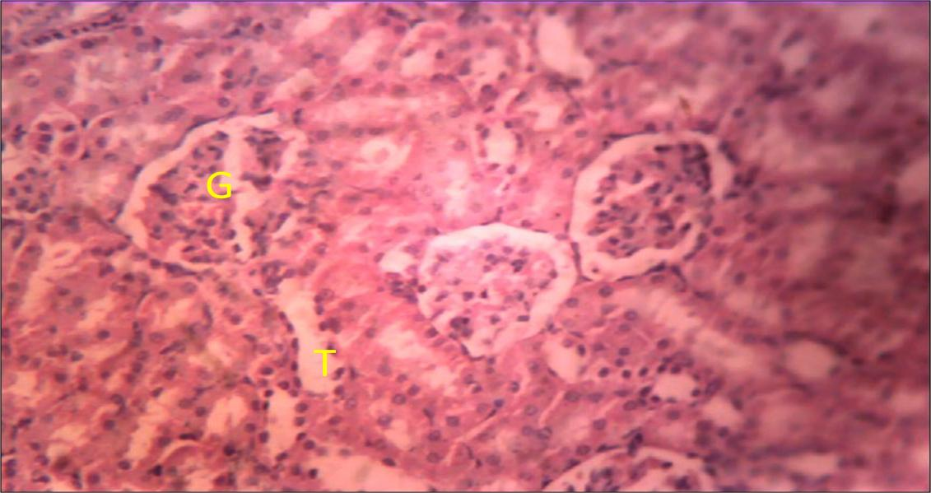
Plate I: Photomicrograph of a kidney section of a non-diabetic rat treated with PEG+H₂O, showing normal Glomeruli (G) and tubules (T) H&E ×250

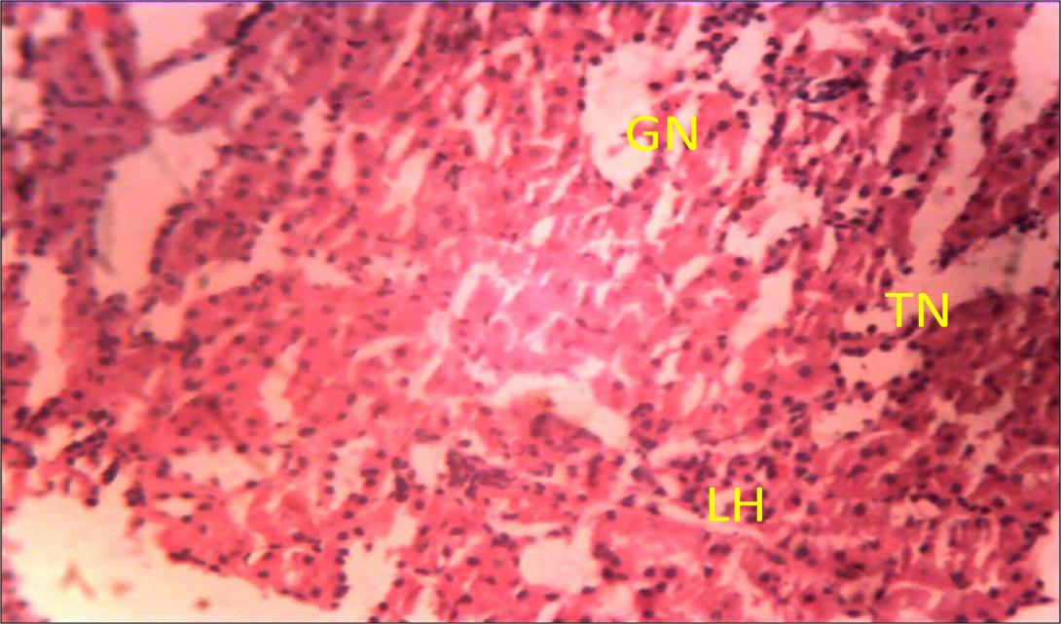
Plate II: Photomicrograph of a kidney section of a diabetic control rat treated with PEG+H₂O, showing tubular (TN) and glomerular necrosis (GN) with lymphocyte hyperplasia (LH) H&E ×250

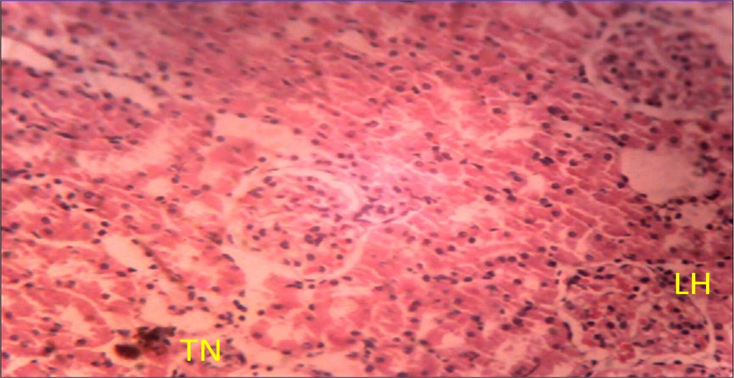
Plate III: Photomicrograph of a kidney section of a diabetic rat treated with glimepiride at 8 pm, showing lymphocyte hyperplasia (LH) with tubular necrosis (TN) H&E ×250

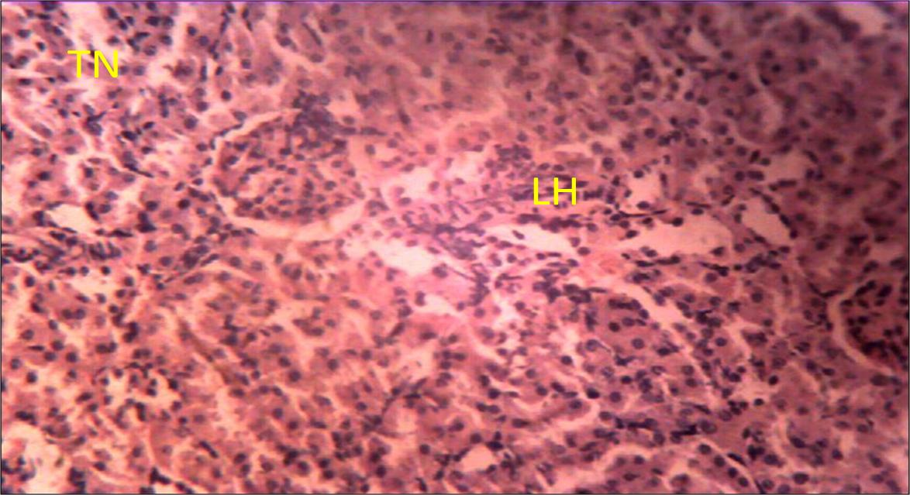
Plate IV: Photomicrograph of a kidney section of a diabetic rat treated with glimepiride at 8 pm and nifedipine at 8 pm, showing moderate lymphocyte hyperplasia (LH) with slight tubular necrosis (TN) H&E ×250

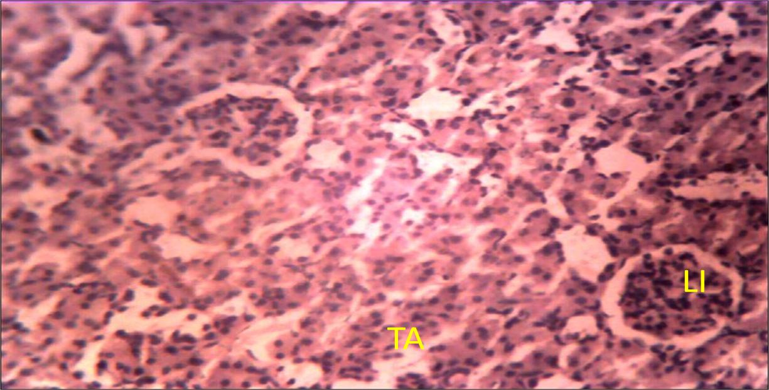
Plate V: Photomicrograph of a kidney section of a diabetic rat treated with glimepiride at 8 pm and nifedipine at 8 am, showing slight tubular adhesion (TA) with moderate lymphocyte infiltration (LI) H&E ×250

Effect of 21-day chronomodulated nifedipine administration on retinopathy in glimepiride treated hyperglycaemic rats

Serum ocular markers
The serum magnesium levels for the diabetic control group was significantly (p<0.05) lower than the non diabetic control. Treatment with glimepiride alone at 8 pm, and concurrent administration of glimepiride and nifedipine at 8 pm did not reveal any significant difference in serum magnesium level when compared to the diabetic control group. However, treatment with glimepiride at 8 pm and nifedipine at 8 am revealed significantly (p<0.05) higher serum magnesium levels when compared to the diabetic control group.

The serum cholesterol and triglyceride levels for the diabetic control group were significantly (p<0.01) higher than the non diabetic control. Treatment with glimepiride at 8 pm, and concurrent administration of glimepiride and nifedipine at 8 pm did not reveal any significant difference in serum cholesterol and triglyceride levels when compared to the diabetic control group. However, treatment with glimepiride at 8 pm and nifedipine at 8 am revealed a significantly (p<0.05) lower serum cholesterol and triglyceride levels when compared to the diabetic control group.

Table 4.6 Effect of 21-day chronomodulated nifedipine administration serum renal markers in glimepiride-treated hyperglycaemic rats

Groups | Mg²⁺ (mg/dl) | Cholesterol (mg/dl) | Triglyceride (mg/dl)
Non-diabetic control | 2.38±0.12 | 65.21±12.55 | 5.00
Diabetic control | 1.08±0.21* | 187.97±6.77** | 18.20*
Glimepiride 8 pm | 1.51±0.13 | 158.74±8.74* | 17.00
Glim8pm+Nife8pm | 1.65±0.26 | 145.12±5.86* | 18.20
Glim8pm+Nife8am | 2.35±0.16# | 63.68±5.57## | 6.60#
Data are mean ± SEM and mean rank (Triglyceride) * =p ≤ 0.05 compared to non-diabetic control, ** = p ≤ 0.01 compared to non-diabetic control, # = p ≤ 0.05 compared to diabetic control, ## = p ≤ 0.01 compared to diabetic control one way ANOVA followed by Bonferoni post hoc test for Mg²⁺ and Cholesterol, Kruskal Wallis and Dunn-Bonferoni post hoc test for triglyceride, n =5-8, Glim8pm+ Nife8am = treated with glimepiride at 8 pm and nifedipine at 8 am; Glim8pm+ Nife8pm = treated with glimepiride at 8 pm and nifedipine at 8 pm

Histology of the retina
Examination of retinal sections of diabetic control rats showed severe distortion of the retinal layers (Plate VII). Representative photomicrographs of the retina of rats treated with glimepiride alone at 8 pm showed necrosis of the rods and cones and the outer nuclear layer cells (Plate VIII). Rats treated with concurrent administration of glimepiride and nifedipine at 8 pm revealed slight necrosis of the inner and outer layer cells (Plate IX) while the representative photomicrograph of the retina of the of rats treated with glimepiride at 8 pm and nifedipine at 8 am revealed normal histo-architectural retinal layers (Plate X) similar to that of the non-diabetic control group (VI).

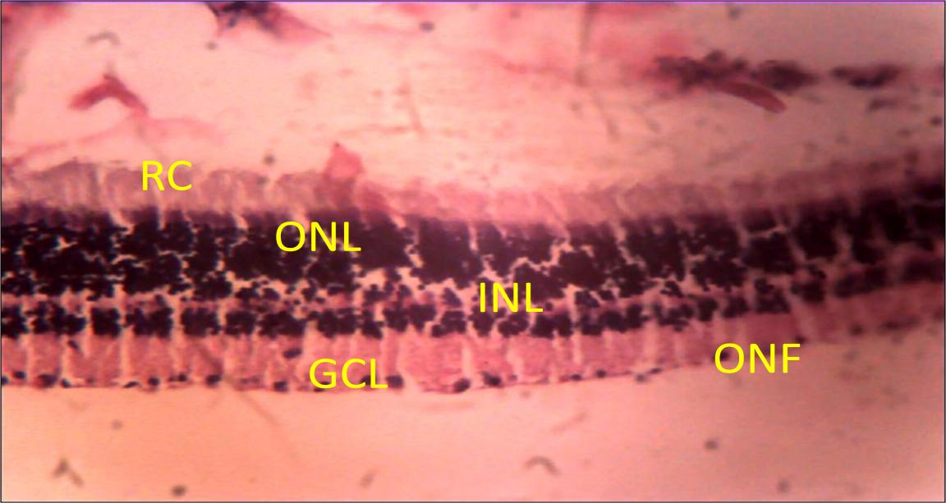
Plate VI: Photomicrograph of retina section of non-diabetic rat treated with PEG+H₂O, showing normal histo-architectural retinal layers with rods and cones (RC), outer nuclear layer (ONL), inner nuclear layer (INL), ganglion cell layer (GCL) and optic nerve fibers (ONF) H&E × 100

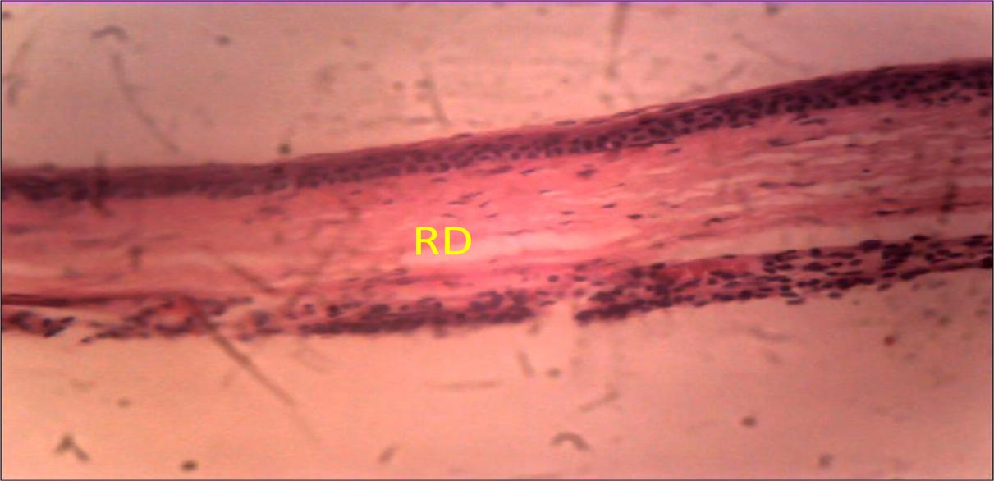
Plate VII: Photomicrograph of retina section of diabetic rat treated with PEG+H₂O, showing distortion of the retinal layers (RD) H&E × 100

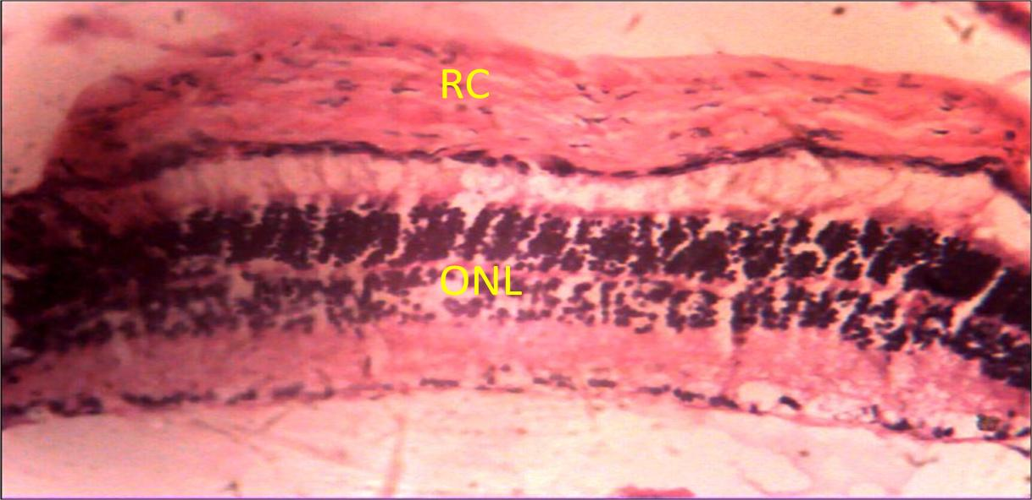
Plate VIII: Photomicrograph of retina section of diabetic rat treated with glimepiride at 8 pm, showing slight necrosis of the rods and cones (RC) and outer layer cells (ONL) H&E × 100
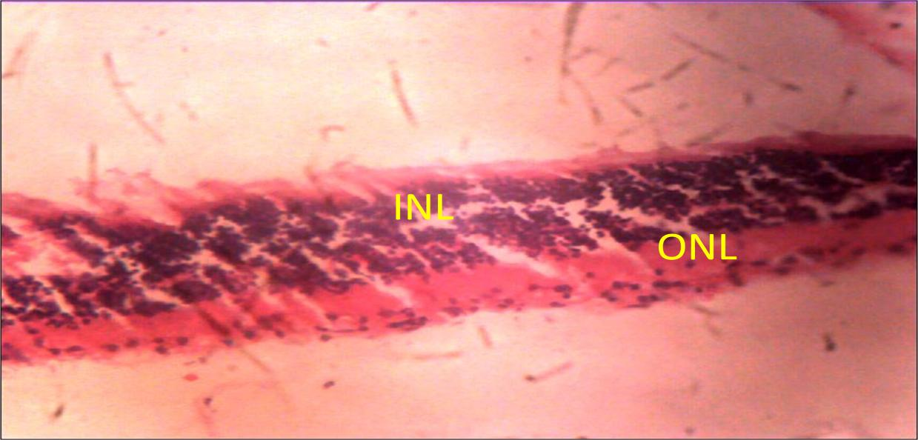


Plate IX: Photomicrograph of retina section of diabetic rat treated with glimepiride 8 pm and nifedipine 8 pm, showing slight necrosis of the inner (INL) and outer layer (ONL) cells H&E × 100

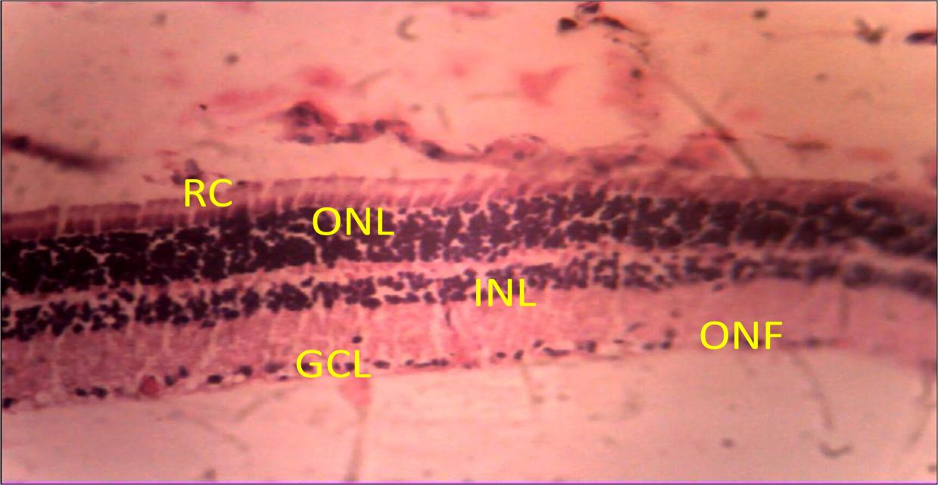
Plate X: Photomicrograph of retina section of diabetic rat treated with glimepiride 8 pm and nifedipine 8 am, showing normal retinal layers with rods and cones (RC), outer nuclear layer (ONL), inner nuclear layer (INL), ganglion cell layer (GCL) and optic nerve fibers (ONF) H&E × 100

CHAPTER FIVE

Discussion
The significant and progressive decrease in FBG and RBG in the group treated with glimepiride alone at 8 pm is as a result of chronotherapeutic considerations in the administration of glimepiride. Although the circadian variation in plasma insulin levels and glucose rhythm are controversial due to variation in food intake, it has been reported that glucose rhythm follows a diurnal variation, with increased plasma levels at the beginning of the night time period (activity period) in fasted rats similar to the dawn phenomenon in humans (Bizot, 1998). This is as a result of diurnal variation in plasma insulin levels and counter regulatory hormones such as cortisol, growth hormone, glucagon and epinephrine that work against the action of insulin (Suresh and Pandit, 2009). Because a number of disease conditions including diabetes follow circadian variations, success of therapy is easily achieved by timing in vivo drug availability to match disease rhythms (Hermida et al., 2008).

A comparison of the glycaemic control data vis a viz fasting and random blood glucose obtained from the nifedipine groups treated at 8 am and 8 pm, authenticates how time of drug administration is an important determinant in the outcome of known and potential drug interactions. This is because time of drug administration often affects pharmacokinetics and predicts pharmacodynamic outcomes. Concurrent administration of glimepiride and nifedipine at 8 pm resulted in impairment of glycaemic control. This is a consequence of interaction between glimepiride and nifedipine when concurrently administered. Glimepiride acts via the sulfonylurea receptor (K_{ATP} channel) and mediates

its closure (Banbemko et al., 1998). Inhibition of the K_{ATP} channels causes membrane depolarization and triggers the opening of voltage dependent LTCCs and insulin release (Murali et al., 2000). Nifedipine on the other hand binds to LTCCs with high affinity, and selectively blocks them, eventually inhibiting insulin release (Yaney et al., 1991; Roenfeldt et al., 1992). This action ultimately affected the glucose lowering property of glimepiride which manifested as a delay and reduction in anti-diabetic effect of glimepiride in this group.

Furthermore, studies on the pharmacokinetics of glimepiride shows that it is rapidly absorbed from the gastrointestinal tract after oral administration (Samala et al., 2011). Similarly, nifedipine has been reported to be rapidly absorbed from the gastrointestinal tract after oral administration (Cao et al., 2005). Deducing from these studies, it takes nifedipine less time (about one hour) to reach peak plasma concentration than glimepiride (about 6 hours) in rat models. This suggests that majority of the LTCCs required for insulin release would have been blocked by nifedipine before glimepiride concentration in the blood peaks. In addition, nifedipine is highly lipid soluble; as such its duration of action is increased in hyperlipidemia, a characteristic feature of diabetes mellitus (Eliot et al., 1999). It has been reported that hyperlipidemia significantly decreased systemic clearance of nifedipine by 40% and increased its pharmacological T_{1/2} by 300%, and also increased the area under the plasma concentration-time curve by 65% in hyperlipidemic rats (Eliot and Jamali, 1999). This is likely to account for the impaired glycaemic control when nifedipine was concurrently administered with glimepiride at 8 pm, but did not affect the glucose lowering benefit of glimepiride when the administration was separated by at

least twelve hours. One other important feature in the FBG data which doesn’t have an obvious explanation and hence requires further investigations, was the fact that the glucose lowering effect of glimepiride was observed from the third day of treatment in the group treated with glimepiride at 8 pm and nifedipine at 8 am. This is in contrast with the glucose lowering effect observed in the group treated with glimepiride alone at 8 pm which was observed after seven days of treatment.

Decrease in body weight is a presentation in diabetes mellitus (ADA, 2010). This is due to continuous excretion of glucose, decrease in both peripheral glucose uptake and glycogen synthesis (Salau et al., 2003), and increase breakdown of body proteins (Bhaskar et al., 2014). In this regard, the progressive increase in body weight produced following treatment with glimepiride at 8 pm and nifedipine at 8 am is as a result of increase in insulin release produced by glimepiride. This suggests that nifedipine did not inhibit the insulin secretory effect of glimepiride when the administration of both drugs is separated by at least twelve hours.

Peripheral neuropathy is one of the most common early complications of diabetes mellitus (Bhatti et al., 2012) and is characterized by clinical features like allodynia and hyperalgesia due to elevated nociceptive response (Zhang et al., 2014). In this study, peripheral neuropathy manifested after seven days. This is consistent with previous findings (Gabra and Sirois, 2003; Honda et al., 2007) which reported that hyperalgesia due to peripheral neuropathy manifests after seven days. Data from both the paw pressure and tail immersion tests revealed that nifedipine ameliorates peripheral neuropathy. This is so

because reduced nerve blood flow is implicated in peripheral neuropathy. Nifedipine, a vasodilator, acts directly on vascular smooth muscles to bring about increase in blood flow and consequently, prevents nerve conduction deficits in experimental diabetes (Robertson et al., 1992). It is noteworthy that the amelioration in peripheral neuropathy offered by nifedipine was only significant when nifedipine was administered at 8 am with glimepiride at 8 pm. This could be due to the fact that nifedipine administration was timed to match the rhythm of endogenous vasodilation with approximate highest plasma concentrations of the drug. Endogenous vasodilation peaks during the rest period (Lemmer, 1996); suggesting a synergy between endogenous and nifedipine mediated vasodilation. This would ultimately result to enhanced blood supply to peripheral nerves.

Diabetic nephropathy is a common complication in type 2 diabetes mellitus and has become the single most important factor implicated in the etiology of end stage renal damage worldwide (Ntemka et al., 2011). Increased levels of serum creatinine, blood urea nitrogen and uric acid, and reduced levels of serum albumin and protein are common markers for diabetic nephropathy (Shah et al., 2007; Idonije et al., 2011). Data obtained from the relative kidney weight indicated that renal enlargement is a characteristic feature of a diseased kidney. This is consistent with the reports of Bodhankar and Kamble, (2013); Pourghasem et al., (2014) who reported that increase in kidney weight is due to glomerular hypertrophy and nephromegaly in diabetic rats.

Findings from this study as evident by the results obtained from the serum renal markers, relative kidney weight and histological findings corroborate previous data (Ravid et al.,

1996; Estacio et al., 2000; Shigeaki, 2001; Toyohiko et al., 2014) that established that nifedipine offers nephro-protection. In their findings, they reported that nifedipine delays the progression and prognosis of nephropathy by increasing glomerular filtration rate as well as effective renal plasma flow. It is however pertinent to note that the nephro- protection in this study occurred after a 21-day chronomodulation of nifedipine at 8 am which was timed to match the endogenous vasodilatory mechanisms involved in increasing glomerular filtration as well as renal plasma flow. Though diurnal changes in the renal blood flow, glomerular filtration and urine excretion are still under investigation, available data suggests that the circadian variation in renal function is as a result of the variation in the blood level of hormones involved in renal activities such as vasopressin, vasoactive peptides, the renin-angiotensin-aldosterone complex and melatonin (Ewa et al., 2007). For instance, melatonin shows a circadian rhythm reaching its peak during the light phase in rats (Kato et al., 2002). Melatonin has also been reported to decrease the renin angiotensin aldosterone system activities in rats (Kawashima et al., 1987) thereby leading to increased renal blood flow and GFR through direct influence on melatonin receptors in the kidney (Song et al., 1993). The action of melatonin on the RAAS during the light phase in rats coupled with nifedipine’s ability to inhibit the vasoconstrictive effect of angiotensin II through the blockade of calcium dependent mechanisms (Luno et al., 1998) may account for the nephro-propection offered by nifedipine when administered at 8 am.

Retinopathy has been reported as one of the leading causes of blindness worldwide (Sher et al., 2014), and decrease in serum magnesium and increase in serum cholesterol and triglyceride levels are common markers for diabetic retinopathy (Ishrat et al., 2004). The

exact mechanism by which magnesium plays a role in diabetic retinopathy is poorly understood, though it has been reported that low serum magnesium levels may contribute to diabetic retinopathy via reduction in the rate of inositol transport, abnormal platelet function and subsequent intracellular depletion of the microvessels supplying the retina (Nadler et al., 1993).

Data obtained from these serum ocular markers reveals that treatment with glimepiride at 8 pm and nifedipine at 8 am ameliorated retinopathy to a near normal state and is strongly supported by histological findings where photomicrographs of the retina of the nifedipine 8 am treated group showed normal histo-architectural features similar to the non-diabetic control group. One of the mechanisms involved in the development of retinopathy is occlusion or complete damage of the microvessels supplying the retina (Curtis et al., 2009), thus lipid lowering therapies have been shown to be beneficial in diabetic retinopathy (Ebru et al., 2013).

The consistency observed in the amelioration of microvascular complications in the group treated with glimepiride at 8 pm and nifedipine at 8 am may be related to the pharmacokinetics of nifedipine when administered at that time of the day. Cao and colleagues in 2005 reported that the plasma concentration, area under the plasma concentration-time curve from zero to six hours [AUC (0-6h)] and the peak plasma concentration [C (_{max})] were significantly higher in rats treated with a single oral dose of nifedipine at 8 am than in rats receiving same single dose of nifedipine at 4 pm and 12 am respectively. Furthermore, the time taken to reach [C (_{max})] [T (_{max})] was reported to be

shortest in rats treated at 8 am when compared to rats treated at 4 pm and 12 am. Earlier studies indicate that the bioavailability of nifedipine reduced by 40 percent after evening dosing when compared to morning dosing (Lemmer et al., 1991; Cao et al., 2010). This is as a result of circadian variation in gastric emptying which is shorter in the morning (Goo et al., 1987) and gastrointestinal tract perfusion which is higher during the early morning hours than in the afternoon (Lemmer and Nold, 1991; Cao et al., 2010). The mechanisms in these reports explain higher C_{max} and shorter t_{max} values following morning oral administration of nifedipine.

CHAPTER SIX

Conclusion and recommendations

Conclusion
Co-administration of glimepiride at 8 pm and nifedipine at 8 am did not inhibit the glucose lowering effect of glimepiride and also ameliorated the prognosis of microvascular complications (retinopathy, nephropathy and peripheral neuropathy) in hyperglycaemic rats treated with glimepiride at 8 pm. This implies that with chronotherapy, co- administration of glimepiride and nifedipine can be successful without losing the glucose lowering benefits of glimepiride, while delaying the progression and improving the prognosis of microvascular complications.

Recommendation and suggestions for further studies
From the outcome of this study, the concurrent use of nifedipine and glimepiride may be considered for the beneficial purpose of glucose control and amelioration of diabetic microvascular complications. The use of both drugs will however need to be separated by at least 12 hours with chronotherapeutic considerations for these benefits to be maximized.

Future studies should be conducted in glimepiride-treated diabetic hypertensive rats to investigate if the time of administration of nifedipine will significantly improve glycaemic control, ameliorate microvascular complications as well as produce antihypertensive effects.

Furthermore, owing to the fact that outcome of animal studies may not be directly extrapolated to man, the present study and the proposed future study should be conducted in human subjects in order to actualize the bench to bedside principle.

REFERENCES
Abdi, S., Haruo, A. and Bloomstone, J. (2004). Electroconvulsive therapy for neuropathic pain: a case report and literature review. Pain Physician, 7:261-263.
Ahmed, A.M. (2002). History of diabetes mellitus. Diabetes mellitus history- from ancient to modern times. Saudi Medical Journal, 23: 373-378.
Akerstedt, T. and Gillberg, T. (1981). The Circadian Variation of Experimentally Displaced Sleep. Sleep, 4: 159-169.
Akinkugbe, O.O. (1997). Non communicable diseases in Nigeria: national survey (final report) on hypertension, coronary heart disease, diabetes mellitus, G6PD deficiency and anaemia. (Ed) National Expert Committee on Non-Communicable Diseases, Federal Ministry of Health and Social Services, Lagos, 1-12.
Al-Homsi, M.F, and Lukic, M.L. (1992). An Update on the pathogenesis of Diabetes Mellitus, Department of Pathology and Medical Microbiology (Immunology Unit) Faculty of Medicine and Health Sciences, UAE University, Al Ain, United Arab Emirates, 15(1): 97-102.
American Diabetes Association (2006). Diagnosis and classification of diabetes Mellitus.

Diabetes Care, 29 (1): 43-48.

American Diabetes Association (2010). Diagnosis and Classification of Diabetes Mellitus.

Diabetes Care 33(1): 62-69.

Anjaneyulu, M. and Chopra, K. (2004). Fluoxetine attenuates thermal hyperalgesia through 5-HT1/2 receptors in streptozotocin-induced diabetic mice. European Journal of Pharmacology, 497: 285-292.

Aram, V.C. (1996). Calcium Channel Blockers: Lessons Learned From MIDAS and Other Clinical Trials. The Journal of American Medical Association, 276(10):829-830.
Arthur, S.J. and John, B. (1978). A colour Atlas of Histopathological Staining Techniques.

Wolf Medical Publisher Limited, London, 14-20.

Ashcroft F.M., Gribble, F.M. (1998). Correlating structure and function in ATP-sensitive K⁺ channels. Trends in Neuroscience, 21:288–294.
Ashcroft, F.M., Proks, P., Smith, P.A., Ammala, C., Bokvist, K. and Rorsman, P. (1994). Stimulus-secretion coupling in pancreatic β cells. Journal of Celluar Biochemistry, 555: 54-65.
Babenko, A.P., Aguilar-Bryan L. and Bryan J. (1998). A view of SUR/KIR6.x K_{ATP} channels. Annual Review of Physiology, 60: 667–687.
Bailey, D.G., Malcolm, J., Arnold, O. and Spence, J.D. (1998). Grape fruit juice-drug interaction. British Journal of Clinical Pharmacology, 46 (2): 101–10.
Baynes, H.W. (2015). Classification, Pathophysiology, Diagnosis and Management of Diabetes Mellitus. Journal of diabetes and metabolism, 6: 541.
Bearse, M.A., Junior, H,Y., Schneck, M.E., Barez, S, and Jacobsen C, (2004). Local multifocal oscillatory potential abnormalities in diabetes and early diabetic retinopathy. Investigative Ophthalmology Visual Science, 45: 3259-3265.
Bertram, G.K. and William, W.P. (2009). Vasodilators and the treatment of Angina Pectoris. In: Bertram G. Katzung, Susan B. Masters, Anthony J. Trevor, Basic and clinical pharmacology, 11th edition, Mc Graw hill, New Delhi, India. 199-202.
Bhatti, R., Shruti, R. Ishar, M.P.S.and Jatinder, S. (2012). Effect of Aegle marmelos Leaf Extract Treatment on Diabetic Neuropathy in Rats: A Possible Involvement Of Α2

Adrenoceptors. International Journal of Pharmacy and Pharmaceutical Sciences, 4(3):632-637.
Bhaskar, S., Mohammed, S.S., Gurudayal, R., Ranjeet, K.Y., Arti, K., Gaurav, S. and Nakuleshwar, D.J. (2014). Rejuvenating of Kidney Tissues on Alloxan Induced Diabetic Mice under the Effect of Momordica charantia. Advances in Pharmaceutics, 2:1-9.
Bibi, Z. (2008). Retracted: Role of cytochrome P450 in drug interactions. Nutrition and metabolism, 5:27-37.
Bizot, E.J.G. (1998). Diurnal rhythms in plasma glucose, insulin, growth hormone and melatonin levels in fasted and hyperglycemic rats. Diabetes metabolism, 24(3):235- 40.
Bodhankar S.L. Kamble, H.V. (2013). Trigonelline and Sitagliptin attenuate Nicotinamide-Streptozotocin induced diabetic nephropathy in Wistar rats. International Journal of Pharmacy and Pharmaceutical Sciences, 5 (4) 583-589.
Bolli, G.B., Gerich, J.E., (1984). The “Dawn-Phenomenon”, a common occurrence in both non-insulin-dependent and insulin-dependent diabetes mellitus. New England Journal of Medicine, 310:746-750.
Brady, P.A. and Terzic, A. (1998). The sulfonylurea controversy: more questions from the heart. Journal of American College of Cardiologists, 31:950-956.
Bryan, J. and Aguilar-Bryan L. (2007). The ABCs of ATP-sensitive potassium channels– more pieces of the puzzle. Current Opinion on cellular Biology, 9: 553–559.
Buckley, N. Dawson A., and Whyte, I. (2007). Calcium Channel Blockers. Medicine, 35
(11): 599-602.

Callaghan, B.C., Little, A.A., Feldman, E. L. and Hughes, R. A. (2012). Enhanced glucose control for preventing and treating diabetic neuropathy. Cochrane Database System Review, 6: 543-547.
Cao, Q.R., Kim, T.W., Choic, J.S. and Lee, B.J. (2005). Circadian variations in the pharmacokinetics, tissue distribution and urinary excretion of Nifedipine after a single oral administration to rats. Biopharmaceutics and drug disposition, 26(9): 427-437.
Cao, Q., Jing, H.C., Jun, B.P., Hyo, K.H., Jaehwi, L., Kyung, Taek, O.H., Inchoon, P. and Beom, J.L. (2010). Effect of food components and dosing times on the oral pharmacokinetics of nifedipine in rats. International Journal of Pharmaceutics, 396(1-2): 39-44.
Carskadon, M., Labyak, S., Acebo, C. and Seifer, R. (1999). Intrinsic Circadian Period of Adolescent Humans Measured in Conditions of Forced Desynchrony. Neuroscience, 260: 129-132.
Castera, V., Dutour-Meyer, A, Koeppel, M., Petitjean, C. and Darmon, P. (2005). Systemic allergy to human insulin and its rapid and long analogs: successful treatment by continous subcutaneous insulin lispro infusion. Diabetes and Metabolism, 31(4):391-400.
Catterall, W.A. and Striessnig, J. (1992). Receptor sites for calcium antagonists. Trends in Pharmacological Sciences, 13:256-262.
Chan, C.N., Wingyee, S.R., Ronald, C.W., Peter, C.Y. and Xilin Y. (2011). The complexity of vascular and non-vascular complications of diabetes: The Hong Kong diabetes registry. Current Cardiovascular Risk Report, 5: 230–239.

Chen, L., Magliano, D.J. and Zimmet, P.Z. (2014). The worldwide epidemiology of type 2 diabetes mellitus: present and future perspectives. Nature Reviews Endocrinology, 228-236.
Cheung, N., Mitchell, P., Wong, T.Y. (2010). Diabetic retinopathy. Lancet, 376, 124–136. Chinenye, S., Ogbera, A.O. (2013). Socio-cultural aspects of diabetes mellitus in Nigeria.
Journal Social and Health Diabetes, 1(1): 15 – 21.

Chung, S., Son, G.H. and Kim, K. (2011). Adrenal peripheral oscillator in generating the circadian glucocorticoid rhythm. Annals of the New York Academy of Sciences, 1220:71–81.
Cooper, M.E. (2001). Interaction of metabolic and hemodynamic factors in mediating experimental diabetic nephropathy. Diabetologia, 44(11): 1957–1972.
Curtis, T.M., Gardiner, T.A. and Stitt A.W. (2009). Microvascular lesions of diabetic retinopathy: clues towards understanding pathogenesis. Eye, 23, 1496–1508.
Davalli, A.M., Biancardi, E., Polio, A., Socci, C., Pontiroli, A.E., Pozza, G., Clementi, F., Sher, E. and Carbone, E. (1996). Dihydropyridine-sensitive and –insensitive voltage-operation-operated calcium channels participate in control of glucose- induced insulin release from human pancreatic beta-cells. Journal of Endocrinology, 150:195-203.
Devdhawala, M.G. and Seth, A.K. (2010). Current status of chronotherapeutic drug delivery system: An overview: Journal of Chemical and Pharmaceutical Research, 2(3):312-328.
Duffield, G.E. (2003). DNA microarray analyses of circadian timing: the genomic basis of biological time. Journal of Neuroendocrinology, 15:991–1002.

Ebru, N.C., Yunus, B., Seyfullah, O., Senay, T., Fulya, A., Hulya, A., and Cem, Y. (2013). Association of serum lipid levels with diabetic retinopathy. International Journal for Opthalmology, 6(3): 346–349.
Efendic, S. and Portwood, N. (2004). Overview of incretin hormones. Hormone and Metabolic Reearch, 36:742-746.
Eliot, L.A. and Jamali, F. (1999). Pharmacokinetics and Pharmacodynamics of Nifedipine in untreated and Atorvastatin-treated hyperlipidemic rats. Journal of Pharmacology and Experimental Therapeutics, 291(1): 188-193.
Eliot, L.A., Foster, R.T. and Jamali, F. (1999). Effects of hyperlipidemia on the pharmacokinetics of nifedipine. Pharmaceutical Research, 16:309–313.
Emara, E. and Abdel-Sater, K.A. (2011). Beneficial Effects of Calcium Channel Blocker “Nifedipine” on Abnormalities of Platelets and Lipid Metabolism in Patients with Type II Diabetes Mellitus. Journal of Diabetes and Metabolism 2(5):131-137.

Estacio, R.O., Gifford, N., Jeffers, B.W. and Schrier, R.W. (2000). Effect of blood pressure control on diabetic microvascular complications in patients with hypertension and type 2 diabetes. Diabetes Care, 23: 54–64.

Eurich, D.T., Majumdar, S.R., McAlister, F.A., Tsuyuki, R.T. and Johnson, J.A. (2005). Improved clinical outcomes associated with metformin in patients with diabetes and heart failure. Diabetes care, 28: 2345-2351.
Evans, R.M. and Marain, C. (1996). Taking Your Medication: A Question of Timing.

American Medical Association, 2: 3-8.

Ewa, S., Zbigniew, M., Wioleta, D. and Maria, S.A. (2007). Review of the renal system and diurnal variations of renal activity in livestock. Irish Veterinary Journal, 60(3): 161–168.
Fineberg, S.E., Galloway, J.A., Fineberg, N.S., Rathbun, M.J. and Hufferd, S. (1983).

Immunocity of recombinant DNA human insulin. Diabetologia, 25:465-469.

Fisman, E.Z., Tenenbaum, A., Benderly, M., Goldbourt, U., Behar, S. and Motro, M. (1999). Antihyperglycemic treatment in diabetics with coronary disease: increased metformin-associated mortality over a 5-year follow-up. Cardiology, 91:195-202.
Foster, D. W., (1998). Diabetes Mellitus, In Harrison's Principles of Internal Medicine 14th edition, (Isselbacher, K.J., Braunwald, E., Wilson, J.D., Martin, J.B., Fauci, A.S. and Kasper, D.L., editors) McGraw-Hill, Inc (Health Professions Division), 2060- 2080.
Francis, L. Ueli, S. (2007). Circadian Rhythms: Mechanisms and Therapeutic Implications.
Annual Review of Pharmacology and Toxicology, 47: 593-628.
Freedman, B.I., Parekh, R.S. and Kao, L. (2010). Genetic basis of non-diabetic end-stage renal disease. Seminars in Nephrology 30(2): 101–110.
Friedman, E.A. Banerji, M.A. (2011). Chronobiology Impacts Response to Antihypertensive Drug Regimen in Type 2 Diabetes. Diabetes Care, 34: 1438- 1439.
Fuhlendorff, J., Rorsman, P., Kofod, H., Brand, C.L., Rolin, B. and MacKay, P. (1998). Stimulation of insulin release by repaglinide and glibenclamide involves both common and distinct processes. Diabetes, 47:345-351.

Gabra, B. H and Sirois, P. (2003). Beneficial effect of chronic treatment with the selective bradykinin B1 receptor antagonists R-715 and R-954 in attenuating streptozotocin diabetic thermal hyperalgesia in mice. Peptides, 24: 1131- 1139
Gillian M.S. (2001). Drug interactions with oral hypoglycaemic drugs. Australian Prescriber, 24 (4): 83-85.
Goo, R.H., Moore, J.G., Greenberg, E. and Alazraki, N.P. (1987). Circadian variation in gastric emptying of meals in humans. Gastroenterology, 93: 515-518.
Greene, D.A., Sima, A.A.F., Feldman, E.L. and Stevens, M.J. (1997). “Ellenberg and Rifkin diabetic neuropathy,” In Diabetes Mellitus, H. Rifkin, D. Porte, and R. Sherwin, Editors., Appleton and Lange, Stanford, Califonia, USA 1009-1076.
Grosso, A., Cheung, N., Veglio, F., Wong, T.Y. (2011). Similarities and differences in early retinal phenotypes in hypertension and diabetes. Journal of Hypertension, 29, 1667–1675.
Halberg, F.,Cornelissem, G. and Katinas, G. (2003). Transdisciplinary unifying implications of circadian findings in the 1950s. Journal of Circadian Rhythms, 1
(1): 1740-1742.

Halim E.M. and Ali H. (2002). Reversal of diabetic retinopathy in streptozotocin induced diabetic rats using Indian anti-diabetic plant Azadirachta indica (L). Indian Journal of Clinical Biochemistry, 17(2) 115-123.
Hermida, R.C., Ayala D.E., Mojon, A. and Fernandez, J.R. (2008). Chronotherapy with nifedipine GITS in hypertensive patients: improved efficacy and safety with bedtime dosing. American Journal Hypertension, 21:948-54.

Hermida, R.C., Ayala, D.E., Mojón, A. and Fernádez, J.R. (2011). Influence of time of day of blood pressure–lowering treatment on cardiovascular risk in hypertensive patients with type 2 diabetes. Diabetes Care, 34:1270–1276.
Hermida, R.C., Calvo, C., Ayala, D.E., Lopez, J.E., Rodroguez, M. and Chayan, L. (2007). Dose-and administration time-dependent effects of nifedipine gits on ambulatory blood pressure in hypertensive subjects. Chronobiology International, 24:471-93.
Holt, R.I. (2004). Diagnosis, epidemiology and pathogenesis of diabetes mellitus: an update for psychiatrists. British Journal of Psychiatry Supplement, 47: 55-63.
Honda, K., Koguchi, M., Koga, K., Nakajima, K., Kobayashi, F. and Migita, K. (2007). Contribution of Ca 2+ dependent protein kinase C in the spinal cord to the development of mechanical allodynia in diabetic mice. Biological Pharmacology, 30: 990- 993.
Howard, B.V., Rodriguez, B.L. and Bennet, P.H. (2002). Prevention Conference VI: Diabetes and Cardiovascular Disease: Writing group I: Epidemiology, 105: 132-7.
Hu, S., Wang, S. and Dunning, B.E. (2001). Glucose-dependent and glucose-sensitizing insulinotropic effect of nateglinide: Comparison to sulfonylureas and repaglinide. International Journal of Experimental Diabetes and Research, 2:63-72.
Hussain, H.E.M.A., Jamil, K. and Mala, R. (2001). Hypoglycemic, hypolipidemic and antioxidant properties of Tulsi (Ocimum sanctum Linn) on streptozotocin induced diabetes rats. Indian Journal Clinical Biochemistry, 16 (2), 190-194.
Idonije, B.O., Festus, O. and Oluba, O.M. (2011). Plasma glucose, creatinine and urea levels in Type 2 diabetic patient attending a Nigerian Teaching Hospital. Research Journal of Medical Sciences, 5(1): 1–3.

International Diabetes Federation (2011). Global burden of diabetes. Diabetic Atlas, fifth edition 201-208.
International Diabetes Federation (2013). Global burden of diabetes. Diabetic Atlas, sixth edition 32-48.
International Diabetes Federation (2014). Global burden of diabetes. Diabetic Atlas,

seventh edition 142-153.

Inzucchi, S.E. and McGuire, D.K. (2008). New drugs for the treatment of diabetes: part II: Incretin-based therapy and beyond. Circulation, 117:574-584.
Ishrat, K., Jaweed, S.A., Bardapurkar J.S. and Patil, V.P. (2004). Study of magnesium, glycosilated haemoglobin and lipid prifil in diabetic retinopathy. Indian Journal of Clinical Biochemistry, 19(2) 124-127
Isomoto, S. and Kurachi, Y. (1997). Function, regulation, pharmacology and molecular structure of ATP-sensitive K⁺ channels in the cardiovascular system. Journal of Cardiovascular Electrophysiology, 8:1431–1446.
Japan Multicentre investigation of Investigation of Antihypertensive Treatment for Nephropathy in Diabetics (J-MIND) (2001). Nifedipine and Enalapril equally reduce the onset and progression of nephropathy in hypertensive type 2 diabetics. Diabetes Research and Clinical Practice, 54 (3) 191-201.
Kafle, D., Singh, N., Singh, S., Singh, N., Bhargav, V. and Singh, A.K. (2012). Persistent hyperglycemia generating reactive oxygen species in renal cells, a probable cause of inflammation in type 2 diabetic nephropathy subjects. Biomedical Research- India, 23 (4): 501-504.

Karam, J.H. (1998). Pancreatic Hormones and Antidiabetic Drugs, Basic and Clinical Pharmacology, (Katzung, B. G., edition) Appleton-Lange, 684-703.
Kato, K., Murai, I., Asai, S., Takahashi, Y., Nagata, T., Komuro, S., Mizuno, S., Iwasaki, A., Ishikawa, K. and Arakawa, Y. (2002). Circadian rhythm of melatonin and prostaglandin in modulation of stress induced gastric mucosal lesions in rats. Alimentary Pharmacology and Therapeutics, 16(2): 29-34.
Kawashima, K., Miwa, Y., Fujimoto, K., Oohata, H.H., Nishino, H. and Koika, H. (1987). Antihypertensive action of melatonin in the spontaneously hypertensive rats. Clinical and Experimental Hypertension, 9: 1121–1131.
Kim, D., Wang, L., Beconi, M., Eiermann, G.J, Fisher, M.H., He, H., Hickey, G.J., Kowalchick, J.E., Leiting, B., Lyons, K., Marsilio, F., McCann, M.E., Patel, R.A., Petrov, A., Scapin, G., Patel, S.B., Roy, R.S, Wu, J.K., Wyvratt, M.J., Zhang, B. B,
Zhu, L., Thornberry, N.A. and Weber, A.E. (2005). (2R)-4-oxo-4-[3-
(trifluoromethyl) -5,6-dihydro [1,2,4]triazolo [4,3-a]pyrazin-7(8H)-yl]-1-(2,4,5- trifluoro-phenyl) butan-2-amine: a potent, orally active dipeptidyl peptidase IV inhibitor for the treatment of type 2 diabetes. Journal of Medicinal Chemistry, 48:141-151.
Knowler, W.C., Barrett-Connor, E. and Fowler, S.E. (2002). Reduction in the incident of type II diabetes with lifestyle intervention or Metformin. North England Journal of Medicine, 346: 393-403.
Korytkowski, M. (2002). When oral agents fail: practical barriers to starting insulin.
International Journal of Obesity and related metabolic disorders, 26(3):18-24.

Kouroumichakis, I., Papanas, N., Zarogoulidis, P., Liakopoulos, V., Maltezos, E. and Mikhailidis, D. (2012). Fibrates: therapeutic potential for diabetic nephropathy. European Journal of International Medicine, 23: 309–316.
Kumar, P.J. and Clark, M. (2002). Textbook of Clinical Medicine, Publisher: Saunders, London, UK. 1099-1121.
Lacoviello, L., Ciccarone, E., Donati, M.B. (2002). Review: the genetics of macrovascular disease in diabetes. British Journal of Diabetes and Vascular Disease, 2(5): 364- 368.
Lamberg, L. (1991). Chronotherapeutics: implications for drug therapy. American Pharmacy, 31(11): 20-23.
Lebovitz, H.E. (2002). Differentiating members of the thiazolidinedione class: a focus on safety. Diabetes Metabolism Research and Review, 18 (2):23-29.
Lemmer, B, Scheidel, B., Behne, S. and Kaiser, R. (1991). Chronopharmacokinetics and cardiovascular effects of Nifedipine. Chronobiology International, 8:485-494.
Lemmer, B. (1991). Circadian rhythms and drug delivery. Journal of Controlled Release, 16: 63-74.
Lemmer, B. (1996). Differential Effects of Antihypertensive Drugs on Circadian Rhythm in Blood Pressure From Chronobiological Point of View. Blood Pressure Monitoring, 1: 161-169.
Lemmer, B. and Bruguerolle, B. (1994). Chronopharmacokinetics-are they clinically relevant? Clinical Pharmacokinetics, 26: 419-427.
Lemmer. B. and Nold, G. (1991). Circadian changes in estimated hepatic blood flow in healthy subjects. British Journal of Clinical Pharmacology, 32: 627-629.

Levetan, C., Want, L.L., Weyer, C., Strobel, S.A, Crean, J., Wang, Y., Maggs, D.G., Kolterman, O.G., Chandran, M., Mudaliar, S.R. and Henry, R.R (2003). Impact of pramlintide on glucose fluctuations and postprandial glucose, glucagon, and triglyceride excursions among patients with type 1 diabetes intensively treated with insulin pumps. Diabetes Care, 26:1-8.
Lotlikar, V., Kedar, U., Shidhaye, S. and Kadam, V. (2010). pH-responsive dual pulse multiparticulate dosage form for treatment of rheumatoid arthritis. Drug Development and Industrial Pharmacy, 36:1295–1302.
Lundkvist, G.B., Kwak, Y., Davis, E.K., Tei, H. and Gene, D.B. (2005). A calcium flux is required for circadian rhythm generation in mammalian pacemaker neurons. Journal of Neuroscience, 25(23): 7682-7686.
Luno, J.E., Soledad, G.V., Francisco, G.C. Inmaculada, L. and Fernando, V.A. (1998). Effects of antihypertensive therapy on progression of diabetic nephropathy. Kidney International, 54(68) 112–119.
Matsuo, T., Yamaguchi, S., Mitsui, S., Emi, A., Shimoda, F. and Okamura, H. (2003). Control mechanism of the circadian clock for timing of cell division in vivo. Science, 302: 255–59.
Mbanya, J. and Sobngwi, E. (2003). Diabetes Micovascular and Macrovascular Disease in Africa. European Journal of Cardiovascular prevention and Rehabilitation, 10(2): 97-102.
McKeage, K. (2007). “Treatment options for the management of diabetic painful neuropathy: best current evidence,” Current Opinion in Neurology, 20(5): 553-557.

Mclnnes, A.D. (2012). Diabetic foot disease in the United Kingdom: about time to put feet first. Journal of Foot and Ankle Research, 5(26): 2–7.
Misbin, R.I., Green, L., Stadel, B.V, Gueriguian, J.L., Gubbi, A. and Fleming, G.A. (1998). Lactic acidosis in patients with diabetes treated with metformin. New England Journal of Medicine, 338:265-266.
Mohammed, Q., Gillies, M.C. and Wong, T.Y. (2007) “Management of diabetic retinopathy: a systematic review,” Journal of the American Medical Association, 298, (8):902-916.

Murali, G., Eduardo, J.M., Char, C.S., Lisa, M.M., Jean, M.R., Kristi, L.W., Scott, V.E.S., James, P.S. and Jorge, D.B. (2000). Pharmacology of human sulphonylurea receptor SUR1 and inward rectifier K⁺ channel Kir6.2 combination expressed in HEK-293 cells. British Journal of Pharmacology, 129(7):1323-1332.

Nadler, J.L., Buchanan, T. and Natrajan, R. (1993). Magnesium deficiency produces insulin resistance and increased thromboxane synthesis. Hypertension, 21:1024-29.
Nasir, A., Jahangir, K., Tahir, S.S. (2008). Types of diabetes mellitus, Journal of Ayubedic Medical College Abbottabad, 20: 51-54.
Naylor, C.D., Mathew, S., Erluo C. and Dan, F. (1997). Screening for gestational diabetes.

Massachusetts Medical Society, 337: 1592-1596.

Niefeld, M.R., Braunstein, J.B., Wu, A.W., Saudek, C.D., Weller, W.E. and Anderson,

G.F. (2003). Preventable Hospitalization among Elderly Medicine Beneficiatiaries with T2DM, Diabetes care, 26(5):1344-1349.

Novakowska, D.E. (1990). Circadian rhythm of 5-Fluorouracil pharmacokinetics and tolerance. Chronobiologia, 17: 27-35.
Ntemka, A., Iliadis, F., Papanikolaou, Ν.Α. and Grekas, D. (2011). Network-centric analysis of genetic predisposition in diabetic nephropathy. Hippokratia, 15 (3): 232–237.
Nyenwe, E.A., Odia, O.J., Ihekwaba, A.E., Ojule, A. and Babatunde, S. (2003). Type 2 diabetes in adult Nigerians: a study of its prevalence in Port Harcourt, Nigeria. Diabetes Research in Clinical Practice, 62: 177 – 185.
Ohdo, S., Nakano, S. and Ogawa, N. Chronopharmacokinetics of Valproic acid following constant-rate administration in mice. Chronobiology International, 1991; 8:35-43.
Oslon, K. (2011). Calcium channel antagonists. Poisoning and drug overdose (6th edition).

McGraw-Hill Medical publishers, NewYork, USA. 45-48.

Padwel, R. and Laupacis, A. (2004). Antihypertensive therapy and incidence of type 2 diabetes. Diabetes care, 27: 247-255.
Patel, M.M. and Amin, A.F. (2011). Design and optimization of colon-targeted system of theophylline for chronotherapy of nocturnal asthma. Journal of Pharmaceutical Science, 100:1760–1772.
Patidar, D. (2011). Pharmacology- III. (2nd edition). Meerut: Shree Sai Prakashan. 113– 114.
Paysse, H., Fagiolino, P., Vazquez, M., Beyssac, E., Cardot, J.M. and Aiache, J.M. (1997). Chronopharmacokinetics of Carbamazepin and 10, 11 Epoxide. Journal de Pharmacia Clinique 16: 60-64.

Pourghasem, M., Ebrahim, N. and Hamid, S. (2014). Early Renal Histological Changes in Alloxan-Induced Diabetic Rats. International Journal for Molecular and Cellular Medicine, 3 (1): 13-15.
Randall, L.O. and Sellito, J.J. (1957). A method for measurement of analgesic activity on inflamed tissue. Archives internationals de pharmacodynamie et de therapie, 1;111(4):409-419.

Ravid, M., Lang, R. Rachmani, R. and Lishner, M. (1996). Long-term renoprotective effect of angiotensin-converting enzyme inhibition in non-insulin-dependent diabetes mellitus: A 7-year follow-up study. Archive of Internal Medicine, 156: 286–289.

Redfern, P., Waterhouse, J. and Minors, D. (1991). Circadian Rhythms: Principles and Measurement.Pharmacological Therapy, 49: 311-327.
Reinberg, A. (1976). New aspects of human chronopharmacology. Archives of Toxicology, 36 (3-4):327-339.
Reppert, S. M. and Weaver D. R. (2002). Coordination of circadian timing in mammals.

Nature, 418(6901):935-941.

Robertson, S., Cameron, M.E. and Cotter, M.A (1992). Effect of calcium antagonist Nifedipine on peripheral nerve function in Steptozotocin induced diabetic rats. Diabetologia, 35(12) 1113-1117
Roenfeldt, M., Safayi, H. and Ammon, H.P. (1992). KCL-induced insulin secreation from RINm5F cells is mediated through calcium influx along L-type calcium channels. Naunyn-Schmiedeberg’s Archives of Pharmacology, 346:527-531.

Rosenstock, J., Samols, E., Muchmore, D. B. and Schneider, J. (1996). Glimepiride, a new once-daily sulfonylurea. A double-blind placebo-controlled study of NIDDM patients. Glimepiride Study Group. Diabetes Care, 19:1194-1199.
Salau, B.A., Osilesi, O., Idowu, G.O., Musa, S. and E.O.A. (2003). Effects of fruits and vegetables on cardiovascular disease risk factors in non-insulin dependent diabetes mellitus (NIDDM) subjects. African Journal of Medical and Pharmaceutical Sciences, 7: 21–26.
Saltiel, A.R. and Olefsky, J.M. (1996). Thiazolidinediones in the treatment of insulin resistance and type II diabetes. Diabetes, 45:1661-1669.
Samala, S., Sandhya, R.T. and Ciddi, V. (2011). Determination of Glimepiride in Rat Serum by RP-HPLC Method (2011). American Journal of Analytical Chemistry, 2, 152-157.
Satwara, R.S., Patel, P.K. and Shaikh, F.B. (2012). Chronotherapeutical approach: Circadian rhythm in human and its role in occurrence and severity of diseases. International Journal of Pharmaceutical Technology and Research, 4(2): 765-777.
Seki, M., Tanaka, T., Nawa, H., Usui, T., Fukuchi, T. (2004). Involvement of brain- derived neurotrophic factor in early retinal neuropathy of streptozotocin induced diabetes in rats: therapeutic potential of brain-derived neurotrophic factors for dopaminergic amacrine cells. Diabetes, 53: 2412-2419.
Shah, S.V., Baliga, R., Rajapurkar M. and Fonseca, V.A. (2007). Oxidants in chronic kidney disease. Journal of American Society of Nephrologists, 18: 16-28.

Sher, Z.S., Rajes, Q., Selva K., Kalaivani, B. and Ikram, S.B.I. (2014). Molecular Mechanisms of Diabetic Retinopathy, General Preventive Strategies, and Novel Therapeutic Targets. Biomedical Research International, 1-18.
Shigeaki, B. (2001). Nifedipine and enalapril equally reduce the progression of nephropathy in hypertensive type 2 diabetes. Research and Clinical Practice, 54
(3): 191-201.

Singh, R., Sharma, P.K. and Malviya, R. (2010). Review on Chronopharmaceutics: a new remedy in the treatment of various diseases. European Journal of Biological Sciences, 2(3): 67-76.
Smolensky, M.H., Di, M.L., Ohayon, M.M. and Philip, P. (2011). Sleep disorders, medical conditions, and road accident risk. Accident Analysis and Prevention, 43:533–548.
Somani, R., Singhai, A., Shivgunde, P. and Jain, D. (2012). Asparagus racemosus wild (Liliaceae) ameliorates early diabetic nephropathy in STZ induced diabetic rats. Indian Journal of Experimental Biology, 50: 469–475.
Song, Y., Poon, A.M.S., Lee, P.P.N. and Pang, S.F. (1993). Putative melatonin receptors in the male guinea pig kidney. Journal of Pineal Research, 15:153–160.
Sonia, B. and Srinivasan, B.P. (1999). Investigations into the Anti-diabetic activity of

Azadirachta indica. Indian Journal of Pharmacology, 31, 138-141.

Staessen, J.A., Birkenhager, W.H. and Fagard, R.H. (2000). Dihydropyridine calcium channel blockers for the treatment of hypertensive diabetic patients. European Heart Journal, 21: 2–7.

Striessnig, J., Berger, W. and Glossman, H. (1993). Molecular properties of voltage- dependent Ca²⁺ channels in excitable tissues. Cellular Physiology and Biochemistry, 3:295-317.
Suresh, S. and Pandit, V. (2009). Emerging Role of Biorhythms in Optimizing Treatment of Diseases. Indian Journal of Novel Drug Delivery, 1(1): 2-10.
Suresha, R.N., Sushma, V.N., Ashwini, V., Kalabharathi, H.L., Jayanthi, M.K. and Prathima, C. (2012). The effect of Nifedipine on oral glucose induced glycaemic changes in normal albino rats international. Journal of Pharmamaceutical and Biological Sciences, 3(3): 499-507.
Tasneem, S. (2010). Study of effect of Amlodipine on Blood Sugar level. Asian Journal of Medical Sciences, 1:4-5.
The Anithypertensive and Lipid-Lowering Treatment to prevent Heart Attack Trial (ALLHAT) Officers and Cordinators for the ALLHAT Collaborative Research Group (2002). Major outcomes in high-risk hypertensive patients randomized to angiotensin-converting enzyme inhibitor or calcium channel blocker versus diuretic. Journal of the American Medical Association, 288: 2981-2997.
Timothy, D., Ardizzone, X.L. and Donard, S.D. (2002). Calcium-independent inhibition of glucose transport In PC-12 and L6 cells by calcium channel antagonists. American Journal of Cellular Physiology, 283: 579–586.
Toyohiko, Y., Junya, A., Yukiyoshi, N., Fumihiro, S., Kazuma, I., Masamichi, Y., Midori, M., Yutaka, K., Yoshiaki, T., Hiroya, M., Ryuichi, M. and Hakuo, T. (2014). Comparison between Two Calcium Antagonists: Blood Pressure Reduction and

Renal Effects in Hypertensive Patients with Type 2 Diabetes, Immunology‚ Endocrine & Metabolic Agents in Medicinal Chemistry, 12(2) 152-159.
Traynor, K. Newton, D.W., Hrushesky, J.M. and Reiter R.J. American Pharmacy, 1992; 32(3): 261-269.
Treffel, P., Renaud, A., Humbert, P., Makki, S., Faivre, B. and Agache, P. G. (1990). Chronopharmacokinetics of 5-methoxypsoralen. Acta Dermato-Venereologica, 70:515-17.
Waterhouse, J., Minors, D. and Waterhouse, M. (1990). Your Body Clock. Oxford University Press, Oxford, England, 215-220.
Wester, K., Jonsson, A.K., Spigset, O., Druid, H. and Hagg, S (2008). Incidence of fatal adverse drug reactions: a population based study. British Journal of Clinical Pharmacology, 65: 573–9.
Wild, S., Roglic, G., Green, A., Sicree, R. and King, H. (2004). Global prevalence of diabetes: estimates for the year 2000 and projections for 2030. Diabetes Care, 27: 1047-1053.
Willich, S.N. and Muller, J.E. (1996). (eds) Triggering of Acute Coronary Syndrome.
Dordrecht: Kluwer Academic.343-346.
Wong, T.Y., Cheung, N., Tay, W.T., Wang, J.J., Aung, T., Saw, S.M., Lim, S.C., Tai, E. S., Mitchell, P. (2008). Prevalence and risk factors for diabetic retinopathy: the Singapore Malay Eye Study. Ophthalmology, 115: 1869- 1874.
Wong, T.Y., Klein, R., Islam, F.M., Cotch, M.F., Folsom, A.R., Klein, B.E., Sharrett A.R. and Shea, S. (2006). Diabetic retinopathy in a multi-ethnic cohort in the United States. American Journal of Ophthalmology. 141, 446–455.

World Health Organization (2013). Fact Sheet, No 312. 1-12.

World Health Organization (2013). Message of the WHO Regional Director for Africa, Dr.

Lius Sambo on the occasion of the World Diabetes Day 2013. 1-18.

World Health Organization (WHO) (2009). Global health risks. Mortality and burden of disease attributable to selected major risk, Geneva, Switzerland 59-61.
Yaney, G.C., Stafford, G.A., Henstenberg, J.D., Sharp, G.W. and Weiland, G.A. (1991). Binding of the dihydropyridine calcium channel blocker (+)-(³H) isopropyl-4- (2,1,3-benzoxadiazol-4-yl)-1,4-diyhdro-5-methoxy-carbonyl-2,6-dimethyl-3- pyridine carboxylate (PN200-110) to RINm5F membranes and cells: characterization and functional significance. Journal of Pharmacology and Experimental Therapeutics, 258:652-662.
Zhang, H., Saaddine, J.B., Chou, C.F., Cotch, M.F., Cheng, Y.J., Geiss, L.S., Gregg, E.W., Albright, A.L., Klein, B.E. and Klein R. (2010). Prevalence of diabetic retinopathy in the United States, 2005–2008. Journal of American Medical Association, 304, 649-653.
Zhang, Y., Yang S., Wang A., Sun, Z., Zhuo, Y., Xu, Y. and He Y. (2014). Protective Effect of Ethanol Extracts of Hericium erinaceus on Alloxan-Induced Diabetic Neuropathic Pain in Rats. Evidence-Based Complementary and Alternative Medicine, 11: 1-5.

APPENDIX I

Calculation of relative kidney weight

Relative kidney weight =
Weight of kidney × 100 Weight of the rat on the day of sacrifice

For example; weight of kidney = 0.6 Weight of rat on day of sacrifice = 140 g

Relative kidney weight =

Relative kidney weight = 0.43
0.6 × 100

140

APPENDIX II

Calculation of force in gram applied to rat foot pad
The force is measured on the scale calibrated in 10 grams steps, by a pointer reverted to the slide. For example, 6.5 on the scale mean 65 g. The scale can however be multiplied by 2 or 3 by adding placing on the slide one or two discs. By adding one disc on the slide the force will be 240 g when the pointer indicates 12. With the pointer in the same position, by adding 2 discs on the slide, the force will be 360 g.

The experiment was carried out using 2 discs. As such, with the pointer on position 3 for example, the force is calculated as 3×10×3=90 grams.

