**CHROMOSOMAL PATTERNS AND VARIABILITY IN THE**

**Cover page**

**AFRICAN GIANT RAT (*Cricetomys gambianus*, WATERHOUSE-1840)**

**BY**

**Ahmad Muhammad IBRAHIM**

**DEPARTMENT OF HUMAN ANATOMY AHMADU BELLO UNIVERSITY, ZARIA NIGERIA**

**JULY, 2018**

i

**Fly leaf**

CHROMOSOMAL PATTERNS AND VARIABILITY IN THE AFRICAN GIANT RAT

**Title page**

(*Cricetomys gambianus*, WATERHOUSE-1840)

BY

Ahmad Muhammad IBRAHIM, M.B.B.S. (UDUS) 2004 (MSc.P13MDHA8027/P16MDHA8051)

A RESEARCH DISSERTATION SUBMITTED TO THE SCHOOL OF POSTGRADUATE STUDIES, AHMADU BELLO UNIVERSITY, ZARIA,

IN PARTIAL FULFILLMENT FOR THE AWARD OF MASTER OF SCIENCE IN HUMAN ANATOMY

DEPARTMENT OF HUMAN ANATOMY FACULTY OF BASIC MEDICAL SCIENCES COLLEGE OF HEALTH SCIENCES AHMADU BELLO UNIVERSITY, ZARIA NIGERIA

JULY, 2018

# DECLARATION

I declare that the work in this Thesis entitled “Chromosomal Patterns and Variability in the African Giant Rat (*Cricetomys gambianus*, Waterhouse-1840)” has been carried out by me in the Department of Human Anatomy, Ahmadu Bello University, Zaria. The information derived from the literature has been duly acknowledged in the text and a list of references provided. No part of this dissertation was previously presented to for another degree or diploma at this or any other institution.

………………………… ……………………..

Ahmad Muhammad IBRAHIM Signature Date

# CERTIFICATION

This dissertation entitled CHROMOSOMAL PATTERNS AND VARIABILITY IN THE AFRICAN GIANT RAT (*Cricetomys gambianus*, WATERHOUSE-1840) by Ahmad Muhammad IBRAHIM meets the regulations governing the award of the degree of MSc Human Anatomy of the Ahmadu Bello University, and is approved for its contribution to knowledge and literary presentation.

|  |  |  |
| --- | --- | --- |
|  | ………………………… | …………………….. |
| Dr. S. A. Musa (BSc, MSc, PhD) | Signature | Date |
| Chairman, Supervisory Committee |  | |
| Department of Human Anatomy, |
| Faculty of Basic Medical Sciences, |
| College of Health Sciences, |
| Ahmadu Bello University, Zaria. |

………………………… ……………………..

Dr. J.O. Nzalak (DVM, MSc, PhD, FCVSN) Signature Date Member, Supervisory Committee

Department of Veterinary Anatomy, Faculty of Veterinary Medicine, Ahmadu Bello University, Zaria.

|  |  |  |
| --- | --- | --- |
|  | ………………………… | …………………….. |
| Dr. Z.M. Bauchi (BSc, MSc, PhD) | Signature | Date |
| The Head |  | |
| Department of Human Anatomy, |
| Faculty of Basic Medical Sciences, |
| College of Health Sciences, |
| Ahmadu Bello University, Zaria. |

………………………… ……………………..

Prof. S.Z. Abubakar (BEng, MSc, PhD) Signature Date Dean, School of Postgraduate Studies

Ahmadu Bello University, Zaria.

# ACKNOWLEDGEMENTS

In the name of Allah, The Beneficent, The Merciful, I am grateful to Almighty Allah for giving me the opportunity to complete my study and work successfully.

My special appreciation goes to my supervisors Dr. S.A. Musa, Department of Anatomy, Faculty of Basic Medical Sciences, College of Health Sciences, Ahmadu Bello University, Zaria; and Dr. J.O. Nzalak of the Department of Veterinary Anatomy, Faculty of Veterinary Medicine, Ahmadu Bello University, Zaria for sacrificing their time, despite all the tight schedules to correct my work and to make it a success. I thank the entire lecturers and the laboratory staff of the Department of Anatomy, Ahmadu Bello University, Zaria for their tutelage and guidance. May The Almighty reward you and your family in all your endeavours, amin.

I am also grateful to my able Head of Department, Dr. Z.M. Bauchi for her academic guidance and support during the course of my study.

I express my sincere gratitude to my University, Usmanu Danfodiyo University, Sokoto for granting me study leave, my Head of Department of Anatomy, Professor A.D. Zagga, who have been a pillar in my academic progress, this work would not be possible without your unquantifiable guide, support, motivation, patience and encouragements.

I also extend my gratitude to my colleagues, especially Drs. Musa Mustapha, Ismail Ahmed, Mahmud Usman, Abdulhakeem Muhammad Miko, Usman Ibe Micheal and then Iliyasu Musa Omoyine, who assisted me in the data analysis.

My special thanks go to my parents, Late Alhaji Muhammad, Halimatu, Hauwa’u to whom I have dedicated this work for their efforts in bringing me up, giving me the right education and to be what I am today.

I thank also my beloved family, children, Brothers Dr. Saidu Muhammad Waziri, Mallam Abbas Muhammad Waziri, Engr. Khadir Muhammad Waziri, Engr. Shuaibu Muhammad Waziri, Abdulhameed Muhammad Waziri and my sisters Halimatu, Amina, Hannatu, Aishatu, Saadatu, Maimunatu, Salamatu and Fatima, and to my friends for their support, encouragements, prayers, advice, and guidance and for always being patient with me. I thank also the Executive Chairman of DNA laboratory, Kaduna where the research was conducted, in person of Mr. Zakari, the Director of the laboratory, Mr. Khalid, the Laboratory scientists, Mr. Ismail and Mr. Muhammad whom I worked with, and the entire staff for their encouragement and support.

Finally, I wish to extend my sincere appreciation to the all staff and my colleagues in the Anatomy family of Usmanu Danfodiyo University, Sokoto for their encouragements and well wishes. To Dr Jibril Usman Dr Abubakar Bello, Dr Emeka Ndodo, Dr Abdulhameed Aliyu, Dr Surajo Bello, Dr Auwal Musa, Dr Tijjani Ammani, Marwan Garzali Bala, Mrs Bethel Onimisi, Dr Rilwan Bello, Dr Zayyanu Usman, Dr Auwal Ahmed and Mr Ogaga. I say thank you.

# TABLE OF CONTENTS

Cover page i

Fly leaf ii

Title page iii

DECLARATION iv

CERTIFICATION v

ACKNOWLEDGEMENTS vi

TABLE OF CONTENTS vii

LIST OF TABLES x

LIST OF FIGURES xii

LIST OF PLATES xiv

LIST OF ABBREVIATIONS xv

ABSTRACT xvii

* 1. INTRODUCTION 1
  2. Background 1
  3. Statement of Research Problem 9
  4. Justification of the Study 9
  5. Aim and Objectives of the Study 10
     1. Aim of the study 10
     2. Objectives of the study 10
  6. Research Hypothesis 10
  7. LITERATURE REVIEW 11
  8. Karyogenetics of the African Giant Rat 11
  9. MATERIALS AND METHODS 25
  10. Materials 25
      1. Acquisition of the experimental animals 25
      2. Equipment 25
  11. Methodology 26
      1. Injection and sacrifice of the animals 26
      2. Place where karyotype studies were carried out 27
      3. Extraction of cells 27
      4. Fixation of cells 27
      5. Spreading of cells and air drying 30
      6. Preparation of Giemsa Stain 30
      7. Staining of cells 30
      8. Chromosome analysis 33
  12. Components of karyotypic patterns of Cricetomys gambianus 34

3.4. Statistical Analyses 36

* 1. RESULTS 37
  2. Anthropometric measurements of Cricetomys gambianus 37
     1. The mean weight and length of Cricetomys gambianus 37
  3. Chromosomal Numbers, Lengths and Morphology of Cricetomys gambianus 41
     1. The mean chromosomal arm lengths of Cricetomys gambianus 67
     2. Sexual dimorphism of chromosomal arm lengths of Cricetomys gambianus 69
     3. Sexual dimorphism of the total chromosomal lengths of Cricetomys gambianus 71

4.2.5 Sexual dimorphism of the centromeric indices of Cricetomys gambianus 73

4.2.7 Chromosomal nomenclature of Cricetomys gambianus 75

5.0 DISCUSSION 77

* 1. CONCLUSION AND RECOMMENDATION 85
  2. Conclusion 85
  3. Recommendations 85
  4. Contributions to Knowledge 87

REFERENCES 88

APPENDIX I 102

APPENDIX II 134

# LIST OF TABLES

Table 4.1: Weight, length, tail length and weight to length ratio of male and female AGR

................................................................................................................................38

Table 4.8: Chromosomal arm lengths of *Cricetomys gambianus* 68

Table 4.9: Sexual dimorphism in the chromosomal arm lengths of *Cricetomys gambianus*

................................................................................................................................70

Table 4.10: Sexual dimorphism of the total chromosomal lengths of *Cricetomys**gambianus* 72

Table 4.11: Sexual dimorphism of the centromeric indices of *Cricetomys gambianus* 74

Table 4.3: Anthropometric Values of *Cricetomys gambianus,* Waterhouse-1840 103

Table 4.4: Chromosomal measurement and nomenclature of a male *Cricetomys**gambianus* using centromeric index 104

Table 4.5: Chromosomal measurement and nomenclature of a male *Cricetomys**gambianus* using centromeric index 105

Table 4.6: Chromosomal measurement and nomenclature of a female *Cricetomys**gambianus* using centromeric index 106

Table 4.7: Chromosomal measurement and nomenclature of a female *Cricetomys**gambianus* using centromeric index 107

Table 4.12: Chromosomal measurement and nomenclature of a male *Cricetomys**gambianus* using centromeric index 108

Table 4.13: Chromosomal measurement and nomenclature of a male *Cricetomys**gambianus* using centromeric index 109

Table 4.14: Chromosomal measurement and nomenclature of a male *Cricetomys**gambianus* using centromeric index 110

Table 4.15: Chromosomal measurement and nomenclature of a female *Cricetomys**gambianus* using centromeric index 111

Table 4.16: Chromosomal measurement and nomenclature of a female *Cricetomys**gambianus* using centromeric index 112

Table 4.17: Chromosomal measurement and nomenclature of a female *Cricetomys**gambianus* using centromeric index 113

4.18. Chromosomal differentiation among the species of *Muridae* and *Heteromyidae*

families 132

Table 4.19: Comparison between *Cricetomys gambianus* and *Dipodomys spectabilis*

variables 133

# LIST OF FIGURES

Figure 4.1: Karyotype of a male *C. gambianus*, 2N = 80, NFa = 88 42

Figure 4.2: Total chromosomal length and number of a male *C. gambianus* 44

Figure 4.3: Ideograms of a male *C. gambianus* showing the chromosomal number and length 46

Figure 4.4: Karyotype of a male *C. gambianus*, 2N = 80, NFa = 90 48

Figure 4.5: Total chromosomal length and number of a male *C. gambianus* 50

Figure 4.6: Ideograms of a male *C. gambianus* showing the chromosomal arm lengths and number 52

Figure 4.7: Karyotype of a female *C. gambianus*, 2N = 80, NFa = 92 55

Figure 4.8: Total chromosomal length and number of a female *C. gambianus* 57

Figure 4.9: Ideograms of female *C. gambianus* showing the chromosomal arm lengths and number 59

Figure 4.10: Karyotype of a female *C. gambianus*, 2N = 80, NFa = 91 61

Figure 4.11: Total chromosomal length and number of a female *C. gambianus* 63

Figure 4.12: Ideograms of a female *C. gambianus* showing the chromosomal arm lengths and number 65

Figure 4.13: Different chromosomal nomenclature of *C. gambianus* (n = 10) 76

Figure 4.14: Karyotype of a male *C. gambianus*, 2N = 80, NFa = 93 114

Figure 4.15: Total chromosomal length and number of a male *C. gambianus* 115

Figure 4.16: Ideograms of a male *C. gambianus* showing the chromosomal arm lengths and number 116

Figure 4.17: Karyotype of a male *C. gambianus*, 2N = 80, NFa = 95 117

Figure 4.18: Total chromosomal length and number of a male *C. gambianus* 118

Figure 4.19: Ideograms of a male *C. gambianus* showing the chromosomal arm lengths and number 119

Figure 4.20: Karyotype of a male *C. gambianus*, 2N = 80, NFa = 95 120

Figure 4.21: Total chromosomal length and number of a male *C. gambianus* 121

Figure 4.22: Ideograms of a male *C. gambianus* showing the chromosomal arm lengths and number 122

Figure 4.23: Karyotype of a female *C. gambianus*, 2N = 80, NFa = 66 123

Figure 4.24: Total chromosomal length and number of a female *C. gambianus* 124

Figure 4.25: Ideograms of a female *C. gambianus* showing the chromosomal arm lengths and number 125

Figure 4.26: Karyotype of a female *C. gambianus*, 2N = 80, NFa = 66 126

Figure 4.27: Total chromosomal length and number of a female *C. gambianus* 127

Figure 4.28: Ideograms of a female *C. gambianus* showing the chromosomal arm lengths and number 128

Figure 4.29: Karyotype of a female *C. gambianus*, 2N = 80, NFa = 78 129

Figure 4.3: Total chromosomal length and number of a female *C. gambianus* 130

Figure 4.31: Ideograms of a female *C. gambianus* showing the chromosomal arm lengths and number 131

# LIST OF PLATES

Plate I: Photograph of an African Giant rat (*Cricetomys gambianus*, Waterhouse-1840).13 Plate II: Photograph of Texas banner-tailed kangaroo rat (*Dipodomys spectabilis*

Merriam, 1890) 18

Plate III: Demonstration of preparation and fixation of cells 29

Plate IV: Giemsa staining of the slides 32

Plate V: Drawing showing different chromosomal nomenclature 35

Plate VI : Mitotic chromosomal spread of a male *C. gambianus* using Giemsa stain 42

Plate VII: Mitotic chromosomal spread of a male C. gambianus using Giemsa stain 48

Plate VIII: Mitotic chromosomal spread of a female *C. gambianus* using Giemsa 55

Plate IX: Mitotic chromosomal spread of a female *C. gambianus* using Giemsa stain 61

Plate X: Mitotic chromosomal spread of a male *C. gambianus* using Giemsa stain 114

Plate XI: Mitotic chromosomal spread of a male *C. gambianus* using Giemsa stain 117

Plate XII: Mitotic chromosomal spread of a male *C. gambianus* using Giemsa stain 120

Plate XIII: Mitotic chromosomal spread of a female *C. gambianus* using Giemsa 123

Plate XIV: Mitotic chromosomal spread of a female *C. gambianus* using Giemsa 126

Plate XV: Mitotic chromosomal spread of a female *C. gambianus* using Giemsa stain .129

|  |  |
| --- | --- |
|  | **LIST OF ABBREVIATIONS** |
| **A** | Acrocentric |
| **AGR** | African Giant Rat |
| **NFa** | Autosomal Fundamental Number |
| **Cm** | Centimetre |
| **CI** | Centromeric Index |
| **2N** | Chromosome Diploid Number |
| **DNA** | Deoxyribonucleic Acid |
| **Kg** | Kilogram |
| **LCAT** | Lecithin Cholesterol Acyl Transferase |
| **LA** | Large Acrocentric |
| **LM** | Large Metacentric |
| **LSM** | Large Submetacentric |
| **M** | Metacentric |
| **MSM** | Medium-sized metacentric |
| **MSSM** | Medium-sized submetacentric |
| **µm** | Micrometre |
| **mm** | Millimetres |
| **KCl** | Potassium Chloride |
| **rRNA** | Ribosomal Ribonucleic Acid |
| **S** | Short Arm Length |
| **SA** | Subacrocentric |
| **SM** | Submetacentric |
| **T** | Telocentric |
| **Vs** | Versus |

**vWF** vonWillebrand Factor

# ABSTRACT

The studies of mammalian chromosomes have constituted an effective area of investigation to explain their relationship. The entire chromosome set of a species is known as a karyotype. Many rodent species show a tendency for extensive chromosomal variability within species and species complexes. The use of molecular methods to provide more insight into the taxonomy and phylogeny of *Cricetomys* was recommended. Karyotypic studies were carried out on the African Giant rat, (*Cricetomys gambianus,* Waterhouse-1840) with the aim of determining its chromosome number, length, centromeric indices and nomenclature. The chromosomes were prepared from the conventional bone marrow of 10 African Giant rats - five male and five female Giant rats, treated intraperitoneally with 2 ml of 0.04% colchicines for 3 hours. Chromosomes in well-spread cells were counted and measured using KaryoType computer software. Arm lengths, centromeric indices and nomenclature were determined from these measurements and were expressed in micrometre (µm). The chromosomes were classified based on the centromeric indices obtained as metacentrics, submetacentrics, acrocentrics, subacrocentrics and telocentrics. Ideograms were also constructed from the measurements. Photomicrographs of well-spread mitotic metaphase chromosomes were used to construct a standard karyotype for the species. A diploid chromosome number of 2n = 80 with an autosomal fundamental number (NFa) of 66 to 95 were obtained for the species of *C. gambianus* used in this study. From the constructed idiogram, there was gradual decrease in length from one chromosome pair to another. The mean chromosomal arm lengths were siginificantly (P < 0.05) higher in the males compared to those of their female counterparts. There was no significant difference in the centomeric indices. The chromosomal nomenclatures were predominantly terminal. The chromosomal numbers, lengths, autosomal fundamental numbers and nomenclatures were similar with those

found in Benin Republic, Senegal, Niger Republic, Cameroun and other countries. The comparative species of the Texas banner-tailed Kangaroo rat, *Dipodomys spectabilis* has a diploid chromosome number of 2n = 72, and an autosomal fundamental number (NFa) of 70, which was closely related to that of the Cricetomys.

# INTRODUCTION

# Background

The African Giant rat (AGR) also known as Gambian pouched rat belongs to the order *Rodentia*, Suborder *Myomorpha*, family *Cricetidae*, subfamily *Cricetomyiane* and genus *Cricetomys* (Delany and Happold, 1979). It is a wild rodent consumed by the rural population in Nigeria. Two species have been recorded in Nigeria, *Cricetomys emni* and *Cricetomys gambianus*, Waterhouse-1840 (Happold*,* 1987). Other Gambian species exist in South Africa and they include *Cricetomys gambianus adventor, C. gambianus selindensis* and *C. gambianus cunator. Cricetomys emni* is distributed naturally in the rain forest zone and is not associated with human habitation. It is less common than the Gambian Giant rat (Happold*,* 1987).

African giant pouched rat is found throughout tropical and subtropical Africa, South of the Sahara desert down to about 27o South latitude (Novak, 2009). Their native range stretches from the Atlantic Ocean coast of West Africa, east across the Congo Basin to the Indian Ocean Coast of East Africa (Peterson *et al.,* 2006) and southwards into the Transvaal and KwaZulu-Natal Provinces of South Africa (Malekani *et al.,* 2002). The African Giant rat is generally considered to be the Gambian Giant rat (*Cricetomys gambianus* Waterhouse-1840) which has been separated as a species from the Southern Giant Pouched rat.

The African giant pouched rat, because of its exceptional size and other interesting attributes, is an economically important rodent within Africa. It is one of the most common mammals exploited as bush meat (Ajayi, 1977; Kingdon, 1997; Assogbadjo *et al.,* 2005) and has been trained to aid in the detection of landmines (Verhagen *et al.,*

2003) and also in the medical diagnosis of pulmonary tuberculosis (Weetjens *et al.,* 2009). The distribution of this rodent (genus *Cricetomys*) spans almost the whole of sub- Saharan Africa, stretching from the savannah zone of West Africa through the Guineo- Congolian forest block to the savannahs of East and southern Africa (Musser and Carleton, 2005). These rodents have been proven to be carriers of disease pathogens (Machang’u *et al.,* 2004; Durnez *et al.,* 2008) and recent reports show that they are potential pest species as invasive populations have been discovered in the Florida Keys in the USA (Engeman *et al.,* 2006, 2007; Perry *et al.,* 2006; Peterson *et al.,* 2006).

In what can be regarded as a most authoritative reference and checklist for mammals, Musser and Carleton (2005) recognized four species of giant pouched rat: *Cricetomys gambianus*, *Cricetomys emini*, *Cricetomys ansorgei*, and *Cricetomys kivuensis*. Before this, most notable publications such as those of Genest-Villard (1967), Rosevear (1969) and Kingdon (1997), although noting the presence of several forms across the geographical range of *Cricetomys*, recognized only two species. The first of these is the broad-snouted *C. gambianus*, which is spread across the savannahs of Africa and possesses a whitish-grey belly that is rather indistinctly defined in relation to the flanks. The second is the slim-snouted *C. emini*, occupying the Guineo-Congolian forest block and possessing a distinct white belly.

Several publications, employing alternative techniques such as karyotyping of the African Giant rat (Granjon *et al.,* 1992; Codjia *et al*., 1994; Dobigny *et al.,* 2002; Corti *et al.,* 2005); plasma biochemical properties of the African Giant rat (Nssien *et al*., 2002; Onwuka *et al.,* 2003); Stereological estimation of the cerebral layers of African Giant rats (Musa *et al.,* 2017); multivariate craniometry (Bellier, 1973); anatomical and histological studies of the digestive system of the African Giant rat (Nzalak *et al.,* 2010*);*

morphologic, morphometric and histologic studies of cerebellum and forebrain of the African Giant rat (Nzalak *et al.,* 2002); morphometric studies of the cerebellum and forebrain of the African Giant rat (Nzalak *et al.,* 2005); morphometric characterization of the African Giant rat (*Cricetomys* Waterhouse 1840) in the forest zone of south western Nigeria (Olayemi and Akinpelu, 2008); weight assessment of some accessory digestive organs in the adult African pouched rat (Nzalak *et al.,* 2010a); gross anatomical, histological and histochemical studies of the oesophagus of the African Giant rat (Nzalak *et al*., 2010b); histological and histochemical studies of the colon of the African rat (Nzalak *et al.,* 2011) and gross anatomical aspect of gastro-intestinal tract of the wild African giant rat - *Cricetomys gambianus* (Ali *et al.,* 2008), have attempted to provide additional information useful for characterization of the various giant pouched rat species. However, the taxonomic impact of these studies has been of restricted importance because they were conducted on limited specimen collections, underscoring the need for more investigations covering the entire range of these rodents.

The use of molecular methods to provide more insight into the taxonomy and phylogeny of *Cricetomys* was recommended. Preliminary molecular studies involving this genus have helped to clarify its position and relationships with regard to other groups within the rodent superfamily *Muroidea* (Peterson *et al.,* 2006).

Until recently *Cricetomys*, based on dental morphology, was grouped alternatively under the family *Muridae* by authors, who viewed its cheek teeth as triserial (Thomas, 1904; Ellerman, 1941; Simpson, 1945; Roberts, 1951), or under the family *Cricetidae* by those who consider its cheek teeth to be biserial (Petter, 1966; Rosevear, 1969; Reig, 1980, 1981).

Molecular techniques, however, have established this genus and others within the subfamily *Cricetomyinae* as close relatives of archaic African muroids such as the *Nesomyinae*, *Dendromurinae*, and *Mystromyinae* (DuBois *et al.,* 1996), mitochondrial 12S rRNA (Verheyen *et al.,* 1996; Jansa *et al.,* 1999), mitochondrial cytochrome *b* (cyt *b*) (Michaux *et al*., 2001), nuclear Lecithin Cholesterol Acyl Transferase (LCAT) and von Willebrand Factor (vWF), and hence belonging to the family Nesomyidae as earlier proposed by Lavocat (1973, 1978) and Chaline *et al.* (1977).

The African Giant rat or the Gambian pouched rat, *Cricetomys gambianus* (Waterhouse- 1840) (order Rodentia; family Muridae) (Plate I), is the world’s largest nocturnal rat and is native to tropical Africa, where it is recorded from 29 countries, many thriving in urban settings (Cooper, 2006). Some of the native names of African Giant rat in Nigeria are: Burgu (Hausa), Okete (Yoruba) and Ikpukpa (Igbo).

The African Giant Rat has a long tail, which is bare with a white tip. The body is covered with buff-grey, relatively long fur whereas the under parts are slightly paler. Front hands are white. Face is characterized by long dark whiskers. An adult measures 75.0 cm from the nose to the tip of the tail, and the tail is about 41.0 cm long. An average male weighs about 1.3 kg and the female 1.2 kg. Small eyes are surrounded by a black eye-patch (Rosevear, 1969).

These animals live up to 14 years in captivity, reaching maximum body weights of approximately 2.80 kg in bucks and 1.39 kg in does. Male Gambian rats are larger than females, achieving weights as high as 2.8 kg (Rosevear, 1969). The weights of adult rats were 1.0-1.4 kg (the adult male was the largest) and the juvenile male weighs 0.5 kg. Total lengths of the animals were 67.2-79.0 cm for males and 69.9 -73.5 cm for females. Tails measured 37.2-40.0 cm for males and 37.4-40.5 cm for females (Perry *et al.,* 2006).

The *Cricetidae* is a vast rodent family found not only throughout Africa but over much Europe, Asia and as well as America. The *Cricetids* are overwhelmingly the majority of the New World rodents (Rosevear, 1969). The ecological range extends from Senegal and the Gambia east across West Africa and the Congo Basin to the Indian ocean coast of East Africa (Halcrow, 1958; Coryndon *et al.,* 1972), where it is mainly used as a meat source (Lacasse *et al.,* 2005). It is agriculturally important and is biologically interesting in terms of its matriarchial social structure and its value to humans, for example when trained to detect landmines. They are trained effectively by the Belgian firm Apopo at Sokoine University of Agriculture in Morogoro, Tanzania, to detect landmines and sniff out tuberculosis. Unfortunately, it is still widely persecuted by slash-and-burn and other destructive practices (Cooper, 2008).

African Giant rats are omnivorous and are reported to consume vegetables, insects, crabs, snails, palm fruits, and palm kernels (Ajayi, 1975). Members of this genus have been linked to several potentially pathogenic zoonoses (leptospirosis, bartonellosis, and trypanasomiasis), including monkeypox, which was introduced into the United States in 2003 (Gretillat *et al.,* 1981; Hutin, 2001; Herder *et al.,* 2002; Centres for Disease Control and Prevention, 2003; Machang’u *et al.,* 2004). Gestation period for *C. gambianus* ranges from 27 to 42 days and litters consist of 1–5 in number; thus, members of the genus Cricetomys must be considered highly fecund (Rosevear, 1969; Ajayi, 1975 and Hayssen *et al.,* 1993). Given their large body size, high fecundity, and omnivorous diet, these rats pose a serious and potentially long-term threat to the indigenous ecological communities within the Florida Keys.

Each gene maps to the same chromosome in every cell. Linkage is determined by the presence of two or more loci on the same chromosome. The entire chromosomal set of a

species is known as a karyotype. In recent times, there has been much interest in cytological studies of different species of organisms, especially vertebrates. This has lead to the completion of genome sequencing in most of these species. Comparative chromosome studies in related species have been of great value for the establishment of systematic relationships in many plants and animals. A seemingly logical consequence of descent from common ancestors is that more closely related species should have more similar chromosomes. However, it is now widely appreciated that species may have phylogenetically similar karyotypes because they are genomically conservative. Therefore in comparative cytogenetics, phylogenetic relationships should be determined on the basis of the polarity of chromosome differences (Graphodatsky, 2007).

Using cladistic analysis rearrangements that have diversified the mammalian karyotype are more precisely mapped and placed in a phylogenomic perspective. "Comparative chromosomics" defines the field of cytogenetics dealing with molecular approaches (Claussen, 2005).

Mammalian comparative cytogenetics, an indispensable part of phylogenomics, has evolved in a series of steps from a purely descriptive science to a heuristic science of the genomic era. Technical advances have marked the various developmental steps of cytogenetics (Graphodatsky *et al.,* 2011).

In comparative cytogenetics, chromosome homology between species was proposed on the basis of similarities in banding patterns. Closely related species often had very similar banding pattern and after 40 years of comparing bands, it seems safe to generalize that karyotype divergence in most taxonomic groups follows their phylogenetic relationship, despite notable exeptions (O’Brien *et al.,* 2006; Graphodatsky, 2006).

The studies of mammalian chromosomes have constituted an effective area of investigation to explain their relationship. Genes provide instructions to build living organisms and each gene maps to the same chromosome in every cell. Linkage is provided by the co-localization of two or more loci on the same chromosome and the largest linkage group is an entire chromosome. The entire chromosome set of a species is known as a karyotype, which can be thought of as a global map of the nuclear genome.

The first step of the Human Genome Project took place when Tjio and Levan, in 1956, reported the accurate diploid number of human chromosomes as 2n = 46 (Tijo and Levan, 1956). During this phase, data on the karyotypes of hundreds of mammalian species (including information on diploid numbers, relative length and morphology of chromosomes, presence of B chromosomes) were described. Diploid numbers (2n) were found to vary from 2n = 6 – 7 in the Indian muntjac (Wurster and Benirschke, 1970) to over 100 in some rodents (Contreras *et al.,* 1990).

The second step derived from the invention of C-, G-, R- and other banding techniques and was marked by the Paris Conference (1971), which led to a standard nomenclature to recognize and classify each human chromosome (Paris Conference, 1971). Chromosome painting data are now available for members of nearly all mammalian orders. It was found that in most orders, there are species with rates of chromosome evolution that can be considered as 'default' rates (Paris Conference, 1971).

The most widely used banding methods are G-banding (Giemsa-banding) and R- banding (reverse-banding). These techniques produce a characteristic pattern of contrasting dark and light transverse bands on the chromosomes. Banding makes it possible to identify homologous chromosomes and construct chromosomal nomenclatures for many species. Banding of homologous chromosomes allows chromosome segments

and rearrangements to be identified. The banded karyotypes of 850 mammalian species were summarized in the Atlas of Mammalian Chromosomes (O'Brien *et al.,* 2006).

Mammalian species differ considerably in heterochromatin content and location. Heterochromatin is most often detected using C-banding (Hsu and Arrighi, 1970). Early studies using C-banding showed that differences in the fundamental number (that is, the number of chromosome arms) could be entirely due to the addition of heterochromatic chromosome arms. Heterochromatin consists of different types of repetitive DNA, not all seen with C-banding that can vary greatly between karyotypes of even closely related species. The differences of the amount of heterochromatin among congeneric rodent species may reach 33% of nuclear DNA in *Dipodomys* species (Hatch *et al.,* 1976), 36% in *Peromyscus* species (Deaven *et al.,* 1977), 42% in *Ammospermophilus* (Mascarello *et al.,* 1977), and 60% in *Thomomys* species where C-value (haploid DNA content) ranges between 2.1 and 5.6 pg (Patton and Sherwood, 1982; Sherwood and Patton, 1982).

Banner-tailed kangaroo rat (*Dipodymos spectabilis,* Merriam-1890) belong to the family, *Heteromyidae*: A large, four-toed, long-tailed kangaroo rat; tail about 1.5 times as long as head and body, with a distinct white tuft at end; hind foot broad and usually 50 mm or more in length; upper parts dark buff; black facial markings and stripes on tail conspicuous. External measurements average: total length, 350 mm; tail, 210 mm; hind foot, 53 mm and weight, 115 g (Plate II). These kangaroo rats are extremely sexually dimorphic. Males are significantly larger in characteristics such as total length, length of tail, greatest length, width, and depth of cranium, and maxillary arch spread. Male banner tails also have the largest baculum in the genus (Best, 1972).

# Statement of Research Problem

There is no published research works on the molecular or genetic property of an African giant rat from different geographical regions of Nigeria to the best of our knowledge. Throughout the past decades, there has been an extensive effort to describe the chromosomal constitution and variation in mammalian taxa, particularly of those distributed in Europe (Zima, 2000, 2004). However, the karyotypes of many African mammalian taxa still remain largely unknown. Their study could contribute to the clarification of their taxonomy and phylogenetic relationships both within and among related taxonomy.

Very little is known on the chromosomal constitution of the *Cricetomys* species in Africa, especially in Northern Nigeria, apart from a study performed by Akintoye and Awopetu (2005) on the genus *Cricetomys emni* in the South Western part of the country. The current may fill this gap, using the G-banding staining techniques. (The results are discussed and compared with those from *Dipodomys spectabilis* (Texas Banner-Tailed Kangaroo Rat).

# Justification of the Study

The result of the study will be of value in identifying the karyotypic patterns of African Giant rat, which will be beneficial in comparing with other mammalian progeny.

The data to be obtained will be used to establish a reference data base for the karyotypic patterns of African Giant rat. Knowledge of particular karyotypic patterns of African Giant rat may be useful the in domestication of the rat and research and development in the field of molecular genetics.

# Aim and Objectives of the Study

# Aim of the study

The aim of the study is to analyse the karyotypic patterns of the African giant rat.

# Objectives of the study

This study is expected to:

* + - 1. Determine the nature of the chromosomal pattern and variability of African giant rat.
      2. Compare karyotypic pattern of African giant rat with that of known Texas banner- tailed kangaroo rat.
      3. Establish phylogenetic linkages between African giant rat with known Texas banner-tailed kangaroo rat.
      4. Determine sexual differences in the karyotypic patterns of African giant rat.

# Research Hypothesis

There is a relationship between the chromosomal numbers and differences in the chromosomal lengths, centomeric indices and morphology of the male and female African Giant rats (*Cricetomys gambianus*, Waterhouse-1840).

# LITERATURE REVIEW

# Karyogenetics of the African Giant Rat

The African giant pouched rat (Plate I) is a wild, subterranean rodent found in Africa including Nigeria (Rosevear, 1969; Ajayi, 1975). The potential of the African giant pouched rat as a laboratory model for biomedical research has not been fully exploited. This may be sequel to the dearth of published detail on biology of the rat, compared to the more widely used Wistar rat. However, efforts are ongoing to effectively domesticate them for several purposes, including serving as a laboratory model (Olayemi and Adeshina, 2002).

Many rodent species show a tendency for extensive chromosomal variability within species and species complexes, making them excellent models for understanding chromosomal evolution. Chromosomal evolution in rodents has been reviewed previously (Patton and Sherwood, 1983; King, 1993). The role of chromosomal change inspeciation remains elusive and disputed with various authors arguing for (White, 1978; Capanna, 1982; Meester, 1988; King, 1993) and against (Carson, 1982; Patton and Sherwood, 1983; Vrba 1985; Paterson, 1985; Coyne, 1994) a causal role for chromosomal change in speciation.

Based on low genetic distances in numerous case studies involving chromosomally differentiated actively speciating complexes, King (1993) argued that chromosomally mediated speciation was prevalent in nature. Coyne (1994) criticized King’s (1993) assumption that electrophoretically detectable genetic distance was a sufficient measure of genetic differentiation in the genes responsible for reproductive isolation, being more an indication of age of a speciation event; thus, data employing other measures of genetic relationship (for example, PCR–RAPDs, microsatellites, DNA sequencing and restriction

fragment length polymorphism) were required wherever possible, as were direct measurements of degree of pre- and postzygotic reproductive isolation.

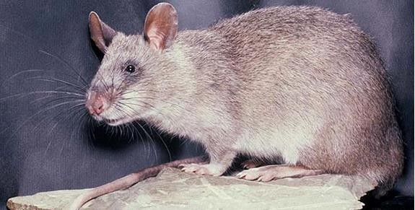

**Plate I: Photograph of an African Giant rat (*Cricetomys gambianus*, Waterhouse- 1840).**

(Reproduced with permission from A Bickers, [www.pouchedrats.co.uk](http://www.pouchedrats.co.uk/)).

Cytotaxonomy has shown for long to be an essential tool for the study of biological diversity in African rodents (Matthey, 1958; Petter, 1971). In the study by Petter (1971), sibling species often prove to display highly differentiated karyotypes, thus signing their reproductive isolation and, from there, their specific status (Volobouev *et al.,*2002, Dobigny *et al.,* 2003; Granjon and Dobigny, 2003). As such, karyotyping represents an important step towards the elaboration of reliable species inventory. In Benin, a list of rodent species has been published, but uncertainties remain about the taxonomic status of specimens from several genera, such as *Cricetomys, Tatera, Mastomys* or *Mus,* due to the absence of cytotaxonomic data (Robbins and Van der Straeten, 1996). Some chromosomal data also exist for the rodents of Benin, concerning the genera *Cricetomys* (Codjia *et al.,* 1994), *Tatera* (Codjia *et al.,* 1994; Colangelo *et al.,* 2001), *Arvicanthis* (Civitelli *et al.,* 1995; Volobouev *et al.,* 2002b) and *Mastomys* (Codjia *et al.,* 1996).

Until recently karyological investigations on rodents of Senegal have mainly focused on *Gerbillidae*, and particularly the genera *Tatera* and *Taterillus.* These karyological studies made it possible to distinguish two sibling species of *Taterillus,* namely *T. gracilis,* with a diploid number of 2n = 36/37, and *T. pygargus* with (2n = 22/23)*, (*Matthey, 1969; Matthey and Jotterand, 1972; Petter *et al*., 1972), and to characterize the two species of *Tatera, T. gambiana* (2n = 52) and *T*. *guineue* (2n = 50) (Matthey, 1969; Matthey and Petter, 1970; Hubert *et al.,* 1973). In the family *Muridae*, data on the two previously known species of *Mastomys, M. erythroleucus* (2n = 38) and *M. huberti* (2n = 32) have been published (Hubert *et al.,* 1983), but recent extensive studies of *Mastomys* genus in Senegal revealed the presence of a third species, *M. cf natalensis,* morphologically indistinguishable from *M. huberti,* and having the same diploid number, but with distinct ecological preferences and a specific autosomal fundamental number (NFa = 54 versus

44) for *M. huberti* (Duplantier, 1988; Duplantier and Granjon, 1988; Duplantier *et al.,*

1990).

Karyotypic studies of mole rats in Turkey were initiated by Savic and Soldatovic (1977, 1979a and 1979b) and Soldatovic and Savic (1978). The karyotype of *Arvicanthis dembeensis* was reported to be identical to that of *Arvicanthis niloticus* from terra typical by Corti *et al*. (1996). Attempts were also made to assess the phylogenetic relationships among the taxa of the genus *Arvicanthis by* Corti *et al.* (1996) on the basis of chromosomal rearrangements, by Capula *et al.* (1997) through multi-locus protein electrophoresis, and by Ducroz *et al.* (1998) on the basis of the sequence of mitochondrial gene for the cytochrome b (cyt b).

The success karyological studies have had in clarifying the systematics of tropical three rodents led researchers to undertake a preliminary chromosomal characterization of other rodent species from Senegal. A diploid number of 80 (NFa = 82) was determined for *Cricetomys gambianus* showing only two small pairs of submetacentric (SM) chromosomes. The only published data was provided by Robbins and Baker, 1978, who found 2n = 78 for a *C. gambianus* of unknown origin.

There are currently four recognised species of giant pouched rats (Genest-Villard, 1967): *Cricetomys ansorgei* (Thomas, 1904), *C. emini* (Wroughton, 1910), *C. gambianus* (Waterhouse, 1840), and *Cricetomys kivuensis*. Previously it was suggested that there existed six (Allen, 1939) or one (Ellerman *et al.,* 1953) species, while Genest-Villard (1967) described predominantly savannah-dwelling (*C*. *gambianus*) and lowland forest (*C*. *emini*) species. This genus has long been considered taxonomically confused, as it was included in a group of genera together with *Cricetomys ansorgei* (Thomas, 1904), *C. emini* (Wroughton, 1910), and *Cricetomys kivuensis*. There are limited data regarding

possible variation, so taxonomy must be considered as provisional for East Africa. Chromosomal descriptions are available for West African specimens only. Matthey (1954) described a karyotype for *C. gambianus* (unknown origin) with 2n = 78. In Senegal, Granjon *et al*. (1992) found a karyotype with 2n = 80 and NFa = 82, and in Benin Republic, Codjia *et al*. (1994) described a karyotype with 2n = 82 and NFa = 88 for

*C. gambianus*, and a karyotype of 2n = 80 and NFa = 88 for *C. emini*. Chen *et al.* (1992) suggested the following factors may be facilitating the C-banded karyotype evolution trend in *Rattus:* (1) Loss or absent of centromeric heterochromatin in the complement; and (2) appearance or increases of interstitial heterochromatin, terminal heterochromatin and heterochromatic arms.

Two specimens (one female, one male) of *Cricetomys gambianus* from Lanta were karyotyped. One of the karyotypes, despite poor quality, showed a diploid number (2n) of chromosomes of at least 79. The other one clearly possessed 2n = 80 chromosomes, and an autosomal fundamental number (NFa, the number of autosomal arms) of 82. These 2n and NFa are exactly the same as those found by Dobigny *et al.* (2002) in Niger Republic, although the quality of the karyotypes in this study did not allow further comparisons. These results from Benin Republic are also quite similar to what Granjon *et al.* (1992) found in Senegal, with the exception of one of the two metacentric autosomal pairs in the Lanta karyotype which appears larger than in the karyotype from Senegal.

In addition, the results obtained in Benin Republic by Ganjon et al. (2002) as 2n = 80, NFa = 82 differ from what was previously found in Benin by Codjia *et al.* (1994), as he found 2n = 82, NFa = 88, from wild (N = 2, from the south of the country) and captive- bred (N = 3) specimens. In all cases, the X chromosome is a large submetacentric, and the Y a small acrocentric. *Dipodomys* s. *spectabilis* (Plate II), *D.S*. *perblandus* and *D.S*.

*baileyi* have 2n = 72 chromosomes, but differ in chromosomal configuration as *D.S*. *spectabilis* has 35 acrocentric chromosomes and a fundamental number of 70. Cesium chloride-buoyant density-peak values for DNA samples of *D*. *spectabilis* do not differ greatly from 92 other species belonging to the 11 orders of mammals (Arrighi *et al.,* 1970). Satellite DNA from twelve species of kangaroo rat has been characterized and correlates well with phylogenetic ranking within the genus *Dipodomys* (Mazrimas and Hatch, 1972).

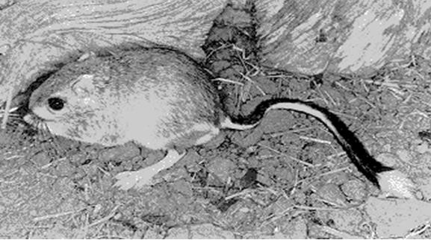

**Plate II: Photograph of Texas banner-tailed kangaroo rat (*Dipodomys spectabilis***

# Merriam, 1890).

(Photo credit: John L. Tveten, The Mammals of Texas-Online Edition)

Most satellite DNAs are nearly identical to that of other *Dipodomys* (Mazrimas and Hatch, 1977) and similarity of satellite DNA can be used in phylogenetic comparisons of

*D*. *spectabilis* to other species (Hatch and Mazrimas, 1977; Mazrimas and Hatch, 1977).

The genus Dipodomys (Kangaroo rats) exhibits major interspecies variations in the proportions of highly reiterated satellite DNA sequences in the genome as well as in the chromosome number and the proportions of uni-armed and bi-armed chromosomes. The relationships of satellite DNA to karyotype structure reveal a new level of hierarchy in the genome that appears capable of exerting global control over environmental adaptation and the evolution of new species (Hatch *et al.,* 1976). Based on 17 proteins, the mean number of alleles per locus per population is 1.06, the mean proportion of loci polymorphic per population is 0.06, and the mean proportion of loci heterozygous per individual is 0.008 (Johnson and Selander, 1971).

The well-studied multimammate mouse complex in southern Africa appears to conform to a situation where irreversible speciation has occurred, accompanied by pre- and post zygotic reproductive isolation, overt chromosomal change, and subtle but distinct phenotypic, genotypic, and ecological divergence. While chromosomally differentiated speciation complexes are typically distributed parapatrically (King, 1993), a similar case of sympatry to that of the southern African multimammate mice was reported for 2 chromosomal forms of the agile kangaroo rat (*Dipodomys agilis*) in California (Sullivan and Best, 1997). Discriminant analysis was used to demonstrate distinct morphometric differences between the forms (now considered species) and to identify a broad zone of sympatry not evident from previous karyotypic and biochemical studies.

Peterson *et al*. (2006) recommended the use of molecular methods to provide more insight into the taxonomy and phylogeny of *Cricetomys*. Preliminary molecular studies

involving this genus have helped to clarify its position and relationships with regard to other groups within the rodent subfamily *Muroidea*.

The *Cricetomys gambianus* clade displays some heterogeneity, with sequences from Senegal and Guinea towards the western portion of West Africa forming a subclade and specimens from Benin, Niger, Nigeria and Cameroon toward the eastern part of West Africa forming another subclade (Olayemi *et al.,* 2012). Actively speciating chromosomal complexes of rodents and other species frequently occur in parapatry (or less commonly in allopatry), often in chains or linear series of colonizing races, thus prompting the stasipatric model of chromosomal speciation advocated by White (1978). This pattern of parapatric races is repeated worldwide, for example, in Venezuelan spiny mice of the *Proechimys guairae* complex (Reig, 1980), deer mice (*Peromyscus* — Robbins and Baker 1981), pocketgophers (*Thomomys taploides* — Thaeler, 1974), and geckos (*Sceloporus grammicus* complex — Sites *et al*., 1987) in North and Central America; common shrews (*Sorex araneus* complex) (Hausser *et al*., 1994) and house mice (*Mus domesticus* — Winking *et al*., 1988) in Europe; the *Rattus rattus* complex in Asia (Yoshida, 1980); mole rats of the *Spalax ehrenbergi* complex in Israel (Nevo, 1991); and geckos (*Gehyra variegata–punctata*) species complex (King, 1979), rock wallabies (*Petrogale assimilis* complex - Eldridge *et al.,* 1988), and flightless morabine grasshoppers (Key, 1981) in Australia.

Three possible cases reviewed here conform to the common parapatric pattern outlined previously: the vlei rat, *Otomys irroratus* complex; the mole rat, *Cryptomys* complex; and 3 of the 4 Southern African *Gerbillurus* species (*G. vallinus* – *G. setzeri* – *G. tytonis*). With additional research, parapatric patterns may apply in the case of the striped mouse, *Rhabdomys pumilio,* in southern Africa, where known karyotypic variants currently

appear to be peripatrically located. King (1993) recognized different classes of chromosomally speciating complexes, depending on genetic distances between races within colonizing series (A–B–C–D). In the present study, the *Otomys irroratus* complex conforms somewhat to King’s (1993) class 3 complexes, that is, ‘‘A linear array of forms ranging from species to chromosome races, with some genic differences at the A end and no genic differences between C and D at the D end.’’*Cryptomys* and *Gerbillurus* most closely represent King’s (1993) class 2, presenting a continuum within a series of races, between genetically well-differentiated species at one end (A end of King, for example, between recognized parapatric species of *Cryptomys* and *Gerbillurus*) and relatively more genetically similar subspecies at the other end (D end of King, for example, recognized subspecies of *Cryptomys hottentotus* and *Gerbillurus paeba*).

In Southern Africa, the rodents species has a widespread karyotype of 2n = 48; however, Mahida *et al.* (1999) documented the occurrence of a 2n = 46 form at Potchefstroom (Gauteng Province, South Africa) and Inyanga (Zimbabwe).This chromosomal change has resulted from a single Robertsonian fusion event that appears to have become fixed at Potchefstroom and Inyanga (a series from Zimbabwe and a single Potchefstroom animal contained the same fusion rearrangement). Potchefstroom is situated near the periphery of the species’ range in South Africa, while Inyanga represents the geographically isolated peripheral population in the dry Limpopo Valley in Zimbabwe. Nevo *et al*. (1986) showed *C. damarensis* to be karyotypically distinct from *natalensis* and *hottentotus,* having 74 or 78 chromosomes as opposed to 54 in the other 2 (probably due to Robertsonian changes). *C. h. natalensis* differed from *C. h. hottentotus* in having 2 extra arms due to a pericentric inversion in chromosome pair 15.

More recently, Aguilar (1993) described populations from Zimbabwe (*C. h. darlingi*) having 54 chromosomes but only 80 arms, which is better explained (in the absence of G- banding data) by numerous pericentric inversions. The multimammate mouse (*Mastomys natalensis* sensu lato) was the 1st case of chromosomal polytypy to be investigated fully in southern Africa. Gordon, 1984 and Green *et al*. (1980) revealed the existence of 2 sibling chromosomal species having diploid numbers of 2n = 32 (*M. natalensis* sensu stricto) and 2n = 36 (*M. coucha*), within what was long regarded to be a single species. A prevalent pattern among southern African rodents appears to be the sympatric occurrence of chromosomally distinguishable sibling species pairs: *Mastomys natalensis* – *M. coucha, Thallomys paedulcus* – *T.nigricauda, Aethomys chrysophilus* – *A.ineptus,* or the sympatric arrangement of ancestral species relative to parapatric or allopatric species complexes: *Gerbillurus paeba* (sister species to the parapatric complex, *vallinus* – *setzeri*

– *tytonis*) and *Tatera leucogaster* (sister species to the allopatric *afra* – *brantsii* species pair) (Dempster *et al.,* 1993; Qumsiyeh, 1986).

In these sympatric cases, species appear to have diverged genotypically, ecologically, and phenotypically and to have achieved a significant measure of reproductive isolation (pre- and postzygotic isolation in *Mastomys* and prezygotic isolation in sympatric *Tatera* and *Gerbillurus* species) and cannot really be regarded as actively speciating. They perhaps represent an older speciation event, somewhat similar to the class 1 series (A–B–C–D) described by King (1993) although differing in their sympatric, rather than parapatrically linear, relationship, that is, A relic, colonising radiation in which all species in a sequence A–D have numerous fixed differences between them. Sympatrically distributed chromosomal complexes or species pairs are not reported frequently worldwide, but a recent case involving 2 forms of *Dipodomys agilis* in California was reported by Sullivan and Best (1997).

The tree rat (*Thallomys paedulcus* sensu lato) demonstrates extreme variability in karyotype, with diploid numbers of 43 to 50 having been recorded, including some 11 unique variants (Gordon, 1987). Gordon (1987) grouped these variants into 2 major groups that are now recognized as good species, *T. paedulcus* having 43 – 46 chromosomes and *T. nigricauda* having 47–50 chromosomes. Each species possesses intraspecific polymorphisms involving Robertsonian centric fusions, tandem fusions, and pericentric inversions, while differences between species are due to the presence of an unexplained supernumerary pair in *T. nigricauda* (either 1 or both members may be present) and differences in banding morphology of the X chromosome. Based on the distribution of karyotyped specimens, Gordon (1987) proposed that distributions were parapatric, *T. nigricauda* being restricted to the Southwest Arid biome and *T. paedulcus* being restricted to the Savanna biome.

In the little-known water rat (*Dasymys incomtus*), a specialized, relatively large (>100 g) species that is confined to wetland habitats, Gordon (1991) documented 2 karyotypes at 2 populations in South Africa: 2n = 46 at Klipfontein Farm in Northern Province and 2n = 38 at Richards Bay on the east coast of Kwa Zulu–Natal. The difference in karyotype can be attributed to3 independent Robertsonian centric fusions. Geographic distributions and evolutionary implications of these chromosome races were reviewed by Sarah Mullin (Professor of Biology, University of the Witwatersrand, Johannesburg, South Africa) who found out that, the fossil record indicated that Dasymys originated in southern Africa, implying that the genus migrated northwards into the rest of Africa, she envisaged that the model may be used to generate testable hypotheses in future investigations; for example, genetic studies could be conducted to complement the morphometric classification (Mullin, 2005).

Gordon (1986) demonstrated profound variation in diploid number (2n) in the pouched mouse from southern Africa, from 28 to 50, including 16 different 2n complements. Numerous centric fusions appear to explain the differences in diploid number, heterochromatic additions (or deletions) and pericentric inversions explain differences in fundamental numbers (Gordon 1986). Gordon (1986) recognized 2 groups and argued for species status based on the presence of fixed differences or large frequency differences at 3 allozyme loci.

The Florida Keys are geographically isolated and have large dispersal barriers, including a 5-mile-long bridge, which provide an opportunity to prevent expansion of the Gambian rat population to mainland Florida. Surveys to determine the range of this population should coincide with an eradication effort. Perrings *et al*. (2000) have argued that in the case of invasive species this shift implies the adoption of control instruments, such as the environmental assurance bond. The consequences of a mainland invasion of these rats are difficult to predict, although risks to the Florida agriculture industry from a large, largely frugivorous rodent are intuitive. Recent models predict the colonization potential of *Cricetomys* in North America (Peterson *et al.,* 2006).

# MATERIALS AND METHODS

# Materials

# Acquisition of the experimental animals

A total of 10 adult African Giant rats (*Cricetomys gambianus,* Waterhouse-1840) of both sexes were captured alive in the wild around Zaria city, Kaduna State, Nigeria using a local metal cage traps without inflicting injuries on them. The captive African giant pouched rats with live weight of at least 0.8 kg were considered as adult (Ajayi, 1977). They were housed in customized laboratory rat cages in the animal house of the Department of Human Anatomy, Faculty of Basic Medical Sciences, College of Health Sciences, Ahmadu Bello University, Zaria, Nigeria and fed with fruits, groundnut pellets and water was given *ad libitum* for a week prior to commencement of study (Ewer, 1967; Ajayi, 1975; Perry *et al.*, 2006).

# Equipment

The equipment used in this study were:

* + - 1. Microscope (oil immersion enhances the prep but is not essential)
      2. Microscope slides (2 - 4 per pair). The type of slides having a frosted end is desirable because it can be marked with a grease pencil.
      3. Microscope coverslips - necessary for oil immersion
      4. Grease pencil
      5. 3-cc syringe with 23 gauge, 1-inch needle
      6. Paper towels (for absorbing excess fluid on slides)
      7. Sharp scissors
      8. Centrifuge (300 rpm minimum).
      9. Incubator
      10. Pasteur pipets with bulbs
      11. Coplin jars (holding 8–10 slides, more if slides are inserted back-to-back)
      12. 2% Giemsa (about 45 ml per Coplin jar)
      13. Yeast solution (0.5 ml per rat)
      14. Colchicine solution (0.1 ml of 0.01% per rat)
      15. Hypotonic solution (0.55% KCL)
      16. Methanol + acetic acid fixative (3:1)

# Methodology

# Injection and sacrifice of the animals

The rats were euthanized using anaesthetic chloroform in a confined container and weighed using a balance (EMPEROR model p.1210), made in Chandler, Arizona, United State of America (USA), with a sensitivity of 0.1 g. Their lengths as well as tail lengths were measured using a measuring tape to a nearest 0.1 cm. The live specimens were taken to the laboratory and injected intraperitoneally with 2 ml of 0.04% colchicine solution (purchased from Sigma Chemical Company, Stock no. C-10542) prepared with sterile physiological saline. After a period of 3 hours of injection, the specimens were sacrificed using cervical dislocation.

# Ethical Approval

Ethical approval and permission were obtained from ABU Committee on Animal Use and Care (ABUCAUC), Ahmadu Bello University, Zaria with the Approval Number (ABUCAUC/2018/024) for conducting the study (See Appendix II).

# Place where karyotype studies were carried out

The karyotype assessments were carried out in DNA laboratory, Kaduna, Nigeria.

# Extraction of cells

The abdominal cavities of the sacrificed rats were opened with a pair of scissors, being careful to not cut into the viscera. The hind leg bones (femur and tibia) were removed by cutting through the bones at the ankle and as near the pelvis as possible. The muscle and fat were trimmed off from the bones as much as possible. The two bones were separated by cutting through the knee joint. After the bones were cut, there was an opening into the bone marrow cavity at both ends of each bone. Dividing cells were obtained from the marrow of the femur and tibia, dissected out in accordance with the methodology described by (Hsu and Patton, 1969; Adegoke and Ejere*,* 1991; Ejere and Adegoke, 2002). Both ends of the femur and tibia were cut open, and a hypodermic needle attached to a syringe containing 1 – 1.5 ml of freshly prepared and pre-warmed (37oC) hypotonic buffer (0.55% KCl) was inserted. The marrow was flushed out into a 15 ml centrifuge tube. Fat lumps were removed with a pasture pipette. The preparation was left to stand in the hypotonic buffer for not more than 15 minutes. The procedure was repeated for the rest of the bones (Deanna and Lynn, 1991).

# Fixation of cells

The tubes were balanced using the hypotonic buffer and centrifuged at 300 x g for 5 minutes at room temperature (25 - 260C). The supernatant was carefully removed using a suction pipette, remaining a small quantity of about 1.5 ml in which the cells were suspended. The tubes were shaken briskly so that sediment mixes with the remaining supernatant to form a cell suspension. Freshly prepared fixative (3:1 methanol – glacial

acetic acid) was added drop wise, with quick agitation after each drop to re-suspend the cells. A total of 2.0 – 2.5 ml of the fixative were added. The suspension was centrifuged at 300 x g for 5 minutes and the supernatant removed. The above process was repeated for two more times and the cells were re–suspended in the fixative (Plate III) (Yoshida *et al.,* 1965).

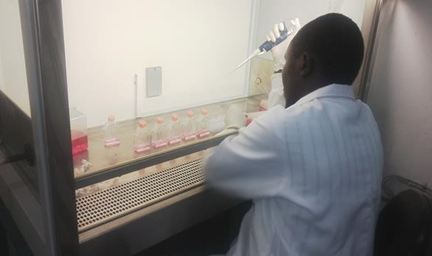

# Plate III: Demonstration of preparation and fixation of cells

# Spreading of cells and air drying

After the last centrifuging, the cells were re-suspended in appropriate volume of the fixative to give an adequate cell suspension for spreading on the slides. The cells were spread on clean slides by holding the slides at an angle of about 450. From a height of about 1 metre, two or more drops of the cell suspension were allowed to fall on the slides uniformly. The slides were blown quickly across its length and placed on a slide warmer set at 600C, and were allowed to dry for about 24 hours before staining. The slides were flame dried for normal metaphase cells and air dried completely before staining (Lee, 1969).

# Preparation of Giemsa Stain

Giemsa powder (0.5 g) was dissolved in 33 ml glycerol and put in Erlmyer bottle in a dark compartment overnight. The next day, it was heated in a water bath set at 60oC for 2 hours and was allowed to cool, after which 33 ml of methanol was added. This solution was stored in an amber coloured bottle as the stock Giemsa stain. G-bands were performed according to Seabright (1971).

# Staining of cells

A total of 5 ml of stock Giemsa stain was diluted with 50 ml of phosphate buffer. The buffer was prepared fresh by simultaneously pouring 25 ml each of sodium dihydrogen orthophosphate (NaH2PO4) and disodium hydrogen orthophosphate (Na2HPO4) into a coupling jar/chamber. Exactly 5 ml of the stock Giemsa stain was then added to it. The resulting stain was stirred with a glass rod to obtain a uniform mixture after which the stain was reduced to an adequate level so as to avoid covering the labels on the slides. The slides were stained for 20 minutes, and rinsed in distilled water to remove the stain

(Plate IV). The slides were dropped back on the slide warmer to dry any adhering water molecule (Baker *et al.,* 1982).

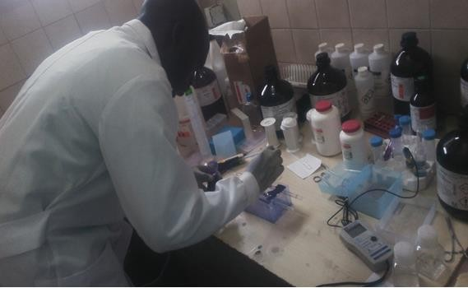

# Plate IV: Giemsa staining of the slides

# Chromosome analysis

The chromosomes of an African giant rat were arranged in order of decreasing size, and the karyotype of *Cricetomys gambianus* were arranged in accordance with the report of Granjon *et al*. (1992). Chromosomes were classified into metacentric (M), submetacentric (SM), telocentric (T) and acrocentric (A), and the autosomal fundamental number (NFa) were determined by considering that both M and SM chromosomes carry two arms whereas A ones have only one (Plate V). The categorization of chromosomes was performed following the criteria of Levan *et al.* (1964).

The slides were scanned for dividing cells systematically from one end to another under the ×10 objective of light microscope. The objective was changed to × 40 once a likely metaphase cell was spotted. Well-spread cells were studied intently under ×100 (oil immersion). Photomicrographs of the chromosomes were taken under oil immersion. Chromosome prints were cut out, grouped as bi-armed chromosomes or acrocentric chromosomes, and arranged in descending order of size in each group to facilitate comparisons between individuals as described by Granjon *et al*. (1992).

The sex chromosomes were readily identified by comparison of male and female karyotypes. All figures for which sex chromosomes were determined have the X and Y or the 2 X's placed in the lower right hand corner (Granjon *et al.,* 1992)**.** The chromosome’s entire length [long arm (q) as well as the short arm (p)] were measured with the aid of KaryoType Computer Software (Version 2.0 build 20160518). The classification of the chromosomes based on centromere position followed that proposed by Abraham and Prasad (1983). Appropriate ideogram (karyotype) representing the entire chromosome length and morphology was constructed.

* 1. **Components of karyotypic patterns of *Cricetomys gambianus***

The measurements included the chromosomal length for both short and long arms, total length, centromeric index, sexual dimorphisms, chromosomal nomenclature, mitotic metaphase chromosomal spread and karyograms. All the units of measurements for the chromosomal lengths were in micrometres (µm). The centromeric index (i) was calculated using the formula below:

**Centromeric index (i) = 100 x S/C** (Denver report, 1960) Where S = Short arm length

C = Total length

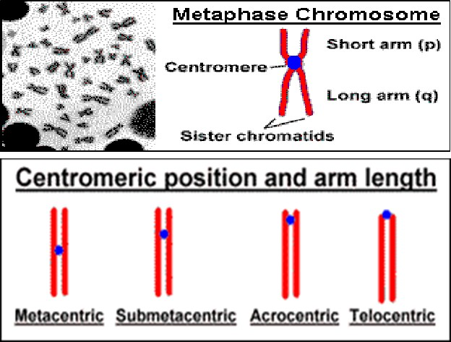

# Plate V: Drawing showing different chromosomal nomenclature.

(Courtesy of Dr. R.A. Siddique, National Dairy Research Institute, Karnal, Haryana, India).

# 3.4. Statistical Analyses

All statistical analyses were performed on an SPSS version 20.0 software package (SPSS Inc., Chicago, Illinois, USA). Data were presented as Mean ± SEM. One way analysis of variance (ANOVA) was used to compare the mean differences. P-values of less than 0.05 were considered to be statistically significant.

# RESULTS

* 1. **Anthropometric measurements of *Cricetomys gambianus***

The following anthropometric measurements were carried out: weight in kg, body and tail lengths in cm and weight to length ratio for both sexes.

**4.1.1 The mean weight and length of *Cricetomys gambianus***

The weights of adult rats were 0.53 – 1.40 kg (the adult male was the largest) and the juvenile male weighed 0.55 kg. The total lengths of the animals were 62–71 cm for males and 56-70 cm for females. Tails measured 11-34 cm for males and 10-37 cm for females (Table 4.3).

The mean weights of the adult rats were 0.90 ± 0.14 kg for males and 0.82 ± 0.15 kg for females; mean lengths were 64.40 ± 2.20 cm for males and 63.80 ± 2.54 cm for females; mean tail lengths were 24.60 ± 5.56 cm for males and 29.00 ± 4.88 cm for females and mean weight-to-length ratios (W:L) were 0.01 ± 0.00 for males and 0.01 ± 0.00 for females (Table 4.1).

Table 4.1 shows the sexual dimorphisms for the means of anthropometric variables such as weight, length, tail length and weight to length ratio of *Cricetomys gambianus.* From the results, the mean weight, length, tail length and weight to length ratio of *C. gambianus* did not indicate significant (P < 0.05) difference.

# Table 4.1: Weight, length, tail length and weight to length ratio of male and female

**AGR**

|  |  |  |  |
| --- | --- | --- | --- |
|  | Male | Female |  |
| Variables | Mean ± SEM | Mean ± SEM | P value |
| Weight | 0.90 ± 0.14 | 0.82 ± 0.15 | 0.73 |
| Length | 64.40 ± 2.20 | 63.80 ± 2.54 | 0.86 |
| Tail length | 24.60 ± 5.56 | 29.00 ± 4.88 | 0.57 |
| W:L | 0.01 ± 0.00 | 0.01 ± 0.00 | 1.00 |

Data presented as Mean ± SEM, n = 5, P < 0.05 (significant), AGR: African Giant rat

A total of ten *Cricetomys gambianus* Waterhouse-1840, also known as African Giant rats were studied to assess their karyotypic patterns. The karyotypes of *C. gambianus* and *Dipodomys spectabilis* show both intrapopulation and interpopulation variation. The karyological study of the ten individuals of *C. gambianus* revealed an autosomal diploid number within the species as 2n = 80 as shown in Table 4.2. All autosomes were found to be bi-armed and of gradually decreasing size. Most of them were telocentric or submetacentric, thus NFa = 66 to 95. In addition, one of the small autosomal pairs appeared to bear a secondary constriction. The X chromosome was large sized and submetacentric, whereas the Y chromosome was approximately equal in size to the smallest autosomal pair and most likely subacrocentric. The diploid and autosomal fundamental numbers are provided in Table 4.2, along with a description of the morphology of the sex chromosomes.

# Table 4.2: Specie, sex, diploid number (2n), autosomal fundamental number (NFa), and morphology of the sex chromosomes of the *Cricetomys gambianus*.

|  |  |  |  |  |
| --- | --- | --- | --- | --- |
| **Specie** | **Sex** | **2n** | **NFa** | **Sex chromosome** |
| *Cricetomys gambianus* | M | 80 | 88 | X= MSSM and Y= Small A |
|  | M | 80 | 90 | X=LM and Y=Small A |
|  | M | 80 | 93 | X=LSM and Y=MSM |
|  | M | 80 | 95 | X=LM and Y=Small A |
|  | M | 80 | 95 | X=LSM and Y=Small M |
|  | F | 80 | 92 | X=LSM and X=MSM |
|  | F | 80 | 91 | X=LSM and X=MSM |
|  | F | 80 | 66 | X=MSM and X=Small A |
|  | F | 80 | 66 | X=MSA and X=Small M |
|  | F | 80 | 78 | X=MSA and X=MSA |

A = Acrocentric, M = Metacentric, LM = Large metacentric, LSM = Large submetacentric, MSA = Medium-sized subacrocentric, MSM = Medium-sized metacentric, MSSM = Medium-sized submetacentric, X = X chromosome, Y = Y chromosome, M = Male and F = Female.

* 1. **Chromosomal Numbers, Lengths and Morphology of *Cricetomys gambianus***

Plate VI shows a mitotic metaphase chromosomal spread of male *C. gambianus* specie. Figure 4.1 shows the karyogram was composed of 2n = 80, NFa = 88 with 2 pairs of metacentric, a pair of submetacentric, 2 pairs of acrocentric and 35 pairs of telocentric chromosomes. The X chromosome was medium-sized and submetacentric, and the Y chromosome was the smallest and acrocentric.

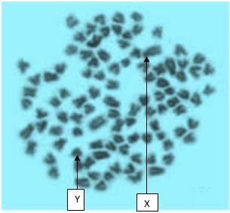

# Plate VI : Mitotic chromosomal spread of a male *C. gambianus* using Giemsa stain X 100 magnification

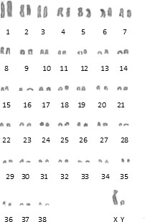

**Figure 4.1: Karyotype of a male *C. gambianus*, 2N = 80, NFa = 88**

Figure 4.2 shows a combination of 12 groups of chromosomes forming a heterogenous pattern with first group having large chromosomes numbered 1-6, which were apparently clearly visible and identifiable on the metaphase spread measuring 15.02 µm,

10.12 µm, 5.01 µm, 4.14 µm, 3.36 µm and 2.96 µm, respectively. It is followed by other chromosomal groups appearing in decreasing order of size, 7 to 8, 9 to 11, 12 to 13, 14 to 15, 16 to 19, 20 to 22, 23 to 24, 25 to 27, 28 to 29, 30 to 33 and 34 to 38. The lengths were as follows; 2.77 µm, 2.57 µm, 1.79 µm, 1.58 µm, 0.80 µm, 0.79 µm, 0.62 µm, 0.59 µm, 0.39 µm, 0.28 µm, 0.26 µm and 0.19 µm, respectively. X chromosome measured

5.73 µm while Y chromosome measured 1.58 µm.

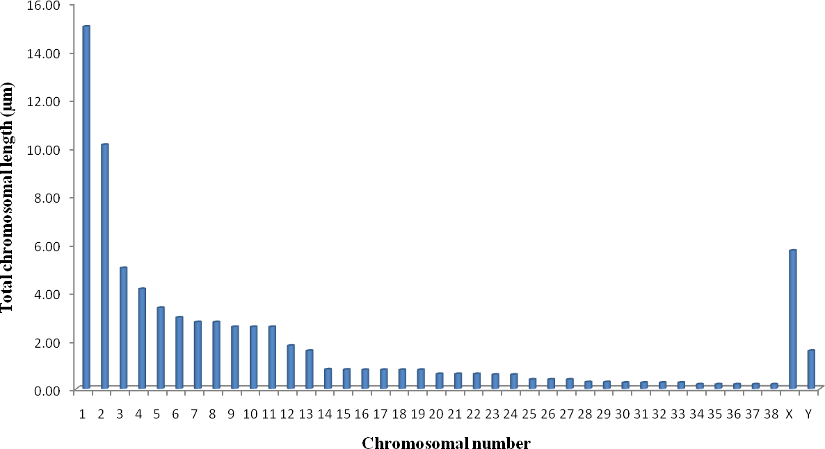

# Figure 4.2: Total chromosomal length and number of a male *C. gambianus*

Table 4.4 shows clear demarcations between short and long arms of the various chromosomes with their respective centromeric indices with the X chromosome having the highest number of 31.06 (ratio). The nomenclature shows 38 terminal and 2 were submedian.

Figure 4.3 shows the morphology of the chromosome for *C. gambianus.* The chromosome 1 was the largest chromosome in the series and the chromosomes 34 to 38 were the smallest within the complement.

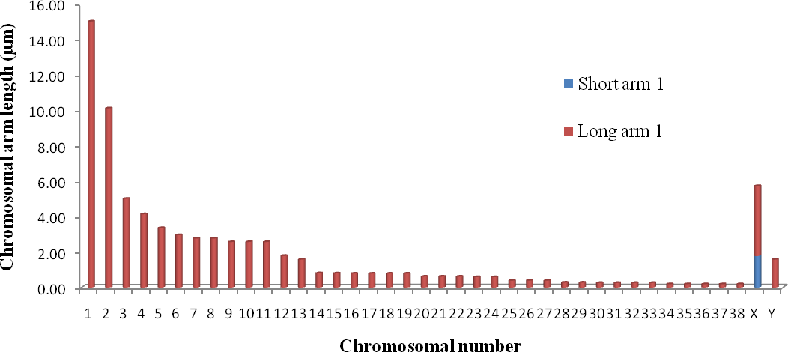

# Figure 4.3: Ideograms of a male *C. gambianus* showing the chromosomal number and length

**The colour demarcated area presented the centromeric position**

Plate VII shows a mitotic metaphase chromosomal spread of a male *C. gambianus*. Figure

4.4 shows the karyotype which composed of 2n = 80. NFa = 90. Autosomes consist of 6 pairs of metacentric, 7 acrocentric and 59 telocentric chromosomes. The X chromosome was large and metacentric, while the Y chromosome was small and acrocentric.

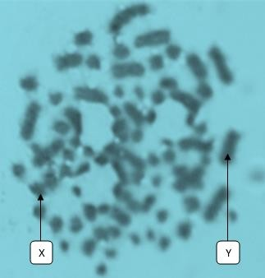

# Plate VII: Mitotic chromosomal spread of a male C. gambianus using Giemsa stain X 100 magnification

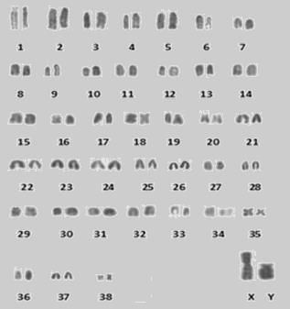

**Figure 4.4: Karyotype of a male *C. gambianus*, 2N = 80, NFa = 90**

Figure 4.5 shows a combination of 23 groups of chromosomes forming a heterogenous pattern with first group having large chromosomes numbered 1-5, which were always clearly visible and identifiable on the metaphase spread measuring 9.71 µm, 6.52 µm,

6.31 µm, 5.33 µm and 5.33 µm, respectively. It is followed by other chromosomal groups appearing in decreasing order of size, 6, 7, 8, 9, 10, 11, 12, 13, 14 to 15, 16 to 17, 18 to 19, 20, 21, 22, 23 to 26, 27, 28, 29 to 30, 31, 32, 33 to 35, 36, 37 having the following lengths; 4.61 µm, 4.54 µm, 3.79 µm, 3.55 µm, 3.40 µm, 3.36 µm, 3.23 µm, 3.16 µm, 2.76 µm, 2.59 µm, 2.57 µm, 2.56 µm, 2.37 µm, 2.36 µm, 2.17 µm, 2.03 µm, 1.98 µm, 1.97 µm, 1.82 µm, 1.79 µm, 1.18 µm, and 0.79 µm, respectively. The X chromosome measured 9.48 µm while Y chromosome measured 5.97 µm.

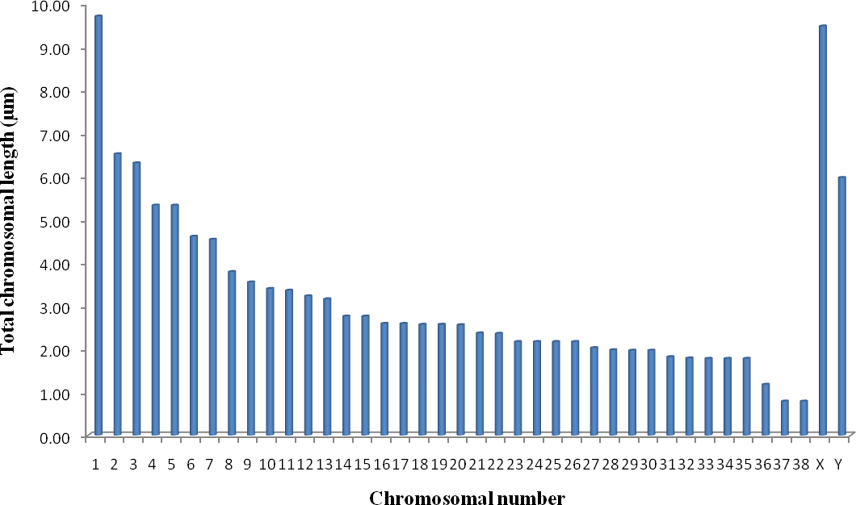

# Figure 4.5: Total chromosomal length and number of a male *C. gambianus*

Table 4.5 shows clear demarcations between short and long arms of the various chromosomes with their respective centromeric indices with the X chromosome having the highest number of 41.67 (ratio), followed by the chromosome 1 that had 26.88 (ratio).

Figure 4.6 shows the morphology of the chromosome for *C. gambianus* having 30 terminal, 2 subterminal, 6 median and 1 submedian nomenclature. The chromosome number 1 was the largest chromosome in the series, while the chromosomes number 37 was the smallest within the complement.

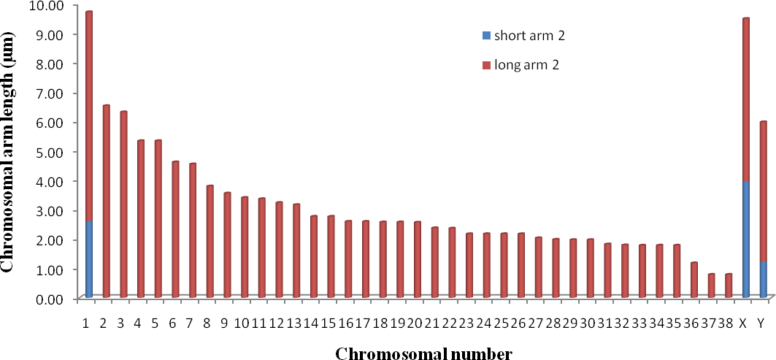

# Figure 4.6: Ideograms of a male *C. gambianus* showing the chromosomal arm lengths and number.

**The colour demarcated area presented the centromeric position**

The above measurements represent the findings of the karyotypic patterns of the male *C. gambianus*. The findings have shown similar patterns in terms of metaphase mitotic spread, karyograms, chromosomal arm lengths, total chromosomal lengths, centromeric indices and nomenclature.

The remaining results were presented in the Appendix.

Plate VIII shows a mitotic metaphase chromosomal spread of a female *C. gambianus* and Figure 4.7 shows a karyotype with a haploid number, 2n = 80, NFa = 92, and has a chromosomal pattern with 5 pairs of metacentric, a pair of submetacentric, 2 pairs of acrocentric and 31 pairs of telocentric chromosomes. The sex chromosomes appeared as large and submetacentric and medium-sized and metacentric X chromosomes, respectively.

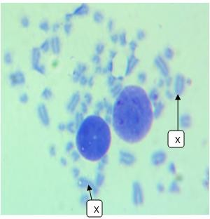

# Plate VIII: Mitotic chromosomal spread of a female *C. gambianus* using Giemsa stain X 100 magnification

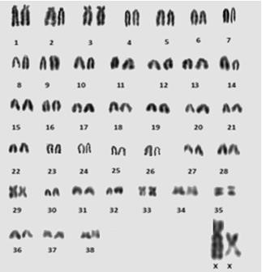

**Figure 4.7: Karyotype of a female *C. gambianus*, 2N = 80, NFa = 92**

Figure 4.8 shows a combination of 30 groups of chromosomes forming a heterogenous pattern with first group having large chromosomes numbered 1-6, which were apparently clearly visible and identifiable on the metaphase spread and measuring 15.22 µm, 9.29 µm, 8.06 µm, 7.10 µm, 6.01 µm and 5.91 µm, respectively. It was followed by other chromosomal groups appearing in decreasing order of size, 7, 8, 9, 10, 11, 12, 13, 14, 15,

16 to 17, 18, 19 to 20, 21, 22 to 23, 24, 25 to 27, 28, 29, 30, 31, 32, 33, 34 to 35, and 36 to

37. The lengths were as follows: 4.93 µm, 4.54 µm, 4.48 µm, 4.40 µm, 4.39 µm, 4.35 µm, 3.95 µm, 3.56 µm, 3.45 µm, 3.40 µm, 3.16 µm 2.96 µm, 2.81 µm, 2.77 µm, 2.76 µm, 2.57 µm, 2.56 µm, 2.37 µm, 2.18 µm, 1.98 µm, 1.97 µm, 0.81 µm, 0.39 µm and 0.28 µm respectively. Both X chromosomes measured 15.99 µm and 16.06 µm, respectively.

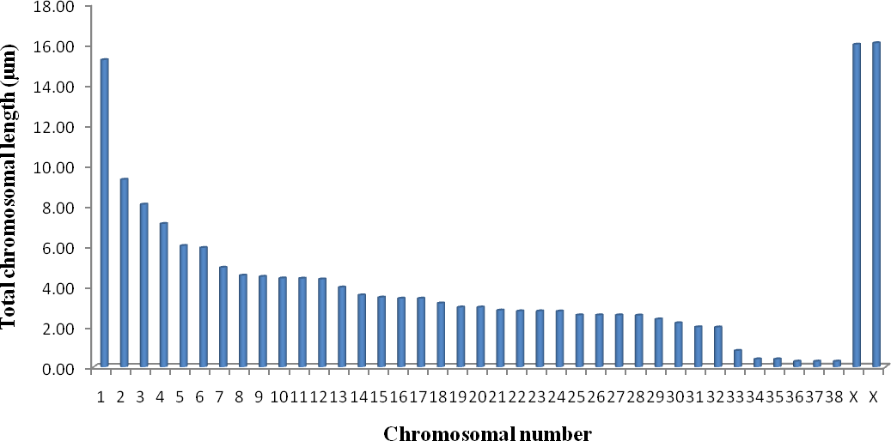

# Figure 4.8: Total chromosomal length and number of a female *C. gambianus*

Table 4.6 shows clear demarcations between short and long arms of the various chromosomes with their respective centromeric indices, and the X chromosomes had the highest numbers of 35.85 (ratio) and 44.71 (ratio), respectively. The chromosomal morphology shows 30 terminal, 4 subterminal, 5 median and 1 submedian normenclatures.

Figure 4.9 shows the morphology of the chromosome for *C. gambianus.* The sex chromosomes were the largest in the series and the chromosomes 36 to 37 were the smallest within the complement.

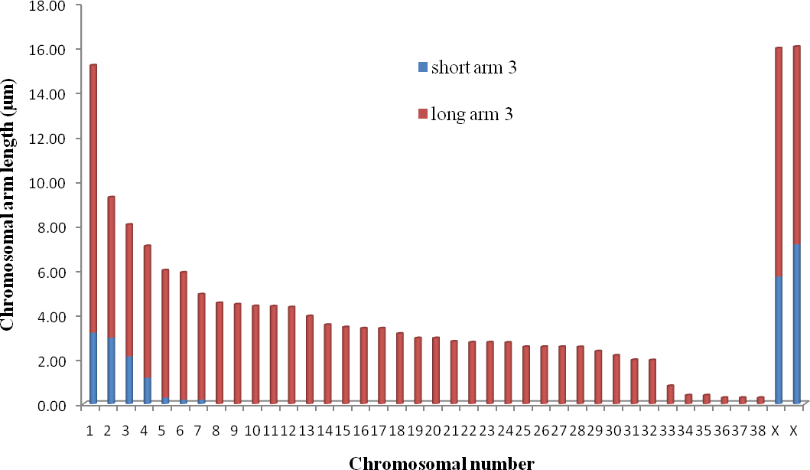

# Figure 4.9: Ideograms of female *C. gambianus* showing the chromosomal arm lengths and number

**The colour demarcated area presented the centromeric position**

Plate IX shows a mitotic metaphase chromosomal spread of another female *Cricetomys gambianus* and Figure 4.10 shows the karyotype with a diploid number 2n = 80, NFa = 91, 5 pairs of metacentric, 1 submetacentric, 1 acrocentric and 33 pairs of telocentric chromosomes. The X chromosomes appeared as large and submetacentric and medium- sized and metacentric chromosomes.

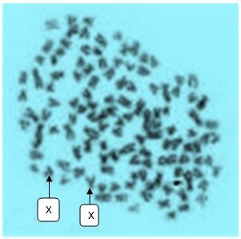

# Plate IX: Mitotic chromosomal spread of a female *C. gambianus* using Giemsa stain X 100 magnification

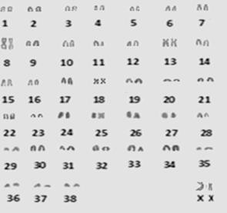

**Figure 4.10: Karyotype of a female *C. gambianus*, 2N = 80, NFa = 91**

Figure 4.11 shows a combination of 18 groups of chromosomes forming a heterogenous pattern with first group having large chromosomes numbered 1-3, which were apparently clearly visible and identifiable on the metaphase spread, measuring 5.27 µm, 2.55 µm and

2.32 µm respectively. It was followed by other chromosomal groups appearing in decreasing order of size, 4, 5 to 6, 7, 8, 9, 10, 11, 12, 13, 14, 15 to 16, 17 to 18, 19 to 23, 24 to 28, 29 to 32 and 33 to 37. The lengths were as follows: 5.27 µm, 2.55 µm, 2.32 µm, 2.23 µm, 2.12 µm, 2.02 µm, 1.92 µm, 1.72 µm, 1.52 µm, 1.21 µm, 1.01 µm 0.93 µm,

0.91 µm, 0.61 µm, 0.40 µm, 0.20 µm, 0.14 µm, and 0.10 µm, respectively. Both X chromosomes measured 10.63 µm and 4.60 µm, respectively.

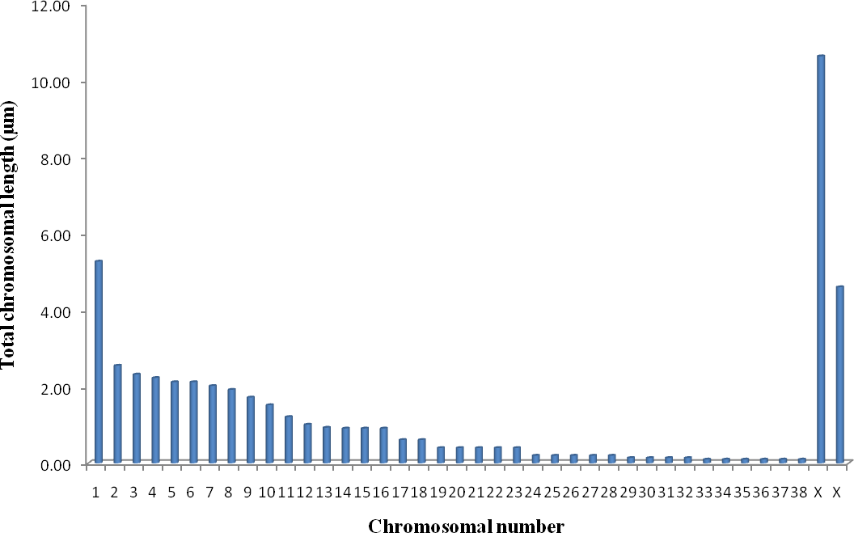

# Figure 4.11: Total chromosomal length and number of a female *C. gambianus*

Table 4.7 shows clear demarcations between short and long arms of the various chromosomes with their respective centromeric indices, and the X chromosomes had the highest numbers of 35.18 (ratio) and 33.48 (ratio) respectively. The chromosomal morphology showed 33 terminal, 1 subterminal and 5 median normenclatures.

Figure 4.12 shows the morphology of the chromosome for *C. gambianus.* The sex chromosomes were the largest in the series, while the chromosomes 33 to 37 were the smallest within the complement.

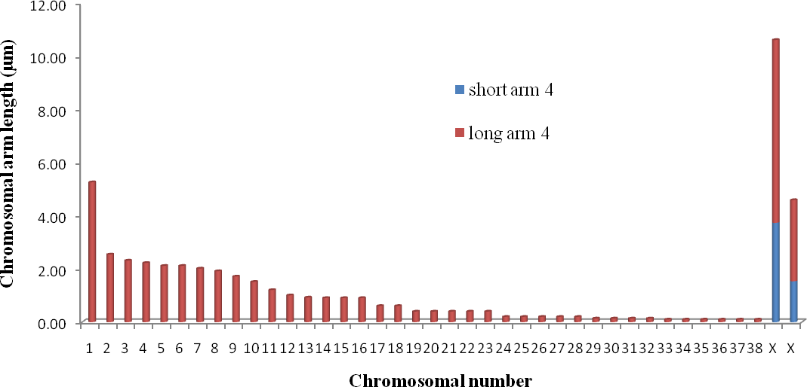

# Figure 4.12: Ideograms of a female *C. gambianus* showing the chromosomal arm lengths and number

**The colour demarcated area represents the centromeric position.**

The karyotypic patterns of the female *C. gambianus* had similar patterns in terms of metaphase mitotic spread, karyograms, chromosomal arm lengths, total chromosomal lengths, centromeric indices and nomenclature.

The remaining results were presented in the Appendix.

* + 1. **The mean chromosomal arm lengths of *Cricetomys gambianus***

Table 4.8 shows the chromosomal arm lengths of the male *C. gambianus* with their respective ranges. The long arms were higher than the short arms, and their mean and SEM were 0.04 ± 0.04 µm, 0.19 ± 0.12 µm, 0.10 ± 0.05 µm, 0.20 ± 0.09 µm and 0.13 ±

0.06 µm for the short arms and 1.86 ± 0.45 µm, 3.05 ± 0.25 µm, 0.99 ± 0.11 µm, 1.75 ±

0.26 µm and 1.97± 0.15 µm for the long arms. The mean values of the long chromosomal arms shows a highly statistical significance (P < 0.05), except for four short arms, while Table 4.8 shows the mean lengths for the female rats were 0.58 ± 0.25 µm, 0.14 ± 0.10 µm, 0.33 ± 0.14 µm, 0.06 ± 0.03 µm and 0.05 ± 0.05 µm for the short arms and 3.85 ± 0.40 µm, 1.15 ± 0.23 µm, 2.01 ± 0.23 µm, 0.83 ± 0.13 µm and 2.69 ± 0.32 µm for the long arms. It was only slightly statistically significant (P < 0.05) among two short arms, but not statistically significant (P > 0.05) among the long arms.

**Table 4.8: Chromosomal arm lengths of *Cricetomys gambianus***

|  |  |  |  |
| --- | --- | --- | --- |
| **Pairs** | **Chromosomal Arm** | **Maxi-Mini** | **Mean ± SEM** |
|  | Short arm1 | 1.78 - 0.00 | 0.04 ± 0.04 |
| 1 | Long arm1 | 15.02 – 0.19 | 1.86 ± 0.45 |
|  | Short arm2 | 3.95 – 0.00 | 0.19 ± 0.12 |
| 2 | Long arm2 | 7.10 – 0.79 | 3.05 ± 0.25 |
|  | Short arm3 | 1.41 – 0.00 | 0.10 ± 0.05 |
| 3 | Long arm3 | 3.34 – 0.10 | 0.99 ± 0.11 |
|  | Short arm4 | 2.76 – 0.00 | 0.20 ± 0.09 |
| 4 | Long arm4 | 7.70 – 0.10 | 1.75 ± 0.26 |
| 5 | Short arm5 | 1.90 – 0.00 | 0.13 ± 0.06 |
| Long arm5 | 6.32 – 0.39 | 1.97 ± 0.15 |
| 6 | Short arm6 | 7.18 – 0.00 | 0.58 ± 0.25 |
| Long arm6 | 12.01 – 0.28 | 3.85 ± 0.40 |
|  | Short arm7 | 3.74 – 0.00 | 0.14 ± 0.10 |
| 7 | Long arm7 | 6.89 – 0.10 | 1.15 ± 0.23 |
|  | Short arm8 | 3.83 – 0.00 | 0.33 ± 0.14 |
| 8 | Long arm8 | 6.91 – 0.44 | 2.01 ± 0.23 |
|  | Short arm9 | 1.18 – 0.00 | 0.06 ± 0.03 |
| 9 | Long arm9 | 3.48 – 0.14 | 0.83 ± 0.13 |
| 10 | Short arm10 | 1.78 – 0.00 | 0.05 ± 0.05 |
| Long arm10 | 7.69 – 0.39 | 2.69 ± 0.32 |

Data presented as Mean ± SEM

* + 1. **Sexual dimorphism of chromosomal arm lengths of *Cricetomys gambianus***

Table 4.9 shows the sexual dimorphisms of mean chromosomal arm lengths of the *C. gambianus*. From the results, the mean chromosomal long arms of the male rats were significantly higher than that of their female counterparts (P < 0.05). However, the chromosomal short arms did not indicate significant differences as shown in Table 4.9. Chromosomal arm lengths were higher (P < 0.05) compared to their females counterparts. The chromosomal arm lengths were independent of sexes, and the total chromosomal lengths of the male rats were significant (P value < 0.05) different compared to their female counterparts.

**Table 4.9: Sexual dimorphism in the chromosomal arm lengths of *Cricetomys gambianus***

|  |  |  |  |
| --- | --- | --- | --- |
|  | Male (n = 5) | Female (n = 5) |  |
| Chromosomal arms | Mean ± SEM | Mean ± SEM | P value |
| Short arm 1 | 0.04 ± 0.04 | 0.27 ± 0.13 | 0.09 |
| Long arm1 | 1.86 ± 0.45 | 3.44 ± 0.36 | 0.01٭ |
| Short arm2 | 0.19 ± 0.12 | 0.00 ± 0.00 | 0.12 |
| Long arm2 | 3.11 ± 0.25 | 0.94 ± 0.18 | 0.00٭ |
| Short arm3 | 0.10 ± 0.05 | 0.28 ± 0.14 | 0.19 |
| Long arm3 | 0.98 ± 0.10 | 1.98 ± 0.24 | 0.00٭ |
| Short arm4 | 0.19 ± 0.09 | 0.06 ± 0.04 | 0.17 |
| Long arm4 | 1.71 ± 0.26 | 0.73 ± 0.11 | 0.00٭ |
| Short arm5 | 0.13 ± 0.06 | 0.05 ± 0.05 | 0.33 |
| Long arm5 | 1.93 ± 0.15 | 2.66 ± 0.33 | 0.05 |

Data presented as Mean ± SEM, P<0.05 (significan)٭ idnicinii yigylh iigditicidn dcinittiii

* + 1. **Sexual dimorphism of the total chromosomal lengths of C*ricetomys gambianus***

Table 4.10 shows the sexual dimorphisms of mean total chromosomal lengths of the *C. gambianus*. The mean total chromosomal lengths of the male rats were significantly (P < 0.05) higher than those of their female counterparts. Comparing the total chromosomal lengths of both males and females in *C. gambianus*, male total chromosomal lengths were higher than those of their female counterparts. The total chromosomal lengths were independent of sexes, and the total chromosomal lengths of the individual rats as well as the overall mean showed a significant (P < 0.05) finding. Table 4.10

**Table 4.10: Sexual dimorphism of the total chromosomal lengths of *Cricetomys gambianus***

|  |  |  |  |
| --- | --- | --- | --- |
|  | Males (n = 5) | Females (n = 5) |  |
| Total length | Mean± SEM | Mean± SEM | P value |
| TL1 | 1.90 ± 0.46 | 3.72 ± 0.46 | < 0.01٭ |
| TL2 | 3.31 ± 0.33 | 0.94 ± 0.18 | < 0.01٭ |
| TL3 | 1.08 ± 0.14 | 2.26 ± 0.37 | < 0.01٭ |
| TL4 | 1.91 ± 0.33 | 0.79 ± 0.13 | < 0.01٭ |
| TL5 | 2.06 ± 0.19 | 2.70 ± 0.36 | > 0.05 |
| Overall | 2.04 ± 0.15 | 2.27 ± 0.19 | < 0.05 |

Data presented as Mean ± SEM, P < 0.05 (Significant), TL= total length of chromosome

٭indicates highly significant difference.

**4.2.5 Sexual dimorphism of the centromeric indices of *Cricetomys gambianus***

Table 4.11 shows the sexual dimorphisms of mean centromeric indices of the *C. gambianus*. The mean centromeric indices of the individual rats did not indicate significant (P < 0.05) difference. However, the total chromosomal length, the chromosomal arm lengths and the overall mean centromeric indices indicated significant (P < 0.05) differences in all the male rats as shown in Table 4.11.

**Table 4.11: Sexual dimorphism of the centromeric indices of *Cricetomys gambianus***

|  |  |  |  |
| --- | --- | --- | --- |
|  | Male (n = 5) | Female (n = 5) |  |
| Centromeric index | Mean ± SEM | Mean ± SEM | P value |
| CI1 | 0.78 ± 0.78 | 2.92 ± 1.28 | > 0.05 |
| CI2 | 2.29 ± 1.34 | 0.00 ± 0.00 | > 0.05 |
| CI3 | 3.52 ± 1.49 | 4.06 ± 1.55 | > 0.05 |
| CI4 | 3.18 ± 1.32 | 1.93 ± 1.04 | > 0.05 |
| CI5 | 2.99 ± 1.28 | 0.51 ± 0.51 | > 0.05 |
| Overall | 2.54 ± 0.56 | 2.81 ± 0.60 | < 0.05 |

Data presented as Mean ± SEM, P < 0.05 (Significant), CI= Centromeric index.

**4.2.7 Chromosomal nomenclature of *Cricetomys gambianus***

Figure 4.13 shows the chromosomal nomenclature of the ten (10) *Cricetomys gambianus,*

Waterhouse-1840:

The first rat had 38 terminal and 2 submedian chromosomes. The second rat had 31 terminal, 2 subterminal, 6 median and 1 submedian chromosomes. The third rat had 33 terminal, 2 subterminal, 4 median and 1 submedian chromosomes. The fourth rat had 33 terminal, 2 subterminal and 5 median chromosomes. The fifth rat had 29 terminal, 7 subterminal, 3 median and 1 submedian chromosomes. The sixth rat had 30 terminal, 4 subterminal, 5 median and 1 submedian chromosomes. The seventh rat had 34 terminal, 1 subterminal and 5 median chromosomes. The eighth rat had 28 terminal, 4 subterminal and 8 median chromosomes. The ninth rat had 36 terminal and 4 subterminal chromosomes and the tenth rat had 38 terminal and only 2 subterminal chromosomes.

The chromosomal nomenclature showed that all the rats had terminal appearance, but nine (9) had additional subterminal, five (5) had additional submedian and seven (7) have additional median nomenclatures.

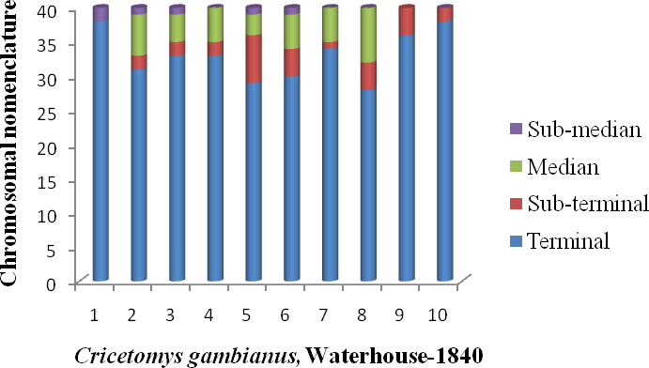

# Figure 4.13: Different chromosomal nomenclature of *C. gambianus* (n = 10)

# 5.0 DISCUSSION

This is the first study on the karyotypic pattern of African Giant rat (*Cricetomys gambianus*, Waterhouse-1840) in the northern part of Nigeria. This assessment was carried out using chromosomal parameters such as chromosomal ideograms or karyograms, total chromosomal length, centromeric index, chromosomal nomenclature and sexual dimorphism between male and female rat species.

The results showed considerable differences in the karyotypes of the *C. gambianus* and *Dipodomys spectabilis*, either in their diploid number or the chromosome forms. They had different habitat, chromosome numerical and structural variations were observed among them. Combining the chromosome characteristics and morphologic features of *C*. *gambianus,* the *Cricetomys* have some peculiarities with *D*. *spectabilis,* especicially the possession of a pale tail that is common to both of them. The function of chromosomes, beyond that of simply carrying genes, is not well known. Swanson *et al*. (1967), gave some logical explanations for the organization of genetic material on the chromosomes. The use of karyotypes as indicators of phylogeny is based on interpretation of the number and types of changes necessary to derive a different karyotype from one inferred to be ancestral. This is because the direction of chromosomal change can sometimes be determined from overlapping changes which could occur only in one direction (White, 1954).

In the present study, the average weights of adult rats were 0.53–1.40 kg and the juvenile male weighed 0.55 kg and this finding is similar with the results of Delany and Happold (1979); Perry *et al*. (2006). The average weights of *Cricetomys gambianus,* Waterhouse- 1840, were 0.90 ± 0.14 kg and 0.82 ± 0.15 kg for males and females, respectively. The African giant pouched rat is larger than Texas banner-tailed kangaroo rat as the later

weighed 115 g (Best, 1972); the male rats were larger and taller than the females, which were in keeping with the study of Rosevear (1969) and Perry *et al*. (2006).

In the present study, the total lengths of the animals were 62–71 cm for males and 56-70 cm for females as against 38 cm found by Delany and Happold (1979), but almost similar to the study of Perry *et al*. (2006). The African giant pouched rat is taller than Texas banner-tailed kangaroo rat as it measured 35 cm in length. Tails measured 11-34 cm for males and 10-37 cm for females. The tail lengths were shorter compared to the findings of Delany and Happold (1979); Perry *et al*. (2006). The tail length of the African giant rat is shorter than that of Texas banner-tailed kangaroo rat, which measured 21 cm as reported by Best (1972). The differences could be as a result of species obtained from different localities.

In the present study, a total of ten (10) African Giant rats known as *C. gambianus* Waterhouse-1840 studied were found to have equal diploid chromosomal number, in which 2n = 80 was found among all the rats, with NFa ranging from 66 to 95. This morphologic feature of *C. gambianus* is similar with those of chromosomal diploid number of 80 (NFa = 82) that was determined for showing only two small pairs of submetacentric (SM) chromosomes, but the finding was not published, and the actual sexes were not known.

These 2n and NFa are exactly the same with those found by Dobigny *et al.* (2002) in Niger Republic. The results are also quite similar to what Granjon *et al.* (1992) found in Senegal, with the exception of one of the two metacentric autosomal pairs in the Lanta karyotype, which appear larger than in the karyotype from Senegal. In addition, the results differ from what was previously found in Benin by Codjia *et al.* (1994), in which, 2n = 82, NFa = 88, from wild (N = 2, from the south of the country) and captive-bred (N

= 3) specimens. The findings also differed with that published data provided by Matthey *et al.* (1978), who found 2n = 78 for a *C. gambianus* of unknown origin. This is also differed with other species from same *muridae* family such as *Tatera kempi* 48 (Colangelo *et al*., 2001), *Taterillus gracilis* 39 (Dobigny *et al*., *200*2), *Arvicanthis rufinus* 62 (Volobouev *et al*., 2002a), *Lemniscomys bellieri* 56, *Mastomys natalensis* 32 (Codjia *et al*., 1996)*, Myomys derooi* 36 (Matthey, 1964) and *Rattus rattus* 38 (Duplantier *et al*., 2003).

In this study, various chromosomal variables were measured including the centromeric indices as well as the sexual dimorphisms, contrary to the karyological studies on *Cricetomys gambianus* performed in Benin Republic, Senegal and Niger Republic centred only on the chromosomal autosomal diploid number, autosomal fundamental number (NFa), sex chromosomes and nomenclature, as the quality of the karyotypes did not allow further comparisons (Dobigny *et al*., 2002).

Other species belonging to the same family, Muridae such as Gerbillinae (*Tatera* and *Taterillus*) and Murinae *(Arvicanthis, Lemniscomys, Mastomys, Myomys and Rattus*) have less diploid number compared to *C*. *gambianus* that shares the same family, such as *Taterillus gracilis* with 2n = 39, NFa = 44 and it has a sex trivalent with a large metacentric X and two smaller bi-armed Y1 and Y2 chromosomes (Dobigny *et al*., 2002; Granjon and Dobigny, 2003). *Arvicnthis rufinus* has 2n = 62, while *Mastomys natalensis* has 2n = 32 with NFa = 54.

The different karyotypes of *C. gambianus* found in West (Granjon *et al*., 1992; Codja *et al*., 1994) and East Africa could correspond to different biological species or represent extremes of some form of chromosomal variation. Nonetheless, these data and parallel analyses suggest that at least there are close similarities among the studied species.

Diversity within the genus *Cricetomyinae* is larger than previously reported and believed in the past, even with the paucity of such karyological research of this genus in West Africa. This is surprising, because most of the African rodent genera show the typical pattern of the order, that is high species diversity associated with or coupled to chromosomal mechanisms of speciation as in *Arvicanthis* (Corti *et al.*, 1995; Capanna *et al.*, 1996; Ducroz *et al.*, 1998; Volobouev *et al.*, 2002; Castiglia *et al.*, 2003b). This obviously creates confusion for taxonomy and systematics, due to the occurrence of several cryptic species complexes, which represents the norm rather than an exception. For this reason, the number of species of the entire order may increase consistently when more detailed analyses on African rodents are carried out. Data presented in this study, however, were not definitive for the taxonomy of the genus as well as for the subfamily. This is because large areas of the distributional range were not included in the study and comparisons with a greater number of Cricetomyinae taxa are needed before an accurate picture can be drawn (Musser and Carleton, 1993).

Although not corroborated by complete G-banding, the karyotypes occurring within *Saccostomus* show diploid numbers not exceeding 2*n* = 50, with a clear tendency towards reduction. On the contrary, the known karyotypes for *Cricetomys* have remarkably higher diploid numbers (2*n* = 78–80; Matthey, 1954; Granjon *et al.*, 1992; Codja *et al.*, 1994). This variability in NFa suggests the presence of a complex chromosomal polymorphism. The different karyotypes of *Cricetomys* cf. *gambianus* found in West (Granjon *et al*., 1992; Codja *et al*., 1994) and East Africa could correspond to different biological species or represent extremes of some form of chromosomal variation.

In the present study, the autosomal fundamental number (NFa) of *C. gambianus* was found to be from 66 to 95 which is similar to those of *Arvicanthis rufinus* 74 (Volobouev

*et al*., 2002a) and *Lemniscomys bellieri* 60-78; but disagree with those of *Tatera kempi* 64 (Colangelo *et al*., 2001), and, *Taterillus gracilis* 44 (Dobigny *et al*., 2002*), Mastomys natalensis* 54 (Codjia *et al*., 1996)*, Myomys derooi* 34 (Matthey, 1964) and *Rattus rattus* 58 (Duplantier, 2003).

In the present study, the comparison of the karyotypic pattern of *C. gambianus* to that of

*D. spectabilis*, which has some peculiar characteristic features with the former, apart from its habitat being in the Southern America, shows that it possessed an autosomal pair of 2n

= 72 chromosomes, but differed in chromosomal configuration. This is because it had 35 acrocentric chromosomes and a fundamental number of 70, while *C. gambianus* has more of telocentric configuration (Arrighi *et al.*, 1970) (Table 4.19). The result of the study suggests that species with similar G-banding patterns are also similar morphologically, but major changes in the karyotype, as shown by G-banding, did not cause morphological change (Baker *et al*., 1985). The closeness of the chromosomal number of the species could be due to ancestral origin because different types of chromosomal change may be found in groups of species which could plausibly have a common ancestry (Koop *et al*., 1984).

In this study, the chromosomal morphology of *C. gambianus* was mostly telocentric, and the sex chromosomes showed an X chromosome that was submetacentric as it was found in *Arvicanthis rufinus* (Volobouev *et al*., 2002a) and Y chromosome that is subacrocentric as found in *Mastomys natalensis* (Codjia *et al*., 1996). Usually in a given taxon, a primitive karyotype is most likely one with a high 2n consisting of mostly acrocentrics, and a derived one with a less 2n consisting of mostly bi-armed chromosomes (Carleton and Myers, 1979). The present findings disagreed with those of *C. emni* which was (Akintoye and Awopetu, 2005) and *Rattus rattus* (Amaka, 2014) which were acrocentric.

In the present study, a very small Y chromosome and like a point was found. This is seldom observed in rodents’ karyotypes, the micro-Y chromosome may be of some evolutionary significance, and further research work will be made in the future. So the karyotype of *C. gambianus* has some specific peculiarities.

There have attempted to fill the existing paucity of information on the karyotype of the species of *C. gambianus.* There was only one similar study for *C. emni*, which showed 37 autosomal pairs (Akintoye and Awopetu, 2005). The result of the study has provided microscopic evidence, statistical karyologic analysis of measurements that certain pairs of chromosomes are distinguishable and others were not. Although, the largest median chromosomes were significantly larger than the shortest terminal autosomes, most of the variability in gross chromosome morphology observed in the strains was in the subterminal chromosomes.

In the present study, the chromosomal arm lengths of the male *C. gambianus* with their respective ranges indicated that long arms were higher than the short arms, and their values were close to those found by Akintoye and Awopetu (2005) for the genus *C. emni,* but and less than those obtained in the black rat by Amaka (2014). The chromosomal length was found to be in decreasing order of size, which is in line with the values reported by Levan *et al*. (1964). The dorminant chromosomal nomenclature for the *C. gambianus* was found to be terminal which was in accordance with the work done by Akintoye and Awopetu (2005); but differed from that of Amaka (2014), which showed more of submedian nomenclature.

In the present study, the total length of each chromosome in male rats showed that the mean total length of each chromosome was longer than in the females; this was similar to

those found by Akintoye and Awopetu (2005), but for the genus *C. emni*, as such finding was absent on the chromosomal measurement of the genus *C. gambianus*.

Comparing the chromosomal arm lengths of (both males and females) *C. gambianus*, based on the present findings, the mean chromosomal arm lengths of the male rats were significantly (P < 0.05) higher than those of their female counterparts. However, the chromosomal short arms were not significantly different. It has been obtained that chromosomal length is independent of sexes, and the total chromosomal lengths in the rats were different (P < 0.05) from what was found in other rodents within the same family. These findings are similar with results obtained by Akintoye and Awopetu (2005) in *C. emni*, and Zhi-Ping *et al*. (1995) in pea’s tree rat (*Chiromyscus chiropus*), but no sexual dimorphism was reported in their study.

The centromeric index in this study was not significant with a p > 0.05, but there are similar values for centromeric index in *C. gambianus*, are lacking in the available literature. In the genus *C. emni* (Akintoye and Awopetu, 2005), almost similar indices were reported but in the Black rat, *Rattus rattus* (Amaka, 2014), a higher number of indices was reported. The difference in the findings could be as a result of species relativity and variation between the former and the later, respectively.

In terms of the chromosomal nomenclature, this study showed that five (5) rats (2 males, 3 females) had X chromosome that was large submetacentric and only three (3) rats had Y chromosome that was small acrocentric, which were exactly the same with what was found in Benin Republic by Codjia *et al*. (1994). Granjon *et al*. (1992) found two metacentric autosomal pairs in the Lanta karyotype, which appears larger than that from Senegal. In this study, there were mixtures of small, medium-sized and large metacentric

pairs. The disparity could be due to tropical variations or poor quality from the karyotype as found in the Lanta karyotype.

In the present study, the significance of the chromosomal measurements in the *C. gambianus* species may be of value in cytotaxonomic differentiation, which has been shown for long to be an essential tool for the study of biological diversity in African rodents (Matthey, 1958; Petter, 1971). An earlier study in Benin Republic has demonstrated a list of rodent species, published with some uncertainties about the taxonomic status of specimens from several genera, such as *Cricetomys*, *Tatera*, *Mastomys* or *Mus*, due to the absence of cytotaxonomic data (Robbins and Van der Straeten, 1996). Therefore, the chromosomal variation occurring in *C. gambianus* requires further investigations such as genetic sequences, stem cells and cell lines, polymerase chain reaction (PCR), fragment-length polymorphism and telomeric lengths.

# CONCLUSION AND RECOMMENDATION

# Conclusion

In this study, *C. gambianus* was found to have an identifiable autosomal diploid number, autosomal fundamental number and characteristic chromosomal arm lengths, total lengths, centromeric indices and nomenclature, which can be used for cytotaxonomic identification and molecular cytogenetic research.

The present study also showed that the cytotaxonomic identification of the chromosomal patterns of *C. gambianus* resulted in a clear way of differentiating this genus from other genus within its family and from variable rodents within the genera such as Texas banner- tailed kangaroo rat (*D. spectabilis*) which has peculiar characteristic features with the former, apart from its habitat being in the Southern America, it possessed an autosomal pair of 2n=72 chromosomes, but differed in chromosomal configuration as it has 35 acrocentric chromosomes and a fundamental number of 70.

# Recommendations

Considering the significance of chromosomal patterns and measurements of *C. gambianus* noted in this study, it is recommended that further studies be carried out to establish its;

1. Genetic sequences
2. Stem cells which can be used in stem cell transplantation
3. Cell lines which could be used in cancer genetics as well as stem cell research
4. Microsatellites
5. Polymerase chain reaction (PCR) in order to outline its DNA
6. Fragment-length polymorphism of restriction endonucleases
7. Telomeric lengths to determine its inheritance
8. Modern, shape-based geometric morphometrics
9. Need for further studies on the cytogenetics of other African mammals, in order to identify their chromosomal number, morphology, nomenclature and measurements, as well to have a structured comparison between various mammals.

# Contributions to Knowledge

1. The diploid chromosomal numbers of male and female *Cricetomys gambianus*, Waterhouse-1840 in Nigeria were 2n = 80.
2. The autosomal fundamental numbers (NFa) of male and female *Cricetomys gambianus*, Waterhouse-1840 in Nigeria were 66 – 95.
3. The total chromosomal lengths of male and female *Cricetomys gambianus*, Waterhouse-1840 in Nigeria were 2.05 ± 0.29 µm and 2.08 ± 0.30 µm, respectively.
4. The centromeric indices of male and female *Cricetomys gambianus*, Waterhouse- 1840 in Nigeria were 2.55 ± 1.24 and 1.88 ± 0.88, respectively.
5. The overall chromosomal lengths of male and female *Cricetomys gambianus*, Waterhouse-1840 in Nigeria were 2.04 ± 0.15 and 2.27 ± 0.19, respectively.
6. The overall centromeric indices of male and female *Cricetomys gambianus*, Waterhouse-1840 in Nigeria were 2.54 ± 0.56 and 2.81 ± 0.60, respectively.

# REFERENCES

Abraham, Z. and Prasad, P. N. (1983). A system of chromosome classification and nomenclature, *Cytologia*, 48: 95-101.

Adegoke, J. A. and Ejere, V. C. (1991). Despcription of the chromosomes of three lizard species belonging to the genus Mabuya (Scincidae, Reptilia). *Caryologia*, 44 (3), 333-342.

Aguilar, G. H. (1993). The karyotype and taxonomic status of *Cryptomys hottentotus darlingi* (Rodentia: Bathyergidae). *South African Journal of Zoology*, 28: 201- 204.

Ajayi, S.S. (1975). Observations on the biology, domestication and reproductive performance of the African giant rat (*Cricetomys gambianus*, Waterhouse) in Nigeria. *Mammalia*, 39: 343-364.

Ajayi, S.S. (1977). Field observations on the African giant rat, *Cricetomys gambianus*

Waterhouse in Southern Nigeria. *East African Wildlife Journal,* 15**:** 191-198.

Akintoye, M.A. and Awopetu, J.I. (2005). Chromosomal studies of the African giant rat and the hairy soled gerbils (*Rodentia*, *Cricetidae*). *Ife Journal of Science*, 7: 163- 171.

Ali, M.N., Byanet, O., Salami, S.O., Imam, J., Maidawa, S.M., Umosen, A.D. and Nzalak, J.O. (2008). Gross anatomical aspect of gastrointestinal tract of the wild African giant rat (*Cricetomys gambianus*). *Journal of Scientific Research and Essay*, 3 (10): 518-520.

Allen, G.M. (1939). A Checklist of African Mammals. *Bulletin of the Museum of Comparative Zoology at Harvard College*, 83: 1-763.

Amaka, J.I. (2014). Studies on the karyotype of the black rat, Rattus rattus, collected at the University of Nigeria Zoological Garden. *IOSR Journal of Pharmacy and Biological Sciences (IOSR-JPBS),* Issue 5 version IV: 64-69.

Arrighi, F.E., M. Mandel, J. Bergendahl, and Hsu, T.C. (1970). Buoyant densities of DNA of mammals. *Biochemical Genetics*, 4: 367-376.

Assogbadjo, A.E., Codjia, J.T.C., Sinsin, B., Ekue, M.R.M. and Mensah, G.A. (2005). Importance of rodents as a human food source in Benin. *Belgian Journal of Zoology,* 135: 11-115.

Baker, R.J., Bickham, J.W. and Arnold, M.L. (1985). Chromosomal evolution in Rhogeesa (*Chiroptera*: *Vespertilionidae*): Possible speciation by centric fusions. *Evolution,* 39: 233-243.

Baker, R.J., Haiduk, M.W., Robbins, L.W., Cadena, A. and Koop, B.F. (1982). Chromosomal studies of South American bats and their systematic implications. *Special Publication Pymatuning Laboratory of Ecology*, 6: 303-327.

Bellier, L. (1973). Application de l’analyse factorielle des correspondances à la biométrie des rongeurs: séparation des *Cricetomys emini* et des *Cricetomys gambianus* de Côte d’Ivoire. *Cahiers Office de la Recherche Scientifique et Technique Outremer (ORSTOM) (Biology),* 18: 61-89.

Best, T.L. (1972). Mound Development by a Pioneer Population of the Banner-Tailed Kangaroo Rat (*Dipodomys spectabilis baileyi)* Goldman, in Eastern New Mexico. *American Midland Naturalist,* 87(1): 201-206.

Capanna, E. (1982). Robertsonian numerical variation in animal speciation: *Mus musculus,* an emblematic model in Mechanisms of speciation (C. Barigozzi, ed.). Alan R. Liss, New York. Pp. 155-157

Capula, M., Civetilli, M.V., Corti, M., Bakele, A. and Capanna, E. (1997). Genetic divergence in the genus *Arvicanthis* (Rodentia: Murinae). *Biochemical Systemic Ecology*, 25(5): 403-409.

Carleton, M.D. and Myers, P. (1979). Karyotypes of some harvest mice, genus Reithrodontomys. *J. Mamm.*, 60: 307-313.

Carson, H. L. (1982). Speciation as a major reorganization of polygenic balances. in mechanisms of speciation (*C. Barigozzi, ed.*). *Alan R. Liss, New York.* Pp. 411- 433.

Centres for Disease Control and Prevention. (2003). Multistate outbreak of monkeypox Illinois, Indiana, Kansas, Missouri, Ohio, and Wisconsin, 2003. *Morbidity and Mortality Weekly Report*, 52: 642-644.

Chaline, J., Mein, P. and Petter, F. (1977). Les grandes lignes d’une classification évolutive des Muroidea. *Mammalia,* 41**:** 245-252.

Chen, Z.P., Wang, Y.X. and Liu, R.Q. (1992). Comparative studies on the C-banded karyotypes of 8 species of genus *Rattus* in China. *Zoological Research*, 13(2): 177-184.

Civitelli, M.V., Castiglia, R., Codjia, J.T.C. and Capanna, E. (1995). Cytogenetics of the genus *Arvicanthis* (*Rodentia*, *Muridae*). I. *Arvicanthis niloticus* from the Republic of Benin (West Africa). *Zeitschrift für Säugetierkunde,* 60: 215-225.

Claussen, U. (2005). Chromosomics. *Cytogenetic Genome Research*, 111(2): 101-106.

Codjia, J.T.C., Chrysostome, C., Civitelli, M.V. and Capanna, E. (1994). Les chromosomes des Rongeurs du Bénin (Afrique de l’Ouest): 1. Cricetidae. *Rendiconti Fisiche Accademia dei Lincei,* 9: 277-287.

Codjia, J.T.C., Civitelli, M.V., Bizzoco, D. and Capanna, E. (1996). Les chromosomes de *Mastomys natalensis* et *Mastomys erythroleucus* (*Rongeurs*, *Muridés*) du sud Bénin (Afrique de l’Ouest): nouvelles précisions sur la variabilité chromosomique. *Mammalia,* 60: 299-303.

Colangelo, P., Civitelli, M.V. and Capanna, E. (2001). Morphology and chromosomes of *Tatera* Lataste 1882 (*Rodentia, Muridae*, *Gerbillinae*) in West Africa. *Tropical Zoology*, 14: 243-253.

Contreras, L.C., Torresmura, J.C. and Spotorno, A.E. (1990). The Largest Known Chromosome-Number for a Mammal, in a South-American Desert Rodent". *Experientia,* 46 (5): 506-508.

Cooper, R.G. (2006). The possibility of naturalization of the African giant rat (*Cricetomys gambianus,* Waterhouse, 1840) in the Caribbean. *Living World. The Journal of the Trinidad and Tobago Field Naturalists’ Club:* 54-55.

Cooper, R.G. (2008). Animal welfare. In: Cooper, J. E., Cooper, M.E. Introduction to Veterinary and Comparative Forensic Medicine. *Blackwell Publishing*, Oxford, London: 51-53.

Corti, M., Castiglia, R., Colangelo, P., Capanna, E., Beolchini, F., Bekele, A., Oguge, N.O., Makundi, R.H., Sichilima, A.M., Leirs, H., Verheyen, W. and Verhagen, R. (2005). Cytotaxonomy of rodent species from Ethiopia, Kenya, Tanzania and Zambia. *Belgian Journal of Zoology,* (Suppl) 135: 197-216.

Corti, M., Vivetilli, M.V., Castiglia, R., Bakele, A. and Capanna, E. (1996). Cytogenetics of the genus *Arvicanthis* (*Rodentia*: *Muridae*) 2. The chromosomes of three species from Ethiopia: *A. abyssinicus, A. dembeensis and A. blicki*. *Z. Saugetierkd*. 61: 339-351.

Coryndon, S.C., Gentry, A.W., Harris, J.M., Hooijer, D.A., Maglio, V.J. and Howell, F.C. (1972). Mammalian remains from the Isimila prehistoric site, Tanzania. *Nature,* 237: 292.

Coyne, J.A. (1994). Speciation by chromosomes. *Trends in Ecology and Evolution,* 9: 76- 77.

Deanna, K.T. and Lynn, W.R. (1991). Techniques in Karyology: The Bone Marrow Extraction Method. *Department of Biology Southwest Missouri State University Springfield, Missouri 65804 Deanna*, Chapter 4, Page 72.

Deaven, L.L., Vidal-Rioja, L., Jett, J.H. and Hsu, T.C. (1977). Chromosomes of *Peromyscus* (*Rodentia*, *Cricetidae*). VI. The genomic size. *Cytogenetics and Cell Genetics,* 19 (5): 241-249.

Delany, M.J. and Happold, D.C.W. (1979). Taxonomy of African Mammals. In: Ecology of African Mammals. *English Language Book Society 4th Ed.*, Pp 4.

Dempster, E.R., Dempster, R., and Perrin, M.R. (1993). Behavioral divergence in allopatric and sympatric gerbil species (Rodentia: *Gerbillinae*). *Ethology*, 93: 300–314.

Denver study group. (1960). A proposed standard system of nomenclature of human mitotic chromosomes. *Acta Genetics*, 10: 322-328.

Dobigny, G., Granjon, L., Aniskin, V., Ba, K. and Volobouev, V. (2003). A new sibling species of *Taterillus* (Muridae, Gerbillinae) from West Africa. *Mammalian Biology,* 68: 299-316.

Dobigny, G., Nomao, A. and Gautun, J.C. (2002). A cytotaxonomic survey of Rodents from Niger: implications for systematics, biodiversity and biogeography. *Mammalia,* 66: 495-523.

Dubois, J.Y., Rakotondravony, D., Hanni, C., Sourouille, P. and Catzeflis, F.M. (1996). Molecular evolutionary relationships of three genera of Nesomyinae, endemic rodent taxa from Madagascar. *Journal of Mammalian Evolution,* 3: 239-259.

Ducroz, J.F., Volobouev, V. and Granjon, I. (1998). A molecular perspective on the systematic and evolution of the genus *Arvicanthis* (*Rodentia*, *Muridae*): inferences from complete cytochrome b gene sequence. *Molecular Phylogenetic Evolution,* 10 (1): 104-117.

Duplantier, J.M. (1988). Biologie évolutive de populations du genre *Mustomys* au Sénégal. Mese d’état, *University of Montpellier, France*, Pp 215.

Duplantier, J.M. and Granjon, L. (1988). Occupation et utilisationde l’espace par des populations du genre *Mustomys* au Sénégal: étude à trois niveaux de perception. *Sciences et Techniques de l’Animal de Laboratoire,* 13: 128-133.

Duplantier, J.M., Britton-Davidian, J. and Granjon, L. (1990). Chromosomal characterization of three species of the genus *Mustomys* in Senegal. *Zeitschrift für zoologische Systematik und Evolutions for schung,* 28: 289-289.

Duplantier, J.M., Catalan, J., Orth, A., Grolleau, B. and Britton-Davidian, J. (2003). Systematics of the black rat in Madagascar: consequences for the transmission and distribution of plaque. *Biological Journal of the Linnean Society,* 78: 335-341.

Durnez, L., Eddyani, M., Mgode, G.F., Katakweba, A., Katholi, C.R., Machang’u, R., Kazwala, R.R., Portaels, F. and Leirs, H. (2008). First detection of *Mycobacteria* in African rodents and insectivores, using stratified pool screening. *Applied and Environmental Microbiology,* 74: 768-773.

Ejere, V.C. and Adegoke, J.A. (2002). Aspects of the reproductive ecology of tropical lizards: Seasonal behaviour of meiotic chromosomes in *Agama agama agama L*, (*Agamidae*, *Reptilia*). *The Zoologist*, 1(1): 86-94.

Eldridge, M.D.B., Dollin, A.E., Johnson, P.G., Close, R.L. and Murray, J.D. (1988). Chromosomal rearrangements in rock wallabies, *Petrogale* (Marsupiala, Macropodidae). I. the *Petrogale assimilis* species complex: G-banding and synaptonemal complex analysis. *Cytogenetics and Cell Genetics*, 48: 228-232.

Ellerman, J.R. (1941). The families and genera of living rodents*.* Vol. 2. *Family Muridae*.

London: Printed by the order of Trustees of British Museum*.*

Ellerman, J.R., Morrison-Scott, T.C.S. and Hayman, R.W. (1953). Southern African Mammals 1758 to 1951*:* A Reclassification. *Trustees, The National History Museum, London, United Kingdom.*

Engeman, M.R., Witmer, G.W., Bourassa, J.B., Woolard, J.W., Constantin, B., Hall, P.T., Hardin, S. and Perry, N.D (2007). The path to eradication of the Gambian giant pouched rat in Florida managing vertebrate invasive species. In: Witmer, W.G., Pitt, W.C. and Fagerstone, K.A., (eds). Proceedings of an international symposium. Fort Collins, CO: USDA/APHIS/WS. *National Wildlife Research Center*, 305-311.

Engeman, M.R., Woolard, J.W., Neil, B., Perry, D., Gary, C., Witmer, A., Hardin, S., Brashears, L., Smith, H, Britta, E. and Constantin, B. (2006). Rapid assessment for a new invasive species threat: the case of the Gambian giant pouched rat in Florida. *Wildlife Research,* 33: 439-448.

Ewer, R. F. (1967). The behaviour of the African giant rat (*Cricetomys gambianus*

Waterhouse). *Z. Tierpsychology,* 24(1): 6-79.

Genest-Villard, H. (1967). Revision Du Genre *Cricetomys* (*Rongeurs*, *Cricetidae*).

*Mammalia*, 31: 390-455.

Gordon, D.H. (1984). Evolutionary genetics of the *Praomys* (*Mastomys*) *natalensis* species complex (Rodentia: *Muridae*). Ph.D. dissertation, University of the Witwatersrand, Johannesburg, South Africa.

Gordon, D.H. (1986). Extensive chromosomal variation in the pouched mouse, *Saccostomus campestris* (*Rodentia*, *Cricetidae*) from southern Africa: a preliminary investigation of evolutionary status. *Cimbebasia,* A8 (5): 37-47.

Gordon, D.H. (1987). Discovery of another species of tree rat. *Transvaal Museum Bulletin*, 22: 30-32.

Gordon, D.H. (1991). Chromosomal variation in the water rat *Dasymys incomtus*

(Rodentia: Muridae). *Journal of Mammalogy*, 72: 411-414.

Granjon, L. and Dobigny, G. (2003). The importance of chromosomally-based identifications for correct understanding of African rodent zoogeography: Lake Chad murids as an example. *Mammal Review,* 33: 77-91.

Granjon, L., Duplantier, J.M., Catalan, J. and Britton-Davidian, J. (1992). Karyotypic data on Rodents from Senegal. *Israel Journal of Zoology*, 38: 106-111.

Graphodatsky, A.S. (2006). Conserved and variable elements of mammalian chromosomes. *Cytogenetics of animals*, 95-124.

Graphodatsky, A.S. (2007). Comparative chromosomics. *Molecular Biology*, 41: 408-

422.

Graphodatsky, A.S., Trifonov, V.A. and Stanyon, R. (2011). The genome diversity and karyotype evolution of mammals. *Molecular Cytogenetics,* 4: 22.

Green, C.A., Keogh, H., Gordon, D.H., Pinto, M. and Hartwig, E.K. (1980). The distribution, identification, and naming of the *Mastomys natalensis* species complex in southern Africa (Rodentia: Muridae). *Journal of Zoology (London),* 192:17-23.

Gretillat, S., Mattei, X. and Marchand, B. (1981). A new *Rickettsiale* of Gambia rats (*Cricetomys gambianus*) in Senegal: Grahamella kaniae n. sp. (Bartonellacae). *Revue d’Elevage et de Medecine Veterinaire des pays Tropicaux,* 34: 383-389 (in French).

Halcrow, J.G. (1958). The Giant rat of East Africa. *Nature*, 181: 649-650. Happold, D.C.D. **(**1987)**.** The Mammals of Nigeria. *Oxford: Clarendon Press*.

Hatch, F.T. and Mazrimas, J.A. (1977). Satellite DNA and cytogenetic evolution: Molecular aspects and implications for man. Human Cytogenetics, ICU-UCLA Symp. *Molecular cell Biology,* 7: 395-44.

Hatch, F.T., Bodner, A.N., Mazrimas, J.A. and Moore, D.H. (1976). Satellite DNA and cytogenetic evolution; DNA quality, satellite DNA and karyotypic variations in kangaroo rats (Genus Dipodomys). *Chromosoma (Berl.),* 58: 155-168.

Hayssen, V., Van Tienhoven, A. and Van Tienhoven, A. (1993). Asdell’s patterns of mammalian reproduction: a compendium of species specific data. *Comstock/Cornell University Press, Ithaca, New York*.

Herder, S., Simo, G., Nkinin, S. and Njiokou, F. (2002). Identification of trypanosomes in wild animals from southern Cameroon using the polymerase chain reaction (PCR). *Parasite,* 9: 345-349.

Hsu, T.C. and Patton, J.L. (1969). Bone marrow preparations for chromosome studies*.* In: Benirschke, K. (Ed), *Comparative Mammalian Cytogenetics*. Springer-Verlag, Berlin: 454-460.

Huasser, J., Fedyk, S., Fredga, K., Searle, J.B., Volobouev, V., Wojcik, J.M., and Zima, J. (1994). Definition and nomenclature of the chromosome races of *Sorex araneus. Folia Zoologica,* 43:1-9.

Hubert, B., Adam, F. and Poulet, A. (1973). Liste préliminaire des Rongeurs du Senegal.

*Mammalia*, 37: 76-87.

Hubert, B., Meylan, A., Petter, F., Poulet, A. and Tranier, M. (1983). Different species in genus *Mustomys* from western, central, and southem Mica (Rodentia, Muridae). *Annales du Musée Royal d’Afrique Centrale, Sciences Zoologiques,* 237: 143-148.

Hutin, Y. (2001). Outbreak of human monkeypox, Democratic Republic of Congo, 1996- 1997. *Emerging Infectious Diseases,* 7: 434-438.

Jansa, S.A., Goodman, S.M., Tucker, P.K. (1999). Molecular phylogeny and biogeography of the native rodents of Madagascar (Muridae: Nesomyinae): a test of the single-origin hypothesis. *Cladistics,* 15: 253-270.

Johnson, W.E. and Selander, R.K. (1971). Protein variation and systematic in kangaroo rats (genus *Dipodomys*). *Systematic Zoology*, 20: 377-405.

Key, K.H.L. (1981). Species, parapatry, and the morabine grasshoppers. *Systematic Zoology,* 30:425-458.

King, M. (1979). Karyotypic evolution in *Gehyra* (Gekkonidae: Reptilia). I. the *Gehyra variegata* –*punctata* complex. *Australian Journal of Zoology,* 27:373-393.

King, M. (1993). Species evolution: the role of chromosome change. *Cambridge University Press, Cambridge, United Kingdom.*

Kingdon, J. (1997). The Kingdon field guide to African mammals*. London: Academic Press*.

Koop, B.F., Baker, R.J., Haiduk, M.W. and Engstrom, M.D. (1984). Cladistical analysis of primitive G-band sequences for the karyotype of the ancestor of the Cricetidae complex of rodents. *Genetica,* 64:199-208.

Lacasse, C., Travis, E., Gamble, K.C. and Craig, T. (2005). Cestode cysts in two African giantpouched rats (*Cricetomys gambianus*). *Journal of Zoo and Wildlife Medicine,* 36: 95-99.

Lavocat, R. (1973). Les rongeurs du Miocene d’Afrique Orientale. *Mémoires et Travaux de l’Ecole Pratique des Hautes Etudes, Institut de Montpellier,* 1: 1-284.

Lavocat, R. (1978). Rodentia and Lagomorpha. In: Maglio VJ, Cooke HBS, eds.

*Evolution of African mammals*. Cambridge, MA: Harvard University Press, 69-89.

Lee, M.R. (1969). A widely applicable technique for direct processing of bone marrow for chromosomes of vertebrates. *Stain Technology*, 44: 155-158.

Levan, A., Fredga, K. and Sandberg, A.A. (1964). Nomenclature for centromeric position on chromosomes. *Hereditas*, 52: 202-220.

Machang’u, R.S., Mgode, G.F., Assenga. J., Mhamphi, G., Weetjens, B.J. and B., Cox, C., Verhagen, R., Sondij, S., Goris, M.G. and Hartskeerl, R.A. (2004). Serological and molecular characterization of *Leptospira serovar* Kenya from captive African giant pouched rats (*Cricetomys gambianus*) from Morogoro, Tanzania. *FEMS Immunology and Medical Microbiology,* 41: 117-121.

Mahida, N., Campbell, G.K. and Taylor, P.J. (1999). Genetic variation in *Rhabdomys pumilio. South African Journal of Zoology,* 34: 91-101.

Malekani, M., Westlin, L.M., Paulus, J.J. and Potgieter, H.C. (2002). Oestrous occurrence in captive female *Cricetomys gambianus* (*Rodentia*: cricetidae). *J. Zool,* 257: 295- 301.

Mascarello, J.T., MJ and Mazrimas, J. A. (1977). "Chromosomes of antelope squirrels (genus *Ammospermophilus*): a systematic banding analysis of four species with unusual constitutive heterochromatin". *Chromosoma,* 64 (3): 207-217.

Matthey, R. (1954). Nouvelles recherches sur les chromosomes des Muridae. *Caryologia,*

6: 1-44.

Matthey, R. (1958). Les chromosomes et la position systématique de quelques Murinae Africains (Mammalia -Rodentia). *Acta Tropica,* 15 (2): 97-117.

Matthey, R. (1969). Chromosomes de Gerbilliiae. Genres *Tuteru* et*Taterillus. Mammalia,*

33: 522-528.

Matthey, R. and Jotterand, M. (1972). L'analyse du caryotype permet de reconnaître deux espèces. *Ecology,* 15: 149-165.

Matthey, R. and Petter, F. (1970). Etude cytogénétique et taxonomique de 40 *Tateru* et *Taterillus* provenant de Haute-Volta et de République Centrafricaine (*Rongeurs*, *Gerbillidae*). *Mammalia,* 34: 585-597.

Mazrimas, J.A. and Hatch, F.T. (1972). A possible relationship between satellite DNA and the evolution of kangaroo rat species (genus *Dipodomys*). *Nature New Biology*, 240: 102-105.

Mazrimas, J.A., and Hatch, F.T. (1977). Similarity of satellite DNA properties in the order Rodentia. *Nucleic Acid Research*, 4: 3215-3227.

Meester, J. (1988). Chromosomal speciation in southern African small mammals. *South African Journal of Science,* 84: 721-724.

Michaux, J., Reyes, A. and Catzeflis, F. (2001). Evolutionary history of the most speciose mammals: Molecular phylogeny of muroid rodents. *Molecular Biology and Evolution,* 18: 2017-2031.

Mullin, S. (2005). The distribution of the water rat Dasymys (Muridae) in Africa: A review. *South African Journal of Science,* 101(3): 117-124.

Musa, S.A., Hambolu, J.O., Ojo, S.A., Adebisi, S.S., Ayo, J.O. and Nyengaard, J.R. (2017). Stereological estimation of the cerebral layers of African giant rats (*Cricetomys gambianus*, Waterhouse-1840). *Book of abstract of 16th scientific conference of society of experimental and clinical anatomy of Nigeria held at Osogbo*, 2017. Abstract no: 1019, pg 33.

Musser, G.G. and Carleton, M.D. (2005). Family Muridae. In: Wilson D.E., Reeder, D.M., eds. Mammal species of the world: a taxonomic and geographic reference. *Baltimore: The Johns Hopkins University Press,* 745-752.

Nevo, E. (1991). Evolutionary theory and processes of active speciation and adaptive radiation in subterranean mole rats, *Spalax ehrenbergi* superspecies in Israel. *Evolutionary Biology,* 25: 1-125.

Nevo, E., Capanna, E., Corti, M., Jarvis, J. U. M., and Hickman, G. C. (1986). Karyotype differentiation in the endemic subterranean mole rats of South Africa (Rodentia, Bathyergidae). *Zeitschrift fu¨r Sa¨ugetierkunde*, 51: 36-49.

Novak, J. (2009). Gambian pouched rat (*Cricetomys gambianus*) bioprofile.

[Http://myfwc.com/docs/WildlifeHabits/Gambianpouchedratbioprofile.pdf](http://myfwc.com/docs/WildlifeHabits/Gambianpouchedratbioprofile.pdf).

Nssien, M.A.S., Olayemi, F.O., Onwuka, S. and Akin, O. (2002). Comparison of some plasma biochemical parameters in two generations of African Giant Rat (*Cricetomys gambianus*, Waterhouse). *African Journal of Biomedical Research,* 5: 63-67.

Nzalak, J.O. (2002). Morphologic, morphometric and histologic studies of cerebellum and forebrain of the African giant rat (*Cricetomys gambianus*, Waterhouse). M.Sc. Thesis, Ahmadu Bello University, Zaria.

Nzalak, J.O. (2010**).** Anatomical and histological studies of the digestive system of the African giant rat (*Cricetomys gambianus*-Waterhouse). Ph.D. Thesis, Ahmadu Bello University, Zaria.

Nzalak, J.O., Ayo, J.O., Neils, J.S., Okpara, O., Onyeanusi, B.I., Ghaji, A. and Ojo, S.A. (2005). Morphometric studies of the cerebellum and forebrain of the African giant rat (AGR) (*Cricetomys gambianus* – Waterhouse). *Tropical Veterinarian,* 23: 87- 92.

Nzalak, J.O., Ibe, C.S., Dauda, S.E. and Suleiman, M.H. (2010a). Weight assessment of some accessory digestive organs in the adult African pouched rat (*Cricetomys gambianus*- Waterhouse). *Nigerian Veterinary Journal,* 31: 300-301.

Nzalak, J.O., Onyeanusi, B.I., Ojo, S.A., Voh, A.A., Ibe, C.S. (2010b). Gross anatomical, histological and histochemical studies of the esophagus of the African rat (*Cricetomys gambianus*-Waterhouse). *Journal of Veterinary Anatomy,* 3: 55-64.

Nzalak, J.O., Onyeanusi, B.I., Ojo, S.A., Voh, A.A., Ibe, C.S. (2011). Histological and histochemical studies of the colon of the African rat (*Cricetomys gambianus*- Waterhouse). *Journal Veterinary Anaomy,* 4: 1-10.

O'Brien, S. J., Nash, W. G. and Menninger, J. C. (2006). "Atlas of Mammalian Chromosomes". *Volume,* 39: 121-152.

Olayemi, A. and Akinpelu, A. (2008). Morphometric characterization of the Giant pouched rat (*Cricetomys* Waterhouse 1840) in the forest zone of south western Nigeria. *Mammalia,* 72: 229-236.

Olayemi, A., Nicolas, V., Hulselmans, J., Missoup, A.D., Fichet-Calvet, E., Amundala, D., Dudu, A., Dierckx, T., Wendelen, W., Leirs, H. and Verheyen, E. (2012). Taxonomy of the African Giant rats (Nesomyidae: *Cricetomys*): molecular and craniometric evidence support an uxexpected high species diversity. *Zoological Journal of the Linnean Society,* 165: 700-719.

Olayemi, F. and Adeshina, E. (2002). Plasma biochemical values in the African giant rat (Cricetomys gambianus, Waterhouse) and the West Africa hinge backed tortoise (Kinixys erosa). *Veterinary Archive*, 72: 335-342.

Onwuka, S.K., Nssien, M.A.S., Olayemi, F.O. and Akin, O. (2003). Further Studies on the plasma biochemistry of the African Giant Rat (*Cricetomys gambianus*, Waterhouse). *African Journal of Biomedical Research,* 6: 33-36.

Paris Conference (1971): Standardization in human cytogenetics. *Cytogenetics,* 11(5): 317-362.

Paterson, H. E. H. (1985). The recognition concept of species. In Species and speciation (E. S. Vrba, ed.). *Transvaal Museum Monograph*, 4: 1-176.

Patton, J.L. and Sherwood, S.W. (1982). Genome evolution in pocket gophers (genus *Thomomys*). I. Heterochromatin variation and speciation potential". *Chromosoma,* 85 (2): 149-162.

Patton, J.L. and Sherwood, S.W. (1983). Chromosomal evolution and speciation in rodents. *Annual Review of Ecology and Systematics,* 14: 139-158.

Perrings, C., Williamson, M. and Dalmazzone, S. (2000). The economics of biological invasions. *Edward Elgar, Cheltenham, United Kingdom,* 254.

Perry, N.D., Hanson, B., Hobgood, W., Lopez, R.L., Okraska, C.R., Karem, K., Damon,

I.K. and Carroll, D.S. (2006). New invasive species in southern Florida: Gambian rat (*Cricetomys gambianus*). *Journal of Mammalogy,* 87: 262-264.

Peterson, T.A., Papes, M, Reynolds, M.G., Perry, N.D., Hanson, B, Regney, R.L., Hutson, C.L., Muizniek, B., Damon, I.K. and Carroll, D.S. (2006). Native range ecology and invasive potential of *Cricetomys* in North America. *Journal of Mammology*, 87: 427-432.

Petter, F. (1966). Affinités des genres *Beamys, Saccostomus* et*Cricetomys* (Rongeurs, Cricetomyinae). *Annales Musée Royal d l’Afrique Centrale. Sciences Zoologiques,* 144: 13-25.

Petter, F. (1971). Nouvelles méthodes en systématique des Mammifères: cytotaxonomie et élevage. *Mammalia,* 35: 351-357.

Petter, F., Poulet, A., Hubert, B., and Adam, F. (1972). Contribution à l'étude des *Tuterillus* du~ Sénégal, *T. pygurgus* (F. Cuvier, 1832) *et T. gracilis* (Thomas, 1982) (Rongeurs, Gerbaidés). *Mammalia,* 36: 210-213.

Qumsiyeh, M. B. (1986). Phylogenetic studies of the rodent family *Gerbillidae*: I. chromosome evolution in the southern African complex. *Journal of Mammalogy*, 69: 680-692.

Reig, O.A. (1981). A refreshed orthodox view of palaebiogeography of South American mammals. *Evolution*, 35(5): 1032-1035.

Reig, O.A., Aguilera, A.M., Barros, M.A. and Useche, M. (1980). Chromosomal speciation in a rassenkreis of Venezuelan spiny rats (genus *Proechimys*, Rodentia, *Echimyidae*). *Genetics*, 52(53): 291-312.

Robbins, E. and Van Der Straeten, E. (1996). Small mammals of Togo and Benin. II. Rodentia. *Mammalia,* 60: 231-242.

Robbins, L. W. and Baker, R. J. (1981). An assessment of the nature of chromosomal rearrangements in 18 species of *Peromyscus* (Rodentia: *Cricetidae*). *Cytogenetics and Cell Genetics,* 31: 194–202.

Robbins, L.W. and Baker, R.J. (1978). Karyotypic data for African mammals, with a description of an *in vivo* bone marrow technique. *Bulletin of the Carnegie Museum of Natural History,* 6: 188-210.

Roberts, A. (1951). The mammals of South Africa. Johannesburg, South Africa.*Journal of Mammalogy,* Volume 34, Issue 1(1): 140-141.

Rosevear, D.R. (1969). The Rodent of West Africa. *British Museum of Natural History, London, United Kingdom,* 603.

Savic, I. and Soldatovic, B. (1977). Contribution to the study Ecogeogrphic Distribution and Evolution of Chromosomal Forms of the *Spalacidae* from the Balkan Peninsula. *Archive Biology Nauka,* 29: 141-156.

Savic, I. and Soldatovic, B. (1979a). Distribution range and evolution of the chromosomal forms in the *spalacidae* from the Balkan Peninsula and bordering regions. *Journal of Biogeography*, 6: 363-374.

Savic, I. and Soldatovic, B. (1979b). Contribution to knowledge of the genus *Spalax*

(*Microspalax*) Karyotype from Asia Minor. *Archive Biology Nauka*, 31: 1-2.

Seabright, M.A. (1971). A rapid banding technique for human chromosomes. *Lancet,* 2: 971-972.

Sherwood, S.W. and Patton, J.L. (1982). Genome evolution in pocket gophers (genus *Thomomys*). II. Variation in cellular DNA content". *Chromosoma,* 85(2): 163-179.

Simpson, G.G. (1945). The principles of classification and the classification of mammals.

*Bulletin of the American Museum of Natural History,* 85: 1-350.

Sites, J.W., JR., Porter, C.A. and Thompson, P. (1987). Genetic structure and chromosomal evolution in the *Sceloporus grammicus* complex. *National Geographic Research,* 3: 343-362.

Soldatovic, B. and Savic, I. (1978). Karyotype in some populations of the genus *Spalax*

(*Mesospalax*) in Bulgaria and Turkey, *Saugetierk. Mitt.*, 26: 252-256.

Sullivan, R.M. and Best, T.J. (1997). Systematics and morphologic variation in two chromosomal forms of the agile kangaroo rat (*Dipodomys agilis*). *Journal of Mammalogy,* 78: 775-797.

Swanson, C.P., Merz, T. and Young, W.J. (1967). Cytogenetics, Prentice-Hall Inc.

*Englewood Cliffs, New Jersey*, 194.

Swofford, D.L. (2002). PAUP: Phylogenetic analysis using parsimony (and other methods), version 4.0b10. Sunderland, MA: *Sinauer Associates Incorporation*.

Thaeler, C.S. (1974). Four contacts between ranges of different chromosome forms of the *Thomomys talpoides* complex (Rodentia: *Geomyidae*). *Systematic Zoology,* 23: 343-354.

Thomas, O. (1904). On the Genera of Rodents, an attempt to bring up to date the current arrangement of the order. *Proceedings of the Zoological Society, London,* 1**:** 1012- 1028.

Tjio, L.A.H.J. and Levan, A. (1956). "The chromosome numbers of man". *Hereditas,* 42: 1-6.

Verhagen, R., Cox, C., Machang’u, R., Weetjens, B. and Billet M. (2003). Preliminary results on the use of Cricetomys rats as indicators of buried explosives in field conditions. In: Mine detection dogs: training operations and odour detection. *Geneva: Geneva International Centre for Humanitarian Demining,* 175-193.

Verheyen, W., Colyn, M, and Verheyen, E. (1996). A mitochondrial cytochrome *b* phylogeny confirms paraphyly of the Dendromurinae Alson, 1896 (Muridae: Rodentia). *Mammalia,* 60: 780-785.

Verheyen, W., Colyn, M. and Hulselmans, J. (1996). Re-evaluation of the *Lophuromys sikapusi* Heller 1911 species complex, with a description of a new species from Zaire (Muridae, Rodentia). *Bulletin Van Het Koninklijk Belgisch Instituut Voor Natuurwetenschappen Biologie,* 66: 241-273.

Volobouev, V.T., Ducroz, J.F., Aniskin, V.M., Britton-Davidian, J., Castiglia, R., Dobigny, G., Granjon, L., Lombard, M., Corti, M., Sicard, B. and Capanna, E. (2002). Chromosomal characterization of *Arvicanthis* species (Rodentia, *Murinae*) from western and central Africa: Implications for taxonomy. *Cytogenetic Genetics Research,* 96: 250-260.

Vrba, E.S. (1985). Introductory comments on species and speciation. Pp. ix–xviii in Species and speciation E. S. Vrba (ed.). *Transvaal Museum Monograph*, 4: 1-176.

Weetjens, B.J., Mgode, G.F., Machang’u, R.S., Kazwala, R., Mfinanga, G., Lwilla, F., Cox, C., Jubitana, M., Kanyagha, H., Mtandu, R., Kahwa, A., Mwessongo, J.,

Makingi, G., Mfaume, S., van Steenberge, J., Beyene, N.W., Billet, M. and Verhagen, R. (2009). African pouched rats for the detection of pulmonary tuberculosis. *International Journal of Tuberculosis and Lung Disease,* 13: 737- 743.

White, M.J.D. (1954). Animal cytology and evolution. *University Press, Cambridge,* 454. White, M.J.D. (1978). Chain processes in chromosomal speciation. *Systematic Zoology*

27: 285-298.

Winking, H., Dulic, B. and Bulfield, G. (1988). Robertsonian karyotype variation in the European house mouse Mus musculus: survey of present knowledge and new observations. *Zeitschrift fu¨r Sa¨ugetierkunde*, 53: 148-161.

Wroughton, R.C. (1910). New African mammals of the genera *Cricetomys* and *Procavia*.

*Annals and Magazine of Natural History,* 8: 269-269.

Wurster, D.H. and Benirschke, K. (1970). "Indian muntjac, *Muntiacus muntjak*: a deer with a low diploid chromosome number". *Science,* 168 (3937): 1364-1366.

Yoshida, T.H. (1980). Cytogenetics of the black rat: karyotype evolution and species differentiation. *University of Tokyo Press, Tokyo, Japan,* 235-256.

Yoshida, T.H., Nakamura, A. and Fukaya, T. (1965). The chromosome number of the Black Rat, *Rattus rattus*. *Chromosoma,* 16: 70-73.

Zhi-Ping, C., Xue-Long, J. and Ying-Xiang, W. (1995). Karyotype and banding patterns of Pea’s tree rat (*Chiromyscus chiropus)* Kunming Institute of Zoology, Chinese Academy of Sciences, Kunming, 650223, Yunnan, China. *Caryologia*, 48(1): 9- 16.

Zima, J. (2000). Chromosomal evolution in small mammals (Insectivora, Chiroptera, Rodentia). *Hystrix,* 11(2): 5-15.

Zima, J. (2004). Karyotype variation in mammals of the Balkan Peninsula. In: Griffiths, H.I., Krystufek, B. and Reed, K.M. (eds), Balkan Biodiversity: Pattern and process in the European hotspot. *Kluwer Academic Publishers, Dordrecht:* 109- 133.

# APPENDIX I

**Solution ingredients Colchicine**

0.01% solution (use distilled H2O) Refrigerate.

Available from: Sigma Chemical Company, Stock no. C-10542 (1-920-422-4065)

# Carnoy's Fixative

3 parts absolute methanol 1 part glacial acetic acid

Must be freshly made no earlier than 1 hour before use

# 2% Giemsa stain

2 ml Giemsa stock solution (0.4% w/v) 98 ml PO4 buffer

# PO4 buffer

0.469g NaH2PO4

0.937g Na2HPO4

1000 ml distilled H2O

**Table 4.3: Anthropometric Values of *Cricetomys gambianus,* Waterhouse-1840**

|  |  |  |  |  |
| --- | --- | --- | --- | --- |
| ***C. gambianus*** | **Weight(kg)** | **Length(cm)** | **Tail length(cm)** | **W:L** |
| 1 | 1.40 | 71.00 | 34.00 | 0.02 |
| 2 | 0.55 | 58.00 | 11.00 | 0.01 |
| 3 | 0.80 | 62.00 | 34.00 | 0.01 |
| 4 | 0.99 | 64.00 | 33.00 | 0.02 |
| 5 | 0.74 | 67.00 | 11.00 | 0.01 |
| 6 | 0.67 | 60.00 | 30.00 | 0.01 |
| 7 | 1.05 | 66.00 | 34.00 | 0.02 |
| 8 | 1.28 | 70.00 | 37.00 | 0.02 |
| 9 | 0.59 | 67.00 | 34.00 | 0.01 |
| 10 | 0.53 | 56.00 | 10.00 | 0.01 |

W:L = Weight-Length ratio

# Table 4.4: Chromosomal measurement and nomenclature of a male *Cricetomys gambianus* using centromeric index

|  |  |  |  |  |  |
| --- | --- | --- | --- | --- | --- |
| **Chromosome No.** | **Short arm S (µm)** | **Long arm L (µm)** | **Total length C (µm)** | **Centromeric index (CI)** | **Nomenclature** |
| **1** | 0.00 | 15.02 | 15.02 | 0.00 | Terminal |
| **2** | 0.00 | 10.12 | 10.12 | 0.00 | Terminal |
| **3** | 0.00 | 5.01 | 5.01 | 0.00 | Terminal |
| **4** | 0.00 | 4.14 | 4.14 | 0.00 | Terminal |
| **5** | 0.00 | 3.36 | 3.36 | 0.00 | Submedian |
| **6** | 0.00 | 2.96 | 2.96 | 0.00 | Terminal |
| **7** | 0.00 | 2.77 | 2.77 | 0.00 | Terminal |
| **8** | 0.00 | 2.77 | 2.77 | 0.00 | Terminal |
| **9** | 0.00 | 2.57 | 2.57 | 0.00 | Terminal |
| **10** | 0.00 | 2.57 | 2.57 | 0.00 | Terminal |
| **11** | 0.00 | 2.57 | 2.57 | 0.00 | Terminal |
| **12** | 0.00 | 1.79 | 1.79 | 0.00 | Terminal |
| **13** | 0.00 | 1.58 | 1.58 | 0.00 | Terminal |
| **14** | 0.00 | 0.81 | 0.81 | 0.00 | Terminal |
| **15** | 0.00 | 0.80 | 0.80 | 0.00 | Terminal |
| **16** | 0.00 | 0.79 | 0.79 | 0.00 | Terminal |
| **17** | 0.00 | 0.79 | 0.79 | 0.00 | Terminal |
| **18** | 0.00 | 0.79 | 0.79 | 0.00 | Terminal |
| **19** | 0.00 | 0.79 | 0.79 | 0.00 | Terminal |
| **20** | 0.00 | 0.62 | 0.62 | 0.00 | Terminal |
| **21** | 0.00 | 0.62 | 0.62 | 0.00 | Terminal |
| **22** | 0.00 | 0.62 | 0.62 | 0.00 | Terminal |
| **23** | 0.00 | 0.59 | 0.59 | 0.00 | Terminal |
| **24** | 0.00 | 0.59 | 0.59 | 0.00 | Terminal |
| **25** | 0.00 | 0.39 | 0.39 | 0.00 | Terminal |
| **26** | 0.00 | 0.39 | 0.39 | 0.00 | Terminal |
| **27** | 0.00 | 0.39 | 0.39 | 0.00 | Terminal |
| **28** | 0.00 | 0.28 | 0.28 | 0.00 | Terminal |
| **29** | 0.00 | 0.28 | 0.28 | 0.00 | Terminal |
| **30** | 0.00 | 0.26 | 0.26 | 0.00 | Terminal |
| **31** | 0.00 | 0.26 | 0.26 | 0.00 | Terminal |
| **32** | 0.00 | 0.26 | 0.26 | 0.00 | Terminal |
| **33** | 0.00 | 0.26 | 0.26 | 0.00 | Terminal |
| **34** | 0.00 | 0.19 | 0.19 | 0.00 | Terminal |
| **35** | 0.00 | 0.19 | 0.19 | 0.00 | Terminal |
| **36** | 0.00 | 0.19 | 0.19 | 0.00 | Terminal |
| **37** | 0.00 | 0.19 | 0.19 | 0.00 | Terminal |
| **38** | 0.00 | 0.19 | 0.19 | 0.00 | Terminal |
| **X** | 1.78 | 3.95 | 5.73 | 31.06 | Submedian |
| **Y** | 0.00 | 1.58 | 1.58 | 0.00 | Terminal |

S = short arm length, L = long arm length and C = total length. The chromosome lengths were measured in micrometers (μm). CI = 100*S/C

# Table 4.5: Chromosomal measurement and nomenclature of a male *Cricetomys gambianus* using centromeric index

|  |  |  |  |  |  |
| --- | --- | --- | --- | --- | --- |
| **Chromosome No.** | **Short arm S (µm)** | **Long arm L (µm)** | **Total length C (µm)** | **Centromeric index (CI)** | **Nomenclature** |
| **1** | 2.61 | 7.10 | 9.71 | 26.88 | Subterminal |
| **2** | 0.00 | 6.52 | 6.52 | 0.00 | Terminal |
| **3** | 0.00 | 6.31 | 6.31 | 0.00 | Terminal |
| **4** | 0.00 | 5.33 | 5.33 | 0.00 | Terminal |
| **5** | 0.00 | 5.33 | 5.33 | 0.00 | Terminal |
| **6** | 0.00 | 4.61 | 4.61 | 0.00 | Terminal |
| **7** | 0.00 | 4.54 | 4.54 | 0.00 | Terminal |
| **8** | 0.00 | 3.79 | 3.79 | 0.00 | Terminal |
| **9** | 0.00 | 3.55 | 3.55 | 0.00 | Terminal |
| **10** | 0.00 | 3.40 | 3.40 | 0.00 | Terminal |
| **11** | 0.00 | 3.36 | 3.36 | 0.00 | Terminal |
| **12** | 0.00 | 3.23 | 3.23 | 0.00 | Terminal |
| **13** | 0.00 | 3.16 | 3.16 | 0.00 | Terminal |
| **14** | 0.00 | 2.76 | 2.76 | 0.00 | Terminal |
| **15** | 0.00 | 2.76 | 2.76 | 0.00 | Terminal |
| **16** | 0.00 | 2.59 | 2.59 | 0.00 | Median |
| **17** | 0.00 | 2.59 | 2.59 | 0.00 | Terminal |
| **18** | 0.00 | 2.57 | 2.57 | 0.00 | Median |
| **19** | 0.00 | 2.57 | 2.57 | 0.00 | Terminal |
| **20** | 0.00 | 2.56 | 2.56 | 0.00 | Median |
| **21** | 0.00 | 2.37 | 2.37 | 0.00 | Terminal |
| **22** | 0.00 | 2.36 | 2.36 | 0.00 | Terminal |
| **23** | 0.00 | 2.17 | 2.17 | 0.00 | Terminal |
| **24** | 0.00 | 2.17 | 2.17 | 0.00 | Terminal |
| **25** | 0.00 | 2.17 | 2.17 | 0.00 | Terminal |
| **26** | 0.00 | 2.17 | 2.17 | 0.00 | Submedian |
| **27** | 0.00 | 2.03 | 2.03 | 0.00 | Terminal |
| **28** | 0.00 | 1.98 | 1.98 | 0.00 | Terminal |
| **29** | 0.00 | 1.97 | 1.97 | 0.00 | Terminal |
| **30** | 0.00 | 1.97 | 1.97 | 0.00 | Terminal |
| **31** | 0.00 | 1.82 | 1.82 | 0.00 | Terminal |
| **32** | 0.00 | 1.79 | 1.79 | 0.00 | Terminal |
| **33** | 0.00 | 1.78 | 1.78 | 0.00 | Terminal |
| **34** | 0.00 | 1.78 | 1.78 | 0.00 | Median |
| **35** | 0.00 | 1.78 | 1.78 | 0.00 | Terminal |
| **36** | 0.00 | 1.18 | 1.18 | 0.00 | Terminal |
| **37** | 0.00 | 0.79 | 0.79 | 0.00 | Median |
| **38** | 0.00 | 0.79 | 0.79 | 0.00 | Terminal |
| **X** | 3.95 | 5.53 | 9.48 | 41.67 | Median |
| **Y** | 1.23 | 4.74 | 5.97 | 20.60 | Subterminal |

S = short arm length, L = long arm length and C = total length. The chromosome lengths were measured in micrometers (μm). CI = 100*S/C

# Table 4.6: Chromosomal measurement and nomenclature of a female *Cricetomys gambianus* using centromeric index

|  |  |  |  |  |  |
| --- | --- | --- | --- | --- | --- |
| **Chromosome No.** | **Short arm S (µm)** | **Long arm L (µm)** | **Total length C (µm)** | **Centromeric index (CI)** | **Nomenclature** |
| **1** | 3.21 | 12.01 | 15.22 | 21.09 | Subterminal |
| **2** | 2.98 | 6.31 | 9.29 | 32.08 | Subterminal |
| **3** | 2.14 | 5.92 | 8.06 | 26.55 | Subterminal |
| **4** | 1.18 | 5.92 | 7.10 | 16.62 | Terminal |
| **5** | 0.28 | 5.73 | 6.01 | 4.66 | Terminal |
| **6** | 0.19 | 5.72 | 5.91 | 3.21 | Terminal |
| **7** | 0.19 | 4.74 | 4.93 | 3.85 | Terminal |
| **8** | 0.00 | 4.54 | 4.54 | 0.00 | Terminal |
| **9** | 0.00 | 4.48 | 4.48 | 0.00 | Terminal |
| **10** | 0.00 | 4.40 | 4.40 | 0.00 | Terminal |
| **11** | 0.00 | 4.39 | 4.39 | 0.00 | Terminal |
| **12** | 0.00 | 4.35 | 4.35 | 0.00 | Terminal |
| **13** | 0.00 | 3.95 | 3.95 | 0.00 | Terminal |
| **14** | 0.00 | 3.56 | 3.56 | 0.00 | Terminal |
| **15** | 0.00 | 3.45 | 3.45 | 0.00 | Terminal |
| **16** | 0.00 | 3.40 | 3.40 | 0.00 | Terminal |
| **17** | 0.00 | 3.40 | 3.40 | 0.00 | Terminal |
| **18** | 0.00 | 3.16 | 3.16 | 0.00 | Terminal |
| **19** | 0.00 | 2.96 | 2.96 | 0.00 | Terminal |
| **20** | 0.00 | 2.96 | 2.96 | 0.00 | Terminal |
| **21** | 0.00 | 2.81 | 2.81 | 0.00 | Terminal |
| **22** | 0.00 | 2.77 | 2.77 | 0.00 | Terminal |
| **23** | 0.00 | 2.77 | 2.77 | 0.00 | Terminal |
| **24** | 0.00 | 2.76 | 2.76 | 0.00 | Terminal |
| **25** | 0.00 | 2.57 | 2.57 | 0.00 | Terminal |
| **26** | 0.00 | 2.57 | 2.57 | 0.00 | Terminal |
| **27** | 0.00 | 2.57 | 2.57 | 0.00 | Terminal |
| **28** | 0.00 | 2.56 | 2.56 | 0.00 | Terminal |
| **29** | 0.00 | 2.37 | 2.37 | 0.00 | Terminal |
| **30** | 0.00 | 2.18 | 2.18 | 0.00 | Terminal |
| **31** | 0.00 | 1.98 | 1.98 | 0.00 | Median |
| **32** | 0.00 | 1.97 | 1.97 | 0.00 | Median |
| **33** | 0.00 | 0.81 | 0.81 | 0.00 | Median |
| **34** | 0.00 | 0.39 | 0.39 | 0.00 | Median |
| **35** | 0.00 | 0.39 | 0.39 | 0.00 | Terminal |
| **36** | 0.00 | 0.28 | 0.28 | 0.00 | Subterminal |
| **37** | 0.00 | 0.28 | 0.28 | 0.00 | Terminal |
| **38** | 0.00 | 0.28 | 0.28 | 0.00 | Terminal |
| **X** | 5.73 | 10.26 | 15.99 | 35.83 | Submedian |
| **X** | 7.18 | 8.88 | 16.06 | 44.71 | Median |

S = short arm length, L = long arm length and C = total length. The chromosome lengths were measured in micrometers (μm). CI = 100*S/C

# Table 4.7: Chromosomal measurement and nomenclature of a female *Cricetomys gambianus* using centromeric index

|  |  |  |  |  |  |
| --- | --- | --- | --- | --- | --- |
| **Chromosome No.** | **Short arm S (µm)** | **Long arm L (µm)** | **Total length C (µm)** | **Centromeric index (CI)** | **Nomenclature** |
| **1** | 0.00 | 5.27 | 5.27 | 0.00 | Terminal |
| **2** | 0.00 | 2.55 | 2.55 | 0.00 | Terminal |
| **3** | 0.00 | 2.32 | 2.32 | 0.00 | Terminal |
| **4** | 0.00 | 2.23 | 2.23 | 0.00 | Terminal |
| **5** | 0.00 | 2.12 | 2.12 | 0.00 | Terminal |
| **6** | 0.00 | 2.12 | 2.12 | 0.00 | Terminal |
| **7** | 0.00 | 2.02 | 2.02 | 0.00 | Median |
| **8** | 0.00 | 1.92 | 1.92 | 0.00 | Median |
| **9** | 0.00 | 1.72 | 1.72 | 0.00 | Terminal |
| **10** | 0.00 | 1.52 | 1.52 | 0.00 | Terminal |
| **11** | 0.00 | 1.21 | 1.21 | 0.00 | Terminal |
| **12** | 0.00 | 1.01 | 1.01 | 0.00 | Terminal |
| **13** | 0.00 | 0.93 | 0.93 | 0.00 | Median |
| **14** | 0.00 | 0.91 | 0.91 | 0.00 | Terminal |
| **15** | 0.00 | 0.91 | 0.91 | 0.00 | Terminal |
| **16** | 0.00 | 0.91 | 0.91 | 0.00 | Terminal |
| **17** | 0.00 | 0.61 | 0.61 | 0.00 | Terminal |
| **18** | 0.00 | 0.61 | 0.61 | 0.00 | Terminal |
| **19** | 0.00 | 0.40 | 0.40 | 0.00 | Terminal |
| **20** | 0.00 | 0.40 | 0.40 | 0.00 | Terminal |
| **21** | 0.00 | 0.40 | 0.40 | 0.00 | Terminal |
| **22** | 0.00 | 0.40 | 0.40 | 0.00 | Terminal |
| **23** | 0.00 | 0.40 | 0.40 | 0.00 | Terminal |
| **24** | 0.00 | 0.20 | 0.20 | 0.00 | Median |
| **25** | 0.00 | 0.20 | 0.20 | 0.00 | Terminal |
| **26** | 0.00 | 0.20 | 0.20 | 0.00 | Terminal |
| **27** | 0.00 | 0.20 | 0.20 | 0.00 | Terminal |
| **28** | 0.00 | 0.20 | 0.20 | 0.00 | Terminal |
| **29** | 0.00 | 0.14 | 0.14 | 0.00 | Terminal |
| **30** | 0.00 | 0.14 | 0.14 | 0.00 | Terminal |
| **31** | 0.00 | 0.14 | 0.14 | 0.00 | Terminal |
| **32** | 0.00 | 0.14 | 0.14 | 0.00 | Terminal |
| **33** | 0.00 | 0.10 | 0.10 | 0.00 | Terminal |
| **34** | 0.00 | 0.10 | 0.10 | 0.00 | Terminal |
| **35** | 0.00 | 0.10 | 0.10 | 0.00 | Terminal |
| **36** | 0.00 | 0.10 | 0.10 | 0.00 | Terminal |
| **37** | 0.00 | 0.10 | 0.10 | 0.00 | Terminal |
| **38** | 0.00 | 0.10 | 0.10 | 0.00 | Terminal |
| **X** | 3.74 | 6.89 | 10.63 | 35.18 | Median |
| **X** | 1.54 | 3.06 | 4.60 | 33.48 | Subterminal |

S = short arm length, L = long arm length and C = total length. The chromosome lengths were measured in micrometers (μm). CI = 100*S/C.

# Table 4.12: Chromosomal measurement and nomenclature of a male *Cricetomys gambianus* using centromeric index

|  |  |  |  |  |  |
| --- | --- | --- | --- | --- | --- |
| **Chromosome No.** | **Short arm S (µm)** | **Long arm L (µm)** | **Total length C (µm)** | **Centromeric index (CI)** | **Nomenclature** |
| **1** | 0.93 | 2.53 | 3.46 | 26.88 | Terminal |
| **2** | 0.64 | 1.82 | 2.46 | 26.02 | Terminal |
| **3** | 0.52 | 1.52 | 2.04 | 25.49 | Subterminal |
| **4** | 0.20 | 1.31 | 1.51 | 13.25 | Terminal |
| **5** | 0.00 | 1.31 | 1.31 | 0.00 | Terminal |
| **6** | 0.00 | 1.31 | 1.31 | 0.00 | Terminal |
| **7** | 0.00 | 1.31 | 1.31 | 0.00 | Terminal |
| **8** | 0.00 | 1.31 | 1.31 | 0.00 | Terminal |
| **9** | 0.00 | 1.11 | 1.11 | 0.00 | Terminal |
| **10** | 0.00 | 1.11 | 1.11 | 0.00 | Terminal |
| **11** | 0.00 | 1.11 | 1.11 | 0.00 | Terminal |
| **12** | 0.00 | 1.11 | 1.11 | 0.00 | Terminal |
| **13** | 0.00 | 1.11 | 1.11 | 0.00 | Terminal |
| **14** | 0.00 | 1.11 | 1.11 | 0.00 | Terminal |
| **15** | 0.00 | 1.01 | 1.01 | 0.00 | Terminal |
| **16** | 0.00 | 1.01 | 1.01 | 0.00 | Terminal |
| **17** | 0.00 | 1.01 | 1.01 | 0.00 | Terminal |
| **18** | 0.00 | 1.01 | 1.01 | 0.00 | Terminal |
| **19** | 0.00 | 0.91 | 0.91 | 0.00 | Terminal |
| **20** | 0.00 | 0.91 | 0.91 | 0.00 | Terminal |
| **21** | 0.00 | 0.91 | 0.91 | 0.00 | Terminal |
| **22** | 0.00 | 0.91 | 0.91 | 0.00 | Terminal |
| **23** | 0.00 | 0.91 | 0.91 | 0.00 | Terminal |
| **24** | 0.00 | 0.81 | 0.81 | 0.00 | Terminal |
| **25** | 0.00 | 0.81 | 0.81 | 0.00 | Terminal |
| **26** | 0.00 | 0.81 | 0.81 | 0.00 | Terminal |
| **27** | 0.00 | 0.81 | 0.81 | 0.00 | Median |
| **28** | 0.00 | 0.61 | 0.61 | 0.00 | Terminal |
| **29** | 0.00 | 0.40 | 0.40 | 0.00 | Median |
| **30** | 0.00 | 0.40 | 0.40 | 0.00 | Terminal |
| **31** | 0.00 | 0.40 | 0.40 | 0.00 | Terminal |
| **32** | 0.00 | 0.40 | 0.40 | 0.00 | Terminal |
| **33** | 0.00 | 0.10 | 0.10 | 0.00 | Terminal |
| **34** | 0.00 | 0.10 | 0.10 | 0.00 | Median |
| **35** | 0.00 | 0.10 | 0.10 | 0.00 | Median |
| **36** | 0.00 | 0.10 | 0.10 | 0.00 | Terminal |
| **37** | 0.00 | 0.10 | 0.10 | 0.00 | Terminal |
| **38** | 0.00 | 0.10 | 0.10 | 0.00 | Terminal |
| **X** | 0.30 | 3.34 | 3.64 | 8.24 | Subterminal |
| **Y** | 1.41 | 2.02 | 3.43 | 41.11 | Submedian |

S = short arm length, L = long arm length and C = total length. The chromosome lengths were measured in micrometers (μm). CI = 100*S/C

# Table 4.13: Chromosomal measurement and nomenclature of a male *Cricetomys gambianus* using centromeric index

|  |  |  |  |  |  |
| --- | --- | --- | --- | --- | --- |
| **Chromosome No.** | **Short arm S (µm)** | **Long arm L (µm)** | **Total length C (µm)** | **Centromeric index (CI)** | **Nomenclature** |
| **1** | 2.76 | 7.70 | 10.46 | 26.39 | Subterminal |
| **2** | 1.59 | 4.35 | 5.94 | 26.77 | Median |
| **3** | 1.57 | 4.35 | 5.92 | 26.52 | Median |
| **4** | 0.44 | 4.14 | 4.58 | 9.61 | Terminal |
| **5** | 0.18 | 3.99 | 4.17 | 4.32 | Terminal |
| **6** | 0.17 | 3.99 | 4.16 | 4.09 | Terminal |
| **7** | 0.00 | 2.76 | 2.76 | 0.00 | Terminal |
| **8** | 0.00 | 2.68 | 2.68 | 0.00 | Terminal |
| **9** | 0.00 | 2.36 | 2.36 | 0.00 | Terminal |
| **10** | 0.00 | 2.36 | 2.36 | 0.00 | Terminal |
| **11** | 0.00 | 1.97 | 1.97 | 0.00 | Terminal |
| **12** | 0.00 | 1.87 | 1.87 | 0.00 | Terminal |
| **13** | 0.00 | 1.86 | 1.86 | 0.00 | Terminal |
| **14** | 0.00 | 1.62 | 1.62 | 0.00 | Terminal |
| **15** | 0.00 | 1.59 | 1.59 | 0.00 | Terminal |
| **16** | 0.00 | 1.59 | 1.59 | 0.00 | Terminal |
| **17** | 0.00 | 1.57 | 1.57 | 0.00 | Terminal |
| **18** | 0.00 | 1.57 | 1.57 | 0.00 | Terminal |
| **19** | 0.00 | 1.57 | 1.57 | 0.00 | Terminal |
| **20** | 0.00 | 1.48 | 1.48 | 0.00 | Terminal |
| **21** | 0.00 | 1.44 | 1.44 | 0.00 | Terminal |
| **22** | 0.00 | 1.44 | 1.44 | 0.00 | Terminal |
| **23** | 0.00 | 1.18 | 1.18 | 0.00 | Median |
| **24** | 0.00 | 0.98 | 0.98 | 0.00 | Terminal |
| **25** | 0.00 | 0.89 | 0.89 | 0.00 | Terminal |
| **29** | 0.00 | 0.28 | 0.28 | 0.00 | Terminal |
| **30** | 0.00 | 0.25 | 0.25 | 0.00 | Median |
| **31** | 0.00 | 0.13 | 0.13 | 0.00 | Terminal |
| **32** | 0.00 | 0.13 | 0.13 | 0.00 | Terminal |
| **33** | 0.00 | 0.12 | 0.12 | 0.00 | Terminal |
| **34** | 0.00 | 0.12 | 0.12 | 0.00 | Terminal |
| **35** | 0.00 | 0.12 | 0.12 | 0.00 | Terminal |
| **36** | 0.00 | 0.12 | 0.12 | 0.00 | Terminal |
| **37** | 0.00 | 0.10 | 0.10 | 0.00 | Terminal |
| **38** | 0.00 | 0.10 | 0.10 | 0.00 | Terminal |
| **X** | 1.26 | 3.03 | 4.29 | 29.37 | Median |
| **Y** | 0.00 | 1.04 | 1.04 | 0.00 | Terminal |

S = short arm length, L = long arm length and C = total length. The chromosome lengths were measured in micrometers (μm). CI = 100*S/C

# Table 4.14: Chromosomal measurement and nomenclature of a male *Cricetomys gambianus* using centromeric index

|  |  |  |  |  |  |
| --- | --- | --- | --- | --- | --- |
| **Chromosome No.** | **Short arm S (µm)** | **Long arm L (µm)** | **Total length C (µm)** | **Centromeric index (CI)** | **Nomenclature** |
| **1** | 1.90 | 3.29 | 5.19 | 36.61 | Median |
| **2** | 0.83 | 2.66 | 3.49 | 23.78 | SubTerminal |
| **3** | 0.25 | 2.53 | 2.78 | 8.99 | Terminal |
| **4** | 0.25 | 2.53 | 2.78 | 8.99 | Terminal |
| **5** | 0.00 | 2.53 | 2.53 | 0.00 | Median |
| **6** | 0.00 | 2.53 | 2.53 | 0.00 | SubTerminal |
| **7** | 0.00 | 2.53 | 2.53 | 0.00 | SubTerminal |
| **8** | 0.00 | 2.27 | 2.27 | 0.00 | SubTerminal |
| **9** | 0.00 | 2.27 | 2.27 | 0.00 | SubTerminal |
| **10** | 0.00 | 2.27 | 2.27 | 0.00 | SubTerminal |
| **11** | 0.00 | 2.27 | 2.27 | 0.00 | Terminal |
| **12** | 0.00 | 2.27 | 2.27 | 0.00 | Terminal |
| **13** | 0.00 | 2.15 | 2.15 | 0.00 | Terminal |
| **14** | 0.00 | 2.15 | 2.15 | 0.00 | Terminal |
| **15** | 0.00 | 2.15 | 2.15 | 0.00 | Terminal |
| **16** | 0.00 | 2.15 | 2.15 | 0.00 | Terminal |
| **17** | 0.00 | 2.15 | 2.15 | 0.00 | Terminal |
| **18** | 0.00 | 2.15 | 2.15 | 0.00 | Terminal |
| **19** | 0.00 | 2.15 | 2.15 | 0.00 | Terminal |
| **20** | 0.00 | 2.15 | 2.15 | 0.00 | Terminal |
| **21** | 0.00 | 2.04 | 2.04 | 0.00 | Terminal |
| **22** | 0.00 | 1.80 | 1.80 | 0.00 | Terminal |
| **23** | 0.00 | 1.80 | 1.80 | 0.00 | Terminal |
| **24** | 0.00 | 1.80 | 1.80 | 0.00 | Terminal |
| **25** | 0.00 | 1.62 | 1.62 | 0.00 | Terminal |
| **26** | 0.00 | 1.62 | 1.62 | 0.00 | Terminal |
| **27** | 0.00 | 1.62 | 1.62 | 0.00 | Terminal |
| **28** | 0.00 | 1.26 | 1.26 | 0.00 | Terminal |
| **29** | 0.00 | 1.26 | 1.26 | 0.00 | Terminal |
| **30** | 0.00 | 1.26 | 1.26 | 0.00 | Terminal |
| **31** | 0.00 | 1.26 | 1.26 | 0.00 | Terminal |
| **32** | 0.00 | 0.90 | 0.90 | 0.00 | Subterminal |
| **33** | 0.00 | 0.90 | 0.90 | 0.00 | Terminal |
| **34** | 0.00 | 0.90 | 0.90 | 0.00 | Terminal |
| **35** | 0.00 | 0.90 | 0.90 | 0.00 | Terminal |
| **36** | 0.00 | 0.88 | 0.88 | 0.00 | Terminal |
| **37** | 0.00 | 0.39 | 0.39 | 0.00 | Terminal |
| **38** | 0.00 | 0.39 | 0.39 | 0.00 | Terminal |
| **X** | 1.39 | 6.32 | 7.71 | 18.03 | Submedian |
| **Y** | 0.38 | 1.26 | 1.64 | 23.17 | Median |

S = short arm length, L = long arm length and C = total length. The chromosome lengths were measured in micrometers (μm). CI = 100*S/C

# Table 4.15: Chromosomal measurement and nomenclature of a female *Cricetomys gambianus* using centromeric index

|  |  |  |  |  |  |
| --- | --- | --- | --- | --- | --- |
| **Chromosome No.** | **Short arm S (µm)** | **Long arm L (µm)** | **Total length C (µm)** | **Centromeric index (CI)** | **Nomenclature** |
| **1** | 3.83 | 6.91 | 10.74 | 35.66 | Median |
| **2** | 2.79 | 6.17 | 8.96 | 31.14 | Terminal |
| **3** | 1.99 | 4.42 | 6.41 | 31.05 | Median |
| **4** | 0.71 | 4.36 | 5.07 | 14.00 | Terminal |
| **5** | 0.59 | 2.79 | 3.38 | 17.46 | Subterminal |
| **6** | 0.19 | 2.76 | 2.95 | 6.44 | Terminal |
| **7** | 0.19 | 2.57 | 2.76 | 6.88 | Median |
| **8** | 0.10 | 2.57 | 2.67 | 3.75 | Terminal |
| **9** | 0.10 | 2.57 | 2.67 | 3.75 | Terminal |
| **10** | 0.00 | 2.54 | 2.54 | 0.00 | Terminal |
| **11** | 0.00 | 2.38 | 2.38 | 0.00 | Terminal |
| **12** | 0.00 | 2.37 | 2.37 | 0.00 | Terminal |
| **13** | 0.00 | 2.17 | 2.17 | 0.00 | Terminal |
| **14** | 0.00 | 2.17 | 2.17 | 0.00 | Terminal |
| **15** | 0.00 | 2.17 | 2.17 | 0.00 | Median |
| **16** | 0.00 | 1.99 | 1.99 | 0.00 | Terminal |
| **17** | 0.00 | 1.98 | 1.98 | 0.00 | Terminal |
| **18** | 0.00 | 1.78 | 1.78 | 0.00 | Terminal |
| **19** | 0.00 | 1.78 | 1.78 | 0.00 | Terminal |
| **20** | 0.00 | 1.67 | 1.67 | 0.00 | Terminal |
| **21** | 0.00 | 1.57 | 1.57 | 0.00 | Median |
| **22** | 0.00 | 1.38 | 1.38 | 0.00 | Median |
| **23** | 0.00 | 1.38 | 1.38 | 0.00 | Terminal |
| **24** | 0.00 | 1.18 | 1.18 | 0.00 | Terminal |
| **25** | 0.00 | 1.18 | 1.18 | 0.00 | Terminal |
| **26** | 0.00 | 1.18 | 1.18 | 0.00 | Terminal |
| **27** | 0.00 | 1.00 | 1.00 | 0.00 | Subterminal |
| **28** | 0.00 | 0.99 | 0.99 | 0.00 | Median |
| **29** | 0.00 | 0.99 | 0.99 | 0.00 | Terminal |
| **30** | 0.00 | 0.78 | 0.78 | 0.00 | Terminal |
| **31** | 0.00 | 0.59 | 0.59 | 0.00 | Terminal |
| **32** | 0.00 | 0.59 | 0.59 | 0.00 | Terminal |
| **33** | 0.00 | 0.44 | 0.44 | 0.00 | Terminal |
| **34** | 0.00 | 0.44 | 0.44 | 0.00 | Terminal |
| **35** | 0.00 | 0.44 | 0.44 | 0.00 | Terminal |
| **36** | 0.00 | 0.44 | 0.44 | 0.00 | Terminal |
| **37** | 0.00 | 0.44 | 0.44 | 0.00 | Terminal |
| **38** | 0.00 | 0.44 | 0.44 | 0.00 | Median |
| **X** | 2.37 | 2.99 | 5.36 | 44.22 | Median |
| **X** | 0.19 | 2.37 | 2.56 | 7.42 | Subterminal |

S = short arm length, L = long arm length and C = total length. The chromosome lengths were measured in micrometers (μm). CI = 100*S/C

# Table 4.16: Chromosomal measurement and nomenclature of a female *Cricetomys gambianus* using centromeric index

|  |  |  |  |  |  |
| --- | --- | --- | --- | --- | --- |
| **Chromosome No.** | **Short arm S (µm)** | **Long arm L (µm)** | **Total length C (µm)** | **Centromeric index (CI)** | **Nomenclature** |
| **1** | 1.18 | 2.69 | 3.87 | 30.49 | Subterminal |
| **2** | 0.63 | 2.37 | 3.00 | 21.00 | Subterminal |
| **3** | 0.22 | 2.37 | 2.59 | 8.49 | Subterminal |
| **4** | 0.16 | 1.26 | 1.42 | 11.27 | Terminal |
| **5** | 0.00 | 1.26 | 1.26 | 0.00 | Terminal |
| **6** | 0.00 | 1.26 | 1.26 | 0.00 | Terminal |
| **7** | 0.00 | 1.11 | 1.11 | 0.00 | Terminal |
| **8** | 0.00 | 1.11 | 1.11 | 0.00 | Terminal |
| **9** | 0.00 | 1.11 | 1.11 | 0.00 | Terminal |
| **10** | 0.00 | 0.95 | 0.95 | 0.00 | Terminal |
| **11** | 0.00 | 0.94 | 0.94 | 0.00 | Terminal |
| **12** | 0.00 | 0.80 | 0.80 | 0.00 | Terminal |
| **13** | 0.00 | 0.80 | 0.80 | 0.00 | Terminal |
| **14** | 0.00 | 0.80 | 0.80 | 0.00 | Terminal |
| **15** | 0.00 | 0.65 | 0.65 | 0.00 | Terminal |
| **16** | 0.00 | 0.65 | 0.65 | 0.00 | Terminal |
| **17** | 0.00 | 0.63 | 0.63 | 0.00 | Terminal |
| **18** | 0.00 | 0.63 | 0.63 | 0.00 | Terminal |
| **19** | 0.00 | 0.63 | 0.63 | 0.00 | Terminal |
| **20** | 0.00 | 0.47 | 0.47 | 0.00 | Terminal |
| **21** | 0.00 | 0.47 | 0.47 | 0.00 | Terminal |
| **22** | 0.00 | 0.47 | 0.47 | 0.00 | Terminal |
| **23** | 0.00 | 0.47 | 0.47 | 0.00 | Terminal |
| **24** | 0.00 | 0.44 | 0.44 | 0.00 | Terminal |
| **25** | 0.00 | 0.44 | 0.44 | 0.00 | Terminal |
| **26** | 0.00 | 0.22 | 0.22 | 0.00 | Terminal |
| **27** | 0.00 | 0.22 | 0.22 | 0.00 | Terminal |
| **28** | 0.00 | 0.22 | 0.22 | 0.00 | Terminal |
| **29** | 0.00 | 0.22 | 0.22 | 0.00 | Terminal |
| **30** | 0.00 | 0.22 | 0.22 | 0.00 | Terminal |
| **31** | 0.00 | 0.16 | 0.16 | 0.00 | Terminal |
| **32** | 0.00 | 0.16 | 0.16 | 0.00 | Terminal |
| **33** | 0.00 | 0.16 | 0.16 | 0.00 | Terminal |
| **34** | 0.00 | 0.16 | 0.16 | 0.00 | Terminal |
| **35** | 0.00 | 0.14 | 0.14 | 0.00 | Terminal |
| **36** | 0.00 | 0.14 | 0.14 | 0.00 | Terminal |
| **37** | 0.00 | 0.14 | 0.14 | 0.00 | Terminal |
| **38** | 0.00 | 0.14 | 0.14 | 0.00 | Terminal |
| **X** | 0.16 | 3.48 | 3.64 | 4.40 | Terminal |
| **X** | 0.16 | 1.89 | 2.05 | 7.80 | Subterminal |

S = short arm length, L = long arm length and C = total length. The chromosome lengths were measured in micrometers (μm). CI = 100*S/C

# Table 4.17: Chromosomal measurement and nomenclature of a female *Cricetomys gambianus* using centromeric index

|  |  |  |  |  |  |
| --- | --- | --- | --- | --- | --- |
| **Chromosome No.** | **Short arm S (µm)** | **Long arm L (µm)** | **Total length C (µm)** | **Centromeric index (CI)** | **Nomenclature** |
| **1** | 1.78 | 7.69 | 9.47 | 18.80 | Median |
| **2** | 0.00 | 7.49 | 7.49 | 0.00 | Subterminal |
| **3** | 0.00 | 6.46 | 6.46 | 0.00 | Terminal |
| **4** | 0.00 | 5.53 | 5.53 | 0.00 | Terminal |
| **5** | 0.00 | 5.53 | 5.53 | 0.00 | Terminal |
| **6** | 0.00 | 5.53 | 5.53 | 0.00 | Terminal |
| **7** | 0.00 | 5.33 | 5.33 | 0.00 | Terminal |
| **8** | 0.00 | 4.58 | 4.58 | 0.00 | Terminal |
| **9** | 0.00 | 4.34 | 4.34 | 0.00 | Terminal |
| **10** | 0.00 | 3.77 | 3.77 | 0.00 | Terminal |
| **11** | 0.00 | 2.57 | 2.57 | 0.00 | Terminal |
| **12** | 0.00 | 2.56 | 2.56 | 0.00 | Terminal |
| **13** | 0.00 | 2.37 | 2.37 | 0.00 | Terminal |
| **14** | 0.00 | 2.36 | 2.36 | 0.00 | Terminal |
| **15** | 0.00 | 2.36 | 2.36 | 0.00 | Terminal |
| **16** | 0.00 | 2.18 | 2.18 | 0.00 | Terminal |
| **17** | 0.00 | 2.17 | 2.17 | 0.00 | Terminal |
| **18** | 0.00 | 2.17 | 2.17 | 0.00 | Terminal |
| **19** | 0.00 | 2.02 | 2.02 | 0.00 | Terminal |
| **20** | 0.00 | 1.98 | 1.98 | 0.00 | Terminal |
| **21** | 0.00 | 1.78 | 1.78 | 0.00 | Terminal |
| **22** | 0.00 | 1.69 | 1.69 | 0.00 | Terminal |
| **23** | 0.00 | 1.60 | 1.60 | 0.00 | Terminal |
| **24** | 0.00 | 1.59 | 1.59 | 0.00 | Terminal |
| **25** | 0.00 | 1.59 | 1.59 | 0.00 | Terminal |
| **26** | 0.00 | 1.59 | 1.59 | 0.00 | Terminal |
| **27** | 0.00 | 1.59 | 1.59 | 0.00 | Terminal |
| **28** | 0.00 | 1.18 | 1.18 | 0.00 | Terminal |
| **29** | 0.00 | 1.18 | 1.18 | 0.00 | Terminal |
| **30** | 0.00 | 1.18 | 1.18 | 0.00 | Terminal |
| **31** | 0.00 | 1.18 | 1.18 | 0.00 | Terminal |
| **32** | 0.00 | 0.79 | 0.79 | 0.00 | Terminal |
| **33** | 0.00 | 0.79 | 0.79 | 0.00 | Terminal |
| **34** | 0.00 | 0.39 | 0.39 | 0.00 | Terminal |
| **35** | 0.00 | 0.39 | 0.39 | 0.00 | Terminal |
| **36** | 0.00 | 0.39 | 0.39 | 0.00 | Terminal |
| **37** | 0.00 | 0.39 | 0.39 | 0.00 | Terminal |
| **38** | 0.00 | 0.39 | 0.39 | 0.00 | Terminal |
| **X** | 0.00 | 3.35 | 3.35 | 0.00 | Terminal |
| **X** | 0.00 | 3.35 | 3.35 | 0.00 | Terminal |

S = short arm length, L = long arm length and C = total length. The chromosome lengths were measured in micrometers (μm). CI = 100*S/C

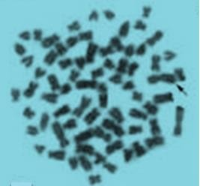

X

Y

# Plate X: Mitotic chromosomal spread of a male *C. gambianus* using Giemsa stain X 100 magnifiation

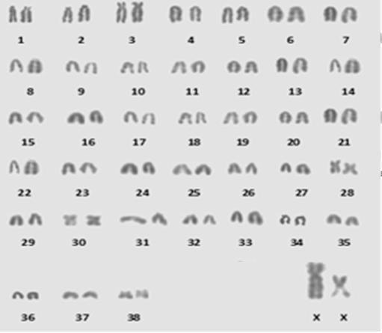

**Figure 4.14: Karyotype of a male *C. gambianus*, 2N = 80, NFa = 93**

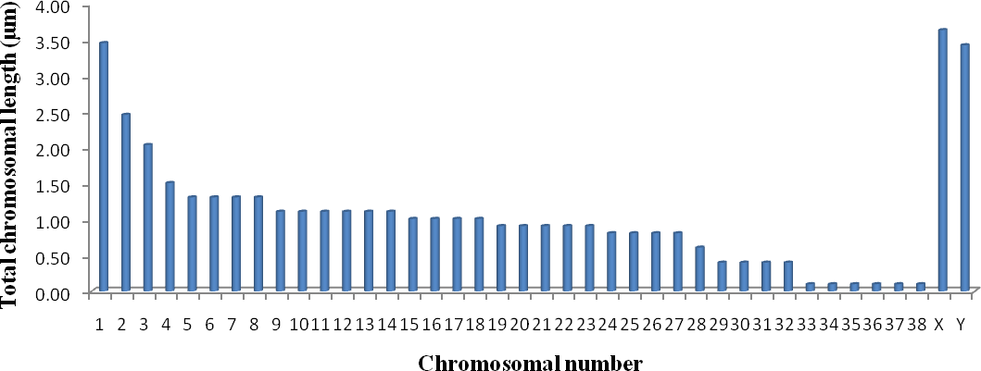

# Figure 4.15: Total chromosomal length and number of a male *C. gambianus*

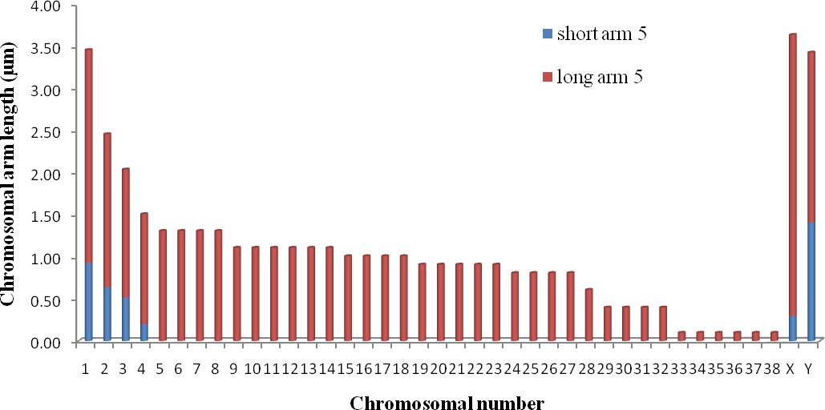

**Figure 4.16: Ideograms of a male *C. gambianus* showing the chromosomal arm lengths and number**

# The colour demarcated area represents the centromeric position.

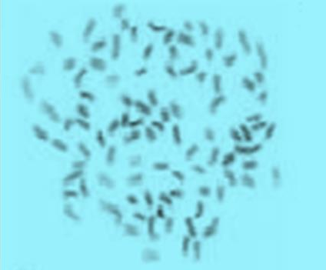

X

Y

**Plate XI: Mitotic chromosomal spread of a male *C. gambianus* using Giemsa stain X 100 magnification**

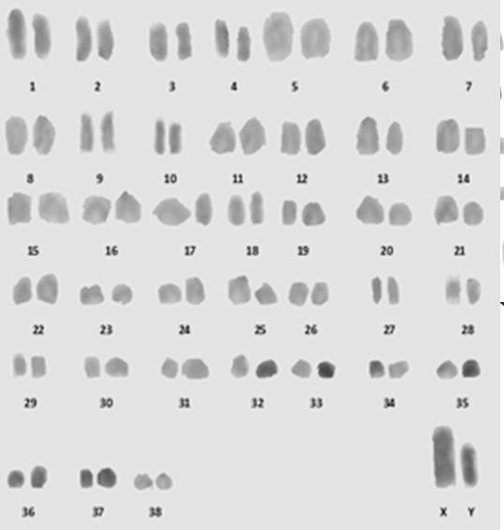

# Figure 4.17: Karyotype of a male *C. gambianus*, 2N = 80, NFa = 95

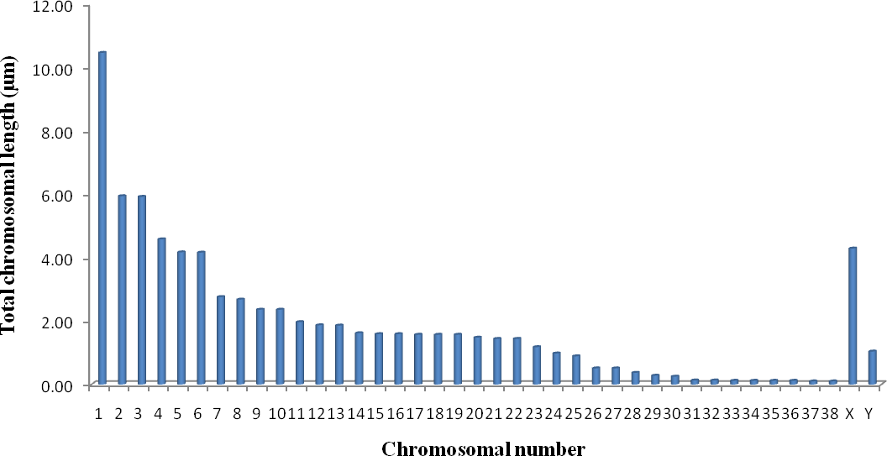

**Figure 4.18: Total chromosomal length and number of a male *C. gambianus***

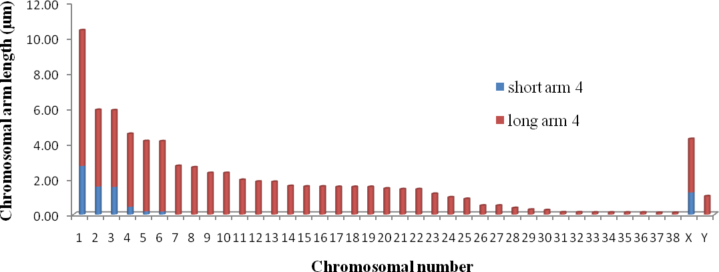

# Figure 4.19: Ideograms of a male *C. gambianus* showing the chromosomal arm lengths and number

**The colour demarcated area represents the centromeric position**

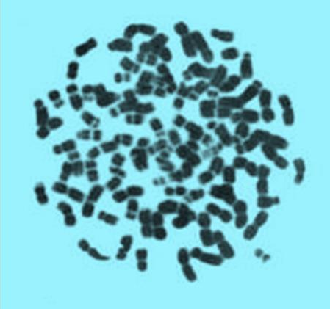

X

Y

# Plate XII: Mitotic chromosomal spread of a male *C. gambianus* using Giemsa stain X 100 magnification

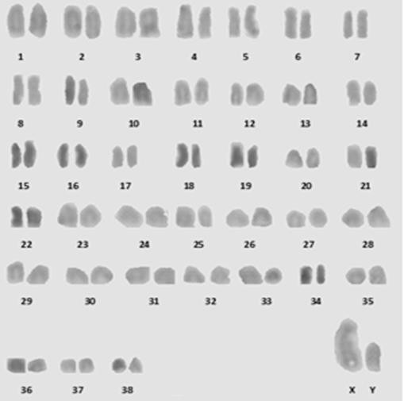

**Figure 4.20: Karyotype of a male *C. gambianus*, 2N = 80, NFa = 95**

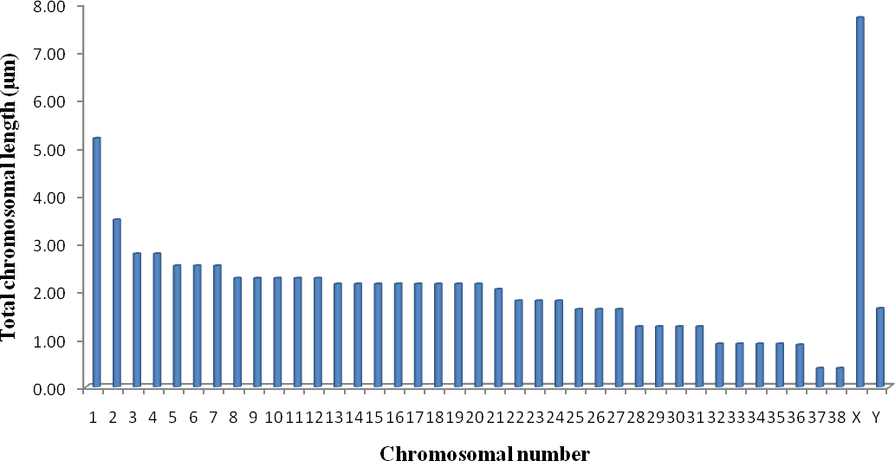

# Figure 4.21: Total chromosomal length and number of a male *C. gambianus*

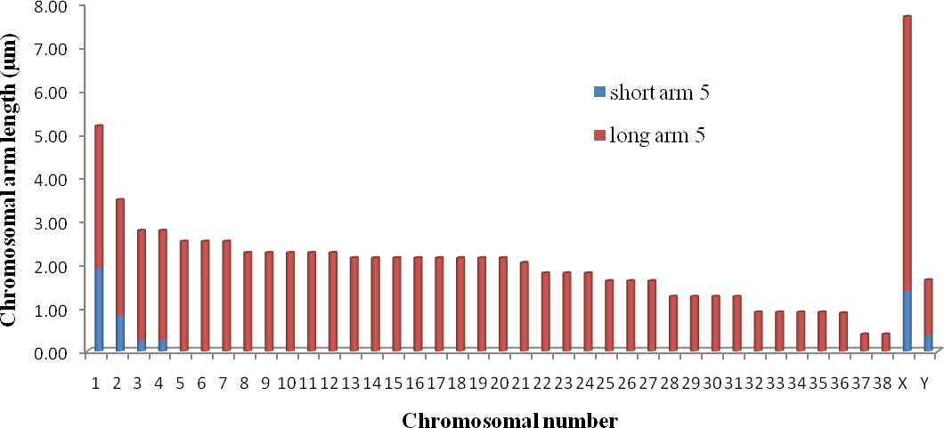

**Figure 4.22: Ideograms of a male *C. gambianus* showing the chromosomal arm lengths and number**

# The colour demarcated area represents the centromeric position

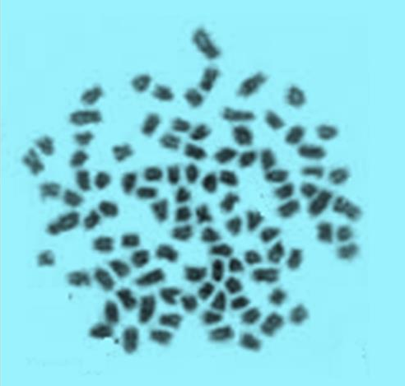

X

X

**Plate XIII: Mitotic chromosomal spread of a female *C. gambianus* using Giemsa stain X 100 magnification**

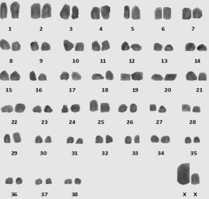

# Figure 4.23: Karyotype of a female *C. gambianus*, 2N = 80, NFa = 66

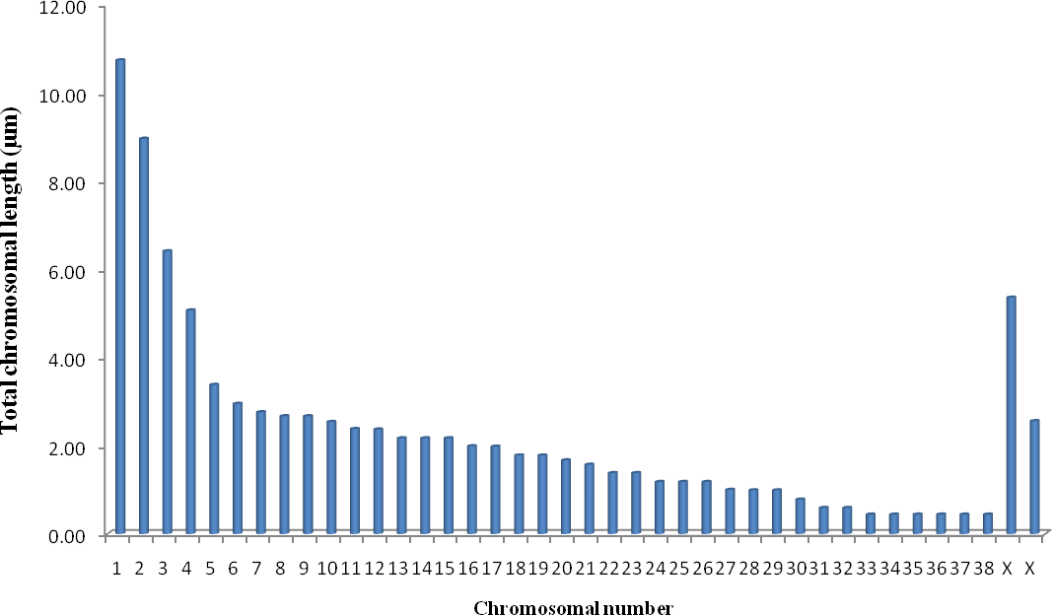

**Figure 4.24: Total chromosomal length and number of a female *C. gambianus***

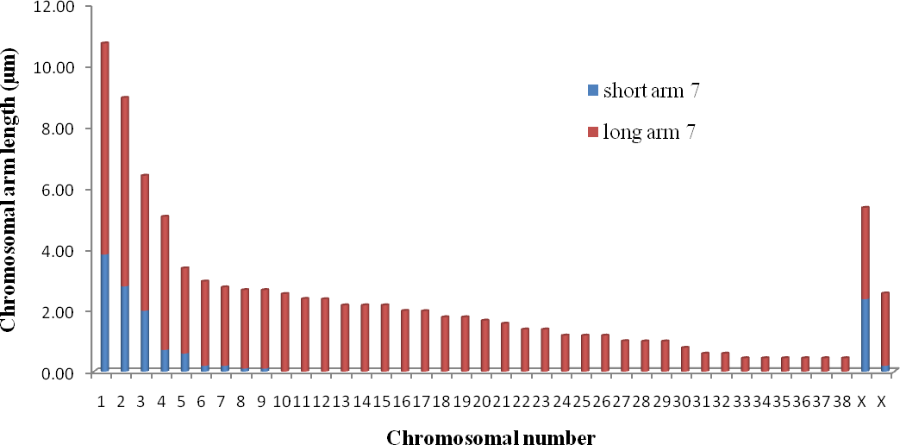

# Figure 4.25: Ideograms of a female *C. gambianus* showing the chromosomal arm lengths and number

**The colour demarcated area represents the centromeric position.**

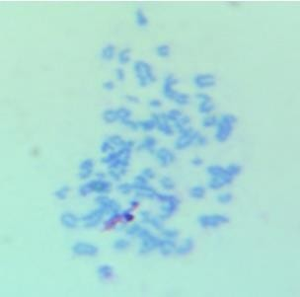

X

X

# Plate XIV: Mitotic chromosomal spread of a female *C. gambianus* using Giemsa stain X 100 magnification

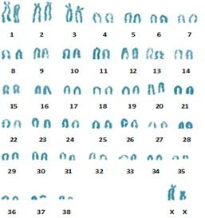

**Figure 4.26: Karyotype of a female *C. gambianus*, 2N = 80, NFa = 66**

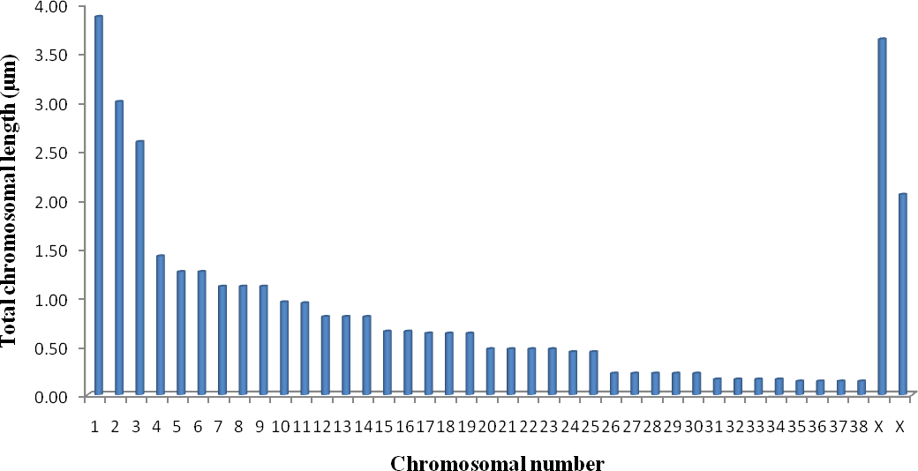

# Figure 4.27: Total chromosomal length and number of a female *C. gambianus*

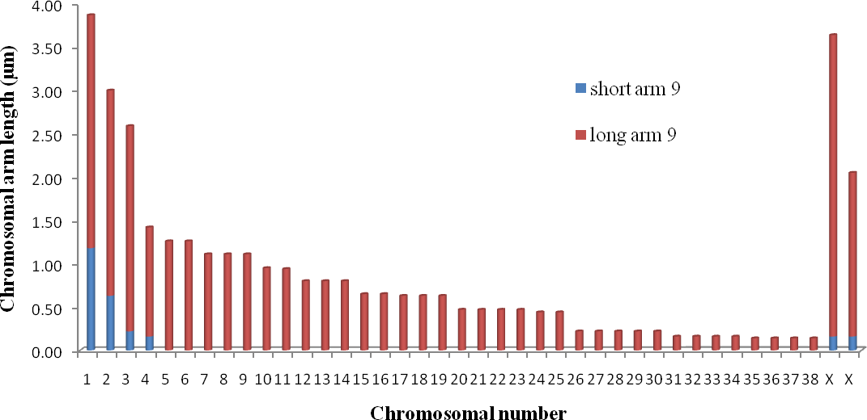

**Figure 4.28: Ideograms of a female *C. gambianus* showing the chromosomal arm lengths and number**

# The colour demarcated area presented the centromeric position

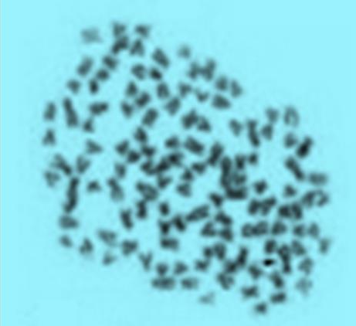

X

X

**Plate XV: Mitotic chromosomal spread of a female *C. gambianus* using Giemsa stain X 100 magnification**

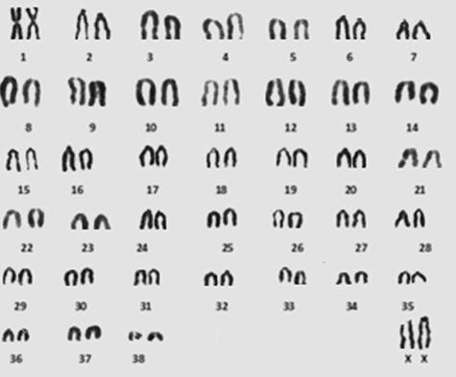

# Figure 4.29: Karyotype of a female *C. gambianus*, 2N = 80, NFa = 78

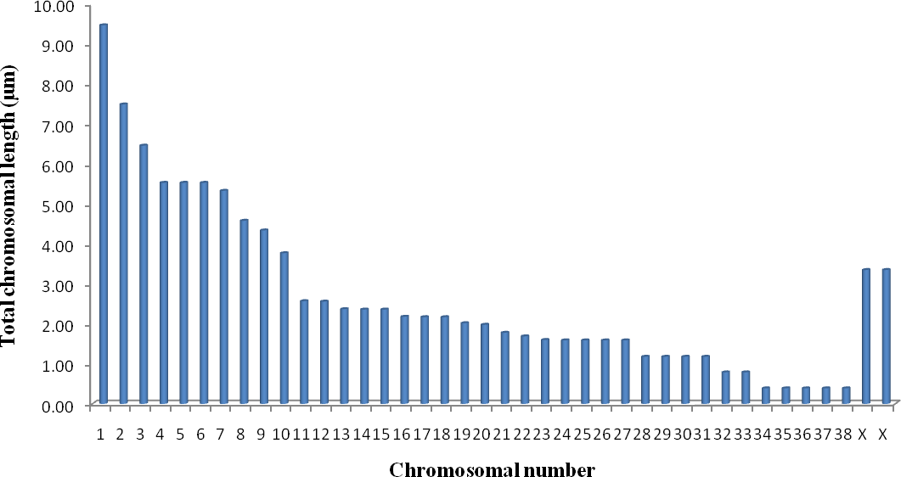

**Figure 4.3: Total chromosomal length and number of a female *C. gambianus***

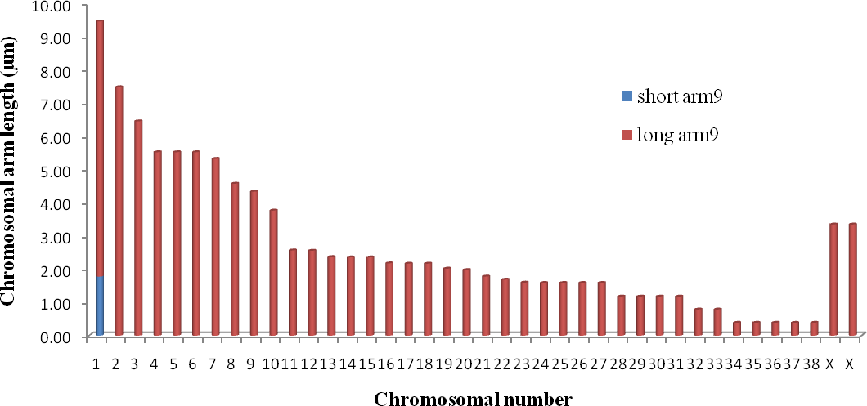

# Figure 4.31: Ideograms of a female *C. gambianus* showing the chromosomal arm lengths and number

**The colour demarcated are present the centromeric position**

**4.18. Chromosomal differentiation among the species of *Muridae* and *Heteromyidae***

# families

|  |  |  |  |  |  |
| --- | --- | --- | --- | --- | --- |
| **Specie** | **2n** | **X** | **Y** | **NFa** | **Reference** |
| *Cricetomys gambianus* | 80 | SM | SA | 66-95 | Present study |
| *Dipodomys spectabilis* | 72 | SM | SA | 70 | Arrighi *et al*., 1970 |
| *Tatera kempi* | 48 | LA | MSM | 64 | Colangelo *et al*., 2001 |
| *Taterillus gracilis* | 39 | LM | SM | 44 | Dobigny *et al*., 2002 |
| *Arvicanthis rufinus* | 62 | SM | MSM | 74 | Volobouev *et al*., 2002a |
| *Lemniscomys bellieri* | 56 | LM | MSSM | 60-78 | Volobouev *et al*., 2002a |
| *Mastomys natalensis* | 32 | LSM | SA | 54 | Codjia *et al*., 1996 |
| *Myomys derooi* | 36 | LSM | MSSM | 34 | Matthey, 1964 |
| *Rattus rattus* | 38 | LM | SM | 58 | Duplantier *et al*., 2003 |

2n = chromosomal diploid number, NFa = Autosomal fundamental number, LA = large acrocentric, LM = large metacentric, MSM = medium-sized metacentric, MSSM = medium-sized submetacentric, SA = subacrocentric, SM = submetacentric, X = x sex chromosome, Y = y sex chromosome.

**Table 4.19: Comparison between *Cricetomys gambianus* and *Dipodomys spectabilis***

**variables**

|  |  |  |
| --- | --- | --- |
| **Variables** | ***Cricetomys gambianus*** | ***Dipodomys spectabilis* (TBKR)** |
| 2n | 80 | 72 |
| NFa | 66-95 | 70 |
| Morphology | Telocentric | Acrocentric |
| Weight (Kg) | 0.82-0.90 | 0.12 |
| Length (cm) | 63.8-64.4 | 35.00 |
| Tail length (cm) | 24.6-29.0 | 21 (Arrhigi et al., 1970) |

2n = Diploid number, NFa = Autosomal fundamental number, TBKR = Texas Banner- tailed kangaroo rat

# APPENDIX II

**ETHICAL APPROVAL LETTER**

