**CHEMICAL AND BIOLOGICAL STUDIES OF HONEY BEE PROPOLIS COLLECTED FROM ZANGO KATAF LOCAL GOVERNMENT AREA OF KADUNA STATE, NIGERIA**

**BY**

**JEPHTHAH OKOLIKO ODIBA**

**DEPARTMENT OF PHARMACEUTICAL AND MEDICINAL CHEMISTRY FACULTY OF PHARMACEUTICAL SCIENCE**

**AHMADU BELLO UNIVERSITY, ZARIA-NIGERIA**

**MAY, 2013**

**CHEMICAL AND BIOLOGICAL STUDIES OF HONEY BEE PROPOLIS COLLECTED FROM ZANGO KATAF LOCAL GOVERNMENT AREA OF KADUNA STATE, NIGERIA**

**BY**

**Jephthah Okoliko ODIBA, B.Pharm (A.B.U) 2010 M.Sc/Pharm Sci/3146/2011-2012**

**A THESIS SUBMITTED TO THE SCHOOL OF POSTGRADUATE STUDIES**

**AHMADU BELLO UNIVERSITY, ZARIA-NIGERIA**

**IN PARTIAL FULFILMENT OF THE REQUIREMENT FOR THE AWARD OF**

**MASTER OF SCIENCE DEGREE IN**

**PHARMACEUTICAL CHEMISTRY**

**DEPARTMENT OF PHARMACEUTICAL AND MEDICINAL CHEMISTRY**

**FACULTY OF PHARMACEUTICAL SCIENCES AHMADU BELLO UNIVERSITY, ZARIA-NIGERIA**

**MAY, 2013**

# DECLARATION

I declare that the work in this thesis entitled: “**Chemical and Biological Studies of Honey Bee Propolis Collected from Zango Kataf Local Government Area of Kaduna State, Nigeria** has been performed by me in Department of Pharmaceutical and Medicinal Chemistry, Ahmadu Bello University, Zaria, under the supervision of Dr A. M. Musa and Dr (Mrs) H.S Hassan.

The information derived from the literature has been duly acknowledged in the text and a list of references provided. No part of this thesis was previously presented for another degree or diploma at any university.

|  |  |  |
| --- | --- | --- |
| Jephthah Okoliko **Odiba** |  | |
| ………………………….. | ……………………….. | ……………………… |
| Name of Student | Signature | Date |

# CERTIFICATION

This thesis entitled: **CHEMICAL AND BIOLOGICAL STUDIES OF HONEY BEE PROPOLIS COLLECTED FROM ZANGO KATAF LOCAL GOVERNMENT AREA**

**OF KADUNA STATE, NIGERIA by Jephthah Okoliko ODIBA** meets the regulations governing the award of a Master of Science degree of Ahmadu Bello University, Zaria, and is approved for its contributions to knowledge and literary presentation.

Dr A. M. Musa Date

B. Pharm., M.Sc., Ph.D. (ABU)

Department of Pharmaceutical and Medicinal chemistry,

Ahmadu Bello University, Zaria (Chairman, Supervisory Committee)

Dr (Mrs) H.S. Hassan Date

B. Pharm., M.Sc., Ph.D. (ABU)

Department of Pharmaceutical and Medicinal chemistry,

Ahmadu Bello University, Zaria (Member, Supervisory Committee)

Dr U. U. Pateh Date

B. Pharm., M.Sc., Ph.D. (ABU)

Head, Department of Pharmaceutical and Medicinal chemistry, Ahmadu Bello University, Zaria

Prof. A. A. Joshua Date

Dean, School of Post Graduate Studies Ahmadu Bello University, Zaria

# ACKNOWLEDGMENT

I wish to express my greatest indebtedness to my supervisors Dr A. M. Musa and Dr (Mrs)

H.S. Hassan for supervising this work and for their persistent advice and encouragement in the course of this work, also for their wealth of skills and experience which they freely made available to me at the period of dire need. I am grateful to Dr Habila James of Chemistry Department, Ahmadu Bello University, Zaria and Mr Dilip Jagjivan of School of Chemistry, University of Kwa Zulu Natal Durban for running the spectra. I also wish to express my gratitude and appreciation to Pharm Sani Yahaya of Pharmaceutical Chemistry Department, Ahmadu Bello University, Zaria for assisting me in the laboratory in the course of carrying out column chromatography.

I want to thank Dr. Ahmed of Pharmacognosy Department, Ahmadu Bello University Zaria for assisting me with specific laboratory reagents and Mrs A.Z Yahaya for sourcing the honeybee Propolis.

I want to acknowledge the cooperation and assistance of the entire staff of the Department of Pharmaceutical and Medicinal Chemistry, Ahmadu Bello University Zaria, especially the Dean and Head of Department, Dr U. U. Pateh and the lecturers who taught our course work for the guidance and knowledge they imparted on us benevolently.

I would not forget to thank my senior colleagues, friends and course mates, Ephriam, Jega, Amina, Nasiru, Hajara, Nkechi, Isaiah, Samuel and Mariya for the interactive sessions and the information we shared during the course work.

I remain thankful to my dear friend Alice Yahaya who did not only take the pains of typing the manuscript of this thesis but supportive towards the completion of the work within the

stipulated time.

To my beloved brothers and sisters, Abigail, Ezekiel, and Sussana I express my love and gratitude.

Finally, I wish to express my sincere gratitude to my beloved parents Mr and Mrs. J.I. Odiba for the limitless love they showered upon me and above all I thank God the almighty for the successful execution of the work.

# DEDICATION

To my beloved parents Mr and Mrs. J.I. Odiba

# ABSTRACT

Honeybee Propolis from *Apis mellifera* (Linn), has been used in ethno medicine as an emollient in the treatment of ringworm, measles, chickenpox and with reported biological activities, such as antitumor, antioxidant, immunomodulatory action and anti-inflammatory action among other ailments, was subjected to chemical and biological studies.

The chemical techniques employed were column chromatography and preparative thin layer chromatography. The antioxidant activity was studied using 1,1- Diphenyl-2-Picrylhydrazyl (DPPH) free radical scavenging activity while the antimicrobial activity was studied using Agar diffusion and Broth dilution methods and the microorganism used were clinical isolates and these includes; Gram- negative strains *(Pseudomonas aeruginosa, Escherichia coli, Klebsiella pneumonia, Shigella dysenteriae* and *Proteus mirabilis*), Gram-positive strains (*Staphyloccocus aureus, Bacillus subtilis, Streptococcus pyrogenes* and *Corynebacterium ulcerans*) and fungal strains (*Candida albicans, Candida krusei* and *Candida tropicalis*).

Preliminary phytochemical screening of the crude ethanol extract revealed the presence of flavonoids, phenolic compounds, saponins, steroids and triterpenes while phytochemical screening of the n-hexane soluble fraction revealed steroids, triterpenoids, and phenolic compound. Extensive chromatographic separation of the n-hexane soluble fraction using silica gel column chromatography followed by preparative thin layer chromatography led to the isolation of a steroid, stigmast-5-en-3β-ol (β-sitosterol). Its structure was determined by spectral analysis including 1D and 2D NMR.

The *in-vitro* DPPH free radical scavenging activity of ethanol extract (CR) and sub- fractions hexane fraction (HH), chloroform fraction (CC), ethyl acetate fraction (EE), butanol fraction

(BB) were determined, with ethyl acetate fraction (EE) having significant antioxidant activity of IC50 value of 1.78 ± 0.01ug/ml in comparism to other extracts and standard ascorbic acid of

2.54 ± 0.01ug/ml at p ≤ 0.05. The order of decreasing antioxidant activity of the extracts was EE>CR>CC>BB>HH.

The *in-vitro* antimicrobial activity of propolis ethanol extracts (CR, HH, CC, EE, and BB) and isolated compound X1 assayed using some clinical isolates as test organisms shows that, the crude ethanol extract showed activity against *S. aureus, B. subtilis, P. aeruginosa, C. krusei* and *C. tropicalis,* while hexane fraction (HH) showed activity only on *B. subtilis* and *C. krusei.* The chloroform fraction (CC), ethyl acetate fraction (EE) and butanol fraction (BB) showed same activity on susceptible organism to the ethanol crude extract with the exception of *P. aeruginosa* which was not susceptible to only the butanol fraction (BB). Isolated compound X1 (β-sitosterol) showed activity on *S aureus, B.substilis, S. pyrogenes, K. pneumonia, S. dysenteriae* and *C. krusei* with the exception of *P. aeruginosa* and *C. topicalis* which are susceptible to the ethanol crude extract. The isolated compound J1 has zone of inhibition ranging from (27-34mm), while the ethanol extract and its sub-fractions exhibit zone of inhibition ranging (20-27mm). The results suggest that the propolis ethanol extract and its sub fractions possess antimicrobial compounds that may be useful in treatment of infections and isolated β- sitosterol (100ug/mL) has an antimicrobial activity even though lower than the standard antibiotic drug (Sparfloxacin, Ciprofloxacin) and anti-fungal agent (Fluconazole) at (5ug/mL) with zones of inhibition ranging (32- 47mm) on the same susceptible organism.

The result of this study has added new knowledge on the chemical and biological studies of honey bee propolis from Northern Nigeria and confirmed the rationale of the ethno medicinal

use of the propolis.

# TABLE OF CONTENT

**Content Page**

Cover Page i

Title Page ii

Declaration iii

Certification iv

Acknowledgment v

Dedication vii

Abstract viii

Table of Contents x

List of Tables xv

List of Figures xvii

List of Plates xviii

Abbreviations xix

CHAPTER ONE: Introduction

* 1. General Introduction 1
  2. Oxidative Stress and Antioxidants 2
  3. Historical Overview of Antibiotics 7
     1. Bacterial and Characteristics of Anti-infective agents 8
     2. Concept of Drug Resistance 10
  4. Statement of Research Problem 12
  5. Justification of the Study 13
  6. Aim and Objectives of the study 14
  7. Statement of Research Hypothesis 15

CHAPTER TWO: Literature Review

* 1. Natural Product Description 16
  2. Medicinal Uses of Honeybee Propolis 17
  3. Chemistry of Some Honeybee Propolis 17
  4. Pharmacological Properties of Honeybee Propolis 18

CHAPTER THREE: Materials and Methods

* 1. Methodology 20
  2. Materials 20
     1. Chemicals/Reagents 20
     2. Equipment 20
     3. Collection of Honeybee Propolis 20
  3. Methods 21
     1. Extraction and Fractionation 21
     2. Preliminary Phytochemical Screening… 21
        1. Test for Steroids and Triterpenes 21
        2. Test for Flavonoids 22
        3. Test for Phenolic nuclues 22
        4. Test for Saponins 23
        5. Test for Alkaloids 23
        6. Test for Anthraquinones 23
        7. Test for Carbohydrate 23
  4. Chromatographic Procedure 24
     1. Preliminary Thin Layer Chromatography (TLC) 24
     2. Thin layer chromatography of ethanol extract and its partition fractions

from honeybee propolis 25

* 1. Column Chromatography 26
     1. Preparative Thin Layer Chromatography (PTLC) 27
     2. Melting Point Determination 27
     3. Spectral Analysis 27
  2. Biological Studies 29
     1. Antioxidant Activity Assay 29
        1. Quantitative Analysis 29
        2. Qualitative Analysis 30
     2. Antimicrobial Screening… 30
        1. Microorganism tested… 30
        2. Antimicrobial Suceptability Test of Propolis Extracts and Isolated Compound X1 29
        3. Minimum Inhibitory Concentration (MIC) 31
        4. Minimum Bactericidal and Fungicidal Concentration (MBC/MFC) 32

CHAPTER FOUR: Results

* 1. Preliminary Phytochemical Studies 33
  2. Result of Thin layer Chromatography 34
     1. Result of TLC of crude ethanol extract 34
     2. Result of TLC of n-hexane fraction 36
  3. Results of Column Chromatography of n-hexane fraction 40
  4. Result of Preparative Thin Layer Chromatography (PTLC) 46
     1. Isolation of compound X1 and X2 47
     2. TLC profile of compound X1 and X2 48
     3. Melting point of X 49
     4. Solubility of X1 49
     5. Chemical Test on X1 49
  5. Spectral Analysis of X1 49
     1. FTIR Spectrum of X1 49
     2. Proton Nuclear Magnetic Resonance of X1 51
     3. Carbon-13 Magnetic Resonance of X1 52
     4. Distortion less Enhancement by Polarization Transfer of X1 53
     5. Correlation Spectroscopy of X1 54
     6. Nuclear Over-hauser Effect of X1 56
     7. Hetero Nuclear Single Quantum Correlation of X1 58
     8. Hetero Nuclear Multiple Bond Correlation of X1 60
  6. Results of Antioxidant Activity 64
     1. Result of *In vitro* DPPH Free Radical Scavenging Activity 65
     2. IC50 Results of Extracts and Standard Drug… 66
     3. Result of Qualitative Antioxidant Test… 67
  7. Result of Antimicrobial Activity Studies 69
     1. Susceptibility Test 69
     2. MIC and MBC/MFC of Extracts and Compound X1 71

CHAPTER FIVE: Discussions

* 1. Chemical Studies 73
  2. Biological Studies 78

CHAPTER SIX: Summary, Conclusion and Recommendations

* 1. Summary 80
  2. Conclusion 81
  3. Recommendations 81

References 82

Appendix 88

# List of Tables

**Title Pages**

Table 4.1: Preliminary Phytochemical Screening of Ethanol and n-Hexane Extract………33 Table 4.2: TLC of the crude ethanol extract using n-hexane: ethyl acetate (9:1) 34

Table 4.3: TLC of crude ethanol extract using n-hexane: ethyl acetate (4:1) 35

Table 4.4: TLC of n-hexane fraction using n-hexane: ethyl acetate (9:1) 37

Table 4.5: TLC of n-hexane fraction using n-hexane: ethyl acetate (8:2) 39

Table 4.6: Result of Column Chromatography of n-hexane fraction 40

Table 4.7: Result of Column Chromatography of fraction H4 (46-59) 42

Table 4.8: Result of Column Chromatography of fraction H5 (60-66) 44

Table 4.9: Result of Preparative TLC of Sub-fraction H4-2 (1-12) 46

Table 4.10: Result of Preparative TLC of Sub-fraction H5-2 (13-16) 47

Table 4.11: TLC profile of X1 and X2 49

Table 4.12: Major Proton-Proton Correlation of X1 54

Table 4.13: Major NOESY of X1 56

Table 4.14: HSQC and DEPT experiment of X1 58

Table 4.15: Major HMBC of X1 61

Table 4.16: Table comparing the spectral of X1 and Literature reported… 63

Table 4.17*: In-vitro* DPPH free radical scavenging activity of extracts 64

Table 4.18: Table showing IC50 of extracts and standard drug… 66

Table 4.19: Zones of Inhibition of extracts and standard drug against test organism 69

Table 4.20: Zones of inhibition of X1 and standard drug against test organism 70

Table 4.21: MIC and MBC/MFC of extracts 71

Table 4.22: MIC and MBC/MFC of compound X1 72

# List of Figures

# Title Page

1.1: Classification of antioxidant agents base on their source 5

* 1. : FTIR spectrum of X1 50
  2. : Proton NMR spectrum of X1 51
  3. : Carbon-13 NMR spectrum of X1 52
  4. : DEPT experiment of X1 53
  5. : COSY spectrum of X1 55
  6. : NOESY spectrum of X1 57
  7. : HSQC spectrum of X1 59
  8. : HMBC spectrum of X1 62
  9. : Bar chart of DPPH Free radical scavenging activity of extracts and standard drug… 64
  10. : Linearity graph of antioxidant activity against concentrations of extracts 65
  11. : Histogram of IC50 of various extracts and standard ascorbic acid… 66
  12. : Proposed structure of Beta-sitosterol 76
  13. : NOESY and HMBC of isolated Beta-sitosterol 77

# List of plates

**Titles Page**

1: TLC profile of ethanol extract using n-hexane: ethyl acetate (9:1) 36

2: TLC profiles of ethanol extract using n-hexane: ethyl acetate (4:1) 36

3: TLC profile of n-hexane fraction using n-hexane: ethyl acetate (9:1) 36

4: TLC profile of n-hexane fraction using n-hexane: ethyl acetate (8:2) 38

5: TLC of fraction H4 (46-59) using n-hexane: ethyl acetate (9:1) 41

6: TLC of fraction H5 (60-66) using n-hexane: ethyl acetate (9:1) 41

7: TLC of fraction H5-2 (1-12) using n-hexane: ethyl acetate (9:1) 43

8: TLC of fraction H4-2 (13-16) using n-hexane: ethyl acetate (9:1) 45

9: TLC of isolated compound X1 and X2 using n-hexane: ethyl acetate (9:1) 48

10: TLC of isolated compound X1 using n-hexane: ethyl acetate (8:2) 48

11, 12: TLC profile of extracts after spraying with 10% aqueous sulphuric acid… 68

13, 14: TLC profile of extracts after spraying with 0.15%w/v DPPH in methanol 68

# ABBREVIATIONS

% Percentage

13C-NMR Carbon-13 nuclear magnetic resonance spectroscopy

1H-NMR Proton nuclear magnetic resonance spectroscopy

Abs control Absorbance of DPPH + methanol

Abs sample Absorbance of DPPH + sample

AF Aqueous fraction

AS Ascorbic acid

BB n-Butanol soluble fraction

CAT Catalase

CC Chloroform soluble fraction

CHCl3 Chloroform

CDCl3 Deuterated chloroform

Cipro Ciprofloxacin

cm-1 Per centimetre (wave number unit)

COSY Correlation spectroscopy

CR Ethanol crude extract

d Doublet

DEPT Distortionless Enhancement by Polarization Transfer

DPPH 1,1-Diphenyl-2-picrylhydrazyl

EE Ethyl acetate soluble fraction

EtOAC Ethyl acetate

Flucoz Fluconazole

GPX Glutathione peroxide

|  |  |
| --- | --- |
| HH | n-Hexane soluble fraction |
| HMBC | Heteronuclear multiple bond coherence |
| HSQC | Heteronuclear single quantum coherence |
| IC50 | 50% Inhibitory Concentration |
| IR | Infrared spectroscopy |
| m | Multiplet |
| MBC | Minimum bactericidal concentration |
| MFC | Minimum fungicidal concentration |
| mg/ml | Miligram per millilitres |
| MHz | Mega hertz |
| MIC | Minimum inhibitory concentration |
| ml | Millilitre |
| mm | Milimeters |
| nm | Nanometer |
| ppm | Parts per million |
| Rf | Retardation factor |
| ROS | Reactive oxygen species |
| SOD | Superoxide dismutase |
| Sparflox | Sparfloxacin |
| TLC | Thin layer chromatography |
| ugmL-1 | Microgram per mililiters |
| UV | Ultraviolet spectroscopy |
| β | Beta |
| δ | Chemical shift in ppm |
| λmax | Maximum absorption wavelength |

# CHAPTER ONE INTRODUCTION

# General Introduction

Natural products are promising source for discovery of new pharmaceuticals and for decades now, minerals, animals and plants were the main sources of drugs (Rates, 2001). Medicinal plants have continued to attract attention in the global search for effective antiviral, analgesic, anticancer and antimicrobial agents that can combat resistant pathogens and diseases that are rendering many conventional drugs obsolete in the treatment of infection (Cox, 1990). Presently, numerous plants are used for medicinal purposes and for this reason the plant kingdom has been described as the ‘sleeping giant’ of drug development (Verpoorte and Hoopes, 1987).

Recently, there is a growing interest in the use of natural products and folk medicine even in the developed countries. In Nigeria, Ghana, Mali and Zambia the first line treatment for 60% of children with fever, resulting from malaria, is the use of herbal medicine at home (WHO, 2003). In 2003, the World Health Organization (WHO) notes that of 119 plants derived pharmaceuticals, about 74% are used in modern medicine in ways that correlated directly with their traditional uses as plant medicines by native culture.

An estimated 25% of prescription drugs and 11% of drugs considered essential by the WHO are derived from natural products and a large number of synthetic drugs are obtained from precursor compounds originating from plants (Rates, 2001). Among the top 150 proprietary drugs from the National prescription from America in 2003, 57% contain at least one major active compound of biological origin, and 17% are modified natural products from plants

(Grifarn *et al.,*1997). It is thus apparent that plants represent a treasure of structural diverse potential bioactive organic molecule. Higher plant and Natural products are potential sources of new drugs and is still highly unexploited. Among the known species, only about 10% has been investigated phytochemically and the fraction subjected to biological or pharmacological screening is even smaller (Hostettmann *et al.*, 1996).

Phytochemical examinations of natural constituent have been made possible by improved methods of extraction using supercritical carbon dioxide (SC02), separation and isolation of active constituents using modern chromatographic techniques, Computer Assisted Structure Elucidation (CASE), one dimensional proton Nuclear Magnetic Resonance (1D 1H – NMR) technique, Carbon – 13 Nuclear Magnetic Resonance (1D 13C NMR) technique, Distortion less Enhancement by Polarization Transfer (DEPT) and two dimensional Nuclear Magnetic Resonance technique such as H –H COSY (proton – proton correlation spectroscopy), H-H NOESY (proton _ proton non scalar correlation), HSQC (Heteronuclear Single and Multiple Quantum Coherence), HMBC (Heteronuclear Multiple Bond Correlation) and X-ray crystallography are used to determine chemical structures of the isolate compounds (Venkat and Kathandaraman, 1998; Blinov *et al.*, 2003)

# Oxidative stress and Antioxidants

Living cells may generate free radicals and other reactive oxygen species by–products as a results of physiological and biochemical processes (Olayinka and Anthony, 2010). Free radicals can cause oxidative damage to lipids, protein and DNA, eventually leading to many chronic diseases, such as cancer, diabetes, aging and other degenerative diseases in humans (Harman, 1998). Oxygen which is an irreplaceable and indispensable element in human life also possesses harmful effect through formation of reactive oxygen species (ROS). These

oxygen radicals and several non- free radical oxidizing agents such as (Hypochlorous acid (HOCl), hydrogen peroxide, ozone and transition metals ions) induced oxidative damage results to carcinogenesis, ageing and atherosclerosis (Halliwell and Gutteridge*,* 1999). The sources of free radical via internal sources generation includes; phagocytosis, prostaglandins synthesis, cytochrome P450 system and xanthine oxidase system. The external sources are; cigarette smoke, environmental pollution, radiation, ozone, some drugs, pesticides, industrial solvents and physiological causes can be via stress and emotion (Halliwell and Gutteridge*,* 1999).

Free radical can be formed by homolytic cleavage of covalent bond of molecules and addition of single electron to a molecule. However free radical are not always harmful, e.g white blood cells release free radical to destroy invading pathogenic microbes as part of their body defence mechanism against disease thus complete elimination of free radical will not only be impossible but also harmful (Shiva, 2011). Reactive oxygen species (ROS) such as superoxide, peroxides and hydroxyls radicals are known to play an important role and have been identified as major contributors to all cell and tissue damage in many disease conditions (Suvakanta *et al*., 2005). In living organisms various ROS can be formed in different ways, but normal aerobic respiration stimulates polymorphonuclear leukocytes and peroxisomes which appear to be the main source of endogenous oxidants producing cells. Exogenous sources of ROS include tobacco smoke, alcohol, pesticides, certain pollutants like shoots, and microbial infections from *Aspergillus flavus* (Robinson *et al.,* 1997).

Reactive oxygen species (ROS), which consist of free radicals such as hydroxyl (OH•), super oxides (O2•), nitric oxide (NO•), peroxyl (RO2•), lipid peroxyl (LOO•) radicals and non- free

radical species such as hydrogen peroxides (H2O2), oxygen (O2), Ozone (O3), lipid peroxide

(LOOH), are different forms of activated oxygen (Helliwell and Gutteridge*,* 1999). ROS are produced by all aerobic organisms and can easily react with most biological molecules including proteins, lipids, lipoproteins and DNA. This ROS can generate oxidative stress and produce many pathophysiological disorders such as arthritis, diabetes, inflammation, cancer and genotoxicity (Kourounnakis and Galanakis*,* 1999; Gulcin and Buyukokuroglu*,* 2002).

Oxidative stress involving enhance generation of reactive oxygen species (ROS) has been implicated in the etiology of over hundred human disease including inflammation, metabolic disorders, cellular ageing and atherosclerosis, heart disease, stroke, diabetes mellitus, cancer, malaria, rheumatoid arthritis and HIV/AIDS (Olukemi *et al.,* 2005). Antioxidants can terminate or retard the oxidation process by scavenging free radicals. These antioxidants are considered as possible protective agents against oxidative damage and lipid peroxidation of human body from ROS and retard the process of many chronic diseases (Lai and Chou*,* 2001).

Natural products are endowed with free radical scavenging molecules, such as vitamins, terpenoids, phenolic acids, stilbenes, tannins, flavonoids, quinones, coumarins, alkaloids, and other metabolites, which are rich in antioxidant activity (Zheng and Wang, 2001; Cai *et al.,* 2003). Studies have shown that many of these antioxidant compounds possess anti- inflammatory, anti-atherosclerotic, antitumor, anti-mutagenic, anti-carcinogenic, antibacterial, and antiviral activities (Sala *et al.,* 2002; Rice-Evan *et al.,* 1995).

Antioxidant are substance in low concentration that inhibit oxidative process, either by acting as free radical scavengers or converting radicals to less reactive species (Mandel *et al.,* 2009). They are used in preservation of food from deterioration, rancidity and protect both enzymatic and non-enzymatic reactions leading to oxidative damage (Halliwell and Gutteridge*,* 1999).

Antioxidants differ in their molecular weight and composition, physical and chemical properties, mechanism and site of action. A schematic diagram below represents classification of antioxidant base on their source;

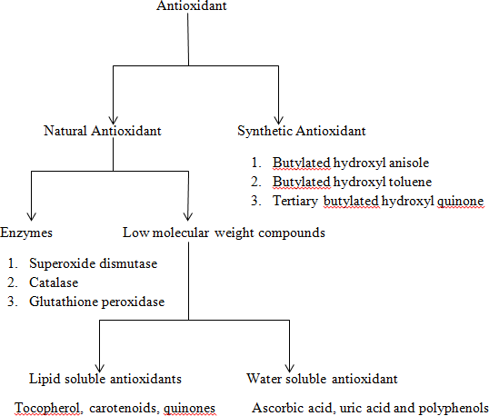

**Figure 1.1**: Classification of antioxidant agents based on their source

Based on their mechanism of action they can also be classify broadly into primary antioxidant and secondary antioxidant. Cofactor such as Superoxide dismutase (SOD) catalysed the transformation of the superoxide’s radical into hydrogen peroxides, which is transform to water and molecular oxygen by catalase (CAT), while glutathione peroxide (GPX) reduce lipid peroxides from oxidation of polyunsaturated fatty acids to stable non-toxic hydroxyl fatty acid molecules in human cells. Lower molecular weight antioxidant delay or inhibit cellular damage by free radical scavenging property (Shiva, 2011). A brief mode of action of antioxidant activity with examples includes;

* + 1. Reduction of concentration of reactive oxygen species e.g glutathione.
    2. Transformation and scavenging initiating radical’s e.g superoxide dismutase which acts in the lipid phase to trap superoxide free radical.
    3. Chelation of transition metal catalyst; via sequestering of metals pro oxidant transition metal.
    4. Chain breaking reaction e.g α-tocopherol which act in lipid phase to trap free radical (Shiva, 2011).

Epidemiological studies have shown wide range of activity of polyphenols, they possess cardio-protective, anticancer, antimicrobial, anti-aging, neuro-protective and anti-diabetic effect. Consumption of polyphenol rich diets, like vegetables, cereals, beverages and fruits like grapes, apple, pear, cherries and berries helps to reduce chronic human disease and these is associated with the phenolic groups in polyphenols to accept an electron to form relatively stable phenoxyl radical, thereby disrupting the initiation and chain propagation oxidation reaction in cellular system. Multiple phenolic hydroxyl substitution in polyphenols at ortho and para position potenciate their biological activity (Kanti and Syed*,* 2009).

# Historical Overview of Antibiotics

The history of the relationship between man and natural product is as old as the history of the creation of the world. Man use natural products for different purposes and its extracts show various medicinal activities, some of which may be related to their biological property.

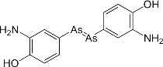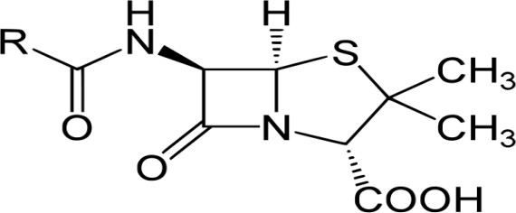The field of antibiotic discovery was initiated by Paul Ehrlich who first coined the term ‘magic bullet’, or Chemotherapy, to designate the use of antimicrobial compounds to treat microbial infections. In 1910, Ehrlich discovered the first antibiotic drug, Salvarsan (I) which was used against syphilis.

(I) (II)

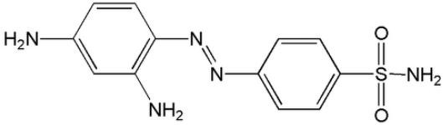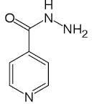In 1928 the accidental discovery of Penicillin (II) by Alexander Fleming which was used as an antibiotic in treatment of *Staphyloccocus aureus* was documented followed by Gerhard Domagk in 1935, which discovered sulpha drugs i.e. prontosil rubrum (III) this pave way to the discovery of anti-tuberculosis drug named Isoniazid (IV).

(III) (IV)

In 1939 Rene Dubos discover antibiotics after purposely looking for it in soil microbes, He discovered Gramicidin (V), which is still use today to treat skin infections. Finally, in 1943,

the first anti-tuberculosis drug, streptomycin (VI) was discovered by Selman Waksman and Albert Schatz.

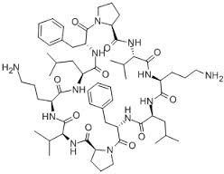 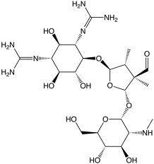

(V) (VI)

Thus the usage of antibiotic has been since 1940s and today about 4000 compounds with antibiotic properties are available (Zhang, 2007).

# Bacteria and Characteristics of Anti-infective agents

Bacteria are microscopic single celled organisms that are found almost everywhere. A vast majority of bacteria in the body are rendered harmless by the protective effects of immune system and few are beneficial. Pathogenic bacteria like *Salmonella spp, Shigellae spp, E.coli, Clostridium spp, Staphylococcus spp*, and *Yersinia spp* cause disease like cholera, syphilis, anthrax, leprosy and typhoid fever. These are easily gotten from contaminated water, poor hygiene, laboratory exposure, and bad sexual life style (Leon *et al.,* 2010). Evidently pathogenic microbial agents like viruses, bacteria, fungi, and protozoa secretes toxins which damage the surrounding cells in human body; common areas often affected by bacteria are throat, ears, respiratory system, sinus and urinary tract with varying degree of pain and swelling (Leon *et al.,* 2010).

The choice of anti-infective agents use to treat infection are categorized on the basis of;

* + - 1. Pharmacological properties, which include ability to target and reach the site of infection.
      2. Spectrum of activity, which include efficacy in treating a disease and susceptibility of the organism to the anti-infective agents.
      3. Patient factor which includes Age, Immunological status, underlying disease condition, history of adverse drug reaction, Pregnancy and lactation, and genetic traits. (Leon *et al*., 2010).

Anti-infective agents are derived from plants, bacteria, fungi, synthetic or semisynthetic compounds. Those derive from natural source are called antibiotics and those produce from synthetic source are called antimicrobials. They are use internally or topically to inhibit or kill growth of pathogens. Anti-infective agents can thus be divided into Bacteriostatic drugs, which merely inhibit the growth of the pathogens, and Bactericidal drugs, which actually kill the bacteria. However, the distinction is not absolute and varies with the drug concentration, the bacterial species and the phase of growth. When two antibiotics are used in combination the effect could be additive or synergistic. They can be broadly divided into two based on the spectrum of activity; the broad spectrum and narrow spectrum antibiotics. For example Tetracycline, a broad spectrum antibiotics, is active against gram positive, gram negative bacteria and even against mycobacteria; whereas all penicillin’s which is narrow spectrum can be used against gram positive bacteria. Others like pyrazinamide have narrow spectrum activity and use merely against *Mycobacteria tuberculosis* (Leon *et al*., 2010). The discovery of antimicrobials like penicillin and tetracycline paved the way for better health for millions around the world.

Antimicrobial agents inhibit certain vital processes of bacterial cells or metabolism, on this basis of their mechanism of action they are divide into five major classes:

1. Cell wall Inhibitors, such as Penicillin and Vancomycin
2. Inhibitors of nucleic acid synthesis, such as Fluoroquinolones which inhibits DNA synthesis, and Rifampicin, which inhibits RNA synthesis
3. Protein synthesis inhibitors, such as Aminoglycosides
4. Anti-metabolites, such as the sulphonamide drugs
5. Inhibitors of plasma membrane functions, such as Polymyxin B, Gramicidin and Daptomycin (Leon *et al.,* 2010).

# Concept of Drug Resistance

Microorganisms are getting ‘wiser’ by the day, the greater the duration of exposure to antibiotics, the greater the risk of developing resistance. Drug Resistance has been posing a major challenge to the effective control of bacterial infection for quite some time. As early as half a century ago, just a few years after penicillin was put on the market, scientist began noticing the emergency of a penicillin resistance strain of *Staphylococcus aureus*, a common bacterium in human body’s normal bacterial flora, resistance strains of *Shigella spp* causing gonorrhoea and dysentery leading to serious public health concern and even the multi-drug resistance tuberculosis (MDR/TB) is no longer confined to any one country or to those co- infected with HIV, but has appeared in locations as diverse as Africa, Asia and Eastern Europe, among health care workers and in the general population (WHO, 2000). Antibiotic resistance is an extremely expensive problem. Its costs in the US alone are estimated at US $5-

$24 billion per year. The major problems to emergence of bacteria resistance are misuse and overuse of antibiotics due to in correct diagnosis, noncompliance to dosing regimen,

substandard and counterfeit drugs (Thomas *et al.*, 1998). Antibiotic use in animal husbandry is also creating some drug resistant bacteria, which can be transmitted to humans. Increased globalisation could also cause the spread of drug resistance, and hospital settings often give rise to antibiotic resistant bacteria. (Thomas *et al.,* 1998).

Multi-drug Resistance mechanism occurs differently in various organism, Basically resistance can be due to plasmid, in which the plasmid of the organism carries different antibiotic resistance gene, resulting to resistance to same range antibiotics simultaneously. The other type of drug resistance mechanism is chromosomal mutation, which is due to sequential accumulation of chromosomal mutation in different drug resistance genes. Some examples of resistance due to chromosomal mutation are:-

1. Alteration of Drug Target Site; e.g. alteration of Penicillin Binding Protein the binding target site for Penicillin’s in methicillin resistance *Staphylococcus aureus* and other penicillin-resistance bacteria. Also, in vancomycin resistance, vancomycin prevents cross-linking of peptidoglycan by binding to D-Alanine-D-Alanine dipeptide of the muramyl pepetide. Most Gram positive bacteria acquire vancomycin resistance by changing D-Alanine-D-Alanine to D-Alanine-D-Lactate, which does not bind to vancomycin.
2. Drug inactivation or modification; e.g. enzymatic deactivation of penicillin G in some penicillin-resistance bacteria through the production of Beta-lactamase enzyme. Another example is Chloramphenicol Acetyl Transferase enzymes which inactivate chloramphenicol’s by addition of an acetyl moiety.
3. Alteration of metabolic pathway; e.g. some sulphonamide resistance bacteria do not

require Para-amino benzoic acid (PABA), an important precursor for the synthesis of

folic acid and nucleic acids in bacteria inhibited by sulphonamides, instead, like the mammalian cells they turn to utilized preformed folic acid.

1. Reduced drug accumulation: by decreasing drug permeability and /or increasing active efflux (pumping out) of the drugs across the cell surface. For example *Neisseria gonorrhoea* porin can acquire mutations and cause resistance to penicillin and tetracycline uptake. (Li and Nikadio, 2009).

Several measures are currently use to prevent drug resistance such as, better treatment strategies, better immunization program, improve hygiene and nutrition awareness, antibiotic surveillance program and regular education of healthcare profession on unnecessary antibiotics prescribing, but as long as antibiotics are use resistance are bound to occur. The resistance problem demands that a renewed effort be made to seek for antibacterial agents that are effective (bactericidal) against pathogenic bacteria resistant to current antibiotics and one of the possible strategies towards this objective is by rational screening of natural product for bioactive secondary metabolites.

# Statement of Research Problem

Chronic disease (atherosclerosis, stroke and ageing), terminal illness (cancer), are by far the leading cause of mortality in the world, representing 63% of all deaths. Out of the 36 million people who died from chronic disease in 2008, 9 million were under 60 years, 90% per cent of these premature deaths occurred in low and middle-income countries (WHO, 2011).

Infectious disease (bacteria, fungi and viral) is the number one cause of death worldwide, and in tropical countries it accounts for approximately 50% of death (WHO, 2008). This may be due to poverty and increasing incidence of multiple drug resistance. It has been reported that

resistance are largely due to indiscriminate use of antimicrobial drugs, poor compliance to medication, low potency and high toxicity of medication and compromise immune system due to oxidative stress. Apart from resistance some antibiotics have undesirable side effects which limit their applications, so there is need to develop new antimicrobial and antioxidant agents that are very effective with minimal unwanted side effects, less toxic with good potency. Higher plants and some natural source represent a potential source of novel antioxidant and anti-infective agents. (Maureer-Grims *et al.,* 1996).

Honeybee Propolis is a potential source of lead for development of new drugs as well (Bankova *et al.,* 2000) lots of research studies has been done on honeybee propolis, but the chemical composition depends on the phyto-geographical characteristics of the site of collection and varies with countries, states, city and locality. Literature search revealed that there is little or no information documented on Honeybee Propolis from Northern Nigeria.

# Justification of the study

Honeybee Propolis is a potential source for development of new drugs with wide pharmaceutical applications. The chemical composition depends on the phyto-geographical characteristics of the site of collection. The qualitative and quantitative variability of the chemical composition depends on the vegetation in that area from which it was collected and bees choose different plants as source of propolis in different habitats. (Bankova *et al.,* 2000). Propolis samples from Europe, South America, and Asia have different chemical composition thus possess different medicinal uses (Jose and Vassya, 2010). For example Egyptian Propolis has been reported to have antimicrobial activity (Ashraf, 2009), Myanmar Propolis has been reported to have cytotoxicity against human pancreatic cancer cell line (Feng *et al.,* 2009),

Brazilian green propolis has immunomodulatory, antitumoral activity, antiallergic and antiulcerogenic activity (Jose and Vassya*,* 2010), The antimicrobial properties of bee propolis is selected as a measure of biological activity because recently, due to globalization, environmental pollution and advancement in technology, human beings and other animals are expose to many chemical substances and pathogenic microorganism that may generate oxidative stress and infectious disease leading to death of humans if not treated properly (Kourounakis and Galanakis*,* 1999). Therefore, this research has the potentials of identifying biologically active anti-infective compounds. Despite this, literature search in scientific data base revealed that no work has been reported on the isolation of any compound from Northern Nigeria Honeybee propolis. Therefore, this work is going to be the first of its kinds in terms of establishing some chemical as well as biological activity of Northern Nigeria honeybee propolis.

# Aim and Objectives of the study

The aim of the study is to identify, isolate and characterized bioactive compounds present in honeybee propolis and to evaluate its antioxidant and antimicrobial activity.

The specific objectives of the study are;

1. To identify the chemical constituent’s in the honeybee propolis using standard phytochemical methods.
2. To isolate and characterized bioactive compounds from the propolis using chromatographic and spectroscopic methods.
3. To evaluate the antioxidant and antimicrobial activity of the extracts and isolated compound by *in-vitro* model.

# Statement of Research hypothesis

Propolis from Northern Nigerian honeybee *Apis mellifera* (Linn) contains bioactive compounds with antioxidant and antimicrobial activity.

# CHAPTER TWO LITERATURE REVIEW

# Natural Product Description

Northern Nigeria Honeybee Propolis (bee glue), is a natural resinous product mixed with beeswax and other secretions, collected by honey bee *Apis mellifera* (Linn) from various plant sources i.e leaf buds, pollens, nectar and cracks in bark of various plants. These salivary and enzymatic secretions enriched product is use by bees as building and insulating material, to seal holes in their honeycombs, smooth out the internal walls and protect the entrance against intruders like ants, insect and bacteria (Ashraf, 2009). The chemical composition varies qualitatively and quantitatively, depending on the vegetation in the area from which it was collected (Bankova *et al.,* 2000).

Due to geographical difference and species of bee, propolis sample all over the world has different chemical composition. For example *Aroeira mansa* or *Schinus terebenthifolus* is the preferred plants source for propolis of *Tetragonisca anjustula* bees in all region of Brazil, however other species of stingless bees also collect resin from different plants depending on the vegetation of that region (Alexander *et al.,* 2009). Usually propolis contain 50% resin (polyphenolic compounds), 30% wax, 10% essential oils, 5% pollen, and 5% various organic

compounds (Ashraf, 2009).

*Apis mellifera* Linn being a social and pollinating insect travel as far as 8km radius to diverse melliferous plant for nectar, pollens and in the Northern guinea savannah of Nigeria some melliferous plants found are *Carica papaya, Lycopersicum esculentum, Zea mays, Sorghum bicolor, Alluim sativa, Citrus sinesis, Vernonia amygdalina, Mangifera indica and Parkia*

*biglobosa.* These melliferous plants have medicinal value and accounts for the ethno- medicinal potential of their honey and propolis (Abel and Banjo, 2012).

# Medicinal Uses of Honeybee Propolis.

Propolis has been used in folk medicine and has been reported to possess wide range of biological activity, such as immunomodulatory, antitumor, antioxidant, anti- inflammatory (allergy, rhinitis and asthma), antimicrobial action, anti-ulcer activity (Jose and Vassya*,* 2010), and Healing potential (Adewumi and Ogunjinmi, 2011). In Nigeria it is used ethno medicinally as emollient in treatment of measles, ringworm and chickenpox disease and locally in making of candles. In recent times it has become a common additive in health food and beverages (Satochi *et al.,* 2005) and these biological activities has attracted the interest of researchers worldwide.

# Chemistry of some Honeybee Propolis

The isolation of new bioactive prenylated flavonoid name (5,3’,4’-trihydroxy-7-methoxy-5’- C-geranyl flavanone (VII), from Egyptian Propolis has been reported. This has been shown to possess antimicrobial activity (Ashraf, 2009).

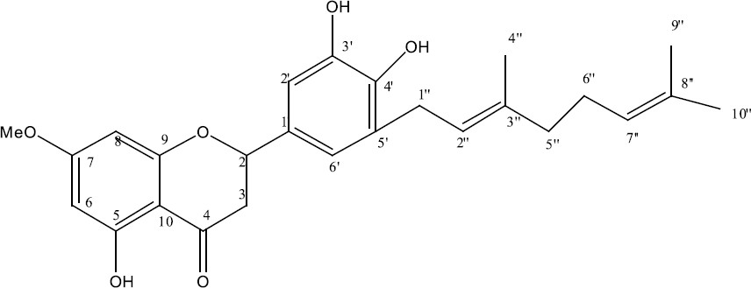

(VII)

The isolation of new cycloartane-type triterpenes named (22Z, 24E)-3-oxocycloart-22, 24- dien-26-oic acid (VIII) from Myanmar Propolis has been reported. This has been shown to possess cytotoxic activity on human pancreatic cancer cells (Feng *et al.*, 2009).

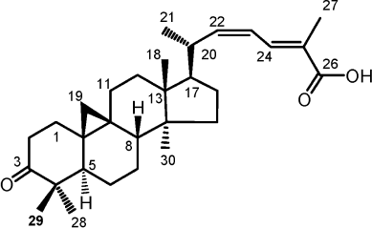

(VIII)

Also the major varied secondary metabolites in different honey bee Propolis in different continents are flavonoids, phenolic acid esters, terpenoids, prenylated derivatives of p- coumaric acids, cinnamic acids, wax and essential oils. (Jose and Vassya, 2010; Ashraf, 2009) To the best of our search, there is no any report on isolation of any compound from Northern Nigeria honey bee Propolis.

# 2.4 Pharmacological Property of Honeybee Propolis*.*

Nigeria honey bee propolis has been reported to have healing properties on septic wounds (Adewumi and Ogunjinmi, 2011) but other propolis has shown promising drug potentials like the Brazilian green propolis which has been reported to have marked activity against different tumor cells *in vitro* (Bassani-Silva *et al.,* 2007). Also it possess anti asthmatic effect on treated patients (Jose and Vassya, 2010). Due to their composition of steroidal, triterpenes,

polyphenols and prenylated flavonoids compounds in propolis, it has been reported to have good antioxidant, anti-inflammatory and antiviral effect (Viuda-Martos *et al.,* 2008).

# CHAPTER THREE MATERIALS AND METHODS

# METHODOLOGY

# MATERIALS

# Chemicals/ Reagents

The chemicals used were of high quality and the reagents used were of analytical grade. Silica gel for column chromatography was of mesh size 60-120 µm (Qualikem product) while that for thin layer chromatography (TLC) was 60 GF254 pre-coated aluminium plates ( Merck), 1,1- diphenyl-2-picrylhydrazyl radical (DPPH) (Sigma-Aldrich Company), Ascorbic acid powder (Sigma-Aldrich Company).

# Equipment

Helios zeta thermo scientific Ultraviolet (UV) spectrophotometer, Fourier Transform Infrared Spectrophotometer- 8400S, Bruker AVANCE -300 (400 MHz) Nuclear Magnetic Resonance Spectrometer.

# Collection of Honeybee Propolis

Honey bee propolis was collected from Zango Kataf Local Government Area of Kaduna State, Nigeria, from Honeybee cultivators, propolis was pressed to remove stored honey from it, sizes reduce with scissors and stored for use.

# METHODS

# Extraction and Fractionation

The raw honey bee propolis (2500g) was extracted with 4 Litres of 95% ethanol (Chia-Chi, *et al.,* 2002) using cold maceration method for 7days. The extract was filtered using Whatman No. 1 filter paper and concentrated *in vacuo* to yield a brown semi solid residue (350g) referred to as honeybee propolis ethanol extract (CR). The ethanol extract (300g) was suspended in distilled water and partitioned successively with n-hexane, chloroform, ethyl acetate and n-butanol to obtain n-hexane fraction 18.5g (HH), chloroform fraction 4.6g (CC), ethyl acetate fraction 7.1g (EE), n-butanol fraction 27.8g (BB), and the residual aqueous fraction 230.7g (AF) respectively.

# Preliminary phytochemical screening

Preliminary Thin Layer Chromatography (TLC) was carried out on the ethanol extract (CR) and all the soluble fractions (HH), (CC), (EE) and (BB). Portion of the ethanol extract and all the soluble fraction were subjected to preliminary phytochemical screening using standard methods as summarized below.

* + - 1. *Test for Steroids/Triterpenes*

Liebermann-Buchard test:

A small portion of the extract was dissolved in chloroform. Equal volume of acetic anhydride and concentrated H2SO4 were added down the test tube. The solution was observed for the presence of a reddish brown ring at interphase indicating steroids and triterpenes (Silva *et al.,* 1998).

Salkowski test:

A small quantity of the extract was dissolved in 1ml chloroform and to it 1ml of concentrated H2SO4 was added down the test tube. Formation of red or yellow colouration in chloroform

layer was taken as an indication for the presence of steroidal ring nucleus (Sofowora, 1993).

**3.2.2.2**. *Test for Flavonoids****.***

Shinoda test:-

A small quantity of the extract was dissolved in methanol. Some pieces of magnesium chip were added followed by five drops of concentrated hydrochloric acid. It was observed for the appearance of pink, orange or red to purple colour which indicates the presence of flavonoids (Silva *et al*., 1998).

Sodium hydroxide test:-

The extract was dissolved in 10% aqueous NaOH solution. The solution was observed for the presence of a yellow colour, a change in colour from yellow to colourless on addition of dilute HCl indicates the presence of flavonoids (Silva *et al*., 1998).

* + - 1. *Test for Phenolic nuclues*

Ferric chloride test:-

A small quantity of the extract was boiled with water and filtered. Two drops of freshly prepared ferric chloride solution was added to the filtrate, formation of a blue-black, or green precipitate was taken as evidence for the presence of phenolic nucleus (Evans, 1996).

* + - 1. *Test for Saponins*

A small quantity of the extract was shaken with water in a test tube for 15 seconds. A froth which persists for 15 minute indicates the presence of saponins (Silva *et al*., 1998).

* + - 1. *Test for Alkaloids.*

0.5g of the extract was stirred with 5ml of 1% aqueous hydrochloric acid on a water bath and filtered. 3 ml of the filtrate was divided into three. To the first, 1ml of freshly prepared Dragendoff’s reagent was added and observed for formation of orange to brownish precipitate. To the second, 1ml of Meyer’s reagent was added and observed for formation of white to yellowish or cream colour precipitate. To the third, 1ml of Wagner’s reagent was added to give a brown or reddish or reddish-brown precipitate (Evans, 1996).

* + - 1. *Test for Anthraquinones.*

Borntrager’s test:-

The extract was shaken with 10ml of benzene, the content was filtered, and 5ml of 10% ammonia solution was added to the filtrate, the mixture was shaken. Presence of a pink, red, or violet colour in the ammoniacal layer (lower phase) indicates the presence of free anthraquinone (Evans, 1996).

* + - 1. *Test for Carbohydrates.*

Molisch’s Test

1ml of the extract was added to 1ml Molisch’s reagent and 1ml Concentrated H2S04 was carefully added. A reddish ring indicates the presence of carbohydrates (Silva *et al*., 1998).

Fehling’s Test:-

1ml of extract was added to 2 ml Fehling’s solution and boiled for 5 minutes. A red precipitate indicates the presence of reducing sugar (Silva *et al*., 1998).

# Chromatographic Procedure

# Preliminary Thin layer chromatography (TLC).

Preliminary thin layer chromatography was carried out using aluminium TLC plates, precoated with silica gel.

Technique: One way ascending.

Spotting and development: spots were applied manually using capillary tube: plates were dried using air blower and developed at room temperature using a Shandon chromatographic tank.

Solvent system: - various solvent systems were used, they include:-

* + - 1. Hexane: Ethyl acetate (9:1) d. Ethyl acetate: Methanol (2:1)
      2. Hexane: Ethyl acetate (8:2) e. Ethyl acetate: Methanol (1:1)
      3. Hexane: Ethyl acetate: Methanol (4:2:1)

**Detection:** Spots on TLC plates were visualized under normal day light and by spraying with 10% aqueous sulphuric acid, followed by heating at 1100C for 5 min (Stahl, 1969)

# Thin layer chromatography of the ethanol extract (CR) and its soluble sub fractions (HH, CC, EE and BB) of Honeybee propolis*.*

The crude ethanol extract of honeybee propolis was subjected to thin layer chromatography using pre-coated aluminium plates. The solvents system used were hexane (100%), ethyl acetate: n-hexane (1:9), ethyl acetate: n-hexane (2:8), and ethyl acetate (100%).

The n-hexane fraction of propolis was subjected to thin layer chromatography using pre- coated TLC aluminium plate. The solvents system used were, n-hexane: ethyl acetate (9:1), and (8:2)

The chloroform fraction of propolis was subjected to thin layer chromatography using pre- coated TLC aluminium plate. The solvents system used were n-hexane: ethyl acetate: methanol (4:2:1) and n-hexane: ethyl acetate (2:1).

The ethyl acetate fraction of propolis was subjected to thin layer chromatography using pre- coated TLC aluminium plate. The solvents system used were hexane: ethyl acetate: methanol (4:2:1) and hexane: ethyl acetate (2:1).

The n-butanol fraction of propolis was subjected to thin layer chromatography using pre- coated TLC aluminium plates. Solvents system used were ethyl acetate: methanol (2:1) and ethyl acetate: methanol (1:1).

# Column Chromatography

The following column conditions were employed:

1. Technique: Gradient elution.
2. Column: Glass column (75cm x 3.5cm) with sintered disc at the bottom.
3. Stationary phase: Silica gel, 60-120μm mesh size.
4. Column packing: Wet slurry method.
5. Sample loading: Dry loading method (Cannell, 2000)

HH (7g) was adsorbed into silica gel and chromatographed over silica gel packed column. The column was eluted continuously with Hexane, then Hexane: Ethyl acetate mixture, and finally ethyl acetate. The results are summarised in table 4.6

The following column conditions were employed in the second column chromatography

1. Technique: Gradient elution.
2. Column: Glass column (70cm x 1.5cm) with sintered disc at the bottom.
3. Stationary phase: Silica gel, 60-120μm mesh size.
4. Column packing: Wet slurry method.
5. Sample loading: Dry loading method (Cannell, 2000)

Fraction H4 and H5 was adsorbed into silica gel and chromatographed over silica gel packed column. The column was eluted continuously with Hexane: Ethyl acetate mixture. The results are summarised in table 4.7 and 4.8.

# Preparative Thin Layer Chromatography (PTLC)

The following conditions were employed:

1. Technique: one way ascending
2. Spotting and development: Spots were applied manually with the aid of a capillary tube; plates were dried using air blower and developed at room temperature using a Shandon Chromatographic tank.
3. Spraying reagent: 10% sulphuric acid
4. TLC plate: Fluka Silica gel precoated glass plate 20cm x 20cm with layer thickness of 0.25mm (Stahl, 1969)

The sample to be separated was dissolved in minimum amount of Chloroform and applied uniformly along the thin base line using capillary tube. The plate was allowed to dry after which it was developed using n-Hexane: ethyl acetate (8:2) as solvent system. The developed plate was air dried in a fume cupboard and the position of the band of interest was marked with pencil and scrapped off the backing of the plate on to a foil. The scrapped sorbent was size reduced using pestle and Mortar, transferred to sintered glass funnel and washed repeatedly with chloroform. The solution obtained was evaporated to give a white crystalline compound which was coded as X1 (Gibbons and Gray, 1998). X1 was subjected to chemical and spectral analysis.

# Melting Point (m.p) determination

The melting point of Compound X1was determined using an electro thermal melting point apparatus.

# Spectral analysis.

* + - 1. FTIR Analysis
      2. Proton and Carbon-13 NMR Spectra.

The IR spectrum was recorded on Fourier Transform Infrared Spectrophotometer 8400S, and the 13C and 1H NMR spectra was obtained on a Bruker AVANCE -300 Japan (400 MHz) spectrometer in deuterated Chloroform (CDC13) using Tetra methyl silane (TMS) as standard.

Both Compound X1 and X2 were subjected to spectroscopic analysis, but compound X2 is still under investigation due to the low signals gotten from the NMR spectral.

# Biological Studies

# Antioxidant activity Assay

# Quantitative Analysis

**1, 1- Diphenyl-2-Picrylhydrazyl (DPPH) Free Radical Scavenging Activity**

The DPPH free radical Scavenging Activity was determined according to the method of (Aliyu *et al.,* 2013). Sample stock solution (1.0mg/ml) of CR, HH, CC, EE, BB and Ascorbic acid (AS) each was prepared. Each fraction was subjected to serial dilution to obtain a final concentration of 50μg/ml, 25μg/ml, 12.5μg/ml, 6.25μg/ml and 3.125μg/ml, in methanol. 0.5ml of 0.1mM DPPH in methanol solution was added to 1.5ml of the sample solutions of different concentrations and allowed to react in the dark at room temperature for 30 minutes. The absorbance value of each concentration was measure at 518nm using UV spectrophotometer.

The scavenging ability of the each fraction was calculated using the equation:

DPPH Scavenging activity (%) = { (Abs control – Abs sample) } x 100

(Abs control) Where: Abs control = absorbance of DPPH + Methanol

Abs sample = absorbance of DPPH radical + Sample

DPPH solution (0.5ml; 0.1mM) Plus methanol (1.5ml) was used as negative control. The positive control was (0.5ml of 0.1mM) of DPPH solution plus (1.5ml) of ascorbic acid solution, methanol (0.5ml) plus propolis extract solution (1.5ml) will be used as a blank and also methanol as blank. The IC50 was calculated from the graph plot of %

DPPH free radical scavenging activity against various extract concentrations and the

mean± standard deviation was calculated and analysed using ANOVA and Student- t- Test (Aliyu *et al.,* 2013)

# Qualitative analysis

The extracts (100μg/ml) was spotted on a TLC plate and developed using the mobile phase in a chromatographic tank. Developed chromatogram was sprayed with DPPH (0.15 % w/v) in methanol solution using an atomizer. The colour change (yellowish colour development on pinkish background on the TLC plate) is an indicator for the presence of antioxidant substances (Saha *et al*., 2008).

# Antimicrobial Screening

# Microorganism tested

All the organisms used were clinical isolates, obtained from the Medical Microbiology Department, Ahmadu Bello University Teaching Hospital Zaria, Nigeria. All the bacterial cultures were checked for purity and maintained on Mueller Hinton agar slant for bacteria and Saboraud dextrose agar for fungi. The organisms were *Pseudomonas aeruginosa, Escherichia coli, Klebsiella pneumonia, Staphylococcus aureus, Streptococcus pyrogenes, Corynebacterium ulcerans, Bacillus subtillis, Shigella dysentariae, Proteus mirabilis, Candida albicans, Candida krusei and Candida tropicalis.*

# Antimicrobial Susceptibility Test of Propolis Extracts and Isolated compound X1

Antimicrobial activity studies of the extracts (CR, HH, CC, EE and BB) and isolated compound X1 were carried out using Agar diffusion techniques (Agbawa and Okolo, 2012). The inoculum were prepared by inoculating the test organism in muller hinton broth and

incubating for 24 hours at 370C for bacteria and while fungi, saboraud dextrose broth was used and incubated for 48 hours at 250C. After incubation, the broth cultures were diluted to 1:1000 for Gram-positive bacteria and 1:5000 for the Gram- negative bacteria.

Each extracts 0.1g and 1mg of isolated compound X1 were weighted and dissolved in 10ml of Dimethyl sulfoxide (DMSO) to obtain a concentration of 10mg/ml and 0.1mg/ml respectively. Muller Hinton agar was used as the growth medium and was prepared according to manufacturer’s instruction, sterilized at 1210C for 15mins, 20ml of the sterile medium was poured into a sterilized petri dishes allowed to cool and solidify. The sterile medium was seeded with 0.1ml of the standard inoculum of the test microorganisms; the inoculum was spread evenly over the surface of the medium with a sterile swab. The seeded plates were allowed to dry in an incubator at 370C for 30 mins. A standard cork borer of 6mm in diameter was use to cut cups (well) at the centre of each inoculated medium and 0.1ml of both extracts and isolated compound solution were introduced separately into each well on the medium, the plates were incubated at 370C for 24 hours for bacteria and 250C for 48 hours for fungi after which the plates were observed for zones of inhibitions of growth. The zones were measured and the result recorded to the nearest millimetres. Filter paper disc containing solvent of extraction without any extract served as a negative control. Standard antibiotic (5μg/ml) of (Sparfloxacin, Ciprofloxacin and Fluconazole) were use as positive control, the antimicrobial activity were tested in triplicate and the mean zone of inhibitions was calculated for each.

# Minimum Inhibitory Concentration (MIC)

The minimum inhibitory concentration was determined on the organisms that were sensitive to the extracts and isolated compound X1, and was carried out using broth dilution method (Agbawa and Okolo, 2012). Mueller hinton broth was prepared according to manufacturer’s

instruction. 10ml of the medium was dispensed in a screw-capped tests tube and were sterilized at 1210C for 15 mins. The broth was then allowed to cool.

MC. Farland turbidity standard scale No. 0.5 was prepared by adding 9.9ml of 1% BaCl2 solution to 0.1ml of test organism to give a turbid suspension of the microorganism. Incubation was made at 370C for 6 hours. After incubation, the broth cultures were diluted with the normal saline continuously until the turbidity matched that of the MC. Farland scale by visual comparism. At this point the microorganism had a concentration of about 1.5x108 cfu/ml. Two-fold serial dilution of the extract and isolated compound with the broth was done to give concentrations of (10mg/ml, 5 mg/ml, 2.5 mg/ml, 1.25 mg/ml and 0.625mg/ml) and 100μg/ml, 50μg/ml, 25μg/ml, 12.5μg/ml and 6.25μg/ml respectively. The tubes were then incubated at 37 0C for 24 hours for bacteria and 250C for 48 hours for fungi, after which the test tubes were observed for turbidity (growth). The lowest concentration of the extract in the test tube which shows no turbidity was recorded as the Minimum Inhibitory Concentration.

# Minimum Bactericidal and Fungicidal Concentration (MBC/MFC)

The contents of the MIC tubes in the serial dilution were sub-cultured into the prepared medium by dipping a sterile wire loop into each test tube and streaking the surface of the prepared labelled agar plates. The plates were then incubated at 370C for 24 hours for bacteria and 250C for 48 hours for fungi, after which they were observed for colony growth. The MBC/MFC was the plate with the lowest concentration of the extract or isolated compound without colony growth (Damintoti *et al.,* 2005).

# CHAPTER FOUR

* 1. **RESULTS**

# Preliminary Phytochemical studies

Results of preliminary phytochemical screening of ethanol extract (CR), n-Hexane fraction (HH), chloroform fraction (CC), ethyl acetate fraction (EE) and butanol fraction (BB) are shown in (Table 4.1).

# Table 4.1: Result of preliminary phytochemical screening of CR, HH, CC, EE and BB

|  |  |  |  |  |  |  |  |
| --- | --- | --- | --- | --- | --- | --- | --- |
| **Constituents** | **Test** | **Observation** | **Inference** | | | | |
|  |  |  | CR HH | | CC | EE | BB |
| **Steriods/ Triterpenes** | a. Lieberman burchards test | Reddish brown colour at the interphase | + | + | + | - | + |
|  | b. Salkwoski test | Brown-red ring colour | + | + | + | - | + |
| **Flavonoids** | a. Shinoda test | Red colouration | + | - | + | + | + |
|  | b. NaOH test | Yellow colouration | + | - | + | + | + |
| **Phenolic**  **nucleus** | a. ferric chloride  test | Green precipitate | + | + | + | + | + |
| **Saponins** | Froth test | Froth persist for 15mins | + | - | - | - | + |
| **Anthraquinone** | Bontrager’s test | Bright pink colouration | - | - | - | - | - |
| **Alkaloids** | a. Dragendroff’s | Orange ppt | - | - | - | - | - |
|  | test |  |  |  |  |  |  |
|  | b. Wagner’s test | Reddish brown ppt | - | - | - | - | - |
|  | c. Meyer’s test | Yellow ppt | - | - | - | - | - |
|  | d. Tannic acid | Yellow ppt | - | - | - | - | - |
|  | test |  |  |  |  |  |  |
| **Carbohydrate** | 1. Molisch’s test 2. Fehling’s test | Reddish colour ring at interphase  Brick red ppt | +  + | -  - | -  - | -  - | +  + |

**Key: =** + present, - absent

# Result of Thin Layer Chromatography

* + 1. **Result of Thin Layer Chromatography of crude ethanol extract**

Thin layer chromatographic analysis of the crude ethanol extract using hexane: ethyl acetate (9:1) as solvent system yielded 5 spots as in (Plate 1; Table 4.2)

# Table 4.2 TLC of the crude ethanol extract using n-hexane: ethyl acetate (9:1)

|  |  |  |
| --- | --- | --- |
| Spot | Rf value | Colour in 10% H2SO4 acid |
| 1 | 0.18 | Yellow |
| 2 | 0.24 | Purple |
| 3 | 0.33 | Light brown |
| 4  5 | 0.40  0.84 | Brown  Light brown |

Thin layer chromatographic analysis of the crude ethanol extract using ethyl acetate: hexane (1:4) as solvent system yielded 6 spots as in (Plate 2; Table 4.3).

# Table 4.3 TLC of crude ethanol extract using n-hexane: ethyl acetate (4:1)

|  |  |  |
| --- | --- | --- |
| Spot | Rf value | Colour in 10% H2SO4 acid |
| 1 | 0.13 | Brown |
| 2 | 0.31 | Brown |
| 3 | 0.51 | Brown |
| 4 | 0.69 | Brown |
| 5 | 0.87 | Brown |
| 6 | 0.95 | Black |

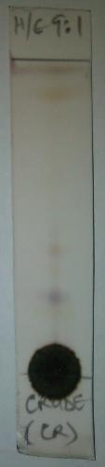 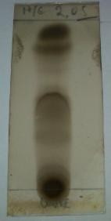

Plate 1 Plate 2

# Result of Thin Layer Chromatography of n-Hexane fraction

Thin layer chromatography of n-hexane fraction using hexane: ethyl acetate (9:1) as solvent system yielded 8 spots as shown on (Plate 3; Table 4.4).

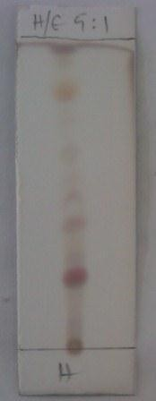

Plate 3

# Table 4.4 TLC of Hexane fraction using Hexane: ethyl acetate (9:1)

|  |  |  |
| --- | --- | --- |
| Spot | Rf value | Colour in 10% H2SO4 acid |
| 1 | 0.20 | Brown |
| 2 | 0.24 | Purple |
| 3 | 0.28 | Brown |
| 4 | 0.40 | Brown |
| 5  6  7  8 | 0.44  0.68  0.84  0.96 | Orange Brown Light brown  Brown |

Thin layer chromatography of Hexane fraction using hexane: ethyl acetate (8:2) as solvent system yielded 4 spots as shown in (Plate 4; Table 4.5).

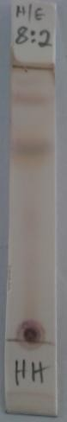

Plate 4

# Table 4.5 TLC of Hexane fraction using hexane: ethyl acetate (8:2)

|  |  |  |
| --- | --- | --- |
| Spot | Rf value | Colour in 10% H2SO4 acid |
| 1 | 0.47 | Brown |
| 2 | 0.72 | Purple |
| 3 | 0.88 | Brown |
| 4 | 0.95 | Brown |

* 1. **Result of Column Chromatography of n-hexane fraction (HH)**

A total of ninety five (95) fractions, 100ml each were collected. The fractions were pooled together based on their TLC profile to give seven (7) major fractions and the column was finally washed with ethyl acetate to give the eighth fraction as shown in (Plate 5 and 6; Table 4.6).

Collections 46-59 (Fraction H4) and Collections 60-66 (Fraction H5) were subjected to another small column chromatography as shown in (Plate 7; Table 4.7 and Plate 8; Table 4.8).

# Table 4.6: Result of column chromatography of n-hexane fraction (HH)

|  |  |  |  |
| --- | --- | --- | --- |
| Fraction | Eluting solvent | Collection | Number of spots |
| H1 | Hexane (100%) | 1-18 | No clear spot |
| H2 | Hexane: EtOAC (97.5%: 2.5%) | 19-34 | 4 |
| H3 | Hexane: EtOAC (95%: 5%) | 35-45 | 5 |
| **H4** | Hexane: EtOAC (92.5%:7.5%) | **46-59** | **5** |
| **H5** | Hexane: EtOAC (92.5%: 7.5%) | **60-66** | **3** |
| H6 | Hexane: EtOAC (90%: 10%) | 67-77 | 2 |
| H7 | Hexane: EtOAC (80%: 20%) | 78-85 | 2 |
| H8 | EtOAC 100% | 86-95 | No clear spot |

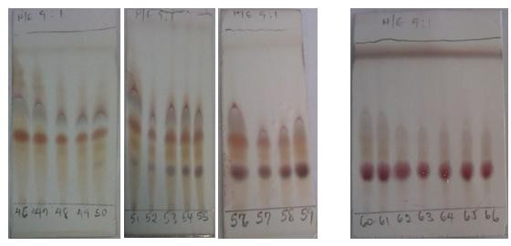

Plate 5: fraction H4 (46-59) Plate 6: fraction H5 (60-66)

# Table 4.7: Result of column chromatography of H4 (46-59) fraction

|  |  |  |  |
| --- | --- | --- | --- |
| Fraction | Eluting solvent | Collection | Number of spots |
| H4-1 | Hexane: EtOAC (95% :5%) | 1-4 | No clear spot |
| **H4-2** | Hexane: EtOAC (92.5%:7. 5%) | **5-7** | **3** |
| H4-3 | Hexane: EtOAC (90%: 10%) | 8-12 | 2 |

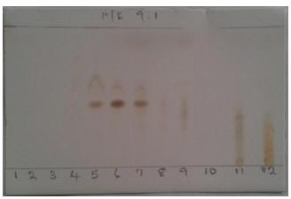

Plate 7: Fraction H4-2 (1-12)

# Table 4.8: Result of column chromatography of H5 (60-66) fraction

|  |  |  |  |
| --- | --- | --- | --- |
| Fraction | Eluting solvent | Collection | Number of spots |
| H5-1 | Hexane: EtOAC (95%: 5%) | 1-12 | No clear spot |
| **H5-2** | Hexane: EtOAC (92.5%: 7.5%) | **13-16** | **2** |
| H5-3 | Hexane: EtOAC (90%: 10%) | 17-18 | 2 |

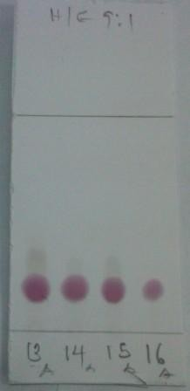

Plate 8: Fraction H5-2 (13-16)

# Result of Preparative TLC (PTLC)

Fraction H4-2 and Fraction H5-2 when subjected to PTLC using n-hexane: ethyl acetate (8:2) gave three and two distinct bands respectively as shown in (Table 4.9; Table 4.10)

# Table 4.9 Table showing the result of preparative TLC of H4-2

|  |  |  |
| --- | --- | --- |
| **Band** | **Colour** | **Rf value** |
| **1** | Light Brown | 0.28 |
| **2** | Orange | 0.44 |
| **3** | Brown | 0.68 |

**Table 4.10 Table showing the result of preparative TLC of H5-2**

|  |  |  |
| --- | --- | --- |
| **Band** | **Colour** | **Rf value** |
| **1** | Purple | 0.24 |
| **2** | Brown | 0.28 |

# Isolation of compound X1 and X2

The Purple band (X1) and the Orange band (X2) were scrapped off the plate and washed with chloroform to obtain 10mg of white crystalline powder which was coded as X1 and 15mg of faint yellow crystals coded as X2 which both gave a single homogenous spot with two solvent systems hexane: ethyl acetate (9:1; 8:2). Both X1 and x2 were subjected to chemical and spectroscopic analysis to elucidate their chemical structure.

# TLC profile of compound X1 and X2

TLC analysis of the isolated compound X1 and X2 using n-hexane: ethyl acetate (9:1), then sprayed with 10% sulphuric acid revealed single homogeneous spot with Rf value of (0.24) and (0.44) respectively in (Plate 9 and 10; Table 4.11).

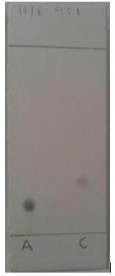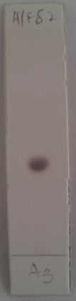

X1 X2 X1

Plate 9 Plate 10

# Table 4.11: Table showing the TLC profile of X1 and X2

Solvent system Number of Spot Colour of spot after heating Rf Value

|  |  |  |  |  |  |
| --- | --- | --- | --- | --- | --- |
|  | | X1 | X2 | X1 | X2 |
| Hex: EtOAc (9:1) | 1 | Purple | Orange | 0.24 | 0.44 |

# Melting point of X1

J1 was found to have a melting point range of 136-1370C

# Solubility of X1

J1 was found to be soluble in chloroform.

# Chemical test on X1

It gave red colour at the interphase when subjected to Salkowski test

# Spectral Analysis of X1

# FTIR Spectrum of X1

The IR spectrum of X1 (Fig 4.1), showed a broad band absorption peak at 3390.9cm-1 (O-H stretching), and moderate intense band at 2935.7cm-1 (aliphatic C-H stretching), weak intense band at 1450.5cm-1(C=C band), 1377.2cm-1 (C-H bending) and 1051.2cm-1 (C-O stretching band)

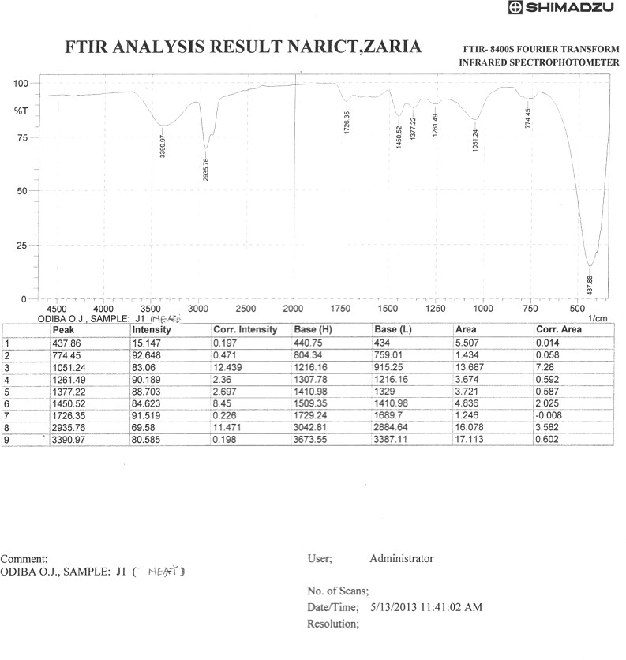

# Fig 4.1: IR spectrum of X1

* + 1. **Proton Nuclear Magnetic Resonance of X1 (1H NMR)**

The 1H NMR spectrum of X1 (Fig 4.2) revealed clusters of protons signal between δ 0.7-1.8, suggesting overlapping methyl and methylene protons in steroids or triterpenes nucleus, a multiplets of two protons at δH 2.30. Also observed a multiplets of one proton at δH 3.50 suggesting a carbinol proton in steroids or triterpenes nucleus and a doublet of one proton at δH

H

5.39 representing an olefinic protons.

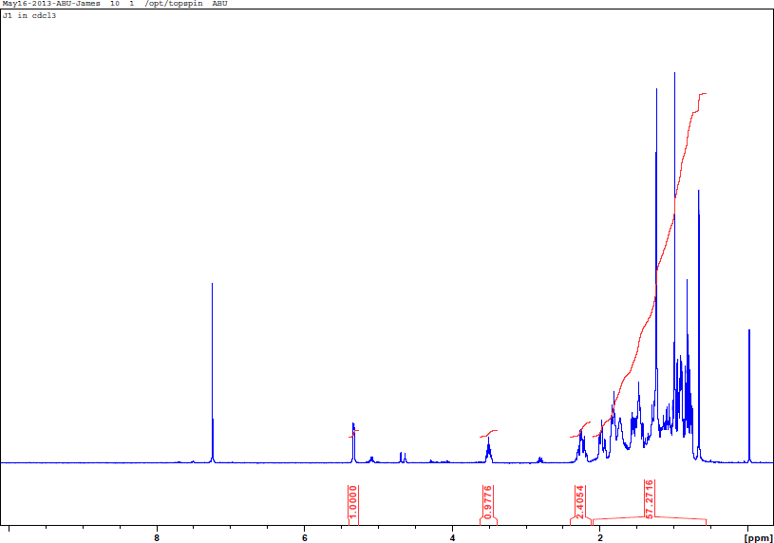

# Fig 4.2: 1H NMR Spectrum of X1 in CDCl3

* + 1. **13C Nuclear Magnetic Resonance of X1** (**13C NMR)**

The 13C NMR of X1 (Fig 4.3) revealed 29 C- signals, with observed signal range between δc (ppm): 11-60, which are characteristic of methyl (CH3), methylene (CH2) and methine (CH) carbons. A recognizable olefinic carbons signal appeared at δc: 140.8 and 121.7, and a secondary hydroxyl bearing carbon at δc: 71.8.

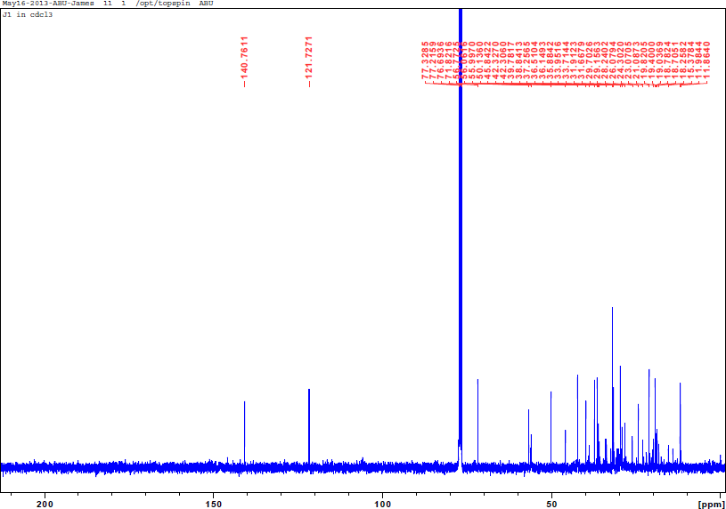

# Fig 4.3: 13C NMR Spectrum of X1 in CDCl3

* + 1. **Distortion less Enhancement by Polarization Transfer of X1 (DEPT)**

The results of DEPT experiment (Fig 4.4) revealed the presence of six methyl carbons at δc: 11.9, 19.8, 18.3, 21.1, 19.4 and 11.9; eleven methylene carbons at (37.3, 35.9, 42.3, 33.9, 29.7,

42.3, 29.2, 33.7, 36.5, 31.7, and 23.1), nine methine carbons at (71.8, 121.7, 36.1, 50.1, 56.8,

56.1, 38.8, 45.8 and 31.9) and three quaternary carbons at (140.8, 39.8, and 42.3). The blue, red and green spectral lines represent 13C-NMR, DEPT 900 and DEPT 1350.

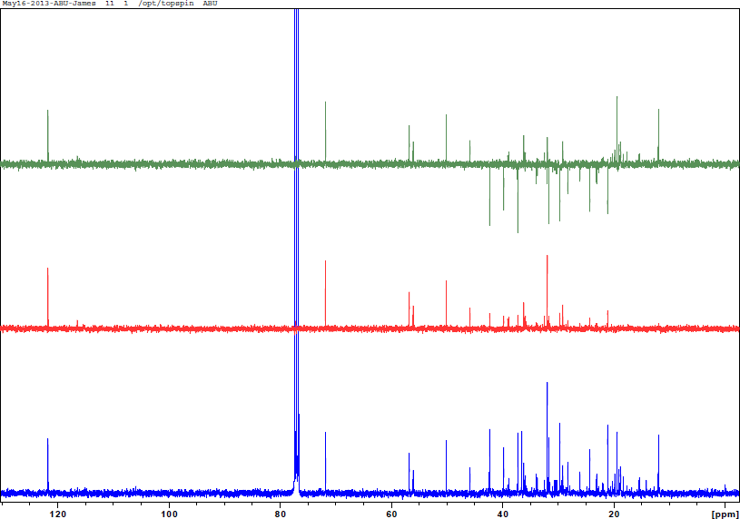

# Fig 4.4: DEPT Spectrum of X1 in CDCl3

* + 1. **Correlation Spectroscopy of X1 (COSY)**

The 1H-1H COSY spectra of X1(fig. 4.5), the methylene proton at (δH 1.90), showed cross peak correlation with methylene proton at (δH 1.30). The carbinol proton of (δH 3.50), showed cross peak correlation with methylene protons at (δH 1.30) and (δH 2.30). The olefinic proton at (δH 5.39), showed cross peaks correlation with methylene proton at (δH 1.51). The methylene proton of (δH 1.51) showed correlation with methine proton at (δH 1.88). The methylene proton of (δH 1.28) showed cross peaks correlation with methylene protons at (δH 2.06).

# Table 4.12: Major 1H-1H COSY of X1

|  |  |
| --- | --- |
| **Proton Number** | **Proton correlation** |
| (1.90, H-1) | (1.30, H-2) |
| ( 3.50, H-3) | (1.30, H-2), (2.30, H-4) |
| (5.39, H-6)  (1.51, H-7)  (1.28, H-11) | (1.51, H-7)  (1.88, H-8)  (2.06, H-12) |

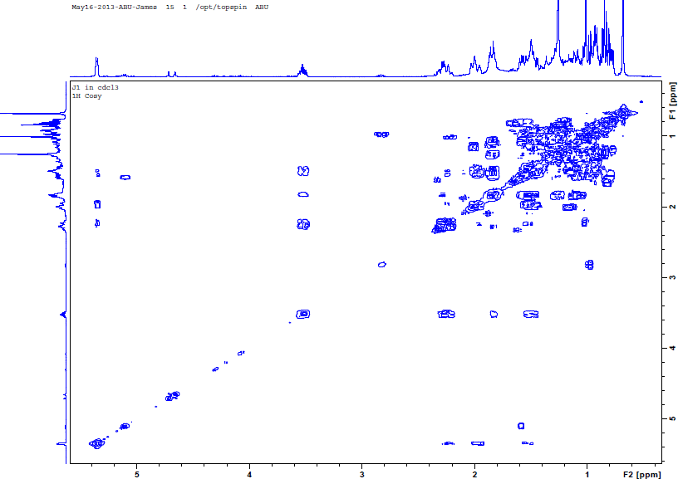

**Fig 4.5:1H-1H COSY Spectrum of X1 in CDCl3**

# Nuclear Over hauser Effect of X1 (NOESY)

In the NEOSY spectra of X1 (fig.4.6), the methyl proton of (δH 0.74) showed space coupling with methylene proton at (δH 2.06), while methyl proton of (δH 1.06) showed space coupling with methylene proton at (δH 1.90).

# Table 4.13: Major NOESY of X1

|  |  |
| --- | --- |
| **Proton Number** | **Proton correlation** |
| (0.74, H-18) | (2.06, H-12) |
| ( 1.06, H-19) | (1.90, H-1) |

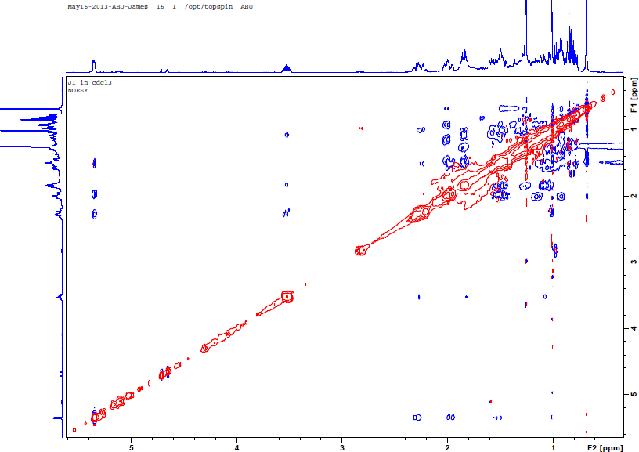

**Fig 4.6: NOESY Spectrum of X1 in CDCl3**

# Hetero Nuclear Single Quantum Correlation of X1 (HSQC)

The result of HSQC (Fig. 4.7) was used to assign protons on their respective carbon

# Table 4.14 Table showing HSQC and DEPT experiment of X1 in ppm

|  |  |  |  |
| --- | --- | --- | --- |
| **S/No** | **1H** | **13C** | **DEPT** |
| **1** | 1.90 | 37.3 | CH2 |
| **2** | 1.30 | 35.9 | CH2 |
| **3** | 3.50 | 71.8 | CH |
| **4** | 2.30 | 42.3 | CH2 |
| **5** | - | 140.8 | C |
| **6** | 5.39 | 121.7 | CH |
| **7** | 1.51 | 33.9 | CH2 |
| **8** | 1.98 | 36.1 | CH |
| **9** | 0.98 | 50.1 | CH |
| **10** | - | 39.8 | C |
| **11** | 1.28 | 29.7 | CH2 |
| **12** | 2.06 | 42.3 | CH2 |
| **13** | - | 42.3 | C |
| **14** | 1.04 | 56.8 | CH |
| **15** | 1.28 | 29.2 | CH2 |
| **16** | 1.30 | 33.7 | CH2 |
| **17** | 1.05 | 56.1 | CH |
| **18** | 0.74 | 11.9 | CH3 |
| **19** | 1.06 | 19.8 | CH3 |
| **20** | 2.00 | 38.8 | CH |
| **21** | 0.93 | 18.3 | CH3 |
| **22** | 1.07 | 36.5 | CH2 |
| **23** | 1.22 | 31.7 | CH2 |
| **24** | 0.97 | 45.8 | CH |
| **25** | 1.74 | 31.9 | CH |
| **26** | 0.88 | 21.1 | CH3 |
| **27** | 0.87 | 19.4 | CH3 |
| **28** | 1.31 | 23.1 | CH2 |
| **29** | 0.89 | 11.9 | CH3 |

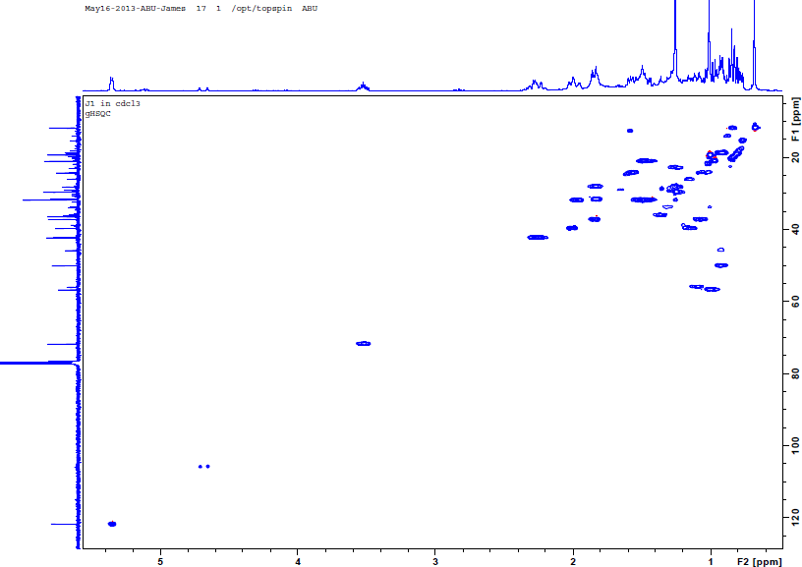

**Fig 4.7: HSQC Spectrum of X1 in CDCl3**

# Hetero Nuclear Multiple Bond Correlation of X1 (HMBC)

In HMBC spectra of X1 (Fig 4.8), the methylene proton of (δH: 1.90, H-1) showed J2 correlation with methylene carbon signal at (δc 35.9, C-2), and J3 correlation with methine carbon signal at (δc:71.8, C-3), quaternary carbon signal at (δc:140.8, C-5) and methyl carbon signal at (δc:11.9, C-19). The methylene proton of (δH 2.30, H-4) showed long range J3 correlation with methylene carbon signal at (δc: 35.9, C-2), and quaternary carbon signal at (δc 140.8, C-5), and J2 correlation with methine carbon at (δc:71.8, C-3) and (δc:121.7, C-6). The methine proton at (δH 5.39, H-6) showed correlation with methylene carbon signal at (δc: 42.3, C-4), (δc: 33.9, C-7) and J3 correlation with methine carbon signal at (δc 36.1, C-8). Also methylene proton at (δH 1.51, C-7) showed J3 correlation with methine carbon signal at (δc 50.1, C-9) and (δc 56.8, C-14). The methine proton at (δH 1.98, H-8) showed J2 correlation with methine carbon signal at (δc 50.1, C-9) and J3 correlation with quaternary carbon signal at (δc 42.4, C-13). The methine proton at (δH 1.04, H-14) showed J3 correlation with methylene carbon signal at (δc 33.7, C-16) and with methine carbon signal at (δc 56.1, C-17). The methylene proton at (δH 2.0, H-20) showed J2 correlation with methyl carbon signal at (δc 18.3, C-21) and J3 correlation with quaternary carbon signal at (δc 42.4, C-13), while the methyl proton at (δH 0.88, H-26) showed J3 correlation with methine carbon signal at (δc 31.9, C-25) and methyl carbon signal at (δc 19.4, C-27).

# Table 4.15: Table showing the result of Major HMBC of X1

|  |  |
| --- | --- |
| **Proton Number** | **Carbon correlation** |
| **H-1** | C-2, C-3, C-5, C-19 |
| **H-4** | C-2, C-3, C-5, C-6 |
| **H-6**  **H-7**  **H-8 H-14 H-20**  **H-26** | C-4, C-7, C-8 C-9, C-14  C-9, C-13  C-16, C-17  C-13,C-21  C-25, C-27 |

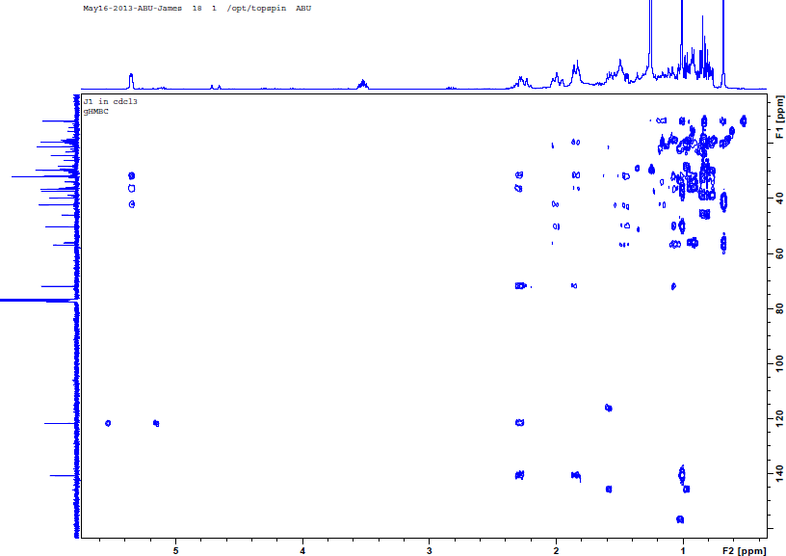

**Fig 4.8: HMBC Spectrum of X1 in CDCl3**

The spectral data of X1 was compared with β-Sitosterol isolated by (Hamada *et al.,* 2012)

# Table 4.16: Table comparing the spectral data of J1 with the literature reported in ppm

|  |  |  |  |  |
| --- | --- | --- | --- | --- |
| **Position** | **δc (Reference)** | **δc (X1)** | **δH (Reference)** | **δH(X1)** |
| **1** | 37.2 | 37.3 | 1.90 | 1.90 |
| **2** | 31.6 | 35.9 | 1.56 | 1.30 |
| **3** | 71.8 | 71.8 | 3.58 | 3.50 |
| **4** | 42.3 | 42.3 | 2.30 | 2.30 |
| **5** | 140.7 | 140.8 |  |  |
| **6** | 121.7 | 121.7 | 5.40 | 5.39 |
| **7** | 31.9 | 33.9 | 1.50 | 1.51 |
| **8** | 31.8 | 36.1 | 2.30 | 1.98 |
| **9** | 50.1 | 50.1 | 0.98 | 0.98 |
| **10** | 36.5 | 39.8 |  |  |
| **11** | 21.1 | 29.7 | 1.50 | 1.28 |
| **12** | 39.7 | 42.3 | 2.06 | 2.06 |
| **13** | 42.3 | 42.3 |  |  |
| **14** | 56.7 | 56.8 | 1.04 | 1.04 |
| **15** | 24.3 | 29.2 | 1.11 | 1.28 |
| **16** | 28.2 | 33.7 | 1.30 | 1.30 |
| **17** | 56.0 | 56.1 | 1.16 | 1.05 |
| **18** | 11.8 | 11.9 | 0.74 | 0.74 |
| **19** | 19.4 | 19.8 | 1.06 | 1.06 |
| **20** | 36.1 | 38.8 | 1.40 | 2.00 |
| **21** | 18.8 | 18.3 | 0.93 | 0.93 |
| **22** | 33.9 | 36.5 | 1.07 | 1.07 |
| **23** | 26.0 | 31.7 | 1.23 | 1.22 |
| **24** | 45.8 | 45.8 | 0.97 | 0.97 |
| **25** | 29.1 | 31.9 | 1.71 | 1.74 |
| **26** | 19.8 | 21.1 | 0.88 | 0.88 |
| **27** | 19.0 | 19.4 | 0.87 | 0.87 |
| **28** | 23.0 | 23.1 | 1.31 | 1.31 |
| **29** | 12.0 | 11.9 | 0.89 | 0.89 |

* 1. **Results of Antioxidant studies**

# *In vitro* DPPH Free Radical Scavenging activity Results

The *in vitro* DPPH free radical scavenging activity of the ethanol extract and its sub fraction in (Figure 4.9) showed a persistent increase in antioxidant activity with increase in concentration of extract, 50μg/ml of each extract showed a higher antioxidant activity than the lowest concentrations. The linearity graph in (Figure 4.10) showed good association between the antioxidant activity and concentration of extracts, as the correlation coefficient (R2) tend towards one.

80

70

60

50

40

30

20

10

Ethanol extract

n-hexane fraction Chloroform fraction Ethyl acetate fraction n-Butanol fraction

Ascorbic acid

0

3.125

6.25

12.5

25

50

**Concentration (ug/ml)**

**Antioxidat Activity (%)**

**Figure 4.9**: DPPH Free radical scavenging activity of Honeybee Propolis extract and its partition fractions presented as the mean value ± standard deviation SD (n=3).

**Figure 4.10:** Linearity graph of Antioxidant activity (%) against concentration of extracts (ug/ml)



**Key linearity**

80

70

60

50

CR y = 0.2465x + 48.983

R² = 0.9852

HH

y = 0.159x + 45.9

R² = 0.7245

40

30

CC y = 0.3121x + 47.813

R² = 0.7077

20

10

EE

y = 0.4204x + 49.254

R² = 0.7773

0

0

10

20

30

40

50

60

BB y = 0.3602x + 46.842

R² = 0.8703

**Concentration (ug/ml)** AS y = 0.3337x + 49.154 R² = 0.8386

**Antioxidant Activity (%)**

# : IC50 results of extracts and standard drug in μg/ml

Comparing the means of 50% free radical scavenging activity of the extracts in (Figure 4.12) at (α = 0.05) gave a P value of 4.46E-28 and also comparing the mean IC50 of ethyl acetate fraction (EE) and standard ascorbic acid (AS) at 95% confidence interval gave a P value of 7.58E-8.

30

25

20

15

10

5

0

Ethanol extract n-hexane

fraction

Chloroform Ethyl acetate

fraction fraction

n-Butanol

fraction

Ascorbic acid

**Extracts**

**IC5O (ug/ml)**

**Figure 4.11**: Graphical presentation of IC50 of various extracts and standard ascorbic acid as mean value ± SEM (n=3) using student, t-test: statistical significant at p≤0.05.

# : Qualitative antioxidant test using 0.15% DPPH in methanol as spraying reagent

The qualitative antioxidant test using hexane: ethyl acetate (9:1) as solvent system for (Plate 11, 13) and hexane: ethyl acetate: methanol (4:2:1) for (Plate 12, 14) revealed that the ethanol extract (CR) and all soluble fractions (HH, CC, EE and BB) possess antioxidant activity with ethyl acetate showing more yellow spots of compounds with antioxidant property than the other fractions.

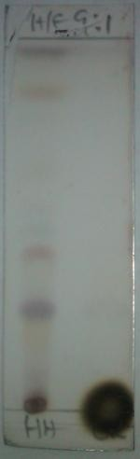 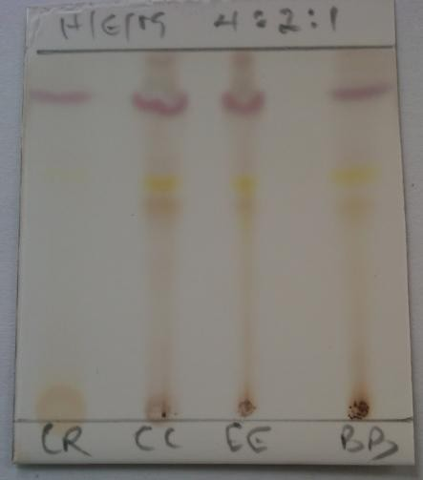

Plate 11 Plate 12

Profile of extracts after spraying with 10% aqueous H2S04

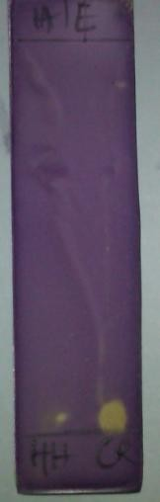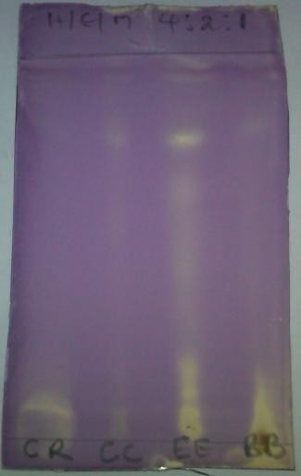

Plate 13 Plate 14

Antioxidant profile of extracts after spraying with 0.15%w/v DPPH in methanol.

# Results of Antimicrobial activity studies

# Susceptibility Test

The extracts (CR, HH, CC, EE, and BB) inhibit the growth of all tested organism (zone of inhibition 20-27mm) with the exception of *E. coli, K. pneumonia* and *C. albican.* In addition, the HH extract did not inhibit the growth of *S. aureus*, *P. aeruginosa* and BB extract did not inhibit the growth of *P. aeruginosa* (Table 4.17), while the isolated compound J1 inhibit the growth of all tested organism (zone of inhibition 23-32mm) with the exception of *C. ulcerans,*

*E. coli, P. mirabilis, P. aeruginosa*, *C. albicans* and *C. tropicalis* (Table 4.18).

# Table 4.19: Zones of Inhibition of Extracts and Standard Drug against Test Organism

|  |  |  |  |
| --- | --- | --- | --- |
|  | **Zon** | **es of Inhibition (mm)** |  |
|  | **Test organism CR HH** | **CC EE BB Sparflox Cipro Flucoz** |  |
|  | *S. aureus* 24 0.0  *B. subtilis* 27 20  *E. coli* 0.0 0.0  *K. pneumoniae* 0.0 0.0  *P. aeruginosa* 24 0.0  *C. albicans* 0.0 0.0  *C. krusei* 26 20  *C. tropicalis* 22 0.0 | 21 22 20 37 32 -  22 21 21 42 37 -  0.0. 0.0 0.0 32 30 -  0.0. 0.0 0.0 47 32 -  26 22 0.0 30 - -  0.0 0.0 0.0 - - 37  24 22 21 - - 40  23 20 20 - - 35 |  |

|  |  |  |
| --- | --- | --- |
| **Key:** CR – crude ethanol extract | HH- n-hexane fraction | CC- chloroform fraction |
| EE- ethyl acetate fraction | BB- n-butanol fraction | Sparflox - sparfloxacin |
| Cipro- ciprofloxacin | Flucoz- fluconazole |  |

**Table 4.20: Zones of Inhibition of X1 and Standard Drug against Test Organism**

|  |  |  |
| --- | --- | --- |
|  |  | **Zone of Inhibition (mm)** |
|  | **Test organism XI** | **Sparflox Cipro Flucoz** |
|  | *S. aureus* 27  *B. subtilis* 34  *S. pyogenes* 30  *C. ulcerans* 0.0  *E. coli* 0.0  *K. pneumoniae* 26  *P. aeruginosa* 0.0  *S. dysenteria* 28  *P. mirabilis* 0.0  *C. albicans* 0.0  *C. krusei* 27  *C. tropicalis* 0.0 | 37 32 -  42 37 -  40 38 -  34 36 -  32 30 -  47 32 -  30 0.0 -  35 37 -  30 32 -  - - 37  - - 40  - - 35 |

**Key:** Sparflox – sparfloxacin Cipro- ciprofloxacin Flucoz- fluconazole

# MIC and MBC/MFC of Extracts and compound XI

The extracts (CR, HH, CC, EE and BB) were found to have MIC values ranging from of 1.25-2.5mg/mL and MBC/MFC values ranging from 5-10mg/mL (Table 4.21).

The isolated compound J1 was found to have MIC values ranging from 12.5-25μg/mL and MBC values ranging from 25-100μg/mL, while MFC value of JI is 50μg/mL (Table 4.22).

# Table 4.21: MIC and MBC/MFC of Extracts *(*mg/mL)

|  |  |  |
| --- | --- | --- |
|  | **MIC (mg/mL)** | **MBC/MFC (mg/mL)** |
|  | **Test organism CR HH CC** | **EE BB CR HH CC EE BB** |
|  | *S. aureus* 2.5 - 2.5  *B. subtilis* 1.25 2.5 2.5  *P. aeruginosa* 2.5 - 1.25  *C. krusei* 1.25 2.5 2.5  *C. tropicalis* 2.5 - 2.5 | 2.5 2.5 5.0 - 10.0 5.0 10.0  2.5 2.5 5.0 10.0 5.0 10.0 5.0  2.5 - 5.0 - 5.0 5.0 -  2.5 2.5 5.0 10.0 5.0 5.0 10.0  2.5 2.5 10.0 - 5.0 10.0 10.0 |

|  |  |  |
| --- | --- | --- |
| **Key:** CR – crude ethanol extract | HH- n-Hexane fraction | CC- chloroform fraction |
| EE- ethyl acetate fraction | BB- n-butanol fraction | Sparflox - sparfloxacin |
| Cipro- ciprofloxacin | Flucoz- fluconazole |  |

**Table 4.22: MIC and MBC/MFC of compound XI (μgmL-1)**

|  |  |  |  |
| --- | --- | --- | --- |
|  | **MIC (μg/mL-1)** | **MBC/MFC (μg/mL-1)** |  |
|  | **Test organism XI** | **XI** |  |
|  | *S. aureus* 25.0  *B. subtilis* 12.5  *S. pyogenes* 12.5  *K. pneumoniae* 25.0  *S. dysenteria* 12.5  *C. krusei* 25.0 | 50.0  25.0  50.0  100.0  50.0  50.0 |  |

**Key: X1 –** Isolated compound

# CHAPTER FIVE

**5.0 DISCUSSIONS**

The Preliminary phytochemical screening of ethanol extract (CR) revealed the presence of flavonoids, saponins, carbohydrate, steroids and triterpenes, while the n-hexane soluble fraction (HH) revealed the presence of phenolic nucleus, steroid and triterpenes, the chloroform fraction (CC) revealed the presence of phenolic nucleus, steroids and triterpenes, flavonoids, the ethyl acetate fraction (EE) revealed the presence of phenolic nucleus, flavonoids and the n-butanol fraction (BB) revealed the presence of phenolic nucleus, steroids and triterpenes, flavonoids, carbohydrate and saponins. The usefulness of these metabolites in phytomedicines or treatment of ailments has been documented. Saponins are used for gastro- intestinal infections; Flavonoids are free radical scavengers and therefore useful in management of inflammatory diseases e.g tumour and oxidative stress- related diseases (Robertson and Haber, 1956; Haslem, 1989; Evans, 2002). Steroids and triterpenes have analgesic, anti-inflammatory, anti-malaria, anti-microbial and anticancer activities, some compounds with phenolic nucleus have antiseptic and antioxidant property (Robertson and Haber, 1956; Haslem, 1989; Evans, 2002). Therefore, the presence of these metabolites in the propolis supports their uses in the treatment of ailments traditionally (Abel and Banjo, 2012; Adewumi and Ogunjinmi, 2011).

Column chromatography of the n- hexane soluble fraction (HH) using silica gel as stationary phase and gradient elution using hexane, hexane: ethyl acetate and ethyl acetate, followed by preparative TLC lead to the isolation of a white crystalline compound X1 which was soluble in chloroform and indicate positive with Salkowski’s test.

The structure of X1 was elucidated by spectroscopic analysis and by comparison of its spectral data with previously reported values. (Hamada *et al*., 2012)

The IR spectrum of X1, showed a broad band absorption peak at 3390.9cm-1 (O-H) bond indicating presences of hydroxyl group, and moderate intense band at 2935.7cm-1 (aliphatic C- H stretching), weak intense band at 1450.5cm-1(C=C band), 1377.2cm-1 (C-H bending) and 1051.2cm-1 (C-O stretching band) (Pateh *et al.,* 2008).

The 1H NMR spectrum (400MHZ, CDCl3) of X1 revealed the presence of six methyl protons at δ 0.74, 0.87, 0.88, 0.89, 0.93 and 1.06 (3H each), this proton signal between (0.7-1.8) are attributed to resonance of overlapping methyl and methylene protons, a characteristic frame work of steroids (Yun-Song *et al,* 2006). The multiplets of two protons at δ 2.30 was observed. The H-3 proton at δ 3.50 is an indication of a carbinol proton in steroids or triterpenes nucleus, while a doublet of one proton at δ 5.39 representing an olefinic protons at H-6. All these resonances are similar to that of β- sitosterol reported by (Hamada *et al.*, 2012).

The result of 13C-NMR and DEPT of X1 showed 29 C- signals. Six methyl groups at [(δc: 11.9 (C-18), 19.8 (C-19), 18.3 (C-21), 21.1 (C-26), 19.4 (C-27), and 11.9 (C-29)], an olefinic

carbons appeared at δc: 140.8 (C-5) and 121.7 (C-6), and a secondary hydroxyl bearing carbon at [(δc: 71.8 (C-3)], in addition to eleven methylene, nine methine and three quaternary carbons. The de-shielded signal at δc 71.8 was due to C-3 with a hydroxyl group attached to it. These carbon-13 resonances are also in agreement with that of β-sitosterol (Pateh *et al.,* 2008; Hamada *et al.,* 2012).

The COSY spectrum of X1 showed some cross peak between the methylene proton at (δH 1.90, H-1), correlation with methylene proton at (δH 1.30, H-2). The carbinol proton of (δH 3.50, H-

3), showed cross peak correlation with methylene protons at (δH 1.30, H-2) and (δH 2.30, H-4).

The singlet of olefinic proton of (δH 5.39, H-6), showed cross peaks correlation with methylene proton at (δH 1.51, H-7). The methylene proton of (δH 1.51, H-7) showed correlation with methine proton at (δH 1.88, H-8). The methylene proton of (δH 1.28, H-11) showed cross peaks correlation with methylene protons at (δH 2.06, H-12).

The NEOSY spectra of X1, the methyl proton of (δH 0.74, H-18) showed space coupling with methylene proton at (δH 2.06, H-12). While methyl proton of (δH 1.06, H-19) showed space coupling with methylene proton at (δH 1.90, H-1).

The HMBC spectra of X1, the methylene proton of (δH: 1.90, H-1) showed J2 correlation with methylene carbon signal at (δc 35.9, C-2), and J3 correlation with methine carbon signal at (δc:71.8, C-3), quaternary carbon signal at (δc:140.8, C-5) and methyl carbon signal at (δc:11.9, C-19). The methylene proton of (δH 2.30, H-4) showed long range J3 correlation with methylene carbon signal at (δc: 35.9, C-2), and quaternary carbon signal at (δc 140.8, C-5), and J2 correlation with methine carbon at (δc:71.8, C-3) and (δc:121.7, C-6). The methine proton at (δH 5.39, H-6) showed correlation with methylene carbon signal at (δc: 42.3, C-4), (δc: 33.9, C-7) and J3 correlation with methine carbon signal at (δc 36.1, C-8). Also methylene proton at (δH 1.51, C-7) showed J3 correlation with methine carbon signal at (δc 50.1, C-9) and (δc 56.8, C-14). The methine proton at (δH 1.98, H-8) showed J2 correlation with methine carbon signal at (δc 50.1, C-9) and J3 correlation with quaternary carbon signal at (δc 42.4, C- 13). The methine proton at (δH 1.04, H-14) showed J3 correlation with methylene carbon signal at (δc 33.7, C-16) and with methine carbon signal at (δc 56.1, C-17). The methylene proton at (δH 2.0, H-20) showed J2 correlation with methyl carbon signal at (δc 18.3, C-21) and J3 correlation with quaternary carbon signal at (δc 42.4, C-13), while the methyl proton at

(δH 0.88, H-26) showed J3 correlation with methine carbon signal at (δc 31.9, C-25) and methyl carbon signal at (δc 19.4, C-27).

Confirmation of the structure of X1 was accomplished by 2D NMR experiments (COSY, NOESY, HSQC and HMBC). Based on the result of 1D and 2D NMR and comparing the data obtained with that in the literature (Hamada *et al.,* 2012), X1 was suggested to be β-Sitosterol as shown in Figure 5.1

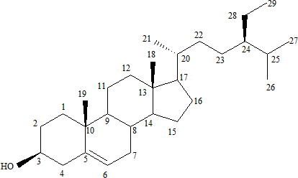

Fig 5.1: Stigmast-5-en-3β-ol (β-Sitosterol)

17-(5-ethyl-6-methylheptan-2-yl)-2,3,4,7,8,9,10,11,12,13,14,15,16,17-tetradecahydro-10,13- dimethyl-1H-cyclopenta (α) phenanthren-3-ol.

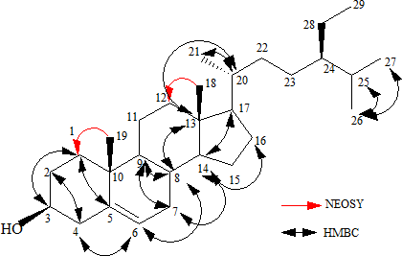

Fig 5.2: NEOSY and HMBC of isolated β-Sitosterol

β-sitosterol is a natural micro-nutrient which is found in the cells and membranes of all oil producing plants, fruit, vegetables, grains, seeds and trees. It has been proven to be a safe, natural and effective nutritional supplement and has shown amazing potential benefits in many diverse applications. It has been known biologically as anti-inflammatory and analgesic agents (Singh, 2006) and has shown effectiveness in reducing serum cholesterol (Brunzel and Austin, 1998). Earlier experimental studies have shown its effectiveness as an anti-diabetic, antioxidant, anti-cancer, anti-ulcer, anti-inflammatory, antipyretic and anti-stress agent. This natural micro-nutrient is also an effective immune booster and used in the treatment of benign prostate hypertrophy, (Berges *et al.,* 1995). It also has antimicrobial activity (Sen *et al.,* 2012).

The qualitative antioxidant screening showed that ethyl acetate fraction (EE) has high antioxidant activity when compared with other extracts indicates that more polyphenolic compounds are present in this fraction, (Haisha *et al.,* 2011).

The *in-vitro* DPPH free radical scavenging activity revealed that all fractions possess a free radical scavenging activity with ethyl acetate fraction (EE) having significant antioxidant activity of with IC50 value of 1.78 ± 0.01μg/ml compare to other extracts and standard ascorbic acid of 2.54 ± 0.01ug/ml at p ≤ 0.05. The order of decreasing antioxidant activity of the extracts was EE>CR>CC>BB>HH. This may be due to high polyphenolic compounds in ethyl acetate fraction, (Haisha *et al.,* 2011; Aliyu *et al.,* 2013). In addition, the low antioxidant activity of the ethanol crude extract (CR) may be associated with complex functional groups interactions in the ethanol crude extract use for the studies. This method which is simple, rapid, sensitive and reproducible shows that propolis extracts are apparently good free radical scavengers and can inhibit autoxidation of lipids and thus be beneficial in the treatment of disease in which lipid peroxidation is there mechanism of pathogenesis.

The *in-vitro* antimicrobial activity of propolis ethanol extracts (CR, HH, CC, EE, and BB) and isolated compound X1 assayed using clinical isolates of Gram- negative strains, Gram-positive strains and fungal strains as test organisms, revealed that the crude ethanol extract showed activity on *S. aureus, B. subtilis, P. aeruginosa, C. krusei* and *C. tropicalis,* while hexane fraction (HH) showed activity only on *B. subtilis* and *C. krusei.* The chloroform fraction (CC), ethyl acetate fraction (EE) and butanol fraction (BB) showed similar activity on susceptible organism to the ethanol crude extract with exception of *P. aeruginosa* which was not susceptible to only the butanol fraction (BB). Isolated compound J1 (β-sitosterol) showed activity on *S aureus, B.substilis, S. pyrogenes, K. pneumonia, S. dysenteriae* and *C. krusei* with the exception of *P. aeruginosa* and *C. topicalis* which are susceptible to the ethanol crude extract. The isolated compound X1 has zones of inhibition ranging from (27-34mm), while the ethanol extract and its sub-fractions exhibit zones of inhibition ranging (20-27mm). The

extract have an MIC value ranging from (1.25-2.5mg/mL) and MBC/MFC value ranging from (5-10mg/mL), while isolated β-sitosterol has an MIC value ranging from (12.5-25μg/mL) and MBC of (25-100μg/mL) and MFC value ranging from (50-100μg/mL). The overall results suggest that the propolis ethanol extract (CR) and its sub fractions (HH, CC, EE and BB) possess antimicrobial compounds like flavonoid, steroids and triterpenes that may be useful in treatment of infections and isolated β- sitosterol (100ug/mL) has an antimicrobial activity more potent than the extracts, although not comparable to the standard antibiotic drug (Sparfloxacin, Ciprofloxacin) and anti-fungal drug (Fluconazole) at (5μg/mL) with zone of inhibition ranging (32- 47mm) on the same susceptible organism.

Our study contributes to establish β-sitosterol as a potent antimicrobial agent as reported by (Sen *et al.*, 2012) against pathogenic strains of *S. aureus* which are known to cause skin and soft tissues infections in humans *B. subtilis* which causes ear infection and urinary tract infection, *S. pyrogenes* and *K. pneumonia* which cause tonsillitis and respiratory tract infections and *C. krusei* which cause thrush and vaginitis. Propolis from Zango Kataf, Kaduna State, Nigeria serve as source for β-sitosterol, however still more scientific evaluation and clinical trials are required to establish its therapeutic efficacy. This study has added new knowledge on the chemical and biological studies of honeybee propolis from Northern Nigeria and confirmed the rationale of the ethno medicinal use of the propolis.

# CHAPTER SIX

**SUMMARY, CONCLUSION AND RECOMMENDATIONS**

# Summary

Preliminary phytochemical screening of the ethanol extract of honey bee propolis revealed the presence of triterpenes, steroids, phenolic compounds, saponins and flavonoids, while the n- hexane soluble fraction revealed the presence of triterpenes, steroids and phenolic, the chloroform fraction (CC) revealed the presence of phenolic nucleus, steroids and triterpenes, flavonoids and the ethyl acetate fraction (EE) revealed the presence of phenolic nucleus, flavonoids, while the n-butanol fraction (BB) revealed the presence of phenolic compounds, steroids and triterpenes, flavonoids, carbohydrate and saponins.

Extensive chromatographic separation of the n-hexane soluble fraction led to the isolation of Stigmast-5-en-3β-ol (β-Sitosterol).

*In vitro* DPPH free radical scavenging activity and Qualitative antioxidant test revealed that the ethyl acetate soluble fraction (EE) possess significantly, potent antioxidant activity of IC50 of 1.78ug/mL at P≤0.05 compare to the ethanol extract, other soluble fraction and standard ascorbic acid.

*In vitro* antimicrobial screening on extracts and isolated β-sitosterol (X1), show that X1 was more potent against some test organism with zones of inhibition ranging from (27-34mm), with MIC values ranging from 12.5-25μg/mL and MBC values ranging from 25-100μg/mL and MFC value of 50μg/mL, while the extracts exhibit zone of inhibition ranging from (20-

27mm) with MIC values ranging from of 1.25-2.5mg/mL and MBC/MFC values ranging from 5-10mg/mL .

# Conclusion

Based on the findings in this work, it can be concluded that the use of honeybee propolis in the treatment of some bacterial and fungi infections has scientific basis. To the best of our search this is the first time β-Sitosterol is being isolated from Northern Nigeria honey bee propolis. The antimicrobial activity of the n-hexane fraction can be linked in part to the β-sitosterol isolated, while the antioxidant activity observed can be due to polyphenolic compounds present in the extracts.

# Recommendations

In order to fully validate the medicinal use of the honey bee propolis, it is recommended that

* + 1. *In vivo* antioxidant studies should be done on the ethanol extracts and soluble fractions to ascertain their potency and mechanism of action.
    2. Detailed antimicrobial studies exploiting other resistance strain of microorganism should be carried out on ethanol extracts and soluble fractions to ascertain the potency and its mechanism of action.
    3. Other pharmacological activities should also be carried out on other fractions of the ethanol extract to investigate their medicinal potential e.g anticancer, antiviral, analgesic and anti-inflammatory activity.
    4. More compounds should be isolated from hexane fraction and other soluble fractions and subjected to biological/pharmacological activity based on the folkloric claims of the honeybee propolis.

# REFERENCE

Abel, A.A. and Banjo, A.D. (2012). Apitherapy in Southern Nigeria: An assessment of therapeutic potentials of some honeybee Products. *Journal of Pharmaceutical and Biomedical Sciences.* 2(2): 9-15.

Adewumi, A.A. and Ogunjinmi, A.A. (2011). The healing potential of honey and propolis lotion on septic wounds. *Asian Pacific Journal of Tropical Biomedicine Science.*

S55-S57.

Agbagwa, O.E. and Okolo, I. (2012). Antibacterial activity of honey and propolis marketed in Nigeria using well-in-agar and disc diffusion method. *International Research Journal of Microbiology*, 3(3): 101-105.

Alexandra, C.H., Juliana, C.P., Leticia, C. D., Maria, C.M., Ivan P.A., Ademilson, E.E., Patricia, V.A., Ildenize, B. D. and Marcos, N.E. (2009). Composition and antioxidant activity of propolis from three species of *Scaptotrigona* stingless bees. *Journal of Apiproduct and Apimedical Science,* 1 (2): 37-42.

Aliyu, A. B., Mohammed, A. I., Aliyu, M.M., Aisha, O.M., Joyce, J.K. and Adebayo, O.O. (2013). Free radical scavenging and total antioxidant capacity of root extracts of *Anchomanes difformis* Engl*. Acta Poloniae Pharmaceutica-Drug Research,* 70 (1): 115-121*.*

Ashraf A. E. (2009). New prenilated compound from Egyptian propolis with antimicrobial activity. *Revista Lantinoamericana de Quimica* 37/1.

Bankova, V., Castro, S.L. and Marcucci, M.C. (2000). Propolis: Recent advances in chemistry and plant origin. *Apidologie,* 31: 3–15.

Bassani-Silva, S., Sforcin, J.M., Amaral, A.S., Gasper, L.F.J. and Rocha, N.S. (2007). Propolis effect in vitro on canine transmissible venereal tumor cells. *Revista Portuguesa de ciencias vetrerinaries,* 102: 261-265.

Berges, R.R., Winder, J., Trampisch, H.J. and Senge, T.H. (1995). Randomised placebo- controlled double blind clinical trial of beta sitosterol in patients with benign prostatic hyperplasia. *Lancet*, 345:1529-1532.

Blinov, R.A., Carison, D., Flyasber, M.E., Martin, G.E., Martirosian, E.R., Molodotsiv, S. and Williams, A. J. (2003). Computer assisted structure elucidation of natural products with limited 2D NMR Data; Application of structure system*. Magnetic Resonance in Chemistry*, 41: 359-372.

Brunzel, J.D. and Austin, M.A. (1998). Plasma triglyceride levels and coronary disease. *New England Journal of Medicine,* 320: 1273.

Cai, Y.Z., Sun, M. and Corke, H. (2003). Antioxidant activity of betalains from plants of the Amaranthaceae*. Journal of Agricultural Food and Chemistry*, 51 (81): 2288-2294.

Cannell, R.J.P. (2000). Methods in Biotechnology, *Natural Products Isolation*, Humana Press, New Jersey (USA). Pp. 1-52.

Chia-Chi, C., Ming-Hua, Y., Hwei-Mei, W. and Jing-Chuan, C. (2002). Estimation of total flavonoid content in propolis by two complementary colorimetric methods*. Journal of Food and Drug Analysis,*10 (3): 178-182.

Cox, P.S. (1990). *Bioactive compounds from plants*. Ciba Foundation Symposium 154, Wiley Pp. 40.

Damintoti, K., Mamoudou, H.D., Jacques, S. and Alfred, S.T. (2005). Antioxidant and antibacterial activities of polyphenols from ethnomedicinal plants of Burkina Faso. *African Journal of Biotechnology* 4 (8): 823-828.

Evans, W.C. (2002). *Trease and Evans Pharmacognosy*, 15th Ed. London: W.B. Sanders. Pp.

183-393.

Feng, L., Suresh A., Hongyan, Z., Yasuhiro, T., Hiroyasu, E. and Shigetoshi, K. (2009).

Chemical constituents of propolis from Myanmar and their preferential cytotoxic against a human pancreatic cancer cell line. *Journal of Natural Product,* 72: 1283- 1287.

Gibbons, S. and Gray, A. I. (1998). ‘Isolation by Planar Chromatography’ in Cannell, R. J. P., (Eds.), *Natural Products Isolation*. Humana Press, New Jersey. Pp. 1-52.

Grifarn, F., Newman, D., Fairfield, A. S., Bharttacharya, B. and Grupenho, J. T. (1997). ‘The Origin of Prescription Drugs’ in Grifo, F. and Rosenthal, J. (Eds.), *Biodiversity* and *Human Health*, Island Press Washington DC. Pp. 1-75.

Gulcin, I. and Buyukokuroglu, M.E. (2002). *In-vitro* Antioxidant properties of melatonin*.*

*Journal of Pineal Research*, 33: 167-171.

Haisha, Y., Yuqionq, D., Huijing, D., Haiming, S., Yunhua, P. and Xiaobo, L. (2011).

Antioxidant compounds from propolis collected in Anhui, China. *Molecules*

16: 3444-3455.

Halliwell, B. and Gutteridge, J.M. (1999)*. Free radical in Biology and Medicine,* Claredon Press, Oxford. Pp. 617-783.

Hamada, H., Soumia, M., Catherine, L. and Mohammed, B. (2012). Chemical constituents of *Centaurea omphalotricha* Coss and Durieu ex Batt. and Trab*. Records of Natural Products*, 6.3: 292-295.

Harman, D. (1998). Aging: Phenomena and theories*. Annals New York Academic of Sciences*, 854: 1-7.

Haslem, E. (1989). Plant polyphenols: Vegetable tannins revisited- chemistry and pharmacology of natural product. Cambridge University Press, Cambridge, Pp. 169.

Hostettmann, K. Wolfinder, J. L. Rodriguez, S and Marston, A. (1996). ‘*Strategy in the search for bioactive plant constituents’,* in Hostettman, K., Chiyanganya, F., Maillard, M. and Wolfinder, J. L. (Eds.). *Chemistry, Biological and Pharmacological Properties of African Medicinal Plants*, Proceedings of the Symposium by International Organization for Chemical Sciences in Development, (IOCD). University of Zimbabwe Publications Limited, Pp. 29- 34.

Jose, M.S. and Vassya, B. (2010). Propolis: Is there a potential for development of new drugs*.*

*Journal of Ethnopharmacology* 133: 253-260.

Kanti, B.P. and Syed, I. R. (2009). Plant polyphenols as dietary antioxidant in human health and disease. *Oxidative Medicine and Cellular Longevity,* 2(5): 270-278.

Kourounakis, A.P. and Galanakis, D.K. (1999). Synthesis and pharmacological evaluation of novel derivatives of anti-inflammatory drugs with increased antioxidant and

anti-inflammatory activities*. Drug Development Research.* 47: 9-16.

Lai, L.S. and Chou, S.T. (2001). Studies on the antioxidant activities of *Mesona procumbens*

leaf gum. *Journal of Agricultural and Food chemistry,* 49: 963-968.

Leon, S., Alan, H.M., Paul, F.S. and Larry, N.S. (2010). *Comprehensive Pharmacy Review* 7th edition Walnut Street, Philadelphia. Pp. 913-917.

Li, X. and Nikadio, H. (2009). Efflux-mediated drug resistance in bacteria: an update. Drug, 69 (12): 1555-1623.

Mandel, P., Tarum, K.M. and Mitali, G. (2009). Free radical scavenging activity and phytochemical analysis in the leaf and stem of *Drymaria diandra*.

*International Journal of Intergrative Biology,* 7(2): 80-83.

Maureer – Grimes, B., Macbeth, D.L., Hallihan, B. and Delph, S. (1996). Antimicrobial activity of medicinal plants of the Scrophulariaceae and Acanthaceae.

*International Journal of pharmacognosy*, 34: 243 – 248.

Olayinka, A.A. and Anthony I.O. (2010). *Preliminary Phytochemical Screening and In vitro antioxidant activities of the Aqueous Extract of Helichrysum longifolium* DC: BMC Complementary and Alternative Medicine. <http://www.biomedcentral.com/1472-6882/10/21>

Olukemi, O.A., Olukemi, I.O., Sofidiya, M.O., Aniunoh, O.A., Lawal, B.M. and Tade, I.O. (2005). Antioxidants activity of Nigeria dietary spices*. Electron Journal of Environmental Agricultural and Food Chemistry,* 49(6):1086-1093.

Pateh, U.U., Haruna, A.K., Garba, M., Iliya, I., Sule, I.M., Abubakar, M.S. and Ambi A.A. (2008). Isolation of Stigmasterol, β-Sitosterol and 2-Hydroxyhexadecanoic acid methyl ester from the Rhizome of *Stylochiton lancifolius* Pyer and Kotchy (Araceae). *Nigerian Journal of Pharmaceutical Sciences,* 8(1): 19-25.

Rates, S. M. (2001). Plants as a Source of Drugs. *Toxicon*, 39: 603-613.

Rice-Evans, C.A., Miller, N.J., Bolwell, P.G., Bramley, P.M. and Pridham, J.B. (1995). The relative activities of plant- derived polyphenolic flavonoid. *Free Radical Research,* 22:375-383.

Robertson, P. and Herber, W.Y. (1956). *Pharmacognosy.* J.B. Lippincott Company; 123-125.

Robinson, E.E., Maxwell, S.R. and Thrope, G.G. (1997). An Investigation of antioxidant activity of black tea using enhanced chemiluminescence*. Free Radical Research*, 1997; 26: 291-302.

Saha, M.R, Hasan, S.M.R., Akter, R., Hossain, M.M., Alam, M.S., Alam M.A. and Mazumder, M.E.H. (2008). *In-vitro* Free radical scavenging activity

of methanol extract of the leaves of *Mimusopd elengi* Linn*. Bangladesh Journal of Veterinary Medicine.* 6(2):197-202.

Sala, A., Recio, M.D., Giner, R.M., Manez, S., Tournie,r H., Schinella, G. and Rios, J.L. (2002). Anti-inflammatory and antioxidant properties of *Helichrysum italicum*. *Journal of Pharmaceutics and Pharmacology* 54 (3):365-371.

Sen, A., Poonan, D., Kshitiz, K.S., Sanjay, S. and Tejovathi, G. (2012). Analysis of IR, NMR and antimicrobial activity of Beta sitosterol isolated from *Momordica charantia. Science Secure Journal of Biotechnology*. 1:9-13.

Shiva, K. (2011). Free radical and antioxidants: Human and Food system*; Pelagia Research*

Library [www.pelagiaresearchlibrary.com](http://www.pelagiaresearchlibrary.com/) ISSN; 0976-8610.

Silva, G. L., Lee, I. and Douglas, K. A. (1998). *‘Special problems with extraction of plants*’.

In Cannell J. P. R (eds). *Natural Products Isolation*. Humana Press Publishers, New Jersey (USA) Pp. 356-358.

Singh, B., Sexena, A., Chandhan, B, K, Bhardwaj, V., Satti, N.K., Gupta, V.N., Suri, O.P. and Handa, S.S.(2006). Hepato protective activity of indigotone-A, bioactive fraction from *Indigofera tinctoria* Linn. *Phytotherapy Research*. 15:294-297.

Sofowora, A. (1993). *Medicinal Plants and Traditional Medicine in Africa*, Second edition, Spectrum books limited, Ibadan, Pp. 134-156.

Stahl, E. (1969). *Thin Layer Chromatography: A Laboratory Handbook*, Second Edition, Springer, New York Development, (IOCD), University of Zimbabwe Publications Limited. Pp. 311-329

Suvakanta, D., Lila, K.N., Satish, B. and Nihar B. (2005). Antioxidant and antimicrobial activities of *Heracleum nepalense Don root*. *Tropical Journal of Pharmaceutical Research*, 4 (1): 341-347.

Evans, W.C. (1996). Trease and Evan’s *Pharmacognosy,* 14th Edition, Balliere, Tindall, London. Pp. 545-546

Venkat, E. and Kothandaraman, S. (1998). ‘*Super Critical Fluid’,* In Cannell, R. J., (Eds.), *Methods in Biotechnology. Natural Products Isolation,* Humana Press, New Jersey. Pp. 74

Verpoorte, R. and Ten-Hoopes, J.G (1987). *Plant cell cultures as a tool in the production of secondary metabolities* In*:Topics in Pharmaceutical Sciences,* Elservier Sciences Publishers London , Pp. 263-282.

Viuda-Martos, M., Ruiz, N.Y., Fern, A.L. J. and P´erez, A.J.A. (2008). Functional properties of honey bee propolis and royal jelly. *Journal of food science*, 73: 9

World Health Organization, (2003). Traditional medicine in developing countries, in [http://www.WHO.Traditional](http://www.who.traditional/) medicine.mht.

World Health Organization, (2011). Chronic Diseases from [www.who.int/](http://www.who.int/) Chronic diseases.

World Health Organization, (2008). World Health Organization Global Burden of Disease: 2004 Update, Retrieved May 25, 2012 from [www.who.int/healthinfo/globalburden-disease/2004reportupdate/en/index.html](http://www.who.int/healthinfo/globalburden-disease/2004reportupdate/en/index.html)

World Health Organization, (2000). Antimicrobial resistance: A global threat. *Essential drugs monitor*, 29: 1-36.

Yun-song, W., Jing-Hua, Y.S., Hong-Bin, Z. and Liang, L. (2006). New cytotoxic steroid from *Stachyurus himalaicus* Var*.himalaicus. Molecule,* 11: 536-542.

Zhang Y. (2007). Mechanism of antibiotic resistance in the microbial world*. Clinical Pharmacology and Therapeutics*. 82:595-600.

Zheng, W. and Wang, S.Y (2001). Antioxidant activity and phenolic compounds in selected herbs*. Journal of Agricultural and Food Chemistry.* 49 (11): 5165-5170.

# APPENDIX

**Table 4.17: Table showing *In vitro* DPPH Free Radical Scavenging activity of Extracts**

|  |  |  |  |  |  |  |
| --- | --- | --- | --- | --- | --- | --- |
| **Extracts (ug/ml)** | **CR%** | **HH%** | **CC%** | **EE%** | **BB%** | **AS%** |
| 50 | 61.0±0.35 | 53.4±0.21 | 61.9±0.07 | 68.6±0.28 | 63.6±0.22 | 64.4±0.07 |
| 25 | 55.9±0.10 | 50.0±0.28 | 56.8±0.21 | 61.0±0.21 | 58.0±0.14 | 59.3±0.07 |
| 12.5 | 51.7±0.07 | 49.2±0.07 | 55.9±0.14 | 59.3±0.14 | 51.7±0.02 | 55.9±0.03 |
| 6.25 | 51.0±0.24 | 48.8±0.07 | 51.7±0.14 | 54.0±0.14 | 51.7±0.21 | 52.5±0.02 |
| 3.125 | 49.2±0.14 | 43.5±0.14 | 43.0±0.21 | 44.1±0.07 | 44.1±0.02 | 46.0±0.02 |

# Table 4.18: Table showing IC50 (ug/ml) of Extracts and Standard drug.

|  |
| --- |
| **Extracts CR HH CC EE BB AS** |
| **IC50** (ug/ml) 4.13±0.01 25.8±0.01 7.01±0.01 1.78±0.01 8.77±0.02 2.54±0.01 |