# CHARACTERIZATION OF UREASE OF BACTERIAL ISOLATES FROM CEMENT FOR CONCRETE ENHANCEMENT

**ABSTRACT**

Ureases are a group of enzymes that hydrolyse urea producing carbon dioxide and ammonia. Urease producing bacteria have shown their importance in microbially induced calcium carbonate precipitation in the construction industry. This study focused on the characterization of bacterial isolates from cement for concrete enhancement. Two (2) bacterial isolates assigned codes CA (B) and CA (F) were isolated from cement samples using enrichment culture technique. The isolates were screened for urease production and both tested positive. Enzyme activities of the two isolates were determined. Isolate CA

(F) had the mean enzyme activity of 0.0005 mg/mM/s while isolate CA (B) had 0.0002 mg/mM/s. Optimum substrate concentration for urease activity of isolate CA (F) was 1mM while that of isolate CA (B) was at 3mM. The optimum temperature of urease activity for isolate CA (B) was 70℃, while isolate CA (F) had the optimum activity at 50℃. Optimum pH of both isolates was 9.5. Isolate CA (F) was identified as *Lysinibacillus fusiformis* strain 5B, using cultural, biochemical and molecular characterizations. It was used for large scale production of urease due to its higher enzyme activity. The urease produced was used in the production of bio-concretes. A control without urease was also cast. The cubes were cured for 7, 14 and 28 days and compressive strength of the cubes was determined. The compressive strength values of concrete calcified with urease on day 7, 14 and 28 were high with mean values of 24.71,

27.55 and 28.14 N/mm2 respectively. The control also had a high compressive strength of 20.46, 23.11 and 22.53 N/mm2 when compared to the International Standard comprehensive strengths for grade 25 concrete which are 16.25, 22.50 and 24.75 N/mm2. Scanning electron micrographs revealed visible precipitates of calcium carbonate crystals on the surface of concrete treated with urease, while the control had no visible crystals. The results of this study showed that urease produced by *Lysinibacillus fusiformis* strain 5B was able to enhance concrete strength.

# CHAPTER ONE

* 1. **INTRODUCTION**

# Background to the Study

Concrete is an important material meant for buildings, civil engineering, and general construction in modern society (Abudoleh *et al.,* 2019). It is primarily a mixture of coarse and fine aggregate, cement and water. The most important part of concrete material is cement. It binds the Segregates; it also fills the space between fine and coarse particles (Seifan *et al.,* 2016). In the construction industry, concrete is one of the most consumed materials but is prone to micro-crack formation due to the presence of pores (Chu, 2016). Although micro-cracks do not affect the firmness of the structure, but it can spread to form a network of micro and large cracks that may consequently affect the permeability of concrete. Plastic settlement, formwork movement and plastic shrinkage due to rapid loss of water from concrete surface result in formation of crack in plastic state, while cracks formation in the hardened state area is a result of thermal stress, weathering, error in design and detailing, chemical reaction, constant overload external load and drying shrinkage (Seifan *et al.,* 2016).

These cracks in concrete are greatly unwanted. This is because they provide a corridor for the entry of water and other harmful substances that may lead to corrosion of reinforcement and reduce the durability and strength of concrete. The repairs of concrete cracks all over the world are highly expensive (Chu, 2016). A variety of methods to repair concrete is available, but the majority of these methods are chemically based, expensive and often lead to environmental and health safety hazards (Chaparro-Acuña *et al.,* 2017). There are two methods by which concretes can be repaired: these are *via* (i) autogenous and (ii) autonomous healing. In autogenous healing, the self-healing process occurs with the use of products formed when water and carbon monoxide dehydrate are present.

Hydration products such as C-S-H or calcium carbonate are formed so as to cause crack healing. The introduction of chemicals such as bentonite and magnesium oxide has the ability to achieve high sealing of cracks with an initial width of about 0.18 mm. On the other hand, autonomous healing is the use of bacteria or its products, organic compounds and encapsulated materials with pozzolan to seal cracks. The use of chemicals such as calcium lactate and microorganism, notably the use of bacteria are distinguished in this treatment (Stanaszek, 2020).

A stronger and more durable concrete has been developed by incorporating a biological approach, namely bacteria, in a technique called microbiologically enhanced crack remediation (MECR) or microbial induced carbonate precipitation (MICP) (Cheng *et al.,* 2019). This approach utilizes bacteria mineral precipitation to increase the strength and durability of concrete, thereby leading to the production of a more durable concrete. Thus, reducing the maintenance cost. In bio-concrete development, microorganisms are used for sealing cracks, increasing compressive strength and durability and sometimes used as water purifiers (Cheng *et al.,* 2019).

Microbiologically induced calcite precipitation has been projected as a more effective repair technique for the plugging of pores and micro-cracks in concrete. This remediation technique is preferred to other techniques because it is bio-based, cost-effective, eco- friendly and durable (Omoregie *et al.,* 2017). Microorganisms play a crucial role in preventing weakening in porous materials, improve properties of sand, repair of limestone monuments and sealing of concrete cracks to more durable material and enhance the durability of building materials (Rao *et al.,* 2017). The initial sets of microorganisms that can induce the carbonate precipitation are photosynthetic microorganisms (e.g., cyanobacteria and microalgae), sulphate-reducing bacteria and some other microorganisms that are involved in nitrogen cycle. Bacteria can induce calcium

carbonate precipitation using mechanisms such as denitrification, sulphate reduction, urea hydrolysis and iron reduction (Abudoleh *et al.,* 2019). Microorganisms able to synthesize the urease are usually called urea-hydrolyzing bacteria, ureolytic bacteria, or urease- positive bacteria. During microbial induced calcite precipitation, microorganisms secret one or more metabolic products such as CO32- that react with ions such as Ca2+ in the environment leading to the formation of CaCO3 precipitate (Dhami *et al.,* 2014). Urease positive bacteria have been found to influence the precipitation of calcium carbonate (calcite) by the production of urease. This particular enzyme catalyzes the hydrolysis of urea to CO2 and ammonia, resulting in an increase in the pH and calcite precipitation in the bacterial environment. The calcium carbonate (CaCO3) precipitation by urea hydrolysis is a straightforward and a controllable mechanism of MICP that can produce high concentrations of CaCO3 within a short period of time. The MICP can occur inside or outside the bacterial cell or even a distance away from the concrete and often bacterial activities simply trigger a change in solution chemistry, which leads to over saturation and mineral precipitation (Vekariya and Pitroda, 2013). Microorganisms have been employed to repair cracks in channels so as to prevent leaching and remediation of granite, mortar, limestone, and concrete (Pheng *et al.,* 2018).

# Statement of the Research Problem

Concrete is a strong and fairly cheap construction material mostly used worldwide. One drawback in the use of concrete for construction work is cracking, a phenomenon that hampers the structural integrity and durability of the concrete materials. Concrete cracking is a major concern, as it leads to a loss of structural strength over time, and constructions often suffer from cracking that leads to deterioration and shortening of their service life. The sum of money spent on maintenance and repair of concrete structures is enormous and greatly affect national economy. Building collapse can lead to injury or

death of individuals (Ghasemi *et al.,* 2019). It is estimated that damage due to corrosion of concrete in the US alone is $276 billion, with an annual cost in repairs to be $18 – 21 billion per year (Mondal *et al.,* 2019). The indirect costs due to traffic jams and loss of productivity due to reparation are greater than the direct costs of maintenance and repair. Also a study by Oseghale (2015), on the cases and effect of building collapse in Lagos state, stated that on two cases studied total direct loss to the building owners was thirty eight million three hundred and eight five thousand, seven hundred and twenty one naira (38,385,721) which is about One hundred and ninety four thousand, eighty hundred and fifty one dollars ($194,851) at one hundred and ninety seven naira to one US dollars, central bank of Nigeria exchange rate as at 14th March, 2015. One of the causes of this building collapse was linked to corrosion of concrete.

There are many disadvantages involved in traditional repair systems. Key among them are huge cost, thermal expansion, weak bonding, environmental and health safety hazards. According to Lee *et al.* (2018) durability problems can be tackled by manual inspection and repair; this involves impregnation of cracks with cement or epoxy-based or other synthetic fillers. Concrete with increasingly high compressive strength have been applied to civil engineering in the last decade (Mondal *et al.,* 2019). Even though the addition of powders and steel fiber has the ability to improve several properties of concrete, most of these materials are brittle. In most cases, the brittleness increases as does the compressive strength. This poses possible dangers or fracture failures of the concrete.

# Justification for the Study

The increasing rate of cases of concrete structural failure often arising from defective concrete which has led to the collapse of buildings, bridges, roads and huge financial costs has necessitated the need to constantly improving the strength of concrete using different

approaches such as the use of use of fibers, glasses, petroleum epoxies and other chemical enhancers. All these approaches are not without any shortcomings (Mondal *et al.,* 2019). For example the use chemical adhesives pose serious environmental threat. Researchers have also employed the use of microorganisms for bio cementation and concrete enhancement, an approach that has gained prominence and growing global traction, and has been reported to be a viable alternative, as it involves the application of microorganisms and/or their products for the treatment of concrete. This method is not only environmentally friendly; it also confers strength on the concrete and in addition, the ability of self-healing on the concrete (Joshi *et al.,* 2017). This process is known as microbially induced calcium carbonate precipitation (MICCP); a highly effective technological process that has been applied in strengthening, repairing, remediating concrete cracks, consolidation and stabilization of soil.

However, studies have further gone into the use of microbial products for concrete enhancement. Microorganisms are able to produce metabolic products that can aid the precipitation of calcite, thereby calcifying concretes and also improving their serviceability and durability. These metabolic products such as Urease have not only proven to be effective and environmentally friendly, it reduces the risk of hazardous implication in humans. It is cost effective as it utilizes microorganisms or their products (Cheng *et al*., 2019).This study could be revolutionary, as it could help in strengthening concrete by way of calcite precipitation, which could be used in roads, bridges and construction of houses.

# Aim and Objectives of the Study

The aim of the study was to characterize urease of bacterial isolates from cement for concrete enhancement. The objectives of this study were to:

* + 1. isolate by enrichment, characterize and identify urease producing bacteria from cement.
    2. determine urease activity and identify the organism with the highest urease activity.
    3. optimize the parameters for urease activity.
    4. produce crude urease for concrete production.
    5. determine the strength characteristics of concrete produced.

# CHAPTER TWO

* 1. **LITERATURE REVIEW**

# Bio-mineralization

Bio-mineralization is the reformation of chemicals in a microenvironment caused by the activity of microorganisms, which results in the precipitation of minerals (Varalakshmi and Devi, 2014). Naturally, bio-mineralization results in the formation of sixty (or more) various biological minerals, which exists as extracellular or intracellular inorganic crystals, although some precipitation of inorganic minerals contains trace elements of organic compounds (Sarkar *et al.,* 2019). It is anticipated that the number of bio-minerals formed will continue to increase (Anitha *et al.,* 2018).

Bio-minerals are distinguished based on specific properties such as size, shape, crystalline nature, and elemental composition (isotopes and trace) (Sarayu *et al.,* 2014). Minerals that are formed through biologically induced mineralization, through passive surface mediation include iron (Fe), manganese (Mn), carbonates, phosphonates, and silicates. Calcium carbonate (CaCO3) is a bio -mineral commonly secreted by most microorganisms (Sarayu *et al.,* 2014). Calcium carbonate mineralization can also be found in natural constructions such as anthills, corals, or caves (Dhami *et al.,* 2013). Of the eight polymorphs of calcium carbonate, one is amorphous and seven are crystalline in nature (Zhang *et al.,* 2020). Calcite, vaterite, and aragonite are pure calcium carbonate, while two-monohydrocalcite and the stable form of amorphous CaCO3 contain one molecule of H2O per calcium carbonate; however, the temporary forms of amorphous CaCO3 lacks H2O (Omoregie *et al.,* 2016).

Carbonate minerals precipitated by microorganisms contribute nearly 50 % of the total bio minerals formed, while 25 % is attributed to phosphate minerals the precipitated

minerals by microbial species (Sarayu *et al.,* 2014). These minerals are usually formed in high quantities and widespread (Kumar and Iyer., 2011). Bio-minerals have uncommon structure as they are often defined by the complexity and variety of secreting microorganisms (Stabnikov, 2016). The bio-mineralization process is divided into two different fundamental groups, which are based on the degree of their biological control (Stabnikov, 2016). These groups are known as biologically induced and controlled mineralization (Stabnikov, 2016).

# Biologically Induced Bio mineralization

Biologically induced mineralization (BIM) involves the interaction of the environment and biological activities resulting in mineral precipitation (Chu and Wen, 2015). In this type of situation, the surfaces of microbial cell often act as a causative agent for nucleation and successive growth of the minerals (Choi *et al.,* 2017). These type of bio-minerals are often secreted to the metabolism of the microbe, and the systems have little or no control over the minerals, which are being deposited (Choi *et al.,* 2017). The precipitation of the extracellular by-product of the microbial metabolism can lead to random crystallization and non-specific crystal morphologies (Reddy and Joshi, 2018).

The organelles of these microbes take part in the process of BIM, and the cell wall acts as nucleation sites (Annamalai *et al.,* 2013). Once these bio-minerals are synthesized, the pH, CO2, and composition of the microenvironments of the microorganisms are often altered, and any changes in the microorganisms will adversely have an effect on the secreted bio-minerals because the whole process of BIM depends primarily on the circumstances prevailing in the microorganism (Dhami *et al.*, 2017). BIM process results in engulfment of the whole cell of the microorganisms by bio-minerals secretions, which causes an encrustation (Dhami *et al.*, 2017). The distinctive feature of BIM is that bio-

minerals, when deposited are usually formed along the surfaces of the microbial cells where they remain firmly attached to the cell wall and organic components of the cell wall (lipids, proteins, and polysaccharide) can influence the process in BIM (Abinaya, 2011).

# Biologically Controlled Bio-mineralization

Biologically controlled mineralization (BCM) as a result of the cellular activities of microorganism are categorized into intercellular, extracellular, and intracellular participations of the microbes (Abinaya, 2011). In extracellular participation, macromolecular matrix (made up of proteins, polysaccharides, and glycoproteins) situated exterior of the cell acts as the site of mineralization, which is related to BIM (Abinaya, 2011). The genes, which are responsible for BCM play active roles in determining the structures and compositions that are incorporated with the organization and regulation of the composite formation (Omoregie *et al.,* 2017). The matrix composition is unique and contains a high proportion of amino acids (Omoregie *et al.,* 2017).

The structures and compositions are genetically programmed to execute vital regulating roles, which result in composite bio-minerals formation (Omoregie *et al.,* 2017). Intercellular participation is observed in a microorganism that lives as a community (Sarayu *et al.,* 2014). The minerals, which are secreted by these microbes nucleates in the epithelial cells and also fill the intercellular spaces in a specific coordination that mimics an exoskeleton (Sarayu *et al.,* 2014). The intracellular involvement is an extremely controlled mechanism that precipitates minerals that give direction to the nucleation of the bio-minerals inside the cells; the environments insides then govern these compositions the vesicles or vacuoles usually determined by the specificity of the species (Rodriguez-

Navarro *et al.,* 2012). Some of the species-specific crystal-chemical properties include uniform particle sizes, high levels of spatial organization, complex morphologies, and well-defined structure and composition (Gadd, 2010).

# Microbially Induced Calcite Precipitation

Natural lithification of sediment occurs due to chemical, physical, and biological processes, which result in placement of minerals in the sediments. These minerals compact the sediments together, reducing pore space together, eliminating water permeability and causing cementation to occur (Paassen, 2009). However, the production of these minerals, which results in a compartment of sediments, undergoes a lengthy process (Lee *et al.,* 2018). On the other hand, mineralization using biological processes can accelerate cementation; the microorganisms (in the presence of right substrates) has the ability to catalyze chemical reactions leading to a dissolution or precipitation of inorganic minerals, which aids in changing the properties of soil (Paassen, 2009).

The precipitation of calcite from a saturated solution in a micro-environment, which occurs due to the occurrence of microbial and biochemical activities is referred to as MICP (Anbu *et al.,* 2016). The MICP utilizes the biologically induced pathway of bio- mineralization (Anbu *et al.,* 2016). During the MICP process, microorganisms can produce CO32- that reacts with ions Ca2+ in the microenvironment resulting into precipitation of minerals (Anbu *et al.,* 2016). There are many factors that confer microorganisms the ability to induce bio-mineralization, in laboratory and natural conditions. Such factors include, the type of the microorganisms; especially their genetic make-up, salinity, and nutrient composition (Anitha *et al.,* 2018).

In the aquatic environment, MICP is primarily caused by photosynthetic microorganisms (Anitha *et al.,* 2018). Heterotrophic microorganisms are also capable of inducing CaCO3

precipitation by carbonate or bicarbonate production and modification of the microenvironment, which favors the precipitations (Chu and Wen, 2015). The abiotic dissolution of gypsum provides an environment rich in calcium and sulphate ions. In addition, the organic matter present as well as lack of oxygen provides a suitable environment for the reduction of sulphate to sulphide by sulphate reducing bacteria (Anitha *et al.,* 2018). The third pathway involved in CaCO3 precipitation involves bacteria that use organic acids as their only carbon and energy sources, wherein some common soil bacteria species are included (Dhami *et al.,* 2014).

Various heterogeneous bacterial groups are linked to this pathway for the MICP process (Dhami *et al.,* 2014). The fourth pathway of the MICP process involves microorganisms involved in nitrogen cycle through urea hydrolysis. This pathway is the easiest and most used method of MICP involving several applications (Dhami *et al.,* 2014). This is attributed to the ability of the urea hydrolysis pathway to induce a high amount of CaCO3 precipitates (Sarayu *et al.,* 2014).

# Microbially Induced Calcite Precipitation via Urea Hydrolysis

Precipitation of CaCO3 via urea hydrolysis by bacteria is an easily controlled mechanism of MICP. It confers to the bacteria the capability to produce CaCO3 in huge quantity within a short period of time (Dhami *et al.,* 2014). Figure 1.1 describes the Pathway of bio-minerals secretion and precipitation in the cell of bacteria:

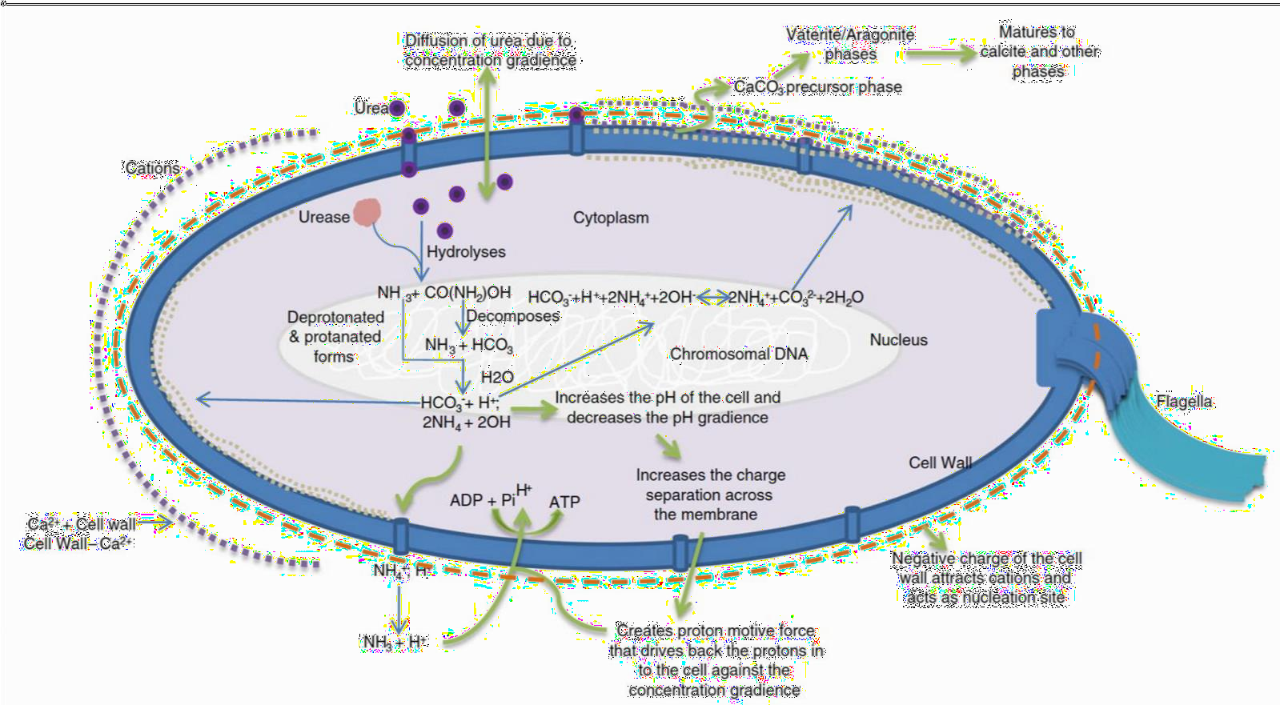

# Figure 1.1: The pathway of secretion and precipitation of bio minerals in bacterial cell (Omoregie *et al.,* 2016)

The bacteria serve as a nucleation site for CaCO3 precipitation in the microenvironment (Sarayu *et al.,* 2014). The precipitation of CaCO3 on the peripheral of the bacterial cell surface often occurs by continual stratification, which makes the cells become entrenched in growing CaCO3 crystals (Sarayu *et al.,* 2014).

# Urease

Both urease and urea (urease substrate) represent an essential milestone in the initial scientific study (Mora and Arioli, 2014). Urease is produced by diverse bacterial species, which includes healthy flora and non-pathogens (Mora and Arioli, 2014). The initial research on microbial urease was related to its relevance in infection (Mora and Arioli, 2014). This interest was strongly stimulated since the discovery of the relationship of

*Helicobacter pylori* with stomach cancer and gastritis (Mora and Arioli, 2014). Mora and Arioli (2014) also reported urease as a virulence factor for some bacteria such as *H. pylori, Staphylococcus saprophyticus* and *Proteus mirabilis.*

# Molecular Characterization of Urease Genes

Microbial ureases are multi-subunit metalloenzymes that hydrolyze urea substrates to form carbonic acid and two molecules of ammonia. The degradation of urea provides ammonium for integration into intracellular metabolites and enables the survival of the microorganism in acidic environments (Omoregie, 2016). The structure of urease was first explained by Jabri *et al.* (1995) showing that ureases may be composed of up to three distinct types of subunits, indicating that all the proteins are closely related. The structural genes that encode the urease subunits, *ureA*, *ureB*, and *ureC* and the accessory proteins necessary for assembly of the urease nickel metallocenter are typically clustered at a single locus (Omoregie, 2016). Diverse patterns of urease expression have been observed in various bacteria (Chu and Wen, 2015). Urease of *Helicobacter pylori* is composed of two subunits, UreA (27 kDa) and UreB (62 kDa), and the subunits form a multimeric enzyme complex with spherical assembly (Pheng *et al.,* 2018).

In *Helicobacter pylori,* ureA and ureB are fused to create the ureA gene, while the ureC gene is labelled as ureB, as shown in Figure 1.2. On the other hand, in *Sporosarcina pasteurii,* the ancestral genes ureA and ureB are not joined together (Figure 1.2). The ureEFGH genes codes for urease accessory proteins, which aid in mediating the proper formation of the complex quaternary structure and also transport nickel ions into the urease enzyme active centre (Mondal and Ghosh, 2019). The ureI gene codes for pH, which regulates the urea channel situated in the cytoplasmic membrane (Omoregie, 2016)

. The ureI and ureA also interact during urea hydrolysis at the cell wall of bacteria, allowing fast diffusion of ammonia and CO2 to occur (Omoregie, 2016).

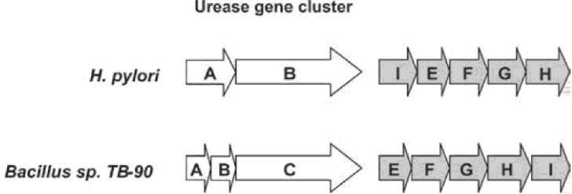

**Figure 1.2: Genetic organisation of urease operon in *Helicobacter pylori* and**

***Sporosarcina pasteurii* (Omoregie, 2016)**.

# Activities of Urease

Urease activity (UA) is the urea hydrolysis activity produced by the enzyme urease per minute (Alhour, 2013). The process of urease production is illustrated in Figure 1.3 (Omoregie, 2016). Enzyme activity regulation is vital for energy efficiency in cell function, however not all enzymes are mandatory, and their production can either be repressed or induced depending on the presence or absence of metabolites (Lee *et al.,* 2018). This type of genetic mechanism is often controlled by the cell at the transcriptional level, where mRNA is produced from the DNA template (Pheng *et al.,* 2018). Enzymes such as urease, controlled at the transcription (inducible/repressible) level are usually inhibited under standard conditions. This helps to converse energy from needless protein synthesis (Lee *et al.,* 2018). The enzyme can be regulated at both the transcriptional or modification levels (Lee *et al.,* 2018). The genetic control is regulated by the microorganism’s cell, where the mRNA codes for the enzyme that is formed from the DNA template (Sarkar *et al.,* 2019).

In *Helicobacter pylori,* the regulation level of enzyme activity by microorganisms involves transcription and translation as shown in Figure 1.3.

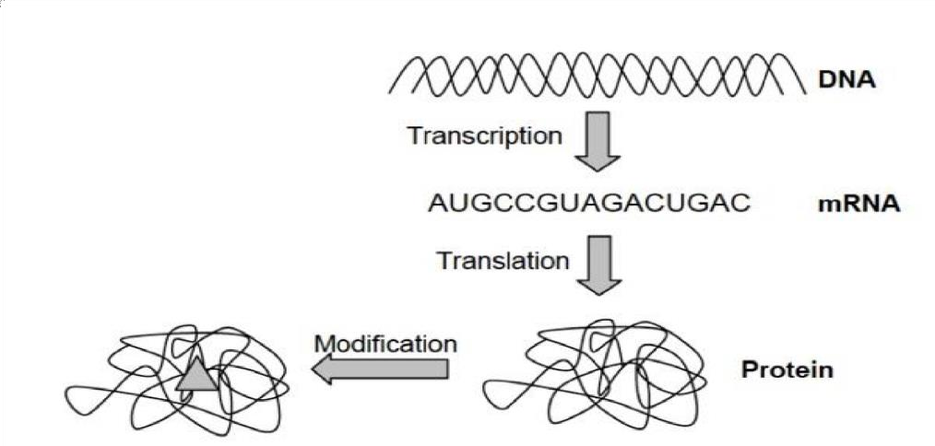

# Figure 1.3: Regulation levels for enzyme activity by microorganisms (Omoregie, 2016)

* + 1. **Source of Urease**

Some bacteria that have been reported to induce CaCO3 precipitates are *Pseudomonas putida*, *Arthrobacter* sp*.*, *Desulfovibrio desulfuricans*, *Phormidium* crobyanum, and *Homoeothrix crustaceans* (Sarayu *et al.,* 2014). Out of the forty-one bacteria, only a few are known to produce urease. Most urease producing bacteria that have been reported to induce CaCO3 precipitates and have been used for MICP applications are of the *Bacillus* genus. Ureolytic bacteria, which have been reported in literature for MICP applications are *Bacillus sphaericus* and *Sporosarcina pasteurii* used for to heal concrete cracks, *Bacillus pseudifirmus* and *Bacillus cohnii* used to treat surfaces of concrete and *Bacillus cereus* and *Shewanella* as cement mortar (Achal *et al*., 2011).

The majority of urease producing bacteria, which have been reported, are mostly from soils and sludge samples. Alhour (2013) reported to have isolated thirty-two ureolytic bacteria (closely related to *Bacillus licheniformis, Bacillus lentus, Bacillus cereus,*

*Pseudomonas antarcticus, Pseudomonas apiaries, Bacillus carboniphilus, Bacillus subtilis, Pseudomonas borealis, Bacillus sporothermodrans, Bacillus lequilensis, Pseudomonas cellulositropicus, Bacillus mycoides, Lysinbacillus sphaericus, Panibacillus barcinonesis, Bacillus isabeliae* and *Bacillus fordii*) from soil, sludge and freshly cut concrete surface samples collected at three locations in Gaza Strip. AlThawadi (2008) reported the isolation three ureolytic bacteria (closely related to *Bacillus aqaarimus* and *Sporosarcina pasteurii*) from activated sludge samples from a wastewater treatment plant collected at different locations in Woodman Point, Perth, Western Australia. Dhami *et al*. (2014) reported they isolated five ureolytic bacteria (closely related to *Bacillus thuringiensis, Bacillus megaterium, Bacillus subtilis*, *Bacillus cereus,* and *Lysinibacillus fusiformis*) from calcareous soil samples collected at Anantapur District, Andhra Pradesh, India.

# Mechanism of Calcium Carbonate Precipitation

Precipitation of calcium carbonate (CaCO3) includes: (i) Nucleation (the formation of new crystals) begins at the point of critical saturation, (ii) The development of supersaturated solution, (iii) Spontaneous crystal growth on the stable nuclei (Alhour, 2013). The CaCO3 precipitation occurs at the surfaces of bacterial cell provided there is an adequate concentration of Ca2+ and CO32− in solution (Figure 1.4) (Anbu *et al.,* 2016). The biochemical reaction that takes place in the urea-CaCl2 medium leads to precipitation of CaCO3.

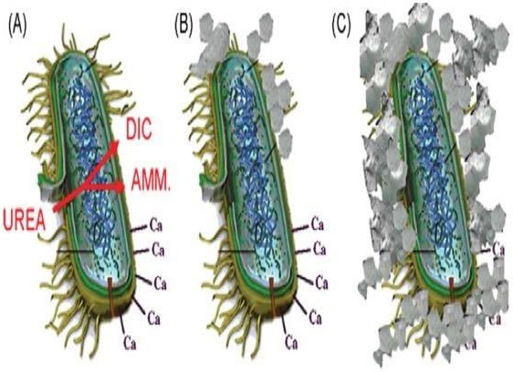

# Figure 1.4: Ureolysis-driven CaCO3 precipitation (De Muynck *et al*., 2010)

1. Bacteria uptake urea and release ammonium (AMM) and dissolved inorganic carbon (DIC), bacterial cells attract calcium ions. (B) A local super-saturation occurs in the presence of Ca2+. This results in CaCO3 precipitation on the bacterial cell wall. (C) The whole-cell is encapsulated.

There are three different stages of CaCO3 precipitated by bacteria. These are: the three anhydrous polymorphs (vaterite, aragonite and calcite); the two hydrated crystalline stages (ikaite, mono-hydrocalcite); and many amorphous stages having different hydration arrays (Gebauer *et al.,* 2010). Both aragonite and mono-hydrocalcite are produced by bacteria (Sánchez-Navas *et al.,* 2009; Gebauer *et al.,* 2010). Kawaguchi and Decho (2002) opined that the proteins secreted by *Bacillus firmus* and *Bacillus sphaericus* are found in the extracellular polymeric substances (EPS), which control the CaCO3 precipitation and selection of aragonite or calcite polymorph. According to Lian *et al*. (2006), the cells and EPS of *Bacillus megaterium* control the precipitation of calcite and vaterite. Likewise, Sarayu *et al.* (2014) reported the precipitation of calcite and vaterite by *Myxococcus* sp. together with other minerals (e.g. sulphate and phosphate). This however depends on the culture medium.

# Factors Affecting the Efficiency of Microbially Induced Calcite Precipitation

Urease activity and the amount of calcite precipitated during the MICP process depends on different environmental factors, such as; cell concentration, pH, temperature and bacterial size (Anbu *et al*., 2016; Dhami *et* al ., 2014 ).

# Concentration of reactants

Calcium ions in bacteria's environment play a significant role in inducing calcite precipitation. The surfaces of microbes are negatively charged. This acts as searchers for cations such as Ca2+ and bind to the cell surfaces in aquatic environments (Sarayu *et al*., 2012). Bicarbonate, which is produced by the bacterial cell, gets released when it combines with the Ca2+ available in the environment to CaCO3 precipitate (Sarayu *et al.,* 2012). Hence, the Ca2+ is supplied either from the medium or from the material to which the bacterium is attached (Anitha *et al.,* 2018). It safeguards the fixation of the surplus toxic calcium in the environment, which enables the bacteria to survive in conditions that are not favourable (Anitha *et al.,* 2018). A reaction between Ca2+ and urea results in calcite formation. However, a solution containing equimolar of 1 mole of calcium chloride and 1 mole of urea provides better conversion to calcite (Rao *et al.,* 2017).

A lower concentration of cementation reagents adds to a satisfactory level of ammonium decomposition, which might enhance microbial activity (Rao *et al.,* 2017). A high concentration of cementation reagents (Ca2+ an urea) extends the precipitation of calcite induced during the MICP process (Rao *et al.,* 2017). It was also confirmed in a study conducted by Lee *et al*. (2018), whereby the weight of soil samples increased when a higher concentration of cementation reagents was added compared to the addition of lower concentration. However, a considerable amount of salinity has an inhibitory effect on microbial activity, urease production, and calcite precipitation, which is mainly

contributed by calcium salts (Lee *et al.,* 2018). In some cases, urease production is still readily available for the MICP process at high salinity. However, the ratio of original calcite precipitated, and abstract calcite composition decreases when there is an increase in reactant concentrations (Lee *et al.,* 2018). Salinity has lower inhibitory effect on moderate halophilic bacteria compare to non-halophilic bacteria (Lee *et al.,* 2018). Several moderate halophilic bacteria were studied for calcite precipitation in the salinity environment (Chaparro-Acuña *et al.,* 2017). Moderate halophilic bacteria are capable of growing at a wide range of salinity. Hence, they should be used for soil treatment during cementation application if the soil environment contains high salinity (Chaparro-Acuña *et al.,* 2017).

# pH

The environmental pH of urease-producing bacteria is one of the essential aspects of the MICP process. The chemical structures of the in vivo fluids, adjacent to the sites of the mineral formation is directly influenced by the understanding of bio-mineralization processes (Soon *et al*., 2012). The pH of the environment regulates the existence and the metabolic activities of the microorganisms and indirectly controls the discharge of the products (Soon *et al.,* 2012). High pH conditions favours the formation of CO32– from HCO3– that is central to calcification of the produced bicarbonate (Dhami *et al.,* 2017).

# Temperature

Enzymatic reactions, such as urea hydrolysis by urease, are dependent on temperature (Anbu *et al* ., 2016). The optimum temperature which favours urease hydrolysis ranges between 20 to 37 oC (Okwadha and Li, 2010 ). However, enzymatic reactions for optimum production are influenced by environmental conditions and the concentration of reactants in the system (Anbu *et al.*, 2016).

# Dissolved inorganic carbon

The presence of inorganic carbon in the environment constitute a significant role in the MICP process (Jian *et al.,* 2012). Dissolved inorganic carbon (H2CO3 + HCO3−+ CO 2−) is a significant product of microbial respiration, which affects microbial activities and its alkalinity (Jian *et al.,* 2012). The dissolved inorganic carbon released from the extracellular polymeric substances of the microorganisms forms a complex with the Ca2+, thereby reducing CaCO3 saturation, and increasing the calcite precipitation (Jian *et al.,* 2012). A study on stimulation of ureolytic MICP in natural soils, reported that interaction between ureolytic and non-ureolytic bacteria was affected during ureolysis. The findings showed an increase in dissolved inorganic carbon concentration when ureolytic and nonureolytic bacteria were co-cultured. This result was supported by a recent study by Omoregie *et al.* (2017) on calcite precipitates using co-culture of ureolytic and non- ureolytic bacteria, namely, *Sporosarcina pasteurii*, DSMZ33 and *Bacillus subtilis*, DSMZ 6397. Their experiment showed that dissolved inorganic carbon concentrations were affected by three processes namely: (i) hydrolysis of urea to produce bicarbonate,

3

(ii) bacterial respiration and mineralization of the NB by ureolytic and non-ureolytic bacteria to produce dissolved CO2, and (iii) precipitation of CaCO3, which led to reduction in the concentration of dissolved inorganic carbon (Omoregie *et al.,* 2017). The decrease in dissolved calcium concentration observed in this experiment may be attributed to the precipitation of CaCO3.

# Bacteria size

The type of bacteria appropriate for the MICP application should be able to catalyst the urea hydrolysis, and they are usually urease positive bacteria (Soon *et al*., 2012). The typical urease positive bacteria used for MICP are aerobic, are often selected for the MICP process because of their ability to release CO2, which is essential for the rise in pH due to the production of ammonium when urea is being broken down (Soon *et al*., 2012 ). Bacterial sizes found in soil range from 0.5 to 3.0 μm. Microbes can move along soil particles through a self-propelled manner or *via* passive diffusion (Soon *et al*., 2012). The compatibility of urease producing bacteria with respect to geometry, is important whenever the movement of bacteria within the soil is required for soil treatment, and small pore size may limit their free passage, depending on soil composition and the size of microbes (Phang *et al.,* 2018). A substantial quantity of clay and silt in the ground may have inhibitory effects on the movement of bacteria (Phang *et al.,* 2018). Therefore it is imperative to select appropriate soil and bacteria for MICP treatment (Phang *et al.,* 2018).

# Nutrients

Nutrients provide a source of energy for bacteria. When adequate nutrient is present, the ureolytic bacteria is critical for precipitation of calcite (Cheng *et al.,* 2019). Nutrients are often supplied to the bacteria during soil treatment and culturing (Cheng *et al.,* 2019). The most common nutrients usually provided to bacterial include Potassium, Sodium, Nitrogen, Calcium, Iron, and Magnesium (Cheng *et al.,* 2019). The unavailability of organic constituents in soil limits bacterial growth, hence the supply of sufficient nutrient to soil containing ureolytic bacteria can promote bacterial growth, which can enhance calcite precipitation required in achieving the desired level of ground improvement (Naeimi *et al.*, 2016).

# Availability of nucleation site

A nucleation site is isolated from the environment by limiting the diffusion in and out of the system and restricting geometry. This ensures electro-neutrality and enables the modification of the activity of ions (Naeimi *et al.*, 2016). The movement of ion is facilitated by active pumping with organelles or through passive diffusion. This allows the microbes use a variety of anatomical arrangements (Naeimi *et al.*, 2016). The biofilm and the EPS, formed by the microbes play an important role in binding ions from the environment and also act as a heterogeneous nucleation site for deposition of minerals (Naeimi *et al.*, 2016). The formation of a robust electrostatic affinity to attract cations and facilitates the accumulation of Ca2+ on the surface of the cell wall and allows the achievement of a sufficient super saturation state of Ca2+, thereby binding it to the carbonate ions and resulting in the formation of CaCO3 on the cell wall (Chu, 2016). This mechanism favours the growth of bacteria and by reducing toxic Ca2+ in the environment (Chu, 2016).

Higher bacterial cell concentration (106 to 108) supplied to soil samples would undoubtedly raise the level of calcite precipitated from the process of MICP (Okwadha and Li, 2010). The rate of urea hydrolysis is directly proportional to the concentration of bacteria cells, as long as there will be sufficient reagent available for the bio cement treatment of sand (Burbank *et al.,* 2012). A high bacteria concentration produces more urease per unit volume to commence the urea hydrolysis (Burbank *et al.,* 2012).

The presence of nucleation sites serves as one of the critical factors for microbial calcite precipitation (Jian *et al.,* 2012). Jian *et al*. (2012) carried out a study using scanning electron micrographs and reported that nucleation of calcite takes place at the cell wall of *Bacillus megaterium.*

# Current Biotechnological Application of Microbially Induced Calcite Precipitation

The MICP is highly desirable process due to its natural availability and lower pollutant production (Al-Thawadi, 2008). The MICP is an effective and environmentally friendly process that can be applied to solve various environmental problems that includes concrete crack and soil instability (Varalakshmi and Devi, 2014). Some of the biological applications of MICP are discussed in the following sections:

# Bio-cementation

Bio-cement is a novel method for strengthening loose sands to yield structural materials, comprising alkaliphilic urease producing bacteria, urea, a source of Ca2+, and sand (Achal *et al*., 2015). A typical set-up for sand consolidation experiment to develop bio- cementation was simplified by Reddy and Joshi (2018) where sand was either mixed with bacterial culture or later injected directly into the sand columns. The sand was plugged through a plastic column, and the cementation fluid that comprises nutrient media, urea, and Ca2+. These were then injected at a particular rate in the column using gravimetric free flow direction. Another study on calcite deposition in sand columns using *Sporosarcina pasteurii* by Omoregie *et al.* (2016) discovered that 40 % of calcite deposited in the sandstone led to a reduction of porosity and permeability in the sandstone. A study by Tiwari *et al.* (2014) on a sand column of a size of 18.40 and 32.10 mm showed the precise amount of compressive strength, measured up to 2 MPa when CaCl2 was used as a calcium source for bio-sandstone. The MICP substance in the bio-sandstone was confirmed using energy dispersion spectroscopy (EDS), x-ray diffraction (XRD) and calcite, which was precipitated in the sandstone as the primary microbial induced

substance in the bio-sandstone (Anitha *et al.,* 2018). The outcome of the MICP process on bio-sandstone led researchers to investigate this building material (Achal *et al*., 2015).

# Creation of biological mortars

The knowledge obtained with MICP treatments resulted in the development of biological mortar for remediation of small cavities on limestone surfaces (Burbank *et al.,* 2012). The purpose of using initiating biological mortars was to avoid some of the problems related to chemical and physical incompatibilities of commonly used mortars with the underlying materials, specifically in the case of brittle materials (Burbank *et al.,* 2012). The resistance of mortar specimens and surface deposition to the degradation process can be improved via microbial calcite precipitation (Omoregie *et al.,* 2018; Phang *et al.,* 2018). An in situ application of bacteria based ureolytic bacterial culture used to repair a system on cracked parking deck is illustrated in Figure 1.5

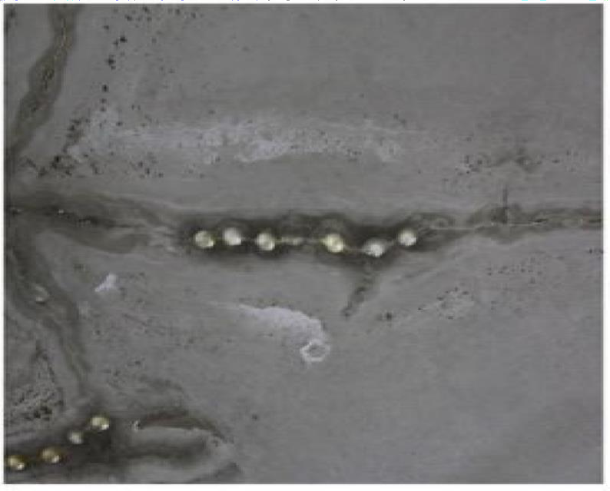

# Figure 1.5: An *in situ* application of bacteria based liquid (Anitha *et al.*, 2018).

* + 1. **Bioremediation of cracks in concrete**

In concrete, cracking is common due to relatively low tensile strength (Anitha *et al.*, 2018). Several mechanisms, such as shrinkage, freeze-thaw reactions, and mechanical compressive and tensile forces, lead to the formation of cracks (Alhour, 2013). Cracking on concrete surfaces often results in the deterioration of embedded steel through ingress of ions and moisture that react with reinforcements in concrete and expansive stressed that leads to spalling (Varalakshmi and Devi, 2014). Thus, it is worthwhile to use adhesives for concrete cracks sealing so as to improve the strength and stability of concretes (Varalakshmi and Devi, 2014). A conventional approach used in repairing cracks involves injecting cement grout or epoxy resin into the concrete. However, they often result in several thermal expansion, environmental, and health safety hazards (Varalakshmi and Devi, 2014). In Figure 1.6, Omoriege (2016) reported self-healed cracks using MICP. Ureolytic bacterial culture was able to produce minerals, which helped to repair and cover the cracks (Omoriege, 2016).

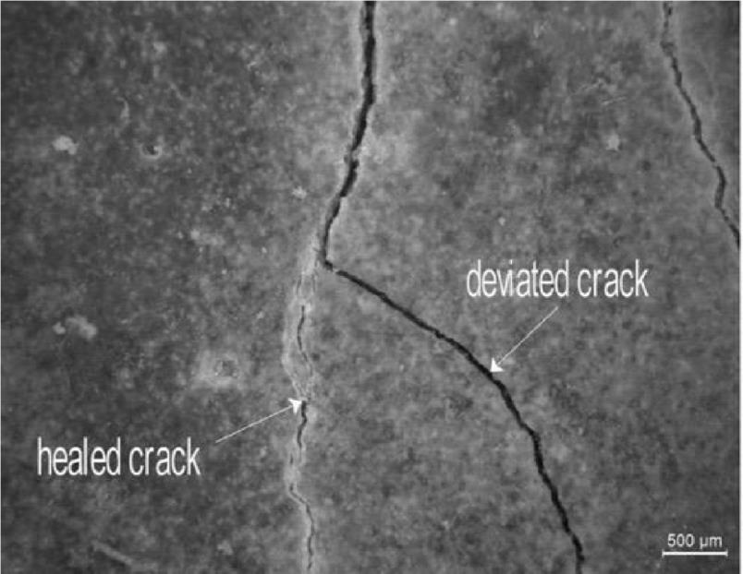

# Figure 1.6: Self-healing crack from the addition of bacterial metabolism *via* urea hydrolysis (Omoriege, 2016).

Omoregie *et al.* (2018) reported the use of MICP as an alternative repair method for concrete cracks *via* bioremediation. Investigations have been made on the potential of using bacteria as a self-healing agent in concrete so as to fix a crack. Specifically, with the use of alkali-resistant spore-forming *Bacillus pseudofirmus* (type strain DSM 8715), and *Bacillus cohnii* (type strain DSM 6307) (Tiwari *et al.,* 2014; Chaparro-Acuña *et al.,* 2017).

# Bio-deposition on cementitious materials

The emergence of the involvement of microorganisms in the precipitation of carbonate has brought about the consideration of this process in a variety of fields, including environmental, civil and geotechnical engineering (Chaparro-Acuña *et al.,* 2017). Among these applications, MICP has been used for biogenic-carbonate-based surface treatments, a process known as Bio-deposition and this is shown in Figure 1.7.

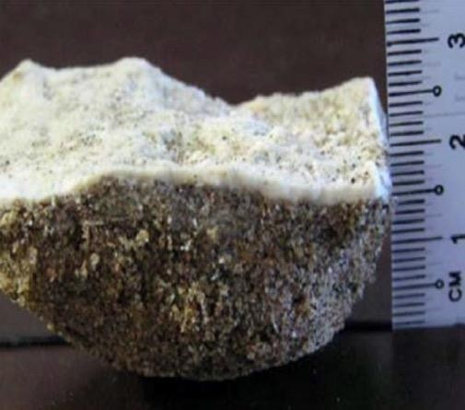

# Figure 1.7: 1mm thick calcite crust formed on the surface of the soil(Noshi and Schubert, 2018).

Bio-deposition of bacterial calcite is a practicable method of surface treatment for cement-based materials that can be applied sustainably (Noshi and Schubert, 2018). If the

size of bacterial cells is around 1 µm, both the cells and their media containing the reactants (urea and calcium ions) can infiltrate into the pores and interface between aggregates or paste of the concrete structure (Noshi and Schubert, 2018). Hence, this allows microbial cementation to take place on the surface of and within such materials, which then provides reinforcement and protection (Wong *et al*., 2015).

A study by De-muynck *et al*. (2010) using ureolytic Bio-deposition treatment was applied to five types of lime stones to investigate the effect of pore structure on the protective performance of biogenic carbonate surface treatment. Their findings showed that in macro porous stone, biogenic carbonate formation occurred to a more significant extent and greater depths than in micro porous stone. Hence, exhibiting a higher protective performance on macro porous stone compared to micro porous stones. Precipitation on micro porous stones was limited to the outer surface of a micro porous rock. From this study, it was clear that Bio-deposition was very useful and more feasible for macro porous stones than for micro porous stones (Raijiwala and Dalai, 2017). Another study by Rajiwala and Dalai (2017) on the remediation technique of cracked concrete by bacterially mediated carbonate deposition showed that bio-deposition was able to improve concrete compressive strength and flexural load using *Sporosarcina pasteurii.* Their findings concluded that this could be used to enhance the strength and flexural load of a faulty concrete specimen.

# Bio grout

Chu (2016) described the application of urease to fortify a porous medium. The report revealed success in reduction of the permeability of porous medium by enzymatic CaCO3 precipitation using *Canavalia ensiformis*. Skinner and Ehrlich (2013) used between 0.1 and 1.0 M (>33 g.L-1) calcite having a high urease activity for a successful plugging of

the sand core. However, they failed to monitor the strength build-up. Stocks-Fischer *et al.* (1999) reported that injection of bacteria and reagents together at low flow rates may result in full clogging of the system near the injection point. An investigation on Bio grout ground improvement using MICP was also performed by Skinner and Ehrlich (2013).

This study was successful in developing an unprecedented 100 m3 field-scale experiment and 40 m3 of the sand were treated using the MICP process within 12 days with *Sporosarcina pasteurii* cell and cementation solution (Al-Thawadi, 2008; Raijiwala and Dalai, 2017). Although in both scale-up experiments, significant increase of the average strength was obtained and different variable mechanical properties were observed in the sand. It could be affected by the induced flow field, bacteria distribution, the supply of reagents, and the crystallization process (Skinner and Ehrlich, 2013). Another study by Skinner and Ehrlich (2013) investigated the potential of using bio grouting as an alternative approach to jet grouting to seal the contact between sheet pilling and bedrock. Their finding showed that the bio grouting process was cheaper than jet grouting and had a much lower environmental impact. Bio grouting also consumed less water and produced less landfilled waste.

# Removal of calcium ions

Some industries face a huge problem due to the discharge of wastewater rich in calcium. This is due to calcification during downstream processing (Verma *et al.,* 2015). A high concentration of calcium ions ranging from 500-1500 mg.L-1 in wastewater can cause substantial scaling in pipelines and reactors as a result of calcium formation as phosphate, carbonate, and gypsum (Dhami *et al.,* 2017). A novel application for the process of MICP as an alternative mechanism for the potential removal of Ca2+ from industrial wastewater instead of a chemical precipitation approach was developed by Al-Thawadi (2008). MICP

process facilitated the removal of soluble calcium from calcium-rich industrial wastewater via a urea hydrolysis pathway, mediated by autochthonous bacteria. The removal of more than 90 % calcium was achieved throughout the experimental period, while the effluent pH of the wastewater remained at a reasonable level (Voicu *et al.,* 2016). A study by Voicu *et al.* (2016) showed that hydraulic retention time required an optimum condition of 5-6 hour to hydrolyze calcium successfully from industrial water using MICP in a bio catalytic calcification reactor.

# Removal of polychlorinated biphenyls

Polychlorinated biphenyls (PCBs) are a recalcitrant contaminant that surfaces on concrete when PCBs contain oil leaks from the equipment (Voicu *et al.,* 2016). The past decades have witnessed an increase in the use of bioremediation for the removal of contaminants, which includes PCBs (Dhami *et al.,* 2017). The conventional method previously used to remove PCBs such as solvent washing, hydro-blasting, and epoxy coating has been less effective due to the resurfacing of the oil over some time. The microbial process using the MICP process has been initiated as an alternative measure to remove PCBs (Dhami *et al.,* 2017). Okwadha and Li (2010) reported the use of *Sporosarcina pasteurii* for the possible treatment of PCB-coated cement cylinders leading to surficial encapsulation of PCB-containing oils. A study by Okwadha and Li (2011) stated that when *Sporosarcina pasteurii* containing urea and calcium ions were applied on the surficial PCB-containing oil, there was no observation of leaching and there was a reduction of permeability by 1- 5 orders of magnitude.

# Production of industrial by-products

Construction materials such as concrete, brick, and pavement blocks are all made from natural resources. Their production has affected our environment as a result of continuous

exploration of limited natural resources. It has led researchers to explore other means of building materials that are environmentally friendly, affordable, and sustainable (He *et al.,* 2018) . There are different types of waste, such as slag, fly ash, wheat straw, saw milk waste, cotton stalk, mining waste tailing, and waste gypsum, which are currently being recycled for potential utilization (He *et al.,* 2018). The production of fly ashes during coal combustion for energy is one of industrial by-products recognized as an environmental pollutant (Dhami *et al.,* 2017). Ash produced from rice husk is another major agricultural by-product (Dhami *et al.,* 2017). These materials can be applied as blocks and bricks without any form of reduction in the quality of the construction materials (Li *et al.,* 2017). Despite the problems associated with ash bricks such as high water adsorption, low strength, and low resistance to abrasion, Dhami *et al.* (2014) investigated the application of bacterial calcite on fly ash and rice rush ash bricks and reported they were very efficient in decreasing water absorption and reducing permeability, which leads to improved durability of ash bricks.

# Production of low energy building materials

The construction sector is responsible for the primary input of energy resulting in the release of CO2 into the atmosphere (Reddy and Joshi, 2018). Hence, it is essential to reduce the emission of these gases released into the air (Skinner and Ehrlich, 2013). The requirements of energy for processing and producing different building materials and various effects on the environment have been previously studied (Skinner and Ehrlich, 2013). Reddy and Joshi (2018) reported that soil blocks containing 6–8 % of cement content uses the moving energy-efficient building materials. These materials have low production costs, are easily recyclable and environmentally friendly as the soils are mixed with additives such as lime (Skinner and Ehrlich, 2013). These building materials do not make use of burning during its production, and these stable mud blocks were able to

converse much energy (Abinaya, 2011). Building materials using low energy by application of ureolytic *Bacillus* sp. have successfully been performed by Dhami *et al.* (2014), which showed the potential of using MICP technology to produce sustainable, cheap, and durable buildings.

# Determining Strength of Concrete

* + 1. **Compressive strength test**

Compressive strength is the capacity of material or structure to resist or withstand compression. Compressive strength resists compression (being pushed together). Especially for concrete, compressive strength is an important parameter to determine the performance of the material during service conditions. Compressive strength of concrete is measured by breaking cylindrical or cubes concrete specimens in a compression testing machine. It is calculated from the failure load divided by the cross-sectional area resisting the load usually after days (7, 14, and 28) of curing. The concrete’s strength is measured by the amount of cement, water coarse and fine aggregates, and various admixtures. However, the principal factor for determining the strength of concrete is the ratio of the water to cement. Thus, the higher the water-cement ratio, the lower the compressive strength and vice versa. Capacity of concrete is reported in units of pound-force per square inch (psi) in US units and Mega Pascals (MPa) in SI units megapascals is a unit of pressure representing one million Pascal’s, and a Pascal is equivalent to one newton of force applied to one square meter of area (1Pa =1N/m2). Concrete compressive strength can vary from 2500 psi (17 MPa) for residential concrete to 4000 psi (28 MPa) and higher in commercial structures. Some applications use higher strengths greater than 10,000 psi (70 MPa) (National Ready Mixed Concrete Association (NRMCA), 2014). Compressive strength results are used to ensure that the concrete mixture as delivered meets the requirements of the specified strengths in the job specification. The compressive strength

of concrete in countries like India, Britain and Europe is determined by analysing concrete cubes denoted as characteristic compressive strength while in American standards, cylinder strengths are used in reinforced concrete (RC) and prestressed concrete (PSC) design. It is achieved by testing concrete cylinder specimen. Though, empirical formulas can be used to convert cube strength to cylinder strength and vice-versa (NRMCA, 2014).

* 1. ***Lysinibacillus fusiformis***

*Lysinibacillus fusiformis* is a Gram-positive, rod-shaped bacterium of the genus *Lysinibacillus* (Josic *et al.,* 2009). The complete characterization of *L. fusiformis* is yet to be carried out, especially as it relates to its pathogenic nature. However, several genome sequencing projects for various strains of *L. fusiformis* are currently underway (Ahmad *et al.,* 2009). *Lysinibacillus* has the following characteristics:

Domain: Bacteria Kingdom: Eubacteria Phylum: Firmicutes Class: Bacilli

Order: Bacillales Family: Bacillaceae Genus: *Lysinibacillus* Species: *fusiformis*

Binomial name: *Lysinibacillus fusiformis*

* + 1. **Morphology of *Lysinibacillus fusiformis***

*Lysinibacillus fusiformis* is rod-shaped and non-motile. Active cells are 2.5-3.0 µm in length, 0.5-0.9 µm in width. They produce endospores that are resistant to chemicals, ultraviolet light and high temperature. The endospores are located terminally or centrally or within the enlarged sporangia and can remain active for long periods of time (Ahmad *et al.,* 2009).

* + 1. **Physiology of *Lysinibacillus fusiformis***

*Lysinibacillus fusiformis* is an obligate aerobe that is positive to oxidase and catalase tests. It uses oxygen to metabolise simple carbohydrates but is unable to metabolise polysaccharides such as starch. The organism does not does not reduce nitrate to nitrite, or produce gas or acid from the metabolism of carbohydrates. *Lysinibacillus fusiformis* can hydrolyse casein and gelatin and can utilize acetate, citrate, succinate, formate and lactate, as carbon sources. *Lysinibacillus fusiformis* is tolerant to heavy metal, Ahmed *et al.* (2009) reported that it has a boron tolerance of about 150 Mm and can also tolerate 5 % sodium chloride. Its cell wall peptidoglycan contains lysine, alanine, glutamic acid and aspartic acid in the molar ratio of 1.81: 1.0: 0.69:0.64 as diagnostic amino acids. Its major polar lipids are diphosphatidylglycerol, phosphatidylglycerol, ninhydrin positive phosphoglycolipid and Comparative analysis of the 16S rRNA gene sequence demonstrated that isolated *Lysinibacillus fusiformis* strains were closely related to *Bacillus fusiformis* DSM 2898T (97.2 % similarity) and *Bacillus sphaericus* DSM 28T (96.9 %) (Josic *et al*., 2009).

# CHAPTER THREE

**3.0 MATERIALS AND METHODS**

# 3.1. Samples Collection

Sterile sample collection bottles were used in the collection of cement samples sold from a cement depot in Bosso Market (Bosso Local Government Area, Minna, Niger State, Nigeria).The sample site lies between 9º38ʼ47.5ˮN 6º32ʼ39.7ˮE ( decimal degrees 9.646517, 6.544362). They were transported to the Department of Microbiology Laboratory, Federal University of Technology, Minna for further analysis.

# Media Preparation

* + 1. **Preparation of nutrient agar**

Nutrient agar (NA) was prepared in accordance with the manufacturer's instruction. Analytical balance was used to weigh 2.8 g of powdered NA into 250 mL conical. Hundred millimeters (100 mL) of distilled water was used to dissolve the powdered NA which was preheated using a heating mantle before sterilizing in the autoclave at 121 °C for 15 minutes, it was allowed to cool before dispensing into petri plates to be used.

# Preparation of urea agar base media

Urea Agar Base media was prepared according to manufacturer’s instruction. Analytical balance was used to weigh 2.1 g of the media which was dissolved into 90 mL of distilled water and preheated using the heating mantle before sterilizing using the autoclave at 121 °C for 15 minutes. Urea solution was not added into the urea agar base during sterilization as heat converts urea to ammonia which is toxic to microbial growth. Four grams (4 g) of urea was weighed and dissolved into 10 mL of sterile distilled water. After sterilizing the urea agar base media, it was allowed to cool before adding the dissolved

urea solution aseptically using a sterile filter paper and mixed gently before dispensing into the Petri dishes and was allowed to gel before used.

# Preparation of starch agar medium

Starch agar media was prepared by weighing 1 g of soluble starch and dispensing it into 100 mL of nutrient agar followed by preheating on a heating mantle in other for the soluble starch and nutrient agar to mix evenly. The media was then sterilized using the autoclave at 121 °C for 15 minutes. The media were then allowed to cool before dispensing it into Petri dishes and allowed to gel before used.

# Preparation of SIM (Sulphide Indole Motility) medium

Sulphide indole motility (SIM) medium was prepared by weighing pancreatic digest of casein 20.0 g/L, peptic digest of animal tissue 6.1 g/L, agar agar 3.5 g/L, ammonium iron

(II) sulphate hexahydrate (Fe(NH4)2(SO4)2.6H2O 0.2 g/L), and sodium thiosulfate (Na2S2O3·5H2O 0.2 g/L).

# Sample Enrichment and Isolation of Bacteria

The enrichment of cement sample for isolation of urease producing bacteria was carried out as reported by Achal *et al*. (2010). One gram of the cement sample was inoculated aseptically into 50 mL of nutrient broth containing 2 % urea. The pH of the medium was adjusted to 8.0 using Sodium hydroxide and then incubated at 37 °C for 120 hours in a shaker incubator of 130 rpm, model SI500 (Stuart).

# Isolation and Screening of Bacteria

For the bacteria isolation, 9 mL of sterile distilled water was prepared into 3 test tubes and labelled 10-1, 10-2 and 10-3. Three-fold (1:3) serial dilution was carried out, where 1

mL of the cultured broth was aseptically transferred into test tube labelled 10-1 containing 9 mL of sterile distilled water. The cap was covered and the mixture was mixed gently before aseptically withdrawing 1 mL from it and dispensing into a second test tube labelled 10-2, same procedure was repeated for test tube labelled 10-3 and 1 mL from the third test tube was withdrawn and discarded. One milliliter (1 mL) was aseptically withdrawn from test tube containing the dilution factor of 101 and was dispensed into the first Petri dish labelled 10-1. Same was done for test tube labelled 102 into Petri dish labelled 10-2. Fifteen milliliters (15 mL) of molten nutrient agar was aseptically dispensed into Petri dish containing 1 mL of the inoculum and was gently swirl clockwise and anticlockwise to ensure homogeneous mixture. Same procedure was done for the Petri dish containing 1 mL of inoculum of 10-2 dilution factor, which was allowed to gel and incubated in the incubator at 37 °C for 24 hours in an inverted position.

# Screening for Urease Producing Bacteria

Urea agar base media was used to screen for isolates that were able to produce urease. The isolates were aseptically streaked onto urea agar base media and incubated at 37 °C for 24 hours. After incubation period, isolates were observed for urease production. A change in the agar medium to pink indicated hydrolysis of urea by urease enzyme.

# Confirmatory test for Urease Production

Confirmatory test was carried out to ensure that the isolates are urease producers. The isolates were aseptically streaked onto urea agar base media and incubated at 37 °C for 24 hours. After incubation period, isolates were observed for urease production. A change in the agar medium to pink indicated hydrolysis of urea by urease enzyme. After incubation, two colonies that were of interest were stored in a nutrient agar slants for further characterization and confirmation. The isolates were aseptically inoculated into a

prepared broth culture composed of nutrient broth and urea which was incubated in a shaker incubator at 37 ℃ for 120 hours.

# Characterization and Identification of Bacterial Isolate

Gram staining and biochemical tests were carried out on the isolates. Characterization of isolates was carried out based on their morphology, motility, catalase, citrate, starch hydrolysis, nitrate reduction, oxidase, gelatin and sugar fermentation tests. These were performed using standard method as described by Cowan and Steel (2002); Cheesebrough (2006).

# Gram staining

Using a sterile wire loop, a loop full of water was placed on a clean, grease free slide. The wire loop was flamed using the Bunsen burner before picking the inoculum and smeared on the slide. A thin smear was made in other to enhance viewing under the microscope as thick smear prevents ascertaining if a cultured plate is pure or not. The slides were air dried before heat fixing by passing it 2-3 times over the flame. The slides were placed over a staining rack and crystal violet ( a primary stain) was applied on the slides and allowed to stay for 60 seconds, which was then flooded with running water. Lugol's iodine (a mordant) was applied on the slides and allowed to stay for 60 seconds before flooding with water. Alcohol (95 %) was applied on the slides and allowed for 5-8 seconds in other to decolorize the crystal violet-iodine complex formed. Safranin (a secondary stain) was applied and allowed for 60 seconds before flooding with water. The slides were allowed to dry before adding immersion oil and the slides were viewed using the microscope at × 100 objective (Cheesebrough, 2006).

# Catalase test

It was performed by placing 2 drops of 3 % hydrogen peroxide (H2O2) on a clean grease free slide. The isolates were smeared on the H2O2 using a sterile glass rod and production of bubbles was observed within first 10 seconds. Production of bubbles indicates the microorganism was positive to catalase test (Cheesebrough, 2006).

# Oxidase test

This was performed by impregnating filter paper with oxidase reagent (tetramethyl-p- phenylenediamine) after which the test isolates which were 24 hours old were picked using a sterile glass rod and smeared on the filter paper. Positive to oxidase test was indicated by purple/blue coloration within 10-15 seconds (Cowan and Steel, 2002).

# Citrate test

Simon's citrate agar (SCA) slants were used in carrying out this test. The sterilized media was inoculated with test isolates by stabbing through the slants using a sterile straight wire and incubated in the incubator at 37 °C for 24 hours. The color of the media was observed for colour change. Citrate positive was indicated by blue colouration and negative retained the initial green colour (Cheesebrough, 2006).

# Hydrogen sulphide production test

Triple sugar iron (TSI) agar was used in performing this test. The test isolates were inoculated into the TSI agar slants by stabbing using a sterile straight wire and incubated at 37 °C for 24 hours. Production of black color indicates the production of hydrogen sulphide (Cheesebrough, 2006).

# Starch hydrolysis test

Sterilized nutrient agar containing soluble starch was inoculated with test isolates by aseptically streaking on the gelled surface of the agar medium using a sterile wire loop after which the plates were incubated at 37 °C for 24 hours. Lugol's iodine was used to flood the plates and the excess was poured out of the Petri dish and observed for color formation and zone of clearance within the streaked line. A positive result was indicated by zones of clearance within the streaked line (Cowan and Steel, 2002).

# Indole test

Test isolates were inoculated into sterilized peptone water using a wire loop aseptically. The test tubes were incubated at 37 °C for 48 hours. After incubation period, 0.5 mL of Kovac's reagent was added to the cultured broth and allowed to stand for 15 minutes. Formation of indole ring at the top of the broth indicates positive whereas no indole ring formation indicates negative (Cowan and Steel, 2002).

# Methyl red test

Methyl red - Voges Proskauer (MR-VP) broth was used for MR test. The test isolates were inoculated into a sterilized MR-VP broth aseptically using a sterile wire loop and incubated at 37 °C for 4 days with their caps loosely on. After the incubation period, 0.5 mL of methyl red was added into the culture broth and shaken gently which was then allowed to stand for 15 minutes. Red coloration indicates positive to methyl red whereas no color change indicates negative to methyl red test (Cheesebrough, 2006).

# Voges Proskauer test

Similar to Methyl red test, MR-VP broth was used for this test. The sterilized MR-VP broth was inoculated with the test isolates aseptically using a sterile wire loop which was then incubated at 37 °C for 4 days after which 0.6 mL of Barit’s reagent was added into the cultured broth and allowed to stand for 15 minutes. Production of red coloration after 15 minutes indicates positive to VP test whereas no Colour change indicates negative (Cheesebrough, 2006).

# Molecular Identification of the Bacterial Isolate

The bacterial isolates were sent for molecular identification of the organisms. Procedures for DNA extraction, polymerase Chain Reaction (PCR) amplification technique, extracted DNA integrity test, methods for purification and sequencing of the extracted DNA was carried out following method described by Frank *et al*. (2008).

# DNA extraction

DNA was extracted using the protocol stated by Trindade *et al.* (2007). Briefly, Single colonies grown on medium were transferred to 1.5 mL of liquid medium and cultures were grown on a shaker at 28 ºC for 48 hours. After this period, cultures were centrifuged at 4600 g for 5 minute. The resulting pellets were resuspended in 520 μL of TE buffer (10 mM Tris-HCl, 1 mM EDTA, pH 8.0). Fifteen microliters of 20 % SDS and 3 μL of Proteinase K (20 mg/ml) were then added. The mixture was incubated at 37 ºC for 1 hour, then 100 μL of 5 M NaCl and 80 μL of a 10 % CTAB solution in 0.7 M sodium chloride (NaCl ) were added and votexed. The suspension was incubated at 65 ℃ for 10 minutes and kept on ice for 15 minutes. An equal volume of chloroform: isoamyl alcohol (24:1) was added, followed by incubation on ice for 5 minutes and centrifugation at 7200

g for 20 minutes. The aqueous phase was then transferred to a new tube and isopropanol (1: 0.6) was added and DNA precipitated at –20 ºC for 16 hours. DNA was collected by centrifugation at 13000 g for 10 minutes, washed with 500 μL of 70 % ethanol, air-dried at room temperature 28 ºC ±2 for approximately three hours and finally dissolved in 50 μL of TE buffer.

# Polymerase chain reaction

PCR sequencing preparation cocktail consisted of 10 µL of 5x GoTaq colourless reaction, 3 µL of 25 mM MgCl2, 1 µL of 10 mM of dNTPs mix, 1 µL of 10 pmol each 27F 5’- AGA GTT TGA TCM TGG CTC AG-3’ and - 1525R, 5′-AAGGAGGTGATCCAGCC-

3′ primers and 0.3 units of Taq DNA polymerase (Promega, USA) made up to 42 µL with sterile distilled water 8 μL DNA template. PCR was carried out in a GeneAmp 9700 PCR System Thermocycler (Applied Biosystem Inc., USA) with a PCR profile consisting of an initial denaturation at 94 °C for 5 minutes; followed by a 30 cycles consisting of 94 °C for 30 seconds, 50 °C for 60 seconds and 72°C for 1 minutes 30 seconds; and a final termination at 72°C for 10 minutes, and chill at 4 oC GEL (Wawrik *et al.*, 2005; Frank *et al.,* 2008).

# Integrity check of amplified products

The integrity of the amplified about 1.5 Mb gene fragment was checked on a 1 % agarose gel ran to confirm amplification. The buffer (1XTAE buffer) was prepared and subsequently used to prepare 1 % agarose gel. The suspension was boiled in a microwave for 5 minutes. The molten agarose was allowed to cool to 60 °C and stained with 3 µL of

0.5 g/mL ethidium bromide (which absorbs invisible UV light and transmits the energy as visible orange light). A comb was inserted into the slots of the casting tray and the molten agarose was poured into the tray. The gel was allowed to solidify for 20 minutes

to form the wells. The 1 X TAE buffer was poured into the gel tank to barely submerge the gel. Two microliter (2 L) of 10 × blue gel loading dye (which gives colour and density to the samples to make it easy to load into the wells and monitor the progress of the gel) was added to 4µL of each PCR product and loaded into the wells after the 100 bp DNA ladder was loaded into well 1. The gel was electrophoresed at 120 V for 45 minutes visualized by ultraviolet trans-illumination and photographed. The sizes of the PCR products were estimated by comparison with the mobility of a 100 bp molecular weight ladder that was ran alongside experimental samples in the gel.

# Purification of the amplified product

The amplified fragments were ethanol purified in order to remove the PCR reagents. Briefly, 7.6 µL of Na acetate 3 M and 240 µL of 95 % ethanol were added to each about 40 µL PCR amplified product in a new sterile 1.5 µL tube eppendorf, mixed thoroughly by vortexing and kept at -20 °C for at least 30 minutes. Centrifugation was done for 10 minutes at 13000 g and 4 °C followed by removal of supernatant (invert tube on trash once) after which the pellet were washed by adding 150 µL of 70 % ethanol and mix then centrifuge for 15 minutes at 7500 g and 4 °C. supernatant were removed and tubes on trash were inverted on paper tissue and allowed to dry in the fume hood at room temperature for 10-15 minutes then resuspended with 20 µL of sterile distilled water and kept at -20 ℃ prior to sequencing. The purified fragment was checked on a 1.5 % agarose gel ran on a voltage of 110 V for about 1 hour as previous, to confirm the presence of the purified product and quantified using a nanodrop 2000 (Thermoscientific, USA).

# Sequence analysis

The amplified fragments were sequenced using a Genetic Analyzer 3130 × l sequencer from Applied Bio systems (inc., USA) using manufacturers manual while the sequencing

kit used was that of Big Dye terminator v3.1 cycle sequencing kit. Bio- Edit software and MEGA 6 were used for all genetic analysis

# Large Scale Urease Production

For a large scale production of the crude urease from the bacterial isolates, an inoculum was prepared of the isolates and then a fermentation medium was formulated.

# Inoculum preparation

A transition was made of the bacterial isolates from a solid agar medium to a broth medium. A nutrient broth medium which served as the basal medium was prepared in a 250 mL conical flask by measuring according to the manufacturer’s instruction in a 100 ml distilled water, and autoclaved at 121 oC for 15 minutes and allowed to cool. A sterilized wire loop was used to aseptically pick the bacteria isolates from the slants and inoculated into the broth. The conical flask was then corked, swirled for proper mixing and incubated at a temperature of 30 ℃ for 5 days in a rotary shaker at 150 rpm and observed for growth.

# Fermentation Medium

The fermentation medium also known as the basic medium was formulated according to the method described by Bakhtiari *et al.* (2006) with modifications. This was carried out in a chemically defined basal medium comprising glucose 5.0 g/L, disodium hydrogen phosphate Na2HPO4 2.0 g/L, magnesium sulphate MgSO4·7H2O 0.5 g/L, calcium carbonate CaCO3 0.1 g/L, monopotassium phosphate KH2PO4 0.8 g/L, sodium chloride

2.5 g/L, calcium chloride 4 g/L, cement 5 g/L (Bakhtiari *et al.,* 2006). These were poured into a 1000 mL conical flask; 500 mL of distilled water was added and autoclaved at 121 oC for 15 minutes. After autoclaving it was then cooled, 50 mL of the inoculum from the

already prepared inoculum was aseptically added with the aid of sterile pipette. The medium was incubated at 32 ℃ for 5 days in a rotary shaker at 150 rpm. After the completion of incubation period, the final liquid culture was centrifuged for 10 minutes at 7000 rpm in order to remove the bacterial cells. The resulting supernatant was separated and then filtered using a 0.22 μm pore size filter membrane in order to obtain a cell free supernatant. In total, 6 L of the culture was prepared. The cell free supernatant was taken as the crude urease enzyme produced, and stored in the refrigerator at freezing temperature for further analysis. Production was continued until about five (5) liters of the crude urease were produced.

# Determination of Urease Activity

The enzyme activity was determined by following and modifying the methods used by Gabrovska and Godjevargova (2009) using urea as the substrate. A reaction mixture made up of phosphate buffer (with a concentration of 0.1 Molar at pH 7.2) and 3 mM urea concentration was used. The 0.1 mL of the crude CA was added to 0.9 mL of the prepared reaction mixture in a test tube. A blank preparation was made without the substrate to serve as a control. Observations was made for colour change and readings were also taken on the ultra violet spectrophotometer (UV spec) at a wavelength of 412 nm for 5 minutes and the values were recorded.

# Determination of Optimum Conditions for Urease Activity

Optimization was performed in order to ascertain and understand the effects of some varying conditions that enhance the production of urease by bacterial isolates. The parameters that were tested for optimization are: temperature, pH, substrates concentration, and the time of incubation.

# Determination of the optimum temperature for urease activity

To check the optimum temperature for urease activity, urea was used as the substrate and the enzyme was incubated at different temperatures (30, 40, 50, 60, 70, 80 oC) for 5 minutes and the absorbance was measured at 412 nm as described by Panchami *et al.* (2019), while considering the effect of high temperature on enzyme inactivation. This experiment was done in triplicate and the average absorbance was recorded.

# Determination of the optimum pH for urease activity

The effect of pH on the activity of urease produced was observed at different pH values (5.5, 6.5.7.5, 8.5, 9.5, 10.5, 11.5) of production medium. Acidic pH of the media was set by using 0.1 NH4 and alkali pH was set by using 0.1 NaOH (Alhour, 2013). This experiment was done in triplicate and the average absorbance was recorded.

# Determination of optimum substrate concentration for urease activity

To determine the optimum substrate concentration, urea was used as a substrate. Urease activity was determined by incubating the enzyme at seven (7) different concentration of the substrate from 0.25, 0.5, 1.0, 1.5, 2.0, 2.5, 3.0 mM for 5minutes, and measuring the absorbance at 412 nm. This test was done in triplicate and the average absorbance was recorded (Panchami *et al.* (2019).

# Bio concrete Preparation

* + 1. **Materials for bio concrete production**

The materials for bio concrete production include cement, fine aggregates (sand), coarse aggregate (stones or pebbles), water and bacteria extract (crude urease enzyme).The cement used was SON certified Dangote cement (Ordinary Portland cement) that was purchased from Bosso market, Minna, Niger State. Sand source used was natural river sand whose fineness conforms to building standards. Coarse aggregate of 20 mm sizes with fine modules conforming to building standards was used. Water used was from approved water source that is relatively pure.

# Specific gravity test of soil sample

Specific Gravity Test on the soil samples were conducted in accordance with British standard (BS) 1377, (1990). The procedure involves: Obtaining weight of a three clean density bottles, the density bottles were filled with clean water, weighed and then recorded. The density bottles were filled with soil sample of 20 g, filled with clean water, shake, filled up with water to the calibrated brim. The density bottles were left for ten minutes to remove the entrapped air and the values were recorded. The specific gravity (Gs) is calculated using the expression in Equation 3.1.

Gs = M1−M2 (M2−m1)(M3−M4)

(3.1)

Where;

Gs: Specific gravity

W1: Weight of empty density bottle

W2: Weight of density bottle and dry soil W2: Weight of density bottle, soil and water

W4: Weight of density bottle filled with water only

# Sieve analysis of soil sample

The sieve analysis of the soil sample was carried out in accordance with British Standard (BS) 1377 (1990). The materials used in conducting the sieve analysis include oven, sieve shaker, an electronic weighing balance, a rifle, a weighing pan, a standard sieve set of varying sieve sizes, sieve cover and test samples of fine aggregate, coarse aggregate (10 mm, sizes) were used. In this study, 300 g of the soil sample was weighed out and placed in labeled can, weighed and left to soak for 24 hours. Washing of the soil sample was carried out thoroughly until clean water passes through using a sieve with the size of 75 µm. The retained soil sample was removed carefully on the pan and was then transferred to another pan for oven drying. The weighing balance was then set up and initialized. The empty sieves set was each weighed and the values recorded correspondingly. The sieves were then arranged in an order of descending sizes, beginning from the largest to the smallest sieve to form the set of sieves as shown in plate I. The sample already oven dried was then transferred into the sieves set placed on the mechanical shaker. The shaker was turned on for a period of 10 minutes, each of the sieves with the retained sample was measured on the electronic weighing balance and the readings were taken and recorded correspondingly. The percentage retained or passes were calculated using equations 3.2 and 3.3 respectively.

Percentage Retained = (Weight of soil sample on each sieve )

Total weight of soil sample

X 100 (3.2)

Percentage passing = 100 - Cumulative weight retained (3.3)

# Concrete Mix Design

This is a process of selecting the right materials for concrete and then determining their relative quantities with the objective of producing, as economically possible, concrete of certain minimum characteristics such as strength, durability and a required consistency (Neville, 2003). The concrete mix design was determined using the Nominal Concrete mix ratio of 1:2:4 for cement:sand:aggregate. In all 25 cubes were casted: 25 Cubes: 12 Cubes for (100 % Water, 0 % urease) + 13 Cubes (20 % Water, 80 % urease). Details are listed in Table 3.1

# Concrete mixing: procedure

Mechanical concrete mixing technique was used in mixing the concrete. It is the process of mixing ingredients of concrete with a motorized concrete mixer. It is highly effective for fulfilling the demands in short mixing time, optimum consistency and homogeneous quality of concrete. Apparatus used for the mixing include: electric weighing balance, head pan, shovel, mixing tray, and bucket, and hand trowel, scoop and concrete mixer machine. The quantities of the various concrete materials (cement, fine and coarse aggregate, crude enzyme, water) were measured as calculated in the mix design. The inner surfaces of the concrete were wet, coarse aggregates were placed in the mixer then followed by sand then cement. The materials were mixed in dry state in the mixing machine for some minutes. After proper mixing of dry materials, specific water and crude enzyme extract was added while the machine was in motion. The mixture was then mixed for some more minutes.

# Table 3.1 Concrete mix details

|  |  |  |  |  |  |
| --- | --- | --- | --- | --- | --- |
| **S/No** | **Materials** | **Weight (kg)** | **S/No** | **Materials** | **Weight** |
| **(12 Cubes: 100% water 0% urease)** | | | (13 Cubes: 20% water 80% urease) | | |
| **1** | Cement | 1.06 × 12 =  12.72 kg | 1 | Cement | 1.06 × 13 =  13.78 kg |
| **2** | Fine Aggregate | 2.21 × 12 =  26.52 kg | 2 | Fine Aggregate | 2.21 × 13 =  28.73 kg |
| **3** | Coarse Aggregate | 5.01 × 12 =  60.12 kg | 3 | Coarse Aggregate | 5.01 × 13 =  65.13 kg |
| **4** | Water | 0.53 × 12 =  6.36 kg | 4 | Water | 0.20× 0.53 ×  13 = 1.378 kg |
| **5** | Extract | 0 kg | 5 | Extract | 0.80× 0.53 ×  13 = 5.512kg |

* 1. **Casting of Concrete Cubes**

The concrete iron moulds of 150 mm ×150 mm ×150 mm dimensions were used. The iron moulds were lubricated to reduce the friction and ease removal of the cubes from the iron moulds. Each of the iron moulds were filled in three layers with concrete mixed and each layer was tamped 25 times. The top surface of concrete cubes was properly finished with

hand trowel and labeled after a while for identification. The concrete cubes were allowed to set for 24 hours before demoulding. After demoulding, the concrete cubes were cured for 7, 14 and 28 days inside the curing tank. Bio-concrete was produced using a mixing ratio of

1:1 1: 3 for Cement: Sand: Aggregate for reduced water cement of 0.50. Number of cubes

2

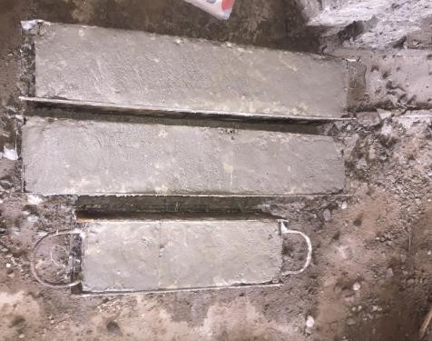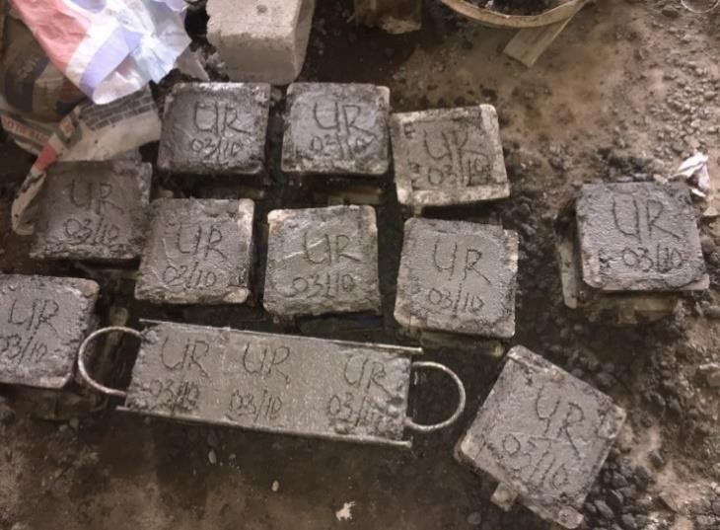casted: 25, 12 Cubes for (100 % Water, 0 % Urease), 12 Cubes (20 % Water, 80 % Urease), concrete cubes casted are shown in Plate I (Concrete cubes cast with 0 % urease) and Plate II (Concrete cubes cast with (80 %) urease).

Plate I: Concrete cubes cast with 0 % urease Plate II: Concrete cubes cast with (80 %) urease

# Curing of Concrete Cubes

The concrete cubes after demoulding were weighed before curing in accordance with the age of interest (7, 14 and 28 days) inside the curing tank. Immersion of concrete cubes in water was the method adopted in this research work. The concrete cubes during curing are shown in Plate III.

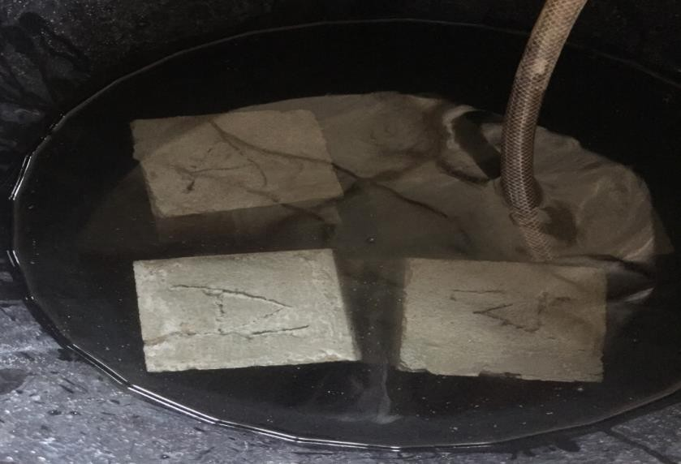

Plate III: Concrete cubes cured in curing tank

# Concrete Cube Test

Compressive strength is one of the concrete cube test carried out to determine the strength and hardness of concrete cubes. It is done through the crushing of the concrete cubes with respect to the age of interest (7, 14 and 28 days). This was carried out in the Department of Civil Engineering, Federal University of Technology, Minna, Niger State. Concrete cubes were removed from curing tank in respect to curing days (7, 14 and 28). The cubes were air dried weighed and were carefully placed with the cast faces having contact with plate of the testing machine as specified in BS 1881 part 116:1983. The machine was plugged to power source and switched “ON”, and was operated to crush the concrete cubes. Immediately it reaches its final crushing strength, the dial gauge reading of the machine stopped moving, the crushing load (kN) reading was recorded. Compressive strength was calculated from the expression in equation 3.4:

Compressive strength ₌ 𝐿𝑜𝑎𝑑 𝑜𝑓 𝑓𝑎𝑖𝑙𝑢𝑟𝑒

𝑐𝑟𝑜𝑠𝑠 𝑠𝑒𝑐𝑡𝑖𝑜𝑛𝑎𝑙 𝑎𝑟𝑒𝑎 𝑜𝑓 𝑡ℎ𝑒 𝑐𝑢𝑏𝑒

(3.4)

The percentage (%) strength gained was calculated as

C𝑜𝑚𝑝𝑟𝑒𝑠𝑠𝑖𝑣𝑒 𝑠𝑡𝑟𝑒𝑛𝑔𝑡ℎ 𝑎𝑡 𝑑𝑎𝑦 28 − 𝑐𝑜𝑚𝑝𝑟𝑒𝑠𝑠𝑖𝑣𝑒 𝑠𝑡𝑟𝑒𝑛𝑔𝑡ℎ 𝑎𝑡 𝑑𝑎𝑦 7 𝑥100

𝐶𝑜𝑚𝑝𝑟𝑒𝑠𝑠𝑖𝑣𝑒 𝑠𝑡𝑟𝑒𝑛𝑔ℎ 𝑎𝑡 𝑑𝑎𝑦 28

# Scanning Electron Microscopy

Concrete samples for scanning electron microscopy (SEM) were collected from the broken pieces of cubes obtained from compressive strength test. The samples were taken for analysis. This analysis was performed in order to determine the bacteria precipitation of calcium in bio-concrete specimens when compared to the control. Scanning electron microscopic observation was carried out using SEM, JEOL JSM-6380LV, and 20 V model. The pieces of cubes were completely dried at 50 ℃ in an oven for three days before the SEM observation. An Energy Dispersive Spectrometer (EDS) connected with SEM was used to detect the components of precipitation. All the selected samples were gold coated with a Denton vacuum Desk IV coating system prior to examination. The concrete samples were then loaded into the SEM with the help of aluminium subs, and then placed in the stage or sample holder. The samples were imaged under a high vacumm at a current of 10.00 kv, 100 µm lens aperture and at 11.0 mm working distance. Collection of the images was done with the aid of the secondary electron detector with an acquisition time/image of 2 minutes and 40 seconds, and the images were 2560 x 1920 pixels each. Lastly, the recorded SEM images ranged from 3,000 x to 20,000 x, and the results recorded for interpretation An energy

dispersive spectrometer (EDS) connected with SEM was used simultaneously to detect the components of the precipitation ( Golding *et al*., 2016).

# Statistical Analysis of Data

The data obtained from this study were analyzed using one way analysis of variance followed by SPSS version 23. P values less than 0.05 were considered statistically significant while P values greater than 0.05 were statistically insignificant.

# CHAPTER FOUR

* 1. **RESULTS AND DISCUSSION**

# Results

* + 1. **Isolated and screened urease producing bacteria from cement**

Two bacterial isolates were obtained from cement sample. The isolates were given the codes CA (B) and CA (F). Both isolates tested positive when cultured on urea agar base media. The isolates produced urease, which hydrolysis urea producing ammonia and CO2 that increases the pH of the medium causing phenol red used as indicator to change from pale yellow to pink after 24 hours of incubation.

# Characterized and identified urease producing bacteria isolates

Morphological characteristics of the two isolates showed that CA (F) was dry filamentous with rough edges, while CA (B) was mucoid, raised with smooth edges. Both isolates CA

1. and CA (F) were positive to gram’s reaction. Microscopic examination showed that CA

(B) being long rod and CA (F) was medium size rod. The Biochemical characteristics of isolate CA (B) showed positive for: Voges-Proskauer, oxidase, catalase, and citrate. It also has the ability to utilize glucose, maltose, lactose, and fructose but could not utilize sucrose and arabinose. Isolate CA (F) biochemical characteristics showed positive to catalase, oxidase, VP and motility test, citrate but negative to hydrogen sulfide, methyl-red and starch hydrolysis test. Isolate CA (F) showed positive to fructose, arabinose, lactose, maltose, fructose, sucrose and glucose. Enzyme extract produced by isolate CA (F) showed a maximum urease activity, while isolate CA (B) had a minimum urease activity. Isolate CA

(F) was further identified to molecular level base on maximum urease activity, while CA (B) was identified morphologically, microscopically and biochemically only. This is shown in Table 4.1.

# Table 4.1: Morphological, Microscopic Characterization and Biochemical Reaction of Urease producing bacterial isolates

|  |  |  |
| --- | --- | --- |
| **Bacterial Isolates** | | |
|  | **CA(B)** | **CA(F)** |
| Morphological and Microscopic Examination | | |
| Shape | Circular | Irregular |
| Size | Medium | Small |
| Margin | Entire | Irregular |
| Texture | Smooth | Rough |
| Elevation | Raised | Flat |
| Color | Milky | Whitish |
| Shape | Bacilli | Bacilli |
| Biochemical Test Reaction | | |
| Gram’s reaction | + | + |
| Urease | + | + |
| Citrate | + | + |
| Hydrogen sulfide | - | - |
| Motility | + | + |
| Starch utilization | - | - |
| Methyl red | - | - |

|  |  |  |  |  |
| --- | --- | --- | --- | --- |
| VP  Oxidase Catalase | +  + + | | +  +  + |  |
| Nitrate reduction | + |  | + |  |
| Spore formation | + |  | + |  |
| Sugar utilization | A | G | A | G |
| Glucose | + | _ | + | + |
| Fructose | + | _ | + | _ |
| Arabinose | _ | _ | + | _ |
| Maltose | + | _ | + | _ |
| Lactose | + | _ | + | _ |
| Sucrose | _ | _ | + | _ |

*Key: + (Positive), - (Negative), A (Acid production), G (Gas production)*

# Molecular Identification of Isolate CA (F)

* + - 1. **Agarose gel image of the amplified DNA of Isolate CA (F)**

Agarose gel image of the bacterial isolate indicating a positive amplification of the 16S region of the bacteria isolate using 16S ribosomal universal primer is showed in Plate IV

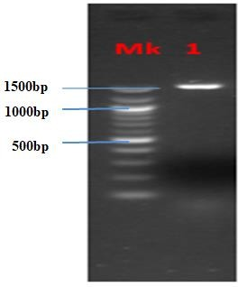 Isolate

Plate IV: Image showing the Agarose gel electrophoresis to PCR amplified DNA

Key: Mk=DNA Ladder 1500 bp, sm= Sample (*Lysinibacillus fusinformis 5B*), Organism’s approximate size = 1500.

# Sequencing results of Isolate CA (F)

Sequence analysis showed that the bacterial isolate CA (F) is 99 % identical to *Lysinibacillus fusiformis* strain 5B:

GGGGGCAACCAACCCTATAGTTTGGGATAACTCCGGGAAACCGGGGCTAATAC CGAATAATCTCTTTTGCTTCATGGTGAAAGACTGAAAGACGGTTTCGGCTGTCG CTATAGGATGGGCCCGCGGCGCATTAGCTAGTTGGTGAGGTAACGGCTCACCA AGGCGACGATGCGTAGCCGACCTGAGAGGGTGATCGGCCACACTGGGACTGAG ACACGGCCCAGACTCCTACGGGAGGCAGCAGTAGGGAATCTTCCACAATGGGC GAAAGCCTGATGGAGCAACGCCGCGTGAGTGAAGAAGGTTTTCGGATCGTAAA ACTCTGTTGTAAGGGAAGAACAAGTACAGTAGTAACTGGCTGTACCTTGACGG

TACCTTATTAGAAAGCCACGGCTAACTAACGTGGCCAGGCAGCCGCGGTAATA ACGTAGGTGGCAAGCGTTGTCCGGAATTATTGGGCGTAAAGCCGCGCGCAGGC GGTCCCTTTAAGCTGAATGTGAAAGCCCACGGCTCAACCGTGGGAGGGGTCAT TGGGAAACTGGGGGACTTGAGTGCAGAAGAGGAAAGTGGAATTTCCAAGTGTA GCGGTGAAATGCGTAGGATTTGGGAGGAACACCAGTGGCGAAGGCGACTTTCT GGTCTGTAACTGACGCTGAGGCGCGAAAGCGTGGGAAGCAAACAGGATTAGAT ACCCTGGCTAGTCCACGCCGTAAAACGATGAGTGCTAAGTGTTAGGGGCTCTC CGCCCCTTAGTGCTGCAGCTAACGCATTAAGCACTCCGCCTGGGGAGTACGGTC GCAAGACTGAACTCAAAGGAATTGACGGGGGCCCGCACAAGCGGTGGAGCAT GTGGTTTAATTCGAAGCAACGCGAAGAACCTTACCAGGTCTTGACATCCCGTTG ACCACTGTAGAGATATAGTTTCCCCTTCGGGGGCAACGGTGACAGGTGGTGCA TGGTTGTCGTCAGCTCGTGTCGTGAGATGTTGGGTTAAGTCCCGCAACGAGCGC AACCCTTGATCTTAGTTGCCATCATTTAGTTGGGCACTCAGGTGACTGCCGGTG ACAAACCGGAGGAAGGTGGGGATGACGTCAAATCATCATGCCCCTTATGACCT GGGCTACACACGTGCTACAATGGACGATACAAACGGTTGCCAACTCGCGAGAG GGAGCTAATCCGATAAAGTCGTTCTCAGTTCGGATTGTAGGCTGCAACTCGCCT ACATGAAGCCGGAATCGCTAGTAATCGCGGATCAGCATGCCGCGGTGAATACG TTCCCGGGCCTTGTACACACCGCCCGTCACACCACGAGAGTTTGTAACACCCGA AGTCGGTGAGGTAACCTTTGAGCCCCACAT

* + - 1. **Phylogenetic tree of *Lysinibacillus fusiformis* Strain 5B**

Phylogenetic tree of *Lysinibacillus fusiformis strain* 5B is shown in Plate V: It shows that the organism is phylogenetically related to Gram positive bacterium *Staphylococcus aureus* SUSST48 and Gram negative bacteria *Pseudomoas aeruginosa* strain Moh-2, *Alcaligenes*

*faecalis* strain G, *Klebsiella pneuomiae* strain DSM 30104, *Klebsiella pneumonia* strain ATCC 13182, *Escherichia coli* strain U 5/41 and *Salmonella enterica* strain ATCC 13314.

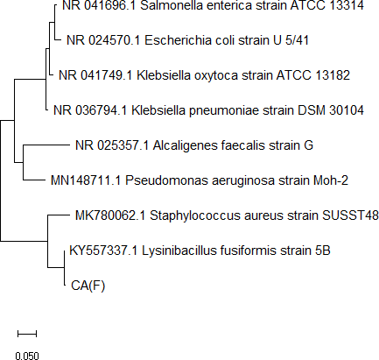

Plate V. Phylogenetic tree of *Lysinibacillus fusiformis strain* 5B

# Urease activity

The crude urease extract from isolate CA (F) obtained from *Lysinibacillus fusiformis* had a higher enzymatic activity value of 0.00005 µ/ml/min, while isolate CA (B) had a mean enzymatic activity value of 0.00002 µ/ml/min. Figure 4.1 shows the graphical representation of the enzyme activities of both isolates.

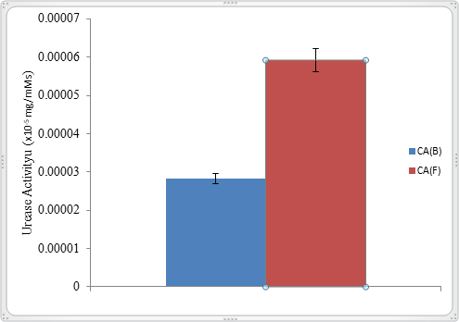

Isolates

# Figure 4.1: Urease activity of the bacterial isolates

* + - 1. **Effect of substrate concentration on urease activity**

High substrate concentration of 1 mM with mean enzyme activity values of 5.01 × 10-5±8.82

× 10-8 was recorded for urease extract of isolate CA (F). Urease from isolate CA (B) had a high substrate concentration of 3 mM with mean enzyme activity of 9.45 × 10-5±1.76 × 10-7. Crude urease from isolate CA (B) result showed an increased urease activity at substrate concentrations of 0.25, 0.5, 1, 1.5, 2.5, and 3 mM with their mean enzyme activity values of

2.4 × 10-5 ± 1.7 × 10-7, 3.14 × 10-5±2.19 × 10-7,4.95 × 10-5±6.67 × 10-8, 9.21 × 10-5±1.76 ×

10-7, 9.36 × 10-5±2.33 × 10-7, 9.37 × 10-5±1.76 × 10-7 and 9.45 × 10-5±1.76 × 10-7 respectively.

Figure 4.2 shows a graphical representation of the effect of substrate concentration on urease activity.

0.0001

0.00009

0.00008

Activity (x10-5 mg/mMs**)**

0.00007

0.00006

0.00005

0.00004

0.00003

0.00002

0.00001

0

0.25 0.5 1 1.5 2 2.5 3

Substrate Concentration (mM**)**

CA(F)

CA(B)

# Figure 4.2: Effect of varying substrate concentration on urease activity

* + - 1. **Optimum Temperature for Urease activity**

The optimum temperature of enzyme activities of the isolates is presented in Figure 4.3. For the crude urease extract from isolate CA (F), result show that there was a significant difference (P>0.05) in the mean enzymatic activity from 30, 40, 50 and 80 ℃ (3.68 × 10-

5±8.82 × 10-8, 1.59 × 10-5±8.82 × 10-8 and 5.01 × 10-5±8.82 × 10-8, 3.35 × 10-5±1.45 × 10-7

respectively). Temperature ranged between 60 and 70℃ showed no significant difference

(P>0.05) in mean enzyme activity of 4.62 × 10-5±6.36 × 10-7 and 4.61 × 10-5±6.01 × 10-7 respectively. For crude urease extract of isolate CA (B) statistical result shows similarity in trends as obtained for isolate CA (F).

6

5

4

Activity (x10-5) (mg/mM/s)

1. CA(F)

CA(B)

2

1

0

30 40

50 60 70 80

Temperature (℃)

# Figure 4.3: Effect of varying temperature on urease activity

* + - 1. **Effect of pH on urease activity**

Crude urease extract from isolate CA (F) and CA (B) was found to have maximum mean enzyme activity at pH 9.5 of 6.20 × 10-5±1.2.33 × 10-7, 2.12 × 10-5±6.25 × 10-7 (Figure 4.4). There was no significant difference (P>0.05) between them.

7

6

Activity (x10-5) (mg/mM/s)

5

1. CA(F)

3 CA(B)

2

1

0

8.5

9.5

10.5

pH

11.5

# Figure 4.4. Effect of varying pH on urease activity

* + 1. **Compressive Strength**

The compressive strength of the concrete cubes was carried out using compression testing machine. Table 4.2 shows the result of compressive strength of the concrete cubes crushed on 7, 14 and 28 days compared to the standard for grade 25 concretes. At each crushing day, concretes calcified with urease had a higher crushing strength when compared with cubes without urease and the international standard for Grade 25 concrete.

# Table 4.2 Compressive strength of the concrete cubes

|  |  |  |  |
| --- | --- | --- | --- |
| **Compressive strength (N/mm2)** | | | |
| **Time**  **(DAYS)** | **Control** | **Urease** | **Standard for Grade 25 concretes** |
| **7** | 20.46±1.43a | 24.71±2.20a | 16.25 ±1.20a |
| **14** | 23.11±0.25a | 27.55±3.08a | 22.50 ±1.75a |
| **28** | 22.53±1.24a | 28.14±7.78a | 24.75 ±3.40a |
| **% strength gained** | 9.2 | 12.1 |  |

* + 1. **Scanning electron micrographs of precipitated CaCO3**

The concretes (control and bio concrete) were viewed using scanning electron microscopy (EVOLS 10 CARL ZEISS, Germany) at 100 µm. The control (A) (Concrete with 0 % urease) had no visible white crystals, while bio concrete (B) (Bio concrete with 80 % urease) had

visibly distinct white crystals of calcium carbonate (CaCO3) as seen in Plate VI below. This was as a result of the reaction involving bicarbonate and calcium ions catalyzed by urease.

CaCO3

crystals

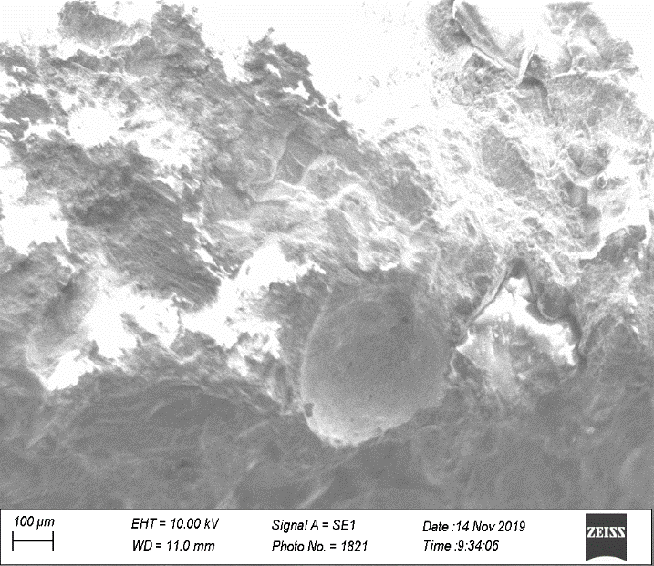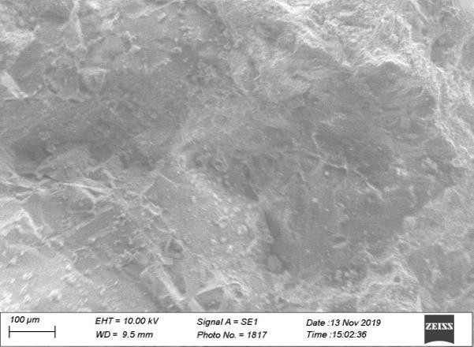

CaCO3

crystals

Concrete with 0% urease (A) Bio concrete with 80% urease (B)

Plate VI: Scanning electron micrographs of A (concrete with 0 % urease) and B (Bio concrete with 80 % urease).

# Discussion

In this study, two bacterial isolates were obtained from cement sample and were given the codes CA (B) and CA (F). They were able to produce urease based on their ability to rapidly hydrolyze urea in urea agar base media producing ammonia and CO2, which changed the medium from pale yellow to pink. Similar results were obtained by Achal *et al*. (2010) who

was able to isolate urease producing bacteria from cement sample. The ability of *Lysinibacillus fusiformis* 5B to survive in such extreme environment of cement could be due to its ability to form endospores. Endospores are special resistant dormant structures formed within a cell that is capable of surviving in adverse environment or hostile conditions. Bacteria can form endospores in approximately 6-8 hours after being exposed to adverse conditions; these spores are metabolically inactive and dehydrated. When exposed to favorable conditions, they can germinate into vegetative cell within 90 minutes (Ramanathan *et al.,* 2015).

Result obtained from crude enzyme activity of the isolates (Figure 4.1) showed that isolate CA (F) (*Lysinibacillus fusiformis* 5B) had a higher mean enzymatic activity of 5.92 × 10- 5±2.60 × 10-7 compared to crude enzyme from isolate CA (B) which had a mean enzymatic activity value of 2.83 × 10-5±8.27 × 10-7. The higher enzyme activity of isolate CA (F) may be due to the increased catalytic ability of the isolate. For crude urease extract obtained from isolate CA (F), the least enzymatic activity was recorded at substrate concentration of 3 mM, while the highest activity was recorded at substrate concentration of 1 mM (Figure 4.2). The reason for this diffrence in results could be that once urease activtiy increase with substrate concentration and it reaches an optimum value it will decrease with rising urea concentration. Isolate CA (B) had optimum activity at 70 ℃ while the optimum temperature for urease actvity of crude urease extract from isolate CA (F) was at 50 ℃ (Figure 4.3). This could be attributed to the high catalytic activity of isolate CA (F). Kim *et al.* (2018) reported that urease is found to be active at temperature ranging from 10-60℃.

The optimum pH for urease produced by both isolate CA (B) and CA (F) was 9.5 with mean enzyme activity of 2.12 × 10-5±6.25 × 10-7 mg/mM/s and 6.20 × 10-5±1.2.33 × 10-7 mg/mM/s

respectively (Figure 4.4). The pH of the medium used to culture urease-producing bacteria is also one of the essential aspects of microbially induced calcite precipitation proceses. It controls the survival and the metabolic activity of the microorganisms that indirectly monitors the secretion of the products. High pH conditions favour the formation of CO32– from HCO3– which leads to calcification of the generated bicarbonate (Dhami *et al.,* 2017). Previous reports by Prah *et al.* (2011) showed that urease enzyme is more active at alkaline pH.

At each crushing day, concretes calcified with urease had a higher crushing strength when compared with cubes without urease and the international standard for Grade 25 concrete (Table 4.2). The 7 days crushing of concrete calcified with urease produced from *L. fusiformis* 5B had a high mean crushing strength of 24.71 N/mm2 when compared to the control that had a mean compressive strength of 20.46 N/mm2. At day 14 the bio concrete gained more strength with a mean compressive strength of 27.55 N/mm2 while the control had a mean crushing strength of 23.11 N/mm2. Thus, the strength of the bio concrete keep increasing as the curing days increased. At the end of 28 days the concrete calcified with urease produced from *L. fusiformis* 5B had the highest mean compressive strength of 28.14 N/mm2 when compared to the control that had a mean crushing strength of 22.53 N/mm2. Thus, the total percentage of strength gained by the concretes calcified with urease from *L. fusiformis* 5B after 28 days was 12.1 %, while compared to the control that had a percentage gain of 9.2 %.

Urease enhanced concrete also had a higher compressive strength when compared to standard for grade 25 concrete; 16.25, 22.50 and 24.75 N/mm2 for day 7, 14 and 28 days. The reason for higher compressive strength compared with control and standard may be due to the inclusion of urease in the concretes, which was able to precipitate calcium carbonate thus

increasing its strength of the bio concrete. There are many reports on the ability of bacteria to increase the compressive strength of concrete when compared to the conventional concrete ( Khan and Murthy, 2015; Harshali *et al.,* 2016; Tripathi *et al.,* 2017; Ravindranatha *et al.,* 2014; Ramesh *et al.,* 2011; Puranik *et al.,* 2019). Suji *et al.* (2015) reported an increase in mechanical property and compressive strength in concretes calcified with *Bacillus sphaericus* compared to the conventional concrete. Alshalif *et al. (*2019) reported an improved strengths of concretes when *Bacillus sphaericus* and *Enterococcus faecalis* cell concentrations of 104, 105,106, 107 cell/ml were used for concrete enhancement for a period of 7, 14 and 28 days. In addition, Tripathi *et al.* (2017) reported an increase in compressive strength of concrete calcified with *Bacillus subtilis*. Scanning electron micrographs (SEM) of both control and bioconcrete revealed obvious differences as observed in Plate 2. The control showed no visible precipitation of CaCO3, while the bio concrete had visible precipitation of CaCO3 crystals. These visible precipitates of CaCO3 crystals are a result of the reaction involving bicarbonate and calcium ions catalyzed by urease. These CaCO3 are stable thermodynamically, ecofriendly and are not readily soluble in water. They are able to fill in the micro-cracks in concrete thus increasing the strength and durability. Similar results was reported by Tripathi *et al.* (2017) and Alshalif *et al.* (2017) where distinct precipitates of calcium carbonate (CaCO3) were visibly presented in the SEM micrographs of bacteria treated concrete.

# CHAPTER FIVE

* 1. **CONCLUSION AND RECOMMENDATION**

# Conclusion

Two organisms were isolated from cement samples in this study, which when enriched with urea rapidly hydrolyzed urea in Christensen urea agar base to produce urease. This was indicated by color change from pale yellow to pink. The isolates were coded as CA (F) and CA (B). Isolate CA (F), identified as *Lysinibacillus fusiformis* 5B had a higher urease activity activity (0.00005 µ/ml/min) and optimum activities at substrate concentration of 1 mM, temperature of 50 °C and a pH of 9.5 and hence it was used for mass production of urease. Urease produced by *Lysinibacillus fusiformis* 5B enhanced concretes with a higher crushing strength when compared to international standards and concrete cubes without urease (control). Scanning electron micrographs also revealed visible calcium carbonate precipitates on the bio concrete when compared to the control. This research discovered that urease produced by *Lysinibacillus fusiformis* 5B can enhance concrete strength.

# Recommendations

1. The use of different methods of curing such as membrane curing, open air, cloth curing, shading curing, or the conventional water spraying method could aid in increasing the strength of the bio concrete.
2. Increasing the concentration of crude urease and adopting a different mixing ratio (1:3:6, 1:1:2, 1:1.5:3).
3. The use of 100 % crude urease for concrete enhancement instead of 80 % used in this research.
4. Crude urease could be combined with other enzymes by percentages, in order to determine the likely effect on the strength of concrete.

# REFERENCES

Abinaya, K. (2011). An Overview of Biocement Production from Microalgae. *International Journal of Science and Engineering*, 4(6), 13–16.

Abudoleh, S. M., Al Mahayreh, A., Al Frejat, A., Al Hulaisy, F., & Hamdan, S.O. (2019). Bio Concrete Development Using Calcite-Precipitating Bacteria Isolated from Different Sources in Jordan. *EDP Sciences,* in *MATEC* Web of Conferences, 278, 01011.

Achal, V., Abhijit, M., & Reddy, M. S. (2010). Characterization of Two Urease-Producing and Calcifying *Bacillus spp*. Isolated from Cement. *Journal of Microbiology and Biotechnology,* 20(11), 1571–1576.

Achal, V., Pan, X., & Özyurt, N. (2011). Improved strength and durability of fly ash-amended concrete by microbial calcite precipitation. *Ecology Engineering*, 37, 554-559.

Achal, V. & Mukherjee, A. (2015). *A review of Microbial Precipitation for Sustainable Construction.* Retrieved from [http://dx.doi.org/10.1016/j.conbuildmat.2015.04.051.](http://dx.doi.org/10.1016/j.conbuildmat.2015.04.051) Accessed September 27, 2019.

Ahmed, I., Yokota, A., Yamazoe, A., & Fujiwara, T. (2009). Proposal of *Lysinibacillus boronitolerans* gen. nov. sp. nov., and transfer of *Bacillus fusiformis to Lysinibacillus fusiformis* comb. nov. and *Bacillus sphaericus* to *Lysinibacillus sphaericus* comb. nov. *International Journal of Systematic and Evolutionary Microbiology*, *57*(5), 1117-1125.

Alhour, M. T. (2013) Isolation, Characterization and Application of Calcite Producing Bacteria from Urea Rich Soils. *Unpublished MSc thesis, Islamic University of Gaza, Gaza, Palestine,* 5, 250-262.

Alshalif, A. F., Irwan, J. M., Othman, N., & Al-Gheethi, A. (2017). New Medium for Isolation of Bacteria from Cement Kiln Dust with a Potential to Apply in Bio- concrete. *IOP Conference Series: Earth and Environmental Science,* 140, 012155. doi:10.1088/1755-1315/140/1/012155.

Al-Thawadi, S. M. (2008). High strength in-situ Bio-cementation of soil by calcite precipitating locally isolated ureolytic bacteria. *School of Biological Sciences and Biotechnology. Arkansas University,* 6(7), 12–13*.*

Anbu, P., Kang, C. H., Shin, Y. J. & So, J. S. (2016). Place period after the closing parenthesis and remove the apostrophe before Microbial 'Formations of calcium carbonate minerals by bacteria and its multiple applications', *Springerplus*, 5, 250- 262.

Anitha, V., Abinaya, K., Prakash, S., Seshagiri Rao, A., & Vanavil, B. (2018). Bacillus cereus KLUVAA mediated biocement production using hard water and urea. *Chemical and Biochemical Engineering Quarterly*, 6(7), 12–13.

Annamalai, S. K., Arunachalam, K. D., Sathyanarayanan, K. S., & Prasath Kumar, V. R. (2013). Characterization and applications of bio-cement enhanced with carbon nanotubes for improved remediation on cracked concrete structures. *Asian Journal of Chemistry* 5, 1–3.

Ariyanti, D. (2012). Feasibility of Using Microalgae for Bio-cement Production through Bio-cementation. *Journal of Bioprocessing & Biotechniques*, 2(3), 4–5.

Bakhtiari, M. R., Faezi, M. G., Fallahpour, M., Noohi, A., Moazami, N., & Amidi, Z. (2006). Medium Optimization by orthogonal array designs for urease production by *Aspergillus niger* PTCC5011. *Process Biochemistry*, 41(3), 547-551.

Burbank, M. B., Weaver, T. J., Williams, B. C., & Crawford, R. L. (2012). Urease Activity of Ureolytic Bacteria Isolated from Six Soils in which Calcite was precipitated by Indigenous Bacteria. *Geomicrobiology Journal*, 6(7), 12–14.

EN, B. (1992). BS 882:1992: Specification for aggregate from natural source for concrete.

London: British Standards Institution,United Kingdom, pp 1210-1218.

EN, B. (1993). BS 1881:1993: *Testing Concrete: Method of Determination of compressive strength of Concrete Cubes*. London: British Standards Institution, United Kingdom, 1008-1117.

Castro-Alonso, M. J., Montañez-Hernandez, L. E., Sanchez-Muñoz, M. A., Franco, M., Rubi, M., Narayanasamy, R., & Balagurusamy, N. (2019). Microbially Induced Calcium Carbonate Precipitation (MICP) and its potential in Bio-concrete: Microbiological and molecular concepts. *Frontiers in Materials*, 6, 126.

Chaparro-Acuña, S. P., Becerra-Jiménez, M. L., Martínez-Zambrano, J. J., & Rojas- Sarmiento, H. A. (2017). Soil bacteria that precipitate calcium carbonate: Mechanism and applications of the process. *Acta Agronomica*, 67 (2), 277-288.

Cheesebrough, M (2006). *District Laboratory Practice in Tropical Countries*, Part 2 Second Edition*.* United States of America :Cambridge University Press.

Cheng, L., Shahin, M. A., & Chu, J. (2019). Soil bio-cementation using a new one-phase low-pH injection method. *Acta Geotechnica*, 14(3), 615–626.

Choi, S. G., Chu, J., Brown, R. C., Wang, K., & Wen, Z. (2017). Sustainable Bio-cement Production *via* Microbially Induced Calcium Carbonate Precipitation: Use of Limestone and Acetic Acid Derived from Pyrolysis of Lignocellulosic Biomass. *ACS Sustainable Chemistry and Engineering*, 4(5), 23–25.

Chu, J. (2016). Solutions to Sustainability in Construction: Some Examples*. In Procedia Engineering,* 145, 1127-1134.

Chu, J., & Wen, Z. (2015). Proof of Concept: Bio-cement for Road Repair. *Journal of Chemical Technology and Biotechnology*, 4(5), 7.

Cowan, S. T., & Steel, K. J. (2002). Manual for the identification of medical bacteria. 2nd edition. Cambridge University Press, 51–120.

De Muynck, W., De Belie, N., & Verstraete, W. (2010). Microbial carbonate precipitation in construction materials: A review. *Ecological Engineering*, 36(2), 118–136. [*https://doi.org/10.1016/j.ecoleng.2009.02.006*.](https://doi.org/10.1016/j.ecoleng.2009.02.006)

Dhami, N. K., Alsubhi, W. R., Watkin, E., & Mukherjee, A. (2017). Bacterial community dynamics and bio-cement formation during stimulation and augmentation: Implications for soil consolidation. *Frontiers in Microbiology*, 4(5), 11–12.

Dhami, N. K., Reddy, M. S., & Mukherjee, A. (2013). Application of calcifying bacteria for remediation of stones and cultural heritages. *Frontiers in Microbiology*, 5(5), 304.

Ernst, F. D., van Vliet, A. H. M., Kist, M., Kusters, J. G., & Bereswill, S. (2007). 'The introduction to Bio-cementation. *Microbiology Journal,* 4(5), 11–12.

Frank, J. A., Reich, C. I., Sharma, S., Weisbaum, J. S., Wilson, B. A., & Olsen, G. J. (2008). Critical Evaluation of Two Primers Commonly Used for Amplification of Bacterial 16S rRNA Genes. *Applied and Environmental Microbiology*. 74, 2461–2470.

Gadd, G. M. (2010) 'Metals, minerals and microbes. *Geomicrobiology and Bioremediation*.

56, 609–643.

Gabrovska, K., & Godjevargova, T. (2009). Optimum immobilization of urease on modified acrylonitrile copolymer membranes: Inactivation by heavy metal ions. *Journal of Molecular Catalysis B: Enzymatic*, 60 (1-2), 69-75.

Gebauer, D., Gunawidjaja, P. N., Ko, J. Y., Bacsik, Z., Aziz, B., Liu, L., Hu, Y., Bergstrom, L., Tai, C. W., Sham, T. K., Eden, M., & Hedin, N. (2010). Protocalcite and proto- vaterite in amorphous calcium carbonates'. *Angewandte Chemie International Edition in English*, 49(47), 8889-8891.

Ghasemi, M., Ghasemi, M. R., & Mousavi, S. R. (2019). Studying the fracture parameters and size effect of steel fiber-reinforced self-compacting concrete. *Construction and Building Materials*, 201, 447-460.

Golding, C.G., Lamboo, L.L., Beniac, D.R., & Booth, T.F. (2016). The scanning electron microscope in microbiology and diagnosis of infectious disease. *Scientific Reports*, 6 (2), 1-7.

Harshali, J., Mitali, S., Neha, A., & Pragati, B. (S2016). Bio-concrete and bacteria based self-healing concrete. *International Journal of Research in Engineering and Technology*, (5), 2321-7308.

He, J., Chu, J., Gao, Y., & Liu, H. (2018). Research advances and challenges in biogeotechnologies. *Geotechnical Research*, 5(6), 13–16.

Jabri, E., Carr, M. B., Hausinger, R. P., & Karplus, P. A. (1995) 'The crystal structure of urease from *Klebsiella aerogenes*'. *Science,* 268, 998-1004.

Jian, C., Volodymyr, I., Stabnikov, V., Jia, H., Bing, L., & Naemi, M. (2012). Bio-cement: Green building- and energy-saving material. *Advanced Materials Research*, 347,4051-4054.

Joshi, S., Goyal, S., Mukherjee, A., & Reddy, M.S. (2017). Microbial healing of cracks in concrete: A review. *Journal of Industrial Microbiology and Biotechnology,* 44, 1511- 1525.

Josic, D., Porobic, M., Milicevic, M., Vukovic, D., Pivic, R., Zdravkovic, M., & Coric, T. (2009). RAPD fingerprinting of indigenous *Lysinibacillus fusiformis* isolates from stabilized sludge and oil-polluted soil. *International Meeting on Soil Fertility, Land Management and Agroclimatology, Special Issue*, 927-933.

Kawaguchi, T., & Decho, A. W. (2002). 'A laboratory investigation of cyanobacterial extracellular polymeric secretions (EPS) in influencing CaCO3 polymorphism'. *Journal of Crystal Growth,* 240(1-2), 230-235.

Khan, S., & Murthy, K. M. (2015). Self-Healing Concrete. *Journal of Civil Engineering and Environmental Technology,* 20(2), 27-33.

Kim, G., Kim, J., & Youn, H. (2018). Effect of temperature, pH, and reaction duration on microbially induced calcite precipitation. *Applied Sciences*, *8*(8), 1277.

Lee, C., Lee, H., & Kim, O. B. (2018). Bio-cement fabrication and design application for a sustainable urban area. *Sustainability (Switzerland),* 6(9), 12–13.

Li, M., Zhu, X., Mukherjee, A., Huang, M., & Achal, V. (2017). Bio-mineralization in metakaolin modified cement mortar to improve its strength with lowered cement content. *Journal of Hazardous Materials,* 5(4), 16–17.

Lian, B., Hu, Q., Chen, J., Ji, J., & Teng, H. H. (2006). 'Carbonate bio-mineralization induced by soil bacterium Bacillus megaterium'. *Geochimica et Cosmochimica Acta*, 70(22), 5522-5535.

Mondal, S., & Ghosh, A. (2019). Review on microbial induced calcite precipitation mechanisms leading to bacterial selection for microbial concrete. *Construction and Building Materials*, 225(1), 67–75.

Mora, D., & Arioli, S. (2014). Microbial Urease in Health and Disease', *PLoS Pathogens*, 10(12), e 1004472.

Naeimi, M., Chu, J., & Haddad, A. (2016). Comparison of Chemical Source and Microbially Produced Ferrous Cations for Iron-Based Bio-cementation of Sand*. Iranian Journal of Science and Technology - Transactions of Civil Engineering*, 3(4), 22–24.

National Ready-mix Concrete Association. (2014). In place strength evaluation, A recommended practice. *NRMCA publication, 133, concrete in practice series, NRMCA RES Committee, silver spring MD.* Retrieved from [http://www.nrmca.org.](http://www.nrmca.org/)

Noshi, C. I., & Schubert, J. J. (2018). Self-healing bio-cement and its potential applications in cementing and sand-consolidation jobs: A review targeted at the oil and gas industry. *Society of Petroleum Engineers - SPE Liquids-Rich Basins Conference - North America,* 7(9), 3.

Okwadha, G. D., & Li, J. (2010). 'Optimum conditions for microbial carbonate precipitation'. *Chemosphere*, 81, 1143-1148.

Omoregie, A. I. (2016). Characterization of ureolytic bacteria isolated from limestone caves of sarawak and evaluation of their efficiency in bio-cementation. *Swinburne University of Technology (Sarawak Campus), Malaysia*, 6 (1), 37-45.

Omoregie, A. I., Khoshdelnezamiha, G., Ong, D. E. L., & Nissom, P. M. (2017). An Improvement of Microbial Induced Carbonate Precipitation (MICP) Using A Sustainable Treatment Technique. *International Journal of Service Management and Sustainabilit*y, 6(8), 19–20.

Omoregie, A. I., Runnie, I., Ginjom, H., Ek, D., Ong, L., & Nissom, P. M. (2016). Cross- Disciplinary Research: Developing Bio-cement Applications Using Locally Isolated Ureolytic Bacteria. *In 4th Borneo Research Education Conference UiTM Sarawak, Kota Samarahan, Sarawak, Malaysia.*

Omoregie, A. I., Siah, J., Pei, B. C. S., Yie, S. P. J., Weissmann, L. S., Enn, T. G., & Nissom,

P. M. (2018). Integrating Biotechnology into Geotechnical Engineering: A Laboratory Exercise. *Transactions on Science and Technology*, 4(5), 7–8.

Oseghale, G. E., Ikpo, I. J., & Ajayi, O. D. (2015). Causes and Effects of building collapse in Lagos State, Nigeria. *Civil and Environmental Research*, 7(4), 34-43.

Panchami, J., Vinod, K.N., & Parvathi, A. (2019). Characterization of marine bacterial carbonic anhydrase and their CO2 sequestration abilities based on a soil microcosm. *Preparative Biochemistry and Biotechnology,* 49 (4), 105-109.

Paassen, L. A. v. (2009). Biogrout Ground Improvement by Microbially Induced Carbonate Precipitation. Unpublished doctoral thesis, Delft University of Technology, Delft, Netherlands. Retrieved from https:/[/www.rese](http://www.researchgate.net/profile/Leon)a[rchgate.net/profile/Leon](http://www.researchgate.net/profile/Leon) van passen

/publication/37795720.

Pheng, I. R. K., Chan, Y. S., Wong, K. S., & Lau, S. Y. (2018). Isolation and characterization of urease-producing bacteria from tropical peat. *Biocatalysis and Agricultural Biotechnology*, 4(6), 6–10.

Prah, J., Maček, J., & Dražič, G. (2011). 'Precipitation of calcium carbonate from a calcium acetate and ammonium carbamate batch system', *Journal of Crystal Growth*, 324(1), 229-234.

Puranik, A. S., Jain, S. G., & Sayali, S. (2019). Bacterial Concrete- A Sustainable Solution for Concrete Maintenance. *International Journal of Innovative Technology and Exploring Engineering,* 8, 2278-3075.

Raijiwala, D. B., & Dalai, G. P. (2017). Restoration of concrete structures by bio- mineralogy. *In Proceedings of the 10th International Conference on Inspection, Appraisal, Repairs and Maintenance of Structures* 4, 5.

Ramanathan, G., Kumar, T. V., Rama, R., & Vijayalalitha, R. (2015). Isolation of Cement Degrading Bacteria and Screening of Their Efficacy for Bio-cementation. *Journal of Pharmaceutical, Chemical and Biological* Science 3(4), 518-527.

Ramesh Kumar, V., Bhuvaneshwari, B., Maheswaran, S., Palani, G. S., Ravisankar, K., and Iyer, N. R. (2011). 'An Overview of Techniques based on Bio-mimetics for Sustainable Development of Concrete'. *Current Science Journal*, 101(6), 741-747.

Rao, M. V. S., Reddy, V. S., & Sasikala, C. (2017). Performance of Microbial Concrete Developed Using *Bacillus Subtilis* JC3. *Journal of the Institution of Engineers (India): Series A*, 4(5), 12–13.

Ravindrantha, N., Kannan N., & Likhit M. L. (2014). Self-healing material bacterial concrete. *International Journal of Research in Engineering and Technology,* 3, 656- 659.

Reddy, M. S., & Joshi, S. (2018). Carbon dioxide sequestration on bio-cement-based composites. *Carbon Dioxide Sequestration in Cementitious Construction Materials* 4, 225–243.

Rodriguez-Navarro, C., Jroundi, F., Schiro, M., Ruiz-Agudo, E., & Gonzalez-Munoz, M.

T. (2012). 'Influence of substrate mineralogy on bacterial mineralization of calcium carbonate: implications for stone conservation'. *Applied and Environmental Microbiology*, 78, 4017–4029.

Sánchez-Navas, A., Martín-Algarra, A., Rivadeneyra, M. A., Melchor, S., & Martí Ramos,

J. D. (2009). 'Crystal-Growth Behavior in Ca−Mg Carbonate Bacterial Spherulites'.

*Crystal Growth & Design,* 9, 2690–2699.

Sarayu, K., Iyer, N. R., & Murthy, A. R. (2014). 'Exploration on the biotechnological aspect of the ureolytic bacteria for the production of the cementitious materials-a review'. *Applied Biochemistry and Biotechnology*, 172(5), 2308-2323.

Sarkar, A., Chatterjee, A., Mandal, S., & Chattopadhyay, B. (2019). An alkaliphilic bacterium BKH4 of bakreshwar hot spring pertinent to biotechnology. *Journal of Applied Microbiology and Biochemistry,* 6, 1742-1750.

Seifan, M., Samani, A. K., & Berenjian, A. (2016). Bioconcrete: next generation of self- healing concrete. *Applied Microbiology and Biotechnology*, 100(6), 2591-2602.

Skinner, H. C. W., & Ehrlich, H. (2013). Bio-mineralization. *Mineralogical Magazine*, 69(5), 621-641.

Soon, N. W., Lee, M. L. & Hii, S. L. (2012) 'An Overview of the Factors Affecting Microbial-Induced Calcite Precipitation and its Potential Application in Soil Improvement', *International Journal of Civil, Environmental, Structural, Construction and Architectural Engineering*, 6(2), 188-194.

Stabnikov, V. (2016). Production of Bio-agent for Calcium-Based Bio-cement.

*International Journal of Biotechnology for Wellness Industries,* 5(5), 8–10.

Stanaszek-Tomal, E. (2020). Bacterial Concrete as a Sustainable Building Material?

*Sustainability*, 12(2), 696.

Stooks-Fischer, S., Galinat, J. K., & Bang, S. S. (1999). Microbiological precipitation of CaCO3. *Soil Biology and Biochemistry,* 31, 1563-1571.

Suji, G. A., Rajesh, R. R., & Elayarajah, B. (2015). Potential Application of Bacterial Inoculum to Increase Different Mechanical Strength in the Prepared Concrete. *International Journal of Innovative Research in Science, Engineering and Technology,* 4, 2319-8753.

Tiwari, P. K., Joshi, K., Rehman, R., Bhardwaj, V., Shamsudheen, K. V., Sivasubbu, S., & Scaria, V. (2014). Draft genome sequence of urease-producing *Sporosarcina pasteurii* with potential application in bio-cement production. *Genome Announcements,* 6(7), 8–12.

Trindade, L. C. D., Marques, E., Lopes, D. B., & Ferreira, M. Á. D. S. V. (2007). *Development of a molecular method for detection and identification of Xanthomonas campestris pv. viticola. Summa Phytopathologica*, 33(1), 16-23.

Tripathi, E., Arora, R. K., & Srivastava, M. (2017). Strength Comparison of Bio-Concrete with Conventional Concrete. *International Journal of Advanced Scientific Research and Management,* 6(2), 2455-6378.

Varalakshmi, V., & Devi, A. (2014). Isolation and Characterization of Urease Utilizing Bacteria to Produce Bio-cement. *IOSR Journal of Environmental Science, Toxicology and Food Technology*, 7(8), 12–13.

Vekariya, M. S., & Pitroda, J. (2013). Bacterial concrete: new era for construction industry.

*International Journal of Engineering Trends and Technology*, 4(9), 4128-4137.

Verma, R. K., Chaurasia, L., Bisht, V., & Thakur, M. (2015). Bio-Mineralization and Bacterial Carbonate Precipitation in Mortar and Concrete. *Bioscience and Bioengineering*, 4(5), 12–14.

Voicu, G., Bădănoiu, A. I., & Andronescu, E. (2016). Bio-cements with potential endodontic use. In Nano-biomaterials in Dentistry: *Applications of Nano- Biomaterials,* 24–35.

Wawrik, B., Kerkhof, L., Zylstra, G. J., & Kukor, J. J. (2005). Identification of Unique Type II Polyketide Synthase Genes in Soil. *Applied Environmental Microbiology,* 71(5), 2232–2238.

Whiffin, V. S. (2004). Microbial CaCO3 Precipitation for the production of Bio-cement. Unpublished doctoral thesis, Murdoch University, Perth, Australia. Retrieved from https://researchrepository.murdoch.edu.au/id/eprint/399.

Wong, L. S. (2015) 'Microbial cementation of ureolytic bacteria from the genus Bacillus: a review of the bacterial application on cement-based materials for cleaner production', *Journal of Cleaner Production*, 93, 5-17.

Zhang, Y., Qiao, L., Yan, H., Zizak, I., Zaslansky, P., Li, Y., & Ma, Y. (2020). Vaterite microdisc mesocrystals exposing the (001) facet formed via transformation from proto-vaterite amorphous calcium carbonate. *Crystal Growth & Design*, 20(5), 3482- 3492.

# APPENDICES

**Appendix A: Concrete Mix Design**

Using nominal concrete mix ratio of 1:1 1: 3 for Cement: Sand: Aggregate

2

For reduced water cement ratio of 0.50:

𝑤 = 0.50

𝑐

Where w is water content; c is cement content Cube size = (0.15× 0.15 × 0.15)𝑚3

= 0.000375𝑚3

Allowance for waste = 5%

Data for Design:

Density of cement, 𝜌𝑐 = 3.15 Density of water, 𝜌𝑤 = 1000 Density of fine aggregate, 𝜌𝑓𝑎 = 2.6

Density of coarse aggregate 𝜌𝑐𝑎 = 3.15

Bulk Density of cement 𝛾𝑐 = 1440

Bulk Density of fine aggregate 𝛾𝑓𝑎 = 1500

Bulk Density of coarse aggregate 𝛾𝑐𝑎 = 1700

Using the Mix ratio of 1:2:4

1440

1440

2 × 1500

:

1440

4 × 1700

:

1440

1: 2.08: 4.72

1𝑚3 = 0.5𝑐 + 1.0𝑐 + 2.08𝑐 + 4.72𝑐

1000 3150 2600 2700

= 1.575𝑐+1.0𝑐+2.52𝑐+5.507𝑐

3150

= 10.602𝑐

3150

c = 3150

10.602

= 297.11 kg

1𝑚3 𝑜𝑓 𝑐𝑒𝑚𝑒𝑛𝑡 = 297.11 kg

Add 5 % for waste, i.e. 1.05x297.11 = 3.11.97 kg Therefore,

1𝑚3 𝑜𝑓 𝑐𝑒𝑚𝑒𝑛𝑡 = 311.97 kg Volume of 1 cube = 0.0003375𝑚3

0.0003375𝑚3 = 0.0003375 × 311.97

1𝑚3

= 1.06 kg

Therefore,

1 Cube of cement = 1.06 kg

1 Cube of fine aggregate = 1.06 kg× 2.08 = 2.21kg

1 Cube of coarse aggregate = 1.06 kg× 4.72 = 5.01 kg

1 Cube of coarse aggregate = 1.06 kg× 0.5 = 0.53 kg

# Summary

**A) 12 Cubes: 100% Water 0% Extract)**

Cement = 12.72 kg

Fine Aggregate = 26.52 kg Coarse Aggregate = 60.12 kg Water = 6.36 kg

Extract= 0 kg (No Extract)

# 12 Cubes: 100% Water 0% Extract)

1. **13 Cubes: 20% Water 80% Extract)**

Cement = 13.78 kg

Fine Aggregate = 28.73 kg Coarse Aggregate = 65.13 kg Water = 1.378 kg

Extract= 5.512 kg

# Appendix B: Enzyme activity of isolate CA (F) and CA (B)

|  |  |
| --- | --- |
| **BACTERIA** | **ACTIVITY** |
| CA(F) | 5.92X10-5±2.60X10-7 |
| CA(B) | 2.83X10-5±8.27X10-7 |

**Appendix C: Substrate concentration of isolate CA (F) and CA (B)**

|  |  |  |
| --- | --- | --- |
| Subtrate concentration (mM) | CA(F) | CA(B) |
| 0.25 | 2.21x10-5±2.4x10-7c | 2.04x10-5±1.7x10-7a |
| 0.5 | 3.36x10-5±1.7x10-7d | 3.14x10-5±2.19x10-7b |
| 1 | 5.01x10-5±8.82x10-8e | 4.95x10-5±6.67x10-8c |
| 1.5 | 1.01x10-5±7.64x10-8a | 9.21x10-5±1.76x10-7d |
| 2 | 1.07x10-5±6.01x10-8b | 9.36x10-5±2.33x10-7e |
| 2.5 | 1.07x10-5±5.77x10-8b | 9.37x10-5±1.76x10-7e |
| 3 | 1.01x10-5±8.5x10-8a | 9.45x10-5±1.76x10-7f |

Mean values with same letter in the same column do not differ significantly at P>0.05

# Appendix D: Effect of temperature on urease production

|  |  |  |
| --- | --- | --- |
| **TEMPERATURE (°C)** | **CA(F)** | **CA(B)** |
| 30 | 3.68X10-5±8.82X10-8c | 2.55X10-5±2.03X10-7c |
| 40 | 1.59X10-5±8.82X10-8a | 1.25X10-5±3.38X10-7a |
| 50 | 5.01X10-5±8.82X10-8e | 3.93X10-5±3.06X10-7d |
| 60 | 4.62X10-5±6.36X10-7d | 4.03X10-5±9.14X10-7de |
| 70 | 4.61X10-5±6.01X10-7d | 4.15X10-5±8.37X10-7e |
| 80 | 3.35X10-5±1.45X10-7b | 2.37X10-5±2.08X10-7b |

Mean values with same letter(s) in the same column do not differ significantly at P>0.05

# Appendix E: Effect of pH on urease production

|  |  |  |
| --- | --- | --- |
| pH | CA(F) | CA(B) |
| 8.5 | 5.85x10-5±1.45x10-7b | 1.89x10-5±1.45x10-7b |
| 9.5 | 6.20x10-5±1.2.33x10-7c | 2.12x10-5±6.25x10-7c |
| 10.5 | 5.86x10-5±1.73x10-7b | 1.83x10-5±1.73x10-7b |
| 11.5 | 5.21x10-5±2.4x10-7a | 1.64x10-5±5.21x10-7a |

Mean values with same letter in the same column do not differ significantly at P>0.05

# Appendix F: The Compressive Strength raw results

* A _7days

|  |  |  |  |  |  |  |
| --- | --- | --- | --- | --- | --- | --- |
| CONCRETE GRADE | | | 30 | |  |  |
| CONCRETE (GRAVIMETRIC): | MIX | RATIO | 1 : 1.5: 3 | |  |  |
| CONCRETE (VOLUMETRIC): | MIX | RATIO | 1 : 2 :4 | |  |  |
| CEMENT: | | | ORDINARY CEMENT | PORTLAND | |  |
| CURING METHOD: | | | IMMERSION IN WATER | |  |  |
| MOULD SIZE/VOL: | | | 150mm x 150mm x 150mm = | | 0.003375 | m3 |
| MOULD LOAD BEARING AREA: | | | 150mm x 150mm = | | 22,500 | mm2 |

|  |  |
| --- | --- |
| Cube Casting Testing Age Mass of Density Crushing Crushing  No Date Date (Days) Cube(Kg) (Kg/m3) Load(KN) Strength(N/mm3) |  |
| 1 3/10/2019 11/10/2019 7 8.40 2488.89 409 18.18  2 3/10/2019 11/10/2019 7 8.50 2518.52 452 20.09  3 3/10/2019 11/10/2019 7 9.00 2666.67 520 23.11 |  |

*Mean Strength: 20.46 N/mm2 *Expected Strength: 19.50 N/mm2 *Ratio/Result: 1.05/Pass

UR _7days

|  |  |  |  |  |  |  |
| --- | --- | --- | --- | --- | --- | --- |
| CONCRETE GRADE | | | 25 | |  |  |
| CONCRETE  (GRAVIMETRIC): | MIX | RATIO | 1 : 1.5: 3 | |  |  |
| CONCRETE  (VOLUMETRIC): | MIX | RATIO | 1 : 2 :4 | |  |  |
| CEMENT: | | | ORDINARY CEMENT | PORTLAND | |  |
| CURING METHOD: | | | IMMERSION IN WATER | |  |  |
| MOULD SIZE/VOL: | | | 150mm x 150mm x 150mm = | | 0.003375 | m3 |
| MOULD LOAD BEARING AREA: | | | 150mm x 150mm = | | 22,500 | mm2 |

Cube Casting Testing Age Mass of Density Crushing Crushing

No Date Date (Days) Cube(Kg) (Kg/m3) Load(KN) Strength(N/mm3)

1 3/10/2019 11/10/2019 7 8.50 2518.52 640 28.44

2 3/10/2019 11/10/2019 7 8.7 2577.78 468 20.80

3 3/10/2019 11/10/2019 7 8.42 2494.81 560 24.89

*Mean Strength: 24.71 N/mm2 *Expected Strength: 19.50 N/mm2 *Ratio/Result: 1.27/Pass

A_14 days

|  |  |  |  |  |  |  |
| --- | --- | --- | --- | --- | --- | --- |
| CONCRETE GRADE | | | 25 | |  |  |
| CONCRETE  (GRAVIMETRIC): | MIX | RATIO | 1 : 1.5: 3 | |  |  |
| CONCRETE  (VOLUMETRIC): | MIX | RATIO | 1 : 2 :4 | |  |  |
| CEMENT: | | | ORDINARY CEMENT | PORTLAND | |  |
| CURING METHOD: | | | IMMERSION IN WATER | |  |  |
| MOULD SIZE/VOL: | | | 150mm x 150mm x 150mm = | | 0.003375 | m3 |
| MOULD LOAD BEARING AREA: | | | 150mm x 150mm = | | 22,500 | mm2 |

Cube Casting Testing Age Mass of Density Crushing Crushing

No Date Date (Days) Cube(Kg) (Kg/m3) Load(KN) Strength(N/mm3)

|  |  |  |  |  |  |  |  |
| --- | --- | --- | --- | --- | --- | --- | --- |
| 1 | 3/10/2019 | 18/10/2019 | 14 | 8.9 | 2637.04 | 520 | 23.11 |
| 2 | 3/10/2019 | 18/10/2019 | 14 | 8.8 | 2607.41 | 510 | 22.67 |
| 3 | 3/10/2019 | 18/10/2019 | 14 | 8.6 | 2548.15 | 530 | 23.56 |

*Mean Strength: 23.11 N/mm2 *Expected Strength: 19.50 N/mm2 *Ratio/Result: 1.19/Pass

* UR _14 days

|  |  |  |  |  |  |  |
| --- | --- | --- | --- | --- | --- | --- |
| CONCRETE GRADE | | | 25 | |  |  |
| CONCRETE  (GRAVIMETRIC): | MIX | RATIO | 1 : 1.5: 3 | |  |  |
| CONCRETE (VOLUMETRIC): | MIX | RATIO | 1 : 2 :4 | |  |  |
| CEMENT: | | | ORDINARY CEMENT | PORTLAND | |  |
| CURING METHOD: | | | IMMERSION IN WATER | |  |  |
| MOULD SIZE/VOL: | | | 150mm x 150mm x 150mm = | | 0.003375 | m3 |
| MOULD LOAD BEARING AREA: | | | 150mm x 150mm = | | 22,500 | mm2 |

Cube Casting Testing Age Mass of Density Crushing Crushing

No Date Date (Days) Cube(Kg) (Kg/m3) Load(KN) Strength(N/mm3)

1 3/10/2019 18/10/2019 7 8.10 2400.00 500 22.22

2 3/10/2019 18/10/2019 7 8.5 2518.52 620 27.56

3 3/10/2019 18/10/2019 7 8.22 2435.56 740 32.89

*Mean Strength: 27.55 N/mm2 *Expected Strength: 19.50 N/mm2 *Ratio/Result: 1.41/Pass

* A_28 days

|  |  |
| --- | --- |
| CONCRETE GRADE | 25 |
| CONCRETE MIX RATIO (GRAVIMETRIC): | 1 : 1.5: 3 |
| CONCRETE MIX RATIO  (VOLUMETRIC): | 1 : 2 :4 |

|  |  |  |  |
| --- | --- | --- | --- |
| CEMENT: | ORDINARY PORTLAND  CEMENT | |  |
| CURING METHOD: | IMMERSION IN WATER |  |  |
| MOULD SIZE/VOL: | 150mm x 150mm x 150mm = | 0.003375 | m3 |
| MOULD LOAD BEARING AREA: | 150mm x 150mm = | 22,500 | mm2 |

Cube Casting Testing Age Mass of Density Crushing Crushing

No Date Date (Days) Cube(Kg) (Kg/m3) Load(KN) Strength(N/mm3)

|  |  |  |  |  |  |  |  |
| --- | --- | --- | --- | --- | --- | --- | --- |
| 1 | 3/10/2019 | 2/11/2019 | 28 | 8.7 | 2577.78 | 563 | 25.02 |
| 2 | 3/10/2019 | 2/11/2019 | 28 | 8.4 | 2488.89 | 481 | 21.38 |
| 3 | 3/10/2019 | 2/11/2019 | 28 | 8.3 | 2459.26 | 477 | 21.20 |

*Mean Strength: 22.53 N/mm2 *Expected Strength: 19.50 N/mm2 *Ratio/Result: 1.16/Pass

* UR_28 days

|  |  |  |  |  |  |  |
| --- | --- | --- | --- | --- | --- | --- |
| CONCRETE GRADE | | | 25 | |  |  |
| CONCRETE (GRAVIMETRIC): | MIX | RATIO | 1 : 1.5: 3 | |  |  |
| CONCRETE  (VOLUMETRIC): | MIX | RATIO | 1 : 2 :4 | |  |  |
| CEMENT: | | | ORDINARY CEMENT | PORTLAND | |  |
| CURING METHOD: | | | IMMERSION IN WATER | |  |  |
| MOULD SIZE/VOL: | | | 150mm x 150mm x 150mm = | | 0.003375 | m3 |
| MOULD LOAD BEARING AREA: | | | 150mm x 150mm = | | 22,500 | mm2 |

Cube Casting Testing Age Mass of Density Crushing Crushing

No Date Date (Days) Cube(Kg) (Kg/m3) Load(KN) Strength(N/mm3)

|  |  |  |  |  |  |  |  |
| --- | --- | --- | --- | --- | --- | --- | --- |
| 1 | 3/10/2019 | 2/11/2019 | 28 | 8.20 | 2429.63 | 740 | 32.89 |
| 2 | 3/10/2019 | 2/11/2019 | 28 | 8.2 | 2429.63 | 869 | 38.62 |
| 3 | 3/10/2019 | 2/11/2019 | 28 | 8.8 | 2607.41 | 291 | 12.93 |

*Mean Strength: 28.14 N/mm2 *Expected Strength: 19.50 N/mm2 *Ratio/Result: 1.44/Pass