CHARACTERIZATION OF METHICILLIN - RESISTANT *STAPHYLOCOCCUS AUREUS* FROM ORTHOPAEDIC PATIENTS IN AHMADU BELLO UNIVERSITY TEACHING HOSPITAL, ZARIA, NIGERIA

By

Ayokunnumi Funke OBAJULUWA

DEPARTMENT OF PHARMACEUTICS AND PHARMACEUTICAL MICROBIOLOGY,

AHMADU BELLO UNIVERSITY, ZARIA, NIGERIA

SEPTEMBER, 2014

CHARATERIZATION OF METHICILLIN- RESISTANT *STAPHYLOCOCCUS AUREUS* FROM ORTHOPAEDIC PATIENTS IN AHMADU BELLO UNIVERSITY TEACHING HOSPITAL, ZARIA, NIGERIA

By

Ayokunnumi Funke OBAJULUWA, B.PHARM. (IBADAN), M.SC.(A.B.U.)

Ph D/PHARM. SCI./15432/2010-2011

A DISSERTATION SUBMITTED TO THE

SCHOOL OF POSTGRADUATE STUDIES, AHMADU BELLO UNIVERSITY, ZARIA, NIGERIA.

IN PARTIAL FULFILMENT OF THE REQUIREMENTS FOR THE AWARD OF DOCTOR OF PHILOSOPHY

IN PHARMACEUTICAL MICROBIOLOGY

DEPARTMENT OF PHARMACEUTICS AND PHARMACEUTICAL MICROBIOLOGY, FACULTY OF PHARMACEUTICAL SCIENCES,

AHMADU BELLO UNIVERSITY, ZARIA, NIGERIA

SEPTEMBER, 2014

## DECLARATION

I declare that the work reported in this dissertation entitled ‗Characterization of Methicillin - Resistant *Staphylococcus aureus* from Orthopaedic Patients in Ahmadu Bello University Teaching Hospital, Zaria, Nigeria‘ was carried out by me in the Department of Pharmaceutics and Pharmaceutical Microbiology, Faculty of Pharmaceutical Sciences, under the supervision of Prof. J.A. Onaolapo, Dr B.O. Olayinka and Dr (Mrs.) G.O.Adeshina.

The information derived from the literature has been duly acknowledged in the text and a list of references provided. No part of this dissertation has been presented in any previous application for another degree or diploma at any other University.

## …………………………………… ……………...

**Ayokunnumi Funke OBAJULUWA Date**

Dept of Pharmaceutics and Pharmaceutical Microbiology, Faculty of Pharmaceutical Sciences Ahmadu Bello University,

Zaria, Nigeria.

## CERTIFICATION

This dissertation entitled ‗CHARACTERIZATION OF METHICILLIN- RESISTANT *STAPHYLOCOCCUS AUREUS* FROM ORTHOPAEDIC PATIENTS IN AHMADU BELLO UNIVERSITY TEACHING HOSPITAL, ZARIA, NIGERIA‘

by OBAJULUWA, Ayokunnumi Funke meets the regulations governing the Award of the Degree Doctor of Philosophy of Ahmadu Bello University, Zaria, Nigeria and is approved for its contribution to knowledge and literary presentation.

|  |  |  |
| --- | --- | --- |
| Prof. J.A Onaolapo |  | |
| **Chairman, Supervisory Committee** | Signature | Date |
| Dept of Pharmaceutics and |  |  |
| Pharmaceutical Microbiology, |  |  |
| Faculty of Pharmaceutical Sciences, |  |  |
| Ahmadu Bello University, |  |  |
| Zaria, Nigeria. |  |  |
| . |  |  |
| Dr B.O. Olayinka |  |  |
| **Member, Supervisory Committee**. | Signature | Date |
| Dept of Pharmaceutics and |  |  |
| Pharmaceutical Microbiology, |  |  |
| Faculty of Pharmaceutical Sciences, |  |  |
| Ahmadu Bello University, |  |  |
| Zaria, Nigeria. |  |  |
| Dr. (Mrs.) G.O. Adeshina |  |  |
| **Member, Supervisory Committee**. | Signature | Date |
| Dept of Pharmaceutics and |  |  |
| Pharmaceutical Microbiology, |  |  |
| Faculty of Pharmaceutical Sciences, |  |  |
| Ahmadu Bello University, |  |  |
| Zaria, Nigeria. |  |  |
| Prof. A.B Isah |  |  |
| **Head of Department** | Signature | Date |
| Dept of Pharmaceutics and |  |  |
| Pharmaceutical Microbiology, |  |  |
| Faculty of Pharmaceutical Sciences, |  |  |
| Ahmadu Bello University, |  |  |
| Zaria, Nigeria. |  |  |
| Prof. Hassan Zoaka |  |  |
| **Dean, School of Postgraduate Studies**  Ahmadu Bello University, | Signature | Date |
| Zaria, Nigeria. |  |  |

## DEDICATION

This work is dedicated to the glory of God Almighty

For His mercies and favour received throughout the course of this study.

To Him be praises and honour forever.

## ACKNOWLEDGEMENT

I appreciate the Almighty God for seeing me through this work successfully. I sincerely appreciate the contributions of Prof. J.A. Onaolapo under whose supervision this work was carried out. His fatherly advice, encouragement and constructive criticisms are highly appreciated.

My profound gratitude goes to Dr B.O. Olayinka and Dr. (Mrs.) G.O. Adeshina for their valuable contributions and encouragement.

My gratitude also goes to all academic, technical and non academic staff of the Department of Pharmaceutics and Pharmaceutical Microbiology for their various contributions to the successful completion of this work. Not to be forgotten is the contribution of Dr (Mrs).Bolatito Ola-Afolabi.

Worthy to mention is the contribution of Mrs. Toryila, Dr Ella and other technical staff of Microbiology Department and Centre for Biotechnology, Ahmadu Bello University, Zaria.

I highly appreciate the understanding, support, encouragement and prayers of my darling husband, Stephen, and my lovely children Anuoluwapo, Iyanuoluwa and Ifeoluwapo. The effort of Epaphras Daniel, Igwe James and all the discipleship class brethren are highly appreciated.

May God bless you all.

## ABSTRACT

Methicillin resistant *Staphylococcus aureus* (MRSA) is now a threat to both the hospitalized patients and community globally. This work was aimed at detecting molecularly, methicillin resistant *Staphylococcus aureus* from the orthopaedic patients in Ahmadu Bello University Teaching Hospital, Zaria, Nigeria. Conventional biochemical methods were used to identify the isolates while API STAPH identification test kit further characterized the isolates to species level. The susceptibility test was carried out using disc agar diffusion method while beta – lactamase production was tested for using nitrocefin. Methicillin resistance was detected phenotypically using cefoxitin 30 µg disc and oxacillin agar screen test. Multiplex polymerase chain reaction (PCR) was used to detect *mecA* gene, the gene coding methicillin resistance and *blaZ* gene, the gene coding for beta- lactamase production with *16SrRNA* gene being the internal control. Sequencing was carried out for the amplified isolates. A total number of 126 samples were collected from wound, skin and bed of orthopaedic patients for 5 months. With the conventional biochemical method of identification, 100(79.4%) isolates were identified as *S. aureus* while with the use of API STAPH identification test kit 39(39%) of the 100 were characterized as

*S. aureus.* The susceptibility test of the *S. aureus* isolates showed that gentamicin had the greatest activity: 100%, 100% and 93.8% in wound, bed and skin respectively, followed by ciprofloxacin (100%, 94.1% and 93.8%) and pefloxacin (100%, 88.2% and 75%) respectively. However, the greatest level of resistance was observed with ampicillin: 100%, 100% and 87.5% in wound, bed and skin respectively followed by ceftriaxone: 100%, 76.5% and 75%; and amoxicillin - clavulanate: 66.7%, 58.8%, 56.2%. Phenotypic detection of MRSA with the use of cefoxitin disc diffusion gave a MRSA prevalence of 83.3%, 64.5% and 56.3% from wound, bed and skin

respectively. These MRSA isolates were generally resistant to the beta lactam antibiotics used, while 11/25 (44%) were multi-drug resistant. However, vancomycin, gentamicin and ciprofloxacin were most active against the MRSA isolates, 15% of these phenotypic MRSA isolates were hyper-producers of beta-lactamase. The gold standard for detecting MRSA using polymerase chain reaction is detection of *mecA* gene and only 2 (5.1%) *S. aureus* isolates were positive. Fifteen (78.9%) of the phenotypic MRSA tested carried plasmid with molecular weight ranging from 9.23 to

13.27 kilobase pairs. The presence of plasmid and hyper- production of beta- lactamase can be suggested to be responsible for the phenotypic detection of MRSA observed in this study; 33.3% of the *S. aureus* isolates amplified *blaZ* gene. The nucleotide sequence of *16SrRNA* gene of isolate S41 in comparison with those from GenBank database showed that the *S. aureus* isolate has 99% identity with *Staphylococcus aureus* strain KIBGE-MB01 with sequence ID (accession) number HM061132.1.

## TABLE OF CONTENTS

Page

Title page ii

Declaration iii

Certification iv

Dedication v

Acknowledgement vi

Abstract vii

Table of content ix

List of figures xv

List of tables xvii

List of plates xix

List of appendices xx

## INTRODUCTION 1

## Statement of the Problem 3

## Brief history of Ahmadu Bello University Teaching

## Hospital, Zaria, Nigeria 3

## Justification of Research 5

## Aim 6

## Specific Research Objectives 6

## Hypothesis 7

## 2.0 LITERATURE REVIEW 8

## Staphylococci 8

* + 1. *Staphylococcus aureus* 8
    2. Pathogenesis of *S. aureus* 11

|  |  |  |  |
| --- | --- | --- | --- |
| 2.1.3 | Virulence factors in *S.aureus* | | 11 |
| 2.1.4 Differentiation of *Staphlococcus aureus* from other coagulase negative | | | |
|  |  | staphylococci | 12 |
| **2.2** |  | **The Development of Chemotherapy** | **13** |
| **2.3** |  | **Antibiotics** | **15** |
| 2.3.1. |  | Definition | 15 |
| 2.3.2 |  | Sources of antibiotics | 15 |
| 2.3.3` |  | Beta-Lactam antibiotics | 16 |
| 2.3.4 |  | Mode of action of beta-lactam antibiotics | 20 |
| **2.4** |  | **Bacterial Drug Resistance** | **21** |
| 2.4.1 | ` | History of development of resistance | 21 |
| 2.4.2 |  | Origin of drug resistance | 22 |
| 2.4.2.1 |  | Non-genetic origin | 23 |
| 2.4.2.2 |  | Genetic origin | 24 |
| 2.4.3 |  | Vertical gene transfer | 25 |
| 2.4.4 |  | Horizontal gene transfer | 26 |
| 2.4.4.1 |  | Mechanisms of horizontal gene transfer | 26 |
| **2.5** |  | **Mechanism of Resistance to Antibiotics in *S. aureus*** | **29** |
| **2.6** |  | **Mobile Genetic Elements of *Staphycoloccus aureus*** | **34** |
| 2.6.1 |  | Definition | 34 |
| 2.6.2 |  | Acquisition of mobile genetic elements by *S. aureus* | 35 |
| 2.6.3 |  | Plasmid – encoded antibiotic resistance | 37 |
| 2.6.3.1 |  | Plasmid encoded penicillin resistance | 37 |
| 2.6.3.2 |  | Plasmid encoded vancomycin resistance | 38 |
| 2.6.3.3 |  | Staphylococci plasmid encoded organic and in organic ions | 39 |

and toxins

* 1. Staphylococcal Cassette Chromosome 42
  2. Methicillin 44
     1. History of methicillin 44
  3. Methicillin Resistant S. aureus (MRSA) 44
     1. Hospital acquired (HA- MRSA) and Community acquired

(CA- MRSA) 45

* + 1. Clinical Implications of MRSA 45
    2. MRSA clones 46
  1. Mechanism of Methicillin Resistance 49
     1. Altered Penicillin Binding Protein (PBP2a) 49
     2. Regulation of PBP2a expression 50
     3. Internal factors affecting methicillin resistance 53
     4. External factors that affect methicillin resistance 53
  2. Clinical Treatments for MRSA Infections 54
     1. Current clinical treatments 54
     2. New weapons in the pipeline: -lactams antibiotics that inhibit

PBP 2a 55

* 1. Detection of Methicillin Resistance 59
  2. Orthopaedics 61
     1. Bone infections 61
     2. Joint infections 62
     3. Fracture 62
        1. Classification of fracture 62
        2. Closed and open fractures 64
        3. Complication of fractures 64
        4. Infection 66

## MATERIALS AND METHODS 68

## Materials 68

* + 1. Culture Media 68
    2. Chemicals 68
    3. Equipment 68
    4. Glassware 69
    5. Plasma 69
    6. Antibiotic discs and powder 69
    7. Other materials 69

## Methods 70

* + 1. Collection of Samples and Pre-treatment 70
    2. Purification and Preliminary Identification of Staphylococcal

Isolates 70

* + 1. Biochemical Test 71
    2. Species Identification by API Staph 73
    3. Test for beta-lactamase Production (Nitrocefin test) 73
    4. Antibiotic Susceptibility Tests 74
    5. Detection of Methicillin Resistance 75
    6. Determination of Inducible Clindamycin Resistance 76
    7. Minimun Inhibitory Concentration (MIC) of Vancomycin 76
    8. Extraction of Plasmid 77
    9. Separation of plasmid DNA by agarose gel electrophoresis 77
    10. Genomic DNA isolation 78
    11. PCR Method for Detection of *16Sr RNA, mecA and blaZ* 79
    12. DNA Sequencing and Bioinformatic Analysis 81
    13. Data Analysis 81
    14. Determination of Multiple Antibiotic Resistance (MAR) Index 82

**4.0 RESULTS 83**

## 4.1. Collection of Samples 83

## Biochemical and Confirmatory Tests 83

## Result of API Staph Identification of the Isolates 85

## Antibiotic Susceptibility 86

## Result of beta lactamase Test 97

## Phenotypic detection of methicillin resistance 102

## Antibiotic Resistant Pattern of Phenotypic MRSA Isolates 102

## D-test for Inducible Clindamycin Resistance 105

## Multiple Antibiotic Resistant (MAR) index 105

## Minimun Inhibitory Concentration (MIC) of Vancomycin 105

## Result of Plasmid Extraction of *S. aureus* Isolates 112

* 1. **Genomic DNA Extraction of *S. aureus* Isolates 117**

## Result of Multiplex PCR for Detection of *mecA* gene and

***bla Z* gene 117**

## Comparison of Cefoxitin Disc Diffusion, Oxacillin Spot Inoculation and *mecA* gene Detection of Methicillin Resistance in *S.aureus* 121

## DNA Sequencing 121

* + 1. Translated protein sequence of *16S rRNA* 125
    2. *BlaZ* nucleotide 129
    3. Translated protein sequence analysis of *blaZ* 133

## 5.0 DISCUSSION 136

## SUMMARY, CONCLUSION AND RECOMMENDATION 148

## Summary 148

## Conclusion 149

## Recommendation 149

## Contribution to knowledge 151

## REFERENCES 152

**APPENDICES 176**

## LIST OF FIGURES

Page

Figure 1 Structure methicillin 2

Figure 2 Structure of *S. aureus* 10

Figure 3 Structure of beta- lactam ring 17

Figure 4 Mechanisms of horizontal gene transfer 28

Figure 5 Mechanism of enzymatic inactivation of beta – lactam antibiotics 31

Figure 6 Acquisition of mobile genetic elements by *S. aureus* 36

Figure 7 Comparison of *S. aureus* Staphylococcal Cassete Chromosome *mec*

types 43

Figure 8 Schematic representation of the *mecA-mecR-mecI* coding region 51

Figure 9 Percentage of *S. aureus* isolates from skin with resistant and hetero- resistant phenotype 94

Figure 10 Percentage of *S. aureus* isolates from bed with resistant and hetero- resistant phenotypes 95

Figure 11 Result of beta - lactamase production test for *S. aureus* isolates 98

Figure 12 Resistance pattern of beta- lactamase producing *S. aureus* to antibiotics

101

Figure13a&b Plasmid extraction of *S. aureus* isolates on 1.5% agarose gel electrophoresis 113

Figure14a&b Genomic DNA extraction of *S. aureus* isolates on 1.5% agarose gel electrophoresis 118

Figure 15a Multiplex PCR for detection of *mecA* and *blaZ* genes from *S. aureus*

isolates 119

Figure 15b Multiplex PCR for detection of *mecA* and *blaZ* genes from *S. aureus*

isolates 120

Figure 16 Alignment of the query *16SrRNA* nucleotide sequence (S41) with *S. aureus* HM061132.1 123

Figure 17 Phylogenetic tree showing the relationship between the query *16SrRNA* nucleotide and other identical *S. aureus* strains from GenBank database 124

Figure 18 Description of some *S. aureus* species from the genBank database aligned with query *16SrRNA* protein sequence 126

Figure 19 Multiple alignment of *16SrRNA* translated protein sequence with other

*Staphylococcus aureus* strain protein sequence 127

Figure 20 Phylogenetic tree of *16SrRNA* translated protein and other Staphylococcus sp protein sequences 128

Figure 21a Alignment of the query *blaZ* nucleotide sequence (S41) with *S. aureus*

AY369353.1 130

Figure 21b Alignment of the query *blaZ* nucleotide sequence (S41) with *S. aureus*

DQ016053.1 131

Figure 22 Phylogenetic tree showing the relationship between the query *blaZ*

nucleotide and other identical *S. aureus* strains from genBank

database 132

Figure 23 Multiple alignment of *blaZ* translated protein sequence with other Staphylococcus sp protein sequence 134

Figure 24 Description of other *S. aureus* species aligned with *blaZ* protein Sequence 135

## LIST OF TABLES

Table 1 Resistance derminants encoded on plasmid, a non – SCC*mec*

Page

Staphylococcal Mobile Genetic Element 40

Table 2 Distribution of major MRSA clones in Africa 47

Table 3 Distribution of major MRSA clones outside Africa 48

Table 4 The primer sequences and predicted sizes used in the multiplex

PCRs 80

Table 5 Distribution of *S. aureus* isolates using biochemical

characterization 84

Table 6 Result of API Staphylococci Identification of the Isolates 85

Table 7 Comparison between biochemical characterization of *S. aureus* and API Staph Identification kit 87

Table 8 Susceptibility Pattern of *S. aureus* isolated from wound of patients in Orthopaedic wards of ABUTH Zaria to different

antibiotics 88

Table 9 Susceptibility Pattern of *S. aureus* isolated from skin of patients in Orthopaedic wards of ABUTH Zaria to different

antibiotics 90

Table 10 Susceptibility pattern of *S. aureus* isolated from bed of patients in Orthopaedic Wards of ABUTH, Zaria to Different

antibiotics 91

Table11 Percentage resistance of *S. aureus* isolates from the sample sites to the various antibiotics used. 92

Table 12 Identification of hetero-resistant strains 96

Table 13 Susceptibility pattern of beta- lactamase producing *S. aureus* isolates to different antibiotics 99

Table 14 Phenotypic detection of methicillin resistance 103

Table 15 The antibiotic resistance pattern of MRSA isolates 104

Table 16 Result of D-test for Inducible Clindamycin Resistance 106

Table 17 Result of multiple antibiotic resistant (MAR) index for *S. aureus*

isolates 109

Table 18 Result of Minimum Inhibitory Concentration (MIC) of vancomycin against the *S. aureus* that showed resistance to vancomycin 30 µg disc

110

Table 19 Identification of *S. aureus* isolates and their plasmid profile 114

Table 20 Antibiotic Resistance of plasmid DNA-containing *S. aureus* isolates 115

## LIST OF PLATES

Page Plate 1 D-test negative: erythromycin (E15) resistance and clindamycin

sensitive 107

Plate 2 No zone of inhibition for clindamycin (CD2) and erythromycin (E15) discs (constitutive clindamycin resistance) 108

Plate 3 Pictoral view of MIC of vancomycin against *S. aureus* isolates using E-test strips 111

## LIST OFAPPENDICES

Page

Appendix 1 Biochemical characteristics of isolates from wound 177

Appendix 2 Biochemical characteristics of isolates from skin 179

Appendix 3 Biochemical characteristics of isolates from bed 182

Appendix 4 Phosphate buffer PH 7.0 184

Appendix 5 McFarland Standard 184

Appendix 6 Interpretative chart for Antimicrobial Susceptibility Testing 185 Appendix 7 Mobility-weight calibration plot of DNA marker 186

Appendix 8 Pictoral view of the DNA sequencing 187

Appendix 9 Individual alignment of *16SrRNA* translated protein sequence with other *S.aureus* species from Genbank database 189

Appendix 10 Individual alignment of *bla Z* protein sequence with similar *S. aureus* species from Genbank database 190

## CHAPTER ONE

**INTRODUCTION**

## INTRODUCTION

*Staphylococcus aureus* is commonly carried on the skin or in the nose of healthy individuals. It is an important pathogen in human infections causing illness ranging from minor skin infections and abscesses to life - threatening diseases such as pneumonia, meningitis, endocarditis, toxic shock syndrome and septicaemia which may be rapidly fatal (Holmes *et al.*, 2005).

Bacterial resistance to antibiotics has been recognized since the first drugs were introduced for clinical use. Penicillin was first introduced in 1941, when less than 1% of *Staphylococcus aureus* strains were resistant to its action. By 1947, 38% of hospital strains had acquired resistance and currently over 90% of *Staphylococcus aureus* isolates are resistant to penicillin. Increasing resistance to antibiotics is a consequence of selective pressure (Power, 1998).

Methicillin was the first penicillinase - resistant semisynthetic penicillin to be derived from the penicillin nucleus, 6- aminopenicillanic acid (6-APA) (Figure 1) (Knudsen and Rolinson, 1960). Initially, it was used widely, but because of its toxicity it was gradually replaced with other penicillinase-resistant penicilins such as nafallin, oxacillin etc.

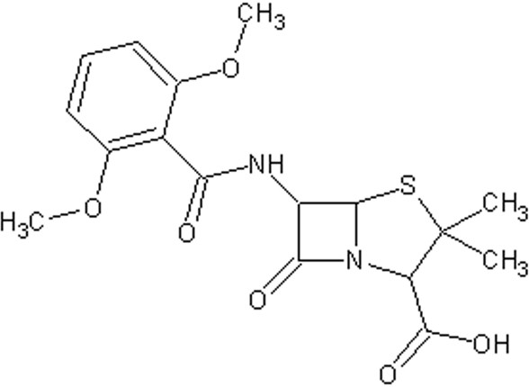

## Figure 1: Structure of Methicillin

Ever since the beginning of the use of antibiotics, bacteria have become very adept at becoming resistant to different antibiotics. Methicillin- resistant *S. aureus* (MRSA) was first discovered in 1961; they are isolates of *S. aureus* which have acquired genes encoding antibiotic resistance to all penicillins including methicillin and other narrow spectrum β lactamase resistant penicillin antibiotics. Since then hospitals worldwide have reported varying proportion of MRSA among *S. aureus* isolates (Foster, 1996). Thus MRSA has become a real clinical and therapeutic problem.

MRSA infections can be classified into two major groups: Hospital-acquired MRSA (HA-MRSA) and Community-acquired MRSA (CA-MRSA). HA-MRSA is responsible for post-operative wound infections, or infections resulting from implanted devices such as catheters, that are acquired within the healthcare setting. Typically, patients infected with HA-MRSA are immune-compromised and the resulting infections are generally more invasive. CA-MRSA typically manifests itself as skin infections, such as pimples or boils, and is classified as being acquired outside of any type of healthcare setting. These infections are typically more serious than minor skin irritation and affect otherwise healthy individuals (Raygada and Levine, 2009).

MRSA becomes resistant by acquiring a *mecA* gene, usually carried on a larger piece of DNA called a staphylococcal cassette chromosome (SCC) mec. Expression of *mecA* yields PBP 2a, a penicillin binding protein with reduced affinity for β-lactam antibiotic binding (Guiguard *et al.*, 2005).

## Statement of the Problem

In orthopaedics, MRSA has been implicated in surgical site infection, post operative infection, implant devices, infection following trauma, chronic osteomyelitis subsequent to an open fracture, meningitis following skull fracture (Nixon *et al*., 2006). Both hip joint surgery especially emergency procedures for femoral neck fractures and the presence of a wound present a high risk of infection. The morbidity and mortality of MRSA can be severe (Power, 1998). MRSA infection colonisation contributes to an increased length of hospital stay; 88 days compared to 11days on average for non MRSA patients (Ho *et al.,* 2008). Diagnosis of MRSA in orthopaedic surgery and the understanding of its epidemiology are therefore crucial to ensure a decrease in the incidence of MRSA. There is need for the early detection of MRSA in orthopaedic patients and the use of appropriate antimicrobial agents to control its spread.

## Brief history of Ahmadu Bello University Teaching Hospital (ABUTH), Zaria, Nigeria

The Ahmadu Bello University Teaching Hospitals complex started as Institute of health in 1967 in accordance with status 15 of Ahmadu Bello University law (Amendment Act schedule 16) by the then Interim Common Services Agency (ICSA) of the former Northern Nigerian government with the objective of providing health care services, training and to conduct research.

In 1976, the Federal Government took over all the Teaching Hospitals in the country, so the control of ABUTHs passed from Ahmadu Bello University (A.B.U.) to Federal Ministry of Health, although close relationship with the University continued. Thus, 1976-1985 was the period of gradual disengagement from the university with the accompanying handing over of facilities like Nursing Home in Kaduna, Orthopaedic Hospital, Dala-Kano (1980), School of Hygiene, Kano (1984) and dispensaries in Zaria and Kaduna to the relevant State Governments.

With the promulgation of the Decree No. 10 of January 1985, ABUTHs became legally and operationally separated from ABU and the hospitals were located in Kaduna and Zaria in Kaduna State and Malumfashi in Katsina State until the hospitals were moved to the permanent site, a 547- bedded Teaching hospital at Shika-Zaria which was commissioned on 11 November, 2005.

Various Departments in the hospital include Pharmaceutical services, Nursing Services, Anaesthesia, Catering services, Opthalmology, Dental Surgery, Radiology, Physiotherapy, Haematology and Blood Transfusion, Chemical Pathology, Medical Microbiology, Pathology, Paediatrics, Surgery, Medicine, Immunology, Radiology and Community Medicine.

In the Orthopaedics department, the commonly prescribed antibiotics are gentamicin, ciprofloxacin and ampicillin – cloxacillin combination. Even though there has not been a reported case of MRSA in this department, there is need to investigate the prevalence of MRSA among the in-patients haven known the clinical implications of MRSA and ABUTH being a major teaching hospital in the north-western part of Nigeria.

## Justification of Research

Detection of MRSA is important for patient care and appropriate utilization of infection control resources. MRSA is a significant pathogen that has emerged over the last 4- decades causing both nosocomial and community - acquired infection. There had been reported cases of MRSA in Nigeria: Adesida *et al.,* (2005) reported a detection of *mecA* gene in 1.4% of hospital isolates collected from hospitals in the South Western region of Nigeria. Likewise Shittu *et al.,* (2006) reported a detection of *mecA* gene in 1.5% of *S. aureus* isolates from clinical samples in South, Western Nigeria. It should be noted that there has not been any report to the best of our knowledge, on the detection of *mecA* gene in the North-western region of Nigeria where this study was carried out, even though Ikeh (2003) and Taiwo *et al.,* (2004) had reported 43% and 34.7% phenotypic expression of MRSA respectively from clinical isolates in this region. Also, Olonitola *et al*, (2007) and Onanuga *et al.,* (2005) had reported phenotypic expression of MRSA among non-hospital isolates in Zaria, (in North-Western region) and Federal capital territory (Abuja) respectively.

In a retrospective study on the cost of MRSA infections in the elective and trauma orthopaedic population in a General Hospital in the United Kingdom, the cost of treating MRSA infection over 12 months was £384,000. This included blood tests, x- rays, days in hospital, minutes in theatre, theatre equipment, Electrocardiograms (ECGs), swabs, dressings and all drugs excluding staff cost (Hassan *et al.,* 2007).

It has been identified that the implications for an orthopaedic patient who contract MRSA in hospital include: extended length of stay, infection and wound breakdown; loss of alignment of fractured bone, failure of internal fixation, delay or non-union of bone, loss of earnings, pain, anxiety and depression (John and David 1991, Makoni 2002). For the hospital staff, the effects include increased workload, disruption to ward

routine and may even result in temporary ward closures. However, managing and controlling MRSA outbreaks can have less of a financial impact than if the outbreak is uncontrolled. Rapid and accurate detection of methicillin resistance in *S. aureus* is important for the use of appropriate antimicrobial therapy and for the control of nosocomial spread of MRSA strains.

## Aim

The aim of this study is to isolate *S. aureus* from orthopaedic patients in Ahmadu Bello University Teaching Hospital, Zaria, detect molecularly the MRSA isolates from there and to determine their antibiotic susceptibility pattern.

## Specific Research Objectives

The objectives of this work are to:

* + 1. Isolate, purify and characterize staphylococci from wounds, skin and beds of orthopaedic patients using conventional and API Staph kit methods.
    2. Determine the antibiotic susceptibility of the isolates by disc agar diffusion (DAD) using antibiotics commonly prescribed in the orthopaedic wards
    3. Identify the methicillin - resistant isolates.
    4. Test for beta - lactamase production and hyper production using nitrocefin.
    5. Detect *blaZ* gene detection methods.
    6. Test the isolates for carriage of *mecA* gene and sequencing of the amplified gene products.
    7. Determine plasmid carriage by the resistant isolates.

## Null Hypothesis

There are no cases of *mecA* - mediated MRSA isolates from clinical specimens in the orthopaedic wards of Ahmadu Bello University Teaching Hospital, Zaria Nigeria.

## CHAPTER TWO

* 1. **LITERATURE REVIEW**

## STAPHYLOCOCCI

Staphylococci were first seen in pus by Koch in 1878 and were first cultivated in liquid medium by Pasteur in 1880 and named so by Sir Alexandar Ogston in 1881 (Gotz *et al*., 2004, Bergdoll and Lee Wong, 2006). The name *Staphylococcus* was derived from Greek words staphyle (bunch of grapes) and kokkos (grain or berry) (Arora, 2006). It is estimated that 20% of human population are long term carriers of *S. aureus.* (Kluytmans *et al*. 1997) which can be found as part of the normal skin flora and in anterior nares of the nasal passage (Cole *et al.*, 2001, Bowersox, 1999).

* + 1. ***Staphylococcus aureus***

The genus *Staphylococcus* belongs to the family Micrococcaceae. They are spherical cocci about 0.8 to 1.0µm in diameter. They are arranged characteristically in grape-like clusters. They are Gram-positive, non-motile (non-flagellated), non-sporing and non- capsulated (Arora, 2006). The cell walls of Gram positive bacteria exhibit a wide diversity from simple to very complex structures (Figure 2). Staphylococci cell walls have a rather extra ordinary type of structural design and to the most highly cross linked type but the walls of other Gram positive bacteria exhibit a much lower degree of cross linking and muropeptide fraction of these walls does not contain long oligometric chains (Galley *et al*., 1991). The cell wall envelope functions as a physical barrier that protects the bacteria from their environment and as a rigid exoskeletal element that prevents bacterial rupture in low osmolar environments such as host tissues. The cell

walls of the microorganisms play an important role in the susceptibility to infections and pathogenicity (Van Heijenoort and Gutmann, 2000).

Structurally, the cell wall of *S. aureus* is composed of murein, techoic acid and wall- associated surface proteins (Tomaz, 2000; Mazmanian *et al.,* 2001). Murein consist of glycan strands that are cross –linked by peptide bridges supplying the structural integrity of the sacculus. It is a distinctive feature of staphylococci that the observed degree of murein cross-linking which was determined as a ratio of bridged peptides to the total amount of all peptide ends in general is extremely high of the order of 80-90% (Gally and Archibald, 1993)

The carbohydrate antigen is a techoic acid which in *S. aureus* is a polymer of N- acetylglucosamine and polyribitol phosphate. Teichoic acids function in the specific adherence of Gram-positive bacteria to mucosal surfaces. The protein component of the cell wall includes protein A which reacts with IgG of normal human serum (Lowy, 1998) and it can be released from the bacterial surface by treatment of staphylococci with lysostaphin, a glycylglycine endopeptidase that cleaves the pentaglycyl cross – bridge of the cell wall. Lysozyme, an N- acetylmuramidase that cuts the glycan strands, release protein A molecules as a spectrum of fragments with varying masses due to the presence of linked peptidoglycan fragments of different sizes (Figure 2)(Navarre *et al*., 1998). The glycan strands of all bacterial peptidoglycan consist of repeat disaccharide units, N acetylglucosamine-(β1-4)-N-acetylmuramic acid. Glycan chains are cross linked by short cell wall peptides and generate a three dimensional molecular network that maintains the integrity of the bacterium. Finally penicillin binding proteins catalyze the polymerization of lipid II subunits via trans-glycosylation and trans-peptidation reactions, thus generating the crosss-linked peptidoglycan that constitutes the main component of the bacterial cell wall (Perry *et al*., 2002).

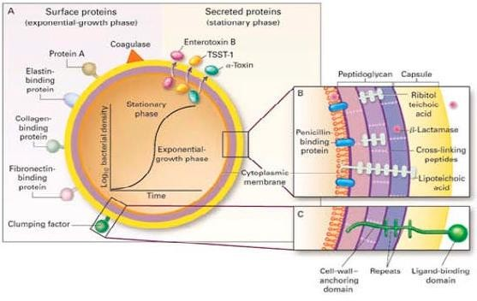

## Figure 2: Structure of *S. aureus* (Gordon and Lowy, 2008)

Pathogenic factors of *Staphylococcus aureus*, with structural and secreted products both playing roles as virulence factors. A, Surface and secreted proteins. B and C, Cross- sections of the cell envelope. TSST-1, toxic shock syndrome toxin 1.

* + 1. **Pathogenesis of *S. aureus***

About 35-50% of normal adults carry *S .aureus* in the anterior nares; it is also the skin normal flora. Other sites of colonization include the perineum, axillae and vagina (Arora, 2006). *S. aureus* carriers are at a higher risk of infection and they are presumed to be an important source of spread of *S. aureus* strains among individuals. The primary mode of transmission of *S. aureus* is by direct contact: usually skin-skin contact with a colonized or infected individual or contact with contaminated objects and surfaces (Miller and Kaplan, 2009). Various host factors including loss of the normal skin barrier, presence of underlying diseases such as diabetes and acquired immunodeficiency syndrome, or defects in neutrophils function predispose to infection.

*S. aureus* can cause a range of illness from minor skin infections such as pimples, impetigo, boils (furnicles), cellulitis, folliculitis, carbuncles, scalded skin syndrome and abscesses, to life threatening diseases such as pneumonia, meningitis, osteomyelitis, endocarditis, toxic shock syndrome (TSS) bacteremia and sepsis. Its incidence ranges from skin, soft tissue, bone, joint, endovascular to wound infections. It is still one of the five most common causes of nosocomial infections and is often the cause of post surgical wound infections (Bowersox, 1999). *S aureus* also causes a painful infection of joint fluid known as septic or infective arthritis. Most serious of all are the deep seated infections such as osteomyelitis and an infection of the heart valves called endocarditis and toxin mediated diseases such as gastroenteritis, Staphylococcal scalded skin syndrome (Yoke-Kqueen *et al.,* 2006; Miller and Kaplan 2009; Anam *et al.,* 2010).

* + 1. **Virulence factors in *S. aureus***

*S. aureus* is a pathogen expressing multiple factors that mediate host colonization, invasion of damaged skin and mucosa, dissemination through the body and evasion of

host defence mechanisms (Chanda *et al.,* 2010).The pathogenecity and virulence of *S. aureus* infections is associated to various bacterial surface components (e.g., capsular polysaccharide and protein A) including those recognising adhesive matrix molecules e.g.clumping factor (*clf*), Fibronectin Bindng Protein(FBN) and to extracellular proteins e.g., coagulase, haemolysins, enterotoxins Toxic Shock Syndrome toxin, exfoliatins toxin and Panton Valentin leukocidin (Labandeira-Rey *et al*., 2007).

Virulence factors can generally be separated into three based on their function:

* Adhesins: they are surface attached proteins that allow the bacteria to attach to a wide variety of human tissues. In *S. aureus* the adhesion genes which include *clf* and *fnb* that encode the fibrinogen and the fibronectin- binding proteins respectively. Fibronectin binding protein (FnBP) A and Fibronectin binding protein (FnBP) B encoded by the *fnb*A and *fnb*B genes respectively, play prominent roles in *S. aureus* colonization and attachment of host tissues or implanted biomaterials (Greene *et al*., 1995)
* Toxins: are secreted proteins that cause tissue damage and generate pus in abscesses which is believed to facilitate transmission between hosts
* Immune dilators: are proteins that interfere with host immunity preventing defence against infections.
  + 1. **Differentiation of *Staphlococcus aureus* from coagulase - negative staphylococci**

The two tests often used to distinguish *Staphylococcus aureus* from other staphylococci are the coagulase test (coagulation of human or animal plasma) and the thermostable nuclease test (breakdown of deoxyribonucleic acid by nucleases that survive boiling). Generally, *Staphylococcus aureus* is Gram-positive cocci, appearing in clusters;

catalase-positive, oxidase-negative. *S. aureus* ferments glucose and lactose to produce acid and gas and also ferments mannitol to produse acids. *S. aureus* are coagulase- positive and deoxyribonuclease (DNAse) positive (Cheesbrough, 2002).

## THE DEVELOPMENT OF CHEMOTHERAPY

The modern era of chemotherapy began with the work of the German physician Paul Ehrlich. Ehrlich was fascinated with dyes that specifically bind to and stain microbial cells. He reasoned that one of the dyes could be a chemical that would selectively destroy pathogens without harming human cells a ―magic bullet.‖ By 1904 Ehrlich found that the dye trypan red was active against the trypanosome that causes African sleeping sickness (Willey *et al*., 2008).

In 1927, Gerhard Domagk discovered that prontosil Red, a new dye for staining leather, protected mice completely against pathogenic streptococci and staphylococci without apparent toxicity. Domagk received the Nobel Prize in physiology or medicine for his discovery of sulfonamides, or sulfa drugs (Bosch and Rosich, 2008).

In the 1920s, Alexander Fleming, a Scottish physician, found that human tears contained a naturally occurring antibacterial substance that he termed ―lysozyme‖. This substance unfortunately had little therapeutic value because it could not be isolated in large quantities and was not effective against many micro organisms. However, it prepared Fleming for the discovery of penicillin, the first true antibiotic to be used therapeutically (Willey et al., 2008).

Penicillin was actually discovered in 1896 by a 21-year-old French medical student named Ernest Duchesne. His work was forgotten until Fleming‘s accidental rediscovery of the antibiotic in September 1928. After returning from a weekend vacation, Fleming noticed that a Petri plate of *Staphylococcus* also had a mould growing on it and, like the

lysozyme he had discovered years before, there were no staphylococcus colonies surrounding it. It has been suggested that a penicillium notatum spore had made its way onto the petri dish before it had been inoculated with the staphylococci. The mold apparently grew before the bacteria and produced penicillin. The bacteria nearest the fungus were lysed. Fleming correctly deduced that the mold contaminant produced a diffusible substance, which he called penicillin. In subsequent studies he showed that this substance could diffuse through agar so that even small amounts of it extracted from both cultures could kill several pathogenic bacteria, including S. aureus. Unfortunately, Fleming could not demonstrate that penicillin remained active *in vivo* long enough to destroy pathogens and thus dropped the research (Sykes, 2001; Willey *et al*., 2008).

In 1939, Howard Florey and Ernest Chain obtained the *Penicillium* culture from Fleming, they then cultured and purified the penicillin. When the purified penicillin was injected into the mice infected with streptococci or staphylococci, practically all the mice survived. Florey and Chain received the noble prize in 1945 for the discovery and production of penicillin (Willey *et al.,* 2008). The discovery of penicillin stimulated the search for other antibiotics. Selman Waksman announced in 1944 that he and his associates had found a new antibiotic, streptomycin, produced by the actionomycete *Streptomyces griseus*. It was the first drug that could successfully treat tuberculosis. Waksman received the noble prize in 1952, and his success led to a world- wide search for other antibiotic from soil micro organisms. Micro organisms producing chloramphenicol, neomycin, terramycin, and tetracycline were isolated by 1953. The discovery of chemotherapeutic agents and the development of newer, more powerful drugs have transformed modern medicine and greatly alleviated human suffering (Willey *et al*., 2008).

## ANTIBIOTICS

* + 1. **Definition**

An antibiotic is an agent that inhibits bacterial growth or kills bacteria. The term antibiotic is used as a synonym for antibacterials used to treat bacterial infections in both people and animals (WHO, 2011). Any substance of natural, synthetic or semi- synthetic origin which at low concentrations kills or inhibits the growth of micro- organisms but causes little or no host damage (WHO, 2000). Today, however, with increased knowledge of the causative agents of various infectious diseases, *antibiotic(s)* has come to denote a broader range of [antimicrobial](http://en.wikipedia.org/wiki/Antimicrobial) compounds, including [anti-fungal](http://en.wikipedia.org/wiki/Anti-fungal_medication) and other compounds. The term antibiotic was first used in 1942 by [Selman Waksman](http://en.wikipedia.org/wiki/Selman_Waksman) and his collaborators in journal articles to describe any substance produced by a microorganism that is [antagonistic](http://en.wiktionary.org/wiki/antagonism) to the growth of other microorganisms in high dilution (Waksman, 1947).

## Sources of Antibiotics

There are three major sources from which antibiotics are obtained:

* + - 1. Natural (through microorganisms) e.g. bacitracin and polymyxin are obtained from some *Bacillus* species; streptomycin, tetracyclines etc from *Streptomyces* species, gentamicin from *Micromonospora purpurea*; griseofulvin and some penicillins and cephalosporins from certain genera (Penicillium, Acremonium) of the family Aspergillaceae. Most antibiotics in current use have been produced from *Streptomyces* species.
      2. Chemical synthesis e.g. chloramphenicol, sulphonamides, quinolones and the oxazolidinones.
      3. Semi-synthesis: This means that part of the molecule is produced by a fermentation process and the product is then further modified by a chemical process. Many penicillins (e.g. ampicillin, amoxicillin, methicillin and ticarcillin), cephalosporins and the carbapenems are produced in this way (Russel, 1998; von Nussbaum *et al*., 2006).

## ` Beta-Lactam antibiotics

1. Penicillins and mecillinams

The penicillins can be considered as being of the following types:-

1. Naturally occurring, for example those produced by fermentation of moulds such as *Penicillin notatum* and *P. chrysogenum* e.g. benzyl penicillin (penicillin G and phenoxymethyl pencillin G) and phenoxymylpencillin (pencillin V).
2. Semisynthetic: In 1959, the penicillin nucleus: 6- aminopenicillanic acid (6- APA) (Figure 3) was isolated in which a thiazolidine is attached to a -lactam ring that carries a free amino group that can be split by bacterial and other amidases (Russell, 2004; Brooks *et al*., 2004). Acylation of 6-APA with appropriate substances resulted in the production of new penicillins with distinct pharmacological activities.

The mecillinams represented by mecillinam and pirmecillinam are essentially 6-

- amidino-pencillins with considerable activity against Gram-negative organisms (Russell, 2004).

# O

CH

CH

S

O=C

N

CH3

# R C NH

C

# CH3

CH COOH

## Figure 3: Structure of beta- lactam ring

1. Cephalosporins:

The cephalosporins are a group of -lactam compounds whose discovery dated back to the 1950‘s when a species of *Cephalosporium* (now *Acremonium*) was isolated near a sewage outfall off the Sardinian coast (Russell, 2004). A study of this isolate revealed the production of these antibiotics:

1. An acidic antibiotic called cephahasporin P, (which is now known to have a steroid- like structure.
2. Another acidic antibiotic, called cephalosporin N which was later shown to be a penicillin since its structure was based on 6-APA.
3. Cephalosporin C, which was obtained during the purification of cephalosporin N, this is a true cephalosporin and from it 7-aminocephalosporanic acid has been obtained for new cephalosporin. Natural cephalosporins have low antibacterial activity but the introduction of various substituents have resulted in cephalosporin with varying pharmacologic properties, antimicrobial spectra and activity (Rusell, 2004, Brooks *et al*., 2004).

There are five generations of cephalosporin now. These include:

* 1. First generation cephalosporins include cefadroxil, cefazolin cephalothin, cephalaxin
  2. Second generation cephahosporin: cephaclor, cephamendole, cefoxitin, cefproxil, cefuroxime.
  3. Third generation cephalosporin include cefixime, cefdimir cefotaxime, ceftazidime ceftriaxone.
  4. Fourth generation cephalosporin include cefepime.
  5. Fifth generation cephalosporin include ceftaroline fosamil and ceftobiprole

1. Clavams

The clavams are structurally similar to the penicillins with two major distinguishing factors. The sulphur in penicillin‘s thiazolidine ring is replaced with oxygen in the clavam oxazolidine ring. Secondly there is no side chain at position 6 (Russell, 2004). Clavulanic acid, a naturally occurring clavam isolated from *Streptomyces clavuligerus* has poor antibacterial activity but is a potent inhibitor of staphylococcal -lactamase and most -lactamase produced by Gram-negative bacteria especially those with a penicillinase rather than cephalosporinase type of enzyme action (Russell, 2004). A formulation of clavulanic acid and amoxicillin (a broad spectrum but -lactamase susceptible penicillin) was introduced into clinical practice in 1981 with remarkable result (Rolinson, 1991). Combination of clavulanic acid with another -lactamase susceptible penicillin, ticarcillin extended its spectrum of activity to include *Pseudomonas aeruginosa* (Rolinson, 1998; Russell, 2004)

1. I-Carbapenems

The I-carbapenems are a family of fused -Lactam antibiotics. They are structural analogues of penicillins or clavams in which the sulphur (penicillin) or oxygen (clavam) is replaced by carbon, examples are imipenem, Doripenem, Meropenem, thienamycin (Russell, 2004).

1. Monobactams:

The mono bactams are a group of monocyclic -lactam antibiotics produced by various strains of bacteria. The nucleus 3-aminomono bactamic acid (3-AMA) has been produced from naturally occurring monobactams and 6-APA. Several monobactams

have been tested for antibacterial activity and aztreonam was found to be highly active against most Gram negative bacteria (Brooks *et al*., 2004) and stable to most types of - lactamases.

1. Penicillanic acid derivatives

Penicillanic acid derivatives are synthetically produced -lactamase inhibitors. Penicillanic acid sulphine (sodium salt) inhibits staphylococcal -lactamases but not all lactamases produced by Gram negative bacteria being less potent than clavulanic acid. Other examples of penicillanic acid derivatives include -bromopenicillanic acid which inhibits -lactamases; tazobactam which is a penicillinanic acid sulphone derivative with comparable -lactamase inhibitory activity to clavulanic acid. Tazobactam is marketed in combination with piperacillin. Sulbactam is semi-synthetic 6-desamino penicillin sulphone with structural similarity to tazobactam. Sulbactam is a potent inhibitor of -lactamase it also has antibacterial activity against Gram negative organisms (Russell, 2004)

## Mode of action of beta - lactam antibiotics

Beta-lactam antibiotics are [bacteriocidal,](http://en.wikipedia.org/wiki/Bacteriocidal) and act by inhibiting the synthesis of the [peptidoglycan](http://en.wikipedia.org/wiki/Peptidoglycan) layer of bacterial [cell walls.](http://en.wikipedia.org/wiki/Cell_wall) The peptidoglycan layer is important for cell wall structural integrity, especially in [Gram-positive](http://en.wikipedia.org/wiki/Gram-positive) organisms, being the outermost and primary component of the wall. The final transpeptidation step in the synthesis of the peptidoglycan is facilitated by [D-alanyl-D-alanine transpeptidases](http://en.wikipedia.org/wiki/DD-transpeptidase) which are [penicillin-binding proteins](http://en.wikipedia.org/wiki/Penicillin-binding_protein) (PBPs). PBPs vary in their affinity for binding penicillin or other β-lactam antibiotics. The amount of PBPs varies among bacterial species.

The initial step in the drug action consists of binding of the drug to cell receptors. After a beta- lactam drug has attached to its receptor, the transpeptidation reaction is inhibited and peptidoglycan synthesis is blocked (Jawetz, 1992). Beta-Lactam antibiotics are analogues of D-alanyl-D-alanine—the terminal [amino acid](http://en.wikipedia.org/wiki/Amino_acid) residues on the peptide subunits of the nascent peptidoglycan layer. The structural similarity between β-lactam antibiotics and D-alanyl-D-alanine facilitates their binding to the active site of PBPs (Pichichero, 2005).

If the synthesis of peptidoglycan is blocked selectively by antibiotic action the bacteria undergo a number of changes in shape and ultimately die following distruption (lysis) of the cells. Mammalian cells do not possess a cell wall and contain no other macromolecular structures resembling peptidoglycan. Consequently antibiotics which interfere with peptidoglycan have a good selective toxicity (Russell, 2004).

## BACTERIAL DRUG RESISTANCE

* + 1. **`History of development of resistance**

Resistant bacteria have always been around and existed long before humans began to use antibiotics therapeutically. What is new in the world of resistance is how quickly new resistant strains arise. The widespread use and misuse of antibiotics contribute to the problem (Saga and Yamaguchi, 2009). The mortality of patients with *S. aureus* bacteremia in the pre-antibiotic era exceeded 80%, and over 70% developed metastatic infections (Skinner and Keefer, 1941). The introduction of penicillin in the early 1940s dramatically improved the prognosis of patients with staphylococcal infection.

However, as early as 1942, penicillin-resistant staphylococci were recognized, first in hospitals and subsequently in the community (Rammelkamp and Maxon, 1942). By the late 1960s, more than 80% of both community- and hospital-acquired staphylococcal isolates were resistant to penicillin. This pattern of resistance, first emerging in hospitals and then spreading to the community, is now a well-established pattern that recurs with each new wave of antimicrobial resistance (Chambers, 2001). Today, 80 percent of *Staphylococcus* strains do not respond to penicillin (Appelbaum, 2007).

In the 1940s and early 1950s, streptomycin, chloramphenicol, and tetracycline were discovered. By 1953, a strain of *Shigella* was found that resisted these antibiotics and sulfanilamides. By the 1970s, resistant strains of gonorrhea arose. The 1990s saw the development of true superbugs, bacteria that resist all known antibiotics.

One antibiotic of last resort is Vancomycin, a powerful antibiotic that attacks bacteria on many fronts. Now there are *Enterococci* strains that resist Vancomycin. Multi-drug resistant tuberculosis strains have arisen. By the 1940s and 1950s, a single antibiotic, such as Streptomycin, no longer cured tuberculosis, as it had in the past. Tuberculosis became the leading cause of death by infectious disease in the world.

Increasing resistance to antibiotics is a consequence of selective pressure but the actual incidence of resistance varies between different bacteria species (Jawetz *et al*., 2007).

## Origin of Drug Resistance

The origin of drug resistance may be genetic or non-genetic.

## Non-genetic origin:

Here the inherent properties of the bacterium are responsible for preventing antibiotic action (Godfrey and Bryan, 1984). There are many antibiotics which are active against Gram positive bacteria which have no effect on Gram negative bacteria and *vice versa.* This intrinsic resistance is thought to be associated with the outer cell layers such as the outer membrane which are absent in Gram positive cells. The Gram negative envelope is effectively impermeable, preventing certain antibiotics from reaching their intracellular target.

Active replication of bacteria is usually required for most antibacterial drug actions. However their offspring are fully susceptible e.g. Mycobacteria often survive in tissues for many years after infection yet are restrained by the host‘s defenses and do not multiply. Such ―persisting‖ organisms are resistant to treatment and cannot be eradicated by drugs (Rang and Dale, 1994).

Microorganisms may lose the specific target structure for a drug for several generations and thus be resistant e.g. penicillin susceptible organisms may change to L-forms (protoplasts) during penicillin administration. Lacking most cell wall, they are then resistant to cell wall inhibitor pump e.g. penicillins, cephalosporins and may remain so for several generations in this form as ―persisters‖ when these organisms revert to their bacterial parent forms by resuming cell wall production, they will then become fully susceptible to penicillin again (Jawetz,1992).

## Genetic origin:

Most drug-resistant microorganisms emerge as a result of genetic change and subsequent selection processes by antimicrobial drugs. Genetic mechanism may be chromosomal or extra-chromosomal.

## Chromosomal resistance:

This develops as a result of spontaneous mutation in a locus on the bacterial chromosome that controls susceptibility to a given antimicrobial. The presence of the drug serves as a selecting mechanism to suppress susceptible strains and promote the growth of drug - resistant mutants. Spontaneous mutation occurs with a frequency of 10-12 to 10-7. This is however an infrequent cause for the emergence of clinical drug resistance within a given patients.

Chromosomal mutants are commonly resistant by virtue of a change in a structural receptor for a drug. Mutation may also result in a loss of penicillin receptors in some microbial species making the mutant penicillin resistant.

## Extrachromosomal resistance:

Bacterial may also acquire extrachromosomal genetic elements called Plasmids. Plasmids are circular DNA molecules, have 1-3% of the weight of the bacterial chromosome and may exist free in the bacterial cytoplasm, or may be integrated into the bacterial chromosome. Some carry their own genes for replication and transfer; others rely on genes in other plasmids. There may be 1-40 copies of a particular plasmid present, depending on the type and there may be more than one type of plasmid in each bacterial cell (Rang and Dale, 1994).

Plasmid that carry genes for resistance to antibiotics (―r genes‖) are referred to as R plasmids. Plasmid genes for antimicrobial resistance often control the formation of enzymes capable of destroying antimicrobial drugs. Thus plasmids determine resistance to penicillins and cephalosporin by carrying genes for the formation of β-lactamases.

Plasmids code for enzymes that destroy chloramphenicol (acetyltransferase); that acetylate, adenylylate or phosphorylate various aminoglycosides and those that determine the permeability of the cell envelope to tetracyclines.

## Vertical gene transfer

The spontaneous mutation for antibiotic resistance is on the order of about of about frequency 10-8- 10-9. This means that one in every 108- 109 bacteria in an infection will develop resistance through the process of mutation. In *E. coli*, it has been estimated that streptomycin resistance is acquired at a rate of approximately 10-9 when exposed to high concentrations of streptomycin. Although mutation is a very rare event, the very fast growth rate of bacteria and the absolute number of cells attained means that it doesn't take long before resistance is developed in a population.

Once the resistance genes have developed, they are transferred directly to all the bacteria's progeny during DNA replication. This is known as **vertical gene transfer** or **vertical evolution**. The process is strictly a matter of Darwinian evolution driven by principles of natural selection: a spontaneous mutation in the bacterial chromosome imparts resistance to a member of the bacterial population. In the selective environment of the antibiotic, the wild type (non mutants) are killed and the resistant mutant is allowed to grow and flourish (Jain *et al*., 1999; Keeling and Palmer, 2008).

## Horizontal gene transfer

Another mechanism beyond spontaneous mutation is responsible for the acquisition of antibiotic resistance. Lateral or **horizontal gene transfer** (HGT) is a process whereby genetic material contained in small packets of DNA can be transferred between individual bacteria of the same species or even between different species (Top *et al*., 2000; Gyles and Boerlin, 2014).

## Mechanisms of horizontal gene transfer:

1. **Transduction:** Transduction is a process by which plasmid DNA is enclosed in a bacterial virus (or phage) and transferred to another bacterium of the same species (Figure 4) (Stearns and Hoekstra, 2005). It is a relatively ineffective means of transfer of genetic material but there is evidence that it is clinically important in the transmission of resistance genes between strains of Staphylococci and between strains of Streptococci.
2. **Transformation:** A bacterium undergoes transformation by taking up naked DNA from its environment and incorporating it into its genome (Stearns and Hoekstra, 2005). It is possible only when the incoming DNA comes from a cell belonging to the same strain as the host bacterium or one that is very closely related (Figure 4).
3. **Conjugation:** Conjugation involves cell-to-cell contact during which chromosomal or extrachromosomal DNA is transferred from one bacterium to another (Stearns and Hoekstra, 2005). It is the main mechanism for the spread of resistance. The ability to conjugate is

encoded in conjugative plasmids; these are plasmids that contain transfer genes which code for the production, by the host bacterium of surface tubules of proteins that connect the two cells-―sex pili‖. The conjugative plasmid then passes from one bacterium to the other which is usually of the same species (Figure 4). Some plasmids can cross the species barrier. Many R plasmids are conjugative. Non conjugative plasmids can make use of sex pili if they coexist in the ―donor‖ cell with conjugative plasmids (Campbell and Reece, 2002).

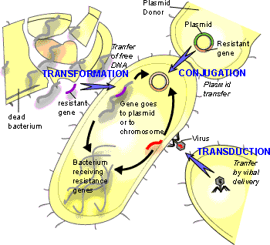

**Figure 4: Mechanisms of horizontal gene transfer** (Adated from Willey *et al*., 2008)

## MECHANISM OF RESISTANCE TO ANTIBIOTICS IN *S. AUREUS*

*Staphylococcus aureus* can exemplify better than any other human pathogen the adaptive evolution of bacteria in the antibiotic era, as it has demonstrated a unique ability to quickly respond to each new antibiotic with the development of resistance mechanisms (Sofia *et al*., 2013) which include:

* + 1. Enzymatic inactivation of the antibiotic (penicillinase and aminoglycoside- modification enzymes),
    2. Alteration of the target with decreased affinity for the antibiotic (notable examples being penicillin-binding protein 2a of methicillin-resistant *S. aureus* and D-Ala-D-Lac of peptidoglycan precursors of vancomycin-resistant strains),
    3. Trapping of the antibiotic (for vancomycin and possibly daptomycin) and
    4. Efflux pumps (fluoroquinolones and tetracycline).

## Enzymatic inactivation of the antibiotic

Mechanism of resistance by enzyme inactivation involves the hyper production of an enzyme that inactivates the antibiotic by an enzymatic cleavage or chemical modification such that they no longer interact with the target site or are no longer taken up by the organism (Powell, 2000). The most common example of this type of resistance is that mediated by β latamases which are widely distributed in both Gram-negative and Gram positive species (Hawkey, 2000).

1. Inactivation of β-lactam antibiotics:

The antibiotics concerned are β-lactam ring of penicillins and cephalosporins. Staphylococci are the principal bacteria producing β-lactamase, and the genes which code for the enzymes are on plasmids that are transferred by transduction.

In staphylococci the enzyme is inducible, its synthesis is at a very low level in the absence of the drug. The enzyme may diffuse through the envelope and inactivate antibiotic molecules in the surrounding medium. Gram negative organisms can also produce β-lactamases, which are a significant factor in their resistance to the semisynthetic broad spectrum β-lactam antibiotics. Here the enzyme may be determined by either chromosomal genes or by plasmid genes. The enzymes are produced constitutively (i.e. they are synthesized even when the substrate is absent) and remain attached to sites in the cell wall preventing access of the drug to the membrane associated target site; they do not inactivate the drug in the surrounding medium. Many of these β-lactamases are encoded by transposons, some of which may also carry resistance determinants to several other antibiotics (Figure 5).

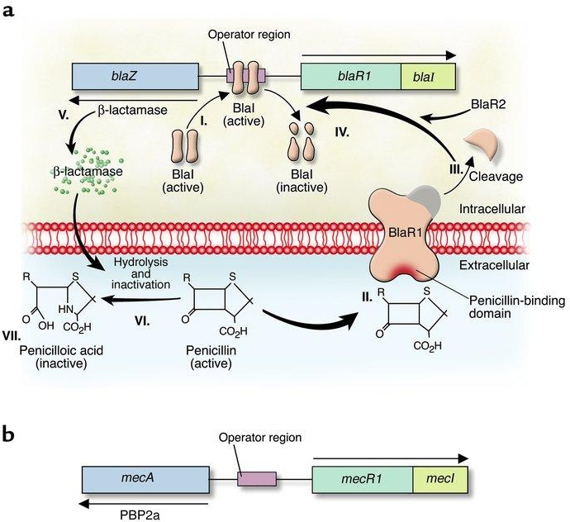

## Figure 5: Mechanism of enzymatic inactivation of beta- lactam antibiotics (Adapted from Lowy, 2003)

* 1. Induction of staphylococcal β-lactamase synthesis in the presence of the β- lactam antibiotic penicillin. I. The DNA-binding protein BlaI binds to the operator region, thus repressing RNA transcription from both blaZ and blaR1-blaI. In the absence of penicillin, β-lactamase is expressed at low levels. II. Binding of penicillin to the transmembrane sensor-transducer BlaR1 stimulates BlaR1 autocatalytic activation. III–IV. Active BlaR1 either directly or indirectly (via a second protein, BlaR2) cleaves BlaI into inactive fragments, allowing transcription of both blaZ and blaR1-blaI to commence. V–VII. β-Lactamase, the extracellular enzyme encoded by blaZ (V), hydrolyzes the β-lactam ring of penicillin (VI), thereby rendering it inactive (VII). (b) Mechanism of *S. aureus* resistance to methicillin. Synthesis of PBP2a proceeds in a fashion similar to that described for β-lactamase. Exposure of MecR1 to a β-lactam antibiotic induces MecR1 synthesis. MecR1 inactivates MecI, allowing synthesis of PBP2a. MecI and BlaI have coregulatory effects on the expression of PBP2a and β-lactamase.

1. Chloramphenicol inactivation is brought about by chloramphenicol acetyltransferase while inactivation of aminoglycosides may be brought about by phosphorylation, adenylation or acetylation, and the requisite enzymes have been found in both Gram-negative and Gram-positive organisms. The resistance genes are carried on plasmids and transposons.

## Alteration of the target with decreased affinity for the antibiotic

The protein on the 30S subunit of the ribosome, which is the binding site for aminoglycosides, may be altered as a result of a chromosomal mutation. A plasmid mediated alteration of the binding site protein on the 50S subunit underlies resistance to erythromycin.

Some staphylococci carry an altered penicillin binding protein (PBP2a) which is coded for by a mutated chromosomal gene; it has much lower affinity for penicillins and it confers intrinsic resistance (Powell, 2000). Vancomycin resistance is another example. Under susceptible conditions, vancomycin prevents cross- linking of peptidoglycan by binding to D-Ala-D-Ala dipeptide of the muramyl peptide. Most Gram positive bacteria acquire vancomycin resistance by changing D- Ala-D-Ala to D-Ala-D-lactate, which vancomycin does not bind to (Bugg *et al*., 1991). Mutations in DNA gyrase A and B subunits in quinolone resistance is another example of an alteration of the drug target. Finally, in Rifampicin resistance, there are mutations in rpoBgene encoding beta-subunit of RNA polymerase.

1. **Increased Efflux Activity (**Efflux pumps)

Efflux pumps are membrane proteins that have the function of detoxifying cells by expelling noxious molecules (Paulsen *et al*., 1996). In *Staphylococcus aureus*, several specific efflux pumps have been associated with resistance to antibiotics, such as tetracycline (*TetK*), *TetL*) and macrolides (*MefA*), *MsrA*) (Poole, 2007). Also, several multidrug efflux pumps have been described that are associated with resistance to antibiotics (e.g., fluoroquinolones) (Poole, 2007). In general, specific efflux pumps can be found either in the chromosome or in plasmids, while multidrug efflux pumps are mainly located in the chromosome, (Sofia *et al*., 2013). An important example of decreased drug accumulating is the plasmid-mediated resistance to tetracycline in both gram positive and gram negative bacteria. The resistance genes in the plasmid code for inducible ―resistance‖ proteins in the membrane which promote energy- dependent efflux of the tetracycline and hence resistance. This has reduced the value of tetracycline in human and veterinary medicine.

Tetracycline efflux was discovered in the early 1980s; *tetK* serves as an example for an efflux -mediated tetracycline resistance. Under normal conditions, the efflux gene, *tetK*, is not expressed, due to a suppressor that is bound to the promoter region. However, in the presence of tetracycline, it binds to the repressor, relieves the suppression, and causes transcription and translation of the efflux pump, thereby leading to tetracycline resistance (Krzysztof *et al.,* 2000).

* + 1. **MOBILE GENETIC ELEMENTS OF *STAPHYCOLOCCUS AUREUS***

## Definition

Mobile genetic elements(MGEs) are typically identified as fragments of DNA that encode a variety of virulence and resistance determinants as well as the enzymes that mediate their own transfer and integration into new host DNA (Frost *et al.*, 2005) MGEs demonstrate intracellular and intercellular mobility, and those within one particular cell are called a ―mobilome‖.

Among staphylococci, *S. aureus* is the most invasive species and an etiological agent of diverse human and animal maladies, including skin infections, abscesses, food poisoning, toxic shock syndrome, septicemia, endocarditis, and pneumonia (DeLeo and Chambers, 2009; Van Belkum, 2006; Weems, 2001). Numerous putative and proven virulence factors, gene responsible directly for host adaptation and toxins, are located on *S. aureus* MGEs (Kuroda *et al.*, 2001; Lindsay and Holden, 2004; Baba *et al*., 2008; Diep *et al*., 2006; Holden *et al.*, 2010).

*S. aureus* contains many types of MGEs including Plasmids, Transposons, (TN), Insertion sequences (IS), Bacteriophages, Pathogenicity islands, and Staphylococcal cassette chromosomes.

It is remarkable that most genes encoded by MGEs remain under the control of global regulators located within the core genome.

* + 1. **Acquisition of MGEs by *S. aureus***

This involves one or more of the following steps as presented in Figure 6:

* + - 1. incorporation of plasmids or plasmid elements into genomic DNA
      2. Plasmids can be maintained as free circular DNA
      3. Suicide plasmid
      4. Transfer of a transposon or an insertion sequence between plasmid and genomic DNA
      5. Transfer of a transposon or an insertion sequence between plasmids within the cell
      6. Transfer of a transposon or an insertion sequence from genomic DNA to another plasmid

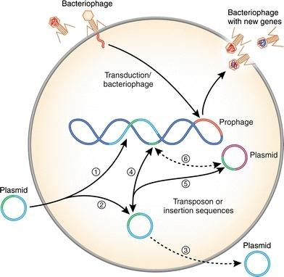

## Figure 6: Acquisition of Mobile Genetic Elements by *S. aureus* (Adapted from Malachowa and DeLeo, 2010)

As a consequence of the limited ability of *S. aureus* to acquire DNA from the environment (low natural competence) compared to bacteria such as *E. coli* and *Bacillus subtilis* most of the intercellular transfer of staphylococcal plasmids occurs by transduction or conjugation (Morikawa *et al*., 2003)

## Plasmid – encoded antibiotic resistance

Plasmids are auto-replicating DNA molecules. Staphylococci typically carry one or more plasmids per cell and these plasmids have varied gene content. Staphylococcal plasmids can be classified into one of the three following groups:

1. Small multicopy plasmids that are cryptic or carry a single resistance determinant

(Malachowa and DeLeo, 2010)

1. Large (15 – 30 kb) low copy (4-6/cell) plasmids, which usually carry several resistance determinants: and
2. Conjugative multiresistance plasmids (Berg *et al*., 1998).

## Plasmid encoded Penicillin resistance:

Penicilin was the first antibiotic mass produced for use in humans. Although initially highly effective for treatment of *S. aureus* infection, today over 90% of human *S. aureus* strains are resistant to this antibiotic (Olsen *et al*., 2006). Penicillin resistance is conferred by β - lactamase, which hydrolyzes the β – lactam ring of penicillin thereby inactivating the antibiotic, and or production of a low – affinity penicillin – binding

protein(PBP2a) encoded by the *mecA* gene (Hackbath and Chambers, 1993; Olsen *et al.*, 2006; Chambers and DeLeo, 2009). In *S. aureus*, β - lactamase is encoded by the *blaZ* gene and the closely linked regulators genes, *blaI* and *blaR.* Aside from plasmid encoded β – lactamase, *bla* genes may be located on transposons or within chromosomal DNA (Olsen *et al.*, 2006; Sidhu *et al*., 2002).

## Plasmid encoded Vancomycin resistance

*Staphylococcus aureus* was found to acquire vancomycin resistance elements from enterococci, resulting in the emergence of vancomycin-resistance *S. aureus* (VRSA) (Wiegel *et al.*, 2003; Zhu *et al.*, 2008).

Tn*1546* encodes the vancomycin resistance gene cluster within a conjugative plasmid. This MGE was most likely transferred to methicillin – resistance *S. aureus* (MRSA) from vancomycin – resistant enterococci (VRE) during co – infection (Weigel *et al.*, 2003; Ballard *et al*., 2005; Zhu *et al.*, 2008; Lindsay, 2010). There are two predicted fates of the enterococcal plasmid upon entering staphylococci: On one hand, the enterococcal plasmid could simply be maintained (Zhu *et al.*, 2008; Perichon and Courvalin, 2009), alternatively, Tn*1546* could be incorporated into a staphylococcal plasmid in which case the original enterococcal plasmid functions as a suicide vector (Zhu *et al*., 2008; Perichon and Courvalin, 2009). Transposon Tn*1546* encodes the *vanA* operon, which consists of *van*A, *van*H, *van*X, *van*S, *van*R, *van*Y, and *van*Z (Weigel *et al*., 2003; Saha *et al*., 2008).

## Staphylococci Plasmid encoded organic and in organic ions and toxins

In addition to gene encoding antibiotic resistance and molecules involved in metabolism, staphylococcal plasmids encode resistance to a variety of organic and inorganic ions, such as cadmium, mercury, arsenate, etc. which are highly toxic for living cells (Table 1) (Jensen and Lyon, 2009).

Staphylococcal plasmids may also encode toxin genes. For example, a large 37.5-kb *S. aureus* plasmid, pRW001, contains genes encoding exfoliative toxinB, bacteriocin and

bacteriocin immunity (Malachowa and DeLeo, 2010).

Summary of the resistance determinants encoded on Staphylococcal plasmid and their mechanism of action is presented in Table 1.

## Table 1: Resistance derminants encoded on plasmid, a non – SCC*mec* Staphylococcal MGE (Adapted from Malachowa and DeLeo, 2010)

|  |  |  |  |
| --- | --- | --- | --- |
| Resistance  derminant | Antibiotic/heavy metal | Mechanism of action | Reference |
| *aad*D | Neomycin,Kanamycin, Paromomycin, and tobramycin | Aminoglycoside adenyltansferase | (Kadlec and Schwarz, 2009) |
| *ant*4‘ | Tobramycin | Aminoglycoside nucleotidyl transferase | (Lelievre *et al*., 1999) |
| *arsRBC* | Arsenate, antimonite | Efflux AtPase | (Broer *et al*., 1993) |
| *blaZ*, *blaI*,  *blaRI* | Penicillin (β-lactam  antibiotics) | β –lactamase | (Kaase *et al*., 2008) |
| *Ble* | Bleomycin | Bleomycin- binding protein prevents DNA damage by binding  bleomycin | (Gennimata *et al*., 1996) |
| *cadD,X* | Cadmium resistance | Efflux | (Massidda *et al*., 2006) |
| *Cat* | Chloramphenicol | Chloramphenicol  acetyltransferase | (Projan *et al*., 1988) |
| *Cfr* | Chloramphenicol, florfenicol,and  clindamycin | Methylation of 23S subunit of bacterial  ribosome | (Kehrenberg and Schwarz, 2006) |
| *dfrA, dfrK* | Trimethoprim | Dihydrofolate reductase | (Kadlec and Schwarz,  2009) |
| *erm B,C* | MLSB resistance (Macrolides:erythromycin, lincosamides:  clindamycin,streptogramm in B) | Methylation of 23S subunit of bacterial ribosome | (Otsuka *et al*., 2007) |
| *fusB* | Fusidic acid | Ribosome protection  mechanism | (Jappe *et al*., 2008) |
| *ileS-2* | High-level resistance to mupirocin (pseudomonic  acid A) | Isoleucyl RNA synthetase | (Patel *et al*., 2009) |
| *mer operon* | Mercury | Reduction of mercury ions to elementary Hg | (Laddaga *et al*., 1987) |
| *mphBm* | Macrolide antibiotics | Putative Phosphorylase | (Matsuoka *et al*., 1998) |
| *msrA* | Macrolide antibiotics | Active efflux | (Matsuoka *et al.*, 1998) |
| *mupA* | High – level mupirocin  resistance | Novel isoleucyl RNA  synthetase | (Patel *et al*., 2009) |
| *qacA,B and*  *smr(qac C/D)* | Quaternary ammonium compounds, biocides | Drug efflux pump | (Nakaminami *et al.*, 2008) |
| *Str* | Streptomycin | Streptomycin | (Projan *et al*., 1988) |

|  |  |  |  |
| --- | --- | --- | --- |
|  |  | adenyltransferase |  |
| *tetK, tetL* | Tetracyclines | Active efflux of  tetracycline | (Tryzeinski *et al*., 2000) |
| *Vat* | Streptogramins type A | Acetylation of the  antibiotic | (Korczynska *et al*., 2007) |
| *Vga* | Streptogramins type A,  lincosamides, and pleuromutilins | Efflux | (Kadlec and Schwarz, 2009) |
| *Vgb* | Streptogramins type B | Inactivation by  virginiamycin B lyase | (Mukhtar *et al*., 2001) |

## 2.7 STAPHYLOCOCCAL CASSETTE CHROMOSOME

This is a mobile genetic element that carries the central determinant for broad-spectrum beta-lactam resistance encoded by the *mecA* gene. The emergence of methicillin- resistant staphylococcal lineages is due to the acquisition and insertion of the SCCmec element into the chromosome of susceptible strains. SCCmec elements are highly diverse in their structural organization and genetic content and have been classified into types and subtypes. The SCC*mec* is comprised of:

1. *mec* gene complex containing the *mecA* gene, its regulatory genes and associated insertion sequences, and
2. cassette chromosome recombinase (*ccr*) gene complex (Ito, 2009; Ito *et al*; 2012).

Six classes of *mec* gene complexes (A, B, C1, C2, D and E) and three *ccr* genes (*ccrA, ccrB* and *ccrC*) for integration and excision of the SCC*mec* element have been reported so far ([www.sccmec.org](http://www.sccmec.org/)).

SCC*mec* elements are classified into types by the combination of the type of *ccr* gene complex and the class of *mec* gene complex. Eleven SCC*mec* elements are reported to date: SCC*mec* I to XI (Ito, 2009; Li *et al*; 2011; Shore *et al*; 2011; Ito *et al*; 2012). Among these, SCC*mec* types I–V are the most commonly reported (Figure 7). SCC*mec* types I–III are usually carried by hospital- associated methicillin resistant *S. aureus* (HA-MRSA) while types IV and V are usually carried by community-associated (CA) MRSA.

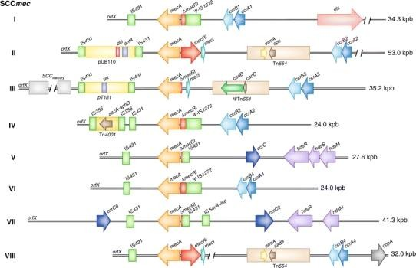

**Figure 7: Comparison of *S. aureus* SCC*mec* types** (Adapted from Malachowa and DeLeo, 2010).

Class A SCC*mec* contains a complete *mecA* regulon (*mec1*-*mecR1*-*mecA*). Class B and class C SCC*mec* contain regulatory genes that are disrupted by IS, IS*1272*- Δ*mecR1*-*mecA* and IS*431*-Δ*mecR1*-*mecA*, respectively. Tn*554* encodes erythromycin (*ermA*) and streptomycin/spectinomycin resistance (*aad9* or *spc*); *copA* encodes a putative copper-transport ATPase; *hsdR*, *hsdM*, and *hsdS* encode a partial restriction-modification system (RM) type I; Tn*4001* encodes an aminoglycoside resistance operon (*aacA*-*aphD*); plasmid pT181 encodes tetracycline resistance (*tet*); ΨTn*554* encodes cadmium resistance (*cadB, cadC*); and plasmid pUB110 encodes

bleomycin (*ble*) and tobramycin resistance (*ant4′*). *pls* Plasmin‐sensitive surface protein

## METHICILLIN

## History of Methicillin

Before the antibiotic era infections with *S. aureus* caused numerous deaths, but the period between 1950 and 1997 represented the golden age for the treatment of staphylococcal infections, as the bacteria were mostly susceptible to penicillins. During the period between 1950 to 1959, approximately 80% of hospital acquired infections caused by *S. aureus* became resistant to penicillin due to the production of beta lactamase. In the early 1960, a semi-synthetic, broad spectrum beta-lactam compound called methicillin was introduced, which was active against penicillinase-producing *S. aureus* (Chambers, 2009)

* 1. **METHICILLIN - RESISTANT *S. AUREUS* (MRSA)**

MRSA is any strain of *S. aureus* that has evolved resistance to beta-lactam antibiotic which include the penicillins (Methicillin, dicloxacilin, nafcillin, oxacillin etc) and the cephalosporins. In 1961, the first isolate of MRSA was reported in England (Jevons, 1961). Since then, MRSA has increasingly been isolated in various countries, and at present, it is one of the major causes of nosocomial infection throughout the world, thus it is alternatively called hospital- acquired MRSA (HA-MRSA). In addition, from 1997 to 1999, another class of MRSA has become a major concern worldwide because it has become an emerging pathogen in the community (Vandenesch *et al*., 2003; Zetola *et al*., 2005; Deurenberg and Stobberingh, 2008). This new class of MRSA is called community- acquired MRSA (CA-MRSA)

* + 1. **Hospital - acquired (HA- MRSA) and Community - acquired (CA- MRSA)** HA-MRSA is typically defined as MRSA isolated from in - patients that had been MRSA-negative at the beginning of hospitalization or MRSA isolated from in patients 48 hours or more after hospitalization (Tacconelli *et al*., 1998; Brumfitt and Hamilton, 1989; Naimi *et al.,* 2003; Vandenesch *et al*., 2003).

Epidemiologically, CA-MRSA are isolate from out patients with no history of hospitalization within the previous year and who presented no other established risk factors for MRSA infection such as surgery, residence in a long term care facility, dialysis or in-dwelling percutaneous medical device or catheters.

## Clinical Implications of MRSA

MRSA is a life-threatening, mullti - drug resistant bacterium, changing its resistance patterns by acquiring resistance to each new antimicrobial agent. This has made MRSA infection more difficult to treat with standard classes of antibiotics and thus more dangerous. MRSA strains are a persistent and increasing cause of nosocomially acquired infection in the world (Narezkina *et al*., 2006)

It has been difficult to quantify the degree of morbidity attributable to MRSA. In- patients with *S. aureus* infection had, on average, 3 times the length of hospital stay, 3 times the total charges and 5 times the risk of in-hospital death than in - patients without this infection (Noskin *et al*., 2005). They affect patients in high dependency units such as intensive care units, burns units and cardiothoracic units. There are also several epidermic strain circulating in milk (Finch, 2000). Clinical implications of CA-MRSA include skin and soft tissue infection (in form of skin abscess, carbuncle, furuncle impetigo); pneumonia, osteomyelitis, arthritis, endocarditis. CA-MRSA can also cause

wound infections, (Demlin and Water house, 2007) CA-MRSA has also been detected from surgical site infection, urinary tract infection (Baba-Moussa *et al.,* 2008), Infection of the eye and orbit (Blomquist, 2006), meningitis and sinusitis (Munckhof *et al*., 2008).

## MRSA Clones

MRSA is typed based on genetic characteristics such as

* + - 1. multilocus sequence type (MLST) (Enright *et al*., 2000),
      2. protein A gene (*spa*) type (Harmsen *et al.,* 2003; Korean *et al*., 2004),
      3. *agr* type (Gilot *et al*., 2002; Strommenger *et al.,* 2004),
      4. coagulase type (Kinoshita *et al.,* 2008; Sakai *et al.,* 2008), and
      5. SCC*mec* type (Oliveira *et al*., 2002; Zhang *et al*., 2005; IWG-SCC 2009).

Generally, sequence typing (ST) and analysis of the clonal complex (cc) to which each ST type belongs is a standard for genotyping. MRSA clones in Africa and outside Africa are presented in Tables 2 and 3 below:

## Table 2: Distribution of major MRSA clones in Africa

|  |  |  |
| --- | --- | --- |
| MRSA Clone | Location  (where reported) | Reference |
| ST8/SCC*mec*V | Ibadan, Ile-Ife and Lagos (South-  western Nigeria) | Shittu *et al*., 2011 |
| ST241: single locus variant  of ST239/ SCC*mec*III | Maiduguri (North-  eastern Nigeria) |  |
| ST5/ SCCmecIV/V  ST88 /SCCmecIV | Central Africa |  |
| ST239/SCCmecIII  ST241/SCCmecIII | Morocco |  |
| ST239 /SCCmecIII | Niger |  |
|  | Senegal |  |
| ST80/SCCmecIV | Algeria |  |
| ST80/SCCmecIV | Tunisia |  |
| ST612/SCCmecIV  ST239/SCCmecIII | South Africa |  |

**Table 3: Distribution of major MRSA clones outside Africa**

|  |  |  |  |
| --- | --- | --- | --- |
| MRSA Clone | Location  (where reported) | When reported | Reference |
| Archaic clone (ST | United kingdom | 1960 | Deurenberg and |
| 250/SCC*mec*I) |  |  | Stobberingh, 2008; |
| Iberian clone | Spain | 1989 | Aires *et al*., 2005; |
| (ST247/SCC*mec*IA) |  |  |  |
| New York/Japan clone | United States | 1998 | Noto *et al.,* 2008; |
| ST5/SCC*mec*II) |  |  |  |
| EMRSA-16 clone | United Kingdom | 1993 | Oliveira *et al*., |
| (ST36/SCC*mec*II) |  |  | 2001; |
| Brazilian clone | Brazil | 1992 | Cox *et al.,* (1995); |
| (ST239/SCC*mec*IIIA) |  |  |  |
| Hungarian clone | Hungary | 1993 | Conceicao *et al.,* |
| (ST239/SCC*mec*III) |  |  | 2007; |
| Pediatric clone | Portugal | 1992 | Gordon and Lowy, |
| (ST5/SCC*mec*IV/IVA |  |  | 2008. |
| EMRSA-15 clone | United Kingdom | 1993 | Gordon and Lowry, |
| (ST22/SCC*mec*IV) |  |  | 2008 |
| Berlin clone | Germany | 1998 | Gordon and Lowry, |
| (ST45/SCC*mec*IVa) |  |  | 2008 |

## Mechanism of Methicillin resistance

Methicillin resistance in clinical isolates has been reported to arise from expression of a methicillin-hydrolysing β-lactamase (Montanari *et al*., 1996) and through the expression of an altered form of PBP2 that has a lower penicillin-binding affinity and higher rates of release of the bound drug compared to the normal PBP2 (Hackbarth *et al*., 1995).

However, the main mechanism of methicillin resistance in *S. aureus* is through the expression of a foreign PBP, PBP2a (not to be confused with PBP2), that is resistant to the action of methicillin but which can take over the transpeptidation (cross-linking) reactions of the host PBPs. Synthesis of PBP2a is regulated and normally kept at low level, but the level of synthesis can be enhanced if mutations occur in the regulatory genes.

## Altered Penicillin Binding Protein (PBP2a)

MRSA differ genetically from methicillin-sensitive *S. aureus* isolates by the presence, in the chromosome, of a large stretch of foreign DNA (40-60 Kb), referred to as the *mec* element, and the presence of the *mecA* gene that encodes the 76 KDa penicillin-binding protein, PBP2a (also referred to as PBP2′). The *mecA* gene has been proposed to originate from *Staphylococcus sciuri* (Wu *et al*., 2001). Although the mechanism of gene acquisition from this specie is not known, two genes, *ccrA* and *ccrB*, present on the *mec* element from one isolate, have been shown to code for recombinase proteins that are capable of excising and integrating the *mec* element into the chromosome (Katayama *et al*., 2000). In common with other PBPs, PBP2a has the common structural motifs that are associated with penicillin binding yet its affinity for β-lactam antibiotics is greatly reduced. Consequently, at therapeutic levels of methicillin that would inhibit

the transpeptidational activities of other PBPs, PBP2a remains active ensuring the cross- linking of the glycan chains in peptidoglycan. PBP2a is not able to completely compensate for the other PBPs since cells grown in the presence of methicillin exhibit a marked reduction in the degree of cross-linking. However, the limited degree of cross- linking is enough to ensure survival of the cell.

## Regulation of PBP2a expression

Adjacent to *mecA* on the staphylococcal chromosome are two genes, *mecR1* and *mecI*, that are co-transcribed divergently from *mecA* (Figure 8). The *mecR1* gene encodes a membrane-bound signal transduction protein (MecR1) while *mecI* encodes a transcriptional regulator (MecI). Between *mecA* and *mecR1* are the promoters for these genes and an operator region that encompasses the −10 sequence of *mecA* and the -35 sequence of *mecR1* (Sharma *et al*., 1998) ([Figure 8A](http://www.ncbi.nlm.nih.gov/pmc/articles/PMC2065735/figure/F3/?report=objectonly)). MecR1 and MecI have high protein sequence homology with the proteins, BlaR1 and BlaI, respectively that are involved in the inducible expression of the plasmid-mediated staphylococcal β- lactamase gene, *blaZ*. The arrangement of the genes coding for *BlaR1* and *BlaI* resembles the *mecA* system suggesting that *mecA* may have acquired the regulatory genes from the *blaZ* system sometime in the past (Song *et al*., 1987). The operator regions are similar enough to allow BlaI to regulate PBP2a expression (Gregory *et al*., 1997). Consequently, the presence of a plasmid carrying the *blaZ* regulatory genes can render PBP2a expression inducible under the control of BlaR1 and BlaI, a situation that commonly occurs in clinical isolates of MRSA (Hackbarth and Chambers, 1993).

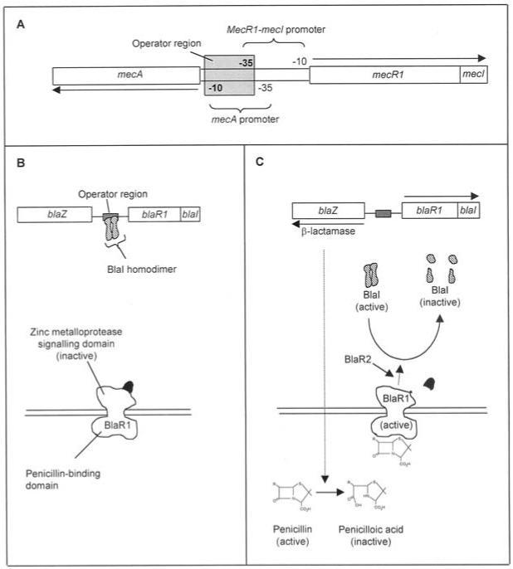

**Figure 8: A**, Schematic representation of the *mecA-mecR-mecI* coding region. Arrows indicate the relative directions of transcription of the mecA and mecR1-mecI genes.

**B**, Repression of *blaZ* and *blaR1-blaI* transcription by *BlaI* in the absence on an inducer. **C**, Induction (Adapted from Sharma *et al*., 1998).

The nature of the signalling system for inducible β-lactamase expression has been elucidated (Zhang *et al*., 2001). *BlaI*, a DNA-binding protein, binds to the operator region as a homodimer and represses RNA transcription from both *blaZ* and *blaR1-blaI* (Figure 8B). Consequently, in the absence of a β-lactam antibiotic, β-lactamase is expressed at low levels. BlaR1, present in the cytoplasmic membrane, detects the presence of the β-lactam by means of an extracellular penicillin-binding domain and transmits the signal via a second intracellular zinc metalloprotease signalling domain (Figure 8B). Binding of a β-lactam to BlaR1 stimulates the autocatalytic conversion of the intracellular zinc metalloprotease domain of BlaR1 from an inactive proenzyme to an active protease (Zhang *et al*., 2001). The activated form of BlaR1 is thought to directly or indirectly cleave BlaI resulting in fragments that are incapable of forming dimers and binding DNA (Figure 8) (Gregory *et al*., 1997). Without BlaI bound to the operator site, transcription of both *blaZ* and *blaR1-blaI* can commence and β-lactam resistance can be conferred through β-lactamase synthesis (Figure 8C). An additional gene product, BlaR2, also regulates β-lactamase synthesis, although the role of this protein has not been elucidated. Whether there are other proteins involved in the signalling system also remains to be determined.

Unlike β-lactamase synthesis, expression of PBP2a is not strongly inducible in isolates carrying the normal regulatory genes (*mecA* and *mecR1*-*mecI*) and induction is much slower (15 minutes for β-lactamase expression compared to up to 48 hours for PBP2a synthesis). This is because MecI is a tight regulator of *mecA* transcription (Kuwahara- Arai *et al*., 1996) and most β-lactam antibiotics do not efficiently activate MecR1.

Consequently, some isolates, referred to as pre-MRSA, are methicillin-sensitive despite carrying the *mecA* gene. However, selective pressure through antibiotic usage has

promoted *S. aureus* isolates that have mutations or deletions in *mecI* or the *mecA* promoter/ operator region giving rise to an inactive repressor and constitutive PBP2a expression (Kobayashi *et al*., 1998).

## Internal factors affecting methicillin resistance

Since PBP2a is essential in conferring methicillin resistance, any factor that interferes with the expression of the *mecA* gene or with the activity of PBP2a will affect methicillin resistance. Genetic and biochemical studies have established that PBP2a has strict substrate requirements. Consequently, any factors that influence formation of the substrate have the potential to perturb or modulate methicillin resistance. Studies have shown that PBP2a requires: Glycan chains to be of certain lengths (Pinho *et al*., 2001), the stem peptide to have the normal peptide configuration (Jonge *et al*., 1996, Ludovice *et al.,* 1998) and the pentaglycine cross-bridge to be intact (Berger-Bächi and Tschierske 1998).

## External factors that affect methicillin resistance

External factors that affect methicillin resistance include among others, salt concentration, pH, medium composition, osmolarity and temperature (Matthews and Stewart, 1984). Some of these external influences are exploited in the clinical laboratory to enhance the detection of strains exhibiting heterogeneous methicillin resistance; isolates are grown in the presence of high sodium chloride concentrations (4%) and at lower temperatures (30-35°C).

## CLINICAL TREATMENTS FOR MRSA INFECTIONS

## Current Clinical Treatments

The difficulty in identifying new compounds with suitable antibacterial activity is one of the major problems faced in the fight against resistant organisms (Payne *et al*., 2007; Wright and Sutherland, 2007).

Penicillin was the first class of the -lactams for the treatment of bacterial infections. With the development of resistance, however, many of these -lactams became ineffective against a significant proportion of *S. aureus* clinical strains (Guignard *et al.,* 2005). The glycopepides belong to a different class of antibiotics effective against Gram-positive organisms. Vancomycin and teicoplanin are the preeminent members of this class of antibiotics (Loffler and Macdougall, 2007), and vancomycin is the antibiotic most commonly used to treat MRSA infections, the inhibition of cell wall biosynthesis by the glycopetides results from their stable noncovalent binding to the D- Ala-D-Ala terminal of peptidoglycan precursors. However some MRSA strains have evolved resistance to vanvomycin (Kollef, 2007; Sakoulas and Moellering, 2008).

Linezoid, quinupristin-dalfopristin, daptomycin, and tigecycline represent newer agents for the treatment of *S. aureus* infections, including those caused by non-vancomycin susceptible MRSA. Linezolid is a synthetic oxazolidinone antimicrobial agent that blocks the formation of protein synthesis initiation complexes (Leticia *et al*., 2009).

Quinupristin-dilfopristin is a mixture of semisyntheric streptogramin derivatives that bind to different sites of the 50S ribosomal subunit, resulting in the irreversible inhibition of bacterial protein synthesis ([Llarrull](http://aac.asm.org/search?author1=Leticia%2BI.%2BLlarrull&sortspec=date&submit=Submit) *et al*., 2009).

Daptomycin is a cyclic lipopeptide that forms a calcium ion complex in the bacterial cytoplasmic membrane causing the loss of the transmembrane electrical potentaial

gradient (Aksoy and Unal, 2008). Inhibition of protein: RNA, DNA, peptidoglycan lipoteichoic acid, and lipid biosynthesis are also observed, although it is not yet clear if these are consequences of the loss of the transmembrane electrical potential gradient or the independent effects of daptomycin.

## New weapons in the pipeline: -lactam antibiotics that inhibit PBP 2a:

Four -lactams antibiotics are being evaluated for the treatment of MRSA associated infections by targeted inhibition of PBP 2a transpeptidase activity. In a review published in 2005, Guignard *et al*., (2005) described 16 novel anti MRSA -lactam antibiotics, only 1 of which (ceftobiprole) remains in clinical development. In a later review, Page (2006) reported on a new cephalosporin (ceftaroline) also active against MRSA, two additional -lactams antibiotics ME1036 and PZ-601, have been added to the anti MRSA pipeline (Butler and Buss 2006; Abbanat *et al.,* 2008; Butler, 2008; Kattan *et al*., 2008).

## Ceftobiprole medocaril:

Ceftobiprole medocaril, a water-soluble cephalosporin prodrug, belongs to a new class of cephem antibiotics with activity against a wide range of Gram-positive organisms, including MRSA and penicillin- resistant *Streptococcus pneumoniae*, and Gram negative pathogenic bacteria (Bush *et al*., 2007; Page, 2007; Anderson and Gums, 2008). Rapid cleavage of ceftobiprole medocaril in plasma produces the active drug, ceftobiprole (Murthy and Schmitt-Hoffmann 2008). Ceftobiprole inactivates all four *S.*

*aureus* PBPs and PBP 2a, as indicated by competition assays against a fluorescent - lactam.

Ceftobiprole medocaril, the prodrug, is converted rapidly and almost completely by type A esterases to active ceftobiprole (Murthy and Schmitt-Hoffmann 2008).

The pharmacokinetics and pharmacodynamic of ceftobiprole describe a drug that should be appropriate for the early emprirical hospital treatment of patients with infections (Murthy and Schmitt-Hoffmann, 2008)

One phase 3 clinical trial for community acquired pneumonia has been completed (Abbanat *et al*, 2008), and two phase 3 trials for complicated skin and skin structure infections (cSSSIs) (Moreillon, 2008; Noel *et al*., 2008a; Noel *et al*., 2008b) are currently on going in the United States. Ceftobiprole monotherapy was as effective as Vancomycin plus ceftazidime for the treatment of patients with a broad range of cSSSIs and infections due to Gram-positive bacteria (including MRSA) and gram-negative bacteria (Noel *et al*., 2008a). In another phase 3 study, the cure rates for patient with MRSA infections were 92% (56/61) with ceftobiprole treatment and 90% (54/60) with vancomycin monotherapy (Noel *et al*., 2008b). Ceftobiprole monotherapy was as effective as vancomycin monotherapy or vancomycin plus ceftazidime (Noel *et al*., 2008a).

## Ceftaroline fosamil.

Ceftaroline fosamil, a water soluble N-phosphono type cephalosporin prodrug, is a member of a new class of cephem antibiotics having antibacterial activity against a wide range of species including the resistant Gram positive pathogens MRSA and multidrug- resistant *Streptococcus pneumoniae*, as well as common Gram-negative pathogenic

bacteria. Ceftaroline fosamil, discovered by Takeda Chemical Industries (Osaka, Japan), is currently being developed by Forest Laboratories (New York, NY) for the treatment of infections, including cSSSIs and community acquired pneumonia.

Ceftaroline, the active form of ceftaroline fosamil, is a potent inhibitor of PBP 2a of MRSA (IC50= 0.16 to 0.18g/ml) (Moisan *et al*., 2008; Villegas-Estrada, 2008), which translates into a high level of inhibitory activity (MIC for MRSA =0.25 to 0.5g/ml) (Moisan *et al*., 2008; Sader *et al*., 2008)

Ceftaroline fosamil the prodrug, undergoes rapid conversion by plama phosphates to active ceftaroline.

Two phase 3 clinical trials with patients with cSSSIs have been completed, and two phase 3 clinical trials with patients with community-acquired pneumonia are currently on going in United States. In a randomized, double blinded study of the efficacy and safety of ceftaroline versus those of vancomycin plus aztreonam in patients with cSSSIs, ceftaroline monotherapy (intravenous) was as effective and well tolerated as vancomycin plus aztreonam combination therapy for the treatment of patients infected with both Gram positive and Gram-negative pathogens (Corey *et al*., 2008). The clinical cure rates were similar for ceftaroline and vancomycin plus aztreonam in clinically evaluable subjects (91% and 93%, respectively). The clinical cure rate for MRSA infections was 95% for both ceftaroline and vancomycin plus aztreonam.

Microbiological success was similar for ceftaroline and vancomycin plus aztreonam overall (92% and 93%, respectively and for MRSA in particular (95% and 92% respectively). In conclusion Ceftaroline monotherapy was as effective as Vancomycin plus aztreonam (Corey *et al.*, 2008).

Girish and Balakrishnan, (2011) reported that the United States Food and Drug Administration has granted approval for ceftaroline fosamil (teflaro) on October 2010, to treat adults with community acquired bacterial pneumonia and acute bacterial skin and skin structure infections, including MRSA. The dose of ceftaroline fosamil recommended is 600 mg intravenously, every 12 h for patients with normal renal function or mild renal dysfunction. The drug formulation of ceftaroline fosamil available is in a powder form for intravenous administration as 400 mg and 600 mg vials (FDA, 2011). This drug is not yet available in India.

## ME1036.

ME1036 is a broad spectrum carbepenem that binds with a high affinity to PBP 2a of MRSA (IC50=0.13 to 0.73g/ml) (Kurazono *et al*., 2004; Villegas –Estrada *et al.*, 2008) and that exhibits potent in vitro inhibitory activity against MRSA (Sader *et al.,* 2008). The inhibitory effect of ME1036 on the enzymatic activity of PBP 2a also appears to coincide with facilitated opening of the active site by allosteric interactions (Villegas- Estrada *et al.,* 2008).

ME1036 has activity against MRSA and multidrug-resistant streptococci, in addition to broad-spectrum activity against organisms that include extended-spectrum -lactamase- producing Enterobacteriaceae and common anaerobes (Kurazono *et al.,* 2004)

## PZ-601 (Razupenem).

PZ-601 is a new carbapenem being developed by Protez pharmaceuticals (now Novartis) that has demonstrated a high degree of potency against MRSA.

PZ-601 has in vivo efficacy against VISA and is in phase 2 clinical trials for the treatment of cSSSIs (Abbanat, 2008). In a study carried out to determine the safety and multiple dose pharmacokinetics of PZ-601 in health male volunteers PZ-601 did not cause any serious adverse events (Lo *et al*., 2008)

The -Lactam antibiotics that inhibit PBP2a is a great progress and offers a glimmer of hope for the future treatment of MRSA infections including those caused by vancomycin-resistant and intermediate strains.

## DETECTION OF METHICILLIN RESISTANCE

Formerly, the National Committee for Clinical Laboratory Standards (NCCLS) recommended the following for detection of oxacillin/methicillin resistance.

1. Minimum Inhibitory Concentration (MIC) susceptibility Method: this involves direct colony inoculums where isolated colonies from an 18 to 24 hour nonselective agar plate are used to prepare a direct inoculum equivalent to a 0.5 McFarland Standard. Here oxacillin is the preferred agent for detection of methicillin resistance. For supplementation of test medium, the addition of 2% NaCl to broth dilution is recommended to enhance detection of MRSA. Incubation time and temperature are

24 hours and 35°C respectively. Interpretation of results: Oxacllin-Susceptible *Staphylococcus aureus* MIC ≤2 µg/ml while Oxacillin-Resistant *Staphylococcus aureus* MIC ≥4 µg/ml.

1. Disk diffusion susceptibility method: This involves a direct colony inoculum preparation, Mueller Hinton agar and 1 µg oxacillin disk are used. Incubation is for 24 hrs at 35° C. Interpretation of results:

Resistant (MRSA): <10 mm zone size of inhibition

Confirm with Oxacillin Screening Agar: 11-12 mm zone size of inhibition Susceptible (No MRSA): >13 mm zone size of inhibition

1. Oxacillin agar screening test: When performed correctly, both disk diffusion and MIC tests accurately detect MRSA. The oxacillin screening plate can be used in addition to or as a backup method. Mueller Hinton agar with 4% NaCl and 6 µg/ml of oxacillin. Direct colony inoculum preparation, dip swab into inoculum, express excess fluid and streak quadrant of the agar or spot inoculate 1 to10 µl of the suspension to a quadrant of the plate. Incubate for 24 hours at 35° C.

> 1 colony or light film of growth = oxacillin /methicillin-resistant

1. The cefoxitin disk test was first approved by the Clinical and Laboratory Standards Institute (CLSI, 2004) (formerly NCCLS) for predicting *mecA* mediated resistance in *Staphylococcus* spp. It is a disk diffusion test with specific breakpoints for both *S. aureus* (≤21mm for resistant and ≥ 22mm for susceptible) and coagulase negative staphylococci (CoNS). (≤ 24mm for resistant and ≥25mm for susceptible) (CLSI, 2013). The test was approved for two reasons:
   1. The test is highly sensitive and specific for the presence of *mecA* mediated resistance especially for CoNS. The cefoxitin disc test is more accurate than oxacillin susceptibility testing for detection of *mecA* mediated resistance.
   2. The cefoxitin disc test is easier to read than the oxacillin disk diffusion test.

The zone around an oxacillin test must be read with close scrutiny and transmitted light. The cefoxitin disk test produces clearer zones and can be read with reflected light.

Oxacillin and cefoxitin are tested instead of methicillin because methicillin is no longer commercially available and that oxacillin maintains its activity during storage better than methicillin and is more likely to detect heteroresistant strains.

Additional tests to detect MRSA

1. Amplification tests based on polymerase chain reaction (PCR) are available to detect the *mecA* gene. However, *mecA* PCR tests will not detect novel resistance mechanisms such as *mecC* or uncommon phenotypes such as borderline- resistant oxacillin resistance.
2. Latex agglutination methods are available for detection of the penicillin-binding protein 2a (PBP2a).

## ORTHOPAEDICS

The term orthopaedics is derived from two Greek words: ‗ortho‘ means ‗straight‘, ‗pais‘ means ‗children‘ together meaning ‗straight children‘. As in all branches of medicine no condition can exist in true isolation thus there is a defined linking system between general diseases and orthopaedic problems as well as the specifically linked components (e.g. shoulder/arm/elbow etc) found in the limbs. An understanding of these inter- relationships is an essential diagnostic and therapeutic feature of orthopaedics (David, 1986).

## Bone Infections

1. Acute Osteomyelitis: An infection of bone is called osteomyelitis, usually pyogenic bacteria are involved and spread along the medullary cavity. The infection may be blood-borne or the organism directly implanted into the bone by trauma (e.g. a compound fracture), surgery (e.g. an infected metal plate or prosthesis) or through skin loss close to bone (e.g. a varicose ulcer).
2. Chronic osteomyelitis: This condition is almost always an unwanted one as a result of an acute infection which has been inadequately treated or it occurs in a patient with a low resistance.
3. Chronic non-suppurative osteomyelitis. This includes tuberculosis osteomyelitis, brucella osteomyelitis and syphilitic osteomyetitis (Ernest and John, 1975).

## Joint infections

These may be acute or chronic

* + - 1. Acute septic arthritis: Here the joint is invaded by a bacterium of one of the pyogenic group, usually the *Staphylococcus*. It may be blood-borne or transmitted through a penetrating wound, surgical wound or by extension from an adjacent focus of osteomyelitis.
      2. Chronic septic arthritis: This may follow an operation or a compound injury involving a joint.

## Fracture

A fracture is a break in continuity of a bone. It may be a complete break in the continuity of a bone or it may be an incomplete break or crack.

## Classification of Fracture

Fractures may be subdivided according to the aetiology into 3 groups.

1. Fracture caused by sudden injury, either by direct or indirect violence.
2. Fatigue or stress fractures: This occurs not from a single violent injury but from often repeated stress.
3. Pathological fractures: This is a fracture through a bone that is already weakened by disease. Often the bone gives way from trivial violence or even spontaneously (John and David, 1991)

The type of fracture which occurs depends on the magnitude and direction of the force causing it:

* 1. A *transverse* fracture is usually caused by a force applied directly to the site at which the fracture occurs. This often represents a three point force system.
  2. A *spiral* or oblique fracture is usually caused by violence transmitted through the limb from a distance.
  3. A *greenstick* fracture occurs in children, whose bones are soft and yielding. The bone bends without fracturing across completely, the cortex on the concave side usually remaining intact.
  4. A *crush* fracture occurs in cancellous bone as a result of a compression force.
  5. A *burst* fracture usually occurs in a short bone such as a vertebra from strong direct pressure in the vertebrae this usually occurs as a result of impaction of the disc.
  6. An *avulsion* fracture is caused by traction, a bony fragment usually being torn off by a tendon or ligament.
  7. A *fracture dislocation* or subluxation is a fracture which involves a joint and results in mal-alignment of the joint surfaces (Duckworth, 1995)

## Closed and Open Fractures

A fracture is closed or simple when there is no communication between the site of fracture and the exterior of the body.

A fracture is open or compound when there is a wound on the skin surface leading down to the site of fracture even though the presence of a wound of the skin in association with a fracture does not necessarily mean that the fracture is an open fracture. The most important consideration when dealing with an open fracture is to reduce the risk of infection.

The development of chronic osteomyelitis at the fracture site is a catastrophe which may lead to delayed or non- union, requiring months or even years of treatment and sometimes leading to loss of the limb. Sepsis is best prevented by early and aggressive cleaning of the wound with excision of dead tissue and all foreign material.

## Complications of Fractures

1. **Immediate complications** (i.e. occurring at the time of injury)
   1. Severe haemorrage: this may be either external or internal
   2. Injury to important internal organs- brain, lung, liver e.t.c.
   3. Injury to local nerves or vessels.
   4. Skin loss or damage.
2. **Early or Intermediate Complications** (occurring during the period of treatment): this may be local or general.
3. Local complication include:
   1. Skin and soft tissue necrosis.
   2. Gangrene from vascular damage or external pressure.
   3. Pressure sores and nerve palsies from splintage or traction.
   4. Infection and wound breakdown.
   5. Loss of alignment. Failure of internal fixation.
   6. Tetanus and gas gangrene.
4. General: The general complication include:
   1. Deep vein thrombosis and pulmonary embolism.
   2. Hypostatic pneumonia.
   3. Renal calculus, acute retention and other urinary tract problems
   4. Fat embolism usually occurring 3- 10 days after fractures of long bones and particularly after major trauma.
   5. ‗Crush syndrome‘ this is usually associated with extensive soft tissue damage or ischaemia of a large volume of tissues e.g. following occlusion of the femoral artery. Its cause is complicated various factors such as fluid loss release of toxic materials from the site of drainage and possibly diffuse intravascular coagulation, all contributing to an effect on the kidneys resulting in acute tubular necrosis with renal failure. It may be prevented by the removal of the damaged tissue before severe renal changes have occurred e.g. by amputation of the limb.

## Late complications:

Some signs of late complication include:

* 1. Delayed and non- union, mal- union i.e. union bad position.
  2. Late wound sepsis with skin breakdown.
  3. Failure of internal fixation e.g. breakage or cutting out of plates or nails.
  4. Joint stiffness and contracture.
  5. Sudek‘s atrophy (algodystrophy) – a condition in which the limb becomes painful, swollen and discoloured, with obvious circulatory changes and x-rays showing diffuse patchy porosis of the bones.
  6. Osteoarthritis resulting from joint damage or occasionally from mal- alignment of the limb.
  7. Compensation neurosis and other psychological disturbances.

## Infection

Wound infection occasionally remains superficial and the bone escapes, but more often the infection extends to the bone, giving rise to osteomyelitis. This is a serious complication, because once a bone is infected with pyogenic organism the infection tends to become chronic. Part of the bone may die through impairment of its blood supply, forming a sequestrum which may lie loose within a cavity in the bone for an indefinite period unless it is removed surgically. In such a case there is nearly always a persistent discharge of pus from a sinus.

Infection is a potent factor in delaying or preventing union (John and David

1991).

## CHAPTER THREE

* 1. **MATERIALS AND METHODS**

## MATERIALS

* + 1. **Culture Media**

Mannitol salt agar (Merck KGaA 64271 Darmstadt, Germany), Nutrient agar, yeast extract and Nutrient broth (Fluka Chemie GmbH CH-9471 Buchs), Deoxyribonuclease agar, Mueller - Hinton agar, Peptone water, typtone water (Oxoid Ltd, Basingstoke, London)

## Chemicals

Sodium dihydrogen phosphate dihydrate, disodium hydrogen sulphate dodecahydrate, barium chloride, iodine crystals, potassium iodide and sodium chloride (all of Analar grade) were products of BDH chemicals Ltd. Poole, England.

Analar grades of hydrochloric acid, sulphuric acid, methylene blue, acetone (May & Baker Ltd, Dagenham, England) and Crystal violet (Fluka Chermie AG, CH-9470 Buchs) were also used while dilute carbol fuschin solution was of the laboratory stock.

## Equipment

Autoclave (portable) (Adelphi Mfg., Co. Ltd. U.K.), Mettler balance PM 16-K, Incubators, Gallenkamp model 1H-150, in England, Binocular microscope, CETI Belgium, Hot air oven (Gallenkamp), Micropipette (Ependorff), Micro centrifuge Ependorff, Thermostated waterbath (Gallenkamp), Soxhlet apparatus and Dessicator, heating block (Grant Instruments Limited, England), electrophoresis machine: model

HU 10 United Kingdom. Photographic machine (LU Vitec, Cambridge, United Kingdom, Votex machine (Lab-line instruments, Inc, United States of America), Eppendorf Centrifuge (Eppendorf Hamburg, Germany), polymerase chain reaction Thermocycler (PCR) machine (Techne TC-312, Cambridge, United Kingdom).

## Glassware

Bijou bottles, glass slides, petri dishes, test tubes, measuring cylinder, conical flasks, pipettes.

## Plasma

Undiluted, pooled human plasma was collected from the blood bank of Ahmadu Bello University Teaching Hospital, Zaria, Nigeria and stored in the freezer until required.

## Antibiotic discs and powder

Ampicillin (10 µg), vancomycin (30 µg), gentamicin (10 µg), ceftriaxone (30 µg), pefloxacin (5 µg), ciprofloxacin (5 µg), amoxicillin-clavulanic acid (30 µg), clindaycin (2 µg), cefoxitin (30 µg) and erythromycin (15 µg) discs, nitrocefin powder (Oxoid Ltd. Basingstoke, London).

## Other Materials

Minimun Inhibitory Concentration (MIC) test strip (Liofilchem, Italy), API Staph (bioMerieux, Inc, Durham, USA ), Plasmid MiniPrep Kit (Norgen Biotek Corporation, Canada), Milk *S. aureus* PCR Detection kit(Norgen Biotek Corporation, Canada), wireloops, ependorff tubes, sterile cotton swabs.

## METHODS

* + 1. **Collection of Samples and Pre-treatment**

A total number of 126 samples were collected from wound, skin or bed of orthopaedic patients from Orthopaedic wards of Ahmadu Bello University Teaching Hospital, Zaria over a period of 5 months. Sterile cotton swabs were moistened in sterile peptone water. The swabs were firmly applied and slowly rotated, thoroughly covering the surface of the wound, skin and the patients‘ beddings. These were dropped in sterile nutrient broth placed in an ice pack and were taken to the laboratory to be incubated at 37 0C for 18 hours.

## Purification and preliminary identification of Staphylococcal isolates

1. **Growth on Selective Media**

A loopful of overnight nutrient broth cultures of the isolates were streaked on previously prepared plates of mannitol salt agar and incubated at 37 0C for 24hours. Isolates that produced colonies exhibiting characteristic deep golden yellow colouration were selected and subcultured into nutrient broth incubated at 37 0C for 18 hours. This was then streaked on nutrient agar slants and later stored in the refrigerator until required for further tests.

## Simple staining

Simple staining of suspected Staphylococci colonies were carried out as described by Cheesbrough, (2002). Using pin inoculators, smears were made from discrete colonies and placed on clean glass slides. After fixing, slides were stained with methylene blue solution. The stained slides were observed under the microscope, colonies whose

smears appeared as cocci in characteristic clusters were selected for further identification procedures.

## Gram Staining

Using the method described by Cheesbrough (2002), a smear of the simple stained culture was made on a clean glass slide and heat-fixed. The smear was stained with crystal violet and fixed with Lugol‘s iodine and decolorized rapidly with 95% ethanol after which it was counterstained with dilute carbol fuchsin solution. On examination microscopically, isolates that appear as violet cocci, predominantly clusters were selected for further identification procedures.

## Biochemical Tests

1. **Catalase Test**

The ability to produce the enzyme, catalase by the organisms was demonstrated by the addition of about 1ml of a 3% hydrogen peroxide solution on a 24 hour nutrient agar slope culture of the isolate. This was carried out for all the isolates and evolution of gas was noted.

## Coagulase Test

The method described by Cheesbrough (2002) was used to differentiate *S. aureus* which produces the enzyme coagulase from *S. epidermidis* and *S. saprophyticus* which do not produce coagulase.

To detect bound coagulase, a drop of physiological saline was placed on each end of a slide. A colony of the test organisms was emulsified in each drop to make two separate thick suspensions. A drop of plasma was then added to one of the suspensions and mixed gently and the ability or inability to form a clumping within 10 seconds was noted.

Tube test was used to detect free coagulase. Pooled human plasma was diluted 1in 10 in physiological saline. Three test tubes were labeled T (test organism), Pos (positive control) and Neg (sterile broth); 0.5 ml of the diluted plasma was pipetted into each tube and 0.1 ml of the test organisms was added to tube ‗T‘ and 0.1 ml of standard *S. aureus* was added to test tube labeled ―Pos‖; while 0.1.ml of sterile nutrient broth was added to the tube labeled ―Neg‖. After mixing gently, the tubes were incubated at 350-37 0C. Clotting was looked out for after 1 hour. Those that do not form clotting were examined at 30 mins intervals for up to 6 hours.

## Deoxyribonuclease (DNAse) Test

The method as described by Cheesbrough (2002) was used to differentiate *Staphylococcus aureus* (producer of the enzyme deoxyribonuclease) from other *Staphylococci* spp.

Deoxyribonuclease agar media was prepared and sterilized by autoclaving at 1210C for 15 minutes. An overnight broth culture of the organisms was spot inoculated onto agar surfaces of the DNAse agar and incubated at 37 0C for 18hours. At the end of the incubation period, the agar surface was flooded with 1N hydrochloric acid and excess drained off. Development of clearing around the colonies within 5 minutes of flooding

with the acid was an indication of the production of the Deoxyribonuclease enzyme by the organisms.

## Species identification by API Staph

The API Staph (bioMerieux, Inc.,Durham, NC) miniaturized biochemical system for identification of *Staphylococcus spp*. was used as recommended by the manufacturers. Briefly, bacterial suspension adjusted to turbidity equivalent to 0.5 McFarland bacterial suspension (approximately a cell density of 1.5 x 108 cfu/ml) were added to each microtube on API Staph test strip and the mixture was incubated at 37 0C for 18 to 24 hours. A 7 digit numeric profile was generated by interpreting the biochemical reaction in each test strip following the API Staph manufacturer‘s instructions. The Apiweb (bioMerieux, Inc) database was consulted and using numeric profile and Apiweb (bioMerieux, Inc) software a species was assigned to each bacterial isolate tested.

* + 1. **Test for β-lactamase production** (Nitrocefin test)

## Preparation of isolates for β-lactamase testing.

Isolate enzyme extracts were prepared as described by Caddick (2005) with modification. Cell suspension of isolates made in 200 µl phosphate buffer solution (PBS) were frozen and thawed rapidly in a water bath two times to distrupt the cells and release the enzymes. The distrupted cells were centrifuged at 3000 xg for 4 minutes to remove whole cells and cell debris.

d. Microplate Nitrocefin assay

One miligramme lyophilized Nitrocefin powder (Oxoid, UK) was reconstituted with 0.1M phosphate buffer, pH7 supplied by the manufacturer to obtain 2 mls. The reconstituted nitrocefin was further diluted 1 in 10 with PBS to give 50 µg/ml solution.

The distrupted cell preparations were used immediately by dispensing 50 µl of preparation into separate wells of a 96 well plate. Fifty micolitre (50 µl) of diluted nitrocefin solution was added into each of the wells and incubated at 37 0C for 10 minutes. In the presence of β-lactamase, the chromogenic nitrocefin substrate will change colour from yellow to pink/red.

## Antibiotic Susceptibility Tests

Disk diffusion tests was performed for each of the isolates previously identified as *S. aureus* by following the method recommended by the Clinical Laboratory Standard Institute (CLSI, 2013). Discrete colonies of isolates on nutrient agar plates were emulsified in 3 – 4 ml of sterile physiological saline and the turbidity adjusted to 0.5 McFarland standard (approximately a cell density of 1.5 x 108 cfu/ml). Using sterile swab sticks, the surface of Mueller Hinton agar (MHA) in a 90 mm diameter plate was inoculated with the bacterial suspension by streaking the surface of agar in three directions, rotating the plate approximately 60 degree to ensure even distribution. The inoculated plates were allowed to dry for 10 minutes before the antibiotic discs were applied aseptically to the surface of the agar. After 30 minutes of applying the discs, the plates were inverted, and incubated at 35 0C.

List of antibiotics used are: cefoxitin 30 µg, ceftriaxone 30 µg, vancomycin 30µg, ampicillin 10 µg, gentamicin 10 µg, pefloxacin 5 µg, Ciprofloxacin 5 µg, amoxicillin- clavulanic acid 30 µg, erythromycin 15 µg and clindamycin 2µg.

## Detection of Methicillin Resistance

1. **Cefoxitin disc diffusion**

Clinical Laboratory Standards Institute (CLSI) has recommended cefoxitin disc diffusion method for the detection of MRSA due to its ability to enhance induction of PBP2a. A 0.5 Mc Farland standard suspension of the isolate was made and a lawn culture was done on MHA plate. Cefoxitin 30 µg discs were placed and plates were incubated at 37 0C for 18 hours and zone diameter was measured in reflected light. An inhibition zone diameter ≤21 mm was reported as methicillin resistant and ≥22 mm was considered as methicillin susceptible (CLSI, 2013)

## Oxacillin in agar screen test

*S. aureus* isolates were spot - inoculated onto Mueller-Hinton agar supplemented with 6µg/ml oxacillin and 4% sodium chloride, from a 0.5 Mc Farland standard suspension. The plates were incubated at 35 0C for 24 hours as recommended by the Clinical Laboratory Standards Institute (CLSI, 2006). The isolates that had growth (more than one colony) were considered methicillin resistant

## Determination of inducible clindamycin resistance

Resistance to clindamycin induced by another member of the macrolide-lincosamide- streptogranin B (MLS) family, Erythromycin was determined by the double-disc diffusion, D-test. A 0.5 McFarland equivalent suspension from overnight culture of the organisms was inoculated onto Muller Hinton agar plates by swabbing and the plate was allowed to dry. Clindamycin 2 µg and erythromycin 15 µg discs were applied at the center of the Muller Hinton agar plate, 15 mm apart. Plates were incubated at 35 0C for 18 hours after which the zone of inhibition was analyzed.

A D-shaped (blunted clindamycin zone) between the discs is indicative of *erm-*mediated inducible resistance to clindamycin (positive D-test), while the absence of D-shaped and clindamycin growth inhibition zone diameter ≤14 is indicative of constitutive clindamycin resistance (Deresinski, 2005; Yilmaz *et al.,* 2007)

## Minimun Inhibitory Concentration (MIC) of Vancomycin

Discrete colonies of isolates on nutrient agar plates were emulsified in 3 – 4 ml of sterile physiological saline and the turbidity adjusted to 0.5 McFarland standard. Using sterile swab sticks, the surface of Mueller Hinton agar (MHA) in a 90 mm diameter plate was inoculated with the bacterial suspension by streaking the surface of agar in three directions, rotating the plate approximately 600 to ensure even distribution. The inoculated plates were allowed to dry for 10 minutes before the vancomycin E-test strip was applied aseptically to the surface of the agar with the MIC scale facing upward and code of the strip to the outside of the plate; pressing it with a sterile forceps of the surface of the agar and ensuring that whole length of the antibiotic gradient was in

complete contact with the agar surface. The plate was incubated in an inverted position for 35 0C for 18 hours.

## Extraction of Plasmid

Bacteria lysate preparation was done according to manufacturer instructions:

An aliquot of 1.5 ml of overnight Luria and Bertani (LB) broth *S.aureus* culture was put into a microcentrifuge tube and centrifuged for 30 seconds to pellet the cells. The supernatant was carefully poured off and 200 µl of resuspension buffer (containing RNAse) was added to the cell pellet. This was then incubated at room temperature for 5 minutes. 250 µl of Lysis solution was added to the cell suspension, the tube capped, and the contents mixed gently by inverting the tube several times. 350 µl of Binding solution was added and immediately mixed by inverting the tube several times and then centrifuged for 10 minutes to clarify the lysate. An insoluble pellicle was collected on the bottom of the centrifuge tube. The lysate was transferred into spin column and centrifuged for 1 minute. The flowthrough was discarded, 600 µl of wash solution was added, and centrifuged for 1 minute. The spin column (with DNA bound to the column) was assembled with a fresh 1.7 ml Elution Tube included with the kit, 50 µl of Elution Buffer was added to the center of the column and allowed to stand at room temperature for 1 minute then the column centrifuged for 2 minutes.

## Separation of Plasmid DNA by agarose gel electrophoresis

Plasmid DNA were separated by horizontal electrophoresis in 1.5% agarose gel in a Tris- acetic acid- EDTA (TAE) buffer containing 10 µl Green nucleic acid stain at room temperature at 80 volts (50mA) for 30 minutes. Briefly, 20 µl of plasmid DNA solution

were loaded into the individual well of the gel and one well was loaded with 20 µl molecular weight marker. DNA bands were visualized and photograph was taken using the gel imaging system. The molecular weight of the unknown plasmid DNA was determined on the basis of its mobility through agarose gel in comparison with molecular weight marker.

## Genomic DNA isolation

The procedure was carried out according to the manufacturer instructions:

Lysate preparation: *Staphylococcus aureus* culture (1.5 ml) was vortexed for 15 seconds and 1 ml was aliquot into a microcentrifuge tube and centrifuged at 14,000 ×g (~ 14,000 RPM). The supernatant was poured out and resuspended in 100 µl of digestion buffer containing lysozyme/lysostaphin mix. The tube was incubated at 37 0C for 45 minutes. After incubation, 300 µl of lysis solution and 10 µl of reconstituted proteinase K was added to the digestion mixture and mixed well by vortexing. The lysate was then incubated at 55 0C for 45 minutes. After incubation, 40µl of binding solution and 180 µl of 96-100% ethanol were added to the lysis mixture, and mixed by vortexing. The sample was spinned for 10 seconds at 14,000 × g (~14,0000RPM). Using a pipette, the clear aqueous phase only was carefully transferred to a spin column that has been attached to a collection tube. The column assembly was centrifuged for 3minutes at 14,000 × g (~14,000 RPM) to bind the bacterial DNA. 500 µl of wash solution I was applied to the column and centrifuged for 2 minutes at 14,000 × g (~14,0000RPM). The flow-through was discarded and the column reassembled and the collection tube. 500µl of wash solution II was added to the column and centrifuged again for 2 minutes at 14,000 × g (~14,0000RPM). The elution was done by transferring the spin column to

the provided 1.7 ml elution tube. Then 75 µl of elution buffer were applied to the column and centrifuge at 2,600 × g (~6,000 RPM) for 2 minutes. This was spinned for an additional 2 minutes at 14,000 × g (~14,0000RPM) to complete the DNA elution.

* + 1. **Polymerase Chain Reaction (PCR) method for detection of *16Sr RNA, mecA and blaZ:***

The amplification was carried out in a total volume of 50 µl. The primer sequences and predicted sizes used in the multiplex PCR is shown in table 4. PCR amplification was achieved as follows: 20 µl of genomic DNA sample was added to 50 µl of PCR mixture ( 20 mmol/l Tris-HCL,pH 8.4; 50 mmol/l KCL, 10 mmol/l MgCl, and 200 µmol/l each of deoxynucleoside triphosphates (Dntps ), l µl each of primers and 25 µl of Green *Taq* DNA polymerase master mix. The amplification process was started with an initial denaturation step (95 0C for 5 min). Each cycle consisted of three steps (denaturation, annealing and extension). Each PCR reaction consisted of 35 cycles of amplification (denaturation at 94 0C for 30 sec, annealing at 60 0C and DNA chain extension at 72 0C for 45 sec). A final extension cycle was performed at 72 0C for 5 min. After amplification of the genes, 20 µl of the PCR products and molecular weight marker were loaded directly onto a 1.5% agarose gel in 1 x Tris-acetic acid -EDTA buffer (TAE) containing 10 µl Green nucleic acid stain. DNA amplicons were visualized using a gel imaging system.

## Table 4: The primer sequences and predicted sizes used in the multiplex PCRs

|  |  |  |
| --- | --- | --- |
| Gene | Oligonucleotide sequence (5‘ -3‘) | Expected amplicon size(bp) |
| *mecA* | 5‘-CCTAGTAAAGCTCCGGA-3‘  5‘-CTAGTCCATTCGGTCCA-3‘ | 314 |
| *16SrRNA* | 5‘-CAG CTC GTG TCG TGA GAT GT-3‘  5‘-AAT CAT TTG TCC CAC CTT CG-3‘ | 420 |
| *blaZ* | 5‘-ACTTCAACACCTGCTGCTTTC-3‘  5‘-TGACCACTTTTATCAGCAACC-3‘ | 173 |

**(Duran *et al,* 2012)**

## DNA sequencing and bioinformatic analysis

DNA sequencing for amplified *16SrRNA* and *blaZ* genes was performed by Inqaba Biotehnological Industry (pty) Ltd in South Africa. Out of the four *S. aureus* isolates sent for the sequencing, only one MRSA isolate (S41) was sequenced eventually. The temperature change and handling in the course of transportation might have affected the others. Bioinformatic analysis of the obtained nucleotide sequences and the deduced amino acid were performed using Basic Local Alignment Search Tool (BLASTn) nucleotide database NCBI (<http://blast.ncbi.nlm.nih.gov/Blast>.). Multiple sequence alignments were performed using CLUSTAL omega (<http://www.ebi.ac.uk/Tools/>).

Comparative analysis of translated protein was done using COBALT protein analysis (<http://www.ncbi.nlm.nih.gov/blast/treeview/>)

## Data analysis

The sensitivity, specificity, positive predictive value and negative predictive value of the cefoxitin disk diffusion test and oxacillin in agar test detecting phenotypic methicillin resistance in the *S. aureus* isolates using the presence of the *mecA* gene as

―gold standard‖ were calculated with the formulas:

Sensitivity= TP

x 100 TP+FN

Specificity= TN

x 100 TN+FP

Positive predictive value = TP

x 100 TP+FP

Negative predictive value = TN

x 100 TN+FN

TP (true positive) means that the disk showed the isolate to be resistant when the *mecA*

gene is present.

TN (true negative) means that the disk showed the isolate to be susceptible when the

*mecA* gene is absent.

FP (false positive) means that the disk showed the isolate to be resistant when the *mecA*

gene is absent.

FN (false negative) means that the disk showed the isolate to be susceptible when the

*mecA* gene is present. (Olowe *et al*; 2013)

## Determination of Multiple Antibiotic Resistance (MAR) Index

The Multiple Antibiotic Resistance (MAR) index was determined for each isolate by dividing the number of antibiotics to which the organisms is resistant to by the total number of antibiotics tested (Krumperman, 1983, Paul *et al*; 1997; Christopher *et al*; 2013).

## CHAPTER FOUR

**4.0 RESULTS**

## 4.1. Collection of Samples

The number of samples collected from each site is shown in Table 5.

## Biochemical and Confirmatory tests

All the isolates that were Gram positive cocci, catalase positive, Deoxyribonuclease positive and coagulase positive were characterized as *S. aureus* (Appendix 1 - 3) and used for subsequent tests while *Staphylococus epidermidis* isolates: 4(16%), 12(26.7%) and 10(17.9%) from wound, bed and skin respectively were discarded. The summary of the result is presented in Table 5.

## Result of API Staph Identification of the Isolates

The 100 isolates that were coagulase positive were further tested with API Staph identification commercial kit in order to further characterize the Staphylococci species. The result of the classification is shown in Table 6.

## Table 5: Distribution of *S. aureus* isolates using biochemical characterization

|  |  |  |
| --- | --- | --- |
| **Source** | **No of**  **sample** | ***S.aureus***  **No (%)** |
| Wound | 25 | 21(84.0) |
| Skin | 56 | 46(82.1) |
| Bed | 45 | 33(73.3) |
| Total | 126 | 100(79.4) |

**Table 6: Result of API Staphylococci Identification of the Isolates**

|  |  |  |  |  |
| --- | --- | --- | --- | --- |
| **Staph Identification** | **Wound No (%) n=21** | **Skin No (%) n=46** | **Bed No (%) n=33** | **Total (%) n=100** |
| *S. aureus* | 6 (28.6) | 16 (34.8) | 17 (51.5) | 39 (39.0) |
| *S. xylosus* | 4 (19.0) | 8 (17.4) | 4 (12.1) | 16(16.0) |
| *S. cohnii cohnii* | 1 (4.8) | 2(4.3) | 1 (3.0) | 4 (4.0) |
| *S. hominis* | 2 (9.5) | 3 (6.5) | 3 (9.1) | 8 (8.0) |
| *S. chromogenes* | 1 (4.8) | 0 | 0 | 1 (1.0) |
| *S. lentus* | 2 (9.5) | 0 | 0 | 2 (2.0) |
| *S. cohnii urealyticum* | 2 (9.5) | 0 | 0 | 2 (2.0) |
| *S. capitis* | 0 | 1 (2.2) | 0 | 1 (1.0) |
| *S. epidermidis* | 0 | 3 (6.5) | 0 | 3 (3.0) |
| *S. hyicus* | 0 | 0 | 1 (3.0) | 1 (1.0) |
| *S. lugdunensis* | 0 | 0 | 2 (6.1) | 2 (2.0) |
| *S. caprae* | 1 (4.8) | 0 | 0 | 1 (1.0) |
| *S. haemolyticus* | 0 | 1 (2.3) | 0 | 1 (1.0) |
| *S. sciuri* | 1 (4.8) | 0 | 0 | 1 (1.0) |
| *Micrococcus spp.* | 0 | 6 (13.0) | 3 (9.1) | 9 (9.0) |
| Undetermined | 1 (4.8) | 6 (13.0) | 2 (6.1) | 9 (9.0) |
| Total | 21 | 46 | 33 | 100(100) |

Only 39.0% (39/100) were characterized as *S. aureus* with 6, 16 and 17 isolates from wound, skin and bed respectively. The comparison between the conventional method of characterization and the API Staph method is shown in Table 7. Only the *S. aureus* isolates were used in the subsequent tests.

## Antibiotic Susceptibility

Antibiotic susceptibility test was carried out for the 39 *S. aureus* isolates and the zones of inhibition obtained were classified based on Clinical and Laboratory Standards Institute (2012) interpretative chart for antimicrobial sensitivity testing (Appendix 6). The antibiogram of the *S. aureus* isolates from the sample sites are presented in Tables 8 - 10.

The susceptibility pattern of *S. aureus* isolated from wound (Table 8) showed the greatest level of resistance with ampicillin (100%) and ceftriaxone (100%) followed by cefoxitin (83.3%), clindamycin (80%), amoxicillin - clavulanic acid (66.7%), and erythromycin (20%).

## Table 7: Comparison between biochemical characterization of *S. aureus* and API Staph Identification kit

|  |  |  |
| --- | --- | --- |
| **Source** | **Suspected *S.aureus* No (%)**  **Conventional Method** | ***S.aureus* No (%)**  **API Staph kit** |
| Wound | 21 | 6(28.6) |
| Skin | 46 | 16(34.8) |
| Bed | 33 | 17(51.5) |
| Total | 100 | 39(40.6) |

**Table 8: Susceptibility Pattern of *S. aureus* Isolated From Wound of Patients in Orthopaedic Wards of ABUTH Zaria to Different Antibiotics**

|  |  |  |  |  |  |  |  |  |  |  |
| --- | --- | --- | --- | --- | --- | --- | --- | --- | --- | --- |
| **Isolates** | **FOX** | **VA** | **AMP** | **CRO** | **CIP** | **CN** | **PEF** | **ERY** | **DA** | **AMC** |
| w4 | S | S | R | I | S | S | S | Nt | Nt | S |
| w7a | R | S | R | R | S | S | S | R | R | R |
| w7b | R | S | R | R | S | S | S | S | S | R |
| w20 | R | S | R | R | S | S | S | S | I | R |
| w39 | R | R | R | R | S | S | S | S | I | S |
| w51 | R | S | R | I | S | S | S | S | R | R |

|  |  |  |  |
| --- | --- | --- | --- |
| KEY: |  | | |
| FOX | Cefoxitin 30 µg | VA | Vancomycin 30 µg |
| AMP | Ampicillin 10 µg | CRO | Ceftriaxone 30 µg |
| CIP | Ciprofloxacin 5 µg | CN | Gentamicin 10 µg |
| PEF | Pefloxacin 5 µg | ERY | Erythromycin 15 µg |

AMC Amoxicillin-clavulanic acid 30 µg

DA - Clindamycin 2 µg

S Sensitive

I Intermediate

1. Resistant

Nt not tested

The antibiotic susceptibility test of the *S. aureus* isolates from skin showed that the isolates were generally resistant to the beta – lactam antibiotic used with the resistance to ampicillin being the highest (87.5%) followed by ceftriaxone (75%), amoxicillin- clavulanic acid (56.2%) and cefoxitin (56.3%) (Table 9).

Highest level of resistance 100% was also observed with ampicillin in the antibiotic susceptibility test of the *S. aureus* isolates from bed of the orthopaedic patients. The isolates were also resistant to ceftriaxone (76.5%), cefoxitin (64.7%), amoxicillin- clavulanic acid (58.8%) and erythromycin (53.3%) and clindamycin (53.3%).

Comparing the three sample sites: the susceptibility test of the *S. aureus* isolates showed that gentamicin had the greatest activity: 100%, 100%, 93.8% in wound, bed and skin respectively, followed by ciprofloxacin (100%, 94.1%, 93.8%) and pefloxacin (100%, 88.2%, 75%). However, the greatest level of resistance was observed with ampicillin: 100%, 100%, and 87.5%) in *S. aureus* from wound, bed and skin respectively followed by ceftriaxone: 100%, 76.5%, 75%; and amoxicillin - clavulanate: 66.7%, 58.8%, 56.2%, as presented in Table 4.5. The percentage methicillin (cefoxitin) resistance is 83.3%, 64.7% and 56.3% in *S. aureus* from wound, bed and skin respectively.

The summary of percentage resistance is shown in Table 11.

## Table 9: Susceptibility Pattern of *S. aureus* Isolated From Skin of Patients in Orthopaedic Wards of ABUTH, Zaria to Different Antibiotics

|  |  |  |  |  |  |  |  |  |  |  |
| --- | --- | --- | --- | --- | --- | --- | --- | --- | --- | --- |
| **Isolates** | **FOX** | **VA** | **AMP** | **CRO** | **CIP** | **CN** | **PEF** | **AMC** | **ERY** | **DA** |
| S1 | S | S | S | S | S | S | S | S | S | R |
| S2 | R | S | R | I | S | S | S | R | R | R |
| S8 | S | S | R | I | S | S | S | S | S | S |
| S12 | R | R | R | R | S | S | S | R | S | I |
| S20 | R | S | R | R | S | S | S | R | S | I |
| S23 | S | S | R | I | S | S | S | S | R | R |
| S24 | R | S | R | R | S | S | S | R | R | R |
| S25 | S | S | R | S | S | S | S | S | S | R |
| S27 | R | R | R | R | S | S | hR | R | S | S |
| S41 | R | S | R | R | S | hR | hR | R | I | S |
| S46 | R | R | R | R | I | S | R | R | hR | hR |
| S47 | S | S | S | S | S | S | S | S | S | R |
| S51 | R | S | R | I | S | S | S | R | I | S |
| S55 | R | S | R | I | S | S | hR | R | I | I |
| S58 | S | S | R | I | S | S | S | S | nt | Nt |
| S72 | S | S | R | S | S | S | S | S | S | R |

|  |  |  |  |
| --- | --- | --- | --- |
| KEY: |  | | |
| FOX | Cefoxitin 30µg | VA | Vancomycin 30µg |
| AMP | Ampicillin 10µg | CRO | Ceftriaxone 30µg |
| CIP | Ciprofloxacin 5µg | CN | Gentamicin 10µg |
| PEF | Pefloxacin 5µg | ERY | Erythromycin 15 µg |

AMC Amoxicillin-clavulanic acid 30µg

DA Clindamycin 2 µg hR: hetero- resistant S: Sensitive I: Intermediate R: Resistant nt: not tested

## Table 10: Susceptibility Pattern of *Staph species* Isolated From Bed of Patients in Orthopaedic Wards of ABUTH Zaria to Different Antibiotics

|  |  |  |  |  |  |  |  |  |  |  |
| --- | --- | --- | --- | --- | --- | --- | --- | --- | --- | --- |
| **Isolates** | **FOX** | **VA** | **AMP** | **CRO** | **CIP** | **CN** | **PEF** | **AMC** | **ERY** | **DA** |
| B1 | S | S | R | R | S | S | S | S | R | R |
| B7 | S | S | R | S | S | S | S | S | nt | nt |
| B8 | S | S | R | I | S | S | S | S | S | I |
| B13 | R | R | R | R | I | S | S | R | I | I |
| B16 | R | S | R | I | S | S | S | R | hR | S |
| B20 | R | S | R | R | S | S | S | S | S | S |
| B22 | R | S | R | I | S | S | S | R | S | S |
| B26 | R | S | R | R | S | S | S | R | S | S |
| B35 | R | S | R | R | S | S | S | R | nt | nt |
| B47 | R | S | R | R | S | S | S | R | I | I |
| B49 | R | S | R | I | S | S | S | R | I | I |
| B50 | S | S | R | S | S | S | S | S | R | R |
| B55 | R | S | R | I | S | S | hR | R | S | S |
| B60 | S | S | R | S | S | S | S | S | R | R |
| B62 | S | S | R | S | S | S | S | S | S | S |
| B69 | R | S | R | R | S | S | S | R | hR | hR |
| B77 | R | S | R | R | S | S | hR | R | S | S |

|  |  |  |  |
| --- | --- | --- | --- |
| KEY: |  | | |
| FOX | Cefoxitin 30µg | VA | Vancomycin 30µg |
| AMP | Ampicillin 10µg | CRO | Ceftriaxone 30µg |
| CIP | Ciprofloxacin 5µg | CN | Gentamicin 10µg |
| PEF | Pefloxacin 5µg | ERY | Erythromycin 15 µg |

AMC Amoxicillin-clavulanic acid 30µg

DA Clindamycin 2 µg hR: hetero- resistant

S: Sensitive I: Intermediate R: Resistant nt: not tested

## Table 11: Percentage resistance of *S. aureus* isolates from the sample sites to the various antibiotics used.

|  |  |  |  |
| --- | --- | --- | --- |
| Antibiotics | Wound (n=6) | Skin (n=16) | Bed (n=17) |
| Cefoxitn 30µg | 83.3 | 56.3 | 64.7 |
| Vancomycin 30µg | 16.7 | 18.8 | 5.9 |
| Ampicillin 10µg | 100.0 | 87.5 | 100.0 |
| Ceftriaxone 30µg | 100.0 | 75.0 | 76.5 |
| Ciprofloxacin 5µg | 0 | 6.2 | 5.9 |
| Gentamicin 10µg | 0 | 6.2 | 0 |
| Pefloxacin 5µg | 0 | 25.0 | 11.8 |
| Amoxicillin-clavulanic acid 30µg | 66.7 | 56.2 | 58.8 |
| Erythromycin 15µg | 20.0 | 46.7 | 53.3 |
| Clindamycin 2µg | 80.0 | 73.3 | 53.3 |

Growth was observed within the zone of inhibition in some isolates. These growth within the zone of inhibition were referred to as hetero-resistant strains, Figures 9 and 10 represent the percentage resistant and hetero-resistant isolates to specific antibiotic.

*Staphylococcus aureus* isolates from skin showed that Clindamycin (DA2) had 6.7% hetero-resistant strains and 43.8% resistance.With pefloxacin, 18.8% showed hetero- resistance while 6.3% were resistant. No hetero-resistant strain was observed with amoxicillin- clavulanic acid but the percentage resistance was 56.2%. Erythromycin had 6.7% hetro-resistance and 40% resistance, gentamicin had 6.25% hetro-resistance and no resistance (Figure 9).

Pefloxacin had 11.8% hetero-resistance, erythromycin: 13.3% hetro-resistance and 40% resistance; Clindamycin had 6.7% hetero-resistance and 46.7% resistance from *S. aureus* isolates from bed (Figure 10).

The hetero-resistant strains from skin and bed were classified into specific Staphylococci species using API Staph identification kit. Only one of the strains (S46s) was identified as *S. aureus* others were *Staph hyicus, Staph lentus* and *Staph xylosus* as presented in Table 12 below:

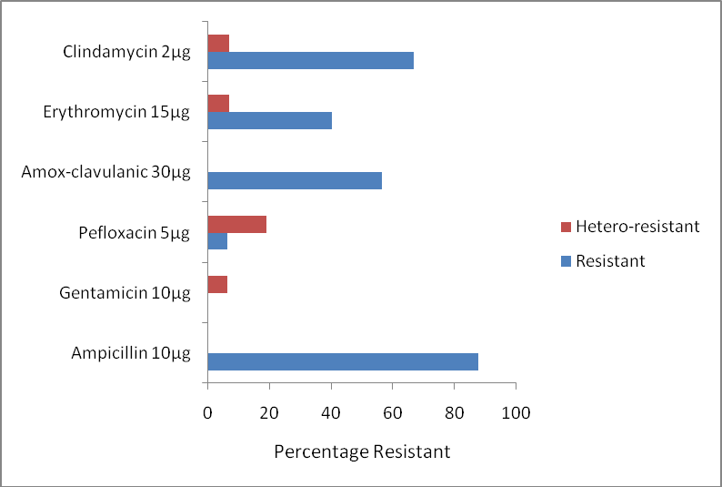

## Figure 9: Percentage of *S. aureus* isolates from skin with resistant and hetero- resistant phenotype

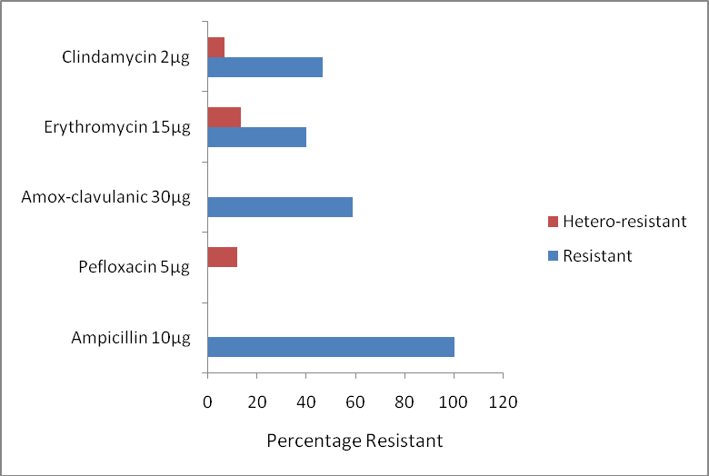

**Figure 10: Percentage of *S. aureus* isolates from bed with resistant and hetero- resistant phenotypes**

## Table 12: Identification of hetero-resistant strains

|  |  |
| --- | --- |
| Hetero-resistant strains | Identification |
| S46s | *Staph aureus* |
| S41s | *Staph hyicus* |
| S55s | *Staph lentus* |
| B16s | *Staph xylosus* |
| B55s | *Staph lentus* |
| B69s | *Staph xylosus* |
| B77s | *Staph xylosus* |

* 1. **Result of beta - lactamase test**

The result of the beta lactamase test showed that 64% produced beta – lactamase out of which 15% were hyper producers. The result is presented in Figure 11.

The antibiotics susceptibility pattern of beta lactamase producers and hyper- producers are presented in Table 13. The greatest activity was observed with gentamicin 96% followed by ciprofloxacin 92%, vancomycin 88%, pefloxacin 80% and erythromycin 60%.

Figure 12 shows the resistant pattern (in percentages) of the producers and hyper- producers of beta lactamase *S. aureus* isolates, it was observed that the beta lactamase producing and hyper- producing isolates were generally resistant to beta lactam antibiotics like ampicillin (96%), ceftriaxone (88%), cefoxitin (76%) and amoxicillin – clavulanate (68%) which are beta lactam antibiotics, also clindamycin (60%) and erythromycin (40%). It was also observed that 28% of the beta lactamase producing S. aureus were multi- drug resistant being resistant to three or more classes of antibiotics.

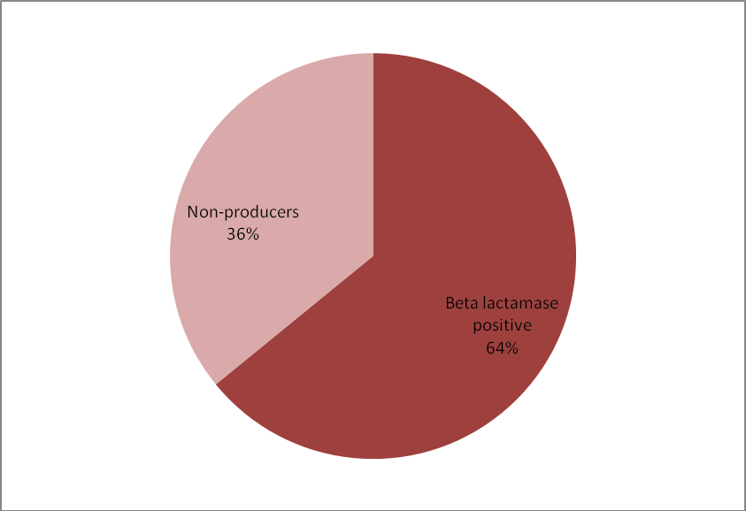

## Figure 11: Result of beta lactamase production test for *S. aureus* isolates

**Table 13: Susceptibility pattern of beta - lactamase producing *S. aureus* isolates to different antibiotics**

|  |  |  |  |  |  |  |  |  |  |  |  |
| --- | --- | --- | --- | --- | --- | --- | --- | --- | --- | --- | --- |
| **Isolates** | **Βeta lacta**  **mase** | **FOX** | **VA** | **AMP** | **CRO** | **CIP** | **CN** | **PEF** | **AMC** | **ERY** | **DA** |
| W7a | + | R | S | R | R | S | S | S | R | R | R |
| W7b | + | R | S | R | R | S | S | S | R | S | S |
| W20 | + | R | S | R | R | S | S | S | R | S | I |
| W39 | + | R | R | R | R | S | S | S | S | S | I |
| W51 | ++ | R | S | R | I | S | S | S | R | S | R |
| S2 | + | R | S | R | I | S | S | S | R | R | R |
| S8 | + | S | S | R | I | S | S | S | S | S | S |
| S20 | + | R | S | R | R | S | S | S | R | S | I |
| S23 | + | S | S | R | I | S | S | S | S | R | R |
| S25 | ++ | S | S | R | S | S | S | S | S | S | R |
| S27 | + | R | R | R | R | S | S | hr | R | S | S |
| S41 | + | R | S | R | R | S | hr | hr | R | I | S |
| S46 | + | R | R | R | R | I | S | R | R | hr | hr |
| S47 | + | S | S | S | S | S | S | S | S | S | R |
| B7 | ++ | S | S | R | S | S | S | S | S | nt | nt |
| B8 | ++ | S | S | R | I | S | S | S | S | S | I |
| B13 | + | R | R | R | R | I | S | S | R | I | I |
| B16 | ++ | R | S | R | I | S | S | S | R | hr | S |
| B20 | + | R | S | R | R | S | S | S | S | S | S |
| B22 | ++ | R | S | R | I | S | S | S | R | S | S |
| B26 | + | R | S | R | R | S | S | S | R | S | S |
| B35 | + | R | S | R | R | S | S | S | R | nt | nt |

|  |  |  |  |  |  |  |  |  |  |  |  |
| --- | --- | --- | --- | --- | --- | --- | --- | --- | --- | --- | --- |
| B55 | + | R | S | R | I | S | S | hr | R | S | S |
| B69 | + | R | S | R | R | S | S | S | R | hr | hr |
| B77 | + | R | S | R | R | S | S | hr | R | S | S |

KEY:

FOX - Cefoxitin 30µg VA - Vancomycin 30µg AMP - Ampicillin 10µg CRO - Ceftriaxone 30µg CIP - Ciprofloxacin 5µg CN - Gentamicin 10µg PEF - Pefloxacin 5µg ERY - Erythromycin 15 µg AMC - Amoxicillin-clavulanic acid 30µg

DA - Clindamycin 2 µg

1. - Sensitive hr – hetero-resistant I - Intermediate nt – not tested

R - Resistant

+ - β- lactamase producer

++ - β- lactamase hyper-producer

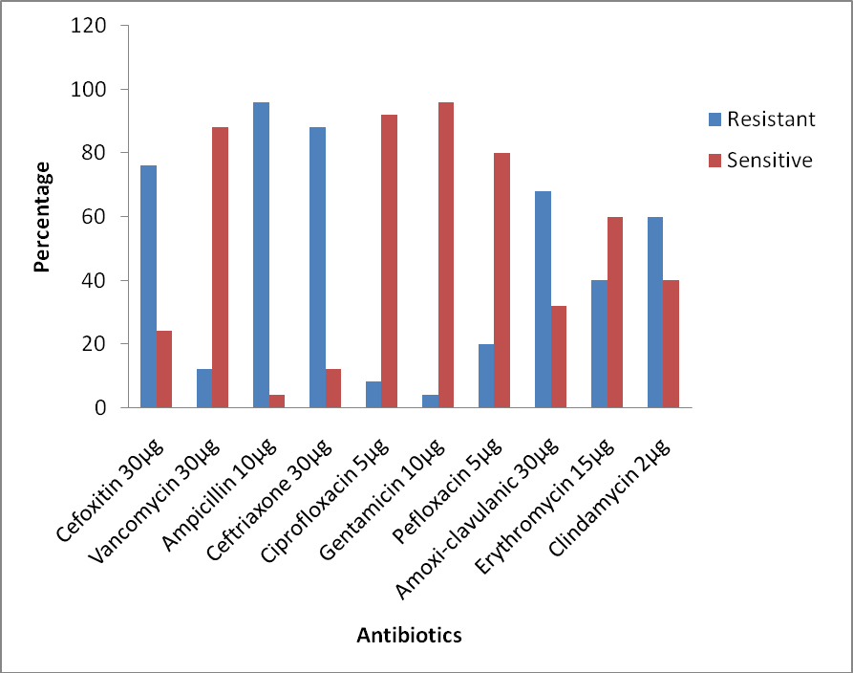

## Figure 12: Resistance pattern of beta - lactamase producing *S. aureus* to antibiotics

* 1. **Phenotypic detection of methicillin resistance**

Methicillin resistance was detected phenotypically using cefoxitin 30 µg disks and oxacillin agar screen tests, the results of which is presented in Table 14 below. The percentage rate of detection of MRSA from the cefoxitin and oxacillin tests were comparable at 64.1 and 66.7 respectively.

## Antibiotic resistance pattern of phenotypic MRSA isolates

Antibiotic susceptibility test was carried out for the 25 MRSA isolates that were phenotypically detected with cefoxitin discs and the resistance pattern is shown in Table

15. It was observed that 11(44%) of the MRSA isolates were resistant to three or more classes of antibiotics which imply that they were multi-drug resistant. Also, all the MRSA isolates were generally resistant to beta lactam antibiotics (ampicillin, ceftriaxone and amoxicillin-clavulanate). Only one of the isolates was resistant to vancomycin.

## Table 14: Phenotypic detection of methicillin resistance

|  |  |  |
| --- | --- | --- |
|  | Oxacillin n (%) | Cefoxitin n (%) |
| Wound (n=6) | 5 (83.3) | 5 (83.3) |
| Skin (n=16) | 7 (43.8) | 9 (56.3) |
| Bed (n=17) | 14 (82.4) | 11 (64.5) |
| Total (n=39) | 26 (66.7) | 25 (64.1) |

**Table 15: The antibiotic resistant pattern of MRSA isolates**

|  |  |  |
| --- | --- | --- |
| **No of Isolates (n= 25)** | **Resistance Pattern** | **No of Antibiotics** |
| 6 | AMP, CRO, AMC, ERY, DA | 5 |
| 4 | AMP, CRO, AMC | 3 |
| 4 | AMP, CRO, DA, AMC | 4 |
| 3 | AMP, CRO, AMC, PEF | 4 |
| 2 | AMP, CRO, AMC, ERY | 4 |
| 1 | AMP, CRO, CIP, AMC, ERY, DA | 6 |
| 1 | AMP, CRO | 2 |
| 1 | AMP, CRO, CN, PEF, ERY,AMC | 6 |
| 1 | AMP, CRO, CIP, PEF, AMC, ERY, DA | 7 |
| 1 | AMC, CRO, PEF, AMC, ERY, DA | 6 |
| 1 | AMP, CRO, DA, VA | 4 |

FOX - Cefoxitin VA - Vancomycin AMP - Ampicillin CRO - Ceftriaxone CIP - Ciprofloxacin CN - Gentamicin PEF - Pefloxacin ERY - Erythromycin AMC - Amoxicillin-clavulanic acid DA - Clindamycin

## D-test for Inducible Clindamycin Resistance

None of the *S. aureus* isolate was positive to the inducible Clindamycin D-test. Only one of the *S. aureus* isolates was both resistant to erythromycin and susceptible to clindamycin but with no D-zone, showing that erythromycin resistance observed did not have any inductive effect on the clindamycin. Nine (29%) *S. aureus* isolates were resistant to both erythromycin and clindamycin which implies that the Clindamycin resistance observed is constitutive. The result is presented in Table 16 and the pictoral view in Plates 1 and 2.

## Multiple antibiotic resistant (MAR) index

The result of the MAR index of the *S. aureus* showed that 32(82.1%) *S. aureus* isolates had MAR index greater than 0.2, details are shown Table 17.

## Minimun Inhibitory Concentration (MIC) of Vancomycin

Minimun Inhibitory Concentration test using vancomycin E-test strips was conducted for *S. aureus* isolates that showed resistance to Vancomycin 30 µg discs in order to verify their resistance (CLSI, 2007).

EUCAST interpretation of vancomycin MIC breakpoint describes isolates with MIC ≤ 2 µg/ml as being susceptible, 4-8 µg/ml intermediate and ≥16 µg/ml resistant. With this, only isolate W39 was resistant to vancomycin with MIC being 32 µg/ml using the vancomycin E-test strips.

The results and the pictoral view are presented in Table 18 and Plate 3 respectively.

## Table 16: Result of D-test for Inducible Clindamycin Resistance

|  |  |  |  |  |
| --- | --- | --- | --- | --- |
|  | Erythromycin sensitive  Clindamycin sensitive | Erythromycin resistant  Clindamycin sensitive  (D zone negative) | Erythromycin resistant  Clindamycin sensitive  (D zone positive) | Erythromycin resistant  Clindamycin resistant |
|  | No resistance | Only macrolide resistance | Inducible  Clindamycin resistance | Constitutive  Clindamycin resistance |
| *S. aureus*  (n=31) | 21 (67.7%) | 1 (3.2%) | 0 | 9 (29.0%) |
| MSSA (n=7) | 3 (42.9%) | 0 | 0 | 4 (57.1%) |
| MRSA (n=24) | 18 (75.0%) | 1 (4.2%) | 0 | 5 (20.8%) |

KEY:

MSSA: Methicillin Sensitive *S. aureus* MRSA: Methicillin Resistant *S. aureus*

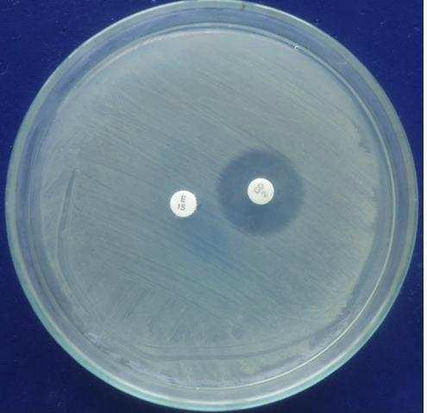

## Plate 1: D-test negative. Erythromycin (E15) resistance and Clindamycin (CD2) sensitive

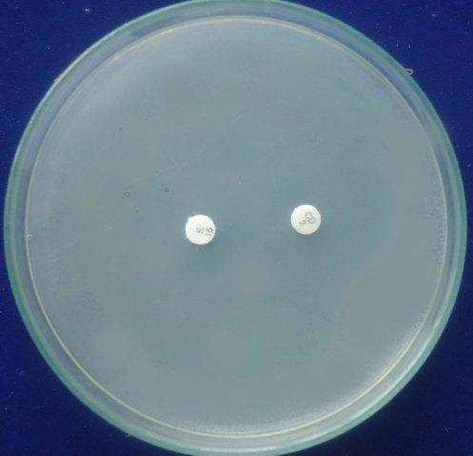

**Plate 2: No zone of inhibition for clindamycin (CD2) and erythromycin (E15) discs (constitutive clindamycin resistance)**

## Table 17: Result of Multiple Antibiotic Resistant (MAR) index for *S. aureus*

**isolates**

|  |  |  |  |  |
| --- | --- | --- | --- | --- |
| No of Isolates (%) | | | | |
| MAR | Wound (n=6) | Skin (n=16) | Bed (n=17) | Total (n= 39) |
| 0.1 | 0 | 2 (12.5) | 2 (11.8) | 4 (10.3) |
| 0.2 | 0 | 3 (11.8) | 0 | 3 (7.7) |
| 0.25 | 1(16.7) | 1 (6.3) | 0 | 2 (5.1) |
| 0.3 | 0 | 0 | 4 (23.5) | 4 (10.3) |
| 0.4 | 1 (16.7) | 1 (6.3) | 3 (17.6) | 5 (12.8) |
| 0.5 | 3 (50) | 2 (12.5) | 4 (23.5) | 9 (23.1) |
| 0.6 | 1 (16.7) | 4 (25) | 3 (17.6) | 8 (20.5) |
| 0.7 | 0 | 2 (12.5) | 0 | 2 (5.1) |
| 0.8 | 0 | 0 | 1 (5.9) | 1 (2.6) |
| 0.9 | 0 | 1 (6.3) | 0 | 1 (2.6) |

## Table 18: Result of Minimum Inhibitory Concentration (MIC) of Vancomycin against the *S.aureus* that showed resistance to vancomycin 30 µg disc

|  |  |
| --- | --- |
| **Isolates** | **MIC (µg/ml)** |
| B13 | 2 |
| B49 | 1 |
| S46 | 2 |
| W39 | 32 |
| S57 | 0.25 |
| S27 | 0.75 |
| S12 | 0.75 |

a.)

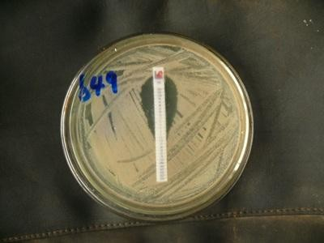

b.)

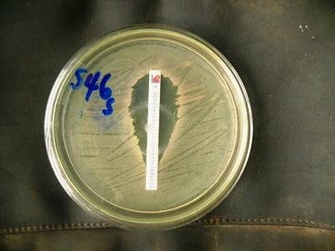

## Plate 3: Pictoral view of MIC of Vancomycin against *S.aureus* isolates using E-test strips

* 1. **Result of Plasmid extraction of *S. aureus* isolates**

The plasmid extraction was carried out with Plasmid MiniPrep Kit (Norgen Biotek Cooporation) for 19 MRSA isolates and 9 MSSA isolates and was run on 1.5% agarose gel electrophoresis. The following isolates had plasmid bands: W7b, W39, S1, B22, S12, B55, S41, B26, B62, S24, S55, B35, W4, W7a (Figure 13a and b). Isolates W39

and S55 showed two bands each suggesting carriage of two plasmids each. These isolates with plasmids represent 12(63.2%) of phenotypic MRSA tested and 2(22.2%) of the MSSA tested.

The mobility weight calibration plot of the DNA marker (Mass ruler ladder) was used to identify the *S. aureus* isolates and their plasmid profile (Appendix 6).

The summary of the plasmid profiles of the *S. aureus* isolates and their molecular weights are presented in Table 19. Out of the 28 *S. aureus* isolates tested only 14 had plasmid bands with molecular size range between 9.2 and 13.3 kilobase.

The resistance pattern of plasmid DNA- containing isolates are presented in Table 20 below. The resistance pattern of the plasmid - containing isolates showed 3/14 (21.4%) to be resistant to three or more classes of antibiotics which is an indication of multi-drug resistance. These multi-drug resistant isolates are all methicillin resistant *S. aureus*.

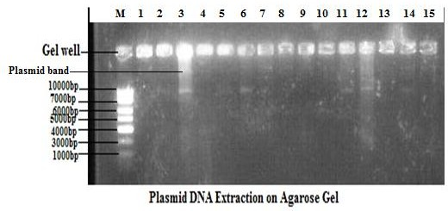

## Figure 13a: Plasmid extraction on 1.5% agarose gel electrophoresis

|  |  |  |
| --- | --- | --- |
| Lane M: Mass ruler ladder, | lane 6: B22 | lane12: B26 |
| 1: W7b | 7: S12 | 13: B20 |
| 2: W51 | 8: B55 | 14: B62 |
| 3: W39 (2 bands) | 9: W20 | 15: B16 |
| 4: S46 | 10: S8 |  |
| 5: S1 | 11: S41 |  |

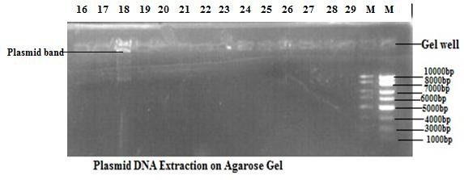

**Figure 13b: Plasmid extraction on gel electrophoresis**

|  |  |  |
| --- | --- | --- |
| Lane 16: B35 | lane 23: S72 | lane 28: S24 |
| 17: B69 | 24: B49 | 29: S46s |
| 18: S55 (2 bands) | 25: W7a | M: Mass ruler ladder |
| 19: B47 | 26: B13 |  |
| 20: W4 | 27: B77 |  |
| 21: S27 |  |  |
| 22: ATCC 25923 |  |  |

## Table 19: Identification of *S. aureus* isolates and their plasmid profile

|  |  |  |
| --- | --- | --- |
| **Isolates** | **No of Plasmids** | **Plasmid size (kb)** |
| W7b | 1 | 12.06 |
| W51 | 0 | No plasmid |
| W39 | 2 | 11.65 and 9.23 |
| W20 | 0 | No plasmid |
| W4 | 1 | 12.06 |
| W7a | 1 | 12.06 |
| S27 | 0 | No plasmid |
| S55 | 2 | 13.27 and 10.04 |
| S72 | 0 | No plasmid |
| ATCC 25923 | 0 | No plasmid |
| S24 | 1 | 12.46 |
| S46s | 0 | No plasmid |
| S8 | 0 | No plasmid |
| S41 | 1 | 9.23 |
| S46 | 0 | No plasmid |
| S1 | 1 | 9.23 |
| S12 | 1 | 12.06 |
| B13 | 0 | No plasmid |
| B35 | 1 | 11.65 |
| B16 | 0 | No plasmid |
| B69 | 0 | No plasmid |
| B22 | 1 | 9.23 |

Table 19 continued:

|  |  |  |
| --- | --- | --- |
| B55 | 1 | 12.06 |
| B26 | 1 | 9.23 |
| B20 | 0 | No plasmid |
| B62 | 1 | 9.23 |
| B47 | 0 | No plasmid |
| B49 | 0 | No plasmid |
| B77 | 0 | No plasmid |

## Table 20: Antibiotic Resistant of plasmid DNA- containing *S.aureus* isolates

|  |  |  |  |
| --- | --- | --- | --- |
| S/no | Lab No | Resistance Pattern | No of antibiotics |
| 1 | W39 | FOX, AMP,CRO,VA,DA | 5 |
| 2 | W7a | FOX, AMP,CRO,ERY,DA,AMC | 6 |
| 3 | W7b | FOX, AMP,CRO,AMC | 4 |
| 4 | S12 | FOX, AMP,CRO,AMC | 4 |
| 5 | S41 | FOX,AMP,CRO,CN,PEF,AMC,ERY | 7 |
| 6 | S24 | FOX, AMP,CRO,AMC,ERY | 5 |
| 7 | S55 | FOX, AMP,CRO | 3 |
| 8 | B22 | FOX, AMP,CRO,AMC | 4 |
| 9 | B35 | FOX, AMP,CRO,AMC | 4 |
| 10 | B26 | FOX, AMP,CRO,AMC | 4 |
| 11 | B55 | FOX, AMP,CRO,PEF,AMC | 5 |
| 12 | B62 | AMP | 1 |
| 13 | S1 | DA | 1 |
| 14 | W4 | AMP,CRO | 2 |

|  |  |  |
| --- | --- | --- |
| AMP- Ampicillin, | CRO- Ceftriaxone, | FOX- Cefoxitin |
| ERY- Erythromycin, | CN- Gentamicin, | CIP- Ciprofloxacin |
| AMC- Amoxicillin-Clavulanate | DA- Clindamycin | PEF- Pefloxacin |
| VA- Vancomycin |  |  |

* 1. **Genomic DNA extraction of *S. aureus* isolates**

The genomic DNA extraction of 22 *S. aureus* isolates was carried out using Genomic DNA isolation kit by Norgen Biotek Cooporation and the presentation of the DNA bands of the *S. aureus* isolates on 1.5% electrophoresis gel is shown in Figure 14a and

b. The DNA bands are of the molecular weight 200 – 1031 base pairs in comparism with molecular weight marker.

## Result of multiplex PCR for detection of *mecA* gene and *bla Z* gene

The result of multiplex PCR products of *mecA, 16SrRNA and blaZ* on 1.5% agarose gel using 2x PCR control master mix is shown in Figure 15a and b. The size of the amplicon for *16Sr RNA, mecA* and *blaZ* gene cosrrespond to 420bp, 314bp and 173bp, respectively, as repersented by MassRuler DNA ladder. Out of the 20 isolates tested, 5 (25%) amplified *16SrRNA* at 420bp (S41,B26, B62, B20 and B22) indicating that 5/20 were confirmed as being *S.aureus.* Amplification of the 314bp indicates presence of *mecA* gene coding for methicillin resistance and only 2 isolates (S41 and B26) representing 5.1% of the 39 *S. aureus* amplified *mecA* gene. The multiplex PCR result showed that 5/15 (S41, S47, B22, W39, and W7b) representing 33.3% amplified *bla Z* the gene coding for the presence of beta lactamase at 173bp.

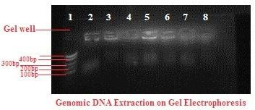

## Figure 14a: Genomic DNA extraction of *S. aureus* isolates on 1.5% agarose gel electrophoresis

|  |  |  |
| --- | --- | --- |
| Lane1: Mass ruler ladder, | lane 4: B22 | lane7: W20 |
| 2: S46, | 5: S12 | 8: S8 |
| 3: S1, | 6: B55 |  |

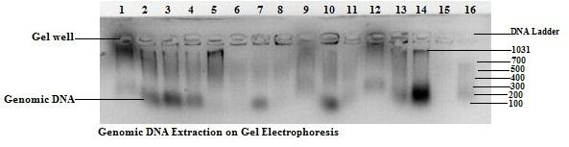

**Figure 14b: Genomic DNA extraction of *S. aureus* isolates on 1.5% agarose gel electrophoresis**

|  |  |  |  |  |
| --- | --- | --- | --- | --- |
| Lane 1:B35, | lane 4:B47 | lane 7:ATCC 25923 | 10:B13 | 13:S46s 16: ladder |
| 2: B69, | 5:W4 | 8: B49 | 11:B77 | 14:W7b |
| 3:S55, | 6:S27 | 9: W7a | 12:S24 | 15:S51 |

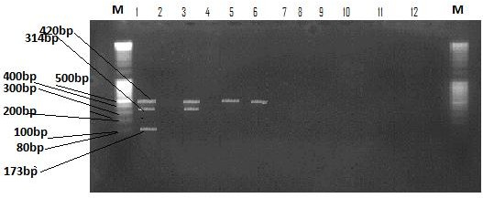

**Figure 15a**: **Multiplex PCR for detection of *mecA* and *blaZ* genes from *S. aureus***

## isolates

M= Mass Ruler DNA Ladder

Lane 1: S41 lane 5: B62 lane 9: W51

|  |  |  |  |
| --- | --- | --- | --- |
| 2: | S8 | 6: B20 | 10: S46 |
| 3: | B26 | 7:S20 | 11: S12 |
| 4: | S55 | 8:B16 | 12: B22 |

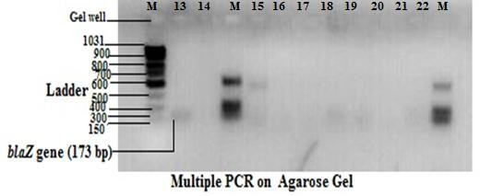

**Figure 15b: Multiplex PCR for detection of *mecA* and *blaZ* genes from *S. aureus***

## isolates

Lane M: ladder lane 14:B22 lane 16:S51 lane18:W7b lane 20:S24 13: S47 15: B55 17:W39 19:B77

## Comparison of cefoxitin disc diffusion, oxacillin spot inoculation and *mecA*

**gene detection of methicillin resistance in *S. aureus***

Two of the 39 *S. aureus* isolates were *mecA* gene positive on PCR analysis, giving a MRSA prevalence rate of 5.1% while 37 were *mecA* gene-negative. Of the 2 *mecA* gene-positive isolates, the cefoxitin disk diffusion test detected phenotypic resistance in 2 of 2 (100%) and the oxacillin spot inoculation test detected resistance in 1 of 2(50%) of *S. aureus* isolates. In the 37 *mecA*-negative *S. aureus* isolates, the cefoxitin disk detected resistance (false) in 23 (62.2%) isolates, the oxacillin spot inoculation detected resistance (false) in 24 (64.9%) isolates. Using the *mecA* gene as the ―gold standard‖ test, the sensitivity of cefoxitin disk and oxacillin agar screeen for MRSA detection were 100% and 50% respectively.

## DNA sequencing

One of the isolates (S41) with plasmid DNA that showed amplification with *16S rRNA, mecA* and *blaZ* gene was picked for sequencing of the PCR products. The result is shown below:

The nucleotide sequence of *16SrRNA* is as shown:

CCCACCGGCTTCGGGTGTTACAAACTCTCGTGGTGTGACGGGCGGT GTGTACAAGACCCGGGAACGTATTCACCGTAGCATGCTGATCTACGATTA CTAGCGATTCCAGCTTCATGTAGTCGAGTTGCAGACTACAATCCGAACTG AGAATAATTTTATGGGATTTGCTTGGCCTCGCGGATTCGCTGCCCTTTGT ATTATCCATTGTAGCACGTGTGTAGCCCAAATCATAAGGGGCATGATGAT TTGACGTCATCCCCACCTTCCTCCGGTTTGTCACCGGCAGTCAACCTAGA GTGCCCAACTTAATGATGGCAACTAAGCTTAAGGGTTGCGCTCGTTGCGG GACTTAACCCAACATCTCACGACACGAGCTGA

The graphical presentation is shown in appendix 7

The sequence analysis of *16S rRNA* showed a 378 base pair encoding 125 amino acids. The result of the nucleotide Basic Local Alignment Search Tool (BLASTn) showed that the query nucleotide of sample (S41) has 99% identity with *Staphylococcus aureus* strain KIBGE-MB01 with sequence ID (accession) number HM061132.1 and 98% identity with other 99 *S. aureus* strains from GenBank database. The alignment of the query nucleotide with *S. aureus* HM061132.1 is shown in figure 16.

The aligned region spanning is at positions 388 to 764 on HM061132.1. The record of this *S. aureus* strain from the GenBank database showed that it was isolated from blood and was submitted to the bank on 3rd April 2010 by Medical Biotechnology, The Karachi Institute of Biotechnology and Genetic Engineering (KIBGE), University of Karachi, University Road, Karachi, Sindh 75270, Pakistan.

The phylogenetic tree comparing the query nucleotide sequence (S41) with the other *S. aureus* strains from the GenBank database is presented in Figure 17, showing that they are of the same origin.

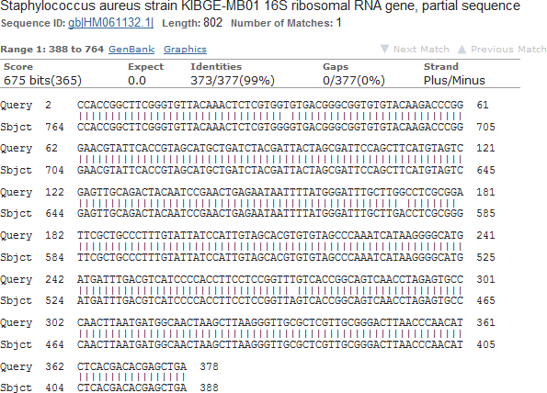

## Figure 16: Alignment of the query *16SrRNA* nucleotide sequence (S41) with *S. aureus* HM061132.1

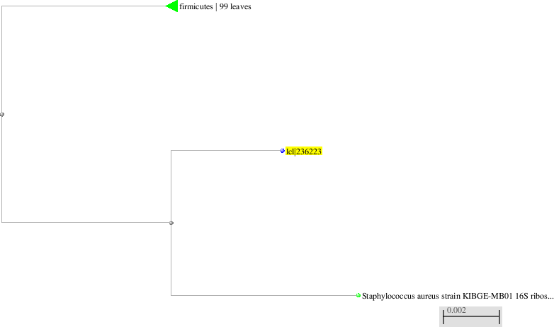

|  |  |
| --- | --- |
| **Blast names color map** | |
|  | Firmicutes (other 99 *S.aureus* strains) |
|  | IcI236223 (query nucleotide S41) |

**Figure 17: Phylogenetic tree showing the relationship between the query *16SrRNA***

## nucleotide S41 and other identical *S. aureus* strains from GenBank database

* + 1. **Translated Protein sequence of *16S rRNA***

The protein sequence encoded 125 amino acids: PPASGVTNSRGVTGGVYKTRERIHRSMLIYDY*RFQLHVVELQTTIRTENNFMG FAWPRGFAALCIIHCSTCVAQIIRGMMI*RHPHLPPVCHRQST*SAQLNDGN*A* GLRSLRDLTQHLTTRA

The protein blast (BLASTp) showed *Staphylococcus aureus* sp with 95% identity with the query protein sequence. These include *Staphylococcus aureus* sp with sequence ID numbers WP002869193.1, WP00203229.1, WP001822037.1 among others. Individual alignment of the query protein sequence with some of the *Staphylococcus aureus* sp from the database is shown in the Appendix 8 while the description of each of the Staph specie is shown in Figure 18.

Comparative multiple alignment of the translated protein with other selected *Staphylococcus aureus* species protein sequence using COBALT protein analysis is presented in Figure 19.

Comparative analysis of translated protein using COBALT protein analysis (<http://www.ncbi.nlm.nih.gov/blast/treeview/>) shows a comparism between the query sequence (*16Sr RNA* protein sequence) and selected *S. aureus* protein sequence from the database. This was presented as a phylogenetic tree shown in Figure 20.

The phylogenetic tree showed that the query protein sequence is within the same origin with the other hypothetical *S. aureus* proteins compared with it.

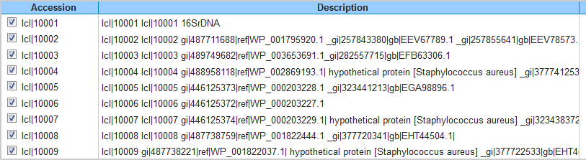

## Figure 18: Description of some *S. aureus* species from the genBank database aligned with query *16SrRNA* protein sequence

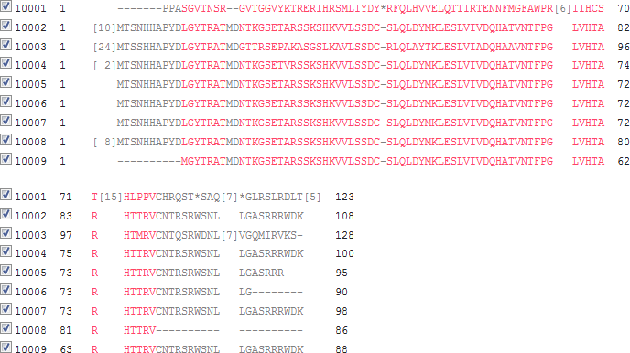

**Figure 19: Multiple alignment of *16SrRNA* translated protein sequence with other**

***Staphylococcus aureus* strain protein sequence**

Key:

* Red colour indicates alignment with the *16SrRNA* protein sequence with one or two point mutations.
* Black colour indicates no alignment

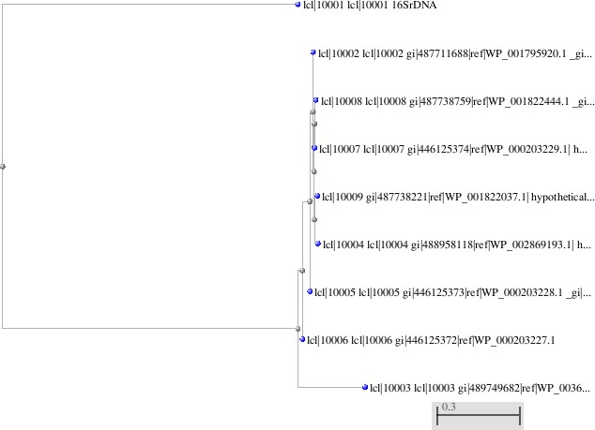

## Figure 20: Phylogenetic tree of *16SrRNA* translated protein and other

***Staphylococcus* sp protein sequences**

* Icl10001 *16SrRNA* is the query isolate
  + 1. ***BlaZ* nucleotide**

Sequence analysis of *bla Z* nucleotide showed 154 base pairs: GTGGTAAGGAAGTAAAATTTAATTCAGATAAGAGATTTGCCTATGCTTCAA CTTCAAAGTTGCTTATTCTCCTATTTTAGAAAAATATGTAGGAAAAGATATC ACTTTAAAAGCACTTATTGAGGCTTCAATGACATATAGTGATAATACAGCA

The nucleotide blast (BLASTn) showed about 100 *Staphylococcus* sp with 100% identity with the *blaZ* nucleotide which includes *Staphylococcus* sp with accession ID numbers AY369353.1 and DQ016053.1 among others. The individual alignment of query *blaZ* nucleotide sequence with AY369353.1 and DQ016053.1 from the GenBank database is shown in Figure 21a and b.

The aligned region spanning is at positions 620 to 716 on DQ016053.1. The record of this *S. aureus* strain from the genBank database showed that it was submitted by Veterinary Pathobiology, Royal Veterinary Agricultural University, Stigbojlen 4, Frederiksberg 1870 C, Denmark. The aligned region spanning is at positions 594 to 690 on AY369353.1.

The phylogenetic tree comparing the query *blaZ* nucleotide sequence (S41) with the other *S. aureus* strains from the GenBank database is presented in Figure 27.

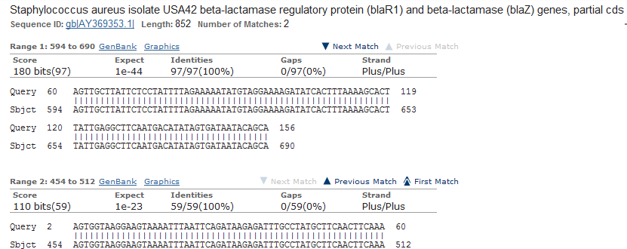

## Figure 21a: Alignment of the query *blaZ* nucleotide sequence (S41) with *S. aureus*

**AY369353.1**

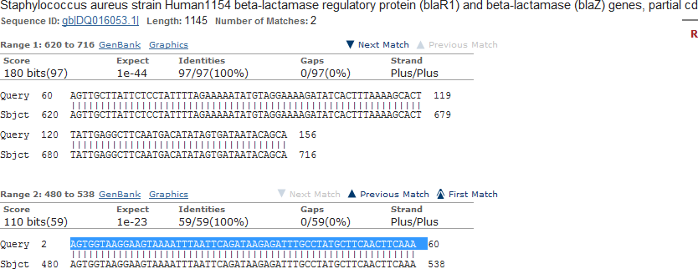

## Figure 21b: Alignment of the query *blaZ* nucleotide sequence (S41) with *S. aureus*Q016053.1

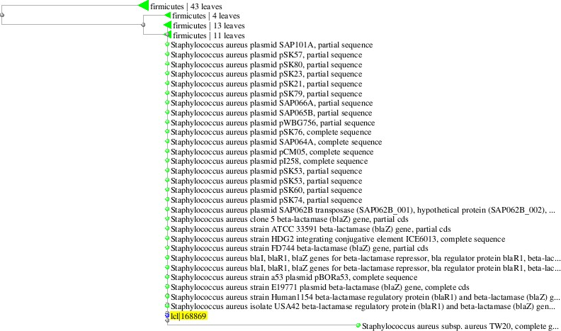

|  |  |
| --- | --- |
| **Blast names color map** | |
|  | Firmicutes ( 100 *S.aureus* strains) |
|  | IcI68869 (query blaZnucleotide S41) |

**Figure 22: Phylogenetic tree showing the relationship between the query *blaZ***

## nucleotide and other identical *S. aureus* strains from genBank database

* + 1. **Translated protein sequence analysis of *blaZ***

The translated protein sequence analysis of *blaZ* is: GKEVKFNSDKRFAYASTSKLLILLF*KNM*EKISL*KHLLRLQ*HIVIIQ

With the protein blast (BLASTp) among the *S. aureus* species with 90% identity with the *blaZ* gene are *S. aureus* with sequence ID numbers gbAAY84133.1, gbAAR12671.1 and refWP017328485.1 with alignments with the *blaZ* gene protein sequence (Appendix 9).

Comparative multiple alignment of the translated protein of *blaZ* gene with other selected *Staphylococcus aureus* species protein sequence using COBALT protein analysis is presented in figure 23 and the description of the isolates presented in Figure 24.

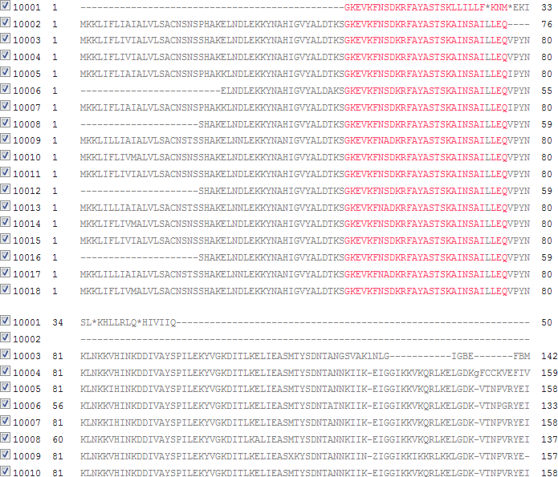

## Figure 23: Multiple alignment of *blaZ* translated protein sequence with other

***Staphylococcus* sp protein sequence**

* + - * Red colour indicates alignment with the *16SrRNA* protein sequence with one or two point mutations while black colour indicate no alignment.

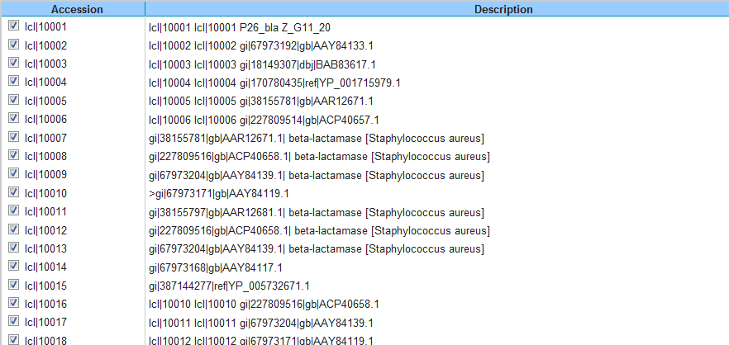

## Figure 24: Description of other *S. aureus* species aligned with *blaZ* protein sequence

**CHAPTER FIVE**

## 5.0 DISCUSSION

Antimicrobial resistance has been noticed as one of the paramount microbial threats in the twenty first century. *S. aureus* has always been a stumbling block for antimicrobial chemotherapy and methicillin resistance of *S. aureus* remains to be a significant problem. The result of the characterization of the Staphylococcus isolates showed that API Staph identification kit is more specific compared with the conventional method of identification. Considering the various sites of sampling, this is an indication that *S. aureus* can cause nosocomial infection. Centre for Disease Control and Prevention (1996) reported that *S. aureus* was the most common cause of nosocomial infections reported in National Nosocomial Surveillance System between 1990 – 1996. Also, Witte *et al.,* (1994), Roberts *et al.,* (1999) and Narezkina *et al.,* (2006) reported that *S. aureus* is one of the most common cause of nosocomial infections. The majority of nosocomial infection is caused by a patient‘s own endogenous microbial flora present upon admission to the hospital (Arif *et al*., 2007).

In this study, the susceptibility test of *S. aureus* showed that gentamicin had the greatest activity: 100%, 100%, 93.8%, against isolates from wound, bed and skin respectively followed by ciprofloxacin (100%, 94.1%, 93.8%) and pefloxacin (100%, 88.2%, 75%). The mechanisms of action of these antibiotics might be responsible for their observed activity. Gentamicin is an example of aminoglycoside whose mode of action is to inhibit 30S ribosome of the organism by first attaching itself to a specific receptor protein on the 30S subunit of the bacteria and thereafter blocks the normal activity of the initiation complex of the peptide formation (messenger RNA (mRNA) + formyl methionine + transfer RNA). Finally the mRNA message is misread on the ‗‘recognition

region‘‘ of the ribosome and as a result a wrong amino acid is inserted into the peptide resulting in a nonfunctional protein (Jawetz, 1992). On the other hand, ciprofloxacin (an example of quinolone) is a potent inhibitor of nucleic acid synthesis. From previous studies, Onanuga and Temedie, (2011), recorded 100% susceptibility to gentamicin in nasal carriage of multi-drug resistant *Staphylococcus aureus* in healthy inhabitants of Amassoma in Niger delta region of Nigeria. This is similar to 100% susceptibility to gentamicin reported for wound and bed isolates in this study, likewise 100% sensitivity was reported by Umolu *et al*., (2002) for *S. aureus* isolates from different human specimens and 91.8% was reported by Ehinmidu (2003).

The susceptibility level of *S. aureus* isolates from skin and bed to ciprofloxacin in this study is a bit lower than those reported by Akerele *et al*., (2001) who reported 99.7% and Ehinmidu (2003) who reported a 97.06% sensitivity level in *S aureus* isolates from urine. Onanuga *et al.,* (2005) reported 96.7%. Therefore, the 100% sensitivity to ciprofloxacin observed in wound sample in this study is higher. The little resistance level observed in this study might not be unconnected with the increasing rate of availability of different cheap brands of generic ciprofloxacin in the market which might have probably led to the misuse of it. The exposure to quinolones may have selected for spontaneous mutants that alter the target protein or increase the level of efflux pump expression (Hooper, 2002; Rogues *et al*., 2007).

The highest level of resistance was observed with ampicillin (100%, 100% and 87.5%) in wound bed and skin respectively followed by ceftriaxone (100%, 76.5%, 75%); amoxicillin- clavulanic acid (66.7%, 58.8%, 56.3%). The high level of the resistance to these β- lactam antibiotics is not surprising. This is consistent with the observation that clinical Staphylococcal isolates are resistant to a large number of commonly prescribed

antimicrobial agents and to β- lactams in particular (Olukoya *et al*., 2005). It is believed that more than 80% of Staphylococcal isolates produce penicillinase regardless of the clinical setting (Lowy 2003; Pantosti *et al.,* 2007). In this study, test for β- lactamase production showed that 64% produced β- latamase out of which 15% were hyper producers of β- lactamase which is the enzyme that hydrolyses the amide bond of the β- lactam ring resulting in an inactive compound. *Bla Z* gene, the gene coding for β – lactamase was detected in 5/15 (33.3%) of the *S. aureus* isolates. Many of these β- lactamases are encoded by transposons, some of which may also carry resistance determinants to several other antibiotics: quartenary ammonium compounds, dyes (acriflavine and ethidium bromide) or heavy metals (lead, mercury and cadmium) (Massidda *et al.,* 2006; Pantosti *et al*., 2007).

The resistance to erythromycin (macrolide) observed in this study did not have any inductive effect on the clindamycin. There are two primary mechanisms of resistance to macrolide antibiotics (Leclercq, 2002). The first involves macrolide efflux and is relatively common in *S. aureus* in some geographic areas. A specific efflux pump is encoded by the gene *msr*(A) in staphylococci (Ross *et al*., 1990). This energy-dependent pump effectively expels macrolides from the bacterial cell before they can bind to their target site on the ribosome. Notably, this mechanism of resistance does not create resistance to lincosamides (e.g., clindamycin and lincomycin), but only to macrolides, azalides (e.g., azithromycin), and group B streptogramins (e.g., quinupristin) (Ross *et al*, 1990; Roberts *et al*; 1999). The second mechanism of resistance to macrolides in staphylococci involves modification of the drug-binding site on the ribosome. This results in resistance to macrolides (and azalides), lincosamides, and group B streptogramins and is commonly referred to as ―MLSB resistance‖ (Roberts *et al*.,

1999). An *erm* gene, usually *erm*(C) or *erm*(A), encodes methylation of the 23S rRNA—binding site that is shared by these 3 drug classes. Phenotypically, resistance can be expressed constitutively (the MLSBc phenotype) or only when induced into production (the MLSBi phenotype) (Weisblum, 1995). When an *erm* gene is present, resistance to macrolides arises through binding of a macrolide to upstream translational attenuator sequences. This binding subsequently leads to alteration of the mRNA secondary structure, exposure of the ribosomal binding site, and translation of the *erm* methylase. For constitutive resistance (MLSBc) to be present, additional changes in these 5′ upstream sequences are required. These modifications can include deletions, duplications, or other mutations, and they result in constitutive expression of the methylase gene with obvious resistance to MLSB drugs (Weisblum, 1995; Werckenthin *et al*., 1999). Clindamycin represents a useful option for therapy for various CA-MRSA infections, including musculoskeletal infections, skin and soft-tissue infections, and even pneumonia with empyema (Martinez-Aguilar *et al*., 2003). Many CA-MRSA isolates are resistant to macrolides because of *msrA*-mediated efflux, and they are thus susceptible to clindamycin (Martinez-Aguilar *et al*., 2003), this was the case with the macrolide resistant and clindamycin sensitive isolate observed in this study, 75% of the MRSA isolates are erythromycin susceptible and clindamycin susceptible. However, the use of clindamycin for these infections has been somewhat hampered by concern over possible inducible resistance to clindamycin and its impact on clinical outcomes eventhough such inducible resistance was not observed in this study.

Analysis of the results of multiple antibiotic resistance index determined for the isolates showed that 100%, 88.2% and 68.8% of wound, skin and bed isolates respectively have MAR index greater than 0.2. This suggests that the isolates originated from a high

risk source of contamination where antibiotics are often used (Paul *et al.,* 1997; Christopher *et al*., 2013). It also indicates that a large proportion of the bacterial isolates have been exposed to several antibiotics. The increasing frequency of drug resistance has been attributed to combination of microbial characteristics, selective pressure of antimicrobial use and societal and technological changes that enhance the transmission of drug resistant organisms (Orozova *et al*., 2008). The reason for the high resistance to antibiotics may also be due to increase in an irrational consumption rate, transmission of resistant isolates between people, self-medication and non-compliance with medication and sales of substandard drug.

The prevalence of phenotypic methicillin resistance was 83.3%, 64.7% and 56.3% from wound, bed and skin respectively. In comparison with other reported phenotypic MRSA isolates from different part of the country, Nigeria: Fayomi (2009) reported a prevalence rate of 31% of MRSA among in-patients at a tertiary health facility in Ido-Ekiti;

Azeez- Akande *et al*., (2008) reported a MRSA prevalence rate of 37.5% from clinical specimens at University of Calabar Teaching Hospital; 43% prevalence was reported in Jos by Ikeh (2003) and from Ilorin, 34.7% was reported by Taiwo *et al*., (2004). Olonitola *et al*., (2007) reported a rate of 33.3% from a Federal Medical Centre; Onanuga *et al*., (2006) reported a higher rate of 71.1% from urine of healthy women in Abuja while Ikeh and Yakeu (2006) reported an alarming 92.6% MRSA out of the *S. aureus* isolated from bacteria flora on the hands of nursing service workers in Jos University Teaching Hospital.

The gold standard for detection of MRSA is the detection of *mecA* gene by polymerase chain reaction. Expression of *mecA* gene yields an altered penicillin binding protein, PBP2a with reduced affinity for β- lactam antibiotic binding. In this study 2(5.1%) out

of the 39 *S. aureus* isolates were confirmed as methicillin resistant *S. aureus* by the detection of *mecA* gene. In the North-western part of Nigeria where this study was carried out, there has not been any reported case of detection of *mecA* gene in clinical isolates to the best of our knowledge. Olayinka *et al*., (2009) reported the absence of *mecA* gene in MRSA isolates obtained from clinical isolates from Medical Microbiology laboratory of Ahmadu Bello University Teaching Hospital, Zaria. Similar report on absence of *mecA* gene in MRSA isolates from non- hospital sources in Zaria was given by Olonitola *et al*., (2007). However there are reported cases of detection of *mecA* gene in MRSA isolates from other parts of this country, Nigeria which include the following: In a research in Benin city, Nigeria, 4 isolates representing 11% were confirmed to carry *mecA* gene according to molecular technique (Obasuyi, 2013); Another research by Clement *et al.,* (2009) confirmed only one MRSA isolate from health care institutions from Ekiti and Ondo states. In another research carried out by Shittu *et al.,* (2011), two MRSA isolaes with *mecA* gene were detected in Ile-Ife, one from Lagos and two from Ibadan (all in South western Nigeria). In the same study, five MRSA isolates with *mecA* gene were detected in Maiduguri (North eastern Nigeria). Okon *et al*., (2013) reported the detection of 12.5% MRSA from clinical specimens from six tertiary hospitals in North eastern Nigeria. However Olowe *et al.,* (2013) reported a higher prevalence of 19.2% MRSA from clinical isolates in Medical Microbiology Laboratory of University Teaching Hospital, Ado-Ekiti.

In this study, comparison was made between the use of cefoxitin disc and oxacillin agar screening and PCR for *mecA* gene for MRSA detection. PCR for *mecA* gene was positive for 2 isolates, these 2 isolates were detected by cefoxitin disk diffusion test (2 of 2 (100%) (cefoxitin is a potent inducer of mecA regulatory system) (Swenson *et al*., 2007) while oxacillin agar screening detected resistance in 1 of 2(50%) of *S. aureus*

isolates even though other 23 and 24 isolates showed phenotypic resistance to methicillin with cefoxitin and oxacillin respectively without the amplification of *mecA* gene. The question is what was responsible for the resistance observed in the other phenotypic MRSA isolates which were *mecA* negative as observed in this study?

There are two types of methicillin resistance in Staphylococci: intrinsic high level resistance (*mecA* positive) and intermediate resistance (borderline resistance) (Khorvash *et al,* 2008). Intrinsic high level resistance in MRSA is mediated by PBP2a encoded by chromosomal *mecA* (Hackbarth and Chambers, 1998). PBP2a increases resistance to all beta lactam antibiotics including penicillin, cephalosporins, cephamycins and carbapenems by decreasing affinity for binding these antibiotics.

Also, some strains of *S. aureus* produce large amounts of penicillinase that hydrolyze the penicillinase resistant penicillins as was observed in this study. Susceptibility tests to oxacillin or methicillin in these strains may show reduction or border line in susceptibility and they are named as Border line oxacillin resistant *S. aureus* (BORSA). The mechanism of resistance of these *mecA* negative strains may be as a result of the production of modified PBPs 1 and 2 with reduced affinities for beta lactamase, production of a new beta lactamase, over production of PBP4 or increased beta lactamase production (Khovash *et al*., 2008). The result of the β- lactamae test in this study showed that 64% produced β- lactamase while 15% of them were hyper producers, this may be a possible reason for the phenotypic MRSA observed.

In addition, there was a report by van Griethysen *et al*., (2005) about the loss of *mecA* gene during storage of 36/250 (14.4%) confirmed MRSA strains at -80°C with the MicroBank system (Pro-Lab Diagnostics, Canada). Also in a study on loss of the *mec*A gene during storage of methicillin-resistant *Staphylococcus aureus* isolates in North

western Nigeria by Kumurya, (2013), it was reported that *mec*A gene was lost in 95.0% of 100 MRSA isolates after 2 years of storage at −80°C with the Micro bank system (Pro-lab Diagnostics, Austin, Tex.). Considering the time interval between the preliminary characterization, storing and sub-culturing over a considerable period of time before the final molecular characterization, and the inconsistent power supply in this environment it is therefore not impossible that some *mecA*-containing isolates might have lost the gene on prolong storage at temperature much higher than -80C.

In this study, the encountered plasmids sizes were between 9.2 and 13.3 kilobase. This is similar to the reports of Diep *et al.,* (2006), Uchechi and Erinma, (2007), Adeleke *et al*., (2010), Akinjogunla and Enabulele, (2010) and Tula *et al*., 2013). The molecular weight of the plasmids observed in this study falls into the category of small multicopy plasmids that carry single resistance. They can also be described as mobilizable resistant plasmids which are relatively small (often less than 10kb in size) encoding only a handful of genes including the resistance genes (Esimone *et al*., 2010). The only resistance gene that was tested for in this study was *blaZ* which codes for β- lactamase and it was borne on the plasmids. It can therefore be suggested that the plasmids observed in this study were plasmids coding for *blaZ* gene eventhough they may also be coding for other resistant genes which were not tested for since some of the isolates were multi drug resistant. All the phenotypic MRSA tested were found to have plasmids out of which 3/14 (21.4%) were multi- drug resistant. Multidrug resistant organisms are defined as acquired non-susceptibility to at least one agent in three or more antimicrobial categories (Nikaido, 2009; Magiorakos *et al*., 2012; CDC, 2013; WHO, 2014). Plasmids are small, double-stranded DNA molecules that can exist independently of the chromosome. Some plasmids are able to integrate into the chromosome and are thus replicated with the chromosome (Willey *et al*., 2008).

Plasmid profile has been reported to be useful in tracing the epidemiology of antibiotic resistance (Mayer, 1988, Olowe *et al*., (2007). It is suggested that more than 90% of MRSA strains carry plasmids while numerous studies have supported the important role plasmids play in staphylococcal multi-drug resistance (Coia *et al*., 1988; Paulsen *et al*., 1998; O‘Brien *et al.,* 2002). Individual plasmid mediated resistance in MRSA isolates has been reported by Al-Mohana *et al.,* (2012) and plasmid carried by resistant isolates have been studied (Dar *et al*., 2006). High level of resistance to antibiotics have been associated in most instances with the presence of plasmids (Bhaka *et al*., 2003; Daini *et al.,* 2006; Diep *et al*., 2006).

The emergence of resistant plasmids in this study could also be due to overzealous desire to treat every infection, diagnosed or not and to the over the counter availability of antibiotics (Okeke *et al*., 1999; Ibeachi and Mbata, 2002; Daini *et al.,* 2006). Earlier survey showed self medication with antibiotics and under-dosage use as common and almost the norm in Nigeria (Esimone *et al*., 2010). Also, plasmids hold genetic information that determine antibiotic resistance, replication, and transmissibility (Lipps, 2008) Staphylococcal plasmids carry resistances to antibiotics, metals, antiseptics, and disinfectants, as well as virulence genes, such as enterotoxins ([Bayles and Iandolo 1989](http://www.g3journal.org/content/1/7/581.full#ref-5); [Omoe *et al*., 2003](http://www.g3journal.org/content/1/7/581.full#ref-53)) and exfoliative toxins ([Jackson and Iandolo 1986](http://www.g3journal.org/content/1/7/581.full#ref-30); [Yamaguchi et al.,](http://www.g3journal.org/content/1/7/581.full#ref-89) [2001](http://www.g3journal.org/content/1/7/581.full#ref-89)). Plasmid genes for antimicrobial resistance often control the formation of enzymes capable of destroying antimicrobial drugs. Thus plasmids determine resistance to penicillins and cephalosporin by carrying genes for the formation of β-lactamases.

The resistance pattern of the phenotypic MRSA isolates to commonly prescribed antibiotics in the orthopaedic ward is: Ampicillin (100), Amoxicillin – Clavulanic acid (92%), Ceftriaxone (68%), Clindamycin (58.3%), Erythromycin (50%). This implies

that MRSA isolates are generally resistant to beta lactam antibiotics as was also reported by Weem, 2001. Also Guignard *et al.,* (2005) reported that many -lactams are ineffective against a significant proportion of *S. aureus* clinical strains. However, vancomycin (96%), gentamicin (96%) and ciprofloxacin (92%) showed greatest activity against the MRSA isolates. Vancomycin is the drug of choice for the treatment of MRSA infections, now vancomycin is often combined with other antibiotics, most often rifampicin or gentamicin for the treatment of serious MRSA infections (Stan, 2009).

The observed activity of gentamicin in this study suggests that it can be combined with vancomycin in the treatment of MRSA infection. A number of studies have demonstrated in vitro synergy between gentamicin and vancomycin against many MRSA isolates (Watanakunakorn and Glotzbecker, 1974). In fact the current guidelines for the treatment of prosthetic valve endocarditis (PVE) due to MRSA recommend the use of the 3-drug combination of vancomycin, rifampin, and gentamicin, with the aminoglycoside administered for only the first 2 weeks of therapy (Baddour *et al*., 2005). The theoretical reasons for this combination include: broadening the spectrum of antistaphylococcal activity (Kim *et al*., 2008; Stryjewski *et al*., 2007; Lodise *et al.,* 2007); enhancing antibacterial activity (the weak bactericidal activity (tolerance) of vancomycin against some MRSA is associated with reduced therapeutic efficacy (Sakoulas *et al*., 2004), co-administration of certain antibiotics may help overcome some of these deficiencies (Rose and Poppens, 2008). This combination also prevents the emergence of strains with reduced susceptibility to vancomycin. Prolonged exposure, both in vitro and in vivo, to vancomycin may lead to the emergence of reduced susceptibility to this glycopeptide antibiotic (Benneth *et al*, 2008; Mariani *et al*., 2006; Mwangi *et al*., 2007). The addition of a second antibiotic that is rapidly bactericidal and that has a high threshold for the development of resistance could

narrow the mutant-selection window (Firsov *et al*., 2006) and has the potential to prevent the emergence of reduced susceptibility to vancomycin); enhancing tissue and intracellular penetration (vancomycin penetration into a number of compartments, including the lungs (Lamer *et al*., 2002; Moise-Broder *et al*., 2004), subcutaneous tissue (Skhirtladze *et al*., 2006), cortical bone (Garazzino *et al*., 2008), and cerebrospinal fluid (Jorgenson *et al.,* 2007), is limited, as is its intracellular activity (Yamaoka, 2007). Co-administration of drugs with more-favorable penetrative characteristics, may have the potential to overcome these deficiencies (Yamaoka, 2007); reducing staphylococcal toxin production since production of at least some toxins is reported to be increased by beta –lactam antibiotics and to be diminished by clindamycin and linezolid, whereas vancomycin has no significant effect (Dumitrescu *et al*., 2008; Stevens *et al*., 2007).

The antibacterial activity observed with ciprofloxacin in this study also suggested that it can be used to treat MRSA infections. In a study by Smith and Eng (1985) on the activity of ciprofloxacin against MRSA it was discovered that ciprofloxacin has the potential to become an effective agent for the therapy of MRSA infections. Both the susceptibility results and the killing kinetic studies showed that ciprofloxacin may have the potential to be the most effective agent for difficult – to- treat infections caused by these organisms. Also, in a study by Mulligan *et al*., (1987) on Ciprofloxacin for eradication of methicillin-resistant *Staphylococcus aureus* colonization, Ciprofloxacin (750 mg orally twice a day) was used to treat 22 episodes of methicillin-resistant *Staphylococcus aureus* (MRSA) colonization among 20 patients. For the 18 patients who received at least two weeks of therapy, results of cultures from 47 of the 56 colonized sites became negative. Ciprofloxacin is a carboxy quinolone with a broad spectrum activity. The bactericidal action of ciprofloxacin results from inhibition of the

enzymes [topoisomerase](http://www.rxlist.com/script/main/art.asp?articlekey=32631) II (DNA gyrase) and topoisomerase IV (both Type II topoisomerases), which are required for bacterial DNA replication, [transcription](http://www.rxlist.com/script/main/art.asp?articlekey=5835), repair, and [recombination.](http://www.rxlist.com/script/main/art.asp?articlekey=5248)

DNA sequencing of housekeeping genes is regularly used to definitively type staphylococcal isolates. Epidemiological typing methods to characterize MRSA strains involved in outbreaks have also moved from the use of bacteriophage typing, protein antigen electrophoresis profile and plasmid fingerprinting to pulse field gel electrophoresis (PFGE) of *SmaI*-digest of genomic DNA, ribotyping, multilocus sequence typing (MLST), PCR amplification of target genes such as *Staphylococcus* protein A (*spa*) and coagulase (*coa*) genes, and more recently sequencing of these DNA (Shopsin and Kreiswirth, 2001). Due to limited resources this study could not go further to do the epidemiological typing of MRSA isolates from this study but the DNA sequencing of the *16SrRNA* and *blaZ* amplicon was carried out in order to confirm that the amplified gene has the same sequence as those already deposited in the GenBank database. Amplification of *16SrRNA* gene was done to validate the *S. aureus* isolates.

The nucleotide and protein sequences of the *16SrRNA* as well as that of the *blaZ* gene were found to have 99% identity with *Staphylococcus aureus* strain KIBGE-MB01 with sequence ID (accession) number HM061132.1. This therefore confirms that the isolates that showed amplification with *16SrRNA* and the *blaZ* genes are actually *S. aureus* with beta lactamase resistance gene*.*

## CHAPTER SIX

* 1. **SUMMARY, CONCLUSION AND RECOMMENDATION**

## SUMMARY

This study showed that API identification kit characterized the Staphylococci isolates to specie level as compared with the conventional method of identification. It showed that 39% of the Staphylococci isolates were *S. aureus*. *S. aureus* is a causative agent for nosocomial infection. Vancomycin, gentamicin and ciprofloxacin were the most active antibiotics against both the MRSA and methicillin sensitive isolates. Majority of the isolates (66.7%) had multiple antibiotic resistant index above 0.3 indicating that they originated from an environment where antibiotics are frequently used. The use of cefoxitin disc in the detection of methicillin resistance has greater sensitivity compared with the use of oxacillin. The phenotypic MRSA isolates obtained was 83.3%, 64.7% and 56.3% from wound, bed and skin respectively. It was observed that the MRSA isolates were generally resistant to beta lactam antibiotics used in this study (ampicillin, ceftriaxone and amoxicillin-clavulanic acid). Sixty four percentage (64%) of the isolates were producers of beta lactamase out of which 15% were hyperproducers.

*MecA* gene was detected in 5.1% of the *S. aureus* isolates. All the phenotypic MRSA tested were found to have plasmids out of which 86.7% (13/15) were multi-drug resistant. The sequencing of the amplified *blaZ* and *16SrDNA* amplicon further confirmed the isolates to be *S. aureus*.

## CONCLUSION

Use of API identification kit is good in the identification of Staphylococci species. *mecA* gene was detected from clinical isolates from the North-western part of Nigeria and they are generally resistant to beta lactam antibiotics in and erythromycin, clindamycin and pefloxacin. The phenotypic resistance to methicillin observed in this study may be due to plasmids carriage and/or the hyper-production of beta lactamase wherewith some *S. aureus* masquerade themselves as MRSA. In comparison with the use of cefoxitin and oxacillin discs, detection of *mecA* gene is still the gold standard for detection of methicillin resistance in *S. aureus* even though cefoxitin had higher specificity than oxacillin. Vancomycin was active against the two *mecA* gene mediated MRSA isolates, but since vancomycin is not readily available in this locality the use of gentamicin and ciprofloxacin can be explored in the treatment of MRSA infections since they are readily available. The nucleotide and protein sequences of the *16SrDNA* as well as that of the *blaZ* gene were found to have 99% identity with *Staphylococcus aureus* strain KIBGE-MB01 with sequence ID (accession) number HM061132.1.

## RECOMMENDATION

This study has further establish that *S. aureus* is a major causative agent for nosocomial infections, therefore it is recommended that proper infection control measure be put in place in our hospitals from primary to tertiary institutions especially in the institution where this study was carried out.

Now that *mecA* gene mediated MRSA has been detected in different part of the country, there is need for the various institution and the government to develop a means of combating its spread either in the hospital or within the community before it becomes a major health problem in Nigeria. Part of the measure to be taken should include:

* + 1. Hospital workers are to be screened regularly for MRSA.
    2. Decolonization may be beneficial in preventing surgical site infections in patients undergoing certain orthopaedic surgery.
    3. Adjust antibiotics based on results of culture and sensitivity testing.
    4. Monitor response to therapy.
    5. Patient education: Provide education on infection control and wound care to patients and care givers.
    6. Proper hygiene and cleanliness should be maintained in our hospitals, patients beddings should be washed and changed regularly. Transmission from patients to patients should be prevented by health workers‘ washing their hands with disinfectant before and after touching each patient.
    7. Contact precaution should be used for all patients with known MRSA infections for patients with skin or soft tissue infection compatible with a diagnosis of a staphylococcal infection until susceptibilities are known and for all patients with maintained body secretion or wound drainage.

There is the need for our research institutes to be properly funded and the provision of standard laboratories made available in different part of the country for detailed molecular study on typing and classification of MRSA for epidemiological control.

Further study is needed to define the optimum use of ciprofloxacin and gentamicin as single agents or in combination therapy for MRSA colonization and infection.

## CONTRIBUTION TO KNOWLEDGE

1. This is the first time of detecting Methicillin resistant *S. aureus* (MRSA) molecularly in the orthopaedic ward of Ahmadu Bello University Teaching hospital, Zaria, Nigeria, to the best of our knowledge.
2. *mecA* was detected from two of the phenotypic MRSA isolates
3. With sequencing analysis of the nucleotide of one of the MRSA isolates, it was observed to have 99% identity with *S. aureus* strain KIBGE-MB01 with sequence ID (accession) number HM061132.1 from GenBank database.
4. *blaZ* gene was detected in 33% of the phenotypic MRSA isolates.

## REFERENCES

Abbanat D., Morrow B, and K. Bush. (2008). New agents in development for the treatment of bacterial infections. *Current Opinion Phamacololgy* 8: 582-592.

Adeleke O.E, Inwezerua C, Smith S.I. (2010). Plasmid- mediated resistance of some of *Staphylococcus aureus* and characterization of MRSA in South Western Nigeria. *Wounds,* 18 (4):77- 84.

Adesida, S., Boelens, H., Babajide, B., Kehinde, A., Snijders, S., Van Leeuven, W., Coker, A. Verbrugh, H. and Van Belkum, A. (2005). Major Epidermic clones of *Staphylococcus aureus* in Nigeria. *Microbial drug resistance*, 11(2): 115-121.

Aires de Sousa M, Conceicao T, Simas C, de Lencastre H. (2005). Comparison of genetic backgrounds of methicillin resistant and susceptible *Staphylococcus aureus* isolates from Portuguese Hospitals and the community, *Journal of Clininical Microbiology* 43: 5150-5157.

Akerele J., Abdulimen P., Okonfua F. (2001). Prevalence of asymptomatic bacteriuria among pregnant women in Benin city, Nigeria. *Journal of Obstetrics Gynaecology* 21(2): 141-144.

Akinjogunla O J, Enabulele I O. (2010). Virulence factors, plasmid profile

and curing analysis of multidrug resistant *Staphylococcus aureus* and coagulase negative Staphylococcus spp. isolated from patients with acute otitis media.

*Journal of American. Science.* 6(11): 1022-1033.

Aksoy D. Y. and S. Unal. (2008). New antimicrobial agents for the treatment of gram- positive bacterial infections. *Clinical Microbiology Infections*. 14: 411-420.

Al-Mohana A.M, Al-Charrakh A.H, Nasir F.H, Al –Kudhairy M.K. (2012). Community acquired methicillin resistant *Staphylococcus aureus* carrying mecA and Panto- Valentin leukocidin (PVL) genes isolated from the holy shrine in Najaf. *Iraq Journal of bacteriology Research* 4(2)15-23

Anam, K., Suganda A.G., Sukandar E.Y and Kardono L.B.S (2010). Antibacterial Effect of component of *Terminalia muelleri* Benth. against *Staphylococcus aureus*. *International Journal of Pharmacology* 6: 407-412.

Anderson, S. D., and Gums J.G. (2008). Ceftobiprole: an extended spectrum anti- methicillin-resistant *staphylococcus aureus* cephalosporin. *Annals of pharmacotherapy* 42: 806-816.

Appelbaum Peter C. (2007). Microbiology of Antibiotic Resistance in

*Staphylococcus*

*aureus Clinical Infecioust Disease.* 45(3): S165*-*S170*.*

Arif M.A, Shahid A.A., Shazia A. and Irfan M. (2007). Nosocomial infections due to methicillin – resistant *Staphylococcus aureus* in hospital patients, *Pakistan Journal of Medical Science*, 23 (4): 593 – 596.

Arora D.R. (2006). Textbook of Microbiology; CBS Publisher and Distributor New Delhi, India; 202-211

Azeez-Akande O., Utsalo S.J, Epoke J. (2008). Distribution and antibiotic susceptibility pattern of methicillin-resistant *Staphylococcus aureus. Sahel Medical Journal* 11 (4): 142-147

Baba-Moussa L, Anani L, Scheftel J.M, Couturier M, Riegel P, Haikou N, (2008).Virulence factors produced by strains of staphylococcus aureus isolated from urinary tract infections, *Journal of Hospital Infections*. 68: 32-38

Baba T, Bae T, Schneewind O, Takeuchi F, Hiramatsu K (2008). Genome sequence of Staphylococcal genomes: polymorphism and evolution of two major pathogenicity islands, *Journal of Bacterio*logy 190: 300-310

Baba T. Takeuchi F, Kuroda M. Yuzawa H, Aoki K-I, Oguchi A, Nagai Y. Iwama N, Asano K, Naimi T, Kuroda H, Cui L, Yamamoto K, Hiramastsu K (2002) Genome and virulence determinants of high virulence community acquired MRSA. *Lancet* 359:1819-1827.

Baddour LM, Wilson WR, Bayer AS, (2005) Infective endocarditis: diagnosis, antimicrobial therapy, and management of complications: a statement for healthcare professionals from the Committee on Rheumatic Fever, Endocarditis, and Kawasaki Disease, Council on Cardio-vascular Disease in the Young, and the Councils on Clinical Cardiology,Stroke, and Cardiovascular Surgery and Anesthesia, American Heart Association: endorsed by the Infectious Diseases Society of America. *Circulation* 111: e394-e434.

Ballard S.A, Pertile K.K, Lim M, Johnson P.D.R, Grayson M.L (2005). Molecular characterization *vanB* elements in naturally occurring gut anaerobes, antimicrob agents. *Chemotherapy* 49:1688-1694.

Bayles, K. W. and Iandolo J.J.(1989). Genetic and molecular analyses of the gene encoding staphylococcal enterotoxin D. *Journal of Bacteriol*. 171**:** 4799-4806.

Bennett J.W, Murray C.K, Holmes R.L. (2008). Diminished vancomycin and daptomycin susceptibility during prolonged bacteremia with methicillin-resistant *Staphylococcus aureus . Diagnostic Microbiology of Infecious Disease;* 60: 437–440.

Berg T, Firth N, Apisiridej S, Hettiaratchi A, Leelaporn A, Skurray R.A (1998).

Complete nucleotide sequence of pSK41: evolution of staphylococcal conjugative multiresistance plasmids. *Journal of Bacteriology* 180: 4350-4359

Berger-Bächi B, Tschierske M. (1998). Role of *Fem* factors in methicillin resistance.

*Drug Resistance Uptakes*; 1: 325-335.

Bergdoll Merlin S. and Lee Wong Amy C. (2006). *Foodborne Infections and Intoxications*. Elsevier Inc. 521-552

Bhakta M, Arora S, Bal M (2003). Intraspecies Transfer of a Chloramphenicol- resistance plasmid of staphylococcal origin. *Indian Journal of Medical Research* 117: 146-151.

Blomquist PH. (2006) Methicillin -resistant *Staphylococcus aureus* infections of the eye and orbit (an American Ophthamological society thesis). *Trans Am Ophthalmol Soc.* 104: 322-345.

Bosch F, Rosich L (2008). ["The contributions of Paul Ehrlich to pharmacology: a](http://www.ncbi.nlm.nih.gov/pmc/articles/PMC2790789) [tribute on the occasion of the centenary of his Nobel Prize"](http://www.ncbi.nlm.nih.gov/pmc/articles/PMC2790789). *Pharmacology* 82 (3): 171–179.

Bowersox John (1999). Experimental Staph Vaccine Broadly Protective in

Animal Studies NH. Archives from the original on May 2007 Retrieved 28 July 2007

Broer S, Ji G, BRoer A, Silver S. (1993) Arsenic efflux governed by the arsenic resistance determinant of *Staphylococcus aureus* plasmid pI258 *Journal of Bacteriology* 175: 3480-3485

Brooks G.F., Butel J.S. and Morse S.A. (2004). Jawetz, Melnick and Adelberg‘s Medical Microbiology. 23rd edition. McCraw-Hill Companies Inc. 161-195, 223-227

Brumfitt W, Hamilton-Miller J. (1989). Methicillin resistant *Staphylococcus aureus N Engl J Med.* 320:1188-1196.

Bugg T.D, Wright G.D, Dutka-Malen S, Arthur M, Courvalin P, Walsh C.T.(1991). Molecular basis for vancomycin resistance in Enterococcus faecim BM 4147: biosynthesis of a depsipeptide peptidoglycan recursor by Vancomycin resistance proteins VanH and VanA. *Biochemistry.* 30 (10): 408-415.

Bush, K., M. Heep, M. J. Macielag, and G. J. Noel. (2007). Anti-MRSA beta-lactams in development with a focus on ceftobiprole: the firs anti MRSA beta lactam to demonstrate clinical efficacy. *Expert Opin. Investing. Drugs* 16:419-429.

Butler, M. S, (2008). Natural products to drugs: natural product-derived compounds in clinical trials. *Nat. prod. Rep* 25: 475-516.

Butler, M. S., and Buss A.. (2006). Natural products the future scaffolds for novel Antibiotics; *Biochem. Pharmacol.* 71: 919-929.

Caddick J.M. (2005). Molecular typing of hospital-acquired, community acquired and multi-drug resistant methicillin –resistant *Staphylococcus aureus*. PhD Thesis Aston University, Birmingham.

Campbell, N.A., and J.B. Reece, (2002). Biology 6th ed. Benjamin Cummings, Publ.

San Francisco.

Center for Disease Control and Prevention (1996). National Nosocomial Infection Surveillance system report data summary from October 1986 – April 1996 Atlanta (GA) US Department of Health and Human services.

Centers for Disease Control and Prevention (2013). 1600 Clifton Rd. Atlanta, GA 30333, USA 800-CDC-INFO (800-232-4636) TTY: (888) 232-6348

Chambers, H.F (2001). The changing epidemiology of *Staphylococcus aureus*?

*Emerging Infect.Diseasde.* **7:**178-182.

Chambers H.F, Deleo F.R (2009) Waves of resistance: *Staphylococcus aureus* in the antibiotic era. *Nat Rev Microbiol* 7: 629-641

Chambers, H.F. (2009). Pathogenesis of Staphylococcal infection: a manner of expression. J.ournal of *Infecioust. Disesases.* 199: 291-293.

Chanda, S., V. BRM, Vaghasiya Y., Patel H. (2010). Global Resistance Trends and the Potential Impact of Methicillin Resistant *Staphylococcus aureus* (MRSA) and its Solutions. In: Current Research, Technology and Education Topics in Applied Microbiology and Microbial Biotechnology, Mendez-valas, A. (Ed.). Formatex, Badazoj, Spain. 529-536.

Cheesbrough M. (2002). *District Laboratory Practice in Tropical Countries*,Part 2.

Cambridge University Press: 135-142, 158-159.

[Christopher](http://www.atmph.org/searchresult.asp?search&author=Ajay%2BFrancis%2BChristopher&journal=Y&but_search=Search&entries=10&pg=1&s=0) A.J, [Hora](http://www.atmph.org/searchresult.asp?search&author=Sandhya%2BHora&journal=Y&but_search=Search&entries=10&pg=1&s=0) S and [Ali](http://www.atmph.org/searchresult.asp?search&author=Ziledar%2BAli&journal=Y&but_search=Search&entries=10&pg=1&s=0) Z (2013). Investigation of plasmid profile,

antibiotic susceptibility pattern multiple antibiotic resistance index calculation of *Escherichia coli* isolates obtained from different human clinical specimens at tertiary care hospital in Bareilly-India. *Annals of Tropical Medicine and Public Health.* 6(3): 285-289.

Clinical and Laboratory Standards Institute (2007). Performance standards for antimicrobial susceptibility testing; 17th informational supplement.CLSI M100- S17. CLSI, Wayne, PA.

Clinical and Laboratory Standards Institute (2012). Performance standards for antimicrobial susceptibility testing: 22nd informational supplement. M100- S22. Wayne, PA.

Clinical and Laboratory Standards Institute . (2013). Performance standards for antimicrobial susceptibility testing approved standard M100-S23. Clinical and Laboratory Standards Institute, Wayne, PA.

Coia J.E, Noor-Hussain I, Platt D.J. (1988). Plasmid profiles and restriction enzyme fragmentation patterns of plasmids of methcillin-sensitive and methicillin- resistant isolates of *Staphylococcus aureus* from hospital and the community. *J. Med. Microbiol.* 27: 271-276.

Cole A.M., Tank S., Oren A., Yoshioka D., KimY.H., Park A., Ganz T. (2001). Determinants of *Staphylococcus aureus* nasal carriage. *Clin Diagn Lab Immunol* 8(6): 1064-1069.

Conceicao T, Aires de Sousa M, Fuzi M, Toth A, Paszti J, Ungvari E. (2007). replacement of methicillin-resistant *Staphylococcus aureus* clones in Hungary over time: a 10 year surveillance study. *Clin Microbiol Infect* 13: 971-979.

Corey. G. R., M. Wilcox, G. H. Talbot, T. Baculik, and D. Thye. (2008). CANVAS-1: randomized double blinded phase 3 study (P903-06) of the efficacy and safety of ceftaroline vs vancomycin plus aztreonam in complicated skin and skin structure infections (cSSSI) poster 1-1515a. Abstr. 48th Annu. Intersci.conf Antimicrob Agents. Chemother (ICAAC)/ infect. Dis. Soc, Am. (IDSA) 46th Annu. Meet American society for microbiology and infectious Diseases society of America. Washington DC.

Cox, R. A., Conquest, C., Mallaghan, C. & Marples, R. R. (1995). A major outbreak of methicillin-resistant *Staphylococcus aureus* caused by a new phage-type (EMRSA-16). *Journal of Hospital Infection* 29: *87*–106

Daini O.A, Ogbolu D.O, Ogunledun A. (2006). Plasmid determined resistance to Quinolones in Clinical Isolates of Gram-negative Enteric Bacilli. *Afr. Med. Sci.* 35: 437-441

Dar J.A, Thoker M.A, Khan J.A, Ali A, Rizwan M, Bhat K.H Dar M.J, Ahmed N, Ahmad S. (2006). Molecular epidemiology of clinical and carrier strains of methicillin resistant *Staphylococcus aureus* (MRSA) in the hospital settings of north India.

David, S. M. (1986). *An outline of othropeadic practice*. John Wright and Sons Ltd; 1-40.

de Lencastre H. Oliveira D Tomasz A (2007) Antibiotic resistant *Staphylococcus aureus* a paradigm of adaptive power. *Curr Opin Microbiol* 10: 428-435.

Deleo F.R, Chambers H.F (2009) Reemergence of antibiotic resistant *Staphylococcus aureus* in the genomic era. *J Clin Invest* 119: 2464-2474.

Demlin R.H. and Waterhouse B. (2007). The increasing problem of wound bacterial burden and infection in acute and chronic soft-tissue wounds caused by methhicillin- resistant *Staphylococcus aureus*. *J Burns wounds*. 7: e8

Deresinski S (2005) Methicillin-resistant *Staphylococcus aureus:* An Evolutionary, Epidemiologic and Therapeutic Odyssey. *Clin Infect. Dis* 40: 562-573.

Deurenberg R.H and Stobberingh E.E.(2008). The evolution of *staphylococcus aureus.*

*Infect Genet Evol.* 8: 747-763.

Diep B.A, Gill S.R, Chang R.F, Plan T.H, Chen J.H, Davidson M.G. (2006). Complete genuine sequence of USA 300, an epidermis clone of community-acquired methicillin-resistant *Staphylococcus aureus.Lancet*. 367: 731-739.

Diep B, Gill S, Chang R, Phan T, Chen J, Davidson M, Lin F. Lin J, Carleton H, Mongodin E, Sansabaugh G, Perdreau Remington F (2006). Complete Genomes: polymorphism and evolution of two Major pathogenicity islands. *J Bacteriology* 190: 300-310.

Duckworth T. (1995). *Lecture notes on orthopaedics and fractures* 3rd (ed) Blackwell Publishing.

Dumitrescu O, Badiou C, Bes M. (2008). Effect of antibiotics, alone and in combination, on Panton-Valentine leukocidin production by a *Staphylococcus aureus* reference strain. *Clin Microbiol Infect*; 14: 384–388.

Duran N., Ozer B., Duran G.G., Onlen Y and Demir C. (2012). Antibiotic resistance genes and susceptibility patterns in Staphylococci. *Indian J Med Res* 135; 389- 396.

Ehinmidu J. (2003). Antibiotic susceptibility patterns of urine bacterial isolates in Zaria, Nigeria. *Trop. J. Pharm Res*. 2(2):223-228

Enright M.C, Day N.P. Davies C.E, Peacock S.J, Spratt B.G. (2000). Multilocus sequence typing for characterization of methicillin resistant and methicillin susceptible clones of *Staphylococcus aureus. J Clin Microbiol* 38: 1008-1015.

Ernest A. and John K. (1975). *Orthopedic diseases: Physiology, pathology, Radiology.*

(4th edn). W.B. Saunders Company: 252.

Esan C.O, Famurewa O., Lin J. and Shittu A.O. (2009). Characterization of *S.*

*aureus* isolates obtained from Health care institutions in Ekiti and Ondo states, South western, Nigeria *Africa Journal of Microbiology Research* 3(12): 962- 968.

Esimone C.O., Nworu C.S., Harrison G.T (2010). Antibiogram and Plasmid Profile of some Multi-Antibiotics Resistant Urinopathogens obtained from Local Communities of Southeastern Nigeria. *Ibnosina Journal of Medicine and* Biomedical Sciences 2(4):152-159.

Fayomi O.D, Oyediran E.I.O, Adeyemo A.T, Oyekale O.T.(2009). Prevalence and

antibiotic resistance Pattern Of Methicillin-Resistance *Staphylococcus aureus* Among In-Patients At A Tertiary Health Facility In Ido-Ekiti, Nigeria*. The Internet Journal of Laboratory Medicine*. 4(2).

Finch R.G. (2000). Clinical uses of antimicrobial drugs. In: Hugo W.B. and Russel A.D. (6th ed): *Pharmaceuticsal Microbiology.* London Edinburgh, Blackwell Scientific Publications: 134.

Firsov A.A, Smirnova M.V, Lubenko I.Y. (2006). Testing the mutant selection window hypothesis with Staphylococcus aureus exposed to daptomycin and vancomycin in an in vitro dynamic model. *Journalof Antimicrobial Chemotherapy* 58: 1185–1192.

Food and Drug Administration approves teflaro for bacterial infections (2011).

[http://www.fda.gov/NewsEvents/Newsroom/PressAnnouncements/2010/ucm23](http://www.fda.gov/NewsEvents/Newsroom/PressAnnouncements/2010/ucm231594.htm) [1594.htm](http://www.fda.gov/NewsEvents/Newsroom/PressAnnouncements/2010/ucm231594.htm) .

Foster, T. (1996). *Staphylococcus.* In: *Barron’s Medical Microbiology* (Barron, S.*, eds)*, 4th ed., Univ. of Texas Medical Branch.

Frost L.S. Lepale R, Summers A.O, Toussaint A (2005). Mobile genetic elements: the agents of open source evolution. *National Rev Microbiol* 3:722-732

Gally, D.L., I.C. Hancock, C.R. Harwood and A.R. Archibald, (1991). Cell wall assembly in *Bacillus* megaterium: Incorporation of new peptidoglycan by a monomer addition process. *J. Bacteriol*., 173: 2548-2555.

Gally, D. and Archibald, A.R (1993). Cell wall assembly in *Staphylococcus aureus*: Proposed absence of secondary crosslinking reactions. *J. Gen. Microbiol.,* 139: 1907-1913.

Garazzino S, Aprato A, Baietto L, (2008). Glycopeptide bone penetration in

patients with septic pseudoarthrosis of the tibia. *Clin Pharmacokinet;* 47:793– 805.

Gennimata D, Davies J. Tsiftsoglour S (1996) Bleomycin resistance in S*taphylococcus aureus* clinical isolates. *Journal of Antimicrobial Chemotherappy* 37:65-75.

Gilot P, Lina G. Cochard T. Poutrel B.(2002). Analysis of the genetic Variability of genes encoding the RNA III-activating components Agr and TRAP in a population of *staphylococcus aureus* strains isolated from cows with mastitis *Journal of Clinical Microbiology* 40: 4060-4067.

Girish C. and Balakrishnan S. (2011). Ceftaroline fosamil: A novel anti methicillin – resistant *Staphylococcus aureus* cephalosporin *J. Pharmacol Pharmacother* 2(3) 209-211

Godfrey A.J. and Bryan L.E.(1984). Intrinsic resistance and whole cell factors contributing to antibiotic resistance. In: *Antimicrobial drug resistance* (ed Bryan L.E.), New York Academic Press, 113-145.

Gordon RJ, Lowy FD, (2008) Pathogenesis of methicillin resistant S*taphylococcus aureus* infection. *Clinical infectious Disease.* 46(5): S350-S359

Götz, F., Bannerman, T., and Schleifer, K.H. (2004). The genera Staphylococcus and Macrococcus . In *The prokaryotes: An evolving electronic resource for the microbiological community.* Eds., Dworkin, M. et al., 3rd edition, release 3.16, Springer-Verlag, New York, [http://link.springer-](http://link.springer-/) ny.com/link/service/books/10125/.

Greene, C., D. McDevitt, P. Francois, P.E. Vaudaux, D.P. Lew and T.J. Foster, (1995).

Adhesion properties of mutants of *Staphylococcus aureus* defective in fibronectin-binding proteins and studies on the expression of fnb genes. *Mol. Microbiol.*, 17: 1143-1152.

Gregory PD, Lewis RA, Curnock SP, Dyke KG. (1997). Studies of the repressor

(BlaI) of β-lactamase synthesis in *Staphylococcus aureus*. *Molecular Microbiol*. 24: 1025–1037.

Guignard, B., Entenza J.M and P. Moreillon. (2005). Beta lactams against methicilllin resistant S*taphylococcus aureus*. *Curr. Opin Pharmacol.* 5: 479- 489.

Gyles, C and Boerlin P (2014). ["Horizontally transferred genetic elements and their role](http://vet.sagepub.com/content/51/2/328.long) [in pathogenesis of bacterial disease"](http://vet.sagepub.com/content/51/2/328.long). *Veterinary Pathology* 51 (2): 328–340.

Hackbarth, C. J. and Chambers HF (1998). Methicillin-resistant staphylococci.

Genetic and mechanisms of resistance . *Antimicrob, Agents Chemother*, 33 (7) 991-994

Hackbarth C.J and Chambers H.F. (1993) *blaI* and *blaR1* regulate β-lactamase and PBP2a production in methicillin-resistant *Staphylococcus aureus*. *Antimicrob. Agents Chemother.* 37:1144–1149.

Hackbarth C.J, Kocagoz T, Kocagoz S, Chambers H.F. (1995). Point mutations in *Staphylococcus aureus* PBP2 gene affect penicillin-binding kinetics and are associated with resistance. *Antimicrob. Agents Chemother*. 39:103–106.

Hassan K., Koh C., Karunaratne D., Hughes C., and Giles S.N. (2007). Financial implications of plans to combat Methicillin Resistant *Staphylococcus aureus* in an Orthopaedic Department. *Ann R Coll Surg Engl.*; 89(7): 668-671.

Hawkey P.M. (2000). Mechanisms of resistance to antibiotics. *Intensive care Med.* 26: S9-S13

Ho K; Harrison J; and Sochart D.H (2008)**.** Cost implication of methicillin-resistant staphylococcus aureus (MRSA) infection in orthopaedic surgery. *Journal of Bone and Joint Surgery - British Volume*, 90-B, (I): 31.

Holden M.T, Lindsay J.A, Corton C, Quail M.A, Cockfield J.D, Pathak S, Batra R, Parkhil J, Bentley S.D, Edgeworth J.D (2010) Genome Sequence of a recently emerged, highly transmissible multi-anti and antiseptic-resistan variant of methicillin resistant *Staphylococcus aureus*, Sequence type 239 (TW) *Journal of Bacteriology* 192: 888-892.

Holmes A., Ganner M., McGuanes, Pitt T.L, Cookson B.D., Kearns A.M. (2005).

*Staphlococcus aureus* isolates carrying Panton- Valentine leucocidin genes in England and Wales: frequency. Characterization, and association with clinical disease. *Journal of Clinical Microbiology* 43 (5): 2384-2390.

Hooper D.C., (2002). Fluoroquinolone resistance among Gram-positive cocci.

*Infectious Diseases* 2 (9): 530-538. <http://blast.ncbi.nlm.nih.gov/Blast>. <http://www.ebi.ac.uk/Tools/>

<http://www.ncbi.nlm.nih.gov/blast/treeview/>

Ibeachi R, Mbata J.T (2002). Rational and Irrational use of antibiotics. *African Health.*

24: 16- 17.

Ikeh, E.C. (2003). Methicillin resistant *Staphylococcus aureus* at Jos University Teaching Hospital. *Afr. J. Clin. Exper. Microbiol.* 4 (1):52-62.

Ikeh E.I and Yakeu G. (2006). Microbial handflora of nursing services workers in a Nigerian University Teaching Hospital. *Nigerian Medical Practitioner* 50 (1): 12-14.

International Working Group on the Classification of Staphylococcal Cassette Chromosome Elements (IWG-SCC) (2009) (SCCmec): guidelines for reporting novel SCCmec elements Antimircrob Agents chemother 53: 4961-4967.

Ito T, Okuma K, Ma X.X, Yuzawa H, Hiramatsu K (2003). Insights on antibiotic Cloning and expression of the exfoliative toxin B gene from *Staphylococcus aureus. Journal of Bacteriology* 166: 574-580

Ito T (2009) International Working Group on the Classification of Staphylococcal Cassette Chromosome Elements (IWG-SCC) Classification of staphylococcal cassette chromosome *mec* (SCC*mec*): guidelines for reporting novel SCC*mec* elements. *Antimicrob Agents Chemother* 53: 4961–4967.

Ito T, Hiramatsu K, Tomasz A, de Lencastre H, Perreten V, (2012) International

Working Group on the Classification of Staphylococcal Cassette Chromosome Elements (IWG-SCC) Guidelines for Reporting Novel *mecA* Gene Homologues. *Antimicrob Agents Chemother* 56: 4997–4999.

Jackson M. P., Iandolo J. J.*,* 1986 *Sequence of the exfoliative toxin B gene of Staphylococcus aureus. J. Bacteriol.* 167*:* 726*–*728*.*

Jain R, Rivera M.C and Lake J.A (1999). Horizontal gene transfer among genomes: the complexity hypothesis. *Proc Natl Acad Sci USA*; 96: 3801–3806.

Jappe U, Heuck D, Strommenger B, Wendt C, Werner G, Altmann D, Witte W (2008).

*Staphylococcus aureus* in dermatology outpatients with special emphasis on community associated methicillin resistant strains, *J Invest Dermatol* 128:2655- 2664

Jawetz E., (1992). Principles of Antimicrobial Drug Action. In: Katzung B.G. *Basic and clinical pharmacology* (5th ed). Prentice Hall International Inc: 617-625.

Jawetz, E. Melnick,J.L. and Adelberg, E.A. (2007). *Medical Microbiology* (*24th ed*.) the McGraw Hill Companies 161-184, 224-232.

Jensen SO, Lyon BR (2009) Genetics of antimicrobial resistance in *Staphylococcus aureus.* Future Microbiol 4:565-582

Jevons, M.P.(1961). Celbenin-resistant Staphylococci. *Br. Med. J*. 1: 124-126. John,C.A. and David, L. H. (1991). *Outline of fractures* (10th edn). Churchhill

Livingstone; 3-51.

Jorgenson L, Reiter P.D, Freeman J.E,. (2007). Vancomycin disposition and penetration into ventricular fluid of the central nervous system following intravenous therapy in patients with cerebrospinal devices. *Pediatric Neurosurgery* 43: 449–53.

Kaase M, Lenga S, Friedrich S, Szabados F, Sakine T, Klein B Gatermann S.G 2008).

Comparison of phenotypic methods for penicillinase detection in

*Staphylococcus aureus*. *Clin microbial infect* 14:614-616

Kadlec K and Schwarz S (2009). Novel ABC transporter gene, vga©, located on a multiresistance plasmid from a porcine methicillin -resistant *Staphylococcus aureus* ST398 strain. *Anti microb Agents Chemother* 53:3589-3591

Katayama Y, Ito T, Hiramatsu K. (2000). A new class of genetic element, *Staphylococcus* cassette chromosome *mec*, encodes methicillin resistance in *Staphylococcus aureus*. *Antimicrob. Agents Chemother*. 44:1549–1555.

Kattan, J. N., M. V. Villegas, and J. P. Quinn. (2008). New developments in Carbapenems. *Clin. Microbiol. Infect* 14:1102-1111.

Keeling P.J and Palmer J.D (2008). Horizontal gene transfer in eukaryotic evolution.

*Nat Rev Genet*; 9:605–618.

Kehrenberg C. and Schwarz S (2006). Distribution of florfenicol resistance genes

*fexA* and *cfr* among chloramphenicol- resistant *Staphylococcus* isolates.

*Antimicrob Agents Chemother* 50: 1156-1163.

Khorvash F., Mostafavizadeh K. and Mobasherizadeh S, (2008). Frequency of *mecA* Gene and Borderline Oxacillin Resistant *Staphylococcus aureus* in Nosocomial Acquired Methicillin Resistance *Staphylococcus aureus* Infections. *Pakistan Journal of Biological Sciences,* 11: 1282-1285*.*

Kim S.H, Kim K.H, Kim H.B, Choe K.W. (2008). Outcome of vancomycin treatment in patients with methicillin-susceptible *Staphylococcus aureus* bacteremia.

*Antimicrob Agents Chemother*; 52:192–197.

Kinoshita M, Kobayashi N, Nagashima S, Ishino M, Otokozawa S, Mise K.

(2008). Diversity of staphylocoagulase and identification of novel variants os staphylocaogulase gene in *Staphylococcus aureus. Microbiol Immunol*.; 52: 334- 348.

Kluytmans J., Van Belkum A,Verburgh H (1997). Nasal carriage of

*Staphylococcus aureus*: epidemiology underlying mechanisms and associated risks *Clin. Microbiol. Rev* 10 (3) 505-20.

Knudsen E.T; Rolinson G.N (1960): Absorption and excretion of a new antibiotic (BRL. 1241) *Brit. Med. J*. 2:700.

Kobayashi N, Taniguchi K, Urasawa S. (1998). Analysis of diversity of mutations in the *mecI* gene and *mecA* promoter/operator region of methicillin-resistant *Staphylococcus aureus* and *Staphylococcus epidermidis*. *Antimicrob. Agents Chemother.* 42:717–720.

Kollef, M. H. (2007). Limitations of vancomycin in the management of resistant staphylococcal infections. *Clin . infect. Dis*. 45 (3): S191-S195.

Korcynska M, Mukhtar T.A, Wright G.D, Berghuuis A.M (2007). Structural basis for Streptogramin B resistance in *Staphylococcus aureus* by virginiamycin B lyase. *Proc Natl Acad Sci* 104: 10388-10393

Korean L, Ramaswamy S.V. Graviss E.A, Naidich S. Musser J.M, Kreiswirth B.N (2004). spa typing method for discriminating among *Staphylococcus aureus* isolates implications for use of a single marker to detect genetic micro and macro variation *J Clin Microbiol*. 42:792-799.

Krumperman, P.H. (1983). Multiple antibiotic indexing *Escherichia coli* to identifying risk sources of faecal contamination of foods. *Applied and Environmental Microbiology* 46: 165- 170.

[Krzysztof T](http://jac.oxfordjournals.org/search?author1=Krzysztof%2BTrzcinski&sortspec=date&submit=Submit), [Ben S. C](http://jac.oxfordjournals.org/search?author1=Ben%2BS.%2BCooper&sortspec=date&submit=Submit)., [Waleria](http://jac.oxfordjournals.org/search?author1=Waleria%2BHryniewicz&sortspec=date&submit=Submit) H and [Christopher G.](http://jac.oxfordjournals.org/search?author1=Christopher%2BG.%2BDowson&sortspec=date&submit=Submit) D. (2000). Expression of resistance to tetracyclines in strains of methicillin-resistant *Staphylococcus aureus J. Antimicrob. Chemother.* 45 (6): 763-770

Kumurya A.S (2013). Loss of the *mecA* gene during storage of methicillin-resistant *Staphylococcus aureus* isolates in Northwestern Nigeria. *Journal of Public Health and Epidemiology* 5 (10): 410-415.

Kurazono, M., T. Ida, K. Yamada, Y. Hirai, T Maruyama, E. Shitara and M. Yonezawa. (2004). In vitro activities of ME1036 (CP5609), a novel parenteral carbapenem against methicillin-resistant staphylococci. *Anti-microb. Agents Chemother* 48:2831-2837.

Kuroda M, Ohta T, Uchiyama I, Baba T, Yuzawa H, Kobayashi I, Cui L, Oguchi A,… Hiramatsu K (2001) Whole genome sequencing of meticillin-resistant *Staphylococcus aureus*. *Lancet* 357:1225-1240

Kuwahara-Arai K, Kondo N, Hori S, Tateda-Suzuki E, Hiramatsu K.(1996) Suppression of methicillin resistance in mecA-containing pre-methicillin-

resistant *Staphylococcus aureus* strain is caused by the *mecI*-mediated repression of PBP2′ production. *Antimicrob. Agents Chemother.* 40:2680–2685.

Labandeira-Rey, M., F. Couzon, S. Boisset, E.L. Brown and M. Bes (2007).

*Staphylococcus aureus* Panton-Valentine leukocidin causes necrotizing pneumonia. *Science,* 315: 1130-1133.

Laddaga RA, Chu L, Misra TK, Silver S (1987) Nucleotide sequence and expression of the mercurial resistance operon from *Staphylococcus aureus* plasmid pI258. *Proc Natl Acad Sci USA* 84:5106-5110

Lamer C, de Beco V, Soler P,(2002). Analysis of vancomycin entry into pulmonary lining fluid by bronchoalveolar lavage in critically ill patients. *Antimicrob Agents Chemother* 46:1475–1480.

Leclercq R*.*(2002)*.* Mechanisms of resistance to macrolides and lincosamides: nature of the resistance elements and their clinical implications*.Clin Infect Dis.* 34*:*482*-* 92*.*

Lelievre H, Lina G, Jones ME, Olice C, Forey F, Rousel-Delvallez M Nicolas-Chanoine M-H Bebear CM, Jarlier B, Andremont A, VAndensch F, Etienne J (1999) Emergence and spread in French hospitals of Methicillin Resistant *Staphylococcus aureus* plasmid PI258. *J Bacteriol* 175:3452-3457.

[Llarrull](http://aac.asm.org/search?author1=Leticia%2BI.%2BLlarrull&sortspec=date&submit=Submit) L.I, [Fisher](http://aac.asm.org/search?author1=Jed%2BF.%2BFisher&sortspec=date&submit=Submit) J.F and [Mobashery](http://aac.asm.org/search?author1=Shahriar%2BMobashery&sortspec=date&submit=Submit) S. (2009). Molecular Basis and Phenotype of Methicillin Resistance in *Staphylococcus aureus* and Insights into New β- Lactams That Meet the Challenge *Antimicrob. Agents Chemother.* 53 (10) 4051- 4063.

Li S, Skov R.L, Han X, Larsen A.R, Larsen J, (2011). Novel types of staphylococcal

cassette chromosome *mec* elements identified in CC398 methicillin resistant

*Staphylococcus aureus* strains. *Antimicrob Agents Chemother* 55: 3046–3050.

Lindsay J.and Holden M (2004) *Staphylococcus aureus*: superbugsuper genomes?

*Trends Microbiol* 12:378-385.

Lindsay JA (2010). Genomic variation and evolution of staphylococcus aureus. *Int J med microbial* 300:98-103.

Lipps G. (2008). Plasmids: Current Research and Future Trends. Norfolk: Caister Academic Press.

Lo, T. S., J. M. Welch, A. M. Alonto, and E. A. Vicaldo-Alonto. (2008). A review of the carbapenems in clinical use and clinical trials recent patents. *Anti-infect. Drug Disc* 3:123-131.

Lodise TP Jr, McKinnon OS, Levine DP, Rybak MJ.(2007). Impact of empirical- therapy selection on outcomes of intravenous drug users withinfective endocarditis caused by methicillin-susceptible *Staphylococcus aureus*.

*Antimicrob Agents Chemother;* 51:3731–3733.

Loffler, C. A., and C. Macdougall. (2007). Update on prevalence and treatment of methicillin-resistant *Staphylococcus aureus* infections. *Expert Rev Anti-Infect. Drug. Ther.* 5:961-981.

Lowy, F.D., (1998). *Staphylococcus aureus* infections. *N. Engl. J. Med.*, 339: 520-532. Lowy F.D. (2003). Antimicrobial resistance: the example of *Staphylococcus aureus,*

*Journal of Clinical Investigation* III(9): 1265-1273.

Ludovice AM, Wu SW, DE Lencastre H.(1998). Molecular cloning and DNA sequencing of the *Staphylococcus aureus* UDP-*N*-Acetylmuramyl tripeptide synthetase (*murE*) gene, essential for the optimal expression of methicillin resistance. *Microbial Drug Resistance*. 4:85–90.

Magiorakos A.P, Srinivasan A. Carey R.B., Carmeli Y., Falagas M.E., Giske, C.G., Harbarth S., Hindler J.F., Kahlmeter G. Olsson-Liljequist B., Paterson D.L., Rice L.B., Stelling J., Struelens M.J. Vatopoulos A. Weber J.T.and . Monnet

D.L. (2012). Multidrug-resistant, extensively drug-resistant and pandrug- resistant bacteria: an international expert proposal for interim standard definitions for acquired resistance. *Clin Microbiol Infect*; 18:268–281.

Makoni T. (2002). MRSA: Risk Assessment and Flexible management. *Nursing Standard*; 16 (28):39-41.

Malachowa Natalia and Frank R. DeLeo, (2010). Mobile genetic elements of S*taphylococcus aureus. Cell Mol Life Sci*; 67(18): 3057–3071.

Mariani PG, Sader HS, Jones RN.(2006). Development of decreased susceptibility to

daptomycin and vancomycin in a Staphylococcus aureus strain during prolonged therapy. *J Antimicrob Chemother;* 58:481–483.

Martinez-Aguilar G, Hammerman WA, Mason EO, Kaplan SL*.* (2003)*.* Clindamycin treatment of invasive infections caused by community-acquired, methicillin- resistant and methicillin-susceptible *Staphylococcus aureus* in children*. Pediatr Infect Dis J;* 22*:*593*-*598*.*

Massidda O. Mingola M. Fadda D, Whalen M, Montanari M, Varaldo P., (2006).

Analysis of border line methicillin-susceptible *Staphylococcus aureus: focus on bla* complex genes and cadmium resistance determinants *cad D and cadX. Plasmids* 55**:**114-127.

Matsuoka M, Endou K, Kobayashi H, Inoue M, Nakajima Y (1998) A plasmid that encodes three genes for resistance to macrolide antibiotics in S*taphylococcus aureus*. *FEMS Microbiol Lett* 167:221-227

Matthews P.R, Stewart P.R. (1984). Resistance heterogeneity in methicillin-resistant

*Staphylococcus aureus*. *FEMS Microbiol. Lett*. 22:161–166.

Mayer L.W. (1988). Use of plasmid profiles in epidemiologic surveillance of disease outbreaks and in tracing the transmission of antibiotic resistance. *Clin. Microb. Rev.* 1: 228-243.

Mazmanian, S.K., H. Ton-That and O. Schneewind,(2001). Sortase-catalysed anchoring of surface proteins to the cell wall of *Staphylococcus aureus*. *Mol. Microbiol.*, 40: 1049-1057.

Miller, L.G. and S.L. Kaplan, (2009). *Staphylococcus aureus*: a community pathogen.

*Infect. Dis. Clin. North Am.*, 23: 35-52.

Moisan, H., M. Pruneau, and F. Malouin. (2008). Binding of ceftaroline (CPT) to penicillin binding proteins (PBPs) of *Streptococcus pneumoniae* (SPN) and methicillin-resistant *Staphylococcus aureus* (MRSA). Poster Cl-183. Abstr 48th Annu. Intersci. Conf. Antimicrob Agents. Chemother (ICAAC) infect. Dis. Soc. Am. (IDSA) 46th Annu. Meet American Society for microbiology and infectious Diseases Society of America, Washington. DC.

Moise-Broder PA, Forrest A, Birmingham MC, Schentag JJ (2004). Pharmacodynamics of vancomycin and other antimicrobials in patients with Staphylococcus aureus lower respiratory tract infections. *Clin Pharmacokinet*; 43:925–942.

Montanari MP, Massidda O, Mingoia M, Varaldo PE.(1996). Borderline susceptibility to methicillin in *Staphylococcus aureus*: a new mechanism of resistance?

*Microb. Drug Resist*. 2:257–260.

Moreillon, P. (2008). New and emerging treatment of *Staphylococcus aureus* infections in the hospital setting. *Clin Microbiol. Infect* 14 (3): 32-41.

Morikawa K, INose Y, Okamura H, Maruyama A, Hayashi H, Tekeyasu K, Ohta TA (2003) New staphylococcal sigma factor in the conserved gene cassette: functional significance and implication for the evolutionary processes. *Gen cell* 8:699-712

Mukhtar TA, Koteva KP, Hughes DW, Wright GD (2001) Vgb from *Staphylococcus aureus* inactivates streptogramin B antibiotics by an elimination mechanism not hydrolysis. *Biochem* 40:8877-8886.

[Mulligan ME](http://www.ncbi.nlm.nih.gov/pubmed?term=Mulligan%20ME%5BAuthor%5D&cauthor=true&cauthor_uid=3555039), [Ruane PJ,](http://www.ncbi.nlm.nih.gov/pubmed?term=Ruane%20PJ%5BAuthor%5D&cauthor=true&cauthor_uid=3555039) [Johnston L](http://www.ncbi.nlm.nih.gov/pubmed?term=Johnston%20L%5BAuthor%5D&cauthor=true&cauthor_uid=3555039), [Wong P](http://www.ncbi.nlm.nih.gov/pubmed?term=Wong%20P%5BAuthor%5D&cauthor=true&cauthor_uid=3555039), [Wheelock JP,](http://www.ncbi.nlm.nih.gov/pubmed?term=Wheelock%20JP%5BAuthor%5D&cauthor=true&cauthor_uid=3555039) [MacDonald K,](http://www.ncbi.nlm.nih.gov/pubmed?term=MacDonald%20K%5BAuthor%5D&cauthor=true&cauthor_uid=3555039) [Reinhardt](http://www.ncbi.nlm.nih.gov/pubmed?term=Reinhardt%20JF%5BAuthor%5D&cauthor=true&cauthor_uid=3555039) [JF,](http://www.ncbi.nlm.nih.gov/pubmed?term=Reinhardt%20JF%5BAuthor%5D&cauthor=true&cauthor_uid=3555039) [Johnson CC,](http://www.ncbi.nlm.nih.gov/pubmed?term=Johnson%20CC%5BAuthor%5D&cauthor=true&cauthor_uid=3555039) [Statner B](http://www.ncbi.nlm.nih.gov/pubmed?term=Statner%20B%5BAuthor%5D&cauthor=true&cauthor_uid=3555039), [Blomquist I](http://www.ncbi.nlm.nih.gov/pubmed?term=Blomquist%20I%5BAuthor%5D&cauthor=true&cauthor_uid=3555039), (1987). Ciprofloxacin for eradication of methicillin-resistant *Staphylococcus aureus* colonization. [*Am J Med*.](http://www.ncbi.nlm.nih.gov/pubmed/3555039)82(4A):215-219.

Munckhof WJ, Krishnan A, Kruger P, Looke D. (2008). cavernous sinus thrombosis and meningitis from community-acquired methicillin resistant *Staphylococcus aureus* infection. *Intern Med J*.; 38:283-287

Murthy, B., and A. Schmitt-Hoffmann. (2008). Pharmacokinetics and pharmacodynamics of ceftobiprole, an anti-MRSA cephalosporin with Broadspectrum activity. *Clin Pharmacokinet*. 47:21-33.

Mwangi MM, Wu SW, Zhou Y, (2007). Tracking the in vivo evolution of

Multi-drug resistance in *Staphylococcus aureus* by whole-genome sequencing.

*Proc Natl Acad Sci USA;* 104:9451–9456.

Naimi TS, LeDell KH, Como-Sabetti K, Borchardt SM, Boxrud DJ…, Etienne J. (2003). Comparison of community and health care associated methicicllin resitant *Staphylococcus aureus* infection. *JAMA*; 290: 2976-2984

Nakaminami H, Noguchi N, Nishijima S, Kurokawa I. Sasatsu M (2008).

Characterization of the pTZ2162 encoding multidrug efflux gene qacB from S*taphylococcus aureus*. *Plasmid* 60:108-117.

Narezkina A., Edelstein I, Dekhnich A, Stratchounski L, Pimkin M and Palagin I(2006) Prevalence of methicillin – resistant *Staphylococcus aureus* in different regions of Russia: results of multicenter study. 12th European Congress of Microbiology and Infectious Diseases.

Navarre, W.W., H. Ton-That, K.F. Faull and O. Schneewind, (1998). Anchor structure of staphylococcal surface proteins. II. Cooh-terminal structure of muramidase and amidase-solubilized surface protein. *J. Biol. Chem.,* 273: 29135-29142.

NCCLS M100-S13. Performance Standards for Antimicrobial Susceptibility Testing.

Thirteenth Informational Supplement.

Nikaido H. (2009). Multidrug Resistance in Bacteria. *Annu Rev of Biochem;*

78:119-146.

[Nixon,](http://www.bjj.boneandjoint.org.uk/search?author1=M.%2BNixon&sortspec=date&submit=Submit)M. [Jackson](http://www.bjj.boneandjoint.org.uk/search?author1=B.%2BJackson&sortspec=date&submit=Submit) B, [Varghese](http://www.bjj.boneandjoint.org.uk/search?author1=P.%2BVarghese&sortspec=date&submit=Submit) P, [Jenkins](http://www.bjj.boneandjoint.org.uk/search?author1=D.%2BJenkins&sortspec=date&submit=Submit) D, and [Taylor](http://www.bjj.boneandjoint.org.uk/search?author1=G.%2BTaylor&sortspec=date&submit=Submit) G,(2006). Methicillin- resistant *Staphylococcus aureus* on orthopaedic wards: Incidence, spread, mortality, cost and control *J Bone Joint Surg Br* 88-B (6): 812-81*7.*

Noel, G. J., K. Bush, P. Bagchi, J. Ianus, and R, S. Strauss. (2008a). A randomized double blind trial comparing ceftobiprole medocaril with vancomycin plus ceftzidime for the treatment of patient with complicated skin and skin structure infections. *Clin Infect. Dis*. 46: 647-655.

Noel G. J., R. S. Strauss, K. Amsler, M. Heep, R. Pypstra, and J. S. Solomkin. (2008b). results of double-blind, randomized trial of ceftobiprole treatment of complicated skin and skin structure infections caused by gram-positive bacteria. *Antimicrob. Agents Chemother*. 52:37-44.

Noskin, G.A, Rubin, R.J, Schentag J.J, Kluytmans J, Hedblom EC, Smulders M, Lapetina E, Gemmen E (2005). The Burden of *Staphylococcus aureus* Infections on Hospitals in the United States: An Analysis of the 2000 and 2001 Nationwide Inpatient Sample Database. *Arch Intern Med*. 165:1756-1761.

Noto M.J, Krieswirth B.N, Monk A.B, Archer G.L. (2008). Gene acquisition at the insertion site for SCCmec, the genome island conferring methicillin resistance in *Staphylococcus aureus*. *J Bacteriol*. 190: 1276-83.

Obasuyi O. (2013). Molecular identification of methicilin resistant *Staphylococcus aureus* in Benin city, Nigeria. *Afr. J.Clin.Exper. Microbiol* 14 (1): 1-4

O‘Brien FG, Price C, Grubb WB,Gustafson JE, (2002). Genetic characterization of *S. aureus* in Benin city, Nigeria. *Afr. J.Clin.Exper. Microbiol* 14 (1): 1-4

Okeke IN, Adebayo L, Edelman R (1999). Socio-economic and behavioural factors leading to acquire bacterial resistance to antibiotics in developing countries. Center for disease control and prevention Atlanta G. A. USA

Okon, K.O, Shittu AO, Usman H, Adamu, N, Balogun S.T, Adesina, O.O (2013). Epidemiology and antibiotic susceptibility pattern of Methicillin-Resistant *Staphylococcus aureus* recovered from tertiary hospitals in Northeastern, *Nigeria Journal of Medicine and Medical Sciences*; 4 (5): 214-220.

Olayinka B.O, Olayinka A.T., Obajuluwa A.F, Onaolapo J.A. and Olurinola P.F. (2009). Absence of *mecA* gene in methicillin resistant *S. aureus* isolates *Afr. J. Infect. Dis.* 3 (2): 49 - 56

Oliveira D.C, Tomasz A, de Lencastre H. (2001). The evolution of pandemic clones of methicillin resistant staphylococcus aureus: identification of two ancestral gentic backgrounds and the associated mec elements. *Microb Drug Resist*.7:349-7361.

Oliveira D.C, de Lencastre H. (2002). Multiplex PCR strategy for rapid identification of structural types and variants of the *mec* element in methicillin-resistant *Staphylococcus aureus. Antimicrob Agent Chemother*; 46:2155-2161.

Olonitola, O.S., Olayinka,B.O. and Onaolapo, J.A. (2007). Absence of *mecA* gene in methicillin resistant *Staphylococcus aureus* isolated from non-hospital sources in Zaria, Nigeria. *Internat. J. of Nat. and Appl. Sci* 3 (2):160-164.

Olonitola O.S, Olayinka B.O, Sani F.D, (2007). Antibiotic susceptibility of *Staphylococcus aureus* isolates from a Nigerian Federal Medical Centre. *Cameroon Journal of experimental Biology* 3 (2): 97-102.

Olowe O.A, Eniola K.I.T, Olowe R.A, Olayemi A.B, (2007). Antimicrobial susceptibility and beta lactamase detection of MRSA in Osogbo, South Western Nigeria. *Nature and Science* 5 (3):44-48.

Olowe O.A., Kukoyi O.O., Taiwo S.S., Ojurongbe O., Opaleye O.O., Oloyede S.B., Adegoke A.A., Makanjuola O.B., Ogbolu D.O. and Alli O.T. (2013). Phenotypic and molecular characteristics of methicillin-resistant *Staphylococcus aureus* isolates from Ekiti State, Nigeria. *Infect Drug Resist*; 6: 87–92.

Olsen JE. Christensen H, Aarestrup FM (2006). Diversity and evolution of *blaZ* from *Staphylococcus aureus* and coagulase negative staphylococci. *J Antimicrob Chemother* 57:450-460

Olukoya DK, Asielue JO, Olasupo NA, Ikea JK (2005).Plasmid profiles and antibiotic resistance patterns of *Staphylococcus aureus* isolates from Nigeria. *Afr. J. Med Sci.* 24**:**135-39.

Omoe K, Dong-Liang H. and Shinagawa K. (2003). Identification and Characterization of a New Staphylococcal Enterotoxin-Related Putative Toxin Encoded by Two Kinds of Plasmids. *Infect. Immun.* 71 (10) 6088 – 6094.

Onanuga A. Olayinka B.O, Oyi A.R. Onalapo J.A. (2006). Prevalence of community- associated methicillin resistant Staphylocccus isolates among women in Federal Capital Territory (Abuja), Nigeria. *J College of Medicine* 11 (1): 47-52.

Onanuga A.,Oyi A.R, Olayinka B.O, Onaolapo J.A. (2005). Prevalence of community- associated methicillin-resistant *Staphylococcus aureus* among healthy women in Abuja, Nigeria. *African J. Biotechnology* 4 (9): 942-945.

Onanuga A and Temedie T.C., (2011). Nasal carriage of multi-drug resistant *Staphylococcus aureus* in healthy inhabitants of Amassoma in Niger delta region of Nigeria**.** *African Health Sciences*; 11 (2): 176 – 181.

Orozova, P., Chikova, V., Kolarova, V., Nenova, R., Konovska, M. and Najdenski, H. (2008). Antibiotic resistance of potentially pathogenic *Aeromonas* strains. *Trakia Journal of Sciences*, 6 (1): 71-78.

Otuska T, Zaraket H, Takano T, Saito K, Dohmae S, Higuchi W Yamamoto T (2007).

Macrolide-Lincosamide-Streptogramin B resistance phenotypes and genotypes among *Staphylococcus aureus* clinical isolates in Japan. *Clin Microbiol Infect* 13:325-327.

Page, M. G. (2006). Anti-MRSA beta-lactams in development. *Curr. Opine Pharmacol* 6:480-485.

Page, M. G. (2007). Emerging cephalosporins. *Expert Opin. Emerg. Drugs* 12:511- 524.

Pantosti A, Sanchini A and Manaco M (2007). Mechanism of antibiotic resistance in in *Staphylococcus aureus. Future Microbiol* 2:323-334.

Patel J.B, Gorwitz R.J and Jernigan J.A (2009). Antimicrobial resistance: *Clin infect Dis*

49:935-941

Paul, S. Bezbarauh, R.L. Roy,M.K. and Ghosh, A.C. (1997).Multiple antibiotic resistance (MAR) index and its reversion in *Pseudomonas aeruginosa. Letters in Applied Microbiology.* 24: 169- 171.

Paulsen, I.T.; Brown, M.H.; Skurray, R.A.(1996). Proton-dependent multidrug efflux systems. *Microbiol. Rev.* 60: 575–608.

Paulsen LT, Brown M.H., Skurray RY, (1998). Characterization of the earliest known

*S. aureus* plasmid encoding a multi-drug efflux system. *J. Bacteriol*. 180: 3477- 3479.

Payne, D. J., M. N. Gwynn, D. J. Holmes, and D. L. Pompliano. (2007). Drug for bad bugs: confronting the challenges of antibacterial discovery. *Nat. Rev. Drug Discov.* 6:29-40.

Perichon B. and Courvalin P (2009). VanA-type vancomycin resistant S*taphylococcus aureus*. *Antimicrob Agents Chemother* 53:4580-4587

Perry, A.M., H. Ton-That, S.K. Mazmanian and O. Schneewind, (2002). Anchoring of surface proteins to the cell wall of *Staphylococcus aureus*. III. Lipid II is an *In vivo* peptidoglycan substrate for sortase-catalyzed surface protein anchoring. *J. Biol. Chem.,* 277: 16241-26248.

Pichichero ME (2005). "A review of evidence supporting the American Academy of Pediatrics recommendation for prescribing cephalosporin antibiotics for penicillin-allergic patients". [*Pediatrics*](http://en.wikipedia.org/wiki/Pediatrics_%28journal%29) 115 (4): 1048–1057.

Pinho M.G, DE Lencastre H, Tomasz A. (2001). An aquired and native penicillin- binding protein cooperate in building the cell wall of drug-resistant staphylococci. *PNAS.* 19:10886–10891.

Poole, K. (2007) Efflux pumps as antimicrobial resistance mechanisms. *Ann. Med. 39*,

162–176.

Popovich K.J, Weinstein RA, Hota B (2008). Are community associated methicillin- resistant *Staphylococcus aureus* (MRSA) strains replacing traditional nosocomial MRSA strains? *Clin Infect Dis* 46: 787–794.

Powell W.J (2000). Molecular mechanisms of Antimicrobial Resistance. Technical Report No. 14 Food Safety Network.

Power E.G.M. (1998). Bacteria Resistance to antibiotics. In: Hugo W.B. and Russel

A.D. (6th ed.) *Pharmaceutical Microbiology*, London, Edinburgh, Blackwell Scientific Publications; 181-197.

Projan S.J, Novick R (1988). Nucleotide sequence of pS194, a streptomycin resistance plasmid from *Staphylococcus aureus. Nuel Acids Res* 16:2179-2188.

Rammelkamp, C.H and Maxon, T (1942). Resistance of *Staphylococcus aureus* to the action of penicillin. *Proc. Royal Soc. Exper. Biol. Med.* 51**:**386-389.

Rang, H.P. and Dale, M.M. (1994). *Pharmacology.* (2d ed) Churchill Livingstone.

765-780.

Raygada J.L and Levine D.P (2009). ‗Managing CA-MRSA infections: Current and Emerging Options. *Infections in Medicine* 26 (2).

Roberts J. R., Catherine A H., Anna Poon Kimberly D., Jeremy A., Greene and Achi

M. (1999). The economic impact of *Staph aureus* infection in New York city hospitals. *Emerging Infectious Diseases* 5(1)

Roberts MC, Sutcliffe J, Courvalin P, Jensen LB, Rood J, Seppala H*. (1999)* Nomenclature for macrolide-lincosamide-streptogramin B resistance determinants*. Antimicrob Agents Chemother;* 43*:*2823*-28*30*.*

Rogues AM, Dumartin C, Amadeo B, Venier AG, Marty N, Parneix P, Gadne JP (2007). Relationship between rates of antimicrobial consumption and the incidence of antimicrobial resistance in *Staphylococcus aureus* and *Pseudomonas aeruginosa* isolates from 47 French hospitals. *Infect Control Hosp Epidemiol*. 28 **(**12): 1389-1395.

Rolinson, G.N. (1991). Evolution of β- lactamase inhibitors. *Review of infectious Diseases* 13 (9): S727-S732.

Rolinson, G.N. (1998). Forty years of β- lactam research. *J. Antimicrob Chemother.* 41: 589-603.

Rose W.E, Poppens P.T. (2008). Impact of biofilm on the in vitro activity of vancomycin alone and in combination with tigecycline and rifampicin against *Staphyloccoccus aureus . J Antimicrob Chemother*; 63:485–488.

Ross JI, Eady EA, Cove JH, Cunliffe WJ, Baumberg S, Wooton JC (1990). Inducible erythromycin resistance in staphylococci is encoded by a member of the ATP- binding transport super-gene family*. Mol Microbiol;* 4*:*1207*-*1214*.*

Russel A.D. (2000) Types of antibiotics and synthetic antimicrobial agents. In: Hugo

W.B. and Russel A.D. (6th ed.) *Pharmaceutical Microbiology*, London, Edinburgh, Blackwell Scientific Publications; 91-129.

Russell A.D. (2004). Types of Antibiotics and Synthetic Antimicrobial Agents in Denyer S.P., Hodges N.A. Gorman S.P. (eds) Hugo and Russell‘s *Pharmaceutical Microbiology* 7th edition Blackwell Science Ltd.152-178.

Sader, H. S,.Fritsche, T.T and R. N. Jones. (2008). Antimicrobial activities of ceftaroline and ME1036 tested against clinical strains of community acquired methicillin resistant *Staphylococcus aureus. Antimicrob. Agents Chemother.* 52:1153-1155.

Saga Tomoo and Yamaguchi Keizo (2009). History of Antimicrobial Agents and Resistant Bacteria. *JMAJ* 52 (2): 103–108.

Saha B, singh AK, Ghosh A, Bal M (2008) Identification and characterization of a vancomycin resistant staphylococcus aureus isolated from kolkata (south Asia). *J Med Microbiol*. 57:72-79.

Sakai F. Takemoto A, Watanabe S, Aoyama K, Ohkubo T, Yanahira S, *et al* (2008).

Multiplex PCRs for assignment of Staphylocoagulase types and subtypes of type VI staphylocoagulase. *J Microbiol Methods*;75:312-317.

Sakoulas, G., and R. C. Moellering. (2008). Increasing antibiotic resistance among methicillin-resistant S*taphylococcus aureus* strains. *Clin. Infect. Dis* 46 (5): S360-S367.

Sakoulas G, Moise-Broder PA, Schentag J, (2004). Relationship of MIC and bactericidal activity to efficacy of vancomycin for treatment of methicillin- resistant *Staphylococcus aureus* bacteremia. *J Clin Microbiol*; 42:2398–2340.

Sharma VK, Hackbarth CJ, Dickinson TM, Archer GL.(1998). Interaction of native and mutant MecI repressors with sequences that regulate *mecA*, the gene encodingg penicillin-binding protein 2a in methicillin-resistant staphylococci. *J. Bacteriol.* 180:2160–2166.

Shittu A., Johnson, L. and Deboye, K. (2006). Antimicrobial susceptibility patterns of *Staphylococcus aureus* and characterization of MRSA in South Western Nigeria. *Wounds,* 18 (4):77- 84.

Shittu A.O, Kennth O, Adesida S., Oyediran O, Witte W, Strommenger B, Layer F and Nubel U. (2011). Antibiotic resistance and molecular epidemiology of *S. aureus* in Nigeria. *B.M.C. Microbiology* 11:92.

Shopsin B, Kreiswirth BN.(2001) Molecular epidemiology of methicillin-resistant

*Staphylococcus aureus. Emerg Infect Dis.* **7:** 323–326.

Shore AC, Deasy EC, Slickers P, Brennan G, O'Connell B, (2011). Detection of Staphylococcal Cassette Chromosome *mec* Type XI Carrying Highly Divergent *mecA, mecI, mecR1, blaZ,* and *ccr* Genes in Human Clinical Isolates of Clonal Complex 130 Methicillin-Resistant *Staphylococcus aureus. Antimicrob Agents Chemother* 55: 3765–3773.

Sidhu MS, Heir E, Leegaard T, Wiger K, Holck A (2002). Frequency of disinfectant Resistance genes and genetic linkage with β-lactamase transposon Tn552 among clinical staphylococci. *Antimicrob Agents Chemother* 46:2797-2803.

Skhirtladze K, Hutschala D, Fleck T, (2006). Impaired target site penetration of vancomycin in diabetic patients following cardiac surgery. *Antimicrob Agents Chemother*; 50:1372–1375.

Skinner, D and Keefer, CS (1941). Significance of bacteremia caused by

*Staphylococcus aureus. Arch. Intern. Med.* 68**:**851-875.

Smith S.M. and Eng R.H.(1985) Activity of ciprofloxacin against methicillin-resistant

*Staphylococcus aureus*. *Antimicrob Agents Chemother.;* 27(5): 688–691.

Sofia S. Costa, Elisabete Junqueira, Cláudia Palma, Miguel Viveiros, José Melo- Cristino, Leonard Amaral and Isabel Couto (2013). Resistance to Antimicrobials Mediated by Efflux Pumps in *Staphylococcus aureus Antibiotics*, *2*, 83-99.

Song MD, Wachi M, Doi M, Ishino F, Matsuhashi M. (1987). Evolution of an inducible penicillin-target protein in methicillin-resistant *Staphylococcus aureus* by gene fusion. *FEBS Lett*. 221:167–171.

Stan Deresinski (2009). Vancomycin in Combination with Other Antibiotics for the Treatment of Serious Methicillin-Resistant Staphylococcus aureus Infections. *CID* :49 (1 October) 1072-1079.

Stearns, S. C., and Hoekstra, R. F. (2005). Evolution: An introduction (2nd ed.).

Oxford, NY: Oxford Univ. Press; 38-40.

Stevens DL, Ma Y, Salmi DB.(2007). Impact of antibiotics on expression of virulence-associated exotoxin genes in methicillin-sensitive and methicillin- resistant *Staphylococcus aureus . J Infect Dis*; 195:202–211

Strommenger B. Cuny C. WErer G. Witte W. (2004). Obvious lack of association between dynamic of epidemic Methicillin resistant *Staphylococcus aureus* in central Europe and agr specificity groups. *Eur J Clin Microbiol infect Dis*; 23:15-19.

Stryjewski ME, Szczech LA, Benjamin DK Jr,. (2007). Use of vancomycin or

first-generation cephalosporins for the treatment of hemodialysis dependent patients with methicillin-susceptible *Staphylococcus aureus* bacteremia. *Clin Infect Dis;* 44:190–196.

Swenson JM, Lonsway D, McAllister S, Thompson A, Jevitt L, Patel JB. (2007).

Detection of mecA-mediated Resistance Using Cefoxitin Disk Diffusion (DD) in a Collection of *Staphylococcus aureus* Expressing Borderline oxacillin MICs.

*Diagn Microbiol Infect Dis*; 58:33-39.

Sykes R (2001). ["Penicillin: from discovery to product"](http://www.ncbi.nlm.nih.gov/pmc/articles/PMC2566502). *Bull. World Health Organ.*

79 (8): 778–779.

Tacconelli E, Tumbarello M, Cauda R.(1998). *Staphylococcus aureus* infections, *N Engl J Med;* 339:2026-2027.

Taiwo SS, Onile BA, Akanbi AA. (2004). Methicillin-resistant *Staphylococcus aureus*

(MRSA) isolates in Ilorin, Nigeria. *Afr.J.Clin. Exper. Microbiol.* 5 (2): 189-197

Tomasz, A., (2000). The Staphylococcal Cell Wall. In: Gram-Positive Pathogens, Fishetti, V.A., R.P. Novick, J.J. Feretti, D.A. Portnoy and J.I. Rood (Eds.). ASM Press, Washington: 351-360.

Top, E.M., Y. Moënne-Loccoz, T. Pembroke, and C.M. Thomas. (2000). Phenotypic traits conferred by plasmids. In Thomas, C.M. (editor), *The Horizontal Gene Pool,* Harwood Academic Publ., Amsterdam, The Netherlands; 249-285.

Tryzeinski K, Cooper BS, Hryniwicz W Dowson CG (2000) Expression of resistance to tetracyclines in strains of methicillin- resistant *Staphylococcus aureus*. *J Antimicrob Chemother* 45:763-770

Tula, M.Y., Azih, A.V., Okojie, R.O. (2013). Antimicrobial susceptibility pattern and plasmid-mediated antibacterial resistance in Staphylococcus aureus and Coagulase-negative Staphylococci (CoNS). *American Journal of Research Communication,* 1(9): 149-166} [www.usa-journals.com,](http://www.usa-journals.com/) ISSN: 2325-4076.

Uchechi NE, Erinma K. (2007). Investigation of plasmid DNA and antibiotic resistance in some pathogenic organisms. *Afr. J. Microbiol.* 6 (7): 877-880.

Umolu, P.I., Okoli, E.N., Izomoh, I.M. (2002). Antibiogram and B lactamase production of *Staphylococcus aureus* isolates from different human clinical specimens in Edo state, Nigeria. *West Afr. Med*. 21 (2): 124-127.

Van Belkum A (2006) Staphylococcal colonization and infection: homeostasis versus disbalance of human (inmate) immunity and bacterial virulence. *Curr Opin infect Dis* 19:339-344

Vandenesch F. Naimi T. enright MC, Lina G, Nimmo GR Heffernan H,. (2003).

Community acquired methicillin resistant staphylococcus aureus carrying Panton-Valentine Leukocidin genes: worldwide emergence. *Emerg infect Dis* 9: 978-84.

[van Griethuysen A](http://www.ncbi.nlm.nih.gov/pubmed?term=van%20Griethuysen%20A%5BAuthor%5D&cauthor=true&cauthor_uid=15750108), [van Loo I](http://www.ncbi.nlm.nih.gov/pubmed?term=van%20Loo%20I%5BAuthor%5D&cauthor=true&cauthor_uid=15750108), [van Belkum A,](http://www.ncbi.nlm.nih.gov/pubmed?term=van%20Belkum%20A%5BAuthor%5D&cauthor=true&cauthor_uid=15750108) [Vandenbroucke-Grauls C](http://www.ncbi.nlm.nih.gov/pubmed?term=Vandenbroucke-Grauls%20C%5BAuthor%5D&cauthor=true&cauthor_uid=15750108), [Wannet W](http://www.ncbi.nlm.nih.gov/pubmed?term=Wannet%20W%5BAuthor%5D&cauthor=true&cauthor_uid=15750108), [van Keulen P](http://www.ncbi.nlm.nih.gov/pubmed?term=van%20Keulen%20P%5BAuthor%5D&cauthor=true&cauthor_uid=15750108), [Kluytmans J](http://www.ncbi.nlm.nih.gov/pubmed?term=Kluytmans%20J%5BAuthor%5D&cauthor=true&cauthor_uid=15750108). (2005).Loss of the *mecA* Gene during Storage of Methicillin- Resistant *Staphylococcus aureus* Strains. [*J Clin*](http://www.ncbi.nlm.nih.gov/pubmed/15750108)[*Microbiol*.](http://www.ncbi.nlm.nih.gov/pubmed/15750108)43(3):1361-1365.

Van Heijenoort, J. and L. Gutmann, (2000). Correlation between the structure of the bacterial peptidoglycan monomer unit, the specificity of transpeptidation, and susceptibility to beta-lactams. *Proc. Natl. Acad. Sci.*, 97: 5028-5030.

Villegas-Estrada, A., M. Lee, D. Hesek, S. B. Vakulenko, and S. Mobashery. (2008). Co-opting the cell wall in fighting methicillin-resistant staphylococcus aureus porent inhibition of PBP 2a by two anti-MRSA beta-lactam antibiotics. *J. Am Chem. Soc.* 130: 9212-9213.

[von Nussbaum F,](http://www.ncbi.nlm.nih.gov/pubmed?term=von%20Nussbaum%20F%5BAuthor%5D&cauthor=true&cauthor_uid=16881035) [Brands M,](http://www.ncbi.nlm.nih.gov/pubmed?term=Brands%20M%5BAuthor%5D&cauthor=true&cauthor_uid=16881035) [Hinzen B](http://www.ncbi.nlm.nih.gov/pubmed?term=Hinzen%20B%5BAuthor%5D&cauthor=true&cauthor_uid=16881035), [Weigand S](http://www.ncbi.nlm.nih.gov/pubmed?term=Weigand%20S%5BAuthor%5D&cauthor=true&cauthor_uid=16881035), [Häbich D.](http://www.ncbi.nlm.nih.gov/pubmed?term=H%C3%A4bich%20D%5BAuthor%5D&cauthor=true&cauthor_uid=16881035)(2006). Antibacterial natural products in medicinal chemistry--exodus or revival? [*Angew Chem Int Ed*](http://www.ncbi.nlm.nih.gov/pubmed/16881035)[*Engl*.](http://www.ncbi.nlm.nih.gov/pubmed/16881035) 45 (31): 5072-129.

Waksman S.A.(1947). "What Is an Antibiotic or an Antibiotic Substance?".

*Mycologia* 39 (5): 565–569.

Watanakunakorn C, Glotzbecker C.(1974). Enhancement of the effects of antistaphylococcal antibiotics by aminoglycosides. *Antimicrob Agents Chemother;* 6:802–806.

Weems J.J (2001) The many faces of staphulococcus aureus infection. Recognizing

and managing it life-threatening manifestation. *postgrad Med* 110:24-26-31, 35- 36.

Weigel LM, Clewell DB, Gill SR, Clark NC, McDougal LK, Flannagan SE, sKolonay JF, Shetty J, Killgore GE, Tenover FC (2003) Genetic analysis of a high-level vancomycin-resistant isolate of *Staphylococcus aureus. Science* 302:1569-1571.

Weisblum B. (1995) Erythromycin resistance by ribosome modification*. Antimicrob Agents Chemother;39:577-85.*Werckenthin C, Schwarz S, Westh H*. (1999).* Structural alterations in the translational attenuator of constitutively expressed *ermC* genes*. Antimicrob Agents Chemother;* 43*:*1681*-*1685*.*

World Health Organization Geneva (2003). *Manual of basic technique for a health laboratory*; 361-362.

World Health Organization. (2011). Tackling antibiotic resistance from a food safety perspective in Europe. WHO Regional Office for Europe, Copenhagen.

World Health Organization. (2000) – Global principals for the containment of antimicrobial resistance in animals intended for food.

World Health Organization.(2014). Antimicribial Resistance Fact sheet N°194 Updated April 2014.

Willey J.M., Sherwood L.M. and Woolverton .J. (2008). Prescott, Harley and Klein‘s Microbiology (7th ed) The McGraw-Hill Companies; 53-54.

Witte, W., Braulke, C., Heuck, D., Cuny, C. (1994). Analysis of nosocomial outbreaks with multiply and Methicillin resistant *Staphylococcus aureus* (MRSA) in Germany: implications for hospital hygiene. *Infection* 22 ( 2) : 128-134.

Wright, G. D., and A. D. Sutherland.(2007). New strategies for combating multidrug resistant bacteria. *Trends Mol. Med.* 13: 260-267.

Wu SW, DE Lencastre H, Tomasz A.( 2001). Recruitment of the *mecA* gene homologue of *Staphylococcus sciuri* into a resistance determinant and expression of the resistant phenotype in *Staphylococcus aureus*. *J. Bacteriol.* 183: 2417–2424.

Yamaguchi T., Hayashi T., Takami H., Ohnishi M., Murata T., (2001). Complete nucleotide sequence of a *Staphylococcus aureus* exfoliative toxin B plasmid and identification of a novel ADP-ribosyltransferase, EDIN-C. *Infect. Immun*. 69: 7760–7771.

Yamaoka T. (2007). The bactericidal effects of anti-MRSA agents with rifampicin and sulfamethoxazole-trimethoprim against intracellular phagocytized MRSA. *J Infect Chemother*; 13:141–146.

Yilmaz G., Aydin K., Iskender S., Caylan R. and Koksal I. (2007) Detection and prevalence of inducible clindamycin resistance in staphylococci. *J. Med. Microbiol*. 55: 342-345.

Yoke-Kqueen, C., J. Laurence and S. Radu, (2006). Characterization of *Staphylococcus aureus* isolated from the skin surface of athletes and training environment by random amplified polymorphic DNA and antibiotic resistance profiling. *Biotechnology,* 5: 489-494.

Zetola N, Francis JS, Nuemberger EL, Bishai WR.(2005). Community acquired methicillin resistant *Staphylococcus aureus*: an emerging threat. *Lancet Infect Dis*; 5:275-286

Zhang HZ, Hackbarth CJ, Chansky KM, Chambers HF.(2001). A proteolytic transmenbrane signalling pathway and resistance to β-lactams in staphylococci. *Science*. 291:1962–1965.

Zhang K, McClure JA, Elsayed S. Louie T. Conly JM (2005). Novel multiplex PCR

assay for characterization and concomitant subtyping of staphylococcal cassette chromosome mec types I to V in methicillin resistant *Staphylococcus aureus J Clin Microbiol*; 43:5026-5033

Zhang K, McClure J-A Elsayed S, Conly JM (2009) Novel Staphylococcus cassette chromosome mec type, tentatively designated type VIII, harboring class a mec and type 4 ccr gene complexes in acanadian epidemic strain of methicillin resistant *Staphylococcus aureus. Antimicrob Agents Chemother* 53:531-540.

Zhu W, Clark NC, Mcdougal LK, Hageman J, Mcdonald LC, Patel JB (2008) Vancomycin-resistant Staphylococcus aureus isolates associated with inc18-like VanA plasmids in Michigan. *Antimicrob Agents Chemother* 52: 452-457

## APPENDIX

**Appendix 1: Biochemical Characteristics of isolates from wound**

|  |  |  |  |  |  |  |
| --- | --- | --- | --- | --- | --- | --- |
| Isolates | **Gram**  **Stain** | **Growth on**  **MSA** | **Catalase** | **Coagulase** | **DNAse** | **Inference** |
| W1 | + | + | + | + | + | *S. aureus* |
| **w4** | + | + | + | + | - | *S. aureus* |
| **w5** | + | + | + | + | - | *S. aureus* |
| **w6** | + | + | + | + | + | *S. aureus* |
| **w7a** | + | + | + | + | + | *S. aureus* |
| **w7b** | + | + | + | + | + | *S. aureus* |
| **w8** | + | - | + | - | + | *S.epidermidis* |
| **w10** | + | + | + | + | - | *S. aureus* |
| **w11a** | + | - | + | - | + | *S.epidermidis* |
| **w11b** | + | + | + | + | + | *S. aureus* |
| **w14** | + | - | + | - | - | *S.epidermis* |
| **w20** | + | + | + | + | + | *S. aureus* |
| **w22** | + | + | + | + | + | *S. aureus* |
| **w25** | + | + | + | + | + | *S.aureus* |
| **w29** | + | - | + | - | + | *S.epidermidis* |
| **w36** | + | + | + | + | + | *S. aureus* |
| **w39** | + | + | + | + | + | *S. aureus* |
| **w40** | + | + | + | + | - | *S. aureus* |
| **w41** | + | + | + | + | + | *S. aureus* |
| **w42** | + | + | + | + | + | *S. aureus* |
| **w44** | + | + | + | + | - | *S. aureus* |
| **w51** | + | + | + | + | + | *S. aureus* |
| **w52** | + | + | + | + | + | *S. aureus* |
| **w55** | + | + | + | + | + | *S. aureus* |
| **w62** | + | + | + | + | - | *S. aureus* |

Key:

- negative w wound isolates + positive a,b different site of wound samples from the same patient

**Appendix 2: Biochemical Characteristics of isolates from skin**

|  |  |  |  |  |  |  |
| --- | --- | --- | --- | --- | --- | --- |
| Isolates | **Gram**  **Stain** | **Growth on**  **MSA** | **Catalase** | **Coagulase** | **DNAse** | **Inference** |
| **s1** | + | + | + | + | + | *S. aureus* |
| **s2** | + | + | + | + | + | *S. aureus* |
| **s6** | + | + | + | + | + | *S. aureus* |
| **s7** | + | + | + | + | + | *S. aureus* |
| **s8** | + | + | + | + | + | *S. aureus* |
| **s9** | + | + | + | + | + | *S. aureus* |
| **s12** | + | + | + | + | - | *S. aureus* |
| **s13** | + | + | + | + | - | *S. aureus* |
| **s14** | + | + | + | + | + | *S. aureus* |
| **s18** | + | + | + | + | + | *S. aureus* |
| **s19** | + | + | + | + | + | *S. aureus* |
| **s20** | + | + | + | + | - | *S. aureus* |
| **s21** | + | - | + | - | + | *S.epidermidis* |
| **s22** | + | + | + | + | - | *S. aureus* |
| **s23** | + | + | + | + | - | *S. aureus* |
| **s24** | + | + | + | + | + | *S. aureus* |
| **s25** | + | + | + | + | + | *S. aureus* |
| **s26** | + | + | + | + | + | *S. aureus* |
| **s27** | + | + | + | + | + | *S. aureus* |
| **s28** | + | + | + | + | + | *S. aureus* |
| **s29** | + | - | + | - | - | *S. epidermidis* |
| **s30** | + | + | + | + | + | *S. aureus* |
| **s31** | + | - | + | - | + | *S.epidermidis* |
| **s33** | + | + | + | + | + | *S. aureus* |
| **s34** | + | + | + | + | + | *S. aureus* |
| **s35** | + | + | + | + | + | *S. aureus* |

|  |  |  |  |  |  |  |
| --- | --- | --- | --- | --- | --- | --- |
| **s36** | + | + | + | + | + | *S. aureus* |
| **s37** | + | + | + | + | - | *S. aureus* |
| **s38** | + | + | + | + | + | *S. aureus* |
| **s39** | + | + | + | - | - | *S.epidermidis* |
| **s40** | + | + | + | + | + | *S. aureus* |
| **s41** | + | + | + | + | - | *S. aureus* |
| **s42** | + | + | + | + | + | *S. aureus* |
| **s43** | + | + | + | - | - | *S.epidermidis* |
| **s44** | + | + | + | + | - | *S. aureus* |
| **s45** | + | + | + | + | + | *S. aureus* |
| **s46** | + | + | + | + | + | *S. aureus* |
| **s47** | + | + | + | + | + | *S. aureus* |
| **s49** | + | + | + | + | + | *S. aureus* |
| **s50** | + | + | + | + | - | *S. aureus* |
| **s51** | + | + | + | + | + | *S. aureus* |
| **s52** | + | - | + | - | - | *S.epidermidis* |
| **s53** | + | + | + | + | + | *S. aureus* |
| **s54** | + | + | + | + | - | *S. aureus* |
| **s55** | + | + | + | + | + | *S. aureus* |
| **s56** | + | - | + | - | + | *S.epidermidis* |
| **s57** | + | + | + | + | - | *S. aureus* |
| **s58** | + | + | + | + | + | *S. aureus* |
| **s59** | + | - | + | - | + | *S.epidermidis* |
| **s60** | + | + | + | + | + | *S. aureus* |
| **s61** | + | - | + | - | + | *S.epidermidis* |
| **s62** | + | - | + | - | + | *S.epidermidis* |
| **s63** | + | + | + | + | - | *S. aureus* |
| **s70** | + | + | + | + | - | *S. aureus* |

|  |  |  |  |  |  |  |
| --- | --- | --- | --- | --- | --- | --- |
| **s71** | + | + | + | + | + | *S. aureus* |
| **s72** | + | + | + | + | - | *S. aureus* |

**Key**:

+ positive - negative s skin isolates

## Appendix 3: Biochemical Characteristics of Isolates from bed

|  |  |  |  |  |  |  |
| --- | --- | --- | --- | --- | --- | --- |
| Isolates | **Gram Stain** | **Growth on MSA** | **Catalase** | **Coagulase** | **DNAse** | **Inference** |
| b1 | + | + | + | + | + | *S. aureus* |
| b2 | + | + | + | + | - | *S. aureus* |
| b4 | + | - | + | - | + | *S.epidermidis* |
| b5 | + | + | + | + | + | *S. aureus* |
| b6 | + | + | + | + | + | *S. aureus* |
| b7 | + | + | + | + | + | *S. aureus* |
| b8 | + | + | + | + | + | *S. aureus* |
| b12 | + | + | + | + | + | *S. aureus* |
| b13 | + | + | + | - | - | *S.epidermidis* |
| b16 | + | + | + | + | + | *S. aureus* |
| b20 | + | + | + | + | + | *S. aureus* |
| b21 | + | + | + | + | + | *S. aureus* |
| b22 | + | + | + | + | + | *S. aureus* |
| b23 | + | - | + | - | + | *S.epidermidis* |
| b24 | + | + | + | + | + | *S. aureus* |
| b25 | + | - | + | - | + | *S.epidermidis* |
| b26 | + | + | + | + | + | *S. aureus* |
| b29 | + | - | + | - | - | *S.epidermidis* |
| b31 | + | + | + | + | - | *S. aureus* |
| b35 | + | + | + | + | - | *S. aureus* |
| b36 | + | + | + | + | - | *S. aureus* |
| b37 | + | + | + | + | + | *S. aureus* |
| b38 | + | + | + | + | + | *S.aureus* |
| b39 | + | + | + | + | - | *S. aureus* |

|  |  |  |  |  |  |  |
| --- | --- | --- | --- | --- | --- | --- |
| b40 | + | + | + | + | + | *S. aureus* |
| b41 | + | - | + | - | - | *S.epidermidis* |
| b43 | + | - | + | - | - | *S.epidermidis* |
| b44 | + | + | + | + | - | *S. aureus* |
| b45 | + | - | + | - | + | *S.epidermidis* |
| b46 | + | + | + | + | + | *S. aureus* |
| b47 | + | + | + | + | + | *S. aureus* |
| b49 | + | + | + | + | + | *S. aureus* |
| b50 | + | + | + | + | + | *S. aureus* |
| b51 | + | + | + | + | + | *S. aureus* |
| b54 | + | - | + | - | + | *S.epidermidis* |
| b55 | + | + | + | + | - | *S. aureus* |
| b56 | + | + | + | + | + | *S. aureus* |
| b60 | + | + | + | + | + | *S. aureus* |
| b62 | + | + | + | + | + | *S. aureus* |
| b68 | + | - | + | - | - | *S.epidermidiss* |
| b69 | + | + | + | + | + | *S. aureus* |
| b72 | + | - | + | - | - | *S.epidermidis* |
| b75 | + | - | + | - | + | *S.epidermidis* |
| b77 | + | + | + | + | + | *S. aureus* |
| b80 | + | + | + | + | + | *S. aureus* |

|  |  |  |  |
| --- | --- | --- | --- |
| **Key**: |  | | |
| + | positive | DNAse | Deoxyribonuclease test |
| **-** | negative | b | bed isolates |

**Appendix 4**

## PHOSPHATE BUFFER PH 7.0

Stock Solution ―A‖

Sodium dihydrogen phosphate dehydrate 4.3g

Distilled water to 250ml

Stock solution ―B‖

Disodium hydrogen phosphate dodecahydrate 8.95g Distilled water to 250ml

To obtain 100ml the phosphate buffer Ph 7.0 the two solutions were mixed in the following proportions.

Stock solution ‗A‘ 39.0ml

Stock solution ‗B‘ 61.0ml (W.H.O., 2003)

## PHOSPHATE BUFFERED SOLUTION (PBS)

Stock solution ‗A‘ 28ml

Stock solution ‗B‘ 72ml

Sodium chloride 1.7g

Distilled water 100ml

## Appendix 5

**MC FARLAND STANDARD**

1% v/v solution of sulphuric acid was prepared by adding 1ml of concentrated sulphuric acid to 99ml of distilled water.

1% w/v solution of barium chloride was prepared by distilling 0.5g of dehydrated barium chloride in 50ml of distilled water.

* 1. ml of barium chloride and 9.95ml of sulphuric acid was measured to make approximately a cell density of 1.5 x 108cfu/ml (Cheesbrough, 2002).

## Appendix 6: Interpretative chart for Antimicrobial Susceptibility Testing

|  |  |  |  |  |
| --- | --- | --- | --- | --- |
| **Antibiotics** | **Disc** | **Diameter of zone of growth inhibition(mm)** | | |
|  | **Potency** | **Susceptible** | **Intermediate** | **Resistant** |
| Vancomycin | 30µg | ≥15 | - | - |
| Cefoxitin | 30µg | ≥22 | - | ≤21 |
| Amoxicillin- clavulanic acid | 30µg | ≥20 | - | ≤19 |
| Ampicillin | 10µg | ≥29 | - | ≤28 |
| Gentamicin | 10µg | ≥15 | 13-14 | ≤12 |
| Ceftriaxone | 30µg | ≥21 | 14-20 | ≤13 |
| Pefloxacin | 5µg | ≥17 | 16 | ≤15 |
| Ciprofloxacin | 5µg | ≥21 | 16-20 | ≤15 |

Clinical and Laboratory Standards Institute (2012). Performance standards for antimicrobial susceptibility testing: 22nd informational supplement. M100 - S22, Wayne, PA.

## Appendix 7: Mobility-weight calibration plot of DNA marker

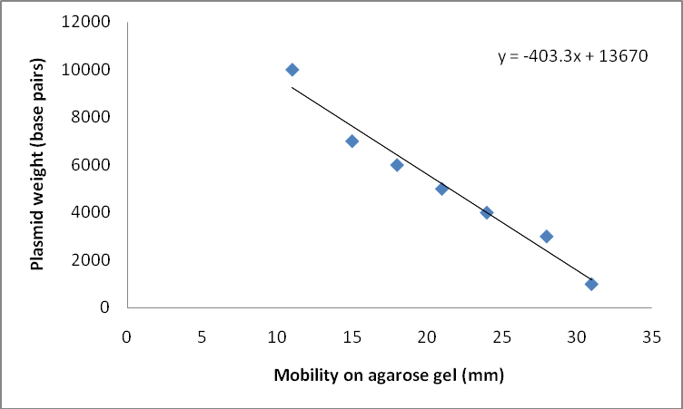

**Appendix 8**

## PICTORAL VIEW OF THE DNA SEQUENCING

* + 1. 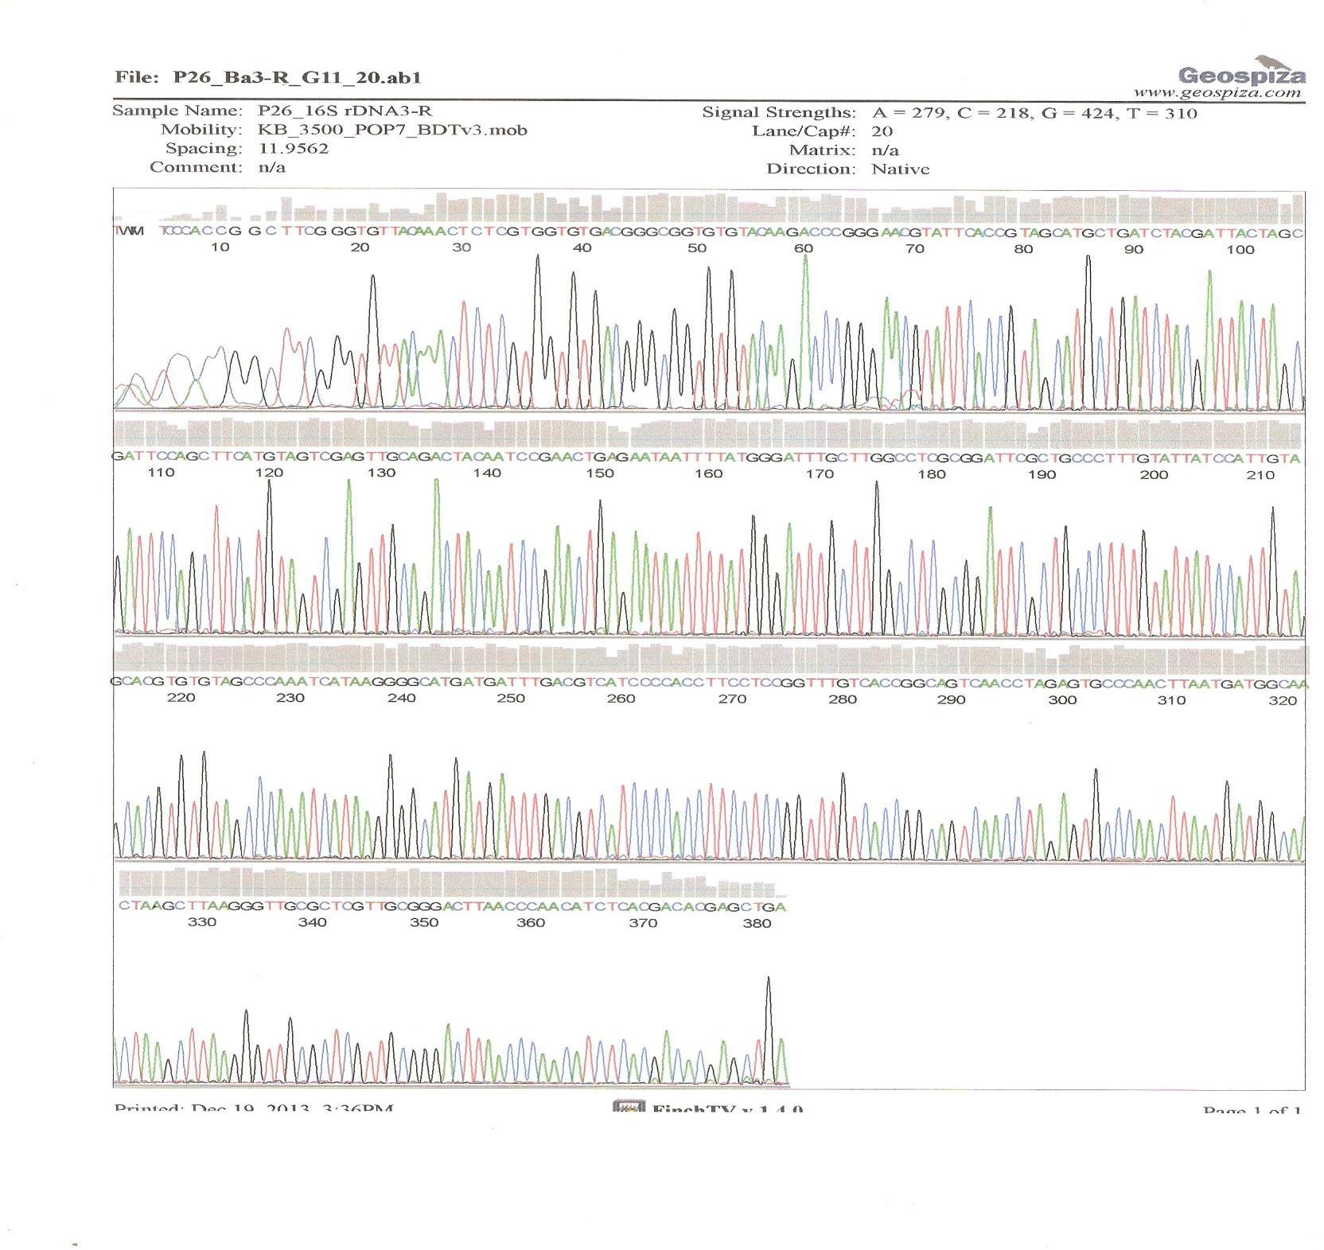**DNA sequencing of *16S rRNA* gene (reverse)**
    2. **DNA sequencing of *16S rRNA* gene (forward)**

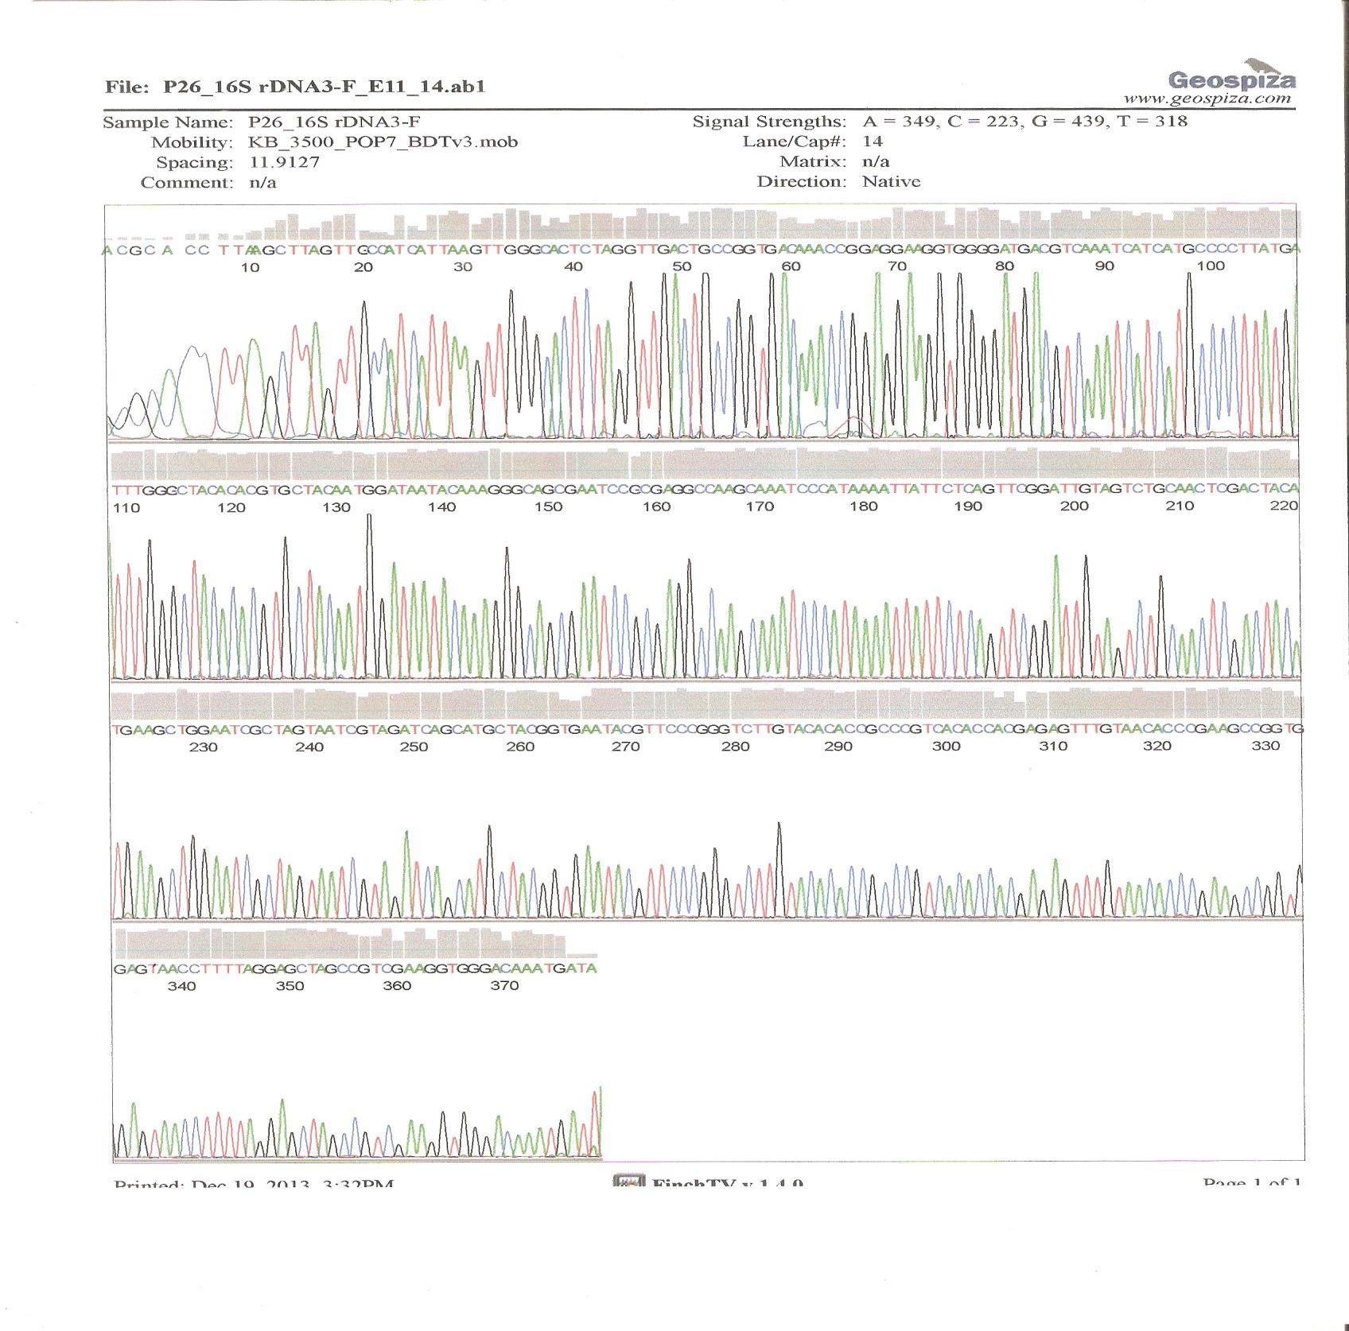

## Appendix 9: Individual alignment of *16SrRNA* translated protein sequence with other *S.aureus* species from Genbank database

a.

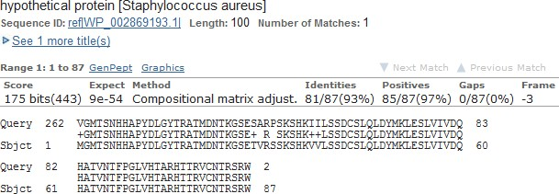

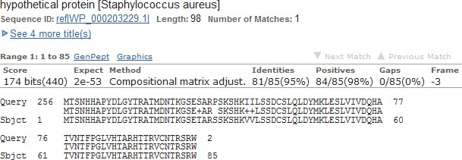b.

## Appendix 10: Individual alignment of *bla Z* protein sequence with similar *S. aureus*

**species from Genbank database**

a.

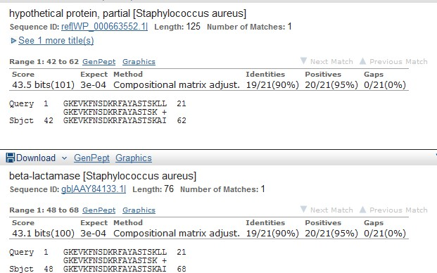

b.

