# CHARACTERIZATION AND FORMULATION OF WAX COMPOSITION FOR INVESTMENT CASTING PATTERN.

**BY**

# BABALOLA, Sunday Abiodun M.ENG/SEET/2009/2152

**DEPARTMENT OF MECHANICAL ENGINEERING, FEDERAL UNIVERSITY OF TECHNOLOGY, MINNA.**

# AUGUST, 2014

# ABSTRACT

In this study selected natural waxes were blended with other selected synthetic waxes like paraffin wax and microcrystalline wax for the purpose of investment casting. Beeswax, carnauba wax and microcrystalline wax were selected to be blended with paraffin wax at the proportion of; 100%-0%, 80%-20%, 60%-40%, 50%-50%, 40%-60%, 20%-80%, and

0%-100% for each blend. Wax properties like ash content, density, specific gravity, melting point, surface finishing, and shrinkage were determined. The results showed that blend F2 (20% beeswax with 80% paraffin wax); blend F3 (20% carnauba wax with 80% paraffin wax); and blend B1 (80% microcrystalline wax with 20% paraffin wax) gave better improvement over the natural waxes. Casting of a gear using wax pattern made from the blend F2 produced cast with smooth surface finishing and dimensional accuracy. Blended wax of F2, F3, and B1 were recommended for the production of wax pattern in investment casting.

# TABLE OF CONTENTS

Title Page

Title Page i

Declaration ii

Certification iii

Dedication iv

Acknowledgement v

Abstract vi

Table of Contents vii

List of Tables xiv

List of Figures xvi

CHAPTER ONE

* 1. INTRODUCTION 1
  2. Background of the Study 1
  3. Statement of the Problem 4
  4. Significance of the Research Work 4
  5. Aim and Objectives of the Project 5
  6. Scope of the Project 5

CHAPTER TWO

* 1. LITERATURE REVIEW 7
  2. Introduction 7
  3. The Principles of Investment Casting 8
  4. Advantages of the Investment Casting 13
  5. Disadvantages of the Investment Casting 14
  6. Properties of Casting Wax 14
  7. Pattern 16
     1. Pattern Materials 16
     2. Plastics 17
     3. Wax 17
     4. Production of Patterns 18
     5. Pattern Dies 18
     6. Pattern Assembly 19
  8. Waxes 21
     1. Types of Wax 21
     2. Additives to Pattern Waxes 26
  9. Slurry 27
     1. Slurry Materials 27
     2. Catalyst 27
     3. Refractories 28
     4. Slurry Preparation 30
     5. Production of Ceramic Shell Moulds 31
  10. Investment Techniques 32
      1. Block Mould Process 32
      2. The Shaw Process 33
      3. The Requirements of the Ceramic Mould 34
  11. Shrinkage 35
  12. Binder Systems 36
  13. Melting and Casting 40
      1. Melting Equipment 40
      2. Casting Methods 41

CHAPTER THREE

* 1. MATERIALS AND METHODS 46
  2. Materials 46
     1. Materials Used 46
  3. Experimental Procedure 49
  4. Experimental Test 52
     1. Procedure for the Determination of the Melting Points of Wax. 52
     2. Procedure for the Determination of the Ash Content 53
     3. Determination of Shrinkage/Contraction after Solidification 54
     4. Procedure for the Determination of the Density of the Wax 54
     5. Determination of the Surface Hardness 55
     6. Determination of the Specific Gravity 56
  5. Casting Processes. 57
     1. Making of a Metallic Die. 57
     2. Production of the Wax Patterns 58
     3. Investment 59
     4. Dewax 60
     5. Pouring and Removal 60

CHAPTER FOUR

4.0 RESULTS AND DISCUSSION. 61

* 1. Results 61
     1. The Result of all the Properties Tested on Natural Waxes. 61
     2. Selected Wax for Blending 65
  2. Results of the Blended Waxes. 66
     1. Result of Percentage Ash Content of the Blended Wax. 66
     2. Result of Density of the Blended Wax. 69
     3. Result of Specific Gravity of the Blended Wax. 71
     4. Result of Melting Point of the Blended Wax. 74
     5. Result of Surface Hardness of the Blended Wax. 77
     6. Result of Percentage Shrinkage of the Blended Wax. 79
     7. Result of Volumetric Shrinkage of the Blended Wax. 82
  3. Discussion 84
  4. Cast part 90

CHAPTER FIVE

* 1. CONCLUSION AND RECOMMENDATIONS 91
  2. Conclusion ` 91

5.1 Recommendations 92

REFERENCES 93

APPENDICES 97

# TABLE

**Table Page**

3.1 The Proportions Selected in the Formulation of Different Wax Blends 51

|  |  |  |
| --- | --- | --- |
|  | **LIST OF FIGURES** |  |
| **Figure** |  | **Page** |
| 2.1:  2.2: | Metal Die and Ejected Wax Pattern  The Solid Patterns are then Assembled into a Cluster and Mounted onto a Wax Runner System. | 8  9 |
| 2.3 | The Covering of a Wax Assembly with a Refractory Material | 9 |
| 2.4 | Removal of the Wax from the Mould. | 10 |
| 2.5 | Pouring of Molten Metal into the Mould | 11 |
| 2.6 | Removal of the Mould from the Casting | 12 |
| 2.7 | Casted Materials after Separated from the Cluster | 12 |
| 4.1 | Density of Different Natural Waxes | 61 |
| 4.2 | Specific Gravity of Different Natural Waxes | 62 |
| 4.3 | Melting Point of Different Natural Waxes | 62 |
| 4.4 | Surface Hardness of Different Natural Waxes | 63 |
| 4.5 | Percentage Shrinkage of Different Natural Waxes | 63 |
| 4.6 | Volumetric Shrinkage of Different Natural Waxes | 64 |
| 4.7 | % Ash Content of Different Waxes. | 64 |
| 4.8  4.9  4.10 | % Ash Content of Blended Wax of Microcrystalline Wax and Paraffin Wax at Different Proportions as Shown in Table 3.1  % Ash Content of Blended Wax of Beeswax and Paraffin Wax at Different Proportions as Shown in Table 3.1  % Ash Content of Blended Wax of Carnauba Wax and  Paraffin Wax at Different Proportions as Shown in Table 3.1 | 67  67  68 |

# Figure Page

* 1. Density of Blended Wax of Microcrystalline Wax and

Paraffin Wax at Different Proportions as Shown in Table 3.1 69

* 1. Density of Blended Wax of Beeswax and

Paraffin Wax at Different Proportions as Shown in Table 3.1 70

* 1. Density of Blended Wax of Carnauba Wax and

Paraffin Wax at Different Proportions as Shown in Table 3.1 70

* 1. Specific Gravity of Blended Wax of Microcrystalline Wax and

Paraffin Wax at Different Proportions as Shown in Table 3.1 72

* 1. Specific Gravity of Blended Wax of Beeswax and Paraffin

Wax at Different Proportions as Shown in Table 3.1 72

* 1. Specific Gravity of Blended Wax of Carnauba Wax and

Paraffin Wax at Different Proportions as Shown in Table 3.1 73

* 1. Melting Point of Blended Wax of Microcrystalline Wax and

Paraffin Wax at Different Proportions as Shown in Table 3.1 74

* 1. Melting Point of Blended Wax of Beeswax and Paraffin

Wax at Different Proportions as Shown in Table 3.1 75

* 1. Chart of Melting Point of Blended Wax of Carnauba Wax and

Paraffin Wax at Different Proportions as Shown in Table 3.1 75

* 1. Surface Hardness of Blended Wax of Microcrystalline Wax and

Paraffin Wax at Different Proportions as Shown in Table 3.1 78

* 1. Surface Hardness of blended wax of Beeswax and

Paraffin Wax at Different Proportions as Shown in Table 3.1 78

# Figure Page

* 1. Surface Hardness of Blended Wax of Carnauba Wax and

Paraffin Wax at Different Proportions as Shown in Table 3.1 79

* 1. Percentage Shrinkage of Blended Wax of Microcrystalline Wax

and Paraffin Wax at Different Proportions as Shown in Table 3.1 80

* 1. Percentage Shrinkage of Blended Wax of Beeswax and Paraffin

Wax at Different Proportions as Shown in Table 3.1 80

* 1. Percentage Shrinkage of Blended Wax of Carnauba Wax and

Paraffin Wax at Different Proportions as Shown in Table 3.1 81

* 1. Volumetric Shrinkage of Blended Wax of Microcrystalline Wax

and Paraffin Wax at Different Proportions as Shown in Table 3.1 82

* 1. Volumetric Shrinkage of Blended Wax of Beeswax and Paraffin

Wax at Different Proportions as Shown in Table 3.1 83

* 1. Volumetric Shrinkage of Blended Wax of Carnauba Wax and

Paraffin Wax at Different Proportions as Shown in Table 3.1 83

|  |  |  |
| --- | --- | --- |
|  | **LIST OF PLATES** |  |
| Plate |  | Page |
| I | Staurto Machine for Determination Melting Point of Wax. | 52 |
| II | Muffle Furnace for Ash Content Determination | 53 |
| III | Electronic Weight Balance. | 57 |
| IV | Components and Assembling of Wax Pattern Die | 58 |
| V | Wax Patterns Produced from the Blended Wax. | 58 |
| VI | The Cast Product. | 90 |

# CHAPTER ONE

# INTRODUCTION

# Background of the Study

Casting is one of the most versatile forms of manufacturing process for producing components, because there is no limit to the size, shape, and intricacy of the parts that can be produced by casting and it offers one of the cheapest methods with high strength and rigidity of the intricate parts.

In casting operation, there are many processes that can be carried out for the production of metallic parts. These processes include; sand casting, No-bake casting, Resin shell mound casting, permanent mould casting, die casting, expendable pattern casting (Lost foam), vacuum process moulding, centrifugal casting, investment casting (Lost wax), etc. These processes are used to produce metallic materials (both ferrous and non-ferrous metals) into a desired shape and dimension (Horton, 2008). However, amidst them all, investment casting can produce metallic parts with excellent accuracy, flexibility of the design, it is best use for casting alloys that are difficult to machine because there is no flash to be removed or parting line tolerances.

Investment casting is an accurate casting process that is used to create metallic components from different metals and alloys. Any metallic components that require complex and thin wall castings can be produced by investment casting. Also, it may also be used for components whose intricate, detail, accuracy and shapes cannot be achieved using another method (Bonilla, Masood, and Iovenitti, 2001).

To produce wax pattern with the same shape as the finished cast part in investment casting process is the first step. This type of pattern is called expendable pattern because it is made from wax, and it will melt away in the process. Specifically, the pattern is made by pouring in wax into the metallic die (mould). The wax pattern is coated with slurry that is made of sand stucco; the process is repeated several times until the thickness needed is achieved. The raw materials and the detailed description of the design of the finished product will determine the thickness mould. According to Rezavand and Behravesh (2007), the applications of investment castings include: machine tool accessories, pumps, air compressors, aircraft, computers, automotives, weapons, medical equipment, textile machinery, food equipment, and other electronics.

Wax play important role in the production of an investment casting part. The main part of the investment casting is the wax pattern. Because the quality of the final cast product is depend upon wax pattern. It is produced by pouring the molten wax into the permanent mould of desire shape and size. A wax pattern should have some properties for making the pattern like lowest thermal expansion, low melting point, low shrinkage, good surface finish, environmental friendly etc.

In another way, Gebelin and Jolly (2003) explained that, the quality of the wax used for patterns has a significant effect on the dimensional accuracy and surface finished of the cast part. They also concluded that, it is common for the investment casting operators to employ precision-machined full–metal dies for the production of the wax patterns when large quantities are needed with highly dimensional accuracy of the component.

Waxes are of different forms/types; there are natural waxes, synthetic waxes (blended wax). The natural waxes include; beeswax, carnauba wax, candelila wax, Montana wax, ceresine wax, ozokerite wax, petroleum wax, etc. In this work, combination of the natural waxes (different proportion) that will give all the properties which are desire to make the pattern wax for investment casting will be investigated.

An important requirement for a wax composition to be used as a pattern material for high precision application is that it must exhibit low shrinkage as the pattern cools from the injection temperature, at which the wax is liquid or semi-solid, to the ambient temperature at which patterns are usually employed to make the refractory moulds. However, convectional moulding waxes exhibit marked changes in volume as they pass through their respective melting points, making it difficult to maintain the wax patterns to the dimensional accuracy required.

Another characteristics that is desirable for investment casting waxes is that the wax composition have low ash content. If the wax composition, when melted out of the ceramic investment, leaves behind ash, the ash deposits cause imperfections on the metal reproduction.

# Statement of the Problem

The purpose that wax served in production of parts in investment casting has demanded much concern for modification of the nature and composition of wax that should be used for the investment casting. There are various types of waxes which possess divers’ forms

of properties like ability to resist shrinkage, melting point, percentage of ash content, hardness and strength.

Many at times, the wax patterns used for investment casting do shrink even when filler materials were used and this can affect both the surface finishing and the strength of the cast part. Ash content in the wax also affect the products of investment casting, if the quantity of ash is high in the wax use for pattern, there will be much inclusion in the cast and the ash in the mould can block easy flow of the molten metal. These show that where good surface finishing casting is required, waxes of high ash content and high shrinkage will not be suitable.

To overcome the problems associated with wax pattern production in investment casing, properties of wax have to be investigated and the method of moulding both the pattern and the ceramic mould can be examined.

# Significance of the Research Work

Production of wax pattern for investment casting has been facing challenges which reduce the perfection of the product. The challenges include shrinkage, high percentage of ash content, hardness, and strength. Even though, these factors affect the performance of wax pattern, wax is still the best material for making pattern in investment casting because, it is cheap to get, easy to shape and can gives high degree of accuracy.

In order for wax to be effectively use for pattern, its ability to shrink and its ash content must be highly reduce. Due to this, formulation of wax composition is important in order to increase the efficiency of the wax pattern which is used in investment casting. Therefore formulation can use different waxes that are easy to acquire and give better properties.

# Aim and Objectives of the Project

The aim of this work is to formulate suitable wax composition for wax pattern use in investment casting, and to cast a simple casting in order to examine the functionality of the formulation.

The specific objectives of this work are;

* + 1. to analyze the properties of some natural wax;
    2. to blend different waxes together at different proportions;
    3. to examine the properties of the blended waxes;
    4. to reduce shrinkage and percentage of ash content in the wax used for pattern; and
    5. to improve the surface finishing, dimensional accuracy with no flash or parting line of cast part.

# Scope of the Project

The study will cover the properties test of the different natural waxes. The waxes examined include beeswax, carnauba wax, candelila wax, Montana wax, investment casting wax, paraffin wax. In addition, the study covers blending those waxes together at different proportion and the properties examined are melting point, ash content, shrinkage, density, surface hardness, and specific gravity. The formulation of the wax composition for

investment casting wax pattern is expected to reduce the percentage of ash content in the wax, to reduce wax shrinkage, to give excellent surface finishing of the cast material and better dimensional accuracy

# CHAPTER TWO

# LITERATURE REVIEW

# Introduction

Investment casting also known as ‘lost wax’ casting. This type of casting is one of the oldest methods of producing metallic parts. This process was adopted by Egyptians in the early ages of technological innovations in producing things such as jewellery. They mould wax into the shape of the jewellery they wanted to produce and buried it in silica sand slurry. The mould was allowed to harden, then the wax was melted and molten metallic gold is poured into it, which was later break to remove the cast. (Lun and Dube, 2004).

According to Kumar and Mishra investment casting, are of two different processes: the solid mould process and the ceramic shell process. The solid mould process is commonly mainly used for dental and jewellery castings. In Singh, Kumar, and Mishra (2006) investigation revealed that ceramic shell casting was one of the frequent methods used in many engineering activities in contrast to solid mould process. The ceramic shell process is a precision casting process, unambiguously created for complex-shaped castings, and near- net-shape.

# The Principles of Investment Casting

There are two basic methods employed in this operation are; block mould production and ceramic mould production (Beeley and Smart 1995). Since shell moulds are generally more economic in their use of raw materials and much more flexible as regards the size

and weight of the castings that can be produced, the majority of investment castings are now made by this method.

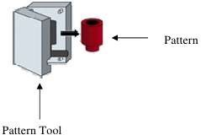

Figure 2.1: Metal die and ejected wax pattern.

The mixture of resin, filler material, and wax is injected into the die under pressure. As the quality of the finished casting depends critically upon the wax, most casters use wax that has been specifically designed for the application. The solid patterns are then tacked together to form a bunch that is mounted on the wax runner as seen in figure 2.2. The runner system comprises a series of passageways and reservoirs that not only guide liquid metal into the main cavity but also provide additional liquid to compensate for cooling contraction.

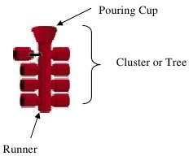

Figure 2.2: The solid patterns are then tacked together to form a bunch that is mounted on the wax runner.

The covering of a wax assembly with silica slurry (mixture of silica sand and sodium silicate material) is called investing (coating) which gives rise to the name for the process, (figure 2.3). The wax tacked together is then immersed in thin silica slurry comprising of liquid binder with silica powder.

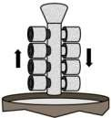

Figure 2.3: The coating of a wax assembly with slurry material.

The excess slurry is removed from the wax pattern that was dipped into the silica slurry and coarse silica sand is deposited on the wet surface of the pattern. This process of coating with outer coarse silica coating is to minimise the rate of cracking of the mould when drying out. Also, the intension of the exterior coating is to make smooth surface of the investment which enhance the adherence of slurry particles. The assembly is immersed briefly in secondary slurry allowed to set and the process is repeated till expected thickness is achieved. Sufficient permeability of the mould is maximised when the coarseness of the silica sand varies from fine to coarse. The slurry invested should be properly allowed to baked (usually chemically set and then air-dried) between dipping (Nagahanumaiah, and Mukherjee, 2003). Thus lost-wax casting mould contains many different strata of fine silica sand particles and coarse silica sand particle bond collectively with the help of binding material that is mixed properly to form set gelatine.

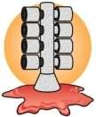

Figure 2.4: Ejecting the wax from mould.

After its drain wax from the mould, the wax pattern material is removed in a steam autoclave, where the shells are subjected to steam at high temperature and pressure. Liu and Leu (2003) state it that, heat transfer occur faster through silica shell causing the waxes to melt and drain away as shown in figure 2.4. The cavity left behind is an exact replica of the original pattern. The mould was fired at an elevated temperature in order to remove every remaining wax and develop the bond strength of the binder.

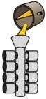

Figure 2.5: Pouring of molten metal into the mould

Metal can be poured into the mould whilst still hot or more usually the mould is allowed to cool and reheated to firing temperature before casting (Kruse and Richard, 2005). Melting and casting under vacuum is frequently used for high temperature alloys where avoidance

of contamination by oxidation products is critical. The ranges of alloys which can be investment cast are wider than that for any other single manufacturing process.

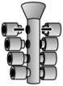

Figure 2.6: Removal of the mould from the casting

As the metal solidifies inside the mould, the mould was knocked-out in order to get the cast as it is in figure 2.6. The process of knocking out include material is removed by blow, shaking, and grit blasting, water blast with high pressure or chemical dissolution which allow easy removal of the castings that are mechanically cut out from the runner system, (Nastac, Gungor, Ucok, Klug, and Tack 2006). Various post-casting operations such as heat treatment, hipping or surface coating may be carried out to meet the customers’ requirements.

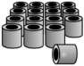

Figure 2.7**:** Casted materials after separated from the cluster

# Advantages of the Investment Casting

The investment casting process has several unique advantages that few alternative metal forming techniques can offer (Ford, 2009):

1. Castings are produced in a wide variety of metallic alloys in both ferrous and nonferrous. Most alloys put into service were really not easy or still not possible to produce by any other manufacturing process.
2. Intricate shape that may be too expensive and not possible to make by machining or fabrication can be produced without difficulty by lost-wax casting.
3. Improved mechanical properties of cast can be tailored to the desire qualities by appropriate heat treatment operations.
4. Tooling was comparatively inexpensive with pliable to alteration. This flexibility gives cast product to formed great numbers.
5. An appreciable accurate dimension and perfect surface finish were obtained evenwhen the process was on for a long time. In general, the tolerances of ± 0.13mm per 25mm were commonly use which may depend on the spatial shape and alignment of the component, equally on the size of the material to be cast.
6. Its cost of producing an article is economical when compare with some forming methods because it does not waste materials and it reduces the cost of labour. Finishing cost of production is low because it does not require any serious finished operation.
7. The component can possesses good visual and standardized shape because only a single mould that does not has any jointed line is employed. Therefore, the need for drafting angles is eliminate.
8. This can give a very high casting reliability.
9. It result in economically weight saving since thin walls and intricate parts can be produced.

# Disadvantages of the Investment Casting

1. Much period of time is needed for the operation and requires much concentration from the operators.
2. Small sizes together with thin walls can be damaged in the process and in immersing the pattern into the slurry.
3. The mould refractories and the metallic alloy may react in the process. Example of such metallic alloy is titanium.
4. This method of casting needs heat to bake the mould, to eject the wax, and to melt the metal.

# Properties of Casting Wax

Lost-wax casting wax material is blends of various composite compounds. The ultimate properties of the wax are affected by individual compound in a means or another (Mahimkar, 2011). Some factors which influence qualities of wax and the productions of patterns were mentioned below.

**Shrinkage and Cavitations’:** constant result of shrinkage and cavitation in wax casting are particularly significant to the foundry. It has been earlier mentioned that the composition and structure affect shrinkage. It then brings out the significance of both the wax company and process organizes practice in the foundry.

**Congealing and Melting Point:** congeal end and melting point were temperature at the start and ending of the semi-liquid condition of wax correspondingly. These factors have the main control on the injection temperature and pressure setting of the injection machine.

**Ash Content:** foundries are conscious of the significance of using and maintain wax with low ash content and of the disadvantageous outcome of ash. The maximum limit require in general, for wax shrinkage is 0.03%.

**Hardness and Elasticity:** Wax pattern ought to contain adequate property of being rigid and resistant to pressure; and the tendency of a body to return to its original shape after it has been stretched or compressed in order to stop the chance of rejecting the wax pattern.

**Viscosity:** This the property of wax for casting which is important to flourishing pattern producing industries, wherein fine sections require to be formed. In such cases, frequently a little viscousness of wax is requisite to permit the wax to go through a smaller space of the mould. In case of big section, a fewer liquid wax can be favoured. Viscosity is usually associated to temperatures of the injection of wax.

**Good Surface Finish:** An excellent surface finishing of pattern-wax is a significant property which results in good surface for mould cavity. Generally, unfilled wax has a lustrous surface; emulsified wax surface is more smoothed, while filled wax surface is a faintly rough.

**Setting Rate:** While a few produced components need extremely quick set and reject from the die, some do not, in another way; a slow setting wax is of benefit.

# Pattern

Pattern is the replicate of the original article to be produce. Pattern for investment casting is made in a special way different from the pattern use in other casting processes like sand casting. In this process, die, metallic mould or ceramic shell is designed in which the size, shape, and dimension of the part to be casted are inscribed in the cavity of the die. Pattern material is then pouring (in the molten/liquid state) into the cavity of the die, it forms the pattern for investment casting (Sabau and Viswanathan, 2001).

# Pattern Materials

Investment casting differs from all other casting processes in the use of a disposable pattern to form the cavity into which the metal is poured. The complexity, detail and surface finish of the casting is directly dependent upon the integrity and dimensional stability of the original pattern. As such, the choice of pattern material is an important step in the process of investment casting, (Yarlagadda and Hock, 2003). Irrespective of the material selected, the same basic properties are required

1. Low ash content
2. Good fluidity to reproduce detail
3. Low contraction and expansion characteristics
4. Stable and reproducible
5. Compatibility with process materials
6. Adequate strength and hardness
7. Easy to join and assemble
8. Non toxic
9. Low cost and readily available
10. Reusable

There are many materials use in investment casting for making pattern. Among them are; plastic, wax, ice, and mercury (Tascroglu and Akar, 2003).

# Plastics

This is the largely use pattern substance, after wax. Polystyrene is the material that is commonly used, since it is more economical, better stability, it is mouldable at a high rate of production when using automatic machinery, as well as extremely higher resistance to handling spoil, yet in a very thin section. The utility of polystyrene is nevertheless restricted, since it has the affinity to allow shell mould cracking when attempting to remove the pattern, along with its requirement of most costly tooling and insertion machines than that of wax (Sabau and Viswanathan, 2001). On the other hand, the mainly significant function on behalf of polystyrene is for elusive devices, applicable in some cases like patterns used for production of nozzle.

# Wax

Various tests for determining the suitability of the material have been determined and documented. Many materials such as wood or mercury have been tried and tested over the last century but at present the one usually chosen for pattern production is wax or a blend

of wax, resin and filler material. Ash-free medium and high impact polystyrenes are widely used to produce patterns for solid mould applications and for the production of extremely thin or fragile shaped components. Attempts to replace wax by urea or plastic have only been successful in a few specialized fields (Morgan, Townley, Kemble, and Smith, 2002). Wax has been used as a pattern material since the time of the early Egyptian and Chinese craftsmen. According to Kolattukudy (1976), a wide range of natural and synthetic waxes have been developed to meet the exacting requirements of the industry. A choice of straight, emulsified and filled pattern wax is available to suit individual component requirements. Feeders and risers are usually manufactured from lower grade or even reclaimed wax, as the requirements for this application are less exacting.

# Patterns Production

Patterns are typically made by inject pattern material into the metal dies which contain one or more cavities of the required shape, in the die. Diverse machineries, through diverse functioning parameter, have been modernized to certify various materials for pattern (Sabau and Viswanathan, 2001). For example, Wax pattern is injected at a low temperature (43.3°C to 76.67°C) and pressure, (0.2758 to 103421Mpascal), in split die use particularly designed equipment.

# Assembly Patterns

Patterns for Lost-wax casting made in dies were set for fixing together in many ways. Big patterns are built and are process differently, although little to average size patterns were generally assemble to cluster for economy in processing e.g. pattern clusters of aircraft

turbine blades may range from 6 to 30 parts. For small hardware part, patterns set in cluster can vary from tens to hundreds. Many patterns were injected through the die sprue. On the other hand, big or intricate components were introduced in sections that fixed together as a whole. The capabilities of insertion machine as well as the price of tooling were vital points to be considered (Tascyogu, Inem, and Akar, 2004).

Gating constituents which include, pouring mouths, gating and runners form tree-like structure that were formed differently, and patterns assembled with these to produce the wax-tree or pattern cluster. Standard extruded wax shapes are often used for gating, especially for mock-up work. Preformed ceramic pour cups are often used in place of wax pour cups. Most assembly is done manually, with skilled personnel.

Wax components are assembled by wax welding, using hot iron or spatula, or a small gas flame. ASTM Standard, (2008) record that, wax at the interface between two components is quickly melted, and the components are pressed together until the wax solidifies. The joint is then smoothed over. A hot melt adhesive can be used instead of wax welding. Currently, laser welding units have been developed to provide improvements in assembling of wax components. Fixtures are essential to ensure accurate alignment in assembling patterns. Joints must be strong, and completely sealed with no undercuts. Care also must be taken to avoid damaging patterns or splattering drops of molten wax over the patterns being assembled (Gebelin and jolly, 2003).

Polystyrene pattern segments are assembled by solvent welding. The plastic at the interface is softened with solvent, and the parts are pressed together until bonded. However, polystyrene becomes very tacky when wet with solvent, and readily adheres to itself. Frequently, only one of the two halves needs to be wet. The assembly of polystyrene to wax is done by welding, with only the wax being melted.

Most assembly and setup operations are performed manually, but some automation is currently being introduced in some investment casting foundries. In one application, a robot is used to apply sealing compound in the assembly of patterns for different integrally cast nozzles, with each nozzle having, from 52 to 120 airfoils apiece (Jackson and Fassler, 1985).

# Waxes

Wax usually refers to a substance that is a solid at ambient temperature and that, on being subjected to slightly higher temperatures, becomes a low viscosity liquid. The chemical composition of waxes is complex; all of the products have relatively wide molecular weight profiles, with the functionality ranging from products, which contain mainly normal alkanes to those, which are mixtures of hydrocarbons and reactive functional species.

# Types of Wax

Waxes are a universal choice as pattern material for investment casting, barring few exceptions. As the ultimate quality of castings in this process depends primarily on quality

of wax patterns, it is necessary to understand how best performance of wax - blend can be achieved.

# Paraffin Wax

Paraffin is classified as natural wax. It is the most commonly used wax for candle making. It can be said to come ultimately from plant life. To protect themselves from bad weather, plants produce a layer of wax on their leaves and stems. The material from dead plants 100-700 million years ago accumulated in large deposits and become buried under the Earth’s surface. After long periods of time, forces of heat and pressure turned slowly decaying plant material into crude oil known as “petroleum”. Because of the nature of waxes, being inert and water repellent, they were unaffected by decomposition of plant material and remained intact, suspended by crude oil.

Petroleum companies “harvests” crude oil and processes it. They refine oil, separating different properties into gasoline, kerosene, lubrication oil, and many other products. In many cases wax that’s in petroleum is considered unwanted and is refined out, (Hossain, Rahman, Ketata, and Islam, 2009). The refinery will process wax into clean, clear liquid or as a solid, milky white block and make it available to companies who may have a use for it. Refined wax is called paraffin. The word paraffin comes from the Latin word “parum” which means “few or without” and “affins” which means “connection or attraction (affinity)”. There are few substances that will chemically react or bind to this type of wax.

# Beeswax

Beeswax is the least common, but more highly renowned wax for candle making. Beeswax is classified as natural wax. A honeybee uses wax to make honeycombs. Beeswax is actually a refinement of honey. The female worker bee eats the honey and her body converts the sugar in the honey into wax. The wax is then expelled from the bees’ body in the form of scales beneath the abdomen. The bee will then remove the wax scale and chew it up, mixing it with saliva to soften and make it pliable enough to work with. They will then attach the wax mixture to the comb that is being constructed. Usually another bee will take the piece of wax that was just attached to the comb, chew it more, adding more saliva, and deposit it on the other section of the comb. As the combs are built up, honey is deposited inside, and then combs are capped with more wax. Since several worker bees construct at the same time, and the hive is constantly active with other bees flying around and walking on combs, depositing foreign matter onto them, the composition of wax is very complex, (Bonilla *et al*, 2001).

As is the case with paraffin, collecting beeswax is also a byproduct of a separate process. Beekeepers main interest is the collection of honey. The wax capping must be removed in order to extract honey. They then save the wax capping until they collect enough to put out on the market. Because beeswax is harvested in small amounts, it does not have the same availability that paraffin does and is therefore more expensive. Beeswax is used extensively in cosmetics and candle making. Candles made of 100% beeswax generally are held in high regard. When burning, the beeswax candle will glow beautifully and give out a very pleasant honey like aroma.

# Carnauba wax.

The source of carnauba wax is the palm tree, whose wax-producing stands grow almost exclusively in the semiarid northeast section of Brazil. Carnauba wax forms on the fronds of the palm, and is removed by cutting the fronds, drying, and mechanically removing the wax. Impurities are removed from the wax by melting and filtering or centrifuging. Wide fluctuations in price and availability have caused markets served by carnauba wax to seek replacements. Whereas there is no other single wax, which combines all the properties of carnauba, suitable substitutes are available for most applications, (Bonilla *et al,* 2001). The major components of carnauba wax are aliphatic and aromatic esters of long-chain alcohols and acids, with smaller amounts of free fatty acids and alcohols, and resins. Carnauba wax is very hard, with a penetration of 2 dmm at 250C and only 3dmm at 43.30C. Carnauba also has one of the higher melting points for the natural waxes at 840C, with a viscosity of 3960 mm2/s at 98.90C, an acid number of 8, and a saponification number of 80.The hardness and high melting point, when combined with its ability to disperse pigments such as carbon black, allows Carnauba wax increasing use in the thermal printing inks. Carnauba is also widely used to gel organic solvents and oils, making the wax a valuable component of solvent and oil paste formulations, (Sidhu, Kumar, and Mishra, 2008). Carnauba polishes to a high gloss and thus is widely used as a polishing agent for items such as leather, candies, and pills. Other uses include cosmetics and investment casting applications.

# Candelila wax

Candelila wax is harvested from shrubs in the Mexican states of Coahuila and Chihuahua and, to a very small degree, in the Big Bend region of Texas in the United States. The

entire mature plant is uprooted and immersed in boiling water acidified with sulphuric acid. The wax floats to the surface and is filtered .The major components of Candelila wax are hydrocarbons, esters of long-chain alcohols and acids, long-chain alcohols, sterols, and neutral resins, and long-chain acids. Typically, Candelila wax has a melting point of 700C, a penetration of 3 dmm at 250C, an acid number of 14, and a saponification number of 55. Principal markets for Candelila include cosmetics, foods, and pharmaceuticals.

# Montana wax

Montana wax is derived by solvent extraction of lignite. The earliest production on a commercial scale was in Germany during the latter half of the nineteenth century, and Germany continues to supply the majority of the world’s production of Montana wax. Montana wax production at Amsdorf is part of a massive coal-mining operation from a continuous vein and raw material is expected to last for decades. The composition of Montana wax depends on the material from which it is extracted, but all contain varying amounts of wax, resin, and asphalt. Black Montana wax may be further processed to remove the resins and asphalt, which is known as refined Montana wax. White Montana wax has been reacted with alcohols to form esters. The wax component of Montana is a mixture of long- chain (C24-C30) esters (62-68 wt %), long-chain acids (22-

26 wt %), and long-chain alcohols, ketones, and hydrocarbons (7-15 wt %). Crude Montana wax from Germany typically has a melting point of 800C, an acid number of 32, and a saponification number of 92, (Sidhu et al, 2008).

The largest traditional use for Montana waxes was as a component in on-time hot-melt carbon-paper inks. With the decrease in the use of carbon-paper inks, uses for the refined grades have become predominant, mainly in the formulation of polishes and as plastics lubricants.

# Ceresine Wax

Predominantly composed of complex hydrocarbons which are formulated into specialty types of waxes, which are then custom, blended to meet the customer's needs.

They are consistent from batch to batch, with specific properties critical to the formulator, including melt point, hardness, penetration, viscosity, gel and colour. This wax is used in a wide range of applications where consistency is absolutely necessary to insure a uniformity of the finished product. Ceresine Waxes typically melt between 130-1600 F. The wax is non-toxic and nonhazardous, thus permitting use in countless personal-care applications (Sidhu *et al*, 2008).

# Additives to Pattern Waxes

Waxes with their many useful properties are, however, deficient in two practically important areas: (a) Strength and rigidity especially required to make fragile patterns; and

(b) Dimensional control, especially in limiting surface cavitation due to solidification shrinkage, during and after pattern injection. Additives are made to waxes to cause improvements needed in these two deficient areas, (Richard, Carl, and Philip, 1983).

The strength and toughness of waxes are improved by the addition, in required volumes, of plastics such as polyethylene, nylon, ethyl cellulose, and ethylene vinyl acrylate.

Solidification shrinkage causing surface cavitations’ in waxes, is reduced to some extent by adding plastics, but is reduced to a greater extent by adding resins and fillers.

Resins suitable for this are: coal tar resins, various rosin derivatives, hydrocarbon resins from petroleum and tree-derived resins such as dammar, Burgundy Pitch, and the terpene resins. These resins have a wide range of softening points and varying viscosity at different temperatures.

# Slurry

Slurry contains ceramic powder, binder and catalyst. The ratio among these three components is important to the performance of the slurry system, the building of ceramic shell or mould, and consequently the quality of castings. Therefore, a right mixing ratio among the three components is critical to controlling the accuracy and surface finish of castings (Beeley and Smart, 1995).

# Slurry materials

It is well known that the slurry is made of the mixture of binder and ceramic materials. Therefore, ceramic materials play an important role in successful mould (shell) making. In general, ceramic materials are used in a very wide range of combinations and include silica sand, alumino-silicates, alumina, fused silica, and zirconium silicate. Suitable choice of the ceramic materials can lead to smooth surface finish, high accuracy, and good property of the metal castings. The following factors need to be considered when choosing the ceramic materials: specific gravity, linear expansion coefficient, chemical composition, cost, and

application (Sidhu *et al*, 2008). For example, a ceramic material usually has several particle sizes with a certain mixing ratio for shell making. The ratio of fine/medium/coarse powder is critical for shell quality.

# Catalyst

A catalyst is required to shorten the gelling time of the slurry (mixture of binder and ceramic material). Otherwise, it will take days or even longer for the slurry to gel. In general, the gelling time mainly depends on temperature, binder composition, and pH value. The effect of pH value is more significant than the effect of the other two factors. The slurry is most stable when pH value is equal to 2, thus the gelling time is the longest when pH=2. On the other hand, the slurry is most unstable and the corresponding gelling time is the shortest when the pH value is between 5.0 and 6.0. When pH value is less than 1.0, the slurry is also unstable. The aim of adding a catalyst is to change the pH value of the slurry from the range where the slurry is stable to the range where the slurry is unstable. The catalyst can be either acid (to change pH value towards 1.0) or alkaline (to change pH value towards 6.0). Sidhu, Kumar, and Mishra, (2008), show that triethanolamine has a good performance when used as a catalyst.

# Refractories

Silica, zircon, alumina and various aluminium silicates are commonly used refractories for both slurry and stucco in making ceramic shell moulds. Alumina is expensive, and as such used selectively, such as in directional solidification processes. Other refractories, such as graphite, zirconia and Yttria have been used with reactive alloys. The refractoriness of a

material is the ability of the substance to withstand high temperatures without fusion or decomposition.

Although the cost of the raw material is an important consideration, other relevant factors to be taken into account are:-

1. strength and mould properties,
2. casting surface finish,
3. consistent casting results,
4. ease of shell removal,
5. thermal expansion characteristics. (Ferenc *et al*, 2009)

**Silica** is generally used in the form of fused silica (silica glass). Fused silica is made by melting natural quartz sand and then solidifying it to form a glass, which is crushed and screened to produce stucco particles, and it is ground to a powder for use in slurries. The extremely low coefficient of thermal expansion of fused silica, its ready solubility in molten caustic solutions provides a means of chemically removing shell material from areas of castings that are difficult to clean by other methods. Silica is sometimes used as naturally occurring quartz, expense of which is very low. However, its utility is limited because of its high coefficient of thermal expansion and by the high, abrupt expansion at 573 °C (1063 °F) accompanying its α-to-β-phase transition, causing excessive cracking of shell mould, if the mould is not fired slowly.

**Zircon** occurs naturally as a sand, and used in this form as stucco. Its primary advantages are high refractoriness, resistance to wetting by molten metal’s, and round particle shape.

Use of zircon is generally limited with prime coats, as it does not occur in sizes coarse enough for stuccoing backup coats. It is ground to powder for use in slurries, often in conjunction with fused silica and aluminosilicates.

**Aluminium silicates** are generally composed of stable compound, mullite (Al2O3.2SiO2) with some free silica, which is usually in the form of silica glass. They are made by calcining fireclays, to produce different levels of mullite, (which contains 72% alumina) and free silica.

Refractoriness and cost increase with alumina content. Fired pellets are crushed or ground and carefully sized to produce a range of powder sizes for use in slurries, and granular materials for use as stuccos.

**Alumina** produced from bauxite ore by the Bayer process, is more refractory than silica or mullite, and is less reactive toward many alloys. However, its use is primarily confined to super alloy casting.

# Slurry Preparation

Compositions of the slurry, which are usually proprietary, are based on the particular refractory powder and the type of binder. Slurry composition is generally in the following broad range:

* Binder solids: 5 -10%
* Liquid (from binder or added): 15 – 30%
* Refractory powder: 60-80%

Slurries are prepared by adding refractory powder to binder liquid, using agitation to break up agglomerates, remove any air entrainment. Stirring is continued until viscosity falls to its final level before the slurry is put to use. Continued stirring is also required in production to keep the powder from settling out of suspension. Either rotating tanks with baffles or propeller mixers are used for this purpose, (Jones and Yuan, 2003). Control procedures for slurries vary considerably among foundries. The most prevalent controls are the measurement of the initial ingredients, slurry temperature, density, pH and viscosity. Viscosity is measured with a Brookfield type rotating viscometer. Properties of the finished ceramic shells that are monitored include: weight, modulus of rupture (green and fired), and permeability.

# Production of Ceramic Shell Moulds

Investment shell moulds are made by applying a series of ceramic coatings to the pattern tree assemblies or pattern clusters. Each coating consists of a fine ceramic layer, with coarse ceramic ‘stucco’ particles embedded in its outer surface. The tree assembly or cluster is first dipped into a ceramic slurry bath, then withdrawn from the slurry, and manipulated to drain off excess slurry, and to produce a uniform layer. The wet layer is immediately stuccoed with coarser ceramic particles, either by immersing it into a fluidized bed of the particles, or by sprinkling or ‘raining’ on it the stucco particles from above, (Jones and Yuan, 2003).

The fine ceramic layer forms the inner face of the mould, and reproduces every detail, including the smooth surface of the pattern. It also contains the bonding agent, which

provides strength to the structure. The coarse stucco particles serve to arrest further runoff of the slurry, help to prevent it from cracking or pulling away, provide keying or bonding between individual coatings layers, and build up shell thickness faster.

Each coating is allowed to harden or set before the next one is applied. This is accomplished by drying, chemical gelling, or a combination of these. The operations of coating, stuccoing, and hardening are repeated a number of times, until the required shell thickness is achieved. The final coat, often called a seal coat, is left unstuccoed, in order to avoid the occurrence of loose particles on the shell mould surface.

# 2.10 Investment Techniques

# Block Mould Process

For certain applications, such as the casting of very small parts, it is often preferable to use an investment method known as the block or solid mould process. The technique was introduced long time ago and was for many years a successful manufacturing route. Block moulds can be either single or double invested depending upon the required casting surface. Double investment moulds differ from single investment moulds only in the use of a primary coat which is applied to the wax pattern prior to the main investing cycle.

The primary coating, consisting of binder and fine grained ceramic refractory, is applied to a wax pattern by spraying or dipping. Whilst the coating is still wet, coarse refractory particles are applied as stucco and the assembly was allowed to dry. The coated pattern is then inverted, fastened to a mould base plate and placed into a suitable metal flask. The flask is then filled with slurry made from refractory and liquid binder. The assembly is vibrated to consolidate the investment and to obtain an intimate contact between pattern

and slurry. The investment is then gelled, either by the prior addition of accelerators, or by gentle heating at temperatures below the softening point of the wax. After gellation excess binder and refractory which will have risen to the surface is removed. The mould is then transferred to a low temperature oven for several hours at a temperature of 150°C, (Sidhu *et al*, 2008). This treatment removes the wax pattern and develops the green strength of the mould. At this point the flask is usually removed from the mould but when added support during both handling and casting is required a flask made from heat resisting steel is used and left in place. Firing of the mould at approximately 1,000°C takes place prior to casting with the metal.

# The Shaw Process

Ethyl silicate slurry moulding (also known as the Shaw process, Avnet-Shaw Osburn- Shaw process and the Dean Process) is a variation of the investment technique which originated in the UK (Sidhu *et al*, 2008). The principal difference between this process and other investment methods is that a gelling agent is added to the refractory slurry before it is poured over the pattern. When this mixture forms a flexible gel, the mould can be stripped off the pattern and fired to develop full ceramic strength. Patterns can be made of various materials such as plaster, wood or metal and can be reused which are not possible when using an expendable (wax or plastic) pattern. A mixture of graded refractory, hydrolyzed ethyl silicate and a liquid catalyst are mixed together to form a slurry. This mixture is poured over the pattern and allowed to gel. The mould is then stripped from the pattern and torched with a high pressure gas flame. This ignites any remaining alcohol within the binder and forms a series of craze cracks throughout the entire mould section. The

presence of the cracks produces a mould of high permeability which is partially immune to thermal shock. Further strengthening is achieved by firing at high temperatures. The resultant mould is inert, gas-free, erosion resistant and collapsible and can be cast successfully at both high and room temperatures, (Kline, 2010).

The process has several advantages including the use of a permanent pattern that does not need pre-coating, the ability to produce undercut shapes and the relative ease with which larger components can be cast. Unfortunately the master pattern is expensive and the accuracy of the pattern can be impaired by the split mould. The moulding process is slow and the casting surface is rougher than that obtained using other investment techniques (Liu and Leu, 2002).

# The Requirements of the Ceramic Mould

The key requirements of an investment casting mould are;

1. Sufficient green (unfired) strength to withstand wax removal without failure.
2. Sufficient fired strength to withstand the weight of cast metal. Excessive strength must be avoided as this hinders the cooling contraction of the metal and produces hot tears or cracks within the casting (as the metal cools it shrinks and if the mould walls are rigid then localised stress concentrations build up which are relieved by fractures).
3. High thermal shock resistance to prevent cracking during metal pouring
4. High chemical stability so that individual components do not break down at high temperatures or prolonged durations at high temperatures.
5. Low reactivity with the metals being cast to improve the surface finish.
6. Sufficient mould permeability and thermal conductivity to maintain an adequate thermal transfer through the mould wall and hence allow the metal to cool.
7. Low thermal expansion to prevent dimensional changes within the mould wall and ultimately the casting.
8. Ability to remove the ceramic material from the casting after metal solidification and cooling.

# Shrinkage

There are three types of shrinkage: shrinkage of the liquid, solidification shrinkage and patternmaker's shrinkage. The shrinkage of the liquid is rarely a problem because more material is flowing into the mould behind it. Solidification shrinkage occurs because metals are less dense as a liquid than a solid, so during solidification the metal density dramatically increases. Patternmaker's shrinkage refers to the shrinkage that occurs when the material is cooled from the solidification temperature to room temperature, which occurs due to [thermal contraction,](http://en.wikipedia.org/wiki/Thermal_contraction) (Craig *et al*, 2005). Most materials contract or shrink during solidification and cooling. Shrinkage is the result of:

* Contraction of the liquid as it cools prior to its solidification
* Contraction during phase change from a liquid to solid
* Contraction of the solid as it continues to cool to ambient temperature.

Shrinkage can sometimes cause cracking to occur in component as it solidifies. Since the coolest area of a volume of liquid is where it contacts a mould or die, solidification usually begins first at this surface. As the crystals grow inward, the material continues to shrink. If

the solid surface is too rigid and will not deform to accommodate the internal shrinkage, the stresses can become high enough to exceed the tensile strength of the material and cause a crack to form. Shrinkage cavitations sometimes occur because as a material solidifies inward, shrinkage occurred to such an extent that there is not enough atoms present to fill the available space and a void is left.

# Binder Systems

Binder is another major slurry material. It is mixed with ceramic material to make the slurry. The binder in an investment casting mould is the adhesive liquid refractory phase which is used to form a ceramic bond between the refractory particles. The type of binder used is determined by many factors such as: size of the casting, mould firing and pre-heat temperatures, method of mould formation and the nature of the metal being cast. The binder solution should have good fluidity at a sub-zero temperature, and the corresponding mould or shell made must have good surface finish, high accuracy and high strength. Alcohol based ethyl silicates and water based silica sols are the predominant binders used, but there are others such as phosphates and sodium silicates, (Kim, 2002). A comprehensive list of the available binders is given below.

1. **Ethyl silicate** - these binders are prepared by the direct reaction between silicon tetrachloride and an alcohol:

SiCl4 + 4C2 H5OH —————————Si(C2 H5 O)4 + 4HCl

C2 H5 OH = ethanol (Kirk 2007)

Water present in the alcohol causes some hydrolysis and polymerization reactions to occur; so the technical grade ethyl silicate preferred for use in foundry technology is a mixture of

orthosilicates (tetraethoxysilanes) and polysilicates (ethoxypolysiloxanes). The hydrolysed binder is fairly stable in the pH range 1.7 to 2.2 and least stable at pH 5< 2 >. A coherent gel structure is formed when an acid or base catalyst (such as ammonia) is added to the mixture of silicates. The catalyst promotes a series of polycondensation, hydrolysis and alcohydrolysis (the reverse of hydrolysis) reactions, which cause cross linking at each silicon atom (Sabau, and Viswanathan, 2003). As the polymerisation sequence proceeds, the cross linking becomes extensive causing the formation of three-dimensional polymers and, ultimately, the gel structure. The alcohol solvent is contained within the pores of the gel. This structure is dried to remove the solvent and fired at high temperatures to produce strong silica bonds. Only ethyl silicate satisfies all the above requirements. Pure ethyl silicate can be used to produce a foundry binder but it is more usual to employ a condensed or concentrated form containing certain amount of silica, say 40% by weight. Ethyl silicate ‘as received’ has no binding properties, but must be chemically decomposed by reacting with water, i.e., hydrolyzed (Beeley and Smart, 1995). The reaction produces alcohol and silica in an active state. Since ethyl silicate is not soluble with water, the reaction only occurs on the interface and thus is slow. Alcohol is soluble with both ethyl silicate and water.

1. **Silica sols (colloidal silica solutions)** - consist of silica particles (4-100 nm in diameter) normally in an alkaline aqueous solution. The silica content can be as high as 50% (by weight) although 30% solutions are more usual. The sol is converted to a gel by adjusting the pH from alkaline to acidic, by the introduction of positively charged ions or by air- drying until the sol is of a high enough concentration for the individual silica particles to

collide and bond together. Whichever method is adopted the gel produced is the same and provides the green bond for the mould. The high temperature bond is developed by heating the gel:

1. **Hybrid binders -** often called 'pre-hydrolysed' ethyl silicates, and consist of a combination of ethyl silicate, colloidal silica, alcohol and other organic solvents. These binders were developed to reduce the problems of rapid evaporation and short storage times that are encountered with standard ethyl silicates. Since the binders are a mixture of sol and ethyl silicate, gellation is achieved by a combination of air-drying (to gel the sol) and the use of a catalyst (to gel the ethyl silicate). Thus, both constituents are present in the final gel structure. Often a base catalyst such as ammonia is used, which gels both the sol and the ethyl silicate constituents together.
2. **Sodium silicate (and potassium silicate) -** It is available in aqueous solution and in solid form and is used in cements, [passive fire protection](http://en.wikipedia.org/wiki/Passive_fire_protection), refractories, textile and lumber processing, and automobiles. Sodium silicate is made by dissolving a fused mixture of silica sand and sodium carbonate in water or [Sodium carbonate](http://en.wikipedia.org/wiki/Sodium_carbonate) and [silicon dioxide](http://en.wikipedia.org/wiki/Silicon_dioxide) react when molten to form sodium silicate and [carbon dioxide](http://en.wikipedia.org/wiki/Carbon_dioxide): (Kirk 2007)

Na2CO3 + SiO2 → Na2SiO3 + CO2

The sodium oxide to silica ratio varies but is usually high for investment casting applications. In industry, the various grades of sodium silicate are characterized by their SiO2: Na2O ratio, which can vary between 2:1 and 3.75:1. Grades with this ratio below 2.85:1 are termed 'alkaline'. Those with a higher SiO2:Na2O ratio is described as 'neutral'. Sodium silicate is a white powder that is readily soluble in water, producing an [alkaline](http://en.wikipedia.org/wiki/Alkaline)

solution. It is one of a number of related compounds which include sodium [orthosilicate](http://en.wikipedia.org/wiki/Orthosilicate), Na4SiO4, sodium [pyrosilicate,](http://en.wikipedia.org/w/index.php?title=Pyrosilicate&action=edit&redlink=1) Na6Si2O7, and others. All are [glassy](http://en.wikipedia.org/wiki/Glassy), colourless and soluble in water. Sodium silicate is stable in [neutral](http://en.wikipedia.org/wiki/PH) and [alkaline](http://en.wikipedia.org/wiki/Alkaline) [solutions](http://en.wikipedia.org/wiki/Solution). In [acidic](http://en.wikipedia.org/wiki/Acidic) solutions, the [silicate](http://en.wikipedia.org/wiki/Silicate) ion reacts with hydrogen ions to form solicit acid, which when heated and roasted forms [silica gel,](http://en.wikipedia.org/wiki/Silica_gel) a hard, glassy substance.

1. **Phosphate binders -** a number of metal phosphates have been used but the most successful is magnesium phosphate (Horton 2008). Moulds bonded with phosphates are prepared by dry mixing the refractory, magnesia and ammonium phosphate and then reacting with water to form the bond (magnesium ammonium phosphate).
2. **Refractory cements -** the word cement is classified as 'hydraulically setting binders of the Portland cement type' i.e. calcium-alumino-silicates and calcium aluminates. Calcium mono-aluminate is produced by heating calcium carbonate with aluminium hydroxide: CaC03 + 2Al (OH) 3 ————— CaO. AljOj + CO2 + 3H2 O (Kirk 2007)

Cement gives a good, stable, high temperature bond which is reasonably refractory but the presence of calcium has a detrimental effect on the refractoriness and so this binder is used at lower casting temperatures.

1. **Plaster of Paris -** is derived from the mineral gypsum (calcium sulphate dihydrate CaSO4.2H2O). After suitable calcining, gypsum loses some of the water of crystallisation to give plaster of Paris (CaSO4.O.5H2O). When mixed with water the plaster rehydrates

and goes into solution. This solution becomes supersaturated and CaSO4.2H2O crystallises, forming a bond by mechanical interlocking of the crystals (Kirk 2007).

2CaSO4.0.5H2O + 3H2O ———————— 2CaSO4.2H2O (crystals)

The bond is reasonably stable at lower temperatures but above 750°C dissociation to calcium oxide and sulphur dioxide takes place.

# Melting and Casting

Different types of equipment are currently in use for melting, and support different casting methods adopted.

# Melting Equipment

Coreless type Induction furnaces are used with capacities ranging from 15 to 750 lb., with normal melting rates of 3 lb/min. They are usually tilting models, and can be employed for melting in air, inert atmosphere or vacuum. They are extensively used for melting steel, iron, cobalt and nickel alloys, and sometimes copper and aluminium alloys. Gas- fired crucible furnaces are used for aluminium and copper alloy castings, while electrical resistance furnaces are sometimes preferred for aluminium casting, since they help reduce hydrogen porosity.

The crucibles typically used are magnesia, alumina and zirconia, which are made by slip casting, thixotropic casting, dry pressing, or isostatic pressing. Magnesium alloys can be melted in gas-fired furnaces using low- carbon steel crucibles.

# Casting Methods

Both air and vacuum casting methods are used in investment casting. There is some use of rammed graphite moulds in vacuum arc furnaces for casting titanium. Most castings are gravity poured, (Richard et al, 1983).

* **Air casting** is used for many investment-cast alloys, including aluminium, magnesium, copper, gold, silver, platinum, all types of steel, ductile iron, most cobalt alloys, and nickel-base alloys that do not contain reactive elements. Zinc alloys, gray iron and malleable iron are usually not investment cast for economic reasons.
* **Vacuum casting** provides cleaner metals with superior properties and is used for alloys that cannot be cast in air, such as the γ’-strengthened nickel base alloys, some cobalt alloys, titanium and the refractory metals. Batch and semi continuous interlock furnaces are normally used. A major advantage of investment casting is its ability to cast very thin walls, due to the use of hot mould. This advantage is further enhanced by specific casting methods, such as vacuum-assist casting, pressurized casting, centrifugal casting and counter gravity casting.
* **In vacuum-assist casting**, the mould is placed inside an open chamber, which is then sealed with a plate and gaskets, leaving only the mould opening exposed to the atmosphere. A partial vacuum is drawn within the chamber and around the mould. The metal is poured into the exposed mould opening, and the vacuum serves to evacuate air

through the porous mould wall and to create a pressure differential on the molten metal, both of which help to fill delicate detail and thin sections.

* **In pressurized casting,** rollover furnaces are pressurized for the same purpose. The hot mould is clamped to the furnace-top with its opening in register with the furnace opening, and the furnace is quickly inverted to dump the metal into the mould, while pressure is applied using compressed air or inert gas.
* **Centrifugal casting** uses the centrifugal forces generated by rotating the mould to propel the metal and to facilitate filling. Vacuum arc skull furnaces discharge titanium alloy at a temperature just above its melting point, and the centrifugal casting is usually needed to ensure good feeling. Dental and jewellery casting use centrifugal casting to fill thin sections and fine detail.
* **Counter gravity casting** assists in filling thin sections, by applying a differential pressure between molten metal and the mould. This technique developed for over 30 years, works effectively in air or under vacuum, for air melted and vacuum melted alloys, to produce castings in aluminium and nonferrous alloys, many types of steels and superalloys, in weights from a few grams to 20 kg (44 lb).
* **Counter gravity Low-Pressure Air (CLA) Process** has the preheated shell mould, with an extended sprue, placed in a chamber above the melt surface of an air melted alloy. The sprue is lowered to below the melt surface, vacuum applied to mould chamber to cause

controlled filling of the mould. The vacuum is released after castings and in-gates solidify, causing molten metal in the central sprue to return to the melt crucible, for use in the next cycle. Besides substantial savings in alloy usage and improved gating efficiency, the other benefits from the process include improved casting quality with reduced dross and slag inclusions.

* **Countergravity Low-Pressure Vacuum (CLV)** Process is similar to CLA process, has the crucible in a vacuum chamber for vacuum melted alloys such as in nickel-base and cobalt-base super alloys.

Horacek and Lubos (1996), studied the influence of injection parameters on the dimensional stability of wax patterns produced by injection moulding process. They found an interrelationship between injection parameters like injection temperature; die temperature, injection force, holding time and their dependency on dimensional parameters.

Okhuysen et al (1998), found that shrinkage of the wax is largest components of the overall dimensional changes between the pattern and its corresponding cast part. He used the computer model to predict the wax dimensions and concluded that, one of the main difficulties in using computer models for the prediction of wax dimensions is the lack of constitutive equations and material properties of the wax. He reported the results of a survey of 18 investment casting companies to determine the tooling allowance practices. It appears that there is no consistency in the way investment casters decide on the application of their tooling shrinkage allowances.

Liu et al (2003) found that most production wax patterns exhibit an abrupt expansion as the crystalline portion of the microstructure melts during de-waxing. In contrast, the ice pattern will shrink, thus relieving the stress on the shell during pattern removal. The cracking of

the shell can be eliminated by making ice patterns with the Rapid Freeze Prototyping (RFP) process.

Gebelin and Jolly (2011) explained that the accuracy of the wax patterns used has a direct bearing on the accuracy achievable in the final cast part. They also concluded that, it is usual for the investment caster to use precision-machined full –metal dies for producing wax patterns when large numbers of highly accurate components are required.

Sabau and Viswanathan (2003) investigated the effect of addition of the additives to the wax. Additives used for making investment casting waxes included a variety of materials such as resins, plastics, fillers, oils and plasticizers. They concluded that dimensional changes between the pattern tooling and its corresponding cast part occur as a result of thermal expansion, shrinkage, hot deformation, and creep of the pattern material (wax), mould material (shell), and solidifying alloy during the processing.

Tascyogylu et al (2004) found that waxes are the complex mixtures of many compounds including natural or synthetic wax, solid fillers and even water. They made tests like penetration, specific gravity, viscosity to determine quality of the wax mixture.

Rezavand and Behravesh (2007) made an experimental study on dimensional stability of simplified wax models. The dimensional accuracy of wax pattern can be determined during injection step which introduces a great influence on the final dimension and thus on finishing process. The focus of this experimental work was on the injection stage, investigating the effects of processing parameters and the shrinkage of critical dimensions. They had chosen injection temperature and holding time as variable processing parameters and concluded that, the final dimensions of wax pattern are affected by: (i) type of wax; (ii) geometry of part and (iii) process parameters.

Bonilla et al (2001) found that the injection parameters play an important role in the accuracy of the wax patterns. These parameters include: the injection flow rate; the injection cycle time; the injection temperature; the injection pressure; and the die temperature.

Liu et al (2003) explained a new investment casting technology, 'freeze cast process' with ice as pattern material. There is an advantage of ice pattern as it prevents shell cracking during pattern removal.

From the above mentioned literature review, it is clear that lot of work has done in investment casting by using pattern materials like plastics, ice, mercury and wax, mostly wax. Even though plastic pattern possesses accurate dimension of the cast product, it is associated with defect of ceramic shell cracking because of its high coefficient of expansion when rejected from the mould. Better dimensional accuracy and minimum shell cracking is achieved by using ice pattern, but it is not easy to measure the surface finishing of an ice pattern. Pattern made from mercury has good dimensional accuracy and will not expand when changing to liquid state, but keeping the pattern in very low temperature is difficult.

# CHAPTER THREE

# MATERIALS AND METHODS

# Materials

In this work, an attempt has been made to produce a wax blend which could offer wax pattern properties like: better surface finish, minimum shrinkage and moderate hardness. Experiments were conducted with different types of waxes namely, Carnauba wax, Bees wax, Montana wax, candelila wax, microcrystalline wax, and Paraffin wax.

Each wax is in their solid state at room temperature. By blending these waxes, different proportions in percentage weight was mixed to improve their properties like ash content, shrinkage, surface hardness, and melting temperature, which was expected to give better dimensional accuracy as well as better surface finish of the cast part. All the mixtures were melted in a steel container with constant agitation in order to get homogenous melt. The proportions selected in the formation of different wax blends are given in Table 3.1. The weight of each wax is measured using electronic balance.

# Materials Used

**Wax:** the waxes used for this study are; Carnauba wax, Bees wax, Montana wax, candelila wax, microcrystalline wax, and Paraffin wax. These waxes were ordered from Faith Industries PVT LTD, 701 Sapath opp. Rajpath Club S.G. Highway Ahmedabad 380015 Gujarat, India.

# Carnauba wax

Carnauba waxes are derived from the leaves of the carnauba palm grown in the north- eastern Brazilian states. It is in the form of hard yellow-brown flakes. It contains mainly fatty esters (80-85%), free alcohols (10-15%), acids (3-6%) and hydrocarbons (1-3%). This wax is the hardest and melts within the range of 60-85°C and is used to make various polishes for shoes, floor, furniture, cosmetics, in food industry, and in the paper industry for paper coating.

# Beeswax.

This wax is an abdominal secretion of bees, its colour being dependent of the flowers gathered by these insects. Its main components are palmitate, palmitoleate, hydroxypalmitate and oleate esters of long-chain alcohols (C30-32) (about 70 to 80% of the total weight). Its melting point is 62-72°C. It is soluble in oils and warm alcohol, but insoluble in water or cold alcohol. Bee wax was used as a modelling material, as component of seals, coatings, polishes, and candles.

# Montana wax

This wax is derived by solvent extraction of lignite or brown coal; it is really fossilized plant wax. The wax component of Montana is a mixture of long chain (C24-C30) esters (62-68 wt %), long-chain acids (22-26 wt %), and long chain alcohols, ketones, and hydrocarbons (7-15 wt %). Its melting points range between 50-75°C. Montana wax is hard and is one of the most resistant to oxidation. Montana wax is used as Carbon papers,

car polishes, shoe polishes, electrical insulators, and lubricant in plastics and in paper industry.

# Candelila wax.

This wax is produced by small shrubs from Mexico. It contains hydrocarbons (about 50% of C29 to C33, mainly C31), esters (28-29%), alcohols, free fatty acids (7- 9%), and resins (12-14% triterpenoid esters). Its melting point is 50-69°C. This wax is used in cosmetics, pharmaceutics and in food stuffs.

# Paraffin wax

Paraffin wax is a refined mixture of solid crystalline hydrocarbons. Paraffin used in cosmetics usually melts between 50 and 650C. It is usually found as a white, odour-less, taste-less, waxy solid. It is non-water soluble, but is soluble in ether, benzene, and certain esters. Paraffin is not affected by the most common chemical reagents, but burns easily.

# Microcrystalline Wax

Microcrystalline wax consists of mixed refined hydrocarbons. It is less brittle and more malleable than paraffin. Its melting point range between 600C and 800C Because of its ability to hold high amounts of oil (more than other waxes), microcrystalline wax finds use in practically all types of cosmetics. Microcrystalline wax is particularly useful in lip balms and lipsticks to prevent “sweating”.

1. **Binder used:** the binder used in this work is sodium silicate.
2. **Slurry system:** Compositions of the slurry used for this work are as follow:
   * Silica flour - 80% by weight
   * Sodium silicate (as binder) - 8%
   * Liquid (water) – 12%

# Chemical composition of the aluminium alloy used for the casting

The following elements were present in the aluminium alloy used for the casting operation; Al – 94.5813; Mg – 0.5141; Si – 4.3010; Cu – 0.2831; Mn – 0.0283; Fe – 0.2230; Zn – 0.0060; Cr – 0.0007; Ti – 0.0114; Ca – 0.0511.

# Experimental Procedure

Some natural waxes have to be selected and determine their properties such as melting point, ash content, shrinkage, density, surface hardness, and specific gravity. Two different waxes were selected from the determined result and blend together then their properties as listed above were determined. Suitable simple casting was carried out by constructing a metallic die for the wax pattern and production of the pattern. Investment mould was made using slurry of fine silica sand and sodium silicate as binder, the mould is fired to Dewax and molten aluminium alloy is poured into the mould. The cast part is removed from the mould, polished and examined.

The procedure for this work was as follows;

* Determination of the properties of wax for different natural waxes. The properties tested include; melting point, ash content, shrinkage, density, surface hardness, and specific gravity.
* Three waxes that are better in properties (Ash content, percentage Shrinkage, surface hardness, and melting point) were selected to be blended with paraffin wax differently. The proportions of the blending are; 100% -0%, 80%-20%, 60%-40%, 50%-

50%, 40%-60%, 20%-80%, and 0%-100% as shown in Table 3.1.

* Determination of the properties of waxes for the proportions in Table 3.1.
* A suitable simple casting was selected and a metallic die was constructed, using this die was used to prepare wax pattern and forming of investment mould using sodium silicate as binder was equally done.
* drying of the investment mould, dewaxing and firing was carried out.
* Aluminium alloy was poured to get the cast part after solidification.

# Table 3.1: The proportions selected in the formulation of different wax blends

|  |  |  |  |  |  |  |  |
| --- | --- | --- | --- | --- | --- | --- | --- |
|  | **BLEND 1** |  | **BLEND 2** |  |  | **BLEND 3** |  |
| **Symbol** | **Proportion** | **Symbol** | **Proportion** |  | **Symbol** | **Proportion** |  |
| A1 | Microcrystalline | A2 | Beeswax 100% | + | A3 | Carnauba | wax |

wax 100% +

Paraffin wax 0%

Paraffin wax 0%

100% + Paraffin

wax 0%

B1 Microcrystalline

wax 80% +

Paraffin wax 20%

B2 Beeswax 80% + Paraffin wax 20%

B3 Carnauba wax 80% + Paraffin

wax 20%

C1 Microcrystalline

wax 60% +

Paraffin wax 40%

C2 Beeswax 60% + Paraffin wax 40%

C3 Carnauba wax 60% + Paraffin

wax 40%

D1 Microcrystalline

wax 50% +

Paraffin wax 50%

D2 Beeswax 50% + Paraffin wax 50%

D3 Carnauba wax 50% + Paraffin

wax 50%

E1 Microcrystalline

wax 40% +

Paraffin wax 60%

E2 Beeswax 40% + Paraffin wax 60%

E3 Carnauba wax 40% + Paraffin

wax 60%

F1 Microcrystalline

wax 20% +

Paraffin wax 80%

F2 Beeswax 20% + Paraffin wax 80%

F3 Carnauba wax 20% + Paraffin

wax 80%

G1 Microcrystalline

wax 0% +

Paraffin wax 100%

G2 Beeswax 0% + Paraffin wax 100%

G3 Carnauba wax 0% + Paraffin

wax 100%

# Experimental Test

The procedures for the tests were in accordance with ASTM as follow;

# Procedure for the Determination of the Melting Points of Wax.

According to ASTM D20 (2000), Open or closed capillary tubes are used to measure the melting point of many of the waxes. The staurto melting point machine (with Model No: MP70, and Temperature range to 3500C) was used to determine the melting point of these wax samples. The wax samples in small particle form were poured inside the capillary tube (the test tube used by the machine) and fixed into the machine as shown in Plate I. The machine is switch on, and then, temperature at which the sample melted inside the capillary tube is recorded. The process is conducted for all the samples and their melting temperatures were read directly from the machine were recorded as M.P. (0C)

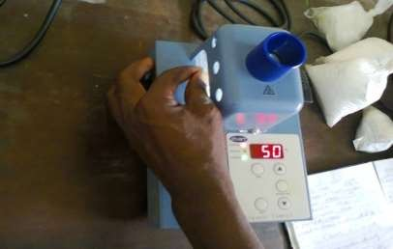

Plate I : Staurto machine (Model No: MP70) for determination melting point of wax.

# Procedure for the Determination of the Ash Content

The ash content is the percentage of non-combustible compounds remaining after burning a measured quantity of wax in air. It represents the bulk mineral matter after carbon, oxygen, sulphur and water (including from clays) has been driven off during combustion. The wax thoroughly burnt and the ash material expressed as a percentage of the original weight. The sample in the crucible was heated without lid in a muffle furnace at 450℃ for two hours according to ASTM Standard D1653 (2008). Plate II shows the crucibles in the furnace.

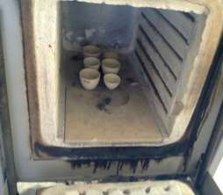 

Plate II: Muffle Furnace (Model No: HZ-1733A) used for ash content determination

The crucible was then taken out, cooled in air, then weighed. Heating, cooling and weighing was repeated, till a constant weight obtained. The residue was reported as ash on percentage basis.

Where, = weight of the empty crucible, (g)

= weight of empty crucible + sample, (g)

= weight of the crucible + ash, (g)

# Determination of Shrinkage/Contraction after Solidification

This was determined by using the volumetric shrinkage method and the process was carried out as follow according to ASTM Standard D33 (2003);

1. Applying a coating of grease on two halves of die to make it leak-proof from water and align the two halves of die together.
2. The die cavity was filled with water and its volume was measured with the help of a measuring flask. (Vd)
3. A measuring flask was filled with water and the initial reading was taken as Vi.
4. the wax sample was immersed inside the measuring flask, volume rises and the final reading was recorded as Vf.
5. the difference between the two readings (Vf - Vi) gives the volume of pattern. f). the percentage of volumetric shrinkage/contraction of the pattern is given by

Where = Percentage Volumetric Shrinkage,

= Volume of the die cavity,

 = volume of the sample and water volume in the flask, (final reading)

= volume of water in the measuring flask, (initial reading)

# Procedure for the Determination of the Density of the Wax

The density of the wax was measured using the Archimedean Principle with density bottle (ASTM Standard D1481, 2004).The principle state that, a solid body immersed in a liquid

loses as much of its own weight as the weight of the liquid it has displaced, (ASTM C20, 2000). The samples were first weighed dry in air and the weight were recorded as M(g). Distilled water was poured into a glass measuring tube and the initial volume (Vi) in cm3 was recorded. The measured sample was immersed in the measuring tube and the raising in the volume of water was recorded as final volume (Vf). Table was constructed for M(g), Vi(cm3), and Vf(cm3) of each wax.

Based on Archimedean Principle, Density is then calculated by using;



Where = Density (g/cm3)



# Determination of the Surface Hardness

Hardness is the property of a material that enables it to resist plastic deformation, usually by penetration. “The penetration of a wax compound is the distance in tenths of a millimetre that a standard needle penetrates vertically into a sample of the material under fixed condition of loading, time and temperature.”

The standard test for the hardness of waxes in industry is the penetration test (ASTM D1653, 2008). This test measures the depth in tenths of a millimetre that a needle of a certain configuration under a given weight penetrates the surface of a wax at a given

temperature, the higher the depth, the softer the wax and the shallower the depth the harder the wax.

The hardness of the wax is tested by using Penetrometer (hardness testing machine). There is pointer pin used for the depth penetration and a graduated scale which gives the values of the penetration. The sample of 20mm diameter and 20mm height was prepared for each of the blended wax. The surface was smoothly prepared and placed under the penetration pin of the machine. The initial reading of the scale is recorded and the final reading. The result is then tabulated.

# Determination of the Specific Gravity

Specific gravity” is the density of a material relative to water. The specific gravity of wax was measured by using the specific gravity bottle. In this process, the empty and clean specific gravity (S.G) bottle was weighed on the electronic weight balance shown in Plate III and recorded as Wi, the S.G bottle is filled with the sample then weighed and recorded as Wii. The SG bottle is filled with water, then weighed and recorded as Wiii. This process was conducted on each of the wax samples (ASTM D1481, 2004).

The specific gravity is then calculated using this relationship;



Where *Wi* = weight of a clean specific gravity bottle

*Wii* = weight of the clean SG bottle + sample

*Wiii* = weight of the clean SG bottle + distilled water.



Plate III: Electronic weight balance (Model No: XY-Q50B).

# Casting Processes.

A metallic gear for car’s oil pump system was selected for the investment casting. The production was done in accordance to ASTM Standard C33 (2008). The processes of production are as follow;

# Production of a Metallic Die.

A metallic die was produced using aluminium- silicon alloy. Aluminium-silicon alloy was selected as the material to be used in producing the die because; it is a low-melting-point metal which can easily be produced. The material was melted in the crucible furnace and poured into a prepared sand mould. The casted die was taken to the machine shop where it was machined to the desired shape and size possessed by the original pattern. Machine operation like, turning, milling, grinding and drilling was carried out on the die. Plate IV shows both the component parts and the assembling of the die.

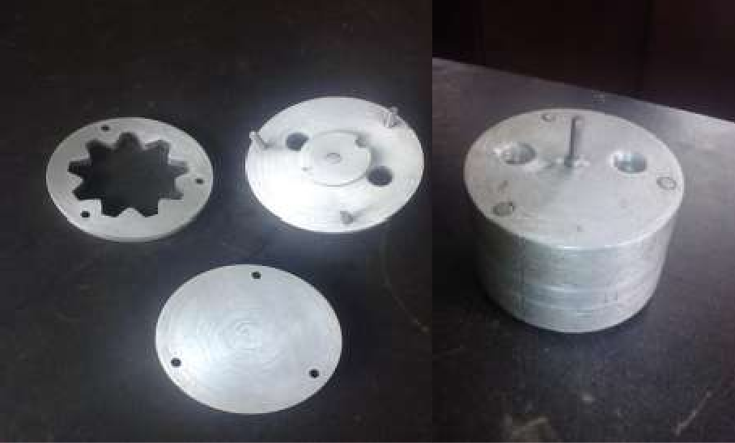

Plate IV: Components and assembling of wax pattern die

# Production of the Wax Patterns

The wax pattern can be produced from materials like, plastic (polystyrene), wax, and frozen mercury. For this work, selected blended wax (20% beeswax with 80% Paraffin wax) was used. The die was assembled by fastening its components together with bolt and nuts. The blended wax was melted, stirred properly to allow thorough mixing, and poured into the metallic die. After solidification, the die was disassembled in order to remove the wax pattern produced as seen in plate V.

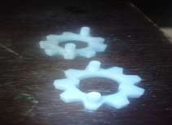

Plate V: Wax pattern produced from the blended wax.

# Investment

At this stage, ceramic mould was made. Slurry is used to produce the ceramic mould and the compositions of the slurry used are; Silica flour - 80% by weight, Sodium silica (as binder) - 8%, and liquid (water) – 12%. Slurries was prepared by adding silica flour to sodium silicate (binder liquid), and stirred using stirring stick. Stirring was continued until there was a uniform mixture before the slurry was put to use. Continued stirring is also required in production to keep the powder from settling out of suspension.

Investment shell mould was made by applying a series of ceramic coatings to the produced wax pattern. This was done by immersing the pattern in paste-like slurry. The pattern was first dipped into a ceramic slurry bath, then withdrawn from the slurry, and manipulated to drain off excess slurry, and to produce a uniform layer. The wet layer was immediately stuccoed with coarser ceramic particles, by immersing it into a fluidized bed of the particles. The fine ceramic layer forms the inner face of the mould, and reproduces every detail, including the smooth surface of the pattern.

Each coating was allowed to set by drying, before the next one was applied. The operations of coating, stuccoing, and hardening are repeated a number of times, until the required shell thickness was achieved. The final coat, often called a seal coat, was left unstuccoed, in order to avoid the occurrence of loose particles on the shell mould surface.

# Dewax

The investment was then allowed to completely dry, which took up to 30 hours. The investment pattern mould was then turned upside-down on a Lift-Up furnace (Model No:BLMT1700) to melt out the wax. The mould was then subjected to a burnout, which heats the mould between 8700C and 9500C to remove any moisture and wax residual, and to sinter the mould. This was done to preheat the mould which allows the liquid metal to fill any detail and to increase dimensional accuracy because the mould and casting cool together.

# Pouring and Removal

The investment mould was then placed upward into box filled with sand. The metal was poured by gravity. The shell was knocked out to release the casting. Then it was cleaned and fettled.

# CHAPTER FOUR

# 4.0 RESULTS AND DISCUSSION

In this chapter, the results of the wax properties tested were presented in the form of bar charts. The detailed results are given in the Appendices.

# 4.1. Results

**4.6.1 The Result of all the Properties Tested on Natural Waxes.**

The table in appendix A gives the result of all the properties of waxes tested and that results were used to draw the following bar charts for the natural waxes.

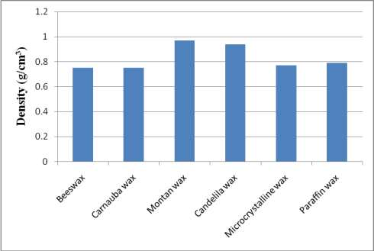

Figure 4.1: Bar Chart for Density of different natural waxes.

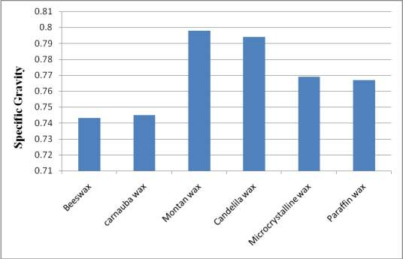

Figure 4.2: Bar Chart for Specific gravity of different natural waxes

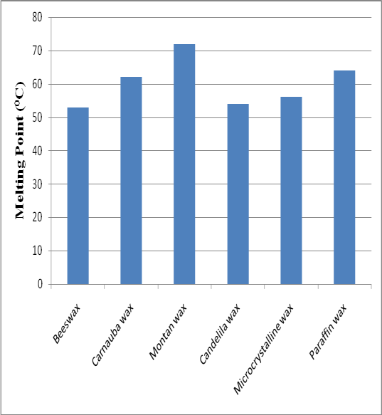

Figure 4.3: Melting Point of different natural waxes

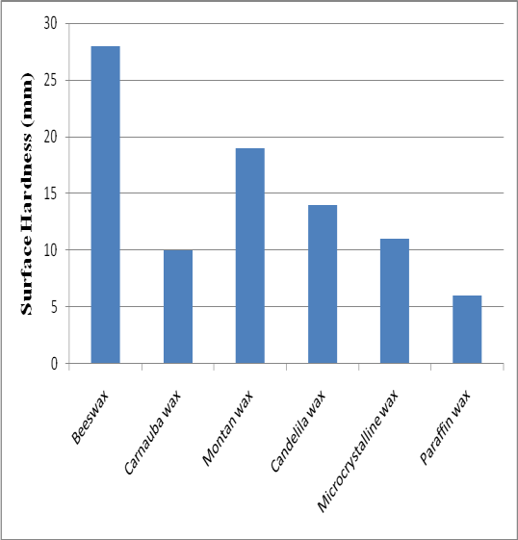

Figure 4.4: Surface Hardness of different natural waxes

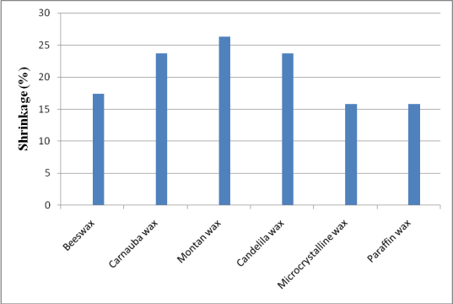

Figure 4.5: Percentage Shrinkage of different natural waxes

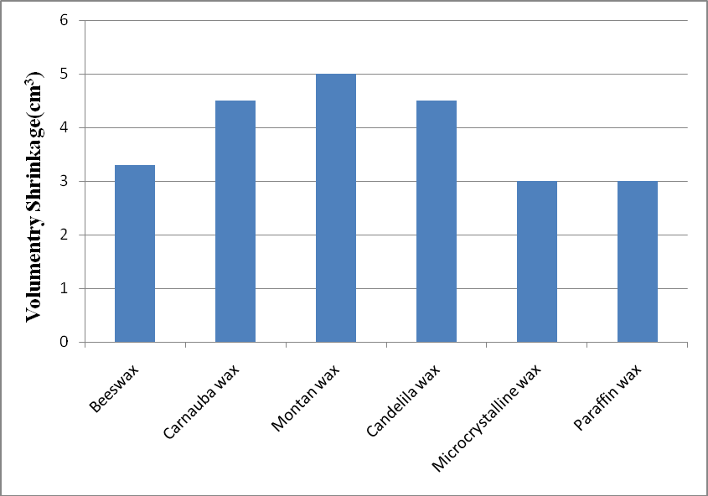

Figure 4.6: Volumetric Shrinkage of different natural waxes

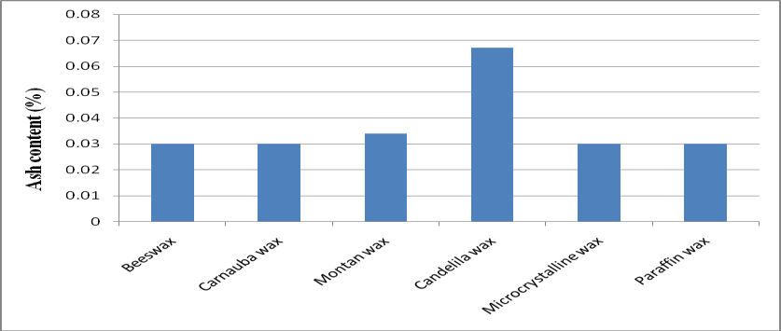

Figure 4.7: % ash content of different waxes.

Figure 4.1 shows the result of density of some waxes. Carnauba wax has the least density (0.74g/cm3) which means that it can flow easier than the others. Beeswax also has low density of 0.775g/cm3 but Montana wax has the highest density and this will take both more time and temperature before it will flow easily. Figure 4.2 indicates the specific gravity of the waxes. This means the density of waxes in relation to water. Beeswax possesses the lowest while Montana wax possesses the highest.

In figure 4.3, chart of melting point of wax were shown. Montana wax gives the lowest melting point, and beeswax has the highest. From this figure, there is clear indication that paraffin wax can melt faster than beeswax, and candelila wax can melt faster than carnauba wax. In figure 4.4, paraffin wax is hard and beeswax is soft. The surface hardness gives how easy to handle wax without any surface deformation, and it is obvious that paraffin wax has better hardness than others. The shrinkage effect is much in carnauba wax and candelila wax as shown in figure 4.5 and 4.6. Paraffin wax has low shrinkage effect.

# 4.1.2 Selected Wax for Blending

From figure 4.1, it shows that, beeswax, carnauba wax, microcrystalline wax, and paraffin wax have the lowest density; and the lower the density the better the wax flow rate (Bemblage and Karunakar, 2011). Also the test results shown in figure 4.2 give the waxes that have low specific gravity as beeswax, carnauba wax, microcrystalline wax, and paraffin wax. In figure 4.3, beeswax, candelila wax, microcrystalline wax, carnauba wax

and paraffin wax gave the low melting point which can help dewaxing process to be easy and faster.

Figure 4.4 shows that, paraffin wax, carnauba wax, microcrystalline wax, and candelila wax were the first four waxes that have high resistant to penetration. In figure 4.5, waxes with low shrinkage effect are paraffin wax, microcrystalline wax, beeswax, and carnauba wax. And the waxes with low ash content are beeswax, carnauba wax, microcrystalline wax, and paraffin wax.

Therefore, from all indications, beeswax, carnauba wax, microcrystalline wax, and paraffin wax posses’ good properties that can be further improved. In this sense, they were selected for the blending process.

# Results of the Blended Waxes.

The waxes selected for blending were those waxes that possess minimum shrinkage and ash content from figures 4.1 to 4.7. These waxes also have better strength compare to other waxes tested. These waxes are beeswax, carnauba wax, microcrystalline wax, and paraffin wax at proportion shown in table 3.1

# Results of the Percentage Ash Content of the Blended Wax.

The results of the three blended waxes on the percentage ash content were presented in figures 4.8, 4.9, and figure 4.10. These bar charts were drawn from the table results in Appendices B, C, and D

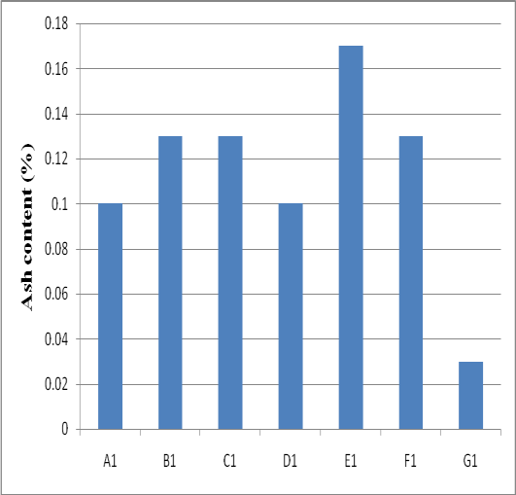

Figure 4.8: % ash content of blended wax of microcrystalline wax and paraffin wax at different proportions as shown in Table 3.1

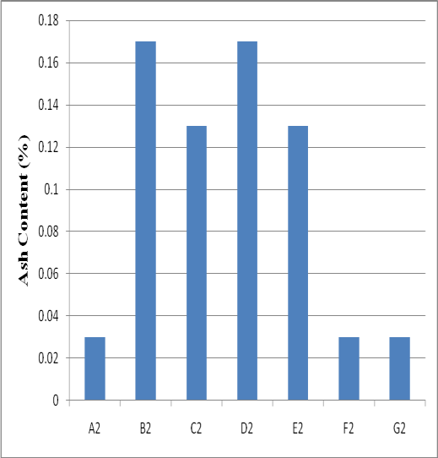

Figure 4.9: % ash content of blended wax of Beeswax and paraffin wax at different proportions as shown in Table 3.1

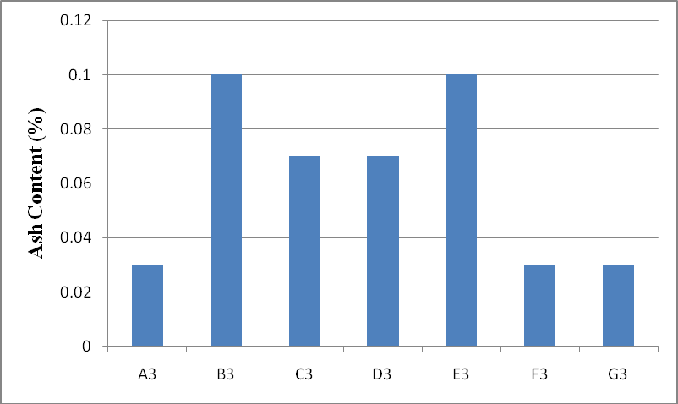

Figure 4.10: % ash content of blended wax of Carnauba wax and paraffin wax at different proportions as shown in Table 3.1

The percentages of the non-combustible residue left after wax is burnt were shown in Figure 4.7; 4.8; 4.9; and 4.10. In Figure 4.7, Beeswax, Candelila wax, Carnauba wax, and Paraffin wax have the lowest ash content percentage of 0.03% (Bemblage and Karunakar, 2011). Microcrystalline wax has highest percentage of ash content, because it is synthetic wax. Figure 4.8 shows the blending of microcrystalline wax and paraffin wax. 100% paraffin wax shows the least ash content but when blended with microcrystalline wax, it increases the ash content and the proportion of 50% to 50% gives the least ash content. Therefore, blending of microcrystalline wax and paraffin wax at a proportion of 50% to 50% gives the lowest blend percentage ash content for wax pattern according to Lorenzo (2012).

Figure 4.9 shows result of blending beeswax and paraffin wax together. In case of beeswax blended with paraffin wax, 60% to 40% and 40% to 60% of beeswax and paraffin wax

give the least ash content. It is clear from this figure that the blend increases the percentage ash content.

Figure 4.10 is the result of the blending of carnauba wax and paraffin wax. The blend at proportion 40%Carnauba wax and 60% Paraffin wax gives better effect (0.03%) and gives drastically decrease in percentage of ash content compare to the blend of investment casting wax (0.10%) and the blend of beeswax (0.13%).

# Result of Density of the Blended Wax.

The results of the three blended waxes on density were presented in figures 4.11, 4.12, and

4.13 below. These bar charts were drawn from the table results in Appendices B, C, and D

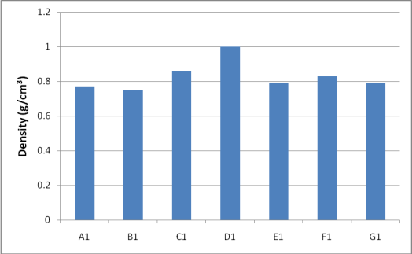

Figure 4.11: Density of Blended wax of microcrystalline wax and paraffin wax at different proportions as shown in Table 3.1

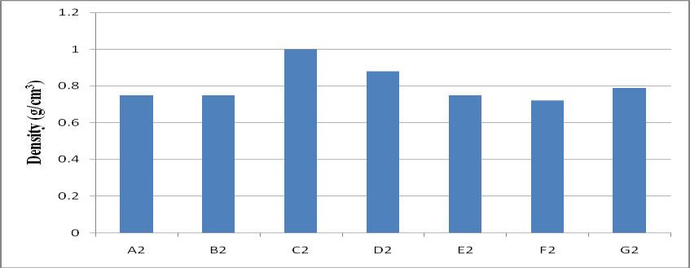

Figure 4.12: Density of blended wax of Beeswax and paraffin wax at different proportions as shown in Table 3.1

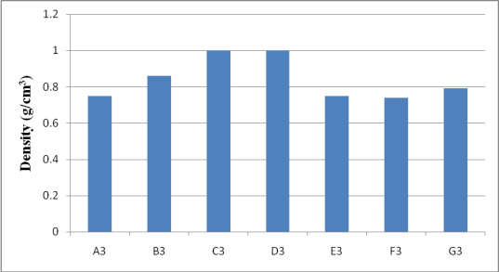

Figure 4.13: Density of blended wax of Carnauba wax and paraffin wax at different proportions as shown in Table 3.1

Figure 4.1 shows the density result of six different waxes both natural waxes and synthetic waxes. From the chart, the lowest in density are beeswax and carnauba wax with 0.75 g/cm3 and the highest in density is Montana wax with 0.97g/cm3. The lower the density, the better for a microcrystalline wax pattern (Gebelin and Jolly, 2011). The best three waxes that possesses low density was picked for blending, they are, beeswax, microcrystalline wax and carnauba wax. The waxes were blended with paraffin wax at different proportion as shown in Table 3.1.

Figure 4.11 clearly shows that, the blend 80% of the microcrystalline wax and 20% paraffin wax has the lowest density and the 50% microcrystalline wax + 50% paraffin wax has the highest density. Form this blend; the lowest is suitable for microcrystalline wax pattern.

In Figure 4.12, beeswax was blended with paraffin wax at different proportions. From the chart, the following blends gave the same density, beeswax 80% + paraffin wax 20%, and beeswax 40% + paraffin wax 60% have the same 0.75g/cm3 density. Blended wax of 20% beeswax + 80% paraffin wax gives the lowest density of 0.72g/cm3.

It is clearly shown from Figure 4.13 that the blends of carnauba wax of 40% + paraffin wax of 60% (E3) and carnauba wax of 20% + paraffin wax of 80% (F3) have almost the same density while the blends of carnauba wax 60% + paraffin wax 40% and carnauba wax 50% + paraffin wax 50% gave the highest density.

# Result of Specific Gravity of the Blended Wax.

The results of the three blended waxes on specific gravity were presented in figure 4.14 to

4.16 below. These bar charts were drawn from the table in Appendices B, C, and D.

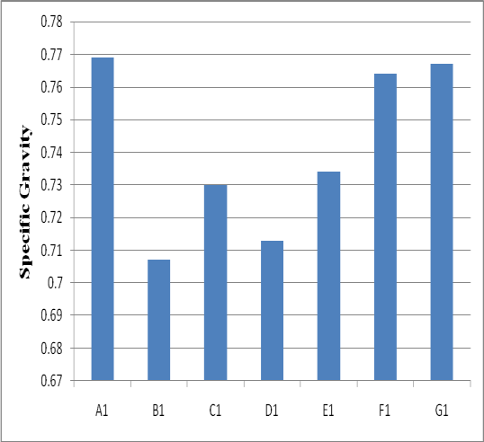

Figure 4.14: Specific Gravity of Blended wax of microcrystalline wax and paraffin wax at different proportions as shown in Table 3.1

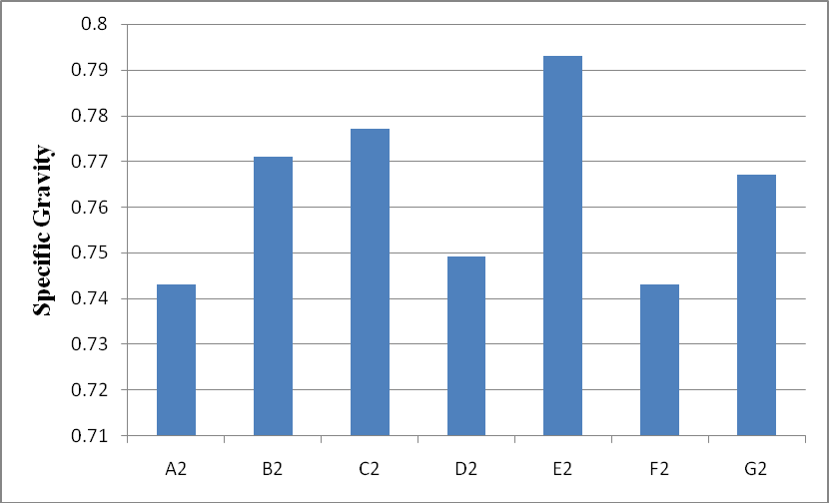

Figure 4.15: Specific Gravity of blended wax of Beeswax and paraffin wax at different proportions as shown in Table 3.1

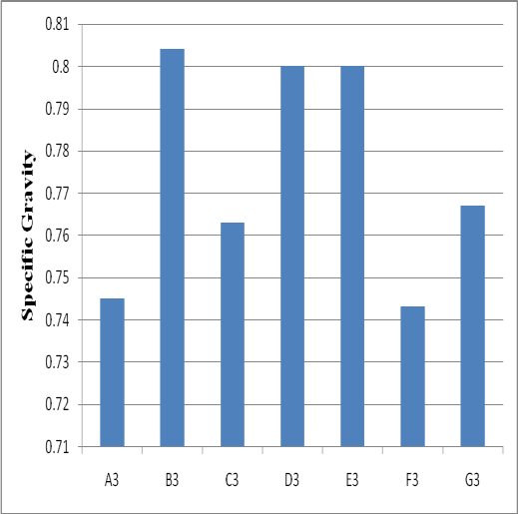

Figure 4.16: Specific Gravity of blended wax of Carnauba wax and paraffin wax at different proportions as shown in Table 3.1

It can be clearly seen in Figure 4.2 that beeswax possesses the least specific gravity of 0.743 followed by carnauba wax with 0.745. The wax that gives the highest specific gravity is Montana with 0.7998. The blend with low specific gravity is suitable for the production of the wax pattern according to Lorenzo (2012).

Figure 4.14 shows the specific gravity of blended wax of microcrystalline wax and paraffin wax at different proportion as shown in Table 3.1. The blend of microcrystalline wax 80%

+ paraffin wax 20% gives the lowest specific gravity and microcrystalline wax 20% + paraffin wax 80% gives the highest specific gravity. This Figure elucidates the effect of blending microcrystalline wax together with paraffin wax, in the sense that, the specific gravity of the blends was lower compare to that of microcrystalline wax alone and paraffin

wax alone. The result of specific gravity of the blends of beeswax and paraffin wax at different proportions was shown in Figure 4.15. Here the blend of 20% beeswax + 80% paraffin wax gives the lowest specific gravity, while 40% beeswax + 60% paraffin wax gives the highest result of specific gravity.

Figure 4.16 shows the result of blending carnauba wax with paraffin wax. The lowest specific gravity of the blended wax is 20% carnauba wax + 80% paraffin wax, and the highest is 80% carnauba wax + 20% paraffin wax. So form this blend, it can be seen that wax proportion of 20% carnauba wax + 80% paraffin wax possesses the better result of wax composition for wax pattern.

# Result of Melting Point of the Blended Wax.

The results of the three blended waxes on the melting point were presented in figures 4.17

– 4.19 below. These bar charts were drawn from the table in Appendices B, C, and D

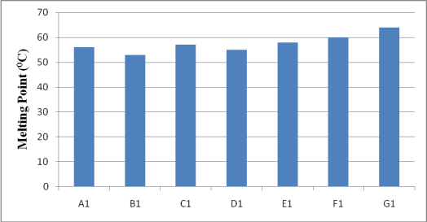

Figure 4.17: Melting point of Blended wax of microcrystalline wax and paraffin wax at different proportions as shown in Table 3.1

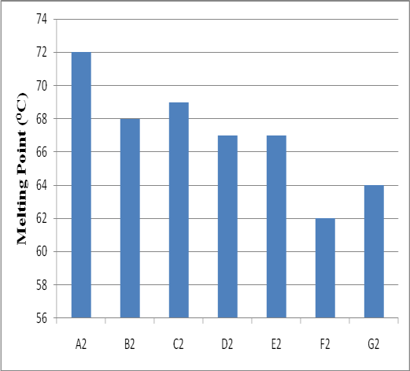

Figure 4.18: Melting Point of blended wax of Beeswax and paraffin wax at different proportions as shown in Table 3.1

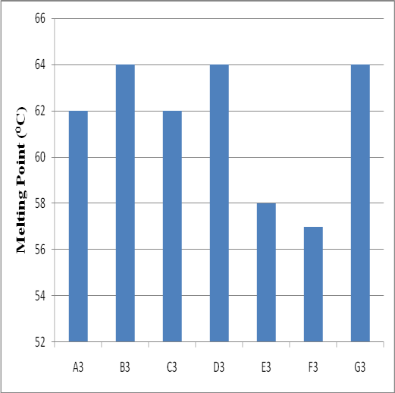

Figure 4.19: Melting Point of blended wax of Carnauba wax and paraffin wax at different proportions as shown in Table 3.1

Figure 4.3 reveals that the melting point of different waxes vary, the melting point of six different waxes range within 530C to 720C. The wax with the lowest melting point is Montana wax (530C) and the highest melting point is beeswax (720C). Figure 4.17 shows the result of melting point when microcrystalline wax is blend with paraffin wax at different ratio. It is clear from this figure that as the proportion of paraffin wax increases, the melting point also increases except in the condition of 60% microcrystalline wax + 40% paraffin wax. Here there is a drop in melting point from 570C to 550C and then increases. Blend of microcrystalline wax 80% + paraffin wax 20% gives the least melting point. According to Bemblage and Karunakar (2011), lower melting point is preferable in wax pattern so that the wax could melt out from the mould easily within a low temperature.

In Figure 4.18, beeswax was blended with paraffin wax at different proportion. The chart reveals the variation in melting point from one blend to another. It is evident evidence from this figure that, the melting point of the blends decrease with increase in the percentage of beeswax added to the blend, with the exception of 60% beeswax. In this case, the lowest in melting point of the blends is the 20% beeswax plus 80% paraffin wax at 620C.

Figure 4.19 shows another relationship between the melting temperature and the proportions of blending of carnauba wax plus paraffin wax. The relationship did not correspond to either increase of decrease in the percentage of the carnauba wax in the blend. 20% carnauba wax plus 80% paraffin wax shows the lowest melting point and the highest are 80% carnauba wax plus 20% paraffin wax and 50% carnauba was and 50% paraffin wax.

# Result of Surface Hardness of the Blended Wax.

The result of the three blended waxes and that of the natural waxes on the surface hardness were presented below.

Hardness is the property of a material that enables it to resist plastic deformation, usually by penetration. From Figure 4.4, 4.20, 4.21, and 4.22, the result shows that in all the blends, there are decreases in millimetre of penetration as the percentage of paraffin wax increases. Figure 4.4 elucidates the result of surface hardness of some waxes. From the chart, paraffin wax shows the lowest penetration into the wax surface which means that, it is the hardest most harden wax and beeswax is the softest wax among the six waxes. In figure 4.20, there is a clear variation in the surface hardness of the blended waxes from the blend of 60% microcrystalline wax + 40% paraffin wax ( C1 ) to 0% microcrystalline wax

+ 100% paraffin wax (G1). This shows that the more the percentage of paraffin wax in the blend the harder it becomes.

Figure 4.21 shows the effect of blending beeswax and paraffin wax at different proportions. This chart is very clear that, increase in the percentage of paraffin wax in the blend gives increase in the hardness of the wax. The variation is from 28mm to 8mm. Therefore, F2 (20% beeswax + 80% paraffin wax) is the most hardened blend in the chart. Figure 4.22 shows the surface hardness of blended waxes at different proportions of carnauba wax and paraffin wax. It is clearly seen from this chart that F3 (carnauba wax 20% + paraffin wax 80%) possesses the most hardened surface compare to the rest of the blended wax. And the bars reduced gradually from C3 to G3, which means addition of paraffin wax is very effective.

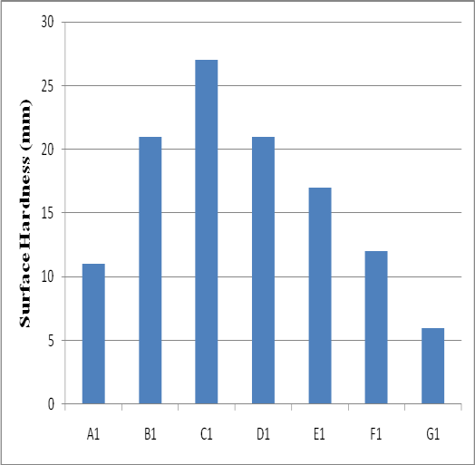

Figure 4.20: Surface Hardness of Blended wax of microcrystalline wax and paraffin wax at different proportions as shown in Table 3.1

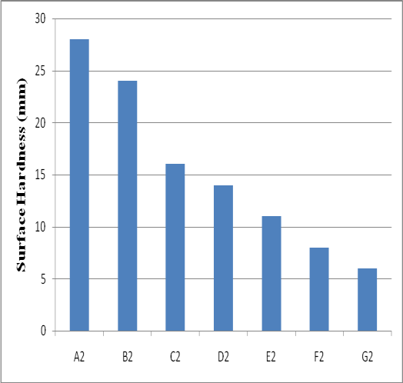

Figure 4.21: Surface Hardness of blended wax of Beeswax and paraffin wax at different proportions as shown in Table 3.1

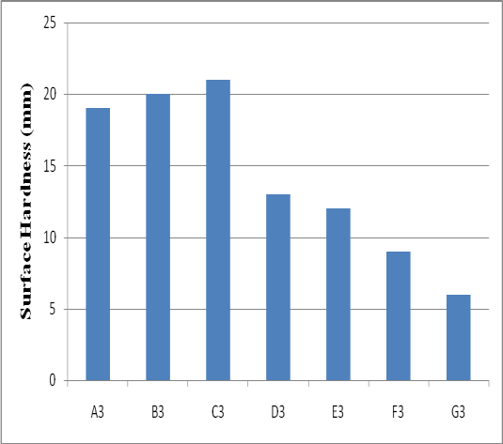

Figure 4.22: Surface Hardness of blended wax of Carnauba wax and paraffin wax at different proportions as shown in Table 3.1

# Result of Percentage Shrinkage of the Blended Wax.

The results of the three blended waxes on the percentage shrinkage were presented in the figure 4.23 to figure 4.25 below. These bar charts were drawn from the table in Appendices B, C, and D

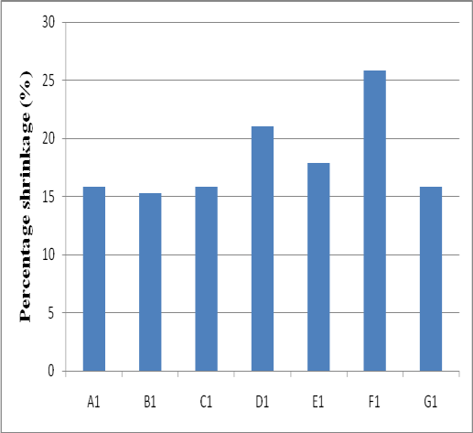

Figure 4.23: Percentage Shrinkage of Blended wax of microcrystalline wax and paraffin wax at different proportions as shown in Table 3.1

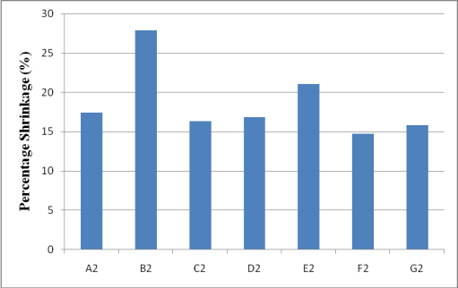

Figure 4.24: Percentage Shrinkage of blended wax of Beeswax and paraffin wax at different proportions as shown in Table 3.1

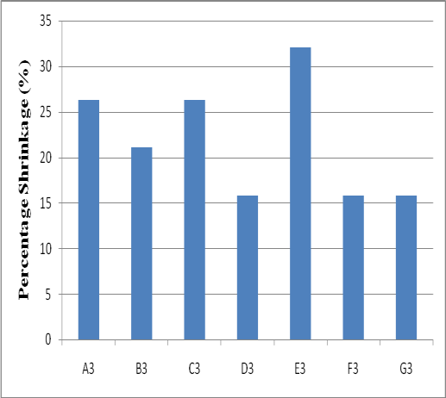

Figure 4.25: Percentage Shrinkage of blended wax of Carnauba wax and paraffin wax at different proportions as shown in Table 3.1

From figure 4.5, it is evident that carnauba wax string in the die more than other wax from the chart. Also, paraffin wax and microcrystalline was string less compared to others. Beeswax also possesses better shrinkage ability in the die. Moreover the range of their difference is within 26.32% to 15.79%.

In figure 4.23, the chart shows the percentage shrinkage result of the blends of microcrystalline wax and paraffin wax. Blend B1 (80% microcrystalline wax plus 20% paraffin wax) gives less shrinkage compared to others. Figure 4.24 shows the relationship of the blended waxes of beeswax and paraffin wax at different proportions and percentage shrinkage of the wax. The blend of 20% beeswax plus 80% paraffin wax gives the lowest percentage compared to others in the chart. This means that at the blending proportion of 20% beeswax with 80% paraffin wax, the wax is good for the production of wax pattern.

The blend of carnauba wax and paraffin wax was shown in figure 4.25. D3 and F3 have the same value in percentage shrinkage of 15.79% each. The highest value of percentage shrinkage is E3 of 32.11%. This value is too high and wax may not be suitable for wax patter.

# 4.2.7 Result of Volumetric Shrinkage of the Blended Wax.

The results of the three blended waxes on the volumetric shrinkage were presented in the figures below. These bar charts were drawn from the table in Appendices B, C, and D

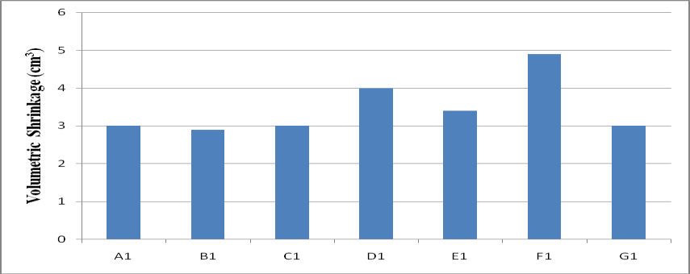

Figure 4.26: Volumetric Shrinkage of Blended wax of microcrystalline wax and paraffin wax at different proportions as shown in Table 3.1

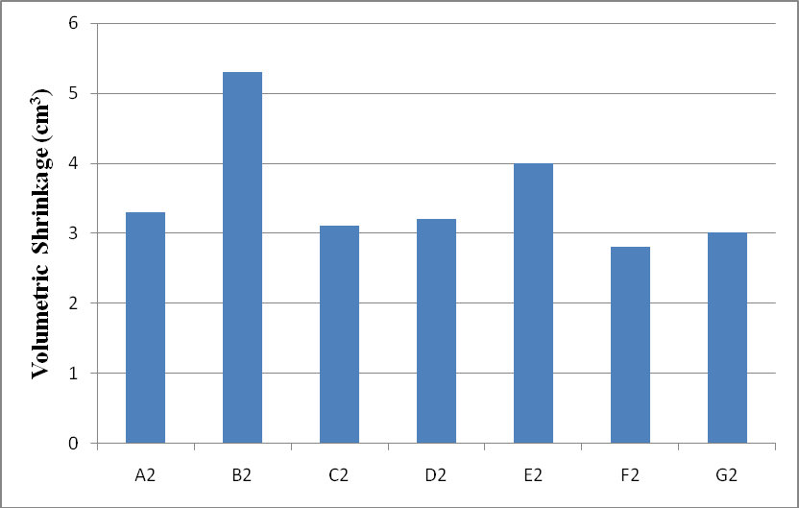

Figure 4.27: Volumetric Shrinkage of blended wax of Beeswax and paraffin wax at different proportions as shown in Table 3.1

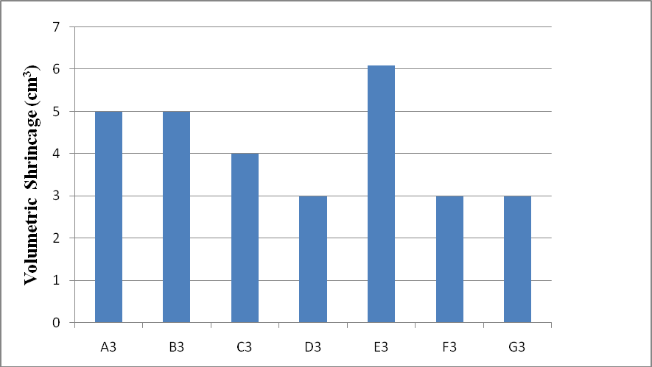

Figure 4.28: Volumetric Shrinkage of blended wax of Carnauba wax and paraffin wax at different proportions as shown in Table 3.1

In figure 4.6, microcrystalline wax shows the least volumetric shrinkage wax of 3.00(cm3). The highest is carnauba wax with 5.00(cm3) which means the rate at which carnauba wax string is high when solidified and it may not be a good material for wax pattern in investment casting. In figure 4.26, microcrystalline wax was blended with paraffin wax at desired proportion. The chart clearly shows that variation in the volumetric shrinkage of the wax. Blended wax B1 gives the lowest shrinkage of 2.90(cm3) followed by A1, C1, and G1 of 3.00(cm3) each. Blended wax F1 be the highest from this chart and the blend may not be recommended for microcrystalline wax pattern.

Figure 4.27 elucidate the blending relationship between beeswax and paraffin wax at different proportion. The chart shows the variations in the values of the blend. F1 gives 2.80(cm3), C2 gives 3.10(cm3), D2 gives 3.20(cm3) and B2 which is the highest gives 5.30(cm3). Therefore, the least which is F2 is preferable for wax pattern.

In the figure 4.28, carnauba wax and paraffin wax were blended together in order to observe the effect of volumetric shrinkage on the blend. From the range of blends produced, D3 and F3 give the least value which indicates that they are preferable blend for the casting of wax patter.

# 4.3 Discussion

Figure 4.7 shows the chart of percentage ash content of some listed waxes for both natural and synthetic waxes. There was slight change in percentage ash content of beeswax, Montana wax, candelila wax carnauba wax and the paraffin wax at about 0.03%. The highest percentage of ash content is in microcrystalline wax which is 0.067%.

Figure 4.8 shows the chart of percentage ash content of blended waxes at different proportion as shown in table 3.1 of microcrystalline wax and paraffin wax. The chart reveals that blended waxes B, C, and F have the same value of percentage ash content of 0.13%. Blend E1 gives the value of 0.17%. The variation in the percentage ash content affected by different proportions of both microcrystalline wax and paraffin wax. Figure 4.9 shows the chart result of percentage ash content of blended wax of beeswax and paraffin wax at proportions A2, B2, C2, D2, E2, F2, and G2 as indicated on table 3.1. It could be seen that the percentage ash content of A2 and G2 are lower than the blended waxes B2 and F2 this is as a result of blending two or more virgin composition of waxes together, and it is obvious from the chart that the blend F2 gives the least value of the percentage ash content. Figure 4.10 shows the chart of percentage ash content for the blend of carnauba wax and paraffin wax. Blend F3 gives the same result with the carnauba wax and the paraffin was respectively. The blending has raised the values of B3, C3, D3, and E3.

Observation: it could be noticed from figure 4.7 to 4.10 that, beeswax, candelila wax, carnauba wax, paraffin wax, F2, and F3 gave the lowest percentage of ash content of 0.03%. From the blending result, 20% beeswax plus 80% paraffin wax and 20% carnauba wax plus 80% paraffin wax yielded better result for the use as wax pattern material.

Figure 4.1 shows the chart of the density result of the selected natural waxes and synthetic waxes. The variation in the result is due to the properties of each wax that was used. Beeswax and carnauba wax have the same density of 0.75g/cm3 as the lowest in the chart and the highest is 0.97g/cm3 which is Montana wax.

Figure 4.11 indicates the density result of blended wax of microcrystalline wax and paraffin wax at different proportions. The blend of microcrystalline wax of 80% +paraffin wax of 20% gives the lowest density of 0.75 g/cm3. This blend is better for wax pattern material.

Figure 4.12 reveals the density result of blended wax of beeswax and paraffin wax at different proportions. It is obvious from the chart that F2 is the blend that has the lowest value. There is irregular variation in the chart and the flow from A2 to G2 did not show any proportionality of the blending. Figure 4.13 shows the chart of density of the blended wax of carnauba wax and paraffin wax at different proportions. It was observed from the chart that, as the percentage of paraffin wax increases so also the chart increase until D3 where the next bar dropped and rises again. F3 gives the density of 0.743 which is the lowest value from this chart. Observation: Figure 4.1, 4.11, 4.12 and Figure 4.13 show the density of waxes at different composition. It is clearly seen from here that beeswax, carnauba wax, B1, A2, B2, E2, A3, E3, gave the same value of 0.75 g/cm3 while F2 gives

0.72 g/cm3 and F3 gives 0.74 g/cm3. This indicates that beeswax of 20% + paraffin wax of 80% gives the lowest density.

Figure 4.2 shows the result of the specific gravity of some natural waxes and synthetic waxes. It can clearly be seen that beeswax and carnauba wax gave the lowest value of specific gravity as 0.743 and 0.745 respectively. These values are good for the production of wax pattern. Figure 4.14 shows the result of the specific gravity of blended waxes at different proportions. The bars in the chart show that the proportionality of the variation from D1 to G1 flow and B1 which is 80% microcrystalline wax + 20% paraffin wax gives the lowest value of 0.707 which indicates its usefulness in wax pattern production.

Figure 4.15 shows the chart result of specific gravity of beeswax and paraffin wax blended together at proportion A2 to G2 as shown in Table 3.1. It was observed that the blend of 20% beeswax + 80% paraffin wax gives better property for wax pattern. The relationship between the blend proportion and specific gravity is clearly seen. The specific gravity increases from A2 as the percentage of paraffin wax increases but at D2, specific gravity dropped and rise again. This means that the proportions of the two waxes differ in composition, therefore, change the specific gravity at different proportion.

Figure 4.16 shows the chart result of specific gravity of blended wax (carnauba wax and paraffin wax) in this case, the blend of 20% carnauba wax + 80% paraffin wax gives the lowest specific gravity and the highest is 80% carnauba wax + 20% paraffin wax. Figure

* 1. shows the chart result of the melting point of both natural waxes and synthetic waxes.

From this chart, Montana wax possesses the lowest melting point while beeswax gives almost constant variation in their melting point from investment casting wax to paraffin wax.

Figure 4.17 reveals the chart of melting point of blended wax of microcrystalline wax and paraffin wax at different percentage. The chart flows in such a way that the melting point dropped from blend A1 to blend B1 and rise to blend C1 but latter dropped again to blend D1 before finally increased gradually to blend G1. This shows that composition of both microcrystalline wax and paraffin wax has effect on the melting point of the blended wax.

Figure 4.18 shows the chart of melting point of blended wax of beeswax and paraffin wax at different proportions. It can be seen that blend A2 has the highest degree and there is decrease in degree from A2 to F2. Blend F2 gives the least melting point of 620C.

Figure 4.19 shows the chart of melting point result of blended wax of carnauba wax and paraffin wax. The bars A3 to bar G3 reveal the proportion at which the waxes were blended. Bar F3 gives the lowest melting point of 570C and the highest melting point were given by B3, D3 and G3. Therefore, in blending carnauba wax and paraffin wax together, there is decrease in melting point at F3

In Figure 4.4, surface hardness of both natural wax and synthetic waxes were shown. It is obvious from this chart that paraffin wax is harder than the remaining waxes, follow by Montana wax, microcrystalline wax, candelila wax, carnauba wax and the softening out of all is beeswax.

Figure 4.20 shows the effect of blending microcrystalline wax together with paraffin wax at different percentage on their surface hardness. The chart shows that as the percentage of paraffin wax increases in the blend, the surface hardness decreases. (Increase in bar height means decrease in surface hardness as shown in the bar A1 to bar C1. At C1 the bars started decreasing which indicate increase in surface hardness. Therefore, the blend F1 is harder than the rest.

Figure 4.21 shows the relationship of surface hardness and blend proportions of beeswax and paraffin wax. It is clearly show that as the percentage of paraffin wax increases in the blend, the surface hardness also increases. This shown that as the percentage of paraffin wax increases in the blend also increases the surface hardness.

Figure 4.22 shows the chart of surface hardness with blended wax of carnauba wax and paraffin wax. In this figure, the effect of paraffin wax is obvious on carnauba wax, in the sense that as the percentage of paraffin wax increases, the surface hardness also increases.

Therefore for the blend of carnauba wax and paraffin wax, F3 with 20% carnauba wax + 80% paraffin wax will be a preferred blend of wax pattern material.

Figure 4.5 shows the effect of percentage shrinkage on some natural waxes and synthetic waxes. From the chart, it was observed that microcrystalline wax and paraffin wax show less shrinkage compare to others. Shrinkage has more effect on carnauba wax, montan wax, and candelila wax when compare to others on the chart. This means that paraffin wax and microcrystalline wax have better resistance to shrinkage than others.

Figure 4.23 shows the relationship between percentage shrinkage and blend of microcrystalline wax with paraffin wax at different proportions. In this case, blending of paraffin wax and microcrystalline wax help in reducing the shrinkage as it can be seen in blend B1 (80% microcrystalline wax +20% paraffin wax).

In Figure 4.24, the blend of beeswax and paraffin wax also shows a decrease in shrinkage. The percentage shrinkage of F2 (20% beeswax + 80% paraffin wax) was reduced compare to A2 and G2. Therefore, blend F2 gives better reduction in shrinkage of the wax pattern.

Figure 4.25 shows the effect of percentage shrinkage on the blended wax of carnauba wax and paraffin wax at different proportion. In this case, the shrinkage of carnauba wax is high and when blend with paraffin wax, the chart shows decrease in shrinkage except in C3 and E3. Therefore, percentage shrinkage of carnauba wax was reduced from 26.32% to 15.79% in D3 and F3.

Note; percentage shrinkage in Figure 4.5, 4.23 to 4,25 show the same effects with volumetric shrinkage in figure 4.6, 26 to figure 4,25.

# Cast Part

In Figure 4.9, 4.21, 4.24, and figure 4.27 show that the blend F2 (20% beeswax + 80% paraffin wax) has low ash content, good surface hardness, and lowest shrinkage when compare to others. This was supported by Bemblage and Karunakar (2011); Sabau and Viswanathan (2003); and Rezavand and Behravesh (2007), that paraffin wax and beeswax have better surface finishing and accuracy of dimension. Base on this, the blend formulation of 20%beeswax and 80% paraffin wax was selected for casting in this research.

An oil pump gear was cast using the formulated wax pattern (F2) as shown in Plate V and the surface finish was examined physically which shows about 75% surface finish. Also, the dimensions of the cast product were taking and the percentage error of the dimensions was found to be about 20%. These errors are as result of using gravity casting method instead of using pressurized casting method.

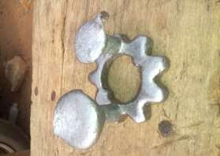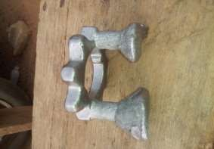

Plate VI: The casted product

# CHAPTER FIVE

# CONCLUSION AND RECOMMENDATIONS

# Conclusion

From the results of the study on the characterization and formulation of wax composition for investment casting pattern, it was concluded that all The characteristics (properties) measured – ash content, density, shrinkages, specific gravity, surface hardness, melting point, and volumetric shrinkage show improved quality on the blended waxes. After the determination of the natural waxes, carnauba wax, beeswax, microcrystalline wax, and paraffin wax were selected for the blending.

The blending was successfully carried out and beeswax at blend F2 (20% beeswax with 80% paraffin wax gave better improvement of 2.80cm3 shrinkage and 0.03% ash content over the natural waxes and the blended waxes. It is therefore suggest that, blended wax F2 could be substituted for natural wax in producing wax pattern for investment casting. Oil pump gear was cast by using this blend (F2) for the pattern in investment casting process; good and smooth surface finishing with precision dimensional accuracy were achieved.

# 5.2.1 Recommendations

In carrying out of this research, much has been achieved and the blended waxes formulated were good and recommended for any suitable shapes and most intricate casting, but at the same time, some challenges that require more investigation on this topic are as follows;

1. More waxes can be studied and blended.
2. Parameters like injection temperature and wax setting time can be determined.
3. Carry out investment casting by using pressurized method.

# REFERENCES

ASTM C20, (2000). Standard Test Methods for Apparent Porosity, Water Absorption, Apparent Specific Gravity, and Bulk Density of Burned Refractory Brickand Shapes by Boiling Water, *ASTM International*, [www.astm.org,](http://www.astm.org/) retrieved on 22nd July, 2012.

ASTM Standard D1653, (2008). Standard Test Methods for Wax for pattern in investment casting, *ASTM International, West Conshohocken*, PA.2006, DOI: 10.1520/C0033- 03R06, [www.astm.org,](http://www.astm.org/) retrieved on 12th October, 2012.

ASTM Standard C33, (2003). Specification for Casting Process; Investment Castings, *ASTM International*, *West Conshohocken*, PA, 2003, DOI: 10.1520/C0033-03E01, [www.astm.org,](http://www.astm.org/) retrieved on 12th October, 2012.

ASTM Standard D1481 (2004). Density and Relative Density (Specific Gravity) of viscous materials *Lipkin Bicapillary Pycnometer*, ww.astm.org, retrieved on 28th August, 2012.

Beeley, P. R., & Smart, R. F. (1995). *Investment Casting,* (1st ed), Cambridge, UK, Institute of Materials, The University Press, pp. 56-71.

Bemblage, O., & Karunakar, D. B. (2011). A study on the blended wax patterns in investment casting process. *The proceedings of the World Congress on Engineering, 1, London, U.K*. pp. 47 – 55.

Bonilla, W., Masood, S. H., & Iovenitti, P. (2001). An investigation of wax patterns for accuracy improvement in investment casting parts, *Bulletin of Industrial Research Institute of Swineburne,* Melbourne, Australia, 18, pp. 348 – 356.

Chakravorty, S. (1999). Assessment of Properties of Investment Casting Waxes,

*Proceedings of 24th BICTA Conference on Investment Casting*, pp. 24 – 29.

Craig, R.G., Eick, J.D., & Peyton, F.A. (2005). Strength Properties of Waxes at Various Temperatures and Their Practical Application, *Journal of Dental Research*, 46, pp. 300 – 301.

Ference, J., Michalski, J., Kurzydlowski, K. J. (2009). The influence of alumina powder on the rheological properties of zircon/silica slurries for investment casting of moulds. *In: Proceedings of the Institution of Mechanical Engineers Part B- Journal of Engineering Manufacture*, 223(11): 1417-1421.

Ford, D. A. (2009). Future Trends in Investment Casting – Drivers for Development, *presented at the World Technical Forum, Brno* [http://www.google.co.uk/search?q=ford+future+trends+in+investment+casting&ie](http://www.google.co.uk/search?q=ford%2Bfuture%2Btrends%2Bin%2Binvestment%2Bcasting&ie)

=utf- [accessed 26 September 2010].

Gebelin, J. C., & Jolly, M. R. (2011). Modeling of the investment casting process,

*Journal of Material Processing Technology,* 139, pp 291 – 300.

Horacek, M. & Lubos, S. (1996). Influence of injection parameters to the dimensional stability of wax patterns, *Proceedings of the Ninth World Conference on Investment Casting, San Francisco, California, USA*, pp. 10–20.

Horton, R. A. (2008). *Investment Casting. Casting, ASM Handbook,* (5th ed). London, United Kingdom, World Gold Council, International Technology, pp. 239 -287.

Hossain, M.E., Rahman, M.S., Ketata, C., & Islam, M.R. ( 2009). Molecular Structure Evaluation of Beeswax and Paraffin Wax by Solid-State 13C CP/MAS NMR, *Journal of Characterization and Development of Novel Materials,* 1(2), pp. 19 -23.

Jackson, J. D., & Fassler, M. H. (1985). Developments in Investment Casting, *Investment Casting Institute.* 3, pp. 11-15

Jones, S., & Yuan, C. (2003). Advances in Shell Moulding for Investment Casting,

*Journal of Materials Processing Technology*, pp. 258-265.

Kim, M. G, Kim, S. K, & Kim, Y J. ( 2002). Effect of mould material and binder on metal-mould interfacial reaction for investment castings of titanium alloys. *Materials Transactions*, 43(4), 45-50.

Kirk–Othmer (2007). *Encyclopaedia of Chemical Technology*, (4th ed.) New York, Blackwell Scientific Publications Inc. 25, pp. 614-626.

Kolattukudy, P. E. (1976). *Chemistry and Biochemistry of Natural Waxes*, Amsterdam, The Netherlands, Elsevier Scientific Publishing Co, pp. 320 – 393.

Kruse, B. L., Richards, V. L. (2005). Thermal and Moisture Characterization during Autoclave Dewaxing in Investment Casting, *Proceedings of the 59th SFSA T&O Conference,* 5(25), pp. 58 - 60.

Liu, Q., & Leu, M. C. (2002). Investigation of part accuracy and surface roughness in rapid freeze prototyping based investment casting, *Proceedings of solid freeform fabrication symposium, University of Texas at Austin, Austin, TX*, pp. 563-574.

Liu, Q., & Leu, M. C. (2003). Fabrication of dental crowns by investment casting with rapid freeze prototyping generated ice patterns, *ASM Materials & Process for Medical Devices Conference, Anaheim, California, U.S.A* pp. 87 -92.

Lorenzo, B.H. (2012). Low shrinkage wax composition for investment casting. *Bulletin of Industrial Research of Swineburne, Melbourne, Astralia,* 19, pp. 268 – 276.

Lun, S., Sin, E., Dube D. (2004). Influence of process parameters on fluidity of Investment cast AZ91D Magnesium alloys, *Materials Science and Engineering,* pp. 34-42.

Mahimkar, C. (2011), Thermo-physical Properties Measurement and Steel-Ceramic Shell Interactions in Investment Casting, *Missouri University of Science and Technology, Thesis,* p. 76.

Morgan, J., Townley, S., Kemble, G. & Smith, R. (2002). Measurement of Physical and Mechanical Properties of Beeswax, *Materials Science and Technology,* 18(4), pp. 463–467.

Nagahanumaiah, R., B. & Mukherjee, N.P. (2003). Tool path planning for investment casting of functional prototypes / production moulds. *National Conference on Investment Casting, CMERI, Durgapur.*

Nastac, L., Gungor, M. N., Ucok, I., Klug, K. L., Tack, W. T. (2006). Advances in investment casting of Ti-6Al-4V alloy: *a review. International Journal of Cast Metals Research,* 19(2), pp. 73-93.

Okhuysen, V.F., Padmanabhan, K., and Voigt, R.C. (1998). Tooling allowance practices in investment casting industry, *Proceedings of the 46th Annual Technical Meeting of the Investment Casting Institute, Orlando, USA,* pp. 56 – 61.

Rezavand, S.A.M., & Behravesh, A.H. (2007). An experimental investigation on dimensional stability of injected wax patterns of gas turbine blades. *Journal of Material Processing and Technology,* 182, pp. 580–587.

Richard, W.H., Carl, R.L., & Philip, C.R. (1983). *Principles of metal casting*. New Delhi, McGraw-Hill, pp. 260 -296.

Rosenthal, H.H. (1979). Shrink Allowance for Pattern Dies in Investment Casting, *Paper No. 2, Proceedings of the 27th Annual Meeting of the Investment Casting Institute*.

Sabau, A.S., & Viswanathan, S. (2001). Determining Wax Pattern Dimensions in Investment Casting Using Viscoelastic Models, *Paper No. 3, 49th Annual Technical Meeting, Investment Casting Institute, Orlando, Florida,* Oct. 7-10.

Sabau, A.S. & Viswanathan, S. (2003). Material properties for predicting wax pattern dimensions in investment casting, *Material Science and Engineering A*, 362,

pp 125–134.

Sidhu, B. S., Kumar, P., & Mishra, K. (2008). Effect of slurry composition on plate weight in ceramic shell investment casting. *Journal of Materials Engineering and Performance,* 17(4), pp. 489-498.

Singh, B., Kumar P., & Mishra, B. K. (2006). Optimization of injection parameters for making wax patterns to be used in ceramic shell investment casting*, Proceedings of Asian Symposium on Materials and Processing, Thailand.*

Smallman, R.E., & Bishop, R. J. (2002). *Modern physical metallurgy and materials engineering*, (6th ed.). Butterworth Heinemann pp. 543 -568.

Tascroglu, S. & Akar, N. (2003). A novel alternative to the additives in investment casting pattern wax compositions, *Journal of Materials and Design*, 24, pp. 693 – 698.

Tascyoglu, S., Inem, B., & Akar, N. (2004). Conversion of an investment casting sprue wax to a pattern wax by the modification of its properties, *Journal of Materials and Design*, 25, pp. 499 – 505.

Yarlagadda, P. K. D. V., & Hock, T. S. (2003). Statistical analysis on accuracy of wax patterns used in investment casting process, *Journal of Materials Processing Technology,* 138, pp. 75–81.

# APPENDICES

**APPENDIX A: The Result of the Properties of Natural Waxes**

|  |  |  |  |  |  |  |
| --- | --- | --- | --- | --- | --- | --- |
| WAX | Ash | Density | Specific | Melting | Surface | Shrinkage after |
|  | content | (g/cm3) | Gravity | Point | Hardness | solidification |

(%)

|  |  |  |  |  |  |  |  |
| --- | --- | --- | --- | --- | --- | --- | --- |
|  | | | | | | PS (%) | VS (cm3) |
| Beeswax | 0.03 | 0.75 | 0.743 | 53 | 28 | 17.37 | 3.30 |
| Carnauba wax | 0.03 | 0.74 | 0.745 | 62 | 10 | 23.68 | 4.50 |
| Montana wax | 0.034 | 0.97 | 0.798 | 72 | 19 | 26.32 | 5.00 |
| Candelila wax | 0.067 | 0.94 | 0.794 | 54 | 14 | 23.68 | 4.50 |
| Microcrystalline wax | 0.03 | 0.77 | 0.769 | 56 | 11 | 15.79 | 3.00 |
| Paraffin wax | 0.03 | 0.79 | 0.767 | 64 | 6 | 15.79 | 3.00 |

(0C)

(mm)

# APPENDIX B: Results of Blended Microcrystalline Wax and Paraffin Wax

Blend composition

|  |  |  |  |  |  |  |  |
| --- | --- | --- | --- | --- | --- | --- | --- |
|  | | (g/cm3) |  |  |  | (%) | (cm3) |
| Microcrystalline wax 100% +  Paraffin wax 0% | 0.10 | 0.77 | 0.769 | 56 | 11 | 15.79 | 3.00 |
| Microcrystalline wax 80% +  Paraffin wax 20% | 0.10 | 0.75 | 0.707 | 53 | 21 | 15.26 | 2.90 |
| Microcrystalline wax 60% +  Paraffin wax 40% | 0.13 | 0.86 | 0.730 | 57 | 27 | 15.79 | 3.00 |
| Microcrystalline wax 50% +  Paraffin wax 50% | 0.13 | 1.00 | 0.713 | 55 | 21 | 21.05 | 4.00 |
| Microcrystalline wax 40% +  Paraffin wax 60% | 0.17 | 0.79 | 0.734 | 58 | 17 | 17.90 | 3.40 |
| Microcrystalline wax 20% +  Paraffin wax 80% | 0.13 | 0.83 | 0.764 | 60 | 12 | 25.79 | 4.90 |
| Microcrystalline wax 0% + Paraffin wax  100% | 0.03 | 0.79 | 0.767 | 64 | 6 | 15.79 | 3.00 |

Ash

content (%)

Density

Specific

Gravity

Melting

Point (0C)

Surface

Hardness (mm)

Shrinkage

PS VS

# APPENDIX C: Results of Blended Carnauba Wax and Paraffin Wax

Ash

content

Density

Specific

Gravity

Melting

Point

Surface

Hardness

Shrinkage

|  |  |  |  |  |  |  |  |
| --- | --- | --- | --- | --- | --- | --- | --- |
| Blend composition | (%) | (g/cm3) |  | (0C) | (mm) | PS | VS |
|  |  |  |  |  |  | (%) | (cm3) |
| Carnauba wax 100%  + Paraffin wax 0% | 0.03 | 0.75 | 0.745 | 62 | 19 | 26.32 | 5.00 |
| Carnauba wax 80% + Paraffin wax 20% | 0.10 | 0.86 | 0.804 | 64 | 20 | 21.05 | 5.00 |
| Carnauba wax 60% + Paraffin wax 40% | 0.07 | 1.00 | 0.763 | 62 | 21 | 26.32 | 4.00 |
| Carnauba wax 50% + Paraffin wax 50% | 0.07 | 1.00 | 0.800 | 64 | 13 | 15.79 | 3.00 |
| Carnauba wax 40% + Paraffin wax 60% | 0.10 | 0.75 | 0.800 | 58 | 12 | 32.11 | 6.10 |
| Carnauba wax 20% + Paraffin wax 80% | 0.03 | 0.74 | 0.743 | 57 | 9 | 15.79 | 3.00 |
| Carnauba wax 0% + Paraffin wax 100% | 0.03 | 0.79 | 0.767 | 64 | 6 | 15.79 | 3.00 |

# APPENDIX D: Results of Blended Bees Wax and Paraffin Wax

Ash

content

Density

Specific

Gravity

Melting

Point

Surface

Hardness

Shrinkage

|  |  |  |  |  |  |  |  |
| --- | --- | --- | --- | --- | --- | --- | --- |
| Blend composition | (%) |  |  | (0C) | (mm) | PS | VS |
|  |  | (g/cm3) |  |  |  | (%) | (cm3) |
| Beeswax 100% +  Paraffin wax 0% | 0.03 | 0.75 | 0.743 | 72 | 28 | 17.37 | 3.30 |
| Beeswax 80% +  Paraffin wax 20% | 0.17 | 0.75 | 0.771 | 68 | 24 | 27.90 | 5.30 |
| Beeswax 60% +  Paraffin wax 40% | 0.13 | 1.00 | 0.777 | 69 | 16 | 16.32 | 3.10 |
| Beeswax 50% +  Paraffin wax 50% | 0.17 | 0.88 | 0.749 | 67 | 14 | 16.84 | 3.20 |
| Beeswax 40% +  Paraffin wax 60% | 0.13 | 0.75 | 0.793 | 67 | 11 | 21.05 | 4.00 |
| Beeswax 20% +  Paraffin wax 80% | 0.03 | 0.72 | 0.743 | 62 | 8 | 14.74 | 2.80 |
| Beeswax 0% +  Paraffin wax 100% | 0.03 | 0.79 | 0.767 | 64 | 6 | 15.79 | 3.00 |