

# CHARACTERIZATION AND BENEFICIATION OF NASARAWA-EGGON LEAD-ZINC ORE, NASARAWA STATE, NIGERIA

**BY MUHAMMAD NURA BALA**

# DEPARTMENT OF METALLURGICAL AND MATERIALS ENGINEERING, FACULTY OF ENGINEERING,

**AHMADU BELLO UNIVERSITY, ZARIA, NIGERIA**

# JANUARY, 2022

**CHARACTERIZATION AND BENEFICIATION OF NASARAWA-EGGON LEAD-ZINC ORE NASARAWA STATE NIGERIA**

# BY MUHAMMAD NURA BALA

**B.Eng. (Met. & Mats.) 2015 P17EGML8005**

# A DISSERTATION SUBMITTED TO THE SCHOOL OF POSTGRADUATE STUDIES AHMADU BELLO UNIVERSITY, IN PARTIAL FULFILLMENT OF THE REQUIREMENTS FOR THE AWARD OF MASTERS OF SCIENCE IN METALLURGICAL AND MATERIALS ENGINEERING.

**DEPARTMENT OF METALLURGICAL AND MATERIALS ENGINEERING, FACULTY OF ENGINEERING,**

# AHMADU BELLO UNIVERSITY, ZARIA, NIGERIA

**JANUARY, 2022**

# Declaration

I declare that the work in the thesis entitled ‗‘Characterization and Beneficiation of Nasarawa-Eggon Lead-zinc Ore, Nasarawa State, Nigeria‟ has been performed by me in the Department of Metallurgical and Materials Engineering. The information derived from the literature has been duly acknowledged in the text and a list of references provided. No part of this thesis was previously presented for another degree or diploma at any institution.

Muhammad Nura BALA

(Signature) (Date)

# Certification

This thesis entitled ‗‘Characterization and Beneficiation of Nasarawa-Eggon Lead-zinc Ore, Nasarawa State, Nigeria‟ by Muhammad Nura BALA meets the regulations governing the award of the degree of Master of Science in Metallurgical and Materials Engineering of Ahmadu Bello University, Zaria, and is approved for its contribution to knowledge and literary presentation.

Prof. R. A. Mohammed (Chairman, Supervisory Committee) (Signature) (Date)

Dr. K. A. Bello

(Member, Supervisory Committee) (Signature) (Date)

Prof. R. A. Mohammed (Head of Department) (Signature) (Date)

Prof. Sani A. Abdullahi (Dean, School of Postgraduate Studies) (Signature) (Date)

# Acknowledgements

I give all glory, honour and adoration to God Almighty for making it possible for the completion of this course despite all the challenges.

I would like to offer special thanks to Prof. R. A. Muhammed and Dr. K. A. Bello who have been supportive throughout this work. I am grateful for your guidance during the course of this work and your assistance given, may God continue to guide, protect, preserve and prosper you in all your lives endeavours.

Special thanks go to all staff of the Department of Metallurgical and Materials Engineering for their moral support and contribution towards this work.

I would like to especially acknowledge my Father and Mother, Engr. B. M. Garba and Hajiya Hadiza Muhammad Laya for their endless love, continuous support, prayers and encouragement while I was away for the study. I would like to acknowledge my caring siblings and fiancée (Umayya) for their love, prayers and support for me to finish this work. I would not forget the encouragement and support I got from my class mates and very special friends, Ruksmern, Dan Gari, B.K, Hammed and Mannas, You guys are wonderful.

My gratitude also goes to Late Alh. Adamu Miringa and his family for their consistent hospitality.

# Abstract

Characterization and flotation studies were carried out on the Nasarawa-Eggon lead- zinc ore sample through Chemical analysis, Mineralogical analysis, Petrological analysis, Work Index evaluation, Particle size/mineral assay analysis, Liberation studies Bulk Froth Flotation and development of a flow sheet. The chemical analysis was carried out using XRF machine to estimate the elements in the ore sample, the analysis revealed that the ore deposit is mainly made up of 16.78%Pb, 12.60%Zn, 21.25%Si, 2.03%Fe, 1.58%Mn, 1.64%Cu. The mineralogical analysis consist of XRD analysis which was carried out using XRD machine, SEM analysis using SEM and Petrological analysis using petrological microscope after thin sectioning. The XRD analysis revealed that the predominant crystalline minerals in the ore sample are Quartz (SiO2), Galena (PbS) and Sphalerite (ZnS) which showed a high phase of 45.2%, 38.7% and 16.0% respectively, the SEM analysis result revealed that the minerals in the ore have different particle sizes, are separated by grain boundaries and are also finely disseminated within each other and the Pretrological analysis showed that the Sulphide minerals (PbS and ZnS) and Quartz occur in close spatial associations and also as intergrowths. The particle size/mineral assay analysis showed that the minerals were distributed on the various sives sizes. The liberation size of the ore was hard to determine because of the dissemination of the minerals within each other. Meanwhile, after the chemical analysis of the various sieve sizes using XRF machine, the mineral has a high degree of freedom the sieve size of -125+90µm. The work index of the ore was evaluated to be 11.64KWh/t using the Bond‘s energy method. A bulk flotation test was carried out in the reverse form at -125+90µm sieve size and the ore was upgraded from 16.30%Pb and 9.79%Zn to 42.43%Pb and 34.57%Zn with 81.65% and 87.30% recovery respectively. Based on the results obtained from the tests conducted, block diagrams where us to

develop a flow sheet for the beneficiation of the Nasarawa-Eggon lead-zinc ore. The results obtained were compared with that of the literatures cited, the research bridged the existing gap in the previous researches of not adequately providing useful information on the beneficiation parameters of Nasarawa-Eggon Lead-Zinc ore. Nasarawa Eggon Lead-Zinc ore may be another potential source of Lead-Zinc ore deposit that can be beneficiated and supplied to iron and steel making industries in the country.

# Table of Content

Cover Page i

Title Page ii

Fly Leaf Error! Bookmark not defined.

Declaration iii

Certification iv

Acknowledgements v

Abstract vi

Table of Content viii

List of Figures xii

List of Tables xiii

List of Plates xiv

Abbreviations, Definitions, Glossary and Symbols xv

CHAPTER ONE 1

INTRODUCTION 1

* 1. Background 1
  2. Statement of Problem of the Research 4
  3. Justifications of the Research 5
  4. Aim and Objectives 5
  5. Scope of the research 6

CHAPTER TWO 7

LITERATURE REVIEW 7

* 1. Lead and its Ore 7
  2. Nigerian Lead-Zinc Mineral Deposits 7
  3. Mineral Processing Conceptual Parameters 8
  4. Comminution Process 11
     1. Purposes of Comminution 12

2.4.2. Theory of Comminution 12

* + 1. Grindability 14
    2. Determination of work index using Modified Bond‘s Method. 14
  1. Characterization Methods 16
     1. X-ray Fluorescence (XRF) 16
     2. Scanning Electron Microscopy (SEM) 17
     3. X-ray Diffraction (XRD) 18
  2. Beneficiation Processes 20
     1. Gravity Concentration Technique 20
     2. Froth Flotation Technique 20
     3. Magnetic Concentration Technique 21
     4. Electrostatic Concentration Technique 22
  3. Lead and Zinc Production 22
  4. Flow-sheets 23
     1. The Flow-sheet Importance 24
  5. Study Area 25
  6. Previous Works on Lead-Zinc Ores. 25

CHAPTER THREE 30

MATERIALS AND METHODS 30

* 1. Materials and Equipment used 30
     1. Location of Nasarawa-Eggon Lead- Zinc Ore Deposit 30
  2. Methodology 31
     1. Ore Sample Collection 31
     2. Sample Preparation 31
     3. Sampling for the Purpose of Tests and Analyses 31
     4. Chemical Composition Analysis 32
     5. Mineralogical Analysis of the Ore 32
     6. Determination of Work Index 34
     7. Particle Size / Mineral Assay Analysis 35
     8. Liberation study 36
     9. Froth flotation process 36
     10. Flow sheet development 38

CHAPTER FOUR 39

RESULT AND DISCUSSION 39

* 1. Result of Chemical analysis of the head sample using XRF 39
  2. Mineralogical analysis of the head sample. 40
     1. XRD analysis of Head Sample 40
     2. Petrographic microscopy of the head sample 41
     3. Scanning Electron Microscope 42
  3. Work Index of Nasarawa-Eggon Lead-Zinc Ore 44
  4. Particle size analysis/ mineral assay analysis 48
  5. Liberation study of the ore sample 50

4.5 Beneficiation of Nasarawa-Eggon Lead-Zinc Ore using Bulk Froth flotation 50

The Developed Flowsheet of Nasarawa-Eggon Lead-Zinc Ore 54

CHAPTER FIVE 56

CONCLUSION AND RECOMMENDATIONS 56

* 1. Conclusion 56
  2. Recommendations 57
  3. Contribution to Knowledge 57

References 59

Appendices 65

# List of Figures

Figure 2.1: Map showing the galena deposits in Nigeria (finlab.com@ 2017) 8

Fig.2.2: A typical Block diagram 24

Figure 2.3: Map of Nasarawa state showing location of Nasarawa-Eggon (GIS, 2021) 25

Figure 4.1: XRD Pattern of the head sample 40

Figure 4.2: Flow sheet of lead-zinc ore bulk flotation 54

# List of Tables

Table 2.1: Lead-zinc ore deposit in Nigeria 8

Table 2.2 Composition ranges of concentrate and sinter for ISF (Zhao, 2013) 23

Table 3.1: Coordinates of the Area of the Deposit 31

Table 4.1: Chemical composition of the head sample 39

Table.4.2: XRD analysis of the Head Sample 40

Table 4.3: The Feed to Ball mill of reference sample (Granite) 44

Table 4.4: The Product of Ball mill Discharge for reference sample (Granite) 45

Table 4.5: The Feed to Ball mill of the test sample (Lead-Zinc Ore) 46

Table 4.6: The Product of Ball mill discharge for test sample (Lead-Zinc Ore) 46

Table 4.7: Particle size analysis of the ore sample. 48

Table 4.8: Chemical analysis of various sieve size using XRF 49

Table 4.9: Parameters used for the Pulp Preparation of the Ore sample 50

Table 4.10a Chemical analysis of the processed Nasarawa-Eggon Lead-Zinc ore using froth flotation method (cleaning stage) 51

Table 4.10b: Elemental composition of mineral of interest in the processed Nasarwa- Eggon Lead-Zinc ore 51

Table 4.11a: Metallurgical statement of distribution of metals of the Lead-Zinc ore (Rougher Stage) 52

Table 4.11b: Metallurgical statement of distribution of metals of the Lead-Zinc ore (Cleaning Stage) 52

# List of Plates

Plate 4.1: (a-b): Petrological micrographs of the lead-Zinc ore sample under cross polarized light (4a) and plane polarized light (4b). 41

Plate 4.2a: SEM micrograph of the head sample sampleat 500x 42

Plate 4.2b: SEM micrograph of the Head sample at1000x 43

Plate 4.2c: SEM micrograph of the head sample at 1500x 43

# Abbreviations, Definitions, Glossary and Symbols

r-m-o run of mine

XRF X-Ray Fluorescence

XRD X-Ray Diffractometer

SEM Scanning Electron Microscope

μm Micrometer

% Percentage

GPS Global Position System

MMSD Ministry of Mines and Steel Development RMRDC Raw Materials Research and Development Council

NEITI Nigeria Extractive Industries Transparency Initiative AJER American Journal of Engineering Research NIJOTECH Journal of Technology

(IOSR-JESTFT) IOSR Journal of Environmental Science, Toxicology and Food Technology

# CHAPTER ONE

# INTRODUCTION

# Background

Emphasis has been placed on the potential importance of the minerals sub-sector of the Nigerian economy. The quest for diversification of the national economy and in particular, the importance attached to breaking the dominance of crude oil in the export structure of the economy, has led to a focus on the sub-sector. Yet, it must be recognized from the outset that solid mineral extraction has historically been an important contributor to the national economy in the past (Maduaka, 2014). The solid minerals and mining sector contributed a paltry 0.5% to the Gross Domestic Product (GDP) in 2018, with annual production averaging 40 million metric tons valued at about 34 billion naira ($95 million US dollars) (Moses, 2019). Nigeria, the most populous nation and largest economy in Africa is endowed with abundant mineral resources, including energy fuels, industrial minerals, gemstones, and metallic minerals. As West Africa has become a major destination for mining investors and exploration companies, Nigeria's mineral resources have generated considerable interest from exploration and mining companies worldwide (Moses, 2020). Nigeria is often described as a country endowed with abundant mineral resources, including the occurrence of over 40 different solid minerals at approximately 450 locations. However, many of these occurrences can be justly described as mineral ‗showings,‘ with little or no commercial prospect. The few metallic minerals of importance are those of iron, lead-zinc, tin-tantalum, gold, manganese and probably nickel, while the valuable Industrial minerals and rocks are barite, halite, talc, kaolin, gemstones, limestone, marble and granite. They occur as relatively small deposits extracted by artisanal and small-scale mining and quarrying.

There is no single, large-scale or ‗major‘ mining operation in the country (Moses, 2019).

In recent years, the Federal Government of Nigeria has affirmed its commitment to the exploration and development of solid minerals and metals by approving a N30billion financial intervention and prioritizing for exploitation seven strategic minerals of vital importance to the economy, i.e., coal, bitumen, iron ore, barites, gold, limestone, lead and zinc, which are available in ample quality to sustain mining activities. Most of these minerals are largely available in Nigeria, which cuts across most locations around the country, among which is lead-zinc ore found in the Nasarawa-Eggon local government of Nasarawa state (Idzi *et al,* 2013).

Lead (Pb) is a relatively soft, malleable, blue-grey, heavy metal and is probably the earliest discovered metal that does not occur naturally in its pure state. Lead has a shiny chrome-silver lustre when it is melted into a liquid. Galena (PbS) is the principal ore mineral, usually found in association with Sphalerite (ZnS) and Barytes. It is found in igneous and metamorphic rocks in medium-to low-temperature hydrothermal veins. In sedimentary rocks, it occurs as veins. Galena frequently contains silver inclusions and is a major source of that metal (Fatoye *et al.*, 2014). Because of its high density, high resistance to chemical attack, high resistance to corrosion, low melting point and softness, lead is one of the most widely used metals in the world and over 60% of all lead produced is used in lead-acid batteries for the storage of energy. It is also used for shielding applications, in hospitals to prevent X-ray radiation to spread, for covering cable, lead foil, plumbing, solder, sound roofing, ammunition, ultraviolet ray protector in PVC plastics etc. due to its mentioned properties (Talan *et al.,* 2016). The presence of Pb in environmental matrices, particularly soil, represents significant health risks to children, adults, and the ecosystem in general. Lead in the environment is hazardous to

human health because it is toxic and cannot be degraded to non-toxic forms using any known method, so it will remain in the environment for decades (Elom, 2018). The two routes of entry for lead into the body are: inhalation of dust or fumes containing lead and the ingestion (swallowing) of lead-containing materials. Exposure to lead causes damage to the nervous system, kidneys, blood and it is suspected of causing cancer (Elom, 2013). Some of the protective measures to take when working with lead are: lead safety information and training should be given, Avoid allowing lead dust to become airborne by, for example, using tools with suitable extraction. Eating and drinking should only be carried out in designated areas that are free from lead contamination (Talan *et al.*, 2016).

Zinc is a brittle, crystalline, bluish white metal and is principally mined as the primary sulphidesphalerite, usually in association with galena. Sphalerite contains 67% Zn and often includes traces of cadmium, gallium, germanium and indium as simple sulphides in solid solution. Zinc readily combines with other metals, forming alloys such as brass (copper, tin, and zinc) and nickel-silver (copper, nickel, and zinc). Zinc is the third most used non-ferrous metal after aluminium and copper. About 50% of production is used for galvanizing steel to protect it from rust. Zinc compounds and dust are used in cosmetics, plastics, rubber, ointments, sunscreen creams, soaps, ink, fertilizers, etc.

Lead-Zinc ore can be concentrated using gravity and froth flotation methods. Before the advent of the floatation process in the early 1900‘s, gravity concentration was the chief method by which lead and lead-zinc ore were concentrated. In extractive metallurgy particularly the two are important unit operations used for the recovery and upgrading of sulphide ores. In spite of the fact that there is occurrence of economic Galena- Sphalerite ore deposits in Nigeria, the country has no Lead smelting plant. Nigeria

depends on importation of lead and lead products for its industrial applications (Ajayi, 2005).

The froth flotation process is based on the ability of certain chemicals to modify the surface properties of the minerals. Other chemicals are used to generate the froth, while others are used to adjust the pH. Certain chemicals are even capable of depressing the flotation of minerals that are either to be recovered at a later time or are not to be recovered (Akindele *et al.,* 2016). The process of froth flotation entails crushing and grinding the ore to a fine size. This fine grinding separates the individual minerals from the waste rock and other mineral particles (Alabi *et al*., 2016). It is therefore an attempt in this study to characterize Nasarawa-Eggon lead-zinc ore and equally adopt the froth floating method as a means of beneficiating the ore in order to generate the necessary technical information and data for use in the chemical and energy industries.

# Statement of Problem of the Research

Based on the extensive literature review conducted, there is little information on the characterization and beneficiation of Nasarawaw-Eggon lead-zinc ore, due to inadequate knowledge on the status of most Nigerian minerals. The concern for the minerals and mining sector to contribute to Nigerian GDP leading to the need to explore and exploit all available local raw materials.

# Justifications of the Research

As a result of the government focus on diversification of Nigeria‘s economy, the solid mineral and mining sector with the leverage of about 3.32 billion private investment is receiving good attention from the Government. The characterization and beneficiation of the Nasarawa-Eggon Lead-Zinc ore deposit will provide the basic information and data about the ore. This will benefit the growth of chemical and energy industries; it will generate employment, promote the rural economy, and significantly contribute to the nation‘s GDP.

# Aim and Objectives

This research is aimed at characterizing and beneficiating the Nasarawa-Eggon lead- zinc ore deposit located in Nasarawa-Eggon, L.G.A., Nasarawa state, Nigeria.

The specific objectives are as follows:

* + 1. To determine the chemical, mineralogical and petrological characteristics of the ore.
    2. To determine the work index of the ore sample
    3. To carry out particle size analysis, mineral assay analysis and liberation study of the ore sample.
    4. To carry out the beneficiation process on the liberated ore sample
    5. To develop a suitable flow sheet for the beneficiation of the ore

# Scope of the research

* + 1. Collection of the ore samples from the Nasarawa-Eggon Lead-Zinc ore site in Nasarawa-Eggon LGA, Nasarawa State, using the grab and trench method.
    2. Crushing and grinding of the ore using a jaw crusher and a ball mill.
    3. Sampling using the coning and quartering method.
    4. Determination of the chemical composition of the ore using XRF.
    5. Determination of the mineralogical characteristics of the ore using XRD and SEM/EDS.
    6. Determination of the petrological characteristics of the ore using an optical microscope
    7. Determination of the work index using the Berry and Bruce method.
    8. Beneficiation of the ore by the froth floatation method
    9. A block diagram flow sheet for the beneficiation of the Nasarawa-Eggon lead-Zinc ore will be developed.

# CHAPTER TWO

# LITERATURE REVIEW

# Lead and its Ore

Lead is usually found in ore with zinc, silver, and (most abundantly) copper, and it is extracted together with these metals with the priority giving to the primary metal of interest (lead). Other impurities found in lead bullion are bismuth, copper, tin, silver, antimony, arsenic, etc. (Alabi, 2016). By far the most important primary ore of the metal is the lead sulfide (PbS) Galena. Galena often contains silver, zinc, copper, cadmium, bismuth, arsenic, and antimony. In fact, the value of the silver content often exceeds that of the lead, in which case it is deemed a silver ore. Other commercially significant lead-containing minerals are lead carbonate (PbCO3) Cerrrusite and lead sulfate (PbSO4) [Anglesite](https://www.britannica.com/science/anglesite). These are known as secondary minerals in that they are derive from galena through natural actions, such as weathering. Cerussite, for instance, is formed by the action of carbonate groundwater on galena, whereas anglesite is formed when galena is subjected to sulfate solutions generated from the oxidation of sulfide minerals (Callaway, 1960).

# Nigerian Lead-Zinc Mineral Deposits

Lead (Pb) is one of the solid minerals that occur in large quantity in different Nigerian states. It has been estimated that Nigeria has over 10,000,000 tons of lead ore deposits with sulphide Galena (PbS) dominating other ores (Elom, 2018). The list of some Nigerian lead zinc ore deposit is presented in Table 2.1

Table 2.1: Lead-zinc ore deposit in Nigeria

|  |  |  |  |  |
| --- | --- | --- | --- | --- |
| S/NO. | STATE | LOCATION | LGA; | TOTAL (tons) |
| 1 | Ebonyi | Ishiagu Abakaliki | Ivo Abakaliki | 1,040,000 |
| 2 | Enugu | Enyigba Nyeba | Umulopa | 450,000 |
| 3 | Plateau | Wase Zurak | Wase | Na |
| 4 | Nasarawa | Akwanga Arufu  Zone | Akwanga | Na |
| 5 | Cross River | Aduaoban | Akamypa | 150,000 |
| 6 | Bauchi | Gwona | Alkaleri | Na |
| 7  8 | Adamawa  Nasarawa | Numan  Nasarawa-Eggon | Numan  Nasarawa-Eggon | Na  Na |

Source: RMRDC, 2004 in Technical Brief on Minerals in Nigeria-Lead/Zinc. No 16(NEITI, 2010).

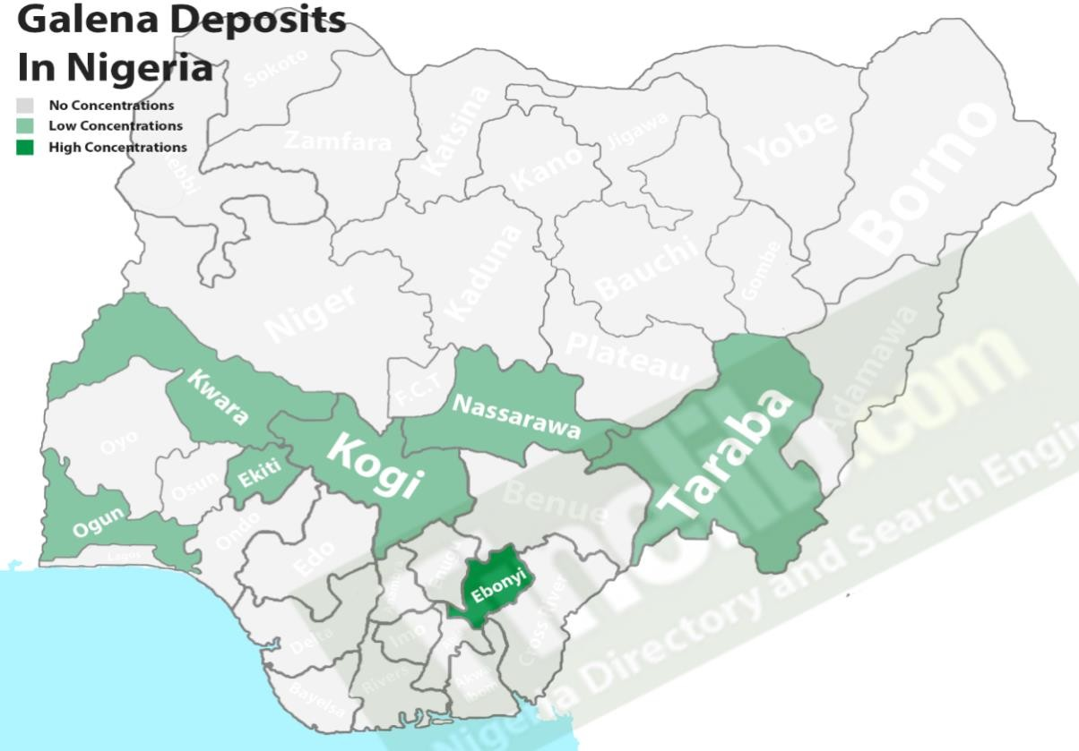

Figure 2.1: Map showing the galena deposits in Nigeria (finlab.com@ 2017)

# Mineral Processing Conceptual Parameters

Treatment of ores to get their metallic concentrate into useful products (concentrate) of smaller bulk, and simultaneously to separate the worthless material (gangue) into discardable waste (tailing), is required for materials manufacturing. The treatment process in called as mineral dressing. There are two major primary operations in mineral processing. One is comminution and the other one is concentration. In addition to these,

there are many other sequential secondary operations involved in mineral processing including sampling and dewatering. The cleaning of ore by the removal of certain valueless portions are also needed for maintaining the quality in output (Balsubramanian, 2015). After the geological survey has been carried out, the standard procedure usually followed in the development of the conceptual flow sheet for the beneficiation of a newly discovered ore deposit are as follows (Thomas and Yaro, 2007);

* + 1. Chemical analysis of the ore;

The chemical analysis involves determining the chemical composition of a Representative Sample to detect and estimate the elements present in the ore. This analysis helps to confirm the result of the geological investigation and probably Mining Engineers who had already worked on the ore deposit.

* + 1. Mineralogical Analysis;

Mineralogical analysis is made up of XRD analysis, SEM analysis and Petrological analysis. These analysis were carried out in order to reveal the major and minor compounds making up the ore under characterization process, grain size of each mineral in the ore, allocation of each element to each mineral present in the ore and the degree of association of valuable minerals to the gangue minerals, examine the mineral fragment and the interpretation of texture and growth pattern of the minerals in the ore.

* + 1. Carrying out Size Analysis;

Sieve analysis is one of the method of sieze analysis used to establish the distribution of both the valuable and gangue minerals in the various sieve size fractions. The quality of grinding and the degree of liberation of the valuable minerals were been determined by this analysis.

* + 1. Establishment of the Liberation size of the ore;

Liberation studies is carried to determine the size at which the ore has the highest degree of freedom. Liberation of the valuable minerals from the gangue is accomplished by size reduction or comminution, which involves crushing and grinding to such a size that the product is a mixture of relatively clean particles of mineral and gangue, that is, the ore minerals are liberated or free. Liberation size of an ore is very significant component in any process design as it gives the operators a clear view of the sieve size. It avoid over grinding and hence save a cost. (Wills, 2016)

* + 1. Evaluation of the Work Index of the ore.

Work index is the comminution parameter which expresses the resistance of the material to crushing and grinding; numerically it is the kilowatt hour per short ton required to reduce the material from theoretically infinite feed size to 80% passing 100μm (Will and Napier-Munn, 2006). The work index is evaluated to determine the resistance of the ore to crushing and grinding.

* + 1. Concentration;

This is the process of separating the valuable minerals from the gangue minerals by utilizing their inherent properties. The choice of the concentration method for the concentration depends on the information obtained in a-d above for the ore.

The size fraction to which the ore will be ground in order to liberate all of the minerals may be determined using the information above, as well as how the different minerals in the ore will affect the concentration process i.e. whether there will be interaction between the valuable mineral and other associated minerals, whether it is finely disseminated or it is an inclusion in the rock, or intimately associated. This will also

show whether waste rejection technique is feasible and how much of the material will be lost with the waste. If it is found out that the minerals are liberated at coarse sizes, the gravity method of separation can be used in order to separate the valuable minerals from the gangue. To do this at laboratory scale, heavy liquid analysis will be carried out on a representative sample ground to reasonable size fractions. Assay of the different fraction obtained at different densities will be carried out, and then a reasonable density of separation is selected. Alternatively, if the valuable mineral ore can only be liberated at fine particle size, then the possibility of using froth floatation technique will be considered and laboratory scale test will be carried out (Yaro, 1997).

Beneficiation processes may be classified into:

* + - 1. Physical separation: Gravity, magnetic, froth floatation (fine particle separation method), electrostatic or high tension and sorting, and optical.
      2. Chemical separation: Leaching, precipitation, solvent extraction, carbon adsorption, electro-winning, autoclaving, chlorination.
      3. Biological separation: Bacterial leaching
      4. Pyro-metallurgical separation: Thermal treatments, which may include roasting, calcination, pelletizing and sintering.

# Comminution Process

Comminution is a process in which the particle size of the ore is progressively reduced until the clean particles or valuable minerals are liberated from the gangue and can be separated by such methods available. Comminution consumes the largest part of the energy used in mining operations, from 30 to 70% (Radziszewski, 2013). Crushing and grinding are the two primary comminution processes. Crushing is normally carried out on "run-of-mine" ore, while grinding normally carried out after crushing. Primary crushers are commonly designed to operate 75% of the available time, mainly due to

interruptions caused by insufficient crusher feed and mechanical delays (Major, 2002). In comminution, the size reduction of particles is done by three types of forces: compression, impact and attrition. Grinding is the last stage in the comminution process where particles are reduced in size by a combination of impact and abrasion, either dry, or more commonly, in suspension in water. It is performed in cylindrical steel vessels that contain a charge of loose crushing bodies—the grinding medium—which is free to move inside the mill, thus comminuting the ore particles (wills, 2016). The primarily used equipment in crushing are-jaw crushers, gyratory crushers and cone crushers. Crushing is a dry process whereas grinding is generally performed wet. (Balsubramanian, 2017).

# Purposes of Comminution

The major purposes of comminution are:

* + - 1. Liberation of one or more economically important minerals from the gangue components in an ore matrix.
      2. Exposure of a large surface area per unit mass of material to facilitate some specific chemical reaction, such as leaching.
      3. Reduction of raw material to the desired size for subsequent processing or handling.
      4. Satisfaction of market requirement concerning particle size specification.

# 2.4.2. Theory of Comminution

Comminution theory is concerned with the relationship between energy input and the particle size produced from a given feed size. Most of the energy input to a crushing or grinding machine is been absorbed by the machine itself leaving a small fraction of the total energy for breaking the material (Gupty, 2003). The oldest theory is that of Von

Rittinger, which states that the energy consumed in the size reduction is proportional to the area of new surface produced.

1 1

E = K ( − ) 2.1

𝐷2 𝐷1

Where E is the energy input, D1 is the initial particle size, D2 is the final particle size, and K is a constant (Will, 2006). While Kick stated that the work required is proportional to the reduction in volume of the particles concerned. Where f is the diameter of the feed particles and p the diameter of the product particles, the reduction ratio R is f/p. According to Kick's law, the energy required for comminution is proportional to log R/log 2 (Will and Napier-Munn, 2006).

Bond (1952) developed an equation which is based on the theory that the work input is proportional to the new crack tip length produced in particle breakage, and equals the work represented by the product minus that represented by the feed. In particles of similar shape, the surface area of unit volume of material is inversely proportional to the diameter. The crack length in unit volume is considered to be proportional to one side of that area and therefore inversely proportional to the square root of the diameter.

For practical calculations the size in microns which 80% passes is selected as the criterion of particle size. The diameter in microns which 80% of the product passes is designated as 15P, the size which 80% of the feed passes is designated as F, and the work input in kilowatt hours per short ton is W. Bond's third theory equation is

10𝖶i

W =

( −

√𝑃

10𝖶i

√𝐹

) 2.2

Where Wi is the work index; work index is the comminution parameter, which expresses the resistance of the material to crushing and grinding. Numerically it is the kilowatt-hours per short ton required to reduce the material from theoretically infinite feed size to 80% passing 100 microns.

# Grindability

Ore grindability refers to the ease with which materials can be comminuted, and data from grindability tests are used to evaluate crushing and grinding efficiency. Most widely used parameter to measure ore grindability is the Bond work index Wi. Berry and Bruce known as modified bond energy equation (1966) developed a comparative method of determining the grindability of an ore. The method requires the use of a reference ore of known grindability. The reference ore is ground for certain time and the power consumption recorded. An identical weight of the test ore is then ground for a length of time such that the power consumed is identical with that of the reference ore. If r is the reference ore and t the ore under test, then from Bond's Equation,

10Wir

10Wir

10Wit

10Wit

( −

√Pr

√Fr

)=W =(

−

√Pt

√Ft

) 2.3

While Bond energy equation is the best-known grindability test for rod and ball mills

# Determination of work index using Modified Bond’s Method.

Bond developed an equation which is based on the theory that the work input into either a crushing or grinding mill is proportional to the new crack tip length produced during the particle breakage which also equals to the work represented by the product minus that represented by the feed. Bond equation is given by;

10Wi

W = ( −

√P

10Wi

)

2.4

√F

Where;

Wi = work index of the material being broken

p = the diameter in micrometer which is 80% of the product passes F = the diameter in micron meter which is 80% of the feed passes

W = work input in kilowatt hour per short ton.

A reference ore of known grindability is used. The reference sample is ground and power consumed during the grinding is measured. An identical weight of the ore whose grindability is to be determined is ground for a length of time such that the power consumed is the same as that consumed in grinding the reference sample. If r stands for reference ore and t stands for ore whose grindability is to be determined called the test ore.

Power consumed in grinding reference sample

10Wi

Wr = Wir ( −

√Pr

10Wi

√Fr

) 2.5

Power consumed in grinding the test sample

10Wi

Wt = Wit ( −

√Pt

10Wi

)

2.6

√Fr

Equating (2) and (3) since energy consumed is the same

Wr = wt = Wir = wit 2.7

Where,

Wr = energy input in grinding the reference ore Wt = energy input in grinding the ore under test Wir = work index of the reference ore

Wit = work index of the ore under test

Fr = 80% passing feed of the reference ore Ft = 80% passing feeed of the ore under test

Pr = 80%passing product of the reference ore Pt = 80% passing product of the ore under test Therefore, the work index of unknown ore is

10 − 10

Wir = Wit (√Pr √Fr) 2.8

10 − 10

√Pt √Ft

This method is relatively simple and is called comparative method of determining the grindability parameter i.e. work index (Will and Napier-Munn, 2006).

# Characterization Methods

Metallurgical analysis involves the qualitative as well as the quantitative analyses of various metallurgical raw materials like ores and products like metals, alloys and slag (Yaro, 1997). Analytical methods employed in metallurgical analysis can be classified into classical and instrumental methods. The classical method is slow and is for practical purpose, the instrumental methods are faster and accurate (Gilchrist, 1989). In the instrumental methods of analyses, measurement is made upon the system as a whole. A particular physical and chemical property of the system is measured in order to get the desired analytical results. Comparison of the results of the samples to be analyzed with standard samples of known composition is necessary in this method (Yaro, 1997). The common instrumental analytical techniques used are Atomic Absorption Spectrophotometer (AAS), X-ray Fluorescence (XRF), X-ray Diffractometer (XRD), Scanning Electron Microscopy (SEM) etc.

# 2.5.1 X-ray Fluorescence (XRF)

X-ray ﬂuorescence is a well-established and powerful tool for nondestructive elemental analysis of virtually any material. It is widely used for environmental, industrial, pharmaceutical, forensic, and scientiﬁc research applications to determine the presence or absence and in some cases to measure the concentration of elemental constituents or contaminants (Chen *et al., 2008*). An x-ray source is used to irradiate the specimen and to cause the elements in the specimen to emit their characteristic of x-rays, when electrons are ejected from the atom making up the material. A detector system is used to measure the positions of the fluorescent x-ray peaks for qualitative identification of the elements present, and to measure the intensities of the peaks for quantitative

determination of the composition. All elements but, low atomic number elements e.g. H, He and Li can be routinely analyzed by XRF (Huang, 1992). The x-rays have a precisely defined energy and the wavelength (velocity of electron) which are related by the plank‘s energy equation:

E1 – E2 = hc 2.9

Where,

E1 = former energy level of the electron before filling the vacancy E2 = new energy level of the electron after filling the vacancy

h = plank′s constant c = velocity of light

As the energies and wavelengths are characteristic of the atoms of the elements emitting the x-rays, they are used for qualitative analysis while the intensity of these characteristic x-rays is related to the concentration of the particular element in the material and is used for qualitative elemental analysis (Thomas and Yaro, 2007). XRF can be used extensively for the analysis of solids, powders and liquid. The technique is non-destructive, rapid, precise and potentially very accurate.

# Scanning Electron Microscopy (SEM)

Scanning Electron Microscope functions exactly as their optical counterparts except that they use a focused beam of electrons instead of light to ―image‖ the specimen and gain information as to its structure and composition. Given sufficient light, the unaided human eye can distinguish two points 0.2 mm apart. If the points are closer together, they will appear as a single point. This distance is called the resolving power or resolution of the eye. (Kannan, 2018)

SEM is often the first analytical instrument used when a ―quick look‖ at a material characteristic is required and the light microscope no longer provides adequate resolution. The method is used to study the properties of material at microscopic level. The most important applications are the investigation of the micro-structure and analysis of in-homogeneity such as defects, dislocations, submicroscopic precipitates, inclusions, domains, etc. it is used for determining the composition of individual grains of particles and surface properties like topography.

In SEM, a small area of the specimen of a material is irradiated with direct electron beam and characteristic x-ray are produced which are used for the qualitative analysis. As the beam interacts with the sample it creates various signals (secondary electrons, internal currents, photon emission, e.t.c), all of which can be appropriately detected (Bindell, 1992). The most important of the produced electrons (x-rays), called backscattered or primary reflected electrons are detected and amplified. The output from this is a function of the composition of the area irradiated by electron beam (Thomas and Yaro, 2007). The intensity of the backscattered electron signal is dependent on the atomic number of the specimen and specimen surface of different chemical composition will produce different signal intensities and appear different on the SEM screen. The signal intensities are used for quantitative analysis.

# X-ray Diffraction (XRD)

X-ray diffraction (XRD) is a powerful nondestructive technique for characterizing crystalline materials. It provides information on structures, phases, preferred crystal orientations (texture), and other structural parameters, such as average grain size, crystallinity, strain, and crystal defects. X-ray diffraction peaks are produced by constructive interference of a monochromatic beam of X-rays scattered at specific

angles from each set of lattice planes in a sample. The peak intensities are determined by the distribution of atoms within the lattice. Consequently, the X-ray diffraction pattern is the fingerprint of periodic atomic arrangements in a given material. This review summarizes the scientific trends associated with the rapid development of the technique of X-ray diffraction over the past five years pertaining to the fields of pharmaceuticals, forensic science, geological applications, microelectronics, and glass manufacturing, as well as in corrosion analysis (Bunaciu *et al., 2015*).X-ray diffraction is now a common technique for the study of crystal structures and atomic spacing. X-ray diffraction is based on constructive interference of monochromatic X-rays and a crystalline sample. These X-rays are generated by a cathode ray tube, filtered to produce monochromatic radiation, collimated to concentrate, and directed toward the sample (Figure 1). The interaction of the incident rays with the sample produces constructive interference (and a diffracted ray) when conditions satisfy Bragg‘s law:

nλ = 2d sin θ 2.10

Where n is an integer, λ is the wavelength of the X-rays, d is the interplanar spacing generating the diffraction, and u is the diffraction angle (Bunaciu *et al., 2015*). The characteristic x-rays which are deflected by the crystal are detected by a detector, registered and displayed on paper chart recorder as series of peaks (x-rays patterns). Each has a unique x-ray powder pattern (fingerprints) because the line position depends on the unit cell size and the type of atoms present and their intensities of powder lines are used for qualitative phase analysis, while quantitative phase analysis depends on the accurate 22 determination of the line intensity (Thomas and Yaro*,* 2007). XRD offers unparalleled strain states in thin films. XRD is non-contact and nondestructive, which makes it ideal for in situ studies. The limitation of XRD is that, compounds to be measured must be in a crystalline form to give rise to measurable signals.

# Beneficiation Processes

There are a number of ways of increasing the concentration of the valuable minerals: in any particular case the method chosen will depend on the relative physical and surface chemical properties of the mineral and the gangue. Concentration means the increase of the percentage of the valuable mineral in the concentrate in relation to the feed.

# Gravity Concentration Technique

Gravity concentration is the process for the separation of minerals of different specific gravity by inducing variable movement in response to gravitational force and one or more natural or applied force with the aid of a flowing film. It is used, sometime along with other processes in particle flotation, magnetic separation and chemical treatment (Gupty, 2003). Gravity concentration is the separation of minerals based upon the difference in density. Techniques of gravity concentration have been around for millennia. Gravity concentration, or density-based separation methods, declined in importance in the first half of the twentieth century due to the development of froth flotation which allowed for the selective treatment of low-grade complex ores. They remain, however, the main concentrating methods for iron and tungsten ores and are used extensively for treating tin ores, coal, gold, beach sands, and many industrial minerals (Will and Napier-Munn, 2006). The major demerit of gravity separation process is the recovery of fines and it is inherent in the process itself, even with advance slime gravity concentrators, the practical lower limit of particle size which can be handle is still about 100μm (Yaro, 1997).

# Froth Flotation Technique

Flotation is a separation process that exploits natural and induced differences in surface properties of the minerals, whether the surface is readily wetted by water, that is, is

hydrophilic, or repels water, that is, is hydrophobic. If hydrophobic the mineral particle can attach to air bubbles and be floated. The system is complex, involving three phases (solids, water, and air) and the interaction of chemical and physical variables. The chemical variables aim to control the transition between the hydrophilic and hydrophobic state. Physical variables include those resulting from properties of the ore, such as particle size and composition (liberation), and machine-derived factors such as air rate and bubble size (Wills, 2016). Froth flotation is an important concentration process. This process can be used to separate any two different particles and operated by the surface chemistry of the particles. In flotation, bubbles are introduced into a pulp and the bubbles rise through the pulp. In the process, hydrophobic particles become bound to the surface of the bubbles. The driving force for this attachment is the change in the surface free energy when the attachment occurs. These bubbles rise through the slurry and are collected from the surface. To enable these particles to attach, careful consideration of the chemistry of the pulp needs to be made. These considerations include the pH and the presence of flotation reagents. This process involves treatment with suitable reagent of an ore pulp to create conditions favorable for the attachment of certain hydrophobic or aerophilic mineral particle to air bubbles and render the other solids hydrophilic or water loving, submerged in the solution (Thomas and Yaro, 2007).

# Magnetic Concentration Technique

The concentration of minerals in accordance with their magnetic susceptibility is a broadly utilized separation method that can be a very effective separation process. Moreover, magnetic separation is usually a low cost technique of retrieval unless high- intensity separators are required. Magnetic separators use the difference in magnetic properties between the minerals in a deposit. They are in use in many installations since they can be very effective, comparatively non-expensive, and more environment

friendly than other methods. Therefore, where looking for a procedure to recover meaningful minerals, magnetic separation should not be ignored. Magnetic separators are used to concentrate a valuable mineral that is magnetic (e.g., magnetite from quartz), to remove magnetic contaminants, or to separate mixtures of magnetic and nonmagnetic valuable minerals. An example of the latter is the cassiterite, commonly associated with some amounts of the meaningful magnetite or wolframite, which can be extracted by magnetic separators. However, the most typical application of magnetic concentration is for iron ore processing in the minerals industry (Bustillo, 2018).

# Electrostatic Concentration Technique

In electrostatic separation (ESS), also called electrical separation, particles come under the influence of an electrical field. They gather a charge that relies on the maximum attainable charge intensity and on the surface area of the particle. These charged components can be split by differential attraction or repulsion. Therefore, the important early stage in electrostatic separation is to impart electrostatic charge to the particles. The three principal manner of charging actions are contact electrification or triboelectrification, conductive induction, and ion bombardment. Where the particles are charged, the split can be carried out by devices with different electrode configuration (Bustillo, 2018). Due to nearly all minerals displaying some contrast in conductivity, this technique would represent the universal beneficiating technique. However, the method has limited applications due to the required processing conditions, notably a perfectly dry feed (Wills and Finch 2016).

# Lead and Zinc Production

Galena (PbS) and sphalerite (ZnS) are the major ore minerals for Pb and Zn respectively. Pyrometallurgical processing of Pb and Zn metals usually includes four

stages: ore dressing, smelting, drossing and refining. Sinter blast furnace route is one of the most important smelting technologies which was adopted from iron and steel industries. Lead-rich sinter is treated in lead blast furnace to produce lead metal. Sometimes it is difficult to separate lead and zinc minerals, Imperial Smelting Process is used to treat mixed zinc-lead ores for production of lead and zinc metals simultaneously. (Zhao, 2013)

Imperial Smelting Furnace (ISF) is also called zinc blast furnace which was developed for mixed zinc-lead ores. Charges to the furnace are lump sinter, hot briquettes, and coke. Slag and lead are continuously tapped from the bottom of the furnace into a fore hearth where separation occurs. The slag containing zinc overflows to the fuming plant to recover zinc. Liquid lead containing copper and precious metals is transferred by ladle to the decopperizing plant. Zinc vapor generated in the furnace enters the lead splash condenser where it is quenched and absorbed by fine lead droplets splashed by the rotors. The hot lead containing zinc is pumped from the condenser to a brick-lined cooling launder fitted with immersion boiler panels. On cooling the recirculating lead stream, crude zinc is released and separated by specific gravity from lead. The lead is then returned to the splash condenser. (Zhao, 2013)

Table 2.2 Composition ranges of concentrate and sinter for ISF (Zhao, 2013)

|  |  |  |  |  |  |  |  |  |  |
| --- | --- | --- | --- | --- | --- | --- | --- | --- | --- |
| Sample | Zn | Pb | Fe | CaO | SiO2 | Al2O3 | MgO | Cu | S |
| Concentrate | 33-42 | 15-19 | 4-9 | 1-5 | 2-6 | 0.7-2 | 0.2-1 | 0.5-1.3 | 19-26 |
| Sinter | 37-44 | 15-22 | 7-12 | 3-6 | 3-5 | 0.6-2 | 0.2-1 | 0.6-1.2 | 0.3-1.6 |

# Flow-sheets

It's a diagrammatic model of the process describe the process steps in a proper sequence using symbols to represent the various components (equipment, lines, and control instrumentation) that make up the unit. They are convenient means of illustrating processes or a combination of processes arranged in chronological order which are

followed in the processing of a material in a plant. Some of the types of flow sheet presentation are: (a) Block Diagram (b) process flow sheet (c) engineering flow sheet. (Sirajo, 2019).

1. Block diagrams are used for illustrating preliminary or basic of what is to be done rather than how it is to be carried out. Block diagrams are used in survey, research summaries and for generally talking out a processing idea, especially at the process development and evaluation stage. A typical is shown in Figure 2.2

Run-of-mine

SEPERATION

COMMUNITION

PRODUCT HANDLING

Fig.2.2: A typical Block diagram

1. Process flow sheet is the most important flow sheet which is used to represent the heat and mass balance of the process together with a reasonable detailed indication of the operating conditions, including the flow rates, temperature and pressure for each item such as steam water, fuels, refrigeration and circulating oil.
2. Engineering flow sheet, these are usually prepared when the design is completed and are used to coordinate all the data from the drawings of individual plant items, which must be separate.

# 2.8.1 The Flow-sheet Importance

* Shows the arrangement of the equipment selected to carry out the process.
* Shows the streams concentrations, flow rates & compositions.
* Shows the operating conditions.
* During plant startup and subsequent operation, the flow sheet from a basis for comparison of operating performance with design. It's also used by operating personnel for the preparation of operating manual and operator training.

# Study Area

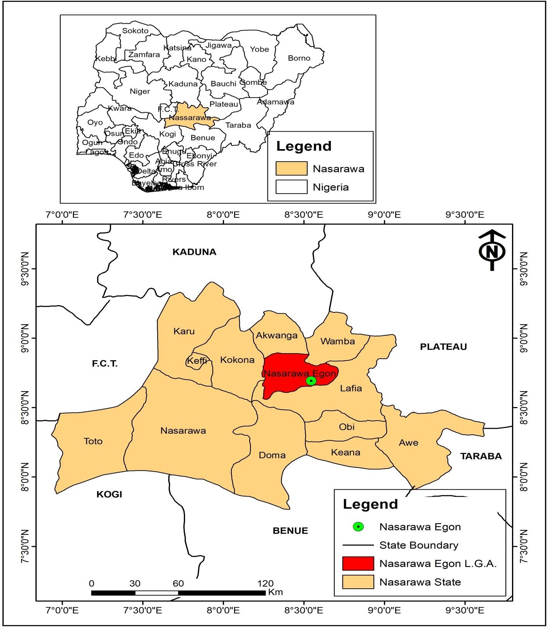Nasarawa-Eggon is a local government area in Nasarawa state, Nigeria with GPS- coordinate; 80 44‘ 33.029‖ N 8032‘ 30.804‖ E. It is 29.7 km away from the state capital It‘s headquarters is in the town Nasarawa-Eggon, it has an area of 1,208 km2 and a population of 149, 129.

Figure 2.3: Map of Nasarawa state showing location of Nasarawa-Eggon (GIS, 2021)

# Previous Works on Lead-Zinc Ores.

Dare *et al* (2019) worked on the Beneficiation and Characterization of Wase Galena with the aid of gravity and froth floatation techniques, he found out that the mineralogical analysis reveals that the mineral composition of the ore contains 13.38%

galena, 6.53% hematite, 3.43%Sphalerite, 1.94% azurite and other minerals by weight, with the oxide forms; 68.50% PbO and a lead metal of 66.42% Pb, 19.50% Fe2O3, 3.77% ZnO, and 2.08% SiO2 while others are in traces. The particle size analysis indicates that the liberation size of the ore is at -0.1+0.2 mm and finally concluded that the Wilfley shaking table technique is the best for the beneficiation of the ore.

Akindele *et al* (2019) investigated the application of reagents dosage in the flotation of Arufu Lead Ore, North-central, Nigeria, he found out that the experiment with 3ml gives better weight and metal recovery than others.

Alabi *et al* (2016) carried out comparative test for the upgrading of lead in Sabon Gari lead-zinc ore (Alkaleri local government, Bauchi state) using gravity and froth floatation method he found out that wilfey shaking table method is the most suitable method for the beneficiation of Sabonlayi lead-zinc deposit.

Allen M.A. (2017) carried out a study on work index evaluation of Ishiagu galena ore Ebonyi state, Nigeria, where he found the work index of the ore to be 5.14KWh/t. Soroush *et al* (2015) carried out the optimization of galena flotation process of Irankouh complex lead ore using a statistical design of experiments where the most important floatation parameters were identified using Taguchi method and were optimized using response surface methodology(RSM). He concluded that; after optimization no reduction in the grade of concentrates happened while the lead recovery was increased to 87% and zinc recovery was decreased to 17.3%, which shows a 10.1% and 25.3% improvement in lead and zinc recovery, respectively.

Onyedika *et al*. (2015) carried out Qualitative and mineralogical characterization of lead deposit in Ishiagu, Ebonyi state Nigeria. He found out that the most dominant and valuable metal is lead (Pb= 95.02%, mass fraction). The main mineral is galena. Ilmenite and sphalerite occur as minors, which account for 2.71% and 0.80%

respectively. Elements like Al, Ca, Mg, Ti, Na, Mn, Si and Sn occurred in trace amounts and are disseminated in the entire ore body.

Yunana (2015) worked on the beneficiation and characterization of Zurak lead-zinc deposit in plateau state. The occurrence of the lead deposit and its associated minerals is of great importance to the socio-economic development of Zurak Community, Wase Local Government Area, Plateau State and Nigeria in general. The Zurak ore deposit is predominantly made up of lead and zinc in the forms of galena (PbS) and sphalerite (ZnS) assaying 6.33% lead and 4.65%Zn as the major minerals constituents. Other minerals associated with the ore are magnetite (Fe3O4), rutile (TiO2), quartz and kaolinite KAL3Si3O10 (OH)2 as minor minerals constituents. The liberation size of the ore was found to be -90+63μm and the work index of the ore was also found to be 11.41KWh/tone making the ore a type B grade(medium soft texture ore) using the grindability curves graph. The concentration criterion (CC) of ore was found to be 1.87 this is an indication that the ore cannot be concentrated using the gravity method. However, literature has shown that froth flotation is the most suitable method of concentrating lead-zinc minerals. The first batch of the flotation test at -90 +63μm produced lead and zinc concentrates assaying 63.02%Pb and 57.92%Zn with recoveries of 83.08% and 65.58%, while the second batch at -180 +125μm, produced lead and zinc concentrates assaying 55.79%Pb and 30.25%Zn with recoveries of 60.47% and 21.94% respectively. All the grade of lead and zinc concentrates obtained met the metallurgical requirement required for smelting lead and zinc concentrates.

Obassi *et al* (2015a) worked on Liberation Size and Beneficiation of Enyigba Lead Ore, Ebonyi State, South-East Nigeria. The mesh of grind was found to be 189 μm, and the liberation size was established to be 63 μm sieve size having the highest percentage of lead of 15.1% then enriched to 69.8% by froth flotation method and was assessed by

using x-ray fluorescence (XRF). The lead concentrate by weight was obtained to be 81.80%, confirmed being of high economic grade having surpassed 60%wtPb element in an ore**.**

Obassi *et al* (2015b) determined the work index of Enyigba lead ore Ebonyi state, South-east Nigeria, the work index was found to be 14.37KWh/ton using the modified bonds energy method.

Obassi *et al* (2015c) worked on the liberation and beneficiation of Arufu lead Ore using froth floatation Nasarawa state, north central Nigeria he found that the mesh of grind was found to be 198μm for Arufu lead ore and liberation size to be 63μm sieve size having the highest percentage of lead of 17.3% which is then enriched to 53.3% by froth flotation method and was assessed by using XRF.

Idzi (2013) carried out geochemical studies of mineral bearing ores from NasarawaEggon and Udege Beki areas of Nasarawa state, Nigeria. He concluded that the researched areas could as well serve as potential local raw material base for the State (Pb, Zn, Sn, Nb and Fe) for industrial advancement and socio economic potential in terms of local sourcing of raw materials to the mineral based and allied industries. Fatoye (2014) worked on Lead-Zinc-Barytes mineralization in the Benue Trough, Nigeria: their geology, occurrences and economic prospective he concluded that Deposits of Lead and Zinc minerals in the form of their ores of galena and sphalerite respectively and barytes occur extensively in the Cretaceous sediments of the Benue Trough sedimentary basin of Nigeria. Pb-Zn deposits in Benue Trough are sedimentary exhalative (Sedex) type of deposit formed when metal-rich hot liquids are released into water-filled basin sediments, which results in the precipitation of ore-bearing material with basin floor sediments.

Damisa (2008) worked on the process design for the beneficiation of Nahuta lead deposit in Bauchi State. He concluded that the major economic minerals present in Nahuta deposit are Lead and copper in the forms of galena (PbS) and covellite (CuS); that bulk floatation followed by differential floatation is best to achieve high recovery in the beneficiation of the ore.

Egbe *et al* (2013) worked on gravity separation of lead-gold ore in Baban Tsauni, Gwagwalada, Abuja using three (3) gravity separation methods. He however, he concluded that Baban Tsauni (Nigeria) lead-gold ore responded well to beneficiation by Jigging, Multi-gravity and Shaking table separations.

Hence, it is shown that little work has been conducted on the characterization and beneficiation of Nasarawa-Eggon lead ore deposit which is the thrust of this research.

# CHAPTER THREE

# MATERIALS AND METHODS

This chapter highlighted the materials and equipment used as well as the methodology of the tests conducted during the course of this research work.

# Materials and Equipment used

Some of the materials and equipment used during this research work are;

* + 1. Nasarawa-Eggon lead-Zinc ore
    2. Global Positioning System (GPS)
    3. Laboratory sledge Hammer
    4. Ball Mill and Pulverizer
    5. Set of sieves,
    6. Laboratory Sieve Shaking Machine
    7. Weighing Balance
    8. X-ray Florescence (XRF) Machine (ARL QUANT`X EDXRF spectrometer)
    9. X-ray Diffractometer (XRD) Machine (Panalytical Empyrean Diffractometer)
    10. Scanning Electron Microscope (Phenom, pro X model),
    11. Flotation Cell (Denver Flotation machine)
    12. Flotation reagents (NaCN, HCL, Pine oil, Oleic Acid).

# 3.1.1 Location of Nasarawa-Eggon Lead- Zinc Ore Deposit

The Nasarawa-Eggon lead-Zinc ore deposit is located in Nasarawa-Eggon town. The town is along Lafia/Akwanga road. It is about 30 km away from Lafia and about 30km to

Akwanga. The reserve has not yet been quantified by any of the agencies responsible for mineral resources development in the country.

# Methodology

# Ore Sample Collection

50Kg of the lead-Zinc ore sample was collected from the deposit site at Nasarawa-Eggon using the grab method which involved collecting small quantities of the ore from underground workings (Mular *et al.,* 2002). The collection was at random basis as ore was mined. The GPS reading of each point of collection was taken and then combining the samples from the different points.

Table 3.1: Coordinates of the Area of the Deposit

|  |  |
| --- | --- |
| S/N | Coordinates |
| Pit 1 | N 8O 41‘36.88836‖ E 8O32‘36.89196‖ |
| Pit 2 | N 8O 41‘36.51324‖ E 8O32‘37.14144‖ |
| Pit 3 | N 8O 41‘36.31668‖ E 8O32‘37.28668‖ |
| Pit 4 | N 8O 41‘31.49052‖ E 8O32‘39.1542‖ |

# Sample Preparation

Sample preparation involves comminution crushing and grinding process. The lump sizes of the ore sample were reduced to the sizes that could be accepted by the crusher using sledge hammer. The sample was crushed using jaw crusher and pulverized using ball mill.

# Sampling for the Purpose of Tests and Analyses

Coning and quartering sampling method was used to obtain a representative sample from the pulverized lead-Zinc ore.

# Chemical Composition Analysis

After communition and proper sampling, the lead-Zinc ore sample was taken and analyzed using ARL QUANT`X EDXRF spectrometer at University Central Laboratory, Umaru Musa Yar` adua University, Katsina. This was carried out to determine the elemental composition of the ore.

# (a) Procedure for Determination of percentage Elemental Composition of the ore sample using ARL QUANT`X EDXRF spectrometer

The Lead-Zinc ore sample was pulverized using jaw crushing machine, disc miller and finally cup miller to fine particle size of 100 mesh (0.15 microns). The powdered sample was placed in the sample cup filling up¾ parts of the cup with the sample. The cup was then covered with film to avoid wrinkles on it, and finally the slim ring was fixed by sliding it down and the thick ring on the top of the cup. After the cups preparation, the cups were placed on the sample stage inside the spectrometer chamber (placed with the side to be analyzed facing down toward the X-ray tube). X-rays from the X-ray tube penetrate the layers on the disk and excite the elements in the sample which emits fluoresce X-ray photons with energies that are characteristic of each element in the sample. These X-ray photons are measured by a detector, which produces a spectrum. The software automatically integrates the peaks for each element.

# Mineralogical Analysis of the Ore

The mineralogy of the ore was determined using X-ray diffraction (XRD) Panalytical Empyrean Diffractometer at the Nigerian Geological Survey Agency (NGSA) Kaduna. While the SEM analysis was carried out using (SEM/EDS) Phenom Pro X model in the Department of Geological service, Research and development unit, National Steel Raw

Materials Exploration Agency (NSRMEA) Kaduna. Polished section was prepared from the sample for Petrological analysis in the thin section and rock polishing lab, Nigerian Geological survey agency (NGSA) Kaduna. After which the sample was viewed under reflected microscope for identification of mineral phases present and determination of grain size of the various minerals. The steps involved in this process are described below;

# Procedure for the Determination of Mineralogical Composition of the oresample Using XRD (X-ray Diffractometer) Panalytical Empyrean Diffractometer.

The lead-Zincore sample was prepared and placed in a standard sample holder of the X-Ray diffractometer. A collimated beam of X-ray was incident on the specimen and diffracted by the crystalline phases in the specimen. The intensity of the X-rays was measured as a function of the diffracted angel 2𝜃 and the specimen`s orientation. The pronounced peaks displayed and expressed the sample composition at the various angle of the degree theta.

# Procedure for the determination of morphology of grain size of the lead ore sample using (SEM/EDS) Phenom, pro X model

In SEM analysis, a small amount of powder sample was taken and placed on the sample holder which was then placed inside the machine and waited for the machine to be ready. A vacuum was built in the sample chamber, the sample was irradiated to generate emission from which micrograph of the sample was produced. During the process the EDS was also carried out to establish the spectra of the major elements.

# Procedure for the Preparation of Polished Section (thin sectioning)

The lead-Zinc ore sample was cut to size using cutting machine and ground optically flat. It is then mounted on a glass slide and then ground smooth using progressively finer abrasive grits and polishing pastes until the sample is only 30 μm thick. The glass

slide was then placed between two polarizing filters set at right angles to each other; the optical properties of the minerals in the thin section alter the colour and intensity of the light as seen by the viewer using an optical microscope. As different minerals have different optical properties. The photomicrography obtained for the polished samples viewed under microscope are shown in plate.

# Determination of Work Index

The work index of the ore was determined using Bond modified method (i.e. Barry and Bruce comparative method), in which a reference ore of known work index was used. The reference ore used was Granite having a work index of 15.13KWh/t (Gupta and Yan, 2016). The grinding was conducted dry. The work Index was carried out at the dry mineral processing laboratory, Department of mining and petroleum resources, Federal Polytechnic Kaduna. Where the Modified Bond‘s method was used which involves the use of a reference and test ores to determine the work index. 200g each of the reference ore (Granite) and the test ore (lead ore) were crushed and pulverized in the laboratory mill for an hour. The same quantity of test and reference ores was measured and sieved into a number of sieve size fractions using automatic sieve shaker for 30 minutes. The selection of sieves was based on scale of root two and arranged from the coarsest on top and the finest sieve at the bottom. The sample was placed at the topmost sieve and a pan was placed at the bottom. The sieve size fraction ranges from +355μm,-355+250μm, -250+180μm, - 180+125μm, -125+90μm, and -90μm (pan) were used. Each sieve fractions for both reference and test samples were weighed and the values obtained were recorded as ―feed‖. The ―feed‖ of the test and reference samples were introduced into the ball mill and ground for 30 minutes. The discharge of test and reference samples from the ball mill was sieved

into different sieve size fractions, they were weighed and the values were recorded as the

―product‖. 80% passing was calculated and the work index was determined. The results of the test are presented in Tables 4.3 to Table 4.6. Modified Bond energy relationship (Berry and Bruce) shown as equation 3.4 was used to calculate the work index of the Lead-Zinc ore.

10 − 10

Wit = Wir (√Pr √Fr) 3.4

10 − 10

√Pt √Ft

Where

Wit = work index of the test ore

Wir = work index of the reference ore

Fr = 80% passing feed of the reference ore Ft = 80% passing feed of the test ore

Pr = 80% passing product of the reference ore Pt = 80% passing product of the test ore

# Particle Size / Mineral Assay Analysis

Particle size and mineral assay analyses were carried out at the dry mineral processing laboratory, Department of mining and petroleum resources, Federal Polytechnic Kaduna. This is to establish the distribution of various minerals especially Lead (Pb) and Zinc (Zn) in the various sieve size fractions. 200g of grounded sample was subjected to sieve analysis to establish the distribution of mineral phases present in the various size fractions. The arrangement of the sieves were done using a sieve scale in which the ratio of the aperture widths of the adjacent sieves is the square root of two (√2=1.414). Sieve sizes ranging from 355μm to 90μm were arranged in a stack with the coarsest sieve on the top and the finest at

the bottom. A tight fitting pan was placed below the bottom sieve to receive the final undersize and a lid was placed on the top of the coarsest sieve to prevent escape of the sample. The arranged sieves were placed on a sieve shaker which vibrates the materials vertically. The ground samples were sieved into the following sieve size fractions; + 355μm, -355μm +250μm, -250μm +180μm, -180μm +125μm, -125μm, +90μm, and -90μm, using automatic sieve shaker for 30 minutes to enhance proper sieving. The amount of material retained on each sieve size was weighed and properly labeled for analyses using XRF. The results are presented in Table 4.7 and 4.8.

# Liberation study

Liberation study was conducted to determine the liberation size of the valuable mineral. The sieve sizes obtained from the sieve analysis of the feed to ball mill for the test ore was subjected to chemically analysis, where each sieve size was analyzed using XRF machine, the sieve size fractions that contains the highest percentage assay of the valuable mineral was acknowledged as the liberation size of the ore.

# Froth flotation process

From the result of the size-assay analysis, -125+90 𝜇m has the highest percentage of Lead and Zinc. Hence, the flotation of the ore at the above sieve size was carried out at the Wet Minerals Processing Laboratory, Department of Mining and Petroleum Resources, Kaduna Polytechnic, Kaduna.

The lead-Zinc ore was subjected to a Bulk flotation in the reverse form through the below procedures:

* + - 1. About 200 g of the sample was obtained from the sieve size of -125+90µm being the liberation size.
      2. A pulp was formed by emptying the sample into the Denver flotation cell and adding 2000 ml of water below the cell tip. The flotation cell containing the pulp was placed on the flotation machine.
      3. The impeller was lowered gently into the cell until it reaches the bottom and was a little bit raised up so as not to settle on the cell.
      4. Agitation with no air was done by starting the impeller for 5 minutes in order to obtain proper suspension of solid particles within the pulp.
      5. The pH was checked and adjusted from alkaline level 8 to acidic level 3 using HCl so as to obtain an acidic environment to froth Silica.
      6. 3 drops of the collector (oleic acid) and 6 drops of the depressant (NaCN) was added into the pulp and then conditioning (without air) was done for 10 minutes.
      7. 3 drops of the frother (pine oil) was added before the expiration of the conditioning time.
      8. Air was then allowed to pass through the pulp at a reasonable rate.
      9. The froth which is rich in silica was formed and skimmed off the flotation cell until barren froth persists.
      10. The Froth (Tailings) and Depressed (Concentrates) were filtered, dried in an oven and weighed before sending for analysis using XRF.
      11. After the analysis, cleaning stage was carried out on the Depressed (Concentrates), where same procedure above was repeated with the Depressed (Concentrates) as feed.
      12. Finally the froth (tailings) and Depressed (concentrate) of the cleaning stage were also filtered, dried in an oven, weighed and sent for analysis using XRF.

# Flow sheet development

The entire exercise from the r-o-m through to communition and beneficiation of the Nasarawa-Eggon lead-Zinc ore deposit was arranged to develop a block diagram flow sheet showing the design of the step by step schematic diagram of the processes involved.

# CHAPTER FOUR

# RESULT AND DISCUSSION

Result of various laboratory experiment and analysis carried out were presented and discussed in this chapter. After conning and quartering sampling of the Nasarawa-Eggon Lead-Zinc Ore, a head sample was obtained which was used to represent the ore in the experiments.

# Result of Chemical analysis of the head sample using XRF

The chemical composition of the head sample obtained after the chemical analysis using XRF is presented in Table 4.1

Table 4.1: Chemical composition of the head sample

|  |  |  |  |
| --- | --- | --- | --- |
| Oxide | % composition | Element | % Composition |
| PbO | 18.07 | Pb | 16.80 |
| ZnO | 15.68 | Zn | 12.60 |
| SiO2 | 45.45 | Si | 21.30 |
| Fe2O3 | 2.63 | Fe | 2.03 |
| MnO | 2.04 | Mn | 1.58 |
| CuO | 2.05 | Cu | 1.64 |

It can be observed from the chemical analysis result as presented in Table 4.1 that the ore contains 16.78% Pb and 12.60% Zn which meets the typical standard feed grades of 1 – 5% Pb and 1 – 10% Zn usually required for mining lead-zinc ore (Wills, 2016). Together with the Pb and Zn are some gangue minerals having composition of 21.30% Si, 2.03% Fe, 1.58% Mn and 1.64% Cu, while others are in a minor quantity. The analysis revealed a large amount of Pb and Zn metal which matched those reported for several mines in Ebonyi and Plateau states, Nigeria (Idzi *et al., 2013*).

# Mineralogical analysis of the head sample.

The mineralogical analysis consists of the XRD analysis, SEM analysis and Petrological analysis of the head sample.

# XRD analysis of Head Sample

Figure 4.1: XRD Pattern of the head sample

Table.4.2: XRD analysis of the Head Sample

|  |  |  |
| --- | --- | --- |
| Mineral Name | Chemical Formula | % Composition |
| Galena | PbS | 38.7 |
| Sphalrite | ZnS | 16.0 |
| Quartz | SiO2 | 45.2 |

As indicated in the XRD analysis (Figure 4.1 and Table 4.3) it can be observed that the predominant crystalline minerals in the head sample are Galena (PbS), Sphalerite (ZnS) and Quartz (SiO2) with composition of 38.7%, 16.0% and 45.2% respectively. The result

revealed the existence of Pb and Zn in conjunction with other elements, as shown by the XRF with Pb in the form of PbS (Galena) and Zinc in the form of ZnS (Sphalerite). The result correlates with the report of (Dessy *et al., 2017*) that Galena is the principal ore of lead mineral and is aalways in association with sphalerite.

# Petrographic microscopy of the head sample

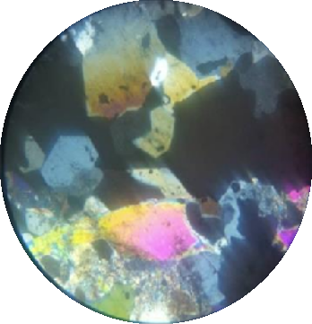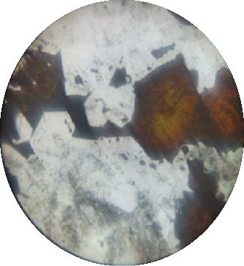

SPHALERITE

GALENA

QUARTZ

Plate 4.1 (a) (b)

Plate 4.1: (a-b): Petrological micrographs of the lead-Zinc ore sample under cross polarized light (4a) and plane polarized light (4b).

The petrological analysis result is presented in Plate 4.1(a-b) with arrows indicating the main minerals in the Lead-Zinc ore sample. Sulphide minerals (PbS and ZnS) and Quartz occur in close spatial associations and also as intergrowths. As can be seen from the micrographs, Galena appears a lead-grey in colour commonly follow grain boundaries of Sphalerite and are seen as intergrowth between alternate bands of Sphalerite, while Sphalerite Brownish black in colour with Anhedral shape . The quartz is seen in veins which occur as anhedral crystals and as overgrowth on the grain boundaries of Sphalerite and Galena. This study's findings compared favorably to the optical descriptions of the minerals by Obiegbu (2018). This result supported the findings of the XRD examination,

which revealed the presence of Galena, Quartz and Sphalerite minerals, as well as the fact that the mineral of interest, Lead and Zinc are present in the Lead-Zinc ore sample.

# Scanning Electron Microscope

The SEM micrographs of the head sample are presented in Plate 4.2 (a-c) at different magnifications of x500, x1000 and x1500 respectively. With labeling; Q = QUARTZ, P = GALENA and Z = SPHALERITE.

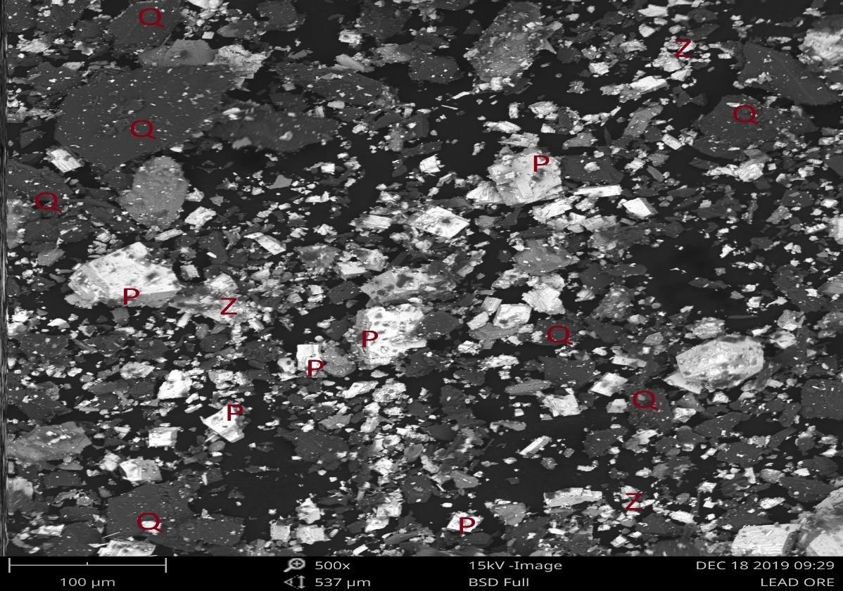

LEGEND

Q = QUARTZ P = GALENA

Z = SPHALERITE

Plate 4.2a: SEM micrograph of the head sample sampleat 500x

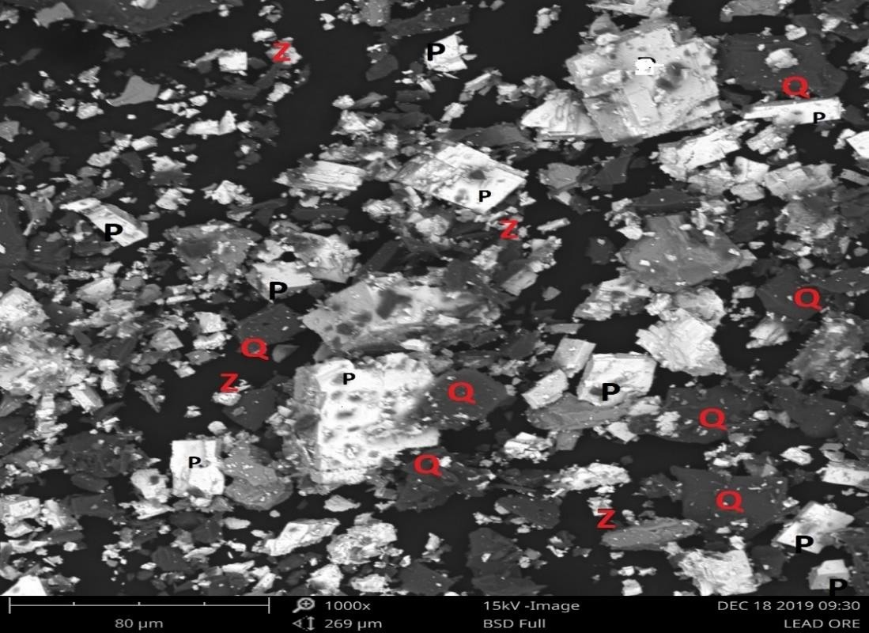

LEGEND

Q = QUARTZ P = GALENA

Z = SPHALERITE

Plate 4.2b: SEM micrograph of the Head sample at1000x

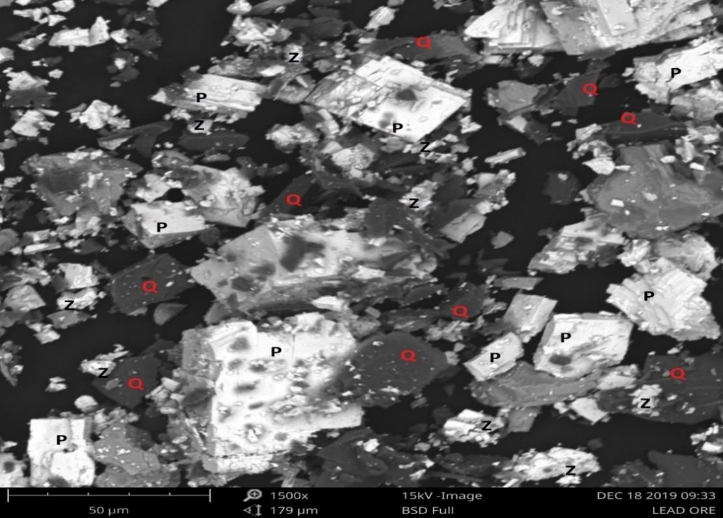

LEGEND

Q = QUARTZ P = GALENA

Z = SPHALERITE

Plate 4.2c: SEM micrograph of the head sample at 1500x

The SEM micrographs of the head sample indicating clearly the Quartz, Galena and Sphalerite were presented in plate 4.2 (a-c) where Q = QUARTZ, P = GALENA and Z = SPHALERITE. It can be observed that the minerals have different particle size, they are separated by grain boundaries, finely disseminated within each other and no interlocking of minerals. The bulk of the world‘s lead and zinc is supplied from deposits, which often occur as finely disseminated bands of Galena and Sphalerite (Wills, 2016). This phenomenon indicates that the mineral can be freed from each other during comminution (Oyeladun, 2015). Furthermore, the result also confirmed the presence of Lead in the form of galena and Zinc in the form of Sphalerite as revealed by the XRD and Petrological analysis results.

# Work Index of Nasarawa-Eggon Lead-Zinc Ore

Table 4.4 and Table 4.5 below presents the sieve analyses of the feed to ball mill and product of the ball mill of the reference sample (granite ore) respectively. While Table 4.6 and 4.7 present the sieve analyses of the feed to ball mill and product of the ball mill of the Test sample (Lead-Zinc Ore) respectively. The value of 80% passing feed and product for both the reference and test ore were calculated using Gaudin-Schumann method.

Table 4.3: The Feed to Ball mill of reference sample (Granite)

|  |  |  |  |  |  |  |
| --- | --- | --- | --- | --- | --- | --- |
| S/N | Sieve size range (μm) | Nominal aperture | Weight retained (g) | % weight retained | Cumulative  % weight retained | Cumulative  % weight passing |
| 1 | + 350 | 350 | 33.80 | 16.90 | 16.90 | 83.10 |
| 2 | -350 + 250 | 250 | 27.71 | 13.855 | 30.755 | 69.245 |
| 3 | -250 + 180 | 180 | 17.34 | 8.67 | 39.425 | 60.575 |
| 4 | -180 + 125 | 125 | 31.77 | 15.885 | 55.31 | 44.69 |
| 5 | -125 + 90 | 90 | 22.98 | 11.46 | 66.80 | 33.20 |
| 6 | -90 | - | 66.4 | 33.2 | 100 | 0.0 |

To calculate 80% passing feed of reference sample. If 350μm 83.10 %

Xμm 80 %

Using Gaudin-Schumann method

80 2

Xµm = ( )

83.10

x 350 = 324.4µm

at 80% passing

Thus, Fr = 324.4µm at 80% passing

Table 4.4: The Product of Ball mill Discharge for reference sample (Granite)

|  |  |  |  |  |  |  |
| --- | --- | --- | --- | --- | --- | --- |
| S/N | Sieve size range (μm) | Nominal aperture | Weight retained (g) | % weight retained | Cumulative  % weight retained | Cumulative  % weight passing |
| 1 | + 350 | 350 | 23.80 | 11.90 | 11.90 | 88.10 |
| 2 | -350 + 250 | 250 | 29.45 | 14.725 | 26.625 | 73.375 |
| 3 | -250 + 180 | 180 | 20.11 | 10.055 | 36.68 | 63.32 |
| 4 | -180 + 125 | 125 | 31.67 | 15.835 | 52.515 | 47.485 |
| 5 | -125 + 90 | 90 | 45.74 | 22.87 | 75.385 | 24.615 |
| 6 | -90 | - | 49.23 | 24.615 | 100 | 0.0 |

To calculate 80% passing product of reference sample If 350μm 88.10%

Xμm 80 %

Using Gaudin-Schumann

80 2

Xµm = ( )

88.10

x 350 = 288.6µm

at 80% passing

Thus, Pr = 288.6µm at 80% passing

Table 4.5: The Feed to Ball mill of the test sample (Lead-Zinc Ore)

S/N Sieve size

range

Nominal

aperture

Weight

retained

%weight

retained

|  |  |  |  |  |  |
| --- | --- | --- | --- | --- | --- |
|  | (μm) | (g) |  | retained | passing |
| 1 | + 350 350 | 35.20 | 17.60 | 17.60 | 82.40 |
| 2 | -350 + 250 250 | 27.60 | 13.80 | 31.40 | 68.60 |
| 3 | -250 + 180 180 | 31.34 | 15.67 | 45.57 | 54.43 |
| 4 | -180 + 125 125 | 32.59 | 16.295 | 63.365 | 36.635 |
| 5 | -125 + 90 90 | 24.60 | 12.30 | 75.665 | 24.335 |
| 6 | -90 - | 48.67 | 24.335 | 100 | 0.0 |

Cumulative

% weight

Cumulative

% weight

To calculate 80% passing feed of test sample. If 350μm 82.4 %

Xμm 80 %

Using Gaudin-Schumann method

80 2

Xµm = ( )

82.40

x 350 = 329.9µm

at 80% passing

Thus, Ft = 329.9µmat 80% passing

Table 4.6: The Product of Ball mill discharge for test sample (Lead-Zinc Ore)

|  |  |  |  |  |  |  |
| --- | --- | --- | --- | --- | --- | --- |
| S/N | Sieve size range  (μm) | Nominal aperture | Weight retained  (g) | % weight retained | Cumulative  % weight retained | Cumulative  % weight passing |
| 1 | + 350 | 350 | 22.20 | 11.10 | 11.10 | 88.90 |
| 2 | -350 + 250 | 250 | 31.80 | 15.90 | 27.00 | 73.00 |
| 3 | -250 + 180 | 180 | 44.67 | 22.335 | 49.335 | 50.665 |
| 4 | -180 + 125 | 125 | 18.50 | 99.25 | 58.585 | 41.415 |
| 5 | -125 + 90 | 90 | 30.33 | 15.165 | 73.50 | 26.50 |
| 6 | -90 | - | 52.50 | 26.25 | 100 | 0.00 |

To calculate 80% passing product of test sample If 350μm 88.90 %

Xμm 80 %

Using Gaudin-Schumann method

Xµm = ( 80 )

2

85.875

x 350 = 283.4µm

at 80% passing

Thus, Pt = 283.4µm at 80% passing

# Work index calculation

Using equation 3.4 to calculate the work index, Given;

Wit = work index of the ore under test,

Wir = 15.13kWh/t Fr = 324.4µm

Ft = 329.9µm Pr = 288.6µm Pt = 283.4µm

10 − 10

Wit = 15.13 l√288.6 √324.4 = 15.13 x 0.7696 I 10 − 10 I

𝗁√283.4 √329.9)

Wit = 11.64KWh/t

The value of the work index of the ore was found to be 11.64KWh/t. This value means that approximately 11.64KWh/t of energy is required to grind the ore from theoretically infinite size to 80% passing 100 micron. Based on the result obtained, the work index of the ore meets the standard range of (7 – 26) KWh/t for Lead-Zinc ores (Weiss, 1985). Furthermore, using grand-abilities test curves, the ore can be classed as a type B ore with a medium soft texture (Thomas, 2007). Energy is so expensive, and grinding is the most energy-intensive activity in mineral beneficiation, this is extremely important (Wills, 2006).

# Particle size analysis/ mineral assay analysis

Table (4.7 - 4.8) presents the particle size analysis of the ore sample and the result of chemical analysis of the various sieve size using XRF after the particle size analysis has been carried out.

Table 4.7: Particle size analysis of the ore sample.

|  |  |  |  |  |  |  |  |  |
| --- | --- | --- | --- | --- | --- | --- | --- | --- |
| S/N | Sieve size range (μm) | Nominal aperture | Weight retained (g) | % weight retained (g) | Cumulative  % weight retained | Cumulative  % weight passing | ASSAY  %Pb | %Zn |
| 1 | +350 | 355 | 28.25 | 28.25 | 14.125 | 85.875 | 10.02 | 6.99 |
| 2 | -350 + 250 | 250 | 30.75 | 59 | 29.50 | 70.50 | 15.33 | 8.79 |
| 3 | -250 + 180 | 180 | 43.67 | 102.67 | 51.335 | 48.665 | 10.05 | 7.30 |
| 4 | -180 + 125 | 125 | 16.50 | 119.17 | 59.585 | 40.415 | 10.92 | 7.23 |
| 5 | -125 + 90 | 90 | 28.33 | 147.5 | 73.75 | 26.25 | 16.30 | 9.79 |
| 6 | -90 | -90 | 52.50 | 200 | 100 | 0.00 | 15.33 | 8.79 |

From Table 4.7 above, it is observed that 28.25g of the total weight was retained on the 355𝜇𝑚, 30.75g on 250𝜇𝑚 sieve size, 43.67g on 180 𝜇𝑚, 16.50g on 125 𝜇𝑚, 28.33g on 90𝜇𝑚, and 52.50g on -90𝜇𝑚. It can be observed that the minerals distributed themselves normally on the sieve sizes and their percentage increases with decreasing sieve size. This pattern compared favorably to the work done by Yunana (2015) where similar pattern was observed.

Table 4.8: Chemical analysis of various sieve size using XRF

|  |  |  |  |  |  |  |
| --- | --- | --- | --- | --- | --- | --- |
| Compoud | **+355** | **-355+250** | **-250+180** | **-180+125** | **-125+90** | **-90** |
| Fe2O3 | 01.58 | 01.90 | 01.63 | 01.42 | 01.90 | 01.99 |
| SiO2 | 38.34 | 40.37 | 42.25 | 39.01 | 40.37 | 46.74 |
| Al2O3 | 0.93 | 01.16 | 01.72 | 0.83 | 01.16 | 02.48 |
| MgO | 0.55 | 0.42 | 01.30 | 1.11 | 0.42 | 01.55 |
| P2O5 | 0.23 | 0.18 | 0.19 | 0.17 | 0.18 | 0.17 |
| SO3 | 05.77 | 05.63 | 06.97 | 7.84 | 08.63 | 07.81 |
| TiO2 | 0.01 | 0.03 | 0.02 | 0.02 | 0.03 | ` 0.02 |
| MnO | 0.03 | 0.05 | 0.04 | 0.03 | 0.05 | 0.05 |
| CaO | 01.42 | 0.17 | 01.59 | 3.09 | 0.17 | 2.49 |
| K2O | 0.22 | 0.29 | 0.24 | 0.31 | 0.29 | 0.31 |
| CuO | 0.05 | 0.06 | 0.05 | 0.08 | 0.06 | 0.07 |
| ZnO | 08.04 | 10.94 | 09.08 | 9.00 | 12.19 | 10.94 |
| Cr2O3 | 0.01 | 0.00 | 0.00 | 0.00 | 0.00 | 0.00 |
| PbO | 12.55 | 16.51 | 10.82 | 11.77 | 17.56 | 16.51 |
| Rb2O | 0.00 | 0.00 | 0.00 | 0.00 | 0.00 | 0.00 |
| Ga2O3 | 0.01 | 0.02 | 0.01 | 0.01 | 0.02 | 0.03 |
| NiO | 0.00 | 0.00 | 0.00 | 0.00 | 0.00 | 0.00 |
| Cl | 0.09 | 0.09 | 0.11 | 0.06 | 0.09 | 0.09 |
| ZrO2 | -0.02 | -0.03 | -0.03 | -0.03 | -0.03 | -0.03 |
| BaO | -0.01 | -0.01 | -0.02 | -0.04 | -0.00 | 0.03 |
| WO3 | 0.90 | 0.37 | 01.00 | 0.37 | 0.37 | 0.37 |
| SrO | 0.35 | 0.33 | 0.38 | 0.35 | 0.33 | 0.25 |
| CeO2 | 0.01 | 0.00 | 0.01 | 0.01 | 0.01 | 0.02 |
| Y2O3 | 0.00 | 0.00 | 0.00 | 0.00 | 0.00 | 0.00 |
| Nb2O3 | 0.00 | 0.00 | 0.00 | 0.00 | 0.00 | 0.00 |

Table 4.7 shows that at +355𝜇𝑚 sieve size the percentage of PbO and ZnO are 12.545% and 8.040%, at -355+250 𝜇𝑚 16.511% and 10.941%, at -250+180𝜇𝑚 are 10.8235% and

9.079%, at -180+125𝜇𝑚 are 11.766% and 9.002%, at -125+90𝜇𝑚 are 17.556% and

12.185% and finally at -90 𝜇𝑚 are 16.511% and 10.941% respectively.

.

# 4.5 Liberation study of the ore sample

As presented in Table 4.7, it can be observed that +355μm contain 10.02%Pb and 6.99%Zn

-355+250μm contain 15.33%Pb, and 8.79%,Zn, -250+180μm contains 10.05%Pb and 7.30%Zn, -180+125μm contains 10.92%Pb and 7.23%Zn, -125+90μm contains 16.30%Pb and 9.79%Zn, while -90μm contain 15.33%Pb and 8.79%Zn. With this, the degree of liberation of the minerals of interest lies in the –125 + 90𝜇𝑚 sieve size with 16.30%Pb and 9.79%Zn which confirms -125+90μm to be the liberation size of the lead-Zinc ore as defined by (Wills, 2006; Mills, 2014).

# 4.5 Beneficiation of Nasarawa-Eggon Lead-Zinc Ore using Bulk Froth flotation

After determination of the liberation size, bulk froth flotation of the ore at the liberation size obtained was carried. Bulk flotation flotation was carried out in the reverse form, where the gangue was floated as tailings while the Lead and Zinc were depressed to form our bulk concentrate. Table 4.9 presents the parameters used in the pulp preparation of the ore sample for the flotation, Table 4.10(a-b) presents the chemical analysis of the processed ore sample using froth flotation and Table 4.11(a-b) presents the metallurgical statement showing the percent assay and recoveries of the mineral of interest in both the tailings and bulk concentrates.

Table 4.9: Parameters used for the Pulp Preparation of the Ore sample Parameter Value

Weight of the Ore 200g

Volume of Water 2000mL

Dilution ratio (1:10)

Pulp density 10%

The pulp was prepared by mixing 200g of the pre-concentrated ore with 2000ml of water at a dilution ratio of 1:10 producing a pulp with pulp density of 10%.

Table 4.10a Chemical analysis of the processed Nasarawa-Eggon Lead-Zinc ore using froth flotation method (cleaning stage)

|  |  |  |
| --- | --- | --- |
| Oxide | Concentrate (%) | Tailings (%) |
| Fe2O3 | 1.153 | 00.577 |
| SiO2 | 4.214 | 87.140 |
| Al2O3 | 2.045 | 01.880 |
| MgO | 1.341 | 01.280 |
| P2O5 | 0.085 | 00.056 |
| SO3 | 5.420 | 01.550 |
| TiO2 | 0.011 | 00.077 |
| MnO | 0.025 | 00.091 |
| CaO | 2.000 | 00.245 |
| K2O | 0.084 | 00.443 |
| CuO | 0.032 | 00.075 |
| ZnO | 43.03 | 02.012 |
| Cr2O3 | 0.000 | 00.005 |
| PbO | 45.71 | 2.833 |
| Rb2O | 0.001 | 0.002 |
| Ga2O3 | 0.007 | 0.001 |
| Cl | 0.054 | 0.142 |
| ZrO2 | -1.015 | -0.005 |
| BaO | -1.021 | -0.046 |
| WO3 | 0.410 | 0.756 |
| SrO | 0.320 | 0.466 |
| CeO2 | 0.004 | 0.003 |
| Y2O3 | 0.001 | 0.003 |
| Nb2O5 | 0.002 | 0.002 |

Table 4.10b: Elemental composition of mineral of interest in the processed Nasarwa-Eggon Lead-Zinc ore

|  |  |  |
| --- | --- | --- |
| Element | Concentrate | Tailing |
| Pb | 42.43% | 2.63% |
| Zn | 34.57% | 1.62% |

Table 4.11a: Metallurgical statement of distribution of metals of the Lead-Zinc ore (Rougher Stage)

Sieve

Size

Product Weight

(g)

Assay (%)

Weight of metal

(g)

Recovery

(%)

|  |  |  |  |  |  |  |  |  |
| --- | --- | --- | --- | --- | --- | --- | --- | --- |
| (μm) |  |  |  | Pb | Zn | Pb Zn | Pb | Zn |
| -125+90 | Feed |  | 200 | 16.30 | 9.79 | 32.60 19.58 | 100 | 100 |
|  | Lead and | Zinc |  |  |  |  |  |  |
|  | Conc. |  | 72.45 | 34.77 | 26.51 | 25.19 19.21 | 77.27 | 78.11 |
|  | Tailings |  | 116.35 | 3.93 | 3.08 | 4.57 3.58 | 14.02 | 18.28 |
|  | Loss |  | 11.2 |  |  |  |  |  |

Table 4.11b: Metallurgical statement of distribution of metals of the Lead-Zinc ore (Cleaning Stage)

Sieve

Size

Product Weight

(g)

Assay (%)

Weight of metal

(g)

Recovery

(%)

|  |  |  |  |  |  |  |  |  |  |
| --- | --- | --- | --- | --- | --- | --- | --- | --- | --- |
| (μm) |  |  |  | Pb | Zn | Pb | Zn | Pb | Zn |
| -125+90 | Feed |  | 72.45 | 34.77 | 26.51 | 25.19 | 19.21 | 100 | 100 |
|  | Lead and | Zinc |  |  |  |  |  |  |  |
|  | Conc. |  | 48.50 | 42.43 | 34.57 | 20.57 | 16.77 | 63.12 | 51.43 |
|  | Tailings |  | 23.95 | 2.63 | 1.62 | 0.62 | 0.39 | 1.93 | 1.19 |
|  | Loss |  | 2.73 |  |  |  |  |  |  |

At the end of the bulk flotation, the rougher stage produces Pb-Zn bulk concentrate having weight of 72.45g assaying 34.77%Pb and 26.51%Zn with recovery of 77.27% and 98.09% respectively and a Tailing weighing 116.35g assaying 3.93%Pb and 3.08%Zn with a recovery of 23.35% and 18.30% respectively. The bulk concentrate was further subjected to the cleaning stage which produces Pb-Zn bulk concentrate weighing 48.50g assaying 42.43%Pb and 34.57%Zn with recovery of 63.12% and 51.43% respectively, and a tailing weighing 23.95g assaying 2.63%Pb and 1.62%Zn with recovery of 2.46% and 2.03% respectively. The high recovery value was due to the fact that the liberation size of the ore was hard to obtained because of its finely dissemination of the minerals within each other, this is line with the Recovery-Grade relationship, the recovery increases with decrease in the grade (wills, 2016). The result revealed that the ore has been upgraded from 16.30%Pb

and 9.79%Zn to 42.43%Pb and 34.57%Zn. Furthermore the grade of the lead and zinc in the Pb-Zn bulk concentrates obtained has meets the metallurgical requirement required for smelting lead and zinc concentrates in imperial smelting process for the production of Lead and Zinc simultaneously (Zhao, 2013; Ajayi, 2005).

# The Developed Flowsheet of Nasarawa-Eggon Lead-Zinc Ore

Nasaraw Eggon Lead-Zinc Ore (16.78%Pb, 12.60%Zn)

+2000 μm



Crushing

-2000 μm

Reagents: NaCN,HCl, Oleic

acid and pine oil

-125+90 μm

Conditioning to

depress Pb-Zn and float silica

Cyclone

Grinding

+125 μm

Tailings



Pb-Zn Bulk flotation (Rougher stage)

3.93%Pb, 3.08%Zn, 75.22%SiO2

Pb-Zn Bulk concentrate 34.77%Pb, 26.51%Zn, 8.13%SiO2



Reagents: NaCN, HCl, Oleic acid and pine oil

Conditioning to depress Pb-Zn and float silica

Tailings

Pb-Zn Bulk flotation (Cleaning stage)

2.3%Pb, 1.62%Zn, 87.14%SiO2

Pb-Zn Bulk concentrate 42.43%Pb, 34.57%Zn, 4.21%SiO2

Figure 4.2: Flow sheet of lead-zinc ore bulk flotation

Figure 4.2 presents the flow sheet of Nasarawa-eggon lead-zinc ore bulk flotation, which is made up of two stages.The first stage is the comminution process where the run-of-mine ore (16.78% Pb, 12.60% Zn) is size-reduced using jaw crusher. The discharge from the crusher is screened, the oversize (+355μm) is recycled back to the crusher while the undersize (-355μm) passed on to rod mill for further grinding to pass -125+90μm (16.30%Pb, 9.79%Zn). The discharged from the rod mill is conveyed to the flotation units where the second stage of the process begins. The second stage is the flotation process, where ground 80% passing -125+90μm is used to form a pulp 10% solid and fed to the flotation cell. The pulp is conditioned by adding reagents (collector: oleic acid at 0.12kg/tonne; depressant: sodium cyanide, at 0.2kg/tonne, activator: lime at 1kg/tonne and frother: pine oil at 0.36kg/t Akindele, *et al.,* 2016) and the pH was maintained at 3 by addition of HCl. Air was introduced into the flotation cell by opening the valve and the tailings (75.22%SiO2) was received as froth, while the bulk concentrate (34.77%Pb, 26.51%Zn) as depressed. The bulk concentrate was then passed through the cleaning stage after which tailing (87.14%SiO2) was received as froth and the bulk concentrate (42.43%Pb, 34.57%Zn) as depressed. The developed flow sheet favorably compared with the flow sheet developed by Yunana (2015)

# CHAPTER FIVE

# CONCLUSION AND RECOMMENDATIONS

# Conclusion

In the present study, Characterization and Beneficiation were carried out on Nasarawa- Eggon lead-zinc ore sample. Based on the result obtained the following conclusions were drawn from the study;

* + 1. The chemical analysis revealed that, the Ore deposit is mainly made up major, minor and traces elements; 16.78%Pb, 12.60%Zn, 21.25%Si, 2.03%Fe, 1.58%Mn, 1.64%Cu etc.
    2. The mineralogical analysis of the ore revealed that the predominant crystalline minerals in the ore sample are Galena (PbS), Sphalerite (ZnS) and Quartz (SiO2) which showed a high phase of 38.7%, 16.0% and 45.2% respectively with quartz having the highest dominance and other associated minerals like Hematite, Alumina, Lime. Then SEM analysis result revealed that the minerals in the Ore have different particle size and are separated by grain boundaries, also no interlocking of minerals observed.
    3. The liberation size of the ore was hard to determine because of the dissemination of the minerals within each other. Meanwhile, at the sieve size of -125+90µm, there was a high degree of freedom of the mineral. The work index of the ore were found to be 11.64KWh/t.
    4. Bulk flotation test in the reverse form was carried out at -125+90μm (Liberation size) and the ore was upgraded from 16.30%Pb and 9.79%Zn to 42.43%Pb and 34.57%Zn with 81.65% and 87.30% recovery.
    5. A Flowsheet for the beneficiation of the ore was developed

# Recommendations

Based on the work carried out, the following recommendations are offered;

* + 1. Nasarawa-Eggon lead-zinc ore should be identified as another potential deposit that can be explored and exploited for usage in chemical and energy industries.
    2. Further research should be carried out so as to establish the estimated reserve of the ore.
    3. Other methods of beneficiation should be tested on the ore to ascertain its suitability to the various methods.
    4. The use of locally made reagents in carrying out the Froth flotation should be explored so as to have an option for the imported ones
    5. Government should enhance the development of the Lead-Zinc ore so as to meet both local and international demand for potential investment opportunities.
    6. For the extraction of either the Lead or the Zinc, imperial smelting furnace can be used.

# Contribution to Knowledge

At the end of this research work, the following contribution of knowledge were achieved;

* + 1. The findings in this research have provided useful data on the chemical, physical and mineralogical characteristics of the Nasarawa-Eggon Lead-Zinc ore deposit.
    2. The research have revealed the liberation size, work index and the response of the ore to low intensity magnetic separation which has not been done in previous researches.
    3. The beneficiation of the ore through bulk froth flotation shows that the ore can be upgraded from 16.30% to 42.43%Pb with 81.65% recovery and from 9.79% to 34.57%Zn with 87.30% recovery
    4. The research bridged the existing gap in the previous researches of not adequately providing useful information on the beneficiation parameters of Nasarawa-Eggon Lead-Zinc ore.

# References

Abubakre, A. O., Usaini, M. N. S. and Ali, M. (2014).Chemical and mineralogical analysis of Anka copper ore. *Nigerian Mining Journal*, vol. 12, 38-42.

Ajayi, J. A. (2005). Froth Floatation Recovery of Galena Concentrate from Abakaliki Sulfide Ore Deposit, South-Eastern Nigeria. *Journal of Mining and Geology*. Vol. 41(1): 137-143

Akindele, U. M., Aye A. E. and Usaini, M. N. S. (2016). Application of reagents dosage in the floatation of arufu lead ore, North-central, Nigeria*. Nigerian mining journal* vol. 14 No. 2, pp. 112-115

Alabi, O.O., Babatunde O. A., Meshack, B. B, Magnus, T.I, Dare, V. A. and Aboki, A.D. (2016). Comparative Test For the Upgrading of Lead in SabonLayi Lead-Zinc Ore (Alkaleri Local Government Area, Bauchi State), Using Gravity and Froth Flotation Beneficiation Methods *International Journal of Advanced Engineering, Management and Science* (IJAEMS) [Vol-2, Issue-6, June- 2016] ISSN: 2454-1311

Allen, M.A (2017). A Study on work Index Evaluation of Ishiagu Galena ore Ebonyi State, Nigeria. *American Journal of Engineering Research (AJER)* Volume-6, Issue-9, pp- 106- 111

Asuke, F. et al (2019). Determination of chemical and mineralogical composition of gurum caseterite deposit, Jos plateau state, Nigeria. *Nigerian mining journal* vol. 17 No. 1, pp. 55-60

Asuke, F., Bello, K.A., Muzzammil, M.A, Thomas, D.G, Auwal, K. and Yaro, S.A (2019). Chemical and mineralogical characterization of gidan jaja iron ore, zamfara state, Nigeria. *Nigerian Journal of Technology (NIJOTECH)* Vol. 38, No. 1, January 2019, pp. 93 – 98

Balsubramanian, A. (2015). Overview of Mineral Processing Methods. Centre for advanced studies in earth science university of Mysore

Balsubramanian, A. (2017). Size Reduction by crushing methods. Centre for advanced studies in earth science university of Mysore

Bindell, J. B. (1992): Scanning electron microscopy. In *C. R. Brundle, Encyclopedia of Materials Characterization* (Pp.70-84). Stoneham: Butterworth- Heinemann.

Bunaciu, A. A., UdriŞTioiu, E. and Aboul-Enein, H. (2015). X-Ray Diffraction: *Instrumentation and Applications. Critical reviews in analytical chemistry* / CRC. 45.

Bustillo, M. R. (2018). Mineral Resources: From Exploration to Sustainability Assessment.

Springer International Publishing. pp.496-499

Callaway, H. M. (1960). *Lead: A material survey.* Bureau of Mines

Chen, Z., Gibson, Walter and Huang, H. (2008). High Definition X-Ray Fluorescence:

*Principles and Techniques*. X-Ray Optics and Instrumentation.

Damisa, E. O. A., (2008): Beneficiation Potentials of Nahuta Lead Deposit, Bauchi State, Nigeria, Ph.D Thesis, Ahmadu Bello University, Zaria.

Dare, A.V., Oyatogun, G.M., Asuquo, L.O., Rominiyi, A.L., Ola, S., Usman, Y., Ogar, M.O., Adejo, H.O., and Otebe, S.I. (2019). Beneficiation and Characterization of Wase Galena Deposit Using Gravity and Froth Flotation Techniques.

Dessy, A., Yunita, R. and Maryono (2017). Extraction of Lead from Galena concentrates using Fluosilicic Acid and Peroxide. *Indonesian Mining Journal* Vol. 20, No.1, April 2017: 69 – 80

Egbe, E.A., Mudiare, E., Abubakre, O.K., and Ogunbajo, M.I. (2013). Effectiveness of Gravity Separation Methods for the Beneficiation of Baban Tsauni (Nigeria) Lead- Gold Ore

Ekeleme, I. A., Olorunyomi, A. E. & Uzoegbu, M. U. (2013). Environmental Impact from Lead-Zinc Mining and Lead-Arsenic Toxicity Effects in Arufu Area, Ne Nigeria. *IOSR Journal of Environmental Science, Toxicology and Food Technology* (IOSR- JESTFT) pp 72-89 156

Elom N.I (2018). Lead (Pb) Mining In Ebonyi State, Nigeria: Implications for Environmental and Human Health Risk‖ *International Journal of Environment and Pollution Research England*.

Elom, N.I., Entwistle, J.A. and Dean J.R. (2013). How safe is the playground? An environmental health risk assessment of As and Pb levels in playing fields in NE.

Fatoye, F. B., 1ibitomi, M. A. and Omada, J. I. (2014): Lead-Zinc-Barytes Mineralization in the Benue Trough, Nigeria: their Geology, Occurrences and Economic Prospective. Department of Mineral Resources Engineering, kogi State polytechnic, Lokoja, Nigeria.Department of Earth Sciences, kogi State University, Anyigba, Nigeria.

Gilchrist, J. D. (1989). *Extraction metallurgy (3rd Ed*). Oxford: Pergamon press Ltd pp84- 90

Gupty, C. K. (2003): *Chemical Metallurgy*. Wiley-VCH Overflag. p130. Retrieved August 22, 2010.

Handbookofmineralogy.org. (2019).Handbook of Mineralogy. [online] Available at: Applications of lead

Huang, T. C. (1992): X-ray florescence. In *C. R. brundle, Encyclopedia of Material Characterization*. Stoneham: Butterworth- Heineman (pp. 338-348).

Ibori, S. (2012). Determination of Chemical, Mineralogical and Work index of Birnin Gwari Iron Ore, Undergraduate Project, Dept. of Metallurgical and Materials Engineering, Faculty of engineering, A.B.U. Zaria. Unpublished. Industrial Application, vol. 1.

Idzi, A.A., Olaleke, A.M., Shekwonyadu, I. and Christian, E.A. (2013). Geochemical studies of mineral bearing ores from Nasarawa Eggon and Udege Beki areas of Nasarawa State, Nigeria*. International Journal of Basic and Applied Chemical Sciences* ISSN: 2277-2073 (Online) an Online International Journal Available at <http://www.cibtech.org/jcs.htm>2013 Vol. 3 (1)

Kannan, M. (2018). Scanning Electron Microscopy: Principle, Components and Applications. In: *A Textbook on Fundamentals and Applications of Nanotechnology*. Daya publishing house p.82

Maduaka, A. C (2014). *Contributions of Solid Mineral Sectors to Nigeria’s Economic Development.* Eastern Mediterranean University Gazimağusa, North Cyprus.

Major, K. (2002). Types and characterization of crushing equipment and circuit flow sheet. In: Mular, A.L. Mineral processing plant design, practice and control. Vol. 1 SME littlleton, USA pp. 566-583

Mikolaj B., Arladiusz K. & Ryszard S. (2017). Overview of Zinc Production in Imperial Smelting Process.

Ministry of Mines and Steel Development Roadmap for the Growth & Development of the Nigerian Mining Industry August, 2016-Publication of the Ministry; <http://www.minesandsteel.gov.ng/wpcontent/uploads/2016/09/Nigeria_Mining_Gro> wth_Roadmap_Final.pdf (accessed 12th June 2018).

Morgan, S.W.K, Temple, D.A. (1967). The place of imperial smelting process in non- ferrous metallurgy. JOM 19, 23-29

Moses, O. (2020). *Mineral Deposits and Exploration Potential of Nigeria*. Prescott Resources

MSMD (2006). Lead-zinc exploration opportunities in Nigeria. Abuja: Ministry of Solid Minerals Development

Mular, A. L., Doug, H. and Derek, J. B. (2002). *Mineral Processing Plant Design, Practice, and Control*. Society for Mining Metallurgy & Exploration Incorporated

NEITI. (2010). *An evaluation of the nature and character of the Nigerian extractive industries. Vol. 2 - Solid minerals.* Abuja: Nigeria Extractive Industries Transparency Initiative

Noguchi, H. (2010) Zinc and Lead Smelting at Hachinohe Smelter. Lead-Zinc (2010).

COM2010, Vancouver, Canada, pp615-620.

Nwachukwu, C. and Agom-eze C. (2017) Mining in Nigeria – Regulation and Incentives. Aina Blankson News Letter/Journal; <http://ainablankson.com/mining-in-nigeria-> regulation-and-incentives/ (accessed 18th May 2018).

[Obassi,](https://www.scirp.org/journal/articles.aspx?searchcode=Ettu%2B%2BObassi&searchfield=authors&page=1) E., [Gundu,](https://www.scirp.org/journal/articles.aspx?searchcode=David%2BTerfa%2B%2BGundu&searchfield=authors&page=1) D.T. and Akindele, M. U. (2015a) Liberation Size and Beneficiation of Enyigba Lead Ore, Ebonyi State, South-East Nigeria*.* [*Journal of Minerals*](https://www.scirp.org/journal/journalarticles.aspx?journalid=1753)

[*and Materials Characterization and Engineering*](https://www.scirp.org/journal/journalarticles.aspx?journalid=1753) > [Vol.3 No.3, May 2015](https://www.scirp.org/journal/home.aspx?issueid=6283&55218)

Obassi E., Gundu, T., Ashwe, Abugh and Akindele, M. (2015b). Determination of Work Index of Enyigba Lead Ore, Ebonyi State, South-East Nigeria. Studies in Engineering and Technology. 2. Vol. 2, No. 1;

Obassi, E, Gundu D.T. and Akindele U.M. (2015c). Liberation Size and Beneficiation of Arufu Laed Ore, Nasarawa State, North-Central Nigeria‖ © 2014 *International Journal for Engineering Development and Research* | Volume 3, Issue 1 | ISSN: 2321-9939

Obiegbu, O. (2018). Petrographic Analysis of Pyroclastic Rocks and Lead-Zinc Deposits in Isiohu-Mini and Environs, Ebonyi, SE Nigeria.

Olade, Moses. (2019). Solid Mineral Deposits and Mining in Nigeria: -A Sector in Transitional Change. 10.13140/RG.2.2.14157.28648*. Achievers Journal for Scientific Research* Volume 2, Issue 1, 2019, p. 1-16

One Mine (2010).Summary and Determination of the Bond Work Index Using an Ordinary Laboratory Batch Ball Mill.

Onyedika, G., Onwukamike, Kelechukwu, Onyenehide, C., Ogwuegbu and Martin (2015). Qualitative and Mineralogical Characterization of Lead Deposit in Ishiagu, Ebonyi State Nigeria. TMS Annual Meeting.

Radziszewski, P. (2013). Energy recovery potential in comminution process. Miner. Eng.

43-47, 83-88

Ralls, K. M, Courtners, T. H, & Wulff, J. (1976). Introduction to Materials Science and Engineering, John Wiley & Sons, 400.

Raw materials Research and Development Council (RMRDC) (2010) Annual Report on Steel Raw Materials in Nigeria

RMRDC. (2004). *Technical brief on minerals in nigeria, lead/zinc pamphlet.* Abuja: Raw Materials Research and Development Council.

Sirajo, M. Z., (2008): Characterization of KotonKarfe iron ore pellets for pig iron production in Nigeria. Department of Metallurgical Engineering, Ahmadu Bello University, Zaria

Soroush, R., Shafaei, Seyed, Noaparast, M., Nasiri, Sarvi and Mehdi. (2015). Optimization of Galena Flotation Process of Irankouh Complex Ore Using A Statistical Design of Experiments. Current World Environment. 10.12944/CWE.10.Special-Issue1.76

Talan, I., Radu R. and Susan B. (2016). *Lead the fact*. Printed and bound in England by Ian Allan Printing Ltd, Hersham, Surrey. Pp78-98

TALAN, D. (2016). Beneficiation of Oxide Lead and Zinc Minerals by Selective Flotation and Ammonia Leaching. The Graduate School of Applied and Natural Sciences of Middle East Technical University

Thomas, D. G. (2007). Development of a process route for the beneficiation of koton-karfe iron ore deposit. Ahmadu Bello University, zaria, Metallurgical Engineering. Zaria.

Thomas, D. G. and Yaro, S.A. (2007): The effects of calcination on the beneficiation of Koton Karfe iron ore. *Nigerian Mining Journal*, A publication of Nigerian Society of Mining Engineers, Vol 5, No 1, pp49-59.

Thrush, paul W.(1968), A dictionary of mining, mineral and related terms. U.S Bureau of mines, Department of Interior

Victor, D. (2019) Beneficiation and Characterization of Wase Galena Deposit Using Gravity and Froth Flotation Techniques. *American Journal of Chemistry and Materials Science*. Vol. 6, No. 2, 2019, pp. 30-35.

Weiss, L. N. (1985). *SME mineral processing handbook.* American Institute of Mining Metallurgical and Petroleum Engineering Incorporated in the United States of America by Kings Port Press.

Wills, B. A. and Finch, J. (2016). *Mineral processing technology – an introduction to the practical aspects of ore Treatment and mineral recovery, 8th edn*. Elsevier Ltd., p512

Wills, B. A., & Napier-Munn, T. Y. (2006).*Wills Mineral Processing Technology. An introduction to the practical aspects of ores treatment and mineral recovery*. Elsevier Science & Technology Books p108-115.

Yaro, S. A., (1997): Development of a process route for the beneficiation of Mallam Ayuba manganese deposit to ferromanganese feed grade. Department of Metallurgical Engineering, Ahmadu Bello University, Zaria

Yerima, M.I and Abdulrahman, A.S. (2015). Physiochemical Analysis of Chanchaga Ore, North Central Nigeria. *Journal of Applied Sciences,* 15: 1020-1-25

Yunana, M.S. (2015). Characterization and Beneficiation of Zurak Lead-Zinc Ore Deposit, Plateau State. Ahmadu Bello University Zaria.

Zhao B. (2013) *Lead and Zinc Sintering.* School of Chemical Engineering, the University of Queensland, Brisbane, Australia

# Appendices

List of Photographs

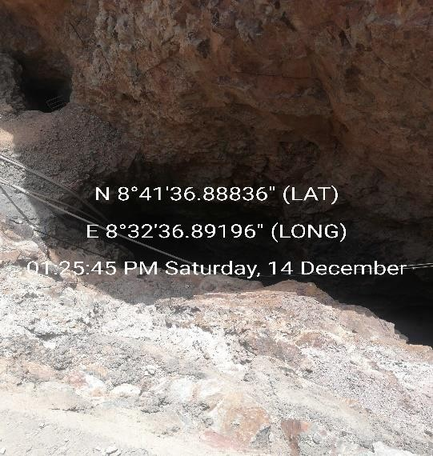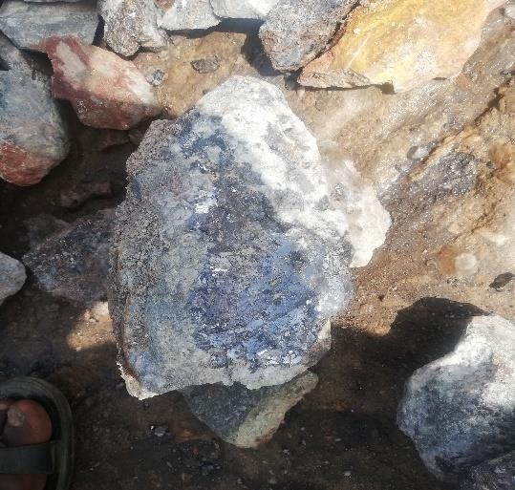

Figure 1: Mining pit Figure 2: Lead-Zinc ore from Nasarawa Eggon

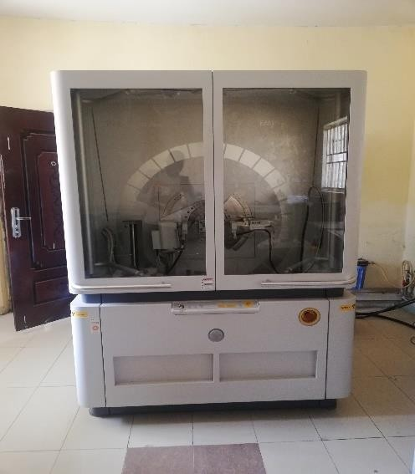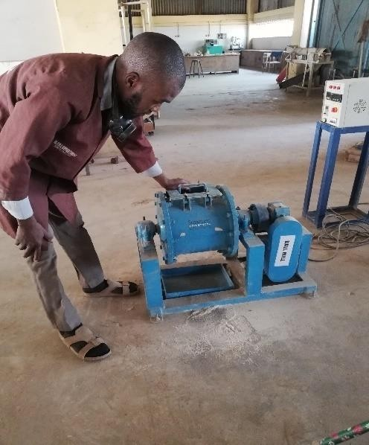

Figure 3: XRD machine Figure 4: Ball Mill machine

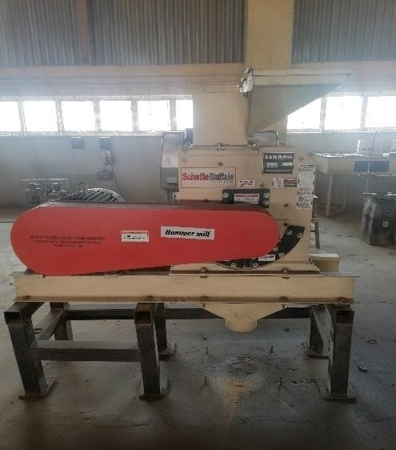 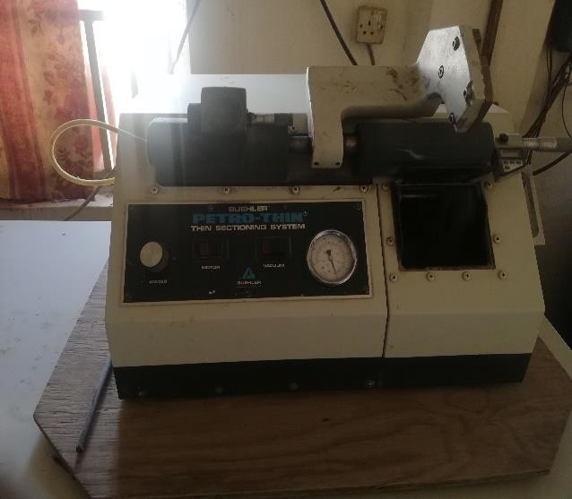

Figure 5: Crushing machine Figure 6: Sample cutting machine

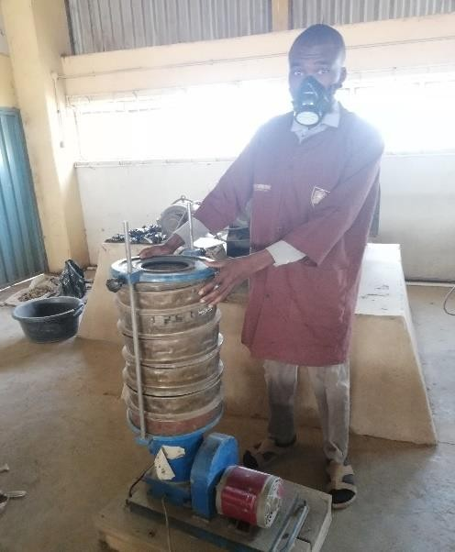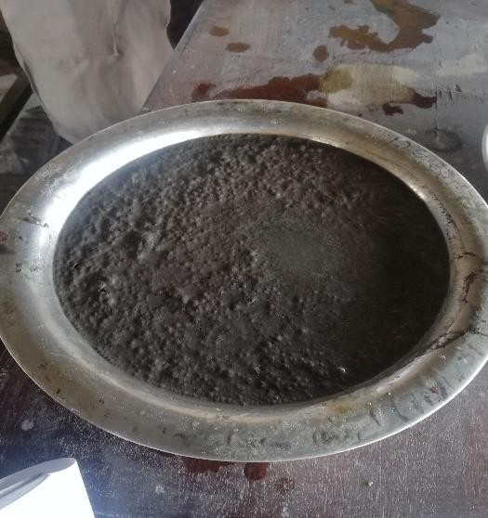

Figure 7: Sieve shaking machine Figure 8: Skimmed froth

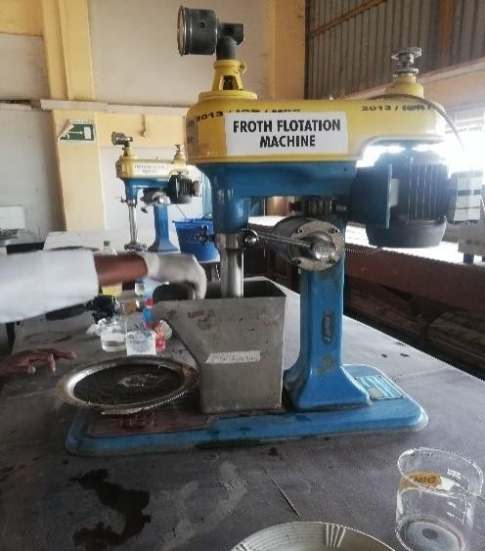 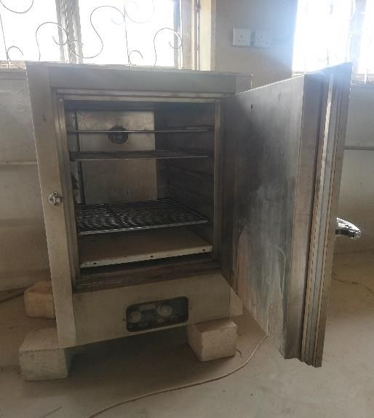

Figure 9: Denver flotation cell Figure 10: oven

Table 1: Chemical analysis of the Head sample

|  |  |
| --- | --- |
| Element | Concentration % |
| Fe2O3 | 2.6316 |
| SiO2 | 45.454 |
| Al2O3 | 2.658 |
| MgO | 1.44 |
| P2O5 | 1.1774 |
| SO3 | 12.947 |
| TiO2 | 1.0156 |
| MnO | 1.04189 |
| CaO | 2.051 |
| K2O | 0.2111 |
| CuO | 0.0537 |
| ZnO | 15.68002 |
| Cr2O3 | 0.00113 |
| V2O5 | [0.00024] |
| As2O3 | 0 |
| PbO | 18.07080 |
| Rb2O | 0.00139 |
| Ga2O3 | 0.1526 |
| NiO | [0.00040] |
| Cl | 0.069 |
| ZrO2 | [-1.03000] |
| BaO | [-1.0400] |
| Ta2O5 | 0 |
| WO3 | 0.84 |
| Br | 0 |
| SrO | 0.460 |
| CeO2 | 0.0068 |
| ThO2 | 0 |
| Y2O3 | 0.00383 |
| Nb2O5 | 0.002898 |