# CHARACTERISTICS OF SOME HYDROLYTIC ENZYMES AND BIOPULPING POTENTIAL OF FUNGAL ISOLATES FROM SELECTED WOOD SAMPLES IN SOUTHWESTERN NIGERIA

**BY**

**FELICIA CHINOMNAZU ADESINA**

**B.Sc., M.Sc. Microbiology (Ibadan)**

OF

**MATRIC NO. 49585**

**A Thesis in the Department**

**MICROBIOLOGY**

**Submitted to the Faculty of Science in partial fulfilment of**

**the requirements for the award of the Degree of**

**DOCTOR OF PHILOSOPHY (Ph.D.)**

**of the**

**UNIVERSITY OF IBADAN, NIGERIA**

**February, 2014**

**Abstract**

Pulping industry is both labour and energy intensive but in Nigeria, electricity supply is unsta- ble. This has contributed to the near collapse of the Nigerian paper and pulp industry despite the rich forest resources in southwestern Nigeria. Use of alternative energy sources such as electricity generating sets further increases production cost. It therefore, becomes pertinent to seek alternative approach aimed at reducing mechanical pulping duration and improving pulp characteristics. The aim of the study was to characterise major hydrolytic enzymes of native fungi from selected wood samples and evaluate their biopulping potential.

Chipped samples of three local woods (*Anogeissus leiocarpus*, *Gmelina arborea* and *Termi- nalia superba*) from Ekiti, Lagos, Ogun, Ondo, Osun and Oyo States were made to undergo spontaneous degradation. Thereafter, fungi were isolated, identified and screened for cellulase and hemicellulase production. Isolates selected based on maximal enzyme activities were used to produce cellulases (glucanase and glucosidase) and hemicellulases (mannanase and xy- lanase) with the chips as substrates. Kinetic, molecular and biochemical properties of partially purified hemicellulases were determined and optimised using standard methods. Chipped wood samples were subjected to treatments with fungal isolates singly and in combination for six weeks. Treated wood samples and pulp were evaluated fortnightly for changes in cellulose, hemicellulose, lignin and ash contents, tensile strength, fibre length and strength. Data were analysed using descriptive statistics and ANOVA at p = 0.05.

Five hundred and twenty-six fungal isolates were obtained and identified as *Aspergillus fla- vus*(13)*, Aspergillus niger*(125)*, Rhizopus* spp(79)*. Lasiodiplodia theobromae*(10), *Penicillium* pur-

purogenum(25)*, Fusarium chlamydosporium*(37)*, Fusarium oxysporum*(30), *Fusarium compa ctum*(25), *Trichoderma harzianum*(75), *Trichoderma reesei*(88) and *Emericella nidulans*(19). *Aspergillus niger, F. compactum, T. harzianum* and *T. reesei* were selected for enzyme pro- duction. Highest production of cellulase was 12.72U/gm±0.11 on *A. leiocarpus* by *T. reesei*. Best producer of mannanase was *A. niger* with 15.50U/gm±0.01 on *G. arborea* while highest xylanase production of 28.93U/gm±0.12 was by *F. compactum* on *A. leiocarpus.* Kinetic properties of xylanase was Vmax 1.402U/min/ml and Km 1.804U/ml with molecular weight of about 90kDa and that of mannanase was Vmax 0.754U/min/ml, Km 1.364U/ml and molecular weight was between 53 and 65kDa. Optimum xylanase activity was at 55oC and pH 5.5 while mannanase was at 30oC and pH 5.5. There was significant reduction in hemicellulose (45- 27%) and lignin (20-15%) in treated wood compared to untreated samples. *Gmelina arborea* singly treated with *F. compactum* gave best result: cellulose, hemicellulose, lignin and ash were reduced by 14.1, 18.9, 4.1 and 4.7 % respectively; while tensile strength, fibre length and strength improved respectively by 6.4, 4.3 and 6.5 %. These conformed to Technical Associa- tion of Paper and Pulp Industries standard. Treatment of *T. superba* with combination of *F. compactum* and *T. harzianum* however, reduced cellulose, hemicellulose, lignin and ash by 20.7, 39.4, 11.9 and 10.6 % respectively, giving a better result than that obtained with single treatment.

Fungal enzyme treated wood samples attained pulp characteristics that met required biopulp- ing standard. Thus, native fungi may be employed for biopulping of common woods in Nige- rian paper and pulp industries.

**Keywords**: Biopulping, Hydrolytic enzymes, Native fungi.

**Word count**: 495

**Acknowledgements**

All glory to God Almighty for His manifold and matchless grace and mercy throughout the

duration of this programme.

My vocabulary falls short when I try switching my thoughts into words to express the deep

sense of gratitude towards my Supervisor and mentor, Prof. Abiodun Anthony Onilude, a

respected Professor of Microbiology, in the Industrial Microbiology Unit, Department of

OF

Microbiology, University of Ibadan. His intellectual prowess, wealth of experience, con-

stant guidance, inspiring attitude and enthusiasm in making this research a success and

more importantly the kind of faith he has on his students has enabled me to work efficient-

ly. My gratitude to him is immeasurable.

Professor Obasola E. Fagade, Head, Department of Microbiology, University of Ibadan, is highly appreciated for his sincere concern and encouraging attitude all through the course of this research. I also say thank you to all other lecturers and technologists in the depart- ment who have in one way or the other contributed to the success of this work. The en- couraging words and effort of Drs. A. A. Ogunjobi and Bukola C. AdebayoTayo is highly acknowledged.

I appreciate the efforts of Professors Babajide Owoeye, S.O. Agunbiade and Mr M.O.

Oluwole all of Lead City University (LCU), Ibadan; Dr Oyin Adenipekun (Botany De-

partment, U.I.), Drs Raphael Okonji and Taiye Awojobi of Obafemi Awolowo University.

The support of Mrs. Bunmi Ayoola of Forestry Research Institute, Ibadan Nigeria is highly

appreciated.

To my colleagues in the Microbial Physiology & Biochemistry Laboratory, Folake, Bun-

mi, Buky, Mr Ayodele; Lola, Jumoke Alao and Sarah Oni of LCU, Thank you so much for

your encouraging words.

I appreciate my brethren for their prayers and encouragement, Revd. KAP Olanrewaju,

Mrs. M. E Adedeji, Revd. (Dr.) Funso Adisa, Revd. Tunde Popoola, Brother Gilbert Olu-

wafemi and others too many to mention, may the Almighty bless you (Amen).

I remain indebted to my husband Mr. Taiwo John Adesina, who is also a pillar to the suc- cess of this programme, thank you MY CROWN for your enormous support, love and un- derstanding throughout the years. I cannot fail to appreciate my NOBLES (John, Johanna and Naomi), thanks for bearing with me and helping where need be. I love you.

To my mum and dad, I am very glad to have you by my side in achieving this feat, God

will bless you abundantly and I pray your effort will not be in vain. To my sisters and

brothers, thanks for accepting me and believing in me, I appreciate your encouragement

always.

Felicia C. Adesina

February, 2014.

**Certification**

I certify that the project work was carried out by **Felicia C. ADESINA**, in the Department

of Microbiology, University of Ibadan, Nigeria, under my supervision.

**………………………………………………………**

OF

Supervisor

**Prof. Anthony Abiodun ONILUDE B.Sc., M.Sc. (Ife) Ph.D. (Ibadan) Professor of Microbiology Department of Microbiology, University of Ibadan. Nigeria.**

**DEDICATION**

OF

This project is dedicated to my parents and teachers who cooperated with the Almighty

God to make something out of nothing that I am.

**LIST OF ABBREVIATIONS**

% Percentage

µg microgram

µm Micrometer

µM Micromolar

AOX Adsorbable organic halogen

oC Degree Centigrade

Ca2+ Calcium ion

OF

CMC Carboxymethylcellulose

CTMP Chemithermomechanical pulping

Cu2+ Copper ion

DDT Dithiothreitiol

DNSA Ditrosalicylic acid

ECF Elemental Chlorine free

EDTA Ethyldiaminetetracetic acid

oE Degree East

Fe2+ Iron ion

Glu D-Glucose

H2O Water

H2O2 Hydrogen peroxide

ISO International Organisation for Standardisation

kDa Kilodalton

Km Michaelis-Menten constant

kPa Kilopascal

M Molar concentration

mg Milligram

Mg2+ Magnesium ion

min Minute

ml Millilitre

mM Millimolar

Mn2+ Manganese ion

OF

oN Degree North

N/cm Newton per centimeter

Na+ Sodium ion

NCPC National Council on Privatisation and Commerciali-

sation

ng nanogram

Nm/g Newton meter per gram

NO3- Nitrate ion

OD Optical density

PGW Pressurized ground Wood

pNP p-nitrophenyl

pNPG p-nitrophenyl β-glucopyranoside

PO43- Phosphate ion

psi Pounds per square inch

RMP Refiner mechanical pulping

RMRDC Raw Material Research and Development Control

rpm Revolution per minute

sec Second

SO42- Sulphate ion

spp. Species

TAPPI Technical Association of Paper and Pulp Industry

TCT Totally Chlorine free

TMP Thermo mechanical pulping

OF

U/g ds Unit per gram dry substrate

U/ml Unit per milliliter

UV Ultraviolet

v/v Volume per volume

Vmax Maximum velocity

w/v Weight per volume

Zn2+ Zinc ion

# TABLE OF CONTENTS

**Content Page**

Title i

Abstract ii-iii

Acknowledgement iv-v

Certification vi

Dedication vii

OF

List of Abbreviations viii-x

Table of Contents xi-xvii

List of Tables xviii-xix

List of Figures xx-xxvi

List of Plates xxvii

List of Appendices xviii

|  |  |  |
| --- | --- | --- |
| CHAPTER 1 |  | |
|  | **Introduction** | 1 |
| 1.1 | General consideration | 1 |
| 1.2 | Statement of problem | 5 |
| 1.3 | Justification of the current work | 5 |
| 1.4 | Aims and objectives of the current project | 6 |

|  |  |  |
| --- | --- | --- |
| **Content**  CHAPTER 2 |  | **Page** |
|  | **Literature Review** | 7 |
| 2.1 | Wood and its components | 7 |
| 2.1.1 | Hard wood and soft wood | 7 |
| 2.1.2 | Structural components of wood | 10 |
| 2.1.2.1 | Cellulose | 14 |
| 2.1.2.2 | Hemicelluloses | 15 |
| 2.1.2.3 | Lignin | 17 |
| 2.2 | Degradation of wood | 18 |
| 2.2.1 | Fungal degradation of wood | 18 |
| 2.2.1.1 | White rot degradation | 19 |
| 2.2.1.2 | Brown rot degradation | 20 |
| 2.2.1.3 | Soft rot degradation | 20 |
| 2.2.2 | Enzymatic degradation of wood Components | 21 |
| 2.2.2.1 | Enzymatic hydrolysis of cellulosic components | 21 |
| 2.2.2.2 | Enzymatic degradation of hemicellulosic Components | 23 |
| 2.2.2.3 | Enzymatic degradation of lignin | 27 |
| 2.2.2.4 | Factors governing fungal enzymatic degradation of wood | 28 |
| 2.3 | Microorganisms in enzymatic hydrolysis of wood | 30 |
|  | components |  |
| 2.3.1 | Cellulose component | 30 |
| 2.3.2 | Hemicellulose component | 31 |

OF

# Content Page

* 1. Solid state fermentation in the production of enzymes 33
     1. Definition General consideration 33
     2. Substrate selection for SSF 35
  2. Industrial uses of hydrolytic enzymes 38
  3. The pulp and paper industry 39
     1. Mechanical Pulping 40
     2. Chemical Pulping 41

OF

* + 1. Biopulping 42
    2. Pulp and paper industry and hydrolytic enzymes 46
  1. Biobleaching 47
  2. Nigerian Forest wood types 47
     1. Potentials of locally sourced fibres for the Nigerian pulp 48

and paper industry

* + 1. Pulp and paper industry in Nigeria 49
  1. CHAPTER 3

Materials and Methods 52

* 1. Sample collection 52
     1. Identification of Wood samples 52
     2. Sample processing 52
  2. Sterilization of glassware, media and other apparatus 53
  3. Isolation and culture methods 55

**Content Page**

* + 1. Isolation procedure 55
    2. Identification of pure cultures of isolates 55
       1. Macroscopic examination 55
       2. Microscopic examination 56
    3. Maintenance of pure culture of selected isolates 56
  1. Screening of fungal isolates for cellulolytic and 56

hemicellulolytic activities

OF

* + 1. Primary/Qualitative Screening of isolates 56
    2. Secondary/ Quantitative Screening of isolates 57
  1. Treatment of Selected Wood Samples 58
     1. Mechanical Milling of Wood Samples 58
     2. Thermal Pre - treatment of Samples 58
  2. Preparation of Fungal Inocula 59
     1. Determination of Inoculum Size 59
  3. Selection of Wood Substrate for SSF 59
  4. Production of hydrolytic enzymes by solid state 60

fermentation of wood chips by isolates

* + 1. Growth medium preparation 60
    2. Inoculation of medium 60
    3. Extraction of enzyme from fungi 60
  1. Assay of Hydrolytic enzyme 61
     1. Glucanase assay 61

# Content Page

* + 1. Glucosidase assay 61
    2. Mannanase assay 62
    3. Xylanase assay 63
    4. Xylosidase assay 63
  1. Protein determination 64
  2. Optimization of Production Conditions for Xylanases 64
     1. Effect of varying initial temperature on xylanase production 64

OF

* + 1. Effect of varying initial moisture content on xylanase production 65
    2. Effect of varied initial pH on xylanase production 65
    3. Effect of various organic nitrogen sources on xylanase production 65
    4. Effect of varied initial aeration on xylanase production 66
    5. Effect of different inoculum sizes on xylanase production 66
    6. Effect of Different moistening media on xylanase production 66
  1. Characterisation of selected hydrolytic enzymes 67
     1. Effect of different temperature on activity of partially purified 67

enzymes

* + 1. Effect of different pH on activity of partially purified enzymes 67
    2. Effect of varying substrate concentration on activity of partially 68

purified enzymes

* + 1. Effect of different anions on activity of partially purified enzymes 68
    2. Effect of different cations on activity of partially purified enzymes 68

# Content Page

* 1. Purification of Enzyme 69
     1. Ammonium sulphate precipitation 69
     2. Dialysis of the enzyme preparation 69
     3. Fractionation of the enzyme concentrates on sephadex 70

G-50 columns

* + 1. Further fractionation by ion exchange chromatography 71
  1. Purification test with SDS – PAGE 72

OF

* + 1. Procedure 73
  1. Studies on Biopulping potentials of isolates and their enzymes

on wood and pulp Samples 74

* + 1. Preparation of wood chip samples 74
    2. Preparation of bulk inoculum 75
    3. Description and preparation of the fermentation vessel 75
    4. Inoculation of wood chip samples using fungal spores 76
       1. Inoculation of Wood Chips with Fungal Spores 76
    5. Determination of cellulose and hemicellulose contents 79

of wood chips

* + 1. Determination of ash content of Wood Chips 81
    2. Determination of lignin content of Wood chips 81
    3. Refinning of Wood Samples 81
    4. Determination of Fiber Length, Fibre strength and Tensile

strength of Wood pulp 82

**Content Page**

* + 1. Xylanase application on brown carton paper pulp 83

3.18 Statistical analysis 84

CHAPTER 4

# Results 85

CHAPTER 5

OF

**Discussion** 147

# Conclusions 173

# Recommendation 174

**REFERENCES** 175

**APPENDICES** 225

# Published Papers from this Work 235

|  |  |  |
| --- | --- | --- |
|  | **LIST OF TABLES** |  |
| **Table** |  | **Page** |
| 2.1 | Some Characteristics of softwood and hardwood fibres | 9 |
| 2.2 | Differences between Solid-state and Submerged liquid | 37 |
|  | Fermentation |  |
| 2.3 | Cost Implication for Non Production by the Three Primary | 51 |
|  | Paper Manufacturers in Nigeria |  |
| 4.1 | Percentage Frequency of occurrence (% F.O.) of isolates on | 89 |
|  | degrading woods |  |
| 4.2 | Relative cellulase activity of fungal isolates from different wood | 91 |
|  | types on primary screening |  |
| 4.3 | Relative hemicellulase activity of fungal isolates from different | 92 |
|  | Wood types on primary screening |  |
| 4.4 | Average Biomass profile, Total protein, Cellulase and Hemicellulase activities of selected fungal isolates in secondary Screening | 93 |
| 4.5 | Purification Table of Glucanase Produced by *T. reesei* TRS | 135 |
| 4.6 | Purification Table for Mannanase Produced by *A. niger* ANGA1 | 136 |
| 4.7 | Purification Table of Xylanase Produced by *F. compactum* FCGA | 137 |
| 4.8 | Physical Characteristics of Chemically pulped *T. superba* | 144 |
|  | pretreated with Fungi and Unpretreated pulp |  |

# Table Page

* 1. Physical Characteristics of pulp of *G. arborea* pretreated with 145

fungi and Unpretreated samples

* 1. Effect of Xylanase treatment on Kappa number of Brown 146

Paper pulp and on the amount of xylose in hydrolysate

* 1. Factors (*f*) (to correct) for different percentages of permanganate used 235

**LIST OF FIGURES**

# Figure Page

* 1. Composition of wood 11
  2. Structural model of lignin 12
  3. A schematic structure of a cellulose chain 13

3.1 Extracted Map of Southwestern Nigeria showing the sampling areas 54

* 1. a Time course on production of hydrolytic enzymes by *A. niger*ANGA1 on 101

*A. leiocarpus* as substrate

4.1b Time course on production of hydrolytic enzymes by *A. niger* ANGA1 on 101

*T. superba* as substrate

* 1. c Time course on production of hydrolytic enzymes by *A. niger*ANGA1 on 101

*G. arborea* as substrate

* 1. a Time course on production of hydrolytic enzymes by *F. compactum*FCGA 102 on *A.leiocarpus* as substrate

4.2b Time course on production of hydrolytic enzymes by *F. compactum*FCGA 102 on *G. arborea* as substrate

* 1. c Time course on production of hydrolytic enzymes by *F. compactum*FCGA 102 on *T. superba* as substrate
  2. a Time course on production of hydrolytic enzymes by *T. harziarnum* 103

THMA on *A. leiocarpus* as substrate.

4.3b Time course on production of hydrolytic enzymes by *T. harziarnum* 103

THMA on *G. arborea* as substrate

# Figure Page

4.5f Xylanase activities of isolates on *A. leiocarpus* as substrate at different 111 inoculum sizes

* 1. g Xylanase activities of isolates on *A. leiocarpus* as substrate using 112

different mineral salts

* 1. a Effect of temperature on activity of partially purified xylanase from 116

*F. compactum* FCGA

4.6b Effect of pH on activity of partially purified xylanase from *F. compactum* 116 FCGA

4.6c Effect of different xylan concentrations on activity of partially purified 116

xylanase from *F. compactum* FCGA

4.6d Effect of different concentrations of some anions on activity of partially 117

purified xylanase from *F compactum* FCGA

4.6e Effect of different concentrations of some cations on xylanase activity 117

of partially purified xylanase by *F. compactum* FCGA

* 1. f Effect of temperature on stability of xylanase from *F compactum* FCGA 117
  2. a Effect of different temperature on activity of partially purified 118

β – mannanase from *A. niger* ANGA1

4.7b Effect of different pH on activity of partially purified β – mannanase 118

from *A. niger* ANGA1

|  |  |  |
| --- | --- | --- |
| **Figure** |  | **Page** |
| 4.7c | Effect of different mannan concentrations on activity of partially | 118 |
|  | purified β - mannanase from *A. niger* ANGA1 |  |
| 4.7d | Effect of different anions‟ concentrations on the activity of partially purified β - mannanase *A. niger* ANGA1 | 119 |
| 4.7e | Effect of different cations‟ concentrations on the activity of | 119 |
|  | partially purified β-mannanase from *A. niger* ANGA1 |  |
| 4.7f | Thermostability of partially purified β - mannanase from *A. niger*  ANGA1 | 119 |
| 4.8a | Effect of different temperatures on activity of partially purified | 120 |
|  | glucanase from *T. reesei* TRS |  |
| 4.8b | Effect of different pH on activity of partially purified glucanase | 120 |
|  | from *T. reesei* TRS |  |
| 4.8c | Effect of different substrate concentration on activity of partially purified | 120 |
|  | glucanase from *T. reesei* TRS |  |
| 4.8d | Effect of different concentration of anion on activity of partially | 121 |
|  | purified glucanase from *T. reesei* TRS |  |

|  |  |  |
| --- | --- | --- |
| **Figure** |  | **Page** |
| 4.15 | Separation of proteins Protein from eluants of *F. compactum* FCGA  during Ion Exchange chromatography and enzymic reactions of | 131 |
|  | towards Xylan |  |
| 4.16 | Separation of proteins of Protein from eluants of *A. niger* ANGA1 during Ion Exchange chromatography and enzymic reactions of fractions | 132 |
|  | towards Mannan |  |
| 4.17 | Separation of proteins from eluants of *T. reesei* TRS during Ion | 133 |
|  | Exchange chromatography and enzymic reactions of fractions towards |  |
| 4.18a | Carboxylmethyl cellulose  Percentage reduction in ash, cellulose, hemicellulose and lignin contents | 141 |
| 4.18b | of *T. superba* pretreated with *F. compactum* FCGA  Percentage reduction in ash, cellulose, hemicellulose and lignin contents | 141 |
|  | of *T. superba* pretreated with *T. harzianum* THMA |  |
| 4.18c | Percentage reduction in ash, cellulose, hemicellulose and lignin | 141 |
|  | contents of *T. superba* pretreated with *T. harzianum* THMA and |  |
|  | *F. compactum* FCGA |  |
| 4.19a | Percentage reduction in ash, cellulose, hemicellulose and lignin contents | 142 |
|  | of *G. arborea* pretreated with *T. harzianum* THMA |  |

# Figure Page

4.19b Percentage reduction in ash, cellulose, hemicellulose and lignin contents 142 of *G. arborea* pretreated with *F. compactum* FCGA

4.19c Percentage reduction in ash, cellulose, hemicellulose and lignin contents 142

of *G. arborea* pretreated with *F. compactum* FCGA and *T. harzianum*

THMA

# LIST OF PLATES

**Plate Page**

* 1. *G. arborea* Wood Chips prepared for pre-treatment with fungi 77
  2. *T. superba* Wood Chips prepared for pre-treatment with fungi 78
  3. Plate culture of *T. reesei* TRS 95
  4. Plate culture of *F. compactum* FCGA 96
  5. Culture plate of *A. niger* ANGA1 97
  6. Culture plate of *T. harzianum* THMA 98
  7. Sodium dodecyl Sulphate Electrophoresis Profile of major hydrolytic enzymes from the isolates 139

# LIST OF APPENDICES

**Appendix Page**

1. Composition of isolation medium and Protein estimation reagent 225
2. Protein Estimation Reagent 226
3. Set up of Gel Chromatography 227
4. Standard mannose curve 228
5. Xylose Standard Curve 229
6. Standard glucose curve 230
7. Standard paranitrophenyl curve 231
8. TAPPI 236 Method for Determination of Kappa number of pulp 232

# CHAPTER ONE

* 1. **INTRODUCTION**

# General Consideration

Virtually all chemical reactions in biological systems are catalysed by macromolecules

called enzymes. An enzyme is a biological catalyst that exhibit enourmous power, increas-

ing the rate of a chemical reaction without causing a permanent chemical change in the re-

OF

actant or substrates and products (Howard *et al.,* 2003). Nearly all known enzymes are pro-

teins and they are among the most remarkable biomolecules known. The global market for

industrial enzymes was $2.9 billion in 2008, $3.1 billion in 2009 and $3.3 billion in 2010

and is expected to reach $4.4 billion by 2015, achieving a compound annual growth rate of

6%, according to the publishers of technology market research reports, reviews and tech-

nical newsletters (BCC Research). Three quarters of the market is for enzymes involved in

hydrolysis of natural polymers i.e. hydrolytic enzymes (Erickson *et al*., 2012).

Hydrolytic enzymes catalyse the conversion of the polymeric carbon source available in

the plant cell wall into simple sugar for microbial metabolism (Howard *et al.,* 2003; Schel-

ler and Ulvskov, 2010). Most of these enzymes are synthesized chemically but due to the

clamour for the need to shift to more environmentally friendly synthetic processes efforts

are being shifted from chemical synthesis of these enzymes to their biosynthesis.

Micoorganisms are the largest group of living cells employed for the production of various

enzymes including hydrolytic enzymes because of their short generation time and high

yields of easy to harvest extracellular enzymes (Filler, 2007). The potential application of

hydrolytic enzymes in biotechnology can not be overemphasized as their significance in

various industries is vast. They are of great use in the production of fuel, chemical, food,

brewery and wine, animal feed, textile and laundry, pulp and paper and agriculture (Tsu-

jibo *et al.,* 2001; Howard *et al.*, 2003; Scheller and Ulvskov, 2010). The main substrate of

hydrolytic enzyme is lignocellulose which is a major component of plant biopolymers, and

OF

it makes up about half of the matter produced by photosynthetic plants (Hagglund, 2002;

Saha, 2003; Jiguang *et al*., 2011). Lignocellulose is made up of three types of polymers -

cellulose, hemicelluloses and lignin which are strongly intermeshed and chemically bond-

ed by non covalent forces and by covalent cross linkages. The cleavages of these bonds are

catalysed by an array of hydrolytic enzymes. Lignocellulose is the major structural compo-

nent of woody plants and represents a major source of organic material. The chemical

properties of the components of lignocellulosics make them a substrate of enormous bio-

technological value (Hagglund, 2002; Mahherbe and Cloete, 2003; Arantes and Saddler,

2011). Many of these lignocellulosic sources can be bioconverted into various different

value added products including paper (Howard *et al*., 2003; Moreira and Filho, 2008).

The biological degradation of cellulose, hemicelluloses and lignin has attracted the interest

of microbiologists and biotechnologists for many years. Fungi have been found to be the

best known microorganisms capable of degrading these three polymers. The insoluble na-

ture of these polymers makes the degradation to occur extracellularly with the aid of extra-

cellular enzymes. These extracellular enzymes are best produced by fungi in solid state

fermentation (SSF) system (Losaine *et al*., 1992; Manpreet *et al*., 2005).

SSF is an ancient fermentation technology; it involves growth of microorganisms on water

insoluble substrates in the presence of varying amount of water (Manpreet *et al*., 2005;

Pandey *et al*., 2007). Agro based substrates products and wastes are considered the best

substrate for SSF processes, and the use in SSF for the production of extracellular hydro-

OF

lytic enzymes is no exception to that. Some of the substrates that have been used include

wood dust, shavings and chips. The successful production of enzymes by SSF method de-

pends on so many factors such as cost of substrate, availability of nutrients in the substrate

and its ability to act as anchorage for the cells.

A very important use of hydrolytic enzymes of which this study is focused on, is the treat-

ment of wood with fungal isolates and their enzymes in the pulp and paper industry which

is generally referred to as biopulping and biobleaching. Pulping refers to the process em-

ployed to convert wood into fibrous material suitable for making paper and allied products.

This technology capitalizes upon the anatomical, physical and chemical properties of

wood.

Wood is pulped by two conventional techniques, these are by mechanical and chemical

methods. Each of these methods have their shortcomings in being highly energy demand-

ing and in generating recalcitrant substances and environmentally unfriendly substances.

One of the most promising technologies is the modification of pulping process through

biological means. Use of fungal inoculants to modify wood constituents before conven-

tional pulping offers an attractive opportunity for mechanical pulp (Shukla *et al*., 2004). In

the case of chemical pulping this method can be used to facilitate easy axtraction of useful

component and increase yield (Castillo *et al*., 2000).

Countries such as America and Sweden have successfully biopulped soft wood of different

genera indigenous or common to their localties with several white rot fungi for modifica-

tion of wood lignin and achieved very good results. China and India have successfully pro-

duced commercial pulp from the biopulping of their indigenous wood - Jute, bamboo and

Eucalyptus and non woody components of plants like kenaf, bargaisse and grasses, (Mon-

OF

teil *et al.,* 2002; Yadov *et al*., 2010).

The wood raw material for the manufacture of pulp and paper is obtained from the forests.

Southwestern Nigeria and some parts of the country‟s South Eastern regions are endowed with woody plants of the hardwood type. Out of the forest vegetation 983,303km2, only

9.75% is made government reserved forest which is a rather low percentage compared to

the available forest vegetation.This small percentage forms the main source of wood sup-

ply for the needs of all the industries utilizing wood as raw material. A very useful

goldmine which can be great source of income and foreign exchange to this country is the

use of this abundant forest vegetation as source of raw material for production of paper

pulp, and the use of native fungi and their enzymes in biobleaching of the pulp. Unfortu-

nately however the paper and pulp industry in Nigeria is more or less dead with the closure

or sale of almost all the government owned paper and pulp industries in the country. Their

prolonged closure prior to eventual sale has amounted to total neglect of the entire pulp

and paper industry in the country. These plants were the bedrock of the industry in Nigeria;

hence all other sectors of the industry that depended on the plants are automatically affect

ed by their closure. The producers of locally sourced fibre raw materials have since aban-

doned the cultivation of these raw materials. Other sectors depending on these plants have

resorted to obtaining their paper products from outside the country. One of the major rea-

sons for the closure of some these industries is the high cost of production for those of

them that use the mechanical pulping method. Electricity supply in Nigeria is epileptic and

the cost of maintaining alternative source of energy is rather high. Treatment of local wood

with native fungi to enhance fibre separation and the use of their enzymes to biobleach

could help in reducing the high cost of production. If this process is successful and is sub-

OF

sequently perfected, it will save the cost of producing paper, create more jobs for the un-

employed and serve as source of foreign exchange for Nigeria.

# Statement of problem

Nigeria is one of the major producers of timber, a woody plant product and raw material for the pulp and paper industry, still the paper and pulp utilized here are imported from other countries. Since the pulping industry in Nigeria is both capital and energy intensive and electricity supply is unstable, being characterised by incessant power outage, it be- comes pertinent to seek how to reduce the use of energy thereby bringing down the high production cost.

# Justification for the current work

Lignocellulose, a substance of enormous biotechnological value, (Godliving and Tui, 2009) is a major structural component of woody plants which are abundant in the Rain for- est region of Nigeria. This resource can be bio-converted into various value added prod- ucts in the paper and pulp industries.

Furthermore, The Nigerian environment is rich in different fungi including mushrooms and micro fungi able to produce extracellular enzymes to hydrolyse and oxidatively breakdown wood components for the purpose of bioconversion. These fungal emzymes also act as bi- obleachers, a situation that could erode the high cost of synthetic bleaching agents in use during pulping thus reduce cost.

Though Nigeria is bemoaned with electrical energy supply and outage problem, the coun- try could take advantage of a developed biopulping procedure to resuscitate our near to death paper and pulp industry. Therefore an investigation of the biopulping potentials of local fungal isolates and their enzymes on our local wood species will go a long way in bringing down the price of paper for local consumption and possible export to realize scarce foreign exchange for the country.

# Aims and Objectives of the Project.

The current work aims at achieving the following objectives:

* + 1. Isolation, identification and screening of fungi from local wood samples for their hydrolytic enzyme activities.
    2. Selection of suitable wood substrate as well as production and optimization of pro- duction condition for maximal production of some hydrolytic enzymes by the iso- lates.
    3. Purification and characterization of the partially purified enzymes.
    4. Application of the fungal isolates and the crude xylanase on wood and different

pulps for plant fiber separation and for biobleaching respectively.

# CHAPTER TWO

* 1. **LITERATURE REVIEW**

# Wood and its components

Wood is an organic material, a natural [composite](http://en.wikipedia.org/wiki/Composite_material) of [cellulose](http://en.wikipedia.org/wiki/Cellulose) fibers embedded in a matrix of [lignin](http://en.wikipedia.org/wiki/Lignin) which resists compression. It is a porous plant material made up of various types of xylem cells in the stems of [trees](http://en.wikipedia.org/wiki/Tree) (and other woody plants) (Saitta *et al*., 2011). Wood may also refer to other plant materials with comparable properties, and to material engi- neered from wood, or wood chips or fiber (Hoadley, 2000).

# Hard and Soft Woods

There is a strong relationship between the properties of wood and the properties of the par- ticular tree that yielded it. For every tree species there is a range of density for the wood it yields. There is a rough correlation between density of a wood and its strength (mechanical properties). For example, while [mahogany](http://en.wikipedia.org/wiki/Mahogany) is a medium-dense hardwood which is excellent for fine furniture crafting, [balsa](http://en.wikipedia.org/wiki/Ochroma_pyramidale) is light, making it useful for [model](http://en.wikipedia.org/wiki/Model_(physical)) building (Lars *et al*., 2005). It is common to classify wood as either [softwood](http://en.wikipedia.org/wiki/Softwood) or [hardwood](http://en.wikipedia.org/wiki/Hardwood). The wood from [co-](http://en.wikipedia.org/wiki/Pinophyta) [nifers](http://en.wikipedia.org/wiki/Pinophyta) (e.g. pine) is called softwood, and the wood from [dicotyledons](http://en.wikipedia.org/wiki/Dicotyledons) (usually broad-leaved trees, e.g. oak) is called hardwood. Not only do hardwood and softwood trees differ in ex- ternal appearance the wood formed by them are morphologically different (Dickison, 2000). The types of cells, their relative numbers and their arrangement are different. Hard- wood contain vessel element while softwood do not. Hardwoods are not nec

essarily hard, and softwoods are not necessarily soft. The well-known balsa (a hardwood) is actually softer than any commercial softwood. Conversely, some softwood (e.g. [yew](http://en.wikipedia.org/wiki/Taxus_baccata)) are harder than many hardwoods (Sheyfauman, 1999; Onilude, 2011). Softwoods consist mainly of long tracheids and smaller ray parenchyma cells. Water transport and stem strength are mainly sustained by the dead tracheid cells. In addition, longitudinal resin ducts exist (Kuhad *et al*., 1997). Examples of softwood include southern pine, douglas fir, spruce, etc. Softwood has higher lignin content than hardwood while the cellulose content of softwood is less than that of hardwood. Their fibres with their length and coarseness are generally used to provide strength to a sheet of paper.

Hardwoods have more diverse types of xylem cells including fibers, vessels, and ray pa- renchyma cells (Dickison, 2000). Examples of common hardwood include birch, aspen, red gum, mahogany, mansonea and other tropical wood species. Hardwood fibres, being finer and more conformable, give a sheet of paper with smooth printing surface and opaci- ty. Hardwood fibres are also easier to bleach to high brightness because they have less lig- nin (Perez *et al.,* 2002).

**Table 2.1:** Some Characteristics of softwood and hardwood fibres

|  |  |  |
| --- | --- | --- |
| Wood characteristics | Softwood | Hardwood |
|  |  |  |
| Cellulose content | 42% +/- 2% | 45% +/- 2% |
| Lignin content | 28% +/- 3% | 20% +/- 4% |
| Extractives content | 3% +/- 2% | 5% +/- 3% |
| Fibre length | 2-6 mm | 0.6-1.5 mm |
| Coarseness | 15-35 mg/100 mm | 5-10 mg/100m |

(Eriksson *et al.,* 1990)

OF

# Structural Components of Wood

The composition of woody biomass depends on the plant species, age, growth conditions

and fractionation or processing steps (Perez *et al.,* 2002). Three important constituents

make up the woody plant cell wall material, two linear polymers (cellulose and hemicellu-

loses), and a non-linear 3 - dimensional polymer, lignin (Harris and Stone, 2008). [Cellu-](http://en.wikipedia.org/wiki/Cellulose)

[lose](http://en.wikipedia.org/wiki/Cellulose) is about 40% – 50% of the wood composition and [hemicellulose](http://en.wikipedia.org/wiki/Hemicellulose) which makes about

15% – 25% is impregnated with [lignin](http://en.wikipedia.org/wiki/Lignin) that is around 15% –30% of the total wood content

depending on wood type (Kappei, 2008). Generally, the lignin content of softwood is high-

OF

er than hardwood (Engelkesera, 1997; Levasseur *et al.*, 2005).

These three constituents of wood form what is called the lignocellulosic material (Jeffries*,*

1994). Lignocellulose is a physically hard, dense material which is recalcitrant to degrada-

tion. It is rich in carbon and chemical energy and hence depolymerisation is essential to

maintain the carbon cycle (Malherbe and Cloete, 2003). Other components of the cell wall

include pectic substances, protein, waxes, cutin, suberin and sporopollenin (Malherbe and

Cloete, 2003). Depending on the wood species, 2-5% of the wood dry weight is made up of

extractives which are non-structural constituents of wood as defined by Dickison (2000)

and may be broadly divided into terpenes, resins, and phenols. In addition, low amounts of

proteins and inorganic compounds are present in the wood (Fengel and Wegeney, 1989;

Levasseur *et al.*, 2008).

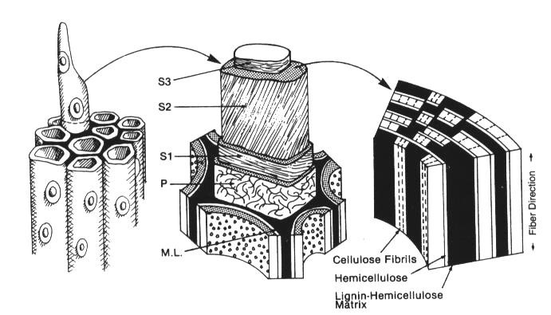

**Figure 2.1**: Composition of wood showing a schematic illustration of the morphology of

OF

the tracheids, secondary wall layers and the relationship of lignin, hemicellulose and cellu- lose in the secondary wall of a tracheid.

ML: middle lamella, P: primary wall, S1-S3: secondary cell wall layers. (Eriksson *et al.,*

1990; Kirk & Cullen, 1998)

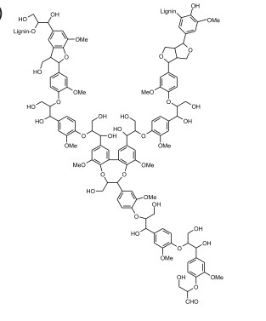

**Figure 2.2**: Structural model of lignin (Brunow, 2001).

OF

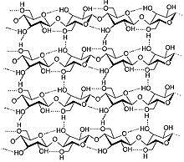

**Figure 2.3:** A schematic structure of a cellulose chain (Ronald and Jaap, 2001)

* + - 1. Cellulose

Cellulose is the main polymeric component of the plant cell wall and is the most abundant polysaccharide on earth. It is a homopolymer consisting of β-D-glucopyranose units that are linked with β-1, 4 glycosidic bonds consisting of about 1,000 to 10,000 resi- dues (Vincent, 1999; Berlin *et al*., 2006). Cellobiose molecules are bound through intra- and intermolecular hydrogen bonds, which assemble to form elemental fibrils and conse- quently form microfibrils linked by van der Waals force (Brown, 1999; Lynd *et al*., 2002; Morais *et al*., 2010). Physical and chemical evidence indicates that cellulose contains highly crystalline molecules that, together with other cell wall components such as hemicellulose and lignin, results in very complex morphologies and less-ordered amorphous regions (Hon, 1994; Chir *et al*., 2011). The amorphous regions are non - or- ganized cellulose chains (Vincent, 1999). The fibre contains about 2.5 billion hydrogen bonds. This hydrogen bonding is the basis of the high tensile strength of cellulose (Henris- sat *et al.,* 1998; Morais *et al*., 2010). Even though cellulose is quite recalcitrant, various cellulolytic organisms such as *Aspergillus* sp. and *Cellulomonas* sp. produce glycoside hy- drolases that are able to cleave the glycosidic linkages in cellulose (Berlin *et al*., 2006). The armouphous region forms the skeleton of the plant wall and has the most desired prop- erties for making paper. These fibres are long, strong and translucent (Paul *et al.,* 2003).

# Amorphous Components of Cellulose:

**The Pectic Substances**:

These consist of polymers of d-galacturonic acid, 1-arabinose, d-galactose and 1-

rhamnose. These substances are found mainly in the middle lamella of primary walls.

(Jeoh *et al.,* 2006). Arantes and Saddler (2011) studied the metabolic changes that occur in 14

the pectic substances deposited in the wall. They deduced that the strongly acidic polyga-

lacturonic acid was formed first.

* + - 1. Hemicelluloses

Hemicellulose consists of several different sugar units and substituted side chains in the form of a low molecular weight linear or branched polymer. Hemicelluloses are co- polymers of both hexose and pentose sugars. The branched structure allows hemicellulose to exist in an amorphous form that is more susceptible to hydrolysis. Within biomass, hem- icelluloses are situated between the lignin and the collection of cellulose fibres underneath. It resembles cellulose in the conformation of the individual polysaccharide chains, and is water insoluble as compared to cellulose (Kumar and Wyman, 2009).

The basic structural components of hemicelluloses are xylan, xylobiose, mannan, manno- biose, galactoglucomannan, - 1, 5 - L - arabinan and arabinogalactan. Different hemicel- luloses are found in wood derived from gymnosperms (softwoods) and angiosperms (hardwood) (Capoe *et al.,* 2000; Petkowicz *et al*., 2001). They function as a major structur- al unit in wood and seeds of plants and is responsible for interacting with and keeping cel- lulose fibres connected (Liepman *et al*., 2007). The amounts of the different hemicelluloses vary depending on the cell type and the stage of development (Capoe *et al.,* 2000). In soft- woods, the major hemicelluloses are o-acetyl-galactoglucomannan and arabino-4–o- methylglucuronoxylan, an exception being larchwood where arabinogalactans is the pre- dominant hemicelluloses (Capoe *et al.,* 2000). The most prevalent hemicellulose in hard- wood is xylan accounting for about 20-35% of the total dry weight in tropical plant bio- mass (Hagglund, 2002). It is composed of D-xylopyranosyl units linked by -1, 4- glycosidic bonds. In hardwood, the xylan backbone is modified with various side chains,

including 4-o–methyl-D-glucuronic acid linked to the xylose units via -1, 2-glycosidic bonds linked to the xylose units at the O-2 and O-3 position. In softwood xylans, in addi- tion to uronic acids, there are L-arabinofuranose residues attached to the main chain by - 1, 2 and / or - 1, 3-glycosidic linkages (Bura *et al*., 2009).

Mannans and heteromannans are widely distributed in nature as part of the hemicellulose fraction in hardwoods and softwoods, seeds of leguminous plants (Buckeridge *et al*., 2000; Handford *et al*., 2003) and in beans (Lundqvist *et al.*, 2002). Consistent with their structure and side group substitutions, mannans seem to be interspersed and covalently linked with lignins at various points while producing a coat around underlying cellulose strands via hydrogen bonds, but as few H-bonds are involved they are much more easily broken down than cellulose. The mannan layer with its covalent linkage to lignin and its non-covalent interaction with cellulose may be important in maintaining the integrity of the cellulose in situ and in helping to protect the fibers against degradation to cellulases (Puls and Schuseil, 1993; Scheller and Ulvskov, 2010). Mannan is the minor hemicellulose in hardwood from angiosperms (Franco *et al.,* 2004). Hardwood mannans are composed of beta-1, 4-linked mannopyranose and glucopyranose units.These consist of glucose, mannose and galactose in the ratio 1:3:1 (Lundqvist *et al.,* 2002). In hardwoods, a smaller amount of glucoman- nan is also found (Jefferies, 1994; Sittikijyothin *et al.*, 2005). The mannan components of hardwood are amorphous and consist of linear or branched polymers of d-xyloses, d- galactose, d-mannose, 1-arabinose, and 1-rhamnose.

Hemicellulose is made up of heterogeneous polymers of sugar residues like D - xylose, D -

mannose, D - galactose, D - glucose, L - arabinose, 4 – o - -methyl - glucuronic acid, D - galacturonic acid, and D - glucuronic acids linked together by -1, 4-glycosidic bonds, but

-1, 3- , -l, 6-,-l, 2-,-l, 3-, and - 1, 6 - glycosidic bonds have also been reported

(Moreira and Filho, 2008).

* + - 1. Lignin

Lignin is a complex polyphenolic compound present in softwood at a concentration of 20 - 30%

and in hardwood at 18 – 23% (Eriksson *et al*., 1990; Jefferies, 1994). It is an aromatic polymer syn-

thesized from phenyl propanoid precursors (Jefferies, 1994). It is responsible for cell wall rigidity

and durability occurring mostly in the middle lamella of plants (Mosier *et al*., 2005). Synthesis of

lignin takes place via the phenylpropanoid pathway through dehydrogenative polymerization of *p-*

hydroxycinnamyl alcohols. The *p*-coumaryl alcohol, *p-*coniferyl alcohol and *p-*sinapyl alcohol are

OF

polyphenolic precursors that are linked in an irregular pattern through polymerization by peroxi-

dase and laccase enzymes resulting in an aromatic polymer (Boudet *et al*., 1995, Perez *et al*.,

2002). Three major groups of lignin can be distinguished into coniferyl alcohol, sinapyl and p-

coumaryl. Coniferyl alcohol is the main precursor in gymnosperms in which case dehydrogenation

forms guaiacyl lignin. In angiosperms dehydrogenation of sinapyl alcohol and *p-*coumaryl alcohol

forms guaiacyl-syringyl lignin. Grasses contain guaiacyl-syringyl-*p-*hydroxyphenyl-lignin (Eriks-

son *et al*., 1990, Grabber, 2005). Its common building block is the phenylpropene unit which con-

sists of a hydroxylated six - carbon aromatic benzene ring and a 3- carbon linear side chain. A sin-

gle lignin molecule can consist of up to 600 cross-linked phenyl propene units (Wiley *et al.,* 2008).

Unlike cellulose or hemicelluloses, lignin is not readily biologically degraded due to the absence of

hydrolysable bonds. It consists of random stable carbon-carbon and ether linkages between mono-

meric units (Perez *et al*., 2002, Mosier *et al*., 2005). A reduction in the concentration, hydrophobi-

city and cross-linking of lignin enhances enzymatic hydrolysis of the structural polysaccharides in

cell walls (Grabber, 2005).

# Degradation of wood

Of the three major components of wood, lignin is the most recalcitrant to degradation whereas cellulose, because of its highly ordered crystalline structure, is more resistant to hydrolysis than hemicellulose. Alkaline hydrolysis (Arantes and Saddler, 2011) and acid hydrolysis (Nguyen, 1993) have been used to degrade wood. Weak acids tend to remove lignin but result in poor hydrolysis of cellulose whereas strong acid treatment occurs under relatively extreme corrosive conditions of high temperature and pH which necessitate the use of expensive equipment. Also, unspecific side reactions occur which yield non- specific by-products other than glucose, promote glucose degradation and therefore reduce its yield. Some of the unspecific products can be deleterious to subsequent fermentation unless removed. There are also environmental concerns associated with the disposal of spent acid and alkaline.

For many processes, enzymes are preferred to acid or alkaline processes since they are specific biocatalysts, can operate under much milder reaction conditions, do not produce undesirable products and are environmentally friendly. Fungi are the best known microor- ganisms capable of degrading lignin, cellulose and hemicelluloses. Because the substrates are insoluble, fungal degradation occurs exocellularly, either in association with the outer cell envelope layer or extracellularly (Perez *et al*., 2002).

# Fungal degradation of Wood

Wood, being poor in nutrients other than organic carbon, is a demanding growth environ- ment for microorganisms. For many decomposers the plant cell wall polysaccharides are their primary carbon energy source. Of all organisms, fungi which form a great part of the ecosystem (Jose and Demain, 2003; Polizeli *et al*., 2005) are the most powerful degraders and recyclers of the wood polymers (Carlile *et al.,* 2001; Saha, 2003). Wood is degraded

by a great number of fungi belonging to the Basidiomycetes, Ascomycetes and Deutero- mycetes (also known as Fungi imperfecti) (Perez *et al*., 2002). Degradation of wood is achieved via the production of enzymes, usually secreted, to degrade the polysaccharides into mono- and oligosaccharides (Jose and Demain, 2003; Polizeli *et al*., 2005). Two ex- tracellular enzymatic systems are used by fungi to degrade wood: the hydrolytic system common among Ascomycetes and Deuteromycetes class of fungi, which produces hydro- lases and is responsible for cellulose and hemicellulose degradation and oxidative and ex- tracellular ligninolytic system found in Basidiomycetes class of fungi, which depolymeris- es lignin (Perez *et al.,* 2002; Goodell, 2003; Makela, 2009). These fungi are traditionally termed white rot, brown rot or soft rot fungi based on the type of degradation they carry out on wood (Irbe *et al*., 2001).

* + - 1. White rot degradation

White rot fungi (Basidiomycetes) attack the lignin component of wood more readily than

the other two components (Blanchette, 2006) by an oxidative process (Deacon, 2005). In

this process they give the wood a bleached appearance and they are therefore called white

rot fungi. The lignin degrading enzymes are glucose oxidase which generates from glu-

cose, manganese peroxidase which oxidizes Mn (II) to Mn (III), which can then oxidize

organic molecules, and lignin peroxidase which catalyzes the transfer of single oxygen

from lignin to aromatic rings and is one of the main initiators on the lignin framework. The

major enzyme that initiates ring cleavage is laccase (Blanchette, 2006).

* + - 1. Brown rot degradation

The brown-rot fungi preferentially degrade cellulose and hemicellulose by an oxidative

process involving the production of hydrogen peroxide (H2O2) leaving behind a modified lignin - rich substrate. Being a small molecule, H2O2 can diffuse through the woody cell

walls to cause a generalized decay (Deacon, 2005). Thus in late stages of this decay, the

brown - rotted wood are a typically cubical shrunken and crumbly material that easily

breaks down into brown powder (Goodell, 2003).

* + - 1. Soft rot degradation

Fungi (usually microfungi) that degrade cellulose and hemicelluloses, but not lignin, are

OF

termed soft rot fungi (Irbe *et al*., 2001). This type of rot is characterized by soft decayed

surface of wood in contact with excessive moisture however, soft rots can also occur in dry

environments (Blanchette *et al.,* 1998). Two distinct types of soft rot are currently recog-

nized. Type 1 is characterized by longitudinal cavities formed within the secondary wall of

wood cells while Type 2 is the erosion of the entire secondary wall. Soft rot fungi have a

relatively simple mode of attack on wood. Their hyphae grow in the lumen of individual

woody cells, usually after entering through a 'pit' (depression) in the wall (Goodell, 2003).

They then produce fine penetration branches that grow through the thin, lignin - coated

layer of the wall, to gain access to the thick, cellulose - rich 82 layer. When the penetration

hyphae find a longitudinal plane of weakness in the 82 layer, they produce broader T -

shaped hyphae which grow along the plane of weakness and secrete cellulase enzymes.

The diffusion of these enzymes creates cavities within the cell wall. These persists even

after the fungi have died, leaving the characteristic 'signature' of a soft - rot fungus. The

soft - rot fungi has been reported to have effect on lignin, which becomes less intact (Dea-

con, 2005) making cellulose more accessible. Fungi from the genera *Aspergillus* and

*Trichoderma* are soft rot fungi. The ability of these soil-living fungi to produce polysac-

charide-hydrolysing extracellular enzymes makes them attractive for several industrial ap-

plications. Enzymes produced by these strains for the degradation of hemicelluloses, in-

clude endo-β-xylanases, endo-β-xylosidases, -Arabinofuranosidases, α-D-g1ucuronidases,

Esterases, endo-β-mannanases, β-mannosidases, α-galactosidases and β-glucosidases (Jose

and Demain 2003; Moreira and Filho, 2008; Polizeli *et al*., 2005).

Whether white, brown or soft rot degradation, the procedure involves an array or consorti-

um of enzymes that act by breaking down the bonds between the different composite

groups of molecules in wood.

# Enzymatic Degradation of Wood Components

The enzymatic degradation of wood is carried out by two major groups of enzymes which are the hydrolytic enzymes and the oxidative enzymes as earlier mentioned.The oxidative enzymes are active in the degradation of lignin and they are mainly, Laccases, Lignin pe- roxidases, Manganese peroxidases etc. Generally, hydrolytic enzymes, e.g. cellulases, hemicellulases, pectinases, etc. are produced by fungi and bacteria, since such enzymes are used to hydrolyse complex substrates in nature by microorganisms for their growth. *Trichoderma* spp. and *Aspergillus* spp. have most widely been used for production of these enzymes (Mansfield *et al*., 1999**)**.

* + - 1. Enzymatic Hydrolysis of Cellulosic Components

Due to the inherent insolubility and physical complexity of cellulose moieties, several dif-

ferent enzymes are needed for complete solubilization (Mansfield *et al*., 1999; Selig *et al*.,

2008). Four classes of enzymes are involved in the biodegradation of cellulose. Endoglu-

canases (E.C. 3.2.1.4) hydrolyze cellulose to glucooligosaccharides. Cellobiohydrolases

(E.C. 3.2.1.91) release cellobiose from crystalline cellulose. β-Glucosidases (E.C. 3.2.1.21)

degrade the oligosaccharides to glucose. Exoglucanases release glucose from cellulose,

cellobiose and gluco oligosaccharides (Ademark *et al*., 2001). The distinction between ex-

oglucanases and cellobiohydrolases is not always clear due to differences in the methods

used to study these enzymes. Endoglucanases and β-glucosidases are also able to degrade

the backbone of xyloglucan. The ability to produce cellulolytic enzymes is widespread

among microorganisms, but only a limited number of species are actually able to degrade

OF

native cellulose in its crystalline form (Chinedu *et al*., 2010). Cellulolytic microorganisms

(fungi and bacteria) can establish synergistic relationships with non-cellulolytic species in

cellulosic wastes (Maheshwari *et al.,* 2000). The ascomycete *Trichoderma reesei* (teleo-

morph *Hypocrea jecorina*) is the major model fungus for cellulose decomposition and soft-

rot type of wood decay (Tomme *et al.,* 1994; Morais *et al*., 2010).

*T. reesei* is a well-studied cellulolytic fungus; that degrades cellulose by synergetic action of endoglucanases (endo-1,4--glucanase), cellobiohydrolases (exo-1, *4-* -glucanase) and

13-glucosidases) (Selig *et al*., 2008). All four classes of cellulases have been identified in

Aspergilli, although the number of isozymes produced by different species or even strains

of the same species can differ. Similarly cellulolytic mechanisms are found in *Phanaero-*

*chaetes chrysosporium* (Rabinovich *et al.,* 2002). Fungal cellulases have frequently been

reported to act synergistically in the degradation of crystalline cellulose.

A commonly held model for the synergism between endoglucanases and cellobiohydrolas-

es suggests that hydrolysis is initiated by endoglucanases that cleave random p- 1, 4-

linkages within the cellulose chain (Jeoh *et al*., 2006). This activity is followed by cellobi-

ohydrolase action that releases cellobiose from the non-reducing ends of the cellulose

chain (Selig *et al*., 2008). Studies with *T. reesei* suggest that the extent of synergism may

be related to the substrate used and the ratio of cellobiohydrolase to endoglucanase. A

model for 'exo-exo' synergism, which is based upon substrate stereospecificity, has been

advanced by Wood and McCrae (1996) When these highly purified enzymes were used to

degrade microcrystalline cellulose in the form of cotton fiber, three enzymes (CBHI,

CBHII, and trace endoglucanase) were reported to be necessary for rapid hydrolysis. En-

zyme purity is required for studies of enzyme synergism and recombinant enzymes pro-

OF

duced in heterologous hosts provide a powerful tool for resolving the uncertainties of cel-

lulase substrate specificity. Ascomycetes produce an additional extracellular enzyme, cel-

lobiose dehydrogenase (CDH), which oxidizes cellobiose to the corresponding lactone

(Kremer and Wood, 1992; Arantes and Saddler, 2011). Furthermore, CDH is believed to

play a role in degradation and modification of cellulose, hemicelluloses, and lignin by gen-

erating hydroxyl radicals in a Fenton-type reaction (Mansfield *et al.*, 1997).

* + - 1. Enzymatic degradation of Hemicellulosic Components

Although the structure of xylan is more complex than cellulose and requires several differ- ent enzymes with different specificities for complete hydrolysis, the polysaccharide does not form tightly packed crystalline structures like cellulose and is thus, more accessible to enzymatic hydrolysis (Hazlewood and Gilbert, 1993; Scheller and Ulvskov, 2010). Diver- sity of structural features associated with the xylan component from different hard woods and soft woods makes it obvious that there is an undisputed necessity for different xylan- degrading enzymes suited to different lignocellulosic substrates used as source materials for the paper industry in different parts of the world.

The biodegradation of the xylan backbone depends on two classes of enzymes. Endoxy-

lanases (EC 3.2.1.8) are able to cleave the xylan backbone into smaller oligosaccharides,

which can then be degraded further to xylose by β-xylosidases (EC 3.2.1.37). Both classes

of enzymes, as well as their encoding genes, have been characterized from many organ-

isms. Various endoxylanases have been identified in *Aspergillus* (Ademark *et al.,* 1999;

Okafor *et al.,* 2007*)*. Although variation is detected in their molecular mass or pH opti-

mum, the major difference between the enzymes is in their isoelectric point (pI), which

ranges from 3.5 (Ito *et al.,* 1992; Kumar and Wymar, 2009) to 9.0 (Merino and Cheryl,

OF

2007). Endoxylanases also differ in their specificity toward the xylan polymer. Some en-

zymes cut randomly between unsubstituted xylose residues, whereas the activity of other

endoxylanases strongly depends on the substituents on the xylose residues neighboring the

attacked residues. These enzymes have been subdivided by their ability to release L-

arabinose from arabinoxylans and from arabinoglucuronoxylans. Arabinose-releasing xy-

lanases are 'de branching' as opposed to the more common 'non-debranching' enzymes that

do not liberate arabinose from the same substrates. Both types are capable of attacking un- substituted 1, 4--D-xylans and glucuronoxylans. Hydrolysis of a glucuronoxylan by an

endoxylanase from *A. niger* resulted mainly in xylobiose, xylotriose, and xylose (Bura *et*

*al*., 2009; Scheller and Ulvskov, 2010), but hydrolysis of an arabinoxylan by the same en-

zyme resulted mainly in oligosaccharides with a degree of polymerization of more than 3.

This suggests that the action of this endoxylanase is reduced by the presence of arabinose

residues on the xylan backbone. Most xylanases that have been purified are produced when

*Aspergillus* is grown on xylan. Most of these enzymes are also produced when xylose was

used as a carbon source, but all at lower levels than on xylan. A large number of filamen- tous fungi, yeasts and bacteria are reported to produce 1, 4--D-Xylanases (Erikkson *et al*.,

1990; Okafor *et al*., 2007; Marao *et al.,* 2010). Debranching and non-debranching 1, 4--

xylanases have been identified in cultures *of A. niger* and *Ceratocystis paradoxa.* Several

fungi that produce xylanase also produce cellulases (Itoh *et al.,* 2003).

Several additional enzymes participate in xylan breakdown by cleaving side chains. α - L- arabinofuranosidases hydrolyse the α-l, 3-linked arabinofuranosyl side chains of arabinans, arabinoxylans and arabinogalactans (Kumar and Wyman 2009). *α-*D-glucuronidases cleave the 4-0-methyl glucuronic substituents from xylan chains (Scheller and Ulvskov, 2010). The esterases hydrolyze the ester linkages between xylose units of the xylan and acetic ac- id (acetylxylan esterase) or between arabinose side chain residues and phenolic acids, such as ferulic acid (ferulic acid esterase) and p-coumaric acid (p-coumaric acid esterase). Many microorganisms, such as *Penicillium capsulatum* and *Talaromyces emersonii,* possess complete xylan degrading enzyme systems (Subraniyan and Prema, 2002; Saha, 2003). Colins *et al*., (2005) reported significant synergistic interaction among endo-xylanase, β- xylosidase, L-arabinofuranosidase, andcetyl xylan esterase of the thermophilic actinomy- cete, *Thermomonospora fusca.* Many xylanases do not cleave glycosidic bonds between xylose units that are substituted. The side chains must be cleaved before the xylan back- bone can be completely hydrolyzed (Lee, 2000). On the other hand, several accessory en- zymes only remove side chains from xylooligosaccharides. These enzymes require a partial hydrolysis of xylan before the side chains can be cleaved, (Saha, 2003).

Enzymatic degradation of mannan components of hemicellulose involves 1, 4--D- mannanases, -mannosidases. -glucosidases and -galactosidases. The main component of mannan is D-mannose, a six carbon sugar, but due to the heterogeneity and complex chemical nature of plant mannans, its complete breakdown into simple sugars that can be

readily used as energy sources by particular microorganisms, the synergistic action of en- do-1, 4-beta-mannanases (E.C 3.2.1.78, mannan endo-1, 4-beta-mannosidase () and exoact- ing beta-mannosidases (E.C 3.2.1.25) is required. Additional enzymes, such as beta- gluco- sidases (EC 3.2.1.21), alpha-galactosidases (EC 3.2.1.22) and acetyl mannan esterases (Tenkenen *et al.,* 1997) are required to remove side chain sugars that are attached at vari- ous points on mannans. β-Endomannanases, generally referred to as β-mannanases, hydro- lyze the backbone of galacto(gluco)mannans, resulting in mannooligosaccharides. The ability of β-mannanases to degrade the mannan backbone depends on several factors, such as the number and distribution of the substituents on the backbone and the ratio of glucose to mannose (Schroder *et al.,* 2001). β-mannanase is most active on galactomannans with a low substitution of the backbone (Moreira and Filho, 2008). The presence of galactose res- idues on the mannan backbone significantly hinders the activity of β-mannanase, but this effect is small if the galactose residues in the vicinity of the cleavage point are all on the same side of the main chain (McCleary, 1991; Moreira and Filho, 2008). β-mannanases release predominantly mannobiose and mannotriose from mannan, confirming that they are true endohydrolases (Ademark *et al*., 1998, Franco *et al*., 2004). It has been shown that *A. niger* β-mannanase binds to four mannose residues during catalysis (McCleary, 1991). Apart from their ability to hydrolyze different mannans, some beta-D-mannanases have also been reported to transglycosylate manno- oligosaccharide substrates (Harjunpaa *et al*., 1995; Schroder *et al.,* 2004).

β-mannosidases (EC 3.2.1.25) are exo-acting enzymes, which release mannose from the nonreducing end of mannooligosaccharides. The substrate specificity of *A. niger* β- mannosidase has been studied (Ademark *et al.,* 1999). Like beta- glucosidases in the cellu- lase system, beta-mannosidases are essential for the complete hydrolysis of plant heter-

omannans. They convert the manno-oligosaccharides produced by beta-mannanases to mannose (Franco *et al.,* 2004). The galactose release from softwood pulp is enhanced by the presence of mannanase in combination with alpha-galactosidase (Clark *et al.,* 2000). The enzyme is able to completely release terminal mannose residues when one or more adjacent unsubstituted mannose residues are present. The presence of a galactose- substituted mannose residue adjacent to the terminal mannose residue reduces the activity of β-mannosidase to 18 to 43%, compared to unsubstituted substrates, depending on the size of the oligosaccharide (Ademark *et al.,* 1999). Complete degradation of the galacto (gluco) mannan backbone to mannose by β-mannanase and β-mannosidase also depends on the action of β-glucosidase and α-galactosidase. Hemicellulose degradation also need ac- cessory enzymes such as xylan esterases, -1-arabinofuranosidases and -4-O- methyl glucuronidases acting synergistically to efficiently hydrolyze wood xylans and mannans (Kulkarni *et al.,* 1999).

* + - 1. Enzymatic Degradation of Lignin

Enzymes involved in lignin breakdown are too large to penetrate the unaltered cell wall of plants, it has been suggested however that lignases employ low-molecular, diffusible reac- tive compounds to affect initial changes to the lignin substrate (Call and Muncke, 1997). Furthermore, because of its cross-linking with the other cell wall components, it minimizes the accessibility of cellulose and hemicellulose to microbial enzymes. Hence, in general lignin is associated with reduced digestibility of the overall plant biomass. Lignin is indi- gestible by animal [enzymes](http://en.wikipedia.org/wiki/Enzyme), but some [fungi](http://en.wikipedia.org/wiki/Fungi) and [bacteria](http://en.wikipedia.org/wiki/Bacteria) are able to secrete [ligninases](http://en.wikipedia.org/wiki/Ligninase) (lignases) that can [biodegrade](http://en.wikipedia.org/wiki/Biodegradation) the polymer. The details of the biodegradation are not yet completely understood. The pathway depends on the type of wood decay - in fungi either

[brown rot](http://en.wikipedia.org/wiki/Brown_rot), [soft rot](http://en.wikipedia.org/wiki/Soft_rot), or [white rot](http://en.wikipedia.org/wiki/Spalting#White_Rot). The enzymes involved may employ [free radicals](http://en.wikipedia.org/wiki/Free_radical) for de- polymerization reactions, (Carlile *et al*., 2001). Well understood lignolytic enzymes are [manganese peroxidase,](http://en.wikipedia.org/wiki/Manganese_peroxidase) lignin peroxidase and [cellobiose dehydrogenase.](http://en.wikipedia.org/wiki/Cellobiose_dehydrogenase) Lignin degrada- tion is made by micro-organisms like fungi and bacteria. [Lignin peroxidase](http://en.wikipedia.org/wiki/Lignin_peroxidase) is a [hemopro-](http://en.wikipedia.org/wiki/Hemoprotein) [tein](http://en.wikipedia.org/wiki/Hemoprotein) from various white-rot fungi of which [*Phanerochaete chrysosporium*](http://en.wikipedia.org/wiki/Phanerochaete_chrysosporium) is one. This fun- gus is with a variety of lignin-degrading reactions, all dependent on [hydrogen peroxide](http://en.wikipedia.org/wiki/Hydrogen_peroxide) to incorporate molecular oxygen into reaction products.

* + - 1. Factors governing fungal enzymatic degradation of Wood

OF

Some factors affecting enzyme degradation of lignocellulose include:

* + - * 1. Crystallinity

The cellulose microfibrils have both crystalline and amorphous regions, and the crys-

tallinity is given by the relative amounts of these two regions. The major part of cellu-

lose (around 2/3 of the total cellulose) is in the crystalline form It was reported that cel-

lulase readily hydrolyzes the more accessible amorphous portion, while the enzyme is

not so effective in degrading the less accessible crystalline form (Lynd *et al*., 2002).. It

is widely accepted that decreasing the crystallinity increases the digestibility of cellu-

lose (Brown, 1999; Godliving and Tui, 2009).

* + - * 1. Effect of accessible surface area

Several studies have shown a good correlation between the pore volume (accessible

surface area for cellulase) and the enzymatic digestibility of lignocellulosic materials

(Mani *et al.,* 2004; Kim and Holtzapple, 2006; Inoue *et al*., 2008). The effect of this ar-

ea may correlate with crystallinity or hemicellulose presentation or both.

* + - * 1. Effect of lignin

The cellulose and hemicellulose are cemented together by lignin. Lignin is responsible

for integrity, structural rigidity, and prevention of swelling of lignocelluloses **(**Berlin *et*

*al.,* 2006**).** Thus, lignin content and distribution constitute the most recognized factor

that is responsible for recalcitrance of lignocellulosic materials to enzymatic degrada-

tion by limiting the enzyme accessibility; therefore the delignification processes can

improve the rate and extent of enzymatic hydrolysis. However, in most delignification

methods, part of the hemicellulose is also hydrolyzed, and hence the delignification

does not show the sole effect of lignin (Wyman, 1999). Dissolved lignin due to for ex-

OF

ample the pre-treatment of lignocelluloses is also an inhibitor for cellulase, xylanase,

and glucosidase. Various cellulases differ in their inhibition by lignin, while the xy-

lanases and glucosidase are less affected by lignin (Berlin *et al.,* 2006).

The composition and distribution of lignin might also be as important as the concentra-

tion of lignin. Some softwood are more recalcitrant than hardwoods **(**Berlin *et al*.,

2006)**.** This might be related to the lignin type since softwoods have mainly guaiacyl

lignin while hardwoods have a mix of guacyl and syringyl lignin. It has been suggested

that guacyl lignin restricts fibre swelling and enzyme accessibility more than syringyl

lignin (Chang and Holtzapple, 2000). However, it was shown that lignin still has a sig-

nificant effect on enzymatic digestibility, even in cases where it no longer prevents fi-

bre swelling. The reason for improved rate of hydrolysis by removal of lignin might be

related to a better surface accessibility for enzymes by increasing the population of

pores after removing of lignin.

* + - * 1. Hemicellulose Content of the Wood

Hemicellulose is a physical barrier that surrounds the cellulose fibers and can protect

the cellulose from enzymatic attack. Many pre-treatment methods were shown to be

able to remove hemicelluloses and consequently improve the enzymatic hydrolysis.

But most of these processes partly remove the lignin as well, so the improvement is not

the result of removal of hemicellulose alone (Inoeu *et al*., 2008). The accessible surface

for enzymatic attack may be related to cellulose crystallinity, lignin, and hemicellulose

content. Dilute-acid treatment of lignocellulosic materials makes hemicellulose more

hydrolyzable by enzymatic hydrolysis using hemicellulases (Saha, 2003).

OF

# Microorganisms in enzymatic hydrolysis of wood components

* + 1. **Cellulose Component**

Cellulose is degraded sequentially by a cocktail of enzymes by the synergistic actions of cellulase system such as endo-1, 4-β-glucanase, exo-1, 4-β-glucanase, and β-D-glucosidase (Bayer, 1998; Zhang and Lynd, 2004). Thsee hydrolytic enzymes are mostly produced by microorganisms, fungi especially (Kirk and Culen, 1998; Uzyol *et al*., 2012)). The cellu- lase system of the mesophilic fungi *Trichoderma reesei, Aspergillus spp.* and *Phanero- chaete chrysosporium* are the most thoroughlystudied (Kirk and Culen, 1996; Onsori *et al*., 2005; Tsukada *et al*., 2006; Fedousi *and* Alimon, 2011; Geng *et al*., 2012). Various species of *Aspergillus* have been reported to have different cellulase enzymes (Helal, 2006; Jahro- mi *et al*., 2010; Fedousi *et al*., 2011) Their endoglucanases have the catalytic domain and the union domain, their molecular masses range from 25 to 50KD and they have optimum activities at acidic pH (Howard *et al*., 2003). Aerobic cellulolytic bacteria of species from the genera *Cellulomonas*, *Pseudomonas* and *Streptomyces* have also been well studied for the production of cellulolytic enzyme (Beguin and Albert, 1994). *Clostridium thermocel-*

*lum* have been reported to degrade cellulosic material (Leschme, 1995). Other well known

anaerobic cellulolytic microorganisms are rumen bacteria, fungi and protozoa which de- grade vast amount of cellulose (Watanabe and Tokuda, 2001). Fungi like *Cerrena* spp, *Pleurotus* spp*.*, *Humicola grisea* var *thermoidea* and *Paracoccidiodes brasiliensis* have been reported to produce cellulases in solid state fermentation (Bruno *et al*., 2005).

# Hemicellulose Component

Although the structure of xylan is more complex than cellulose and requires several differ- ent enzymes with different specificities for complete hydrolysis, the polysaccharide does not form tightly packed crystalline structures like cellulose and is thus more accessible to enzymatic hydrolysis (Hazzlewood & Gibert, 2001; Scheller and Ulvskov 2010). Hemicel- lulose biodegradation also require accessory enzymes such as xylan esterases, ferrulic and p-coumaric esterase, α-1- arabinofuranosidase and α-4-O-methyl glucuronosidases acting synergistically to efficiently hydrolyse wood xylans and mannans (Kirk and Cullen, 1998).

Xylanases

Hydrolysis of the xylan backbone of wood is carried out by endoxylanases (E.C.3.2.1.8.) and β xylosidases (E.C.3.2.1.37) along with other accessory enzymes (Collins *et al*., 2005). Several microorganisms including fungi and bacteria have been reported to produce xy- lanases (Asha, 2006; Sridevi and Charya, 2011). Fungi reported to have xylanase system include species of *Aspergilus, Trichoderma* and *Alternaria* (Chinedu *et al*., 2008; Sridevi and Charya, 2011; Wipusaree *et al*., 2011). The white rot fungus has been shown to pro- duce multiple endoxylanases (Kirk and Cullen, 1998). Also bacterial xylanases have been described in several aerobic bacterial species and some ruminal genera (Kulkani *et al*., 1999; Asha, 2006; Azeri *et al*., 2010). Thermostable xylanases and xylosidases are more biotechnologically useful in pulping of wood and other biotechnological processes. Ther-

mophylic xylanases were described in Actinobacteria such as *Thermonospora* and *Actino- madura* (George *et al*., 2001), *Thermoascus ziligii* (Lo Legio *et al.,* 1999; Ghatora *et al*., 2011). Also xylanases active at alkaline pH were isolated from *Bacillus sp.* (Asha, 2006; Azeri *et al*., 2009). Optimum temperatures for xylanases from bacterial and fungal origin were observed to range from 40oC-60oC (Asha, 2006; Ghatora *et al*., 2011). A multiplicity of xylanases differing in stability, catalyze efficiency and activity on substrates has been observed in some xylanases of thermophilic fungi (Maheshwari *et al*., 2000). Also xy- lanases that are active at alkali pH have been described from *Bacillus sp* (Asha, 2006).

Xylosidases are less common than endo xylanases, they are larger than xylanases, they have been described in *T. reesei*, *P. chrysosporium, Fusarium* spp and their molecular masses range from 90-122 kDa and most of them have acidic optimum pH (Kirk and Cul- len, 1998; Saha, 2003; Ahmed *et al.,* 2012). *Penicillium chrysoporium* and *Bacillus stea- rothermophilus* have also been used to produce this enzyme. (Kambe and Jadhave, 2012). Some fungi such as *Penicillium capsulatum*, *Talaromyces emersonii* and *Aspergilus niger* possess complete xylan degrading enzyme with significant synergistic interaction among endo-xylanase, β-xylosidase, Y-arabinofuranosidase, and acetylxylan

esterase (Horikoshi, 1999). This array of enzymes have been found to be useful in the pa- per and pulp industry and so their production has been carried out by both submerged fer- mentation (sMF) and solid state fermentations (SSF). Cost of production in SmF systems is however high and it is uneconomical to use them in the production of many of the afore mentioned enzymes. The enzyme in SSF crude product was concentrated; thus it could be used directly in such agro-biotechnological applications as silage or feed additive, ligno- cellulosic hydrolysis, and natural fibre (e.g. jute) processing. A number of reports have ap- peared on microbial cellulase production in past years. (Draude *et al.,* 2001; Howard *et al*., 2003; Godliving and Tui, 2009) have reviewed processing of agricultural wastes in SSF systems for cellulolytic enzyme production. They argued that with the appropriate technol- ogy, improved bioreactor design, and operation controls; SSF may become a competitive method for the production of these enzymes. Ideally, almost all the known microbial en- zymes can be produced under SSF systems.

# Solid state fermentation in the Production of enzymes

* + 1. **Definition and General Consideration:**

Solid state fermentation is used in a more general sense to describe any process in which solid particles of substrates were involved, regardless of the amount of free water (Pandey *et al*., 2000; 2007). Therefore, SSF includes the processes in a solid matrix with an aque- ous phase leaching through it, slurries of solid particles and solids suspended in an aqueous phase. SSF stimulates the growth of microorganisms in nature on the moist solids and has been credited to be responsible for the beginning of fermentation technique in ancient time (Manspreet, 2005). The first milestone in the development of SSF was achieved during 1950-1960, when steroid transformation was reported using fungal cultures. The trend con-

tinued with the production of mycotoxins by SSF. Then production of protein rich feed was the next major activity reported, which involved utilization of agro-industrial residues. This was the time when SSF was reported to hold tremendous potential for the production of enzymes. It can be of special interest in those processes where the crude fermented products may be used directly as the enzyme source (Tengerdy, 1998; Pandey *et al.,* 2007). Economic analysis has indicated that SSF technology can considerably reduce the capital investment and total production cost as well as increases profitability, thereby making it an ideal technology in several industrial sectors (Castilho, 2000). It is gaining more and more attention in recent years, due to the possibility of using cheap and abundant agro industrial waste as substrates, higher productivity, simplicity, low energy requirement, better recov- ery of product, lesser waste water output, and there is no catabolic repression (Pandey *et. al.,* 2000, Krishna, 2005). SSF is characterized by the complete or almost complete ab- sence of free liquid unlike submerged fermentation in which all materials are dissolved in water.

Water, which is essential for microbial activities, is present in an absorbed or in complexed

form with the solid matrix and the substrate (Mitchell *et al.,* 2000; Manspreet *et al*., 2005).

These cultivation conditions are especially suitable for the growth of fungi and yeast

known to grow at relatively low water activities. As the microorganisms in SSF grow un-

der conditions closer to their natural habitats, they are more capable of producing enzymes

and metabolites which will not be produced or will be produced in low yield in submerged

conditions (Ningam and Singh, 1996). The major difference between SSF and SLF is of

the free water content in the substrate. Other differences between SLF and SSF are high-

lighted on Table 2.2.

# Substrate selection for SSF

Agro - industrial residues are generally considered the best substrates for the SSF process- es, and the use of SSF for the production of enzymes is no exception to that. A number of such substrates have been employed for the cultivation of microorganisms that produce a host of enzymes. Some of the substrates that have been used include sawdust, aspen pulp, apple pomace, peanut meal, rapeseed cake, coconut oil cake, mustard oil cake, cassava flour, wheat flour, corn flour, steamed rice, steam pre - treated willow, starch, sugar cane bargasse, wheat bran, rice bran, maize bran, gram bran, wheat straw, rice straw, rice husk, soy hull, sago hampas (Nigam and Singh, 1996; Pandey *et al*., 2000). The selection of a substrate for enzyme production in a SSF process depends upon several factors, mainly related with cost and availability of the substrate, and thus may involve screening of sever- al agro - industrial residues. In a SSF process, the solid substrate not only supplies the nu- trients to the microbial culture growing in it but also serves as an anchorage for the cells (Mitchell *et al*., 2000). The substrate that provides all the needed nutrients to the microbes growing in it should be considered as an ideal substrate. However, some of the nutrients may be available in suboptimal concentrations, or even absent in the substrates. In such cases, it would become necessary to supplement them externally.

It has also been a practice to pre - treat (chemically or mechanically) substrates before use in SSF processes especially lignocellulosic matarials including wood shavings, thereby making them more easily accessible for microbial growth (Pandey *et al*., 2000). The latter procedure, however, brings an increase in overhead and when chemical pretreatment. Among several factors that are important for microbial growth and enzyme production in SSF are moisture level/ water activity and particle size are the most critical (Pandey *et al*.,

2007). Generally, smaller substrate particles provide larger surface area for microbial at-

tack, and thus, are a desirable factor. However, too small a substrate particle may result in substrate accumulation, which may interfere with microbial respiration/aeration, and there- fore result in poor growth. In contrast, larger particles provide better respiration/aeration efficiency (due to increase in inter-particle space), but provide limited surface for microbi- al attack. This necessitated a compromised particle size for a particular process (Nigarn and Singh, 1996; Pandey *et al*., 2007).

It is crucial to provide an optimized water content and control the water activity (aw) of the

fermenting substrate since the availability of water in lower or higher concentrations af-

OF

fects microbial activity adversely (Howard *et al*., 2003). Moreover, water has profound

impact on the physico - chemical properties of the solids and this, in turn, affects the over-

all process productivity (Nigam and Singh, 1996; Mitchell *et al*., 2000).

# Table 2.2: Differences between Solid-state and Submerged liquid Fermenta- tion Source: (Manspreet *et al.,* 2005)

|  |  |
| --- | --- |
| **Solid-state fermentation (SSF)** | **Submerged liquid fermentation (SLF)** |
| Organisms requiring less water for growth are preferred such as filamentous fungi.  Less chances of contamination because of low availability of water.  Inert support containing all components for growth in the form of solution.  Lots of difficulties in measuring the quanti- ty of biomass present and other online pro- cesses.  Small size bioreactors can be used.  Less consumption of energy for aeration and gas transfer.  Limiting factor for growth is diffusion of nutrients.  Downstream processing is easy, cheaper and less time consuming.  High quantity of liquid waste is produced,  causes difficulties in dumping. | Media concentration is very much lower as compared to water content.  Higher water activity becomes the major cause of contamination in SLF  Required processed ingredients are ex- pensive  Online sensors are available and sampling is easy for biomass measurement.  Large-scale bioreactors are required be- cause media is very much diluted.  High air pressure consumes more power and there is poor transfer of gas in SLF. Vigorous mixing makes diffusion easy.  Water makes downstream process diffi- cult and very expensive.  Liquid waste is not produced. |

37

# Industrial Uses of Hydrolytic Enzymes

Plant cell walls are a major part of the crude biomass which is used in a wide variety of industrial processes. A first step in the industrial processing of biomass frequently involves (partial) degradation of the polymeric fraction. It is therefore obvious that enzymes capable of degrading the plant cell wall can be applied in many of these processes and provides a good alternative to chemical processing.

Applications of xylanolytic enzymes can be found in a variety of industrial processes. In the pulp and paper industry cellulase-free xylanolytic enzyme preparations can be of great value in the biobleaching of pulps (Vikarii *et al*., 1993). Enzymatic degradation of the hemicellulose-lignin complexes present in pulps leaves the cellulose fibers intact and strongly reduces the amount of bleaching chemicals (e.g., chlorine) required. This not only results in a reduction in costs of chemicals but also reduces the environmental problems caused by the use of chlorine. The most important enzyme that is used in enzyme-aided bleaching is endoxylanase (Christov *et al.,* 1999), but the addition of other xylanolytic en- zymes has also been shown to be effective (Vikarii *et al*., 1993; Gizzele *et al.*, 2007). A second area in which the xylanolytic enzyme preparations are widely used is the bakery industry for solubilizing the arabinoxylan fraction of the dough, resulting in increased bread volume and an improved quality of the dough (Pandey *et al.,* 2000). Other applica- tions include increasing the feed conversion efficiency of animal feed and clarifying juices (La Grange *et al*., 2001), and producing xylose, xylobiose and xylooligomers (Sonia *et al.,* 2007) used as functional food additives or alternative sweeteners with beneficial proper- ties.

α-Galactosidases are used to improve the gelling capacity of galactomannans, which have applications in the food industry as well in the cosmetic and pharmaceutical industries (Tsuchibo *et al.,* 2001). Additionally, they reduce the concentration of raffinose and other oligosaccharides in soybean milk (Mulimani and Ramalingam, 1995), cowpea meal (Somiari and Ballogh, 1995), and sugar beet syrup (Ganter *et al.,* 1988).

All industrial applications to date utilize the enzymes during the processing of the crude plant material. In the last decade, in vivo modifications of plant cell wall polysaccharides using *Aspergillus* enzymes has received increasing interest. Transgenic plants have been obtained containing the *A. aculeatus* endogalactanase-encoding gene (Oxenboll *et al.*, 2000). The galactosyl content of rhamnogalacturonan I in these plants was reduced by 70%, indicating the potential applications of introducing *Aspergillus* genes in plants for in vivo polysaccharide modifications.

# The Pulp and Paper Industry:

Paper has been produced since the dawn of civilization and the raw materials used then include rag, old paper and cotton linters. However, a series of inventions occurred that rev- olutionized the pulp and paper industry. The development made wood the most desirable raw material for pulping. Pulping of wood is the process of converting wood or lignocellu- losic woody materials into pulp a dry fibrous material for paper making **(**Guerra *et al*., 2006**).** Usually wood is delivered to the mill either in whole log form or as wood chips from the saw mills. The logs are debarked using either drum debarkers, hydraulic debark- ers or pectinlytic enzymes. Debarked logs are chipped by multiknife chipper into suitable size pieces and are then screened to remove oversized chips. This is important because chip thickness determines the speed and penetrability of the cooking chemicals into the

wood chip (Kirk and Culen, 1998). A range of pulp and paper products with varying strength, printability and other characteristics were produced until this process was perfect- ed to give paper of very good quality. The leading countries in the production of pulp and paper from wood and agro- based fibres like straw and sugar bargaisse include America, Canada, Japan, China, Finland, Sweden Germany Brazil, France and India (Ferraz and Ma- sarin, 2008). The goal of pulping is to separate the fibres from the bulk material. The pulp and paper industry basically uses mechanical and chemical methods of pulping until re- cently when biopulping was introduced.

# Mechanical Pulping

This is the use of mechanical force to separate wood fibers, here; mechanical energy is used to convert pulpwood or chips to wood pulp. In the process of mechanical pulping, “grinding” and “refining” are the two main methods used to create the pulp (Godliving and Tui, 2009). “Grinding” refers to the method of pressing logs and chips against a turning stone to produce fibers. “Refining” is the term used to describe the treatment of wood – chips with chemicals or heat, then crushing the objects between two disks, one or both of which are rotating. There are four main types of “Refiner pulping”, which include Refiner Mechanical Pulping, Thermo – mechanical Pulping, Chemi – mechanical Pulping, and Chemi – thermomechanical pulping(Gustafson, 2010).The different techniques used in mechanical pulping include, Ground wood mechanical pulping in which short logs are used. The pressurised ground wood (PGW) was developed in Finland by Tampella Oy (Miller Freeman Publications, 1990). It involves grinding logs in a pressurised atom in a conventional grinder. It is just an improvement on ground wood. Other methods are ther- momechanical pulping (TMP) and refiner mechanical pulping (RMP). RMP is a two stage

process which allows for the use of chips combined with sawdust wastes while TMP is an improvement on the RMP.

Mechanical pulping, when compared to chemical pulping, has a high pulp yield (85-95%) because lignin and other residues are retained. Mechanical pulp is an energy intensive pro- cess since it involves the use of mechanical force to separate wood fibres and yields lower quality pulp because lignin is retained (Scott *et al*., 2002; Guerra *et al*., 2006; Siemens,

2010).

# Chemical Pulping

[Chemical pulping](http://en.wikipedia.org/wiki/Chemical_pulping) is used to chemically disband the [lignin](http://en.wikipedia.org/wiki/Lignin) found in the cell walls of the material undergoing the process. Wood chips are cooked in an aqueous solution at high temperature and pressure. Chemicals are used to dissolve the lignin that holds the fibres together while leaving the cellulose fibres relatively unchanged. After the [cellulose](http://en.wikipedia.org/wiki/Cellulose) fibers are separated from the lignin, a pulp is created which can then be treated to create durable paper, boxes, and corrugated cardboard (Akhtar *et al.,* 1998; Ferraz and Masarin, 2008). Chemical pulping is characterized by two main methods namely: alkaline based ([Kraft](http://en.wikipedia.org/wiki/Kraft)) pulping and acid based (sulfite) pulping and these two methods have different benefits. Kraft pulping can be performed on a wide range of tree varieties and results in the creation of a strong type of paper. Conversely, sulfite pulping results in a higher volume of pulp which is easier to bleach and process. Kraft pulping is more widely used (about 75% of the pulp in the world is produced by this process). This is because the product is more du- rable and the chemicals used in the process can be recovered, thus resulting in minimal en- vironmental pollution (W.S.D.E. 2010). Chemical pulping though does not require high energy for production like mechanical pulping, but requires significant waste treatment be-

cause of the presence of recalcitrant substances (Siemens, 2010). Chemical pretreatment of wood helps in improving the pulp strength properties, however it results in lower pulp yield by removing wood substances. The production of the chemical pulps has been dra- matically altered over the past decade in response to new environmental regulations and consumer activism (Sabharwal, 1988; Oriaran, 1990).

Recently, significant interest has developed in the production of bleached kraft pulp origi- nating from high lignin content pulps. The primary factor contributing to this research is the well known loss of pulping selectivity when attempting to remove the last vestiges of lignin in pulps by kraft delignification (Gustafson, 2010). Unfortunately, chemical con- sumption and environmental considerations severely limit the types of delignification technologies that can be employed with high kappa pulps. An alternative pretreatment of wood is the use of white rot fungi and other microorganisms instead of chemical otherwise termed “Biopulping”.

# Biopulping

The paper industry has been investigating biological replacements for some of the chemi- cals used in the paper making process in the hope of reducing capital and operating costs and minimizing its environmental impact and for reducing refining energy consumption in mechanical pulping processes. It has been shown that certain fungal treatments can achieve this end without damage to the resulting fiber and possibly with better quality fiber in the end (Ferraz *et al*., 2008). There has also been some success in pretreating wood chips for chemical pulping processes. In this type of application more uniform delignification, im- proved yield, or decreased chemical usage are the goals (Rai *et al*., 2004). Research into chip treatment with cellulose and hemicellulose enzymes is just beginning. Pretreatment of

hard wood chips with *Phanerochaetes chrysosporium* shows an improvement in kraft pulp yield after 20 days, but is more pronounced after a period of 30 days (Akhtar *et al.,* 1998). The resulting pulp compared at the same kappa number has a higher tensile strength and corresponding lower tear strength. The pulps also refine faster, thus saving refining energy to achieve the same pulp properties (Akhtar *et al.,* 1998; Masarin and Ferraz, 2008).

Hybrid pulping involves combining two or more pulping techniques usually biological pulping combined with either mechanical or chemical pulping process for obvious advan- tageous reasons. One of the hybrid methods is biomechanical pulping sometimes termed biopulping.

Biomechanical pulping is the treatment of wood chips and other lignocellulosic materials with natural wood decay fungi prior to thermomechanical pulping. Biopulping research was conducted by a no of companies and research institutes in the United States and Swe- den in the 1950s-1960s. In the 1970s extensive concurrent work was conducted at the For- est Polts Laboratory (Machison) in the United States and Sweden. Research in Sweden re- sulted in the first published report on Biopulping (Eriksson and Ander, 1976) and a poten- tial method for producing cellulose pulp (Eriksson *et al.,* 1976). Research continued till 1977 leading to the defining of biopulping processes.

Around 1985 Sweden and America embarked on joint research achieving a more simpli- fied, energy saving and environmentally-friendly method of pulping which is competitive- ly high pulp yielding like the existing method of pulping. By 1987, a biopulping consorti- um was established involving the University of Wisconsin, industrial participants from the pulp and paper industry and supplier industries from the U.S and other countries. A num- ber of softwoods found in that region were used but Aspen and loblolly pine gave very

good yield (Carlson, 2001).

Since 2002, the pulp and paper industry in America concentrated on achieving more sim- plified processes and reduction in capital intensive and operating cost to maintain the vital- ity of the industry. Currently a two week process of biopulping done in storage piles or storage silos in pulp mill wood yard, nutrients and fungus are applied to the chips as they are piled into the piles and silos and temperature is maintained to optimise fungal growth. Chips get ready for pulping and in the case of mechanical pulping, a 30% reduction in electrical energy use is achieved (Siemens, 2010).

Today these countries are among the world leading producers of pulp and paper because of their painstaking and unending research into the world of pulp and paper production. It is hoped that Nigeria being a major producer of timber in Africa would take a cue from these countries.

The technical and economic feasibility of biopulping was established through two industry sponsored consortia and 22 pulp and paper and related companies of U.S.A. They also es- tablished that treatment of wood chips with fungus results in the softening of wood thereby reducing the energy requirement for the mechanical pulping of the wood **(**Masarin and Fer- raz, 2008**).** The fungal treatment process used fits well into a mill‟s woodyard operations which usually involve debarking of wood, chipping and screening according to normal mill operations. Then chips are briefly steamed to reduce natural chip microorganisms, cooled with forced air, and inoculated with the cultures of the biopulping fungus. The inoculated chips are piled and ventilated with filtered and humidified air for 1 to 4 weeks prior to pro- cessing. While engineering analysis indicates that the biopulping process is technologically feasible, economic analysis indicates that the biopulping process is also economically ben- eficial (Masarin and Ferraz, 2008). The potentials of white rot fungi and filamentous fungi

in this process are being harnessed and positive results have been obtained (Yadov *et al*., 2010).

Presently some Asian and North American countries have adopted this method of pulping, using bamboo, kenaf, cotton fibre and jute species since these are the local tree species common in their environment.

Impressive results have also been obtained using coniferous wood types (Guerra *et al*., 2006; Ferraz *et al.,* 2008). There are certain process conditions and design requirements necessary to achieve a biopulping effect (Akhtar *et al.,* 1998). Biopulping can be carried out in bioreactors of different types, including open chip piles, depending on the require- ments of the particular white-rot fungi for optimal results. High moisture content (around 55-60%) should be kept in wood chips during the biotreatment step to ensure an optimal colonization and penetration of fungal hyphae. The degree of asepsis should be controlled to ensure a successful wood colonization by the particular fungal strain used depending on its resistance against contamination and ability to compete with the microbial biota exist- ing in the wood chips (Scott *et al.,* 2002; Masarin and Ferraz *et al.*, 2008). In a recent de- velopment of a biopulping pilot plant, significant energy savings were obtained during thermomechanical and chemithermomechanical pulping (TMP and CTMP, respectively) of biotreated *Eucalyptus grandis* wood chips with the white-rot fungus *Ceriporiopsis sub- vermispora*. Trials with pre-colonized wood chips as inoculants of a 50-ton chip pile were successful (Guerra *et al*., 2006; Ferraz *et al.,* 2008).

In America, Sweden and India, biopulping involves use of highly specialized fungal iso- lates developed over a long period of research time that selectively modify the wood cell wall leaving the cellulose for pulping **(**Kirk and Culen, 1998**).**The fungal isolates soften up

the chips for easier delignification by either mechanical or chemical pulping methods. The

advantages of biopulping include reduced electrical energy consumption (at least 30%) during mechanical pulping**;** potential 30% increase in mill through put for mechanical pulping; improved paper strength properties; reduced pitch content and reduced environ- mental impact **(**Guerra *et al*., 2006**).**

Although paper products from India are of low quality compared to those of America, Sweden and Finland, it is still listed among the world‟s largest producers of pulp. Re- searches are still ongoing with the aim of producing better quality pulp and paper despite the fact that India has the setback of having low quality raw material for producing paper.

# Pulp and Paper Industry and Hydrolytic Enzymes

The most potent application for enzymes is consistent with its potential use in enzymatic bleaching of softwood pulps. The extraction of lignin from wood fibers is an essential step in bleaching of dissolving pulps **(**Guerra *et al*., 2006**).** Pulp pretreatment under alkaline conditions hydrolyzes hemicelluloses covalently bound to lignin and thus facilitates subse- quent removal of lignin. The pulp is bleached using chlorine dioxide stage followed by neutralization and calcium hypo chloride. The oxidizing agent in either case oxidizes and destroys the dyes formed from the tannins of the wood and accentuated (reinforced) by sulphides present in it. There is a drawback to alkaline treatment of wood pulps however, in that it creates an environmental pollution problem. The alternate use of hemicellulases equally facilitates lignin removal in pulp bleaching and yields results comparable to alka- line pretreatment (Cuevas *et al.,* 1996). Enzymatic bleaching requires that hemicellulase treatment do not impair pulp quality by attacking cellulose fibres. Hemicelulases are useful in chlorine-free bleaching processes for paper pulp (chemical, semichemical pulps, me-

chanical pulps or kraft pulps) in order to increase the brightness, thus decreasing or elimi- nating the need for hydrogen peroxide in the bleaching (Tenkanen *et al., 1*997).

# Biobleaching

Biobleaching of kraft with laccase/mediator continues to receive strong interest, in part due to the discovery of new mediators for laccase. Therefore, new environmentally-benign el- emental chlorine free (ECF) and totally chlorine free (TCF) bleaching technologies are necessary for minimizing the hemi-cellulose content in dissolving pulp, adjusting the brightness at a high level and improving simultaneously, the quality of the effluents in terms of toxicity and adsorbable organic halogen (AOX). Biological methods of pulp pre- bleaching using xylanases provide the possibility of selectively removing up to 20% of xy- lan from pulp and saving up to 25% of chlorine containing bleaching chemicals. Xylanase technology which is optimized for the soft-wood-based paper industry in the western world was predicted not to be directly applicable to the hard-wood-based paper industry of India and other developing Asian countries (Akhtar, 2000) but this is only a prediction which has not been proved. Alternatively, pulp from either hardwood or softwood can be bleached with white-rot fungal enzymes. Advantages of biobleaching include the following: reduced consumption of bleaching chemical, reduced adsorbable organic halogen, improved pulp and paper quality, improved brightness, reduced effluent toxicity and pollution load (Akh- tar, 2000; Yadov *et al*., 2010).

# Nigerian Forest Wood Types

With the south to north progressive decline in total rainfall and length of wet season, vege- tation belts in Nigeria are demarcated on west-to-east zonation pattern characterised by transitional zones from one belt to another. Nigeria has two broad belts of vegetation types,

namely, the forest and savannah types. There is, however, also the mountain vegetation of the isolated high plateau regions in the central and far eastern parts of the country. Forests are vegetation types or plant formations in which trees are the dominant species. Nigeria has a heavily forested coastal south where humid tropical conditions favour tree growth. The forest vegetation is further divided into the Saline Water Swamp forest, Fresh water swamp forest and tropical evergreen forest. The focus here is the tropical evergreen forest region which is found in the Southern part of the country.

The Tropical Evergreen Rainforest:

This is a belt of tall trees with dense undergrowth of shorter species dominated by climbing plants. The dominant species of the climbing plants is the lianas which are clustered and entangled in nature, making accessibility and exploitation of big trees very difficult. This luxuriant vegetation belt stretches from the western border of Nigeria with Benin Republic, through a narrow stretch on the Niger-Benue river system into the extensive area in the south-east of the country. The tropical evergreen rainforest accounts for a great number of plant species classified by their layering structure into three, namely: lower, middle and top layers.

# Potentials of locally sourced fibres for the Nigerian Pulp and Paper Industry

Nigeria is much endowed with adequate forested land to enable her provide for wood products needs including paper products. The distribution of Nigeria‟s forested areas is shown on Table 2.3. Out of a land area of 983, 303km2, only 9.7% of it is declared gov- ernment forest reserve. This has formed the main wood supply needs for industrial round wood, sawn wood supply and wood based panel products. The forested areas estimated at about 5 million hectares are abundantly rich in tropical hard wood, whose current level of

utilization is relatively low, for example out of about 600 indigenous hardwood species growing in Nigeria, less than 60 of them are of economic importance (Onilude & Bada, 2000).

# Pulp and Paper Industry in Nigeria

The story of the Nigerian paper and pulp manufacturing sub-sector of the economy, espe- cially in the last three decades, only, at best, resonates with the familiar tale of their coma- tose operational state of the country‟s manufacturing sector in general. No doubt, the fail- ure of the sector, which was caused in part by a number of known factors, has inflicted co- lossal losses on the economy. For about thirty years, the nation has been counting losses in trillions of naira. The impact of this negative trend in the pulp and paper industry causes about ₦400bn yearly loss to paper products importation (RMRDC, 2010). The amount could be saved, once the major operating firms in this sub-sector are revived.

Basically there are three paper mills in the country and the production operational activities of the three paper manufacturing plants in Nigeria have remained comatose. However the three mills have been sold by the National Council on Privatisation and Commercialisation (NCPC). One of them has commenced production since November 2009 and it is the only mill where any semblance of pulp and paper manufacturing activities are currently being recorded in the entire country.The long closure of these three mills for a period of over thirteen years amounted to total neglect of the entire pulp and paper industry in the coun- try. The three paper plants constitute the bedrock of the industry, making all other sectors that depend on them to be automatically affected by their closure. These sectors include producers of locally sourced fibre raw materials that depend on the patronage of the plants for their raw materials. Presently their raw material is supplied from outside the country.

Table 2.3 shows the cost implication of non-production by the three primary paper manu- facturing plants in a period of about four years (2006-2009):

# Table 2.3: Cost Implication for Non Production by the Three Primary Paper Manu- facturers in Nigeria

|  |  |  |  |  |  |  |  |  |  |
| --- | --- | --- | --- | --- | --- | --- | --- | --- | --- |
| **Company** | **Product Description** | **Installed Capacity (Metric**  **Tonnes)** | **Revenue** | **Yearly Revenue** |  |  |  |  | **4-year Deficit turnover (billion)** |
|  |  | **2006** | **2007** | **2008** | **2009** |
| **NPM**  **Jebba** | **Industrial grades of paper** | 65,000 | 120,000 | 7.8 | 7.8 | 7.8 | 7.8 | 6.85 | 30.25 |
| **NNME**  **Oku- Iboku** | **Newsprint** | 110.000 | 170,000 | 18.78 | 18.78 | 18.78 | 18.76 | 18.7 | 74.8 |
| **IPPC**  **Iwopin** | **Bond Paper** | 60,000 | 200,000 | 12.06 | 12.0 | 12.0 | 12.0 | 12.0 | 48 |
| **Total** |  |  |  |  |  |  |  |  | 153.05 |

*Source:* Raw Material Research and Development Council (2010)

# CHAPTER THREE

* 1. **MATERIALS AND METHODS**

# Sample collection

Chip samples of eleven common wood types were collected from sawmills at major cities in each of the South western states (Ekiti, Lagos, Ogun, Ondo, Osun and Oyo) in Nigeria with concentration on places where lumber is in abundance in each of these States.The sample area span through Longitude 3.2oE to 4.7oE and Latitude 6.2oN to 8oN Each sample was kept in clean polythene bags and brought to the laboratory within 12 hours of collec- tion.

# Identification of Wood Samples

The collected wood samples were identified at the herbarium of the Forestry Research In- stitute of Nigeria Idishin, Ibadan Oyo State Nigeria as T*erminalia superba* (Afara), *Ano- geisus leiocarpus* (Ayin), *Chlorophora excelsa* (Iroko), *Anagerea sativum* (Ayo), *Hol- optera grandis* (Landosan), *Albizia zygia* (Ayunre), *Gmelina arborea* (Melaino), *Manso- nia altissima* (Mesona) and *Sweetenia macrophylla* (Maogani).

# Sample Processing

Each sample was milled into chips and subjected to spontaneous degradation by soaking them in distilled water for three hours, wrapped with clean clothes and kept in the dark while sampling for culturing was carried out fortnightly for duration of six months.

# Sterilization of glass ware, Media and other Apparatus

In every aspect of this work, all the chemicals used were of analytical grade. Glassware was fully sterilized using hot air oven (Gallenkampus, Model NYC –101) at 180oC for three hours. Inoculating needles were sterilized by flaming. The media used were sterilized by autoclaving at a temperature of 121oC, 1.02kgcm2 for 15 minutes except for those hav- ing heat labile components, which are sterilized by membrane filtration.

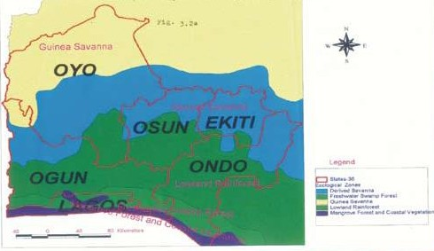

Oyo town

Ado Ekiti

Ijebu ode

Ile-Ife

Akure

Agege

Figure 3.1: Extracted Map of Southwestern Nigeria showing the sampling areas.

OF

# Isolation and Culture Methods

* + 1. **Isolation Procedure**

This was carried out using the method of Onilude (1996). A sterile 0.5mm cock borer was used to remove tissue disk from area near the edge of symptomatic lesion to obtain actively growing mycelia. Such disk was then inoculated aseptically at the centre of sterile Potato dextrose agar (PDA) plate. This procedure was carried out aseptically in a lamina flow chamber. The inoculated plates were then incubated at 28oC + 2oC. Each plate was exam-

ined for growth after 48 hours during which mixed culture of fungal mycelia were ob- served. Isolation of fungi from the degrading wood samples was done fortnightly for a pe- riod of twelve weeks and later every four weeks for a period of eight weeks.

# Identification of Pure Cultures of Isolates

The fungal isolates obtained were severally subcultured on identified using their cultural and macroscopic characters when cultured on different media in plates (Singh *et al*., 1991). Microscopic characterization was done with reference to Domsch *et al*. (1980), Singh *et al*. (1991) and Kiffer and Morrelet (2000).

* + - 1. Macroscopic Examination

Pure cultures of the fungal isolates were aseptically inoculated onto sterile potato dextrose agar, Malt extract agar and Czapek agar respectively using sterile inoculating needle. The point of inoculation was the centre of the Petri dish to allow for even distribution of growth. The plates were incubated at 28oC + 2oC and isolates were examined after 4 - 5

days of incubation for the cultural characteristics of each of them.

* + - 1. Microscopic Examination

A pin head size of mycelium from 72-96 hours culture was put onto a drop of cotton blue in lactophenol on a clean grease- free slide. The mycelium was properly teased apart using inoculation needle and covered with a cover slip inclined at an angle of 45oC to avoid air bubbles on the slide. The slide was then observed under x10 and x40 objective lenses. The shapes and arrangement of the fruiting bodies were noted. This was done for the different isolates and the observation recorded. The Compedium of Soil Fungi (Domsch *et al*., 1980), Singh *et al*. (1991); Kiffer and Morrelet (2000) and Dr Fungus ([www.doctorfungus.org](http://www.doctorfungus.org/)) were used for their identification.

# Maintenance of Pure Culture of Selected Isolates

Pure cultures of the selected fungal isolates were regularly sub-cultured onto fresh sterile Potato Dextrose Agar (PDA), (LABM) slants every 2-3 weeks to maintain viability and kept in liquid nitrogen (Mcdaniel and Bailey, 1968). Each isolate was coded for easy dif- ferentiation.

# Screening of fungal isolates for cellulolytic and hemicellulolytic activities.

* + 1. **Primary/ Qualitative Screening of Isolates**

The different fungal isolates were subjected to screening for their cellulolytic and hemicel- lulolytic properties using the agar diffusion test method (Downie *et al.,* 1994; Whitaker, 2002). Ten microlitres (10μl) of spore suspension of each isolate was dropped onto 6 mm diameter of sterile paper disc cut out of Whatman No. 1 filter paper. The inoculated paper discs were dried at room temperature in a lamina flow chamber and put onto the center of the medium plates. Hemicellulases were tested by using a mannan-agar medium containing

0.4 % locust bean gum (Sigma) (Nascimento *et al*., 2001) for mannanase activity. Xylan agar medium consisting of 0.8% Birch-wood xylan (Sigma) (Cordeirro *et al*., 2002) was used to evaluate xylanase activity of the isolates. Cellulase was assayed for by using a cel- lulose-agar medium containing 1% Carboxyl methyl cellulose (Sigma) (Strauss *et al.,* 2001). Each medium also contained the following constituents which served as mineral salt and nitrogen sources (g/l): 0.05g MgSO4. 7H2O, 0.005g CaCl2, 0.005g NaNO3, 0.009g FeSO4.7H2O, 0.002g ZnSO4, 0.012g MnSO4, 0.23g KCl, 0.23g KH2PO4, 2g peptone, 19g Agar (LAB M). After seventy two hours (72h) of incubating the plates at 28o + 2oC, each

was flooded with 0.4 % congo red for 10 min and then destained with 1 M NaCl. The hy- drolysis zones were measured and the relative enzyme activity of each isolate was deter- mined using the following formula:

Relative Enzyme activity = Diameter of clearing (mm)

Diameter of growth (mm)

Isolates with wide clear zones (high relative enzyme activities) were selected for further work.

# Secondary/ Quantitative Screening of Isolates

Selected fungal isolates were subjected to secondary screening using birch wood xylan, locust bean gum and carboxymethyl cellulose as main carbon sources for xylanase, man- nanase and cellulase production respectively. Other components of the secondary screen- ing media in g/l were: 0.05g MgSO4. 7H20, 0.005g CaCl2, 0.005g NaNO3, 0.009g FeS04.7H20, 0.002g ZnSO4, 0.012g MnSO4, 0.23g KCl, 0.23g KH2PO4, 7g peptone and

either of 0.4%(w/v) birch wood xylan (Sigma-Aldrich) or 1%w/v carboxylmethylcellulose

(Sigma) or 0.5%(w/v) locust bean gum(Sigma- Aldrich) in 1000ml citrate buffer (pH 5.6).

250ml Erlenmeyer flasks each containing 90ml of the secondary screening medium were each inoculated with 72 hour culture of fungus using sterile 5mm corkborer. Each flask was inoculated with three 5mm fungal culture and incubation was done at 28 + 2oC in in- cubator with shaker at 120 rpm at ambient temperature of 28 + 2oC for a duration of 6

days. Samples were taken after 144 hours, the cell free supematant was recovered by cen- trifuging samples at 12,000 rpm at 4oC for 15 min in a cold centrifuge (Model: IEC B- 20A). Dry weight of mycelia, total soluble protein (Lowry *et al*., 1951) and glucanase, mannanase and xylanase activities of the isolates were calculated from the amount of re- ducing sugar present in the fermentation medium which was estimated using the method of Miller (1959). The result obtained was used to select isolates for further work.

# Treatment of Selected wood Samples

* + 1. **Mechanical Milling of Wood Samples**

Each selected wood sample for solid state fermentation was milled. Milling involved chip- ping almost all the individual wood samples into sizes of about 4mm dimension (Kirk and Culen, 1998) at the Forestry Research Institute of Nigeria, idi-ishin, Ibadan. The chipped wood were collected into clean cellophane bags according to identity and brought to the laboratory immediately where they were stored in an airy but dry atmosphere.

# Thermal Pre - treatment of Samples

Each wood sample was dried in a Gallemkamp oven (Model NYC 101) until a stable weight was obtained. 10gramme of each of the dried woodchips was dispensed into 250ml Erlenmeyer flask and subjected to thermal pretreatment by utoclaving at 121oC for one hour. This is was done to loosen the saw-dust to provide particles of even sizes so that fun-

gal growth would not differ due to differences in oxygen diffusion, nutrient absorption and assimilation by mycelia (Goyal *et al*., 2008).

# Preparation of Fungal Inocula

Isolates coded with ANGA1*,* AR4*,* THMA, TRS were selected for this study based on their high hydrolytic enzyme activities from the screening test. Each inoculum was prepared by pouring 10ml of sterile distilled water onto sporulating 5-day old growth of each organism on Malt Extract Agar slants. Sterile wire loop was aseptically used to wash the spores care- fully into the water.The slant was shaken well to obtain a uniform mixture.

* + 1. Determination of Inoculum Size

Each spore suspension (stained with 2% lactophenol blue) was subsequently diluted out with more sterile distilled water until a spore count of 106-107 per ml was obtained. To monitor the spore count, 1ml of the stained spore suspension was drawn using a Pasteur pipette and introduced into the Neubauer Haemocytometer by capillary action until com- pletely filled. The Haemocytometer was mounted on Olympus microscope for low power magnification objective lens. Counting was carried out in 4 square of 0.04mm2 (located at the corners of the central square) plus one middle square to get the number of spores. This was thereafter multiplied by 0.02mm (the volume of 5 squares) and 1000mm3 to obtain the number of spores per ml ([http://en](http://en/) .wikipedia .org/wiki/ Haemocytometer).

# Selection of Wood Substrate for Solid State Fermentation

Wood samples from which isolates that gave high enzyme activity on primary screening were obtained were used as substrates for hydrolytic enzyme production by selected iso- lates.

# Production of Hydrolytic Enzymes in Solid State Fermentation of Wood Chips by Selected Isolates.

* + 1. **Growth Medium Preparation**

The growth medium for moistening the wood substrates contained the following compo- nents (g/l): 0.05g MgSO4.7H2O, 0.5 KCl, 3 NaNO3, 0.01 FeSO4.7H2O, 0.5 MnSO4. 7H2O,

1 KH2PO4, 7 Peptone and 1ml of the solution of trace elements containing in g /l the fol- lowing compounds: 1 ZnSO4 and 0.5 CuSO4. 5H2O. The components were dissolved in one liter of citrate buffer solution at pH 5.6.

# Inoculation of Medium

An aliquout of 7ml of the growth medium was introduced into each 10g of wood chips in 250ml Erlenmeyer flask. All the flasks were autoclaved at 121oC for 15 minutes after addi- tion of the nutrient solution (Chahal, 1985) and allowed to cool to room temperature. 1.5ml of each fungal isolate was aseptically spread over the surface of 10g of each wood shaving in different 250ml Erlenmeyer flasks covered with aluminum foil and incubated for dura- tions of 3, 6, 9, and 12 days at 25 oC + 2oC .

# Extraction of Enzyme from Fungi

The enzyme was extracted by a simple contact method (Krishna *et al.,* 1999). 30ml of ster- ile citrate buffer solution (0.1M) at pH 5.6 was introduced aseptically into each fermented sample. Homogeneity was attained by stirring with sterile spatula. The fermented sample was transferred onto sterile muslin cloth and aseptically squeezed firmly to separate the mycelia from the enzyme filtrate. It was subsequently kept in sterile MacCartney bottles. The filtrates were then subjected to cold centrifuge a t 12,000 revolutions per minute (rpm)

for 10 minutes using a refrigerated centrifuge (Model: IEC B-20A). The supernatants were decanted as crude enzyme extract and stored at -2oC to prevent denaturation of the enzyme.

# Assay of Hydrolytic enzymes

* + 1. **Glucanase assay**

Carboxymethyl cellulose (CMCase) or Endo-β-1, 4- glucanase activity was determined according to the method of Mandels and Webber (1969). 0.5 ml of 1% Carboxymethyl cel- lulose (CMC) (Sigma) in 0.1 M citrate buffer pH5.6 was placed in a test tube and 1.0 ml of culture filtrate added. The test tube was incubated at 40oC in a water bath (Uniscope SM 101 Shaking water bath) for 30 min (Baldrian and Gabriel, 2002). The reaction was termi- nated by adding 2.0 ml of 3,5- dinitrosalicylic acid (DNS) reagent to the reaction mixture, boiled for 5 minutes and (Miller, 1959). The absorbance of the appropriately diluted reac- tion mixture was read at 540nm using a spectrophotometer (752W, UV-VIS Grating Spec- trophotometer). One unit of CMCase was defined as the amount of enzyme that released I mol reducing sugar as glucose equivalent per minute in the reaction mixture under the specified assay conditions. All enzyme assays were performed in triplicates.

# β- Glucosidase assay

β-glucosidase assay was performed using p-nitrophenyl β-D glucopyranoside (pNPG) (Sigma-Aldrich, India) as substrate as specified in Ghose & Bisaria (1987). Appropriately diluted enzyme sample of 0.5ml was incubated with 0.5ml of 10mM pNPG in citrate buff- er (0.05M, pH 4.8) and 1ml of citrate buffer (0.05M, pH 4.8) at 40 °C for 15 min. The re-

action was terminated by adding 2ml of 0.2M Na CO solution. Appropriate blanks devoid

2 3

of enzyme or substrate were also run in parallel to the enzyme assay. The color developed

due to liberation of p-Nitrophenol (pNP) was read at 420nm in a UV-Visible spectropho- tometer (752W UV-VIS Grating Spectrophotometer) and the amount of pNP liberated was calculated by comparing the reading corrected for blanks against a standard curve generat- ed using varying concentrations of pNP. One unit of β-glucosidase activity was defined as the amount of enzyme needed to liberate 1μM of p-nitrophenol (pNP) per minute under the standard assay conditions and was expressed in units per gram dry substrate (U/gds), in the case of SSF or as units per milliliter (U/ml) in the case of submerged fermentation. All enzyme assays were performed in triplicates and averages and standard errors of the exper- iments were determined.

# Mannanase assay

0.25g of locust bean gum (Sigma) was dissolved in 50ml of 0.1M citrate buffer at pH 5.6 to make 0.5% w/v solution of the substrate by the method described by Xu *et al*. (2002). Homogeneity was achieved by heating the mixture on a hot plate and stirring vigorously. 0.4ml of enzyme filtrate was added to 3.6ml of the locust bean gum buffer solution in 50ml Erlenmeyer flasks. These were placed in a water bath (Uniscope SM 101 Shaking water bath) at 30oC for 30 minutes. After the time interval, 4ml of 3, 5-dinitrosalicylic acid (DNS) was added to the reaction mixture to terminate the reaction. The reaction mixture was appropriately diluted and the absorbance was read at 540nm using a Spectrophotome- ter (752W, UV-VIS Grating Spectrophotometer) (Miller, 1959). One unit of mannanase was defined as the amount of the enzyme in 1.0ml of the filtrate which releases 1 mol of reducing sugar from 1ml of 0.5% locust bean gum in one minute at 30oC. All enzyme as- says were performed in triplicates.

# Xylanase assay

Xylanase or Endo- 1,4- Beta- xylanase activity was determined according to the method of Bailey *et. al.* (1992). 0.5ml of 0.8%(w/v) of birch wood xylan (Sigma) (0.8 g in 100 ml of 0.1M citrate buffer at pH 5.6) was placed in a MacCartney bottle and 1ml of enzyme fil- trate added. The reaction mixture was incubated in the water bath (Uniscope SM 101 Shak- ing water bath), at 50oC for 30 minutes and the reaction terminated by adding 2.0ml of 3,5- dinitrosalicylic acid (DNSA) reagent to the reaction mixture, heated for 5 minutes at 80OC in a water bath. Absorbance was read at 540nm using spectrophotometer (Model 752W, UV-VIS Grating Spectrophotometer) to determine the concentration of sugar released by the enzyme. One unit (U) of Xylanase was defined as the amount of enzyme that released

1.0 mol reducing sugar as xylose equivalent per minute in the reaction mixture under the specified assay conditions. All enzyme assays were performed in triplicates.

# Xylosidase assay

β-Xylosidase activity was routinely assayed in a reaction mixture containing 2mM *p*- nitrophenyl-β- -xyloside (*p*NPβX) (Sigma) in 1.0ml of 50 mM citrate buffer, pH 5.6,and 1ml of appropriately diluted enzyme solution was added.The reaction mixture was incubat- ed in a water bath (Uniscope SM 101 Shaking water bath) at 50oC for 30 minutes. The re- action was stopped by adding 1ml of ice-cold 0.5M Na2CO3 and the color that developed as a result of *p*-nitrophenol (*p*NP) liberation was measured at 410 nm wavelength (Saha, 2003) using spectrophotometer (Model 752W UV-VIS Grating Spectrophotometer). One unit (U) of β-xylosidase activity was defined as the amount of enzyme that liberated 1 μmol *p*NP per minute in the reaction mixture under the specified assay conditions. All en- zyme assays were performed in triplicatest.

# Protein Determination:

Enzymatic protein was determined by the method of Lowry *et al.* (1951) as follows: 50ml of 2% Na2CO3 in 0.1M NaOH was mixed with 1.0 ml of 0.5% CuSO4. 5H2O in 1% Potas- sium sodium tartarate and the mixture labeled „reagent C‟ Folin reagent (BDH) was diluted twice with distilled water and labeled „reagent D‟.The standard 0.01% protein was pre- pared using Bovine Serum Albumin (Sigma), dissolved in distilled water with continuous agitation before dilutions of it were prepared. 0.1ml of each of the enzyme solutions and each of the different dilutions of the bovine serum albumin was taken in clean sterile test tubes. To each was added 0.5ml of sterile distilled water, followed with 3ml of reagent „C‟ and contents thoroughly mix. After incubation for 10 minutes at room temperature, 0.3 ml of Reagent ‟D‟ was added to each tube and incubated again at room temperature, for 30minutes. The optical Density (O.D.) was taken at 670nm using 752W, UV-VIS Grating Spectrophotometer. The protein content of the enzymes in the solution was then extrapo- lated from a standard graph obtained from those of the different dilutions of bovine serum albumin.

# Optimization of production conditions for xylanases in solid state fermentation.

* + 1. **Effect of Varying Initial Temperature on xylanase Production**

The fermenting flasks containing 10g of the best substrates for each isolate were moistened with the moistening medium and pH adjusted to 5.6 using 0.1 M Citric acid followed by inoculation with the respective isolates. Incubation was then effected at 30oC, 35oC, 40oC and 45oC for 12 days and the xylanase activities at different temperatures were determined (Saha, 2003).

# Effect of Varying Initial Moisture Content on xylanase Production

The fermenting medium containing 10g of the best substrate for each isolate in 250 ml Er- lenmeyer flasks were moistened at different initial moisture contents of 30%, 40%, 50%, 60% and 70% (Akhtar *et al*., 1996) using the moistening solution and pH adjusted to 5.6 with 0.1 M Citrate buffer. This was followed by inoculation of the medium with the appro- priate isolate. Incubation was effected at 28±2oC for 12 days after which xylosidase and xylanase activities were determined.

# Effect of Varied Initial pH on xylanase Production

The pH of the moistening medium was adjusted with 0.1M Citric acid to various values including pH 4, 5, 6, 7 and 8 and applied to wood chip substrates for each of the isolates in Erlenmeyer flasks before sterilization. The sterilized flasks containing the medium was in- oculated with the isolates and incubated at 28±2oC for 12 days. The xylanase activities of isolates were determined thereafter (Asha, 2006).

# Effect of Various Nitrogen Sources on xylanase Production

The same quantity of different nitrogen sources which included yeast extract, peptone, soy meal, urea and corn steep liquor were weighed into fermenting flasks to substitute for pep- tone (the nitrogen source in the moistening medium) moistened with the Mandel and We- ber salt solution with pH adjusted to 5.6 using 0.1M citric acid before sterilization after they were inoculated with the respective organisms. Incubation was then effected at 28±2oC. After which xylanase activities of isolates were assayed for (Saha, 2003).

# Effect of Varied Initial Aeration on xylanase Production

The fermenting flasks were moistened with the Mandel and Weber salt solution and pH adjusted to 5.6 using 0.1 M Citric acid at the different initial aeration of 10%, 20%, 30%, 40% and 50% created by using sodium thioglycolate at different concentrations followed by sterilization and inoculation. Incubation was effected at 28±2oC, for 12 days, afterwhich xylanase activities isolates were determined (Akhtar *et al*., 1996).

# Effect of Different Inoculum Sizes on xylanase Production

The fermenting flasks were moistened with the Mandel and Weber salt solution and pH adjusted to 5.6 using 0.1 M Citrate buffer at different inoculum load of 106, 109,1012, 1015 and 1018 followed by inoculation. Incubation was effected at 28±2oC, for 12 days and xy- lanase activity was determined (Xu *et al*., 2002).

# Effect of Different moistening media on xylanase production

Based on past works of some researchers, different moistening media were prepared in cit- rate buffer at the best pH of each isolate and tried on *A. leiocarpus* in order to determine the moistening medium most suited for use in the scale up experiment. These moistening media included distilled water, tap water, Mm3 as described by Abdel~Naby and Dae Young (1992) consisting of the following components in g/l KH2PO4, 2.0; (NH4)2SO4, l; MgSO4 '7H2O, 0.3; CaCl2, 0.3; urea, 0.3; Tween-80, 1 ml; FeS04.7H2O, 0.05; MnSO4.H2O,

0.016; ZnSO4.7 H2O. 0.014; CoCl, 0.02 (pH 5.5). The fourth moistening medium (Mm4) consist of the following in g/l: K2HPO4, 2.0; MgSO4.7H2O, 0.40; MnSO4, 0.2; NaCl, 10; (NH4)2 S04, 2.0; Yeast Extract, 2.0 and Peptone, 4.0 (Asha, 2006). The fifth moistening medium tested (mm5), had the following constituents in 1 litre of buffer used: 0.3g of

KH2PO4, 0.5g KCl, 0.05g MnSO4.7H2O, 3g NaNO3 0.01g FeSO4.7H2O, 7g of peptone and 1ml of trace elements made up of 0.5g of CuSO4.5H2O and 0.3g of ZnSO4 in one litre of the buffer.

# Characterisation of selected hydrolytic enzymes

The enzymes were characterized related to its optimum activity pH, temperature, tempera- ture stability range, effect of cations as well as anios on partially purified enzyme fractions.

# Effect of different temperature on the activity of partially purified enzymes

The effect of temperature on enzyme activity was determined by performing the standard assay procedure for 10 minute at pH 6 for xylanase and 5.6 for other hydrolytic enzymes within a temperature range of 30-65oC. Thermostability was determined by incubation of the partially purified enzymes at temperatures of 50oC, 55oC, 60oC and 65oC. The residual enzyme activities were measured at every 5 minute interval for a period of 30 minutes.

# Effect of different pH on the activity of partially purified enzymes

The optimum pH of the hydrolytic enztmes was determined by incubating each of the en- zymes in citrate buffer at different pH. Effect of pH on the activity was measured by essen- tially testing the enzymes activities at pH range of 4 – 8 with intervals of 0.5 between the values.

# Effect of different substrate concentration on the activity of partially purified enzymes

The Michaelis - Menten constant (Km) and maximum velocity (Vmax) were determined by using carboxymethyl cellulose, locust bean gum and birch wood xylan each as the sub- strate for glucanase, mannanase and xylanase respectively. Initial reaction rates of hydrol- ysis of each substrate were determined at different substrate concentrations range of (0.5, 1.0, 1.5, 2.0 and 2.5 %) for cellulase; (0.25, 0.5, 0.75, 1.0 and 1.25 %) for mannanase and (0.2, 0.4, 0.6, 0.8 and 1.0 %) for xylanase. Each of the concentrations of the substrates was prepared in 0.1 M citrate buffer pH - 6.0 for xylan while pH 5.6 was used for the other substrates. Reaction rate vs. substrate concentration curve 151 was plotted to determine whether the enzyme obeys Michaelis-Menten kinetics, and constants were determined from a Lineweaver-Burk plot (Lineweaver and Burk, 1934).

# Effect of different anions on the activity of partially purified enzymes

The effects of various anionic additives on ezymes activities were determined by incubat- ing partially purified enzyme fractions at room temperature (28+2oC) with different cati- ons. The different monovalent and divalent cations like PO4 3- , SO4 2- and NO3- were used to check their effect on the enzyme activities. Activities were monitored after 30 minutes of incubation at room temperature. Residual activity was expressed as the percentage of the activity observed in the absence of any compound (Asha, 2006).

# Effect of different cations on the activity of partially purified enzymes

The effect of various cationic additives on ezymes activities were determined by incubat- ing partially purified enzyme fractions at room temperature (28+2oC) with different cati-

ons. The different monovalent and divalent cations like Na+, Mg2+, Ca2+, Mn2+, Fe2+, Zn2+ and Cu2+ were used to check their effect on the enzyme activities. Activities were monitored after 30 minutes of incubation at room temperature. Residual activity was ex- pressed as the percentage of the activity observed in the absence of any compound (Asha, 2006).

# Purification of the enzymes

* + 1. **Ammonium Sulphate Precipitation**

The crude enzymes were precipitated using Ammonium Sulphate Precipitation method (Dixon and Webb, 1971). The clarified extracts were dispensed into clean 250ml Erlen- meyer flasks and treated with solid Ammonium sulphate (Analytical grade) within the lim- its of 40-100% saturation. The mixture for each batch of percentage saturation was stirred continuously for 15 minutes to allow for dissolution of the Ammonium Sulphate into the medium. In each case, the mixture was kept at 4oC to allow for precipitation. The precipi- tate was later separated from the supernatant after centrifugation at 12,000rpm at 4oC for 15 minutes on a cold Ultra centrifuge **(**(Model: IEC B-20A). In each case the precipitate was collected into a separate 500ml Erlenmeyer flasks and later pooled together. The pooled precipitate was dissolved (in initial volume of culture filtrate) in 0.1M citrate buffer (pH 5.6) for all the enzyme types and 0.05M of the same buffer at same pH for xylosidase to give a ten fold concentration of the original culture filtrate.

# 3.13.2. Dialysis of the enzyme preparation

Each enzyme concentrate obtained was dialysed for 24 hours at 4oC against large volume (5 litre) of 0.1M citrate buffer (pH 5.6) for Glucanase, Mannanase and Xylanase and 0.05M citrate buffer (pH 5.6) for Xylosidase as described above using Visking dialysis

tubing (Gallenkamp). The dialysed enzyme filtrate preparations were then subsequently employed as partially purified enzyme preparation in the various assay procedure pending fractionation.

# Fractionation of the enzyme concentrates on Sephadex G – 50 columns

1. Preparation of Sephadex G-50 column

The column with internal dimension of 2.5cm x70cm (Pharmacia) of Sephadex G – 50 sur- rounded by a water jacket maintained at 20oC was prepared and callibrated according to the method described by Olutiola and Cole (1980). The sephadex bead was suspended in the eluting buffer (0.1M citrate buffer pH 5.6) mixed with 5mM Sodium azide NaN3 (BDH) (for prevention of microbial contamination) and allowed to swell for 3 days at 4oC. Thereafter the gel suspension was poured in, to bring the liquid to the top of the glass tube. The eluting buffer was simultaneously allowed to flow through the growing bed of gel. The column was connected to the reservoir and the buffer was allowed to percolate through it to wash the gel until a constant bed height of 60cm was obtained. A sample applicator was placed on top of the gel to prevent distortion during the application of sample and to ensure free flow of buffer through the column. Before and after each experiment, the col- umn was checked for uniform packing by observing the passage of Ferritin through it. The column was equilibrated with 0.1M Sodium citrate buffer pH 5.6. 5.0ml of the enzyme concentrate was applied to the column and eluted with 0.1M sodium citrate buffer at a flow rate of 1.67 ml per min. The eluted fractions were collected in a calibrated 5ml tube each being analysed for protein estimation. Cellulase, mannanase and xylanase activities of the eluted fractions were also determined.

1. Calibration of the column

The column was calibrated with materials of known molecular weight using the method of Olutiola and Cole (1980). The materials were Sephadex G- 50 (particle size 40-140) sup- plied by Phamacia, Sweden; egg albumen (mol. wt. 45,000); DNP-alanine (mol. wt. 255.2) and bovine serum albumin (mol.wt. 12,400). During calibration 5 mg of each of the sub- stances were dissolved in 10ml of 0.1M citrate buffer (pH 5.6) and the solution was ap- plied to the gel bed. Fractions (10ml per tube) were collected in an LKB automated frac- tion collector 2212(HELIRAC). The protein content of the eluted fractions was determined by the method of Lowry *et al*. (1951). The relationship between the elution volume of each reference material was determined according to the method of Andrews (1964).

1. Application of Enzyme Concentrate to Sephadex G-50 column

1.0ml of the enzyme concentrate was applied to the column and eluted with 0.1M sodium citrate buffer containing 5mM Sodium azide (NaN3). The eluted fractions were collected in a calibrated 5ml tube each being analysed for protein estimation. Cellulase, mannanase and xylanase activities of eluted fractions of the respective enzymes were also determined.

# Further purification by Ion exchange chromatography

For each enzyme, all fractions which showed appreciable enzyme activity after gel filtra- tion through sephadex G-50 column were pooled and reduced to one-fifth of the original volume by concentration in a vacuum evaporator (Model R-10) at 30oC. The column sur- rounded by a water jacket at 20oC was pre-equilibrated with 50mM Tris HCl buffer, washed with 200ml of respective buffer pH 5.6 at rate of 1.0ml/ min. This was followed by sample elution with 5 bed volume of NaCl in gradient 0.1 - 0.5M in equilibrating buffer

(Olutiola and Cole, 1980.) The eluted fractions were collected in calibrated 10ml tubes. Each eluted fraction from their respective enzymes was analysed for total soluble protein estimation, glucanase, mannanase and xylanase activities as the case may be respectively. The active fractions were pooled and dialyzed overnight against respective buffers after- wards

# Purification test with Sodium Diodecyl Sulfate Polyacrylamide Gel Electropho- resis (SDS-PAGE)

The enzyme protein samples were separated using sodium diodecyl sulphate polyacryla- mide gel electrophoresis (SDS – PAGE) on vertical electrophoresis kit SE 245 series using a discontinuous gradient gel buffer system as described by Laemmli (1970). The following were prepared:

1. 30% acrylamide, 0.8% Bis – acrylamide, 30 grams of acrylamide and 0.8g of N, N1 methylene Bis – acrylamide (BDH) were dissolved in 60ml distilled water in 100ml stand- ard volumetric flask and made up to the mark. The solution was stored at 4oC.
2. Stacking gel buffer

The stacking gel buffer powder was dissolved in 500ml distilled water in a 1 litre standard volumetric flask. The pH was adjusted to 6.8 with sodium hydroxide solution. The solution was then made up to mark with distilled water and stored at 4oC.

1. Running gel buffer

1.5M Tris, 8mM EDTA, SDS pH 8.8 in 1 litre standard volumetric flask. The pH was ad- justed to 8.8 with hydrochloric acid. The solution was then made up to mark with distilled

water and stored at 4oC.

1. 1% Ammonium persulphate

1 gram of Ammonium persulphate (CNH4)2S2O8) was dissolved in 100ml distilled water and used immediately.

1. Electrode buffer: Glycine, SDS, EDTA

All the components (Glycine, sodium diodecyl sulphate and EDTA) as they came with the kit were dissolved in 4 litres distilled water with constant stirring as recommended by manufacturers. The solution was kept at 4oC.

1. Sample buffer

6ml glycerol mixed with 1.2ml of sodium phosphate buffer pH 7.0, 1.5g of sodium di- odecyl sulphate (SDS), 30mg dithiothreitol (DDT) and 10mg bromophenol blue. Distilled water was added to make 20ml. The mixture was dispensed into test tubes in aliquots of 1ml washed and stored at 20oC until needed.

# Procedure

The stacking gel and running gel were prepared on the day of the experiment. The running gel solutions were poured into the gel assembles to a level of about 6.5cm below the max- imum filling level. Distilled water was layered on the gel surfaces using a Pasteur pipette to ensure an even surface and also to avoid evaporation of the gel while the polymerizing gel was allowed to polymerize for 1-2 hours.The water on the gel was poured off and the stacking gel was poured on to the polymerized gel and a comb (1.5mm thick) was gently inserted to obtain wells. It was allowed to polymerize for one hour before removing the comb. The gel was then clamped to the electrophoresis chamber. The upper and lower

chambers were filled with electrode buffer and the bubbles formed were removed with a syringe. The protein samples were prepared by mixing sample buffer (in a dilution of 1:1 v/v) with enzyme samples. The mixtures were then placed in a dry bath fan heated for 4 minutes at 95oC. Equal volume of samples was applied to the bottom for the sample wells with a Hamilton syringe. Molecular weight standards used were the SDS-PAGE standards (medium range). The molecular weight of protein markers were phosphorylase b (97.0 kDa), albumin (66.0 kDa), ovalbumin (45.0 kDa), carbonic anhydrase (30.0 kDa), trypsin inhibitor (20.1 kDa). Molecular weight standards were then applied into wells alongside the samples to serve as markers.

Gel electrophoresis was conducted at 120 volts in a vertical electrophoresis apparatus for about 1.5 hours or until the bromophenol blue dye has migrated to the bottom of the gel. At the end of the electrophoresis, the gel was carefully removed from the glass plates and stained by soaking in the staining solution for 20 minutes with gentle agitation. Excess stain was removed by immersing the gel for 1 hour in several changes of the destaining solution each lasting for 15 – 20 minutes. The gel was then removed and allowed to dry.

# Studies on Biopulping potentials of isolates and their enzymes on Wood and Pulp Samples

* + 1. **Preparation of Wood Chip Samples**

Each wood sample was processed into desired size of chips at the Forestry Research Insti- tute Idi- ishin, Ibadan and packed into separate polythene bags. The bags were brought into the laboratory. 200 gramme of each wood chip sample was measured and wrapped into clean foil paper afterwhich they were steam treated in an autoclave at 121oC at 15 psi for

one hour to allow for penetration of fungal hyphae into the components of the wood. The steam pretreated wood chips were allowed to cool to room temperature.

# Preparation of Bulk Inoculum

The culture medium used contained 24 g potato dextrose broth (Difco Laboratories, De- troit, Mich.) in 1litre of citrate buffer (at optimum pH of growth of each isolate) and 7. 27 g yeast extracts (LAB M) (Akhtar *et al.,* 2000). 100ml of this medium was decanted into 250ml Erlenmeyer flasks and autoclaved for 15 min. at 121° C. at 15 psi and later cooled to room temperature. Each flask was inoculated with 10 plugs cut with a 9 mm diameter cork borer from 5-day old PDA plate cultures of each fungal isolate. The flasks were incu- bated at 28°C ± 2°C and 65±5% relative humidity for 10 days without agitation. The spent growth medium from the cultures was decanted; the mycelial mats were washed with ster- ile water, and aseptically blended in a Waring blender. Sterile water was added in suffi- cient quantity to the blended mycelium to make the mycelial suspension stock (Akhtar *et al.,* 2000).

* + 1. Description and preparation of the fermentation vessel:

The vessel used in this work is transparent poly ethylene plastic containers of about 4mm thickness, a capacity of 12 litre with an internal diemeter of 80cm and length of 15cm with a fitting cover of 81cm diameter. Uniform temperature within the bioreactor was main- tained by intermittently immersing the bioreactor into a wider diameter bowl containing water of about 4oC and stirring with a sterile glass rod.

# Inoculation of Wood Chip Samples Using Fungal Spores

* + - 1. Inoculation of Wood Chips with Fungal Spores

The steam treated wood chip samples was transferred into each sterile bioreactor after cooling and spread uniformly in the vessel. Each wood substrate in the vessel was sprayed with the best moistening medium for xylanase production using yeast extract as the organic nitrogen source yeast 60% moisture content for *F. compactum* and 55% for *T. harziarnum* based on the optimization testscarried out. Liquid inoculum of the isolate was used to in- oculate each wood chip sample singly and in combination at each of the isolate‟s optimum inoculum sizes per gramme of the substrate. The wood chips were thoroughly mixed with sterile stirring rods and incubated at optimum temperature of each isolate for 42 days. Sta- ble aeration was maintained by intermittently stirring the fermenting medium everyday and temperature was also maintained by dipping the bioreactor in a big bowl of water at tem- perature of about 2oC for 3minutes. Samples of the biotreated wood chips were taken forthnightly and washed with sterile distilled water to remove the superficial mycelium. The fungal treated wood chips were air dried and tests to determine hemicellulose, cellu- lose, lignin and ash of the wood samples were carried out thereafter.

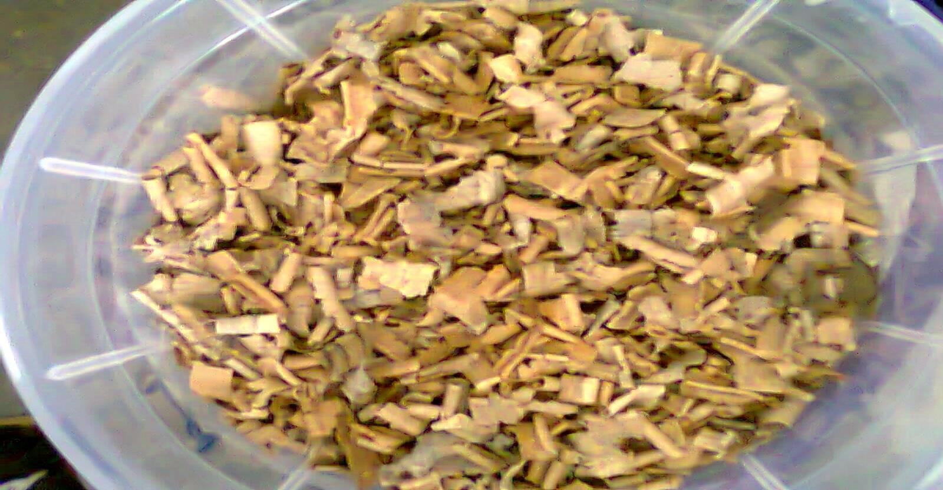

# Plate 3.1: *G. arborea* Wood chips prepared for pre-treatment with fungi.

OF



**Plate 3.2: *T. superba* Wood chips prepared for pre-treatment with fungi.**

OF

# 3.16.1 Determination of Cellulose and Hemicellulose Contents of Wood chips

The first of these methods was accomplished in accordance with TAPPI Standard T 249 cm-85 “Carbohydrate composition of extractive-free wood and wood pulp by gas-liquid chromatography.” The three principal monosaccharides determined from this procedure included glucan, mannan and xylan,. The samples were first thoroughly washed with de- ionized water and air-dried prior to Soxhlet extraction with acetone for 24 hours. Samples were weighed out to the nearest 0.1 mg and the moisture content was determined. The tar- get sample weight was 0.35 ± 0.01 g. The sample was placed in a 15 ml glass centrifuge tube and exactly 3 ml of 72% sulfuric acid was added with stirring. The centrifuge tube was placed in a 30oC water bath for one hour with occasional stirring. The contents of the centrifuge tube were quantitatively transferred to a 250 ml beaker with deionized water. The beaker was placed in an autoclave for 1 hour at 15 psi (103 kPa). The sample is then cooled to room temperature using an ice bath. Exactly 10.0 ml of reagent grade Inositol (internal standard solution containing 1%, w/v) was added with mixing and the solution was transferred to a 50 ml beaker. Several drops of bromophenol blue indicator were added and a barium hydroxide solution was added while mixing with a magnetic stirring bar until the color of the solution changes from yellow to blue-violet. The contents of the 50 ml beaker were again transferred quantitatively to a 50 ml centrifuge and the solution was cen- trifuged until the supernatant is clear. The clear solution was then decanted into a 100 ml round bottom flask. Sodium borohydride (80 mg) was added to the sample, and mixed oc- casionally for 1.5 to 2 hours. Excess borohydride was removed by adding glacial acetic acid drop-wise until gas evolution ceases. The solution was concentrated on an evaporator with the water bath set at ≤ 40oC. Approximately 10 ml of methanol was added to the syr-

up and evaporated to dryness several times. The residue was heated in an oven at 105oC to ensure complete removal of the water. The residue was then acetylated by adding 7.5 ml of acetic anhydride and 0.5 ml sulfuric acid and placing the sample in a water bath maintained at 50-60 oC for 1 hour. The sample was allowed to cool and then extracted successively with 25, 15, and 10 ml portions of methylene chloride. The combined methylene chloride extracts were concentrated using a flash evaporator with the water bath set at 75oC. Ap- proximately 1 ml of water was added to the residue and evaporated to dryness on the flash evaporator. The residue was dissolved in 2 ml methylene chloride. The dissolved solution of alditol acetates (0.5 μl) was injected into the gas chromatograph and the peak areas were determined for each of the three sugars and the internal standard. The percent of each com- ponent as a polysaccharide was calculated according to the equation:

Percent = A x WS x C x 100

As x W x *k*

*A* is the chromatographic area of the component peak;

*AS* is the chromatographic area of the internal standard peak;

*WS* is the weight of internal standard in milligrams;

*W* is the oven-dry weight of the sample in milligrams;

*C* is the conversion factor for monosaccharide to polysaccharide (0.88 for pentoses and 0.90 for hexoses);

*k* is the calibration factor for each individual component.

# 3.16.2. Determination of Ash Content of Wood Chips

Ash, content of the treated and untreated wood samples were determined as follows: four samples of air dried, ground (0.5 mm) wood sample (0.7 g each) were boiled with 5 ml of 72% w/w H2SO4 solution for 4.5 h in order to hydrolyse the cellulose and hemicellulose. The suspension remaining after the above treatment was filtered through a crucible and the solid residue dried at 105oC for 24 h and weighed (W1). The residue was then transferred to a pre-weighed dry porcelain crucible and heated at 600o C for 5 h. After cooling down, it was weighed and ash content (%) was determined (TAPPI T211, 2002).

# 3.16.3 Determination of Lignin Content of Wood Chips.

The wood samples were milled to pass through a 0.75-mm-pore-size screen. Milled wood was treated with 95% ethanol for 6 h in a Soxhlet apparatus to remove extractives. Extract- ed wood samples were hydrolyzed with 72% (w/w) sulfuric acid at 30°C, as described by Ferraz *et al*. (2008). The residual material was cooled and filtered through porous glass filter number 3 (Schott-Duran). Solids were dried to a constant weight at 105°C and deter- mined to be Klason insoluble lignin. The soluble lignin concentration in the aqueous frac- tion was determined by measuring the absorbance at 205 nm and using the value of 105 liters / g cm as the absorptivity of soluble lignin.

# Refinning of Wood Samples

After pretreatment with fungal isolates, the pretreated samples of *G. arborea and T. super- ba* chips were refined using pressurized refiner at the Central Laboratory of the Obafemi Awolowo University, Ife. Wood sample chips were first saturated in a digester (Model

103-A 200-mm-diameter atmospheric refiner) before going through size reduction through

mechanical refining. The wood chip loaded digester was purged with steam to a tempera- ture of 100oC. The digester was afterwards vacuumed to about 25 inches of mercury for about 15 minutes. The digester was then filled with hot water for about 40% solids. Each refining run used 5kg wood chip samples. The wood fiber obtained was then analysed for changes in fibre length and strength and tensile strength respectively.

# Determination of Fiber Length, Fibre strength and Tensile strength of Wood pulp

Tensile strength was performed on a Kinston tester and on a Lorentz and Wetter (Alperton) tester determined using the zero span breaking strength method of TAPPI T231 and TAPPI T 273 respectively. Wet tensile testing was performed according to TAPPI T- 456 with a 5 min span between wetting the sample and testing.

The fiber quality analyzer (FQA) was used to optically characterize the fiber length of the pulp. It uses uniform, diffuse light at an infrared wavelength to illuminate an 80 mm2 view- ing area. Since fibrous materials contain crystalline cellulose, the light is polarized. A charged coupling device (CCD) camera is used to capture the light that has been polarized, thus capturing images of the fibers. The fiber length was analyzed in this process. Freeness testing was used to determine the fibre strength of the pulp. It gives an indication of the ability of a pulp to drain and is relative to the level of pulp refining. Freeness of pulps was characterized using TAPPI method T227. One liter of the 0.30% consistency pulp was rap- idly poured into the freeness tester, and the volume discharged from the side orifice was recorded in milliliters.

# : Xylanase application on brown carton paper pulp

The enzymatic treatment was carried out on brown carton paper pulp. The xylanase used for this experiment was obtained from *F. compactum* and *T. harzianum*. 5g of oven dried brown paper pulp sample was weighed and cut into small pieces and soaked in distilled water for 2 hours. The soaked paper was transferred into an electric blender (Model NY- 306) and blended in wet blender for 10 minutes at low speed and for 15 minutes at high speed. The pulp was afterwards made into a consistency of 3.5% (w/v) and treated with different concentrations of diluted 2U/ml, 4U/ml and 6U/ml of xylanase. The enzyme was applied on the previously prepared brown carton pulp*.* After application, the mixture was incubated in a thermostatic bath at 50oC for 180 minutes. At 15 minutes intervals the pulp suspension was mixed well for proper distribution of enzyme. The pulp was filtered on a Buchner funnel and washed with 100ml of distilled water. The colour of the pulp was ob- served for visible colour change from deep brown to yellowish cream colour. The en- zyme-mediated release of chromophoric material from pulp was measured spectrophoto- metrically (237nm and 465nm) in the enzyme filtrates after the 180 minutes incubation pe- riod using a spectrophotometer (752W UV-VIS Grating Spectrophotometer). Reducing sugars released from the paper pulp was measured over the same incubation period accord- ing to the dinitrosalictlic acid method. Effect of enzyme treatment on the Kappa number of the brown carton paper was evaluated using TAPPI Classical Method T 236 cm-85 “Kappa Number of Pulp.” (Tasman and Berzins, 1957; I.S.O., 1993)

# 3.18 Statistical Analysis

Obtained data was analysed using one-way ANOVA test while differences between and within Means were separated using Duncan's Multiple Range Test (Duncan, 1955) where applicable.

# CHAPTER FOUR

**3.0 RESULTS**

# Isolation of wood degrading fungi from wood chips

Isolates obtained from the different wood samples were were identified as follows: *Asper- gillus flavus, A. niger, Emericella nidulans, Lasiodiplodia theobromae, Fusarium chla- mydosporium, F. compactum, F. oxysporium, Penicillium purpurogenum, Rhizopus sto- lonifer, Trichoderma harzianum* and *T. reesei.* Cultural and morphological characteristics of these isolates are listed on page 83, these fungi occurred at different frequencies on each of the wood samples (Table 4.1). *Terminalia superba* sample had the highest number of isolates among all the wood samples used with a percentage frequency of occurrence of 17.11%. *Holoptera grandis* however had the least percentage of occurrences of isolates among the wood samples used (5.86%). Percentage frequencies of occurrence of isolates on *G.arborea, M. altissima*, *A. leiocarpus* and *A. zygia* were 10.70%, 9.45%, 11.34% and

10.02 % respectively. Fungal isolate that occurred most on all the wood samples was *A. niger* with a total percentage frequency of occurrence of 18.71% in all the wood sampls (Table 4.1). The isolate that occurred in all the wood samples was *L. theobromae* with a value of 2.26 percentage frequency while this was closely followed by *A. flavus* with a to- tal percentage occurrence of 2.46 %. *Trichoderma* spp*.* and *R. stolonifer* also occurred at a relatively high percentage as shown on Table 4.1.

# Cultural and Microscopic Characteristics of Identified Isolates

## Emericella nidulans

Colonies on potato dextrose agar at 28oC are initially white, quickly becoming brown with conidial production.

## Aspergillus flavus

Mycelia were yellowish initially and became yellowish green with age. Reverse was creamy yellow. Microscopically, the conidial head was radial; stipe was long with dome shaped vesicle, small Philiades with globose conidia.

## Aspergillus niger

The upper part of colony had blackish brown with yellowish mycelia and creamish reverse. Under the microscope, the head appeared globose with long stipe and thick walled globose vesicle. Philiades appeared short.

## Laesodiploida theobromae

Colonies on potato dextrose agar at 25 °C was initially creamy in colour with wooly myce- lia but became dark on the surface and the reverse with longer period of incubation.

## Fusarium chlamydosporium

Colonies appeared floccose with creamish yellow observe and deep burgundy reverses on PSA. Microconidia produced rabbit ear shaped septate conidiophores. Macroconidia was not many and are sickle shaped while chlamydospores are many and appeared in chains.

## Fusarium compactum

Whitish cream floccose observes with reverse that started with red colour and turned to burgundy with age. Microconidia is absent while Macroconidia are borne on structures that look like Philiades. Chlamydospores appear in chains.

## Fusarium oxysporium

Observe of colony appeared creamy blue while the reverse gave violet like colour. Micro- conidia appeared like beads, macroconidia have pointed apical cells and each have three septa and they are borne on monophialides.

## Penicillium purpurogenum

Dark green observe with deep red reverse. Stipe of conidiophore is small and conidia ap- peared ellipsoidal.

## Rhizopus stolonifer

Colonies on potato dextrose agar at 28oC incubation temperature first appeared wooly and white initially and gradually turned to grey with black dots that represented the mature sporangia with time. Growth was very rapid filling the culture plates within 2-3 days.

## Trichoderma harzianum

Mycellia was initially white and downy, became light green and later deep green with compact tufts and rings with green coloured spores and fast growing, the reverse was deep- ly brown. Microscopically, the conidia were repeatedly branched with flask shaped phillia- des.

## Trichoderma reesei

Mycellia was initially scanty and white, became light green and later very deep green with scanty tufts and rings having hallows in between with deep green coloured spores. There was yellowish secretion into the agar. Microscopically, the conidia were repeatedly branched with oval shaped philliades.

# Table 4.1: Percentage Frequency of occurrence (% F.O.) of isolates on degrading woods

|  |  |  |  |  |  |  |  |  |  |
| --- | --- | --- | --- | --- | --- | --- | --- | --- | --- |
|  | ***T. su-***  ***perba*** | ***A. leiocar-***  ***pus*** | ***A. sa-***  ***tivum*** | ***H.***  ***grandis*** | ***A.***  ***zygia*** | ***C. ex-***  ***celsa*** | ***S. macro-***  ***phylia*** | ***M. altis-***  ***sima*** | ***G. ar-***  ***borea*** |
| **Isolates** | **%F.O** | **%F.O** | **%F.O** | **%F.O** | **%F.O** | **%F.O** | **%F.O** | **%F.O** | **%F.O** |
| *E. nidulans* | 5.6 | 3.3 | 7.1 | 2.3 | 0 | 6.5 | 0 | 4 | 5.3 |
| *A. flavus* | 4.4 | 0 | 0 | 5.5 | 3.9 | 0 | 1.4 | 0 | 3.5 |
| *A. niger* | 15.6 | 31.7 | 26.2 | 20.5 | 33.3 | 6.5 | 25 | 12 | 26.3 |
| *L. theobromae* | 2.2 | 0 | 1.24 | 0 | 0 | 0 | 2.8 | 0 | 8.8 |
| *F. chlamydosporium* | 8.9 | 0 | 0 | 4.2 | 5.9 | 9.7 | 18.1 | 0 | 12.3 |
| *F. compactum* | 0 | 3.3 | 9.5 | 9.6 | 5.9 | 0 | 2.8 | 0 | 8.8 |
| *F. oxysporium* | 6.7 | 10 | 7.1 | 8.2 | 0 | 0 | 8.3 | 6 | 0 |
| *P. purpurogenum* | 5.6 | 0 | 11.9 | 8.2 | 5.9 | 3.2 | 0 | 10 | 0 |
| *R. stolonifer* | 12.2 | 18.3 | 28.6 | 8.2 | 11.8 | 19.4 | 11.1 | 18 | 17.5 |
| *T. harzianium* | 17.8 | 10 | 0 | 16.4 | 11.8 | 19.4 | 18 | 24 | 7 |
| *T. reesei* | 21.1 | 20 | 7.1 | 16.4 | 21.6 | 29 | 12.5 | 14 | 10.5 |

**Result of qualitative screening of isolates**

Results of qualitative screening of isolates showing their cellulase and hemicellulase ac- tivities are represented on Tables 4.2 and 4.3 respectively. Table 4.2 shows the relative cel- lulase activities of some of the isolates after statistical analysis of the raw data obtained in the test. Generally *Trichoderma* spp from all the wood samples had high relative cellulase activity as compared to other isolates obtained during the course of this work. The maxi- mum relative cellulase activity of 1.59 was obtained with *T. harzianum i*solated from *M. altissima*, followed by the same isolate from *Gmelina arborea*. The cellulase activity rec- orded for *Fusarium chlamydosporium* from *Holoptera grandis* wood sample was least (1.10) among the isolates tested.

Results obtained from plate screening test of isolates for hemicellulase production is shown on Table 4.3. The results showed that *Aspergillus niger* from *M. altissima* and *G. arborea* had the highest hemicellulase activity of 1.55 each. *Rhizopus stolonifer* from *A. sativum* and *Chlophora excelsa* had the least hemicellulase activity of 1.10 each and it was observed that generally, the hemicellulase activities of *R. stolonifer* from all the wood samples were low as compared to that of other isolates. Some of the isolates were also ob- served not to have either cellulase or hemicallulase activity or both as shown on Tables 4.2 and 4.3.

This result however gave only a qualitative result of the hydrolytic enzyme producers with the clear zones shown only able to distinguish producers from nonproducers among the isolates. There was therefore a need for a more quantitative result to better evaluate the quantity of hydrolytic enzymes produced by each isolate. For this reason quantitative test was done using selected isolates and the result obtained is presented on Table 4.4.

# Table 4.2: Relative cellulase activity of fungal isolates from different wood types on primary screening

|  |  |  |  |  |  |  |  |  |  |
| --- | --- | --- | --- | --- | --- | --- | --- | --- | --- |
| **Isolates** | ***A. adianthi- folia*** | ***A. leio- carpus*** | ***A.***  ***robosta*** | ***C.***  ***excelsia*** | ***G. arbor- ea*** | ***H. gran- dis*** | ***M. altis- sima*** | ***S. macro- philla*** | ***T.***  ***superba*** |
| *E. nidulans* | 0.00 | 1.32+0.02 | 1.32+0.01 | 1.28+0.03 | 1.29+0.02 | 1.23+0.02 | 0.00 | 0.00 | 1.30+0.03 |
| *A. flavus* | 1.22+0.05 | 1.32+0.01 | 1.32+0.01 | 0.00 | 0.00 | 1.23+0.02 | 1.26+0.02 | 0.00 | 1.25+0.04 |
| *A. niger* | 1.36+0.01 | 1.41+0.00 | 1.36+0.01 | 1.36+0.01 | 1.46+0.02 | 0.00 | 1.44+0.01 | 1.43+0.01 | 1.38+0.01 |
| *F. chlamydosporim* | 1.34+0.00 | 0.00 | 1.27+0.01 | 1.32+0.01 | 1.35+0.02 | 1.19+0.01 | 0.00 | 1.31+0.00 | 1.26+0.00 |
| *F. compactum* | 0.00 | 1.27+0.01 | 1.30+0.01 | 0.00 | 1.24+0.01 | 0.00 | 0.00 | 1.25+0.00 | 0.00 |
| *F. oxysporium* | 0.00 | 1.25+0.00 | 1.26+0.01 | 1.24+0.01 | 0.00 | 1.24+0.01 | 0.00 | 1.32+0.01 | 1.26+0.02 |
| *L. theobromae* | 0.00 | 0.00 | 0.00 | 0.00 | 1.24+0.00 | 1.41+0.01 | 0.00 | 0.00 | 0.00 |
| *P. purpurogenum* | 1.26+0.01 | 0.00 | 1.31+0.01 | 1.28+0.04 | 0.00 | 1.27+0.02 | 1.33+0.02 | 0.00 | 1.26+0.00 |
| *R. stolonifer* | 1.23+0.02 | 1.22+0.01 | 1.22+0.02 | 1.23+0.02 | 1.24+0.01 | 1.22+0.02 | 1.25+0.02 | 1.23+0.01 | 1.22+0.01 |
| *T. harzianum* | 1.52+0.02 | 1.45+0.01 | 1.50+0.03 | 1.42+0.01 | 1.52+0.02 | 0.00 | 1.59+0.01 | 1.51+0.01 | 1.37+0.02 |
| *T. reesei* | 1.43+0.04 | 1.43+0.01 | 1.43+0.00 | 1.45+0.00 | 1.50+0.01 | 1.34+0.01 | 1.45+0.00 | 1.53+0.00 | 1.56+0.02 |

Values represent means of triplicates + standard error

# Table 4.3: Relative hemicellulase activity of fungal isolates from different wood types on primary screening

|  |  |  |  |  |  |  |  |  |  |
| --- | --- | --- | --- | --- | --- | --- | --- | --- | --- |
| **Isolates** | ***A. adianthifo-***  ***lia*** | ***A. leio-***  ***carpus*** | ***A.***  ***robosta*** | ***C.***  ***Excelsia*** | ***G.***  ***arborea*** | ***H.***  ***grandis*** | ***M.***  ***Altissima*** | ***S. macro-***  ***phillia*** | ***T. super-***  ***ba*** |
| *E. nidulans* | 1.19+0.01 | 1.20+0.01 | 1.24+0.04 | 1.19+0.01 | 1.25+0.01 | 1.22+0.01 | 1.26+0.0 | 0.00 | 1.22+0.00 |
| *A. flavus* | 1.20+0.00 | 0.00 | 1.23+0.01 | 0.00 | 1.25+0.01 | 0.00 | 0.00 | 1.26+0.01 | 1.26+0.01 |
| *A. niger* | 1.42+0.00 | 1.50+0.03 | 1.42+0.01 | 1.40+0.01 | 1.55+0.01 | 1.42+0.05 | 1.48+0.02 | 1.49+0.01 | 1.55+0.03 |
| *F. chlamydosporium* | 1.23+0.01 | 0.00 | 1.25+0.01 | 1.22+0.00 | 1.29+0.01 | 0.00 | 0.00 | 1.28+0.01 | 1.27+0.00 |
| *F. compactum* | 1.19+0.01 | 1.19+0.01 | 1.22+0.01 | 1.22+0.01 | 1.47+0.01 | 1.20+0.01 | 0.00 | 1.23+0.01 | 0.00 |
| *F. oxysporium* | 0.00 | 1.24+0.02 | 1.25+0.01 | 1.22+0.01 | 0.00 | 1.24+0.01 | 0.00 | 1.27+0.00 | 1.26+0.01 |
| *L. theobromae* | 0.00 | 0.00 | 0.00 | 0.00 | 1.16+0.01 | 1.14+0.01 | 0.00 | 1.14+0.00 | 1.43+0.00 |
| *P. purpurogenium* | 1.19+0.01 | 0.00 | 1.23+0.01 | 0.00 | 0.00 | 1.22+0.01 | 1.24+0.00 | 1.20+0.00 | 1.24+0.01 |
| *R. stolonifer* | 1.10+0.00 | 1.14+0.02 | 1.13+0.01 | 1.10+0.00 | 0.00 | 1.14+0.00 | 1.13+0.01 | 1.14+0.01 | 1.16+0.01 |
| *T. harzianum* | 1.36+0.00 | 1.45+0.01 | 1.42+0.00 | 1.39+0.01 | 1.40+0.01 | 0.00 | 1.43+0.01 | 1.43+0.01 | 1.45+0.01 |
| *T. reesei* | 1.44+0.01 | 1.48+0.01 | 1.33+0.00 | 1.39+0.20 | 1.51+0.01 | 1.34+0.01 | 1.45+0.01 | 1.46+0.01 | 1.49+0.00 |

Values represent means of triplicates + standard error

# Table 4.4: Average Biomass profile, Total protein, Cellulase and Hemicellulase activities of selected fungal isolates in secondary screening

|  |  |  |  |  |  |  |
| --- | --- | --- | --- | --- | --- | --- |
| Isolates | No of strains tested | Average Total pro- tein (mg/ml) | Aver-  age Biomass (mg/ml) | Average Cellulase activity (U/ml) | Average Mannanase activity (U/ml) | Average Xylanase activity (U/ml) |
| *A. niger* | 3 | 2.461 | 39.21 | 6.07 | 6.13 | 4.85 |
| *F. compactum* | 2 | 2.331 | 75.08 | 2.49 | 3.44 | 9.33 |
| *F. oxysporium* | 2 | 2.004 | 65.09 | 2.47 | 4.31 | 3.09 |
| *L. theobromae* | 2 | 1.774 | 28.18 | 1.92 | 1.10 | 1.03 |
| *P. purpurogenium* | 2 | 1.366 | 47.12 | 3.47 | 2.11 | 1.61 |
| *R. stolonifer* | 2 | 1.662 | 38.12 | 3.42 | 2.18 | 1.29 |
| *T. harzianum* | 5 | 3.771 | 88.24 | 6.58 | 4.64 | 5.54 |
| *T. reesei* | 5 | 3.524 | 67.46 | 6.95 | 4.04 | 3.53 |

Each value is a mean of triplicate determinations

# Results of quantitative screening of isolates

Results obtained from the secondary screening revealed that *A. niger* ANGA1 had the highest average mannanase activity (6.13U/ml) while *F. compactum* FCGA had the high- est average xylanase activity of 9.33U/ml. Isolate with the highest average cellulase activi- ty was *T. reesei* TRS (6.95U/ml) which is closely followed by *T. harzianum* THMA pro- ducing a cellulase with average activity value of 6.58U/ml and a xylanase with a relatively high activity of 5.54U/ml. Isolates with very low activities of each of the enzymes are *L. theobromae* and *P. purpurogenum*. Based on these results, *A. niger* ANGA1*, F. compac- tum* FCGA*, T. harzianum* THMA and *T. reesei* TRS were therefore selected for further work. These isolates are presented on Plates 4.1 – 4.4.

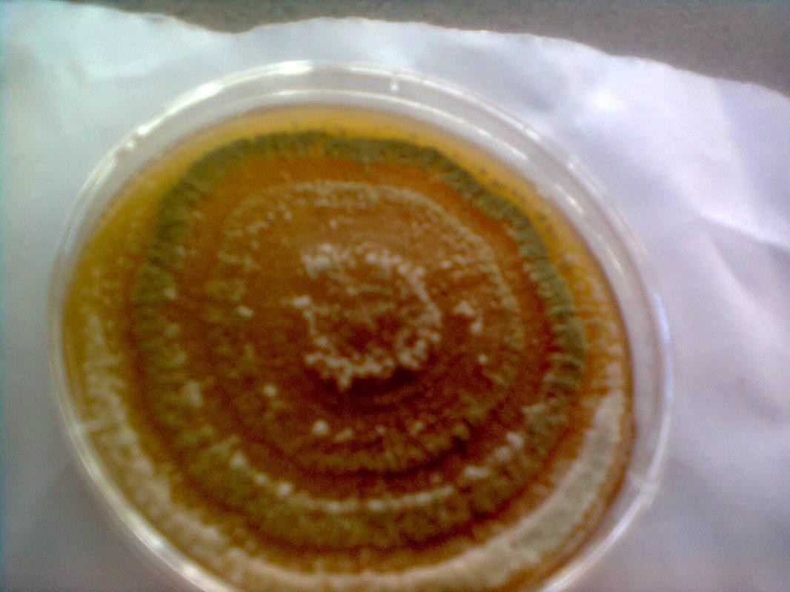

**Plate 4.1:** Four day old culture plate of *T. reesei* TRS

OF

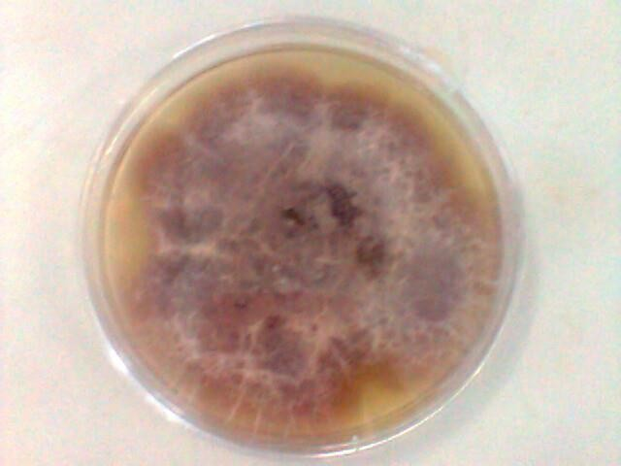

**Plate 4.2:** Seven day old culture plate of *F. compactum* FCGA

OF

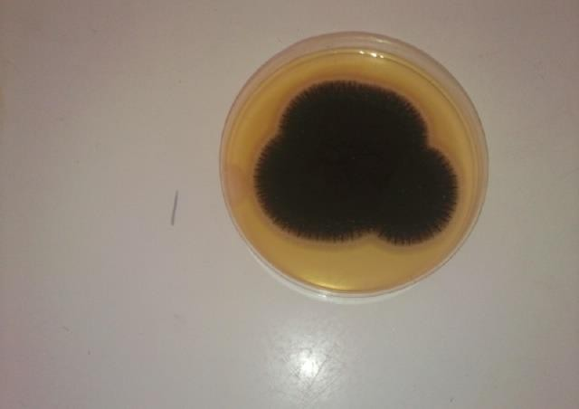

**Plate 4.3:** Four day old culture plate of *A.niger* ANGA1

OF

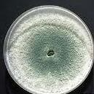

**Plate 4.4:** Four day old culture plate of *T. harzianum* THMA

OF

# Results of hydrolytic enzymes production profile of selected isolates

Figures 4.1a-c, 4.2a-c, 4.3a-c and 4.4a-c show the results obtained on the time course for the production of hydrolytic enzymes by the selected isolates on different substrates. Gen- eraly, all the selected isolates produced hydrolytic enzymes on the substrates in solid state fermentation, although at different quantities and various times. Also, it was observed that the production of hydrolytic enzymes by the isolates was generally low at the first few days of incubation except on few substrates. Glucosidase and xylosidase were produced at lower amount than glucanase, mannanase and xylanase by almost all the isolates on the subsrtrates used.

Among the hydrolytic enzymes produced by *T. reesei* TRS, glucanase was produced max- imally on *A. leiocarpus* as substrate with an activity of 19.39U/g of dry weight of substrate on the 15th day. Significant differenceswere observed in the amount of glucanase produced on the days assays were carried out. On *G. arborea* and *T. superba*, glucanase production was highest on 12th (13.71U/g ) and 15th(11.48U/g ) days respectively and there were also considerable difference in the amount of enzyme produced by the isolate on the substrates (Figures 4.4a-c). Xylanase and mannanase production by this isolate was highest on *A. lei- ocarpus* with values of 13.16U/g on the 15th and 8.81U/ g on the 9th day respectively as shown on Figure 4.4a. However, on *G. arborea*, highest production of xylanase by this fungus was achieved on the 9th day and that of mannanase was on the 12th day (Figure 4.4b). Production of mannanase and xylanase by *Trichoderma reesei* TRS was highest on *Terminalia superba* on the 12th day of incubation with enzyme activities of 10.27U/g and 9.38U/g respectively as presented on Figure 4.4c. More of glucosidase was produced by *T. reesei* TRS compared to xylosidase on all the substrates except on *G. arborea* on which

highest xylosidase production by *T reesei* TRS was 12.39 U/g while glucosidase produc- tion was 11.64U/g both on the 15th day of incubation (Figures 4a-4c).

Generally, from Figures 4.2a-c, *F. compactum* FCGA released less glucanase on all the substrates used than all the other isolates selected for hydrolytic enzyme production. This isolate also produced more xylanase than any other isolates on all the substrates used and the amount of xylanase produced on each of the substrates varied but was generally achieved on the 12th day of incubation (Figures 4.2a-c). *A. leiocarpus* supported the highest xylanase production of 28.93U/g by this isolate as compared to the other substrates which supported lower production of xylanase. *T. superba* supported xylanase production of 16.44U/g which represented the least amount of xylanase produced by this isolate while xy-

lanase production of 21.6U/g was achieved on *G. arborea* by this isolate (Figures 4.2b and 4.2c).

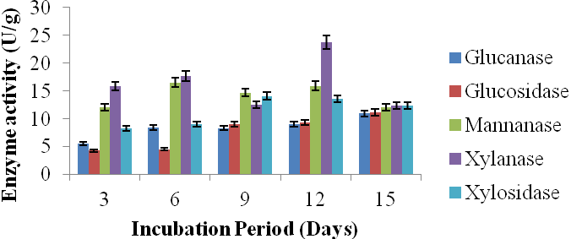

**Figure 4.1a:**Time course on production of hydrolytic enzymes by *A. niger* ANGA1 on *A. leiocarpus* (as substrate)

OF

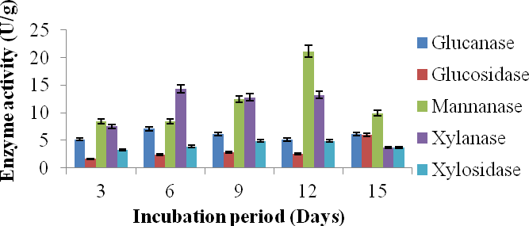

**Figure 4.1b:**Time course on production of hydrolytic enzymes by *A. niger* ANGA1 on *T. superba* (as substrate)

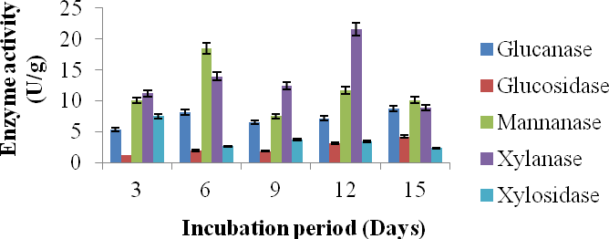

**Figure 4.1c:**Time course on production of hydrolytic enzymes by *A. niger* ANGA1 on *G. arborea* (as substrate)

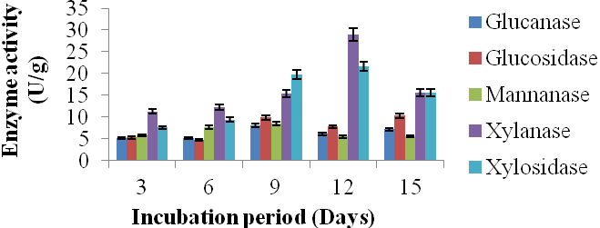

**Figure 4.2a:**Time course on production of hydrolytic enzymes by *F. compactum* FCGA on

*A.leiocarpus* (as substrate)

OF

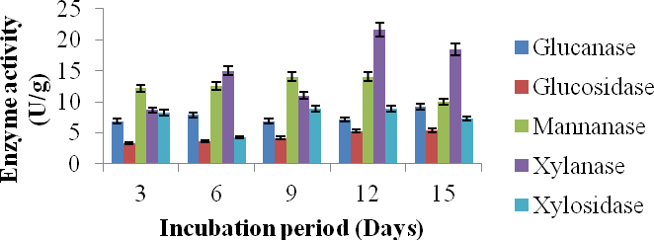

**Figure 4.2b:**Time course on production of hydrolytic enzymes by *F. compactum* FCGA on *G. arborea* (as substrate)

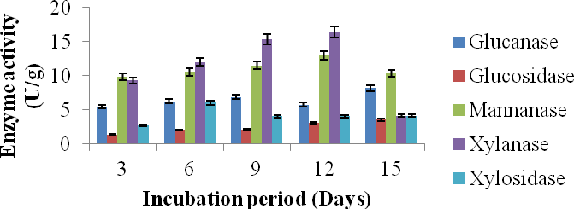

**Figure 4.2c:**Time course on production of hydrolytic enzymes by *F. compactum* FCGA on *T. superba* (as substrate)

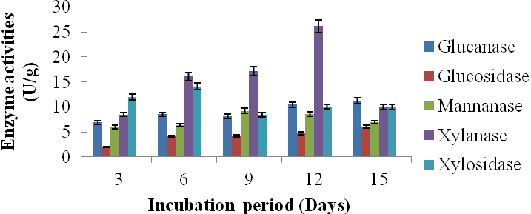

**Figure 4.3a:**Time course on production of hydrolytic enzymes by *T. harzianum* THMA on

*A. leiocarpus* (as substrate)

OF

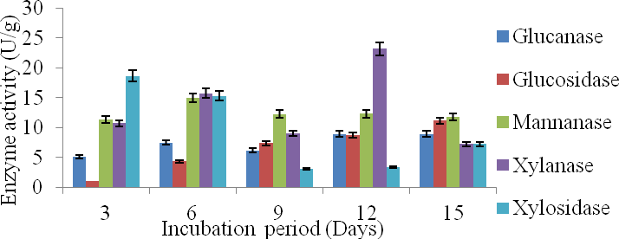

**Figure 4.3b:**Time course on production of hydrolytic enzymes by *T. harzianum* THMA on *G. arborea* (as substrate)

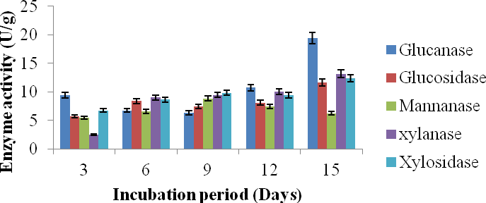

**Figure 4.3c:**Time course on production of hydrolytic enzymes by *T. harzianum* THMA on

*T. superba* (as substrate)

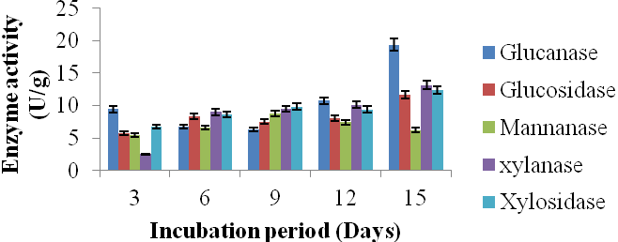

**Figure 4.4a:**Time course on production of hydrolytic enzymes by *T. reesei* TRS on *A. leiocarpus* (as substrate)

OF

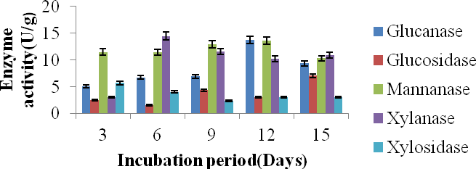

**Figure 4.4a:**Time course on production of hydrolytic enzymes by *T. reesei* TRS on *G. arborea* (as substrate)

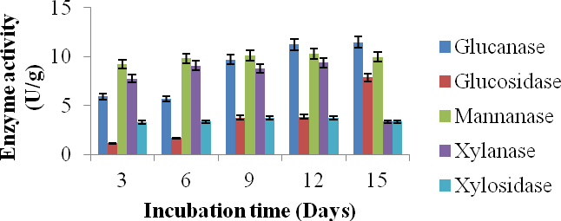

**Figure 4.4c:**Time course on production of hydrolytic enzymes by *T. reesei* TRS on *T. superba* (as substrate)

Highest mannanase production by *F. compactum* FCGA among all the substrates was on

*G. arborea* with an activity of 14.05U/g on the 12th day of incubation, while the lowest was on *A. leiocarpus* with activity of 8.54U/g on the 8th day (Figures 4.2a-c).

On all the substrates, glucanase production by this isolate was highest on the 15th day of incubation as observed on Figures 4.2a-c. *G. arborea* supported highest production of glu- canase by the isolate among all the substrates as shown on and least glucanase activity by

*F. compactum* FCGA was recorded on *A. leiocarpus* as substrate (Figures 4.2a-c).

On *G. arborea,* glucanase production by the isolate was lowest on 9th day. Xylosidase was produced at considerably high amount by this isolate as compared to glucosidase which is considerably low. Highest xylosidase production of 21.62U/g by *F. compactum* FCGA was recorded on *A. leiocarpus* on the 12th day of incubation while the lowest was on *T. superba* as substrate for the fungus. On *A. leiocarpus,* least production of the xylosidases was on the 3rd day*.*

Generally*, A. niger* ANGA1 produced more xylanase than any other enzyme on *A. leiocar- pus* and *G. arborea* while more mannanase was produced by the isolate on *T. superba*. This isolate also produced more hemicellulases than cellulases across board the substrates and their maximum production was achieved between the 9th and 12th day of incubation (Figures 4.1a-c). It was observed that no single substrate singly supported the overall high- est production of all the enzymes produced by this isolate and there were considerable dif- ferences in the amount of enzymes produced among the substrates and within the isolates (Figures 4.1a-c).

On *A. leiocarpus*, least production of all the enzymes was on the 3rd day of incubation ex- cept for xylanase where a downtone of xylanase production(12.49U/g) was recorded on the

9th day and it represented the least amount of xylanase produced during incubation time (Figure 4.1a). Highest glucanase activity of 10.96U/g by *A. niger* ANGA1 was recorded for on the 15th day of incubation on this substrate while highest mannanase and xylanase activities of 16.5U/g and 23.7U/g were recorded on the 6th and 12th days respectively as presented on Figure 4.1a. Highest glucosidase activity of 11.17U/g was recorded for the isolate on the substrate by the 15th day of incubation while for xylosidases the highest ac- tivity(14.11U/g) was on the 9th day of incubation (Figure 4.1a).

*A. niger* ANGA1 inoculated on *G.arborea* had highest glucanase production of 8.69U/g on the 15th day of incubation while highest xylanase production was 21.6U/g on12th day of incubation and mannanase was 18.48 U/g on 6th day of incubation. Highest xylosidase pro- duction by the isolate on this substrate was on 3rd day of incubation with activity of 7.56U/g and glucosidase was on the 15th day with an activity of 8.69U/g (Figure 4.1b).

*T. superba* supported highest production of glucanase by *A. niger* ANGA1 on the 6th day of incubationwhile the least was on the 3rd day with activities of 7.14 U/g and 5.18U/g respec- tively. Mannanase and xylanase production was highest by the isolate on the 12th and 6th days of incubation with activity values of 21.18U/g and 14.33U/g respectively (Figure 4.3c). Xylosidase and glucosidase were produced at their peakby the isolate using *T. su- perba* as substrate on the 12th and 15th days of incubation respectively (Figure 4.1c).

Among all the hydrolytic enzymes produced by *T. harzianum* THMA*,* xylanase was most produced on all the substrates while *A. leiocarpus* supported the best production of the enzyme. The hydrolytic enzyme least produced by this isolate on all th substrates was glucosidase (Figure 4.3a-c).

*A. leiocarpus* supported highest glucanase activity(11.28U/g) by *T. harzianum* THMA on the 15th day while mannanase ad xylanase activities of the isolate was at their peaks on the 9th and 12th days with values of 9.34U/g and 26.15U/g respectively (Figure 4.3a). Gluco- sidase and xylosidases activities of the isolate were highest on the 15th and 6th days of in- cubation respectively (Figure 4.3a).

On *G. arborea*, *T. harzianum* THMA produced its peak glucanase on the 12th day of incu- bation with glucanase activity of 8.92U/g while the highest mannanase and xylanase activi- ties by the isolate was 14.94U/g and 23.16U/g on the 6th and 12th days of incubation. High- est xylosidase and glucosidase activities of 18.65U/g and 11.12U/g by the isolate were rec- orded on the 3rd and 15th days respectively (Figure 4.3b).

Xylanase was produced at its peak by *T. harzianum* THMA on *T. superba* on the 12th day with activity value of 13.49U/g while mannanase was on the 12th day with noconsiderable rise in activities throughout the duration of incubation. Glucanase activity by this isolate on the substrate was on the 15th day with a value of 10.69U/g and there was significant change in the activities on the days of incubation except between the 6th and the 9th day the same trend was noticed in the production of glucosidase by the isolate on this substrate but dif- ferent values of activities were obtained. Xylosidase was produced at its peak on the 9th and 12th days with activity value of 5.99U/g (Figure 4.3c).

# Optimisation of Xylanase Production Process Condition

*F. compactum* FCGA and *Trichoderma harzianum* THMA were selected for the optimization of process condition for enhanced xylanase production since they both had relatively higher xylanase activities as compared to other isolates used in the production of

hydrolytic enzymes in SSF. Maximum production of xylanase by these isolates was achieved on *A. leiocarpus* as substrate, therefore, it was selected as substrate of choice for optimisation tests. The optimisation test was considered for xylanase because this enzyme has been reported to be very useful in bleaching of pulp, saccharification and separation of wood fiber. Highest xylanase activities by these isolates were obtained on the 12th day of incubation in SSF so for the optimisation tests 12 days duration was used for incubation by these isolates. Temperature, pH, aeration, moisture content of substrate, inoculum size and organic nitrogen sources for the fungi were varied to determine the optimum production condition for this enzyme by the fungi.

Optimum temperature for the production of xylanase by *F. compactum* FCGA was 40oC at which xylanase activity was 34.97U/g while for *T. harzianum* THMA, it was at 30 oC (24.85U/g) as shown on Figure 4.5a.

Results of the effect of pH on xylanase production by each of the isolates showed that there was great variation in enzymes production by the isolates at different initial pH of the substrate. Optimum xylanase production by *F. compactum* FCGA was at pH 5 while for *T. harzianum* THMA, the enzymemost produced at was pH 6 (Figure 4.5c). There was considerable differences in the xylanase activities at the pH ranges tested for this work.

Highest xylanase production by *F. compactum* FCGA and *T. harzianum* THMA was observed at initial moisture content of substrate of 50% (30.62U/g) and 60%(26.97U/g). as shown on Figure 4.5b. Xylanase production by *F. compactum* FCGA was also ralatively high at 60% (28.49U/g) initial moisture content of substrate.

Xylanase production by *F. compactum* FCGA increased from inoculum size of 106 to 1015 and maximum production was at 1015. There was a slight drop in enzyme production at inoculum size 1018 with xylanase activity of 41.159U/g. The difference in xylanase activity of the fungus at inoculum size of 1015 and 1018 was not very significant (Figure 4.5f). *T. harzianum* THMA on the other hand had highest xylanase production at inoculum size 109.

Among the different organic nitrogen sources tested to support the production of the enzyme by these fungi, yeast extract supported its optimum production by *F. compactum* FCGA (43.357U/g) and *T. harzianum* THMA (29.604U/g) as shown on Figure 4.5d.

Figure 4.5e shows the xylanase production of the isolates at different aeration. The optimum enzyme activity by *F. compactum* FCGA was at 50% initial aeration of the fermenting vessel. It was observed that there was increase in xylanase activity of the fungus as the initial aeration of the fermenting vessel was increased from 10% to 50%. *T. harzianum* THMA also had its optimum xylanase production at 50% initial aeration of the fermenting vessel.

Figure 4.5g shows that moistening medium 6 supported the highest xylanase production by both fungi so it was subsequently used as the growth or moistening medium for production of the enzyme by either of the isolates.

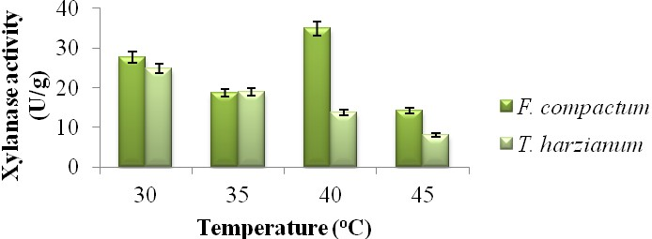

**Figure 4.5a**: Xylanase activities of isolates on *A. leiocarpus* as substrate at different tem- perature.

OF

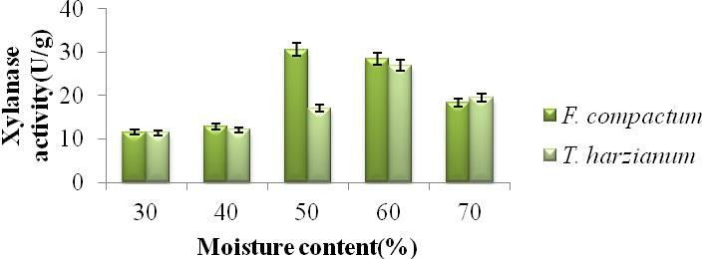

**Figure 4.5b:** Xylanase activities of isolates at different moisture content of *A. leiocarpus*

as substrate.

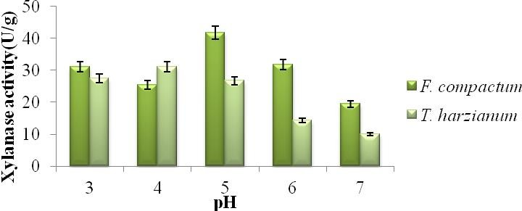

**Figure 4.5c:** Xylanase activities of isolates on *A. leiocarpus* as substrate at varied pH.

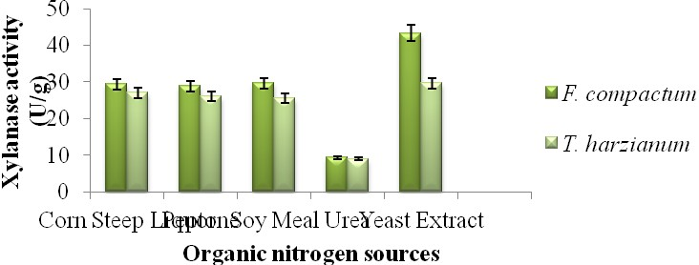

**Figure 4.5d:** Xylanase activities of isolates on *A. leiocarpus* as substrate with different or- ganic nitrogen sources**.**

OF

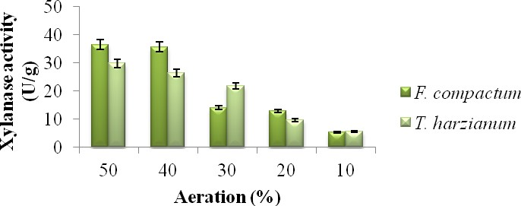

**Figure 4.5e:** Xylanase activities of isolates on *A. leiocarpus* as substrate at different aera- tion**.**

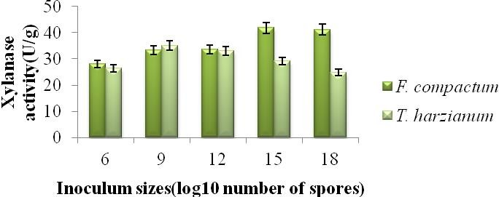

**Figure 4.5f:** Xylanase activities of isolates on *A. leiocarpus* as substrate at different inocu- lum sizes

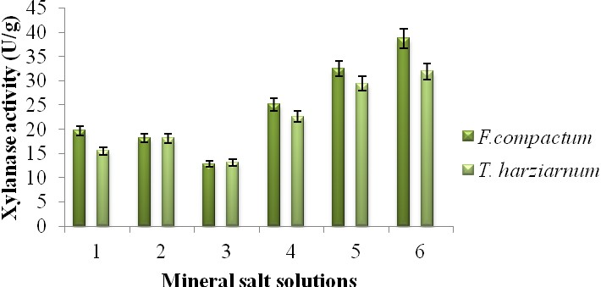

**Figure 4.5g:** Xylanase activities of isolates on *A. leiocarpus* as substrate using different mineral salts

# Characterisation of Enzymes

Glucanase, mannanase and xylanase produced by selected isolates were each characterized. The results obtained for the characerisation tests are presented on Figures 4.6 - 4.8. Xy- lanase produced by *F. compactum* FCGA was partially purified by ammonium sulfate pre- cipitation and characterized. Peak activity of the enzyme was at 40oC and 55oC while the least was at 65oC when the enzyme activity was virtually lost (Figure 4.6a). Figure 4.6c shows the effect of different xylan concentrations on activity of partially purified xylanase from *F. compactum* FCGA. Enzyme activity was at its peak at 0.8% xylan concentration while the least was at 0.2% concentration of xylan. Effect of pH on activity of partially purified xylanase from *F. compactum* FCGA is shown on Figure 4.6b. The xylanase had its highest activity at pH values of 5.5 and 6.5 while the lowest was at pH 4.0.

Fig 4.6d shows that all the anions had least effect on the activity of the xylanase at their lowest concentrations but none of them induced higher enzyme activity.

Effect of different concentrations of some cations on xylanase activity of partially purified xylanase by *F. compactum* FCGA is presented on Figure 4.6e. All the cations caused the enzyme to virtually lose its activity at high concentrations except magnesium ion. Sodium ion least caused reduction of activity of the enzyme. The cations at different concentrations used in this work induced reduction in enzyme activity (Figure 4.6e).

Thermal stability test of the enzyme showed that the activity was very low at 65oC. At 50 and 55oC the enzyme activity was low but was stable up to 30 minutes of exposure to such temperature, as shown on Figure 4.6f.

The optimum activity for mannanase by *A. niger* ANGA1 was at 30oC (5.143 U/ml) while the least activity was at 65oC (0.329U/ml) as shown on Figure 4. There was a downturn of enzyme activity from 30oC to 65oC but the activity was almost nil between 60oC and 65oC

indicating that mannanase by *A. niger* ANGA1 may lose its activity at such temperature range.

The activity of the mannanase was very low at a concentration of 0.25% mannan (0.162U/ml) and highest at 0.75% mannan concentration. It was observed that there was sharp increase in activity of the enzyme between 0.25% and 0.50% mannan concentration. There was no considerable difference in mannanase activity between 0.5% and 1.0% sub- strate concentrations (Figure 4.7c).

Influence of varying pH on the activity of the enzyme is shown on Figure 4.7b.The enzyme was most active at pH 5.5 (5.111 U/ml). The pH at which the enzyme activity was lowest was 7 (3.014U/ml), however there was a significant rise in the activity at pH 6.5 after a downward turn at pH 6.0.

Figure 4.7e shows the effect of different cations concentrations on the enzyme activity. Generally the cations did act as inducers to this enzyme. However it was noticed that the enzyme activity was not drastically affected at low concentration of the cations but was practically denatured at higher concentrations except for sodium and manganese ions.

Among anions tested on the enzyme, sulphate ion seems to act as inducer at 0.2M concen- tration while at other concentrations of each of the ions the enzyme activity was lowered. Nitrate ion at 0.1M only maintained the activity of the enzyme while other concentrations reduced it. Chloride ion had mild inhibitory effect on the enzyme as shown in Figure 4.7d.

Figure 4.7f shows the thermostability of the enzyme at different temperatures. The enzyme was stable throughout the duration of exposure to 50oC and 55oC, the activity however,

dropped when it was exposed to 60oC for more than 15 minutes. The activity of the en- zyme was virtually lost at temperature of 65oC.

.

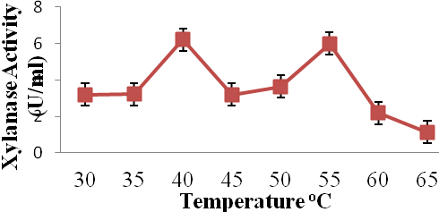

**Figure 4.6a**:Effect of temperature on activity of partially purified xylanase from *F. compactum* FCGA.

OF

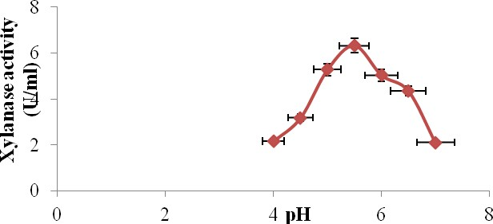

**Figure 4.6b:** Effect of pH on activity of partially purified xylanase from *F. compactum*

FCGA.

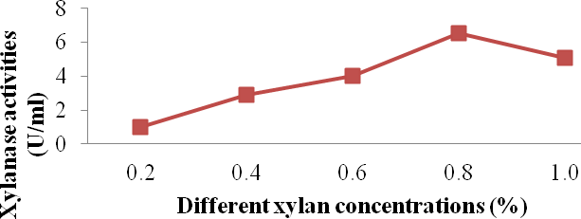

**Figure 4.6c:** Effect of different xylan concentrations on activity of partially purified xylanase from *F. compactum* FCGA.

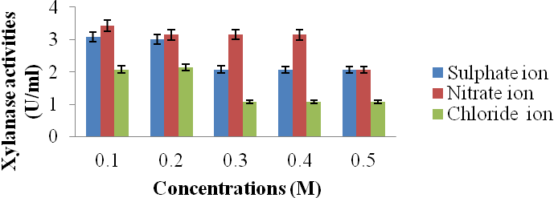

**Figure: 4.6d:**Effect of different concentrations of some anions on activity of partially purified xylanase from *F compactum* FCGA.

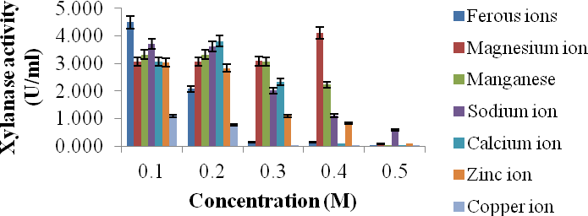

**Figure 4.6e:** Effect of different concentrations of some cations on xylanase activity of par- tially Purified xylanase by *F. compactum* FCGA

OF

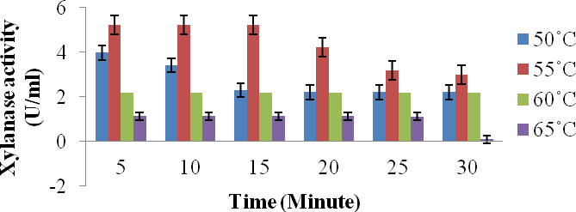

**Figure 4.6f:** Effect of temperature on stability of xylanase from *F. compactum* FCGA

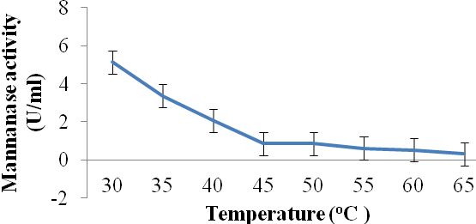

**Figure 4.7a:** Effect of different temperatures on activity of partially purified β – man- nanase from *A. niger* ANGA1**.**

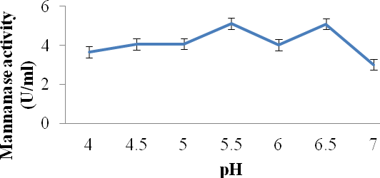

**Figure 4.7b**: Effect of different pH on activity of partially purified β - mannanase from *A. niger* ANGA1.

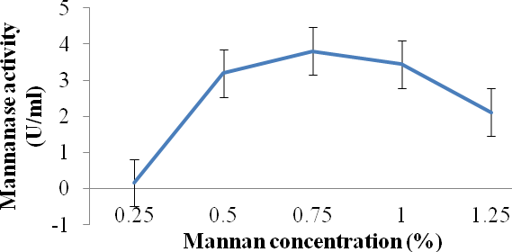

**Figure 4.7c**: Effect of different mannan concentrations on activity of partially purified β - mannanase from *A. niger* ANGA1.

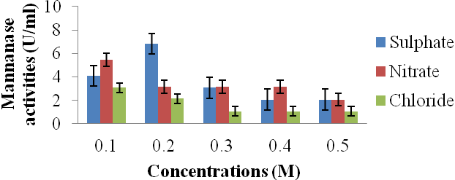

**Figure 4.7d:** Effect of different anions‟ concentrations on the activity of partially purified β-mannanase from *A. niger* ANGA1

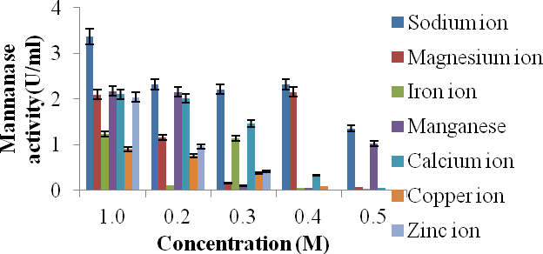

**Figure 4.7e**: Effect of different cations‟concentrations on the activity of partially purified β

- mannanase *A. niger* ANGA1

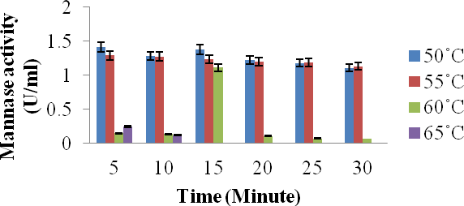

**Figure 4.7f:** Thermostability of partially purified β - mannanase from *A. niger* ANGA1

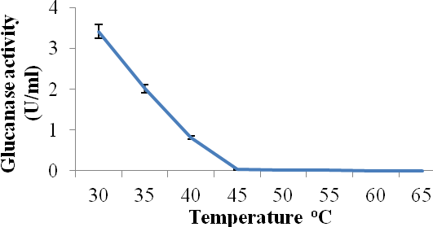

**Figure 4.8a:** Effect of different temperatures on activity of partially purified glucanase from *T. reesei* TRS**.**

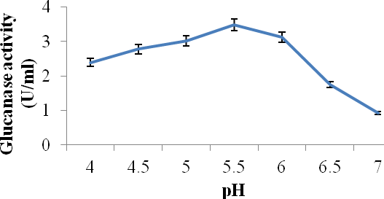

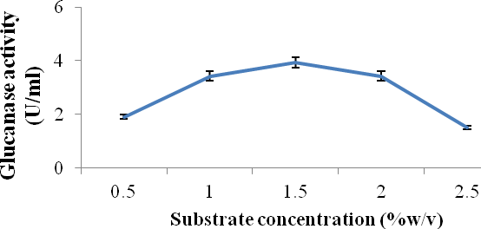**Figure 4.8b:** Effect of different pH on activity of partially purified glucanase from *T. reesei* TRS**.**

**Figure 4.8c:** Effect of different substrate concentration on activity of partially purified glucanase from *T. reesei* TRS**.**

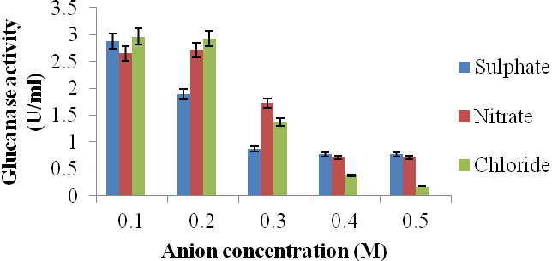

**Figure 4.8d:** Effect of different concentration of anion on activity of partially purified glu- canase from *T. reesei* TRS.

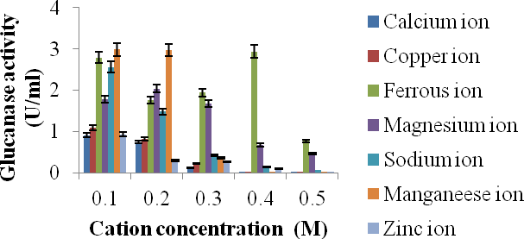

**Figure 4.8e:** Effect of different concentration of cation on activity of partially purified glu- canase from *T. reesei* TRS**.**

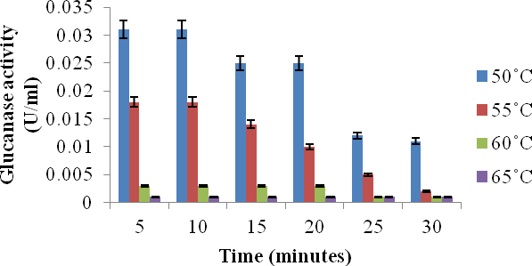

**Figure 4.8f:** Thermostability of partially purified glucanase from *T. reesei* TRS

From the result on kinetic characterization of partially purified mannanase produced by *A. niger* ANGA1 (Figure 4.9), the Km (Michelis-Menten constant) value is 0.754mg/ml while the Vmax (maximum velocity) value was 1.364U/mg/min. The Km value for the xylanase produced by *F. compactum* FCGA was 1.402mg/ml while the Vmax value was 1.804U/mg/min (Figure 4.10).

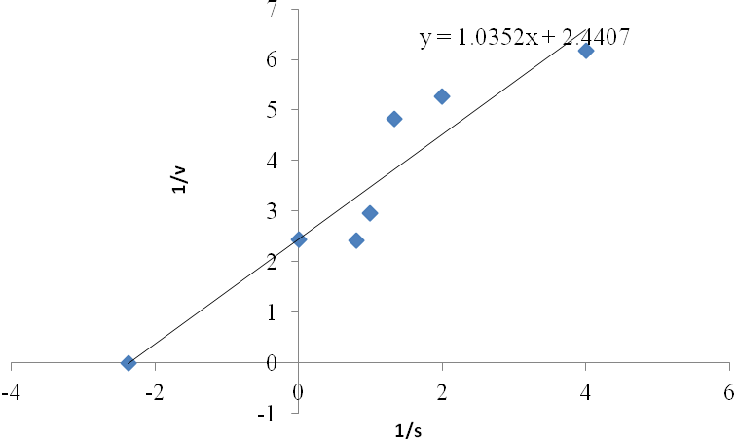

**Figiure 4.9:** Lineweaver-Burk graph showing reciprocal of Km and Vmax values of partially purified mannanase by *A. niger* ANGA1

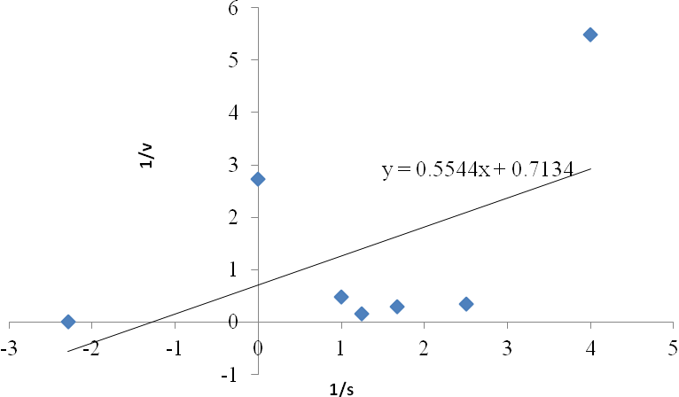

**Figiure 4.10:** Line weaver-Burk graph showing reciprocal of Km and Vmax values of partially purified xylanase by *F. compactum* FCGA

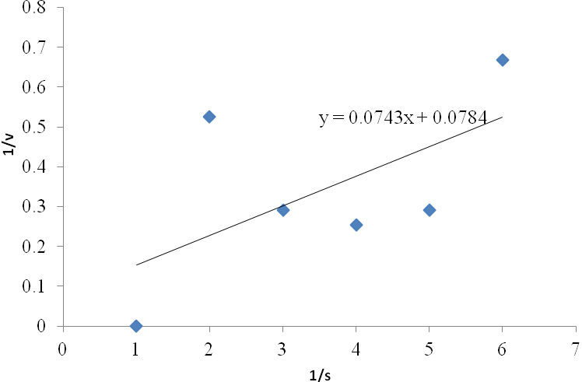

**Figiure 4.11:** Lineweaver-Burk graph showing reciprocal of Km and Vmax values of partially purified glucanase by *T. reesei* TRS***.***

OF

# Purification of Enzymes

Figures 4.12 shows the elute profile of xylanase produced by *F. compactum* FCGA, two sharp peaks were observed in the curve obtained and these corresponded to the high pro- tein contenst and xylanase activities obtained for the elutes from tubes 8 and tube 22. When these were pooled together and subjected to ion exchange chromatography, an early broad xylanase activity peak was observed but did not correspond to very high protein con- tent. However shaper peaks of high protein content and xylanase activity indicating the elution of the enzyme was obtained from tube 21 out of the 30 tubes used to collect the elute as presented on Figure 4.15.

The elute profile of mannanase produced by *A.niger* ANGA1 (Figures 4.13 and 4.16). Figure 4.13 showed the peaks obtained for the gel filtration chromatography was from tubes 8, 14 and 18 with high protein content and mannanase activities. Figure 4.16 shows the result obtained from the ion chromatography carried out on the pooled elute from gel filtration chromatography. The result showed that mannanase activity and protein peaks were obtained from elutes in tubes 9 and 19 this may be an indication that mannanases produced by this isolate are of different molecular weights. Molecular characterization of the pooled elutes later revealed the elute consists of mannanases with different molecular weights.

The elute profile of gel filtration chromatography of cellulase produced by *T.reesei* TRS is shown on Figure 4.14, a single peak of high protein content and glucanase activity was ob- tained from elutes of tube 12. Results of ion exchange chromatography purification on this elute (Figure 4.17) indicates that an early low gradient peak of xylanase activity and pro-

tein content from the elute from tubes 7 and 9 was observed, however a higher peak indi- cating higher protein content and glucanase activity was later obtained in tube 17 elute.

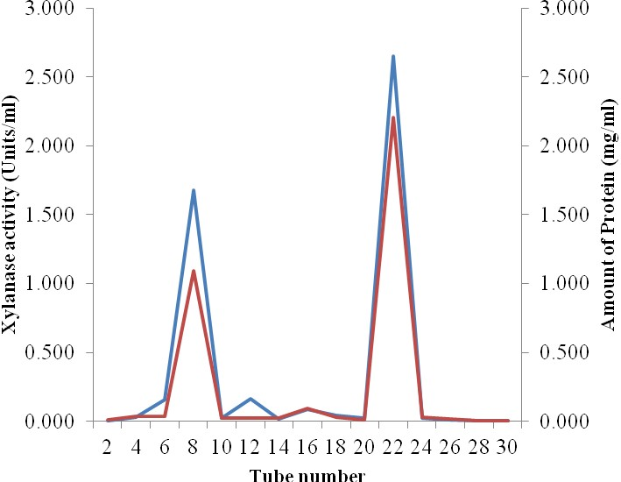

**Figure 4.12:** Separation of Protein in culture filtrate of *F. compactum* FCGA during Gel Filtration and the enzymic reaction of the eluant towards xylan.

OF

**KEY:** Blue line- Xylanase activity Red line- Protein content

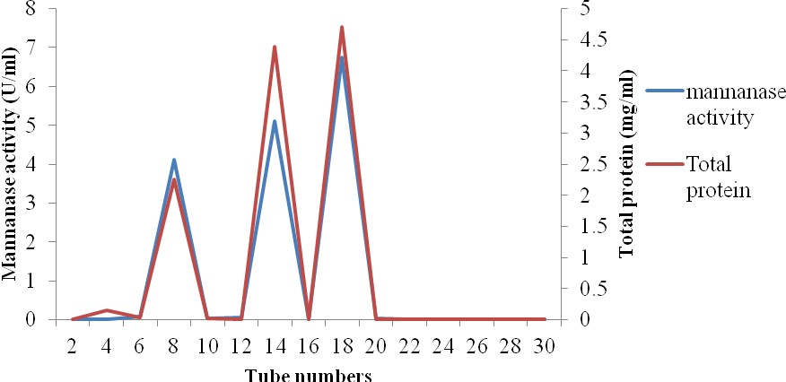

**Figure 4.13:** Separation of Protein in culture filtrate of *A. niger* ANGA1during Gel Filtra- tion and the enzymic reaction of the eluant towards mannan.

**KEY:** Red line: Total Protein content Blue line: Mannanase activity

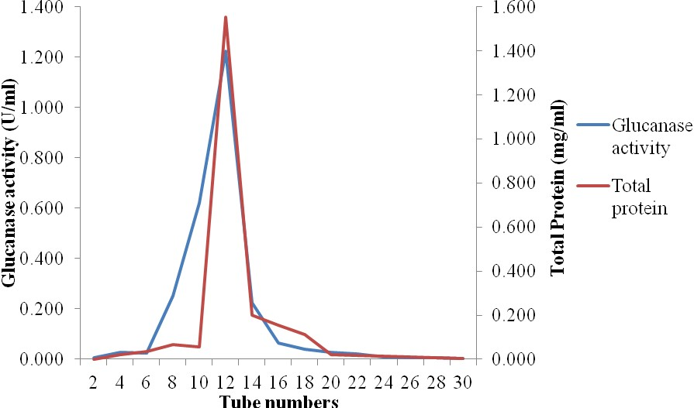

**Figure 4.14:** Separation of Protein in culture filtrate of *T. reesei* TRS during Gel Filtration and the enzymic reaction of the eluant towards carboxylmethyl cellulose.

OF

**KEY:** Blue line: Glucanase activity Red line: Total Protein content

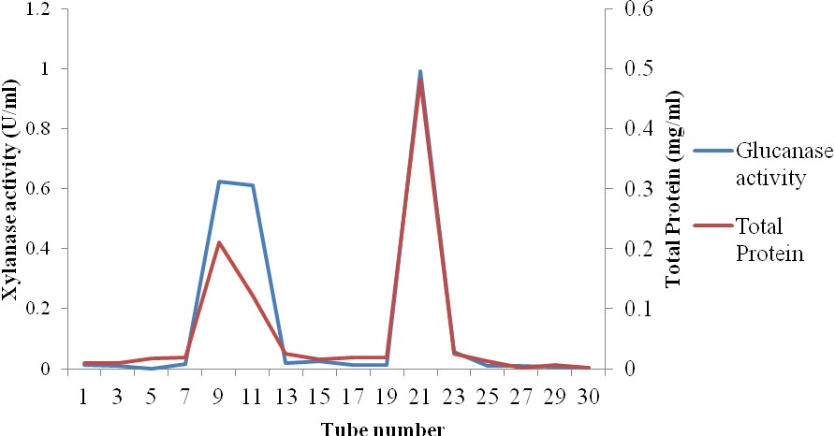

**Figure 4.15:** Separation of proteins Protein from eluants of *F. compactum* FCGA during Ion Exchange chromatography and enzymic reactions of fractions towards Xylan.

**KEY:** Blue line: Xylanase activity Red line: Total protein

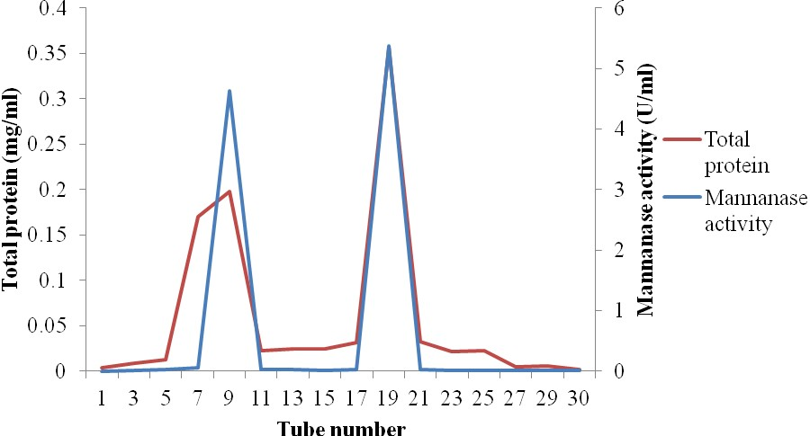

**Figure 4.16:** Separation of proteins of Protein from eluants of *A. niger* ANGA1 during Ion Exchange chromatography and enzymic reactions of fractions towards Mannan.

**KEY:** Blue line: Mannanase activity Red line: Total protein

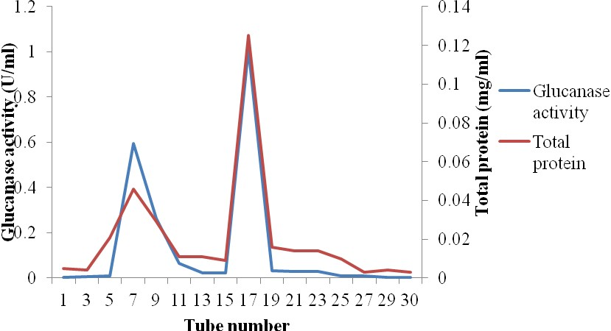

**Figure 4.17:** Separation of proteins from eluants of *T. reesei* TRS during Ion Exchange chromatography and enzymic reactions of fractions towards Carboxylmethyl cellulose.

**KEY:** Blue line: Glucanase activity Red line: Total protein

Table 4.5 shows the purification table for glucanase produced by *T. reesei* TRS*,* the total yield of 47.91% was obtained after ion exchange chromatography with a purification fold of 18.319. Total specific glucanase activity of 9.068U/mg was obtained after ion exchange chromatography from an initial value of 0.257U/mg from the crude enzyme filtrate.

The purification Table for mannanase produced by *A. niger* ANGA1 is presented on Table

4.6. The result showed that total protein reduced from1814.6mg for the crude enzyme to 26.4mg from the ion exchange chromatography elute. A purification fold of 15.894 was obtained after ion exchange chromatography with a corresponding total yield of 23.1% and total specific mannanase activity of 19.09U/mg.

The result obtained for the purification of xylanase produced by *F. compactum* FCGA from the crude enzyme to ionexchange chromatography is presented on Table 4.7. A total yield of 3.0% and a purification fold of 18.684 were obtained for the enzyme after ion ex- change chromatography. A corresponding final total specific xylanase activity of 7.38U/mg was obtained after ion exchange chromatography of the enzyme from an initial value of 0.395U/mg obtained for the crude enzyme.

# Table 4.5: Purification Table of Glucanase Produced by *T. reesei* TRS

|  |  |  |  |  |  |  |  |
| --- | --- | --- | --- | --- | --- | --- | --- |
| **Form of isolate’s**  **Enzyme** | **Total Volume (ml)** | **Total Soluble Protein (mg)** | **Glucanase Activity (U)** | **Total Glu- canase Activity (U)** | **Total Specific Glucanase Ac- tivity (U/mg)** | **Total Yield (%)** | **Purification Fold** |
| **Crude** | 100 | 1647.9 | 4.24 | 424 | 0.257 | 100 | 1.00 |
| **Ammonium sulfate pre- cipitation** | 100 | 1290 | 3.42 | 348 | 0.270 | 82.08 | 1.057 |
| **Gel filtration** | 100 | 155.3 | 1.223 | 122.3 | 0.788 | 28.844 | 3.066 |
| **Ion exchange** | 100 | 12.5 | 1.012 | 101.2 | 8.096 | 23.87 | 31.502 |

**Table 4.6: Purification Table for Mannanase Produced by *Aspergillus niger* ANGA1**

|  |  |  |  |  |  |  |  |  |
| --- | --- | --- | --- | --- | --- | --- | --- | --- |
| **Form of isolate’s En- zyme** | **Total Volume (ml)** | **Total Soluble Protein**  **(mg)** | **Mannanase Activity**  **(U)** | **Total Man- nanase Activi- ty**  **(U)** | **Total Specific Mannanase**  **Activity (U/mg)** | **Total Yield (%)** | **Purification Fold** |  |
| **Crude** | 100 | 1814.6 | 21.788 | 2178.8 | 1.201 | 100 | 1.00 |  |
| **Ammonium sulfate pre- cipitation** | 100 | 1541.7 | 11.571 | 1157.1 | 0.751 | 53.1 | 0.6253 |  |
| **Gel filtration** | 100 | 474.6 | 6.72 | 672 | 1.416 | 30.18 | 1.1782 |  |
| **Ion exchange** | 100 | 26.4 | 5.04 | 504 | 19.09 | 23.1 | 15.895 |  |

# Table 4.7: Purification Table of Xylanase Produced by *F.compactum* FCGA

|  |  |  |  |  |  |  |  |
| --- | --- | --- | --- | --- | --- | --- | --- |
| **Form of isolate’s En- zyme** | **Total Volume (ml)** | **Total Soluble**  **Protein (mg)** | **Xylanase Activity (U)** | **Total xylanase Activity**  **(U)** | **Total Specific xylanase**  **Activity (U/mg)** | **Total Yield (%)** | **Purification Fold** |
| **Crude** | 100 | 1773.6 | 8.33 | 833 | 0.395 | 100 | 1.00 |
| **Ammonium suphate pre- cipitation** | 100 | 1407.0 | 6.50 | 650 | 0.462 | 78 | 1.17 |
| **Gel filtration** | 100 | 225.3 | 2.608 | 260.8 | 1.158 | 31.31 | 2.932 |
| **Ion exchange** | 100 | 50.2 | 1.091 | 109.1 | 2.173 | 13.10 | 5.501 |

**Molecular Characterisation** The molecular characterization of cellulase by *T. reesei* TRS, mannanase produced by *A. niger* ANGA1 and xylanase from *F. compactum* FCGA (Plate 4.7). The molecular weight of the ammonium sulfate precipitated cellulase were 29 and 60 kDa that of mannanase fell within the range of 29, 33, 46 and 65kDa. For xylanase, only one protein band of molecular weight 90 kDa was visible.

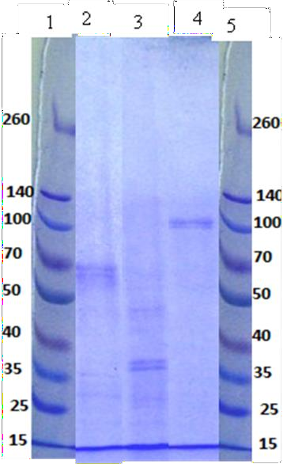

Lanes

**Plate 4.5:** Sodium dodecyl Sulphate Electrophoresis Profile of major hydrolytic enzymes from the isolates

OF

**KEY:** Lane 1- Molecular marker

Lane 2- Cellulase from *T. reesei* TRS Lane 3- Mannase from *A. niger* ANGA1

Lane 4- Xylanase from *F. compactum* FCGA Lane 5- Molecular marker

# Chemical analyses of Fungi pretreated wood samples

The analyses carried out on the six week treatment of wood chips with fungi gave the re- sults presented on Figures 4.18 to 4.19. For the wood samples tested, the pretreatment af- fected the parameters that were monitored but the effect varied depending on the wood sample and the fungi used for pretreatment. All the parameters treated reduced progres- sively as the duration of treatment advanced as shown on these Figures.

From the results obtained after 6 weeks of pretreatment, *T. superba* wood sample treated with a combination of *T. harzianum* THMA and *F. compactum* FCGA gave the best result with the highest reduction in hemicellulose (39.4%), ash (10.6%) and lignin (11.9%) con- tents, cellulose was reduced by 20.7% (Figure 4.18c).

*G. arborea* treated with a combination of *T. harzianum* THMA and *F. compactum* FCGA had a reduction of 25.5% in hemicellulose content, 10.8% of lignin content was reduced, ash was reduced by 11.5% and cellulose by 23.1% after 42 days of pretreatment (Figure 4.19c).

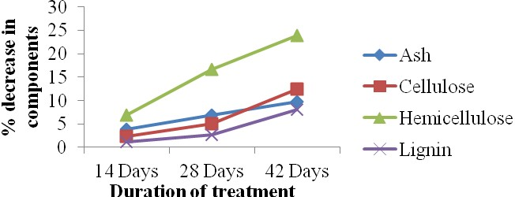

**Figure 4.18a:** Percentage reduction in ash, cellulose, hemicellulose and lignin contents of

*T. superba* pretreated with *F. compactum* FCGA.

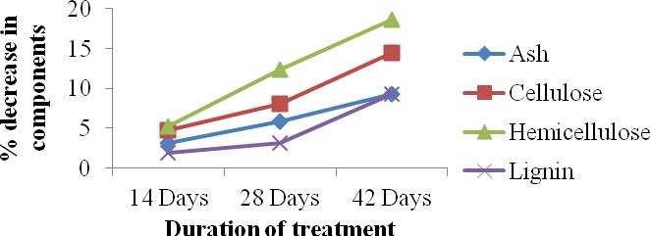

**Figure 4.18b:** Percentage reduction in ash, cellulose, hemicellulose and lignin contents of

OF

*T. superba* pretreated with *T. harzianum* THMA

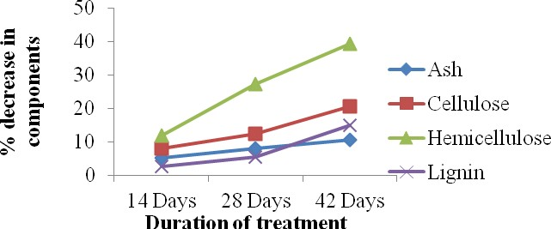

**Figure 4.18c:** Percentage reduction in ash, cellulose, hemicellulose and lignin contents of

*T. superba* pretreated with *T. harzianum* THMA and *F. compactum* FCGA**.**

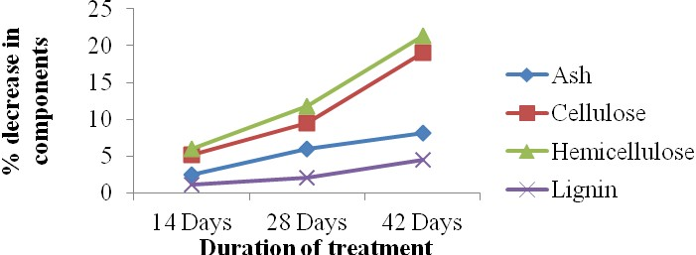

**Figure 4.19a:** Percentage reduction in ash, cellulose, hemicellulose and lignin contents of

*G. arborea* pretreated with *T. harzianum*THMA

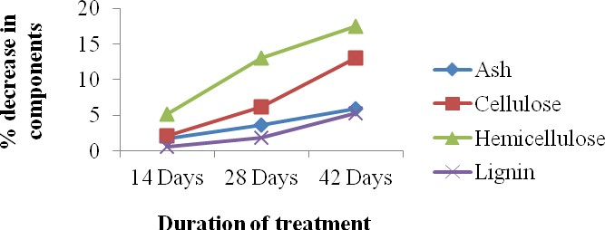

**Figure 4.19b:** Percentage reduction in ash, cellulose, hemicellulose and lignin contents of

OF

*G. arborea* pretreated with *F. compactum* FCGA. .

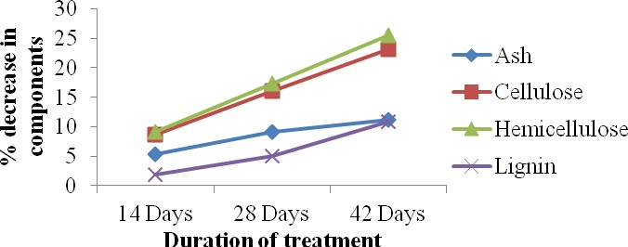

**Figure 4.37c:** Percentage reduction in ash, cellulose, hemicellulose and lignin contents of

*G. aborea* pretreated with *F. compactum* FCGA and *T. harzianum* THMA

Physical characteristics of pulp obtained from wood samples pretreated with fungal iso- lates are presented on Tables 4.9 and 4.10. These results showed that pulp from wood samples treated with fungi had better physical characteristics than the control samples which were not pretreated with fungi. Pulp from wood samples that were treated in combi- nation gave better pulp characteristics than those that were treated singly.

Among the two wood samples treated, the best result obtained from single treatment was on *G. arborea* that was treated with *F. compactum* FCGA wiich had fibre length of 2.03mm, fibre strength of 83.1 N/cm and tensile strength of 65.7Nm/g (Table 4.9). Best characteristics obtained from wood treated in combination was on *T. superba* treated with

*F. compactum* FCGA and *T. harzianum* THMA with pulp characteristics of 1.72mm fibre length,72.9N/cm fibre strength and 54.8Nm/g tensile strength (Table 4.8).

Effect of xylanase treatment on kappa number of brown paper pulp and on the amount of xylose in hydrolysate is presented on Table 4.10. This result showed that the treatment reduced the Kappa number of the pulp as the concentration of xylanase used in treating the pulp was increased. It was also observed that amount of reducing sugar in the hydrolysate increased with increase in enzyme concentration, the highest amount of xylose (3.16mg/g of pulp) was recorded for the hydrolysate obtained from the pulp treated with 6.0U/ml of xylanase (Table 4.10).

**Table 4.8:** Physical Characteristics of *T. superba* pulp pretreated with Fungi and the Un- pretreated Samples

|  |  |  |  |
| --- | --- | --- | --- |
| Treatments | Fibre Length (mm) | Fibre Strength (N/cm) | Tensile Strength (Nm/g) |
| *T. herziarnum*THMA | *1.69 + 0.0071 | 70.2 | 52.5 |
| *F.compactum* FCGA | **\***1.70 + 0.060 | 71.7 | 53.7 |
| *T. herziarnum*THMA  **+***F.compactum*FCGA | **\***1.72 + 0.009 | 72.9 | 54.8 |
| Control | **\***1.69 + 0.015 | 69 | 52 |

**\***Each value is the mean of triplicate values + Standard Error.

**Table 4.9:** Physical Characteristics of *G.arborea* pulp prereated with Fungi and the Unpre- treated samples.

|  |  |  |  |
| --- | --- | --- | --- |
| Treatments | Fibre Length  (mm) | Fibre Strength  (N/cm) | Tensile Strength  (Nm/g) |
| *T. herziarnum*THMA | **\***1.93 + 0.006 | 79 | 63.5 |
| *F.compactum* FCGA | **\***2.03 + 0.007 | 83.1 | 65.7 |
| *T. herziarnum*THMA  **+***F.compactum*FCGA | **\***1.94 + 0.013 | 81 | 64.3 |
| Control | **\***1.91 + 0.009 | 78 | 63 |

**\***Eachvalue is the mean of triplicate values + standard error.

**Table 4.10:** Effect of Xylanase treatment on Kappa number of Brown Paper pulp and on the amount of xylose in hydrolysate

|  |  |  |  |
| --- | --- | --- | --- |
| Treatments of pulp | Kappa number | Amount of xylose  (mg/g of pulp) at 237nm | Amount of xylose (mg/g of pulp) at 465nm |
| Initial pulp | **\***43.1±0.013 | **\***0.01±0.007 | 0.0 |
| 2U/g of xylanase | **\***42.3±0.041 | **\***1.33±0.003 | **\***0.019±0.007 |
| 4U/g of xylanase | **\***41.8±0.032 | **\***2.68±0.001 | **\***0.129±0.004 |
| 6U/g of xylanase | **\***40.4±0.013 | **\***3.16±0.003 | **\***0.114±0.17 |
| Control | **\***43.1±0.019 | **\***0.01±0.007 | 0.0 |

**\***Eachvalue is the mean of triplicate values + standard error

# CHAPTER 5

**5.0 DISCUSSION**

Onilude and Bada (2000) and Ero and Adebo (2011) in their respective researches have classified woods of trees such as *H. grandis, G. arborea, M. altissima* and *T. superba* as relatively low density woods. This may explain the relative higher frequencies of oc- curence of isolates on these wood samples, since their low density will enhance easier pen- etration of fungal hyphae into the matrices of these woods. *A. leiocarpus* is particularly described by Goodel (2003) as a wood rich in hemicellulosic and cellulosic components and so may serve as a good source of carbon to microorganisms that can degrade these components of wood. This may be the reason fungal colonization of the wood was high as observed from the results showing the percentage frequencies of occurrence of isolates on different wood samples and the relatively high hemicellulase and cellulase activities of the isolates obtained from the wood sample.

The isolates obtained from degrading wood used in this work identified as *Aspergillus spp, Lasiodiplodia theobromae, Penicillium purpurogenum, Trichoderma* spp *E. nidulans* and *Fusar*i*um* spp. have been previously isolated from lignocellulosic materials (of which wood chips is one) by other researchers (Brown *et al.,* 1987; Immanuel *et al.,* 2001; Goodel, 2003; Gathorra *et al*., 2006; Sridevi and Charya, 2011). They have also been re- ported to be associated with soft rot degradation in wood (Hoffmann and Wood, 1985; Goodel, 2003). The most frequently isolated among these isolates were *A. niger*, *Trichderma* spp., *R. stolonifer* and *A. niger*. *R. stolonifer* and have been reported as a

ubiquitous fungi found on the surface of almost every surface (Alexopoulus *et al*., 1996). It may be on the wood as an opportunistic colonizer, making use of available oligosaccha- rides and starch resulting from hydrolysis of cellulose and hemicellulose in the wood as source of nutrient (Domsch *et al*., 1981). Species of *Trichoderma* are well known wood colonizers (Sridevi and Charya, 2011).

All the isolates were screened on plates by an agar diffusion method for their ability to produce hemicellulases and cellulases. This method has previously been used for screening hydrolytic enzymes producing fungi and was reported to be a suitable qualitative screening method (Bhallal & Josho, 1993; Abde Sater & El – Said, 2001; Asha, 2006; Sridevi and Charya, 2011). The presence of membrane-bound hydrolases has however been reported to induce formation of clearing when the substrates are being hydrolysed on agar plate (Asha, 2006) however, this can also be due to the regional presence of enzyme secreted near the growing colony in the agar plates. In addition to growth kinetics of isolates, migration of enzyme released also depend on the percentage of the agar in the solid medium, molecular weight and size of the enzyme and the growth temperature (Tsang *et al.*, 2000; Sridevi and Charya, 2011). This however, will not occur in liquid medium, and so there was need to screen some of the isolates in liquid defined medium. These results also revealed that even isolates in the same species and genera differ in their hemicellulase and cellulase activities depending on the wood type from which they were obtained. Isolates from the wood sam- ples such as *A. leiocarpus, M. altissima, T. superba* and *G. arborea* had higher hydrolytic enzyme activities and this may be related to the amount of the substrates of these enzymes contained in the wood samples. This may be as a result of easy accessibility of their com- ponents for hydrolysis by the isolates because they have been classified by some research-

ers as low density woods and so prone to fungal attack (Onilude and Bada, 2000; Ero and Adebo, 2011).

Four isolates namely; *A. niger* ANGA1*, F. compactum* FCGA, *T. harzianum* THMA and

*T. reesei* TRS were selected for further work. These fungi have been reported by many re- searchers as being producers of cellulases, xylanases and mannanases (Kazuhisa, 1997; Ghatora *et al*., 2006; Leglimhi *et al*., 2013; Adesina *et al.*, 2013; Adesina and Onilude 2013). Their biochemistry, physiology and genetics are well studied, thereby facilitating their further development and greater exploitation for industrial purposes (Alexoupoulus *et al*., 1996). There are also a number of reports related to hydrolytic enzyme production by these fungi (Ademark, 1998; Karlsson *et al*., 2002).

SSF is gaining more importance than submerged fermentation system for production of enzymes in recent times for many reasons. Economic analysis has indicated that SSF tech- nology can considerably reduce the capital investment and total production cost as well as increases profitability, thereby making it an ideal technology in several industrial sectors (Castilho, 2000). It is gaining more and more attention in recent years, due to the possibil- ity of using cheap and abundant agro industrial waste as substrates, higher productivity, simplicity, low energy requirement, better recovery of product, lesser wastewater output, and there is no catabolic repression (Pandey *et. al.,* 2000, Krishna, 2005). Nevertheless, its use is limited by the fact that not all organisms are able to grow in SSF, and the process cannot be well characterized. Fungi produce higher levels of hydrolytic enzymes than bac- teria or yeasts. Furthermore, utilisation of some of the standard substrates for these en- zymes especially birch wood xylan and locust bean gum is very costly for the production

of these enzymes (Bocchini *et al*., 2006). Selection of a suitable substrate for SSF process depends on several factors mainly related to cost and availability.

The chips of the wood samples were selected as substrate for SSF because they are readily available as wood shavings in our environment and they are cheap since they are regarded as waste usually difficult to dispose of. Even when they are to be disposed, the mode of disposal (burning of biomass) is not an environmentally-friendly method. These substrates are also not in the group of lignocelluloses used as feedstock for farm animals and live- stock. Preparation and pretreatment of the substrates are necessary steps to convert the raw substrate into a form suitable for use aand to make the components of the wood easily available to the microorganisms (Krishna, 2005). The objective of the pretreatment is to destructure the lignocellulosic matrix to facilitate the separation of the constitutive poly- mers. Pretreatments are based on a controlled hydrolytic depolymerization in aqueous me- dia, which is catalyzed by the acidic species in wood (autohydrolysis) or by the addition of catalytic amounts of mineral acids (prehydrolysis) (Ojumu *et al*., 2003a). Solomon *et al.* (1990), achieved hydrolysis of sawdust using cellulase with an activity of 0.056 IU/ml de- rived from *Triplochiton scleroxylon*. Ojumu *et al*. (2003a) produced cellulase enzyme of 0.0743IU/ml activity from *Aspergillus flavus* Linn isolate NSPR 101 using sawdust as sub- strate.

All the isolates produced hydrolytic enzymes in SSF throughout the duration of incubation but the amount produced differ with substrate, isolates and incubation period. The result obtained may be attributed to the amount of xylan, mannan and cellulose in each substrate (Haltrich *et al*., 1994; Ghanem *et al*., 2000). The ability to produce cellulases, xylanases and mannanase is distributed among a wide variety of fungi of which *Trichoderma* spp.,

*Fusarium* spp. and *Aspergillus* spp. are included (Kazuhisa, 1997; deVries and Visser, 2001; Cherryand Fidantsef, 2003; Ghatora *et al.,* 2006; Dhawan, 2008). Many researchers have reported some of these fungi as being able to produce a bouquet of hydrolytic en- zymes when cultured in solid state fermentation, (deVries and Visser, 2001; Cherry and Fidantsef, 2003). These microfungi are known to tolerate a wide range of temperature, pH, dryness and oxygen concentrations better than the wood rotting basidiomycetes called white rot fungi (Blanchette, 2000; Blanchette *et al.,* 2004).

The low synthesis of the enzymes by the isolates on the first 3 days may be because en- zyme production tend to be higher at post exponential period of incubation or during the stationary phase and decline in production of most of the enzymes after 12 days of incuba- tion can be considered as a result of intracellular protease from autolysed cells that inacti- vate hydrolytic enzymes (Espinar *et al.,* 1992). The general decline in the synthesis of the enzyme as the incubation period increased may be as a result of certain prevailing envi- ronmental and metabolic factors among which are that the fungi had entered their sporula- tion stage, accumulation of toxic metabolites and changes in the prevailing pH of the envi- ronment.

All the substrates supported production of hydrolytic enzymes by the isolates. *A. leiocar- pus* least supported mannanase synthesis by the fungi probably because it contains the least content of glucomannan among the substrates used (Onilude and Bada, 2000) so synthesis of mannanase was minimally induced while glucoxylan and cellulose present in abundance induced high production of xynases and cellulases respectively. *G. arborea* and *T. superba* were able to support a relatively higher mannanase synthesis by the isolates because of their higher glucomannan content as compared to *A. leiocarpus*. The best fungal growth

and enzyme synthesis was on *A. leiocarpus* as substrate probably because the components are more accessible to the fungi than in other substrates. The dark colour of *A. leiocarpus* as compared to the other substrates which will reduce light transmission may have also contributed to better fungal growth and enzyme synthesis as fungi grow better in dark en- vironments.

*Trichoderma* spp*.* in this work were able to produce all the major hydrolytic enzymes at different amounts on the different substrate used, *Trichoderma* spp has been reported by many researchers to produce a bouquet of hydrolytic enzymes in SSF systems (Onilude, 1996; Blanchette *et al*., 2004; Deshpand *et al*., 2008). A *Trichoderma harzianum* isolate was reported by Rubeena *et al*. (2013) to have a cellulase activity of 140 U/ml in sub- merged fermentation while Deshpand *et al*. (2008) reported glucanase activity 0.85U/ml from a *T. reesei* isolate used in SSF of a combination of water hyacinth, wheat bran and wood straw after 10 days. These results are in variance from what was obtained in this work. *Trichoderma viride* used by Solimon *et al.* (2012) was also able to produce xylanase on barley bran with maximum activity of 24.22 U/gsubstrate on the fourth day of incuba- tion. Generally, the optimum fermentation period for maximum xylanase production dur- ing SSF was dependent on the nature of substrate, organism, additive nutrients and many other fermentable conditions (Dekker, 1983; Mishra *et al*., 1985). Little or no research has been done on production of fungal cellulase and xylanase in solid state fermentation of wood chips or shavings so it is relatively difficult to compare the results obtained in this research with that of other researchers that had used wood shavings. However *Trametes versicolor* was grown on Eucalyptus shavings for the production of hydrolytic enzyme and cellulase and xylanase activities of 3.8 and 335U/culture respectively.

*Trichoderma reesei* TRS*.* had the highest cellulase activities among other isolates on al- most all the substrates used in this work and has been reported to have highly efficient cel- lulase secreting system being able to hydrolyse different cellulosic component of lignocel- lulosic substrates Blanchette *et al.* (2004); Leghlimi *et al*. (2013) reported. It has also been reported to be the most widely employed fungus for production of cellulolytic enzymes and has been extensively studied (Stockton *et al*., 1991). *T. harzianum* THMA did not pro- duce cellulase as much as *T. reesei* TRS on the substrates and this is in conformity with what Chinedu *et al*. (2010) and Leghlimi *et al*. (2013). While the highest glucanase and glucosidase activities of *T. reesei* TRS and *T. harzianum* THMA were on the 15th day of incubation, the result obtained by Leghlimi *et al*. (2013) showed that highest glucanase and glucosidase activities of *T. reesei* Rut C-13 were on the seventh and tenth day with activi- ties of 10.37U/ml and 0.37U/ml in SmF respectively. The mannanase enzyme system of *T. harzianum* THMA was best enhanced when *G. arborea* was used to grow the fungus this may be because this wood has the highest amount of glucomannan among the other sub- strates. *A. leiocarpus* supported highest xylanase production by this fungus which may be because the cellulose and hemicellulose components of *A. leiocarpus* were easily accessi- ble to these fungus than that of other substrates.

*Fusarium compactum* FCGA had the highest xylanase activity with relatively low cellu- lase activity as compared to other isolates used in this work, only a few researchers have worked on xylanase system of *Fusarium* spp. Keshri and Maggan (2001) used wheat meal as substrate for production of xylanases by a *Fusarium proliferatum* and obtained maxi- mum xylanase activity of 10.85U/ml after 48 hours of incubation only. *Fusarium compac- tum* FCGA used in this work had a xylanase activity that was close to this value (11.25U/g) on *A. leiocarpus* as substrate after 3 days of incubation. However maximum xylanase ac-

tivity of 2.58U/ml which was very low compared to what was obtained here was recorded for *Fusarium moniliforme* after 96 hours of incubation. A maximum xylanase production of 52.0 U/ml by a *Fusarium* sp. was obtained by Mishra and Dadish (2010) in SmF. Other researchers have used wheat bran, corn cob, soy bean hull and other lignocellulosic materi- als to produce fungal xylanase (Maria *et al.,* 2002; Pandey and Pandey 2002; Assamoi *et al*., 2010; Coman and Barhim, 2011) but few used wood shavings. Okafor *et al*. (2008) used saw dust as substrates in SSF for the production of xylanase by *A. niger* obtaining xy- lanase activities of 0.9 U/ml which is lower than the maximum activity obtained from this fungus the wood substrates used. Xylanase yield from this fungus increased gradually from the third day to twelfth day and declined when the nutrient content depleted resulting in growth decline and reduced enzyme synthesis. On lignocellulosic materials as substrates, fungi usually take time to adapt well to their environment before reaching maximum growth phase and enzyme production (Dahlman *et al*., 2000**).** Xylosidase was well pro- duced by this fungus especially on *A. leiocarpus* propably because xylanase has released oligosaccharides that would act as inducers and substrates for this enzyme. Keshri and Maghan (2001) also obtained a xylosidase activity of 2.58U for *F. moniliforme* in SSF of wheat meal which is lower than what was obtained as maximal production of this enzyme by the fungus while Bokhari *et al*. (2010) reported a xylosidases activity of 580U/g for *Humicola lanuginosa*. The cellulase system of this fungus may be very weak as it was poorly produced on all the substrates.

*A. niger* was able to produce both cellulases and hemicellulases in solid state fermentation on all the substrates used in this work although at lower quantity in most cases than *T. har- zianum* THMA and *F. compactum* FCGA. It, however, seems to produce mannanase and xylanase more than glucanase on most of the substrates. Members of the genus *Aspergillus*

had been reported as being able to synthesize hydrolytic enzymes of which cellulase and hemicellulases are included. This finding correlated to the result obtained by Immanuel *et al*. (2007) who reported *A. niger* grown in sawdust supplemented medium produced high amount of hydrolytic enzymes. Gammerith *et al.* (1992) reported concomitent production of cellulases and xylanases on substrate containing hemicelluloses by the fungus. The early peak production of mannanase by this fungus is also related to what was btained by Puchart *et al*. (2004), who recorded highest mannanase activity of this fungus on locust bean gum after 3 days of incubation. *A. fumigatus* was also reported by some authors to produce its maximum mannanase after 4 days of incubation in the medium of fermentation (Vladimir *et al*., 1997). This fungus was reported to have good fermentation capabilities and high levels of protein secretion (Davies, 1994). *Aspergillus niger* has also been used to produce mannanase in both solid state using different substrates and submerged fermenta- tion (Puchart *et al.,* 2004; Siti Norita *et al*., 2010). The early peak of mannanase activity by this isolate compared to other enzymes synthesized may also be due to easier accesibility of the fungus to the glucomannan content of the wood.

Highest production of xylanase by this isolate on the 12th day and that of glucanase on the 15th day may still be due to the fact that xylanase production usually shields fungal acces- sibility to cellulose content of lignocellulosic materials (Espinar *et al*., 1992; Velkoska *et al.,* 1997). Bakri *et al*. (2008) cultivated *A. niger* SS7 on sawdust and obtained a maximum activity of 15U/ml after 6 days of incubation, their result is in agreement with what was obtained with *A. niger* ANGA1 on all the wood substrates after 6 days of incubation. Ab- del Naby and Dae Yong (1992) however recorded a xylanase activity of 6.84U/ml and a xylosidases activity of 0.54 U/ml in submerged fermentation flasks, this result is in vari- ance with what was obtained in this work. *A. niger* ANGA1 isolated by Kavya and

Padmavathi (2009) and cultivated on saw dust for xylanase production had a maximum activity of 4 U/ml after 6 days of incubation which far lower than what was obtained in ths work. Higher xylanase activity during the likely lag phase of growth can be counted as the reflection of small amount of xylanase liberated by the cell undergoing autolysis (Subramaniyan *et al.,* 1997).

The late production of cellulases by *A. niger* ANGA1 and *F. compactum* FCGA used in this work correlates to the claim of Chahal (1985) that some fungi easily metabolise hemi- celluloses at the initial stage of growth while cellulose is broken down later. The substrates used in this work supported enzyme activities that are quite comparable and sometimes greater in quantity than other commonsubstrates that had been used by other researchers. These common substrates are usually utilised as feed-stock or ingredients for livestock and other farm animals which makes them relatively expensive as compared to sawdust or wood chips which are generally regarded as waste and burnt for disposal. Using sawdust and wood shavings as substrate for fungal enzyme production will go a long way in reduc- ing cost of enzyme production and it will provide a better alternative of disposing this waste. Best producers of each of the major hydrolytic enzymes were used to monitor the optimization of production of these enzymes subsequently.

Enzyme-based biotechnological processes require optimization to increase their activi- ties in the solid substrate by selecting the best nitrogen sources and optimizing other pro- cess variables (Gomes *et al.,* 2000; de Santos *et al.,* 2003). In view of this, optimization test was carried out for production of xylanase and xylosidase by *F. compactum* FCGA and

*T. reesei* TRS using the best substrates for their initial xylanase production. Optimization for production of xylanase was done because the enzymes were suitable for use as alterna- tive or supplementary bleaching agent of pulp in other to reduce chlorine load of effluents

in pulp and paper industry. The incubation period for the optimization of the production of these enzymes by the isolates was 12 days since highest production of the enzyme was ob- tained at that period. Microbial enzymes are mostly extracellular and are greatly influenced by nutritional and physicochemical factors, such as temperature, pH, nitrogen and carbon sources, inorganic salts, agitation and dissolved oxygen concentration (Lin *et al*., 2004; Li *et al.,* 2005; Mudau and Setati, 2006). In carrying out these tests cutting down the produc- tion cost to the possible minimum was targeted, so organic nitrogen sources which are cheaper were used and the synthetic forms and local forms were tested.

Generally microbes produce enzymes optimally at their optimum temperature of growth. This result showed that the isolate is a mesophylic fungus with optimum growth between 25-35oC. *T. reesei* was reported to be a mesophylic fungus (Kiffer - Morrelet, 2000). The result obtained from optimization test indicates that temperature was an influencing factor for enhanced microbial enzyme production which reportedly has profound effect on speed at which enzyme is produced and enzyme activity especially in solid state fermentation (Fadel, 2001; Pang *et al*., 2006; Hanh and Kim, 2012). Highest levels of enzyme produc- tion in fungal system have already been reported to occur generally at temperatures opti- mum for growth of culture in SSF (Sudgen and Bhat, 1994). The isolate is a thermotolerant fungus and a good candidate for industrial production of this enzyme which is highly use- ful in the pulp and paper industry. Bokhari *et al*. (2010) emphasized that it is important to monitor temperature changes in solid state fermentation than in submerged fermentation as it has massive effect on enzyme production by microorganisms. Archana and Sathyana- rayana (1997) have reported optimum xylanase activity (19.8 U/ DBB) at 50°C.

An important factor in any fermentation process is pH, and it may change in response to metabolic activities. Each microorganism possesses a pH range for its growth and activity with an optimum value within the range. The initial pH of the medium has strong influence on enzyme production and it influences many enzymatic system and transport of several species of enzymes across the cell membrane (Moon and Parulekar, 1991). The hydrogen ion concentration of the external environment of the organism, to which it gets adapted, is an important factor that influences growth, production and stability of metabolite produced by it (Horikoshi, 1999). The most obvious reason is the secretion of organic acids that will cause the pH to drop. On the other hand, the assimilation of organic acids, which may be present in some media, will lead to an increase in pH, and urea hydrolysis will result in al- kalinization (Krishna, 2005). Xylanase production by *F. compactum* FCGA and *T. harzi- anum* THMA was also affected by initial pH of the substrate. Highest production of xy- lanase by *F. compactum* FCGA was at pH 6. The initial pH influences many enzymatic systems and the transport of several species of enzymes across the cell membrane (Asha, 2006). This result is in agreementwith the result obtained by Wusapree *et al*. (2010) who worked with a species of *Fusarium* that the optimum xylanase production was at pH 6. It is in accordance with the result of Maciell (2008) who obtained an optimum pH of 6 – 6.5 for

*A. niger*. Many workers have established presence of pH regulatory enzyme systems in many filamentous fungi of which *Trichoderma, Fusarium* and *Aspergillus* are included (Penalvo and Arst, 2002).

The importance of water in any SSF system is attributed to the fact that majority of the vi- able fungal cells require the moisture content of 50 - 70 % for the synthesis of new cells. The significance of moisture and water activity (aw) implies that, while preparing a sub- strate, it is necessary to consider the exact quantity of water addition to the substrate to sat-

isfy the requirement of the system (Pandey *et al.,* 2000). Babu and Satynarayana (1996) did some pioneering work in this area. The water activity of the substrate in SSF is a very important factor that dictates the amount of product recovered from the process. Fungi generally are known to be more productive at low water activity of substrate. In this work moisture content was found to affect the production of the enzymes by the isolates. Xy- lanase production by *F.compactum* FCGA was at its peak at 50% while it was optimum for

*T. harzianum* THMA 60% moisture content of the substrate. The critical importance of moisture level in SSF media and its influence on the biosynthesis and secretion of enzymes can be attributed to the interference of moisture with the physical properties of the solid particles (Macielli, 2008).

There could be some correlation between microbial growth and product synthesis with the level of moisture content selected. Low moisture may reduce the solubility of lignin and nutrients in the substrate and the swelling capacity of substrate, and so higher water tension minimizes microbial growth. Higher moisture content results in swelling of substrate, thereby facilitating better utilization of the substrate by the microorganism (Pandey *et al.,* 2000; Ellaiah *et al*., 2002) though but it reduces the porosity of substrates thus limiting ox- ygen transfer. However an increase in moisture level must not wet through the substrate (leaving free water). A reduction in enzyme yield at very high moisture level (70 %) may be due to the steric hindrance of growth of the organism through reduction in inter particle space, decreased porosity, gummy texture, alteration in wheat bran particle structure and impaired oxygen transfer (Feniksova *et al.,* 1960*).*

Varied aeration had different effect on the production of the various hydrolytic enzymes by the isolates used in this work. Xylanase was produced at optimal level *by F. compactum* at

40% initial aeration. These fungi were observed to produce the enzyme optimally at higher aeration of the fermenting substrate; this may be because they are aerobic microorganisms requiring oxygen for their metabolic activities (Willey *et al*., 2008). Size of the chips was also reported to affect aeration of the medium because it determines the amount of void space which is occupied by air. The rate of oxygen transfer into the void spaces affects growth and enzyme production by microorganisms in SSF process. The wood chips were in particulate form not in powdery form and it may have enhanced aeration of the ferment- ing medium.

Effect of inoculum size on the production of hydrolytic enzymes by these isolates varied, while some of the isolates require relatively high inoculum size for optimum production of hydrolytic enzyme others were able to produce relatively large amount of hydrolytic en- zymes even at low inoculum sizes. Size of inoculum has been reported to have a profound effect on the production of enzyme by fungi in solid state fermentation systems because apart from the substrate being a source of nutrient, it also serves as anchorage for the my- celia fungus to ramify (Manspreet *et al*., 2007). Too much ramification of solid substrate with fungal hyphae is reported to disrupt the easy release of enzyme into the medium (Pandey, 1992).

*F. compactum* FCGA was able to produce xylanase optimally at 1018 inoculum size on its substrate while xylosidase was produced maximally by this fungus at inoculum size of 1012. A higher initial inoculum size may have been required by this fungus as observed in this work probably because it is a slow growing fungus with limited hyphae production when compared to the other isolates used.

The production of primary metabolites by microorganisms is highly influenced by their growth, which is determined by the availability of the nutrients in the substrates. The me- dium play an essential role in enzyme production by microorganisms and a good nitrogen source enhances better enzyme production since enzymes are proteins. Therefore, the im- provement of the nutritional value of wood shavings by the supplementating it with nitro- gen sources will enhance enzyme production by *F. compactum* FCGA aand *T. harzianum* TRS. Result shows that yeast extract was the best in enhancing xylanase production among the nitrogen sources used and about 2-fold increase in enzyme activity was obtained for *F. compactum* FCGA compared to the value obtained in the Time course test. Lemos *et al*. (2001) reported that this complex nitrogen source contains elements that are necessary for the metabolism of fungus and this may have resulted in the result obtained in this work. Nitrogen sources have a dramatic effect on the production of xylanolytic enzyme by fungi (Kuhad *et al*., 1998). The results are in good agreement with those of Lemos *et al.* (2001) and Abdel-Sater and El-Said (2001). Peptone, corn steep liquor and soy meal were also effective in inducing the enzyme. Urea was least efficient.

Nitrogen is an essential element in microbial metabolism needed for the synthesis of im- portant cell constituents such as nucleic acid, purine, pyrimidines, amino acids, enzymes and other proteins needed for proper cell functioning (Kulkarni *et. al.,* 1999; Willey *et al*., 2008). Organic nitrogen sources are not only good nitrogen sources for enzyme produc- tion but also are usually rich in other elemental nutrients. In this work synthetic organic nitrogen sources like peptone, yeast extract and urea were incorporated into the growth medium for enzyme production. Other nitrogen sources used were corn steep liquor and soy meal which serve as cheaper sources of organic nitrogen to bring down the production cost of these enzymes.

Corn steep liquor and soy meal are cheaper souces of organic nitrogen as compared to yeast extract and peptone and they could serve as alternative sources of protein for peptone and even yeast extract if cost should be considered. Corn steep liquor and peptone support- ed the production of this enzyme almost equally. This result further shows that the cheaper sources of organic proteins may serve as replacement to the expensive synthetic types thereby reducing production cost and obtaining optimum production from the fungus. It was however observed that urea supported very low enzyme production by both fungi in this work. Urea was reported as a strong recalcitrant source of protein, which at relatively high concentration represses endoxylanase production and is capable of disrupting tertiary protein structure (Kalogeris *et al.,* 1998; Sa- Perira *et al.,* 2002). Another reason may be related to the fact that addition of urea results in making the medium more alkali as the in- cubation period increases and since the fungi are not alkalophilic fungi, xylanase produc- tion was reduction because of the prevailing environmental condition (Wiley *et al*., 2008). It is also possible that toxic inorganic nitrogen compounds accumulated or nitrogen com- pounds that reduced the availability and utilization of available oxygen in the medium ac- cumulated and since the isolates are aerobic microorganisms; production of enzyme by the fungi was reduced or completely hindered at a stage.

Optimum activity of 40oC and 55oC were obtained for the xylanase produced by *F. com- pactum* FCGA indicating a possible multixylanase system of the fungus showing a thermo- tolerant and a thermophilic xylanases. The thermostability test also confirmed this. Similar result was obtained for xylanase produced byan actinomycetes (Georis *et al.,* 2000). The temperature-optima at 40°C is similar to that reported for xylanase obtained from *Aspergil- lus ficuum* AF-98 and *Trichoderma reesei* at 45°C (Tenkanen *et al.,* 1992; Fengxia *et al*., 2008). Optimum temperature for xylanases from fungal sources has been found to be simi-

lar or slightly higher than those that were reported earlier by other workers. *Penicillium citrinum* (Tanaka *et al*., 2005), *Penicillium* sp. AH-30 (Li *et al.*, 2007), *Aspergillus sydowii* SBS 45 (Nair *et al.*, 2008) and *Aspergillus niveus* RS2 (Sudan and Bajaj, 2007) synthesised xylanase with maximum activities at 50°C. *Penicillium purpurogenum* (Belancic *et al.,* 1995), *Aspergillus oryzae* (Kitamoto *et a*l., 1999) and *Aspergillus niger* (Coral *et al*., 2002) produced xylanase with maximum activities at 60°C. Optimal temperature of 55°C report- ed for xylanase from *Aspergillus nidulans* KK-99 by Kavita *et al*. (2002) and *Aspergillus versicolor* (Carmona *et al*., 1998) is similar to the optimum temperature obtained in this work. *Thermomyces lanuginosus* (Damaso *et al*., 2000) however produced a xylanase with optimum temperature of 75°C which is in variance with and higher than that of the xy- lanase produced by the fungus used in this work. . The considerable stability at acid- alkaline pH values of this xylanase from *F. compactum* FCGA isolate makes it potentially effective for use in industry. These results are in accordance with that reported by Kavita *et al*. (2002).

The two peak activities at pH 5.5 and 6.5 of the enzyme may be as a result of the presence of a multi xylanase system. The second peak at near neutral pH and the relative high activi- ty even at pH 7 showed the enzyme will be stable at these pH ranges even when used in- dustrially since most industrial production of enzyme is done at near neutral. The effect of cations on the enzyme may be because the concentrations of the ions used was higher compared to what was used initially for the growth medium and by other researchers who recorded that some of these ions acted as inducers at much more lower concentrations. Asha (2006) reported that manganese, zinc, sodium and copper ions acted as inducers for xylanase production by *Bacillus pumillus*. Substrate concentration is one of the most im-

portant factors, which determines the velocity of enzyme reaction, which can be deter- mined by the Michaelis -Menten constant (Km).

The activity of the enzyme was at its peak at 0.8% concentration of substrate with a slight decline at 1.0% of substrate. This result was used to determine the Km and Vmax value of the enzyme which was 1.402mg/ml and 1.804U/mg/min respectively. This result is at vari- ance with that obtained by Wipusaree *et al.* (2011). Xylanase from *Trichoderma* sp. was reported to have a Km value range of 0.5 – 12mg/ml and a Vmax value of 4.025 U/mg. Sim- ilar Km for birchwood xylan was reported as 2.3mg / ml while maximal velocity (Vmax*)* of the xylanase was 233.1 umol / mg / min of protein from *Aspergillus versicolor* (Carmona *et al.,* 2005). The xylanase obtained from *Rhizopus oryzae* reported to obeys Michaelis- Menten kinetics with Km and Vmax values being 18.5 mg xylan / mL and 90 IU / mg pro- teins, respectively (Bakira *et al.,* 2001). The maximum velocity value shows that the en- zyme in the presence of appropriate substrate will rapidly bond its active site to the sub- strate within short period of time thereby making the reaction between enzyme and sub- strate rapid enough. This enzyme may be considered as an industrially stable one and can be produced at commercial scale even at temperature range of as high as 55oC as far as it is not exposed to such temperature for longer than 30 minutes.

The optimum activity for this enzyme was achieved at 30oC (5.143 U/ml), this finding is important in view of possible industrial applications of this enzyme. The optimum temper- ature of the enzyme is higher than that obtained by Putchert *et al.* (2004) but lower than what was observed by McCutchen *et al.* (1996). Amany *et al.* (2006) also recorded opti- mum temperature at 30oC for mannanase produced by *A. niger.*

Influence of varying pH on the activity of the mannanase showed that the enzyme was most active at pH 5.5 (5.111 U/ml). The two peaks obtained in this figure may also be an indication that the isolate has a multi mannanase system i.e. probably two mannanases with different pH optima were produced. This may be an indication that two distinct β - man- nanases may have been secreted by the fungus. Viikari *et al*. (1993) reported that man- nanases were usually secreted into the culture fluid as multiple enzyme forms. The pH op- timum obtained for this enzyme is in accordance with the acidic pH of up to 5.5 reported for fungal mannanases (Christgau *et al*., 1994; Ademark *et al*., 1998; Sachslehner and Hal- trich, 1999). An optimum pH of 6 was observed by Amany *et al.* (2006) for the man- nanase produced by *A. niger* in a mannan medium, recently, mannanase produced by *Scopulariopsis candida,* was also reported to be most active at pH 6 (Mudau and Setati, 2008). These results are in variance with what was obtained in this work.

The relatively high activity at pH 6.5 makes the enzyme a possible candidate for some in- dustrial applications. The Lineweaver Burk plot obtained using this enzymes affinity to its substrate revealed that the Vmax and Km values for the enzyme were 1.364 U/mg/min and 0.75mg/ml respectively. Km values for different galactomannan substrates have been de- termined for the *Candida. saccharolyticum* β-mannanase and reported to be 0.127 mg/ml for Locust Bean Gum (Bicho *et al.,*1991) while *Termomyces neapolitana* mannanases had Km value range of 0.23-0.55mg/ml.

At 0.1M concentration sodium ion seems to have the least effect on mannanase activity of the isolate. Iron and manganese ions, have the most considerable effect on the mannanase activity of *A.niger* at 0.1M concentration. Chloride of these cations were used for this test, Mudau and Setati, (2008) recorded relatively good mannanase activities at up to 2% NaCl concentration using a yeast strain on locust bean gum substrate. The level of halotolerance

observed with the enzyme is similar to other polysaccharide hydrolyzing enzymes from halotolerant fungus *Aspergillus oryzae* (Hashimoto and Nakata, 2003)

Optimum glucanase activity was at 30oC, cellulase activities from *Trichoderma* spp. and other mesophilic fungi are at their optimum when assayed at about 30°C to 50°C (Mandels *et al*., 1974; Kawamori *et al*., 1987). In another study, the optimum temperature of CMCase activity from *T. reesei* was 60°C (Busto *et al*., 1996). Jun *et al*. (2009) reported 50°C as optimum temperature for both FPA and endoglucanase produced by the mutant strain NU-6 of *T. reesei* Rut C-30.

Towards pH, endoglucanase was optimum at pH 6.5. Jun *et al.* (2009) described that en- doglucanase produced by the mutant strain NU-6 of *T. reesei* Rut C-30, have an optimal activity at pH 6.0, a pH range that is within the same class of what was obtained here.. In another study conducted by Busto *et al*. (1996), the endoglucanase activity of *T. reesei* showed a narrow range of pH (4.0 to 6.0) with a maximum activity at pH 5.0. Manganese had the least effect on glucanase activity of this fungus. An increase in enzyme activity in the presence of manganese and cobalt was reported by some workers (Wipusaree *et al*., 2011). The reason anions and cations did not induce more glucanase activity may be be- cause the concentrations of the ions used were too high for the enzyme. Some researchers that used lower concentrations of these ions reported that they induced higher enzyme ac- tivity.

In the absences of any interfering factor present in the cell or culture substrate for the mi- croorganism producing the enzyme, the characteristics of an enzyme usually reflects the important properties to be considered from the industrial point of view. Purification to ho- mogeneity often proves very difficult owing to the complexity of the systems and usually

multiple steps required before the enzyme is sufficiently pure to be considered homoge- nous (Warren, 1996). Sepharose and Sephadex column were universally used for protein purification. Sepharose column often with stand the change in salt concentration and pH without much change in column bed volume where as Sephadex column in bed volume is affected by high concentration of salt as well as high and low pH values which leads to very low flow rate.as observed in the elution profiles from gel filtration and ion exchange chromartograpohy. Purification of enzymes to homogeneity is crucial to study the charac- teristics of enzyme.

The yield of glucanase from *T-reesei* was 23.87%, meaning that most of the protein pro- duced in the crude enzyme filtrate may be other bioprotein that are not enzymatic and most of them had been removed during dialysis and ion exchange chromatography. Yang *et al.* (2006), reported ammonium sulphate fraction (20 - 60% saturation) of crude xylanase from fungus *Paecilomyces thermophila* JI8, yielded 74 % of the enzyme with 3.6-fold purifica- tion.

The yield obtained for mannanase purification was 23.1% with 15.894 fold purity after ion exchange chromatography of the crude enzyme. The crude filterate after precipitation by ammonium sulfate and dialysis reduced to about half of the initial yield. This shows that about half of the proteins present in the filterate consist of low molecular weight proteins which were dialysed out in the buffer. This yield is relatively good although lower than what was obtained by Carrington *et al*. (2002) after ion exchange chromatography of the elute.The crude xylanase enzymes produced by *F.compactum* gave a total yield of 13.10%. The yield though low, still retained a lot of the xylanase because the specific xylanase ac- tivity was 2.172U/mg within the filtrate.This result is in agreement with what is obtained

by Okafor *et al*. (2008) who obtained a specific xylanase activity of less than 2 U/mg fron crude xylanase filtrate eproduced by *A.niger* on Obeche wood sawdust. The enzymes were well purified with the sephadex beads used because the specific activities of each increased at each further purification step.

The elution pattern of xylanase showed two protein peaks from tubes 7, 8 and 22, 23 with corresponding high xylanase activity and protein content in the elution profile of xylanase for gel filtration chromatography. Ion exchange chromatography elution profile shown in Figure 4.35b, revealed that there was a peak on the unbound fraction allowing separation from a significant amount of bound proteins including the peak at fractions 21 to 23. Com- pared to ammonium sulfate precipitation fraction yield of Wipusaree *et al*. (2011), the ion exchange fraction had a yield of 3%. The fact that the xylanase activity in the Sephadex-75 gel filtration was distributed across most of the elution profile is probably due to the ex- pression of a wide spectrum of xylanases by filamentous fungi, as observed with *Aspergil- lus niger* strains (Berrin *et al.*, 2000; 2007). Compared to the ammonium sulfate cut frac- tion, the gel fitration xylanase fraction showed an 87% reduction in the total protein con- tent for only a loss of 70% xylanase activity. A combination of this broad elution of xy- lanase and loss in specific activity, possibly due to removal of some stabilizing elements in the culture supernatant on purification of the enzyme, may be largely accountable for the low yields of activity in the selected distinct peak.

Carmona *et al.* (2005) reported the purification of xylanase 11 from *Aspergillus versicol- or,* with DEAE Sephadex and HPLC GF-51O gel filtration which help to obtain a purifica- tion of 28-fold. Purification of xylanase from *T. longibrachiatum* was reported to follow four-step purification scheme involving Ultrafiltration, ammonium sulphate precipitation

and cation exchange (CM - Sepharose CL - 6B) and gel filtration chromatography (Chen *et a!.,* 1997). The yield obtained for glucanase was relatively good after ion exchange chro- matography with about 32 fold enrichment. the fact that the glucanase activity reduced as the purification progressed indicates that unwanted enzymatic and non enzymatic proteins were being removed through out the purification period. The elution pattern of a sharp peak through out the two chromatographic purification showed that the protein is a mono- mer with one distinct band of protein.

For mannanase, purification on gel chromatography protein peaks were basically three with 2 of the peaks correspondiong to mannanase activity peaks i.e fractions 7-9, 13-16, 18-20, which were pooled together. In ion exchange chromatography pattern, peaks were observed in the unbound fraction 7-11 and 17-21 corresponding to protein and mannanase activity peaks. The elution pattern of these enzymes showed several protein peaks and sev- eral enzymes activity peaks. Broad elution of mannanase is possibly due to removal of some stabilizing elements in the culture supernatant on purification of the enzyme. The enrichment to near homogeneity suggests that the enriched xylanase could be a dimeric one that dissociates into subunits under enrichment conditions.

Discontinuous reducing SDS-PAGE resolution of the enriched mannanase fraction re- vealed several faint bands with apparent molecular weight range of 35-45 kDa in the crude enzyme filtrate but three strong bands were very obvious after purification of the extracts. This further establishes the enzyme as a polymer having two or more isomers. It had been reported that enzymes sometimes are produced from different genes (Stalbrand *et al.,* 1995; Hossain and Hizukari 1996; Millward -Sadler *et al.,* 1997; Toorop *et al.,* 2000; Mar- raccini *et al.,* 2001), and in other cases, the enzymes are isoforms produced from the same

gene (Stalbrand *et al.,* 1995). These isoforms may be caused by differences in post - trans- lational modifications. This was also observed in the mannanase produced by *A. niger* ANGA1.

The pulp and paper industries have been categorized as one of the major sectors that pose a threat to the environment. Economic condition and environmental pressures have hit the pulp and paper industry hard, it has been under tremendous pressure to improve the per- formance related to release of pollutants. Increased environmental concerns are creating pressure for adopting new eco-friendly technologies (Dhiman *et al*., 2009).

Chemical anlyses test carried out on fungal treated wood samples and untreated samples showed that for all the wood samples, the pretreatment affected the lignin, cellulose and hemicellulose content of the wood samples used by reducing them. Use of fungal inocula prior to pulping offers an attractive opportunity for mechanical wood pulp facilities and this process has been reported to save energy in the refining of mechanical pulp (Shukla *et al*., 2004). The effect however varied depending on the wood type fungus or fungi used in combination, in this work the gungal isolates used had more effect on the hemicellulose component of the wood. Reduction in the hemicellulose content and cellulose content of all the wood samples treated with the fungi further established that these fungi released extracellular hemicellulases and cellulases that hydrolysed the cellulose and hemicellulose contained within the wood samples. However the reduction in the lignin content of each of the wood samples, though very minimal showed that these fungi not only have hydrolytic enzyme system but are also able to degrade lignin in the wood. Although these fungi are classified as soft rot fungi but they may also possess oxidative characteristics of degrading lignin or enhance the removal of lignin by a sort of natural process. These fungi especially

*F. compactum* FCGA is observed to have the best ability to reduce lignin among all the isolates used and degrade hemicellulose.

Furthermore, the degradation of the hemicellulose component which acts as a cement be- tween lignin and cellulose could have enhanced the gradual removal of lignin. (Erikksson *et al.,* 1990; Hussaini *et al*., 2011). Increased degradation of the wood components ob- served on *T. superba* wood samples when the fungi were used in combination may be be- cause both isolates are degrading the components in synergy thus resulting in increased degradation (Knowles *et al.,* 1987) and not necessarily increased efficiency from both fun- gi. However using *Trichoderma* to treat the wood samples may not improve the fiber quali- ty and the fiber strength of the wood pulp because it had the fastest rate of reducing the cel- lulose content of the wood as compared to *F. compactum* FCGA. Reduction of cellulose content of wood or pulp usually results in low viscosity of the pulp and consequently low quality paper is recovered (Camarero *et al.,* 1998). However, since the objective of this work was to determine if the fungal isolates could separate the fiber in wood and this was done by some of the isolates by reducing the hemicellulose which is the cementing com- ponent considerably within six weeks. Further work may be done to determine a way of improving the pulp obtained from fungal pretreated wood. The characteristics of the pulp obtained from fungal pretreated wood met with the standards of Technical Association of Paper and Pulp Industries (TAPPI) for pulp meant for paper making

The observed increase in the brown carton paper pulp brightness and reduction in Kappa number of the paper after treatment with xylanase shows that xylanase synthesized by the- se fungi (*Trichoderma harzianum* THMA and *F. compactum* FCGA) in the colour of the brown paper and reduction in Kappa number of the pulp is an indication that this enzyme

is suitable for bleaching of pulp and consequently reducing chlorine consumption as ob- served in commercial xylanases (Bajpai *et al*., 1994).

# CONCLUSIONS

In conclusion, in this work glucanase, mannanase and xylanase extracted and charac- terised chemically, kinetically and molecularly were found to have potentials for in- dustrial application in the pulp and paper industry. Fungi native to wood such as *F. compactum* FCGA and *T. harzianum* THMA were used to pretreat some local wood chips, the wood chips were refined and the physical characteristics of the pulp evalu- ated. The pulp recovered was found to have better characteristics than the pulp of untreated wood samples and it was within the TAPPI standard for pulp meant for pa- per making. Xylanase from *F. compactum* FCGA was successfully used to bleach brown paper pulp and the Kappa number was reduced, indicating that the xylanase could be used to biobleachpulp prior to chemical bleaching thereby reducing the chlorine consumption of such pulp.

Nigeria being blessed with abundant forest resources which are mainly used for fur- niture making, building houses and fuel can not boast of having a paper mill working to full capacity. The three major Paper mills in the country are either totally ground- ed or near to death. Some of these forest resources such as *G. arborea* and *T. super- ba* could be pretreated with fungi and processed into pulp which will serve as raw materials for paper making since imported pulp is very expensive. The use of xy- lanase derived from fungi, such as the one used in this work, will reduce cost of pur- chasing bleaching chemicals which have been implicated in environmental pollution because they generate recalcitrant compounds.

# RECOMMENDATION

Better performance of the xylanase produced by *F. compactum* FCGA can be achieved by genetically manipulating the gene responsible for the xylanase production in the fungus. Gene, transcription mechanism and ability to produce fer- rulic esterases by the isolates should further be researched and manipulated to make the isolates more industrially efficient. Genes responsible for the cellulase enzyme system of the *F. compactum* FCGA and *T. harzianum* THMA could also be manipu- lated upon at the molecular level to achieve a cellulase free xylanase from this iso- lates in order to maximally utilize them in biobleaching and biopulping.

# REFERENCES

Abdel-Sater, M. A., El–Said, A. H. M. 2001. Xylan-decomposing fungi and xylano- lytic activity in agricultural and industrial wastes. *International Journal of Biodeterioration. Biodegradation.* **47**: 15-21.

Abdel~Naby, M. A. and Dae Young, K. 1992. Production of Xylanase and Xylo- sidase by *Aspergillus niger* NRC 107 *Korean Journal Applied Microbial Bi- otechnology.* **20**(5): 543-550

Ademark, P., Lundqvist, J., Häglund, P., Tenkanen, M., Torto, N., Tjerneld, F. and Stålbrand, H. 1999. Hydrolytic properties of a β-mannosidase purified from *Aspergillus niger*. *Journal of Biotechnology*. **75**: 281-289.

Ademark, P., Varga A., Medve, J., Harjunpa, A.V., Drakenberg, T. and Tjerneld, F. 1998. Softwood hemicellulose-degrading enzymes from *Aspergillus niger* : purification and properties of a -mannanase*. Journal of Biotechnology.* **63**: 199-210.

Ademark, P., de Vries, R.P., Hagglund, P., Stålbrand, H. and Visser, J. 2001. Cloning and characterization of *Aspergillus niger* genes encoding an alpha-galactosidase and a beta-mannosidase involved in galactomannan degradation. *European Journal of Bi- ochemistry.* **268**: 2982-2990.

Adesina, F. C. and Onilude, A. A. 2013. β 1,4-Xylosidase Production Potential of a *Fusarium sp.* on Wood Shavings. *British Biotechnology Journal*. **3**(3): 274- 285.

Adesina, F. C., Oluboyede, O. A., Agunbiade, O. S., Aderibigbe, B. O., Kolade, O. H. and Oluwole, E. M. 2013. Production and characterization of fungal extracel- lular β-mannanase. *Amirican Journal of Research Communication*. **4**(6): 1-11

Akhtar, M. 2000. Biopulping: “*Technology learned from nature that give back to nature*”[.http://www.fpl.fs.us/4710biopulp.html.](http://www.fpl.fs.us/4710biopulp.html)

Akhtar, M., Blanchette, R. A., Myers, G. and Kirk, T. K. 1998. An overview of bio- mechanical pulping research*. In* R. A. Young and M. Akhtar *(ed.), Environ- mentally Friendly Technologies for the Pulp and Paper Industry.* Young, R.

A. and M. Akhtar, M. eds.John Wiley New York. pp. 309-340.

Akhtar, M., Kirk, T. K. and Blanchette, R. A. 1996. Biopulping: An overview of consortia research. In: Biotechnology in the pulp and paper industry. Fac- ultas-Universitätsverlag, Berggasse 5, A- 1090 Wien, Austria

Ahmad, Z. 2009. Production and Characterisation of Xylanase for Utilisation in Baking Industry. Ph.D. Thesis National Institute of Food Science and Technology, Univer- sity of Agriculture, Fasalabad.

Ahmed, S., Imdad, S. S. and Jamil, A. 2012. Comparative study for the kinetics of extra- cellular xylanases from *Trichoderma harzianum* and *Chaetomium thermophilum*. *Electronic Journal of Biotechnology.* ISSN: 0717-3458 **15**(3):1207-1213.

Akhtar, M., Scott, G. M., Swaney, R. E. and Shipley. D. F. 2000. Biomechanical pulping: a mill-scale evaluation. *Resource Conservation and Recycling*. **28**: 241-252.

Alexopoulous, C. J., Mims, C.W. and Blackwell, M. 1996. *Introductory Mycology,* Edition

* + 1. John Wiley and Sons.Tokyo. NY. London.

Amany, S. Y., Moustafa, Y. N., Samy, A. A. and Ehab, A. B. 2006. Optimization of Cul- tural Conditions for β -mannanase Production by a Local *Aspergillus niger* Isolate. *International Journal of Agriculture and Biology*. **8**(4): 539-545.

Andrea, J. and Lars, L. 2011. New laws, new needs: the role of wood science in global pol- icy efforts to reduce illegal logging and associated trade . *IAWA Journal*. **32** (2): 125–136.

Andrews, P. 1964. Estimation of the molecular weights of proteins by Sephadex gel- filtration. *Biochemistry Journal.* **91**(2): 222–233.

Arantes, V. and Saddler, J. N. 2011. Cellulose accessibility limits the effectiveness of minimum cellulase loading on the efficient hydrolysis of pretreated lignocellulosic substrates. *Biotechnology and Biofuels*. **4**: 3-9.

Archana, S. and Sathyanarayana, T. 1997. Xylanase production by thermophilic *Ba- cillus licheniformis* A99 in Solid - state fermentation. *Enzyme and Microbial Technolgy*. **21**: 12 - 17.

Assamoi, A. A., Destain, J. and Thonart, P. 2010. Xylanase Production by Penicilli- um canescens on Soya Oil Cake in Solid-State Fermentation. *Applied Bio- chemistry and Biotechnology*. **160**: 50-62.

Asha, P. C. 2006. Production and Characterization of endoxylanase from *Bacillus pumilus* using Solid State Fermentation andits application in Paper and pulp processing. A Ph. D. Dissertation in Cochin University of Science and Tech- nology, India. Pp.74-117.

Atalla, R. H., Hackney, J. M., Uhlin, I. and Thompson, N. S. 1993. Hemicelluloses as structure regulators in the aggregation of native cellulose. *International Journal of Biology and Macromolecules.* **15**: 109-112.

Azeri, C., Tamer, A. U. and Oskay, M. 2010. Thermoactive cellulase-free xylanase pro- duction from alkaliphilic *Bacillus* strains using various agro-residues and their po- tential in biobleaching of kraft pulp. *African Journal of Biotechnology*. **9** (1): 063- 072.

Babu, K. R. Satyanarayana, T. 1996. Production of bacterial enzymes by Solidstate fer- mentation. *Journal Science and Industrial Resources*. **55**: 464 - 467.

Bakira, U., Yavascaoglu, S., Guvenc, F. and Ersayin, A. 2001. An endo 1,4xylanase by *Aspergillus niger* grown under solid state fermentation conditions*. Journal of Bio- logical. Science*. **1**: 401–411.

Bakri, Y., Jawhar, M., Arabi, M. I. E. 2008. Improvement of xylanase production by *Cochliobolus sativus* in solid state fermentation. *Brazilian Journalof Microbiology*. **39**: 602-604.

Baldrian, P and Gabriel, J. 2003. Lignocellulose degradation by *Pleurotusostreatus* in the presence of cadmium. *FEMS Microbiology Letters.* **220**: 235-240.

Bastwade, K. B. 1992. Cellulolytic enzymes of a thermotolerant *Aspergillus terreus* strain and their action on cellulose substrate. *World Journal of Microbiology and Bio- technology*. **8**: 45-49.

Bajpai, P., Bhardwaj, N. K. and Bajpai, P. K. 1994. The impact of xylanase on bleaching of Eucalyptus kraft pulp. *Journal of Biotechnology.* **38**: 1-6.

Bauer, M. W., Bylina, E. J., Swanson, R. V. and Kelly, R. M. 1996. Comparism of β- galactosidase and a β-mannosidase from the hyperthermophilic archae on *Py- rococcus furiosis*. Purification, characterization, gene-cloning and sequence analysis*. Journal of Biology and Chemistry.* **271**: 23749-23755.

BCC Research. 2011. Enzymes in Industrial Application : Global Market. Bayer, E., Chanzy, H. and Lamed, R. 1998. Cellulose, cellulase and cellulosomes. *Current Opinion in Structural Biology*. **8**: 548-557.

Béguin, P. and Aubert, J. P. 1994. The biological degradation of cellulose. *FEMS Microbi- ological Review.* **13**: 25-58.

Belancic, A., Scarpa, J., Peirano, A., Diaz, R., Steiner, J. and Eyzaguirre, J. 1995. *Penicil- lium purpurogenum* produces several xylanases: purification and properties of two of the enzymes. *Journal of Biotechnology*. **41**: 71–79

Bemguin, P. Cornet, P. and Aubert, T. 1985. Sequence of the cellulase gene of the thermo- philic bacterium *Clostridium thermocellum*. *Journal of Bacteriology*. **162**: 102 – 105.

Bennet, J. W. 1998. Mycotechnology: The Role of Fungi in Biotechnology: A Re- view. *Journal of Biotechnology*. **66**: 101-107.

Berrin J. G., Williamson, G., Puigserver, A., Chaix, J. C., McLauchlan, W. R., Juge,

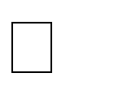N. 2000. High-level production of recombinant fungal endo- -1, 4-xylanase

in the methylotrophic yeast *Pichia pastoris*. *Protein & Experimental Purifi- cation.* **19**: 179-187.

Berlin, A., Balakshin, M., Gilkes, N., Kadla, J., Maximenko, V., Kubo, S.and Sad- dler, J., 2006. Inhibition of cellulase, xylanase and β-glucosidase activities by softwood lignin preparations. *Journal of Biotechnology*. **125** (2): 198– 209.

Bhallal T. C, Joshi M. 1993. Production of cellulase and xylanase by *Trichoderma viride* and *Aspergillus* sp. on apple pomace*, Indian Journal of Microbiology*. **34**: 253-255.

Bhat, M. K. 2000. Cellulases and related enzymes in biotechnology. *Biotechnological Ad- vances*. **18**: 355-383.

Bicho, P. A., Clark, T. A., Mackie, K., Morgan, H. W., and Daniel, R. M. 1991. The char- acterisation of a thermostable endo-beta-mannanase cloned from Caldocellum sac- charolyticum. *Applied Microbiology and Biotechnology*. **36**: 337- 343.

Bhat, M. K. 2000. Cellulases and related enzymes in biotechnology. *Biotechnologi- cal Advances*. **18**: 335-383.

Biely, P., Vrsanka, M. and Kratky, Z. 1980. Xylan- degrading enzymes of the yeast Cryp- tococcus albidus. Identification and cellular localization. *European. Journal of Bio- chemistry*. **108**: 313 – 321.

Blanchette, R. A., Burnes T. A., Leatham, G. F. and Effland, M. J. 1998. Selection of white-rot fungi for biopulping. *Biomass*. **15**: 93-101.

Blanchette, R.A**.** 2000. A review of microbial deterioration found in archaeological cell wall polysaccharides. *Microbiology and Molecular Biology Review*. **65**: 497–522.

Blanchette, R. A., Held, B. W., Jurgens, J. A., McNew, D. L., Harrington, S. M., Duncan

R. L., and Farrell T. C. 2004. Wood-destroying soft rot fungi in the historic expedi- tion huts of Antarctica. *Appied and Environmental Microbiology*. **70**: 1328–1335

Blanco, A., Vidal, T., Colom, J., Pastor, F. I. J. 1995. Purification and properties of xy- lanase A from alkali-tolerant *Bacillus sp.* strain BP-23. *Appllied Environmental Microbiology*. **61**: 4468-4470.

Blanco, J., Coque, J., Velasco, J. and Martin, J. F. 1997*. Cloning, expression in Streptomy- ces lividans and biochemical characterization of a thermostable endo-beta-1,4- xylanase of Thermomonospora alba ULJB1 with cellulose-binding ability. Appllied Microbiology and Biotechnology*. **48**: *208*-217*.*

Bocchini, D. A., Damiano, V. B., Gomes, E., Da Silva, R. 2003. Effect of *Bacillus circu- lans* D1 Thermostable Xylanase on Biobleaching of Eucalyptus Kraft Pulp. *Applied Biochemistry and Biotechnology*. **106**: 393-402.

Bokhari, I. A. S., Latif, F., Akhtar, W. M. and Rajoka, I. M. 2010. Characterization of a β – xylosidases. *Annals of Microbiology*.**10**:13213-13226.

Boudet, A. M., Hawkins, S., Cabané, M., Ernst, D., Gallaino, H., Heller, W., Lange, M., Sandermann, H.(Jr). and Lapierre, C. 1995. Developmental and stress lignification. In: Bonnet-Mazimbert, M. (ed) *Contribution to Forest Tree Physiology*. Eurosilva Inra, Paris, France.

Bourgault, R. and Bewley, J. D. 2002. Gel diffusion assays for endo-β-mannanase and pec- tin methylesterase can underestimate enzyme activity due to proteolytic degrada- tion: a remedy. *Analytical Biochemistry.* **300**: 87-93.

Brenner, E. D., Katari, M. S., Stevenson, D. W., Rudd, S. A., Douglas, A. W., Moss, W. N., Twigg, R.W., Runko, S. J., Stellari, G. M., McCombie, W. R. and Coruzzi,

G.M. 2005. [Analysis in *Ginkgo biloba*: an assessment of conserved developmental](http://www.ncbi.nlm.nih.gov/entrez/query.fcgi?cmd=Retrieve&db=pubmed&dopt=Abstract&list_uids=.16225698) [regulators and gymnosperm specific genes.](http://www.ncbi.nlm.nih.gov/entrez/query.fcgi?cmd=Retrieve&db=pubmed&dopt=Abstract&list_uids=.16225698) *BMC Genomics*

Briffa, K. and Singh, A. 1963. Trends in recent temperature and radial tree growth span- ning 2000 years across northwest. *Eurasia*. **363**: 2271-2284.

Brown, R. M. 1999. Cellulose structure and biosynthesis. *Pure and Applied Chemistry* **71**: 767-775.

Bruno, C. S., Roseli, G. M., Sônia, N. B., Francides, G. S. and Edivaldo, X. F. F. 2005. Effect of cellulase-free xylanases from *Acrophialophora nainiana* and *Humicola grisea* var. *thermoidea* on eucalyptus kraft pulp**.** *Process Biochemistry.* **40**(1): 343- 349

Brunow, G. 2001. Methods to reveal the structure of lignin. *Biopolymers*. **1**: 89-116.

Buchanan, G. J. 2000. *Biochemistry & Molecular Biology of Plants*. 1st edition.American Society for Plant Physiology. N.Y. Boston.

Buchert, J., Salmien, J., Siika-Aho, M., Ranua, M. and Viikari, L. 1993. The role of *Trichoderma reesei* xylanase and mannanase in the treatment of softwood kraft pulp prior to bleaching. *Holzforschung*. **47**(6): 473-478.

Buckeridge, M. S., Pessoa, S., dos Santos, H. and Tine, M. A. 2000. Mobilisation of stor- age cell wall polysaccharides in seeds. *Plant Physiology and Biochemistry*. **38**: 141-156.

Bura, R., Chandra, R., Saddler, J. 2009. Influence of xylan on the enzymatic hydrolysis of steam-pretreated corn stover and hybrid poplar. *Biotechnological Progress****.* 25**(2): 315-322.

Busto, M. D., Ortega, N. and Perez-Mateos, M. 1996. Location, Kinetics and stability of cellulases induced in *Trichoderma reesei* cultures. *Bioresource Technology*

Call, H.P. and Muncke, I. 1997. History, overview and applications of mediated lignolytic systems, especially laccase-mediator systems (lignozyme(R)-process). *African Journal of Biotechnology.* **9**(1): 1063-1072.

Cem Azeri, A. Tamer, U. and Mustafa O. 2009. Thermoactive cellulase-free production from alkaliphilic *Bacillus* strains using various agro-residues and their potential in biobleaching of kraft pulp. *Journal of Biotechnology*. **53**: 163 – 202.

Camarero, S. Sarkar, S. Ruiz-Dueñas, F. J., Martinez, M. J. and Martinez, A. T. 1998. De- scription of a versatile peroxidase involved in the natural degradation of lignin that has both manganese peroxidase and lignin peroxidase substrate interaction sites. *Jourmal of Biological Chemistry.* **274**: 10324-10330

Canel, E., and Moo-Young, M. 1980. Solid state fermentation systems. *Process Biochem- istry*. **15**: 24-28.

Capoe, P., Kuackova, M. and Alfoldi, J. 2000. Galactoglucomannan from the secondary cell wall of *Picea abies. L. Krast. Carbohyrate Research*. **329**: 635-645.

Carlile, M. J., Watkinson S. C. and Gooday G. W. 2001. *The Fungi*. The 2nd edition Aca- demic Press. New York. Toronto. Sydney. pp: 260–268.

Carmona, E. C. Fialho, M. B. Buchgnani, E. B. Coelho, C. D. Brocheto - Braga, M. R. and Jorge, 1. A. 2005. Production, purification and characterization of a minor form of xylanase from *Aspergillus versicolor*. *Process Biochemistry*. **40**: 359 - 364.

Carmona, E., Brochetto-Braga, M.R., Pizzirani-Kleiner, A.P. and Jorge, J.A. 1998. Purifi- cation and biochemical characterization of an endoxylanase from *Aspergillus versi- color*. *FEMS Microbiology Letter*. **166**: 311-315.

Carrington, C. M. S. and Vendrell, M. and Domı´nguez-Puigjaner, E. 2002. Characterisa- tion of an endo-(1, 4)-β-mannanase (LeMAN4) expressed in ripening tomato fruit. *Plant Science.* **163**: 599-606.

Castillo, M. D. P., Dorado, A., Sierra, R. and Field, J. 2000. Biopulping by white rot fungi.

Ph.D. Thesis, Wageningen Agricultural University Netherlands.

Chahal, D. S., McGuire, S., Pikor, H. and Noble, G. 1982. Production of cellulase com- plex by *Trichoderma reesei* RUT-C30 on lignocellulose and its hydrolytic poten- tial. *Biomass.* **2**: 127-138*.*

Chahal, D. S. 1985. Solid state fermentation with *T. reesei* for cellulose production. *Ap- plied and Environmental Microbiology.* **49**: 205-210.

Chahal, D. S. 1992. Bioconversions of poysaccharides of lignocellulose and simultaneous degradation of lignin. In. Kennedy *et al*. (eds) *Lignocellulosics: Science, Technolo- gy, Development and Use*. Ellis Horwood Limited, England, pp. 83-93.

Chahal, P. S., Chahal, D. S. and Lee, G. B. B. 1996. Production of cellulose in solid – state fermentation with *Trichoderma reesei* MCG 80 on wheat straw. *Applied Bio- chemistry and Biotechnology.* **57/58**: 433-442.

Chang, V. S. and Holtzapple, M. T. 2000*.* Fundamental factors affecting biomass enzy- matic reactivity. *Applied Biochemistry and Biotechnology.* **86**: 5*-*37*.*

Chen, X., Ping, Z. H. and Long Y. C. 1998. `Separation properties of alcohol-water mix- ture through silicalite-I-filled silicone rubber membranes by pervaporation', *Journal of Applied Polymer Science***. 67**: 629-636.

Cherry, J. R. and Fidantsef, A. L. 2003. Directed evolution of industrial enzymes: an up- date. *Current Opinion in Biotechnology* **14**: 438 - 443.

Chinedu, S. N., Eni, A. O., Adeniyi A. I. and Ayangbemi, J. A. 2010. Assessment of growth and cellulase production of wild-type microfungi isolated from Ota, Nige- ria. *Asian Journal of Plant Science*. **9(**3): 118-125.

Chir, J., Wan, C., Chou, C. and Wu. A. 2011. Hydrolysis of cellulose in synergistic mix- tures of beta-glucosidase and endo/exocellulase Cel9A from *Thermobifida fusca*. *Biotechnology Letters.* **33**(4)**:** 777-782.

Christov, L. P, Szakacs, G. and Balakrishnan, H. 1999. Production partial characterization and use of fungal cellulase free xylanase in pulp bleaching. *Process Biochemistry*. **34**: 511-517.

Christgau, S., Kauppinen, S., Vind, J., Kofod, L.V. and Dalboege, H. 1994. Expression cloning, purification and characterization of -1,4-mannanase from *Aspergillus acu- leatus. Biochemistry and Molecular Biology International*. **33**: 917-925.

Chum, H.L., Douglas, I.J., Feinberg ,D.A. and Schroeder, H.A. 1985. Evaluation of pre- treatment of biomass for enzymatic hydrolysis of cellulose. Solar Energy Re- search Institute: Golden,Colorado. pp.1-64.

Clarke, J. H., Davidson, K., Rixon, J. E., Halstead, J. R., Fransen, M. P., Gilbert, H. J. and Hazlewood G. P. 2000. A comparison of enzyme-aided bleaching of softwood pa- per pulp using combinations of xylanase, mannanase and α-galactosidase. *Applied. Microbiology and Biotechnology*. **53**(6): 661-667

Collins, T., Gerday, C. and Feller, G. 2005. Xylanases, xylanase families and extremor- philic xylanases*. FEMS Microbiological Review.* **29**: 3-23.

Coman, G. and Bahrim, G. 2011. Optimization of xylanase production by *Streptomyces sp*. P12-137 using response surface methodology and central composite design. *Annals of Microbiology*. **61**: 773–779.

Coral, G., Arikan, B., Unaldi, M. N. and Guvenmes, H. 2002. Some properties of crude carboxymethyl cellulase of *Aspergillus niger* Z10 wild-type Strain. *Turkish Jour- nal of Biology.* **26**: 209-213.

Cordeiro, C. A. M., Martins, M. L. L., Luciano, A. B. and DaSilva, R. F. 2002. Production and properties of xylanase from thermophilic *Bacillus* spp. *Brazilian Archives Bi- ology and Technol*ogy. **45**: 413-418.

Cuevas, W. A., Kantelinen, A., Tanner, P., Bodie, B. and Leskinen, S. 1996. Purification and characterization of novel mannanases used in pulp bleaching, pp. 123-126. In.

E. Strebonik, K. Messner.(eds.) *Biotechnology in the Pulp and Paper Industry*. Vi- enna, Austria: Facultas – Universitatsverlag.

Damaso, M. C. T., Andrade, C. M. and Pereira, N.(Jr.) 2000. Use of corncob for endoxy- lanases production by thermophilic fungus *Thermomyces lanuginosus* IOC-4145. *Applied Biochemistry and Biotechnology*. **84/86**: 821–834

Deacon, J. 2005. *Fungal Biology*. Blackwell Publishing. New York. Diego, USA. pp. 293

De Vries, R. P., and Visser, J. 2001. *Aspergillus* enzymes involved in degradation of plant cell wall polysaccharides. *Micobiologiy and Moecular Biology Review*. **65**: 497- 522.

de Santos, E., Piovan, T., Roberto, I. C. and Milagres, A. M. F. 2003. Kinetics of the solid state fermentation of sugarcane bagasse by *Thermoascus aurantiacus* for the pro- duction of xylanase. *Biotechnology Letters*. **25**:13-16.

Dekker, R. F. H. 1983. Bioconversion of hemicellulose: Aspects of hemicellulase produc- tion by *Trichoderma reesei* QM 9414 and enzymic saccharification of hemicellu- lose. *Biotechnology and Bioengineering.* **25**: 1127-1146.

Dekker, M. 2003. *Handbook of fungal biotechnology*. Arora, DK ed., New York, pp. 600

Dhawan, S. and Kaur, J. 2007. Microbial mannanases: an overview of production and ap- plica tions. *Critical Review of Biotechnology*. **27**(4): 197–216.

Dhiman, S. S., Garg, G., Mahajan,R., Garg,N. and Sharma, J. 2009. Single layout and mixed lay out enzymatic processes for biobleaching of kraft pulp. *Bioresource Technology.* **100**: 4736-4741.

Dickison, W. C. 2000. *Integrative Plant Anatomy*. Academic press. San Diego, San Fran- cisco, New York, Boston, London, Toronto, Sydney Tokyo.

Dixon, M. and Webb, E. E. 1971. *Enzymes*. Longmans, Green, London ISBN 0586 46214 2.

Domsch, K. H., Gams, W., Anderson, T. H. 1980 *Paecilomyces*. In. *Compendium of Soil fungi.* Academic Press, London, pp: 530–532.

Donnelly, P. K., Entry, J. A., Crawford, D. L. and Cromack, K.(Jr.). 2007. Cellulose and lignindegradation in forest soils: Response to moisture, temperature and acidity. *Journal of Microbial Ecology.* **20**(1): 289-295.

Downie, B., Hilhorst, W. M. and Bewley, J. D. 1994. A new assay for quantifying endo- beta-mannanase activity using Congo red dye. *Phytochemistry* **36**: 829-835.

Draude, K. M., Kurniawan, C. B. and Duti S. 1. 2001. Effect of oxvgen delignification on the rate and extent of enzymatichydrolysis of lignocellulosic material. *Bioresources Technology* **79**: 113-120

Duncan, D. B. 1955. Multiple range and multiple F-test. *Biometrics*. **11**: 1-42.

Ellaiah, P., Adinarayana, K., Bhavani, Y., Padmaja, P. and Srinivasulu, B. 2002. Optimiza- tion of process parameters for glucoamylase production under solid state fermenta- tion by a newly isolated *Aspergillus. Process Biochemistry.* **38**: 615–620.

Eriksson, K. E., Blanchette, R. A. and Ander**.** P. 1990. *Microbial and enzymatic degrada- tion of wood and wood components*, Springer-Verlag, New York, N.Y.

Eriksson, K.E., Ander, P. Henningsson, B., Nilsson, T. and Goodell, B. 1976. Methods for producing pulp. U. S., Patent . No. 3.962.033.

Erickson, B., Nelson, J. E. and Winters, P. 2012. Perspective on opportunities in industrial biotechnology in renewable chemicals. *Biotechnology Journal*. **7**:1- 10.

Ero, F. A. and Adebo, B. A.2011. Determination of gamma radiation shielding characteri- syics of some woods in western Nigeria. *International Archive of Science and Technology.* **3**(2): 14-20.

Espinar, M. T. F., Ramon, D., Pinaga, F. and Valles, S. 1992. Xylanase production by *As- pergillus nidulans. FEMS Microbiology Letters*. **9**: 92-96.

Evans, R., Newman, R. H., Roick, U., Suckling, I. D. and Wallis, A. F. A. 1995. Changes in cellulose crystallinity during kraft pulping. Comparison of infrared, x-ray dif- fraction and solid state NMR results. *Holzforschung*. **49**: 498-504.

Fadel, M. 2001. High-level xynalase production from sorghum flour by a new isolate of *Trichorderma harzianum* cultivated under solid waste fermentation. *Annals of Mi- crobiology*. **51**: 61-78

Fadel, M. 2000. Production of thermostable amylolytic enzyme by *Aspergillus niger* F-909 under solid state fermentation. *Egyptian Journal of Microbiology*. **35**: 487-505.

Fengel and Wegeney 1989. *Wood Chemistry Ultrastructure reactions*.Walter de Grilyter Pub. pp 613

Feniksova, R. V. Tikhomrova, A. S. and Rakhleeva, B. E. 1960. Conditions for forming amylases and proetinase in surface culture of *Bacillus subtilis. Mikrobiologica.* **29**: 745 - 748.

Ferdousi, B. and Abdul, R. A. 2011. Bioconversion and saccharification of some lignocel- lulosic wastes by *Aspergillus oryzae* ITCC-4857.01 for fermentable sugar produc- tion. *Electronic Journal of Biotechnology* ISSN: 0717-3458 **14** (5): 22-25

[Ferraz, A. and](http://related.springerprotocols.com/search?author=Ferraz%2C%2BAndr%C3%A9) [Masarin, F.](http://related.springerprotocols.com/search?author=Masarin%2C%2BFernando) 2008. [Evaluation of *Eucalyptus grandis* Hill ex Maiden bi-](http://www.reference-global.com/doi/abs/10.1515/HF.2008.001) [opulping with *Ceriporiopsis subvermispora* under non-aseptic conditions](http://www.reference-global.com/doi/abs/10.1515/HF.2008.001). [*Interna-*](http://related.springerprotocols.com/search?journal_journal_name=Holzforschung%2B-%2BInternational%2BJournal%2Bof%2Bthe%2BBiology%2C%2BChemistry%2C%2BPhysics%2Band%2BTechnology%2Bof%2BWood)[*tional Journal of Biology, Chemistry, Physics and Technology of Wood*](http://related.springerprotocols.com/search?journal_journal_name=Holzforschung%2B-%2BInternational%2BJournal%2Bof%2Bthe%2BBiology%2C%2BChemistry%2C%2BPhysics%2Band%2BTechnology%2Bof%2BWood). **62** (1): 23

– 29.

Filler, K. 2007. Understanding enzyme production is the key to meeting feed needs.

*Feed International*. **46**: 38- 42.

Forestry Management Evaluation and Coordinating Unit (FORMECU). 1990*. Forest platation development in Nigeria* by FORMECU/PUB.14: 13.

Franco, P. F., Ferreira, H. M. and Filho, E. X. F. 2004. Production and characteriza- tion of hemicellulose activities from *Trichoderma harzianum* strain T4. *Bio- technology and Applied Biochemistry.* **40**: 255-259.

Ganter, C., Bock, A., Buckel, P. and Mattes, R. 1988. Production of thermostable, recombinant α-galactosidase suitable for raffinose elimination from sugar beet syrup. *Journal of Biotechnology.* **8**: 301 - 310.

Geng, A., Zou, G., Yan, X., Wang,Q., Zhang, J., Liu, F., Zhu, B. and Zhou, Z. 2012. Expression and characterization of a novel metagenome-derived cellu- lase exo2b and its application to improve cellulase activity in *Trichoderma reesei. Applied Microbial Biotechnology.* **10:**.1007-1019.

Georis, J., Giannotta, F., De Buyl, E., Granier, B. and Frère J. M. 2000. Purification and properties of three endo-β-1,4-xylanases produced by *Streptomyces* sp. strain S38 which differ in their ability to enhance the bleaching of kraft pulps. *Enzyme and Microbial Technology*. **26**(2-4): 178-186.

Ghatora, S.K., Chadia, B.S., Bhadan, A. K and Bhat, M. K. 2011. Identification and characterisation of diverse xylanases from thermophilic and thermotolerant fungi. *Bioresources.* **1**(1): 18-33.

Godliving, Y. S. and Tui, M. 2009**.** Recent advances in pre-treatment of lignocellulo- sic wastes and production of value added products. *African Journal of Bio- technology*. **8** (8): 1398-1415.

Gomes, J., Gomes, I. and Steiner, W. 2000. Thermolabile xylanase of the Antarctic yeast *Cryptococcus adeliae*: production and properties. *Extremophiles*. **4**: 227–235.

Goodell, B. 2003. Brown-rot fungal degradation of wood: Our evolving view. Goodell B, Nicholas D.D. and Schultz T.P. (eds.). *Wood deterioration and preservation.* ACS Symposium series 845, Washington DC, USA: pp. 97-118.

Goring, D.A. 1977. A speculative picture of delignification. In: Arthur, J.C. (ed.): Cel- lulose chemistry and technology, American Chemical Society, Washington, D.C., pp. 273-277.

Goyal, M., Kalra, K. L., Sareen, V. K., and Soni, G. 2008. Xylanase production with xylan rich lignocellulosic wastes by a local soil isolate of *Trichoderma viride. Brazilian Journal of Microbiology*. **39 (**3): 1-10.

Grassin, C. and Fauquembergue, P. 1996. Fruit Juice *In.* T. Godfrey and S.I. West(ed.) *In- dustrial Enzymology*. 2nd ed. Stockton Press New York. pp. 225-264.

Gubitz, G. M., Sachslehner, A. and Haltrich, D. 2001. Microbial Mannanases: Sub- strates,Production and Applications,. In Baker, J. O. and Himmel, M. E. (ed.), *Gly- cosyl Hyrolases for Biomass Conversion*, vol. 769. American Chemical Society, Washington D.C. pp. 236-262.

Grabber, J. H. 2005. How do lignin composition, structure, and cross-linking affect degra- dability? A review of cell wall model studies. *Crop Science* **45**: 820-831.

Guerra, G. M., Casado, R. L. G. Arguelles, J. Sanchez, M. I., Manzano, A. M. and Guz- man, T. 2006. Cellulase production with sugarcane straw by *Trichoderma viride* on solid bed. *Sugar Technology.* **8**: 30-35.

Gustafson, R. 2010. ["Pulping and Bleaching"](http://www.cfr.washington.edu/classes.pse.476/Powerpoint/Powerpoint-Renata/pse%20476-2%20mechanical%20pulping.ppt). University of Washington. [http://www.cfr.washington.edu/classes.pse.476/ Powerpoint/Powerpoint Renata/pse](http://www.cfr.washington.edu/classes.pse.476/ Powerpoint/Powerpoint Renata/pse%20476-2%20 mechanical%20pulping.ppt)

[%20476-2%20 mechanical%20pulping.ppt.](http://www.cfr.washington.edu/classes.pse.476/ Powerpoint/Powerpoint Renata/pse%20476-2%20 mechanical%20pulping.ppt) Retrieved 23 November 2010.

Hagglund, P. 2002. Mannan hydrolysis by hemicellulase: *enzyme polysaccharide interac- tion of a modular β-mannanase*. Doctoral Dissertation. Department of Biochemis- try. Lund University. Sweden.

Hammel, K. E. 1997. Fungal degradation of lignin. In: *Driven by Nature: Plant Litter Quality and Decomposition.* G. Cadisch and K.E. Giller (eds.) CAP International Wallingford: pp. 33-45.

Han, D. K., Eng, J., Zhou, H. and Aebersold, R. 2001. Quantitative profiling of differentia- tion-induced microsomal proteins using isotope-coded affinity tags and mass spec- trometry. *Natural Biotechnology.* **19**: 946–951.

Handford, M. G., Baldwin, T. C., Goubet, F. 2003. Localization and characterization of cell wall mannan polysaccharides in *Arabidopsis thaliana. Planta.* **218**: 27-36.

Hanh, V. V. and Kim, K. 2012. Hyper-production of raw-starch-digesting enzyme by mu- tant fungal strain and optimization of solid by-products. *Journal of Vietnamese En- vironment*. **3**(2): 66-70.

Harjunpaa, V., Helin, J., Koivula, A., Siika-aho, M. and Drakenberg, T. 1999. A compara- tive study of two retaining enzymes of *Trichoderma reesei*: transglycosylation of oligosaccharides catalysed by the cellobiohydrolase I, Cel 7A, and the β- mannanase, Man5A. *FEBS Letters*. **443**(2): 149-153.

Harman, G. E., Kubicek, C. P. 1998. *Trichoderma* and *Gliocladium*: Enzymes, biological control and commercial applications, Vol. 2. London: Taylor & Francis Ltd, pp. 393.

Harris, P. J. and Stone, B. A. 2008. Chemistry and molecular organization of plant cell walls. In Himmel, M.E., ed. Biomass Recalcitrance. Blackwell, Oxford, pp. 60-93.

Hatakka, A. 1994. Lignin-modifying enzymes from selected white-rot fungi: production and role in lignin degradation. *FEMS Microbiology Review.* **13**: 125-135.



-L-

-xylosidase from soy sauce koji mold, *Asper-*

*gillus oryzae*, in high salt condition. *Journal of Biosciences and Bioengineering*.

**95**: 164-169.

Hazlewood, G. P. and Gilbert, H. J. 1992. The molecular architecture of xylanases from *Pseudomonas fluorescens* subsp. *cellulosa* . In. Visser, J., Beldman, G., Kusters- van Someren, M.A. and Voragen, A.G.J. (Eds.) Xylan and Xylanases. Amsterdam: Elsevier Kim and Holtzapple, 2006 Science Publishers. pp. 259 - 273.

Hazlewood, G. P. and Gilbert, H. J. 1993. Molecular biology of hemicellulases. In: *Hemi- celluloses and Hemicellulases,* M.P. Coughlan, G.P. Hazlewood (Eds.), Portland Press, London, UK pp. 103–126.

Helal, G. A. 2006. Bioconversion of straw into improved fodder: preliminary treatment of rice straw using mechanical, chemical and/or gamma irradiation. *Mycobiology* **34**: 14-21.

Helinski P. M. 2000. *Heterobasidion annosum* and wood decay: Enzymology ofcellulose, hemicellulose, and lignin degradation A Doctorate Dissertation in the University of Helinski.

Henrissat, B., Teeri, T. T. and Warren, R. A. J. 1998. A scheme for designating enzymes that hydrolyze the polysaccharides in the cell wall of plants. *FEBS Letters*. **425** (2): 352-354.

Hoadley, R. B. 2000.*Understanding Wood: A Craftsman's Guide to Wood Technology*. The Traunton Press Inc. pp 10-22

Ho, X. et al., 2002. Systematic identification of protein complexes in *S. cerevisiae* by mass

spectrometry. *Nature*. **4-5**: 180-183.

Hon, D. N. S. 1994. Cellulose: a random walk along its historical path. *Cellulose* **1**: 1-25.

Horikoshi, K. 1999. Alkaliphiles: some applications of their products for biotechnology.

*Microbiological and Molecular Biology Reviews.* **63**: 735-750.

Hossain, M. Z. J. and Hizukari, S. 1996. Multiple forms of β-mannanase from *Bacillus* sp.

KK01. *Enzyme Microbiology and Technology*. **18**(2): 95-98.

Howard, R. L., Abotsi, E., Jansen, V., Rensburg, E. L., Howard, S. 2003. Lignocellu- lose biotechnology: issues of bioconversion and enzyme production. *African. Journal of Biotechnology.* **2**: 602-619.

Hrmová, M., Biely, P. and Vrsanská, M. 1989. Cellulose- and xylan-degrading enzymes of *Aspergillus terreus* and *Aspergillus niger. Enzyme and Microbiological Technolo- gy.* **11:** 610–616.

Hurlbert. J. C., Preston. J. F. 2001. Functional characterization of a novel xylanase from a corn strain of *Erwinia chrysanthemi. Journal of Biotechnology.* **183**: 2039-2100.

Husain, A, Fisol, F. A., Yun, L. C., Hussain, M. H., Muid, S. and Roslan, H. A. 2011. Lig- nocellulolytic enzymes produced by tropical white rot fungi during biopulping of *Acacia mangium* wood chips. *Journal of Biochemical Technology* **3**(2): 245-250

Iizuka, Y., Shinoyama, H., Kamiyama, Y. and Yasui, T. 1992. The condensation reaction of *Aspergillus niger* crude β-xylosidase using xylose. *Biosciences, Biotechnology and Biochemistry*. **56**: 331–332.

Immanuel, G., Bhagavath, C. M. A., Raj, P. I., Esakkiraj, P. and Palavesan, A. 2007. Pro- duction and partial purification of cellulose by *Aspergillus niger* and *Aspergillus*

*fumigatus* in Coir wastes and sawdust. *The Internet Journal of Microbiology.* **3(**1): 2-12.

Inoue, H., Yano, S., Endo, T., Sakaki, T. and Sawayama, S. 2008. Combining hot- compressed water and ball milling pretreatments to improve the efficiency of the enzymatic hydrolysis of eucalyptus*. Biotechnology and Biofuels*. **1**(2): 1-9.

Irbe, I., Andersone, I., Andersons, B. and Chirkova, J. 2001. Use of 13C NMR, sorption and chemical analyses for characteristics of brown-rotted Scots pine *International Biodeterioration and Biodegradation.* **47**: 37-45.

Itoh, H., Wada, M., Honda, Y., Kuwahara, M. and Watanabe, T. 2003. Bioorganosolve pretreatments for simultaneous saccharification and fermentation of beech wood by ethanolysis and white rot fungi. *Journal of Biotechnology*. **103**(3): 273-280.

Ito, K., Ikemasu, T. and Ishikawa, T. 1992. Cloning and sequencing of the *xynA* gene en- coding xylanase A of *Aspergillus kawachii*. *Biosciences, Biotechnology and Bio- chemistry.* **56**: 906–912.

Jacobson, R. H., Zhang, X. J., DuBose, R. F. and Mattews, B. W. 1994. Three dimension- alstructure of β-galactosidase from *E.coli*. *Nature.* **369**(6483): 761-766.

Jahromi, M. F., Liang J. B., Rosfarizan, M., Goh, Y. M., Shokryazdan, P. and Ho, Y.W. 2010. Effects of *Aspergillus niger* (K8) on nutritive value of rice straw. *African Journal of Biotechnology*. **9**(42): 7043-7047.

Jeffries, T. W. 1994. Biodegradation of lignin and hemicelluloses. *In*. Ratledge C. (ed.).

*Biochemistry of Microbial degradation*. Kluwer, Dordrecht, pp. 223-227.

Jeffries, T.W. 1996. Biochemistry and genetics of microbial xylanases. *Current Opinion in Biotechnology.* **7**: 337–342.

Jeoh, T., Wilson, D. B., Walker, L. P. 2006. Effect of cellulase mole fraction and cellulose recalcitrance on synergism in cellulose hydrolysis and binding. *Biotechnological Progress.* **22**(1): 270-277.

Jiguang, Z.Q., Cong, Q., Yan, N.K. and Du, X. 2010. Characterisation of a thermostable xylanase from *Chaetomium* sp. and its application in Chinese steamed bread. *Food Chemistry.* **120**: 457-62.

Jose, L.A. and Demain, A. 2003. Fungal biotechnology. *International Microbiology* **6**: 191-199.

.Juers, D. H., Heightman, T. D., Vasella, A., McCarter, J. D., Mackenzie, L., Withers, S.

G. and Mattews, B. W. 2001. A structural view of the action of *Escherichia coli (lac Z)* β-galactosidase. *Biochemistry*. **40**(49): 14781-14794.

Jun, H., Bing, Y., Keying, Z., Xuemei, D. and Daiwen, C. 2009. St Olsson rain improve- ment of *Trichoderma reesei* Rut C-30 for increased cellulase production. *Indian Journal of Microbiology*. **49**(2):188-195.

Kalogeris, K. Christakopoulos, P. Kekos, D. and Macris, B. J. 1998. Studies on the Solid- state production of thermostable endoxylanases from *Thermoascus aurantiacus:* Characterization of two isozymes. *Journal of Biotechnology*. **60**: 155 - 163.

Kamble, D. R. and Jadhav, R. A. 2012. Isolation, Purification, and Characterization of Xy- lanase Produced by a New Species of Bacillus in Solid State Fermentation. *Interna- tional Journal of Microbiology.* **2**(2): 100-108.

Kappei, K. Masaru, S., Ikuko, M. and Reiko T. 2008. .Reactive oxygen species inleaf ab-

scission signalling. *Journal of Plant Signalling & Behaviour*. **3** (110): 1014- 1015.

Karlsson, J., Siika-aho, M., Tenkanen, M. and Tjerneld, F. 2002. Enzymatic properties of the low molecular mass endoglucanases Cel12A (EG III) and Cel45A (EG V) of *Trichoderma reesei*. *Journal of Biotechnology.* **99**: 63-78.

Kavita, T., Gupta, S., and Kuhad, R. C. 2002. Properties and application of a partially puri- fied alkaline xylanase from an alkalophilic fungus *Aspergillus nidulans* KK-99. *Bi- oresource Technology*. **85**: 39-42.

Kavya, V. and Padmavathi, T. 2009. Optimisation of Growth Conditions for xylanase pro- duction by *A, niger* in Solid State Fernentation. *Polish Journal of Microbiology*. **58**(2): 125-130.

Kawamori, M., Takayama, K. and Takasawa, S. 1987. Production of cellulase by a ther- mophilic fungus *Thermoascus aurantiacus* A-T3. *Agricultural Chemistry*. **51**: 647- 654.

Kazuhisa, M. 1997. Renewable biological system for alternative sustainable energy pro- duction (FAO-Agricultural Services Bulletin, 128) Osaka University, Osaka, Japan pp. 22-31.

Kazuhisa. O., Sieko, S. and Satoru, O. 1988. Effective purification of glucoamylase in koji, a solid culture of Aspergillus oryzae on steamed rice by affinity chromatography using an immobilized acarbose (BAYg-5421). *Agricultural Biology and Chemistry*. **52**:1707–1714.

Kent Kirk, T. Richard, R. Burgess, and Koning, Jr John W. 1998. Use of Fungi in Pulping Wood: An Overview of Biopulping Research In. Leatham, Gary F., ed. Frontiers in

industrial mycology. *Proceedings of Industrial Mycology symposium*; 1998 June 25–26; Madison, WI. New York: Routledge, Chapman& Hall.

Kiffer, E. and Morelet, M. 2000. *The Deuteromycetes. Mitosporic Fungi Classification and Generic Keys.* U.S.A.: Science Publishers Inc . pp.273

Kirk, T. K., Chang, H. M. 1990. Overview of biotechnology in pulp and paper manufac- ture. In:

Kirk T.K., Chang H.-M., editors*. Biotechnology in Pulp and Paper Manufacture. Applications and Fundamental Investigations.* Butterworth-Heinemann, Boston, USA. pp. 1-13.

Kirk, T. J. and Jeffries, T. W. 1996. Roles of microbial enzymes in pulp and paper pro- cessing. *ACS Symposium Series.* **655**: 2-14.

Kirk, T. K. and Cullen D. 1998. Enzymology and molecular genetics of wood degradation by wooddegrading fungi. In: Young, R.A. & Akhtar, M. (eds.): *Environmentally Friendly Technologies for the Pulp and Paper Industry*, John Wiley & Sons, New York, pp. 273-307.

Kirk, T. K. and Farrell, R. L. 1987. Enzymatic "combustion": the microbial degradation of lignin. *Annual Review of Microbiology*. **41**: 465-505.

Kitamoto, N., Yoshino, S. Ohmiya, K. and Tsukagoshi. N. 1999. Purification and charac- terization of overexpressed *Aspergillus oryzae* xylanase XynF1. *Bioscience Bio- technology and Biochemistry*. **63**: 1791–1794.

Knowles J, Lehtovaara P, Teeri T. (1987) Cellulase families and their genes. *Trends in Bi- otechnology.* **5**: 255-261

Kormelink, T. J., Cefebvire, B., Strozyk, F. and Voragen, A.G. 1993. Purification and characterisation of of an acetyl xtlan esterase from *A. niger. Journal of Biotech*nol- ogy. **27**: 267-282.

Krishna, C. 1999. Production of bacterial cellulases by Solid state bioprocessing of banana wastes. *Bioresource Technology.* **69**: 231 - 239.

Krishna, C. 2005. Solid State Fermentation systems – An overview. *Critical Reviews in Biotechnology*. **25**: 1-30.

Kremer, S. M. and Wood, P. M. 1992. Production of Fenton‟s reagent by cellobiose oxi- dase from the cellulolytic cultures of *Phanerochaete chrysosporium*. *European Jounal of Biochemistry* **208**: 807-814.

Kuhad, R. C., Singh, A. and Eriksson, K. E. 1997. Microorganisms and enzymes involved in the degradation of plant fiber cell walls. *Advances in Biochemical Engineering and Biotechnology*. **8**: 45-125.

Kuhad, R. C. and Singh, A. 1993. Lignocellulose biotechnology: current and future pro- spects. *Critical Reviews in Biotechnology*. **13**: 151-172.

Kulkarnim, N. and Rao, M. 1996. Application of Xylanase from Alkaliphilic Thermophilic *Bacillus* sp. NCIM 59 in biobleaching of bagasse pulp. *Journal of Biotechnology*. **5**: 167-173.

Kulkarni, N., Shendye, A. and Rao, M. 1999. Molecular and biotechnological aspects of xylanases, *FEMS Microbiology Review.* **23**: 411–456.

Kumar, R., and Wyman, C. E. 2009. Cellulase adsorption and relationship to features of corn stover solids produced by leading pretreatments. *Biotechnology and Bioengi- neering*. **103**(2): 252-267.

Kurek, B., Martinez-Inigo, M. J., Artaud, I., Hames, B. R., Lequart, C. and Monties,

B. 1998. Structural features of lignin determining its biodegradation by oxida- tive enzymes and related systems. *Polymer Degradation and Stability.* **59**: 359- 364.

La Grange, D. C., Pretorius, I. S., Claeyssens, M., van Zyl, W. H. 2001. Degradation of xylan to D-xylose by recombinant *Saccharomyces cerevisiae* coexpressing the *As- pergillus niger* beta-xylosidase (*xln*D) and the *Trichoderma reesei* xylanase ii (*xyn*2) genes. *Applied and Environmental Microbiology.* **67**: 5512–5519

Laemmli, U. K. 1970. Cleavage of structure proteins during the assembly of the head of bacteriophage T4, *Nature (Lond*). **227**: 680-685.

Lars, C., Theo V. and Swoyambhu, A. 2005. Wood production in agroforestry and in short-rotation forestry systems – synergies for rural development. *Proceedings of the IUFRO:s conference* (session 12, 128) Brisbane. Report from the Department of Crop Production Ecology (VPE) No.4. Swedish University of Agricultural Sci- ences (SLU).

Lee, J. 1997. Biological conversion of lignocellulosic biomass to ethanol. *Journal of Bio- technology*. **56**: 1-24.

[Lee, R. L.,](http://mmbr.asm.org/search?author1=Lee%2BR.%2BLynd&sortspec=date&submit=Submit) [Paul, J. W.](http://mmbr.asm.org/search?author1=Paul%2BJ.%2BWeimer&sortspec=date&submit=Submit), [Willem, H. V.](http://mmbr.asm.org/search?author1=Willem%2BH.%2Bvan%2BZyl&sortspec=date&submit=Submit) and [Isak, S. P.](http://mmbr.asm.org/search?author1=Isak%2BS.%2BPretorius&sortspec=date&submit=Submit) 2000. Microbial Cellulose Utiliza- tion: Fundamentals and Biotechnology*. Microbiology and Molecular Biology Re- views.*

Leghlimi, H., Meraihi, Z., Boukhalfa-Lezzar, H., Copinet, E and Duchiron, Francis. 2013 Production and characterization of cellulolytic activities produced by *Trichoderma longibrachiatum* (GHL). *African Journal of Biotechnology*. **12**(5): 465-475

Lemos, J. L. S., Bon, E. P. S., Santana, M. F. E. and Pereira, N.(Jr.). 2000. Thermal stabil- ity of xylanases produced by *Aspregillus awamori*. *Brazilian Journal of Microbiol- ogy.* **31**: 206-211.

Lewis, N. G. and Yamamoto, E. 1990. Lignin: occurrence, biogenesis and biodegrada- tion. *Annual Review of Plant Physiology and Molecular Biology* **l41**: 455-496.

Levasseur, A., Asther, M., Record, E. 2005. Overproduction and characterization of xy- lanase B from *Aspergillus niger*. *Canadian Journal of Microbiology*. **51**(2):177– 183.

Li, K., Azadi, P., Collins, R., Tolan, J., Kim, J. and Eriksson, K. 2000. Relationships be- tween activities of xylanases and xylan structures. *Enzyme and Microbial Technol- ogy*. **27**: 89–94.

Li, C. L. and Lee, K. R. 2006. `Dehydration of ethanol/water mixtures by pervaporation using soluble polyimide membranes. *Polymer International*. **55**: 505-512.

Li, M., Wang, B.H., Zhang, M.H., Rantalainen, M., Wang, S.Y., Zhou, H.K., Zhang, Y.,

Shen, J., Pang, X.Y., Zhang, M.L., Wei, H., Chen, Y., Lu, H.F., Zuo, J., Su, M.M.,

Qiu, Y.P., Jia, W., Xiao, C.N., Smith, L.M., Yang, S.L., Holmes, E., Tang, H.R.,

Zhao, G.P., Nicholson, J. K., Li, L. J. and Zhao, L. P. 2008. Symbiotic gut mi- crobes modulate human metabolic phenotypes. *Proceedings of National Academy of Science*. U. S. A. **105**: 2117–2122.

Li, X. T., Jiang, Z. Q., Li, L. T., Yang, S. Q., Feng, W. Y., Fan, 1. F. and. Kusakabe,1. 2005. Characterization of a cellulase-free, neutral xylanase from *Thermomyces la- nuginosus* CBS 288. 54 and its biobleaching effect onwheat straw pulp. *Biore- sources Technology* **96**: 1370 – 1379.

Liepman, A. H., Nairn, C. J., Willats, W. G. T., Sørensen, I., Roberts, A. W. and Keegstra,

K. 2007. Functional genomic analysis supports conservation of function among cel- lulose synthase-like A gene family members and suggest diverse roles of mannans in plants. *Plant Physiology.* **143**: 1881-1893.

Lin, T.C. and Chen, C. 2004. Enhanced mannanase production by submerged culture of *Aspergillus niger* NCH-189 using deffatted copra based media. *Process Biochemis- try*. **39**: 1103-1109.

Lin, Y., Lee, Y., Tseng, M. and Lee, W. 2013. Xylooligosaccharides as By-products of Fuel Ethanol from Cellulosic Biomass. Innovative Bio-production of Fuels and Chemicals from Renewable Resources (i-BioS) Singapore. pp. 21-26.

Lo Leggio, L., Kalogiannis, S., Bhat, M. K. and Pickersgill, R. W. 1999. High resolution st ructure and sequence of T. aurantiacus xylanase I: implications for the evolution of thermostability in family 10 xylanases and enzymes with (beta)alpha-barrel archi- tecture. *Proteins.* **36**: 295–306.

Lonsane, B. K. Saucedo-Castaneda, G. Raimbault, M. Roussos, S. Vinigera Gonzalez, G. Ghildyal, N. P., Ramakrishna, M. and Krishnaiah, M. M. 1992. Scale up strategies for Solid-state fermentation systems. *Process Biochemistry*. **27**: 259 - 273.

Lowry, O. H., Rosebrough, N. J., Farr, A. L. and Randall, R. J. 1951. Protein measurement with the folin phenol reagent*. Journal of Biology and Chemistry*. **193**: 265- 275.

Lundqvist, J., Teleman, A., Junel, L., Zacchi, G., Dahlman, O., Tjerneld, F., Stalbrand, H. 2002*.* Isolation and characterization of galactoglucomannan from spruce *(Picea abies). Carbohydrate Polymers.* **48**: 29–39.

Lynd, L. R., Weimer, P. J., van Zyl, W. H. and Pretorius, I. S. 2002. Microbial cellulose utilization: Fundamentals and biotechnology. *Microbiology and Molecular Biology Reviews.* **66**: 506-512.

Maciel, Giselle M., Vandenberghe, L. P., Haminiuk, C. W. I., Fendrich1, R. C., Bianca, B. E.,Brandalize, T. Q., Pandey, A. and Soccol, C. R. 2008. Xylanase Production by *Aspergillus niger* LPB 326 in Solid-State Fermentation Using Statistical Experi- mental Designs. *Food Technology and Biotechnology*. **46**(2):83-189.

Macris, B. J. 2003. Production and characterization of cellulolytic enzymes from man- nanases from *Scopulariopsis candida* strains isolated from solar salterns. *African Journal of Biotechnology.* **7**(13): 2279-2285.

Maheshwari, R., Bharadwaj, G., Bhat, M. K. 2000 . Thermophilic fungi: their physiology and enzymes. *Microbiolog and Molecular Biology Review.* **64**: 461- 488.

Maijala, P. 2000. *Heterobasidion annosum* and wood decay: Enzymology of cellulose, hemicellulose, and lignin degradation. Ph.D. Thesis submitted to Dept. of Biosci- ence, University of Helinski. Pp.11-28.

[Mäkelä,](http://mic.sgmjournals.org/search?author1=Miia%2BR.%2BM%C3%A4kel%C3%A4&sortspec=date&submit=Submit) M. R., [Hildén](http://mic.sgmjournals.org/search?author1=Kristiina%2BHild%C3%A9n&sortspec=date&submit=Submit), K. [Hatakka,](http://mic.sgmjournals.org/search?author1=Annele%2BHatakka&sortspec=date&submit=Submit) A. and [Lundell,](http://mic.sgmjournals.org/search?author1=Taina%2BK.%2BLundell&sortspec=date&submit=Submit) T. K. 2009. Oxalate decarboxylase of the white-rot fungus *Dichomitus squalens* demonstrates a novel enzyme primary structure and non-induced expression on wood and in liquid cultures. *Microbiolo- gy*.**155** (8): 2726 -2738.

Malherbe, S. and Cloete, T. E. 2003. Lignocellulose biodegradation: fundamentals and applications: A review. *Environmental. Science and Biotechnology*. **1**:

105-114.

Mandels, M., Hontz, L. and Nystrom, J. 1974. Enzymatic hydrolysis of waste cellulose.

*Biotechnology and Bioengineering.* **16**: 1471-1493.

Mandels, M. and Weber, J. 1969. The production of cellulases . In: Cellulases and their applications. Hajny, G.J. and E.T. Resse (ed.). *American Chemical Society of Ad- vance Research.* **95**: 391-414.

Manpreet, S., Sawraj, S., Sachin, D., Pankaj, S. and Banerjee, U. C. 2005. Influence of Process Parameters on the Production of Metabolites in Solid-State Fermentation. *Malalaysian Jounal of Microbiology.* **1**(2): 1-9

Mani S, Tabil L. G, Sokhansanj S. 2004. Grinding performance and physical properties of wheat and barley straws, corn stover and switchgrass. *Biomass and Bioenergy*.

**27**(4): 339-352.

Mansfield, S. D., Mooney, C. and Saddler, J. N. 1999. Substrate and enzyme characteris- tics that limit cellulose hydrolysis. *Biotechnological. Progress.* **15**: 804-816.

Marraccini, P., Rogers, W. J., Allard, C. Andre, M. L., Caillet, V., Lacoste, N., Lausanne, F and Michaux, S. 2001. Molecular and biochemical characterization of endo-β- mannanases from germinating coffee (*Coffea arabica*) grains. *Planta*. **213**(2): 296- 308.

Masarin, F. and Ferraz, A. 2008. Evaluation of *Eucalyptus grandis* Hill ex Maiden bi- opulping with *Ceriporiopsis subvermispora* under non-aseptic conditions. *Interna- tional Journal of the Biology, Chemistry, Physics and Technology of Wood.* **62**: 1-5

McCutchen, C.M., Duffaud, G.D., Leduc, P., Petersen, A.R.H., Tayal, A., Khan, S.A. and Kelly, R. M. 1996. Characterization of extremely thermostable enzymic breakers (α-1, 6-galactosidase and β-1, 4-mannanase) from the hyperthermophilic bacterium *Thermotoga Neapolitana* 5068 for the hydrolysis of guar gum. *Biotechnology and Bioengineering*. **52**(2): 332-339.

Mcdaniel, M.C. and Bailey, E.C. 1968. Liquid Nitrogen Preservation of Standard Inocu- lum. *Journal of Applied Microbiology*. **16**(6): 912-916.

Messener, K., Fackler, K., Lamapis,P., Gindl, W., Srebonik, E. and Watanabe, T. 2003. Overview of white-rot research: Where we are today. In: Goodell B, Nicholas DD and Schultz T. P (eds.) *Wood deterioration and preservation.* ACS Symposium se- ries 845, Wahington D, USA.pp. 73-96.

Miller, G. L. 1959. Use of dinitrosalicyclic reagent for the determination of reducing sug- ars. *Analytical Chemistry*. **31**: 426-428.

Millward-Sadler, S. J., Hazlewood, G. P., Laurie, J. I. and Gilbert, H. J. 1997. Arabinanase A from *Pseudomonas fluorescens* sub species *cellulosa* exhibits both an endo- and an exo- mode of action. *Biochemical Journal.* **323**: 547-555.

Mishra, B. K. and Dadhich, S. K. 2010. Production of Amylase and Xylanase Enzymes from molecular size distributions of cellulose molecules during hydrolysis of cellu- lose by recombinant *Cellulomonas fimi* beta-1,4-glucanases. *Applied and Envi- ronmental Microbiology*. **64**: 2374-2379.

Mitchell, D. A., Berovic, M. and Krieger, N. 2000. Biochemical engineering aspect of sol- id statebioprocessing. In: Sheper, T. (ed.) *Advances in Biochemical Engineering & Biotechnology.* **68**: 61-138.

Mönkmann, H., Hölker, V., Golubnitchaya-Labudova, O., Lichtenberg-Frate, H. and Höfer, M. 1996. Molecular evidence of a lignin peroxidase H8 homologue in *Fusarium oxysporum*. *Folia Microbiology.* **41**: 445-448.

Monteil, M. D., Hernandez, M., Rodriguez, J. and Arias, M. E. 2002. Evaluation of an en- do-β-mannanase produced by *Streptomyces ipomoea* CECT 3341 for the biobleach- ing of pine kraft pulps. *Applied Microbiology and Biotechnol*ogy **58**(1): 67-72.

Moon, A. G. and Parulekar, S. J. 1991. A parametric study of protease production in batch and fed batch cultures of *Bacillus firmus. Biotechnology and Bioengineering.* **37**: 467 - 483.

Moraïs, S., Heyman, A., Barak, Y., Caspi, J., Wilson, D. B., Lamed, R., Shoseyov. O., Bayer, E. A. 2010. Enhanced cellulose degradation by nano-complexed enzymes:

synergism between a scaffoldlinked exoglucanase and a free endoglucanase. *Jour- nal of Biotechnology*. **147**: 205–211.

Moreira, L. R. S. and Filho, E. X. F. 2008. An overview of mannan structure and mannan- degrading enzyme systems. *Applied Microbiology and Biotechnology.* **79**: 165- 178.

Mosier, N., Wyman, C., Dale, B., Elander, R., Lee, Y.Y., Hotzapple, M. and Ladisch, M. 2005 Features of promising technologies for pretreatment of lignocellulosic bio- mass. *Bioresource Technology.* **96**: 673-686.

Mudau, M. M. and Setati, M. E. 2006. Screening and identification of endomannanase producing microfungi from hypersaline environments. *Current Microbiology*. **56**: 477-481

Mudau, M. M., Setiati, E. M. 2008. Partial purification and characterization of endo-β-1,4- mannanases from *Scopulariopsis candida* strains isolated from solar salterns. *Afri- can Journal of Biotechnology.* **17**(13): 2279-2285.

Mulimani, V. H. and Ramalingam, S. T. 1995. Enzymic hydrolysis of raffinose and stach- yose present soymilk by crude [alpha]-galactosidase from *Gibberella fujikuroi*. *Bi- ochemical & Molecular Biology Inernational.* **36**: 897-905.

Nair, S. G., Sindhu, R. and Shashidhar, S. 2008. Fungal xylanase production under solid state and submerged fermentation condition. *African Journal of Microbiology Re- search*. **2**: 82-86.

Nascimento, W. M. Cantliffe, D. J. and Huber, D. J. 2001. Endo-β-mannanase activity and seed germination of thermosensitive and thermotolerant lettuce genotypes in re- sponse to seed priming. *Seed Science Research.* **11**: 255-264.

Nguyen, Q. A. 1993. Economic analyses of integrating a biomass-to-ethanol plant into a pulp/saw mill. In. Saddler (eds) *Bioconversion of Forest and Agricultural Plant*. CAB International, UK, pp. 321-340.

Nguyen, Q. D., Rezessy Szabó, J. M., Claeyssens, M., Stals, I. and Hoschke, A. 2002. Pu- rification and characterisation of amylolytic enzymes from fungus *Thermomyces lanuginosus* strain 34626. *Enzyme Microbiology and Technology*. **31**: 345–352.

Nigam, P. and Singh, D. 1995. Process for fermentation production of xylitol – a sugar substitute. A review. *Process Biochemistry*. **30** (2): 117 – 124.

Ningam, P. and Singh, D. 1996. Processing of agricultural wastes in solid state fermenta- tion for cellulolytic enzymes production. *Journal of Scientific and Industrial Re- search*. **55**: 451-463.

Ojumu, T. V., Attah-Daniel, B. E., Betiku, E. and Solomon, B. O. 2003a. Auto-hydrolysis of lignocellulosics using extremely low acid under high temperature in a batch pro- cess. *Biotechnology and Bioprocess Engineering*. **8**: 291-293.

Ojumu, T. V., Solomon, B. O., Betiku, E., Layokun, S. K. and Amigun, B. 2003b. Cellu- lase production by *Aspergillus flavus* Linn isolate NSPR 101 fermented in sawdust, bagasse and corncorb. *African Journal of Biotechnology*. **2**: 150-152.

Okafor, U. A. Emezuo, T. N..Okochi,V. I., Onyegeme, O. B. and Nwodo, C. 2007. Xy- lanase production by *Penicillum chrysogenum* (PCL5O11) fermented on cellulosic wastes. *African. Journal of Biochemistry Research.* **1**(4): 45 – 55.

Okafor, U. A., Okochi, V. I., Onyegeme-okerenta, B. M. and Nwodo-Chinedu, S. 2008. Xylanase production by *Aspergillus niger* ANL 301 using agro – wastes. *African Journal of Biotechnology.* **6**: 1710-1714.

Olutiola, P. O. and Cole, O. O. 1980. Extracellular invertase from *Aspergillus flavus*, *Phys- iologia Plantarum.* **50**: 26-31.

Onilude, M. A. 2011. *Pulp and Paper Industry: A neglected Goldmine in Nigeria*. An In- augural Lecture in the University of Ibadan Nigeria..

Onilude, A. A. 1996. Effect of cassavar cultivar, age and pretreatment processes of cellu- lase and xylanase production from cassava waste by *Trichoderma harzianum.*

*Journal of Basic Microbiology*. **36**: 421–431.

Onilude, M. A. and Bada, S. O. 2000. Pulp and paper characteristics and some selected wood properties of *Sterculia setigera* (Del). *Nigerian Journal of Science*. **34**: 427- 430.

Onsori, H., Zamani, M. R., Motallebi, M. and Zarghami, N. 2005. Identification of over producer strain of endo-_-1,4-glucanase in *Aspergillus Species*: Characterization of crude carboxymethyl cellulose. *African. Journal of Biotechnology.* **4**(1): 26-30.

Oriaran, T. P. and Blankenhorn, P. R. 1990. Kraft pulp paper making properties of *Phan- erochaete chrysosporium* degraded aspen.*Tappi Journal.* **73**(7): 147-152.

Oxenboll, S. S., Pauly, M., Bush, M., Skjo,t M., McCann, M. C., Borkhardt, B. and Ulvskov, P. 2000. Pectin engineering: modification of potato pectin by *in vivo* ex- pression of an endo-1,4-β-d-galactanase. *Proceedings of National Academy of Sci- ence*. USA. **97**:7639–7644.

Pandey, A. 1992. Recent process development in a solid state fermentation. *Process Bio- chemistry***. 27**:109-117

Pandey, A., Soccol, C. R. and Mitchell, D. 2000. New developments in solid-state fermen- tation: I bioprocesses and products. *Process Biochemistry.* **35**: 1153-1169.

Pandey, A., Soccol, C. R. and Larroch, C. 2007. *Current Developments in Solid-state Fer- mentation*, Editors-, Springer, USA & Asiatech Publishers, Inc., New Delhi, pp. 51- 81

Pang, P. K., Darah, I., Poppe, L., Szakacs, G. and Ibrahim, C.O. 2006. Xylanase produc- tion by a local isolate, *Trichoderma* sp. FETL c3-2 via solid state fermentation us- ing agricultural wastes as substrates. *Malaysian Journal of Microbiology* **2**(1): 7- 14.

Paul, S. S., Kamra, D. N., Sastry, V. R. B., Sahu, N. P., Kumar, A**.** 2003. Effect of phenol- ic monomers on biomass and hydrolytic enzyme activities of an anaerobic fungus isolated from wild nil gai (*Baselophus tragocamelus.) Letters in. Applied Microbi- ology.* **36**: 337–381

Pauly. M., Andersen, L. N., Kaupinnen, S., Kofod, L. V., York, W. S., Albersheim, P., Darvill, A. 1999. A xyloglucan-specific endo-β-1,4-glucanase from *Aspergillus*

*aculeatus*: expression cloning in yeast, purification and characterization of the re- combinant enzyme. *Glycobiology.* **9**: 93–100.

Penalvo, M. A and Arst, H. N. 2002. Regulation of gene expression by ambient pH in fil- amentous fungi and yeast. *Microbiology and. Molecular Biology Reviews.* **3** (66): 426-446

Penttilla, M. 1998. Heterologous protein production in *Trichoderma*. In *Trichoderma* and *Gliocladium*, Harman, G..E, Kubicek, C.P. (ed.). Taylor & Francis Ltd.: London; 365-382.

Perez, J., Munoz-Dorado, J., de la Rubia, T. and Martinez, J. 2002. Biodegradation and biological treatment of cellulose, hemicelluloses and lignin:an overview. *Interna- tional Journal of Microbiology*. **5**: 53-63.

Perez, S., Mazeau, K., Herve du Penhoat, C. 2000. The three-dimensional structures of the pectic polysaccharides. *Plant Physiology and Biochemistry.* **38**: 37–55.

Petkowicz, C. L. D., Reicher, F., Chanzy, H., Taravel, F. R. and Vuong, R. 2001. Linear mannan in the endosperm of *Schizolobium amazonicum. Carbohydrate Polymers.* **44**: 107-112.

Petit, S., Ralainirina, R., Favre S. and de Baynast, R. 1993. International Patent 93/02092.

Polizeli, M. L. T., Rizzatti, A. C. S., Monti, R., Terenzi, H. F., Jorge, J. A. and Amorim, D.

S. 2005. Xylanases from fungi: properties and industrial applications. *Applied Mi- crobiology and Biotechnology.* **67**: 577-591.

Preziosi-Belloy, L., Nolleau, V. and Navarro, J. M. 2000. Xylitol production from aspen wood hemicellulose hydrolysate by *Candida guilliermondii. Biotechnology Letters****.* 22**: 239-243.

Puchart, V. Katapodis, P. Biely, P. Kremnicky, L. Christakopoulos, P. Anska, M. V. Kekos, D. Macris, B. 1. Bhat, M. K. 1999. Production of xylanases, mannanases, and pectinases by the thermophilic fungus *Thermomyces lanuginosus. Enzyme & Microbial Technology.* **24**: 355 - 361.

Puls, J, Borneman, A., Gottschalk, D., Wiegel, J. 1988. Xylobiose and xylooligomers.

*Methods in Enzymology* **160**: 528–536.

Puls, J. Schorn, B. and Schuseil, J. 1992. Acetylmannanesterase: a new component in the arsenal of wood mannan degrading enzymes. In: Kuwahara M, Shimada M, editors. *Biotechnology in pulp and paper industry.* Tokyo, Japan: Uni Publishers Co., Ltd. pp. 357–363.

Qing, Q. and Wyman, C E. 2011**.** Supplementation with xylanase and β-xylosidase to re- duce xylo-oligomer and xylan inhibition of enzymatic hydrolysis of cellulose and pretreated corn stover **4**(18): 10-17.

Rabinovich, M. L., Melnik, M. S., Bolobova, A. V. 2002. Microbial cellulases: A review.

*Applied Biochemistry and Microbiology*. **38**(4): 305-321.

Rezende, M. I., Barbosa, A. M. Vasconcelos, A. F. D. and Endo, A. S. 2002. Xylanase production by *Trichoderma harzianum* rifai by solid state fermentation on sugar- cane bagasse. *Brazilian Journalof Microbiology*. **33**(1): 388-411

R.M.R.D.C. 2010. .Multidisciplinary committee report of the multi-disciplinary report of the techno-economic survey on pulp, paper products, printing and publishing sec- tor. 7th update. Fed. Min. of Sc. and Tech. Abuja, Nigeria.

Ronald, P. V. and Jaap, V. 2001. *Aspergillus* Enzymes Involved in Degradation of Plant Cell Wall Polysaccharides *Microbiology and Molecular Biology Reviews.* **65**(4): 497–522.

Ross, J. M., Saura, D., Coll, L., M. M., Laencina J. 1996. Oligouronides of pectins in membrane reactor by enzymatic degradation of pectins from citrus peel. A prelimi- nary study.In. *Pectins and pectinases*, eds Visser J., Voragen A. G. J. Elsevier Sci- ence, Amsterdam, The Netherlands, **14**: 983–990.

Royer, J. C. and Nakas, J. P. 1989. Xylanase production by *Trichoderma longibrachiatum*.

*Enzyme & Microbial Technol*ogy. **11**: 405 – 410

Rubeena, M. K., Sajith, S., Sreedevi, S., Priji, K. N., Unni, M. K., Sarath, V. N., Jisha, S. and Pra- deep, S. B. 2013. Lignocellulolytic activities of a novel strain of *Trichoderma harzi- anum. Advances in Bioscience and Biotechnology* **4**: 214-221**.**

[Sabharwal,](http://www.sciencedirect.com/science/article/pii/0003986188901427) H. [B. Nilsson](http://www.sciencedirect.com/science/article/pii/0003986188901427), [G., Grönberg, M. A., Chester](http://www.sciencedirect.com/science/article/pii/0003986188901427), [J. D.](http://www.sciencedirect.com/science/article/pii/0003986188901427) and V. 1988. Oligosaccha-

rides from feces of preterm infants fed on breast milk. [*Archives of Biochemistry*](http://www.sciencedirect.com/science/journal/00039861)[*and Biophysics*](http://www.sciencedirect.com/science/journal/00039861). [**265**(2](http://www.sciencedirect.com/science/journal/00039861/265/2)): 390–406.

Sachslehner, A., Foidl G, Foidl, N., Gübitz, G., Haltrich, D. 2000. Hydrolysis of isolated coffee mannan and coffee extract by mannanases of *Sclerotium rolfsii. Journal of Biotechnology.* **80**: 127-134

Sachslehnerm, A. and Haltrich, D. 1999. Purification and some properties of a thermosta- ble acidic endo-beta-1,4-d-mannanase from *Sclerotium (Athelia) rolfsii*. *FEMS Mi- crobiology Letters*. **177**(1): 47–55.

Saha, B. C. 2000. α-L-Arabinofuranosidases:biochemistry, molecular biology and applica- tion inbiotechnology. *Biotechnological Advances.* **18**: 403-423.

Saha, B.C. 2003. Hemicellulose bioconversion. *Journal of Industrial Microbiology and Biotechnology*. **30**: 279-291.

Sa - Pereira, P., Mesquita, A., Duarte, 1. C., Barros, M. R. A. and Costa - Ferreira, M. 2002. Rapid production of thermostable cellulase - free xylanase by a strain of *Ba- cillus subtilis* and its properties. *Enzyme and MicrobioIogy Technology*. **30**: 924 - 933.

Saitta, A., Bernicchia, A., Gorjón, S. P., Altobelli, E., Granito, V. M., Losi, C., Lunghini, D., Maggi, O. Medardi, G., Padovan, F., Pecoraro, L., Vizzini, A. and Persiani, A. M. 2011. Biodiversity of wood-decay fungi in Italy,.*Plant Biosystems* . **145**(4): 958-968

Scheller, H.V., Ulvskov, P. 2010. Hemicelluloses. *Annual Review of Plant Biology.* **61**: 263-289.

Schröder, R., Nicolas, P., Vincent, S. J. F., Fischer, M., Reymond, S., Redgewell, R. J. 2001. Purification and characterization of galactoglucomannan from kiwifruit (*Ac- tinidia deliciosa*). *Carbohydrate Research.* **331**: 291-306.

Scott, G. M., Akhtar, M. and Lentz, M. 1996. Bisulfite pulping using Ceriporiopsis sbver- mispora, Biotechnology in the pulp and paper industry: Recent advances in Applied and Fundamental Research; Srebotnik, E.and Massner,K.(eds.), Facultas Universi- tats Verlag, Austria, pp. 217- 219.

Scott, G. M., Akhtar, M. and Kirk, T. K. 2000. An update on biopulping commercializa- tion. In Proceedings of the 2000 Pulping Conference. Tappi Press, Atlanta, G.A.

Scott, G. M., Akhtar, M., Swaney, R. E,, Houtman, C. J. 2002. Recent development in bi- opulping technology at Madison, Wisconsin. In: Viikari, L. and Lantto, R. (eds.) *Progress in biotechnology,* vol **21***. Biotechnology in the pulp and paper industry*: eighth ICBPPI meeting. Elsevier, Amsterdam, pp. 61–72

Selvakumar, P., Ashakumary, L. and Pandey, A. 1994. *Journal of Science and Industrial Research.* **55:** 443–449.

Shallom, D. and Shoham, Y. 2003. Microbial hemicellulases. *Current Opinion in Microbi- ology*. **6**: 219-228.

Sheyfauman, T.A. 1999. Hardwood and Softwood. In U. S. Department of Agriculture (eds.) *The Encyclopedia of Wood.* Skyhorse Pub. Inc. pp. 1-2.

Shewale, J. G. and Sadana, J. C. 1979. Enzymatic hydrolysis of cellulosic materials by *Sclerotium rolfsii* culture filtrate for sugar production.*Canadian. Journal of Micro- biology.* **25**: 773 – 783.

Shukla, O. P., Rai, U. N. and Bubramanyam, S. V. 2004. Biopulping and biobleaching: An energyand environmental saving technology for Indian Pulp and Paper Industry. *Newsletter of ISEB India*.

Si-

mens, A. G. 2010. *Pulp and Paper Technologies.* Siemens A. G. [http://www.indust](http://www.industrysolutions.siemens.com/paper/en/index.htm.%20Retrieved%20November%2023%202010) [rysolutions.siemens.com/paper/en/index.htm. Retrieved November 23 2010](http://www.industrysolutions.siemens.com/paper/en/index.htm.%20Retrieved%20November%2023%202010).

Singh, K., Frisvad, J. C, Thrane, U., Mathur, S. B. 1991. An Illustrated Manual on Identifi- cation of some seed borne Aspergilli, Fusaria, Penicillia and their Mycotoxins. Odense, Denmark. pp. 36-68.

Sittikijyothin, W., Torres, D. and Goncalves, M. P. 2005. Modelling the rheological behav- iour of galactomannan aqueous solutions. *Carbohydrate Polymers.* **59**: 339-350.

Siti, N. M., Rosfariza, M. and Ariff, A. B. 2010. Evaluation of the activities of concentrat- ed crude mannan-degrading enzymes produced by *Aspergillus niger. Malaysian Journal of Microbiology* **6**(2): 171-180.

Sjostrom, E. 1993. *Wood chemistry: Fundamentals and applications*. Academic Press, San Diego, USA. pp. 293.

Smith, G. S. 1971. Plant cell wall structure and cell wall growth. *Tuatara.* **19**: 43-48.

Somiari, R. I. and Balogh, E. 1995. Properties of an extracellular glycosidase of *Aspergil- lus niger* suitable for removal of oligosaccharides from cowpea meal*. Enzyme Mi- crobiology and Technology***. 17**(4): 311–316.

Sonia, K. G., Chadha, B. S. and Saini, H. S. 2005. Sorghum straw for xylanase hyper- production by *Thermomyces lanuginosus* (D2W3) under solid-state fermentation. *Bioresources Technology.* **96**: 1561–1569.

Sridevi, B. and Singara-Charya, M. A. 2011. Isolation, identification and screening of po- tential cellulase-free xylanase producing fungi. *African Journal of Biotechnology.* **10**(22): 4624-4630.

Stalbrand, H., Saloheimo, A., Vehmaanpera, J., Henrissat, B. and Penttila, M. 1995. Clon- ing and expression in *Saccharomyces cerevisiae* of a *Trichoderma reesei* beta- mannanase gene containing a cellulose binding domain. *Applied Environmental Microbiology*. **61**(3): 1090-1097

Stewart, J. C., Lester, A. and Milburn, B.1984. Xylanase and cellulase production by *As- pergillus fumigatus*. *Applied Biochemistry and Biotechnology*. **9**: 417-418.

Strauss, M. L. A., Jolly, N. P., Lambrechts, M. G. and Rensburg, P. V. 2001. Screening for the production of extracellular hydrolytic enzymes by non-*Saccharomyces* wine yeasts. *Journal of Applied Microbioogy*. **91**: 182-90.

Subramaniyan, S. Prema, P. and Ramakrishna, S. V. 1997. Isolation and screening for al- kaline thermostable xylanase. *Journal of Basic Microbiology*. **37**: 431 - 437.

Subramaniyan, S. and Prema, P. 2002. Biotechnology of Microbial Xylanases: Enzymolo- gy, Molecular Biology, and Application. *Critical Review in Biotechnology*. **22**: 33- 64

Sudan, R. and Bajaj, B. K. 2007. Production and biochemical characterization of xylanase from an alkalitolerant novel species *Aspergillus niveus* RS2. *World Journal Micro- biology and Biotechnology*. **23**: 491-500

Sudgen, C. and Bhat, M. K. 1994. Cereal straw and pure cellulose as carbon sourcessugar- cane bagasse by *Thermoascus aurantiacus* for the production of xylanase. *Biotech- nology Letter.* **25**: 13–16

Sun Henson, C. A. 1991. A quantitative assessment of the importance of barley seed α- amylase, β –amylase debranching enzyme and α- Glucosidase in starch degrada- tion. *Archives of Biochemistry and Biophysics.* **284**: 296 – 305.

Suurnakki, A., Clark, T., Allison, R., Buchert, J. and Viikari, L. 1996. Mannanase aided bleaching of soft-wood kraft, pp. 69-74. In. K. Messner and E. Srebotnik (ed.), *Bio- technology in pulp and paper industry - advances in applied and fundamental re- search*. WUA Universitatsverlag Vienna.

Tanaka, H., Toshihide. N., Sachio, H. and Kazuyoshi, O. 2005. Purification and properties of an extracellular endo-1,4-!-xylanase from Penicillium citrinum and characteriza- tion of the encoding gene. *Journal of Bioscience and Bioengineering.* **100**: 623– 630.

Tengerdy, R. P. 1998. In: Pandey, A. (ed) *Advances in Biotechnology*. Educational Pub- lishers and Distributors. pp. 13-16.

Tenkenen, M., Makkonen, M., Perttula, M., Viikari, L. and Teleman, A. 1997. Action of *Trichoderma reesei* mannanase on galactoglucomannan in pine kraft pulp. *Journal of Biotechnology*. **57**(1-3): 191-204.

Tomme, P., Gilkes, N. R., Miller, R. C. (Jr) 1994. An internal cellulose- binding domain mediates adsorption of an engineered bifunctional xylanases/cellulase*. Protein En- gineering*. **7**: 117-123.

Toorop, P. E., Aelst, A. C. and Hilhorst, H. W. 2000. The second step of the biphasic en- dosperm cap weakening that mediates tomato (*Lycosperscion esculentum*) seed germination under control of ABA. *Journal of Experimental Botany*. **51**(349): 1371-1379.

Tseng, Y. H., Fang, T. J., Tseng, S. M. 2000. Isolation and characterization of a novel phytase from *Penicillium simplicissimum*. *Folia Microbiology* (Praha). **45**(2): 121- 127.

Tsujibo, H., Takada, A., Kosaka, M., Miyamoto, K. and Inamori, Y. 2001. Cloning, se- quencing, and expression of the gene encoding an intracellular beta-D-xylosidase from *Streptomyces thermoviolaceus* OPC-520. *Biosciences, Biotechnology & Bio- chemistry.* **65**: 1824–1831

Tsukada, T., Igarashi, K., Yoshid, M. and Samejima, M. 2006. Molecular cloning and characterization of two intracellular β-glucosidases belonging to glycoside hydrolase family 1 from the basidiomycete *Phanerochaete chrysosporium*. *Applied Microbiology and Biotechnology.* **73**(4): 807-814.

Uzyol, K. S., Berna, S. A., Aziz, A. D. 2012. Thermostable amylase from moderately *hal- ophilic halomonas* sp. AA D21. *Turkish Journal of Biology.* **36**: 327-338.

Velkovska, S., Marten, M. R. and Ollis, D. F. 1997. Kinetic model for batch cellulose pro- duction by T. reesei RUT C30. *Journal of Biotechnology*. **54**: 83-94

Viikari, L., Pere, A., Suurnakki, A., Oksanen, T. and Buchert, J. 1998. Use of cellulases in pulp and paper applications, pp: 245-254. In. M. Claeyssens, W. Nerinckx, and K. Piens(ed.), *Carbohydrases from Trichoderma reesei and other microorganisms:*

*Structure, Biochemistry, Genetics and Applications*, Vol. 219: Royal Society Of Chemistry, Cambridge.

Viikari, L., Tenkanen, M., Buchert, J., Ratto, M., Bailey, M., Siika-aho, M. and Linko, M. 1993. Hemicellulases for Industrial Applications, pp. 131-182. In. Saddler, J. N. (ed.), *Bioconversion of forest and agricultural plant residues*, vol. 9. C.A.B. Inter- national, Wallingford, UK.

Vincent, J.F.V. 1999. From cellulose to cell. *Journal of Experimental Biology.* **202**: 3263- 3268.

Watanabe H, and Tokuda, G. 2001. Animal cellulases. *Cell and Molecular Life Sciences.*

**58**: 1167-1178.

Warren, R. A. 1996. Microbial hydrolysis of polysaccharides. *Annual Review of Microbi- ology*. **50**: 183-212

Whitaker, D. R., Handson, K. R. and Delta, P. K. 1963. Improved procedures for prepara- tion and characteristics of *Myrothecium* cellulose, Part 2. Purification procedure. *Canadian Journal of Biochemistry* **4**: 671-696.

Whitaker, J. R. Voragen, A. G. J. Wong, D.W.S. 2002 . *Handbook of Food Enzymology*, Routledge, USA pp. 879–916.

Willey, J. M., Sherwood, L. M. and Woolverton, C. J. 2008. *Prescott, Harley, and Klein’s Microbiology*. 7th Edition, McGraw Hill companies, inc., New York. Boca Raton. pp. 627-632.

Wipusaree, N., Sihanonth, P., Piapukiew, J., Sangvanich, P. and Karnchanatat, A. 2011. Purification and characterization of a xylanase from the endophytic fungus *Alter- naria alternata* isolated from the Thai medicinal plant, *Croton oblongifolius* Roxb. *African. Journal of Microbiological Research* **5** (31): 5697- 5712.

Wong, K. K., Tan, Y. and Saddler, J. N. 1988. Multiplicity of E-1,4-xylanase in microor- ganisms: function and applications. *Microbiological Reviews.* **52**: 305-317

Wong, K. K. Y., and Saddler, J. N. 1993. Applications of hemicellulases in food, feed, and pulpand paper industries, p. 127-143. In. M.P. Coughlan and G.P. Hazlewood (ed.), *Hemicellulose and Hemicellulases*, vol. 4. Portland Press Res. Mongr. London.

Wood, T. M. and McCrae, S. I.1996. Arabinoxylan-degrading enzyme system of the fun- gus *Aspergillus awamori*: purification and properties of an α-l-arabinofuranosidase. *Applied Microbiology and Biotechnology.* **45**: 538–545.

Wyman, C. 1999. Biomass ethanol: Technical progress, opportunities, and commercial challenges. In: Socolow, R., Anderson, D., Harte, J. (eds). *Annual Review of Energy Environment*. **24**: 189–226.

Wyman, C. E., Goodman, B. J. 1993. Biotechnology for production of fuels, chemicals and materials from biomass. *Journal of Applied Biochemistry and Biotechnology*. **89**: 39 – 59.

Xu, B., Sellos, D. and Janson, J. 2002. Cloning and expression in *Pichia pastoris* of a blue mussel (*Mytilus edulis*) β-mannanase gene. *Euopean. Journal of Biochemistry.* **269**: 1753-1760.

Yadov, R. D., Chaudry, S. and Dhiman, S. S. 2010. Biopulping and its potential to reduce effluent loads from bleaching of hardwood kraft pulp. *Bioresources.* **5**(1): 159 - 171.

Yamamoto, K., Li, S. C. and Li, Y. T. 2000. Microbial glycosidases. *Carbohydrate Chem- istry and Biology*. 3:497-511. (ed.) *Industrial Enzymology*. 2nd ed. Stockton Press New York. Weinheim, Germany. *Biopolymers.***1**: 89-116.

Yang, B., Boussaid, A., Mansfield, S. D., Gregg, D. J. and Saddler, J. N. 2002. Fast and efficient alkaline peroxide treatment to enhance the enzymatic digestibility of steam-exploded softwood substrates, *Biotechnology and Bioengineering.* **77**: 678- 684.

Yang, B. Willies, D. and Wyman, C. 2006. Changes in the enzymatic hydrolysis rate of avicel cellulose with conversion. *Biotechnology and Bioengineering*. **94**: 1122- 1128

Yang, B., Dai, Z., Ding, S. and Wyman, C. E. 2011. Enzymatic hydrolysis of cellulosic biomass. *Biofuels* **2**(4): 421–450..

Zhang Y. H. P. and Lynd L. R. 2004. Kinetics and relative importance of phosphorolytic and hydrolytic cleavage of cellodextrins and cellobiose in cell extracts of *Clostridi- um thermocellum*. *Applied Environmental Microbiology and Bioengineering*. **88**: 797-824.

# APPENDICES APPENDIX I

**Composition of Isolation Medium**

Preparation of Potato Dextrose Agar medium: Thirty nine grams of the medium was dis- solved in 1L distilled water and homogenized in water bath after which it was autoclaved at 121o C, 15psi for 15 minutes. It was then allowed to cool at 47OC according to the di- rection of the manufacturer before pouring into sterile petri dishes.

# Potato Dextrose Agar (LAB M) Formulation.

**Grams/litre**

Potato extract 4.0

Dextrose 20.0

Agar No. 1 15.0

# APPENDIX II

**Protein Estimation Reagent by Lowry *et al*., (1951) Reagent A**

Anhydrous Na2CO3 2g

0.1N NaOH 100ml

# Reagent B

1% Sodium Tartarate 1g

Distilled water 100ml

Cupric sulphate 0.25g

# Reagent C

Reagent A 50ml

Reagent B 1ml

Mix reagent A and B to prepare Reagent C only when ready to use.

# Reagent D.

Dilute Folin Calcateau reagent (standard) for the experiment

Dilute Folin Calcateau reagent 0.3ml

Soluble Protein (filtrate from fermented wood shavings). 1ml

# APPENDIX III

OF

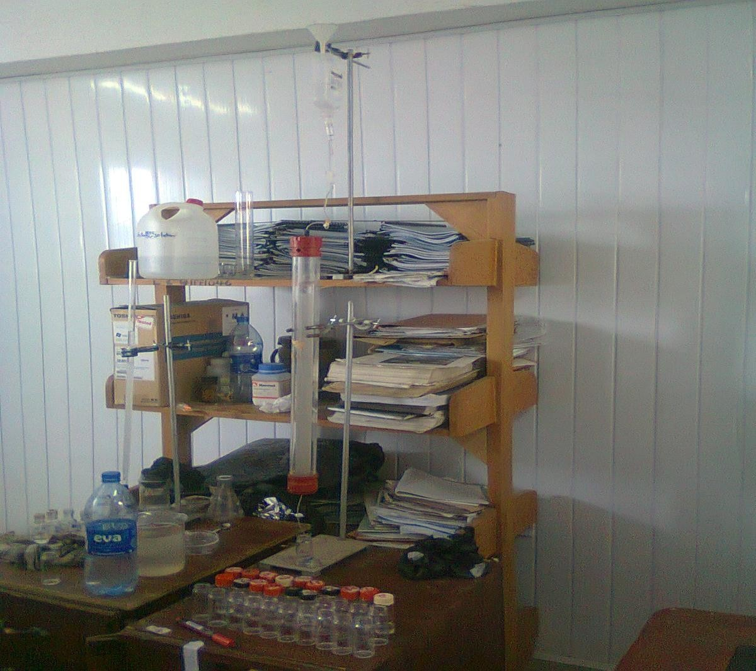

**Plate 1: Set up of Gel Chromatography**

# APPENDIX IV

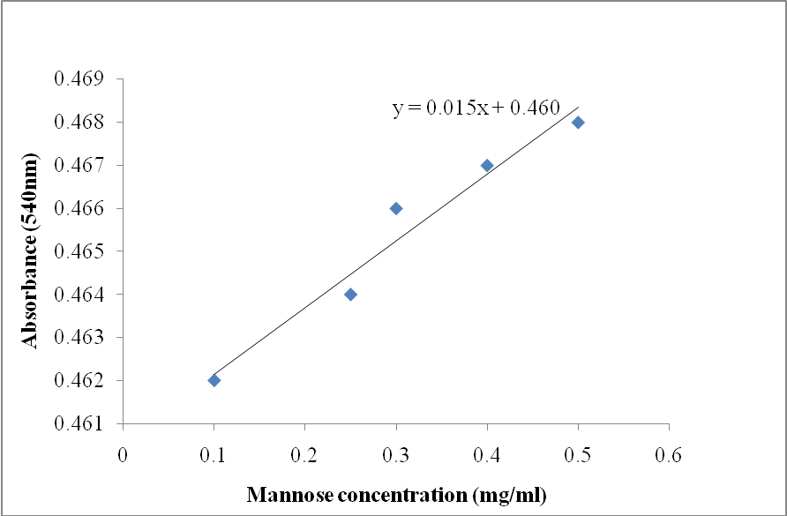

**Standard mannose curve**

# APPENDIX V

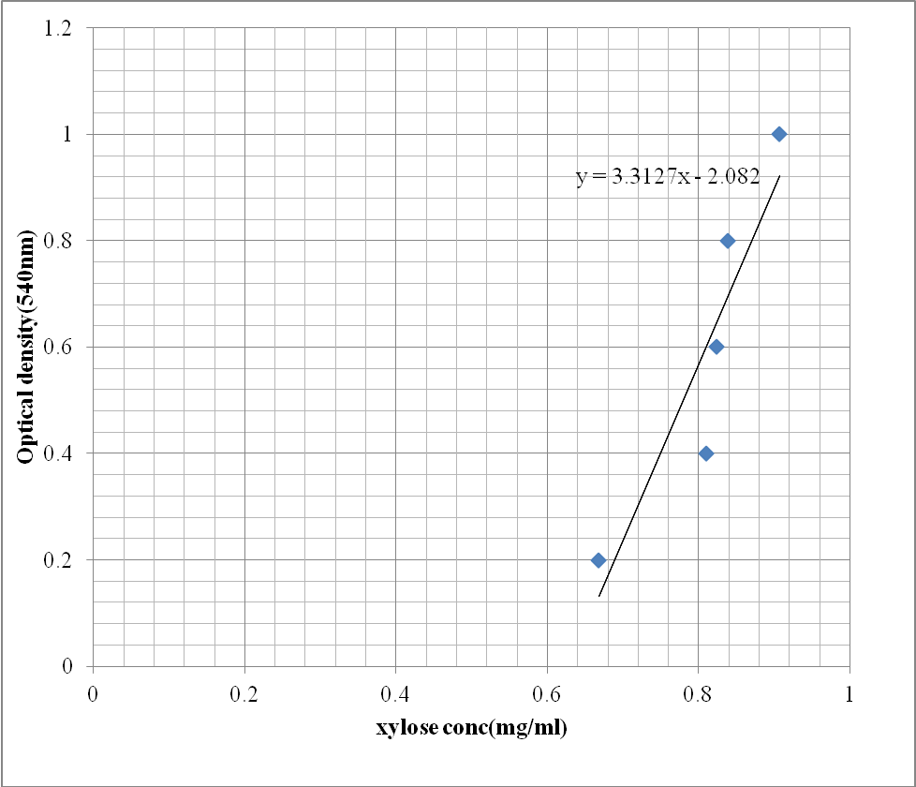

**Xylose Standard Curve**

# APPENDIX VI

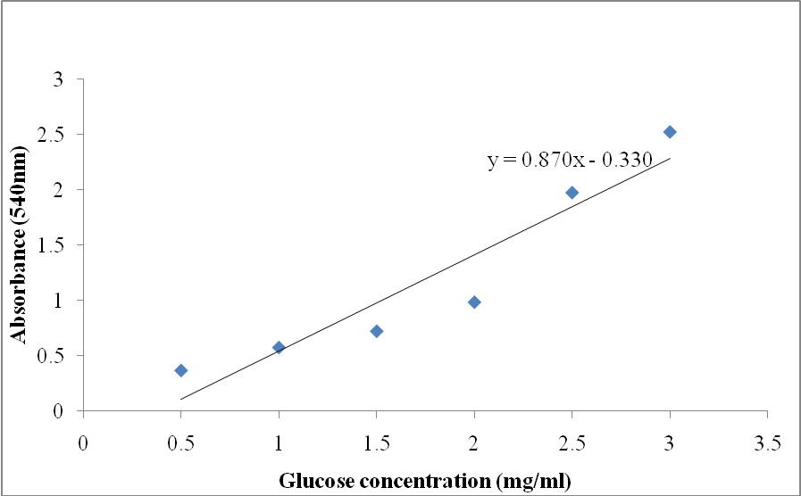

**Standard glucose curve**

# APPENDIX VII

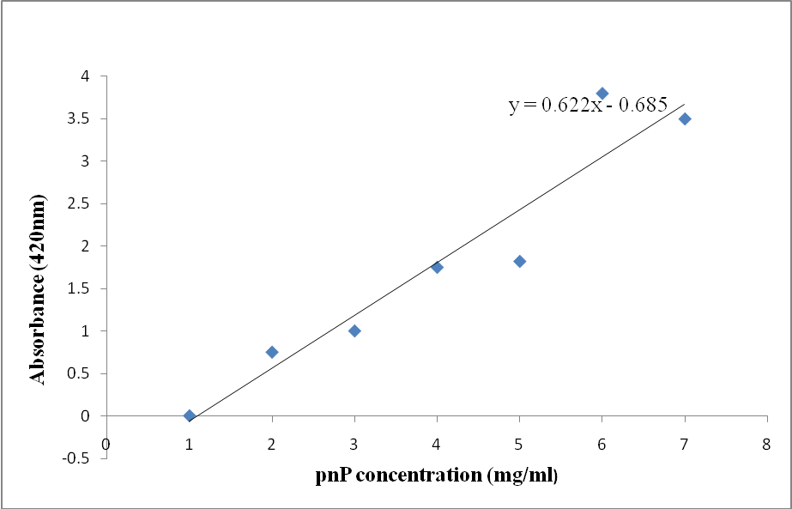

**Standard paranitrophenyl curve**

# APPENDIX VIII

**TAPPI 236 Method for Determination of Kappa number of pulp**

# Reagents

* 1. N Potassium permanganate (KMnO4) solution,
  2. N Sodium thiosulfate solution (Na2S2O3) 1.0N Potassium iodide solution(KI).

4.0N Sulfuric acid, (H2SO4) 0.2%.Starch indicator solution,

# Procedure

1. 4 g of air dried pulp sheet was torn into small pieces and conditioned in the atmosphere near the balance by leaving it it at room temperature for 20 minutes..
2. Using Table 4.11, the amount of pulp (to the nearest 0.001 g) which would consume approximately 50%

of the potassium permanganate solution was weighed out from the conditioned pulp for further work.. At the same time, a second specimen was weighed out and its moisture con- tent was determine in accordance with TAPPl T 210 "Sampling and Testing Wood Pulp Shipments for Moisture."

1. The test specimen was disintegrated in 500 ml of distilled water until free of fiber clots and undispersed fiber bundles, with care in order to avoid disintegration by extensive cut- ting of the fibers.
2. Disintegrated test specimen was transferred to a 2000ml reaction beaker and rinsed with enough distilled water to bring the total volume to 795 ml at about 25.0 ± 0.2°C room tem- perature.
3. The beaker was placed in a constant temperature bath adjusted so that the reaction tem- perature stays at 25.0 ± 0.2°C during the entire reaction. The suspension was continuously stirred so as to produce a vortex of about 25 mm deep but not fast enough to introduce air into the mixture (10.1).
4. 100.0 ± 0.1 ml of Potassium permanganate solution and 100 ml of the sulfuric acid solu- tion was Pipetted into a 250-mL beaker. This mixture was quickly brought to 25°C and added immediately to the disintegrated test specimen, simultaneously starting a stopwatch. The beaker was rinsed out using not more than 5 ml of distilled water was added to the reaction mixture bringing the total volume to1000 ± 5 ml.
5. At the end of 10.0 min, the reaction was stopped by adding 20 ml of the potassium io- dide solution from a graduated cylinder.
6. Immediately after mixing without filtering out the fibers, the free iodine was titrated with the sodium thiosulfate solution, a few drops of the starch indicator was added toward the end of the reaction.
7. A blank determination was carried out using exactly the same method as above but omitting the pulp

# Calculations

Kappa number was calculated from the end point value obtained using the following for- mulae:

***K*= *pf***

# W

And

where:

***p* = (*b-a)N***

# w

*K* = kappa number

*f* = factor for correction to a 50% permanganate consumption, dependent on the value of *p*

(see Table 4.12)

w = weight (g) of moisture-free pulp in the specimen,

*p* = amount (ml) of 0.1N permanganate actually consumed by the test specimen(ml)

*b* = amount (ml) of the thiosulfate consumed in the blank determination

*a* = amount (ml) of the thiosulfate consumed by the test specimen

*N* = normality of the thiosulfate

Factors (*f*) in Table 4.11 are based on the equation: log *K* = log *p/w* + 0.00093 (*p*-50).

**Table 4.11:** Factors (*f*) (to correct) for different percentages of permanganate used

|  |  |  |  |  |  |  |  |  |  |  |
| --- | --- | --- | --- | --- | --- | --- | --- | --- | --- | --- |
| f + | 0 | 1 | 2 | 3 | 4 | 5 | 6 | 7 | 8 | 9 |
| 30 | 0.958 | 0.960 | 0.962 | 0.964 | 0.966 | 0.968 | 0.970 | 0.973 | 0.975 | 0.977 |
| 40 | 0.979 | 0.981 | 0.983 | 0.985 | 0.987 | 0.989 | 0.991 | 0.994 | 0.996 | 0.998 |
| 50 | 1.000 | 1.002 | 1.004 | 1.006 | 1.009 | 1.011 | 1.013 | 1.015 | 1.017 | 1.019 |
| 60 | 1.022 | 1.024 | 1.026 | 1.028 | 1.030 | 1.033 | 1.035 | 1.037 | 1.039 | 1.042 |

# PUBLISHED PAPERS FROM THIS WORK.

1. Adesina F. C. and Onilude A. A. 2013. Isolation, identification and screening of xy- lanase and glucanase-producing micro fungi from degrading wood in Nigeria. *African Journal of Agricultural Research*. **8**(34): 4414 - 4421
2. Adesina, F. C., Oluboyede, O. A. and Onilude, A. A. 2013. Production, purification and characterisation of a β-mannanase by *Aspergillus niger* through solid state fermentation (SSF) of *Gmelina arborea* shavings*. African Journal of Microbiology Research*. **7**(4): 282- 289
3. Adesina, F. C. and Onilude, A. A. 2013. β 1,4-Xylosidase Production Potential of a

*Fusarium sp.* on Wood Shavings. *British Biotechnology Journal*. **3**(3): 274-282

237

240

1