# CHARACTERISATION OF RECYCLED STEEL IN NIGERIA FOR QUALITY ASSESSMENT

**BY**

# BALOGUN, Bashir Temitope M.ENG/SIPET/2018/8892

**A THESIS SUBMITTED TO THE POSTGRADUATE SCHOOL FEDERAL UNIVERSITY OF TECHNOLOGY, MINNA, NIGERIA IN PARTIAL FULFILMENT OF THE REQUIREMENTS FOR THE AWARD OF THE DEGREE OF MASTER OF ENGINEERING (M.ENG) IN MECHANICAL ENGINEERING**

# (MATERIALS AND METALLURGICAL ENGINEERING)

SEPTEMBER, 2021

# ABSTRACT

The chemical and mechanical properties of recycled mild steel from scraps in Nigeria was investigated using the mechanical (strength of materials) testing approach, chemical (elemental composition) testing approach and metallurgical (microstructural analysis) testing approach methods. The aim of this study is to investigate the quality of recycled mild steel reinforcement used for engineering applications in Nigeria by obtaining as- produced mild steel samples of 12mm diameter rod used for reinforcement for engineering applications in Nigeria from twenty five (25) steel plants located across the six (6) geopolitical zone in Nigeria. The elemental composition test, ultimate tensile strength test, the microstructural analysis and determination of hardness of samples from each steel plants were carried out on the mild steel of 12mm diameter rod used for reinforcement for engineering applications in Nigeria. The result of ultimate tensile test UTS reveals that out of twenty (25) steel plants A to Y, from which samples of 12mm steel rod was tested, only nine (9) steel plants were able to produced quality steel in accordance with the British Standard. The majority of the steel plants produced steel were below the British Standard. From the result obtained from elemental composition, virtually most of the steel produced from Nigeria steel plants contain excessive carbon content. It was also revealed from the result of elemental composition that, out of twenty five (25) steel plants, only two (2) steel plants conformed with the British BS: 4449 standard of carbon content at 0.25 (wt % C), twenty three (23) steel plants were having excessive or high carbon contents which did not conform with the British BS: 4449 standard. Finally, based on the results obtained from this study, most as-produced mild steel from the twenty five (25) steel plants in Nigeria did not meet the British BS: 4449 standard, and are not suitable for reinforcement of building structures.

# TABLE OF CONTENTS

|  |  |
| --- | --- |
| **Contents**  Cover Page | **Page** |
| Title | i |
| Declaration | ii |
| Certification | iii |
| Dedication | iv |
| Acknowledgement | V |
| Abstract | vi |
| Table of contents | vii |
| List of Tables | viii |
| List of Figures | xi |
| List of Abbreviations | x |
| **CHAPTER ONE** |  |
| **1.0 INTRODUCTION** | 1 |
| 1.1 Background to the Study | 2 |
| 1.2 Problem Statement | 2 |
| 1.3Aim and Objectives of the Study | 3 |
| 1.4 Scope of the Study | 3 |
| 1.5 Justification of the Study | 3 |

|  |  |
| --- | --- |
| **CHAPTER TWO** |  |
| **2.0 LITERATURE REVIEW** | **5** |
| 2.1 Structural Steel | **5** |
| 2.2 Chemical Composition of Mild Steel | 6 |
| 2.3 Properties of Carbon Steel | 10 |
| 2.4 Production and Refining of Mild Steel | 11 |
| 2.5 Method of Production of Mild Steel | 11 |
| 2.6 Types of Steel | 12 |
| 2.7 Common Steel Alloying Agents | 13 |
| **CHAPTER THREE** |  |
| **3.0 MATERIALS AND METHODS** | 16 |
| 3.1 Material Selection | 16 |
| 3.2 Methods | 16 |
| 3.3 . Sample Preparation | 17 |
| 3.3.1. Cuttings | 17 |
| 3.3.2. Grindings | 18 |
| 3.4 Ultimate Tensile Strength Test | 18 |
| 3.5 Microstructural and Elemental Composition Test | 20 |
| 3.6 Determination of Carbon Content by Elemental Composition Test | 20 |
| **CHAPTER FOUR** |  |
| **4.0 RESULTS AND DISCUSSION** | 21 |

|  |  |
| --- | --- |
| 4.1 Elemental Composition and Microstructures Test | 21 |
| 4.2 Ultimate Tensile Strength Test | 24 |
| 4.3 Hardness Value of the Steel Produced from each Plants | 26 |
| * 1. Hardness value of the Steel Production from Each Steel Plans by Breniel Hardness Test   2. Comparism of Hardness Value by EDS and Breniel Hardness Test   3. Microstructural Analysis   **CHAPTER FIVE** | 27  29  30 |
| * 1. **CONCLUSION AND RECOMMENDATIONS**   2. Conclusion | 55  55 |
| * 1. Recommendations   2. Contribution to Knowledge | 57  57 |
| **REFERENCES** | 58 |

**LIST OF TABLES**

|  |  |  |
| --- | --- | --- |
| **Table** |  | **Page** |
| 2.1 | Chemical composition of carbon and alloy steels for medium  carbon content for (AISI-SAE) steels. |  |
|  | 7 |
| 2.2 | Elemental composition of 12mm reinforcing bars samples | 8 |
| 2.3 | Carbon and other major residual elements in the 16mm  reinforcing steel bars samples compared with the previous studies and standard |  |
|  | 9 |
| 3.1 | Various steel plants where samples were sorted | 17 |
| 4.1 | Elemental Composition | 23 |
| 4.2 | Ultimate tensile strength | 24 |

* 1. Carbon content 26
  2. Hardness value of steel produced from each

plants by Briniel Hardness tesrt (BUT). 28

* 1. Comparism of hardness value by EDS and Briniel

Hardness tesrt (BUT). 29

# LIST OF FIGURES

|  |  |  |
| --- | --- | --- |
| **Figure** |  | **Page** |
| 3.1 | Ultimate tensile strength test (procedures). | 18 |
| 4.1 | Elemental composition and microstructures | 25 |

**LISTS OF ABBREVIATIONS**

|  |  |
| --- | --- |
| AISC | American Institute of Steel Construction |
| NBRRI | Nigerian Building and Road Research  Institute |
| BBC | Body Cubic Cantered |
| FCC | Face Cubic Cantered |
| HCP | Hexagonal Closed Packed |
| NIS | Nigerian Industrial Standards |
| NSE | Nigerian Society of Engineers |
| SON | Standard Organization of Nigeria |
| COREN | Council for the Regulation of Engineering  in Nigeria |
| NCP | Nigerian Code of Practice |
| SDG | Sustainable Development Goals |
| UN | United Nations |
| NSRMEA | National Steel Raw Materials Exploration  Agency |
| SEM | Scanning Electron Microscope |
| EDS | Energy Dispersive X-ray Spectroscopy |
| BS | British Standards |
| SAE | Society of Automobile Engineers |
| ASM | American Society for Materials |
| ASTM | American Society for Testing and  Materials |
| AISI | American Iron and Steel Institute |
| AMS | American Metals Steel |

# CHAPTER ONE

* 1. **INTRODUCTION**

# Background to the Study

With the recent and frequent increase in the rate of building collapses which can be termed as structural failure in Nigeria (Bamigboye *et al.,* 2019), this call for urgent decisions from the building and engineering industry to take a giant step in verification of the quality requirements of steel reinforcement as against other civil materials. (Obot and Archibong 2016) stated that the incidence of building collapses in Nigeria has reached an alarming proportion and dangerous for the national growth. Variation in the quality of steel reinforcement may render the quality and sustainability of the building hazardous to human lives, properties, nation economy and development in general (Adejuyigbe *et al.,* 2019). Steel reinforcement consumption in Nigeria should be considered of high quality standard as set by the concerns authorities such as Nigerian Society of Engineers (NSE), Standard Organization of Nigeria (SON) and the Council for the Regulation of Engineering in Nigeria (COREN), in order to bring the pathetic situations under control.

The methods of production and the processing route to achieve steel product in Nigeria are the same. For the purpose of this study, in order to investigate the chemical and mechanical properties of as-produced mild steel from scraps in Nigeria, the author visited twenty five (25) different steel plants located in Nigeria across all the six (6) geopolitical zones. It was then discovered that out of these 25 steel plants, only two (2) steel plants were known to be integrated mills that have a complete and vibrant processing route in their productions. These two companies have their processing route starting from the blooms, billets, microstructures examinations of billets, reheating furnace, from reheating furnace then temperature gradient, from 150 oC to 910 oC for

recrystallization stage, normalizing at austenitizing temperature of 1200 oC to 1250 oC, soaking zone in the furnace where the steel temperature is to be reduced to at least 50% of the austenitizing temperature, then rolling where the reduction of the billet diameter have to takes place by (20% to 30% ), then followed by 3-stage rolling: rough, intermediary and the finishing. Finally, the production of steel ends by air cooling. The above process are the complete processing route in a steel making company. The products from these two companies are: bars, rods, and light sections. Others steel plants are rolling mills and mini mills categories which are producing steels mainly from the scraps. Their product is either bars or rods or light sections or both bars and rods or either bars and sections or rods and sections, none of these rolling mills category are producing bars, rods and light sections at the same time like the two integrated mill steel plants.

The aim and objectives of this research is to assess and investigate the quality of steel reinforcement consumption for engineering applications in Nigeria by mechanical (strength of materials) testing approach, chemical (elemental composition) testing approach and metallurgical (microstructural analysis) testing approach and also to ascertain the validity of the results obtained from the previous researchers. This is because, there are still much and frequent occurrence of construction failure such as building, bridges, culverts and a lots of structures collapses in Nigeria long time ago up till recent time

# Problem Statement

Accessing the good quality of steel rod of various diameter that meet standard and specifications of AISI, SAE, BS4449, NIS 117 and ASTM A706 standards used for engineering applications in Nigeria has been a major challenge for a long time until in

the recent times lack of production of mild steel according to specifications and standard are responsible for frequent or persistence buildings and structures collapses in Nigeria.

Also lack of integrated approved National code concerning construction and the use of steel materials for engineering applications was responsible for engineering steel material failure in Nigeria.

# Aim and Objectives of the Study

The aim of this study is to investigate the recycled mild steel reinforcement used for engineering applications in Nigeria.

The study objectives are to determine:

* + 1. elemental composition of mild steel used for reinforcement.
    2. the tensile strength of mild steel used for reinforcement.
    3. hardness of mild steel used for reinforcement
    4. microstructure of mild steel used for reinforcement.

# Scope of the study

The scope of this study covers only the chemical (elemental composition), mechanical properties and the microstructural analysis of mild steel using for engineering applications in Nigeria.

# Justification of the study

The quality of mild steels produced for engineering application by different steel plants in Nigeria has been doubtful and creating fears and concern due to the reoccurrence and frequent building collapse, collapse of bridges and culverts, and failure of structures for the past three (3) decades in Nigeria. As the issue of failures in engineering applications

such as building collapses, collapse of bridges and culverts and failure of structures across the cities and states in Nigeria, our reliance on the existence findings from the previous researchers on causes of mild steel failure in engineering applications in Nigeria which has not been extended very much to the areas of the strength of materials, very much details of elemental composition and the microstructural analysis for quality control in the production of mild steel has drawn much kin interest to this present research.

The result obtain from this study will also be useful for steel manufacturers in Nigeria so as to produce mild steel base on the required specifications and standard.

Lastly, this research findings, if available to the public it would enable the building engineers, structure engineers, the contractors, even the consultants to advise and prescribe for the clients in the execution of engineering structures according to specifications and standard.

As a matter of fact, as at the recent time of filling the report of this study, Nigerian citizens still lost their lives due to steel failure in engineering applications. Carrying out this study would enact the public about the poor quality of mild steel products produced by most of the steel plants located in Nigeria, in which are consumed daily in engineering applications.

# CHAPTER TWO

* 1. **LITTERATURE REVIEW**

# Structural Steel

Structural steel has been the widely used in engineering applications. (Adzora *et al.* 2019; Oke *et al*. 2019). The behaviour of structural steel in engineering applications is is predictable and it must base on the engineering ethics, norms and values, specification and standard before put in practice. These standard are duly established by agencies such as the American Institute of Steel Construction (AISC), American Steel and Testing of Materials (ASTM), Nigerian Industrial Steel (NIS 117), and British Standard Steel (BS4449), Nigerian Society of Engineers (NSE), Council for the regulation of Engineering in Nigeria (COREN), Nigerian Code of Practice (NCPC), International Standard Organization (SON), National Steel Raw materials Exploration Agency (NSRMEA).

The primary function of steel in the building industry and in engineering applications is to form a skeleton that holds everything together ( Adzora *et al.* 2019). Structural steel is mainly used as a reinforcement material to counter concrete’s low tensile strength and ductility ( Bamigboye *et al*. 2019, Adejuyigbe *et al*. 2019).

*Ductility* is an important property of structural steel. It allows for the redistribution of stresses in continuous members and at points of high local stresses, such as at holes or other discontinuities. As a rule of thumb, although structural steel is always used below its yield point (in the elastic region), ductility is an important property because it provides a warning signal before actual failure, thus making the failure less catastrophic (Sinaie *et al.* 2014; Tee *et al*. 2012).

Structural steel is 100% recyclable and one of the most reused materials in the world (Fewings and Henjewele, 2019, Shuaib-Babata *et al*. 2019). Steel can be classified as

carbon steel, high-strength low-alloy (HSLA) steel, heat-treated carbon steel, and heat- treated constructional alloy steel. Structural steel under the prolonged influence of operational factors such as pressure, temperature, cyclic loads, radiation, and the environment can lead to embrittlement as a result of thermal aging and fatigue as well as corrosion damage. This can lead to the degradation of mechanical properties and eventually failure (Sukrawa *et al*. (2019).

# Chemical composition of mild steel

Mild steel used for building construction, road and bridges and any structural or engineering applications contains: Carbon C, Manganese Mn, Phusphorous P, Sulphur S, Silicon S, Vanadium V, Aliminium Al, Titanium Ti, Niobium Nb, Nickel Ni, Copper Cu, and Chromium Cr, (Cosham and Andrews, 2019 ; Sachan and Choo 2020 and Chong *et al*. 2016).

Mild steel can contains Carbon C, Manganese Mn, Phusphorous P, Sulphur S, and Silicon Si, as mojor elemental composition.

Odusote *et al*. (2019) research in to Chemical and Mechanical Properties of Reinforcing Steel Bars from Local Steel Plants. These researchers affirmed that: NIS 117, BS4449 and ASTM standard contains C Mn Si S P Cr as the major elemental composition that present in mild steel rolling mills products. In their study, 10mm, 12mm and 16mm were sampled and tested from eight steel plants in Nigeria and those eight still plants sampled were only located in the south-west region in Nigeria. In their findings, steel produced in Nigeria consists of C, Mn, Si, S, P, Cr, Mo, Cu, and Ni as the major elemental composition presents when eight steel plants were considered as a case study. Table 2.2 Presents the elemental composition of 12mm diameter of steel reinforcement in engineering application in Nigeria, while Table 2.3 Presents the elemental composition of 16mm diameter of steel reinforcement based on their findings

and in accordance with the NIS 117, BS4449 and American Society for Testing and Materials (ASTM) standard by Odusote *et al.* (2019).

According to Odusote *et al*. (2019), hardness test, ultimate tensile strength test was carried out on steel, in their findings, the 12mm structural steel met the BS4449, NIS 117 and (ASTM) A706 standards and also have good ductility, but the carbon content of those structural steel tested were higher compared to the normal existing standard. Finally, they affirmed thjat: all the structural steel tested were suitable for engineering applications.

According to Mehi (1972), in the records of American Society for Metals (ASM), the chemical compositions of carbon and alloy steels of medium carbon content for (AISI- SAE) steels are presented in Table 2.1.

# Table 2.1a: chemical compositions of carbon and alloy steels of medium carbon content for (AISI-SAE) steels.

**s**

**…..**

**…..**

**…..**

**…..**

**…..**

**…..**

**…..**

**…..**

**…..**

**…..**

**…..**

**…..**

**…..**

**…..**

**…..**

**…..**

**…..**

|  |  |  |  |  |  |  |  |  |  |
| --- | --- | --- | --- | --- | --- | --- | --- | --- | --- |
| **Steel** | **C** | **Mn** | **P.max.** | **S. max.** | **Si** | **Ni** | **Cr** | **Mo** | **Other** |
|  |  |  |  | **AISI- SAE**  **steels.** |  |  |  |  |  |
| 1025 | 0.22-0.28 | 0.30-0.60 | 0.040 | 0.050 | **………..** | **………..** | **………..** | **………..** | **……** |
| 1030 | 0.28-0.34 | 0.60-0.90 | 0.040 | 0.050 | **………..** | **………..** | **………..** | **………..** | **……** |
| 1035 | 0.32-0.38 | 0.60-0.90 | 0.040 | 0.050 | **………..** | **………..** | **………..** | **………..** | **……** |
| 10B35 | 0.32-0.38 | 0.60-0.90 | 0.040 | 0.050 | **………..** | **………..** | **………..** | **………..** | **……** |
| 1038 | 0.35-0.42 | 0.60-0.90 | 0.040 | 0.050 | **………..** | **………..** | **………..** | **………..** | **……** |
| 1040 | 0.37-0.44 | 0.60-0.90 | 0.040 | 0.050 | **………..** | **………..** | **………..** | **………..** | **……** |
| 1045 | 0.43-0.50 | 0.60-0.90 | 0.040 | 0.050 | **………..** | **………..** | **………..** | **………..** | **……** |
| 1050 | 0.48-0.55 | 0.60-0.90 | 0.040 | 0.050 | **………..** | **………..** | **………..** | **………..** | **……** |
| 1052 | 0.47-0.55 | 1.20-1.15 | 0.040 | 0.050 | **………..** | **………..** | **………..** | **………..** | **……** |
| 1151 | 0.48-0.55 | 0.70-1.00 | 0.040 | **(a)** | **………..** | **………..** | **………..** | **………..** | **……** |
| 1524 | 0.19-0.25 | 1.35-1.65 | 0.040 | 0.050 | **………..** | **………..** | **………..** | **………..** | **……** |
| 1527 | 0.22-0.29 | 1.20-1.50 | 0.040 | 0.050 | **………..** | **………..** | **………..** | **………..** | **……** |
| 1541 | 0.36-0.44 | 1.35-1.65 | 0.040 | 0.050 | **………..** | **………..** | **………..** | **………..** | **……** |
| 1340 | 0.38-0.43 | 1.60-1.90 | 0.035 | 0.040 | 0.20-0.35 | **………..** | **………..** | **………..** | **……** |
| 4047 | 0.45-0.50 | 0.70-0.90 | 0.035 | 0.040 | 0.20-0.35 | **………..** | **………..** | 0.20-  0.30 | **……** |
| 4130 | 0.28-0.33 | 0.40-0.60 | 0.035 | 0.040 | 0.20-0.35 | **………..** | 0.80-1.10 | 0.15-  0.25 | **……** |
| 4340 | 0.38-0.43 | 0.60-0.80 | 0.035 | 0.040 | 0.20-0.35 | 1.65-2.00 | 0.70-0.90 | 0.20-  0.30 | **……** |

**Table 2.1b: chemical compositions of carbon and alloy steels of medium carbon**

|  |  |  |  |  |  |  |  |  |  |
| --- | --- | --- | --- | --- | --- | --- | --- | --- | --- |
| 4350 | 0.48-0.53 | 0.60-0.80 | 0.035 | 0.040 | 0.20-0.35 | 1.65-2.00 | 0.70-0.90 | 0.20-0.30 | **………..** |
| 5046(b) | 0.43-0.48 | 0.75-1.00 | 0.035 | 0.040 | 0.20-0.35 | **………..** | 0.20-0.35 | **………..** | **………..** |
| 5132 | 0.30-0.35 | 0.60-0.80 | 0.035 | 0.040 | 0.20-0.35 | ............. | 0.75-1.00 | **………..** | **………..** |
| 8645 | 0.43-0.48 | 0.75-1.00 | 0.035 | 0.040 | 0.20-0.35 | 0.40-0.70 | 0.40-0.60 | 0.15-0.25 | **………..** |
| 8650(b) | 0.48-0.53 | 0.75-1.00 | 0.035 | 0.040 | 0.20-0.35 | 0.40-0.70 | 0.40-0.60 | 0.15-0.25 | **………..** |
|  |  |  |  | **AMS**  **Steels.** |  |  |  |  |  |
| 6417 | 0.38-0.43 | 0.60-0.90 | 0.010 | 0.010 | 1.45-1.80 | 1.65-2.00 | 0.70-0.95 | 0.30-0.50 | 0.05-0.10V(c) |
| 6419 | 0.41-0.45 | 0.60-0.90 | 0.010 | 0.010 | 1.45-1.80 | 1.65-2.00 | 0.70-0.95 | 0.30-0.50 | 0.05-0.10V(c) |
| 6470 | 0.38-0.43 | 0.50-0.70 | 0.040 | 0.040 | 0.20-0.40 | 0.25 max | 1.40-1.80 | 0.30-0.40 | 0.95-1.30Al |
| 6485 | 0.38-0.43 | 0.20-0.40 | 0.020 | 0.020 | 0.80-1.00 | ……….. | 4.75-5.25 | 1.20-1.40 | 0.40-0.60V(c) |

* + 1. Range of sulphur content is 0.08 to 0.13%. (b) SAE only. (c) Also contains 0.35% max copper. (Robert, 1972)

# Table 2.2: Elemental composition of 12 mm reinforcing bar samples Elements Samples

|  |  |  |  |  |  |  |  |  |
| --- | --- | --- | --- | --- | --- | --- | --- | --- |
| **(wt.%** | **A2R16** | **B2R16** | **C2R16** | **D2R16** | **E2R16** | **F2R6** | **G2R16** | **H2R16** |
| C | 0.200 | 0.270 | 0.400 | 0.400 | 0.360 | 0.280 | 0.320 | 0.330 |
| Si | 0.210 | 0.130 | 0.210 | 0.320 | 0.060 | 0.230 | 0.150 | 0.190 |
| Mn | 0.830 | 0.620 | 0.590 | 1.520 | 0.480 | 0.560 | 0.560 | 0.660 |
| P | 0.050 | 0.030 | 0.050 | 0.010 | 0.030 | 0.040 | 0.010 | 0.050 |
| S | 0.010 | 0.080 | 0.070 | 0.010 | 0.070 | 0.070 | 0.070 | 0.020 |
| Cr | 0.250 | 0.230 | 0.150 | 0.030 | 0.160 | 0.110 | 0.220 | 0.330 |

(Odusote *et al.,* 2019)

**Table 2.3: Carbon and other major residual elements in the 16 mm reinforcing steel bars compared with previous studies and standards**

|  |  |  |  |  |  |  |  |  |  |
| --- | --- | --- | --- | --- | --- | --- | --- | --- | --- |
| Samples | C | Mn | Si | S | P | Cr | Mo | Cu | Ni |

|  |  |  |  |  |  |  |  |  |  |
| --- | --- | --- | --- | --- | --- | --- | --- | --- | --- |
| A3R16 | 0.200 | 0.850 | 0.240 | 0.060 | 0.030 | 0.200 | 0.020 | 0.220 | 0.130 |
| B3R16 | 0.220 | 0.660 | 0.100 | 0.060 | 0.020 | 0.320 | 0.020 | 0.480 | 0.210 |
| C3R16 | 0.190 | 0.360 | 0.120 | 0.050 | 0.030 | 0.320 | 0.020 | 0.380 | 0.150 |
| D3R16 | 0.200 | 1.360 | 0.340 | 0.030 | 0.020 | 0.070 | 0.020 | 0.140 | 0.060 |
| E3R16 | 0.230 | 0.500 | 0.150 | 0.060 | 0.010 | 0.110 | 0.010 | 0.200 | 0.090 |
| F3R16 | 0.340 | 0.630 | 0.180 | 0.060 | 0.030 | 0.190 | 0.020 | 0.330 | 0.160 |
| G3R16 | 0.210 | 0.580 | 0.140 | 0.060 | 0.020 | 0.270 | 0.030 | 0.310 | 0.140 |
| H3R16 | 0.350 | 0.760 | 0.240 | 0.070 | 0.030 | 0.260 | 0.030 | 0.330 | 0.140 |
| PSM | 0.112 | 0.580 | 0.149 | 0.060 | 0.071 | 0.186 | 0.009 | 0.256 | 0.118 |
| IFSM | 0.277 | 0.720 | 0.319 | 0.057 | 0.069 | 0.138 | 0.005 | 0.285 | 0.115 |
| PHSM | 0.194 | 0.610 | 0.245 | 0.049 | 0.043 | 0.264 | 0.013 | 0.245 | 0.104 |
| A16 | 0.329 | 0.555 | 0.176 | 0.036 | 0.042 | 0.164 | 0.0001 | 0.261 | 0.112 |
| B16 | 0.169 | 0.579 | 0.228 | 0.047 | 0.056 | 0.204 | 0.0001 | 0.292 | 0.085 |
| NIS 117 | 0.350 | 1.200 | 0.300 | 0.040 | 0.040 | **...........** | **...........** | **...........** | **...........** |
| BS4449 | 0.250 | 1.000  0. | 400 | 0.050 | 0.050 | **...........** | **...........** | **...........** | **...........** |
| ASTM  706 | 0.30 | 1.500 | 0.500 | 0.035 | 0.045 | **...........** | **...........** | **...........** | **...........** |

(Odusote *et al*., 2019)

# Properties of Carbon Steels

Carbon steels are alloys made from a combination of iron and carbon. By varying the percentage of carbon, it is possible to produce steel with a variety of different qualities. In general, the higher the carbon level the stronger and more brittle the steel (Lu, 2010). Steel, the world's foremost construction material, is an [iron](https://www.thebalance.com/metal-profile-iron-2340139) alloy that contains between 0.2% and

2% carbon by weight (Westin, 2010).

Sinaie *et al.* (2014) also studied Mechanical properties of cyclically-damaged structural mild steel at elevated temperatures. In their research, the potential changes that the mechanical properties of structural grade mild steel experience under a loading condition was investigated in which the cyclic loading was experience in their study. In their findings, the cyclic loading significantly affects the ductility and the strength of the medium carbon steel when subjected to a loading at high temperature. It was also stated clearly as the outcome of their research that the mechanical structure of material contains elemental compositions which causes the main basis or foundations for the mechanical property of structural steel and also liable to changes due to the load experience by the material during engineering application in real practice.

In a recent development, a lots of researchers have researched in to the areas of steel and its properties,

Yi *et al*. (2012); Oluwasola *et al*. (2014); Yildirim and Prezzi (2011), gave an account of chemical, physical and mechanical properties of steel products and how the properties affects the performance of steel in engineering applications.

* 1. ***Production and Refining* of Mild Steel**

Structural steels are normally produced for engineering applications in many different ways such as: hot rolling, control rolling, normalized, or quenched and tempered. Different shapes can also be produced such as: bars, rods, slabs anglar shapes and so on (Sinha et al ., 2016). According to these researchers, carbon steels have minimum of tensile strengths of 410 MPa, quenched and tempered carbon and low-alloy steels have a standard of minimum tensile strengths of 720 MPa, and quenched and tempered low-alloy steels have a standardise minimum tensile strengths of 1000 to 1200 MPa.

Strucural steel are made up of carbon steel and it therefore pose a reasonable usefulness in engineering application all over the world. Even structural cables such as wires and ropes are constructed from carbon steel which are being produced by wire drawing method in a steel producing plants. A practical example is Ajaokuta steel rolling mills, located in Kogi State, Nigeria.

Production of structural steel does not just produced for merely sake, it is being produced in order to satisfy the human needs and to justify this, it has to meet the standard tensile strength and the yield strength to avoid failure in engineering applications whenever put in practice. This makes the work of Sinha et al ., (2016), to be appreciated by affirming that: Tensile strengths vary from 1300 MPa to 2200 MPa. It was also stressed by these researchers that structural steel may contain carbon content ranging from (0.40–0.85%).

# Method of Production of mild Ssteel

Sinha *et al*. (2016), affirmed in Encyclopedia and steel that most steel is produced by basic oxygen methods. This is a method whereby oxygen is being blown in to the liquid iron or molten scrap of steel. There are different furnaces used for production of steel, but the most effective one is an electric arc furnace (Wang and Yan, 2010; Francisca, and Glatstein 2020;

Claveau-Mallet *et al*. 2012; Cikmit *et al*. 2019; Navarro *et al*. 2010 and Pan *et al*.2014). In this sudy, the mechanical property of steel produced in Nigeria is to be investigated and it is in the opinion that any property that structural steel possessed comes from the method of production.

Sinha *et al.*(2016), therefore gives the analysis of steel contents and expressed that: If copper is specified, the minimum is 0.2%, Boron, 0.0005% minimum, Copper, 0.35% maximum; nickel, 0.25% maximum; chromium, 0.25% maximum; molybdenum, 0.008% maximum,

molybdenum, 0.45–0.65%; nickel, 1.50% maximum; chromium, 1.20% maximum; boron,

0.001–0.005%.

The above analysis is given based on the desire of the steel producers and it affirmed that every contentsof the steel were present during the production. It is very clear that the quality of steel produced is from the manufacturers and as a result, any low quality of steel product that does not meet the specification and standard should be referred to its producers. This is why in this study, the author of this paper will make sure of visiting different steel plants in Nigeria to investigate the chemical and mechanical properties of mild steel from each steel plants across the six geopolitical zones in Nigeria.

# Types of Steel

Steels are produced based on the mechanical and physical properties required for the engineering application. Steel that produced all over the world have different grades in accordance with the the BS4449, NIS and ASTM A706 standards. Various grading systems are used to distinguish steels based on these properties, which include density, elasticity, melting point, thermal conductivity, strength, and hardness among others. The manufacturers of steel products varies the type and the quality of steel products in order to suit the desire of

the consumers. According to the American Iron and Steel Institute (AISI), steels can be broadly categorized into four groups based on their chemical compositions:

* + 1. Carbon Steels
    2. Alloy Steels
    3. Stainless Steels
    4. Tool Steels

Based on the above identification of steel products, in this present study, therefore only carbon steels product was considered and as the only area of study for the investigation of chemical and mechanical properties of mild steel produced in twenty five (25) steel plants in Nigeria.

# Common Steel Alloying Agents

Based on the general standard, below is a list of commonly used alloying elements and their impact on steel which can be serves as reference bench mark for all steel manufacturers in Nigeria.

1. Aluminum (0.95-1.30%): A deoxidizer. Used to limit the growth of austenite grains.
2. Boron (0.001-0.003%): A hardenability agent that improves deformability and machinability. But it should be added in a small quantity just to give hardness to the steel.
3. Chromium (0.5-18%): This is the major alloying element of stainless steel.
4. Cobalt: This gives strength and magnetic permeability to steel at high temperatures.
5. Copper (0.1-0.4%): It is added to steel in order to give ductility and also gives the corrosion resistance
6. Lead: It is insoluble in liquid or solid steel but it can also be added to steel for easy machining.
7. Manganese (0.25-13%): This tremendously improves the strength of a steel at an elevated temperatures. It also increase the hardenability, [ductility](https://www.thebalance.com/ductility-metallurgy-4019295) and wear resistance

of steel.

1. Molybdenum (0.2-5.0%): It is always added in a small quantities to steel and also gives good hardness and strength to steel. It also serves as a corrosion resistance to steel.
2. Nickel (2-20%): It is being added at over 8% content to high chromium stainless steel which improve the strength and the toughness as well as the resistance to oxidization and corrosion as a protection for steel.
3. Niobium: It is added to steel in order to stabilise the carbon content of a steel. It also increase the yield strength of steel.
4. Nitrogen: It is added to steel in order to Increases the austenitic stability of stainless steels and improves the yield strength.
5. Phosphorus: It is usually added to mild steel along with sulphur to improve the machinability of mild steel. It is also added in order to improve the strength and corrosion resistance of mild steel.
6. Selenium: It improve the machinability of steel.
7. Silicon (0.2-2.0%): It is added to steel so as to improve the strength, the elasticity, resistance against acid attack and results in larger grain sizes. It is also used as a deoxidizing agent in steel making plants. It is a requirement to be present in a steel products.
8. Sulfur (0.08-0.15%): It is sometimes added in small quantities to a steel in order to improve the machinability without resulting in hot shortness.
9. Titanium: It is added to a steel in order to Improve both strength and corrosion resistance of a steel. At addition of 0.25% to 0.60 % of titanium, carbon combines with the titanium, allowing chromium to remain at the grain boundaries and resist oxidization.
10. Tungsten: It is added to a steel in order to produce stable carbides and refines grain size so as to increase hardness, especially at high temperatures.
11. Vanadium (0.15%): Like titanium and niobium, vanadium can produce stable carbides that increase the strength of a steel at high temperatures. This is achieved by a fine grain structure of material. It also improve the ductility of steel products.
12. Zirconium (0.1%): This improve the strength and gives a fine grains siz structure.

Addition of Zirconium at (0.1%) also prevents the structural steel from fracture or failure.

# CHAPTER THREE

* 1. **MATERIALS AND METHODS**

The materials and equipment used in this study are mild steel (as-received) of 12mm steel rod, etchants, water, cotton wool, carbide papers, emery clothes, Scanning Electron Microscope/Electrons Diffraction Spectrometry (SEM/EDS), Analogue Tensile Testing Machine (500kN), Briniel Hardness Testing Machine and Electric Arc Saw Cutting Machine.

# Material Selection

A 12mm of mild steel were selected based on its widely used for building construction, road construction, and culverts. It is almost about 65% available in the market across the three geopolitical regions in Nigeria and the steel bar have the same method of production from the steel plants Based on the afore mentioned reasons, the author consider it to be suitable material for the investigation of chemical and mechanical properties of mild steel produced in Nigeria for human consumption.

# Methods

The method used in this study are random sampling of materials, sample preparation such as: cutting, grinding, microstructure and determination of carbon content by elemental composition, which are highlighted below.

# Sampling of the Material

The material sampling was done by taking samples from each steel plant products from different cities across the country and twenty five (25) steel plants across the six geopolitical zones were investigated as it were presented in Table 3.1.

# Table 3.1: Various steel plants where samples were sorted

|  |  |  |  |
| --- | --- | --- | --- |
| **Steel Plants** | **Locations** | **Sample diameter(mm)** | **No of sample** |
| A | Onitsha | 12 | 1 |
| B | Asaba | 12 | 1 |
| C | Enugu | 12 | 1 |
| D | Ajaokuta | 12 | 1 |
| E | Jos | 12 | 1 |
| F | Katsina | 12 | 1 |
| G | Ilorin | 12 | 1 |
| H | Ikorodu | 12 | 1 |
| I | Oweri | 12 | 1 |
| J | Oshogbo | 12 | 1 |
| K | Eket | 12 | 1 |
| L | Otta | 12 | 1 |
| M | Ilorin | 12 | 1 |
| N | Abuja | 12 | 1 |
| O | Otta | 12 | 1 |
| P | Ikeja | 12 | 1 |
| Q | Ikeja | 12 | 1 |
| R | Ikorodu | 12 | 1 |
| S | Ibadan | 12 | 1 |
| T | Ilorin | 12 | 1 |
| U | Abuja | 12 | 1 |
| V | Ugheli | 12 | 1 |
| W | Warri | 12 | 1 |
| X | Kano | 12 | 1 |
| Y | Aladja | 12 | 1 |

* 1. **Sample Preparation**

# Cutting

The steel rod samples were obtained from each still plants was cut to a length of 500mm. From this maximum length, a standard gauge length of 300mm was prepared from each samples for an ultimate tensile test. A length of 10mm was also prepared from each samples to meet the test requirement for the hardness test, Microstructural test and Elemental composition.

# Grinding

In accordance with the preparation for the laboratory test, for the purpose of microstructural test, hardness test and elemental composition test, each samples cut were grinded by the use of grinding machine. The grinding were done in three stages: At first stage, the grinding machine was operated at a speed of 80 rev/min so as to have rough grinding. At stage two, the machine speed was increased to 100 rev/min so as to have average grinding. At stage three, the speed of the machine was increased to 150 rev/min so as to have smooth grinding. The final stage prepared the samples for microstructural test, hardness test and elemental composition test.

# Ultimate tensile strength test

Figure 3.1 Presents the tensile test in the laboratory according to the standard method employed in the laboratory.

F = 500(KN) F = 500(KN)



Cross-section of the Chuck

Ød Gauge length (GL ) = 300mm

Cross-section of Steel rod

F = 500(KN)

# Figure 3.1: Ultimate tensile strength test (procedures)

The tensile strength test was carried out in this study so as to determine the yield strength of each samples produced for engineering applications by the different steel plants in Nigeria. The reason for the author decision to carry out ultimate tensile strength is that: in a structural analysis, yield strength normally used to determine whether a structure will undergo structural failure or otherwise (Ede *et al;* 2015).

From the average tensile strength (N/mm2), an average yield strength (N/mm2) for each samples of different diameters from different steel plants in Nigeria will be determined.

In this study, the use of equations: (1) and (2) will be employed

σu = Pu /Ao (3.1)

where;

σu : is the average tensile strength of the samples, Pu : is the applied breaking load on the samples,

Ao : is the cross sectional area of the test piece samples.

δu = Fu /Ao (3.2)

where;

δu : is the average yield strength of the samples, Fu : is the applied yield load on the samples,

Ao : is the cross sectional area of the test piece samples.

# Microstructural and Elemental Composition test

In this study, the Microstructural and Elemental composition test is intended to be carried out so as to know the surface morphology of the phases presents in the mild steel produced by the different steel plants in Nigeria. This was done by the use of the Scanning Electron/Energy Dispersive X-ray Spectroscopy (SEM/EDS) machine.

The material sample was cut in to 10 by 10mm dimension and grinded by the use of grinding machine. It was well polished and etched with emery cloth and properly etched by the use of natal solution. The period of etching was 60 seconds in order to avoid over etching .Finally, it was examined by the machine and the image was finally printed out.

# 3.6. Hardness Test and Determination of Carbon Content by Elemental Composition Test

After the microstructural and Elemental composition test, the weight percent of carbon content (wt%C) that contained in each samples produced from each steel plants were determined. This was done by extracting the result of the carbon contents present in each steel plants and compared with the standard such as: American Institute of Steel Construction (AISC), American Steel and Testing of Materials (ASTM), Nigerian Industrial Steel (NIS 117), and British Standard Steel (BS4449) (Odusote *et al*. 2019; Ede *et al.* 2015). In order to carry out the hardness test on the materials, the material sample was cut in to 10 by 10mm dimension and grinded by the use of grinding machine. It was slotted inside the harness machine and the hardness of each samples was determined and displayed on the monitor screen of the system and finally, the value from each samples was printed out by the machine.

# CHAPTER FOUR

* 1. **RESULTS AND DISCUSSION**

# Chemical Composition

The weight percentage (wt. %) of each major element such as: (Fe), (C), (S), (P), (Si), (Mn), (Cr) and other residual elemental constituents that combined to 100% from the twenty five

(25) steel plants are presented in Table 4.1.

The British BS 4449 standard was the bench mark used to determine the carbon content of the mild steel used, which is (0.25 wt. % C) (Odushote et al., 2019).

The carbon contents from different steel plants range from 0.14 to 0.51 (wt. %). Out of the

(25) steel plants from which 12mm steel rod was examined, only (4) steel plants: C, G, P and U were produced at a normal carbon content of (0.25 wt. % C) in compliance with the British standard BS 4449. This implies that other (21) steel plants products are too brittle with excessive carbon content and this was presented in Table 4.3.

The sulphur and phosphorous content are in the range of 0.01 to 0.86 (wt. %).

The maximum sulphur and phosphorous content to be contained in AISI steel for engineering application is 0.010 to 0.050 and 0.010 to 0.040 (wt. % max.) respectively (Odushote et al., 2019; Robert, 1972).

In this study, out of (25) steel plants examined, only (9) steel plants produced at standard lower range of sulphur and phosphorous content most numbers (16) of steel plants produced steel that contains high sulphur and phosphorous contents, as it was shown in Table 4.1.

Most microstructures reveals steel of lower quality of coarse grained structures that contains a severe sulphur and phosphorous contents which causes excessive brittleness of the steel thereby may results to “red or cold shortness” of the steel at high and room temperature respectively, and may lead to short life span of the steel in engineering application.

**Table: 4.1: Elemental Compositions of as- Produced Mild Steel by each Steel Plants**

|  |  |  |  |  |  |  |  |  |  |  |  |  |  |  |  |  |  |  |  |  |  |
| --- | --- | --- | --- | --- | --- | --- | --- | --- | --- | --- | --- | --- | --- | --- | --- | --- | --- | --- | --- | --- | --- |
| **S/ N** | **Steel plants** | **Elemental compositions (wt%)** | | | | | | | | | | | | | | | | | | | |
| **Fe** | **C** | **S** | **P** | **Si** | **K** | **Cr** | **Ni** | **Mn** | **V** | **Cu** | **Al** | **Sn** | **Ag** | **Na** | **Ti** | **O** | **Mo** | **Cl** | **Ca** |
| 1 | A | 90.35 | 0.14 | 0.75 | 0.62 | 0.80 | 0.82 | 0.52 | …. | ..... | 0.31 | …. | 0.48 | 0.82 | 1.27 | 0.67 | 0.51 | 0.06 | …. | 1.27 | 0.61 |
| 2 | B | 87.87 | 0.16 | 0.68 | 0.39 | 1.24 | 1.54 | …. | …. | …. | …. | …. | 0.70 | 1.23 | 1.42 | 1.09 | 0.39 | 0.03 | …. | 2.53 | 0.73 |
| 3 | C | 87.74 | 0.25 | 0.65 | 0.71 | 0.91 | 2.62 | …. | …. | …. | …. | …. | 0.42 | 1.13 | 1.74 | 2.58 | 0.28 | 0.10 | …. | …. | 0.87 |
| 4 | D | 84.29 | 0.19 | 0.86 | 0.62 | 1.14 | 2.32 | 0.57 | …. | …. | 0.58 | …. | 0.77 | 2.07 | 1.76 | 3.00 | 0.66 | 0.11 | …. | …. | 1.06 |
| 5 | E | 87.72 | 0.37 | 0.51 | 0.44 | 1.00 | 0.97 | 0.89 | …. | …. | 0.46 | …. | 0.13 | 1.37 | 1.25 | 1.58 | 0.50 | 0.12 | …. | 2.06 | 0.63 |
| 6 | F | 91.93 | 0.28 | 0.05 | 0.04 | 1.14 | 2.32 | .... | …. | …. | …. | …. | 0.07 | 0.02 | 0.06 | 3.00 | …. | 0.01 | …. | …. | 1.08 |
| 7 | G | 90.36 | 0.25 | 0.03 | 0.01 | 2.36 | 2.82 | …. | …. | …. | …. | …. | 0.01 | 0.03 | 0.74 | 2.49 | 0.08 | 0.10 | …. | …. | 0.72 |
| 8 | H | 87.74 | 0.34 | 0.02 | 0.03 | 0.91 | 2.62 | 0.75 | 1.80 | 0.65 | …. | …. | 0.42 | …. | 1.74 | 2.58 | …. | 0.10 | 0.22 | …. | 0.08 |
| 9 | I | 92.21 | 0.35 | 0.03 | 0.01 | 1.01 | 1.22 | …. | …. | …. | …. | …. | 0.42 | …. | 1.32 | 2.75 | …. | 0.02 | …. | …. | 0.66 |
| 10 | J | 90.50 | 0.51 | 0.73 | 0.51 | 0.46 | 1.86 | …. | …. | 1.36 | …. | …. | 0.32 | …. | 1.26 | 1.03 | …. | 0.60 | …. | …. | 0.86 |
| 11 | K | 86.92 | 0.45 | 0.70 | 0.65 | 2.58 | 3.41 | …. | …. | 0.72 | …. | …. | 0.28 | …. | 0.26 | 2.96 | …. | 0.21 | …. | …. | 0.86 |
| 12 | L | 91.57 | 0.32 | 0.03 | 0.03 | 0.37 | 2.53 | …. | …. | 0.80 | …. | …. | 0.22 | …. | 0.51 | 2.75 | …. | 0.01 | …. | …. | 0.86 |
| 13 | M | 95.58 | 0.38 | 0.01 | 0.03 | 0.32 | 1.32 | 0.06 | 0.01 | …. | .... | …. | 0.22 | 0.11 | 0.21 | 1.32 | 0.19 | 0.01 | …. | …. | 0.23 |
| 14 | N | 94.35 | 0.43 | 0.02 | 0.01 | 0.23 | 0.95 | 0.23 | …. | …. | …. | 0.70 | 0.32 | …. | 0.44 | 1.53 | …. | …. | …. | …. | 0.79 |
| 15 | O | 81.65 | 0.33 | 0.63 | 0.91 | 2.08 | 3.26 | 1.10 | 1.19 | 0.62 | …. | 0.72 | 0.90 | …. | 0.32 | 3.15 | …. | 0.72 | .... | …. | 2.42 |
| 16 | P | 95.40 | 0.25 | 0.01 | 0.01 | 0.38 | 0.92 | …. | …. | 0.35 | …. | 0.30 | 0.12 | …. | 0.81 | 1.06 | …. | 0.01 | …. | …. | 0.38 |
| 17 | Q | 93.12 | 0.35 | 0.03 | 0.01 | 1.20 | 1.08 | …. | …. | 0.90 | …. | 0.27 | 0.35 | …. | 0.41 | 1.76 | …. | 0.01 | …. | …. | 0.51 |
| 18 | R | 85.51 | 0.38 | 0.68 | 0.50 | 1.50 | 2.36 | 0.75 | 1.68 | 0.65 | 0.35 | 0.32 | 0.36 | …. | …. | 3.42 | …. | 0.20 | 0.32 | …. | 1.02 |
| 19 | S | 82.14 | 0.40 | 0.90 | 0.36 | 1.59 | 3.75 | 5.02 | …. | 0.26 | 0.55 | 0.30 | 0.42 | …. | …. | 1.36 | …. | 0.35 | 1.35 | …. | 1.25 |
| 20 | T | 89.28 | 0.43 | 0.68 | 0.77 | 0.31 | 1.49 | 1.42 | 0.22 | 0.55 | …. | 0.31 | 0.98 | …. | 1.74 | 1.06 | …. | 0.10 | 0.35 | …. | 0.31 |
| 21 | U | 87.77 | 0.25 | 0.56 | 0.38 | 1.91 | 2.62 | 0.75 | 1.68 | 0.61 | 0.08 | 0.33 | …. | …. | 0.81 | 1.29 | …. | 0.10 | 0.35 | …. | 0.51 |
| 22 | V | 88.27 | 0.40 | 0.36 | 0.72 | 0.20 | 2.95 | 0.71 | 1.72 | 0.60 | …. | …. | 0.12 | …. | 1.13 | 1.86 | …. | 0.10 | …. | …. | 0.86 |
| 23 | W | 86.15 | 0.23 | 0.48 | 0.72 | 1.28 | 1.71 | …. | …. | 1.42 | …. | …. | 0.42 | …. | 2.36 | 3.02 | …. | 0.30 | …. | …. | 1.91 |
| 24 | X | 87.38 | 0.38 | 0.72 | 0.66 | 0.30 | 1.98 | …. | …. | 1.65 | …. | …. | …. | …. | 2.36 | 2.41 | …. | 0.20 | …. | …. | 1.96 |
| 25 | Y | 87.78 | 0.50 | 0.48 | 0.36 | 2.05 | 2.86 | …. | …. | 1.00 | …. | …. | …. | …. | 1.75 | 2.25 | …. | 0.11 | …. | ... | 0.86 |

# Ultimate Tensile Strength Test

The tensile strength test that was carried out in this study is to determine the yield strength of each samples produced for engineering applications by the twenty five

(25) steel plants in Nigeria. The reason for the author decision to carry out ultimate tensile strength is that: in a structural analysis, yield strength normally used to determine whether a structure will undergo structural failure or otherwise (Ede *et al.,* 2015).

From the average tensile strength (N/mm2), an average yield strength (N/mm2) for each samples of 12mm from each twenty five (25) steel plants in Nigeria was determined.

In this study, a threshold maximum of yield strength BS: 4449 standard of 500 (N/mm2), Odushote *et al.* (2019) and minimum of yield strength BS: 4449 standard of 460 (N/mm2), Ede *et al.,* (2015), were used.

The results of ultimate tensile strength test is as shown in Table 4.1 and Figure 4.1

# Table 4.2a: Ultimate Tensile Strength Test

|  |  |  |  |  |  |
| --- | --- | --- | --- | --- | --- |
| S/N | Steel plants | Average Tensile strength (N/mm2) | Average Yield Strength (N/mm2) | Average percentage elongation (%) | Remarks |
| 1 | A | 559.36 | 426.85 | 12.44 | Failed |
| 2 | B | 680.05 | 426.79 | 18.67 | Failed |
| 3 | C | 693.1 | 442.04 | 15.33 | Failed |
| 4 | D | 691.53 | 426.52 | 16.40 | Failed |
| 5 | E | 627.37 | 446.29 | 12.13 | Failed |
| 6 | F | 618.24 | 504.54 | 11.67 | Passed |
| 7 | G | 712.38 | 536.07 | 11.55 | Passed |
| 8 | H | 615.62 | 499.65 | 11.67 | Passed |
| 9 | I | 675.93 | 474.92 | 17.22 | Passed |
| 10 | J | 609.06 | 413.64 | 18.22 | Failed |
| 11 k | | 556.74 | 374.74 | 18.33 | Failed |

**Table 4.2b. Ultimate tensile strength test**

Average Yield Strength (N/mm2)

|  |  |  |  |  |  |  |
| --- | --- | --- | --- | --- | --- | --- |
|  | 12 | L | 666.20 | 579.63 | 12.00 | Passed |
|  | 13 | M | 546.98 | 474.49 | 7.33 | Passed |
|  | 14**Tab** | **l**N**e 4.2b** | **: Ul**7**t**2**i**2**m**.9**a**4**te ten** | **sile str**5**e**9**n**2.**g**51**th test** | 9.44 | Passed |
|  | 15 | O | 696.21 | 430.33 | 16.70 | Failed |
|  | 16 | P | 613.36 | 500.54 | 11.67 | Passed |
|  | 17 | Q | 804.27 | 707.88 | 9.43 | Passed |
|  | 18 | R | 625.97 | 397.29 | 19.10 | Failed |
|  | 19 | S | 575.12 | 435.57 | 11.67 | Failed |
|  | 20 | T | 630.40 | 440.57 | 19.22 | Failed |
|  | 21 | U | 659.16 | 410.60 | 15.30 | Failed |
|  | 22 | V | 772.51 | 426.77 | 15.13 | Failed |
|  | 23 | W | 634.61 | 453.64 | 12.50 | Failed |
|  | 24 | X | 660.74 | 447.15 | 13.53 | Failed |
|  | 25 | Y | 630.81 | 402.15 | 16.80 | Failed |

Figure: 4.1: showing an average Yield strength of steel plants against BSS

800

700

600

500

400

300

200

100

0

A B C D E F G H I J K L M N O P Q R S T U V W X Y

Steel Plant

Average Yield Strength (N/mm2) Standard (N/mm2)

Graph of Average Yeild Strength against BSS:Standard (N/mm2)

standard

The yield strength a mild steel product must possessed according to ASTM standard is 415 (N/mm2), for BSS 4449 standard, the value of yield strength is 500 (N/mm2).

In this study, due to the fact that Nigeria has been recording mild steel material failure in engineering application every day, the author decided to use the British BSS 4449

standard as a bench mark to assess the strength of the steel that are produced for engineering application in Nigeria, due to its highest value of yield strength standard as it was established by (Odusote *et al*. 2019). The result of the ultimate tensile strength in table 2 reveals that out of twenty (25) steel plants from which samples of 12mm steel rod was tested, only nine (9) steel plants B, C, F, G, I, M, Q, T and X were able to produced steel rod of 12mm in accordance with the British standard. The majority of the sixteen (16) steel plants A, D, E, H, J, K, L, N, O, P, R, S, U, V, W and Y produced steel below British standard, contrary to what Odusote et al., (2019), has presented in the recent time that all the steel samples of 12mm met standard. Although, the reasons for their affirmation is not farfetched, asides BSS 4449 standard their judgement was also based on ASTM and NIS standard.

# Hardness value of the steel produced from each steel plants by EDS

Based on the result of the elemental composition of each steel plants from steel plant A-Y, the carbon contents presents in each steel plants are presented in table 4.3.

# Table: 4.3 a: Carbon content of the steel produced from each steel plants by EDS

|  |  |  |  |
| --- | --- | --- | --- |
| S/N | Steel plants | Carbon content  (%wt. C) | Remarks |
| 1 | A | 0.14 | Low |
| 2 | B | 0.72 | High |
| 3 | C | 0.25 | Normal |
| 4 | D | 0.19 | Low |
| 5 | E | 0.37 | High |
| 6 | F | 0.28 | High |
| 7 | G | 0.25 | Normal |
| 8 | H | 0.34 | High |
| 9 | I | 0.35 | High |

**el plants by EDS**

|  |  |  |  |
| --- | --- | --- | --- |
| 10 | J | 0.51 | High |
| 11 | K | 0.45 | High |
| 12 | L | 0.32 | High |
| 13 | M | 0.38 | High |
| 14 | N | 0.43 | High |
| 15 | O | 0.33 | High |
| 16 | P | 0.25 | Normal |
| 17 | Q | 0.35 | High |
| **Table**1**:**8 **4.3 b: Car** | **bo**R**n conte** | **nt of** 0**t**.**h**38**e steel p** | **roduce**H**d**ig**f**h**rom each ste** |
| 19 | S | 0.40 | High |
| 20 | T | 0.43 | High |
| 21 | U | 0.25 | Normal |
| 22 | V | 0.40 | High |
| 23 | W | 0.23 | Low |
| 24 | X | 0.38 | High |
| 25  NIS117 BS:4449 | Y | 0.50  0.35  0.25 | High High  Normal(control) |
| ASTM |  | 0.30 | High |

From Table 4.3, the carbon contents from each plants was extracted out from the result of elemental composition in table 4.1a (A-Y). It was observed that out of twenty five

(25) steel plants, twenty (21) steel plants were having excessive or high carbon contents which extremely not conformed with the British BS: 4449 standard at 0.25 (wt

% C), left with only four (4) steel plants C, G, P and U that met the standard except steel plants A and D with the carbon content very much lower than the standard.

# Hardness Value of the steel produced from each steel plants by Breniel Hardness test (BHT).

Based on the result of the hardness test of each steel plants from steel plants A to Y, the hardness presents in each steel plants are presented in Table 4.4.

**Table: 4.4: Hardness value of the steel produced from each steel plants by Briniel Hardness test (BHT)**

|  |  |  |  |  |  |  |  |
| --- | --- | --- | --- | --- | --- | --- | --- |
| **S/N** | **Steel plants** | **Hardness**  **(HBW)** |  |  | **AVG** | **%wt C** | **Remarks** |
|  |  | **Replicate 1** | **Replicate 2** | **Replicate 3** | |  |  |
| 1 | A | 141.5 | 140.2 | 140.0 | 140.6 | 0.14 | Pass |
| 2 | B | 720.2 | 721.0 | 721.3 | 720.8 | 0.72 | Pass |
| 3 | C | 251.4 | 250.2 | 250.1 | 250.6 | 0.25 | Pass |
| 4 | D | 192.0 | 190.2 | 193.0 | 191.7 | 0.19 | Pass |
| **5** | E | 375.2 | 374.0 | 373.5 | 374.2 | 0.37 | Pass |
| **6** | F | 278.2 | 278.9 | 280.2 | 279.1 | 0.28 | Pass |
| **7** | G | 252.3 | 251.0 | 252.3 | 251.9 | 0.25 | Pass |
| 8 | H | 346.1 | 341.2 | 346.0 | 344.4 | 0.34 | Pass |
| 9 | I | 352.6 | 350.2 | 349.8 | 350.9 | 0.35 | Pass |
| 10 | J | 510.2 | 513.2 | 510.4 | 511.3 | 0.51 | Pass |
| 11 | K | 450.8 | 455.0 | 472.6 | 459.5 | 0.46 | Pass |
| 12 | L | 326.3 | 360.1 | 310.3 | 332.2 | 0.33 | Pass |
| 13 | M | 378.8 | 380.0 | 381.0 | 379.9 | 0.38 | Pass |
| 14 | N | 431.8 | 430.6 | 431.0 | 431.1 | 0.43 | Pass |
| 15 | O | 334.2 | 333.0 | 333.1 | 333.4 | 0.33 | Pass |
| 16 | P | 250.5 | 252.4 | 250.8 | 251.2 | 0.25 | Pass |
| 17 | Q | 360.0 | 351.0 | 350.0 | 353.7 | 0.35 | Pass |
| 18 | R | 378.9 | 378.0 | 379.9 | 378.9 | 0.38 | Pass |
| 19 | S | 398.9 | 399.6 | 340.0 | 379.5 | 0.38 | Pass |

|  |  |  |  |  |  |  |  |
| --- | --- | --- | --- | --- | --- | --- | --- |
| 20 | T | 429.9 | 428.9 | 429.9 | 429.6 | 0.43 | Pass |
| 21 | U | 248.9 | 249.9 | 250.0 | 249.6 | 0.25 | Pass |
| 22 | V | 410.0 | 400.3 | 398.6 | 403.0 | 0.40 | Pass |
| 23 | W | 222.9 | 230.1 | 229.8 | 227.6 | 0.23 | Pass |
| 24 | X | 378.6 | 381.0 | 379.6 | 379.7 | 0.38 | Pass |
| 25 | Y | 498.6 | 499.0 | 478.9 | 492.2 | 0.49 | Pass |

# Comparism of Hardness Value by EDS and Breniel Hardness Test

The hardness value obtained from EDS was relatively compared to the hardness value obtained from the BHT and the results obtained from the two test was summarised as thus in Table 4.5.

**Table 4.5: Comparism of hardness value by EDS and Breniel Hardness test**

|  |  |  |  |  |
| --- | --- | --- | --- | --- |
| **S/N** | **Steel plants** | **Carbon contents (%wt)** |  | **Remarks** |
|  |  | **EDS** | **BHT** |  |
| **1** | **A** | **0.14** | **0.14** | **Same** |
| **2** | **B** | **0.72** | **0.72** | **Same** |
| **3** | **C** | **0.25** | **0.25** | **Same** |
| **4** | **D** | **0.19** | **0.19** | **Same** |
| **5** | **E** | **0.37** | **0.37** | **Same** |
| **6** | **F** | **0.28** | **0.28** | **Same** |
| **7** | **G** | **0.25** | **0.25** | **Same** |
| **8** | **H** | **0.34** | **0.34** | **Same** |
| **9** | **I** | **0.35** | **0.35** | **Same** |
| **10** | **J** | **0.51** | **0.51** | **Same** |
| **11** | **K** | **0.45** | **0.46** | **Deviation** |
| **12** | **L** | **0.32** | **0.33** | **Deviation** |
| **13** | **M** | **0.38** | **0.38** | **Same** |
| **14** | **N** | **0.43** | **0.43** | **Same** |
| **15** | **O** | **0.33** | **0.33** | **Same** |
| **16** | **P** | **0.25** | **0.25** | **Same** |
| **17** | **Q** | **0.35** | **0.35** | **Same** |
| **18** | **R** | **0.38** | **0.38** | **Same** |

|  |  |  |  |  |
| --- | --- | --- | --- | --- |
| **19** | **S** | **0.40** | **0.38** | **Deviation** |
| **20** | **T** | **0.43** | **0.43** | **Same** |
| **21** | **U** | **0.25** | **0.25** | **Same** |
| **22** | **V** | **0.40** | **0.40** | **Same** |
| **23** | **W** | **0.23** | **0.23** | **Same** |
| **24** | **X** | **0.38** | **0.38** | **Same** |
| **25** | **Y** | **0.50** | **0.49** | **Deviation** |

From Table 4.5 and from the results obtained from steel plants K, L, S and Y, it was observed that, the hardness value which depicts by the carbon content present in their products were slightly different from each other when compare the result obtained from EDS to Briniel Hardness test (BHT). It was shown that a steel product from steel plant K contained 0.45 wt % C as it was revealed by EDS test compared to 0.46 wt % C as it was revealed by BHT test. Likewise, steel plants L, S and Y steel products reveals carbon contents of: 0.32 wt % C (EDS)/ 0.33 wt % C (BHT), 0.40 wt % C (EDS)/ 0.38 wt % C (BHT) and 0.50 wt % C (EDS)/ 0.49 wt % C (BHT) respectively.

Finally, it was observed from Table 4.5 that: the hardness value or the carbon contents of steel products from other twenty one (21) steel plants.

# Microstructural Analysis

The microstructure of as-produced steel from the (25) steel plants are presented in Figure 4.1a to 4.1y. Each microstructures were named using AISI designation, which is subject to the carbon content that present in each steel plant products as it were reveals by the EDS/SEM results. Most microstructures reveals steel of lower quality of coarse grained structures that contains a severe sulphur and phosphorous contents which causes excessive brittleness of the steel thereby may results to “red or cold shortness” of the steel at high and room temperature respectively, and may lead to short life span of the steel in engineering application.

Out of (25) steel plants examined, (23) steel plants reveals poor microstructures of steel products that does not pass through a complete production or a complete processing routes.

As was vividly observed through the result of the microstructure in this study shows that only two (2) steel plants G and P produced steel at British BS: 4449 standard at

0.25 (wt % C) and with their processing route starting from the blooms, billets, microstructures examinations of billets, reheating furnace, from reheating furnace then temperature gradient, from 150 oC to 910 oC for recrystallization stage, normalizing at austenitizing temperature of 1200 oC to 1250 oC, soaking zone in the furnace where the steel temperature was reduced to at least 50% of the austenitizing temperature, then to the rolling operation where the reduction of the billet diameter was taken place by (20% to 30% ), then followed by 3-stage rolling: rough, intermediary, then finishing and finally air cooled which ends the production processing route of mild steel.

All others steel plants did not pass through a complete production of mild steel. Also, the temperature gradient gradually from 150 oC to 910 oC for recrystallization stage was not observed instead, the billet were just heated directly at faster rate to attain a maximum of 910 oC and then hot rolled and finally air cooled or quenched in a media (this is a bad process of mild steel).

The microstructure of as-produced steel from each steel plants is as shown in figure 4.1a

-4.1b.

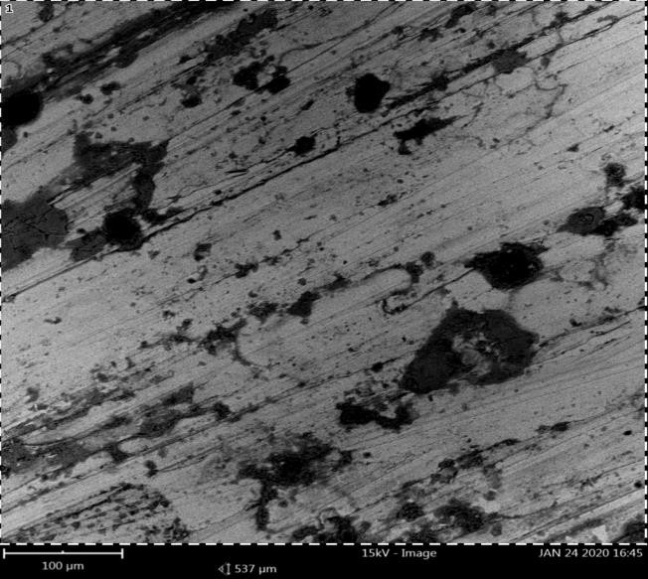

**Sulphur & Phusphorous**

**Figure 4.1a: The microstructure reveals AISI-1524 Steel The Chemical Composition of Steel Plant A**

# Steel plant A

There is a severe Phosphorus and Sulphur content at the black region of the microstructure in the steel thereby making the steel very brittle and depleting its mechanical properties. As a result of this, there will be “red shortness” in the steel, therefore the steel may fracture when in practice in engineering application. The microstructure reveals decarburization which makes the carbon content present much lowered than the normal AISI standard.

The microstructure also reveals the presence of Iron-Sulphide (FeS) precipitate at the grains boundaries and shows some features of untarred Martensite (dark) and Pearlite (black). In the microstructure, it reveals that during the production, short-cut process of production took place, by austenitizing the steel at a lower temperature of about 800oC instead of 1200oC or 1250oC.

**Verdict:** The steel is of lower quality that contains a severe Sulphur and Phosphorus which causes excessive brittleness of the steel thereby may resulted to “red shortness” in practice and may fracture.

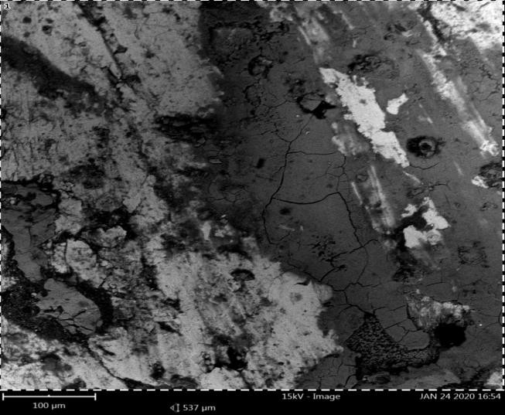

**Sulphur & Phusphorous**

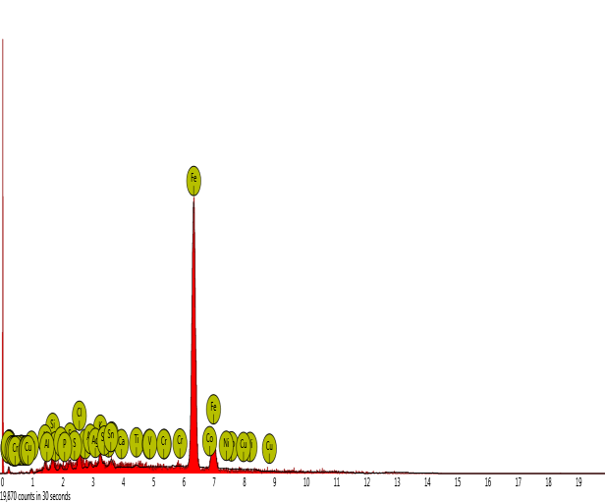**Figure 4.1b: The microstructure reveals AISI-1524 Steel The Chemical Composition of Steel Plant B**

# Steel plant B

The microstructure reveals **AISI-1524** steel. The microstructure contains coarse grain structure, consisting of pearlite (black) in the matrix of ferrite (white). It also reveals a severe phosphorus and sulphur as much as too much of oxygen content which leads to the formation of oxygen sulphide with the presence of Iron-Sulphide (FeS) precipitate at the grain boundaries.

The formation of Iron-Sulphide in the presence of oxygen will eventually make the steel to melt at a lower temperature thereby may lead to fracture. There is a crack in the steel due to formation of Iron-Sulphide (FeS).

The microstructure reveals a steel that has subjected to a fatigue striation which will be further lead to a fatigue aberration and finally leads to failure (fracture). This may be as a result of the presence of Tin (Sn) and Titanium (Ti) at high weight percent concentrations.

**Verdict:** It is a low quality of steel product. The crack present in the steel structure may occurred as a result of presence of HCP elemental composition that mainly meant for

AMS composition such as: Titanium (Ti), Chromium (Cr), Tin (Sn) and FCC chemical composition such as: Aluminium (Al), and Silver (Ag) which were included at a high weight percent (wt%) concentrations. This is very abnormal in the steel product of structural steel AISI-SAE products.

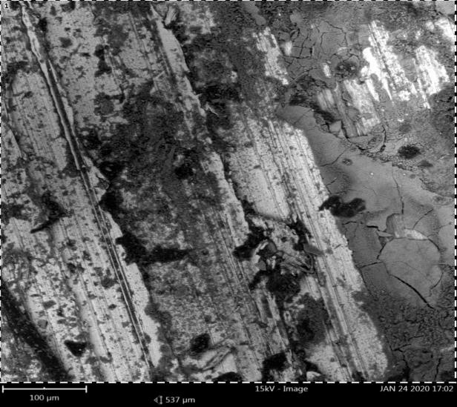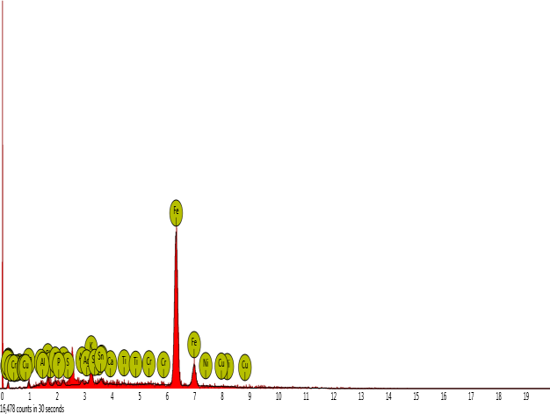

**Sulphur & Phusphorous**

**Figure 4.1c: The microstructure reveals AISI-1524 Steel The Chemical Composition of Steel Plant C**

# Steel plant C

The microstructure reveals a normal carbon content of 0.25 wt%C according to AISI- SAE, AMS and British standard. There is high phosphorization and sulphurization in the steel structure, which makes it to be brittle and thereby makes it loose its mechanical properties.

The microstructure contains pearlite (white) light coloured-like flat plate structure in a moderate proportion with pearlite (black). It also reveals ferrite (dark) stripes between the flat plate structures like a tiny rope within the flat plate structure.

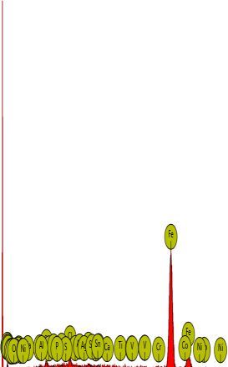**Verdict:** The steel is of low quality that may fracture easily in the practice thereby have short life span.



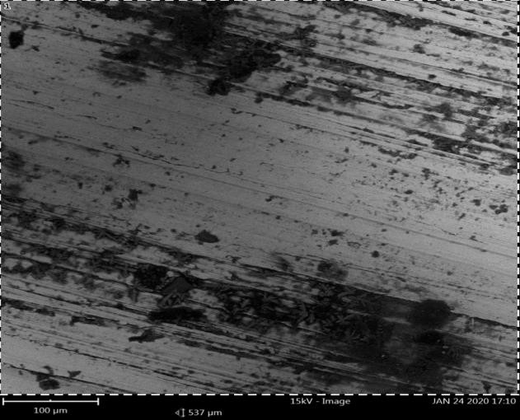

**Sulphur & Phusphorous**

**Figure 4.1d: The microstructure reveals AISI-1030 Steel The Chemical Composition of Steel Plant D**

# Steel plant D

The microstructure reveals **AISI-1030** steel. It shows austenitizing at 900oC. It reveals excessive sulphur and phosphorus contents. FCC and HCP elemental composition such as: Aluminium (Al), Silver (Ag), Chromium (Cr) and Vanadium (V) were present at a high weight percent (wt%) concentration.

**Verdict:** Poor quality of steel, with the deplenish and detonation of mechanical property. Fracture may occur when in practice during engineering applications.

xiv

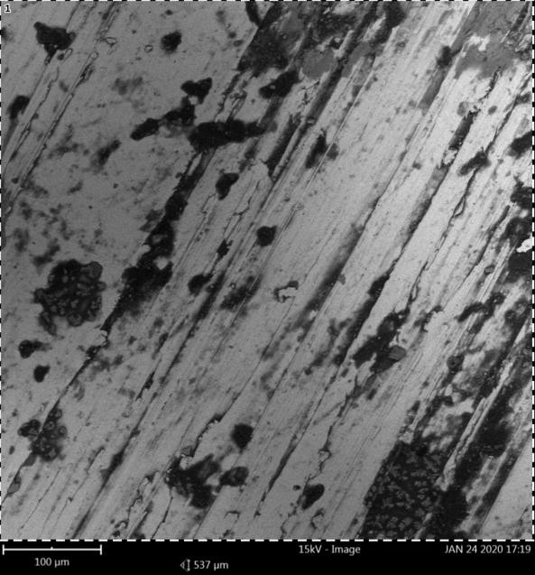

**Sulphur & Phusphorous**

**Figure 4.1e: The microstructure reveals AISI-1030 Steel The Chemical Composition of Steel Plant E**

# Steel plant E

Phosphorization and sulphurization is very obvious, as well as carburization is well pronounced in the steel. The microstructure reveals fine grain structure but the method of production has made the steel to have very low mechanical properties due to carburization, phosphorization and sulphurization.

FCC elemental composition such as: Aluminium (Al) and Silver (Ag) were present at a controlled weight percent (wt%) based on AISI-SAE standard. The microstructure reveals pearlite (black) in the matrix of ferrite (white).

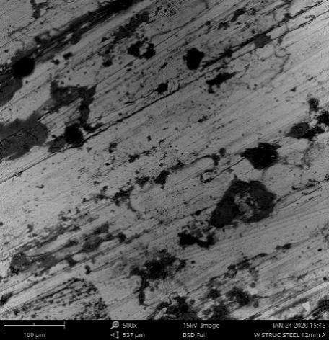**Verdict:** The structure reveals a low quality steel.



**Figure 4.1f: The microstructure reveals AISI-1030 Steel The Chemical Composition of Steel Plant F**

# Steel plant F

It contains fine grain structure, with the presence of pearlite (black) in the matrix of ferrite (white). During the production, the steel was normalized by austenitizing at about 900oC temperature and cools down to a soaking temperature of about 350oC.It also reveals a normal carbon content of 0.28 wt%C, as well as a normal phosphorus and sulphur contents at a very lower level according to AISI standard. There is also very low level of oxygen content to avoid melting of the steel at a lower temperature when put in practice.

There is no presence of HCP elements such as Vanadium (V), Chromium (Cr), Cobalt (Co) and Nickel (Ni). This makes the steel to be a good structural steel that is readily to withstand any structural engineering application with a long life span in service. There is presence of FCC elements such as Aluminium (Al), Tin (Sn) and Silver (Ag) at a moderate formulated and desirable content.

**Verdict:** The steel is a good quality that can withstand any structural engineering application.

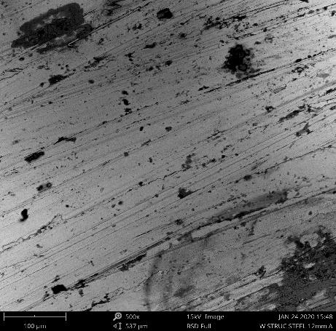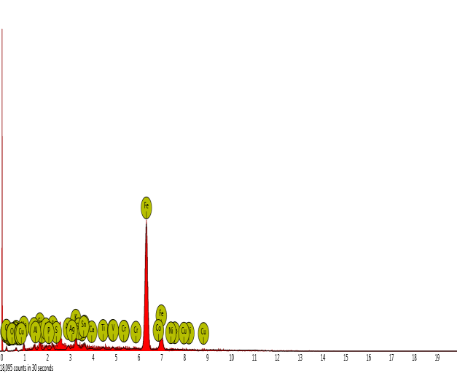

**Sulphur & Phusphorous**

**Figure 4.1g: The microstructure reveals AISI-1030 Steel The Chemical Composition of Steel Plant G**

# Steel plant G

The steel reveals **AISI-1030** steel. It contains fine grain structure with moderate carbon, sulphur and phosphorus content according to AISI standard. It undergone good and normal metallurgical processing route, and conform to the AISI standard of production.

It reveals pearlitic structure (black) interwoven with the ferrite (white) in a good or evenly distributions of equaxed grains orientations.

**Verdict:** It is a good product of steel readily withstand any structural engineering applications

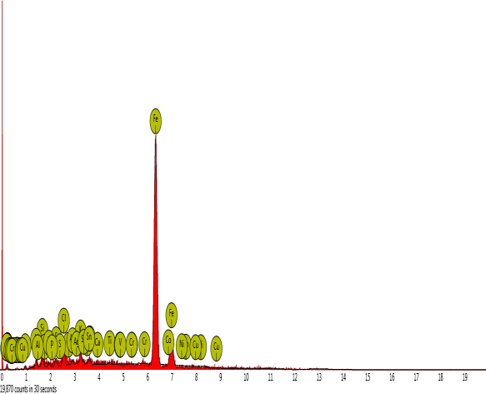

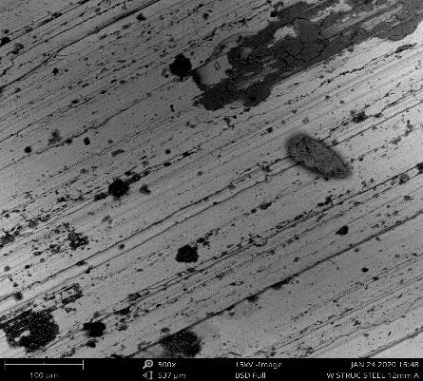

**Sulphur & Phusphorous**

**Figure 4.1h: The microstructure reveals AISI-4340 Steel The Chemical Composition of Steel Plant H**

# Steel plant H

The microstructure reveals **AISI-4340** steel. It shows fine grain structures with equaxed and evenly distribution with good orientations, of pearlite (black) in the matrix of ferrite (white). It also have a normal carbon, sulphur, phosphorus and oxygen contents.

**Verdict:** Good quality of steel.

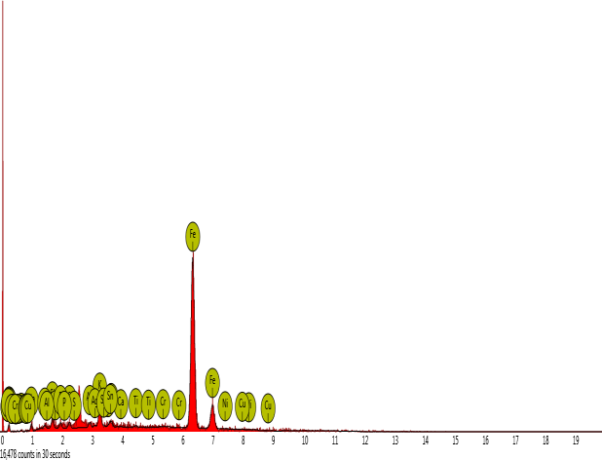

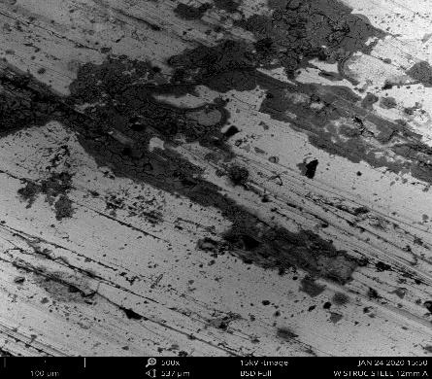

**Sulphur & Phusphorous**

**Figure 4.1i: The microstructure reveals AISI-1050 Steel The Chemical Composition of Steel Plant I**

# Steel plant I

It contains fine grain structures of pearlite (black) in the matrix of ferrite (white).

The production of steel is good by revealing a structural steel that is normalized at austenitizing temperature of 910oC and soaked at 50% of its austenitizing temperature before it cooled down in the air for ultimate homogenizationThere is normal carbon, sulphur, phosphorus and oxygen content of 0.35 wt%, 0.03 wt%, 0.01 wt% and 0.02 wt% respectively. The steel maintained AISI standard.

**Verdict:** It is a good quality of steel.

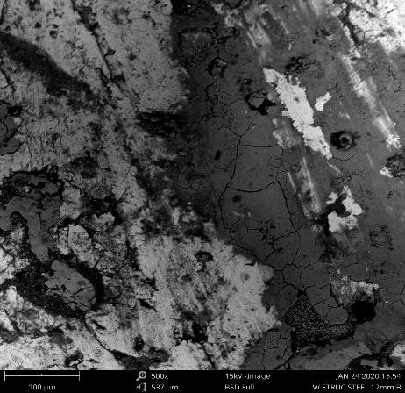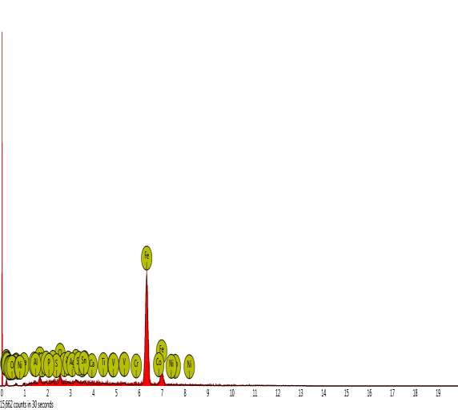

**Sulphur & Phusphorous**

**Figure 4.1j: The microstructure reveals AISI-1052 Steel The Chemical Composition of Steel Plant J**

# Steel plant J

It reveals a coarse grain structures with too much of pearlite (black) dominated the microstructure thereby causing low quality of ferrite (white) by the formation of Iron- Sulphide which also formed oxygen sulphide due to high content of oxygen. The reason for this is as a result of poor production.

The microstructure also reveals a severe sulphur and phosphorus content which makes the steel to be too brittle and thereby causes red and cold shortness.

Too much of oxygen content that leads to oxygen sulphide will make the steel to melt at very lower temperature which may result to fracture.

**Verdict:** Poor and low quality of steel.

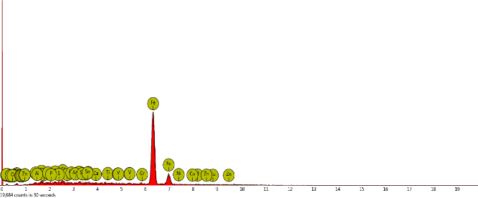

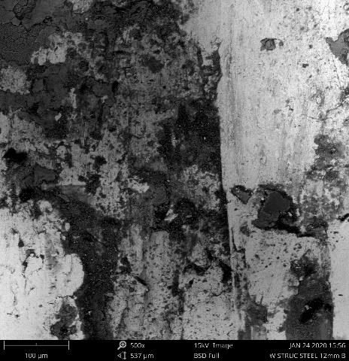

**Sulphur & Phusphorous**

**Figure 4.1k: The microstructure reveals AISI-4047 Steel The Chemical Composition of Steel Plant K**

# Steel plant K

The microstructure reveals **AISI-4047** steel. It contains coarse grain structure with carborization, sulphurization and phosphorization at high level with pearlite (black) in the matrix of ferrite (white). Formation of Iron-sulphide is also severe which renders the steel not so much vibrant in engineering application, which may fracture at any time in service.

**Verdict:** Poor and low quality of steel.

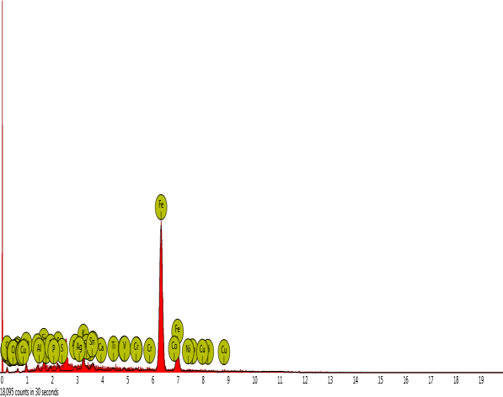

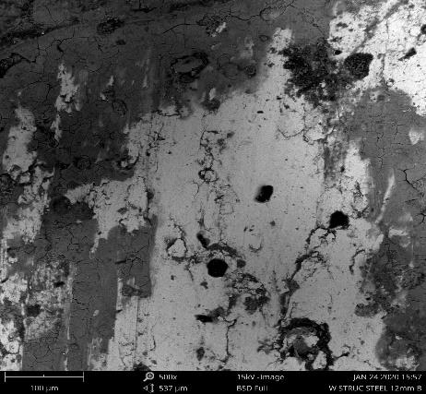

**Sulphur & Phusphorous**

**Figure 4.1l: The microstructure reveals AISI-1030 Steel The Chemical Composition of Steel Plant L**

# Steel plant L

It contains fine grain structure with pearlite (black) in the matrix of ferrite (white). The steel was produced by normalizing austenitizing at 900oC and soaking temperature of about 450oC.

The production maintain AISI standard as it contains low sulphur, phosphorus and oxygen content, at 0.03 wt% of phosphorus and sulphur but very lower content of sulphur in which its low hardness has been compensated for by the presence of manganese (Mn) at 0.80 wt%.

**Verdict:** It is good for structural application.

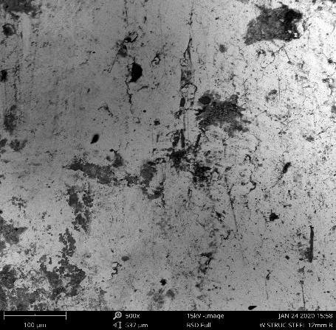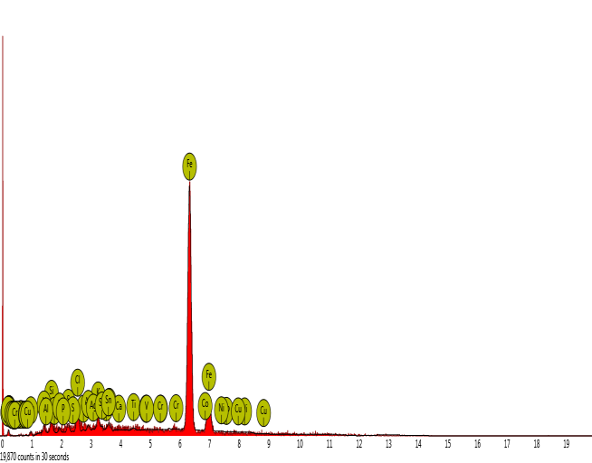

**Sulphur & Phusphorous**

**Figure 4.1m: The microstructure reveals AISI-8650 Steel The Chemical Composition of Steel Plant M**

# Steel plant M

The microstructure contains fine grain structure with pearlite (black) in the matrix of ferrite (white). The steel was normalized by austenizing at temperature of about 900oC and the soaked to a lower temperature of about 450oC. Phosphorization and sulphurization is at normal level but it shows a higher carborization in the structure.

**Verdict:** Good quality of steel

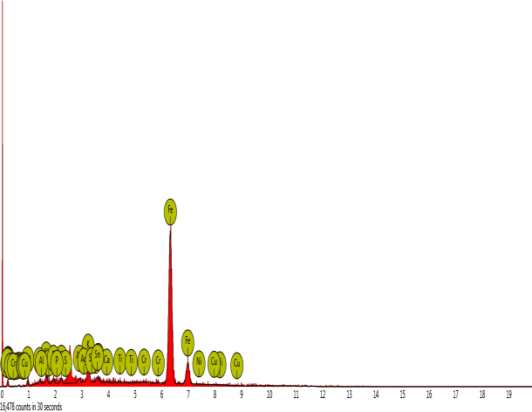

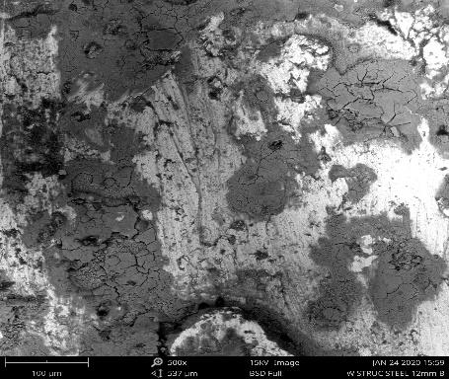

**Sulphur & Phusphorous**

**Figure 4.1n: The microstructure reveals AISI-1043 Steel The Chemical Composition of Steel Plant N**

# Steel plant N

The structure reveals **AISO-1043** steel. It reveals the presence of HCP elemental composition such as: Chromium (Cr) at 0.23 wt%, and at lower sulphur and phosphorus content, but with high wt% of carbon content of 0.43,wt% which is still at SAE standard of hardness.

It reveals ferrite (white) that contains austenite grains and contains particles of (black dots) pearlite and gray colour of martensite grains within the matrix of ferrite (white).

**Verdict:** It is a good quality of steel.

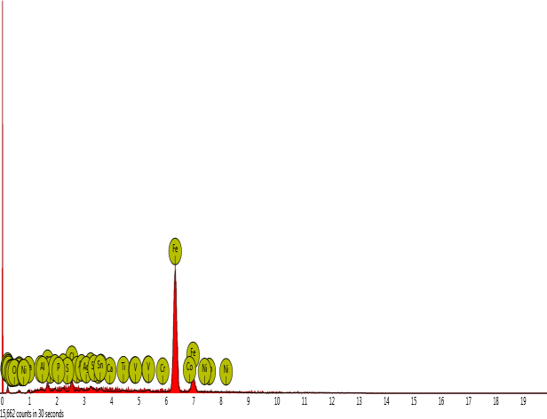

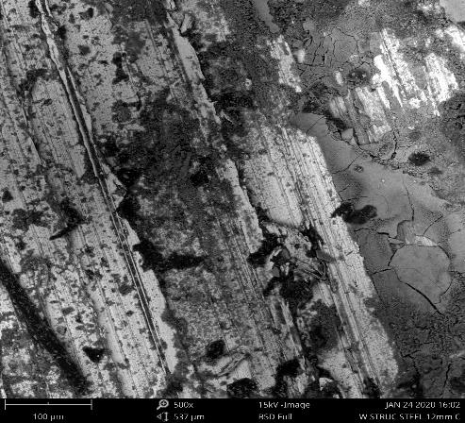

**Sulphur & Phusphorous**

**Figure 4.1o: The microstructure reveals AISI-4130 Steel The Chemical Composition of Steel Plant O**

# Steel plant O

The structure shows low quality of steel, as it contains a severe phosphorus and sulphur content thereby make the steel to be brittle which may make it experience fatigue aberration easily at a constant loading, thereby causing unexpected failure in practice. It shows pearlite (black) in the matrix of ferrite (white), but the carbon content conformed to the AISI standard.

**Verdict:** Poor quality of steel.

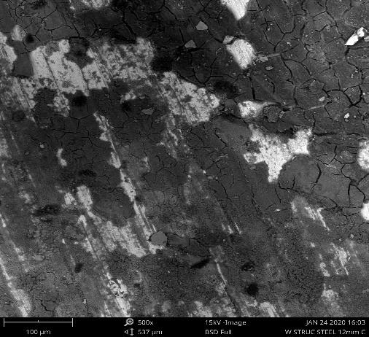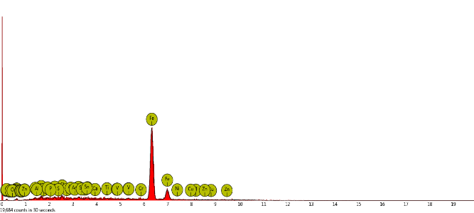

**Sulphur & Phusphorous**

**Figure 4.1p: The microstructure reveals AISI-1025 Steel The Chemical Composition of Steel Plant P**

# Steel plant P

It contains much (pearlite) black and martensite (dark) in the matrix of ferrite (white) probably due to the short period of soaking temperature which is less than less 1 hour as it indicates in the microstructure. But still austenitizing at 900oC for adequate normalizing but soaking time is less than 50% of austenitizing temperature.

Phosphorus and sulphur are at normal content as well as carborization at normal level according to AISI standard.

The HCP elemental composition are not present and the presence of FCC elemental composition are moderate.

**Verdict:** Good quality product.

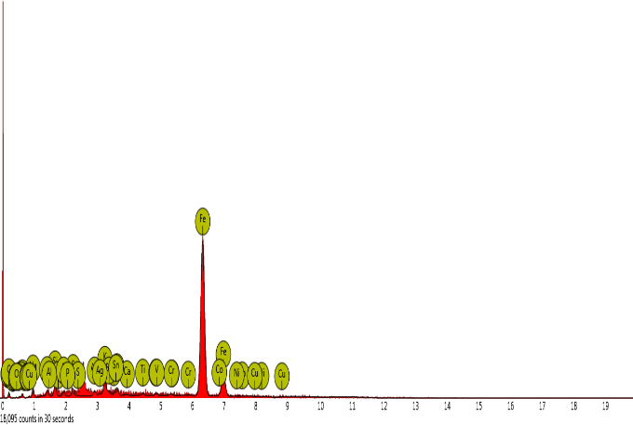

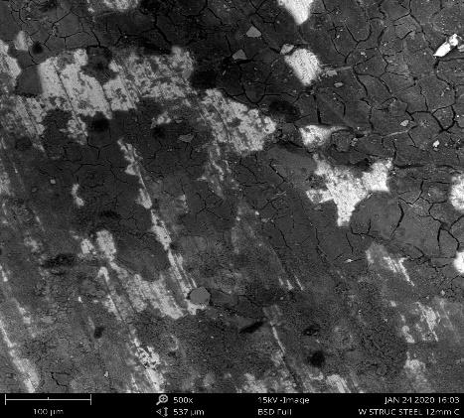

**Sulphur & Phusphorous**

**Figure 4.1q: The microstructure reveals AISI-1040 Steel The Chemical Composition of Steel Plant Q**

# Steel plant Q

It reveals fine grain structure. The steel was normalized to austenitizing temperature of 900oC and then soaked at 50% of austenitizing temperature, then cooled in air.The microstructure shows pearlite (black) with little martensite (dark) presence in the matrix of ferrite (white) probably due to the rapid cooling during soaking period.

There is dephosphorization and sulphurization to a tolerant level of AISI standard.

**Verdict:** Good quality of steel.

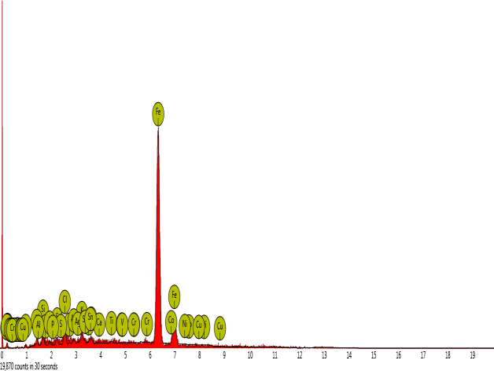

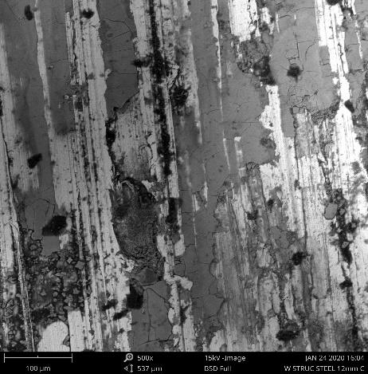

**Sulphur & Phusphorous**

**Figure 4.1r: The microstructure reveals AISI-1038 Steel The Chemical Composition of Steel Plant R**

# Steel plant R

It contains coarse structure.

It contains AMS content of steel meant mostly for spare parts in automobile instead of composition of structural steel.

It contains a severe phosphorus, sulphur and carborization, thereby making the steel to be brittle.

The steel lack of ductility thereby cannot withstand the structural engineering application.

**Verdict:** It is a low quality of steel.

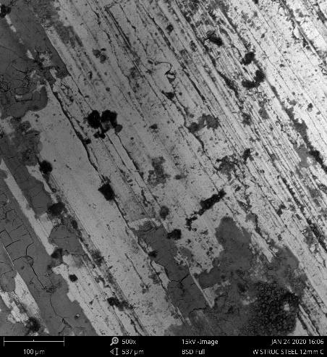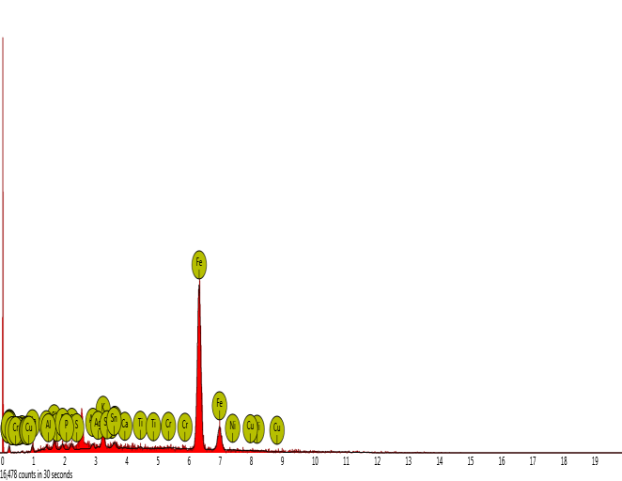

**Sulphur & Phusphorous**

**Figure 4.1s: The microstructure reveals AISI-1040 Steel The Chemical Composition of Steel Plant S**

# Steel plant S

It reveals ferrite (white) flat-like structure embedded with the pearlite grains (black) in the matrix of ferrite (white).

There is presence of HCP elemental composition such as: Chromium (Cr), Vanadium

(V) and Molybdenum (Mo), and the presence of Copper (Cu) as the only FCC element present in the excessive carborization, phosphorization and sulphurization contents of the steel, thereby may cause fracture in application.

There is formation of Cementite (FeC) dark formation within the matrix of ferrite (white), due to the high content of carbon. The microstructure also reveals a steel that does not undergone temperature gradient gradually and it contains excessive content of HCP elemental composition.

**Verdict:** The steel is low quality.

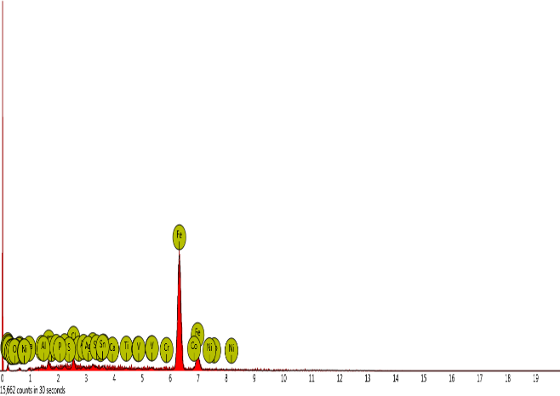

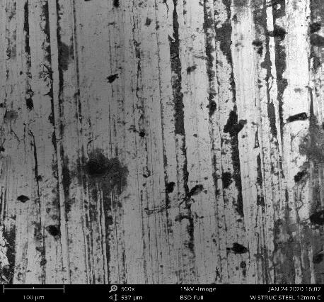

**Sulphur & Phusphorous**

**Figure 4.1t: The microstructure reveals AISI-1043 Steel The Chemical Composition of Steel Plant T**

# Steel plant T

It reveals steel that austenized at a very lower temperature of about 800oC instead of attaining a normalized temperature of 1200oC or 1250oC, and it then quenched instead of air cooled, thereby making martensite (dark) to be present.

There is white-like coloured like flat plate structure which shows ferrite (dark) stripes within the ferrite (white) coloured like flat plate structure. There is also a formation of rows of cementite (FeC) due to the excessive carbon content, thereby making the steel to be brittle, and may cause red or cold shortness when put in practice.

**Verdict:** It is low quality of steel.

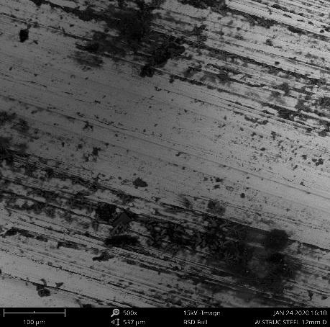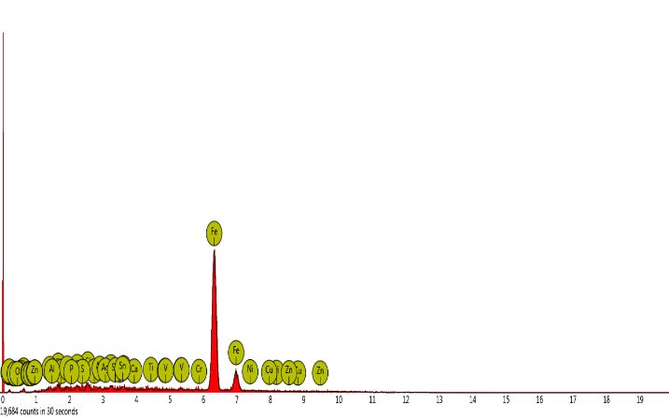

**Sulphur & Phusphorous**

**Figure 4.1t: The microstructure reveals AISI-1025 Steel The Chemical Composition of Steel Plant U**

# Steel plant U

It shows a steel that was austenitizing at a very lower temperature below 800oC, cooled in liquid instead to be air cooled.

The microstructure also reveals the excessive carbon content that leads to the formation of Cementite (FeC) dark in the matrix of ferrite (white) grains.

Phosphorization and sulphurization is also in excess which leads to the brittleness of the steel thereby may lead to fracture.

**Verdict:** It is low quality of steel.

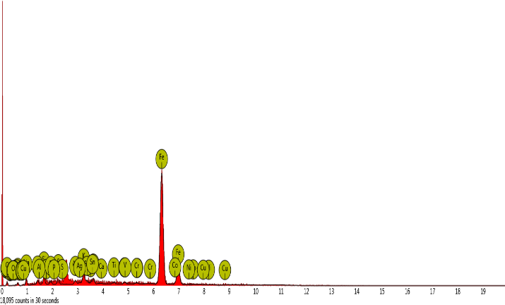

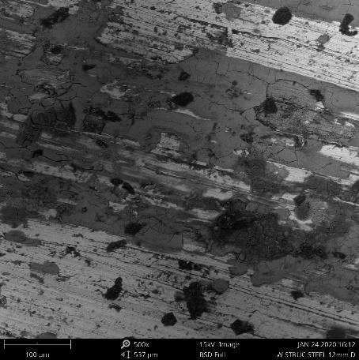

**Sulphur & Phusphorous**

**Figure 4.1v: The microstructure reveals AISI-4350 Steel The Chemical Composition of Steel Plant V**

# Steel plant V

It reveals steel that was normalized at austenitizing temperature of 900oC and held for 1 hour in the reheating furnace.

There is excess phosphorization, sulphurization and carborization contents, making the steel to be brittle thereby loose its mechanical properties. The microstructure reveals the pearlite (black) with interwoven of martensite (dark) in the matrix of ferrite (white).

**Verdict:** It is a low quality of steel.

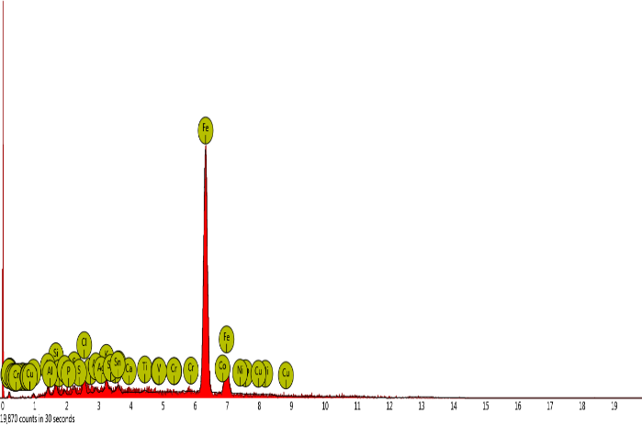

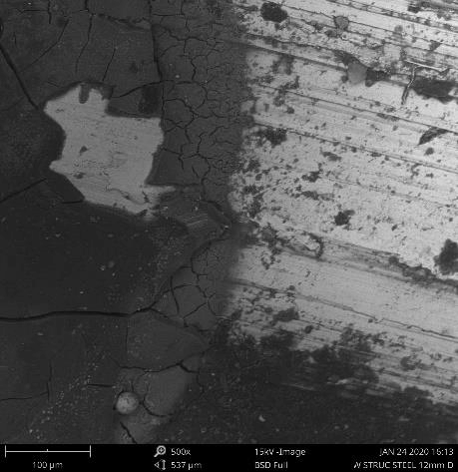

**Sulphur & Phusphorous**

**Figure 4.1w: The microstructure reveals AISI-1524 Steel The Chemical Composition of Steel Plant W**

# Steel plant W

It reveals high content of phosphorization, sulphurization but there is decarburization during the process of production at lower content of carbonof 0.23 wt%C.

Due to the presence of high content of phosphorus and sulphur, the steel is very brittle and may cause ‘red or cold shortness’ thereby may cause fracture when put in practice and it may experience a very short life span in engineering application.

**Verdict:** Poor quality of steel.

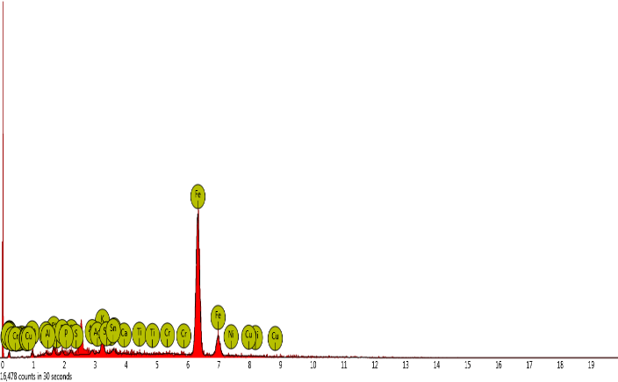

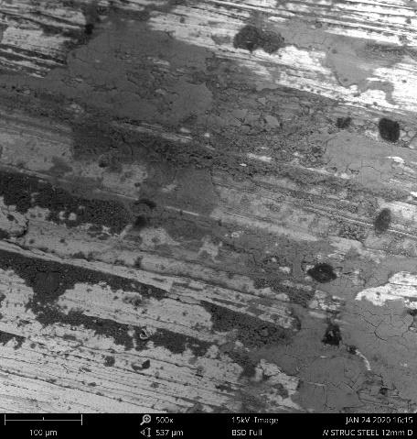

**Sulphur & Phusphorous**

**Figure 4.1x: The microstructure reveals AISI-1340 Steel The Chemical Composition of Steel PlantX**

# Steel plant X

There is formation of Cementite (FeC) dark embedded with pearlite (black) in the matrix of ferrite (white).

There is also high degree of phosphorization, sulphurization and carborization. The microstructure reveals a steel that produced at abnormal lower temperature of about 800oC without proper homogenization.

**Verdict:** Poor quality of steel.

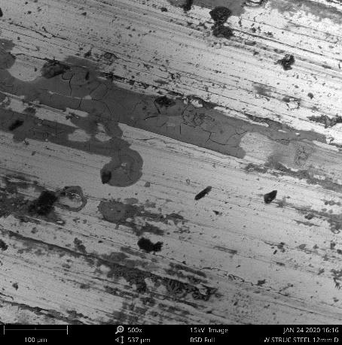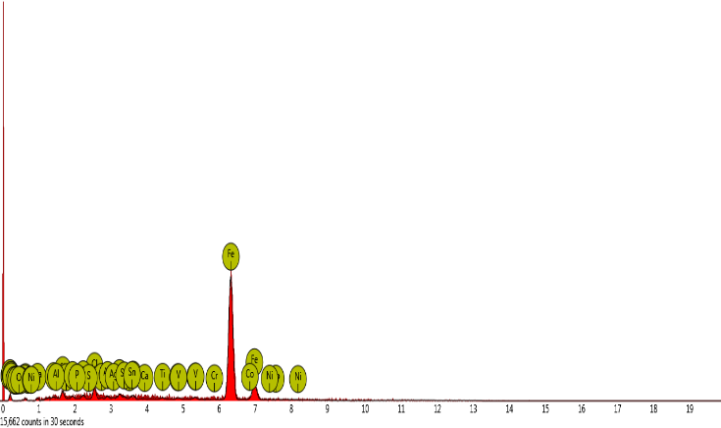

**Sulphur & Phusphorous**

**Figure 4.1y: The microstructure reveals AISI-1151 Steel The Chemical Composition of Steel Plant Y**

# Steel plant Y

It reveals steel that austenitizing and normalizing at a lower temperature of about 800oC, soaked at about 400oC for 1 hour and quenched instead of air cooled.

The microstructure also reveals ferrite (white) light like-flat structure with (dark) stripes within the light (white) like-flat structure and as well as pearlite (black) in a small quality in the matrix of ferrite (white). There is also Cementite formation (FeC) dark in the structure couple with a high degree of carbonization, phosphorization and sulphurization.

**Verdict:** Poor quality of steel.

# . CHAPTER FIVE

**5.0. CONCLUSION AND RECOMMENDATIONS**

# Conclusion

The quality of as-produced mild steel from scraps in Nigeria has been thoroughly examined, investigated and tested. From the result of the elemental composition, the carbon content reveals that out of twenty five (25) steel plants, twenty one (21) steel plants were having excessive or high carbon contents which extremely not conformed with the British BS: 4449 standard at 0.25 (wt % C), left with only four (4) steel plants C located at Enugu, G located at Ilorin, P located at Ikeja and U located at Abuja that met the standard except steel plants A and D with the carbon content very much lower than the standard. The elemental composition, also reveals that the steel plants in are Nigeria are producing three (3) different categories of steel: AISI for steel plants A, B, C, D, E, F, G, H, I, J, K, L, O, P, Q, V, W, X and Y. The SAE for steel plants M and N and AMS for steel plants R, S, T, U.

From the result of the microstructures and ultimate tensile strength, only nine (9) steel plants: F, G, H, I, L, M, N, P, and Q are producing good and vibrant quality of steel out of twenty five (25) steel plants. The majority, sixteen (16) steel plants are producing steel of low quality below standard.

From the result obtained from elemental composition, virtually the steel produced from Nigerian steel plants contains excessive carbon content which make it very brittle, thereby makes most of the Nigerian steel products loose its mechanical properties and

not to be vibrant thereby making most of as-produced steel in Nigeria to be subjected to a very short life span in service or in engineering application compared to international British BS: 4449 standard.

It was also discovered through the microstructures, that most of the steel plants produced AISI category of steels which is meant for the purpose of the engineering structures such as: buildings, bridges and culverts, constructions of roads and dams and so on.

It was also discovered that even though, those steel plants that produced AISI steels does not produced based on AISI standard due to the presence of HCP elemental composition such as: Nickel (Ni), chromium (Cr), Tin (Sn), Molybdenum (Mo) and Titanium (Ti) at higher percent (wt. %) and maybe this occurred due to the production of steel by the use of higher percentage of scraps mixed with the few percentage of billets.

Finally, based on the results obtained from this study, most of the steel plants are not suitable for engineering application, probably due to the fact that the steel were produced from the scraps. Also, during the production process, most of these steel plants did not pass through:

1. the microstructure examination of the billet
2. They did not observed the gradual temperature gradient.
3. Only recrystallization at austenitizing temperature of 910 oC was obtained inside

the reheating furnace without reaching or attaining a homogenisation at a temperature of 1200 oC to 1250 oC before rolling.

1. They did not pass through what is called “soaking zone” where the steel

temperature would be reduced to at least 50% of its homogenisation temperature in the furnace and stay for the period of one hour (1hr) before pushing in to the

rolling

mill.

1. Most of the steel plants did not gradually air cooled the hot-rolled products, they

rapidly cooled in a liquid, in the end, they produced poor or low quality steel products.

# Recommendations

Having gone through study on the quality of as-produced mild steel in Nigeria by using the mechanical (strength of materials) testing approach, chemical (elemental composition) testing approach and metallurgical (microstructural analysis) testing approach, based on the findings through the results obtained and also based on the conclusion drawn, the following recommendations were made.

First, steel of good quality of various diameter that met standard and specifications of British BS4449 standards must be compulsorily used for engineering applications in Nigeria in order to avoid failure in engineering applications.

Secondly, it is highly recommended for the future researcher on this work using larger sample size to carry out statistical analysis on the results and carrying out same test for steels that have been in service for a given period to allow some validation.

# Contribution to Knowledge

Having gone through this study, the research work has revealed the quality of steel being produced in Nigeria for engineering applications. It has revealed that most steel

producers in Nigeria need to improve on steel production through scraps as it contains some elemental compositions that are not in conformity with the British Standard and Nigeria Standard for engineering applications.

# REFERENCES

Adejuyigbe, I. B., Chiadighikaobi, P. C., & Okpara, D. A. (2019). Sustainability Comparison for Steel and Basalt Fiber Reinforcement, Landfills, Leachate Reservoirs and Multi-Functional Structure. *Civil Engineering Journal*, *5*(1), 172- 180.

Adzora, S. A., Nnukab, E. E., & Nnakwob, K. C. (2019). Effect of welding consumable on mechanical properties of micro-alloyed steel weldment. *International Journal of Innovative Science and Research Technology*, *4*(6), 419-425.

Bamigboye, G. O., Michaels, T., Ede, A. N., Ngene, B. U., Nwanko, C., & Davies, I. (2019, December). The Role of Construction Materials in Building Collapse in Nigeria: A Review. In *Journal of Physics: Conference Series* (Vol. 1378, No. 4, p. 042022). IOP Publishing

Chong, T. V. S., Kumar, S. B., Lai, M. O., & Loh, W. L. (2016). Effects of elevated temperatures on the mechanical properties of nickel-based alloy clad pipelines girth welds. *Engineering Fracture Mechanics*, *152*, 174-192.

Cikmit, A. A., Tsuchida, T., Kang, G., Hashimoto, R., & Honda, H. (2019). Particle-size effect of basic oxygen furnace steel slag in stabilization of dredged marine clay.

Claveau-Mallet, D., Wallace, S., & Comeau, Y. (2012). Model of phosphorus precipitation and crystal formation in electric arc furnace steel slag filters. *Environmental science & technology*, *46*(3), 1465-1470.

Cosham, A., & Andrews, R. (2019). The assessment of locally thinned areas: Background to the guidance given in Annex G of BS 7910: 2013. *International Journal of Pressure Vessels and Piping*, *169*, 177-187.

Ede, A. N., Egunjobi, E. O., Bamigboye, G., & Ogundeji, J. (2015). Assessment of Quality of Steel Reinforcing Bars Used in Lagos, Nigeria. *International Research Journal of Innovative Engineering*, *1*(3).

Fewings, P., & Henjewele, C. (2019). *Construction project management: an integrated approach*. Routledge. 2(6).

Francisca, F. M., & Glatstein, D. A. (2020). Environmental application of basic oxygen furnace slag for the removal of heavy metals from leachates. *Journal of Hazardous Materials*, *384*, 121294.

Lu, K. (2010). The future of metals. *Science*, 328(5976), 319-320.

Navarro, C., Díaz, M., & Villa-García, M. A. (2010). Physico-chemical characterization of steel slag. Study of its behavior under simulated environmental conditions. *Environmental Science & Technology*, 44(14), 5383-5388.

Obot I. D. and Archibong A. E. (2016). Collapsed Buildings in Nigeria. *Global Journal of Engineering Research*, 15, 11 – 15.

Odusote, J. K., Shittu, W., Adeleke, A. A., Ikubanni, P. P., & Adeyemo, O. (2019). Chemical and Mechanical Properties of Reinforcing Steel Bars from Local Steel Plants. *Journal of Failure Analysis and Prevention*, *19*(4), 1067-1076.

Oke, S. R., Ige, O. O., Falodun, O. E., Okoro, A. M., Mphahlele, M. R., & Olubambi, P.

A. (2019). Powder metallurgy of stainless steels and composites: a review of mechanical alloying and spark plasma sintering. *The International Journal of Advanced Manufacturing Technology*, *102*(9-12), 3271-3290.

Oluwasola, E. A., Hainin, M. R., & Aziz, M. M. A. (2014). Characteristics and utilization of steel slag in road construction. *Jurnal Teknologi*, *70*(7).

Pan, S. Y., Chiang, P. C., Chen, Y. H., Tan, C. S., & Chang, E. E. (2014). Kinetics of carbonation reaction of basic oxygen furnace slags in a rotating packed bed using the surface coverage model: Maximization of carbonation conversion. *Applied energy*, *113*, 267-276.

Robert M. R. (1972). American Society for Metals (ASM). Metals Park, Ohio 44073, 8th edition, 7, 29-42.

Sachan, A., & Choo, Y. S. (2020). Mooring chain strength tests and ductile failure modeling using micromechanics and phenomenology based failure models. *Ocean Engineering*, *195*, 106663.

Shuaib-Babata, Y. L., Adewuyi, R. A., Ajao, K. S., Ambali, I. O., Aremu, N. I., Ibrahim, H. K., & Abdul, J. M. (2019). Quality evaluation of commercially available steels in some selected Nigerian markets. *Acta Technica Corvininesis- Bulletin of Engineering*, *12*(2).

Sinaie, S., Heidarpour, A., & Zhao, X. L. (2014). Mechanical properties of cyclically- damaged structural mild steel at elevated temperatures. *Construction and Building Materials*, *52*, 465-472.

Sinha, A. K., Wu, C., & Liu, G. (2016). Nomenclature: Steel. In *Encyclopedia of Iron, Steel, and Their Alloys (Online Version)* (pp. 2434-2488). CRC Press

Sukrawa, M., Pringgana, G., & Sanjaya, P. D. T. (2019). Comparative analysis and design of tower using diagrid, conventional moment frame and braced frame system of steel structures. In *MATEC Web of Conferences* (Vol. 276). EDP Sciences.

Tee, B. C., Wang, C., Allen, R., & Bao, Z. (2012). An electrically and mechanically self-healing composite with pressure-and flexion-sensitive properties for electronic skin applications. *Nature nanotechnology*, *7*(12), 825.

Wang, G., Wang, Y., & Gao, Z. (2010). Use of steel slag as a granular material: volume expansion prediction and usability criteria. *Journal of Hazardous Materials*, *184*(1-3), 555-560.

Westin, L. (2010). *U.S. Patent No. 7,700,037*. Washington, DC: U.S. Patent and Trademark Office.

Yi, H., Xu, G., Cheng, H., Wang, J., Wan, Y., & Chen, H. (2012). An overview of utilization of steel slag. *Procedia Environmental Sciences*, *16*, 791-801.

Yildirim, I. Z., & Prezzi, M. (2011). Chemical, mineralogical, and morphological properties of steel slag. *Advances in Civil Engineering*, *2011*.