CHARACTERISATION AND APPLICATION OF NATIVE

AND CROSS-LINKED CASHEW (Anacardium occidentaleL.) GUM IN TABLETTING

BY

Abdulrahman ABDULSAMAD B. Pharm. (ABU, 1993), M.Sc Pharm. (ABU, 2004) (PhD/Pharm.Sci./43273/200-405)

A DISSERTATION SUBMITTED TO THE POST GRADUATE SCHOOL, AHMADU BELLO UNIVERSITY ZARIA IN PARTIAL FULFILLMENT OF THE REQUIREMENTS FOR THE AWARD OF DOCTOR OF PHILOSOPHY IN
PHARMACEUTICS

DEPARTMENT OF PHARMACEUTICS AND PHARMACEUTICAL MICROBIOLOGY
FACULTY OF PHARMACEUTICAL SCIENCES AHMADU BEL LO UNIVERSITY, ZARIA

JULY, 2012

DECLARATION

I declare that the work in thiDs issertation entitled C“ haracterisation and Application of Native andCross-linked Cashew A(nacardium occidentaleL.) Gum in Tableting” has been carried out by me in the Department of Pharmaceutics and Pharmaceutical Microbiology, Faculty of Pharmaceutical Sciences, Ahmadu Bello University Zaria, under the supervision of Prof. A. R. Oyi (Mrs), Dr. A.B. Isah and Dr. I. OdidTi.he information derived from literature has been duly acknowledged in the text and list of references provided. No part of this Dissertation was previously presented for another higher degree or diploma in any University.

AbdulrahmanABDULSAMAD Date

CERTIFICATION

This Dissertation entitled“ Characterisation and Application of Native aCndross-linked Cashew A( nacardium occidentalLe.) Gumin Tableting” by AbdulrahmanABDULSAMAD meets the regulations governing thweaard of the Doctor of Philosophy in Pharmaceutics of Ahmadu Bello University and is approved for its contributions to knowledge and literary presentation.

Prof. A. R. Oyi (Mrs) B.Sc Pharm., M.Sc., PhD (Pharmaceutics) Date
Chairperson, Supervisory Committee Department of Pharm. & Pharm. Microbiology Ahmadu Bello University, Zaria

Dr. A.B. Isah B.Pharm., M.Sc., Ph(DPharmaceutics) Date
Member, Supervisory Committee
Department of Pharm. & Pharm. Microbiology Ahmadu Bello University, Zaria

Dr. I. Odidi B.Sc Pharm., M.Sc., PhD Date
Member, Supervisory Committee IntelliPharmaceutics Int. Corp.
Toronto, Canada

Dr. A.B. Isah B.Pharm., M.Sc., PhD (Pharmaceutics) Date
Head of Department
Department of Pharm. & Pharm. Microbiology Ahmadu Bello University, Zaria

Prof. A.A. Joshua Date
Dean, Post Graduate School, Ahmadu Bello University, Zaria

DEDICATION

This work is dedicated to my parenAtslhaji Abdulsamad and Hajia Hassu, my wife Bilkisu and mychildrenAdam andMuhammad.

ACKNOWLEDGEMENT

All praises are due to the almighAtyllah , the all knower and the master provider, by whose grace this work was accomplished. Peace and blessings be upon His noble prophet Muhammad (SAW).
My wholeheartedapprecai tion and profound gratitude gto my supervisorsProf. A.R. Oyi (Mrs.), Dr. A.B. Isah and Dr. I. Odidi for their effective supervisory role that saw to the successful completion of this work.
I remain indebted to my wifBe ilkisu and my childrenAdam andMuhammad for having to stoically bear with my long absence during the course of this work.
Members of my family and friends whose contributions and support cannot be quantified are hereby acknowledged and immensely appreciated.
The contributions of lal and sundry but especially the entire staff of the Department of Pharmaceutics and Pharmaceutical Microbiology, the entire staff of IntelliPharmaceutics Int. Corp. Toronto, Canada are acknowledged and greatly appreciated.
The opportunity afforded me bIyntelliPharmaceutics Int. Corp. Canada to carry out some aspects otfhis work in their facility is acknowledged and profoundly appreciated. Support from theAhmadu Bello University Board of Research (UBR), Education Trust Fund (ETF) Nigeria, Science and Tehcnology Education Post Basic (STE-PB) Scheme
(a World Bank Assisted Project) and of course theAhmadu Bello University for facilitating these supports and the fellowship award granted me, are all acknowledged and greatly appreciated.

ABSTRACT

The exudatefrom cashew tree, referred to as cashew gum (CG) had been investigated for use as binder in conventional tablet formulations. In this study,-clinroksesd derivatives of
the gum were synthesized and invgeastei d for their physicochemical anpdhysicotechnicla

properties and applicability in modifying drug release in tablet formulations. The crude dried latexes of CG were purified by extraction using acetoTnwe.o cross-linked derivatives of
the gum were synthesized by heati(nag), a 1:1 weight ratio of CG ancditric acid (CTR) at 140 ºC for 30 min and (b), a 1:1:1 weight ratio of CG, CTR and glycerol (GLY) atº1C70
for 30 min. In each case, monobasic sodium phosphate was used as catalyst at 2 %w/w concentration. The cro-slisnking was demonstrated qualitativyebl y Differential Scanning Calorimetry (DSC), Fourier Transform Infrared F(TIR) and ¹³C Nuclear Magnetic Resonance ¹³(C NMR) and quantitatively by polymer yield. Determinations of moisture content, moisture loss on dryi,nsgwelling ratio, water holding anwdater sorption capacities
were used to characterize the derived polymers-.aScute toxicity studies were carrieodut

to ascertain the safety or otherwise of the c-rlionsksed derivative, CrosCCG. Wistar rats were fed with the polymer ovear 28-day periodand blood samples from the animals were
assessed for changes in hematological and biochemical parameters. The purified CG and its derivatives were used to formulate tablets of Venlafaxine hydrochloride (Ven. HCl), a water soluble antidepressant, using twhet granulation method. Increasing concentrations of CG
and its admixtures with MCC PH 102 were used as binder/matrix former in formulating the tablets. The synthesized derivative, CrosCCG, was assessed for drug release modification when used either alonoer in admixtures with HPMC ER (K100). The drug release

enhancingpropertyof the derivative was also investigated and compared with some known superdisintegrants, Croscamellose and Crospovidone at 3 %w/w disintegrant concentration.
Results obtained revealed that cr-olinsksing of CG with CTR yielded an esterified derivative that was insoluble in all common solvents. The esterification reaction occurred be–tween
OH of the sugar from the gum an–Cd OOH of CTR. Whilebeing insoluble, on ocntact with

water, however, the polymer sorped weart and swelled. Cro-slsinking of CG with a

combination of CTR and GLY yielded a polymer with improved yield and swelling potentials. Toxicity studies showed the polymer to have no apparent harmful efftehcet on
animals and did not cause changes in the blood parameters tested. When used in tableting, CG was found to form good tablets of Ven. HCl with a crushing strength of 5.9 KN and friability of 0.03 %. Increasing concentration of CG or its admixture witChCMPH 102
offered no added advantage. CrosCCG could not modify the release of drug from the formulated tablets when used alone. Admixtures of CrosCCG at concentroaft1io5nsand 25
%w/w respectivelywith HPMC K100 at 7.5 %w/wshowed a furthedr elay in release of the

drug. Concentrations lower than 10 %w/w of CrosCCG, however, showed a release enhancingability. At 3 %w/w concentration, CrosCCG surpassed both Croscamellose and Crospovidone inenhancingdrug release as observed from a 30 imn ivnitro dissolution data.
It can thus be concluded that, this work has led to the discovf earysafe novel cro-slsinking process that uses safe and environmentally friendly -clirnoksinsg agents in derivatisation processes. Cro-slisnking CG using this method has led toe tphroduction of a powerful drug release enhancinaggent.

TABLE OF CONTENTS

Title page i
Declaration ii
Certification iii
Dedication iv
Acknowledgement v
Abstract vi
Table ofContents viii
List of Tables xx
List of Figures xxiii
List of Schemes xxvi
List of Plates xxvii
List of Appendices xxviii
Acronyms andAbbreviations xxx
CHAPTER ONE 1
INTRODUCTION 1
  - Introductionto Solid DosageForms 1

  - Powders/Granules as Solid Dosage Forms 3
    - Advantages of Powders/Granules as Dosage Forms 3
    - Disadvantages of Powders/Granules as Dosage Forms 4
  - Tablets as Solid Dosage Forms 4
    - Advantageosf Tabletsas Dosage Forms 5
    - Disadvantages of Tableats Dosage Forms 6
    - Methods of Tableting 6
      - Granulation Methods 6
        - Dry Grnaulation 8
        - Wet Granulation 9
        - Fluidized BeGd ranulation 9
      - Evaluation of Granules 10
1.3.3.21. Granule Size Analysis 10
        - Flow Rate 10
        - Angle of Repose 11
        - Bukl and Tapped Density 11
      - Direct Compression Method 12

    - Components of Tablets 12
      - Active Pharmaceutical Ingredient (API) or Active Agent 13
        - Venlafaxine Hydrochloride 13
      - Diluents 14
        - Properties of Diluents 15
      - Granulating or Binding Agtesn 15
      - Disintegrating Agents 17
        - Super Disintegrants 20
      - Sweetening Agents 21
      - Coloring Agents 21
      - Lubricating Agents 22
      - Glidants 22
    - Typesof Tablet Dosage Forms 23
      - Mouth Dissolving Tablets 25
        - Ideal Propertiesf Mo outh Dissolving Tablets 25
        - Advantages of Mouth Dissolving Tasblaest Dosage Forms 26
      - Conventional Immediate Reaesl e Tablets 26

      - Modified-Release Tablet Dosage Forms 29
        - Some Disadvantages Associated Ewxithended-Release Dosage Form3s1
      - Rat-eControlledDelivery Systems 32
      - Diffusion Systems 32
      - DissolutionSystems 33
      - Osmotic ySstems 34
      - Swelling Systems 36
      - Erosion Controlled Systems 38
      - TargeteDd rug Delivery 38
  - Capsulse as Solid Dosage Forms 39
  - Statement foResearch Problem 40
  - Justification 41
  - Hypothesis 42
  - Aim of the Study 42
CHAPTER TWO 45
LITERATURE REVIEW 45
  - Use of Natural Materials in Pharmaceutical Formulations 45

    - Polysaccharides 45
      - Celluloses 47
      - Starches 50
      - Gums 52
        - The Cashew Tree and its Medicinal and Economic Values 56
        - Cashew Gum and Modes of Collection 58
        - Relevance of Cashew GiunmPharmacy 59
  - Use of ModifiedPolymeric Materials inPharmaceutical Formulations 61
    - Derivatisation Processes 61
      - Grafting 63
      - Cros-slinking 67
        - Chemical Cros-slinking 68
CHAPTER THREE 74
MATERIALS AND METHODS 74
  - Materials 74
  - Methods 75
    - Colletcion and Identification 75

    - Extraction/Purification of Cashew Gum 75
    - Cross-Linking of Cashew Gum 76
      - Cross-linking of Cashew Gum usingpEichlorohydrin(EPC) 76
      - Cross-linking of CG usingPolycarboxylicAcids(PCAs) 77
      - Cros-slinking Cashew Gum using CitriccAid and/or Glycerol 80
    - Residual Solvent Analysbisy Gas Chromatography (GC) 81
    - Thermal Analysis using DifferenltiSacanning Calorimetry (DSC) 82
    - Fourier Transform Infra Red (F-ITR) Studies 83
    - Determination of Solubility of the Polymers 83
    - Solid State¹³C Nuclear Magnetic Resonance (¹S³CS NMR) 84
    - Moisture Loss on Drying 84
    - Water Content Determination Using Karl Fisher Titrimetry 85
    - Residue onIgnition/Sulphated ash 85
    - Determination of Moisture Sorption/Desorption over Saturated Salt Solutions 86
    - Swelling Ratio Determination 89
      - Siliconisation of Cylindrical Tubes 89
      - Measurement oSf welling Ratio using the CylindricaluTbes 91

    - Water Holding Capacity 92
    - Evaluation of Powder Flow Properties 93
      - Density Measurements 93
      - Powder Flow Rate 94
      - Angle of Repose 94
      - Determination ofPowderParticle Size Distribution 94
    - Tablet Formulation Studies 95
      - Formation of Granules 95
      - Tests on Granules 99
      - Addition of Extragranular xEcipients 99
      - Compression of Granules 99
      - Evaluation ofTabletProperties 99
        - Uniformity of Weight 99
        - Tablet CrushingStrength 100
        - Tablet rFiability Test 100
        - Tablet Dissolution Test 100
        - Drug Relase Data Model Fitting 101

        - TheKinetic Equations 101
        - Uniformity of dosage unit test 103
    - Sub-Acute Toxicity Studies 104
    - Statistical Analysis 105
CHAPTER FOUR 106
RESULTS 106
  - Production Yield 106
    - Percentage Yield for thEextraction of Cashew Gum 106
    - Percentage Yield of Cro-lsinsking Cashew Gum with Epichlorohyrdin 106
    - Percentage Yield of Cro-lsinsking Cashew Gmu with Polycarboxylic acids 106
    - PercentageieYld of Cross-linking of Cashew Gum with CitricAcid
and/or Glycerol 108
  - Physical Appearances ohfet Cros-slinked Polymers 112
  - Residual Solvent Analysis by Gas Chromatography (GC) on Cashew G1u1m7
  - Thermal Analysis by DSC 119
  - Fourier Transform Infrared (F-ITR) Spectral Studies 127
  - Solid State¹³C NMR Spectral Analysis of CrosCCG Polymer 134
  - Proposal on the Cashew Guanmd Citric Acid Reaction Scheme 136

  - Properties of CG, CsroCCand CrosCCG Powders 138
    - Organoleptic/Physicochemical Properties 138
    - Water Content Determination Using Karl Fisher (KF) Titrimetry 139
    - Flow Properties of CG,roCsCC and CrosCCG Powders 141
    - Moisture Sorption/Desortion Determination 143
    - Swelling Properties of CG, CrosCC, CrosCCG and CrosCEdePrsow 145
  - Formulation Studies 149
    - Drug polymer compiabtility studies using DSC 149
    - Formulation Properties of Venlafaxine HCl Tablets Containing
MCC PH 102and/or CG as Binder 152
      - Granule Properties 152
      - Tablet Properties 153
    - Formulation Properties of Venlafaxine HCl Tablets Containing HPMC
or CrosCCG as Binders 157
      - Granule Properties 157
      - Tablet Properties 158
    - Formulation Prpoerties of Venlafaxine HCl Tablets Containing HPMC
as Binder and rCosCCGasRelease Modifier 161
      - Granule Properstie 161
      - Tablet Properties 164

    - Formulation Properties of Venlafaxine HCl Tablets Containing CHPaMs Binder And CrosCCG and Some Polymers as Release Facilitating ag1e6n7ts
      - Granule Properties 167
      - Tablet Properties 170
    - Drug release kinetics and mechanism 176
  - Sub-Acute Toxicity Studies 177
CHAPTER FIVE 180
DISCUSSION 180
  - Production Yield (%) 180
    - Extraction Yield of CG 180
    - Yield of CrosCE (%) 180
      - Why EPC was dropped and the PCAs Selected for C-lirnoksinsg
CG in thisStudy 181
    - Yield of Cross-linking of CG with PCAs (%) 182
    - Yield of Cross-linking of CG with CTR and/or GLY (%) 183
  - Physical Appearancesfothe Cros-slinked Polymers 184
  - Residual Solvnet Analysisby Gas Chromatography (GC) on CG 185
  - Thermal Analysis by DSC 186
  - Fourier Transform Infrared (F-TIR) Spectral Studies 188

  - Solid State¹³C NMR Analysis of CrosCCG Polymer 191
  - Proposal on the Cashew Gum and Citric Acid ReacMtioenchanism 191
  - Properties foCG, CrosCC and CrosCCG Powders 192
    - Organoleptic/Phsyicochemical Properties 192
    - Water Content Determinationsiung Karl Fisher (KF) Titrimetry 194
    - Flow Properties of CG,roCsCC and CrosCCG Powders 195
    - Moisture Sorption/Deosrption Determination 196
    - 5 Swelling Properties of CG, CrosCC, CrosCCG and CrosCE Powders 197
  - Formulation Studies 198
    - Drug-Polymer Compatbi ility Studies using DSC 198
    - Formulation Properties of V.eHnCl TabletsContainingMCC PH102
and/or CG as Binder 200
      - Granule Propeertsi 200
      - Tablet Properties 201
    - Formulation Properties of V.eHnCl Tablets Containing
HPMCor CrosCCG as Binders 201
      - Granule Properties 202
      - Tablet Properties 202
    - Formulation Properties of V.eHnCl Tablets ContainingHPMC as
Binder and CrosCCGasRelease Modifier 203

      - Granule Properties 203
      - Tablet Properties 204
    - Formulation Properties of Ve. nHCl Tablets ContainingHPMC as
Binder and CrosCCG Release FacilitatinggeAnts 205
      - Granule Properties 205
      - Tablet Properties 205
  - Sub-Acute Toxicity Studies 209
CHAPTER SIX 211
SUMMARY, CONCLUSION AND RECOMMENDATION 211
  - Summary 211
  - Conclusion 214
  - Recommendations 215
REFERENCES 216
APPENDICES 236

LIST OF TABLES

  - Types ofSolid DosageForms 2

  - Advantages and iDsadvantages oDf ifferent Methods ofFormulating tablets 7

  - Some Diluents used in theWet GranulationMethod 15

  - Commonly used Granulating/BindinggAents 17

  - Types of Disintegrating gAents 18

  - Mechanism ofDisintegrant Action 19

  - Super Disintegrants 20

  - Types of Tablet Dosage Forms and TheroirpPerties 24

  - Definition of SomeTerminologies used iDn escribingModified-Release Formulations 30

  - Advantages oEf xtended-Release DosageForms 31

  - Classes oPf olysaccharidesCommonlyEmployed inPharmaceutical Processing 47

  - Pharmaceutical Applications ofuGms 55

  - Pharmaceutical Applicatiosnof Modified Gums 62

  - Formula for cros-slinking CG using EPC 77

  - Formulae for Cros-slinking CG using PCAs 79

  - Formulae for Cros-slinking CG using CTR and or GLY 81

  - Solvents used for Solubility eDtermination 84

  - Composition ofSaturatedSalt Solutions 87

  - Ven. HCl Tablet Formulae oCntaining MCC PH 102and/or
CG as Binder 96
  - Ven. HCl TabletFormulaeContaining HPMC or CrosCCG
asBinder 96
  - Ven. HCl Tablets Formulae oCntaining HPMC ER 7.5% aBsinder andSomePolymers asReleaseRetardant 97
  - Ven. HCl TabletFormulaeContaining HPMC ER 7.5% aBsinder andSomePolymers as Disintegrants at3% w/w Concentration 98
  - Drug-ReleaseMechanismExponents 101
  - Interpretation of theSolid State¹³C NMR of CrosCCG 136
  - Organoleptic andSomePhysicochemicaPl roperties of thePolymers 139
  - Flow Properties of CG, CrosCC and CrosCCPoGwders 141
  - Properties of Ve.nHCl GranulesContaining MCC PH 102and/or
CG asBinder 153
  - Properties of Ve.nHCl TabletsContaining MCC PH 102and/or
CG asBinder 154
  - Properties of VenH. Cl GranulesContaining HPMC (LV),
HPMC (ER) or CrosCCG aBs inder 158
  - Properties of Ve.nHCl TabletsContaining HPMC (LV),
HPMC (ER) or CrosCCG aBs inder 159
  - Properties of VenH. Cl GranulesContaining HPMC (ER) aBs inder
and CrosCCG aRseleaseModifier 162
  - Properties of VenH. Cl TabletsContaining HPMC (ER) aBs inder
and CrosCCG aRseleaseModifier 165
  - Properties of Ve.nHCl Granules Containing HPMC (ER) aBs inder
at 7.5 %w/w and Some Polymers aissiDntegrants at 3%w/w 168
  - Properties of Ve.nHCl Tablets Containing HPMC (ER) as Binder
and Some Polymers asDrug ReleaseFacilitating Agents at 3 %w/w 171
  - Mechanismand Kinetics of Dru-gRelease fromTablets ofVen. HCl Made withHPMC ER 7.5% as iBnder andCrosCCG at 25 %w/w

as Release eRtardant 176
  - Hematological Parameters in Wistar Rats Fed with CrosCCG Over
a 28 Day Period 178
  - Biochemical Parameters in Wistar Rats Fed with CrosCCG Over
a 28 DayPeriod 179

LIST OF FIGURES

  - Venlafaxine hydrochloride 14

  - Comparison of typical pharmacokinetic profiles seen for conventional Versus contrloled releaseformulations 28

  - Osmotic delivery system 35

  - Intragastric residence positions of floating and-nfloanting
gastroretentive units 37

  - Chemical structure of a) cellulose and b) hydroxypropyl Methylcellulose 49

  - Chemical structure of starch, with a) amylose and b) amylopectin 51

  - Chemical structure of a) guar gum, b) locust bean gum 54

3.1 Moisture Sorption/Desorption Studies Over Some Selected Saturated Salt Solutions 88

  - Effect ofcomposition on polymer yield (%) obtained by
cross-linking CG with PCAs at 140ºC for 30 min 107

  - Effect of composition on polymer yield (%) obtained by
cross-linking CG with CTR and or GLY at 14º0C for 30 min 109

  - Effect of composition onpolymer yield (%) obtained by
cross-linking CG with CTR and or GLY at 17º0C for 30 min 110

  - Effect of composition on polymer yield (%) obtained by
cross-linking CG with CTR and GLY at 17º0C for 30 min 111

  - Residual Solvent Concentrations m(p)pof Acetone and Ethanol
in CG 118

  - DSC thermogram of Crude CG Powder 120

  - DSC Overlay of Crude and processed CG powders 121

  - DSC overlay of Powders of CG and CrosCE 122

  - DSC of CTR (cros-slinking agent) 123

  - DSC of CrosCC Polymer 124
  - DSC Overlay of CrosCC and 50:50 binary mixture of CG and CTR 125
  - DSC Overlay of CG, CrosCE and CrosCC powders 126
  - FT-IR spectrum of Uncros-lsinked CG powder 128
  - FT-IR spectrum of CTR 129
  - FT-IR spectrum of binary (50:50) mixture of CG and CTR 130
  - FT-IR spectrum of CrosCC Polymer 131
  - FT-IR spectral overlay of (1) CG and (2) CrosCC 132
  - FT-IR spectrum of CrosCCG 133
  - Solid State¹³C NMR of CrosCCG 135
  - Water content (%) for CG, CrosCC and CrosCCG determined
by Karl Fisher titration 140
  - Particle Size Distribution of CG, CrosCC and CrosCCG Powders 142
  - Moisture sorption/desorption isotherm of CG, CrosCC and
CrosCCG after subjectintgo varying humidity challenges 144
  - % Swelling Ratio of CG and CrosCC: Effect of cr-olisnsking 146
  - % Swelling Ratio of CG, CrosCC and CrosCCG: Effect of Copolymerization 147
  - % Swelling Ratio of CrosCE and CrosCCEGff:ect of cros-slinker type 148
  - DSC Overlay of Ve.nHCl (API) and its 50/50 mixture with CG
(excipient) 150

  - DSC Overlay of Ve.nHCl (API) and its 50/50 mixture with
CrosCCG (excipient) 151
  - Drug release profileof Ven. HCl tablets containing MCC PH 102
and/or CG asbinder 155
  - Drug release profile of Ve.nHCl tablets containing MCC PH 10in2 admixture with CG as binder 156
  - Drug release (%) of Ve.nHCl tablets containing HPMCor
CrosCCG as binders at selected concentrations 160
  - Size Distribution of GranulesMade with HPMC ER K100 asinBder at
7.5% andIncreasing Concentrations of CrosCCG aesleRaseRetardant 163
  - Effect of Concentration of CrosCCG on Drug Release of
Ven. HCl Containing HPMC ER as Binder at 7.5 %w/w 166
  - SizeDistribution ofGranulesContaining HPMC ER K100 aBsinder at 7.5%w/wand somePolymers as Release EnhangciAngents at 3 %w/w 169
  - Effect of VariousPolymers on EnhancinDgrug Release from
Ven. HCl Tablets Containing HPMC R 7.5% asinBder 172
  - Effect of VariousPolymers on EnhancinDgrug Release from
Ven. HCl Tablets Containing HPMC ER 7.5% asinBder 173
  - Effect of Time on Drug Release of Ve.nHCl using CrosCCG or Croscamellose aDsrug-ReleaseEnhancerat 3 %w/w Concentration 174
  - Effect of Time on the Swelling Ratio of CrosCCG and Croscamellose after 90 minExposure 175

LIST OF SCHEME S

  - Process foGrafting XanthanGum 65

  - Grafting ofGuar Gum with Polyacylamide (pAAm-g-GG) Followed
by Cross-linking with Glutaraldehyde. 65

  - Carboxymethylation oGf ums 66

  - Cross-linking Chitosan usingGlutaraldehyde 69

  - Cross-linking Chitosan usingEpichlorohydrin 71

  - The Structure of Cashew GumroCss-linked with Epichlorohydrin 71

  - Scheme foCross-linking between Citric Acid andCyclodextrins 73

4.1 Proposed StructuraRlepresentation of CrosCC Synthesis 137

LIST OF PLATES
  - Cashew A( nacardium occidentiaLl .) Tree 57
  - Cashew A( nacardium occidentalLe.) Nut andPeduncle (FalseFruit) 58
  - Cashew tree exudteas (a) Collection of ExudatesolFlowing Deliberate Incision, (b) Dried ExudatesCollected fromTreeBark 59
3.1 Silico nised Cylindrical TubeAssembly forDetermination ofPolymer Swelling Ratio 90
  - A Picture of CG:EPC Crosslink afteTr eatment withHeat andPrior
to Washing 113
  - A Picture of CG:CTR Crosslink Heat Treated at 1ºC40for 30 min 114
  - A Picture of Washed and Dried CG:CTR Crosslinked Polymer
Heat Treated at 14º0C for 30 min 115
  - A Picture ofPlain (Uncros-slinked) CG, HeatTreated at 140ºC
for 30 min 116

LIST OF APPENDICES

A | FT-IR Air Background Scan (Daily Calibration) | 236
B | FT-IR Jasco PolystyrenSecan (Daily Calibration) | 237
C | Moisture sorption/desorption isotherm of CG, CrosCC and CrosCCG after subjection to varying humidity challenges | 238
D | Swelling ratio (%)of CG, CrosCC and CrosCCG | 239
E | Effect of time on the swelling ratio (%) of CrosCCG, Croscamellose and Crospovidone after 90 min exposure | 240
F | Drug release profile of Ven. HCl tablets made with MCC PH 102 or increasing concentrations of CG | 241
G | Drug release profile of Ven. HCl tablets made with MCC PH 102 or its admixtures with CG | 242
H | Dissolution profiles of HPMC LV (5 %w/w)H, PMC ER (5 %w/w), HPMC ER (7.5 %w/w) and CrosCCG (25 %w/w) as binder/release retardant in Ven. HCl tablets | 243
I | Dissolution profiles of CrosCCG as release retardant at  10, 15 and 25 %w/w concentration in Ven. HCl tablets containing HPMC ER asbinder at 7.5 %w/w | 244
J | Dissolution profiles of CrosCCG, CrosCC, Croscam, Crospov and CrosCE at 3 %w/w concentration in Ven. HCl tablets containing HPMC ER as binder at 7.5 %w/w | 245
K | Drug release Vs square root of tim– eHiguchi kinetic; Ven.HCl formulated withHPMC ER as binder at 7.5% | 246
L | Log drug release Vs Log tim–eKorsmeye-rPeppas kinetics; Ven. HCl formulated usingHPMC ER as binder at 7.5% | 247
M | Drug release Vs Square root of tim– eHiguchi kinetic; Ven HCl tabletsformulated using HPMC ER as binder at 7.5 %w/w and CrosCCG as realese retardant at 25 %w/w | 248
N | Log drug release Vs Log tim–eKorsmeye-rpeppas model; Ven HCl tablets formulated using HPMC ER as binder at 7.5 %w/w and

CrosCCG as realese retardant a2t5 %w/w 249
- Blood Parameters Test Results 250
- Biochemical Parameters of Wistar Rats Fed with CrosCCG
over 28 Day Period 251

ACRONYMS AND ABBREVIATIONS

API | Active pharmaceutical ingredient
Ven. HCl | Venlafaxine hydrochloride
CG | Cashew gum
CrosCC | Cashew gum cro-slsinked with citric acid
CrosCCG | Cashew gum cro-slsinked with citric acid and glycerol
CrosCE | Cashew gum cro-slsinked with epichlorohydrin
EPC | Epichlorohydrin
PCA | Polycarboxylic aicds
ADA | Adipic acid
SCA | Succinic acid
CTR | Citric acid
BTCA | Butanetetracarboxylic acid
MCC | Microcrystalline cellulose
HPMC | Hydroxypropyl methylcellulose
LV | Low viscosity
ER | Extended release
HCl | Hydrochloride
ODT | Orally dissolving tablet
MTD | Maximum tolerable dose
MEC | Minimum effective concentration
GIT | Gastro intestinal tract
R & D | Research and development
DSC | Differential scanning calorimetry

UV Vis Ultraviolet visible region FTIR Fourier transform infrared
GC Gas chromatography

KF Karl Fisher

SS¹³C NMR Solid state carbon 13 nuclear magnetic resonance min Minutes
s Seconds

h Hour

g Gram

g/s Gram per second

g/ml Gram per milliliter

Kg Kilogram

KgF Kilogram force

rpm Revolutions per minute

r² Correlation coefficient
T_{80%} Time of 80 % dissolution
t Time

Vs Versus

Ft Feet

In Inch

— P Micrometer ml Millimeter
cm Centimeter

m Meter

h Height

d Diameter

r Radius

G Granule

T Tablet

Theta

L Liter

ºC Degrees Celsius
% Percent

NaOH Sodium hydroxide

NaH₂PO₄ Sodiumdihydrogen Phosphate KBr Potassium bromide
w/w Weight over weight

v/v Volume over volume

USA United States of America

USP United States Pharmacopoeia

-OH Hydroxyl

-COOH Carboxyl

TiO₂ Titanium dioxide
DI Deionised

PCV Packed cell volume TWBC Total white blood cells ALP Alkaline phosphatase
AST Aspertate transaminase

ALT Alanine transaminase

SGOT Serum glutamic oxaloacetate transaminase

SGPT Serum glutamic pyruvate transaminase etc Etcetera
e.g. Example

CO₂ Carbon dioxide
ppm Parts permillion

LOD Loss on drying

± SD Plus or minus standard deviation et al and others
TMS Tetramethylsilane

CHAPTER ONE INTRODUCTION
1.1 Introduction to Solid DosageForms

Perhaps after air, water and food in order of priority for survival in humans, is medicine.

Medicines are agents usedpirneventing,treating/combating disease conditions or often used

just to provide palliative measures. These agents, therefore, need to be readily available and relatively inexpensive to make life meaningful to people. Medicines come in different forms and are adminisetred via varying routes. Several factors including physicochemical properties of the drug, disease condition and patient’s response/compliance, individually or collectively, inform the choice of dosage form design in drug delivery. Medicines are thus formulated as solid, sem-siolid or liquid dosage forms including injectables to ensure effectiveness, convenience and safety in use.
Solid dosage forms are a group of medicaments prepared and presented in their solid state. They range from loose powdered drutgoscompressed products. Absence of moisture in these products affords them the one advantage of microbial stability, without the necessity of including a preservative. Microbial contamination is a factor that bedevils their liquid dosage form counterpa.rtsPowdered drugs are rarely used these days but tablets and capsules remain popular. Tablets and capsules offer the patient the advantage of ease and convenience of administration when compared with, for example the injectable dosage forms, where adminisatrtion mostly requires the attention of qualified personnel.
The oral solid dosage forms such as tablets and hard gelatin capsules had been in existence since the 1^{t}9^{h} century and still remain popular, accounting for about half of all medicines

licensed (Davies, 2009) or 90% of all dosage forms used to provide systemic administration of therapeutic agents (Jones, 20.0T8a)ble 1.1 presents the commonly available solid dosage formulations.
Table 1.1: Types ofSolid DosageForms Dosage form Design of dosageform

Powders/granules Divided powders/granules

Bulk powders/granules Large dose oral powders Dusting powders

Tablets

Conventional compressed tablets Multiple compressed tablets
Coated tablets Sugar coated Film coated Entericcoated

Modified-release tablets Sustaine-drelease Extended-release Targeted-release

Effervescent tablets Solution tablets Dispersible tablets Mouth dissolving tablets Chewable tablets
Buccal and sublingual tablets Vaginaltablets

Capsules Hard gelatin capsules Soft gelatin capsules

Others Pastilles

Culled from Allenet al.(2005); Dinget al.(2005); Alderborn (2007); Davies (2009)

  - Powders/Granules asSolid DosageForms

Powders/granules as dosage forms represent one of the oldest dosage forms in history which has now been replaced largely by tablets and capsules (O’Ceotnnaol.,r 2005). They are possibly one of the simplest and cheapest dosage forms to praesptahrey do not require sophisticated machinery or expensive precautionary measures during formulation. Powders as dosage forms are medicated and intended to be used internally or externally depending on the powder type (Lund, 1994; Alleent al., 2005). The powdered drug is commonly mixed
with excipients, also in powdered form, to produce the final product. Those powders intended for use internally are normally mixed with water prior to use while those for use externally are dusted on the affected area fraomsifter type container or applied from a powder aerosol (Allenet al., 2005).
Granules as dosage forms are developed by aggregating the particles of the powder to form larger particles. Though the granule size is much bigger than the granules usremdining fo
tablets, the method of manufacture is similar (Summers, 2007). The following had been presented as the advantages and possible drawbacks of use of powders/garsanduolseage forms (Summers, 200):7

    - Advantages ofPowders/Granules asDosageForms

xSolid preparations are more chemically and microbiologically stable than their liquid counterparts with shelve lives going into ye. ars
xBy circumventing the process of disintegration, orally administered powders and granules of soluble medicaments havefasater rate of dissolution than tablets and capsule.s
xThey provide a convenient and more acceptable way of administering drugs with a large dose e.g. compound magnesium trisilicate oral powder with a do-s5e gofis1 easier taken as a draught after disipoenrsin water.

    - Disadvantages ofPowders/Granules as DosageForms

xIt is difficult to mask unpleasant tastes in drugs presented as powders, though taste masking via effervescence has been employed in some pr.oducts
xAccuracy in dosing is a set backuinsing potent drugs in powdered form. Attempt to remedy this has been by presenting the medicament as divided prep.arations
xBulk powders or granules are far less convenient for the patient to carry than a small container or blister pack of tablets or capes.ul
xPowders and granules are not suitable for the administration of drugs that cause irritations in the stomach, are inactivated in the gastric acid or by gastric enzymes and those liable to first pass eff.ect

  - Tablets as Solid DosageForms

Tablets arehard solid dosage forms obtained by compression of a powdered or granulated mixture of substances. They typically comprise of an active agent commonly referred to as active pharmaceutical ingredient (API) admixed with other agents referred to as ex,cipients
which aid or facilitate the compression of the tablet into a compact uniform dosage unit. The process of compaction is carried out using baletapress. The popularity osfolid dosage
forms is owed to tablets which remain the most popular of all dosoarmges fin contemporary pharmaceutical dosage form designT.he advantages associated with tablets are not a product of serendipity but a result of some meticulous designs. Some drug powder mixes are compressedwithout further treatmenwt hile others requireosme tactful engineering. For a powder to bedirectly compressibleit must possess an inherent binding ability or else a binder, as excipient, is incorporated in the tablet formula. Where the p’oswfldoewrability is
poor, the added binder is used to impart granular properties to facilitate the requisite flowability. Granulation reduces the interparticulate attractions thereby enhancing the flow property of the powder. Uniformity in dosing is governed by uniformity in deosuangits

which, intablets, isdependent on the appropriate flow of the powder or granules into the die cavity (Summers and Aulton, 2007; Jones, 2008).
Tablets are formed by a series of processes that are normally preceded by a unit operation called granualtion where granule sizes are optimized. Tablet size and shape is predetermined by the choice of die setting, otherwise referred to as tooling. The precise amount of powder or granule to fill the die is also predetermined by adjusting the depth the louwncehr pcan go
as it descends. The powder or granules as the case may be, is then made to flow via a hopper into the die cavity. The lower punch in the die setting descends to admit the powder into the die cavity before the upper punch in turn descends toprceosms the powder to make the
tablet. Tablet presses are the machines used in compressing tablets. The single punch press produces few tablets per min, while multiple punch presses or rotary presses may have capacity of producing multiples of thousands aobf let ts an hour (Janeit al., 2009). Jones
(2008) presented the following as the reasons why tablets have an edge over other dosage forms as he equally listed some of the dosage form’s drawbacks.

    - Advantages of Tabletsas Dosage Forms

xTablets areconvenient to use and are an elegant dosage. form
xA wide range of tablet types aarevailable, offering a range of drug release rates and durations of clinical effec. t
xTablets may be formulated to release the therapeutic agent at a particular site within the gastrointestinal tract to reduce s-eidffeects, promote absorption at that .site
xTablets may be formulated to contain more than one therapeutic agent (even if there is a physical or chemical incompatibility between each active )a.gent
xWith the exception of proteins, all classes of therapeutic agents may be administered orally in the form of tablet.s
xIt is easier to mask the taste of bitter drugs using tablets thaonthfeor dosage forms
e.g. liquids.
xTablets are generally an inexpensive dosage.form
xTablets may be easily manufactured to show product identific.ation

xThe chemical, physical and microbiological stability of tablet dosage foarmes superior to other dosagfoerms

    - Disadvantages ofTabletsas Dosage Forms

xThe manufacture of tablets requires a series of unit operations and therefore there is an increased level of product loss at each stage in the manufacturing .process
xThe absorption of therapeutic eangts from tablets is dependent on physiological factors e.g. gastric emptying rate and shows -ipnatetirent variation.
xThe compression properties of certain therapeutic agents are poor and may present problems in their subsequent formulation and manufacatsurteablet.s
xThe administration of tablets to certain groups, e.g. children and the elderly may be problematic due to difficulties in swallowing. These problems, however, may be
overcome by using effervescent, dispersible or solution tablets dosage. forms

    - Methods of Tableting

Several methods of tableting are employed in pharmacy (Tabl,ew1h.2ic)h include direct compression, dry granulation or wet granulation. Choice of method is guided by the physical and chemical stability of the active agetnhte, nature of the excipient, available facilities and operational cost (Jones, 2008).

      - Granulation M ethods

When a drug material or the diluent lacks the ability to flow well, the chances o- f non

uniform die fill is high, leading topossiblegross and unacceptable intra and i-nptreorduction

batch variations. This is commonly countered by a process called granulation where the particles are agglomerated to give larger free flowing agglomerates otherwise called granules. Granulation is commonlaychieved by the use of a formulation aid called granulating agent or binder. Two types of granulation processes are in use, the dry

granulation and the wet granulation, depending on whether granulating liquid is involved in the process or not.
Table 1.2: Advantages andDisadvantages oDf ifferent Methods ofFormulatingTablets Method Advantages Disadvantages

Direct Simple, cheap process. No heat or Not suitable for all drugs,

compression
moisture, so good for unstable compounds. Prime particle dissolution.
generally limited to low-dose compounds. Segregation
potential. Expensive excipients.

Wet granulation (aqueous)
Robust process suitable for most compounds. Imparts flowability to a formulation. Can reduce elasticity problems. Coating surface with hydrophilic polymer can improve wettability. Binds drug with excipient, thus reducing segregation potential.
Expensive: tim-e and energ-y consuming process.
Specialized equipment required. Stability issues for moisture-sensitive and thermolabile drugs with aqueous granulation.

Wet granulation (nonaqueous)
Suitable for moistur-esensitive drugs. Vacuum-drying technique can remove/reduce need for heat.
Expensive equipment: explosion proof; solvent recovery.

Dry granulation (slugging)
Eliminates exposure to moisture and drying (heat)
Dusty procedure. Not suitable for all compounds. Slow process.

Dry granulation (roller compaction)

Eliminates exposure to moisture and drying (heat)

Slow process

Adapted from Davies(2009)

        - Dry Granulation

Tablet formulation that requires granulation but contains therapeutic agent(s)/athreat is

sensitive to moisture or heat is better granulated using the dry method. This is the granulation process that does not involve the use onfuglartaing solvent; it rather involves
the application of high stresses to the mixed po.wdTewro methods employed in dry granulation areslugging and roller compactio(nJones, 200;8Davies, 2009.)

          - Slugging

This is a process whereby the powder to be made into tablet, comprisingaoctfivtheeagent,

a binder, diluenat nd a disintegrant is dry mixed and compressed into a large tablet which is subsequently broken and milled. The stress applied brings the popwadrteicrles close together and upon milling thselugs, the particles remain as aggregates, with an acquired better flow property. The granules are thereafter lubricated and compressed idnetosirtehde
tabletform.

          - Roller Compaction

In roller compaction, thepowder mix is made to pass between two oppositely rotating rollers, a process that transforms it to a sheet like material. This sheet is then turned to granules by milling; the granules are then lubricated and compressed to tablets.

        - Wet Granulation

This is the most commonly used method for the manufacture of tablets (Jones, 2008). As the name implies, a liquid usually water or ethanol or a mixture of the two are employed as granulating liquid in the formation of granules. The ingredients excludibnrgicalunt and
glidant are dry mixed using an appropriate mixing device. The granulating liquid is either used to make mucilage of the binder before incorporation into the powder mix or it is added straight into the powder mix. The liquid is added and the smheixared to form the granules
using shear facilities at appropriate shear rates. The wet mass is dried and milled to a desired granule size as obtained in large scale operations or it is screened through a mesh of appropriate aperture and dried, a commoranctpice in small scale laboratory productions (Davies, 2009.)

        - Fluidized Bed Granulation

This is another form of wet granulation where the powder is fluidized and sprayed with binder liquid. The powder is admitted into fluid bed dryer and is fluidized by a stream of hot air. While in this state, the granulating liquid is sprayed onto it whimicpharts cohesive properties and causes agglomeration of the particles. The airborne state is maintained until the formed granules are dried. This process has the advantage of granulating and drying in the same chamber.

      - Evaluation of Granules

Some simple tests carried out on granules to assess their integrity and also to ascertain status of the imparted flow properties include gralenusize analysis, density (bulk and tapped) measuremens,t flow rate and angle of repose determinations.

        - Granule Size Analysis

Granulesize distribution is determindeby sieve analysis usinagnest ofsieves arranged on a shakerlike is obtainedwith the Endecott sieve shaker. A stacktaorfredsieves of different aperturesare arranged on the shaker in ascendoirndger with theone having thelargest aperturesize on top and the dust collecting pan at the bottom. A certain amount of the granules, usually 50 g, is placed onto the top most sieve and the shaker is set to vibrate for a preset time in minutes. The amot uonf granules retained on each sieve is collected and weighed.The quantity of granules retained on each sieve is determined using the differences in the weight of each sieve when empty and when containing granules.

        - Flow Rate

The angle of repose of the granules is determined using generally two types of approaches, the funnel method or the flow rate tester. The time taken for a 50 g sample of the material to pass throughthe orificeis determined and the rate in g/s is caltceudla. In the funnel method,
the funnel is clamped on a retort stand, the opening of the funnel blocked and the material is introduced into the funnel. Removing the block from the opening of the funnel will allow the material fall froma height of commonly,10 cm, andthe time takenfor the granule to completely flow throughis noted.

        - Angle of Repose

The arrangement is similar tohat of determining flow rate using the funnel method. The

conical heap from the base formed by the material is now tuoseddetermine the angle of repose. The angle of repose is calculated from the geometrye ohfetahp of the granules usingequation1:

$ Q J O H R I U H S R V H (W1) D Q

Where h is the height of the heap, r is the radius of the base of the heap.

Values R I
º is aVn inPdicaDtionOof gOoodHflowU (AllenetWal., 2K005D; SQtaniforth and

Aulton, 2007).

1.3.3.24. Bulk and Tapped Densities

The bulk and tapped densities of each batch of the powders or granules are determined using

a 100 ml measuring cylinderA. 50 g quantityof the granules is placed itnhe measuring

cylinder and the volume it occupied is used to calculate the bulk density. Thereafter, the cylinder is dropped fifty times from a height of 2 cm and the new volume afte0r, 32,51and
50 taps is recorded and used to calculate the tapped deAnusitoym. ated systems of

determining densities are also available e.g. the USP density measurement machine, where cylinders of two capacities, 50 ml and 100 ml are used. A weighed amfotuhnet moaterial is introduced into either of the cylinders and the machine operated for presetndgrso. pTphi e
cylinder is dropped aat constant rate and from a constant height. After each round, volume occupied is noted and entered into the machine whicthurnin calculates and print out the results of the respective densities.

      - Direct CompressionM ethod

This is the method adopted for compressing powders with inherent flow and compressibility properties. For a drug to be formulated into high doasbelet using the direct compression method, the API would have to be free flowing and compres(sSibhleiihii et al., 2012). On
the other hand, the bulking agent needs to possess appropriate flow and compressibility properties for it to be used in formulating low dodsreugs (Muazu et al., 2011). Powder particle size distribution is optimized prior to compression tourensuniformity in dosage
unit. Direct compression is becoming popular as it circumvents lots of unit operation

processes associated with other tableting techniques especially the wet granulation. method

This makes it the manufactus’repreferred method ast oi ffers the advantage of saving cost and time(Davies, 2009.)

    - Components ofTablets

Tablet as a dosage form is hardly formulated containing only the active agent but almost always with other substances referred to as excipients or aids. Incamsoes,st he excipients
while expected to be inert, collectively account for the largest weight proportion in tablet formulation formula. Excipients givae tablet the structure it requires to serve as dosage unit. Diluents offera tablet the bulk to make it of compressible size as binder affords it the requisite adhesive strength to hold together during formulation, transportation and handling by the patient. Disintegrants are included in the formulation to counter the effecntdoefr bi
by breaking the tablet upon contact with a liquid medium. Lubricants and glidants are to give the tableting process the “smoothness” it requ(irReusdnic and Schwartz, 2005; Alderborn, 2007.)

      - Active Pharmaceutical Ingredient (API) or Active Agent

This is the tabelt. Almost all tablets, excepmt ay be placebo tablets for experimental purposes, contain one or more active agents. This is the agent responsible for the desired or observed pharmacological effect. It is what makes the “dose” in tasbleat dosage unit.
When the proportion of the API in the tablet formula is large, the taisblteetrmed “high dose” (Shiihiiet al., 2012) and when on the contrary, it is called “low dose” (Mueatzaul., 2011) tablet. The terms analge,siacntibiotic, tranquillizer ect . used to describe a tablet are basically defining the nature or type of the APAnI. example of API is Ve.nHCl, the test drug in this study.

        - Venlafaxine Hydrochloride (Ven. HCl)

Ven. HCl with molecular structure ₁C₇H₂₇NO₂.HCl (Figure 1.1,) molecular name (R/S-1)- [2-(dimethylamino-)1-(4-methoxyphenyl) ethyl] cyclohexanol hydrochloriadned molecular
mass313.87is a white to of-fwhite crystalline solid with 501 mg/ml solubility in water at pH 7.09 (Wyeth, 2012)T. he high waet r solubility of this drug makes it a potential candidate for studies ontablet drug-release modification.It is an orally active serotoninand
noradrenalin reuptake inhibitor used in the treatment of major depressive disorders (Doddayya et al., 2011; Wyeth, 2012). It is a structurally novel phenylethylamine
antidepressanwt hich is chemically unrelated to tricyclic, tetracyclic or other available

antidepressant agents. It wfairst introduced in 1994 for the treatment of major depression in its immediate release form. The exten-dreldease forms of this medication are now
greatly employed in the treatment of major depressive disorder, generalized anxiety disorder, panic disordr,e and social anxiety disorder. Ven. HCl undergoes extensive

metabolism in the liver primarily to an equiactive and equipotent metabo-lidte,sOmethy-l

venlafaxine (Martni and Jacobs, 2007).
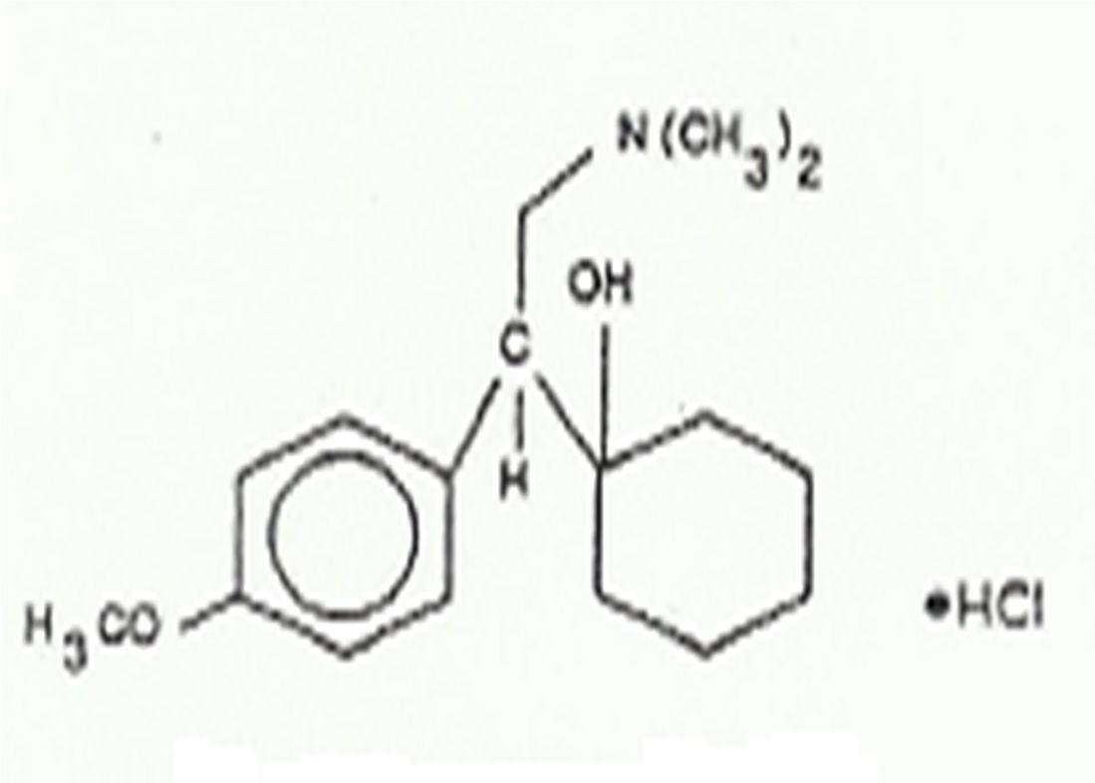

Figure 1.1: Venlafaxine hydrochlorid(Re aoet al.,2009; Wyeth,2012).

      - Diluents

Diluents are excipients commonly used in tablet formulations to bulk up the size of the drug material for ease of compression into tablets. Examples of commonly used diluent types are given in Table 1.3. Some drugs, owingthtoeir potency, are needed in quantities so small
that processing becomes a problem and diluents are used to bulk them up at least to a size of 50 mg (Rubinstein, 1988). These agents are equally used to promote the flow properties and compression charactisetrics of tablet mix (Allenet al., 2005). Sometimes quantities of diluents large enough to completely define the properties of the powder mix could be used, and because of this, diluentseaerxpected to have uniquperoperties

        - Properties of Diluents

A diluent should be inert physiologically and pharmacologically

xIt should not have any compatibility problems with either the drug substance or remaining excipient.s
xIt should be chemically and microbiologically sta.ble
xIts physical and chemicachl aracteristics should be consis.tent xIt should have an appealing color or better still, colo.rless
xIt should have optimum particle size or be capable of being size reduced to match the particle size distribution of the API.

Table 1.3: SomeDiluents used in theWet GranulationMethod Diluent Comments

Dextrose Hygroscopic

Dicalcium phosphate Inexpensive, insoluble in water

Lactose BP Inexpensive, relatively inert; the most frequently used
diluents
Mannitol Freely soluble; usepdarticularly for chewable tablets Microcrystalline cellulose Excellent compression properties; has some disintegrating
ability

Sodium chloride Freely soluble; used for solution tablets

Sucrose Sweet taste but hygroscopic; may not be diluwteidth lactose

Adapted from Rubinstein (1988)

      - Granulating or Binding Agents

Formulation of a good tablet is dependent on the flow properties of the powder particles to be compressed and also their ability to stick to one another after compreWshsiolen.some powders may posses the inherent ability to flow well and gum together after compression, a sizeable number of materials need to have such qualities imparted on them. Binders are used

as excipients to form agglomerates, otherwise called granoufletsh,ese particles, which eventually change the physicochemicparloperties of the powdered material. Optimum concentration of binder could form granules that would flow better to ensure uniform die fill during compression and give the tablet the requihsaiterdnessto withstand rigors of transportation and handlingIn.sufficient binder gives soft tablets while too much of it leads
to the production of too hard tablets that may present with prolonged disintegration time and associated problems with bioavabiillaity. Performance of a binder in tableting is also dependent on the type of binder used. Starches, celluloses and gums had been and are still in use as binders in tableting. These agents are often modified as in the pregelatinisation of starch or methyltaion of celluloses, a procedure that enhances the materials solubility and promotes its usability. Table 1.4 presents some of the binders and their concentrations in common use as pharmaceutical aids.

Table 1.4: Commonly usedGranulatingB/ inding Agents

Granulating agent
Normal use concentration (%)
Comments

Starch 5-25 Was once the most commonly used binder. The starch
has to be prepared as a paste, which is time consuming

Pregelatinised starch (PGS)
5-10 Cold water soluble.Easierto prepare than starch

Acacia 1-5 Requires preparation of paste prior to use. Can lead to
prolonged disintegration time if used at too high a concentration

PVP 2-8 Available in range of molecular weights/viscosities.
Can be added hwether dry orin solution. Soluble in water or in ethanol

HPMC 2-8 Available in range of molecular weights/viscosities.
Soluble in water and ethanol

MC 1-5 Low-viscosity grades most widely used Abbreviations: PVP, polyvinylpyrollidone; HPMC, hydroxyprophyl methylcellulose;
MC, methyl cellulose (Davies, 2009)
.

      - Disintegrating Agents

Tablets after administration/ingestion and upon getting in contact with gastric fluid, are expected to deaggregate/disintegrate back to the former granular or particulate state, prior to their getting dissolved and finally absorbed to elicit the expechteadrmpacological activity.
Disintegration of tablets to granules, facilitated by a disintegrant, presents more surface area for the action of the dissolution medium. A disintegrant, therefore, is that ingredient added in tablets and responsible for the bruepakof tablets into granules/particles. Rate of disintegration of tablets is often dependent on type and concentration of disintegrant used. Different classes of polysaccharides produce disintegration in tablets at varying times and

through varying mechanmiss as shown in Tables 1.5 and 1.6. Disintegrants are graded based on the speed with which they deaggregate the tablet into granules or particles. A special class of disintegrantws hich produces disintegration at low concentratioisnsreferred to as superdsi integrant.s

Table 1.5: Types ofDisintegratingAgents

Disintegrant Normal Use Concentratio n (%)
Comments

Starch 5-10 Probably work by wicking; swelling is minimal at body temperature

Microcrystalline cellulose Strong wicking action. Losedsisintegrant action when highly compressed

Insoluble ion exchange resins
Strong wicking tendencies with some swelling action

Sodium
starch glycollate
2-8 Free flowing powder that swells rapidly on contact with water

Croscamellose sodium 1-5 Swells on contact with water,

Gums-agar, guar, xanthan
<5 Swells on contact with water; form viscous gels that can retard dissolution, thus limiting concentration that can be used

Alginic acid, sodium alginate
4-6 Swell like gums but formless viscous gels

Crospovidone 1-5 High wicking action

Adapted from Davies (2009)

Table 1.6: Mechanism ofDisintegrantAction

Disintegrant action
Explanations

Water wicking This describes the ability of a disintegrant to draw water into the porous network of a tablet thereby causing the breakup of the tablet. Water is drawn into tablets without necessarily being accompanied by volume increase.

Swelling This is probably the most widely accepted mechanism of action for tablet disintegranst. A positive correlation is noted between the rate of swelling and the disintegrant action for some disintegrants. The swelling of some disintegrants is dependent on the pH of the media.

Deformation recovery
This implies that the shapes of thdeisintegrant particles are distorted during compression, and that the particles return to their precompression shape upon wetting, thereby causing the tablet to break apart. Crospovidone and starch are said to act by this mechanism

Repulsion theory
According to this theory, water penetrates into the tablet through hydrophilic pores and a continuous starch network which conveys water from one particle to the next, imparting a significant hydrostatic pressure. The water then penetrates between starch grains because of its affinity for starch surfaces, thereby breaking hydrogen bonds and other forces holding the tablet together. At present, this theory is not supported by adequate data.

Heat of wetting During wetting, particles e.g. of starch were noted to exhibit slight exothermic properties, which was thought to cause localized stress resulting from the expansion of air retained in the tablet matrix aiding breakup of the tablet. Heat of wetting alohnoew, ever, is probably inadequate to explain disintegration.

Culled from Encyclopedia of Pharmaceutical Technology by Swarbrick and Boylan (2001)

        - Super Disintegrants

A sub class, in the classification of disintegrants, is the sduipseinrtegrants. Tihs classof disintegrants producserapid disintegration of tablets at disintegrant concentration range of 2-4 %w/w (Rudnic and Schwartz, 250)0. The super disintegrants (Table 1.7) are characterized by their hydrophilicity and great abiolitfyswelling and themechanism they follow in causing disintegrationof tablets. Disintegrants generally are widely believed to exert their action by swelling (Tab1le.6). The polymer strands absorb water and this makes them to swell and consequently dipstruand break the tablet. Superdisintegrants are a product of derivatisation of polymeric materials. Evdeisnpersiblepolymers like gums when appropriately cros-slinked are rendered insoluble, absorwbater and swell(Silva et al., 2006).

Table 1.7: SuperDisintegrants

Disintegrant Normal Use Conc. (%)
Nature Mechanism
of disintegration

Sodium starch glycollate
2-8 Cross-linked starch; insoluble material
Free flowing powder that swells rapidly on contact with water

Croscamellose sodium
1-5 Cross-linked sodium carboxymethyl cellulose; insoluble material
Swells on contact with water

Crospovidone 1-5 Cross-linked polyvinylpyrollidon; insoluble material
High wicking action

Adapted from Swarbrick and Boylan (2001); Davies (2009); Deshemt aklh., 2012)

      - Sweetening Agents

Some therapeutic agents are bitter and so is their tablet after formulation posing palatability problem especially in children. Bitter tastes in etatsbl are masked by a process called coating. Tablets are coated using three main methods: sugar coating, film coating and
compression coating (Davies, 2009M).annitol and uscrose are examples of materials

commonlyused to sugar coat tablets.

      - Coloring Agents

These are suedprincipally for aesthetic reaso,nso asto make the tablet more appealing to the patient. Allam and Kumar (2011) referred to colorants as cosmetics for the pharmaceutical dosage forms. Also color in tablet helps the matunruefratco control product during its preparation as well as serve as a means of identification to the user.
During tableting, colorants are usually incorporated with the binder solution prior to granulation. This is however associated with the problem olofr cmoigration during the process of drying. Solvent migration leads to transfer of colors giving rise to the production of tablets with varying color shades (mottled appearance). This can however be prevented when the granules arderied slowly with constatnstirring. A similar colored lubricant can
also be used to achieve proper color. Materials used as coloring agents include Red No. 3, Yellow No. 6 (Sunset yellow FCF), Blue No.2 etc (Oetttoal., 2005; Allam and Kumar,
2011).

      - Lubricating A gents

Lubricants are agents used to reduce friction between moving partsb. leIntintga, they perform multiplefunctions like: (1) ensuring smooth ejection of the tablet from the die cavity; (2), facilitating frictionless movement between the punches and thedudrieng compression and ejection of tab; leatnd (3), enhancing the flow properties of the granules (Rubinstein, 1988; Davies, 2009). They are added in small amounts commonly not greater than 1 % of the tablet weight. Insufficient quantity of lubricants may give rise to picking, capping, sticking, binding tothe die cavity while too much of it may lead to decrease in tablet hardness, increase in tablet disintegration times and decrease in rate of dissolution of the tablet (Davies, 2009). Magnesium stearate, talc and stearic acid are examples of
lubricants wiht magnesium stearate being the most popular.

      - Glidants

These are aids that enhance the flow characteristics of a powder mtihxetuyrere; gulate the

flow characteristics of the granules from the hopper into the die cavity. Glidants act by reducing ht e inter-particulate cohesiveforces and consequently permthite granules’ smooth
and uniform flow. Uniform flow ensures uniform fill of die which eventually gsivueniform tablet weights.Like lubricants, they are also added in small quantities. The gt loidfacnhoice is fumed silica (Lund, 1994), with others commonly used includstinagrch and talc.

    - Types of Tablet Dosage Forms

Tablets as solid dosage forms are numerous and varied depending on the intended use. Tables 1.1 and 1.g8ive an overview of the various types of tablets in common use. Some of these tablet types shall be described in relative details. Tablets are formulated containing different types or amounts of excipients which generally define where the tablet is intended to disintegrate and or dissolve and be absorbed to elicit the desired effect. Some tablets are intended to quickly dissolve in the mouth while some are desired to disintegrate and dissolve in the colon. This presents a wide range of environments that tghegedtrsu exposed to and
so to define where or when the tablet is to disintegrate and or dissolve requires some tactful approaches. Tablets can be broadly classified: i1n,tothose designed to instantly dissolve upon contact with a liquid medium like the svaliin the mouth e.g. the orally dissolving tablets (Shuklaet al., 2009;Raoet al., 2010);2, those expected to dissolve in the stomach after getting in contact with the gastric fluid and this class of tablets otherwise called conventional immediate relseea tablets are expected to dissolve within 30 min (DeVane, 2003; Pathaket al., 2011; Govedaricaet al., 2011); and3, those tablets whose rate of drug
release has been modified and the drug is released usually over an elongated period of time running to several hours e.g. the extended release, enteric coated formulations (eHt eailn.,ig
1997; York, 2005D; ing et al., 2005; Collate and Moretone, 2007).

Newer approaches in drug delivery are geared towards formulating drug delivery systems that will bring about the improvement in the overall bioavailability of the drug with minimal toxic effects. Such delivery systems’ effectiveness is demonstrated byevtehnetual pharmacokinetic disposition of the drug in the body (Shaertgael., 2005).

Table 1.8:Types ofTablet DosageForms andTheir Properties Formulation type Description

Immediate release The dosage form is designed to release the dsruubgstance
immediately after ingestion

Delayed release The drug substance is not released until a physical event has
occurred, e.g. time elapsed, change in pH of intestinal fluids, change in gut flora

Chewable tablets Strong, hard tablets tgoive good mouth feel

Lozenges Strong slowly dissolving tablets for local delivery to mouth or
throat. Often prepared by a candy molding process

Buccal tablets Tablets designed to be placed in buccal cavity or mouth for
rapid action

Effervescent tablets Taken in water, the tablet forms an effervescent, often
pleasan-ttasting drink

Dispersible tablets Tablets taken in water, the tablet forms a suspension for ease
of swallowing

Soluble tablets Tablets taken in water, thteablet forms a solution for ease of
swallowing

Pastilles Intended to dissolve in mouth slowly for the treatment of local infections. Usually composed of a base containing gelatin and glycerin

Adapted from Davies (2009)

      - Mouth Dissolving Tablets

A drug delivery system that is fast growing and greatly gaining acceptance is the orally disintegrating tablet (ODT), also called intraoral dosage form or mouth dissolving tablet; where the tablet, without the necessity of using water, is desigondeidsstolve in the mouth (Goel et al., 2008). These tablets are designed to instantly disintegrate and dissolve once they get in contact with a liquid medium; thereby leading to rapid onset of action. The tablet
is placed on the tongue, where it dispersneds raelease the drug in the saliva which is

subsequently absorbed into the systemic circulation. Agents that quickly facilitate drug release e.g. the superdisintegrants, are employed in designing this type of tablet dosage form. Super disintegrants had beuesned to developfast disintegrating tablets oef lfodipine (Hariprasannaet al., 2010), ketorolac tromethamine (Paetilt al., 2009), metoprolol tartrate (Namdev, 2010)z, idovudine (Raoet al., 2010a).
The following have been presented as the ideal properties of mouth dissolving tablets, and the advantages of same had also been highlightedet(Faul., 2004; Shulkaet al., 2009; Sahoraet al., 2010; Bala and Pawar, 2011; Konapuerteal., 2011; Ravichandrai n et al.,
2011; Kashyapet al., 2011).

        - Ideal Properties of M outh Dissolving Tablets

xIt should disperse in minimal amounts of liquid, use of water should not be necessary for the table to disintegrate and dissolve in the mouth within seconds of administration
xHave a pleasing mouth feel
xLeave minimal or no residue in the mouth after administration
xBe compatible with the required formulation excipients including taste masking agents
xBe adaptable and amenable to existing processing and packagcihnignemrya

xAllow the manufacture of tablets using conventional processing and packaging equipment at low cost
xAllow high drug loading
xHave sufficient strength to withstand the rigors of the manufacturing process and post manufacture handling

        - Advantages of Mouth Dissolving Tablet asDosageForms

xEase of administration to patients that experience difficulties in swallowing tablets
e.g. pediatric, geriatric and psychiatric patients xConvenience of administration has improved compliance xBenefits ofliquid medication in the form of solid preparation
xThere is precision of dose unlike when the drug is given in liquid form
xPregastric absorption may promote bioavailability by circumventing the first pass effect; this may allow use of reduced doses wsitshoaciated reduction in side effect without compromising efficacy
xRapid onset of drug action following absorptions in the mouth, pharynx and esophagus
xIncreased bioavailability
xDoes not require the use of water for dissolution xAllows high drug loading

      - Conventional Immediate ReleaseTablets

These are the oldest known tablet types. A large proportion of tablets in use today are designed to immediately release the entire medicament upon contact with a solubilising liquid e.g. the gastrointestinalufid. They are commonly compressed while containing an appropriate amount of binder that holds the tablet together and a disintegrant that will cause the rupture of the tablet on contact with a liquid medium. Releasing the medicament at once may not posenya problem with the less potent drugs or when the medicament is

taken once a day or occasionally, but worries may arise with
-mdousltei
therapies,

especially of potent drugs. Drugs with short h-laivlef s, prepared as rapid release products, often need to begiven at frequent intervals to maintain blood concentrations within the

therapeutic window. Peaks and valleys commonly associated with these types of formulations and the possible patient n-coonmpliance may affect the outcome of the therapy (Ding et al., 2005; Shargeel t al., 2005; Varshosaezt al., 2006; Collett and Moreton, 2007).
Lloyd (1999) reported that there is an inverse correlation between the frequency of dosing and patient compliance.
Ding, et al. (2005) highlighted the potential problems inehnetr in multiple dose therapy as:

xIf the dosing interval is not appropriate for the biological h-laiflef of the drug, large peaks and valleys in the drug blood level may result. For example, drugs with short half-lives require frequent dosing to maintacionnstant therapeutic levels.
xThe drug blood level may not be within the therapeutic range at sufficiently early time points, an important consideration for certain disease states.
xPatient non-compliance with the multip-ldeosing regimen can result in faileurof this approach.

Following oral administration of a do,stehe drug is absorbed into the systemic circulation at

a rate and extent that is dependent on the pharmacokinetic parameters of the drug. In multiple dose therapies, the half life of the drug uised to guide the frequency of administration of doses such that the concentration of the drug in the plawsmithainisthe therapeutic windowi.[e. below the maximum tolerable concentration (MTD) but above the minimum effective concentration (MEC)a] s shown in Figure 12.. However, apntess or otherwise in administeinrg the dose will define the therapeutic outcome. Doses taken too close to each other may predispose the patient to toxic concentrations when plasma drug levels of the drug go beyond the MTD, iwlehdelayed dosing may lead to risks of plasma concentrations dropping below the MEC. The former case is more pronounced when dealing with potent drugs that have narrow therapeutic windows, while the latter may lead to development of resistance as seenhwsiut b-curative concentrations of antimicrobial agents

(Shargelet al., 2005; Dinget al., 2005;Chaubal, 2006).

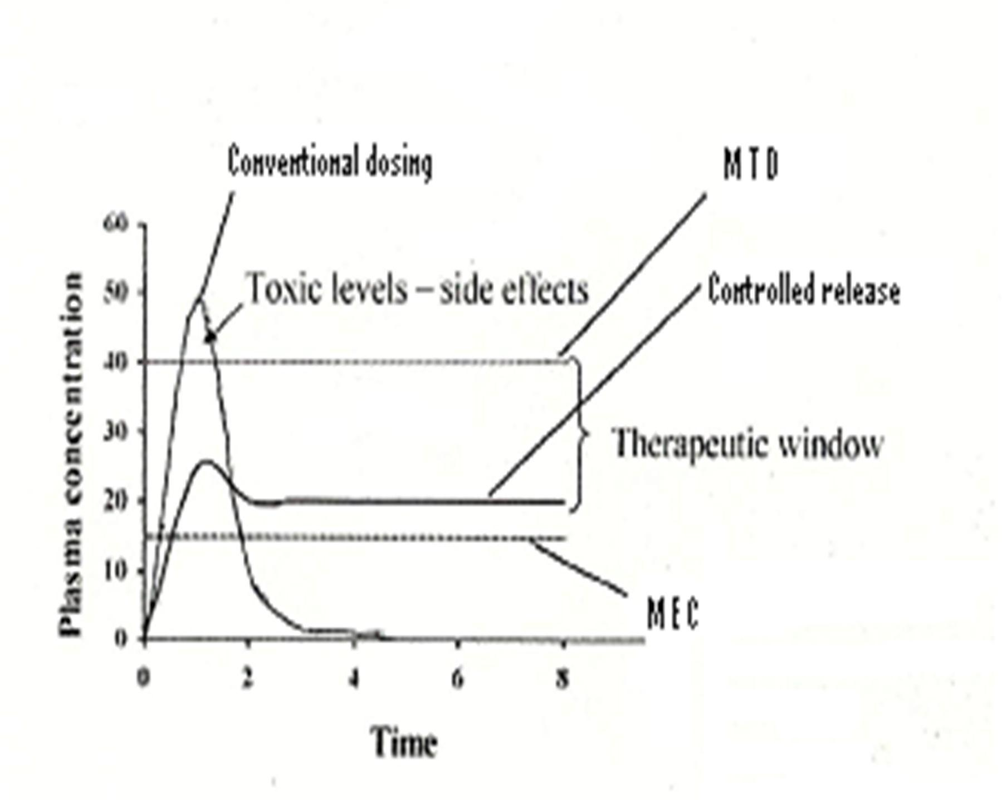
Figure 1.2: Comparison of typical pharmacokinetic profiles seen for conventional versuscontrolled release formulations. Key: MTD, minimum tolerable dose; MEC, minimum effective concentration (Chaubal, 2006)

      - Modified-ReleaseTablet DosageForms

Dosing interval factored by the h-alilfe of the drug, associated witchhances of patient no- n

compliance and the drug’s toxicity had led to the emergence of mo-rdeifleieadse dosage forms. Researches into ways of improving therapeutic outcomes had given rise to the modification of tablet release profiles culminating into thmeeergence of delayed release, extended release, receptor targeteredlease or site specific drug products through use of some specialized polymeric materials (Alleetnal., 2005; Ding et at., 2005; Shargeel t el.,
2005). These products are designed to otfhfer potential benefits of sustained drug blood levels, site specific drug release, attenuation of adverse effects and promoting patients’ compliance, eventually improving the therapeutic outcomD el.ayed release, exnteded release, receptor targeterdeleaseare some terminologies used in modi-friedlease dosage applications and are often mixed up and interchanged (Aeltleanl., 2005) and s,oDing et al.
(2005), offered some definitions to these terminologies as shown in Table 1.9.

The modified-release oral dosage forms are becoming increasingly popuolavrer the conventional immediate release dosage foormwisng to some advantages they are associated with as shown in Table 1.10. Different methods are used to control the rate of release of drugs from delivery ssytems (Dinget al., 2005).

Table 1.9:Definition of SomeTerminologies used iDn escribingModified-Release Formulations

Terminology Definition

Delayed-release systems
These systems use repetitive intermittent dosing of a drug from one or more immediate release units incorporated into a single dosage form, or an enteric delayed release system

Extended-release systems
These include any dosage form that maintains therapeutic blood or tissue levels of the drug for a prolongpeedriod. If the system can provide some actual therapeutic control, whether this is temporal or spatial or both, of drug release in the body, it is considered a controlled drug delivery system. This explains why extende-drelease is not equivalent to contlreodl release.

Site-specific and receptor targeting

This refers to targeting a drug directly to a certain biological location. In the case of si-tsepecific release, the target is adjacent to or in the diseased organ or tissue; for receptor release, the target is the particular drug receptor within an orgaonr tissue.
Both of these systems satisfy the spatial aspect of drug delivery requirement and are also considered controlled drug delivery systems.

Adapted from Dinget al., (2005)

Table 1.10:Advantages oEf xtended-ReleaseDosageForms

Advantage Explanation

Less fluctuation in drug blood levels
Controlling rate of release eliminates peaks and valleys of blood levels

Frequency reduction in dosing
Extended-release products frequently carry and deliver more than a single dose, hence may tbaeken less often than conventional forms

Enhanced convenience and compliance

With less frequency of dosing, a patient is less apt to neglect taking a dose, also greater convenience with day and night administration

Reduction in adverse sideeffects

Because of fewer blood level peaks outside therapeutic range and into toxic range, adverse side effects are less frequent

Reduction in overall health care costs

Although initial cost of extende-rdelease dosage forms may be greater than forconventional forms, overall cost of
treatment may be less because of enhanced therapeutic benefit, fewer side effects, reduced time for health care personnel to dispense and administer drugs and monitor patients

Adapted from Allenet al. (2005)

1.3.5.31. SomeDisadvantagesAssociated with Extended-ReleaseDosageForms (Shargelet al., 2005)include:

xHigher cost
xUnpredictable or pooirn vitro in vivocorrelation xDose dumping
xLarge dose drugs anreot suitable for formulation in extended releafosrems xRemoval of drug in response to adverse drug reaction or intoxication is difficult xReduced potential for dose adjustment
xPoor systemic availability due to erratic or variable absorption from the GI tract

      - Rate-controlled delivery systems

These are systems designed to deliver drugs for systemic or local action at a predetermined rate for a specific time period. These systems are classified based on the mechanism used in optimizing drug release. Controlled drug release has been facilitatedesbigynidng drug-
delivery that can be described by any or a combination of some of the following mechanism,svis: diffusion, swelling, dissolution, osmotic or erosion controlled systems.

      - Diffusion systems

Diffusion systems are used to describe release of drugs via diffusion through an inert membrane barrier, usually an insoluble polymer. Drug release can be controlled by regulating the rate at which the drug dissolves or diffuses out of the tablet mMaattrrixic.es
or reservoir devices are employed to control release of drug by controlling the rate at which water permeates into the device or the rate at which the drug leaches out after being dissolved from within the device. Drug release from such devicedsesiscribed by the Higuchi equation (Dinget al., 2005;Shargelet al., 2005) as described later in the te. xt

Monolithic matrix systems are very popular technologies used in controlled drug delivery because they are relatively inexpensive, easy to preapnadresimple to use in formulations and are generally acceptable (Benetkeal., 2009). Tablets are compressed by dispersing the
drug in the matrix material prior to compression. The drug needs to be in small quantity compared to the matrix for it (the drutgo) be properly protected and its release controlled (Shargelet al., 2005). To ensure optimum delivery of doses, two types of granules are made with one containing the matrix former and the other part without the ingredient. Upon

compression, the granuslenot containing the matrix former will provide the immediate effect and the dru-gexcipient granules provide extended action (Aleletnal., 2005). The hydrophilicity of the polymer used in forming the matrix allows for the gradual permeation of the devicewith water and the eventual dissolution of the drug, with the gelling property on the other hand, limiting the passage of the dissolved drug. Sheat ragle. l(2005) gave three examples of modified mat-rriexlease mechanisms. eThdrug-matrix is coated with, ia soluble membrane; ,ii an insoluble membrane and , iiai n insoluble membrane with “windows” created by dissolving soluble parts of the membrane in water. Excipients including methylcellulose, gum tragacanth, Veeg®umand alginic acid are said to form a viscous mass and provide a useful matrix for controlling drug dissolution. The gelling
strength and concentration of the gum plays a very important role in such formulations (Shargelet al., 2005).

      - Dissolution systems

A drug with a slow dissolution rate will yield an inherently sustained blood level. This principle has been used in extending drug release of highly water soluble drugs by reducing their solubility in water. Dissolution of highly water soluble gdsrucan be reduced by derivatizing or preparing an appropriate salt of the drug, by coating the drug with a slowly soluble material, or biyncorporatingit into a tablet with a slowly soluble carrier (Dinegt al.,
2005).

      - Osmotic systems

This isa drug delivery system that relies on pressure buildup from within the tablet to cause

release ofthe drug. A semipermeable membrane containing a -ldarsiellerd hole, an

osmotically active drug or osmotically inactive drug in admixture with an osmotaiccatlilvye

salt are required in designing this type of dosage form. The semipermeable membrane allows passage of water into the device but prevents passage of drug except through the laser-drilled orifice. Upon contact with water, the osmotically active drrugagoent generates
osmotic pressure and the pressure difference created causes water to enter the device and the drug is forced out through the orifice (Dinegt al., 2005; Shargeel t al., 2005)such device is
shown in Figure 1..3A newer device has been developed and is made to contain two compartments separated by a movable piston. In this case the drug and the osmotic agent are housed separately with the drug on the side of the orifice (Detinagl., 2005; Allenet al.,
2005). Examples of products formulated as osmotic delivery device include Ac®utarinmd Procardia-XL ® (Shargelet al., 2005).

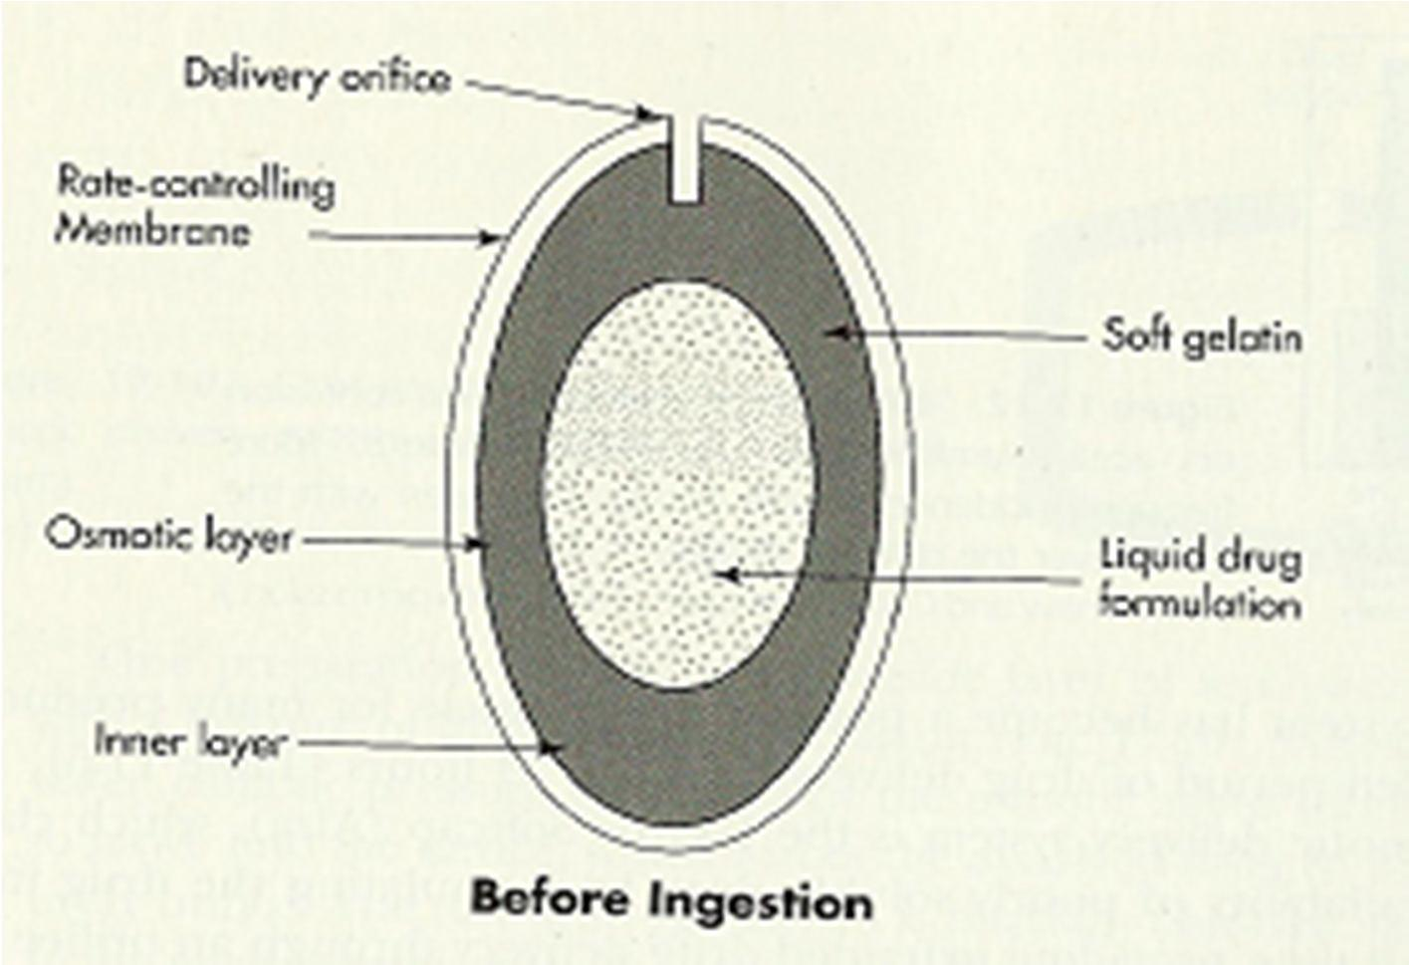

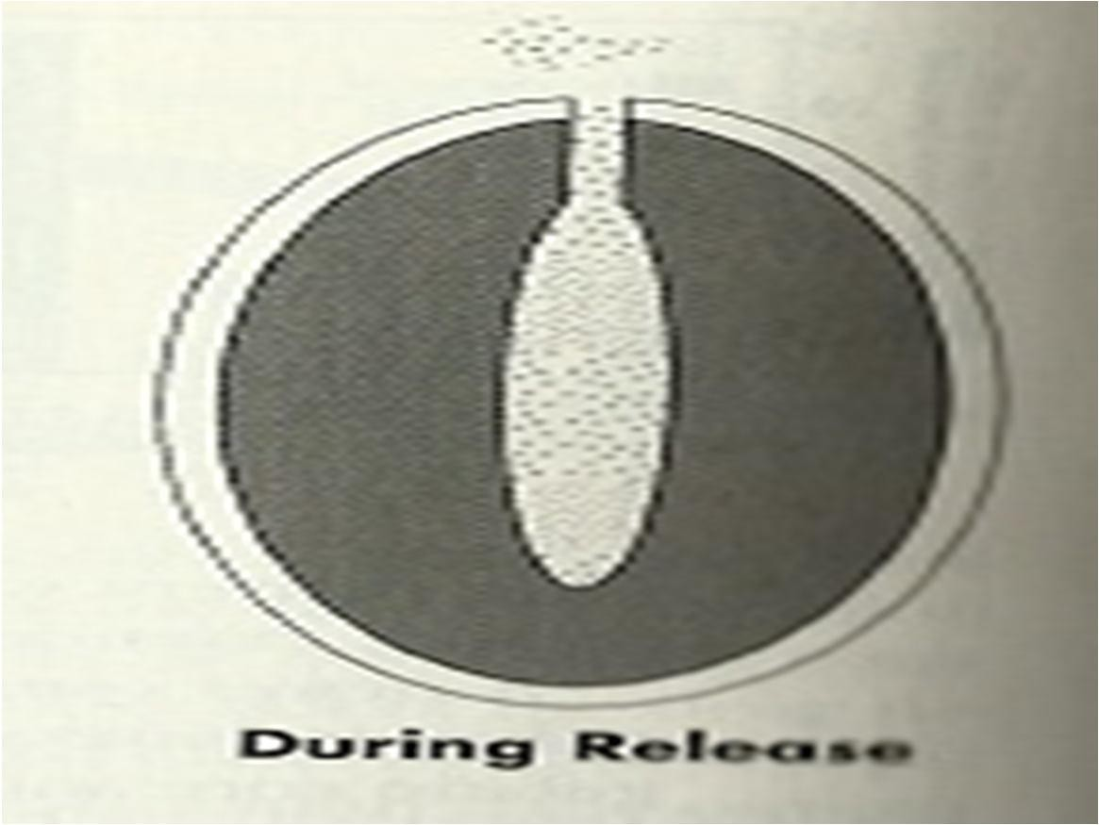

Figure 1.3: Osmotic delivery system (Shargeetlal., 2005)

      - Swelling Systems

These systems, otherwise called gastroretentive drug delivery systems are designed to have prolonged resident time in the stomach to allow for the optimum release of the drug prior to its passage to the intestinal region of the GIT. Medicaments for trnetatomf egastric and duodenal ulcers and other gastrooesophagial ailments are good candidates for formulation as gastroretentive devices (Ray and Prusty, 2010; Krishnaerat jaln., 2012). Daveet al.(2004) developedgastroretentive tablets comprising of gugaurm, xanthan gum and hydroxypryol p
methylcellulose as matrix formers and sodium bicarbonate was incorporated a-s a gas

generating agent to deliver ranitidine hydrochloride in the stomach. The authors observed that the sodium bicarbonate caused the genoenraotficarbon dioxide C( O₂) in the presence
of dissolution medium. The gas generated was trapped within the gel formed by the hydration of the polymer and this decreased the density of the tTabhleett.ablet became buoyant when the density became less than 1, and remained so for o(vSeinr g8hhand Kim,
2000). Tablets made with materials that can swell and expand without becoming buoyant can still be used to give spatial placement of a dosage fotrhme isntomach. Gastric emptying
is a size-dependent process and may prevent passage of swollen tablets into the duodenum thereby increasing the resident time of the drug in the stomach e(Dt ianlg., 2005). Aroraet
al. (2005) reported that for gastric contse to pass into the small intestine, their sizes will have to be in the range of 1 to 2 mm and that indigestible solids larger than the pyloric
opening are propelled back thereby spending mtoimre in the stomach (Figure 1).4

Valrelease® is an example oaf product formulated as floating tablets of diazepam (Shargel

et al., 2005).

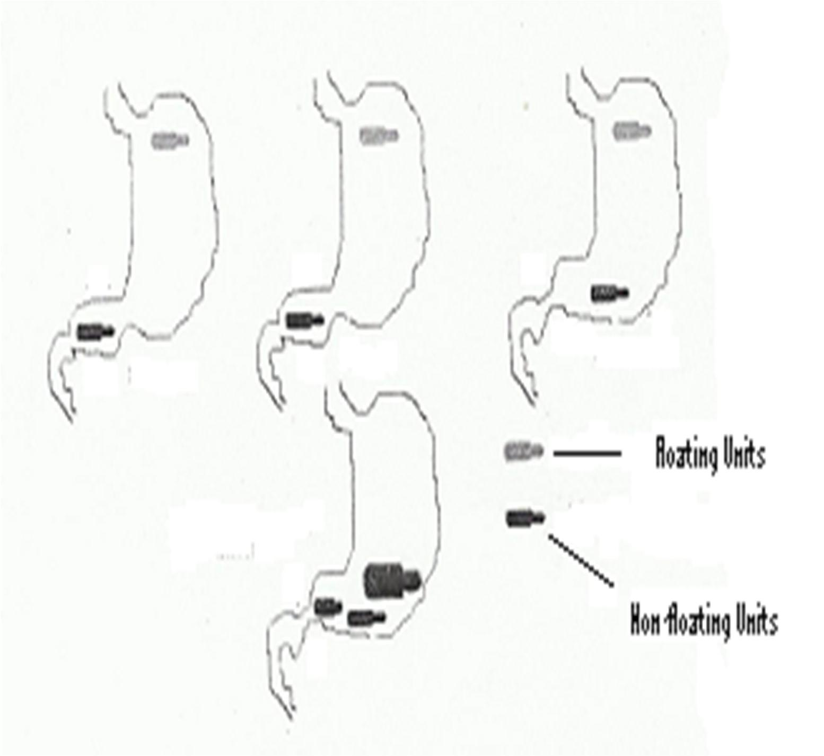

Figure 1.4: Intragastric residence positions of floating and nonfloating gastroretentive units (Aroreat al., 2005)

      - Erosion Controlled Systems

These are systems that operate on the principle of the tablet eroding from the surface. Surface erosion of the polymer caused the controlled release of the drug. This is a relatively safe method of controlling drug release as possibility of dosepidnugmis eliminated. Drug release rate is proportional to polymer erosion and this can be controlled by changing polymer thickness or quantity of drug in the device (Deint gal., 2005). Constan-Tt ® and Tenuate Dospa®ncontainingtheophylline anddiethylpropion HClrespectivelyare examples
of productswhose drug release is controlled by erosion of the tablet (Sheatragle.,l2005).

      - Targeted Drug Delivery

These are a group of modifi-eredlease delivery systems designed to lodge the drug at therapeutic concentratios in specific sites with minimal access to nontarget siteset(Dal.in, g
2005). Colonic delivery is a form of targeted drug delivery intended for targeted drug release into the lower gastrointestinal (GI) tract. They are mostly uinsetdhe localized infections involving the colon such as irritable bowel syndrome, inflammatory bowel disease and colon cancer (Singh, 2007). Technologies developed in formulating the colonic delivery systems are broadly divided into (a) p-Hdependent (or edlayed-release) system designed to release
thedrug in response to change in pH, (b) t-idmeependent (time-drelease) system designed to release thedrug after predetermined time, (c) microbia-dlleypendant (or microbial-ly
controlled) system making use ofethabundant enterobacteria in the colon, and (d) pre-ssure

dependant system making use of luminal pressure in the colon (Singh, 2007).

Targeted delivery to pathological areas has also been of great benefit in the management of cancers (Torchilin, 2007). Daeisand Kumar (2004) prepared and evaluated a novel buccal

adhesive system containing propranolol hydrochloride. In general, a targeted drug delivery system is preferred in the following situations (Deintgal., 2005).
- Pharmaceutical: drug instability, loswolubility
- Pharmacokinetic: short ha-llife, large volume of distribution, poor absorption
- Pharmacodynamic: low specificity, low therapeutic index

  - Capsules as Solid Dosage Forms

Capsules are solid dosage forms in which the medicinal agen/ta(sre) cisontained in a hard

or soft shell made using gelatin. The medicinal agent could be in powdered or granular form and the shell is designed to dissolve upon contact with a liquid substance e.g. the gastric fluid. Hard gelatin capsules are used in most cormcimalemedicated capsules. They come in different colorsand size.s Capsules are tasteless, easily administered and easily filled either extemporaneously or in large quantities. The shells are prepared separately to contain two sections. The drug is comepllyetsealed by a slipping action of one part of the capsule over the otheLr u( nd, 1994;Allen et al., 2005; Dinget al., 2005).
The soft gelatin capsules are also made of gelatin but to which glycerin or a polyhydric alcohol such as sorbitol has been addaendd commonly contain a preservative. They are designed to contain medicaments in liquid forms, as pastes or as solidse(tAall.e,n2005).

  - Statement of Research Problem

Drug delivery is still a subject of great relevance in the horizosncioefntific research. While

the discovery or synthesis of novel therapeutic agents is taking the center stage in most pharmaceutical companies, excipients development is the next most important area worthy
of being researched on. Excipients take the bulkthoef floor in any research and

development (R & D) unit of any pharmaceutical company, underpinning their relevance in drug delivery. An excellent therapeutic agent may be worthless if it cannot be formulated into an appropriate dosage unit, and this ims mcoonly facilitated by optimally harnessing the varied functionalities of excipients or pharmaceutical aids required to make the dosage unit.
Drugs/medicines are either imported into the underdeveloped/developing nations or the raw materials are brought infor local production of pharmaceuticals. The import of either case
is that, it economically overburdens a large proportion of the populace who are predominantly poor. Most of the active agents or excipients needed for the production of such medicines, padraoxically, can be found relatively available in the local habitats of such nations and where they araebsent, suitable substituteasbound. The underdeveloped world
may be lacking in technological advancement but are blessed with abundance of natural resources. And,as Chaubal(2006) opined, majority of polymers used in oral drug delivery
are derived from natural sourc.es

Gums and other polysaccharides habveeen found to be of great relevance in the production of pharmaceuticals and their derivatives are even of greater significance. Modification of
drug release with its attendant beneficial effects has been made possible by derivatisation of polymeric mateirals. Explorations into the abundant natural resources may lead to valuable discoveries and derivatisations of the discovered polymers may pave way for the production

of novel pharmaceutical actives or aids. Cashew is a tree that can thrive in a variety of environments and the gum it produces has so far been popular for use as varIntsishes.
relevance in immediate release dosage formulation had been rep(Oorkteodye et al., 2009; Ofori-Kwakye et al., 2010; Gowthamarajan et al., 2011). Investigating thetableting potentialsof cross-linked derivativesof this gummay open up another opportunity of getting yet another polymeric material for use in specialized drug delivery systems.
In all, such discoveries may produce a multiplier effect in that theionn’sat foreign exchange may receive a boost if the product is of export quality, while the local people get employed for cultivation or harvest of the product. Health care delivery may as well become relatively cheaper when the actives and or excipientspraordeuced locally.

  - Justification

Gums, starches and celluloses are greatly employed in pharmaceutical procedures to modify drug release profiles. Developing nations usually import these materials, a feat that is not economically reasonable in most nations endowed with locally availabdle eaansily renewable materials that can substitute the imported ones.
The cashew tree is well adapted to seasonally wet/dry tropical climates (Noel, 2000) and has become naturalised in many tropical countries, particularly in coastal areas (Pursglove, 1971). The tree is greatly abundant in some parts of Nigeria and if desired, can be grown in almost all parts of the country thereby multiplying the beneficial economic influences of the tree or its products on the common man and the nation in general.

The abiilty of CG to form matrices, the gum’s abundance and the significance of the modified-release dosage forms in medicine, attract fuller investigation into applications of CG and its derivatives as matrices in the preparation of mod-rifeieledase formulations.
Cashew gum can stand as prototygpuem in this typeof investigational procedure so that other gums and in general polysaccharides can be assessed thereby widening the researchable scope.

  - The Null Hypotheses

i. CG cannot be cros-lsinked using citricacid (CTR), a polycarboxylic acid.

- Cross-linking CG with CTR does notconfer tablet sustained-releaseproperties to CG.

- Cross-linking CG with CTR does not confetarbletdrug-release enhancing property to CG.

  - Aim of the Study

To study thetablet formulation properties of cro-slinsked cashew A(nacardium occidentale L.) gum.

The specific objectives of this work include:

    - to collect and identify crude cashew exud.ates

    - to extract and produce the cashew gum powder from the crude cashew e.xudates

    - to cross-link the gum using epichlorohydr.in

    - to cross-link the gum using polycarboxylic acids at varying ra.tios

    - to cross-link the gum using citric acid and glycerol at varying ra.tios

    - to carry out differential scanning calorimetry (DSC), Fourier tranrmsfoinfrared

(FT-IR) and nuclear magnetic resonance (NMR) spectral analysis of the gum and the cross-linked polymer.s
    - to determine the solubility profile of the cro-lsinsked polymer.s

    - to study the physicohemical and physicotechnical properties includilnogss on drying, hydration, swelling, water content and water retention capacities of the developed polyme.rs
    - to determine dru-gpolymer compatibility between Ve. nHCl (test drug) and CG, CrosCC or CrosCCG (excipient polyme.rs)
    - to carry out formulation stduies on tablets of Ve.n HCl, a water soluble antidepressant, made with varying concentrations of CG or its admixtures with MCC PH 102 as binder or release retard. ant
    - to carry out formulation studies on teatbsl of Ven. HClmade with HPMC ER K100 as binderand varying concentrations of CrosCCG as release reta. rdant
    - to carry out formulatino studies on tablets of Ven. HCmlade with HPMC ER K100 as binder and CrosCCG as d-rrueglease facilitating ge.nt
    - to establish teh mechanism and kinetics Voef n. HCl release from tablets containing HPMC ER K100 as binder and CrosCCG as release retardant by rfeitlteinagse data into various drug-release mode.ls
    - to statistically analyez andcomparethe results obtained from the studies as basis for the use of cashew gumin tablet formulations and also to substantiate any value added by its cros-lsinking.

    - to establish the safety status of the c-rloinsksed polymer (CrosCCG) using s-uabcute toxicity studies on laboratory anim.als

CHAPTER TWO

LITERATURE REVIEW

  - Use of Natural Materials inPharmaceuticalFormulations

    - Polysaccharides

Carbohydrates, structurally made of carbon, hydrogen and oxygen, are the single most abundant class of organic compounds found in nature. They areuap gorfosubstances that include the sugars, starches, gums and celluloses. Carbohydrates are broadly classified into monosaccharides, disaccharides, oligosaccahrides and polysaccharides. Of these classes, the polysaccharides, owing to their long chains, perotov be of immense relevance in drug delivery in the pharmaceutical arena.
Polysaccharides are high molecular weight carbohydrates composed of multiples of

U H S H D W L Q J P R Q -R1, 4P- glHycosUidicL linFkages wVith aX J D U

molecular weight range of 16,000 to 14,000,00D0altons (Ali, 2002). They are the most abundant (by mass) of all organic substances in living organisms, comprising ab-out two
thirds of the dry weight of the total biomass (BeMiller, 2009). Polysaccharides are termed homoglycan when the repeating sugar units oafrethe same type or heteroglycan when comprising ofmore than one sugar typeo. lPysaccharides serve as reserve nutrients e.g. in starches, skeletal materials as with celluslosoer protective against diseacsoenditions in
gums (Balbaa, 1978; Agarwal, 2000).

The polysaccharides, comprising of starches, gums and celluloses; and their derivatives, represent a class of polymeric compounds largely used in pharmaceutical formulations and in systems for controlled drug delivery (Covieelltoal., 2005; Rajeshet al., 2009; Ogajiet
al., 2012). Polysaccharides with varying physicochemical properties can be extracted from plants at relatively low cost and can be chemically modified to suit specific nBeeendesk(eet
al., 2009). They are thus indispensable componentsthein manufacture of medicines for human or animal use where they are employed to provide varniecdtiofnus (Table 2.1) as dictatedby the polymer’s physicochemical properties
Researches inpharmaceutical technology are aimed at improving the technology of production/derivatisation of pharmaceutical asidvia explorations into the vast untapped natural resources. This is desirous especially in the developing nations, as it offers the opportunity of discovering raw materials with pharmaceutical relevapnocsesessing higher
or comparable performance that can possibly, often after modifications, present themselves as affordable substitutes.
The polysaccharides commonly used in pharmaceutical processing comprise of long linear or branched chains of monomeriucgsar units that are held together principally b-y41but
often with additional -16 glycocidic linkages. They have varied physicochemical properties that are commonly defined by the polymer’s molecular weight, chain length and or branching. They thus rangferom soluble gums to insoluble starches and celluloses. These properties are what guide the employment of polysacchairnidpehsarmaceutical processing.
Structural modifications have been used to effect some changes that eventually tailor the properties ofpolysaccharides to suite a particular interest. The polysaccharides currently in use include eclluloses, starches and gu.ms

Table 2.1:Classes of Polysaccharides CommonmlypEloyed inPharmaceutical Processing

Class Ingredient Use in pharmacy

Celluloses Methyl cellulose (MC) Suspending and or viscos-itnycreasing agent;
tablet binder; coating agent
Ethyl cellulose (CMC) Tablet binder; coating agent

Sodium carboxymethyl cellulose (SCMC) Hydroxypropyl methyl cellulose (HPMC)
Tablet binder and disintegrating agent, viscosifier
Suspending and or viscos-itnycreasing agent; tablet binder; coating agent; film former; emulsion stabilizer

Starches Maize starch Binder, filler for tablets and capsules;
disintegrant in tablets; coating agent
Potato starch Tablet binder
Cassava starch Tablet binder, filler and disintegrant

Gums Acacia gum Emulsifier and suspending or viscosity
increasing agent, tablet binder
Xanthan gum Thickening , stabilizing and suspending agent,
controlled release agent
Guar gum Tablet binder and disintegrant
Tragacanth gum Viscosifier or suspending agent

Adapted from (Janei t al., 2009; Ranaet al., 2011)

      - Celluloses

Cellulose is a colorless solid, insoluble in water and organic solvents but readily soluble in

- P P R Q L D F D O F X S U L F-1,4-linkKed D\ -gGlucoUse R [ L G

units (Figure 2.1). It is the most abundant, widely distributed anadtlygruesed plant related material in pharmacy. Cellulose and its derivatives are greatly employed excipients in pharmaceutical preparations as binders, coating agent, suspending agent, viscosity enhancing agentstce. Cellulose,whose structure is shown inigFure 2.1a,is insoluble in

water and indigestible by the human body and this has reduced its applicability in formulations where solubility in water is desired. This, hhaoswever, been overcome by the development of cellulose derivatives with improved fopremr ances. Derivatisation of celluloses through cro-slisnking, etherification, esterification or graft copolymerization has yielded polymers like hydropropyl methyl cellulose, cellulose ac,eetatct,ewhich have been
used in modification of drug release fpilreos (Benekeet al., 2009; Ogaji,et al., 2012).

Cellulose derivatives had been used to make monolithic matrix systems or in film coating techniques to prepare enteric coated tablets or prepare-peser mei able membranes for osmotic pump delivery systems (Beneekteal., 2009). Example of an ethfeierid derivative of cellulose popularly used in controlled drug releasehyidsroxyprophyl methylcellulose (HPMC) (structure shown in Figure 2.1bH).PMC wasused as reference binder/matrix former in assessing the drug release modification of the-clinroksesd derivatives of CG in
this study.

HPMC has been described as the most important hydrophilic cmarariteerrial used for the preparation of oral controlled drug delivery systems. It functions by forming a gelatinous barrier layer around the tablet upon cont twaicth water (Siepmann and Peppas, 2001; Levina and Rajab-iSiahboomi, 2004).

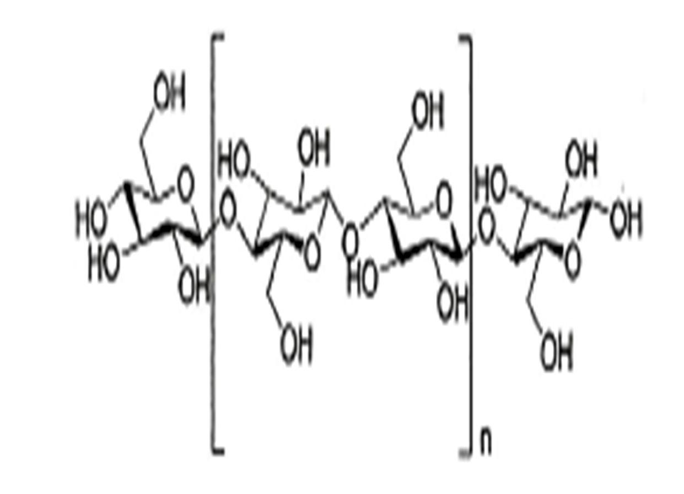
a

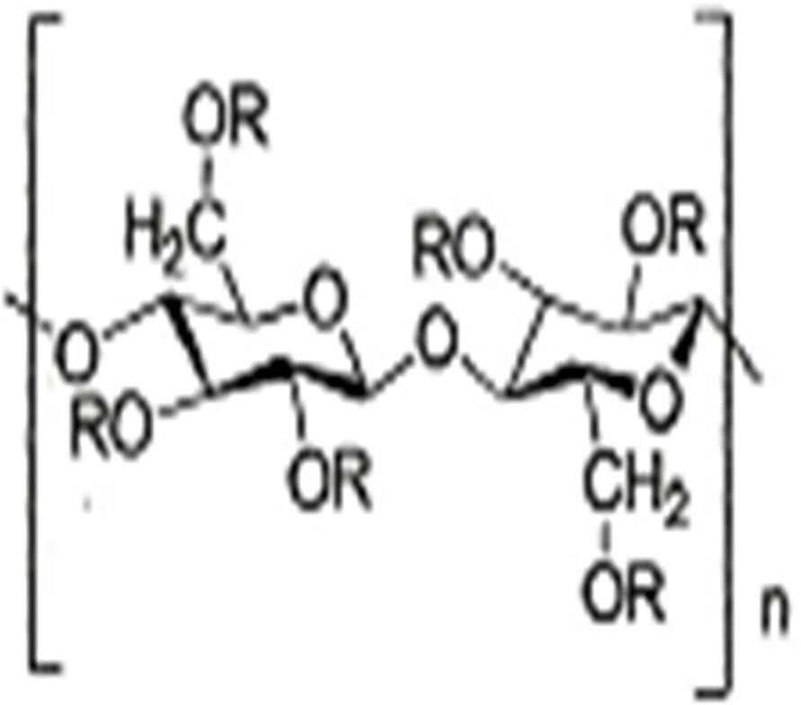
b

Figure 2.1: Chemical structure of a) cellulose and b) hydroxypropyl methylcellulose (HPMC). The substituent R represents eithe–rCaH₃; a –CH₂CH(CH₃)OH, or a hydrogen atom(Siepmann and Peppas, 200B1e;neke, 2009)

      - Starches

Starch is comprisedof two polymers namely amylose and amylopectin. Amyliossae non-

- U D Q F K L Q J -1K, 4 HlinkeOd D-LgluFcoseD mOonomersS(FigurR eO2.2,\a) P H U

while amylopectinon the R W K H U K D Q G L V -1, D4 K L

D -Q1, 6Glinked D.-glucose monomers as shown in Figure 2.2b (Beneetkael., 2009).

Tables 1.4, 1.5, 1.7 and 2.1 reflect the worthiness of starches in pharmacy. Straercuhsesd a

in tablet formulations as filler, binder or disintegrant, depending on the formulation design. Starches from maize, potato and cassava are very popular in the formulation arena.
Oyi et al. (2009) reported use of wheat and rice starcinhetsablet formulation,where they concluded that wheat starch made stronger tablets and could thus be suitable for the formulation of chewable tablets and lozenges. Garr and Bangudu (1991) compared sorghum starch with maize starch when used as tablet binder andtedgirsaints. Ibeizm et al. 2008) reported the role of ginger starch as a binder in acetaminophen tablets. The results obtained from this work showedthat at a binder concentration of 2-8.0.0 %w/w, ginger starch produced tablets that were as good as thoseucperoddusing gelatin. Uhumwangheot al.
(2006) while working on the influence of some starch binders on the brittle fracture tendency of paracetamol tablets compared the binder effects of cassava and cocoyam starch with that of maize starch. The authors fodutnhat cassava starch which was the most viscous, displayed the highest potential for ameliorating brittle fracture during manufacture of paracetamol tablets.

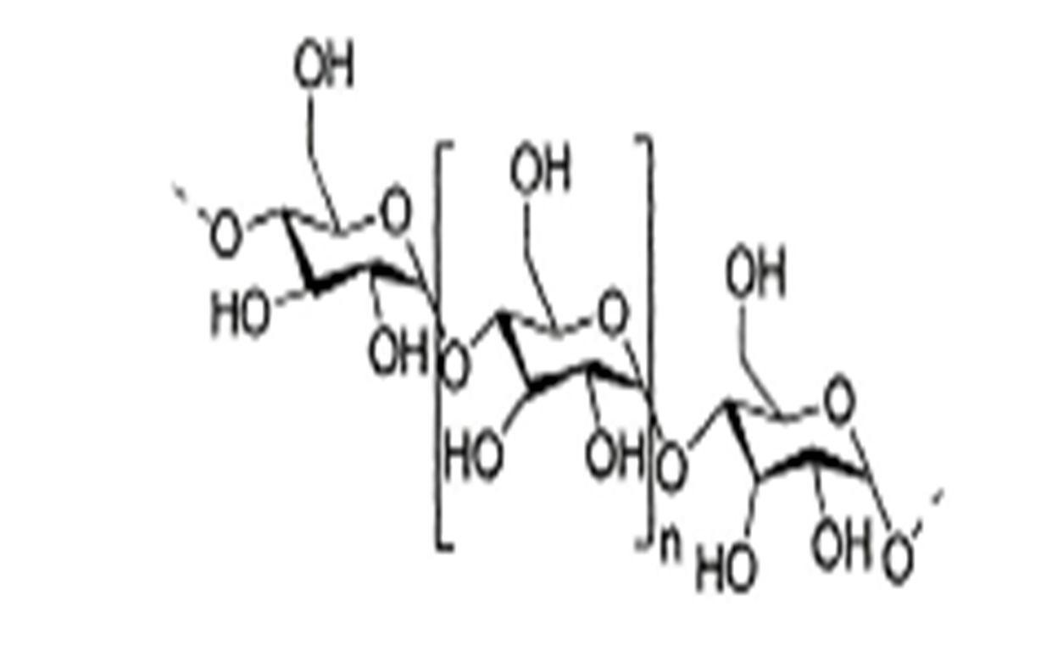
a

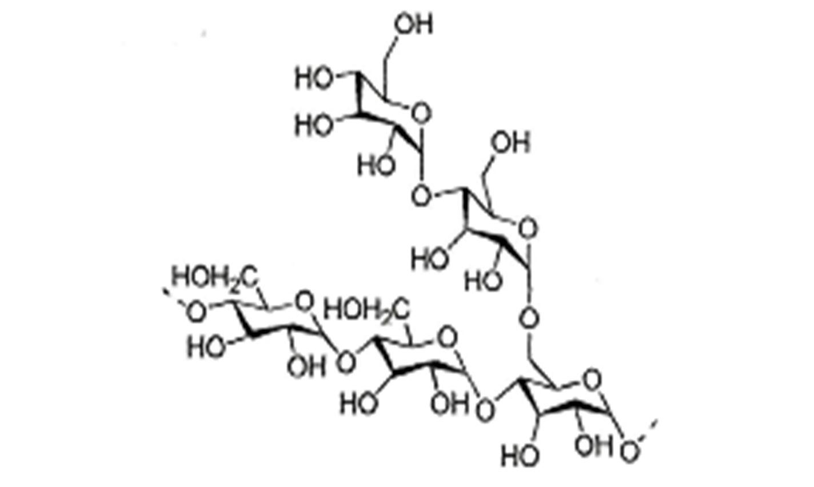
b

Figure 2.2: Chemical structure of starch, with a) amylose and b) amylopectin (Benekeet al., 2009)

      - Gums

Gums are naturally occurring polymeric materials of plant or animal origin. They are components ofplants, making both higher and lower plants serve as good sources of gum for pharmaceutical applicationsG.ums were formally known mostly in book binding but have now found use in foods (Nussinovitch, 2003) and also in pharmaceutical processing as raw materials for formulation of both conventional and novel dosage forms. Abundance,
sustainability, biodegradalbityi and biosafetyhadmade the polysaccharide gums a subject of

intensive research in industrial raw material development (eJtaanli., 2009; Ameliaet al., 2011; Ranaet al., 2011, Ogajiet al., 2012).Gums can be of exudative, extractive or seed source.
The plant tree gums are obtained as exudates on the bark of the tree trunks or branches following accidental or deliberate incision on the plant part. As a protective measure following incision on the plant part, a viscous fluid is secreted by thehtaret eflotws over the affected area and even beyond in some instances and eventually dries to a brittle, translucent, glassy hard mass. Gums are thus said to be pathological products produced mainly as protective in consequence to an injury inflicted onltahnet p(Ogajiet al., 2012).
These authorsreported that the application of gums in pharmacy has been recognized since the 1800s with the United States Pharmacopoeia of 1820 containing gums like tragacanth, acacia, stercul,iawhile the National Formulary of 1947 reporting on sodium alginate and agar. And also thatgoggle browser checks have shown that gums and mucilages are the most highly investigated materials in recent time as potential pharmaceutical excipients.
Gums aer now used as binders, drug release modifiers, disintegrants, emulsifiers, thickeners,

viscosifiers etc. when employed in their natural forms or as derivatives after some structural

modifications(Anthony and Sanghavi, 1997; Hagerstrom, 2003; Seintgahl., 2010; Nep and Conway, 2010; Onunkwo2,010; Singhet al., 2010;Srivastavaet al., 2010; Avachatet al., 2011; Chaudhari and Pa, ti2l 011; Rana et al., 2011). Gums like gum Arabic, guar gum (structure shown in Figure 2.3an) d locust bean gum(structure shwo n in Figure 2.3b)have
shown excellent potential as carrier materials in matrix type controlled release dosage forms such as microparticles, beads, tablets and -clirnoksesd hydrogels (Beneke, 2009). Gums are therefore versatile in their use as pharmaceaul tai ids and hence need to be very readily available and also relatively inexpensive. Most local habitats abound with gum producing plants, exploration of which is thus, desirable for formulataionnd economicconcerns.
Pharmaceutical applications or usefsgoums (Table 2.2) as culled from a larger table on pharmaceutical applications or uses of gums and mucilagese(tJaln.,i 2009) have shown the versatility of gums in pharmacy.
Other gums investigated for phaarcmeutical applications includeamngo (Mangifera indica)

gum, which has been characterized and evaluated for use in formulations of paracetamol tablets (Singhet al., 2010). The gum, extracted using acetone, was found to make good tablets when used as binder at a concentration of 5 %w/w. Locust bean gum derived from the seeds of the plant caroCbe, ratoniasiliquaLinn has been combined with chitosan to modify the relesae of mesalazine (Ogaejti al., 2012).

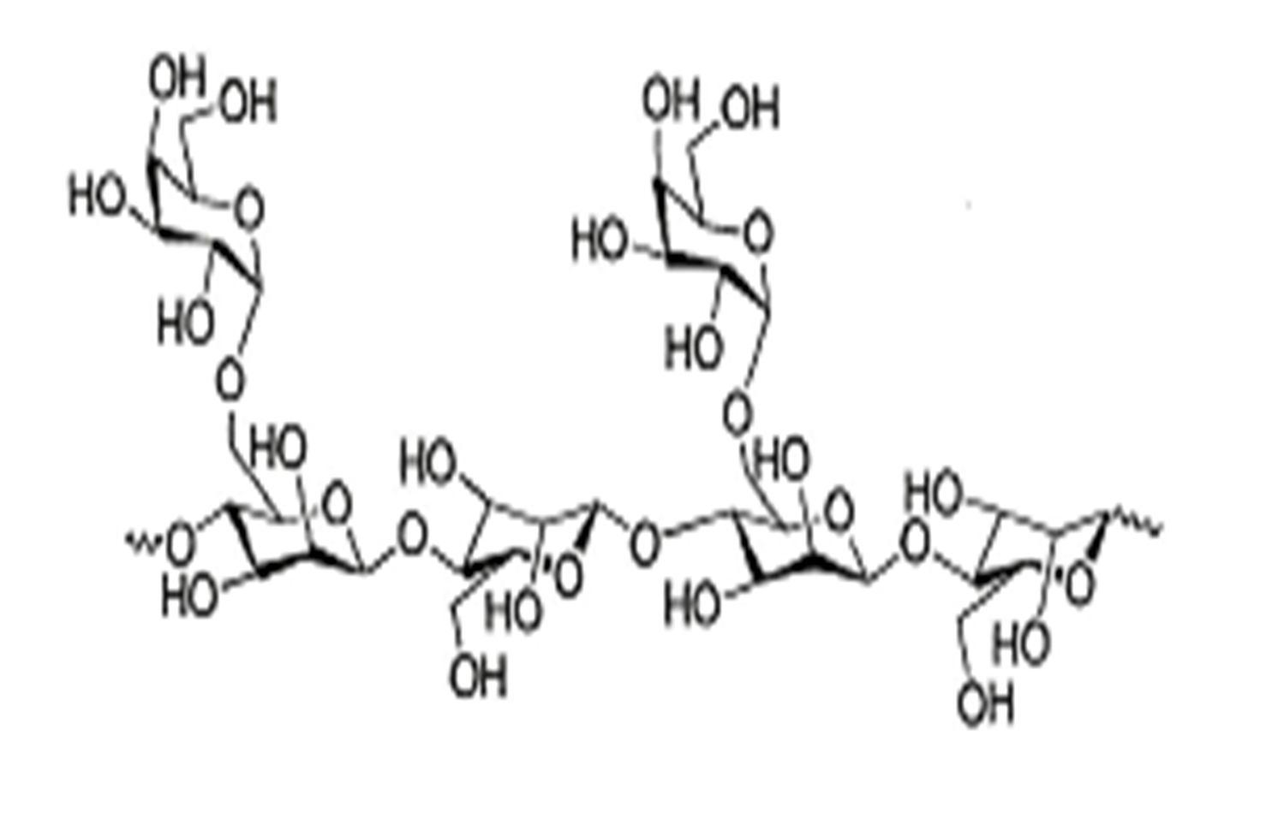
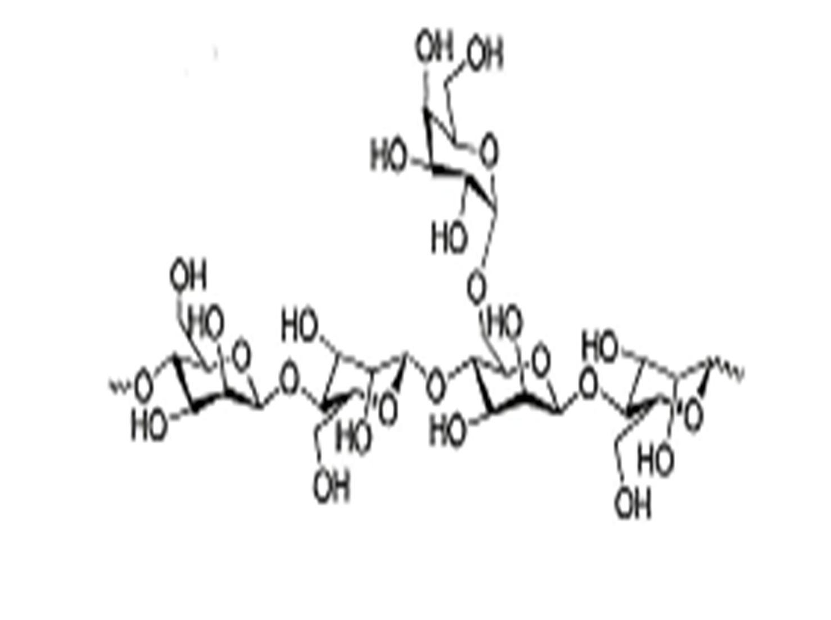
a

b

Figure 2.3: ChemicalStructure of a) Guar Gum, b) LocustBeanGum (Beneke, 2009)

Table 2.2:Pharmaceutical Applications ofGums

Common name
Botanical name Family Pharmaceutical application

Albizia gum Albizia zygia Leguminoseae Tablet binder

Cashew gum Anacardium
occidentale
Anacardiaceae Suspending agent

Guar gum Cyamompsis tetraganolobus
Leguminoseae Binder, disintegrant, thickening
agent, sustained release agent

Gum acacia Acacia arabica Leguminoseae Binder, emulsifier, suspending
agent

Gum ghatti Anogeissus latifolia Combretaceae Binder, emulsifier, suspending
agent

Gum tragacanth
Astragalus gummifer
Leguminoseae Suspending and emulsifying
agent, sustaine-drelease agent

Karaya gum Sterculia urens Sterculieaceae Suspending and emulsifying
agent. Sustaine-drelease agent Khaya gum Khayagrandifolia Meliaceae Binding agent

Leucaena
seed gum
Leucaena
leucocephata
- Emulsifier, suspending agent,
disintegrant, binder in tablets

Xanthan gum Xanthomonas
lempestris
- Suspending agent, emulsifier, sustained-release agent

Gellan gum Pseudomonas
elodea
- Disintegrant

Adapted from Janei t al. (2009)

        - The Cashew Tree and its Medicinal and Economic Values

The cashewA, nacardium occidentale(Plate 2.1) is a resilient and fast growing evergreen

tree that can grow to a height of 20 m (60 ft) (Davis, 1999)is. Iat member of the

Anacardiceae family and has been described as a multipurpose tree with great economic importance principally because of the nutritious kernel used extensively in confectionary.
The tree is well adapted to seasonwaelt/dry tropical climaets, and has the capacity to grow and yield satisfactorily on well drained, light textured soils with minimum inputs. Cashew
tree has good adaptability to wide ecological differences (Grundon, 2000; Ezeagu, 2002; Hammedet al., 2008). Nonetheless, a statitcisian has been reported describing cashew tree as the most variable agricultural plant he has worked with, when he noticed otrdeuecsinpgr
up to 40 kg of nuts in ayear and bythe following year the productiongot reduced to zero (Hilton, 1998).
Cashew tere is popular because of its edible nut. The nut or seed 2(P.2la) tise kidney-shaped

and resembles a large bean (Ike and Chukwuji, 2005). It develops below the peduncle or apple and is usually separatferodm the appleduring harvest by a twisting actionEz(eagu,
2002). The nutis roasted and consumed as salted nuts locally where processing is a problem (Hilton, 1998). Adequate processing, however, especially in nations with processing industries, has made cashew nut an international trade commodity upsoepdualasr dessert
nut (Davis, 1999; Grundon, 2000; Mitchell, 2004).

Processing of cashew nut is associated with the emission of a poisonous substance called cashew nut shell liquid (CNSL). This substa,ncoentaining 90 % anacardic acid and 10 % cardol (Davsi , 1999) has been used as brake fluids in automobiles and airplanes, antimicrobials, varnishes, insecticides and electrical insulations (Grundon, 2000; Ezeagu,

2002). The pseud-ofruit or apple of cashew (Plat2e.2) is the swollen red or yellow fleshy peduncle where the nut is attached. It is fibrous but juicy, sweet, pungent and rich in vitamins A and C (Davis, 1999) and has been used in making drinks, wines, pickles, candy and jam as well as in animal feed (Davis, 1999; Grundon, 2000).
Extracts ofleavesfrom cashew tree have been shown to have antifunngtaibl,aacterial and nematicidal activity (Grundon, 200,0w) hile the bark is chewed for sore gums and toothache (Davis, 1999).
Cashew tree has been used as an ornamental and alley tree and greatly employed in afforestation and erosion control schemes in Nigeria (Ezeagu, 2002; Haemt male.,d2008).
The tree exudes a gum that can be used in varnishes or in place of gum Arabi,c1(9D9a9v,is

Lima et al., 2002). This gum presents a great potential for industrialization (Miranda, 2009).

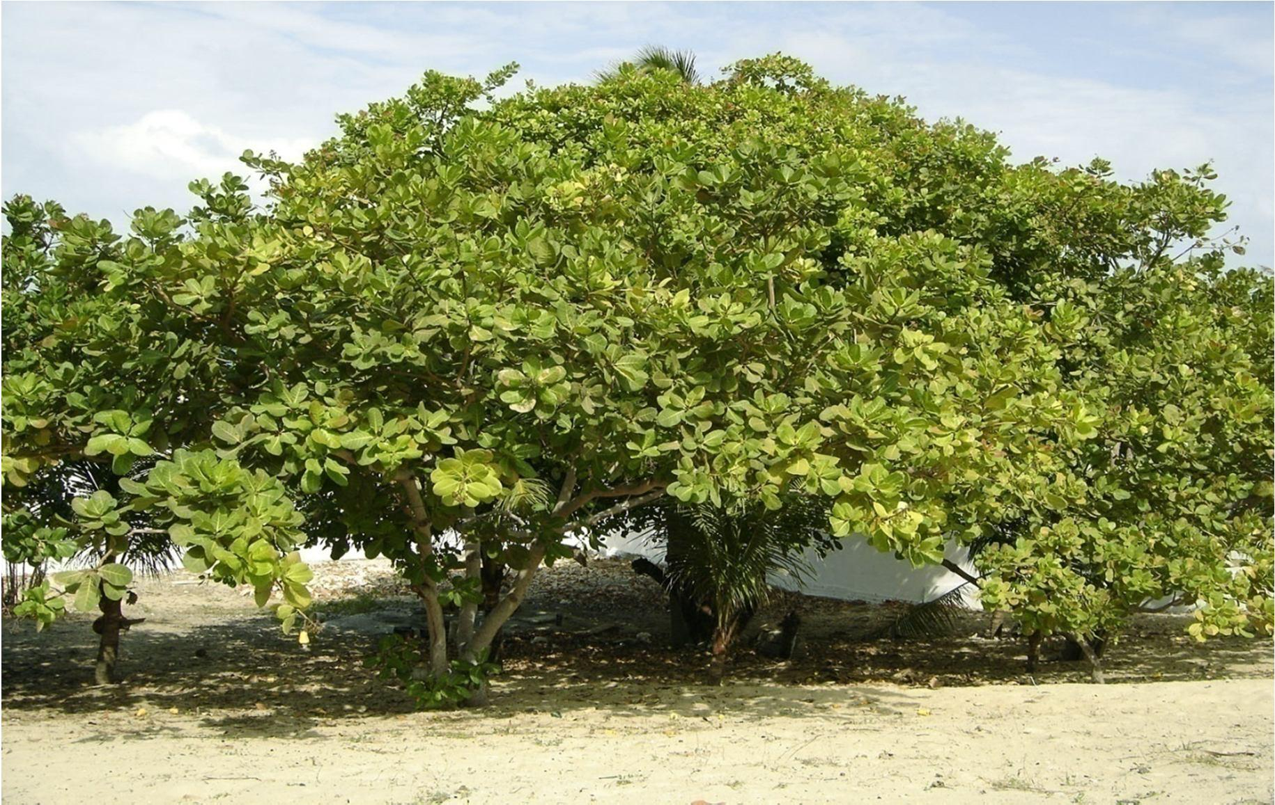

Plate 2.1: Cashew A( nacardium occidentaelL.) Tree

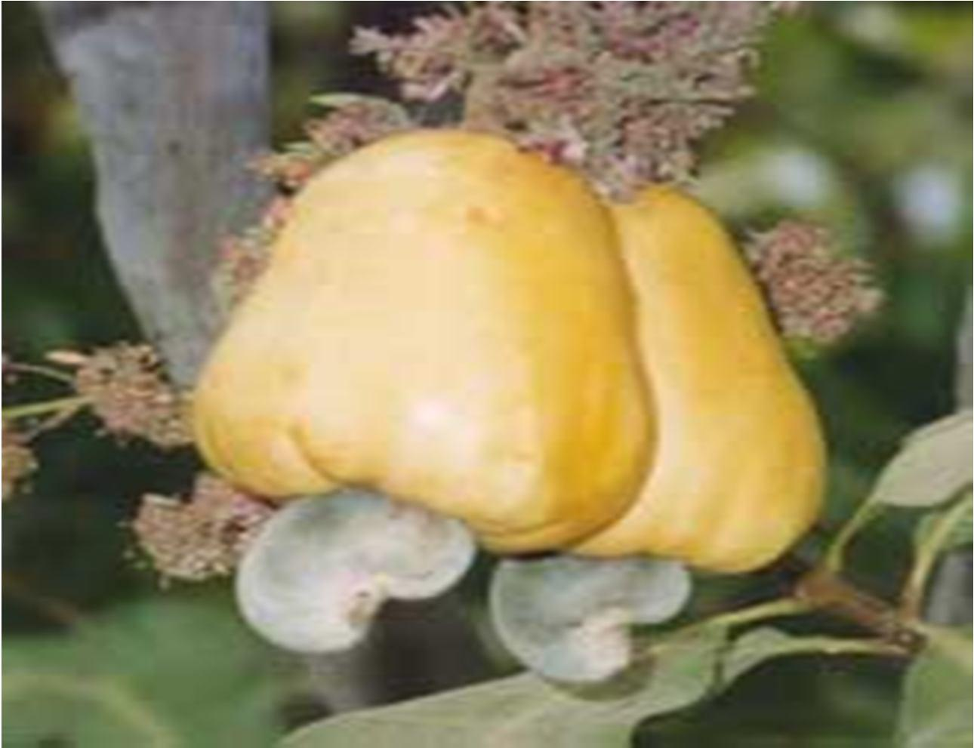

Plate 2.2: Cashew A( nacardium occidentalLe.) nut and peduncle (false fruit)

        - CashewGum and Modes of Collection

A gum from the cashew tree, commonly called cashew gum is the subject of discussion in this work. Its physicochemical properties had been investigated (Marques and-FXilahvoie, r
1991; de Paulaet al., 1998; Mothe and Rao, 1999; Limeat al., 2002; Gyedu-Akoto et al., 2007). A studyof cashew gumfrom Brazil revealed thepresence oaf rabinose, mannose, xylose, rhamnose, galactose and glucose suagfatersr hydrolysis(Paula and Rodrigues, 1995); while Abduslamadet al.(2008) reported identifying glucose, xylose galactose, ribose
and rhamnose sugars in a sample from Nigeria. The differences in composition may be associated with differences in climatic conditions (Liemt aal., 2002).
Collection of cashew gumis achievedthrough two principal method. sOne method is by deliberately making incisions into the stem or branches of the tree and the exudates collected as shown in Plate2.3a. The other method is collection via plucking of the dried gum

generally foundattached to the stem or branches. This method relies on the accidental breakages of tree parts as a result of strong winds or often after illnesses of the tree. Such collections appear nodular in shape as shown in P2.l3abte, and in most cases requsiroeme separation from stem bark and other extraneous matter (Miranda, 2009).

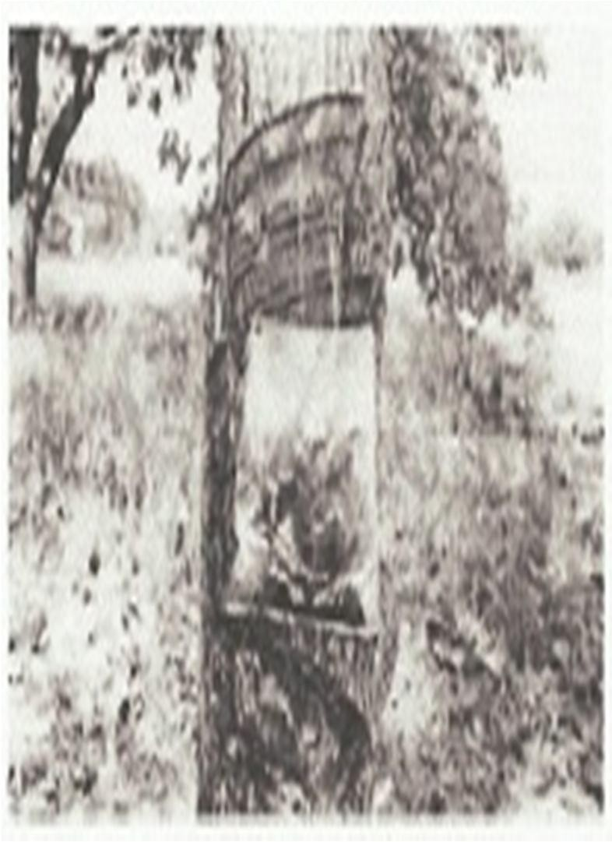
a 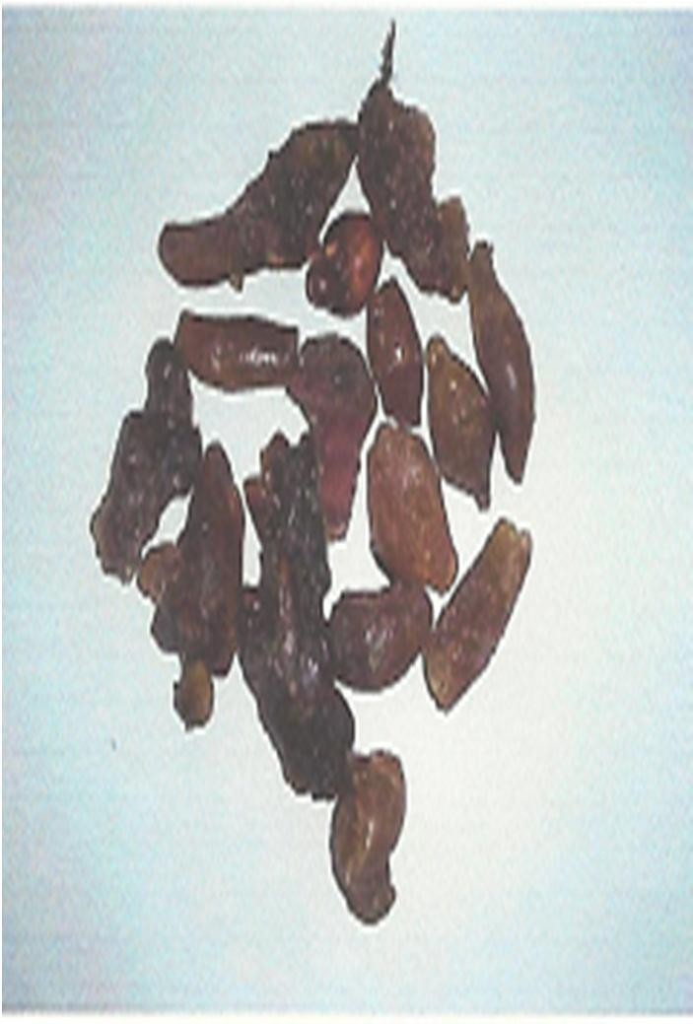b
Plate 2.3: Cashew tree exudates (a) Collection of exudates following deliberate incision,
(b) Dried exudates collected from tree bark (Liemt al., 2002; Miranda2, 009)

        - Relevance ofCashewGum in Pharmacy

CG has been investigated for use as binder in conventional immediate release tablet formulations. Abdulsamadet al. (2008) investigated the binding properties of CG in metronidazole tablet formulations in comparison to acacia gum. The authors reported that the gum at 5 %w/w binder concentration effectively made good tablets of metronidazole. In

a similar study,Ofori-Kwakye et al. (2010) used CG as binder at concentrartaionnge of4 -

8 %w/w to prepare metronidazole tableGtso. wthamarajan(2011) reported that the gum could be used as binder at concentrations as low as 2.5 %w/w to make paracetaemtso. l tabl
In a separatetusdy, Okoyeet al. (2009) concluded that CG at binder concentration range of

1.0 – 3.0 %w/w when used to formulate paracetamol tablets achieved very good release profile and mechanical properties and should thus be exploited as alternative to povidone and gelatin. This, they argude, could reduce cost of tablet production. Okoeyt eal., (2010) submitted that CG belongs to the same “family” as acacia when both gums were used in establishing the relevance of brittle fracture index (BFI) as a tool in the ficlatsiosni , grouping and ranking of some binders used in tablet formulaTtiohne. gum has been combined with other polymers to form drug release matrices, example witehtyrlaetaecd chitosan M( aciel et al., 2006), HPMC and aCrbopol (Garneshet al., 2010).Suspending and emulsifying potentials of CG had been investigaatnedcompared to acacia (Abdulsamaedt
al., 2006b) andxanthan gum (Asantewaat ael., 2011).

From the preceding paragraphs, it can be seen that CG has been and is still receiving attention asa researchable polysaccharide for use in formulation of tablets. However, no report has yet been found on the use of modified CG in tablet formulaAtlitohno.ugh the
gum is a pathologic product, no report has yet been found on the influence of exudation and collection of such exudates on the yield of other commercial products of the tree, like the nut, fruit etc. and no attempt was made in this studyertoifyvthat.

  - Use of Modified polymeric materials in Pharmaceutical Formulations

Structural modifications on gums and other polysaccharides have given rise to derivatives with improved functionality (Hennink and Nostrum, 2002; Rana, 2011). Gumsraglleyne
known to be soluble and commonly used as binders for imme-rdeilaetaese tablets have been modified and used as disintegrants and in some cases to produce controlled drug release as shown in Table 2.3. Development of novel drug delivery systems anedriamlsatfor other biotechnological applications can be achieved and should be pursued through discoveries of newer materials as well as modification of the existing streusctuorf polymeric materials
(Janiet al., 2009).

    - DerivatisationProcesses

Rana et al. (2011) opined that gums in their putative forms are required in very high concentrations to successfully function as drug release modifiers in dosage forms. Polymers whose structures have not been modified are generally of limited use in edlrivuegryd, especially when drug releamseodificationis desired. But, the simplest and most widely used method of effecting changes in the drug release profile of polymers is said to be by
formation of cros-slinked hydrophilic networks (Branno-Pneppas, 1994M; ukesh et al.,

2000).

Derivatisation is the process of imparting changes in the structure of existing molecules usuallyachieved using methods like addition of functional groups as in carboxymethylation or via cros-slinking strands of polymeric materialTs.he main essence of derivatisation is to enhance suitability or promote functionality of an existing polymeric material.

Table 2.3:Pharmaceutical Applications of Modified Gums

Gum | Modification technique |  |  | Application
Karaya gum | Heat treatment in hoatir oven |  |  | Disintegrant
Agar and Guar gum | Heat treatment with c-ogrinding materials | of | both | Disintegrant

Tragacanth Chemical modification using epichlorohydrin Disintegrant

Acacia gum Chemical modification using epichlorohydrin Disintegrant

Guar gum Chemical modification of guar gum Disintegrating agent

Sesbania gum Chemical modification using tartaric acid Sustaine-drelease
formulation

Chemical modification using acetone:chloroform mixture
Gelling agent

Guar gum Chemical modification using glutaraldehyde Colonic delivery

Chemical modification using isopropanol Film coating
hydrogel

Adapted from Janei t al. (2009)

Derivatisation in gums, as in other polymeric materials, is gaining popularity in recent times targeting the modification of these materials to better their performances in advanced drug delivery E( nel andMcclure, 2004;Rane and Kale, 2009; Viraelt al., 2010). Polymer modification is required to imparst pecific properties to the modified material, such as enhanced thermal stability, multiphase physical responses, compatibility, impact response, flexibility and rigidity (Bhattacharya and Ray, 2009).
Derivatives or modified forms are semisythetic products obtained following some changes effected on the structure of an existing biomolecule. Such changes are introduced to address some limitations of the existing biomolecule or impart other desired physeimcoi cahl or biological properties. The resulting derivatized molecule will expectedly have superior
properties over the original moleculBeh. attacharya and Ray (2009) reported thaetret are

predominantly two methods of polymer modificati-ongsrafting and corss-linking, with a less popular third being the reversible physiosorption.

      - Grafting

Grafting is an irreversible covalent attachment process where a functionalized monomer is made to react with the backbone polymer to form the grafted(Bohnaettacharya and Ray, 2009). Grafting of polymers has greatly increased their physicochemical advantages and current demands in biomedical field, for instance cyclodextrins (CDs) had been grafted to make novel designs in many biomedical applications (aMeist ral., 2009).Sandet al. (2010) reportedgraft copolymerization of -2acrylamidoglycolic acid on to xanthan gum by free radical polymerization using bromated/thiourea redox pair in an inert atmospThheere.
resulting graft copolymer showed better proipeesrt for swelling, metal ion sorption,

flocculation studies and was thermally more stable than pure xanthan gum. Metisahlr.a

(2008) developed a new green polymeric material of specialty application by grafting polyacrylamide with okra mucilage.
Fellows (2009) suggested that a method of following kinetics of grafting include monitoring of monomer consumption by FTIR, NMR, UV/Vis spectroscopy, calorimetry or use of a microbalance. The author equally proposed soxhlet extraction as way of verifying whether the “grafted” polymer is really grafted and not just entangled. Grafting has been used in the polymerization of xanthan gum as shownSicnheme 2.1 (Ranaet al., 2011). These authors
also reportedgrafting of guar gum with polyacrylamide followed by cr-olisnsking with

glutaraldehyde S(cheme 2.2) and carboxymethylation of gumsSc(heme 2.3). Graft

copolymerization of dextran and polyacrilamide (Krishnamooerthial., 2007) and 2- acrylamidoglycolic aicd on to xanthan gum (Sanedt al., 2010).

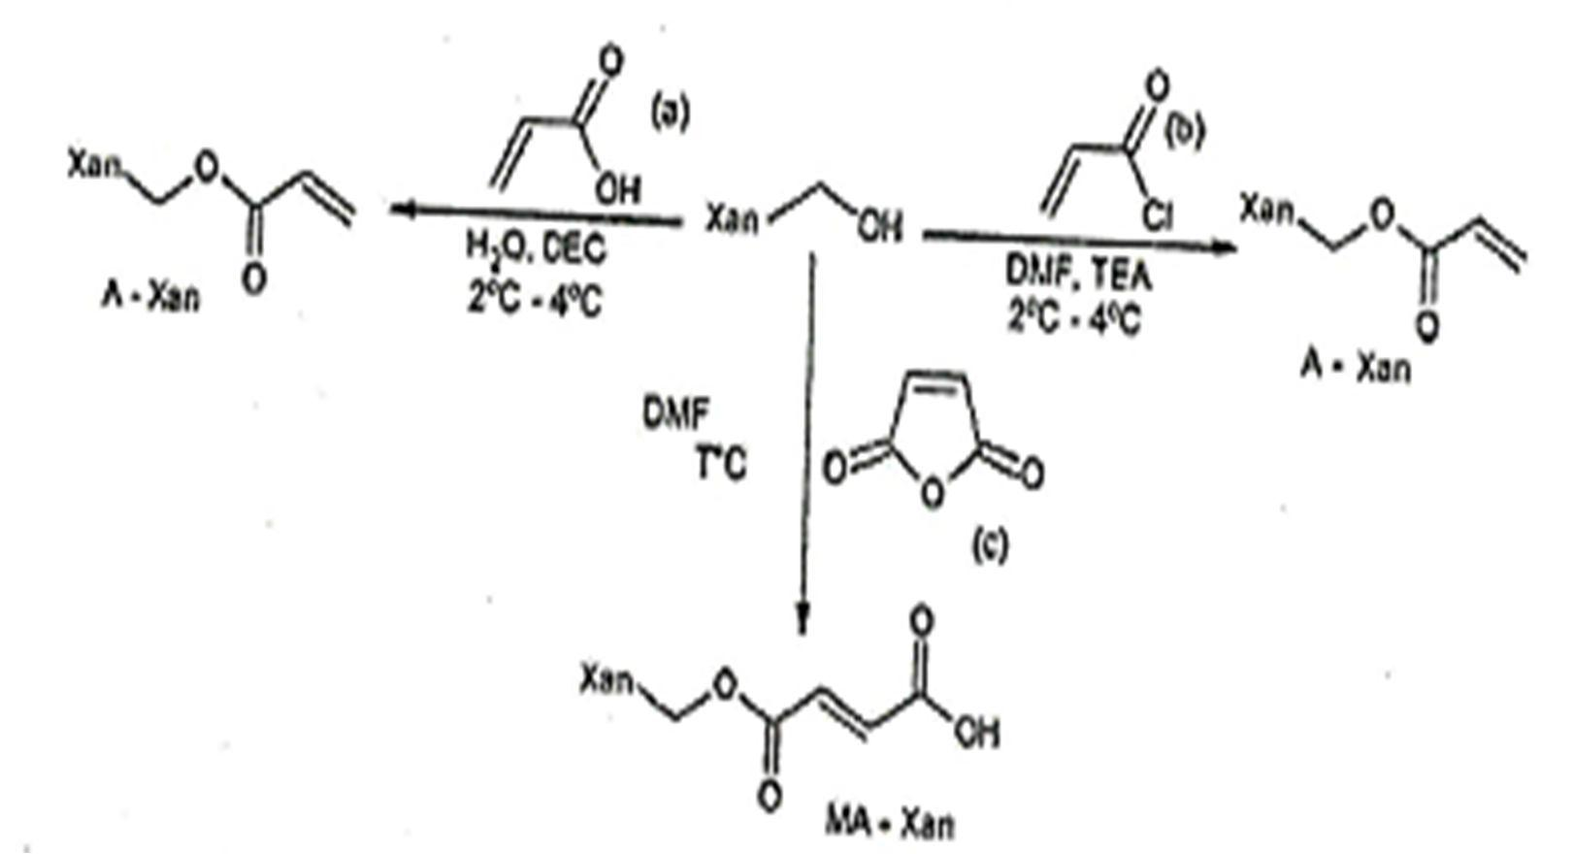

Scheme2.1: Process of Grafting XanthanGum. Key: (a) acrylic acid; (b) Acryloyl chloride;
(c) Maleic anhydride. A-Xan: Xanthan gum,TEA: Trtiehanolamine, DMF: Dimethylformamide, DEC: N-’[3-(dimethylamnopropyl)-]N-ethylcarbodiimide hydrochloride, MA; Maleic anhydride, ACT: Acetone (Raentaal., 2011)

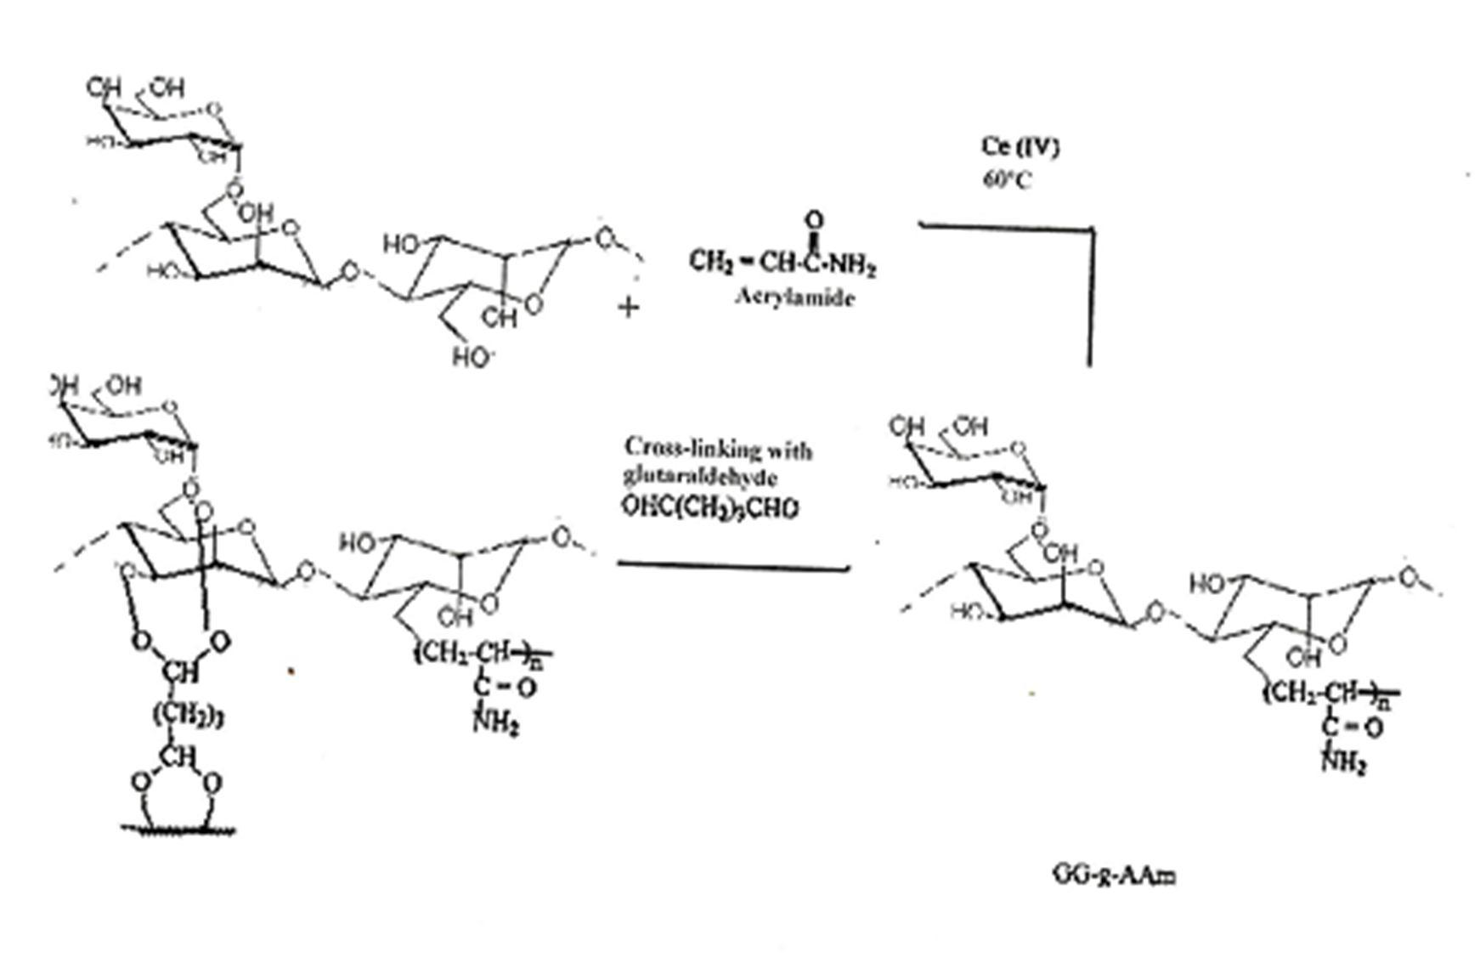

Scheme 2.:2Grafting ofGuar Gum with Polyacylamide (pAAm-g-GG) followed by Cross-linking with Glutaraldehyde(Ranaet al., 2011).

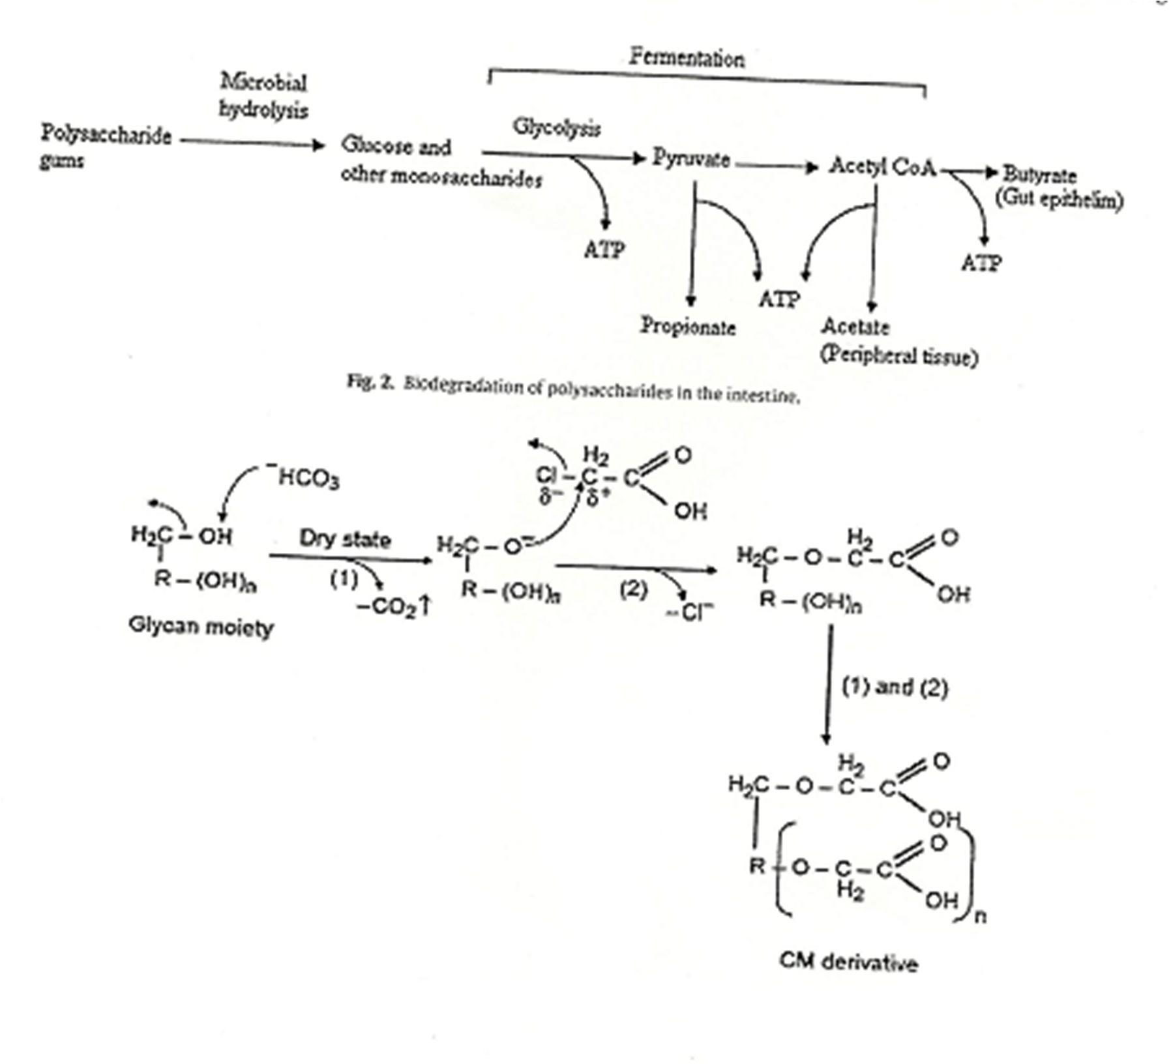

Scheme 2.:3Carboxymethylation of Gums (Ranaet al., 2011)

      - Cross-linking

Cross-linking is used to describe the association of polymers through chemical or physical bond formations. The association could be i-ntorra intermolecular and in most cases is irreversible (Bhattacharya and Ray, 200. 9)Cross-linking has been used to mkea three- dimensional networks of wateinrsoluble polymer,sreferred to ashydrogelsthat areof great pharmaceutical and biomedical relevance (Hoare and Kohane, 2008). Hydrogels are formed either by physical cros-lsinking, generally referred to as s-goel l transition, or by covalent bonding (chemical cro-slsinking) between polymer chains (Misreat al., 2009). Physically
cross-linked hydrogels are obtained by processes li-kbeoHnding, stere-ocomplex formation, hydrophobic and electrostatic interactsi,opnrotein interactions or by physically cro-slisnking amphiphilic block and graft copolymers (Hennink and Nostrum, 2002; Hoare and Kohane, 2008). Formation of hydrogels via chemical cr-olinsksing is achievable through radical polymerization, chemical reaction ocof mplimentary groups, by high energy irradiation or
by enzyme action (Hennink and Nostrum, 2002). Hydrogels being products o-flinckroinsgs

are insoluble in water but capable of imbibing large amountsaotef rw, a process that make them swell (Peppaset al., 2000; Hennink and Nostrum, 2002, Hoare and Kohane, 2008; Misra et al., 2009). While the kinetics of grafting is assessable, that of-clinroksinsg is best monitored using gel fraction as rate of cr-olinssk formation is rarely experimentally assessable(Fellows, 2009).
Cross-linked polymer networks are a group of polymeric materials that are synthesized or sem-i synthesized by joining strands of the polymers through covalent or ionic bond formation, or by simple physical means. They have found relevance in pharmacderugical
delivery courtesy of their ability to swell and had been principally categorized into two by

virtue of their uses i.e. as swellable devices or as disinteg(rOanmtsidian and Par,k2008). These authorsin describing agents and devices in oral drug deeryli,v grouped sodium carboxymethylcellulose, sodium starch golylacte, and cros-lsinked poly(vinyl pyrollidone) as swellable cros-lsinked products used as pseurdisintegrantsw, hereas acrylamide, acrylic acid, salts and esters of acrylic acid including sodiaunmd sulfopropyl acrylates, - 2
hydroxyethyl methacrylate were grouped as another class of-lcinrkoesds materials used as swellable devices in controlling drug release. In genedrearli,vatisation of the natural polymers had availed the pharmaceutical intrdieuss of better performing or multifunctional biomaterials for use in drug delivery (Peppeats,al., 2000; Hennink and Nostrum, 2002; Hoare and Kohane, 2008; Jaent ial., 2009; Ranaet al., 2011).

        - Chemical Cross-linking

Modification by chemical methods involves joining two or more polymer chains via formation of covalent or ionic bonds. Chemicarol scs-linking of polymer chains is achieved with the aid of a cros-slinking agent that has at least two reactive ends capable of chemically attaching to specific functional groups on the cr-olisnsking polymer strands. The cross-linking process eventually insolubilises a water soluble polymer giving a matrix that is highly hydrophilic and completely permeated by water. Aldehydes, ketones, cacrboxyli
acids, sulfonic acids, glutaraldehyde, epichlorohydrin are examples of molecules used as cross-linking agents. Glutaraldehyde has been used to -clrinoksschitosan polymer strands
as shown inScheme 2..4Singh and Vashistha (2008) roertped on the radiaotin-induced polymerization of sterculia gum.

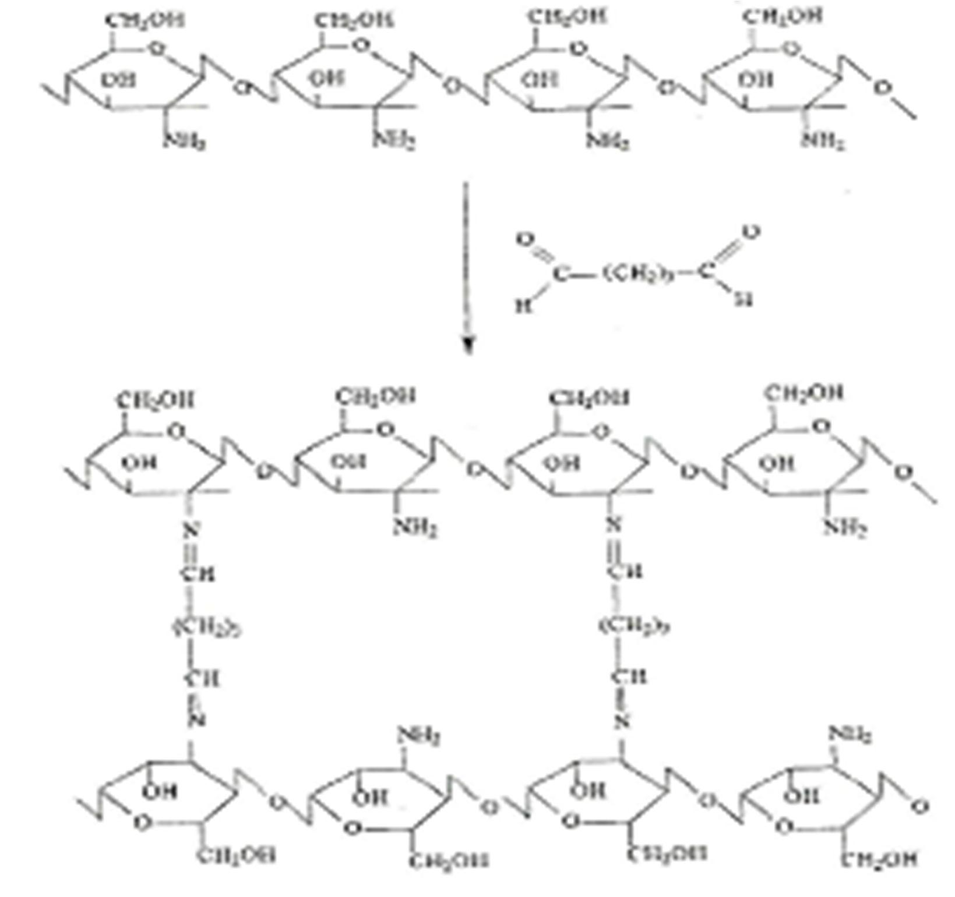

Scheme 2.:4Cross-linking Chitosan usingGlutaraldehyde (Goncalveest al., 2005)

Epichlorohydrin is another powerful cro-lsiksing agent and reports of its being used in polymerization of chitosanS(cheme 2.)5and cashew gum(Scheme 2.)6are in the literature (Goncalveset al., 2005; Silva et al., 2006). Cross-linking by irradiation was reported by Nagasawaet al. (2004) when they synthesized a new biodegradable starch derivative hydrogel by irradiation in higlhy concentrated solutionC. hemical cross-linking of polymers based on poly(-Llactic acid-co-L-aspartic acid)has been reported bEylisseeffet al. (1997),
while cross-linking sucrose polymer by thi-oelne photo-polymerizationreported byOrtiz et al. (2010).
Employing the use of epichlorohydrin as cr-olisnsking agent, Limaet al., (2002) had investigated the potential use of CG as chromatographic matrix anadbaiosaffinity ligand for proteins (lectins). This etherified derivative of CSGch(eme 2.)6with its matrix forming
ability has not been assessed for use in tablet formulations. Epichlorohydrin, though a powerful cros-slinking agent that has found use in ridveatisation processes involving starches, gums and cellulosesot(hL and Philip, 1989; Hamdei t al., 2001; Paradossei t al.,
2009), is nonetheless reported to be a potential toxic and hazardous substance (Solvay Chemicals Inc., 2003; Marteelt al., 2005; Crini and Peindy, 2006; Solvay Chemicals, Inc., 2008).
Safety for use in pharmaceuticals and foods, handling concerns and environmental friendliness precludes the involvement of potential toxins during processing or manufacture
of foods and mediinces. Epichlorohydrin may thus be a poor candidate as -clrinokssing

agent in processing of foods and pharmaceuticals, watirnrganthe search for alternative safer materials for use as cro-lsinsking agents.

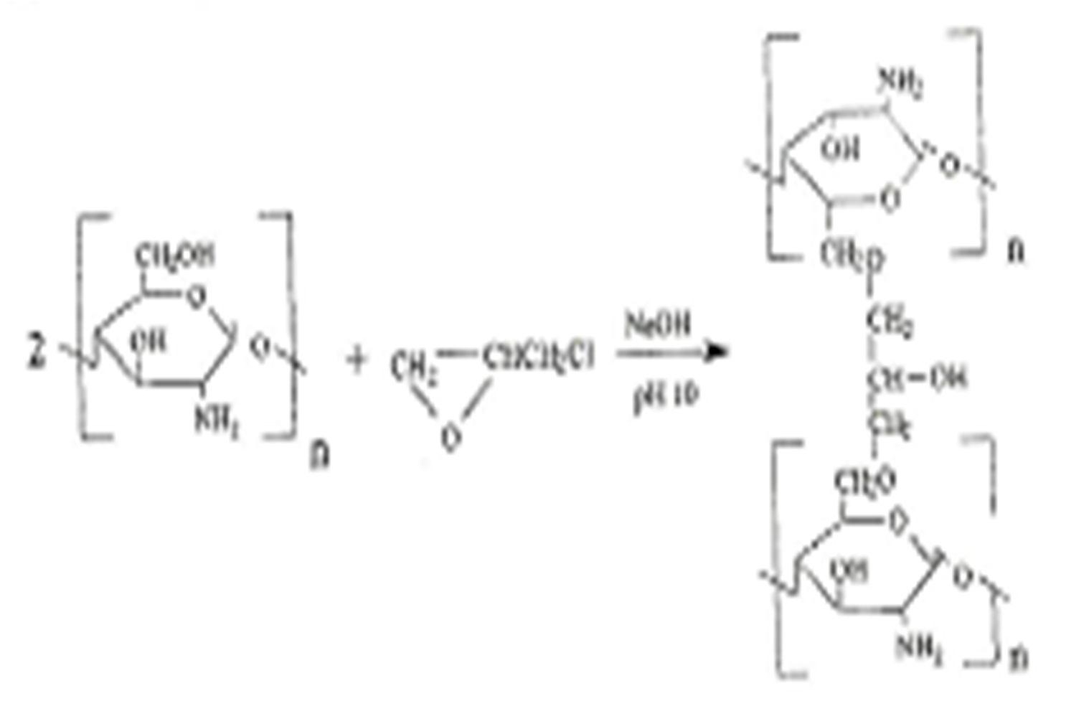

Scheme 2.:5Cross-linking chitosan using epicohrlohydrin (Goncalveset al., 2005)

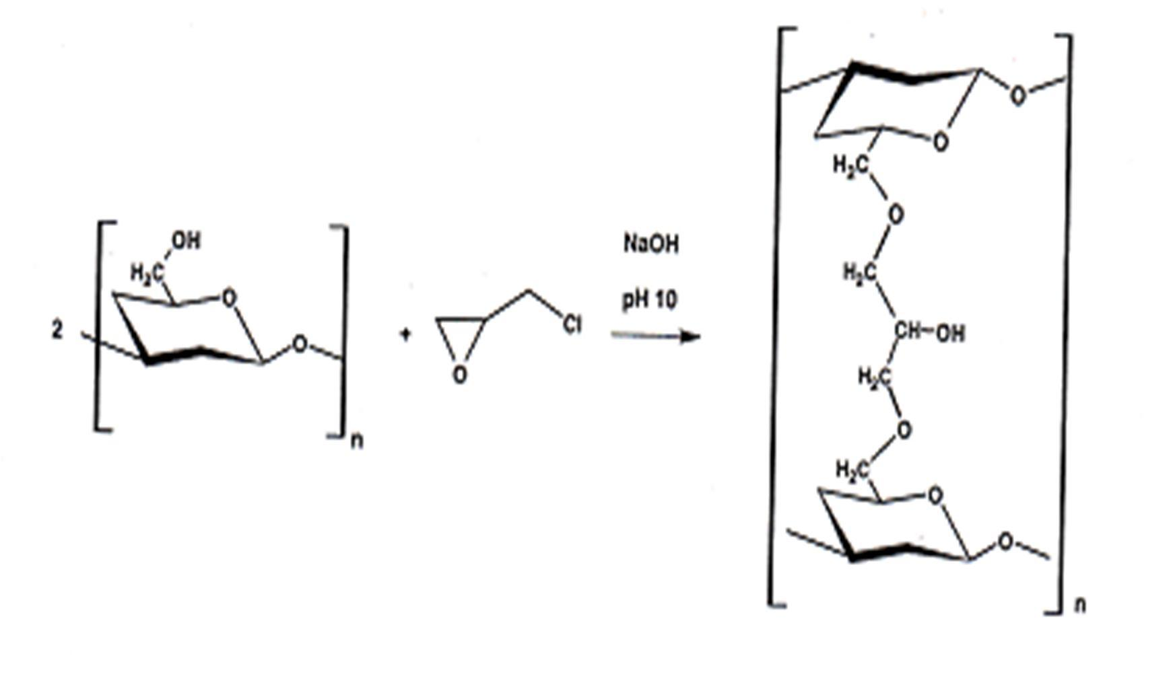

Scheme 2.:6The structure of cashew gum cr-olisnsked with epichlorohydrin (Silva et al., 2006)

Polycarboxylic acids owing to the presence–CofOOH groups in their structures have been

reported to be used incross-linking hydroxyl -(OH) containing starch (Reddy and Yang,

2010) and cyclodextrinsW( elch, 1992; Dukoroy et al., 2007a, Martel et al., 2005,). In a processof esterification, the–COOH and–OH reacting groups are covalently joined to give an ester S( cheme 2.)7. Gums with free alcoholic-O( H) groups seem to be good candidates for modification by cros-slinking (Ranaet al., 2011). Hydrogen bond formation between the
–OH and –COOH molecules of the reacting substances aids -clirnoksisng process

(Brannon-Peppas, 1994, Hennink and Nostrum, 2002) while covalent bonds are principally responsible for holding the polymers together.
Copolymerizationhas generally been utilized to enhance the mechanical properties of hydrogelsfor use inpharmaceutical formulatnios (Peppaset al., 2000). Copolymerisation of
–COOH containing molecules with those carryin–gOH may possibly enhance the polymerization yield and functionality of the polymer.

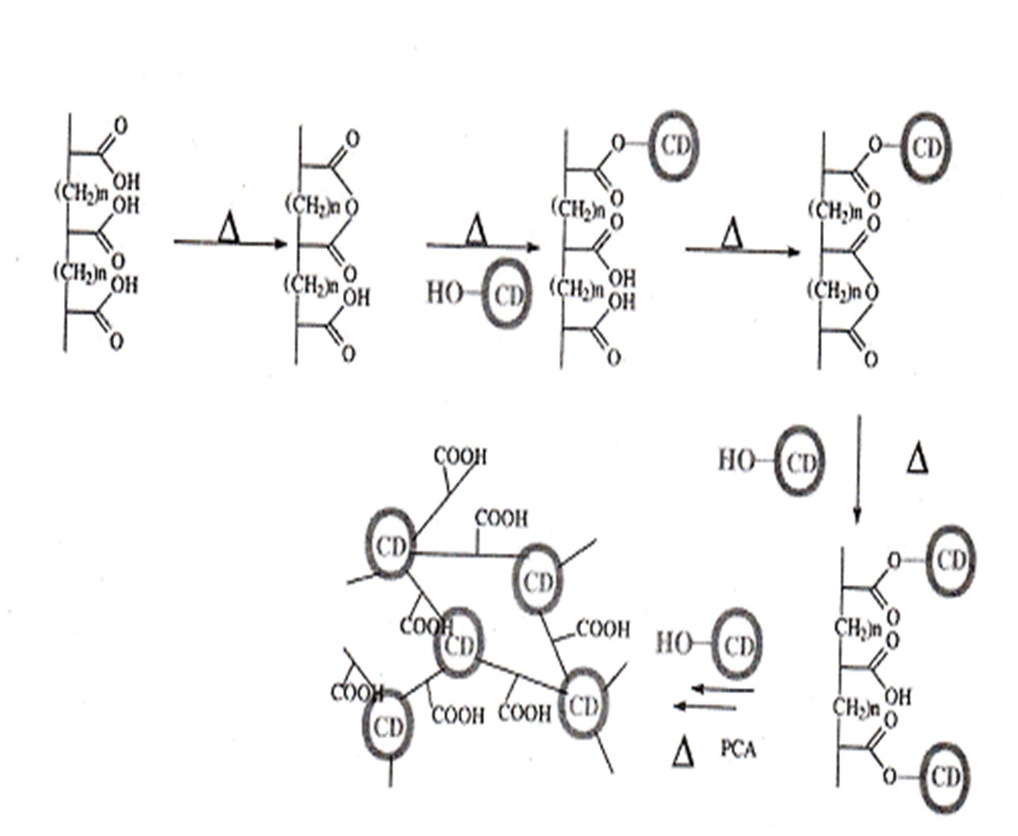

Scheme 2.:7Scheme of cros-lsinking between citric acid and cyocdlextrin (Ducoroyet al., 2007a) Key: CD- Cyclodextrin

CHAPTER THREE

MATERIALS AND METHODS

  - M aterials

xEpichlorohydrin, Succinic acid, Adipic acid, 1,2,-3B,4utanetetracarboxylic acid Dichlorodimethyl silane, DimethylformamidDe,imethylsulphoxide, Ethyl acetate, Toluene, Cyclo hexane, Sulphuric acid, Magnesium Chloride hexahydrate, Magnesium nitrate hexahydrate, (Sig-mAaldrich, USA)

xAcetone UN 1090, Citric acid, Sodium chloride, Potassium chloride, AquTMaline Complete 5, (FishreScientific, USA)

xSodium phosphate monobasic, Methanol UN 1230, (Caledon Laboratories Ltd, Canada)

xEthanol 95%/2-Propanol 5% (Commercial alcohols, Canada) xVenlafaxine HCl (Cadila Health Care Ltd., India)
xHydroxypropyl methycellulose- HPMC LV, HPMC ER(K100) (Dow Chemicals, USA)

xPolyplasdone XL (Crospovidone NF) (ISP Technologies, USA) xCroscamellose Sodium (FMC Biopolymer, USA)
xLactose anhydrous (Kerry Bioscience, USA)

xMicrocrystalline cellulose (MCCPH 102) (FMC Biopolymer, Ireland) xSilicone Dioxide (Evonik Industries, USA)
xMagnesium stearate, (Tycol Healthcare, USA)

xCashew gum was as purified in the laborat(oInrytelliPharmaceutics Inc., Canada)

x CrosCE, CrosCC and CrosCCG were as synthesized in the laboratory (IntelliPharmaceutics IncC., anada)

  - M ethods

    - Collection and Identification

The dried exudate and leaf samples obtained from the cashew trees froemthwehgeur m was

to be collected wereidentified in the Herbarium of the Biological Sciences, Ahmadu Bello University, Zaria; and assigned oVucherNumber 184.The dried latexes from the back of cashew trees were plucked frothme identifiedplantation in Likoro along Zaria- Kano road
in Northern Nigeria.

    - Extraction/Purification of Cashew Gum (CG)

Manually, treebarks and other relatively big particles were picked out of the collected gum. Five hundred (500) grams of the gum was weighed and stirred in 1.5 L of deionised (DI) water contained in a 3 L beaker. The beaker was placed over a boiling water bath (Isotemp. 210, Fisher Scientific, USA) and occasionally stirred until the gum dissolved to give a
viscous solution otherwise referred to “amsucilage” . The mucilage was filtered using

suction through a fine muslin cloth to remoavlel extraneous matter.

About 1.5L of acetone was used to precipitathte gum from the aqueous solution of the

mixture. One (1.0) L portion of the acetone was gradually poured into the beaker containing the mucilage while stirring to ensure effective distribution of the acetone in theagmeu.cIinl
a process ocf oacervatio,nthe gum began to get separated from the water, becoming more solid on further additions of acetone. Stirring was continued even after the last part of the 1 L acetone has been added. The w-aatecretone solution was thenecdanted and the remaining
500 ml acetone was poured onto tphreecipitated gum to further the extraction and

purification of the gum.The gum was then separated from the acetboynea process of sedimentation and decantatioann,d the wet mass waspread on onn-stick baking trays and dried in an oven (Memmert, Germany) atº4C0for 5 h.
The extraction yield (%) was calculated using the relation: ship

% Yield = ( [ ) 6 5 4 4
[ 5

(2)

Where W₁ is weight of crude gum, W₂ is weight of purified gum

    - Cross-Linking o f CG

      - Cross-linking of CG using Epichlorohydrin (EPC)

Epichlorohydrin was used as cro-lisnsking agent in the cro-slsinking of CG to give a product coded CrosCE(Table 3.1) using a method described by Sielvtaal. (2006) with some modifications.
The gum (100g) was mixed with 120ml of 5 M NaOH solution and 70 ml of deionised (DI) water until a homogenous paste was formed. To this mixture was added 40 ml of epichlorohydrin and further kneaded for homogenizatione. Thohmogenized mixture was transferred into a culture dish and heated in an oven (Memmert, Germany) firsºtCafto4r0
24 h followed by a second heating time of 15 h atºC7.0The oven was placed in a fume hood (Mott. Manufacturing Ltd., Canada). DI watearswpoured on the resulting gel that was clung to the dish, to soak it and giet tseparated from the dish. The gel was placed on a fine muslin cloth lining a mesh and washed with DI water. The gel was washed by passing DI water until the dark colouarssociated with the washings ceased to appear. The gel was then

soaked in DI water for 24 h and rinsed thoroughly with more DI water and thereafter dried in an oven (Memmert, Germany) at º4C0 for 5 h.
Cross-link yield (%) was calculated using the follonwgi relationship:

% Yield = (3)

Where Mgel is mass of cro-slinsked polymer, Mgum is mass of gum used

Table 3.1: Formula for Cross-linking CG using EPC Ingredients Quantity

CG 100 g

5 M NaOH 120 ml

De-ionised (DI) water 70 ml

Epichlorohydrin 40 ml

      - Cross-linking of CG using Polycarboxylic Acids (PCAs) Types of PCAsused for the cros-lsinking
        - Di-Carboxylic acids, Adipic acid (ADAa) nd Succinic acid (SCA)

ADA - 

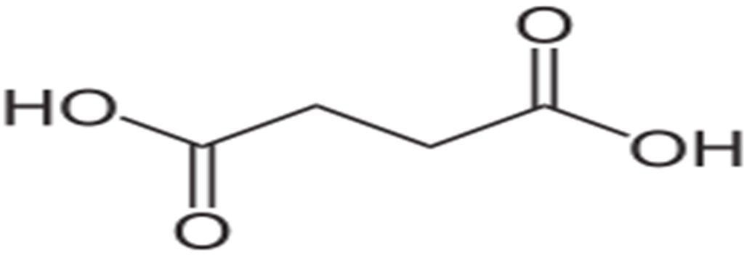
SCA -

        - Tri-Carboxylic acid, Citric acid (CTR)


        - Tetra-Carboxylic acid, 1,2,3,-4Butanetetracarboxylic acid (BTCA)
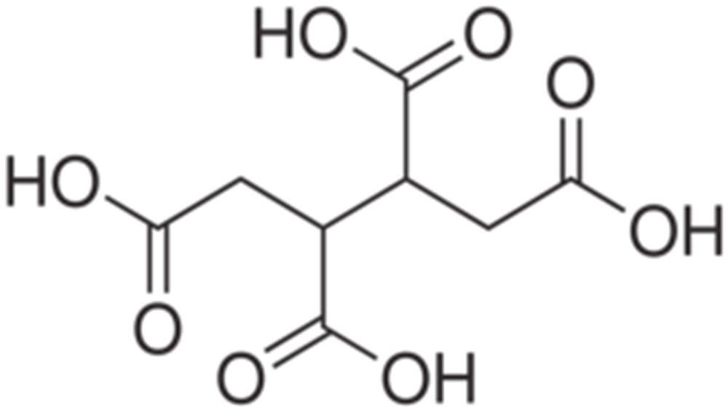

The methods described foprolymerization of cyclodextrins by Marteelt al., (2005), Ducoroyet al. (2007a), Ducoroyet al., (2007b), Zhaoet al., (2009a), Zhaoet al., (2009b) where varying proportions of cyclodextrins (a polysaccharide) and polycarboxylic acids (cross-linking agents) were employedw, ere used with some modifications to crosslink cashew gum, another polysaccharide.

An appropriate quantity of the gum to make 10 %w/vxtumrie (Ducoroyet al., 2007a) in DI water was weighed into baeaker.Polycarboxylic acid a(dipic acid,succinic acid,citric acid
or 1,2,3,4-Butanetetracarboxylic acid) ansdodium dihydrogen phosphate (serving as catalyst) were weighed and mixed with thuemgas shown in Table 3.2A.bout 100 ml ofDI water was added into the beakwerh,ile beingstirred and the total volume made to 200 ml with more DI water. The mixture was stirred over boiling water bath until homogenous.

Table 3.2: Formulae for Cros-slinking CG using PCAs(ADA, SCA, CTR orBTCA)

 | Batch 1 | Batch 2 | Batch 3
Ingredient | CG:PCA (1:1) | CG:PCA (2:1) | CG:PCA (1:2)
CG (g) | 20 | 20 | 20
PCA (g) | 20 | 10 | 40
NaH₂PO₄ (g) | 2 | 2 | 2
DI water to (ml) | 200 | 200 | 200

The homogenous mixture was transferred into a culture dish and concentrated by heating at 40 ºC for 18 h. The resulting solid mass was then heated aºtC14fo0r 30 min for the cros-s
linking process to take place (Marteetl al., 2005). The material was thereafter allowed to cool and some quantity of DI water was poured on to the polymer, now clung to the plate,

which made the latter to swell and separate from the plate. The now fibrous looking material was transferred onto a me, slihned with fine muslin cloth, and thoroughly percolated with DI water. The material was soaked in DI water for 24 h and further rinsed with more DI water before the water was drained off and the polymer spread on-astinckonbaking tray and
dried at 40ºC for 5 h. The polymer was milled using a coffee bean mBiolld(um^{(R)}, China) and packed in a moisture free container.
Cross-link yield was calculaetd using the following relatiosnhip:

% Yield = ( ^{Ð} ^{5?} ^{Ð})⁶
Ð 5

1T00 (4)

Where W₁ is the sum of the ewights of the CG, PCA and sodium dihydrogen phosphate
W₂ is the weight of the cro-slsinked polymer

      - Cross-linking CG using CTR and/or glycerol (GLY)

Appropriate quantities of CG, CT,RGLY and NaH₂PO₄ as coded for convenienceTa( ble

3.3) were weighed and mixed with some DI water contained in a beaker. The mixture was rendered homogenous by stirring over a boiling water bath and thereafter made to volume with more DI water. The homogenous mixture was transferred into a culture dish and concentrated by heating at 4ºC0 for 18 h. The solid mass was heated at 140 orºC17fo0r 30
min for the cros-linking process to take place, and thereaDftIerwater was poured on to the polymer, now clung to the plate, which upon soakwinitgh sufficient DI water, swelled and
got separated from the platTeh. e now fibrous looking material was transferred onto a mesh, lined with fine muslin cloth, and percolated with DI water.

The material was soaked in DI water for 24 h and thereafter rinsed with more DI water before the DI water was strained off and the polymer spread on-satinckonbaking tray and dried at 40ºC for 5 h. The polymer was milled using a coffee bean mBiolld(um^{(R)}, China)
and packed in a moisture free contar.inTehe yield was determined usinegquation (4).

Table 3.3: Formulae for Cros-slinking CG using CTR and or GLY

Ingredient | CG:CTR | CG:GLY | CG:CTR:GLY
 | (CrosCC) |  | (CrosCCG)
Ratio (g) | 1:1 | 1:1 | 1:1:1 1:1:2 | 2:2:1
CG (g) | 20 | 20 | 20 20 | 20
CTR (g) | 20 | - | 20 20 | 20
GLY (g) | - | 20 | 20 40 | 10
NaH₂PO₄ (g) | 2 | 2 | 2 2 | 2
DI water (ml) to | 200 | 200 | 200 200 | 200

    - Residual Solvent Analysis by Gas Chromatography (GC)

CG was extracted using the following three extraction solvents,: ac(1e)tone;(2), acetone followed by washing with DI wate(rto rid the gum of acetonea);nd (3), ethanol (95%) + -2
propanol (5%). Five hundred (500) mg samples of CG obtained by the respective methods were weighed and used in the determination of residual solvent guassincghromatograph (Agilent 6850 Sreies System, USA). Acetone andtheanol (95%)/2-propanol (5%) were used
as reference solvents for the test.

    - Thermal Analysis using Differential Scanning Calorimetry (DSC)

Heat flux DSC (NETZSCH-Geratebau, Germany) was used to study the degradation temperatures of crude, processed and c-rloinsksed CG. Crude CG is a sample of the gum as obtained from the plantation. Processed CG is the gum after extraction with acetone while the cros-slinked CG is the polymer obtained after the c-rloinsksing processes withthe polycarboxylic acids. About 10 mg samples of the respective polymers were encapsulated in aluminium disposable pans. DSC scans were run to measure the energy changes associated with heating the samples to 5º0C0 at a scan rate of 1º0C/min usingnitrogen as purge gas.
The thermogram obtained was usedastocertainwhether the usefoacetone for extraction affectedthe integrity of the gum. This was done by overlaying the two thermograms to compare the degradation temperatures of the carund the processed CG as reflected on their respective thermograms. DSC was also used to obtain valuable information on the cross-link formation between CG and the PCAs. Thermograms of the-clinroksesd polymers
were laid over those of the uncr-olisnsked CGand observed differences were noted.

Compatibility status of CG or its cro-slisnked derivativesas excipients and Ve. nHCl as active pharmaceutical ingredient (API) waasssessed by the following procedure. About 10 mg samples of Ve.nHCl and a thoroughyl triturated 50/50 physical mixture opfowders of CG or its cros-slinked polymers on the one hand and V.enHCl on the other, were respectively encapsulated and the DmSCeasurementstaken as mentioned earlier. These thermograms were used to determine thme pcaotibility or otherwise of Ve.nHCl with the polymers as excipients.

In all the cases, appearance or disappearance of peak(s) in the overlaid thermograms would suggest the formation of new bonds/structures (Saunders, 2008).

    - Fourier Transform Infra Red Studies (FT-IR)

Fourier transform IR (F-TIR) spectra of CG and its cro-slisnked derivativeswere obtained using JASCO IR spectrophotometer (model 4200, Jasco Inc. Japanp)o. wTdheredsamples were mixed withpotassium bromide (KB,r)compressed intopelletsand analysedbetween
400 and 4000 cm⁻¹. The spectrum of CG was compared with other spectra of CG reported in literature (Silvaet al., 2006; Chunhaet al.,2007) foridentification purposesH(su, 1997).
The spectra of CG and that of the cr-olinssked CG (CrosCC and CrosCC)Gwere respectively overlaid to reveal the presence or absence of IR absorption bands representative of respective functional groups of interest. Appearance, disappearance or broadening of absorption band(s) on the spectra of thoessc-rlinked polymers in comparison with the spectrum of CG was used to asstehsescros-slinking of CG (Hsu, 1997; Coates, 2000).

    - Determination of Solubility of the Polymers

The method of evaluating solubility as described by NICEATM (2003) was followed with some modifications. Samples of CG, CrosCC and CrosCCG weighing 20e0acmhgwere respectively dispersed in 10 ml of each of the solvents contained in tes(tTtaubeles34. ). At
ambient temperaturehet tubes were shaken using vortex mixer (Touch mixer model 231,

Fisher Scientific, USA) for 2 min, sonicatefodr 5 min, using sonicator (Model FS220, Fisher scientific, Mexico)a, llowed to stand for 10 min and observed for thielityabof the powders to go into solution.

Table 3.4: Solvents used foSrolubility Determination Class of solvent Solvent
Non-polar Diethyl ether, cyclohexane, toluene

Polar aprotic Ethyl acetate, dimethylformamide (DMF), dimethyl sulfoxide (DMSO)
Polar protic Isopropanol, ethanol, water

    - Solid State¹³C Nuclear Magnetic Resonance (S¹S³C NMR)

The solid state¹³C MAS NMR experimentson CrosCCGwere performed on a Bruker AVANCE, 400 spectrometer, equipped with a magic a-nsgplienning (MAS) inclined at
57.4º. The sample (about 5 mg) was spun at 8.0 kHz in a 4.0 mm outer diameter zirconia ceramic rotor spinner. The proton decoupling was applied. The recycle delay time was set to

5 ms. ¹³C chemical shifts were referenced
toetramethylsilane T(MS) using solid

adamantine as a secondary standard.

    - Moisture Loss on Drying

A weighing balance (AT 261 DeltaRange®,eMttler Toledo, Switzerland) was used to weigh

2 g samples (W₁) of powders of CG, CrosCC and CrosCCG respectively into threed tarre evaporating dishes. The dishes with covers were earlier conditioned by heatingºCatfo1r05
30 min after which they were cooled in a desiccator for 30 min. The samples were heated at 105 ºC for 2 h, cooled in a desiccator for 30 meinachand weighed. Teh samples were heated again for two more periods of 30 meainch, cooled and weighed (₂W). Three(3) h of

total drying timebroughtthe sampleto constant weight adnthe drying was thereby stopped. The moisture loss on drying (MLD) was determined usingfotlhloewing relationship

% MLD = ( Ð 5? Ð) 6
Ð 5
5 4 4
(5)

Where W₁ and W₂ are weights of powders before and after drying respectively

    - Water Content Determination Using Karl Fisher Titrimetry

Karl Fisher titratorhas been described as apnpropriate method of determining water

contents of both solid and liquid samplePsrz(ybylek, 2010;Shaikhet al., 2012;Tavcaret al., 2012). Karl Fisher titrator (Mettler Toledo DL3,8Switzerland) was used to determine the percent water content in CGC,rosCC and CrosCCG respectiv,elays described by Przybylek(2010). Two samples weighing 2 g each of CG and its c-lrionsks were spread on
tarred sample dishes and stored (1) over activated silica gel and (2) over water for a period

of 7 days, respectivelyA. third 2 g sample was weighed out directly from the container of

the powders kept at ambient temperature and humidity. Quantities weighing 150 mg of powders from the three samples were tested for percent water content. Karl Fisher volumetric reagent, AqaulineTM Complete5 andanhydrous methanol were used for the tests.

    - Residue onI gnition/Sulphated ash

The residue on ignition was determineads described in the USP (USP, 201T1h).ree porcelain crucibles and their covers, placed side by side,cwoenrdeitioned by ignition at 600
± 50 ºC in a 48000 Barnstead/thermolyne furnace (Clarkson Laboratory & Supply Inc., USA) for 30 min. With the aid of tongs, the crucibles were covered, removed and placed

inside a desiccator containing activated silica ger l 3f0o min to cool. After cooling, the

crucibles with the covers were weighed using a balance (AT 261 Delta®RaMnegtetler Toledo, Switzerland). Using the same balance, 1 g quantities of CG were weighed and placed respectively into the crucibles and the wtesigohf the crucibles with the material were
again noted. From inside a fume hood, about 1 ml of concentrated sulphuric acid was used to wet the sample. The crucibles containing the samples were then placed inside the furnace, the covers removed and placeedsibde them and heated gently with the furnace lid slide open. The furnace temperature was gradually increased until the evolution of white fumes ceased. The sample was then ignited by closing the furnace lid and setting the furnace temperature to 600 5±0 ºC. The contents of the crucible were checked after every 30 min to observe whether the material is charred. After 2 h of ignition, the sabmepclaemetotally
charred and so the crucibles were covered, removed and allowed to cool in a desiccator for 30 min and then weighed. Concentrated sulphuric acid was used to wet the ash and the process of heating and igniting was repeated for two more times. This procedure was repeated to determine the residue on ignition for CrosCC and CrosCCG respectively.

    - Determination of Moisture Sorption/Desorption over SaturatedSalt Solutions

Saturated salt solutions omfagnesium chloridem, agnesium nitratep, otassium chloride and sodium chloride were prepared as in Table5 t3o. provide controlled changes in relative humidity (Greenspan, 1976; Airaksinen, 2005). This was achieved by changing the type of salt solution aftear 7 day exposure as shownFinigure 3.1. Three sample dishes containing 2
g weights of dried CG, CrosCC and CrosCCG respectively pwrerpeared. An assembly of

sample and saturated salt solution all contained in a desiccator was made such that, the salt

solution is placed at the bottom while the samples contained in tarred dishes were placed on top of the separator plate. The assembly was allowed tod sfotarn7 days during which the dishes containing the powders were brought out and weighed daily, to monitor the mass change as a function of time. Care was taken to avoid over exposure of the material to outside humidity. No attempt was made at controlltihneg temperature and the prevailing temperature was 222±ºC.

Table 3.5: Composition of Saturated Salt Solutions

Salt | Humidity (%) at 25 ºC Salt (g) Water (mL)
Magnesium Chloride | 33 | 200 | 25
Magnesium Nitrate | 53 | 200 | 30
Sodium Chloride | 75 | 200 | 60
PotassiumChloride | 84 | 200 | 80

Culled from Jowitt and Wagstaffe (19)89

First phase (Increasing humidity)

Figure 3.1: Moisture Sorption/Desorption Studies Over Some Selected Saturated Salt Solutions
Desorption
e
Potassium Chlorid (84 % humidity)
(75 % humidity)
Chloride
Sodium
Magnesium Nitrate (53 % humidity)
Magnesium Chloride (33 % humidity)
Salt (humidity %)
Sorption
Description of humidity challenge
Second phase (Decreasing humidity)

    - Swelling Ratio Determination

The siliconisedcylindrical tube model used for the estimation of contact angles in liquid penetration studies (Odidi and Newton, 1993) was employed in determining polymer swelling ratio with some modifications.
The swelling rate and extent of the polymewresre determined using a simply assembled measuring device (Figure 3.2A). cylindrical tube, open on both ends, measuring 12 cm in length with 1.25 cm internal diameter was used for the determinations. A cheaply constructed stopper designed to retain spoalidrticles but allow water to seep through, was used to block the lower end of the tube. The stopper was made of a perforated pen cover, with the narrower end inserted into the cylindrical tube to the point the pen cover is broad enough not to pass throu.gIhnto the hollow portion of the stopper is inserted a spongy material that is impermeable to solids but allow water to seepugth.roThe tube was first siliconisedto limit its adsorption of water by the following meth:od

      - Siliconisation ofCylindrical Tube

The procedure of Noteboom and Will (1982) was adopted with some modifications. Cylindrical glass tubes for swelling ratio determination were washed and siliconised as follows:

        - Washing of the Glassware

Formula for making 1 L of nochromi(xcleaning) solution

Sodium peroxide (3 %v/v) solution 500 ml Conc. sulphuric acid 500 ml

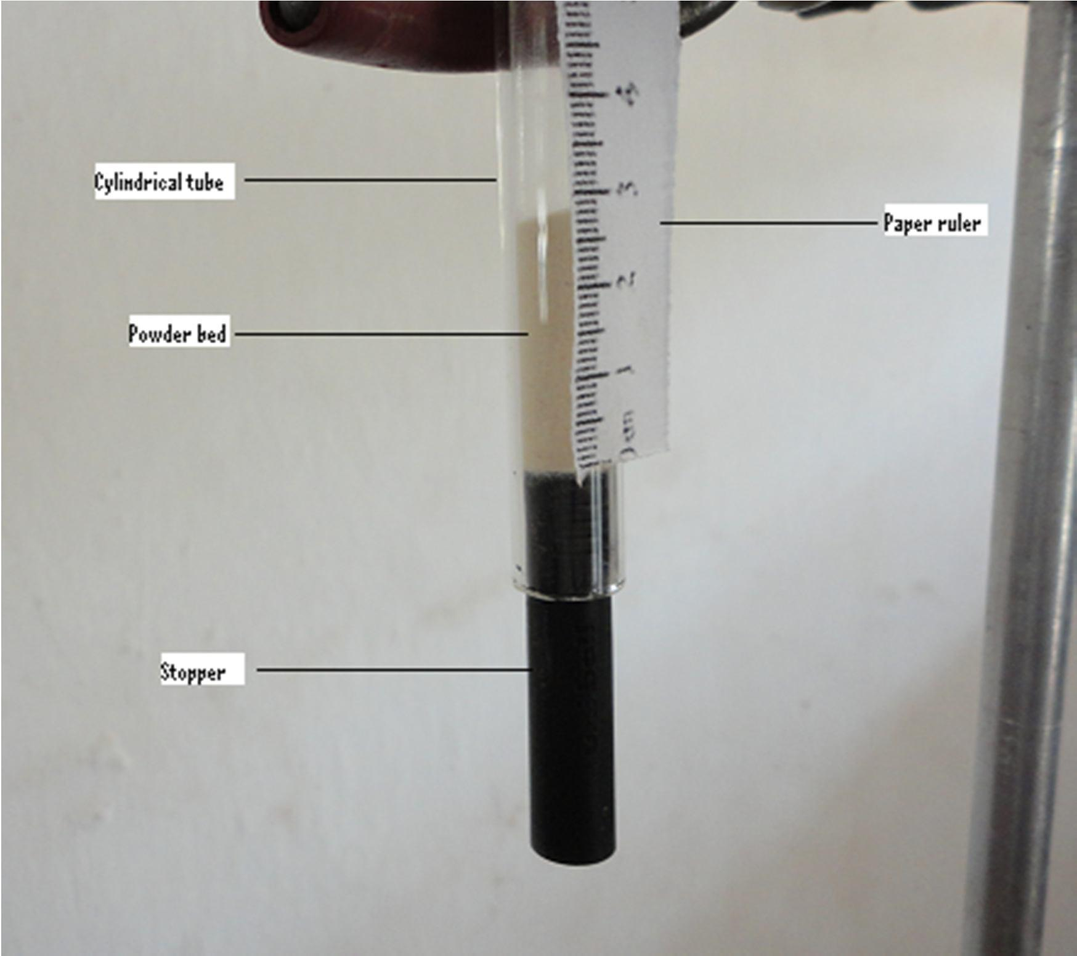

Plate 3.1: Siliconised Cylindrical TubeAssembly forDeterminationof Polymer Swelling Ratio

The cleaning solution was prepared by placing 500 m3l o%f v/v hydrogen peroxide solution into a glass bottle placed in ice water contained in rubber jacket. This was followed by the slow addiotin while swirling of 500 ml of ocnc. sulphuric acid. The solution was allowed to cool completely while surrounded wthiethice water.
The glass tubes were thoroughly washed with water, rinsed with DI water and then completely immersed in the prepared nochromix solution for about 30 min. The tubes

were removed and drained completely by tilting them at an angle of abºoiunt f4u5me hood. They were then rinsed with DI water and thoroughly dried.

        - Siliconisation of the Glassware

Formula for making 100 ml of siliconising solution

Dichlorodimethylsilane 1 ml

Toluene to 100 ml

The cleaned and dried tubes were immersed in the prepared 1 %v/v solution of dichlorodimethylsilane in toluene and their surfaces made to contact with the solution. The tubes were rinsed withliattle quantityof toluene and allowed to air dry in a fume hood. The dried tubes were baked in an oven aºtC8f0or 3 h.

      - Measurement of Swelling Ratio using the Cylindrical Tube

One (1) gram weight of the powdered sample was placed intsoilitchoenisedcylindrical tube with the lower end blocked with the designed stop(Fpiegrure 3.2)and the tube tapped 100 times from a distance of about 2 cm (Odidi and Newton,. 1T9h9e3t)ubewas thereafterclamped to a retort stand and lined witphaaper ruler in mililmeter units using which the powder bed heighwt as determine.dWith the aid of a pipette, 40 ml of DI
water was added into the tube with caution not to disturb the settled powder bed. The height attained ybthe powder bed upon swelling swanoted using a mtier. The swelling
was assessed every 1 mutienfor the first 10 min and thereaftervery 10 min for the next

90 min. The powder bed was made to remain below the water level by adding more DI water. The height attained by the swollen polymer be_{S}d) (inH relation to the original

height of the dry polymer bed (_{D}H) was used to determine the swelling ratTioh.e experiment waserplicatedfive times and the average used to calculate the swelling ratio (SR) using the following relationship:

% 5 =4
Á ?Ì Á½

Á ½
1T00 (6)

    - Water Holding Capacity (WHC)

The method described by Vittadini and Vodovotz (2003) was followed with some modifications. Two (2) g samples of CrosCC and CrosCCG were placed in tarred siliconised 50 ml centrifuge tubes and weighed ₁()W. DI water (30 ml) was added into
the tubes, shaken and allowed to stand for 1 h. The samples were centrifuged (Hanil Science Industrial Co. Ltd., Korea) at 4,500 rpm for 25 min but as the samples were not seen to stetle satisfactorily, the centrifuge speed was changed to 5,0m00anrpd allowed
to run for 25 min. A syringe was used to suck out the liqufriodm the tube. The tubes were thereafter placed in a forc-derdaft air oven (Model 1370 F, VWR Scientific Products, USA) at an angle of 1–520º, allowed to dry at 50ºC for 25 min and then cooled in a desiccator for 3m0in. The tubes with the dried samples were weighe₂d) (W using AT 261 DeltaRang^{(R}e⁾ Balance (Mettler Toledo, SwitzerlandT).he WHC was calculated using equtioan 7:

% 9 *=
%@^{Ð} ^{6?} ^{Ð} ⁵ A1T00 (7)
Ð 6

Where W₁ and W₂ are weights of dry and hydrated samples, respectively.

    - Evaluation of Powder Flow Properties

      - DensityM easurements

Densities of powders of CG, CrosCC and CrosCCG were meaussuirnegd tap density tester USP (Electrolab, Model ET-D1020, Globepharma, U.S.A.), where the bulk and tapped densities as well as compressibility index and Hausner ratio were determingedthuesUinSP
1 method. A weighed quantity of the powder was pouredthinetocylinder, the powder bed noted and the cylinder made to drop at a rate of about 300 drops/min from a height of 14 mm ±2. Threerounds (1, 2, and 3) otaf ps weredesigned to subject the cylinder to 10, 500, and 1250 taps respectively, with each powdeedr hbeight noted and imputed in subsequent tap round. A variation of not more than 2 ml between powder bed hereigahdtisngs marked
the end point for the measureme.ntDensities were determined using the following relationships:

Initial Density = | (W/Vo) | (8)
Tap Density= | (W/Vf) | (9)
Hausner Ratio= | (Vo/Vf) | (10)

Compressibility Index = [(Vo-Vf)/Vo ] x100 (11) Where W is weight of sampl,eVo is Initial Volume and Vf is the Final Volume

      - PowderFlow Rate

Glass funnel held bay retort stand with the tip 10 cm from the surface of the table top was used to measure the flow rate ofwpders of CG and its cro-slisnked derivative.sFifty (50) g sample was poured into the funnel with the opening blocked with a gloved finger. Using a timer, the time taken for the material to pass through the opening upon removal of the block was determinedT. he average of three readings was used to calculate the flow rate.

      - Angle of Repose

The height(h) and the diameter (d) formed by the CG and its c-lrionsksed derivatives

powder heaps in earlier flow measurement were measured and used to calculate the angle of

U H S R V H
equation 1.
R I W K H P D W H U L

      - Determination of Powder Particle Size Distribution

Ro-Tap (Model RX-29, W.S. Tyler, USA) was used for the determination. Tarred sieves

(W₁ Z L W K G L I I H U H Q W V L ] H V Z

W K H Q
- P — P
- P 0 —(paPn)—at tPhe bottoDm. PQowGder I L

weighing 50 g was placed on the topmost sieve and the shaker operated for 10 min. The sieves with the retained powder were weighed₂)(. WThe weight of powder retained on each sieve was calculated using the following relationship
Weight of powder retained = W₂ – W₁ (12)

    - Tablet Formulation Studies

      - Formation of Granules

The Ven. HCl, Lactose DT andthe ingredients used as binder/release retardant/release enhancingagents (Table3.6 to 3.9) were accurately weighed anddry mixed for 6 min using
a low shear mixerK(itchen aid, St. Joseph, Michigan USA) operated at moderate shear rate. Intermittently, the mixer was stopped and the powder laying on its surfaces scrapped back and further mixed with a spatula. DI water, aasngurlating liquid, was added in aliquots of 10
ml to a total quantity just enough to wet mass the powder mix. The damp mass awraesd she

using appropriate spindle run sapteed2 for 6 min to obtain optimum granulation. The damp granule mass was spread on epralpaid on a tray and dried in a forced air oven (Model 1370 F, VWR Scientific Products, USA) for 3 h or when moisture content determined using moisture analyser (Model LJ 16, Mettler Toledo, Switzerland) was lower than 2%. The dried granules were milled ybpassing through a mill (Quadro Comil, Model no. 197 R, Quadro Engineering Inc., Ontario Canada) fitted with a metal screen affixed to the granulator.

Table 3.6: Ven. HCl Tablet Formulae Containing CMC PH 102and/or CG asBinder Ingredients Batch Number/Quantity (%)
 | G1 | G2 | G3 | G4 | G5 | G6
Venlafaxine HCl | 30 | 30 | 30 | 30 | 30 | 30
Lactose DT | 59 | 64 | 59 | 44 | 54 | 34
MCC PH 102 | 10 | - | - | - | 10 | 10
CG | - | 5 | 10 | 25 | 5 | 25
Silicone dioxide | 0.5 | 0.5 | 0.5 | 0.5 | 0.5 | 0.5
Magnesium stearate | 0.5 | 0.5 | 0.5 | 0.5 | 0.5 | 0.5
TOTAL | 100 | 100 | 100 | 100 | 100 | 100

Table 3.7: Ven. HCl Tablet Formulae Containing HPMC or CrosCCGBainsder

Ingredients | Batch | Number/Quantity (%)
 | G7 | G8 | G9 | G10
Venlafaxine HCl | 30 | 30 | 30 | 30
Lactose DT | 64 | 64 | 61.5 | 59
HPMC LV | 5 | - | - | -
HPMC ER | - | 5 | 7.5 | -
CrosCCG | - | - | - | 25
Silicone dioxide | 0.5 | 0.5 | 0.5 | 0.5
Magnesium stearate | 0.5 | 0.5 | 0.5 | 0.5
TOTAL | 100 | 100 | 100 | 100

Table 3.8: Ven. HCl Tablets Formulae Containing HPMC ER 7.5% as Binder and Some Polymers as Release Retardant

Ingredients | Batch | Number/Quantity (%)
Venlafaxine HCl | G11  30 | G12  30 | G13  30
Lactose DT | 51.5 | 46.5 | 36.5
HPMC ER | 7.5 | 7.5 | 7.5
CrosCCG | 10 | 15 | 25
Silicone dioxide | 0.5 | 0.5 | 0.5
Magnesium stearate | 0.5 | 0.5 | 0.5
TOTAL | 100 | 100 | 100

Table 3.9: Ven. HCl Tablet Formulae Containing HPMC ER 7.5% as Binadnedr Some Polymers as Disintegrants at 3% w/w Concentration

Ingredients Batch Number/Quantity (%)

 | G14 | G15 | G16 | G17 | G18
Venlafaxine HCl | 30 | 30 | 30 | 30 | 30
Lactose DT | 61.5 | 61.5 | 61.5 | 61.5 | 61.5
HPMC ER | 7.5 | 7.5 | 7.5 | 7.5 | 7.5
CrosCCG | 3 | - | - | - | -
CrosCC | - | 3 | - | - | -
Croscarmellose | - | - | 3 | - | -
Crospovidone | - | - | - | 3 | -
CG:EPC | - | - | - | - | 3
Silicone dioxide | 0.5 | 0.5 | 0.5 | 0.5 | 0.5
Magnesium stearate | 0.5 | 0.5 | 0.5 | 0.5 | 0.5
TOTAL | 100 | 100 | 100 | 100 | 100

      - Testson Granules

The granule density, size distribution and flow properties were determsininegd mu ethods described earlie(rsee section 3.2.15).

      - Addition of Extragranular Excipients

Weighed quantities of silicone dioxide and magnesium stea(Tratbeles 36. to 3.9) were

added to the granules and blended using the shear mixer and afterwards thoroughly shaken in cellophane bag.Granule flow rates were determined as earlier descr(ibsedction 3.2.15.2.)

      - Compression of Granules

BetapressManesty Machine (No. 74182, Manesty Machines Ltd., England) was oused t

compress the granules (Tables 3.6 to)3u.9sing0.2756in (7mm) punch and die setting and compression pressure of 4.5 metric tonnes to produce a batch of 1,000wtaitbhleatstarget weight of 167mg.

      - Evaluation of Tablet Properties

        - Uniformity of Weight

Twenty (20) tablets were randomly selected and individually weighed using AT 261 DeltaRange balance (Mettler ToledSow, itzerland). The mean weight andeviations from
the mean were calculated.

        - Tablet Crushing Strength

The crushing strength(KgF) of 10 tablets selected at random from each bawtachs determined using VK 200 Tablet Hardness Tester (Vankel, USA). The mean and standard deviations were calculated.

        - Tablet Friability Test

FAB-2 Friability tester (Logan Instruments Corp., USwAa)s used to carry out the friability

test. Twenty (20) tablets from each batch were taken and weighed and then placed on the friabilator, which was then operated for four (4) min at 25 rpm (100 revolutions). The tablets were de-dusted reweighed and theffedri ence in weight was determined using the following relationship:
% Friability = (W₁- W₂ / W₁) 100 (13)

Where W₁ = original weight, W₂ = final weight.

        - Tablet Dissolution Test

Dissolution test was carried out using the padmdelethod on D 800 Dissolution tester (Logan Instruments Corp, .USA) as described in the US(PUSP 2011). The automated tester was set
to analyze the amount of drug released after every 15 min of dissolution time. Paddle speed was 100 rpm as quantities amounngtito 900 ml of DI water were used as dissolution medium, while the temperature was set atº3C7± 0.5 ºC. Drug released was assessetdheat
Ven. HClwavelength of 229 nm.

        - Drug ReleaseData Model Fitting

The drug release data was fittiendto various drug release kinetic models. Zero order, first order, Hixon Crowell and Higuchi kinetic models (Table03) .w1 ere employed in describing the drug-release kinetics whileKorsmeye-rPeppas equation providevdaluable information
on the drug-releasemechanism. The model that best fits the data was taken as the model describing the dru-grelease mechanism for the preparation.

Table 3.10: Drug-release mechanism exponents

Release exponent (n)
Diffusion mechanism

0.45 Fickian diffusion

0.45 < n <0.89 Anomalous (no-nFickian) diffusion

0.89 Case II transport

n > 1 Super case II transport

Adapted from Talukdaer t al.(1996);Shoaibet al. (2006); Dashet al.(2010)

        - The kinetic equations

          - Zero Order Model

Zero order modedl escribes drug release rate that is independent of the concentration of the drug. It is represented by equati1o0n(Kalam et al., 2007) and a ptloof cumulative % drug release sv. time will be linear S( hoaibet al., 2006)

A₀-A_{t} = Kt (14)

Where A₀ is the initial amount of drug in the dosage form_{t}; isA the amount of drug remaining after time “t” and K is the proportionality constant.

          - First Order Model

Drug release rate from dosage forms agreeing with first order model is concentration dependetnand can be depicted by the equation(K11alam et al., 2007) and a plot of log cumulative of percendtrug remainingvs. time will be linear S( hoaibet al., 2006).
Log A_{t} = LogA₀ + K₁t/2.303 (15)

Where A_{t} is the amount of drug released in time “t”₀, iAs the initial amount of drug otrhe amount of drug at zero time, K is the first order rate constant.

          - Hixon-Crowell Model

Hixon-Crowell model is used to evaluate the drug release with changes in the saurerface

and the diameter of the particles/tablets (Kaelatmal., 2007) using the following equation:

A ^{1/3} - A ^{1/3} = K t (16)
0 t s

Where A₀ is the initial amount of drug in the dosage form_{t} ,isAthe remaining amount of drug in the dosage form at time “t” and K is the rate constant for H-Cixronwell rate equation. A plot of cube roootf percentdrug remainingin matrix vs time will be linear.

          - Higuchi Model

This model is used to describeeraesl e ofwater soluble and low solubdlerugsincoperated in sem-i solid and solid matrices (Kalaemt al., 2007)and is given bythe followingequation. A
plot of cumulative percentdrug releasde vs square root of time will give a linear

relationship.

A = Kt^{1/2} (17)

Where A is the amount of drug released at time “t” and K is the Higuchi dissolution constan.t

          - Korsmeyer-Peppas equation

The Korsmeye-rPeppas equation otherwise called the power law equation is used to determine the mechanism of diffousni in polymeric networks. The mechanism is described by the value of “n”obtained from equation81, and used to characterize different release mechanismssagiven in Table 3.10.
A_{t}/A ’= Kt^{n} (18)

Where A_{t}/A ’is fraction of drug released at time t, K is the rate constant and n is the release exponent

        - Uniformity of dosageunit test

The USP method(USP 2011)was used to determine the content unifoyrmuist ing Hewlett Packard dioderaray spectrophotometer. Ten (10) tablets were weighed individually and the

mean weight determined. The tablets were crushed and three samples of approximate weights to the mean tablet weight were assaTyehde. average of threvealues wastaken as
the drug conten. tTen (10) tablets were weighed individually and the weights were used to determine the uniformity of the dosage units proportionaatceclyording tothe USP metho.d

    - Sub-Acute Toxicity Studies

The method described by Tametat al. (2009 was adopted withsome modifications. The experiment was designed and the animals were treated in ancceorwdiath the Committee for the Purpose of Control and Supervision on Experiments onAnimals (CPCSEA) 1986 Animal Guidelines. The animals (Wistarats) were grouped intofour with each group
having 6 animals. Subgroups of 3 males and 3 females were made on each group. The animals were conditioned as per the environment, mode of feeding and water supply.
CrosCCG was not soluble and so could not be made into solutionsalfoorr oinrtraperitonial (IP) administrations and this precludes the conduction of acute toxicity studie-sa.cuStueb
toxicity studies were thus carried to ascertain the safety or otherwise of the poGlyrmouepr.

- was made to serve as control while groups a2n,d34 were fed 2.5, 5.0 and 10.0 grams of CrosCCG per 1 Kg feed ovear28 day period, respectively. The polymwear s added in its
solid state into the feed mix prior to being molded. The same mold formula as per respective groups was sued to feed the animlsathroughout the 28 day period of treatment. Continuous water supply was ensur,eadd libitum, using clean drinkers. Deaths, loss of weight, inability
to eat or drink during the study period wererecorded.

The animals were sacrificed on the 2th9 day and blood samples were collected.

Hematological parameters includinpgacked cell volume P(CV), hemoglobin count,

neutrophils, lymphocytes, omnocytes,eosinophils levels were also determined. Biochemical parameters includingalkaline phosphatase (ALP)a,spertate transaminase (ASTS, GOT), alanine transma inase (ALT, SGPT) were tested.

    - Statistical Analysis

All the results obtained that require statistical analysis were analyzed using GraphPad Prism softwarepackage. Resusltwere expressed as mean ± SD adnifdferences between means
were considered significant at P < 0.05 using the analysis of variance (ANOVA) or student’s t test.

CHAPTER FOUR RESULTS
  - Production Yield

    - PercentageYield for the Extraction of CG

A yield of 78.0% was obtained following extraction of CG using acetone as extraction solvent.

    - PercentageYield of Cross-link ed CG with EPC

A yield of 18.81% was obtained following cro-lsinsking of CG with EPC.

    - PercentageYield of Cross-linking CG with P CAs

Cross-linking CG with PCAs at 140ºC led to varied yields dependent on the type and concentration or proportion of the reactants used. The dicarboxylic acids, ADA and SCA, gave a cros-slink yield only when used at a CG:PCA wetigrhatio of 2:1 (Figure 4.1). At this ratio, the yields obtained for the cro-lsinsked products CG:ADA and CG:SCA were 32.13 % and 34.81 %, respectively. At 1:1 and 1:2 weight ratios, neither ADrASCnoA was found to
be effectivein cross-linking CG, and sono yield was recorded. The tricarboxylic acid, CTR cross-linked CG at all the three ratios tested. The ysiereldcorded for CG:CTR weight ratios of 2:1, 1:1 and 1:2 in order of increasing cr-olinskser concentration, were 51.11, 57.61 and
57.95 % respectiveyl. The tetracarboxylic acid, BTC on the other hand, gave a yield of 54.84, 56.99 and 69.89 % for the CG: BTAC weight ratios of 2:1, 1:1 and 1:2 respectively.

Yield (%)
70
60
50

40

30

20
(1:1)
(1:2)
(2:1)
10

0
CG:APA
CG:SCA
CG:CTR
CG:BTAC
Crosslink composition

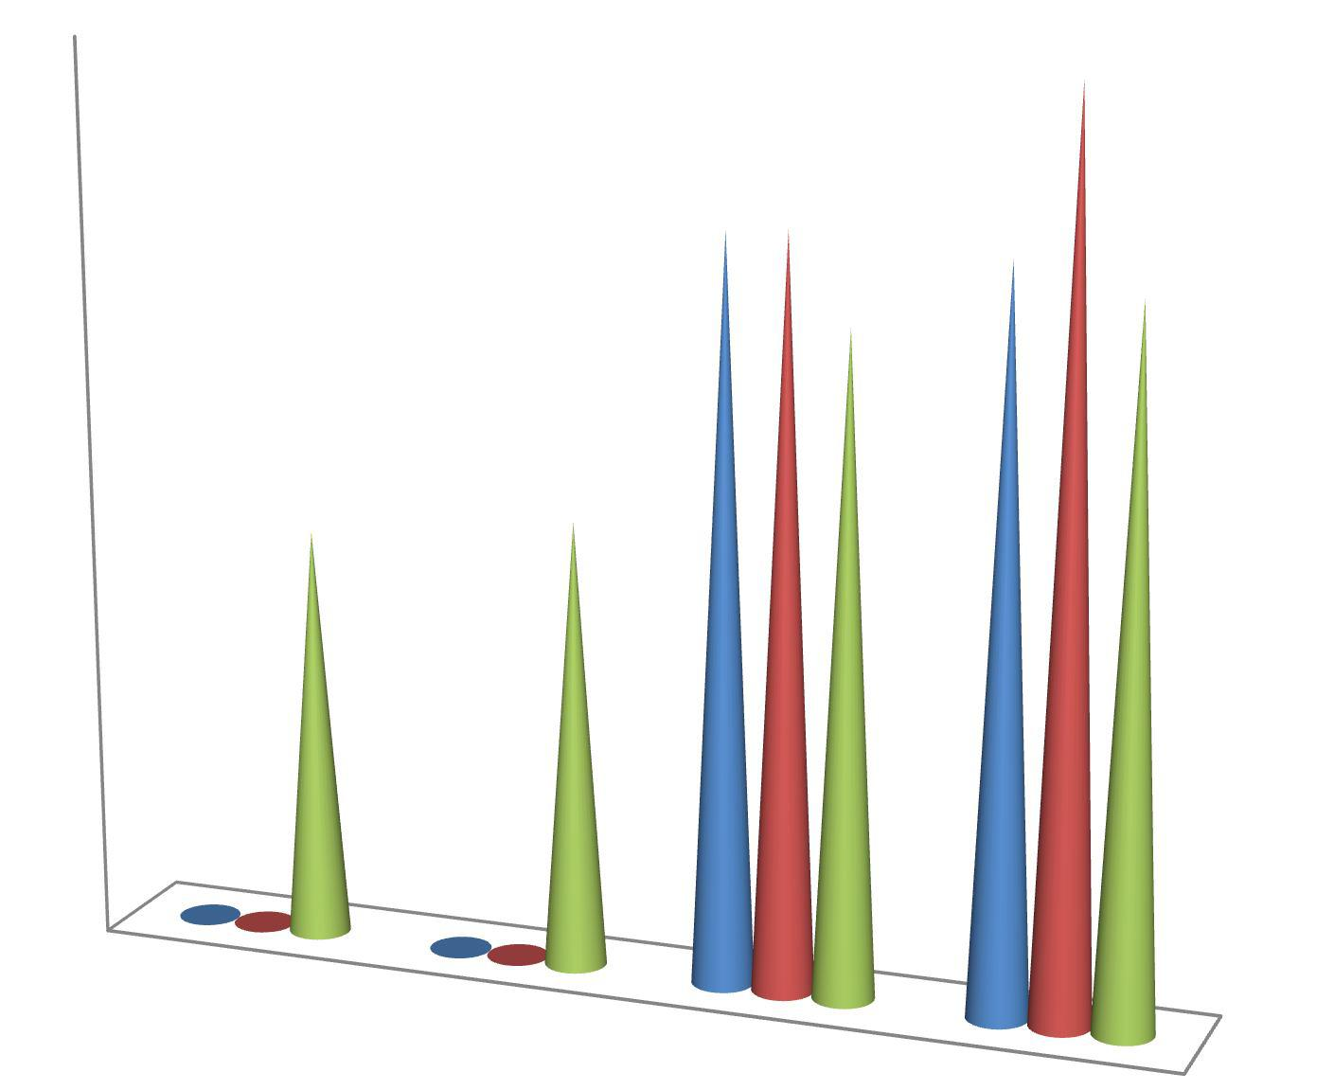Figure 4.1: Effect of Composition on Polymer % Yield Obtained byCross-linking CG with PCAs at 140ºC for 30 min

    - Percentage Yiedl of Cross-linking of CG with CTR and/or GLY

Figure 4.2 shows the cro-slinsk % yield of cross-linking reactions between CG, CTR and or GLY conducted at 140ºC for 30 min. Heating the mixtures under this condition gave a cross-link % yield of 64.72 ±1.13 and 26.22 ±1.59 for cros-slinks of CG:CTR (1:1) and CG:CTR:GLY (1:1:1) in weight ratios, respectively. No cr-olinsks yield was obtained when CG:GLY mixture was ehated at the 140ºC for 30 min. A whitish solid mass that readily dissolved in water was obtained, instead.
At 170 ºC (Figure 4.3),% yields of 54.73± 2.88 and 73.60± 3.61 were obtained for cro-ss

linking weight ratios of CG:CTR(1:1) and CG:CTR:GLY (1:1:1), respectively.erHe also,

no yield was gotten bysubjecting CG:GLY (1:1) to the same experimental conditions. A

statistically significant (P<0.005) decrease in c-rloinsks yield of CG:CTR (1:1) was

observed when the cro-slinski ng temperature was changed from 1ºC40for 30 min to 170ºC for 30 min. In contrast, a statistically significant (P<0.0001) increase in-lcinroksysield of CG:CTR:GLY (1:1:1) was observed following similar change in temperature.
Figure 4.4 shows the cro-slinsk yield obtained when weight ratios of CG and CTR were maintained but that of GLY varied and the samples heat treated at a temperatureºCof 170
for 30 min. A slight increase in yield was observed as the concentration of GLY was increased. When CG:CTRL:GY mixture at (2:2:1) weight ratio was heat treated at the said condition, a yield of 74.89 2±.30 % was obtained. Increasing the GLY ratio concentration to 1:1:1 and 1:1:2 gave yields of 75.12.±80 % and 75.3 ±3.80 %, respectively. Differences in
the yield obtained was not found to be statistically significant (P>0.05).

Cross-link yield (%)

70
60
50
40
30
Yield (%)
20
10
0
CG:CTR (1:1)
CG:GLY (1:1)
CG:CTR:GLY (1:1:1)
Cross-link components (g)

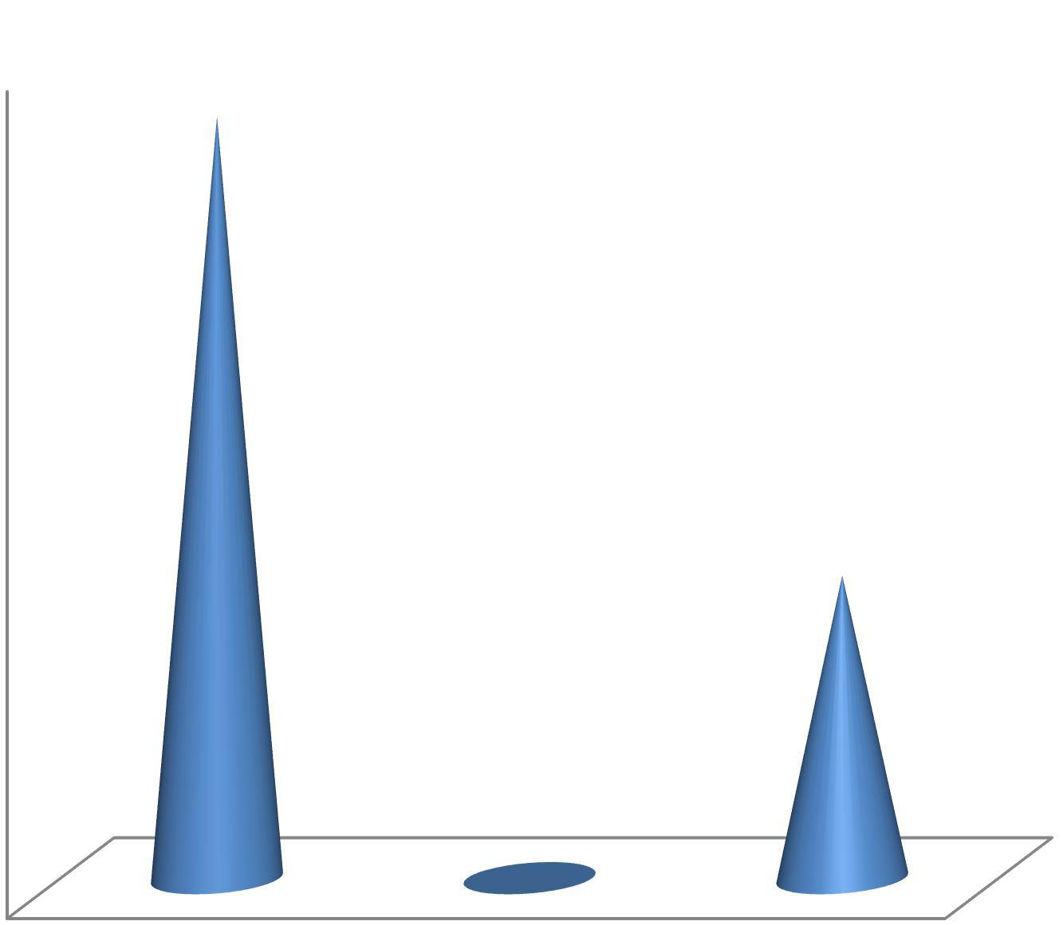Figure 4.2: Effect of Composition on Polymer iYeld (%) Obtained byCross-linking CG with CTR and/or GLY at 140ºC for 30 min

Yield (%)

80
70
60
50
40
Yield (%)
30
20
10
0
CG:CTR (1:1)
CG:GLY (1:1)
Crosslink Composition
CG:CTR:GLY (1:1:1)

Figure 4.3: Effect of Composition onPolymer Yield (%) Obtained by Cross-linking CG with CTR and/or GLY at 170ºC for 30 min

Yield (%)

75.4

75.3

75.

75.

7

74.
Yield (%)
74

74

74
(1:1:1)
(1:1:2)
CG:CTR:GLY (2:2:1)
Crosslink Composition

Figure 4.4: Effect of Composition onPolymer Yield (%) Obtained byCross-linking CG with CTR and GLY at 170ºC for 30 min

4.2 Physical Appearances of the Cross-linked Polymers

Plates4.1 to 4. 4 represent the physical appearances of the products obtained following cross-linking of CG with EPC or CTR.Plates4.1 and 4.2 show the appearances of two cross-link products immediately after heat treatment and prior to washing with water. Plate
4.1 was the product of cro-slisnking CG with EPC, a product that displayed some hollow off-white swellings as against the brown to kdbarown flaky or spongy appearance (Plate 4.2) of CG cros-slinked with CTR. Washing the product in pla4te.1 gave an insoluble globular polymer,while washing the CG:CTR cro-slisnk product with water yielded a brown spongy insoluble polymer as shown inteP4la.3. Plate 4.4 was CG heat treated at the same temperature and time of 1º4C0 for 30 min used to cro-slsink CG with CTR, but without the cros-slinking agent.

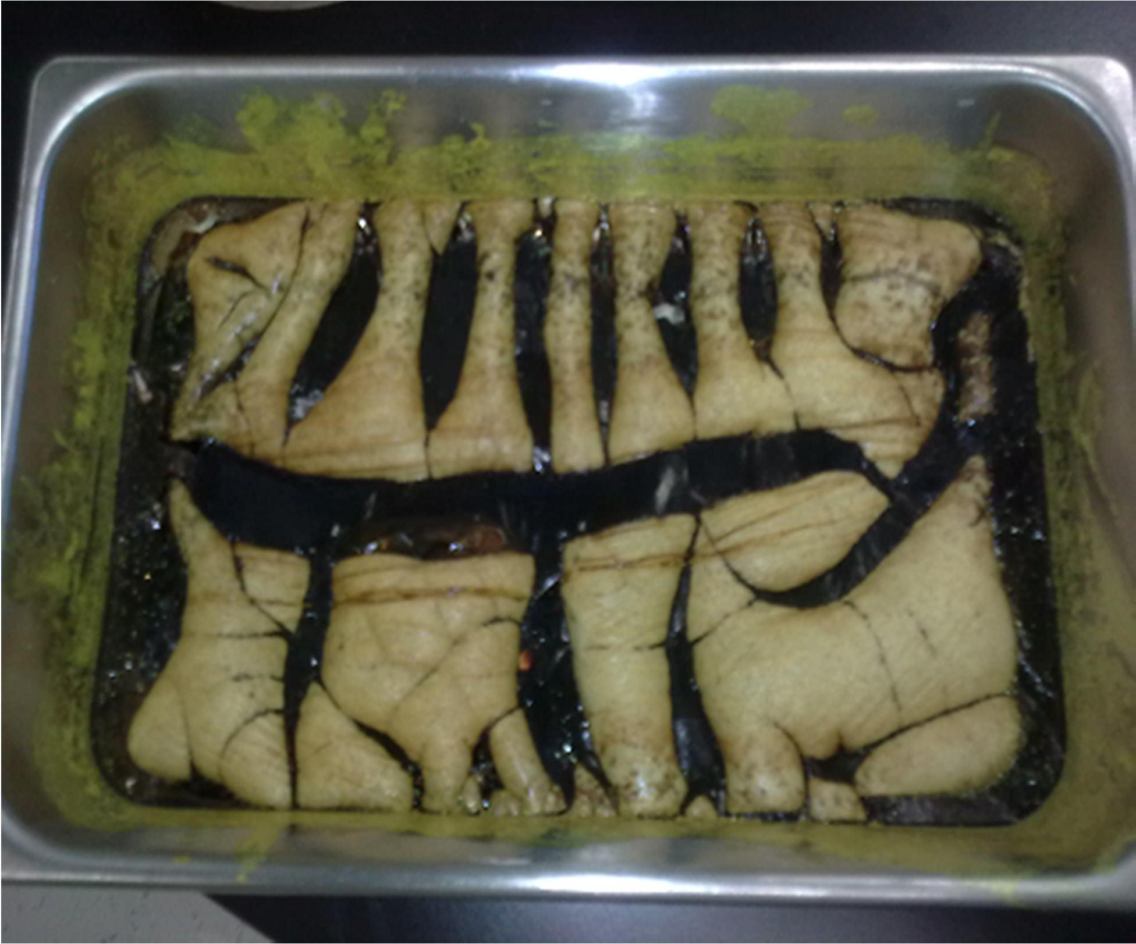

Plate 4.1: A picture of CG:EPC Cros-lsinked Polymer After Treatment with Heat and rPior to Washing

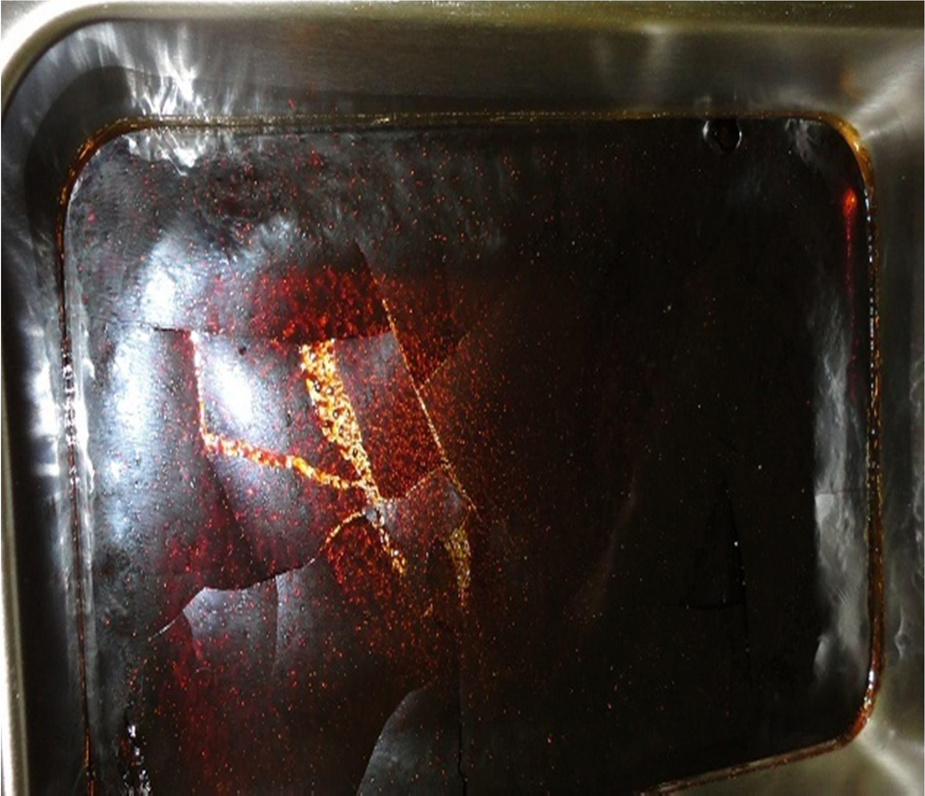

Plate 4.2: A Picture of CG:CTR Cros-lsinked PolymerHeat Treated at 14º0C for 30 min

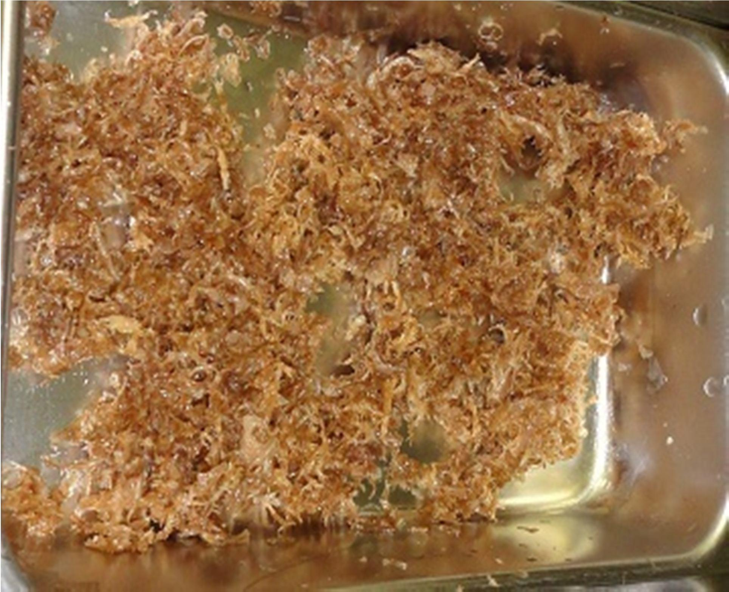

Plate 4.3: A Picture of Washed and Dried CG:CTR Cr-olinssked Polymer Heat Treated at 140ºC for 30 min

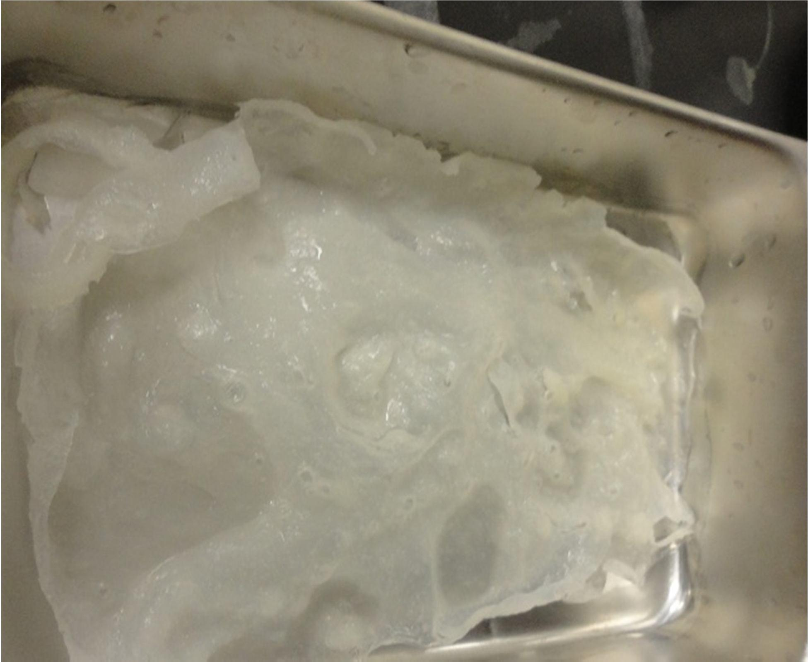

Plate 4.4: A Picture of Plani (uncross-linked) CG, HeatTreated at 140ºC for 30 min

  - Residual Solvent Analysis by Gas Chromatography (GC)noCG

Both acetone andtheanol were present as residual solvents in concentrations above the permissible level of 5000 ppm (Figure 4.w5h) en tested using GC. The residual level of acetone in the tested gum sample was found to be 7446 ppm. Washing the precgiupmitated
with distilled water (Limaet al., 2002) reduced the residual solvent quantity to a relatively lower value of 5730 ppm. Etnhoal at 95 %v/v concentration when used to extract CG was found to be retained as residual solvent at a concentration of 6424 ppm, -wphroilepa2nol
that made up the ethanol solution used for the extraction was present at a concentration of 266 ppm.

Concentration (ppm)

8000

7000

6000

5000

4000
Conc. (ppm)
3000

2000

1000

0
Acetone
Acetone
+Washing
Ethanol (95%)
2-Propanol (5%)
Solvent Type

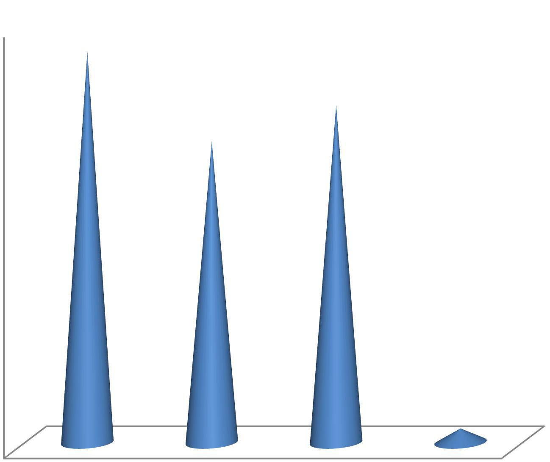Figure 4.5:Residual Solvent Concentrations (ppm) of Acetone and Ethanol in CG

  - Thermal Analysis by DSC

Figure 4.6 is the DSC thermogram of crude CG powder showing the degradation

temperatures of CG at 311º.C6 while the event at 25-200 ºC was due to evaporation of

water (Silva et al., 2006). Overlay of this thermogram upon that of CG processed using acetone (Figure 4.7) showed some level of variations in the curves. The figure showed processing the gum to have caused a slingchrtease in the degradation temperatpuereakat 313.6ºC.
Figure 4.8 is the overlay of DSC curves of CG and CrosCE synthesized polymer. The degradation temperature of the cr-olinssked polymer was found to be 324º.C4 , a figure
much higher than the 311º.C6 of CG.

CTR was found to have a melting temperature peak 6o.f31º5C (Figure 4.9). This peak was however noticed to be completely missing following the usage of CTR in-lcinrokisnsg CG as shown inthe DSC curveof CrosCC (Figure 4.10) and better demorantsetd by the DSC
overlay of curves of CrosCC and binary mixture of CG and CTR (Figure 4.11). Figure 4.12 is the DSC overlay of thermogmras of CG, CrosCE and CrosCC showinvgarying degradationetmperature.s

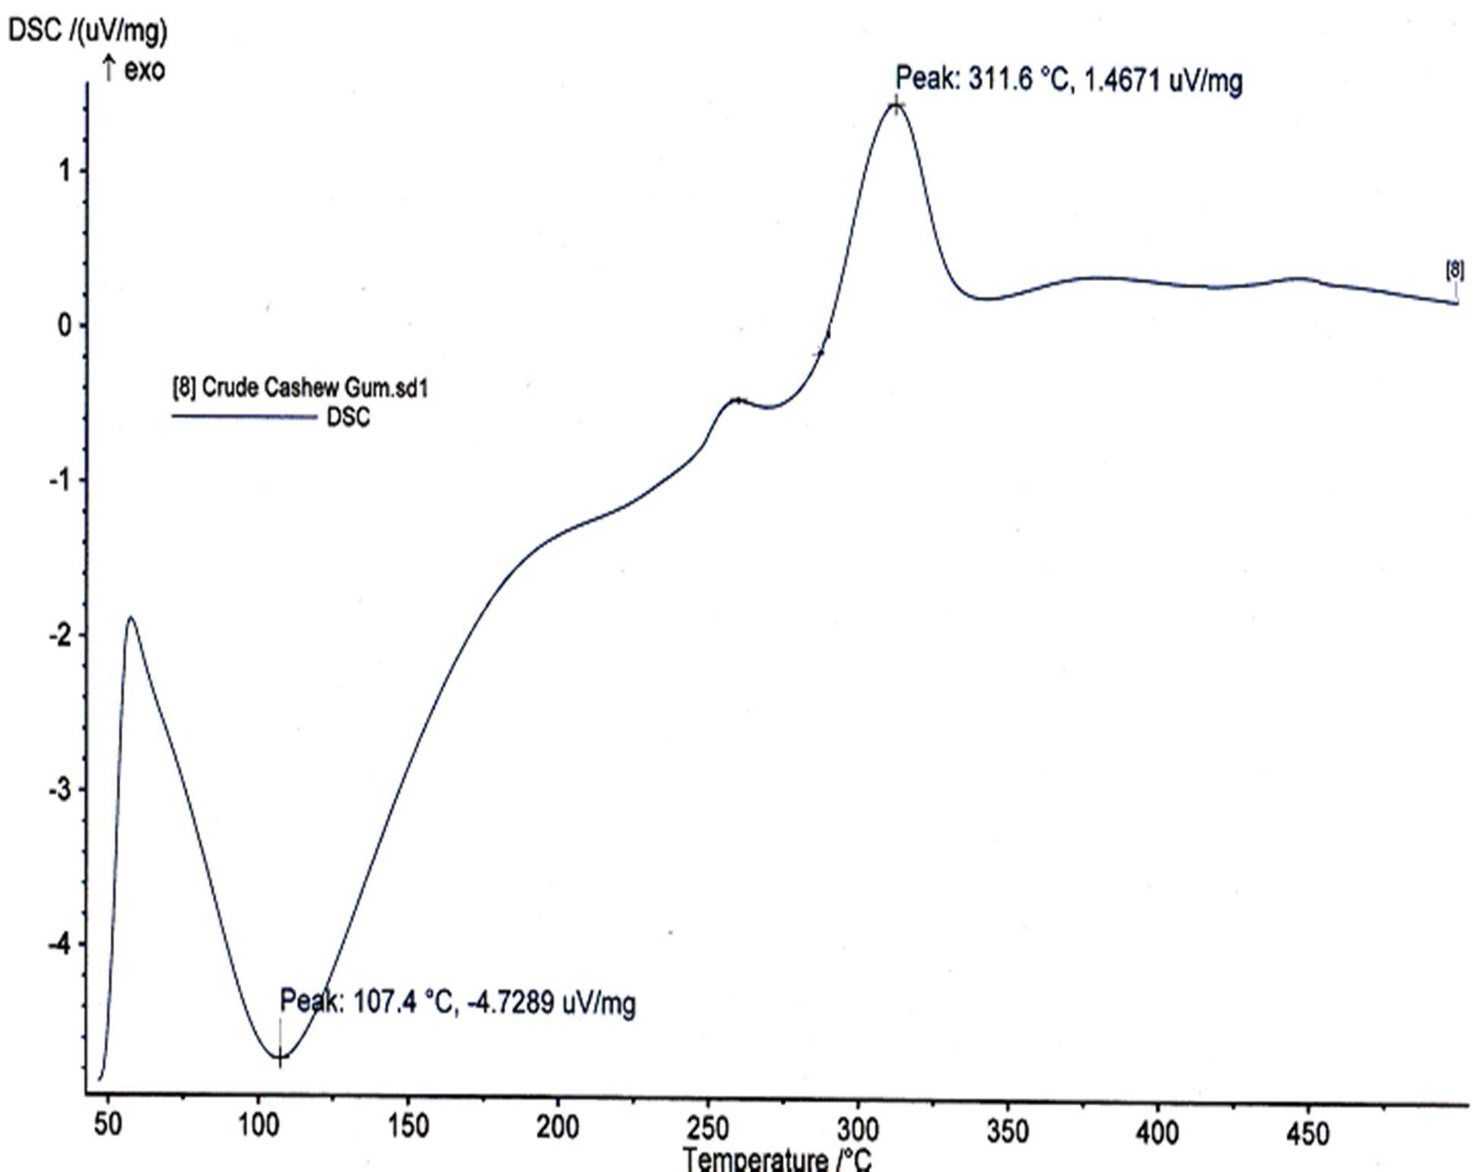

Figure 4.6: DSC Thermogram of Crude CG Powder

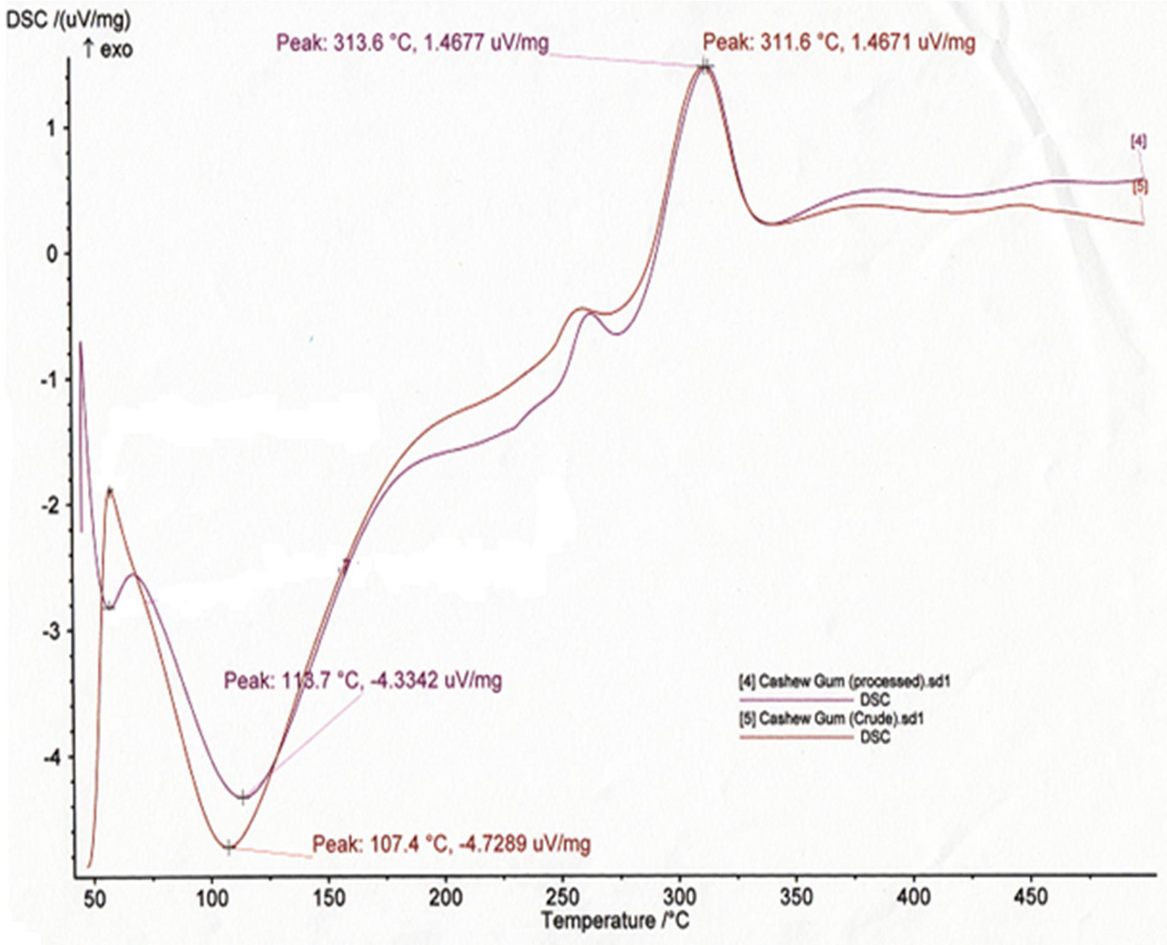

Figure 4.7: DSC Overlay of Crude androPcessed CGPowders

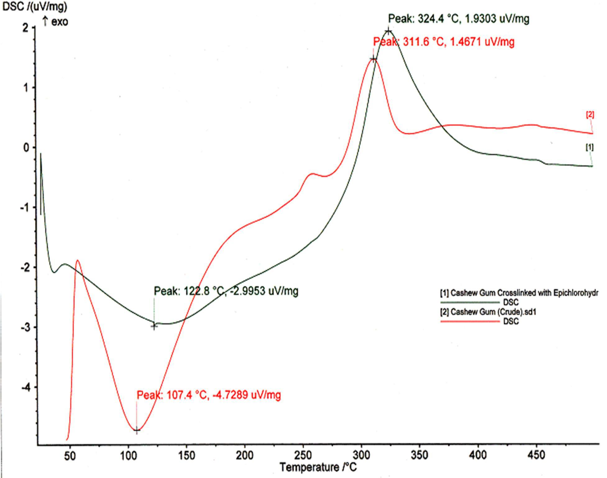

Figure 4.8: DSC Overlay of Powders of CG and CrosCE

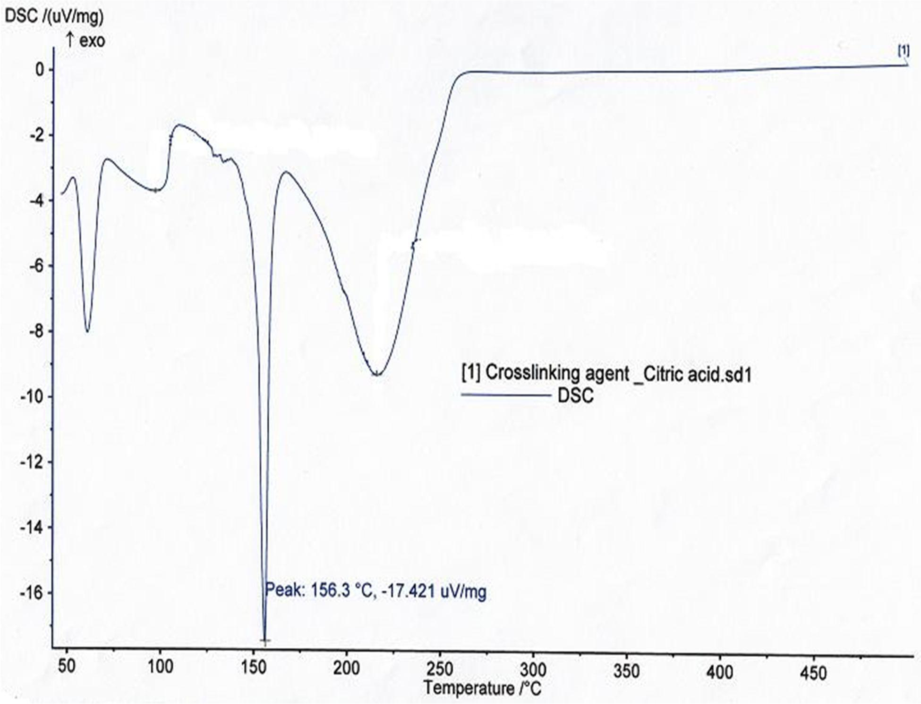

Figure 4.9: DSC of CTR (cros-slinking agent)

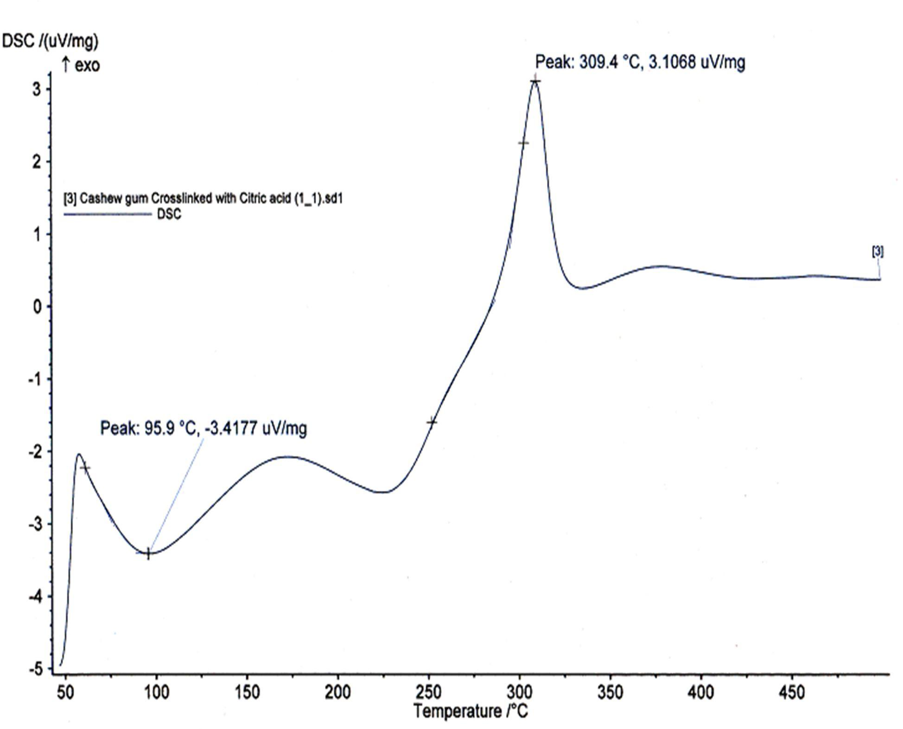

Figure 4.10: DSC of CrosCC Polymer

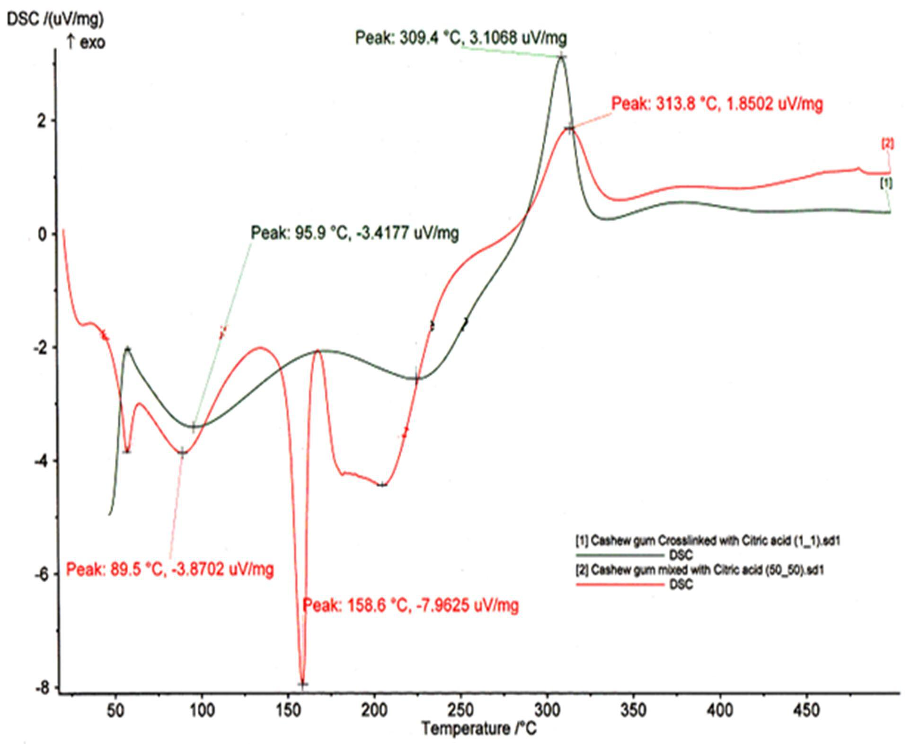

Figure 4.11: DSC Overlay of CrosCC and 50:50 BinaryixMture of CG andCTR

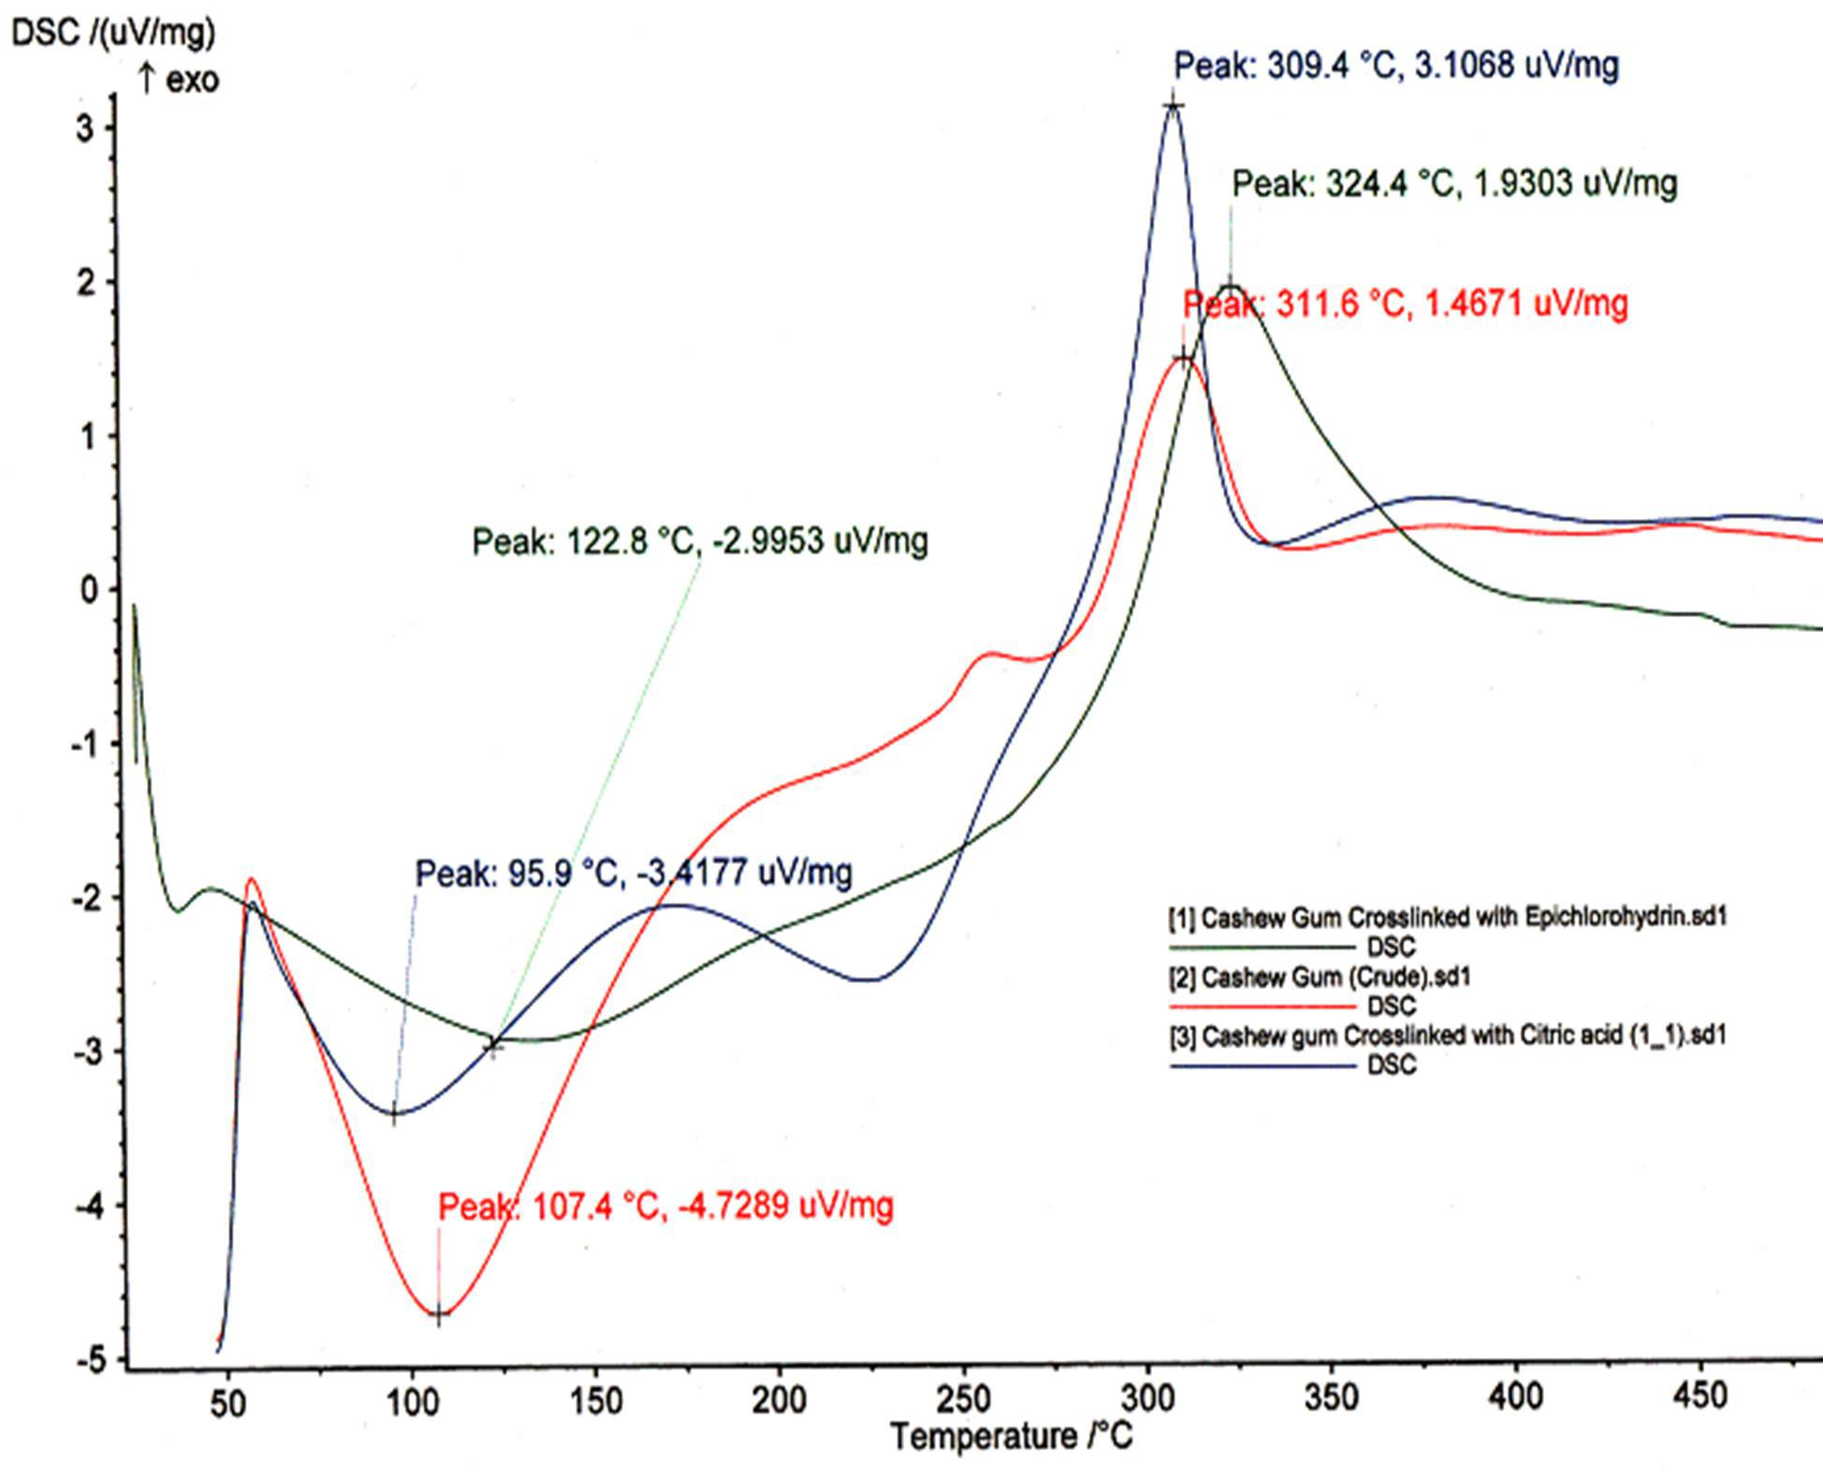

Figure 4.12: DSC Overal y of CG, CrosCE and CrosCCowPders

  - Fourier Transform Infrared (FT -IR) Spectral Studies

Figure 4.13 is the F-TIR spectrum of plain (uncro-slisnked) CG showingthe characteristic absorption bands associated with aromatic sugars of carbohydrates. The band with peak at
3388.32 is H–bonded OH stretch band of aromatic compou(nHdssu, 1997.) Figure4.14 is

the spectrum of CTR showing the characteristic stretch carbonyl frequoef nccayrboxylic acids at1726 cm⁻¹ (USP, 2011.)

Figure 4.15 is the F-TIR spectrum of 50/50 binary mixture of CG and CTR showing the absorption bands associated with the stretachrbocnyl frequency of carboxylic acids appearing at 1726 and or 17c1m3⁻¹. Figure 4.16 is the spectrum of CrosCC, a c-rlionsksed product of CG and CTR. Similar absorption bands can be seen as those found with the uncross-linked CG (Figure 4.13). The stron1g729 cm⁻¹ carbonyl frequency band of CTR
seemed to have disappeared and in its place appeared a strong and sharp band a⁻¹t 1735 cm

associated with the carbonyl frequency of ester group.

Figure 4.17 is the overlay of F-ITR spectra of CG and CrosCC higghhliting the formation of

the prominent peaakt 1735 cm⁻¹ assigned to the new ester molecule formed in consequence to the cros-slinking process. Figure 4.18 shows the spectrum of CrosCCG which appeared very similar to that of CrosCC.

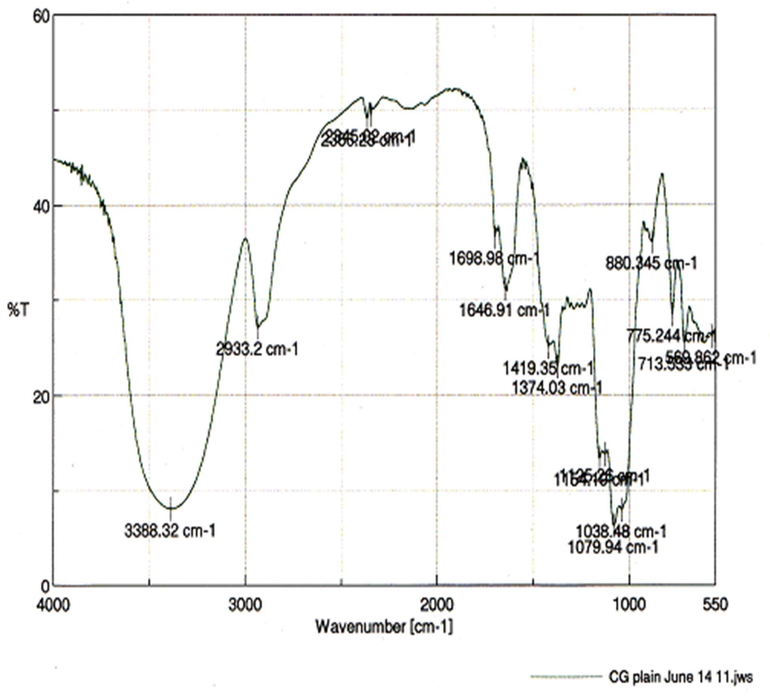

Figure 4.13: FT-IR Spectrum of Uncros-lsinked CG Powder

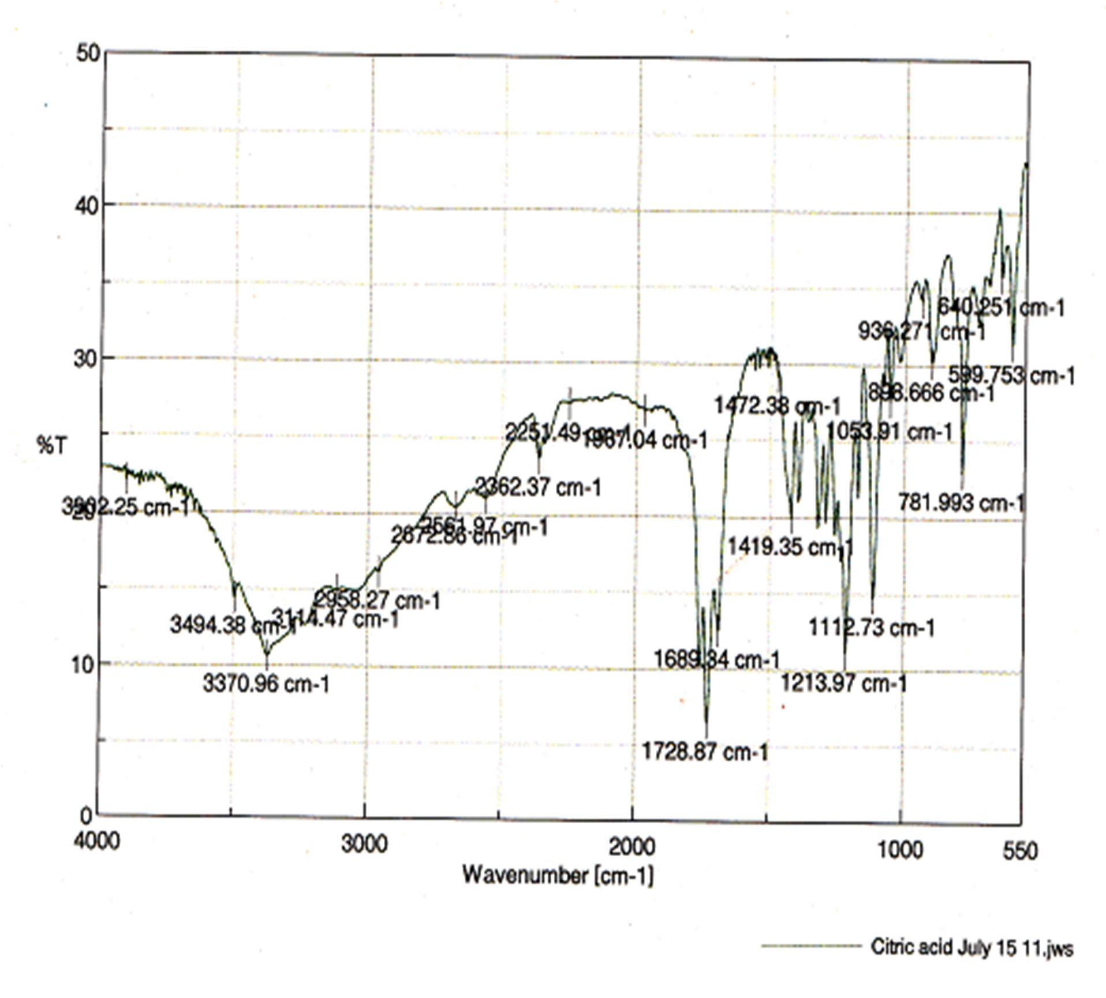

Figure 4.14: FT-IR Spectrum of CTR

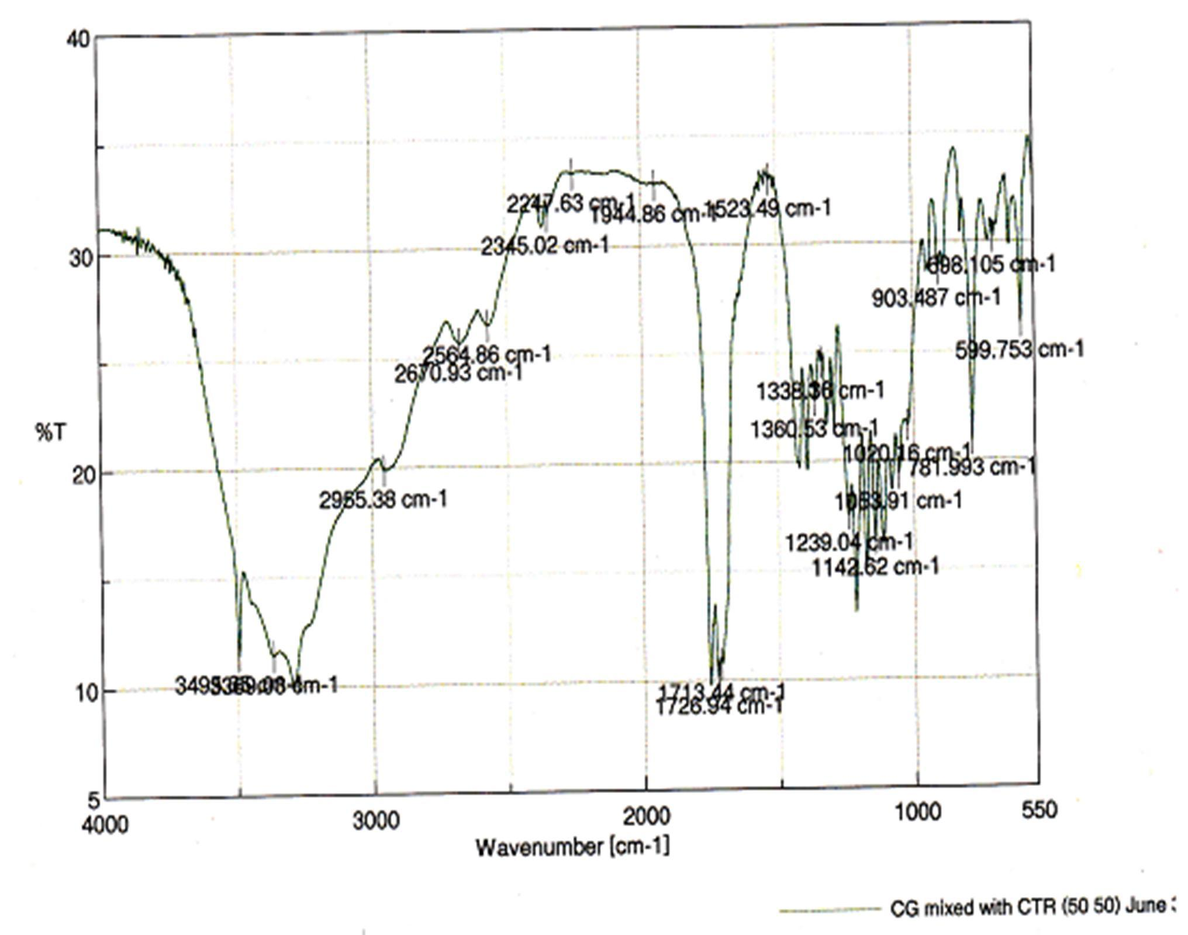

Figure 4.15: FT-IR Spectrum of Binary (50:50)Mixture of CG and CTR

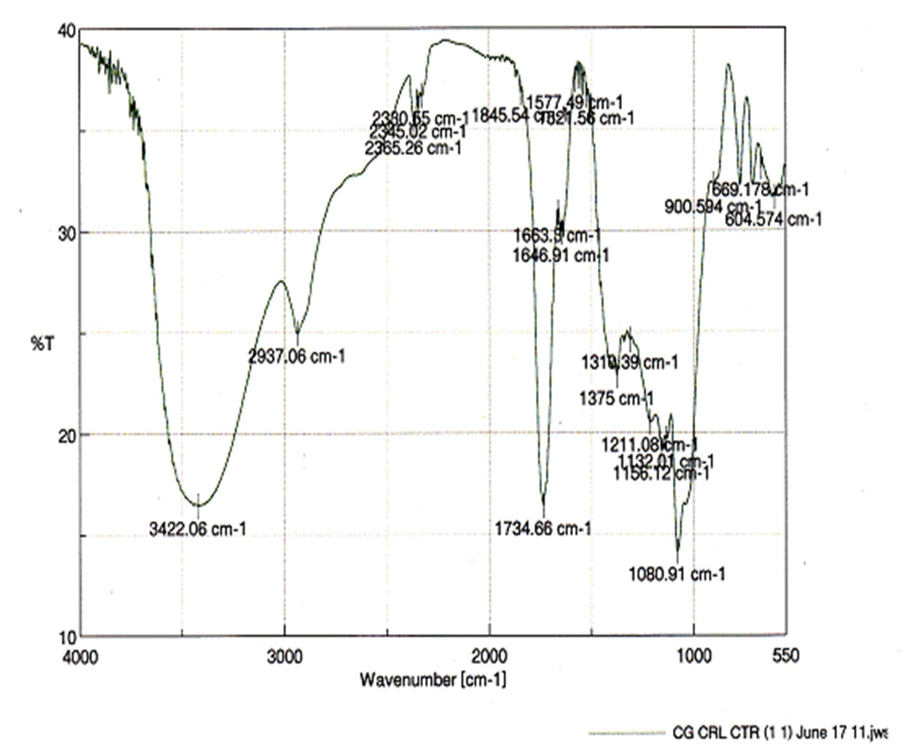

Figure 4.16: FT-IR Spectrum of CrosCC Polymer

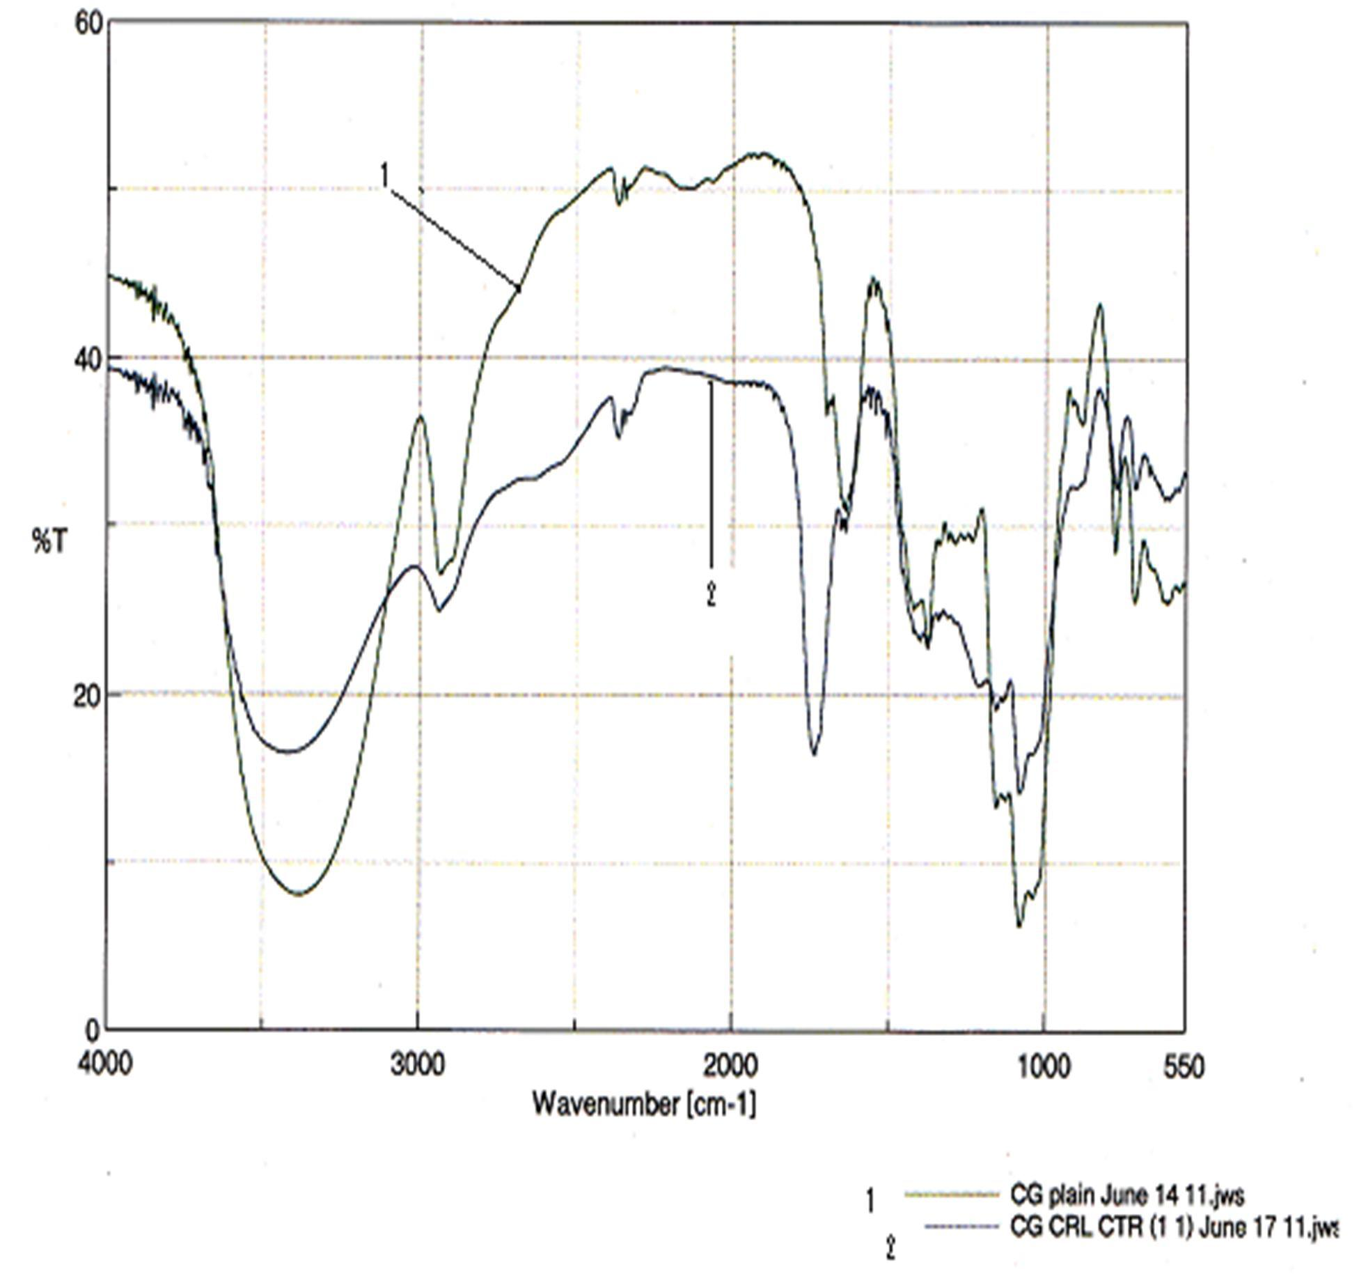

Figure 4.17: FT-IR SpectralOverlay of (1) CG and (2) CrosCC

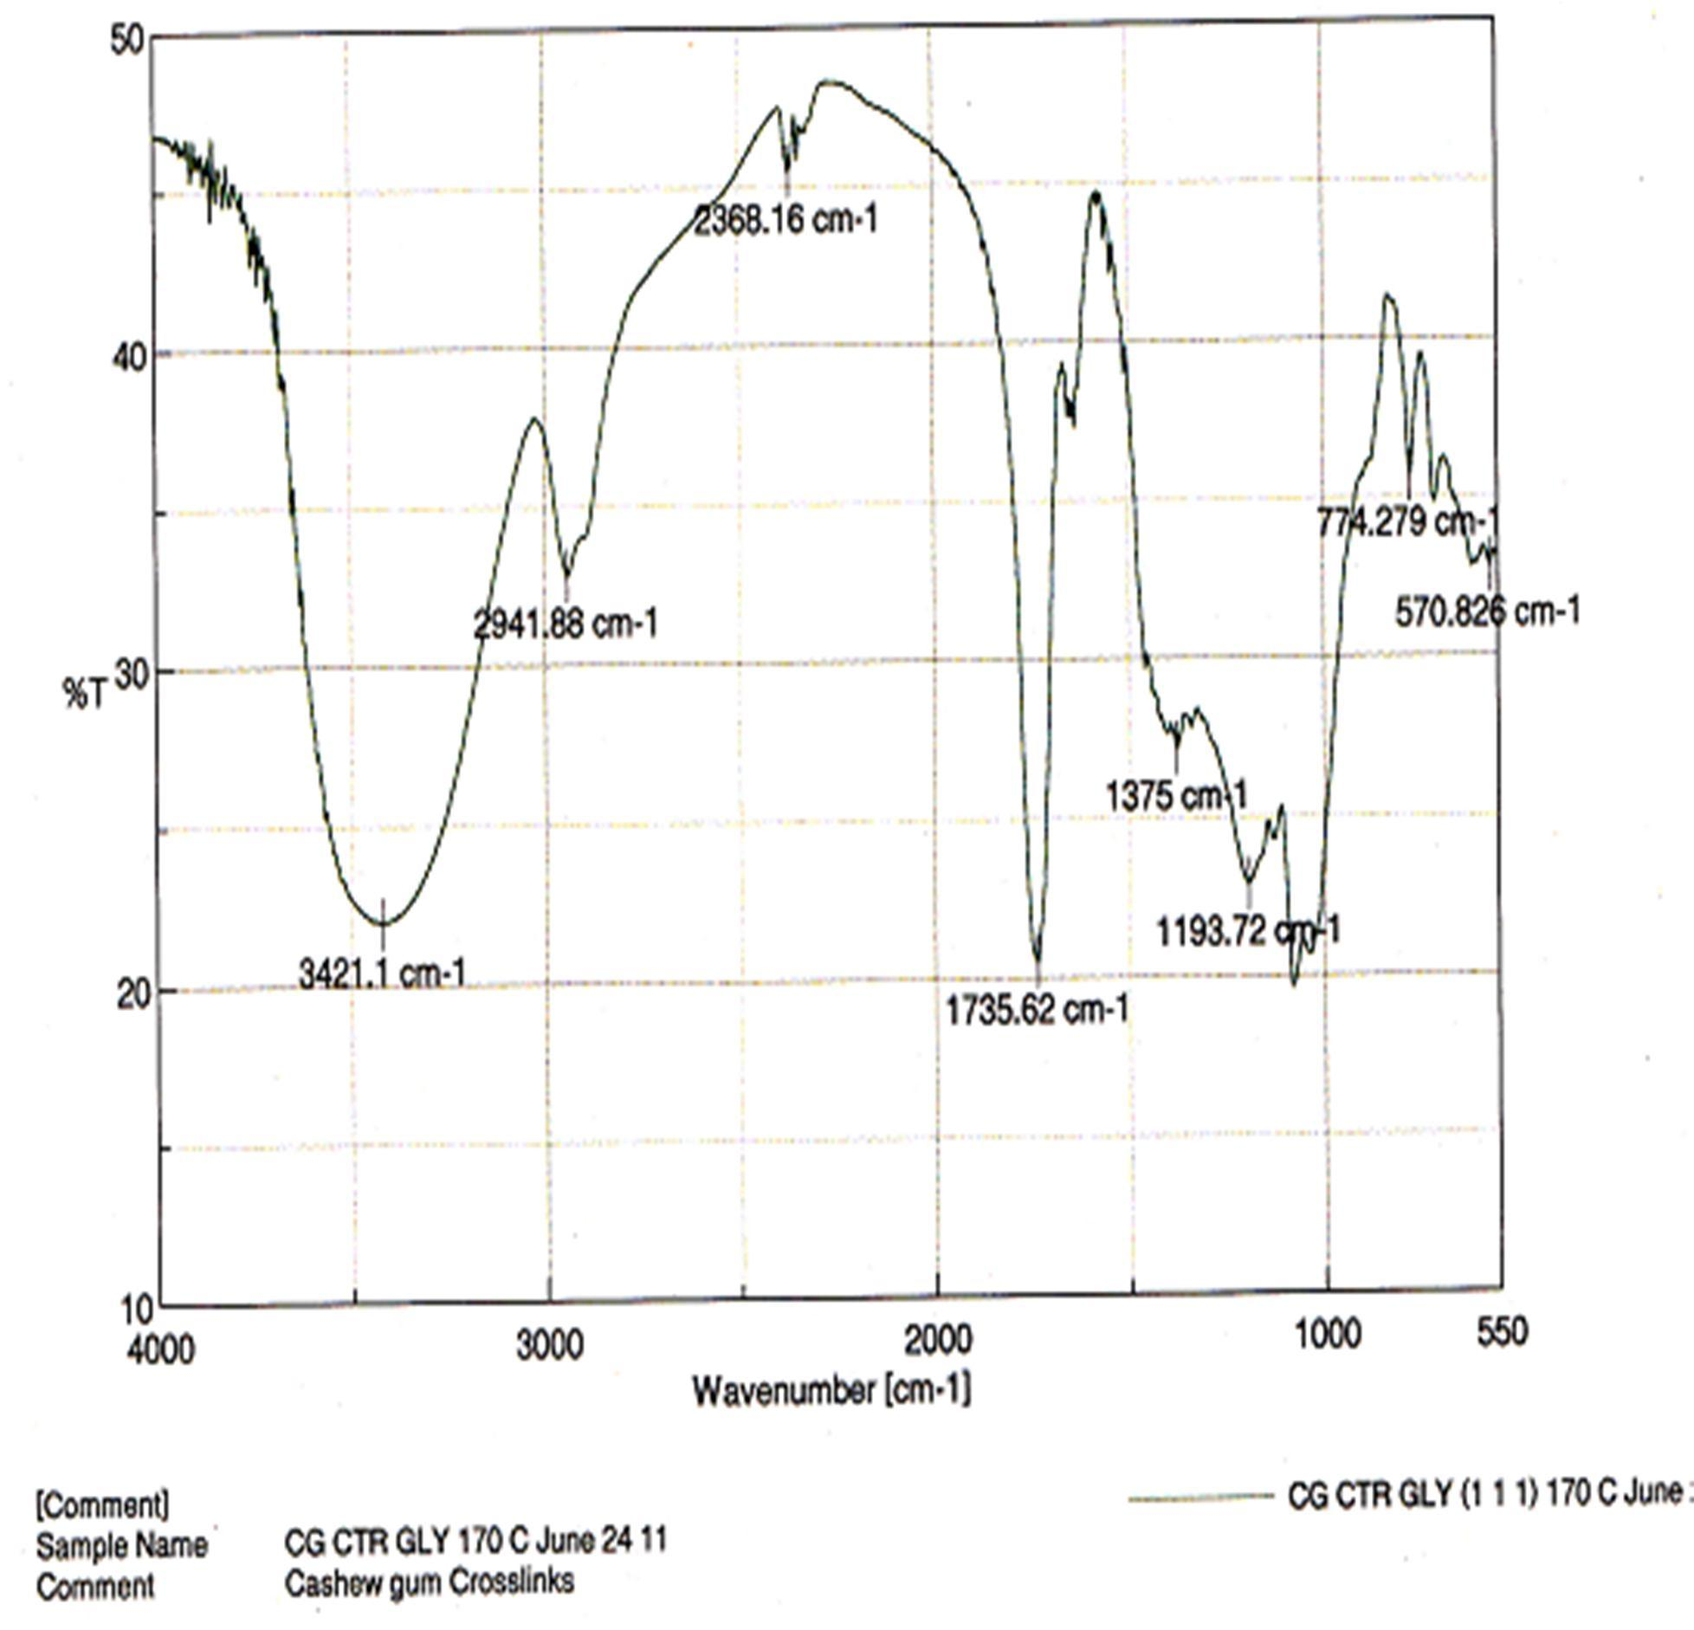

Figure 4.18: FT-IR Spectrum of CrosCCG

4.6 ¹³C NMR Spectral Analysis of CrosCCG Polymer

Figure 4.19 is the solid stat¹e³C NMR spectrum of CrosCCG showing the various resonances associated with respective resoncaatirnbgons as interpreted in Table 4.1.

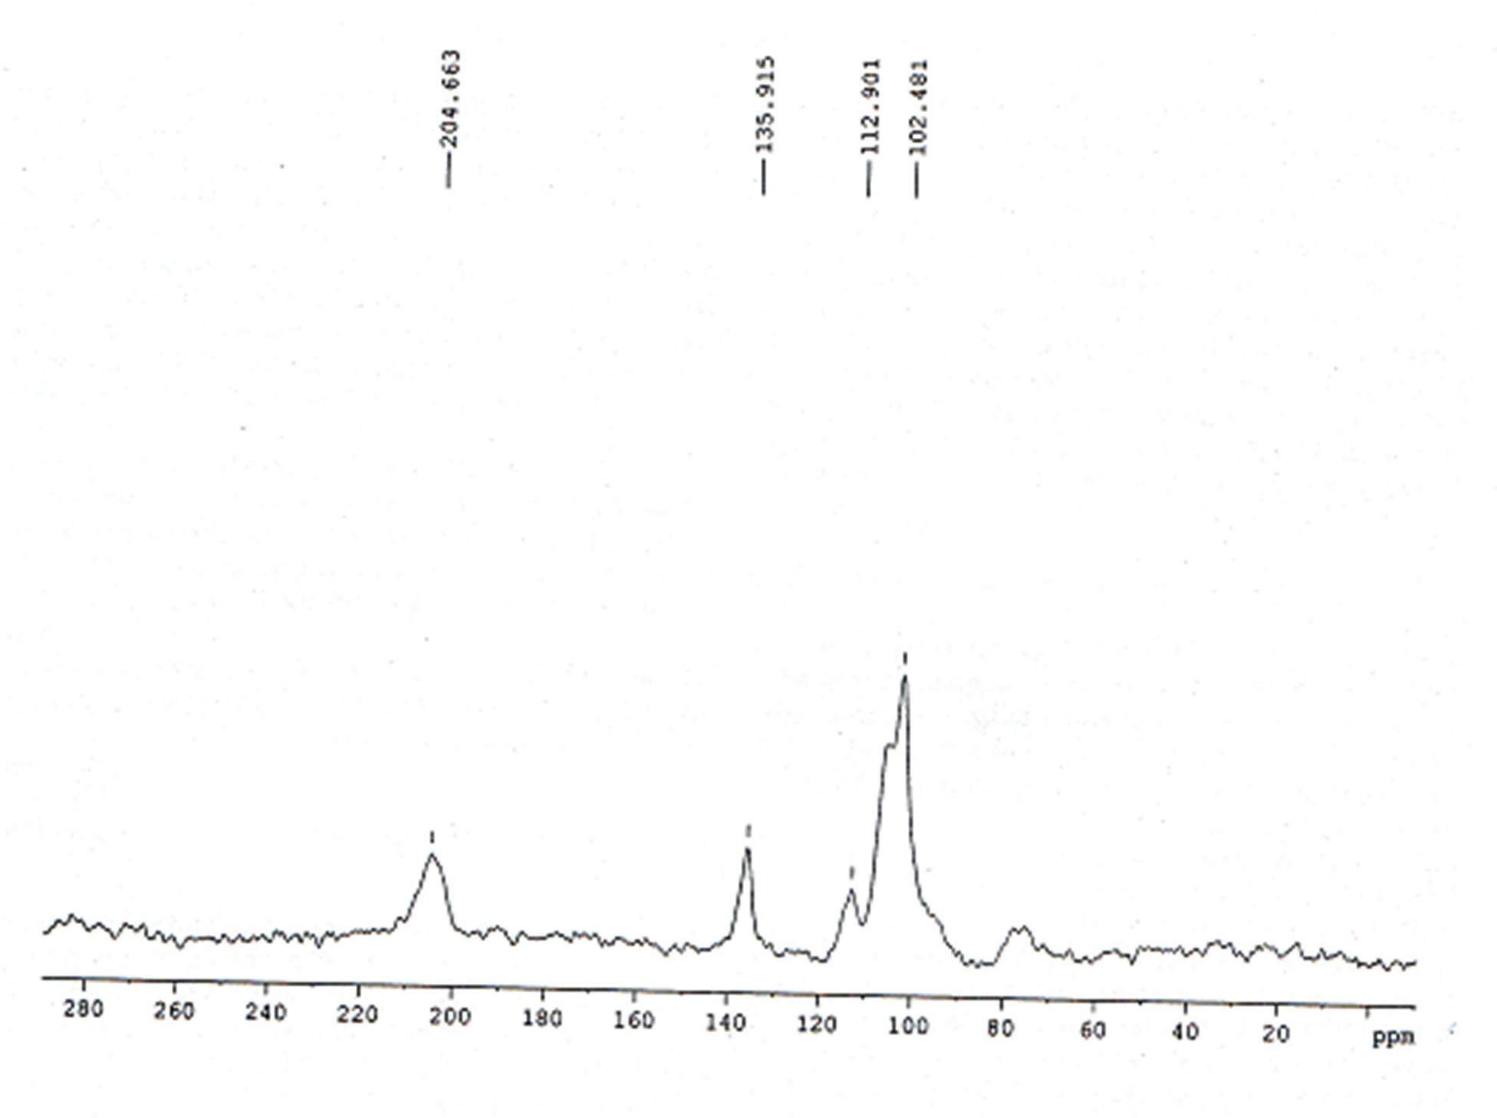

Figure 4.19: Solid State¹³C Nuclear Magnetic Resonance of CrosCCG

Table 4.1: Interpretation of theSolid State¹³C Nuclear Magnetic Resonance of CrosCCG

Resonance (ppm) | Responsible Carbon
18.0 | Methyl group of Rhamnose
73.0 | C-2, C-4, C-5
102.5 | Anomeric carbon resoan ce of glucose, galactose andyxlose sugars
112.9 | $ Q R P H U L F -FD D | U | E
 | ribofuranose
204.0 | Carbonyl frequency

  - Proposal on the CGand CTR Reaction Scheme

Scheme4.1 shows the proposed mechanism of formation of CrosCC resulting from-cross

linking CG with CTR. The scheme depicts a molar ratio reaction components involved in the synthesis of CrosCC. Two (2) moles of the CG eredawctith 1 mole of CTR to give 1
mole of CrosCCG. The attachment of the sugar molecule was stepwise with one attached before the other and in each case 1 mole of watelrimisinated. Steric hindrance mahyave prevented the attachment of the third sugar molecule onto the third and unreacted carboxyl group situated at the center of the structure.

H O
OH
HO
H
H
O
OH
O H
H
H

HO
C C
H OH
H
O
HO
H
OH
H OH

O
heat

HO
- H +
H
C COOH C C
O H O

H
C C
OH
H OH H

HO C COOH

O
H
C C
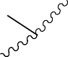H O
H
H O
HO
H
H
H
OH
O

HO

Scheme4.1: Proposed Structural Representation of CrosCC Synthesis

  - Properties of CG, CrosCC andCrosCCG Powders

    - Organoleptic/Physicochemical Properties

Table 4.2 showsthe organoleptic and some physicochemical properties of CG, CrosCC and CrosCCG. CG was light brown to off white in color, tasteless and odoTrlheessC. olour of CrosCC and CrosCCG was found to range between dark brown to light brown with CrosCCG polymers generallhyaving lighter colorations. Hypochloric acid was found to bleach these polymetros white colour.
The various solventsused for determination of solubility of CG and the cr-olisnsked polymers(Table 3.4) show that variation inpolarity was used in selecting the solvents for use in thesetests. CG was found to disperosnely in water among all the solvents tried. The cross-linked polymers, CrosCC and CrosCCG failed to dissolrvedispersein any of the solvents used for the study.
Moisture loss on drying (LOD) was fodunto be somewhat similar fothr e three polymers. CrosCC had the lowest LOD value of 7.21% followed by CrosCCG with 7.39% and finally CG with 8.47%.
CrosCCG was found to possess greater capacity of holding waitesr minacromolecular structure than CrosCC. CrosCCG with a water holding capacity of 244 % almost doubled the 143 % value for CrosCC. Water holding capacity could not be determined for CG because of the gu’ms solubility in water.

Table 4.2: Organoleptic adn Some Physicochemical Properties of the Polymers Parameter Polymer type

CG CrosCC CrosCCG

Color Light brown, Off
Brown : : K BrLownW H
: : K L W H

Taste Odor  Solubility (Solvent) | white Tasteless Odorless  Soluble (Water) | (bleached) Tasteless Odorless  Insoluble | (bleached) Tasteless Odorless  Insoluble
Sulphated ash (±SD) | 1.39 ±0.03 | 1.91 ±0.04 | 2.70 ±0.04
% Moisture loss | on 8.47 ±0.65 | 7.21 ±2.10 | 7.39 ±3.81
drying (± SD)
Water holding capacity % ND (± SD) |  | 143.4± 19.57 | 244 ±5.25
Key: ND = Notdone; SD= Standard deviation

    - Water Content Determination Using Karl Fisher (KF) Titrimetry

The percentage water content determined for CG, CrosCC and CrosCCG using the Karl Fisher titration is reported in Figure 40.2CG was found to contain a rteivlaely higher percentage of water than did the derivatives. At ambient temperature and humidity, samples collected from sealed storage containers showed CG to have 8.53 % water content while CrosCC and CrosCCG had 7.12 and 7.04 %, respectively. Deteromnisnaotni samples stored
for one week over activated silica gel contained in a desiccator gave a 4.59, 3.15 and 2.96 % water contents for CG, CrosCC and CrosCCG, respectively.

Water content (%)

9
8
7
6
5
4
3
2
1
0
Ambient humidity
Over Desiccant
CG
CrosCC
Polymer type
CrosCCG

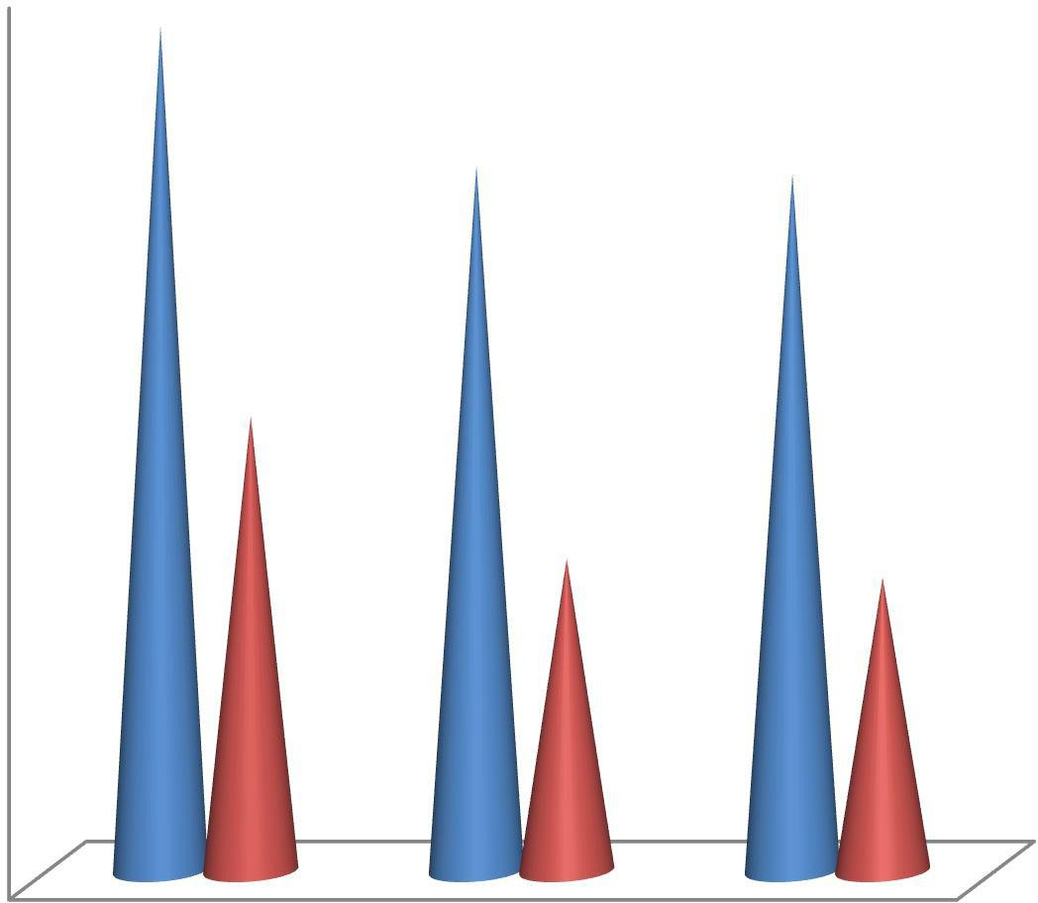Figure 4.20: Water conten(t%) for CG, CrosCC and CrosCCGetDermined by Karl Fisher Titration

    - Flow Properties of CG, CrosCC and CrosCCG Powders

Table 4.3 showsthe parameters describing the flow of CG, CrosCC and CrosCCG. Among the powders, CG had the lowest flow with a rate of 10 g/s compared to CrosCC and CrosCCG where each showed a rate of 12.5 g/s. Asnogflerepose for CG, CrosCC and CrosCCG werefound to berelatively uniform with values 30.96º, 30.11 º and 29.24º, respectively. CrosCCG, nonetheless, showed the lowest angle of repose. Density measurements showed CG to be more compressible than the-linckreodsspolymers with compressibility index andHausner ratio of 17.30 % and 1.22, respectively. Compressibility
of CrosCC was found to be slightly higher nthtahat of CrosCCG as can be seen from the table. Particle size distribution (Figure 14).2showedthat all the powdesr had sizes that skewed to thelarger size fraction. CG appears to have relatively more of the smaller sized particles than the derivatives.

Table 4.3: Flow Properties of CG, CrosCC and CrosCCG Powders

Parameter |  | Powder type
 | CG | CrosCC | CrosCCG
Flow rate (g/s) | 10 | 12.5 | 12.5
Angle of repose (º) | 30.96 | 30.11 | 29.24
Bulk density (g/ml) | 0.732 | 0.556 | 0.549
Tap density(g/ml) | 0.897 | 0.739 | 0.714
Compressibility index (%) | 17.30 | 21.92 | 23.00
Hausner ratio | 01.22 | 01.26 | 01.29

Weight (%)

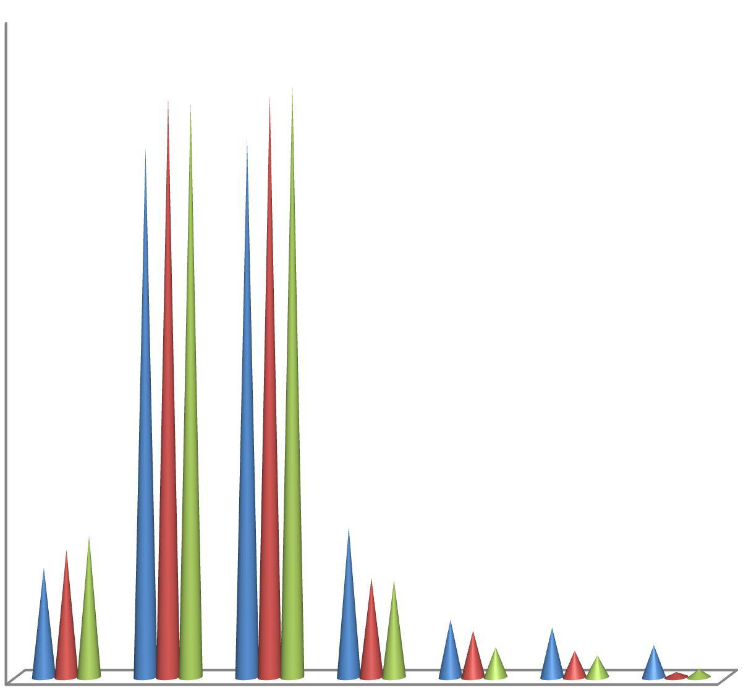u •
45

40

35

30

25

20

15
CG
CrosCC CrosCCG
10

5

0
600 425 250 150 106
53
0
D • Z • ] Ì ~ R

Figure 4.21: Particle Size Distribution of CG, CrosCC and CrosCPCoGwders

    - Moisture Sorption/Desopr tion Determination

Figure 4.2 and Apendix Cshow the moisture sorption/desorption isotherm of 2 g samples each of CG, CrosCC and CrosCCG subjected to humidity changes (T5abalend3.Figure 3.1). All the samples were found to sorp moisture to a maximounmthe 4th week, corresponding to exposure over saturated salt solution of potassium chTlohreidesa. mples sorped least quantiteosf water at weeks 1 and 7 creosrponding to sorption and desorption
equivalents respectively following exposures over magnesium chloride. CrosCCG sorped a maximum of 0.59 g at week, 4corresponding to 0.13 g and 0.23 g of water sorped by CG and CrosCC respectively. Similarities were noted in quantities of moisture saonrdpetdhat desorped at eacrhoundof exposure.

Change in mass (g)
0.7
0.6
0.5
0.4
0.3
CG
CrosCC CrosCCG
0.2
0.1
0
0
2
4
Time (days)
6
8

Figure 4.22: Moisture sorption/desorption isotherm of CG, CrosCC and CrosCCG after subjection to varying humidity challenges

    - Swelling Properties of CG, CrosCCC, rosCCG and CrosCE Powders

Figure 4.23shows the effect of cro-slisnking on the swelling properties of CG over 10 min periodof swelling. CG has been found to sorpmseo amounts of water (Figure 4.)2, 2but this did not make itswell to an appreciable level. CrosCC, a c-rloinsksed derivative of CG was
found to have a swelling ratio 0.0 % at 0.0 min, 31.6 % at 1 min, 54.2 % at 2 min and 82.2

% after 10 mincontact with waterI.n an apparent^{s}1^{t} order process,wselling of CrosCC was

faster within the first 5 min and thereafter the rate dropped and the polymer almost stopped swelling.
Figure 4.24 and Appendix Dshowthe effect ofcross-linking of CG with CTR and GLY on the swelling property of CG. Cro-slisnking CG with a combination of CTR and GLY
produced a polymer with a greater swelling capacity over that of CrosCC, a polymer obtained by cros-slinking CG with CTR alone. The swelling ratio CofrosCCG was found to
be 0.00% at 0.00 min, 87.5 % at 1 min, 120.3 % at 2 min and 195.3% after 10 min contact with water. Swelling in CrosCCG was found to be faster within the first 1 min and then it became steady to the end of the 10 min study.
Figure 42. 5 shows the swelling ratio (%) of CrosCE and CrosCCG. CrosCE was found to possess greater swelling capacity than CrosCCG, with the former having a swelling ratio of 166.7% as against the latter’s 87.5% within the first one minute. In both cases thfe rate o
swelling was steady within the 10 min period of study. The difference in the rate was statistically significant (P < 0.0)5.

Swelling ratio (%)
90

80

70

60

50

40

30
CG
Cros CC
20

10

0
0
2
4
6
Time (min)
8
10
12

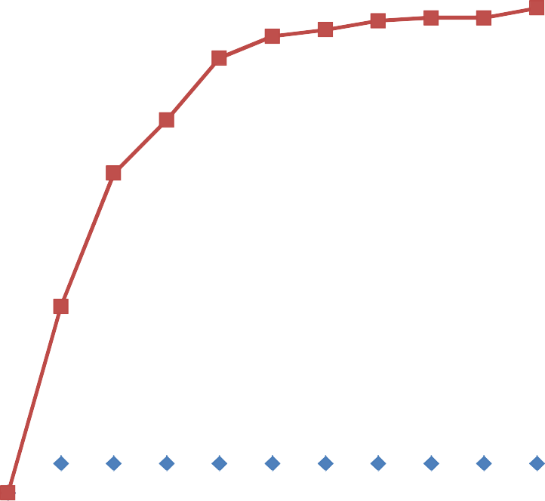Figure 4.23: The Effect of Cross-linking on Percentage%() Swelling Ratio of CGand CrosCC

Swelling ratio (%)
250
200
150
CG
100
Cros CC
CrosCCG
50
0
0
2
4
6
Time (min)
8
10
12

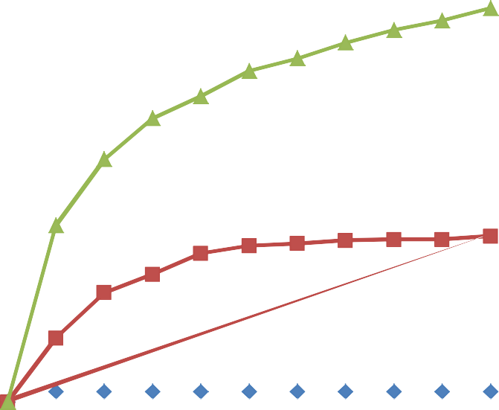Figure 4.24: The Effect of cros-slinking on Percentage%( ) Swelling Ratio of CG

Swelling ratio (%)
350
300
250
200
150
CrosCE
CrosCCG
100
50
0
0
2
4
6
Time (min)
8
10
12

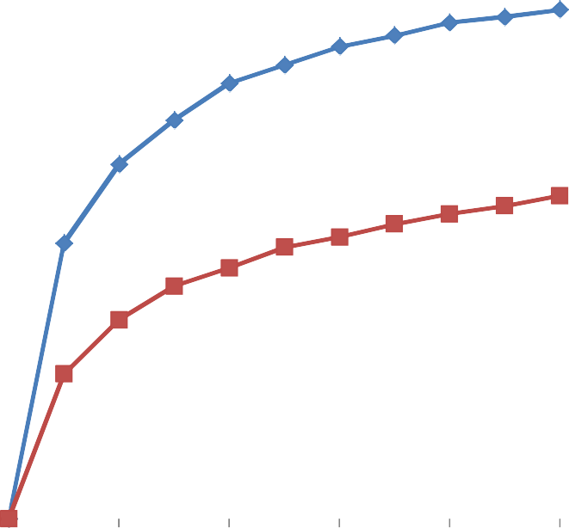Figure 4.25: The Effect of Cross-linker type on Percentage%() Swelling Ratioof CrosCE and CrosCCG

  - Formulation Studies

    - Drug Polymer Compatibility Studies using DSC

Figures 4.26 and 4.27 show theDSC measurement curves demonstrating the compatibility or otherwise of Ve.nHCl (test drug) against CG and CrosCCG (test polymers), respectively. Figure 4.26 shows the DSC measurement curve of 50/50 binaxrytumrei of Ven. HCl and
CG overlaid on that of the pure drug. Figure74d.2isplays the DSC thermograms overlay of 50/50 binary mixture of VenH. Cl and CrosCCG on that of the pure drug. In both cases, the melting temperaturseof the drug (Ven. HCl) in its pure form appeared sharper and more prominent than after its admixture with the polymer (CG or CrosCCG). The curve in the binary mixturewasshorter, broader and of lower peak melting temperature.

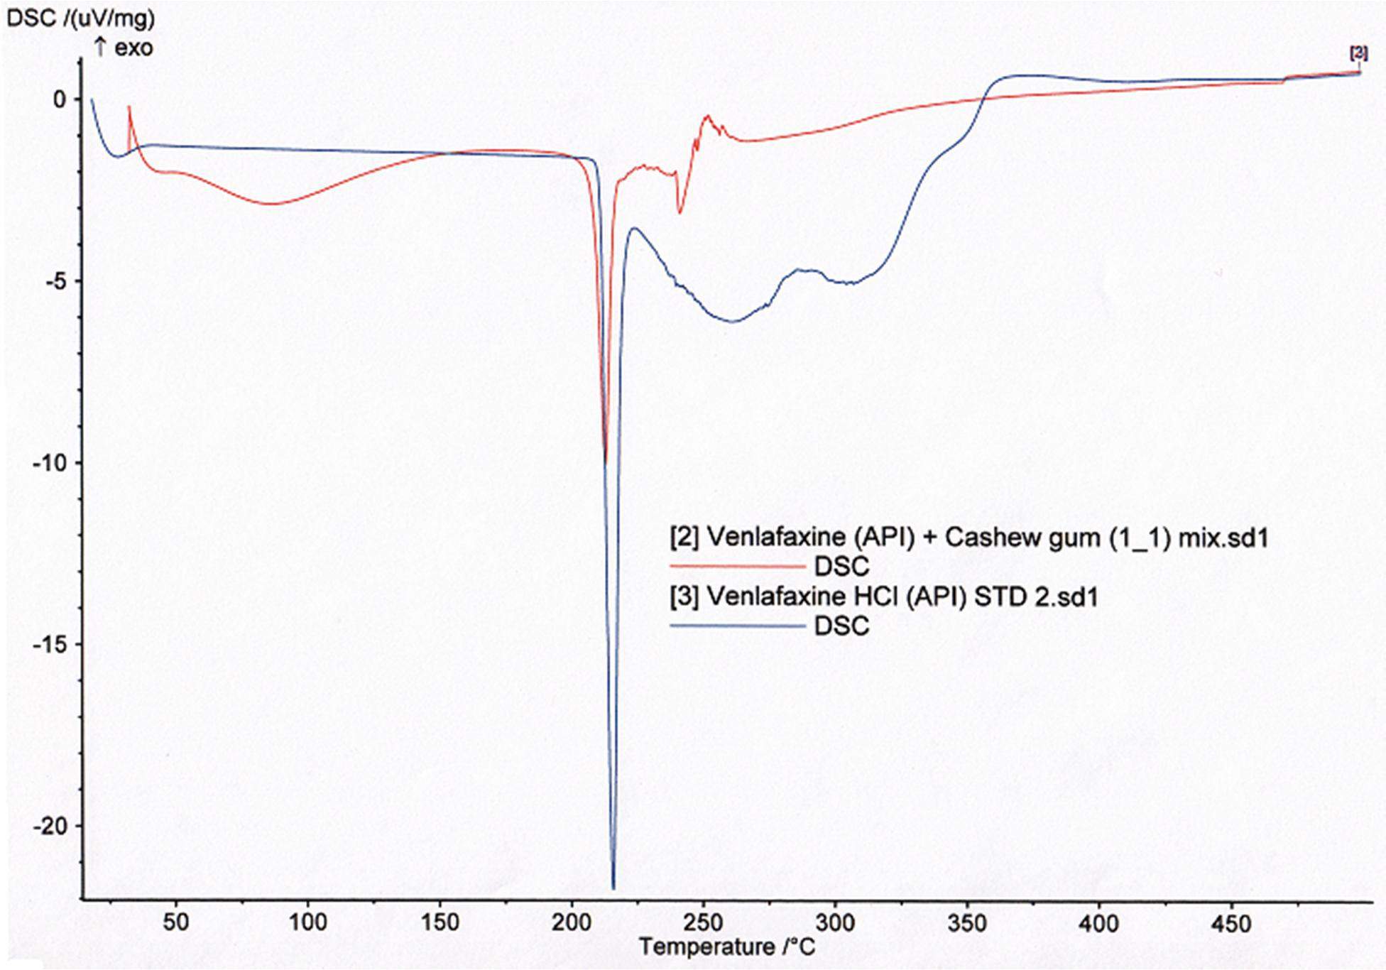

Figure 4.26: DSC Overlay of Ve.nHCl (API) and its 50/50 mixture with CG (excipient)

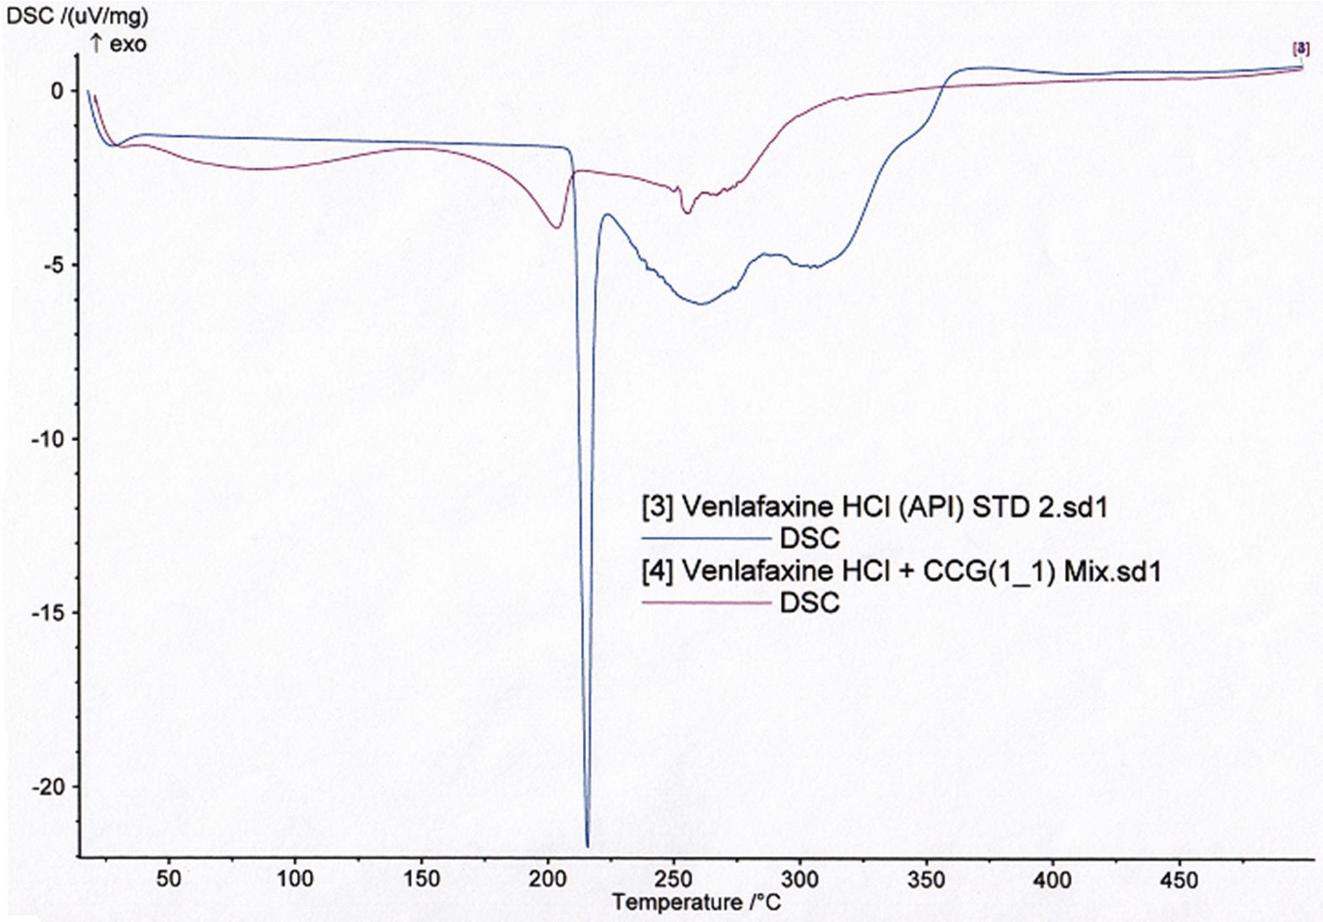

Figure 4.27: DSC Overlay of Ve.nHCl (API) and its 50/50 mixture with CrosCCG (excipient)

    - Formulation Properties of Ven. HCl Tablets Containing MCC PH 102and/or CG as Binder

      - Granule Properties

Table 4.4 showsthe properties of granules of V.eHnCl made using MCC PH 102r oCG or admixtures of the two. Batch ofragnules containing MCC PH 102 a(Gs1) binder can be seen to present with a compressibility index of 25.20 % and Haurastnioerof 1.35, which
werehigher than those obtained for the other batches containing CG. All the other batches (G2 – G6) appear to share some similarities in values of creosmspibility index and Hausner
ratio. Mean granule size was not widely different in all the batches. Flow rate showed some variations between the granule batches with G5 containing a mixture of CG aCndPMHC
102 in 1:2 ratio havingthe highest rate. G1 anGd6 had comparatively the poorest flow. All the batches had angle of repovsaeluesthat were above 3º0with the highest being 33.51 for G6 and the lowesbteing30.47for G2.

Table 4.4: Properties of Ve.nHCl Granules Containing Mcc and or CGBainsder Parameter Batches
 | G1 |  | G2 | G3 | G4 | G5 | G6
Bulk density (g/ml) | 0.566 |  | 0.657 | 0.511 | 0.680 | 0.657 | 0.680
Tapped density (g/ml) | 0.767 |  | 0.839 | 0.663 | 0.877 | 0.839 | 0.877
Compressibility index (%) | 25.20 |  | 20.60 | 21.80 | 21.40 | 20.6 | 21.40
Hausner ratio | 1.35 |  | 1.29 | 1.29 | 1.28 | 1.27 | 1.28
0 H D Q J U | 1D48.3Q7 | X | 1O45.H23 | 146V.72L | 1]46.H9 | 146.21 | —148P.98
Flow rate (g/s) B/L | 2.49 |  | 2.73 | 3.0 | 3.13 | 4.28 | 2.5
A/L | 2.41 |  | 2.54 | 3.13 | 3.29 | 3.8 | 2.27
Angle of repose º() B/L | 33.37 |  | 31.90 | 32.12 | 31.72 | 33.66 | 33.51
A/L | 32.29 |  | 30.47 | 31.49 | 31.03 | 30.85 | 33.51

Key: G=Granule,; G1=MCC PH 102 10%, G2=CG 5%, G3=CG 10%, G4=CG 25%,
G5=MCC PH 102 10% +CG 5%, G6=MCC PH 102 10%+CG 25%; B/L and
A/L=before and after lubricatio,nrespectively.

      - Tablet Properties

Properties ofVen. HCl tablets compressed using either MCC PH 102 or CG or a combination of the two as bindeisr shownin Table 4.5 and Figures 48.2- 4.29. The tablest
showed some uniformity in tablet weights across the batcMhCesC. PH 102 at 10 %w/w

(T1) producedthe hardest tablets with crushing strength of 8.05 KN and friability of %0.0, 0

while CG at 5 %w/w (T2) producetdhe softestabletsthat failed at 5.90 KN with friability of 0.03%.The other batches dhacrushing strength values lying-binetween. All the batcehs
released 80 % of their drug content within 15 ,meixncept those batches made with 25 % CG

either alone or in admixture with MCCPH 102, which showed aT_{80%} of 30 min each. Contenst of active ingredient for all the batchewsere between 95 an1d05 %. Drug release profiles of the batches made with MCC PH 102inocrreasing concentrations oCfG are shown in Figure 4.28and Appendix Fwhile those of the adimxtures of MCC PH 102 and CG are shownin Figure 4.29and Appendix G.

Table 4.5: Properties foVen. HCl Tablets Containnig MCC PH 102and/or CG asBinder

Parameter |  |  | Batches
 | T1 | T2 | T3 T4 | T5 | T6
Weight variation | 165.55 | 166.31 | 164.93 165.01 | 161.85 | 167.9
(mg ± SD) | ± 1.32 | ± 3.1 | ± 2.47 ± 1.20 | ± 1.73 | ± 2.69
Crushing | 8.05 | 5.90 | 6.79 6.11 | 6.18 | 6.89
Strength (KN ± | ± 0.88 | ± 0.46 | ± 0.91 ± 0.87 | ± 0.79 | ± 0.57
SD)
Friability (%) | 0.00 | 0.03 | 0.26 0.13 | 0.06 | 0.06
Content of active | 98.79 | 96.93 | 102.01 99.10 | 98.92 | 100.21
ingredient (%)
T_{80%} (min) | 15 | 15 | 15 15 | 15 | 15
Diameter | 7.040 | 7.040 | 7.040 7.040 | 7.040 | 7.040
(mm ± SD) | ± 0.006 | ± 0.006 | ± 0.005 ± 0.005 | ± 0.006 | ± 0.006

Key: T=Tablet; T1=MCC PH 102 10%, T2=CG 5%, T3=CG 10%, T4=CG 25%,
T5=MCC PH 102 10%+CG 5%, T6=MCC PH 102 10%+CG 25%

Drug release (%)
120
100
80
60

40
T1 (Mcc 10%)
T2 (CG 5%)
T3 (CG 10%)
T4 (CG 25%)
20
0
0
20
40
Time (min)
60
80

Figure 4.28: Drug ReleaseProfile of Ven. HCl TabletsContaining MCC PH 102or CG asBinder

Drug release (%)
120
100
80
60
40

20
T1 (Mcc 10%)
T5 (MCC 10% + CG 5%)
T6 (MCC 10% + CG 25%)
0
0
20
40
Time (min)
60
80

Figure 4.29: Drug ReleaseProfile of Ven. HCl TabletsContaining MCC PH 102in Admixture with CG asBinder

    - Formulation Properties of Ven. HCl Tablets Containing HPMC or CrosCCG as Binders

      - Granule Properties

The properties of granules formulatuesding HPMC LV at 5 %w/w, HPMC ER at 5 %w/w,

and HPMC ER at 7.5 %w/w or CrosCCG at 25 %w/w are shown in Table 4.6. Granules formed using HPMC LV (G7) possessethde poorest flow properties by failing to flow through funnel and also having the highest compressibility index and eHraruastino values of
39.00 % and 1.63, respectively compared wthiteh other batchesT.ablet batches conatining HPMC ER (G8 and G9) also possessr eldatively high values of compressibility index and Hausner ratio and failed to flow through funnel. G10 owing to the high content of CrosCCG possessedgood flow together with lower valuesof compressibility index (17.70) and Hausner ratio (1.21).

Table 4.6: Properties of Ve.nHCl Granules Containing HPMC (LV), HPM(CER) or CrosCCG as Binder

Parameter |  |  | Batches
 | G7 | G8 | G9 | G10
Bulk density (g/ml) | 0.495 | 0.532 | 0613 | 0.556
Tap Density (g/ml) | 0.812 | 0.791 | 0.846 | 0.676
Compressibility index | 39.00 | 31.50 | 26.50 | 17.70
(%)
Hausner ratio | 01.63 | 01.48 | 01.38 | 01.21
Flow rate (g/s) B/L | NF | NF | NF | 4.17
A/L | NF | NF | NF | 3.85
Angle of B/L repose (º) | - | - | - | 30
A/L | - | - | - | 31.14

Key: G7=HPMC (LV) 5%; G8=HPMC (ER K100) 5%; G9=HPMC (ER K100) 7.5%;
G10=CrosCCG 25%; NF= No Flow,- = No Reading

      - : Tablet Properties

Table 4.7 and Figure 40.3show the properties of batches of V.eHnCl tablets formulated using HPMC LV at 5 %w/w, HPMC ER at 5 %w/w, HPMC ER at 7.5 %w/w or CrosCCG at 25 %w/was binder.sThe tablets compressed using CrosCCG (Ta1s0)bindershowed higher tablet weight values of 168.7 mg as against 164.9 mg for batchaincionngt HPMC LV as
binder. The low standard deviation values in all the groups showed that there was uniformity in the weights of the tablets. HPMC ER at 7.5 %wp/rwoducedthe hardest tablets amongst

the batches with a crushinsgtrength of 5.6 KN. CrosCCGropducedthe softest and most friable tabletsamongall the batches with the tablets breaking at 4.0 KN and a friability of
0.58. HPMC LV and CrosCCG were found to release 80 % of their drug content within 15 min of starting the in vitro dissolution te(sstee Appendix H.) HPMC ER at 5 %w/w had a T_{80%} of 30 min while HPMC ER at 7.5 %w/w displayed_{80%}Tof 105 min. The tablets were
of uniform diameter.

Table 4.7: Properties of Ve.nHCl Tablets Containing HPMC (LV), HPMC(ER) or CrosCCG as Binder

Parameter |  | Batches
 | T7 | T8 T9 | T10
Weight variation (mg ± SD) | 164.87 ±2.90 | 167.20 ±1.36 166.23 ±1.97 | 168.71 ±1.13
Crushing Strength (KN ± SD) | 4.76 ±1.10 | 5.48 ±0.95 5.63 ±1.31 | 3.95 ±2.71
Friability (%) | 0.37 | 0.41 0.12 | 0.58
Content of active ingredient (%) | 96.20 | 91.87 101.56 | 97.69
T_{80%} (min) | 15 | 30 105 | 15
Diameter (mm ± SD) | 7.040 ± 0.006 | 7.040 ± 0.005 7.040 ± 0.007 | 7.040 ± 0.005

Key: T7=HPMC (LV) 5%, T8=HPMC (ER K100) 5%, T9=HPMC (ER K100) 7.5%, T10=CrosCCG 25%

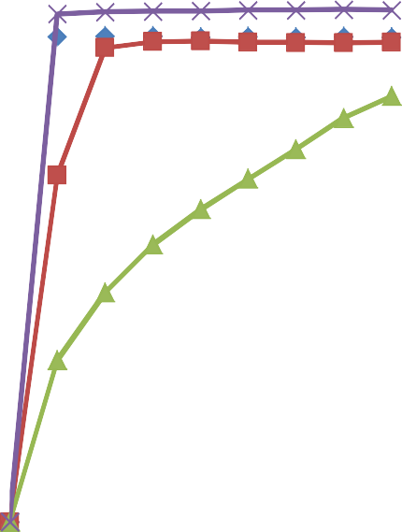
Drug release (%)
120
100
80
60
40

20
T7 (HPMC LV 5%) T8 (HPMC ER 5%) T9 (HPMC ER 7.5%)
T10 (CrosCCG 25%)
0
0
50
100
150
Time (min)

Figure 4.30: Drug Release (%) of Ve.nHCl TabletsContaining HPMC orCrosCCG as Binders at SelectedConcentrations

    - Formulation Properties of Ven. HCl Tablets Containing HPMC as Binder and CrosCCG Release Modifier

      - GranuleProperties

The properties of granules formed using HPMC ER at 7.5 %w/w as binder and CrosCCG at varying concentrations as drug release modifier are shown in Table 4.8. The compressibility index and the Hausner ratio were found to decreasteheasconcentraiotn of CrosCCG increased. At 10 %w/w concentration of CrosCCG, the granules were found to have a compressibility index and Hausner ratio2o4f.20% and1.34 respectively, while at 25 %w/w concentration the values were reduced t0o.602% and 1.27 respectively. As the concentration of CrosCCG increas, ethde flow rateincreased whileangle of reposewas
found to decreas.eInter-batch granule size distribution (Figure 14).3was found to be somewhat uniform and skewed to the smaller size ranges. CGrosaCt 10 % (G9)produced
relatively bigger granules with 28.45 o%f the granule proportion E H L Q J J U H D

as against the 210.7, 24.05, and 2.300 % for G11, G12 and G13, respectively.

Table 4.8: Properties of Ve.nHCl Granules ContaininHg PMC (ER) as Binder and CrosCCG as Release Modifier

Parameter |  | Batches
 | G11 | G12 | G13
Bulk density (g/ml) | 0.619 | 0.645 | 0.682
Tap density (g/ml) | 0.829 | 0.849 | 0.871
Compressibility index (%) | 24.20 | 22.90 | 20.60
Hausner ratio | 01.34 | 01.31 | 01.27
Flow rate (g/s) B/L | 1.87 | 2.12 | 2.42
A/L | 2.03 | 2.38 | 2.83
Angle of repose º() B/L | 34.19 | 33.84 | 33.26
A/L | 33.51 | 33.11 | 32.40

Key: HPMC ER 7.5% + CrosCCG 10% (G11); CrosCCG 15% (G12); CrosCCG 25%
(G13)

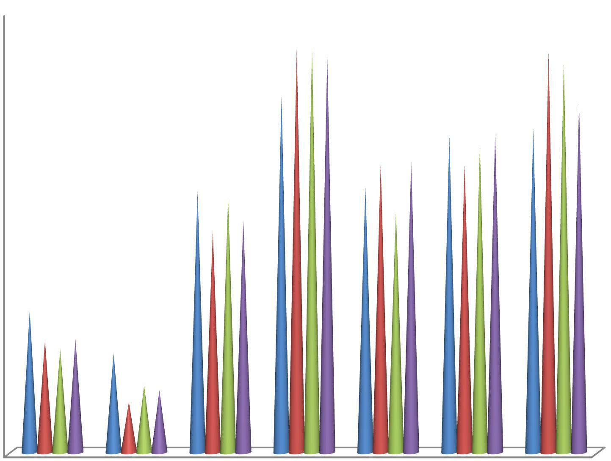u •
25
20
15

10
G9 G11 G12
G13
5
0
600
425
250 150 106
D • Z
53
•
0
]
Ì
~ R
Granules weight retained on mesh (%)

Key: HPMC ER K100 at 7.5%, alone (G9) plus CrosCCG 10% (G11); CrosCCG 15% (G12) and CrosCCG 25% (G13)

Figure 4.31: Size Distribution of GranulesMade with HPMC ER K100 aBsinder at 7.5% and IncreasingoCncentrations of CrosCCG as ReleaRsetardant

      - Tablet Properties

Properties of tablets formulated using HPMC ER at 7.5 %w/w as binder and CrosCCG at varying concentrations as drug release retardants are shown in Table 4.9 and F2ig.ure 4.3
Determinations on weighvtariations of the tablets have shown that the -ingtrroaup weights

were not so different, as shown by the values of the standard deviations obtained. Across the groups the tablet weights also seem somewhat similar. Intra and inter batch similarities in tablet crushing strength and friability were also observed as these parameters were studied on T11– T13 tablet batches. Concentration of CrosCCG was found to affect drug release as T11 containing 10 %w/w concentration showed ₈a_{0%}Tof 90 min, while T_{80%} of 120 min
was shown each for concentrations of 15 %w/w and 25 %w/w. Dissolution profile of the tablets (Figure 4.23) showed CrosCCG at 25 %w/w to have delayed the release of the drug most. At 15 min of commencing thine vitro drug dissolution test, the drugleraese from tablets containing CrosCCG at 10, 15 and 25 %w/w concentration was found to be 39.5 %,
31.56 % and 27.54 %, respectively. This trend was continued up to ^{t}t^{h}hemi9n0when release between concentrations of 15 and 25 %w/w became similar (sedeixaIp)p. en

Table 4.9: Properties of Ve.nHCl Tablets Containing HPMC (ER) as Bindaenrd CrosCCG as Release Modifier

Parameter |  | Batches
 | T11 | T12 | T13
Weight variation (mg ± SD) | 168. 10 ±2.08 | 165.96 ±1.74 | 167.03 ±1.35
Crushing strength (KN ± SD) | 5.12 ±1.73 | 5.79 ±2.21 | 5.44 ±1.45
Friability (%) | 0.43 | 0.39 | 0.57
Content of active ingredient(%) | 100.81 | 94.23 | 99.08
T_{80%} (min) | 90 | 120 | 120
Diameter (mm ± SD) | 7.040 ± 0.005 | 7.040 ± 0.005 | 7.040 ± 0.006

Key: HPMC ER 7.5% + CrosCCG 10%(T11); CrosCCG 15% (T12); CrosCCG 25% (T13)

Drug release (%)
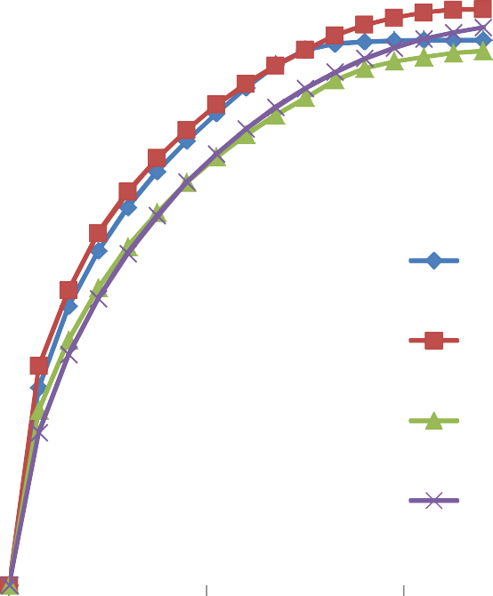

Figure 4.32: Effect of Concentration of CrosCCG on Drug Release of. VHeCnl Containing HPMC ER as Binder at 7.5 %w/w
120
100
80
60
T9 (HPMC ER 7.5%)
40
T11 (HPMC ER 7.5% + CrosCCG 10%)

T12 (HPMC ER 7.5% + CrosCCG 15%)
20
T13 (HPMC ER 7.5% + CrosCCG 25%)
0
0
100
200
300
Time (min)

    - Formulation Properties of Ven. HCl Tablets Containing HPMC as Binder and CrosCCG and Some Polymers as ReleaEsenhancing Agents

      - Granule Properties

Properties of granules made with 7.5 %w/w HPMC ER as binder and 3 %w/w concentrationsof CrosCCG, CrosCC, CrosCE, Croasmcellose and Crospovidonuesed as release enhancinaggents are shown in Table 4.1G0r.anules from none of the batches were found to flow throughthe funnel. A near similar % compressibility and Hausner ratio were
displayed by the granules from the respveectbi atches. The compressibility einxd and

Hausner ratio average2d5 ± 0.707% and 1.35± 0.01, respectively.Granule size distribution is shown in Figure 4.33, where the chart depicted granules with siwzehsich skewed to the
small size fraction. The granules collected on pan accounted for an average of 20 % of each batch.

Table 4.10:Properties of Ve.nHCl Granules Containing HPMC (ER) as Binder at 7.5 %w/w and Some Polymers as Disintegrants at 3%w/w

Parameter |  |  | Batches
 | G14 | G15 | G16 | G17 | G18
Bulk density (g/ml) | 0.523 | 0.627 | 0.623 | 0.613 | 0.613
Tap density (g/ml) | 0.708 | 0.843 | 0.843 | 0.841 | 0.838
Compressibility index (%) | 25.00 | 24.40 | 25.00 | 26.00 | 25.70
Hausner ratio | 1.35 | 1.34 | 1.35 | 1.37 | 1.36
Flow rate (g/s) B/L | NF | NF | NF | NF | NF
A/L | NF | NF | NF | NF | NF
Angle of repose º() B/L | - | - | - | - | -
A/L | - | - | - | - | -

Key: HPMC ER 7.5% + CrosCCG 3% (G14); CrosCC 3% (G15); Croscamellose 3% (G16); Crospovidone 3%(G17); CrosCE 3% (G18)

