CHALLENGES OF INDISCIPLINE IN THE NIGERIA POLICE AND ITS IMPLICATIONS FOR NATIONAL SECURITY


Ph.D. THESIS

THE INSTITUTE OF AFRICAN STUDIES UNIVERSITY OF IBADAN
IBADAN

OJO SUNDAY ABRAHAM
B.Sc. [ANI.SC] M.A. [Peace & Conflict Studies] MATRIC NO. 72406

Thesis submitted to the Institute of Africa Studies (IAS), University of Ibadan in partial fulfillment of Requirements for award of degree of Doctor of Philosophy (PCS) of the University of Ibadan.

NOVEMBER, 2011

ABSTRACT

As an important arm in governance and social control, attention has been focused on the police. Corruption, inadequate funding, poor governance, and public attitude to the police force, under-staffing, and inadequate training have been identified by scholars and policymakers as major problems of the Nigerian Police. However, little has been done on indiscipline in the Nigeria Police in relations to these challenges. This study examined the linkages of indiscipline with these issues and their implications on national security management in Nigeria.
Quantitative and qualitative methods of data collection and analysis were used in the study. Qualitative data were generated through in-depth interviews and focus group discussions (FGD). Quantitative data were obtained through a structured questionnaire. Three hundred copies of the questionnaire were administered in the sample areas randomly selected from the six geo-political zones in the country and two hundred and eighty (86.7%) were successfully retrieved and were augmented with data collected through interviews and focus group discussions with top echelons in the police, junior officers and the ranks and files, traditional rulers, civil societies, police service commission chairman etc. Frequency count percentages and Pearson chi-square were employed to analyze the result.
The Nigerian Police Force has not been able to contribute effectively and efficiently to the maintenance of national security of Nigeria because of indiscipline. There is lot of laxity, insolence and disrespect among men and officers of the Nigerian Police. Corruption, inadequate funding, poor training, and interference of governments in Police duties, under- staffing and poor training are results of circumvention of standards. Rules and orders stipulated by the Nigeria Police Acts and provisions by the constitution of the Federal Republic of Nigeria are not adhered to. This results in their dismal performance. Greater percentage (69.9%) of the Nigerian populace are not satisfied of the increasing impairment of the police effectiveness (χ²
= 28.805; df = 2; P < 0.05) and its severe implications on national security (χ² = 11.877; df
= 2; P < 0.05). Other factors such as non-conducive working environment, lack of motivation, erroneous perception of national security from coercive force perceptive contributes to unsatisfactory performance by the Nigeria Police. Also communication gap existing between the police and the general public makes security to be seen by the public as purely police affairs.
Lack of motivation, under-staffing, poor attitude to the police force, corruption, poor governance, inadequate funding, non-conducive working environment, and poor training are all outcomes of indiscipline. The communication gap between police and general public should be blurred. Furthermore, the police force and general public must be sensitized and reoriented on what constitute national security. This will result in effective and efficient management of security in Nigeria. The prospect of effective and efficient policing of Nigeria lies in addressing indiscipline jointly by the government, the Police Force and the general public. Massive orientation of the police personnel and general public on implications of indiscipline on national security is urgent.

Key words: Indiscipline, Corruption, Nigeria Police, National security.

Word Count: 485

DEDICATION
I dedicate this work to the Almighty God for making it a success. His presence and ever present help and faithfulness saw me through those stressful moments in the course of the work. Also to my late father Samuel Adeyanju Ojo for all his love and support for this work.

CERTIFICATION
I certify that this thesis was written by Sunday Abraham OJO in the Department of Peace and Conflict Studies, Institute of African Studies, University of Ibadan under my supervision.

……………………………. ……………………………………….
Date Supervisor
Prof. O.B.C. Nwolise Department of Political Science University of Ibadan.

ACKNOWLEDGEMENT
If not for His grace, I would not have been able to accomplish this task. I, therefore, acknowledge the grace of God upon my life for making this work a reality. Thank you Lord; must also acknowledge the efforts of many people that have contributed to the completion of this work.
Mention must be made of my supervisor, Dr. O.B.C . Nwolise who has taken his time to read the work and offer useful suggestions that have contributed greatly to the quality of this work, also for his support and intellectual guidance. His in-dept knowledge of national security and for the materials he provided were invaluable contributions that made this work a success. To him I will always remain grateful.
I wish to place on record the invaluable contributions of the Director, Institute of African studies, Prof. I.O. Albert, Dr. Danjibo, Dr Olorunyomi, Dr. K.M. Samuel for the success of this work. Their concern and assistance marks them out for special mention. I express my profound gratitude to Dr. O.B. Olaoba. He deserves special mention for his concern and constant encouragement, indeed you are a mentor. I also thank my lecturers, Drs. Adekola, Adekunle, Ishola, Faleti, Danjibo, the sub-dean Dr. Olorunyomi.
I also wish to acknowledge the moral and financial contribution of my mentors, General Osemwota, Compol Alkali and Acpol Bola Longe, for being there for me in times of need, mention must also be made of Barrister Olubukola Anjola Ayeni, you are a friend indeed, God bless you.
I acknowledge the contributions of my colleagues in the Institute of African Studies – Drs. Fransisca Essien, David Udofia, Kayode Owojori, Andrew Sawyer, Bose Babatunde, Willi Eselebor, Mrs. Alabi, Elebute, Salawu, Ojo Adesoji, John Oritsetiseyi and a host of others.
I thank the entire staff of the institute of African Studies for their assistance throughout the duration of this course. My sincere gratitude also goes to Mr. Ogunmola and the entire IFRA and the Institute Library staff – Mr. Raji and Mrs. Mary Emoekpeire.
My family deserves special mention. First, I want to place on record, the immense contribution of my Late Father Mr. Adeyanju Ojo and my mother Mrs. Abimbola Ojo for the success of this work and being there for me during my wilderness experience. To you I will remain eternally grateful. I am deeply grateful to my siblings for their unflinching love and support. To all my colleagues in the Nigeria Police Force especially the Course 3/2009 set, I will forever remain grateful to all of you for the love, concern, support and encouragement.

My deep gratitude also goes to the entire staff of CLEEN, NISER, Police Service Commission, Police Affairs and every good people I met during the fieldwork at Abuja, Lagos, Borno/Gwoza etc. for their concern and assistance throughout the period of my studies. I also acknowledge the assistance of my sister Deaconess Funmilayo Ojo and her family for typing this work from beginning to the end God bless you.
Finally, my gratitude goes to my best friend and wife Olubusayo Rebecca Ojo, you deserve special mention for your contributions to the success of this work and for keeping the home front, God will perfect your matter.

TABLE OF CONTENTS
Title Page i

Abstract ii
Dedication iii
Certification iv
Table of Contents v
List of Tables vii
List of Figures ix
List of Plates x
Chapter One
Introduction 1
  - Background 1
  - Statement of the Research Problem 5
  - Objectives of Study 12
  - Significance of Study 13
  - Scope of the Study 14
  - Limitations of the Study 15
Chapter Two
Literature Review 17
  - National Security 17
  - Policing 29
  - Discipline 32
Chapter Three
Methodology of the Study 123
  - Research Design 123
  - Methodology 124
  - Sources of Data Collection 125
  - Data Analysis 130
Chapter Four
Data Analysis, Research Findings and Discussions 132
4.0 Data Analysis and Research Findings 132
Chapter Five
Conclusion and Recommendations 243
  - Summary 243
  - Conclusion 245
  - Recommendations 245
Bibliography 248

LIST OF TABLES

Table 4.1: | Respondents response to the statement that, “The Nigeria Police Force is the most visible law enforcement agent.” | 135
Table 4.2: | Respondents response to the statement that, “Duties of the police is to protect lives and properties of citizenry at all cost” | 135
Table 4.3: | Respondents response to the statement that, “Police plays vital roles in the maintenance of law and order in the society” | 136
Table 4.4 | Respondents response to the statement that, “the public sees the police as a body of oppressors and traitors not as friends” | 137
Table 4.5: | Respondents response to the state that, “the police serves the elite in the society and not the masses/general public” | 137
Table 4.6 | Respondents response to the statement that “there is inefficiency and ineffectiveness in the performance of the police duties” | 138
Table 4.7 | Respondents response to the statement that “the roles of the police in the society have been well satisfactory” | 139
Table 4.8: | Respondents response to the statement that, “societal ethics does not affect the performance of the police” | 139
Table 4.9 | Respondents response to the statement that, “Ethics in the force are inimical to public safety and good order” | 140
Table 4.10 | Respondents response to the statement that, “God-fatherism, ethnicity, religious bigotry affects the standard of police” | 141
Table 4.11 | Respondents response to the statement that “lack of motivation,  poor welfare and socialization causes poor performance in the police” | 142
Table 4.12: | Respondents response to the statement that “Lack of proper screening for character and emotional stability leads to indiscipline in the forces” | 143
Table 4.13: | Respondents response to the statement that “The environment of operation also contributes to low income and lead to poor productivity …” | 144
Table 4.14: | Respondents response to the statement that “indiscipline in the police are caused by prejudice, stereotype” | 145
Table 4.15: | Respondents response to the statement that, “Non-compliance with laid down procedure in carrier development and advancement  leads to poor productivity within the police” | 145

Table 4.16: | Respondents response to the statement that, “Police Acts is not  sufficient to meet modern policy” | 146
Table 4.17: | Respondents response to the statement that, “Indiscipline in the police has great consequences for national development” | 147
Table 4.18: | Respondents response to the statement that, “The media gives a biased coverage of police performance in Nigeria” | 147
Table 4.19: | Respondents response to the statement that, “Some were enlisted into the police because of lack of employment” | 148
Table 4.20: | Respondents response to the statement that, “Indiscipline in the police promotes national disunity” | 149
Table 4.21: | Respondents response to the statement that, “Transparency and accountability must be emphasized in the NPF activities” | 149
Table 4.22: | Respondents response to the statement that, “An efficient police is a prerequisite for sound internal security and democratic development” | 150
Table 4.23: | Table showing the establishment, strength and vacancy in the NPF from 1997 – 2007 | 167
Table 4.24: | Number of Police Dismissed (Insp, Rank And Files) (1997 – 2007) | 169
Table 4.25: | No of Policemen and Women (Insp, Rank and File) Reduced in Rank (1997 – 2007) | 170
Table 4.26: | Discipline Superior Police Officer (2007) | 171
Table 4.27: | Police – Citizens Ratio (1997 – 2007) | 176
Table 4.28: | Trends and Changes in Revenue Allocation Formula to the NPF | 181
Table 4.29: | Salary of the NPF compare with some African countries | 182
Table 4.30: | Accommodation Status of Police Personnel Nationwide | 183

LIST OF FIGURES

Fig. 1.1: | Conflict Tree Analysis of Erosion of Discipline in the Nigeria Police Force | 10
Fig. 2.1: | Explaining the Grand Strategy Framework | 27
Fig. 2.2: | Police Administrative Structure Before 1976 | 96
Fig. 2.3: | Police Administrative Structure Police Re-Organization into Directorate and Zonal Command 1986 | 97
Fig. 2.4: | The Nigeria Police Force Organizational Chart | 98
Fig. 2.5: | The Structure of Expectancies | 117
Fig. 4.1: | Age Structure of Nigerian Human Resources | 160
Fig. 4.2: | Breakdown of the 68% Literacy Level of Nigeria | 161
Fig. 4.3: | Ethnic Composition of Nigerian Human Resources | 161
Fig. 4.4 | Number of Police Dismissed (Insp, Rank And Files) (1997 – 2007) | 167
Fig. 4.5: | Police Service Commission Organizational Chart | 211
Fig. 4.6: | No of Policemen and Women (Insp, Rank and File) Reduced in Rank (1997 – 2007)
Fig. 4.7: | Diagram of Good Governance Showing the Basic Eight Tenets | 220
Fig. 4.8: | Holistic Components of Security Sector | 222
Fig. 4.9: | Cyclical Web of Rule of Law and Security Sector | 224

LIST OF PLATES

Plate 1: | The rot of shabby dressing (recent) by member of police force compare to American police at the middle | 227
Plate 2: | Shabby dressing by members of the Police Force has been from the past | 227
Plate 3: | Agonies of the Police Force, some policemen pushing “blackmaria” lorry to conveyed prisoners/convicts from the court premises. | 228
Plate 4: | Part of the ill-equipment of the Police that has enables them to be inefficient and ineffective to distress calls by the public. | 228
Plate 5: | Policemen whose lives were snuffed out through armed robbers’ gun in Lagos State | 229
Plate 6: | Policemen at a crime scene, parading lots of obsolete equipment, due to lack of modern amenities to combat crime. | 229
Plate 7: | Militants have held the nation’s security by the jugular | 230
Plate 8: | Militants have held the nation’s security by the jugular | 230
Plate 9: | Too many arms and ammunition in wrong hands | 230
Plate 10: | A section of the barrack in Ibadan, showing dilapidated infrastructure in the barracks which pose a social concern for all and sundry | 231
Plate 11: | Squalid state of the barracks in Lagos, (Elere Police Barrack, Lagos) due to neglect by the past and present leaders | 231

Plate 12: Section of the “A” Division barrack, Jos Plateau state; Children born into this home stand the risk contacting infectious disease due to the
maintenance culture of the men and women in the Nigerian Police barracks 232

Plate 13: Section of the Wukari Barrack, Taraba State, showing the Present state of destruction in the barracks due to neglect of the welfare of the
Nigerian Police Force 232
Plate 14: How old are each of the quarters since erected and commissioned, have the building ever been refurbished, repainted or revamped to enhance the
image of the Nigerian Police and the nation’s corporate image 233
Plate 15: A pit latrine used in the barracks due to sordid state of overcrowding,
threat of epidemic is real in the Nigeria police Barracks 233
Plate 16: Nigerian Policemen in a rickety bus that can barely give robbers a chase 234

Plate 17: | A “911”Truck belonging to the “45 PMF FHQ” as fully inscribed  on the tyre conveying wives of the police officers because of lack of response to Police welfare | 234
Plate 18: | Men under training at Police Mobile Training School, Gwosa, Maiduguri | 235
Plate 19: | Men under training at Police Mobile Training School, Gwosa, Maiduguri, considering the condition of training in democratic era | 235
Plate 20: | Entrance of the Mobile Training Camp, Gwosa, Borno-State, showing officer on training to enhance discipline in the Nigerian Police Force | 236
Plate 21: | Entrance of the Mobile Training Camp, Gwosa, Borno-State, showing officer on training to enhance discipline in the Nigerian Police Force | 236
Plate 22: | The Researcher and members of “ASP” Course 3 2009 Officer on training to enhance discipline in the Nigerian Police Force at Police Staff College Jos | 237
Plate 23: | The Researcher and some officers at a Combat Drill exercise in Gwosa Camp | 237
Plate 24: | Members of the Police Force paraded for extorting money from commuters and motorists | 238
Plate 25: | A “unique” way to track high-tech crime. The police needs more equipment to combat crime | 238
Plate 26: | The researcher and some of the people at the focus group discussion in Jos, Plateau State | 239
Plate 27: | Some Newly Acquired “Armoured Personnel Carrier”, Training equipment, skilled personnel to facilities and structure, deficiencies in the Police evidence | 239
Plate 28: | Newly built barracks for Police in Abuja and some states in the country under the Federal Mortgage Bank/Police Loan Scheme | 240
Plate 29: | A Ghanaian Police Officer delivering a lecture at the peacekeeping Department FHQ Abuja, poor intellectual diet in the  Nigerian Police Force fuels a malfunctioning force | 240
Plate 30: | Some Police officers in an Indoor- Shooting –Range Exercise, poor intellectual diet in the Nigerian Police Force fuels a malfunctioning force | 241

Plate 31: | Members of the Nigeria Police Force before their departure for Peace  Mission in Darfur, Sudan, happy Police make a happy nation. | 241
Plate 32: | Members of the Nigeria Police Force during the visit of the Inspector –General of Police to Zone 7 HQ Abuja, a happy Police make a happy nation when they are fully motivated | 242

CHALLENGES OF INDISCIPLINE IN THE NIGERIA POLICE AND ITS IMPLICATIONS FOR NATIONAL SECURITY

BY
OJO SUNDAY ABRAHAM
B.Sc. [ANI.SC] M.A. [Peace & Conflict Studies] MATRIC NO. 72406
A THESIS IN THE INSTITUTE OF AFRICA STUDIES (IAS), SUBMITTED TO THE FACULTY OF
IN PARTIAL FULFILMENT OF THE REQUIREMENTS FOR THE AWARD OF THE DEGREE OF DOCTOR OF PHILOSOPHY
OF THE
UNIVERSITY OF IBADAN

NOVEMBER, 2011

  - Background

CHAPTER ONE INTRODUCTION


Since the dawn of history a citizen's loyalty to his state or community is directly proportional to the degree to which the latter is able to protect him (Tamuno, 1991:40) and meet his needs. Taken in its broadest sense, such protection covers the preservation of the lives and property of the people against every possible threat. In doing this, government relies on the police, except in unusual circumstances when the services of soldiers are required (Tamuno, 1991:40). The police play an important role without which the sustenance of order, legality, development and democracy may be difficult. Therefore, any pro-poor change initiative must take account of the facilitative roles of the police in society. The primary role of the police is policing – securing compliance with existing laws and conformity with precepts of social order. But the police are not the only agency involved in this role in the broad sense of the term. Policing is necessary in all societies for the preservation of order, safety and social relations.
The necessity of policing is more evident in the modern societies which are characterized by diversities and contradictions arising from population heterogeneity, urbanization, industrialization, conflicting ideologies or appropriate socio-political and economic form of organization. However, the emergence of the police, (a body of men recruited and paid by the state to enforce law and maintain order,) is a recent development in human history (Reiner, 2000:5). But, it has been difficult for the police in Nigeria to be seen as a people-oriented force, and for this reason, the police has not been able to achieve the kind of functional cooperation that will enhance its performance from members of the public. The level of citizen participation in individual and collective crime prevention is borne out of their fear of the unpredictability of breakdown of law and order at the community level (Taylor and Perkins, 1996:10). Thus loss of confidence in the Nigeria police, as an institution, has prevented the public from working closely with the police.
Ibrahim Coomassie, a former Inspector General of Police, once expressed shock at the spate of indiscipline in the force, asserting that discipline, which ought to be the bedrock of the force, was being disregarded with impunity by some unscrupulous policemen (The Guardian, '98:3). He stressed further that without discipline "the Nigeria police will not make any meaningful impact on the society." According to him, some members of the force are greedy and selfish. They were, indeed, not amenable to discipline and did not have respect for

fundamental liberty of the ordinary man on the street. All over the world, the police is respected and regarded as one of the most cherished forces because it is the most directly involved with the public (Daily Times, '91:40), Policemen and women are expected to be seen as friends of the society, serving as agents of protection and guardian angels of sorts.
On the contrary, the police image in Nigeria seems not to be getting favourable response from members of the public. The average Nigerian might be unconsciously tempted to see the police more as an agent of protection. This seemingly negative image of the police has been so entrenched in the minds of the public that even the good works of the police seem not to be generally appreciated. From scores of published articles in the newspapers, books and journals, policemen have sometimes been branded as a necessary evil, and if possible many would vote for a general overhaul or disbandment of the police force in Nigeria, as it was done in 1891 by McDonald, successor to Annesley the Acting Consul of Lagos Protectorate. For instance, either as a result of experience or otherwise, many try as much as possible to avoid any contact with the Nigeria police even when their assistance is needed to arrest a suspect, or to serve as witnesses in court. Even within the police the plight of the Nigeria police force is such that the military makes an inferior fiddled of it. The civilian governments take the police for granted; the force itself has no image that the public may respect. Worse still, policemen themselves are haunted by hatred for and insincerity to one another. Unfortunately, in the same generally corrupt society, it is only in the Nigeria Police Force that various man-hunting squads – X-squads, B-squads, C-squads, are established to trap and deal with one another, destroying espirit de corps as if other equally corrupt institutions and bodies could survive similar trauma if put under the same trial.
Relationship amongst officers were destroyed by very many factors, which eventually resulted into decline of discipline and bad precedence for others to follow in the force with effects on the public/national security. According to Sir Robert Mark, visitors to Britain often commented that the policemen were wonderful and this made an impression on public opinion. The causal factors of these wonderful qualities, according to him, were due to the limitation of the police power; a high degree of accountability for their actions and freedom from political interference. However, these three qualities, which have made the British police tick, is absent within the police in Nigeria.
The issue of police accountability is a serious matter in any society and its impact has been captured in the phrases „Who shall guard the guardians‟ and „Who shall police the police‟ Alemika (2003). The two phrases draw attention to the role of the police as guardians

while at the same time express the fears that guardians are not always benevolent and need to be subject to monitoring. More substantively, the coercive power of the state is routinely exercised by the police. No other public institution has the opportunities as well as temptation to abuse power as the police. First, those who seek to abuse public power often require the collaboration or acquiescence of the police. On their own, the police are strategically placed within the vector of power such that they may perform three different roles in the exercise and abuse of power – repellant of abuse, instigator of abuse, and executor of abuse. Therefore, there is need to be subject to strong mechanisms of accountability to public authorities and civil society. In Nigeria, there is widespread concern about the performance, integrity and conduct of the Nigeria police force. For example, the police are widely criticized for extra- judicial killings, corruption, incivility, brutality and torture, various forms – indiscipline, non- response to distress calls by the citizens. It must be emphasized that no police force can be accountable if the government lacks accountability, as the case is in Nigeria.
The critical issue is where does Nigeria stand in terms of institutions, mechanisms and procedures for holding police accountable? In general, the country has multiple institutions for holding police accountable. However, the institutions are weak, ineffective and uncoordinated. This is caused by the fact that there are too many of such mechanisms; lack of interaction by both the personnel in charge of the mechanisms and the information or statistics they generate; the casual manner with which most complaints against the police are received and treated; and the fact that there is absence of standardized method in the recording and processing of data generated by the mechanisms.
Also the large number of these mechanisms creates confusion among the citizens as to which of them to send their petitions to, which further compounded by the fact that there is no regulation guiding the invocation of the mechanism. Such a regulation would have provided information as to which of the mechanisms could be complained to for particular offences, in particular areas and at which stage. This has led to a situation where a citizen could wake up and write petition to the Inspector General of Police in far away Abuja, the Federal Capital Territory, for allegations of police misconduct that could have been handled by the divisional police officer in his local community. And when he or she does not get either a reply or redress on time, the conclusion would be as we found that the police do not take complaints against it personnel seriously which thereby resulted into high level of indiscipline and incivility to members of the public. Discipline, that has been regarded as the bedrock of the police, has been given a less priority, successive chiefs of police at federal and state level in

Nigeria have failed to recognize discipline and disciplinary mechanisms as tools that could be used in a fair and consistent manner to remove those police officials who are undermining police effectiveness and improved public relations in the country. This could be gleaned from the priority areas of concern, resource allocation to disciplinary mechanism and more importantly absence of periodic review of the disciplinary system.
Police authorities in Nigeria hardly publish priority areas of concern of their administration. And when they do, such articulation rarely goes beyond identification of armed robbery and establishment of ad hoc task forces to tackle it, which hardly provides more than momentary succour. An exception to this rule was the eight-point agenda drawn up by the then Inspector General of Police, Mr. Tafa Balogun. On assumption of office in March 2002, in which he outlined the following strategy for transforming the force: (a) Community Partnership, (b) Robust Public Relations, (c) Serious Anti-Corruption Crusade, (d) Fast and Decisive Crises/Conflict Management etc.
The priority agenda is commendable given the fact that it was the first time a police chief would draw up priority areas of attention in the country‟s contemporary history, which is worthy of note that the successive Inspector Genera of Police has been following his footstep. However, there is no recognition of discipline or disciplinary mechanism as important in realizing the agenda. There is also absence of neither a plan for their implementation nor measurable benchmarks for evaluating them. Thereby rendering the agenda to become a mere shopping list rather than a well articulated strategy for the transformation of the police.
For us in Nigeria, the implications of erosion of discipline in the Nigeria police possess a lot of challenges on National Security. According to Onovo (2004), National Security have been made more complex by a number of factors, like ethnic diversity, plurality of religions, economic down-turn and unemployment, our nascent democracy and the accompanying release of bottled-up emotions from years of repression of the civil population under military governance. Under no other form of government have the challenges of national security been more daunting and potently sensitive than in a democracy, with its unique features, particularly those relating to human rights, rule of law, freedom of association, freedom of expression amongst others, which could sometimes generate countervailing forces that constitute a threat to national security. Threat to National security leads to state of insecurity, which can be described as an unstable period, especially one of

extreme range of situations characterized by violence (physical, structural and psychological), destruction, law breaking and human rights violations – all resulting in human suffering.
Such a condition can create lack of confidence, by law-abiding citizens, in government‟s ability to provide them with basic protection from internal violence, riots, disturbances, exploitations, menace of armed-robbers and hired assassins within the ambit of the laws of the land. A significant consequence of national insecurity is that it breeds an unstable polity – a conflict situation where the accepted norms and values of the society are put under severe stress. If the conflicts arising from insecurity are not properly managed, such situation is capable of derailing an otherwise stable social order, and this can be inimical to peace, progress and good governance. Such situation can cause disaffection among the populace and/or discredit constituted authority with the aim of overthrowing such an authority. Besides, the effect of threat to security on economic and social sectors could be very disastrous and cause loss of human lives and properties.
National insecurity also, and most importantly, exposes lapses in the security machinery of government, a situation that puts into serious questioning, the ability and capability of the various security agencies, especially the police. The moment there is a police force that commands abundant authority plus sufficient public respect, the whole nation will be on a path of sanity. Such effects of a virile police system will permeate all spheres of our national life and will spell the dawn of an era of national discipline. It is pertinent to mention that the police system, worth its salt, will effortlessly mobilize the public to her assistance to police the nation. The public will never cooperate with an institution offering such an institution an assistance that might be eventually turned against it irresponsibly. Since the wealth and fame of a nation depend on effective security network, put in place, policing therefore, requires discipline, empowered officers committed to problem solving and partnership, which demands changes in police management style and organization. It is in the light of the foregoing discussion, that this study intends to investigate the erosion of discipline in the Nigeria police force and its implication for national security.

Statement of the Research Problem
The fundamental problem is that discipline has been grossly eroded in the Nigerian police, and this has led to not only ineffectiveness and inefficiency in the performance of police duties, but has turned the police into a body of oppressors in the eyes of the people. Indeed, at the international scene, Nigeria has been rated low with regard to security. The

impact of military rule on police discipline, abuse of power and respect of human rights has been well documented in various publications of human rights groups in Nigeria that they need not be repeated; but sufficed it to say that they disobey court orders (Asemota, 1993, 1993; Chukwuma, 1995), tortured suspects (Ubani, 1990; Nwankwo, 1993; Chukwuma, 1994), kept people in jail for long period without trial (Ajomo and Okagbue, 1991), became very corrupt (Gambo, 1989) and enjoyed a pervading impunity in all of these (Nowrojee, 1992). One of the cardinal attributes of a democratic society is the supremacy of the rule of law. Once a court order is made, it subsists until set aside on appeal. The practice of disobeying or ignoring court orders properly entered is perhaps the most embarrassing manifestation of military regimes. However, in line with the emerging democratic culture in Nigeria and the paradigm shift in policing, the Nigeria Police Force now has utmost regard and respect for court orders and judgments. Now, the Nigeria Police always complies with the terms of court orders and judgments that emanate from our courts of law.
Any objections to such orders / judgments are now by way of appeal as authorized and laid down by the law. This is because the Inspector General of Police has always emphasized the view that to guarantee the observance and protection of human rights and fundamental freedoms in any society, including our own, it is absolutely imperative that the authorities should always comply with pronouncements of the courts.
However, the biggest casualty of police participation in military government in terms of discipline became the police itself. All the officers who were appointed to political position under military found it difficult to subordinate themselves to their superiors when they came back to the service, as they had become richer and developed more influential contact within the military and the political class. Similarly, as the military became more vicious in its treatment of the civil populace, a distinct class of police officials noted for their cruel and disgusting behaviour were needed to work with their military colleagues in prosecuting vigilante operations against opponents of the regime whether perceived or real. All the officers specially recruited for these assignments, mostly from the middle ranks and above became authorities unto themselves and that nobody could touch within the force. A cursory look at the activities of officers of the police, revealed that the issues of indiscipline on the part of police officers need to be addressed.
The erosion of discipline in the Nigeria police force has been variously assessed by different analysts. As at 1962, Abubakar Tsav (a retired CP) and many others were attracted to the police by the level of discipline and the authority they commanded, as well as their

neatness and the confidence that the public had in them as an organisation that is responsible for the safety of the public. Expressing a similar view, Umar Maiwada Sulaiman (a retired AIG) (1968), described the Nigeria police force as a discipline organisation, Adewusi (1976), Yusuff (1977), Gambo (1978), Coomassie (1985), Wushishi (1998), Jemibewon (1999); all shared their views on how disciplined the Nigeria police was.
However, Jemibewon (1999:2), when he became the Minister of Police Affairs, m maintained that:
The leadership of the Nigeria police force in the past years eroded the espirit de corps, discipline, efficiency and professionalism.

Wole Soyinka also lent credence to the quality, disciplined nature of the police force (1960-76). He stressed that he has no business to flatter anyone and will not be unfairly critical of any public officer discharging his public functions effectively. But, along the line, according to Commassie (1994:15) lamented the alarming “spate of disciplinary offences” against superior police officers (SPOs).
According to him:
The commonest amongst these cases include corruption, lack of supervision, negligence of duty, abuse of office, insubordination, disobedience to lawful order and incivility to members of the public serious of other cases include criminal offences bordering on stealing, theft, armed robbery, rape, forgery and altering, misappropriation of funds, extortion and demanding by menaces.

Therefore, discipline, which has been described as the bedrock of the force, was disregarded with impunity. Commassie (1998), also stressed that he was worried with the indiscipline that exist within the police force. He said the policemen are greedy, extortive and selfish, they are not amenable to discipline, and do not have respect for the fundamental liberty of the ordinary man on the street; abuse of police power, general laxity of officers, conspiracy between police and criminals.
Tsav (1998), also established that there is no discipline in the police force today. He said there is sectionalism, fatherism etc. in the force. At the time the military were retreating in 1999 the situation in the police force, just like in the military, had gotten so bad with regard to discipline, accountability, respect for human rights and observance of the famed police

„civil tradition‟ that the former Inspector General of Police, Alhaji Ibrahim Coomassie (1994:10) was to lament:
The force (Nigeria Police Force) has been torn between the civil populace and the military, so much so that its civil traditions are almost lost military authoritarianism.

Kwajafa (1994:29), affirmed that, “gone are those days when the uniform and the cleanliness of force personnel were the glamour and fear instilling weapons of the force. These days, all these qualities have been eroded not only by uniform but also by the lukewarm attitude of force personnel on cleanliness.
According to Kwajafa:
One may be forced to ask where the discipline of the force has gone with the years. Among the rank and files, constables do not respect their NCOs again. They believe any punishment meted out on them will in turn be visited on any officer who did it by their big brothers. It is the same thing among the senior cadre. Tribal sentiments, factional leaning and political undertones have derailed the beautiful discipline of the Nigeria police force.
That it will only take an act of God to retrieve this lost glory of the force.
In his own view, former prelate Sunday Mbang (1999:25) also maintained that there is no discipline in the Nigeria police force:
To me, the IGP does not appear to be concerned about the indiscipline, corruption etc. issues. They blame the civil society but they demand for bribes at gun-point. The doctrine of decency has to be preached from the top.

He berated men of the Nigeria police force and other uniform men for being disobedient:
The police needs to remedy its image by setting its house in order, and they wouldn't require a lot of seminars and orientation programmes;" "Again, I see a lot of disobedience to the law by people in uniform. It looks like the laws are not meant for them. So, government would need to do something fast. If you travel overseas, uniformed men are most discipline citizens because they see their uniforms as "Uniforms of respect and so do not disgrace them.
Anegbode (2007:95) also confirmed that:
Discipline problems have become very prominent in the force in recent years. The organization has suffered major public relations disasters due to the serious breaches of

discipline by police officers. The occurrences have ranged from simple acts of disobedience to flagrant violations of police ethics and criminality.
Also, considering the verdict of the late head of state (General Abacha) reported in the Daily Champion (1994:10), while inaugurating the probe panel to review the structure and management of the police force; He said:
The Nigeria police force had become a threat to public safety hence the need for a "surgical operation," he described the force as one of the nation's most troubled public agencies and said that, the ethics in the force had become inimical to the requirements of public safety and good order.
General Abacha, Daily Champion (1994:10) pointed out that there is an urgent need to restore public confidence in the nation‟s law and order apparatus; that the troubles afflicting the force are far beyond the issue of bad image. He said there were several structural, institutional, personality origin problems, which had, over the years, become so endemic that it was impossible for even dedicated officers to operate well and function optimally, that these problems ranged from the attitudinal, infrastructural, administrative to bureaucratic (Fig. 1a). He recalled that there were those:
“Old days” when the mere sight of the policeman‟s uniform was enough to re-assure the law-abiding citizen of his safety and to drive great fear into the heart of the criminally-minded. But, these days, the slogan, “police is your friend” now appears to hold true only for the outlaw.
The seriousness of the present situation is born out by the fact that nearly every Nigerian or a visitor to Nigeria has one unsavoury story or the other to tell about the police. If it is not non-challance in the handling of genuine cases, then it would be for over-zealousness in the pursuit of self-serving ends. To say that public confidence in this vital national institution has been severely eroded is not merely to state the obvious, it is under-state it.
Some of the charges which form the basis of police bad image are correct and often corroborated by almost daily evidence of wrong doings and official misconduct by officers and men of the organisation.
Recently, the former IGP Sunday Ehindero (2006:18) had cried out in the media that his subordinates, particularly the respective Commissioners of Police in charge of the states were not following his orders emphasizing that.
The force, in public perception remains an institution of indiscipline and corruption.

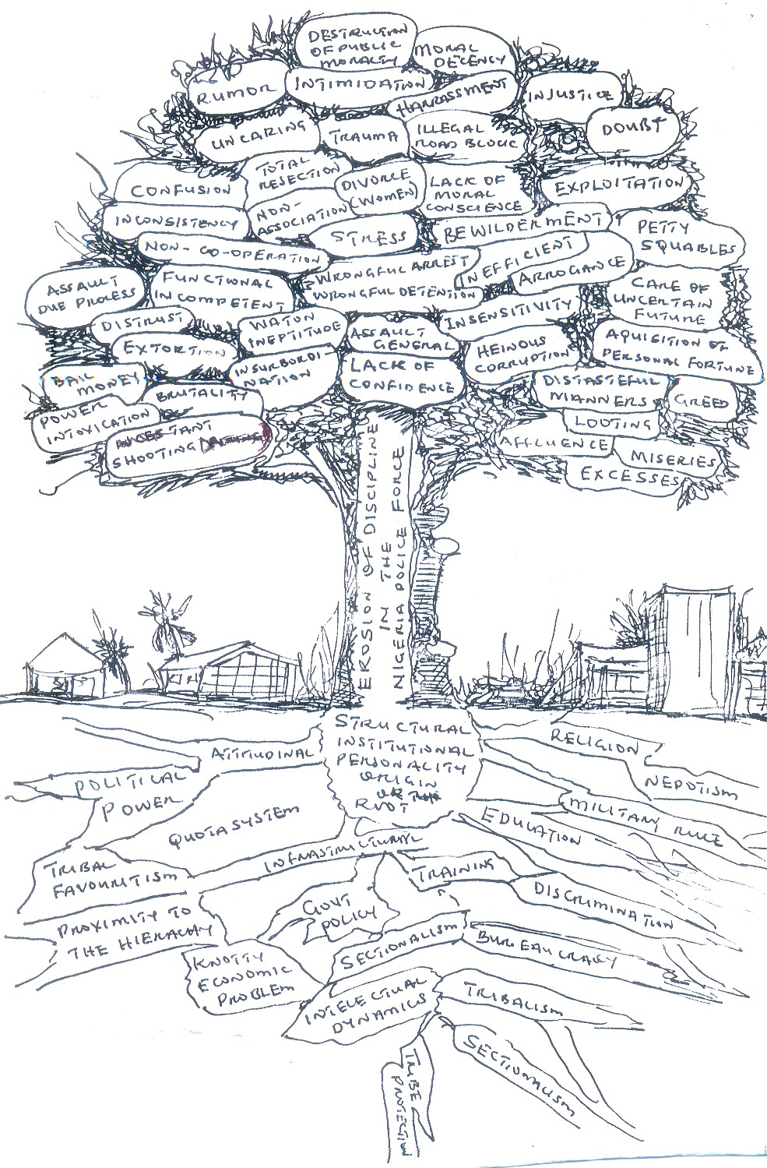

Fig. 1.1: Conflict Tree Analysis of Erosion of Discipline in the Nigeria Police Force
Source: Created by the researcher based on BOTKIN et al., (1995), Environmental Science

Fig. 1 depicts the causes, the core problem and the effects of erosion of discipline in the Nigeria police force and its implications on national security.
At a session held with officers of the rank of commissioner and above in Abuja, Ehindero (2004:58) observed that the force is leaving with acts of indiscipline and insurbordination. Almost resignedly, he decried in fury:
The penchant of senior officers for disobeying his orders." I said no road blocks, but if you go to our highways, everywhere is full of road blocks; I asked you people to get rid of scrap cars in your stations and commands, they are still there. I gave directive on the use of siren, individuals still blare siren at will in your states. Even as I.G., I don't use my owns.

Ehindero‟s gesture of resignation quite plausibly, can be regarded as the result of a self-evaluation exercise.
The development, in no little way, further raised people's anxiety over the security situation in the country. Though, it was not the first time Nigerians would be noticing a crack in the command structure of the agency saddled with the job of policing the country, but Ehindero's alarm will actually be the first time an I.G. would publicly complain of his insurbodination by his lieutenants. Analysts believe Ehindero's outburst, not only signals breakdown of discipline in the force, but also validates the rising feeling foreboding in the country, which can affect the peaceful co-existence of the nation as a whole. The incumbent Inspector General of Police Sir Mike Okiro (2008) also vowed to tackle every acts of indiscipline in the police.
Lai Olurode (2006:52) corroborated the above revelation by the Inspector General of police, as evidence that discipline and morals have completely broken down in the force. He stated that:
A policeman is supposed to radiate authority. But it is not so with the Nigerian police; our policemen are not well dressed, they look unkempt; always begging for money. They do not communicate power, you cannot see authority flowing from them.

There was already a growing public outcry arising from alleged harassment, torture, high-mindedness, incivility etc. in respect of cases handled by members of the police force, consequently widened the gulf between the force and the general public, it was constitutionally mandated to protect, raising the question whether the Nigerian police force was truly a friend or a foe of the people. The feeling that cut across the Nigerian public was

that the attitude and perception of the average policeman to his work, ran against the stream of some of the individual rights he was paid to protect. The situation was seen to be a far cry from what it used to be when the policeman was seen as embodiment of all that was orderly, just and impartial.
The research seeks answers to the following questions:
- What are the factors responsible for indiscipline in the Nigeria Police Force?
- What are the implications of an undisciplined police to National Development?
- How does ethics within the police affect societal ethics?
- How does the general/breakdown of morality and ethics in the society affect the outlook and performance of the police?
- What are the factors responsible for the lack of public trust in the police force?

Objectives of Study
The several years of military misrule traumatized the average Nigeria to a point where life has become meaningless (Onyeozili, 2005). By a calculated design, the military junta so much politicized and ethnicized the police to a point where espirit de corps is utterly non- existent. In the hope of perpetuating self-succession, and destroying police cohesiveness, the police were owed several arrears of salary as a way of subjecting them to mental anguish and inactivity. By the time the country returned to democratic rule in 1999, what was left of the initial not – too – efficient law (non) enforcement agency, was an indiscipline, cruel, ineptitude, unarmed, demoralized, rag-tag semi-zombies. Most of them especially the rank and files survive by naked extortion from commercial drivers at various illegal check points set up for that purpose.
While the appointment into “political” offices and the immense opportunity to acquire wealth often thrust on young officers as reward for personal loyalty and other considerations produced affluence for a few, this often made them insolent and disrespectful to the superiors who were not in the circle of the clique ruling and has turned the police profession to where “anything is possible,” since decisions concerning – enforcement, policies, police resources, organization and administration are essentially matter of political choices; it is against this background that one can begin to comprehend the reason for the total collapse of police ineffectiveness in law enforcement. It also explains why some police themselves join and become members of armed robbery gangs. Some others rent out or sell their rifles to armed

robbers for an agreed fee and other forms of disgusting behaviour, which amount to be indiscipline that further tarnished the image of the force.
No wonder the widespread public loss of confidence in the police, which has led to the emergence of ethnic militia groups all over the country, whose activities constitute a threat to security of lives and property, as well as the rising wave of armed robberies by criminals emboldened by their close connection to the police. It could therefore be argued that by helping to arm the criminals, the police are constituent part of police ineffectiveness.
In the words of Lawrence F. Locke et al., “all research emerges from a perceived problem, some unsatisfactory situation in the world that we want to confront.” Since issue of security has been recognized as an important pillar of societal survival, the broad purpose of this study, is to examine the erosion of discipline in the Nigeria police force, within the context of the credibility and its functions of maintaining law and order, as well as the activities of the force and its implications for national security and development.
Specific Objectives:
- To examine factors that breed indiscipline among the rank and file of the police.
- To examine the implications of an undisciplined police for National development.
- To make an assessment of police ethics vis avis societal ethics.
- To look at how the general breakdown of morality and ethics in society affects the outlook of the Nigeria Police Force.
- To examine the factors responsible for the lack of public trust in the Nigeria Police Force and formulate strategies for restoring public trusts in NPF.

Significance of Study
The study is deemed significant for several reasons. Firstly, it will serve as a guide to the police administrators and successive chiefs of police at federal and state level of recognize discipline and disciplinary mechanism as tools that could be used in a fair and consistent manner to remove those police officials who are undermining police effectiveness and improved public relation.
It will also benefit the Nigeria police force, SSS and other security organizations generally, given the commonality in their core functions and practices; and enhance their performance in national security. The study would add to the body of knowledge that already exists in this field and as well as serve as a reference materials to future researchers.

Thirdly, it will enhance the aspiration to make Nigeria one of the largest 20 economy by 2020, since there will be guarantee of lives and property by the security agents which will have a great impact on both the social and economic development. The study will also generate data that are of academic and policy purposes, especially in the following areas:
- Providing information on the patterns, trend, consequences and control of indiscipline in Nigeria police force; and
- Providing information that can be useful for the formulation of policies and creation of intelligence data bank aimed at effective strengthen of the national security. Also to create awareness of the government, of the need to take the issue of funding and training of the police force properly, so as to be able to meet-up with the modern ways of policing, and also, to impart in the police the ability to transform itself into a people friendly organization, loved by the people and enjoying the peoples cooperation and trust.
Finally, the project will serve as a reference material as well as provoke further research on the subject.

Scope of the Study
The study focuses on the erosion of indiscipline in the Nigeria police force and its implications to National Security. Since the society is said to be dynamic and like the human being, it lives. Its health therefore depends on the proper functioning of its established institutions. However, some institutions are not only more important but indispensable to its existence. The police force in Nigeria happens to be one of them. This is because of its primary responsibility of maintaining peace, law and order in the society. Since all other human activities depend on security, the approach by the police towards its statutory duties vis-à-vis attitude towards members of the public should therefore be of concern to all and sundry.
With pressures from the despotic rulers to curb and crush opposition and curtail rising crimes coupled with institutional neglect (suffered by the police) which is manifested in lack of resources, embargo on recruitment and promotion for several years, victimization and nepotism, the Nigeria police embraced a culture of impunity. As a result, extra-judicial killing, indiscipline, detention without trial and corruption became widespread and were condoned by the successive governments.

The inefficiency of the police regarding maintenance of law and order became glaring as cases of armed robbery involving the use of sophisticated weapon and high causalities as well as incidences of ethno-religious conflicts persisted.
The period of study covers from 1999 to 2006. The period is informed by the fact that it marked the height of decline of discipline in the Nigeria police force. There is widespread loss of confidence in the ability and sincerity of the force to police the country. There‟s also so much laxity in the system. Everyone does his own. Hence, people had to device their own security machineries.
The result has been an explosion of societal ills from instant or mob „justice‟ to a plethora of non-constitutional agencies such as ethnic militias and vigilante organisations with their lofty aspirations, and various growing feeling of insecurity among Nigerians has put the Nigerian security agencies, especially the police force, in the front burner of national discourse.
Within the police force, however, the officers (rank and files) engage the authorities in a battle of wits over welfare in 2001 and 2006 respectively and the authorities consider it as an anathema.

Limitations of the Study
This is a relatively sensitive area of study as a host of difficulties were encountered in the course of the work, especially during the field trip. Due to the relatively sensitivity of the nature of study, the field work posed a great challenge. There is the general mistrust about the motive of the researcher whom many assumed to be the fourth estate of the realm or the fifth estate of the realm (saboteurs) informant, most especially at a time when the government paid little attention to the force.
The respondents, especially the high ranking police officers, some were not willing to respond positively, supplied bias and subjective information for example at the provost section that supposed to be the watchdog of the force, misunderstood these research work viewing it as an attempt to further dent the image of the force, thereby if an officer at the epitome of power/authority gives a wrong perception of an instrument or oil on the wheel of the progress, how effective will this be. Some of the ranks and files in the police also remain uncooperative during the course of the research especially as regards their role in the compliance with discipline which may affect the validity and reliability of data gathered for

the research and damaged the camera of the researcher. All these problems made the fieldwork to last longer than it was estimated, and this meant additional financial cost.
Also, as the study relied heavily on closed/structured questionnaire, it might have fore closed the advantage of open/unstructured questionnaire. But this is not likely to create a major drawback for the research work because the questionnaire were supplemented by structured interviews, focus group discussion, that focused on the same points and efforts were made to obtain data from reliable sources like the Police Service Commission (PSC), NDC, NOA, NLC, non-governmental organizations such as CLEEN, CLO, NBA, and other secondary sources; such as unpublished materials, magazines, newspapers.

CHAPTER TWO LITERATURE REVIEW
This entails the process of conceptual discourse, insight into relevant works and theoretical framework.

CONCEPTUAL DISCOURSE
The researcher finds it necessary to conceptualize the following: National Security, Policing, Discipline, for a clear understanding.

National Security
The concept of security means different things because the word „security‟ no longer refers only to the size of arms and the strength of a nation‟s military. Robert McNamara (1968), the U.S. Secretary of Defence in the Kennedy administration, observes that most nations tend to conceive of national security almost solely as a state of armed reactions, and a vast awesome arsenal of weaponry. McNamara (1968:2) therefore defines national security as:
the protection and preservation of the territory, sovereignty and stability of a country from threats. It entails the freedom to pursue its core values and interests without let or hindrance.

For this reason, when collecting intelligence, the United States intelligence services collect and collate information relating to all military, economic, political, scientific and technological, as well as other aspects of foreign development, which pose actual or potential threats to US national interest. According to McNamara (1968:3), who was also a former World Bank President:
… security is not military force, though it may involve it, security is not traditional military activity though it may include it … national security is the aggregation of all these values considered together for the wellbeing of the state.

It is, therefore, safe to say that national security is the promotion and preservation of national interests.
Shinkaiye (2004:3), asserts that “Since national security deals with the protection of the physical existence of the state and its core values and objectives at the core of national security, therefore, is an important subset, namely of national interest.”

Today, security is viewed in a broader sense. It encompasses a number of variables including as an integrated concept, which embraces value, interest, and the social classes. In its ordinary sense, security is the state of being secured, freedom from apprehension, confident of safety and freedom from danger or risk. Okon (1998) defines security as a paramount condition required to be satisfied in order to guarantee a feeling of survival within the world system that is anarchic in nature. Following this principle, Schumann (1979) asserts that, “Since survival is the first law of life, the primary duty of diplomats is the promotion of national security.”
Noble et al., (1993), assert that national security is an elusive concept. As already noted, security studies have traditionally limited their focus to externally generated military or power threats to certain core interests of states (for example, their independence and territorial integrity, as well as relative power position and autonomy). However, far-reaching changes in the setting of both international and domestic politics have led to questioning this restrictive interpretation and define national security in much broader terms.
Brynen (1993) in the re-evaluation of the concept of national security raises several sets of issues. The first concerns the range of interests whose infringement could be considered a matter of national security. State interests have generally been considered to be the core of national security. There are, however, a variety of societal interests or mixed state-societal interests which can be regarded by a community or its political representatives as important collective interests at any time. These, according to Brynen, include the physical survival of a people, national unity/integration, a strong, competitive and not overly dependent economy, the material and ecological well-being of a population, and the preservation of its basic values, ideology and cultural identity.
In addition, there are what might be termed regime interests, notably the security of tenure of existing authorities and the maintenance of the system of government, both of which can be threatened by either internal or external challenges. The protection of such regime interests can be identified with national security for two main reasons. One is that elites/regimes constitute the supreme authority in the state and are, therefore, bound to perceive a threat to them as a threat to the state as a whole. They are also largely responsible for the national security agenda. The second reason is that acute challenges and prolonged internal instability seriously weaken not only the regime but also the position of the state itself in the international arena.

Thus, from Noble and Brynen‟s views, national security encompasses a range of state, societal and regime interests. These are distinguishable analytically, but in practice overlap substantially, making them difficult to disentangle. Any or all can arguably be regarded as important collective interests of a community which if threatened or under serious pressure, deserved to be protected or promoted through state action, including that of the police for the maintenance of law and order. In this sense, they are deemed to be national security interests. Moreover, national security is a doubly ambiguous symbol. Its invocation tends to mask potential differences not only between state, societal and regime interests but also between the national security interests of individual states.
Furthermore, Usman (1989) sees national security as the sum total of the efforts of government and the citizenry to prevent, detect, control or eliminate sources of danger and risk (internal and external, natural and man-made), threatening the collective interests of any nation. Imobighe (1987) opines that a secured nation is one that is, free from aggression of unwarranted threat or violation of its territorial integrity.
According to Zabadi (2001),national security is the ability of a country to maintain its sovereignty, tackle its political, economic, social and other interests in a sovereign manner, and likewise act in relation to others in the international system. Nwolise (2001) asserts that “threats to national security can manifest in economic, political, and social forms. It is also within this context that Nwolise (2004) observes that the contemporary thinking about security is more all-encompassing. As Ochoche (1997:27) argues:
National Security is about the protection and enhancement of values against those that seek to limit it or destroy their realization. Contrary to the position of conventional security doctrine, those threats need not necessarily be military in nature …

A rather militant approach was taken by Walter Lippman, when he described national security as revolving around “the ability of a nation to maintain its core values and avoid war, and if challenged, its ability to maintain such core values by victories in war”. In his contribution, Almarshal cited in Balogun (1999:10) argues that “national security is higher than territorial defense and includes psychological quality of life of members of a nation both in the domestic arena and in the larger global system.”
Garuba (1997:5), based on military variables and the over-emphasis on weapons in the Cold War era asserts that the Cold War “gave the highest currency to conventional security doctrine that rests on the assumption that only a strong military system can effectively deter

force (attacks), and also provide the means of fighting if the attack is not deterred.” The Cold War “elevated security and its dependency on arms to the level of another ideology, indeed, a religion.
In their quest for security, nations have expended considerable proportions of their resources in procurement and accumulation of military hardware, leading to a time of intense arms race. But security is not only about military power accumulation, as it was believed during the Cold War era, that once tough laws and policies were made and strong military forces were assembled there would be security.
Thus, national security is not only about the physical survival of a nation as it used to be conceived or reduced to the military factor in a country, but the realization of the inadequacies of the Cold War concept of security in meeting the security needs of nations that stimulated a new thinking.
According to Rogers (1998), from the 1970s the concept of „national security‟ was broadened to include international economics, when it became obvious that the US economy was no longer the giant it once was. Still, in realization of the inadequacies of the Cold War thinking, the Report of the Palme Commission on Disarmament and Security Issues (1982) states that, “Unilateral military action was no longer adequate to protect a state and its people.”
Therefore, thinking of national security in terms of military threats according to Richard (1983), arising from beyond the borders of one‟s own country. But that emphasis is doubly misleading. One draws attention away from the non-military threats that promise to undermine the stability of many nations during the years ahead. Two, it presupposes that threats arising from outside a state are somehow more dangerous to its security than threats that arise inside it.
This military assumption leads to a „false image‟ of reality, which first causes states to concentrate on military threats and to ignore others, and perhaps, even more harmful dangers. Thus, it reduces their total security. And second, it contributes to a pervasive militarization of international relations that in the long run can only increase global insecurity.
Others have argued that amid the growing salience of issues interdependence, it is desirable to deal not only with „national‟ but also with „international‟ security. Jessica Mathews (1989:20) states that:

The 1990s will demand a redefinition of what constitutes national security. In the 1970s the concept was expanded to include international economics as it became clear that the US economy as no longer the independence force it had once been, but was powerfully affected by economic policies in dozens of other countries.

Global developments now suggest the need for another analogous, broadening definition of national security to include resource, environmental and demographic issues. From the broader perspective, national security covers not only the military preparedness of a country, but also includes political, social and economic condition. The conception of national security by John Mroz as “the relative freedom from harmful threats,” and that if Ian Bellany as “relative freedom from war coupled with a relative high expectation that defeat will not be a consequence of any war that should occur,” typify the Cold War era thinking about national security (Barry Buzan as cited in Nwolise, 2001). Barry further enumerated five dimensions of the new concept of national security. These are;
- Military Security.
- Political Security.
- Economic Security.
- Societal Security, and
- Environmental Security.
He explains and links these five dimensions in this way;
Military security concerns the two-level interplay of the armed offensive and defensive capabilities of the state… political
security concerns the organizational stability of state, system of government, and the ideologies that give them legitimacy. Economic security concerns access to the resources, finance and markets necessary to sustain acceptable levels of welfare and state power. Societal security concerns the sustainability within acceptable conditional patterns of language, culture, and religion and national identity and custom. Environmental security concerns the maintenance of the local and the planetary biosphere as the essential support system on which other human enterprises depend.

Nwolise extends the list to fifteen (15) by introducing physical security, psychological security, spiritual security, technological security, national image security, territorial security, legal security, treasury security, peoples power security, and global security. According to Nwolise, physical security concerns the safety of the human person which must be guaranteed by the state. Without this physical security, every other form of security has no meaning.

Psychological security involves the satisfaction and happiness of the people, without which loyalty and allegiance to the state, as well as willingness to obey laws, cooperate with law enforcement agents, and perform civic duties will be jeopardized. Technological security involves mobilizing national resources for catalysed technological development to enhance self-reliance in development efforts. Spiritual security concerns citizens being linked to God, ensuring spiritual growth which promotes morality, fairness, equity, and justice. National image security, concerns ensuring that both government and citizens avoid acts that tarnish the national image which external forces or interests can capitalize on to incapacitate the ability of the country to defend its territorial integrity, maintain internal security, or catalyse development.
Territorial security concerns the effective mobilization of the defense and security forces, citizens, allies, and diplomatic assets to ensure that the nation is secure from external and internal hostile elements. Legal security concerns the supremacy of the constitution and laws of the land, application of the judiciary and incorruptibility of judges. Treasury security concerns the safety of the commonwealth of the citizens and involves ensuring that all public revenue go into the national treasury, that no money is appropriated without due process of legislative debate and authority that all money appropriated must be spent judiciously on what they were budgeted for, that there is effective oversight function over all appropriated money, and that any misappropriated money is recovered and returned to the national treasury and the rogues prosecuted. People‟s power security concerns the protection of the democratic rights of the people to elect their leaders, and determines public policies, through elections based on best democratic principles that place the nation‟s First eleven (best leaders in terms of knowledge, expertise, experience, patriotism) in political leadership positions. It also involves the use of state power only in pursuit of the common good. Global security concerns national contribution to world peace and security without which there can be no national security. It involves participation in combating global security problems such as international terrorism, global warming, transnational crimes, and others.
From the above, it becomes very clear that contemporary thinking on national security has gone far beyond concentration on the military variable alone. It has expanded to in addition social, political, economic, environmental, technological, psychological, national image, and even spiritual aspect. It is crucial that every political leader bears this new thinking of national security in mind especially when matters relate to the police.

This is more so following Stalin‟s dictum that “everyone imposes his own system as far as his army has power to do so” (South Magazine, 1983). It is this over-emphasis on weapons and military variables in the cold war era that prompted Garuba (1997:45), to assert that the cold war:
gave the highest currency to conventional security doctrine that rest on the assumption that only a strong military system can effectively deter force (attacks) and threats of force (black man) aiming at changing the society, and also provide the means of fighting if the attack is not deterred. The cold war elevated security and its dependency on arms to the level of another ideology, indeed a religion.

In their quest for security, nations of the world have expended considerable proportion of their resources in procurement and accumulation of military hardware leading a time to intense arms race. But security is not only about military power accumulation as it was believed during the cold war era, that once tough laws and policies are made and strong military force assembled there will be security. Thus, national security is not only about the physical survival of a nation as it used to be conceived or reduced to the military factor in a country. It is the realization of the inadequacies of the cold war concept of security in meeting the security needs of nations that stimulated a new thinking.
Such thoughts expand the scope of national security to cover both the military and non-military threats emanating from political, economic and social security. Expressing a similar view, Mathew (1989) notes that global interdependencies in the technological age are common problems, which transcend national borders, has made the notion of “common security” imperative. It is along this line that Mohammed (1996) opines that security now has to be treated as a holistic phenomenon. He argues that in the new world order the military concept of security is broadened horizontally to include political, social, economic and environmental aspects. In a similar manner, Nwolise notes that seeing security only from the militarist point of view is a product of being tied for long to military thinking. Citing Booth Nwolise (2001:5) opines,
... one of themes of new thinking is the idea that security policy should have political accommodation as a primary and persistent aim … The adverse effects of identifying security almost exclusively with military strength was evident throughout the Cold War.

According to him, security should be viewed from a broader perspective beyond military weapons. Following this broader interpretations of national security as a politico- military struggle for power among states are over. The objects of security have evolved to include individuals, groups, regions and the global community. In this regard, Nyinguro (1993) notes that external military threats to the sovereignty and territorial integrity of the state in the absence of the Cold War tension have been replaced by non-military threats such as poverty, global inequality, social injustice, human rights abuses, brutality, incivility and oppression. In the light of this, Hudson (1996) identifies five „sectors‟ of security, namely: military, political, economic, social and environmental. His typology therefore serves as a useful analytical tool particularly relevant to the context of this study is seen as the pursuit of human security through maintenance of the social, economical development, political and environmental support system of the national security.
But notwithstanding the dramatic global changes Hudson (1996) observes that the state in practice still remains the primary referent in international politics. He explains that given the fact that the state has often been (and still is) the root cause of insecurity among its people, it is imperative that the broadening of the security concept should challenge the status quo. Expressing the same opinion McNamara (1996:19) states that,
Any society that seeks to achieve adequate military security against the background of acute food shortages, population explosion, low level of productivity and per capital income, low technological development, inadequate and inefficient public utilities, and chronic problem of unemployment, has a false sense of security.
It is within this broad context of national security that Nwolise (1985:20) asserts:
A country may have the best army in terms of training and equipment, the most efficient police force, the most efficient customs men, the most active secret service agents, and best quality prison, but yet be the most insecure nation in the world, as a result of defence and security problems from within – bad government, alienated and suffering masses, ignorance, hunger, unemployment, and even activities of foreign residents or companies.
To ensure national security, it is not merely enough to have the police and the armed forces provide security, but must be the police that is self-discipline, high moral code of conduct and standard of performance for the nation/country as prescribed in sections 324 and 325 of the Nigeria Police Regulation. The concept is expensive and also includes the necessity for good governance, a government based on the will of the people, a competent leadership, a

caring government that provides for the common good, a constitutional and legal system that treats everyone equally, and a government that is transparent and accountable. Anything short of the totality of good governance minimizes the meaning of national security. Unfortunately, most leaders in Nigerian and Africa as a whole do not seem to realize the importance of good governance and transparency. As a result, they tend to define national security very narrowly and focus entirely on the security aspect. The fact is rightly observed by Nwolise (2006), when he identifies sources of national insecurity to include:
Political domination or inequality, socio-economic injustices, human right abuses, resource mismanagement, poor leadership, military coups, extreme deprivation and marginalization, civil wars, revolution, terrorism, secession, ethnic and religious riots, food riot and others, all hinging on bad government, and manipulation of ethnic and religious differences.
Although, the survival of the state and its citizens must be ensured as a primary duty of the government. According to Tamuno (1991), a citizen‟s loyalty to his state or community is directly proportional to the degree to which the latter is able to protect him and meet his needs. Such protection covers the preservation of the lives and property of the people against every possible threat. In doing this, government usually relies heavily on the police establishment except under abnormal circumstances when the services of troops are required, Tamuno asserted.
Therefore, it is not enough to ensure national security to the exclusion of other critical elements. The issue of relating security to good governance, development and the overall well-being of the people is very crucial to the Nigerian experience, especially with regards to the erosion of discipline in the Nigeria Police Force and its implications for national security. This is because much of the cries about loss of confidence in the police as an institution has prevented the public from working closely with the police and as earlier reiterated, this seemingly negative image of the police has been so entrenched in the minds of the public that even the good works of the police seem not to be generally noticed.
Thus, national security is about the confidence that the people of a state have in the leadership and the national institutions (e.g. police) that their interests can be protected against any act of adversaries. It is pertinent, therefore, that national security goes beyond mere armaments and military personnel. It involves the development of a state, socially, politically, economically, provision of food, eradication of poverty, creation of employment to reduce crime and, above all, for this study, Nigeria police officers of high and low ranks that will

offer prompt obedience to lawful orders, be determined and incorruptible in the exercise of police duties, have a strict regard to the correctness of general behaviour; and take a proper pride in their appearances both in uniform and out of uniform; having integrity in refusing to allow religious, racial, political or personal feelings, or other considerations to influence them in the performance of his duties.

Nigeria‟s Grand Strategy for National Security
This is a broad initiative of the President, Olusegun Obasanjo in year 2001:2 According to him:
The primary objective of National Security shall be to strengthen the Federal Republic of Nigeria, to advance her interest and objectives, to contain instability, control crime, eliminated corruption, enhance genuine development, progress and growth, improve the welfare and well-being and quality of life of every citizens.
National security is conceptualized holistically, in both traditional military terms as an index for measuring national development. Over time and through civilizations, the institution of government has emerged as the main instrument through which national security can be guaranteed. It has become a contractual agreement between the citizens and the state, hence, Zabadi (2002:14) asserts that:
Political community emerged as a result of the realization by man that his need for safe, conducive and secure environment, stable for him to seek and develop a
„commodious living,‟ can be better achieved only in association with other men who also seek after the same goals.
In a democratic political system with its requisites of participation, accountability and transparency in governance, citizens are also actively concerned with matters of national security. This was why the Grand Strategy for National Security was enunciated. Obasanjo (2001) also maintains that the strategy also provides guidance for the employment of the elements of national power and resources for the security of Nigeria. Thus, it focuses on the preservation of the safety of Nigerians at home and abroad and the protection of the sovereignty of the country and the integrity of her assets. This national security objective is achieved through consultation and coordination of the resources and activities of all elements of government and the civil society. The core elements of Nigerian‟s national security include; economy, social well-being, foreign policy, defence, information, law and order.

Domestic
Environment National Interest of International objectives. Environment
(vital & peripheral)

National Security Strategy Elements. – Foreign Policy, Defence, Economic, Information, Social Development, Law and Order, Military

Resources

Resource Allocation

Fig. 2.1: Explaining the Grand Strategy Framework
Source: The Nigeria Army Peace Support Operation, Army Headquarters, Abuja (2001)

In Grand Strategy formulation, the defence element is considered the bastion of national defence, which is expected to meet the nation‟s territorial defence needs and other requirements of its national, regional and international commitments. These commitments, according to Obasanjo (2001), arise from the foreign policy objective which is “peace, security and prosperity” through friendship.
Okunade (2007) opines that the issue of national security must be taken seriously; that national security is very critical in democratic governance, it is a sine qua non for political stability. He asserts that why much emphasis must be placed on national security is that if political violence, armed banditry, intra-boundary skirmishes, hostage taking and abduction, sectarian crisis and trans-border crimes that characterized Nigeria‟s recent history are to continue without adequate measures to curb them; if lives and properties of Nigerians are not

safe and secured, democratic dividends and sustainable development will be a mirage; that national security is a national challenge and involves cooperation of all.
But from all indications, what operates in Nigeria today shows that Nigeria‟s concept of national security is still in line with its traditional definition of building up a strong coercive machinery to combat sources of threat with the resultant use of police force and the military to deal ruthlessly with citizens and groups that complain about environmental degradation, social injustices, marginalization or demonstration against harsh government policies. Examples of uprisings that were retaliated with government punitive, reprisal, abound: Odi, Ogoni, Bakalori, Zak-Ibiam and Lokoja (Kogi).
There needs to be a change in the core conception of national security. There hasn‟t been a change in the conceptual understanding of national security, that is why our leaders have not regarded issues such as poverty, disease, hunger, ignorance, unemployment, exploitation by foreign firms and indiscipline as threats to national security. That is why Bassey (1985:5) insists:
Any discourse on national security must necessarily identify the source, nature, and the type of threat, as well as the management capability and policy options to deal with them.

Bassey maintains, “that this in turn raises the domestic coping mechanism. That is the context of national security policy of a given country, comprising the decision context, regime type, and the relationship between the state and society including that of civil military relations.”
Continuing along Buzman‟s conception of national security, there is the need to add that for developing countries like Nigeria there should be a continuation to which is added psychological, technological and image dimensions. The technological dimensions have to do with harnessing our national resources for the technological advance to the extent that we can depend on ourselves and promote development in all sectors of our national life. Image wise, the citizens and government (including all government institutions such as the police establishment) should guard their behaviours and speech wherever they find themselves whether in the country or abroad so as not to put any dent on the nation‟s image but also to make sure that the nation‟s image is enhanced abroad.

Psychologically, the state needs to be able to instill in the citizenry the confidence that can guaranty the safety of their lives and property. According to Zabadi (2002:17), this is paramount:
It is often asserted even at the level of the individual, that self preservation is the first law of nature. That unless one can be assured of his physical security or safety, everything else will be meaningless.

If the people are assured of their safety they would go about their businesses without any fear of molestation, and there is a general feeling of well being that translates into loyalty and patriotism towards the state as well as a willingness to obey the laws and cooperate with law enforcement officers, i.e. the police who are disciplined to enhance National Security.

Policing
The concept of policing means a situation whereby the police are organized by the state as a para-military force to defend the status quo, that is, to enforce laws, values and ideologies that justify, legitimize and defend prevailing distribution of power and wealth in a society. It is in this light that Bowden (1978:27) observes that the police are established and maintained, “not only to monitor but also to discourage and destroy challenges to the existing order of things.” He asserts further that the primary task of the police is enforcement of law and order. He added that whenever the government is facing a crisis the police are deployed as a “buffer between the elites and the masses and perform the essential holding operations against the malcontents until military force could be applied in a punitive and salutary manner.”
This is the public understanding of the concept of policing which can be said to be that the police is for the elites. Neiderhoffer and Blumberg (1976:12) reinforce the idea of the police as a containment agency, observing that the police serve as controlling radar to keep a society within structural confines. This confine relates to limits of the law as contained.
Bayley‟s (1969:4) descriptive definition of the police as employees of the community whose special purpose is to ensure that the community‟s laws are observed and who do so by initiating the process through which sanctions are applied. Shane (1980:2) opines that the “police represent alternatively and simultaneously civil order repression and help. They are greeted with fear, respect, warmth and hatred.” This is the actual case, especially in Nigeria and some other developing countries.

Arguing further on the concept of policing, Klockars (1983:17) sees it as:
an institution or individuals given the general right to use coercive force by the state within the states domestic territory

The police also possess an exclusive domestic mandate and are usually the initial point of contact between citizen and enforcement machinery.
All over the world, according to Alemika (1993:59) the “police are servant of government, assembled, trained, deployed and rewarded for enforcing the law and maintaining order in society ultimately” He asserts further that:
The police are guardians of social order. As an institution, the police force helps to preserve, fortify and reproduce the prevailing social order and are hardly catalyst for its change … The message therefore, is that the role and performance of the police are dependent on the political and economic structures of the society.

To effectively perform their functions, the police are empowered to “exercise state power, if necessary through coercion and violence” It has also been observed that the main function of the police has been to protect the property and well-being of the citizens, especially the upper class; this conceptualization of functions and powers of the police would appear as seeing the police essentially as an instrument of oppression and class distinction. However, the extent and purposes to which the police are used by governments vary across societies and time; e.g., in the U.S. and U.K., the police is seen as the people‟s police and the last hope of the common man. Therefore, the outlook of the police depends largely on the extent to which justice, equity, democracy and conflicts permeate the socio-political and economic structures of the society. That is why Clark and Sykes (1968:4) noted that “the sources of coercion exercised by the police are as un-explicated as they are diverse”. Thus, it can be deducted that policing involves coercive and or ideological persuasion of social life through the use of the police and other similar organs.
The main essence of policing is to promote harmony and to secure life and property. It is also to defend the status quo, that is, enforcing law, defending societal value, ideologies and the distribution of power and wealth in the community. Police inhibits people from propagating alternative to the established norms and social order.
At whatever stage of societal development, the police are empowered to coerce and suppress, although the level at which these acts are perpetrated will differ both in time and

space. This will in turn depend on the level of political and economic development of the people, that is, the extent to which the concepts of democracy, justice and equity are imbibed and practise. It is no wonder then that Alemika (1993:20) concludes that:
Policing therefore involves coercive and, or ideological regimentation of social life, through the activities of police and sundry state intelligence and security forces … aimed at suppressing behaviour, actions and orientations that threaten the prevailing social order.

It is pertinent that to police effectively, police organisations need to be abreast of relevant laws, the rule of law and the societal arrangement, else the ruling class may turn it into an instrument of state terrorism against its critics, imagined or real enemy and to oppress the already marginalized poor in the society. These are the reasons why the police is perceived differently by the people. These different perceptions of police also account for the differing definitions of police, according to Black cited in Alemika (1993:25).
The police are legal officials who handle complaints from citizens and who proceed against conduct that they themselves define as offensive. Police work is arguably the most visible species of legal life, it touches the most people and it is probably the most controversial.

In line with Black, Tamuno (1995:129) also conceptualizes policing as:
The maintenance of public order and the protection of persons and property from hazards of public accidents and the commission of unlawful acts.

He goes further to add that earlier meanings of policing included limited activities like paving the streets, lighting and sanitation. Nwolise (2004) observes that the definitions of Tamuno, Alemika, etc. “highlight crime prevention of law and order and protection of life and property as the key goals of policing. He adds, however, that policing also involves conflict resolution (Conflicts emanating from inequalities in society leading to trade disputes, demonstrations, riots, etc.). Hence, taking a cue from Herman Goldstein (1977:49) quoted by Tom O‟ Conner, gives a vivid picture of what the ideal police force should be involved in. According to him,
“Functions of a modern police force are to prevent and control conducts that are threatening to life and property; to facilitate the movement of people and vehicles; to assist those who cannot care for themselves, the intoxicated, the addicted, the mentally ill, the physically disabled, the old and the young; to resolve conflict, whether it be between

individuals, groups of people, or individuals and their government; to identify problems that have the potential for becoming more serious problems; and to create and maintain a feeling of security in communities.”

Policing in colonial Nigeria was close to Pothoim‟s (1969) view that the primary functions of policing in the African context remains the maintenance of law and order, para- military operations, regulatory activities, and regime representation. It is reactive, repressive, and fraught with discrepancies. Things have moved further away from this line of operation and the need to move on towards the achievement of a people oriented police organization, is not only a task for government as noted by Bayley, instead, it is an activity to make society safe.
The researcher hereby adopted Bowden‟s, Black and Nwolise‟s conceptualizations of police for this study. Policing is all about conflict resolution, peace keeping and law enforcement, It is the duty of the police to ensure that people live in peace and that national security is not endangered. The police is a containment agency and it also serves as a controlling radar to keep a society within structural confines, which must be within the limits of the law; it therefore calls for the self-discipline in the Nigeria police force to be able to perform the above roles; and the hands that seek to make another clean must not itself be soiled. He who lives in a glass house must not throw stones. In other words policing must be done according to the rules.

Discipline
Everyone seems to have a different idea of what discipline is. It is indeed an elusive word. Whether at the individual, societal or corporate level, discipline is viewed fundamental to the maintenance of order and the ensuring of control of behaviour of people in the group. Discipline is both an instrument and a process in ensuring the co-ordination of the activities of individuals directed to achieve the goals of the group or corporate body. As an instrument, discipline governs the behaviour of people. As a process and value orientation, discipline is an index of group-life. The word “discipline” is most commonly restricted to situations involving the handling of misbehaviour by imposing punishment. According to Anegbode (2007), discipline is a guiding principle for ensuring proper conduct in both public and private lives. It connotes self-control for the greater good of the society and is the bedrock of efficiency. It involves a consistent and programmed training of the mind for the control of behaviour such

that the aims and objectives of the organization may be attained with minimum fuss. Discipline can also be considered as a behaviour in accordance with the rules (as of an organization; prompt and willing obedience to the order of superiors; systematic, willing, and purposeful attention to the performance of assigned tasks; orderly conducts).
Lee (1963:396), states this view:
… disciplinary role implies a punitive power. This power is of necessity external, exclusively directive, and threatening. It is external because it is imposed upon by the administrative authorities. It is exclusively directive because it spells out in precise terms what these authorities wish the subordinates to do or undo. It is threatening because of its essence, punishment must be threatening to a person.

Discipline requires that social control, based upon imposing conformity or obedience to authority will be maintained by external restraining authorities such as parents, teachers and representatives of the law.
A concept of discipline by Lee views discipline from the aspect of rehabilitative function, and emphasizes on those who commit errors, where discipline is seen as a reconstructive effort so that errant individuals may find substitute channels for unacceptable actions that result from feeling of frustration and disappointment. Dambazau (1991) asserts that “in the military discipline involves a state of mind which lead to a willingness to obey a legal order no matter how unpleasant the task to be performed.” He states that discipline as far as the military is concerned may be described briefly as a practical demonstration of orderly behaviour conforming with established norms and culture of a specific constituted authority in society. Walsh (1997) opines that discipline as a “state in which an organization‟s members behave in ways that best serve its goals and purposes.” That if police discipline is to be more than adherence to empty bureaucratic motives and personal agenda, therefore, it is first necessary to carefully define organizational goals and to assure that they are in accord with the public interest.
The third conceptual view of Lee stipulates that discipline is a process designed to help individuals accept the reality of external authority. The advocate of this concept of discipline believes that the people who misbehave need help in perceiving and accepting authority as it impinges upon their inner life and overt behaviour. While the disciplinary process stresses the fact that misbehaving individuals need to learn to understand and accept

emotionally the necessity and wisdom of authority as it affects responsible self-direction in society.
Lee (1963:398) also observes that:
Discipline is a preventive force. Optimum development of individuals comes through providing an emotional climate and environment that encourages, assists, and permits positive healthy attitudes and feelings.” He further stressed that home environment, working place environment etc. should be minimally repressive so that little motivation for misbehaving exists.”

This type of environment encourages the discovery of satisfactions that conform to healthy and acceptable social standards. This view of discipline focuses on training to develop self- control.
Also, in a system where there is positive superior/subordinate relationship, order and good behaviour among subordinates follow. This allowed for the system of organizational maintenance. This, according to Martins (1990), must be maintained, for it is a survival issue. The concept of discipline has, therefore, existed since man has been human because it is understood to have a human characteristic. Without discipline, any community will disintegrate as discipline is thought to regulate people‟s behaviour in a particular organization. An organization can only survive by discipline which holds the individuals together and, enables them to work co-operatively. In any organization such as the Nigeria Police Force, the operative discipline depends on the structure of the social group and its conditions of living. If it were possible for a man to live in isolation on a desert island for instance, he could have no need for discipline, no morals, and no ethics. These characteristics cannot develop in a single person living alone; they can only appear in the process of social interaction or living. Throughout the ages and, in every civilization, discipline has always evolved and has always been passed from generation to generation and gradually changed as the social units change with man‟s growing conquest of nature.
The concept of discipline can also be likened to the psychological concepts of reinforcement and punishment. Reinforcement is concerned with the influence of satisfactory and unsatisfactory state of affairs and behaviour. It states that any behaviour that is followed by a satisfactory state of affairs is learned or stamped in and that which is followed by an unsatisfactory state of affairs is unlearned or stamped out. In an organization (police),

therefore, any behaviour that conforms with the rules of organization is reinforced positively; that is, it is rewarded for continuance.
On the other hand, any behaviour that does not conform to prescribed rules is reinforced negatively; that is, it is punished so that it is unlearned and a process toward learning the prescribed rules is set in motion to enable conformity.
Punishment occurs when a stimulus delivered to an individual decreases the rate or probability of occurrence of the response that preceded it. In common usage, punishment is usually in some way painful – either physically, e.g. extra drills or fatigues, or psychologically, e.g. reduction in rank, it is a painful, unpleasant aversive stimulus that is presented to an individual after some behaviour has been perpetrated, (Gerow, 1989). If the rate of the individual‟s misbehaviour decreases, it is said that the behaviour has been punished.
The researcher adopted Lee‟s conceptualization of discipline to be a preventive force, when the optimum development of individuals (police) comes through providing an emotional climate and conducive environment that encourages, assist and permits positive healthy attitudes and feelings toward the public that they are meant to serve, since discipline is the application of authority to acquire good conduct and the willing compliance with the lawful orders and commands of that authority. For the nation‟s laws prescribed for the police (as regards the very high moral code of conduct and standard of performance as in Section 324 and 325 of Nigeria police regulation (1968), (1999) etc.) to be thoroughly accomplished, it must be in tune with this Lee‟s concept.
And what should be clear also is that discipline is primarily the result of leadership, but leadership is not the exercise of authority through the issuance of commands and the threat of punishment for non-compliance.

Disciplinary Procedure in the Force and its Maintenance
Where a superior police officer commits an act in breach of the code of conduct, he is queried by his commander. If the offence is of a serious nature, a copy of the query is forwarded to the force secretary. In line with the principles of fair hearing, his representation is called for by the command, usually within 72hours. The query, his representation and comments by the Commissioner of Police (CP) are sent to the Force secretary. In this regard, the zonal Assistant Inspector-General of Police (AIG) plays an intermediary role.

Upon receiving the query and representation, the Force secretary prepares a memorandum to the Force Disciplinary Committee setting out the facts of the case. The committee comprises the Deputy Inspector-General of Police (DIGs) with the Deputy Inspector-General of Police, in charge of „A‟ Department (DIG „A‟), as the chairman. A date is fixed for hearing and the defaulter is notified to attend. At the end of the sitting the committee recommends to the Inspector-General of Police (IGP) whether to dismiss, retire, reduce, reprimand or exonerate the defaulter.
Where a defaulter is indicted, a memorandum is prepared by the Force secretary on the instruction of the Inspector-General of Police (IGP) to the Police Service Commission for appropriate award of punishment. However, under the instrument of delegation by the police service commission, the Inspector-General of Police (IGP) is empowered to deal with disciplinary matters affecting police officers up to the rank of superintendent of police (SP). Where an inspector, non-commissioned officer or constable is guilty of a disciplinary offence, he is tried in what is called an Orderly Room. Such offence ranges from:
- Absence from duty or being late for duty without leave or reasonable excuse.
- Breach of confidence in divulging any matter, which is his duty to keep.
- Corrupt practices.
- Discreditable conduct by acting in a disorderly manner or acting in any manner prejudicial to discipline or unbecoming of a member of the force.
- Disobedience to lawful orders.
- Drunkenness or drinking on duty.
- Falsehood or prevarication
- Insubordination
- Neglect of duty
- Improper conduct
- Uncleanness
- Unlawful or unnecessary exercise of authority
The check that can be awarded range from dismissal, reduction in rank, withholding or deferment of increment, severe reprimand, fine, reprimand, confinement to barracks for up to
14 days, and fatigue. The range of officers delegated to award punishments and the appropriate authority are contained in 2nd schedule, Police Act, Cap 359 laws of the Federation of Nigeria, 1990.

The disciplinary procedure in the Police Act and Regulations does not diminish or affect the liability of any member of the force to prosecution before any court for any crime. In fact, such officers are tried and dealt with departmentally before being arraigned in court.

REVIEW OF EXISTING LITERATURE
The review of interactive has been compartmentalized into six sections:
- Traditional Police System in Nigeria Society.
- Function and Status of Policing in Colonial Era.
- Nigeria Police Force since Independence.
- Police, Policing and the Public
- Assessment of Nigeria Police Force and National Security
- Police Indiscipline and National Security.
- National Security and the Nigeria Police

Traditional Policing System in the Nigerian Society
The character of police units all over the world might appear the same on cursory observations, but a close look, would reveal differences in organization, owing mainly to the historical and ideological antecedents of each society. According to Ero cited in Olabomi (2006), before the emergence of colonial governments in Nigeria, the ethnic nationalities that make up the nation-state had a rather unique style of police services. Among the Igbo of eastern Nigeria, for instance, the whole society acted as general law enforcers. Everybody knew the do‟s and don‟ts of the society, and everybody was meant to be on the watch for offenders and to invoke the traditional processes for punishing infractions. Apart from this general level of community law enforcement strategy, there were particularly among the Igbo and the Efik/Ibiobio peoples, age-grade organizations and secret societies such as the Ekpe and Ekpo which were characteristically policing agencies that executed the orders of the Ama-ala or the Oha-neze (village assembly), which institutes such legislations. This was phenomenal, because an infraction of a societal rule was believed to have disastrous consequences for the people. Similarly, in Yorubaland, members of the Agemo, Egungun, Adamu Orisa and Gelede cults were responsible for enforcing customary law, much like the Areku mask did among the Akpoto in the Idoma division and the Mmuo societies did among the Igbo. These structures kept the society in check. Thus, interpersonal relationships were maintained and the norms of the society were kept.

According to Smith in Kemi Rotimi (2001), there is evidence that in the pre-jihad Hausa city-states was a body of men drawn from the class of palace slaves who served as bodyguards to the Sarki or king. They were known as dogari. Smith in his study on Zaria, claims that the dogari were under the political control of a member of the chamber of eunuchs entitled the Galadima while the most senior dogari was called the sarkin dogari.
After the Fulani had overthrown the Habe rules, the dogari institution continued. But Smith notes that the political control exercised by the Galadima was discontinued because, “In Fulani Zaria, the king‟s eunuchs were purely personal attendants with no governmental roles.” In both of these epochs the dogari had the duty to “capture and discipline offenders and to guard the town together with warders” Smith also claims that there was another police organization in the palace of the Emir of Zaria in pre-colonial times called the yan doka. This claim has no evidence to support it. It derives from Smith‟s limited understanding of the reformation of the pre-colonial dogari institution into the yan doka, as part of the efforts by the British to modernise the pre-colonial police organization.
The dogari of the emirates had their counterparts in the Yoruba kingdoms. They were also drawn from palace slaves, but did not have a common name as in the north. In the Oyo Kingdom, they were known as ilari. They were a special category of palace slaves, both (males and females), and they were in a considerable number. The male ilari were under the general authority of the Osi Iwefa, while their executive head was called Are Apeka who was responsible for the conduct of the ilari outside the palace.
According to Olagbaju and Omisakin in Rotimi (2001), in the Ife, Ijesha and Ekiti kingdoms the counterparts of the Oyo ilari were known by the common title of emese. In Ijebu-Ode, similar officials were called agunren. The dogari were distinguished by their peculiar mode of dressing. As described by Ahmadu Bello,
They all wore scarlet rigas (sometimes with another colour inserted) with great scarlet turbans, ill-balanced on their heads, and a huge sword.

The Yoruba ilari and emese had as their most common and distinctive physical features the „scar-head‟ which was a peculiar manner of shaving their heads. They were known to also carry batons. Describing an emese on duty, Oroge in Rotimi (2001:3) asserts that:
Each time an emese went on an errand he held a beaded baton (Opa Ileke) carefully chosen to signify the purpose or gravity of his mission. The batons were of various sizes and

designs. For example, an emese sent out to arrest people accused of affray would carry a baton of smaller size and simpler design than the sent to arrest a thief.

Apart from their primary duty of bodyguards to the kings, these slave officials performed other police functions as enumerated by Smith, i.e. „capture and discipline offender and to guard the town together with warders.‟ Ubah (1973) and Fika (1978) delve into the multifarious duties of the dogari in their studies on Kano. They performed the important police duty of preventing crime or detecting, and bringing into judgement the criminal after a crime had been committed. They also executed the commands of justice. As part of the judicial process, Fika notes that in civil matters the plaintiff went up to the court and lodged his complaint in company of official orderlies and messengers.
Once the complaint was brought before the Alkali (Muslim judge) and the grievance was formally outlined, a dogari would be directed to summon the respondent. If it was a criminal offence, the accused was usually arrested by dogari and brought before the court in chains. In regard to the execution of the commands of justice, Ubah states that where punishment was by mutilation or death, the sarkin dogari supervised those who performed the duty.
In the Yoruba kingdoms, the ilari, emese and agunren represented in the eyes of the populace the symbols of legitimate force. Like the emirate dogarai they apprehended and arrested criminals and executed the commands of justice. It is even affirmed that the consent of the agunren was necessary to give the stamp of legitimacy to any Ijebu military campaign. In both the emirates and the Yoruba kingdoms, these officials bore message from the chiefly authorities in the headquarters to the districts. The Oyo ilari were often ordered by the Alaafin to escort an Oba or Baale – designate from a tributary town who had gone up to Oyo to obtain the Alaafin‟s approval.
Fika and Ubah further give elaborate descriptions of the processes of assessing, collecting and transmitting tax dues from the districts to the emirate headquarters. It is quite probable that the dogari helped in the process by accompanying the official tax collectors known as Jakadu of both the Emir and the hakimai, that is, fief-holding free-born palace officials who before colonial rule resided in the capital. The dogari would have, in that capacity provided the necessary security to the men and given the force of legitimacy of their task. They were also involved in regulating the economy, particularly the markets, where they maintained the peace, collected tolls and controlled the traffic.

Under changed circumstances, the traditional police either disappeared in some localities or struggled in other areas to keep pace with the colonial police. There is no doubt than the „police idea‟ in its rudimentary form was already familiar with the various peoples who inhabited the country later designated „Nigeria‟, even before they had contacts with Europeans. Much, of course, depends on what one means by the „police idea‟. Encyclopaedia Britannica (1955 edition) defines it as, the maintenance of public order and the protection of persons and properly from the hazards of public accidents and the commission of unlawful acts. Earlier meanings included such limited activities as street paving and lighting, or scavenging and sanitation…” The British police tradition, especially after the inauguration of the Metropolitan Police Force in 1829, emphasized the prevention of crime and the detection and punishment of criminals. Street lighting, sanitation and scavenging were not noticeable features of traditional police in Nigeria. Traditional police here were mainly concerned with delivering „messages‟ which occasionally had the force of summonses from the local authorities, guarding the persons of rulers, acting as bailiffs and hangmen, the detection and arrest of criminals, and generally assisting the elders of towns and villages in the maintenance of law and order.
The messengers of village and town heads sometimes performed „police‟ functions: e.g., by summoning people before the traditional authorities to answer criminal and other charges. This close link between the duties of messengers and police persisted up to the 1930s and 1940s when questions of reorganizing local police forces in the former Northern and Western Nigeria were seriously considered by the appropriate authorities.
Throughout this era in Nigeria, there was a great deal of „self-policing‟, owing largely to forces of social control besides the police. Banton‟s (1983) commends that such „control is maintained by the rewards and punishments, which are built into every relationship, and which are evident in the conferring and withholding of esteem, the sanctions of gossip, and the institutional, economic and moral pressures that underline behavioural patterns‟. The validity of „social norms‟ is understandably greater in smaller and more tightly-knit village communities than in the more amorphous conditions of cosmopolitan and industrial areas. The sanctions of informal social controls among rural populations, where the good conduct or misbehaviour of the component families could hardly have been secret, at times, rendered less urgent the existence of large-scale police forces, prisons and mental hospitals, which are indispensable to modern cities. In any case, some towns and villages in pre-colonial Nigeria

made informal police arrangements as opposed to the formal police systems, which operated in post-British Nigeria.
There is another fundamental difference between Western European and African ideas concerning the identity of „Police‟. Whereas Western Europeans entrust police functions to human beings, some traditional African societies, as in pre-colonial Nigeria, took this a step further. In Nigeria both human and supernatural agencies (for example, oracles, jujus, the departed spirits of ancestors) were supposed to have been actively involved, especially, in the prevention and detection of crime.
This mystical link between dead and living forces both in the making and enforcement of African laws and customs is of crucial importance. The fear of breaking such laws and customs, involving dread punishment by unseen and allegedly powerful elements in traditional religion, provided an effective preventive factor. Meek (1983) in his anthropological investigations among the Gwari and Soli groups of Verre, Yola Province, notes, that religion and law were so closely linked among these and other peoples that religion became „the engine of the law‟.
At another level, an extended family as the keeper of the conscience of its members, provided checks against misdemeanour. The extended family in early Nigerian societies was the king-pin of nascent police activities. As a kindred (extended family) could be held responsible for the wrongs of any of its members, family-heads often sold into slavery, and punished in other ways, persons whose behaviour endangered the security of this social unit an the well-being of the community. The object of such transactions, for instance with Aro slave-dealers, Chapman an Assistant District Officer for the Amaseri village group of Afikpo, observed was not to obtain money for the sale of the man, and actually this was not taken, but to rid the family of a useless burden. Also, by disowning a recalcitrant member, an extended family left him unprotected and at the mercy of the persons he had wronged. Such practice was considered necessary because in some communities like the Agbaja- Igbo of Onitsha, the
„relatives‟ of a murderer were required by customary law to flee a town or village, or lose their property if they failed to do so. „This idea of the whole family suffering for the crime of one of its member,‟ Assistant District Officer Milne notes, „was probably the strongest deterrent of such a crime.‟ It was therefore not always urgent for every community to have an organized police force. Little wonder then, that in some areas, such as the Osopong village in Obubra, „there was no especial company or body of men responsible for the detection of

crimes or the arrest of culprits. The family of the wrongdoer was responsible for his arrest and detention until his trial.‟
The notion of a „crime‟ differed from place to place and so were the means available for detecting, preventing and settling it. Among Akassa Ijaws, for example, „there was never any distinction between civil and criminal matters in the old days, except what the British later regarded as crimes were considered more serious than the causes we call civil. This is reflected in the Ijaw interpretation of civil and criminal summonses today. A civil summons is a small summons, a criminal summons is a big summons.‟
Despite such local distinctions, communities in Nigeria, traditionally, did not regard every „crime‟, or breach of the peace, as deserving of public attention in the first instance. Customary usage allowed settlement – through reparations, fines, and other penalties – between the families involved in a dispute arising from the commission of a crime. Thus, as among the Mbama-Igbo in the Okigwi and Owerri, murder, theft and manslaughter, were regarded as „private matters‟ for arbitration among the families concerned. Public action was required where the „crime‟ committed infringed religion, and thus came within the category of
„abominations‟. The content of such „abominations‟ varied from locality to locality, but among the Abboh, Uduma, Mpu and Okpanku-Igbo in Awgu, these included some classes of murder, theft, adultery, and the birth of twins, deformed babies, or those with teeth. Where the persons concerned hesitated to commit suicide, punish or purify themselves in a manner prescribed by customary law, the public had to intervene if the safety of the community was not to be endangered. It was to correct breaches of customary law, where the public interest was directly involved, that a rudimentary police structure developed in some areas.
A survey of the various methods by which Nigerian communities were traditionally policed shows that police duties were performed in most cases, by part-time workers. In these circumstances the modern police rule which debars Nigerian policemen and women from other occupations such as trade may seem harsh though patently unavoidable. Probably, here lay one explanation of difficulties in recruiting the new police especially in early times. Dogarai, who acted as the bodyguard of Northern Nigeria Emirs, diviners, priests and priestesses of cults or oracles (sometimes also called jujus),attained a degree of professionalism that was exceptional. Elsewhere, members of open or secret societies combined police duties with their manifold tasks. The fines and rewards, which they obtained while on police duties were merely casual emoluments, which supplemented revenue from regular occupations such as farming, trading, fishing, and so on.

It is noticeable that the traditional police were sometimes para-military bodies. The colonial constabularies and quasi-military police were therefore not without precedents in Nigeria. Trusted slaves, descendants of former slaves, and others skilled in the use of guns, bows, arrows and other weapons, comprised the bodyguards of Emirs in Nigeria before British occupation. Among the Aka-Eze Igbo of Afikpo, age-grades (comprising persons 31 – 40 years old), which were responsible for building houses, preserving order in markets, arresting „reluctant criminals‟ and bringing them before the elders, were also „the first line of warriors‟. In the Nnam area of Obubra, the members of the Nyamagbe club or Ekong (comprising adult males in the village) while investigating case of theft, arson and damage, carried, amongst other things, guns. Among the Yoruba of Iddo district, Ekiti, the elegbe (the leaders of communal workers) who were „responsible for law and order‟ in the towns also provided the group from which balogun (war chiefs) were selected and appointed. The ilari (in Oyo), odi (in Ijebu), and emese (Ife, Ijesha and Ekiti) were to some Yoruba Oba what the dogari were to the Fulani Emirs. In the other communities of old Nigeria, there were similar organisations, known by different local names, such as (a) Igbo – Ndimkpa or Onosolueze (peculiar to those parts of Igbo that has the kingship tradition like Nri, Onitsha, etc.). (b) while among the Ishan it is known as Ikoloko and among the Idoma it is known as Oflaje, for the maintenance of law and order. These court officials, besides general administrative duties, investigated criminal cases, summoned parties and witnesses to the court, arrested offenders, and provided the „personal bodyguard‟ of traditional authorities. While Oba or principal chiefs had orise called ilari, those of subordinate ones acted as „messengers, heralds, bailiffs and police‟. The ode, guild of hunters also performed guard duties in towns and villages.
In the Uromi village area of Ishan, the inotu, who traditionally performed police duties, belonged to three „war companies‟ each represent a ward in the village. Similarly, the inotu of Ewohimi group of Ishan not only collected fines and arrested murderers but also served as „village guard‟. The olotu, the leaders of the warriors of the Owe group, Warri province, also constituted the „executive agents‟ of the council of elders.
In some areas, traditional police, like the modern police, were distinguished either by a
„uniform‟ or other paraphernalia whilst on duty. Traditional regalia, like the uniform and other equipment of the new police, had the same effect of preventing crime amongst wrongdoers, and of reassuring the rest of the populace concerning the enforcement of customary law. In place of identity cards, warrants, batons (and occasionally rifles) of the modern police, traditional police masked dancers, purporting to represent a spirit cult, Omabe, were

employed by the council of elders whenever there was difficulty in enforcing law and order. The head of a family, no less a policeman, among the Olokoro Igbo of the Bende (now Edo state), used his ofo stick (believed to represent the spirits of ancestors) „to prevent strife within the ezi (family) and especially the poisoning of one member by another member of the same family.‟ A palm leaf or an ogrisi tree leaf, over a debtor‟s door indicated that the Okonko society (membership of which was open to all free-born who could pay the prescribed entrance fee) was attempting to enforce the payment of a debt. No one could pass through an entrance „guarded‟ by the leaf signifying Okonko operations.
The village head of Bette, Obudu district, who was a priest-king, called Ushe, used to give his „stick‟ to „messengers‟ who also performed police duties, as a mark of authority when officially engaged. Similarly, „messengers‟ of the head chiefs in the Ukelle section of Ogoja division were „completely clothed‟ in the royal regalia which consisted of a red or black cap adorned with a white feather, a crocodile skin collar round the neck, black gown, broad brass bands as bracelets and anklets. „Messengers‟ representing the okala-kala (judge of the land), among the same ethnic group, carried a palm leaf as evidence of their mission. The Nyamagbe club or Ekang, whilst on police duty in the Nnam area of Ogoja Province, went to the house of an accused with „two skin drums, one gong and a gun‟. The osha (titled public men) of Uvuru, Nyibu, Ugbene, and Abi sections of Nsukka from whose ranks the „messengers‟ of the elders were drawn – had as „regular insignia‟ the agbala (iron staff), which they placed in the house of a man against whom a judgement was to be enforced. The senior osha of a village also brought before the elders persons who had infringed village customary law. The Ntul Nnam, the head of the Nnam group, Obubra, gave his „messengers‟ his ceremonial dagger (emang). Where the recipient of the message was „a powerful personage‟, the Ntul sent a
„calabash wrapped in leopard skin and no doubt containing substances of a powerful magical nature‟. Such a „message‟, sometimes amounting to a summons, „would never be disregarded‟.
The Sekiapu club (also known as Sekeni or Ekine) among Okrika, Kalabari, Nembe and Akassa Ijo, who enforced the payment of debts, investigated and settled petty or private cases such as defamation and adultery, and generally formed „a watch and ward‟ in each village, were essentially masqueraders. Similarly, the oro, agemo, egungun, adamu-orisa and gelede cults, which were dedicated to the worship of ancestral and other spirits, in Yorubaland, in the form of masquerades and other means, enforced strict and unquestioned obedience of customary law. The Okpoto areku, like the Igbo mmo society, masquerading on

special occasions, in honour of departed spirits, caught offenders against customary law and brought them to justice. The Leopard or Ekpo (Egbo) society of Efik settlements, by masks and other means, enforced customary law, recovered debts, and protected the lives and property of members.
The „hornman‟ or „bellman‟ (akede) who acted as the „messenger‟ of the Baale and council, among the Ikpokia Yoruba of the Ilaro, wore his cloth (often white) in a distinctive fashion when on duty. He, however, carried on „stick‟ or „badge‟ to distinguish his office.
In the Irrua group of the Ishan, the egare („men who divide‟ according to custom an offering or fine to the elders), whose duty involved compelling attendance before the councils of elders and enforcing judgements, carried an okbaw stick. This insignia of the Edion age- grade of elders was a peeled wand, about 0.9m. (three feet) long, with a ring of cowries along the middle. Where a decision of the elders was not immediately complied with, the egare with
„numerous followers‟ proceeded with the okbaw stick to the house of a delinquent. „The fear of having the okbaw stick in his house and the expense of entertaining such a large party,‟ District Officer Hawkesworth remarked, „usually produced a speedy compliance on the part of the culprit.‟ The iko („messengers‟) of the okpaku (elders) of the Owe group, Warri Province, carried, according to custom, „a carved stick‟ whilst on duty. The ilari, who had the distinguishing mark of shaving one side of the head, and leaving a patch of hair on top, long and plaited, bore staves on public missions.
What types of men constituted the traditional police (including messengers and bodyguards)? Here, again, there were similarities as well as differences concerning the qualifications of persons for police duties as demanded by traditional authorities and the alien government. Both placed premium on physical fitness and character. Where specific age- grades or age-sets were traditionally entrusted with the task of enforcing law, notions of formal recruitment were superfluous. Membership of a military „grade‟ or „company‟ or of an
„age-grade‟, as has already been indicated, constituted an advantage in certain areas for police duties. In general, however, persons who were not too old for arduous executive duties were preferred under traditional police arrangements. More important than the above qualifications, people who performed police duties traditionally were those known to others in a village or town; in short, they were not outsiders. Such persons possessed local knowledge, which was invaluable for police work – especially as regards investigations following the commission of a crime that demanded public attention. The modern police, on the other hand, employed

policemen in areas where they were perfect strangers; and so were distrusted and disliked by the local inhabitants.
The use of local men in routine police work, particularly in crime control, assisted the collection of valuable intelligence for preventive and detective work. It also had the further merit of inspiring confidence among the people needing protection.
Persons entrusted with police duties, traditionally, by and large commanded the respect of townsmen and villagers. Evidence has already been adduced to show the link between persons acting as police and warrior groups – men of valour and military acclaim. The Ayadi, the chief of police and chief executioner, and the Orunbato and the Legiri, who assisted him in his police duties, were, as elegbe, chiefs of quarters in the Ondo district. The Apena who would be required to give the sacred object, edan, to a „messenger‟ to investigate murder and other cases, was as the spokesman, an important dignitary of the Ogboni (or Osugbo) secret society, which had considerable authority among some Yoruba groups – e.g., the Egbas and Ijebu. The Sekeni or Sekiapu club, which performed police and other duties among Ijo groups, comprised elderly men of wealth and young persons of influence. The asogwa, who acted as policemen, in some towns and villages of the Nsukka division, were ama title holders. Among the Ibiobio-Efik, the Obong (chiefs) in charge of the main secret societies – ekong (war), ekpe ikpa ukot (man-leopard), and ekpo or egbo (ghost) – dealt with police and other matters at appointed times during the year.
With such considerations in mind, one doubts whether the new police, which, for much of the second half of the nineteenth century, comprised fugitive slaves, and the droppings of society, had much respect among Nigerian communities. Subsequent recruits, mainly persons with Standard Six or Middle II certificates, did not appreciably fill the social void in the lower ranks of the modern police. Here, too, one can see a probable element of hostility towards the new police on the part of the people amongst whom they worked.
How revolutionary was the later use of women police in Nigeria? Did this factor also lead to popular dislike of the modern police, especially after the 1950s? The revolutionary aspect lay in the fact that the employment of women for police duties, which was regular after the 1950s was irregular in old Nigeria. Women, as a whole, assumed a less active role in the enforcement of customary law. Whereas, a man entrusted with police duties could take action against women as well, a woman, with some exceptions, when engaged in enforcing customary law or good behaviour acted within the ranks of people of her sex. There were

more recorded instances of female participation in „police‟ activities south of the Niger than north of it.
The Nzeanzo, the most honoured cult of the Bachama, Bata Mbula, in Yola Province, and the resort of victims of theft, was believed to have „spoken‟ through the mouth of a virgin priestess known as the Mbamto. The reputation of the god served by this cult was such that a thief confessed his guilt after learning that the shrine had been consulted by the person who had suffered loss by theft. Confession came swiftly, for it was believed that „the god takes vengeance on an unrepentant thief, not merely by killing the thief himself, but by extirpating his entire family.‟ It is important to note that the Mbamto worked closely with a male, the Kisami, who headed this cult. A cult of Dagire, which was useful in the investigation of cases of theft, among the Bata-speaking peoples of Adamawa Emirate, was also served by a priestess past the age of menstruation and for whom sexual intercourse was taboo. At Ojogo, close to the Tiv area, W.B. Baikie‟s party of 1854 met a woman named Onuse, described as the „President of the Board of Trade‟ who had to „attend to all commercial affairs, regulate prices, and watch the markets…‟
There is not much recorded evidence about the participation of Yoruba women in functions that might be described as „police‟. Though the olori, as wives of high chiefs, might have unofficially assumed „police‟ duties, where women were concerned. The general picture here, as elsewhere, indicates that women took a back seat in the traditional machinery for the enforcement of customary law.
In Ogrugru, Igga and Asaba, the elders appointed „one or more elderly women to be looking after affairs in the market, and to report any disputes, which they cannot settle themselves either to the elders or to the Irumato.‟ Among Okrika Ijo the egbele ereme, a body of women who had passed the age of child bearing, had an important duty in enforcing right conduct among the female population, especially those near the age of puberty. Women here also had their own age groups, one of which – the Ngu Ogbo – punished its members for wrongdoing, e.g., theft. The Ngu Ogbo resembled the Ebre society of the Ibiobio-Efik. In the Ubium group of Eket, no thief could belong to the Ebre society, and this „assisted greatly in keeping the women honest‟. A similar stipulation was also valid among women in the Uruan group, Uyo district, and others in Ika, Abak district. Known female thieves were „sung‟ by members of the Ebre society at a yam festival and publicly disgraced.
The women of Ete group in the Nsukka had a reputation for restoring peace by coming between combatants. If Gunning, an Assistant District Officer, is to be believed, female

asogwa, with no official recognition, had in parts of Nsukka „acted as police to collect the women “Awha” (elders) to meetings and bring women who had committed offences before their council. The class of offence on which the women might adjudicate include obscene slanders on women; petty assaults by one woman or another … damages to crops by cattle; etc.‟ These women, called umuada (daughters), were no doubt early examples of women police in Nigeria. Elsewhere, as in the Aka Eze group, among the Igbo, women‟s „meetings‟ dealt specifically with women‟s discipline. The investigation and punishment of adultery affecting persons from different kindred was therefore left in the hands of women in this area. When such a case occurred, „All the married women of Aka Eze danced to the house of the woman suspected of adultery and there they danced and sang until the woman came out and confessed her guilt (Tamuno, 1964).
The role of women in the fight against crime and as agents of social control in pre- British Nigeria was informal and not very considerable. Their principal weapons were mob action, and the public ridicule or social ostracism of women who had behaved badly. Although, the introduction of women into the Whiteman‟s police in the 1950s in Nigeria is often described as an aberration, there were nonetheless “recorded instances of female participation in „police‟ activities” in pre-British Nigeria. Tamuno (1966) believes that women involvement in police activities in pre-colonial Nigeria was more prevalent in southern rather than in Northern Nigeria. However, it was not really on an active involvement. According to Tamuno (1964), with the exception of the Bata-speaking people‟s of Adamawa emirate where in the first instance a virgin priestess known as the Mbamto and the latter where an elderly priestess past menstruation and “for whom sexual intercourse was taboo,” women as police were a rarity in pre-colonial northern Nigeria.
On the other hand, instances of women groups functioning as traditional police in pre- colonial Nigeria were prevalent in southern Nigeria. Among the Ogrugru, Igaa and Asaba some appointed elderly women helped in policing affairs in the market; similarly, the Egbele Ereme, „a body of women who had passed the age of child bearing‟ among the Okrika Ijos were drafted into policing activities, especially among the female population. Throughout the length and breadth of the Ibiobio – Efik area, there were women groups that helped maintain law and order among fellow women.
The Umuada among the Igbo also played similar roles. However, as Tamuno (1966) confirms that, the women actually played a restricted role. But they nonetheless played a significantly functional role. According to Tamuno:

The role of women in the fight against crime and as agents of social control, in pre-British Nigeria was informal and not very considerable. Their principal weapons were mob action, and the public ridicule or social ostracism of women who had behaved badly.

Men too used the force of public opinion, the fear of public ridicule, and harsh punishment (involving the loss of social rights and privileges) to enforce compliance with customary law. In the Kaje group, Jemaa division, Benue Province, a murderer was compelled to flee his village for two years, at the end of which he was allowed to return subject to giving the elders an „expiatory feast‟. Even so, the culprit was not allowed to eat or drink with other men for the rest of his life. In Nsukka division, persons convicted of theft forfeited titles (e.g., ozo) already held and were precluded from attempting to obtain new ones. In Ebu town, Oguta area, a murderer‟s property was confiscated by priests, and he himself could no longer marry an Ebu girl not shake an Ebu man by the hand. The murderer, in both Ebu and Egwe, was required by custom to flee the town, and in the case of Egwe never allowed to return.
I was reliably informed by persons familiar with some communities in the Niger- Benue Valley that the pre-colonial practice whereby known thieves had their fingers, ears and other organs cut off was not necessarily to punish and deter but to identify to the public those who had infringed the well-known code of conduct. Such practices achieved the desired effect.
In some respects, the custom whereby a murderer was expected to run away from his village or town (the scene of the crime) made the investigation of crime unnecessary in certain cases. Furthermore, the small size of villages and towns, “not very large populations,” and the resultant ease with which persons were known to one another, facilitated criminal investigation when occasion demanded this. Where modern police detective work demands finger-print indexes, photographic sections, and so on, rudimentary, but no less effective, methods had been adopted to haunt out criminals in old Nigeria.
Diviners, skilled in legerdemain and applied psychology, using the hypnotic effect of their weird surroundings to maximum advantage in a question-and-answer dialogue, or relying on the allegedly magical potency of their „medicines‟, claimed to, and probably in some cases did, „smell out‟ or detect criminals when an appeal was made to them. Their services were particularly needed in disputed cases about murder, theft, poisoning, and witchcraft. The dibia from Ohafia, who traded in a medicine known as “ogwu”, by using skulls of animals, containing „certain herbal ingredients‟, had a reputation for „smelling out‟

offenders. They covered their eyes with leaves, and with the skull in one hand marched round the town, where a suspect stayed, in an attempt to round him up. By a dexterous application of local intelligence, probably obtained through secret agents, diviners could, when they so desired, successfully attribute offences to persons of well-known shady character. The asogwa of Obolo, Nsukka division, used to employ diviners „to smell out‟ thieves.
The Idiong, a secret society of diviners among the Efik-Ibibio, as members of a widespread Guild of Seers and Magicians, had such a high reputation that persons going to consult them, or members of the Idiong society on their way to investigate cases, were unmolested even in otherwise hostile areas. Aba of Korokoro, a diviner among the Ogoni, Opopo division, had a reputation for his „strong eye‟.
The Igbo dibia or medicine man, known by different names in other ethnic groups, accordingly became the expert whose evidence or finding was of paramount significance in the investigation and determination of a crime or offence. Some of the diviners probably indulged in verdicts similar to the ambiguities often credited to the “Delphic oracle”. Others, no doubt, mindful of their reputation and the possibility of consultants seeking the opinion of another diviner, might conceivably have taken pains to arrive at a well-considered decision.
Fetishes, oracles (juju) had also played a prominent part in the investigation of crime. The Long Juju of Aro and the Igwe at Umonoha constituted the two most important investigation and arbitration centres, traditionally, for litigants in south-eastern Nigeria. Urhobo, west of the Niger, had considered the usere juju most effective in determining cases of witchcraft. Persons accused of witchcraft were believed to endanger the safety and fertility of a village. The usere ordeal in a pool, the habitat of crocodiles, usually ended in death by drowning or other cause. Any person who succeeded in swimming across from the middle of the pool, where suspects were dropped, had his or her witchcraft allegedly „purged‟. The usere juju of the Urhobo was similar, in some respects, to the cult of Dagire among the Bata- speaking peoples of the Adamawa Emirate. A major exception was that the cult of Dagire was also designed to check the incidence of constant feuds during the election of a chief, and to „protect the royal kindred from illness, especially illness produced by witchcraft or sorcery‟.
In Yorubaland, alawo (Ifa priests and soothsayers) headed by a babalawo (father of secrets) were no less distinguished. They were particularly proficient in settling offences against the gods. When confessions were not forthcoming, ordeals – such as esere bean, sasswood, boiling oil and so on – were resorted to by parties involved in an offence:

particularly allegations of witchcraft, theft, poisoning and murder. Death almost invariably followed when such ordeals were applied. It is not to be imagined that in every case only the guilty persons died, but the victims of trials by ordeal were believed, rightly or wrongly by their accusers at least, to have had a fair trial. Whatever merits trials by ordeal may have had in Old Nigeria, they did not constitute a fool-proof method of detecting crime. Oral evidence made available to me in 1979 suggested that, for the Efik-Ibiobio communities in particular and others in general, a great deal depended upon the dexterity of those who administered such trials by ordeal. Such persons, I understand, sometimes knew in advance the identity of the suspect and so increased the portion of poison in his cup or gave him a more lethal kind. Despite its imperfections, this method of investigating crime and settling disputes arising there from met the needs of the time especially in areas where it was judiciously applied.
One such area comprised the Tiv districts of Northern Nigeria. To avoid undue loss of lives during the preliminary investigations following the commission of a crime, e.g., murder, chickens were substituted for human beings for trials by ordeal (sasswood). The investigation of a case of murder among the Tiv was conducted by a process of elimination involving all the members of a village or town. After the commission of a murder, the indier drum, believed to be capable of summoning the spirits of the departed ancestors, would be sounded. This was also a signal for the elders to meet and set right wrong. Where the culprit was not forthcoming, and was unknown, „all the heads of kindred groups would bring chicken to the head of the kindred group in which the murder was committed, and a process of elimination would take place by administering sasswood to the chickens. The death of a chicken was the indication of the unit in which the murderer was to be found, and this process went on through the family group heads, to the household heads and to the individuals until murderer was discovered, and he would then be put to the sasswood ordeal‟. The Tiv ordeal with chickens was clearly arbitrary, but it must have averted a reckless destruction of human beings in the name of crime detection.
At Ogumale, Idoma division, dogs were been substituted for men so as not to deplete manpower through trial by ordeal (sasswood). Where detection failed to yield results in cases of witchcraft, theft, or murder, every person from each quarter in the village came up by representation. The guilty quarter was that whose „representative‟ died from the trial by ordeal. The guilty man would then be required to expose himself; if not, all the people in his quarter, including the Onyiraku (head chief) who could be „represented‟ by a son or other

person, would be compelled to drink the sasswood potion in the presence of the ojira (council of elders).
The process of investigation differed in other places. Where the modern Criminal Investigation Department relied very much on finger-prints, traditional criminal investigators placed much premium on „footmarks‟ at a time when most people went about unshod. When an Arewa man in the Argungu division of Sokoto Province had committed a theft, highway robbery, or adultery, and was at large, one of his „footmarks‟ was covered with a calabash. People were thereupon invited to „give evidence as to whose foot it was‟. Among not very populous villages, detection by such means would not have been extremely difficult. The Uzairue group, Afenmai division, Benin Province, followed a similar procedure in criminal investigation. „The village council at a full village meeting,‟ observed Assistant District Officer Blair, „was the only detective agency if an offender was not known. If he had left some clue like a footprint, the feet of the whole village (sic) would be examined to see which fitted. In the absence of a clue, the village would lay a curse on the unknown offender, who generally gave himself away by falling sick.‟
Not every investigation was successful. In Borno, for example, where a murderer was undetected, „collective damages‟ were imposed by the local authority on the district in which the crime was committed.
Then, as now, it was not always easy to obtain a confession in the investigation of crime. Small wonder then that on occasion refined cruelty, trial of nerves, and other methods, similar to the Russian and American „Third Degree‟, were adopted with the aim of obtaining a confession. The Nkim and Nkum groups in Ogoja division for instance, occasionally adopted such a procedure in investigating cases of theft. When other methods e.g., trial by ordeal, failed, „the subject was tied up in the market, water was thrown on the rope to make it contract, while pepper was rubbed into his eyes until he confessed, whereupon he was released and his relatives were required to pay compensation.‟

Functions of the Nigerian Police
Police perform three broad functions: law enforcement, order maintenance, and social welfare services. The degree of emphasis placed on each of these varies across countries and over time. The functions of the police in Nigeria (Nigeria Police Force) are spelt out in the nation‟s constitution and the other statutes. Both the Police Act (1967) and 1979 constitution provided that the police through the Inspector-General and Commissioner of State Commands

have responsibilities for maintaining and securing public safety and order when so directed by the Head of Federal Government and Governor of a State respectively. Section 4 of the Police Act (1967) defines the functions or general duties of the police:
The police shall be employed for the prevention and detection of crime, apprehension of offenders, the preservation of law and order, the protection of property and due enforcement of all laws, and regulations with which they are directly charged, and shall perform such military duties within or without Nigeria as may be required of them by, or under the Authority of this or any other Act (emphasis added).

There is a curious omission in the list of police functions or duties enumerated in the Act. While protection of property was indicated, there was nothing about the protection of life and person. This omission is perhaps and indication of the reason why the police in Nigeria treat the safety of the life of the citizens with levity and recklessness as manifested by police brutality and extra-judicial killings. This omission was only rectified by Decree No. 23 of 1979 (Laws of Federation of Nigeria, 1990) wherein the protection of life was now listed as a duty or function of the Nigerian Police.
Several other police functions are embedded in the constitutional and statutory powers of the police, for example the police in the country are empowered to prosecute, grant bail, serve summonses; to effect duties of the Nigerian Police. The functions or duties of the police have been variously specified and published at different periods. The Police Ordinance, No. 14 of 1987 (amending the Police Ordinance, No. 10 of provided that the Force (Lagos Police Force) shall be employed for the “prevention and detection of crime, the repression of internal disturbance, and the defence of the colony and protection against external aggression.” The force was therefore charged with police and military duties, a common situation, there was little distinction between police, constabulary and the military.
In the Annual Report on colonial Nigeria Police in 1906, Major Bain enumerated the duties of police as:
Investigating and detecting crime, escorting residents and other officials; prosecuting offenders; guarding goals and prisoners at work outside the precincts of the prisons, serving summons and executing warrants; patrolling, aiding and protecting revenue and customs officials; guarding and escorting goods; and suppressing slave raiding (p. 1).

The emphasis on the protection of colonial officials and extractive/extortionist activities (such as guiding and protecting revenue and custom officials, guarding and escorting goods) in the list of police enumerated above is glaring. This underscores the primary of economic exploitation in the colonial province. The intensive and extensive colonial exploitation generated widespread hostility towards colonial domination (rule) and oppression: The response of the colonialists to the opposition is the establishment of police for purposes of surveillance, harassment and terrorism.
Different views about the functions of the police pervade the literature. Some have argued, and history of policing in colonial and post-colonial Nigeria tend to support this, “that the police were not create to serve society or the people but to serve some parts of society and some people at the expense of others.” Colonial Governors and officials in Nigeria were and behaved like brigands and an army of occupation. It has been contended that historically in capitalist societies.
Historically, the main function of the police has been to protect the property and well- being of those who benefit most from an economy based on the extraction of private profit. The police were created primarily in response to rioting and disorder directed against oppressive working and living conditions…
Bowden (1978) argues that the police function as the “buffer between elites and masses” and perform essential holding operation against the malcontents until military force could be applied in a punitive salutary manner.” This view was put more succinctly by Brogden (1982) who observes that the “police forces structured, organisationally and ideologically to act against the marginal strata.” In reaction to the foregoing critical perspectives on the police, an exuberant and patronising American police officer and
„reformer‟ counselled that:
The public must drop its childish attitude of hostility and learn to appreciate this friendly, reassuring helpfulness, unceasing vigilance, and other services that the professionally trained policeman stands ready to give all the people, high and low, rich and poor (Vollmer, 1922).

This view is, however, contradicted by the history of police development in Nigeria and even in both American and British societies. As Berkley (1969) observed:
There was and remains much resistance to the concept of police in democratic countries. The fears always remain that they will become agents of repression and are basically anti-democratic.

Police work embodies ironies. The Police are instruments of oppression and exploitation in totalitarian and unjust social systems. Yet they are essential to the preservation of justice and democracy in just and democratic societies. It is and direction of police work are dictated by the socio-political and economic organisation of society. Thus, it was highlighted elsewhere that the police derive their professional character (functions, orientations and performance) from the mode of economic and political organisations, as well as the ideology, horizon and composition of the ruling class of society.
The police are guardians of social order. As an institution, the police force, helps to preserve, fortify and reproduce the prevailing social order, and are hardly catalyst for its change. Thus when a social order is oppressive, exploitative and unjust, the police preserve it by suppressing and defusing demand for democracy and elimination of oppression and injustices. Similarly, in a democratic, just and equitable society, the police have greater chances of serving as vanguard for social democracy, human rights and socio-economic justice.
Besides the duties or functions of order maintenance and law enforcement, police are also expected to assist in the delivery of social and welfare services to the public – to locate missing children, to assist children and the elderly to cross busy streets, to rescue and assist citizens in distress. In doing these they cultivate acceptance and legitimacy for their more repressive functions.

NIGERIA POLICE SINCE INDEPENDENCE
Prelude to Independence
Nigeria, as a colonial dependency, existed under the wide umbrella of British colonial and defence policies. Security was principally the duty of the colonial administrators who, with the aid of powerful chiefs, a local police force and, initially, the West African Frontier Force, and, later on, the Nigerian Army, sought and succeeded in creating the appropriate environment for the peaceful implementation of British colonial policy and the attainment of British goals and interests in Nigeria (Olusanya, 1980).
To be sure, Pax Britannica was imposed and maintained in Nigeria with the instruments of coercion. But after the pacification of Northern Nigeria and parts of Southern Nigeria, which were recalcitrant, and particularly after the amalgamation of the Northern and Southern Protectorates of Nigeria, military force was hardly needed to reinforce the fact of

British sovereignty in Nigeria. Although, the institutions of legitimate coercion existed, and were constantly reformed and expanded in accordance with contemporary needs, they were hardly taxed. The Army, in particular, was essentially a passive instrument of colonial rule. The challenges to colonial authority hardly grew beyond the control and competence of the police.
However, the Second World War II brought increasing pressures on the machineries of state security. Apart from the need to mobilize several thousand men to aid the British war effort, there was the inevitable demand to police the state more effectively in view of the possibility of infiltration of elements loyal to the German Reich and the potential for subversion from neighbouring Cameroons and even Togo, which still had a heavy dose of German influences and sympathy. Several thousand men volunteered for military service and for service in civil defence and other para-military organisations. The police force was significantly expanded to cope with the job of keeping the population in a state of law and order and preventing infiltration and subversion. Fortunately for Nigeria, World War II passed without any major acts of physical or material destruction. In other words, Nigeria was never directly involved in the war and, although she provided materials, men and services in support of the British was effort; she never had to face the physical consequences of the logic of her belligerent status.
If Nigeria was fortunate to escape the physical consequences of war, she was not so lucky with the political and psychological fall-out of the war. In the first place, the war had been fought by the Allied Powers on the platform of racial justice and the right of all men to determine their destiny. Secondly, several thousand able-bodied Nigerians had taken part in various capacities in the war. They had served as combatants, porters, cooks, artisans, in Burma, in North Africa, and even in the European war theatre. They were not only exposed to the egalitarian principles, which underlay the commitment to end the German threat, they also came in contact with men and ideas from other colonies and from places such as the United States, which had a more established exposure to ideas of decolonization and racial justice. These men, on their demobilization and return to their homelands, were to provide a great impetus than ever before for the movement for self-government in the colonies. They became agents of social change and of political mobilization. Thirdly, World War II had a profound effect on the perception of imperialism and colonial possessions. The two great powers, which emerged from the second world war – the United States and the Soviet Union – were, fortunately, non-colonial powers and, therefore, had no great reservations in appealing to the

principals of racial equality and the right of all peoples to manage their own affairs, to put pressure on the colonial powers to begin the process of freeing their peoples and colonial territories and granting them sovereign status in the international system.
The anti-colonial sentiments gathered momentum almost as the last guns of the war became silent. Significantly, the momentum was strong enough to enshrine the commitment to decolonization throughout the world in the Charter of the United Nations Organization, which was created in succession to the League of Nations. Indeed, in its first few years, issues of decolonization were very much at the forefront of United Nations discussions. The United Nations Decolonization Committee was one of the busiest committees in the first few years after the Second World War.
Whilst the forces of idealism and nationalism were propelling the United Nations towards a concerted effort at decolonization and creating more and more viable political movements and parties in the colonies, the imperial powers themselves were being conditioned by the new structure of power in the world and their own power and economic status to accept a commitment to rapid decolonization. It has been agued, for instance, that, although Britain emerged from the second world war as one of the world‟s greatest powers, her economic fortunes were no longer commensurate with her imperial power status. Olusanya (1980:25) also observes:
Beneath the appearances lay some ominous economic facts. Britain had had to dispose of a quarter of its overseas assets to finance its war efforts. It had lost much of its merchant shipping fleet. Exports had dropped to about half of their pre-war level. A vast debt had accumulated. The industrial plan and become obsolescent and inefficient. After years of war-time sacrifice and shortages the population was both fatigued and discontented.

If this picture of post-war Britain is correct, it can be argued that Britain‟s decolonization policy was motivated not by idealism or altruism but by sheer economic necessity. It was, indeed, the domestic politico-economic problems of British, which led to the remarkable defeat of Churchill‟s Conservative Party by the Labour Party in the first general election, held after the war, in the spring of 1945. This election was remarkable for two major reasons. First it meant that the British public had rejected the man who steered them to victory in their most trying hours in favour of the party which was considered capable both in spirit and in skill to stem the tide of British economic decline. Secondly, and more significantly for

the colonies, it meant that Britain now had a government whose outlook was not only rhetorically but also demonstrably egalitarian.
The British Labour Party acceded to power with its long tradition of opposition to the idea of empire and of sympathy with the indigenous colonial population. Indeed in its election manifesto, the party had called for self-government in the colonies. Although, it is not clear whether the general public favoured a policy of rapid decolonization, there were, nevertheless, powerful groups and elements, which championed the cause of self-government for the colonies, and they were effective to the extent to which they were lucky to have a government, which was itself predisposed to the same policy.
The point here is that the attitude of Britain towards the colonies after World War II was that she was willing to cut them loose. Thus, the process of dismantling the empire was begun in earnest and policies were fashioned and adopted with the intent of appearing and guiding the colonial territories toward self-government. This process was generally structured into three stages. The first stage was that of direct rule by a governor appointed by and responsible to the secretary of state for the colonies. The second state was that in which “representative government” was introduced into the colonies. This meant that Legislative Councils may be created in which the majority of the members will be elected rather than appointed, as was the case before the war. The third and final stage was the granting of Independence itself.
This disposition to decolonize had its consequences for the burden of managing the affairs of the colonies in a period of greater political consciousness and better organized nationalist agitation. The focus shifted, in the nationalist mind, from the pursuit of the idea of independence to the mere struggle for an increased momentum in the phase of decolonization. In other words, the nationalists did not require to fight for independence although they still needed to struggle to bring it about more quickly than perhaps the colonial masters desired. To be more precise, the task protecting the peace and orderliness of the colonies was infinitely lightened on the one hand by Britain‟s willingness to decolonize and, on the other, by the perception, on the part of the nationalists, of this commitment. Rather than fight a nationalist war with its military and economic implications, the British plan for decolonization meant that she only needed enough security commitment to the territories such as would guarantee law and order as well as keep the excesses of the nationalist in check.
Thus, between 1945 and 1960, there was hardly any serious threat to national security. To be sure, there were sporadic outbreaks of violence most of them deriving from Labour

agitations and restiveness about new tax laws such as the Burutu strike in 1947, the Abeokuta Women‟s Riot of 1948, the Enugu Colliery Strike of 1949, the sporadic outbreak of politically motivated uprisings in Tivland and the anti-South Kano Riots of 1953. But none of these developed beyond the competence of the Nigerian Police Force. In almost all these examples, the Police proved adequate in restoring law and order.
At the external level, the threat to security did not go beyond external encouragement from the African Diaspora for the nationalist agitation in Nigeria. Although, in the 1950s there was some concern about the infiltration of Communist ideas and literature, this phenomenon was not seen as one which was potent enough to threaten the state. Besides, Nigeria‟s borders were fairly safe, as the territories of Chad, Niger, Cameroon, and Dahomey (Republic of Benin) were still securely within the French sphere of influence whose commitment to decolonization and friendship with Britain created a general atmosphere of cordiality and peace in the West African sub-region.
The major instrument of national security in this period was the Nigerian Police Force which was continually adapting and being adapted to the needs and expectations of an increasingly literate, complex and politically conscious population. It is of course, true that the Nigerian Army, which had benefited considerably from its participation in the Second World War, was also being modernized and adapted to the needs of modern society. Its role was, however, never seen as going beyond that of a professional reserve force, which could have been activated to supplement police efforts where these had been inadequate or where the threat to national security had been manifestly outside the competence of the police. The Army was hardly needed before Independence; although, it participated, briefly, in quelling the Tiv uprisings of 1960 it was, essentially, perceived as a passive deterrent within the framework of national security management.

Security in the First Republic 1960 – 1966
The attainment of Independence on October 1, 1960 brought with it considerable optimism about the future of democracy and the prospects for the emergence of a strong and virile state. Independence had been won with very little social upheaval and in spite of differences of outlook, ideology and interests between the North and the South, and even between the East and the West, it was generally hoped that the acrimonies of the nationalist struggle would be replaced with a firm commitment to the promise of a potentially great nation. Both at the internal and external levels, the Balewa government in its first year or so

in office, did not perceive or foresee any major threat to national security for which the police force was not adequately equipped or with which the Police could not deal. Though the Army was seen as a veritable instrument of national security, it was the police force, in its national, regional and local contexts, which was perceived as the major instrument for maintaining law and order and ensuring security of the state.
Also important to the perception of security was the Balewa government‟s foreign police attitude and orientation. Balewa saw Nigeria as just another struggling African country, which was emerging from colonial tutelage and needed time to establish the frameworks of a modern state and acquire, in general, the attributes of a nation. Balewa was resolute in his belief that Nigeria had no hegemonistic ambitions. He also committed himself to the principle of maintaining the colonial boundaries inherited by newly emergent African states. This committed Nigeria to a policy of friendly relations with all states, particularly those of Africa, and Nigeria‟s neighbours, as well as a global policy of peaceful co-existence. Thus, the initial perception of Nigeria, both in its domestic interaction and international relations, was that of a country with a promise of peaceful and stable relations within and without.
The optimism of the Independence Day celebrations was quickly soured by the excesses and immaturity of the political leaders. The 1959 elections had left a legacy of bitterness among the major political parties: the Northern Peoples Congress (NPC), the National Council of Nigerian Citizens (NCNC), and the Action Group (AG). The first two had managed to fashion a coalition government, leaving the Action Group as an alienated official opposition. The Action Group maintained a policy of hostility towards the Federal Government and consistently pursued a policy of opposition to all major Federal Government proposals and policies.
Apart from the bitterness, which attended the formation of the first democratic government in independent Nigeria, there ware also the irritations created by the incipient ideological gap, particularly between the NPC and the Action Group. The Action Group had adopted “democratic socialism” with its appeal to the ordinary people and its vituperations against feudalists and privileged groups. The NPC leadership saw itself as the object of the Action Group polemics although, in actual fact, the political rivalry between the Action Group and the NCNC was more intense in view of the strength of the NCNC in the West and the AG in the East respectively. The NPC, with its religions and conservative sensitivities, had a great perception of threat from the Action Group policies and tactics, particularly at the federal level and, therefore, sought to check the AG‟s effectiveness by undermining it through

fractionalization. This was the basis of the support given to the S.L. Akintola faction in the AG‟s crisis, which broke into the open in May 1962. This crisis was to have considerable implications for the peace and orderliness of the Federation and, indeed, for the survival of both democratic government and the nation as a whole.
The Independence Constitution also contained flaws, which had negative implications for the security and stability of the state. In the first place, it made, an allowance for relatively autonomous and powerful Regions. This not only created but ensured a pathology of friction and undermined the opportunities for cooperation, compromise or even consensus. In the second place, the 1960 constitution put the control of the main instrument for maintaining law and order and guaranteeing the security of the state on the concurrent list. This opened up the opportunity for un-coordinated law and order programmes and for the misuse of the police to threaten security of defined opponents, be it individuals or groups, or even whole towns. The Western Region for example, had its own Local Government Authority Police Forces; it also controlled the regional detachment of the Nigeria Police Force. The same was true of the North, which had a Native Authority Police System in addition to control of the regional detachment of the Nigeria Police Force.
This arrangement was fraught with several limitations and consequences for effective management or law and order. It created problems of areas of responsibility as well as problems of political loyalty, especially where the politicians were intent on using the police force to attain partisan or vindictive objectives. These problems were, indeed, identified within the first year of Independence. Balewa, for example, was in August 1961 expressing concern over the use of Local Authority Police Forces and the friction between these forces and the Nigeria Police Force:
As I have said, there have been these allegations about law and order in the Western Region. There had been cases of victimization of political opponents; I heard many times that the party in power, which is the Action Group, was out to destroy all opposition: people being beaten up, people being heavily assessed in taxes, customary courts being used, local government forces being used against political opponents.
The Nigeria Police find it difficult, because they cannot have anything to do, in the sense of a policeman‟s duty, with the customary courts, and short of fighting local government police forces in the Western Region, they can hardly be effective.

While this picture was painted in respect of the Western Region, there was little doubt that similar problems existed nationwide. The Native Authority Police Forces in the North were also used to carry out political objectives and although frictions between the NA forces and Nigeria Police Force might have been less in the North than in the South, because of continuities in outlook and political loyalty, there was little doubt that the existence of a dualism in police organization in the country adversely affected the attainment of optimum efficiency in the pursuit of the goal of maintaining law and order and the security of all citizens.
The two most serious threats to national security in the Balewa years were the uprisings in the Middle Belt (the Tiv Riots of 1964) and the breakdown of law and order in the Western Region, particularly between 1964 and 1965. The Tiv uprisings of 1964 were a recurrence of the disaffection of the institutional arrangements of local administration, which had plagued Tivland since 1929. The 1964 uprising was widespread, intense and proved difficult to suppress; indeed, the Nigeria Police Force alone could not cope with the task of restoring law and order in Tivland. Consequently, detachments of the Nigerian Army were sent to help the police to suppress the disturbances and restore law and order to the area. In bringing in the Army, the Balewa government was merely giving demonstration to its conception of the role of the Armed Forces in the framework of Nigeria‟s security management. The Balewa government saw the Army essentially as an instrument for maintaining domestic order and security.
In spite of the intervention of the Nigerian Army, the Tiv were never totally pacified; there were persistent pockets of violence and sabotage in Tivland until the military coup d‟etat of January 15, 1965. This warranted the deployment of a detachment of the Nigerian Army almost on a permanent basis in this territory, and the allocation of considerable police resources – men and materials – to the task of maintaining law and order there.
In the Western Region, the rift in the Action Group and the polarization between the Awolowo and the Akintola factions, which came to the fore in the violent confrontation in the Western House of Assembly in May 1962, soon assumed an invidious dimension. The Federal Government attempted to contain the public consequences of this rift by imposing a state of emergency in the Western Region. This meant the dissolution of the legislature, the disbandment of its executive, and the appointment of a federal official as administrator of the Region during the period of the emergency.

Unfortunately, however, the period of emergency only provided a lull in a conflict in which both sides were continually manipulating all the processes and forces for the purposes of achieving victory at the end of the day. As soon as constitutional government was restored in the West, the conflict resumed and gathered steady momentum, culminating in the general breakdown of law and order in the Region. Between 1964 and January 1966, political thuggery, arson, intimidation, kidnapping and murder were perennial features of life in the Western Region. These problems also spilled over to the capacity city of Lagos, particularly to the outskirt neighbours of Mushin and Ikeja, which, apart from their traditional affinity and the West, were also strong bastions of Action Group loyalty.
The problem in the west was a constant source of concern to the Federal Government, and a considerable drain on the resources of the police. The Nigeria Police Force had to cope with disturbance, which were occurring simultaneously, sometimes, in as many as twenty towns and villages. They did not cease for almost eighteen months. It is not surprising, therefore, that the police, as in the Tiv case, could not cope with the burden of maintaining law and order on the scale and magnitude of the western crisis. In the event, the Nigeria army was brought in to compliment the efforts of the police to keep the peace in the west. However, the Army‟s role was limited strictly to police duties; that are, patrolling the street to deter and apprehend troublemaker.
It is not clear what impact the use of the Army to moderate a purely political dispute and keep what appeared to be an unpopular government in power had on the perception in the Army of its duties and role within the structure of civil-military relations. If some accounts of the coup d‟etat of January 1966 were to be believed, it would appear that, although the military was alive to its role as keeper of the peace and guarantor of national security, it was not happy to be used to serve partisan political objectives. This was, at least, the impression given by the chief plotters of the January 1966 coup d‟etat.
If the chaos and violence in Western Nigeria constituted a major challenge to the authority of government and its ability to govern, the military coup d‟etat of January 1966 terminated the rights of all the government of the federation to govern and, with it, the sources of political conflict and violence in the first civilian Republic. The military Coup itself constituted a major threat to national security. In the first place, it challenged the structure and values of a major security institution-the Nigeria Army. The planners of the coup were themselves middle-level officers, mostly Majors, whilst their primary targets for elimination were some of the most senior officers in the military hierarchy. In the second place, there was

an initial danger of confrontation between the Forces of the status quo led by the General Officer Commanding the Nigeria Army, Major General Aguiyi Ironsi, and the planners of the coup whose consequence and ramification could have been grave. In the end, the impasse was resolved in favour of the military establishment. Aguiyi Ironsi went on to form the first military government in independent Nigeria.
The military coup January 1966 cannot be attributed to the failure of security policies or security institutions. Rather, it was the result of the inability of the political elites to moderate their conflicts in the interest of the common good. The Balewa government in spite of its concern for the stability of the country and commitments to the maintenance of law and order could not extricate itself from the irrational drive-to-drive political advantages through the use of the powers and institutions of government to undermine the viability of opposing political parties, particularly the Action Group. Once the Police and, later, the Army had been contaminated with the invidious cancer of political partisanship, their ability to perform their functions in the interest of justice and other was compromised; fractionalization and discord became invisible and series of crises which would have been easily contained were allowed by political irrationalities to grow into unmanageable proportions and ultimately to create context for the elimination of democratic government.
Whereas domestic security was compromised by political problems and excesses. Nigeria‟s external security was hardly threatened throughout the Balewa years. Nigeria‟s relations with her immediate neighbours were, overall, very cordial. If there was an external threat at all, it was in the form of alleged externally supported attempts by the Action Group to overthrow the Federal Government in 1962. Ghana, under Nkrumah, was supposedly the training ground for the plotters and this support by Ghana treated tension for Ghana-Nigeria relations. But apart from this threat, which was quickly contained with the arrest, trial and imprisonment of Chief Obafemi Awolowo and some of his followers, there was hardly any serious danger from the external environment to the Nigeria polity.
Safety from external threat can be said to be due, to a large measure, to the foreign policy orientation of the Balewa government. Balewa perceived Nigeria strictly as another independent African country with no expansionist ambition.
“ourselves on any other country and shall threat every Africa territory big or small, as When Nigeria appreciate the advantages which then size of our country and of its population give us. But we have absolutely no aggressive intentions. We shall never impose our equal

because we honestly feel that it is only on that basis of equality that peace can be maintained in our continent”.
The foreign policy orientation derived from Balewa‟s assessment of Nigeria‟s economic and power capabilities. Balewa saw Nigeria essentially as a country with a weak economic base, a fragile multi-ethnic environment and a limited military capacity. It was, perhaps, this perception of Nigeria‟s reality which persuaded Balewa to be penetrably disposed to the Anglo-Nigeria Defence Pact which was abrogated in January 1962 as a result of pressures from oppositions parties, Youth Movements, Student Organizations and other such bodies which saw the Pact not only as an instrument of neo-colonialism but also one for ensuring a continuity of conservative authority in Nigeria. It is not impossible that Balewa saw the pact within the framework of Nigeria security needs. It was supposed to create opportunities for experienced British Officers to provide training assistance to the Nigeria Army, thereby expanding and improving the abilities of the Army to maintain national security. In the end, the pacts were not available to Balewa either to strengthen instrument neither of domestics control and security nor as a deterrent to external aggression. It is not even sure that the pact would have useful in the domestic crises in Nigeria between 1962 and 1965 although it would have been a major input into the dynamics of the January 1966 military coup. It is even possible that, had it excised the opportunities for conceiving and executing the coup would have been considerably less favourable or, at least, the chances of success would have been considerably smaller.
With the Anglo-Defence Pact and without a strong domestic and military the, Balewa by his policy of peaceful co-existence with all countries, this adoption to non-aligned role, and his general quest for cooperation in Africa, was able to set Nigeria away from any major crisis and external threats, It is, indeed, to his credit that during his time rather than being the object of external threats or insecurity, Nigeria was an active percipient in the maintenance of peace in the international system. The Nigeria Army was used in 1964 to undermine the plot to overthrow the government of Julius Nyerere in Tanganyika (later Tanzania) whilst the same Army and Police were very active participants in the United Nation peace-keeping operations in the Congo (Later Zaire) Crises of 1960-61
Another area of concern in the security arena for the Balewa government, of an international dimension, was the issue of what was considered to be subversive literature and the role of communist movements and organization in the country. Balewa was very edgy about relations with the eastern European bloc, and was apprehensive about the effect of

literature of the Marxist Genry on the peace and security of Nigeria. It is, however, to its credits, that in spite of his apprehension, it was his government, which abrogated the 1955 colonial order, prohibiting communist literature in December 1960.

Security in the First Military Era 1966 – 1979
The public rejoicings, which greeted the military coup of January 15, 1966, manifested deep and popular dissatisfaction with the way in which the politicians of the Balewa era had managed the affairs of the state, and their mode of conflict resolution. But, if the coup was a popular, political solution to the collective weakness of the political class, it reinforced the cynicism of those who were wont to suggest that Africans could not manage their own affairs. It also undermined faith in the ability of the democratic system to deal with its own problems and correct its excesses.
However, it was not the coup, per se, but the way in which it was perceived which was to create an environment of mistrust, disagreement and, ultimately, a crisis of immense proportion for national security and national survival. The coup was ultimately seen by a significant segment of the Nigeria population, principally the Northerner, as an instrument of a grand design by Igbo to take over political and economic power to exclusion of other groups in Nigeria. This perception of the coup was not so far-fetched, considering what may be called the pattern of assassinations during its execution. Most of the top military officers from the Northern region were eliminated in the coup; the Northern Premier, Prime Minister Balewa and their ally in the west, Akintola, were killed as well. But more significant was the fact that only one senior Ibo officer was killed, and no Igbo civilian leader lost his life. With General Ironsi‟s accesses to power, the picture of Igbo hegemonistic ambition acquired increased credibility.
The policies of the Irons administration did not do much to dilute or discourage the image of Igbo hegemony, which was fast gaining ground through the clandestine activities of Northern politicians who had been allowed to return to their district, rather than detained, as was the case with politicians in the South. In the first place, there was the clear tendency on the part of Ironsi to prefer Igbo officials as his close advisers. There was also the promotion of Igbo officers and their gradual monopoly of the major commands in the Army. But, the policy, which had the most serious consequences for national security, was the constitutional reform programme announced on May 24, 1966, which abolished the federal structure of government and establishment a unitary national system of government. In an atmosphere

already poisoned by suspicious of Igbo intentions, the unitary of government was seen in the North, and by substantial opinion in the west, as a pretext for imposing Igbo officials on the institutions of government throughout the federation. Northern civil servant were particularly concerned about the prospects of the more experienced and better educated Igbo taking their jobs or superceding them in the hierarchy of the Civil Service and the parastatals. The May 1966 Constitutional reform was intended to remove what was considered to be one of the major causes of instability and insecurity in the Balewa years: regionalism and regional competition. By the unitary system, Ironsi sought to create a legal framework for national integration and national consciousness; but rather than solve this problem, the policy precipitated further controversies and friction which were ultimately to consume the Ironsi regime itself and threaten the survival of Nigeria as a nation.
The Ironsi regime operated throughout its six months in office in an atmosphere of mutual group suspicion and of general instability and insecurity. The Army, which had been thrust into the forefront of Nigerian politics and, by consequence, had become the major instrument of national cohesion and stability was increasingly politicized and polarized. Northern elements within the Army gradually changed their attitude of passive acceptance the January 1966 coup to one of quiet disobedience and, ultimately, to one of open rebellion to the Ironsi regime. Northerners in the Army became increasingly conscious of the political consequences of the elimination of top Northern officers in the January 1966 coup and the attempt by the Ironsi regime to give major commands to Ibo officers. Neither Iron‟s policy of pacifying the North by seeking the allegiance and cooperation of Northern Emirs nor his macro-political innovation of unitary system of government could solve the problem of the credibility gap which existed between the policies and intentions of his government on the other. In the end, this credibility gap became impossible to breach. The announcement of the introduction of the unitary system of government was followed by demonstrations in the North, violent attacks on Igbo and, ultimately, another military coup in which the Ironsi government was overthrown and Ironsi himself killed.
The coup of July 29, 1996 came about principally because the major security institution of the state--the army and the police--had been contaminated and polarized by ethnic chauvinism. The Northern officers and men who planned and implemented the coup, successfully, were, essentially, agents and avengers of the interests and anger of the Northern elite, including traditional rulers, former politicians and civil servant. It is, therefore, not surprising that the primary targets were Igbo officers and men in the Nigeria Army who were

seen not only to have provided protection to the justice of the Ironsi days but also to have benefited considerably during Ironsi‟s 200 days in government.
Igbo officer and men were killed in large numbers during the coup; those who survived were forced to flee to the security of their homeland in the Eastern Region. The security environment threatened to be one of anarchy; the army was mutinous significant segments of it were in disarray and alienated whist the police force was polarized and dispirited. When Lt. Col. Yakubu Gowon took the mantle of leadership, after three days in which Nigeria had no government, he was confronted with a situation of utter hopelessness, the most impossible task of restoring confidence to all sections of the nation and rekindling the basis of Nigeria unity and survival if the elimination of large numbers of Igbo officers and men and the fear and hostility which it generated were design to hamper Gowon‟s ability to attain the objective of restoring confidence to the Nigeria system, the geo-politics of the July 1966 coup conspired to make this task impossible. The coup had been successful in the north and in the west; but in the Eastern Region, there was virtually no move in support of the coup plotters in spite of the presence of large numbers of Northern officers and men. This meant that Lt. Col. O. Ojukwu, who had been appointed military governor under Irons and had his loyalty to that regime, was still in control of a major component of the Nigeria tripod.
This would not have been significant in itself but for a number of factors. First Ojukwu considered himself as part of the Ironsi regime and was not inclined to accord legitimacy to the Gowon regime. Second, the mass murder of Igbo officers and men alienated the Ibos who constituted the majority in Eastern Nigeria and whose feelings Ojukwu naturally shared. In the third place, Ojukwu considered himself superior to Gowon in terms of seniority and was reluctant to make orders from Gowon. These factors created tension in the relationship between Lagos and Enugu. With the removal of Northern soldiers from the Eastern Region, the sense of separateness and autonomy developed increasingly in the Eastern Region with adverse consequences for national cohesion, peace and security.
Gowon‟s attempts to placate the Igbo and bring the Eastern Region back into the fold included the setting up an ad hoc constitutional assembly whose intent was fashion a new constitutional arrangement, which would take account of the interest and sensitivities of the various groups in the Nigeria policy as well as create the basis for enduring unity and stability. But this enterprise was quickly frustrated by events which Gowon did not foresee. While the meeting of the ad hoc constitutional conference was going on in September 1966, violence once again erupted in the northern Region with the Igbos as the primary targets.

Thousands of Igbo were massacred or injured while several thousand others had to flee to the security of the Eastern Region.
Indeed such was the fear and insecurity among the Igbo that it was estimated that nearly one million of them abandoned their properties and livelihoods and moved back to the east. Picture of the killed, the maimed, the deprived, generated both a psychology of despair, and disenchantment with the Nigeria polity. It led to the hardening of attitude in the East and desire to reconstitute or restructure the Nigeria polity on terms, which would manifestly guarantee the security and interest of the people of Eastern Nigeria. The Eastern Region withdrew its participation from the ad hoc constitutional conference and the conferment itself went into indefinite recess and was never reactivated. Without a forum for debates and for forging a national consensus, and with an over-abundance of anger and distrust, the communication gap between the Eastern Region and Federal Government increasingly widened while the dangers of violent confrontation became more apparent.
After the September 1966 massacres in the North, the descent to war gathered increasing momentum. Neither the Aburi Conference of January 1967 nor the myriad of mediation efforts by domestics and external groups and state could arrest this seemingly ineluctable drive towards self-destruction. The Aburi arrangement, which was supposed to provide the last hope for reconciliation by the Federal and Eastern Government respectively. Whereas Ojukwu interpreted the Aburi Agreement to mean acceptance of a de facto confederal system for Nigeria with each Region having the power on decision at the centered, the Gowon Government saw it as no more than legating more powers to the Regions to assuage the fears and apprehension of the rious groups in Nigeria. Thus, whilst Ojukwu called uncompromisingly for the inomentation of the Aburi agreement, the Gowon Government was only willing to such concessions as might not compromise the superintending role of the federal Government:
Emphasize that it was never the intention that any military governor should power to veto decisions taken by the Supreme Military Council (Yakubu Gowon, Lagos have March 1967).
Defacement about Aburi was the last straw in the catalogue of failure, which ultimately led to war. Both sides began to prepare for war, a programme or armed purchase was embarked upon by both sides. There was open talk of secession too in the Eastern Region. The Ojukwu government issued edicts which, in essence, gave autonomy in legal and revenue matters to the East, and empowered him to sequestrate federation institution such as

the Nigeria Railway, Posts and Telegrams Department. The federal Government retaliated by imposing a state of emergency and announcing the creation of twelve-state structure for Nigeria. The creation of more states was significantly, intended to set the minority areas of the rivers and Cross-River sates adrift from Ojukwu‟s control, narrow the limits of Ojukwu‟s sovereignty, and attract the loyalty of the minority groups in the East. Declaring the creation of twelve-states by the Gowon government as an interference in the territorial integrity of the Eastern Region Ojukwu announced, on May 30, 1967, the session of Eastern Nigeria, and the establishment of “the sovereign and independent state of Biafra”
While the announcement of the creation of the allegedly sovereign state of Biafra it became only matter of time before hostilities broke out because of the attempt by the Federal Government to impose its authority on the Eastern Region and keep Nigeria as a single legal entity. The war did break out with the first shots fired on July 6, 1967 was to consume Nigeria‟s energies and a substantial proportion of her material and human resources for two and half years. In January 1970, the rebel forces surrendered to units of the third Marine- Commandos under the command for then Col Olusegun Obasanjo.
The civil was fought by both sides in pursuit of the most important objectives of all the survival of the Nigeria State on the one hand, and that of the unilaterally declare state of Biafra on the other. Both sides had to make and material resources and era of external support. As in all wars, the security needs of the state were intended by the objective desire to survive and the vulnerability of the state to subvention by agents of the enemy.
In Nigeria the major security institutions were expanded ten-fold. The army, for example whose total size was about 27,000 under the Balewa regime, grew to 250,000 men. The police, the air force, and the navy, also grew very rapidly to make expanded requirement of the war. Apart from these traditional institutions of society, such organization as the Civil- Defense were encourage and mobilized to help detecting and apprehending alleged saboteurs and those generally regarded as the enemies of the stat. Also, partly because of subversions particularly in and around Lagos, the intelligence section of the Nigeria Police Force, Special Branch, were restructured and expand to enable it protect the ability of the government to attain its war objectives. This was also true of the various armed services whose rudimentary intelligence networks were expanded and improve to enable them perform, efficiently, their role of enabling the armed services and the government to attain their objectives. There was, of course, the programme of mass mobilization of the Nigeria. Such measures attempted to sensitize them to the implication of government efforts to keep Nigeria one. This was also

intended to achieve the goal of collective or communal security. It is, perhaps, true that increased public vigilance was a major factor in the ability of government to protect the lives and properties of people whilst fighting a war of unity
One major area of concern during the war was the attitude of other countries. In the first place, where was the threat posed by the reluctance of Nigeria‟s „traditional‟ suppliers of weapons, particularly Britain, to make available her offensive weapons with which to quickly end what was initially described as „a police action‟. Secondly, there was the danger inherent in the difference of some Nigeria‟s neighbours to her effort to end the rebellion in Eastern Nigeria. This indifference in the case of Cameroon‟s and the Republic of Benin, was particularly worrying in view of their “connivance” with groups and countries, such as France, who were using their airport as transit points for ferrying arms to „Biafra‟. In the third place, there was the threat posed by the recognition of „Biafra‟ by a number of Africa States – Tanzania, Zambia, Gabon, and Ivory Coast- which threatened to strengthen the ability of extra- African States to aid Biafra and, thereby, increase Nigeria‟s burden of successfully prosecuting the war.
At the end of the civil war, Gowon began the task of restoring Nigeria to a state of health and laying, once again, the foundations of a virile state. The first in the list of programmes which he set for himself was the reorganization of the armed forces. Apart from the immediate and voluntary demobilization of several hundreds of men, the old and infirm were demobilized to reduce the size of the army and the burden of its maintenance on the Nigeria economy. At the end of this exercise, the army still had more than 230,000 men, a figure which was considered out of proportion to Nigeria‟s security requirements.
Between the end of civil war and Gowon‟s overthrow, there was increasing investment in all sectors of the security machinery of the state. The army was restructured into three main divisions and a garrison organization based in Lagos. The air force acquired its autonomy from the army and became full-fledged service, which was increasingly adapted to the security needs of the state. The navy, the police, immigration, the customs department, also underwent processes of change, which, from 1973 enjoyed almost a decade of unprecedented wealth.
Until its overthrow, the Gowon government was able to assure a generally peaceful domestic environment. There were no major social upheavals of conflicts. However, there was increasing threat to private lives and property from the activities of armed men whose ranks were swollen by the availability of large numbers of demobilized men from both the

Nigerian and Biafran armies as well as the availability of weapons in private hands, in spite of the efforts of government to recover them, and in spite of the illegality of private possession of arms. Fortunately, however, this menace was contained by the introduction of the death penalty and public execution.
If the domestic environment was calm in Nigeria after the civil war, the external environment was even calmer. Gowon pursued a policy of forgiveness in respect of all those countries, which had either recognized directly or had given surreptitious support to Biafra. He also pursued a policy of good neighbourliness and, within the framework of the Economic Community of West Africa States (ECOWAS); he promoted a policy of cooperation and friendship whose consequence was to guarantee the security of Nigeria‟s immediate external environment. At the continental and global levels, Gowon‟s conviviality and Nigeria‟s oil wealth ensured friendship and peaceful relations with the greats powers and all the other countries of the world.
Thus, when the Gowon government was overthrown in July 1975, there were no appreciable threat to the security of Nigeria both from the external and the internal environment. His fall, if anything can be attributed to the corruption, arrogance of power, and insufficiency which became the hallmark of his government in later years, particularly years in which there were large resources to manage and large opportunities for corruption.
The assessment of the Gowon regime, in its later years, by the group of officers who overthrow him, as articulated by their leader and successor head of State, General Murtala Mohammed, was that it had been characterized by domestic incompetence and inefficiency as well as complacency in the external environment. However, in spite of the restiveness of the population at Gowon‟s reluctance to hand over power, the blatant corruption of public officials, and inefficiency of public institutions, the domestic environmental was more or less stable and there was hardly any appreciable threat to the security of the state from the external environment. This was to change very quickly with the increasing radicalization of attitude and policies by the successor government.
The government of General Mohammed embarked on policy of radical reform at home with the aim of creating a new culture of public responsibility and accountability. In its relations with the external environment, the government accepted, without hesitation, and, as never before, the historicist role of Nigeria as leader of Africa, and articulated a foreign policy orientation, which sought to assert this role. Africa was declared as the centerpiece of Nigeria‟s foreign policy, which meant a new perception of Nigeria‟s role and a new sense of

commitment to the major issues and problems of Africa, particularly in the area of de- colonization.
It can be argued that this new radicalism, particularly in foreign policy matters, helped to alter the structure of threats to the nation had been largely internal Nigeria‟s voluntary acceptance of the burden of leadership attracted to new enemies and new sources of threat. Therefore, General Mohammed was assassinated shortly after his mobilization of the OAU in support of the MPLA at the Extra-Ordinary Summit of Head of States in Addis Ababa, January 1976, it was not surprising that large sections of opinion in Nigeria saw his death as the result of an external conspiracy.
The assassination of Mohammed in the attempted coup of February 13, 1976 represented in itself a threat to the security of the state, but it was nonetheless quickly contained, thus ensuring the continuity of government and the spirit of radical reforms, which had been established by General Mohammed.
The Olusegun Obasanjo administration did not deviate significantly from the programmes of the Mohammed government. Because of its awareness of the consequences of an enhanced and more radical role for national security, the administration embarked on a major policy of modernization and reorganization of the key security institutions. An intelligence organization, the Nigeria Security Organization, was established primarily with elements from the police Special Branch with Brigadier Umaru Mohammed as its first Director-General. The Police Force itself was expanded whilst a programme of reorganization was embarked upon. The half-hearted approach of the Gowon regime to the issue of demobilization in the armed forces was replaced by a sharp and steady commitment not only to demobilization, but also so making the armed forces much more efficiency and more relevant to the modern needs of Nigeria as an active participant in the international politics of Africa and as an industrializing state. The Army Chief of Staff Brigadier (Later Lt. General)
T. Y. Danjuma was particularly anxious to get “more bangs per Naira” from the Nigeria army. This meant replacing a “back-log of old and rickety” equipment and transforming the army from being an immobile force to a dynamic strike force which could be used, at short notice, and at any point. By 1979, over 50,000 men had been demobilized from the army and its size was reduced to about 180,000 men.
The other sections of the security machinery-the air force, the navy, immigration and customs-also had their share of rationalization and modernization.

In its four years of governing Nigeria, the Obasanjo administration did not experience any major challenge to its authority nor did it have to deal with any major domestic threat. At the external level, however, there were rumblings in relations with the Cameroons over territorial claims. The Chadian civil war had spill-over effects on Borno state, and there was constant sensitivity to the strategic implications of Libyan‟s intervention in the affairs of Chad. While the Obasanjo government adopted the usual policy of military deployment to contain the potential dangers to the territories integrity of Nigeria, its major instrument of external security management was diplomatic. It increased the tempo of friendship with the Republics of Benin and Niger, and settlement in the territorial disputes with the Cameroons. Thus, it can be said that the four years of the Obasanjo administration were a period of relative security and stability both in the domestic and the external environment.

Security Situation in the Second Republic 1979-1983
In spite of the apparently good intentions of the military and the scrupulous preparation for the return to civil and the election, the Second Republic began in a cloud of suspicion and mistrust. The election campaign, which had been conducted fairly peacefully, was climaxed by a dispute about the presidential election results, which was resolved not by electoral, but by the Supreme Court.
The dispute over the declaration of Shehu Shagari as President of the Federal Re- public and the formation of an accord between the National Party of Nigeria and the Nigeria Peoples Party appeared to have been a recreation of the situation at the inception of the First Republic. If these similarities were merely accidental, the re-creation of the political culture of the Balewa years was not. The politicians quickly resumed the habit of unbridled competition characterized by a winner-takes-all syndrome with its corruptive influences. Once again, the security institutions of the state were assaulted by partisan considerations; a gradual decline into tension and instability became inevitable.
Bitter political competition among the political parties generated violent clashes among their followers and there was a regular threat to law and order from politically motivated violence. The two most serious outbreaks of violence in the Shagari era were the Maitasine Riots in Kano in 1980 which were ostensibly religious fanned by political expediency and opportunism. The second was the Kano riot of July 10 1981, which was intended to be a protest against what as perceived to be the assault of the P.R.P. government of Abubakar Rimi on the integrity of the Emir of Kano. However, the Kano Riot was, in

essence, a politically stage-managed attempt to demonstrate the limitations of the powers of a state government relative to the federal government, particularly a state whose attitude was seen to be hostile to the federal government.
In the Kano riots, as in several other cases of politically motivated violence, the Nigeria Police Force was often perceived to be partisan in its containment of the violence as well as in the apprehension and prosecution of offenders. While these accusations were, perhaps, far-fetched, there was little doubt that the police, in interpreting its role and status as a federal government agency, tended to mistake itself as an agent of the political party in power. This perception was not helped by the federal government, which caused the removal of state police commissioners from the control of the state governor in 1981.
As the 1983 elections drew close, so did the tempo of political violence and police partisanship increase? By the time of the elections, the police had become a veritable instrument for restoring the NPN to power whilst there was a general danger of a total breakdown of law and order in several parts of Nigeria--- Ondo, Oyo, Niger, Kaduna, and Plateau states.
The police force can be assessed to have performed satisfactorily its role of keeping the peace in the Shagari years. It was able to do so because of the Shagari government‟s policy of investing huge sums of money to improve the quantitative and qualitative base of police activities. The police force was armed with newer and better guns, and for the first time in its history, it acquired armoured vehicle which were put to good effect, at least, in creating a deterrent psychology among the people.
While the police force can be said to have enjoyed a qualitative change in the level of armament and its ability to perform the role of maintaining law and order, the other security institutions, particularly the armed services, enjoyed only incremental growth.
It can, in fact, be argued that one of the marginal reasons for another army intervention in December 1983 was the perceived change in the power relations between the police and the army resulting from the Shagari government‟s policy of introducing heavy armaments into the police harmony.
One irony of the security situation in Nigeria was the seeming inability of the police to give adequate protection to private lives and property at a time when it was efficiently suppressing outbreaks of political violence. The incidence of assaults on the homes and properties of Nigeria by burglars and armed robbers increased and, indeed, reached alarming proportions between 1979 and 1983. This was due, in part, not only to the perceived

lawlessness of the political class but also to the blatant use of thugs and criminals for political purposes.
Another area of concern in the Shagari years was decline in the economic security of the average Nigeria and of the states as a whole. This was the result of a number of factors including the recklessness and corruption of public functionaries. The decline in externally generated revenue, as a result of the oil glut in the international market, and the Shagari‟s management machinery. In this period, several thousands of Nigerians lost their means of live hood as a result of the collapse of several companies and the bankruptcy of others.
In the international environmental, Nigeria‟s external security was threatened by the recurrent problems of Chad, the expansionist ambitions Libya, and by worsen ling relations with Cameroon over territorial disputes. Nigeria‟s borders were constantly violated by brigands from Chad in search of food and materials, which were in desperate, short supply in their country. There was also a violent clash with Cameroonian gendarmes in 1981 in which several Nigeria soldiers were killed. Although, appropriate security measures were taken, Shagari‟s main approach to solving these various security problems was, as in the case of the Obasanjo administration, diplomatic. Nigeria continued the tradition of participating actively in finding a lasting solution to the problems of Chad and even sent a peace-keeping force to Chad; she demanded and got an apology and a promise of compensation for the families of the murdered Nigeria soldiers from the Republic of Cameroon; she also continued with Niger and the Republic of Benin, and she participated actively in the formulation, adoption and the signing of the ECOWAS “Protocol Relating to Mutual Assistance On Defense” otherwise known as the ECOWAS Defence Pact.
In all, the Shagari era was a period of heightened tensions both domestic and at the external levels. However, the various threats to the Nigeria polity were contained largely because the Shagari administration had at its disposal a network of security institutions, which had been created by its predecessors and had been adapting constantly to the reality and needs of a modern state.

Security in the Second Military Era
- The General Buhari Years
The coup d‟etat of December 31, 1983 brought an abrupt end to the second experiment in democratic governance in Nigeria. The coup was a very popular move going by the scenes of rejoicings, which followed it. This was not altogether surprising considering the

harsh realities of the Nigeria situation between 1981 and 1983. Food prices had escalated astronomically, lives had become increasingly insecure, social services had become more and more inefficient, and above all, the politicians had become more negligent in their corruption and arrogance, not to talk of their inability to arrest the slide to social and economic anarchy.
The inheritance of the military administration under Major- General Muhammad Buhari was one of a battered economy, a dispirited people, and a volatile security environmental. The military coup and the promise of better government provided a therapy to the battered psyche of Nigerians. In other words, Nigerians were willing to cooperate with the Buhari administration, thereby; creating a potentially stable environment within which a programme of needed reforms could be implemented. But although the domestic environmental promised to be peaceful and stable, there was the potential threats posed by refugees among several powerful politicians of the Shagari regime, some of whom like Umaru Dikko, publicity threatened to work for the overthrow of the Buhari administration. This potential for mischief by ex-politicians in exile was compounded by the Buhari administration‟s programme of recovering public property from corrupt politicians of the second civilian republic through trials as special military tribunals. Indeed, in its first year, the Buhari administration operated in a tense security environment characterized by constant threats from counter revolutionary‟ force both within and from without.
The violate security environment in which the administration operated dictated a policy of considerable reliance on intelligence agencies. The National Security Organization acquired a greater role than at any time in its existence. The same could be said for the intelligence corps or directorate of the army, the air force, and the navy, which apart from their traditional role of providing information for military activities were also used extensively for the general security of the state. It is, indeed, for the reason of extra-military role of the intelligence corps of the armed services that an integrated defence agency, known as the Defence Intelligence Agency, was created.

The General Babangida Years
The military assertiveness and abrasiveness short-lived Buhari regime and this witnessed the commencement of General Ibrahim Babangida regime. Inspectors-General of Police were hitherto in command of the force before General Babangida administration which transferred the function to the president and commander-in-chief of the armed forces, thereby leaving the Inspector-General with delegated authority and responsibility. Of course, the

under-funding of the police force, especially the Police Mobile Force Unit began to manifest. This was noticeable from Buhari to Babangida regime even though their usefulness was never in doubt. This major problem of under-funding and others beset the police force and was signaling the gradual demise of Police Mobile Force Unit. Thus, the Police Mobile Force Unit became irrelevant because the posture of Babangida regime was such that since 1985 there was the increasing deployment of the military for internal security duties with a corresponding and gradual marginalization of the Nigeria Police Force. In other words, the military did not need the police to deal with internal disturbances. This trend became more pronounced after General Mamman Vatsa‟s and, most certainly, since Orkar‟s abortive coups when internal security was equated with regime or even leadership security.
The Force continued to witness a dwindling efficiency which could be said to have reached the bottom in 1992 when Inspector-General Alhaji Aliyu Atta, a member of the Armed Forces Ruling Council – the legislative and executive body of government of Nigeria- made public his frustration. While lamenting over the state of the Nigeria Police Force and the neglect to which the force has been subjected overtime, he attributed the afflictions plaguing the police to the federal government official neglect of the institution.
Instead of the police institution being given adequate attention thereby resuscitating of rival organizations including the National Guard (N.G), National Drug Law Enforcement Agency (NDLEA) and Federal Road Safety Commission (FRSC) to mention but a few. These organizations enjoyed encouraging funding from the government (Sunday Punch, 2002).
The road to the Third Republic in Nigerian political terrain started in 1987. Of course, there were hopes and aspirations raised but then dashed with reasons adduceable the inconsistencies. However, Nigerians went to the polls on June 12, 1993 for the presidential election after series of elections have been conducted into the local and state governments as well as the House of Representatives and Senate. Little did anybody know that the June 12 election which was seen as the realization of the hopes, yearnings and aspirations of Nigerians for civil rule was going to plunge the whole of the country into convulsion. It was this situation that later brought in the police to clash with the people as they demonstrated against the annulment of the election.
African Concord (1993), asserts that the events which culminated into the annulment started to unfold after all was already set for the election when an Abuja High Court gave a ruling at night, restraining the National Electoral Commission (NEC) from conducting the election. This was precisely on 10th June, 1996. This injunction was given by the presiding

judge of the court, Justice Bassey Ikpeme at the instance of one Mr. Abimbola Davis of the Association for Better Nigeria (ABN). He sought an injunction restraining the NEC from conducting election and President Ibrahim Babangida from handing over on August 27th and ordering him to extend the transition programme beyond August 1993.
Events that followed the annulment were to cause indignation whereby the police were brutally used to suppress the people‟s expression and displeasure. Unlike what obtained in the Second Republic under the civilian regime when government took recourse in the armed policemen especially PMF, armed soldiers were seen patrolling and taking positions at strategic public building and major roads, while the members of the NPF were giving assistance in some occasions. Security was seriously needed in many state capitals, an action taken in anticipation of the appropriate response from the public. In spite of this militarization, people still protested as there was palpable tension everywhere.
Thus began a series of riots and protests. Eminent citizens, social critics and politicians started their negative views. Aggrieved Nigerians mostly youths and adults took to the streets chanting “IBB Must Go” and “No More Election”. They were also making bonfire on major roads of the cities. Widespread demonstrations held in Oyo, Osun, Ogun, Ondo and Kwara States against the annulment and cancellation of the June 12 election. Expectedly, such a situation would bring the police face to face with the people.
The police rose to the enormous challenges of protecting public property from the mob. In this attempt at maintaining law and order, they clashed with the rioting public and this left several people dead and wounded in some parts of the country. Although, it is generally believed that the police cannot fold their arms while there is total breakdown of law and order in the country, the question is whether they could have used crowd control measures instead of resorting to the use of lethal weapons.
There is no doubt that some of the members of the Force were not happy at the dirty jobs they were made to do as they also felt the gross misrule of Babangida but they were trained to obey order without question. This, no doubt, dented the image of the police and further strained their relationship with the general public and various pro-democracy groups in particular.

Security Situation in the Fourth Republic (1999 – 2003)
It is pertinent to note that the Police Force, which the civilian administration inherited, was a dysfunctional and bastardized one. Security in the pre-democratic era was bedeviled by

lots of complexities outright disregard, misconception, mismanagement, misinformation, defective and anti-people‟s security policies. Those who were adequately trained to fight wars became champions in internal security, while the law enforcement organizations that had constitutional duties to perform were disturbingly neglected or relegated. All these factors led to inefficient and non-challant attitude of the Nigerian Police both in pre- and post-democratic era.
The fact that Nigeria for many years has been ruled by undemocratic military regimes has heightened the relation between the Nigeria police and the civil society in the conduct of elections in Nigeria. This has resulted in very severe political, social and economic crises. These anomalies have impacted negatively on the development of the Nigeria police despite the many international norms and institutions designed to evolve a functional Nigeria police.
The various CLO reports affirmed that the elections that ushered in the Fourth Republic were reasonably peaceful, except for isolated cases of electoral violence leading to intimidation by party faithfuls and, in some cases, death. Law enforcement officers were reportedly civil, except there weren‟t enough of them, and some of them were ignorant of the Independent National Electoral Commission‟s (INEC) guideline. Kemi Rotimi (2003) confirms that when the military disengaged from governance on 29th May, 1999, it bequeathed a prostrate police organization to the incoming civilian administration. This is an elementary fact that in a democracy the police are in the frontline, most visible organization for the protection of lives and property, and for the routine maintenance of law and order. The Nigeria police had, in the preceding years of military rule, been under-funded, marginalized in the matter of security by the appropriation of its care functions by units of the armed forces, and literally immobilized. The morale of not just the rank and file, but also that of the superior officers had sunk to its slowest ebb.
After two and a half years of waiting in vain for the dividends of democracy, the first strike in the history of policing in Nigeria took place on 31st January and 1st February, 2002. Not even the consequent of security score that followed the bomb explosions in a military cantonment in the commercial city of Lagos on Sunday, 27th January, 2002, occasional huge losses of lives and property, could dissuade the aggrieved policemen to rethink their decision to go on strike. The strike collapsed but it had succeeded in calling national attention to the plight of the officers and men in the police. According to Rotimi (2003), this action (strike) led to the exit of the Inspector-General of Police, Musiliu Smith, and while handing over to his successor, Tafa Balogun, Smith M.A.K. (2002:5) said:

Policing Nigeria is a Herculean task, ever tension-soaked, persistently attracting criticisms, a few constructive and most often, ill-informed and malicious. You are not a stranger to the problems facing the Nigeria Police Force and which have been inhibiting efficient service delivery. I have no doubt that you will do your utmost best to keep the force moving.

In the face of these daunting and Herculean problems facing the Nigeria Police, they fell to the manipulations of the political class in the discharge of their constitutional duties. It is natural for those who fall victim of the power elite‟s manipulation of the police to react to acts of intimidation visited on them. The reactions ranged from employment of body guards by opposition politicians, civil disobedience by sections of the citizenry sympathetic of the cause of the opposition politicians and legal redress by victims of police tyranny. Where criminal sentiments were high in favour of opposition politicians, the police and their political mentors were wise enough not to press their desire.
Asemota (1993) confirms that in a constitutional democracy the police is answerable to the executive and the judiciary. The fact that there is a minister of police affairs at the national level and state commissioners in the fourth republic showed that the police participated in the government of Nigeria. The question which continues to arise is how effective and efficient would the police be able to participate in a democratic government, which will not hinder its fundamental and constitutional role of maintaining law and order. The implication of this, of course, is that the police was drawn to the political arena which could hardly have been contemplated by those who drafted the constitution thus created an Inspector-General of Police who is the head of the Nigeria Police, and stipulated that there shall be a commissioner of police for each state. It is the president who appoints the IGP, while the commissioners are appointed by the police service commission. However, only the president or any designated minister had the power to give lawful order or otherwise as regards the maintenance of law and order to the Inspector-General of Police.
Thus, it is obvious from the above that the structure of the police that evolved in the Fourth Republic was one of a chain of commands with a national structure under the control of the federal government. Whichever party that formed the government at the centre automatically had the control of the police. Even states were powerless as regards the control of police in their various areas of jurisdiction. Adejo (2000) also confirms that the commissioner of police was not obliged to carry out the state governor‟s directives except such was approved by the president. In the struggle for the control of the police between the

federal and state government, some of the states attempted to circumvent the constitutional provision by creating “police forces” under different names, and indeed went ahead to constitute paramilitary groups which they founded.
An open exhibition of the poor relationship between the state, federal government and the police high command occurred when early in July 2004, the minister endorsed the demand by the Governor of Anambra State, Chris Ngige, that an urban militia group, the Bakassi Boys, should operate as police. The force Public Relations Officer Young Arebamen a Deputy Commissioner of Police at the time, berated the minister and the governor, when he said that:
It is a serious concerns to the police that in a civilized country, certain highly placed public officers who sworn to defend the constitution, have turned around to violate the same constitution.

Events in Anambra State since the governorship election, the criminal abduction of the state Governor, Chris Ngige, the revelations made so far and the threat to reveal more sordid facts on the election, would tend to lend credence to the reports of election observers from outside the country who contended that not all was well with elections in Nigeria.
According to the Comet Newspaper report on 28th April 2003, while responding to the call of a coup de‟tat to prevent the winner from being sworn in, the PDP chairman Audu Ogbeh retorted:
How can a coup be solution to electoral problems? How can the suspension of the constitution be the solution to electoral malpractices? Let us be careful not to mistake a poacher for a goal keeper.

While the ineffectiveness and inefficiency of the police in carrying out its daily is attributed to the unpopular laws; it is expected to enforce the prevailing and worsening socio- economic and political crises and also constitute economic obstacles to laws enforcement and order maintenance. Security agents (police) have been accused of being partisan and taking sides with sections of the society. Thus, the operation of social control and law enforcement mechanisms are stifled and corrupted by such social, political and economic situations. In which case, the police, for example, cannot be more friendly with the people than the government, especially with respect to those, the political rulers view as their enemies. Security in a democratic environment presupposes that the people should be involved and well informed about happenings around them.

POLICE, POLICING AND THE PUBLIC
Most police forces were established in response to threats to the social disorder and dominant interests of the dominant groups (Tamuno, 1970), also instituted for the study of labour and economic crisis, Shane (1980). Generally, the police bureaucracies are organized to managed (defect, investigate, sieve, arrest, sort out, detain, prosecute, harass) those considered to be dangerous for the preservation of the status quo.
To enable the police perform their functions, they are granted powers to use coercion and violence (Das, 1983:54). As Blumberg (1979:58) argues:
Politically, the police constitute a social lightening rod. Protests of all kinds, directed at any of the varied institutional subsystems of … society, invariably become confrontational with the police before they clash with the intended target of their grievances.

Blumberg, maintained that in the process the anger and the fury of a protest movement are diverted, diluted and sometimes even extinguished; that the initial quotient of hostility is redirected at the police, who become the barrier that must be surmounted and subdue before the movement can address itself to the programs and priorities of its original agenda. It is in this role that the police serve their most important functions in society – that of acting as a buffer in insulating and protecting existing political and social structures (Blumberg, 1979:58).
Against this background, Alemika (2007), cited in Jike (2004:12) maintained that it is easy to comprehend why in Nigeria, protects against government policies by student or workers often attract police intervention and brutality. Subsequently, the police intervention diverted attention from the issues that gave rise to protest. Debate about police handling of the demonstrators displaces the substantive grievances. In the end, the original grievances are forgotten or abandoned in favour of police-bashing or scapegoat police. This is not accidental, but was also a part of state‟s mechanism for using the police as a buffer and boundary maintenance agency. But more critically, they are also used to violently intervene in citizens‟ protests in order to amplify the effects of protest actions and thereby divert attention from the failure of government.
After a repression of citizens‟ protest, governmental propaganda machinery are developed to blame the victims of flawed and failed state policies for the problems in society. Chukwuma (2000) also affirms that police function entails defending the interest of some groups while undermining the interests of some other groups. The Police relationship with

different segments of society will be influenced by the extent to which their interests are incorporated in the definition of public interests to be defended by the police. This is so because the laws which the police are called upon to enforce are often instruments for controlling and disciplining the masses, and those occupying the marginal strata of society. Consequently, the police are organized against a large population in a nation with gross political and socio-economic inequalities between a minority ruling clique and an oppressed majority (Bowden, 1978; Brogden, 1983; Odekunle, 1979; Alemika, 1993).
Therefore, Alemika affirms that, the strained relations between police and the public result in part from the nature and scope of police powers. Police are granted enormous powers by laws and the constitution. The exercise of such powers may and often adversely affect the freedom of a large proportion of the population. Often, the public resent the exercise of police power. The public resentment against police powers may be traced to the effects of those powers as well as their misuse by the police.
Blumberg (1979:104) also argues:
Power-granted (the police) by law and judicial authority, convince many police officers that they are not merely servants of the law, but are in fact masters of the law.

From this base, some police officers develop the rather peculiar philosophy that they can in good conscience exploit the legal mantle of their authority for their own purposes. Police-public hostility results in part from the character of the encounter between citizens and law enforcement officials, most official encounters between the public and police in the country occur at the check-points where the law enforcement officers demand and receive bribes, or at police station where police will insist on being bribed before a suspect can be released on bail pending investigation or being taken to court; or during riot control when police seemed determined to „kill the citizen and go‟ (Odekunle, 1979; Alemika, 1993; Alemika and Chukwuma, 2000; Ibidapo-Obe, 1995; Nwakwo et al., 1993).
Police presence may reassure the citizens of their safety, but it is equally true that the presence of police “conjures”, up images of surveillance, inconvenience, embarrassment, frustration and indignation (Clark, 1965) as well as prospect of coercion and violence. The police are not spared of anxieties in their encounters with citizens, as White et al., (1991:275) point out:
… Contacts between citizens and the police reflect more than a simple exchange of information, or an officer‟s effort to enforce the law. Under currents of pre-established

perceptions, prejudices, knowledge, and presumptuous colour both sides of these exchanges.

White et al., (1991) maintain that citizens often bring to the interaction an array of attitudes and preconceived notions about the police and their conducts that sometimes are inaccurate. These include pre-held perceptions of officer. Insensitivity, prejudice, incompetence and abusiveness that colour the citizens receptiveness to the officer‟s efforts at interaction and communication.
Likewise, according to White (1991:274), the officers bring to the interaction a similar attitude of presumptions, prejudices, and perceptions of the citizens. Various schools of thought confirmed that the officers are:
… Prejudiced, calloused by contacts with undesirable and unrepresentative population elements, and is trained to assert authoritative control in these contacts.

In addition, the police culture abounds with perceptions of the public as uncooperative, unsupportive, and antagonistic toward the police (White et al., 1991:275). Westley (1953) also confirms that, as part of their occupational culture, police develop a perspective of the public, which determines their relationship with different subgroups in society. As a result, a policeman:
… regards the public as enemy, feels his occupation to be in conflict with the community and regards himself to be a pariah; the experience and the feeling give rise to a collective emphasis on secrecy, an attempt to coerce respect from the public and a belief that almost any means are legitimate in completing an important arrest.

Therefore, the mutual hostility between the police and the public in Nigeria is intense. The Police believe that they are misrepresented and mistreated by members of the public. On the other hand, the public distrusts the police, which they see as ineffective, inefficient, callous, indisciplined, insensitive and corrupt (Tamuno, 1991; Alemika, 1993b; Alemika and Chukwuma, 2000; Lewis et al., 2001).
The nature of police-public relations in Nigeria resulted from the colonial development of the forces as well as post-colonial government repression under successive military administration which many agreed ruined the police to be ineffective in nature and thereby require surgical dialysis. Osayande (2000) asserts, “You cannot use the police of the 60s for the year 2000 as new skills and techniques have to be introduced”. Balogun (2003)

opines that the “Nigeria police of the pre-independence Nigeria bear close resemblance to that of the post independence period. We need to assess how well the police force has fared in its bid to live up to it statutory obligation of „a national police with exclusive jurisdiction throughout the country‟, as enshrined in the 1979 and 1999 constitution.”
Generally, the members of the public have repeatedly criticized the Nigeria police force for alleged brutality, corruption and ineffectiveness. To some people, the Nigeria Police Force have not live up to expectations while to others, the Nigeria police is just doing fine given the institutional and structural constrains that beleaguer their attempt to carry their constitutional responsibility.
Police Public Relation Officer Emmanuel Ighodalo, now chief superintendent of police, commented during an interview on BBC World Service‟s Africa live programme on September 11, 2003 that “we are friends to the people-both the international community and the local people”. According to him, corroborating Osayande (2000) that “the military regime actually caused a lot of problems for the country and the Nigeria public. But now we have civilian administration, [police chiefs] have been doing a lot to boost public relations.” While admitting that the police indeed seem pitched against the public in the past, Ighodalo insist that much of the negative stereotypes have been dispelled since the end of military rule in 1999. Accordingly, he argues that much had changed in the police force and the members of the public in Nigeria have started appreciating the effort of the police at bridging the gap.
Ighodalo‟s arguments stand in sharp contrast to that of Emmanuel Adepegba, a retired chief inspector, who commented on the same programme that the Nigeria police have an acute image problem. In particular, he believes that corruption remains a big problem that the force needs to address urgently:
People do complain about Nigeria police. People say it everywhere in the world about their conduct especially as it has to do with bribe taking.

Public perceptions of the police have been shaped by the brutal excesses of the past. Some examples of violent police behaviour that are now etched into the collective memory of the people as cited by Dudley (1973); Osaghae (2002); Falola and Ihonvbere (1985); Anifowose (1982); Owowade (1988); Ehidiamen (2003); Alemika (2003); Tamuno (1991);
Albert (1995) and Roberts (1999) include:
- The Action Group crisis in Western Nigeria in 1962;
- The general elections‟ quandary of 1964;

- The Agbekoya Rebellion in Ibadan in 1968;
- The Western Regional-election crisis of 1965;
- The various student uprisings, especially those of 1971, 1978 and 1986, in which scores of people lost their lives;
- Bakolori Dam Peasant Revolt in 1980;
- The rampage in Kano in 1981;
- Anti-SAP riots of 1988, 1989 and 1992;
- Demonstrations, in June 1993 and June 1994, against the annulment of the June 12, 1993 presidential election which resulted in the deaths of many protesters in Nigeria; and the
- Protest against hike in the price of petroleum products in 2004.
Most members of the public are observed that the police did not deserve the collaboration of the people on account of what they consider “brazen acts of aggression against innocent citizens” (Security & Safety, 2001), which will continue to make it difficult to elicit information and the cooperation of people so victimized in the future.
The populace believes that the Nigeria police have failed to satisfy the yearnings of the public to whom they owe their primary duties. Comments by daily newspapers on the roles of „men in black‟ give much cause for concern to all. For instance, The Guardian of April 23, 2002 quoted the IGP as saying that efforts to reform the Nigeria police led him to raise “a 555-man anti-corruption squad,” code-named “Ghost Squad”, in the force. At the inauguration of the squad at the Force Headquarters in Abuja, the IGP charged them to arrest, detain and prepare for protection, any police officer found to have compromised the ethics of the profession for personal gains.
Public disaffection with the Nigeria police derives from perceived incompetence of the police in controlling crime, detecting and apprehending offenders, and protecting the rights of citizen who come in contact with them either as complaint of offender. Besides, as Roberts and Simbine (2002) note, the Police Force has been accused by members of the public of using excessive force and unnecessary brutality in discharging their duties. Police action has been particularly criticized over the modus operandi of the fight against crime. The proliferation of anti-crime operation has been particularly been cited as resulting in cases of extra-judicial executions, deaths in custody, acts of torture and cruel, inhuman and degrading treatment in police detention centres throughout the country.

Public concern over increase in the volume of crime has indirectly increased the pressure on the police to apprehend as many criminal as possible. But the resultant effect has also been a source of acerbic criticism from the public by the public against the Nigeria police, which they have continued to vilify for systematically exploiting the fears of the public to justify human rights violations on the pretext that it is an unavoidable part of the fight against crime and criminality.
The performance of the Nigeria police in relation to crime and the sense of mistrust, which this inspires among Nigerians, have facilitated the creation of armed vigilante groups at local and state levels, with the tacit, and sometimes explicit, endorsement from some state governments, state houses of assembly and the public at large (Ehidiamen, 2003).
Media reports are also rife with accusations that policemen sometimes collude with criminals in various acts of misdemeanor (Nkwocha, 2002). The situation became so had in some areas like Lagos that when armed robbers tell of imminent „visits‟ to some neighbourhoods with letters announcing such visits, the common response is to report that local police outposts have been „settled‟ to look the other way.
In Nigeria, public perception of police brutality and violence, which influence their uncooperative and un-supportive attitude towards the police is broad, and encompass both physical and verbal assault, harassment and restraint from exercise of constitutional rights. In particular, police roles in industrial dispute resulting in workers strike, student demonstrations, public processions and demonstrations against unpopular government policies frequently involve violence, harassment, intimidation, arrest and detention.
Isibor (2000) notes that under military governments, the issuance of the “shoot at sight” order against suspects as well as demonstrators gave many policemen the wrong impression that firearms and violence were to be used as tool of routine police work. There are also claims that whenever there are extra-judicial killings, the victims are simply described as armed robbery suspects. It is believed that many Nigerians may have been murdered this way.
There are several accounts of reprisal killings. Such practices existed during colonial era where the police and the military embarked on punitive expeditions when a community maltreated their colleagues or colonial officers. Detachment of police and the army were sent to destroy or raze down such communities. A notable example was the attack on Benin kingdom in 1897. Such practice has also been recorded in recent history (Roberts, 1999).
On 27th December 1988, a contingent of policemen went to Iri, a town in then Bendel State, and killed and maimed residents in reprisals for alleged murder of police detectives in

the town. Similar reprisal killings were carried out by police in Umuechem in Rivers State on 1st November 1990 (Roberts, 1998); Ovwiam in delta state on December 6, 1993 Patani in Delta State on February 15, 1994 (Alemika, 2003; Ehidiarmen, 2003).
These reprisals dented and undermined public estimation of respect for, and cooperation with the police. All these show that the most striking aspect of the relationship between the Nigeria police and the citizenry is largely characterized by suspicion, prejudice, mutual disrespect, conflict and violence. The citizens consider the police to be uncivil, and that many policemen want to arrogate undue power and authority to themselves.
Members of the public attribute police-public violence to lack of education and enlightenment on the part of the police regarding their powers and relationship with the public and the influence of long military rule which account for arbitrary police powers. Violence against the police by the public was generally viewed as a reaction to police intimidation and government repression of people with grievances. According to Smith, the violence against the community by the police is part of social problem following the long period of military rule. Everybody wants to acquire power and so is also the police. Because of the general dissatisfaction with law enforcement by the Nigeria police, the communities react violently.
There are two principal areas of disaffection with colonial and post-colonial Nigeria police Forces. These are in conduct, deriving from allegations of pervasive corruption, incivility, and insensitivity to the plights of citizens and especially crime victims. Police procedures and sometimes crude tactics employed in the course of crime investigation, arrest, and interrogation is also a source of public dissatisfaction with police.
Tamuno (1970) is of the view that in analyzing police behaviour, including violence, in contemporary Nigeria, it is common to relate present realities to the odious the legacies bequeathed to Nigeria by British colonial administration. The history of policing in Nigeria shows that the various Forces were structured to regulate and regiment the indigenous people and facilitate their exploitation. The earlier police Force were organized units and employed in several punitive to maim and kill “belligerent natives” and to burn and loot villages whose inhabitants proved difficult to handle in any other way. It was believed that escape from this mentality has proved rather difficult since independence. The Lagos Standard (1919:4), a newspaper published during the colonial era, captured the deeds of colonial police in the following words:

Policemen of the Lagos Government placed in different towns have not secured for themselves or this government a good reputation… report have been brought to the colony testifying that they ceased to keep the peace, that on the contrary they have turned themselves loose upon the people, filling the role vacated by kidnappers, and rioters … marauders and freebooters… there is one painful cry echoing from town, from city to city of the evil deeds of the Lagos Constabulary. Goods have been seized from traders, maidens have been browbeaten and women have been robbed.

Colonial governors established and maintained repressive police Forces. This legacy bequeathed to the nation‟s post-colonial rulers, constitute a source of continuing police- community conflicts in the country. Onoge (2001) notes in this regard that, “the burden of colonial policing was the subordination of the national interests of the political and economic interests of the (colonial) state”. Generally, police violence thrives under dictatorial political system and exploitative economic relations. Colonialism is an embodiment of both, hence the pervasive incidence of police violence in colonial Nigeria.
At independence, Nigeria inherited a police Force whose orientation had been defined and refined under colonial rule. The Nigeria Police Force saw itself as a tool of government to wage war against the people (Anifowose, 1982, Williams 1980). As a result, it became a ready instrument in the hands of every regime wishing to crush any perceived opposition.
According to Tamuno (1991), the introduction of the Republican Constitution of 1963 necessitated a shift of allegiance away from the British Crown towards the Nigeria President and, during the early years of the republic, a number of constitutional changes influenced the organization, deployment and control of the service. He noted for example that the police came under the complete command of the political authorities, which were responsible for appointing the Inspector-General of Police and regional Police Commissioners.
While this has been as a problems needing urgent attention, the curious logic of constitution making in Nigeria has not protected the service from direct politically motivated laws and orders, including those that could endanger the peace.
The police is granted wide powers of arrest. Although, these powers are supposed to deter crime, it is a well-known fact that there is widespread abuse. A fairly common feature of the Nigerian law-enforced system that has source of public angst, for example, is the practice of detaining relatives, friends, associates and even neighbours when a suspect cannot be located.

Broadly speaking, most of the constitutional powers granted to the Nigeria Police are the same as those guiding the activities of other police formations around the world (Inyang, 1989). It is the operations, which lead to abuse of power, and this is one of the targets of reform at the national and PCRC intervention or community levels.
However, we must note here that any assessment of police performance need also acknowledges the extent to which the service has been denied badly needed resources. Compared to other military and security agencies, the police Force is unquestionably the most poorly funded in Nigeria. The appearance of officers, usually in worn-out uniforms would confirm their low status within the security apparatus. They have little professional pride and they go through intense career frustration. Bad living and working conditions, poor pay, and wage arrears of several months are common, making officers vulnerable to bribery and forms of corruption.
The Nigeria police suffer from inadequate logistics and equipment support, which are essential for effective policing. Though every police station in the country is supposed to have at least one functional four-wheel vehicle, one station wagon, and one motorcycle, most stations do not have these. As a result of these disabilities, Alemika opines that even with the best of intentions, the police find it difficult to respond to distress calls and emergencies. At the same time, communications hardware are either difficult to maintain, not in working order, or obsolete.
The availability, quality and distribution of social infrastructure also affect police performance, and police-public relations. These also have impacted on the extent and severity of crime as well as the capacity of police to respond to the security and welfare needs of the citizens (Inyang, 1989).
Be that as it may, note here that although the Nigeria Police Force still suffers from a number of malaises that serve to reduce their efficiency, there have been noticeable positive changes. This can be seen in the amount of letters of appreciation received from the public and published in Police News. In such letters, members of the public who have directly or indirectly experienced good conduct from policemen express their joy at seeing manifest changes in the Nigeria Police which are at variance with the previous public image of the “resident evil‟s
There is little doubt that there are honorable men and women in the force. Unfortunately, the perception of the public is that the erring ones outnumber those that are

good. That is why public complaint and outcry against the activities of the men of the Nigeria police has been on the increase.

Development of Police Force in Nigeria
The history of modern and specialized police in Nigeria dated back to 1861 when Lagos was annexed as a colony by the British imperialist power. In that year, a British merchant in Lagos McCorsky was appointed as colonial governor. McCorskry established a small police force of twenty-five in the new colony. Thereafter, as the boundary of colonial territory was expanded, the colonial rulers established several other police forces in the different territories that were brought under colonial domination and exploitation between 1861 and 1904. The several hundreds of relatively independent nations (with varying political structure-kingdoms, emirates, republics, city states etc.) brought under colonialism were finally amalgamated into a colonial Nigeria State in 1914.
Numerous police forces were established in the various provinces and protectorates by the colonial rulers, between 1861 and 1960. The Nigerian Police Force, which is currently the only „civil‟ force in the country was created in 1930, as a national police force. However, Nigeria Police co-existed with many Native Authority Police Forces in the Northern Provinces and various local Government Police Forces in Western Nigeria.
Dongari Local Police Forces were disbanded based on the Report of the working party on police and prisons which were established to investigate the widespread allegations of corruption, political partisanship and oppression, and brutality levied against the local police forces in Northern and western parts of Nigeria. The working party was also asked to consider and determine the desirability or otherwise of maintaining a dual system of national and local police forces considering the poor quality and conduct of their personnel. The recommendation was accepted by the government and since the late 1960s. Nigeria had one national police-Nigerian Police Force. However, qualified officers of the local police force were absorbed into the national police force.

Organization and Administration of Nigeria Police Force
The provisions for the establishment, composition, functions and powers of the Nigeria Police Force are contained in the constitution and other statutes of the country. Section 3 of the Police Act (1967) provides that, “There shall be established for Nigeria a police force to be known as the Nigeria police force”. A similar provision is also contained in

the 1979 constitution provision were made both in the nation‟s Constitution and the Police Act for the command of the nation‟s force and its contingents in the States of the federation Section 6 of the Police Act provides that, “The Nigeria Police Force shall be under the command of the Inspector-General, and the contingents of the Force stationed in a state shall subject to the authority of the Inspector-General, be under the command of the commissioner of that State”. A Police Council, with the president as its Chairman, acts as the apex
„Governing Council‟ for the police in the country.
Organizationally, Nigeria Police Force, consist of the Force Headquarters, and States
(30) and the Federal Capital Territory Commands. As a result of the reorganization of the Force announced on 14th October, 1986, a new structure was introduced. Under the new structure, the Force remains under the command of the Inspector-General, though control was vested in the president and the Police Council. Provisions were made for the appointment of five Deputy Inspectors-General, each to head one of the five directorates that were also created as parts of the exercise. The directorates were (1) Operations: (2) Training (3) Investigations and Intelligence: (4) Finance and Administration, and (5) Logistics and Supply. Zonal commands were also created, under the leadership of an Assistant Inspector-General, as Zonal Commander. At the State level, the Force is under the command of a Commissioner who is assisted by a Deputy Commissioner. The Directorates in the States are headed by an Assistant Commissioner. Area Commands under the Superintendence of Assistant Commissioners were also created to supervise the activities of Divisional Police Offices.
The reorganization was embarked upon in 1986, at a time when crime, especially armed robbery and other violent crimes, were reported as increasing by mass media. The reports were amplified by the government, leading in some cases to mass hysteria. The government‟s amplification of the crime, law and order problems served, to some extent, as diversion from its failure to solve the more fundamental socio-employment and economic crises in the Nigeria society. Many of the government policies in the 1980s, such as employment and wage freeze, under-funding of education and restricted access to social services including education, health care, deflected the youth to criminal pursuits. Nonetheless, there were public fear and sometimes hysteria about insecurity of life and property, particularly in Lagos and Bendel (now Edo and Delta) States. The thrust of the reorganization, according to government, was to improve police operational efficiency and effectiveness so that the Nigeria Police Force could better combat crimes.

The command structure of the police has been constructed to bring command closer to the grassroots and to engender quick and effective response in crisis situation. However, the vertical movement of information along the command structure promotes administrative bottle-necks in information dissemination.
Again, granted that the strength of the Nigeria Army became over-bloated as an aftermath of the civil war; and the need not to unleash them on the public but keep them busy were discharged into the police. This was ill-advised because by training, a soldier is a killer and not a promoter or protector of civil rights. They no doubt infested the rank and file of the Nigeria police with their brutish nature.
The bane of the Nigeria Police under the various dispensations was its over-exposure to the whims and caprices of the military political adventurists, notwithstanding the fact that the top echelon of the police willingly collaborated in the erosion of the powers of the police by their overt and covert actions and inactions. This could to a large extent be eradicated by granting the police the constitutional autonomy that is required to function as a non-partisan umpire.
The reorganization was also intended to speedily and effectively respond to and suppresses political opposition to the martial rule in the country and to survey and harass agitators against the socio-economic and political policies of Babangida Military regime‟s economic policies which were packaged as structural Adjustment Programme (SAP). The core of the structural Adjustment Programme includes liberalization, which led to free marketeering and racketeering, privatization and commercialization. The implementation of the programme did not achieve the stated goals, instead, it led to drastic decline in production, investment, and value of the local currency. The gap between the few rich people and the impoverished overwhelming majority widened. Distortions in the economy in favour of foreign exchange speculation, commence in imported consumption goods worsened. The programme brought poverty, misery, injustices and oppression upon the vast majority of the citizens. The government resorted to violent suppression of opposition to its economic policies. Also, extra-judicial killing of members of the public on the streets and homes became vicious since the reorganization of police and during the implementation of SAP.

Functions of the Nigerian Police
The Police perform three broad functions: law enforcement, order maintenance, and social welfare services. The degree of emphasis placed on each of these varies across countries and over time. The functions of the police in Nigeria (Nigeria Police Force) are spelt out in the nation‟s Constitution and other statutes. Both the Police Act (1967) and the 1979 Constitution provide that the police through the Inspector-General and Commissioner of State Commands have responsibility for maintaining and securing public safety and other Police Act (1967) explicitly defines the function or general duties of the police:
The police shall be employed for the prevention and detection of crime, apprehension of offenders, the preservation of law and order, the protection property and due enforcement of all laws, and regulations with which they are directly charged, and shall perform such military duties within or without Nigeria as may be required of them by, or under the Authority of this or any other any other Act (emphasis added)

INSPECTOR GENERAL OF POLICE

DEPUTY INSPECTOR GENERAL OF POLICE

Assistant Inspector General (AIG)

A.I.G A.I.G A.I.G
A.I.G
A.I.G.
AI.G

„A‟ „B‟ „C‟
Dept Dept Dept Administration Operation Works
„D‟
Dept Criminal Investigation
„E‟
Dept Training
„F‟
Dept Research

12 State Commands Commanded by CP

Area Commands

Police Station

Police Post
Village Police Post

Fig. 2.2: Police Administrative Structure Before 1976
Source: FHQ “F-Dept Abuja (2008)

INSPECTOR GENERAL OF POLICE

Deputy Inspector General of Police (DIG)

D.I.G. D.I.G. D.I.G. D.I.G. D.I.G.

Directorate of | Directorate of | Directorate of | Directorate of | Directorate of
Finance and | Operation | Investigation | Logistic | Training
Administration |  | and | and Supply
 |  | Intelligence

A.I.G.
A.I.G.
Commandant Police Staff College, Jos
Force Secretary

Seven Zones Commanded by A.I.G.

19 States
Commanded by Commissioner of Police

Fig. 2.3: Police Administrative Structure Police Re-Organization into Directorate and Zonal Command 1986
Source: FHQ “F-Dept Abuja (2008)

INSPECTOR-GENERAL OF POLICE

DEPUTY INSPECTOR-GENERAL OF POLICE

DIG „A‟ DEPT

Gen. Admin Personnel Medical Provost Mar. Police Band Ports Authority Police
Railway Police
DIG „B‟ DEPT

Police Mobile Traffic Control Force Armament Communication Force Animals Bomb Disposal Marin
Transport Air wing
DIG „C‟ DEPT
Works Equipment Stores/Supplies Cooperative Board of Survey Accoutrement
DIG „D‟ DEPT

Investigation Interpol Technical Branch Intelligence
DIG „E‟ DEPT

Training Command Police Staff College Police Academy Police Colleges
DIG „F‟ DEPT

Research and Planning Inspection Management Organ./Methods Computer

ONE TWO
ZONES
HEADQUARTERS
KANO LAGOS
STATES KANO, JIGAWA AND KATSINA LAGOS AND OGUN

THREE FOUR FIVE SIX SEVEN EIGHT NINE TEN ELEVEN
TWELVE
YOLA MAKURDI BENIN CITY CALABAR ABUJA LOKOJA UMUAHIA SOKOTO OSOGBO BAUCHI
ADAMAWA, TARABA AND GOMBE BENUE, NASARAWA AND PLATEAU EDO, DELTA AND BAYELSA
RIVERS, CROSS-RIVER, AKWA-IBOM AND EBONYI KADUNA, FCT AND NIGER
KOGI, EKITI AND KWARA
IMO, ABIA, ANAMBRA AND ENUGU SOKOTO, KEBBI AND ZAMFARA OYO, OSUN AND ONDO
BAUCHI, BORNO AND YOBE

COMMISSIONER OF POLICE (CP) STATE POLICE COMMAND

 | DEPUTY  DC | COMMISSIONER OF P (2ND) IN COMMA | POLICE ND
AC „A‟ DEPT | AC „B‟ DEPT | AC „C‟ DEPT | AC „D‟ DEPT | AC „E‟ DEPT

POLICE AREA COMMAND (127), EACH HEADED BY ASSISTANT COMMISSIONER OF POLICE, ACP POLICE DIVISIONS (1,129), EACH HEADED BY AN SPO, THE DIVISIONAL OF POLICE OFFICERS, DPO
POLICE STATIONS (1,579), EACH HEADED BY AN INSPECTOR OR NCO

Fig. 2.4: The Nigeria Police Force Organizational Chart
Source: FHQ “F-Dept Abuja (2008)

A curious omission occurs in the list of police functions of duties enumerated in the Act. While “protection of property was indicated,” there was nothing about the protection of life and person” This omission is perhaps an indication of the reason why the police in Nigeria treat the safety of the life of the citizens with levity and recklessness as manifested by police brutality and extra-judicial killings. This omission about life was now listed as a duty or function of the Nigeria Police.
Several other police function are embedded in the constitutional and statuary powers of police. For example, the police in the country are empowered to prosecute, grant bail, serve summonses: to effect duties of the Nigerian Police. The functions or duties of police have been variously specified and published at different periods. The Police Ordinance No. 14 of 1987 (amending the Police Ordinance No. 10) provided that the Force (Lagos Police Force) shall be employed for the “prevention and detection of the repression of internal disturbance, and the defense of the colony and protection against aggression”. “The Force was, therefore, charged with police and military duties, a common situation, there little distinction between police, constabulary and the military. In the Annual Report on colonial Nigeria Police in 1906, Major Bain enumerated the duties police as:
Investigating and detecting crime, escorting Residents and other officials; prosecuting offenders; guarding goal and prisoners at work outside the precincts of the prisons, serving summons and executing warrants; patrolling, aiding and protecting revenue and customs officials; guarding and escorting goods; and suppressing slave raiding.

The emphasis on the protection of colonial officials and extractive/extortionist activities (such as and protecting revenue and custom official, guarding and escorting goods) in the list of police enumerated above is glaring. This underscores the primacy of economic exploitation in the colonial period. The intensive and extensive colonial exploitations generated widespread hostility towards colonial domination (rule) and oppression: the response of the colonialist to the opposition was the establishment of the police for purposes of surveillance, harassment and terrorism.
Divergent views on the functions of the police pervade the literature. Some have argued, and history of policing in colonial and post-colonial Nigeria tend to support this, “that the police were not here to serve „ society „ or the „people „but to serve some parts of society and some people at the expense of others”. Colonial governors and officials in Nigeria

behaved like brigands and an army of occupation it has been of contented that in capitalist societies:
Historically, the main function of the police has been to protect the property and well- being of the citizen who benefit most from an economy based on the extraction of private profit. The police were created prime in response to rioting and disorder directed against oppressive working and living conditions.
Bowden argues that the police function as the “buffer between elites and masses” and perform essential holding operations against the mal-content until military force could be applied in a punitive salutary manner”. This view was put more succinctly by Brogden who observes that the “police forces structure, organizationally and ideological to act against the marginal strata”. In reaction to the foregoing critical perspective on the police, an exuberant and patronizing American police officer and reformer counseled that:
The public must drop its childish attitude of hostility and learn to appreciate this friendly, reassuring helpfulness, unceasing vigilance, and other services that the professionally trained policemen stands ready to give all the people, high and low, rich and poor.
There was and remains much resistance to the concept of police in democratic countries. The fear always remains that they will become agents of repression and is basically anti-democratic. Police work embodies ironies. The Police are instruments of oppression and exploitation in totalitarian and unjust social systems. Yet they are essential to the preservation of justice and democracy in just and democratic society. Thus, it was highlighted elsewhere that the police derive their professional character (functions, orientation and performance) from the mode of economic and political organization, as well as the ideology, horizon and composition of the ruling class of society.
The police are guardians of social order. As an institution, the police force help to preserve, fortify and reproduce the prevailing social order, but are hardly catalysts for its change. Thus, when a social order is oppressive, exploitative and unjust, the police preserve it by suppressing and defusing demands for democracy and elimination of oppression and injustices. In a democratic, just and equitable society, the police have greater chances of serving as a vanguard for social democracy, human rights and socio-economic justice.
Beside the duties or functions of order maintenance and law enforcement, the police are also expected to assist in the delivery of social and welfare services to the public- locate missing children, assist children and the elderly to cross busy streets, and, rescue and assist

citizens in distress. In doing these they cultivate acceptance and legitimacy for their more repressive functions.

Police Conduct: Corruption and Brutality
Police behaviours are governed by several statutes in Nigeria. The law expects the police to enforce the law, maintain order and public peace and respect the fundamental human rights of citizens as enshrined in the constitution. However, in enforcing the law and maintaining order, the Nigeria police often trample on the rights of citizens. Unfortunately, the involvement of military rule in partisan politics has militarized law enforcement and legitimized police terrorism. Consequently, extra-judicial murder of citizens by the police has become routine over the years, contrary to the provision of the law.
In the performance of their numerous burdensome, conflicting and often dangerous functions, and in their interactions with members of the public, the police are expected to demonstrate several exemplary skills and attributes--friendliness, civility, self-restraint, altruism, incorruptibility, accountability; conforming, counselling and assisting citizens in distress; strict observance of the rule of law and respect for human rights.
The society demands from the police skills of the military, intellectuals and philosophers, lawyers, medical doctors, social workers, clergymen and so on, and also expects them to demonstrate exemplary standards of morality. However, the structure and nature of professional training of the vast majority of officers as well as the contradictory demands made on the police by different social groups are at variance with public expectations. Police work reflects the structural features and conflicts of the community in which it is undertaken.
Therefore, when the police are asked to demonstrate higher standards of morality than the rulers and members of the public, and are criticized for failing to do so when they fail, officers experience cognitive dissonance and moral ambivalence which often produce police cynicism and deviance (corruption and debauchery, brutality, etc.). In Nigeria, the rulers (civilian and military) corruptly enrich themselves, ride on the crest of ethnic and religions bigotry to power, and engage in immoral and devious conducts, in disregard of laws and sometimes with the manipulations of laws in the country.
The nation‟s laws prescribe a very high moral code of conduct and standard of performance for the police. Section 324 of the Nigeria Police Regulations (1968) provides that the: Standard of conducts required of a police officer are that he shall (a) offer prompt obedience to lawful orders; (b) be determine and incorruptible in the exercise of this police

duties; (c) have a strict regard to the correctness of his general behaviour; (d) take a proper pride in his appearance both in uniform. Sections 325 of the Regulations Further Provided that: A police officer required to have a through understanding and knowledge of the laws, and of police orders and instructions, and to develop the attributes of a (a) efficiency and thoroughness through meticulous attentions to detail in the performance of their duties: (b) courtesy, forbearances and helpfulness in his dealings with members of the public; (c) tact, patience and tolerance, and the control of his temper in trying situations; (d) integrity in refusing to allow religious, racial, political or personal feelings, or other considerations to influence him in the execution of his duties; (e) impartiality in the avoidance of feeling of vindictiveness and in the living of evidence.
These precepts are observed more in breach than compliance (as demonstrate below). But this is not unexpected in the light of the political and economic environment of Nigeria. The police forces in Nigeria since the colonial era have been characterized by several undesirable features such as repression and brutality, corruption, debauchery, incivility, political partisanship, functional incompetence and dependence on and manipulations by corrupt and authoritarian regimes. These problems have structural, institutional and personality and origins. The colonial rulers organized the police force to defend British economic interests and to exploit the indigenous population. Therefore, colonial police forces were structured to act repressively and violently against opposition to colonial exploitation and oppression by the indigenous people. The authoritarian structure and features of colonial and post-colonial regimes in the nation entrenched police violence and corruption, as weapons of control and denigration.
Political tyranny undermines accountability and promotes brigandage, oppression and debauchery on the part of official actors. The colonial government alienated the police from the public. A deliberate policy in this direction was evident in the colonial practice that encouraged police officers to be recruited and deployed to communities in which they were strangers. This was to ensure a social distance between the police and the publics and render the former more effective in carrying out their representative functions. Police work in colonial Nigeria was preponderantly concerned with order maintenance, and very frequently police forces performed military and law enforcement duties.
This partly accounts for the para-military organization and militaristic policing traditions of Nigeria police since the colonial era. Police corruption and brutality have been widespread phenomena in Nigeria since the colonial officer as well as by colonial and post-

colonial government. The working party or police and prisons reported in 1967 that “corruption in the Nigeria Police Force… is so complex that no one has been able to come up with concrete proposals to end it”. The working in its report identified two kinds of corruption association with the police force and this is,” self-perpetuating”. It is manifested “in relation to recruitment… promotion transfers and assignment of duties…” According to the report< police officers offer bribes to fellow officers and superiors” to secure promotion of effect transfers to‟ lucrative‟ stations or „moving –line‟ duties. The second kind of police corruption is “in relation to the public”, and is manifested in the extortion of bribes from the members of public. The problem of police corruption in Nigeria has received wide coverage and generated concern among members of the public because of its consequences on criminal justice administration crime control and the rights of citizens including criminal suspects.
A senior Police Officer, then the Force Secretary (and now in 1994, the Inspector – General of Police Ibrahim Coomassie in a paper presented at a seminar for Assistant Commissioners of Police in March 1999 at the Police Staff College in Jos, lamented the alarming “spate of disciplinary offences” against superior Police Officers (SPOs).
According to him:
The commonest amongst these cases include corruption, lack of supervision, negligence of duty, abuse of office, insubordination, and disobedience to lawful order and incivility to members of the public. Serious other cases include criminal offences bordering on stealing/theft, armed robbery, rape, forgery and altering, misappropriation of funds, obtaining under false pretence, extortion and demanding by menaces. In some instances, capital offences such as arson, and libel against the state are included. Some SPOs are known to have bought stolen cars, engaged in smuggling activities dealt in dangerous drug and planted exhibits on unsuspecting victims. The rates at which these incidents occur is not only alarming but an embarrassment to the force. The pity of it all is that these disciplinary offences are committed by those who are supposed to be the shining examples to subordinates.

Sherman (2004) puts the issue of police corruption in its structural context. He notes that all over the world, “in the course of history, it seems that policing has more often been corrupt than not”. However, he observes that the “problem of police corruption is merely a slice of the large problem of official corruption… Ball (2001) direct attention to the institutionalization of corruption can proceed from those whose personal ethical and moral

standards are not lower than those of a typical citizen. Dramatic stories of ineffectiveness, bribery, brutality, and the manipulation and usurpation of power are the surface manifestation of a deeper structural corruption” in the political and socio-economic systems and among the power-holders of society. Police officers in Nigeria are not necessarily more corrupt than their military or civilian counterparts, judging by reports of various panels of enquiry in the country. However, Nigeria police suffer dehumanization in the hands of the country rulers in order to deny them the value of human dignity, so that they also can dehumanize other citizens.
Police corruption, debauchery and violence or brutality must be understood against the background of widespread corruption, theft of public funds, and violent temperament against opposition between successive civilian and military rulers in the nation since independence. The colonial legacy of policing in Nigeria predisposes the police to violence against government opponents.
It must be noted also that a vocal minority of political and ethics elites, mass media owners and practitioners are intolerant of government and regimes that do no grant them patronage, even if the policies, programmes and activities of such regime are largely in the interest of the public and national sovereignty. It was observed that successive Nigeria rulers were deeply involved “in squander mania, corruption and indiscipline”, Major-General Mohammadu Buhari in his maiden broadcast on January 1, 1984 after emerging as Military Head of State, consequent upon the overthrow of Alhaji Shehu Shagari‟s civilian regime (1979 - 1984), observed with respect to the Second Civil Republic that:
The corrupt, inept and insensitive; leadership in the last four years have been the source of immorality and impropriety in our society … corruption has become so pervasive and intractable that a whole Military has been erected (sic) to stem it.

Ironically, these problems became worse under successive military regimes since 1984. From the foregoing, the nation‟s rulers and the police have shown themselves to be exemplary law-breakers. An analysis of police function and functional performance must locate them within the structural and institutional frameworks that define and influence police functions and performance. In the case of Nigeria, colonial domination, the socio-economic and political systems and values, undermine satisfactory police performance and behaviours.

ASSESSMENT OF THE NIGERIA POLICE VIS-À-VIS NATIONAL SECURITY
The quest for peace and prosperity has been a fundamental preoccupation of human society throughout history. While out of the concern for the peace and prosperity was born the institution we today know as the police, the police were and still are designed to maintain peace and order to ensure smooth functioning of the society and hence its progress. A careful analysis of these objectives reveals that the responsibilities assigned to the police largely impact on the existence of the society, for each of the responsibilities touches on aspects of national life. In this respect, the Nigeria Police Force is a central institution in the existence of the nation.
Attempts have been made in available literature to assess the role, functions and ability of the Nigeria Police Force in carrying out their obligations, most especially in crime prevention as it affects national development. Since it is ascribed that “No security, no development” either socially, political and economic development with Nigeria‟s domestic environment and as it affects the external environments.
Several schools of thought have made various contributions to this. While some have rated the NPF high, others have recorded a low rating for its performance level. Commenting on NPF‟s performance from its inception during the colonial and post colonial (independence period), Tamuno (1970) makes a remarkable feature to the re-organized NA police and NPF for their cooperation, particularly in the investigation of criminal cases, and praise the NPF for its contributions to the enhancement of internal security in the country. He identifies police gallantry in the fight against criminal gangs of “Man Leopard Society” of Abak, Opobo and Uyo in Eastern Nigeria; the “Awo Opa” scare group of Lagos and its environs; the “Odozi-Obodo” in Abakaliki, the “Atinga Cult” of western and eastern Nigeria and the “Owegbe cult” of the defunct Mid Western Nigeria. Describing NPF‟s handling of political crises that arose from the 1964 and 1965, Federal and Regional elections respectively as satisfactory, he concludes thus, as cited in Balogun (1998):
On the whole, as far as records go, the role of the modern police force in Nigeria in the period … considerably justify the money spent on it (sic) from public funds (Pg. 293)

That is, the 55.6 million people of Nigeria spent £7,683,260 on the NPF alone in 1965. This figure amounted to an expenditure of about 2/10d per head per annum (ARNPF, 1965, pg 15).

Unamka (1994) identifies the force as an effective internal security agent. Describing the outfit as the good conscience of the nation and the heart of Nigeria‟s peaceful existence, he commended the NPF for playing a unifying and stabilizing role in the country, and affirms that the stability of the country had been adequately sustained, he concluded by recommending that government should improve police welfare and logistic holdings to ensure sustenance of police high standard on management of internal security.
Orobator (1993) concludes that a reasonable pass mark should be given to the NPF, after his assessment on the organization‟s role during the Nigeria Civil War (1967 – 1970) and the various forms of political, ethnical and religious disturbances that tested the capacity of the NPF between 1960 and 1994, Suleiman (1996). In Dambazau et al., is satisfied with NPF‟s policing methods of crime control and maintenance of peace, especially beat and vehicle patrols and these informed his recording an excellent rating in its favour. Nweze (1994) also praises the NPF efforts in handling civil unrest in the country, he particularly referred to the student‟s crises of 1971 and 1978; anti-structured adjustment programme‟s (SAP‟s riots of 1989; the Onitsha disturbances various religious unrest of 1980s most especially the Maitasine religious crises, the Tiv-Jukun ethnic clashes of the 1990s (even though the police were accused of bias) and riots and arson of 1994 arising from the annulment of the 1993 presidential elections.
Osanaiye (1994) affirms in his assessment of the “problems and prospects in the control of major threats to internal security in Nigeria, while citing the anti Anglo-Nigerian Defence Pact riot of 1961; the Zango Kataf riots of 1993; and concluded that the organization deserved positive rating for its marvelous performances in these internal crises.
Carter (1981), makes a remarkable contribution to further understand the performance of police roles on internal security between 1930 – 1980, from his empirical data gathered from various respondents from Kano, Kaduna, Zaria, Bida, Jos, Maiduguri, Kafanchan and Hadejia, he recorded a positive assessment and high rating for the NPF generally on “peace keeping, solving and prevention of crimes” and discipline nature of the force by maintaining good relationship with the public.” Carter work reveals that 75% of respondents scored the organization “excellent” and “good” while only 25% responded negative. He noted the police loyalty and commitment to national cause and security recorded over 60% confirmation of the gathered data. With these data and findings, Carter concludes thus:
Evaluation of the police tends to be positive …

Ehindero (1998) makes a descriptive analysis of NPF‟s crisis management ability, and recorded a high score for the force and thereby concluded that it was his contention that the police response to crowd disorder had been fine-turned and commendable. A study of internal security problem of cosmopolitan Lagos by Oyinlola (1998), describes the police anti-crime efforts as encouraging and praise-worthy. While Omooba (1994) opines that several threats to law and order should have turn the country apart if the NPF had not been effective in its legal responsibility.
General overview of all the above contributions above is inevitable: in all, only Carter undertook an empirical research before arriving at his findings. Despite this, his work could not be adopted wholly as all his respondents were drawn from cities of northern Nigeria only. Though very convincing with his data presentation and analysis, a major drawback of his work is the over concentration on only a certain part of the country. A better spread would have made his assessment of NPF more credible. Other scholars contributing to the high rating of the NPF in crime prevention, such as Tamuno, Osainaiye, Orobato, Nweze, Ehindero, Omooba and Oyinlola, did not display any empirically gathered data that informed their evaluation of the NPF. In addition Tamuno‟s assessment focused on 1930 –1965, which involved the amalgamation of the N.A Police and the Nigeria police force, thus covering few years before independence and too far for this study; while Oyinlola‟s position was only on crime condition in Lagos and could therefore not be an error-proof discussion of police‟s role on a nationwide national security in Nigeria.
Rotimi (2001) opines that the local government and native authority police forces that existed in the first decade of Nigeria‟s independence and condemned the NPF for being a destabilizing agents and instruments of political confusion and unrest between 1960 and 1968 and did not see them performing a significant roles; while Asemota and Aahire, also condemned the NPF for their militant posture and they concluded that it could not have been rated high, given its abandonment of internal security roles.
Brigg (1992) in his dynamics of national security analysis affirmed that the NPF cannot be effective in the performance of its responsibility because of its closed intimacy or connection with the government in power, if they are protecting the interest of the government in power. Corroborating Brigg‟s assertion Adisa and Osaghae (1994) lament and were greatly disappointed with the roles of the NPF, based on the proliferation of violent crimes in the country with its consequences on insecurity of life and property. They were not impressed by police efforts, Adisa‟s unequivocal condemnation of NPF‟s ineffectiveness was dramatized by

the scenario that fear of insecurity across the country had led to general construction of high security fences around buildings and with doors and windows of many houses being heavily decorated with heavy iron bars, reminiscent of insecurity. Describing armed robbers‟ arsenal as being superior in quality to those of the police, he concludes that the NPF remained an ineffective crime control agency.
Emiola (1994) condemns the NPF for its oppressive crime investigation techniques, unfriendly attitude to journalists, trade unions, students, dismal crisis management approach and the overall poor community relations, all of which, had given the NPF an extremely unpleasant rating. Many scholars therefore scored the police low as an internal security agent. Odekunle (1978) vehemently argues that policing in the country was „repressive and ineffective‟. Opining that NPF failed „woefully‟ in fulfilling most of its functions, he concluded that the organisation‟s performance ranged between “practically negligible” and virtually “non-existent”.
A crime correspondent, Enemikhuere observed that the organization had recorded more hostility than friendship, from the public it was designed to serve. He found a wide psychological distance between the force and the citizenry. He added that by engaging in arbitrary arrests, unconstitutional use of offensive weapons on defenceless demonstrates, the NPF personnel constitute “a law unto themselves”. Against this background, he doubted the capability of the NPF in the management of National Security.
Alemika (1993) criticizes the organization for paying a lip service to security of life and property of the citizens. Balogun (1998), cited Parry Osayande‟s critical position by castigating the police and other agencies of internal security in the following words:
Very unfortunately, the police, customs, the immigration and prison services have been seriously penetrated by cankerworms
… They have discarded their official mandates and are now well organized to cooperate, protect and provide cover for criminals, and in return they get protection fees.

Balogun (1998) in his empirical study of the police and management of internal security in Nigeria opined that the NPF has failed in its responsibility of protecting the populace from various violent crimes and civil disturbances, when he weighted the factors of organizational structure, recruitment and training, policing methods, inter-service cooperation, morale and funding which are prerequisites for effective policing, he affirmed in the totality of his findings that the NPF had not been able to adequately manage crime control, while its handling of civil disturbances had been found to be unsatisfactory.

An evaluation of the works above has revealed that only Balogun did empirical research that informed his assertion. The major drawback of that study is that it could not be a thorough representative of the opinions of the present day Nigeria with a spinning population of 140,003,454 million according to the 2006 census. The other contributing authors, Briggs, Adisa, Odekunle, Alemika, Osayande and Rotimi could not show that empirical data were used. As no primary data were supplied, this constitutes a major drawback for their works. At best the exercise was descriptive and subjective.
This drawback has led the researcher to attempt to fill the vacuum, which they conspicuously created. Therefore, this study will attempt to contribute to knowledge on the implication of erosion of discipline in the NPF for National Security through an empirical research.

National Security and the Nigeria Police
The concept of „security‟ as a social science terminology has undergone series of changes. Of utmost concern to us, in this study, is that apart from the determination of conceptual meanings of „national security‟, especially in the post cold war era, where emphasis seems to have shifted towards „common security,‟ human security and
„comprehensive security.‟
“Security,” according to Albert (2002:2), is a broad historical concept that draws its strength and emotional resonance from its intellectual breadth. The contemporary forcefulness of the concept is a logical culmination of long period of consistent academic and policy criticism enervated by gradual improvement in the global human rights standards. Many of the issues now “dragged into security discourses are social gains and losses in a world of sweeping political and legal changes. As the social and political dynamics of the modern world and the engine of technology spin out social, economic and political effects anew, we expect the meaning of “security” and its associated theories of social change to keep adjusting.
The central question for the future of the concept is one of balance, a balance between the forces of cohesive central authorities and shared values, as opposed to the diversity and pluralism of the changing mass population and the better informed global community. National Security has continued to be the focus of intense academic debates. Much of the debates centred around what ought to be protected or security against what? Threat is a very crucial and important element in this flow of debate.

Wolfers (1994) observe that in an objective sense, security means “an absence of threat to acquired values such as territorial sovereignty and independence, socio economic interests and political traditions.” Makinda (1994) considers it to be “the preservation of the norms, rules, institutions and values of society.” But in a subjective sense, Wolfers considers security to be “absence of fear that such values will be attached.” The threat could be against the social; economic, political and environmental well being of a person, groups or state/nation. Nwolise (2002) is able to identify two schools of thought on matters relating to the discourse on National security to include:
- The New Thinking, and
- The Obsolete Conception
Both schools recognize threat as a major factor while the obsolete conception of National security implied “Safety from war or in the form of safety from external military threats.” The new thinking embraces other factors including Economics, Politics, Social and Environmental circumstances. Sabella O. Abidde (2005) also believes that:“national security once meant military power.”
This, to some extent, meant relative freedom from threat and the military undertone, which fuelled the arms race prevalent during the period of cold war. This has also been referred to as the pre-Cold War or Cold War era conception of national security. The new thinking gained ascendancy when the former President Olusegun Obasanjo (2001:2) in his formulation of a Grand Strategy for National Security believes that:
The primary objective of National security shall be to strengthen the Federal Republic of Nigeria, to advance her interest and objectives, to contain instability, control crime, eliminate corruption, enhance genuine development, progress and growth, improve the welfare and well-being and quality of life of every citizen.

Obasanjo, therefore, conceptualized National Security holistically (in both the traditional and military terms, and as an index for measuring national development. Over time and through civilizations, the institution of government has emerged as the main instrument through which national security is to be guaranteed. It has become a contractual agreement between citizens and the state, hence, “… political community emerged as a result of the realization by man that his need for safe, conducive and secure environment, stable for him to seek and develop a „commodious living,‟ can be better achieved only in association with other men who also seek after the same goals” (Zabadi, 2002:20).

The new thinking also gains ascendancy when globalization began to take shape after the collapse of communist Soviet Union. According to Matthews (1989:5):
global development new thinking suggests the need for another analogous, broad definition of national security to include resource, environmental and demographic issues.

The Rwandan Genocide of 1994 yielded conditions of massive insecurity related to refuse flows and the demographic consequences of population displacement. The presence of armed elements within the refugee population had deleterious effects on security, thus leading to a reconceptualization of the meaning of security.
Re-conceptualization of national security goes beyond resource, environment and demography. It includes issues like good governance, human security or human rights and international security. A good example is the issue of human security, refugee crisis are caused by threats of human security, people become refugees because of fear of extermination, persecution or other threats to which they are vulnerable. As people become displaced, they are likely to lack access to food, water, medicine and shelter. They are exposed to physical attack, intimidation, robbery and rape, like issues that occurred in Liberia, Sierra Leone, Darfur etc.
The New Thinking with regards to national security concept is best articulated by Nwolise (1985:20).
A country may have the best armed forces in terms of training and equipment, the most efficient police force, the most efficient customs men, the most active state security service and best quality prisions, but yet be the most insecure nation in the world, as a result of defence and security problems within – bad government, alienated and suffering masses, ignorance, hunger, unemployment or even activities of foreign residents or companies.

The above quotation represents the emerging global thinking on security matters. The thought transcends arms and ammunitions to food security, health and safety and above all what the future holds. Similarly, Robert McNamara (1968:20) supports this school of thought:
Any society that seeks to achieve adequate military security against the background of acute food shortages, population explosion, low level of productivity and per capita income, low technological development, inadequate and inefficient public utilities and chronic problems of unemployment has a false sense of security.

The current situation in Nigeria and, indeed, most nations of Africa cannot be far from the above. Redefining Nigeria‟s national security is now fundamental in our democratic political system and development. Obasanjo (2001:2) observes “that in a democratic political system with its requisites of participation, - accountability and transparency in governance, citizen is also actively concerned with matters of national security. This was why the grand strategy for National security was enunciated.” The strategy also provides guidance for the employment of all elements of national power and resources for the security of Nigeria. Thus, it focuses on the preservation of the safety of Nigerians at home and abroad and the protection of the sovereignty of the country and the integrity of her assets.
Ken Booth (1991:50) also observes that:
One of the themes of New Thinking is the idea that security policy should have political accommodation as a primary and persistent arm … The adverse effects of identifying security almost exclusively with military strength were evident throughout the cold war. This approach can be described as strategic reductionism that is conceiving security in a technical and mechanistic military way … strategic reductionism takes the politics out of strategy and reduces it to military accounting.

This strategic reductionism cum military accounting is no longer in vogue. The East – West dichotomy has disappeared with the collapse of the Soviet Union and the new thinking now focuses on the welfare of mankind. Threats to national security can manifest in HIV/AID pandemic, drought, genocide, malaria or even human trafficking.
Abdulsalami Abubakar (2005:15) writing on the challenges of security in Nigeria observes that:
Some of the major security problems currently confronting the nation have been identified to include: Political and electioneering conflicts, socio-economic agitations, ethno- religion crises, ethnic militias, boundary disputes, cultism criminality and organized crimes.

To him, electoral fraud poses a major challenge to democracy because of the problem of credibility associated with elections that are not free and fair till today. When voter‟s registers are inflated with a view to rigging elections into offices, the nation faces problems of threat to national security.
Therefore, since elements of violation of human rights exist in all nations because law and order must be obeyed and enforced by the police and these laws at times infringe on fundamental rights. The system of government a nation operates goes a long way in

determining its police response to issues of National Security. Corroborating Abubakar‟s position, Dunn (1952:50) states that it is not easy to find out what is the role of the police in a democracy, for it is odd that although many people write of the relationship between the police and the public and the organisation of the police, their actual role varies between countries and is hard to define. A “democracy”, it is assumed, is meant a country in which elections are perfectly free and that any citizen can cast his vote without being submitted to any political pressure or duress. What is meant by “police” is more difficult to define. The law enforcement officials of a country may be termed “police”, but that does not make a very satisfactory definition because in practically every country, there are many officials who enforce the law and whom we would never think of as policemen at all. For instance, in this country, the law enforcement officials of the Ministries of Agriculture, Health, Organisations etc. are never thought of by the public as police – they are frequently called “snoopers‟ – but in some countries these officials are often policemen. According to Dahl, the police in the liberal democracies are more liable to respect and safeguard human rights in the discharge of their duties. For him, this is possible because the liberal democracies enshrine issues of human rights within their constitutions and they have developed, over the years, a political culture that accommodates these rights. It is, therefore, rare to see cases of unlawful arrests and detention in western liberal democracies, compared to what exist in Nigeria and Africa as a whole, because the laws are there to protect the citizens against such abuse.
On the other hand, Dahl argues that police in non-democracies violate human rights with impunity, which has great consequences on their National Security. The nature of their political system (military, authoritarian etc.) is such that vital decisions, including those that affect the National Security, are taken by the despots or their cronies and in most cases the police are used to execute such irrational decisions.
Such leaders place high premium on the survival of the regime and infringe on the rights of anyone that challenges, them as it was vividly seen during the military and civilian eras in Nigeria. Police in such a situations, are more or less, the state police than the people‟s police. Such police exist not only to protect and safeguard the powers-that-be, but also to quell any opposition against them. Laws are, therefore, formulated for the interest of the ruling class rather than the entire citizenry, and their compliance are usually sacrosanct. To challenge such laws even in the law courts is usually futile.
The police in modern Nigeria are charged with two primary functions – law enforcement and order maintenance (Police Act 1990). In the phraseology of the government

and police authorities, these functions are referred to as the maintenance of “law and order.” However, the police requirements and orientation for the maintenance of order on one hand, and those for law enforcement on the other hand are often different. Skolnick (1975:35) argues that the phrase “law and order” when attributed to police work reveals tension and incompatibility. But according to Lenin (1971:14), coercion cannot sustain conformity for a long period, and „law and order‟ enforcement by coercion is expensive. Therefore, rulers also enforce compliance by means of persuasion, ideology and indoctrination, and socialization within family and other institutions (religions, professional bodies, club and associations, cultural and traditional systems, mass media and education, trade unions, political parties, etc.).
In reaction to the foregoing critical perspectives on the police, an exuberant and patronizing American police officer and reformer counselled that:
The public must drop its childish attitude of hostility and learn to appreciate this friendly, reassuring helpfulness, unceasing vigilance, and other services that the professionally trained policeman stands ready to give all the people, high and low, rich and poor.

The above view by Vollmer (1922) is, however, contradicted by the history of police development in Nigeria and even in both American and British societies. As Berkley (1969) observed:
There was and remains much resistance to the concept of police in democratic countries. The fear always remains that they will become agents of repression and are basically anti-democratic.

Police work embodies ironies. Police are instruments of oppression and exploitation in totalitarian and unjust social systems. Yet they are essential to the preservation of justice and democracy in just and democratic societies. It is and direction of police work is dictated by the socio-political and economic organization of society.
Thus, it was highlighted elsewhere that the police derive their professional character (functions, orientations and performance) from the mode of economic and political organizations, as well as the ideology, horizon and composition of the ruling class of society. According to Alemika the police are guardians of social order. As an institution, the police force, helps to preserve, fortify and reproduce the prevailing social order, and are hardly catalyst for its change. Thus when a social order is oppressive, exploitative and unjust, the police preserve it by suppressing and defusing demand for democracy and elimination of

oppression and injustices. Similarly, in a democratic, just and equitable society, police have greater chances of serving as vanguard for social democracy, human rights and socio- economic justice.
Therefore, for peace to reign in Nigeria and to curb every cold or latent conflicts and violence, which can arise through the indisciplined nature of the police, which can have a detrimental effect on the public, viewing the role of the police in conflict regulation and peace building but if the public fails to regain their confidence in the police to play the aforementioned roles will be difficult.

THEORETICAL FRAMEWORK
Like every scholarly work, the need to adopt a theoretical perspective to direct the study is highly essential. However, with the Nigeria Police Force, the actual nature of the Erosion of Discipline and its implications on national security may likely fraught a single paradigm with inadequacies. It should be noted that challenges of Discipline in the Nigeria police force as already discussed, arise from multiple causes and run through various facets which really affect the role, standard and devastated implications on national security. Thus, Osayande (2000) notes that, the “police have been polluted to such an extent that the force requires a complete surgical operation and dialysis.” Recently in an interview, Osanyande (2008) also maintains that, “A very large percentage of the people serving now should not be there, that people don‟t apply themselves to the job and the society collaborates”. Effective response to Erosion of Discipline requires matching appropriate tools to the circumstances and devising and implementing multi-tooled, place-specific strategies. Considering the complexity and the role of the police to the entire populace, prevention strategy for curbing Erosion of Discipline in the Nigeria police force needs an array of techniques, methods and programmes.
The study, therefore, reviews the following theories in order to provide a theoretical explanation for the work:
- Expectancy Theory of Motivation
- Social Cognition and Role of Perception on Behaviour Theory

Expectancy Theory of Motivation
Expectancy theory (Graen, 1969; Lawler, 1973; Porter and Lawler, 1968; Vroom, 1964) is another motivation model that uses the exchanger concept in explaining the individual decision-making processes of membership and performance. The earlier conception developed by Vroom, in which behaviour was seen to reflect the relative attractiveness of different possible outcomes from different behaviours, helped to establish motivation theory as being something to do with „considered responses‟ to environmental stimuli.
„Expectancies‟ are defined as a special category of belief or theories about the nature of dynamics of the environment and in this sense are to be regarded as important to perception, judgement and decision taking (or choice) by the individual. Expectancies are simply the beliefs that individuals hold about what leads to what in the environment Expectancies specify the relationships between what a person does and what outcomes he obtains in the organizational environment. How expectancies influence the voluntary behaviour of individuals in organizations forms the „problem‟ to be explained by expectancy theory (Porter, Lawler, Hackman, 1975).
Considering the Nigeria Police Force and erosion of discipline which has been considered to have a great impact on National Security, the theory therefore seeks to bring together a large number of separate factors, which might be expected to influence the police organization, the individual‟s within the force and expenditure of effort and his level of performance or achievement, these being the related aspects of „behaviour‟ to be explained. The factors thus identified as influential are the individual perceptions of these two factors and the link between them, and of the rewards and satisfactions available and likely to be allocated to him (together with the constraining factors upon performance, of skills and abilities and normative conceptions of that performance).

Value of Reward

Abilities (skills and traits)

Perceived Effort – Performance
Intrinsic Rewards

EFFORT PERFORMANCE SATISFACTION

Extrinsic Rewards

Perceived Performance – Reward Probability

Role Perceptions

Perceptions of Equity in Available Rewards

Fig. 2.5: The Structure of Expectancies
Modified from L.W. Porter and E.E. Lawler: Managerial Attitudes and Performance: (Irwin- Dorsey, 1968)

The whole is encapsulated in a set of feedback loops which informs the perceptions of the individuals, and which form a set of intervening and mediating variables between satisfaction-and-reward and effort-and-achievement. It is, therefore, essentially a decision- making model, which seeks to link subjective factors and processes to environmental factors and processes.
In its simplest form, the theory shows that the individual‟s decision to expend effort will depend upon three perceptions or beliefs about the effort-receiving situation; first, that there are available rewards for successful achievement resulting from the effort to be expended and that these rewards have value or attractiveness for the individual; second, that the achievement of success as a result of expending the effort will in fact bring forth these rewards; and third, that the expenditure of effort will result in successful achievement. It also states that successful performance (achievement) will depend not only upon this decision to expend effort but also upon the traits and skills or abilities of the individual (which is essentially to be defined in terms of possession of appropriate standards or norms of
„success‟).
The skills or abilities for the Nigeria Police Force therefore comes through proactive, regular and effective training to be able to meet up with the modern day policing, while the standard or norms of „success‟ for policing can be derived through the „codes‟ of ethics,
„canons‟ of professional responsibility, statements of values, „principles‟ of conduct,
„standards‟ of practice along with „pledges;, „maxims‟, etc. And a code of ethics, if it is to be used for occupational purposes, must set a standard above ordinary morality. As all these will pave ways for rewards associated with performance may be either „intrinsic‟ (given by the individual to himself as a consequence of „successful‟ performance) or „extrinsic‟ (given to the individual by someone else in the same circumstances).
It should also be admitted that whatever these rewards may be they do not stand alone in the sense that both must conform to the individual‟s perception of what is fair and equitable. In the way of reward for the performance, which will in turn likely to involve comparisons. Those rewards, when evaluated, are the source of satisfaction to the individual, and this „satisfaction‟ in turn influences the value, which the individual will subsequently place on any reward. It appears to be worth changing the status of the factor „perceived equitable rewards‟ in the Porter-Lawler model to permit this to be treated (along with the condition and the two types of expectancy) as a factor, which will influence effort. In the original, it is seen to be derived from performance, since it is regarded as „determined by the

individual‟s perception concerning how well he fits into the role requirements of the job, and his perceptions of how well he actually performs on the job‟ (Landy and Trumbo, 1976).
Mediated by the factor of „satisfaction‟, it is seen to feedback on the basic condition, the perceived value of rewards, and this is clearly likely to be so. But to see its „effect‟ as occurring by this route disallows the possibility that conceptions of „equity‟ in rewards, or of what is „fair‟, might have a direct effect on effort in some distinction from the perception of rewards as valued objects in so far as they give satisfaction.
The number of influential factors incorporated into the theory makes it impossible to argue that in the normal case, either the payment of more money will produce more performance (Brown, 1954) or the happy worker is a high producing worker (Landy and Trumbo, 1976). Therefore, going by the above factors, various analysts believed, concerning the Nigeria Police Force that payment of more money will not deter the police from receiving gratification from the members of the public, because “it is this gratification that augments the monthly take-home pay of the average policeman.” This is because in spite of the hazardous nature of police work, the conditions of service are very poor. The situation is so bad that the police is unattractive to job seekers. Except in exceptional cases, those who join the force nowadays do so because no alternatives are open to them, the conditions of service in the police force as enshrined in the Police Regulations of 1968 and in the existing civil service rules and the constitution.
In order to survive most of the „junior ranks‟ in the police have had to „lobby‟ their superior officers to be posted to beats regarded as juicy. With so many influencing variables, a positive effect of one might easily be cancelled out by the negative effect of another. Simple statements of what in the way of rewards or satisfactions will motivate individuals to higher performance are, the theory suggests, not realistic. The value of the theory therefore does not lie in reducing the theoretical propositions to a few simple rule-of-thumb statements.
Its value, therefore, lies rather in the relationships on which attention is to be focused in seeking to explain high or low achievement and/or to initiate action to improve them. Concerning the Nigeria Police Force there is a great need to improve on the values and the low achievement rating as the Nigeria police have cut a love-hate figure among the people they are supposed to serve, and this is not without some hard evidence. What then will be the expectation and motivational bases for the Nigeria Police Force? Therefore the needs for the change in perception from the parasitic to a symbiotic relationship. Hence, the use of social cognition and role of perception on behaviour theory.

Social Cognition and Role of Perception on Behaviour Theory
Thinking here of a situation at a social gathering where a young man introduces himself as a policeman. Another says he is a teacher. Yet another is a soldier. Our reactions or responses to these different persons will definitely vary not because they are three different persons but perhaps, more importantly, because of our previous experiences in our relationships with soldiers, policemen and teachers. On a second consideration, our reaction may be drawn from the impressions they make on us here and now. This illustration is meant to show that the images and impression we create out of situations and encounters with people go a long way to shape our perceptions of reality or the world. Perception is, therefore, an important way of knowing the world around us. It is, therefore, a cognitive process i.e. way of knowing.
According to Nweze (1993), perception and cognition are intertwined psychological concepts dealing with how we gain information from the environment and make meaning out of the information. Cognition is a general term that covers the various modes of learning and acquiring meaning out of the world. The processes of cognition includes; perception, memory, judgement, thought, imagery, reasoning etc. out of the processes of cognition, perception stands out as an important way of gaining information. Indeed, people‟s understanding of the social world is underscored by the way they make sense out of people they meet and out of situations in their lives. Perception in general and social cognition gears itself to the study of how people arrive at common sense about themselves, about others, and about social situations. Social cognition has become very important in the study of social behaviour because it helps us understand how the world makes sense to us and how the sense we make of the world influences our behaviours. Through social cognition the world becomes classified and categorized for the individual.
Krech et al., cited in Nweze, acknowledge that certain principles are known to control the process of social cognition. First is selectivity of organization. This means that all sense of impressions impinging on the individual in any social setting become selectively processed. According to Krech, in a social situation such as a dinner or cocktail party, there are many people, scenes and event but the individual concentrates on few items, events or persons in a selective manner. The selectivity dimension implies that our emotions, feelings, goals, aspirations and mental set tend to prepare us for what we perceive.

The second principle is that our cognitions develop into systems. Things that are similar in size, shape, proximity in time and space or have case-effect relationship become grouped together as a system of perceptual or cognitive set. According to Bloxon (1981), these pre-existing categories help us to group or slot persons, events and things according to predetermined cognitive set. Another principle of social cognition is that the properties of cognitive system become influenced by the system, which it is a part. To illustrate this point, a poorly dressed policeman or soldier gets easily noticed because of the contrast between him and those well dressed. A final point has to be made to the effect that our cognitions can only change when changes are introduced in our original cognitive system. When we form bad impressions of people, the impressions constitute cognitive set influencing our perception and relationship with such people. Therefore our relationship with such people can only change when the impressions earlier formed get changed. Therefore, the cognitive systems (impression) can be changed through new information, propaganda and other methods of attitude change.
The behaviour of the individual in the group implies an adaptive response influenced by his subjective perception of the societal environment. Explicitly, social behaviour is better understood as a function of the individual‟s perception of the world around him rather than as a function of the objective view of the environment (Zajonc, 1980). The antecedents of the individual‟s perception are the impressions, images and interpretations that he arrives at. Kurt Lewin‟s field theory of human behaviour is better understood in the following behavioural equation:
B | = | f(P x E)
where:
B | = | Behaviour
P | = | Personal Attributes/Personality
E | = | Environment Characteristics
f | = | Function
X | = | Sign of Interaction
The equation thus stats that human behaviour (B) is the result or function (f) of the individual‟s personal attribute (P) interacting (X) with those of the social environment (E).
Therefore, condoning indiscipline in an organization that is supposed to be an epitome of discipline (Behaviour/Function). Apparently, because of the shabby treatment the native gives to its police (environmental characteristics), the average Nigeria policeman has become

agitated, disenchanted and disillusioned (sign of reaction/personality attributes). Some believed that he has become a monster, which must terrorize the very society it is meant to protest. This gives rise to loss of confidence by the public on the police resulting in conflicts. Therefore, from these theories, motivation and perception of behaviour play vital roles in police performance, which have an implication for national security.

Introduction
CHAPTER THREE METHODOLOGY OF THE STUDY

Peace and security of life and property are primary conditions for the progress of society. All over the world, the principal agency established by government to guarantee the internal peace and security of nations, and by implication their progress also, is the police. Opinions may, however, be widely divided on how well the Nigeria police has executed its statutory mandate to maintain peace and protect law and order in the country. This chapter focuses on the guidelines and methods to be used in solving the research questions. It presents methods to be adopted in the process of gathering data and analysis of data obtained. The format takes the following sequence:
  - Research Design
  - Methodology
  - Sources of Data
  - Data Analysis

Research Design
Research design provides the conceptual framework for testing relations among variables within which an investigation is carried out and concluded. It also provides a blueprint or useful guide for proper investigating among the web of variables of the study, prior to the actual study. In other words, it helps a researcher to answer such questions as “what is” or “why it is”.
This study is an empirical research, that is what can be observed, investigated, measured, analyzed, described and explained (Akinboye and Akinboye, 1998). This study, therefore, examines the implications of Erosion of Discipline in the Nigeria Police Force to National Security. An empirical research of this nature involves the actual interaction with experience and data. It is rooted in first-hand information and gathering of data to describe, explain and predict events.
In order to realize the set objectives of the study, an ex post facto research design was adopted. The expression “ex post facto” means “after the fact”. This implies that the cause(s) of an event have already occurred. Moreover, the course or the independent variables involved is not manipulated.

According to Kerlinger (1996), an ex post facto research is a systematic empirical enquiry in which the scientist has no direct control of the independent variables. Inferences about relations among variables are therefore made without a current interaction between the independent variables and dependent variables.
The research design is, therefore, most suitable for survey studies of this nature because the aim is to observe the effects of what has already occurred. The essence is to identify or seek the opinion of a large number of people (police and civilians) about the erosion of discipline in the Nigeria police force. While the outcome of an event cannot be manipulated, the design allows the researcher to create a situation that generated the requisite data for analysis.

Methodology
The study adopted the descriptive survey methodology in carrying out the research in order to arrive at research findings. Descriptive research is concerned with the collection of data for the purpose of describing and interpreting existing phenomenon that has already occurred and which can be empirically investigated. Variables in this type of design are neither manipulable nor controllable. A survey method is very useful for the study of this nature because the purpose was basically to gather information about the variables to be used in problem solving.

Population
The population of study consisted of both civilian and the security agents (literate and illiterate) people living in the six geo-political zones in the country. The population is made up of personalities in these zones, who are very conversant with the roles, activities and attitudinal behaviour of the police in the regions or whose inputs proved very useful to the study.

Sample
A survey usually gathers relatively limited data from a relatively large number of cases. The random sampling method was adopted for the society, using the convenience, multi-stage or purposive sampling method. The method provides quantitative data from respective samples, which was representative of the whole population, to minimize bias. The sample was taken from 300 Nigerians, but with more emphasis on the indigenes, of the area,

drawn from various categories of people and from different professions. A total of 50 respondents were drawn from each zone, which consist of adult population.

Sources of Data Collection
Data for the research were collected from two main sources namely: primary sources and secondary sources. Primary data were gathered from such sources as youth organizations, government officials, non-governmental organizations and traditional rulers. Secondary data consisted of information gathered from books, journals and unpublished works in the area of study. Information was also gathered from newspapers, materials from governmental agencies such as the Police Service Commission, Police Affairs; especially as regards their developmental programmes, official documents like reports of panel of enquiries and the internet. Questionnaires were also used in the collection of data for this study and were supplemented by in-depth interviews and focus group discussions. Data were also obtained from other relevant centres, agencies, organizations and institution dealing with related issues on security. such as CLEEN, CLO, NISER, etc.

Methods of Data Collection
Representing reality has been a major problem in social discourse. Whereas the selection of primary method of investigating a problem is in itself problematic to the researcher, the appropriateness of a particular method has in most cases been a reflection of the cognitive orientation of a scholar and the nature of the problem. Though the scientific method in research with its emphasis on substantiality and intimacy of facts may have gained dominance in the past, the human element has become recognized increasingly as a critical and determining factor in the definition of truth (Osuala, 1982). In this regard, the use of a naturalistic qualitative method in social research should be seen as not just an objective way of investigation but as a way of capturing “what people say and do as a product of how they interpret the complexity of their world …” (Osuala, 1982: 171).
In opposition to this viewpoint is the “epistemological underpinnings of the quantitative motive” which sees social facts as definable and quantifiable.
Modern researches, however, see an advantage in combining these two methods. In a way, no single method is seen as capable of proffering answer to all questions or providing the leeway to all issues. In the light of this, both qualitative and quantitative data gathering methods were utilized in generating sufficient data for this study. The field methods of focus

group discussions, in-depth interviews and the survey questionnaire are of primary sources data collection.
Apart from yielding enormous data, the combination of these methods enhanced an objective validation and made reliable the data gathering cum analysis processes. Secondary data were also obtained from other relevant centres, agencies, organizations and institution dealing with related issues on security and also from books, journals, and unpublished works in the area of study.
These sources provided complementary and supplementary information in addition to those obtained from fieldwork.
The method used in the collection of data for the study included structured questionnaire, focus group discussions and in-depth interview. The survey method enabled the researcher to extract information from a largest population through the use of questionnaires, interviews, and focus group discussion, where the researcher‟s interviewing skills were utilized, such as familiarity with questionnaire, ability to ask the same questions in the same way in the same order, empathy and active listening, probing and neutral questions responsiveness, adaptable and observation of behaviour.

Design of Questionnaire
This research technique was designed to solicit information on the erosion of discipline in the Nigeria police force and its implications for National Security. This was structured and guided by existing literature. Other items to standardize the instrument were extracted from journal articles, magazines, books, other relevant documents and archival materials, personal discussions with some lecturers, security experts, top police officers and military officers, junior rank i.e. rank and files, inclusive, also retired security agents (both of the police and the army) and other diverse sources.
The instrument consisted of twenty-two items with a NINE-line space at the end for comments, suggestions and observations that could enhance the success of this work. It was divided into two sections. A and B, and structure on Likert Rating Scale as indicated below.
A – Bio-data and background information. B – Substantive data:
Which was further divided into four sections that emphasized on (a) Roles of the police to the society, (b) Standard of the police in terms of performance ratio, (c) Causes of

erosion of discipline in the Nigeria police force and (d) The implications of the erosion of discipline in the Nigeria police force on National Security.
The standard reactions used for items in section B was based on the Likert-type scale of measurement as follows:
SA - Strongly Agreed
A - Agreed
SD - Strongly Agreed
D - Disagreed
This 4 point Likert-type researcher-developed questionnaire and the variables contained in Section B of the questionnaire were meant to elicit responses or information on the causes and implications of erosion of discipline in the Nigeria Police Force.

Administration of Questionnaires
The process of examining, measuring and analyzing the implications of erosion of discipline in the Nigeria police force on National Security. Three hundred (300) structured interview questionnaires were administered on the basis of 100 per zones randomly selected out of the six-geopolitical zones in the country. Respondents were evenly spread across four age groupings i.e. (a) 16 – 25, (b) 26 – 45, 46 – 65, and 66 and above.
Care was adequately taken to avoid gender bias in the sampling process. The researcher had previously and formally visited all the relevant agencies, commissions and the different police headquarters, made formal arrangements necessary for administering the questionnaires. During the visits, contact phone numbers of respondents were collected for easy communication – booking of appointments and dates for the collection of questionnaires. Issues that needed further explanation or clarification were always directed to the researcher while very few questionnaires were filled on the spot meanwhile majority of them were filled to be collected later.
Out of a total of 300 questionnaires administered, 262 of them were retrieved and found valid for analysis. This stood at a response rate of 86.7%.

In-Depth Interview
It is a social interaction, artificial situation fraught with power dynamics which provides the following advantages and disadvantages:

Advantages
- Obtain in-depth, sensitive, qualitative data.
- Observe behaviour of interviewee.
- Good response rate
- Flexibility
- Observe group behaviour and influences (group interview and focus group)

Disadvantages
- Possible Interviewer bias.
- Social desirability.
- Answers that are not readily comparable if questions are less standardized.
- Cost.
- Time implications.
- Less anonymity
Responses gathered through the questionnaires were augmented with data collected through interviews and focus group discussions. Interviewing is a mainline toward getting into the lives of people so that our understanding of the nature of their experience is secure. In fact, a major contribution to the history of qualitative research is the growing contribution in the literature about solid interviewing techniques. Kerlinger (1996) explains three main uses of interviews; they can be used as an exploratory device to help identify variables and relations; to suggest hypotheses, and to guide other phases of the research. They can be the main instrument of the research. Lastly, interviews can supplement other methods; and follow up unexpected results.
Under this method, each of the selected interviewees was interviewed at length and the data collected were used to give depth to the study. Interviews conducted were mainly personal interviews. Interview was conducted on prominent citizens and police officers from the study area. A minimum of thirty in-depth interviews, were conducted in each zone, including the police service commission, police affairs department and many non- governmental organizations which added to minimum of ninety interviews.
Efforts were made to interview major stakeholders in security arenas such as top/high ranking police officers from the rank of Deputy-Inspector General of Police, Assistance Inspector General of Police, many commissioners of police and many other police officers including inspectors and rank and files. The chairman, police service commission, staff of the

PSC, some active senior officers who served in the “good old days,” opinion leaders and traditional rulers, other groups included students, youth leaders, civil society groups, human right activists, non-governmental organizations (NGO) that are involved in security matters.
Both structured and unstructured interviews were administered depending on the personalities. Mostly interviews with senior police officers and heads of organizations and institutions follow the structured format, while others were conducted using the unstructured procedure. Interviews with the illiterate members of the communities were conducted with the help of interpreters.

Focus Group Discussions (FGD)
This involved a small group, who are together for an in-depth discussion on a specific issue. It is like an in-depth interview, but using a group rather than an individual. Aim to collect data that is a product of group interaction or reflection, where the data collector serves as the moderator.
The focus group discussion as a technique is the most common type of research in the social sciences, that is primarily a qualitative method involving the administration of open- ended questions to a carefully chosen target group; it requires a great deal of patience, fortitude, tact, diplomacy and tenacity. This is because some participants can be over reactive or sensitive to handle. For instance, while some of the participants lost their temper or composure, others argued a lot. While some broke down in the course of the discussion based on the negative impacts that the police had on them or their families and basically on the temporary and permanent trauma caused on their lives as a result of the indiscipline and bad conduct of the police. This challenged the researcher to tactfully, patiently, courageously and diplomatically handle the situation so as to achieve the intended purpose of the discussion.
The objective of FGD is to make the subject an active participant. FGD is regarded as a non-directive interviewing method that is increasingly popular in market research, impact evaluation in human services programme and researches in community development. Health, environmental and security matters have also benefited from the FGD technique.
In view of the importance of this method to survey research, and especially to this study, the study generated part of its data through FGD. For the FGD, it was three (3) in each zone, at the force headquarters and PSC. They comprise of senior and junior police officers, staff of the PSC, NGO‟s, government officials, youth groups, civil societies. The FGD were conducted with the males, females, youths and elderly respectively.

The groups were conventionally homogeneous, save for sex. That is, members were recruited to a particular group on the strength of similarities in social and economic status, age, experience and other characteristics important to the discussions. The discussions were held in a relatively informal setting and this allowed for the participants, freedom and in effect a greater participation. Most of the discussions took place in the evening when participants must have had enough rest after the days work and some at the various sections of the police offices based on the shifting nature of their work. For all the discussions; the researcher acted as the moderator, directing affairs with a prepared outline. The outline which reflected the objectives of the research contained such headings as: (1) The roles of the police in the society, (2) the standard of the police, (3) causes of indiscipline in the police, and (4) the implications of the erosion of discipline on national security.
In order to stimulate a friendly and informal environment, the researcher often made jokes, narrate various ordeals from books/experiences. The FGDs apart from providing aggregate views on the subject of study acted as objective corroborative test for most of the data obtained from the questionnaires survey. The FGD was made up of groups of 5 – 13 with similar background. Since free discussion was encouraged; new lines of enquiry emerged during the FGD session, which assisted the researcher in the final report. Since FGD have the following advantages that is it is good for measuring attitudes, expectations, opinions, perceptions that are formed in the group, it is also cheap and fast but it is not good for sensitive or extremely controversial topics.

Data Analysis
Involves the transcription/notes of the interview.
Data collected from the various sources already mentioned, were analyzed qualitatively and quantitatively. The qualitative data were obtained from a series of in-depth interviews and FGD already mentioned above.
The quantitative data were generated from the responses of the respondents to a structured questionnaire. First the responses from the open-ended items on the questionnaire were extracted and necessary codes were developed. Thereafter, the codes were applied on the questionnaires and then edited to affirm internal consistency.
The questionnaires were entered into the computer using EPIDATA, which is a window-based data entry package that has the capacity of reducing data entry errors due to the facilities in the programme, and allows for a check of the validity of virtually all entries made

by the data entry clerk. Thereafter, the data were transferred into the statistical package for the researcher. Data analysis involved the use of descriptive statistics vis-à-vis frequency tabulations, percentages, mean and standard deviation, among other tools.
The data were used to evaluate and test the implications of indiscipline in the Nigeria police force on National Security. It helped the researcher to draw conclusions and have a good understanding of the relationship that exists between the variables in the study: Erosion of Discipline in the Nigeria Police Force and its implications on National Security.
The analysis of the primary data have also been complimented with various secondary information, obtained from the various zones in the study, Police Service Commission (PSC), National Orientation Agency (NOA), NLC, NBA, academic sources, non-governmental organizations (NGO), CLO and youths association, documents, mass media reports and the archives/archival materials.

CHAPTER FOUR
  - DATA ANALYSIS, RESEARCH FINDINGS AND DISCUSSIONS Introduction
This chapter deals with the analysis of the research, data presentation of research findings collected from fieldwork, followed by a discussion of the findings.
One will be repeating the obvious by stating that the Nigeria police force plays vital roles in the maintenance of law and order in the society. They are expected to be neutral in their various obligations where they were severally accused of directly participating in various forms of in disciplinary behaviours such as extortion, robbery, massive fraud that characterized elections, just to mention a few.
Particularly, the police seized the opportunity at their disposal provided by the constitution to unleash terror on innocent Nigerians at various instances. When a normal call to duty were turned into an avenue for not just extortion of money from innocent citizens, the police used various occasions to terrorize and brutalize those who refused to give in to their demands. For instance, some youngmen and women were seriously manhandled by policemen on the mere suspicion of protesting the results of the elections, which they felt were a subversion of their collective will. These youths were stripped by the security agents and forced to lie on their backs on the bare ground, facing the scorching sun (Nigerian Tribune 4/5/07).
Policemen unabashedly displayed lack of civility. They scored high marks in the area of psychological injury they inflicted on Nigerians. It is, therefore, wrong and immoral for some misguided security agents who are being maintained by the taxpayers to constitute themselves into a terror group and torment their benefactors. Thus, the Nigeria Police Force is in several areas bedeviled by social problems, which are mutually exclusive towards the performance of their obligations to the entire country. These are socially debilitating attitude, behaviour of indiscipline which further impaired or destroyed as if by eating or wearing away as of the strength, effectiveness and the resources of the entire police organization and there after have a detrimental effect on the national security and development of the country.
The populace often reacts to the above effects or problems. One needs not belabour the point here that incidents of crime, and by inference, threats to mutual peaceful co- existence had, overtime, been on a predictable increase. For that is part of the actual life experiences of all Nigerians as well as expatriates, either directly or vicariously. Some

Catholic Bishops in Nigeria recently had the following to say about the nature of indiscipline nature of the police which further procure insecurity and violence in Nigeria:
There is today a widespread feeling of fear and insecurity in the land. Nigerians do not feel safe anywhere: at home, at work, on the highways, at the airports and even within the hallowed precincts of places of worship…
It is possible to link the unprecedented rise in violent crimes and the alarming new dimensions of organized terrorist activities to the refusal of the authorities to engage in meaningful dialogue. (Quoted in UNDP 1998. p.59)

Some Nigerians see this development as the unavailable option to express deep-seated frustration and anger …; for violence invariably begets even further violence. This is why the survey focuses on the three geo-political zones which, however, will serve as a representative sample for other geo-political zones in the country.

Data Analysis and Research Findings
This section deals with analysis of the research data and presentation of findings collected from the field. The findings are presented in a tabular form, expressed in percentages and computed by simple percentages.
% Positive response = (Strongly Agree + Agree)/262 x 100
% Negative response = (Strongly Disagree + Disagree)/262 x 100

Social Backgrounds of Respondents Frequencies
RANK
 | Frequency | Percent | Valid Percent | Cumulative  Percent
Officers | 84 | 32.1 | 32.1 | 32.1
Junior Ranks | 84 | 32.1 | 32.1 | 64.1
Civilians | 94 | 35.9 | 35.9 | 100.0
Total | 262 | 100.0 | 100.0

SEX
 | Frequency | Percent | Valid Percent | Cumulative  Percent
Male | 174 | 66.4 | 66.4 | 66.4
Female | 88 | 33.6 | 33.6 | 100.0
Total | 262 | 100.0 | 100.0

AGE
 | Frequency | Percent | Valid Percent | Cumulative  Percent
16 – 26 | 24 | 9.2 | 9.2 | 9.2
26 – 45 | 170 | 64.9 | 64.9 | 74.0
46 – 65 | 62 | 23.7 | 23.7 | 97.7
66 + | 6 | 2.3 | 2.3 | 100.0
Total | 262 | 100.0 | 100.0

MARRIED
 | Frequency | Percent | Valid Percent | Cumulative Percent
Single | 66 | 25.2 | 25.2 | 25.2
Married | 196 | 74.8 | 74.8 | 100.0
Total | 262 | 100.0 | 100.0

OCCUPATION
 | Frequency | Percent | Valid Percent | Cumulative  Percent
Civil Servant | 140 | 53.4 | 53.4 | 53.4
Public Servant  (police) | 72 | 27.5 | 27.5 | 80.9
Civil Society | 26 | 9.9 | 9.9 | 90.8
Others | 24 | 9.2 | 9.2 | 100.0
Total | 262 | 100.0 | 100.0
Note: These exclude respondents with whom in-depth interviews were conducted.

Table 4.1: Respondents response to the statement that, “The Nigeria Police Force is the most visible law enforcement agent.”
 | Frequency | Percent | Valid Percent | Cumulative  Percent
Valid SD | 4 | 1.5 | 1.5 | -
D | 2 | 0.8 | 0.8 | 1.5
A | 76 | 29.0 | 29.0 | 2.3
SA | 180 | 68.7 | 68.7 | 31.3
Total | 262 | 100.0 | 100.0 | 100.0

Extant literature reveals that the Nigeria Police Force is the most visible law enforcement agency and that policing is the most far-reaching of the powers of the state anywhere. As prescribed by the constitution of the Federal Republic of Nigeria, Section 214
(1) and (2), that the members of the Nigeria police shall have such powers and duties as may be conferred upon them by law.
The study sought to know the people‟s perception on the functions of the Nigeria police force. From Table 4.1 above, 180(68.7%) and 76(29.0%) with a total number of 256 our of 262 respondents, marked SA and A respectively Strongly Agreed and Agreed that the Nigeria police force is the most visible law enforcement agent. On the other hand, only 6(2.3%) respondents strongly disagreed and disagreed to the statement.

Table 4.2: Respondents response to the statement that, “Duties of the police is to protect lives and properties of citizenry at all cost”
 | Frequency | Percent | Valid Percent | Cumulative  Percent
Valid SD | 10 | 3.8 | 3.8 | -
D | 4 | 1.5 | 1.5 | 3.8
A | 64 | 24.4 | 24.4 | 5.3
SA | 184 | 70.2 | 70.2 | 29.8
Total | 262 | 100.0 | 100.0 | 100.0

No doubt in crime prevention, there is the need for the use of force, but the amount of force required has always been the subject of a major debates. Therefore, for an organization like the Nigeria police force shouldered with the tremendous responsibility of not only checking the upsurge of criminal activities but also confronted by an ever increasing prevalence of violent social unrests etc.
The responses from the questionnaires show that, 10(3.8%) of the respondents strongly disagreed that the duties of the police is to protect lives and properties of citizenry at all cost, while just 4(1.5%) disagreed, and 64(34.4%) respondents agreed and 184(70.2%) strongly agreed with the statement. Table 4.2, therefore, shows that majority of the respondents 248 (94.6%) agreed with the statement, as compared to 14(5.3%) that disagreed.

Table 4.3: Respondents response to the statement that, “Police plays vital roles in the maintenance of law and order in the society”
 | Frequency | Percent | Valid Percent | Cumulative  Percent
Valid SD | 2 | .8 | .8 | -
D | 10 | 3.8 | 3.8 | .8
A | 84 | 32.1 | 32.1 | 4.6
SA | 166 | 63.4 | 63.4 | 36.6
Total | 262 | 100.0 | 100.0 | 100.0

According to Ehindero (2007), peace and security of life and property are primary conditions for the progress of society. All over the world, the principal agency established by governments to guarantee the internal peace and security of nations, and by implication their progress also, is the police. Table 4.3 above illustrates that a large number of the respondents agreed that police plays vital roles in these maintenance of law and order in the society. 166 respondents representing 63.4% strongly agreed, closely followed by 84 respondents 32.1% agreed to the statement while 10 respondents (3.8%) disagreed and 2 respondents representing a mere (0.8%) strongly disagreed. Therefore, on the overall, 250 respondents out of 262 respondents, representing 95.5 percent are positive that police plays vital roles in the maintenance of law and order in the security.

Table 4.4 Respondents response to the statement that, “the public sees the police as a body of oppressors and traitors not as friends”
 | Frequency | Percent | Valid Percent | Cumulative  Percent
Valid SD | 70 | 26.7 | 26.7 | -
D | 32 | 12.2 | 12.2 | 26.7
A | 92 | 35.1 | 35.1 | 38.9
SA | 68 | 26.0 | 26.0 | 74.0
Total | 262 | 100.0 | 100.0 | 100.0

From the scores or respondents who were able to perceive the general attitudes and behaviour of the police into four major categories, i.e. extremists, moderate conservatives and the orthodox. Therefore, taking a cue from the orthodox category, which comprises a mixture of people from all walks of life; their common characteristics range from fear to suspicion of policemen. The average policeman, in their view, is a harbinger of death – he hacks innocent citizens down without justification; and he is trigger-happy. Table 4.4 above illustrate that a large number of the respondents agreed that the police are seen as a body of oppressors and traitors, 92 respondents (35.1%) agreed to the statement and 68 respondents (26.0%) strongly agreed, while 70(26.7%) and 32(12.2%) respondents disagreed and strongly disagreed. On the overall, 160 respondents out of 262 respondents, representing 61.1 percent are positive that the public sees the police as a body of oppressors and traitors not as friends.

Table 4.5: Respondents response to the state that, “the police serves the elite in the society and not the masses/general public”
 | Frequency | Percent | Valid Percent | Cumulative  Percent
Valid SD | 102 | 38.9 | 38.9 | -
D | 62 | 23.7 | 23.7 | 38.9
A | 66 | 25.2 | 25.2 | 62.6
SA | 32 | 12.2 | 12.2 | 87.8
Total | 262 | 100.0 | 100.0 | 100.0

The study sought to know the respondents‟ perception on how the police serves the elite in the society and not the masses or general public. 102(38.9%) strongly disagreed to the statement, while 62(23.7%) of the respondents disagreed to the assertion. On the other hand, 66(25.2%) and 32(12.2%) of the respondents strongly agreed and agreed respectively. On the overall, 98(37.4%) agreed with the statement; while 164(62.6%) of the respondents disagreed, that the police serves the elite in the society and not the masses/general public.

Table 4.6 Respondents response to the statement that “there is inefficiency and ineffectiveness in the performance of the police duties”
 | Frequency | Percent | Valid Percent | Cumulative  Percent
Valid SD | 30 | 11.5 | 11.5 | -
D | 54 | 20.6 | 20.6 | 11.5
A | 102 | 38.9 | 38.9 | 32.1
SA | 76 | 29.0 | 29.0 | 71.0
Total | 262 | 100.0 | 100.0 | 100.0

The above table shows that 102(38.9%) respondents agreed and 76(29.0%) strongly agreed with the statement, while 54(20.6%) disagreed and only 30(11.5%) strongly disagreed to the inefficiency and ineffectiveness in the performance of the police duties, on the whole, 84(32.1%) respondents out of a total of 262 disagreed to the inefficiency and ineffectiveness of the police duties. In Nigeria today, human security is the scarcest commodity and, therefore, arguably the most essential need. To address these problems that have rendered the police duties to be ineffective and inefficiency, there is need for a new attitude to policing that is rooted in popular legitimacy and has credibility with the people.

Table 4.7 Respondents response to the statement that “the roles of the police in the society have been well satisfactory”
 | Frequency | Percent | Valid Percent | Cumulative  Percent
Valid SD | 50 | 19.1 | 19.1 | -
D | 72 | 27.5 | 27.5 | 19.1
A | 102 | 38.9 | 38.9 | 46.6
SA | 38 | 14.5 | 14.5 | 85.5
Total | 262 | 100.0 | 100.0 | 100.0

The above table shows that 50(19.1%) of the respondents strongly disagreed with the roles of the police in the society. while 72(27,5%) disagreed and only 38(14.5%) strongly agreed ,while 102(38.9%) agreed. On the whole, 140(53.4%) respondents out of a total number of 262 agreed to the satisfactory roles of the police in the society; while 122(46.6%) disagreed with the satisfactory roles of the police in the society. In his own contribution, Emiola opines that, since independence, the force has not been able to perform its statutory role of “keeping the peace”. He added that it had maintained poor community relations, oppressive crime investigation techniques, unfriendly attitude to journalists, trade unions and a dismal crisis management approach, all of which, had given it an odious reputation.

Table 4.8: Respondents response to the statement that, “societal ethics does not affect the performance of the police”
 | Frequency | Percent | Valid Percent | Cumulative  Percent
Valid SD | 48 | 18.3 | 18.3 | -
D | 56 | 21.4 | 21.4 | 18.3
A | 102 | 38.9 | 38.9 | 39.7
SA | 56 | 21.4 | 21.4 | 78.6
Total | 262 | 100.0 | 100.0 | 100.0

Aside from having the public on their side, the police desperately need to have politicians who care more about the public interest than their own political survival or advancement. Ethical policing works best in an ethical climate. However, even if the political

leaders are a bunch of bunglers, and even if all society becomes a Sodom and Gomorrah, this is no excuse for the police to abandon their ethics, since their commitment to a code of ethics is unconditional. You do not lower your ideals (or revise your mission statement) just because circumstances in the environment have changed, since the true test of character is keeping your faith in the face of adversity. Therefore, the table above shows that 102(38.9%) respondents agreed and 56(21.4%) respondents strongly agreed with the statement; while 56(21.4%) respondents disagreed and 48(18.3%) respondents strongly disagreed with the statement, on the whole, 158(60.3%) respondents strongly agreed and agreed with the statement, while 104(39.7%) only disagreed with the statement that the societal ethics does not affect the performance of the police.

Table 4.9 Respondents response to the statement that, “Ethics in the force are inimical to public safety and good order”
 | Frequency | Percent | Valid Percent | Cumulative  Percent
Valid SD | 34 | 13.0 | 13.0 | -
D | 116 | 44.3 | 44.3 | 13.0
A | 60 | 22.9 | 22.9 | 57.3
SA | 62 | 19.8 | 19.8 | 80.2
Total | 262 | 100.0 | 100.0 | 100.0

Every criminal justice profession and association has “codes” of ethics, “Canons” of professional responsibility, “statements” of values, “principles” of conduct, etc. Therefore, a code of ethics, if it is to be used for occupational purposes, must set a standard above ordinary morality. Otherwise, there‟s no need for a code of ethics at all. This is especially relevant to police work, where it‟s going to take more than just a commitment to being an ordinary, decent human being. Further, it‟s going to take being a user of the code, not just being a promiser. There have been lots of complaints by the people about the “ethics” in the Nigeria police force as their mode of conduct/behaviour are not in contrary to the appropriate laid down regulations. Table 4.9 above illustrate that a large number of the respondents disagreed with the statement. 116 respondents representing 44.3% while 34(13.0%) strongly disagreed. However, 60 respondents representing (22.9%) agreed and 52 respondents representing 19.8% strongly agreed. On the overall, 150 respondents out of 262 respondents, representing 57.3

percent are negative/disagreed that ethics in the force are inimical to public safety and good order.

Table 4.10 Respondents response to the statement that, “God-fatherism, ethnicity, religious bigotry affects the standard of police”
 | Frequency | Percent | Valid Percent | Cumulative  Percent
Valid SD | 22 | 8.4 | 8.4 | -
D | 18 | 6.9 | 6.9 | 8.4
A | 78 | 29.8 | 29.8 | 15.3
SA | 144 | 55.0 | 55.0 | 45.0
Total | 262 | 100.0 | 100.0 | 100.0

There are several factors that directly affect performance, morale and general productivity of the Nigeria Police Force. Being an employees of the government and as operators of government policies and decisions, it will be impossible to accomplish results in training, developmental and motivational matters without total disregard to issues of religious bigotry, sectionalism, God-fatherism etc. within the Nigeria police force, as it was gathered that in some sections within the police, where if you are not from the tribe or you understand the language of the man in the helms of affair you cannot work or the trust will not be there, hence you will be side tracked from functioning as a policeman. Yet they are critical factors that cannot wait a second if police entrants are to imbibe all these characteristics that make for efficient police practitioners. The study, therefore sought to know the respondents‟ perception on the statement, where 144(55.0%) strongly agreed to the statement, while 78(29.8%) of the respondents‟ agreed. On the other hand 22(8.4%) strongly disagreed, while mere 18(6.9%) of the respondent disagreed with the statement. On the overall, 222 respondents out of 262 respondents, representing 84.8 percent are positive that god-fatherism, ethnicity, and bigotry affect the standards of the Nigeria Police Force.

Table 4.11 Respondents response to the statement that “lack of motivation, poor welfare and socialization causes poor performance in the police”
 | Frequency | Percent | Valid Percent | Cumulative  Percent
Valid SD | 4 | 1.5 | 1.5 | -
D | 14 | 5.3 | 5.3 | 1.5
A | 76 | 29.0 | 29.0 | 6.9
SA | 168 | 64.1 | 64.1 | 35.9
Total | 262 | 100.0 | 100.0 | 100.0


Various analysts have at different times comes to the conclusion that the Nigeria police performance is unsatisfactory that the police are ineffective and inefficient in their job of prevention of crime, crime/criminal investigation and response to distress calls by citizens. The poor performance is due to several factors but mainly to lack of development of productive and social infrastructure in society; inappropriate policing strategies; poor remunerations and lack of motivation by the force cannot guarantee the security of citizens and as a result of this failure cannot command the respect of the public. The responses from the questionnaire show that, 14(5.3%) of the respondents disagreed that lack of motivation leads to indiscipline in the force while mere 4(1.5%) of the respondents strongly disagreed with the statement. On the other hand, 168(64.1%) of the respondents strongly agreed with the statement and 76(29.0%) of the respondents agreed with the statement. Table 4.11 therefore shows that majority of the respondents 244(93.1%) agreed with the statement, as compared to 18(6.8%) that disagreed that lack of motivation, poor welfare and socialization causes poor performance in the police.

Table 4.12: Respondents response to the statement that “Lack of proper screening for character and emotional stability leads to indiscipline in the forces”
 | Frequency | Percent | Valid Percent | Cumulative  Percent
Valid SD | 12 | 4.6 | 4.6 | -
D | 42 | 16.0 | 16.0 | 4.6
A | 102 | 38.9 | 38.9 | 20.6
SA | 106 | 40.5 | 40.5 | 59.5
Total | 262 | 100.0 | 100.0 | 100.0

The most frequent complaint about entry-level into police training is that it does not adequately reflect or prepare officers for the realities of police work on the streets. Among those realities, unfortunately, are the temptations toward wrongdoing and the possibility that new officers will be exposed to it on the part of their colleagues. If, like parents who are reluctant to discuss the facts of life with their children, top police administrator do not make certain that new officers are prepared to deal with these issues or adhere to the discredited theory that “discussing details of indiscipline, corruption, character, might teach some recruits tricks they don‟t know” (Knapp et al., 1972). To pretend otherwise and to trust that officers will have the common sense to do the right thing when confronted with them is too great a danger to tolerate. From the table above, the study sought to know the respondents perception, on how lack of proper screening for character and emotional breeds indiscipline in the force. Table 4.12 indicates that the majority of the respondents that is, 38.9% and 40.5% totaling 79.4% were positive about the statement, while 20.6% disagreed with the statement. The table shows that majority of the respondents agreed to the statement that lack of proper screening breeds indiscipline in the Nigeria police force.

Table 4.13: Respondents response to the statement that “The environment of operation also contributes to low income and lead to poor productivity …”
 | Frequency | Percent | Valid Percent | Cumulative  Percent
Valid SD | 20 | 7.6 | 7.6 | -
D | 14 | 5.3 | 5.3 | 7.6
A | 136 | 51.9 | 51.9 | 13.0
SA | 92 | 35.1 | 35.1 | 64.9
Total | 262 | 100.0 | 100.0 | 100.0

The optimum development of individuals comes through providing an emotional climate and environment that encourages, assists, and permits positive healthy attitudes and feelings. The work or home environment should be minimally repressive so that little motivation for misbehaving exists; this type of environment encourages the discovery of satisfactions that conform to healthy, acceptable social standards.
The Nigeria Police Force surely has experienced different leadership qualities, trainings and several reorganizations and purges of the so-called bad eggs. But how near is the nation to a sufficiently friendly, responsive, literate, largely honest, well-equipped, numerically adequate and efficient Police Force that is able to sustain public confidence in any appreciable sense and the impact of the environmental factors towards the achievement of the set goals? The responses from the questionnaire shows that 20(7.6%) of the respondents strongly disagreed, while 14(5.3%) disagreed with the statement. A total number of 136(51.9%) respondents agreed, while 92(35.1%) strongly agreed with the statement, Table
4.13 therefore, shows that majority of the respondents 228(87.0%) agreed with the statement, as compared to 34(12.9%) that disagreed that, the environment or operation does not contributes to the low outcome and productivity in the police force.

Table 4.14: Respondents response to the statement that “indiscipline in the police are caused by prejudice, stereotype”
 | Frequency | Percent | Valid Percent | Cumulative  Percent
Valid SD | 60 | 22.9 | 22.9 | -
D | 98 | 37.4 | 37.4 | 22.9
A | 58 | 22.1 | 22.1 | 60.3
SA | 46 | 17.6 | 17.6 | 82.4
Total | 262 | 100.0 | 100.0 | 100.0

The study sought to know the respondents‟ perception, on how prejudice, stereotype and stigmatization of the police by the public are the causes of indiscipline in the Nigeria Police Force, Table 4.14 above, indicates that majority of the respondents that is, 98(37.4%) and 60(22.9%) totaling 158(60.3%) were negative about the statement while only about 104(39.7%) respondents agreed to the statement.

Table 4.15: Respondents response to the statement that, “Non-compliance with laid down procedure in carrier development and advancement leads to poor productivity within the police”
 | Frequency | Percent | Valid Percent | Cumulative  Percent
Valid SD | 10 | 3.8 | 3.8 | -
D | 68 | 26.0 | 26.0 | 3.8
A | 86 | 32.8 | 32.8 | 29.8
SA | 98 | 37.4 | 37.4 | 62.6
Total | 262 | 100.0 | 100.0 | 100.0

There have been lots of complaints by the people about the non-compliance with laid- down procedure in carrier development and advancement, which in turns leads to poor productivity within the police. Table 4.15 above illustrate that a large number of the respondent agreed that one of the major impact of poor productivity in the Nigeria police force is the non-compliance with laid-down procedure. In career development, in a situation where juniors are promoted above their senior colleagues based on the flimsy excuse of quota

system. 98 respondents representing 37.4% strongly agreed, closely followed by 86 respondents 32.8% agreed to the statement.
However, 68 respondents representing 26.0% disagree and 10 respondents representing a mere 3.8% strongly disagreed. Overall, 184 respondents out of 262 respondents, representing 60.2% are positive that non-compliance with laid down procedure in carrier development and advancement leads to poor productivity within the police.

Table 4.16: Respondents response to the statement that, “Police Acts is not sufficient to meet modern policy”
 | Frequency | Percent | Valid Percent | Cumulative  Percent
Valid SD | 32 | 12.2 | 12.2 | -
D | 24 | 9.2 | 9.2 | 12.2
A | 62 | 23.7 | 23.7 | 21.4
SA | 144 | 55.0 | 55.0 | 45.0
Total | 262 | 100.0 | 100.0 | 100.0

Nigeria‟s political context makes it difficult to promote and defend the rule of law. According to Agbakoba (2008), democracy in Nigeria has no rule of law content, that the constitution is largely ignored and many democracy scholars view Nigeria as extremely fragile and weak. The Nigerian state is semi-authoritarian, Agbakoba asserts, and it was no surprise that “Brookings Report 2007”, classified Nigeria as “Critically Weak”. Therefore the key challenges are weak or mock national institutions (police). From the table above, Table
4.16 indicates that the majority of the respondents that is, 55.0% and 23.7% totaling 78.7% were positive that the Police Act is not sufficient to meet modern policing, while 9.2% disagreed and 12.2% strongly disagreed to the assertion. The table shows that the majority of the respondents agreed to the statement that Police Act is not sufficient to meet modern policing.

Table 4.17: Respondents response to the statement that, “Indiscipline in the police has great consequences for national development”
 | Frequency | Percent | Valid Percent | Cumulative  Percent
Valid SD | 16 | 6.1 | 6.1 | -
D | 24 | 9.2 | 9.2 | 6.1
A | 102 | 38.9 | 38.9 | 15.3
SA | 120 | 45.8 | 45.8 | 54.2
Total | 262 | 100.0 | 100.0 | 100.0

If lives and properties of Nigerians are not safe and secured, democracy dividends and sustainable development would be a mirage. According to Okunade (2007), “one of the justifications for the movement from the state of nature was security” and unless we have security of lives and property there can not be development. , Soludo (2008) opines that the aspiration to make Nigeria one of the largest 20 economy by 2020 will not be achieved if security of lives and property are not guaranteed but this can be guarantee if the Nigeria police force that is mandated to keep the law and maintain order are discipline and adhere strictly to the “Oaths” of office, “Maxims” and “tenets” of their profession. From Table above, 120(45.8%) and 102(38.9%) with total number 222 out of 262 respondents, marked SA and A respectively strongly agreed and agreed that indiscipline in the police has great consequences for national development. On the other hand, only 56(21.4%) respondents strongly disagreed and disagreed with the statement.

Table 4.18: Respondents response to the statement that, “The media gives a biased coverage of police performance in Nigeria”
 | Frequency | Percent | Valid Percent | Cumulative  Percent
Valid SD | 36 | 13.7 | 13.7 | -
D | 20 | 7.6 | 7.6 | 13.7
A | 62 | 23.7 | 23.7 | 21.4
SA | 144 | 55.0 | 55.0 | 45.0
Total | 262 | 100.0 | 100.0 | 100.0

The police officer is usually the first point of contact between the citizen and the law. Indeed, for many persons, the police are the law, and for this reason their appearance, conduct, and effectiveness do much to destroy or create respect for the law, which often gives room for the media to either be subjective or objective in their coverage of police news and thereby become bias. With the increasing complexity of our society, with its urbanization, industrialization, technological improvement and mobility, which has brought greater need for law and efficient police protection. The response from the questionnaires shows that, 20(7.6%) of the respondents disagreed that, media gives a bias coverage of police performance in Nigeria, while 36(13.7%) strongly disagreed, and 62(23.7%) respondents agreed, while 144(55.0%) strongly agreed with the statement. Table 4.18 therefore, shows that majority of the respondents 206(78.7%) agreed with the statement, as compared to 56(21.3%) that disagreed that, the media gives a bias coverage of police performance in Nigeria.

Table 4.19: Respondents response to the statement that, “Some were enlisted into the police because of lack of employment”
 | Frequency | Percent | Valid Percent | Cumulative  Percent
Valid SD | 12 | 4.6 | 4.6 | -
D | 42 | 16.0 | 16.0 | 4.6
A | 102 | 38.9 | 38.9 | 20.6
SA | 106 | 40.5 | 40.5 | 59.5
Total | 262 | 100.0 | 100.0 | 100.0

Recruitment is a process of attracting and accepting potential applications for placement into specific posts in an organization. It is part of the employment process that encourages potential applicants to apply for existing or anticipated job openings. The police force at inception did not attract the best in the society. During the colonial period, it attracted the dregs of the society who found succor in the force. These were men who lived by their wits and were ready for hire, for any cause; over the years however, recruitment into the force witnessed a kind of revolution. From Table 4.19 above, 140(53.4%) and 60(22.9%) with a total number of 200 out of 262 respondents, marked SA and A respectively strongly agreed and agreed that some were enlisted into the police because of lack of employment. On the other hand 62 out of 262 respondents (23.6%) strongly disagreed and disagreed respectively.

Table 4.20: Respondents response to the statement that, “Indiscipline in the police promotes national disunity”
 | Frequency | Percent | Valid Percent | Cumulative  Percent
Valid SD | 68 | 26.0 | 26.0 | -
D | 62 | 23.7 | 23.7 | 26.0
A | 50 | 19.1 | 19.1 | 49.6
SA | 82 | 31.3 | 31.3 | 68.7
Total | 262 | 100.0 | 100.0 | 100.0

According to Aliyu (2008), yearnings for a country where its people would appreciate the essence of unity in diversity and be proud of their national identity over ethnic or religious backgrounds. Aliyu opines that, it was ridiculous for Nigerians to challenge the existence of the nation at the slightest provocation or misunderstanding and also expressed worry at why Nigerians allow primordial identities to supercede national identity. The study sought to know the respondents‟ perception on how indiscipline in the police promotes national disunity. As 68(26.0%) strongly disagreed to the statement, while 62(23.7%) of the respondents disagreed to the assertion. On the other hand 82(31.3%) strongly agreed and 50 respondents agreed to the statement. On the overall, 132(50.4%) agreed with the statement, while 130(49.6%) of the respondents disagreed that indiscipline in the police promotes national disunity.

Table 4.21: Respondents response to the statement that, “Transparency and accountability must be emphasized in the NPF activities”
 | Frequency | Percent | Valid Percent | Cumulative  Percent
Valid SD | 8 | 3.1 | 3.1 | -
D | 4 | 1.5 | 1.5 | 3.1
A | 80 | 30.5 | 30.5 | 4.6
SA | 170 | 64.9 | 64.9 | 35.1
Total | 262 | 100.0 | 100.0 | 100.0

Accountability certainly helps to improve the level of efficiency in any system and its absence also produces the opposite effect. This follows logically from the nature of man when he exercises power he tends to misuse it. If he exercises absolute power the temptation to abuse it is overwhelming and makes the system of checks and balances necessary as clearly spelt out. Table 4.21, shows that 170(64.9%) respondents strongly agreed with the statement, while 80(30.5%) respondents agreed, which forms a total of 250 out of 262 (95.4%) of the respondents, while 12(4.6%) of the respondents disagreed with the statement. It, therefore, shows that majority of the respondents are positive that transparency and accountability must be emphasized in the Nigeria police force activities.

Table 4.22: Respondents response to the statement that, “An efficient police is a prerequisite for sound internal security and democratic development”
 | Frequency | Percent | Valid Percent | Cumulative  Percent
Valid SD | 4 | 1.5 | 1.5 | -
D | 4 | 1.5 | 1.5 | 1.5
A | 62 | 23.7 | 23.7 | 3.0
SA | 192 | 73.3 | 73.3 | 26.7
Total | 262 | 100.0 | 100.0 | 100.0

Credible policing requires a re-direction of policing priorities from incident-based, and forensic policing. For which resources and skills are very limited, to community and intelligence-based policing which is comparatively more resource efficient. Community- oriented policing is both a philosophy (a way of thinking) and an organizational strategy (a way to carry out the philosophy) that allows the police and the community to work together in new ways to solve problems of crime, disorder and safety issues. In view of this, the views of respondents were sought on the statement that, an efficient police is a prerequisite for sound internal security and democratic development. Only 4(1.5%) respondents strongly disagreed and 4(1.5%) disagreed, while 62(23.7%) agreed and 192(73.3%) strongly agreed to the statement. Table 4.22 shows that an overwhelming majority of the respondents are of the strong opinion that an efficient police is a prerequisite for sound internal security and democratic development.

AETIOLOGY OF INDISCIPLINE IN THE NIGERIA POLICE FORCE
Any thorough work on management on the police and National Security must attempt a discussion of causative factors of erosion of discipline in the NPF and its implications on National Security. This is due to the fact that they constitute the focal targets of policing. An examination of these factors is the focus of discourse below:

Eroded esprit de corps
The police force is obviously an institution of government and police officers are government officials who carry out law enforcement functions. A Nigerian policeman is not his brother‟s keeper. Our policemen and women live with this reality everyday. There is no mutual relationship between the generality of the officers plus between the rank and file alike.
According to, Oseni (1993), members of the Nigerian Police Force live in solitude within the system. All interactions are almost completely restricted to the hours of business only and that itself could be very formal and uninteresting all because of the constraints that often characterize such interactions in terms of what to say in someone else‟s office, whom to be seen mixing with as if no one would want to be incriminated.
One would expect among one‟s foremost friends or bosom associates, coming from the person‟s colleagues at work because, like married couples, persons on the same job routine, invariably in the same office, see and interact enormously daily enabling a cord of amiable relationship to develop between them. Such chord hardly exists in the Nigeria Police Force.
Oseni (1993) also asserts that a police officer cannot just bump into a fellow officer‟s abode as friends without the latter reading sinister meanings to such visit. The would-be-host could as well fake not being home or quickly meet the visitor at his entrance to foil the visit, evoking any excuse that could put off the guest. He or she might even use his rank to harass the visiting officer in order to discourage him from such further visit if the latter‟s rank is inferior to his. There are instances where very senior officers in their Olympian heights adopting the posture of complete inaccessibility through their gate-guards and orderlies who were made to simply turn back officers wanting to visit them. Some officers would usher fellow officers visiting them into shabbily furnished outer mini-sitting area deliberately fashioned for a camouflage, shutting off such guests from the better furnished inner hall, all to give a false impression that all is not well.

This tradition of secrecy, reluctance to open up mutually to one another stems from lack of mutual trust and love for one another more often than not caused by the various hierarchies of the system. All the past hierarchies were conservatively disturbing to the growth of mutual relationships among policemen and women.
Many high ranking officers are involved in the disintegration of the traditional values that exist in the Nigeria Police Force by adopting awkward interpretation to the saying, “No smoke without fire.” They encourage anonymity within the system, believing to catch bad eggs. Trying to impress a hardline of disciplinarians, and true to them, actually rigid, very unbending, unwilling to change their opinions, decisions, etc. based on sectionalism, tribalism, arrogation of power etc. in their governance, as they ruled through fear, coercion and intimidations.
Anonymous petitions and complaints among police officers and men against one another and to them in person heightened by gossips, rude lies and various forms of indiscipline, also about one another and to them directly were built into policies and made the order of the day. It was so bad and awkward that a very low rank, as low as a constable, could disguise and make up false stories against as high a rank as a Commissioner of Police and on any issue at all, including the commissioner‟s private life in order to embarrass the commissioner out of a grudge that the commissioner once took a disciplinary action against the constable for a misdeamenor.
Also taking a cue from the Oyo State Command; recently, when a woman constable approached the Deputy Commissioner of Police in the state to report her Divisional Police Officer (DPO), simply because the DPO refused to grant her casual leave application, because shortage of manpower in the division. On his receipt of such fabrications from the woman constable the D.C. immediately called the DPO for clarifications. But in most cases, on receipt of such fabrications anonymously, cause such a very senior officer to be investigated secretly. Not until the team of investigators had run into a no-solution while investigating falsehoods would the senior officers be aware of what was happening behind him.
This police boss was daily having heaps of these no-author letters before them throughout their tenure of office. Unfortunately, it was arresting them away completely from their various serious desk. They would start their day‟s everyday opening all the letters in turn; directing various organs within the force and their personal monitoring units to investigate the contents and at the same time personally following up the investigations.

They gain nothing from these activities at the end of it all because they did not get anybody trapped throughout the period of stays in office. Instead, they sacked responsibilities and rather unintelligently too, made a Don Quixote of themselves chasing shadows, and messed up the system before their inglorious exit. They employed the monster practice to persecute and intimidate their lieutenants who were also very senior officers to their frustrations; a few of them quit their offices voluntarily but prematurely.
And to uphold tribal mafia, those who were most persecuted and intimidated, made to quit the job were from a block of the nation; their era witnessed a completely breakdown in discipline within the system. Nobody was paying a notice to erring subordinates any longer no matter how indisciplined the subordinates were. It eventually attained a situation where everybody was a boss and where it was only their names the superiors needed to evoke on their subordinates before they could get things done.
From various modes of studies, it was gathered that police officers hardly exchange mutual visits. In the light of the circumstances afore discussed, junior officers are never able to muster sufficient courage to pay their bosses courtesy calls.
The seemingly confident though very negligible few that have been able to break the ice into such relationships with their bosses were readily labelled and dreaded by their colleagues, believing that their „boldness‟ into such relationships was for them to talk in poor light of others to those bosses; and true to this contention some of the bosses could be very unaccommodating except if the junior officers were coming close to them to gossip on falsehood and fabrications about their colleagues and such bosses have acted on these gossips without discretions.
Yet some of the officers could be such unbelievable social enigma; possessing such a rapport at their height and would go out of their ways to collect a relatively small rank of a Deputy Superintendent of police from their various house for a game of squash, lawn-tennis and equally made the small officer much at ease in their company; but they are very few, while others can even criticize them of belittling themselves.
Some of the high-ranking officers found in the above description from historical point of view includes: D.I.G. V.D. Pam, D.I.G. Alhaji Bashir Wali, D.I.G. Parry Osayande etc. all retired Deputy Inspectors- General of Police. They all made their doors very sufficiently open to officers. They would accord you all the listening yet not many officers utilized this opportunities.

Kayode Oseni (1993) also asserts that during the course of his visits to the houses of some of the senior officers, nearly all of them were ghost houses, except, of course, specific instances of officers united by tribes and/or religion.
He pointed to a particular exception. According to him, was a Benin Officer Parry Osayande, whose social enigmatism cut across the society. Going by Oseni‟s assertion, his kind was unique. His unbelievable social rapport won him very many admirers among police officers and non-police officers alike. He always had a full house of highly responsible friends yet he was firm and purposeful with his duty calls. He put an end to the Anini Saga; the dare - devil robbery gang that shook the nation and based in his home state now of Bendel (Edo State).
According to Oseni, it was a special assignment to him from the very top when very many officers failed, which also led to the untimely retirement of then Inspector General of Polie when he was asked by the then Head of State General Ibrahim Babangida thus “My friend where is Anini”. He accomplished it smoothly. I am not surprised that because he was shoulders high in his official committals despite his unbelievable social enigmatism he was rewarded two ranks into the enviable apex status of Deputy Inspector General of Police from his original rank of Commissioner of Police; Oseni affirmed.
Till date, the rapport between officers and men in the Nigeria police is nothing to write home about. Little interactions with the members of the Nigeria armed forces, immigration, custom, etc. make an impression on me as to their kind of togetherness which was also part of the reasons for embarking on this research work. But for the military in politics which has almost eroded their traditional mutual relationships, the cord of mutuality among them seems to me much stronger than tribal, religious or any other cord that exists in other places. They seem to enjoy one another so well with a lot of interests in one another that all the members of their families, wives and children are made the same one big family of their force. Watching this admirably well in them and regret the police opposite relations that make them look like they are one another‟s enemies without any cord of mutuality. A military president, once in his address to senior police officer, was down to earth with his observations.
“Regrettably, a virtue that should form the framework of your relationship with each other “esprit de corps” have been thrown overboard by you. Rather than working together toward achieving your goals and objectives you indulge in petty squabbles, distrust, lack of confidence in one another rumour mongering and apathy to your jobs.

The resultant effect is that the entire force becomes inefficient.”

Alozie Ogugbuaja, a retired superintendent of police, neither talked nor wrote contemptuously of the police force rather, he extolled the police force while he made unpleasant remarks about the Nigeria Army. The army which was supposed to be the offended party did not react. It maintained a civilized silence. The police on the other hand clamoured for the head of the poor officer and actually ensured that he was dismissed from the force. According to Alozie Ogugbuaja in an interview:
What happened to me as police spokesman wouldn‟t happen in the military; they will protect you outside and roast you inside, my bosses wanted to protect their jobs, that is all about it. So they had to sacrifice me like a lamb.

He affirmed that they sacrificed him for their own personal interest just to remain in the Nigeria police force. Ironically, today they are all retired.
He narrated his ordeal, that there was a nationwide students‟ riot in 1986 during the Babangida regime. They raped and killed over 20 students at the Ahmadu Bello University, Zaria and president Babangida set up a judicial commission of inquiry headed by Justice Mustapha Akanbi, where he was summoned to appear in his official position as the PPRO, Lagos command and testified for more than three hours. And in response to a question as to what is to be done to reform the police, he responded that enough funds would have to be injected into the system for us to achieve a quality police force.
“By that time, police officers were receiving a monthly salary of about N5,000 but soldiers went behind closed doors and increased their salaries under Babangida. And they had no job to do except to drink pepper soup and plan coup.”

Ogugbuaja confirmed that the press now picked it up from there. All they remembered was that Alozie said soldiers are idle, they only drank pepper soup etc.
“Wednesday December 13th between 5.30pm and 6.30pm. A group of soldiers were driving past in a military Jeep NA 821152, when they got a hint that an army captain mufti had been harassed by an ordinary policeman and they simply went berserk. They jumped down from the jeep and went to give the policeman a raw deal. They booted and beat him until his colour became red with blood… By the time the soldier were through, the policeman was a pitiable wreck.”

Now if you ever wondered what is meant by the national adage which says, “POLICEMAN NO GET BROTHER,” it was graphically displayed that, while the beating was on, nobody dared intervene on behalf of the law man, not even his colleagues nearby could assist him.
Savagery attack of the kind by the military boys on a member of a sister force or anybody at all stands much to be desired. It at best passes for conservation and barbarism in a civilized concept. Nonetheless the military chaps exhibited their committed to being their brothers‟ keeper very much absent from within the police services; where many demonstrate and cleaved to the slogan O.Y.O. i.e. on-your-own but how far thus this slogan work for the police and the image of the force at large.
Get to any police station and then introduce yourself as a policeman, they will think you are there to spoil their work, knowing that you know the intrigues of the law and you might or will not allow them to get the appropriate benefits from the suspect, while they will continue to quote different laws that can even rope the policeman and be ready to charge him for conspiracy.
If you are in a public bus, and was stopped by a policeman and you dare introduce yourself as a policeman, they will asked for your identity card and thereafter ask several questions which can lead to the rest passengers submitting to the fact that the policeman would have allowed the driver to give the “appropriate thing” (money), they are requesting for on the road.
Also, considering the personal experience by the researcher during the course of this research work when some policemen out of envy damaged the digital camera and the pictures he had been collating since three years earlier, then where is the mutuality esprit de corps?.
Might be the public would not have enjoyed a bond of solidarity between members of the Nigeria Police Force. Since the tradition of secrecy among police officers and men does not allow them to open up to one another, they characteristically enthuse to incriminate one another even on no-issues. As a matter of fact, the otherwise liberal officers among them readily recoil like the dancing masquerade of Chinua Achebe‟s Ant-hill who does not “hear English” but when they say “catch am” he needs nobody to tell him before he shows his heels. Efforts to build camaradene of officers often meet with rebuff. The various police officers messes, from the researcher‟s observation are supposed to be good point of social gathering,but they hardly attract anybody. Except the Friday semi-formal gatherings designed

to enforce brief social coming together of officers at the end of the day‟s work on Fridays, even that is not effective.
A journalist once observed that you could hardly find your police officers in Discos. This is a loaded observation. It depicts the reluctance of police officers to socialize sophisticatedly even at embryo whereas an amount of sophistication is required for their kind of job.
Unlike the conservative past, it is impressive to see touring police officers lodging in good hotels as guest as opposed to the old practice of squatting in squalors with relations and friend or even in touring vehicles. Yet the prohibitive prices of our hotels mainly because of the nation‟s economic crunch is sure to throw police officers out of this privilege once again. Unfortunately, people in other employments, some of them with much lower status, would not be bothered by the costs. Their employers are equal to it, if only to ensure the comforts of their employees.
The plight of the NPF is such that the military made an inferior fiddle of it. The civilian governments took it for granted. The force itself has no image for the public to respect. Worse still, the members themselves are haunted by hatred for and insincerity to one another. Unfortunately, in the same generally corrupt society, it is only in the NPF that various man-hunting squads – X-squad, B-squad, C-squad,- are set up to trap and deal with one another, thereby destroying esprit de corps as if other equally corrupt institutions and bodies of the nation could survive similar trauma if put under the same trial. Some of the retired officers also confirmed that the relationships among officers are destroyed by very many factors. Prominent among these factors are the inconsistencies in promotion exercises. All the police administrations are guilty of this. While very many officers and men are made to wear the same rank for several years; could be ten years or more, without justifiable reasons, a few other officers receive their promotions with relative ease, could be twice in three years, not out of any established merit but out of nepotism and proximity to the hierarchy. Many of them were unequal to the executive ranks on their shoulders in terms of executive police decision profound intellectualism and even executive supervision required of such high ranks.
Oseni (1993) stresses that intelligent and able officers are never taken along in the course of events, rather promotions of officers plus officer‟s official responsibilities are determined by tribe, could even be religion of officers, both of which endear proximity to the

hierarchy. Coincidentally, there is hardly a yardstick to measure productivity in our public system generally, insisting that:
In the Nigeria police force therefore inferior materials continued to graze on undeserved ranks, and responsibilities thrust on them. Because they are square pegs in round holes their contributions to the growth of the nation is negative

Oseni asserts such officers are planted in the day-to-day routine administrations; they are incapable of initiating new policies but are rather disposed to fire-brigade reactions to situations. They are incapable of breaking new grounds to new ideas.
Many interviewees corroborated the above assertions by Oseni and maintained that, the practice of leaving the deserved ones unrecognized while the undeserved ones readily climb to the top with good responsibilities to the bargain, kill mutual relationship and discipline amongst officers. The rule that officers within the same seniority-group should enjoy advancements the same time, which is meant to offer respectable consistency and discipline, is unfortunately readily impaired by a bigger address to the monstrous nepotism.
The above reasons were advanced to veil the ugliness of the practice quota system. If by the politics of the nation quota system should live, merits and consistency should not be thrown overboard as it is presently being done. Quota should be limited to points of entry into the services while individual competence and merit should prevail thereafter. Ranks issues are too sensitive in uniformed forces. Very disciplined forces hardly disturb issues of promotions like the NPF brazenly does. It could completely destroy discipline, the very foundations of the system as it is now with the Nigeria police force.

General Breakdown of Morals and Ethics in the Society
All over the world, the police force, whether organized as a civil force or a quasi- military force, performs similar functions and roles. The functions and roles are geared primarily towards the promotion and maintenance of the social order of the nation.
Before the advent of the British, there existed rudimentary informal and even formal forms of policing in traditional Nigerian societies. However, it was British colonialism that introduced the current mode and pattern of policing in Nigeria. The colonial police force sought to impose and maintain a colonial order. Thus, by the time Nigeria got independence in 1960, it had inherited a police force cultivated under colonial rule. Some of the negative effects of this legacy still endure till today.

It is pertinent to mention that in order to be more effective, police forces are vested with vast statutory authority, thereby placing an inordinate amount of power in the hands of those who control them. The dynamics usually create two dangerous possibilities that further endanger the force as a whole and yielded various forms of indiscipline within and outside the force, the possibilities are:
- the possibility that government officials would use their control of the police to perpetuate their own administration, and;
- the possibility that the police may no longer be accountable to the public whose interest they are supposed to serve.
According to Iyamabo (1998), the fear of these potentials results as well as varying local needs have shaped the development of many peace organizations and the structure of the police force has been specifically adopted to meet local needs.
Nigeria has adopted the centralized police system with a unique command structure, since our federation was formed under a unitary government, which devolved by the principles of fissiparity part of its powers to the central government. Therefore, according to Nwabueze (1983), the reverse process in which we are engaged that of the creation of a federal government by devolution is a political experiment for which there is no precedent to guide us and we are very conscious of the dangers inherent in such an experiment, he maintained that the political experiment with no precedent creates myriad of problems for our democracy including that of law enforcement (police).
Arthur Worrey (2003), as cited by Ehindero, that Worrey introduced Nigeria in his novel with an assertion that “Nigeria is a paradox.” Worrey goes on to seek explanation as to why Nigeria seemingly love disorder, violence and recklessness and no one has really been able to isolate and explain in clear terms its peoples‟ seemingly insouciant attitude towards the proper management of its affairs. He goes on to ask a number of questions:
- Can any person out there explain with any level of convincing analysis and compelling articulateness why Nigeria defies all known propounded economic, social, political, cultural, moral, historical and psychological theories?
- Can any person out there propound some basic, rational, explicable, logical, sociological, anthropological, spiritual or even metaphysical explanation for our endemic and recurring decimal of bad governance, misery, poverty, filth, venality,

chaos, mutual disregard, shamelessness (alainitiju), dishonesty, violence, incivility, disorderliness, credulity and laggardliness?
- Can any person out there explain why we have the most under-funded police and court systems in the world; why the level of theft by workers from employees is so high; why most of the multi-nationals are bringing in their own people to take back the management of companies that were traditionally headed by indigenous managers; why we have continually produced corrupt government officials even when they comprise people who while on the outside complained most about corruption, inefficiency and waste?
- Can any person out there encapsulate the reason why we import what we already have and export what we need; why no humanly designed system solely and exclusively manned by Nigerians, be it administrative, managerial or technological has ever worked in Nigeria in spite of massive capital investment and a huge skilled workforce complemented by experts and professionals in every field; why no town or city in the whole land mass known as Nigeria is free of filth, bad roads, poor transportation, beggars, bandits, lawless commercial drivers and motorcycle riders, disorganized and dirty motor parks and markets, area boys or street urchins; why we have such a scandalous member of abandoned projects littered across the national landscape; why we are incapable of enthroning a culture of maintenance, attention to detail, and observance of deadlines and schedules?
- Can there be any enlightenment as to why we are the loudest, noisiest, rudest most argumentative, most boastful citizens on the face of the planet; why we are the people least wanted as visitors to other parts of the world; why we have the worst reputation in all negative aspects of human activity?
- Can the young people of our beleaguered land be advised on how a nation that seems to pay so much attention to the rituals of worship and the intonation of God‟s name can be so profligate in its expenditure of His goodwill and so cavalier in its embrace of decadence, corruption and sin? So that the lessons they learn in the mosque and in church and moral instruction they received at home and in school can make sense to them?
- Perhaps someone could please tell us why we design the most absurd methods of doing things and choose the most difficult and rocky paths to destinations that other

nations seem to reach so easily; why we engineer our systems in such a manner as to produce every decade new forms of self-immolation; armed robbery, cultism, un- natural disaster, ethnic warfare and religious slaughter?
- Can someone please explain why it is that the most widely travelled political, business, educational, professional and trading elite in Africa is unable to translate this extraordinary level of international exposure to a conducive living environment at home; why we have one of the highest level of economic emigrants even though we are potentially one of the richest countries in the world;
- Questions. So many questions and yet more questions. What are the answers? Is this our lot for all times, to be described as the country of great potential, the country of tomorrow, the country of the future yet never able to get going; always agonizing, hoping, wishing, but never quite achieving our goals?
The above lamentation of Fola Arthur-Worrey is comparable to Prophet Jeremiah‟s. It is a case of paradox in the management of our resources and the ineptitude, non-challance and lack of transparency attendant to it. Nigeria is endowed with human and other resources. Paradoxically, we fail to in manage our resources for quick improvement in the quality of life of our people. Instead of the progress and development that we experienced before this administration came on board, persistent deterioration in the quality of our governance leading to instability and the weakening of all public institutions (the Nigeria police force inclusive). Good men were shunned and kept away from government; citizens developed distrust in government and all its institutions (police) because promises made for the improvement of the conditions of the people were not kept, and thereby led to various forms of indiscipline towards the members of the public that they are paid to serve.
Government officials became progressively indifferent to good conduct and showed little commitment to promoting the general welfare of the people and the public good. Government and its agencies became thoroughly corrupt and reckless. Members of the public had to bribe their way through in ministries and parastatals to get attention. The impact of official corruption indiscipline, etc. was so rampant and has earned Nigeria a very bad image at home and abroad. Beside, it has distorted and retrogressed development on infrastructure, roads, housing and other social services were allowed to decay and collapse.
Going by the 1998 Human Development Report prepared by the United Nations Development Programme (UNDP) considered two variables, Human Development Index

(HDI) and Human Poverty Index (HPI). In the World Human Development Report for 1999, Nigeria was ranked low in both reports. Life expectancy was just over 50 years with only 55% of adults being literate; around 49% have access to safe water and health services, and just over 33% will survive to the age of 40.
Forty-nine percent (49%) of the citizens lived below the poverty level. The rate of impoverishment between 1993 and 1997 was highest in the history of modern Nigeria. The population of extreme poor has accelerated even faster, from 29% in 1985 to 40% in 1992 and 60% in 1997 of the total population of the poor. Nigeria‟s population of the poorest amongst the poor trebled within twelve years, reading a phenomenal figure of over 37 million in 1997. It is hardly surprising that Nigeria in 1999 ranked amongst the 25 poorest countries of the world.

60.00%

50.00%

40.00%

30.00%

20.00%

10.00%

0.00%
0-14years 15-64years 65 & above

Fig. 4.1: Age Structure of Nigerian Human Resources Data Source: World Factbook, 2006

This is made up of 42.3% (0 – 14 years); 54.6% (15.66 years) and 3.1% (65 years and above). For a country that has been comparatively peaceful without any major threat of internally or externally induced war, the import of this data is that Nigeria has a vibrant human resource base (15 – 65 years). Even more cherry is the fact that the total literacy population of the country (2003 estimate) is 68%. This is made up of 75% male and 60.6% (female). By implication 68% of Nigerian above the age of 15 can read and write.

80%

70%

60%

50%

40%

30%

20%

10%

0%
Males Females

Fig. 4.2: Breakdown of the 68% Literacy Level of Nigeria Data Source: World Factbook, 2006

Also significant to the human resources configuration of Nigeria is the fact that the country is made up of more than 250 ethnic groups, which according to data contained in the world fact book (2006) is composed as follows:


Hausa/Fulani Yoruba
Igbo Ijaw Kanuri Ibibio Tiv
Others

Fig. 4.3: Ethnic Composition of Nigerian Human Resources Data Source: World Factbook (2006)

Strong as the human resource base of Nigeria is, there are some major negative influences that constantly threaten its vibrancy. Based on all the above assertions by Worrey, it is quite difficult even for a saint to survive and function effectively in this type of atmosphere, since it is generally uphold that “the police force is largely the reflection of the society it is expected to police, as it is moulded out of the experiences of its society.” Hence, if there is no discipline in the country as a whole then the police cannot be an exception.
But in contrary to all the above assertions, August Vollmer once said that,
“Ethical policing works best in an ethical climate”, that even if the political leaders are a bunch of bunglers, and even if all society becomes a Sodom and Gomorrah, this is no excuse for the police to abandon their ethics.

He maintained that, their commitment to a code of ethics is unconditional. You don‟t lower your ideals (or revise your missions statement) just because circumstances in the environment have changed, that the true test of character is keeping your faith in the face of adversity, now how far can this assertion be observed in Nigeria context.

Moratorium on Recruitment
The study also reveals that the erosion of indiscipline within the police can be traced to different modes of recruitment into the force, which continued to have an adverse effect on the national security till date.
In-depth interviews, FGDs and the respondents‟ responses from the research questionnaire revealed that, the Nigeria Police Force has a flood of jump-ins- people who were not traditionally policemen by vocation and career. That President Obasanjo started it all in 1978 as the military head of state and commander-in-chief of the armed forces flooded the police force with demobilized soldiers whom he wanted to be rid off in his exercise of thinning down his army. It was obvious he did not give the police the good ones. Since soldiers by training and exposure are supposed to possess personal characteristics that the police authority seeks for in their men but unfortunately these people hadn‟t. Rather than self- confidence they were overbearing, rather than possessing social maturity they were intrusionists, and rather than acceptance of legitimate authority they were confrontational.
Most of the participants in the FGDs confirmed that Obasanjo by this singular act turned the police force into a dump of crisis-ridden soldier-policemen who did not fit into the police services comfortably. Oseni (1993) confirms that he was an eye witness to the difficulties the Police College, Ikeja went through while trying to mould them. The college

authorities, according to him, at a stage had to hurriedly push them through the training programmes for the college to be rid of them and their problems, but unfortunately to be inherited by the populace.
The study also reveals that there are Ports Authority security guards, which eventually converted to policemen. That there are once supernumerary policemen, otherwise police aids but were made to convert to regular policemen with no adequate trainings. The Ports Authority security guards men did not pose a difficulty imbibing the police traditions and disciplines, although there were traits of originality lacking in them, which eventually contributed to the erosion of discipline in the Nigeria Police Force. Participants in the in-depth interviews also confirmed that there are the President Shagari (the first civilian president in Nigeria) half-baked policemen rushed into the NPF without much training to make up the so called strength deficiency of the force, which were eventually retrained a few years after to fit better into the services.
An in-depth interview with a retired Deputy Commissioner of Police revealed that there were the civilians, who after going through cheap accelerated promotions and advancements somewhere else decided to transfer their services into various officer cadres of the police force on at platter of gold, short-circuiting their paths to the very top ranks. While many are made to wear the same rank for several years within the police, these civilians turned police, without justifiable reasons bag their promotions with relative ease, could be twice in three years, not out of any established merit but out of tribal favouritism and proximity to the hierarchy. Infact, very many of them were unequal to the executive ranks on their shoulders in terms of executive police decisions, profound intellectualism and even executive supervision required of such high ranks.
They came into the NPF on tribal basis, and equally to favour kiths and kins that were looking for juicy employments. One of such officers rose to the very apex of the force within a relatively short spell. He held the reign of administrations for a while and failed woefully. The respondents confirmed that they made a bad example of a non-career officers circumstantially made to head such a body like the NPF; that it was obvious from his woeful example that such a mantle of leadership of the force should ordinarily go to the career officers at least officers that have gone through about all senior officer ranks of the force and have thus acquired sufficient experience and exposure.
The leadership of the police was indeed trivialized into the hands of non-career officers who did not grow with the system from a good beginning. This issue also contributed

to the ineffective nature of police responsibilities, which then leads to erosion of discipline in the NPF.
Going by the assertion of Parry Osayande a retired DIG who is the current chairman of the Police Service Commission during the course of in-depth interview for this research work, “the military has destroyed the police”, and that the police have been polluted to such an extent that the force requires a complete surgical operation and dialysis.
Osayande maintained that a very large percentage of the people serving now should not be there, that there is massive corruption. “People don‟t apply themselves to the job and the society collaborates.” He stated thus:
The blame should first of all, go to the government, starting from the time the military made an incursion into government. Because they felt the police was their supplants. Even the water cannons we bought at the time were seized: they thought they would be used against them.

Corroborating all the above positions as the source or the aetiology of erosion of discipline in the police, the report of the panel set up by the federal government to examine the activities, and re-organise/reform the NPF in 1994 in its report stated thus:
The deterioration in the established standards of the force began to manifest after 1968 when emergency recruitment and training of recruit constables to replace the massive withdrawal of police officers of former Eastern Region at the outbreak of the Nigeria civil war began.

That the full implications of the emergency recruitment and training schemes on standards are implicit in the reduction of the training period at the instance of the military government from six to three months, which also meant a reduction in the course content. Also, because of the pressure on the police due to shortage of manpower, in-service training could not be continued with. The report also affirmed that the situation was compounded by the requirement of the civil war which exposed civil policemen to para-military duties in both liberated areas as well as at the rear.
The report also stated that there was the attendant rise in crime wave, particularly violent crimes associated with extra military activities of deserters which called for stem response. In the process, policemen had to perform joint patrol duties with soldiers whose training and orientation as stated earlier were completely different and which did not fail to affect the discipline of the men. Shooting of civilians at the roadblocks started during this period and has since remained prominent.


There was also the case of the ill-effect of unprecedented massive retirement of trained, seasoned and experienced police officers in all ranks in 1975. The government- polices decision to double the police strength from 40,000 to 80,000 in 1976 in preparation for the political programme for returning the country to civilian rule in 1979 watered down the quality of police manpower. Even though there were improvised training institutions at the State Command level, the training period also lasted for three months only. It must be said, according to the report that there was massive injection into the force of hardly literate and demobilized soldiers who were recruited into the army during the war. They too were put through the same three months emergency training and absorbed at the instance of government into the police force in spite of the difference in orientation and training, the report confirmed.
The urgency for massive recruitment which occurred in 2001, was necessitated by the fact that throughout the six years of General Abacha‟s administration, when there was a moratorium on recruitment of police officers in Nigeria and because of the high attrition rate in force – retirement, death on duty and dismissals – the total strength of the police was barely 135,712 at the time the military left in 1999. The situation was further compounded by the increased responsibilities brought about by the creation of new states and local government areas in which new police commands and formations had to be established. As indicated in the table below:

Table 4.23: Table showing the establishment, strength and vacancy in the NPF from 1997 – 2007
Year | Establishment | Strength | Vacancy
1997 | 200,925 | 160,558 | 40,367
1998 | 200,925 | 157,242 | 43.683
1999 | 205,835 | 135,712 | 70,123
2000 | 232,858 | 160,240 | 72,618
2001 | 232,858 | 180,056 | 53,304
2002 | 577,608 | 193,570 | 384,034
2003 | 577,608 | 234,316 | 343,288
2004 | 417,608 | 311,941 | 106,081
2005 | 417,608 | 309,049 | 110,657
2006 | 577,612 | 318,610 | 270,465
2007 | 577,608 | 316,684 | 273,948
Source: F. Dept, FHQ Abuja (2009)

This numbers on the table above was considered highly inadequate to police a nation of over 140 million, hence the approval of the Obasanjo government in 1999 for annual recruitment of 40,000 over a five-year period beginning from 1999.
The main point of discuss here is that before the decision to embark on the massive intake of new police officers was made, there was no prior preparation of the eight police colleges and training institutions, which were basically abandoned during the period of moratorium under the military, to absorb the new intake.
The result was that the capacities of the training institutions were overstretched beyond the breaking point. Furthermore, the scrutiny of the background of the new intake and quality of training they received were compromised in the mad rush to recruit more before another moratorium was imposed. The end result was what the commandant of one of the training school interviewed refers to as “garbage in garbage out” …, thus worsening the image of the force and further deepened the erosion of discipline in the police; also according to Fulani Kwajafa (1994) Commissioner of Police (rtd), “one may be forced to ask where the discipline of the force has gone with the years‟ that:
Among the rank and file, constables do not respect their NCOs again. They believe any punishment meted out on them will in turn be visited on any officer who did it by their big brothers. It is the same thing among the senior cadre. Tribal sentiments, factional leaning and political undertones have derailed the beautiful discipline of the Nigeria police force.

He maintains that it will only take an act of God to retrieve this lost glory of the force; this mix-up therefore has all along led to the dismissal and reduction in rank for some officers, which has been considered as “bad eggs” within the force as shown in the table below within the scope of this research work.

Table 4.24: Number of Police Dismissed (Insp, Rank And Files) (1997 – 2007)

Year | Number of Police Dismissed
1997 | 600
1998 | 450
1999 | 235
2000 | 193
2001 | 151
2002 | 434
2003 | 467
2004 | 847
2005 | 920
2006 | 1,224
2007 | 880
Source: F. Dept, FHQ Abuja (2009)

1400

1200

1000
No of Police Dismissed

800

600

400

200

0
1997 1998 1999 2000 2001 2002 2003 2004 2005 2006 2007

Year

Fig. 4.4 Number of Police Dismissed (Insp, Rank And Files) (1997 – 2007) Source: F. Dept, FHQ Abuja (2009)

Table 4.25: No of Policemen and Women (Insp, Rank and File) Reduced in Rank (1997 – 2007)
Year | Number of Police Dismissed
1997 | 530
1998 | 470
1999 | 150
2000 | 121
2001 | 106
2002 | 189
2003 | 227
2004 | 541
2005 | 173
2006 | 316
2007 | 330
Source: F Department FHQ Abuja

600

500
No of Policemen and Women Reduced in Rank

400

300

200

100

0
1997 1998 1999 2000 2001 2002 2003 2004 2005 2006 2007
Year

Fig. 4.5 No of Policemen and Women (Insp, Rank and File) Reduced in Rank (1997 – 2007)
Source: F. Dept, FHQ Abuja (2009)

The table above indicating the year and total number of the policemen and women mainly inspectors, rank and files, reduced in ranks and dismissed due to disciplinary actions which occurred as a result of ill-training, recruitment etc.
While in the period under review, disciplinary matters affecting SPOs were processed to the Inspector-General of Police (IGP) after the Force Disciplinary Committee‟s deliberations, cases that attract severe punishment were processed for onward transmission to the Police Service Commission (PSC) for final determination, when reconstituted. Disciplinary matters affecting inspectors and the rank and file were treated through the internal disciplinary mechanism. Below is the breakdown of punishment awarded (SPOs) which is very minimal compared to the inspectors and the rank and file.
E.g. Discipline SPOs (2007)

Table 4.26: Discipline Superior Police Officer (2007)
S/N | Discipline | AIG | CP | DCP | ACP | CSP | SP | DSP | ASP
1. | Dismissal | - | - | - | - | - | - | - | -
2. | Retirement | - | - | - | - | - | - | 1 | -
3. | Reduction in Rank | - | - | - | - | - | 1 | - | 1
4. | S/Reprimand | - | - | - | - | 5 | - | - | -
5. | Reprimand | - | 2 | - | - | 1 | - | - | -
6. | Warning Letter | 1 | - | - | - | - | - | - | -
7. | Letter of Advice | - | - | 2 | - | - | - | 1 | -
8. | Letter of Admonition | 1 | - | - | - | - | - | - | -
9. | Exoneration | 2 | - | 1 | 3 | 3 | 1 | - | -
 | Total | 4 | 2 | 3 | 3 | 9 | 2 | 2 | 1

Source: F-Dept (FHQ), Abuja (2008) Irresponsible Use of Police Personnel
The study reveals that apart from moratorium on recruitment erosion of discipline in the Nigeria police can be traced to the irresponsible nature of the use of police personnel. The study notes that, it is very ridiculous how police attention have been irresponsibly arrested away over the years from the statutory duties of policing the entire nation into irrelevant deployment of route lining for V I Ps to pass, permanent guard duties of the residences and

other private concerns of V I Ps, politicians, orderly duties to serve these “big ones”, escorts, all at the expense of the nation.
The Nigeria police are unencumbered in terms of jurisdiction. It is affirmed as the only police force for Nigeria under section 194(1) of the 1979 constitution and section 214 of the 1999 Constitution and section 220(b) and (c) of the 1999 Constitution of the Federal Republic of Nigeria dwells on the duties of the police. Some of which transcend the civil realm. The constitution stipulates that “no other force shall be established for the federation or any part therefore.” That apart, the force is also unfettered by virtue of the provisions in part IV of the Police Act which bestows on it the following duties:
- the prevention and detection of crime
- the apprehension of offenders
- the preservation of law and order
- the protection of life and property, and
- the enforcement of all laws and regulations with which they are directly charged, as well as the performance of such military duties within and outside Nigeria as may be required of them.
According to an Assistance Commissioner of Police at the FHQ, the role-demand of the police is sometimes in conflict with their role-expectation by the public. He noted that the conflict is sometime at the root of police-public mistrust. Arguing that circumstances where the police are expected by the public to adopt law enforcement approach, but they chose to adopt peace-making approach (for example mediating between family members rather than apprehend a party) may (wrongly) lead to accusation of incompetence, indiscipline or bias; he noted, that when the police choose to adopt a law enforcement approach rather than peace- making approach, contrary to expectation of the public, they may be accused of high- handedness, brutality and corruption. He affirmed that policing is a very difficult task in which issues of performance (effectiveness or productivity): conduct (attitude, indiscipline, brutality, incivility), transparency and accountability are constantly in focus.
However, there are divergent views on the nature and significance of different police roles. The views can be classified into two broad perspectives: consensus and conflict. The consensus – functionalist theorists portray state laws as product and expression of consensus among the disparate classes and social groups in society over norms governing their social, political and economic institutions. On this view, the police as law enforcer are neutral government employees who are impartial in dealing with everyone, irrespective of class;

status, gender and age. Therefore, the police are responsible for the enforcement of laws that promote the common interests of the different classes and groups in society.
Social conflict theorists argue that society is divided into groups and classes with common interests in some areas and conflicting interest in many fundamental areas, including the organization, mobilization and distribution of economic and socio-political resources. According to the institute for study of labour and economic crisis, a society with conflicting interests among classes and groups, is often the reality “that the police were not created to serve “society” or the “people” to serve some parts of society and some people at the expense of others.” The variation and attitude of the police towards the police partly reflects the differently services rendered by the police to the various segments of society.
Police roles vary across societies with different political and economic organizations.
The Institute for the Study of Labour and Economic Crisis (1982:12) affirms that:
“… the main function of the police has been to protect the property and well-being of those who benefit most from an economy based on the extraction of private profit.”

That the police were created primarily in response to rioting and disorder directed against oppressive working and living conditions. Bowden (1978) argues that the roles of the police include the repression of the poor and powerless in order to protect the interest of the rulers. The police, therefore, stand as a “buffer between elites and masses.” They perform “the essential holding operation against the mal-contents until military force could be applied in a punitive and salutary manner” he assert that the police perform “the essential holding operation against the mal-contents until military force could be applied in a punitive and salutary manner” by the state.
Brodgen puts this view more forcefully, stating that “police forces are structured, organizationally and ideologically to act against the marginal strata” (1992:203). The social conflict theorists focus on and emphasize the repressive aspects of police work in a society characterized by class conflict underlined by unequal and inequitable economic and power relations. Their view explains why the poor and powerless experience greater police violence than the elites. But police role is not limited to repression. While the colonial enterprise was facilitated by crude brutal force to achieve the subjugation of many African communities, including the entities now known as Nigeria.
Having achieved forcible occupation, the apparatus of colonialism was put in place including a police force that owed its allegiance and operational control to the colonial

authorities. According to Nwankwo (1993), the fundamental perception of the modern African police force is informed by the initial role they played in the subjugation of their own people by the colonialists. That the modern-day Nigeria police could then be seen as having been fashioned after the ethics of the colonial police and its European counterpart of the ancient regime. Therefore, patterns of police brutality and irresponsible use in Nigeria are such a diffused concept, which entails a proper analysis and demand an inquiry into the patterns of police violence to better understand its dimension and as it leads to progressive destruction and impairment of the strength resources and effectiveness of the Nigeria Police Force.
Most of the respondents and the FGDs confirmed that the ineffectiveness and inefficiency in the performance of police duties that resulted from irresponsible uses occurred through two basic situations of contact between the police and citizen which may precipitate indiscipline, incivility and brutality. These are: situations of “crime control”; and situations of “crowd control”.
“Crime control” situations include, first, contact between police and suspects during investigation of particular crimes when such suspects are invariably held in police custody and tortured. Second, the torture may lead to the death of the suspect who may be summarily or arbitrarily executed. Thirdly, random contact that may occur when police are on checkpoint at various locations in the community.
“Crowd control” situations occasioning contact between police and citizen when deadly or lethal force may be unleashed by them include student‟s demonstrations, political agitations and labour unrests.
Brutality or torture as an investigation device is often preceded by several unlawful acts and irresponsible use of police personnel, most especially when money had exchange hands between the police and complainants; different methods of torture that are employed includes: applications of electric shock, cigarette burns, inserting broomsticks or pins into the penis, beating with electric cables, hand-cuffing or chaining hands and feet, and a host of other deviously imaginate crude and truly sickening techniques.
The study notes that some policemen kill at the behest of rich complainants or engage in armed robbery came into the public consciousness with the notorious saga of DSP Iyamu‟s conspiracy in the 80s and inspector Johnson of the Lagos Command, who according to the investigation revealed that, they were responsible for the supply of arms and ammunition used in their various operations. This indicates that criminal conspiracies are still being hatched

within the Nigeria police force which further dents the image of the organization. Many Nigerians find it difficult to accept that policemen would turn themselves into killers for hire. The evidence however clearly points to this, thus raising fears that the Nigerian police force unfortunately still has many bad officers, like Inspector Johnson and Iyamu in its ranks who through irresponsible use further destroy the effectiveness of the police.
Lai Olurode (2006) affirms that policemen are supposed to radiate authority. But it is not so with the Nigeria police. Our policemen are not well dressed; they look unkempt, always begging for money. They do not communicate power, you cannot see authority flowing from them. If you go to some big markets where traders buy in large numbers and come with their vehicles to carry their goods, you will see policemen hanging around approaching the traders to accompany their vehicles in order to make some money from the traders. These policemen are not on official duties. At Ketu and Ojota (in Lagos State) you will see them. It is a disgrace to the uniform they are wearing. Olurode maintains that “what they are supposed to do they are not doing it, that public confidence in the police is going down every day”, Lai Olurode also confirms that “some policemen have been caught in armed robbery while some give their weapons to robbers.”
In 2006, it was reported that about 382 governorship aspirants (and the number grew) across the federation applied for police protection. If four policemen were to be assigned to each of these aspirants, people wondered who would police the rest of society. By international standards, especially as set by the UN, each country is expected to be policed on the ratio of 1:400 citizens. For a country of 140 million people, the number of policemen is too low to be effective and inadequate rather than been used in a wrong way for irresponsible activities to show or demonstrate ego and might in the country. Even the few officers and men are often wrongly and ineffectively deployed.
The Police Service Commission reckons that about 100,000 or 30 percent of the 377,000 policemen in the force are on illegal duties, serving as private guards to some wealthy individuals and top members of the political class. Others are on the highways and streets, mounting illegal checkpoints while the nation is left at the mercy of bandits and hoodlums.
The above confirms the opinions of many contradictions that characterize the force today. There‟s so much laxity in the system. Everyone does its own.

Table 4.27: Police – Citizens Ratio (1997 – 2007)

1997 | 1:1000
1998 | 1:1200
1999 | 1:800
2000 | 1:556
2001 | 1:492
2002 | 1:457
2003 | 1:488
2004 | 1:439
2005 | 1:446
2006 | 1:440
2007 | 1:538
Source: F. Dept FHQ Abuja (2009)
Note: The table above was based on the 1991 and 2006 census

Based on the above table, it is affirmed that the NPF have not been able to fulfill the UN mandate of 1:400 police/citizen ratio, and if 30% of the ineffective population of the police still involved in an irresponsible posting and illegal duties, then there cannot be effectiveness in the performance of the obligation of by the NPF.
As observed from the field, many DPO‟s do send the junior ranks some dirty (jobs) assigned duties that are not even parts of the obligation of the NPF mainly for their own selfish benefits, which often leads to the overstressing of other junior ranks to do the work of the ones on illegal duties.
It was also confirmed that some of the junior ranks on their own (O-Y-O) do involved in various illegal duties like escorting stolen vehicles, stealing of election/voters cards, serve as errand boys to politicians, etc. all of which according to Balogun (2004), amount to the reason why the NPF performs poorly and is vilified. Instances of how policemen that are meant to guide has been turned to a “gateman”, opening and closing gates and neglect their obligations and responsibilities.
It is also disheartening, to see some policemen escorting tomatoes lorry, all in an attempt to block some fellow policemen from stopping the lorry from one checkpoint to the other, which amount as part of irresponsible use of the police by the public, government and the police organization as a whole. Recall the issue of Governor Ngige of Anambra

resignation/coup attempt? Also, the allegation of bias against the police during the Tiv-Jukun crisis, and many more.
The people alleged that no government governs by repression alone, precisely because this renders governance unstable, expensive, and unacceptable. Rulers must also enforce compliance to law and order by of persuasion, indoctrination and incorporation of diverse interests into public crime control and law enforcement policies.
A senior police officer lamented that the irresponsible use of police personnel resulted from the love of money and urge to acquire wealth. According to the immortal words of Oputa, J.S.C, “it is good to have money, it is good to have what money can buy, but it is also good to reflect once in a while whether one has not lost what money cannot buy”. Money cannot buy good conscience; money cannot buy honour and happiness.

Severe Under-Funding of the Police
The study reveals that apart from the general breakdown of moral and ethics in the society, the erosion of discipline in the NPF is also linked to the under-funding of the police. The study notes that, what later became the Nigeria police today was established in 1861 by the British colonialists. Today, it is reputed to be the largest police force in Africa. But its achievements in terms of crime prevention and other obligations seem not to be commensurate with its size. The major disservice done to the police in Nigeria was the intermittent usurpation of political power by the military in Nigeria. Paradoxically, the fate suffered by the police during the military interregnum also became the lot of the institutions that produced “the men in khaki.” The army itself lost professionalism as its high echelon had got its eyes trained on political power and its attendant vanities.
According to an Assistant Superintendent of Police, the problems of the police force in Nigeria are multifaceted. That the scope of those problems is getting wider by the day. Policing a society that has lost complete trust in its credibility and transparency; fractured on every side both by internal and external corruption, and extremely under-funded, under- equipped and ill-trained by the administration that runs it, that the Nigeria police is in a dilemma of the worst sort. Commented on the limitations of the police force, that there are dimensions to the limitations of the police. We have to look at the technical know-how and also tools. Equipment are needed which resulted from poor funding.
Expressing the same opinion, an Assistant Commissioner of Police maintained that, “we do not fight crimes bare-handed. Someone who has not been trained cannot be expected

to fight crime. The rate of crime in Nigeria is becoming alarming. What obtained before were three-man or four-man robbery gang but now we have gangs numbering about 25 to30 people. If you talk about logistics and tools, how can somebody who has just twenty rounds of ammunition meet another who has an armament. An armament can take about 1,500 rounds. Imagine a robbery gang of about 25 to 30 people. While each of them has this, the police officers will of course be at the receiving end. As a result, the public will consider this as ineffectiveness on the part of the police and eventually leads to indiscipline and lack of trust in the law enforcement agent.
Some interviewees claimed that the border system is porous. Most of the aftermath of elections is negative based on the various forms of arms acquired before the election. There are so many light arms in circulation. That most of the election touts are left by their godfathers after elections. Now idle and left without jobs, they go into crime and thereby have a negative effect on the entire security system of the country.
In in-depth interviews with some junior police personnel, they maintained that, “during recruitment, most of the policemen are poorly trained. Most policemen took up the job as last resort. That the mind of the average policeman is not in his job, psychologically, he is not prepared. There is no insurance package for him. If perhaps he pays the supreme sacrifice of death, there is no back up plan for his family”.
Whether under a military or civilian regime, the abasement, caducity, decadence, declension, and in-operativeness of the Nigeria police should call urgently for a concerted effort both by the police force itself and the generality of Nigeria‟s citizenry. Many police officers go about in turn boots, tattered uniforms and without means or wherewithal to fend for their families. It is interesting to observe that a large number of them try to combat criminals, who are heavily armed, without bullet-proof jackets and other safety outfits. Unfortunately, the societal pool where most of these policemen are taken is one that is starved of basic amenities; denied of adequate infrastructure, a pool that is poorly educated, all as a result of poor-funding. The police cannot be different as it is a clear reflection of the society that set it up.
As observed, the poor funding of the police started from 1966 after the first military coup. Their functions were usurped by the military. The succeeding heads of state worsened the plight of the members of the force as little or no attention was paid to them, the Nigerian police began to get less attention from government.

The government of the General Murtala Mohammed was indifferent to the police. Their salaries were not prompt and the welfare of the force was not considered. The policemen were on their own. The head of state appointed an Inspector-General of Police who he controlled and manipulated. Aptly, the policemen engaged in various unholy acts to survive. Their situation worsened during the military regime of General Obasanjo regime. During the period a handful of policemen resigned while others engage in other vices.
However, hope beamed on them when President Shehu Shagari became the civilian president. As usual the military ceased to be in control. The police came up again. They still operated with the colonial mentality. The government put certain measures to check their excesses. This was sequel to numerous allegations of indiscipline ranging from corrupt practices to high-handedness. The government of Shagari was toppled and the military took over power again thereby drawing a battle line between the police and the Nigeria Army. The army chased the police away.
The police were not recognized, even their traditional roles of maintaining peace and order was usurped by the military (political interference). According to a retired inspector of police, in one of the focus group discussion, the police were severally beaten by the military and treated with disrespect. The plight of the men of the force, particularly the junior ranks forced them to certain vices of stealing, indiscipline, torture, extortion, robbery etc, some of the senior police officers who were fortunate to serve along with the military men were robots, willingly manipulated by the authority that put them. He opined that it was common during the military regime for military administrators to determine who should be arrested and prosecuted. Having this at the back of their mind, the police indulged in receiving gift or gratification in exchange for criminals.
A police officer who was demoted because he arrested the friend of a military administrator (Governor) in one of the states did confirm that some of them were pushed to the wall by the government in power to the certain vices. The gentle officer, now a legal practitioner, said he was offered some money by the suspect which he declined, thinking that he was serving his fatherland. But when the news got to the administrator, he said he (an inspector then) was court marshalled/orderly room trial and later demoted to a sergeant, a situation that forced him out of the force to read law.
The police during the military era derogated the force in the process of trying to make both ends meet. As earlier mentioned, some police allegedly lent their service rifles to men of the underworld who in turn “settled” them. Due to under-funding it was revealed that the

beginning of indiscipline in the early days of independence reached its peak as the police converted every avenue to corruption. Even at checkpoints, the police collected bribe; as earlier mentioned they had their reasons. The mere fact that any policemen who arrested a suspect believed to be closed ally of the government would be sanctioned compelled the police to let go of anything, even contra-bands in exchange for money. Before the police could know it, it became part and parcel of them. Today it has become too difficult for them to shed off the toga.
This neglect it suffered from the 60s appears to have eaten deep into its fabric that it failed to display the wherewithal to confront the rising menace of armed robbery which got to its peak in the 70s with the likes of Ishola Oyenusi riding on the crest of weak security to kill maim and disposes hundreds of Nigerians of their property.
In the 80s and 90s it was the turn of armed robbers like Lawrence Anini, Mighty Joe and Monday Osunbor etc., the 2000s became so dangerous that there were no more autonomous names in armed robbery; it became an all-comer affair, which automatically resulted from the gradual impairment in the quality of the Nigeria police force, apart from every internal collaborator with the men of the underworld, the issue of funding has not be taken serious by different government/regime.
However, the coming of the government of President Olusegun Obasanjo May 29, 1999 now as a civilian seems or with the prime intention to right all the wrong of the military administration, marked a new beginning for the police. Before then, policemen were not properly placed in the scheme of things they were devastated.
According to the late Minister of Police Affairs, Mr. Steven Akiga, who wept, on assumption of office when he toured key police formations in Lagos, it was condemnable for the government to have treated such a vital organ in the way and manner he met it. He then promptly made some recommendations to the presidency over the sorry state of the force. When he queried the government in one of such visits, requesting it, to inform him how a person in that state of mind would perform.
His action was in order, because on many occasions, men of the Nigeria police have excelled in foreign missions. They have won several laurels and awards from the international community but back home they are clay-footed and made to look ordinary because lack of proper funding and neglect by various administrations. Obasanjo did a lot to enhance the performance of the force, by providing logistics support. Also, during his administration, he

approved a reasonable sum of money for the police to procure gadgets and equipment to curb the rising wave of armed banditry in the country.

Table 4.28:  Years | Trends and Changes in Revenue Allocation Formula to the NPF  Amount Released
2000 | 33,694,57,136.33
2001 | 45,229,113,436.33
2002 | 60,319,795,289.00
2003 | 66,135,795,289.00
2004 | 74,460,076,604.00
2005 | 84,407,937,713.00
2006 | 85,983,000.002.00
2007 | 178,605,205,078
Source: F. Dept FHQ Abuja (2009)
Note: This table clearly shows a phenomenal increase in the trend of revenue allocation between 2000 – 2007, depicting a tremendous increase in the personnel of the force, this was never matched with a corresponding increase in overhead and capital funds required to secure materials and facilities for effective police performance.
In fact, the situation became so precarious between years 2000 and 2007, when ideally, the funding of the police under the democratic setting should have become more robust, given the law enforcement demands inherent in democratic systems. During this period at no time had the funding approached more than 5% of the total national budget. Worse still, the budget is not designed to address commitments on the ground. More emphasis seems to have been given to award of contract rather than proper corporate planning. This, to say the least, is disastrous and unacceptable, in view of the government‟s constitutional fact with the people to secure their lives and property. This clearly shows that the force had been deprived of the requisite equipment and facilities for its operations for many years, in spite of the increase in the number of its personnel and the challenges of policing an increasing sophisticated society.

Table 4.29: Salary of the NPF compare with some African countries

Countries | Monthly | Annually
Nigeria | 42,250.00 | 507,000.00
Benin | 50,000.00 | 600,000.00
South Africa | 60,000.00 | 720,000.00
Ghana | 45,000.00 | 540,000.00
Mali | 45,000.00 | 540,000.00
Senegal | 50,000.00 | 600,000.00
Source: F-Dept FHQ Abuja

The president was not alone, state governors, chairmen of various local governments under the aegis of Association of Local Government of Nigeria (ALGON) purchased over 700 PRADO SUVS to enable the police reach out to inter lands. The question is that who maintain this equipment after the handing-over to the police? In some cases handing-over to the police at the divisional level, it is the patrol teams that will be fueling the vehicle, change the tyres etc. which further shows a picture of total neglects by the government from the federal to the local government levels; most of the local government chairmen believed that the police should be able to maintain the vehicles for effective patrol, even at that when some of these chairmen of local governments release allocation for the maintenance of the vehicle some of the DPO‟s will just pocket the allocation in collaboration with some of the local government staffs, which is another forum for the police to dent the image of the force and also reduced the level of trust and discipline in the force.
Omololu (2006) opines that the profile of a typical Nigerian police officer is pitiable. “In terms of the comportments and the living conditions; I think so many things are still wrong and there are still a lot that the society can do for the police, especially because of their critical roles; he believes the psyche of the police has been affected, that there is the tendency for people to just look down on the police. The only thing that the police have is just the backing of the law, beyond that, everybody looks at them with contempt.” According to Omololu, when you see a policeman abroad – in the US or the United Kingdom- the person commands respect and his dressing is decent. This is unlike in Nigeria, where officers wear all kinds of shoes, their belts are in very bad shapes, their uniforms often times are faded and they look haggard. This really should not be the situation. Even at the home front, they live in very pitiable conditions as a result of the under-funding of the Nigeria police force.

Table 4.30: Accommodation Status of Police Personnel Nationwide

Categories of Police  Personnel | Numbers of  Personnel | Numbers of those  Accommodated | Percentage
SPOs | 17,984 | 1,610 | 8.9
Inspectors | 26,597 | 2,759 | 10.4
Rank and File | 368,135 | 32,415 | 8.8
Total | 412,716 | 36,775 | 8.9
Source: F-Dept FHQ, Abuja

Our people are the poorest of the poor; they are made to buy their own uniforms, buy stationery at the police stations while the economic living condition in the police barracks is worse than that of pigs. No reasonable country will allow this condition to continue unchecked. Nigerian policemen and women are the most maltreated and dehumanized of all the police institutions in the world, while the top ranking of the police hierarchy remain the most corrupt, a woman police sergeant alleged.
Some of the senior police officers interviewed noted that one other problem associated with under-funding of the police occurred through training and re-training of its personnel, while nobody has ever liked to work in the training department in the police, which many have referred to as “punishment ground”. If an officer got a signal that he had been posted to the training school, the first natural reaction was what had the officer done? So officers see posting to training school as punitive. If you ask an officer to go on a transfer to training school, he would say he is an illiterate, but when you say let the officer be transferred to Rivers State, he gladly accepts, that he can manage! As observed, even cadets bemoan being posted to training schools instead of being allowed to stay where they can easily make money. That the biggest headache in the police is training and re-training because of under- funding of the police. Training schools are in a dilapidated condition and are not attractive to the police officers for training, while kudos should be giving to the military. In the military, the best brains go to their training institutions. PSC in the military means that the officer not only went to Staff College, but he also taught there. And they have a lot of respect for them. And the career progression in the military is well streamlined. You must attend specified courses and pass before you get promoted. All the laid down conditions must be met before promotion, and no external influence. But this was not the same with the Nigeria police.

Recently the police high command declared that the Nigeria police (NP) is „broke‟ and so will not be able to fund the training expenses of the rank and file. In a highly-classified document with reference number CH: 4640/A‟Dept/FHQ/ABJ/ Vol4/79, where all the beneficiaries of the promotion exercise are “to attend a non-residential three-week refresher course at the police college or training school in or at the nearest to their command or formation” to their base.
In an in-depth-interview with some of the senior personnel at Force Armament Department, they asserted that the logistics support to the police is terrible due to the under- funding of the police; the force armament department under the logistic Directorate is another section which is most relevant to the effective maintenance and dispensation of law and order. A well protected, equipped and armed policeman feels more confident when confronting mobs, while an ill-equipped and armed policeman will probably take to his heels for fear of his life and limb, which the public will adjudged to ineffectiveness and inefficiency on the path of the police personnel. As observed, when you saddle a man with so many responsibilities without commensurate level of logistic support and empowerment, it can‟t work.
In some Commands you see officers and men without both office and personal accommodation. Many of them sleep on the staircase and in their offices. Unfortunately, the expectation on the police is very high, i.e. people expect a higher standard of service from the police in spite of the very difficult condition under which they worked, particularly due to various forms of political interference involved. Naturally, because of these problems the quality and caliber of persons in the police are low. Therefore, to prevent anarchy and uncontrollable mobs, the police force should be fully prepared, protected and equipped. Provision of needed equipment is very expensive. No amount of funds can be expended to restore one lost life while less can be expended to save millions of lives. One of the paramount duties of the police is to protect life and property; hence the provision of such equipment to enhance the force in executing this responsibility should not be ignored or treated with levity.
This action is considered necessary in a situation where robbers and assassins operate with more sophisticated weapons. The force needs to acquire modernized assault rifles as replacement for outdate/phased out types in its arsenals. Going by a report in a national magazine once described the police gun as sounding “POA --- POA (intermittently) like an Ondo woman pounding yam.” While the robbers‟ guns were sounding “ta-to-to-ta-ta like a

new Scooter motorcycle.” The insufficient funds in acquiring arms and ammunitions resulted to inadequate arms supply to the patrol teams, resulting in inadequate, inefficient and ineffective confrontation with armed robbers.
The need to adequately equip the police cannot be overemphasized while the force issues little ammunition to the patrol men, the armed robbers have abundant supply of ammunition. The tendency is that the robbers may overpower police team in the event of a shoot out, which does not augur well for the safety of the policemen and the populace in general. Based on the detailed information from the armament department, the present stock of ammunition is inadequate for the operational needs and shooting practice, since constant musketry practices and annual shooting practice/competitions are organized for the policemen to improve their effective use of firearms.
Perhaps, apart from indiscipline, corruption and despicable level of dearth of logistics in the Nigeria Police Force, in most instances, policemen often fuel their rickety operation vehicles from their pockets or any money collected from various extortion and other means of fund generation that might not be generally accepted. It is not uncommon to see Nigerian policemen disembarking their vans to give them a push when they develop faults.
This development, perhaps, informed the institution of Police Equipment Fund (PEF) during the immediate past tenure of president Obasanjo. The fund is an initiative to help cater to the needs of the police in terms of provision of vehicles, crime-fighting gadgets and other necessary equipment. But the body itself is currently enmeshed in a scandal which has put its principal officials on the spot.
Many have argued that a nation gets the type of police it deserves. It has been identified that the collapsed security in the country is a bye-product of the disrupted society. While some argued that the police needed to be decentralized so that states would be indirect control of their individual formations and fund the police, others have argued that such a decision would not only help to advance the cause of those angling for a dismembered country, but also give sitting state governors the leeway to use them against political opponents.
It is, however, important to state that apart from attitudinal change, government needs to shift from its present behaviour of paying lip service to issues of security. Security agencies, particularly the police, need to be adequately funded. While training and retraining of men and officers of the force should occupy top of priority list. With less than 350,000 men

in the force, government needs to do more in the area of recruitment, if the United Nations (UN) benchmark of one policeman to every 400 citizens would be attained.

Implications of Erosion of Discipline in the Nigeria Police Force for Nigeria‟s National Security‟
The study reveals that the implications of erosion of discipline in the police force for national security are almost entirely on the negative side. As it is an indisputable fact that the security situation in Nigeria is deteriorating, with worrisome consequences for the social, political and economic development of the country. Recently, the world woke up to the chilling accounts of how the British police thwarted a terrorist plot to blow up several airlines over the Atlantic and kill thousands in a plane. Investigators said this would have equalled the scale of 9/11. While the world praised tenacity and assiduity of the British security agencies for nipping a catastrophe in the bud, Nigerians at home and in the Diaspora chorused a thunderous, “Thank God it‟s not Nigeria!” These Nigerians who joined the chorus may have been labelled unpatriotic, but on a closer look, that seeming betrayed of motherland may not be unconnected with widespread fear and anxiety over the security situation in their motherland.
Never in the history of the 51-year old economic and political giant of the black race have people been made to feel so insecure as recent events have made Nigerians. Rising from the days of arson, state-sanctioned, murders, extra-judicial killings, brazen disregard for human rights and life, wanton oppression and state-induced terrorism of the military rule years, Nigerians at home and in the Diaspora had thought the return to democratic governance in 1999 would bring about peace and mutual trust. How wrong they were!
As observed from the study, the security situation in the country would appear to have degenerated. Terror threats, group killings, sectional strife/ethnic violence, armed robbery and sundry crime have risen to some of their highest levels across the country. In Nigeria today, everyday holds its own security anxiety. The security situation in African‟s most populous country is, to say the least, appalling. Hence, the widespread loss of faith in the security system among Nigerians, whether at home or in the Diaspora.
On 15 May 2005, the United States National Intelligence Council predicted that Nigeria as a state might fail within the next fifteen years (around Year 2020), many people thought the prediction was out of place, that America just didn‟t wish Nigeria well. In fact, the

presidency and the National Assembly, and many of the self-acclaimed opinion leaders in the nation, went to town disparaging the authors of the report.
With the prevailing violence in the political arena as characterized by assassinations and assassination attempts, death threats, thuggery, armed robbery, proliferation of arms, the chaos in the Niger-Delta – hostage taking, oil installation attacks, armed confrontation and killing of federal soldiers, police bomb-blasts among others, that „prophecy of doom‟, as it was tagged then, is beginning to show signs of its fulfillment event before its predetermined date of 2020. If Nigeria would seize to be, the process will be ignited by the security problem. Another school decries the lack or total collapse of the intelligence arm of the Nigerian Police Force, as has been internationally acknowledged, the British security agencies were able to foil the planned terrorist attacks on air-planes because they had strong intelligence reports. “In Nigeria, the police is merely fighting crime, they are not prompt at detecting or preventing crime.” This is because the intelligence arm of the force is literally non-existent. The force has never been known to detect and nip a crime in the bud. What they have are black spots, in which they station their men. And how do they discover these black
spots, definitely not through intelligence gathering.
This concludes that the police and the public are not friends. There is widespread distrust of the force among the public. Even when you have intelligence information for the force, you are afraid that the force might turn the good gesture against you in the end. So many are wary of coming forward with information to the force. Hank Eso (2006), opines that, “all is certainly not well with Nigeria, security wise.” He maintains that:
“Today in Nigeria, no matter your social or economic status, poor or rich, it is foolhardy to sleep with both eyes closed. There is fear in the land.”

According to Eso, there is fear everywhere, at home, work, even in religious worship centers, be it mosque or church, where there has been series of report about stolen babies within the church (House of God), no one feels secure anymore. Neither are those who expressed anxiety over the security situation in Nigeria necessarily negativists, pessimists or mere alarmists. As Eso (2006) argues, people‟s sense of foreboding and feeling of resignation are closely linked to the general awareness that security has deteriorated to an all time low in the land.

Proliferation of Small Arms and Sophisticated Weapons
The study notes that erosion of discipline in the Nigeria Police Force has given rise to proliferation of small arms within and outside the force. In-depths interviews and focus group discussions reveals that the proliferation of small arms is a security risk. Many of those who were interviewed and those that participated in the FGDs admitted that, there is a link between the erosion of discipline in the force e.g. arbitrariness in exercising of power, corruption, perversion of justice, brutality, incivility, delays in the administration of justice, extra-judicial killings etc. with the circulation of small arms and sophisticated weapons in the country.
A participant in one of the FGDs agreed that the development is an indication of a heightened level of insecurity in the country, which has serious implications for national security, especially with the growing brazenness of armed gangs. Ibeanu (2005) confirmed that the recurrent conflicts in the Niger Delta has fuelled further small arms and light weapons bazaar that is unprecedented in Nigerian peacetime history.
The study notes that the weapons come from many sources into the country and then to different region where they were urgently needed. According to one of the interviewees, the pronounced source of acquisition is from the official sources where some of the erstwhile importers of small arms had started domestics production through reverse engineering, licenses for co-production with suppliers and turn-key production arrangement between sellers and clients. Unlike the production of major weapon system, most small arms do not require complex materials and sophisticated technology for manufacturing. According to an octogenarian who participated in one of the FGDs, the end of World War II was followed by a marked shift in manufacturing techniques for rifles and machine guns from shaping different component to metal sheet pressing, which allows for mass production of precision spares, that the techniques for cold press of steal sheets, a major breakdown in its time, is a standard knowledge. There are thus little chances of controlling a further proliferation of small arms manufacture through supplier controls over transfers technology.
Also, in a two-day conference which held from August 20 – 21, 2003 and organized by the Department of Political Science, University of Ilorin, Awodola Bosede, in her paper “Proliferation of Small Arms and Light Weapons: The Consequences on Nigeria‟s Development” cited as one of the sources of small arms proliferation in the Nigeria civil war, which was not followed by any serious disarmament programmes, as responsible for the proliferation of arms in Nigeria. The civil war left many weapons in the hands of Nigerians,

which eventually found their ways to the hands of the underworld. This phenomenon is not limited to Nigeria, but is common to any society that has witnessed or experienced one violent conflict or the other.
Supporting this assertion, Adekanye (2001:15-16) states that “But for states just emerging from years of armed conflicts, the issues of proliferation of illegal surplus arms serves only to remind one that programmes of demobilization and re-integration of ex- combatants, however, successful, are rarely accompanied by effective disarmaments.” He cited as example research studies of South Africa, Uganda, Ethiopia and Mali by the PRIO- based “Disarming Ethnic Guerillas”
The study also notes that the weapons come from many sources and most of the people link the source of the weapons to some corrupt police officers who sell some from their own stocks or armoury/arsenal of the police. Many even participated in robbery, as they proclaimed to secure their future after retirement. According to one Inspector Johnson with Area G, Area Command, who was caught on a robbery scene, whose confessions was revealing.
“I participated in robbery to secure my future after retirement, I was made to understand that, policemen, after retirement, hardly find anything to engage themselves in to keep them going, except you will apply for a private security job. With the money (N9 million) (his share from Bank robbery), I thought I would be able to plan for my future” (Sunday Punch 4/6/2006).

This further confirmed the illegal transfer of weapons by security agents to men of the underworld to commit crime with the purpose of monetary compensation. Sometimes offering training for extra fee. A few others traced the sources of illegal arms proliferation to politicians that import weapons to arm their personal, while some others believed that many of the guns found their ways to the country through the oil companies that employed and arm youths to protect their facilities.
Furthermore, other sources of small arms proliferation in Nigeria include the many conflicts in the West Africa sub-region, from Liberia to Sierra-Leone, Guinea and Cote- d‟voire. The availability of small arms and light weapons has defined the course of conflicts in these West Africa countries especially Liberia, coupled with the porous nature of Nigeria‟s border, which made the trafficking through illegal routes easy. This porous nature of the border is helped by the geographical spread of Nigeria, e.g., Nigeria shares about 1,000km of land border with the Republic of Benin and approximately 1,500km with Niger Republic. The

sharing of land borders with four countries and coastline is undoubtedly a Herculean task to police and invariably provide good opportunity(ies) for smugglers/traffickers to exploit these porous borders to bring in assorted contrabands, drugs are fire arms into the country. In a detailed write up by TELL Magazine (TELL 2001:33), Agekamah Dele puts it succinctly thus:
The weapons are dismantled, packed in bags and placed on camels. Oftentimes, the smugglers simply put them on their heads and walk into the country. Deserters from the war zones on the northern borders also end up in Nigeria with smuggled arms, which are resold to willing buyers at give-away prices. The rebels who are dislodged from their hideouts in the neighbouring countries also often invade the northern parts of Nigeria to carry out robberies on highways.

The Punch of February 6, 2003 reported that at Seme Border, men of the Customs intercepted and seized 15,000 rounds of ammunition and guns that were being smuggled into the country, while This Day of 26/7/1999 reported that, customs men also arrested in Lagos six men trying to smuggle 96 sacks containing 72,500 rounds of live ammunition and an unspecified number of guns into Nigeria. Recently, men of the Lagos command of the police arrested and impounded a taxi-cab loaded with 26,000 round of ammunition loaded in a yam- flour bag around Ikorodu area of Lagos State. Irrespective of their sources, it was generally agreed that these guns often end up in the hands of armed robbers, militants, assassins, etc. who also buy them directly from international dealers. The study also notes that the situation is exacerbated by international arms dealers who continued to find Nigeria a lucrative market, and by neighbouring African states that recruit Nigerians as mercenaries, creating a reservoir of people with the means and the motive to maintain a violent atmosphere.
Vanity Fair (2006) confirms that most of the small arms were illegally imported via Eastern Europe to West African countries. He confirms this point of entry when it stated that most recent arms shipment was 300 Russian-made AK-47s, built in 1969 but which were never used, and that it came from Moscow via London.
The availability and use of sophisticated firearms as revealed from the study have enabled the armed robbers, assassins, militants, to inflict severe damage on the entire national security. Interviewees admitted that, the easy accessibility to small arms has enabled militants in the Niger Delta area to launch series of attacks on oil facilities and thereby reducing oil production. Essien citing Frynas (2004) confirms that the arms are used for anti-government

activities since Nigeria is a mono-economy and all these activities have translated into loss of revenue for the country.
Essien (2008) also affirms in her study of the Niger Delta area that a good number of people interviewed were worried about the sophisticated nature of the weapons carried by the new generation militants. Arms experts note that, armed groups and armed robbers all over the country deploy arsenal that includes assault rifles (AK47, Czech SAVz 58, G3, FNFNC, and FNFAL) and pump-action short guns as revealed from the field.
In general, the study shows that proliferation of small arms and sophisticated weapons have consistently contributed to the erosion of discipline in the Nigeria Police Force and its implications has seriously been felt on the national security and it continues to undermine the security of the country.
The degenerated security situation now being experienced in Nigeria because of the easy availability of weapons in wrong hands holds dire consequences for the security agents (police) and for the country as a whole, because of “their low cost, easy of use and availability may escalate conflicts (ethnic/religious), undermine peace agreement intensify violence and impact of crime impede economic and social development and hinder the development of social stability, democracy and good governance.” Therefore, small arms, which lie beyond the control of the legitimate authority are potentially destabilizing and have a negative impact on the environment.

Proliferation of Ethnic Militia Groups
The study notes that the erosion of discipline in the Nigeria Police Force has given rise to the formation of armed ethnics militias due to the playing of politics with the issue of equipping the Nigeria police to be able to fight crime and has brought a sour taste in the mouth of Nigerians as it has become a common feature to see criminal gangs being better equipped and ready to take on the Nigeria police even broad daylight, they reject the authority and legitimacy of the federal and state governments and operate outside the effective control of traditional governing institutions and resisting the state‟s military weapons. The inability of the police to fight crimes inspired the formation of vigilante groups to help the police as well as the loss of faith in the police by a lot of Nigerians.
The phenomenon of ethnic militias, which emerged in the 1990s had its roots in the colonial period. The phenomenon has however gone through both continuities and disjuncture, which all contributed to the unique character it now assume within Nigeria

political history, which has since the days of agitation for the nation‟s independence from colonial rule, has been volatile.
Though the aim(s) of their formation is well intended, their complicity in crisis and crimes in which small arms feature prominently leaves a lot to be desired. There excesses meant more rush for arms for self-protection thereby making nonsense the fight to curb the menace of small arms proliferation.
The study notes that the activities of ethnic militias in the country have great implications for national security, as they were all over the country with each region with peculiar militia groups, in the eastern part, we have the Bakasi Boys, in the South West where the Odua People Congress (OPC) exist, which in the South-South region based on the Peculiar agitations in the area have various radical militant groups.
According to Essien (2008), no less than twenty-four ethnic-based radical militant groups emerged in the Niger Delta region, as revealed by the study. These included Egbesu Boys of Africa (EBA), Ijaw National Congress (INC), Isoko National Youth Movement (INYM), Movement for the Survival of the Ogoni People (MOSOP). The latest arrival and perhaps the most deadly so far is the Movement for the Emancipation of the Niger Delta (MEND) which emerged in January 2006 after the arrest and detention of Asari Dokubo. MEND tends to be the coalition of many other smaller groups.
The rise in violent protests against the oil companies including hostage taking, vandalization of oil installations, arms proliferation, illegal bunkering and other criminal activities, and the general collapse of law and order in the region are not unconnected with the emergence of these armed groups. Many respondents from the FGDs shared a general acceptance that militant activities pose a very serious threat to national security and has indeed enables the public to note that there is ineffectiveness and inefficiency in the performance of the police duties. Even the police have shown to be helpless in the incessant killings that litter the entire country. The police at a point admitted that “WE ARE NO MAGICIANS;” that there was nothing they could do, since the gangsters were operating with sophisticated weapons that it had. A commissioner of Police once confirmed that the source of funding available to the militant groups shows they have powerful people supporting them. According to him, the least price for an AK47 rifle is about N500,000, while other guns go for less, says, N200,000 and N150,000. That the militants have access to great wealth to be able to acquire so many of these weapons, especially the AK47 that they use. This has led to loss of lives and invaluable property. This has affected the people‟s daily life throughout the

country. Many prominent persons have fallen victims to the bullets of violent men on the loose.
A participant in one of the focus group discussions said that, given the threats posed to internal security by the militarized (dis)order since the new government assumed office, the role of policing has been the subject of widespread debate in the country, especially against the backdrop of opposition to the use of military power to enforce civil authority, the rise of ethnic militias, and public perceptions of police inefficiency and collusion with agents of crime and insecurity. Whilst the United Nations suggests a police to citizen ratio of 1:400, the ratio in Nigeria is currently 1:538 or above. Added to the severe personnel shortages are inadequate accommodation and transportation, poor communication networks; poorly funded training institutions; and insufficient crime intelligence gathering capacity.
Based on the determination shown by the new government at the inception of the democratic dispensation in 1999, to (a) restructure and „demilitarise‟ the responsibility for internal security by giving the police the sole responsibility for maintaining internal security and public order; (b) strengthen the efficiency of the police force by reforming its doctrines, codifying it‟s procedures, improving training and standards (especially to prevent the recurrence of human rights abuses), increasing the resources available to the police, reducing the „dead wood‟ in its ranks, expanding its role in intelligence and security information gathering, and injecting new blood into the force; (c) to increase the size of the police force and pay of its members.
In spite of government‟s declared commitment to the above, there was evidence to suggest that it will seriously exclude the military completely from internal security issues. But this is not so, especially given the recurrence of situations where the police have found it difficult to cope with internal dissension. The question of engaging civil policing for democratic governance is central to the issue of exorcising militarism from the body politic as it is relevant to the issue of returning security to the community, ensuring democratic accountability and revisiting the structure of federalism in the country.
The study also reveals that, due to the nature of the various inter-ethnic squabbles and community clashes that are prevalent in the country, yet, emboldened by their citizen‟s campaigns for security, many states responded by employing the services of ethnic militias for internal security duties. For example, in Lagos, Oyo, Osun, Rivers, Enugu and Abia States, „Odua People‟s Congress and „Bakassi Boys‟ operatives have taken full charge of traffic management and are confronting armed robbers with the approval of the state

executive (directly or indirectly directing their affairs) and with tacit endorsement of the federal police authorities.
Interviews with some police officers confirmed that several years of neglect have left the Nigerian security forces especially the police with little more than few equipment for crowd control/quick investigation techniques and poor crime control. As crime proliferation is often synonymous with public perception of heightened internal security problems created by various militia groups, it is lamentable that in many of Nigerian cities today, violent crimes are prevalent. According to Balogun (1998), this phenomenon has made the public castigate the NPF as being helpless in the face of sophisticated firepower of armed robbers; he asserted that society is sometimes described as being “under siege” of armed robbers militants etc. especially in Lagos, Niger Delta areas and many parts of the country.
Also, many were of the opinion that police handling of various civil disturbances in the years past has often been described as unsatisfactory by the public. Quick references are often made to the Ife-Modakeke Crisis of 1998, which was a typical example of a conflict that has “become its own raison d„etre, its own self-empowered, self-fulfilling cycle” (Augsburger, 1992:53) and the Tiv-Junkun ethnic clashes characterized by barbarity and atrocities of unimaginable proportions. The methods by which the two sides killed each other were best heartless. It was shameful that government at all levels did not give this conflict the amount of attention it deserved especially at the end of the hostilities, while the role of the police in quelling the conflicts was very controversial. They left a tale of woes behind. It was alleged by some interviewees that the police did more destruction than the conflicting parties did to each other. The allegation was that the police had been paid to fight on the side of one of the parties in the conflict. Although, all the crises were eventually stopped in the country, but the public deplores the loss of many lives in each case. A better management of these crises that is not partisan, tribalistic, etc. would have minimized the death toll.
As a result of the various occurrences many of the participants at the FGDs admit that various ethnic will thereafter be determined to defend themselves/tribes from the inefficient police force that is partial and supportive to the highest bidders, which shows that the public trust in the security outfits has degenerated and led to the establishment of various militias to fight the various inequalities that has entrench the nation.
Since the inception on May 29, 1999 of the fourth republic, ethnic, religious, geo- ethnic conflicts have punctuated the political process and rendered extremely fragile the security of persons, group and their properties. Former President Olusegun Obasanjo travelled

widely to convince or attract investors into our country/economy. However, this bold step has been stoically rebuffed as investors fear to keep their money where it will not be secure. The high level of militias has brought a reverse on Nigeria‟s economic development. General Theophilus Danjuma (Danjuma, 2002:119) lamenting what the scourge has cause the nation and has this to say:
as long as different disgruntled groups acquire arms illegally and use them to forment trouble in different parts of the country under ethnic or religious guise, no amount of presidential goodwill would attract foreign investment in the country.

The militants in Nigeria always maintain that wherever they wield their power, it is to bring sanity to chaotic situation prevailing such area. This has, however, brought about clashes between the police and the militants because of the latter‟s perceived crudeness and lack of training to do police jobs. The police think the actions of militants are tantamount to eroding the power and authority of the force, just as a section of the media believed also that the ethnic militia emergence is like going back to the Wild, Wild West days in Nigeria. These instances have led to several collisions that have resulted in loss of lives on both sides, especially in Lagos, Ibadan and many parts of the country. In Lagos, OPC members have been accused of several attacks on policemen, allegedly bathing them with acid or outright killing them. An example is the alleged killing of DPO Amao in Lagos by Gani Adam led OPC. Also, in Ibadan another ASP was killed and buried immediately before the dead body was discovered, several police officers in the Niger Delta area, eastern parts of the country, where police stations were set ablaze in an attempt to free their members in police detention.
Later, the government reasoned that it would be wrong to allow the militants to take over the responsibility of the police without questioning for to do that is to create a lawless monster and allow it to challenge the authority of security institutions and question the legitimacy and power of government itself. Such a situation will be an affront and constitutes a threat to the very law and order which is the objective of all.
The emergence of militant groups in relations to the combating of crimes is clearly therefore the consequence of the inadequacies of the police force for providing security. We would therefore believe that if the decay in the police force is addressed with single mindedness, with the effective implementation of the various reform programmes and given the equipment, training and re-orientation of all formation of the force, then the militants in

relation to crime prevention and control will fade as eventually as they have been caused to emerge.
Some interviewees, also confirmed that the militants are obsessed with an ethnic agenda and its functions as a vigilante group. This is a contradiction. In effect ethnic militarism and vigilante services in a multi-ethnic society especially in Nigeria cannot possibly go together without general frictions. The ethnic militias also became suppliers of charms and amulets to politicians.
Many people involved in the FGDs also affirmed that the police relationship with members of the ethnic militias started on a note of mutual suspicion, intolerance and avoidance. But given the dwindling level of public and governments trust in the efficiency of the police, the soaring popularity of the ethnic militias compelled the police to review their relationship with the ethnic militias from intolerance to tolerance and from, avoidance to accommodation, and now joint problem- solving.

Public Image of the Police
The study revealed that the general public attitude towards the police is characterized by mistrust, poor cooperation, negative perception and lack of appreciation. The major point where public loss of confidence in the police starts from when people lodge complaints at the police stations. From then on, the complaint is put into all manners of inconveniences, often to the advantage of the suspect, particularly if the suspect is richer or has greater power and visibility. At the point of investigations, attempts are made in some cases to rope in the complainants, who are then criminalized, while the suspect is allowed to go scot-free. This loss of police credibility is further accentuated by a litany of investigation failures on the part of the police. So many heinous crimes and assassinations and serious financial crimes have gone uninvestigated despite the fact that the cases have been reported to the police.
The Nigeria Police Force has its own rules just as any other organization, police rules and regulations are essentially contained in such documents as force order and Police Acts and Regulations of 1990. More often than not, members of NPF fail to stick to these rules; for example, such cases as unlawful breaks from duty post infringe on police discipline. Thus, the observance of police rules is necessary for the organisation‟s survival. As in the larger society where there are people who will not always obey the law despite social pressures on them to do so, there are also people in the police service who will not obey the rules of policing despite their knowledge of binding rules and regulations meant to control the behaviours of

people in the force. Such people may, depending on the extent of their refusal to conform to the rules, constitute a threat to society, the organization and the moral of their colleagues. Some go to the extent of abusing drugs and alcohol and even engage in hetero-sexual behaviours towards suspects. These have negative consequences for the organization.
Failure to stick to the rules causes serious damage to the whole police image. There have been several cases in which the action of some policemen has threatened to bring the police force into disrepute. Conduct such as indulgence in corrupt practices for financial gain, manufacturing evidence for professional glory or involvement in armed robbery are now prevalent in the force. Some policemen have legally, on a few occasions, been condemned to death by the firing squad, for their various involvements in armed robbery. Some have aided robbers by releasing arms and ammunition to them. The case of police officer DSP Iyamu in then Bendel State (now Edo) who aided the greatest hoodlum that shook the entire country to its foundations in the 1980s and also presently one Inspectors Jonathan (Lagos Command), Corporal Niyi Adebayo (Oyo Command), and many others that participated in various armed robbery.
Some have gone to the courts to give false evidence just for financial gains and to be part of history in celebrated cases. Others have mounted illegal road-blocks as a means of collecting money from motorists. Some collect bribe and allow robbers to make away with other people‟s car only to detain authentic owners of vehicles and tag them robbery suspects. Some beat up innocent citizens who sometimes are shot dead attributing the shooting to the so-called “accidental discharge”. Thus, the police that are charged with the protection of life and property, crime prevention and detection, are now perceived by the public as criminals and destroyers of life and property because of a few bad eggs in the police organization.
Given such a situation, there must then be a mechanism for dealing with such erring people and the authorities in the force must be prepared to accept their part in its workings. According to Bunyard (1978:14):
If there is one thing worse than a corrupt policeman, it is that corruption was ignored or covered by supervisors.

Some corrupt policemen perpetrate ingratiatory behaviours to their supervisors in order to be covered up or to gain approbation from them. If successful, the supervisors can be seen to have flagrantly disregarded the rules and should be disciplined too. These erring officers should be punished to instill discipline in them else, others will say, “he did it and got away with it; why can‟t I?”

Such actions by erring officers throw doubt, not just on the honesty of those bad eggs in the police, but also on the integrity and image of the whole police force.

Redefining Nigeria‟s National Security
Nyinguro (1993) identifies non-military threats such as poverty, global inequality in the distribution of wealth between North and South, social justice, human rights abuses, oppression and ecological degradation as threats to national security. Although, it is also very convenient to see national security in terms of military threats to a nation, however, there is also a growing awareness that an equal danger may be chaos as a result of hunger, economic disaster, arms proliferation and terrorism.
In Nigeria there has been an ongoing debate to broaden the concept of national security to include non-military threats and the protection of social welfare. Unfortunately, the growing awareness of the redefinition of national security does not seem to have caught with government officials. This reasoning is informed by the fact that the national security goal of, Nigeria has always been to expel external aggression and contain internal upheavals. Under such paradigm, the state and military power becomes the primary focus.
But while the rest of the world has now come to recognize terrorism, environmental issue, inadequate funding, provision of employment, good governance, proper accountability etc. as part of the national security. Nigeria still sticks to the narrow notion of national security and neglecting non-military threats. The solution to the current crisis lies in understanding national security from a broader perspective that includes non-military issues like provision of employment, social justice, proper accountability, good governance and security sectors reform.

Social Justice and Police Effectiveness
National security in a broad sense implies the absence of threat to life, property and socio-economic well being of the people. Such non-military threats as social injustice, poor governance, poor accountability, etc. have been identified as threats to national security under the new thinking. The study reveals that government‟s role in the dispensation of justice by the police to the agitations and demands of the people are a serious security concern.
In an attempt to address the security threats and ensure peace in the country, the federal government‟s approach is always that of injustice, brutality and suppression through mass deployment of troops. Many of those interviewed complained that, social justice has

been wrongly perceived by the government of the country. Some even view social justice as an imprecise or vague concept. It is imprecise because there is no universal definition of justice, that justice has many facets or faces. There are various dimensions of justice; formal justice, informal justice, substantial justice, distributive justice, individual justice and social justice, that social justice subsumes all these dimensions because it is justice in social relationships.
Lucas (1980) aptly describes justice as the „bond of society‟ and as the „cornerstone of human togetherness‟ while Oputa‟s (1985) implicit definition of justice is an acceptance by all, of each other‟s existence, respect for each other‟s right and rendering to one another his or her dues; it is the condition in which the individual can feel, able to identify with society; feel at home with it and accept its rulings. It has to do with one‟s relation and dealing with other persons and concerns not every reasonable relationship or dealing between one person and another, but only those relationships and dealings which are necessary or appropriate for the avoidance of a wrong.
Implicit in any definition of justice is the notion of the common good. That is the ensemble of the conditions of collaboration which enhance the well-being of all members of the community. Social justice also involves the equitable distribution of resources, opportunities, profits, advantages, roles, offices, responsibilities, taxes and burden in general. The concept of justice varies from age to age. For the Greeks, justice essentially embodied the idea of inequality. They argue that the lack of natural equality between human beings called for different treatment. Thus, you do not feed a big man with the same ration as a small child. Give each person his due, is justice according to the Greeks. However, in modern times, equality or proportionality has been regarded as the very essence of justice. In fact, it is the attainment of equality not the preserving of inequality that modern philosophy treats as the function of justice.
Social justice has both formal and the informal aspects. The formal aspect refers to the adherence to legal rules and procedures. The informal aspects related to sanctions. In other words, for a society to be fully justified it must be just in its informal as well as in its formal aspects.
Nwabueze (1998:26), asserts that social justice can best be described as:
Justice viewed in relation to the way the affairs of society and social relationships generally are arranged and conducted. It embraces the justice of decisions, actions, laws or institutions made or established by society as they affect or apply to

individuals or component groups, as, for instance, the distribution or allocation of benefits between individuals or groups of interventions by society in the affairs or relation of individuals or groups.

Implicit in this definition is that social justice is predicted on the notion that organized society, as an association of people, creates in the members certain reasonable expectation or claims. They include:
- The duty of organized society, in return for the individual‟s obedience and fidelity, is to protect his life and property and to cater for his welfare and maintain at least a minimum standard of living, in particular, his need for health, food, shelter, clothing and other basic necessities for the decent and full life. A just society will provide a certain minimum level of welfare for everyone, a sort of happy and contended life. A society is unjust if by its laws and measures it unnecessarily impoverishes the lives of its members materially, aesthetically or otherwise. A just society, then, is one which respects, protects, secures and promotes a minimum level of good life of its members.
- The unequal or discriminating treatment of citizens with a view to the protection of the underprivileged and the disadvantaged through the redressing of existing inequalities.
- The recovery of public property lost through corruption is within the proper sphere of social justice.
Therefore, considering the view of social justice and police, how does social justice apply to the police? To a policeman, justice is abstract. Laws do not guarantee justice. For a law to be just it must be based on the principles of justice enunciated above. In the view of people at the Focus Group Discussion, police do not and cannot ensure justice in terms of equal enforcement of the law. This according to them is that the police are selective in their enforcement of laws. Thus, if two offenders break the Road Traffic Laws, if police stop and prosecute one offender, that offender may say the law has not been equally or justly enforced. But he cannot complain that the law is unjust, in most cases we selectively enforce the law. In the area of selective enforcement, police can be judged as either fair or unfair. To arrest and prosecute offender in Ajegunle for urinating in a gutter might be unjust. But to do the same thing in Victoria Island might not be unjust. The repealed law of wandering was unjustly enforced by police, according to some of the Focus Group Discussion, can it then be said that police has been effective in implementing the tenets of social justice? Perhaps the more

pertinent question is how far has the police been efficient and effective in the enforcement of social justice. In the management of crisis, the Nigeria Police has been rated above average.
In the annulled June 12, 1993 election and other forms of crisis in Nigeria, where the root causes of unrest have been identified to be frustration, the electorate was tired of being called upon to vote. The police are among the most criticized organizations in this country. But when the pros and cons are considered realistically there is much for which to commend the police. Within obvious constraints the police have done much for the preservation of lives and property. They have often battled with armed robbers on uneven terms to protect lives and property. If social justice guarantees fair distribution of wealth or the opportunity to earn it, the purpose is lost if some beneficiaries are forcibly deprived of it. We are happy and we praise the police when our stolen cars are recovered. The helpful policemen cannot even legitimately receive a reward from the car owner.
The study notes that police activity ensure freedom of movement on our roads. When, late in 2005, police check-points on the highways were dismantled because they facilitates police corruption, highway robbery increase tremendously resulting in insecurity of lives and property on the highways.
A Daily Times (2005:32) Editorial commented that:
Reports speak of extensive stick-ups, large-scale robbery of cash and valuables as well as the killing of innocent travelers. Consequently, transporters have resorted to enlisting the services of private guards to escort their vehicles and passengers to safety … the nefarious activities of the robbers, the hoodlums now seem to be enjoying a free rein. At it were, they have constituted themselves into lords of the highways, leaving travelers at their mercy. As observed, social justice can only thrive in an orderly society. It cannot exist in a situation of anarchy or near anarchy. The effective role of mobile policemen in quelling communal riots and other disturbances is well known.

Criminals who constitute a menace to peace, order and stability without which social justice cannot thrive, are brought to justice by the police. That we have an ordered society is a credit to the police. It is the function of the police to preserve those basic conditions without which social justice cannot exist. One must shudder to think of what would happen if the police were to go on industrial strike for a couple of weeks.
Okonkwo (1993) condemns police illegalities and affirmed that there are many good policemen in the force devoted to the role mapped out for the force, the misdeeds of the bad

ones seriously undermine social justice and dent the image of the force. Notorious examples of such misdeeds occur in the matter of arrest, bail, detention, use of force etc. The law lays down clearly the ground for, and manner of making arrests. Those are designed to ensure, as Viscount Simon had observed: A person is prima facie entitled to his freedom and is only required to submit to restraint on his freedom if he knows in substance the reason why it is claimed that his restraint should be imposed. According to him, there are also legal rules against illegal detention and use of force. These are designed to safeguard the freedom of movement, personal interest in bodily security and dignity of the human person in the lower social stratum of society – the poor, illiterate persons who do not know or cannot assert their rights.
In order to redefine national security, the practice of arresting the relatives of a person wanted by the police in order to thereby compel his appearance is very serious infringement of fundamental rights. Sometimes an aged mother was seized in order to compel the arrest of his wanted son.
Extortion through the bail process is tending to be institutionalized. Members of the public are used to the idea that you must pay money to secure bail. Although, the police authority continued to educate the public that bail is free. But when you are in custody under hard conditions many will yield to extortion to regain their freedom. Still on the matter of bail, unfair social discrimination arises from the fact that women are hardly accepted as surety concerning police bail. There is clearly no justification today for this discriminatory practice. Women now own land and other forms of substantial property which can guarantee their compliance with the obligation contained in the bail bond. All the above-mentioned issues negate the expression “social justice” as popularly understood to convey the idea of fair and equal opportunities, benefits, equal protection for all under the law; equal and unimpeded access to justice under the legal system.
While the major part of the constituents of social justice involves considerations of governmental policy and direct executive acts which have nothing to do with the police. Therefore, the relevance of the police activities to social justice has more in the area of administration of justice protection of life and property, etc. as enshrined in section 4 of the Police Act. Social justice therefore constitutes the great challenges of our time, capable of determining the success or failure of national security in a democratic dispensation. The pervasiveness of poverty and the inevitable conflicts over scarce resource should be addressed. According to Anderson, the chief constable of Devon, “society in which consensus

is fairly well defined and understood, in which the laws and the manner of their enforcement appear just, in which the division of labour and goods is broadly acceptable as fair, even if by no means equal, has a very good chance of enjoying the benefit of a tranquil social order.” Therefore, popular and good government is a strong foundation for social justice and peace.

Accountability
Accountability is a concept in ethics with several meanings. According to Schedler (1999), accountability is defined as “A is accountable to B when A is obliged to inform B about A‟s (past or future) actions and decisions, to justify them, and to suffer punishment in the case of eventual misconduct. Suffice it to say that, trustworthiness is paramount with accountability since party A must have respect for party B, for it is assumed that they are operating with equality and justice. It is synonymous with answerability, enforcement, responsibility, blameworthiness, liability and governance in both public and private sectors. In leadership it implies that an individual acknowledges and assumes responsibilities for actions, decisions, policies including the administration, governance and implementation within the role or employment position and encompassing the obligation to report, explain and be answerable for its consequences. In other words, no policy is initiated and implemented without individual or group being responsible. Thus, policies are not created within a vacuum, for they have origins and targets.
Politically, accountability is an important factor in securing legitimacy of public power, particularly in representative democracy. It constrains the extent to which elected representatives and other office-holders can willfully deviate from theoretical responsibilities, thus reducing corruption. They must be prepared for scrutiny whenever the need arises. In totality, it reinforces good governance. BruceStone and Jabbra (2007), list 8 types of accountability, namely: moral, administrative, political, managerial, market, legal/judicial, constituency relations, and professional. However, these are integrated in good governance.

Effective Police Accountability
Effective management of National Security of any country or a large bureaucracy requires systematic, formalized, and comprehensive mechanisms to ensure attainment of the organization‟s goals and objectives. Among the most important are mechanisms to achieve accountability – rewarding and encouraging positive police behaviour, as well as preventing, mitigating, and improving negative police performance.

Accountability certainly helps to improve the level of efficiency in any system and the absence of it also produces the opposite effect. This follows logically from the nature of man. When he exercises power he tends to misuse it. If he exercises absolute power the temptation to abuse it is overwhelming. This makes a system of checks and balances necessary as clearly spelt out, for example, by a former Irish Prime Minister, Garret Fitzgerald, in an interview with Geoffrey Stern of the London School of Economics. Stern asked the ex-prime minister; “was the historian, Lord Acton, wrong when he said that power tends to corrupt?” Fitzgerald (1999:24) replied as follows:
Oh, I think it does tend to corrupt, but it does not need to do so. And in any event the checks and balances of the democratic system as we know it here are such that the opportunities to abuse power are fortunately few, and not everybody has the instinct to want to abuse power anyway…

Fitzgerald‟s remarks contain three vital elements regarding the nature and scope of the subject of this study. First, he agrees that power tends to corrupt. Experience the world over shows that this is true. And the fact that power tends to corrupt makes accountability necessary. Second, that the opportunities to abuse power in his part of the world, which is Western Europe, are relatively rare. The third point is that not everyone has the inclination to want to abuse power.
The corrupting influence of power creates a problem wherever human beings relate be it in politics, business or in social matters. If Fitzgerald‟s position is to be consider that the opportunities for the abuse of power are relatively rare in Western European public life which he must for obvious reasons have in mind, and that in any case not everyone is inclined to want to abuse power, we probably still want to find out why the opportunities for the abuse of power are relatively rare in Western Europe.
The study notes that we may not be able to know whether there are more or less people in Western Europe than elsewhere who may wish to abuse power. That the number of people so inclined may depend on the worth-wholeness of the misuse of power without serious consequences to themselves or to the cause they wish to advance. As public office holders can they get away with incompetence or corruption no matter the level? In some countries, it is more difficult for public office holders to get away with the misuse of power than in others like Nigeria. For example, as rightly pointed out by Fitzgerald, in Western democracies the checks and balances in the political system as well as the weight of public

opinion reduce the prospects of successful abuse of power. But in Third World countries in general where most regimes are still authoritarian, the prospects for successful abuse of power are still good.
The study also affirmed that, Fitzgerald‟s position may be more important for the police bureaucracy than for any other because the police “are given special powers, unique in our society, to use force, even deadly force, in the furtherance of their duties.” As enforcers of the law, they are not only an agent of the values our society deems most important, they are the most visible barrier between civilized society and its alternatives. It is axiomatic, as “the right to use force carries with it a heavy responsibility not to abuse it” when armed law enforcers engage in use of excessive force, abuse of power, or “merely” rude or discourteous behaviour, the injury is not only to individual citizens but to the constitution, our sense of community, and our collective sense of dignity.
In a time of enormous social change – in racial and ethnic composition, economic direction, family structure, sub-urban relationship and the role of government, we must be especially vigilant to uphold, and not to take for granted, the social balance of power. Police must serve the community; community members must not become the servants, tools, or whipping boys (and girls) of the police. It is essential that those at the top, police leaders and manager devise control mechanisms that work. According to the Christopher Commission (1991:20), it is also essential that:
Leadership… be comprehensive and constant, not isolated or sporadic. They must make their weight felt throughout the system, from recruitment, thro training, promotion, assignment, and discipline … To make genuine progress on issues relating to excessive force, racism, and bias, leadership must avoid sending mixed signals … Leniency in discipline or easy forgiveness … will be misread as condoning improper practices.

The leadership of the police must make clear both the rules of conduct and the consequences for violation of the rules, whether the misconduct is by actual behaviour, by ignoring the improper conduct of other officers or by failing to supervise.
It is of significance for accountability to become an important element in the discourse of the ground rules for the governance of nations, their national security and corporate entities. But to the Nigeria Police Force what is accountability? What is its relevance for the organization, command and control of the Nigeria Police Force? What are the existing

frameworks for police accountability in the country? How adequate are the various element of the framework for the accountability of the nation‟s police? How can the accountability of the Nigeria Police Force be enhanced, by who and through what mechanisms? These and many more questions must be proffers solution to, so as to enhance the accountability of the NPF and National Security of the country without undermining the capability of the force to promote safety and security.
The study notes that accountability is the requirement that one demonstrate that one‟s conduct has been consistent with a predetermined standard of performance. Because the police can have such powerful effects on the lives, liberties, rights, safety, and dignity of the public, it is essentially critical that police be held closely accountable for their policies and actions. In a democracy, police accountability does not stop at the top of the police department‟s organizational chart. Certainly everyone in a police agency must answer to its chief executive, and the heads of police departments must have sufficient authority to ensure the discipline and good order of their organizations. But police must also report to the elected executives who appoint them and, when asked, must also explain and defend their policies and actions to judicial and legislative officials, as well as to the press and to members of the public. As a general rule, the police should be willing to provide these people and institutions with any and all information that does not endanger lives and/or investigations.
According to Schedler the “term accountability … expresses the continuing concern for checks and oversight, for surveillance and institutional constraint on the exercise of power” (p. 13). Furthermore, Schedler argues that:
The notion of political accountability carries two basic connotations: answerability, the obligation of public officials to inform about and to explain what they are doing; and enforcement, the capacity of accounting agencies to impose sanctions on power holders who have violated their public duties. This two-dimensional structure of meaning makes the concept a broad and inclusive one that, within its wide and loose boundaries, embraces (or at least overlaps with) lots of other terms – surveillance, monitoring, oversight, control, checks, restraint, public exposure, punishment – that we may employ to describe efforts to ensure that the exercise of power is a ruled-guided enterprise.

Accountability, according to Schedler “embraces three different ways of preventing and redressing abuse of political power. It implies subjecting power to the threat of sanctions; obligating it to be exercised in transparent ways; and forcing it to justify its acts.”

The popularity of demand for accountability in public and corporate governance continues to grow. Diamond et al., (1999) attributes this to the realization in both old and new democracies that elections, cannot always restrain power. According to them:
Elections – however competitive, free, and fair – are by themselves too weak to guarantee “decent” government. They are a necessary but by no means a sufficient condition for keeping state power under control; protecting civil liberties, making public officials follow established rules and procedures, keeping them responsive to citizens‟ preferences; making them observe norms of fairness and efficiency in the appropriation and expense of public money; and deterring them from exploiting public office for private gain (p. 2).

Accountability is not intended to eliminate or undermine power but rather, to control it from becoming an instrument of repression and exploitation and to ensure that power is exercised in a transparent manner, and according to rules. There are various types of political accountability. They include the following varieties appropriately identified by Schedler (1999:22):
… political accountability (in its narrow senses) assesses the appropriateness of both substantive policies and policymaking processes, but it also brings judgment on the personal qualities of political actors; administrative accountability reviews the expediency and procedural correctness of bureaucratic acts; professional accountability watches over ethical standards of professionalism, such as medical, academic, and judicial professionalism; financial officials to norms of austerity, efficiency, and propriety; moral accountability evaluates political acts on the basis of prevailing normative standards (independent of formal rules and regulations); legal accountability monitors the observance of legal rules; and constitutional accountability evaluates whether legislative acts are in accordance with constitutional rules.

Many of these varieties are applicable to discussion on police accountability.
The literature on accountability identified and proposed two types or levels of accountability – vertical and horizontal systems of accountability. Vertical accountability
„describes a relationship between unequals: it refers to some powerful “superior” actor holding some less powerful “inferior” accountable (Schedler, 1999: 23). Example of this is “electoral accountability, in which citizens holds judgment over their representatives through periodic elections” (Schedler, 1999:23). This is different from horizontal accountability that

„describes a relationship between equals: it refers to somebody holding someone of roughly equal power accountable. In democratic theory, the division of power – executive, legislative, and judiciary constraining each other through the classic “check and balances” – represents its prototypical expression‟ (Schedler, 1999:23). Series of example and domain of application of vertical and horizontal form of accountability have been proposed:
… vertical accountability may take place within the state as well as within the civil society and across the boundaries of the two spheres. Tax officials who stage sit-ins in front of the finance minister‟s office are an example of vertical accountability within the state; union members who accuse their long-standing leaders of corrupt behaviour are also an example of vertical accountability within civil society; and citizens who vote incumbent parties out of office are an example of vertical accountability running from civil society to state (Schedler, 1999:24).

Similarly, it has been observed that:
… horizontal accountability too may take place both within and across state and civil society. A judge compelling a military officer to testify in court is an example of horizontal accountability within the state; a journalist denouncing nepotism within the bar association represents an example of horizontal accountability within the civil society; and the chamber of commerce questioning the constitutionality of selective price subsidies may count as an example of horizontal accountability from civil society to state (Schedler, 1999: 24 – 25).

Police Accountability Mechanisms
The Police exist to guarantee order, safety and security. In securing these, police exercise enormous power. According to Goldstein (1977:1):
The police, by the very nature of their function, are an anomaly in a free society. They are invested with a great deal of authority under a system of government in which authority is reluctantly granted, and when granted, sharply curtailed. The specific form of their authority – to arrest, to search, to detain, and to use force – is awesome in the degree to which it can be disruptive of freedom, invasive of privacy, and sudden and direct in its impact upon individual. And this awesome authority, of necessity, is delegated to individuals at the lowest level of the bureaucracy, to be exercised, in most instances without prior review and control.

If the powers of the police are not controlled and subjected to mechanisms of accountability, the rights and freedom of citizens can be jeopardized. Democratic societies have devised mechanisms to hold agencies of government, including the police, accountable for their performance, action, and management of resources. Different countries have evolved pro-active and reactive mechanisms for police accountability. Among such are the following:
- Constitutional guarantee of fundamental rights, which serves as limitation on exercise of police power. Such provisions may be construed as pro-active or preventive measures to the effect that they are intended to control the abusive exercise of power by the police and other organs of the state.
- Statutory provisions on procedures for policing and law enforcement. One of such potent provisions is the exclusionary rules in respect of evidence obtained from suspects through torture and deception. These provisions may also be construed as both proactive and reactive as they seek to create disincentive for police abuse of their powers.
- Internal administrative review that focuses on the intake, investigation and review of complaints against the police by members of the public or by a police officer against another. This mechanism is reactive because it focuses on investigating complaints rather than preventing police conducts that are abusive before they occur.
- Judicial mechanism – criminal and civil liability of police for abuse of power.
- Special Investigation Commissions.
- Civilian complaints review board.
Discussions of police accountability tend to be dominated by the controversy over whether mechanisms should be internal or external. There are several advantages and disadvantages for either internal or external complaint review systems. The police generally resist external complaint review board for several reasons including the following:
- Police commandants argue that external review board undermines their authority and the confidence of their subordinate.
- Police fear that external review board can used by citizens as a platform for vendetta, revenge for arrest and prosecution, and for frustrating prosecution.
- Police fear that non-police citizens who do not understand the peculiarities of police work, especially the ubiquity of danger, will sit in judgment over their conduct and actions.

As a result of these and other considerations, police officials are usually hostile to an external review board. The fears of the police are not unwarranted. In any case most professions are allowed wide powers of self-audit and self-discipline.
However, citizens do not usually have trust in internal administrative review procedures maintained by the police. The following arguments are often canvassed against the mechanism:
- Police commandants are not enthusiastic about uncovering and punishing misconduct among their officers and are therefore likely to dismiss complaints without adequate investigation.
- There is a great deal of solidarity between officers, and rank and file that inhibits effective investigation leading to substantiation of complaints;
- Code of secrecy and silence in police departments inhibit effect investigation.
- Administrative review mechanisms within the police are opaque and lack transparency.
- Standard of proof used by the police authority is subjective and favours police officers accused of wrongdoing.
- Intimidation of and threat against civilian complaints by police officers.
- Complaints are not adequately informed about how their complaints are being processed, and of the final decisions.
In contrast, external civilian review boards are associated with several advantages, including the following:
- Citizens have greater access to complaint review board.
- Procedure for the intake and investigation of complaints are more widely publicized and transparent.
- Chances of intimidation are minimized.
- Overcomes of minimizes the impact of code of secrecy among officers and within police department.
- Legitimizes the police, because the process portrays the police department as unobtrusive of investigation, and the attribution of misconducts to “rotten apples” rather than “rotten police agency” is sustained.
One of the major weaknesses of discussions and policies on police accountability is the tendency to limit the exercise to holding police accountable for the way they exercise their

powers of arrest, search, detention, use of force and especially firearms. Police corruption is conceived as scandal and also a matter that influence how and why the police exercise their powers. What is absent in the discourse on police accountability is a comprehensive view of accountability running through the entire gamut of organizational and policing policies, resource allocation and management, conduct, integrity and performance.

EXTERNAL MECHANISMS OF POLICE ACCOUNTABILITY
The Constitution of the Federal Republic of Nigeria established two principal organs for the control of the Nigeria Police Force. In essence, the police are directly accountable to the organs. These are the Nigeria Police Council (NPC) and the Police Service Council (PSC). Had the democratic transition been consolidated in the country, the two organs, especially the latter would have constituted effective civilian oversight of the Nigeria Police.

The Nigeria Police Council
The 1999 Constitution established the Nigeria Police Council, as was the case in the 1963 Constitution but omitted in the 1979 Constitution. The Third Schedule of the 1999 Constitution created the Nigeria Police Council and the Police Service Commission. The Police Council consists of:
- The President who shall be the Chairman;
- The Governor of each state of the federation;
- The Chairman of the Police Service Commission; and
- The Inspector-General of Police.
The Constitution defined the functions of the Police Council to include:
- The organization and administration of the Nigeria Police Force and all other matters relating thereto (not being matters relating to the use and operational control of the Force or the appointment, disciplinary control and dismissed of members of the force);
- The general supervision of the Nigeria Police Force; and
- Advising the President on the appointment of the Inspector-General of Police.
Section 216(2) requires the President to consult the Nigeria Police Council before making appointment to the office of the Inspector-General of Police and before removing him or her. The state governors constitute an overwhelming majority of the membership of the highest organ of control of the Nigeria Police Force.

The Council as the highest organ of the state responsible for the policy on organization and administration of police in the country can be an important organ of police accountability. It can, for example act proactively by closely monitoring the reports on police by the public, mass media and other civil society organizations and in that light undertake annual evaluation of the force with a view to dealing with structural and organizational factors that engender police abuse of power. More important, the council can hold the police abuse of power. More important, the council can hold the police accountable for the implementation of policies and programmes that it introduced. But as at present, there appears to be no political will to establish strong mechanisms for accountability at this level. It seems that the chairman of the Council treats it only as a „fire-brigade‟ contraption available to the president for addressing his concern on security and safety and for confirming his nominee for appointment into the office of Inspector-General. There is need for the Council to establish a strong and effective office for policy development and implementation. In that case, it can hold the police accountable for the implementation of such roles. The process of policy development should be broad-based including the legislature, executive, judiciary and civil society. There is much to be done in this direction as current police laws and regulations, except for minor amendments, were formulated and enacted during colonial rule and more than five decades ago.
Some of the responsibilities of the Council have been delegated to the Minister of Police Affairs. However, the bureaucratic structure of the Ministry gives the impression that its responsibilities are limited to sourcing funds for the payment of salary and pension for the police and for executing capital projects like building and renovating barracks, purchasing vehicles, etc. The Ministry can potentially serve as an institution for holding the police accountable for allocated public fund, if it is on its own part transparent. The Nigeria Police Council should discharge its responsibility of making and supervising policing policies for the country, and holding police accountable for their implementation of policies and programmes and for the use of allocated resources.

Police Service Commission
The 1999 Constitution of the Federal Republic of Nigeria also provides for the establishment of the Police Service Commission with the following members:
- Chairman; and
- Such number of other persons, not less than seven but not more than nine, as may be prescribed by an Act of the National Assembly.

The Constitution stipulated that the Commission shall have the power to:
- Appoint persons to offices (other than the office of the Inspector-General of Police) in the Nigeria Police Force; and
- Dismiss and exercise disciplinary control over persons holding any office referred to above.
The Police Service Commission (Establishment) Act, No. 15 of 2001, in Section 6 charged the Commission with the responsibility of:
- appointing and promoting all officials of the NPF (other than the Inspector-General of Police, IGP);
- dismissing and exercising disciplinary control over the same persons;
- formulating policies and guidelines for the appointment, promotion, discipline and dismissal of officers of the NPF;
- identifying factors inhibiting and undermining discipline in the NPF;
- formulating and implementing policies aimed at efficiency and discipline within the NPF;
- performing such other functions as, in the opinion of the Commission are required to ensure optimal efficiency in the NPF; and
- carrying out such other functions as the President may from time to time direct.
The membership of the Commission includes representatives of the human rights community, organized private sector, women and the media as well as a retired justice of supervisor court of record. If strengthened – organizationally, financially, materially and staff- wise – and allowed to function as an independent organization as provided for the Constitution, the Police Service Commission will be one of the most powerful and autonomous civilian oversight institutions for the police in the world. However, thus far, the

potential of the Commission has not been realized due to several factors. Among them are the following:
- Members are yet to grapple with the enormous responsibilities of the Commission arising from constitutional and statutory provisions above. Consequently, appropriate structures, directories, policies and guidelines are yet to be established.
- The Commission has been very poorly funded and this has constituted a serious limitation on its operations, including the establishment of structures and directories, and formulation of policies and guidelines.
- The power of the Commission to appoint, promote and discipline cannot be effectively exercised, if there are no reliable performance assessment guidelines as well as monitoring and investigation personnel. The Commission is not intended to be simply a bureaucratic contraption for merely legitimizing promotion by the police force or preemptive actions of the presidency in relations to matters and powers constitutionally assigned to it.
- As is the case, in many parts of the world, the relationship between civilian oversight body and the police force is often characterized by tension, suspicion and sometimes open hostility. The Commission has an advantage in that unlike most of its counterparts in other many countries, it has and exercises power of promotion and discipline. In many countries, civilian oversight bodies only makes recommendations to the police commandant for implementation but have no disciplinary power of their own. The Commission and the Nigeria Police Force must find a common ground that enables each to effectively and efficiently discharge its responsibilities, than is currently the case.

Fundamental Human Rights Provisions
The Constitution of the Federal Republic of Nigeria that came into effect on May 29, 1999 contained in chapter four a „Bill of Rights‟. Many of the provisions have bearing on the mechanism and processes of police accountability. The Constitution guaranteed the rights to life and dignity, prohibited tortured and unusual punishment; guaranteed rights of accused person to be presumed innocent until adjusted guilty by a competent court, to due process, and to private property, etc. It also guaranteed freedom of movement, religion and association, etc. These provisions, as indicated above, represent pro-active mechanisms for accountability. They set limit on the action of public authorities in their exercise of coercive powers and also

provide parameters for complaints against abuse of power by the police. The potential benefits of these provisions have not been realized because of widespread poverty that prevents aggrieved persons from taking civil action against the police and there is yet no complaints review board that is effective and accessible.

Judicial Mechanism
Police officers who abuse their powers are liable to civil and/or criminal proceedings, depending on the nature of the abuse. Sections 341 and 374 of the Police Regulations clearly pronounced the liability of individual police for abuse of power. In the case of criminal liability, either the Nigeria Police Force or the Attorney-General of a state or of the Federation will have to invoke the process. They will do this only in a case they consider serious and in which the power exercised by an officer is considered unjustified. Again as in the constitutional provisions, the prospect of an aggrieved citizens taking recourse to civil action is limited because of grinding poverty among the majority of the citizens.

The President of the Federation and Governors of the State
Section 215(3) (4) makes the police responsible to the President and State Governors in matters and directions on „maintenance and securing public safety and public order‟. This is significant because the President is the Chairman of the Nigeria Police Council and state governors are also members of the Council. Their membership affords them the opportunity to translate their experiences with the police into policy development for policing but which sadly is not being done. The danger of the provision must be realized. It is capable of turning the civil police to political police – that which is an instrument of the President and Governors rather than a public agency pursuing common good.

INTERNAL MECHANISMS FOR POLICE DISCIPLINE AND ACCOUNTABILITY
The Police Act and Police Regulations provided for internal disciplinary measures and mechanisms in the Nigeria Police Force.

Code of Police Conduct
The nature of rules of policing establishment by police forces, adherence to these rules, rewards or punishment for compliance or non-compliance have serious influence on police integrity, performance and image. There are rules in the Police Act and Police

Regulation which if enforced should positively impact on police-community relations. Section 339 of Police Act (CAP 359 of the Laws of the Federation of Nigeria, 1990) provides that:
The standards of conduct required of a police officer are that he shall:
- offer prompt obedience to lawful orders;
- be determined and incorruptible in the exercise of his police duties;
- have a strict regard to the correctness of his general behaviour;
- take a proper pride in his appearance both in uniform and out of uniform.
Further to this, section 340 of the Act also prescribes the attributes of a police officer, as follows:
A police officer is required to have a thorough understanding and knowledge of the laws, and of police orders and instructions, and to develop the attributes of:
  - efficiency and thoroughness through meticulous attention to details in the performance of his duties;
  - courtesy, forbearance and helpfulness in his dealings with members of the public;
  - tact, patience and tolerance, and the control of his temper in trying situations;
  - integrity, in refusing to allow religious, racial, political, or personal feelings or other considerations to influence him in the executions of his studies;
  - impartiality, in the avoidance of feelings of vindictiveness, or the showing of vindictiveness towards offenders;
  - strict truthfulness in his handling of investigations, and in the giving of evidence. Section 341 provides that: in the individual exercise of his powers as a police officer,
every police officer shall be personally liable for any misuse of his powers, or for any act done in excess of his authority (emphasis added). The First Schedule of the Police Regulations listed several offences which are referred to as offences against discipline and which are subject to internal disciplinary processes and sanctions. From these provisions, it is clear that police misbehaviours are not entirely due to lack of rules but are rather due to inadequate compliance and enforcement.

Administrative Mechanisms
The Police Regulations make elaborate provisions for the handling of misconduct on the part of the police against the citizens and among themselves. Also, in order to ensure that citizens are provided with access to the police authorities to ventilate their grievances, the

Nigeria Police Force has at various times established different public complaints mechanisms. They include the PMB A22; advertised telephone hotline numbers, and the establishment of the Public Complaints Bureau within the Police Public Relations Office at the State Command Headquarters. The police authorities promise confidentiality in the use of these media of complaints. These media were also expected to increase the willingness of citizens to report police misconducts.
However, in a country where there is a deep mistrust between the police and the citizens, these internal administrative review mechanisms were frequently not effectively utilized and administered. They were also plagued by the problems of such systems enumerated above. But in addition, lack of resources to sustain the mechanisms contributed to their ineffectiveness. The Inspector-General of Police has ordered the resuscitation of the Public complaint bureau. However, it remains to be seen the level of financial, human and other resources that the police will commit to the operations of the department, in order to make it an effective mechanism that will cultivate and sustain the confidence of the citizens. The police routinely use the internal mechanism to address problems that are identified by the public. However, the outcomes of the disciplinary procedures resulting in dismissals of hundreds of officers for corruption and other forms of abuse of power are not made available to the public, thereby inadvertently creating the impression of a police force that is complacent towards public complaints against abusive exercise of power.
From the large number and powers of the agencies and mechanisms above, which directly or indirectly, have some responsibilities for ensuring police accountability, it is clear that the nation‟s problem is that of lack of political will which is reflected in failure to provide assistance to poor citizens to vindicate their grievances through the judiciary or other but effective and accessible organizations and mechanisms. Another problem is lack of coherent policy on policing and police accountability. The weaknesses identified above should guide in designing accessible, effective, and efficient system of police accountability for the country. Such system must go beyond reviewing complaints but must set standards of performance, conduct and integrity; ensure adequate funding, facilities and incentives for both the police and for ensuring police accountability. The strengthening and proper coordination of the activities of the Nigeria Police Council; the Police Service Commission; and the Public Complaint Bureau and the internal administrative review systems of the police should be given or accorded priority.

Good Governance
To ensure national security, it is not merely enough to have the police and armed forces provide security. The concept is expansive and includes the necessity for good governance, a government based on the will of the people, a competent leadership, a caring government that provides for the common good, a constitutional and legal system that treats everyone equally, and a government that is transparent and accountable. Anything short of the totality of good governance minimizes the meaning of nationality security. This is because a dissatisfied population would most likely refuse- to cooperate in making the state governable, regardless of the security forces deployed against it.
In Nigeria, like most states in Africa, the leaders do not seem to realize the importance of good governance and transparency. As a result, they tend to define national security very narrowly and focus entirely on the security aspect to the exclusion of other critical elements.
Associated with findings were the discovering of new insights such absent of good governance, inadequate security reform process and proliferation of small arms and light weapons due to the porous borders. Interestingly, some of the states used in the fieldworks shared boundaries with foreign nations e.g. Benin Republic, Chad and their borders are used for all sort of illegal importations and smuggling of goods most especially Badagary/Seme border in Lagos State and Shaki-Ikemeru border in Oyo State.
Considering absence of good governance, the research revealed that this is perhaps the main root of the emergence of indiscipline in the police. Before explaining what constitute good governance it is imperative to vividly defined governance. Governance means the process of decision-making and the process by which decisions are implemented or not implemented (UNESCAP, 2005). It can be used in several contexts such as corporate governance, international governance, national governance and local governance as well as by even the ethnic groups and their militias. It is operationalised by the formal and informal actors involved in decision-making and implementing the decisions made and the formal and informal structures that have been set in place to arrive at and implement the decision. Assessments of its functionality with regards to set goals and objective give rise to good and poor governances.
According to Albert (2003:52), the World Bank and several other members of the international community made good governance an important conditionality for those seeking development assistance (Krinter, 1996:1). Those that have written on this concept provide two basic grounds on which it could be clearly understood. They delineated between the

symptoms of poor and good governance. The manifestation of poor governance is, for example, said to include:
- Failure to make a clear separation between what is public and what is private, hence a tendency to direct public resources for private gain.
- Failure to establish a predictable framework of law and government behaviour conducive to development or arbitrariness in the application of rules and laws;
- Excessive rules, regulations, licensing requirements, and so forth, which impede the functioning of markets and encourage rent-seeking;
- Priorities, inconsistent with development, resulting in a misallocation of resources;
- Excessively and narrowly based on non-transparent decision making (World Bank, 1992:9).
The other symptoms of poor governance, according to the British Council (1991), are “excessive costs, poor service to the public and failure to achieve the aims of the policy.” people familiar with leadership styles in Nigeria will not find it too difficult to agree that the country has many of the problems enumerated above and much more besides. The problems are most easily noticeable within the top and middle range leadership. How do we stem the tide?
Examining the symptoms of “good governance” which includes:
- the promotion of democracy and open pluralistic societies;
- the strengthening of transparent, accountable, efficient and effective national and local governments;
- the promotion of respect for human rights;
- the reinforcement of the rule of law, including a fair and accessible legal and judicial system;
- the promotion of independent media and the dissemination of information; anti- corruption initiatives; and
- efforts to reduce excessive military expenditure (OECD, 1992).
“Good governance” covers every good thing that leaders of a country are expected to provide for their followers (citizens). It is within this framework that Khan (1996:x) argues that good governance “ensures good vision and pragmatic direction for the economy, creates an enabling environment for investment opportunities, guarantees rational allocation of resources

and their proper use, and maintains political commitment to and a sense of urgency about economic development and poverty alleviation”.
Basically, good governance consists of 8 characteristics- participation, rule of law, transparency, responsiveness, consensus orientation, equity and inclusiveness, effectiveness and efficiency, accountability (wikipedia, 2008). Its cardinal principle is to assure that corruption is minimized, the views of minorities are taken into account and that the voices of the most vulnerable in society are heard in decision-making. It is also responsive to the present and future needs of society, thus it nexus with sustainable development. Distinctively, each characteristic has its own connotations. Participation centres on both men and women active involvement either direct or through legitimate intermediate institutions or representatives. It also means freedom of association and expression on the one hand and an organized civil society on the other hand. The rule of law requires fair legal frameworks that are enforced impartially. It emphasis on full protection of human right particularly those of minorities, independent judiciary and impartial and incorruptible police force. Transparency means decisions taken and their enforcement done in a manner that follows rules and regulations. Also, information is freely available and directly accessible to those who will be affected by such decisions and their enforcement. Responsiveness connotes situation where institutions and processes to try and serve all stakeholders within a reasonable timeframe. Consensus orientation stress the need of mediation of the different interests in society to reach a broad consensus in society on what is in the best interest of the whole community and how this can be achieved. It also requires a long-term perspective for sustainable human development and how to achieve the goals of such development.
Furthermore, equity and inclusiveness ensuring that all members of society feel that they have a stake in it and do not feel excluded from the mainstream. This requires all groups, and especially the most vulnerable, to have opportunities to maintain or improve their well- being. Effectiveness and efficiency entails processes and institutions produce results that meet the needs of society while making the best use of resources at their disposal. It also means sustainable use of natural resources and the protection of the environment. Under accountability governmental institutions (police) as well as the private sector and civil society organizations must be accountable to the public and to their institutional stakeholders. In general organizations and institutions are accountable to those who will be affected by decisions or actions. All these have been absent in the operations of Nigerian government since independent. More worrisome is that the self-acclaimed ethnic security militias do not

equally imbibe any of these good governance principles. This further worsens the internal security of the nation rather than salvaging. The above 8 characteristics is diagrammatically presented thus:

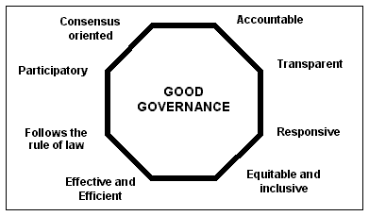Fig. 4.7: Diagram of Good Governance Showing the Basic Eight Tenets.
Source: UNESCAP, 2005

Under security reform, the finding revealed that while the federal government was battling to instill security in the land, they did not find it necessary to embark on comprehensive security reforms since past years of military rule had done much havoc to the security and related organizations in the country. Apart from lack of proper training the police force to handle modern and sophisticated level of criminalities the nexus between other security sectors and the judiciary were knowingly or unknowingly ignored. For national security situation to be improved and sustained in a post-military and undemocratic state there must be strong and comprehensive Security Sector Reforms (SSR). This is necessary because of the dysfunctional security sector that is unable to provide security to the state and its people effectively coupled with the introduced ethnic militia formations. In this respect, an unreformed or misconstructed security sector represents a decisive obstacle to the promotion of sustainable peace, development and democracy, hence the need for synergy.
Security sector refers to the intricate networks of institutional instruments and/or bodies of people that can either positively or negatively affect public safety and the rule of law. It includes those organs of government which, with the power of coercive authority, execute the will of the state as well as those structures that oversee institutions which hold the coercive powers of the state (Schnabel and Ehrhardt, 2006). It also refers implicitly to those bodies which would challenge the authority of the state through force. In this respect, an

insurgent, ethnic militia, warlord or crime boss, integrated or non-reintegrated ex-combatants is as much a part of the security sector as the police officer, soldier, judge, legislator or human rights activist. Thus, security of the state depends on strategic reforms that gather for the interest of all stakeholders appropriately. The security sector reforms is defined, for the purposes of this thesis, as a reorganization and restructuring processes of broad grouping of institutions, state and non-state alike in post-military regime whose negligence could threatened the internal security of the country. It encompasses core security actors, non- statutory security forces, justice and law enforcement institutions, and security management and oversight bodies. It implies a holistic understanding of what security is, who is affected by it, who provides it and how those institutions can be strengthened for effective and efficient service delivery. This implies that SSR is a precondition for good governance, security, human rights, and the achievement of long-lasting peace. Activities within SSR continuum consist of disarmament, demobilization and reintegration of former combatants, including child soldiers and female; serving soldiers; small arms and light weapons (SALW); transitional justice; strengthening the rule of law; de-mining, fighting trafficking in human beings and drugs; dealing with ethnic militias, and good practices for the security sector. SSR is conducted at a number of levels ranging from the political level of a policy and budgetary debate, to the development of the relevant institutions and finally the capacity of groups or individuals within these institutions. It is broad based, and embraces a variety of unarmed and non-uniformed actors beyond the traditional understanding of armed and uniformed security sector practitioners. The overlap and interdependence of the security sector actors is captured well below.

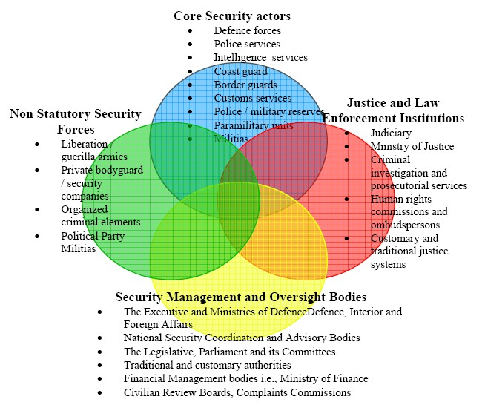Fig. 4.8: Holistic Components of Security Sector

Source: “Understanding and Supporting Security Sector Reform”, Department for International Development (DFID), London, UK, 2002, p.7.

The total components of SSR shown above indicate that internal security cannot be operated effectively and efficiently without considering SSR in its holistic form. In other words internal security and SSR are interwoven and both could not be ignored for institutionalization of human security and stable government in any country. In Nigeria investigation revealed that more emphasis has been placed on core security sector with particular reference to defense and police forces at the expense of other sectors. There is no strong synergy between core and other non-core security areas in operations as both seem to have operated differently. The SSR operations as implemented in Nigeria is not laying emphasis on holistic structural reforms with regard to national security as proposed by Rees,(2006). It is done in disarray, with much concentration on the military and police forces

separately. The constituents as proposed by Rees consist of (1) Development of national security policy; (2) the reform and development of the executive management and oversight of national security policy and coordination; (3) the reform and development of executive management and oversight of defence forces; (4) the reform and development of executive management and oversight of the public security apparatus; (5) the reform and development of legislative oversight of the security sector; and (6) the development of civil society oversight of the security sector. But worthy of note is that for above to be feasible rule of law must be observed. The rule of law entails the supremacy of the principle of law that all citizens are subject to it and equally entitled to its protection. A recent report by the Secretary General of United Nation, Ban Kimoon holds that rule of law:
…refers to a principle of governance in which all persons, institutions or entities, public and private, including the State itself, are accountable to laws that are publicly promulgated, equally enforced, and independently adjudicated, and which are consistent with international human rights norms and standards. It requires, as well, measures to ensure adherence to the principles of supremacy of law, equality before the law, accountability to the law, fairness in application of the law, separation of powers, participation in decision making, legal certainty, avoidance of arbitrariness and procedural and legal transparency.

The rule of law as observed is a complicated web of persons, institutions, legal frameworks and processes which are guided by a constitutional order established by a majority of citizens with due respect to the rights of minorities, as well as to their neighbours. The rule of law is the system which defines the broad parameters of the citizens‟ relationship to the state, and vice versa, as well as amongst themselves. The rule of law is, therefore, a state of being, an end-state, as well as a process in continual motion. The figure below shows the cyclical nature of rule of law, security sector and citizen/ state.

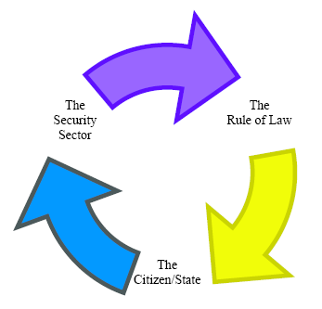Fig. 4.9: Cyclical Web of Rule of Law and Security Sector.
Source: Understanding and Supporting Security Sector Reform, Department for International Development (DFID), London, UK, 2002.

Observation showed that implementation of SSR in Nigeria with regards to the above cyclical nature was weak. There was no smooth flow of the cycle.The rule of law was rarely adhered to and there was disconnect between the citizen and the state mostly occasioned by absence of good governance. Good governance in the security sector is a sine qua non to effective rule of law. In the case of crisis, security sector is invariably at the heart of the problem as well as its solution. If putting communities on the road to the rule of law is a central goal of peace operations and national security, SSR is therefore of critical importance.
Interviews with top officials of Nigerian Police Force showed that most of them did not know much about Security Sector Reforms, whereas, this is highly needed for maintenance of internal security, national security and peace in the country. It is pertinent to note that since Nigerian citizenry especially in the South-West or South-South has come to see existence of ethnic militia as a necessity, there is need to carry out comprehensive reform that incorporate them for the security apparatus of the nation. Observation also shows that Police Force in the country recognizes the contribution of ethnic militia in security management though not constitutional backed. In Lagos State particularly, there had been joint OPC and Police patrol when there was high level of criminality and the outcome was

always in the positive. The OPC as observed uses traditional methods (juju or diabolical means) to detect who is a criminal and where they are located which are beyond modern scientific approach of crime detection as created by the British Police. This is a big lesson that must be learnt and Nigeria needs to adopt a combination of traditional and modern methodologies of crime detection since the nation is still a traditional society. Moreover, the, ultimately desire of government is to maintain internal security and all available means need to be applied.

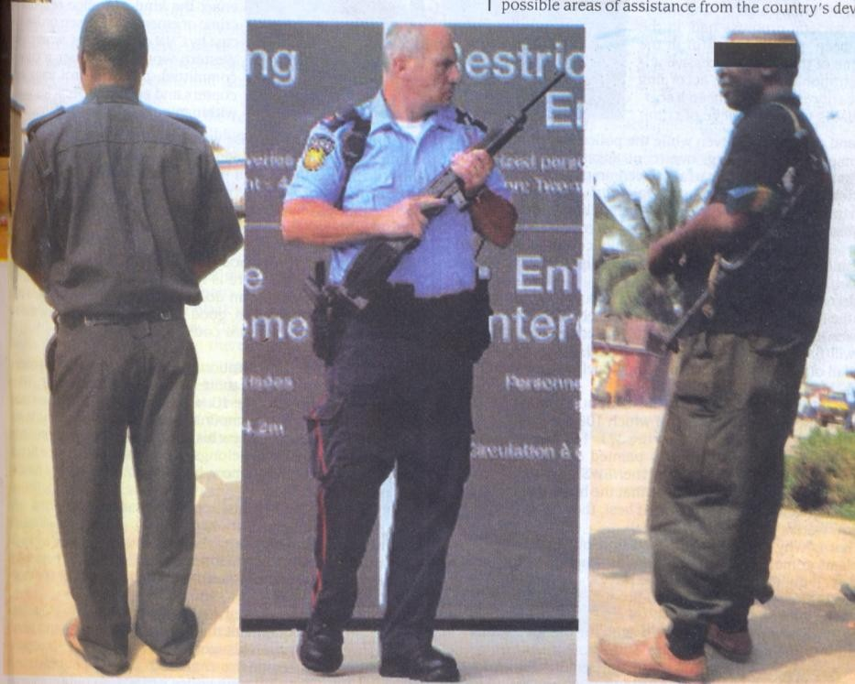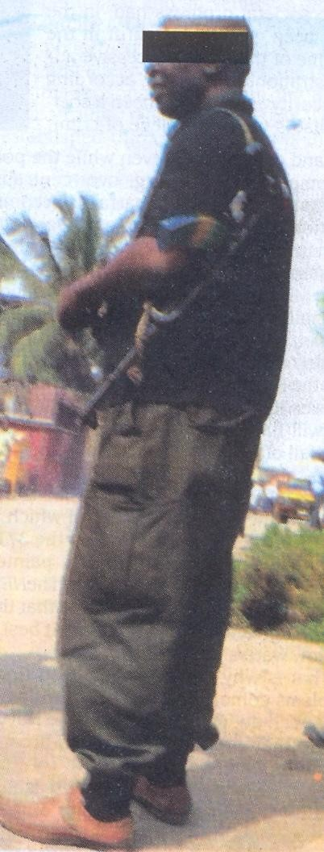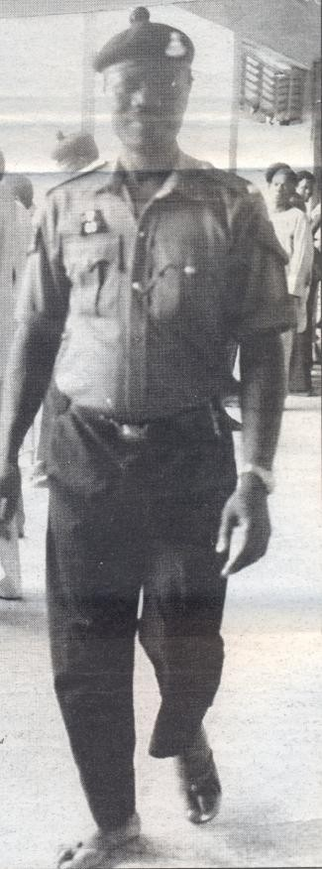

Plate 1: The rot of shabby dressing (recent) by member of police force compare to American police at the middle
Source: Field work 2008

Plate 2: Shabby dressing by members of the Police Force has been from the past
Source: Field work 2008

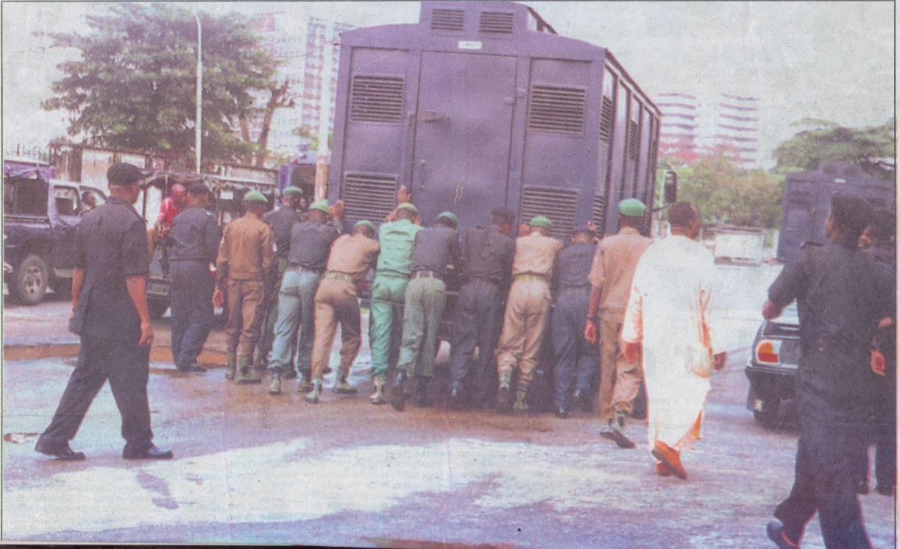Plate 3: Agonies of the Police Force, some policemen pushing “blackmaria” lorry to conveyed prisoners/convicts from the court premises.
Source: Field work 2008s

Plate 4: Part of the ill-equipment of the Police that has enables them to be inefficient and ineffective to distress calls by the public.
Source: Field work 2008

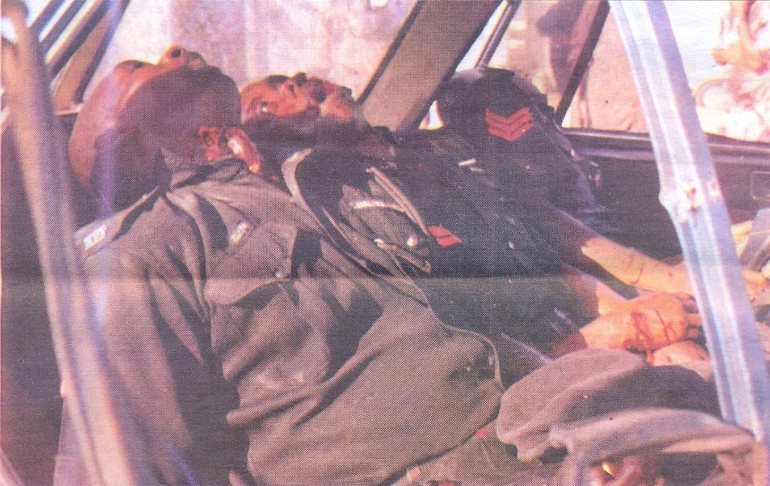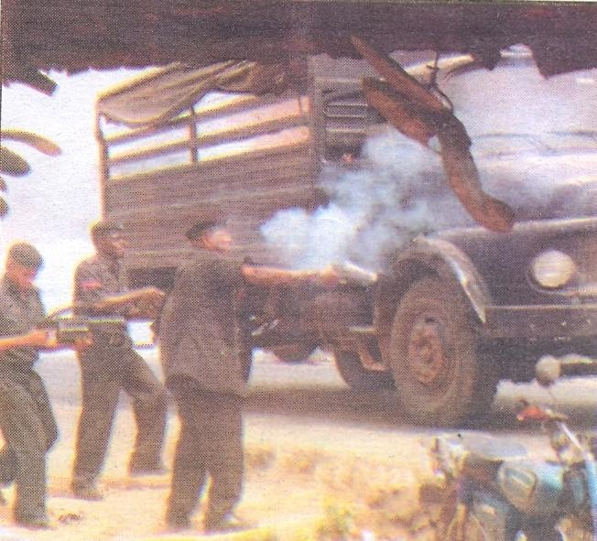Plate 5: Policemen whose lives were snuffed out through armed robbers‟ gun in Lagos State
Source: Field work 2008

Plate 6: Policemen at a crime scene, parading lots of obsolete equipment, due to lack of modern amenities to combat crime.
Source: Field work 2008

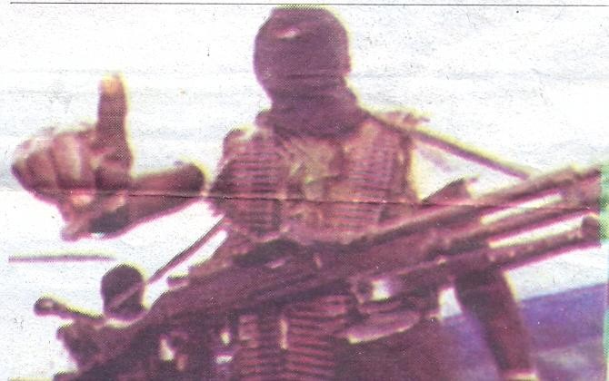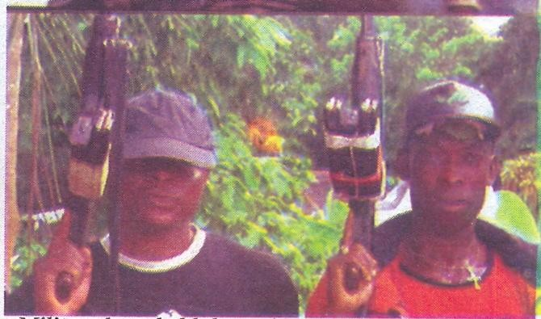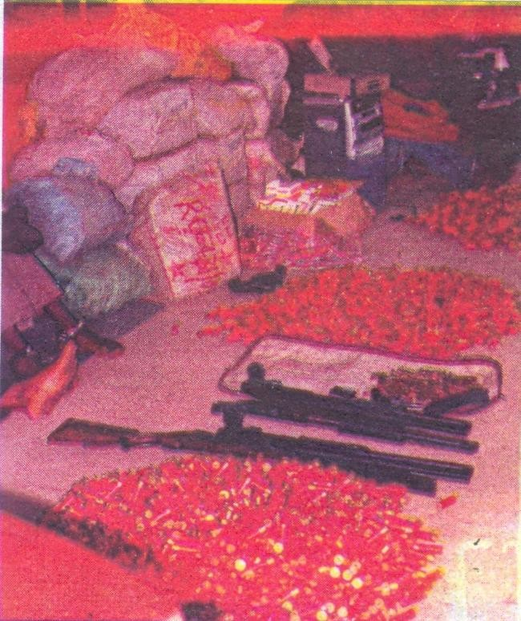

Plate 7: Militants have held the nation‟s security by the jugular
Source: Field work 2008

Plate 8: Militants have held the nation‟s security by the jugular
Source: Field work 2008

Plate 9: Too many arms and ammunition in wrong hands
Source: Field work 2008

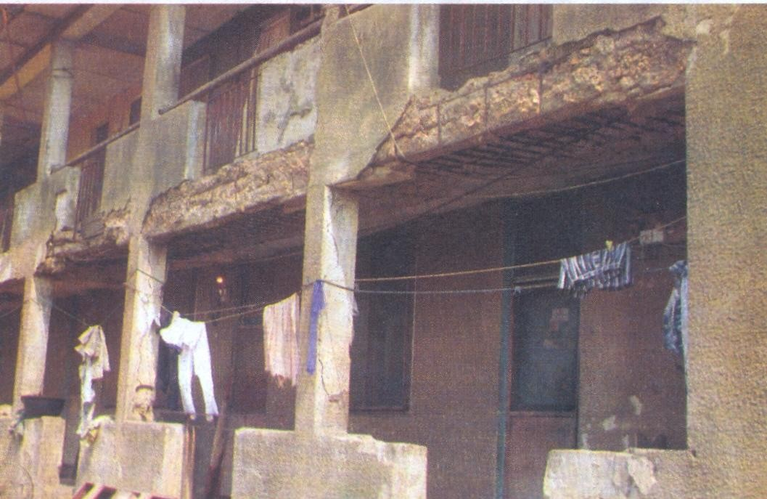Plate 10: A section of the barrack in Ibadan, showing dilapidated infrastructure in the barracks which pose a social concern for all and sundry
Source: Field work 2008

Plate 11: Squalid state of the barracks in Lagos, (Elere Police Barrack, Lagos) due to neglect by the past and present leaders.
Source: Field work 2008

Plate 12: Section of the “A” Division barrack, Jos Plateau state; Children born into this home stand the risk contacting infectious disease due to the maintenance culture of the men and women in the Nigerian Police barracks Source: Field work 2008

Plate 13: Section of the Wukari Barrack, Taraba State, showing the Present state of destruction in the barracks due to neglect of the welfare of the Nigerian Police Force
Source: Field work 2008

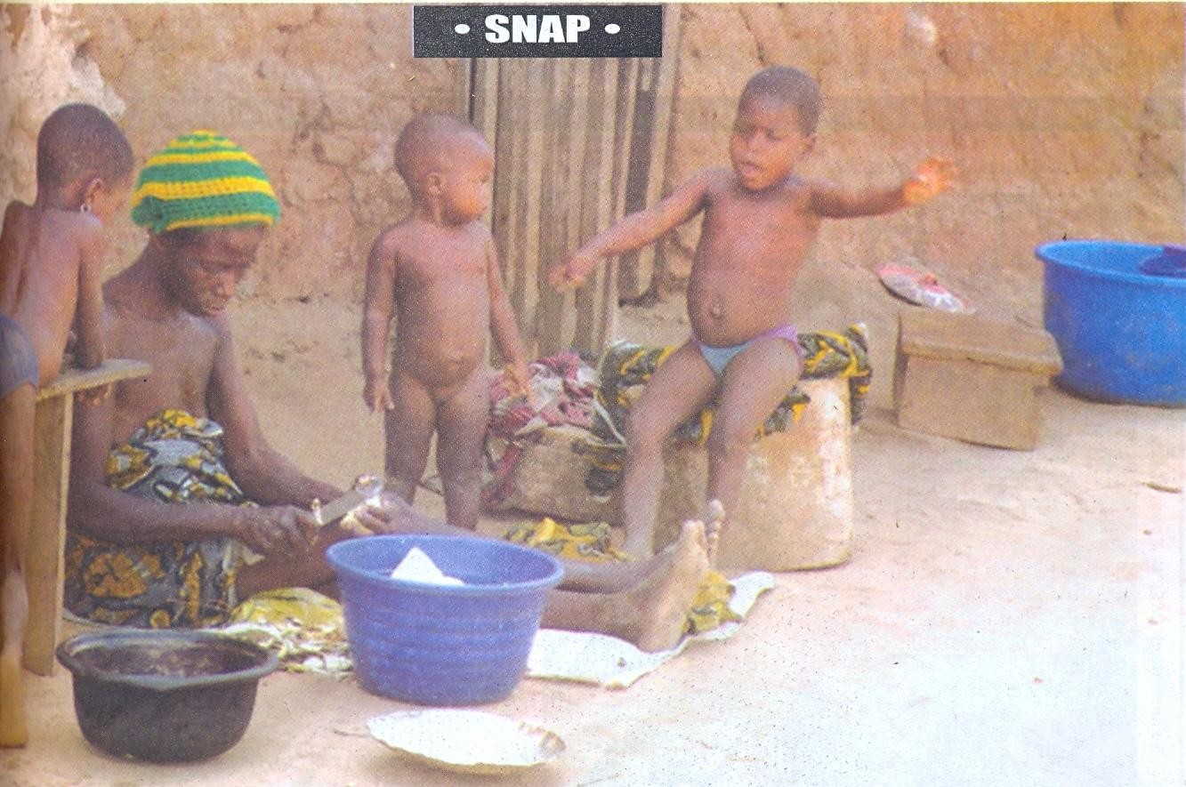

Plate 14: How old are each of the quarters since erected and commissioned, have the building ever been
refurbished, repainted or revamped to enhance the image of the Nigerian Police and the nation‟s corporate image
Source: Field work 2008

Plate 15: A pit latrine used in the barracks due to sordid state of overcrowding, threat of epidemic is real in the Nigeria police Barracks.
Source: Field work 2008

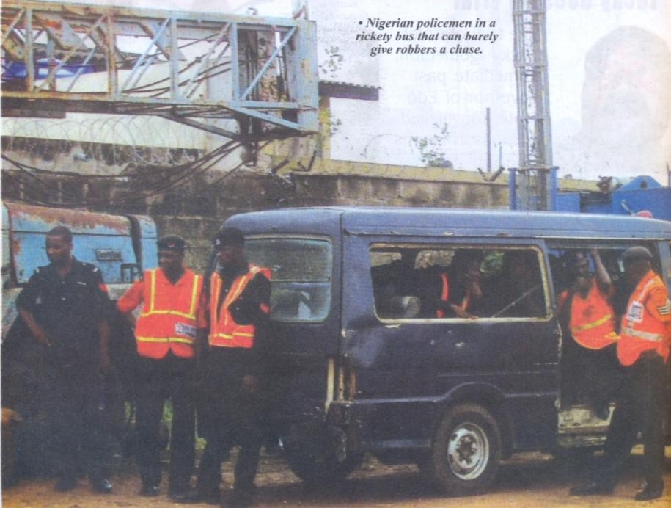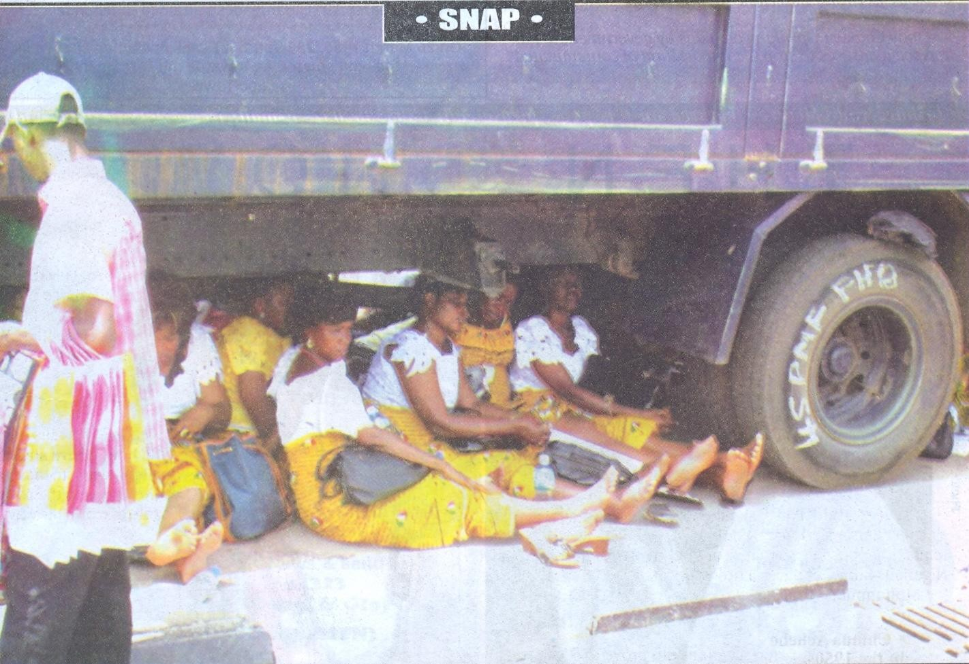Plate 16: Nigerian Policemen in a rickety bus that can barely give robbers a chase
Source: Field work 2008

Plate 17: A “911”Truck belonging to the “45 PMF FHQ” as fully inscribed on the tyre conveying wives of the police officers because of lack of response to Police welfare Source: Field work 2008

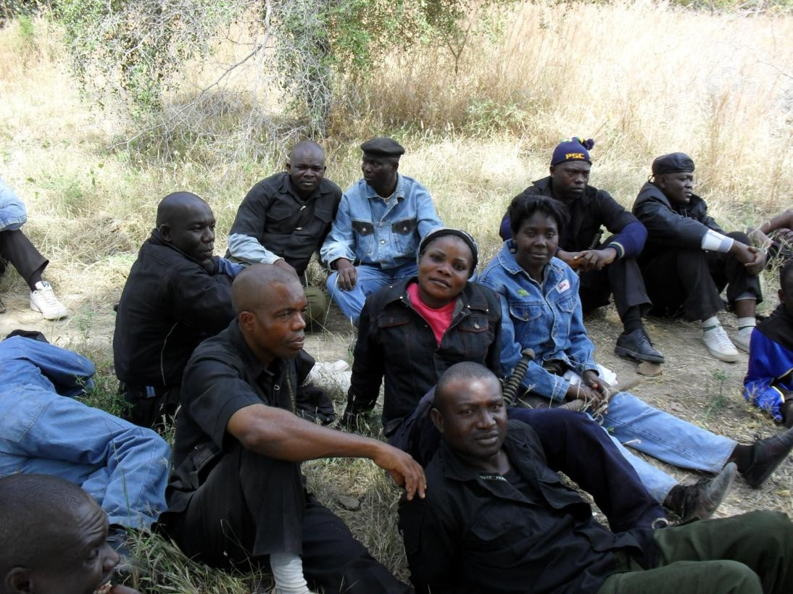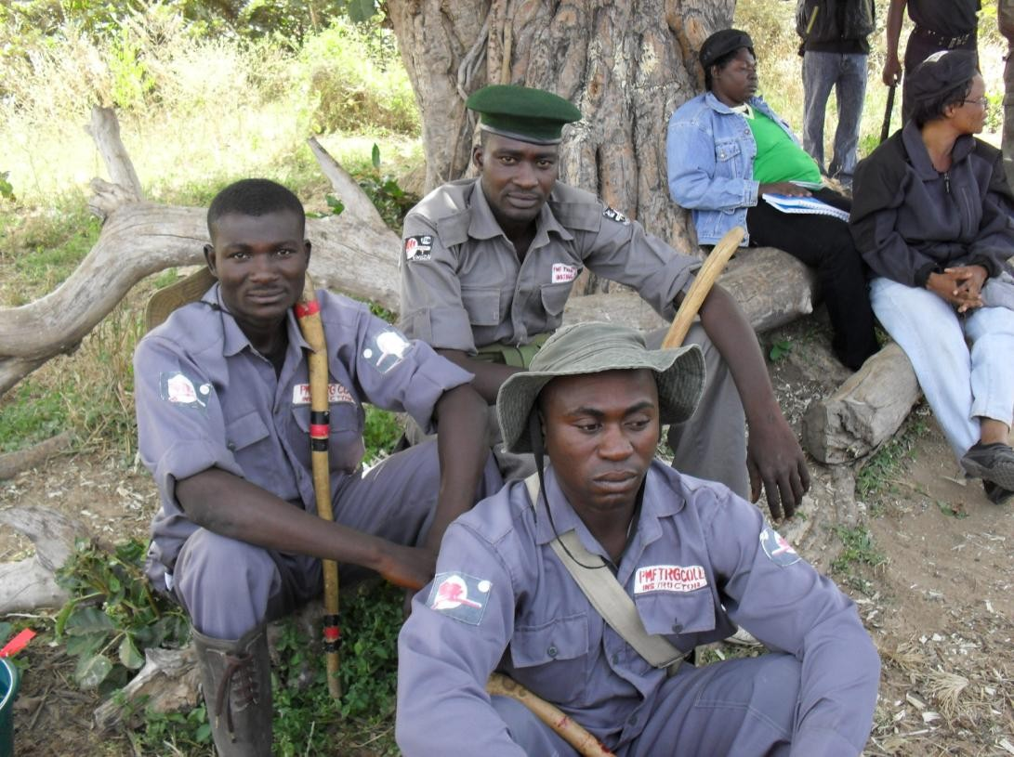

Plate 18: Men under training at Police Mobile Training School, Gwosa, Maiduguri
Source: Field work 2008

Plate 19: Men under training at Police Mobile Training School, Gwosa, Maiduguri, considering the condition of training in democratic era
Source: Field work 2008

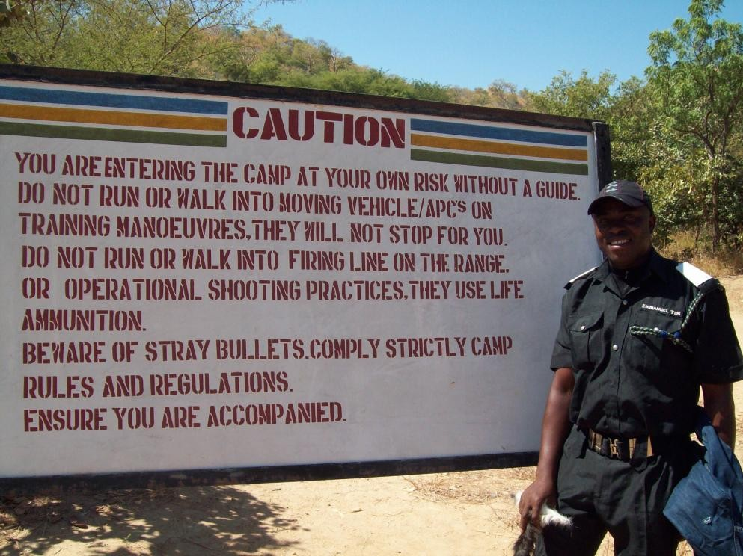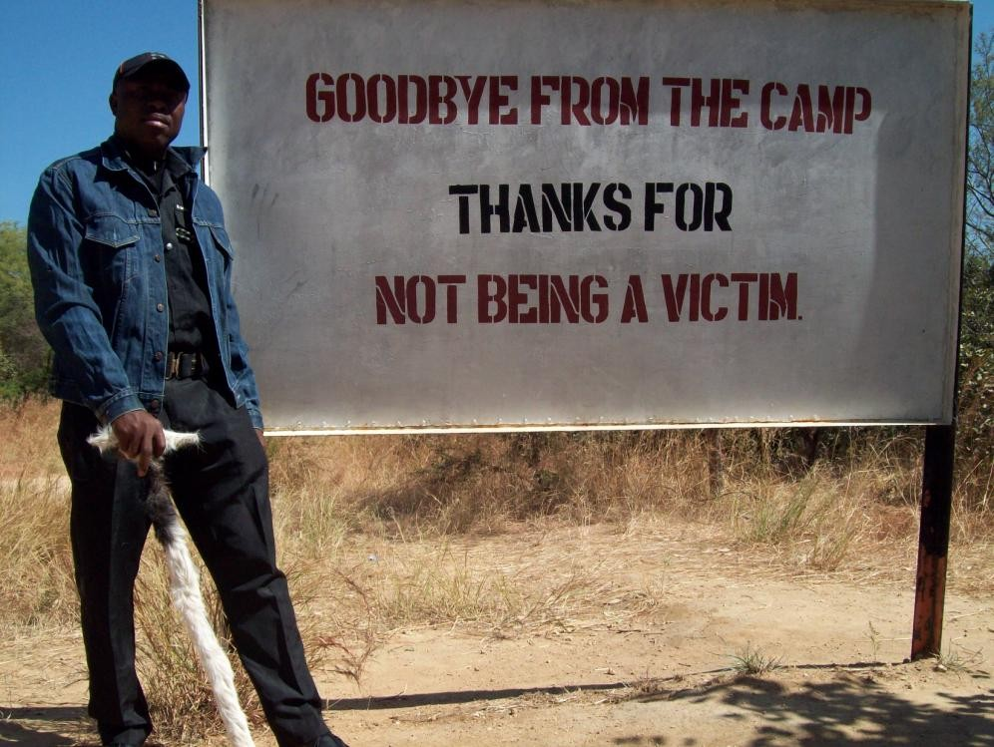Plate 20: Entrance of the Mobile Training Camp, Gwosa, Borno-State, showing officer on training to enhance discipline in the Nigerian Police Force
Source: Field work 2008

Plate 21: Entrance of the Mobile Training Camp, Gwosa, Borno-State, showing officer on training to enhance discipline in the Nigerian Police Force
Source: Field work 2008

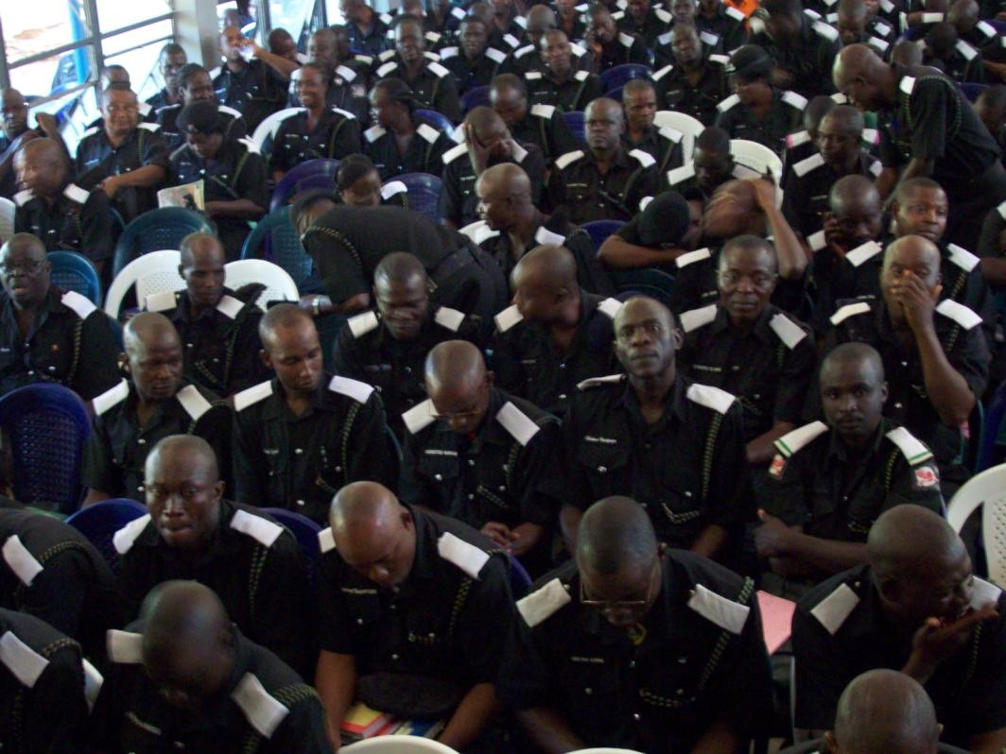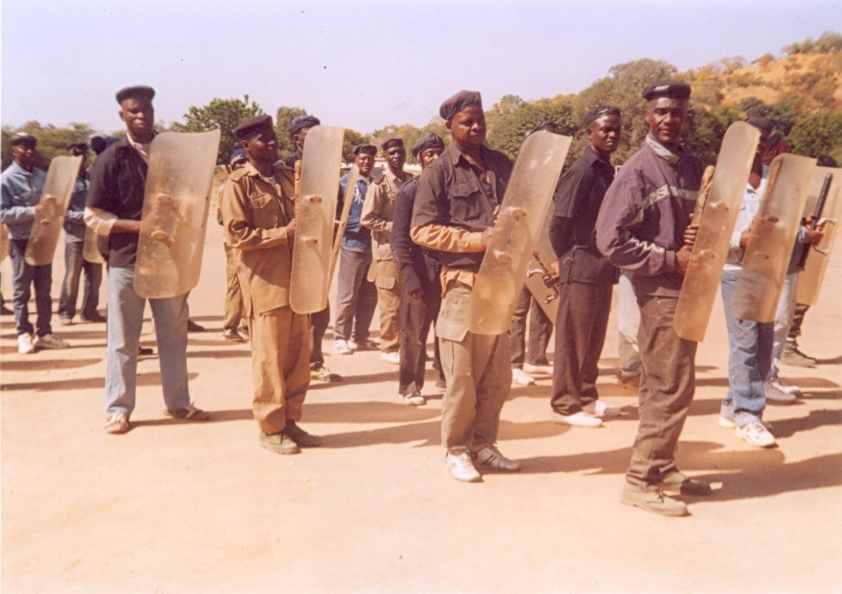

Plate 22: The Researcher and members of “ASP” Course 3 2009 Officer on training to enhance discipline in the Nigerian Police Force at Police Staff College Jos.
If you don‟t train them enough, you can hardly blame them.
Source: Field work 2008

Plate 23: The Researcher and some officers at a Combat Drill exercise in Gwosa Camp.
Source: Field work 2008

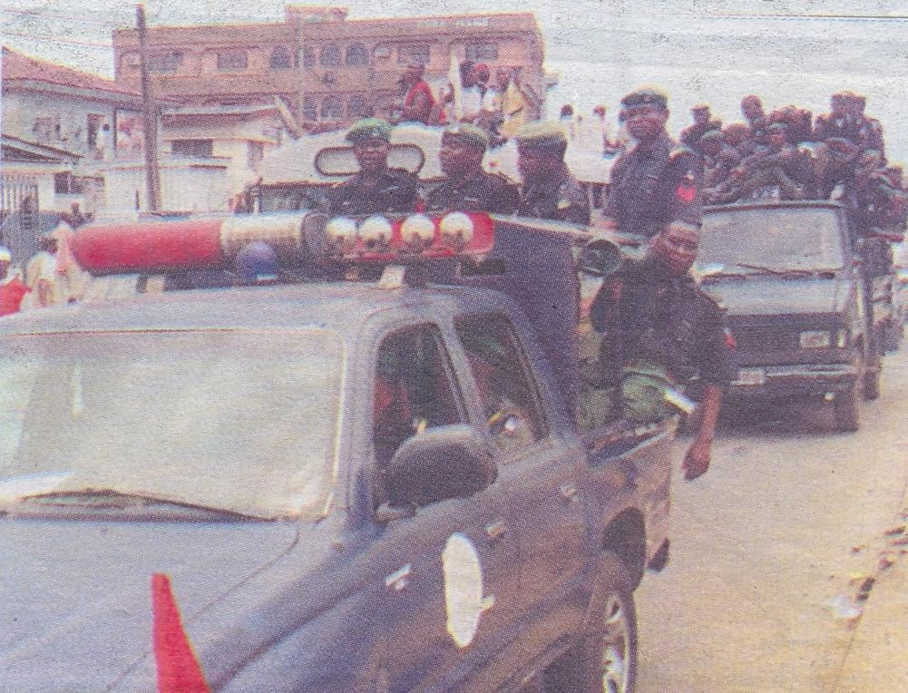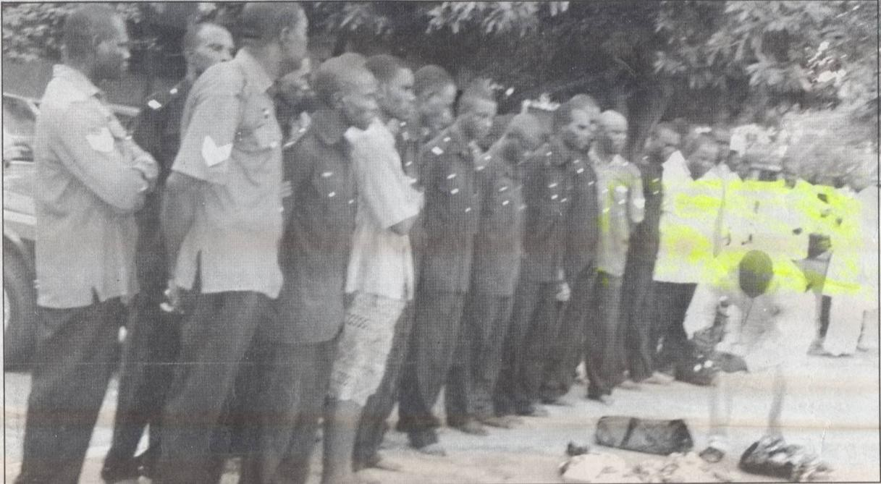

Plate 24: Members of the Police Force paraded for extorting money from commuters and motorists
Source: Field work 2008

Plate 25: A “unique” way to track high-tech crime. The police needs more equipment to combat crime.
Source: Field work 2008

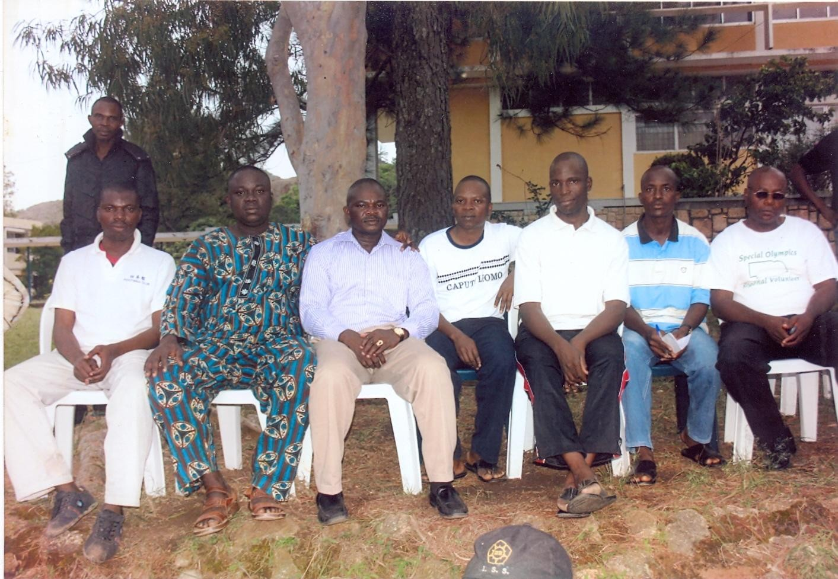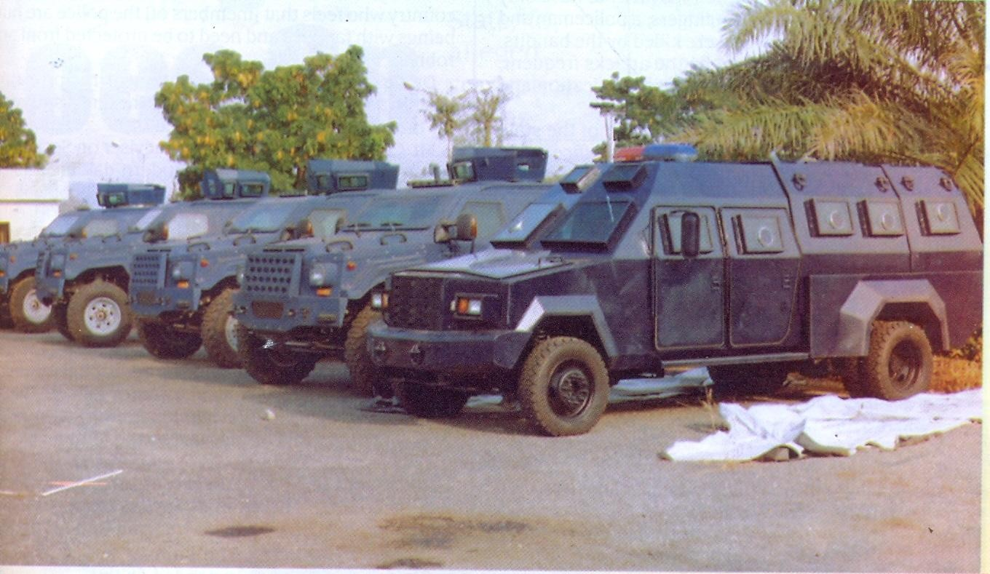

Plate 26: The researcher and some of the people at the focus group discussion in Jos, Plateau State.
Source: Field work 2008

Plate 27: Some Newly Acquired “Armoured Personnel Carrier”, Training equipment, skilled personnel to facilities and structure, deficiencies in the Police evidence.
Source: Field work 2008

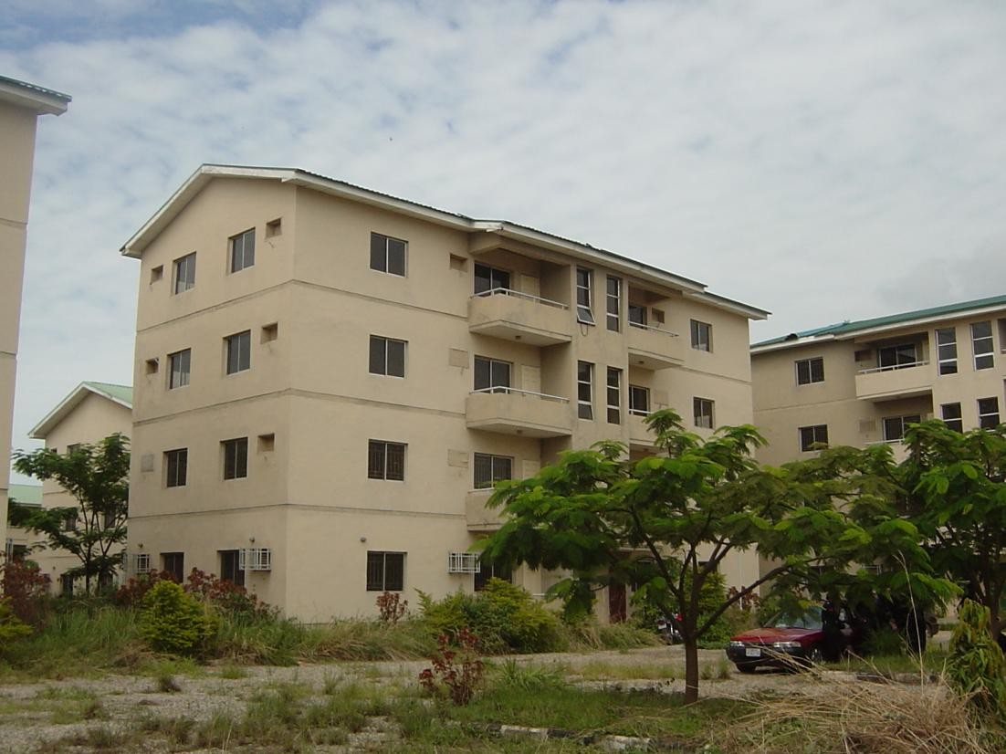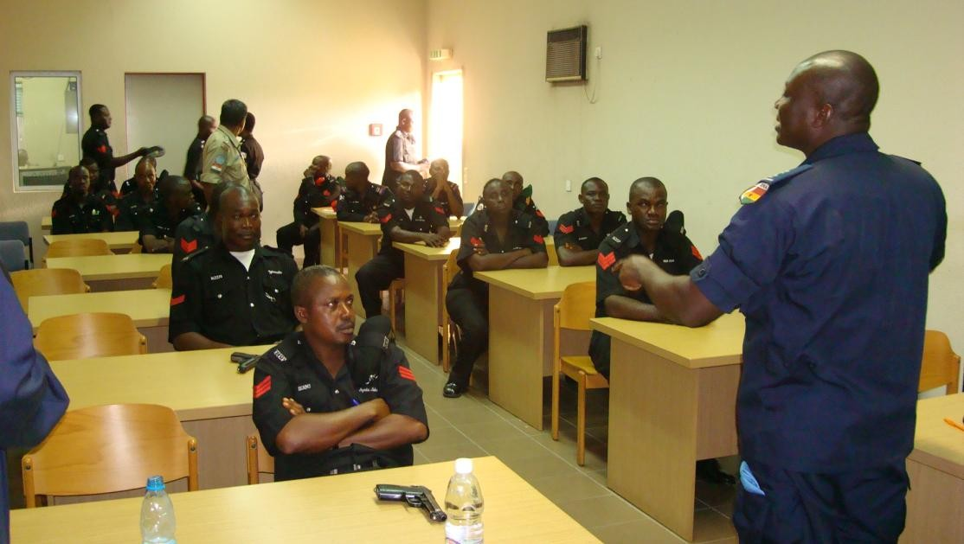Plate 28: Newly built barracks for Police in Abuja and some states in the country under the Federal Mortgage Bank/Police Loan Scheme.

Plate 29: A Ghanaian Police Officer delivering a lecture at the peacekeeping Department FHQ Abuja, poor intellectual diet in the Nigerian Police Force fuels a malfunctioning force
Source: Field work 2008

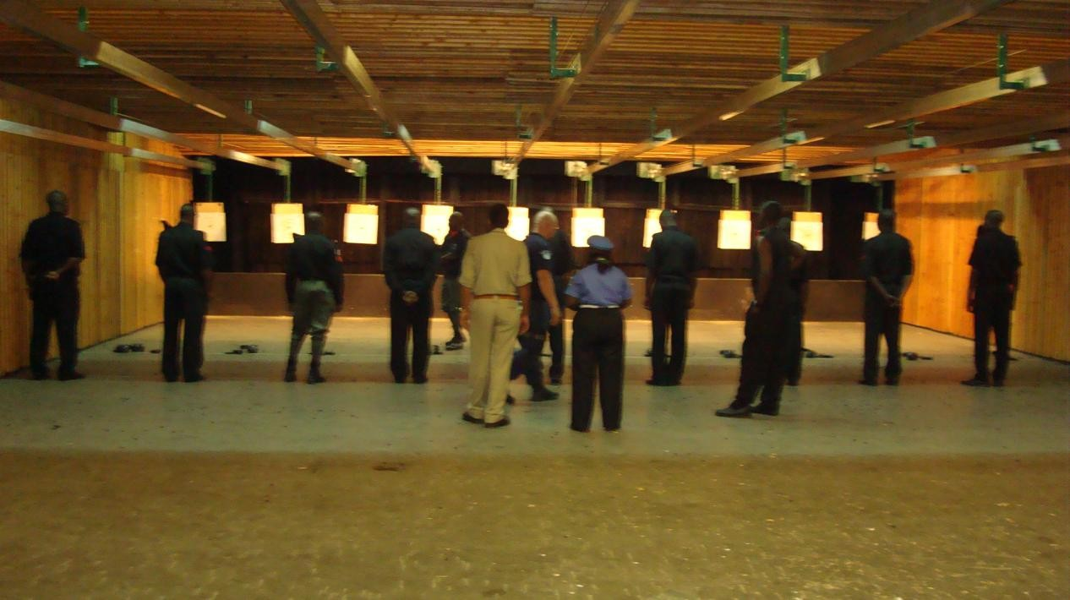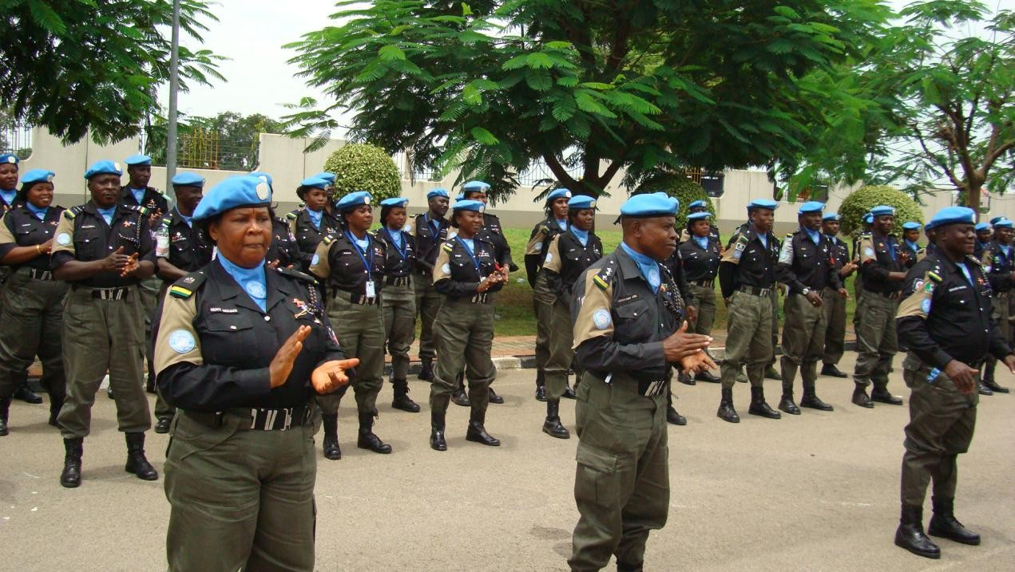Plate 30: Some Police officers in an Indoor- Shooting –Range Exercise, poor intellectual diet in the Nigerian Police Force fuels a malfunctioning force

Plate 31: Members of the Nigeria Police Force before their departure for Peace Mission in Darfur, Sudan, happy Police make a happy nation.
Source: Field work 2008

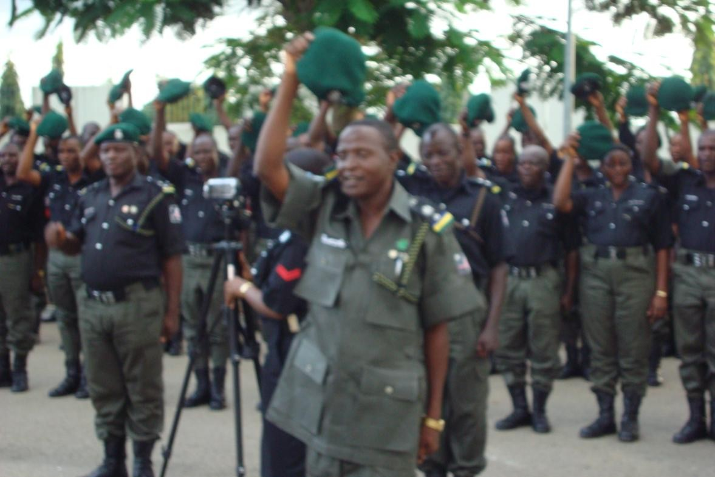Plate 32: Members of the Nigeria Police Force during the visit of the Inspector –General of Police to Zone 7 HQ Abuja, a happy Police make a happy nation when they are fully motivated Source: Field work 2008

Summary
CHAPTER FIVE CONCLUSION AND RECOMMENDATIONS

This study is on erosion of discipline in the Nigeria Police Force and its implications on national security. The overall goal of the study is to examine the implications of an undisciplined police for national development. The study seeks to transcend the existing perception of national security in Nigeria, and identifies indiscipline in the police, lack of accountability, good governance and social justice as a serious threat to Nigeria‟s national security. To this end, the research set out with five key objectives: (a) to examine factors that breed indiscipline among the rank and file of the police; (b) to examine the implications of an undisciplined police for national development; (c) to make an assessment of police ethics vis a vis societal ethics; (d) to look at how the general breakdown of moral and ethics in society affects the outlook of the Nigeria Police Force; (e) to examine the factors responsible for the lack of public trust in the Nigeria Police Force; and formulate strategies for restoring public trust in the Nigeria Police Force.
Data for the study were gathered from both primary and secondary sources through in- depth interviews, questionnaires, focus group discussions, library research official bulletins, newspapers and internets. Research data collected from the field were qualitatively and quantitatively analyzed. The analysis of collected data gave rise to the following interesting findings:
- The research findings reveal that apart from the general breakdown of moral and ethics in the society, that what later became the Nigeria Police today was established in 1861 by the British colonial lords and that major disservice done to the police in Nigeria was the intermittent usurpation of political power by the military in Nigeria. While the fate suffered by the police during the military interregnum also became the lot of the institutions that produced “the men in Khaki.” The problem of the police started since 1966 when they were sent to the barrack and their functions were usurped by the military.
- Field observations clearly showed that NPF training institutions across the country are not in anyway conducive for any form of training. The teaching staff and trainees lack adequate and comfortable accommodation. The manner some NPF personnel handle simple civic matters like the „APO 6‟ killings is a demonstration that these personnel

are not properly trained. They seem to lack basic training and this has over the years caused the NPF serious embarrassment.
- The Nigeria Police needs a complete professional re-orientation. Part of these lies somewhere in the society itself, because many times, individuals induced their corrupt attitude, when they initiate corruption through gratification even when the policeman does not ask. The temptation is overwhelming, because the economic disposition of the average policeman is well below the poverty line.
- Lapses in the screening and selection process lead to hiring personnel of questionable character, ex-convicts who would at will compromise national security, the selection, screening, testing and other prerequisite activities that are not properly addressed at the initial point of entry adversely impact on discipline, orientation, attitude, performance and service delivery.
- Emergence of clandestine vigilante groups, the attendant uncertainty of life as a result of poor police performance and lack of trust and confidence in the credibility of personnel of NPF led to the emergence of vigilante groups like the Bakasi Boys. The perception of the people is that the government has failed since ethnic militia are sprouting up in all part of the country with the same reason of providing security to inhabitants of their regions as paramount reason.
- Also the security profile of Nigeria presents a paradox: despite the abundant resources committed to internal security provision in the country. This has led to deep-seated resentment among the population and persistent calls for an establishment of state police.
- The Nigeria Police Force is over-centralized. There is too much control of resources at the centre without adequate system of distribution. This is why no matter the amount of money spent on the acquisition of resources that would enable the organization function effectively, not much is felt at the level of the Divisional Headquarters. It is for the same reason why accountability is difficult to achieve and of course this invariably creates the atmosphere for corruption.
- Nigeria needs home-fashioned good governance that emphasises the socio-economic needs and well being of the people; promotion of social justice; respect for human rights and freedom, education against internal human rights threats, accountability, responsiveness and rule of law.

- Nigeria also needs to redefine its national security model beyond the militaristic perspective. The various structural, institutional and logistics obstacles highlighted in this study would have to be addressed. If these are done, police will be better placed to meet the expectation of citizens and thereby earned the cooperation of the public which they require to fulfill their mandate.
- Good governance and national security are mutually self-reinforcing and face common threats. The more these common threats are combated and their influenced eroded, the more the Nigerian nation is built, the more the nation‟s security is guaranteed and the more Nigeria‟s peace and development is sustainable.

Conclusion
Discipline is one of the bedrocks of every organization. No meaningful progress can be made in an atmosphere of indiscipline. One of the major factors militating against police effectiveness centres on acts of indiscipline demonstrated by some policemen in the discharge of their duties. Some of these acts include brutality, unlawful arrest and detention and incivility to members of the public which in most cases lead to public outcry and subsequently drag police image into the mud. In most cases, indiscipline is usually caused by lack of effective control and supervision of police personnel.
For the traditions of the Nigeria Police Force to be maintained, all the internal control mechanisms must be reactivated. To ensure that discipline is not eroded, officers should not neglect their supervisory functions and disciplinary control of t heir subordinates in line with the provisions of police regulations, force orders, force administrative instructions etc.

Recommendations
Based on the above findings, which have policy and behavioural implications, the internal self-criticism of the force will aid a better perception of an individual, organization or establishment by the outsider. Consequently, the police should first put its house in order and this would need the very serious and active support of the Federal Government itself. Of all the agencies and apparatuses of states responsible for security, law enforcement, and protection and lives and property, the Nigeria Police is the most visible, over-worked, over- stretched, most exposed and under-paid. To the public eye, the average policeman (rank and file) is viewed and perceived as a wretched poor in spite of his penchant for „tolls‟, insecure in

terms of tenure and career expectations, oftentimes a convenient scapegoat, proficient liar who learned that art because he is constantly exposed to danger, on obvious target of the underworld unless he „co-operates‟ and unwelcome visitor to most homes and generally regarded as a brute by the lower echelon of society. There is need, therefore, for a change of attitude from that of superior versus inferior for the force to be seen as a friend and protector of society.
Second, the police should be shielded from political appointments. The role of law enforcement in any civilized society is to serve and protect the citizens. Political appointments corrupt the officers, destroy esprit de corps, skew their sense of neutrality and impartiality, and infuse a sense of allegiance to appointing authority. It is a major obstacle to police effectiveness and must be discouraged at all cost if improved police performance must be achieved.
Third, efforts should be made to fully professionalize the police in order to enable it discharge its civic duties to the society. Full professionalism would be achieved through further training and re-education such as targeted special college equipment classes in social sciences, and criminal law and procedure. This would improve the police officer‟s human relations capacity. The police personnel should refocus their perception of the force on being responsible only to the government. This shift in perception would go a long way towards fostering peaceful relationship between the Nigeria Police and civil society.
Fourth, with professionalism goes meritorious recruitment and depoliticization. Police officers should be recruited based on established minimum criteria and educational standard. People who do not qualify should not have a place in the national police. Meritorious recruitment will therefore enhance meritorious promotion since officers will aspire to get to the top, and not await promotion as a birthright. This will also eliminate politics of intrigue from the process.
Fifth, strengthen of internal disciplinary system to control indiscipline, incivility, corruption and brutality among police officers so that they can be models of good citizenship.
Sixth, the training process which starts from the point of recruitment should permeate all levels. The entire training process should be designed to build confidence in the trainee rather than make him/her timid. Also additional avenues should be found to promote social interaction between the trainee and his/her instructors. Police ethics and conduct should also be taught at all levels of training (confidence building technology).

Seventh, the police should strengthen its relationship with the community so that police officials can establish partnership with citizens to prevent the incidence of acts of indiscipline and crime that threaten public safety and personal security, respect for human rights, rule of law and civility will enhance police – public relations.
Eight, the police should strengthen its criminal information management system. This entails collecting, analyzing, storing(intelligence) and publishing social, political and economic data that impact on types, patterns and trends of indiscipline, crime and delinquency in the country. Efforts in this direction will produce statistics and information that the public and government can use for better planning and decision. The idea is that the police should develop social-economic and political data bank which can be analyzed and used to advise the government against crime and criminal generating actions. They will also assist the police in planning proactive and preventive police work.
Ninth, there should be mandatory statutory provisions requiring the state and local governments to participate meaningfully in police funding by setting aside specific percentage of funds annually for construction of barracks and police station buildings, purchase of vehicles, communication equipments and welfare packages to enable them perform their functions effectively in their respective state and local governments. It will lead to a healthy competition among the local governments and the states in the provision of logistics support to the police and ease the burden on the federal government.
Tenth, the minimum standard is for every police station to have at least one lorry, one pick-up van, one station wagon car, a motorcycle and effective communications gadgets. Most of our police stations in the country are in deficit of these basic requirements. Efforts must be made to ensure that the force is fully mobilized at all times in order to perform its responsibility effectively.
Finally, the researcher recommends a decentralized system of police organization, i.e. a three-tier police structure; the federal police, the state police and local government police. While the federal and state police departments deal with federal and state law enforcement matters, the local government police will be organized along the model of a vigilante force in touch with the community they serve, and solely deployed to deal with law enforcement and order maintenance functions in the local communities. This will not only bring people closer to their police, but will also prevent the hijacking of the police command by corrupt and tainted absentee politicians in Abuja. Local (not detached federal and military style) policing is the key to communicating police. The common practice of using police intimidation in poll rigging and (s)electing the president‟s praise singers as congress-persons, will become a thing of the past, and the opposition will have a voice like in other democracies.

BIBLIOGRAPHY

Adam, S. O. and Johnson, L. T. (1988), Statistics for Beginners: Samuel Adamu and Associates (SAAL Publications) Bodija, Ibadan, Nigeria.

Adekanye, J.B. (1999), The Retired Military Phenomenon, Heinemann, Ibadan.

Adekanye, J.B. (2001), “From Violence to Politics: Key Issues Internationally” Paper delivered at the 5th international ethnic studies network (ESN) Conference Northern Ireland June 27 – 30.

Adewusi, S. A., (1992), “The Police as an Organization: Management Challenges.” Paper presented at the Police Commissioner‟s Training Week. PSC Jos, Feb.

Adisa, J. (1994), “Urban Violence in Lagos,” in E. Osaghae and Adisa J. (eds) Urban Violence in African. Pilot Studies French Institute for Research in Africa (IFRA). Ibadan: Intec Printers.

Afigbo, A. E. (1989), “Federal Character: Its Meaning and History,” in P.P Ekeh, and E Osaghae, (eds), Federal Character and Federalism in Nigeria, Ibadan.

Agbakoba Olisa (2008), “How the Nigeria Bar Association Promotes and Defends the Rule of Law in Nigeria, NBA Hq., Lagos.
Akinboye, J. and Akinboye, D. (1998), Research Methods. Stirling-Horden, Ibadan. Akinfenwa, S.O. (2002), “How the Citizens Can Process Complaints Against the Police,”
Paper presented at the police community partnership workshop in Ibadan Northeast
Local Government Council, Oyo State on July 23, 2002.

Albert, I.O. (1995), “University Students in the Politics of Structural Adjustment in Nigeria” in T.N. Mkandawire and A. Olukoshi (eds), Between Liberalization and Oppression: The Politics of Structural Adjustment in Africa, Dakar: CODESRIA.

Alemika, E. and Chukwuma, I. (2000), Police-Community Violence in Nigeria, Lagos: Centre for Law Enforcement Education (CLEEN).

Alemika, E. O. (1995), “Criminology and the Philosophy of Policing”, in Tamuno T. N. et al.
(eds), Policing Nigeria: Past, Present and Future. Lagos: Malthouse Press.

Alemika, E.E.O. (1988), “Policing and perceptions of Police in Nigeria.” Police Studies
11(4): 161 – 176.

Alemika, E.E.O. (1993), “Colonialism, State and Policing in Nigeria” Crime, Law and Social Change (20) 187 – 219.

Alemika, E.E.O. (2003), “Police Accountability in Nigeria: Framework and Limitations,” in Civilian Oversight and Accountability of Police in Nigeria, Lagos: CLEEN and Police Service Commission.

Alemika, E.E.O. and Chukwuma, I. (2003), Civilian Oversight and Accountability of Police in
Nigeria Lagos: (CLEEN and PSC).

Allport, G. W. (1995), Becoming: Basic Consideration for a Psychology or Personality. New Haven: Yale University Press.

Anegbode, M.O. (2007), Internal Force Control Mechanism Policing Nigeria, in the 21st Century by E. Solomon Arase and Iwuofor I.P.O., (eds): Ibadan, Spectrum Books Limited, Ibadan.

Anifowose, R (1982), Violence and Politics in Nigeria: The TIV and Yoruba Experiences,
New York: NOK Publishers.

Arthur, F. Worrey (2003), The Diaries of Mr. Michael, A Novel About Nigeria, (Josadeen Nigeria Limited). Pg. 1.

Asemota, A. (1993), “Policing Under Civilian and Military Administration”, in Tamuno T.N. and others (eds)

Asemota, S.A. (1993), “Policing Under Civilian and Military Administrations”, in T.N. Tamuno et al., (eds) policing Nigeria: past, present and future, Lagos: Malthouse Press Limited.

Asika, N. (1990), Research Methodology in the Behavioural Sciences, (A Summary of an African Based Research Method Book) Longman Nigeria Limited Ikeja.

Awodola, B. (2003), “Proliferation of Small Arms and Light Weapons: The Consequences on Nigeria‟s Development.” University of Ilorin, Aug. 20 – 21st.

Ball, C. and Dunn (1996), Non-Government Organisation: Guidelines for Good Police and Practice. London: The Commonwealth Foundation.

Bernard L. Gainmire (1977), Local Government Police Management. Washington D. C.: Municipal Management Publication.

Bittner, J. R. (1999), Mass Communication; An Introduction. Ibadan: Heinemann Educational Books Nig. Plc. 5th Edition.

Bloxon, B.M. (1981), “Cognitive Sets: Attribution and Social Interaction”. Personality and Social Psychology 41(2): 243 – 252.

Boutros-Ghali, B. (1992), An Agenda for Peace, New York: United Nations.

Bowden, T. (1978), Beyond the Limits of the Law: A Comparative Study of Police in Crisis.
London: Penguin Books.

Bunyard, R. S. (1978), Police Organization and Command, London: Macdonald and Evans. Burton, J. (1987), World Society. Lauham: University Press of America.
Burton, J. (1997), Violence Experienced: The Source of Conflict Violence, Crime and Their Prevention. New York, Manchester University Press.

Butler, A. J. P. (1992), Police Management (Second Edition). Dartmouth Publishing Company Ltd, Brookfield, U.S.A.

Buzan, B. (1991), People, States and Fear: An Agenda for International Security Studies in the Post- Cold War Era. Hemel Hempstead: Harvester Wheatsheaf.

Buzan, B. (1991), „The Case For A Comprehensive Definition of Security and The institutional Consequences of Accepting It‟

Campbell, D. (1978), Police: The Exercise of Power, London Plymouth Macdonald and Evans.

Chabal, P. and J. P. Daloz (1999), Africa Works: Disorder as Political Instrument. Oxford: James Currey.
Chatterjee, P. (1993), The Nation and its Fragments..Princeton: Princeton University Press. Chukwuma, I. (1994), Above the Law: A Report on Torture and Extra-judicial Killings by the
Police in Nigeria Lagos: CLO.

Chukwuma, I. and Ibidapo-Obe (1995), Law Enforcement and Human Rights in Nigeria.
Lagos: Civil Liberty Org.

Constitution of the Federal Republic of Nigeria (CFRN) (1999), Federal Ministry of Justice.
Lagos: Federal Government Printer, 1990.

Constitutional Right Project – Reports of CLO 1998, Lagos: CRP, 1998.

Cooley, C. H. (1964), Human Nature and Social Order. New York: Charles Scribner and Sons Ltd.

Daniel, B. B. and Edward, A. K. (1995), Environmental Science, Earth as A Living Planet, 2nd Edition. Texas printer,Texas.

Dokun Oyeshola (1995), Essentials of Environmental Issues: The World and Nigeria in
Perspective,Ibadan: Daily Graphics Limited.

Dudley, B. (1973), Instability and Political Order: Politics and Crisis in Nigeria. Ibadan: Ibadan University Press.

Ehidiramen, M. (2003), “Activities of Ethnic Militias and Their Implications for National Security: A Perspective from the Police,” in Tunde Babawale ed. (2003), Urban Violence, Ethnic Militias and the Challenge of Democratic Consolidation. Lagos: Malthouse Press.

Ehindero, S. G. (1998), The Police and Human Rights.(Jos: Ehindero Nig. Limited.

Emiola, A. (1994). “Nigeria Police and Maintenance of Law and Order”, in A.E Ekoko, and Tamuno (eds.).

Emmanuel, C. N. Obiako (1999), Image of the Police in the Administration of Justice in Nigeria Minna: Allanza Int Books Minna, Niger State.

Enahoro, E. O. et al (1987), Culture and Management in Nigeria. Ikeja: Lantern Books, Lagos.

Enemikhuere, J., in Ekoko and Tamuno (eds.) op cit..

Etim Inyang (1989), “The Nigeria Police Force: Peacekeeping in Nigeria,” In T.N Tamuno and J.A. Atanda (eds)– Nigeria Since independence: The First 25 Years, Vol. IV Ibadan .Government and Public Policy,

Fafowora, O. et al (1995), Nigeria: In Search of Leadersh: The Third Obafemi Awolowo Foundation dialogue. Ibadan Spectrum Book Limited.

Falola, T. and H. Ihonvbere (1985), The Rise and Fall of the Second Republic: 1979 – 84, London: Zed Books Ltd.

Federal Republic of Nigeria (2001), The Constitution of the Federal Republic of Nigeria 1999 (Amended) Vol. 11. Lagos: Government Press.

Fika, A.M. (1978), The Kano Civil War and British Over-rule, 1882 – 1940. Ibadan Oxford University Press.

Fitzgerald, G. (1999), Accountability, Politics and Development in Colonial and Post Colonial Africa, Lagos: Impact Press.

Gerow, J.R. (1989), Psychology: An Introduction. London: Scott, Foresman and Company.

Ibeanu, et al., (2005), Oiling Violence: The Proliferation of Small Arms and Light Weapons in
the Niger Delta. Lagos: Frankard Publishers.

Imonitie, C. Imoisili (1996), Social Research Methods for Nigerian Students.Lagos Malthouse Press Limited.

John D. Brewer et al., (1996), The Police, Public Order and the State, St. Martin Press Inc.
New York.

John Rawls (1999), “The Law of Peoples”, in Obrad savic (eds), The Politics of Human Rights, Verso, London, New York.

Ken Booth (1991), New Thinking about Strategy and International Security, London: Hearper Collins.

Kerlinger, F. (1996), Foundations of Research. New York: Heinemann. Klockars, C. (1985), The Idea of Police. Beverly Hills Cal: Sage.
Kwajafa Fulani, (1994), “The Nature of Police Work in My Time.” Policing Nigeria Reminiscences, Lagos: Malthouse Ltd.

Law Enforcement Review, Centre for Law Enforcement Education (CLEEN) July – September, 2000.

Lawler, E. and Suttle, J.L. (1972), “A Casual Correctional Test of the Need Hierarchy Concept.” Organizational Behaviour and Human performance. Vol. 7.

Lawrence, F. Locke, Waneen Wyrick Spirduso and Stephen, J. Silverman, Proposals that Work: A Guide for Planning Dissertations and Grants Proposals, 2nd ed., Newbury Park: SAGE Publications, 1987.

Lee, J.M. (1963), “Counselling versus Discipline: Another View” The Catholic Counsellor 7 (Spring 1963).

Louis Henkin (1990), The Age of Rights .New York: Columbia University Press. Martins, P. (1990), Psychological Factors Responsible for Indiscipline in Schools.
Maslow, A. (1970), Motivation and Personality. New York: Harper and Row. Originally Published 1954.

McClelland, D. C. et al., (1953), The Achievement Motive. New York: Appleton Century Crofts.

McNamara, R.S. (1968), The Essence of Security. Texas Harper and Row.

McNamara, R.S. (1968), The essence of security. Harper and Row: In Nwolise O.B.C. Media Correspondents – Security Agents Relations and the issue of National Security an in- house view point. Lecture delivered at the National Workshop on the Media, Duty, Patriotism and National Security, 26 – 27 January 1999.

Meek, C.K. (1983), “Traditional Religion in West Africa”, in Traditional Police in Nigeria Tekena Tamuno (eds) by E.A. Ade Adegbola, Daystar Press Ibadan.

Momah, S. (1994), Global Strategy, Lagos: Vista Books.

Morgan, C. T. and R.C. King, (1966), Introduction to Psychology. New York: McGraw-Hill.

Nabudere, D. W. (1998), Globalization, the African Post-Colonial State.

Nerderhoff, A. and A.S Blumberg, (1976), “The Police and the Social System Reflections and Prospects.” The ambivalent force. Hinsdale, 11: The Dryden Press.

Nigel Nicholson (2003), How to Motivate Your Problem People. Harvard Business Review
U.S.A.

Nigeria Since Independence: The First 25 years vol. IV, Government and Public Policy: National Security: by Femi Otubanjo, 1989.
Northedge, F. S. (ed) (1974), The Foreign Policies of the Powers.London: Faber and Faber. Nowrojee, B. (1992), The Nigeria Police Force: A Culture of Impunity, New York: Lawyers
Committee for Human Rights.

Nwabueze, B.O. (1983), Federalism in Nigeria Under the Presidential Constitution .London: Sweet and Maxwell.

Nwabueze, B.O. (1992), Military Rule and Democracy in Nigeria, Ibadan Spectrum Books Limited.

Nwankwo, C. (1993), Human Rights Practices in the Nigerian Police. Lagos: Constitutional Rights Project.

Nwolise, O.B.C. (1985), “Nigeria‟s Defence and Security System Today”, in Uma Eleazu (ed), Nigeria: The First 25 years. Ibadan: Spectrum Books Ltd.

Nwolise, O.B.C. (2002), Time to redefine Nigerian‟s Concept of National Security and Reconstant its Management Strategy and System. A Public Lecture delivered in honour or Chief Ajibola Ige, and in stimulation of a new-thinking. In the Conception and Management, delivery of Security in Nigeria. Organized by the Institute of African Studies, University of Ibadan, 22 January 2002.

Nwolise, O.B.C. (2004), The Nigeria Police in International Peace-Keeping Under the United Nation., Ibadan: Spectrum Books Ltd.

Obiekezie, I. C. (1986), “The Police and Instability in Nigeria”. An M.Sc. thesis submitted to the Department. of Political Science, University of Ibadan.

Ochoche, S. (1997), “Electoral Violence and National Security in Nigeria,” in African Peace
Review” .

Odekunle, O. (1978), “Capitalist Economy and the Crime Problem in Nigeria,” Contemporary crisis.

Okere, Etherlbert (1991), Nigeria: Agenda for a Modern Police Force. Abuja: New Concept
Media Limited.

Omooba, H. (1994), “Policing in My Time”, in A.Ekoko op. cit.

Onoge, O.F. (1993), “Social Conflicts and Crime Control in Colonial Nigeria”, in T.N. Tamuno, et al., op.cit

Onovo, O.O. (2004), “Now I.G.P.” Interagency Intelligence Gathering and Sharing for Effective Crime Control: Perspectives from the Police”. NOPRIN Lagos.

Orewa, G. O. (1997), “We Are all Guilty: The Nigerian Crisis. Ibadan: Spectrum Books Limited.

Orobator, S.E. (1993), “The Political and Socio-economic Environment of Policing Since 1960s”, in Tamuno T.N. and others .op.cit.

Osaghae, E.E. (2002), Crippled Giant: Nigeria Since independence, Ibadan: John Archers Publishers Limited

Oseni Kayode (1993), “Inside Out” The circumstances of the Nigeria Police Force.Lagos: RAOSE Limited.

Osuala, E.C. (1982), Introduction to Research Methodology. Onitsha Africana -Fep Publishers Ltd. Onitsha.

Owoade, M.A. (1988), “Law and Order.”, in V. Ayeni, and K. Soremekin (eds). Nigeria‟s Second Republic. Lagos: Daily Times Publication.

Police Brutality (1999), Tamara L. Roliff, Greenhaven Press Inc. U.S.A.

Policing Nigeria (1994), Reminiscences (Panel on Policing Nigeria Project) Lagos:
Malthouse Press Limited.

Potter, L.W. and Lawler, E.E. (1968), Managerial Attitudes and Performance,London: Irwin Publishers.

Raven, B. H. and Kruglanski, A. (1970), “Conflict and Power,” in Paul Swindle (ed.). The Structure of Conflict. New York: Academic Press.

Reiner, R. (2000), The Politics and the Police. Oxford University Press.

Robert Dahl, (1999), “Democracy and Human Rights under Different Conditions of Development,” in Obrad Savic (ed).

Robert, N. (1999), The State, Accumulation and Violence: The Politics of Environmental Security in Nigeria‟s Oil- producing Areas. Ibadan: NISER.

Rotimi Kemi (2001), “Local Police in Western Nigeria: End of An Era”, in Tamuno T.N. and others (eds.) op cit.

Sabella, O. Abidde (2005), Redefining Nigeria‟s National Security. The Nigeria Village Square.

Shinkaiye, J.K. (2004), “Threat Assessment and External Threats to Nigeria‟s Security”. Paper presented at a seminar on Contemporary Studies for Officers on Grade Levels 13 – 17, Abuja, 24 – 25 May 2004.

Skinner, B. F. (1953), Science and Human Behaviour New York: McGraw San Francisco. Sprott, W. J. R. (1970), Human Groups. England. Middlesex: Penguin Books.
Stein, Mark (1997), Resolving Conflict Once and for All. Louisville, Kentucky: Harmony House.

Suleiman, A. (1996), Nigeria Police and Crime Prevention in A.B Danbazau , Jumare M.M. and others (eds.) Issues in Crime Prevention and Control in Nigeria Kaduna: Baraka Press.

Tamuno, T. N. (1970), The Police in Modern Nigeria. Ibadan: University Press.

Tamuno, T. N. (1983), “Traditional Police in Nigeria” In E. A. Adegbola (ed) Traditional Religion in West Africa .Ibadan: Daystar Press.

Tamuno, T.N. (1964), Reports on N.A. Police Development, 1862 – 1962. African Notes, 2, 1, 1964, Institute of African Studies, University of Ibadan.
Tamuno, T.N. (1991), Peace and Violence in Nigeria. Lagos: Federal Government Press. Tamuno, T.N. (1995), “Crime and Security in Pre-Colonial Nigeria,” in Policing Nigeria:
Present and Future, Lagos: Malthouse.

The Nigeria Police Acts Regulation, Cap 359 (1990), Section 339, 340 and 341.

The Nigeria Police Regulation (1968), Section 324 & 325. The Nigerian Law Report, Vol. II December 1983.
Tony Michael (1988), Modern Policing. Chicago: Basic Books.

Unamka, P. (1994), “Motivational and Logistic Reminiscences”, in Ekoko A., Nweze, E., and another (eds), Policing Nigeria: Reminiscences. Lagos: Malthouse Press Limited.

Vroom, V.H. (1964), Work and Motivation: London: John Wiley Publisher. Whisenand, P. M., (1997), Crime Prevention, Boston: Holbrook Press, 1997.
Wole Soyinka (1972), The MAN DIED, Prison Notes of Wole Soyinka: Middlesex: Penguin Books.

Wright, Charles, R. (1986), Mass Communication: A Sociological Perspective. New York: Random House.
Young, K. (1969), Handbook of Social Psychology. London: Routledge and Kegan Paul. Yusuf, M.D (2010),The Military, The Media And Nigeria‟s National Security. Gold Press
Limited.

Zajonc, R.C. (1980), “Cognition and Social Cognition: A Historical Perspective”, in L. Festinger (ed.) Four Decades of Social Psychology. Vol. 2, N/Y: Cambridge University Press.

Zhong, S. (1985), “Prevention of Crimes: The Role of the Public Security of Safeguarding Public Security”: In P Shen, Report on Comprehensive Management of Public Security in Shanghai, Shanghai.

JOURNALS AND OFFICIAL PUBLICATIONS

Ajayi, S. T. (1998), “Productivity, Measurement and Improvement in the Civil Service Commission in the Federation,” Kano, Nigeria.

Ake, C. (1998), “Governmental Instability”. Nigeria Forum, January – March, NIIA Publications, Lagos, Nigeria.

Alderfer, C. F. (1969), “An Empirical Test of the New Theory of Human Needs”.
Organizational Behaviour and Human Performance, Vol. 4.

Armstrong Adejo (2000), “Police and Crime Management”. African Journal of Economy and Society, Vol. 2, No. 2, p.25.
1. Barry Buzan, „The Case For A Comprehensive Definition of Security and The institutional Consequences of Accepting It‟‟, Working papers, Centre For Peace And Conflict Resolution,Copenhagen,1990,p.7.

Bassey, O. (1989), “Retrospects and Prospects of Political Stability in Nigeria.” The African Studies. 32 (1).

Baton, M. (1983), “Traditional Religion in West Africa”,Ade Adegbola (eds), Ibadan, Daystar Press Ibadan.

Brogden, M. (1987), „The Emergency of the Police: The Colonial Dimensions”. British Journal of Criminology, 27, 1: 4 – 14.

Carter, M. (1981), Law Enforcement and Political Change in Post-war Nigeria”, in Journal of Criminal Justice Volume 9 (USA: Pergaman Press).

CFRN 1999 – The Police Act Cap 1990

Chukwuma Innocent, “Police Powers and Human Rights in Nigeria‟ Law Enforcement Review, Lagos, January – March, 2001.

Criminal Procedure Code Cap 359 (1990)

Critchley, T. A.; A History of Police in England and Wales, 900 – 1966, London, 1967.

Ehindero, S. G. (1986), Police and the Law in Nigeria. Times Press, Apapa Lagos,p.1–3.

Finckenner, J. O. (1975), „Higher Education and Police Education,‟ Journal of Political Science Administration 3.

Garuba, C. (1997), “Security in the Post Cold War Era: The Need to Break New Grounds”, in
Africa Peace Review, Vol. 1: No. 1 1997 p 3.

Global Peace Magazine, Vol. 1, Issue 1 (Periodic Publication of Global Youth Peace (Foundation Nigeria).

Global Trends (2005), CIA Reports.

Guler, I. B. (1972), “Higher Education and Policing: Attitudinal Differences Between Freshmen and Senior Police College Students”. Journal of Criminal Law, Criminology and Political Science. 6.

Kemi Rotimi (2003), “The Nigeria Police Mutiny” of February 2002, Journal of Economic History, Vol. 2, NQ 3, p.128.
Makinda, S. M. (1998), „Sovereignty and Global Security”, Security Dialogue, Vol. 29 No. 3. Matthew, J.T. (1989), “Redefining Security”. Journal of Foreign Affairs Vol. 68(2), Spring
1989.

Membere, C. F. L. (1982), Standard Police Studies Manual (Nigeria) Vol. 1: Police and Law Enforcement, Benin City 1982.

Musa, A. B. (ed) (1992), Inspector- General of Police, Alhaji A. Atta: Legacy for the Nigeria Police Neptune Communication Worldwide, 1992.

Niki Tobi (1980), “The Admissibility of Confessions: The Dilemma of the Accused”, In
Maiduguri Law Journal.

Nweze, A. “The Efforts and Control of Stress in Police Duties.” Paper presented at the Seminar/Workshop for Intermediate Command Course 16/93. PSC Jos, February, 93.

Odekunle, O. (1979), “The Nigeria Police Force: A Preliminary Assessment of Functional Performance,” International Journal of Sociology of Law, No. 7, pg. 61 – 66.

Okonkwo (1998), The Police and Social Justice Evaluation of Concept and practice. NOA Abuja, Nigeria.

Onyeozili, E.C. (2005), African Journal of Ciminology and Justice studies,vol.1 2005.

Oseni, K. (1976), “Public Expectations and Police Role Concepts: Nigeria Police Chief (May) 58 – 59.

Pathoim, C. “The Multiple Roles of the Police as Seen in the African Context,” in Journal of Developing Areas, 3, January 1969.

Police, Law and Order in Nigeria (1998), NOA Publication. Police: The Voice of Service, Vol. 2, Feb. 1992 .
Security and Safety (2001), “Extortionists in Uniform” Vol. 5, No. 29. pg. 4.

Tamuno, T. N. (1964), “Report on Native Authority (N.A.) Police Developments 1862 – 1962, African Notes” Institute of African Studies of Ibadan.

Taylor, M. (1983b), „Undergraduate Programme in Police Studies,‟ Police Journal LIV, 128 – 141.

Yakubu, J. A. (2000), Conflict Management Techniques and Alternative Strategies to Conflict Resolution, Ibadan: Demyaxs Limited.

UNPUBLISHED WORKS

Agbakoba, O. (1982), “The Need for an Effective Intelligence System in Nigeria” Nigeria Forum, Feb.

Agbakoba, O. (1984), “In Defence of National Security: An Appraisal of the Nigerian Intelligence System.” Spectrum Jan/Feb 1984.

Akeredolu, T. A. (2000), “The Nig Police,” Lecture delivered to Course 9 NWC, 19th October.

Alemika, E. E. (1999), “A New Nig. Police: Its Role in the Next Millennium,” Paper Presented at the International Conference Centre, Abuja, 19 – 20 October.

Balogun, T. A. (1999), “The Police and Management of Internal Security in Nigeria: An Appraisal,” NWC Project, Course 7.

Bayo Okunade (2007), Welcome Address on the occasion of the first University of Ibadan/National Defense College Distinguished Lecture at the University of Ibadan.

Briggs, A. (1992), “The Dynamics of National Security – A theoretical analysis” (Unpublished – Text of a lecture delivered at Police Staff College Jos to Executive Course 1/1992 for Commissioners of Police on 24th February 1992.

Bukhari Bello (2000), “Human Rights and Policing under the Present Democratic Dispensation.” Paper Presented at a Two-Day Conference, on Promoting the Role of Police Lawyers in the Administration of Justice, Abuja, Nov. 21 – 22.

Coomassie, I. A. (1991), Law Enforcement for Socio-Economic Development in Nigeria in the Third-Republic, Kuru.

Coomassie, I. A. (1994), “State Security and Individual Liberties.” A Police Dilemma, A Keynote Address delivered at the Workshop on Law Enforcement and Human Rights in Nigeria, ASCON Badagry: 30th of May.

Coomassie, I. A. (1994), Managing the Protection of Human Rights – Chairman‟s Opening address at an International Seminar held at Abuja, Nigeria.

Coomassie, I.A. (1996), Lecture to course 5 National War College Abuja, Nigeria.

Ero, C. (2004), The place of the police in an emerging democracy (intermediate command course, course 47 Project at Police Staff College, Jos, pg. 22).

Essien, F. (2008), “Niger Delta Conflict and Nigeria‟s National Security; an unpublished Ph.D. Thesis, submitted to the IAS University of Ibadan.

Former President Obasanjo Olusegun (2001), Grand Strategy for National Security, 14 February.

Martins, P. (1990), Psychology factor responsible for indiscipline in schools. Paper presented at the National Conference on Discipline and Motivation in Schools. Lagos, November, 25 – 30.

Mohammed, A. (1999), “Meeting the current challenges of National Security – Lecture at the NWC January, 1999.

Mohammed, U., “Human Rights under Military Regime,” Seminar Paper, Faculty of Law, ABU Zaria, 3 March.

Nweze, A. (1992), “Application of Psychology in Law Enforcement” Presented at the Executive Course ¹/₉₂ and ²/₉₂ for Police Commissioners, Police Staff College, Jos Feb. 1992.

Nweze, A. (1992), “Family Environment, Self-Concept and Emotional Adjustment of Nigerian Adolescents” Paper presented at the International Workshop on Child Development and National Development in Africa. Yaoundé, Cameroon.

Nwolise, O. B. C. (1985), “Maximising Effective Public Relations and Information Management in a New World Order.” Text of a lecture delivered at the Training Seminar of the Army Public Relations Directorate, Bonny Camp, Lagos.

Odekunle, F. (1978), “Capitalist Economy and the Crime Problem in Nigeria”. – Paper presented at Zaria in 1978 at the Social Science Faculty Seminar, (Zaria: Ahmadu Bello University Press).

Olabomi, S.A. (2006), The challenges of policing an emerging democracy in Nigeria, 1999 – 2006, being an M.A. Project in the Institute of African Studies University of Ibadan.

Oputa, C.A. (1985), “Towards Justice With a Human Face” Paper presented at the Law Week of the NBA 18 – 23 Feb.

Osanaiye, R. (1994), “Problems and Prospects in the control of major threats to internal security in Nigeria (unpublished). Project submitted at National War College Lagos as course 2 participant.

Oyinlola, O. (1998), “Violent crimes in Lagos” (unpublished). Project submitted at National War College, Abuja as course 6 participant.

Report of the panel set up by the federal government to examine the activities, and re- organize/reform the Nigeria Police Force 1994.

Smith, M. A. (2001), “The Nigeria Police” – Lecture to Course 9, NWC Abuja, October. Smith, M. A. K. (2001), “Nig. Police Force,” Lecture Delivered to Course 10, NWC, Abuja. Soludo Charles (2008), Police News FHQ Abuja.
Tafa Balogun (2002), Promotion dates/paper – IFRA.

Ubah, C.N. (1973), Administration of Kano emirate under the British, 1900 – 1930, Ph.D. Thesis, Ibadan.

Zabadi, I. S. (2002), “National Security Decision-Making in a Democracy” Paper delivered at the National War College, Abuja.

NEWSPAPERS

Abubakar, Abdulsalami (2005), “The Challenges of Security in Nigeria.” NewsWatch Vol.
XIX, 20.

Alex Olise and Felix Ugwuoke (2008), “Another March to Re-engineer the Police Force”. The Guardian, Friday 11 January.

Alozie Ogugbuaja (1986), Sunday Guardian, June 29.

Commassie Ibrahim (1998), “Indiscipline in the Police Worries Coomassie”. The Guardian, 13 July.

Coomassie Ibrahim (1998), “Laundering the Police‟s Image”. The Guardian 24 January, p.
14.

Ehindero, S.A. (2006), “Rising Anxiety Over Security in the Nation”,. The Guardian, Saturday 26, August, Pg. 59.

Emmanuel Ighodalo (2003), “BBC News/Africa/Chief Defends Nigerian Police,” Sept, 11, 2003.

Gen Sani Abacha (1994), Inaugurating Panel on Review of the Structure and Management of the Police Force. Daily Champion, 9 April.

Isibor, O. (2000), “Security Challenges Ahead for the Police” ThisDay October 1, 2000. Iyke W. Nwodu (1999), “The Police for a Civil Society,” Nigerian Tribune, 10 August.
Jemibewon, D. (1999), Commenting on the Crime Wave and the Challenges of Policing the Nation”. The Guardian Friday, 6, August.

Jemibewon, D. (2002), “The Police Must not Brutalise Society,” THIS DAY, Lagos, 8: 33. Murphy Ganagana (2008), “IBB, Dele Giwa and I … The Untold Story”, by Alozi Ogugbuaja, Sunday SUN, 10 August, p10.
News Watch (1986), „The Police: Friend or Foe?‟ Lagos, 30 June p13-20 Nkwocha, T. (2001), “The Police and the Press in Nigeria.,” Police News ,2001.
Ogundare, O. (1991),” Towards a Kinder, Gentler Police Force”. Daily Times 15 Nov. p40.

Okiro, M. (2008), “I.G. Vows to Tackle Indiscipline in Nigeria Police,” The Punch Saturday, 13 September.p10

Olurode Lai (2006), “Corrupt Society Begets A Corrupt Police”. The Guardian, Saturday, Sept. 2.

Parry Osayande (2000), “The Military Ruined the Police”, in Adekunbi ERO, Tell Magazine, 28 February.

Sunday Mbang (1999), “Police and the Challenge of Democracy”, The Guardian, Thursday, 25 Feb. P.6.

The “New York” Policeman, Nigeria Tribune Monday 9 April, 2007.

The African Guardian (1986), „Why the Police is Helpless,‟ Lagos 4 Sept. p.18 –19. The African Guardian (1988), „Police: A Hard Road to Travel.‟ Lagos 28 January, P. 3.

The Comet, 28 April 2003.

The Comet, Lagos, 16 July, 2000.

The Guardian Lagos, 13 March, 2002, P. 8.

The Lagos Standard. 20 March 1919, as cited in Tamuno T.N.

Umar Sulaiman (1968), Special Interview after a Meritorious Service to Nigeria. The Guardian, 04 Sept.

